SRM UNIVERSITY
DEPARTMENT OF SOFTWARE ENGINEERING
III YEAR- V SEMESTER

SE1014-CLOUD COMPUTING
ASSIGNMENT



Faculty Information
Name : KRISHNAVENI S
Phone : 9841190067
Email : krishnaveni.s@ktr.srmuniv.ac.in
Website : https://krishnavenis.wordpress.com

GROUP NO:
S.NO | NAME | REG.NO
1
2
3
4
5
6

Assessment Criteria:
Assignment 1 :
- [5 Marks] Presentation
Assignment 2 & 3 :
- Group Project Demonstration
- [8 Marks] Correctly hosting web applications on Google Cloud with fully functional links .
- [2 Marks] Quality and creativity of your website.
- [5 marks] Hard copy print out
- [5 marks] Viva

SIGNATURE OF FACULTY IN-CHARGE

SE1014 - CLOUD COMPUTING
ASSIGNMENT - 2
PROJECT:
This tutorial walks you through developing applications in Eclipse environment using java as programming language and later deploying the completed application on Google App spot using the GoogleApp Engine SDK.
Steps:
1. Download and install Eclipse IDE for EE Developers (Juno) from http://www.eclipse.org/downloads/
2. Follow steps available on https://developers.google.com/appengine/docs/java/tools/eclipse to download and update eclipse with google app engine sdk.
3. Create an account (or login if you already have a gmail account) at https://developers.google.com/appengine/ and sign in. create an application with unique application identifier at appspot.com and a new application title. For authentication options select “Open to all google account users”.
4. Follow instructions given at https://developers.google.com/appengine/docs/java/tools/eclipse to create a new web application project in eclipse. Compile and run the project. If there are no errors then proceed with uploading the project on appspot website.
5. Test the program at appspot and follow the instructions in the exercise section below:
EXERCISE:
Create a website describing your interest in technology (e.g. like a blog). Use any article of liking (from wiki or other sources) about technological advances in computing and provide your comments on it. Users of your website would have a choice to post comments and rate your content. Any posted comments should be appended to your page (at the bottom) along with user rating. You may choose the style of user rating (e.g. score between 0 and 5 etc).

DEVELOP AND DEPLOY SCALABLE APPS WITH GOOGLE APP ENGINE(GAE)

What is Google App Engine
It is a platform for hosting web applications in Google-managed data centers. It is cloud computing technology which virtualizes applications across multiple servers and data centers.
Steps 1:
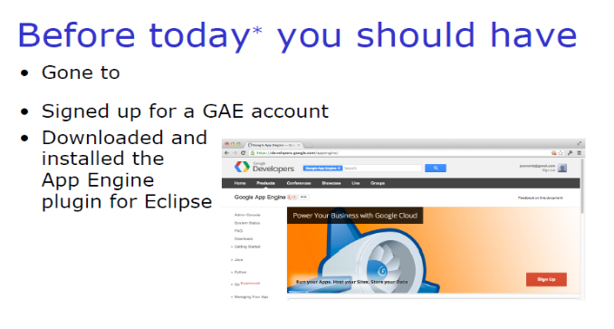
Steps 2:
Downloading, Installing and setting up the Eclipse IDE for GAEJ
We will need the following software to be present on your development machine. I am assuming that you are comfortable with downloading and setting up of the software from public sites.
1. Java Development Kit 1.6.x : Please ensure that the JDK version is setup appropriately on your machine.
2. Eclipse 3.3 / 3.4 / 3.5 : Choose any Eclipse IDE version that you want. I am using the latest version 3.5 Galileo Release.
3. GAEJ Plug-in: Go to the following page: http://code.google.com/eclipse/docs/getting_started.html This page contains links to the GAEJ plugin for Eclipse download/installation. I list below the update site URL for the GAEJ Eclipse plugin from that page:
o Eclipse 3.5 (Galileo) http://dl.google.com/eclipse/plugin/3.5
o Eclipse 3.4 (Ganymede) http://dl.google.com/eclipse/plugin/3.4
o Eclipse 3.3 (Europa) http://dl.google.com/eclipse/plugin/3.3
Depending on the version of Eclipse that you have, I reproduce from the Google site the links for installing the plugin depending on the version of Eclipse that you have. Please follow the instructions on the page, it is straightforward and I do not wish to replicate it here.
o http://code.google.com/eclipse/docs/install-eclipse-3.5.html
o http://code.google.com/eclipse/docs/install-eclipse-3.4.html
o http://code.google.com/eclipse/docs/install-eclipse-3.3.html
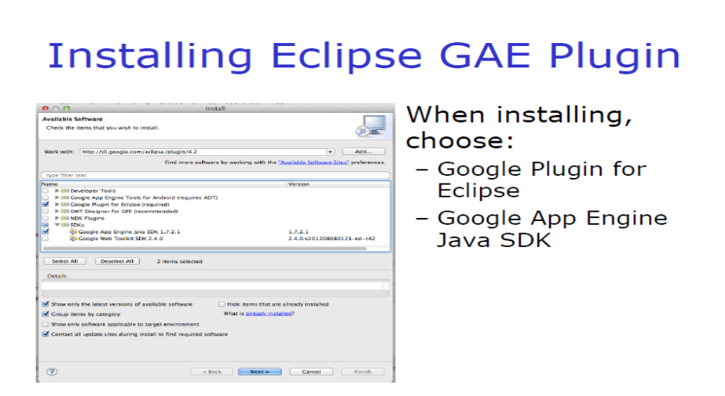
Steps 3:
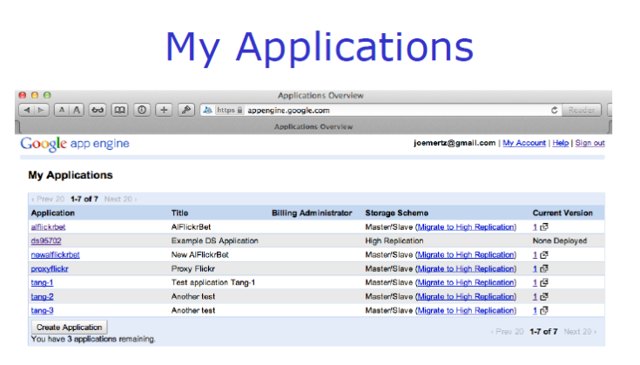

Step 4:
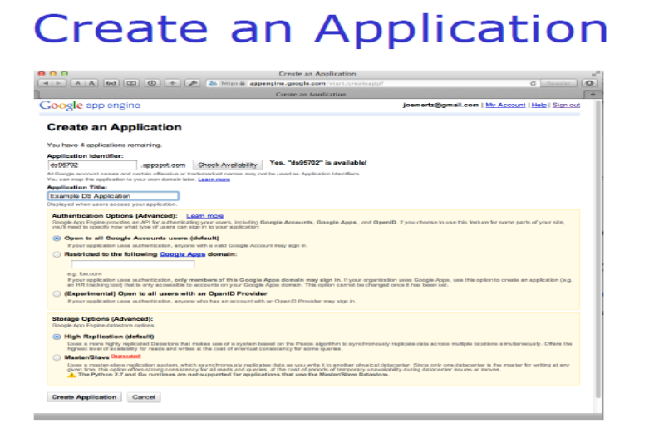
Step 5:
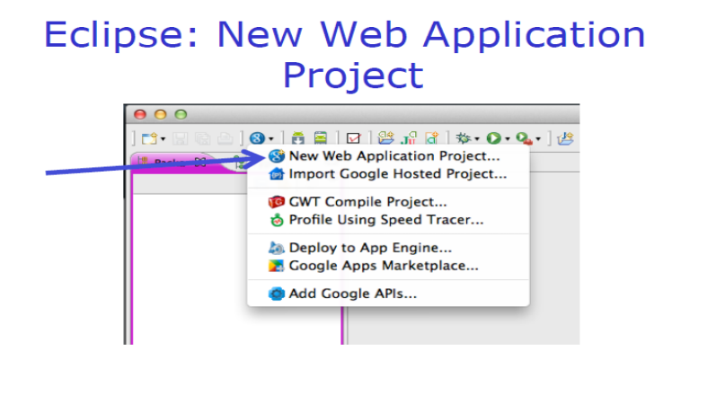
Step 6:
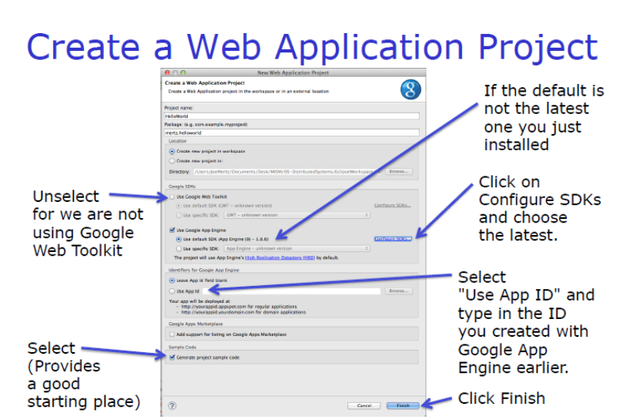

Step 7:
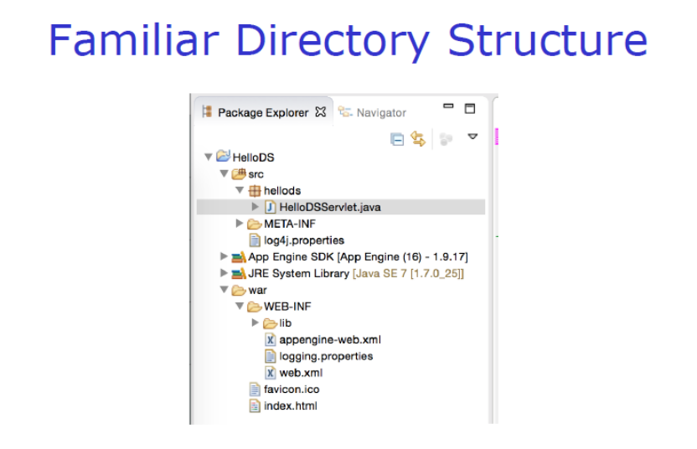
Step 8:
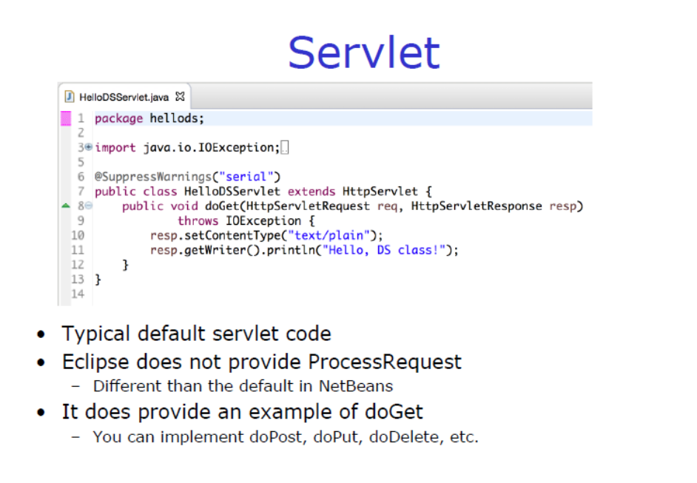

Step 9:
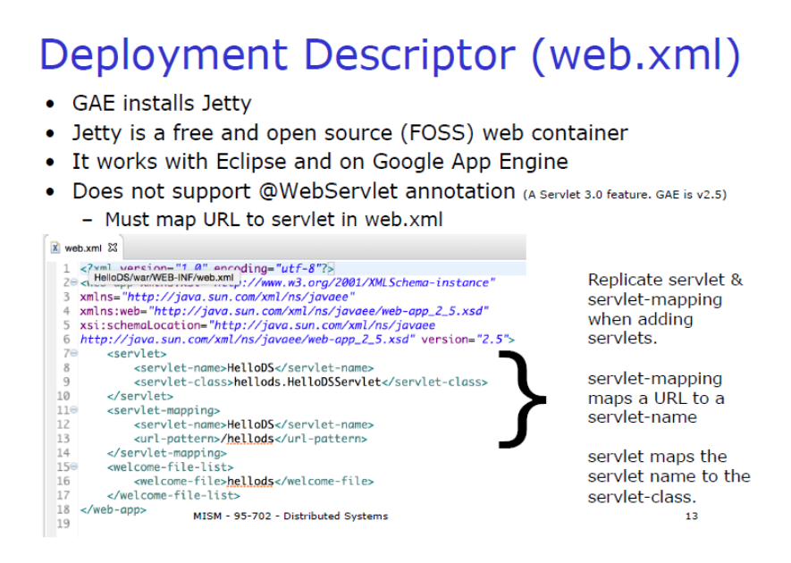
Step 10:
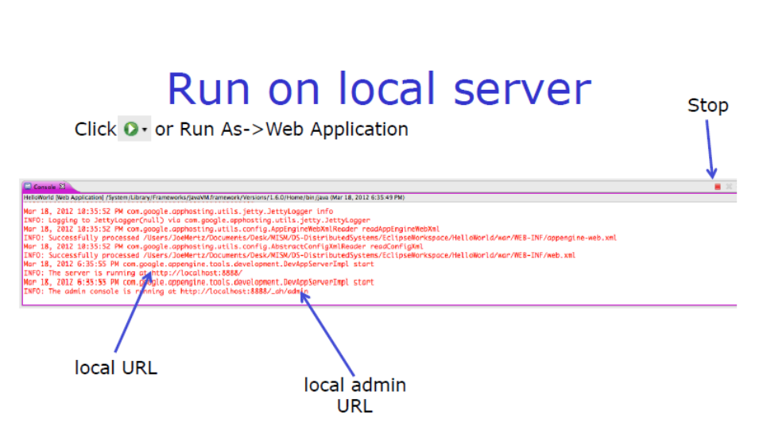
Step 11:
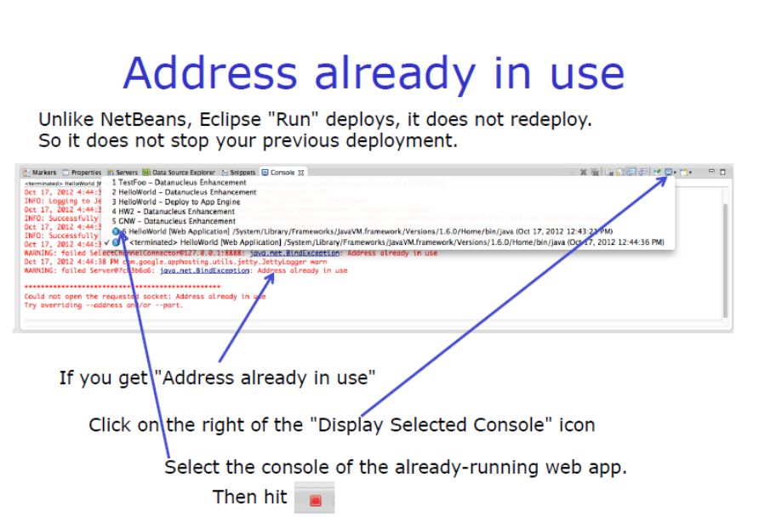
Step 12:
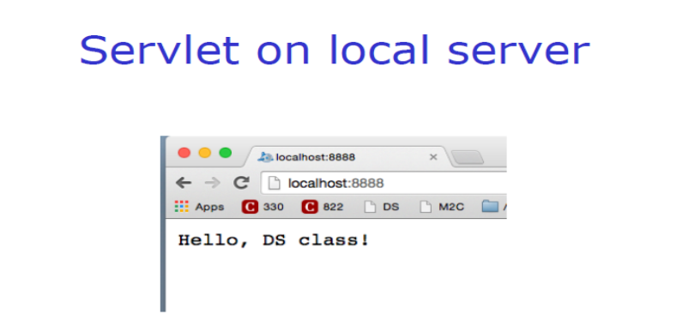
Step 13:
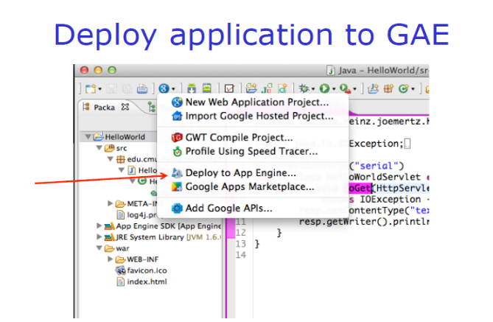

Step 14:
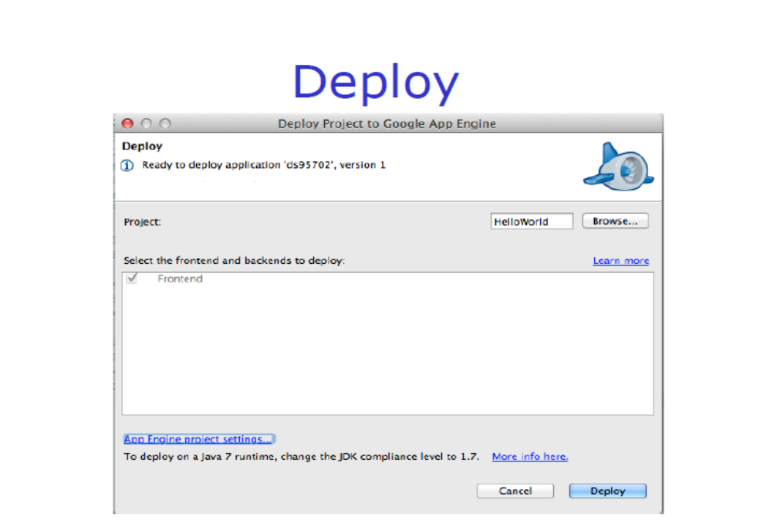
Step 15:
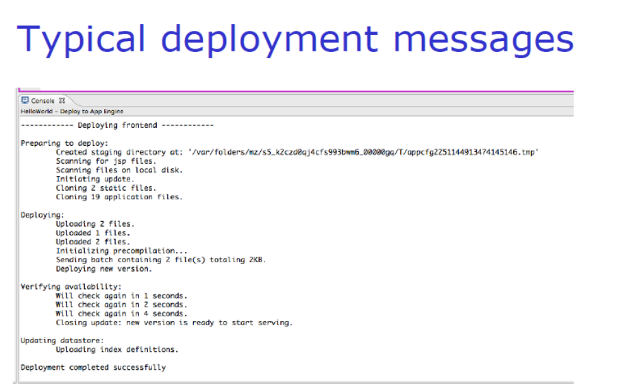

STEP BY STEP PROCEDURE:
1.Sign up for Google App Engine

You need to first sign up for the Google App Engine Account. This is easy and is a breeze in case you already have a Google Account (Gmail, Apps, etc) in which case it is best that you use that straight away. Go to http://appengine.google.com and simply login with your account. Even if you do not have an account, you can sign up for a Google Account, a link for which is provided on the page.
Whether you already have a Google Account or have signed up for a new one, do login first. Once you are logged in, you will be presented with a list of applications that you are currently running on the Google App Engine under the account which we logged in with. Google provides a total of 10 applications that you can deploy under a single account. Please be aware that as of this date, there is no way to delete an application and use that slot for another application — so use with care.

Episode 1 : Google App Engine Java Development Setup 2 Here is a screen shot of my account page at the Google App Engine after login:
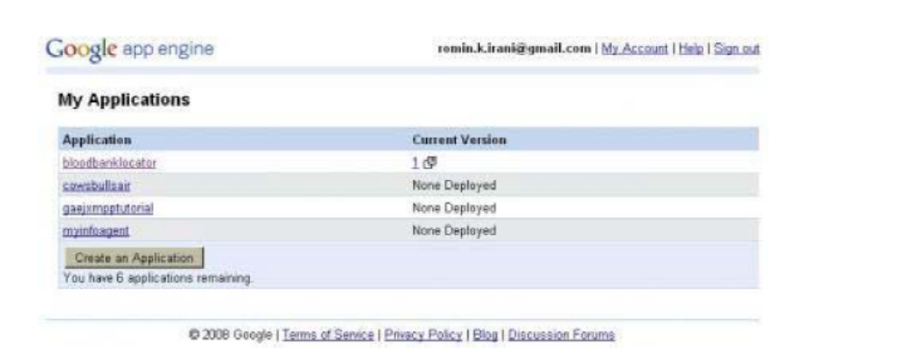

It shows that I have 4 applications registered on Google App Engine and have 6 more to go. You might have no applications listed if you are logging in for the first time and/or have not created any application.

Note: If you are registering your 1st application, the process is as follows:

1. Click on Create an Application.
2. Once you have selected a name, then you will be prompted for your Mobile Number. Enter your mobile number (with country code, etc).
3. Google will send you a SMS with an code. You will be prompted on the next screen to enter the code that you received on SMS. Enter that to confirm the process.
This is only required for registering your 1st application and once the SMS verification process is complete, you will not be prompted again when you create your 2nd application and so on.

2.Registering your Application

Cool, let’s create an application then but before that we must tell your application to show its ID. So let us talk about Identity first.

Identity, Identity, Identity….

Yes, everyone needs to show an ID. And the same applies to your application too that is hosted in the cloud. Let me explain that a little. As you know Google App Engine is a PaaS (Platform as a Service), which means that you can develop and deploy your application (following some Episode 1 : Google App Engine Java Development Setup 3 specification) into their infrastructure (in the cloud). Now what this means is that while it would be nice for you to get an application name of your choice, it is not feasible in a hosted environment where you are sharing all resources with other applications too.
By default, your application needs to be unique within this so called name space:

YOUR_APPLICATION_ID.appspot.com

where YOUR_APPLICATION_ID can be any name that you wish for your application, that has not already been taken by someone else. So before you start with an application in mind, it pays to plan it out a little first and that includes what name you would like for your application and then registering it as quickly as possible so that you have it.

Note: Please keep in mind that what I am discussing here is the basic facilities provided by Google. It is perfectly possible for you to purchase a domain name and then point it to the URL where your application is hosted in the Google App Engine cloud. But we will not discuss all that know and will keep the discussion to what is provided straight of the bat.

OK. So you have thought of the application name and wish to register it. So since we are going to write a “Hello World” sort of an application — we should go ahead and create an application identifier first.

Let us actually do that before moving on. Assuming that you are logged in as described earlier, click on the Create An Application button. This will bring up a page as shown below:

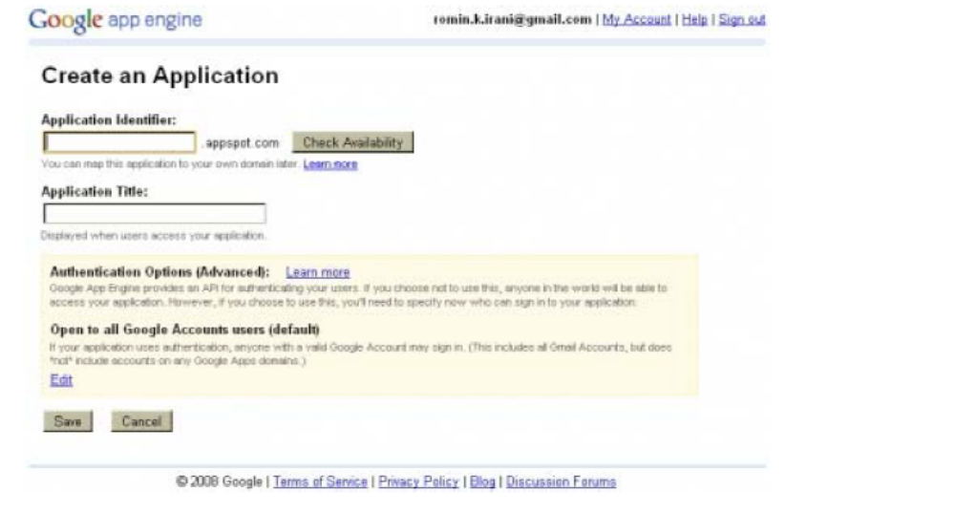
This page will allow you to select an Application Identifier that we have been talking about. Go ahead. Try out a few names like myhelloworld, myfirstapp, etc and see which one is available. Give any string for the Application Title and go with the default options

Episode 1 : Google App Engine Java Development Setup 4 for the Account options (we can skip it for now). Click on the Save button. If all is well, the application identifier will be created and your first application is registered. Congratulations! But we have a lot to do including writing the application.

Please make sure that you note down your Application Identifier since this will be used later on to verify your entire setup. OK, let me not scare you — you can always go back to the Google AppEngine account and see the applications listed
Do check out the excellent monitoring portal that Google App Engine provides to view/monitor a number of things about your application. Just click on the registered application in the application list and you will be lead to the portal where you can check the logs/quotas and configure several other stuff. As this blog develops, I will cover more of this but for now, just browse around and familiarize yourself.

3.Downloading, Installing and setting up the Eclipse IDE for GAEJ

We will need the following software to be present on your development machine. I am assuming that you are comfortable with downloading and setting up of the software from public sites.

1. Java Development Kit 1.6.x : Please ensure that the JDK version is setup appropriately on your machine.
2. Eclipse 3.3 / 3.4 / 3.5 : Choose any Eclipse IDE version that you want. I am using the latest version 3.5 Galileo Release.
3. GAEJ Plug-in: Go to the following page: http://code.google.com/eclipse/docs/getting_started.html This page contains links to the GAEJ plugin for Eclipse download/installation. I list below the update site URL for the GAEJ Eclipse plugin from that page:

- Eclipse 3.5 (Galileo) http://dl.google.com/eclipse/plugin/3.5
- Eclipse 3.4 (Ganymede) http://dl.google.com/eclipse/plugin/3.4
- Eclipse 3.3 (Europa) http://dl.google.com/eclipse/plugin/3.3

site the links for installing the plugin depending on the version of Eclipse that you have. Please follow the instructions on the page, it is straightforward and I do not wish to replicate it here.
- http://code.google.com/eclipse/docs/install-eclipse-3.5.html
- http://code.google.com/eclipse/docs/install-eclipse-3.4.html
- http://code.google.com/eclipse/docs/install-eclipse-3.3.html

Episode 1 : Google App Engine Java Development Setup 5 Once you have finished the setup and restarted your Eclipse IDE, you should see the following 3 icons in the toolbar of the Eclipse IDE.

4.Writing our first GAEJ application

So far we have signed up for Google App Engine, registered our Application Id and setup the GAEJ plug-in for Eclipse. We are ready to write our application now. The Gods always tell us to start any new thing on an auspicious note by crying out “Hello World” and we shall stick to the tradition.
As we shall see things unfold, GAEJ plug-in for Eclipse makes things very simple. It does all the hard work after we give it some inputs and then it generates an entire web application for us along with sample servlet that pretty much does just that i.e. says “Hello World”. What we will be writing no code, you say? Yes. All this code is generated for us and is pretty much a template that we can take and put our application logic in there.
So let us move forward and generate our first project now (steps along with explanation follow):

1. Launch your Eclipse (if not started).
2. Either click on File –> New –> Other or press Ctrl-N to create a new project. Select Google and then Web Application project. Alternately, you could also click on the New Web Application Project Icon [part of GAEJ Eclipse Plugin] in the Toolbar:
3. This will bring up a New Web Application Project page as shown below:
Episode 1 : Google App Engine Java Development

Setup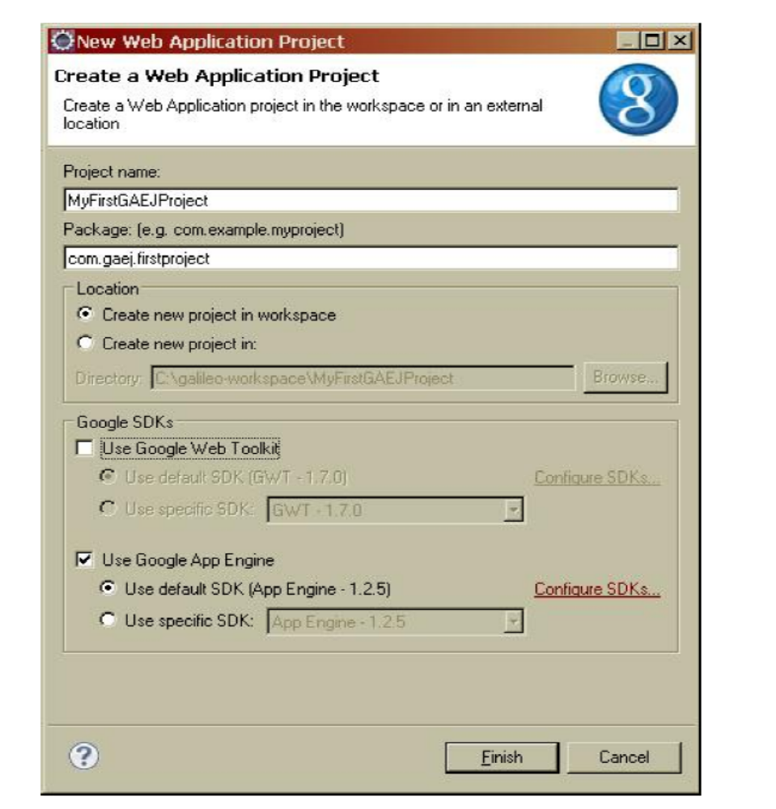
Enter the details as given below:

* Project Name : MyFirstGAEJProject. You can select any name that you like. * Package : com.gaej.firstproject. You can select any name that you like. * Deselect the Use Google Web Toolkit option.

4. Click on Finish. This will generate an entire project for you which is ready to be deployed.
5. But before that, let us look at the files that have been generated. I reproduce for you the screen from my Package Explorer as shown below:
Episode 1 : Google App Engine Java Development Setup
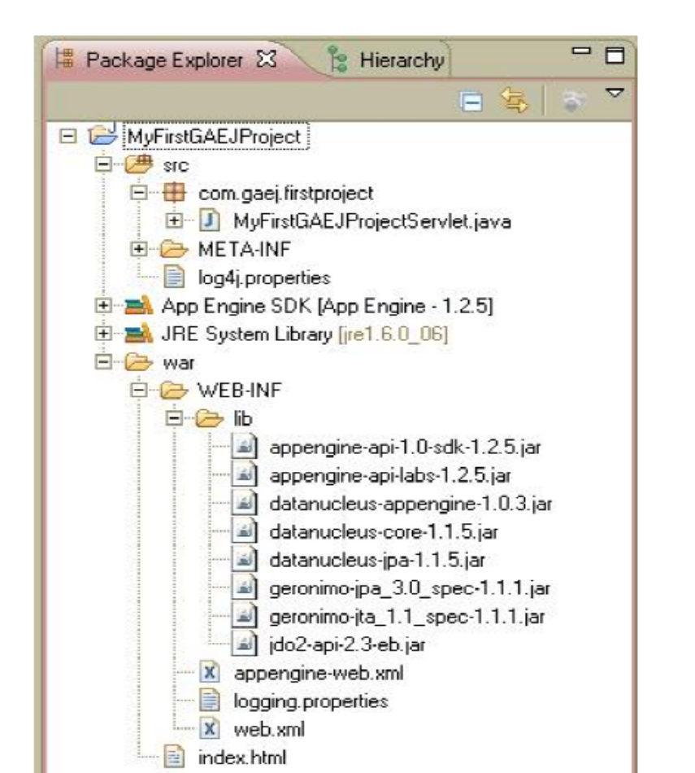

6. If you are familiar with Java Web applications, this should be straightforward stuff with directories like WEB-INF, WEB-INF\classes, WEB-INF\lib, etc. But let us cover it in brief:

• src : This contains the source files. You will find that it has generated a sample file name MyFirstGAEJProjectSerlvet.java for you. It has been created as per the package hierarchy that you selected. You can keep all your source files over here as you develop more.

• war : This is the war file structure i.e. Web Application Archive. This if you recollect will be deployed into the Servlet Container of the App Engine that will eventually host your Java Web Application. In this directory, you have the following:
o WEB-INF\lib: All appropriate JAR files that provide the Java SDK libraries along with Google Java APIs for the App Engine have been linked correctly into the project build path and the necessary JAR files are also present in the WEB-INF\lib folder
o index.html : This is the first page served. You can actually customize it to any that you want. All your additional html files/resources could go in here.
Episode 1 : Google App Engine Java Development Setup 8

- logging.properties: If you are familiar with Java logging, you should be able to make sense of this file and tweak your logging preferences over here.
- web.xml : This is a standard web application configuration file. You will find the Servlet entries present here for the sample servlet that is generated for us.
- appengine-web.xml : This is a Google App Engine specific configuration file. And the main element here of interest to us is the application element that will contain the Application ID of the application that we registered for Google and which will be pointing to a hosted version of this WAR. We will set this up at the time of deploying the application, which we will cover later.
7. MyFirstGAEJProjectServlet : Let us cover this in brief, which can also act as a refresher for writing and setting up a servlet configuration in case you are little rusty (happens to the best of us!).
The servlet code is straightforward as shown below[Omitting package and import declarations]:

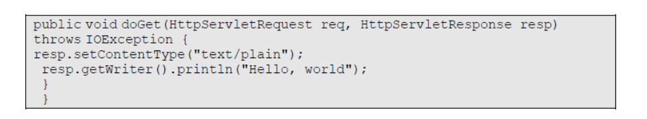

It extends the javax.servlet.http.HttpServlet class and implements the GET method. You could parse out the request parameters if needed (in this case there are none of interest). All that the servlet does is to get a handle to the response stream and then mention its content type and send across the text Hello World to the client.
Now, we need to set the servlet url and its java class in the web.xml configuration file. Open up the web.xml file and you will find the appropriate entries as shown below:

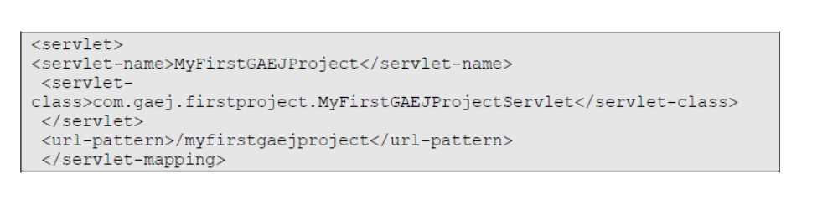

Episode 1 : Google App Engine Java Development Setup 9 And finally, if you open index.html, you will find a link that references the servlet as shown below:
so that when the index.html page is served, you will see a Hyperlink named MyFirstGAEJProject and on clicking it will invoke the MyFirsGAEProject servlet implemented in com.gaej.firstproject.MyFirstGAEJProjectServlet which will then print out Hello World.

5.Testing it locally

GAEJ Eclipse plug-in ships with a local server, where you can deploy your application and test it out. Ensure that port 8080 is free on your machine and that no other web server is running on it.
To test the application, all you need to do is the following:

1. Select the project and then Run As –> Web Application
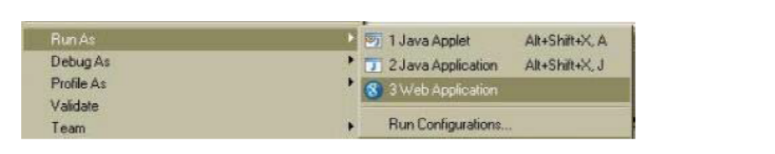
2. This will compile/deploy your application the local server and the server will be started on port 8080. You will see the server starting in the console window as shown below:
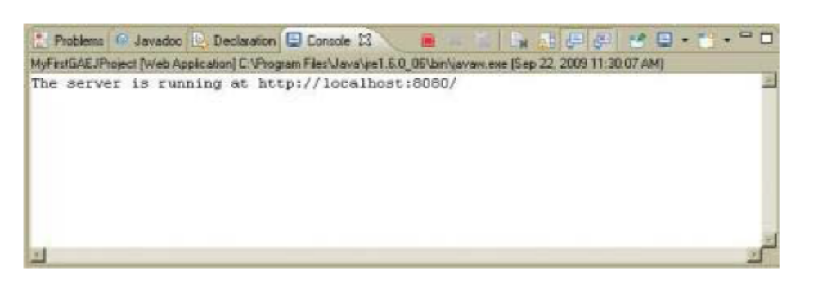
3. If all is well, you will get the message that the server is running at http://localhost:8080 as shown above.

4. Once that notification is shown, launch your browser and navigate to the url : http://localhost:8080. This will bring up a default JSP page that is generated for you with
Episode 1 : Google App Engine Java Development Setup 10 the servlet URL in it as shown below
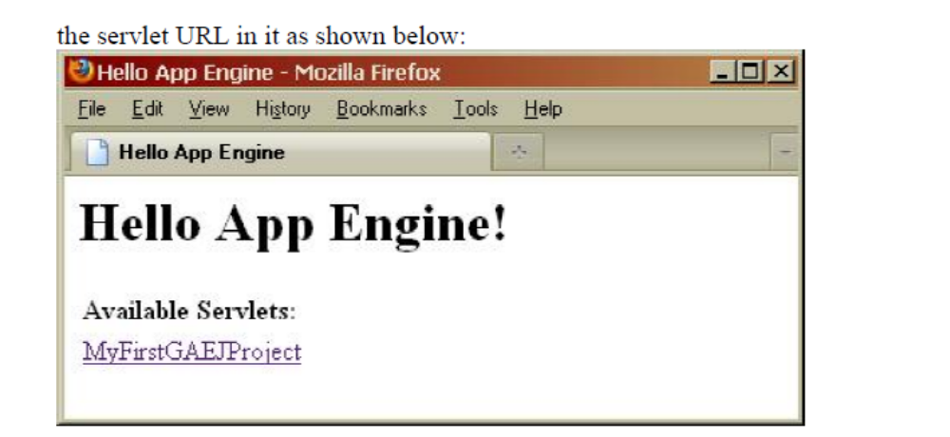
5. Click on the link and you will see your servlet getting invoked and telling you “Hello World”.
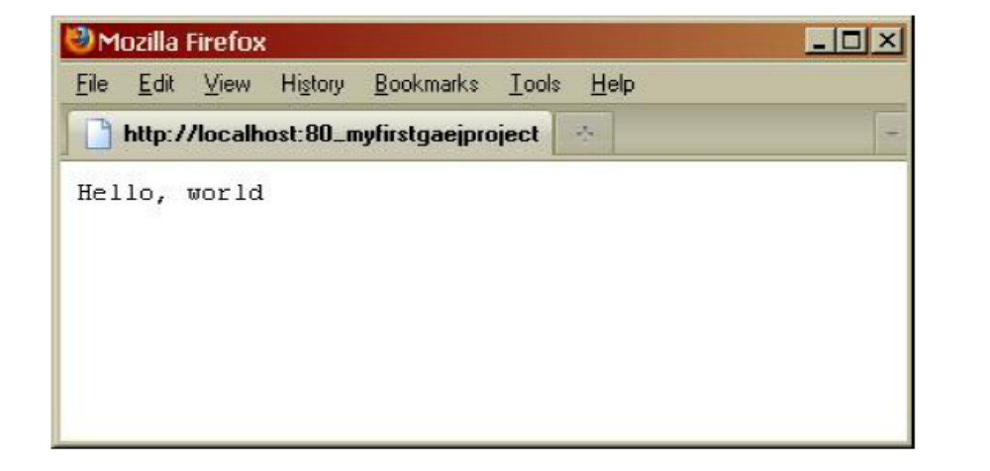

Now that things work, we need to deploy this application into the Google App Engine infrastructure. So lets go to that.

6.Deploying it into the Cloud
To deploy the application in the cloud, simply click on the Deploy App Engine Project Icon available in Toolbar[part of GAEJ Eclipse Plugin]. This will bring up a dialog where you will need to provide your Google Account credentials (username and Episode 1 : Google App Engine Java Development Setup 11 password). Do not click on Deploy yet.

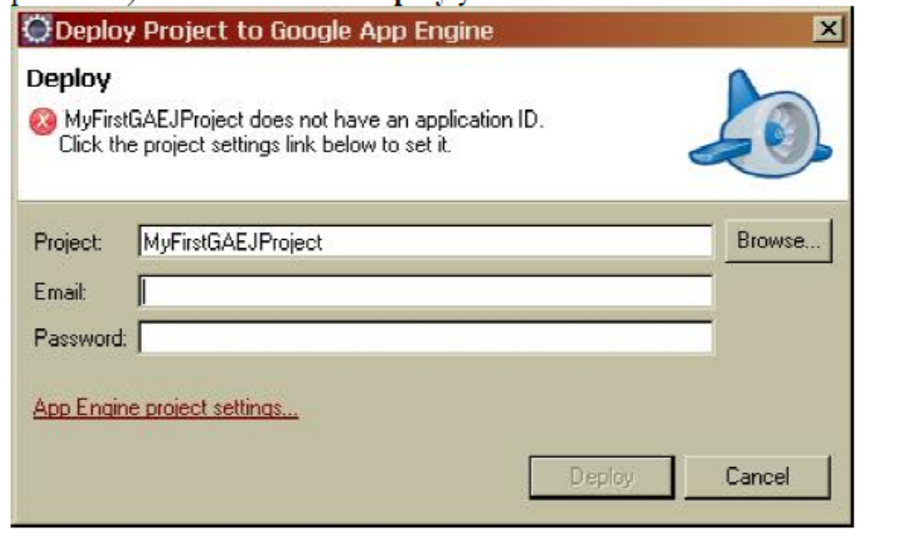
Click on the App Engine Project settings link in the above dialog. This will bring up a properties page as shown where you need to entire the Application ID. Remember the Application ID that we discussed earlier and you registered one for you. Well that is the Application Id that you need enter over here. Enter that and click OK as shown below [Remember to enter your Application ID before clicking

OK]: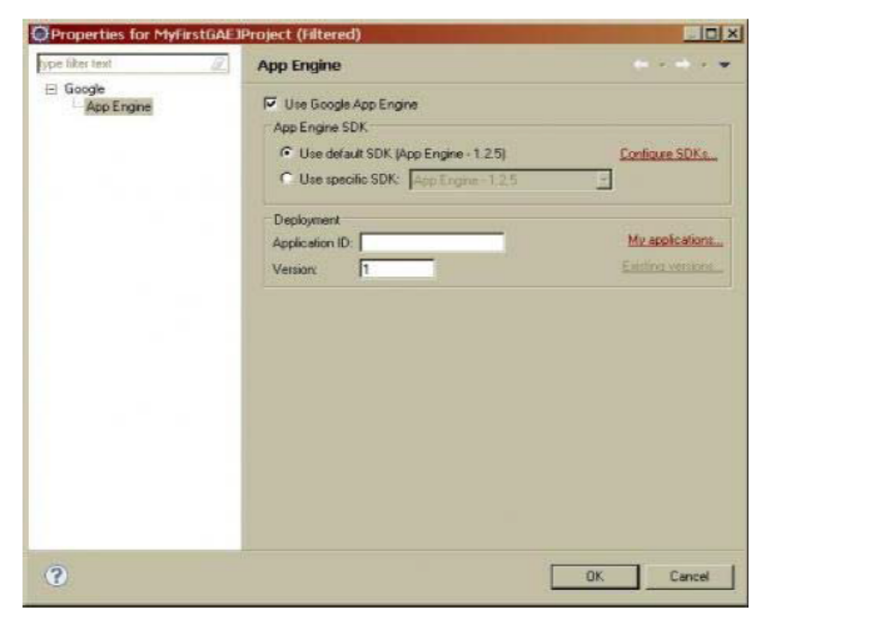

Episode 1 : Google App Engine Java Development Setup 12 This will lead you back to the Deploy Project to Google App Engine dialog box. Now simply click Deploy. This will connect to Google App Engine and deploy your application and register it with the Application Id that you used. A snapshot of the Progress dialog on my machine is shown below:
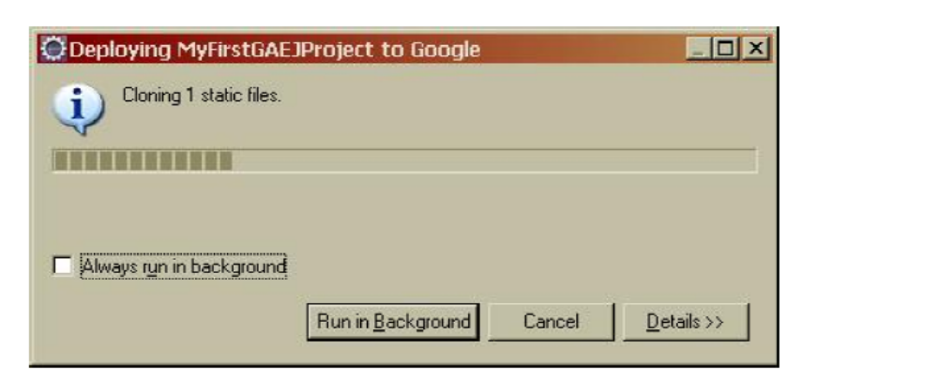
You will a lot of activity in your Console bar (a snapshot is shown) and at the end of it you should see a message saying that the application is available.

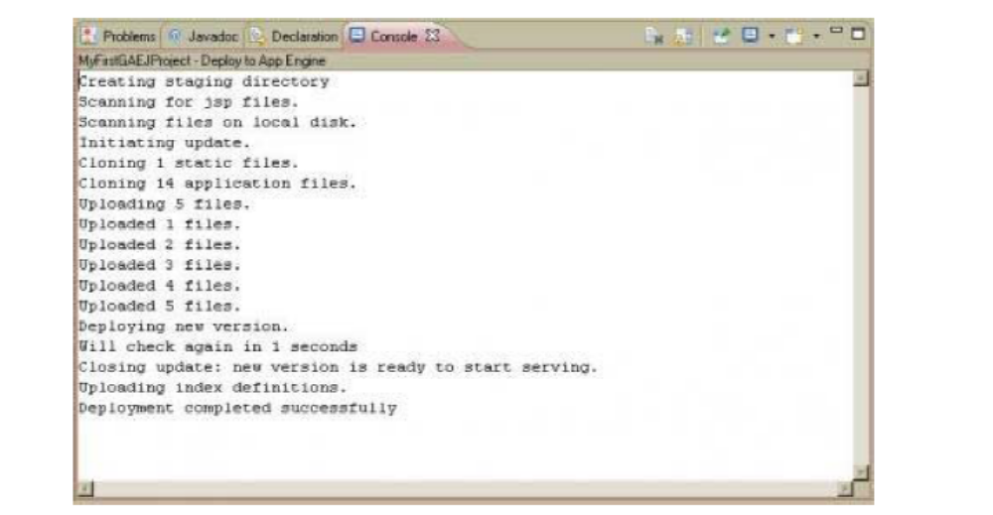
You can deploy your application several times as you make changes. There is a certain quota limit to how many times you can deploy it in a day and you can read that up but for the moment, you can rest assured that the number is quite huge.
Congratulations! You now have your own application hosted on the Google App Engine. It is already available to the world and that is what we will verify in the next section.
7.Testing the hosted/online version of our application

Your application is available under the url : http://YOUR_APPLICATION_ID.appspot.com. So if you Application ID is myapp, the url is http://myapp.appspot.com. Go ahead and access your URL.
Technically it is even possible to have different versions running, but for the purposes of this article we will limit it to the latest version that you deploy and which is available under the url that I have mentioned above.

Next Steps

So we have ended our mini journey for now in which we did the following:
• Registered for Google App Engine
• Registered our first application
• Setup the Developer Environment for developing and deploying GAEJ Java applications
• Used the Google Eclipse Plug-in to develop our first GAEJ application
• Tested and deployed our first GAEJ application

SE1014 - CLOUD COMPUTING
ASSIGNMENT # 3
1. The purposes of this assignment are:
A) To get your Azure development environment installed and working and ready for future projects, and
B) To familiarize you with the basic steps of generating and deploying an Azure project, and
C) To show you how easy it is to get your simple app plugged into the Cloud

Prerequisites:
There are a few prerequisites that you must have in order to complete this lab guide.
- A Microsoft ID
Sign up
- Windows Azure account (Trial, Pay As You Go, or Purchased Plan)
o Windows Azure 30 Day Trial
o You will need a credit card to create a trial account (You will NOT be charged)

Lab Guide:

Windows Azure Account
Sign up for a Windows Azure 30-Day Trial account here.
**Note: You will need a credit card to sign up for the trial account.
What you get with your Windows Azure 30-Day Trial:
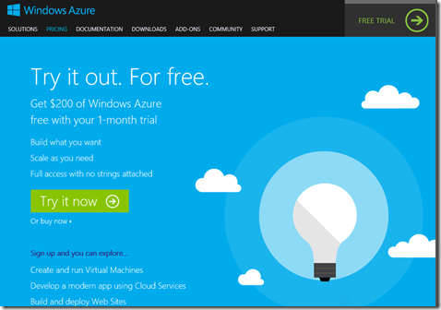
$200 USD of Windows Azure services. Build what you want, scale as you need, and full access with no strings attached.
- Create and run Virtual Machines
- Develop a modern app using Cloud Services
- Build and deploy Web Sites
- Spin up Mobile back-ends for Android,
- iOS or Windows Phone 8
- Store, backup, and recover data
- Encode and share video
- And much, much more...
Let’s create a Website!
Creating Microsoft Azure Web Sites

Microsoft Azure supports several ways to create web sites. Of the available Microsoft Azure offerings, Cloud Services and Virtual Machines are the most flexible. While both of these approaches allow a great deal of control over your environment, they also require skill and time. A more streamlined experience is available with Microsoft Azure Web Sites. For web applications written by using ASP.NET, Node.js, PHP, or Python, Microsoft Azure Web Sites enables rapid deployment, easy configuration, monitoring, high scalability, and a service level agreement (SLA). This paper provides guidance on using Microsoft Azure Web Sites.

Creating a web site from the gallery

You can easily create a new Microsoft Azure web site by selecting a starter project from the gallery in the Microsoft Azure Management Portal. These options provide solutions to get you closer to your goal with less work than if you started with a blank project. The gallery contains Microsoft-provided options, such as ASP.NET-related starter projects, as well as options for Python, PHP, and Node.js that are based on community projects or from other third parties.

This paper assumes that you already have a Microsoft Azure subscription. (If you do not have an account, sign up for a free one-month trial of Microsoft Azure.)

After logging into your account on the Management Portal, you will see a window similar to the image in Figure 1.
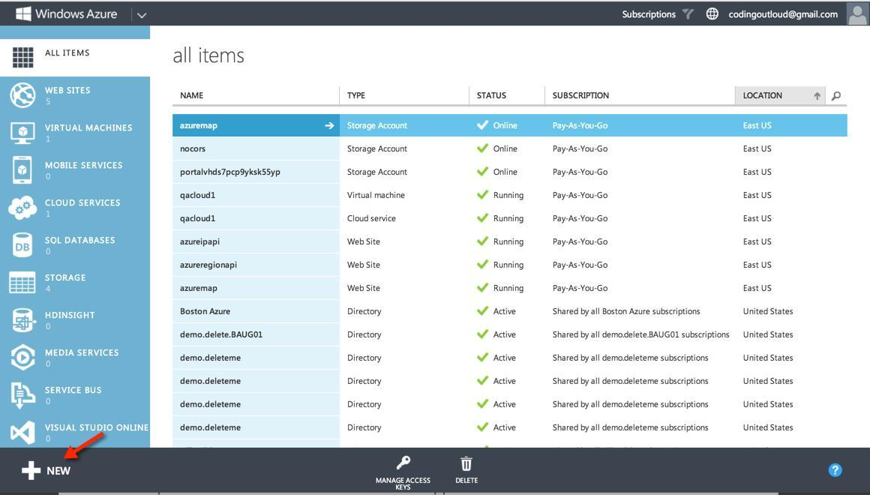

Figure 1

- Select + New to open a wizard from which you can create many types of cloud resources.

Creating Microsoft Azure Web Sites
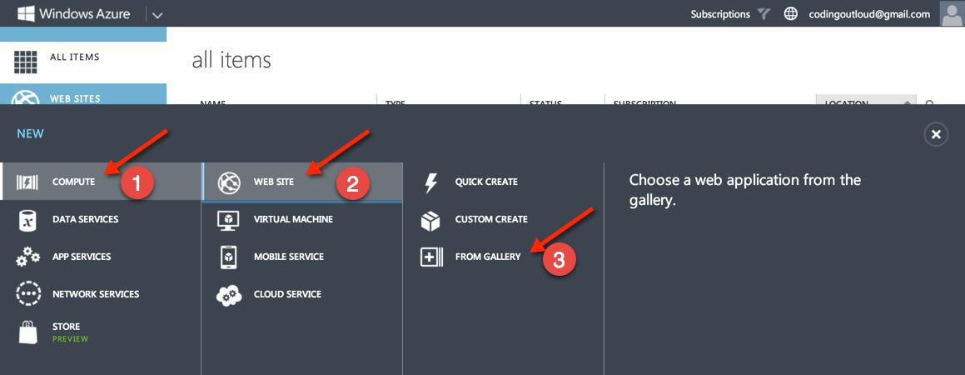

Figure 2

2. Select COMPUTE > WEB SITE > FROM GALLERY.

From the gallery, you can select from a variety of starter projects for a range of technologies, including Node.js, Python, PHP, and ASP.NET, as shown in Figure 3.
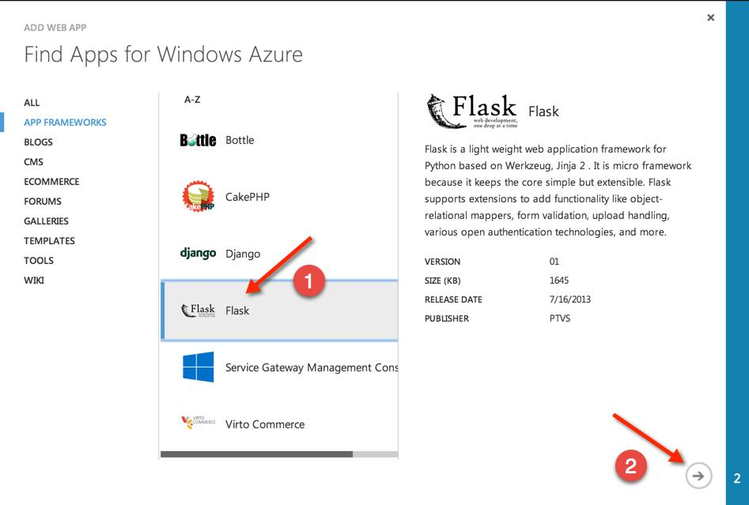

Figure 3

3. Select the Flask option, then click the right arrow (→) to move to the next step in the wizard.

2.Creating Microsoft Azure Web Sites
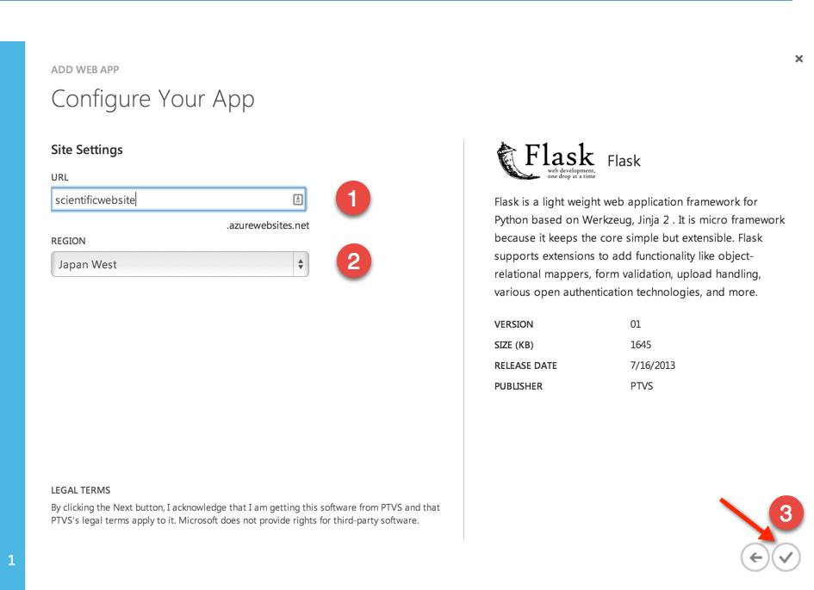

Figure 4

- Provide a subdomain name: scientificwebsite (1).

- Select a region, Japan West (2).

- Click the checkmark button (3).

This creates our new web site, as shown in Figure 5.
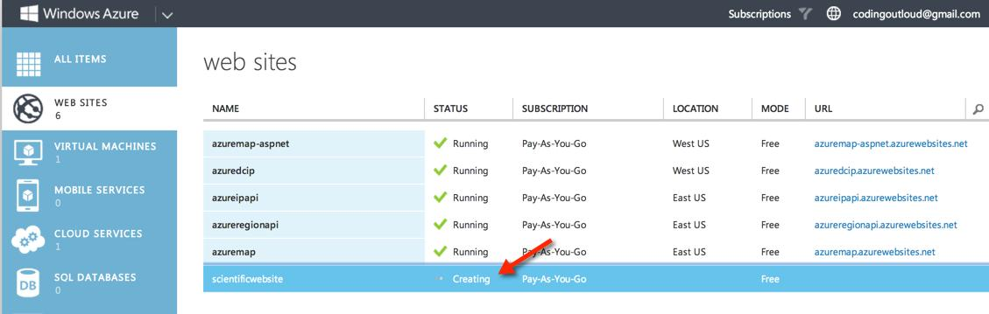

Figure 5

3.Creating Microsoft Azure Web Sites

Since the subdomain we chose for our web site is “scientificwebsite,” the web site will be created at http://scientificwebsite.azurewebsites.net, or at the equivalent HTTPS URL by using the built-in wildcard SSL support.

7. Click the name of the web site, scientificwebsite, to get to the next screen.
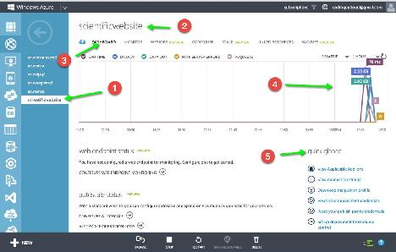

Figure 6

In this screen (Figure 6), you can that see we have selected our web site (1); our web site name displays at the top (2). Relating specifically to our web site, we are on the DASHBOARD tab (3), which has a lot of useful information, including a summary of the monitoring data (4), and the ability to view and make changes to various credentials for FTP, management through the API, and more (5).

In addition to the DASHBOARD tab, there are other tabs where you can configure specialized settings. For example, from the SCALE tab, you can manage manual scaling and configure auto-scaling rules, and the CONFIGURE tab provides options for logging parameters, configuring a custom domain name, and more.

4. Creating Microsoft Azure Web Sites

Initial creation of Python web sites and using third-party tools

The simplest way to start configuring a Python web site is to select an option from the gallery. This ensures that proper site configuration is in place and that the Python libraries (for example, Django) are deployed for the web site. Once deployed, you can use FTP to capture the source code from the site and copy it locally. Once the source is local, you can edit with any tool (such as Vim, PyCharm, or Microsoft Visual Studio). Alternatively, if you would like to start a project from within another tool, you can set up Python configuration settings yourself.

In addition to configuration settings, deployments must include all non-standard Python libraries needed by your web site, such as all the libraries you downloaded by using pip or a similar package manager.

For instructions on setting up Python configuration settings and deploying additional Python libraries, see the tutorial, Creating Web Sites with Django.

Automatic publishing to web sites

Web Sites supports integration with a number of source code repositories, such as Bitbucket, GitHub, and VisualStudio.com, and even other services, such as Dropbox. You can configure any of these so that changes to source code deploy automatically to one or more web sites.

In this section, you will learn how to configure a web site to support continuous deployment from a GitHub repository. Continuous deployment means that if there is a change, the web site updates automatically. If someone uses the commands git commit and then git push to record changes to the repository, GitHub executes a WebHook. A WebHook allows a repository to communicate with a web server whenever the repository receives a push. In this example, the WebHook communicates with the Microsoft Azure web site, which performs a git pull and redeploys the code. For more information about WebHooks, see Creating Webhooks on GitHub Help.

Aside from the advantage of keeping your web site updated, there are additional benefits associated with continuous deployment. For example, if you don't want to give people access to your web server, you can give them access to the GitHub repository instead and they can check in their changes there. If you want to review changes before they appear on the web site, you can use the git pull feature (commonly known as a “pull request”).

The next section is a procedure for creating the web site by using existing code. It assumes that you already have a GitHub account with a repository (in addition to your Microsoft Azure subscription). Your repository should contain some code that can appear on your web site, such as a "Hello, word" example. If you would like, you can also clone the flasky GitHub repository that is in this example.

5.Creating Microsoft Azure Web Sites

Creating a web site from source control

Follow these steps to create a custom Flask web site that deploys code from your GitHub repository and supports continuous deployment.

Go to the Microsoft Azure Management Portal and select WEB SITES in the menu on the left, as shown in Figure 7.
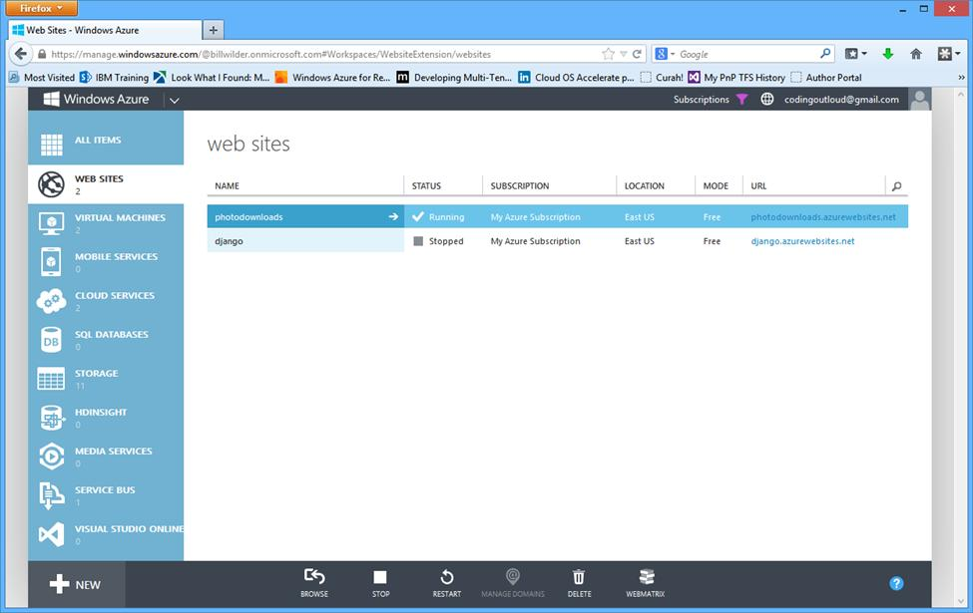

Figure 7

2. Select + New at the lower left of the screen.

6.Creating Microsoft Azure Web Sites
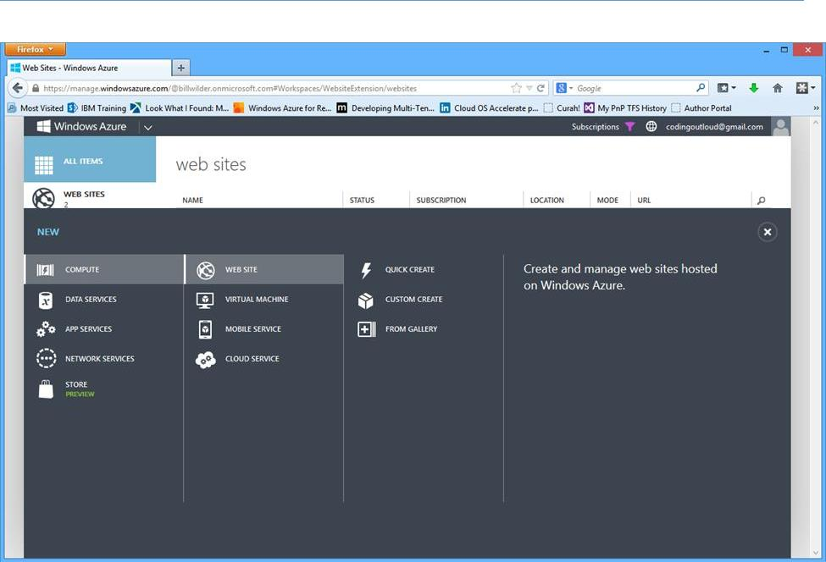

Figure 8
3. In the next screen (Figure 8), select COMPUTE > WEB SITE > CUSTOM CREATE.

The Create Web Site dialog box appears (Figure 9).

7.Creating Microsoft Azure Web Sites
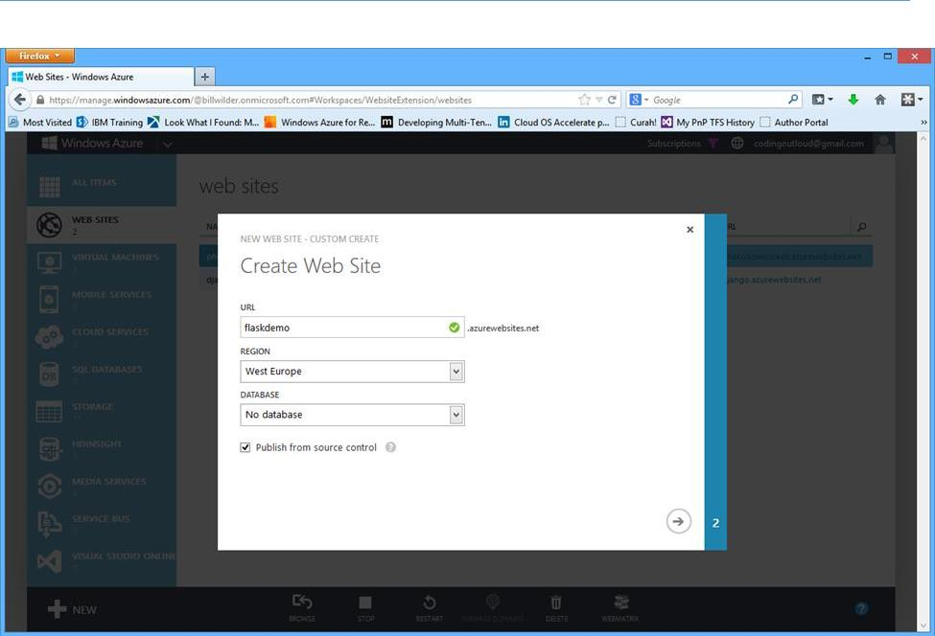

Figure 9

4. In the URL field, enter a unique name for the web site.

Microsoft Azure automatically checks to see if the URL is acceptable. If it is, a green checkmark appears next to the name, as shown in Figure 9. The URL of the web site will be name.azurewebsites.net. In this example, it will be flaskdemo.azurewebsites.net.

- From the REGION drop-down box, select the region that will host the web site.

- Make sure that the DATABASE field is set to No database.

Select the Publish from source code checkbox to enable integration with a source control system.

- Click the right arrow (→) at the bottom right of the dialog box.
The second page of the dialog box appears (Figure 10). This is where you select your source repository.

8.Creating Microsoft Azure Web Sites
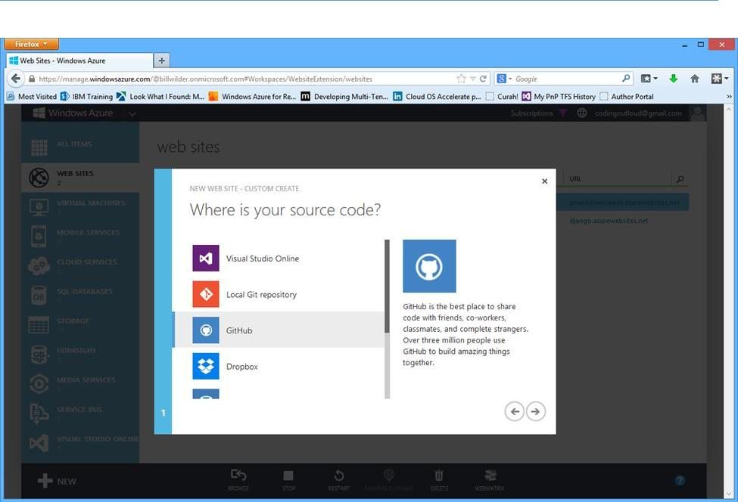

Figure 10

- Select GitHub.
- Click the right arrow (→) at the bottom right of the dialog box.
- If you are not already signed in to GitHub, a GitHub sign-in page appears. Enter your GitHub user name and password. Click Sign in.

If the authorization is successful, the Choose a repository to deploy dialog box appears (Figure 11).
9.Creating Microsoft Azure Web Sites

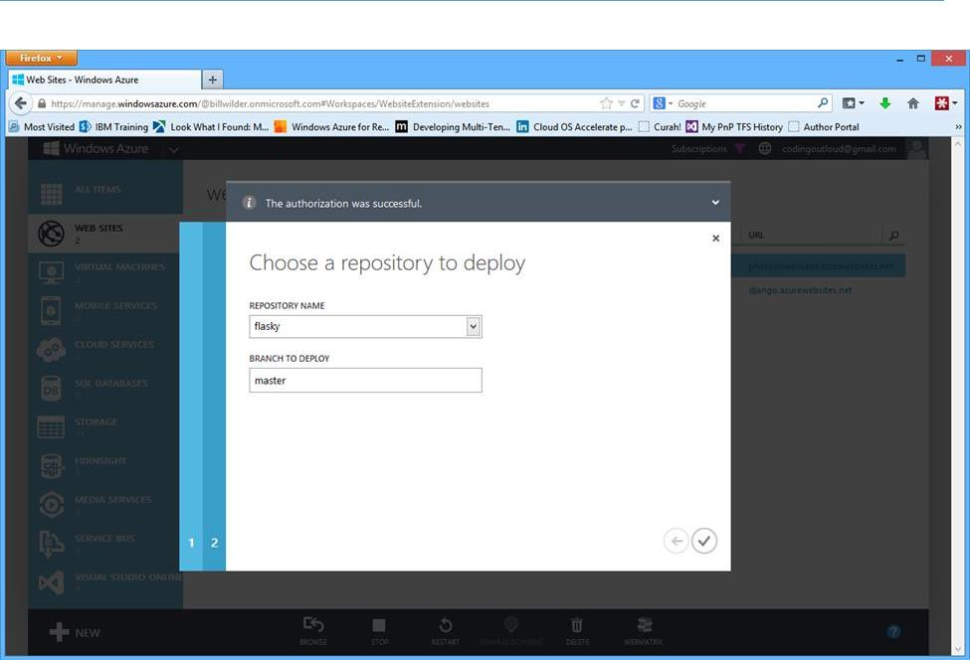

Figure 11

- Select a repository from the REPOSITORY NAME drop-down box.

- Enter a branch in the BRANCH TO DEPLOY field.

- Click the checkmark button. Microsoft Azure Web Services will create your web site.

Go to the Microsoft Azure Management Portal to see the status of your web site

(Figure 12).

10.Creating Microsoft Azure Web Sites
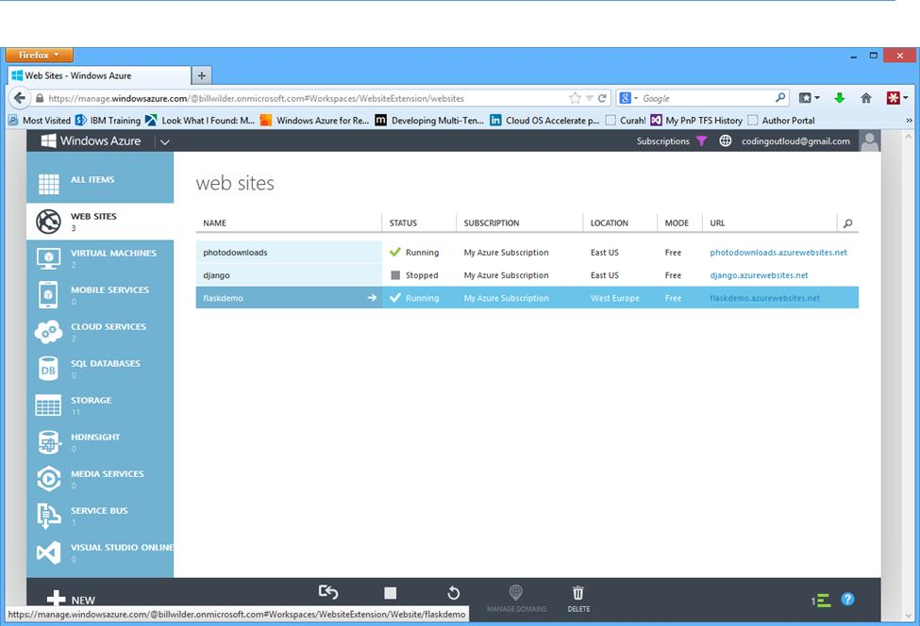

Figure 12

In Figure 12, you can see that the status of flaskdemo is Running.

15. Go to your web site. In this example, the address is http://flaskdemo.azurewebsites.net/.

You can see that the web site is already populated with the code from the flasky repository on GitHub. Any updates to the code in the repository will deploy automatically to the web site.

Viewing WebHook settings

If you are interested in seeing what the integration with the web site looks like from within GitHub, go to https://github.com/username/reponame/settings/hooks (insert your GitHub user name [username] and the repository name [reponame] in the URL where indicated).

11.Creating Microsoft Azure Web Sites
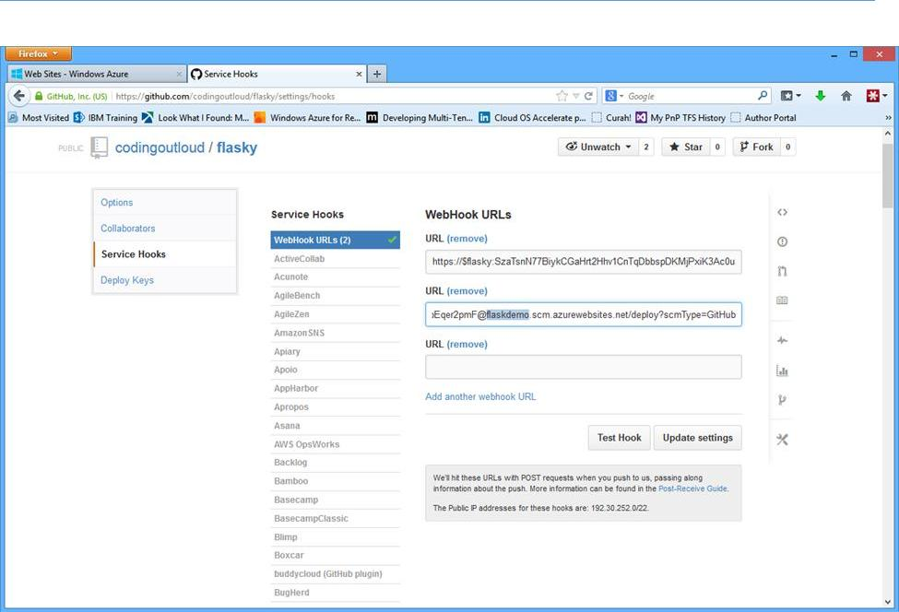

Figure 13

You will see that a new WebHook URL has been added (displayed in the second URL field in Figure 13), which is attached to the flaskdemo web site.

Managing and scaling web sites

The Microsoft Azure Web Sites service offers plans that target various common workloads. For low-volume web sites, there is a free plan that includes a modest amount of traffic and some space in either MySQL or Microsoft Azure SQL Database. For higher-traffic and more complex web applications, there are paid options that support custom domain names, auto-scaling, and the ability to scale between 1 and 40 CPU cores. For more information about pricing, see Microsoft Azure pricing at-a-glance.

Full management of web sites is available through the Microsoft Azure Management Portal, but there are also management APIs to enable integration with other tools. The APIs can be accessed natively through REST-style integration, but there are also platform-specific SDKs written for Node.js, Python,

.NET (for C#, F#, or any other .NET Framework programming language), Java, popular mobile platforms, and others (see the full list). Microsoft also exposes management features through a suite of PowerShell cmdlets and a set of Cross-Platform Command Line Interface (xplat-cli) commands, both of which allow for easy scripting; the xplat-cli runs on Linux, Mac, and Windows, while PowerShell runs only on Windows. Visual Studio and third-party tools can also integrate by using the APIs. You can also create custom integrations as needed.

12.Creating Microsoft Azure Web Sites

Simplicity is a feature

Powerful features are helpful only for sites that need them—now or in the future. However, if you run a small lab, you probably don’t need custom integration or Internet-scale features; you may not even have the resources to maintain your own web site. With Microsoft Azure, once your web site is running, you can forget about it. If the web site fails or crashes, it restarts automatically—no manual intervention required. You have a simple view, including monitoring and management, directly from the Microsoft Azure Management Portal.

Learn more

Microsoft Azure Web Sites (http://azure.microsoft.com/en-us/documentation/services/web- sites/)

Microsoft Azure pricing at-a-glance (http://azure.microsoft.com/en-us/pricing/overview/)

Flask (http://flask.pocoo.org/)

GitHub Help (https://help.github.com/)

GitHub Webhooks (https://help.github.com/articles/post-receive-hooks)
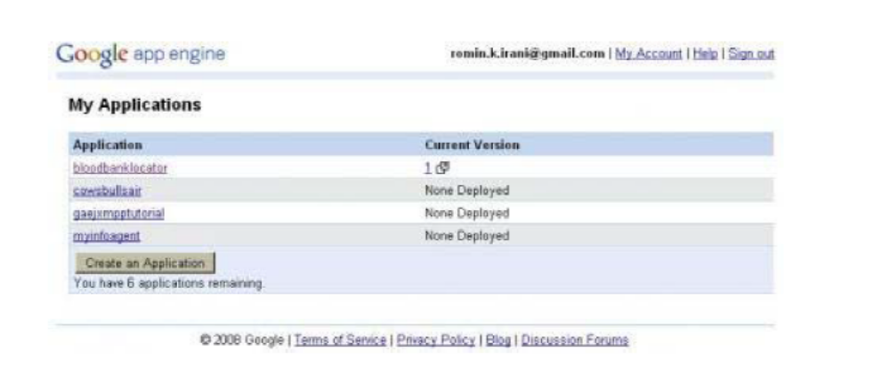

Cloud Computing Interview Questions and Answers

1.How does cloud computing provides on-demand functionality?
Cloud computing is a metaphor used for internet. It provides on-demand access to virtualized IT resources that can be shared by others or subscribed by you. It provides an easy way to provide configurable resources by taking it from a shared pool. The pool consists of networks, servers, storage, applications and services.

2.What is the difference between scalability and elasticity?
Scalability is a characteristic of cloud computing through which increasing workload can be handled by increasing in proportion the amount of resource capacity. It allows the architecture to provide on demand resources if the requirement is being raised by the traffic. Whereas, elasticity is being one of the characteristic provide the concept of commissioning and decommissioning of large amount of resource capacity dynamically. It is measured by the speed by which the resources are coming on demand and the usage of the resources.

3.What are the different layers of cloud computing?
Cloud computing consists of 3 layers in the hierarchy and these are as follows:
1. Infrastructure as a Service (IaaS) provides cloud infrastructure in terms of hardware like memory, processor speed etc.
2. Platform as a Service (PaaS) provides cloud application platform for the developers.
3. Software as a Service (SaaS) provides cloud applications which are used by the user directly without installing anything on the system. The application remains on the cloud and it can be saved and edited in there only.
4.What resources are provided by infrastructure as a service?
Infrastructure as a Service provides physical and virtual resources that are used to build a cloud. Infrastructure deals with the complexities of maintaining and deploying of the services provided by this layer. The infrastructure here is the servers, storage and other hardware systems.

5.How important is platform as a service?
Platform as a Service is an important layer in cloud architecture. It is built on the infrastructure model, which provides resources like computers, storage and network. This layer includes organizing and operate the resources provided by the below layer. It is also responsible to provide complete virtualization of the infrastructure layer to make it look like a single server and keep it hidden from the outside world.

6.What does software as a service provide?
Software as Service is another layer of cloud computing, which provides cloud applications like google is doing, it is providing google docs for the user to save their documents on the cloud and create as well. It provides the applications to be created on fly without adding or installing any extra software component. It provides built in software to create wide varieties of applications and documents and share it with other people online.

7.What are the different deployment models?
Cloud computing supports many deployment models and they are as follows:
- Private Cloud
Organizations choose to build there private cloud as to keep the strategic, operation and other reasons to themselves and they feel more secure to do it. It is a complete platform which is fully functional and can be owned, operated and restricted to only an organization or an industry. More organizations have moved to private clouds due to security concerns. Virtual private cloud is being used that operate by a hosting company.
- Public Cloud
These are the platforms which are public means open to the people for use and deployment. For example, google, amazon etc. They focus on a few layers like cloud application, infrastructure providing and providing platform markets.
- Hybrid Clouds
It is the combination of public and private cloud. It is the most robust approach to implement cloud architecture as it includes the functionalities and features of both the worlds. It allows organizations to create their own cloud and allow them to give the control over to someone else as well.

8.What are the different datacenters deployed for this?
Cloud computing is made up of various datacenters put together in a grid form. It consists of different datacenters like:
- Containerized Datacenters
These are the traditional datacenters that allow high level of customization with servers, mainframe and other resources. It requires planning, cooling, networking and power to access and work.
- Low-Density Datacenters
These datacenters are optimized to give high performance. In these datacenters the space constraint is being removed and there is an increased density. It has a drawback that with high density the heat issue also creeps in. These datacenters are very much suitable to develop the cloud infrastructure.

9.What is the use of APIï¿½s in cloud services?
API stands for Application programming interface is very useful in cloud platforms as it allows easy implementation of it on the system. It removes the need to write full fledged programs. It provides the instructions to make the communication between one or more applications. It also allows easy to create application with ease and link the cloud services with other systems.
10.What are the different modes of software as a service?
Software as a Service provides cloud application platform on which user can create application with the tools provided. The modes of software as a service are defined as:
1. Simple multi-tenancy: in this each user has its own resources that are different from other users. It is an inefficient mode where the user has to put more time and money to add more infrastructure if the demand rises in less time to deliver.
2. Fine grain multi-tenancy: in this the functionality remains the same that the resources can be shared to many. But it is more efficient as the resources are shared not the data and permission within an application.
11.What is the security aspects provided with cloud?
Security is one of the major aspects which come with any application and service used by the user. Companies or organizations remain much more concerned with the security provided with the cloud. There are many levels of security which has to be provided within cloud environment such as:
- Identity management: it authorizes the application service or hardware component to be used by authorized users.
- Access control: permissions has to be provided to the users so that they can control the access of other users who are entering the in the cloud environment.
- Authorization and authentication: provision should be made to allow the authorized and authenticated people only to access and change the applications and data.

12.What is the difference between traditional datacenters and cloud?
Cloud computing uses the concept of datacenter as it is the datacenter is based on the tradition one so the difference between them are as follows:
- Cost of the traditional datacenter is higher, due to heating issues and other hardware/software related issues but this is not the case with the cloud computing infrastructure.
- It gets scaled when the demand increases. Most of the cost is being spent on the maintenance being performed on the datacenters, whereas cloud platform requires minimum maintenance and not very expert hand to handle them.

13.What are the three cost factors involves in cloud data center?
Cloud data center doesn't require experts to operate it, but it requires skilled people to see the maintenance, maintain the workloads and to keep the track of the traffic. The labor cost is 6% of the total cost to operate the cloud data center. Power distribution and cooling of the datacenter cost 20% of the total cost. Computing cost is at the end and is the highest as it is where lots of resources and installation has to be done. It costs the maximum left percentage.

14.How the cloud services are measured?
Cloud computing provides the services to the organizations so they can run their applications and install them on the cloud. Virtualization is used to deploy the cloud computing models as it provides a hidden layer between the user and the physical layer of the system. The cloud services are measured in terms of use. Pay as much as you use that can be on the basis of hours or months or years. Cloud services allow users to pay for only what they use and according to the demand the charges or the prices gets increased.

15.What are the optimizing strategies used in cloud?
To optimize the cost and other resources there is a concept of three-data-center which provides backups in cases of disaster recovery and allows you to keep all the data intact in the case of any failure within the system. System management can be done more efficiently by carrying out pre-emptive tasks on the services and the processes which are running for the job. Security can be more advanced to allow only the limited users to access the services.

16.What are different data types used in cloud computing?
Cloud computing is going all together for a different look as it now includes different data types like emails, contracts, images, blogs, etc. The amount of data increasing day by day and cloud computing is requiring new and efficient data types to store them. For example if you want to save video then you need a data type to save that. Latency requirements are increasing as the demand is increasing. Companies are going for lower latency for many applications.

17.What are the security laws which take care of the data in the cloud?
The security laws which are implements to secure data in the cloud are as follows: Input validation: controls the input data which is being to any system. Processing: control that the data is being processed correctly and completely in an application. File: control the data being manipulated in any type of file. Output reconciliation: control the data that has to be reconciled from input to output. Backup and recovery: control the security breaches logs and the problems which has occurred while creating the back.

18.How to secure your data for transport in cloud?
Cloud computing provides very good and easy to use feature to an organization, but at the same time it brings lots of question that how secure is the data, which has to be transported from one place to another in cloud. So, to make sure it remains secure when it moves from point A to point B in cloud, check that there is no data leak with the encryption key implemented with the data you sending.

19.What do you understand from VPN?
VPN stands for virtual private network; it is a private cloud which manages the security of the data during the transport in the cloud environment. VPN allows an organization to make a public network as private network and use it to transfer files and other resources on a network.

20.What does a VPN consists of?
VPN is known as virtual private network and it consists of two important things:
1. Firewall: it acts as a barrier between the public network and any private network. It filters the messages that are getting exchanged between the networks. It also protects from any malicious activity being done on the network.
2. Encryption: it is used to protect the sensitive data from professional hackers and other spammers who are usually remain active to get the data. With a message always there will be a key with which you can match the key provided to you.
21.Name few platforms which are used for large scale cloud computing
There are many platforms available for cloud computing but to model the large scale distributed computing the platforms are as follows:
1. MapReduce: is software that is being built by Google to support distributed computing. It is a framework that works on large set of data. It utilizes the cloud resources and distributes the data to several other computers known as clusters. It has the capability to deal with both structured and non-structured data.
2. Apache Hadoop: is an open source distributed computing platform. It is being written in Java. It creates a pool of computer each with hadoop file system. It then clusters the data elements and applies the hash algorithms that are similar. Then it creates copy of the files that already exist.
22.What are some examples of large cloud providers and their databases?
Cloud computing has many providers and it is supported on the large scale. The providers with their databases are as follows:
- Google bigtable: it is a hybrid cloud that consists of a big table that is spilt into tables and rows. MapReduce is used for modifying and generating the data.
- Amazon SimpleDB: is a webservice that is used for indexing and querying the data. It allows the storing, processing and creating query on the data set within the cloud platform. It has a system that automatically indexes the data.
- Cloud based SQL: is introduced by Microsoft and it is based on SQL database. it provides data storage by the usage of relational model in the cloud. The data can be accessed from the cloud using the client application.
23.What are some open source cloud computing platform databases?
Cloud computing platform has various databases that are in support. The open source databases that are developed to support it is as follows:
1. MongoDB: is an open source database system which is schema free and document oriented database. It is written in C++ and provides tables and high storage space.
2. CouchDB: is an open source database system based on Apache server and used to store the data efficiently
3. LucidDB: is the database made in Java/C++ for data warehousing. It provides features and functionalities to maintain data warehouse.

24.What essential things a user should know before going for cloud computing platform?
A user should know some parameters by which he can go for the cloud computing services. The parameters are as follows:
1. User should know the data integrity in cloud computing: It is a measure to ensure integrity like the data is accurate, complete and reasonable.
2. Compliance: user should make sure that proper rules and regulations are followed while implementing the structure.
3. Loss of data: user should know about the provisions that are provided in case of loss of data so that backup and recovery can be possible.
4. Business continuity plans: user should think about does the cloud services provide him uninterrupted data resources.
5. Uptime: user should know about the uptime the cloud computing platform provides and how helpful it is for the business.
6. Data storage costs: user should find out about the cost which you have to pay before you go for cloud computing.

25.What are system integrators?
Systems integrators are the important part of cloud computing platform. It provides the strategy of the complicated process used to design a cloud platform. It includes well defined architecture to find the resources and the characteristics which have to be included for cloud computing. Integrators plan the users cloud strategy implementation. Integrators have knowledge about data center creation and also allow more accurate private and hybrid cloud creation.
26.What is the requirement of virtualization platforms in implementing cloud?
Virtualization is the basis of the cloud computing and there are many platforms that are available like VMware is a technology that provides the provision to create private cloud and provide a bridge to connect external cloud with private cloud. There are three key features that have to be identified to make a private cloud that is:
- Cloud operating system.
- Manage the Service level policies
- Virtualization keeps the user level and the backend level concepts different from each other so that a seamless environment can be created between both.

27.What is the use of eucalyptus in cloud computing environment?
Eucalyptus stands for Elastic Utility Computing Architecture for Linking Your Programs to Useful Systems and provides an open source software infrastructure to implement clusters in cloud computing platform. It is used to build private, public and hybrid clouds. It can also produce your own datacenter into a private cloud and allow you to extend the functionality to many other organizations. Eucalyptus provides APIs to be used with the web services to cope up with the demand of resources used in the private clouds.

28.Explain different layers which define cloud architecture
Cloud computing architecture consists of many layers which help it to be more organized and can be managed from one place. The layers are as follows:
1. Cloud controller or CLC is the top most level in the hirerachy which is used to manage the virtualized resources like servers, network and storage with the user APIs.
2. Walrus is used for the storage and act as a storage controller to manage the demands of the users. It maintains a scalable approach to control the virtual machine images and user data.
3. Cluster Controller or CC is used to control all the virtual machines for executions the virtual machines are stored on the nodes and manages the virtual networking between Virtual machines and external users.
4. Storage Controller or SC provides a storage area in block form that are dynamically attached by Virtual machines.
5. Node Controller or NC is at the lowest level and provides the functionality of a hypervisor that controls the VMs activities, which includes execution, management and termination of many instances.

29.How user will gain from utility computing?
Utility computing allow the user to pay per use means whatever they are using only for that they have to pay. It is a plug in that needs to be managed by the organizations on deciding what type of services has to be deployed from the cloud. Utility computing allows the user to think and implement the services according to them. Most organizations go for hybrid strategy that combines internal delivered services that are hosted or outsourced services.

30.Is there any difference in cloud computing and computing for mobiles?
Mobile cloud computing uses the same concept but it just adds a device of mobile. Cloud computing comes in action when a task or a data get kept on the internet rather then individual devices. It provides users on demand access to the data which they have to retrieve. Applications run on the remote server, and then given to the user to be able to, store and manage it from the mobile platform.

