TNT RECOMMITMENT GUIDE

Nationwide Children’s Hospital Columbus Half and Full Marathon

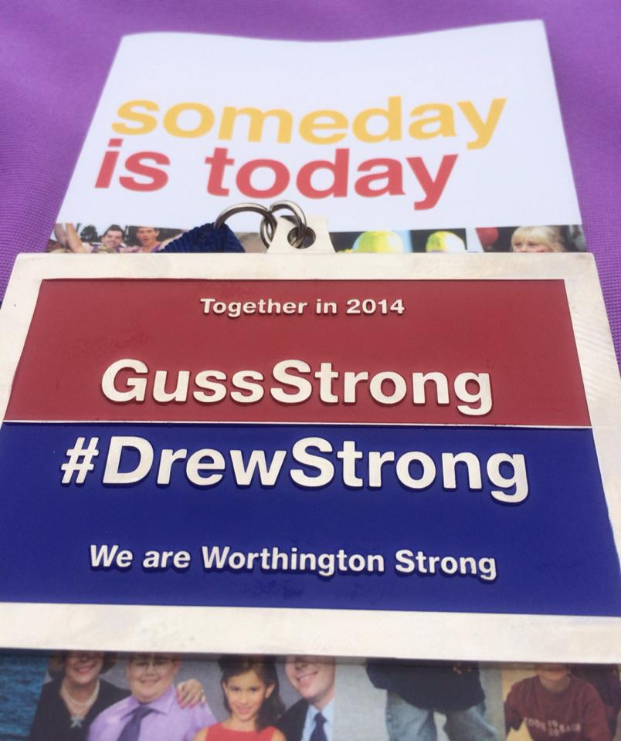

In honor of our Team Hero Drew George

TNT RECOMMITMENT GUIDE
2014 Columbus Half and Full Marathon

Please read carefully before completing the attached form as this guide will explain next steps.

Step One: Recommitment Form: This form confirms your status with our team. If you choose to continue training with the team for the Columbus Half and Full Marathon, you must completely fill out the recommitment form and by fax or email no later than 1:00 p.m. on Friday, August 8th. If you choose to not recommit, please indicate that on the form or contact Alysia at alysia.smith@lls.org.

Step Two: Race Day Apparel Your purple race day jersey isn’t just a piece of clothing; it’s a symbol of all you’ve accomplished, of all we’ve done together as a team. On the recommitment form, you’ll select the size of your jersey and know that you will wear it with pride as you cross the finish line on race day! Once everyone has returned their forms on August 8th, 2014 at 1PM, staff will place the order the same day at 2PM. Once the jerseys have been printed on with the fall season sponsors – staff will pass out the jerseys!
* If your order is not in on time (August 8th, 2014 at 1PM) – you run the risk of not getting a TNT race day jersey.

Step Three: Participant Medical, Fitness and Emergency Information Form This form must be filled out completely and handed in with your recommitment forms to ensure your participation within the Team in Training program.

Step Four: Inspiration Dinner Ticket Form We will host the Inspiration Dinner the night prior to the event on Saturday, October 18th, 2014. This event is an opportunity to honor our heroes, to learn about the advancements being made in blood cancer research, and to come together to celebrate our accomplishments as a TEAM. Each teammate will receive a complimentary ticket to this event. You are welcome to bring friends, family members and/or personal heroes to this event. If you’d like to bring a guest, you will need to purchase a ticket. The event will take place at the Gateway Film Center, and will include free parking.

Once we’ve received your recommitment form, we will send you the race registration entry code.
The Columbus Half and Full Marathon require that each entrant complete their own individual online entry. We will send you a code to register yourself upon receiving your recommitment form. Registration is at no charge to the participant. If you’ve already purchased an entry, please let staff know.
*You are responsible for completing your online entry form. This race has historically sold out for the half marathon distance, so please do not delay to complete your entry.

RECOMMITMENT FORM

When you registered for Team In Training, you committed to raising life-saving funds in return for your participation in the Nationwide Children’s Hospital Columbus Half and Full Marathon. Fundraising commitment levels are set to ensure that The Leukemia & Lymphoma Society (LLS) is able to keep the program costs low, maintain credibility to all of the donors and most importantly, maximize the funds invested in research. By signing this form, you are confirming your commitment to the team and to reaching your selected fundraising minimum.

In order to secure your place on the team, you must recommit to the program by, Thursday, August 8th, 2014. Unless you have already reached your fundraising commitment, LLS requires that you guarantee your commitment with a MasterCard, Visa or American Express credit card number. Your credit card number will be placed in a confidential file until the final fundraising deadline on Thursday, October 16th, 2014. If you have not reached your fundraising commitment by this deadline, you will be responsible for donating the difference. LLS will charge the balance due to your credit card at this time, or you can opt to send a personal check. You will then have 30-days (November 15th, 2014) from the date of your event to continue fundraising and request reimbursement up to the amount of your personal contribution.

THIS FORM MUST BE RECEIVED IN THE OFFICE BY 1:00 PM ON Thursday, August 8th, 2014 Fax to 614.476.7189 or scan and email to alysia.smith@lls.org.

Name (Please print):_______________________________________________

 I have completed TNT events in two other sports and will earn my “Triple Crown” at the completion of this event.
 I am a cancer survivor

Credit Card #________________________ Exp____________ 3-Digit Security Code________

{ } Visa { } MC { } AMEX

Name as it appears on card________________________________________________

Cardholder’s Signature____________________________________________________

Please confirm your selected fundraising commitment level:
{ } $1000 – Columbus Half Marathon Run_____ Walk_____
{ } $1000 – Columbus Full Marathon Run_____ Walk_____

Please check one of the following:
{ } I have already met my fundraising commitment! (Please sign below and return form)
{ } I have not yet met my fundraising commitment, but wish to pledge my firm commitment to completing the fundraising so that I can participate in the Nationwide Children’s Hospital Columbus Marathon with the team. I understand that if I am not able to reach the full fundraising commitment level by October 16th, 2014, my credit card listed above will be charged to bring my account up to the required participation commitment. (Fill out above credit card information)
{ } I am unable to recommit and do not plan to continue with Team In Training. (Please contact Alysia Smith for more information on how to officially drop from the program).

Signature: Date: _________________________________ Date:_____________________
Order your Purple Team In Training Singlet for Event Day!

Please indicate your size and return this with your recommitment forms.

Name: ____________________ _____Female _____Male

_________ I would like a purple singlet (sleeveless)

_________ I would like a purple jersey (short sleeve)

Please circle the correct size. These garments will not shrink and are sized separately for men and women. (Please note: women’s singlets run small, order a size larger. If you’d like more length in the torso, order a short sleeve jersey.)

S M L XL XXL XXXL

PARTICIPANT MEDICAL, FITNESS AND EMERGENCY INFORMATION
Name ________________________________________________________________________________
Address_______________________________________________________________________________
City____________________________________________State_______________Zip________________
Home Phone __________________Work Phone____________________ Fax ______________________

MEDICAL INFORMATION

Medical Insurance Company ______________________________ Insurance ID#____________________
Current Medications _____________________________________________________________________
Condition Requiring Medications___________________________________________________________
Allergies (food, medications, etc.) __________________________________________________________
Have you experienced any of the following symptoms in the last year?
___ A Chronic Illness ___ Back Problems ___ Fainting Spells ___ High Blood Pressure
___ Heart Murmur ___ Diabetes ___ Trouble Breathing ___ Chest Pain ___ Unusual Fatigue
___ Heart Condition (if so, please write in what type ________________) ___ Asthma ___ Liver Condition
Do you have any conditions that might affect your health and safety while training for your endurance event? ____
Is there anything else, not listed above, that you would like us to know about?
If above symptom box or boxes checked marked, Team In Training will require a note from a physician giving medical permission to participate in any Team In Training program.

FITNESS INFORMATION
Age Range: ( ) 18-25 ( ) 26-35 ( ) 36-45 ( ) 46-50 ( ) 51-60 ( ) Over 60 Date of Birth:
I currently engage in athletic/sports/fitness activities:
❑ Daily  5-6 Days/week  3-4 Days/week  1-2 Days/week  Almost Never
List any previous or current athletic injuries __________________________________________________
I have completed (state number completed): ____Marathon(s)____Half-Marathon(s)____10K(s)____5K(s)____Century Ride(s)____Triathlon(s)
Please describe other races/tours/competitions completed________________________________________
EMERGENCY INFORMATION
In case of emergency, please notify:______________________________ Relationship: spouse friend relative
Emergency contact phone - Cell: _________________________ Work:___________________________
I am also aware that I must sign the Society’s Liability Release form.
Signature __________________________________________ Date ______________________________ PMFI 09 02Traverse
GUEST AND EXTRA FEES
Inspiration Dinner: Gateway Film Center
1550 N High St, Columbus, OH 43201
Time: TBA
   _____# of children guests x $12 (participant tickets are complimentary)
*Your credit card will be charged on 10/16/14 for additional tickets.
   _____# of adult guests x $25 (participant tickets are complimentary)
*Your credit card will be charged on 10/16/14 for additional tickets

Total Guest Fees: $_______________________

Payment Method:

 Check #_________________________ paid on____________________ (dd/mm/yyyy)

 Credit Card # ___________________________________________________________

Exp: ___________________________________________ Security Code:_______________
Card Holder Name:___________________________________________________________
Card Holder Signature: _______________________________________________________

