Community | Code No | Applicant | Recommendation | Page No
WRO | P/ 2008/1012 | MR A WILLIAMS | GRANT | 3 - 8
WRO | P/ 2008/1038 | PENNAF HOUSING GROUP LTD | GRANT | 9 – 18
BRO | P/ 2008/1066 | HIREMADE FURBS & FIFERS 11 LTD | GRANT | 19 – 31
WOR | P/ 2008/1098 | MR D PARRY | REFUSE | 32 – 34
WRC | P/ 2008/1190 | RANK GROUP GAMING DIVISION | GRANT | 35 – 39
MAE | P/ 2008/1206 | MISS LILO BLUHM | GRANT | 40 – 43
BRO | P/ 2008/1219 | ERIC ROBERTS (BUILDERS) LTD | GRANT | 44 – 53
ABE | P/ 2008/1235 | WREXHAM COUNTY BOROUGH COUNCIL | GRANT | 54 – 70
WRA | P/ 2008/1238 | WREXHAM COUNTY BOROUGH COUNCIL | GRANT | 71 – 90
BRY | P/ 2008/1249 | T/A C LAMBERT BUILDERS  MR RA LAMBERT | GRANT | 91 – 97
LLA | P/ 2008/1256 | MR & MRS DARREL & ANITA CHARLTON-EVANS | GRANT | 98 – 104
ESC | P/ 2008/1258 | MISS KIM NORMAN | REFUSE | 105 – 110
BRY | P/ 2008/1276 | MISS LINDA WEBB | REFUSE/GRANT | 111 – 119
WRO | P/ 2008/1279 | PENNAF HOUSING GROUP LTD | GRANT | 120 – 128
RHO | P/ 2008/1286 | RHOS AELWYD F.C.  MR JOHN HUGHES | GRANT | 129 – 131
WRC | P/ 2008/1289 | MR MARC JONES | GRANT | 132 – 138
WRC | P/ 2008/1294 | MECCA BINGO LTD | GRANT | 139 – 142
GRE | P/ 2008/1301 | MR F CREWE | GRANT | 143 – 148
RUA | P/ 2008/1320 | CYMDEITHAS TAI CLWYD  MR BRYN DAVIES | GRANT | 149 – 152
CHI | P/ 2008/1322 | MR PAUL JONES | GRANT | 153 – 157

GRE | P/ 2008/1324 | EARDLEY PROPERTY CO. LTD | GRANT | 158 – 165
WRC | P/ 2008/1343 | MR J BRADBURY | GRANT | 166 - 168

Total Number of Applications Included in Report: 22

All plans included in this report are re-produced from Ordnance Survey Mapping with the permission of the Controller of Her Majesty’s Stationery Office. © Crown Copyright. Unauthorised reproduction infringes Crown Copyright and may lead to prosecution or civil proceedings.
WCBC Licence No. LA0902IL

All plans are intended to be illustrative only and should be used only to identify the location of the proposal and the surrounding features. The scale of the plans will vary. Full details may be viewed on the case files.

APPLICATION NO:  P/2008 /1012  COMMUNITY:  Offa  WARD:  Brynyffynnon | LOCATION:  WREXHAM MAELOR HOSPITAL CROESNEWYDD ROAD WREXHAM  DESCRIPTION:  CONSTRUCTION OF 2 STOREY LOW SECURE, OLDER ADULT MENTAL HEALTH UNIT WITH LINK (TO APPROVED ADULT MENTAL HEALTH UNIT), ADDITIONAL DECKS TO MULTI-STOREY CAR PARK, ASSOCIATED HARD AND SOFT LANDSCAPING AND ALTERATION TO EXISTING AND PEDESTRIAN ACCESS TO CROESNEWYDD ROAD.  APPLICANT(S) NAME:  MR A WILLIAMS | DATE RECEIVED:  16/09/2008  CASE OFFICER:  KH  AGENT NAME:  AEDAS ARCHITECTS LIMITED  MR A MUNRO
______________________________________________________________

SITE
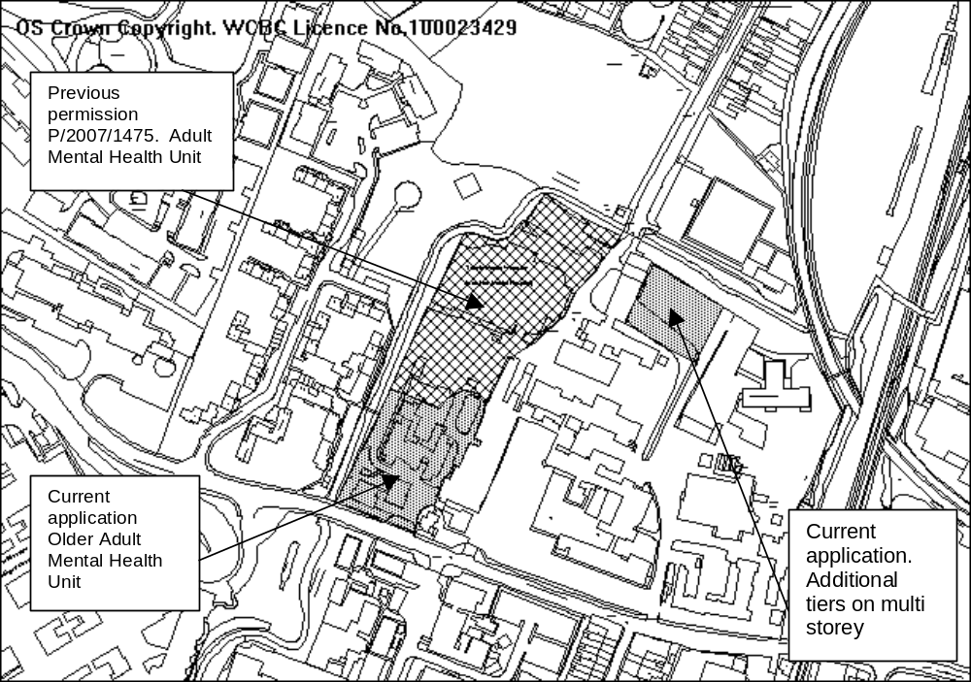
Located off the northern side of Croesnewydd Road. Area of approximately .45 ha with Croesnewydd Road to the immediate south, hospital residential accommodation to the west, existing hospital buildings to the east with a car park to the north. The car park will be replaced by a new adult mental health facility which has recently been granted planning permission.

PROPOSAL

Provision of 2 storey Older Adult Mental Health Unit, comprising 28 in-patient beds with internal and external therapy spaces and support accommodation, a 16 place day hospital and officer accommodation. The application also includes an additional 4 storeys to the previously approved 2 tiered car park to the north east of the site. The proposal includes minor amendments to the site plan already approved for the Adult Mental Health Unit which adjoins the site.
The proposal will be physically linked to the previously approved Adult Mental Health facility to the immediate north.

HISTORY (most relevant)

P/2007/1475 Demolition of existing hospital buildings, provision of low
level adult mental health facility and construction of
surface and deck car parking. Grant of Planning
Permission, 02/06/08.

DEVELOPMENT PLAN

Within settlement limit. Policies PS1, PS2, GDP1 and EC13 refer.

CONSULTATIONS

Community Council: No objection subject to adequate parking and capacity at access points.
Local Member: Notified 17 Sept 08.
Public Protection: No objection.
Highways: No objection in principle subject to provision of Travel Plan, a plan to manage traffic through access points and improvements to the access onto Croesnewydd Road.
Welsh Water: Conditions required.
Environment Agency: No objections.
Other representations: Concerns from adjoining landowner, Carlsberg UK and concerned application may compromise current application for housing by Morris Homes. Raises following concerns:
- Development proposal unclear.
- Concerned at scale, mass, bulk and character of the multi-storey and that the adjacent land is not compromised.
- Materials inappropriate.
- Suspended ramp to car park unconventional and may raise Health and Safety concerns.
- Development will compromise problems of flooding on adjacent land.
- Car park should be set back to ensure no risk of flooding.
- Views of potential future developers, Morris Homes, should be sought.
- If planning permission is granted, conditions should include details of surface water arrangements, materials of multi-storey and landscaping conditions to ensure adequate screening.
Site Notice: Expired 23 Oct 08.
Press Notice: Expired 24 Oct 08.

SPECIAL ISSUES/CONSIDERATION

Proposal: The redevelopment of the Adult Mental Health Unit and the Older Adult Unit will enable the Trust to re-provide existing services located on the site at an increased level which is currently restricted due to the existing facilities being classified as clinically unfit for purpose.
The adjoining Adult Mental Health Unit was subject to a separate planning application, P/2007/1475 and subsequent approval. The application is for the additional Older Adult Unit which is immediately adjacent to the Adult Mental Health Unit.

Older Adult Health Unit: The building is 2 storey and utilises a combination of materials – render brickwork, polished block, timer, pre-paternated copper and curtain walling systems. The building is of a high quality design and existing and proposed landscaping will ensure it is not overly dominant.

Sustainability: The design maximises natural ventilation and natural lighting and where elements of the facility receive increased amount of solar gas, the building fabric provides shading. The construction specification where possible follows BRE green guide category A. The design is fully supportive of the drive towards a low carbon economy.

A travel plan will help reduce reliance on the car and a green corridor for wildlife is retained along the river connecting to open land to the north.

Highways: Parking will be predominantly provided by adding additional tiers to a previously approved parking decking system and an existing car park to the northern extremity of the site. The proposed parking and provision of a Travel Plan which is being prepared and at an advanced stage will ensure that the parking provision is adequate and the scheme will not increase traffic on the adjoining highway network.

The proposal will utilise both access points onto Croesnewydd Road which will help filter traffic and Highways are satisfied that with a condition to enable management of flows between the two accesses it will not significantly compound problems of congestion.
A condition will also be required to provide improvements to the access to S.E. side of the site.
Highways have no objections in principle.

Multi storey car park: This is located on the northern boundary. A previous permission allowed a two tiered decking system and this proposal seeks to provide an additional 4 levels. The car park has been designed to provide split levels which significantly reduces the height (overall height approx 9.5m). Whilst trees have been removed a replanting scheme will require new trees to be planted which will in conjunction with existing trees provide a screen and reduce the visual impact.

Concern has been raised regarding the design and use of materials. The structure will be a combination of steelwork and a mesh screen. I consider the materials will help reduce the bulk of the building and planting will further soften the impact.

Concern has been expressed from owners/developers of adjoining land at Maesgwyn Road that the car park may impact on future development which is subject of a current application. Given the height of the development, proposed and existing screening and the distances to proposed development, over 60m, I do not consider the car park will have any significant impact on future residential amenity or in the wider landscape.

With regard to potential flooding of adjoining land, a condition will be attached with regards to surface water and attenuation.

CONCLUSION

I am satisfied the proposal is acceptable and will have no significant impact on the amenity of existing hospital residential accommodation or future occupiers of dwellings on land at Maesgwyn Road. I am satisfied parking provision is adequate and in conjunction with the Travel Plan to be submitted will ensure congestion is not compounded, and improvements to existing access points will ensure adequate visibility.
P/2008 /1012
RECOMMENDATION: That permission be GRANTED

CONDITION(S)

1. The development hereby permitted shall be begun before the expiry of five years from the date of this permission.
2. Materials for the development hereby approved shall be strictly in accordance with the details indicated on the approved plans.
3. No trees shall be lopped, topped, felled or uprooted without the prior written permission of the Local Planning Authority, nor shall any trees be wilfully damaged.
4. Within 3 months of commencement of development on site, full details of both hard and soft landscape works for the site shall be submitted to and approved in writing by the Local Planning Authority. The works shall be implemented in accordance with a timescale to be approved in conjunction with the scheme of details.
5. Within six months of the first use of the development, trees and shrubs shall be planted on the site in accordance with a scheme which has been submitted to and approved by the Local Planning Authority. Any trees or shrubs removed, dying, being severely damaged, or becoming seriously diseased within five years of planting shall be replaced by trees or shrubs of a similar size and species to those originally required to be planted.
6. A scheme for the provision and implementation of a surface water regulation system shall be submitted in writing for the further approval of the Local Planning Authority. Works shall only be carried out strictly in accordance with the details as approved and retained thereafter unless otherwise agreed, in writing with the Local Planning Authority.
7. Cycle parking facilities shall be provided within the curtilage of the site in accordance with details to be submitted for the further approval of the Local Planning Authority. Such facilities shall be made available prior to implementation of the use(s) hereby permitted and shall thereafter be retained.
8. The facilities indicated on the submitted plans to be provided for the loading, unloading, turning around and parking of vehicles shall be made available for those purposes prior to the first occupation of the development hereby approved and shall thereafter be retained.
- A detailed scheme of improvements to the access onto Croesnewydd Road on the S.E. corner of the site shall be submitted, in writing, for the further approval of the Local Planning Authority. The works as approved shall be completed prior to the first use of the development hereby approved.
- The proposed improvements to the access on to Croesnewydd Road and indicated on the approved drawing A-VOO-GA-GR-207, shall be fully implemented prior to the first use of the development hereby approved and retained thereafter in accordance with those details.
- Details of an internal site traffic management scheme to ensure a distribution of traffic between the two access points onto Croesnewydd Road and to minimise potential conflict between vehicular and pedestrian movements on site shall be submitted, in writing, for the further approval of the Local Planning Authority. The scheme, as approved, shall be fully implemented prior to the first use of the development hereby approved and maintained thereafter unless otherwise agreed, in writing, with the Local Planning Authority.
- Details of fume extraction equipment and air handling plant shall be submitted, in writing, to the Local Planning Authority. No part of the process shall be commenced until those details have been approved, in writing, by the Local Planning Authority, and the approved scheme fully implemented. The works shall be retained in full accordance with the approved details.
- Within six months of commencement of development, a Travel Plan shall be submitted to and approved, in writing, by the Local Planning Authority. The plan shall be fully implemented prior to the first occupation of the development hereby approved and shall be retained thereafter.
- There shall be no vehicular access onto Maesgwyn Road.

REASON(S)

1. To comply with Section 91(3) of the Town and Country Planning Act, 1990.
2. To ensure a satisfactory standard of appearance of the development in the interests of the visual amenities of the area.
3. To protect trees which are of significant amenity value to the area.
4. To ensure a satisfactory standard of appearance of the development in the interests of the visual amenities of the area.
5. To ensure a satisfactory standard of appearance of the development in the interests of the visual amenities of the area.
6. To avoid satisfactory drainage and to ensure the proposal does not compound problems of flooding.
7. To ensure that adequate parking facilities are provided and maintained within the curtilage of the site in the interests of the free flow of traffic, highway safety and the amenities of the locality.
8. To provide for the parking and turning of vehicles clear of the highway and to ensure that reversing by vehicles into or from the highway is rendered unnecessary in the interest of traffic safety.
- To ensure that a properly constructed access is available for use when the development is completed thereby enabling safe and convenient access to and egress from the site in the interests of road users and pedestrians.
- In the interests of highway safety.
- To ensure the development does not significantly increase congestion on the adjoining highway network and does not compromise pedestrian safety.
- To protect the amenities of the occupiers of nearby properties.
- To maximise the opportunities for reducing car journeys.
- In the interest of Highway safety.
______________________________________________________________

APPLICATION NO:  P/2008 /1038  COMMUNITY:  Offa  WARD:  Brynyffynnon | LOCATION:  JACQUES YARD MOLD ROAD WREXHAM  DESCRIPTION:  OUTLINE APPLICATION FOR 60 NO. APARTMENTS EXTRA CARE DEVELOPMENT  APPLICANT(S) NAME:  PENNAF HOUSING GROUP LTD | DATE RECEIVED:  23/09/2008  CASE OFFICER:  DSW  AGENT NAME:  AINSLEY GOMMON ARCHITECTS
______________________________________________________________
P/2008 /1038

THE SITE

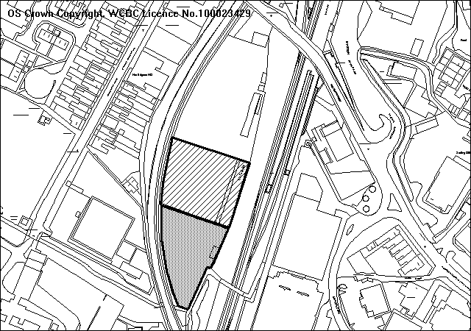
The site occupies 0.26ha of land currently occupied by Jacques Garage. It is set well back from Regent Street/Mold Road which provides the only means of access. It is bounded to the east by vacant land and the main line railway running through Wrexham General Station. To the west it is bounded by the Wrexham General and Wrexham Central railway line. With the exception of the site frontage, the site is effectively landlocked. The site occupies a peripheral town centre location and beyond the railway line is surrounded by a mix of commercial land and buildings.
Proposed location of extra care development
Proposed location of EMI development

PROPOSAL

As above. This is an outline application with all matters reserved for the further approval of the Council. However, details of the height and mass of the proposed building shown in relation to the previously approved scheme for residential use (P/2006/0756) have been submitted with the application.

HISTORY

P/2006/0375 Residential development – erection of 228 two-bedroom
apartments with undercroft car parking. Submitted
    - Appeal against non-determination
subsequently withdrawn.
P/2006/0756 Erection of 228 residential two-bedroom apartments in four blocks with undercroft parking. Approved

Adjoining Site
P/2008/1279 Outline for 72 bedroom EMI Residential Care Development – Current Application.

DEVELOPMENT PLAN

Within defined settlement limit. UDP policies PS1, PS2, PS3, PS4 and GDP1 apply. Local Planning Guidance Notes 6 – Access for the Disabled, 7 – Landscape and Development, 16 – Parking Standards, 21 – Space Around Dwellings, 22 – Sustainable Building, 24 – Designing Out Crime.

CONSULTATIONS

Offa Community Council: Defer decision until January. The Community
Council would make the following preliminary comment that concerns exist over the cumulative effect of traffic from this site, the proposed developments on Maesgwyn Road and the racecourse development on the already problematic and difficult traffic situation along the entire length of Mold Road from the B & Q roundabout through to the Central Retail Park circular. Concerns have also been raised over the proximity of the EMI unit to the railway line and the possible effect on residents with mental health problems living adjacent to a busy railway line.
Local Member: Supportive of the “Extra Care” facility in principle, however, justification/details required to assess the impact of a seven-storey block in this location and whether it detrimentally affects Maesgwyn Road residents.
Adj Local Member: Notified.
Cadw: Notified 20.01.09
Environment Agency: No objections subject to a condition to prevent the risk of flooding and pollution of the water environment.
Fire & Rescue Service: As we no longer occupy premises near the site we have no comments to make.
CPAT: As indicated previously (P/2006/0375 and P/2006/0756) recommend the scheduled monument alignment is protected with a suitable exclusion zone which takes into account the buried western ditch. It was also agreed with Cadw that the existing monument could usefully be stabilised and enhanced through an agreed management scheme and that the linearity of the monument should be preserved as a component of any design.
Network Rail: Notified.
Public Protection: No objections subject to an appropriate condition to deal with potential combination.
Highways: No objections, in principle. The proposed 60 no. extra care apartments will simply displace a number of the originally proposed two-bedroomed apartments and will result in a reduction in traffic movements if the site combined with the original application (Ref P/2006/0756) given the nature of the proposed units. I would therefore recommend that this application be subject to the same conditions which were previously imposed on planning application P/2006/0756. Only 50% parking provision is provided, this shortfall needs to be justified.
Welsh Water: No objections subject to appropriate conditions to deal with foul and surface water drainage.
CCW: No objection in principle. However, we wish to issue a holding objection in respect of the proposal until a satisfactory ecological survey has been submitted. If the survey results suggest protected species are likely to be present, the applicant should be conditioned to propose and deliver appropriate species compensation schemes and mitigation proposals such as Reasonable Avoidance Measures (RAMs) to the satisfaction of the Local Planning Authority.
Other Representations: No observations received from adjoining commercial properties or residents in Maesgwyn Road.
Site Notice: Expired 20.10.08
Press Notice: Expired 09.01.09

SPECIAL CONSIDERATIONS/ISSUES

Background: The current application is one of two outline applications for Extra Care and EMI Residential Care Home on the former Jacques site. A partnership between Pennaf Housing Group and the Council has submitted a formal bid to the Welsh Assembly Government to provide ‘social housing grant’ for the new extra care scheme. This bid is currently under consideration and it is anticipated funding will be approved this year. A key part of this scheme is the close relationship of the new Extra Care Scheme and the Care Home is that certain aspects of the accommodation will be closely linked and shared between the two developments. This specifically relates to the kitchen facilities, which will prepare hot meals for residents and it is envisaged this will be centralised with access to both developments.

The site presently has an extant permission for 228 apartments approved under Code No P/2006/0756 on 17 March 2006. The approved scheme involved the erection of four separate blocks set in a linear form varying in height from five-storey at the front to a maximum height of seven-storeys towards the rear. The current proposals occupy the bottom half of the site, furthest away from Mold Road. Combined the current two outline applications take up approximately 50% of the site and would effectively replace blocks 3 and 4 of the previously approved scheme for apartments. This proposal would not therefore prejudice the future development of the front of Jacques Yard. However, a modification to the existing Section 106 Agreement would be required as a result of the reduced number of apartments and the impact this would have on the level of affordable housing and financial contributions towards improving off-site recreational facilities, providing improved educational facilities and to offset the shortfall of parking provision.

The site owner is actively marketing the front area of land (area occupied by blocks 1 and 2 as previously approved under P/2006/0756) for a number of commercial, residential and institutional uses but in the current economic climate has been unable to secure definitive use of the land at present. In any event, any variation to the approved scheme, either in terms of use or design, would require permission. In this regard I believe sufficient controls are in place to ensure compatibility with the proposed uses to the rear of the site and to ensure an attractive, high quality frontage to be provided to Mold Road/Regent Street.

Policy: As the site lies within settlement limits there can be no objections, in principle, to the proposed use of the site, provided the technical criteria set out in Policy GDP1 are satisfied. The redevelopment of a brownfield site also accords with the sustainable use of land as set out in PPG Wales.

Highways: The site has permission for the erection of 228 no. residential two-bedroomed apartments. This scheme displaces a number of the originally proposed apartments and will result in a reduction in traffic movements at the site compared with the original application (P/2006/0756).

Whilst I note the concerns of Offa Community Council with regards to movement congestion and movement on Mold Road, Highways have raised no objections subject to conditions imposed previously to improve the access arrangements and provide a scheme enabling the co-ordinating of traffic signals along Mold Road/Regent Street. In addition, a scheme for the provision of signal controlled pedestrian crossing of the proposed new access road leg of the new junction with Regent Street is proposed. As the access onto Regent Street now lies outside both application sites, these will form Grampian Conditions. Castlemead Homes currently retain ownership of the whole site (Jacques Yard).

Network Rail: Network Rail had previously raised the need to obtain access to their land. The Network Rail access is immediately adjacent to Regent Street and vehicles leaving this land would not be controlled by the new junction’s signals. Larger vehicles would need to reverse in and out of the access across the mouth of the junction, as there is insufficient turning space within the Network Rail site. This may have potential adverse effects on safety and convenience of all road users. A new access to their land is therefore required from a suitable point along the new internal access road. This will form a condition of any permission granted.

Parking: Local Planning Guidance Note No 16 “Parking Standards” requires 1.5 spaces to be allocated per single bedroom. However, I would accept demand for parking in ‘extra care’ housing is significantly less than that of general needs housing. Although this is an outline application, the applicants have indicated their aim to provide 50% of required parking spaces. The reserved matters application will therefore require the submission of a Green Travel Plan and a Section 106 Agreement will require a financial contribution to offset this shortfall. The general principle of a shortfall in this highly sustainable location would be acceptable however, especially bearing in mind the nature of the proposed use.

Design/Appearance: I note the Local Member’s concerns in respect of the proposed height and scale of the proposed building and despite it being an outline application, further information has been submitted to assess the impact of this proposal upon its surroundings. Cross-sectional drawings have been provided which superimpose the current proposed seven-storey block against the previously approved scheme. The previous scheme for the whole of Jacques Yard consisted of four blocks which varied in height. At this point, block 3 was a seven-storey block with undercroft parking. The current scheme is lower by approximately 2.5 metres due to the removal of the undercroft parking and a different roof style. It is, however, marginally wider than the previous development. Given the lower ground levels within Jacques Yard, the distance from Mold Road and given the height of the approved scheme (of which this is 2.5 metres lower) I would not consider its impact overly intrusive in visual terms. Details of the appearance of the building, in terms of its design and use of materials, will be considered at the reserved matters stage. A condition will be imposed to ensure the height and mass of the building reflect that shown on the cross-sectional drawings (ie lower than the previously approved scheme).

Amenity: Given the isolated nature of the site, the development scheme will not impact upon neighbouring development. The nearest residential dwelling in Maesgwyn Road is over 55 metres away from the development and is separated by the railway line. The proposed building has also been relocated slightly further back into the site to provide improved separation with block 2 of the previously approved scheme.

Contamination: Given the existing and previous use of the site as a scrapyard and garage, the area may be subject to potential ground contamination. Any permission will therefore be conditioned to ensure that any potential contamination issues are adequately dealt with.

Archaeology: The scheduled ancient monument, Wats Dyke, runs along the eastern boundary of the development site. As this stretch of Wats Dyke would be affected by the development, scheduled monument consent from the Assembly Government will be required. Excavation and clearance work has revealed that the dyke itself has been damaged in the past and that a small section on the north is the only section to survive as an upstanding earthworks. Despite its condition, Cadw have previously indicated that the line of the dyke should be respected. The precise siting will be addressed at the reserved matters stage. However, a condition will be imposed to ensure the scheduled area remains free of building. However, Cadw had previously accepted landscaping and an element of parking provision.

Sustainability: In accordance with Local Planning Guidance Note 22, a sustainability statement will be required as part of the Reserved Matters application. This will form a condition of the current outline approval. In general terms, the proposal offers the opportunity to develop a brownfield site within the town centre and in close proximity of public transport facilities. The siting of building is also positioned to maximise the use of natural daylight and solar energy. Main elevations face in a south-west and south-east direction. Precise details can only be given proper consideration at the reserved matters stage, although a very good BREEAM rating will be expected from this development.

Designing Out Crime: All areas within the site are overlooked by the proposed development which will provide good natural surveillance to the adjoining car parks. The site is naturally well enclosed which will increase security and gated or barrier entry will be provided. I consider the scheme complies with the design principles set out in Local Planning Guidance Note 24 – Designing Out Crime.

Noise: The site lies between the Wrexham General and Wrexham Central railway lines. I note the concerns raised by Offa Community Council with regards to noise and disturbance from passing trains. However, an independent noise impact assessment carried out as part of the previous submission in 2006 recommended suitable sound insulation and Public Protection raised no objections. A condition of any outline permission granted will require the submission of a similar assessment and the recommendations for noise mitigation will be a condition of the subsequent Reserved Matter Approval.

Flood Risk: The application site lies almost entirely within Zone C2 as defined by the development advice map (dam) referred to under TAN 15 Development and Flood Risk (July 2004). However, a Flood Consequence Assessment (FCA) has been forwarded with the application which was submitted to and assessed by the Agency in 2006. This FCA has been found to be acceptable and in the circumstances the Environment Agency raise no objections subject to an appropriate condition addressing surface water disposal.

Ecology: I note CCW’s observations with regards to the need for an ecological survey. However, I consider this can be conditioned as part of any outline approval to be submitted with the Reserved Matters. Members are reminded that the site already has full permission for development and CCW are not objecting in principle, but request conditions to deliver appropriate species compensation schemes and mitigation proposals such as Reasonable Avoidance Measures (RAMs) should a protected species be found present on site.

Assisted Living: The Assisted Living Scheme involves a significant element of care and will be linked into the adjoining EMI Residential Care development as described earlier. It is therefore not residential use (C3) and falls within a C2 use as described in the Use Classes Order.

As such, the normal requirements for an element of affordable housing, Public Open Space, and schools contributions, do not apply. A condition will be imposed which will restrict the use to an Assisted Living Scheme within the C2 use class which should ensure and control any potential sale on the open market for C3 residential use. Similarly, I would insist upon details of the future occupancy of these units to form part of the accompanying Section 106 Agreement.

CONCLUSION

The principle of high rise development on this site has previously been established. The current proposal will not result in a taller building than that previously approved. The proposed Assisted Living Scheme will result in less traffic generation and reduced pressure on parking provision. In the absence of any residential interest in developing the site, the current proposal offers an opportunity to regenerate the area and enhance the image of the town. New development to the rear of the site could also stimulate interest in the front end which would have a positive impact on the appearance of Mold Road.

RECOMMENDATION A

That the Council enters into an obligation with the applicant under Section 106 of the Town and Country Planning Act 1990, to offset the shortfall in parking provision and to control the future occupancy of the development to an Assisted Living Scheme.

RECOMMENDATION B

That permission be granted on completion of the obligation, subject to the following conditions:-

CONDITION(S)

1. Approval of the following details shall be obtained from the Local Planning Authority before any part of the development is commenced:
a. the siting of the building(s)
b. the design of the building(s)
c. the external appearance of the building(s)
d. the means of access to the site and building(s)
e. the landscaping of the site.
2. Plans and particulars of the reserved matters referred to in condition 1 (above) shall be submitted in writing to the Local Planning Authority before the expiry of three years from the date of this permission. The development shall only be carried out in strict conformity with such details as are thereby approved.
3. The development hereby permitted shall be begun before the expiry of five years from the date of this permission or two years from the date of approval of the last of the reserved matters required to be approved, whichever is the later.
4. The reserved matters application shall include a programme of sustainable works. The approved programme shall be implemented in accordance with a timescale to be agreed with the Local Planning Authority.
5. The reserved matters application shall provide a scheme to deal with potential contamination at the site. The scheme shall include a phased investigation approach to identify the extent of contamination and any measures required to remediate the site, including post-development monitoring. Where remediation works are required, the development shall not be occupied/used until a Validation Report to show that the works have been satisfactorily carried out has been submitted to and approved, in writing, by the Local Planning Authority.
6. The reserved matters application shall provide a noise assessment to include noise mitigation measures. The mitigation measures shall be implemented in accordance with the scheme agreed by the Local Planning Authority, prior to the first use of the site.
7. No development shall take place within the scheduled ancient monument area of Wats Dyke.
8. Details of all boundary treatment shall be submitted to the Local Planning Authority as part of the reserved matters application. The development shall only be carried out in strict conformity with the approved details.
9. No development approved by this permission shall be commenced until a scheme for the provision and implementation of a surface water regulation system has been submitted to and approved, in writing, by the Local Planning Authority. Such a scheme shall be implemented prior to the construction of any impermeable surfaces draining to the system unless otherwise agreed, in writing, by the Local Planning Authority. Surface water generated from new impermeable surfaces must be limited to equivalent Greenfield rate for the site, the level of which is to be agreed with the Agency.
10. No development approved by this permission shall be commenced until:-
a) The application site has been subjected to a detailed scheme for the investigation and recording of contamination and a report has been submitted to and approved by the Local Planning Authority.
b) Detailed proposals in line with current best practice for the removal, containment or otherwise rendering harmless such contamination (the "Contamination Proposals") have been submitted to and approved by the Local Planning Authority.
c) For each part of the development, contamination proposals relevant to that part (or any part that would be affected by the development) shall be carried out either before or during such developments appropriate.
d) If during development works any contamination should be encountered which was not previously identified and is derived from a different source and/or a different type to those submitted to the Local Planning Authority.
e) If during development work site contaminants are found in areas previously expected to be clean, then their remediation shall be carried out in line with the agreed "Contamination Proposals".

11. Any facilities for the storage of oils, fuels or chemicals shall be sited on impervious bases and surrounded by impervious bund walls. The volume of the bunded compound should be at least equivalent to the capacity of the tank plus 10% of the largest tank, or the combined capacity of interconnected tanks, plus 10%. All filling points, vents, gauges and sight glasses must be located within the bund. The drainage system of the bund shall be sealed with no discharge to any watercourse, land or underground strata. Associated pipework should be located above ground and protected from accidental damage. All filling points and tank overflow pipe outlets should be detailed to discharge downwards into the bund.
12. The existing public sewerage system serving the site shall be improved to obtain sufficient capacity too meet the needs of the development, prior to its first use.
13. No development shall commence until a scheme for the provision of a new access to Network Rail land, away from the proposed signal controlled junction connecting the site to Regent Street shall be submitted, in writing, for the further approval of the Local Planning Authority. The new access shall be constructed prior to the first occupation of the new dwellings.
14. No development shall commence until a scheme for the provision of signal controlled pedestrian crossing of the proposed new access road leg of the new junction with Regent Street be submitted in writing for the further approval of the Local Planning Authority. The new signal controlled crossing shall be brought into use prior to the first occupation of the new dwelling.
15. No development shall commence until a scheme enabling the co-ordinating of traffic signals along Mold Road/Regent Street shall be submitted, in writing, for the further approval of the Local Planning Authority. The scheme shall be implemented prior to the first occupation of the new dwellings.
16. One tenth of the total proposed car parking spaces shall be to mobility standard.
17. The height of the building hereby approved shall be no higher than the details shown on the cross-sectional plans provided as part of this outline application.
18. The number of units hereby approved shall be limited to 60.
19. Notwithstanding the provisions of the Town and Country Planning (Use Classes) Order no part of the premises shall be used except for the precise purposes described in the application plans and documents.

REASON(S)

1. To comply with the provisions of the Town and Country Planning (General Development Procedure) Order, 1995.
2. To comply with Section 92 of the Town and Country Planning Act, 1990.
3. To comply with Section 92 of the Town and Country Planning Act, 1990.
4. To meet the criteria set out in Local Planning Guidance Note 22.
5. To deal with potential contamination at the site.
6. To protect the amenity of further occupants.
7. To protect the line of Wats Dyke.
8. To ensure a satisfactory standard of appearance of the development in the interests of the visual amenities of the area.
9. To prevent the increased risk of flooding on and off site.
10. To prevent pollution of the water environment.
11. To prevent pollution of the water environment.
12. To ensure there is sufficient capacity in the public sewerage system to meet the needs of the development.
13. To remove the need to use the existing sub-standard access.
14. In the interests of pedestrian safety.
15. In the interests of free and save movement of highway traffic.
16. To meet the requirements of LPG 16.
17. In the interests of visual amenity and to ensure a satisfcatory standard of appearance of the development
18. To control the intensity of use to an acceptable level.
19. To ensure the premises are used solely for the purposes described within the application details given the shortfall in parking and potential traffice generation.
______________________________________________________________

APPLICATION NO:  P/2008 /1066  COMMUNITY:  Broughton  WARD:  New Broughton | LOCATION:  FORMER GATEWEN COLLIERY SITE GATEWEN ROAD NEW BROUGHTON WREXHAM  DESCRIPTION:  APPLICATION FOR ACCESS ROADS, FOUL AND STORM WATER SEWERS, FOUL WATER PUMPING STATION, GROUND REMEDIATION AND GENERAL ACCOMMODATION WORKS TO ALLOW RESIDENTIAL DEVELOPMENT TO COMMENCE IN A PHASED PROGRAMME.  APPLICANT(S) NAME:  HIREMADE FURBS & FIFERS 11 LTD | DATE RECEIVED:  01/10/2008  CASE OFFICER:  MP  AGENT NAME:  PAUL WREN ASSOCIATES LTD
______________________________________________________________

SITE

The site is part of the old Gatewen Colliery site, located to the north of Gatewen Road.

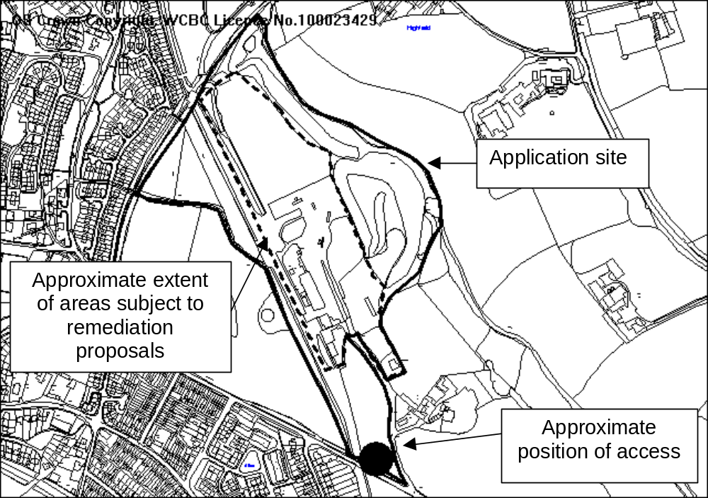

PROPOSAL

The application proposes works that will prepare the site for future residential development. The proposed works include earth works and changes in ground levels that will also enable contamination from previous industrial uses to be removed. Site infrastructure essential for any future residential development will also be installed. This includes foul and surface water drainage systems, the new site access from Gatewen Road, together with a spine road into the site and provision of a combined footway/cycleway along the former railway line along running adjacent/through the site.

HISTORY

P/2002/0767 Outline application for residential development, construction of new vehicular & pedestrian access & alteration to existing vehicular & pedestrian access. Granted 10.3.2003
P/2006/0066 Variation of condition 1 and 2 of Planning Permission code no. P/2002/0767 to allow phased development of the site and to extend the time period by which reserved matters need to be submitted by a further two years. Refused 6.3.2006
P/2006/0295 Reserved matters application for residential development (215 no. dwellings). Refused 9.6.2006
P/2006/0984 Variation of Condition no. 2 of Planning Permission Code no. P/2002/0767 (outline for residential development) to allow one further year for the submission of the reserved matters. Granted 2.10.2006
P/2005/1383 Outline application for residential development. Granted 17.2.2006 This permission covers land that was not included in the original development proposals.
P/2007/1174 Residential Development and associated works (295 no
dwellings) (submission of matters reserved under original outline). Pending.
P/2008/0790 Variation to condition no. 1, 6, 11 & 17 imposed under planning permission code no. p/2007/0700 to allow for the phased development of the site and to allow site infrastructure and other associated site preparation works to take place in advance of the approval of details relating to the number, siting and design of dwellings. Granted 8.9.2008

DEVELOPMENT PLAN

Approximately two thirds of the application area is within settlement boundary and is an allocated housing site. The remainder of the site is within a Green Barrier but benefits from planning permission for housing. The site is approximately 50 metres from the Gatewen Marsh Site of Special Scientific Interest and adjoins a local wildlife site. GDP1, EC1, EC4, EC6, T1 and T10 apply.

CONSULTATIONS

Community Council: Opposed to the application until the B5433 is brought up to a safe and an acceptable standard. The footpath on this road, over the bridge, is not wide enough and following a series of accidents, which has damaged significant lengths of fencing, Members also wish to see an extension of the 30mph speed limit to include this stretch of road (before any site works are carried to which would result in increased traffic volumes).
Adjacent Community Council: No observations (same response to consultation of revised highway details).
Local Member: Notified 6.10.08

Adjacent Local Member: Notified 6.10.08
Highways: Make the following comments:
- access current being assessed for adequacy in terms of highway safety;
- layout generally meets within minimum standards for adoptable highways but concerned that the first part of the access road leading from the roundabout does not have any traffic calming and may lead to vehicles exceeding 30mph;
- details of road alignment, construction and surfaced water drainage proposals currently being assessed as part of a section 38 submission;
- inadequate detail for proposed cycleway;
Public Protection: Notified 6.10.08
CPAT: Recommend that either industrial remains are preserved within the development, or are excavated. On the basis of the applicant intending to excavate the site, happy to impose condition requiring this.
Environment Agency: Have submitted comments on the following issues:
- further works information and assessment required with regards to proposals to deal with contamination;
- satisfied with the proposed drainage strategy;
- recommend conditions with regards to securing mitigation proposals in respect of dealing with contamination;
- further details/clarification required regarding surface water drainage proposals;
- recommend conditions to secure surface water drainage measures, prevent infiltration within the site and piling without approval.
CCW: Make the following comments:
- No objection in principle;
- Concerned about potential for surface water to enter the Gwenfro and impact on SSSI. Recommend any scheme should be subject to surface water monitoring subject to Environment Agency approval. Presume any advice and recommendations made by the Environment Agency will be followed and subject to condition or planning obligation if necessary;
- Applicant has not provided satisfactory mitigation and compensation in respect of great crested newt. Issue a holding objection until this issue is addressed.
Welsh Water: Initially objected that the proposed foul drainage systems would overload the existing public sewerage system. No improvements are planned and it would be premature to consider any development in advance of improvements. The developer could fund the accelerated provision if replacement infrastructure. Welsh Water have no accepted that permission could be granted subject to a condition preventing the connection of the proposed on site drainage to the public sewerage system until a scheme for improvements has been submitted to and approved, and a timescale for implementation agreed.
Other representations: 11 letters received expressing the following concerns/objections;
- proposed access will reduce visibility for Gatewen Lane/make existing access worse;
- reduce highway safety;
- creating new dangerous access in preference to continued use of current safer road layout, which could be made safer again by a reduction of speed limit would be reckless;
- woodland habitat destruction – noise/disruption to nearby properties;
- increase in traffic;
- increase in pupil numbers from 214 houses not sustainable;
- increase in children attending school – parking problems at Ysgol Penrhyn;
- local facilities such as doctors already have lengthy waiting lists;
- former railway line – will it revert to a footpath/cycleway. It may become a dumping ground for builders;
- road scheme similar to one that was rejected. Safety issues have not been addressed;
- there are trees and hedges that applicant has no control over not shown on the plan, so not highlighting the lack of visibility;
- Highways view this junction as sub-standard;
- Waste of a green field to bring a new road into a site that already has an existing one. Has Wrexham got some many green field sites that it can build over them with no regard;
- New road scheme will only benefit the traffic from development and to the detriment of the local community;
- Total housing allocations appears to have been increase to 300 dwellings. It is clear the applicant will seek to increase the housing allocation above the previously state 214. Increases may be achieved at a later detailed planning stage or appeal, creating significant changes to the amenity and character of the area;
- Site contains a plot of land detailed for up to 17 properties. A previous permission limited development of this land to 4 bungalows. Applicant has no notion of restrictions;
- Access to this parcel appears to be unworkable;
- Applicant not taken up the option to upgrade Gatewen Lane instead of building a new site access;
- Access gives priority to vehicles leaving the housing site at the expense of other road users;
- Despite a condition on the outline permission, the applicants have used Gatewen Lane to service the site;
- The applicant intends to cut down trees and hedges and contractors have stated they can use the applicant’s field and Gatewen Lane. Any right of access over Gatewen Lane for the benefit of the applicant does not extend to access the verges beyond the applicants field;
- Condition 6 requires new access road to be completed prior to commencement of site works;
- Initial ground works for this development is very significant in scale – we look to the Council to ensure that any approved new road scheme will be restricted by conditions so prevent construction traffic creating nuisance and danger by using Gatewen Lane;
- Request a condition is imposed preventing the applicants use of Gatewen Lane in respect of site clearance, preparation and works;
- Concerned that proposals will direct surface water towards Gatewen Lane and increase risk of flooding of adjacent land. Gatewen Lane is already prone to flooding and additional water any make it impassable by foot;
- Increase in traffic a B & Q;
- Playing field off Gatewen Road is going to have an increase in children using it – what about the increase in traffic along this road, a danger to everyone;
- Gatewen Road will need to be closed to allow works. Dale Road will become more of a ‘rat run’ than it already is. Existing traffic problems on Dale Road. Request Dale Road is made into a one way street during any closure of Gatewen Road. Suggest parking ban (double yellow lines) on Dale Road;
- Do not need more speed bumps. Need parking cars (on Dale Road) to be removed.
Site Notice: Expired 30.10.08
Press Notice (Major Dev): Expired 14.11.08

SPECIAL CONSIDERATIONS

Site preparation/remediation works: The works proposed by this application are intended to prepare the site for future housing development. This will include earthworks in those areas of the site that are hard surfaced or made up/bare ground.

Remediation works are required to deal with those parts of the site where the ground was contaminated by previous industrial/commercial uses of the site. In initial proposals have been submitted with the application, but consultation responses from the Environment Agency have advised further information is required before a final strategy can be agreed. Conditions requiring the submission of and implementation of a final remediation strategy will be attached.

Earthworks are also proposed across the site which will prepare the site for the proposed site drainage and access road, as well as for future housing development. These works are to take place in those parts of the site previously used for industrial/commercial purposes. Once the works are complete, the finished ground levels will be, on average, around 1m higher than at present.

Highways and access: The position of the main site access was approved as part of the outline permission granted in October 2007 (P/2007/0700). The current application includes full details of the junction, together with details of an internal spine road into the site. The layout of the roadway into the site is acceptable and is capable of accommodating the number of dwellings that could be built.

Details of a fence and stile have been submitted with this application which will be placed at the end of Gatewen Lane once the new site access is complete. This will block the Lane off as a means of vehicular access to the site, but will allow for continued use by pedestrians (the Lane is a Public Right of Way). Gatewen Lane will also continue to serve as a means of vehicular access to Gatewen Hall and a small number of existing dwellings. The closure of the Lane as means of access to the site once the new site access is complete will meet the requirements of condition 10 of the outline permission.

As part of this development, a combined footway and cycleway will be constructed along the former railway line that runs through the site. It will link into the existing footway and cycleway granted permission under P/2006/1361 on 22 January 2007. This will eventually provide a valuable link for pedestrians and cyclists between the site (as well as the surrounding area) and Wrexham.

Further and revised access details have been submitted since Highways made their initial comments. These submissions are intended to address issues raised by Highways in response to an application made to them under the Highways Act 1980 to allow for the proposed road alterations to be carried out. I am waiting for comments from Highways as to the suitability of the additional submissions.

Drainage: The development proposes the installation of foul and surface water drainage systems that will eventually serve a housing development. Welsh Water have expressed concerns about a connection being made between the new foul drainage system and the existing off site public sewerage infrastructure before improvements to the latter have been carried out. It has now been agreed that permission can be granted subject to a condition that prevents a connection being made until a scheme for off site improvements has been approved and a timetable for implementation of it agreed.

Surface water will be directed to either a balancing pond in the north-east corner of the site or swales at the southern end of the site (alongside the access road). Swales are effectively shallow ditches lined with vegetation that contain water during wet weather/after a storm, but which may also contain no water during dry weather.

The balancing pond will regulate the flow of water from the site and will also act as a filter (silts, salts and other materials will settle and be treated by vegetation in the pond). Water will then flow into another pond before being discharged from the site.

The system is a form of sustainable urban drainage (SUDs) and will serve the following purposes:

- Controlling the amount and quality of surface water drainage flowing from the site, both to the benefit of the environment (in particular the nearby Gatewen Marsh SSSI);
- Reducing the risk of flooding in the locality and/or overloading of public sewer systems.

Temporary surface water drainage measures will be required whilst site construction works take place to control water the quality/amount of water flowing from the site to ensure this does not harm the environment beyond the site – in particular the SSSI.

A drainage strategy has been submitted, however the Environment Agency have requested some additional information – particularly with regards to ensuring contamination does not escape from the site via the surface water drainage systems.

The Agency recommended conditions to secure the details/information needed both in terms of drainage and remediation. Conditions requiring this information will be attached.

Landscape: The proposed works within the site will not have a significant impact upon the local or wider landscape, and are in any case only an intermediate step. The only permanent feature proposed by the application is the spine road, which will eventually be viewed in the context dwellings, private driveways, garden areas landscaping etc. These details will be the subject of future applications. The road layout leaves sufficient flexibility to allow for an acceptable housing layout to be designed in due course.

The most noticeable change will be the creation of the new roundabout junction, as well as the first 200 metres of access road from Gatewen Road into the site. The latter will be constructed on a new embankment, which will be up to two metres higher than the surrounding ground level and will cross the existing paddock/field between Gatewen Road and the previously developed areas of the site. Subject to appropriate landscaping, the road will not have an adverse impact upon the appearance of the locality. No residential development is proposed on this part of the site, so the first 200 metres of road will not impact upon the layout and design of any future residential development. The land either side of the road will be retained as open space/landscaped area. The proposed swales (part of the surface water drainage systems) will also be installed on this part of the site. Once grass is established on the swales, they will not have a significant impact upon the appearance of the site.

Ecology: Surveys submitted with the application have identified that the Gatewen Road railway bridge is a potential bat roost, and a Great Crested Newt has been recorded in pond in the north-east corner of the site. Proposals for habitat creation/enhancement for both bats and have been submitted with the application. These surveys/proposals have been submitted since CCW forwarded their initial comments. They have been consulted on the submissions and I await their comments. Provided they confirm that these proposals should ensure that the development does not have any adverse long term impacts on protected species, a planning agreement will be required to secure the long term management of the areas to be retained as habitat before permission can be granted.

The proposed works will take place approximately 100m from the Gatewen Marsh SSSI. Consultation responses from CCW to both this application and earlier applications have highlighted the need to ensure that the potential impact of development on ground and surface water needs to be controlled and monitored. The implementation of surface water drainage systems both during and post development will be required by condition (see above) and should address this issue raised by CCW.

Archaeology: The applicant intends to excavate the industrial remains of the site, rather than to preserve them. I have received confirmation from CPAT that they are happy for permission to be granted subject to a condition requiring these works to be carried out.

Environmental Impact Assessment: The size of the site and nature of the development requires the proposal to be screened under the Environmental Impact Assessment (EIA) regulations. It is necessary for the Council to determine if the proposals will result in impacts of ‘more than local importance’. It is not sufficient that the development will have off site local impacts. More than local impact means beyond their immediate locality, which give rise to substantial national or regional controversy or which may conflict with national policy on important matters. The fact that there are likely to be environmental effects beyond the site boundaries but within the general locality of the site does not, therefore, in itself, constitute ‘more than local importance’.

Having considered the current proposals, I am satisfied that the development will not result in impacts of more than local significance. The development does have the potential to impact upon the SSSI, however provided appropriate controls during and following completion of the development, particularly with regards to careful site management when dealing with contamination, and effective control of surface water drainage, these risk of adverse impacts should be significantly reduced. These controls can be secured by condition. I am therefore satisfied that a full EIA is not required. Members should note however that full consideration has been given to the local impacts of the development and which I have commented on in this report.

Other issues: A number of the representations received express concern about the impact of residential development on the locality and the number of dwellings proposed. The current application does not involve a scheme of residential development. The site does however benefit from outline planning permission for residential development and therefore the general impacts have already been considered. The majority of the site is also specifically allocated for housing in the UDP, therefore the principle of development is well established.

The exact number of houses to be built has yet to be determined and will be the subject of future applications. The development proposed by this application does not make it more or less likely that any particular number will be approved/granted permission in future. The final number that the site can/will accommodate will considered when detailed plans are submitted and much will depend upon a specific scheme meeting local and national policies. The outline permission provides for a maximum of 214 dwellings or a higher number if it can be demonstrated that traffic movements do not exceed a specific number. A condition attached to the outline permission also specifies that under no circumstances will the number of dwellings on the site be allowed to exceed 300.

CONCLUSION

Subject to the outstanding consultation responses from CCW, and Highways confirming that the details submitted are acceptable, I am satisfied that the development accords with the relevant development plan policy.

RECOMMENDATION A

Delegated powers be given to the Chief Planning Officer determine the application subject to confirmation from CCW and Highways that the additional/revised details are acceptable.

RECOMMENDATION B

That the Council enters into an obligation under Section 106 of the Town and Country Planning Act 1990 requiring:-

Provision of measures to secure long-term maintenance agreement of habitat areas and permanent surface water drainage systems.

The Chief Planning Officer be given delegated authority to settle the final form and content of the obligation.

RECOMMENDATION C

Upon completion of the obligation, planning permission be GRANTED subject to the following conditions and any others that arise from the consultation:-

CONDITION(S)

1. The development hereby permitted shall be begun before the expiry of five years from the date of this permission.
2. Development shall not take place until a programme of archaeological work has been implemented in accordance with a scheme that shall first have been submitted to and approved in writing by the Local Planning Authority. The archaeological work shall be undertaken to the standards laid out by the Institute of Field Archaeologists. Upon completion of the works and any post site excavation analysis on the investigation shall be submitted to and approved in writing by the Local Planning Authority
3. Notwithstanding the BSP Drainage Strategy dated December 2008, development shall not commence until a detailed scheme to dispose of surface water has been submitted to and approved in writing by the Local Planning Authority. Development shall thereafter take place in strict accordance with the approved scheme unless otherwise agreed in writing by the Local Planning Authority.
4. Development shall not commence (to include any earthworks, excavations, changes in ground levels or formation of the access road hereby granted permission) until a scheme to deal with potential contamination risk to human health and controlled waters at the site has been submitted to and approved in writing by the Local Planning Authority. The scheme shall include
a) A detailed assessment of the risk to all receptors that may be affected by the development and/or provide details of measures to remediate contamination, including those located outside of the development site. Specifically to include:
· Detailed assessment of the risk to controlled waters and SSSI including further groundwater, surface water analysis and assessment of groundwater regime.
· Environment Agency P20 risk assessment for soils (including ballast) and groundwater to derive cleanup targets to satisfaction of Environment Agency including revised Conceptual Site Model.
b) A remediation strategy giving full details of the remediation measures required and how they are to be undertaken;
c) A Method Statement for the treatment of the mine shaft and fan drift.
d) Proposals for contingency action if contamination not previously identified is found to be present whilst development is taking place.
e) Provision of the order of phasing for the implementation of the remediation works.

Site remediation works shall thereafter be carried out in strict accordance with details as approved unless otherwise agreed in writing by the Local Planning Authority.
5. Unless otherwise agreed in writing by the Local Planning Authority, no phase of development shall take place within the site (to include earth works, excavations and changes in ground levels), other than works required to implement remediation measures (undertaken in accordance with Condition 5) until a validation report associated with a specific phase of works has been submitted to and approved in writing by the Local Planning Authority demonstrating that the remediation measures proposed in that scheme have been completed
6. No piling shall take place on any part of the site unless otherwise agreed in writing by the Local Planning Authority.
7. Upon completion of the construction of the proposed roundabout junction and of the proposed road to at least base coat standard as far Areas 1 and 2 (as shown on approved drawing no 1491/1J), Gatewen Lane the northern end of Gatewen Lane shall be closed to all vehicular in accordance with the approved plans. Thereafter the only means of vehicular access to the site subject to this permission shall be via the access road hereby granted permission.
8. No connection shall be made between the sewers shown on drawing no. 06435-150 and the existing off-site public sewers until a scheme for essential off site infrastructure work has been submitted to and approved in writing by the Local Planning Authority. The works shall be carried out to a timescale that shall be agreed in writing with the Local Planning Authority (in consultation with Welsh Water).
- The erection of fencing for the protection of trees, hedges and shrubs shall be undertaken before any equipment, machinery or materials are brought onto the site for the purposes of the development, and shall be maintained until all equipment, machinery and surplus materials have been removed from the site. The above mentioned fencing shall consist of a scaffold framework in accordance with Figure 2 of British Standard 5837:2005 comprising a vertical and horizontal framework, well braced to resist impacts, with vertical tubes spaced at a maximum interval of 3 metres. Onto this, 2.1 metre weldmesh panels shall be securely fixed with wire or scaffold clamps. This fencing shall be erected at the extent of each trees Root Protection Area, as set out in British Standard 5837:2005. Nothing shall be stored or placed in any area fenced in accordance with this condition and the ground levels within those areas shall not be altered, nor shall any excavations be made without the written permission of the Local Planning Authority.
10. No development shall take place until an Arboricultural Method Statement has been submitted to and approved in writing by the Local Planning Authority. The statement shall include a specification for tree protection fencing and ground protection measures that complies with British Standard 5837:2005; a plan showing the location of retained trees with their crown spreads, root protection areas, construction exclusion zones and the location of protective fencing and ground protection plotted. A full specification for any access, driveway, path, underground services, wall or fence foundations within retained trees root protection areas, including any related sections, details of general arboricultural matters including proposed practices with regards to cement mixing, material storage and fires; details of the frequency of supervisory visits and procedures for notifying the finding of such visits to the Local Planning Authority and method statement for protecting retained trees during demolition works should also be included. Works shall be carried out in accordance with the approved method statement.

REASON(S)

1. To comply with Section 91(3) of the Town and Country Planning Act, 1990.
2. The site is considered to be of considerable archaeological interest and it is important that the opportunity created by the development to expose the history of the land is not lost.
3. To prevent pollution of the water environment.
4. To ensure the development will not cause pollution of controlled waters and in the interests of future occupiers of the site.
5. To ensure the development will not cause pollution of controlled waters and in the interests of future occupiers of the site.
6. To prevent pollution of the water environment.
7. To ensure a satisfactory vehicular access is provided to the development site in the interests of highway safety.
- To protect the integrity of the public sewerage system and prevention of pollution to the environment.
- To protect the trees which are of significant amenity value to the area.
- To protect the trees which are of significant amenity value to the area.

NOTE(S) TO APPLICANT

The maximum number of dwellings shown on each of the areas of drawing no. 1491/1J have been considered as being for illustration purposes only. The granting of this permission should not be taken as any indication that permission/approval will be granted for this number of dwellings to be built.
______________________________________________________________

APPLICATION NO:  P/2008 /1098  COMMUNITY:  Willington and Worthenbury  WARD:  Bronnington | LOCATION:  HAWTHORN COTTAGE TALLARN GREEN MALPAS CHESHIRE  DESCRIPTION:  ERECTION OF DWELLING WITH INTEGRAL GARAGE AND NEW VEHICULAR AND PEDESTRIAN ACCESS  APPLICANT(S) NAME:  MR D PARRY | DATE RECEIVED:  14/10/2008  CASE OFFICER:  PF  AGENT NAME:  S MURRAY & ASSOCIATES
______________________________________________________________

SITE

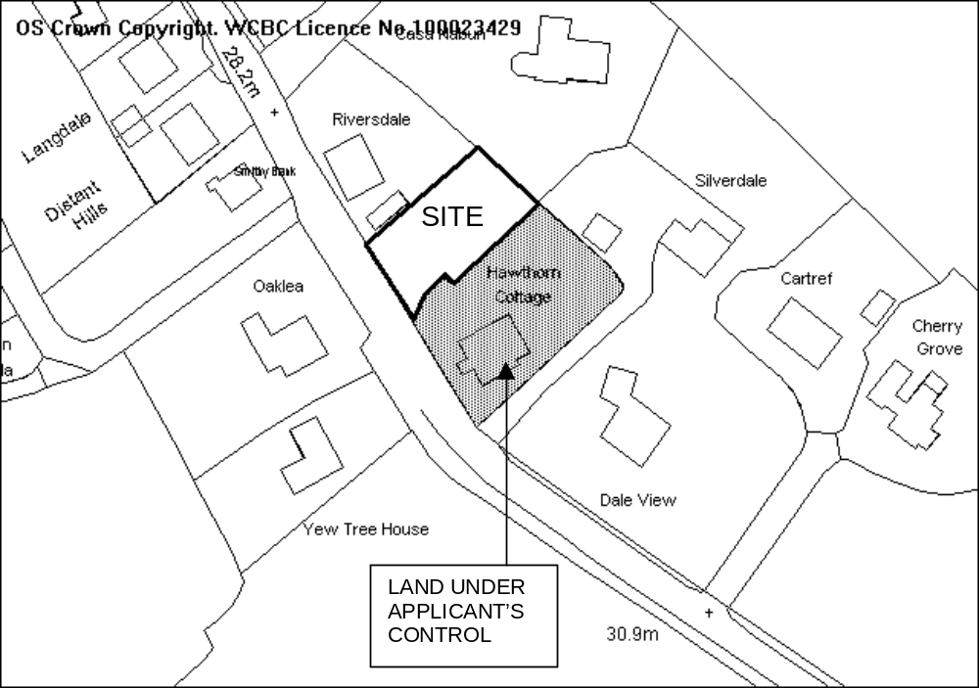

PROPOSAL

As above.

HISTORY

None.

DEVELOPMENT PLAN

Within settlement limit. Policies H2, GDP1, PS2 of the Wrexham Unitary Development Plan and Local Planning Guidance Notes 16 and 21 refer.

CONSULTATIONS

Community Council: Consulted 15.10.2008
Local Member: Requests application is reported to committee.
Highways: Object. Application does not demonstrate adequate visibility
Public Protection: No objection subject to soil porosity tests for proposed septic tank and note relating to construction times.
Welsh Water: Advise that there are no public sewers in area.
Environment Agency: Issued standard advice.
Other representations: 6 neighbouring occupiers notified. 1 letter of objection received raising the following concerns:
- Visibility is substandard caused by vehicles parked on the road outside Hawthorn Cottage.
- Any vehicles parked on the road will force vehicles on to opposite side of road ahead of bad bend.
Site Notice: Expired 11.11.2008

SPECIAL CONSIDERATIONS

Back ground: The application is for a dwelling house in the garden area of Hawthorne Cottage. The design of the house is simple and fits in with streetscene given the existing mixture of dwelling types. The main issue to consider is the impact of the proposal upon the existing highway.

Highways: The application site is situated on a classified road subject to a 30mph speed limit. Any proposed access in this location would need to provide visibility splays of 2.4 x 56 metres in both directions where there are no obstructions in excess of 1 metre in height. In order to achieve this the applicant would need to demonstrate with an agreement visibility splays that would cut across land outside the applicant’s control.

I am concerned that in the north western direction visibility is less than half the required standard (24 metres) and in the south east direction only 35 metres. I do not consider, given the geometry of the road that this is adequate and would cause danger to highway users. The photographs below are taken from the position of the proposed access looking in both directions.

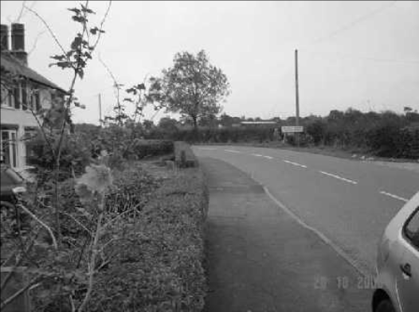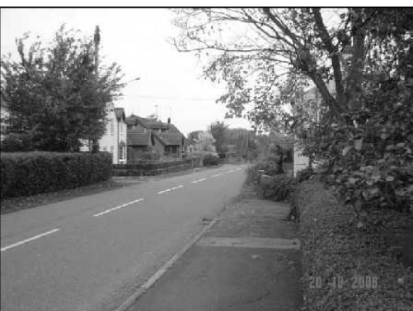
Visibility in south east (left picture) and north west (right picture).

In accordance with the maximum parking standards required by LPG 16, 3 vehicle spaces are required along with an adequate turning facility onto a classified road. The applicant has submitted an amended plan demonstrating sufficient parking and turning facilities on site.

CONCLUSION

I do not consider that this scheme demonstrates adequate visibility in both directions and to allow the development would compromise the safety of future occupiers, existing highway users and pedestrians. As such I recommend accordingly.

RECOMMENDATION: That permission be REFUSED

REASON(S)

1. The proposal would make inadequate provision for access visibility in both directions onto a classified road. To allow the development would lead to an increased danger to road users and would be contrary to policy GDP1(d) of the Wrexham Unitary Development Plan (2005).
______________________________________________________________

APPLICATION NO:  P/2008 /1190  COMMUNITY:  Caia Park  WARD:  Smithfield | LOCATION:  MECCA BINGO HALL SMITHFIELD ROAD WREXHAM  DESCRIPTION:  REMOVAL OF EXISTING SMOKING SHELTER AND EXISTING PLANTING AND INSTALLATION OF LARGER TIMBER CLAD SMOKING SHELTER  APPLICANT(S) NAME:  RANK GROUP GAMING DIVISION | DATE RECEIVED:  12/11/2008  CASE OFFICER:  PF  AGENT NAME:  RIDGE AND PARTNERS LLP  MR GREGG THATCHER
______________________________________________________________

SITE
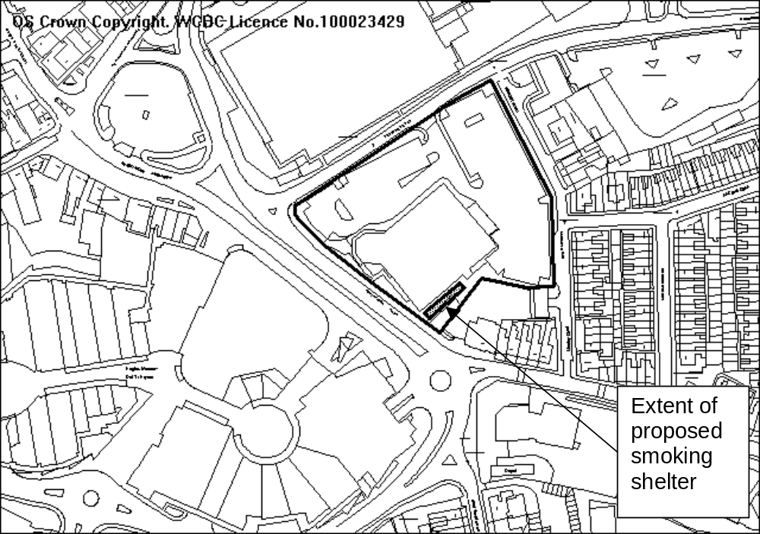

PROPOSAL

As above.

HISTORY - Most relevant

CB01025 Erection of Bingo club with associated external and h highway works. Granted 12.05.1997.
P/2007/0273 Erection of smoking shelter to rear of building. Granted 08.05.2007.
P/2008/0566 Erection of smoking shelter (previously granted under code no. P/2007/0273). Granted 18.07.2008.
P/2008/1294 Variation of condition no. 1 of planning permission code no. P/2006/1444, to permit opening until 12.00 (midnight) on any day. Pending.

DEVELOPMENT PLAN

Within settlement limit. Policy GDP1 refers.

CONSULTATIONS

Community Council: No objection provided construction complies with regulations for smoking shelters.
Local Member: Notified 10.12.2008
Public Protection: Concerns relating to noise and smoking legislation.
Other representations: 23 neighbouring occupiers notified. 2 letters of objection received raising the following concerns:
- Speaker system in existing smoking shelter can be a nuisance. Larger shelter will compound problem.
- Existing planting screens the shelter
- Timber cladding would not suit surroundings.
Site Notice: Expired 07.01.2009

SPECIAL CONSIDERATIONS

Design: The proposed structure is similar in shape to the existing structure. Whereas the existing structure is butted up to the building, the proposed structure is approximately 2.2 metres from the building thus encroaching upon part of the existing planting area.

Timber cladding is proposed as a facing material. Given that the majority of the structure is behind planting and the new timber cladding on the Smithfield Road elevation of the Eagles Meadow complex, I do not consider that this material will cause detriment the character of the area.

Amenity: The main issue to consider is the impact that the proposal will have upon neighbouring properties. At present the existing shelter also has facilities for playing the main bingo game but not amusement machines. This includes machines and a loud speaker/public address system. There is potential for this area to be used by a larger number of players as a result of the extension and as such a potential noise nuisance to the neighbouring properties on Manley Road and Smithfield Road.

This planning application is being considered along with an application to extend the opening hours on the bingo club (see report later in agenda - P/2008/1294). I am aware that bingo games occur in sessions and the last game usually ends between 2130 and 2200hrs. Therefore, there should be no use of any machines or loud speaker/public address system after this time. Public Protection have noted that whilst there have been no formal complaints about the current use, there is the potential for an increased floor area to cause nuisance. Given the proximity to the town centre, and background noise from the main ring road and Eagles Meadow I do not consider that the congregation of people in the shelter will further compound any noise nuisance. However, the increased use of any loud speakers should be controlled.

The extended part of the structure is proposed back towards the car park, away from Smithfield Road. The existing planting is a good screen against any visual impact. Any planting to be removed is towards the rear between the existing shelter and the car park where an emergency exit route is proposed. I will condition the provision of a landscaping scheme fully detailing an amenity screen along the full length of the shelter.

Smoking legislation: In order to be able to smoke in any structure, it must be 50% open in accordance with The Smoke-free Premises etc. (Wales) Regulations 2007. I have advised the applicant that the structure should comply with this legislation and that if any element of the design needs changing as a result of none compliance with these regulations a new application for planning permission may be required. The application cannot be refused on this basis, as this is a matter dealt with under other legislation.

CONCLUSION

I consider that the shelter itself will not cause any detriment to the visual amenity of the area subject to the submission of a satisfactory scheme of boundary treatment. I have given careful consideration regarding the potential for noise nuisance and along with controls of the use of such equipment I am satisfied that a permission is appropriate.
008 /1190
RECOMMENDATION: That permission be GRANTED

CONDITION(S)

1. The development hereby permitted shall be begun before the expiry of five years from the date of this permission.
2. Development shall only be carried out in strict accordance with the approved plans unless the prior written approval of the Local Planning Authority has been obtained.
3. The use of any loud speakers, public address system or electronically audible gaming equipment shall not be audible at the nearest noise sensitive property.
4. No use of any loud speaker, public address system and electronically audible gaming equipment shall be made after 2200hrs on any day unless otherwise agreed in writing by the Local Planning Authority.
5. No development shall commence until a scheme of boundary treatments fully detailing the existing planting and additional planting along the south eastern boundary of the site as marked in red on drawing no. 280579/3030/03 has been submitted to and approved in writing by the Local Planning Authority. The scheme shall be implemented in accordance with a time scale to be approved in conjunction with the scheme of details and retained thereafter.

REASON(S)

1. To comply with Section 91(3) of the Town and Country Planning Act, 1990.
2. To ensure that the development fully complies with the appropriate policies and standards.
3. To protect the amenities of the occupiers of nearby properties.
4. To protect the amenities of the occupiers of nearby properties.
5. To protect the amenities of the occupiers of the adjoining dwelling.

NOTE(S) TO APPLICANT

You should ensure that any difference between the plans approved under the Town and Country Planning Acts and under the Building Regulations is resolved prior to commencement of development, by formal submission of amended plans.

This permission is granted subject to the above conditions. Some conditions may require your attention prior to you carrying out any work on the proposal. These conditions are known as "conditions precedent". You should be aware that it is important that you comply with any "conditions precedent". If you do not, then any work you undertake on the development subject of this permission would not have planning permission.

In relation to condition 3, noise is a statutory nuisance as defined within the Environment Protection Act 1990. Any complaints received by this Council relating to noise from the property will be investigated and dealt with under the provisions of this Act. The applicant is advised to take steps in order to prevent any nuisance to neighbouring properties caused as a result of noise from the smoking shelter. The applicant is advised to seek advice of an acoustic consultant to help minimise any potential noise nuisance.

The applicant is advised that the structure should comply with the provisions of The Smoke-free Premises etc. (Wales) Regulations 2007, which are enforced by this Council. Further advice on this matter can be obtained from The Chief Housing and Public Protection Officer, Housing and Public Protection Department, High Street, Ruabon.

The proposed development lies within an area which could be subject to current coal mining or hazards resulting from past coal mining. Such hazards may currently exist, be caused as a result of the proposed development, or occur at some time in the future. These hazards include:

· Collapse of shallow coal mine workings.
· Collapse of, or risk of entry into, mine entries (shafts and adits).
· Gas emissions from coal mines including methane and carbon dioxide.
· Spontaneous combustion or ignition of coal which may lead to underground heatings and production of carbon monoxide.
· Transmission of gases into adjacent properties from underground sources through ground fractures.
· Coal mining subsidence.
· Water emissions from coal mine workings.

Applicants must take account of these hazards which could affect stability, health & safety, or cause adverse environmental impacts during the carrying out their proposals and must seek specialist advice where required. Additional hazards or stability issues may arise from development on or adjacent to restored opencast sites or quarries and former colliery spoil tips.

Potential hazards or impacts may not necessarily be confined to the development site, and Applicants must take advice and introduce appropriate measures to address risks both within and beyond the development site. As an example the stabilisation of shallow coal workings by grouting may affect, block or divert underground pathways for water or gas.

In coal mining areas there is the potential for existing property and new development to be affected by mine gases, and this must be considered by each developer. Gas prevention measures must be adopted during construction where there is such a risk. The investigation of sites through drilling alone has the potential to displace underground gases or in certain situations may create carbon monoxide where air flush drilling is adopted.

Any intrusive activities which intersect, disturb or enter any coal seams, coal mine workings or coal mine entries (shafts and adits) require the prior written permission of the Coal Authority. Such activities could include site investigation boreholes, digging of foundations, piling activities, other ground works and any subsequent treatment of coal mine workings and coal mine entries for ground stability purposes.

Failure to obtain Coal Authority permission for such activities is trespass, with the potential for court action. In the interests of public safety the Coal Authority is concerned that risks specific to the nature of coal and coal mine workings are identified and mitigated.

The above advice applies to the site of your proposal and the surrounding vicinity. You must obtain property specific summary information on any past, current and proposed surface and underground coal mining activity, and other ground stability information in order to make an assessment of the risks. This can be obtained from The Coal Authority's Property Search Service on 0845 762 6848 or at www.groundstability.com

______________________________________________________________

APPLICATION NO:  P/2008 /1206  COMMUNITY:  Maelor South  WARD:  Overton | LOCATION:  8 CAMBRIAN VIEW BETTISFIELD WHITCHURCH SHROPSHIRE  DESCRIPTION:  REMOVAL OF EXISTING PORCH AND ERECTION OF SINGLE STOREY FRONT PORCH.  APPLICANT(S) NAME:  MISS LILO BLUHM | DATE RECEIVED:  18/11/2008  CASE OFFICER:  LB1  AGENT NAME:  MISS LILO BLUHM
______________________________________________________________

SITE

End terraced house in Bettisfield.

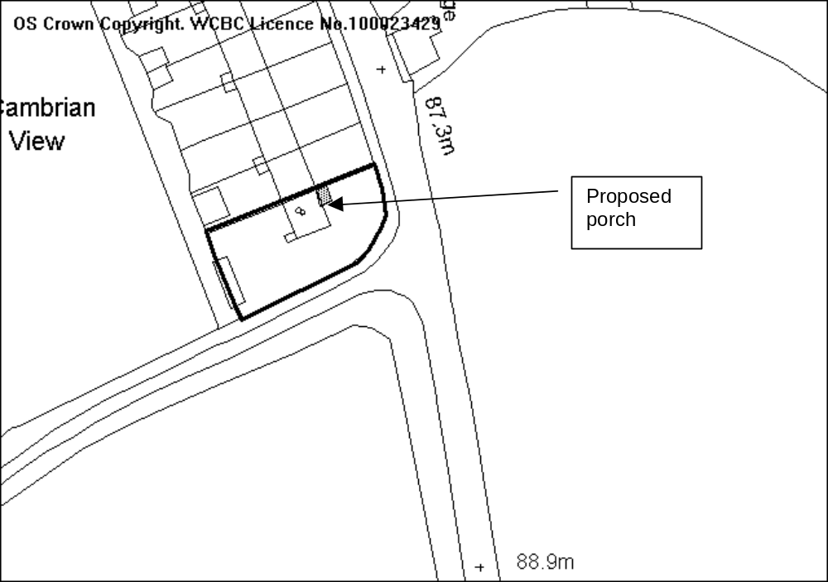

PROPOSAL

Removal of existing and erection of replacement porch.

HISTORY

None relevant.

DEVELOPMENT PLAN

Lies within settlement limit, Policies GDP1, PS2 and LPGN 20 apply.

CONSULTATIONS

Community Council: No objections

Local Member: Consulted 24/11/08
Other representations: One letter received raising the following points:
- The window in the proposed porch on the boundary would overlook the neighbouring property and would be intrusive.
- The side-facing window may impede development on the adjoining property.
- Concerned as to how the porch will attach to the existing one on the neighbouring property and whether it will overhang neighbouring site.
- A vital drain will be built over. If a blockage should occur and the house is unoccupied access will be a problem.
- All houses have the same porch the proposed porch will be out of character with the area.
Site Notice: Expired 17/12/08

SPECIAL CONSIDERATIONS

The property is an end terrace with a small flat roofed porch to the front. This porch is linked to the porch on the adjoining property. The other properties in the terrace all originally had similar porches, however several have now been altered so they are not all identical.

The proposal is to remove the porch and replace it with a pitched roof structure. The existing porch roof, which is a concrete slab that forms the roof for both No. 8 and No. 7 will be cut in two and made good by the applicant. The existing party wall between the two porches will remain and a new wall erected for the new porch. Any works on the boundary will be covered by the Party Wall Act and the applicant will have to notify neighbouring occupiers with details of the proposed works. A note to the applicant will be added to any condition to ensure that works are solely on the application site and do not overhang the neighbouring property.

The design of the porch, whilst different from that on the adjoining house will not detract from the design and style of the property. It is of a size that is appropriate in relation to the property.

The applicant will have to enter into a building over agreement in relation to the sewer. This will ensure that if necessary it will be possible to access the drain and clear any blockages.

There is a side-facing window proposed in the new porch, however a porch is not a habitable room and any overlooking will be minimal. It is understood that there are no plans at present to extend the adjoining property and it is not possible to determine the impact upon proposed extensions which may or may not be built.

CONCLUSION

The design and size of the porch are in keeping with the property and will not have an adverse impact on the location and I therefore recommend accordingly.

RECOMMENDATION: That permission be GRANTED

CONDITION(S)

1. The development hereby permitted shall be begun before the expiry of five years from the date of this permission.
2. No facing materials shall be used other than materials matching those used on the existing building.
- Development shall only be carried out in strict accordance with the approved plans unless the prior written approval of the Local Planning Authority has been obtained.
- The side window on the north elevation facing the adjoining dwelling shall only be glazed or re-glazed using obscure glass.
REASON(S)

1. To comply with Section 91(3) of the Town and Country Planning Act, 1990.
2. To ensure a satisfactory standard of appearance of the development in the interests of the visual amenities of the area.
- To ensure that the development fully complies with the appropriate policies and standards.
- To protect the amenities of the adjoining occupiers.

NOTE(S) TO APPLICANT

You should ensure that any difference between the plans approved under the Town and Country Planning Acts and under the Building Regulations is resolved prior to commencement of development, by formal submission of amended plans.

You are advised that building work which involves work on an existing wall shared with another property, building on the boundary with a neighbouring property or excavating near a neighbouring building may require the separate consent of the neighbour under the provisions of the Party Wall Act. If you require further information or advice please contact the Building Control Section on 01978 292050.

You are advised that the planning permission hereby granted does not authorise any building over, diversion, connection or other interference with any sewer, public or private, which crosses the site. You are advised to contact Welsh Water, PO Box 10, Treharris, CF46 6XZ (Tel: 01443 331155) in this regard, prior to undertaking any groundwork in connection with the development. Should you be required to depart from the details hereby approved, you should contact the Council's planning department to seek further advice with regard to the submission of amended plans and / or a new planning application.
______________________________________________________________

APPLICATION NO:  P/2008 /1219  COMMUNITY:  Broughton  WARD:  Bryn Cefn | LOCATION:  BRAKE CHAPEL BRAKE ROAD MOSS WREXHAM  DESCRIPTION:  RESIDENTIAL DEVELOPMENT (14 NO. FLATS) FORMATION OF VEHICULAR ACCESS AND ASSOCIATED WORKS  APPLICANT(S) NAME:  ERIC ROBERTS (BUILDERS) LTD | DATE RECEIVED:  20/11/2008  CASE OFFICER:  SJG  AGENT NAME:  THE GARSTON PARTNERSHIP  MR J GARSTON
______________________________________________________________

THE SITE

The site is on the north side of Brake Road and on the east side of the junction with Francis Road.

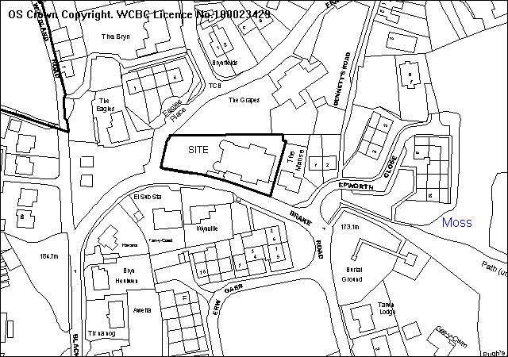
PROPOSAL

As above.
Is for demolition of the chapel and erection of 14 two bedroom flats in a 2 and 3 storey block at the eastern end of the site. A new 2 storey building to provide a bat habitat on an open space area is proposed at the western end. Access to Brake Road is via a new access leading to 20 parking spaces, and a new 2 metre footpath is proposed around the site.

The application includes an access statement, site survey, cross-sections, sustainable building report and a bat report.

RELEVANT HISTORY

P/2004/0715 5 dwellings Withdrawn August 2004
P/2007/1426 4 dwellings Withdrawn November 2008

DEVELOPMENT PLAN

The site lies within the settlement limits. Policies GDP1 GDP2 PS1 PS11 CLF5 H2 EC6 AND T8 of UDP are relevant, together with LPGN 10 16 2122 and 27.

CONSULTATIONS

Broughton C Council: Concerned with the size and height of the development which does not appear to be in character with the surrounding area, footway is required, stone from chapel should be re-used.
Local Member(s): Consulted 24/11/2008
Highways: Recommend conditions
Public Protection: Comments regarding construction works and drainage
Env Agency: standard advice applies
Welsh Water: Recommend conditions
CEnvO: Comments on layout of POS. further details required
Education: Schools contribution of £55,440 required
Wrexham Access Group: Comments regarding disabled parking provision
CCW: Licence required for works affecting bats. No objection in principle.
CPAT: photographic survey required
Site Notices: Expired 18/12/2008
Press advert: Expired 9/1/2009
Other representations: Adjoining occupiers notified 26/11/2008. 3 letters of objection received, on grounds of:
- Excessive development of a small site, not in-keeping with the area
- Height of buildings will over-dominate the area
- Inadequate parking will cause problems on narrow roads
- Entrance is near a busy junction
- Inadequate space between the development and adjoining dwellings
- Overlooking and loss of privacy
- Concerns over proposed shed for accommodating bats on site
1 letter of support received, stating that the development is a very good idea and the site is an eyesore at present.

SPECIAL CONSIDERATIONS/ ISSUES

Policy: Within the settlement limit no objection in principle subject to compliance with GDP1. If minded to grant permission education payments may be necessary and re-use of demolition materials should be encouraged.

Residential amenity: The development meets separation distances and achieves a sympathetic relationship with the adjoining dwellings. There is a two storey section adjoining the house to the east. The open space area would form an attractive amenity for residents, but is considered too small to be suitable for adoption by the Council.

Built conservation: Although not listed this is a significant building both architecturally and culturally. 3 English Wesleyan chapels were built in this area, each bigger than the last to accommodate the ever growing mining community. As the last to be built, the Brake chapel is the only remaining (the memorial stone from the previous chapel has been built into the existing). All the stone used in the construction was quarried on the Moss Road itself giving the building special local identity. The size of the chapel alone is unique and indicates its former importance and significance in the area. Capel has opposed demolition in the past and suggested conversion by a Housing Association

However the principle of demolition has been accepted in dealing with the previous application in 2007/8.

This unusual chapel contributes significantly to the streetscene of Brake Road and forms an effective termination to the southern vista from Bryn Road to the North of the site. Whilst there appears to be no planning constraint on demolition, other than ecology issues, a comprehensive photographic record is required.

The building proposed is of similar scale to the existing when viewed from the north and south, and its footprint is considerably less than that of the current one. The walls are rendered blockwork with reclaimed stone quoins.

Dressed stone elements such as doorjamb blocks, lintels - and inscribed stones especially - should be incorporated in the development. The opportunity to address sustainability issues on such a development does not appear to have been optimised.

Sustainability: The site involves the re-development of the brownfield site for 14 flats, which would constitute an efficient use of land in accordance with national planning policy. The siting of the dwellings maximises the availability of natural sunlight with south facing principle windows. The application provides details of energy efficiency and I consider the re-development of the site would be more beneficial, in terms of energy efficiency, than adapting the original building. Whilst the site does not lie within close proximity of community facilities, ie. Shops, public transport is available in the area.

Ecology: A bat survey has been undertaken at regular times, and the site layout and replacement structure are sympathetic to nature conservation (although the two storey bat building will be a conspicuous and unusual feature). A licence will be required from WAG.

Highway safety: The highway authority accepts the reduced parking provision and revised plans to address their concerns have been submitted. The development brings significant improvements in terms of the provision of a footway at this busy junction.

Public Open Space: The area of public open space at the western end of the site may be suitable for adoption, subject to receipt of further details of layout and management. The applicants have considered managing the area themselves should this be the case then a contribution would not be necessary. However this will be addressed as part of the Section 1O6 Agreement.

RECOMMENDATION A

That the Council enters into an obligation under Section 106 of the Town and Country Planning Act 1990, requiring:

contribution to schools places of £55,440
- a commuted sum to provide £14,000 for public open space adoption on the site/ or in management scheme for private maintenance
The Chief Planning Officer be given delegated authority to determine the form of the agreement.

RECOMMENDATION B

That permission be granted on completion of the agreement, subject to conditions:-

CONDITION(S)

1. The development hereby permitted shall be begun before the expiry of five years from the date of this permission.
2. Development shall only be carried out in strict accordance with the approved plans unless the prior written approval of the Local Planning Authority has been obtained.
3. No part of the development shall be commenced until samples of all external facing and roofing materials have been submitted to and approved in writing by the Local Planning Authority. The development shall only be carried out in strict accordance with such details as are approved.
4. This permission shall operate only to allow development to be carried out in accordance with the approved drawings and the application documentation. Notwithstanding the provisions of the Town and Country Planning (General Permitted Development) Order 1995, no further development shall take place within the site (other than the painting of the buildings).
5. The vehicle parking and turning areas indicated on the approved plans shall be laid out, surfaced and drained prior to the first use of the building hereby granted and shall thereafter be retained for those purposes.
6. No development shall commence until the developer has submitted a scheme for the comprehensive and integrated drainage of the site to the local planning authority and received approval in writing from the Local Planning Authority. The scheme shall demonstrate how foul water, surface water and land drainage will be dealt with satisfactorily and that no surface water or land drainage run-off shall be allowed to connect (either directly or indirectly) to the public drainage system.
7. The site shall be developed in accordance with the ground and floor levels indicated on the approved plans. No changes to floor levels or external ground levels shall be made without the prior written approval of the Local Planning Authority.
8. No part of the development hereby permitted shall be commenced until full details of both hard and soft landscape works for the site have been submitted to and approved in writing by the Local Planning Authority. The works shall be implemented in accordance with a timescale to be approved in conjunction with the scheme of details.
9. All hard and soft landscape works shall be carried out in accordance with the approved details as set out in Condition 8. The works shall be carried out:
a) prior to the occupation of any part of the development;
b) in accordance with the programme agreed with the Local Planning Authority;
c) within 3 months of the first use of the development with the exception of soft
landscaping which shall be carried out in the first planting season (November to March) or seeding season (April to September) following the first use.
10. Any trees or shrubs removed, dying, being severely damaged or becoming seriously diseased within five years from the completion of the scheme shall be replaced by trees or shrubs of similar size and species to those originally required to be planted unless otherwise approved in writing by the Local Planning Authority.
11. The open amenity area(s) indicated on the submitted 1:200 scale layout plan shall be completed to a standard indicated in writing by the Local Planning Authority as suitable for adoption as Public Open Space prior to occupation of any dwelling erected on land adjacent thereto and shall thereafter be maintained to that standard for a minimum period of one year.
12. The highway boundary wall shall be set back to the position shown on the approved plans before any dwellings are first occupied, and the wall shall be built of natural stone. No part of the boundary wall shall exceed 1 metre in height.
13. Details of a notice board/ plaque to be erected near the entrance to the site shall be submitted to and approved by the local planning authority before any headstones are removed from the site. The board/plaque as approved shall be erected at the site within a time period to be specified as part of the submission, and thereafter the board/plaque shall be fully maintained at the site.
14. Prior to the commencement of any demolition works on site, the following details shall be submitted for the further approval of the local planning authority:
i. an audit of all existing building materials
ii. the potential re-use and recycling of those materials for incorporating into an agreed, replacement site development, and
iii. where relevant, the recipient of remaining building materials.
The approved audit shall form part of the building contract agreed for new building development for the site, a copy of which shall be submitted for record purposes for the local planning authority.
15. The development hereby permitted including the demolition of the chapel shall not commence until a scheme for the translocation of the brown long eared bats and nesting birds identified on the application documents has been submitted to and approved by the Local Planning Authority. The scheme shall include details of future management of the recreated habitat and no deviation shall be made from the approved details without the written approval of the Local Planning Authority. The agreed scheme shall be implemented within 6 months of the substantial completion of the development hereby permitted.
16. The proposed access shall have a visibility splay of 2.4 x 25m in both directions measured along the nearside edge of the adjoining highway within which there shall be no obstruction in excess of 1m in height.
17. A 2m wide footway shall be constructed back from the existing carriageway on Brake Road and Francis Road along the full frontage of the development site prior to the occupation of any dwelling hereby approved.
18. A 6m kerb radius shall be provided at the junction of Brake Road and Francis Road prior to the occupation of any dwelling hereby approved.
19. A scheme to resurface the quadrant of land at the junction of Brake Road and Francis Road shall be submitted to and agreed in writing by the Local Planning Authority in consultation with the Highway Authority prior to the proposed development being brought into use. The work shall be completed prior to the occupation of any dwelling hereby approved.
20. No gates shall be erected within 5m the highway boundary.
21. The access shall be hard surfaced in a bound material for a distance of 5m behind the highway boundary.
22. Development shall not begin until an appropriate photographic survey of the existing buildings on the site has been carried out in accordance with details to be submitted to, and approved by, the Local Planning Authority. The resulting photographs should be deposited with the County Sites and Monuments Record, operated by The Clwyd-Powys Archaeological Trust (7a Church Street, Welshpool, Powys, SY21 7DL. Tel: 01938 553670).
23. Prior to the commencement of development, a programme of sustainable works shall be submitted for the written approval of the Local Planning Authority. The approved programme shall be implemented in accordance with a timescale to be agreed with the Local Planning Authority.
24. The site shall be developed in accordance with the ground and floor levels indicated on the approved plans. No changes to floor levels or external ground levels shall be made without the prior written approval of the Local Planning Authority.
25. Construction works, ancillary works and the use of plant or machinery audible at or beyond the site boundary shall only be carried out between the hours of 07:30 and 19:30 (Monday to Friday) and 08:00 to 14:00 (Saturday) and at no time on Sundays or Bank Holidays.

REASON(S)

1. To comply with Section 91(3) of the Town and Country Planning Act, 1990.
2. To ensure that the development fully complies with the appropriate policies and standards.
3. To ensure a satisfactory standard of appearance of the development in the interests of the visual amenities of the area.
4. To ensure a satisfactory standard of appearance of the development in the interests of the visual amenities of the area.
5. To provide for the loading, unloading, parking and turning of vehicles clear of the highway and to ensure that reversing by vehicles into or from the highway is rendered unnecessary in the interest of traffic safety.
6. To ensure the proper drainage of the site and to minimise the risk of pollution
7. To ensure that the development fully complies with the appropriate policies and standards.
8. To ensure a satisfactory standard of appearance of the development in the interests of the visual amenities of the area.
9. To ensure a satisfactory standard of appearance of the development in the interests of the visual amenities of the area.
10. To ensure a satisfactory standard of appearance of the development in the interests of the visual amenities of the area.
11. To ensure an adequate provision of open amenity space for use by residents in accordance with the Council's standards.
12. In the interests of amenity and highway safety.
13. To ensure that the historic interest of the former use of the site is preserved at the site.
14. To ensure that the development involves a sustainable approach.
15. The development will detrimentally affect bats and has been allowed because of exceptional circumstances. In order to ensure that the bats are conserved, it is necessary for adequate provision to be made to secure the recreation of the habitat outside the development area.
16. In the interests of highway safety.
17. In the interests of highway safety.
18. In the interests of highway safety.
19. In the interests of highway safety.
20. In the interests of highway safety.
21. In the interests of highway safety.
22. To provide for a record of a building or buildings of local architectural or historic interest
23. To meet the criteria set out in the Local Planning Guidance Note 22.
24. To ensure that the development fully complies with the appropriate policies and standards.
25. To protect the amenities of the occupiers of nearby properties.

NOTE(S) TO APPLICANT

The scheme of landscaping referred to in the above conditions shall inlcude any changes to ground levels (shown by existing and proposed contours/levels) and any existing vegetation (showing that to be retained) and proposed planting. In addition, any of the following which apply to the particular site must be included:-
means of enclosure, car parking layout, access and circulation areas, materials for hard surfaced areas, any minor structures (e.g. refuse stores, lamp columns, play equipment) location of services, and any historic landscape features to be retained/improved.

This permission is granted subject to the above conditions. Some conditions may require your attention prior to you carrying out any work on the proposal. These conditions are known as "conditions precedent". You should be aware that it is important that you comply with any "conditions precedent". If you do not, then any work you undertake on the development subject of this permission would not have planning permission.

You are advised to contact the Council's Ecology Officer at The Planning Department, Lambpit Street, Wrexham on Tel: 01978 292517.
The planning permission requires that development be carried out in accordance with the approved plans, including the construction of an estate road intended for adoption by the Council under the Highways Act 1980. It is essential therefore that the detailed proposals are submitted to the highway authority and confirmed as acceptable BEFORE development commences. Please contact:-

The Operational Manager (Highways Planning), Crown Buildings, Chester Street, Wrexham. LL13 8BG telephone: 01978 292000

Your attention is drawn to Highway Supplementary Notes Numbered 1, 3, 4 and 5 on the enclosed "Applicants' Rights and General Information".

The separate written consent of the Local Highway Authority must be obtained before any work is carried out within the confines of the highway.

The proposed footway on Brake Road and Francis Road should be constructed to a standard suitable for adoption by the Council for future maintenance at the public expense and the developer will need to enter into an agreement with the Council under section 38 of the Highways Act 1980.

The quadrant of land to be resurfaced should be constructed to a standard suitable for adoption by the Council for future maintenance at the public expense and the developer will need to enter into an agreement with the Council under section 38 of the Highways Act 1980.

You are advised that this grant of planning permission was made following the completion of an Agreement under Section 106 of the Town and Country Planning Act. Before undertaking any work under this permission you are advised to obtain full details of the Agreement and ensure that you are able to comply with its terms.
The proposed development lies within an area which could be subject to current coal mining or hazards resulting from past coal mining. Such hazards may currently exist, be caused as a result of the proposed development, or occur at some time in the future. These hazards include:

· Collapse of shallow coal mine workings.
· Collapse of, or risk of entry into, mine entries (shafts and adits).
· Gas emissions from coal mines including methane and carbon dioxide.
· Spontaneous combustion or ignition of coal which may lead to underground heatings and production of carbon monoxide.
· Transmission of gases into adjacent properties from underground sources through ground fractures.
· Coal mining subsidence.
· Water emissions from coal mine workings.

Applicants must take account of these hazards which could affect stability, health & safety, or cause adverse environmental impacts during the carrying out their proposals and must seek specialist advice where required. Additional hazards or stability issues may arise from development on or adjacent to restored opencast sites or quarries and former colliery spoil tips.

Potential hazards or impacts may not necessarily be confined to the development site, and Applicants must take advice and introduce appropriate measures to address risks both within and beyond the development site. As an example the stabilisation of shallow coal workings by grouting may affect, block or divert underground pathways for water or gas.

In coal mining areas there is the potential for existing property and new development to be affected by mine gases, and this must be considered by each developer. Gas prevention measures must be adopted during construction where there is such a risk. The investigation of sites through drilling alone has the potential to displace underground gases or in certain situations may create carbon monoxide where air flush drilling is adopted.

Any intrusive activities which intersect, disturb or enter any coal seams, coal mine workings or coal mine entries (shafts and adits) require the prior written permission of the Coal Authority. Such activities could include site investigation boreholes, digging of foundations, piling activities, other ground works and any subsequent treatment of coal mine workings and coal mine entries for ground stability purposes.

Failure to obtain Coal Authority permission for such activities is trespass, with the potential for court action. In the interests of public safety the Coal Authority is concerned that risks specific to the nature of coal and coal mine workings are identified and mitigated.

The above advice applies to the site of your proposal and the surrounding vicinity. You must obtain property specific summary information on any past, current and proposed surface and underground coal mining activity, and other ground stability information in order to make an assessment of the risks. This can be obtained from The Coal Authority's Property Search Service on 0845 762 6848 or at www.groundstability.com

Please note the attached comments from The Countryside Council for Wales, Welsh Water and the Environment Agency.

You are advised that the re-use of land which may have previously been used for burial purposes is subject to the requirements of the Town and Country Planning (Churches, Places of Religious Worship and Burial Grounds) Regulations 1950. You are advised to seek advice on the procedures to be followed regarding the removal and re-internment of human remains, the disposal of monuments and in respect of any other consents which may be needed, prior to commencement of development.
______________________________________________________________

APPLICATION NO:  P/2008 /1235  COMMUNITY:  Abenbury  WARD:  Holt | LOCATION:  LAND ON JUNCTION OF BRIDGE ROAD SOUTH AND CLYWEDOG ROAD SOUTH LAND ON JUNCTION OF CEFN ROAD AND BRIDGE ROAD SOUTH LAND BETWEEN THE JUNCTION OF CEFN ROAD AND BRIDGE ROAD SOUTH AND THE A525 WREXHAM  DESCRIPTION:  CONSTRUCTION OF WREXHAM INDUSTRIAL ESTATE ACCESS ROAD (SOUTHERN SECTION) COMPRISING:-  NEW SINGLE CARRIAGEWAY FROM THE JUNCTION OF CEFN ROAD AND BRIDGE ROAD SOUTH TO A NEW JUNCTION ON THE A525, 380M NORTH WEST OF THE EXISTING CROSS LANES CROSSROADS.  IMPROVEMENTS TO BRIDGE ROAD SOUTH FOR A DISTANCE OF 230M NORTH EAST OF ITS JUNCTION WITH CEFN ROAD.  NEW BRIDGES OVER RIVER CLYWEDOG AND BEDWELL BROOK.  ASSOCIATED NEW ROUNDABOUTS, LIGHTING AND DRAINAGE.  (THE APPLICATION IS ACCOMPANIED BY AN ENVIRONMENTAL STATEMENT)  APPLICANT(S) NAME:  WREXHAM COUNTY BOROUGH COUNCIL | DATE RECEIVED:  25/11/2008  CASE OFFICER:  DSW  AGENT NAME:  WREXHAM COUNTY BOROUGH COUNCIL  S STEVENS - OPERATIONS MANAGER
______________________________________________________________

SITE

Land between the junctions of Cefn Road/Bridge Road on the south westerly edge of Wrexham Industrial Estate and the A525 Wrexham – Whitchurch Road to the west of residential properties known as The Hollies and Hollycroft.

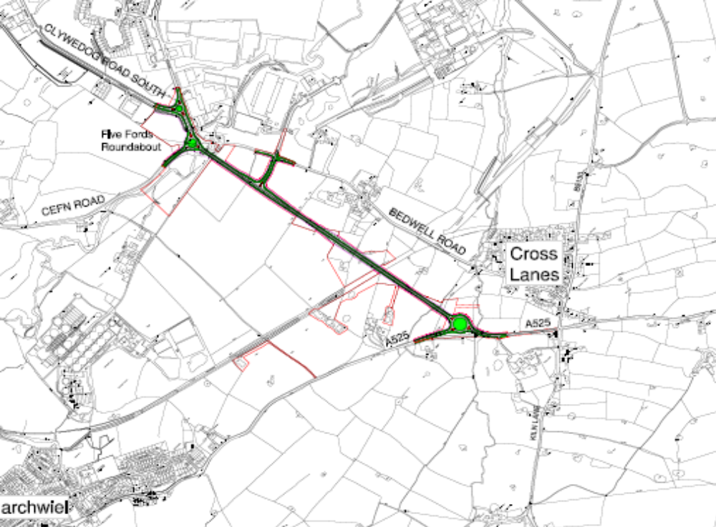PROPOSAL

This is a full application for the construction of a new southerly link road to Wrexham Industrial Estate. It comprises of a new 7.3m wide single carriageway with 1m wide hardstrips which extends for a distance of 1.2km (0.75 mile) from Cefn Road/Bridge Road South to the south of Pentre Maelor. It also involves minor improvement works to the existing A525 to the north of the A525/B5130 junction in Cross Lanes and improvement of Bridge Road South between its junctions with Cefn Road and Clywedog Road South. The proposals include three roundabouts which will be provided with lighting and a T-junction with a ghost island for right turning traffic for a new link road providing access to Tetra Pak factory and Bedwell Road. The proposed route crosses farmland to the west of Bedwell Road. Running south from a new roundabout at Five Fords, the route would cross the River Clywedog on a new bridge and form a junction with the existing A525 at a new roundabout (Cross Lanes Roundabout) located 350 metres north of the existing signal controlled junction at Cross Lanes. Two bridges, two culverts and a retaining wall would be constructed as part of the scheme.

The application includes an Environmental Impact Assessment and has been submitted in conjunction with a further proposal for the construction of a northern access road into the Wrexham Industrial Estate, Code No P/2008/1238 which is also to be considered at this meeting.

HISTORY

CB/1999/3139 Construction of new access road to Wrexham Industrial
Estate and associated accommodation works. Approved
06/12/1999.
P/2007/1167 Construction of Wrexham Industrial Estate Access Road (Southern Section) at land on junction of Bridge Road South and Clywedog Road South, land on junction of Cefn Road and Bridge Road South and land between the junction of the Cefn Road and Bridge Road South and the A525, comprising new single carriageway improvements, new bridges and associated new roundabouts, lighting and drainage. Approved 07.01.08

DEVELOPMENT PLAN

Outside settlement/Wrexham Industrial Estate boundary. The principle of this scheme is supported by UDP policy T5 which safeguards land for this road improvement scheme. Subject to regard being had to other UDP policies, namely policy EC1 Green Barrier; policy EC2 Agricultural Land; Policy EC4 Hedgerows Trees and Woodlands; policy EC6 Biodiversity Conservation; Policy EC12 Development and Flood Risk; Policy EC13 Surface Water Runoff; policy EC14 Protection of Controlled Waters and Policy GDP1, there are no policy objections.

CONSULTATIONS

Abenbury CC: Notified 26.11.08
Sesswick CC: Supports the application but with regards to the Environmental Statement wish to make the following points:
- The northern end of Bedwell Road would not be connected to the roundabout to prevent through traffic using Bedwell Road.
The Council considers that as long as Five Fords Bridge remains useable, a route for pedestrians and cyclists towards the Industrial Estate should be left in place over the bridge. Should circumstances change, consideration should be given to providing an alternative pedestrian and cycle route over the River Clywedog.
- The superseded length of the existing A525 to the west of the new roundabout would be kept open for pedestrians.
The Council consider that the area shown as “Land required for Landscape Mitigation” on drawing number 02754/D/676 B should not only have a route for pedestrians, but also for cyclists, a link to the footpath with safe crossing points for al users, and include an amenity area with trees, bulbs etc to create a small park area. A children’s play area could also be included.
- A T-junction with a ghost island for right turning traffic would be provided at Chainage 300 on the new access road.
The Council have expressed concerns about the potentially dangerous situation of loaded slow moving HGVs, turning right out of the new Tetra Pak link road, onto the new access road which will carry faster traffic. The Council considers that similar arrangements for these vehicles turning right should be provided and should include a waiting area in the centre of the new access road.
- Through traffic would be discouraged from travelling through Cross Lanes village and from using Bedwell Road.
The Council consider that to facilitate this, the road signs should indicate only the presence of businesses (ie Tetra Pak, Maelor Abattoir and Fairfield Meats).
- The proposed scheme would significantly reduce traffic in the village on the Kiln Lane.
The Council agrees that traffic on Bedwell Lane will be substantially reduced, but considers that traffic on Kiln Lane (including HGVs) would remain very similar to the present level, due to lack of alternative routes from the A528 and A483 and drivers following instructions from sat. navs.
- It is considered that the reduction in traffic in Cross Lanes village and provision of a signed cycle route on Bedwell Road would provide a substantial benefit for users.
Although few cyclists use this road at present, the Council considers this is a worthwhile proposal. However, as some traffic will continue to use Bedwell Road, which is narrow with very restricted visibility in parts, substantial risks will still be created to pedestrians and cyclists. There is no footway between Bedwell Crescent and the Lower Bedwell Bridge, yet five properties have access between these points. Should a cycle route be constructed between these two points, consideration should be given to incorporating a joint footway and cycle route to serve these properties.
- Consideration should be given to constructing a bus ‘pull in clear’ facility for either one or both directions.
- Consideration should be given to diverting the footpath between Bedwell Lane and the A525 so that it becomes wholly within the Sesswick boundary, and exits near the safe crossing point to be built across the A525 near the Hotel entrance. This will save the cost of building a safe crossing point over the new link road and also maintaining the present wooden footbridge over Bedwell Brook.
- Between Bedwell Crescent and the Lower Bedwell Bridge, the road not only gives access to five properties, but also to the footpath leading to the A525.
Marchwiel CC: Notified 26.11.08
Local Members: Notified 26.11.08
(Cllr MG Morris & Cllr Mrs June Fearnall)
Transport Directorate WAG:Notified 26.11.08
Planning Division WAG: Notified 03.12.08

National Farmers’ Union
(NFU): Notified 26.11.08
Dee Valley Water Group: Notified 26.11.08
North Wales Police: Notified 26.11.08
Clwyd Badger Group: Notified 26.11.08
Ramblers Association: Notified 26.11.08
CCW: No objections subject to conditions which require the appropriate implementation of proposed ecological mitigation and compensation proposals. The proposal is not likely to cause a significant affect on the features and integrity of the River Dee and Bala Lake Special Area of Conservation. Implementation of the scheme may only proceed on receipt of the appropriate licence issued by the Welsh Assembly Government.
CPAT: Refer to previous comments made in response to applications P/2007/1165 and P/2007/1167.
Highways: Notified 26.11.08
Welsh Water: Advise that a pumping station and a number of public assets cross the application site. These will need to be addressed during the detail design stage.
Environment Agency: Notified 26.11.08
CPRW: Notified 26.11.08
North Wales Wildlife Trust: Notified 26.11.08
Public Protection: No objections subject to appropriate condition to deal with potential contamination issues.
Other Representations: 32 letters sent to landowners and adjoining occupiers. One letter received from the occupiers of Chetwynd Grove, Marchwiel, objecting for the following reasons:
- The ‘take’ of any land in this location will result in the loss of mature trees and amenity to this property.
- The creation of a cycle route along the disused part of the old A525 fronting this property will create a huge lay-by with problems of litter and overnight parking etc. Access to this area should therefore be linked in same way.
- The new roundabout will be a major visual impact upon this property. It is incorrect of the Environmental Statement to state its effect is only “moderate adverse”.
- Significant increase in traffic volumes, up to 80% increase over what is currently passing our property.
- The proposals do not take any account of increased noise pollution, no bunching, tree planting or mitigating works have been included.
- Potential light pollution from the new roundabout.
Site Notice: Expired 09.01.09
Press Notice: Expired 16.01.09

Given the short length of time involved between this application and your consideration of the previous one (P/2007/1167) on 7 January 2008, I consider it pertinent for Members to have due regard to the comments made at that time in your consideration of the current proposal. These concerns are likely to remain despite your previous resolution to grant permission and are repeated below:-

Abenbury CC: Notified 11.10.07
Sesswick CC: Notified 11.10.07
Marchwiel CC: Notified 11.10.07
Local Members:
Cllr MG Morris: Notified 11.10.07
Cllr Mrs June Fearnall: Notified 11.10.07
Transport Directorate
Welsh Assembly Gov: Does not wish to issue a directive in this instance. The construction of these access roads will impact upon the A5156/A483 interchange as access to the Industrial Estate is improved. It is therefore important that we continue to liaise so that both Highways Authorities can take account of, and address, traffic flow issues on the overall network.
Welsh Assembly Gov: Notified 11.10.07
(Planning Division)
NFU: Notified 11.10.07
Dee Valley Water Group: Notified 11.10.07
North Wales Police: Notified 11.10.07
Clwyd Badger Group: Notified 11.10.07
Ramblers’ Association: Notified 11.10.07
CCW: No objections subject to conditions requiring the
implementation of appropriate protected species mitigation in relation to Badgers and Great Crested Newts. The mitigation proposals with regards to the great crested newt ie creation of new ponds are considered appropriate. Implementation of the scheme may only proceed on receipt of the appropriate licence, issued by the Welsh Assembly Government. The licence can only be issued by WAG on condition that there is no satisfactory alternative and the development will not be detrimental to the maintenance of the population of the species.
CPAT: The archaeological assessment of this road
scheme should follow the guidance set out in the
Design Manual for Roads and Bridges Vol. 2
Section 3 Part 2 – Cultural Heritage. We therefore
recommend a geophysical survey of the route set
out in this application along with surface collection
of artefacts on ploughed fields by means of
systematic fieldworking.
Highways: Notified 11.10.07
Welsh Water: Notified 11.10.07
Environment Agency: Notified 11.10.07
CPRW: Notified 11.10.07
North Wales Wildlife Trust: Notified 11.10.07
Public Protection: No objections subject to appropriate condition to
deal with potential contamination issues.
Other Representations: 32 letters sent to landowners and adjoining
occupiers.
Two letters have been received raising the following concerns:
- Concerns with regards to the proposed drainage and the flood compensation areas. Concerned that this will increase the risk of flooding to Glanrafon Cottage.
- Loss of mature trees and impact on amenity of Chetwynd Grove.
- The creation of a cycle route along the disused part of the old A525 fronting Chetwynd Grove will create a huge lay-by, with the attendant problems of litter, overnight parking etc. Access needs to be limited in some way.
- The sighting of the new roundabout will have a major visual impact on Chetwynd Grove not a “moderate adverse effect” as described in the Environmental Statement. This is especially so given the predicted 80% increase in vehicles a day shown in the 2003 Traffic Census, many HGVs which will be using this roundabout.
- The current design takes no cognisance of the vastly increased noise pollution that will occur, no bunding, tree planting or other mitigating works have been included.
- Concerns with regards to ‘light pollution’.
Site Notice: Expired 09.11.07
Press Notice: Expired 16.11.07

SPECIAL CONSIDERATIONS/ISSUES

Background: The Council is promoting a scheme to improve access to Wrexham Industrial Estate, the principle of which was established by the former Clwyd County Council in 1984. The principle of a new northern access was first established by virtue of permission Code No CB/1999/2953 granted on 10 January 2000, and has since lapsed. A more recent revised scheme (P/2007/1165) was approved on 7 January 2008. The current application has been submitted to comply with complex European legislation with regard to the River Dee SAC and to accommodate minor design revisions. The actual position of the carriageway in relation to the previous scheme, however, remains unchanged. The scheme which involves the provision of improved access roads to the north and south of the Estate, has been developed as a single scheme, however, as previously, separate applications have been made for each of the northern and southern routes.

This application is the culmination of a lengthy public consultation process which considered alternative options. In 2004 and 2005 views of local residents, landowners and other interested parties were sought on various alternative routes for both northern and southern access roads. The preferred routes were announced in July 2005 and have been subject to further surveys and design. An Environmental Impact Assessment has been prepared to assess the effect of these proposals and submitted as part of the planning applications.

Policy: UDP Policy T5 promotes the provision of improved access to the north and south of the Industrial Estate. The policy states that land will be safeguarded for both road improvement schemes where the land take is not yet known. Subject to consideration of detailed environmental effects, the principle of constructing both north and south access roads is supported by the adopted Unitary Development Plan.

Alternative Schemes: A number of alternative route corridors for access roads to the Estate were investigated during 2003 and formed part of an extensive public consultation exercise in December 2003 and January 2004. More detailed studies were then carried out on four route corridors in the north and three in the south. A further public consultation process was carried out in February and April 2005 on two routes (Blue and Brown) in the north and two routes (Purple and Yellow) in the south. The consultation demonstrated that there was overwhelming support for improvements to the existing access routes. Residents in the south suggested some alternatives to the published Yellow route and on 5 July 2005 the Council’s Executive Board confirmed the Blue route in the north and the Alternative Yellow (Y5) route for the new access roads.

Despite the comments made with regards to “alternative routes which have a lesser environmental impact” I believe careful consideration has been given to a range of alternatives, with full public involvements and the chosen route has the least environmental impact.

Economic Benefits/Need: The Industrial Estate suffers from poor links to the strategic highway network, and as a consequence is not attractive to new businesses and does not help with the retention of existing owners, tenants and occupiers. Existing access routes to the Estate suffer from congestion, particularly at peak times. To enable the Estate to compete effectively with other major employment sites in the region and to encourage economic development, it is essential that high quality, direct and convenient access to the strategic highway network, is provided. The scheme has been designed to alleviate congestion, improve safety and provide a better environment for local communities. Generally, the implementation of improved north and south access roads would have significant benefits in terms of safeguarding and promoting the future economic prosperity of this Industrial Estate.

Landscape and Visual Impact: A landscape and visual impact assessment has been carried out as part of the EIA. This has considered the impact of road construction and vehicle movements along the new and existing routes. The landscape and visual effects of the proposed southern access route largely centre around the construction of a new road through open agricultural and pastoral farmland. Another principal effect will be the translocation of vehicles, many of them high sided off Bedwell Road onto the new access road effectively by passing the village of Cross Lanes. The route takes a straight north-south alignment and the main landscape and visual effects would be caused by the removal of existing vegetation including hedgerows and mature trees; mainly in the southern section of the route. The construction of the Cross Lanes Roundabout would also introduce a large man made element into a primarily rural landscape. The Five Fords Roundabout within closer proximity of the Industrial Estate will have less visual impact. The roundabouts will contain other associated highway infrastructure such as lighting columns and signage. The visual impact could be quite significant particularly on the Cross Lanes roundabout. Mitigation of lighting will need to be carefully considered, details of which will be reserved for further approval.

The landscape along the route varies from generally low quality agricultural land in the north to good quality more pastoral land in the south. Initially, there will be negative effect on both these areas but this will lessen with time as landscape mitigation measures establish and mature. These measures involve extensive hedgerow and hedgerow tree planting along the full length of the route, replacing hedgerow boundaries lost due to modern farming practices. There would also be extensive clusters of woodland planting required as mitigation measures for great crested newts habitat that would become significant features in the landscape. Given the relatively short stretch of new highway I believe the scheme can be successfully assimilated into the landscape with substantial planting proposals which will form a condition of any permission granted. The loss of trees and hedgerows protected by UDP Policy EC4 will be more than compensated by the introduction of extensive new planting areas.

There will, however, be significant benefits for residents of Cross Lanes with the removal of over 90% of HGVs off Bedwell Road, with traffic diverted onto the new access road. There would be some adverse effects on a few residential properties to the west, although these are also currently affected to some extent by the existing A525.

Loss of Agricultural Land: Agriculture is the dominant land use. UDP Policy EC2 states that development on agricultural land of grades 1, 2 or 3a will only be permitted if it does not lead to the irreversible loss of that land. Overall, this scheme results in the permanent loss of 0.74 ha of grade 3a which amounts to less than 10% of the total permanent land take. Given the need for the new road recognised by UDP Policy T5, I do not consider this loss significant in the context of whole scheme.

Ecology: The proposed scheme involves the construction of a bridge over the River Clywedog west of the existing Five Fords Bridge. The Clywedog is a tributary of the River Dee which is a Special Area of Conservation (SAC) protected by National and Euoropean Legislation (Conservation Natural Habitats & C) Regulations 1994 (which transposes Article 6(3) of European Directive 92/43 EEL. Although the River Clywedog is not designated and the River Dee at this point lies approximately 4km away, there is a hydrological link to the SAC sited downstream.

In view of the need to establish whether there are likely to be any significant effects upon the SAC resulting from this development, a “screening” exercise or Test of Significance has been carried out in accordance with the requirements of the above legislation. This has been carried out in consultation with CCW and exercising the powers delegated to me, I have concluded that there are no significant effects upon the River Dee SAC and that an “appropriate assessment” of the effects of the scheme under the regulations is therefore not required.

Extensive ecological surveys have been undertaken in recent years in the vicinity of the southern routes. The results have revealed a declining population of great crested newts due to the loss of breeding ponds and terrestrial habitat. Whilst the proposed route has been selected in discussion with CCW to minimise the scale of adverse impact on great crested newts, potential impacts do remain. Although there is no direct loss of any pond and therefore no impact on any great crested newt breeding habitat, the proposed route would result in some severance both with regard to the connectivity of the overall pond network and with regard to the availability of terrestrial habitat. Extensive mitigation and enhancement proposals are therefore proposed. This involves the erection of amphibian exclusion fencing isolating the construction area; followed by a period of capture to ensure that reasonable effort is made to ensuring that all great crested newts have been removed from the construction area in advance of construction. Off-site mitigation will involve the restoration of existing ponds and the creation of new ponds to maintain the overall pond network and address the potential severance resulting from the scheme. Ponds will be maintained and managed as part of a long-term management plan. Specific to the design of the road itself amphibian friendly drainage systems are to be used with additional amphibian fencing in sensitive locations to prevent their access to the carriageway. The mitigation measures will be subject to an appropriate planning condition which will ensure the details are agreed in accordance with an appropriate timescale before development commences on site. I am satisfied the Environmental Impact Assessment has taken full account of existing biodiversity interests and there are no identified effects upon other nature conservation interests including Badgers and Bats and within close vicinity of the proposed route. CCW have raised no objections.

Noise: An assessment of the effects of road traffic noise and vibration on the area surrounding the proposed southern link road has been carried out in accordance with the appropriate standard and guidelines. Of the properties assessed it was found that 13 properties would experience noise decreases with the scheme, 50 properties would experience a noise increase of 1 to 3dB, three properties would experience a noise increase of 3 to 4.9dB and one property would experience an increase of 5 to 10 dB. If the scheme did not go ahead all 68 properties would be expected to experience noise increases of 1 to 3dB. In general terms there are significant advantages as the scheme would reduce noise levels at a number of residential properties along Bedwell Road.

Air Quality: In overall terms, the level of air pollutants at most properties in the Cross Lanes area would reduce with the scheme. The net amount of air pollutants would be reduced with the whole scheme and the requirements of national air quality objectives would be met. The whole scheme would result in a small initial reduction of 0.7% in emissions of the greenhouse gas carbon dioxide for the year 2010 (when the scheme is anticipated to open). However, there would be an estimated increase of 2% in 2025 (15 years after opening) due to increased traffic and vehicle speeds.

Public Footpaths/Cycleways: Two public footpaths would be affected. One would be maintained by providing an at-grade crossing of the new access road, the other would be closed off and users diverted to a safe crossing point at Cross Lanes roundabout. No cycleways are affected, however, a new cycle route is proposed along Bedwell Road which would be provided as part of the scheme. On balance therefore there will be an improvement in pedestrian and cycleway provision in the area, further enhanced by the reduction in traffic in the village of Cross Lanes. In this regard the proposed development complies with UDP Policy T9.

Flood Risk and Water Quality: An assessment of both flood risk and water quality is addressed in the EIA. The general conclusions would indicate that the impact upon the water environment and potential flood risk would result in an improvement over the existing situation. The proposed drainage system would have sufficient storage to cope with a 1 in 100 y ear storm plus an allowance for global warming, without increasing the flow into streams and rivers. The drainage would be treated in ponds designed to contain a spillage and to settle out and filter silt. This represents an improvement over the existing road drainage by reducing flood risk and providing better pollution control. New culverts and a bridge over the River Clywedog would be designed to avoid any increase in flood risk and allow for the passage of wildlife.

Residential Amenity: One of the key benefits of this scheme would be the diversion of over 90% of HGV traffic from Cross Lanes. Many dwellings front or back onto Bedwell Road and there would be significant benefits both in terms of visual amenity and a substantial reduction in traffic noise. Although a small number of properties will become more exposed to the new road, both visually and as a result of noise level increases eg The Hollies, Chetwynd Grove; Cross Lanes Hotel, the level of disturbance in amenity terms is not regarded as significant when the landscaping establishes and matures. Despite the points raised by the occupiers of Chetwynd Grove, extensive landscaping proposals, including tree planting will reduce the impact upon this property. Any adverse affect is also outweighed by the significant benefits it brings to the residents of Cross Lanes.

Archaeology: I note the comments raised by CPAT with regards to the assessment of the archaeological resource. In order to satisfy the guidance set out in the Design Manual for Roads and Bridges Vol 3, Section 3 in its entirety, a geophysical survey of the route should be completed, along with surface collection of artefacts on ploughed fields by means of systematic fieldwalking. The survey will form a condition of any permission granted.

Consultations: Members will note that at the time of writing this report, which was after the end of the statutory consultation period, I had not received many responses. However, the principle of improving north and south access links to the Industrial Estate is well established and the general impact in terms of improving the quality of life for many residents along the Hugmore Lane and Bedwell Road, Cross Lanes is a positive one and I believe this route has the least environment impact.

Community Council Comments: With regards to the observations made by Sesswick Community Council, I would respond as follows:-

- Bedwell Road at Five Fords Bridge will be stopped up to all vehicular traffic, its use being restricted to pedestrians/cycle and horses.
- The area between the A525 roundabout and the existing A525 on the frontage at Chetwynd Grove is intended to be used for a cycle/footway and landscape mitigation. It is not proposed to provide a children’s play in this area as it is not justified by the scheme.
- This is the access to Tetra-Pak. A right turn lane will be provided for vehicles turning off the new road to access Bedwell Road and Tetra-Pak.
- A “waiting area” in the centre of the road for vehicles turning right onto the new road will not be provided. It is considered that visibility and traffic flow are adequate and also that provision of a “waiting area” would present a greater hazard than that identified by Sesswick Community Council.
- The signing strategy for the scheme will direct all traffic along the new road. Signing will have to be provided at the junction to access Bedwell Road/Tetra-Pak, although the exact identification/businesses have yet to be decided.
- Reduction in traffic in Cross Lanes and Kiln Lane. The situation will be monitored “post opening” prior to any action being proposed.
- A signed cycleway will be provided via Bedwell Road, its use will be monitored and assessed against traffic volumes and appropriate action proposed.
- Public Rights of Way may only be proposed for closure or diversion where justified by the scheme. The diversion suggested by Sesswick is considered to be outside of this parameter and as such would not be possible to achieve within this scheme.
- The comment regarding the properties between Bedwell Crescent and Lower Bedwell Bridge is noted.

CONCLUSIONS

The proposed scheme is supported by UDP Policy T5 which recognises the importance of improving access to Wrexham Industrial Estate. The principle of a southern link road has been established for some time and agreed as a protected route since 1984. I am satisfied that the current scheme has been designed to reduce, as far as possible, any impact upon the environment. The scheme alignment aims to avoid sensitive areas of landscape and ecology and with extensive landscaping will not result in any adverse impact. Extensive mitigation proposals will be included to reduce the visual impact and protect wildlife conservation. The existing route for heavy vehicles through Cross Lanes and along a seriously substandard road is unsatisfactory in terms of noise/vibration and highway safety. Although the proposed new link road will itself have certain negative impacts in terms of harm to landscape and ecological interests and noise/visual impact to a small number of residential properties close to the new road line this scheme on balance represents a significant improvement. Subject to condition to minimise adverse impact I support the scheme.

RECOMMENDATION

That Wrexham County Borough Council RESOLVES in accordance with Regulation 3 of the Town and Country Planning General Regulations 1992 that planning permission be granted subject to the conditions specified below:-

CONDITION(S)

1. The development hereby permitted shall be begun before the expiry of five years from the date of this permission.
2. The development shall only be carried out in strict conformity with the details shown on the approved drawings and in the application documentation.
3. The erection of fencing for the protection of trees and shrubs shall be undertaken before any equipment, machinery or materials are brought onto the site for the purposes of the development, and shall be maintained until all equipment, machinery and surplus materials have been removed from the site. The above mentioned fencing shall consist of a scaffold framework in accordance with Figure 2 of BS 5837 (2005) comprising a vertical and horizontal framework, well braced to resist impacts, with 2.1m vertical tubes spaced at a maximum interval of 3 metres. Onto this, weldmesh panels shall be securely fixed with wire or scaffold clamps. This fencing shall be erected at the full extent of the canopy of each tree and shrub. Nothing shall be stored or placed in any area fenced in accordance with this condition and the ground levels within those areas shall not be altered, nor shall any excavations be made without the written permission of the Local Planning Authority.
4. No part of the development hereby permitted shall be commenced until full details of both hard and soft landscape works for the site and the timescale for carrying them out have been submitted to and approved in writing by the Local Planning Authority. The works shall be implemented in accordance with approved details and timescale unless otherwise agreed by the Local Planning Authority in writing.
5. Within six months of the first use of the development, trees and shrubs shall be planted on the site in accordance with a scheme which has been submitted to and approved by the Local Planning Authority. Any trees or shrubs removed, dying, being severely damaged, or becoming seriously diseased within five years of planting shall be replaced by trees or shrubs of a similar size and species to those originally required to be planted.
6. A landscape management plan, including long term design objectives, management responsibilities and maintenance schedules for all landscape areas shall be submitted to and approved in writing by the Local Planning Authority prior to the occupation of the development or any phase of the development, whichever is sooner, for its permitted use. The landscape management plan shall be carried out as approved unless otherwise agreed by the Local Planning Authority in writing.
7. Badger fencing along the new carriageway with dedicated crossing points shall be submitted for the further approval of the Local Planning Authority. The approved scheme shall be implemented before the approved highway becomes operational.
8. Before development commences, a detailed scheme of terrestrial searching for Great Crested Newts and other amphibians within the site should be submitted to and approved by the Local Planning Authority. The report of survey shall also include details of any mitigation measures required and a timescale for the carrying out of such measures. The mitigation measures identified in the scheme shall be completed in accordance with the details and timescales approved by the Local Planning Authority before development commences on site.
9. Construction works, ancillary works and the use of plant and machinery audible at or beyond the site boundary shall only be carried out between the hours of 07:30 and 19:30 (Monday to Friday) and 08:00 to 14:00 (Saturdays) and at no time on Sundays or Bank Holidays unless otherwise agreed in writing with the Local Planning Authority.
10. Prior to the commencement of any demolition works on site, the following details shall be submitted for the further approval of the Local Planning Authority:
i. an audit of all existing building materials
ii. the potential re-use and recycling of those materials for incorporating into an agreed, replacement site development, and
iii. where relevant, the recipient of remaining building materials.
The approved audit shall form part of the building contract agreed for new building development for the site, a copy of which shall be submitted for record purposes for the Local Planning Authority.
11. The development hereby approved shall be implemented in accordance with the ground levels indicated on the approved plans and cross sections. No changes to floor levels or external ground levels shall be made without the prior written approval of the Local Planning Authority.
12. A scheme of noise attenuation measures including the timescale for carrying out such measures shall be submitted for the written approval of the Local Planning Authority. The approved scheme shall be implemented as approved unless otherwise agreed by the Local Planning Authority in writing.
13. Development shall not begin on site until a scheme to deal with potential contamination at the site has been submitted to and approved in writing by the Local Planning Authority. This scheme shall include a phased investigation approach to identify the extent of contamination and any measures required to remediate the site, including post-development monitoring. Where remediation works are required, the development shall not be occupied/used until a Validation Report to show that the works have been satisfactorily carried out has been submitted to and approved in writing by the Local Planning Authority.
14. No operations shall commence until details of any temporary access points and soil materials storage areas have been submitted and measures for protection of existing trees, hedges, watercourses, and habitats to be retained have been further approved by the Local Planning Authority.
15. Notwithstanding the provisions of Part 4 of Schedule 2 of the Town and Country Planning (General Permitted Development) Order 1995, the further permission of the Council shall be obtained for any compounds to house buildings, plant, machinery etc.
16. Any archaeological geophysical survey of the approved route corridor along with surface collection of artefacts on ploughed fields shall be carried out prior to the commencement of development.
17. A scheme of street lighting and road signage shall be submitted for the written approval of the Local Planning Authority.
18. Development shall not begin on site until a scheme to deal with potential contamination at the site has been submitted to and approved in writing by the Local Planning Authority. This scheme shall include a phased investigation approach to identify the extent of contamination and any measures required to remediate the site, including post-development monitoring. Where remediation works are required, the development shall not be occupied/used until a Validation Report to show that the works have been satisfactorily carried out has been submitted to and approved in writing by the Local Planning Authority.
19. Prior to the commencement of the development, a construction environmental management plan shall be submitted to the Local Planning Authority for approval. The construction environmental management plan shall address the following matters:
1. Detailed noise and vibration impacts once the final selection of plant, equipment processes (should these depart from the assumed plant detailed in the Environmental Statement) and dates have been made. The impacts shall relate to the locations as detailed in Section 13 of the Environmental Statement.
2. Details of proposed noise/vibration mitigation measures to be employed to minimise the noise/vibration impacts of the operations and show that the assessment of that impact will be ongoing throughout the construction process, to include confirmation of good site management, the application of Best Practice and Best Practicable Means, the phasing of the works and the monitoring methodology and frequency to be employed to ensure that the impact of the works will be minimised as far as is reasonably practicable.
3. Detailed proposals for a public consultation program designed to keep the public (occupiers of locations as detailed in Section 13 of the Environmental Statement) fully informed over the scale and nature of the works, when they are to take place, and who to contact if they are disturbed. The public consultation program shall include proposals for a letter to be sent to all the potentially affected residents to ensure the above information is imparted.
The environmental management plan shall be implemented as approved unless otherwise agreed in writing by the Local Planning Authority.
20. A dust management scheme shall be prepared and submitted to and shall be approved in writing by the Local Planning Authority prior to any construction work being undertaken. The scheme shall include a procedure which allows an effective response to any dust complaints that may be received and for an assessment of the source of dust of concern and a review of mitigation measures as appropriate. The development shall only be undertaken in strict accordance with the details which are approved.

REASON(S)

1. To comply with Section 91(3) of the Town and Country Planning Act, 1990.
2. To ensure that the development fully complies with the appropriate policies and standards.
3. To protect trees which are of significant amenity value to the area.
4. To ensure a satisfactory standard of appearance of the development in the interests of the visual amenities of the area.
5. To ensure a satisfactory standard of appearance of the development in the interests of the visual amenities of the area.
6. To ensure landscape features are properly considered and protected.
7. To protect badgers within the vicinity of the site.
8. In order to protect wildlife interests, which are afforded special protection.
9. To protect the amenities of the occupiers of nearby properties.
10. To ensure that the development involves a sustainable approach.
11. To ensure a satisfactory standard of appearance of the development in the interests of the visual amenities of the area.
12. In the interests of residential amenity.
13. To deal with potential contamination on site.
14. To ensure that any potential harmful landscape/ecology impact resulting from temporary ancillary development is minimised.
15. To ensure that any potential harmful landscape/ecological impacts resulting from temporary ancillary development is minimised.
16. To ensure that any archaeological interest is recorded.
17. In the interests of visual amenity and highway safety.
18. To ensure any issues of contamination are safety dealt with.
19. To protect the amenities of nearby residents.
20. To protect the amenities of nearby residents.
______________________________________________________________

APPLICATION NO:  P/2008 /1238  COMMUNITY:  Acton  WARD:  Holt | LOCATION:  A5156 BETWEEN BORRAS ROAD AND HOLT ROAD LAND ON AND ALONGSIDE THE A534 BETWEEN ITS JUNCTION WITH THE A5156 AND BORRAS HALL LANE, LAND BETWEEN THE JUNCTION OF A534 & BORRAS HALL LANE & THE JUNCTION OF BRYN LANE WITH HUGMORE LANE WREXHAM  DESCRIPTION:  CONSTRUCTION OF WREXHAM INDUSTRIAL ESTATE ACCESS ROAD (NORTHERN SECTION) COMPRISING:-  DUALLING OF EXISTING A5156 BETWEEN BORRAS ROAD AND HOLT ROAD.  NEW DUAL CARRIAGEWAY ON/ALONGSIDE THE A534 FROM THE A5156 TO THE JUNCTION WITH BORRAS HALL LANE.  NEW DUAL CARRIAGEWAY FROM THE JUNCTION OF A534/BORRAS HALL LANE TO THE JUNCTION OF BRYN LANE WITH HUGMORE LANE.  ASSOCIATED NEW ROUNDABOUTS, LIGHTING AND DRAINAGE.  (THE APPLICATION IS ACCOMPANIED BY AN ENVIRONMENTAL STATEMENT)  APPLICANT(S) NAME:  WREXHAM COUNTY BOROUGH COUNCIL | DATE RECEIVED:  25/11/2008  CASE OFFICER:  DSW  AGENT NAME:  WREXHAM COUNTY BOROUGH COUNCIL  S STEVENS - OPERATIONS MANAGER
______________________________________________________________

P/2008 /1238

THE SITE

Land on and alongside the A534 between its junction with A5156 and Borras Hall Lane and the junction of Bryn Lane with Hugmore Lane comprising dualling of the existing road, new dual carriageway and associated new roundabouts.

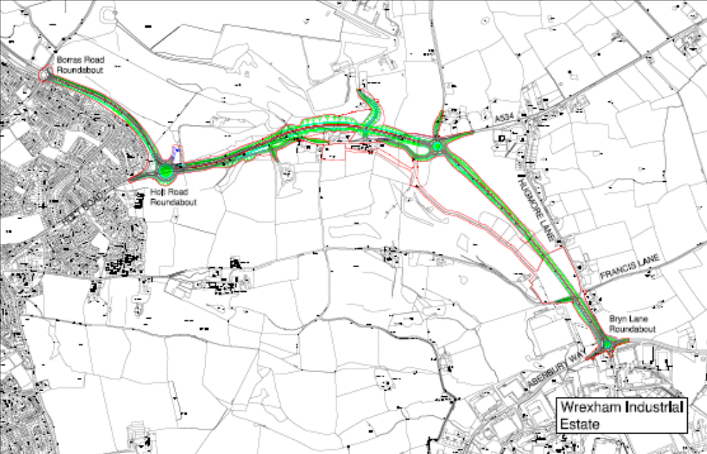

PROPOSAL

This is a full application for the construction of a new northern access link road to Wrexham Industrial Estate. It comprises 3.2km (2.0 miles) of new two-lane dual carriageway with three at grade roundabout junctions. Each carriageway is 7.3m wide with two 1.0m hardstrips and a minimum verge width of 2.5m. The central reserve is generally 4.5m wide.

Running in a south easterly direction from the existing Borras Road roundabout, the route closely follows the existing A5156 and A534 corridors until it reaches a point just south of the existing A534/Borras Hall Lane junction where the new Gourton Hall Roundabout would be constructed. The final part of the route into the Industrial Estate runs in a south easterly direction from the proposed Gourton Hall Roundabout and crosses farmland and part of Clays Farm golf course to the west of Hugmore Lane. Apart from the Gourton Hall Roundabout (A534/Borras Hall Lane junction) two further enlarged roundabouts are proposed. The A5156 /A534 junction (Holt Road Roundabout) and where the new access road would enter the Industrial Estate (Bryn Lane Roundabout). The existing Borras Road Roundabout would be retained. A bridge would be provided to carry the new A534 over a realigned access road to the Tarmac Quarry. This would also provide pedestrian access under the new road for public footpath users.

The application includes an Environmental Impact Assessment and has been submitted in conjunction with a further proposal for the construction of a southern access road into the Wrexham Industrial Estate, code no. P/2008/1235 which is also to be considered at this meeting.

HISTORY

CB/1999/2953 Construction of dual carriageway and accommodation
works. Approved 10.01.2000
P/2007/1165 Construction of Wrexham Industrial Estate Access Road
(Northern Section) at A5156 between Borras Road and Holt Road; alongside the A534 between its junction with A5156 and Borras Hall Lane; between the junction of the A534 and Borras Hall Lane and the junction of Bryn Lane with Hugmore Lane comprising dualling of existing road, new dual carriageways and associated new roundabouts, lighting and drainage. Approved 07.01.08.

DEVELOPMENT PLAN

Outside settlement/Wrexham Industrial Estate boundary. The principle of this scheme is supported by UDP Policy T5 which safeguards land for this road improvement scheme. Subject to regard being had to other UDP policies namely Policy EC1 Green Barrier; Policy EC2 Agricultural Land; Policy EC4 Hedgerows Trees and Woodlands; Policy EC6 Biodiversity Conservation; Policy EC12 Development and Flood Risk; Policy EC13 Surface Water Runoff; Policy EC14 Protection of Controlled Waters and Policy GDP1 there are no policy objections.

CONSULTATIONS

Acton CC: Notified 26.11.08
Holt CC: Notified 26.11.08
Abenbury CC: Notified 26.11.08
Sesswick CC: Notified 26.11.08
Marchwiel CC: Notified 26.11.08
Local Members: Notified 26.11.08
(Cllr MG Morris & Cllr JC Connolly)
Transport Directive WAG: Notified 26.11.08
Planning Division WAG: Notified 03.12.08
NFU: Notified 26.11.08
Dee Valley Water Group: Notified 26.11.08
North Wales Police: Notified 26.11.08
Clwyd Badger Group: Mitigation measures required to protect badger habitat. We would like an assurance that the maximum possible area of the copse is fenced off to prevent inadvertent damage by contractors while work is being carried out. A penalty clause for breaches would help to protect this site. The artificial badger sett in the proposed site to the north of the link road should be in position well before any work starts.
Ramblers Association: Notified 26.11.08
CCW: The application site is not located within or adjacent to the boundary of any statutory sites of ecological, geological and/or geomorphologic interest. Furthermore, in our view, the proposal is not likely to cause a significant effect on the features and integrity of the River Dee and Bala Lake Special Area of Conservation. The implementation of appropriate protected species mitigation in relation to Badgers and Great Crested Newts is required. Implementation of the scheme may only proceed on receipt of the appropriate licence, issued by the Welsh Assembly Government. No objections, in principle, to the proposed road improvement scheme. However, any consent will need to be subject to conditions in respect of the appropriate implementation of submitted ecological mitigation and compensation proposals.
CPAT: Refer to previous comments made in response to application P/2007/1165 and P/2007/1167. These are set out later in my report.
Highways: Notified 26.11.08
Welsh Water: Notified 26.11.08
Environment Agency: Notified 26.11.08
CPRW: Notified 26.11.08
North Wales Wildlife Trust: Notified 26.11.08
Public Protection: Notified 26.11.08
British Telecom: In discussion with WCBC regarding the impact upon existing plant.
Other Representations: 128 letters sent out to landowners and adjoining occupiers and eight (8) letters of objection have been received. The objections raise the following concerns:
- Appearance and character of the area will decline with the scale of the proposed dual carriageway.
- There will be a negative impact on residential amenity as the proposed dual carriageway will lead to increased HGV usage with substantial increase in noise levels and vibrations for those properties in Concorde Row.
- Concerns raised about highway safety. The existence of a grass verge along the existing carriageway near Concorde Row was intended to separate the existing carriageway from the properties, thereby ensuring some level of safety in the event of a vehicle inadvertently coming off the road. The grass verge would have ensured that a vehicle would sufficiently slow down prior to hitting a boundary fence of those properties, creating a buffer. Its removal will result in an increased risk of accidents.
- Increase in noise and traffic volumes.
- Devaluation of property.
- Noise, disturbance and inconvenience caused during the construction period.
- Adverse impact upon air quality.
- Need assurances that “noise reduction” fencing will be erected to protect residents in Plas Goulbourne.
- Concerns expressed with regards to the re-alignment of the road to avoid infringement upon Wrexham Golf Club. The repositioning of the roundabout will cause unacceptable environmental pollution to 18 properties. There is no practical reason to justify the repositioning of the roundabout and unnecessary intrusion into the greenbelt land and rural setting.
- Adverse impact upon Plots 81, 81A and 201 as defined on Wrexham County Borough Council’s ownership detail plans. This land has a high degree of amenity and nature conservation value. It is suggested alternative routes would have a lesser environmental impact.
- Inadequate consultation and consideration be given to alternative routes, access provision, and the provision of services.
- Excessive land is being taken for visibility for vehicles exiting the Public House on the A534.
- Inadequate consultation has been given to the re-routing of existing public footpaths.
- Excessive landtake.
- Adverse effects upon Llan y Pwll and Cae Ffynnon Fawr with particular regard to:
- Loss of 25% of land
- Permanent effects of the future viability of the farm, increase in noise, headlight glare, leading to a diminution of property values
- Adverse effect of pollution of air, water and vision
- Detrimental visual impact with the new road within 50m of both properties
- Increased noise levels. The EIA indicate a probable increase by some 3db. This has not been investigated thoroughly by Wrexham County Borough Council.
- Effect of establishment of road water settlement pond near farm buildings. Despite WCBC being informed of the presence of the Gredington Arms Sewage Tank at the precise location where a Drainage Attenuation pond is proposed.
- Effects upon land drainage and adverse effect upon farm ditches.
- Reduction in livestock numbers as a result of the loss of 35% of land.
- Loss of potential conversion opportunities.
- Concerns raised about the southern “mouth” underpass which is designed to exit directly opposite both dwellings. These include:
- Intrusion from lighting
- Intrusion from anti-social behaviour
- HGV traffic movement associated with Tarmac
- Effects of windblown dust, sand, fuel fumes etc
- Clothes drying tarnished by polluted air from the underpass
- Request application should be called in by the National Assembly for Wales and subjected to full processes of a Public Inquiry.
- Loss of land at JCB Transmissions which will disrupt operations and prejudice future expansion plans.

Two further letters have been received from Wrexham Golf Club and Marstons who have not expressed an objection, in principle, but raise the following concerns.

Marstons express concerns regarding the loss of land from their site arising from the realignment of the dual section between Borras Road Roundabout and Holt Road Roundabout. Also request the diversion of Bieston 2 Footpath around their land.

Wrexham Golf Club have requested that provision is made to ensure that access is open at all times to the golf course during the construction period. Also that the 9th Tee is reconstructed to a high standard of landscaping in order to prevent straying golf balls. Concerns also expressed with regards to the adverse effects of increased noise and a deterioration in air quality.
Site Notice: Expired 09.01.09
Press Notice: Expired 16.01.09

Given the short length of time involved between this application and your consideration of the previous one (P/2007/1165) on 7 January 2008, I consider it pertinent for Members to have due regard to the comments made at that time in your consideration of the current proposal. These concerns are likely to remain despite your previous resolution to grant permission and are repeated below:-

Acton CC: Notified 11.10.07
Holt CC: Notified 11.10.07
Abenbury CC: Notified 11.10.07
Local Members: Notified 01.10.07
(Cllr MG Morris
Cllr JC Connolly)
Transport Directorate
Welsh Assembly Gov: Does not wish to issue a directive in this instance.
The construction of these access roads will impact
upon the A5156/A483 interchange as access to
the Industrial Estate is improved. It is therefore
important that we continue to liaise so that both
Highways Authorities can take account of, and
address, traffic flow issues on the overall network.
Planning WAG: Notified 11.10.07
NFU: Notified 11.10.07
Dee Valley Water Group: Notified 11.10.07
North Wales Police: Notified 11.10.07
Clwyd Badger Group: Notified 11.10.07
Ramblers’ Association: Notified 11.10.07
CCW: No objections subject to conditions requiring the
implementation of appropriate protected species mitigation in relation to Badgers and Great Crested Newts. The mitigation proposals with regards to the great crested newt ie creation of new ponds are considered appropriate. Implementation of the scheme may only proceed on receipt of the appropriate licence, issued by the Welsh Assembly Government. The licence can only be issued by WAG on condition that there is no satisfactory alternative and the development will not be detrimental to the maintenance of the population of the species.
CPAT: The archaeological assessment of this road
scheme should follow the guidance set out in the
Design Manual for Roads and Bridges Vol. 2
Section 3 Part 2 – Cultural Heritage. We therefore
recommend a geophysical survey of the route set
out in this application along with surface collection
of artefacts on ploughed fields by means of
systematic fieldworking.
Highways: Notified 11.10.07
Welsh Water: Notified 11.10.07
Environment Agency: Notified 11.10.07
CPRW: Notified 11.10.07
North Wales Wildlife Trust: Notified 11.10.07
Public Protection: No objections subject to appropriate condition to
deal with potential contamination issues.
Other Representations: 128 letters sent to landowners and adjoining
occupiers.
14 objection letters have been received raising the
concerns.
- It is suggested that alternative routes would have a lesser environmental impact and inadequate consideration and consultation has been given to alternative routes to avoid the land or, at best, to mitigate the impact will have upon the beneficial ownership arising from severing the land.
- Inadequate consideration has been given with regards to the provision of access to severed portions of land (mainly farmland) and replacement of any buildings. Areas will become landlocked.
- The siting of the proposed road requires an excessive land take .… it is suggested that this landtake can be significantly reduced by an alternative scheme.
- Adverse affect upon farm viability and severance of farmland.
- Increase in highway related noise.
- Adverse affects of vehicular lights beaming into dwellings or headlight glare.
- Effects of pollution of air and water during construction phase. Loss of privacy.
- Impact upon land drainage, particularly with regards to the proposed pond near Llanypwll Farm.
- A range of concerns relating to the proposed underbridge serving the Tarmac Quarry. These relate to the following:
- The southern “mouth” of the underpass has been designed to exit directly opposite Llanypwll Farm and Cae Ffynnon and only some 40m distance from the actual dwelling walls.
- Intrusion from lighting within the underpass.
- Intrusion from anti-social behaviour – particularly after darn in the form of boy-racing, drug-taking and exchange, graffiti artists, loud music etc.
- The noise of HGVs ingressing and egressing will be heightened by the very nature of the tunnel – all of which will be directed towards the properties. The underpass will also act as a noise conduit.
- The properties will be directly affected by windblown dust, sand, fuel fumes etc as draughts in the underpass will be directed directly towards neighbouring dwellings.
- Pollution on garden area of Cae Ffynnon and clothes drying will be tarnished by polluted air from the underpass.
- The constant HGVs in and out activities will heighten the already present problems of vibration.
- Vehicles reversing bleepers will be a constant pollutant.
- Noise from the proposed carriageway will be “captured” and heightened by the underpass and will directly flow towards Cae Ffynnon and Llanypwll Farm.
- The acquisition of a substantial piece of land from JCBs site may restrict future expansion plans.
- Land to the south of the Gourton Hall roundabout – how will access be provided?
- Field to the north of Bryn Lane Roundabout – how will access be provided?
- Area of land south of Bryn Lane – how will access be provided?
- Gourton Hall Farm garden access onto existing A534 – what arrangement will be made to replace the existing access?
- Impact upon the Gredington Arms, Llanypwll. As the CPO progress cannot be guaranteed there will be a risk that the resulting access will be unsatisfactory with regard to manoeuvring difficulties and reduced visibility. Also concerned that business will be adversely affected during the construction of the road.
- Adverse impact of the new carriageway on the visual amenity of Bryn Villa, Hugmore Lane. In addition, the traffic using it will be able to move more quickly and will therefore be noisier and bring with it an increase in pollution.
- Loss of privacy to Bryn Villa as users of the new road will have full visual access into the property.
- Reservations made with regards to the loss of lands in Marstons ownership arising from the realignment of the A5156. Also that the option to divert the footpath around their land should be considered at this stage.
- Concerns expressed as to why it has been necessary to move the roundabout from its originally demonstrated position (ie the location of the existing roundabout) to its new location where it has a severe impact on the landscape.
- The scheme will result in a significant impact upon “Tyn Twll”, Holt Road as a result of land loss and will have a severe impact upon the landscape.
- It was stated that the Blue route would have less impact on agricultural land than the Brown route but the route now chosen is significantly different to the original proposal and has a greater impact as well as costing significantly more than previously indicated. It is to safeguard the golf course?
- No information has been provided detailing the area of land required for mitigation land at “Tyn Twll”, Holt Road. The occupier of “Tyn Twll” also claims to have been misinformed and aggrieved at not having had the opportunity to express concerns and that these have not been taken into consideration. These relate to the loss of land due to the position of the Holt Road roundabout; access to land currently accessed off Holt Road; access of land owned by the occupier of Tyn y Twll accessed off the tarmac quarry access road; landscape proposals to mitigate the effects of the Holt Road roundabout.
Site Notice: Expired 09.11.07
Press Notice: Expired 16.11.07

SPECIAL CONSIDERATIONS/ISSUES

Background: The Council is promoting a scheme to improve access to Wrexham Industrial Estate, the principle of which was established by the former Clwyd County Council in 1984. The principle of a new northern access was first established by virtue of permission Code No. CB/1999/2953 granted on 10 January 2000, and has since lapsed. A more recent revised scheme (P/2007/1165) was approved on 7 January 2008. The current application has been submitted to comply with complex European legislation with regard to the River Dee SAC and to accommodate minor design revisions. The current proposal provides for updated visibility requirements and alterations to the scheme boundary to include additional land for accommodation works. The actual position of the carriageway in relation to the previous scheme however, remains unchanged. The scheme which involves the provision of improved access roads to the north and south of the Estate, has been developed as a single scheme, however, as previously, separate applications have been made for each of the northern and southern routes.

Policy: UDP Policy T5 promotes the provision of improved access to the north and south of the Industrial Estate. The policy states that land will be safeguarded for both road improvement schemes where the land take is not yet known. Subject to consideration of detailed environmental effects, the principle of constructing both north and south access roads is supported by the adopted Unitary Development Plan.

Alternative Schemes: A number of alternative route corridors for access roads to the Estate were investigated during 2003 and formed part of an extensive public consultation exercise in December 2003 and January 2004. More detailed studies were then carried out on four route corridors in the north and three in the south. A further public consultation process was carried out in February and April 2005 on two routes (Blue and Brown) in the north and two routes (Purple and Yellow) in the south. The consultation demonstrated that there was overwhelming support for improvements to the existing access routes. Residents in the south suggested some alternatives to the published Yellow route and on 5 July 2005 the Council’s Executive Board confirmed the Blue route in the north and the Alternative Yellow (Y5) route for the new access roads.

Despite the comments made with regards to “alternative routes which have a lesser environmental impact” I believe careful consideration has been given to a range of alternatives with full public involvement and the chosen route has the least environmental impact.

Economic Benefits/Need: The Industrial Estate suffers from poor links to the strategic highway network, and as a consequence is not attractive to new businesses and does not help with the retention of existing owners, tenants and occupiers. Existing access routes to the Estate suffer from congestion, particularly at peak times. To enable the Estate to compete effectively with other major employment sites in the region and to encourage economic development, it is essential that high quality, direct and convenient access to the strategic highway network, is provided. The scheme has been designed to alleviate congestion, improve safety and provide a better environment for local communities. Generally, the implementation of improved north and south access roads would have significant benefits in terms of safeguarding and promoting the future economic prosperity of this Industrial Estate.

I note the concerns of JCB with regards to the acquisition of a substantial piece of land from their site at the industrial estate which they state restrict future expansion plans. Discussions however are on-going with JCB to minimise any adverse impact on their existing bunds and landscaping on Hugmore Lane. If it is agreed with JCB that the existing bund profile is to be replicated in relation to the proposed highway boundary, this would result in a loss of part of the existing car parking area. Any displacement of parking, however, could be provided by extending the existing car park towards Bryn Estyn Road. On balance, and in planning terms, the small loss of JCB land is more than off-set by the wider economic benefits the scheme will bring to the whole of the industrial estate.

Landscape and Visual Impact: A landscape and visual impact assessment has been carried out as part of the Environmental Impact Assessment. The northern access road follows the alignment of the existing road network particularly along the A5156 and A534 and then runs southwards crossing open agricultural land. The landscape character of this route is more urban fringe in appearance than the southern route. It is characterised by a number of man made features, including the residential areas of Borras; Golf Courses; localised industry; individual farms and dwellings, the local highway network and the fringes of the Industrial Estate. The principal effects upon the landscape involve the loss of scrub woodland alongside the A534 between Keepers Cottage and Hillside Farm; demolition and loss of Keepers Cottage; a large cutting north of the Gredington Arms with the realignment of the Tarmac Access; removal of existing vegetation and quarry in proximity of the existing Tarmac Access and a new link to Bryn Villa. A further significant effect will be the introduction of two new roundabouts at Gourton Hall and Bryn Lane and the relocation and extension of the Holt Road Roundabout. Landscape mitigation measures however will include the protection and minimisation of woodland clearance, sensitive regrading works and planting of woodland, trees and hedgerows. Subject to appropriate landscaping of the route corridor, I consider any adverse visual impact can be significantly reduced in time. The proposals however will result in a significant improvement to the visual amenity of residents on Hugmore Lane with the removal of most high side vehicles from the frontage of residential properties. The route generally follows the line of the existing highway with the exception of the section from the Gourton Hall Roundabout and the Bryn Lane Roundabout which by-passes Hugmore Lane. In this regard, I consider the landscape has been minimised. Whilst the route lies within a designated green barrier I do not consider that it would unduly affect its openness and will therefore not conflict with the requirements of this policy.

Loss of Agricultural Land: Agriculture is the dominant land use, with the majority of land being good quality grazing land. UDP Policy EC2 states that development on agricultural land of grades 1, 2 or 3a will only be permitted if it does not lead to the irreversible loss of that land. Improving the existing road alignment reduces agricultural land take, although overall it will result in the permanent loss of approximately 7.5 ha of best and most versatile quality. Altogether, five farm units will be affected, four of which will result in the severance of land from the farmstead. I note the concerns raised with regards to the severance of farmland and the impact on viability of affected farm units but I believe the scheme has been designed to ensure any inconvenience is minimised as far as possible and any disruption to farming operations will be addressed within the compensation procedures. New access arrangements will be provided where necessary and most of the farms will not be unduly affected in the long term. Any areas required for temporary works during the construction period will be restored to agricultural use.

Ecology: The key affect of the northern access road on ecological interest involves the removal of areas of scrub woodland in the Llan y Pwll area and some hedgerow habitat. Elsewhere the landtake for the access road affects areas of low value habitat such as arable land, improved pasture and roadside verge. The landscape mitigation measures will result in more habitats being created than currently exists and therefore there should be some beneficial effects in the form of habitat creation. Appropriate conditions will be imposed to ensure these are implemented within an appropriate timescale and effectively managed in future.

The most significant impact of the route is on badgers. Extensive mitigation measures are proposed. This will be both with regard to pre-construction, during construction and in the long term once the proposed road is in use. Advance mitigation measures will be associated with the closure of the occasionally used sett impacted as a result of the scheme. To address this loss, mitigation will involve the provision of a replacement badger sett to be provided prior to the construction of the road. This will form a condition of any permission granted. Similarly, a condition will be imposed to ensure adequate protection measures are in place during the construction period and in the longer term extensive badger proof fencing will be installed along the majority of the new carriageway with dedicated crossing points, details of which will be reserved for further approval.

The EIA has shown that the proposed northern access road presents a negligible risk to great crested newts. Nonetheless, an appropriate condition will be imposed to ensure their protection. This may involve a precautionary capture programme to be agreed with CCW. The pond at Erlas Hall which is owned by the Council has been identified as an area of mitigation which can be enhanced and managed in perpetuity. CCW have raised no objections subject to appropriate mitigation measures.

In view of the scale of the proposed scheme and its potential, effects upon land drainage and soil contamination which may affect the River Dee SAC a precautionary approach proportional to the proposed scheme has been undertaken. This is also consistent with the approach taken on the southern Link Road. A “screening” exercise or Test of Significance has been carried out in accordance with Regulation 48 of the Conservation (Natural Habitats & C) Regulations 1994 (which transposes Article 6(3) of the European Directive 92/43). It has been carried out in consultation with CCW and I have concluded, exercising powers delegated to me, that there are no significant effects upon the River Dee SAC and an “appropriate assessment” of the effects of the scheme under the regulations is therefore not required.

Noise: An assessment of the effects of road traffic noise and vibration on the area surrounding the northern link road has been carried out in accordance with the appropriate standards and guidelines. If the scheme is not built, 68 properties would experience an increase in noise levels as a result in traffic using the existing routes. If the scheme is built, five residential properties would benefit from a slight decrease in noise, 16 would benefit from a major decrease in noise, while 60 properties would experience some increase in noise levels. Appropriate mitigation measures will be in place to deal with construction noise and a condition requiring a scheme of noise mitigation measures will be included as part of any permission granted. This is intended to provide appropriate measures for those individual properties which will experience an increase in noise levels. I note the concerns raised by the occupiers of “Llanypwll Farm” and “Cae Ffynnon” with regards to noise levels, but these are expected to reduce at these two properties and is considered to have a slight beneficial effect. The proposed carriageway will be a greater distance away from the properties than the existing A534. Traffic flows on the existing A534 on the frontages of the properties will also be reduced by the proposed scheme. All “through traffic” will be removed and only vehicles wishing to access Hansons, Tarmac Quarry, Llanypwll and Sandy Lane will use this section of road. I also note the concerns raised by residents in Concorde Row and the Goulbourne but “Noise Fencing” was erected along the boundary between the highway and Concorde Row as part of the highway improvements carried out in 2001. The overall impact is a positive one as the proposed scheme would also lead to a substantial reduction in noise levels along Hugmore Lane.

Highway Safety: Despite the concerns raised by residents in Concorde Row, it is not considered that there will be any reduction in highway safety following the construction of the new dual carriageway between the Holt Road roundabout and the Borras Road roundabout, as there are no proposals to reduce the width of the existing grass verge referred to by objectors.

Air Quality: In general terms, the level of air pollutants at most properties will reduce with the scheme. The net amount of air pollutants would be reduced with the scheme and the requirements of national air quality objectives would be met. In terms of greenhouse gas emissions there would be an initial reduction of 0.7% in carbon dioxide emissions for the year 2010 (when the scheme would be due to open) with a subsequent estimated increase to 2% in 2025 due to increased traffic and vehicle speeds.

Public Footpaths/Cycleways: Four public footpaths would be affected by the scheme. The proposals include closing off short sections of footpath and diverting users to safe crossing points at roundabouts and a new underbridge at the Tarmac Quarry access road. I note the observations of ‘Marstons’ in connection with the diversion of the Bieston 2 footpath which involves stopping up the existing crossing of the A5156 and diverting pedestrians along the A5156 verges to a crossing point at Holt Road roundabout. Marstons state that the option should be taken to divert the footpath around their land. However, any public footpath diversions carried out as part of this scheme would be subject to a legal diversion process and would have to be proven necessary strictly as a direct consequence of the scheme. The diversion proposed by Marstons could not be shown to meet this criteria and could not therefore be included in the scheme. In terms of pedestrian safety residents in Llan y Pwll and properties on Hugmore Lane would benefit from a significant reduction in traffic on existing roads.

There would be a new continuous cycle route between Holt Road roundabout and the estate running on the existing road network where traffic flows would be much lower than at present. Existing cycle routes to the estate would be maintained and additional signed routes, including short lengths of new cycleway, would be provided. There will be no impact upon existing pedestrian and cycling facilities during the construction period.

Flood Risk and Water Quality: The proposed drainage system would have sufficient storage to cope with a 1 in 100 year storm plus an allowance for global warming, without increasing the flow into streams and rivers. The drainage would be treated in ponds designed to contain a spillage and to settle out and filter silt. Concerns have been expressed by the occupiers of Llan y Pwll Farm and Cae Ffynnon about the construction of a road water settlement pond near farm buildings. The proposed pond, however, is a minimum distance of 42m from the nearest Llan y Pwll Farm buildings and the proposed outfall pipeline which will run through the field south of the farm buildings will be no nearer to the buildings than the existing outfall pipeline. With regards to their general concerns raised regarding land drainage, the proposed pond is required to attenuate flows into the existing ditch at the south east boundary of the Llan y Pwll Farm land. The rate of discharge in relation to the existing ditch will be subject to Environment Agency approval. As a consequence, land drainage from the Llan y Pwll Farm land will not be adversely affected by the proposals. In addition, during construction of the pond and its outfall any existing land drains encountered will be repaired or replaced. The applicants are aware of the septic tank referred to, which will be taken into account during the detail design stage for the scheme. During the construction period strict controls would be imposed to minimise the risk of pollution from accidental spillage. Run off from the site would be controlled. I am awaiting the observations of the Environment Agency and these will be reported as an addendum item.

Archaeology: I note the comments raised by CPAT with regards to the assessment of the archaeological resource. In order to satisfy the guidance set out in the Design Manual for Roads and Bridges Vol 3, Section 3, in its entirety, a geophysical survey of the route should be completed, along with surface collection of artefacts on ploughed fields by means of systematic fieldwalking. The survey will form a condition of any permission granted.

Consultations: Members will note that at the time of writing this report, which was after the end of the statutory consultation period, I had not received many responses. However, the principle of improving north and south access links into the Industrial Estate is well established and the general impact in terms of improving the quality of life for many residents, along the Hugmore Lane and Bedwell Road, Cross Lanes is a positive one. In addition, extensive consultations have been carried out during recent years. Two Public Consultations have been carried out in December 2003 and February/March 2005 and a range of alternatives have been considered. All directly affected landowners were notified of the consultations, together with other owners and residents in the vicinity. The preferred route was selected in July 2005 by the Council’s Executive Board. I note the comments made with regards to “alternative routes which have a lesser environmental impact”, but “environmental impact” was only one of seven criteria assessed within the route selection process and the route was only selected following careful consideration of all seven criteria. Besides, your decision as Planning Committee can only be based upon the merits of the submitted scheme.

CONCLUSIONS

The proposed scheme is supported by UDP policy T5 which recognises the importance of improving access to Wrexham Industrial Estate. The principle of a northern link road has been established for some time and agreed as a protected route since 1984. I am satisfied that the current scheme has been designed to reduce, as far as possible, any impact upon the environment. The scheme alignment aims to avoid sensitive areas of landscape and ecology and with extensive landscaping will not result in any adverse impact. Extensive mitigation proposals will be included to reduce the visual impact and protect wildlife conservation. The existing route for heavy vehicles along Hugmore Lane is unsatisfactory in terms of noise/vibration and highway safety. Although the proposed new link road will itself have certain negative impacts in terms of harm to landscape and ecological interests and noise/visual impact to a small number of residential properties close to the new road line, this scheme on balance represents a significant improvement. Subject to condition to minimise adverse impact I support the scheme.

RECOMMENDATION

That Wrexham County Borough Council RESOLVES in accordance with Regulation 3 of the Town and Country Planning General Regulations 1992 that planning permission be granted subject to the conditions specified below:-

CONDITION(S)

1. The development hereby permitted shall be begun before the expiry of five years from the date of this permission.
2. The development shall only be carried out in strict conformity with the details shown on the approved drawings and in the application documentation.
3. The erection of fencing for the protection of trees and shrubs shall be undertaken before any equipment, machinery or materials are brought onto the site for the purposes of the development and shall be maintained until all equipment, machinery and surplus materials have been removed from the site. The above mentioned fencing shall consist of a scaffold framework in accordance with Figure 2 of BS 5837 (2005) comprising a vertical and horizontal framework, well braced to resist impacts, with 2.1m vertical tubes spaced at a maximum interval of 3m. Onto this, weldmesh panels shall be securely fixed with wire or scaffold clamps. This fencing shall be erected at the full extent of the canopy of each tree and shrub. Nothing shall be stored or placed in any area fenced in accordance with this condition and the ground levels within those areas shall not be altered nor shall any excavations be made without the written permission of the Local Planning Authority.
4. No part of the development hereby permitted shall be commenced until full details of both hard and soft landscape works for the site have been submitted to and approved, in writing, by the Local Planning Authority. The works shall be implemented in accordance with a timescale to be approved in conjunction with the scheme of details.
5. Within six months of the first use of the development, trees and shrubs shall be planted on the site in accordance with a scheme which has been submitted to and approved by the Local Planning Authority. Any trees or shrubs, removed, dying, being severely damaged, or becoming seriously diseased within five years of planting shall be replaced by trees or shrubs of a similar size and species to those originally required to be planted.
6. A landscape management plan, including long-term design objectives, management responsibilities and maintenance schedules for all landscape areas shall be submitted to and approved, in writing, by the Local Planning Authority prior to the occupation of the development or any phase of the development or any phase of the development, whichever is sooner, for its permitted use. The approved landscape management plan shall be carried out as approved.
7. The development hereby permitted shall not commence until a scheme for the replacement of the existing badger sett identified within the Environmental Impact Assessment has been submitted to and approved by the Local Planning Authority. The scheme shall include details of future management of the badgers and no deviation shall be made from the approved details without the written approval of the Local Planning Authority.
8. Details of badger fencing shall be for the duration of the construction period submitted to and approved by the Local Planning Authority prior to the commencement of development. The approved scheme shall be implemented prior to the commencement of development.
9. Details of badger fencing along the new carriageway with dedicated crossing points shall be submitted for the further approval of the Local Planning Authority. The approved scheme shall be fully implemented before the approved highway becomes operational.
10. Before development commences, a detailed scheme of terrestrial searching for Great Crested Newts and other amphibians within the site should be submitted to and approved by the Local Planning Authority. The report or survey shall also include details of any mitigation measures required, and these measures shall be completed in accordance with timescales to be agreed as part of the measures before development commences on site.
11. Construction works, ancillary works and the use of plant or machinery audible at or beyond the site boundary shall only be carried out between the hours of 0730 and 1930 (Monday to Friday) and 0800 to 1400 (Saturday) and at no time on Sundays or Bank Holidays, unless otherwise agreed in writing with the Local Planning Authority.
12. Prior to the commencement of any demolition works on site, the following details shall be submitted for the further approval of the Local Planning Authority:
i. an audit of all existing building materials
ii the potential re-use and recycling of those materials for incorporating into an agreed, replacement site development, and
iii where relevant, the recipient of remaining building materials.

The approved audit shall form part of the building contract agreed for new building development for the site, a copy of which shall be submitted for record purposes for the Local Planning Authority.
13. The development hereby approved shall be implemented in accordance with the ground levels indicated on the approved plans and cross sections. No changes to floor levels or external ground levels shall be made without the prior written approval of the Local Planning Authority.
14. A scheme of noise attenuation measures shall be submitted for the written approval of the Local Planning Authority. The approved scheme shall be implemented in accordance with a timescale to be agreed with the Local Planning Authority.
15. Development shall not begin on site until a scheme to deal with potential contamination at the site has been submitted to and approved, in writing, by the Local Planning Authority. This scheme shall include a phased investigation approach to identify the extent of contamination and any measures required to remediate the site, including post-development monitoring. Where remediation works are required, the development shall not be occupied/used until a Validation Report to show that the works have been satisfactorily carried out has been submitted to and approved in writing by the Local Planning Authority.
16. No operations shall commence until details of any temporary access points and soil material storage areas have been submitted and measures for protection of existing trees, hedges, watercourses, and habitats to be retained have been further approved by the Local Planning Authority.
17. Notwithstanding the provisions of Part 4 of Schedule 2 of the Town and Country Planning (General Permitted Development) Order 1995 the further permission of the Council shall be obtained for any compounds to house buildings, plant, machinery etc.
18. An archaeological geophysical survey of the approved route corridor along with surface collection of artefacts on ploughed fields shall be carried out prior to the commencement of development.
19. A scheme of street lighting and road signage shall be submitted for the written approval of the Local Planning Authority.
20. Development shall not begin on site until a scheme to deal with potential contamination at the site has been submitted to and approved, in writing, by the Local Planning Authority. This scheme shall include a phased investigation approach to identify the extent of contamination and any measures required to remediate the site, including post-development monitoring. Where remediation works are required, the development shall not be occupied/used until a Validation Report to show that the works have been satisfactorily carried out, has been submitted to and approved, in writing, by the Local Planning Authority.
21. Prior to the commencement of the development, a construction environmental management plan shall be submitted to the Local Planning Authority for approval. The construction environmental management plan shall address the following matters:

1. Detailed noise and vibration impacts once the final selection of plant, equipment processes (should these depart from the assumed plant detailed in the Environmental Statement) and dates have been made. The impacts shall relate to the locations as detailed in Section 13 of the Environmental Statement.
2. Details of proposed noise/vibration mitigation measures to be employed to minimise the noise/vibration impacts of the operations and show that the assessment of that impact is ongoing through the construction process, to include confirmation of good site management, the application of Best Practice and Best Practicable Means, the phasing of the works and the monitoring methodology and frequency to be employed to ensure that the impact of the works will be minimised as far as is reasonably practicable.
3. Detailed proposals of a public consultation program designed to keep the public (occupiers of locations as detailed in Section 13 of the Environmental Statement) fully informed over the scale and nature of the works, when they are to take place and who to contact if they are disturbed. The public consultation programme shall include proposals for a letter to be sent to all the potentially affected residents to ensure the above information is imparted.
22. A dust management scheme shall be prepared and submitted to and shall be approved in writing by the Local Planning Authority prior to any construction work being undertaken. The scheme shall include a procedure which allows an effective response to any dust complaints that may be received and for an assessment of the source of dust of concern and a review of mitigation measures as appropriate. The development shall only be undertaken in strict accordance with the details which are approved.

REASON(S)

1. To comply with Section 91(3) of the Town and Country Planning Act 1990.
2. To ensure that the development fully complies with the appropriate policies and standards.
3. To protect trees which are of significant amenity value to the area.
4. To ensure a satisfactory standard of appearance of the development in the interests of the visual amenities of the area.
5. To ensure a satisfactory standard of appearance of the development in the interests of the visual amenities of the area.
6. To ensure landscape features are properly considered and protected.
7. To provide a replacement badger sett and management scheme for the protection of badgers.
8. To protect badgers within the vicinity of the route corridor during the construction period.
9. To protect badgers within the vicinity.
10. In order to protect wildlife interests which are afforded special protection.
11. To protect the amenities of the occupiers of nearby properties.
12. To ensure that the development involves a sustainable approach.
13. To ensure a satisfactory standard of appearance of the development in the interests of the visual amenities of the area.
14. In the interests of residential amenity.
15. To deal with potential contamination on site.
16. To ensure that any potential harmful landscape/ecology impact resulting from temporary ancillary development is minimised.
17. To ensure that any potential harmful landscape ecological impacts resulting from temporary ancillary development is minimised.
18. To ensure that any archaeological interest is recorded.
19. In the interests of visual amenity and highway safety.
20. To ensure any issues of contamination are safetly dealt with.
21. To protect the amenities of nearby residents.
22. To protect the amenities of nearby residents.

NOTE(S) TO APPLICANT

Further advice on compliance with this condition may be obtained by contacting the Council's Environmental Protection Section on 813722. Should the investigation identify contamination issues that may affect receptors other than the site users eg groundwater, then it is recommended that these issues are also addressed in consultation with the Public Protection Department prior to works commencing on site, so as to avoid enforcement under Part II of the environmental Protection Act, 1990.
______________________________________________________________

APPLICATION NO:  P/2008 /1249  COMMUNITY:  Brymbo  WARD:  Brymbo | LOCATION:  BRYMBO ROAD/HARWD ROAD BRYMBO WREXHAM  DESCRIPTION:  ERECTION OF 3 NO. DETACHED DWELLINGS AND ASSOCIATED WORKS.  APPLICANT(S) NAME:  MR RA LAMBERT T/A C LAMBERT BUILDERS | DATE RECEIVED:  28/11/2008  CASE OFFICER:  SJG  AGENT NAME:  TR DESIGN SERVICES
______________________________________________________________

THE SITE

The site is at the junction of Harwd Road and Bryn Road and has an area of 800m². The existing dwelling 4 Bryn Road is to be retained.

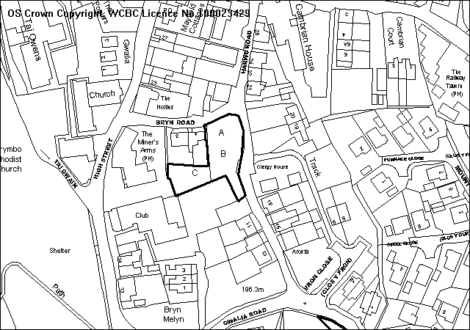
PROPOSAL

The three dwellings are 3 bedroom. The plans show an improvement scheme to Bryn Road and Harwd Road, including a 2 metre wide footway, and works to improve the access to the adjoining club premises to the south. Each dwelling has an access to Harwd Road, and a parking space is proposed for 4 Bryn Road. A street scene and levels have been supplied.

The scheme has been revised from the previous proposal by the setting back of plot C, allowing for a more spacious layout of plots A and B.

RELEVANT HISTORY

P/2002/1060 Taxi office and car park Refused 9/12/2002
P/2008/0945 3 dwellings and highway works Withdrawn November 2008

DEVELOPMENT PLAN

The site lies within the settlement limits. Policies GDP1 H2 and T8 of UDP are relevant, together with LPGN 16 21 and 23.

CONSULTATIONS

Brymbo C Council: Consulted 1/12/2008
Local Member: Consulted 1/12/2008
Highways: Recommend conditions
Public Protection: Recommend contamination condition. Comments regarding construction works
Env Agency: Comments regarding contamination, waste and drainage
Welsh Water: Recommend conditions
Site Notice: Expired 29/12/2008
Other representations: Adjoining occupiers notified 4/12/2008. 1 objection received, on grounds of:
- Adverse impact on nearby dwellings through overlooking and loss of privacy and light
- Dwellings will be built at a higher level and will tower over nearby properties
- Additional traffic causing danger to users of unsuitable roads.
- Damage to adjoining properties from construction works and traffic
- No need for further housing development in the area

SPECIAL CONSIDERATIONS/ ISSUES

Residential amenity: The dwellings are sited well away from the dwellings opposite on Harwd road, and are 1 metre higher than the road at the northern end of the site frontage. The revised scheme allows for a more spacious layout complying with LPGN21.

Highway safety: The site is positioned at the junction of two unclassified highways within a 30 mph speed limit. Both roads are of substandard width and alignment and lack adequate pedestrian provision. Visibility at the junction of Bryn Road and Harwd Road is 2.4 x 8m – well below TAN 18 recommendations.

The scheme proposes to introduce a 2m footway along the full frontage of the site and a widening of the carriageway to a minimum 4.1m.

These highway improvements will be a significant benefit to highway safety in the vicinity of the site particularly as visibility at the Bryn Road junction with Harwd Road will be substantially better than currently exists.

The existing site access also serves the Conservative Club. The applicant is to provide a new access at the south of the site and it is essential that adequate visibility is established at this access. Vehicular speeds from the southerly direction are considered to be no more than 15 mph due to geometry of the road for which Manual for Streets recommends a splay of 2.4 x 18m. This appears to be achievable from the proposed access location.

CONCLUSION

The scheme represents an appropriate development of land within the settlement limits and brings the opportunity for some highway improvements.

RECOMMENDATION: That permission be GRANTED

CONDITION(S)

1. The development hereby permitted shall be begun before the expiry of five years from the date of this permission.
2. Development shall only be carried out in strict accordance with the approved plans unless the prior written approval of the Local Planning Authority has been obtained.
3. Development shall not begin on site until a scheme to deal with potential contamination at the site has been submitted to and approved in writing by the Local Planning Authority. This scheme shall include a phased investigation approach to identify the extent of contamination and any measures required to remediate the site, including post-development monitoring. Where remediation works are required, the development shall not be occupied/used until a Validation Report to show that the works have been satisfactorily carried out has been submitted to and approved in writing by the Local Planning Authority.
4. Prior to their use on the development samples of all external facing and roofing materials shall be submitted to and approved in writing by the Local Planning Authority. The development shall only be carried out in strict accordance with such details as are approved.
5. The site shall be developed in accordance with the ground and floor levels indicated on the approved plans. No changes to floor levels or external ground levels shall be made without the prior written approval of the Local Planning Authority.
6. All foul drainage should be directed to a foul sewerage system and all surface water drainage to a surface water system unless otherwise agreed by the Local Planning Authority.
7. The proposed access to the Conservative Club shall have a visibility splay of 2.4m x 18m to the centre line of the adjoining highway in a southerly direction over land within the control of the applicant and/or the Highway Authority. Within the splays there shall be no obstruction in excess of 1 metre in height above the level of the adjoining carriageway. The splay shall be provided prior to commencement of occupation of the development hereby approved and shall thereafter be retained clear of such obstruction.
8. The proposed access to the Conservative Club shall have a visibility splay of 2.4m x 25m to the nearside edge of the adjoining highway in a northerly direction over land within the control of the applicant and/or the Highway Authority. Within the splays there shall be no obstruction in excess of 1 metre in height above the level of the adjoining carriageway. The splay shall be provided prior to commencement of occupation of the development hereby approved and shall thereafter be retained clear of such obstruction.
9. The access to the Conservative Club shall be a minimum of 4.5m wide and shall be hard surfaced in a bound macadam for a minimum of 5m behind the highway boundary.
10. The proposed access shall have a visibility splay of 2.0m x 25m in both directions measured along the nearside edge of the adjoining carriageway over land within the control of the applicant and/or the Highway Authority. Within the splays there shall be no obstruction in excess of 1 metre in height above the level of the adjoining carriageway. The splay shall be provided prior to commencement of use/occupation of the development hereby approved and shall thereafter be retained clear of such obstruction.
11. Notwithstanding the provisions of the Town and Country Planning (General Permitted Development) Order 1995, no gate or other barrier shall be erected across the access within 5 metres of the boundary of the highway.
12. The access shall be hard surfaced for a distance of 5m behind the highway boundary before the development is brought into use.
13. The vehicle parking and turning areas indicated on the approved plans shall be laid out, surfaced and drained prior to the first use of the building hereby granted and shall thereafter be retained for those purposes.
14. From a point on the centre line of the access 2.4 metres back from the edge of the footway, to points 3.3 metres to both sides of that point measured along the edge of the carriageway, all obstructions to visibility shall be reduced to and thereafter maintained at a height not exceeding 0.6 metre above the level of the adjacent carriageway.
15. A 2.0m wide footway shall be provided on Bryn Road and Harwd Road prior to the occupation of any dwellings hereby approved along the full frontage of the site (beyond the Conservative club access) for a distance of approximately 55m in accordance with details to be agreed, in writing, by the Local Planning Authority. The development shall be carried out in accordance with the details as agreed.
16. There shall be no development permitted on site until a scheme showing a detailed layout, design, drainage and construction of the proposed new footway, retaining wall, relocation of utility services and road widening has been submitted to and approved by the Local Planning Authority in consultation with the Highway Authority.
17. No water of any kind generated by the proposed development shall be permitted to flow from any part of the site, such as driveways, on to the highway or into the highway drainage system or be allowed to accumulate in such a way as to affect the highway surface or structure.
18. No part of the development hereby permitted shall be commenced until full details of both hard and soft landscape works for the site have been submitted to and approved in writing by the Local Planning Authority. The works shall be implemented in accordance with a timescale to be approved in conjunction with the scheme of details.
19. All hard and soft landscape works shall be carried out in accordance with the approved details as set out in Condition 18. The works shall be carried out within 3 months of the first use of the development with the exception of soft landscaping which shall be carried out in the first planting season (November to March) or seeding season (April to September) following the first use.
20. Any trees or shrubs removed, dying, being severely damaged or becoming seriously diseased within five years from the completion of the scheme shall be replaced by trees or shrubs of similar size and species to those originally required to be planted unless otherwise approved in writing by the Local Planning Authority.

REASON(S)

1. To comply with Section 91(3) of the Town and Country Planning Act, 1990.
2. To ensure that the development fully complies with the appropriate policies and standards.
3. In the interests of the amenities of the future occupants of the buildings
4. To ensure a satisfactory standard of appearance of the development in the interests of the visual amenities of the area.
5. To ensure that the development fully complies with the appropriate policies and standards.
6. To ensure the proper drainage of the site and to minimise the risk of pollution
7. In the interests of highway safety.
8. In the interests of highway safety.
9. In the interests of highway safety.
10. To ensure that adequate visibility is provided at the proposed point of access to the highway.
11. In the interests of highway safety.
12. To ensure that no deleterious material is carried onto the highway, in the interests of highway safety.
13. To provide for the parking and turning of vehicles clear of the highway and to ensure that reversing by vehicles into or from the highway is rendered unnecessary in the interest of traffic safety.
14. For the safety and convenience of all pedestrians, but in particular, the elderly, the disabled and wheelchairs, pram, and pushchair users.
15. In the interests of highway safety.
16. In the interests of public and highway safety and the visual amenities of the area.
17. In the interests of highway safety.
18. To ensure a satisfactory standard of appearance of the development in the interests of the visual amenities of the area.
19. To ensure a satisfactory standard of appearance of the development in the interests of the visual amenities of the area.
20. To ensure a satisfactory standard of appearance of the development in the interests of the visual amenities of the area.

NOTE(S) TO APPLICANT

Your attention is drawn to Highway Supplementary Notes Numbered 1, 3, 4 and 5 on the enclosed "Applicants' Rights and General Information".

The proposed development lies within an area which could be subject to current coal mining or hazards resulting from past coal mining. Such hazards may currently exist, be caused as a result of the proposed development, or occur at some time in the future. These hazards include:

· Collapse of shallow coal mine workings.
· Collapse of, or risk of entry into, mine entries (shafts and adits).
· Gas emissions from coal mines including methane and carbon dioxide.
· Spontaneous combustion or ignition of coal which may lead to underground heatings and production of carbon monoxide.
· Transmission of gases into adjacent properties from underground sources through ground fractures.
· Coal mining subsidence.
· Water emissions from coal mine workings.

Applicants must take account of these hazards which could affect stability, health & safety, or cause adverse environmental impacts during the carrying out their proposals and must seek specialist advice where required. Additional hazards or stability issues may arise from development on or adjacent to restored opencast sites or quarries and former colliery spoil tips.

Potential hazards or impacts may not necessarily be confined to the development site, and Applicants must take advice and introduce appropriate measures to address risks both within and beyond the development site. As an example the stabilisation of shallow coal workings by grouting may affect, block or divert underground pathways for water or gas.

In coal mining areas there is the potential for existing property and new development to be affected by mine gases, and this must be considered by each developer. Gas prevention measures must be adopted during construction where there is such a risk. The investigation of sites through drilling alone has the potential to displace underground gases or in certain situations may create carbon monoxide where air flush drilling is adopted.

Any intrusive activities which intersect, disturb or enter any coal seams, coal mine workings or coal mine entries (shafts and adits) require the prior written permission of the Coal Authority. Such activities could include site investigation boreholes, digging of foundations, piling activities, other ground works and any subsequent treatment of coal mine workings and coal mine entries for ground stability purposes.

Failure to obtain Coal Authority permission for such activities is trespass, with the potential for court action. In the interests of public safety the Coal Authority is concerned that risks specific to the nature of coal and coal mine workings are identified and mitigated.

The above advice applies to the site of your proposal and the surrounding vicinity. You must obtain property specific summary information on any past, current and proposed surface and underground coal mining activity, and other ground stability information in order to make an assessment of the risks. This can be obtained from The Coal Authority's Property Search Service on 0845 762 6848 or at www.groundstability.com

Further advice on compliance with Condition No. 3 may be obtained by contacting the Council's Environmental Protection Section on Wrexham 297041.
Please note the attached comments from The Environment Agency, Welsh Water and Public Protection.

This planning permission requires that development be carried out in accordance with the approved plans, including the construction of a footway and road widening intended for adoption by the Council under the Highways Act 1980. It is essential therefore that the detailed proposals are submitted to the Highway Authority and confirmed as acceptable BEFORE development commences. Please contact:
The Operational Manager, Traffic & Transportation, Crown Buildings, Chester Street, Wrexham, LL13 8EG. Telephone: 01978 292000.
It is suggested that Aco drains are used to prevent water flowing from the site onto the public highway or into the highway drainage system.

Technical approval for any construction works affecting any existing retaining walls supporting the highway or any change of use of the land supported by any existing retaining wall in relation to structural stability will be required under the provisions of the Highways Act 1980. You must submit further details prior to undertaking any construction on site.
______________________________________________________________

APPLICATION NO:  P/2008 /1256  COMMUNITY:  Llay  WARD:  Llay | LOCATION:  GRANGE NURSERY RACKERY LANE LLAY WREXHAM  DESCRIPTION:  CHANGE OF USE OF 3 NO. NURSERY BUILDINGS TO FORM 2 NO. DWELLINGS WITH NEW LINK BETWEEN BUILDINGS AND ERECTION OF DETACHED GARAGE.  APPLICANT(S) NAME:  MR & MRS DARREL & ANITA CHARLTON-EVANS | DATE RECEIVED:  02/12/2008  CASE OFFICER:  CB  AGENT NAME:  S MURRAY & ASSOCIATES  MRS SANDRA LEA-MURRAY
______________________________________________________________

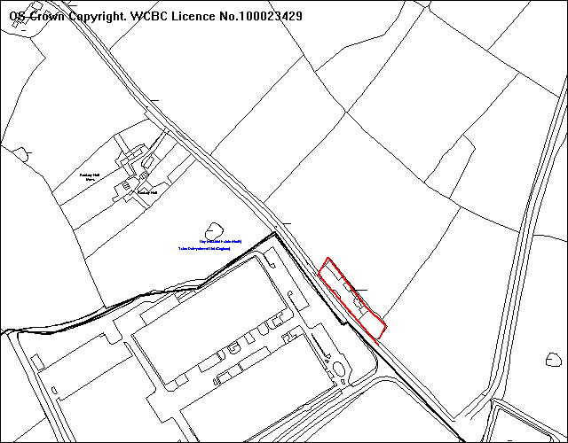
Application Site
Llay Settlement Boundary
Sharp Manufacturing

SITE

The site consists of two nursery and baby units which currently forms the Grange Nursery on Rackery Lane, which once formed Rackery Cottage. Llay Industrial Estate is located 40 metres to the west of the site and 360 metres of Astbury Landfill Site. The site once formed Rackery Cottage before it became a children’s nursery.

PROPOSAL

Change of use from 3 nursery buildings into 2 no dwellings, with new linkage and the erection of a detached garage.

HISTORY

Application Site
6/16962 Conversion of residential to children’s day nursery.
Granted 6/9/1989
6/16963 Erection of single storey children’s day nursery unit and
replacement garage. Granted 21/3/1990.
6/18273 Erection of baby unit (Partly in retrospect). Granted 8/10/1990

Adjacent Site: Sharps
6/14060 Phase II Erection of 2nd Factory 15,600 sq ft Granted 27/4/1987
6/19226 Sharps Finished Goods Storage Area Extension.
Granted 15/4/1991
6/22005 Extension to provide storage facility and re-alignment of service road. Granted 24/1/1994
P/2000/0682 180m ² Storage Extension. Granted 23/8/2000.

DEVELOPMENT PLAN

Located outside the settlement limit of Llay, Policies PS2, GDP1, CLF1 and H3 apply. Local Planning Guidance Note 3: Converting Rural Buildings and Local Planning Guidance Note 16: Parking Standards also apply.

CONSULTATIONS

Community Council: Notified 3rd December 2008
Local Member: Notified 3rd December 2008
Environment Agency: No comment. Standard advice note applies.
Highways: Some concerns raised regarding the adequacy of the turning area to Plot 1, and condition therefore required for further details of parking and turning, to be submitted to and approved by the LPA and supplementary notes.
Public Protection: Condition required for potential contamination and working hours of construction and notes to applicant regarding treatment plants, bonfires and dust management.
Welsh Water: No comment given the utilisation of private drainage facilities.
Adjacent Occupiers: One letter of strong objection which raises issues regarding noise levels from manufacturing and traffic and associated problems with existing residents. Issue of delivery and staff movements to and from the site which are day and night, and include weekends. The impact on the flexibility and type of manufacturing which could be undertaken in the future for the site.
Site Notices: Expired 9th January 2008

SPECIAL CONSIDERATIONS

Main Issues: There are two main issues relating to the suitability of the buildings for conversion into residential use and the compatibility of the proposed use in relation to the manufacturing use, located opposite on the Llay Industrial Estate.

Conversion of Existing Buildings: The three buildings involved once formed a residential dwelling. The style of the original building and additional building are domestic in appearance and would require minimal amount of alterations. The separate nursery and baby unit would require a small link to form one dwelling and garage. The second dwelling would require an additional double garage.

In terms of Policy H3, the building is non agricultural and does not need to demonstrate that alternative uses have proved inappropriate. One of the units was formally a dwelling and this and the modern unit appear in good structural condition and their existing use as a nursery would demonstrate that it is structurally sound.

The remaining garden areas associated with the dwellings would not constitute an undesirable intrusion into the landscape, and would not create access problems, and the floor area of the two units is sufficient to create two habitable dwellings.

Unit 1 would provide single storey accommodation and Unit 2 would provide single storey and attic bedroom with dormer window. The dormer window faces east towards the boundary hedge and would not cause issues of overlooking or loss of privacy to the adjacent dwelling. The erection a 1.8 metre boundary wall between the properties would protect the amenity of the potential occupiers and it will be necessary to retain this by condition.

Loss of a Community Facility: The existing nursery would constitute a community facility, which has seen a general reduction in numbers. The supporting information states that the remaining children would be relocated to The Grange Nursery on Gegin Lane which is under the same ownership. The amalgamation of the two sites would make it possible to continue this facility and prevent any loss of existing provision would comply with policy CF1.

Noise and Issues of Compatibility: The issue of noise, neighbour compatibility and impact on long term viability are important material considerations. The buildings, to which the site involves, once formed a residential unit and it is important to consider the level of use and scale of development when assessing issues of compatibility. It is also important to look at the history of the adjacent Sharp site in relation to the history of this site.

The nursery once formed a residential property known as “Rackery Cottage”, until 1989 when change of use application was granted subject to conditions. This residential use was still established when planning permission was granted in 1987 for Phase II of the developments at Sharp. This involved the erection of a second factory of 15,600 sq ft, which doubled the size of the original factory. The additional factory formed an assembly line and production storage unit and was granted subject to conditions. There is a condition (5) on this permission 6/14060 which states that “no nuisance shall be caused to the nearby occupiers or other users of the land as a result of these proposals by reason of any atmospheric or airborne pollution or by pollution transmitted by any other means. For clarification, such nuisance shall include noise, vibration, smoke, smell, fumes, dust, ash, soot, grit, light, dazzle, windblown paper, radio or TV interference.” Condition 4 of 6/14060 states that there is no direct access gained from Rackery Lane (B5373). The creation and existence of the access to Rackery Lane could potentially cause issues of noise and disturbance in terms of traffic movements and also because there are no conditions restricting hours of operations for this site.

The condition on planning permission 6/14060 demonstrates that there is an existing restriction on the Sharps site so that it doesn’t cause disturbance to nearby occupiers, at a time when this site had an established residential use.
The re-alignment of the service road onto Rackery Lane has occurred since the change of use occurred to the application site. The main issue to consider is whether the adjacent industrial use and use the service road would detrimentally affect the amenity of adjacent occupiers. The service road feeds onto Rackery Lane which is a busy B road and subject to heavy traffic flows, it would be important to address the issue of noise and it has been requested that the agent submits a noise survey for further consideration.

The change of use to form two dwellings would not be considered significant enough in terms of scale to compromise the level of development on the Industrial Estate.

Sustainability: Although the site is somewhat separated from the main residential community of Llay and the community facilities it provides it is located off a main road which has frequent bus services. The conversion scheme would involve minimal alterations and would facilitate an alternative use of an existing group of buildings is considered sustainable.

CONCLUSION

The issue of noise and impact on the amenity of potential occupiers is an important consideration and additional noise survey has been requested. It is requested that the Chief Officer be given delegated powers to determine the application subject to the findings of the noise survey report, based on the split recommendation set out below.

RECOMMENDATION A

If a noise survey is submitted and the findings demonstrate noise levels are not sufficient to cause harm to the amenity of future occupiers. It is recommended that permission be GRANTED subject to conditions:-

CONDITION(S)

1. The development hereby permitted shall be begun before the expiry of five years from the date of this permission.
2. Development shall only be carried out in strict accordance with the approved plans unless the prior written approval of the Local Planning Authority has been obtained.
3. No facing materials shall be used other than materials matching those used on the existing building.
4. Development shall not begin on site until a scheme to deal with potential hazardous ground gas at the site has been submitted to and approvd by the Local Planning Authority. This scheme shall include a phased investigation approach to identify the extent of hazardous ground gas at the site and any measures required to remediate the site including post development monitoring. The phased investigation should be carried out in accordance with current guidance (CIRIA C665: Assessing risks posed by hazardous ground gases to buildings)Where remediation works are required, the development shall not be occupied or used until a Validation Report to show that the works have been satisfactorily carried out has been submitted to and approved in writing by the Local Planning Authority.
5. The 2 metre high boundary wall which subdivides the site into 2 plots shall be retained at its proposed height, and any alterations shall be submitted to and approved in writing by the Local Planning Authority.
6. No trees either existing or planted in accordance with this or a previous permission shall be lopped, topped, felled or uprooted without the prior written permission of the Local Planning Authority, nor shall any trees be wilfully damaged.
7. Any garage erected under this permission shall be used only for a purpose incidental to the use of that dwelling as a single dwelling house provided that such use shall not preclude the garaging of a private motor car.
8. Within 3 months of commencement of development on site, full details of both hard and soft landscape works for the site shall be submitted to and approved in writing by the Local Planning Authority. The works shall be implemented in accordance with a timescale to be approved in conjunction with the scheme of details.
9. Any trees or shrubs removed, dying, being severely damaged or becoming seriously diseased within five years from the completion of the scheme shall be replaced by trees or shrubs of similar size and species to those originally required to be planted unless otherwise approved in writing by the Local Planning Authority.
- Vehicle parking and turning facilities shall be provided within the curtilage of the site in accordance with details to be submitted for further approval. Such facilities shall be made available for those purposes prior to the first occupation of the building(s) hereby permitted and shall thereafter be retained.
- The permission shall operate only to allow development to be carried out in accordance with the approved drawings and the application documentation. Notwithstanding the provisions of the Town and Country Planning (General Permitted Development) Order 1995, no further development shall take place within the site (other than the painting of buildings).

REASON(S)

1. To comply with Section 91(3) of the Town and Country Planning Act, 1990.
2. To ensure that the development fully complies with the appropriate policies and standards.
3. To ensure a satisfactory standard of appearance of the development in the interests of the visual amenities of the area.
5. To protect the amenities of the occupiers of nearby properties.
6. To protect trees which are of significant amenity value to the area.
7. To ensure that the garage is not used in a manner prejudicial to or likely to cause nuisance or disturbance to the occupiers of nearby properties and to ensure that facilities for the garaging of a car remain available at this address at all times.
8. To ensure a satisfactory standard of appearance of the development in the interests of the visual amenities of the area.
9. To ensure a satisfactory standard of appearance of the development in the interests of the visual amenities of the area.
- To provide for the loading, unloading, parking and turning of vehicles clear of the highway and to ensure that reversing by vehicles into or from the highway is rendered unnecessary in the interest of traffic safety.
- The site lies outside defined settlement limits where extensions and outbuildings would need to be controlled in the interests of visual amenity.

RECOMMENDATION B

If a noise survey is not submitted or the findings of the report demonstrate that the residential units could not provide an adequate level of amenity. It is recommended that permission be REFUSED for the following reasons:-

- The proximity of the site to the Llay Industrial Estate and the B5373 would not provide adequate level of amenity to the future occupiers. The living conditions would be unacceptably compromised by way of excessive noise, the proposal fails to comply with Policy GDP1(f) of the Wrexham Unitary Development Plan (2005) paragraph 13.14.1 Planning Policy Wales and paragraph 10 of Technical Advice Note (TAN) 11.

- The proposed development would be incompatible with the characteristics of the immediate locality, which is principally industrial and commercial in character, it would fail to satisfy Policy GDP1 of Wrexham Unitary Development Plan (2005).
_____________________________________________________________

APPLICATION NO:  P/2008 /1258  COMMUNITY:  Esclusham  WARD:  Ponciau | LOCATION:  TAN Y LAN BRONWYLFA WREXHAM  DESCRIPTION:  LISTED BUILDING CONSENT FOR CONVERSION OF EXISTING BARN AND STABLES TO DWELLING.  APPLICANT(S) NAME:  MISS KIM NORMAN | DATE RECEIVED:  01/12/2008  CASE OFFICER:  CB  AGENT NAME:  SIMON J CUSHING CHARTERED ARCHITECTS  MR SIMON CUSHING
______________________________________________________________

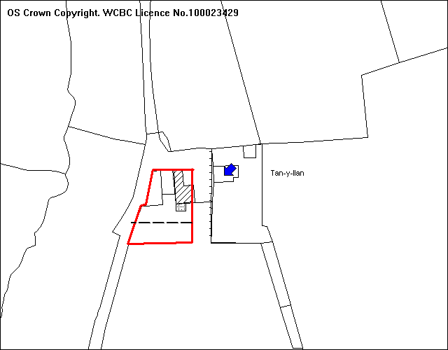
Application Site
Grade II Listed Building
Garden curtilage- new boundary
Proposed Extension

SITE

The site consists of a small barn which stands in the courtyard of Grade II Listed Cottage. Access is gained via a track immediately south of Bronwylfa, 500m approx and West of the B5426 West of Talwrn.

PROPOSAL

Listed Building Consent for the conversion of existing barn and stables to dwelling

HISTORY

CB/00362 Conversion of part of outbuilding to form ancillary living accommodation Granted 14/2/1997

CB/00363 Listed Building Consent for the conversion of part of outbuilding to form ancillary living accommodation. Granted 11/11/1996
P/2000/1000 Conversion of part outbuilding to form ancillary living accommodation (Previously granted under code CB000363) Withdrawn 15/12/2000
P/2000/1001 Listed Building consent to convert part outbuilding to form ancillary living accommodation (Previously granted under code CB/000363) Withdrawn 15/12/2000
P/2001/1063 Conversion of part of outbuilding to form ancillary living accommodation (Previously granted under code CB000363) Granted 18/4/2002
P/2001/1064 Listed Building consent to convert part of outbuilding to form ancillary living accommodation (Previously granted under code CB000363) Granted 30/4/2002
P/2002/0085 Listed Building consent for renovation works. Granted 19/7/20002
P/2007/0369 Part conversion of barn to provide living accommodation (Previously granted under Code No. P/2001/1063) Withdrawn 13/4/2007
P/2007/0310 Listed Building Consent for conversion of part of outbuilding to form ancillary living accommodation (Previously granted under P/2001/1064) Withdrawn 13/4/2007
P/2008/1257 Conversion of Existing barn and stables into dwelling. Pending.

DEVELOPMENT PLAN

Outside settlement limit and within Special Landscape Area, policies PS2, GDP1, EC5 and H3 are relevant. Local Planning Guidance Note 3: Converting Rural Buildings and 16: Parking Standards are also relevant.

CONSULTATIONS

Community Council: No objections or observations
Civic Society: The civic society is concerned with the excessive glazing to the proposed extension, which is totally out of character with the existing building and should in the Society’s opinion be substantially reduced. The civic society accordingly objects to this application.
CPAT: Request for photographic survey on existing and internal elevations prior to development commencement condition and general advice note to applicant.
Adjacent occupiers: Notified 8th December 2008
Local Member: Notified 3rd December 2008
Environment Agency: Unable to make full response.
Highways: No recommendations
Public Protection: Conditions and notes to applicant regarding working hours, prohibition of bonfires, and potential contamination.
RCAHMW: Condition required for photographic survey.

Site Notices: Expired 3/12/2008
Press Notice: Expired 12/12/2008

SPECIAL CONSIDERATIONS

Main Issue: This listed building consent has been put forward to Committee because the Civic Society strongly objects to amount of glazing to the extension, and this objection is contrary to the recommendation. The planning application P/2008/1257 did not receive any objections and will be dealt with as a delegated matter.

Local Planning Guidance Note 3: Converting Rural Buildings states that there is a presumption against large extensions to the building itself, and against the erection of ancillary structures within and adjoining to the curtilage. It also states that the attachment of porches and other extraneous features is likely to adversely affect the original appearance of the building and should be avoided.

The extension consists of a double glazed oak frame with natural slate light constitutes a lightweight construction which contrasts with the traditional construction of the stone barn. The extension would not detrimentally affect the form and mass of the original building. The extension would only provide additional living accommodation on the ground floor and upper void. It will be important to condition on the planning application (P/2008/1257) that no additional floor is inserted and boundary hedge retained to avoid issues of overlooking and loss of privacy.

Other Issues: There are however a number of other concerns with the application proposal, relating to its separate residential use, potential requirements for additional storage, size of the garden area, structural survey or appraisal, extent of glazing, window type, trees and ecology. These concerns are largely addressed through the corresponding planning application P/2008/1257, the main consideration is the impact of the conversion and extension on the setting of the listed building. The principle of conversion is acceptable as the proposal meets the requirements of policy H3 within the UDP. The corresponding planning application therefore is supported and as no objections have been received this will be determined under delegated powers.

Residential Use: The application proposal involves a separate residential usage for the whole unit which is different to the established principle of the ancillary residential use. The separate residential use raises issues of potential overlooking from the eastern window from bedroom 3 facing Tan y Llan and it has been requested that this window is recessed blocked with stone or fixed shut and obscurely glazed.

The separate residential use also raises the issue of whether a non residential use would be suitable for this site. The existing barn has historically been used for domestic scale storage of pets and feed associated with the dwelling of Tan y Llan. The previous permission related to a partial conversion scheme for ancillary accommodation and although this has been implemented, it is still used for storage.

The rural location of the barn and its proximity to a residential property make the barn unsuitable for a separate non-residential use.

Existing storage: The scale of storage would easily be accommodated in the remaining part of the open fronted barn. It will be important to condition that storage for Tan y Llan is maintained so that there is not a requirement for additional ancillary storage which could potentially and detrimentally affect the setting of the Listed Building. The requirement for an Aboricultural method statement on P/2008/1257 will be covered by condition and will detail any potential outbuilding instability by the removal of the sycamore tree.

Garden Area: The garden area for the proposed dwelling is excessive in size and would include the paddock. It is has been agreed that the garden be significantly reduced in size to follow in line with the garden of Tan y Llan, and leave the remaining area to be retained as a paddock.

Structural Survey: The agent has provided 3 copies of previous structural survey statements, with the latest version dated March 2007 and states that the building general condition shows no further signs of deterioration, over another five year period. The previous permissions for the partial conversion have been implemented and a large part of the works, have already been undertaken.

Roof Glazing and Window Type: The extent of the roof glazing on the western roof slope is excessive and detrimental to the character of the building. It has been suggested that the roof glazing be significantly reduced. The single en-suite roof light on the eastern elevation would not cause issues of overlooking and its limited size would not affect the setting of the Listed Building. The utilisation of existing openings and proposed side hung casements are reflective of the windows on the adjacent cottage and the same as the window type approved on previous permissions.

Impact on the setting of the Listed Building: The proposed conversion of the barn and extension would respect the setting and character of the Grade II Listed Building of Tan y Llan, and it would comply with Policy EC9.

Public Protection: The conditions required by public protection will be attached to the planning application, reference P/2008/1257. The decision on the planning application will follow the listed building application because the amendments relate to both applications.

CONCLUSION

The domestic storage and use of the barn and principle of ancillary residential use has already been established for this site. Although there are no objections to the design, size and construction of the proposed extension. The conversion to a separate residential use has raised several issues and although these have been verbally discussed, additional information and amended plans are yet to be received, my split recommendation is as follows:

RECOMMENDATION A

If amended plans or additional information are not submitted or do not address the issues raised, it is recommended that Listed Building Consent be REFUSED for the following reason:-

- The proposed development is unacceptable and undesirable in respect of the alterations to an existing barn, within the setting of a Grade II Listed Building. To approve the scheme would result in a development, which would not respect the setting of the listed building and is therefore contrary to Policy GDP1 and EC9 of the Wrexham Unitary Development Plan (2005).

RECOMMENDATION B

If amended plans and additional information is submitted and addresses the issues raised, it is recommended that the National Assembly for Wales should be advised that Wrexham County Borough Council is disposed to grant Listed Building Consent in accordance with Article 3 of the Planning (Listed Building Conservation Area) Regulations 1990 subject to the conditions specified below:-

CONDITION(S)

1. The works hereby granted consent shall be begun before the expiry of five years from the date of this consent.
2. The works granted consent shall only be carried out in strict conformity with the details shown on the approved drawing(s) and in the application documentation.
3. Prior to their use on the development samples of all external facing and roofing materials shall be submitted to and approved in writing by the Local Planning Authority. The development shall only be carried out in strict accordance with such details as are approved.
4. Development shall not begin until an appropriate photographic survey of the existing buildings on the site has been carried out in accordance with details to be submitted to, and approved by, the Local Planning Authority. The resulting photographs should be deposited with the County Sites and Monuments Record, operated by The Clwyd-Powys Archaeological Trust (7a Church Street, Welshpool, Powys, SY21 7DL. Tel: 01938 553670).

REASON(S)

1. To comply with Section 18 of the Planning (Listed Building and Conservation Areas) Act 1990.
2. To ensure the works reflect the character and appearance of the Listed Building.
3. To ensure a satisfactory standard of appearance of the development in the interests of the visual amenities of the area.
4. To provide for a record of a building or buildings of local architectural or historic interest

NOTE(S) TO APPLICANT

The proposed development lies within a former coal mining area. You should take account of any hazards to stability which may arise from coal working in or near the site. Specific advice on any past working may be obtained from the Coal Authority Mining Reports Service. Phone 0845 762 6848 or from www.coal.gov.uk.

Any operations which may involve entry into former workings, shafts or adits or implementation of site investigations or other works may need permission from the Coal Authority.

You should ensure that any difference between the plans approved under the Town and Country Planning Acts and under the Building Regulations is resolved prior to commencement of development, by formal submission of amended plans.

RECOMMENDATION C

That the Chief Planning Officer be authorised to issue the appropriate certificate forthwith if NAfW refers the application back to the Council for determination.

______________________________________________________________

APPLICATION NO:  P/2008 /1276  COMMUNITY:  Brymbo  WARD:  Minera | LOCATION:  ADJOINING THE FERNS WESLEY ROAD BWLCHGWYN WREXHAM  DESCRIPTION:  Erection of 2 no. split level bungalows and garages  APPLICANT(S) NAME:  MISS LINDA WEBB | DATE RECEIVED:  05/12/2008  CASE OFFICER:  CB  AGENT NAME:  D B DAVIES
______________________________________________________________

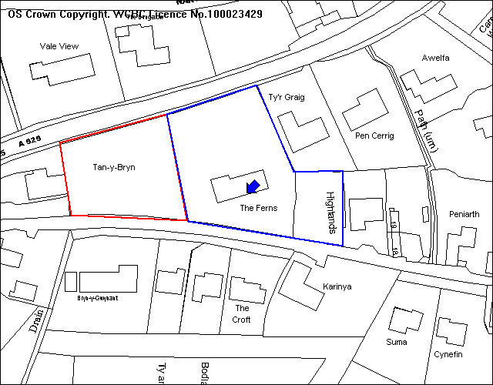
Wesley Road
Application site

SITE

As above.

PROPOSAL

As above.

HISTORY

P/2007/1153: Outline application for residential development
(2 no detached dwellings) Granted 5 /11/2007.

DEVELOPMENT PLAN

Inside settlement, therefore policies PS1, PS2, GDP1, H2 and T8 are relevant. Local Planning Guidance Notes 16 and 21 Space around Dwellings also apply.

CONSULTATIONS

Community Council: Re-consulted 23 December 2008 and 20th January 2009
Local Member: Re-consulted 23 December 2008. Verbal discussions regarding residents concerns with Cllr D. Kelly Re-consulted 20th January 2009
Adjacent occupiers: 2 emails and 3 letters of objections received raising the following matters:
- The width of Wesley road and encroachment onto land by turning vehicles.
- The single storey height restriction on the outline application and the conflicting nature of this proposal.
- The impact on amenity from the split level scale and height of the development.
- An indication that the height of the dwellings should be no more than 5ft.
- Impact on view
- Provision of parking, and vehicle turning, access for residents kept clear at all times.
- Working hours condition same as P/2007/0010
- Size and position of dwellings and impact on adjacent property of Trem yr Aber no.14 Ruthin Road, and its impact on light.
- Increased traffic generation and impact on adjacent occupiers.
Re-consulted 20th January 2009
Airbus: No objection.
Environment Agency: No comment
Highways: Requested conditions relating to gates, vehicle parking and turning areas, water flow, construction of footway and visibility splay, and hard surfacing and supplementary advisory notes.
Public Protection: Conditions required for potential contamination, hours of working and prohibition of fires, and dust management. Separate permission for connection to the main sewer would be required from Welsh Water.
Welsh Water: Conditions and advisory notes regarding foul water and surface water discharge.
Site Notices: Expired 3/12/2008

SPECIAL CONSIDERATIONS

This application description and type has changed from a reserved matters application to a Full Planning application, because it involves proposals which are not single storey in height. There is a condition on the outline consent which restricts development to single storey. The outline consent was limited to a single storey because the ground levels information provided was inadequate to satisfy the Council that the required separation standards would be met.

The principle of residential development for two dwellings on this site has been established through the grant of outline consent P/2007/1153. The main issue to assess is whether the site is capable of supporting two dwellings which is split level in scale, single storey to Wesley Road and two storey facing Ruthin Road.

Design, Position (Siting) and Scale: The simple design and external materials would accord with the general character of the area.

The appearance of the dwellings from Wesley Road would appear to be single storey and the separation to the dwellings would appear to be adequate. Ground levels and Finished Floor level details have been provided by the agent and a sectional drawing showing the profile of the site in relation to the houses opposite has been requested.

The position and finished floor levels proposed would satisfy the Council’s separation standards in accordance with Local Planning Guidance Note 21: Space around Dwellings. The original footprints of the proposed dwellings would appear excessive in relation to the plot size, and the position and orientation of Plot 1 would detrimentally impact on the amenity of the adjacent occupier.

The amended scheme shows a significant reduction in the proposed footprints for both dwellings and the orientation has altered to follow the line of The Ferns. The alterations in footprint and orientation would show that Plot 1 would not cause any loss of light or overshadowing. The position of no.14 has altered and the exact position needs to be verified.

Access: The site has access onto an unclassified highway (Wesley Road) and has demonstrated visibility requirements of 2.4 by 33 metres in both directions. The 3m wide road has no pedestrian provision and although a 2 metre wide footway is not characteristic of the area. The increased traffic generation from the proposal would necessitate an improvement, and make provision for pedestrian movements. There is another site further down Wesley Road which was refused and dismissed at appeal because of the width of the road and lack of footway provision (Local Planning Authority reference P/2004/0607). It would be considered necessary to provide a footway of minimum width of 1.2 metres across the entire frontage of the site, including the area outlined in blue.

I am satisfied that the rural characteristics of the site can be retained through a detailed landscaping scheme which includes the re-instatement of the front (native species) boundary hedge, the use of boundary hedges between the two properties and the retention of the remaining boundary hedges around the perimeter of the site.

The hard and soft landscaping details within the site shall be provided by the landscaping condition and this will ensure that an inclusive surface and access is provided and maintained.

CONCLUSION

The recommendation of the report depends on the submission of amended plans. If the position and size of the footprint is adequately altered and a section drawing shows that the required separation distances would be provided. It will be necessary to re-consult and allow fourteen days for further comments to be received and I therefore conclude a split recommendation.

RECOMMENDATION A

If the position of the adjacent property can not be verified to show that Plot 1 would not detrimentally impact on the amenity of the adjacent occupiers, it is recommended that permission be REFUSED for the following reasons:-

- The size, position and orientation of the proposed dwelling (Plot 1) would have a detrimental impact on the amenity of the adjacent occupier and would thus be contrary to GDP1 of the Wrexham Unitary Development Plan (2005).

- The application has failed to demonstrate that the site is capable of supporting a proposal for two dwellings without compromising the Council’s separation standards requirements of Local Planning Guidance Note 21: Space around Dwellings, and Policy GDP1 of the Wrexham Unitary Development Plan (2005).

RECOMMENDATION B

If amended plans are received it is requested that the Chief Officer be given delegated powers to GRANT permission subject to conditions:-

CONDITION(S)

1. The development hereby permitted shall be commenced before the expiry of five years from the date of this permission.
2. The development shall only be carried out in accordance with the amended plan(s) dated 20th January 2008.
3. Development shall not begin on site until a scheme to deal with potential contamination at the site has been submitted to and approved in writing by the Local Planning Authority. This scheme shall include a phased investigation approach to identify the extent of contamination and any measures required to remediate the site, including post-development monitoring. Where remediation works are required, the development shall not be occupied/used until a Validation Report to show that the works have been satisfactorily carried out has been submitted to and approved in writing by the Local Planning Authority.
4. Notwithstanding the provisions of the Town and Country Planning (General Permitted Development) Order 1995 no windows or other openings shall be inserted in any elevation of the buildings facing east or west.
5. Prior to their use on the development, samples of all external facing materials shall be submitted to and approved in writing by the Local Planning Authority. The development shall only be carried out in strict accordance with such details as are approved.
6. The existing hedges shall be retained and shall not be cut down, grubbed out or otherwise removed or topped or lopped so that the height of the hedges falls below 1.8 metres at any point without the previous written permission of the Local Planning Authority. Any hedges removed without permission or dying or being severely damaged within five years from the completion of development shall be replaced with hedges of such size and species as may be agreed with the Local Planning Authority.
7. No part of the development hereby permitted shall be commenced until full details of both hard and soft landscape works for the site have been submitted to and approved in writing by the Local Planning Authority. The works shall be implemented in accordance with a timescale to be approved in conjunction with the scheme of details.
8. All foul drainage should be directed to a foul sewerage system and all surface water drainage to a surface water system unless otherwise agreed by the Local Planning Authority.
9. The site shall only be drained by means of a separate system of drainage with no surface water being discharged to the foul drain/sewer.
10. The driveway shall be drained so that no surface water discharges onto the highway.
11. Construction works, ancillary works and the use of plant or machinery audible at or beyond the site boundary shall only be carried out between the hours of 07:30 and 19:30 (Monday to Friday) and 08:00 to 14:00 (Saturday) and at no time on Sundays or Bank Holidays.
12. The proposed access shall have a visibility splay of 2.4 metres by 33 metres in both directions measured to the nearside edge of the adjoining carriageway and over land within the control of the applicant and/or the Highway Authority. Within the splays there shall be no obstruction in excess of 1 metre in height above the level of the adjoining carriageway. teh splay shall be provided to commencement use/occupation of the development hereby approved and shall thereafter be retained clear of obstruction.
13. The vehicle turning area(s) as indicated on the amended plan shall be provided prior to the occupation of the building(s) and shall thereafter be retained ina usable condition.
14. The car parking ares indicated on the amended plan shall be provided prior the occupation of the building and shall thereafter be retained in a usable condition.
15. The access shall be hard surfaced for a distance of 5m behind the highway boundary before the development is brought into use.
16. Notwithstanding the approved plans, the footway shown along the frontage of the site shall only be 1.2 metres wide and shall extend across the site frontage and along the frontage of the land outlined in blue.
17. Provision shall be made for ambulant and wheelchair bound disabled people to gain easy and convenient access into and through the building in accordance with details that shall be submitted to and approved in writing by the Local Planning Authority and such facilities shall be maintained and kept clear of obstruction, so that they may be used at all times.

REASON(S)

1. To ensure that the development fully complies with the appropriate policies and standards.
2. To ensure that the development fully complies with the appropriate policies and standards.
3. In the interests of the amenities of the future occupants of the buildings
4. To protect the amenities of the occupiers of nearby properties.
5. To ensure a satisfactory standard of appearance of the development in the interests of the visual amenities of the area.
6. To protect landscape features which are of significant amenity value in the area and which would ensure a satisfactory standard of appearance the development.
7. To ensure a satisfactory standard of appearance of the development in the interests of the visual amenities of the area.
8. To ensure the proper drainage of the site and to minimise the risk of pollution
9. To ensure satisfactory drainage of the site and to avoid flooding.
10. To ensure the proper drainage of the site and to minimise the risk of pollution
11. To protect the amenities of the occupiers of nearby properties.
- To ensure the formation of a safe and satisfactory access.
- To ensure a sufficient turning area is provided within the confines of the site.
- To ensure sufficient parking spaces are available within the site to meet the needs of the development
15. To ensure that no deleterious material is carried onto the highway, in the interests of highway safety.
16. To ensure that adequate parking facilities are provided and maintained within the curtilage of the site in the interests of the free flow of traffic, highway safety and the amenities of the locality.
17. In order to secure the satisfactory provision of facilities and access for disabled persons.

NOTE(S) TO APPLICANT

The stability of the site shall remain the responsibility of the developer.

Prior to any soil or other material being removed from the site the Council's Chief Public Protection Officer should be notified and afforded an opportunity of taking samples for analysis to test for contamination of the land and these results should be available to the Council.

You should ensure that any difference between the plans approved under the Town and Country Planning Acts and under the Building Regulations is resolved prior to commencement of development, by formal submission of amended plans.

The proposed development lies within an area which could be subject to current coal mining or hazards resulting from past coal mining. Such hazards may currently exist, be caused as a result of the proposed development, or occur at some time in the future. These hazards include:

· Collapse of shallow coal mine workings.
· Collapse of, or risk of entry into, mine entries (shafts and adits).
· Gas emissions from coal mines including methane and carbon dioxide.
· Spontaneous combustion or ignition of coal which may lead to underground heatings and production of carbon monoxide.
· Transmission of gases into adjacent properties from underground sources through ground fractures.
· Coal mining subsidence.
· Water emissions from coal mine workings.

Applicants must take account of these hazards which could affect stability, health & safety, or cause adverse environmental impacts during the carrying out their proposals and must seek specialist advice where required. Additional hazards or stability issues may arise from development on or adjacent to restored opencast sites or quarries and former colliery spoil tips.

Potential hazards or impacts may not necessarily be confined to the development site, and Applicants must take advice and introduce appropriate measures to address risks both within and beyond the development site. As an example the stabilisation of shallow coal workings by grouting may affect, block or divert underground pathways for water or gas.

In coal mining areas there is the potential for existing property and new development to be affected by mine gases, and this must be considered by each developer. Gas prevention measures must be adopted during construction where there is such a risk. The investigation of sites through drilling alone has the potential to displace underground gases or in certain situations may create carbon monoxide where air flush drilling is adopted.

Any intrusive activities which intersect, disturb or enter any coal seams, coal mine workings or coal mine entries (shafts and adits) require the prior written permission of the Coal Authority. Such activities could include site investigation boreholes, digging of foundations, piling activities, other ground works and any subsequent treatment of coal mine workings and coal mine entries for ground stability purposes.

Failure to obtain Coal Authority permission for such activities is trespass, with the potential for court action. In the interests of public safety the Coal Authority is concerned that risks specific to the nature of coal and coal mine workings are identified and mitigated.

The above advice applies to the site of your proposal and the surrounding vicinity. You must obtain property specific summary information on any past, current and proposed surface and underground coal mining activity, and other ground stability information in order to make an assessment of the risks. This can be obtained from The Coal Authority's Property Search Service on 0845 762 6848 or at www.groundstability.com

The separate written consent of the Local Highway Authority must be obtained before any work is carried out within the confines of the highway.

Your attention is drawn to Highway Supplementary Notes Numbered 1, 3, 4 and 5 on the enclosed "Applicants' Rights and General Information".

The planning permission requires that development be carried out in accordance with the approved plans, including the construction of an estate road intended for adoption by the Council under the Highways Act 1980. It is essential therefore that the detailed proposals are submitted to the highway authority and confirmed as acceptable BEFORE development commences. Please contact:-

The Operational Manager (Highways Planning), Crown Buildings, Chester Street, Wrexham. LL13 8BG telephone: 01978 292000

The site is affected by an overhead line and you should contact Scottish Power MANWEB, Electricity House, Rhostyllen, Wrexham, LL14 4DU regarding any diversion which may be necessary.

You are reminded that the Disability Discrimination Act 1995 applies to residential development and you will be required to provide (amongst other things) level access, down stairs cloak room and wider doorways.
When preparing detailed drawings and/or implementing this permission you are advised to give full consideration to the housing needs of the disabled.

The scheme of landscaping referred to in the above conditions shall inlcude any changes to ground levels (shown by existing and proposed contours/levels) and any existing vegetation (showing that to be retained) and proposed planting. In addition, any of the following which apply to the particular site must be included:-
means of enclosure, car parking layout, access and circulation areas, materials for hard surfaced areas, any minor structures (e.g. refuse stores, lamp columns, play equipment) location of services, and any historic landscape features to be retained/improved.
______________________________________________________________

APPLICATION NO:  P/2008 /1279  COMMUNITY:  Offa  WARD:  Brynyffynnon | LOCATION:  JACQUES YARD MOLD ROAD WREXHAM  DESCRIPTION:  OUTLINE APPLICATION FOR 72 BEDROOM EMI RESIDENTIAL CARE DEVELOPMENT  APPLICANT(S) NAME:  PENNAF HOUSING GROUP LTD | DATE RECEIVED:  08/12/2008  CASE OFFICER:  DSW  AGENT NAME:  AINSLEY GOMMON ARCHITECTS  MR PETER FISK
______________________________________________________________
P/2008 /1279

THE SITE

The site occupies 0.28ha of land currently occupied by Jacques Garage. It is set well back from Regent Street/Mold Road which provides the only means of access. It is bounded to the east by vacant land and the main line railway running through Wrexham General Station. To the west it is bounded by the Wrexham General and Wrexham Central railway line. With the exception of the site frontage, the site is effectively landlocked. The site occupies a peripheral town centre location and beyond the railway line is surrounded by a mix of commercial land and buildings.

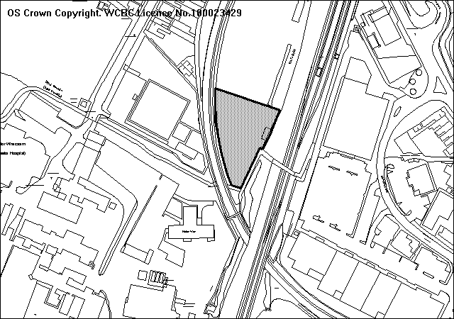
Proposed location of EMI Development

PROPOSAL

As above. This is an outline application with all matters reserved for further approval. Illustrative drawings have been submitted showing a three-storey building.

HISTORY

P/2006/0375 Residential development – erection of 228 two-bedroom
apartments with undercroft car parking. Submitted
    - Appeal against non-determination
subsequently withdrawn.
P/2006/1756 Erection of 228 residential two-bedroom apartments in four blocks with undercroft parking. Approved

Adjoining Site
P/2008/1038 Outline application for 60 no. apartments Extra Care Development. Current application.

DEVELOPMENT PLAN

Within defined settlement limit. UDP policies PS1, PS2, PS3, PS4 and GDP1 apply. Local Planning Guidance Notes 6 – Access for the Disabled, 7 – Landscape and Development, 16 – Parking Standards, 21 – Space Around Dwellings, 22 – Sustainable Building, 24 – Designing Out Crime.

CONSULTATIONS

Offa Community Council: Resolved to defer decision to next meeting on 20 January.
Local Member: Notified 10.12.08
Adjoining Local Member: Notified
Cadw: Notified 21.01.09
Environment Agency: No objections, in principle, but consider a limited Flood Consequences Assessment will be appropriate in this situation.
Fire & Rescue Service: As we no longer occupy the premises near the site we have no comments to make.
CPAT: As indicated previously (P/2006/0375 and P/2006/0756) recommend the scheduled monument alignment is protected with a suitable exclusion zone which takes into account the buried western ditch. It was also agreed with Cadw that the existing monument could usefully be stabilised and enhanced through an agreed management scheme and that the linearity of the monument should be preserved as a component of any design.
Network Rail: Notified
Public Protection: No objections subject to an appropriate condition to deal with potential combination.
Highways: No objections, in principle. The proposed 60 no. extra care apartments will simply displace a number of the originally proposed two-bedroomed apartments and will result in a reduction in traffic movements if the site combined with the original application (Ref P/2006/0756) given the nature of the proposed units. I would therefore recommend that this application be subject to the same conditions which were previously imposed on planning application P/2006/0756. Only 50% parking provision is provided, this shortfall needs to be justified.
Welsh Water: No objections subject to appropriate conditions to deal with foul and surface water drainage.
CCW: No objection, in principle, but recommend changes to reduce the potential impact of the scheme. From aerial photographs it appears that trees may be affected by the proposed development. CCW therefore recommend the site be surveyed for bats/birds and appropriate conditions are imposed.
Other Representations: No observations received from adjoining commercial properties or residents in Maesgwyn Road.
Site Notice: Expired 09.01.09
Press Notice: Expired 09.01.09

SPECIAL CONSIDERATIONS/ISSUES

Background: The current application is one of two outline applications for Extra Care and EMI Residential Care Home on the former Jacques site. A partnership between Pennaf Housing Group and the Council has submitted a formal bid to the Welsh Assembly Government to provide ‘social housing grant’ for the new extra care scheme. This bid is currently under consideration and it is anticipated funding will be approved this year. A key part of this scheme is the close relationship of the new Extra Care Scheme and the Care Home is that certain aspects of the accommodation will be closely linked and shared between the two developments. This specifically relates to the kitchen facilities, which will prepare hot meals for residents and it is envisaged this will be centralised with access to both developments.

The site presently has an extant permission for 228 apartments approved under Code No P/2006/0756 in 17 March 2006. The approved scheme involved the erection of four separate blocks set in a linear form varying in height from five storeys at the front to a maximum height of seven-storeys towards the rear. The current proposals occupy the bottom half of the site, furthest away from Mold Road. Combined the current two outline applications take up approximately 50% of the site and would effectively replace blocks 3 and 4 of the previously approved scheme for apartments. This proposal would not therefore prejudice the future development of the front of Jacques Yard. However, a modification to the existing Section 106 Agreement would be required as a result of the reduced number of apartments and the impact this would have on the level of affordable housing and financial contributions towards improving off-site recreational facilities, providing improved educational facilities and to offset the shortfall of parking provision.

The site owner is actively marketing the front area of land (area occupied by blocks 1 and 2 as previously approved under P/2006/0756) for a number of commercial, residential and institutional uses but in the current economic climate has been unable to secure definitive use of the land at present. In any event, any variation to the approved scheme, either in terms of use or design, would require permission. In this regard I believe sufficient controls are in place to ensure compatibility with the proposed uses to the rear of the site and to ensure an attractive, high quality frontage to be provided to Mold Road/Regent Street.

Policy: As the site lies within settlement limits there can be no objections, in principle, to the proposed use of the site, provided the technical criteria set out in Policy GDP1 are satisfied. The redevelopment of a brownfield site also accords with the sustainable use of land as set out in PPG Wales.

Highways: The site has permission for the erection of 228 no. residential two-bedroomed apartments. This scheme displaces a number of the originally proposed apartments and will result in a reduction in traffic movements at the site compared with the original application (P/2006/0756).

Whilst I note the concerns of Offa Community Council with regards to movement congestion and movement on Mold Road, Highways have raised no objections subject to conditions imposed previously to improve the access arrangements and provide a scheme enabling the co-ordinating of traffic signals along Mold Road/Regent Street. In addition, a scheme for the provision of signal controlled pedestrian crossing of the proposed new access road leg of the new junction with Regent Street. As the access onto Regent Street now lies outside both application sites, these will form Grampian Conditions. Castlemead Homes currently retain ownership of the whole site (Jacques Yard).

Network Rail: Network Rail had previously raised the need to obtain access to their land. The Network Rail access is immediately adjacent to Regent Street and vehicles leaving this land would not be controlled by the new junction’s signals. Larger vehicles would need to reverse in and out of the access across the mouth of the junction, as there is insufficient turning space within the Network Rail site. This may have potential adverse effects on safety and convenience of all road users. A new access to their land is therefore required from a suitable point along the new internal access road. This will form a condition of any permission granted.

Parking: Local Planning Guidance Note No 16 “Parking Standards” requires 1.5 spaces to be allocated per single bedroom. However, I would accept demand for parking in ‘extra care’ housing is significantly less than that of general needs housing. Although this is an outline application, the applicants have indicated their aim to provide 50%. The reserved matters application will therefore require the submission of a Green Travel Plan and a Section 106 Agreement will require a financial contribution to offset this shortfall. The general principle of a shortfall in this highly sustainable location would be acceptable however, especially bearing in mind the nature of the proposed use.

Design/Appearance: Whilst the proposed building will occupy a much larger footprint the height is substantially reduced when compared with the previously approved scheme. The previous scheme (block 4) was six-storey, whereas the current EMI unit is three-storey. The visual impact therefore is far less. Given the building’s position to the rear of the site, lower land levels and the screening afforded by the proposed 60 bedroom Extra Care Scheme, the overall impact beyond the site boundaries will be negligible. However, details of the appearance of the building, in terms of its design and use of materials, will be considered at the reserved matters stage. A condition will be imposed to ensure the height and mass of the building reflect that shown on the cross-sectional drawings.

Amenity: The nearest residential dwelling in Maesgwyn Road is over 55 metres away and is separated by the railway line. Given the isolated and enclosed nature of the site, the development will not impact upon neighbouring properties.

Contamination: Given the existing and previous use of the site as a scrapyard and garage, the area may be subject to potential ground contamination. Any permission will therefore be conditioned to ensure that any potential contamination issues are adequately dealt with.

Archaeology: The scheduled ancient monument, Wats Dyke, runs along the eastern boundary of the development site. As this stretch of Wats Dyke would be affected by the development, scheduled monument consent from the Assembly Government will be required. Excavation and clearance work has revealed that the dyke itself has been damaged in the past and that a small section on the north is the only section to survive as an upstanding earthworks. Despite its condition, Cadw have previously indicated that the line of the dyke should be respected. The precise siting will be addressed at the reserved matters stage. However, a condition will be imposed to ensure the scheduled area remains free of building. However, Cadw had previously accepted landscaping and an element of parking provision.

Sustainability: In accordance with Local Planning Guidance Note 22, a sustainability statement will be required as part of the Reserved Matters application. This will form a condition of the current outline approval. In general terms, the proposal offers the opportunity to develop a brownfield site within the town centre and in close proximity of public transport facilities. The position of building is also positioned to maximise the use of natural daylight and solar energy. Main elevations face in a south-west and south-east direction. Precise details can only be given proper consideration at the reserved matters stage, although a very good BREEAM rating will be expected from this development.

Designing Out Crime: All areas within the site are overlooked by the proposed development which will provide good natural surveillance to the adjoining car parks. The site is naturally well enclosed which will increase security and gated or barrier entry will be provided. I consider the scheme complies with the design principles set out in Local Planning Guidance Note 24 – Designing Out Crime. It should be noted that the enclosed nature of this site, which restricted access, was a key factor in its selection for an EMI care development.

Noise: The site lies between the Wrexham General and Wrexham Central railway lines. I note the concerns raised by Offa Community Council with regards to noise and disturbance from passing trains. However, an independent noise impact assessment carried out as part of the previous submission in 2006 recommended suitable sound insulation and Public Protection raised no objections. A condition of any outline permission granted will require the submission of a similar assessment and the recommendations for noise mitigation will be a condition of the subsequent Reserved Matter Approval.

Flood Risk: I note the observations of the Environment Agency with regards to the need for a limited Flood Consequences Assessment. The Agency have also indicated that re-modelling of the flood map for the River Gwenfro in this location has indicated that flood risk may be potentially less severe than that indicated by present flood maps. In view of this and the Agency’s response to the adjoining application for 60 no. Extra Care apartments (P/2008/1038) which accepts the conclusions of the Flood Consequence Assessment submitted and assessed by the Agency in 2006, I do not consider it necessary to require a further assessment. Appropriate conditions will be imposed to address surface water disposal.

CONCLUSION

This proposal is very much linked to the adjoining 60 bedroomed Extra Care scheme (P/2008/1038) which is also to be considered at your meeting. There will be an element of shared amenities/facilities, particularly with regards to catering. The two principal issues relate to the visual impact and highway matters. As with the adjoining scheme, the height of the building is lower than the previously approved scheme (P/2006/0756) but in this case, considerably lower at three-storey. Traffic generation will also be significantly lower. Matters relating to affordable housing and financial contributions for schools and public open space as addressed in my earlier report P/2008/1038 for the adjoining site. In general terms therefore, I find the proposed use acceptable, in principle, and more detailed concerns will be addressed at the reserved matters stage. It should be noted that unlike the adjoining Extra Care development, I do not propose it necessary to control the future occupancy of the EMI Residential Care development through a Section 106 Agreement because of the substantially higher level of care and the use is quite distinct from residential C3 use.

RECOMMENDATION A

That the Council enters into an obligation with the applicant under Section 106 of the Town and Country Planning Act 1990, to offset the shortfall in parking provision.

RECOMMENDATION B

That permission be granted on completion of the obligation, subject to the following conditions:-

CONDITION(S)

1. Approval of the following details shall be obtained from the Local Planning Authority before any part of the development is commenced:
a. the siting of the building(s)
b. the design of the building(s)
c. the external appearance of the building(s)
d. the means of access to the site and building(s)
e. the landscaping of the site.
2. Plans and particulars of the reserved matters referred to in condition 1 (above) shall be submitted in writing to the Local Planning Authority before the expiry of three years from the date of this permission. The development shall only be carried out in strict conformity with such details as are thereby approved.
3. The development hereby permitted shall be begun before the expiry of five years from the date of this permission or two years from the date of approval of the last of the reserved matters required to be approved, whichever is the later.
4. The reserved matters application shall include a programme of sustainable works. The approved programme shall be implemented in accordance with a timescale to be agreed with the Local Planning Authority.
5. The reserved matters application shall provide a scheme to deal with potential contamination at the site. The scheme shall include a phased investigation approach to identify the extent of contamination and any measures required to remediate the site, including post-development monitoring. Where remediation works are required, the development shall not be occupied/used until a Validation Report to show that the works have been satisfactorily carried out has been submitted to and approved, in writing, by the Local Planning Authority.
6. The reserved matters application shall provide a noise assessment to include noise mitigation measures. The mitigation measures shall be implemented in accordance with the scheme agreed by the Local Planning Authority, prior to the first use of the site.
7. No development shall take place within the scheduled ancient monument area of Wats Dyke.
8. Details of all boundary treatment shall be submitted to the Local Planning Authority as part of the reserved matters application. The development shall only be carried out in strict conformity with the approved details.
9. No development approved by this permission shall be commenced until a scheme for the provision and implementation of a surface water regulation system has been submitted to and approved, in writing, by the Local Planning Authority. Such a scheme shall be implemented prior to the construction of any impermeable surfaces draining to the system unless otherwise agreed, in writing, by the Local Planning Authority. Surface water generated from new impermeable surfaces draining to the system unless otherwise agreed, in writing, by the Local Planning Authority. Surface water generated from new impermeable surfaces must be limited to equivalent Greenfield rate for the site, the level of which is to be agreed with the Agency.
10. No development approved by this permission shall be commenced until:-
a) The application site has been subjected to a detailed scheme for the investigation and recording of contamination and a report has been submitted to and approved by the Local Planning Authority.
b) Detailed proposals in line with current best practice for the removal, containment or otherwise rendering harmless such contamination (the "Contamination Proposals") have been submitted to and approved by the Local Planning Authority.
c) For each part of the development contamination proposals relevant to that part (or any part that would be affected by the development) shall be carried out either before or during such developments appropriate.
11. Any facilities for the storage of oils, fuels or chemicals shall be sited on impervious bases and surrounded by impervious bund walls. The volume of the bunded compound should be at least equivalent to the capacity of the tank plus 10%. If there is multiple tankage, the compound should be at least equivalent to the capacity of the largest tank, or the combined capacity of interconnected tanks, plus 10%. All filling points, vents, gauges and sigh glasses must be located within the bund. The drainage system of the bund shall be sealed with no discharge to any watercourse, land or underground strata. Associated pipework should be located above ground and protected from accidental damage. All filling points and tank overflow pipe outlets should be detailed to discharge downwards into the bund.
12. The existing public sewerage system serving the site shall be improved to obtain sufficient capacity to meet the needs of the development, prior to its first use.
13. No development shall commence until a scheme for the provision of a new access to Network Rail land, away from the proposed signal controlled junction connecting the site to Regent Street, shall be submitted in writing for the further approval of the Local Planning Authority. The new access shall be constructed prior to the first occupation of the new dwellings.
14. No development shall commence until a scheme for the provision of signal controlled pedestrian crossing of the proposed new access road leg of the new junction with Regent Street be submitted in writing for the further approval of the Local Planning Authority. The new signal controlled crossing shall be brought into use prior to the first occupation of the new dwelling.
15. No development shall commence until a scheme enabling the co-ordinating of traffic signals along Mold Road/Regent Street shall be submitted in writing for the further approval of the Local Planning Authority. The scheme shall be implemented prior to the first occupation of the new dwellings.
16. One tenth of the total proposed car parking spaces shall be to mobility standard.
17. The height of the building hereby approved shall be no higher than the details shown on the cross-sectional plans provided as part of this outline application.
18. Notwithstanding the provisions of the Town and Country Planning (Use Classes) Order no part of the premises shall be used except for the precise purposes described in the application plans and documents.

REASON(S)

1. To comply with the provisions of the Town and Country Planning (General Development Procedure) Order, 1995.
2. To comply with Section 92 of the Town and Country Planning Act, 1990.
3. To comply with Section 92 of the Town and Country Planning Act, 1990.
4. To meet the criteria set out in Local Planning Guidance Note 22.
5. To deal with potential contamination at the site.
6. To protect the amenity of the future occupants.
7. To protect the line of Wats Dyke.
8. To ensure a satisfactory standard of appearance of the development in the interests of the visual amenities of the area.
9. To prevent the increased risk of flooding on and off site.
10. To prevent pollution of the water environment.
11. To prevent pollution of the water environment.
12. To ensure there is sufficient capacity in the public sewerage system to meet the needs of the development.
13. To remove the need to use the existing sub-standard access.
14. In the interests of pedestrian safety.
15. In the interests of free and safe movement of highway traffic.
17. To ensure a satisfactory appearance of the development in the interest of the wider visual amenities of the area.
18. To control the nature of the use given the shortfall in aprking and the potential traffic generation.
______________________________________________________________

APPLICATION NO:  P/2008 /1286  COMMUNITY:  Rhos  WARD:  Ponciau | LOCATION:  CAR PARK AREA RHOS RECREATION GROUND PONCIAU BANKS CLARKE STREET PONCIAU WREXHAM  DESCRIPTION:  RENEWAL OF TEMPORARY PERMISSION CODE NO. P/2007/1203 FOR SITING OF 40' (12.3 METRES) STEEL STORAGE CONTAINER  APPLICANT(S) NAME:  MR JOHN HUGHES RHOS AELWYD F.C. | DATE RECEIVED:  08/12/2008  CASE OFFICER:  PF  AGENT NAME:  RHOS AELWYD F.C.  MR JOHN HUGHES
______________________________________________________________

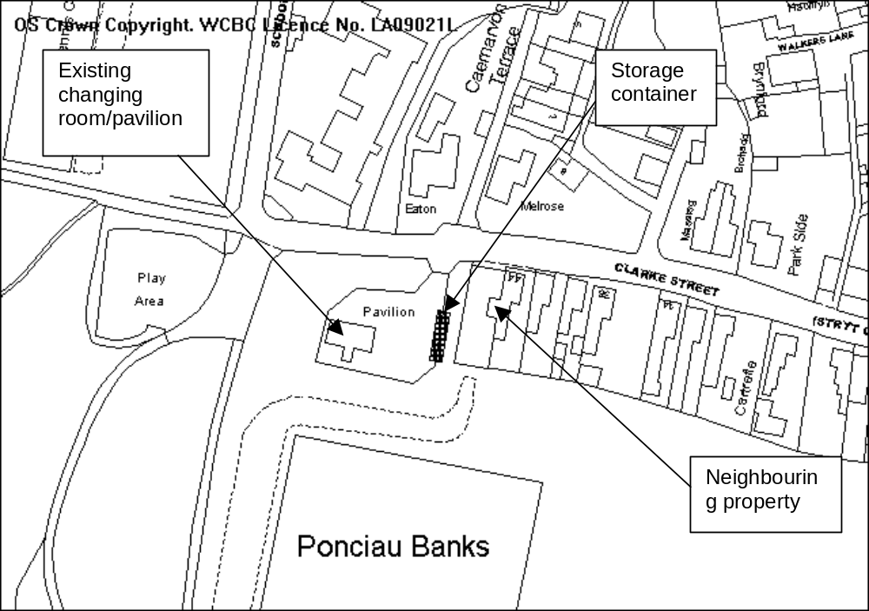

PROPOSAL

To retain a 12.3 metre by 2.5 metre steel shipping container on the eastern side of the car park area at the football and rugby playing field in Ponciau. The unit is used for the storage of equipment in relation to football and ruby teams that use the site.

HISTORY

6936 Erection of temporary additional changing accommodation to serve football fields. Granted 28.8.1980
12139 Continuation of temporary additional changing accommodation. Granted 26.07.1985
14104 Demolition of existing and erection of anti vandal changing accommodation. Granted 12.08.1987
15362 Extension to existing changing rooms. Granted 17.06.1988
P/2007/1203 Siting of steel storage unit (in retrospect). Granted 07.01.2009

DEVELOPMENT PLAN

Site is within settlement. Policies GDP1 and PS2 apply.

CONSULTATIONS

Community Council: Consulted 10.12.2008
Local Members: Cllr Pemberton supports.
Cllr Roberts notified 10.12.2008
Highways: No recommendations.
CCW: Do not wish to comment.
Other representations: 3 neighbouring occupiers notified. 1 letter of objection received raising the following concerns:
- Siting is detracting from the appearance of the regenerated park area.
- Further extension to permission will set a precedent.
Wrexham Access Group: Notified 09.10.2007
Site Notice: Expired 02.11.2007

SPECIAL CONSIDERATIONS

Design/Amenity: The container is located in a semi-residential location adjoining a property on Clarke Street. The boundary of this property is made up of a dense hedge approximately 2.5 metres high and 1.5 metre thick. The gap between the hedge and the container is 2 metres. The unit is painted green and is sited across the car park from the existing changing rooms/pavilion. The container albeit sited in a residential area is substantially screened from view by mature hedgerows from Clarke Street. Although visible from the playing field and adjacent to the newly renovated park area it is not considered to have an immediate impact upon the residential amenity or surrounding area. I acknowledge that the siting of a structure of this type would not normally be approved on a permanent basis. I have requested further justification from the applicant regarding its retention and this will be reported in the addendum.

Other issues: I have spoken with the North Wales Police Architectural Liaison Officer regarding any reports of anti-social behaviour caused as a result of the container. This point was raised as a concern during the consideration of the previous application (P/2007/1203). They have confirmed no incidents.

The site falls within 500 metres of the Johnstown Newt Site Special Area of Conservation (SAC). I do not consider that the retention of the structure will have any adverse impact upon the integrity of the SAC, which has been confirmed by a test of likely significance under the Habitats Regulations 1994.

CONCLUSION

A temporary permission for the retention of the container is considered acceptable to allow further time for suitable accommodation to be found. However a note to the applicant that the granting of such permission does not imply that any further permissions will necessarily be granted in the future and that efforts should be made to seek further accommodation is required.

RECOMMENDATION: That permission be GRANTED

CONDITION(S)

1. The use of the building shall cease not later than 30 June 2011. The building together with any hard standing, base or slab upon which it stands shall be completely removed and the land restored to its previous condition not later than one month after that date.

REASON(S)

1. Having regard to its design and materials of construction, planning permission would not normally be granted in respect of temporary buildings in this location. Permission has been granted in this instance solely to allow the applicant adequate time to seek permanent, satisfactory accommodation.

NOTE(S) TO APPLICANT

The applicant is advised that this permission has been given to allow sufficient time for permanent storage accommodation to be found. The granting of this planning permission does not automatically impply that a further planning application for an extension of time will be approved. Efforts should be made to seek alternative permanent accommodation.
______________________________________________________________

APPLICATION NO:  P/2008 /1289  COMMUNITY:  Caia Park  WARD:  Holt | LOCATION:  LAND ADJACENT TO PENTRE GWYN COMMUNITY CENTRE CEFN ROAD WREXHAM  DESCRIPTION:  USE OF LAND AS COMMUNITY GARDEN.  APPLICANT(S) NAME:  MR MARC JONES | DATE RECEIVED:  09/12/2008  CASE OFFICER:  LB1  AGENT NAME:  WREXHAM COUNTY BOROUGH COUNCIL  MRS NICOLA ELLIS
______________________________________________________________

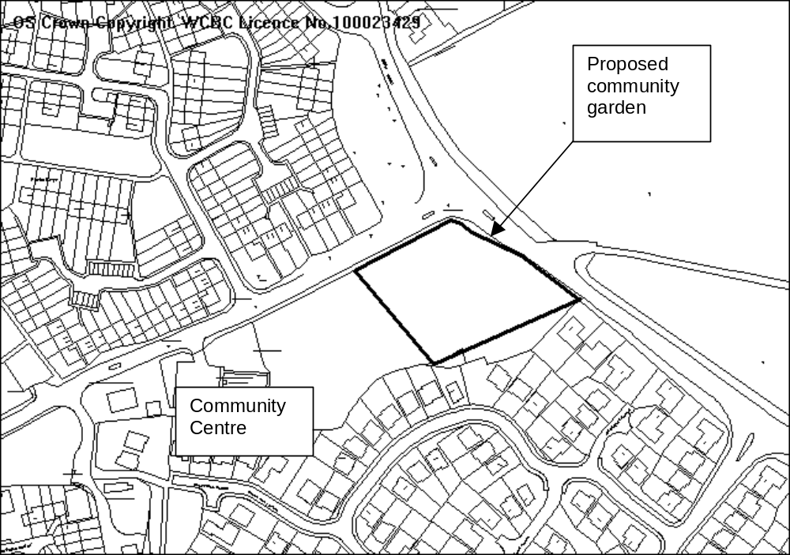SITE

Land adjacent to Pentre Gwyn Community Centre, Cefn Road.

PROPOSAL

Change of use of playing field to community garden (allotments).

HISTORY

None relevant.

DEVELOPMENT PLAN

Lies within the settlement limit, Policies GDP1, PS2, CLF1, CLF4 and EC4 apply.

CONSULTATIONS

Community Council: Concerns raised about the loss of playing field, no objections subject to provision being made for the football pitch to remain on site in a suitable location and of appropriate size and condition.

Local Member: Is the applicant
Public Protection: No objections

Highways: No objections subject to appropriate conditions

Environment Agency: Standard advice applies
Other representations: Two letters of objection received raising the following points:
- Playing facilities for the children in the area are required so they do not play on the streets in the estate.
- Access to the boundary fences of properties adjacent to the site is required to enable maintenance.
- The site has flooded on a number of occasions, what works are to be put in place to ensure this does not occur in the future.

Site Notice: Expired 06/01/09

SPECIAL CONSIDERATIONS

The Site: The land currently forms part of an area of public open space, which includes a playing field and informal open space. The football pitch that is to be removed will be replaced by one to the south western end of the site, this will be a better site for the football pitch as the northern section is prone to flooding. By relocating the pitch closer to the community centre the pitch will be improved and will be available for use for more of the time.

The site is bounded by hedges and trees to the road boundaries, the hedge on the north western boundary is well established, however that on the north eastern boundary is sparse in places. To the south eastern side the boundary is formed by the rear walls and fences of the properties on the Llwyn Onn estate supplemented by trees.

The proposal is for the creation of 73 allotment plots on the north eastern end of the site in an arrangement as indicated below.

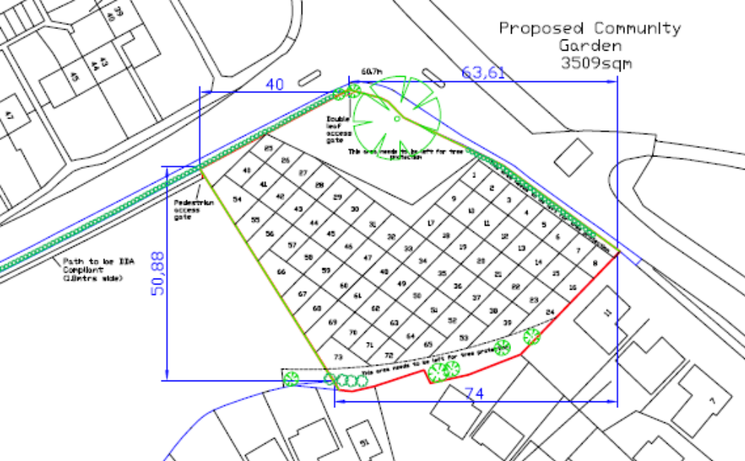

An area of land has been left in the northern corner for the retention of a large oak tree. A 1.8m palisade fence will form the boundary to the allotments; this will have a 3m double gate entrance as well as pedestrian entrances. This fence is required for security, only those who rent allotments and the community council (as owners of the site) will have access to the allotments.

Policy: Policies CLF1 and CLF4 seek to protect local facilities and ensure that land is not lost for sport and recreation purposes. In this instance, while an area of open space is being lost it is being replaced with allotment plots, which contribute to recreation facilities within the locality. The proposal is therefore in accordance with adopted policy.

Community meetings have been conducted regarding the loss of open space are area and the provision of allotments and the community council, as owners of the land have taken this on board prior to the submission of an application.

Landscape: Whilst the use of the land as allotments may not have a direct impact on the locality the associated sheds/greenhouses and other structures have the potential to create an untidy appearance, particularly given the prominent corner location of this site.

Any person who rents an allotment will have to have approval from the Community Council as owners of the site to erect and building or greenhouse on their plot. However, given the prominent location of the site a condition restricting the materials to be used for any buildings and the size will help ensure that the site does not have a detrimental impact on the locality.

The plots as indicated on the above plan will be set out in a geometric layout to allow for the best use of the land. A 1 metre footpath between each plot will allow for access to all the plots.

The palisade fencing, whilst necessary is not an attractive feature and this will be conditioned to be painted to minimise the effect on the landscape. Additionally the hedge on the north eastern boundary will have to be replanted to ensure a full boundary and to minimise views of the site from Cefn Road. The fencing will have to be set 1.5m within this hedge line to allow for growth.

The area of land under the oak tree is to be kept as a wild meadow with wild flowers planted, this will be an area of open space within the development for use by all the allotment occupiers.

Impact on neighbouring properties: The use of land as an allotment is unlikely to have any additional adverse impact on neighbouring properties than the existing open space and playing field.

A strip of land around the edge of the site will enable access to rear boundaries for those adjacent properties for maintenance of fences/walls etc.

The drainage issues have been considered as part of the application and are being looked at in conjunction with the Highways Department. As the land is cultivated drainage in the area may improve naturally.

Highways: The development site is bounded by Cefn Road (classified) to the north east and Abenbury Road (classified) to the north west. Cefn Road is subject to a 40mph speed limit along this section and Abenbury Road is subject to a 30mph speed limit.

There appears to be an existing gated access serving the development site located directly behind the traffic lights off Cefn Road. This access is poorly located directly behind the existing traffic lights, is difficult to access for vehicles approaching from the north west along Cefn Road due to the splitter island and suffers from inadequate visibility in the easterly direction.

I assume those people attending the allotments would normally park in the Pentre Gwyn Community Centre and walk along the proposed footway to the site. However, if on occasion there was insufficient space in the car park or they needed to drop off heavier items eg/ fertiliser or tools, it is likely that that they would attempt to park in close proximity to the site. This may involve them parking at the existing access (adjacent to the traffic lights) or along the frontage of the site along Cefn Road or Abenbury Road. On occasion, should a party or similar event take place at the community centre, there may be insufficient spaces to accommodate those tending to their allotments. This may once again cause indiscriminate parking along Abenbury Road or Cefn Road.

In view of the above Highways have recommended that the existing substandard gated access serving the development site off Cefn Road is permanently closed up and the footway reinstated to full height construction.

In order to avoid indiscriminate parking along these sections of Cefn Road and Abenbury Road, Highways recommend that the applicant funds a TRO (Traffic Regulation Order) to implement double yellow lines along these sections of Cefn Road and Abenbury Road. This will form a condition of any permission granted.

It is assumed that the existing gated access providing access onto Cefn Road located on the northern edge of the development site provides access to maintenance vehicles wishing to cut the grass and maintain the football pitch etc. Highways therefore recommend that an alternative access is provided for this purpose being served off the Pentre Gwyn Community Centre car park. Again this will be controlled by a condition.

CONCLUSION

The impact of the proposal on the neighbouring properties will be minimal and with conditions restricting the buildings on the site and maintaining the boundary hedges the impact on the landscape will be minimised. I therefore recommend accordingly.

RECOMMENDATION: That permission be GRANTED

CONDITION(S)

1. The development hereby permitted shall be begun before the expiry of five years from the date of this permission.
2. Development shall only be carried out in strict accordance with the approved plans unless the prior written approval of the Local Planning Authority has been obtained.
3. Prior to the commencement of development a boundary treatment scheme shall be submitted to and approved, in writing, by the Local Planning Authority. The scheme shall include provision for additional planting to the north eastern boundary hedge and be implemented within the first planting scheme following the commencement of development. Development shall only take place in accordance with those details as approved.
4. Prior to its installation on site, details of the proposed colour of the palisade fencing shall be submitted to and approved, in writing, by the Local Planning Authority. Development shall only take place in accordance with the details as approved.
5. The palisade fencing hereby approved shall be installed a minimum of 1.5m from the boundary hedge.
6. No direct selling of goods to the public shall take place from any part of the application site.
7. No floodlighting or other forms of lighting shall be installed on site unless otherwise agreed, in writing, by the Local Planning Authority.
8. No more than one shed measuring 2.5m by 2m and one greenhouse measuring 2.5m by 2m shall be located on each plot.
9. Any shed erected at the site shall only use wood as its external material.
10. Other than one shed and one greenhouse per plot, no other structures, permanent or movable shall be erected on the site.
11. All external surfaces of the sheds hereby approved shall be stained or painted dark brown, or any other such colour as shall be approved, in writing, by the Local Planning Authority.
- Within three months of the commencement of development the new football pitch to the south western end of the site shall be installed and available for use.
- The existing gated access serving the development site located directly behind the traffic lights off Cefn Road shall be permanently closed up prior to the first use of the allotments. The existing footway shall be reinstated to full height construction (see note).
- A suitable alternative access for maintenance vehicles shall be provided within the existing Pentre Gwyn Community Centre car park
- The applicant shall fund a TRO (Traffic Regulation Order) to implement double yellow lines along Cefn Road and Abenbury Road to the satisfaction of the Planning Authority.
- The erection of fencing for the protection of trees, hedges and shrubs shall be undertaken before any equipment, machinery or materials are brought onto the site for the purposes of the development, and shall be maintained until all equipment, machinery and surplus materials have been removed from the site. The above mentioned fencing shall consist of a scaffold framework in accordance with Figure 2 of British Standard 5837:2005 comprising a vertical and horizontal framework, well braced to resist impacts, with vertical tubes spaced at a maximum interval of 3 metres. Onto this, 2.1 metre weldmesh panels shall be securely fixed with wire or scaffold clamps. This fencing shall be erected at the extent of each trees Root Protection Area, as set out in British Standard 5837:2005. Nothing shall be stored or placed in any area fenced in accordance with this condition and the ground levels within those areas shall not be altered, nor shall any excavations be made without the written permission of the Local Planning Authority.
- No development shall take place until an Arboricultural Method Statement has been submitted to and approved in writing by the Local Planning Authority. The statement shall include a specification for tree protection fencing and ground protection measures that complies with British Standard 5837:2005; a plan showing the location of retained trees with their crown spreads, root protection areas, construction exclusion zones and the location of protective fencing and ground protection plotted. A full specification for any access, driveway, path, underground services, wall or fence foundations within retained trees root protection areas, including any related sections, details of general arboricultural matters including proposed practices with regards to cement mixing, material storage and fires; details of the frequency of supervisory visits and procedures for notifying the finding of such visits to the Local Planning Authority and method statement for protecting retained trees during demolition works should also be included. Works shall be carried out in accordance with the approved method statement.

REASON(S)

1. To comply with Section 91(3) of the Town and Country Planning Act, 1990.
2. To ensure that the development fully complies with the appropriate policies and standards.
3. To ensure views of the site are minimised from the adjacent road.
4. To maintain a satisfactory standard of appearance.
5. To ensure the hedge has sufficient space to become established.
6. To ensure the site remains as a community facility and not a retail outlet.
7. To maintain the amenity of the neighbouring properties.
8. In the interests of the visual amenities of the area.
9. In the interests of the visual amenities of the area.
10. In the interests of the visual amenities of the area.
11. In the interests of the visual amenities of the area.
- To ensure a football pitch is retained at the site for the use of the local community.
- In the interests of highway safety.
- To ensure the formation of a safe and satisfactory access.
- In the interests of highway safety.
- To protect trees which are of significant amenity value to the area
- To protect trees which are of significant amenity value to the area
______________________________________________________________

APPLICATION NO:  P/2008 /1294  COMMUNITY:  Caia Park  WARD:  Smithfield | LOCATION:  MECCA BINGO CLUB SMITHFIELD ROAD WREXHAM  DESCRIPTION:  VARIATION OF CONDITION NO. 1 OF PLANNING PERMISSION CODE NO. P/2006/1444, TO PERMIT OPENING UNTIL 12.00 (MIDNIGHT) ON ANY DAY.  APPLICANT(S) NAME:  MECCA BINGO LTD | DATE RECEIVED:  11/12/2008  CASE OFFICER:  PF  AGENT NAME:  MURDOCH ASSOCIATES
______________________________________________________________

SITE
TESCO
MECCA BINGO

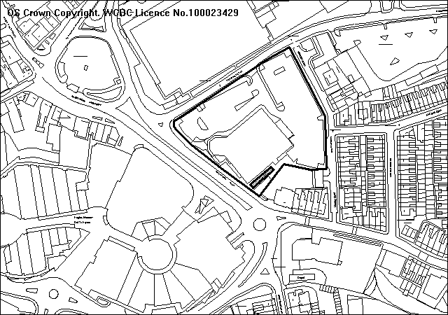
EAGLES MEADOW
Proposed smoking shelter extension

PROPOSAL

Is for the relaxation of condition no. 1 of P/2006/1444 to extend the opening hours of the bingo club from 1000hrs to 0900hrs and from 2300hrs until 0000hrs on any day.

HISTORY - Most relevant

CB01025 Erection of Bingo club with associated external and
highway works. Granted 12.05.1997
P/2005/0726 Variation of condition no. 12 of Planning Permission
CB0125 to permit opening until 12.30am. Refused 24.08.2005
P/2005/1320 Variation of condition no. 12 of planning permission
CB1025 to permit opening until 11.00 p.m. Granted 09.01.2006
P/2006/1444 Variation of condition no. 1 of planning permission code
no. P/2005/1320 to continue opening to 11:00pm.
Granted 05.03.2007
P/2008/1190 Removal of existing smoking shelter and existing planting and installation of larger timber clad smoking shelter. Pending

DEVELOPMENT PLAN

Within settlement limit. Policy GDP1 refers.

CONSULTATIONS

Community Council: No objection.
Local Member: Notified 12.12.2008.
Highways: No recommendations.
Public Protection: No comments.
Other representations: 25 notification letters issued. 2 letters of objection received raising the following points:
- Noise from smoking shelter will be later.
- Will encourage people to stand outside smoking in existing shelter.
- Council should not be encouraging gambling.
Site Notice: Expired 07.01.2009

SPECIAL CONSIDERATIONS

Background: A number of applications have been submitted previously to extend the opening hours of the bingo hall. The current opening hours were relaxed from 2230hrs until 2300hrs under planning permission P/2006/1444. Previous to this an application was submitted under code no. P/2005/0726 to open until 0030hrs which was refused.

Applicant’s justification: The current operation of the bingo hall revolves around the number of games, which are played in sessions. The last game usually finishes between 2130 and 2200hrs. After this time customers are able to stay in the hall to utilise gaming/amusement machines until closing time. The hall is licensed for this purpose under the Gambling Act 2005 between 0900 and 0000hrs on any day.

There have been changes in local circumstances since the previous consideration including opening of the Eagles Meadow complex, which has no hours restriction and offers much of the same facilities that Mecca Bingo offer. The Tesco Extra superstore is also operating on a 24-hour basis.

Amenity: The key consideration is the impact on residential amenity. There are residential properties to the east on Manley Road and Barons Road and to the south east with properties on the lower part of Smithfield Road. I am conscious of the existing uses around the bingo hall, especially the recently completed Eagles Meadow. However, given that the primary use of the site will have ceased by 2230hrs with only a small number of customers remaining I would not anticipate the increased opening hours significantly compounding any problems of noise and disturbance that currently exist.

I am however aware that the existing smoking shelter is used as a gaming area with loud speakers. The Council’s Licensing section has confirmed that machines and speakers in this area are used solely to play bingo games and do not include amusement machines. A current planning application for the extension of this smoking shelter is being considered (see report earlier in agenda – P/2008/1294). I do not anticipate that allowing extended opening hours will compound the increase in noise and disturbance if a condition that no use of any loudspeaker or public address system on any external part of the site or the smoking shelter be made after 2200hrs.

Other issues: I would not anticipate the additional morning and evening hours compounding any parking problems that may exist. Highways do not wish to make any recommendations.

Any concerns relating to the impact of gambling are issues covered under the Gambling Act 2005 and cannot be considered under the Town and Country Planning Act.

CONCLUSION

I am satisfied the proposal will not significantly affect the amenity of nearby residents and subject to controls over the external public address system I consider the additional morning and evening opening hours are acceptable.
P/200
RECOMMENDATION: That permission be GRANTED

CONDITION(S)

1. This permission shall be valid until 1 February 2010 and after that date the premises shall open at 1000 hours and close at 2300 hours unless a further permission has been granted by the Local Planning Authority.
2. No use of any external loud speaker, public address system or electronically audible gaming equipment shall be made after 2200 hours on any day unless otherwise agreed in writing by the Local Planning Authority. For the avoidance of doubt, this includes the smoking shelter to the south east of the building.

REASON(S)

1. In order that the Local Planning Authority may have the opportunity reviewing the impact of this development on the amenities of occupants of other properties in the vicinity in the light of experience of its operation.
2. To protect the amenities of the occupiers of nearby properties.

NOTE(S) TO APPLICANT

You are reminded that with the exception of Condition 12 of the original planning permission CB01025, all other conditions are still applicable.
You are reminded that there are residential properties nearby and every effort should be taken to avoid disturbing residents in the late evening.
______________________________________________________________

APPLICATION NO:  P/2008 /1301  COMMUNITY:  Gresford  WARD:  Marford & Hoseley | LOCATION:  LAND AT 48 WYNNSTAY LANE MARFORD WREXHAM  DESCRIPTION:  SUBSTITUTION HOUSE TYPE AND ALTERATIONS TO VEHICULAR ACCESS  APPLICANT(S) NAME:  MR F CREWE | DATE RECEIVED:  12/12/2008  CASE OFFICER:  SEH  AGENT NAME:  PARRY DAVIES PARTNERSHIP
______________________________________________________________

THE SITE

A flat site currently part of the residential curtilage of No. 48 Wynnstay Lane, Marford.

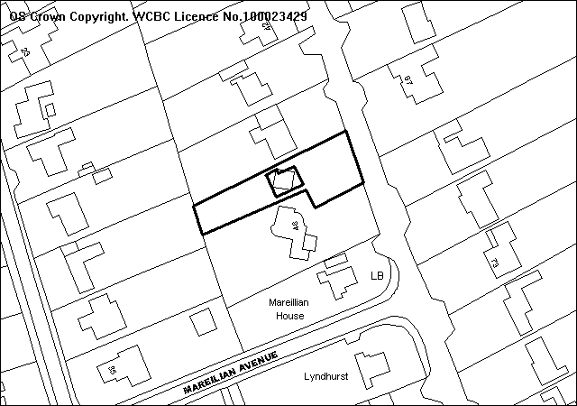
Application Site
Central Vehicular Access

PROPOSAL

Substitution house type and vehicular access improvements.

RELEVANT HISTORY

P/2006/0061 | Outline application for erection of dwelling | Refused | 15/03/2006
P/2006/0368 | Outline application for erection of dwelling | Granted | 6/06/2006
P/2006/1359 | Erection of detached dwelling (reserved matters) | Granted | 5/02/2007
P/2007/1166 | Erection of detached dwelling (substitution house type) | Refused | 18/02/2008

DEVELOPMENT PLAN

Within a defined settlement limit. UDP Policies PS1, PS2, GDP1, H2, EC4 and T8 apply. Local Planning Guidance Notes 16 ‘Parking Standards’ and 21 ‘Space around Dwellings’ are also relevant.

CONSULTATIONS

Community Council: Consulted 15.12.2008
Local Member: Consulted 15.12.2008
Public Protection: Consulted 15.12.2008
Highways: Consulted 15.12.2008
EA: No comments
Welsh Water: No objections subject to recommended planning conditions.
WACS: Object on the grounds that the erection of a dwelling on this site would be detrimental to the established character of the area where the houses are well spaced out with mature gardens, trees and other features.
Access Group: Notified 16.12.2008
Site Notice: Expired 07.01.2009
Other Representations: One letter of objection received raising the following:
- Appearance detrimental to the streetscene;
- Inappropriate scale and design;
- Lack of separation;
- Impact upon boundary trees;
- Need for adequate screening;
- Need for a garage;
- Loss of light;
- Overlooking.

SPECIAL CONSIDERATIONS/ ISSUES

Background: This is full application for the erection of a single two-storey dwelling and alterations to the vehicular access. Planning permission was granted for a two storey dwelling on this piece of land in February 2007 and this application seeks to amend the design of the building, and relocate the existing access to a central location within the frontage of the site. A previous application for such an amendment was refused in February 2008 due to the inappropriate design of the proposal and the detrimental impact that it would have on the appearance of the streetscene. Following discussions with the applicant and agent, I believe the current proposal overcomes these issues.

Design and Residential Amenity: The proposed dwelling has been designed to incorporate the features found within the existing surrounding dwellings. The scale and mass of the building is such that it sits comfortably within the site and the proposed dwelling does not overdominate the streetscene and is in-keeping with the character of the area.

The dwelling has been designed in such a way as to protect the privacy and provision of natural daylight (BRE standards) to the adjacent properties, and the separation distances as recommended within Local Planning Guidance Note No.21 ‘Space around Dwellings’ have been achieved.

Greater detail is required in relation to the proposed landscaping and boundary treatments for the site to ensure that the development does not cause any detrimental impact upon the amenities of the adjacent properties particularly in terms of natural screening for the development. Submission of these details will be secured by way of planning condition.

Highways: The existing vehicular access to the site is currently substandard and improvements are proposed to relocate it to a more central position within the frontage, to be shared with the existing house. The appropriate planning conditions will be attached to any subsequent consent to ensure that the access meets with the Council’s visibility standards. The new access arrangement will be a significant improvement on the existing and will be of benefit to the area.

CONCLUSION

The proposal is acceptable in terms of scale and design, and the development would make a positive visual contribution to the character and appearance of the area. The improved access arrangements to the site would be of benefit to highway safety in the area, and I recommend accordingly.

RECOMMENDATION: That permission be GRANTED

CONDITION(S)

1. The development hereby permitted shall be begun before the expiry of five years from the date of this permission.
2. Prior to their use on the development samples of all external facing and roofing materials shall be submitted to and approved in writing by the Local Planning Authority. The development shall only be carried out in strict accordance with such details as are approved.
3. Development shall only be carried out in strict accordance with the approved plans unless the prior written approval of the Local Planning Authority has been obtained.
4. This permission shall operate only to allow development to be carried out in accordance with the approved drawings and the application documentation. Notwithstanding the provisions of the Town and Country Planning (General Permitted Development) Order 1995, no further development shall take place within the site (other than the painting of the buildings).
5. Prior to commencement of development full details of both hard and soft landscaping works proposed for the site, to include boundary screening details (planting and fencing), shall be submitted to and approved, in writing, by the Local Planning Authority. Any trees or shrubs removed, dying, being severely damaged or becoming seriously diseased within five years of planting shall be replaced by trees or shrubs of similar size and species to those originally required to be planted.
6. All boundary treatments, hard and soft landscape works shall be carried out in accordance with the details approved in connection with condition number 5 above, and the works shall be carried out within 3 months of the first use of the development with the exception of soft landscaping which shall be carried out in the first planting season (November to March) or seeding season (April to September) following the first use.
7. The erection of fencing for the protection of trees and shrubs shall be undertaken before any equipment, machinery or materials are brought onto the site for the purposes of the development, and shall be maintained until all equipment, machinery and surplus materials have been removed from the site. The above mentioned fencing shall consist of a scaffold framework in accordance with Figure 2 of BS 5837 (2005) comprising a vertical and horizontal framework, well braced to resist impacts, with 2.1m vertical tubes spaced at a maximum interval of 3 metres. Onto this, weldmesh panels shall be securely fixed with wire or scaffold clamps. This fencing shall be erected at the full extent of the canopy of each tree and shrub. Nothing shall be stored or placed in any area fenced in accordance with this condition and the ground levels within those areas shall not be altered, nor shall any excavations be made without the written permission of the Local Planning Authority.
8. Any gates erected at the access point shall only open inwards and shall be sited no closer than 5 metres back from the highway.
9. Foul and surface water discharge shall be drained in accordance with the details contained within the application documentation.
10. No surface water shall be allowed to connect to the public sewerage system.
11. No land drainage run-off shall be permitted to discharge into the public sewerage system.
12. Prior to first use of the development the vehicle parking and turning facilities shall be implemented in accordance with the approved plan and shall thereafter be permanently retained free of all obstruction and made available for the parking of vehicles at all times.
13. Notwithstanding the provisions of the Town and Country Planning (General Permitted Development) Order, 1995 no additional windows shall be inserted into the north or south elevations of the building.
14. The rooflights as shown on drawing no. 4734/1 rev A shall be top opening only.
15. The ridge height of the proposed dwelling shall not exceed the ridge height of the adjacent property known as No. 46 Wynnstay Lane.

REASON(S)

1. To comply with Section 91(3) of the Town and Country Planning Act, 1990.
2. To ensure a satisfactory standard of appearance of the development in the interests of the visual amenities of the area.
3. To ensure that the development fully complies with the appropriate policies and standards.
4. Due to the restricted application site and its relationship with adjoining properties it is considered important to ensure that no additional development as described in the condition is carried out without the permission of the Local Planning Authority.
5. To ensure a satisfactory standard of appearance of the development in the interests of the visual amenities of the area.
6. To ensure a satisfactory standard of appearance of the development in the interests of the visual amenities of the area.
7. To protect trees which are of significant amenity value to the area.
8. To avoid the need for vehicles to wait within the highway.
9. To protect the integrity of the Public Sewerage System.
10. To prevent hydraulic overloading of the public sewerage system.
11. To prevent hydraulic overloading of the public sewerage system.
12. In order to provide sufficient parking clear of the highway.
13. In the interests of residential amenity of adjoining properties.
14. To protect the amenities of the occupiers of nearby properties.
15. To ensure a satisfactory standard of appearance of the development in the interests of the visual amenities of the area.

NOTE(S) TO APPLICANT

All ancillary operations and the use of plant and machinery, which are audible at the boundary, shall be carried out only between 07.30 hours to 19.30 hours Monday to Friday, between 08.00 hours and 14.00 on Saturdays and at no time on Sundays and Bank Holidays.

There shall be no bonfires on site; to include the prohibition of the burning of cleared vegetation.

A suitable dust management scheme shall be implemented on site to prevent dust nuisance from arising.

Applicants should note that the Council has the option to control construction site noise by means of a Control of Pollution Act 1974, Section 60, Notice, where deemed necessary.
______________________________________________________________

APPLICATION NO:  P/2008 /1320  COMMUNITY:  Ruabon  WARD:  Ruabon | LOCATION:  LAND ADJOINING TURNER HOUSE DANIELS DRIVE RUABON WREXHAM  DESCRIPTION:  AMENDMENT TO PLANNING PERMISSION CODE NO. P/2006/1160 TO PROVIDE WHEELCHAIR STORE AND COVERED WALKWAY.  -  APPLICANT(S) NAME:  MR BRYN DAVIES CYMDEITHAS TAI CLWYD | DATE RECEIVED:  19/12/2008  CASE OFFICER:  LB1  AGENT NAME:  ISP ARCHITECTS  MR CRAIG BAUGH
______________________________________________________________

SITE

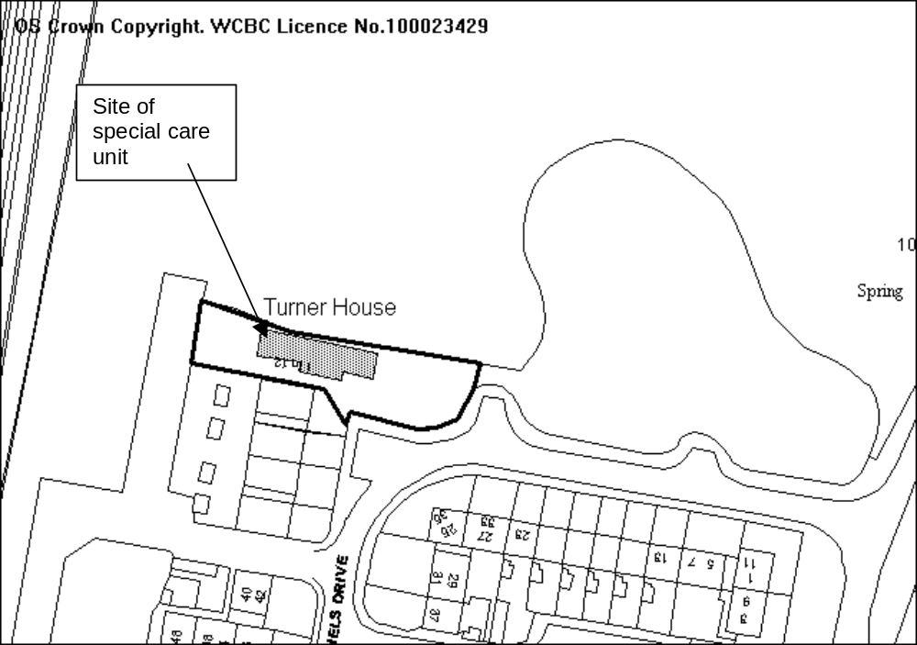Land adjacent to Turner House, Ruabon.

PROPOSAL

Amendment to planning permission code no. P/2006/1160 to provide wheelchair store and covered walkway.

HISTORY

P/2006/1160 Erection of single storey special care unit with 3 no. residents' bedrooms for an independent housing with support and long term care.

DEVELOPMENT PLAN

Lies within settlement limit and buffer zone for SAC, GDP1, PS2, EC6 and Guidance Notes 20, 16 & 21 apply.

CONSULTATIONS

Community Council: No objection

Local Member: No objection

Highways: Consulted 22/12/08
Public Protection: Recommend contamination condition added due to proximity to former Gardden Lodge landfill site.
CCW: Consulted 23/12/08
Other representations: One letter of objection received raising the following points:
- Constant disruption to locality from previous builders in the area.
- Area should be returned to the way it was previously so children can play football.
- The area has wild flowers and animals such as newts and toads and should remain for them.
Site Notice: Expired 16/01/09

SPECIAL CONSIDERATIONS

History: The site was granted planning permission in 2006 (application P/2006/1160) for a special care unit with 3 no. bedrooms. The current application is for amendments to the approved plans to include an external wheelchair store and covered walkway from the building to the parking area.

There was a previous application on the adjacent site (P/2006/0107) for the erection of a children’s play area to the east of the unit. This was withdrawn, however the land is designated for a play area in relation to the housing estate on the other side of New Hall Road.

Design and amenity: The design of the unit is simple and in keeping with the area, the amended details do not adversely affect the design.

The single storey unit lies adjacent to a three-storey apartment block and does not adversely affect the amenity of those occupiers. The unit is provided with sufficient garden area for the number of bedrooms and does not affect the designated children’s play area.

Ecology: The site lies 350m away from the designated SAC/SSSI site at Hafod Quarry. As such a Test of Likely Significance needs to be carried out to determine if there will be any adverse impact on protected species. As the site is currently an open area adjacent to a more secluded area of trees there may be potential for newts to be present at the site. Mitigation such as newt proof fencing should be installed prior to the commencement of development and if newts are found the appropriate licence obtained from the Welsh Assembly.

Other considerations: There are sufficient parking spaces at the site and adequate visibility has previously been demonstrated.

Children’s play equipment is to be installed adjacent to the site and an area will be designated for an informal play area under the terms of the permission for the housing estate.

CONCLUSION

The unit has previously been granted permission and the proposed amendments are acceptable with no adverse impact on the amenity of neighbouring properties. Appropriate working practices will ensure that protected species are not harmed during the construction process.
P/2008 /13
RECOMMENDATION: That permission be GRANTED

CONDITION(S)

1. The development hereby permitted shall be begun before the expiry of five years from the date of this permission.
2. No part of the development shall be commenced until samples of all external facing materials have been submitted to and approved in writing by the Local Planning Authority. The development shall only be carried out in strict accordance with such details as are approved.
3. Development shall only be carried out in strict accordance with the approved plans unless the prior written approval of the Local Planning Authority has been obtained.
4. The boundary treatments shall be in accordance with Drawing Number 6339L(9) 01 Revision C.
5. No surface water run off from the development site shall be allowed to flow onto the adjoining highway.
6. Development shall not begin on site until a scheme to deal with potential contamination at the site has been submitted to and approved in writing by the Local Planning Authority. This scheme shall include a phased investigation approach to identify the extent of contamination and any measures required to remediate the site, including post-development monitoring. Where remediation works are required, the development shall not be occupied/used until a Validation Report to show that the works have been satisfactorily carried out has been submitted to and approved in writing by the Local Planning Authority.
7. Prior to commencement of development details of Reasonable Avoidance Measures in relation to protected species shall be submitted to and approved in writing by the Local Planning Authority. These measures shall be put in place before development commences.

REASON(S)

1. To comply with Section 91(3) of the Town and Country Planning Act, 1990.
2. To ensure a satisfactory standard of appearance of the development in the interests of the visual amenities of the area.
3. To ensure that the development fully complies with the appropriate policies and standards.
4. In the interests of highway safety and the visual amenity of the area.
5. In the interests of highway safety.
6. In the interests of the amenities of the future occupants of the buildings
7. To ensure that protected species are not harmed in the construction process.
______________________________________________________________

APPLICATION NO:  P/2008 /1322  COMMUNITY:  Chirk  WARD:  Chirk North | LOCATION:  LLETY YR EOS WHITEHURST CHIRK WREXHAM  DESCRIPTION:  PORCH EXTENSION AND ERECTION OF DETACHED DOUBLE GARAGE WITH HOBBY ROOM ABOVE.  APPLICANT(S) NAME:  MR PAUL JONES | DATE RECEIVED:  19/12/2008  CASE OFFICER:  LB1  AGENT NAME:  MR PAUL JONES
______________________________________________________________

SITE

Detached property in Whitehurst.

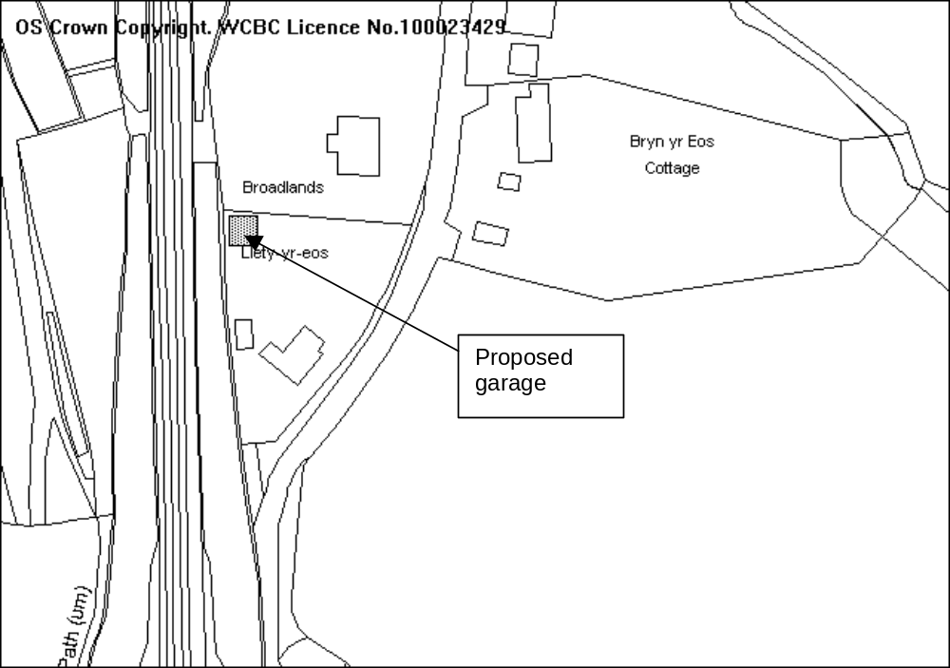

PROPOSAL

Erection of detached double garage with hobby room above and porch extension to front of property.

HISTORY

None relevant.

DEVELOPMENT PLAN

Lies outside of settlement limit in Green Barrier and within buffer zone for potential World Heritage Site. Policies GDP1, PS2, EC1 and Guidance Notes 20 and 21 apply.

CONSULTATIONS

Community Council: Consulted 22/12/08

Local Member: Consulted 22/12/08
Other representations: Two letters of objection received raising the following points:
- The building will be a similar height to that of a bungalow rather than that of a usual garage
- The building will be more prominent due to it’s siting at the highest part of the garden.
- The velux windows should be high level to ensure no overlooking is created.
- The building would be intrusive to neighbouring properties
- Rainwater from the roof of the building should drain into soakaways and not into neighbouring gardens.
Site Notice: Expired 16/01/09

SPECIAL CONSIDERATIONS

The site: The property lies outside of the settlement limit and within the green barrier, however is sited within a cluster of 8 houses. Whilst the site lies within the buffer zone for the potential World Heritage Site the canal is not visible from the site and the adjacent railway line acts as a buffer between the house and canal. There will therefore be no adverse impact on the potential World Heritage Site.

As the site is within a cluster of houses the erection of a garage will not have an adverse impact on the openness of the green barrier.

The site slopes down towards the road to the east by approximately 2m. There are hedges along the boundaries of the property with the road and the neighbouring property and sparse trees along the boundary with the railway line.

The proposal: The property is a two storey detached property some 7.5m high. The proposed porch is of simple design with materials to match the existing house. It will have no adverse impact on the nearby properties.

The proposed garage will be 5.85m high, lower than the existing house. It will be a double garage on the ground floor with a study/hobby room above. The upper level will be accessed by an internal staircase and will have high level rooflights to provide light. As there are no windows there will be no overlooking to neighbouring houses created. The rooflights are at a level that would prevent direct overlooking; additionally the distance from the proposed garage to neighbouring properties meets the required separation distances. The rooflights will be secured at high level by condition.

The garage does lie at the highest part of the site in relation to neighbouring properties, however the distance from neighbouring properties will ensure that the building will not overdominate the locality.

Whilst the garage is higher than a traditional single storey structure, it’s height and size are not such that it could be used as an additional dwelling. A condition will be placed on any permission ensuring that the garage is used only for ancillary purposes.

The design of the garage is appropriate for the location and the materials used will be similar to that on the house.

CONCLUSION

Given the location of the garage it will not have a detrimental impact on the neighbouring properties and I therefore recommend accordingly.

RECOMMENDATION: That permission be GRANTED

CONDITION(S)

1. The development hereby permitted shall be begun before the expiry of five years from the date of this permission.
2. No facing materials shall be used other than materials matching those used on the existing building.
3. Development shall only be carried out in strict accordance with the approved plans unless the prior written approval of the Local Planning Authority has been obtained.
4. Any garage erected under this permission shall be used only for a purpose incidental to the use of that dwelling as a single dwelling house provided that such use shall not preclude the garaging of a private motor car.
5. The rooflights at their lowest level shall be a minimum of 1.8m from the finished first floor level of the building.

REASON(S)

1. To comply with Section 91(3) of the Town and Country Planning Act, 1990.
2. To ensure a satisfactory standard of appearance of the development in the interests of the visual amenities of the area.
3. To ensure that the development fully complies with the appropriate policies and standards.
4. To ensure that the garage is not used in a manner prejudicial to or likely to cause nuisance or disturbance to the occupiers of nearby properties and to ensure that facilities for the garaging of a car remain available at this address at all times.
5. To ensure no overlooking to neighbouring properties is created.

NOTE(S) TO APPLICANT

You should ensure that any difference between the plans approved under the Town and Country Planning Acts and under the Building Regulations is resolved prior to commencement of development, by formal submission of amended plans.

You are advised that building work which involves work on an existing wall shared with another property, building on the boundary with a neighbouring property or excavating near a neighbouring building may require the separate consent of the neighbour under the provisions of the Party Wall Act. If you require further information or advice please contact the Building Control Section on 01978 292050.

The proposed development lies within an area which could be subject to current coal mining or hazards resulting from past coal mining. Such hazards may currently exist, be caused as a result of the proposed development, or occur at some time in the future. These hazards include:

· Collapse of shallow coal mine workings.
· Collapse of, or risk of entry into, mine entries (shafts and adits).
· Gas emissions from coal mines including methane and carbon dioxide.
· Spontaneous combustion or ignition of coal which may lead to underground heatings and production of carbon monoxide.
· Transmission of gases into adjacent properties from underground sources through ground fractures.
· Coal mining subsidence.
· Water emissions from coal mine workings.

Applicants must take account of these hazards which could affect stability, health & safety, or cause adverse environmental impacts during the carrying out their proposals and must seek specialist advice where required. Additional hazards or stability issues may arise from development on or adjacent to restored opencast sites or quarries and former colliery spoil tips.

Potential hazards or impacts may not necessarily be confined to the development site, and Applicants must take advice and introduce appropriate measures to address risks both within and beyond the development site. As an example the stabilisation of shallow coal workings by grouting may affect, block or divert underground pathways for water or gas.

In coal mining areas there is the potential for existing property and new development to be affected by mine gases, and this must be considered by each developer. Gas prevention measures must be adopted during construction where there is such a risk. The investigation of sites through drilling alone has the potential to displace underground gases or in certain situations may create carbon monoxide where air flush drilling is adopted.

Any intrusive activities which intersect, disturb or enter any coal seams, coal mine workings or coal mine entries (shafts and adits) require the prior written permission of the Coal Authority. Such activities could include site investigation boreholes, digging of foundations, piling activities, other ground works and any subsequent treatment of coal mine workings and coal mine entries for ground stability purposes.

Failure to obtain Coal Authority permission for such activities is trespass, with the potential for court action. In the interests of public safety the Coal Authority is concerned that risks specific to the nature of coal and coal mine workings are identified and mitigated.

The above advice applies to the site of your proposal and the surrounding vicinity. You must obtain property specific summary information on any past, current and proposed surface and underground coal mining activity, and other ground stability information in order to make an assessment of the risks. This can be obtained from The Coal Authority's Property Search Service on 0845 762 6848 or at www.groundstability.com

______________________________________________________________

APPLICATION NO:  P/2008 /1324  COMMUNITY:  Gresford  WARD:  Gresford East & West | LOCATION:  5 BODWYN PARK GRESFORD WREXHAM  DESCRIPTION:  DEMOLITION OF EXISTING HOUSE AND GARAGE AND ERECTION OF ONE BLOCK OF 5 SELF CONTAINED FLATS.  APPLICANT(S) NAME:  EARDLEY PROPERTY CO. LTD | DATE RECEIVED:  19/12/2008  CASE OFFICER:  SJG  AGENT NAME:  TECWYN WILLIAMS
______________________________________________________________

THE SITE

The site is on the east side of Bodwyn Park entrance fronting Chester Road. The site has an area of 576m².
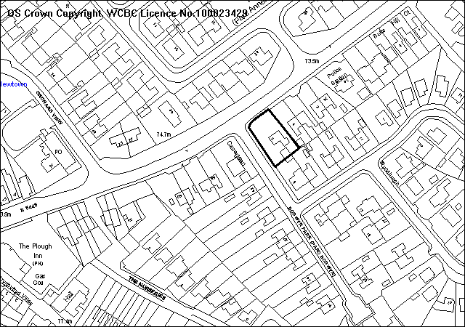

PROPOSAL

As above.

The scheme involves an L shaped block providing 2, two bed flats fronting Chester Road and 2 one bed flats in the rear wing fronting Bodwyn Park. The roofpace is utilised to provide a further one bedroom flat. The scheme includes a detailed design statement and a street scene. Access to Bodwyn Park is retained and a new access is proposed to Chester Road, creating a total of 8 parking spaces.

The Chester Road elevation has eaves matching the level of the adjoining dwelling (4) and 3 rooflights are used for the second floor flat. There are 8 solar panels and a rooflight on the rear wing facing Bodwyn Park. Materials are rendered walls and a natural slate roof.

A detailed Design and access statement has been supplied.

SITE PLAN

RELEVANT HISTORY

P/2008/1049 5 flats Withdrawn November 2008

DEVELOPMENT PLAN

The site is within the settlement limits. Policies GDP1 GDP2 H2 PS1 PS2 and T8 of the UDP are relevant, together with Local Planning Guidance Notes 16, 21, 22 and 27.

CONSULTATIONS

Gresford C Council: Consulted 22/12/2008
Local Member: Objects on grounds of:
- The development is totally out of keeping with the present houses
- Adverse visual impact of flats damaging to Gresford Village
- Site is at a busy road junction, and the increased traffic would create more highway safety problems
Highways: No objections subject to conditions
WACS: Whilst the Society feels that the proposed new building is somewhat large in comparison to existing dwellings, they are happy to withdraw their previous objection
Public Protection: Recommend conditions
Env Agency: Standard advice applies
Welsh Water: Recommend conditions. Sewer crosses site
Site Notice: Expired 19/1/2009
Other representations: Adjoining occupiers notified 23/12/2008. 19 objections received, on grounds of:
- Development of 5 flats would be out of character with the locality and contrary to policy GDP1a.
- Over-development of the site to the detriment of visual and residential amenity
- Inadequate parking provision will lead to on-street parking in an area where problems already occur due to proximity to shops and services.
- Additional traffic using an inadequate entrance to the estate, which was not designed for current traffic levels.
- No-waiting restrictions should be considered.
- Existing foul drainage problems will be exacerbated causing nuisance to dwellings from flooding
- Overlooking of adjoining properties from windows and excessive height of building
- Parking area fronting Bodwyn Park is incorrect and would require removal of a fence belonging to adjoining property (revised plan received)

SPECIAL CONSIDERATIONS/ ISSUES

Policy: The application site is within the development boundary of Gresford, the following development plan policies are applicable:

This is a re -submission of a previously withdrawn application for the same proposal. The scale and mass of the revised proposal has been reduced with a reduction in the roof height and the removal of the outrigger previously proposed on the south west elevation. In addition the extent of hard-surfacing has been reduced. The proposal is now considered to be acceptable in relation to criterion a) of GDP1.

LPG 16 in relation to parking standards recommends a maximum of 8.5 spaces for this proposal. The proposal is providing 8 spaces, I have no objection to the amount of parking space being provided as long as highways are satisfied that there will be no adverse highway safety impacts.

(Schools contributions do not apply in this case as there are only 2no. 2 bed flats.)

Residential amenity: The development achieves separation distances and provides adequate amenity space for the dwellings.

Sustainability: The development achieves many positive aspects in terms of accessibility, recycling and energy use/conservation. There are also roof mounted solar panels to provide for domestic water heating.

Parking and highway safety: The provision of 8 spaces is considered acceptable for the development in terms of LPGN16/TAN18. The highway authority previously recommended conditions and a traffic regulation order to provide for double yellow lines at the junction. A revised plan has been submitted to clarify the parking spaces and boundary treatment adjoining 6 Bodwyn Park.

Drainage: No objections are raised by Welsh Water.

RECOMMENDATION A

That the Council enters into an obligation under Section 106 of the Town and Country Planning Act 1990, requiring:
A payment to cover the costs of a traffic regulation order to provide for double yellow lines at the Chester Road/ Bodwyn Crescent junction
The Chief Planning Officer be given delegated authority to determine the form of the agreement.

RECOMMENDATION B

That permission be granted on completion of the agreement, subject to conditions:-

CONDITION(S)

1. The development hereby permitted shall be begun before the expiry of five years from the date of this permission.
2. Development shall only be carried out in strict accordance with the approved plans unless the prior written approval of the Local Planning Authority has been obtained.
3. Prior to their use on the development samples of all external facing and roofing materials shall be submitted to and approved in writing by the Local Planning Authority. The development shall only be carried out in strict accordance with such details as are approved.
4. No part of the development hereby permitted shall be commenced until full details of both hard and soft landscape works for the site have been submitted to and approved in writing by the Local Planning Authority. The works shall be implemented in accordance with a timescale to be approved in conjunction with the scheme of details.
5. All hard and soft landscape works shall be carried out in accordance with the approved details as set out in Condition 4. The works shall be carried out within 3 months of the first use of the development with the exception of soft landscaping which shall be carried out in the first planting season (November to March) or seeding season (April to September) following the first use.
6. Any trees or shrubs removed, dying, being severely damaged or becoming seriously diseased within five years from the completion of the scheme shall be replaced by trees or shrubs of similar size and species to those originally required to be planted unless otherwise approved in writing by the Local Planning Authority.
7. The vehicle parking and turning areas indicated on the approved plans shall be laid out, surfaced and drained prior to the first use of the building hereby granted and shall thereafter be retained for those purposes.
8. This permission shall operate only to allow development to be carried out in accordance with the approved drawings and the application documentation. Notwithstanding the provisions of the Town and Country Planning (General Permitted Development) Order 1995, no further development shall take place within the site (other than the painting of the buildings).
9. The site shall be developed in accordance with the ground and floor levels indicated on the approved plans. No changes to floor levels or external ground levels shall be made without the prior written approval of the Local Planning Authority.
10. Construction works, ancillary works and the use of plant or machinery audible at or beyond the site boundary shall only be carried out between the hours of 07:30 and 19:30 (Monday to Friday) and 08:00 to 14:00 (Saturday) and at no time on Sundays or Bank Holidays.
11. The proposed access to Chester Road shall be a minimum width of 4.5 metres, and shall provide visibility splays of 2.4 metres by 43 metres in both directions measured along the nearside edge of the adjoining highway in which there shall be no obstruction in excess of 1.0 metre in height.
12. From a point on the centre line of the accesses 2.4 metres back from the edge of the footway, to points 3.3 metres to both sides of that point measured along the edge of the carriageway, all obstructions to visibility shall be reduced to and thereafter maintained at a height not exceeding 0.6 metre above the level of the adjacent carriageway.
13. The accesses shall be hard surfaced for a distance of 5m behind the highway boundary before the development is brought into use.
14. Notwithstanding the provisions of the Town and Country Planning (General Permitted Development) Order 1995, no gate or other barrier shall be erected across the access within 5 metres of the boundary of the highway.
15. A 2m wide footway shall be constructed along the entire frontage on Chester Road prior to the occupation of any dwelling hereby approved. The existing street lighting column (no. 43) shall be re-located to the satisfaction of the Local Planning Authority as part of the scheme.
16. No water of any kind generated by the proposed development shall be permitted to flow from any part of the site, such as driveways, on to the highway or into the highway drainage system or be allowed to accumulate in such a way as to affect the highway surface or structure.

REASON(S)

1. To comply with Section 91(3) of the Town and Country Planning Act, 1990.
2. To ensure that the development fully complies with the appropriate policies and standards.
3. To ensure a satisfactory standard of appearance of the development in the interests of the visual amenities of the area.
4. To ensure a satisfactory standard of appearance of the development in the interests of the visual amenities of the area.
5. To ensure a satisfactory standard of appearance of the development in the interests of the visual amenities of the area.
6. To ensure a satisfactory standard of appearance of the development in the interests of the visual amenities of the area.
7. To provide for the loading, unloading, parking and turning of vehicles clear of the highway and to ensure that reversing by vehicles into or from the highway is rendered unnecessary in the interest of traffic safety.
8. Due to the restricted application site and its relationship with adjoining properties it is considered important to ensure that no additional development as described in the condition is carried out without the permission of the Local Planning Authority.
9. To ensure that the development fully complies with the appropriate policies and standards.
10. To protect the amenities of the occupiers of nearby properties.
11. To ensure that adequate visibility is provided at the proposed point of access to the highway.
12. For the safety and convenience of all pedestrians, but in particular, the elderly, the disabled and wheelchairs, pram, and pushchair users.
13. To ensure that no deleterious material is carried onto the highway, in the interests of highway safety.
14. In the interests of highway safety.
15. In the interests of highway safety.
16. In the interests of highway safety.

NOTE(S) TO APPLICANT

The proposed development lies within an area which could be subject to current coal mining or hazards resulting from past coal mining. Such hazards may currently exist, be caused as a result of the proposed development, or occur at some time in the future. These hazards include:

· Collapse of shallow coal mine workings.
· Collapse of, or risk of entry into, mine entries (shafts and adits).
· Gas emissions from coal mines including methane and carbon dioxide.
· Spontaneous combustion or ignition of coal which may lead to underground heatings and production of carbon monoxide.
· Transmission of gases into adjacent properties from underground sources through ground fractures.
· Coal mining subsidence.
· Water emissions from coal mine workings.

Applicants must take account of these hazards which could affect stability, health & safety, or cause adverse environmental impacts during the carrying out their proposals and must seek specialist advice where required. Additional hazards or stability issues may arise from development on or adjacent to restored opencast sites or quarries and former colliery spoil tips.

Potential hazards or impacts may not necessarily be confined to the development site, and Applicants must take advice and introduce appropriate measures to address risks both within and beyond the development site. As an example the stabilisation of shallow coal workings by grouting may affect, block or divert underground pathways for water or gas.

In coal mining areas there is the potential for existing property and new development to be affected by mine gases, and this must be considered by each developer. Gas prevention measures must be adopted during construction where there is such a risk. The investigation of sites through drilling alone has the potential to displace underground gases or in certain situations may create carbon monoxide where air flush drilling is adopted.

Any intrusive activities which intersect, disturb or enter any coal seams, coal mine workings or coal mine entries (shafts and adits) require the prior written permission of the Coal Authority. Such activities could include site investigation boreholes, digging of foundations, piling activities, other ground works and any subsequent treatment of coal mine workings and coal mine entries for ground stability purposes.

Failure to obtain Coal Authority permission for such activities is trespass, with the potential for court action. In the interests of public safety the Coal Authority is concerned that risks specific to the nature of coal and coal mine workings are identified and mitigated.

The above advice applies to the site of your proposal and the surrounding vicinity. You must obtain property specific summary information on any past, current and proposed surface and underground coal mining activity, and other ground stability information in order to make an assessment of the risks. This can be obtained from The Coal Authority's Property Search Service on 0845 762 6848 or at www.groundstability.com

Your attention is drawn to Highway Supplementary Notes Numbered 1, 3, 4 and 5 on the enclosed "Applicants' Rights and General Information".

The applicant will need to widen the existing dropped kerb crossing outside the property along Bodwyn Park including strengthening of the footway at the point of access and will need to apply for formal consent pursuant to Section 184 of the Highways Act 1980.

The proposed footway along Chester Road should be constructed to a standard suitable for adoption by the Council for future maintenance at the public expense and the developer will need to enter into an agreement with the Council under s.38/278 of the Highways Act 1980.

You are advised that the Highway Authority will require such works to be completed to their satisfaction before they will formally adopt the relevant Highway works for public use and to be maintained at public expense. This will include the provision of a bond to cover the estimated value of such works.

The appropriate fees will become due to the Council when the Highways Authority approve the proposed works to be carried out.

Any proposed modifications to the existing street lighting column along Chester Road will require approval from our Street Lighting Section. Please liaise with Mr. Geoff Edwards (WCBC Street Lighting Engineer) on Tel: 01978 296003.

The proposed double yellow lines either side of the Bodwyn Park/Chester Road junction will be subject to a public consultation exercise. Please liaise with Mr. Darren Green (Senior Traffic Engineer) on Tel: 01978 297141 to discuss/instigate this process.

Please note the attached comments from Welsh Water and Public Protection.
______________________________________________________________

APPLICATION NO:  P/2008 /1343  COMMUNITY:  Caia Park  WARD:  Queensway | LOCATION:  LAND OFF COED ABEN CAIA PARK WREXHAM  DESCRIPTION:  INSTALLATION OF NEW CHILDREN'S PLAY AREA WITH BOW TOP FENCING  APPLICANT(S) NAME:  MR J BRADBURY | DATE RECEIVED:  29/12/2008  CASE OFFICER:  LG  AGENT NAME:  MR J BRADBURY
______________________________________________________________

THE SITE

A flat site of land currently part of Coed Aben informal open space.

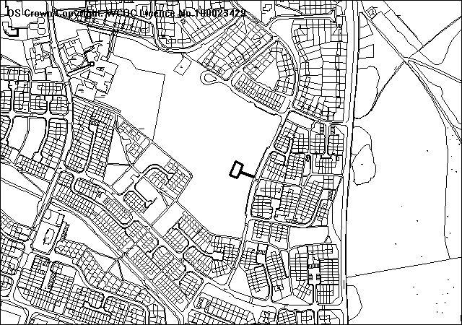
Proposed Play Area

PROPOSAL

As above.

RELEVANT HISTORY

None relevant.

DEVELOPMENT PLAN

Within a defined settlement limit. UDP Policies PS2, GDP1 and CLF4 apply.

CONSULTATIONS

Community Council: Consulted 06.01.2009
Local Member: Consulted 06.01.2009
Public Protection: Consulted 06.01.2009
Highways: No objections subject to a condition to provide adequate pedestrian access
Access Group: Notified 06.01.2009
Site Notice: Expired 30.01.2009
Other Representations: One letter of objection received raising the following:
- Impact on the area in terms of noise, and
- Users parking in the lay by.
A further representation has been received from a resident stating they have no objections provided that the play area does not encourage anti-social behaviour

SPECIAL CONSIDERATIONS/ ISSUES

Background: This is full application for the installation of a children’s’ play area on land which forms part of an informal open space area. The play area is relatively small measuring approximately 200 square metres and will be secured by steel bow topped fencing with a pro-safe self-closing gate. Proposed are bitumen macadam pathways connecting the wetpour safe surface areas between the play equipment. The area will include items such as children’s swings and a slide etc, together with a supervision bench, aimed at an age range of 4-10 years. The main issues to consider relate to impact upon highway safety and residential amenity.

Residential Amenity: The proposed play area is located some 35 metres away from the nearest dwelling. Given this substantial distance and the fact this area is already informal recreation land I do not consider that the proposed play area would give rise to increased noise disturbance problems in the area.

Highways: Given the minor nature of the development, it is considered unlikely that a high number of users would visit the play area by car. As this development is aimed at use local people arriving on foot, it is unlikely that the proposal will increase the intensity of the use of the highway or add any significant pressures to the available parking facilities.
I

CONCLUSION

I do not consider that the proposed play area would significantly detrimentally impact upon local residential amenity or highway safety, and I recommend accordingly.

RECOMMENDATION: That permission be GRANTED

CONDITION(S)

1. The development hereby permitted shall be begun before the expiry of five years from the date of this permission.
2. Development shall only be carried out in strict accordance with the approved plans unless the prior written approval of the Local Planning Authority has been obtained.
3. The access path shall be 2.0m wide in accordance with the Department of Transport Inclusive Mobility Guidelines.

REASON(S)

1. To comply with Section 91(3) of the Town and Country Planning Act, 1990.
2. To ensure that the development fully complies with the appropriate policies and standards.
- For the safety and convenience of all pedestrians.

NOTE(S) TO APPLICANT

The applicant’s attention should be drawn to item nos. 1, 3, 4 & 5 of the supplementary notes.
______________________________________________________________

LIST OF DELEGATED DECISIONS ISSUED

WRO P/2007/1087  WITHDRAWN  on 07/01/2009 | Barracks Fields Brynycabanau Road Wrexham LL13 7BW | Residential development (25 no. Dwellings)
BRN P/2008/0671  GRANTED  on 14/01/2009 | THE COTTAGE HIGHER LANES ISCOYD WHITCHURCH SHROPSHIRE SY13 3AX | GROUND AND FIRST FLOOR EXTENSIONS
CHI P/2008/0765  GRANTED  on 12/01/2009 | WHITEHURST HOUSE WHITEHURST CHIRK WREXHAM LL14 5AS | GARDEN ROOM/KITCHEN EXTENSION AND ALTERATIONS AND REPAIR TO OUTBUILDING TO OPERATE UTILITY ROOM.
CEI  P/2008/0870  GRANTED  on 19/12/2008 | LLIDIART CAE HIR LLANARMON DYFFRYN CEIRIOG LLANGOLLEN LL20 7LF | ERECTION OF 14M REPEATER MAST
WRR P/2008/0925  GRANTED  on 14/01/2009 | 12 WESTON DRIVE STANSTY WREXHAM LL11 2DE | LISTED BUILDING CONSENT FOR NEW WINDOWS TO FRONT AND SIDE ELEVATIONS, AND MINOR INTERNAL ALTERATIONS.
GRE P/2008/0935  GRANTED  on 16/01/2009 | GLADWYN LODGE CHESTER ROAD GRESFORD WREXHAM LL12 8PP | ALTERATIONS AND EXTENSION
WRR P/2008/0991  GRANTED  on 14/01/2009 | 12 FLEMING DRIVE WREXHAM LL11 2BP | SIDE AND REAR EXTENSIONS.
GLY P/2008/1061  GRANTED  on 06/01/2009 | CASTLE MILL BRIDGE CASTLE MILL CHIRK WREXHAM LL14 5BL | LISTED BUILDING CONSENT FOR ERECTION OF BRONZE PLAQUE
LLA P/2008/1124  GRANTED  on 19/12/2008 | 14 ASH GROVE LLAY WREXHAM LL12 0UF | 30% CROWN VOLUME REDUCTION, THIN INNER CROWN AND CROWN RAISE TO 3 METRES TO 1 NO. OAK TREE (WCBC NO. 46)
GRE P/2008/1141  GRANTED  on 18/12/2008 | FAIRFIELD BARKERS LANE BORRAS WREXHAM LL13 9TP | CHANGE OF USE OF LAND TO PROVIDE TURNING AREA IN ASSOCIATION WITH ADJOINING SITE (IN RETROSPECT)
GRE P/2008/1148  WITHDRAWN  on 22/12/2008 | 48/48A CHESTER ROAD GRESFORD WREXHAM LL12 8NE | DEMOLITION OF NO. 48/48A AND RE-BUILDING 2 NO. SHOPS WITH FLAT ABOVE AND CAR PARKING TO REAR.
BRO P/2008/1159  GRANTED  on 23/12/2008 | SUNNYSIDE WREXHAM ROAD BRYNTEG WREXHAM LL11 6HS | TWO STOREY EXTENSION TO SIDE OF EXISTING DWELLING
PEN P/2008/1170  GRANTED  on 29/12/2008 | NANT Y CROGFRYN LAMBPIT STREET PEN Y CAE WREXHAM LL14 2RB | PRUNE BACK SIDE OF CROWN ON WEST AND EAST SIDE, OFF CROWN BY UP TO 2.5M IN LENGTH PRUNING BACK TO SUB-LATERAL BRANCHES (WITHIN A CONSERVATION AREA).
ESC P/2008/1171  GRANTED  on 19/12/2008 | TALWRN NURSERY TALWRN ROAD LEGACY WREXHAM LL14 4ER | REMOVAL OF CONDITION 2 OF PLANNING PERMISSION CODE NO. 6/ESA/5317 RELATING TO AGRICULTURAL OCCUPANCY.
GRE P/2008/1173  GRANTED  on 08/01/2009 | 5 EYTON GRANGE HILLOCK LANE GRESFORD WREXHAM LL13 0SW | SINGLE STOREY REAR EXTENSION
COE P/2008/1178  GRANTED  on 29/12/2008 | 73 HIGH STREET COEDPOETH WREXHAM LL11 3UF | OUTLINE APPLICATION FOR ERECTION OF DETACHED DWELLING
BRO P/2008/1179  GRANTED  on 23/12/2008 | 4 BRYN CELYN MOSS WREXHAM LL11 6EJ | EXTENSION ABOVE EXISTING GARAGE TO FORM BEDROOM
GRE P/2008/1181  GRANTED  on 19/12/2008 | LAND ADJACENT TO TURNPIKE CROFT PANT LANE MARFORD WREXHAM LL12 8SH | RE-SITING OF PROPOSED DWELLING PREVIOUSLY APPROVED UNDER PLANNING PERMISSION CODE No. P/2007/1321
CHI P/2008/1193  REFUSED  on 09/01/2009 | PLAS OFFA FARM CHIRK WREXHAM LL14 5AN | OUTLINE APPLICATION FOR ERECTION OF 10 NO. AFFORDABLE TWO BEDROOM DWELLINGS.

WRR P/2008/1196  GRANTED  on 07/01/2009 | 8 DORSET DRIVE WREXHAM LL11 2UW | EN SUITE EXTENSION TO BEDROOM TO FRONT ELEVATION AND REMOVE FLAT ROOF TO GARAGE AND REPLACE WITH PITCHED ROOF TO MATCH EXISTING.
ROS P/2008/1197  GRANTED  on 09/01/2009 | DARLAND GOLF CHESTER ROAD LAVISTER, ROSSETT WREXHAM LL12 0DF | REVISED DESIGN OF CLUB HOUSE BUILDING PREVIOUSLY APPROVED UNDER PERMISSION CODE NO. CB 1168.
WRC P/2008/1207  GRANTED  on 23/12/2008 | GLAN GORS OFF ANTHONY EDEN DRIVE CAIA PARK WREXHAM LL13 9FF | CONSTRUCTION OF 4 NO. 2 BEDROOM BUNGALOWS WITH ASSOCIATED PARKING, CAR PORTS AND EXTERNAL STORES TOGETHER WITH ROAD WIDENING AND NEW FOOTPATH.
HOL P/2008/1211  GRANTED  on 19/12/2008 | 3 MILLFIELD HOLT WREXHAM LL13 9WJ | SINGLE STOREY EXTENSION TO REAR OF DWELLING
BRO P/2008/1214  GRANTED  on 23/12/2008 | 1 AFONDALE GATEWEN ROAD NEW BROUGHTON WREXHAM LL11 6UP | RELOCATION OF EXISTING VEHICULAR ACCESS
WRO P/2008/1215  GRANTED  on 12/01/2009 | SCHOOL OF ART AND DESIGN 49 REGENT STREET WREXHAM LL11 1PF | DISPLAY OF NEW NAME SIGNS
WRR P/2008/1217  GRANTED  on 12/01/2009 | GLYNDWR UNIVERSITY MOLD ROAD WREXHAM LL11 2AW | DISPLAY OF NEW NAME SIGNS
RUA P/2008/1220  WITHDRAWN  on 07/01/2009 | GARDDEN COTTAGE TATHAM ROAD RUABON WREXHAM LL14 6RF | INSTALLATION OF A RADIO BASE STATION COMPRISING 3.5M EXTENSION TO EXISTING 20M MAST COMPRISING ANTENNAS, TRANSMISSION DISHES, GROUND BASED EQUIPMENT CABINETS ETC.
HOL P/2008/1221  GRANTED  on 12/01/2009 | HUGMORE HOUSE FARM HUGMORE LANE LLANYPWLL WREXHAM LL13 9YE | CONSTRUCTION OF SMALL PRIVATE RECREATIONAL LAKE WITH CONSERVATION POOL TO ENHANCE BIODIVERSITY
GRE P/2008/1222  GRANTED  on 14/01/2009 | 59 STANCLIFFE AVENUE GRESFORD WREXHAM LL12 8LN | CONVERSION OF EXISTING GARAGE INTO HABITABLE ROOM / SHOWER ROOM TOGETHER WITH EXTENSION, REMOVAL OF EXISTING REAR EXTENSION AND ERECTION OF NEW SINGLE STOREY EXTENSION
WRO P/2008/1223  GRANTED  on 13/01/2009 | PHOENIX HEALTHCARE DISTRIBUTION LTD DOLYDD ROAD WREXHAM LL13 7TF | NEW LOADING CANOPY
RUA P/2008/1225  GRANTED  on 23/12/2008 | BEAUMONT NEW HIGH STREET RUABON WREXHAM LL14 6AW | GROUND FLOOR REAR EXTENSION
WRC P/2008/1227  GRANTED  on 29/12/2008 | JANE NORMAN UNIT C3 EAGLES MEADOW WREXHAM LL13 8DB | ERECTION OF NEW SHOPFRONT (IN RETROSPECT)
WRA P/2008/1228  GRANTED  on 19/12/2008 | 80 SMITHY LANE ACTON WREXHAM LL12 8AS | SINGLE STOREY EXTENSION TO REAR OF PROPERTY AND NEW GARAGE ROOF
RUA P/2008/1229  GRANTED  on 09/01/2009 | CLWYD COMPOUNDERS GARDDEN INDUSTRIAL ESTATE RUABON WREXHAM LL14 6RG | EXTENSION TO EXISTING FACTORY TO FORM STORAGE AREA
MAR P/2008/1230  GRANTED  on 05/01/2009 | 1 BERWYN CLOSE MARCHWIEL WREXHAM LL13 0PT | SINGLE STOREY EXTENSION TO SIDE OF PROPERTY COMPRISING LOUNGE, BEDROOM AND GARAGE
WRC P/2008/1231  GRANTED  on 23/12/2008 | ODEON CINEMA EAGLES MEADOW WREXHAM LL13 8DB | 2 NO. ILLUMINATED FASCIA SIGNS
CEF P/2008/1232  GRANTED  on 12/01/2009 | LOWOOD THE BYEWAY ACREFAIR WREXHAM LL14 3TA | LOUNGE EXTENSION AND CONSERVATORY

MIN P/2008/1236  GIVES APPR  on 22/12/2008 | BRYN HEULWEN FARM NEW BRIGHTON WREXHAM LL11 3DT | INSTALLATION OF 2 NO. HARSH ENVIRONMENT ENCLOSURES (ALL WEATHER SHELTERS)
RHO P/2008/1239  GIVES APPR  on 05/01/2009 | FOOTPATH JUNCTION OF STRYT LAS AND RUABON ROAD JOHNSTOWN WREXHAM LL14 2AN | VODAFONE BASE STATION INSTALLATION
WRC P/2008/1246  GRANTED  on 29/12/2008 | UNIT D8 EAGLES MEADOW WREXHAM WREXHAM LL13 9UT | INSTALLATION OF NEW SHOP FRONT TO EXISTING RETAIL UNIT (IN RETROSPECT)
WRR P/2008/1247  WITHDRAWN  on 19/12/2008 | 37 HOLYROOD CRESCENT WREXHAM LL11 2EN | CHANGE OF USE OF VACANT SHOP TO BOOKMAKERS
WRO P/2008/1248  REFUSED  on 05/01/2009 | LIDL UK GMBH 50/52 SALOP ROAD WREXHAM LL13 7AF | ERECTION OF 48 PAGE COLOUR BILLBOARD
BRY P/2008/1250  GRANTED  on 24/12/2008 | COLLEGE FIELDS LAND OFF BRYMBO ROAD TANYFRON WREXHAM | SUBSTITUTION OF HOUSE TYPES (PLOTS 42-50)
BRY P/2008/1251  REFUSED  on 16/01/2009 | THE FLASH BWLCHGWYN WREXHAM LL11 5YG | ERECTION OF FIELD SHELTER FOR USE BY THREE HORSES.
BRY P/2008/1252  GRANTED  on 09/01/2009 | BRYN AWEL RUTHIN ROAD BWLCHGWYN WREXHAM LL11 5UT | EXTENSION TO KITCHEN AND NEW SUN LOUNGE.
WOR P/2008/1255  GRANTED  on 07/01/2009 | KILN FARM WORTHENBURY WREXHAM LL13 0AN | ERECTION OF NEW MILKING PARLOUR.
WOR P/2008/1260  GRANTED  on 14/01/2009 | LAND AT TY BROUGHTON HALL LANE TALLARN GREEN WREXHAM | ERECTION OF LEAN-TO, TO EXISTING BUILDING TO FORM AGRICULTURAL STORAGE BUILDING AND CATTLE HANDLING FACILITY
WRC P/2008/1265  GRANTED  on 07/01/2009 | 10 COED ABEN WREXHAM LL13 9NT | SINGLE STOREY REAR EXTENSION.
LLR P/2008/1266  GRANTED  on 06/01/2009 | DOLWEN TREVOR HALL ROAD TREVOR WREXHAM LL20 7UP | AGRICULTURAL BUILDING FOR ANIMAL HOUSING AND FODDER STORE.
CEF P/2008/1269  GRANTED  on 12/01/2009 | 5 CRANE STREET CEFN MAWR WREXHAM LL14 3AB | CHANGE OF USE OF TWO STOREY DWELLING, TO FORM FIRST FLOOR FLAT AND REINSTATE ORIGINAL GROUND FLOOR SHOP.
LGC P/2008/1270  GIVES APPR  on 07/01/2009 | ARQUIVA TRANSMITTING STATION GLEBE FFRITH CHURCH HILL GLYN CEIRIOG LLANGOLLEN LL20 7LY | INSTALLATION OF TELECOMMUNICATIONS EQUIPMENT.
MAR P/2008/1277  GRANTED  on 07/01/2009 | 3 YORKE AVENUE MARCHWIEL WREXHAM LL13 0SG | ERECTION OF SINGLE STOREY SUMMER HOUSE (PARTLY IN RETROSPECT)
LLA P/2008/1288  GRANTED  on 07/01/2009 | 30 FFORDD GRYFFYDD LLAY WREXHAM LL12 0RT | AMENDMENTS TO PREVIOUSLY APPROVED PERMISSION P/2008/0503 TO CHANGE CONSERVATORY ROOF TO CONTINUE EXISTING TILED ROOF (IN RETROSPECT)
WRA P/2008/1298  GRANTED  on 12/01/2009 | 18 FFORDD MADOC BORRAS PARK WREXHAM LL12 7PS | PARKING AND OPERATION OF 1 NO. PRIVATE HIRE VEHICLE (TAXI AND AIRPORT TRANSFER SERVICE).
OVE P/2008/1300  GRANTED  on 09/01/2009 | GRANGE COTTAGE SALOP ROAD OVERTON WREXHAM L L13 OLE | EXTENSION TO PROVIDE BEDROOM ACCOMMODATION, WASHING FACILITIES AND ACCESS TO KITCHEN FOR DISABLED PARENT
WRA P/2008/1306  GRANTED  on 14/01/2009 | 23 PARK AVENUE WREXHAM LL12 7AL | EXTENSION TO CREATE 2 NO. EN-SUITE BATHROOMS.
WRA P/2008/1308  GRANTED  on 13/01/2009 | 70 RHOSNESNI LANE WREXHAM LL12 7NA | TWO STOREY EXTENSION TO SIDE OF DWELLING.
RUA P/2008/1310  GRANTED  on 16/01/2009 | 2 CINDERS COTTAGE CINDERS RUABON WREXHAM LL14 6HL | EXTENSION AND ALTERATIONS TO PROVIDE KITCHEN AND FAMILY AREA.
LLA P/2008/1313  GRANTED  on 09/01/2009 | GRESFORD LODGE SINGRETT HILL LLAY WREXHAM LL12 0NS | EXTENSIONS AND ALTERATIONS TO PROVIDE FAMILY AREA, UTILITY AND BEDROOM AT FIRST FLOOR LEVEL.
ROS P/2008/1321  GRANTED  on 16/01/2009 | UNIT 3 ROSSETT BUSINESS VILLAGE LLYNDIR LANE ROSSETT WREXHAM LL1 20AY | INSTALLATION OF ONE NEW DOUBLE DOOR, ERECTION OF TWO NEW CANOPIES AND REPLACEMENT OF ONE DOUBLE DOOR.
MAR P/2009/0016  WITHDRAWN  on 14/01/2009 | FIVE FORDS WASTE WATER TREATMENT WORKS CEFN ROAD WREXHAM LL13 0PA | CONSTRUCTION OF AN ENHANCED DIGESTION FACILITY, ESTABLISHMENT OF A NATURE RESERVE, IMPROVEMENTS TO MEANS OF ACCESS, PROVISION OF LANDSCAPING AND FORMATION OF A TEMPORARY CONSTRUCTION COMPOUND.

