Community | Code No | Applicant | Recommendation | Page Nos
WRR | P/ 2007/0125 | MacNiven & Cameron | GRANT | 3-17
WRR | P/ 2008/0164 | MACNIVEN & CAMERON | GRANT | 18-20
GRE | P/ 2007/1260 | Mr Gino Paletta | GRANT | 21-28
GRE | P/ 2007/1271 | Mr Gino Paletta | GRANT | 29-31
ABE | P/ 2007/1265 | Poplar Properties  Mr Haydn Jones | REFUSE | 32-35
RHO | P/ 2007/1308 | Mr & Mrs Richards | GRANT | 36-41
CHI | P/ 2007/1423 | MONTEC HOMES | GRANT | 42-55
OVE | P/ 2007/1478 | MRS G FITZHUGH | REFUSE | 56-58
WRO | P/ 2008/0088 | ERDDIG DEVELOPMENTS LTD | GRANT | 59-63
MAE | P/ 2008/0133 | MR & MRS D ROGERS | GRANT | 64-69
ROS | P/ 2008/0185 | MR & MRS S DAVIES | REFUSE | 70-72
ROS | P/ 2008/0195 | G J WALTON AND PARTNERS | GRANT | 73-84
ROS | P/ 2008/0196 | G J WALTON AND PARTNERS | GRANT | 85-89
ROS | P/ 2008/0210 | MR D ROBERTS | GRANT | 90-93
BRO | P/ 2008/0227 | OAK HOMES LTD | GRANT | 94-101
ESC | P/ 2008/0242 | MR PHILIP WILSON | GRANT | 102-109
ESC | P/ 2008/0243 | MALCOLM HUGHES CAR SALES | GRANT | 110-115
MIN | P/ 2008/0247 | PN & JA TOMLINSON | GRANT | 116-119
COE | P/ 2008/0251 | THE RED ROSE RESTAURANT  MR Z CHOWDHURY | REFUSE | 120-123

ROS | P/ 2008/0270 | MR J MILLS | GRANT | 124-126
WRA | P/ 2008/0277 | MR A SING | REFUSE | 127-130
MIN | P/ 2008/0282 | PRICE & ROBERTS | GRANT | 131-135
WRA | P/ 2008/0290 | MR L PATTERSON | GRANT | 136-139
ESC | P/ 2008/0291 | MR I CRUMP | REFUSE | 140-142
BRN | P/ 2008/0299 | MRS ELAINE LANGLEY | GRANT | 143-145
BRN | P/ 2008/0300 | MRS ELAINE LANGLEY | GRANT | 146-147
HOL | P/ 2008/0304 | MR & MRS DE MORRIS | GRANT | 148-154
GRE | P/ 2008/0321 | MR TOM WILLIAMS | GRANT | 155-157
RHO | P/ 2008/0332 | MR A GREGORY | GRANT | 158-163
MIN | P/ 2008/0333 | MR M PRYDE | REFUSE | 164-166
WRC | P/ 2008/0354 | MR L DAVIES | GRANT | 167-169
WRA | P/ 2008/0355 | MR RONALD BYROM | GRANT | 170-172

Total Number of Applications Included in Report: 32

All plans included in this report are re-produced from Ordnance Survey Mapping with the permission of the Controller of Her Majesty’s Stationery Office. © Crown Copyright. Unauthorised reproduction infringes Crown Copyright and may lead to prosecution or civil proceedings.
WCBC Licence No. LA0902IL

All plans are intended to be illustrative only and should be used only to identify the location of the proposal and the surrounding features. The scale of the plans will vary. Full details may be viewed on the case files.

APPLICATION NO:  P/2007 /0125  COMMUNITY:  Rhosddu  WARD:  Grosvenor | LOCATION:  The Racecourse Mold Road Wrexham  DESCRIPTION:  Submission of reserved matters pursuant to outline planning permission ref no. P/2006/0443 providing for a mixed use development comprising private residential apartments, student accommodation units, retail, site for new stand and associated works.  APPLICANT(S) NAME:  MacNiven & Cameron | DATE RECEIVED:  06/02/2007  CASE OFFICER:  DSW  AGENT NAME:  GVA Grimley LLP
_____________________________________________________________________

P/2007 /0125
THE SITE

A 1.52 hectare site which occupies part of the existing football ground at the Crispin Lane end, part of the car park at the rear of the Yale Stand and the Dickens Car Sale Garage. The site is bounded by Mold Road to the south, Crispin Lane and Wrexham General Station beyond, to the east, the NEWI Sports Ground to the north and the existing football ground to the west.
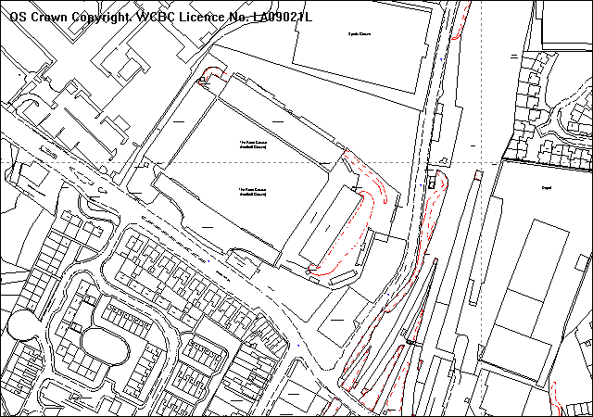
3 Student blocks
Traffic lights

PROPOSAL

This application has been amended since it was submitted in Feb 2007. The proposal now is for student accommodation on the rear of the site and proposals for the remainder of the site will be submitted at a later date (see below).. The amended proposals provide for the erection of three eight-storey accommodation blocks adjacent to NEWI land on Crispin Lane. The application includes a Design and Access and Sustainability Statement; a Geotechnical Desk Study; an Arboricultural Report; a Green Travel Plan and a Noise Impact Assessment. A Planning Statement has also been submitted which illustrates how the partial reserved matters meets the conditions of the outline permission.

The developers are proposing to submit applications in three phases.

Phase 1. This is the current application covering the detail of the student accommodation element of the original outline permission and seeks to discharge the relevant outline conditions for this phase.

Phase 2. A separate application under Section 73 of the Town and Country Planning Act 1990 has been submitted to relax Condition No 15 of the outline permission P/2008/0164 (next item on agenda). This is required to allow the student accommodation element of the scheme to be built without implementing the traffic signals at the approved junction under the outline permission. The basis for this amendment is that the student accommodation will not be providing any new car parking facilities and therefore the revised junction layout and signalling would not be required for this stage of development.

Phase 3. This phase will involve the submission of a full application bringing forward detailed proposals for the new stand of the Football Ground and an affordable housing scheme and a small scale retail unit, which will make up the remainder of the site. The application will also include details of a revised junction, as the current junction is not deliverable due to third party ownership. This is to be submitted as a full application because it includes land that is not within the boundary of the outline permission. This application will be submitted in due course.

RELEVANT HISTORY

CB0002 Remodelling of existing stands, new stands, with associated retail
development, office development, replacement public house, hotel
development, leisure development, bingo hall, cinema, ten pin bowling
alley and swimming pool, multi-storey car parks, formation of new
accesses and closure of existing access including built development
exceeding 20m high. Resolution to approve (subject to S106).
Application withdrawn.
P/2006/0443 Outline application for demolition of existing east stand and existing
car showroom to facilitate a mixed use development comprising
private residential apartments, student accommodation units, retail, site
for new stand and associated works. Approved 05.06.06.
P/2008/0164 Change of wording of Condition No 15 of planning permission
P/2006/0443 to state the following: No part of the development
(except for the proposed student accommodation) shall be occupied
until traffic signals have been installed and are operational at Crispin
Lane/Maesgwyn Road/Mold Road junction and these co-ordinated
with the signs at Mold Road/Regent Street. Next item on this agenda.

DEVELOPMENT PLAN

Within settlement limits and unannotated land in the Unitary Development Plan - policies PS1, PS2, PS3, PS4, GDP1, refer.

Local Planning Guidance Notes 7 – Landscape and Development; 16 – Parking Standards; 17 – Trees and Development; 22 – Sustainable Development; 23 – Development of Sites with Land Contamination; 24 – Designing out Crime, also refer.

CONSULTATIONS

Comments received with regards to the original reserved matters submission for student accommodation and mixed use in the whole site.
Rhosddu CC: Although they appreciate some redevelopment of the site is
acceptable, there are some aspects that are not acceptable.
- The proposed height of 8-storeys is too high for the residential blocks. This would be an over-intensification of the site and set a bad precedent for future multi-storey residential development in Wrexham. Caxton Place at 5-storeys is acceptable and this development should be the same, which would be in-keeping with the height of the Football Stands. Will cause overlooking into the Football Ground.
- The development should be set back from Mold Road so as to allow for the future widening of Mold Road to dual carriageway to link the existing dual carriageway in front of the football ground to the dual carriageway outside the sorting office on the gyratory.
Offa CC: Holding objection until phases 2 and 3 are received so the
application can be considered as a whole. The community
council’s views are those which were expressed at a Special
Meeting held with Rhosddu Community Council and
representatives from the Council’s Planning and Highways
Departments. These are namely the proposed height of the
blocks, the density of the development and the traffic impact on
the surrounding area of Mold Road, Crispin Lane and Stansty
Road.
Local Member: Notified 28.02.07.
WAG Transport: Do not wish to issue a direction in respect of this proposal.
Welsh Water: No objections subject to appropriate conditions to deal with
surface and foul water discharge.
Env Agency: No objections subject to compliance with conditions imposed
on the outline consent.

Wrexham Area: Support in principle but concerns raised in respect of the
Civic Society following.:-
- Question the need for additional student accommodation as it is understood there is little take up of this accommodation in the town. Also should it be more beneficially located at the western and of the site nearer to NEWI.
- Little visual cohesion to the proposals.
- Access arrangements appear unclear. Also, any building fronting Mold Road must be set back sufficiently to allow for future road improvements and widening of Mold Road and adjacent railway bridge.
- The overall height of some blocks of 12-storeys is far too excessive and would dwarf adjacent settlements. Height of blocks should be restricted to no more than five or possibly six storeys.
- Overall design and site layout is very disappointing while elevational treatment and proposed materials lack any real vibrancy.
Public Protection: No objection subject to appropriate contamination condition.
Highways: Notified 28.02.07
Sports Council: Notified 28.02.07
Network Rail: Notified 28.02.07
County Archaeologist: Notified 28.02.07
Director of Education: Notified 28.02.07
Ambulance Service: Notified 28.02.07
North Wales Police: Notified 28.02.07
Mr Ian Lucas MP: Notified 28.02.07
NE Wales NHS Trust: Notified 28.02.07
Other Reps: One petition of 56 names objecting to the future development
12-storey buildings and a further three letters of objection raising the following concerns:
- Height of some blocks are 11/12 storeys which will not be in-keeping with other similar developments in the area. The Council should seek a reduction in height of the blocks.
- There is no demand for further student accommodation in the town centre. If approved, will the Council be imposing student only conditions?
- The development should be set back into the site to allow for possible future widening on Mold Road. Equally, no consideration seems to have been given to future bridge improvements.
- The proposals will add to existing parking pressures on Mold Road.
- There is no plan to widen Crispin Lane which might allow for an easier flow of traffic.
Below are comments received on the amended application which only relates to the provision of student accommodation. The amendments were received by the Council on 18 February 2008:
Rhosddu CC: Object for the following reasons:
- The height is excessive. The existing football stands appear to be 5-storeys high and that should be the benchmark. Eight-storeys would be overbearing. The site is on the periphery of the town and development density should not be as high as the town outline. Residents in Spring Gardens should be consulted. Have the Fire Service been consulted given the proposed height?
- There appears to be a lack of demand for student accommodation in the town. Existing purpose built student accommodation in the town centre is not occupied. It would be useful to see a letter of support from NEWI and confirmation that 300 units of student accommodation is required. Will there be conditions restricting the units to be used solely for student accommodation?
- The development has no parking provision. A further 300 students will inevitably bring extra cars and no provision is made for these in the scheme. NEWI car parks are always pretty full as is Crispin Lane. Students will inevitably park in nearby residential streets causing nuisance to residents.
- The development lies between three listed buildings, Aston College, the Railway Station and the Turf Hotel. Design needs to complement these buildings. Concrete render is totally unacceptable and the exterior of the buildings should be brick clad.
- Concerns raised over the transfer of funds to the Football Club. There should be a condition or Section 106 Agreement stipulating that none of the units are to be occupied until the replacement stand has been constructed to all appropriate standards including the Sports Stadium Regulations.
- The development takes away any vehicular access to the football ground. The application needs to demonstrate that adequate access for emergency vehicles is maintained.
Offa CC: Considers this application will have a serious negative impact
on the surrounding area and raises the following objections:
- Over intensive use of the land.
- The allocation of only four parking spaces for 305 student units is totally unacceptable. Many of the students will have their own vehicles and parking provision needs to be provided for them, their visitors and also service vehicles.
- There is no provision at all for disabled parking within the scheme.
- Parking provision is also required for the rest of the development.
- The loss of the current 300 car parking spaces used by the football club and NEWI will impact greatly on surrounding residential areas with displaced vehicles parking in nearby residential streets.
- The proposed road improvements must be carried out prior to any construction work commencing and the Community Council are absolutely opposed to the removal of the condition that requires these improvements to Mold Road.
- This is an important site within the town and an application for the full site is required not piecemeal development.
- The application will have a negative impact on the new Grosvenor Gardens development off Gerald Street in Rhosddu due to the excessive height of the apartment blocks. They should be no higher than the height of the adjacent poplar trees.
Local Member: Notified 14.03.08
WAG: Notified 14.03.08
Welsh Water: Notified 14.03.08
EA: Notified 14.03.08
Wrexham Area Civic Society: supportive in principle but reiterate concerns above –
site should not be considered as a series of isolated individual
reserved matters applications but as a fully coherent and
integrated development.
Public Protection: Notified 14.03.08
Highways: No objections but concerns raised over the lack of parking provision. As this accommodation is linked with the adjoining NEWI campus and occupation of the apartments will be restricted to non-car owners suggests that a Section 106 Agreement should be considered to control this.

It would appear that third party land (NEWI) may be required in order to provide the specified 2.4 x 56 metre visibility splay at the junction of the access road with Crispin Lane, as the student accommodation is linked to NEWI. suggests it be protected by a Grampian Condition.
Sports Council: Notified 14.03.08
Network Rail: Notified 14.03.08
County Archaeologist: Notified 14.03.08
Director of Education: Notified 14.03.08
NEWI: No objections. The current demand/supply ratio for student
accommodation is approximately 4:1. In terms of location the evidence from our students would suggest that they prefer to be on campus and so within close proximity of the range of services and facilities we offer including those outside core office hours eg library services.
In respect of car parking, NEWI’s room allocation policy currently prioritises overseas and European students. These students tend not to own vehicles; however those who do would be able to avail themselves of NEWI’s car parking facilities.
In summary, would like to confirm that NEWI is in support of the scheme for the provision of 305 rooms for student accommodation.
Ambulance Service: Notified 03.04.08
North Wales Police: Notified 03.04.08
Fire Service: Essential that access to Building Regs standard is provided.
Ian Lucas MP: Notified 03.04.08
NE Wales NHS Trust: Notified 03.04.08
Other Reps: 43 adjoining occupiers re-notified on 25.02.08 and 03.04.08.
Site Notice: Expired 06.03.07

SPECIAL CONSIDERATIONS/ISSUES

Background: Outline permission was granted on 5 June 2006 to bring forward residential and student accommodation with associated works including car parking, as part of an enabling development to provide for the future of the Football Club.

The original submission of reserved matters was made on 6 February 2007. It comprised a mixed-use development comprising private residential apartments, student accommodation units, retail, site for new stand and associated works. It provided for six residential buildings and one building of student accommodation with retail use at ground floor level. The residential buildings ranged in height from five to twelve storeys in height comprising of 277 one, two and three bedroom private residential apartments. The student accommodation block consisted of a 76 bed five-storey building with retail below on Mold Road. Following discussions with the developers, particularly with regards to the proposed height of the buildings and having regard to the financial situation of Wrexham Football Club, it was agreed a phased approach was required for the submission of detailed proposals for the site. This application is thus an amendment to the (undetermined) Feb 2007 submission. This approach allows for the student accommodation element of the scheme to proceed at a faster pace to ensure sufficient funds are returned to the Football Club before June 2008.

The three phases are described in more detail earlier in this report. The current amendments only provide for the erection of three student accommodation blocks on approximately one-quarter of the land with outline permission. This amendment was submitted on 18 February 2008 and a further series of consultations has been undertaken on this part of the scheme.

It has been submitted in conjunction with a further application to vary Condition 15 of the outline consent which would be necessary to allow this part of the development to proceed without implementing the signalling to the approved junction at Mold Road. This application is also being reported to your meeting. A further full application which will include details of the new stand, an affordable housing scheme and a small scale retail unit, will be submitted in due course for the remainder of the site. The revised junction arrangements on Mold Road will be included within that application. The Turf Public House will not be affected by any of these proposals.

Policy: The principle of student accommodation on this site has already been established by the outline planning permission and I am satisfied the proposals reflect the approved description of development and are compatible with the terms of that permission. Student accommodation would be close to public transport links, community and social services in the town centre and the NEWI campus area. There are no objections on policy grounds provided the details meet the technical requirements of UDP Policy GDP1.

Whilst the current proposals only take up approximately 25% of the land with the outline permission, the legislation does allow for the phased submission of reserved matters within approved timescales.

Design and Appearance: The proposals provide for the erection of three student accommodation buildings, all eight storeys in height, comprising 305 student apartments, a building manager’s office, ancillary outbuildings and landscaping. The three buildings are located on the northern boundary of the site to the rear of the stadium overlooking the NEWI playing fields. The blocks are arranged on a gentle curve, with all apartments facing approximately east and west, reducing the number of apartments receiving too much or too little sun, and ensuring that none of the bedrooms are looking towards the back of the football stand. Each block contains two apartments per floor, with the exception of the eighth floor which has only one apartment.

The three-block arrangement preserves the principle of a façade facing onto Crispin Lane, and allows the formation of two defined spaces between the three blocks. The siting does not allow for the principal elevation of all three blocks to be viewed simultaneously, therefore reducing the mass of the development. The layout only allows for a direct view of one building with partial views of the other two from key vantage points around the site, eg Mold Road and the railway line. Despite the concerns raised by Rhosddu Community Council with regards to the height of the buildings, they are set well back from M old Road and near the existing football ground stands which are approximately five storeys high. They are also four storeys lower than the original submission. I consider the principle of an eight storey building in this location is acceptable. It is inevitable there will be additional development between this part of the site and Mold Road and existing views into this area are already restricted by the football stands. The nearest residential properties in Spring Gardens are approximately 130 metres away and separated by the railway line. Given the site’s context therefore near the football ground, with open NEWI land to the north, I do not consider eight storeys unduly intrusive in visual terms. The general arrangements form and orientation of the three buildings will help break up the mass of the buildings and create a more varied and interesting visual perspective. The proposed siting of the development blocks will also allow for the successful retention of the adjoining poplar trees which will provide context and aid assimilation of the development into the area.

With regards to materials, the upper floors are to be clad in render with a selection of sympathetic tones being used on different panels. Traditional brick is to be used on the ground floor. I note the concerns of Rhosddu Community Council with regards to the use of materials but these will be conditioned for further approval. In my opinion to insist upon a brick clad on this style of building would give it a heavier/bulkier appearance. Their modern design requires the use of more modern materials of different tones and textures. A mixture of hard and soft landscaping will be between the three blocks the details of which will be conditioned for further approval.

Setting of Listed Building: The impact upon the Wrexham General Station, a Grade II Listed Building, is a key consideration. However, given the distance involved and the change in character and land levels between the two areas, I do not consider the principle of high rise development objectionable in this instance. Despite the concerns raised by Rhosddu Community Council, the former Aston College building is not seen in the same visual context of this site, is separated by the football stadium and its setting will therefore not be affected. The Turf Public House is not a Listed Building.

Residential Amenity: The three student blocks are located well away from existing housing. The closest dwellings are in Spring Gardens approximately 130 metres away from the site and are separated by the railway line. The only effect upon these properties will therefore relate to the visual impact but this is reduced in many respects by the siting and orientation of the buildings and the block with frontage onto Crispin Lane will screen the other two from view from this direction. Dwellings on Mold Road will have limited views, those to the west will not see the development because of the Football Ground in foreground. Those to the east will have views of the gable ends of the three blocks but in time this will be restricted by further development on the remainder of the site (ie between the student accommodation and Mold Road). I am satisfied therefore that there will be no adverse affect upon existing levels of residential amenity in the area. Within the site, the proposals satisfy the requirements of Local Planning Guidance Note No 21 which should ensure appropriate levels of privacy.

Need for Student Accommodation: I note the concerns raised by consultees with regards to the need for such a high number of student flats and the lack of demand for student accommodation in the town. Although need/demand is not a material planning consideration, I have nonetheless received written confirmation from NEWI of their support for a scheme of 305 rooms for student accommodation in this location. Discussions are ongoing between the developers and NEWI to progress this scheme.

Trees: The 22 poplar trees on the northern boundary of the site are subject to Tree Preservation Order No WMBC 9. They are prominent skyline features and their height will provide a strong visual context for high rise development. The application includes a full arboricultural survey as is required under the outline permission. I am satisfied the survey adequately addresses the impact of the proposal on the trees. Subject to a condition to ensure appropriate tree protection measures are implemented during the construction phase, I am satisfied there will be no adverse effect.

Contamination: Given the existing and previous uses of the site, the area is subject to potential ground contamination. A geotechnical desk study has been submitted in accordance with the outline. Public Protection have raised no objections subject to an appropriate condition to deal with contamination issues.

Highways: A Transport Impact Assessment was submitted at the outline state as the access arrangements were not reserved for further approval. Details of a four-way signalised junction on Mold Road/Crispin Lane/Maesgwyn Rd were approved at that time. Condition 15 stated that: “No part of the development shall be occupied until traffic signals have been installed and one operational at the Crispin Lane/Maesgwyn Road/Mold Road junction and these are co-ordinated with the signals at Mold Road/Regent Street.”. In line with the phased approach to development on this site a separate application submitted under code ref P/2008/0164 has been submitted to relax this condition.

This is relaxation is required to allow the student accommodation element of the scheme to be built without implementing the signalling to the approved junction under the outline permission. The basis for this amendment is that the student accommodation will not be providing only 4 car parking facilities and therefore the revised junction layout and signalling would not be required for this stage of development on the basis that there will not be any significant increase in traffic generation. The revised condition, however, if my recommendation is accepted, will still require the implementation of the signalised junction prior to the occupation of any part of the development proposed for the remainder of the site. Highways have indicated that given the proposed limited level of parking provision for the student accommodation, such a development is unlikely to result in a significant increase in traffic generation. In the circumstances, they cannot justify the implementation of the proposed traffic signals for this particular aspect of the development alone. Highways therefore raise no objections but have raised concerns with regards to the lack of parking provision which are addressed below.

Parking: Condition No 8 of the outline consent required the reserved matters application to make parking provision in accordance with Local Planning Guidance Note 16 and/or include the submission of a Green Transport Plan. The proposals only provide no. 4 spaces for staff and do not include any new car parking spaces for residents. LPG requires one space per two bedspaces for student accommodation but these are maximum standards and the guidance does allow for the submission of a Green Travel Plan to illustrate how the resulting shortfall will be catered for. This is in accordance with Planning Policy Wales and TAN 18 which promote a demand management approach to parking provision, the level of which has a major influence on the choice and means of transport. A comprehensive Green Travel Plan has been submitted as part of this application. In support it identifies this site as one of the most sustainable locations in Wrexham. It lies next to the railway station on a key bus route on Mold Road and within easy walking distance of the town centre and the main NEWI campus site which adjoins the site. I note the concerns of the Community Councils with regards to the absence of parking provision but existing parking facilities are available on the NEWI campus within close proximity and easy walking distance away from the site. It is also envisaged many students will not own cars given its sustainable location and close proximity to the main campus site. NEWI have indicated that their room allocation policy currently prioritises overseas and European students. They state that these students tend not to own vehicles, but those who do would be able to use NEWI’s car parking facilities. I note the observations of Highways with regards to use of a Section 106 Agreement to restrict the occupation to non-car owners but NEWI have indicated it would be difficult to implement and enforce and I agree. Issues of prejudice may arise through this process. However, I believe the student accommodation use is distinct from a general residential use, particularly given its relationship with the college in this location. I believe the pressure for parking is likely to be much lower. An appropriate condition restricting the use of student accommodation only, should ensure this continues to be the case in perpetuity. Besides, the student accommodation use falls within class C2 (Residential Institutions) of the Use Classes Order and any change to individual dwellings/flats (C3 use) would require permission. I therefore believe sufficient controls exist to ensure that overspill parking problems are unlikely to become an issue in future.

I note the concerns of consultees with regards to on-street parking on Crispin Lane but this already exists. It does not cause obstruction and does not compete with residents parking elsewhere in the area. I do not therefore believe the current proposals will compound the existing situation given the availability of parking facilities at NEWI.

Sustainability: The proposal involves the development of a brownfield site within close proximity of the town centre and with good access to public transport. The application includes a Design, Access and Sustainability Statement. The buildings have been sited and designed to maximise energy conservation through the construction of their fabric, rather than accepting a lesser quality fabric and making up some of the energy losses with on-site renewable energy generation. This design principle is in accordance with government advice preferring reducing energy use to renewable energy generation. The revised orientation of the three blocks allows for all bedrooms to face either east or west (an improvement from the previous pre-application scheme which had some north facing bedrooms) and as such all rooms will receive sunlight. The primary student block heating systems will be driven from a centralised plant to ensure the maximum efficiency can be achieved. A combined heat and power central plant will be investigated in detail during the development stage. I propose to include this requirement as a condition of the permission. Other forms of heat sources such as borehole ground source heat and air source heat pumps are also considered as a possible alternative to a centralised plant. The condition will ensure these methods are fully investigated prior to the commencement of development. Options for wind power are limited and whilst capacity exists to install photovoltaics in future these are not included as part of the initial construction. Materials will be sourced where possible utilising recycled or recyclable products.

Designing out Crime: The siting and design of the three student blocks allows for unobstructed views into all surrounding areas which will be open and well illuminated at night. The hard landscaped areas between the blocks provides defensible space distinguishing between public, semi-private and public zones. Surveillance is also enhanced by minimising visual obstacles and places of concealment. Given the nature of the use and the density involved it is likely that many flats will be occupied during the day which should improve security. CCTV cameras are a condition of the outline consent. The siting of camera will be reserved for further approval. I am satisfied however that the proposed development adopts a number of the design principles set out in LPG No 24 – Designing out Crime.

Enabling Development: Members will recall that the key objective of the outline approval for a mixed-use scheme was to facilitate the return of funds to Wrexham Football Club. The Football Club has experienced a number of difficulties in recent years and was been taken into administration. Following the completion of legal proceedings, the Club is now looking to move forward to secure its long-term future. The current proposals involve the release of currently underused land for development generating a financial return to assist the Football Club. Condition 22 of the outline states that:
“The reserved matters application shall provide full details of how the enabling development hereby permitted will facilitate the development of the new stand and contribute towards the future financial prosperity of the Wrexham Football Club.”

Condition 23 states that:
“No development shall commence until a statement demonstrating the financial viability of the scheme has been submitted to and approved in writing by the Local Planning Authority. If the Local Planning Authority concludes that the statement demonstrates that the financial viability exceeds that required to assure the future of the Football Club then the development shall make provision for affordable housing, commuted car parking payments, school contributions, and contribution in lieu of public open space in accordance with Council adopted policy guidance.”

With regards to these two conditions I have not, at the time of writing this report, received a full financial statement. I have received an undertaking from applicants that the proceeds of the sale of this part of the site will be used to pay off a loan which is due for immediate repayment. However, as this is a partial reserved matters application for student accommodation on approximately one quarter of the total outline site area I consider it is not unreasonable for the applicants to be required to submit full information as part of a further application for the remainder of the site. In addition, Condition 23 is a pre-commencement condition as it requires a statement to demonstrate how normal planning requirements (ie affordable housing; commuted car parking payments; school contributions; and contributions in lieu of public open space) could influence the financial balance of the scheme potentially affecting its financial viability, before development commences. This does not therefore prevent the determination of this application but the information would be required before works commenced. In any event, Condition 23 would not directly apply to this part of the proposed development as the normal planning requirements, with the exception of commuted parking payments do not relate to student accommodation. However, in the absence of a financial statement with the current partial reserved matters application I have attached a similar condition to Conditions 22 and 23 of the outline consent to ensure that the previously required financial statement for the whole of the site including the proposed development is submitted for further approval prior to the commencement of this proposal.

Conclusion: The principle of student accommodation on this site has already been established by the outline permission. The two key issues of concern raised by consultees relate to the height of the buildings and lack of parking. However, I do not consider three eight storey buildings in this location are unduly intrusive in the context of the football stadium and subject to the use of appropriate materials will enhance the appearance of this part of Wrexham. In addition, appropriate conditions will be imposed to restrict its use to student accommodation only. This, together with the availability of parking provision on the NEWI campus site should alleviate parking pressures in the area. All the outline planning conditions relating to this part of the site have been addressed but in the absence of a full financial statement I propose a further condition requiring its submission prior to the commencement of development.

RECOMMENDATION That permission be GRANTED

CONDITION(S)

1. The development hereby permitted shall be begun before 05 June 2011 or two years from the date of approval of the last of the reserved matters required to be approved, whichever is the later.
2. The development shall only be carried out in accordance with the amended plan(s).
3. No part of the development shall be commenced until samples of all external facing and roofing materials have been submitted to and approved in writing by the Local Planning Authority. The development shall only be carried out in strict accordance with such details as are approved.
4. The erection of fencing for the protection of trees and shrubs shall be undertaken before any equipment, machinery or materials are brought onto the site for the purposes of the development, and shall be maintained until all equipment, machinery and surplus materials have been removed from the site. The above mentioned fencing shall consist of a scaffold framework in accordance with Figure 2 of BS 5837 (2005) comprising a vertical and horizontal framework, well braced to resist impacts, with 2.1m vertical tubes spaced at a maximum interval of 3 metres. Onto this, weldmesh panels shall be securely fixed with wire or scaffold clamps. This fencing shall be erected at the full extent of the canopy of each tree and shrub. Nothing shall be stored or placed in any area fenced in accordance with this condition and the ground levels within those areas shall not be altered, nor shall any excavations be made without the written permission of the Local Planning Authority.
5. No part of the development hereby permitted shall be commenced until full details of both hard and soft landscape works for the site have been submitted to and approved in writing by the Local Planning Authority. The works shall be implemented in accordance with a timescale to be approved in conjunction with the scheme of details.
6. Within six months of the first use of the development, trees and shrubs shall be planted on the site in accordance with a scheme which has been submitted to and approved by the Local Planning Authority. Any trees or shrubs removed, dying, being severely damaged, or becoming seriously diseased within five years of planting shall be replaced by trees or shrubs of a similar size and species to those originally required to be planted.
7. The development hereby approved shall only be used as student accommodation.
8. No development shall take place until a scheme of foul drainage and surface water drainage has been submitted to and approved by the Local Planning Authority. The approved scheme shall be complete before the development is occupied
9. Details of the siting of CCTV cameras and the proposed operational measures shall be submitted for the written approval of the Local Planning Authority prior to the commencement of development. The scheme shall be implemented in accordance with the agreed details before the development is first occupied.
10. Details of improved pedestrian links between this site and NEWI land shall be submitted to and approved in writing by the Local Planning Authority. The approved scheme shall be fully implemented before the development is first occupied.
11. The vehicular turning area(s) as indicated on the submitted plan shall be provided prior to occupation of the building(s) and shall thereafter be retained in a usable condition.
12. Cycle parking facilities shall be provided within the curtilage of the site in accordance with details to be submitted for the further approval of the Local Planning Authority. Such facilities shall be made available prior to implementation of the use(s) hereby permitted and shall thereafter be retained.
13. The vehicle parking and turning areas indicated on the approved plans shall be laid out, surfaced and drained prior to the first use of the building hereby granted and shall thereafter be retained for those purposes.
14. Details of all boundary treatment shall be submitted for the further approval of the Local Planning Authority. The approved scheme shall be fully implemented before the development is occupied.
15. Development shall not begin on site until a scheme to deal with potential contamination at the site has been submitted to and approved in writing by the Local Planning Authority. This scheme shall include a phased investigation approach to identify the extent of contamination and any measures required to remediate the site, including post-development monitoring. Where remediation works are required, the development shall not be occupied/used until a Validation Report to show that the works have been satisfactorily carried out has been submitted to and approved in writing by the Local Planning Authority.
16. Details of a combined heat and power central plant shall be provided or other forms of sustainable heat sources shall be submitted for the further approval of the Local Planning Authority. The approved scheme shall be fully implemented before the development is occupied.
17. The development hereby approved shall not be occupied until 2.4 x 56 metre visibility splays are provided at the junction of the access road with Crispin Lane and the approved splays shall thereafter be maintained clear of any obstruction to visibility.
18. No development shall commence until a statement demonstrating the financial viability of the scheme has been submitted to and approved in writing by the Local Planning Authority. The statement shall address all the issues raised in Conditions 22 and 23 of the outline permission (Code No. P/2006/0443).

REASON(S)

1. To comply with Section 92 of the Town and Country Planning Act, 1990.
2. To ensure that the development fully complies with the appropriate policies and standards.
3. To ensure a satisfactory standard of appearance of the development in the interests of the visual amenities of the area.
4. To protect trees which are of significant amenity value to the area.
5. To ensure a satisfactory standard of appearance of the development in the interests of the visual amenities of the area.
6. To ensure a satisfactory standard of appearance of the development in the interests of the visual amenities of the area.
7. To control the level of traffic generation from the site and in the absence of parking provision.
8. To ensure satisfactory drainage of the site and to avoid flooding.
9. In the interest of site security and crime prevention.
10. To improve pedestrian links and connectivity between this site and NEWI.
11. To provide for the turning of vehicles clear of the highway and to ensure that reversing by vehicles into or from the highway is rendered unnecessary in the interest of traffic safety.
12. To promote the use of bicycles and to ensure adequate and secure facilities for cycle parking are provided within close proximity of the buildings.
13. To provide for the parking and turning of vehicles clear of the highway and to ensure that reversing by vehicles into or from the highway is rendered unnecessary in the interest of traffic safety.
14. To ensure a satisfactory standard of appearance of the development in the interests of the visual amenities of the area.
15. In the interests of the amenities of the future occupants of the buildings
16. To comply with the requirements of Local Planning Guidance Note No 2.
17. To ensure the formation of a safe access.
18. To ensure that financial return from this development is invested into the Football Club.
_____________________________________________________________________

APPLICATION NO:  P/2008 /0164  COMMUNITY:  Rhosddu  WARD:  Grosvenor | LOCATION:  LAND AT WREXHAM FOOTBALL CLUB MOLD ROAD WREXHAM  DESCRIPTION:  CHANGE OF WORDING OF CONDITION NO. 15 OF PLANNING PERMISSION P/2006/0443 TO STATE THE FOLLOWING:  NO PART OF THE DEVELOPMENT (EXCEPT FOR THE PROPOSED STUDENT ACCOMMODATION) SHALL BE OCCUPIED UNTIL TRAFFIC SIGNALS HAVE BEEN INSTALLED AND ARE OPERATIONAL AT CRISPIN LANE/MAESGWYN ROAD/MOLD ROAD JUNCTION AND THESE CO-ORDINATED WITH THE SIGNS AT MOLD ROAD/REGENT STREET.  APPLICANT(S) NAME:  MACNIVEN & CAMERON (WXM) LTD, N&G DICKENS LTD | DATE RECEIVED:  15/02/2008  CASE OFFICER:  DSW  AGENT NAME:  GVA GRIMLEY LLP
_____________________________________________________________________

P/2007 /0125
THE SITE

The application relates to condition 15 of an outline permission for development of
a 1.52 hectare site of part of the existing football ground The site is bounded by Mold Road to the south, Crispin Lane and Wrexham General Station beyond, to the east, the NEWI Sports Ground to the north and the existing football ground to the west. (see plan on P/2007/0125 – previous item)

PROPOSAL

As above. This application has been submitted in conjunction with a partial reserved matters for student accommodation (P/2007/0125) This is to allow the student accommodation element of the scheme to be built without implementing the signalling to the approved junction under the outline permission.

HISTORY

CB0002 Remodelling of existing stands, new stands, with associated retail
development, office development, replacement public house, hotel
development, leisure development, bingo hall, cinema, ten pin bowling
alley and swimming pool, multi-storey car parks, formation of new
accesses and closure of existing access including built development
exceeding 20m high. Resolution to approve (subject to S106)
Application withdrawn.
P/2006/0443 Outline application for demolition of existing east stand and existing
car showroom to facilitate a mixed use development comprising
private residential apartments, student accommodation units, retail, site
for new stand and associated works. Approved 05.06.06.
P/2007/0125 Submission of reserved matters pursuant to outline planning permission ref no P/2006/0443 providing for a mixed use development comprising private residential apartments, student accommodation units, retail, site for new stand and associated works. (previous item)

DEVELOPMENT PLAN

Within settlement limits and unannotated land in the Unitary Development Plan. UDP policies PS1, PS2, PS3, PS4, GDP1, refer.

Local Planning Guidance Notes 7 – Landscape and Development; 16 – Parking Standards; 17 – Trees and Development; 22 – Sustainable Development; 23 – Development of Sites with Land Contamination; 24 – Designing out Crime, also refer.

CONSULTATIONS

Community Council: Notified 18.02.08
Local Member: Notified 18.02.08
Highways: Although concerned over the lack of parking provision for the proposed student accommodation understands that this accommodation is linked with the adjoining NEWI campus and NEWI will restrict occupation of non car owners. Suggest that a Section 106 Agreement should be considered to control this.
Given the proposed limited level of parking provision for the student accommodation, such a development is unlikely to result in a significant increase in traffic generation and cannot therefore justify the implementation of the proposed traffic signals for this particular aspect of the development alone.
On that basis no objections to the above relaxation.
Other Reps: 43 adjoining occupiers notified 07.01.08
1 response: no objection in principle provided traffic lights are
implemented before any further development is considered. Developers would need to join in negotiations with adjoining developer for release of their land (could not be before Dec 2009).
Site Notice: Expired 11.03.08

SPECIAL CONSIDERATIONS/ISSUES

Background: This is an application to relax a condition of the outline permission. : “15. No part of the development shall be occupied until traffic signals have been installed and one operational at the Crispin Lane/Maesgwyn Road/Mold Road junction and these are co-ordinated with the signals at Mold Road/Regent Street.”

The relaxation is required to allow the student accommodation element of the scheme to be built without implementing the signalling to the approved junction under the outline permission. The basis for this amendment is that the student accommodation will not be providing any new car parking facilities (just 4 staff parking places) and therefore the revised junction layout and signalling could not reasonably be justified for the stage of development. Details of the phased approach to the development of this site are set out in my report P/2007/0125 (above).

Highways: A Transport Impact Assessment was submitted at the outline stage as the access arrangements were not reserved for further approval. Details of a four way signalised junction on Mold Road/Crispin Lane/Maesgwyn Rd were approved at that time. The revised condition, however, if my recommendation is accepted will still require the implementation of the signalised junction prior to the occupation of any part of the development proposed for the remainder of the site. Highways have indicated that given the proposed limited level of parking provision for the student accommodation, such a development is unlikely to result in a significant increase in traffic generation. In the circumstances, they cannot justify the implementation of the proposed traffic signals for this particular aspect of the development alone. They therefore raise no objections to this relaxation. .

Conclusion: The principle of student accommodation on this site has already been established by the outline permission. Since this part of the development does not generate any significant traffic generation (and arguably reduces the traffic accessing the site from Crispin Lane) I can see no justification for insisting that the traffic lights are installed at this point in time.

RECOMMENDATION That permission be GRANTED

CONDITION

- No part of the development (except for the proposed student accommodation) shall be occupied until traffic signals have been installed and are operational at Crispin Lane/Maesgwyn Road/Mold Road junction and these are co-ordinated with the signs at Mold Road/Regent Street.

REASON

1. In the interests of highway safety.

NOTE TO APPLICANT

You are reminded that all the other conditions on the planning permission remain in force.

APPLICATION NO:  P/2007 /1260  COMMUNITY:  Gresford  WARD:  Gresford East & West | LOCATION:  Land at Min Y Dyffryn Gresford Road Gresford Wrexham  DESCRIPTION:  Erection of three detached 2 storey dwellings and detached garages together with new vehicular private drive access and associated external works.  APPLICANT(S) NAME:  Mr Gino Paletta | DATE RECEIVED:  23/10/2007  CASE OFFICER:  DSW  AGENT NAME:  Castlemead Homes Ltd
_____________________________________________________________________

P/2007 /1260
THE SITE

A triangular shaped piece of land lying adjacent to a residential cul-de-sac and occupied by a single, detached, two-storey dwellinghouse on the edge of the settlement and conservation area of Gresford.

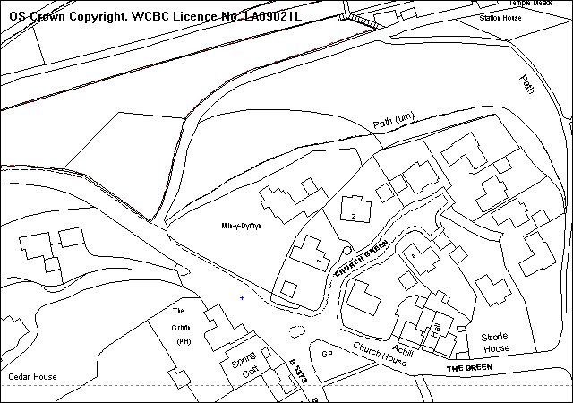
Diagrammatic location of dwellings
Existing dwelling to be demolished

PROPOSAL

As above. This is a full application with all matters submitted for approval. It is accompanied with a further application for Conservation Area Consent to demolish the existing dwelling submitted under Code No P/2007/1271.

HISTORY

P/2004/0598 Erection of 3 no. two-and-a-half storey dwellings, construction
of new vehicular and pedestrian access and alteration to existing vehicular and pedestrian access.
Refused: 06.08.04 Appeal Dismissed: 01.04.05
P/2004/0599 Demolition to existing dwelling (within a Conservation Area).
Refused: 06.08.04 Appeal Dismissed: 01.04.05
P/2006/0971 Fell 8 no. trees and remove overhanging branches to trees on northern
boundary (works as prescribed by canopy tree survey dated 3 August 2006). Refused: 23.10.06
P/2006/1378 Fell 7 no. trees and remove overhanging branches to trees on northern
boundary (TPO No 20). Approved: 09.01.07
P/2007/1271 Conservation Area consent for demolition of existing two-storey detached dwelling. Application pending.

DEVELOPMENT PLAN

Within settlement limit and Conservation Area. Policies PS1, GDP1, H2, EC4, EC7 and EC8 apply. Local Planning Guidance Notes 7, 16 and 21 also apply.

CONSULTATIONS

Community Council: Considers that if permission is granted for this development conditions must be imposed to retain the “green” appearance of the area opposite the Griffin Inn and the area generally in the interest of the environment.
Local Member: Following observations made:
- Need to ensure satisfactory means of access as this is a busy road at times with traffic accelerating at the top of the Griffin Hill at this point.
- Need to ensure adequate protection measures are in place to protect the retained Poplar Tree.
- A judgement should be made that there are no parts of the proposals which are uncomfortably close to neighbouring properties on the Green.
- Streetscene. An assessment should be made that the view from the road/Griffin PH is in keeping with the Conservation Area and not compromised.
Wrexham Area Civic Soc: Object as the application will result in the majority of
trees on site having to be removed. Suggest a reduction
to 2 no. dwellings would not only enable more trees to
be retained but would give the opportunity for an
improved layout.
Welsh Water: No objections subject to appropriate conditions to deal with foul/surface water disposal.
Public Protection: No objections.
Environment Agency: No objections.
Highways: No objections subject to conditions.
CPAT: Suggest the presence of an archaeologist during the early stages of construction.
Wrexham Access Group: Notified 24.10.07
Other Representations: 5 letters from neighbouring occupiers objecting for the following reasons:
- The proposed density is detrimental to the character and appearance of the area.
- The height and size of the buildings are significantly greater than the buildings they replace.
- Object to the design which does not reflect the current appearance of Min y Dyffryn or the Conservation Area.
- There will be a loss of the spacious feel to this part of the Conservation Area.
- Substandard access and adverse affect upon highway safety in the area.
- Poor pedestrian access from the site to the village.
- Wall along the site entrance should be retained.
- Important to preserve the tree and shrub screen along the front wall of the site.
- Slate should be the roofing material.
- The chimney on Plot 1 is too close to the kitchen of the Barn (1 Church Green).
- Plots 1 and 2 should be sited further towards the north west boundary and further away from Church Green.
- The garage on Plot 1 would be better placed directly behind the garage of “The Barn” Church Green.
- Some form of speed reduction device (for example sleeping policemen) is implemented by the developers before work starts on site.
Site Notice: Expired 23.11.07
Press Notice: Expired 30.11.07

SPECIAL CONSIDERATIONS/ISSUES

Background: Permission is sought to demolish the existing dwelling and replace it with three two-storey dwellings accessed by a shared driveway. A previous application for three dwellings (P/2004/0598) was refused and the subsequent appeal dismissed. The key concerns in the Inspector’s decision were the adverse impact of the scheme upon the visual character of the area, by virtue of intensive design and layout; the impact upon trees both within and adjoining the site; issues relating to separation distances and overlooking into neighbouring dwellings in Church Green; and loss of amenity as a result of inadequate parking space which would involve considerable manoeuvring to leave the site in a forward gear. This, in the Inspector’s opinion, would create significant noise and disturbance, resulting in a loss of residential amenity.

The cumulative effect of all the shortcomings mentioned above was, in the Inspector’s opinion, unsatisfactory both in terms of its layout and its impact on the special character and appearance of the Conservation Area. An accompanying application for Conservation Area Consent (P/2004/0599) to demolish the existing dwelling was dismissed on the basis that the above proposal for redevelopment did not positively enhance the area.

The current application is an attempt to address and overcome these concerns.

Policy: The site lies within settlement limits where Policy H2 of the UDP indicates it is accepted subject with compliance with Policy GDP1. The site also lies within the Gresford Conservation Area and any proposal would need to satisfy the requirements of UDP policies EC7 and EC8.

Previous Appeal Decision (P/2004/0598). The headings set out below relate to the concerns raised by the Inspector in dismissing the previous appeal and how this application has overcome them.

Impact upon the visual character of the area
Unlike the previous scheme which involved dwellings backing onto the road, the current proposals introduce an active frontage by proposing two frontage units in order to reflect the predominant pattern and layout of the buildings in the Conservation Area. The frontage units (Plots 1 and 2) are comparable in height and scale to those in Church Green and are designed to reflect the arts and crafts style of development, a characteristic feature of the Conservation Area. The dwellings are set back into the site which will allow for the retention of the mature vegetation screen along the boundary between Plot 1 and 1 Church Green. The shared driveway also creates a further visual break between Plots 1 and 2. Plot 2 has been angled towards the entrance of the village to create a gateway building signalling the arrival into the village. It creates less formality along the site frontage, more visual interest and reflects the general pattern of development within this part of Gresford. Plot 3 takes on a completely different form and design. It is designed to be a subservient building within the development, having a significantly lower ridge height with limited views from the Conservation Area. I consider the layout adds visual interest to the locality by introducing a positive frontage development onto Gresford Road and views through these frontage buildings create areas of space and interest throughout the site. It provides a harmonious layout which compliments the other buildings in the vicinity.

Impact upon trees both within and adjoining the site
The site and the immediate wider area is covered by a Tree Preservation Order No 20 (1953). Members will note that the trees within and adjoining the site were the subject of an application for tree works Ref P/2006/1378 which was granted on 9 January 2007. The works have now been undertaken. The site is now cleared of many of the trees and the overhanging trees from the adjoining land are now cut back to the boundary in accordance with the consent. The frontage of the site, however, will retain certain trees and shrubs and the impact of the development upon the frontage will therefore be much reduced. Each plot will be set back into the site in order to preserve the feeling of space along the road frontage. Many of the trees referred to by the Inspector have therefore been removed under the previous consent P/2006/1378. Nevertheless, many mature trees remain outside the site which will screen the development from the north-west. The proposed dwellings are set away from this boundary in order to ensure that the remaining trees are not affected by the development. I am satisfied that subject to an appropriate condition to protect trees during the construction period there will be little impact upon remaining trees. Additional landscaping will be required as a part of any permission granted.

3 Issues relating to separation distances and overlooking into neighbouring dwellings
There are no windows in the gable end of Plot 1 facing 1 Church Green. There is also a double detached garage to the front which is positioned to assist in screening the site from 1 Church Green. I note the concerns raised by the occupiers of 1 Church Green with regards to the position of the garage (ie it should be directly behind theirs). However, this would involve bringing the proposed double garage forward and in line and the accumulative affect of both would form a visually conspicuous feature on the site frontage. It would also involve removing existing boundary planting. I am satisfied therefore that there will be no loss of privacy to 1 Church Green as a result of overlooking.

The Inspector raised greater concerns with regards to 2 Church Green and in particular a ground floor kitchen window. The current scheme however addresses these concerns by re-designing Plot 3 which is now an essentially single storey building. The elevation facing 2 Church Green has been specifically designed to ensure that it has minimal impact upon the adjacent dwelling. The facing elevation only contains an obscure glazed bathroom window at first floor level and a rooflight serving a stairway. I am satisfied the previous Inspector’s concerns have been fully considered and the scheme now creates no loss of privacy and no overbearing impact or overshadowing to the neighbouring property, 2 Church Green. There are dwellings surrounding the site but a combination of distances, orientation, internal layout/design and boundary treatments negate any detrimental impact upon surrounding residential properties.

- Parking and manoeuvring space
The scheme proposes a single access point onto the B5373 Gresford Road with a 4.2m wide shared private driveway through the development. Parking provision meets the requirement of Local Planning Guidance Note No 16. Each plot now has its own individual parking spaces and the central shared private driveway allows Plots 1 and 2 to turn easily and leave the site in a forward gear. Plot 3 to the rear has turning facility within a rear courtyard which significantly reduces any affects of noise and disturbance to neighbouring occupiers.

Objections: The remaining concerns raised by consultees relate to density of development; poor pedestrian access; retention of frontage wall; plots 1 and 2 should be re-sited further north-west and the chimney on Plot 1 is too close to the kitchen on 1 Church Green.

With regards to density. The density is no greater than neighbouring development in Church Green and follows the general pattern of development is thus part of the Conservation Area. Footpaths are available on the B5373 however pedestrian access via The Green is substandard. This, on its own, is not a sufficient reason to justify a refusal of permission given the scale of development involved and the additional pedestrian movement expected.

Where possible, the frontage wall will be retained. A section may need to be removed and set back for visibility purposes but the stone will be reused.

Should plots 1 and 2 be re-sited further north-west then this would have an adverse affect upon the adjoining woodland area.

Finally, I am satisfied sufficient space exists between the chimney of Plot 1 and 1 Church Green. There are no minimum standards for facing gables with no windows and the relationship here is no different to similar cases elsewhere in the area.

Conclusion: I am satisfied this proposal addresses the concerns raised by the previous Inspector. The application is in accordance with the Council’s adopted policies and will enhance the Gresford Conservation Area.

RECOMMENDATION That permission be GRANTED

CONDITION(S)

1. The development hereby permitted shall be begun before the expiry of five years from the date of this permission.
2. No part of the development shall be commenced until samples of all external facing and roofing materials have been submitted to and approved in writing by the Local Planning Authority. The development shall only be carried out in strict accordance with such details as are approved.
3. No gates shall be erected within 5.0m of the carriageway edge.
4. The boundary wall to the right as viewed from the site shall be altered (in accordance with details which have first been agreed in writing by the Local Planning Authority) in order to provide a visibility splay of 2.4m x 70m. The land between the existing footway and the revised boundary wall shall be brought up to Highway Authority adoptable standard prior to first occupation of any dwelling and the visibility shall thereafter be maintained clear of any obstruction .
5. This permission shall operate only to allow development to be carried out in accordance with the approved drawings and the application documentation. Notwithstanding the provisions of the Town and Country Planning (General Permitted Development) Order 1995, no further development shall take place within the site (other than the painting of the buildings).
6. Notwithstanding the provisions of the Town and Country Planning (General Permitted Development) Order 1995, no buildings (including any sheds, greenhouses, outbuildings etc) shall be built, erected, or constructed on the land.
7. Details of all doors and windows shall be submitted to the Local Planning Authority and work shall be carried out in full accordance with the agreed details before the first occupation of the dwellings.
8. Notwithstanding the details shown in the approved plan, full details of the boundary treatment shall be submitted for further approval and shall be implemented in accordance with a timescale to be agreed in writing by the Local Planning Authority.
9. No part of the development hereby permitted shall be commenced until full details of both hard and soft landscape works for the site have been submitted to and approved in writing by the Local Planning Authority.
10. The landscaping including the paving and footpath areas referred to in Condition 9 shall be completed in all respects within three months of the first use of the building with the exception of soft landscaping which shall be carried out in the first planting season (November to March) to seeding season (April to September) following the first use. Any trees or shrubs removed, dying, being severely damaged or becoming seriously diseased shall be replaced with trees or shrubs of similar size and species to those originally required to be planted.
11. Before the dwellings hereby approved are first occupied the parking and turning areas shall be laid out and surfaced and shall thereafter permanently retained for such purposes free of all obstruction.
12. None of the existing trees shown on the approved plan to be retained shall be lopped, topped or felled without the prior written permission of the Local Planning Authority.
13. The first floor windows proposed for the south-east side elevation on plot 3 shall be glazed with obscure glass and shall be permanently retained in this condition unless otherwise agreed in writing by the Local Planning Authority.
14. Apart from the windows shown on the approved plan and notwithstanding the provisions of the Town and Country Planning (General Permitted Development) Order 1995, no windows or other openings shall be inserted in any elevation of plots 1 and 3 facing south-east, unless otherwise agreed in writing by the Local Planning Authority.
15. No development works of any kind shall begun until the presence of a contracted archaeologist has been secured on site according to the prescriptions set out in a curational design brief and approved by the Planning Authority. Access at any reasonable time should be given to this archaeologist to enable the observation and recording continued of any archaeological remains uncovered during the early stages of development. A report of any archaeological records made must be deposited within the County Sites and Monuments Record, Clwyd-Powys Archaeological Trust, 7a Church Street, Welshpool, Powys, SY21 7DL, tel: (01938) 553670 within one month of the completion of this work.

REASON(S)

1. To comply with Section 91(3) of the Town and Country Planning Act 1990.
2. To ensure a satisfactory standard of appearance of the development in the interests of the visual amenities of the area.
3. To ensure a safe and satisfactory entrance in the interests of highway safety.
4. To ensure a safe and satisfactory entrance in the interests of highway safety.
5. Due to the restricted application site and its relationship with adjoining properties it is considered important to ensure that no additional development is carried out without the permission of the Local Planning Authority.
6. Due to the restricted application site and its relationship with adjoining properties it is considered important to ensure that no additional development is carried out without the permission of the Local Planning Authority and to preserve the characteristics of the Conservation Area.
7. To ensure a satisfactory standard of appearance of the development in the interests of the visual amenities of the area.
8. To ensure a satisfactory standard of appearance of the development in the interests of the visual amenities of the area.
9. In the interests of visual amenities of the area.
10. In the interests of visual amenities of the area.
11. To ensure adequate off-road parking in the interests of highway safety.
12. To ensure a satisfactory standard of appearance of the development in the interests of the visual amenities of the area.
13. In order to prevent any issues of overlooking.
14. In order to prevent any issues of overlooking.
15. In order to ensure that an appropriate record is made of any important archaeological features.
_____________________________________________________________________

APPLICATION NO:  P/2007 /1271  COMMUNITY:  Gresford  WARD:  Gresford East & West | LOCATION:  Land at Min Y Dyffryn Gresford Road Wrexham  DESCRIPTION:  Conservation area consent for demolition of existing 2-storey detached dwelling.  APPLICANT(S) NAME:  Mr Gino Paletta | DATE RECEIVED:  26/10/2007  CASE OFFICER:  DSW  AGENT NAME:  Castlemead Homes Ltd
_____________________________________________________________________

P/2007 /1271
THE SITE

A triangular shaped piece of land lying adjacent to a residential cul-de-sac and occupied by a single, detached, two-storey dwellinghouse on the edge of the settlement and conservation area . For plan please see P/2007/1270 – above.

PROPOSAL

As above. The building is a relatively modern dwelling.

RELEVANT HISTORY

P/2004/0599 Demolition to existing dwelling (within a Conservation Area).
Refused: 06.08.04 Appeal Dismissed: 01.04.05.
P/2007/1260 Erection of three detached two-storey dwellings and detached garages together with new vehicular private drive access and associated external works. Previous item.

DEVELOPMENT PLAN

Within Gresford Conservation Area. Policy EC8 relates.

CONSULTATIONS

Community Council: Considers that if permission is granted for this development conditions must be imposed to retain the “green” appearance of the area opposite the Griffin Inn and the area generally in the interest of the environment.
Local Member: Following observations made:
- Need to ensure satisfactory means of access as this is a busy road at times with traffic accelerating at the top of the Griffin Hill at this point.
- Need to ensure adequate protection measures are in place to protect the retained Poplar Tree.
- A judgement should be made that there are no parts of the proposals which are uncomfortably close to neighbouring properties on the Green.
- Streetscene. An assessment should be made that the view from the road/Griffin PH is in keeping with the Conservation Area and not compromised.
Wrexham Area Civic Soc: Object as the application will result in the majority of
trees on site having to be removed. Suggest a reduction
to 2 no. dwellings would not only enable more trees to
be retained but would give the opportunity for an
improved layout.
Other Representations: 5 letters from neighbouring occupiers objecting for the following reasons:
- The proposed density is detrimental to the character and appearance of the area.
- The height and size of the buildings are significantly greater than the buildings they replace.
- Object to the design which does not reflect the current appearance of Min y Dyffryn or the Conservation Area.
- There will be a loss of the spacious feel to this part of the Conservation Area.
- Substandard access and adverse affect upon highway safety in the area.
- Poor pedestrian access from the site to the village.
- Wall along the site entrance should be retained.
- Important to preserve the tree and shrub screen along the front wall of the site.
- Slate should be the roofing material.
- The chimney on Plot 1 is too close to the kitchen of the Barn (1 Church Green).
- Plots 1 and 2 should be sited further towards the north west boundary and further away from Church Green.
- The garage on Plot 1 would be better placed directly behind the garage of “The Barn” Church Green.
- Some form of speed reduction device (for example sleeping policemen) is implemented by the developers before work starts on site.
Site Notice: Expired 23.11.07
Press Notice: Expired 30.11.07

SPECIAL CONSIDERATIONS/ISSUES

Policy: UDP Policy EC8 indicates that the demolition of any building in a Conservation Area will not be permitted unless certain criteria are met. However, it is accepted that some buildings and structures represent discordant elements in the streetscene and would be better removed and the site developed to higher quality design standards.

Case for Demolition: The existing dwelling on site is set back from the road and is well screened from its surroundings. It is a relatively modern building which does not reflect the character, layout or detailing of traditional properties within the Conservation Area. In my opinion, its demolition and replacement within the development proposed under P/2007/1260 (erection of three dwellings) would be a positive benefit to the Conservation Area’s enhancement. The Inspector, in discussing the previous appeal, accepted that the “existing building itself does not make a positive contribution to the Conservation Area”. The appeal case failed because the scheme of redevelopment was not acceptable.

It therefore follows that if an appropriate scheme for the redevelopment of the site is submitted, then the principle of the demolition of the existing dwelling within the Conservation Area would be acceptable.

RECOMMENDATION That permission be GRANTED

CONDITION(S)

1. The works hereby granted consent shall be begun before the expiry of five years from the date of this consent.

REASON(S)

1. To comply with section 18 of the Planning (Listed Building and Conservation Areas) Act 1990.

APPLICATION NO:  P/2007 /1265  COMMUNITY:  Abenbury  WARD:  Holt | LOCATION:  Plot 3 Coed Aben Road Wrexham Industrial Estate Wrexham  DESCRIPTION:  Erection of storage unit with ancillary office and associated external works and parking.  APPLICANT(S) NAME:  Mr Haydn Jones Poplar Properties | DATE RECEIVED:  24/10/2007  CASE OFFICER:  MP  AGENT NAME:  ISP Architects LLP  Mr Craig Baugh
_____________________________________________________________________

SITE

The plot is on the south west side Coed Aben Road and on either side are industrial/business units.

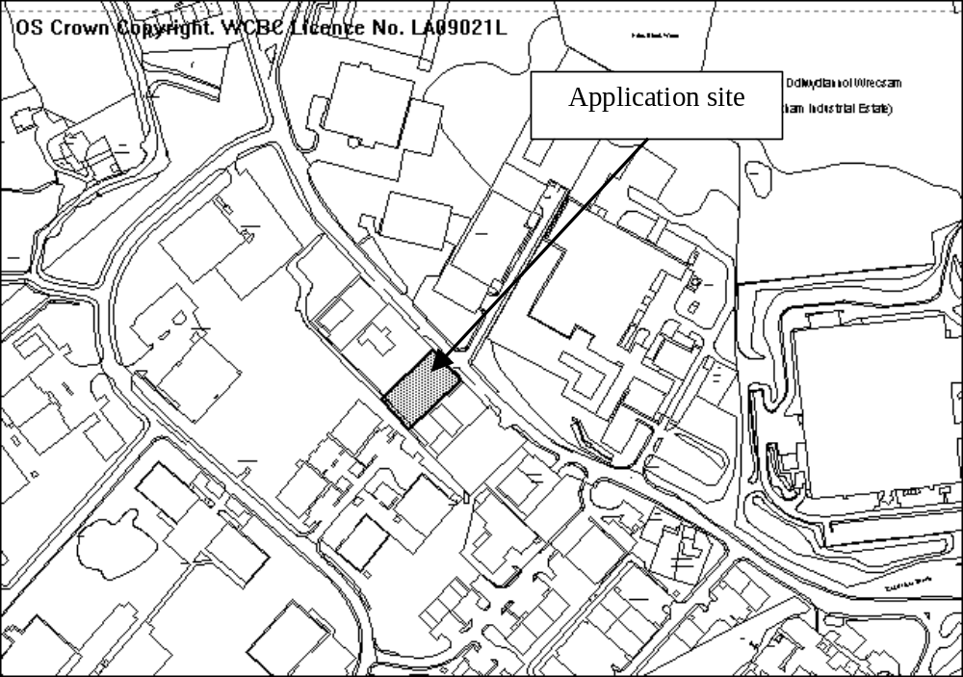

PROPOSAL

The erection of a 575 sq.m unit for storage/distribution use with associated offices. A parking/turning area is also provided.

HISTORY

CB01907 Erection of three detached industrial units for B1(c), B2 and B8 uses, construction of new vehicular and pedestrian access. Granted 5.5.98
P/2004/0965 Erection of new commercial building. Granted 10.9.2004

Adjacent plot (Plot 2)
P/2005/0879 Erection of new commercial building and construction of new vehicular access and alteration to existing vehicular access. Granted 26.9.2005
P/2006/0614 Erection of new commercial building (amendments to previously approved scheme code no. P/2005/0879). 23.6.2006

DEVELOPMENT PLAN

Within settlement limit. Policies PS2, PS2, GDP1, E4 and EC6 apply.

CONSULTATIONS

Community Council: Notified 24.10.07
Local Member: Requests application reported to committee.
Environment Agency: The application has low environmental risk.
Welsh Water: Recommend drainage conditions.
Highways: Recommend conditions requiring visibility splays as well as specifying access layout and parking/turning provision within site.
Public Protection: No contamination issues (based on previous assessments).
CCW: 1) Consider the survey conducted satisfactory;
- Avoidance, mitigation and compensation measures are advised in respect of Great Crested Newts). This will include the provision of appropriate agreed compensation areas together with perpetuity site security and management.
- A Regulation 44 (2) (e) licence will be required.
The scheme is not acceptable if no compensation is provided and that on this basis they object to the scheme.
Other representations: Nearby occupiers notified 29.10.07
Site Notice: Expired 19.11.07

SPECIAL CONSIDERATIONS

Applicant’s submission: The following summarised points are taken from a report submitted in support of the application on behalf of the applicants:

Site context: The site is flanked either side by other two-storey steel frame cladded industrial units of similar scale and appearance forming a streetscape along this portion of Coed Aben Road. To the front of the site is the busy Coed Aben Road and large Stadex Factory. To the rear is a steep bank with dense undergrowth beyond which is another large scale factory, Roil Foods Ltd.

Planning issues: The proposals to redevelop the site respond positively to the site context.

The 25 m set back [of the building] from the pavement is consistent with the existing street scene and large areas of nature conservation/soft landscaping and native tree species are indicated to the site frontage between 8-10 m deep. This again is consistent and improves upon approvals obtained for adjacent plots. Structure planting of native species is proposed either side of the proposal from the front of the site to the rear giving opportunity for potential migrating species to use this as a through corridor to the existing overgrown steep bank to the rear and for potential temporary shelter.

Conclusions:
- It is acknowledged the development presents issues relating to Ecology and the environment which are to be addressed;
- The latest legislation and good practice guidance on ecological matters has been aimed for throughout the design and consultation stages;
- The site was of low ecological value but it is acknowledged that there is potential for a newt presence;
- The applicant is open to suggestions regarding preventative measures that can be undertaken during the construction process such as protective newt fencing, newt-safe gullies etc;
- A large plot of adjacent, which has no potential for development increases the natural habitat and provides further migration corridors other than that proposed on this site;
- Redevelopment of the site is an economic and practical option. Redevelopment for commercial use is consistent with adjacent uses and character;
- The applicant feels a commuted sums based on draft guidance in the form of a 40% built development, 40% Nature Conservation and 20% soft landscaping land use split make development of smaller sites uneconomic;
- The development as proposed is a positive response to the combined context of established commercial development and office complexes, improving the amenity value of Coed Aben Road and Wrexham Industrial Estate for all whilst maintained a healthy balance with sustainability and ecology;
- The site has historically obtained permissions for industrial/commercial use and appears to have been ‘caught up’ in a transitional stage. The applicant feels that to allow this minor development to proceed as submitted would be a ‘common sense’ approach, particularly as mitigation accommodated by the occupier over and above that which they would have had to carry out prior to this discussion.

Siting and design: The position of the building within the site is acceptable and allows for a parking/turning area to the front. The building is also of an acceptable design, being similar in appearance to other nearby premises.

Parking/access: The parking and access arrangements are acceptable and will meet Highway requirements for visibility and turning as well as meeting LPG16 in terms of parking standards.

Ecology: There are several ponds between 280 and 500 metres from the site where Great Crested Newts (GCN) have been recorded. An ecological appraisal of the site has been carried out and a report submitted. The site is described as being dominated by hardstandings and bare surfaces with some sparse but heavily disturbed vegetation.

No evidence of species afforded legal protection (including GCN) was recorded within the application site, however the report notes that it could potentially support GCN. The report advises that the likelihood that GCN utilise the terrestrial habitat within the site is considered to be low, but that there is the possibility individuals may use or traverse the site.

CCW have advised that avoidance, mitigation and, because the site is potential GCN habitat compensation measures should be provided. The applicant has indicated they are willing to provide avoidance and mitigation but not compensation. Compensation habitat for GCN will require either
- Reducing the developable area of the site. This is likely to make the proposals un-viable owing to the fact the building would need to be substantially smaller;
- CCW have advised that an alternative would be for an off-site compensation scheme to be required by condition.

Conclusion: Policy EC6 states development permitted near to sites of intrinsic nature conservation value, compensatory measures should be provided. In the absence of a commitment to provide such measures the development will result in the loss of potential Great Crested Newt habitat and is therefore contrary to policy EC6.

RECOMMENDATION That permission be REFUSED

REASON(S)

1. The development will result in the loss of potential habitat for Great Crested Newts. In the absence of adequate compensatory habitat provision and ecological mitigation measures, the development will have an adverse impact upon Great Crested Newts, a species protected under the provisions of the Wildlife and Countryside Act 1981 (as amended) and the EC Habitats and Species Directive and identified in the UK Biodiversity Action Plan as a priority species. The development is therefore contrary to Wrexham Unitary Development Plan Policy EC6.
_____________________________________________________________________

APPLICATION NO:  P/2007 /1308  COMMUNITY:  Rhos  WARD:  Ponciau | LOCATION:  Land adjacent to Haulfryn Fennant Road Ponciau Wrexham  DESCRIPTION:  Outline application for erection of 1 no. 2 bedroom detached dwelling and provision of 4 no. off-street parking spaces.  APPLICANT(S) NAME:  Mr & Mrs Richards | DATE RECEIVED:  07/11/2007  CASE OFFICER:  MP  AGENT NAME:  Mr & Mrs Richards
_____________________________________________________________________

The application was deferred in January (following a site visit) after members requested revised access arrangements/and or traffic calming. A revised access has been submitted in order to address the original reasons for refusal.

Applicant’s submission:

The layout of the site has been revised to allow for a single access located roughly two thirds of the way along the frontage of the application site (i.e. slightly closer to the boundary with Haulfryn than 4 Fennant Road). The position of the dwelling has also been amended, with it located closer to the western boundary rather than in the centre of the site. This will allow for a shared parking/turning area to be provided.

With regards to the location of the dwelling, I am satisfied the separation distances to adjacent properties advised by LPG21 are achievable and that adequate parking/turning for both the existing and proposed dwelling can be provided.

Highways have advised that visibility in a westerly direction from the proposed shared access is concurrent with the requirements of Manual for Streets. However to the east a splay of 2.4 x 56m is only achievable to the centre line of the carriageway. Although visibility in both directions is restricted by the proliferation of parked vehicles in the vicinity of the site, Manual for Streets considers this acceptable as it does not create significant problems in practice.

The existing site has a recently lapsed planning permission for a side extension and two double garages. This would have increased the size of the existing house to 4 bedrooms. Given that the proposed dwelling is only two bedroom it is considered that traffic generation for the two proposals could be broadly comparable and that the proposed dwelling is unlikely to give rise to a significant increase in vehicles.

Pedestrian provision in the vicinity of the site is extremely poor and it is considered necessary to construct a footway across the full site frontage (to include the existing dwelling Haulfryn).

There are some concerns over the proposed parking and turning facilities, however there is room on the site to provide them with an alternative layout.

Given that this proposal removes a seriously substandard access, albeit with an access which is still below recommended standards it is considered that there will be an overall benefit to highway safety particularly if the new footway is constructed.

Conclusion: On the basis of the revised submissions and the advice received from Highways, the proposals are considered acceptable.

My original report: Is appended below together with a revised recommendation.

SITE

The application site is part of the residential curtilage/garden area of Haulfryn

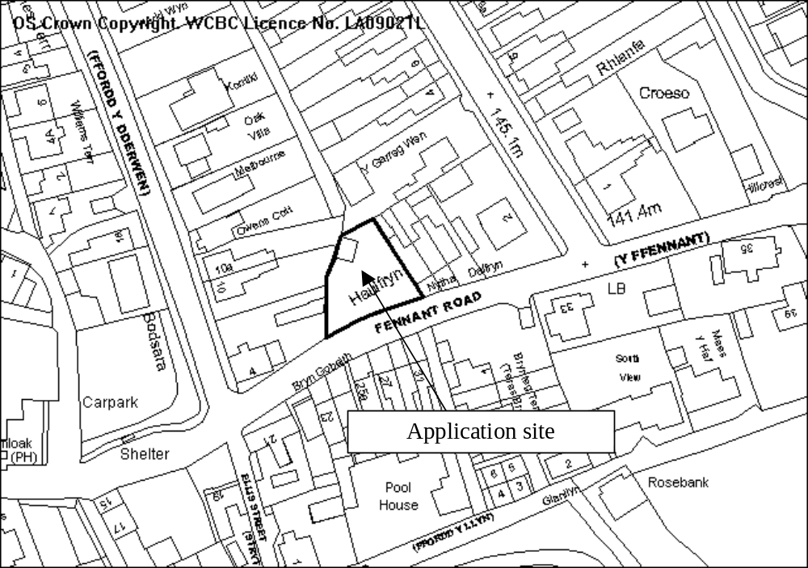

PROPOSAL

The applicant seeks approval for the siting of the dwelling and the means of access to the site. Design, landscaping and external appearance are reserved for subsequent approval.

HISTORY

P/2003/0072 Two-storey side extension, rear extensions and 2 No. double garages. Granted 4.3.2003 (to date unimplemented).
P/2004/0679 Outline application for residential development (1 dwelling). Withdrawn.
P/2007/0979 Outline application for erection of two storey 3 bedroom dwelling. Withdrawn.

DEVELOPMENT PLAN

Within the settlement limit. Policies PS2, GDP1 and H2.

CONSULTATIONS

Community Council: Notified 7.11.07
Cllr Pemberton: Notified 7.11.07
Cllr A Roberts: Requested the scheme goes to planning committee.
Highways: Recommend refusal on the grounds that the plans fail to demonstrate adequate visibility.
Welsh Water: Recommend conditions regarding drainage.
Other representations: Nearby occupiers notified 7.11.07
Site Notice: Expired 3.13.07

SPECIAL CONSIDERATIONS

Background: Two previous outline applications for single residential plots have been withdrawn after the applicants were advised that the proposals were likely to be refused owing to inadequate visibility at the site access, although there is no objection in principle to the development of the site. The current proposals seek to address these concerns by providing a new parking area parallel to Fennant Road with 2 spaces each for the proposed dwelling and the existing dwelling.

Siting of the dwelling: The siting of the proposed dwelling shown on the submitted plan is acceptable. I am satisfied that the site can be developed in accordance with the standards for new dwellings set out in LPG21 (with the exception of the advice on car parking – see below).

Proposed access arrangements: I am concerned that the proposals will not provide a safe and satisfactory means of access to either the existing or proposed dwelling. Vehicles manoeuvring in or out of the parking spaces are unlikely to be provided with clear views of the road in either direction. Fennant Road is also a classified road and LPG21 advises that new dwellings accessed off classified roads should be provided with turning facilities to avoid the need for vehicles to reverse or manoeuvre on the highway. Whilst the parking layout allows vehicles to exit the site without having to turn, the layout may well may well result in vehicles reversing/manoeuvring in the highway and is likely to prove as hazardous as if a driveway without a turning space were proposed.

The applicant has suggested that a condition could be attached to require vehicles to park facing an easterly direction, thus maximising the visibility available to drivers. Such a condition would not be enforceable however and it would not be possible to prevent drivers parking facing a westerly direction. If a vehicle were to access a parking space in this direction, they would be required to cross from one side of the road to the other and then manoeuvre into an available parking space in the face of on-coming traffic. The driver of a vehicle parked facing west would also be placed in a very disadvantageous position when attempting to exist a parking space because they would have extremely limited views of on-coming traffic, thus putting themselves and other road users at risk.

RECOMMENDATION That permission be GRANTED

CONDITION(S)

1. Approval of the following details shall be obtained from the Local Planning Authority before any part of the development is commenced:
a. the design of the building(s)
b. the external appearance of the building(s)
c. the landscaping of the site.
2. Plans and particulars of the reserved matters referred to in condition 1 (above) shall be submitted in writing to the Local Planning Authority before the expiry of three years from the date of this permission. The development shall only be carried out in strict conformity with such details as are thereby approved.
3. The development hereby permitted shall be begun before the expiry of five years from the date of this permission or two years from the date of approval of the last of the reserved matters required to be approved, whichever is the later.
4. This permission shall operate only to allow development to be carried out in accordance with the approved drawings and the application documentation. Notwithstanding the provisions of the Town and Country Planning (General Permitted Development) Order 1995, no further development shall take place within the site (other than the painting of the buildings).
5. The reserved matters shall include full details of parking and turning areas for the proposed dwelling and Haulfryn.
6. Foul and surface water discharges shall only be drained separately from the site.
7. No surface water or land drainage run-off shall be allowed to connect (either directly or indirectly) to the public sewerage system.
8. The site shall be provided with an access in a position shown on the approved plans. The access shall be a minimum of 4.1m wide, shall be hard surfaced with a bound material for a minimum of 5m behind the highway boundary and shall have a maximum gradient of 1 in 8 for a distance of 5m behind the highway boundary.
9. Notwithstanding the provisions of the Town and Country Planning (General Permitted Development) Order 1995 no gates shall be erected within 5 m of the highway boundary.
10. The access from the site onto Fennant Road shall have a visibility splay measuring 2.4 x 56m in a westerly direction measured to the nearside kerb edge of the adjoining highway within which there shall be no obstruction in excess of 1m in height.
11. The access from the site onto Fennant Road shall have a visibility splay measuring 2.4 x 56m in an easterly direction measured to the centre line of the adjoining highway within which there shall be no obstruction in excess of 1m in height.
12. The access shall be provided with pedestrian visibility splays of 2.4m by 3.3m in both directions, within which there shall be no obstruction to visibility in excess of 0.6m in height. The splays shall be provided prior to the first occupation of the apartments hereby approved and thereafter maintained.
13. The reserved matters shall include full details of a 2.0m wide footway that shall be constructed from the edge of the existing highway along the full frontage of the development site and the existing dwelling Haulfryn and measures to include its future protection..
14. The new access as shown on the approved plans shall be constructed and brought into use prior to the first occupation of the dwelling hereby granted permission. Following the completion of the new access to the satisfaction of the Local Planning Authority and prior to the first occupation of the new dwelling, the existing access shall be effectively and permanently closed to vehicular traffic by means to be agreed in writing by the Local Planning Authority.

REASON(S)

1. To comply with the provisions of the Town and Country Planning (General Development Procedure) Order, 1995.
2. To comply with Section 92 of the Town and Country Planning Act, 1990.
3. To comply with Section 92 of the Town and Country Planning Act, 1990.
4. Due to the restricted application site and its relationship with adjoining properties it is considered important to ensure that no additional development as described in the condition is carried out without the permission of the Local Planning Authority.
5. To ensure adequate provision is made for the parking and turning of vehicles clear of the highway.
6. To protect the integrity of the public sewerage system.
7. To prevent hydraulic overload of the public sewerage system and pollution of the environment.

8. To ensure the formation of a safe and satisfactory access.
9. To ensure the formation of a safe and satisfactory access.
10. To ensure that adequate visibility is provided at the proposed point of access to the highway.
11. To ensure that adequate visibility is provided at the proposed point of access to the highway.
12. To ensure the formation of a safe and satisfactory access.
13. In the interests of pedestrian safety.
14. In the interests of highway safety.

NOTE(S) TO APPLICANT

You should ensure that any difference between the plans approved under the Town and Country Planning Acts and under the Building Regulations is resolved prior to commencement of development, by formal submission of amended plans.

The proposed development lies within a former coal mining area. You should take account of any hazards to stability which may arise from coal working in or near the site. Specific advice on any past working may be obtained from the Coal Authority Mining Reports Service. Phone 0845 762 6848 or from www.coal.gov.uk.

Any operations which may involve entry into former workings, shafts or adits or implementation of site investigations or other works may need permission from the Coal Authority.

All works, ancillary operations and the use of plant and machinery which are audible at the site boundary shall be carried out only between 07.30 hours to 19.30 hours Monday to Friday, between 08.00 hours to 14.00 hours on Saturdays and at no time on Sundays and Bank Holidays.

There shall be no fires on site, to include the prohibition of the burning of cleared vegetation.

A suitable dust management scheme shall be implemented on site to prevent dust nuisance from arising.

Your attention is drawn to Highway Supplementary Notes Numbered 1, 3, 4 and 5 on the enclosed "Applicants' Rights and General Information".
_____________________________________________________________________

APPLICATION NO:  P/2007 /1423  COMMUNITY:  Chirk  WARD:  Chirk South | LOCATION:  FORMER PLAS Y WAUN INN CHAPEL LANE CHIRK WREXHAM  DESCRIPTION:  ERECTION OF 12 NO. DWELLINGS AND 6 NO. APARTMENTS.  APPLICANT(S) NAME:  MONTEC HOMES | DATE RECEIVED:  11/12/2007  CASE OFFICER:  JGK  AGENT NAME:  FITZSIMON PLANNING & DEVELOPMENT LTD
_____________________________________________________________________

THE SITE

As above.
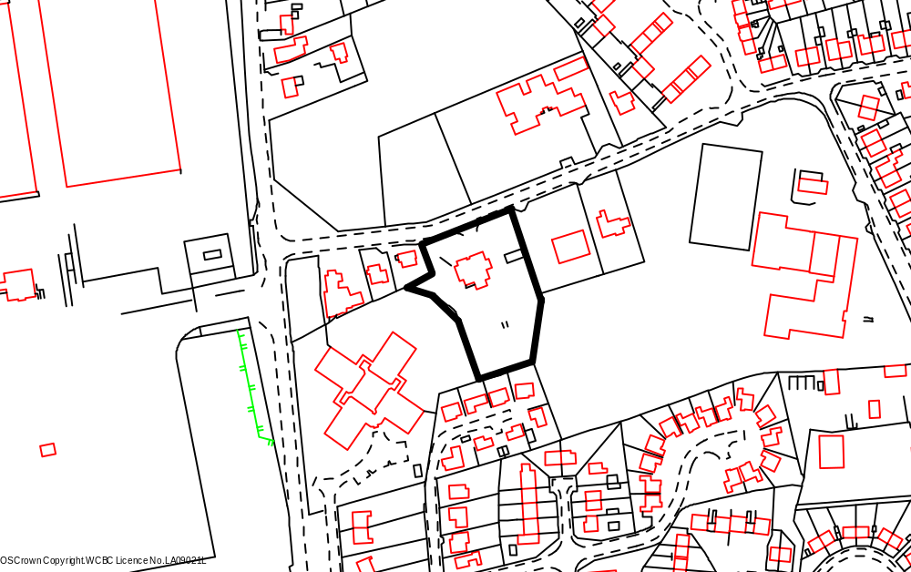

Chapel Lane
Schools

Holyhead Rd

Application site

Playing field
Maes yr Ysgol

PROPOSAL

As above.

RELEVANT HISTORY

P/2004/0085 Outline application for residential development and alteration to existing vehicular and pedestrian access. Granted 05.04.04.
P/2004/1382 Erection of 16 no three storey dwellings and associated works. Withdrawn 09.11.04.
P/2007/0691 Variation of condition no. 2 of planning permission code no. CHI/P/2004/0085 to extend the period for submission of reserved matters for 12 months to 30 June 2008. Granted 16.07.07.

DEVELOPMENT PLAN

Within settlement limit UDP Policies PS1, PS2, PS4, GDP1, EC4, H2, CLF5 and T8. Local Planning Guidance Notes 7 – Landscape and Development, 10 – Public Open Space in New Housing Development, 15 – Cycling, 16 – Parking Standards, 17 - Trees and Development, 21 – Space around Dwellings and 22 – Sustainable Building.

CONSULTATIONS

Community Council: Detailed concerns as follows:
- Development will add to the hazardous conditions, which already exist on Chapel lane especially at school (Chirk Infants) opening and closing times due to parking of vehicles.
- Parking bay should be provided at school entrance by developer.
- Works, including the movement of HGVs, equipment, use of machinery and other traffic flow should be carefully controlled to not impinge upon safety/sensitivity/privacy of neighbours/nursing home/infant school.
- Site boundaries to be properly secured.
- S106 agreement to be secured for payment in lieu of open space provision for improvements to recreational area opposite development.
- Welsh water to provide evidence that public sewerage system is adequate to cope with additional development and not overload the system in the locality.
Local Member: Not happy about the design of this site. The block of flats is out of character with the area next to a three hundred year old cottage. Will be asking for a site at Committee. Asks that the two trees between the cottage and Maes yr Ysgol be put forward for TPOs as they are of excellent quality in the summer bloom .
Adj Local Member: Notified 13.12.07.
Highways: Adequate parking provide. Recommends that any permission to include conditions re. traffic calming, adequate visibility, turning and parking on site and provision of a detailed layout for design, drainage and construction of internal estate road. Add Notes to Applicant.
Property Services: Notified 13.12.07.
Education: There is spare capacity at the primary school. Secondary school is full. Financial contribution required.
Public Protection: Add condition requesting submission of Noise Impact
Assessment Report to also include a noise mitigation scheme.
Environment Agency: Standard ‘Guidance Note for Developers’.
Welsh Water: Add conditions to protect integrity of public sewerage system.
Site Notice: Expired 12.01.08.
Press Notice: Expired 18.01.08.
Adjoining Occupiers: Objections received as follows:
- Too many dwellings for site.
- Impact upon privacy of adjoining properties - rear portion of site already raised and therefore, houses 9,10, 11 and 12 would significantly overlook gardens of 3,5 and 7 Maes yr Ysgol. These proposed properties should be built at the lower level of those adjacent to the entrance from Chapel lane.
- Queries from adjacent landowner regarding boundary issues – location of ditch, tree line and metal fence; boundary treatment and possible damage to existing fence.
- Chapel Lane is already hazardous with school and chapel traffic and associated parking.
- Inadequate drainage – previous problems.
Letter received from the Governing Body of Ceiriog Junior School asking that the boundary to the school property be a solid wooden fence with concrete posts with no access the school premises.

Agent/Applicant’s comments on objections
- The applicant has agreed previously to introduce traffic calming measures along Chapel lane, to the requirements of the Highway Authority which will over come any issues raised; discussions have already taken place with highways about this matter.
- Contractors are bound by law to comply with statutory Health & Safety requirements. I can confirm that full site security fencing will be erected for the duration of the scheme. If required our client is more than willing to arrange for all site deliveries outside the busiest school times. Delivery time/times could be introduced as a planning condition. (Appropriate condition attached).
- The client is well aware that a section 106 agreement is required for payment in lieu of an open space prevision. We are awaiting confirmation of the sum from the local Authority.
- As discussed yesterday we are prepared to reduce the existing ground levels at the rear of the site to the level of 338.00m this brings the level of the rear in line with these adjacent to Chapel Lane. This will overcome the over looking issues with existing properties. (Amended plans submitted demonstrating that the levels will be lowered).
- Drainage - if required during further consultation with Welsh Water, full on site attenuation will be designed as per the requirements of any drainage scheme. This will be carried out to the requirements of Welsh Water and a planning condition could be introduced to this effect. (Appropriate condition attached).
- Apartment Block - the apartment block has been discussed on several occasions and finally agreed with the local planning authority. This building is designed to give the impression of terrace properties. Utilising the same materials and details as the rest of the site.

SPECIAL CONSIDERATIONS/ ISSUES

Background: This is full planning application for residential use. An outline planning permission for residential development was granted in 2004. Since then the applicant has undertaken numerous pre-application discussions with the planning department on a number of varied proposals. The site, accessed off Chapel Lane, originally accommodated the Plas Y Waun Inn, car park and associated gardens. The public house has since been demolished. A variety of house types and materials are in evidence in the local area. A play area comprising informal and equipped play space is located directly opposite the site.

Proposal: Following comments and the identification of a number of constraints by the planning and highway departments the current scheme was submitted in December 2007 for the erection 12 dwellings and a single block of 6 apartments. Following further discussions with the applicant/agent, amendments have been submitted addressing a number of issues and resulted in the number of dwellings being reduced to 11.

Apartments – the apartment block is purposely located at the entrance to the site, set behind the existing low stone wall (to be restored) and a large communal space. It has attractive front and rear elevations, well designed as a terrace of small cottage-like properties with interesting features, including stone detailing and a central gable (see Plan 2 below). It will give the entrance to the site some presence and focus. It does not impact upon the three TPO trees to the frontage of the site. Another area of communal space is located to the rear of the block adjacent to the car parking area – two parking spaces per property. The communal areas will be maintained by management agreement.
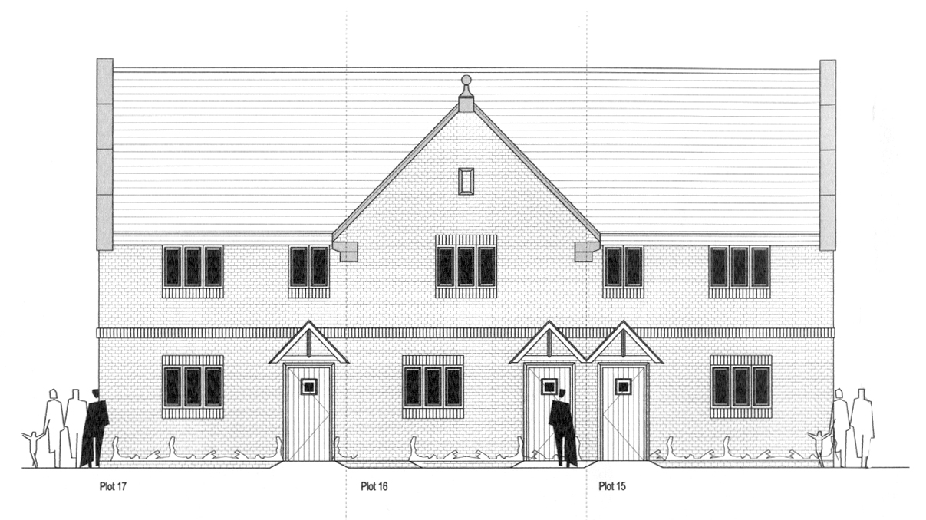
Front elevation to apartment block as seen from Chapel Lane

Houses – there are 4 different house types. A detached property is located at the entrance to the site again set back from the existing stone wall and adding interest to the street scene. There are six plots with semidetached properties with roof dormers to the front elevations and rooflights to the rear to ensure acceptable separation distances. As with the apartment block, the dwellings will be similar in design with stone detailing, decorative chimneys and storm porches. Plots 4, 5 and 6 are designed in a row of mews houses, again of traditional design with pitched roof broken up by two symmetrical gables to add architectural interest. Plot 11 is a detached property with similar features as described above and now does not impact upon the mature beech tree located nearby.
Each property has at least 2 off-street parking spaces and a landscaped open plan front garden.

Policy: There are no policy objections in principle to the proposal as the site is within the settlement limits of Chirk (UDP Policy PS1 refers). However, UDP Policies PS2 and GDP1 together with Local Planning Guidance Notes 7 – Landscape and Development, 10 – Public Open Space in New Housing Development, 16 – Parking Standard, 21 – Space around Dwellings, 22 – Sustainable Building and 27 – Developer Contribution to Schools list criteria for consideration when processing detailed applications for housing development and I comment on these as follows:

Highways: The development has access on to an unclassified road subject to a 30-mph speed limit and highway advice considers that traffic can easily travel up to this limit. Highway advice at the time of considering the outline planning application took account of the history of the site – a public house for approximately 30 years – resulting in no objection to the proposal on highway grounds subject to certain conditions, particularly the implementation of a scheme for traffic calming. There are two schools in close proximity to the site and a traffic calming scheme is considered essential to enhance highway and pedestrian safety; it will also enable adequate visibility splays to be provided at the access that will be in accord with the recommendations of Manual for Streets. The applicant/agent has submitted amended plans demonstrating the proposal has adequate parking provision and highway design/layout. In order to minimise the conflict of delivery/construction traffic with the busiest school times I have attached a condition to ensure the delivery of materials and accessing of the site by heavy construction vehicles is outside of these busy school times.
Conditions are attached to ensure:

- Access has adequate visibility
- Submission and approval of a detailed scheme for the layout, design and construction of the internal estate road
- Provision of adequate on site parking and turning
- Submission and approval of a scheme of traffic calming on Chapel Lane
- Provision of a means of enclosure not exceeding 1m in height
- Delivery of materials and accessing of the site by heavy construction vehicles is outside of busy school times
Provision of tactile paving to the footway either side of the access from Chapel lane will be constructed to the further approval of the council as highway authority under s38 of the Highways Act.

Landscape: There are mature trees (two on the frontage to the site are covered by TPO – see Tree comments below) and hedges to the southern, eastern and western boundaries. Lengthy pre-application discussions have taken place how best to deal with the existing trees, overgrown beech hedging and proposed supplementary landscape treatment of the site. In support of this aspect of the proposal, the applicant/agent has submitted a Landscaping Scheme and Specification, Maintenance and management Plan. The proposed layout and landscape proposals for the site have been well considered, and would retain much of the existing landscape features of the site, which include mature trees along the site boundary, the overgrown beech hedge boundary and stone wall frontage. These features are of value in their contribution to local character, and in providing an instant and mature setting to the new housing development particularly in views from Chapel Lane. Some selective thinning and crown lifting work would be required to the boundary hedgerow, which due to lack of maintenance for many years now forms a line of tall thin trees, some in poor condition. This positive management, plus supplementary hedgerow planting and post and rail fencing, are proposed to retain a long term ‘green’ boundary to the site, rather than have a more visually dominant close board fence erected. The planting proposals for the site include tree and ornamental shrub planting to provide an attractive character to the site entrance and internal areas.

Trees: There are two large sycamores on the northern boundary adjacent to the existing entrance subject to TPO - WCBC No.90 and an extremely dominant beech on the western boundary to the rear of Yew Tree Cottage subject to TPO WCBC 22.

Impact upon TPO’d trees - these trees will require important consideration in the acceptance of any proposed layout. The currently submitted information has inconsistencies in the crown spread of trees TPO'd T1 & T2 on the frontage of the site and are underestimated on drawing No. RAL/099-01 for both trees. Stem diameters are also not accurate - this is important as the Root Protection Area as per BS 5837:2005 is calculated from the stem diameter. Underestimating obviously gives a smaller Root Protection Area (RPA) than is required by the standard. Despite the assurances stated in the Method Statement, the RPA for tree T2 needs to be extended resulting in the apartment block needing to be moved further into the site. The very large TPO'd Beech tree outside the site to the south west of the apartment block may be detrimentally affected by this building, however no tree survey data is available for this tree, so its RPA cannot be worked out exactly. Beech trees' do not take well to root disturbance and overmature trees less so as they do not have the vitality and vigour to cope with root severance and soil compaction.

Way forward - an acceptable solution to these problems is to pivot the apartment building so that it is more face onto the main road. This will result in more room for tree 2 and the large Beech adjacent to the site. This is shown on recently submitted amended proposed site plan Drawing No. JIG/0390/06. This is more acceptable than the previous footprint location and further discussions are ongoing with the agent to ensure that the solution is acceptable.

Tree Protection - the drawing that accompanied this Method Statement report showing Tree Protection fencing locations is inadequate. I have attached a condition to ensure that approved fencing, prior to the commencement of development protects all trees. This information will need to be plotted accurately on a scaled drawing. Details of protective fencing type are acceptable. This needs to be agreed before any works start on site and preferably before planning consent is issued. Existing hard standing comes very close to retained trees. As a portion of this is to be removed within the trees' Root Protection Areas, a subsequent revised Method Statement will be required prior to work commencing on site that shows how the tarmac will be removed without damage to the trees' roots and soil structure.

Although not ideal, the realignment of the building closest to the TPOd Sycamores and Beech tree will ensure a better chance of survival for these trees. Subject to attaining acceptable additional information for Protective fencing and revised Method Statement to include tree survey information on the TPO’d Beech tree and how hard surfaces will be removed within RPAs, the proposal is acceptable.

Amenity and Design: The application site is broadly flat and level with Chapel Lane with the exception of the mound to the rear of the site. This material to the rear will be removed off site and the levels reduced to that similar to Chapel Lane – a drop of approximately 2 metres (a note has been attached to the recently resubmitted proposed Site Plan). I have attached a condition to ensure that this reduction in levels takes place. I have also added a condition for the submission and approval of floor levels. The submitted ‘Planning, Access and Design Statement’ addresses the issues of separation distances with adjoining properties and how the proposed scheme has been designed accordingly. The apartment layout at first floor level is such that the windows on the side elevations relate to bathrooms to be obscurely glazed and fixed in order to prevent overlooking and loss of privacy for the occupiers of nearby dwellings (condition attached). The properties on the rear plots 8 to 11 (plots 9 and 10 are 2½ storey result in 24/25m separation distances with the existing properties on Maes yr Ysgol exceeding the 22m requirement asked for in LPG 21. Rooflights are proposed instead of dormers to the rear elevation. Rear boundary treatment will assist in protecting the amenity of adjoining occupiers. Each dwelling has private space in excess of the Council’s adopted standards. It is evident that much thought has gone into the house types and their detailing to ensure that they are characteristic of the wider local area. Materials will reflect the traditional nature of the house designs, ie. Slate roofs, sandstone and a soft brick/render

Impact upon Yew Tree Cottage - it is suggested that the scheme will adversely affect the nearby the cottage located to the west of the application site. Yew Tree Cottage is originally of stone built construction with later extensions to the rear and side elevations. To the front elevation the upper floor has been reconstructed in brick with painted mock timber framework. It is likely to have been altered when the dormer windows were installed. The cottage has a clay tile roof and painted finish. Windows are timber but neither these nor the window openings are to the original proportions. Although the original construction would appear to be of some age, due to later alterations, it is unlikely that the building would be listed.
This being the case the impact of the neighbouring development should be considered upon the impact of its design on the street scene rather than its impact upon any special character the cottage may possess. The proposed apartment block will have the most impact. However, it is set back from the road frontage so as not to over dominate or overshadow the existing cottage. The materials and detailing proposed are characteristic of the local area and the gabled bay to the frontage helps break up the overall massing of the structure.

Sustainable Development: A key objective of the Council is to significantly increase the overall sustainability of development proposals. The applicant/agent has submitted a Sustainable Design Statement. It seeks to ensure that the proposal satisfies the six key sustainable planning principles outlined in Local Planning Guidance Note 22 – Sustainable Buildings, namely: location and layout; building design; supplying and using energy and water; waste management; transport and access; promoting wildlife and building in local distinctiveness.

Whilst there exists some positive sustainable building elements within the scheme, a notable gap exists in terms of maximising the potential for renewable energy and reducing water use. UDP Policy PS12 ‘Renewable Energy’, together with GDP1 c) supports the principle of renewable energy, provided no overall detrimental impacts are involved. I have added a condition asking for the submission and approval of detailed feasibility schemes for energy saving and reducing water use that will maximise the full potential for the site.

Education: Although there is spare capacity at the primary school, the secondary school is full. Therefore, in accord with L P G 27 – Developer Contributions to Schools, a contribution’ is required. The cost of such provision has been identified as £43,152 . The payment will be secured through a s106 agreement.

Public Open Space: In accord with Policy CLF5 and Local Planning Guidance Note 10 – Public Open Space in New Housing Development, a development of 18 dwellings would need to provide on site POS. In certain appropriate circumstances the Guidance Note also allows for a commuted payment in lieu, it states that ‘In suitable developments of less than 20 dwellings the local planning authority may agree that there is a adequate council owned play and amenity provision in close proximity to the proposed development, … in such circumstances the developer must enter into a legal agreement with the council to pay the commuted sum‘. There is a play area opposite the site and the applicant has proposed to provide a commuted payment to enable this play area to be upgraded, enhanced and maintained. The required payment of £9000 will be secured through a s106 agreement.

Drainage: Welsh Water has not identified any issues to do with foul and surface water drainage regarding redevelopment the application site. I have attached a condition seeking the submission and subsequent approval of full details of foul and surface water drainage.

Conclusion: I consider that the redevelopment proposal has carefully considered the Council’s development plan polices and guidance. I consider that the end result is a scheme that is well integrated with the existing village and has met WAG guidance in that the ‘ … design of housing should be to establish a sense of place and community, with the movement network used to enhance these qualities’ and that ‘ … the layout and built form should reflect local context, including topography and building fabric’ (Planning Policy Wales Technical Advice Note 12: Design refers).
I consider the proposed scheme is an improvement to the locality, will set well within the street scene and I am satisfied that there will be no loss in amenity or adverse impact upon local residents or the area in general.

RECOMMENDATION A

That the applicant enters into an obligation under Section 106 of the Town and Country Planning Act 1990, requiring:
- The establishment of a management company to ensure the future maintenance of all public open space, landscape features and areas of ecological importance.
- The payment of £43,152 as developer’s contribution to the shortfall in education facilities.
- The payment of £9,000 to contribute to improvements to the play area on the opposite side of chapel Lane opposite the application site.

That the Chief Planning Officer is given delegated authority to determine the final form and content of the obligation.

RECOMMENDATION B

That the application be approved on completion of the obligation subject to the following conditions:

P/2007 /1423
CONDITION(S)

1. The development hereby permitted shall be begun before the expiry of five years from the date of this permission.
2. Prior to their use on the development samples of all external facing and roofing materials shall be submitted to and approved in writing by the Local Planning Authority. The development shall only be carried out in strict accordance with such details as are approved.
3. Development shall only be carried out in strict accordance with the approved plans unless the prior written approval of the Local Planning Authority has been obtained.
4. The vehicle parking for the apartment block shall be surfaced and marked out in full accordance with the approved drawings before the apartment block is occupied and thereafter shall not be used or permitted to be used for any purpose other than the parking of vehicles belonging to the residents of the apartment block.
5. The proposed access shall have a visibility splay of 2.4m x 33m in a south easterly direction to the centre line of the adjoining highway within which there shall be no obstruction in access of 1m in height.
6. A scheme of traffic calming shall be submitted to and approved by the planning authority prior to commencement of any site works and shall be constructed prior to occupation of the first dwelling.
7. The detailed layout, design, drainage and construction of the internal estate road shall be submitted to and approved by the Local Planning Authority in consultation with the Highway Authority prior to commencement of any site works. This layout is to include details demonstrating that no water of any kind shall flow from private driveways on to the highway or into the highway drainage system.
8. Parking facility shall be provided and retained at the proposed dwellings in accordance with the approved plan (Drawing No JIG/0390/06 rev C) and shall be completed prior to the proposed development being brought into use
9. No part of the development shall be commenced until a noise survey has been undertaken to determine noise levels for both day and night having regard to Planning Policy Guidance (Wales) Technical Advice Note 11 - Noise. The detailed report to be submitted and approved by the Local Planning Authority shall include:
a. noise levels arising from day/night activities arising from the nearby industrial use to the proposed development and Holyhead Road and the impact on the proposed accommodation.
b. a detailed scheme on noise insulation and/or attenuation measures so designed to safeguard the amenity of the future occupants of the proposed accommodation hereby approved.
All data shall be representative of typical conditions for both day (0700 - 2300 hours) and night (2300 - 0700 hours). The report shall be submitted to and approved in writing by the local Planning authority. Any mitigation measures required shall be implemented in accordance with timescales to be agreed as part of the measures before development is commenced.
10. Before beginning work, the contractor shall contact the Chief Planning Officer giving him seven days notice of a meeting on site to review all work procedures, access routes, storage areas and tree protection measures. Development shall be carried out in strict accordance with the agreed measures.
11. No development or other operations shall commence on the site until adequate steps, which shall have been previously agreed with the Local Planning Authority, have been taken to safeguard against damage or injury during construction works, all trees on the site or whose root structure may extend within the site, which are subject of Tree T1 and T2 (WCBC 90 Preservation Order 2002) and WCBC 22 Preservation Order 1998. In particular, no excavations, site works, trenches or channels shall be cut or pipes or services laid in such a way to cause damage or injury to the trees by interference with their root structure and no soil or waste shall be deposited on the land in such a position as to be likely to cause damage or injury to the trees by affecting their root structure.
13. No development shall take place until an arboricultural method statement has been submitted to and approved in writing by the Local Planning Authority. The statement shall include a specification for protective fencing that complies with BS5837 : a plan showing the position of the protective fencing; a full specification for the construction of any access, driveway or path under the crown spread of the trees, and related sections, details of general arboricultural matters including proposed practices with regard to cement mixing, material storage and fires; and details of the frequency of supervisory visits and procedures for notifying the finding of such visits to the Local Planning Authority. Works shall be carried out strictly in accordance with that approved method statement.
14. The existing trees, shrubs and hedges indicated on Drawing No RAL.099.01 Issue 3 to be retained shall not be cut down, grubbed out, lopped or uprooted without the previous written permission of the Local Planning Authority. Any pruning of trees approved shall be carried out in accordance with the current British Standard 3998 and subsequent revisions (Tree Work). Any tree, shrubs or hedges removed without such permission, or being severely damaged or diseased within three years of the date of occupation of the development for its permitted use shall be replaced with trees, shrubs and hedging plants of such a size and species as may be agreed with the Local Planning Authority.
15. The erection of fencing for the protection of trees and shrubs shall be undertaken before any equipment, machinery or materials are brought onto the site for the purposes of the development, and shall be maintained until all equipment, machinery and surplus materials have been removed from the site. The above mentioned fencing shall consist of a scaffold framework in accordance with Figure 2 of BS 5837 (2005) comprising a vertical and horizontal framework, well braced to resist impacts, with vertical tubes spaced at a maximum interval of 3 metres. Onto this, 2.1m weldmesh panels shall be securely fixed with wire or scaffold clamps. This fencing shall be erected at the full extent of the canopy of each tree and shrub. Nothing shall be stored or placed in any area fenced in accordance with this condition and the ground levels within those areas shall not be altered, nor shall any excavations be made without the written permission of the Local Planning Authority.
16. Additional tree pruning required for clearance during construction must be performed by a qualified arboriculturist and not by construction personnel.
17. The implementation and management of the soft landscape works shall be carried out in accordance with the approved details as set out on drawing(s) No(s) RAL.099.0 Issue 3 and the landscape specification, maintenance and management plan. The works shall be carried out prior to the occupation of any part of the development.
18. No part of the development hereby permitted shall be commenced until full details of road, paving and footpath surfaces have been submitted to and approved in writing by the Local Planning Authority. The works shall completed in all respects within three months of the first use of any building.
19. Any trees or shrubs removed, dying, being severely damaged or becoming seriously diseased within five years from the completion of the scheme shall be replaced by trees or shrubs of similar size and species to those originally required to be planted unless otherwise approved in writing by the Local Planning Authority. No part of the approved planting scheme, shall be removed after the expiration of 5 years, without written approval from the Local Planning Authority.
20. Foul water and surface water discharges must be drained separately from the site.
21. No surface water shall be allowed to connect (either directly or indirectly) to the public sewerage system.
22. No land drainage run-off will be permitted, either directly or indirectly, to discharge into the public sewerage system.
23. No part of the development shall be commenced until a dust management scheme has been submitted and approved in writing by the local planning authority. The approved measures of dust management shall be implemented throughout the development of the site
24. Prior to the commencement of development, the following details shall be submitted for further written approval of the Local Planning Authority:
i) A detailed feasibility scheme for energy saving has been submitted to and approved by the Local Planning Authority. The works shall be implemented in accordance with a timescale a timescale to be approved in conjunction with the scheme of details;
ii) A detailed feasibility scheme for reducing water use been submitted to and approved by the Local Planning Authority. The works shall be implemented in accordance with a timescale a timescale to be approved in conjunction with the scheme of details;
iii) Details to show that all materials will, wherever possible, be sustainably sourced from suppliers who operate a recognised Environmental Management System;
iv) Waste recycling scheme;
v) A sample welcome pack which will be provided for future occupiers.
The details as subsequently approved shall be fully implemented as part of the development or in accordance with timescales to be agreed, in writing, with the local planning authority.
25. This permission shall operate only to allow development to be carried out in accordance with the approved drawings and the application documentation. Notwithstanding the provisions of the Town and Country Planning (General Permitted Development) Order 1995, no further development shall take place within the site (other than the painting of the buildings).
26. Deliveries of materials and arrival and departure of other construction traffic shall be limited to 0930 to 1500 hours and 1630 to 1930 hours Monday to Friday and 0800 to 1400 hours on Saturdays.
27. Construction works, ancillary works and the use of plant or machinery audible at or beyond the site boundary shall only be carried out between the hours of 07:30 and 19:30 (Monday to Friday) and 08:00 to 14:00 (Saturday) and at no time on Sundays or Bank Holidays.

REASON(S)

1. To comply with Section 92 of the Town and Country Planning Act, 1990.
2. To ensure a satisfactory standard of appearance of the development in the interests of the visual amenities of the area.
3. To ensure that the development fully complies with the appropriate policies and standards.
4. To ensure that adequate parking facilities are provided and maintained for use by the residents of the approved apartment.
5. To ensure that adequate visibility is provided at the proposed point of access to the highway.
6. In the interests of highway safety.
7. In the interests of highway safety.
8. To ensure that the estate road system is constructed to a standard suitable for adoption.
9. To protect the amenities of the future occupiers of proposed development.
10. To ensure that the works on the site properly take account of the future health of the trees.
11. To protect trees which are of significant amenity value to the area.
13. To ensure the amenity afforded by the trees is continued into the future.
14. To ensure the amenity afforded by the trees is continued into the future.
15. To protect trees which are of significant amenity value to the area.
16. To ensure the work is carried out to accepted arboricultural practices for the long term well being of the tree(s).
17. To ensure a satisfactory standard of appearance of the development in the interests of the visual amenities of the area.
19. To ensure a satisfactory standard of appearance of the development in the interests of the visual amenities of the area.
20. To protect the integrity of the public sewerage system.
21. To prevent hydraulic overloading of the public sewerage system, to protect the health and safety of existing residents and ensure no detriment to the environment.
22. To prevent hydraulic overload of the public sewerage system and pollution of the environment.
23. To minimise the potential to cause nuisance by way of dust due to the close proximity of residential properties.
24. To maximise potential for sustainable building.
25. Due to the restricted application site and its relationship with adjoining properties it is considered important to ensure that no additional development as described in the condition is carried out without the permission of the Local Planning Authority.
26. In the interests of pedestrian and highway safety during hours of busy school times.
27. To protect the amenities of the occupiers of nearby properties.

NOTE(S) TO APPLICANT

You are advised that the planning permission hereby granted does not authorise any building over, diversion, connection or other interference with any sewer, public or private, which crosses the site. You are advised to contact Welsh Water, PO Box 10, Treharris, CF46 6XZ (Tel: 01443 331155) in this regard, prior to undertaking any groundwork in connection with the development. Should you be required to depart from the details hereby approved, you should contact the Council's planning department to seek further advice with regard to the submission of amended plans and / or a new planning application.

Your attention is drawn to Highway Supplementary Notes Numbered 1, 3, 4 and 5 on the enclosed "Applicants' Rights and General Information".

The proposed widening of the footway fronting no. 19 Plas Acton Road shall be constructed to a standard suitable for adoption by the Council for future maintenance at public expense and the developer will need to enter into an agreement with the Council under s.278 of the Highways Act 1980.

The proposed access and footway shall be constructed to a standard suitable for adoption by the Council for future maintenance at public expense and the developer will need to enter into an agreement with the Council under s38 of the Highways Act 1980. Parking shall be in accordance with Local Planning Guidance Note No 16 - Parking Standards.

The scheme of landscaping referred to in the above conditions shall inlcude any changes to ground levels (shown by existing and proposed contours/levels) and any existing vegetation (showing that to be retained) and proposed planting. In addition, any of the following which apply to the particular site must be included:-
means of enclosure, car parking layout, access and circulation areas, materials for hard surfaced areas, any minor structures (e.g. refuse stores, lamp columns, play equipment) location of services, and any historic landscape features to be retained/improved.

There shall be no fires on the site, to include the prohibition of the burning of cleared vegetation.

Any works (including temporary works) in, under, over or adjacent to any watercourse may require the formal consent of the Environment Agency prior to works commencing. In accordance with the Agency's "no-culverting" policy, Pconsent for culverting will only normally be granted for site access purposes.

Any works (including temporary works) in, under, over or adjacent to any watercourse may require the formal consent of the Environment Agency prior to works commencing. In accordance with the Agency's "no-culverting" policy, Pconsent for culverting will only normally be granted for site access purposes.

Any waste excavation material or building waste generated in the course of the development must be disposed of satisfactorily and in accordance with section 34 of the Environmental Protection Act 1990.

The activity of importing waste into the site for use as, for example hardcore, must be registered by the Environment Agency Wales as an exempt activity under the Waste Management Licencing Regulations 1994.

If evidence of storage/spillage of agro-chemicals are found in or around the farm buildings/outbuildings/area, then it would be prudent to investigate the potential for residual contamination. Should you require any advice on this issue please contact the Public Protection Department of the Council on 01978 2977041.

Please note that the developer will be responsible for the costs of designing, consulting, advertising and implementing the traffic calming scheme.

Any new roads serving more than five dwellings should be constructed to a standard suitable for adoption by the Council for future maintenance at the public expense and the developer will need to enter into an agreement with the Council under section 38 of the Highways Act 1980 so that the new road can be adopted for maintenance at the public expense.

The proposed widening of the footway on Chapel Lane should be constructed to a standard suitable for adoption by the Council for future maintenance at the public expense and the developer will need to enter into an agreement with the Council under section 38 of the Highways Act 1980.

The accessway ramp /tactile paving details are incorrect and must be constructed to the further approval of the highway authority under s38 of the Highways Act.

Your attention is to be drawn to the following supplementary notes; 1, 3, 4, 5, 6, 7, 8 & 9.
_____________________________________________________________________

APPLICATION NO:  P/2007 /1478  COMMUNITY:  Overton  WARD:  Overton | LOCATION:  THE BROW WREXHAM ROAD OVERTON WREXHAM  DESCRIPTION:  LISTED BUILDING CONSENT FOR ALTERATIONS AND REFURBISHMENT, ENTRANCE PORCH EXTENSION AND TENNIS COURT IN GARDEN  APPLICANT(S) NAME:  MRS G FITZHUGH | DATE RECEIVED:  21/12/2007  CASE OFFICER:  LG  AGENT NAME:  CASELY & WHALE
_____________________________________________________________________

THE SITE

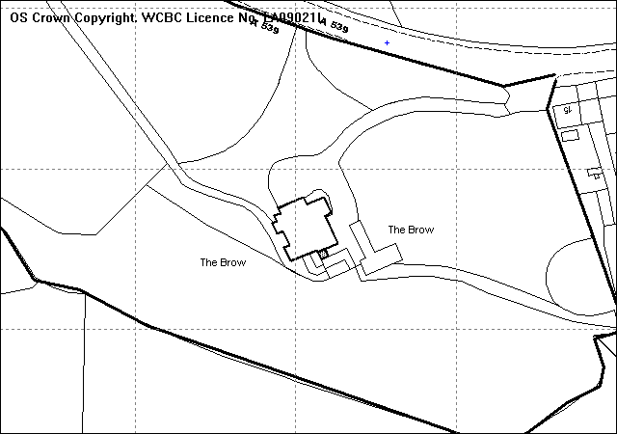
Site
Proposed porch
Outbuildings

PROPOSAL

Listed Building Consent for alterations and refurbishment and entrance porch extension.

HISTORY

P/2006/1490 Alterations, refurbishment and improvements to The Brow and conversion of stables into dwelling. Withdrawn 13.02.07
P/2006/1491 Listed Building Consent for alterations, refurbishment and improvements to The Brown and conversion of stables into dwelling. Withdrawn 13.02.07
P/2007/1477 Alterations and refurbishment and entrance porch extension. Approved 04.03.08

DEVELOPMENT PLAN

Outside settlement limit and within an area designated as special landscape. UDP Policies PS2, GDP1, EC5 and EC9 are relevant.

CONSULTATIONS

Community Council: No objections
Local Member: Consulted 27.12.07
WACS: Consulted 27.12.07
RCAHMW: No Observations
FHS: Consulted 27.12.07
DHS: Consulted 27.12.07
Other Representations: Notified 28.12.07 & 07.01.08
Site Notice: Expired 22.01.08

SPECIAL CONSIDERATIONS/ISSUES

Background: The Brow is a Grade II Listed Building built around 1820. It is located on the western edge of the village within an area designated as Special Landscape above the slopes of the River Dee. The application is made for a proposed entrance porch extension on the south east elevation of the dwelling and for external and internal alterations and refurbishment to the building. When visiting the site it was noted that the applicant has carried out some of the internal works already and as such can only apply to retain the alterations from this point, as a retrospective application cannot be made in respect of a Listed Building.

Residential Amenity: Due to the location of the property, set within large open grounds, screened to the main public highway (Overton Road) by trees and planting, the proposals would have no impact on the amenity of the neighbouring dwellings

Impact on Listed Building: In order to fully assess the impact of the works proposed on the listed building, the following information was requested.

- A brief structural condition survey is necessary, particularly in respect of the external render and the damp problem to the study. The causes of the damp problem should be identified.
- Conservation Method Statement – this should provide justification for the works and a fully specified schedule of works including the proposed methods to remedy the problems as identified within the structural condition survey. For example, the use of bitumen on the external walls would not be supported as this will undermine the building's ability to breathe further compounding any damp problems. The removal of what is presumably a cement based render should immediately assist the building in drying out if the problem is penetrating damp. Once removed, the walls should be re-pointed in a lime, sand mortar (no cement) and rendered in a lime render with a breathable wash or paint finish.
- Details of the materials for the proposed boot room extension should be confirmed.
- The kitchen window to the north east elevation should remain in its present form as there is no justification/need for its alteration.
- Detailed drawings should be provided of the new french doors and windows to the kitchen area.
- In bedroom 3, the fireplace is to remain in-situ and this should be demonstrated on the plans.

The information remains outstanding following several attempts to obtain the details required to progress the application.

Conclusion: The above information is required to assess the impact of the alterations to the historic integrity and identity of the listed building and without it, full assessment of the possible harm cannot be ascertained.

RECOMMENDATION That permission be REFUSED

REASON(S)

1. Insufficient detail has been submitted for the internal and external alterations to enable a proper assessment of the impact on the character of the Listed Building and the Local Planning Authority cannot be satisfied that no harm would be caused to the historic integrity and identity of the building. To allow the development would be contrary to Policy EC9 of the adopted Wrexham Unitary Development Plan (2005).
2. The proposed use of bitumen on the external walls will undermine the building's ability to breathe, further compounding any damp problems which is detrimental to the integrity and character of the Listed Building. To allow the development would be contrary to EC9 of the adopted Wrexham Unitary Development Plan (2005).

NOTE(S) TO APPLICANT

The works already carried out to the building do not have the benefit of Listed Building Consent and are unauthorised. As such they are liable to be subject to enforecement action and you must contact the Local Planning Authority urgently to clarify how matters may be remedied.
_____________________________________________________________________

APPLICATION NO:  P/2008 /0088  COMMUNITY:  Offa  WARD:  Brynyffynnon | LOCATION:  SENSOR HOUSE WREXHAM TECHNOLOGY PARK CROESNEWYDD ROAD WREXHAM  DESCRIPTION:  TWO STOREY OFFICE UNIT  APPLICANT(S) NAME:  ERDDIG DEVELOPMENTS LTD | DATE RECEIVED:  29/01/2008  CASE OFFICER:  MP  AGENT NAME:  ERDDIG DEVELOPMENTS LTD
_____________________________________________________________________

SITE

West of the existing car park and access to the unit occupied by Ellison Sensors adjoining the former Brother factory site..

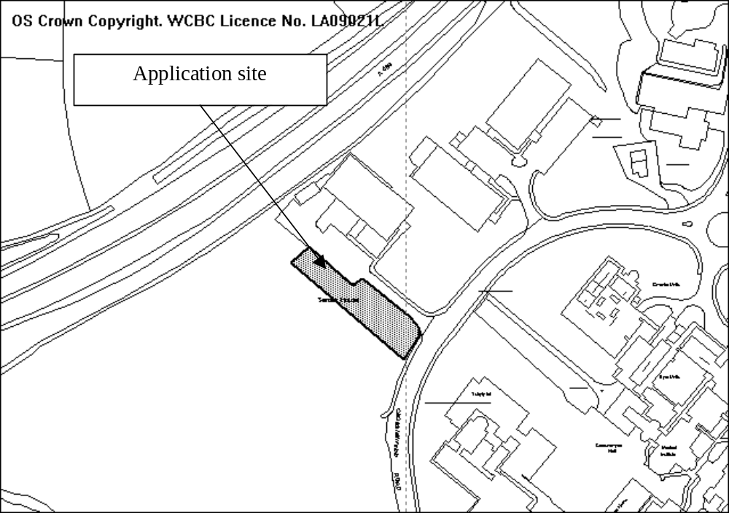
(former) Brother site
Former Brother factory site

PROPOSAL

Erection of a 2 storey office unit and provision of associated parking.

HISTORY

P/2005/1278 Extension of existing single storey building providing new offices and workshop. Granted 12.12.2005

Adjoining site
P/2005/1464 Outline application for residential development (122 no. dwellings) and alteration to existing vehicular and pedestrian access. Refused 15.9.2006 Appeal dismissed (although principle of residential development on the site accepted by Inspector).

DEVELOPMENT PLAN

Within settlement limit. Policies E4 and GDP1 apply.

CONSULTATIONS

Community Council: Notified 30.1.08
Local Member: Notified 30.1.08
Highways: Recommend conditions requiring splays at access onto Croesnewydd Road as well as adequate parking and turning.
Public Protection: Recommend measures to limit impact of construction works.
Welsh Water: Recommend drainage conditions.
Environment Agency: No comments, standard advice applies.
CCW: No objections. No statutory sites affected and statutory protected species not likely to be affected. Proposals will not cause adverse impacts on any statutory protected landscapes.
Other representations: 1 letter received (based on original submission) from adjoining landowner with following comments:
- proposals is on unregistered land;
- building will result in the loss of an area of landscaping identified as important by an appeal Inspector. Loss of landscape character formed part of the Council’s case;
- proposal is unacceptably close to the boundary of former Brother Site. Principle of residential development has been established and a new application is subject to pre-application discussions. It would be prudent to ensure that there is not significant level of overlooking form the rear elevation of proposed development.
Site Notice: Expired 26.2.08

SPECIAL CONSIDERATIONS

Background: The proposal as originally submitted was for a two storey office unit located to the front of the site with parking to the rear. I was concerned this would adversely impact upon the character of the area and suggested the building was located towards the rear of the site, with parking to the front and space left for landscaping. Amended plans have been submitted along these lines and it is on this basis the decision will be made.

Siting and design: The new position of the building some 30m back from the highway boundary is sufficient to ensure it will not have a significant or adverse impact upon the visual amenity of the locality. The purpose of locating the building some distance from the highway is to ensure the open impression when travelling along Croesnewydd Road is maintained and to ensure that a suitable area of landscaping between the car park and highway can be retained/enhanced in the interests of the visual amenity of the area.

The building is of a simple design typical of the office units found elsewhere in the Technology Park and is considered acceptable.

Highways/parking: The site layout provides sufficient space for a parking area that accords with Local Planning Guidance Note 16 both in respect of parking spaces and layout (i.e. there will be sufficient space to provide turning).

Ecology: An ecological report has been submitted in support of the application. No evidence of any protected species was found on site, which was found to be of negligible conservation value. This concurs with the advice received from CCW that on the basis of information available to them, no statutory protected species are likely to be affected.

Residential amenity: I appreciate that the Inspector accepted the principle of residential development on the adjacent site, however a new application has yet to be submitted. I am therefore only able to give limited weight to the possible impact upon the amenity of future residential properties. Nevertheless I have the following comments on the proposals:
- The development makes provision for the retention of the existing hedge along the south-west boundary of the site which will ensure an effective screen is in place thus limiting any overlooking of any future residential properties;
- The agent has confirmed the south-west elevation will be obscure glazed so as to limit overlooking of the adjoining site (thus having taken account of the comments made by the owners of the adjacent site);
- The proposal is for an office unit, a use considered acceptable within or close to a residential area, therefore it should not adversely impact upon amenity by way of noise, vibration, dust etc.

On the basis of the above, I am of the opinion the development will not prejudice the development of the adjacent site.

Conclusion: I am satisfied the development accords with adopted UDP policies.

RECOMMENDATION That permission be GRANTED

CONDITION(S)

1. The development hereby permitted shall be begun before the expiry of five years from the date of this permission.
2. Prior to their use on the development samples of all external facing and roofing materials shall be submitted to and approved in writing by the Local Planning Authority. The development shall only be carried out in strict accordance with such details as are approved.
3. The erection of fencing for the protection of trees and shrubs shall be undertaken before any equipment, machinery or materials are brought onto the site for the purposes of the development, and shall be maintained until all equipment, machinery and surplus materials have been removed from the site. The above mentioned fencing shall consist of a scaffold framework in accordance with Figure 2 of BS 5837 (2005) comprising a vertical and horizontal framework, well braced to resist impacts, with 2.1m vertical tubes spaced at a maximum interval of 3 metres. Onto this, weldmesh panels shall be securely fixed with wire or scaffold clamps. This fencing shall be erected at the full extent of the canopy of each tree and shrub. Nothing shall be stored or placed in any area fenced in accordance with this condition and the ground levels within those areas shall not be altered, nor shall any excavations be made without the written permission of the Local Planning Authority.
4. Within 3 months of commencement of development on site, full details of both hard and soft landscape works for the site shall be submitted to and approved in writing by the Local Planning Authority. The works shall be implemented in accordance with a timescale to be approved in conjunction with the scheme of details.
5. The premises shall not be used for any purpose other than a purpose within Class B1(a) of the Schedule to the Town and Country Planning (Use Classes) Order 1987 (or in any provision equivalent to that class in any statutory instrument revoking and re-enacting that Order with or without amendment).
6. The vehicle parking and turning areas indicated on the approved plans shall be laid out, surfaced and drained prior to the first use of the building hereby granted and shall thereafter be retained for those purposes, free of all obstruction.
7. The access onto Croesnewydd Road shall be provided with visibility splays of 2.4 metres x 56 metres in both directions as measured to the nearside edge of the adjoining highway within which there shall be no obstruction in excess of 1.0 metre in height. The splay shall be provided prior to the first use of the building hereby granted permission and thereafter retained free of all such obstruction.
8. No development shall commence until a scheme for the comprehensive and integrated drainage of the site showing how foul water, surface water and land drainage will be dealt with has been submitted to and approved, in writing, by the Local Planning Authority. The development shall be carried out in strict accordance with the details as approved.
9. No trees/shrubs located along the south-western boundary of the site shall be lopped, topped, felled or uprooted without the prior written agreement of the Local Planning Authority, nor shall any trees/shrubs be wilfully damaged.

REASON(S)

1. To comply with Section 91(3) of the Town and Country Planning Act, 1990.
2. To ensure a satisfactory standard of appearance of the development in the interests of the visual amenities of the area.
3. To protect trees which are of significant amenity value to the area.
4. To ensure a satisfactory standard of appearance of the development in the interests of the visual amenities of the area.
5. To ensure the use of the premises does not adversely impact upon the occupiers of adjacent properties.
6. In the interests of highway safety.
7. To ensure that adequate visibility is provided at the proposed point of access to the highway.
8. To ensure effective drainage facilities are provided for the proposed development and that no adverse impact occurs to the environment or the existing public sewerage system.
9. To ensure the existing tree/shrub screen is retained in the interests of the visual amenity of the locality.

NOTE(S) TO APPLICANT

Your attention is drawn to Highway Supplementary Notes Numbered 1, 3, 4 and 5 on the enclosed "Applicants' Rights and General Information".

All works, ancillary operations and the use of plant and machinery which are audible at the site boundary shall be carried out only between 07.30 hours to 19.30 hours Monday to Friday, between 08.00 hours to 14.00 hours on Saturdays and at no time on Sundays and Bank Holidays.

There shall be no fires on site, to include the prohibition of the burning of cleared vegetation.

A suitable dust management scheme shall be implemented on site to prevent dust nuisance from arising.
_____________________________________________________________________

APPLICATION NO:  P/2008 /0133  COMMUNITY:  Maelor South  WARD:  Overton | LOCATION:  WOOD FARM HOUSE BREADEN HEATH WHITCHURCH SHROPSHIRE  DESCRIPTION:  EXTENSION TO EXISTING FARM HOUSE, CONSTRUCTION OF NEW ENTRANCE PORCH AND INTERNAL ALTERATIONS.  APPLICANT(S) NAME:  MR & MRS D ROGERS | DATE RECEIVED:  08/02/2008  CASE OFFICER:  LG  AGENT NAME:  WHITMORE & HUMPHREYS
_____________________________________________________________________

THE SITE

As above.
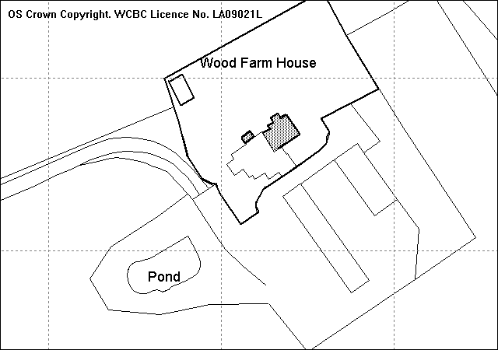
Proposed extension
Existing Stables
Swimming pool

PROPOSAL

As above.

HISTORY

6/0000/1043 Alterations, improvements and extensions to existing building and provision of new septic tank. Approved 19.03.75
6/0002/3360 Conversion of barn into 6 No holiday cottages, regularisation/alteration of associated link block and erection of new swimming pool building. Approved 05.06.95
P/2006/1114 Double open fronted garage with playroom/storage above. Approved 24.11.06

DEVELOPMENT PLAN

Outside settlement limit within Special Landscape Area. UDP Policy GDP1, PS2 and EC5 are relevant. Local Planning Guidance Note Nos. 13 – Housing in the Countryside and 20 - House Extensions are also relevant.

CONSULTATIONS

Community Council: No objections to the proposal. Re-consulted 10.04.08
Local Member: Consulted 11.02.08. Re-consulted 10.04.08
CCW: Consulted 25.03.08
Other Representations: 2 Letters of objection received objecting:
- The proposed extension added to the previous extensions exceeds the one third guidelines with the proposed extension equating to an increase of 63 % of the original footprint.
- Whilst the west gable may be in need of repair to alter the building as stated to get a more modern idiom resulting in a definition between old and new would not be in keeping with current buildings within the vicinity.
- Feel that the detailed extension would intrude on privacy with a clear view into the private swimming pool area, of which there are two velux windows to the south east elevation. LPG 21 advises that there should be 22 metres between habitable windows that directly face each other.
- The applicant fails to recognise the roof area would increase by some 60% and extend the rear roof line by some 13.2 metres causing a shadow over the rear garden area and cause an intrusion to privacy.
- The proposal is not conducive with current buildings in the vicinity and would look out of place and is such a contravention of LPA guidance notes.
- Request that the application be rejected as it is clearly over-development which would destroy the character and appearance of the original building, it’s scale, proportion and massing would have a significant impact/intrusion on it’s neighbours privacy.
- The proposal along with the stables will reduce the actual footprint of the garden.
- Question of the validity of the plans as they do not reflect the true layout of the existing property.
- The current footprint of the building and internal layout in our opinion is more than ample to fulfil a families needs and that the applicants proposals will be detrimental to what is considered in the area a house of significant interest due to it’s age and construction.
- Question the relevance and content of the applicant’s justification for a large extension.
- Bats are currently nesting within the roof space of the property and any disturbance would be in contravention of The Wildlife & Countryside Act 1981.
- A number of mature trees have been felled within the site.
- The following non-material planning objections were also raised:
- should any development take place there would be significant disruption caused to the electricity supply
- The two properties share a waste treatment plant for sewerage and any increase in its functionality due to increase in flow would incur the occupants of Wood Farm additional cost in maintenance and running.
- Drawings submitted do not show where surface water will run to.
Re-notified 10.04.08
Site Notice: Expired 04.03.08

SPECIAL CONSIDERATIONS/ISSUES

Background: Wood Farm House is the former farm building in a small complex known as Wood Farm. The main house itself and the converted barn became separate units in 2005. As detailed above the property has been subject to several previous extensions, not all of which have been fully implemented. The proposed extension is to create an additional bedroom with an en-suite/dressing room to on the first floor and a family/kitchen area on the ground floor. The proposal also involves the creation of a small front porch to the north west elevation to allow easier access from the existing parking area. Amended plans have been received that address concerns regarding the size, design and appearance of the extension.

Design: The existing property is an attractive modest sized former farmhouse of some age. The gable on the south-west elevation appears to be the oldest section of the property and is constructed of stained timber frames and herring bone brickwork. The proposed extension has attempted to replicate this distinct character feature, and in doing so has created a higher quality design that improves the appearance and retains the character of the original property.

The size and mass of the proposed extension has been reduced bringing the extension more in proportion with the original building. The proposed gable feature on the north west elevation is subsidiary to the existing gable and retains the scale. The use of timber frames and more styles of modern glazing adds interest to what was a plain elevation and enhances the appearance of the dwelling when viewed from the public footpath.

Special Landscape: The property is located in the open countryside in an area defined as special landscape. The proposed extension enhances the appearance of the farmhouse and would not detract from the quality of the special landscape area or the openness of the countryside.

Floor area: The proposed two storey extension will project 5 metres from the existing rear elevation and measures 8.4 metres in width at it widest point creating around 84 sq.m of additional floor area. The proposed extension combined with the previous extensions and stables and the unimplemented garage would represent well over 100% increase. If the garage/playroom is revoked (see below) it would still be around a 70% increase of the original floor area which still exceeds the levels quoted in LPG 13. However, these limits are guidance only, and LPG 13 also states that where a higher quality design more in keeping with the character of the original dwelling can be achieved, extensions that result in an increase of more than one third in floor area will be allowed.

This calculation excludes the floor area of the two-storey garage granted permission in 2006 which has yet to be implemented and should the committee be minded to grant planning permission, the permission should be subject to a Revocation Order to remove that permission. The revocation is required in order to protect the openness of the countryside and prevent over-development of the site.

Residential Amenity: The current proposal is in accordance with The Building Research Establishment 45 degree daylight test and would not result in a detrimental loss of daylight to the neighbouring dwelling.

The first floor glazing on the north east elevation will be to an en-suite bathroom and master bedroom. The windows closest to the boundary with the neighbouring dwelling will be obscurely glazed, as secured by planning condition, to prevent overlooking into the garden area and swimming pool of the neighbouring dwelling.

With regards to comments received concerning overlooking, the velux windows on the south east elevation facing the neighbours outbuilding (containing a swimming pool), are from a bathroom and closet, neither of which are classed as habitable rooms so the required separation distance is not 22 metres. Privacy will be maintained through planning condition, regarding opening direction, and I do not consider side velux windows to lead to a significant loss of privacy for either the applicant or adjoining occupiers.

The proposal, which extends the roof by around 10 metres, will be visible from the garden area of the neighbouring property. However as the extension will be located some 11 metres away from the adjoining property and given it’s north facing orientation, I do not consider the proposal to result in overshadowing or to be a visual intrusion.

Parking: The proposal will result in a further one bedroom at the dwelling and there is adequate parking within the curtilage to accommodate the increase.

Ecology: The letter of objection has raised the issue that bats are roosting in the roof of the existing building. The Countryside Council for Wales has been consulted and any comments received shall be included in the addendum.

Trees: The objection letter has raised the concern regarding the felling of the trees at the site. There are no TPOs present on the site and the applicants would not require permission to fell trees. There is a large mature oak tree to the front of the dwelling, which has been shown on the proposed location plan. No proposed works are within 5 metres of the tree and no damage would result.

Conclusion: The amended plans represent a smaller and more simplified scheme which has incorporated the high quality and distinctive design elements of the original farm house and replicated them successfully on the proposed extension, enhancing the overall appearance and character of the dwelling. Concerns regarding impact on amenity can be addressed through planning condition and I consider that the proposal is in accord with Local Policy.

RECOMMENDATION

- That an Order be made under Section 97 of the Town and Country Planning Act 1990 (using the procedure set out in Section 99 of the Act for unopposed cases) revoking the following permission granted:-

Permission Code | Date of Permission | Development Permitted
P/2006/1114 | 24.11.06 | Double open fronted garage with playroom/storage above

- That permission be GRANTED following the coming into effect of the Revocation Order subject to the conditions set out below:-

RECOMMENDATION That permission be GRANTED

CONDITION(S)

1. The development hereby permitted shall be begun before the expiry of five years from the date of this permission.
2. No facing materials shall be used other than materials matching those used on the existing building.
3. Development shall only be carried out in strict accordance with the approved plans unless the prior written approval of the Local Planning Authority has been obtained.
4. The velux rooflights on the south east elevation shall only open from the top downwards.
5. The first floor windows on the north east elevation to the en-suite shall only be glazed or re-glazed using obscure glass.
6. This permission shall operate only to allow development to be carried out in accordance with the approved drawings and the application documentation. Notwithstanding the provisions of the Town and Country Planning (General Permitted Development) Order 1995, no further development shall take place within the site (other than the painting of the buildings).

REASON(S)

1. To comply with Section 91(3) of the Town and Country Planning Act, 1990.
2. To ensure a satisfactory standard of appearance of the development in the interests of the visual amenities of the area.
3. To ensure that the development fully complies with the appropriate policies and standards.
4. To protect the amenities of the occupiers of nearby properties.
6. To allow the Local Planning Authority to review the impact of any subsequent development on the appearance of the property and to protect the openness of the surrounding countryside.

NOTE(S) TO APPLICANT

You should ensure that any difference between the plans approved under the Town and Country Planning Acts and under the Building Regulations is resolved prior to commencement of development, by formal submission of amended plans.
_____________________________________________________________________

APPLICATION NO:  P/2008 /0185  COMMUNITY:  Rossett  WARD:  Rossett | LOCATION:  FIELDSIDE BURTON ROSSETT WREXHAM  DESCRIPTION:  TWO STOREY KITCHEN AND BEDROOM EXTENSION.  APPLICANT(S) NAME:  MR & MRS S DAVIES | DATE RECEIVED:  22/02/2008  CASE OFFICER:  SEH  AGENT NAME:  J I G ARCHITECTURAL LTD
_____________________________________________________________________

THE SITE

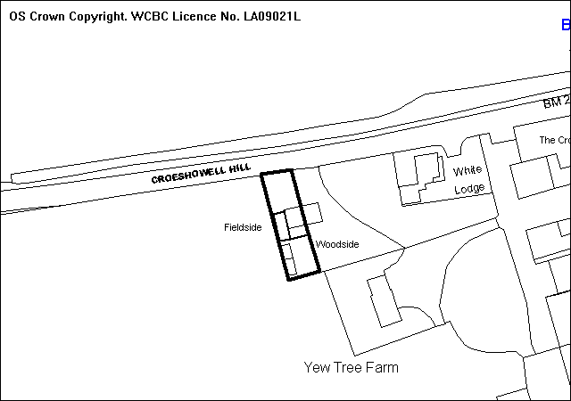
Proposed Extensions

PROPOSAL

As above.

HISTORY

None relevant.

DEVELOPMENT PLAN

Outside settlement limit, within green barrier and within a Special Landscape Area. UDP Policies GDP1, PS2, EC1, EC4, EC5 and T8 apply. Local Planning Guidance Notes Nos. 13 ‘Housing in the Countryside’, 16 ‘Parking Standards’ and No. 21 ‘Space around Dwellings’ are also relevant.

CONSULTATIONS

Community Council: No objections
Local Member: Consulted 25.02.2008
Other Representations: One letter received based on the following grounds:
- No objection to the proposal provided that all drains are within the boundary of the site, and any foundations are well away from the hedge which forms the boundary with the field.
Site Notice: Expired 17.03.2008

SPECIAL CONSIDERATIONS/ISSUE

Background: This is an application for two storey side and rear extensions to a dwelling which is situated outside settlement limit, within green barrier, and within a special landscape area where development is strictly controlled. Local Planning Guidance Note No.13 provides that the size of extensions to dwellings in these locations should be restricted to no more than one third of the original dwelling. The aim of this restriction is to allow for a reasonable increase in size of existing dwellings whilst protecting the countryside from out of scale development. The visual prominence of the building and quality of design of the proposal will be factors in the determination of house extensions in the countryside.

Design and Residential Amenity: The proposed extension is of simple design incorporating a two storey side extension which projects to the rear, and a single storey rear extension. The daylight test as recommended by the Building Research Establishment has been applied, and the extension would not significantly reduce the amount of daylight to the rear windows of the adjoining property.

The proposed extension exceeds the one third size restriction significantly, as described above, with an increase of almost 100%. The impact of such a large extension to the property would be minimal when viewed from the front elevation, particularly as the extension would be set back slightly with a lower ridge line than the original roof. However, when viewed from the side, the extension would create a significant visual impact, with this elevation doubling in length, and would be readily visible from the highway particularly when view from Croeshowell Hill (to the west).

The proposed extension would leave no room for access to the rear of the property, resulting in domestic bin storage to the front of the property. Further, due to the proximity to the boundary, the development could inevitably cause damage to the existing boundary hedge.

Highways: The location of the proposed extension is such that all of the on-site parking, as required, is re-located to the front of the property. The size of this area is restricted and, although some alterations are proposed to increase the size of the area, is not large enough to accommodate 3 no. parking spaces together with a workable unobstructed turning circle. This could lead to awkward turning manoeuvres, reducing visibility from the access, and lead to increased dangers to users of this busy road.

Applicant’s Submission: The applicants were asked to consider reducing the size of the proposed extension. However, they felt that the extension as proposed would not be viewed by the general public, except by passers by, and that too much emphasis is being placed on an impulse to their detriment. Further, they felt that the proposal would give depth and character to the property and would be flanked by the existing boundaries.

Other Representations: Location of drainage is not a relevant consideration for this application.

Conclusion: The proposal is unacceptable in terms of scale and design, and would result in a significant negative visual impact. The proposal fails to minimise the visual impact from nearby and distant viewpoints contrary to local planning policy. Further, the proposal would reduce on-site parking/manoeuvring provision to an unacceptable level.

RECOMMENDATION That permission be REFUSED

REASON(S)

1. The proposal, by virtue of its size, mass and prominent siting in the countryside, would have a detrimental impact on the quality of the landscape and would be unsympathetic to the character of the surrounding countryside location. The development would result in a visual intrusion in this area of special landscape and make a negative contribution to the appearance of the locality. To allow the development would be contrary to the adopted Wrexham Unitary Development Plan Policies GDP1(a), PS2, EC1, EC4, EC5 and the Council's adopted Local Planning Guidance Note 13 - Housing in the Countryside.
2. The proposed development does not make adequate provision for the parking and manoeuvring of vehicles within the site and would therefore be likely to result in vehicles reversing onto or manoeuvring on the highway, or leaving the site at such an angle that would impede visibility, with consequent risk of additional danger to all users of the road and interference with the free flow of traffic and as such, would be contrary to Policy GDP1(d) of the Wrexham Unitary Development Plan and the Council's Local Planning Guidance Note 21 - Space Around Dwellings.
_____________________________________________________________________

APPLICATION NO:  P/2008 /0195  COMMUNITY:  Rossett  WARD:  Rossett | LOCATION:  LAND NORTH EAST OF OAK TREE FARM GOLLY BURTON WREXHAM  DESCRIPTION:  ERECTION OF FREE-RANGE EGG LAYING UNIT  APPLICANT(S) NAME:  MR G WALTON G J WALTON AND PARTNERS | DATE RECEIVED:  25/02/2008  CASE OFFICER:  LB1  AGENT NAME:  IAN PICK ASSOCIATES LTD  MR IAN PICK
_____________________________________________________________________

SITE

Land opposite OakTree Farm, Golly, Rossett.

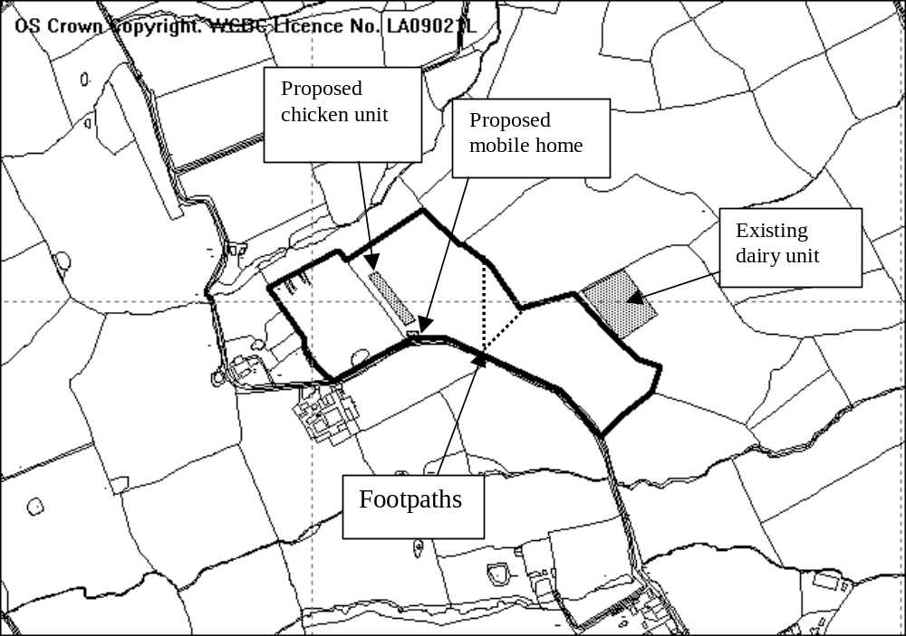

PROPOSAL

Erection of 10,000 bird free range egg laying unit.

HISTORY

P/2007/0415 – Application for 12,000 bird free range egg unit. Refused 15/06/07 appeal dismissed
P/2007/0416 – Erection of mobile home for use as dwelling in connection with free range egg unit. Refused 15/06/07 appeal dismissed.
P/2008/0196 Siting of mobile home for use as a temporary agricultural dwelling in association with the free range egg laying unit.
Next item on the agenda

DEVELOPMENT PLAN

Outside settlement limit, GDP1, PS2, EC3 & EC4 apply.

CONSULTATIONS

Community Council: Does not object now application has been revised.
Local Member: Notified 26/02/08
Public Protection: No objections in principle, request that the same conditions as advised for the previous application be put on any permission.
Highways: No objection subject to conditions
Welsh Water: No objection as private drainage facilities are to be utilised.
Environment Agency: Satisfied that the proposals will not have a detrimental impact on the environment.
Flintshire County Council: Notified 26/02/08
Ramblers Association: Object to the proposal for the following reasons:
- The route of Path 19 goes through the area of tree planting. This would be an unacceptable restriction on what is currently an open path.
- The previous application detailed the type of gates and stiles that were to be employed to retain the chickens within the free-range area, these details have not been supplied.
- Investigation with the land registry indicates that there is ample space to site this diversification on other areas of land registered to the farm, which are not traversed by Rights of Way.
- It is stressed that avian flu will at some point arrive in this part of the country, granting of this application will inevitably lead to the closure of footpaths. This would be an avoidable inconvenience to the public at large when there is sufficient ground to site this free range area away from public rights of way.
- The addition of even low amounts of traffic using the roads to and from the unit would be detrimental to the actual roads. This could deter people from taking exercise, which is high on the Governments agenda.
- Interesting to note that it was previously stated that 12,000 birds were required to make the unit cost effective, but suddenly 10,000 birds are cost effective, this appears to be a case of spin and must throw into doubt the validity of other assertions made in this application i.e. the number of HGV vehicles which will use the unsuitable lane.
Other representations: 15 letters of objection received raising the following points:
- The information submitted is inadequate, particularly with regard to traffic movements.
- The proposed site is inappropriate as there is alternative land available which would have a lesser impact on the rural community.
- The skyline development, although reduced in size from the previous application will not be adequately screened by the tree planting proposals and topographical surveys have not been submitted showing the trees will screen the development.
- Increased number of vehicles and their frequency passing and re-passing through Golly on the rural lane would not take place if the egg laying unit and dwelling were sited at Llyntro Farm.
- The Environment Agency concerns have not been met.
- There is a danger of spread of disease by footpath users.
- The applicant is not proposing to remove hen manure away from the areas for incineration.
- The current road is weak and damaged in places, this will be exacerbated by additional vehicles.
- An increase of vehicles will have an impact on the safety of the road, particularly given the number of children living in the area.
- There is limited passing facilities along the road.
- Increase in traffic will have a detrimental affect on safety of other road users, including horse riders.
- Removal of hedgerow will have a detrimental impact on wildlife.
- The arithmetic in relation to the proposed traffic movements seems to be inaccurate and does not address the fact that the vehicles are still enormous for a single track road.
- The roadway is in poor condition and the increase in traffic will have a detrimental impact.
- There are few passing places and most of these are informal consist of gateways.
- Concerns over noise, smell and inevitable increase in the number of vermin and flies.
- Concerns over the removal of waste and dead chicken carcasses.
- The number of vehicle movements has not altered since the first application, surely smaller lorries will need to make more visits to the site.
- The supporting statement does not take into account increases in milk prices, surely this now brings the whole reason for diversification into egg farming unnecessary.
- There are no sanctions or safeguards in place for nearby residents should the control system in place for rodent control should fail.
- Concerns about spread of botulism from chickens to neighbouring dairy unit.
- Wild birds attracted to the site would scavenge on the range area and could potentially spread disease to the neighbouring unit.
- The proposed visits stated appear to be unrealistic.
- Submit that it is not good farming practice to site two intensive units in adjoining fields within 250m of each other with a disease risk.
- It is noted that lighting would be required for 14 hours in each 24 hour period. The roar of air conditioning would be continuous and within a few hundred yards of residential properties.
- Who will monitor which vehicles are to be used?
- It is thought that the vehicle movements are inaccurate and there could be up to 12 visits a week which would result in 24 vehicle movements through the hamlet.
- The track evolved from a horse track, the sub-structure is inadequate and there is no edge support causing damage to adjoining land.
- Query whether the unit is to be organic or not.
- Query how the grass in the field is to be kept under control so it doesn’t grow wild.

Additional comments received following the submission of further information – propose that conditions requiring the following be included on any permission:
- A Section 106 Agreement limiting the size of vehicles
- A Section 106 Agreement limiting the size of unit.
- No existing trees should be removed
- Hedging to be removed should be replaced
- Hedging should be planted to mask the views of the buildings from the lane
- Landscaping proposals should include native trees and be undertaken prior to the commencement of development.
- All measures that the Environment Agency request should be conditioned
- Any bird manure on the road should be removed immediately by the applicant.
- Two passing places should be constructed prior to the commencement of development.
Site Notice: Expired 20/03/08

SPECIAL CONSIDERATIONS

Members may recall the previous application at this site, which was considered at Committee on 04/06/07 and site committee on 15/06/07. The application was refused on highway grounds (concerns relating to the size of vehicles and the state of the narrow roads) and the subsequent appeal was dismissed, again on highway grounds.

This application and the associated application for the erection of the dwelling (P/2008/0196) differ from the original application in that the proposed unit is smaller – 10,000 birds as opposed to 12,000 birds; the applicants have agreed to sign a Section 106 Agreement restricting vehicle size and routes; landscaping proposals have been submitted with the application and the building is to be set into the ground to limit the impact on the skyline.

The Inspector, in his summary of the appeal decision stated that the proposal whilst poorly related to the existing farm complex at Llyntro Farm there are mitigating circumstances that bring the proposal within the terms of Policy EC3. However ‘the size of the vehicles proposed to service the egg laying unit would have unacceptable highway consequences, contrary to Policy GDP1 (d) and is unacceptable’.

In terms of overcoming the reasons for refusal of the previous application the size of vehicles and impact upon the highway network will be the key consideration, together with the impact upon the landscape, however each aspect of the application will be considered.

Introduction: The application is the erection of a free range egg laying unit which will house 10,000 chickens. To be classified as a free range unit there has to be an adequate area of land designated as the range, in this instance 10 hectares (1 hectare per 1000 birds). The range area is classified as agricultural land and as such change of use is not required for the use of land as a range area. However the impacts of this use will be considered.

This application is therefore to determine whether the siting, design and landscaping of the building itself are acceptable.

The unit operates on a 60 week cycle. At the beginning of the cycle the chicks are delivered to the unit and on a daily basis after that eggs are collected from the nesting boxes and packed. These are then stored until collection by lorry, usually once or twice a week when they are sent to be washed and packed before delivery to supermarkets. On a daily basis the birds are allowed access to the range area, no part of which can be more than 350 metres from the unit. They are open from 6 am to 9.00 pm (or dusk). The range area has a paddock rotation system to ensure that the birds are directed to fresh pasture to prevent degradation of grass and the build up of detritus.

Food is provided by automatic feeder and water supply by nipple drinkers. The unit has lighting internally which operates on a time switch providing the birds with 14 hours of daylight per day. Ventilation is fan assisted with side inlet vents and roof fans.

During the 60 weeks the manure in the unit is stored for the duration of the flock and is removed by lorry, or tractor and trailer at the end of the cycle when it is disposed on arable land as fertiliser (not at this site) or is sent to the biomass power station at Thetford. At the end of the cycle the birds are removed and the unit is cleaned.

The unit is not to be organic (accreditation takes two years) and the range area will be grazed by sheep in order to ensure that the grass does not grow wild.

Policy: Policy EC3 allows for the erection of isolated buildings in ‘exceptional circumstances where there is an essential agricultural need and no reasonable alternative location for the development.’

Llyntro Farm is a dairy unit that has previously diversified to include sheep and an equestrian enterprise although the main income is still derived from the dairy unit. There has been a recent uplift in the dairy industry with mile selling for higher prices than in previous years, however this is to some extent offset by the increase in feed prices.

The applicant has provided information showing the extent of land under the ownership of Llyntro Farm. This indicates that the two largest pockets of land are at Llyntro Farm and the site in question. The land at Llyntro Farm is utilised to support the dairy herd and there is insufficient remaining land to provide the required land area. There are other fields within the ownership of the applicant, however these are either isolated sites or closer to residential properties. It is therefore accepted that there is an overriding reason for locating the building in this location.

Highways: The applicant has indicated that the number of vehicle movements will be an average of 2.4 a week. This consists of egg collection and feed delivery (maximum would be one feed delivery every fortnight and three egg collection per week). The cleaning out period will involve 16 rigid lorry loads or 31 tractor and trailer loads over a 2 day period.

Although traffic generation is generally light there are periods within the process when flows will increase to significant levels (during the cleaning out period). Given the number and size of vehicles proposed it is therefore considered necessary to construct two passing places between the site and the hamlet of Golly to allow vehicles to pass one another with ease.

Staff movement will result in 2 vehicle movements a day with a part time worker travelling to and from the site. This traffic generation is not significant and with the construction of passing places will not have a detrimental impact on the road itself or the create traffic congestion.

Design: The building itself measures 60m x 20m with an eaves height of 3.2 m and a ridge height of 5.9 metres. The building is therefore comparatively low in relation to other farm buildings, although it is longer than an average barn or other agricultural unit. It sits on a concrete base and has weatherboard external walls and polyester coated profiled steel sheeting roof. The design of the unit is typical of agricultural buildings in the area and is not inappropriate. Two feed stores will be erected to the front of the unit which come to a height of 6 metres.

The building therefore, despite its length is not as tall as the majority of agricultural buildings and with the proposed landscaping will not be an obtrusive feature on the landscape.

Landscape: The land slopes from the road towards Stringers Brook and down towards the public footpaths. The siting will therefore be prominent on the skyline. To mitigate this the building will be sunk into the ground so the highest part of the building by the road will only be 4m above ground level.

Landscaping has been proposed between the building and the footpaths. This will consist of a mixture of native trees and will be protected from damage by rabbit guards and stakes; the landscaping is to form part of the range area for the chickens. The difference in the height of land is such that the footpath is 4.5 metres lower than the land adjacent to the proposed building. The proposed landscaping will therefore screen the building from walkers on the footpath.

I am satisfied that the proposed landscaping together with the existing hedges and trees will break up the visual impact of the building and reduce views of the building from the footpath.

The visibility splays require the removal of hedgerow at the entrance to the site, this will amount to approximately 2.5m either side of the existing gateway. The hedgerow in this area is to be replanted behind the visibility splay.

Amenity:
Noise: Noise from the chicken unit will be created from the operation of the ventilation system and from the birds themselves. The ventilation system is noise insulated and is unlikely to be distinguishable above normal background noise at distances beyond 100 metres from the unit. A submitted noise survey indicates that the sound level at the nearest property will result in a less than negligible impact. The nearest property to the unit is Oak Tree Farm which lies 150 metres away. Additionally the fans will not be operating all of the time but as and when the need arises, during warmer weather it is likely that will operate more frequently.

It is not possible to limit the potential noise from the chickens themselves. Whilst in the range the concentration of the number of chickens is likely to be sparse and any noise likely to be within normal levels for an agricultural setting. Although the unit is for the production of free range eggs the chickens are not forced to go outside. It is likely that at any one time a proportion of the chickens will remain inside so it is most unlikely that all 10,000 chickens will be outside at the same time. Within the unit itself it is likely that there will be a far greater noise level produced by the chickens with this effect exacerbated by the small area of the unit, however this will be contained within the unit itself.

Smell: There is potential for smell to be created by the presence of the chicken litter in the unit, however this is mainly contained within the unit itself. The litter remains dry and natural composting begins to take place within the unit. To ensure the litter remains dry water usage is monitored to ensure that any leaks are dealt with. Litter on the range area will not be concentrated as the paddocks are rotated on a regular basis, with limited build up of manure and the fact that this will naturally compost there is likely to be minimal as there is no build up there will be little smell from litter in the paddock area.

During the clean out of the unit (once every 60 weeks) there is potential for smells to be emitted during the removal of the litter, however this is not anticipated to last longer than 1-2 days and due to its infrequency this would be acceptable and comparable to manure or slurry being spread on fields.

Light pollution: The unit is a self contained sealed unit and the lights used to provide light for the birds will not spill outside the walls when the pop holes are closed.

One outside light will be provided above the personnel door to the egg store. This is to be a single bulb. The light pollution is therefore minimal.

Vermin & Foxes: The unit is protected from rodents and foxes and is secure whilst it is closed. There is potential for rodents to enter the unit during the day but it is regularly inspected under contract, this is essential to ensure the integrity of the eggs.

The range area, is not directly protected from rodents however it is patrolled regularly to ensure that there are no carcasses on the area that may attract rodents. The nearby watercourse is a likely current habitat for rodents and whilst there is potential for disease to be spread by rodents, there is nothing to suggest that this risk will increase if a chicken unit is located nearby.

The range area is protected from foxes by an electric fence. Again the patrol by a member of staff will ensure that this fence is maintained and that no carcasses will be on the range to attract foxes.

Rights of Way: There are two footpaths that cross the site. Currently these are accessed by stiles from the neighbouring field and the road. The Ramblers Association have raised objections to the proposals as there may be hen muck on the footpaths and consequently spread across neighbouring fields and an increased risk of cross contamination of diseases. As a change of use is not required to keep chickens in the field the Planning Authority cannot prevent the use of the field as a range area.

If there were an outbreak of bird flu or other disease then footpath restrictions would be put in place in a similar manner to that which takes place if there is a foot and mouth outbreak thus restricting cross contamination and spread of disease. In relation to walkers crossing a field that contains hen muck, this cannot be prevented and is equal in consideration to walkers crossing a field containing other animals. Providing the footpath is not obstructed there is no objection to the field containing a ranging area for chickens.

The applicant has stated that the intention is to provide spring loaded kissing gates at entrance and exit points to the field and the path will not be obstructed by the proposed landscaping.

Spread of disease: Potential spread of disease between different animal groups is not one that comes under the remit of the planning process and is controlled by the Department for Environment, Food and Rural Affairs (Defra). Should there be an outbreak of disease at any farm in the locality then measures will be taken to prevent its spread, these will include controlling movements of animals, closing footpaths and installing wheel wash and boot wash facilities at farms.

Botulism, a disease which affects the nervous system of cattle, has been evidenced to have spread to cattle from nearby fields which have been spread by poultry manure, usually from a broiler (chickens bred for meat) unit. In this case much of the manure is to be removed from the site and not spread on the field itself thus there is a minimal risk of spread of disease. Defra do not advise against chicken and cattle being kept in adjoining fields.

Nitrate Vulnerable Zone: The site lies within a Nitrate Vulnerable Zone (NVZ), this restricts the amount of manure that can be spread onto land in order to maintain the quality of the soil and prevent leaching into nearby watercourses. The NVZ is monitored by the Environment Agency who keep records of the amount of manure that is spread in these areas.

The majority of the land area is to be used as part of the range over which the chickens can roam freely. There is no intention to spread manure on this land, however the animals may deposit some as they range. Nitrogen deposited by grazing animals is not included in the calculation of nitrogen deposition, therefore providing that no manure is to be spread on the ground the integrity of the NVZ should not be harmed. The Environment Agency have raised no concerns to the proposals.

Other Considerations: Notwithstanding the details on the submitted documentation I have received confirmation that there is to be no incinerator on the site. There is a mortality rate of up to 5% over the life cycle of the flock and birds which die are placed in a freezer on the site until collection by an appropriately licensed person can be organised. It is likely however that should the applicant desire an incinerator in the future such a structure would fall under permitted development rights and not require a further application, however permitted development rights can be removed by condition.

The unit is to be operated by the applicant, the application is not being made by John Bowler (Agriculture) Ltd, the applicant has entered into a contract with John Bowler who will provide a guaranteed market for all eggs produced. The applicant is a local farmer and is not part of national company.

The use of land for the production of free-range eggs is generally not considered an intensive farming industry, unlike battery or broiler units.

Section 106 Agreement: The applicant has agreed to enter into a Section 106 Agreement restricting the size and number of vehicles and the route that the vehicles will use.

The suggested terms are –
- Maximum size of feed lorries at 29,000 kg gross weight rigid lorry. Maximum frequency of visits once every 14 days.
- Maximum size of egg collection at 18,500kg gross weight rigid lorry. Maximum frequency of visit 3 times per week.
- Traffic route to be restricted from A483 to the site on a specified route – through Golly and along Rosemary Lane in Burton.

In addition the Local Authority would request the following terms be added:

Conclusion: I am satisfied that the proposed building will not have a detrimental visual impact upon the landscape and that the proposed use will not have an adverse impact upon nearby residential properties. Restricting the size and route of the vehicles needed to service the site by means of a Section 106 Agreement will minimise the impact on the roads, I therefore recommend accordingly.

RECOMMENDATION A

The Local Planning Authority enters into an obligation under Section 106 of the Town and Country Planning Act 1990, requiring:
- A restriction on the size and number of vehicles accessing the site.
- A restriction on the route used to access the site.

The Chief Planning Officer be given delegated authority to determine the final form and content of the obligation.

RECOMMENDATION B

That planning permission be granted on completion of the obligation, subject to the following conditions:-

CONDITION(S)

1. The development hereby permitted shall be begun before the expiry of five years from the date of this permission.
2. Development shall only be carried out in strict accordance with the approved plans unless the prior written approval of the Local Planning Authority has been obtained.
3. No part of the development hereby permitted shall be commenced until full details of both hard and soft landscape works for the site have been submitted to and approved in writing by the Local Planning Authority. The works shall be implemented in accordance with a timescale to be approved in conjunction with the scheme of details.
4. Within six months of the first use of the development, trees and shrubs shall be planted on the site in accordance with a scheme which has been submitted to and approved by the Local Planning Authority. Any trees or shrubs removed, dying, being severely damaged, or becoming seriously diseased within five years of planting shall be replaced by trees or shrubs of a similar size and species to those originally required to be planted.
5. The length of hedgerow that is to be removed in order to achieve the visibility splay shall be replaced with a hedgerow behind the visibility lines in accordance with details to be submitted to and approved in writing by the Local Planning Authority within six months of the first use of the development. The new planting shall be protected from damage by vehicles or pests/disease and any planting which is damaged or becomes diseased or dies within five years of planting shall be replaced with plants of simiar size and species.
6. No part of the development hereby permitted shall be commenced until full details of existing and proposed levels are submitted to and approved in writing by the Local Planning Authority. Details are to confirm the location and extent of new earth works, mounds, gradients and areas to be regraded. Development shal only be carried out in acordance with such levels as are thereby aproved.
7. Prior to the commencement of development a scheme detailing the hard landscaping at the site shall be submitted to and approved in writing by the Local Planning Authority. The scheme, as approved, shall be implemented within six months of the first use of the development.
8. From a point on the centreline of the site access road 2.4m back from the nearside edge of the carriageway to points on that same edge of carriageway 70m each side of the access, nothing shall be erected or allowed to grow above a height exceeding 1m above the level of the adjacent carriageway.
9. The access shall be hard paved over a width of 4.1m for a distance of 15m from the highway and any gates shall be sited no closer than 15m from the highway and shall only open inwards.
10. Prior to first use of the development, a turning space shall be provided (and shall be kept clear of any obstruction) within the site to accommodate the largest vehicles serving the development.
11. The rating level of any noise generated by reason of this development shall not exceed the pre-existing background level by more than 5dB(A). The noise levels shall be determined at the nearest noise sensitive premises. Measurements and assessments shall be made in accordance with BS4142:1997 'Method of Rating Industrial Noise Affecting Mixed Residential and Industrial Areas'.
12. The disposal of dead birds shall only take place in accordance with the details provided in 'Information in Support of Planning Application - GJ Walton & Partners, Llyntro Farm, Burton'. No incinerator shall be brought onto the site without the prior written permission of the Local Planning Authority.
13. No part of the development shall be commenced until samples of all external facing materials have been submitted to and approved in writing by the Local Planning Authority. The development shall only be carried out in strict accordance with such details as are approved.
14. Development shall not commence until two passing places have been provided along the road between the site entrance and Golly Farm, in accordance with details to be that have first been submitted to and approved in writing by the Local Planning Authority. The passing places shall be constructed to Highway Authority adoptable standard.
15. Measures shall be put in place before the development is brought into use and shall therafter be retained in a condition to ensure that no contaminated water can enter or pollute surface or underground waters.
16. No water other than clean and unpolluted water shall be discharged to any soakaway.
17. All foul drainage, including contaminated surface water runoff shall be disposed in such a way as to prevent any discharge to any borehole, well, spring, soakaway or watercourse including dry ditches with a connection to a watercourse
18. No material shall be deposited within 10m of any watercourse/ditch or spring
19. Carriers transporting waste from the site shall be Registered Waste Carriers.

REASON(S)

1. To comply with Section 91(3) of the Town and Country Planning Act, 1990.
2. To ensure that the development fully complies with the appropriate policies and standards.
3. To ensure a satisfactory standard of appearance of the development in the interests of the visual amenities of the area.
4. To ensure a satisfactory standard of appearance of the development in the interests of the visual amenities of the area.
5. To ensure a satisfactory standard of appearance of the development in the interests of the visual amenities of the area.
6. To ensure a satisfactory standard of appearance of the development in the interests of the visual amenities of the area.
7. In the interests of visual amenity.
8. To ensure adequate visibility from and of emerging vehicles.
9. To prevent vehicles carrying mud etc onto the highway and to enable vehicles to stand clear of the highway whilst any access gates are opened or closed.
10. To ensure that the manoeuvring of vehicles within the classified road in order to enter and leave the site is rendered unnecessary in the interests of highway safety.
11. To protect the amenities of the occupiers of nearby properties.
12. In the interests of the amenities of the area.
13. To ensure a satisfactory standard of appearance of the development in the interests of the visual amenities of the area.
14. In the interest of safety and the free flow of traffic on the public highway.
15. In the interests of maintaining water quality
16. To maintain water quality.
17. To maintain water quality in the locality.
18. To maintain the existing watercourse
19. In the interests of the environment

NOTE(S) TO APPLICANT

An agreement under Section 278 of the Highways Act 1980 will be required in order to form the access into the site and to construct passing places within the highway. The applicant is requested to contact the Operational Manager Traffic and Transportation, 31 Chester Street, Wrexham LL13 8BG for further information.

You are advised that this grant of planning permission was made following the completion of an Agreement under Section 106 of the Town and Country Planning Act. Before undertaking any work under this permission you are advised to obtain full details of the Agreement and ensure that you are able to comply with its terms.

This permission is granted subject to the above conditions. Some conditions may require your attention prior to you carrying out any work on the proposal. These conditions are known as "conditions precedent". You should be aware that it is important that you comply with any "conditions precedent". If you do not, then any work you undertake on the development subject of this permission would not have planning permission.

You are advised that the site is crossed by two Public Footpaths and that these shall not be closed without the prior written approval of the Local Authority.
_____________________________________________________________________

APPLICATION NO:  P/2008 /0196  COMMUNITY:  Rossett  WARD:  Rossett | LOCATION:  LAND NORTH OF OAK TREE FARM GOLLY BURTON WREXHAM  DESCRIPTION:  SITING OF MOBILE HOME FOR USE AS TEMPORARY AGRICULTURAL DWELLING IN ASSOCIATION WITH FREE RANGE EGG LAYING UNIT  APPLICANT(S) NAME:  MR G WALTON G J WALTON AND PARTNERS | DATE RECEIVED:  25/02/2008  CASE OFFICER:  LB1  AGENT NAME:  IAN PICK ASSOCIATES LTD  MR IAN PICK
_____________________________________________________________________

SITE

PROPOSAL

As above.

HISTORY

P/2007/0415 – Application for 12,000 bird free range egg unit. Refused 15/06/07 appeal dismissed.
P/2007/0416 – Erection of mobile home for use as dwelling in connection with free range egg unit. Refused 15/06/07 appeal dismissed.
P/2008/0195 Application for 10,000 bird free range egg laying unit.
Previous item on the agenda

DEVELOPMENT PLAN

Outside settlement limit, Policies GDP1, PS2, H5 apply.

CONSULTATIONS

Community Council: Council has no objection
Local Member: Notified 26/02/08
Public Protection: No objections in principle. Request that the conditions as advised for the previous application be placed on any permission.
Highways: No objection.
Environment Agency: Application has been assessed as having a low environmental risk.
Welsh Water: No objection as applicant is to utilise private facilities.
Ramblers Association: The associated application for the free range unit should be refused therefore there is no requirement for a mobile home.
Other representations: Several letters objecting to the associated application raise concerns over the proposed mobile home:
- The proposed mobile home is enormous, with a large ground area.
Flintshire County Council: Notified 26/02/08
Site Notice: Expired 20/03/08

SPECIAL CONSIDERATIONS

Policy: TAN 6 allows for temporary agricultural dwellings to be erected on land adjacent to new farm units providing they satisfy the following criteria:
- There is clear evidence of a firm intention and ability to develop the enterprise concerned.
- There is a functional need.
- There is clear evidence that the proposed enterprise has been planned on a sound financial basis.
- The functional need could not be fulfilled by another dwelling on the unit or existing accommodation in the area.
- Other normal planning requirements such as siting and access are satisfied.

Policy H5 of the Wrexham UDP contains the following criteria relating to erection of an agricultural workers dwelling
- the long term financial viability and functional management of the enterprise is proven
- the person, due to the nature of the work, has to live on the site rather than in a nearby settlement
- there are no suitable buildings nearby which could be converted into a dwelling
- the new dwelling is sited adjacent to an existing building, can be landscaped, and is of a form, bulk, design and materials which reflect the locality’s rural character

The applicant is proposing to erect a new agricultural business immediately adjacent to the proposed temporary dwelling. The investment in this new business is in the region of £200,000 and shows a clear intent to develop the enterprise over the next 6 months.

Financial Assessment: The applicants have submitted data that indicates that based on current prices Free Range Egg Laying Units achieve gross margins, after feed of £8 a bird equating to a gross margin of £85,000 for the proposed unit. Net profits achieved after finance, water, power and labour and depreciation equate to £16,000 per annum for the unit. The unit is being developed under a franchise arrangement which provides a 5 year rolling contract and guarantees a market for the eggs.

On the basis of the information provided I am satisfied that the enterprise has been planned on a sound financial basis with a significant level of investment.

Alternative accommodation: The proposed site is 1.5 miles from the main farm holding at Llyntro Farm. There is no other accommodation in the immediate location or structures suitable for conversion within the vicinity. Additionally there are no suitable buildings for conversion at Llyntro Farm. The occupants of Llyntro Farm operate the dairy farm at that location and it is proposed that a worker solely for the new enterprise will be housed in the mobile home.

Functional need: The applicant has submitted the following details relating to the need for a full time worker at the site:
- there is a substantial requirement for labour which it outside of normal working hours. The pop holes to the unit have to be opened at 7.00am every morning and closed every evening at 9.00pm (or dusk) following the rounding up of birds.
- The feeding, ventilation, temperature and water systems have to be regularly monitored as failure will have an adverse impact on bird welfare and production.
- The free range enterprise has a labour requirement of 2.4 full time workers based on standard data, therefore the need relates to a full-time requirement.
- The availability of supervision is necessary to ensure that the business complies with or exceeds the requirements of The Welfare of Livestock Regulations 1994 and the Codes of Recommendations for the Welfare of Livestock – Domestic Fowls (MAFF, DAFS & WOAD 1990.
- Laying birds are nervous by nature, quick decisive action is required in the event of power failure to avoid distress to the birds.
- Birds housed on the floor, as distinct from laying cages are prone to panic resulting in smothering eg if disturbed by vermin or in the event of a wild bird entering the house.

The details the applicant has submitted indicate that a full time worker is required to ensure that the chickens are looked after to a high standard, complying with the relevant regulations. There is a clear functional need that a worker is required to be on site at all times.

In the inspector’s report following the appeal of the previous refusal it was accepted that there is a ‘functional and labour need with a unit of this size for a worker – the unit manager – to be immediately on hand’.

Siting and Design: Details submitted with the application indicted that the proposed mobile home would be a three bedroom structure measuring 12m x 6m and 3m high.

Amended plans were requested and submitted and the proposed building measures 9m x 3.5m and will be 3m high. This is to be a one bedroom structure.
No details of the proposed colour of the unit have been submitted and this will have to be a condition of any permission. Ideally the unit should be green or similar colour in order to be unobtrusive on the landscape.

The mobile home itself is of a simple design that will not be prominent on the landscape. It is proposed that there will be post and rail fence surrounding the mobile home to ensure it is separate from the range area. This style of fence is appropriate within the locality.

The mobile home will be screened from the road by the existing hedges and trees at the site.

Highways: Traffic movements to and from the dwelling will be minimal and would not have a detrimental impact upon the highway network or on road safety. Parking space adjacent to the mobile home will be provided.

Other considerations: In accordance with local and national policies the occupancy of the proposed mobile home will be linked to the egg laying unit. A temporary permission should be granted in order to allow a time period (3 years) in order to establish the financial viability of the business. Should a permanent dwelling be applied following the expiration of the temporary period and be subsequently granted it will be conditioned to remain as an agricultural workers dwelling, however granting of permission for a temporary unit does not imply that consent will necessarily be forthcoming for a permanent dwelling. The applicant would have to satisfactorily demonstrate that there is requirement for a worker at the site and that the business is financially viable.

Conclusion: The requirement for a worker to be on site has been satisfactorily demonstrated and the financial viability of the site has been evidenced, I am therefore satisfied that there is a demonstrable requirement for the siting of a mobile home in this location.

RECOMMENDATION That permission be GRANTED

CONDITION(S)

1. The occupation of the building shall be limited to a person or persons solely or mainly working, or last working, in the locality in agriculture, as defined in Section 336 of the Town and Country Planning Act, 1990 or in forestry or a widow or widower of such a person, and to any resident dependant.
2. The mobile home shall not be brought onto the site or occupied until the associated free range egg laying unit has been brought into use.
3. The mobile home together with any associated hard surfacing and services shall only remain on the site for three years, following this time period the mobile home together with any associated hardstanding shall be removed and the site restored to its previous condition unless the prior written permission of the Local Planning Authority has been obtained.
4. No part of the development shall be commenced until samples of all external facing materials have been submitted to and approved in writing by the Local Planning Authority. The development shall only be carried out in strict accordance with such details as are approved.
5. The development shall only be carried out in strict conformity with the details shown on the approved drawing(s) numbered IP/03, dated March 2008 and in the application documentation.

REASON(S)

1. To ensure that the dwelling is only occupied by a family of a bona fide agricultural worker in accordance with the Council’s established planning policies governing residential development in the countryside.
2. The mobile home has only been granted permission to serve the associated egg laying unit and to allow its establishment without the associated business would be contrary to policy.
3. To allow time for the restablishment of the associated free range egg laying unit.
4. To ensure a satisfactory standard of appearance of the development in the interests of the visual amenities of the area.
5. To ensure that the development fully complies with the appropriate policies and standards.

NOTE(S) TO APPLICANT

Your attention is drawn to Highway Supplementary Notes Numbered 1, 3, 4 and 5 on the enclosed "Applicants' Rights and General Information".

The separate written consent of the Local Highway Authority must be obtained before any work is carried out within the confines of the highway.

There shall be no interference with any public or private right of way within, or adjacent, to the application site.
_____________________________________________________________________

APPLICATION NO:  P/2008 /0210  COMMUNITY:  Rossett  WARD:  Rossett | LOCATION:  MEADOW FARM MEADOW LANE ROSSETT WREXHAM  DESCRIPTION:  SUBMISSION OF DETAILS OF GARAGE AND HARD AND SOFT LANDSCAPING AND BOUNDARY TREATMENT FOR P/2003/0171 (IN RETROSPECT).  APPLICANT(S) NAME:  MR D ROBERTS | DATE RECEIVED:  28/02/2008  CASE OFFICER:  JS  AGENT NAME:  MR B SMITH
_____________________________________________________________________

THE SITE

The site is located adjacent to the lane leading to Almere Ferry (approx 550 m east of Griffin Inn, Trevalyn).
Application Site
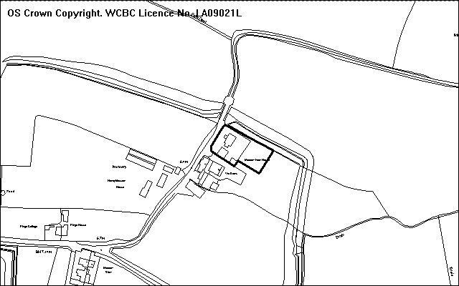
PROPOSAL

Includes the submission of revised details for the garage, the retention of a playhouse, landscaping details, and the boundary treatments. These details are all outstanding matters following the approval of the replacement house, as allowed by P/2003/0171. All the work is in retrospect. Amended plans have been received to clarify a few details.

RELEVANT HISTORY

P/2006/0517 Demolition of farmhouse and erection of replacement dwelling, conversion of 2 No. barns into residential use, construction of new vehicular and pedestrian access, alteration to existing vehicular and pedestrian access and installation of septic tanks. Granted 29.4.03
Enforcement action is currently being taken to remove an unauthorised garage that has been erected behind the garage subject of this application.

DEVELOPMENT PLAN

Outside settlement limits and within a Special Landscape Area.

CONSULTATIONS

Community Council: Objects. The garage is another so-called garage that is in fact a small bungalow.
Local Member: Notified 28.2.08
Public Protection: Consulted 20.3.08
Site Notice: Expired 3.4.08
Other representations: 3 neighbours notified 20.3.08

SPECIAL CONSIDERATIONS/ ISSUES

Garage details and ancillary function: The size of the existing garage was authorised as part of the original planning permission, but its use had to be ancillary to the house. Internal alterations have subsequently been carried out (to provide a ground floor kitchen area, bathroom and internal stairs leading to first floor bedroom), and thus reduces scope for an ancillary domestic use to continue. With limited further alterations the building could become fully established as a separate dwelling.

The plans as submitted show that the ground floor kitchen is to be removed but the internal wall separating this area from the garage area would remain. However, the building will not be able to be used as a garage because vehicles will not have enough room to park inside the garage. The internal depth is only 4.2m, whereas 5.5m is the norm. As a result, the internal wall should be removed and this would allow room enough depth for cars to park inside. A condition would be required to ensure that this wall is removed.

Landscaping details: The site is surrounded by a bund, which has been constructed as a local flood defence measure. This has a significant local impact on the visual impact of the scheme when viewed from the north. Although landscaping works within the site have generally raised local ground levels to form a level plateau area alongside the bund, this finished level is below the top level of the bund and so the visual impact is acceptable. From the other direction, it is proposed to introduce some native tree planting at intervals along the southern boundary to help indicate the boundary, and this should in time help improve the rural setting of the development.

Boundary treatment: The scheme will retain existing brick walls (which matches brickwork on the existing house) for the boundaries nearest the house. This is not objectionable. Beyond this area, the boundaries will be appropriately defined with post and wire fencing, with some trees also marking this line. This is in character with landscape character of the area. Hedges would not be appropriate for open boundaries behind the house.

Conclusion: Whilst I understand the concerns expressed by the Community Council, I am satisfied that the amendments I have sought will restore the garage to its originally intended purpose or for genuinely ancillary residential uses.
P/2008 /0210

RECOMMENDATION That permission be GRANTED

CONDITION(S)

1. The internal wall of the garage as indicated on the approved plan Drawing No 1A/1 shall be removed within two months of the date of the permission, and thereafter no other internal wall orpartition shall be erected within the building in addition to those shown on the approved plans.
2. The use of the garage building that is subject to internal alterations in connection with condition 1 above shall only be used in a manner ancillary to the use of Meadow Farm as a single dwellinghouse..
3. All tree planting shown on the approved plan shall be carried out in the first planting season that is between November 2008 to March 2009.
4. All trees, shrubs and hedge plants supplied shall comply with the requirements of the current BS 3936 Specification for Nursery Stock. All pre-planting site preparation, planting and post-planting maintenance works shall be carried out in accordance with the requirement of the current BS 4428 Code of Practice for General Landscape Operations (excluding hard surfaces). All new tree planting shall be carried out in accordance with guidance contained in Section 13 of the current BS 5837 A guide for Trees in Relation to Construction - Recommendations.
5. Any trees or shrubs removed, dying, being severely damaged or becoming seriously diseased within five years from the completion of the scheme shall be replaced by trees or shrubs of similar size and species to those originally required to be planted unless otherwise approved in writing by the Local Planning Authority.
6. The boundary treatment details as approved by this permission shall be fully erected within three months of this permission unless otherwise approved in writing by the Local Planning Authority before this date and these boundaries shall thereafter be retained to this approved specification.

REASON(S)

1. To ensure that a functional garage use for the ground floor area of the building is provided and maintained and to ensure that the ancillary use of the building is retained and to avoid the need for additional garages within the site, which is located within the countryside.
2. To prevent the building becoming used for an independent residential use which would be contrary to policy H5 of the Wrexham Unitary Development Plan.
3. To ensure a satisfactory standard of appearance of the development in the interests of the visual amenities of the area.
4. To ensure a satisfactory standard of appearance of the development in the interests of the visual amenities of the area.
5. To ensure a satisfactory standard of appearance of the development in the interests of the visual amenities of the area.
6. To ensure that the site is defined in a way appropriate for its rural location within an area of special landscape value, to accord with Policy EC5 of the Wrexham Unitary Development Plan.

NOTE(S) TO APPLICANT

You are advised that there is an unauthorised garage building within the application site and this is subject to enforcement action and should be removed.
_____________________________________________________________________

APPLICATION NO:  P/2008 /0227  COMMUNITY:  Broughton  WARD:  New Broughton | LOCATION:  LAND AT SCHOOL LANE SOUTHSEA WREXHAM  DESCRIPTION:  CONSTRUCTION OF 15 NO. APARTMENTS WITH PARKING AND AMENITY SPACE, AND FORMATION OF VEHICULAR ACCESS  APPLICANT(S) NAME:  OAK HOMES LTD | DATE RECEIVED:  29/02/2008  CASE OFFICER:  SJG  AGENT NAME:  ESP ARCHITECTS & PLANNERS LTD
_____________________________________________________________________

THE SITE

The site is between School Lane and Ysgol Penrhyn. It has an area of 0.4 hectare and is steeply sloping, with a hedge along the edge of the estate road on the west side.
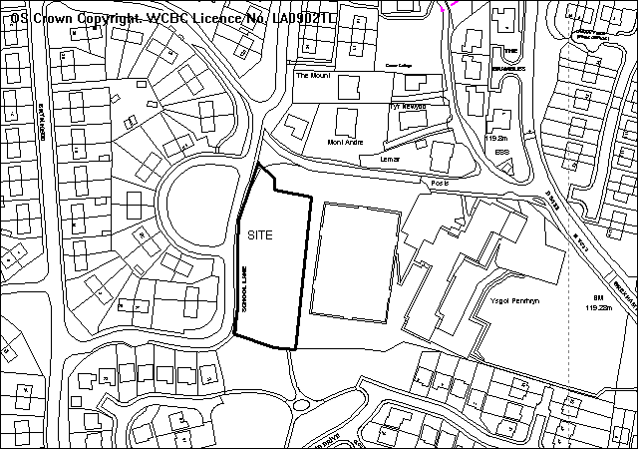
school
PROPOSAL

As above. The dwellings are arranged in two blocks of three storey, 2 bedroom units. The blocks would appear as 2 storey units from School Lane and 3 storey from the school direction. Parking is provided as the lower ground floor level, involving an access way passing beneath the blocks. A new footway would be provided along School Lane.

RELEVANT HISTORY

P/2007/0055 Outline for residential development Granted 5/3/2007

DEVELOPMENT PLAN

Within settlement limits. Policies H2 PS2 CLF4 CLF5 EC4 GDP2 and GDP1 of UDP are relevant, together with LPGN 7 (LANDMAP area 7d)10 17 21 24 and 27 .

CONSULTATIONS

Broughton C Council: Object on grounds of:
- Adverse visual impact on properties in School Lane
- Out of character with the area
- 15 apartments is an over-development of the site
- Inadequate parking provision
Local Member: Cllr A Edwards considered 15 units is too many on highway safety grounds and number should be reduced to a maximum of 12 units
Highways: Recommend conditions
Landscape Manager: Requests contribution towards off-site play facilities
Public Protection: Recommend conditions regarding construction works
Education: Schools contribution required for both secondary and primary places of £59,400
Airbus: No aerodrome safeguarding objections
CCW: No objections
Env Agency: Recommend conditions regarding sustainable drainage
Welsh Water: Recommend conditions. Sewer crosses site
Site Notices: expired 3/4/2008
Other representations: Adjoining occupiers notified 12/3/2008
4 letters of concern/ objection received on grounds of:
- There should be no access from the site to the Mountain View/ Tegid Drive development to the south on community safety grounds. Adequate fence/ wall required
- Flats will overlook a school playground
- Loss of view from houses to the west
- Additional traffic will cause problems and dangers on existing roads, used by young children
- Local school is already over-subscribed

SPECIAL CONSIDERATIONS/ ISSUES

Topography: The site has a steep (1 in 4) slope from School Lane down towards the school curtilage, (which contains a large all-weather playing pitch). It constitutes as unallocated land within settlement limits. Policy H2 states "residential development on un-annotated land within settlement limits will be permitted subject to compliance with Policy GDP1". Given the slope and the adjoining school fields, this will be a difficult site to develop and the original outline permission included a note to emphasised this point.

The site is very prominent and overlooks the school, and there is potential for the residential amenity of future occupants to be compromised by the proximity to the all-weather pitch. The layout shows the dwellings positioned close to the School lane frontage, allowing a gap of 16-20 metres from the east boundary with the play area. This is considered to provide a reasonable separation from the school/ play area and allows for planting and open space.

Landscape: The site is rough grassland and brambles within a bowl shaped steeply sloping hillside location, with an easterly aspect. The site boundaries comprise tall hedgerows and occasional trees, which provide rural characteristics, and where intermittent allow views of and over the site to the wider area. The site therefore has a positive function in providing rural characteristics, naturalness (of at least local nature conservation value) and openness within the built settlement pattern. These site features and attributes are all the more visible by virtue of the elevated site position. The scheme reflects these characteristics and includes sketch landscaping details.

Design: The units have been broken up into two blocks and care has been taken to ensure that the design fits in with the locality. It is inevitable that the dwellings will be conspicuous from the east/ south-east.

Residential Amenity/ Separation distances: The dwellings comply with adopted guidance with regard to the separation distances for the dwellings opposite in School Lane.

Open space: The scheme includes an area of private open space. The development adjoins a large area of open space provided for the adjoining development. The Council’s landscape manager has identified a need for improvements to play facilities in the locality, and a contribution towards these improvements is required under policy CLF5 and LPGN10. There is also a need to review the footpath links in the locality as part of the landscaping scheme.

Schools Contributions: As the development is now more extensive than originally envisaged, a contribution towards additional school places is required under policy GDP2 and LPGN 27.

Sustainable Development: The application includes a full site survey, design statement, ecological assessment ands sustainability statement and is considered to comply with LPGN22, subject to additional details. The development site has good links to surrounding schools and facilities.

Parking/ Access: The development site fronts School Lane which is a classified road subject to a 30mph speed limit although I would estimate typical vehicle speeds at being around 20mph along this section due to the geometry of the road. The existing carriageway width of School Lane fronting the development site is less than the required 5.5m width and it is proposed to widen this to the appropriate width. A 2m wide footway is proposed along the site frontage providing a continuous link with the existing footpath running west to east alongside Ysgol Penrhyn.

It is proposed to provide 26 parking spaces for the 15 two bedroom flats. Although this is a shortfall of 4 on the maximum standards required by LPGN no 16, given previous planning appeal decisions on car parking standards it is considered that a recommendation for refusal on the grounds of inadequate parking is unjustifiable.

Although the parking bays are of acceptable length and width, there appears to less than the required 6m turning space behind. However as the access road to the parking bays is to remain under private control it is considered that this will have no detrimental impact on the adjoining public highway.

RECOMMENDATION A

That the Council enters into an obligation under Section 106 of the Town and Country Planning Act 1990, requiring:
- A commuted sum based on Local Planning Guidance Note 10 for contribution towards provision and improvement of public open space provision in the community (amount to be determined)
- A contribution towards primary and secondary school provision of £59,400.
The Chief Planning Officer be given delegated authority to determine the final form and content of the obligation.

RECOMMENDATION B

That planning permission be granted on completion of the Obligation, subject to the following conditions:

RECOMMENDATION That permission be GRANTED

CONDITION(S)

1. The development hereby permitted shall be begun before the expiry of five years from the date of this permission.
2. Development shall only be carried out in strict accordance with the approved plans unless the prior written approval of the Local Planning Authority has been obtained.
3. Prior to their use on the development, samples of all external facing materials shall be submitted to and approved in writing by the Local Planning Authority. The development shall only be carried out in strict accordance with such details as are approved.
4. The site shall be developed in accordance with the ground and floor levels indicated on the approved plans. No changes to floor levels or external ground levels shall be made without the prior written approval of the Local Planning Authority.
5. This permission shall operate only to allow development to be carried out in accordance with the approved drawings and the application documentation. Notwithstanding the provisions of the Town and Country Planning (General Permitted Development) Order 1995, no further development shall take place within the site (other than the painting of the buildings).
6. The vehicle parking and turning areas indicated on the approved plans shall be laid out, surfaced and drained prior to the first use of the building hereby granted and shall thereafter be retained for those purposes.
7. No part of the development hereby permitted shall be commenced until full details of both hard and soft landscape works for the site have been submitted to and approved in writing by the Local Planning Authority. The works shall be implemented in accordance with a timescale to be approved in conjunction with the scheme of details.
8. All hard and soft landscape works shall be carried out in accordance with the approved details as set out in Condition 7. The works shall be carried out within 3 months of the first use of the development with the exception of soft landscaping which shall be carried out in the first planting season (November to March) or seeding season (April to September) following the first use.
9. Any trees or shrubs removed, dying, being severely damaged or becoming seriously diseased within five years from the completion of the scheme shall be replaced by trees or shrubs of similar size and species to those originally required to be planted unless otherwise approved in writing by the Local Planning Authority.
10. No development shall take place until a scheme of foul drainage and surface water drainage has been submitted to and approved by the Local Planning Authority. The approved scheme shall be complete before the development is occupied
11. No development shall commence until a scheme for the comprehensive and integrated drainage of the site indicating provision for foul water, surface water and land drainage has been submitted to and approved in writing by the local planning authority. Prior to the submission of those details, an assessment shall be carried out into the potential for disposing of surface water by means of sustainable drainage systems (SuDS) in accordance with the principles of sustainable drainage systems set out in Technical Advice Note 15: Development and Flood Risk, and the results of the assessment provided to the local planning authority. Where a SuDS scheme is to be implemented, the submitted details shall:
(i) Provide information about the design storm period and intensity, the method employed to delay and control the surface water discharged from the site and the measures taken to prevent pollution of receiving ground water and/or surface waters;
(ii) Specify the responsibilities of each party for the implementation of the SuDS scheme, together with a timetable for that implementation; and,
(iii) Provide a management and maintenance plan for the lifetime of the development which shall include the arrangements for adoption by any public authority of statutory undertaker and any other arrangements to secure the operation of the scheme throughout its lifetime.
The scheme as approved shall be implemented in accordance with a timescscale to be agreed as part of the submitted details and maintained thereafter.
12. A 2m wide footway shall be constructed toHihgway Authority adoptable standard along the School Lane frontage of the proposed development site in accordance with details to be submitted to and agreed by the Local Planning Authority and the footway shall be completed in accordance with the approved details prior to occupation of any dwellings on the site and shall thereafter be retained clear of obstruction.
13. Prior to the commencement of development, a programme of sustainable works shall be submitted for the written approval of the Local Planning Authority. The approved programme shall be implemented in accordance with a timescale to be agreed with the Local Planning Authority.
14. The proposed access on to School Lane shall provide visibility splays of 2.4 x 33m in both directions measured to the nearside edge of the adjoining highway in which there shall be no obstruction in excess of 0.6m in height.
15. No partof the development shall be occupied until School Lane fronting the development site has been widened to a minimum width of 5.5m in accordance with Highway Authority adoptable standards.
16. The proposed access shall be a minimum of 4.5m wide and shall have a gradient no greater than 1 in 24 for the first 5m behind the public highway.
17. A scheme of street lighting shall be submitted to and further approved by the Planning Authority prior to undertaking any construction on the proposed development. The approved street lighting scheme shall be implemented prior to the proposed development being brought into use.
18. No development shall be commenced until full details of construction works or new retaining walls adjoining the adopted highway along School Lane, and management measures for the internal access road and parking areas have been agreed in writing by the local planning authority. The development shall only be carried out in accordance with the details as agreed.

REASON(S)

1. To comply with Section 91(3) of the Town and Country Planning Act, 1990.
2. To ensure that the development fully complies with the appropriate policies and standards.
3. To ensure a satisfactory standard of appearance of the development in the interests of the visual amenities of the area.
4. To ensure that the development fully complies with the appropriate policies and standards.
5. To ensure a satisfactory standard of appearance of the development in the interests of the visual amenities of the area.
6. To provide for the loading, unloading, parking and turning of vehicles clear of the highway and to ensure that reversing by vehicles into or from the highway is rendered unnecessary in the interest of traffic safety.
7. To ensure a satisfactory standard of appearance of the development in the interests of the visual amenities of the area.
8. To ensure a satisfactory standard of appearance of the development in the interests of the visual amenities of the area.
9. To ensure a satisfactory standard of appearance of the development in the interests of the visual amenities of the area.
10. To ensure satisfactory drainage of the site and to avoid flooding.
11. To ensure proper drainage of the site.
12. In the interests of pedestrian and highway safety.
13. To ensure that the development fully complies with the appropriate policies and standards.
14. To ensure that adequate visibility is provided at the proposed point of access to the highway.
15. In the interests of highway safety.
16. In the interests of highway safety.
17. In the interests of highway safety.
18. In the interests of highway safety.

NOTE(S) TO APPLICANT

The proposed development lies within a former coal mining area. You should take account of any hazards to stability which may arise from coal working in or near the site. Specific advice on any past working may be obtained from the Coal Authority Mining Reports Service. Phone 0845 762 6848 or from www.coal.gov.uk.

Any operations which may involve entry into former workings, shafts or adits or implementation of site investigations or other works may need permission from the Coal Authority.

You are advised that this grant of planning permission was made following the completion of an Agreement under Section 106 of the Town and Country Planning Act. Before undertaking any work under this permission you are advised to obtain full details of the Agreement and ensure that you are able to comply with its terms.

You are advised that the planning permission hereby granted does not authorise any building over, diversion, connection or other interference with any sewer, public or private, which crosses the site. You are advised to contact Welsh Water, PO Box 10, Treharris, CF46 6XZ (Tel: 01443 331155) in this regard, prior to undertaking any groundwork in connection with the development. Should you be required to depart from the details hereby approved, you should contact the Council's planning department to seek further advice with regard to the submission of amended plans and / or a new planning application.

When preparing detailed drawings and/or implementing this permission you are advised to give full consideration to the housing needs of the disabled.

You should check carefully that the levels agreed as part of this permission are complied with. Any divergence from these levels is likely to invalidate your permission and could result in enforcement action which could require demolition of the building(s).

This permission is granted subject to the above conditions. Some conditions may require your attention prior to you carrying out any work on the proposal. These conditions are known as "conditions precedent". You should be aware that it is important that you comply with any "conditions precedent". If you do not, then any work you undertake on the development subject of this permission would not have planning permission.

Please note the attached comments from Welsh Water, Countryside Council for Wales, Environment Agency and Public Protection.

The scheme of landscaping referred to in the above conditions shall inlcude any changes to ground levels (shown by existing and proposed contours/levels) and any existing vegetation (showing that to be retained) and proposed planting. In addition, any of the following which apply to the particular site must be included:-
means of enclosure, car parking layout, access and circulation areas, materials for hard surfaced areas, any minor structures (e.g. refuse stores, lamp columns, play equipment) location of services, and any historic landscape features to be retained/improved. The details should include full details of boundary treatment including measures to prevent unauthorised access to/from the school and the adjoining open space area to the south.

The proposed new footway and carriageway widening should be constructed to a standard suitable for adoption by the Council for future maintenance at the public expense and the developer will need to enter into an agreement with the Council under s.38 / 278 of the Highways Act 1980. You are advised that the Highway Authority will require such works to be completed to their satisfaction before they will formally adopt the relevant Highway works for public use and to be maintained at public expense. This will include the provision of a bond to cover the estimated value of such works. The appropriate fees will become due to the Council when the Highways Authority approve the proposed works to be carried out.

Technical approval for any construction works or retaining wall affecting or adjoining the highway will be required under the provisions of the Highways Act 1980. The applicant must contact Sharon Stevens 01978 297109 to discuss this technical approval.
_____________________________________________________________________

APPLICATION NO:  P/2008 /0242  COMMUNITY:  Esclusham  WARD:  Esclusham | LOCATION:  THE WELSH MG CENTRE WREXHAM ROAD RHOSTYLLEN WREXHAM  DESCRIPTION:  OUTLINE APPLICATION FOR RESIDENTIAL DEVELOPMENT.  APPLICANT(S) NAME:  MR PHILIP WILSON | DATE RECEIVED:  05/03/2008  CASE OFFICER:  JGK  AGENT NAME:  MR PHILIP WILSON
_____________________________________________________________________

THE SITE

Opposite Black Lion Inn Rhostyllen.

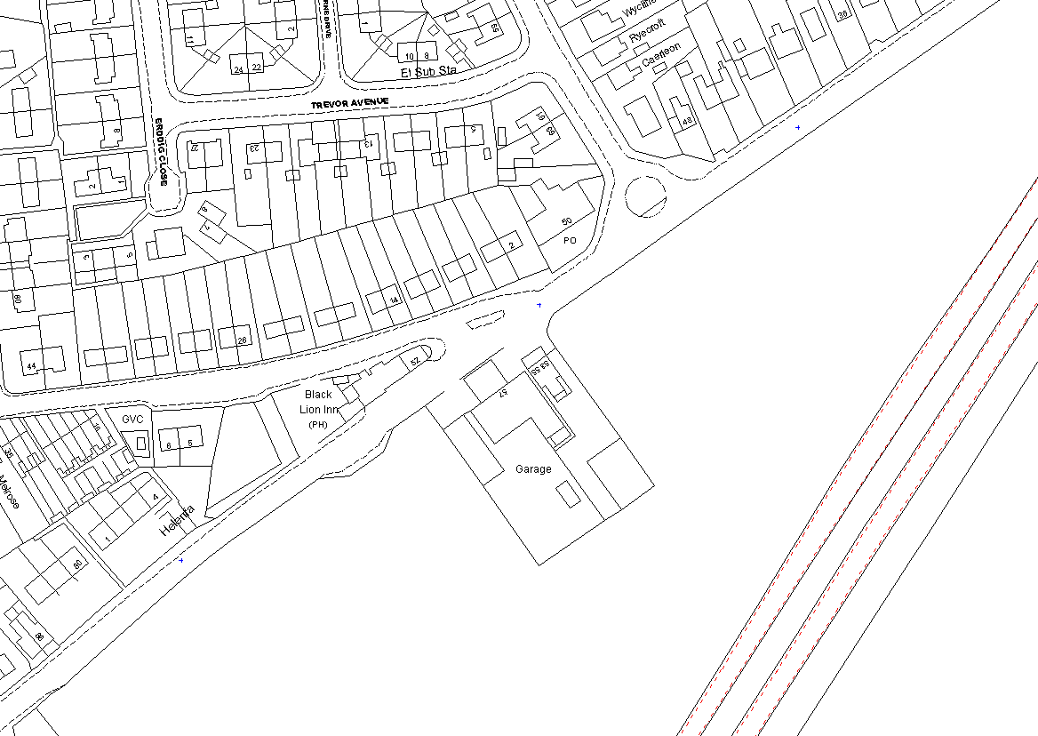
Application Site
Adjacent application Site (P/2008/0243)
National Trust application site

PROPOSAL

As above – all details reserved.

RELEVANT HISTORY

P/2008/0243 Outline application for residential development – (adjacent site – see Plan 1). Next item on agenda.

DEVELOPMENT PLAN

Within settlement limit. UDP Policies PS1, PS2, GDP1 and H2. Local Planning Guidance Notes 7 – Landscape and Development, 10 – Public Open Space in New Housing Development, 15 – Cycling, 16 – Parking Standards, 17 - Trees and Development and 21 – Space around Dwellings.

CONSULTATIONS

Community Council: Notified 10.03.08.
Local Member: Notified 10.03.08.
Highways: No objection in principle. Existing access on to classified road. Add conditions to secure for further agreement - the details a revised access, adequate onsite parking and turning facilities and a 2mfootway across the frontage.
Welsh Water: Add conditions to protect integrity of public sewerage system and submission of a scheme for the comprehensive and integrated drainage of the site.
Environment Agency: Notified 20.03.08.
CCW: Notified 20.03.08.
Wrexham Access Group: Notified 10.03.08.
Site Notice: Expired 08.04.08.
Adjoining Occupiers: one letter saying “No”. (no reasons given)

SPECIAL CONSIDERATIONS/ ISSUES

Background: A similar proposal for residential redevelopment (P/2008/0243 refers) has been submitted in relation to the adjacent site (see above plan and following report on the agenda). Both applications are seeking outline planning consent with most of the detailed issues reserved for later consideration. Members are reminded that the National Trust application (P/2007/0686 refers) is still under consideration. This development, if approved, will surround these application sites on three sides (again see above plan).

Policy: There are no policy objections in principle to either proposal as the sites are within the settlement limits of Rhostyllen and are shown as unanotated within the Wrexham UDP (Policies PS1 and H2 refer). The surrounding land (the National Trust land) is specifically allocated for housing within the UDP and has an outline planning consent for residential development. The details of this proposal have previously been considered by the Planning Committee and it appears that, subject to an acceptable change to the access arrangements and possibly increased landscaping, they may be approved. UDP Policies PS2 and GDP1 list criteria for consideration when processing applications for housing development. The Local Planning Guidance Notes detailed above supplement these. I comment as follows:

Amenity and Streetscene: As stated earlier the application is in outline and there are no details submitted with the proposal. However, it is important to consider any likely impact on adjoining properties and the local street scene. Should the National Trust proposal be approved the two sites will become a peninsular of car sales/repair commercial operations into the approved residential development and could result in complaints. The clearance and subsequent redevelopment of the two sites to housing would overcome this issue and result in substantial improvement to the visual appearance of the street scene and this part of the village.

Highways: Whilst access to these application sites would be preferable from the National Trust land, it has to be accepted that there are existing accesses direct on to the adjacent Wrexham Road, a classified road. Wrexham Road is subject to a 30 mph speed limit and it is considered that vehicles travel up to this limit. Both sites have commercial use and it is not considered that traffic generation of each, if redeveloped for residential purposes, would exceed existing movements. I have attached a condition reserving the submission of details relating to the proposed means of access but adding a Note to Applicant strongly urging that the site/s be developed accessing on to the new road layout adjacent to the southern boundary with the National trust land (if that application is approved). Even the repositioning of the site access shared centrally on the highway boundary with Wrexham Road would represent an alternative improvement in highway visibility in relation to both sites.

Education: As these are outline planning applications with no indication of quantity or mix of units it is difficult to identify the pupil output. I have assumed that the sites of this size may trigger the Local Planning Guidance Note 27 – Developer Contribution to Schools threshold. I have attached an appropriate condition in accordance with this guidance Note and UDP Policies PS2 and CLF2, and with Local Planning Guidance Note 27 – Developer Contributions to Schools.

Landscape: It will be important that any subsequent details submitted as part of reserved matters take into account the changing site context character, as a result of, if approved, housing development on the adjacent NT site (appropriate condition attached).

Ecology: The application sites are close to the nearby Glanyrafon Brook and Wildlife Site. It will be important that a comprehensive ecological report is undertaken to enable complete consideration of any redevelopment proposal for these sites. The report will need to:
- Take account of any protected species issues
- Provide a method statement detailing how any recognised ecological issues will be safeguarded, taking account of any possible mitigation/compensation
- Provide ‘reasonable avoidance measures’
- Investigate the possibility of providing a wildlife area is provided as part of the scheme to offset any loss to local biodiversity
- Provide a bat roost and bird breeding survey. If present then the applicant must propose and deliver appropriate conservation schemes and specific ‘reasonable avoidance measures’
Recognise that any loss of vegetation is considered and works to guidelines regarding the bird-breeding season running from 01 March to 30 September.
It will be important that specialist consultants are used to produce the above ecological report. I have attached an appropriate condition.

Conclusion: The application sites are within the settlement limits of Rhostyllen and their proposed redevelopment to residential use is in accord with adopted UDP policies and the relevant Guidance Notes. I do not consider that the development of the site, subject to the satisfactory compliance with the attached conditions and appropriate consideration at detailed application, will have an adverse impact upon local residents or the area in general.

RECOMMENDATION That permission be GRANTED

CONDITION(S)

1. Approval of the following details shall be obtained from the Local Planning Authority before any part of the development is commenced:
a. the layout of the building(s)
b. the scale of the building(s)
c. the appearnace of the building(s)
d. the means of access to the site and building(s)
e. the landscaping of the site.
2. Plans and particulars of the reserved matters referred to in condition 1 (above) shall be submitted in writing to the Local Planning Authority before the expiry of three years from the date of this permission. The development shall only be carried out in strict conformity with such details as are thereby approved.
3. A two metre footway shall be constructed across the full frontage of the site to the Highway Authority adoptable standards prior to first occupation of any dwelling.
4. Vehicle parking and turning facilities shall be provided within the curtilage of the site in accordance with details to be submitted for the further approval of the Local Planning Authority. Such facilities shall be made available prior to implementation of the use(s) hereby permitted and shall thereafter be retained.
5. No development shall take place within the site until a scheme detailing the proposed access arrangements and the layout, dsign, drainage and construction of the internal estate road has been submitted and approved by the Local Planning Authority.
6. The level of traffic generation of any development of the site that proposes access direct onto Wrexham Road shall be strictly limited in numbers to a level consistent with the existing site usage.
7. No part of the development hereby permitted shall be commenced until full details of both hard and soft landscape works for the site have been submitted to and approved in writing by the Local Planning Authority. The works shall be implemented in accordance with a timescale to be approved in conjunction with the scheme of details.
8. Prior to commencement of the development provision shall be made to offset the shortfall in education facilities as agreed with the Local Planning Authority. This will be a financial contribution towards the provision of additional facilities to nearby existing primary schools.
9. The reserved matters submission shall be accompanied with a comprehensive ecological survey of the site and surrounding area undertaken by specialist consultants. The report of survey shall:
· Take account of any protected species issues
· Provide a method statement detailing how any recognised ecological issues will be safeguarded, taking account of any possible mitigation/compensation
· Provide 'reasonable avoidance measures'
· Investigate the possibility of providing a wildlife area is provided as part of the scheme to offset any loss to local biodiversity
· Provide a bat roost and bird breeding survey. If present then the applicant must propose and deliver appropriate conservation schemes and specific 'reasonable avoidance measures'
The report shall be submitted to and approved by the Local planning Authority. Any mitigation measures required shall be implemented in accordance with time scales to be agreed as part of the measures before development commences on site.
10. Prior to the commencement of any demolition works on site, the following details shall be submitted for the further written approval of the local planning authority:
· An audit of all existing building materials;
· A method statement which identifies the potential and subsequent re-using and recycling of those building materials for incorporation into an agreed, replacement site development; and
· Where relevant, the recipient of all other remaining building materials.
11. No development shall commence until a scheme has been submitted for the comprehensive and integrated drainage of the site showing how foul water, surface water and land drainage will be dealt with and has been agreed in writing by the Local Planning Authority.
12. Foul water and surface water discharges shall only be drained separately from the site.
13. No surface water shall be allowed to connect (either directly or indirectly) to the public sewerage system.
14. No land drainage run-off shalll be permitted, either or indirectly, to discharge into the public sewerage system.
15. Construction works, ancillary works and the use of plant or machinery audible at or beyond the site boundary shall only be carried out between the hours of 07:30 and 19:30 (Monday to Friday) and 08:00 to 14:00 (Saturday) and at no time on Sundays or Bank Holidays.

REASON(S)

1. To comply with Section 92 of the Town and Country Planning Act 1990, as amended by Section 42 of the Planning and Compulsory Purchase Act 2004
2. To comply with Section 91 of the Town and Country Planning Act 1990, as amended by Section 51 of the Planning and Compulsory Purchase Act 2004
3. In the interests of highway safety.
4. In the interests of highway safety.
5. To ensure the formation of a safe and satisfactory access in the interests of high safety.
6. In the interests of highway safety.
7. To comply with Section 91(3) of the Town and Country Planning Act, 1990.
8. To accord with UDP Policies GDP2 and CLF1 together with LPG Note 27 - Developer Contributions to Schools.
9. The site is likely to contains features of ecological interest and it is necessary for the precise location of these features to be shown so that adequate provision can be made to ensure that later development does not damage any habitats or species identified
10. To ensure a sustainable approach to building methods.
11. To ensure that effective drainage facilities are provided for the proposed development, and that no adverse impact occurs to the environment or the existin public sewerage system.
12. To protect the integrity of the public sewerage system.
13. To prevent hydraulic overloading of the public sewerage system, to protect the health and safety of existing residents and ensure no detriment to the environment.
14. To prevent hydraulic overload of the public sewerage system and pollution of the environment.
15. To protect the amenities of the occupiers of nearby properties.

NOTE(S) TO APPLICANT

With regard to condition no 4 you are advised that the Council will be seeking to approve the site being accessed from the adjacent road layout with the National Trust land should its application be approved. If that is demonstrated to be impossible the Council will seek a shared access with the adjacent development site.

You are advised that the planning permission hereby granted does not authorise any building over, diversion, connection or other interference with any sewer, public or private, which crosses the site. You are advised to contact Welsh Water, PO Box 10, Treharris, CF46 6XZ (Tel: 01443 331155) in this regard, prior to undertaking any groundwork in connection with the development. Should you be required to depart from the details hereby approved, you should contact the Council's planning department to seek further advice with regard to the submission of amended plans and / or a new planning application.

Your attention is drawn to the following supplementary notes - 1, 3, 4, 5, 6, 7, 8 and 9.

Turning facilities shall be provided in accordance with the Council's publication - 'Supplementary Guidance to design Bulletin 32 - Residential Roads and Footpaths.
Parking shall be in accordance with Local Planning Guidance Note No 16 - Parking Standards.

You are advised to contact the Council's Landscape Officer in relation to complying with condition no 10.

The scheme of landscaping referred to in the above conditions shall inlcude any changes to ground levels (shown by existing and proposed contours/levels) and any existing vegetation (showing that to be retained) and proposed planting. In addition, any of the following which apply to the particular site must be included:-
means of enclosure, car parking layout, access and circulation areas, materials for hard surfaced areas, any minor structures (e.g. refuse stores, lamp columns, play equipment) location of services, and any historic landscape features to be retained/improved.

Any new estate roads serving more than five dwellings should be constructed to standards suitable for adoption by the Council for future maintenance at public expense and the developer will need to enter into an agreement with the Council under s38 of the Highways act 980 so that the new road can be adopted for maintenance at public expense.

With regard to the ecological surveys and condition no 12, you are advised to contact the Council's Ecology Officer to arrange for advice/brief.

You are advised to recognise that in considering any loss of vegetation and/or demolition of any building that the works must be to guidelines with regard to the bird-breeding season running from 01 March to 30 September and bat roost season.

With regard to the sustainable building condition you are advised to contact the Council's Planning Environment section.

You are advised to comply with Building Regulation Note 11 - Demolition.
_____________________________________________________________________

APPLICATION NO:  P/2008 /0243  COMMUNITY:  Esclusham  WARD:  Esclusham | LOCATION:  MALCOLM HUGHES CAR SALES 53-55 WREXHAM ROAD RHOSTYLLEN WREXHAM  DESCRIPTION:  OUTLINE APPLICATION FOR RESIDENTIAL DEVELOPMENT  APPLICANT(S) NAME:  MALCOLM HUGHES CAR SALES | DATE RECEIVED:  05/03/2008  CASE OFFICER:  JGK  AGENT NAME:  MALCOLM HUGHES CAR SALES
_____________________________________________________________________

THE SITE

Application Site
Adjacent application Site (P/2008/2008/0242)
National Trust application site

PROPOSAL

As above.

RELEVANT HISTORY

P/2008/0242 Outline application for residential development – The Welsh MG Centre (adjacent site). Previous item on this agenda.

DEVELOPMENT PLAN

Within settlement limit. UDP Policies PS1, PS2, GDP1 and H2. Local Planning Guidance Notes 7 – Landscape and Development, 10 – Public Open Space in New Housing Development, 15 – Cycling, 16 – Parking Standards, 17 - Trees and Development and 21 – Space around Dwellings.

CONSULTATIONS

Community Council: Notified 10.03.08.
Local Member: Notified 10.03.08.
Highways: No objection in principle. Existing access on to classified road. Add conditions to secure for further agreement - the details a revised access, adequate onsite parking and turning facilities and a 2mfootway across the frontage.
Welsh Water: Add conditions to protect integrity of public sewerage system and submission of a scheme for the comprehensive and integrated drainage of the site.
Environment Agency: Notified 20.03.08.
CCW: Notified 20.03.08.
Wrexham Access Group: Notified 10.03.08.
Site Notice: Expired 08.04.08.
Adjoining Occupiers: One letter saying “no”. – no reasons given

SPECIAL CONSIDERATIONS/ ISSUES

Background: This application relates to the site adjoining that referred to in the previous report on this agenda. Both applications are seeking outline planning consent with most of the detailed issues reserved for later consideration. Members are reminded that the National Trust application (P/2007/0686 refers) is still under consideration. This development, if approved, will surround these application sites on three sides (again see above plan).

Policy: There are no policy objections in principle to either proposal as the sites are within the settlement limits of Rhostyllen and are shown as unannotated within the Wrexham UDP (Policies PS1 and H2 refer). The surrounding land (the National Trust land) is specifically allocated for housing within the UDP and has an outline planning consent for residential development. The details of this proposal have previously been considered by the Planning Committee and it appears that, subject to an acceptable change to the access arrangements and possibly increased landscaping, they may be approved. UDP Policies PS2 and GDP1 list criteria for consideration when processing applications for housing development. The Local Planning Guidance Notes detailed above supplement these. I comment as follows:

Amenity and streetscene: As stated earlier the application is in outline and there are no details submitted with the proposal. However, it is important to consider any likely impact on adjoining properties and the local street scene. Should the National Trust proposal be approved the two sites will become a peninsular of car sales/repair commercial operations into the approved residential development and could result in complaints. The clearance and subsequent redevelopment of the two sites to housing would overcome this issue and result in substantial improvement to the visual appearance of the street scene and this part of the village.

Highways: Whilst access to these application sites would be preferable from the National Trust land, it has to be accepted that there are existing accesses direct on to the adjacent Wrexham Road, a classified road. Wrexham Road is subject to a 30 mph speed limit and it is considered that vehicles travel up to this limit. Both sites have commercial use and it is not considered that traffic generation of each, if redeveloped for residential purposes, would exceed existing movements. I have attached a condition reserving the submission of details relating to the proposed means of access but adding a Note to Applicant strongly urging that the site/s be developed accessing on to the new road layout adjacent to the southern boundary with the National trust land (if that application is approved). Even the repositioning of the site access shared centrally on the highway boundary with Wrexham Road would represent an alternative improvement in highway visibility in relation to both sites.

Education: As these are outline planning applications with no indication of quantity or mix of units it is difficult to identify the pupil output. I have assumed that the sites of this size may trigger the Local Planning Guidance Note 27 – Developer Contribution to Schools threshold. I have attached an appropriate condition in accordance with this guidance Note and UDP Policies PS2 and CLF2, and with Local Planning Guidance Note 27 – Developer Contributions to Schools.

Landscape: It will be important that any subsequent details submitted as part of reserved matters take into account the changing site context character, as a result of, if approved, housing development on the adjacent Erddig site (appropriate condition attached).

Ecology: The application sites are close to the nearby Glanyrafon Brook and Wildlife Site. It will be important that a comprehensive ecological report is undertaken to enable complete consideration of any redevelopment proposal for these sites. The report will need to:
- Take account of any protected species issues
- Provide a method statement detailing how any recognised ecological issues will be safeguarded, taking account of any possible mitigation/compensation
- Provide ‘reasonable avoidance measures’
- Investigate the possibility of providing a wildlife area is provided as part of the scheme to offset any loss to local biodiversity
- Provide a bat roost and bird breeding survey. If present then the applicant must propose and deliver appropriate conservation schemes and specific ‘reasonable avoidance measures’
Recognise that any loss of vegetation is considered and works to guidelines regarding the bird-breeding season running from 01 March to 30 September.
It will be important that specialist consultants are used to produce the above ecological report. I have attached an appropriate condition/s.

Conclusion: The application sites are within the settlement limits of Rhostyllen and I consider their proposed redevelopment to residential use is in accord with adopted Unitary Development Plan policies and the relevant Council Guidance Notes. I do not consider that the development of the site, subject to the satisfactory compliance with the attached conditions and appropriate consideration at detailed application, will have an adverse impact upon local residents or the area in general.

RECOMMENDATION That permission be GRANTED

CONDITION(S)

1. Approval of the following details shall be obtained from the Local Planning Authority before any part of the development is commenced:
a. the layout of the building(s)
b. the scale of the building(s)
c. the appearnace of the building(s)
d. the means of access to the site and building(s)
e. the landscaping of the site.
2. Plans and particulars of the reserved matters referred to in condition 1 (above) shall be submitted in writing to the Local Planning Authority before the expiry of three years from the date of this permission. The development shall only be carried out in strict conformity with such details as are thereby approved.
3. No development shall take place within the site until a scheme detailing the proposed access arrangements and the layout, dsign, drainage and construction of the internal estate road has been submitted and approved by the Local Planning Authority.
4. A two metre wide footway shall be constructed across the full frontage of the site to Higway Authority adoptable standards before the approval of the Local Planning Authority.
5. Vehicle parking and turning facilities shall be provided within the curtilage of the site in accordance with details to be submitted for the further approval of the Local Planning Authority. Such facilities shall be made available prior to implementation of the use(s) hereby permitted and shall thereafter be retained.
6. The level of traffic generation of any development of the site that proposes access onto Wrexham Road shall be strictly limited in numbers to a level consistnet with the existing site usage.
7. No part of the development hereby permitted shall be commenced until full details of both hard and soft landscape works for the site have been submitted to and approved in writing by the Local Planning Authority. The works shall be implemented in accordance with a timescale to be approved in conjunction with the scheme of details.
8. Prior to commencement of the development provision shall be made to offset the shortfall in education facilities as agreed with the Local Planning Authority. This will be a financial contribution towards the provision of additional facilities to nearby existing primary schools.
9. The reserved matters submission shall be accompanied with a comprehensive ecological survey of the site and surrounding area undertaken by specialist consultants. The report of survey shall:
· Take account of any protected species issues
· Provide a method statement detailing how any recognised ecological issues will be safeguarded, taking account of any possible mitigation/compensation
· Provide 'reasonable avoidance measures'
· Investigate the possibility of providing a wildlife area is provided as part of the scheme to offset any loss to local biodiversity
· Provide a bat roost and bird breeding survey. If present then the applicant must propose and deliver appropriate conservation schemes and specific 'reasonable avoidance measures'
The report shall be submitted to and approved by the Local planning Authority. Any mitigation measures required shall be implemented in accordance with time scales to be agreed as part of the measures before development commences on site.
10. Prior to the commencement of any demolition works on site, the following details shall be submitted for the further written approval of the local planning authority:
· An audit of all existing building materials;
· A method statement which identifies the potential and subsequent re-using and recycling of those building materials for incorporation into an agreed, replacement site development; and
· Where relevant, the recipient of all other remaining building materials
11. No development shall commence until a scheme has been submitted for the comprehensive and integrated drainage of the site showing how foul water, surface water and land drainage will be dealt with and has been agreed in writing by the Local Planning Authority.
12. Foul water and surface water discharges shallonly be drained separately from the site.
13. No surface water shall be allowed to connect (either directly or indirectly) to the public sewerage system.
14. No land drainage run-off shall be permitted, either or indirectly, to discharge into the public sewerage system.
15. Construction works, ancillary works and the use of plant or machinery audible at or beyond the site boundary shall only be carried out between the hours of 07:30 and 19:30 (Monday to Friday) and 08:00 to 14:00 (Saturday) and at no time on Sundays or Bank Holidays.

REASON(S)

1. To comply with Section 92 of the Town and Country Planning Act 1990, as amended by Section 42 of the Planning and Compulsory Purchase Act 2004
2. To comply with Section 91 of the Town and Country Planning Act 1990, as amended by Section 51 of the Planning and Compulsory Purchase Act 2004
3. To ensure the formation of a safe and satisfactory access in the interests of high safety.
4. In the interests of highway safety.
5. In the interests of highway safety.
6. In the interests of highway safety.
8. To accord with UDP Policies GDP2 and CLF1 together with LPG Note 27 - Developer Contributions to Schools.
9. The site is likely to contains features of ecological interest and it is necessary for the precise location of these features to be shown so that adequate provision can be made to ensure that later development does not damage any habitats or species identified
10. To ensure a sustainable approach to building methods.
11. To ensure that effective drainage facilities are provided for the proposed development and that no adverse impact occurs to the environment or the existing public sewerage system.
12. To protect the integrity of the public sewerage system.
13. To prevent hydraulic overloading of the public sewerage system, to protect the health and safety of existing residents and ensure no detriment to the environment.
14. To prevent hydraulic overload of the public sewerage system and pollution of the environment.
15. To protect the amenities of the occupiers of nearby properties.

NOTE(S) TO APPLICANT

With regard to condition no 4 you are advised that the Council will be seeking to approve the site being accessed from the adjacent road layout with the National Trust land should its application be approved. If that is demonstrated to be impossible, the Council will seek a shared access with the adjacent development site.

You are advised that the planning permission hereby granted does not authorise any building over, diversion, connection or other interference with any sewer, public or private, which crosses the site. You are advised to contact Welsh Water, PO Box 10, Treharris, CF46 6XZ (Tel: 01443 331155) in this regard, prior to undertaking any groundwork in connection with the development. Should you be required to depart from the details hereby approved, you should contact the Council's planning department to seek further advice with regard to the submission of amended plans and / or a new planning application.

Your attention is drawn to the following supplementary notes - 1, 3, 4, 5, 6, 7, 8 and 9.

Turning facilities shall be provided in accordance with the Council's publication - 'Supplementary Guidance to design Bulletin 32 - Residential Roads and Footpaths'.
Parking shall be in accordance with Local Planning Guidance Note No 16 - Parking Standards.

You are advised to contact the Council's Landscape Officer in relation to complying with Condition No 10.

The scheme of landscaping referred to in the above conditions shall inlcude any changes to ground levels (shown by existing and proposed contours/levels) and any existing vegetation (showing that to be retained) and proposed planting. In addition, any of the following which apply to the particular site must be included:-
means of enclosure, car parking layout, access and circulation areas, materials for hard surfaced areas, any minor structures (e.g. refuse stores, lamp columns, play equipment) location of services, and any historic landscape features to be retained/improved.

Any new estate roads serving more than five dwellings should be constructed to standards suitable for adoption by the Council for future maintenance at public expense and the developer will need to enter into an agreement with the Council under s38 of the Highways act 980 so that the new road can be adopted for maintenance at public expense.

With regard to the ecological surveys and condition no 12, you are advised to contact the Council's Ecology Officer to arrange for advice/brief.

You are advised to recognise that in considering any loss of vegetation and/or demolition of any building that the works must be to guidelines with regard to the bird-breeding season running from 01 March to 30 September and bat roost season.

With regard to the sustainable building condition you are advised to contact the Council's Planning Environment section.

You are advised to comply with Building Regulation Note 11 - Demolition.
_____________________________________________________________________

APPLICATION NO:  P/2008 /0247  COMMUNITY:  Minera  WARD:  Minera | LOCATION:  LAND TO THE REAR OF TOMLINSONS DAIRIES PEN Y PALMANT FARM MINERA WREXHAM  DESCRIPTION:  RETENTION OF EXTENSION TO HARDSTANDING TO REAR OF DAIRY AND IMPLEMENTATION OF SUPPLEMENTARY LANDSCAPING WORKS.  APPLICANT(S) NAME:  PN & JA TOMLINSON | DATE RECEIVED:  06/03/2008  CASE OFFICER:  JS  AGENT NAME:  HASTON REYNOLDS  DAVID A HASTON
_____________________________________________________________________

THE SITE

The site is located on south west side of B5430 and the existing dairy and to the NW of Minera Industrial Estate.

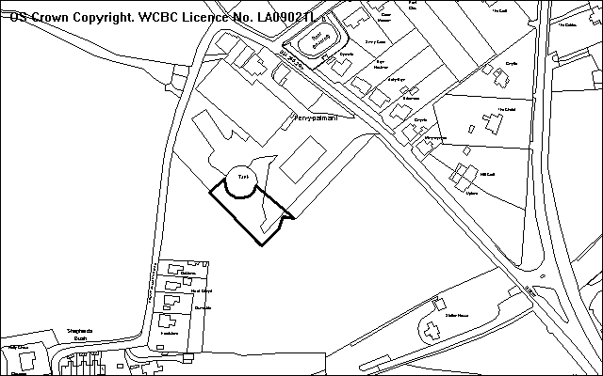
Application Site

PROPOSAL

As above. The application is submitted with a supporting statement to explain the background, and the proposals. The proposals are partly in retrospect.

RELEVANT HISTORY

6/22611 Alterations and additions to existing dairy unit and agricultural buildings. Granted 19.10.1994.
P/2007/1323 Formation of temporary parking area. Granted 7.1.07 (Temporary until 31.1.10).

DEVELOPMENT PLAN

Outside the settlement limits and within a green barrier; policy EC1 refers.

CONSULTATIONS

Community Council: Concerned that this breach was omitted from the report for P/2007/1323 which was considered in January 08, and information supplied to the Community Council has been contradicted in the current application documents.
Local Member: Notified 10.3.08
Public Protection: No comments
Site Notice: Expired 3.4.08
Other representations: 8 neighbours notified 17.3.08

SPECIAL CONSIDERATIONS/ ISSUES

Details: Some concerns have been raised to state that the previous committee report for P/2007/1323 had incorrectly stated that some development within the site had occurred because they benefited from permitted development. This information was thought to be the case at the time that my report was written for Planning Committee. However, further investigations were undertaken, and the area of the current application site (eg P/2008/0247) was deemed to be outside the original development site, and therefore the work undertaken within this area requires planning permission. I requested a planning application to formally consider the outstanding details and the current application has been submitted to regularise the planning breach.

Unfortunately, the breach was not directly referred to as part the committee report for 7 January 2008 meeting, I do not believe the justification and approval for a temporary hardstanding area would have changed. The temporary hardstanding area of P/2007/1323 only allows the parking of vehicles – no other storage is allowed. However the proposed hardstanding area subject of this current application is required for general outdoor storage for operational reasons connected to the dairy. Some items have been stored within this area for non-operational reasons, but these items are to be removed and its ancillary use can be controlled by conditions.

Policy: The site is within a green barrier, and development can only granted if it maintains the open character of the area, and does not conflict with the green barrier purpose for the area. Accordingly it is noted that the whole of the farm and dairy are within the green barrier and the hardstanding area within the application site is a relatively small extension to the existing complex, and does not include new buildings. As a result, I do not consider that the green barrier policy at this location will be jeopardised by this proposal.

Visual impact: Better management of this part of the dairy site including various control measures by planning conditions will ensure that the height of ancillary storage is kept lower than has been the case, and it will ensure that items are strictly limited to those items that are ancillary to the operational use of the dairy. Additional landscaping, including a bund and tree planting is also proposed along this south and western edges to help supplement existing landscaping measures at the site, and should bring about longer term visual enhancements.

Conclusion: Whilst I accept that my earlier report did not fully address the issue of this part of the hardstanding, it is important to recognise that the area in question is relatively small and its impact is limited. With suitable conditions I am satisfied that the development will be acceptable./2008 /0247

RECOMMENDATION That permission be GRANTED

CONDITION(S)

1. The earth bund, as described and shown in the approved application documentation and plans, shall be fully formed within three months of the date of the permission and the landscaping measures (including tree and shrub planting) shall be fully implemented within the first planting season following completion of the bund in accordance with the specifications given in the same approved documents.
2. The development shall only be carried out in strict conformity with the details shown on the approved drawings and in the application documentation.
3. Any trees or shrubs removed, dying, being severely damaged or becoming seriously diseased within five years from the completion of the scheme shall be replaced by trees or shrubs of similar size and species to those originally required to be planted unless otherwise approved in writing by the Local Planning Authority.
4. Storage on the hardstanding area shall be strictly limited to ancillary purposes in connection with the adjacent dairy building.
5. No storage on site shall exceed the height of 2m above the existing level of the hardstanding areas as shown on the approved plan.
- Details of any external lighting (in particular its brightness, orientation and hours of use) for this area shall be submitted to and approved by the Local Planning Authority within one month of the date of this permission and the development shall only be carried out in strict conformity with such details as are thereby approved. No other lighting shall be installed or operated.
- Notwithstanding the Town and Country Planning (General Permitted Development) Order 1995, as amended, no structures or other buildings shall be erected within the site.

REASON(S)

1. In the interests of the visual amenities of the area.
2. To ensure that the development fully complies with the appropriate policies and standards.
3. To ensure a satisfactory standard of appearance of the development in the interests of the visual amenities of the area.
4. To ensure that the storage is retained only for purposes ancillary to the dairy use of the adjacent site.
5. In the interests of the visual amenities of the area and to ensure that its use remains ancillary to the dairy use of the building.
- To enable control of matters not detailed in the application in compliance with appropriate policies and standards.
- In the interests of the visual amenities of the area given the site’s location within a green barrier.

NOTE(S) TO APPLICANT

This permission does not authorise the tipping of waste materials on the site.

You are reminded that the Disability Discrimination Act 1995 applies to this site.
_____________________________________________________________________

APPLICATION NO:  P/2008 /0251  COMMUNITY:  Coedpoeth  WARD:  Coedpoeth | LOCATION:  THE RED ROSE RESTAURANT 45 HIGH STREET COEDPOETH WREXHAM  DESCRIPTION:  PROVISION OF A TAKE AWAY HOME DELIVERY SERVICE ANCILLARY TO EXISTING RESTAURANT (VARIATION OF CONDITION NO. 2 OF PLANNING PERMISSION CODE NO. P/2003/1454)  APPLICANT(S) NAME:  MR Z CHOWDHURY THE RED ROSE RESTAURANT | DATE RECEIVED:  07/03/2008  CASE OFFICER:  SJG  AGENT NAME:  MR M CLARK
_____________________________________________________________________

THE SITE

On the corner of Park Road and High Street in the centre of Coepoeth shopping area.

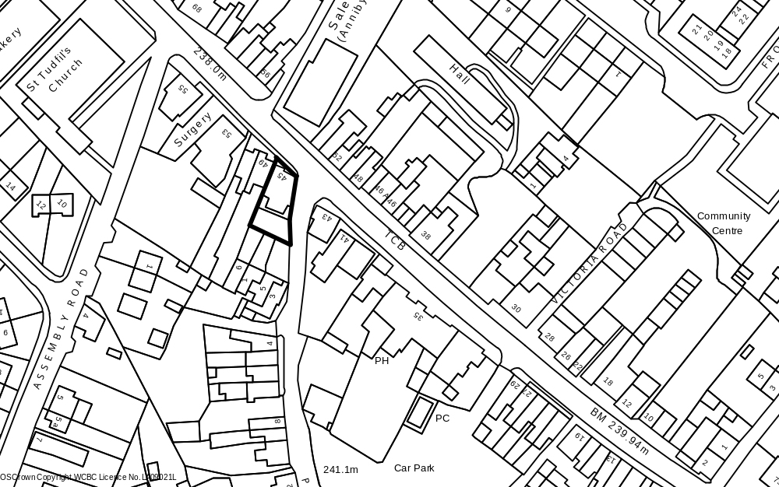

PROPOSAL

As above. The condition states:
2. “The premises shall not be used for any purpose within Class A3 ...... other than as a restaurant/cafe. For the avoidance of doubt, no hot food or drinks shall be sold for consumption off the premises.” Reason: Sales by takeaway could be likely to lead to highway difficulties and dangers and would increase impacts on nearby residents.

In addition to this condition there are 5 other conditions, including a restriction on hours of use of 11pm last customer admission and 12 midnight for any food sales.

The applicant has supplied a justification statement and a petition signed by 100 customers supporting the application. He states as follows:
- The home delivery/ take-away service would cease at 10 pm
- A new kitchen has been provided on the Park Road side, away from the nearest dwelling
- Cooking odour is now minimal
- 6 full-time staff are employed in the premises which has been open for 4 months.
- Space is available for 4 vehicles at the rear and there are 2 car parks nearby
- The business cannot achieve a sustainable return without the take-away/ home delivery

RELEVANT HISTORY

P/2003/1454 Change of use from shop to cafe Granted 9/2/2004
P/2005/0771 Variation of condition 2 to allow take-away sales
Refused 10/8/2007, Appeal dismissed
P/2005/1189 Alterations to extraction flue Refused 5/12/2005

DEVELOPMENT PLAN

Within settlement limits and adjoins the District Shopping centre. Policies GDP1 T8 S5 and S6 of UDP are relevant, together with LPGN 9 and 16.

CONSULTATIONS

Coedpoeth C Council: Consulted 11/3/2008
Local Members: Councillor R M Davies confirms that he has received no complaints regarding the limited take-away/home delivery service. The restaurant provides a much-needed service and the take-away/home-delivery aspect is purely ancillary.
Cllr Griffiths consulted
Highways: Recommend refusal on highway safety grounds appeal inspector agreed would be detrimental to highway safety and that car park was too distant and rear yard was too restricted
Public Protection: No comments
Site Notice: Expired 7/4/2008
Other representations: Adjoining occupiers notified 17/3/2008.
1 letter of comment received. No vehicles should be allowed to park at the front or side of the property where there are double yellow lines. Concerned at additional traffic from a home delivery service

SPECIAL CONSIDERATIONS/ ISSUES

Issues: The application poses a number of issues – Is this the right location for a takeway? Would any concerns about takeaway be alleviated by restricting to home-delivery service? Is it possible to satisfactorily distinguish between the two? Is the offer to cease off-sales at 10pm practicable or enforceable?

Previous applications: The original application for an A3 use was submitted as a proposal for a cafe/restaurant only. I considered that there was an inevitable demand for take-away sales in such a location, bearing in mind the “passing trade” and considered that the highway and amenity issues could not be met by conditions. However, although the application was recommended for refusal, permission was granted subject to the condition in question.

The 2005 application to vary condition 2 was a retrospective application, and at that time the main use of the property was as a hot-food take-away. In the appeal decision the Inspector agreed that the variation of the condition was unacceptable on residential amenity and highway safety grounds.

Residential amenity: The main concerns during the 2005 application were the location of the kitchen and extraction system in close proximity to 49 High Street, and the noise and disturbance from activities around the premises from take-away sales. The first aspect of this issue has been resolved by the new kitchen. The second aspect is still of concern, but is modified by the offer to cease take-away/ home delivery use at 10pm. In this regard it is considered that such a time limit is not practical and would be difficult to enforce, as the application only relates to the use condition (number 2) and not to the hours of opening condition (number 3).

Highway safety: The location of the premises at a busy junction with narrow or no footways and restricted visibility, means that any illegal parking would be a serious problem. The Inspector agreed that such parking would unacceptable endanger and inconvenience other road users, particularly in the evening when there is no effective supervision. Guidance Note 9 states that take-away uses will not be appropriate in areas where there are double yellow lines.

Conclusion: This Committee made it clear from the outset that there were serious concerns about takeaway sales. This is an awkward corner site where parking is severely restricted and vehicles stopping even briefly to pick food would cause problems. Whilst home delivery might be less objectionable it is difficult to see how this could be effectively enforced and experience elsewhere in the County Borough has shown that the temptation is for “home delivery” to mean staff walking out across the pavement and handing the goods to a customer waiting outside. This does not resolve the parking/congestion issue.

In terms of hours of use, a limit would mean that one part of the premises would operate different hours from another and would again make enforcement difficult. In any event, in my experience, off sales tend to occur later in the evenings and there would be considerable temptation for customers to enter and for staff to serve customers after the earlier limit if the rest of the premises remain open and trading.

RECOMMENDATION That permission be REFUSED

REASON(S)

1. The use of the property as a hot food take-away detracts from the amenities of adjoining and nearby dwellings by reason of increased noise, smell and late night activity, contrary to Policy GDP1 (f) of the adopted Wrexham Unitary Development Plan.
2. The use of the property as a hot food take-away leads to additional problems of parking and deliveries at a busy junction with the A525 to the detriment of highway safety and contrary to Policy GDP1 (d) of the adopted Wrexham Unitary Development Plan.
_____________________________________________________________________

APPLICATION NO:  P/2008 /0270  COMMUNITY:  Rossett  WARD:  Rossett | LOCATION:  THE GRANGE ROSEMARY LANE BURTON ROSSETT WREXHAM  DESCRIPTION:  WORKS TO TREES (WCBC NO 97)  APPLICANT(S) NAME:  MR J MILLS | DATE RECEIVED:  14/03/2008  CASE OFFICER:  MS  AGENT NAME:  MR J MILLS
_____________________________________________________________________

THE SITE

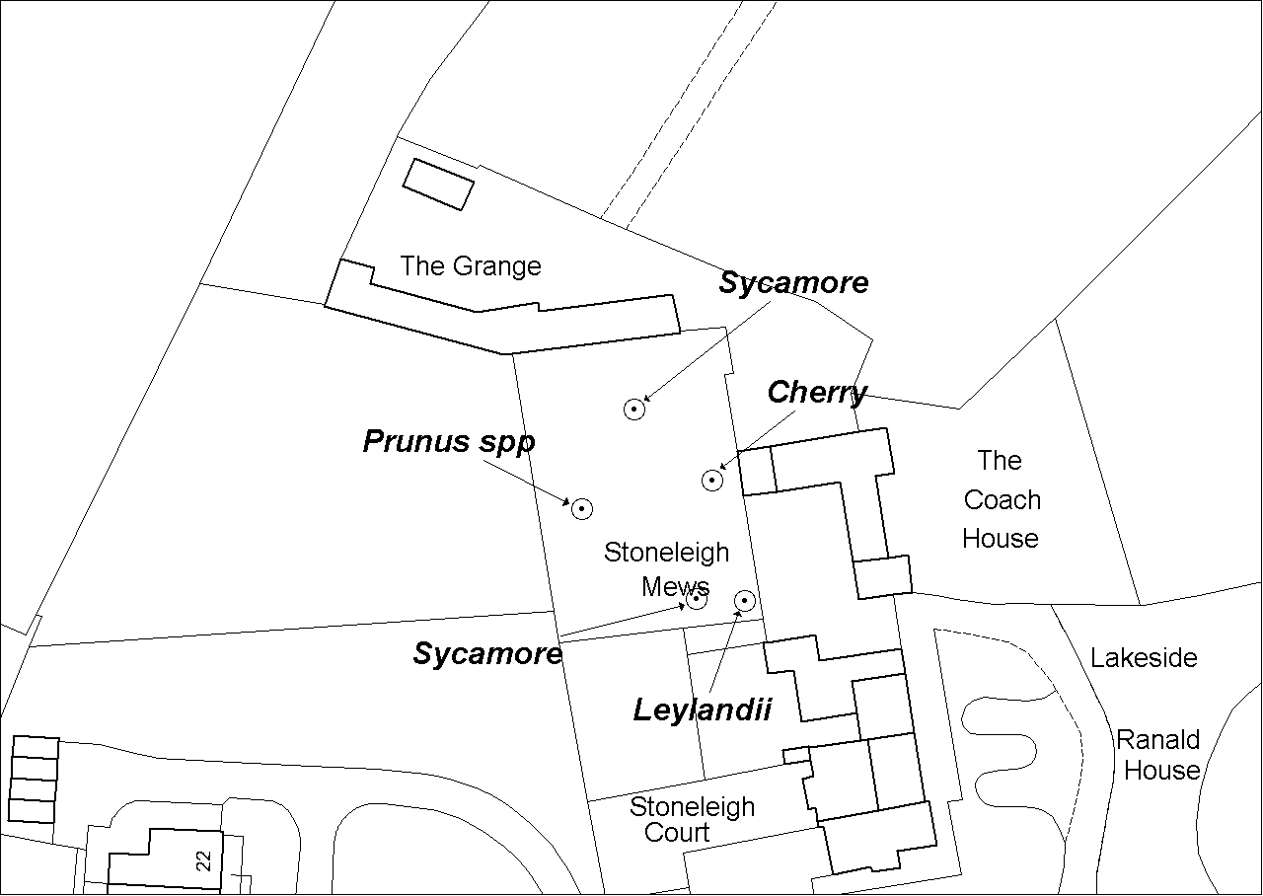The trees are located in a walled garden to the rear of the applicant’s property, with properties immediately to the east and west. The surrounding area is predominantly rural.

PROPOSAL

Fell to ground level one Leylandii and two Sycamore trees. Prune back from building one Cherry tree to achieve 4-5 metres clearance and reduce crown of one Prunus spp tree by one third.

HISTORY

P/2006/0421 Application to fell four Leylandii and one Larch trees. Granted with no conditions.

DEVELOPMENT PLAN

Outside settlement limit Policy EC4: Hedgerows, Trees and Woodland.

CONSULTATIONS

Community Council: Notified 14/03/08.
Local Member: Notified 14/03/08.
Building Control: Notified 14/03/08.
Other representations: 3 adjacent properties notified on 28/3/08.

The consultation period runs until the 18th April.

SPECIAL CONSIDERATIONS

The Leylandii tree is growing within one metre of an overhead utility cable, has a very limited amenity value and would have to be extensively pruned away from the line in due course. It is expedient to allow it to be felled. The two Sycamore trees are very small in size; thus have a very low amenity value. I have no objection to these being felled. The pruning works to the Cherry tree are necessary to abate damage to the neighbouring property and the crown reduction of the Prunus spp tree is in my opinion necessary as the lower limbs are decayed.

Conclusion: The proposed felling and pruning works will not be to the detriment of the amenity of the locality.

RECOMMENDATION

That the Chief Planning Officer is given delegated authority to grant permission, subject to the following planning conditions, upon expiry of the consultation period provided that no additional issues are raised:-

RECOMMENDATION That permission be GRANTED

CONDITION(S)

1. All tree works shall be undertaken to the standards set out in British Standard 3998: Recommmedations for Tree Work: 1989.
2. The tree works hereby approved shall be commenced within two years of consent being granted.

REASON(S)

1. To preserve the health and safety and amenity value of the trees to be worked on.
2. To ensure compliance with section 91 (3) of the Town & Country Planning Act.
_____________________________________________________________________

APPLICATION NO:  P/2008 /0277  COMMUNITY:  Acton  WARD:  Little Acton | LOCATION:  4 KENSINGTON GROVE BOX LANE WREXHAM  DESCRIPTION:  REMOVAL OF LIME TREE (WMBC NO. 167)  APPLICANT(S) NAME:  MR A SING | DATE RECEIVED:  17/03/2008  CASE OFFICER:  MS  AGENT NAME:  MR A SING
_____________________________________________________________________

SITE

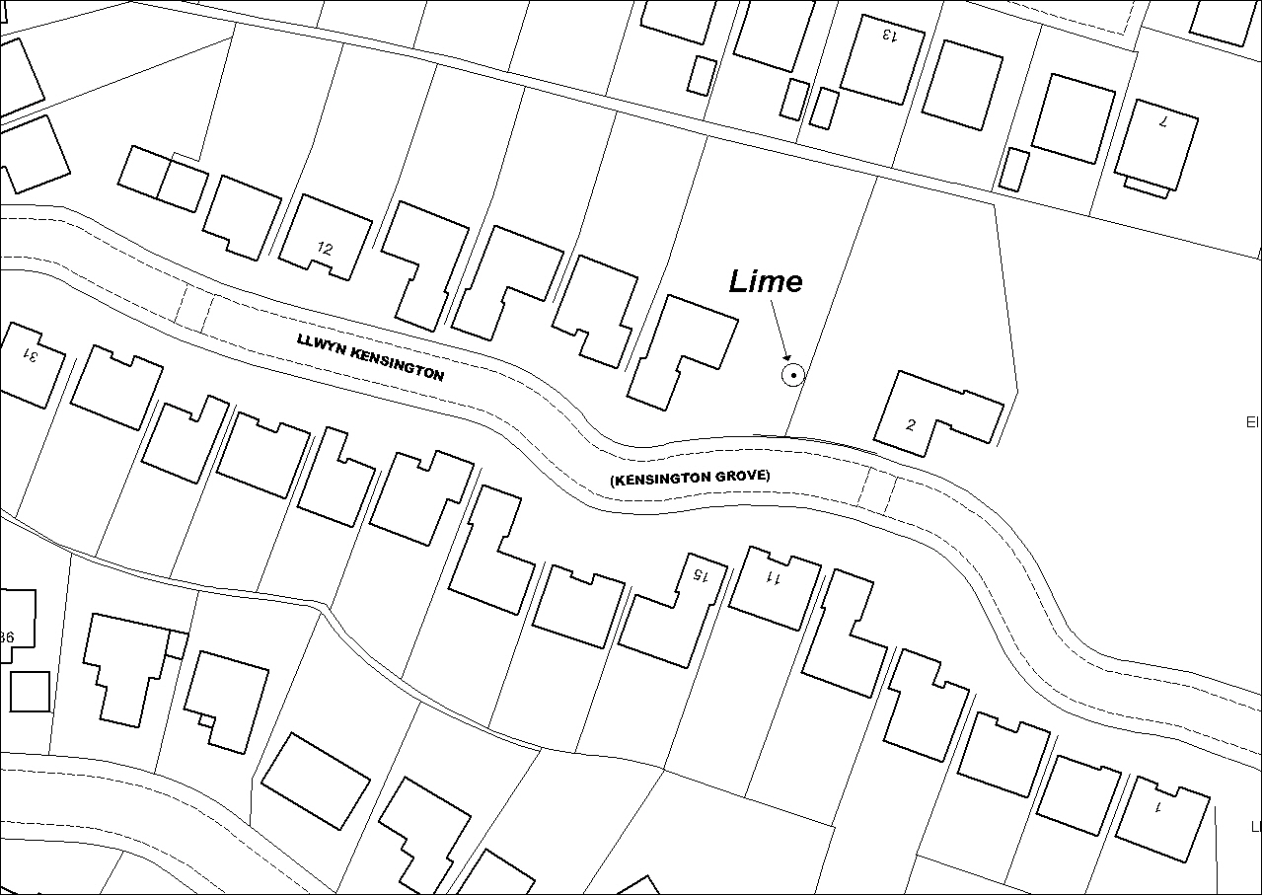The tree is located in the side garden of a private residence.

PROPOSAL

Removal of one Lime tree protected by TPO WMBC 167. The applicant states that the trees condition has deteriorated over four years and believes the tree is completely dead and that there are many brittle branches that can be brought down by high winds. Additionally, the previous Tree Officer recommended removing part of the tree, but cannot accept the advice as a sound financial judgement. Each year the tree sheds its leaves in June, and the following year those parts fail to re-grow. In 2007 the final live quarter of the tree shed its leaves early and expects the tree not to produce any leaves this spring. An adjacent neighbour is concerned about the tree’s condition and his solicitor has been in contact urging action.

A report on the tree’s health and safety has also been submitted. This was produced in 2004 and its main findings are as follows:

- There is significant die-back throughout the crown.
- The leaf size is smaller than normal for the species,
- There are a number of cavities in the scaffold limbs.
- Pruning wounds have been infected by a fungi, which has resulted in large cavities extending a considerable way into the trunk.
- The tree’s health is declining and the tree is under stress.
- The largest cavity has extended into the centre of the trunk, causing the tree to hollow.
- An analysis of the trunk at 2.5 metres with a Picus tomograph device, which detects sound wood and decayed wood by sending a stresswave through the timber, was undertaken. This shows 43% solid wood, 33% of wood at an early stage of decay, but which remains solid and 24 % decayed wood and cavities.
- That research has shown that trees’ can remain stable if solid wood surrounds cavities and that the safety margin for this residual wood thickness is one-third the radius.
- The tomograph shows that the safety margin has been exceeded, with only half the residual wall remaining intact.
- The presence of open cavities further increases the wood strength loss due to decay.
- There is a high risk that the trunk may fail in the vicinity of the cavities at 2.5 metre height.
- The tree has a hazard rating of 11 out of twelve.

HISTORY

The Council has received no formal applications, however there is correspondence in the TPO file from the applicant that relates to this tree.

DEVELOPMENT PLAN

Policy EC4: Hedgerows, Trees and Woodland.

CONSULTATIONS

Community Council: Notified 18/03/08.
Local Member: Notified 18/03/08. Considers tree to have a significant amenity value and that if it can be safely retained it should be.
Other representations: 2 adjacent properties notified on 27/3/08.

The consultation period runs until the 18th April. No written representations have been received so far. Late representations will be added as an addendum.

SPECIAL CONSIDERATIONS

The tree is a late mature specimen, which by its girth, age and condition is classed as a veteran tree. DEFRA characterises veteran/ ancient trees as having a very large girth for the species, hollow or hollowing trunk and a large amount of deadwood in the canopy. This tree fits into that category, therefore it is considered more important than a smaller tree of the same species.

There are numerous wounds on the trunk and major scaffold limbs in the crown and the top of the tree has small dead branches present. One scaffold limb appears to have suffered significantly increased levels of die-back. The tree has had its crown reduced in the past. Leaf coverage and density was not assessed, as the leaves hadn’t come out yet, however there were many healthy looking leaf buds especially in the lower crown. This indicates that the tree is not dead.

I agree with points 1 and 3 of the consultant’s report. With regards to point 4 I agree that the likely cause of the cavities is fungi related, however the decay fungi is not identified. This does have a bearing on the tree’s ability to defend itself against further decay. I agree with point five, however point out that stress is reversible. I also agree with point 6 and 11, but dispute that the hollowing of the tree is extensive enough that the trunk will snap. With regards to point seven I have practical experience of this particular decay detection device. Sometimes the results can be skewed by particular growth patterns and wetwood. In this case wet wood, which is structurally sound, can be visually represented as wood at an early stage of decay. The applicant told me that discharges of liquid have been observed from the tree’s trunk, which if described correctly sounds like bacterial wetwood. This wetwood could result in the Picus tomograph result being inaccurate. I agree with points 8 and 10. With regard to point 9 I disagree that the safety margin has been exceeded. The test results show 43% sound wood, which is above the 33% safety margin. Also if you take into account the 33% incipient decayed wood/ wetwood, which is classed as structurally sound the percentage of structurally sound wood rises to 76%. This is well above the safety threshold. Of note, the safety threshold of two thirds decayed wood or cavity does not mean that a tree has to be felled, rather it means that reduction of the height and sail area of the tree should be considered first. I also disagree with point 11 as the tree is not a full crowned tree, it has already been reduced in height and any further reduction would reduce the risk of failure even further. Point 12 states that the tree has a hazard rating of 11. I am experienced in tree risk assessment and am fully conversant with the risk assessment methodology used by the consultant. This system was never intended by its authors to be used to assess the risk of failure of individual trees. It was designed for owners of a large number of trees so that an assessment of which trees should be worked on first could be ascertained, as working on large numbers of trees’ is usually prohibitive in cost terms. The use of the system for individual tree’s can be misleading.

Conclusion: In summary the tree is obviously suffering from stress and the die-back in the crown is indicative of this. The cause of this stress is not known, however from personal experience the symptoms are atypical of poisoning of the tree’s vascular system, whether by natural or unnatural causes . The deadwood in the crown of the tree is hazardous, however this can be removed from the tree without applying for permission from the LPA, as it is exempt from the formal application procedure.

The proposed felling of this significant tree would be to the detriment of the amenity of the locality. The tree has a significant ecological value and there is a possibility that it provides habitat for protected species i.e. bats. Bearing in mind these factors it is recommended that the application to remove the tree be refused, as it is contrary to policy EC4 of the Unitary Development Plan.

It is recommended that the applicant be informed that removal of dead wood from the canopy of the tree is exempt from the application process and that this can be undertaken at any time. Additionally, the applicant should be informed that an application to pollard the tree i.e. a significant reduction of the tree’s crown would be looked on favourably by the Local Planning Authority.

It is also recommended that the Council issues an article 5 certificate with the refusal notice. This certificate can only be used for trees with a special amenity value, which I consider this tree to have.

RECOMMENDATION That permission be REFUSED

The removal of the tree would be to the detriment of the visual amenities of the area and would be contrary to policy EC4 of the Wrexham Unitary Development Plan.

Certificate under Article 5 of the Tree Preservation Order Wrexham Maelor Borough Council No. 167

The Council certifies that in respect of the Lime tree the subject of this application for consent that it is satisfied that they have special amenity value.

The reason for issuing this certificate is that the tree forms an attractive and prominent feature and have considerable landscape value adding to this part of the area.

The affect of this certificate is to remove liability to pay compensation for any loss or damage as a result of the decision.

You can appeal within 28 days to the Welsh Assembly Government against this Certificate by writing to the Assembly Government at Cathays Park, Cardiff. If your appeal is successful this certificate may be cancelled.

_____________________________________________________________________

APPLICATION NO:  P/2008 /0282  COMMUNITY:  Minera  WARD:  Minera | LOCATION:  BRYN Y GWYNT FFORDD UCHAF GWYNFRYN WREXHAM  DESCRIPTION:  ERECTION OF 2 NO. DORMER BUNGALOWS (ONE WITH INTEGRAL GARAGE AND ONE WITH DETACHED GARAGE).  APPLICANT(S) NAME:  MR J PRICE PRICE & ROBERTS | DATE RECEIVED:  17/03/2008  CASE OFFICER:  SEH  AGENT NAME:  MR B SMITH
_____________________________________________________________________

THE SITE

A sloping site located on land to the rear of ‘Ais Gill’.

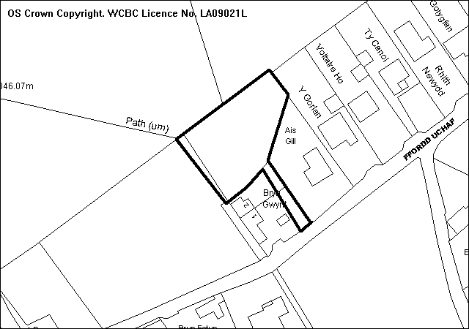
Application Site

PROPOSAL

As above.

RELEVANT HISTORY

P/2005/0948 Outline application for residential development & alteration to existing vehicular & pedestrian access. Approved 09.05.06
P/2007/1356 Reserved matters application for residential development (2 no dwelling) & alteration to existing vehicular & pedestrian access. Refused 11.01.08

DEVELOPMENT PLAN

Within settlement limit. UDP Policies PS1, PS2, GDP1, H2 and T8 apply, L P G 16 ‘Parking Standards’ and 21 ‘Space around Dwellings’ are also relevant.

CONSULTATIONS

Community Council: Consulted 19.03.2008
Local Member: Consulted 19.03.2008
Public Protection: Consulted 19.03.2008
Highways: No objections (see below)
Welsh Water: No objections subject to recommended planning conditions.
Access Group: Notified 19.03.2008
Site Notice: Expired 11.04.2008
Other Representations: One letter of objection received raising the following:
- The dwellings are to be opposite ‘Ais Gill’
- The road is narrow and access onto it would be dangerous
- Other properties on the area could be renovated instead
- Properties take a long time to sell in the area
- Gwynfyn is already over-developed
- No facilities exist to support this development

SPECIAL CONSIDERATIONS/ ISSUES

Background: This is an application for approval of the reserved matters following the grant of outline planning permission back in 2006. A previous application for permission for 2 no. three storey dwellings was previously refused due to the negative impact upon the amenities of the adjacent properties in terms of loss of light, overlooking, overdominance, and the negative visual impact of such a large scheme. This application is for 2 no. bungalows of a significantly reduced scale and the main issues to consider relate to the impact upon local residential amenity, highway safety and the visual impact of development.

Design and Residential Amenity: The proposed bungalows are of simple design, with bedrooms in the roof space. No dormer windows have been proposed in connection with the scheme. Adequate space within the site has been provided around the proposed dwellings, with the layout making most of the natural daylight available and maximising the views of the countryside.

The dwellings have been designed in such a way as to protect the privacy and provision of natural daylight to the adjacent properties, and the separation distances as recommended within Local Planning Guidance Note No.21 ‘Space around Dwellings’ have been achieved.

Cross sections of the proposed development have been submitted which demonstrate that the properties have been situated within the site with the aim of protecting the appearance of the area from any overdominating visual impact when viewed from the adjacent properties and highway.

Highways: The existing access to the site is currently substandard and improvements are proposed in connection with this development. Although the access would not meet with the Council’s visibility standards, the access will be significantly improved and, as such, will be of benefit to the area in terms of highway safety.

Other Representations: The existence of other properties worthy of renovation and rate of property sales are not relevant planning considerations. It is noted that a local resident feels that this area is overdeveloped and suffers from a lack of supporting facilities, however, the principle of residential development has already been established and these are not relevant considerations at this stage.

Conclusion: The proposal is acceptable as being in accordance with local planning policy and the development would make a positive contribution to the area.

RECOMMENDATION That permission be GRANTED

CONDITION(S)

1. The development hereby permitted shall be begun before the expiry of five years from the date of this permission.
2. Prior to their use on the development samples of all external facing and roofing materials shall be submitted to and approved in writing by the Local Planning Authority. The development shall only be carried out in strict accordance with such details as are approved.
3. The development shall only be carried out in accordance with the amended plan(s).
4. No gates shall be erected at the proposed new access point within 5 metres of the highway boundary.
5. Prior to first use of development, the access shall be paved using hardbound materials for a minimum distance of 5 metres behind the highway boundary.
6. The parking spaces as indicated on the approved plan shall be fully implemented prior to first use of the development and shall thereafter be retained free of all obstruction and made available for the parking of vehicles at all times.
7. The garages as approved as part of this permission shall not be converted without the written permission of the Local Planning Authority, and shall be retained free of all obstruction and made available for the parking of vehicles at all times.
8. There shall be no discharge of surface water to the combined sewer system.
9. All foul drainage shall be directed to a foul sewerage system and all surface water drainage to a surface water system unless otherwise agreed by the Local Planning Authority.
10. No land drainage run-off shall be permitted, either directly or indirectly, to discharge into the public sewerage system.
11. A scheme showing all boundary treatments shall be submitted to and approved in writing by the Local Planning Authority and such details as approved shall be fully implemented prior to first occupation of the site.
12. This permission shall operate only to allow development to be carried out in accordance with the approved drawings and the application documentation. Notwithstanding the provisions of the Town and Country Planning (General Permitted Development) Order 1995, no further development shall take place within the site (other than the painting of the buildings).
13. The site shall be developed in accordance with the ground and floor levels indicated on the approved plans. No changes to floor levels or external ground levels shall be made without the prior written approval of the Local Planning Authority.
- Prior to first occupation of the development the access onto Ffordd Uchaf shall have visibility splays measuring 2.4m x 33m in both directions measured to the centre line of the adjoining highway within which there shall be no obstruction in excess of one metre in height
- No additional windows, including dormer windows, shall be inserted into the roof of the dwelling.

REASON(S)

1. To comply with Section 91(3) of the Town and Country Planning Act, 1990.
2. To ensure a satisfactory standard of appearance of the development in the interests of the visual amenities of the area.
3. To ensure that the development fully complies with the appropriate policies and standards.
4. In the interests of highway safety.
5. To ensure a satisfactory standard of appearance of the development in the interests of the visual amenities of the area and to ensure that no deleterious material is carried onto the highway.
6. To ensure provision and retention of on-site parking in the interests of highway safety.
7. To ensure provision and retention of on-site parking in the interests of highway safety.
8. There is insufficient capacity in the existing system to cater for additional surface water flow.
9. To ensure the proper drainage of the site and to minimise the risk of pollution
10. To ensure the proper drainage of the site and to minimise the risk of pollution
11. To ensure a satisfactory standard of appearance of the development in the interests of the visual amenities of the area.
12. Due to the restricted application site and its relationship with adjoining properties it is considered important to ensure that no additional development as described in the condition is carried out without the permission of the Local Planning Authority.
13. To ensure that the development fully complies with the appropriate policies and standards.
14. In the interests of highway safety.
15. To protect the amenities of the occupiers of nearby properties.

NOTE(S) TO APPLICANT

If a connection is required to the main sewerage system, the developer is advised to contact the Dwr Cymru Welsh Water's Network Development Consultants on 01443 331155.

All ancillary operations and the use of plant and machinery, which are audible at the boundary, shall be carried out only between 07.30 hours to 19.30 hours Monday to Friday, between 08.00 hours and 14.00 hours on Saturdays and at no time on Sundays and Bank Holidays.
_____________________________________________________________________

APPLICATION NO:  P/2008 /0290  COMMUNITY:  Acton  WARD:  Rhosnesni | LOCATION:  20 ANSELL ROAD WREXHAM  DESCRIPTION:  FIRST FLOOR EXTENSION TO SIDE OF PROPERTY.  APPLICANT(S) NAME:  MR L PATTERSON | DATE RECEIVED:  18/03/2008  CASE OFFICER:  LG  AGENT NAME:  MR S CATTELL - OPERATIONAL MANAGER
_____________________________________________________________________

THE SITE

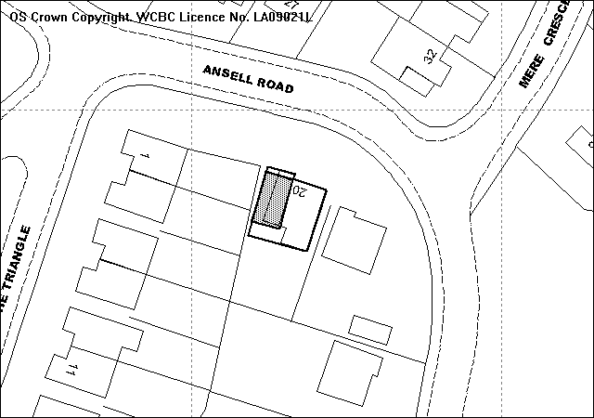
Proposed first floor extension
Existing single storey extension
Site

PROPOSAL

As Above.

HISTORY

CB00979 Demolition of existing garage and extension to provide bedroom,
utility room, store and kitchen. Approved 18.04.97.

DEVELOPMENT PLAN

Within settlement limit. UDP Policies GDP1 and PS2 LPG No 20 ‘House Extensions’, 21 ‘Space around Dwellings’ and 16 ‘Parking Standards’ are relevant.

CONSULTATIONS

Community Council: Consulted 20.03.08
Local Member: Consulted 20.03.08
Other Representations: 7 neighbouring dwellings notified, 1 letter of objection received raising the following concerns:
- The proposed upper floor extension height and design would have an impact on the character of the actual property.
- The proposed extension would have a severe impact, such as the view from the lounge, kitchen and bedrooms and would block out considerable amounts of daylight to the rear.
- Was assured verbally by planning department that permission would only be given for the ground floor to be constructed and that any upper floor would not be granted because of the impact to neighbouring properties.

Site Notice: Expired 16.04.08

SPECIAL CONSIDERATIONS/ISSUES

Background: The application site and the neighbouring dwelling are located on the bend of Ansell Road and Mere Crescent and is bounded by the rear gardens of the properties on The Triangle. The property has had a large side and rear extension granted in 1997, and it is on top of this which the proposed first floor extension is to be located. Amended plans have been requested to reduce the width of the extension to 3 metres in order to address concerns regarding the scale and appearance of the proposal. This report is written on the assumption that the amendments will be made as requested.

Scale/appearance: Local Planning Guidance Note 20 states extensions should retain the scale of the original property and with regards to side extensions, the width should not be more than half the width of the original frontage. Although the existing side extension is more than half the width of the original frontage, as it is only single storey in size it appears clearly subservient to the original building and does not compromise the appearance or scale of the dwelling.

The proposal to extend above the existing side extension would serve only to emphasis the width of the extension distorting the scale of the original dwelling. The combined affect of the extensions would be over dominant in relation to the original dwelling and would have an adverse affect on the appearance of the property and the street scene.

To address the above concerns it has been advised that the first floor side extension be reduced in width to 3 metres so that part of the existing ground floor side extension forms a wrap around along the side elevation. This would allow the extension to appear subsidiary and in scale with the original property whilst still providing a reasonable sized first floor extension.

Residential Amenity: The proposed side extension will be located over 13 metres away from the rear windows of neighbouring dwellings on The Triangle. This accords with Local Planning Guidance Note 21 which states that where a habitable room window faces a blank wall, the height of which exceeds the top of that window, there should be a minimum distance of 13 metres between them. There are no side facing windows proposed so no overlooking or loss of privacy would result.

The proposed extension is in accordance with the British Research Establishment 45 degree daylight test and no detrimental loss of daylight would result to the dwellings on The Triangle.

Number 3 The Triangle has a conservatory located on the rear elevation. Only part of the extension will be directly in front of the conservatory and I do not consider that a small reduction in separation distance would lead to a detrimental loss of amenity to the occupiers.

The proposed first floor window to the rear of the extension is to a bathroom and will be conditioned obscurely glazed to prevent overlooking into the rear gardens of the surrounding dwellings.

Car Parking: The number of bedrooms will remain at 4 so there is no increased demand on parking within the site.

Other issues: With regards to verbal confirmation that a first floor extension would not be granted at the site, guidance and policy has changed since the ground floor extension was granted in 1997 and the proposal meets the current guidance with regards amenity and separation distance.

Conclusion: The proposed development meets the current guidance with regards to separation, daylight and overlooking and I am satisfied no detrimental loss of amenity of result.

RECOMMENDATION

That subject to the receipt of satisfactory amended plans to address concerns regarding scale and appearance as outlined above, the Chief Planning Officer be given delegated authority to grant permission, subject to the conditions specified below with such amendments and/or additional conditions he considers necessary and provided no significant new issues are raised as a result of any necessary re-publicity of the application.

CONDITION(S)

1. The development hereby permitted shall be begun before the expiry of five years from the date of this permission.
2. No facing materials shall be used other than materials matching those used on the existing building.
3. Development shall only be carried out in strict accordance with the approved plans unless the prior written approval of the Local Planning Authority has been obtained.
4. Notwithstanding the provisions of the Town and Country Planning (General Permitted Development) Order no windows or other openings shall be inserted in the north west elevation of the building.
5. Notwithstanding the provisions of the Town and Country Planning (General Permitted Development) Order 1995 any window or opening in the south elevation shall only be glazed or re-glazed using obscure glass.

REASON(S)

1. To comply with Section 91(3) of the Town and Country Planning Act, 1990.
2. To ensure a satisfactory standard of appearance of the development in the interests of the visual amenities of the area.
3. To ensure that the development fully complies with the appropriate policies and standards.
4. To protect the amenities of the occupiers of nearby properties.
5. To protect the amenities of the occupiers of nearby properties.

NOTE(S) TO APPLICANT

You should ensure that any difference between the plans approved under the Town and Country Planning Acts and under the Building Regulations is resolved prior to commencement of development, by formal submission of amended plans.

The permission hereby granted does not authorise encroachment upon, or interference with, the adjoining property.
_____________________________________________________________________

APPLICATION NO:  P/2008 /0291  COMMUNITY:  Esclusham  WARD:  Ponciau | LOCATION:  5 BRYN OFFA FENNANT ROAD PONCIAU WREXHAM  DESCRIPTION:  EXTENSION OF AND CONVERSION OF EXISTING LOFT SPACE TO FORM ADDITIONAL BEDROOM  APPLICANT(S) NAME:  MR I CRUMP | DATE RECEIVED:  18/03/2008  CASE OFFICER:  LB1  AGENT NAME:  MR I CRUMP
_____________________________________________________________________

SITE
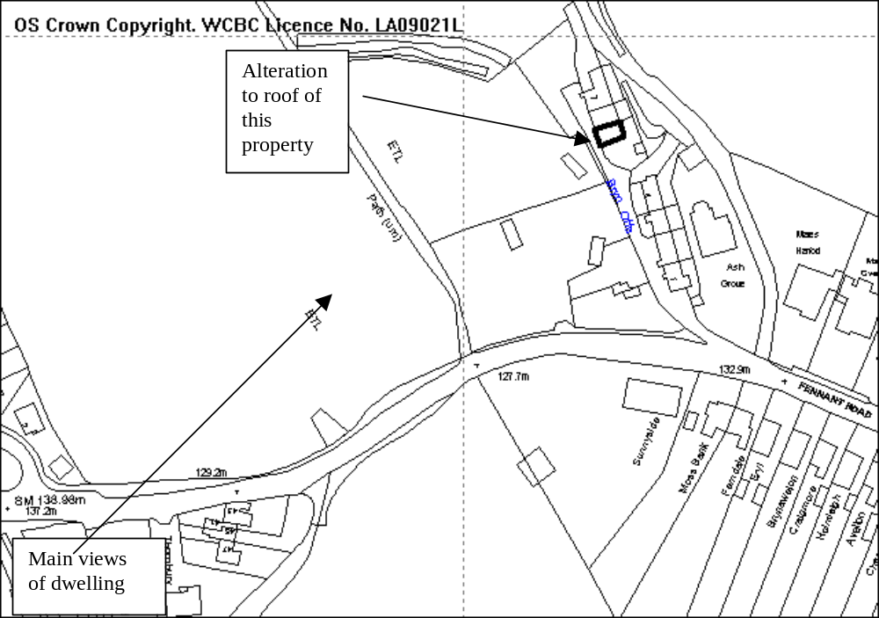

PROPOSAL

As above.

HISTORY

None relevant.

DEVELOPMENT PLAN

Outside settlement limit, GDP1, PS2, LPGN 20 & 13 apply.

Lies adjacent to a Special Landscape Area

CONSULTATIONS

Community Council: Consulted 20/03/08
Local Members: Councillors Pemberton & Roberts: both request application is considered by Committee.
Other representations: Neighbouring properties notified.
Site Notice: Expired 17/04/08

SPECIAL CONSIDERATIONS

The property is an end terraced house that lies in a terrace of three properties that has a hipped roof line at either end of the row. The proposal is to create an additional bedroom in the loft space, to accommodate the necessary room and head height it is proposed that the roof shape be altered to create a gable roof line.

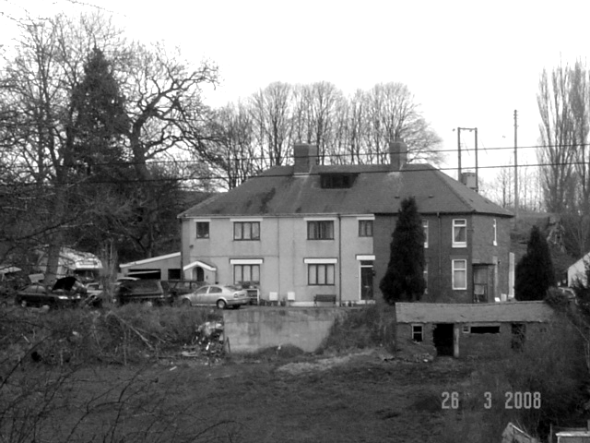

The property is prominent when viewed from Fennant Road (see photo) and the alteration in the roof line will destroy the symmetrical appearance of the row of terraces. This will have a detrimental impact upon the appearance of the properties . Local Planning Guidance Note 20 advises that roof alterations should be kept as small as possible so as to minimise the visual impact on the surrounding area. Additionally Guidance Note 13 advises that extensions should respect the scale, form and detailing of the original dwelling.

The proposed extension would alter the appearance of the property to such an extent that it would appear completely different to the original dwelling and row of properties and would therefore be contrary to adopted Guidance.

Given the prominent setting of the property within the open countryside and adjacent to a Special Landscape Area and the fact that the appearance of the row of terraces will be disrupted the proposal is unacceptable in terms of its design and I therefore recommend accordingly.
P/2008 /0291

RECOMMENDATION That permission be REFUSED

REASON(S)

1. The proposal, by virtue of its size, mass and prominent setting, would have a detrimental impact on the property and the aesthetic appearance of the adjoining houses and is unsympathetic to the form and character of the existing properties. This extension would make a negative contribution to the appearance of the property. To allow the development would be contrary to the adopted Wrexham Unitary Development Plan Policies GDP1(a) and PS2 and the Council's adopted Local Planning Guidance Note 20 - House Extensions.
_____________________________________________________________________

APPLICATION NO:  P/2008 /0299  COMMUNITY:  Bronington  WARD:  Bronington | LOCATION:  MAES Y GROES ISCOYD WHITCHURCH  DESCRIPTION:  CHANGE OF USE FROM FARM WORKSHOP (CLASS B1) TO PICTURE FRAMING WORKSHOP, STUDIO AND GALLERY (CLASS A1) IN RETROSPECT.  APPLICANT(S) NAME:  MRS ELAINE LANGLEY | DATE RECEIVED:  19/03/2008  CASE OFFICER:  SJG  AGENT NAME:  MRS ELAINE LANGLEY
_____________________________________________________________________

THE SITE

The site is on the west side of the lane between Higher Wych and Redbrook.

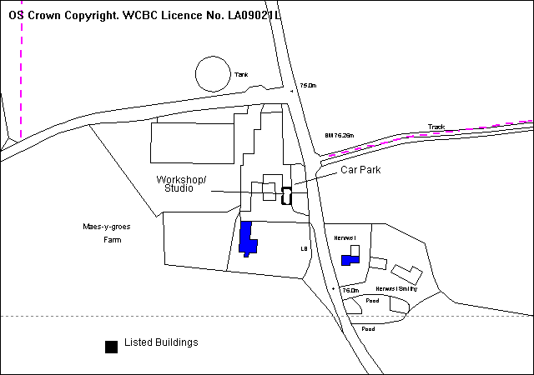
PROPOSAL

As above. The alterations carried out have been minimal, involving alterations to doors and windows to the front and rear within existing openings. The Building is on the north side of the farm and has a car park to the front. A picture framing workshop was created in 2003/4 in the end section of the single storey building, and the applicant has agreed to include the workshop as part of this application. The picture framing studio/ sales area is in the adjoining section of the building, with a retail area of 16m². The applicant states that it is a continuation of a farm diversification project. The premises are accessible to the disabled, subject to a proposed ramp for the 80mm step.

RELEVANT HISTORY

P/2008/0300 LBC for same development next item.

DEVELOPMENT PLAN

outside settlement limits and within a Special Landscape Area. Policies PS2 EC 5 EC9 E5 E6 T8 and GDP1 of UDP are relevant, together with LPGN 3 and 7 (LANDMAP Area 13b).

CONSULTATIONS

Bronington C Council: No objection
Local Member: Consulted 20/3/2008
Highways: Consulted 20/3/2008
Public Protection: Consulted 20/3/2008
Env Agency: Standard advice applies
Site Notice: Expires 18/4/2008
Other representations: Adjoining occupiers notified 31/3/2008

SPECIAL CONSIDERATIONS/ ISSUES

Policy: The proposal complies with adopted policies for small farm-based employment projects in the countryside. The retail element is small.

Listed Building: The minor alterations carried out appear acceptable and are recommended for Consent in my next report. .

RECOMMENDATION That permission be GRANTED

CONDITION(S)

1. Development shall only be carried out in strict accordance with the approved plans unless the prior written approval of the Local Planning Authority has been obtained.
2. The vehicle parking and turning areas indicated on the approved plans shall be laid out, surfaced and drained prior to the first use of the building hereby granted and shall thereafter be retained for those purposes, free of all obstruction.
3. No use of the development shall be made before 9.00am or after 6.00pm on any day.
4. No retailing shall take place other than from the areas specifically shown on the approved plans for that purpose.

REASON(S)

1. To ensure that the development fully complies with the appropriate policies and standards.
2. In the interests of highway safety.
3. To ensure that the development is not used at a time which would be likely to cause nuisance or disturbance to nearby residents.
4. To protect the amenities of the occupiers of nearby properties.

NOTE(S) TO APPLICANT

You are advised that this permission does not in itself authorise the carrying out of the development hereby permitted until the necessary Listed Building Consent has been obtained. Your concurrent application for Listed Building Consent has now been forwarded to the National Assembly for Wales.

Your attention is drawn to Highway Supplementary Notes Numbered 1, 3, 4 and 5 on the enclosed "Applicants' Rights and General Information".

You are reminded that the Disability Discrimination Act 1995 applies to this development.
_____________________________________________________________________

APPLICATION NO:  P/2008 /0300  COMMUNITY:  Bronington  WARD:  Bronington | LOCATION:  MAES Y GROES ISCOYD WHITCHURCH SHROPSHIRE  DESCRIPTION:  LISTED BUILDING CONSENT FOR ALTERATIONS TO FARM WORKSHOP TO FORM PICTURE FRAMING STUDIO AREA AND GALLERY (IN RETROSPECT)  APPLICANT(S) NAME:  MRS ELAINE LANGLEY | DATE RECEIVED:  19/03/2008  CASE OFFICER:  SJG  AGENT NAME:  MRS E LANGLEY
_____________________________________________________________________

THE SITE

The site is on the west side of the lane between Higher Wych and Redbrook (For plan see previous report).

PROPOSAL

As above. The alterations carried out have been minimal, involving alterations to doors and windows to the front and rear within existing openings.

RELEVANT HISTORY

P/2008/0299 Planning application for same development previous item.

DEVELOPMENT PLAN

Outside the settlement limits and within a Special Landscape Area. Policy EC9 and Circular 61/96 are relevant.

CONSULTATIONS

Bronington C Council: No objections
Local Member: Consulted 25/3/2008
WACS: Consulted 25/3/2008
DHS: Consulted 25/3/2008
FHS: Consulted 25/3/2008
Royal Commission: Consulted 25/3/2008
Site Notice: Expires 18/4/2008
Press advert: Expires 25/4/2008
Other representations: Adjoining occupiers notified 31/3/2008. No comments received

SPECIAL CONSIDERATIONS/ ISSUES

Listed Building: Than main farmhouse is a Grade II* listed building (hence the need for a committee decision). It is listed as a fine late 17th century house.

The building is a single storey structure to the north of the main house.

The alterations to achieve the conversion have been carried out in a sympathetic manner and do not harm the character and appearance of the building. In providing a viable alternative use they have helped to safeguard the building for the future.

Recommendation a

That Cadw, on behalf of the Welsh Assembly Government, be advised that the Wrexham County Borough Council is disposed to grant LISTED BUILDING CONSENT in accordance with Article 3 of the Planning (Listed Buildings & Conservation Areas) Regulations 1990, subject to the conditions specified below.

CONDITION(S)

1. Development shall only be carried out in strict accordance with the approved plans unless the prior written approval of the Local Planning Authority has been obtained.

REASON(S)

1. To ensure that the development fully complies with the appropriate policies and standards.

Recommendation B

That I be authorised to issue the appropriate certificate forthwith if WAG refers the application back to the Council for determination.
_____________________________________________________________________

APPLICATION NO:  P/2008 /0304  COMMUNITY:  Holt  WARD:  Holt | LOCATION:  ROSE COTTAGE CHURCH STREET HOLT WREXHAM  DESCRIPTION:  ERECTION OF SINGLE DWELLING, OFF ROAD PARKING AND RECONSTRUCTION OF BOUNDARY WALL.  APPLICANT(S) NAME:  MR & MRS DE MORRIS | DATE RECEIVED:  19/03/2008  CASE OFFICER:  LB1  AGENT NAME:  MR & MRS DE MORRIS
_____________________________________________________________________

SITE

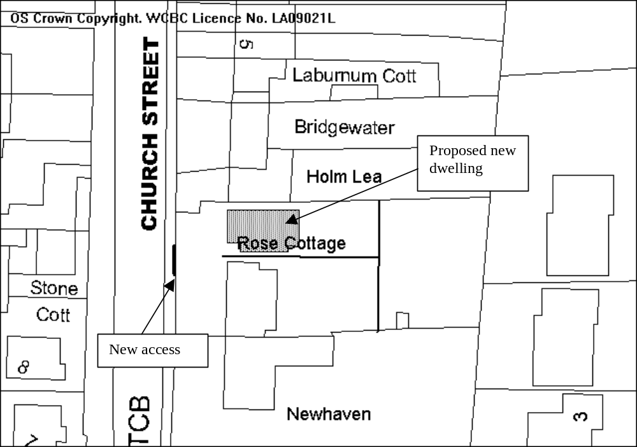

PROPOSAL

As above.

HISTORY

19580 Erection of detached dwelling 1991 – Refused – Insufficient parking and no visibility splay provided
20057 Erection of detached dwelling 1992 - Granted
P/2006/1249 – Erection of detached dwelling. Refused 15/12/06 – Insufficient
parking, no visibility splay and demolition of boundary wall.
P/2007/0898 Erection of single dwelling with off road parking to new dwelling and Rose Cottage and new wall to Church Street. Refused 24/08/07

DEVELOPMENT PLAN

Within settlement limit and Holt Conservation Area, GDP1, PS2, EC7, LPGN 4,16, 20 and 21 apply

CONSULTATIONS

Community Council: Consulted 25/03/08
Local Member: Consulted 25/03/08
Highways: recommend refusal – visibility splays not demonstrated
on plan, shared access is of inadequate width.
Welsh Water: No objections subject to conditions relating to sewerage
system and water run off being imposed.
CPAT: Plot is situated within Holt Medieval historical core and
require archaeological surveys to be completed.
Public Protection: No objections but require note to applicant to limit
construction times.
Environment Agency: No comment, standard advice applies
Other representations: One letter of objection :
same reasons as previous applications
- The street on which the development is proposed is the main thoroughfare from Holt to Farndon and is an extremely busy road. Despite the attempt to create parking space within the plot there is still a potential hazard with egress taking place onto the main road.
- The proposed new dwelling almost completely fills the site and although Council conditions regarding distances between dwellings appear to be complied with, the plot originally was only planned for one dwelling and constitutes over development within the conservation area of Holt.
- The proposed new 3 bedroom property is at a higher level than properties on Vicarage Court and is therefore bound to have an impact on residential amenity overlooking the lower property.
- The garden area was never intended for residential development. The fit is extremely poor and a new property jammed in between a row of mature properties from the earliest days of the village is simply a blight
- The elevation of the ground to the rear of the proposed dwelling is higher than the properties to the rear and the residents of the new house will be able to look directly into existing houses effecting both privacy and light.
- The parking situation on Church Street is dangerous, it is nearly impossible to exit Vicarage Court or Bridge Court with parked traffic blocking the visibility. Off road parking adds nothing as clearly the vehicles would have to emerge from between parked cars.
- The application does not appear to have been changed from previous applications and there is no reason why it should be supported.
Site Notice: Expired 18/04/08

SPECIAL CONSIDERATIONS

Background: Planning permission for the proposed development was refused in December 2006 and August 2007 due to the impact the development would have on the brick boundary wall which is listed within the Holt Conservation Area Assessment as ‘an important stretch of brick boundary’ and the fact that visibility requirements could not be met. Since the original application in 2006 Manual for Streets has been published and the visibility splay requirements have been reduced from 90m to 56m.

The site had previously been granted planning permission for a single dwelling in 1992 however this was not implemented.

Archaeology: The site lies in the historic centre of Holt and as a relatively undisturbed site there is potential for archaeological remains to be present. CPAT would prefer that the application is withdrawn until an appropriate study and survey can be completed, however I am satisfied that a condition requiring a survey to be done prior to the commencement of development is sufficient. The applicant is aware of this requirement and that there may be subsequent issues relating to the construction of foundations dependent on what is discovered.

Conservation: The design of the property is in keeping with the neighbouring properties with window details being similar to that on Rose Cottage itself. The colour of the render can be agreed by condition (a white or cream colour is considered appropriate in this area) as can the use of cast iron rain water goods.

The boundary wall to the front of the property, whilst listed in the Conservation Area Assessment as an important stretch of brick boundary is in a poor state of repair with a concrete coping on the top which is not in keeping with the remainder of the wall. The wall itself is a mixture of brick types, some from the early 20th Century whilst the top courses are of bricks from the 1950s/60s era. A concrete render has been applied to the lower part of the wall, which is broken and cracked in places and the bricks are showing signs of weather damage. The wall is not original to the site. Whilst it is important to ensure that a wall is maintained in this location to retain the character of the Conservation Area it is acceptable for this brick wall to be replaced by another built of reclaimed bricks of an appropriate colour and style for the area. A single access point to the properties will be formed in the same location as the existing pedestrian access.

In terms of the general street scene I am satisfied that the proposed dwelling will not be out of place, there are a variety of rendered and brick properties along Church Street. Retention of a wall will also maintain the existing linear features in this area. The removal of part of the front garden area in order to provide off street parking will remove some trees and shrubs and replace them with hard surfacing. The plan indicates that there is to be some new planting around the edges of the parking area, exact details will be required by condition. Additionally to ensure that the hard surfacing of the car park does not detrimental to the general street scene conditions will be required for details of materials to be submitted. The applicant has agreed that tarmac would be unacceptable in this location and is willing to use some form of paving with exact details and colours to be agreed.

Highways: I note the comments of Highways. The new access is to provide access to both the new property and Rose Cottage. The standard width for a joint access is 4.1 metres which is set to enable two cars to pass each other at the entrance i.e. one car entering the property at the same time as another one leaving. In this instance the applicant is proposing an entrance of 3 metres, this represents a shortfall of 1.1 metres. As the access is to serve only two properties and the location of the entrance is such that it would be apparent to anyone wishing to enter the site that a car is looking to exit I do not believe that the shortfall in this instance will present a danger to highway safety. Additionally the narrower entrance area is likely to reduce the speed of any vehicles exiting or leaving the site thus improving pedestrian and highway safety. It would also reduce the impact upon the wall and Conservation Area.

It is recognised that the parking provided at the properties does not comply with LPGN 16 in that only two places are provided for each property instead of the required 3, however in this instance it is considered a priority to remove cars from the road where they currently park. Therefore in order to improve highway safety I would be prepared to accept a lower number of parking places for each dwelling. The village of Holt contains local shops and is well served by local buses thus providing alternatives to car usage.

The turning and parking area are a shared facility for both the properties, there is to be a joint access with parking spaces in front of the respective houses.

The visibility splay required is 2.4 metres x 56 metres in both directions with no obstruction in excess of 1 metre in height. The visibility at present is hampered by the existing boundary wall, plants within the applicants garden and lampposts along the edge of the pavement. As part of this application the boundary wall is to be set back from the boundary line to create a visibility splay and the plants removed in order to form the parking area. Other boundary walls outside of the applicants control are no more than 1 metre high, as the road in this location is straight and flat the visibility is only impaired by the existing lampposts. Whilst the reduction in the visibility splays is not ideal I am of the opinion that the impairment is not so great to have a detrimental impact on highway safety given the speed of traffic on the road. I understand Highways accept that view if the wall is below 1 metre.

Amenity: The proposed new dwelling has no side facing windows to create overlooking to neighbouring properties. The rear windows will be 36 metres from the properties to the rear, and no closer than the existing properties therefore complying with LPGN 21. Taking into account the difference in floor levels the required separation would be 22m + 4 metres. The windows to the front will be 22.5m from the facing houses opposite. The property passes the BRE tests in relation to neighbouring houses. There is a private garden area to the rear of 93 square metres for the new dwelling and 150 square metres left for Rose Cottage.

Other Considerations: Whilst there has not been a dwelling in this location, the width of the site is adequate to accommodate one. The dwellings along this street are a mixture of terraces, semi detached and detached properties and there is no standard separation between the properties. The addition of a dwelling in this location would reflect the existing street scene and would not create the impression that a property was jammed in or create overdevelopment of the area.

The trees that are to be removed which are mainly to the front of the property, whilst adding to the general amenity of the street scene are not the subject of a TPO nor do I consider them to be worthy of an Order. They are to be replaced by shrubs and bushes as part of the landscaping scheme adjacent to the driveway.

Conclusions: Whilst the proposal represents a reduction in the standards for highway safety I am of the opinion that these are not so great as to warrant a refusal of permission. I am satisfied that the erection of a dwelling on this plot will preserve the character of the Conservation Area. The design of the property is in keeping with nearby dwellings and the amenity of neighbouring properties will not be adversely affected.

RECOMMENDATION That permission be GRANTED

CONDITION(S)

1. The development hereby permitted shall be begun before the expiry of five years from the date of this permission.
2. No part of the development shall be commenced until samples of all external facing and roofing materials have been submitted to and approved in writing by the Local Planning Authority. The development shall only be carried out in strict accordance with such details as are approved.
3. Development shall only be carried out in strict accordance with the approved plans unless the prior written approval of the Local Planning Authority has been obtained.
4. This permission shall operate only to allow development to be carried out in accordance with the approved drawings and the application documentation. Notwithstanding the provisions of the Town and Country Planning (General Permitted Development) Order 1995, no further development shall take place within the site (other than the painting of the buildings).
5. Prior to the commencement of development details of the materials to be used for the parking area shall be submitted to and approved, in writing, by the Local Planning Authority. Development shall only take place in accordance with those details as approved.
6. The vehicle parking and turning areas indicated on the approved plans shall be laid out, surfaced and drained prior to the first use of the building hereby granted and shall thereafter be retained for those purposes, free of all obstruction.
7. Within three months of the commencement of development samples and details of the replacement boundary wall shall be submitted to and approved in writing by the Local Planning Authority. Development shall only take place in accordance with those details as approved.
8. Work on the replacement boundary wall shall be commenced within three months of the first occupation of the dwelling hereby approved.
9. No development shall take place until an archaeological survey of the site has been carried out and the results forwarded to and approved in writing by the Local Planning Authority.
10. The developer shall afford access to the site at all reasonable times to any archaeologist nominated by the Local Planning Authority and shall allow such persons to observe the excavations as they are carried out and to record items of archaeological interest and finds.
11. All new and replacement rainwater goods shall be cast iron.
12. Foul water and surface water discharges shall be drained separately from the site.
13. No surface water shall be allowed to connect, either directly or indirectly, to the public sewerage system unless otherwise approved, in writing, by the Local Planning Authority.
14. Land drainage run-off shall not be permitted to discharge, either directly or indirectly, into the public sewerage system.
15. Construction works, ancillary works and the use of plant or machinery audible at or beyond the site boundary shall only be carried out between the hours of 07:30 and 19:30 (Monday to Friday) and 08:00 to 14:00 (Saturday) and at no time on Sundays or Bank Holidays.

REASON(S)

1. To comply with Section 91(3) of the Town and Country Planning Act, 1990.
2. To ensure a satisfactory standard of appearance of the development in the interests of the visual amenities of the area.
3. To ensure that the development fully complies with the appropriate policies and standards.
4. Due to the restricted application site and its relationship with adjoining properties it is considered important to ensure that no additional development as described in the condition is carried out without the permission of the Local Planning Authority.
5. In the interests of the visual amenity of the area.
6. In the interests of highway safety.
7. In the interests of the visual amenity of the area.
8. In order to ensure that the boundary features within the Conservation Area are retained.
9. The site contains archaeological remains which it is essential should be protected from damage.
10. The site is considered to be of considerable archaeological interest and it is important that the opportunity created by the development to expose the history of the land is not lost.
11. To ensure the works reflect the character and appearance of the building.
12. To protect the integrity of the public sewerage system.
13. To prevent hydraulic overloading of the public sewerage system, either directly or indirectly, into the public sewerage system.
14. To prevent hydraulic overload of the public sewerage system and pollution of the environment.
15. To protect the amenities of the occupiers of nearby properties.
_____________________________________________________________________

APPLICATION NO:  P/2008 /0321  COMMUNITY:  Gresford  WARD:  Gresford East & West | LOCATION:  30 BURTON RISE GRESFORD WREXHAM  DESCRIPTION:  RETENTION OF STAINLESS STEEL FLUE ON GABLE END OF PROPERTY  APPLICANT(S) NAME:  MR TOM WILLIAMS | DATE RECEIVED:  25/03/2008  CASE OFFICER:  MP  AGENT NAME:  MR TOM WILLIAMS
_____________________________________________________________________

SITE

As above.

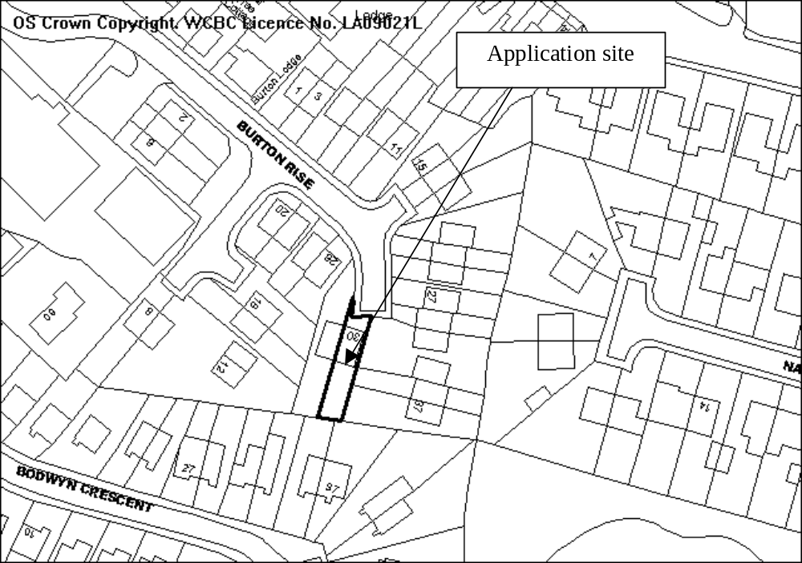

PROPOSAL

The applicant has erected a stainless steel flue on the east facing gable wall of the dwelling and is applying in retrospect for permission to retain it. (See picture overleaf)

HISTORY

None.

DEVELOPMENT PLAN

Within the settlement limit. Policy GDP1 applies.

CONSULTATIONS

Community Council: asks that steps are taken so that flue has no adverse affect on public health.
Local Member: Notified 26.3.08
Public Protection: Notified 31.3.08
Other representations: 1 letter received expressing the following concerns:
- noticed the smell of burning;
- it is not an attractive addition to the outside of the house;
- would not like the view;
- would find the smell very offensive if I lived nearer.
Site Notice: Expired 21.4.08

SPECIAL CONSIDERATIONS

Amenity: The key issue in my opinion is whether the flue has a significant and unacceptable impact upon the visual amenity of the locality

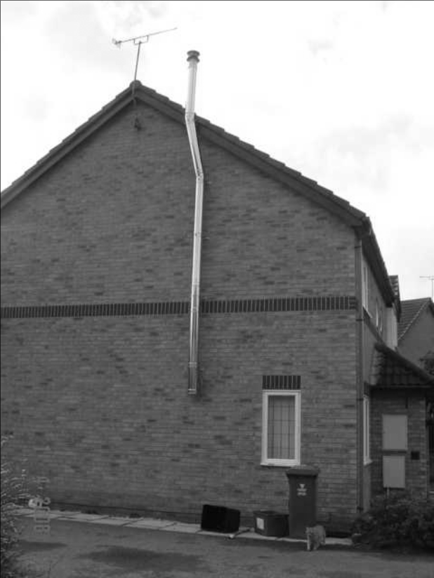

The installation of vents and flues in connection with domestic heating equipment does not normally require planning permission. In the case of the applicant’s property, the flue requires permission because it exceeds the highest part of the roof by 35 centimetres. Were it reduced in height by this amount, permission would not have been required. In my opinion the extra height of the flue does not have either a significant or detrimental impact upon the visual amenity of the locality.

It is worth noting that changes to the Town and Country Planning (General Permitted Development) Order 1995 recently introduced in England allow for the installation of flues for biomass heating systems without planning permission provided they do not exceed the highest part of the roof by 1 metre. The Assembly Government has also consulted on introducing similar changes in Wales, which if adopted, would mean the flue would not need planning permission. The implication being that both Central Government and the Assembly Government consider that flues of the type installed at 30 Burton Rise will not have a significant or unacceptable impact.

Health: I understand the stove burns untreated wood and I am unaware of any specific health issues arising from this form of heating system.

RECOMMENDATION That permission be GRANTED
_____________________________________________________________________

APPLICATION NO:  P/2008 /0332  COMMUNITY:  Rhos  WARD:  Ponciau | LOCATION:  65-67 HIGH STREET RHOSLLANERCHRUGOG WREXHAM  DESCRIPTION:  DEMOLITION OF EXISTING SHOP AND ERECTION OF 2 NO. SEMI DETACHED DWELLINGS.  APPLICANT(S) NAME:  MR A GREGORY | DATE RECEIVED:  27/03/2008  CASE OFFICER:  MP  AGENT NAME:  MR T BRIDLE
_____________________________________________________________________

SITE

As above.
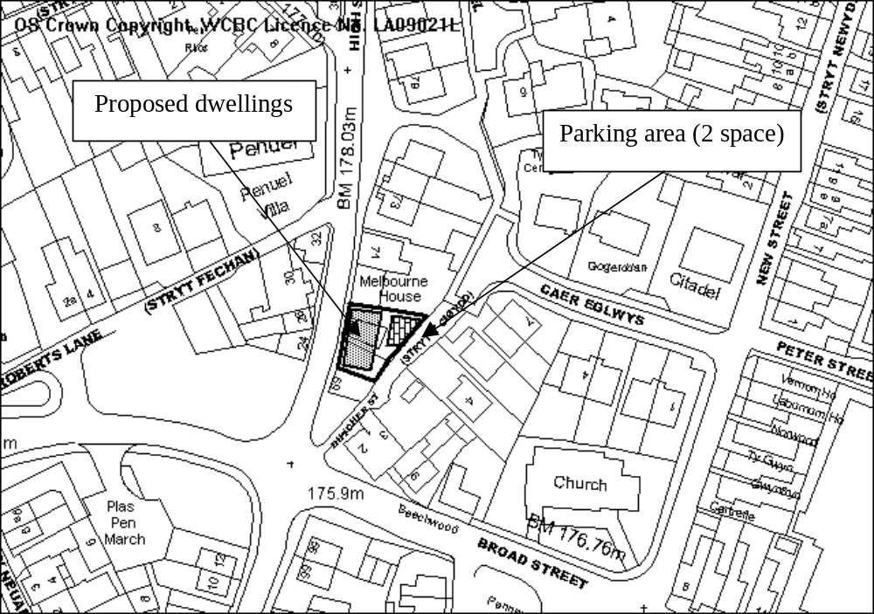

PROPOSAL

As above.

HISTORY

P/2006/0981 Demolition of existing shop and erection of 4 no. single bed flats. Refused 11.10.2006.
P/2007/0770 Demolition of existing shop and erection of 2 no. 2 bedroom terrace
houses. Refused 1.8.2007.

DEVELOPMENT PLAN

Within settlement limit. Policies PS1, PS2, GDP1, H2 and T8 apply.

CONSULTATIONS

Community Council: Object on the following grounds:
- there is insufficient parking in the area and on site.
- Amenity to the occupants – to expect residents to live in a dwelling that offers little or no outside space.
Cllr A Roberts: Notified 28.3.08
Cllr Pemberton: Verbal comments – ok provided scheme meets minimum parking standards.
Highways: Have made the following comments:
- existing access onto High Street suffers from severely substandard visibility of both pedestrians and vehicles;
- the application proposes the closure of this access which is to the benefit of highway safety on High Street;
- The footway fronting the site on High Street is to be widened to improve pedestrian provision;
- It is proposed to provide vehicular access on to Butcher Street. Although it is considered that this highway is too narrow to cater for any significant increase in vehicular movement, the road is unclassified and it maybe difficult to prevent the site owner establishing rights of access to the site;
- Visibility at the access locations is concurrent with the requirements of Manual for Streets for a 10 mph vehicular speed;
- There is a shortfall of 2 parking spaces on the maximum standards required by LPGN no 16; however it has been determined at previous planning appeals that it is inappropriate to apply these as minimum standards;
- The availability of a regular bus service in close proximity to the site ensures that there is no essential need to own a car to reach everyday destinations. The site is close to the various facilities provided in the village centre;
- Given previous planning appeal decisions on car parking standards a recommendation for refusal on the grounds of inadequate parking is unjustifiable;
- Although previously recommended that no further vehicular traffic should be generated on Butcher Street it is considered that this scheme will generate only a marginal increased use;
- The scheme offers highway benefits in removing a substandard access from High Street and the provision of a widened footway on High Street.
- Conditions recommended regarding visibility, parking provision, access design.
Welsh Water: Recommend drainage conditions.
Other representations: Nearby occupiers notified 2.4.08
Site Notice: Expired 23.4.08

SPECIAL CONSIDERATIONS

Background: Two previous proposals to develop the site have been refused. The first refusal, in 2006, on design grounds, poor outlook from habitable rooms and lack of visibility at the proposed access. The second, in 2007, was due to concerns about Butcher Street (to the rear) being unsuitable to serve as a means of vehicular access to the development.

The current proposals are similar in terms of the number of dwellings proposed as well as the external design. The position of the dwellings has been amended slightly to provide a wider footway along the frontage (approximately doubling its current width). The number of parking spaces provided to the rear has also been reduced to 2 (1 per unit).

Siting/design: The layout provides around 8 metres separation distance to the properties on the opposite side of High Streets, which is significantly below the standards normally required in accordance with LPG21. This situation is very common in Rhos, indeed the separation distances between existing properties adjacent to the site and those opposite are similar. I am of the opinion that although the separation distances are below what would normally be expected, accepting a relaxation of adopted standards can be justified in case in the interests of ensuring the development fits into the wider street site. The privacy of existing occupiers is also already affected by the fact that the dwellings front onto High Street with little in the way of garden areas/screening between them and the highway. Arguably they currently do not enjoy a completely private outlook and I am of the opinion the new development will not unacceptably compromise amenity any further.

The properties to the rear are approximately 20 metres distant, again below LPG21 recommendations. The orientation of these properties relative to the proposed dwellings is such that direct overlooking will not occur.

Both properties will have private amenity areas slightly below the 30 sq.m that LPG21 advises should normally be provided for dwellings of this size. The position of the car parking spaces limits opportunities to significantly increase garden area, although I believe there is scope to amend the layout slightly to achieve the minimum garden standards, as well as improve the shape of the rear garden areas. The boundary treatment shown on the plans also needs to be enhanced to ensure the garden areas are not overlooked from Butcher Street, as well as ensuring that occupiers are not disturbed by car lights when vehicles turn in to/exit the parking area. Subject to some minor changes I am satisfied that proposals can provide each dwelling with a rear garden area suitable for a range of ancillary domestic uses (e.g. bin storage, a washing line) and on that basis I believe future occupiers will be provided with a reasonable standard of amenity. Due to the minimum provision of private garden space, permitted development rights for domestic extensions should be withdrawn to ensure that this provision is retained.

The design of the properties is acceptable, in keeping with development in the locality and, in my opinion, will significantly improve the appearance of the site.

Access/Parking: The proposal will provide each dwelling with 1 space each. Although LPG16 advises that 2 bedroom properties should normally have 2 spaces each, the site is close to the village centre where there is a range of facilities, and that frequent public transport is accessible as well. Recent appeal decisions on parking have also generally not favoured refusal where there are small shortfalls on developments where, due to its location, future occupiers would not necessarily need to rely on private cars, as is that case with this development.

Highways had previously recommended refusal for a similar proposal, albeit one proposing 4 parking spaces to the rear, served off Butcher Street. Although Butcher Street is not suitable to accommodate any significant increase in vehicular use, the proposal is only likely to result in a marginal increase in traffic. It is also worth noting that as Butcher Street is an unclassified road, the site owner could establish an access off it without the need for planning permission.

On the basis of the advice received from Highways, by removing an existing substandard access off High Street and providing a widened footway, the proposals offer clear benefits in terms of the safety of road users and pedestrians. The benefits of permitting the development in my opinion outweigh the disbenefits of a marginal increase in the amount of traffic use of Butcher Street.

Conclusion: The development will result in a significant improvement in the appearance of the site and will improve both highway and pedestrian safety along High Street. On this basis I conclude the scheme accords with policy GDP1.
P/2008 /0332

RECOMMENDATION That permission be GRANTED

CONDITION(S)

1. The development hereby permitted shall be begun before the expiry of five years from the date of this permission.
2. Prior to their use on the development samples of all external facing and roofing materials shall be submitted to and approved in writing by the Local Planning Authority. The development shall only be carried out in strict accordance with such details as are approved.
3. This permission shall operate only to allow development to be carried out in accordance with the approved drawings and the application documentation. Notwithstanding the provisions of the Town and Country Planning (General Permitted Development) Order 1995, no further development shall take place within the site (other than the painting of the buildings).
4. Notwithstanding the approved plan, a scheme of boundary treatment shall be submitted to and approved in writing within three months of the date of commencement of development.
5. Notwithstanding the details shown on the approved plans, parking facilities private amenity space shall be provided in accordance with revised details to be submitted to and approved in writing by the Local Planning Authority. The parking spaces and private amenity space shall be provided in accordance with the details as approved prior to the first occupation of the dwelling and thereafter retained.
6. Foul and surface water discharges shall be drained separately from the site.
7. No surface water or land drainage run-off shall be allowed to connect (either directly or indirectly) to the public sewerage system.
8. The proposed access on to Butcher Street shall provide visibility splays of 2.0 x 11m in both directions measured to the centre line of the adjoining highway in which there shall be no obstruction in excess of 0.6m in height. The splays shall be provided prior to the first use of the access and shall thereafter be permanently retained free of all such obstruction
9. No part of the development shall commence until full details of the footway along the site frontage on High Street has been submitted to and approved by the Local Planning Authority. The scheme as approved shall be fully implemented to Highway Authority adoptable standard prior to the first occupation of the dwellings hereby granted permission.
10. Within 3 months of commencement of development on site, full details of both hard and soft landscape works for the site shall be submitted to and approved in writing by the Local Planning Authority. The works shall be implemented in accordance with a timescale to be approved in conjunction with the scheme of details.

REASON(S)

1. To comply with Section 91(3) of the Town and Country Planning Act, 1990.
2. To ensure a satisfactory standard of appearance of the development in the interests of the visual amenities of the area.
3. Due to the restricted application site and its relationship with adjoining properties it is considered important to ensure that no additional development as described in the condition is carried out without the permission of the Local Planning Authority.
4. In the interests of the visual amenities of the area and the privacy and amenity of future occupiers of the dwellings.
5. In the interests of highway safety and the amenity of future occupiers.
6. To protect the integrity of the public sewerage system.
7. To prevent hydraulic overload of the public sewerage system and pollution of the environment.
8. To ensure that adequate visibility is provided at the proposed point of access to the highway.
9. In the interests of pedestrian safety.
10. To ensure a satisfactory standard of appearance of the development in the interests of the visual amenities of the area.

NOTE(S) TO APPLICANT

You should ensure that any difference between the plans approved under the Town and Country Planning Acts and under the Building Regulations is resolved prior to commencement of development, by formal submission of amended plans.

The proposed development lies within a former coal mining area. You should take account of any hazards to stability which may arise from coal working in or near the site. Specific advice on any past working may be obtained from the Coal Authority Mining Reports Service. Phone 0845 762 6848 or from www.coal.gov.uk.

Any operations which may involve entry into former workings, shafts or adits or implementation of site investigations or other works may need permission from the Coal Authority.

All works, ancillary operations and the use of plant and machinery which are audible at the site boundary shall be carried out only between 07.30 hours to 19.30 hours Monday to Friday, between 08.00 hours to 14.00 hours on Saturdays and at no time on Sundays and Bank Holidays.

There shall be no fires on site, to include the prohibition of the burning of cleared vegetation.
A suitable dust management scheme shall be implemented on site to prevent dust nuisance from arising.
Your attention is drawn to Highway Supplementary Notes Numbered 1, 3, 4 and 5 on the enclosed "Applicants' Rights and General Information".

Technical approval for any construction works or retaining wall affecting or adjoining the highway will be required under the provisions of the Highways Act 1980. The applicant/developer is advised to contact The Principle Engineer 01978 297109 to discuss this technical approval.

The scheme of landscaping referred to in the above conditions shall inlcude any changes to ground levels (shown by existing and proposed contours/levels) and any existing vegetation (showing that to be retained) and proposed planting. In addition, any of the following which apply to the particular site must be included:-
means of enclosure, car parking layout, access and circulation areas, materials for hard surfaced areas, any minor structures (e.g. refuse stores, lamp columns, play equipment) location of services, and any historic landscape features to be retained/improved.
_____________________________________________________________________

APPLICATION NO:  P/2008 /0333  COMMUNITY:  Minera  WARD:  Minera | LOCATION:  TY BRITH PENTRE MINERA WREXHAM  DESCRIPTION:  PARKING OF 4 NO. VANS AND USE OF EXISTING BUILDING AS STORES (IN RETROSPECT)  APPLICANT(S) NAME:  MR M PRYDE | DATE RECEIVED:  27/03/2008  CASE OFFICER:  PF  AGENT NAME:  MR M PRYDE
_____________________________________________________________________

SITE

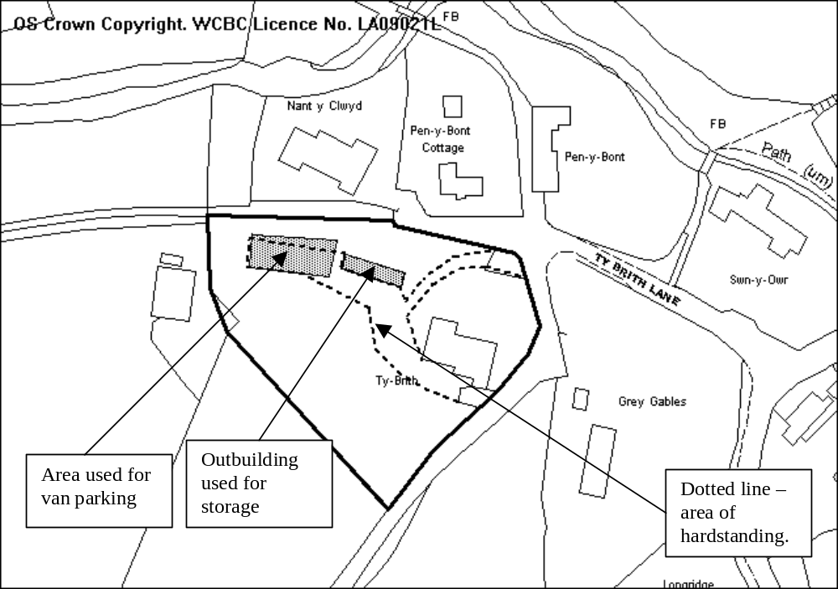

PROPOSAL

Use of an existing brick built outbuilding for storage of items in connection with the applicant’s electrical business and also the parking of four vans.

HISTORY

P/2007/1009 | Erection of garden equipment and wood store | Granted 3/12/2007

DEVELOPMENT PLAN

Outside settlement, within Minera Conservation Area and within the curtilage of a listed building. Policies PS2, GDP1, EC7 and E5 of the UDP apply. The application is made in retrospect.

CONSULTATIONS

Community Council: Consulted 28.03.2008
Local Member: Notified 28.03.2008
Public Protection: Consulted 28.03.2008
Highways: No objections
Other representations: 4 neighbouring occupiers notified. 1 letter of support received outlining there have been no extra problems as a result of the parking of vans. The old buildings have been in need of restoration.
Site Notice: Expires 22.04.2008
Press Notice: Expires 02.05.2008

SPECIAL CONSIDERATIONS

Policy: Policy E5 of the UDP allows for small-scale employment development in the countryside through the conversion of an existing building, therefore using the store for business purposes would be acceptable subject to compliance with GDP1.

Amenity: I consider that the use of the storage element will have no adverse impact upon the structure of this curtilage listed structure nor upon the setting of the listed building. The use of the site for the parking of the 4 no. vans is also not considered to have any detrimental impact upon the setting of the listed building.

The use of the building is indicated for the storage of miscellaneous equipment /supplies in connection with the business and the applicant states that no deliveries are made as supplies are collected on a day by day basis. I have consulted Public Protection in connection with the use of this building.

I am concerned that the use of this site for the parking of vans has a detrimental effect upon the amenity of the occupiers in the surrounding properties, by way of noise disturbance in the early morning and early evening in what is a completely residential area. This especially applies to the occupiers of Nant y Clwyd and Pen-Y-Bont Cottage which sit at a lower land level than Ty Brith.

Highways: Ty Brith has two access points onto a narrow lane. The application documentation states that employees drive to the site, leave their own cars and then leave the site in the vans. This happens once in the morning and once in the evening. This will intensify the use of the access points.

Conclusion: I am concerned that to allow this proposal would detrimentally harm the residential amenity of the occupiers of the adjacent occupiers of Ty Brith by way of increased noise and traffic generation. As such my recommendation is follows as the press notice does not expire until 02 May 2008.

RECOMMENDATION

Delegated powers be given to the Chief Planning Officer to refuse the application upon the expiry of the consultation period (2 May 2008) subject to no new matters arising.

_____________________________________________________________________

APPLICATION NO:  P/2008 /0354  COMMUNITY:  Caia Park  WARD:  Smithfield | LOCATION:  29 SALOP ROAD WREXHAM  DESCRIPTION:  TWO-STOREY EXTENSION (IN RETROSPECT)  APPLICANT(S) NAME:  MR L DAVIES | DATE RECEIVED:  03/04/2008  CASE OFFICER:  LB1  AGENT NAME:  MR L DAVIES
_____________________________________________________________________

SITE

Opposite the Lidl store on Salop Road.
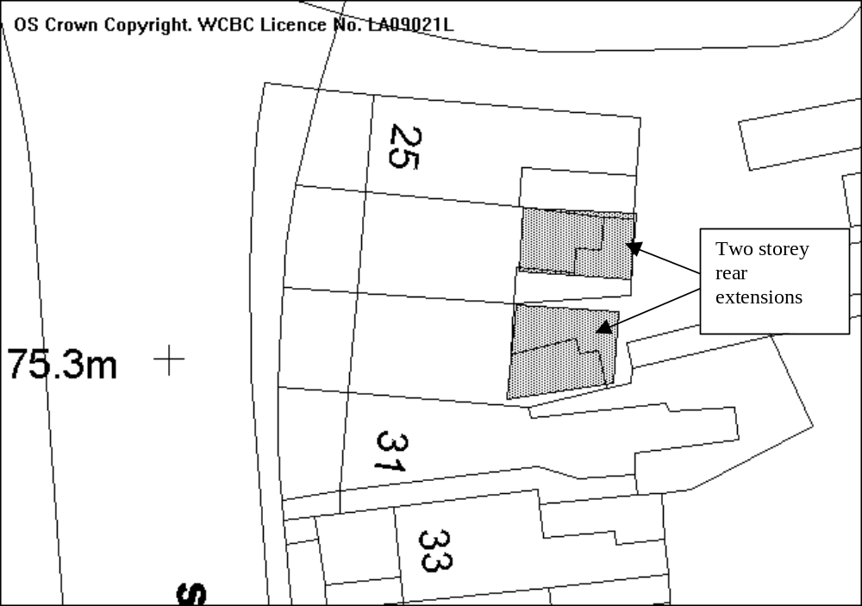

PROPOSAL

As above.

HISTORY

Application received as a result of enforcement action.
P/2007/0308 Extension to dwelling Refused 08/05/07 at May Planning Committee
P/2007/1236 Extension to dwelling Refused 14/12/07 following site visit at
December Planning Committee

DEVELOPMENT PLAN

Within settlement limit, GDP1, PS2 apply.

CONSULTATIONS

Community Council: No objection
Local Member: Consulted 04/04/08
Other representations: Neighbouring properties notified 08/04/08
Site Notice: Expired 30/04/08

SPECIAL CONSIDERATIONS

Background: Members will recall that there were three properties in this location with extensions constructed without the benefit of planning permission. Applications at No. 25 and 27 Salop Road have been submitted and approved.

The first application at the site (also in retrospect) was for a two-storey extension where the upper storey extended the full length of the ground floor. The previous application shows a decrease in the length of the first floor, this was refused following a site visit. The current application is for shows a further reduction in the length of the first floor extension so that it is now 2m shorter than the original submission.

Design: The extension is a two-storey design with a flat roof. Whilst extensions to properties immediately adjacent to the site have pitched roofs many other properties in the terrace have flat roofs; this extension therefore will not be out of keeping with the surrounding houses. The external appearance of the extension is currently breeze block, however it is stated in the application documentation that it will be rendered to match the existing property when construction work has been completed.

Amenity: The extension lies approximately 1.5 metres away from the rear extension of No. 31. As No. 31 lies higher than No. 29 the rear extension only affects the ground floor windows of No. 31. There is a side facing kitchen window in the side elevation of No. 31 that faces the extension, the proposal passes the BRE test in relation to this window. There are no windows in the extension that face No. 31.

The extension has two windows that face the rear extension of No. 27, which lies 2 metres away. The ground floor window is for the kitchen and directly faces the rear door of the extension on No. 27. The first floor window, a secondary window for the bedroom directly faces the only window for the bedroom in the extension of No. 27. This window is to be obscurely glazed to prevent overlooking, this can be ensured by condition.

Other Considerations: There is no vehicle access off Salop Road for this property although there is an access adjacent to No. 25 which gives access to the rear. There is no allocated off street parking for this property.

Conclusion: The extension does not have a significant detrimental impact on the neighbouring properties and I therefore recommend that permission be granted.

As the consultation period for the application does not expire until the 30th April I request delegated powers to grant the application subject to the following conditions providing no objections are received.
P/2008 /0354

RECOMMENDATION That permission be GRANTED

CONDITION(S)

1. Works to reduce the size of the first floor extension commence within three months of the date of this permission.
2. Development shall only be carried out in strict accordance with the approved plans unless the prior written approval of the Local Planning Authority has been obtained.

REASON(S)

1. To ensure the works are carried out within a satisfactory timescale.
2. To ensure that the development fully complies with the appropriate policies and standards.
_____________________________________________________________________

APPLICATION NO:  P/2008 /0355  COMMUNITY:  Acton  WARD:  Maesydre | LOCATION:  THE GRANGE HOLLY WALKS WREXHAM  DESCRIPTION:  REMOVAL OF YEW BUSH AND PRUNING OF SILVER BIRCH (WCBC NO. 21).  APPLICANT(S) NAME:  MR RONALD BYROM | DATE RECEIVED:  03/04/2008  CASE OFFICER:  MS  AGENT NAME:  STC TREE SURGERY
_____________________________________________________________________

SITE

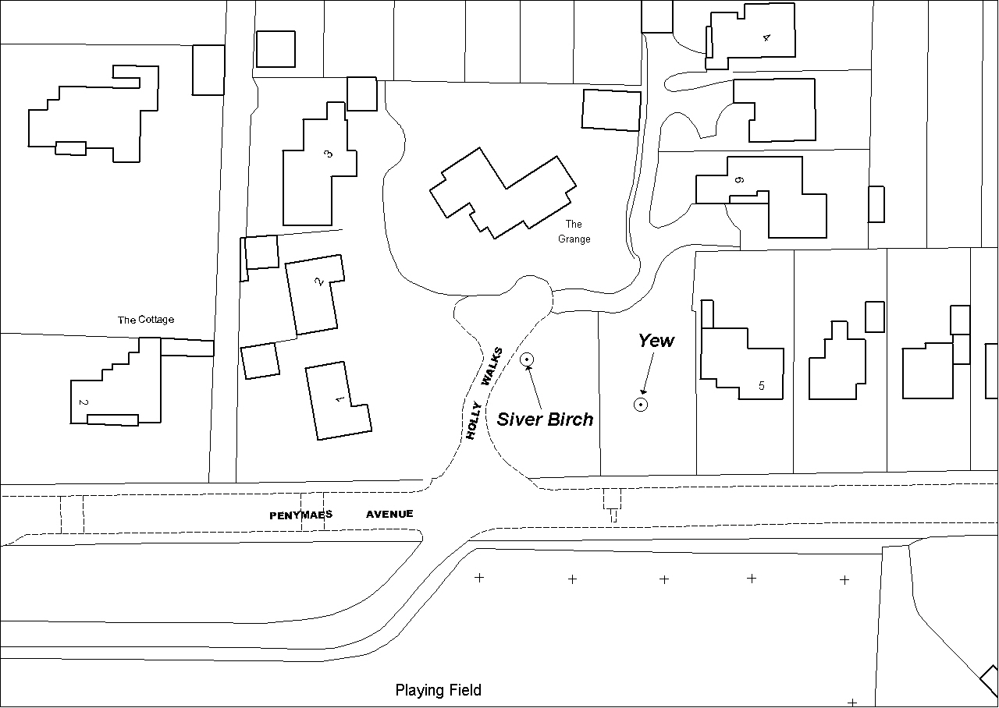The site is a mature large garden surrounding the applicant’s property located in a residential cul-de-sac.

PROPOSAL

Removal of 1 yew, felling of 1 sycamore, pruning of 1 silver birch and trees overhanging road. The applicant states that the works have been suggested by a tree surgeon and that the yew will be replaced with a Red Maple.

HISTORY

P/2007/1185 Erection of a dwelling on the front garden area: Refused.
P/2008/0111 Various tree works, including felling: Granted. 7/4/08

DEVELOPMENT PLAN

Policy EC4: Hedgerows, Trees and Woodland.

CONSULTATIONS

Community Council: Notified 04/04/08.
Local Member: Notified 04/04/08.
Building Control: Notified 04/04/08.
Other representations: 7 adjacent properties notified on 08/04/08.

The consultation period runs until the 29th April. No written representations have been received so far. Late representations will be added as an addendum.

SPECIAL CONSIDERATIONS

The Yew tree proposed to be removed is very small and cannot be seen out-with the applicant’s garden, therefore its amenity value is very limited. The pruning of the Silver Birch tree has been quantified as raising the crown to 5 metres in height measured from ground level. The felling of the Sycamore has been previously granted under application P/2008/0111, therefore permission is not required. The applicant has withdrawn the pruning of trees adjacent to the road from the application, as works to abate a nuisance are exempt from control.

Conclusion: The proposed felling and pruning works would not be to the detriment of the amenity of the locality. The Yew tree is very small and it is proposed that a larger growing tree will replace it. The works to the birch tree will not be the detriment of its amenity value or its health and safety.

RECOMMENDATION

That the Chief Planning Officer is given delegated authority to grant permission, subject to the planning conditions below, upon expiry of the consultation period provided that no additional issues are raised.

CONDITION(S)

1. All tree works to be undertaken to the standards set out in British Standard 3998: Recommendations for Tree Work: 1989.
2. The tree works hereby approved shall be commenced within two years of consent being granted.
3. The works hereby consented shall consist only of those detailed in the application as amended by the applicant by e-mails dated 14 April 2008.
4. One replacement tree of a species and size and planting location to be agreed upon by the Local Planning Authority to be planted during the next available planting season.

REASON(S)

1. To preserve the health and safety and amenity value of the trees to be worked on.
2. To ensure that compliance with Section 91 (3) of the Town & Country Planning Act.
3. To ensure works are undertaken in accordance with good working practice, are not detrimental to the health or the structural integrity of the protected tree and to preserve its amenity value.
4. To ensure the amenity of the local area is preserved.
_____________________________________________________________________

LIST OF DELEGATED DECISIONS ISSUED

LLA P/2007/0940  GRANTED  on 27/03/2008 | Llay Hall Farm Llay Road Llay Wrexham LL12 0TH | Listed building consent for conversion of agricultural barns to nine dwellings.
ESC P/2007/1339  REFUSED  on 04/04/2008 | Co-op Shop 50 Wrexham Road Rhostyllen Wrexham LL14 4DH | Extensions and alterations to existing local convenience store
MAE P/2007/1408  WITHDRAWN  on 10/04/2008 | LAND AT ELLESMERE LANE PENLEY WREXHAM LL13 0LP | OUTLINE APPLICATION FOR RESIDENTIAL DEVELOPMENT (3 NO. DWELLINGS)
LGC P/2008/0063  REFUSED  on 11/04/2008 | CAM HELYG ISAF LLANARMON ROAD PANDY LLANGOLLEN LL20 7PB | CHANGE OF USE OF EXISTING OUTBUILDINGS INTO INDIVIDUAL PRIVATE DWELLINGS.
BRO P/2008/0076  GRANTED  on 09/04/2008 | 2 CROSS LANE PENTRE BROUGHTON WREXHAM LL11 6AR | DECKING AREA TO REAR OF PROPERTY (PARTLY IN RETROSPECT)
ESC P/2008/0097  GRANTED  on 26/03/2008 | LAND ADJACENT TO GREEN ACRES OFF SMITHY LANE PENTRE BYCHAN WREXHAM LL14 4EW | OUTLINE APPLICATION FOR ERECTION OF DWELLING AND GARAGE
BRY P/2008/0102  WITHDRAWN  on 10/04/2008 | BUILDING PLOT AT ARGOED BRYMBO ROAD BWLCHGWYN WREXHAM LL11 5UB | ERECTION OF DETACHED DWELLING.
BRY P/2008/0120  GRANTED  on 31/03/2008 | LAND ADJACENT TO TY NEWYDD CEFN ROAD BWLCHGWYN WREXHAM LL11 5YE | ERECTION OF DETACHED DWELLING (AMENDMENTS TO PLANNING PERMISSION PREVIOUSLY GRANTED UNDER CODE NO. P/2003/0881)
ROS P/2008/0126  REFUSED  on 14/04/2008 | LOWER HONKLEY FARM STRINGERS LANE BURTON, ROSSETT WREXHAM LL12 0AP | LISTED BUILDING CONSENT FOR REFURBISHMENT OF FARMHOUSE
WRO P/2008/0136  GRANTED  on 28/03/2008 | ISLAND GREEN SHOPPING CENTRE WREXHAM LL13 7LW | ERECTION OF 2 X 6 SHEET FREE STANDING ADVERTISING DISPLAY BOARDS
WRR P/2008/0154  GRANTED  on 28/03/2008 | PRINCIPALITY BUILDING SOCIETY 20-22 REGENT STREET WREXHAM LL11 1SA | INSTALLATION OF AUTOMATED TELLER MACHINE
WRO P/2008/0161  GRANTED  on 10/04/2008 | CAMBRIAN VAULTS TOWN HILL WREXHAM LL13 8NA | EXTERNAL PLATFORM AND STEPS FROM PUB FLOOR TO FORM SMOKING AREA
LLR P/2008/0162  GRANTED  on 28/03/2008 | LLANERCH FARM YR OCHR FRONCYSYLLTE LLANGOLLEN LL20 7RS | CHANGE OF USE OF GARAGE AND WORKSHOP TO SEPARATE LIVING ANNEXE (GRANNY ANNEXE)
WOR P/2008/0165  GRANTED  on 04/04/2008 | WISTERIA COTTAGES WORTHENBURY WREXHAM LL13 0AW | TWO STOREY EXTENSION TO REAR AND ALTERATIONS TO ROOF
BRO P/2008/0170  GRANTED  on 08/04/2008 | BEREA CHURCH SOUTHSEA ROAD SOUTHSEA WREXHAM LL11 6PP | OUTLINE APPLICATION FOR DEMOLITION OF EXISTING BUILDING AND ERECTION OF PAIR OF SEMI DETACHED DWELLINGS.
HOL P/2008/0171  REFUSED  on 09/04/2008 | TAVA CASTLE STREET HOLT WREXHAM LL13 9YL | ERECTION OF SIGNS (IN RETROSPECT)
WRR P/2008/0172  GRANTED  on 02/04/2008 | 8 GARDD ESTYN GARDEN VILLAGE WREXHAM LL11 2SY | GROUND FLOOR REAR EXTENSION

ROS P/2008/0173  GRANTED  on 14/04/2008 | LAND TO THE REAR OF KINGSLEY HOUSE CHESTER ROAD LAVISTER WREXHAM LL12 0DN | MODIFICATIONS TO PREVIOUSLY APPROVED DETACHED DWELLING (TYPE C) PREVIOUSLY GRANTED UNDER PLANNING PERMISSION CODE NUMBER P/2007/1161.
BRO P/2008/0179  GRANTED  on 02/04/2008 | 3 WOODLAND ROAD MOSS WREXHAM LL11 6BD | ERECTION OF CONSERVATORY
RHO P/2008/0183  GRANTED  on 04/04/2008 | KRYSLYN OSBORNE STREET RHOSLLANERCHRUGOG WREXHAM LL14 2HT | FRONT PORCH EXTENSION.
BAN P/2008/0186  REFUSED  on 31/03/2008 | TURN OF DEE COTTAGE OVERTON ROAD BANGOR ON DEE WREXHAM LL13 0DA | TWO STOREY EXTENSION
ISY P/2008/0187  GRANTED  on 31/03/2008 | UNIT 6 BRIDGE ROAD WREXHAM INDUSTRIAL ESTATE WREXHAM LL13 9RE | ROOF ALTERATIONS
LLA P/2008/0191  GRANTED  on 15/04/2008 | 1 CAE PENTRE SINGRETT HILL GRESFORD WREXHAM LL128RL | SITING OF STATIC CARAVAN (IN RETROSPECT)
WRA P/2008/0193  GRANTED  on 15/04/2008 | 31 BIRKDALE ROAD WREXHAM LL13 9QR | EXTENSION TO DWELLING
ESC P/2008/0194  GRANTED  on 09/04/2008 | 16 WREXHAM ROAD RHOSTYLLEN WREXHAM LL14 4DH | SINGLE STOREY SIDE / REAR EXTENSION
CEF P/2008/0198  GRANTED  on 31/03/2008 | DEE VIEW HOUSE PARK ROAD NEWBRIDGE WREXHAM LL14 3YY | GROUND AND FIRST FLOOR EXTENSIONS
COE P/2008/0204  GRANTED  on 27/03/2008 | 22 PROSPECT DRIVE COEDPOETH WREXHAM LL11 3PE | ERECTION OF CONSERVATORY TO REAR OF DWELLING
LLA P/2008/0208  GRANTED  on 15/04/2008 | 5 FFORDD GRYFFYDD LLAY WREXHAM LL12 0RT | PORCH AND WC TO FRONT ELEVATION
WOR P/2008/0209  GRANTED  on 31/03/2008 | 4 THE ORCHARDS KINGSMILLS WREXHAM LL13 0NR | TWO STOREY EXTENSION TO REAR OF EXISTING DWELLING.
LLR P/2008/0211  GRANTED  on 09/04/2008 | BEE COTTAGE SCHOOL LANE FRONCYSYLLTE LLANGOLLEN LL20 7SU | TWO STOREY REAR EXTENSION
LGC P/2008/0212  GRANTED  on 14/04/2008 | THEO DAVIES & SONS BERWYN MILL GLYN CEIRIOG LLANGOLLEN LL20 7HF | ALTERATION TO TIMBER STORE.
HOL P/2008/0218  GRANTED  on 14/04/2008 | CROSS COTTAGE CASTLE STREET HOLT WREXHAM LL13 9YL | DEMOLITION OF EXISTING GLAZED LINK AND ERECTION OF NEW LINK
LLR P/2008/0219  GRANTED  on 09/04/2008 | HILLCREST YR OCHR FRONCYSYLLTE WREXHAM LL20 7RS | CONSTRUCTION OF NEW VEHICULAR ACCESS.
GRE P/2008/0220  GRANTED  on 01/04/2008 | THE ELMS LODGE VICARAGE LANE GRESFORD WREXHAM LL12 8UT | ERECTION OF GARDEN ROOM AND MINOR ALTERATION WORKS.
COE P/2008/0222  GRANTED  on 07/04/2008 | 21 BRYN Y WERN COEDPOETH WREXHAM LL11 3SL | SINGLE STOREY BEDROOM/SHOWER EXTENSION TO REAR OF PROPERTY.
ISY P/2008/0223  WITHDRAWN  on 10/04/2008 | LIGHT OAK HOUSE BOWLING BANK WREXHAM LL13 9RY | REFURBISHMENT, EXTENSION AND MINOR ALTERATION TO VEHICULAR ACCESS.

LGC P/2008/0224  GRANTED  on 09/04/2008 | ISFRONYDD QUARRY ROAD GLYN CEIRIOG LLANGOLLEN LL20 7DA | ERECTION OF CONSERVATORY.
WRC P/2008/0228  GRANTED  on 08/04/2008 | FARM FOODS KINGSMILLS ROAD HIGHTOWN WREXHAM LL13 8NN | 2 NO FLEXIBLE SKIN BOX SIGNS, 1 NO ALUMINIUM GOODS IN SIGN, WINDOW VINYL LOGOS
ROS P/2008/0230  REFUSED  on 11/04/2008 | LAND AT DARLAND LANE ROSSETT WREXHAM LL12 0BA | ERECTION OF 2 NO DWELLINGS AND CONSTRUCTION OF NEW VEHICULAR AND PEDESTRIAN ACCESS
RHO P/2008/0233  GRANTED  on 15/04/2008 | 2 BRYN HYFRYD JOHNSTOWN WREXHAM LL14 1PR | REPLACEMENT GARAGE FLAT ROOF WITH PITCHED ROOF.
PEN P/2008/0234  GRANTED  on 09/04/2008 | GLANRAFON BRIDGE STREET PENYCAE WREXHAM LL14 2RH | ERECTION OF CONSERVATORY
GWE P/2008/0235  GRANTED  on 08/04/2008 | ADJACENT TO DHL DEPOT RHOSDDU INDUSTRIAL ESTATE RHOSROBIN WREXHAM LL11 4YL | ERECTION OF 8M CCTV COLUMN
GWE P/2008/0236  GRANTED  on 08/04/2008 | ADJACENT TO MOUNTAIN VIEW WORKSHOPS RHOSDDU INDUSTRIAL ESTATE RHOSROBIN WREXHAM LL11 4YL | INSTALLATION OF 5M CCTV COLUMN
CEF P/2008/0240  GRANTED  on 15/04/2008 | 27 TREFYNANT PARK ACREFAIR WREXHAM LL14 3SR | SINGLE STOREY EXTENSION TO REAR OF PROPERTY (IN RETROSPECT)
RHO P/2008/0245  GRANTED  on 14/04/2008 | 12 MAES GLAN RHOSLLANERCHRUGOG WREXHAM LL14 2DT | GROUND FLOOR REAR EXTENSION
WRR P/2008/0250  GRANTED  on 14/04/2008 | 8 ACTON GATE WREXHAM LL11 2PN | TWO STOREY REAR EXTENSION TO FORM BEDROOM AND DINING ROOM
GRE P/2008/0260  GRANTED  on 14/04/2008 | 1 LAKE VILLAS HIGH STREET GRESFORD WREXHAM LL12 8PY | PART TWO AND PART SINGLE STOREY EXTENSION TO DWELLING
BRN P/2008/0279  GRANTED  on 14/04/2008 | HIGHER BARNS LOWER WYCH MALPAS CHESHIRE SY13 7LA | EXTENSION, ALTERATIONS AND IMPROVEMENTS
WRO P/2008/0292  GRANTED  on 16/04/2008 | 63 PERCY ROAD WREXHAM LL13 7EB | NEW PORCH AND SINGLE STOREY EXTENSION

