Community | Code No | Applicant | Recommendation | Page Nos
CHI | P/ 2007/1423 | MONTEC HOMES | GRANT | 4-19
GRE | P/ 2008/0124 | NUNNDALE LTD | GRANT | 20-27
BRY | P/ 2008/0184 | BRYMBO DEVELOPMENTS LTD | GRANT | 28-34
CEF | P/ 2008/0238 | MR BRIAN DAVIES | REFUSE | 35-39
CHI | P/ 2008/0239 | BYRONS (HOLDINGS) LTD | GRANT | 40-49
GRE | P/ 2008/0316 | MR M PRICE | GRANT | 50-56
RHO | P/ 2008/0346 | MORGAN ELECTRO CERAMICS | GRANT | 57-60
LLA | P/ 2008/0357 | MR & MRS HUMPHREYS | GRANT | 61-65
LLA | P/ 2008/0358 | MR & MRS HUMPHREYS | GRANT | 66-68
WRC | P/ 2008/0414 | MESSRS RIGBY & GOODE LTD | GRANT | 69-73
GWE | P/ 2008/0416 | MR M COATES | GRANT | 74-77
WRA | P/ 2008/0418 | MR & MRS ADRIAN EDWARDS | GRANT | 78-82
MAR | P/ 2008/0422 | MR W L PRICE | GRANT | 83-85
GRE | P/ 2008/0427 | MR & MRS J A SLOAN | GRANT | 86-88
ESC | P/ 2008/0429 | MR D WILLIAMS | REFUSE | 89-90
WRA | P/ 2008/0432 | MR P C HUGHES | GRANT | 91-94
WRR | P/ 2008/0438 | MR J SIMON | GRANT | 95-99
MAE | P/ 2008/0458 | MRS J HALL | GRANT | 100-104
WRA | P/ 2008/0461 | MR K JONES | GRANT | 105-109
HOL | P/ 2008/0462 | MR P YATES | GRANT | 110-112
BRY | P/ 2008/0466 | MR & MRS D T JONES | GRANT | 113-117
BRY | P/ 2008/0472 | M S BENNETT | GRANT | 118-122
LLA | P/ 2008/0482 | MR B HUYUK | REFUSE/  GRANT | 123-125
RUA | P/ 2008/0483 | USED TYRE DISTALLATION RESEARCH LTD | GRANT | 126-131
ESC | P/ 2008/0497 | CHARLES OWEN COMPANY LTD | GRANT | 132-136
WRA | P/ 2008/0502 | MR & MRS B HUGHES | GRANT/  REFUSE | 137-140
WRO | P/ 2008/0508 | MR ROBERT DICKENSON | GRANT | 141-143
BRO | P/ 2008/0519 | MR L HARPER | GRANT | 144-147
ISY | P/ 2008/0526 | MR & MRS JE MORRIS | REFUSE | 148-150
WRR | P/ 2008/0534 | DONE BOOKMAKERS | GRANT | 151-154
LLR | P/ 2008/0537 | MR P LIGHTFOOT & DR R WILLIAMS | GRANT | 155-158
GRE | P/ 2008/0550 | ROBIN JAMES THOMAS | GRANT | 159-161
HOL | P/ 2008/0557 | TARMAC LIMITED | GRANT | 162-179
ISY | P/ 2008/0558 | MR & MRS LIGHTWOOD | REFUSE | 180-183
WRR | P/ 2008/0559 | HOLLINS MURRAY GROUP | GRANT | 184-187

ROS | P/ 2008/0571 | MR & MRS S NUTKINS | GRANT | 188-191
LLR | P/ 2008/0574 | MRS J PACKENHAM-WALSH | GRANT | 192-196
RHO | P/ 2008/0576 | TRINITY ENTERPRISES | GRANT | 197-201
WRR | P/ 2008/0586 | ERIC ROBERTS (BUILDERS) LTD | GRANT | 202-206
BRO | P/ 2008/0593 | MR G EDWARDS | REFUSE | 207-209

Total Number of Applications Included in Report = 40

All plans included in this report are re-produced from Ordnance Survey Mapping with the permission of the Controller of Her Majesty’s Stationery Office. © Crown Copyright. Unauthorised reproduction infringes Crown Copyright and may lead to prosecution or civil proceedings.
WCBC Licence No. LA0902IL

All plans are intended to be illustrative only and should be used only to identify the location of the proposal and the surrounding features. The scale of the plans will vary. Full details may be viewed on the case files.

APPLICATION NO:  P/2007 /1423  COMMUNITY:  Chirk  WARD:  Chirk South | LOCATION:  FORMER PLAS Y WAUN INN CHAPEL LANE CHIRK WREXHAM  DESCRIPTION:  ERECTION OF 12 NO. DWELLINGS AND 6 NO. APARTMENTS.  APPLICANT(S) NAME:  MONTEC HOMES | DATE RECEIVED:  11/12/2007  CASE OFFICER:  JGK  AGENT NAME:  FITZSIMON PLANNING & DEVELOPMENT LTD
_____________________________________________________________________
This application was the subject of a Committee site visit on 13 June. The following additional information/ amendments have been provided to address Members’ concerns. My original report is included after this update.

The principal concerns of Members following the site visit were as follows:
- Impact from the apartment block upon the significant Beech tree located on adjacent land
- Implementation of a 2m pavement across the frontage to the development without detriment to the two existing TPO trees

I have discussed both issues at length with the applicant’s agent and the Council’s Tree Officer and comment as follows:

Relocation of apartment block: I have received an amended site plan detailing the relocation of the apartment block a further 2m back into the site from the frontage and the two TPO trees and also 2m further away from the Beech tree on the adjacent land to the west. The crown of the Beech tree extends 3.2 m over the fence line, which brings it to within 0.8 m from the gable wall of the side elevation of the apartment block. There are no windows to habitable rooms in this elevation. I consider that this relocation will now result in no adverse impact upon the Beech tree and the Tree Officer has indicated that limited pruning if necessitated in the future would not be an issue. Nevertheless, I have asked for confirmation relating to the tree’s Root Protection Area, which will enable me to consider the matter further. Advice from the Council’s Tree Officer is that, if required, additional protection can be achieved by imposing a condition securing specialised ground protection measures as part of the arboricultural method statement (condition attached and Note to Applicant added).

Pavement provision: I have looked carefully at the issue of widening the pavement. The pavement to the eastern frontage can be widened to 2m. However, the existing pavement to the western frontage is impacted by the immediate location of the two protected sycamore trees. It currently measures from between 0.9m to 1.0m and has an existing dwarf stone wall along the frontage to the site. To achieve any pavement widening at this location will require work in relocating the existing wall and lowering of existing ground levels. This will result in all roots within the footprint of the proposed widened section of the pavement being severed leading to the trees declining in health and likely subsequent loss. In the meantime, root loss so close to their trunks could affect their structural stability and be a danger to the local community, particularly in an area which includes a route to school. The potential loss of these trees resulting from works to widen the pavement would be contrary to UDP policy EC4 UDP. I consider on balance that the pavement to the western frontage should not be widened and should remain as existing.

In my original report, the recommendation required the provision and implementation of traffic calming along Chapel Lane. Highways are currently working on a scheme of traffic calming which will be designed and implemented this year. A further contribution of £15,000 from the developer would allow that scheme to be extended across the frontage of this site. I have asked Highways to look at possible widening of the section of pavement as part of the scheme. The s106 Agreement can deal with this.

Conclusion: The recently submitted amendments now safeguard the beech tree. A 2m footway across the eastern site frontage can be achieved. Whilst it is not desirable to do so along the western section because of the impact upon the two protected trees, it may be possible to provide some widening as part of the traffic calming scheme and every effort should be made to achieve that.. On that basis I believe the scheme is now acceptable.

Original report to March Committee

THE SITE
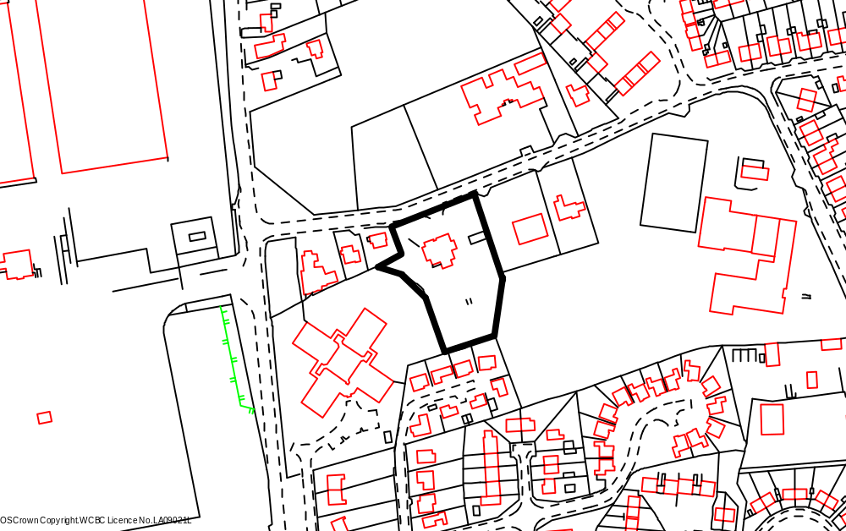

Chapel Lane
Schools

Holyhead Rd

Application site

Playing field
Maes yr Ysgol

PROPOSAL

As above.

RELEVANT HISTORY

P/2004/0085 Outline application for residential development and alteration to existing vehicular and pedestrian access. Granted 05.04.04.
P/2004/1382 Erection of 16 no three storey dwellings and associated works. Withdrawn 09.11.04.
P/2007/0691 Variation of condition no. 2 of planning permission code no. CHI/P/2004/0085 to extend the period for submission of reserved matters for 12 months to 30 June 2008. Granted 16.07.07.

DEVELOPMENT PLAN

Within settlement limit UDP Policies PS1, PS2, PS4, GDP1, EC4, H2, CLF5 and T8. Local Planning Guidance Notes 7 – Landscape and Development, 10 – Public Open Space in New Housing Development, 15 – Cycling, 16 – Parking Standards, 17 - Trees and Development, 21 – Space around Dwellings and 22 – Sustainable Building.

CONSULTATIONS

Community Council: Detailed concerns as follows:
- Development will add to the hazardous conditions, which already exist on Chapel lane especially at school (Chirk Infants) opening and closing times due to parking of vehicles.
- Parking bay should be provided at school entrance by developer.
- Works, including the movement of HGVs, equipment, use of machinery and other traffic flow should be carefully controlled to not impinge upon safety/sensitivity/privacy of neighbours/nursing home/infant school.
- Site boundaries to be properly secured.
- S106 agreement to be secured for payment in lieu of open space provision for improvements to recreational area opposite development.
- Welsh water to provide evidence that public sewerage system is adequate to cope with additional development and not overload the system in the locality.
Local Member: Not happy about the design of this site. The block of flats is out of character with the area next to a three hundred year old cottage. Will be asking for a site at Committee. Asks that the two trees between the cottage and Maes yr Ysgol be put forward for TPOs as they are of excellent quality in the summer bloom .
Adj Local Member: Notified 13.12.07.
Highways: Adequate parking provide. Recommends that any permission to include conditions re. traffic calming, adequate visibility, turning and parking on site and provision of a detailed layout for design, drainage and construction of internal estate road. Add Notes to Applicant.
Property Services: Notified 13.12.07.
Education: There is spare capacity at the primary school. Secondary school is full. Financial contribution required.
Public Protection: Add condition requesting submission of Noise Impact
Assessment Report to also include a noise mitigation scheme.
Environment Agency: Standard ‘Guidance Note for Developers’.
Welsh Water: Add conditions to protect integrity of public sewerage system.
Site Notice: Expired 12.01.08.
Press Notice: Expired 18.01.08.
Adjoining Occupiers: Objections received as follows:
- Too many dwellings for site.
- Impact upon privacy of adjoining properties - rear portion of site already raised and therefore, houses 9,10, 11 and 12 would significantly overlook gardens of 3,5 and 7 Maes yr Ysgol. These proposed properties should be built at the lower level of those adjacent to the entrance from Chapel lane.
- Queries from adjacent landowner regarding boundary issues – location of ditch, tree line and metal fence; boundary treatment and possible damage to existing fence.
- Chapel Lane is already hazardous with school and chapel traffic and associated parking.
- Inadequate drainage – previous problems.
Letter received from the Governing Body of Ceiriog Junior School asking that the boundary to the school property be a solid wooden fence with concrete posts with no access the school premises.

Agent/Applicant’s comments on objections
- The applicant has agreed previously to introduce traffic calming measures along Chapel lane, to the requirements of the Highway Authority which will over come any issues raised; discussions have already taken place with highways about this matter.
- Contractors are bound by law to comply with statutory Health & Safety requirements. I can confirm that full site security fencing will be erected for the duration of the scheme. If required our client is more than willing to arrange for all site deliveries outside the busiest school times. Delivery time/times could be introduced as a planning condition. (Appropriate condition attached).
- The client is well aware that a section 106 agreement is required for payment in lieu of an open space prevision. We are awaiting confirmation of the sum from the local Authority.
- As discussed yesterday we are prepared to reduce the existing ground levels at the rear of the site to the level of 338.00m this brings the level of the rear in line with these adjacent to Chapel Lane. This will overcome the over looking issues with existing properties. (Amended plans submitted demonstrating that the levels will be lowered).
- Drainage - if required during further consultation with Welsh Water, full on site attenuation will be designed as per the requirements of any drainage scheme. This will be carried out to the requirements of Welsh Water and a planning condition could be introduced to this effect. (Appropriate condition attached).
- Apartment Block - the apartment block has been discussed on several occasions and finally agreed with the local planning authority. This building is designed to give the impression of terrace properties. Utilising the same materials and details as the rest of the site.

SPECIAL CONSIDERATIONS/ ISSUES

Background: This is full planning application for residential use. An outline planning permission for residential development was granted in 2004. Since then the applicant has undertaken numerous pre-application discussions with the planning department on a number of varied proposals. The site, accessed off Chapel Lane, originally accommodated the Plas Y Waun Inn, car park and associated gardens. The public house has since been demolished. A variety of house types and materials are in evidence in the local area. A play area comprising informal and equipped play space is located directly opposite the site.

Proposal: Following comments and the identification of a number of constraints by the planning and highway departments the current scheme was submitted in December 2007 for the erection 12 dwellings and a single block of 6 apartments. Following further discussions with the applicant/agent, amendments have been submitted addressing a number of issues and resulted in the number of dwellings being reduced to 11.

Apartments – the apartment block is purposely located at the entrance to the site, set behind the existing low stone wall (to be restored) and a large communal space. It has attractive front and rear elevations, well designed as a terrace of small cottage-like properties with interesting features, including stone detailing and a central gable (see Plan 2 below). It will give the entrance to the site some presence and focus. It does not impact upon the three TPO trees to the frontage of the site. Another area of communal space is located to the rear of the block adjacent to the car parking area – two parking spaces per property. The communal areas will be maintained by management agreement.

Houses – there are 4 different house types. A detached property is located at the entrance to the site again set back from the existing stone wall and adding interest to the street scene. There are six plots with semidetached properties with roof dormers to the front elevations and rooflights to the rear to ensure acceptable separation distances. As with the apartment block, the dwellings will be similar in design with stone detailing, decorative chimneys and storm porches. Plots 4, 5 and 6 are designed in a row of mews houses, again of traditional design with pitched roof broken up by two symmetrical gables to add architectural interest. Plot 11 is a detached property with similar features as described above and now does not impact upon the mature beech tree located nearby.
Each property has at least 2 off-street parking spaces and a landscaped open plan front garden.

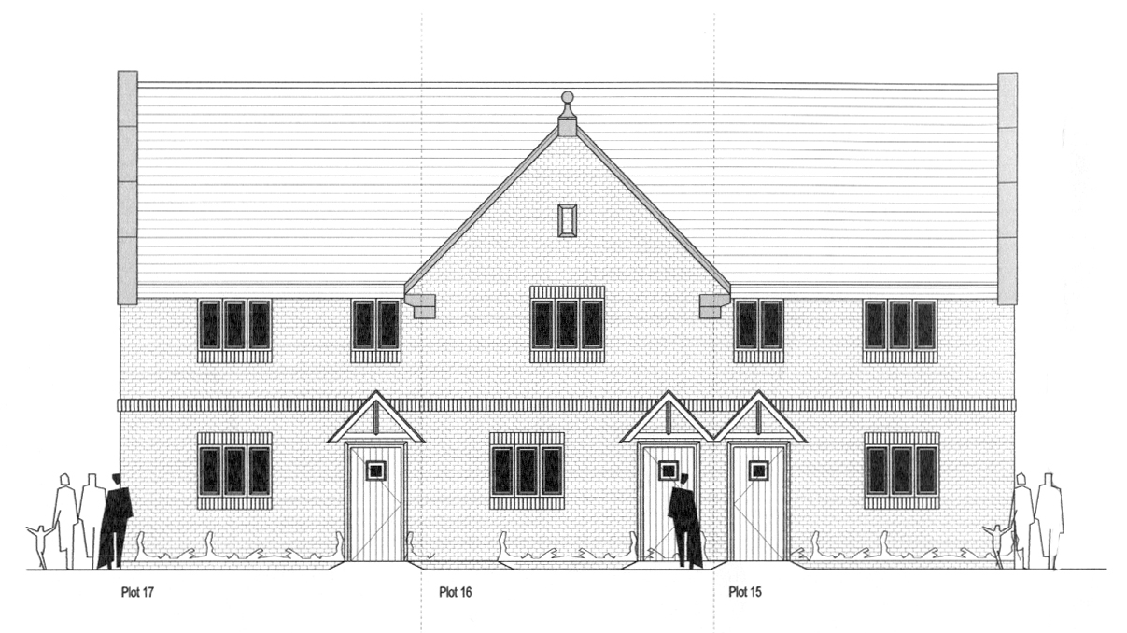
Front elevation to apartment block as seen from Chapel Lane

Policy: There are no policy objections in principle to the proposal as the site is within the settlement limits of Chirk (UDP Policy PS1 refers). However, UDP Policies PS2 and GDP1 together with Local Planning Guidance Notes 7 – Landscape and Development, 10 – Public Open Space in New Housing Development, 16 – Parking Standard, 21 – Space around Dwellings, 22 – Sustainable Building and 27 – Developer Contribution to Schools list criteria for consideration when processing detailed applications for housing development and I comment on these as follows:

Highways: The development has access on to an unclassified road subject to a 30-mph speed limit and highway advice considers that traffic can easily travel up to this limit. Highway advice at the time of considering the outline planning application took account of the history of the site – a public house for approximately 30 years – resulting in no objection to the proposal on highway grounds subject to certain conditions, particularly the implementation of a scheme for traffic calming. There are two schools in close proximity to the site and a traffic calming scheme is considered essential to enhance highway and pedestrian safety; it will also enable adequate visibility splays to be provided at the access that will be in accord with the recommendations of Manual for Streets. The applicant/agent has submitted amended plans demonstrating the proposal has adequate parking provision and highway design/layout. In order to minimise the conflict of delivery/construction traffic with the busiest school times I have attached a condition to ensure the delivery of materials and accessing of the site by heavy construction vehicles is outside of these busy school times.
Conditions are attached to ensure:

- Access has adequate visibility
- Submission and approval of a detailed scheme for the layout, design and construction of the internal estate road
- Provision of adequate on site parking and turning
- Submission and approval of a scheme of traffic calming on Chapel Lane
- Provision of a means of enclosure not exceeding 1m in height
- Delivery of materials and accessing of the site by heavy construction vehicles is outside of busy school times
Provision of tactile paving to the footway either side of the access from Chapel lane will be constructed to the further approval of the council as highway authority under s38 of the Highways Act.

Landscape: There are mature trees (two on the frontage to the site are covered by TPO – see Tree comments below) and hedges to the southern, eastern and western boundaries. Lengthy pre-application discussions have taken place how best to deal with the existing trees, overgrown beech hedging and proposed supplementary landscape treatment of the site. In support of this aspect of the proposal, the applicant/agent has submitted a Landscaping Scheme and Specification, Maintenance and management Plan. The proposed layout and landscape proposals for the site have been well considered, and would retain much of the existing landscape features of the site, which include mature trees along the site boundary, the overgrown beech hedge boundary and stone wall frontage. These features are of value in their contribution to local character, and in providing an instant and mature setting to the new housing development particularly in views from Chapel Lane. Some selective thinning and crown lifting work would be required to the boundary hedgerow, which due to lack of maintenance for many years now forms a line of tall thin trees, some in poor condition. This positive management, plus supplementary hedgerow planting and post and rail fencing, are proposed to retain a long term ‘green’ boundary to the site, rather than have a more visually dominant close board fence erected. The planting proposals for the site include tree and ornamental shrub planting to provide an attractive character to the site entrance and internal areas.

Trees: There are two large sycamores on the northern boundary adjacent to the existing entrance subject to TPO - WCBC No.90 and an extremely dominant beech on the western boundary to the rear of Yew Tree Cottage subject to TPO WCBC 22.
These trees will require important consideration in the acceptance of any proposed layout. The currently submitted information has inconsistencies in the crown spread of trees TPO'd T1 & T2 on the frontage of the site and are underestimated on drawing No. RAL/099-01 for both trees. Stem diameters are also not accurate - this is important as the Root Protection Area as per BS 5837:2005 is calculated from the stem diameter. Underestimating obviously gives a smaller Root Protection Area (RPA) than is required by the standard. Despite the assurances stated in the Method Statement, the RPA for tree T2 needs to be extended resulting in the apartment block needing to be moved further into the site. The very large TPO'd Beech tree outside the site to the south west of the apartment block may be detrimentally affected by this building, however no tree survey data is available for this tree, so its RPA cannot be worked out exactly. Beech trees do not take well to root disturbance and overmature trees less so as they do not have the vitality and vigour to cope with root severance and soil compaction.

Way forward - an acceptable solution to these problems is to pivot the apartment building so that it is more face onto the main road. This will result in more room for tree 2 and the large Beech adjacent to the site. This is shown on recently submitted amended proposed site plan Drawing No. JIG/0390/06. This is more acceptable than the previous footprint location and further discussions are ongoing with the agent to ensure that the solution is acceptable.

Tree Protection - the drawing that accompanied this Method Statement report showing Tree Protection fencing locations is inadequate. I have attached a condition to ensure that approved fencing, prior to the commencement of development protects all trees. This information will need to be plotted accurately on a scaled drawing. Details of protective fencing type are acceptable. This needs to be agreed before any works start on site and preferably before planning consent is issued. Existing hard standing comes very close to retained trees. As a portion of this is to be removed within the trees' Root Protection Areas, a subsequent revised Method Statement will be required prior to work commencing on site that shows how the tarmac will be removed without damage to the trees' roots and soil structure.

Although not ideal, the realignment of the building closest to the TPOd Sycamores and Beech tree will ensure a better chance of survival for these trees. Subject to attaining acceptable additional information for Protective fencing and revised Method Statement to include tree survey information on the TPO’d Beech tree and how hard surfaces will be removed within RPAs, the proposal is acceptable.

Amenity and Design: The application site is broadly flat and level with Chapel Lane with the exception of the mound to the rear of the site. This material to the rear will be removed off site and the levels reduced to that similar to Chapel Lane – a drop of approximately 2 metres (a note has been attached to the recently resubmitted proposed Site Plan). I have attached a condition to ensure that this reduction in levels takes place. I have also added a condition for the submission and approval of floor levels. The submitted ‘Planning, Access and Design Statement’ addresses the issues of separation distances with adjoining properties and how the proposed scheme has been designed accordingly. The apartment layout at first floor level is such that the windows on the side elevations relate to bathrooms to be obscurely glazed and fixed in order to prevent overlooking and loss of privacy for the occupiers of nearby dwellings (condition attached). The properties on the rear plots 8 to 11 (plots 9 and 10 are 2½ storey result in 24/25m separation distances with the existing properties on Maes yr Ysgol exceeding the 22m requirement asked for in LPG 21. Rooflights are proposed instead of dormers to the rear elevation. Rear boundary treatment will assist in protecting the amenity of adjoining occupiers. Each dwelling has private space in excess of the Council’s adopted standards. It is evident that much thought has gone into the house types and their detailing to ensure that they are characteristic of the wider local area. Materials will reflect the traditional nature of the house designs, ie. Slate roofs, sandstone and a soft brick/render

Impact upon Yew Tree Cottage - it is suggested that the scheme will adversely affect the nearby the cottage located to the west of the application site. Yew Tree Cottage is originally of stone built construction with later extensions to the rear and side elevations. To the front elevation the upper floor has been reconstructed in brick with painted mock timber framework. It is likely to have been altered when the dormer windows were installed. The cottage has a clay tile roof and painted finish. Windows are timber but neither these nor the window openings are to the original proportions. Although the original construction would appear to be of some age, due to later alterations, it is unlikely that the building would be listed.
This being the case the impact of the neighbouring development should be considered upon the impact of its design on the street scene rather than its impact upon any special character the cottage may possess. The proposed apartment block will have the most impact. However, it is set back from the road frontage so as not to over dominate or overshadow the existing cottage. The materials and detailing proposed are characteristic of the local area and the gabled bay to the frontage helps break up the overall massing of the structure.

Sustainable Development: A key objective of the Council is to significantly increase the overall sustainability of development proposals. The applicant/agent has submitted a Sustainable Design Statement. It seeks to ensure that the proposal satisfies the six key sustainable planning principles outlined in Local Planning Guidance Note 22 – Sustainable Buildings, namely: location and layout; building design; supplying and using energy and water; waste management; transport and access; promoting wildlife and building in local distinctiveness.

Whilst there exists some positive sustainable building elements within the scheme, a notable gap exists in terms of maximising the potential for renewable energy and reducing water use. UDP Policy PS12 ‘Renewable Energy’, together with GDP1 c) supports the principle of renewable energy, provided no overall detrimental impacts are involved. I have added a condition asking for the submission and approval of detailed feasibility schemes for energy saving and reducing water use that will maximise the full potential for the site.

Education: Although there is spare capacity at the primary school, the secondary school is full. Therefore, in accord with L P G 27 – Developer Contributions to Schools, a contribution’ is required. The cost of such provision has been identified as £43,152 . The payment will be secured through a s106 agreement.

Public Open Space: In accord with Policy CLF5 and Local Planning Guidance Note 10 – Public Open Space in New Housing Development, a development of 18 dwellings would need to provide on site POS. In certain appropriate circumstances the Guidance Note also allows for a commuted payment in lieu, it states that ‘In suitable developments of less than 20 dwellings the local planning authority may agree that there is a adequate council owned play and amenity provision in close proximity to the proposed development, … in such circumstances the developer must enter into a legal agreement with the council to pay the commuted sum‘. There is a play area opposite the site and the applicant has proposed to provide a commuted payment to enable this play area to be upgraded, enhanced and maintained. The required payment of £9000 will be secured through a s106 agreement.

Drainage: Welsh Water has not identified any issues to do with foul and surface water drainage regarding redevelopment the application site. I have attached a condition seeking the submission and subsequent approval of full details of foul and surface water drainage.

Conclusion: I consider that the redevelopment proposal has carefully considered the Council’s development plan polices and guidance. I consider that the end result is a scheme that is well integrated with the existing village and has met WAG guidance in that the ‘ … design of housing should be to establish a sense of place and community, with the movement network used to enhance these qualities’ and that ‘ … the layout and built form should reflect local context, including topography and building fabric’ (Planning Policy Wales Technical Advice Note 12: Design refers).
I consider the proposed scheme is an improvement to the locality, will set well within the street scene and I am satisfied that there will be no loss in amenity or adverse impact upon local residents or the area in general.

AMENDED RECOMMENDATIONS:

RECOMMENDATION A

That the applicant enters into an obligation under Section 106 of the Town and Country Planning Act 1990, requiring:
- The establishment of a management company to ensure the future maintenance of all public open space, landscape features and areas of ecological importance.
- The payment of £43,152 as developer’s contribution to the shortfall in education facilities.
- The payment of £9,000 to contribute to improvements to the play area on the opposite side of chapel Lane opposite the application site.
- A payment of £15,000 as a contribution towards traffic calming along Chapel Lane.
That the Chief Planning Officer is given delegated authority to determine the final form and content of the obligation.

RECOMMENDATION B

That the application be approved on completion of the obligation subject to the following conditions:

CONDITION(S)

1. The development hereby permitted shall be begun before the expiry of five years from the date of this permission.
2. Prior to their use on the development samples of all external facing and roofing materials shall be submitted to and approved in writing by the Local Planning Authority. The development shall only be carried out in strict accordance with such details as are approved.
3. Development shall only be carried out in strict accordance with the approved plans unless the prior written approval of the Local Planning Authority has been obtained.
4. The vehicle parking for the apartment block shall be surfaced and marked out in full accordance with the approved drawings before the apartment block is occupied and thereafter shall not be used or permitted to be used for any purpose other than the parking of vehicles belonging to the residents of the apartment block.
5. The proposed access shall have a visibility splay of 2.4m x 33m in a south easterly direction to the centre line of the adjoining highway within which there shall be no obstruction in access of 1m in height.
6. No dwellng shall be occupied until the scheme of traffic calming along Chapel Lane has been constructed and is in operation.
7. The detailed layout, design, drainage and construction of the internal estate road shall be submitted to and approved by the Local Planning Authority prior to commencement of any site works. This layout is to include details demonstrating that no water of any kind shall flow from private driveways on to the highway or into the highway drainage system.
8. Parking facility shall be provided and retained at the proposed dwellings in accordance with the approved plan (Drawing No JIG/0390/06 rev C) and shall be completed prior to the proposed development being brought into use.
9. No part of the development shall be commenced until a noise survey has been undertaken to determine noise levels for both day and night having regard to Planning Policy Guidance (Wales) Technical Advice Note 11 - Noise. The detailed report to be submitted and approved by the Local Planning Authority shall include:
a. noise levels arising from day/night activities arising from the nearby industrial use to the proposed development and Holyhead Road and the impact on the proposed accommodation.
b. a detailed scheme on noise insulation and/or attenuation measures so designed to safeguard the amenity of the future occupants of the proposed accommodation hereby approved.
All data shall be representative of typical conditions for both day (0700 - 2300 hours) and night (2300 - 0700 hours). The report shall be submitted to and approved in writing by the local Planning authority. Any mitigation measures required shall be implemented in accordance with timescales to be agreed as part of the measures before development is commenced.
10. Before beginning work, the contractor shall contact the Chief Planning Officer giving him seven days notice of a meeting on site to review all work procedures, access routes, storage areas and tree protection measures. Development shall be carried out in strict accordance with the agreed measures.
11. No development or other operations shall commence on the site until adequate steps, which shall have been previously agreed with the Local Planning Authority, have been taken to safeguard against damage or injury during construction works, all trees on the site or whose root structure may extend within the site, which are subject of Tree T1 and T2 (WCBC 90 Preservation Order 2002) and WCBC 22 Preservation Order 1998 & TPO 128 .2008. In particular, no excavations, site works, trenches or channels shall be cut or pipes or services laid in such a way to cause damage or injury to the trees by interference with their root structure and no soil or waste shall be deposited on the land in such a position as to be likely to cause damage or injury to the trees by affecting their root structure.
12. No development shall take place until an arboricultural method statement has been submitted to and approved in writing by the Local Planning Authority. The statement shall include a specification for protective fencing that complies with BS5837 : a plan showing the position of the protective fencing; ground protection measures where development works encroach onto the RPA of retained trees a full specification for the construction of any access, driveway or path under the crown spread of the trees, and related sections, details of general arboricultural matters including proposed practices with regard to cement mixing, material storage and fires; and details of the frequency of supervisory visits and procedures for notifying the finding of such visits to the Local Planning Authority. Works shall be carried out strictly in accordance with that approved method statement.
13. The existing trees, shrubs and hedges indicated on Drawing No RAL.099.01 Issue 3 to be retained shall not be cut down, grubbed out, lopped or uprooted without the previous written permission of the Local Planning Authority. Any pruning of trees approved shall be carried out in accordance with the current British Standard 3998 and subsequent revisions (Tree Work). Any tree, shrubs or hedges removed without such permission, or being severely damaged or diseased within three years of the date of occupation of the development for its permitted use shall be replaced with trees, shrubs and hedging plants of such a size and species as may be agreed with the Local Planning Authority.
14. The erection of fencing for the protection of trees and shrubs shall be undertaken before any equipment, machinery or materials are brought onto the site for the purposes of the development, and shall be maintained until all equipment, machinery and surplus materials have been removed from the site. The above mentioned fencing shall consist of a scaffold framework in accordance with Figure 2 of BS 5837 (2005) comprising a vertical and horizontal framework, well braced to resist impacts, with vertical tubes spaced at a maximum interval of 3 metres. Onto this, 2.1m weldmesh panels shall be securely fixed with wire or scaffold clamps. This fencing shall be erected at the full extent of the canopy of each tree and shrub. Nothing shall be stored or placed in any area fenced in accordance with this condition and the ground levels within those areas shall not be altered, nor shall any excavations be made without the written permission of the Local Planning Authority.
15. Additional tree pruning required for clearance during construction must be performed by a qualified arboriculturist and not by construction personnel.
16. The implementation and management of the soft landscape works shall be carried out in accordance with the approved details as set out on drawing(s) No(s) RAL.099.0 Issue 3 and the landscape specification, maintenance and management plan. The works shall be carried out prior to the occupation of any part of the development.
17. No part of the development hereby permitted shall be commenced until full details of road, paving and footpath surfaces have been submitted to and approved in writing by the Local Planning Authority. The works shall completed in all respects within three months of the first use of any building.
18. Any trees or shrubs removed, dying, being severely damaged or becoming seriously diseased within five years from the completion of the scheme shall be replaced by trees or shrubs of similar size and species to those originally required to be planted unless otherwise approved in writing by the Local Planning Authority. No part of the approved planting scheme, shall be removed after the expiration of 5 years, without written approval from the Local Planning Authority.
19. Foul water and surface water discharges must be drained separately from the site.
20. No surface water shall be allowed to connect (either directly or indirectly) to the public sewerage system.
21. No land drainage run-off will be permitted, either directly or indirectly, to discharge into the public sewerage system.
22. No part of the development shall be commenced until a dust management scheme has been submitted and approved in writing by the local planning authority. The approved measures of dust management shall be implemented throughout the development of the site
23. Prior to the commencement of development, the following details shall be submitted for further written approval of the Local Planning Authority:
i) A detailed feasibility scheme for energy saving has been submitted to and approved by the Local Planning Authority. The works shall be implemented in accordance with a timescale a timescale to be approved in conjunction with the scheme of details;
ii) A detailed feasibility scheme for reducing water use has been submitted to and approved by the Local Planning Authority. The works shall be implemented in accordance with a timescale a timescale to be approved in conjunction with the scheme of details;
iii) Details to show that all materials will, wherever possible, be sustainably sourced from suppliers who operate a recognised Environmental Management System;
iv) Waste recycling scheme;
v) A sample welcome pack which will be provided for future occupiers.
The details as subsequently approved shall be fully implemented as part of the development or in accordance with timescales to be agreed, in writing, with the local planning authority.
24. This permission shall operate only to allow development to be carried out in accordance with the approved drawings and the application documentation. Notwithstanding the provisions of the Town and Country Planning (General Permitted Development) Order 1995, no further development shall take place within the site (other than the painting of the buildings).
25. Deliveries of materials and arrival and departure of other construction traffic shall be limited to 0930 to 1500 hours and 1630 to 1930 hours Monday to Friday and 0800 to 1400 hours on Saturdays.
26. Construction works, ancillary works and the use of plant or machinery audible at or beyond the site boundary shall only be carried out between the hours of 07:30 and 19:30 (Monday to Friday) and 08:00 to 14:00 (Saturday) and at no time on Sundays or Bank Holidays.

REASON(S)

1. To comply with Section 92 of the Town and Country Planning Act, 1990.
2. To ensure a satisfactory standard of appearance of the development in the interests of the visual amenities of the area.
3. To ensure that the development fully complies with the appropriate policies and standards.
4. To ensure that adequate parking facilities are provided and maintained for use by the residents of the approved apartment.
5. To ensure that adequate visibility is provided at the proposed point of access to the highway.
6. In the interests of highway safety.
7. In the interests of highway safety.
8. To ensure that the estate road system is constructed to a standard suitable for adoption.
9. To protect the amenities of the future occupiers of proposed development.
10. To ensure that the works on the site properly take account of the future health of the trees.
11. To protect trees which are of significant amenity value to the area.
12. To ensure the amenity afforded by the trees is continued into the future.
13. To ensure the amenity afforded by the trees is continued into the future.
14. To protect trees which are of significant amenity value to the area.
15. To ensure the work is carried out to accepted arboricultural practices for the long term well being of the tree(s).
16. To ensure a satisfactory standard of appearance of the development in the interests of the visual amenities of the area.
18. To ensure a satisfactory standard of appearance of the development in the interests of the visual amenities of the area.
19. To protect the integrity of the public sewerage system.
20. To prevent hydraulic overloading of the public sewerage system, to protect the health and safety of existing residents and ensure no detriment to the environment.
21. To prevent hydraulic overload of the public sewerage system and pollution of the environment.
22. To minimise the potential to cause nuisance by way of dust due to the close proximity of residential properties.
23. To maximise potential for sustainable building.
24. Due to the restricted application site and its relationship with adjoining properties it is considered important to ensure that no additional development as described in the condition is carried out without the permission of the Local Planning Authority.
25. In the interests of pedestrian and highway safety during hours of busy school times.
26. To protect the amenities of the occupiers of nearby properties.

NOTE(S) TO APPLICANT

You are advised that the planning permission hereby granted does not authorise any building over, diversion, connection or other interference with any sewer, public or private, which crosses the site. You are advised to contact Welsh Water, PO Box 10, Treharris, CF46 6XZ (Tel: 01443 331155) in this regard, prior to undertaking any groundwork in connection with the development. Should you be required to depart from the details hereby approved, you should contact the Council's planning department to seek further advice with regard to the submission of amended plans and / or a new planning application.

Your attention is drawn to Highway Supplementary Notes Numbered 1, 3, 4 and 5 on the enclosed "Applicants' Rights and General Information".

You are advised that the revised submitted Aboricultural Method Statement (see condition 13 shall include:
· Tree survey and RPA information on the protected Beech tree located on the adjacent land to the west. This should also include ground protection measures for the above beech tree and position of protective fencing for RPA.
· How hard surfaces will be removed within any Root Protection Areas.
· Results of investigation of the RPA to the protected sycamore trees in relation to the potential implementation of a 2m wide section of pavement to the adjacent radius of the proposed access.

The scheme of traffic calmimg shall consider the possibility of widening the pavement along the western frontage (in addition to the eastern side) to the development site.

The proposed access and footway shall be constructed to a standard suitable for adoption by the Council for future maintenance at public expense and the developer will need to enter into an agreement with the Council under s38 of the Highways Act 1980. Parking shall be in accordance with Local Planning Guidance Note No 16 - Parking Standards.

The scheme of landscaping referred to in the above conditions shall inlcude any changes to ground levels (shown by existing and proposed contours/levels) and any existing vegetation (showing that to be retained) and proposed planting. In addition, any of the following which apply to the particular site must be included:-
means of enclosure, car parking layout, access and circulation areas, materials for hard surfaced areas, any minor structures (e.g. refuse stores, lamp columns, play equipment) location of services, and any historic landscape features to be retained/improved.

There shall be no fires on the site, to include the prohibition of the burning of cleared vegetation.

Any works (including temporary works) in, under, over or adjacent to any watercourse may require the formal consent of the Environment Agency prior to works commencing. In accordance with the Agency's "no-culverting" policy, Pconsent for culverting will only normally be granted for site access purposes.

Any works (including temporary works) in, under, over or adjacent to any watercourse may require the formal consent of the Environment Agency prior to works commencing. In accordance with the Agency's "no-culverting" policy, Pconsent for culverting will only normally be granted for site access purposes.

Any waste excavation material or building waste generated in the course of the development must be disposed of satisfactorily and in accordance with section 34 of the Environmental Protection Act 1990.

The activity of importing waste into the site for use as, for example hardcore, must be registered by the Environment Agency Wales as an exempt activity under the Waste Management Licencing Regulations 1994.

If evidence of storage/spillage of agro-chemicals are found in or around the farm buildings/outbuildings/area, then it would be prudent to investigate the potential for residual contamination. Should you require any advice on this issue please contact the Public Protection Department of the Council on 01978 2977041.

Please note that the developer will be responsible for the costs of designing, consulting, advertising and implementing the traffic calming scheme.

Any new roads serving more than five dwellings should be constructed to a standard suitable for adoption by the Council for future maintenance at the public expense and the developer will need to enter into an agreement with the Council under section 38 of the Highways Act 1980 so that the new road can be adopted for maintenance at the public expense.

The proposed widening of the footway on Chapel Lane should be constructed to a standard suitable for adoption by the Council for future maintenance at the public expense and the developer will need to enter into an agreement with the Council under section 38 of the Highways Act 1980.

The accessway ramp /tactile paving details are incorrect and must be constructed to the further approval of the highway authority under s38 of the Highways Act.

Your attention is to be drawn to the following supplementary notes; 1, 3, 4, 5, 6, 7, 8 & 9.
_____________________________________________________________________

APPLICATION NO:  P/2008 /0124  COMMUNITY:  Gresford  WARD:  Gresford East & West | LOCATION:  CLAPPER LANE GARDENS CLAPPER LANE GRESFORD WREXHAM  DESCRIPTION:  DEMOLITION OF EXISTING BUNGALOW AND REPLACE WITH 2 NO. FOUR BEDROOM DWELLINGS AND ALTERATION TO VEHICULAR ACCESS  APPLICANT(S) NAME:  NUNNDALE LTD | DATE RECEIVED:  07/02/2008  CASE OFFICER:  SJG  AGENT NAME:  BLUE PRINT
_____________________________________________________________________

This application was deferred at Planning Committee on 4 April 2008 at the applicant’s request.

Revised/updated information:
A meeting was held with the applicant and agent on 14/4/2008, to discuss a possible amendment to meet highways requirements, and relocate the dwellings to the west (rear) requiring the felling of a protected tree. A detailed tree report and revised plans have now been received, showing the following:
- Dwellings moved back (west) on site by 6 metres
- Tree to be felled in centre of site
- Speed hump relocated to north
- Footway widened to 2 metres except under tree.

Revised Consultations were carried out on 19/5/2008.

Responses:

New Local Member: No observations
Gresford C. Council: No further comments received
Highways: No objections subject to the conditions in the
recommendation
Local Residents: 1 letter received re-stating previous objections
IMAGE remains convinced that these 4 bedroom dwellings give
a two storey aspect and would therefore not be in keeping with the bungalow properties in the area. they will not fit in with the streetscene. Also concerned that the septic tank would appear to be quite near to the Highway and question if WCBC has guidance on this aspect as it is believed other councils do.

(Revised/Additional Observations)
The revised details have enabled the proposal to be re-assessed in the light of the issues set out in the conclusions below.
The Arboricultural Officer has no objections in principle to development subject to suitable replacement planting. I consider that these issues have now been addressed, but I would stress that the objections from local residents and the Community Council, to both the principle of two-storey development and the detailed plans, remain. I do not accept that the construction of dwellings adjacent to bungalows in this particular location raises any objections in principle.
There is no policy in relation the location of the septic tanks adjacent to the highway from Building Control, Highways or Public Protection.

My previous report

THE SITE

The site is on the west side of Clapper Lane. The site has an area of 0.27 hectare and contains a bungalow at the southern end.
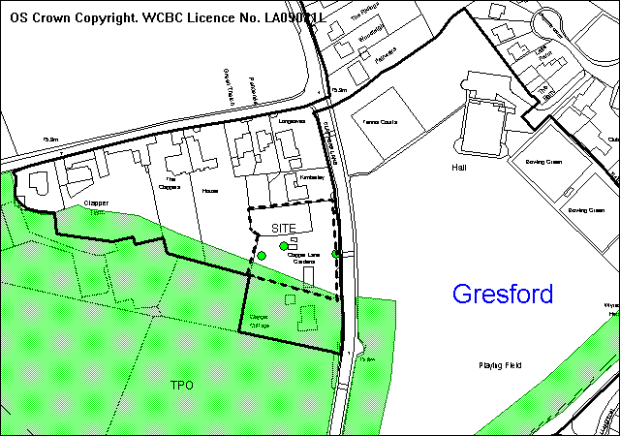
site
settlement
PROPOSAL

As above. The dwellings are four bedroom, two storey properties. The design includes a projecting two storey front gable containing an integral double garage with master bedroom above. Foul drainage is to septic tank. The access would be slightly south of the centre of the frontage, adjoining a speed hump.

RELEVANT HISTORY

7215 Dwelling Withdrawn 21/11/1980

DEVELOPMENT PLAN

Within settlement limit and affected by 2 tree preservation orders, including TPO WBC 109 preserving three trees on the site. Policies H2 EC4 and GDP1 of UDP are relevant, together with LPGN 7 and 21.

CONSULTATIONS

Gresford C Council: Very concerned that the proposed development will be out of keeping with the area. Any development should be single storey only.
Previous Local Member (Councillor A Bailey):Concerns over 2-storey development. Requests committee referral
Highways: Recommend refusal as the proposed access is of inadequate width, would conflict with the existing traffic calming humps and a 2 metre wide footway has not bee shown on the plans
If these issues can be overcome, recommend conditions for improvement of access. Accept that the footway can be reduced in width where it abuts the tree on the frontage
Public Protection: Comments regarding construction works and drainage
Env Agency: Standard advice applies
Welsh water: No comments
Site Notice: Expired 3/3/2008
Other representations: Adjoining occupiers notified 12/12/2008
6 letters of objection received, on grounds of:
- 2 storey dwellings would be out of character with the area
- Overlooking and over-dominance of adjoining dwellings
- Dwellings will be forward of the building line and too prominent
- Dangerous access to a busy road
- Question whether speed hump is to be moved
- Footpath is inadequate
- Additional surface water run-off may cause local flooding
- Parking restrictions should be brought in
- Concerned over impact on protected trees

SPECIAL CONSIDERATIONS/ ISSUES

Visual amenity and character: The dwellings along this side of Clapper Lane are bungalows or dormer bungalows, whereas along Pontycapel Lane and the eastern side of Clapper Lane the dwellings are mostly 2 storey. The design of the dwellings includes a single storey, hipped roof element on the outer sides of both dwellings, giving a substantial gap between the 2-storey element and the side boundaries (7 metres minimum). In my view this creates a design which is not inappropriate for the locality, although this is clearly a matter of judgement.

However, the projecting two storey front gable is an unattractive feature which will be very prominent in the street scene, particularly when viewing the site from the south or north. This is an unacceptable feature.

Residential amenity: In my opinion, the design and layout of the dwellings takes account of the amenity of adjoining dwellings and would comply with adopted LPG 21.

Trees: The two proposed buildings appear not impact upon the TPO trees on site. However a full arboricultural report is required to fully assess the impact of the access and the Highway requirements for a pavement.

Highway safety: Previous discussions included a requirement for a 2 metre footway across the frontage, but there were concerns over the impact of the works on the protected tree close to the proposed access and it may be appropriate to seek a compromise of a narrower pavement along all or part of the length. The location of the access would conflict with the traffic hump.

Drainage: The septic tank drainage system is a cause of concern in a developed area, but I understand that there is no sewer available in the area. This issue will need to be considered in detail under the Building Regulations.

Conclusion: Residential development of the site is acceptable in principle but this scheme would not satisfactorily integrate with its surroundings, would raise highway concerns, and finally the impact on the trees has not been resolved.

(Original) RECOMMENDATION That permission be REFUSED

REASON(S)

1. The development proposed would be unsatisfactory and undesirable having regard to the design and siting of the dwellings and their relationship with adjoining properties, in terms of the large, two-storey front gable projections. The development would result in an unacceptable degree of visual intrusion and would prove contrary to Policy GDP1a of the adopted Wrexham Unitary Development Plan.
- The proposal would be contrary to Policy EC4 of the adopted Wrexham Unitary Development Plan as the details are not sufficient to show that the development can be carried out without adversely affecting protected trees on the site, as required by adopted Local Planning Guidance Note 7 Trees and Development.
- The development does not provide for a safe vehicular and pedestrian access to the site in terms of the required access width, location in relation ton the traffic calming humps and frontage footway. For these reasons the proposal would be contrary to policy GDP1(d) of the adopted Wrexham Unitary Development Plan.

RECOMMENDATION That permission be GRANTED

CONDITION(S)

1. The development hereby permitted shall be begun before the expiry of five years from the date of this permission.
2. Development shall only be carried out in strict accordance with the approved plans unless the prior written approval of the Local Planning Authority has been obtained.
3. Prior to their use on the development samples of all external facing and roofing materials shall be submitted to and approved in writing by the Local Planning Authority. The development shall only be carried out in strict accordance with such details as are approved.
4. All hard and soft landscape works shall be carried out in accordance with the approved details as set out on drawing(s) No(s) TS/4/LP/WRM/02. The works shall be carried out within 3 months of the first use of the development with the exception of soft landscaping which shall be carried out in the first planting season (November to March) or seeding season (April to September) following the first use.
5. All trees, shrubs and hedge plants supplied shall comply with the requirements of the current BS 3936 Specification for Nursery Stock. All pre-planting site preparation, planting and post-planting maintenance works shall be carried out in accordance with the requirement of the current BS 4428 Code of Practice for General Landscape Operations (excluding hard surfaces). All new tree planting shall be carried out in accordance with guidance contained in Section 13 of the current BS 5837 A guide for Trees in Relation to Construction - Recommendations.
6. Any trees or shrubs removed, dying, being severely damaged or becoming seriously diseased within five years from the completion of the scheme shall be replaced by trees or shrubs of similar size and species to those originally required to be planted unless otherwise approved in writing by the Local Planning Authority.
7. No trees shall be lopped, topped, felled or uprooted without the prior written permission of the Local Planning Authority, nor shall any trees be wilfully damaged.
8. Development works must comply with the Council’s Supplementary Planning Guidance for Protection of Trees on Development Sites, and British Standard guide for Trees in Relation to Construction Sites (BS 5837) (1991).
9. Notwithstanding the provisions of the Town and Country Planning (General Permitted Development) Order 1995, no extensions or additions to the dwelling shall be built, erected or constructed.
10. Notwithstanding the provisions of the Town and Country Planning (General Permitted Development) Order 1995, no buildings (including any sheds, greenhouses, outbuildings etc) shall be built, erected, or constructed on the land.
11. The proposed access shall have a visibility splay of 2.4m x 33m in both directions measured along the nearside edge of the adjoining carriageway over land within the control of the applicant and/or the Highway Authority. Within the splays there shall be no obstruction in excess of 1 metre in height above the level of the adjoining carriageway. The splay shall be provided prior to commencement of use/occupation of the development hereby approved and shall thereafter be retained clear of such obstruction.
12. From a point on the centre line of the access 2.4 metres back from the edge of the footway, to points 3.3 metres to both sides of that point measured along the back edge of the footway, all obstructions to visibility shall be reduced to and thereafter maintained at a height not exceeding 0.6 metre above the level of the adjacent carriageway.
13. The access shall be widened to a minimum of 4.5 metres for the first 5 metres behind the highway boundary and shall take the form of a dropped vehicular crossing.
14. The access shall be hard surfaced for a distance of 5m behind the highway boundary before the development is brought into use.
15. Notwithstanding the provisions of the Town and Country Planning (General Permitted Development) Order 1995, no gate or other barrier shall be erected across the access within 5 metres of the boundary of the highway.
16. A 2 metre wide footway shall be constructed along the road frontage of the site where indicated on the approved plan (avoiding the spread of the branches or the root protection zone as set out in BS5837:2005) of the Sycamore tree T3 (TPO WMBC109.) in accordance with details to be submitted to and agreed by the Local Planning Authority. The footway shall be completed in accordance with the approved details prior to occupation of any dwellings on the site.
17. The vehicle parking and turning areas indicated on the approved plans shall be laid out, surfaced and drained prior to the first use of the building hereby granted and shall thereafter be retained for those purposes.
18. The existing traffic calming humps fronting the proposed access shall be relocated to the north in accordance with a detailed scheme which has been submitted to and approved in writing by the Local Planning Authority, prior to occupation of the dwellings.
- No part of the development hereby approved shall be brought into use until the existing access shown on the approved drawing(s) No(s) N009/06 D has been closed in accordance with a specification which has been submitted to and approved in writing by the Local Planning Authority.
20. The erection of fencing for the protection of trees and shrubs shall be undertaken before any equipment, machinery or materials are brought onto the site for the purposes of the development, and shall be maintained until all equipment, machinery and surplus materials have been removed from the site. The above mentioned fencing shall consist of a scaffold framework in accordance with Figure 2 of BS 5837 (2005) comprising a vertical and horizontal framework, well braced to resist impacts, with vertical tubes spaced at a maximum interval of 3 metres. Onto this, 2.1 metre weldmesh panels shall be securely fixed with wire or scaffold clamps. This fencing shall be erected at the full extent of the canopy of each tree and shrub. Nothing shall be stored or placed in any area fenced in accordance with this condition and the ground levels within those areas shall not be altered, nor shall any excavations be made without the written permission of the Local Planning Authority.

REASON(S)

1. To comply with Section 91(3) of the Town and Country Planning Act, 1990.
2. To ensure that the development fully complies with the appropriate policies and standards.
3. To ensure a satisfactory standard of appearance of the development in the interests of the visual amenities of the area.
4. To ensure a satisfactory standard of appearance of the development in the interests of the visual amenities of the area.
5. To ensure a satisfactory standard of appearance of the development in the interests of the visual amenities of the area.
6. To ensure a satisfactory standard of appearance of the development in the interests of the visual amenities of the area.
7. To ensure a satisfactory standard of appearance of the development in the interests of the visual amenities of the area.
8. To ensure a satisfactory standard of appearance of the development in the interests of the visual amenities of the area.
9. Due to the restricted application site and its relationship with adjoining properties it is considered important to ensure that no additional development as described in the condition is carried out without the permission of the Local Planning Authority.
10. Due to the restricted application site and its relationship with adjoining properties it is considered important to ensure that no additional development as described in the condition is carried out without the permission of the Local Planning Authority.
11. For the safety and convenience of all pedestrians, but in particular, the elderly, the disabled and wheelchairs, pram, and pushchair users.
12. For the safety and convenience of all pedestrians, but in particular, the elderly, the disabled and wheelchairs, pram, and pushchair users.
13. In the interests of highway safety.
14. In the interests of highway safety.
15. In the interests of highway safety.
16. In the interests of pedestrian and highway safety.
17. In the interests of highway safety.
18. In the interests of highway safety.
19. In the interests of highway safety.
20 To protect the health of trees of high amenity value.
NOTE(S) TO APPLICANT

Your attention is drawn to Highway Supplementary Notes Numbered 1, 3, 4 and 5 on the enclosed "Applicants' Rights and General Information".

The site is adjacent to a designated main river which is subject to the Land Drainage Acts and Welsh Water's Byelaws. No structure, fence, tree planting etc., is permitted within 7 metres of either the top of the batter of the bank or the landward toe of the embankment without the written consent of the Local Land Drainage Committee.

No part of the irrigation or soakaway system should come within 10m of any watercourse. The resultant discharge of effluent to ground requires consent under the provision of the Control of Pollution Act, 1974.

There should be no discharge of trade effluent to any watercourse, or land drainage system leading thereto.

The scheme of landscaping referred to in the above conditions shall inlcude any changes to ground levels (shown by existing and proposed contours/levels) and any existing vegetation (showing that to be retained) and proposed planting. In addition, any of the following which apply to the particular site must be included:-
means of enclosure, car parking layout, access and circulation areas, materials for hard surfaced areas, any minor structures (e.g. refuse stores, lamp columns, play equipment) location of services, and any historic landscape features to be retained/improved.

This permission is granted subject to the above conditions. Some conditions may require your attention prior to you carrying out any work on the proposal. These conditions are known as "conditions precedent". You should be aware that it is important that you comply with any "conditions precedent". If you do not, then any work you undertake on the development subject of this permission would not have planning permission.

The proposed development lies within a former coal mining area. You should take account of any hazards to stability which may arise from coal working in or near the site. Specific advice on any past working may be obtained from the Coal Authority Mining Reports Service. Phone 0845 762 6848 or from www.coal.gov.uk.

Any operations which may involve entry into former workings, shafts or adits or implementation of site investigations or other works may need permission from the Coal Authority.

You are reminded that the Disability Discrimination Act 1995 applies to residential development and you will be required to provide (amongst other things) level access, down stairs cloak room and wider doorways.

Please note the attached comments from the Environment Agency, Welsh Water and Public Protection Officers.

The proposed footway should be constructed to a standard suitable for adoption by the Council for future maintenance at the public expense and the developer will need to enter into an agreement under sections 38 and 278 of the Highways Act 1980.

This permission gives approval for the felling of the Acacia tree (2) in the centre of the site. The other protected trees (1 and 3) are covered by TPO number 109 and must be preserved.
_____________________________________________________________________

APPLICATION NO:  P/2008 /0184  COMMUNITY:  Brymbo  WARD:  Brymbo | LOCATION:  LAND AT BLAST ROAD BRYMBO WREXHAM  DESCRIPTION:  RESERVED MATTERS APPLICATION FOR RESIDENTIAL DEVELOPMENT OF 17 NO. DWELLINGS IN SEMI-DETACHED AND TERRACE FORMATS CONSISTING OF TWO AND THREE BEDROOM UNITS AND CONSTRUCTION OF NEW VEHICULAR ACCESS.  APPLICANT(S) NAME:  BRYMBO DEVELOPMENTS LTD | DATE RECEIVED:  21/02/2008  CASE OFFICER:  SJG  AGENT NAME:  PARRY DAVIES PARTNERSHIP  MRS KATHRYN GRATTON
_____________________________________________________________________

THE SITE

The 0.5 hectare site is located on the north side of Blast Road and backs onto residential properties in Argoed. At the eastern end of the site there is a games area and play area with pedestrian access to Argoed.

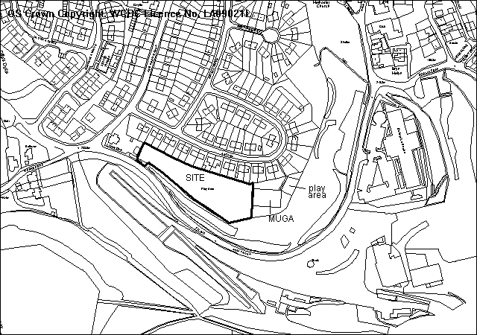
Former steel works site
PROPOSAL

Approval of reserved matters for the erection of 17 three bedroom semi-detached and terraces houses. Vehicular access is to Blast Road at the western end of the site.

A revised scheme to address open space/ Secured by Design issues was received on 13/6/2008. Consultees have been made aware of the revised plan.

RELEVANT HISTORY

CB03378 Residential development (outline) Granted 6/9/1999
P/2003/0787 Extension of time for submission of details Granted 8/9/2003
P/2005/0014 Outline for residential development Granted 7/3/2005

DEVELOPMENT PLAN

Within the settlement limits. Policies PS1 PS2 H2 EC4 EC6 CLF5 T8 GDP2 and GDP1 of UDP are relevant, together with LPGN 7, 10, 16, 17, 21, 22, 23, 24 and 27.

CONSULTATIONS

Brymbo C Council: Object. This area of land has been used as a playing field for over 70 years. The area is lacking in play facilities and lacks essential infrastructure for additional dwellings. Brownfield land should be developed first
Local Members: consulted 25/2/2008 and 17/6/2008
Highways: Recommend conditions
Public Protection: Recommend contamination condition. Comments regarding construction works and drainage.
Env Agency: Standard advice applies
Welsh Water: Recommend conditions
CCW: Holding objection pending detailed proposals to address newt conservation issues.
Landscape manager: The adjoining MUGA requires refurbishment or reinstatement, as it is unsuitable for adoption. The play area also requires a new safe surface
Education: A schools contribution for primary and secondary places would now apply to a full application on this land
Airbus: No aerodrome safeguarding objections
Site Notices: expired 20/3/2008
Other representations: Adjoining occupiers notified 27/2/2008 and 17/6/2008
3 objections received, on grounds of:
- Loss of important play/ recreation area enjoyed by local residents
- Dangerous access to Blast Road
- Excessive housing development in the locality already

SPECIAL CONSIDERATIONS/ ISSUES

Principle: As the application is for approval of reserved matters, the principle of development cannot be questioned. The outline application was considered in terms of the loss of an informal recreation area, and it was concluded that this was not an issue in view of the history of permissions and the inclusion of the site within settlement limits.

Layout: The revised layout avoids the problem of creating a secluded area at the rear of houses with no natural surveillance and provides for vehicular access to the play area for maintenance purposes.

Public Open Space: Based upon your standards, 17 units require 1360 sq m of open space. Although the MUGA and play area is currently open space (and maintained by the community council) its future cannot be secured and thus it is considered appropriate to accept it as part of the requirement. The scheme also provides for a small area of open space to complement the existing space. It is considered that the dedication and construction of a vehicular access together with the opportunity to seek a contribution towards upgrading the adjoining games area would be acceptable. The development site itself is not POS.

Parking and access: The scheme is acceptable subject to highways to conditions.

Ecology: The applicant has responded to the CCW objection, and refers to the on-going ecological management of the adjoining land in the same ownership. There is no specific ecological condition on the outline permission. Therefore it is considered unreasonable to withhold approval of reserved matters based on the lack of a detailed ecological site survey.

Schools Contributions: At the time of the outline application, it was confirmed that Schools Contributions did not apply, and so no condition was imposed to cover schools contributions. The situation has changed since then, but this requirement cannot be added on a reserved matters application.

Sustainable Development: Most of the dwellings have a southerly aspect and are located within walking distance of the village centre and adjacent to a bus route..

RECOMMENDATION A

That the Council enters into an obligation under Section 106 of the Town and Country Planning Act 1990, requiring:
- The dedication of the site of the adjoining public open space/ games area and a contribution towards their upgrading of £10,000 in accordance with policy CLF5 and Local Planning Guidance Note 10
The Chief Planning Officer be given delegated authority to determine the final form and content of the obligation.

RECOMMENDATION B

That planning permission be granted on completion of the obligation, subject to the following conditions:

CONDITION(S)

1. The development hereby approved shall be commenced before 7 July 2010.
2. Development shall only be carried out in strict accordance with the approved plans unless the prior written approval of the Local Planning Authority has been obtained.
3. Development shall not begin on site until a scheme to deal with potential contamination at the site has been submitted to and approved in writing by the Local Planning Authority. This scheme shall include a phased investigation approach to identify the extent of contamination and any measures required to remediate the site, including post-development monitoring. Where remediation works are required, the development shall not be occupied/used until a Validation Report to show that the works have been satisfactorily carried out has been submitted to and approved in writing by the Local Planning Authority.
4. Prior to their use on the development samples of all external facing and roofing materials shall be submitted to and approved in writing by the Local Planning Authority. The development shall only be carried out in strict accordance with such details as are approved.
5. No part of the development hereby permitted shall be commenced until full details of both hard and soft landscape works for the site have been submitted to and approved in writing by the Local Planning Authority. The works shall be implemented in accordance with a timescale to be approved in conjunction with the scheme of details.
6. All hard and soft landscape works shall be carried out in accordance with the approved details as set out in Condition 5. The works shall be carried out within 3 months of the first use of the development with the exception of soft landscaping which shall be carried out in the first planting season (November to March) or seeding season (April to September) following the first use.
7. Any trees or shrubs removed, dying, being severely damaged or becoming seriously diseased within five years from the completion of the scheme shall be replaced by trees or shrubs of similar size and species to those originally required to be planted unless otherwise approved in writing by the Local Planning Authority.
8. The proposed access shall have a visibility splay of 2.4m x 90m in both directions measured along the nearside edge of the adjoining carriageway over land within the control of the applicant and/or the Highway Authority. Within the splays there shall be no obstruction in excess of 1 metre in height above the level of the adjoining carriageway. The splay shall be provided prior to commencement of use/occupation of the development hereby approved and shall thereafter be retained clear of such obstruction.
9. The vehicle parking and turning areas indicated on the approved plans shall be laid out, surfaced and drained prior to the first use of the building hereby granted and shall thereafter be retained for those purposes.
10. The gradient of the access from the edge of the existing carriageway for a minimum distance of 10m shall be 1 in 24 and a maximum of 1 in 15 thereafter.
11. No gates shall be constructed within 5 metres of the highway boundary.
12. No development shall take place until a scheme of foul drainage and surface water drainage has been submitted to and approved by the Local Planning Authority. The approved scheme shall be complete before the development is occupied
13. The site shall only be drained by means of a separate system of drainage with no surface water being discharged to the foul drain/sewer.
14. Details of floor and ground levels, boundary treatment, refuse storage facilities, rear access to gardens/refuse storage areas shall be submitted to the Local Planning Authority before any part of the development is commenced and the development shall only be carried out in strict conformity with such details as are thereby approved.
15. Prior to the commencement of development, a comprehensive ecological survey of the site shall be undertaken. The report of survey shall also include details of any mitigation measures required, and these measures shall be approved by the local planning authority and completed in accordance with time scales to be agreed as part of the measures before development commences on site.
16. The erection of fencing for the protection of trees and shrubs shall be undertaken before any equipment, machinery or materials are brought onto the site for the purposes of the development, and shall be maintained until all equipment, machinery and surplus materials have been removed from the site. The above mentioned fencing shall consist of a scaffold framework in accordance with Figure 2 of BS 5837 (2005) comprising a vertical and horizontal framework, well braced to resist impacts, with 2.1m vertical tubes spaced at a maximum interval of 3 metres. Onto this, weldmesh panels shall be securely fixed with wire or scaffold clamps. This fencing shall be erected at the full extent of the canopy of each tree and shrub. Nothing shall be stored or placed in any area fenced in accordance with this condition and the ground levels within those areas shall not be altered, nor shall any excavations be made without the written permission of the Local Planning Authority.
17. Prior to the commencement of development, a programme of sustainable works shall be submitted for the written approval of the Local Planning Authority. The approved programme shall be implemented in accordance with a timescale to be agreed with the Local Planning Authority.

REASON(S)

1. To comply with Section 92 of the Town and Country Planning Act, 1990.
2. To ensure that the development fully complies with the appropriate policies and standards.
3. In the interests of the amenities of the future occupants of the buildings
4. To ensure a satisfactory standard of appearance of the development in the interests of the visual amenities of the area.
5. To ensure a satisfactory standard of appearance of the development in the interests of the visual amenities of the area.
6. To ensure a satisfactory standard of appearance of the development in the interests of the visual amenities of the area.
7. To ensure a satisfactory standard of appearance of the development in the interests of the visual amenities of the area.
8. To ensure that adequate visibility is provided at the proposed point of access to the highway.
9. To provide for the parking and turning of vehicles clear of the highway and to ensure that reversing by vehicles into or from the highway is rendered unnecessary in the interest of traffic safety.
10. In the interests of highway safety.
11. In the interests of highway safety.
12. To ensure satisfactory drainage of the site and to avoid flooding.
13. To ensure satisfactory drainage of the site and to avoid flooding.
14. To ensure that the development fully complies with the appropriate policies and standards.
15. The site is likely to contains features of ecological interest and it is necessary for the precise location of these features to be shown so that adequate provision can be made to ensure that later development does not damage any habitats or species identified
16. To protect trees which are of significant amenity value to the area.
17. To meet the criteria set out in the Local Planning Guidance Note 22.

NOTE(S) TO APPLICANT

Further advice on compliance with Condition No. 3 may be obtained by contacting the Council's Environmental Protection Section on Wrexham 297041.
Your attention is drawn to Highway Supplementary Notes Numbered 1, 3, 4 and 5 on the enclosed "Applicants' Rights and General Information".

The proposed development lies within a former coal mining area. You should take account of any hazards to stability which may arise from coal working in or near the site. Specific advice on any past working may be obtained from the Coal Authority Mining Reports Service. Phone 0845 762 6848 or from www.coal.gov.uk.

Any operations which may involve entry into former workings, shafts or adits or implementation of site investigations or other works may need permission from the Coal Authority.

You are reminded that the Disability Discrimination Act 1995 applies to residential development and you will be required to provide (amongst other things) level access, down stairs cloak room and wider doorways.

The scheme of landscaping referred to in the above conditions shall inlcude any changes to ground levels (shown by existing and proposed contours/levels) and any existing vegetation (showing that to be retained) and proposed planting. In addition, any of the following which apply to the particular site must be included:-
means of enclosure, car parking layout, access and circulation areas, materials for hard surfaced areas, any minor structures (e.g. refuse stores, lamp columns, play equipment) location of services, and any historic landscape features to be retained/improved.

This permission is granted subject to the above conditions. Some conditions may require your attention prior to you carrying out any work on the proposal. These conditions are known as "conditions precedent". You should be aware that it is important that you comply with any "conditions precedent". If you do not, then any work you undertake on the development subject of this permission would not have planning permission.

You are advised to contact the Council's Ecology Officer at The Planning Department, Lambpit Street, Wrexham on Tel: 01978 292517.

The planning permission requires that development be carried out in accordance with the approved plans, including the construction of an estate road intended for adoption by the Council under the Highways Act 1980. It is essential therefore that the detailed proposals are submitted to the highway authority and confirmed as acceptable BEFORE development commences. Please contact:-

The Operational Manager (Highways Planning), Crown Buildings, Chester Street, Wrexham. LL13 8BG telephone: 01978 292000.

The site is affected by an overhead line and you should contact MANWEB, Electricity House, Rhostyllen, Wrexham, LL14 4DU
regarding any diversion which may be necessary.

Please note the attached comments from the Environment Agency, Countryside Council for Wales, Welsh Water and Public Protection.
_____________________________________________________________________

APPLICATION NO:  P/2008 /0238  COMMUNITY:  Cefn  WARD:  Cefn | LOCATION:  FORMER NAT WEST BANK CRANE STREET CEFN MAWR WREXHAM  DESCRIPTION:  ERECTION OF 4 NO TWO BEDROOM SEMI-DETACHED DWELLINGS  APPLICANT(S) NAME:  MR BRIAN DAVIES | DATE RECEIVED:  04/03/2008  CASE OFFICER:  MP  AGENT NAME:  MR BRIAN DAVIES
_____________________________________________________________________

The application was deferred in June after Members requested

further clarification from the HSE regarding their recommendation to refuse 4 dwellings (but accept 2);

A revised parking layout to address Highway objections.

Parking layout: The previous plans had provided 2 spaces for each dwelling but left insufficient space to allow vehicles to manoeuvre and turn within the site. The applicant has provided revised plans showing two alternative parking arrangements:
- One option shows 8 spaces plus a garage with additional space provided by reducing the garden area to the rear of the properties to 2 metres in depth. Although the dwellings would have amenity space to the rear of the parking area, this arrangement provides insufficient private amenity space immediately adjacent to the dwellings;
- The other shows 4 parking spaces together with 1 garage to the rear of the dwellings. The site is close to the centre of Cefn Mawr, a range of facilities and is served by good public transport. I therefore believe a reduction in the maximum standards required by LPG16 can be justified in this case. There is also a public car park within 50 metres. Nevertheless, although being an improvement over the previous layout, it would still be difficult to turn vehicles within the site so I do not consider the proposals acceptable. I am however satisfied that it should be possible to provide an acceptable parking/turning layout if each dwelling were only provided with 1 space each. A revised parking layout could therefore be secured by condition if permission was granted.

HSE: Officers have discussed the proposals with the two separate officers of H&SE.

The following response has been received:
HSE's methodology in considering housing developments, categorises
houses, flats, retirement flats, bungalows, residential caravans, and
mobile homes as dwelling units. The number of dwelling units and the
density of the dwelling units determines the sensitivity level of that
development. Between 3 and 30 (inclusive) dwelling units at a density
of no more than 40 per hectare are categorised as sensitivity level 2.
They are considered to be developments where people live or are
temporarily resident and it may be difficult to organise people in the
event of an emergency.

If the density of the dwelling units is more than 40 per hectare the
sensitivity level is increased to 3 due to the higher density of the
development. If it is a larger development for more than 30 dwelling units the
sensitivity level is increased to 3 due to the substantial increase in
numbers of people at risk. Small developments of 1 or 2 dwelling units are classified at a lower sensitivity level of 1 and considered to be a minimal increase in the numbers of people at risk.

HSE's role in the land use planning system is advisory. It has no power
to refuse a planning application. It is the responsibility of the Local
Planning Authority (LPA )to make the decision, weighing local needs and
benefits and other planning considerations alongside HSE advice in
making a decision on the proposed development. If after weighing all
the factors the LPA is minded to grant planning permission or hazardous
substances consent against HSE's advice, it should give HSE advance
notice of that intention, and allow 21 days from that notice for HSE to
give further consideration to the matter.

Conclusion: As noted in my original report, I am aware that the recent announcement regarding Flexys, however the site is likely to continue to operate for some time yet. Furthermore the possibility that the site may be taken over and existing operations on site continue. Until I am notified by the HSE that the existing consultation zones are to be amended or removed then I can only recommend that the Local Planning Authority follows the advice received from them.

I am now satisfied that the concerns raised on highways grounds can be overcome.

My original report: Is appended below together with a revised recommendation.

SITE

As above.
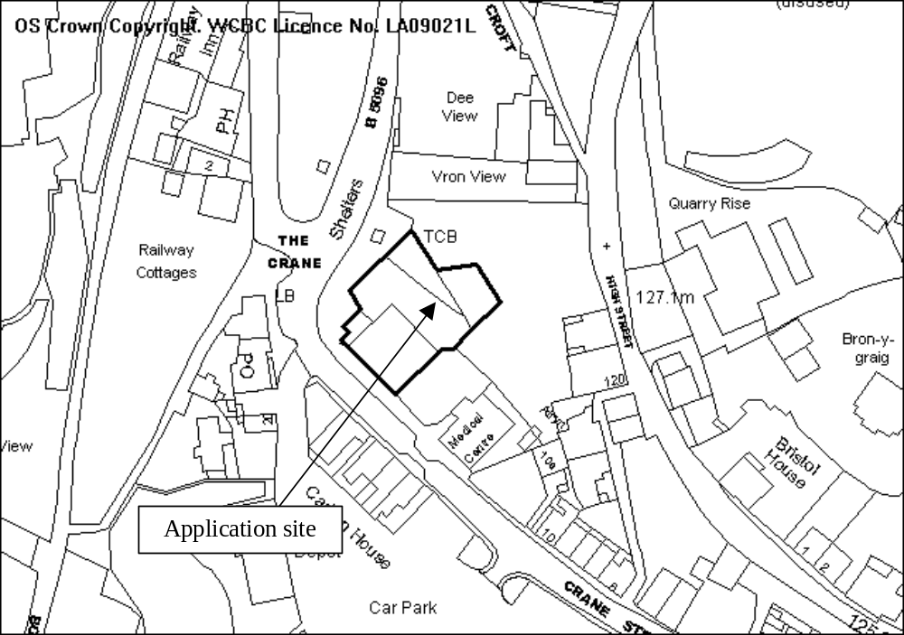

PROPOSAL

As above.

HISTORY

No recent relevant history.

DEVELOPMENT PLAN

Within settlement and Conservation Area. Policies PS2, GDP1, H4 and EC7 apply.

CONSULTATIONS

Community Council: Supports application subject to compliance with conservation regulations.
Cllr Coleman: Supports application.
Cllr Moysen: Notified 5.3.08
Highways: Traffic generation from access considered to be equivalent to existing use (A2).
Not enough space behind parking bays to allow for turning. Recommend refusal.
Public Protection: Recommend condition requiring site to be investigated for contamination and measures to mitigate any contamination found on site.
Welsh Water: Recommend drainage conditions.
HSE: Advise against granting planning permission
Other representations: Nearby occupiers notified
Site Notice: Expired 7.4.08

SPECIAL CONSIDERATIONS

Siting, design amenity: The development would provide two pairs of semi-detached properties located adjacent to each other on the site of the former bank building and fronting onto Crane Street, with garden areas and a parking area to the rear. In design terms, the properties would reflect the Victorian character of other properties in locality. The proposals would therefore result in a significant improvement in the appearance of the site and surrounding locality, and enhance the character of the Cefn Conservation Area.

Nevertheless no application for demolition consent has been received.

The separation distance between the southern pair of dwellings to the property immediately opposite the development is much less than LPG21 advises is normally acceptable, being around 12 metres. The siting of the dwellings close to the back of the footway however is reflective of the pattern of development further along Crane Street, where existing separation distances typically fall below currently adopted standards. As noted above, the development would improve the appearance of the site significantly, and therefore whilst it falls short of normal standards, I believe there are grounds for accepting a reduction in this case.

The development provides each property with a small rear year area, together with a raised garden area behind the parking area. Together would be sufficient to provide

Highways: The internal layout of the site does not provide enough space to allow for the parking and turning of vehicles within the rear yard/parking area.

Health and Safety: Due to the close proximity of the site to the Flexys chemical plant and the likely danger to any future residents, the HSE have advised against the granting of planning permission for 4 dwellings (it is likely however than 2 dwellings on this site would be acceptable). The applicant has indicated verbally that he wishes to pursue the current scheme. On the basis of the advice received from the HSE, permitting the development will result in an unacceptable level of risk to future occupiers. In the circumstances I cannot support the proposal. The proposals do not therefore accord with policy GDP1 (f).

I am aware of the recent announcement regarding the future of the Flexsys site but clearly the site appears to be still operational could be for several years at the least. There is no certainty that someone else will not take over all or part.

Conclusion: The scheme makes inadequate provision for the parking and turning of vehicles clear of the highway, and will put expose future occupiers to and unacceptable level of risk. The scheme is therefore contrary to policy GDP1(d) and (f).

Members are advised that if that if they are considering granting planning the Council is required to notify the Health and Safety Executive of its intentions and given them 21 days from the date of that notice to consider whether or not to request that the Welsh Assembly Government calls in the application to enable it to be determined by them.

RECOMMENDATION That permission be REFUSED

REASON(S)

1. The site lies adjacent to Flexys which is a major hazard complex and as such the development will result in an unacceptable level of risk to future occupiers contrary to policy GDP1 (f) Wrexham Unitary Development Plan.
_____________________________________________________________________

APPLICATION NO:  P/2008 /0239  COMMUNITY:  Chirk  WARD:  Chirk South | LOCATION:  LAND ADJACENT TO BEVERLEY LLOYDS LANE CHIRK GREEN CHIRK WREXHAM  DESCRIPTION:  DEMOLITION OF EXISTING BUNGALOW AND ERECTION OF 11 DWELLINGS AND ASSOCIATED ACCESS  APPLICANT(S) NAME:  BYRONS (HOLDINGS) LTD | DATE RECEIVED:  04/03/2008  CASE OFFICER:  DSW  AGENT NAME:  PLATT WHITE PARTNERSHIP
_____________________________________________________________________

TP/2008 /0239

BACKGROUND

This application was considered by the Committee following the site visit on 13 June 2008.

A number of issues/questions arose and I address these below:
- sight lines: The measured speeds are 24.5mph (towards Colliery Road) and 25.5mph in the other direction. TAN 18 requires 22m for 20mph, 31m for 25mph and 36m for 28mph. Interpolating between these gives 29.2m (ie 30m) for 24.5mph and 31.8m (ie 32m) for 25.5mph.
Thus 31m is acceptable to the north and 32m to the south.
Details of the access are shown over the page.
- loss of amenity for Ingleby: The layout plan now shows 2 parking spaces on the site to be allocated to Ingleby. The applicant has also submitted a revised plan showing the provision of a 72 sq m area screened private garden which would meet your normal standard. Both parking and open space could be conditioned.
- Section 106 – the agreement for the POS maintenance has already been completed. Education have now confirmed that a contribution is necessary to deal with the fact that Ruabon High School is full. S 106 now covers.
- Triangle of land at the rear of the site. A landscaping plan is being prepared and I will update Members at the meeting. I understand that the land will be sold to the occupiers of the two adjacent houses who will be required to undertake to maintain the screen planting. A further condition is suggested.
- Conditions: I have reviewed the conditions and agree that several of them need to be reworded to ensure their enforceability.
- Drainage: I have spoken at length to Welsh Water and they say they have no records of overloading of the sewers in that area. The Town Council have now given me details of their concerns and these have been passed to WW for comments.

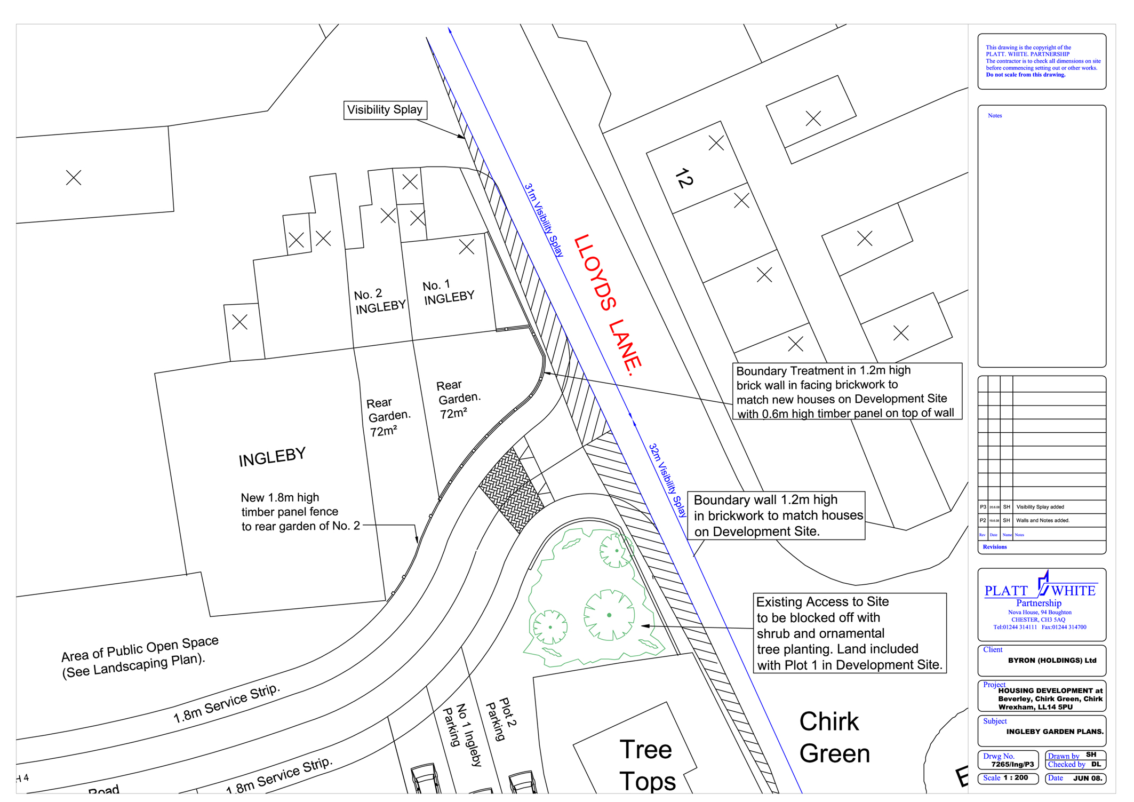

My original report together with the amended conditions follows:
-------------------------------------------------------------------------------------------------------

THE SITE

The 0.35 ha of land off Lloyds Lane, Chirk, which includes “Beverley”, an existing bungalow and open ground to the rear previously used as a coach depot. The existing access is off Lloyds Lane. The site is bounded by residential development on three sides with the existing haulage yard/depot to the other. Mature boundary trees and hedgerow planting enclose the site from neighbouring development.

PROPOSAL

As above. This is a full application with all matters submitted for the approval of the Council. The application is partly retrospective as construction work has begun on site.

HISTORY

P/2004/1009 Erection of 5 dwellings. Granted 2004.
P/2007/0006 Demolition of existing bungalow and coach maintenance building.
Erection of 13 no. dwellings and construction of new vehicular and
pedestrian access. Withdrawn 21.02.07
P/2007/0341 Demolition of existing bungalow and coach maintenance building,
erection of 11 no. dwellings and construction of 11 no. dwellings and
construction of new access. Withdrawn 03.08.07.
P/2007/1023 Demolition of existing bungalow, erection of 11 no. dwellings,
construction of new vehicular and pedestrian access and alteration to
existing vehicular and pedestrian access. Refused 3/12/2007

DEVELOPMENT PLAN

Within settlement limits.

CONSULTATIONS

Town Council: Raise the following concerns:
- Problems occur at times with the overloading and surcharging of the public sewerage system causing flooding to houses. Sufficient capacity should exist in the public sewerage system to accommodate this development without causing further problems to the community.
- The Council considers that surface water from the development, including dwellings and roads, should not be allowed to discharge to soakaways or the nearby ditch. This would cause problems elsewhere.
- The Council notes the new proposals for access off Lloyds Lane but this seems dependent on securing land from the adjoining dwelling. The Council are still concerned that the access should ensure adequate safe passage for pedestrians on pavements made to present criteria.
- The Council notes that a new fence is to be erected inside the existing North, west and south boundaries of the site. This appears to leave a strip around that part of the site as “no man’s land” as does the triangular plot on the western boundary. The Council recommends that the Planning Authority is assured that there is an owner for these areas for future control and maintenance.
- Request play facilities are provided.
- Express concern that three storey type houses are proposed to be built. The Council considers two storey dwellings would be more in keeping on this site.
Local Member: Notified 05.03.08
Welsh Water: No objections subject to appropriate conditions to deal
with foul and surface water disposal.
Environment Agency: Notified 05.03.08
Public Protection: No objections subject to conditions to deal with
potential contamination issues.
Highways: No objections. The speed surveys carried out by the
applicants would confirm that adequate visibility can be achieved at the point of access. Welcome the footway improvements on Lloyds Lane which will improve pedestrian safety in the area. Given the proximity of the local high school there is a requirement for a traffic calming scheme to be implemented on Lloyds Lane, north of the proposed access. Conditions are recommended to deal with visibility, traffic calming, construction of a footway and accessway ramp and the permanent closure of the existing site access.
Other Representations: One letter received from an adjoining occupier
expressing concerns regarding the:-
- Loss of privacy as a result of overlooking from three storey dwellings.
- Concerned that work is continuing on site without planning permission.
Site Notice: Expired 2 April 2008.

SPECIAL CONSIDERATIONS/ISSUES

Policy: No objection, in principle, to housing subject to the proposals meeting the technical criteria set out in UDP Policy GDP1.

Site History: The principle of residential development on this site was established when permission was granted for five dwellings in 2004. The current application is the latest of four applications submitted for residential development on this site this year. The first application P/2007/0006 for 13 dwellings was withdrawn in February due to concerns raised with regards to the proposed means of access, substandard layout and design and an absence of Public Open Space. Following discussions a further application for 11 dwellings was submitted in May P/2007/0341. This scheme provided an improved layout and addressed previous concerns with regards to house types, open space and access arrangements. In particular, the application site involved the creation of a new access off Lloyds Lane a few metres north of the existing access, which was to be removed. To achieve the visibility standards in a southerly direction required the agreement of the owners of “Treetops” the adjoining property. Construction work however began during last summer without planning consent and it became apparent the applicants had failed to secure the agreement of the owner of “Treetops”. The key planning issue related to the means of access, although there were a number of outstanding technical matters that needed to be resolved prior to the details, a contamination report and an arboricultural survey.

The most recent application therefore submitted under code no. P/2007/1023 was refused by Planning Committee on 3 December 2007. The reasons for refusal related to highway visibility and pedestrian safety; the absence of any alternative parking provision for No 1 Ingleby; failure to deal with contamination issues; the absence of an acceptable Arboricultural Report; and the introduction of a three storey house type which would be out of keeping with neighbouring development.

Construction work has stopped on site and extensive discussions have taken place between the applicants and representatives of the Highways and Planning Departments to address the previous reasons for refusal. The outcome is the re-submission of an application which I believe addresses these concerns. They are addressed in turn below.

Highways: To address problems with regards to visibility southwards the applicants have submitted amended plans which show an access sited some 10m north of that shown on the original application. This takes up part of Nos 1 and 2 Ingleby (adjoining property to the north). The applicant has confirmed an agreement exists to acquire this land from the occupiers.

The site has planning permission for five dwellings. It was limited to this number because the existing access suffers from substandard visibility in both northerly and southerly directions. Highways only recommended approval due to the comparable levels of traffic generation at the site from the previous use by a coach operator. This application proposes a new access road to serve up to 11 new dwellings at the above site. The traffic generated by such a proposal will obviously increase significantly over and above what has been previously agreed and it is therefore essential that a safe and satisfactory access is provided.

The site has access on to a classified highway subject to a 30 mph speed limit. The applicant has undertaken a speed survey that determined 85th percentile vehicular speed of traffic travelling in both directions to be 27.5 mph. Wet weather adjustment means that this speed is actually 25.25 mph.

For a 25.25 mph speed Manual for Streets recommends the provision of visibility splays measuring 2.4 x 35m in both directions. To the north it would appear that the applicant has gained control of the dwelling known as Ingleby and can provide adequate visibility in this direction. To the south it is only possible to achieve a splay of 32m to the nearside kerb edge.

A second speed survey undertaken by the applicant determined similar vehicular speed in both directions. Using the Welsh Assembly TAN 18, Table B of Annex B states that for a 25.5 mph speed a 32m splay is appropriate.

There is a clear difference in the recommendations made by Manual for Streets and those within TAN 18. However, as TAN 18 is written specifically for use by Welsh Authorities I can only conclude that its recommendations hold more weight and it would be very difficult to defend a recommendation for refusal on highway grounds at an appeal. The first reason for refusal on the previous application has therefore been addressed.

The proposed adoptable access road to the site conforms to highway standards and parking provision is concurrent with the requirements of TAN 18.

Given the proximity of the local high school there is a requirement for a traffic calming scheme to be implemented on Lloyds Lane north of the proposed access. A suitable condition is attached.

Pedestrian Safety: There is an existing footway on Lloyds Lane in the vicinity of the site. However, it is below current standards in terms of width. The footway actually terminates adjacent to Ingleby and forces pedestrians to walk in the highway. This is of particular concern given its proximity to the school.

The applicant proposes to construct a 2m wide footway across the full frontage of Ingleby, through the existing site access up to the boundary of Treetops. This will be of significant benefit in terms of pedestrian safety and will also ensure visibility can be maintained in perpetuity. An accessway ramp will be required at the site access, the design of which must be further agreed under the Section 38 agreement. The accessway ramp provides adequate facility for pedestrians wishing to cross the proposed new road. This will form a condition of any permission granted. This addresses the second reason for refusal on the previous application.

Parking Provision for No 1 Ingleby: The third reason for refusal related to the failure to make suitable alternative parking provision for No 1 Ingelby. The provision of a 2m footway across the front of Ingleby will result in the loss of the existing parking bay. Provision has been made to ensure No 1 Ingleby has dedicated parking within the current scheme.

Contamination: The site was previously used as a bus depot and repair yard with associated fuel storage, a potentially contaminative use. In the light of this a pre-commencement condition would normally have been imposed to deal with any potential contamination issues. However, as work has commenced on site this was not possible to achieve and as the contamination issue had not been effectively addressed at that time, it constituted a further reason for refusal of the previous application. Since then discussions have been ongoing with the Council’s Public Protection Department with regards to a phased investigation with remedial measures and I have received confirmation they are satisfied with the submitted contamination reports. Subject to an appropriate condition to ensure that the recommended remediation measures are undertaken there can be no objections on contamination grounds. The fourth reason for refusal has been addressed.

Trees: There are a number of important trees within the site that provide a very useful role in screening the proposed dwellings from outside the site. These will be protected by condition. A number of the proposed properties and garages have already been built. There is visual evidence of extensive damage such as raising of soil levels and compaction to the ground within the Root Protection Areas (RPA) of retained trees. As these structures exist I have no objections to their retention. However, I propose a condition of soil remediation measures in order to give the retained trees a change of survival. A further condition will be imposed to re-position the garages outside the Tree Protection Areas. This will involve moving the position of the garages further forward and away from the site boundary. Subject to the imposition of appropriate conditions I am satisfied the fifth reason for refusal has been addressed.

Three Storey Development: Whilst there are no objections to the proposed site layout which meets the Council’s separation distances, Members expressed concern regarding the introduction of a three storey house type in this location, given the open nature of the site. However, I have since received cross-sectional drawings and further written justification from the applicants which I have taken into account. This information can be summarised as follows:

- Whilst the accommodation is across three floors the overall scale of the buildings are only 2.5 storeys in height. The ridge heights of the proposed dwellings are lower than the existing three storey flats located to the south west of the site at Longfield.
- The present ground levels are not at the finished levels – the final levels are yet to be established around the footings of the dwellings. The present exposure of the lower parts of the buildings creates the illusion of the buildings being higher than they actually are.
- The development site is on land that slopes so that its access point at the eastern end is at the highest point and the ground slopes away to the bottom of the site to the west. There is also a slope across the width of the site so that the ridge heights of the houses to the south of the site are equivalent to those on the development site. Owing to the difference in ground levels across the site the impact of the 2.5 storey dwellings is not as great as it may otherwise be in a flat site.
- The development site is enclosed by the mature tree cover around the perimeter to the extent that those plots having dormers in the roof areas are well screened from view for outside the development. This also means that there is no incidence of overlooking of other habitable rooms in the surrounding dwellings from the dormer windows.
- Only two of the new dwellings located along the southern part of the site on plots 4 and 5 will have roof dormers as the rest will have rooflights. The dormers will be screened by the tops of the coniferous Scots Pines along the perimeter so there will be all year round protection between the upper floors of the existing and proposed dwellings. Additional planting will be introduced along the site boundaries. In addition, the applicants have now also agreed to purchase the triangle of land to the west of the site and undertake to plant this as woodland to provide further screening tot he properties located at ‘The Nurseries’, to the western side of the development.
- The dwellings at plots 8 and 9 are sufficiently distant from the boundary and separated from the nearby flats by an intervening car park that the incidence of overlooking is minimal.

On the basis of the above I consider a refusal of permission solely on the grounds of introducing three-storey dwellings cannot be justified.

RECOMMENDATION A

That the Council enters into an Obligation with the applicant under Section 106 of the Town and Country Planning Act 1990 requiring a commuted sum towards the future maintenance of the public open space in accordance with Local Planning Guidance Note No 10 and towards the shortfall of educational facilities

RECOMMENDATION B

That planning permission be granted upon completion of this Obligation subject to the following conditions:-

CONDITION(S)

1. The development hereby permitted shall be begun before the expiry of five years from the date of this permission.
2. No further development shall be carried out until samples of all external facing and roofing materials have been submitted to and approved in writing by the Local Planning Authority. The development shall only be carried out in strict accordance with such details as are approved.
3. No further development shall commence until full details of both hard and soft landscape works for the site have been submitted to and approved in writing by the Local Planning Authority. The works shall be implemented in accordance with a timescale to be approved in conjunction with the scheme of details.
4. Within six months of the first first occupation of any dwelling, trees and shrubs shall be planted on the site in accordance with a scheme which has been submitted to and approved by the Local Planning Authority. Any trees or shrubs removed, dying, being severely damaged, or becoming seriously diseased within five years of planting shall be replaced by trees or shrubs of a similar size and species to those originally required to be planted.
5. No further developemnt shall be carried out until a scheme of boundary treatments has been submitted to and approved in writing by the Local Planning Authority. The scheme as approved shall be implemented in accordance with a timescale to be approved, in writing, with the Local Planning Authority.
6. No trees shall be lopped, topped, felled or uprooted without the prior written permission of the Local Planning Authority nor shall any trees be wilfully damaged.
7. No further development shall commence until a survey has been undertaken by a suitably qualified arboricultural consultant showing all trees which are to be retained and the extent of any soil compaction which has occured. The report shall confirm measures for the de-compaction of the soil within the Root Protection Areas’ (as set out in British Standard 5837:2005) and shall be approved in writing by the Local Planning Authority before any further development commences.
8. A recognised mycorrhizal treatment (which has been approved in writing by the Local Planing Authority) shall be applied to the root systems of all the trees which have been surveyed and listed in the report which has been approved as required by condition 7.
9. Prior to the first occupation of any of the dwellings hereby permitted within the Root Protection Areas (as set out in British Standard 5837:2005) of any retained trees ground levels shall be restored back to their original levels and shall theeafter not be altered..
10. A method statement detailing any further proposed ground level regrading works demonstrating that they are not detrimental to tree health and stability shall be submitted and be approved in writing by the Local Planning Authority, prior to the first occupation of any of the dwellings hereby permitted. The works shall be carried out strictly in accordance with the approved method statement. No further regrdding of land shall take palce on the site.
11. Prior to any further building works, the access from the site on to Lloyds Lane shall be constructed to Highway Authority adoptable standards and shall be provided with a visibility splay measuring 2.4 x 31m to the north measured to the nearside kerb edge of the adjoining highway within which there shall be no obstruction in excess of 1m in height. The splay thus created shall be retained clear of any such obstruction to visibility thereafter
12. Prior to any further building works, the access from the site on to Lloyds Lane shall be constructed to Highway Authority adoptable standards and shall be provided with a visibility splay measuring 2.4 x 32m to the south measured to the nearside kerb edge of the adjoining highway within which there shall be no obstruction in excess of 1m in height. The splay thus created shall be retained clear of any such obstruction to visibility thereafter
13. No further development shall commence until a scheme of traffic calming has been submitted to and has been approved in writing by the Local Planning Authority. The scheme as is approved shall be fully implemented prior to the first occupation of any dwelling on site.
14. No further development shall commence until the detailed layout, design, drainage and construction of the internal estate road has been submitted to and has been approved in writing by the Local Planning Authority. The road shall be constructed to Highway Authority adoptable standard prior to any dwelling being occupied.
15. A 2m wide footway shall be constructed back from the existing carriageway along the full frontage of the site from Treetops in a northerly direction for a distance of approximately 40m and shall be completed to Highway Authority adoptable standard prior to first occupation of the dwellings and shall thereafter be retained clear of obstruction to pedestrian use..
16. An accessway ramp shall be constructed on the access road to the further approval of the Highway Authority.
17. The existing site access shall be permanently closed to vehicular traffic in accordance with details which have previously been approved in writing by the Local Planning Authority, prior to the first occupation of any of the dwellings hereby permitted.
18. Prior to any development commencing, full details of the proposed surface water drainage system shall be submitted and approved by the Local Planning Authority and the development shall only be carried out in strict accordance with such details as are thereby approved.
19. No further development shall commence until a scheme to deal with potential contamination at the site has been submitted to and approved in writing by the Local Planning Authority. This scheme shall include a phased investigation approach to identify the extent of contamination and any measures required to remediate the site, including post-development monitoring. Where remediation works are required, the development shall not be occupied/used until a Validation Report to show that the works have been satisfactorily carried out has been submitted to and approved in writing by the Local Planning Authority.
20. No further development shall take place until plans showing the repositioning of the (unbuilt) garages outside the Root Protection Areas have been submitted to and been approved by the Local Planning Authority. The development shall be carried out in accordance with the approved plans as amended.
21. A programme of sustainable works shall be submitted to and approved in writing by the Local Planning Authority before any further work takes place on site. The development shall only be implemented in strict accordance with the approved scheme.
22. Neither plot 11 or 10 shall be occupied until the traingular area to the rear of those plots has been landscaped in accordance with drawing no7265/T.L. P1 rev A. The planting shall be maintained in accordance with the requirements of conditions 4 and 6 above.
23. No dwelling shall be occupied on the site the site, until a screen wall/fence has been erected to the rear gardens to nos 1 & 2 Ingleby (as shown on drawing 7265/Ing/P1), that fencing shall thereafter retained.
24. The site shall be developed in accordance with the ground and floor levels indicated on the approved plans. No changes to floor levels or external ground levels shall be made without the prior written approval of the Local Planning Authority.

REASON(S)

1. To comply with Section 91(3) of the Town and Country Planning Act, 1990.
2. To ensure a satisfactory standard of appearance of the development in the interests of the visual amenities of the area.
3. To ensure a satisfactory standard of appearance of the development in the interests of the visual amenities of the area.
4. To ensure a satisfactory standard of appearance of the development in the interests of the visual amenities of the area.
5. To ensure a satisfactory standard of appearance of the development in the interests of the visual amenities of the area.
6. To protect trees which are of significant amenity value to the area.
7. To remediate damage to retained trees in order to ensure their survival.
8. To remediate damage carried out to the rhizosphere of retained trees in order to ensure their survival.
9. To remediate damage to retained trees in order to ensure their survival.
10. A method statement detailing ground level regrading works that are not detrimental to tree health and stability is to be submitted and be approved in writing by the Local Planning Authority, prior to the first occupation of any of the dwellings hereby permitted. The works shall be carried out in accordance with the approved method statement.
11. To ensure that adequate visibility is provided at the proposed point of access to the highway.
12. To ensure that adequate visibility at the proposed point of access.
13. In the interests of highway safety.
14. To ensure the estate road is constructed to a standard suitable for adoption by the Highway Authority.
15. To ensure adequate pedestrian provision.
16. In the interests of highway safety.
17. In the interests of highway safety.
18. To ensure an adequate method of drainage.
19. In the interests of the amenities of the future occupants of the buildings
20. To protect trees on the site.
21. To ensure the development is carried out in a sustainable manner.
22. To protect the amenities of the occupiers of nearby properties.
23. To ensure an adequate provision of open amenity space for use by residents in accordance with the Council's standards.
24. To protect the privacy and amenity of residents.
_____________________________________________________________________

APPLICATION NO:  P/2008 /0316  COMMUNITY:  Gresford  WARD:  Marford & Hoseley | LOCATION:  SWN Y COED TURNPIKE LANE MARFORD WREXHAM  DESCRIPTION:  CONVERSION AND EXTENSIONS OF EXISTING GARAGE INTO SELF-CONTAINED RESIDENTIAL ACCOMMODATION  APPLICANT(S) NAME:  MR M PRICE | DATE RECEIVED:  25/03/2008  CASE OFFICER:  JS  AGENT NAME:  MR M PRICE
_____________________________________________________________________

THE SITE

The site is located at the head of a cul-de-sac. The site contains a large, and fairly modern garage building. This site is separated from Swn Y Coed (a detached bungalow) by a public footpath.
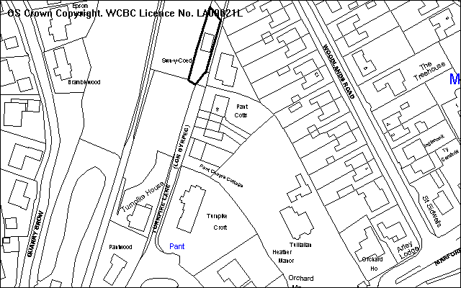
Public Footpath
Application Site
Marford Wood/
Quarry
(TPO and SSSI area)
Settlement limit

PROPOSAL

As above. The proposal will provide a one bedroom dwelling only, and includes two small extensions.

RELEVANT HISTORY

P/2005/0293 Conversion of existing garage to 2 bedroom dwelling. Refused 4.5.05. (Contrary to GDP1, H3 and T8 for reasons of scale of new extensions, lack of parking and turning facilities)
P/2006/0502 Change of use of redundant garage to 2 bedroom dwelling. Refused 19.6.06 (Contrary to H3 and GDP1 for reasons of scale of extensions and overlooking issues and lack of turning facilities)

DEVELOPMENT PLAN

Outside settlement limits, and within a green barrier and special landscape area. Policies PS1, PS2, H3, H5, EC1, EC4, EC5, EC6 and GDP1 apply. LPG Notes 3, 13, 16 and 21 are also relevant. The site is adjacent to SSSI area (Marford Quarry) and a woodland TPO (Marford Wood).

CONSULTATIONS

Community Council: The proposal is out of character with the area and may cause congestion for neighbouring properties. Inadequate parking is available for both properties.
Local Member: Has concerns about the amount of traffic generation along a very narrow road which is poorly surfaced. Both the plot and the existing bungalow (Swn Y Coed) will not have a garage.
Highways: Site is situated at northern end of Turnpike Lane which is narrow unadopted lane which already serves in excess of 5 dwellings. It is current Council policy that no more than 5 dwellings be permitted off an existing private drive unless it is an adoptable standard. The passing of two vehicle is not possible and the road surface is unbound and in a poor condition, and there is a public footpath. Adequate off street parking is provided for both the existing dwelling and the proposed annexe. On the basis that the new accommodation will not generate significant increase traffic movements because it would be tied to the existing dwelling, the application can be supported subject to conditions. Concern about boundary fencing to path possibly creating a “tunnel” effect.
Rights of Way: Temporary closure of Right of Way might be required.
WACS: Objects. Garage is unsuitable and unsustainable for conversion into residential use being excessively close to an existing public footpath, having windows within touching distance of the footpath. Excessive over development of a small plot and increased traffic generation. The public footpath has been excessively narrowed in the past.
Site Notice: Expired 14.4.08
Other representations: 8 neighbours notified, raising the following:
- The building should just be used as a garage.
- The location is not appropriate for this change of use, whether ancillary or not.
- New windows and doors are too close to the public footpath.
- The rear of the building is too close to Pant Wood.
- Trees overhang the property and these will need to be trimmed back from time to time, which could damage them, and this is not environmentally friendly.
- The septic tank may not have sufficient capacity.
- The plot is too small and narrow to accommodate a house. Even a single storey house will not work.
- Turnpike Lane is narrow (single track for first section) and unadopted. The public footpath is frequently used by pedestrians and dog walkers.
- Parking and turning in Swn Y Coed would be very restricted if garage and associated parking were converted.

SPECIAL CONSIDERATIONS/ ISSUES

Policy: The conversion of buildings outside settlement limits is allowed as part of Policy H3 subject to five criteria. The relevant ones are addressed below.

The building appears structurally sound being a more modern building made of brick and tile, and it has a floorspace greater than 40sqm. It does not cause an eyesore, and there is no risk of flooding. The extensions are small (see below) and raise no issues of concern in terms of the policy requirement.

The main policy issue for assessing this application is Policy H3 d). That is, the dwelling must not create access problems. The applicant has confirmed that a legal agreement can be entered in order to control this problem. This is considered below:

Consideration must also be given to Local Planning Guidance Notes 3 and 13.

Legal Agreement
The agreement under S106 is offered to allow the converted garage building to be tied to the main dwelling in perpetuity. Although no specific information regarding the agreement has been submitted, it is presumed that this is offered to help overcome the access reason for refusing the earlier planning applications.

In order to support a agreement, it must be:
- Necessary
- Relevant to planning ie necessary to make the proposed development acceptable
- Directly related to the proposed development
- Fairly and reasonably related in scale and kind to the proposed development
- Reasonable in all other respects

I am of the opinion that such agreement will not of itself make the proposed development acceptable. It is highly likely that pressure will be brought to give the building full independent usage, and therefore both this and the adjacent bungalow will generate their own traffic. Even if one of the occupants becomes too incapacitated to drive, the successor will have a legitimate claim to have the obligation removed, if reasons for controlling it in the first place are not justified. If the obligation does not control traffic usage, then it will not serve any useful planning purpose in connection with this scheme.

In instances where agreements have been attached to annexes, these have been because the shared use is relevant constraint – eg the shared use of a garden area, a shared turning area, a communal parking area or garage, etc. Otherwise there might be other physical constraints that make a link important, eg. the lack of suitable amenity separation standards, or noise and disturbance issues because habitable windows are very close to each other. In this instance the garage building subject of this application is quite separate from the existing property, by a public footpath, and each property will have its own private garden area, on-site parking/turning, and it will not cause amenity separation issues between windows.

In instances where formal agreements have been made, the LPA has a duty to consider applications to remove them after 5 years, and they can be discharged if they no longer serve a useful purpose. Given the lack of shared facilities the applicant may well be able to prove this, and has rights of appeal if the LPA refuses to lift controls. In view of the independent nature of the proposal it would be likely that the removal of agreement would be difficult to justify.

Whilst the presence of the Agreement might assist, its long term retention cannot be confirmed and as a result the proposal should be considered in relation to the planning merits of the scheme on the basis of no legal agreement.

Conversion Details: The details of the conversion scheme are acceptable in context with the existing building and its location immediately adjacent to a modern bungalow. The existing building does not have many openings, but given the design of this building the provision of new openings will not be detrimental to the appearance of the building. The extensions are small scale (representing 20 % increase) and they add some visual interest to the existing building.

Highway Issues: The site is served via Turnpike Road that is narrow (about 3m in places), poorly surfaced, has no footways and no communal turning head. Therefore extra traffic generated by the use will have issues for existing residents and public footpath users. It is the Council’s policy not to allow more than 5 dwellings off a private drive, and this number is already exceeded by the other developments along the road – there are 7 using this road. However the scale of the development is confined by the size of the existing building – and will be restricted to a one bedroom. As a result the use is only likely to generate between 4 to 6 vehicular trips per day. This will have limited additional impact on the existing road, above those impacts already experienced. It should also be noted that there is virtually no scope for further development off this lane because of the current policy designations attached to the land on the west side of the lane. The scale of the current building can also be controlled in the future by planning conditions, to remove permitted development rights.

Other items: Some representations have expressed concern about the location of proposed windows and doors close to the public footpath. It should be noted that these windows are a kitchen, bathroom, and utility rooms, and the new door provides a secondary window for the lounge area. Although the windows are all close to the path (about 1.4m from the edge of the footpath) the windows do not provide light to any habitable rooms and they would need to be fitted with obscure glazing. And it is not untypical for front doors to be located close to a pavement/path. All the other habitable room windows are facing away from the path, and these will have privacy.

The existing hedge at the path boundary reduces the width at this side of the building, but this could be replaced with a fence that would give more room at this point – for both the occupants of the conversion scheme and the public footpath. It is necessary to take away permitted development rights for fencing along the path to prevent/limit the “tunnel” effect.

Although the plan gives an impression of being tight, I am satisfied that the plot is not too small for a one bedroom property. The proposal will have a private garden space of 40m2, and room for 2 cars to park clear of an on-site turning area. It therefore meets the Council’s Space and Parking Standards. The boundary treatment scheme for eastern edge of the site is however required to ensure that privacy to the rear garden area is afforded by the current boundary treatment, and because a fence cannot be constructed above 1m high without the benefit of planning permission. As explained above, this will also ensure that the width of the public footpath is maintained to its correct width.

A couple of trees (within Marford Wood) overhang the site at present, and whether there is a need to trim them back is an issue for site whether the building is used as a garage or as a dwelling. This situation is not changed by the application, and it is noted that the garden area is not excessively overshadowed by trees because they are located further back from the boundary at this area.

The lack of garage facilities for both properties is not a significant issue. It is desirable for properties to have garages but not essential.

The suitability of the existing septic tank is assessed as part of the building regulations.

Conclusion: Previous objections to the scheme have been mostly overcome by this latest application. The only issue remaining is related to highway concerns. But given the size of the accommodation it is considered that this will have limited additional impact to existing users. In reality the property may increase traffic movements along the lane by an extra 4 to 6 trips per day It should also be noted that there is very limited scope for further properties to be constructed off this lane due to most of the vacant land being outside the settlement.

RECOMMENDATION That permission be GRANTED

CONDITION(S)

1. The development hereby permitted shall be begun before the expiry of five years from the date of this permission.
2. Notwithstanding the approved plans, before any development commences, further details shall be submitted to and approved to confirm the proposed boundary treatment for the eastern boundary. The details as subsequently approved shall be fully implemented as part of the development before the dwelling is first occupied, and thereafter shall be maintained in accordance with the scheme approved as part of submission of details.
3. No facing materials shall be used other than materials matching those used on the existing garage building.
4. Notwithstanding the provisions of the Town and Country Planning (General Permitted Development) Order 1995 any window or opening in the eastern elevation shall only be glazed or re-glazed using obscure glass.
5. This permission shall operate only to allow development to be carried out in accordance with the approved drawings and the application documentation. Notwithstanding the provisions of the Town and Country Planning (General Permitted Development) Order 1995, no further development shall take place within the site (other than the painting of the buildings).
6. The areas indicated for vehicular manoeuvring space and parking on the Site Plan (scale 1:200) shall at all times be kept free of obstruction and be available solely for those purposes within both the red and blue areas as defined on the Location and Site Plan, as approved as part of the application documentation.
- The development shall not be occupied until details of the precise nature of surface improvements and measures for future maintenance to be carried out to Turnpike Lane have been submitted to and approved by the Local Planning Authority and the details as approved have been completed.
- Notwithstanding the provisions of the Town and Country Planning (General Permitted Development) Order 1995, no boundary hedges, walls or fences shall be planted/erected adjacent to the public footpath except in strict accordance with details which have been approved in writing by the Local Planning Authority.

REASON(S)

1. To comply with Section 91(3) of the Town and Country Planning Act, 1990.
2. To ensure that privacy is provided and maintained for the new occupants of the building and to ensure that both the width of the public footpath is properly maintained and for the path not to be made too enclosed by the new boundary details, in the interests of the amenities of the new occupants and the area.
3. To ensure a satisfactory standard of appearance of the development in the interests of the visual amenities of the area.
4. To protect the amenities of the occupiers of nearby properties and the occupiers of the proposed dwelling given the close location of the public footpath at this side of the dwelling.
5. To ensure that control is maintained over the site to ensure that any new development does not extend the scale of use so as to generate more traffic to and from the site.
6. In the interests of highway safety.
- To facilitate improvements to the surface of Turnpike Road before the dwelling is occupied in the interests of the amenities of future and existing occupants using the lane.
- To protect the amenities of person(s) using the footpath.

NOTE(S) TO APPLICANT

The site is within 500m of woodland which offers good foraging and refugia for Great Crested Newts. Great Crested Newts are protected species and this permission does not authorise any disturbance of these species. In order to verify that none are present you should commission a terrestrial searching survey to be undertaken by an Ecologist, to ensure that no species are present before starting any work on the development.

You are advised that trees located beyond the western boundary of the site are protected by an area Tree Preservation Order (Marford Wood).

The site is adjacent to a Site of Special Scientific Interest (Marford Quarry).
Any further information to be submitted to and agreed by the Council in accordance with the above conditions must be forwarded to and approved by the Planning Department.

This permission is granted subject to the above conditions. Some conditions may require your attention prior to you carrying out any work on the proposal. These conditions are known as "conditions precedent". You should be aware that it is important that you comply with any "conditions precedent". If you do not, then any work you undertake on the development subject of this permission would not have planning permission.

It is unlikely that the Council will permit fences/hedges/walls immediately adjacent to the public footway which exceed one metre in height.
_____________________________________________________________________

APPLICATION NO:  P/2008 /0346  COMMUNITY:  Rhos  WARD:  Johnstown | LOCATION:  MORGAN ELECTRO CERAMICS VAUXHALL INDUSTRIAL ESTATE RUABON WREXHAM  DESCRIPTION:  ERECTION OF INDUSTRIAL STORAGE BUILDING  APPLICANT(S) NAME:  MORGAN ELECTRO CERAMICS | DATE RECEIVED:  01/04/2008  CASE OFFICER:  MP  AGENT NAME:  MORGAN ELECTRO CERAMICS
_____________________________________________________________________

SITE

As above.

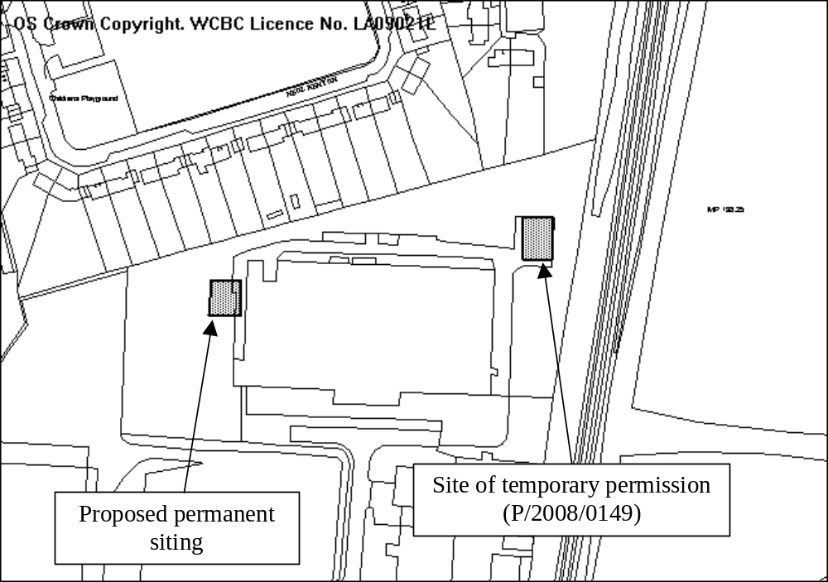

PROPOSAL

Permanent siting for a storage building granted a temporary permission in April (see below). The temporary location is on the east side of the factory, between it and the Wrexham-Shrewsbury railway line. The proposed permanent location is on the west side of the factory.

HISTORY

P/2008/0149 Erection of temporary building for storage of non-hazardous materials, tools and equipment. Granted 7.4.08

DEVELOPMENT PLAN

Within settlement limit. Policy GDP1 and EC6 apply.

CONSULTATIONS

Community Council: Notified 1.4.08
Local Member: Notified 1.4.08
Public Protection:
Highways: There appears to be a problem of inadequate parking in the locality but the proposal does not result in the loss of existing parking space nor does it involve an increase demand for parking. Given parking problems it is essential that the new facility is used solely for storage.
CCW: Advised that:
- the may support Great Crested Newts. The applicant should be conditioned to proposed an deliver amphibian avoidance/mitigation measures to the satisfaction of the LPA. It is anticipated these measures will entail Reasonable Avoidance Measures such as amphibian fencing prior to and throughout the duration of the proposed scheme.
- No objection due to temporary use of facility.
Environment Agency: Advised that:
- details imply that two ponds will be filled with natural groundwater/surface water or rain water run-off from the buildings. If this is the case, there are no water resource concerns. However if the application proposed to divert of abstract water from any watercourse or well/borehole, then they will be need to apply for an abstraction licence from the EA if more than 20 cubic metres per day is to be abstracted;
- In accordance with TAN15, the suitability of Sustainable Urban Drainage Systems must be considered. If SUDS are shown to work for the site, this system should be implemented;
- If the car park capacity is to be increased above 50 spaces then a suitably designed oil interceptor should be provided within the surface water drainage system;
- Waste from the maintenance and desilting of the ponds may be re-used on site. If otherwise, they must be disposed of at a suitable licensed facility or exempted site;
- Waste excavation or building waste much be disposed of in accordance with the Environmental Protection Act 1990;
- Importing waste for use as hardcore must be registered by the Agency as an exempt activity under the Waste Management Licensing Regulation 1994.
Other representations: 1 letter of objection expressing the following concerns:
- Applicants intend to use the building as a permanent building;
- The building is to be 7m tall and will over dominate garden;
- Impact on residential amenity as it will bring the factory and resultant noise and use close to the residential area;
- The siting is insensitive as there is plenty of land around the site to site the building away from the residential area;
- As the building is only for storage, could it be lower;
- The house of use should be limited to Mon-Fri 08:00-18:00, as the factory seems to run 24 hours a day.
Site Notice: Expired 5.3.08

SPECIAL CONSIDERATIONS

Siting, size, scale and design: The building will measure 15 metres x 20 metres, 4 metres high to the eaves and 7 metres to the ridge and is of a simple lightweight metal construction. In the context of the existing factory unit and wider industrial estate, this is a modestly sized structure. Its siting will not have a significant or adverse impact upon the visual amenity of the locality.

Residential amenity: The building would be located around 20 metres from the rear boundary of the nearest residential property and around 50 metres from the nearest dwelling. It will not come closer to any residential properties or boundaries than the existing factory unit. Given that the intended use is for storage only, I am satisfied it the proposal will not have a significant impact upon residential amenity. A condition limiting the use of the building to that proposed will be attached.

Ecology: The site lies around 30 metres from the Johnstown Newt Site Special Area of Conservation, although the application site itself is some 200 metres from the SAC boundary. The site therefore has the potential to support Great Crested Newts (GCN). The application includes a management plan for the site which proposes mitigation areas for GCN. CCW have advised a condition should be attached requiring these measures to be implemented. They have also confirmed that they have no objection in principle to the development but advise it is necessary for an assessment to be carried out under Regulation 48 of the Habitats Regulations. I am in the process of completing this assessment.

Conclusions: The siting, size and design of the development is acceptable, and subject to the implementation of mitigation proposals, it should not have an unacceptable impact upon Great Crested Newts.

RECOMMENDATION

That the Chief Planning Officer be given delegated authority to grant planning permission once a Habitat Regulations Assessment has been completed and agreed with the Countryside Council for Wales, subject to the following conditions:

CONDITION(S)

1. The development hereby permitted shall be begun before the expiry of five years from the date of this permission.
2. The building shall be constructed of the materials specified in the application documentation unless otherwise agreed in writing by the Local Planning Authority.
3. Notwithstanding the provisions of the Town and Country Planning (Use Classes) Order no part of the premises shall be used except for the precise purposes described in the application plans and documents.
4. Prior to commencement of development the mitigation areas described in The Mitigation Area Management Plan produced by Marches Ecology and dated March 2008 shall be created and shall thereafter be permanently retained and managed in accordance with The Mitigation Area Management Plan unless otherwise agreed in writing by the Local Planning Authority.

REASON(S)

1. To comply with Section 91(3) of the Town and Country Planning Act, 1990.
2. To ensure a satisfactory standard of appearance of the development in the interests of the visual amenities of the area.
3. To protect the amenities of the occupiers of nearby properties.
4. In order to protect wildlife interests, which are afforded special protection.

NOTE(S) TO APPLICANT

Your attention is drawn to Highway Supplementary Notes Numbered 1, 3, 4 and 5 on the enclosed "Applicants' Rights and General Information".

You are advised to take note of the advice issued by the Environment Agency in their letter dated 23 April 2008.
_____________________________________________________________________

APPLICATION NO:  P/2008 /0357  COMMUNITY:  Llay  WARD:  Llay | LOCATION:  1 RACKERY HALL MEWS RACKERY LANE LLAY WREXHAM  DESCRIPTION:  LEAN TO EXTENSION  APPLICANT(S) NAME:  MR & MRS HUMPHREYS | DATE RECEIVED:  03/04/2008  CASE OFFICER:  PF  AGENT NAME:  HOLT CONSERVATORIES
_____________________________________________________________________

THE SITE

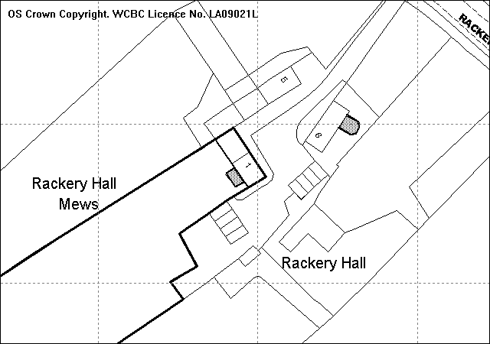
Existing UPVC conservatory
Approximate position of extension
Listed Building
Site
Garage
Application site
Application Site
Proposed site

PROPOSAL

As above.

HISTORY

16861 | Conversion of barns to 6 houses and alteration to existing vehicular and pedestrian access | Approved | 31.07.89
16862 | Listed Buildings Consent for conversion of barns to 6 houses | Approved | 15.09.89
CB/1999/3438 | Listed Buildings Consent for two storey extension | Refused | 06.09.99
CB/1999/3439 | Two storey extension to dwelling | Refused | 06.09.99
P/2003/0720 | Listed Building Consent for conversion and alteration to form 1 dwelling | Approved | 08.12.03
P/2008/0358 | Listed Building Consent for Lean to extension | Pending | next item

DEVELOPMENT PLAN

Outside settlement limit. UDP Policies EC9, PS2 and GDP1 apply. LPG. 13 ‘Houses in the Countryside’, 20 ‘House Extensions’ and 21 ‘Space around Dwellings’ apply.

CONSULTATIONS

Community Council: No Observations/objections
Local Members: No observations. Re-consulted 10.06.08
Other representations: 1 letter received:
- If the proposed plan sets a standard for any future lean-to extensions then there are particular concerns regarding the style of the windows and to maintain aesthetics the windows should be without a crossbar and of a similar style and design as the existing French windows currently on all properties regardless of whether they open or not
- If the proposal sets a design standard then object to the design of the windows on this proposed extension
- If permission to extend the barns is directly affected by what can and can’t be from the road then for parity no extensions should be allowed on any part of the barn conversion regardless of what can or can’t be seen from the road and regardless of any previous planning issues or exceptions
- The proposed drawings are incorrect as the extension is shown to be coming from living and dining room and the proposed extension extends only from the living room as properties 1 and 2 were converted into 1 dwelling.
- Properties 1 and 2 are elevated by at least 18 to 30 inches above the level of numbers 3, 4 and 5 which is significant for number 3 and causes fundamental concerns as the only door on the proposed extension is shown to open parallel to the direction of number 3.
- Concerned about that the proposed extension will result in an increase in noise nuisance as the extension will dissipate noise towards number 3 and will result in the outdoor space being closer to the boundary with number 3. Windows on the side will also result in noise from the living area be projected along this side of the building and as a result of the height differences will result in amplified noise nuisance.
- Concerned about privacy. A substantial part of garden and main living room is already overlooked from the patio and garden area of number 1 and the proposed extension by the very nature of it’s location will reduce privacy further as it will force social area of number 1 closer to boundary fence. Feel that any additional building that does not fully enclose number 1 would further erode privacy to an unacceptable level.
Re-notified 10.06.08 Further response received:
- Not specified whether glazing will be opening/obscured – reiterates points in previous letter re amplified noise nuisance from higher windows, suggest door and window is moved so that noise directed down garden
- Large 3 panelled window is out of keeping and excessive.
Site Notice: Expired 29.04.08

SPECIAL CONSIDERATIONS/ISSUES

Background: 1 Rackery Mews is a listed former agricultural building that was converted into 5 attached units forming an ‘L’ shape and 1 detached unit within the grounds of Rackery Hall. 1 Rackery Mews is situated at the south west end of the site furthest away from the main road. Number 1 and 2 Rackery Mews were converted into 1 dwelling in 2003. The proposal is for a small single storey lean to extension to the rear of property.

Amended plans have been received that show the extension to be 1 metre wider to remove the void area between end of extension and south east side boundary wall. As a result the south east boundary wall will be removed and the gable of extension will form new boundary. This will result in the boundary being stepped in slightly from the existing gable of the barn to the extension gable. The plans also show the door repositioned on the rear elevation of extension and a single 3 panel centralised mid height window on the north west side elevation.

Design/appearance: The proposed alterations have not significantly altered the appearance of the extension. The proposal remains relatively small in size and reflects the scale and design of the original barn and there appears to have been a former attachment to the building in a similar location prior to the conversion. The extension has a lean to roof and has used matching brick and slate to retain the character of the building and avoid appearing as a modern and obtrusive addition. The proposed windows match those on the existing building and would not adversely affect the appearance.

The side boundary wall that would be removed as part of the amendments is not an original feature of the barns or listed building and was constructed at the time of conversion. Although the retention of the wall would obscure the proposed extension to some extent and provide a clear break between the original building and the extension, the void that would leave a redundant space that could potentially lead to damp issues to the barn.

Although the retention of the wall is preferable is not an original feature and it may be possible to get a better matching brick on the extension than what is currently used for the wall. The extension would be stepped in by around 0.2 –0.3 metres from the main gable end and this will provide some visual break and distinction between the original building and the proposal.

Residential Amenity: The proposed extension is in accordance with the BRE daylight test on the adjoining dwelling. The garden of the adjoining dwelling is set at a lower level than the applicants. The repositioning of the door to the rear elevation has reduced overlooking into the garden area of the adjoining dwelling. The extension has also been set down below existing ground level, which further inhibits direct overlooking from the remaining side window. To minimise overlooking a condition requiring a planting scheme along part of the boundary with number 3 Rackery Hall Mews will be secured through condition. However I do not consider that obscure glazing is necessary.

With regards to concerns raised over noise being projected from the side window of the proposed extension I do not believe that there is any particular reason to raise this as a concern and in most cases this development would be permitted development and not be subject to control. Whilst the side window could be required to be fixed closed, I do not think that would make any significant difference to noise in the next door property.

Other issues: With regards to the points raised concerning the extension setting a precedent for other similar extensions, any subsequent application at the site would be determined on its own individual merits.

Conclusion: The new alterations are not significant in relation to the original submission and the impact on the setting and appearance of the listed building is minimal. Concerns raised regarding overlooking can be addressed through planning conditions and I am satisfied the no detrimental loss of amenity would result from the proposal.

RECOMMENDATION That permission be GRANTED

CONDITION(S)

1. The development hereby permitted shall be begun before the expiry of five years from the date of this permission.
2. No part of the development shall be commenced until samples of all external facing and roofing materials have been submitted to and approved in writing by the Local Planning Authority. The development shall only be carried out in strict accordance with such details as are approved.
3. Development shall only be carried out in strict accordance with the approved plans unless the prior written approval of the Local Planning Authority has been obtained.
4. Prior to the commencement of development a planting scheme for the first five metres on the north west boundary between numbers 1 and 3 Rackery Hall Mews shall be submitted to and approved, in writing, by the Local Planning Authority. The works shall be implemented in accordance with a timescale to be approved in conjunction with the scheme of details and shall be mantained for a period of not less than five years.

REASON(S)

1. To comply with Section 91(3) of the Town and Country Planning Act, 1990.
2. To ensure a satisfactory standard of appearance of the development in the interests of the visual amenities of the area.
3. To ensure that the development fully complies with the appropriate policies and standards.
4. To protect the amenities of the occupiers of nearby properties.

NOTE(S) TO APPLICANT

You should ensure that any difference between the plans approved under the Town and Country Planning Acts and under the Building Regulations is resolved prior to commencement of development, by formal submission of amended plans.

Please note that Listed Building Consent is required for the works hereby approved and development should not commence until such consent has been obtained.
_____________________________________________________________________

APPLICATION NO:  P/2008 /0358  COMMUNITY:  Llay  WARD:  Llay | LOCATION:  1 RACKERY HALL MEWS RACKERY LANE LLAY WREXHAM  DESCRIPTION:  LISTED BUILDING CONSENT FOR LEAN TO EXTENSION.  APPLICANT(S) NAME:  MR & MRS HUMPHREYS | DATE RECEIVED:  03/04/2008  CASE OFFICER:  PF  AGENT NAME:  HOLT CONSERVATORIES
_____________________________________________________________________

THE SITE

(see plan attached to P/2008/0357)

PROPOSAL

As above.

HISTORY

See previous report

DEVELOPMENT PLAN

Outside settlement limit. UDP Policies EC9, PS2 and GDP1 apply. LPG. 13 ‘Houses in the Countryside’, 20 ‘House Extensions’ and 21 ‘Space around Dwellings’ apply.

CONSULTATIONS

Community Council: No Observations/objections
Local Member: No observations
WACS: Object to the proposal as the proposed conservatory (aka lean to extension) is totally alien and out of character with a fine, well proportioned listed building, and as such it should be recommended for refusal.
RCAHMW: No observations
FHS: Consulted 07.04.08
DHS: Consulted 07.04.08
Site Notice: Expired 29.04.08

SPECIAL CONSIDERATIONS/ISSUES

Background: 1 Rackery Mews is a curtilage listed former agricultural building that was converted into 5 attached units forming an ‘L’ shape and 1 detached unit within the grounds of Rackery Hall. The site is at the south west end of the site furthest away from the main road. Number 1 and 2 Rackery Mews were converted into 1 dwelling in 2003. The proposal is for a small single storey lean to extension to the rear of property. Number 6 Rackery Mews, the detached unit, has a UPVC conservatory on the rear elevation facing the Listed Building that was made retrospectively and granted on appeal. The appeal decision stated that the Rackery Hall had undergone a lot of alterations and no longer reflected its original form and it was concluded that the UPVC conservatory did not have a harmful affect on the setting or character of the Listed Building.

Built Conservation: Although it is not normally considered appropriate to extend former barns, an unfortunate precedent has been set on the site despite the buildings being listed structures. The proposed extension, in this instance however, is located on the rear elevation of the barn, away from the main frontage of the Listed Building and so is not visible from the road or from within the former farm yard itself.

Conclusion: The proposal has been subject to some minor amendments involving a slight increase in width and the re-organising of the windows/doors. However the design of the extension remains as a simple lean-to with 3 full height and uniform glazed openings on the rear and 1 small 3 panel window on the side. The extension is of a scale and design that does not detract from the character or the simple agricultural form of the building. The rear location of the proposal and the sympathetic design would not detract from the character or setting of the Listed building I would recommend approval.

RECOMMENDATION A

That Welsh Assembly Government should be advised that Wrexham County Borough Council is disposed to grant Listed Building Consent in accordance with Article 3 of the Planning (Listed Building Conservation Area) Regulations 1990 subject to the conditions specified below.

CONDITION(S)

1. The works hereby granted consent shall be begun before the expiry of five years from the date of this consent.
2. Before they are installed on the development, full details of all new and replacement windows (including rooflights) and doors and railings shall be submitted for the further approval of the Local Planning Authority. The works as approved shall be carried out strictly in accordance with the details as approved.

REASON(S)

1. To comply with Section 18 of the Planning (Listed Building and Conservation Areas) Act 1990.
2. To ensure the works reflect the character and appearance of the building.

RECOMMENDATION B

That the Chief Planning Officer be authorised to issue the appropriate certificate subject to the following conditions, forthwith if WAG refers the application back to the Council for determination.
_____________________________________________________________________

APPLICATION NO:  P/2008 /0414  COMMUNITY:  Caia Park  WARD:  Whitegate | LOCATION:  SITE OF THE BUNGALOW (ADJACENT TO THE COMMUNITY CENTRE) ABENBURY ROAD WREXHAM  DESCRIPTION:  ERECTION OF 1 NO. BLOCK OF 5 APARTMENTS, CONSTRUCTION OF PARKING AND ALTERATION TO EXISTING VEHICULAR ACCESS.  APPLICANT(S) NAME:  MESSRS RIGBY & GOODE LTD | DATE RECEIVED:  16/04/2008  CASE OFFICER:  KH  AGENT NAME:  ANTHONY WOOD
_____________________________________________________________________

P/2008 /0414

THE SITE

Land located off the southern side of Abenbury Way and currently occupied by a bungalow. Access to the site is onto Frog Hall Lane. There are residential properties to the north and south with the Community Centre and associated car park to the east.
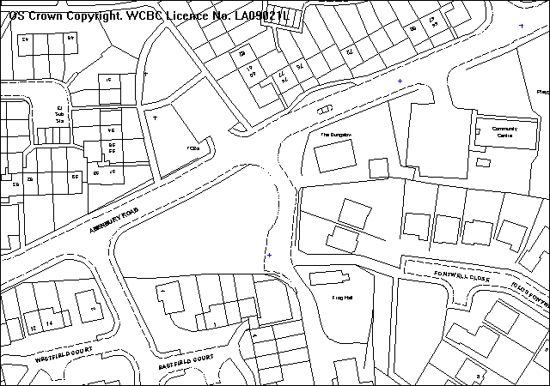
site

PROPOSAL

Reserved matters application for five apartments, 4 x 2 bedroom and 1 x 1 bedroom.

HISTORY

P/2006/1043 Outline permission for the demolition of existing bungalow and
erection of 5 no. 2 bedroom flats. Granted 25.05.07

DEVELOPMENT PLAN

Within settlement, policies PS1, PS2, H2 and GDP1 refer.

CONSULTATIONS

Community Council: No objection
Local Member: Notified 07.09.06
Highways: Subject to adequate visibility, parking and gates set
back from the highway, no objections.
Other Representations: 2 letters of concern with regard to:
- overlooking
- noise associated with 5 properties compared to the previous one dwelling
- concerned that vehicles will park on Frog Lane at the junction with Abenbury Road
- junction of Frog Lane and Abenbury Road needs to be kept clear of construction equipment related to the new development
- concerned regarding visibility from Frog Lane eastwards with adequate visibility required to cater for increased traffic
Site Notice: Expired 21.05.08

SPECIAL CONSIDERATIONS/ISSUES

Visual impact of building: I consider the proposed building is not overly large with the main two-storey element of the building comparable to a pair of semi-detached properties. A single-storey element, closest to Abenbury Road, would minimise the impact on the streetscene whilst overall, reducing the mass of the building when viewed in particular from lower lying land, to the east.

Highways: Access to the site would be via an existing access onto Frog Hall Lane which connects to Abenbury Road. A condition to remove all obstructions to visibility over a metre, 2.4m back from the nearside edge of the carriageway of Abenbury Road to the north east corner of the site, will ensure the increase in traffic can be accommodated safely. Visibility to the west benefits from crossing open space.

Applying maximum parking standards 10 spaces would be required. Scheme provides 8 spaces but I am satisfied that given the proximity to local facilities and bus routes and the ease of accessibility to the Town Centre, the reduction can be justified. The location is likely to encourage less reliance on the car and the number of spaces provided will ensure highway safety is not compromised.

Amenity: The building’s orientation and distances to nearby properties ensures no significant loss of light/privacy to adjoining properties. A ground floor kitchen window on the northern gable elevation is within approximately 18m of windows on properties at Pentre Gwyn but I am satisfied that privacy can be maintained with appropriate boundary treatment. There are two windows proposed on the southern gable elevation but privacy can be similarly protected by retention of existing fence/new fence to the ground floor obscurely glazing the first floor bathroom window.

A first floor window will to some extent overlook the adjoining garden of an existing property to the south but given its use as a bedroom as opposed to a living room I would not anticipate any significant loss of privacy.

Small private garden/patio areas are provided for each apartment and the site is adjacent to extensive existing recreation land.

General: I cannot control the parking of vehicles at the junction of Frog Hall Lane and Abenbury Road. The section of the road closest to the junction is adopted and should vehicles cause an obstruction then the police have powers to intervene. I would not anticipate levels of noise from increased occupation significantly impacting on existing amenity.

Conclusion: I am satisfied the scheme is acceptable and will not significantly compromise nearby amenity or highway safety. The design is appropriate in the context of nearby existing development and will not be overly intrusive.

I have, however, requested minor alterations to the parking layout and provision of the visibility splay east of the junction of Abenbury Road/Frog Hall Lane on the block plan.

RECOMMENDATION That permission be GRANTED

CONDITION(S)

1. The development hereby approved shall be commenced before 7 July 2012.
2. No part of the development shall be commenced until samples of all external facing and roofing materials have been submitted to and approved in writing by the Local Planning Authority. The development shall only be carried out in strict accordance with such details as are approved.
3. Notwithstanding the approved plans details of all means of site boundary enclosure (including internal sub-division) shall be submitted to and approved by the Local Planning Authority. The works as approved shall be carried out strictly in accordance with the details prior to the first occupation of any of the units hereby approved and retained thereafter unless otherwise agreed, in writing, with the Local Planning Authority.
4. Prior to commencement of development, details of excavation works and finished floor levels in relation to nearby existing residential development on Llwyn Onn Park and Abenbury Road shall be submitted to and approved by the Local Planning Authority. Works shall be carried out strictly in accordance with the details as approved.
5. Prior to the first occupation of any of the units hereby approved, from a point on the centreline of Frog Hall Lane, 2.4m back from the nearside edge of the carriageway of Abenbury Road to the north east corner of the site, all obstructions to visibility including all vegetation shall be reduced to and thereafter retained at a height not exceeding 1 metre above the level of the adjoining carriageway.
6. Within 3 months of commencement of development on site, full details of both hard and soft landscape works for the site shall be submitted to and approved in writing by the Local Planning Authority. The works shall be implemented in accordance with a timescale to be approved in conjunction with the scheme of details.
7. Within six months of the first use of the development, trees and shrubs shall be planted on the site in accordance with a scheme which has been submitted to and approved by the Local Planning Authority. Any trees or shrubs removed, dying, being severely damaged, or becoming seriously diseased within five years of planting shall be replaced by trees or shrubs of a similar size and species to those originally required to be planted.
8. Before development hereby approved is occupied the first floor window indicated on the southern gable elevation shall be glazed with obscure glazing and shall thereafter be permanently retained in this condition. Notwithstanding the approved plans no part of the window shall be capable of being opened below a height of 1.7m above the first floor, finished floor level.
9. Details of a scheme to protect the privacy of residents of properties of Pentre Gwyn off the northern side of Abenbury Road, from the use of windows on the northern gable elevation of the proposed development shall be submitted to and approved, in writing, by the Local Planning Authority. The scheme, as approved, shall be fully implemented prior to the first occupation of teh proposed unit and retained thereafter.
10. Foul water and surface water discharges shall be drained separately from the site.
11. No surface water shall be allowed to connect, either directly or indirectly, to the public sewerage system unless otherwise approved, in writing, by the Local Planning Authority.
12. Land drainage run-off shall not be permitted to discharge, either directly or indirectly, into the public sewerage system.
13. No windows, door or other openings shall be inserted into any elevation of the building, other than those indicated on the approved plans.
14. The vehicle parking and turning areas indicated on the approved plans shall be laid out, surfaced and drained prior to the first use of the building hereby granted and shall thereafter be retained for those purposes, free of all obstruction.

REASON(S)

1. To comply with Section 92 of the Town and Country Planning Act, 1990.
2. To ensure a satisfactory standard of appearance of the development in the interests of the visual amenities of the area.
3. In the interests of the general visual amenities of the area and to protect nearby residential amenity.
4. In the interests of the general visual amenities of the area and nearby residential amenity.
5. To ensure adequate visibility from and of emerging vehicles.
6. To ensure a satisfactory standard of appearance of the development in the interests of the visual amenities of the area.
7. To ensure a satisfactory standard of appearance of the development in the interests of the visual amenities of the area.
8. To protect the amenities of the occupiers of the adjoining dwelling.
9. To protect the amenities of the occupiers of nearby properties.
10. To protect the integrity of the public sewerage system.
11. To prevent hydraulic overloading of the public sewerage system, to protect the health and safety of existing residents and ensure no detriment to the environment.
12. To prevent hydraulic overload of the public sewerage system an dpollution of the environment.
13. To protect the amenities of the occupiers of nearby properties.
14. In the interests of highway safety.

NOTE(S) TO APPLICANT

Your attention is drawn to Highway Supplementary Notes Numbered 1, 3, 4 and 5 on the enclosed "Applicants' Rights and General Information".

If a connection is required to the public sewerage system, the developer is advised to contact Dwr Cymru, Welsh Waters Network Development Consultants on 01443 331155.
_____________________________________________________________________

APPLICATION NO:  P/2008 /0416  COMMUNITY:  Gwersyllt  WARD:  Gwersyllt West | LOCATION:  COPPINS MOLD ROAD GWERSYLLT WREXHAM  DESCRIPTION:  ALTERATIONS TO PROPERTY TO EXTEND BEDROOMS AND LOUNGE AND NEW CONSERVATORY.  APPLICANT(S) NAME:  MR M COATES | DATE RECEIVED:  17/04/2008  CASE OFFICER:  PF  AGENT NAME:  MR D B DAVIES
_____________________________________________________________________

SITE
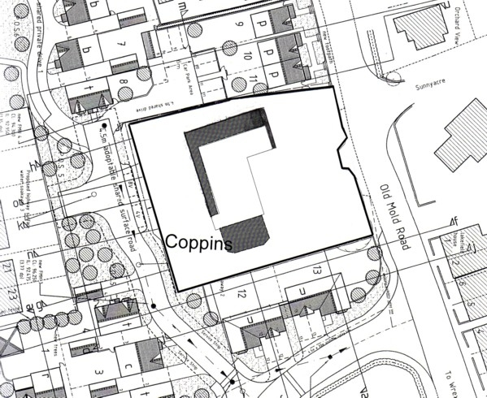
Extensions
Proposed plot 12
Proposed plot 11
Existing boundary fence

NB this plan shows part of approved layout for Jutland Avenue residential scheme (as yet unbuilt)

PROPOSAL

As above.

HISTORY

6/22712 Erection of glazed cover over swimming pool and link conservatory. Granted 20.10.1994

Adjoining site
P/2006/0091 Residential development comprising of 9 no. detached dwellings, 2 no.
semi-detached dwellings and 2 no. split-level detached bungalows,
new vehicular/pedestrian access and all associated external works.
Granted 05.07.2007

DEVELOPMENT PLAN

Within settlement. Policies GDP1, PS2 and Local Planning Guidance Note 20 (LPG20) apply.

CONSULTATIONS

Community Council: No observations
Local Member: Notified 21.04.2008
Other representations: 12 neighbouring occupiers notified 07.05.2008. 1 letter of objection received raising the following concerns:
- The existing dwelling is substantial at present and proposals would lead to excessively large dwelling out of proportion with the plot size.
- The conservatory is close to the boundary of plots on the Castlemead development leading to loss of privacy for both parties.
- Bedroom extensions would lead to over dominance, loss of privacy and loss of light to plots on Castlemead development.
Site Notice: Expired 14.05.2008

SPECIAL CONSIDERATIONS

Background: The existing dwelling is two storeys and within a generous sized plot. The site is surrounded by a plot of land which has a permission for the erection of 13 dwellings. Development on this site has commenced and will form a material planning consideration in the determination of this application.

Design: The site lies within the settlement limit where there is no policy restriction upon the size of extensions to dwellings. However, any proposals must accord with GDP1. Alterations are proposed to the rear of the dwelling over an existing decking at first floor level area to provide an extension to the living space. The projection is minimal at 2.5 metres. The roof will incorporate 4 small gables. The extension wraps around the northern elevation projecting 3.8 metres. This then ties into the existing front projection of the dwelling. The dwelling is set back 16 metres from the road. I do not consider that the extensions will have a detrimental impact upon the street scene given the existing projection and the mixture of dwelling types in the area. A conservatory is also proposed projecting 5.6 metes from the southern elevation and I do not see any impact caused by this part of the proposal on the street scene.

Privacy: The application is surrounded by the proposed residential development on the north, south and western elevations. The northern elevation currently has four bedroom windows. This is reduced to one bedroom window which would face a parking area of the residential development. The other windows will be to the proposed dressing room and en-suite (obscurely glazed) and a study. I consider this an improvement upon the current situation in terms of overlooking and loss of privacy. I do not consider any loss of amenity caused by the lounge extension to the rear.

The conservatory extension is proposed leaving a distance of 12 metres to the rear of proposed plot no. 12 on the residential development. This is separated by a boundary fence (currently in situ). Normally, LPG20 requires a distance of 22 metres between directly facing habitable room windows. However in this particular instance I believe that any potential overlooking can be mitigated by the improvement of the existing boundary fence to bring it to a sufficient height above the finished floor level of the conservatory.

Daylight: The extension to the northern elevation is will bring the dwelling closer to the boundary with proposed plot 11 on the neighbouring development. A gap of 1.5 metres will remain between the front elevation and rear elevation of the two dwellings. I have carried out the BRE daylight test to the rear habitable room windows of plot 11. I consider that the remaining gap between the extension and boundary and the fact that the extension will sit further back than plot 11 will mean there will not be a detrimental loss of daylight.

Other issues: The remaining site has adequate parking facilities and private garden space in accordance with current Council planning guidance.

Conclusion: I have given the above issues careful consideration and conclude that subject to suitable condition addressing potential overlooking and privacy issues the proposal will not cause detriment to existing surrounding occupiers or potential occupiers of the neighbouring residential development. Although the proposed works appear significant, I do not consider them out of accord with policy GDP1. As such I recommend accordingly.

RECOMMENDATION That permission be GRANTED

CONDITION(S)

1. The development hereby permitted shall be begun before the expiry of five years from the date of this permission.
2. Development shall only be carried out in strict accordance with the approved plans unless the prior written approval of the Local Planning Authority has been obtained.
3. No facing materials shall be used other than materials matching those used on the existing building.
4. Notwithstanding the details shown on the approved plans numbered MC/01/01 and MC/01/03 the study room window shall only be glazed and reglazed using obscure glass.
5. Prior to the first use of the conservatory hereby approved the close boarded fence between points A and B as highlighted in blue along the southern boundary on Drawing No. MC/01/01 shall be increased in height to 1.8m above the finished floor level of the conservatory. The fence shall be permanently retained and not reduced below this height without the prior written permission of the Local Planning Authority.

REASON(S)

1. To comply with Section 91(3) of the Town and Country Planning Act, 1990.
2. To ensure that the development fully complies with the appropriate policies and standards.
3. To ensure a satisfactory standard of appearance of the development in the interests of the visual amenities of the area.
4. To protect the amenities of the occupiers of nearby properties.
5. To protect the amenities of the occupiers of nearby properties.

NOTE(S) TO APPLICANT

You should ensure that any difference between the plans approved under the Town and Country Planning Acts and under the Building Regulations is resolved prior to commencement of development, by formal submission of amended plans.

You are advised that building work which involves work on an existing wall shared with another property, building on the boundary with a neighbouring property or excavating near a neighbouring building may require the separate consent of the neighbour under the provisions of the Party Wall Act. If you require further information or advice please contact the Building Control Section on 01978 292050.

The proposed development lies within a former coal mining area. You should take account of any hazards to stability which may arise from coal working in or near the site. Specific advice on any past working may be obtained from the Coal Authority Mining Reports Service. Phone 0845 762 6848 or from www.coal.gov.uk.

Any operations which may involve entry into former workings, shafts or adits or implementation of site investigations or other works may need permission from the Coal Authority.

_____________________________________________________________________

APPLICATION NO:  P/2008 /0418  COMMUNITY:  Acton  WARD:  Rhosnesni | LOCATION:  79 HOLT ROAD WREXHAM  DESCRIPTION:  DEMOLITION OF EXISTING SHOP UNIT & TWO STOREY FLAT OVER, ERECTION OF 1 NO. STOCK OF 6 NEW FLATS, CONSTRUCTION OF NEW VEHICULAR & PEDESTRIAN ACCESS AND PARKING AREA.  APPLICANT(S) NAME:  MR & MRS ADRIAN EDWARDS | DATE RECEIVED:  17/04/2008  CASE OFFICER:  KH  AGENT NAME:  LAWRAY PARTNERSHIP  MR KEITH O'HANLON
_____________________________________________________________________

P/2008 /0418

THE SITE
A 2¹/₂ storey building. The ground floor is used for retail premises with a two-storey dwelling over.
site

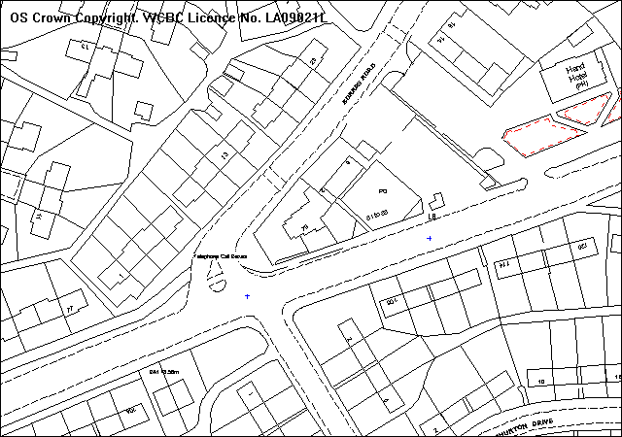

PROPOSAL

As above.

HISTORY

P/2000/0001 Change of Use to A3. Permission refused.
CB03135 Change of Use from chemist to fast-food take-away. Refused
04.06.99

DEVELOPMENT PLAN

Within settlement limit. Policy GDP1 refers.

CONSULTATIONS

Community Council: Object on the grounds the proposal would be too close
to a busy junction and felt the vehicular access and
parking area were inadequate for a development of this
size.
Local Members: Notified 22.04.08
Highways: Concerns re automatic gate and clearance behind each
parking space to allow for turning. Subject to the above
issues being addressed then conditions regarding
visibility at access, access width and relocation of
existing speed cushions on Borras Road.
Welsh Water: No objections subject to conditions.
Environment Agency: No observations.
Other Representations: None
Site Notice: Expired 09.06.08

SPECIAL CONSIDERATIONS/ISSUES

Design: The site is prominently located at the junction of Borras Road and Holt Road, particularly when viewed from the west, travelling out of the Town Centre. The overall height is marginally higher than the existing building but the proposed building is brought further forward on the site and its width and length increases to give greater mass.

I am generally satisfied with the design and whilst it will contrast with more conventional dwellings in the area it will not be overly dominant or intrusive and will positively affect the streetscene. Materials and details of windows will be important and both are conditioned. Materials will be a combination of render, brick and timber.

I am requesting minor changes to the design, in particular to the front elevation.

Highways: Concerns have been expressed by the community council with regard to access arrangements and parking provision for the development.

I am conscious that the existing residential and retail uses could generate comparable movements to the proposed development. Parking is currently haphazard with parking areas extending closer to the junction with all vehicles having to reverse off the site onto Borras Road.

The current proposal concentrates movements to one access point which is further away from the junction. Maximum parking standards would require 9 parking spaces with the proposal providing 6 – 1 space for each one-bedroomed apartment. The site is however located close to public services and shopping facilities and is in walking distance of the Town Centre. Due to the location it might be seen by prospective occupiers as a place where private car ownership is not essential and this would align with sustainable transport initiatives to discourage use of the car.

Amenity: The proposal complies with adopted separation distances and will ensure the amenity of nearby existing occupiers is protected.

Conclusion: I am satisfied the proposal is acceptable with the building complimenting the streetscene whilst ensuring that residential amenity or highway safety is not compromised.

I have requested minor changes to the front elevation. Subject to the receipt of satisfactorily amended plans, I recommend approval.

RECOMMENDATION That permission be GRANTED

CONDITION(S)

1. The development hereby permitted shall be begun before the expiry of five years from the date of this permission.
2. No part of the development shall be commenced until samples of all external facing and roofing materials have been submitted to and approved in writing by the Local Planning Authority. The development shall only be carried out in strict accordance with such details as are approved.
3. Before they are installed on the development, drawings to scale 1:20 fully detailing all new windows (including roof lights) and doors shall be approved in writing by the Local Planning Authority. The details shall fully describe the proposed materials, decorative finish, sills, heads etc, method of opening and glazing type. Works shall only be carried out in strict accordance with such details as are approved.
4. No development shall commence until finished floor levels for the proposed building in relation to existing development has been submitted to and approved in writing by the Local Planning Authority. Development shall be carried out strictly in accordance with these details.
5. Notwithstanding the approved plans full details of the finished treatment of all elevations including areas of brickwork, render and timber cladding shall be submitted to and approved by the Local Planning Authority. Works shall only be carried out in strict accordance with the details as approved.
6. Details of all boundary means of enclosure shall be submitted to and approved by the Local Planning Authority. Works as approved shall be completed prior to the first occupation of any of the units hereby approved and retained thereafter.
7. No windows, doors or other openings shall be inserted into any elevation of the building, other than those indicated on the approved plans.
8. Notwithstanding the provisions of the Town and Country Planning (General Permitted Development) Order 1995, no gates shall be erected within 5m of the highway boundary.
9. Development shall only be carried out strictly in accordance with the recommendations/mitigation contained within the Protected Species Survey dated 8 May 2008.
10. The proposed access shall have a visibility splay of 2.4m x 33m in both directions measured along the nearside edge of the adjoining carriageway over land within the control of the applicant and/or the Highway Authority. Within the splays there shall be no obstruction in excess of 1 metre in height above the level of the adjoining carriageway. The splay shall be provided prior to commencement of use/occupation of the development hereby approved and shall thereafter be retained clear of such obstruction.
11. From a point on the centre line of the access 2.4 metres back from the edge of the footway, to points 3.3 metres to both sides of that point measured along the edge of the carriageway, all obstructions to visibility shall be reduced to and thereafter maintained at a height not exceeding 0.6 metre above the level of the adjacent carriageway.
12. Details of reinstating to full height construction the existing dropped vehicular crossing along Borras Road and relocation of the existing speed cushions fronting the proposed access along Borras Road shall be submitted to and approved in writing by the Local Planning Authority. The works shall be carried out strictly in accordance with the details as approved to a timescale to be agreed as part of the submitted details.
13. Foul water and surface water discharges shall be drained separately from the site.
14. No surface water shall be allowed to connect, either directly or indirectly, to the public sewerage system unless otherwise approved, in writing, by the Local Planning Authority.
15. Land drainage run-off shall not be permitted to discharge, either directly or indirectly, into the public sewerage system.
16. The vehicle parking and turning areas indicated on the approved plans shall be laid out, surfaced and drained prior to the first use of the building hereby granted and shall thereafter be retained for those purposes, free of all obstruction.

REASON(S)

1. To comply with Section 91(3) of the Town and Country Planning Act, 1990.
2. To ensure a satisfactory standard of appearance of the development in the interests of the visual amenities of the area.
3. To ensure a satisfactory standard of appearance of the development in the interests of the visual amenities of the area.
4. To protect the amenities of the occupiers of nearby properties.
5. To ensure a satisfactory standard of appearance of the development in the interests of the visual amenities of the area.
6. To ensure a satisfactory standard of appearance of the development in the interests of the visual amenities of the area.
7. To protect the amenities of the occupiers of nearby properties.
8. In the interests of the free and safe movement of traffic on the adjacent highway.
9. In order to protect wildlife interests, which are afforded special protection.
10. To ensure that adequate visibility is provided at the proposed point of access to the highway.
11. For the safety and convenience of all pedestrians, but in particular, the elderly, the disabled and wheelchairs, pram, and pushchair users.
12. In the interests of vehicular and pedestrian safety.
13. To protect the integrity of the public sewerage system.
14. To prevent hydraulic overloading of the public sewerage system, to protect the health and safety of existing residents and ensure no detriment to the environment.
15. To prevent hydraulic overload of the public sewerage system and pollution of the environment.
16. In the interests of highway safety.

NOTE(S) TO APPLICANT

Your attention is drawn to Highway Supplementary Notes Numbered 1, 3, 4 and 5 on the enclosed "Applicants' Rights and General Information".

The proposed access shall take the form of a dropped vehicular crossing for which the applicant will need to construct a dropped kerb crossing outside the property including strengthening of the footway at the point of access and will need to apply for formal consent pursuant to Section 184 of the Highways Act 1980.

The reinstatement of the existing dropped kerb crossing fronting the development site along Borras Road to full height construction will also require Section 184 consent.

The relocation of the existing speed cushions fronting the proposed access along Borras Road will require a public consultation and the necessary construction works. In order to carry out these works the applicant will be required to enter into a Section 278 agreement with the Council. The cost of the consultation process and construction works shall be borne by the developer.

With regard to Condition 05 further consideration is required of the areas to be rendered or clad with timber and areas of brickwork.

If a connection is required to the public sewerage system, the developer is advised to contact Dwr Cymru, Welsh Waters Network Development Consultants on 01443 331155.
_____________________________________________________________________

APPLICATION NO:  P/2008 /0422  COMMUNITY:  Marchwiel  WARD:  Marchwiel | LOCATION:  BRYN Y GROG HALL FARM MARCHWIEL WREXHAM  DESCRIPTION:  ERECTION OF REPLACEMENT AGRICULTURAL BUILDING.  APPLICANT(S) NAME:  MR W L PRICE | DATE RECEIVED:  17/04/2008  CASE OFFICER:  PF  AGENT NAME:  MR R LYNCH
_____________________________________________________________________

SITE

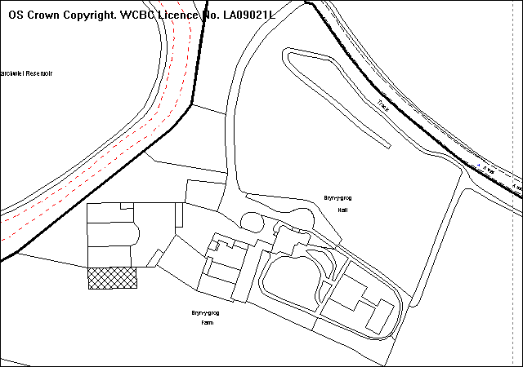
Proposed building
Location of previous proposal
Bryn Y Grog Hall
A 525

PROPOSAL

The erection of a 610m² steel framed agricultural building. The building would be 5.9 metres to the ridge.

HISTORY

16193 Erection of stock buildings GRANTED 06.04.1989
P/2004/0914 Notification for storage barn GRANTED 05.08.2004
P/2007/1177 Erection of replacement agricultural building. REFUSED 03.12.2007

DEVELOPMENT PLAN

Outside settlement limits and within Green Barrier and a Special Landscape Area (SLA). Bryn-. Bryn-Y-Grog Hall is a listed building. Policies EC1, EC3, EC5, EC9, PS2 and GDP1 of the UDP are relevant, together with LPGN 7.

CONSULTATIONS

Community Council: Object. There is no agriculture taking place on site. The building is not a replacement.
Local Member: Notified 21.04.2008.
Highways: No objections.
Public Protection: Comments relating to building works and noise.
Dee Valley Water: Notified as adjoining occupier (Marchwiel Reservoir).
Press Notice: Expired 06.06.2008.
Other representations: 1 neighbouring occupier notified 24.04.2008
Site Notice: Expired 14.05.2008.

SPECIAL CONSIDERATIONS

Background: This application is a resubmission following a previous refusal of planning permission for the erection of an agricultural building to the front of the site as detailed above (P/2007/1177). This was refused on the basis that it would detract from the setting of Bryn Y Grog Hall, a Grade II listed building. The previous application also included justification for the agricultural need for the building. Policy EC3 allows for the construction of new agricultural buildings within an existing farm complex. There is evidence of a previous agricultural building which, according to the applicant was destroyed by fire.

Built Conservation and Landscape: The revised location addresses the built conservation in terms of the impact of the proposed structure on the setting of the listed building. Although the building sits to the south of the walls outside the farm complex, the proposed location is an improvement upon the previous application and is has considerably less visual intrusion upon the SLA and is closely related to the existing farm complex. As such no objections raised.

Highways: The access from Bryn Y Grog Hall Farm on to the A525 is considered inadequate in both directions. The applicant has stated that the farm is linked to two other farms by internal field tracks and as such the building will not result in a marked increase in use of this access. On this basis highways would raise no objection.

Conclusion: The applicant has previously submitted justification for the agricultural need for this proposal. Subject to a condition strictly restricting the use to agriculture I recommend accordingly.

RECOMMENDATION That permission be GRANTED

CONDITION(S)

1. The development hereby permitted shall be begun before the expiry of five years from the date of this permission.
2. Development shall only be carried out in strict accordance with the approved plans unless the prior written approval of the Local Planning Authority has been obtained.
3. No part of the development shall be commenced until samples of all external facing and roofing materials have been submitted to and approved in writing by the Local Planning Authority. The development shall only be carried out in strict accordance with such details as are approved.
4. The agricultural building hereby approved shall be used solely for agricultural purposes in connection with the agricultural use of the site.

REASON(S)

1. To comply with Section 91(3) of the Town and Country Planning Act, 1990.
2. To ensure that the development fully complies with the appropriate policies and standards.
3. To ensure a satisfactory standard of appearance of the development in the interests of the visual amenities of the area.
4. The site lies outside any recognised settlement limits within open countryside where other uses would not be permitted.

NOTE(S) TO APPLICANT

All works, ancillary operations and the use of plant and machinery which are audible at the site boundary shall be carried out only between 0730 hours and 1800 hours Monday to Friday, between 0800 hours and 1400 hours on Saturdays, and at no time on Sundays and Bank Holidays.

Applicants should note that the Council has the option to control site noise by means of a Control of Pollution Act 1974, Section 60, Notice, where deemed necessary.

There shall be no bonfires on the site, to include the prohibition of the burning of cleared vegetation.
_____________________________________________________________________

APPLICATION NO:  P/2008 /0427  COMMUNITY:  Gresford  WARD:  Marford & Hoseley | LOCATION:  21 SYCAMORE DRIVE MARFORD WREXHAM  DESCRIPTION:  EXTENSION OVER EXISTING GARAGE.  APPLICANT(S) NAME:  MR & MRS J A SLOAN | DATE RECEIVED:  18/04/2008  CASE OFFICER:  LB1  AGENT NAME:  W A DARLINGTON
_____________________________________________________________________

SITE

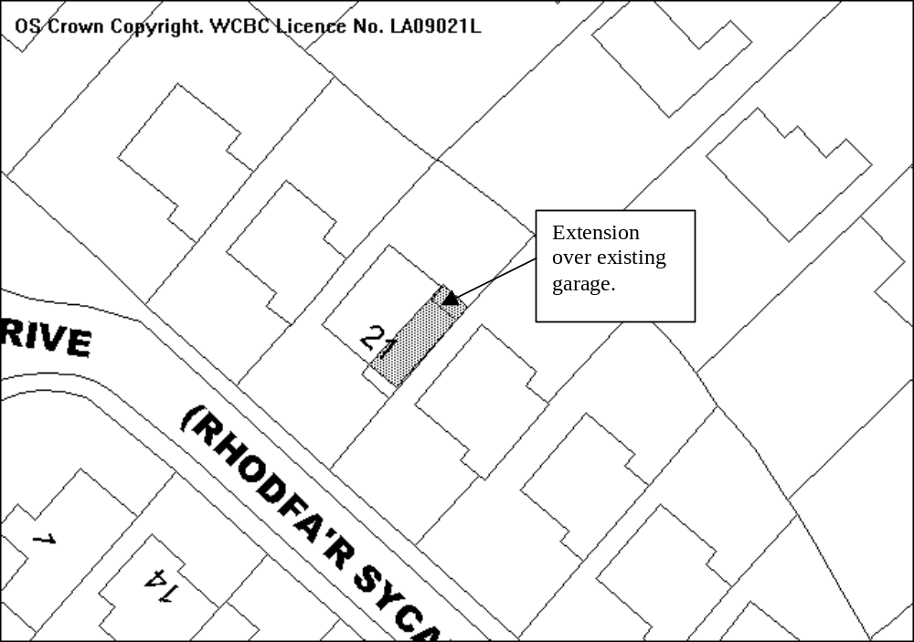

PROPOSAL

As above.

HISTORY

No relevant history.

DEVELOPMENT PLAN

Lies within settlement limit, GDP1, PS2, LPGN 20, 21 and 16 apply.

CONSULTATIONS

Community Council: No objections
Local Member: Consulted 22/04/08
Other representations: One letter received:
- The more houses that are allowed to have house extensions the less properties there are available for people trying to climb the property ladder.
- Another house with no garage will exacerbate the on street parking problem that currently exists on the road.
- There may be an adverse impact upon local services, these houses were meant for one or two children families. The house isn’t supposed to grow with the family, it should be other way round.
Site Notice: Expired 15/05/08

SPECIAL CONSIDERATIONS

The property is a three bedroomed detached house which currently has a garage and drive to allow for off street parking. The proposed extension is above the existing garage to create an additional bedroom and en-suite; the garage is to be converted to a playroom.

The design of the extension is the same as that on the two neighbouring properties that have previously been extended in the same way. It is in keeping with the locality and will not have a detrimental impact upon the street scene. The proposed extension passes the BRE daylighting test in relation to the neighbouring properties and no overlooking will be created.

The existing garage is to be converted into a playroom; to ensure that there is adequate off street parking the existing driveway is to be extended to allow off street parking for 3 cars. The provision and retention of this parking will be conditioned.

In my view, the property will not be excessively extended and there are a variety of three and four bedroomed properties in the area, thus there will be no detrimental impact on those wishing to climb the property ladder.

Conclusion: The proposed extension will have no adverse impact on any neighbouring properties and sufficient off street parking is being provided to prevent congestion on the road. I therefore recommend accordingly.

RECOMMENDATION That permission be GRANTED

CONDITION(S)

1. The development hereby permitted shall be begun before the expiry of five years from the date of this permission.
2. No facing materials shall be used other than materials matching those used on the existing building.
3. Development shall only be carried out in strict accordance with the approved plans unless the prior written approval of the Local Planning Authority has been obtained.
4. The proposed additional parking area indicated on the approved plan shall be completed within one month of the first use of the development and shall therafter be retained clear of any obstruction to its use for private car parking.

REASON(S)

1. To comply with Section 91(3) of the Town and Country Planning Act, 1990.
2. To ensure a satisfactory standard of appearance of the development in the interests of the visual amenities of the area.
3. To ensure that the development fully complies with the appropriate policies and standards.
4. To ensure there is adequate off road parking in the interests of highway safety.
_____________________________________________________________________

APPLICATION NO:  P/2008 /0429  COMMUNITY:  Esclusham  WARD:  Esclusham | LOCATION:  9 Y DDOL BERSHAM WREXHAM  DESCRIPTION:  PROVISION OF DORMER TO PROVIDE BEDROOM IN ROOF SPACE.  APPLICANT(S) NAME:  MR D WILLIAMS | DATE RECEIVED:  18/04/2008  CASE OFFICER:  PF  AGENT NAME:  MR D WILLIAMS
_____________________________________________________________________

SITE
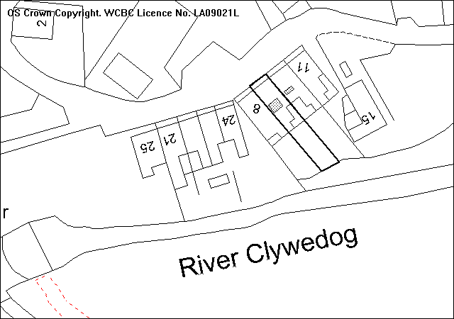
Proposed roof extension
Existing smaller roof extension, 10 Y Ddol

PROPOSAL

a 2.7 metre wide by 1.9 metre high roof extension on the rear elevation of the dwelling. The structure would sit more than half way across the rear roof plane. A small roof light is also proposed in the same elevation

HISTORY

P/2008/0025 – Provision of dormer to provide bedroom in roof space.
Refused 06.03.2008

DEVELOPMENT PLAN

Within settlement limit and Bersham Conservation Area. Policies GDP1, PS2, EC7, Local Planning Guidance Notes 4 (Conservations Areas) and 20 (House Extensions) are relevant.

CONSULTATIONS

Community Council: Support application.
Local Member: Requests application be reported to committee.
Other representations: 3 neighbouring occupiers notified.
Site Notice: Expired 14.05.2008

SPECIAL CONSIDERATIONS

Background: This application is a resubmission following a previous refusal as detailed above. This proposal differs very little in so far as the window has moved towards the eastern side of the structure. The neighbouring property has an existing roof extension on a much smaller scale. A more traditional style dormer has been suggested.

Design: The design of the extension is inappropriate and out of character with the Bersham Conservation Area. The extension is out of proportion with the building and consisting of poor quality materials, not of a standard appropriate to a conservation area. Detailed as drawn, the extension could potentially project over the ridge-line in construction, further detracting from the appearance of the building. This would be contrary to the guidelines set out in LPG 20, which states that roof extensions should not cover and over dominate the roof.

The neighbouring dwelling has a roof extension of similar design but at a much smaller scale and built prior to extension of the Bersham Conservation Area. Allowing a much larger extension such as this in this design could set a precedent within the Conservation Area and as such should be refused. As such I recommend accordingly.

RECOMMENDATION That permission be REFUSED

REASON(S)

1. The roof extension, by virtue of its scale, design, materials and siting, would neither preserve nor enhance the character of the Bersham Conservation Area and as such would be detrimental to the visual amenity of the area. This would be contrary to policy EC7 of the Wrexham Unitary Development Plan and Local Planning Guidance Notes 7 (Conservation Areas) and 20 (House Extensions).
_____________________________________________________________________

APPLICATION NO:  P/2008 /0432  COMMUNITY:  Acton  WARD:  Acton | LOCATION:  12 FFORDD ELWY WREXHAM  DESCRIPTION:  FIRST FLOOR BEDROOM EXTENSION  APPLICANT(S) NAME:  MR P C HUGHES | DATE RECEIVED:  21/04/2008  CASE OFFICER:  SEH  AGENT NAME:  MR P C HUGHES
_____________________________________________________________________

THE SITE

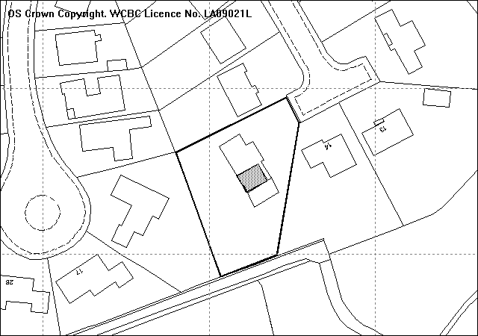
Approximate position of first floor extension
Site

PROPOSAL

As Above.

HISTORY

Code No | Description | Decision | Decision date
11381 | Extension to dining room, porch and cloakroom | Granted | 17/10/1984
16277 | Extension to provide conservatory | Granted | 30/1/1989
19931 | Provision of pitched roof to existing garage | Granted | 12/12/1991
P/2001/0476 | Single storey garage extension | Granted | 14/6/2001

DEVELOPMENT PLAN

Within settlement limit. UDP Policies GDP1 and PS2 apply. L PG No 20 ‘House Extensions’, 21 ‘Space around Dwellings’ and 16 ‘Parking Standards’ are relevant.

CONSULTATIONS

Community Council: Consulted 22.04.08
Local Member: No Observations
Other Representations: 1 letter of objection received raising the following concerns:
- Windows overlooking into first floor bedrooms
- Blocking of sunlight onto the back garden and patio during early evening
- Loss of privacy in the back garden
Site Notice: Expired 15.05.08

SPECIAL CONSIDERATIONS/ISSUES

Background: The proposal is to create a fifth bedroom .

Scale/appearance: The proposed extension is set back from the existing front elevation and has a lower ridgeline and appears clearly subservient in accordance with LPG 20. The design is in keeping with the original dwelling and proposed materials match those already present. The proposal retains the scale and character of the original dwelling and no adverse affect would result to the street scene.

Residential Amenity: The first floor window to the front of the extension faces onto the side of 14 Ffordd Elwy. This window is to the en-suite area and obscure glazing will be secured through condition so no loss of privacy or over looking between habitable rooms would result. There are no windows proposed on the south side elevation of the extension facing the rear garden of 14 Ffordd Elwy and I am satisfied no loss of privacy to the private garden would occur.

The proposed extension passes the BRE daylight test and no detrimental loss of daylight would result to the neighbouring dwellings.

Two sets of double doors are proposed on the rear elevation of the extension which face towards the rear boundary with 15 Ffordd Elan. The proposed doors will be located 25 metres away from the rear elevation of 15 Ffordd Elan and exceeds the recommended separation distance between habitable room windows in LPG 21.

Car Parking: 4 parking spaces are required at the dwelling in accordance with LPG 16. There is adequate room within the existing garages and driveway to accommodate these without impinging onto the highway.

Conclusion: The proposed development meets the current guidance with regards to separation, daylight and overlooking and I am satisfied no detrimental loss of amenity would result. The extension is acceptable with regards to scale and appearance and reflects the original dwelling.

RECOMMENDATION That permission be GRANTED

CONDITION(S)

1. The development hereby permitted shall be begun before the expiry of five years from the date of this permission.
2. No facing materials shall be used other than materials matching those used on the existing building.
3. Development shall only be carried out in strict accordance with the approved plans unless the prior written approval of the Local Planning Authority has been obtained.
4. The existing integral garages shall not be converted without the prior written permission of the Local Planning Authority.
5. Notwithstanding the provisions of the Town and Country Planning (General Permitted Development) Order no windows or other openings shall be inserted in the south east elevation of the building.
6. Notwithstanding the provisions of the Town and Country Planning (General Permitted Development) Order 1995 any window or opening in the facing east elevation shall only be glazed or re-glazed using obscure glass.

REASON(S)

1. To comply with Section 91(3) of the Town and Country Planning Act, 1990.
2. To ensure a satisfactory standard of appearance of the development in the interests of the visual amenities of the area.
3. To ensure that the development fully complies with the appropriate policies and standards.
4. To ensure adequate provision of on-site parking.
5. To protect the amenities of the occupiers of nearby properties.
6. To protect the amenities of the occupiers of nearby properties.

NOTE(S) TO APPLICANT

You should ensure that any difference between the plans approved under the Town and Country Planning Acts and under the Building Regulations is resolved prior to commencement of development, by formal submission of amended plans.

The permission hereby granted does not authorise encroachment upon, or interference with, the adjoining property.

The proposed development lies within a former coal mining area. You should take account of any hazards to stability which may arise from coal working in or near the site. Specific advice on any past working may be obtained from the Coal Authority Mining Reports Service. Phone 0845 762 6848 or from www.coal.gov.uk.

Any operations which may involve entry into former workings, shafts or adits or implementation of site investigations or other works may need permission from the Coal Authority.

Any operations which may involve entry into former workings, shafts or adits or implementation of site investigations or other works, may need permission from the coal authority.
_____________________________________________________________________

APPLICATION NO:  P/2008 /0438  COMMUNITY:  Rhosddu  WARD:  Grosvenor | LOCATION:  69 RHOSDDU ROAD WREXHAM  DESCRIPTION:  OUTLINE APPLICATION FOR DEMOLITION OF PRINTING WORKS AND ERECTION OF 6 NO. SELF-CONTAINED FLATS AND PARKING.  APPLICANT(S) NAME:  MR J SIMON | DATE RECEIVED:  22/04/2008  CASE OFFICER:  SJG  AGENT NAME:  D B DAVIES
_____________________________________________________________________

THE SITE

The site is on the south-west side of Rhosddu Road, on the north side of St John’s Church. There is vehicular access on the north side.

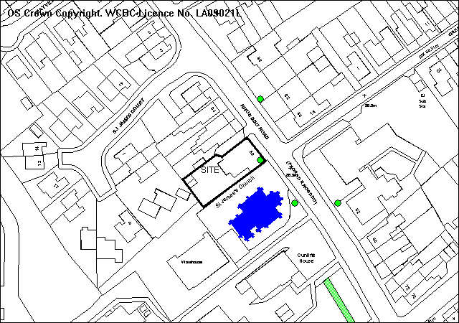
Dots- TPO trees Black- listed building

PROPOSAL

As above. The sketch plans show a 3 storey building comprising 6, two bedroom apartments. All matters are reserved for subsequent approval, but the application includes a sketch plan indicating the footprint of a building built close to the stone wall along the south-east boundary, together with 6 parking spaces in the rear yard. Sketch elevations are also supplied showing the second floor to be within a false hipped roof, together with a street scene elevation drawing.

APPLICANT’S STATEMENT
The details of the design are submitted for illustration. The mansard style roof would limit the height of the development whilst providing useable second floor accommodation. The Lime tree would not be adversely affected due to a cellar. The site is in an accessible location, and the applicants are seeking a commuted parking payment in lieu of providing the required number of parking spaces.

RELEVANT HISTORY

P/2007/0236 Conversion of building to 4 flats Granted 8/5/2007
P/2007/0238 Outline for erection of 4 flats Granted 8/5/2007

DEVELOPMENT PLAN

Within settlement limits The lime tree on the frontage is covered by TPO 11. St John’s church to the south is a listed building. Policies H2 EC4 EC9 T8 GDP2 and GDP1 are relevant, together with LPGN 16 17 21 and 27.

CONSULTATIONS

Rhosddu C Council: Consulted 25/4/2008
Local Member: Concerned at possible over-development
Highways: Recommend conditions
Welsh Water: Recommend conditions
Education: schools contribution of £11,760 required for primary provision
Public Protection: Recommend contamination condition. Comments regarding construction works.
WACS: No objection in principle but would prefer improved design. Also concerned with future well-being of the mature lime tree.
Site Notice: expired 19/5/2008
Other representations: Adjoining occupiers notified 29/4/2008.
1 objection received on grounds of:
- Adverse impact on highway safety by vehicles manoeuvring onto Rhosddu Road
- Development of 6 flats would be out of character with the locality
- The tree on the frontage is protected by a TPO
- Previous application was reduced from 6 to 4 flats.
- Existing building should be demolished on safety grounds.

SPECIAL CONSIDERATIONS/ ISSUES

Residential amenity: The dwellings would have a limited but adequate communal living space based on the sketch plan.

Trees: A significant mature TPO Lime tree is located within 2 metres of the proposed building immediately outside the site. Currently the tree’s trunk is 3.3 metres from the main building and 1.5 m from the entrance porch. The proposed building will result in a portion of the tree’s crown having to be removed to accommodate the new building. However since permission has already been granted for a two storey building on the site of the same ground area, the development will not increase any impacts upon the trees.

A BS5837: 2005 Tree Constraints Plan undertaken by a competent arboriculturist should be undertaken to determine layout design and an Arboricultural Implication Assessment should undertaken in order to evaluate and mitigate the extent of direct and indirect impacts on the tree. This should also include a method statement on how the current building will be demolished without harming the tree.

Setting of listed building: The effect of redevelopment on the setting of the listed church to the south-east is a material consideration. No objections to redevelopment of the site are raised at this stage, but must to draw attention to the need for a good standard of design to be submitted at reserved matters stage.

Highway safety: Highways accept that the site has an existing use for offices, and is in a sustainable location. Therefore they do not object to the change to 6 units and the level of parking provision is considered adequate.

Design: The sketch design is bland and not in keeping with the character of the locality, but as the application is in outline only, further consideration can be given at the detailed stage. (see above).

Schools Contributions: As the development is now for 6, two bedroom flats, schools contributions would be applicable under LPGN 27. This is covered by condition 6.

RECOMMENDATION That permission be GRANTED

CONDITION(S)

1. Approval of the following details shall be obtained from the Local Planning Authority before any part of the development is commenced:
a. the siting of the building(s)
b. the design of the building(s)
c. the external appearance of the building(s)
d. the means of access to the site and building(s)
e. the landscaping of the site.
2. Plans and particulars of the reserved matters referred to in condition 1 (above) shall be submitted in writing to the Local Planning Authority before the expiry of three years from the date of this permission. The development shall only be carried out in strict conformity with such details as are thereby approved.
3. The development hereby permitted shall be begun before the expiry of five years from the date of this permission or two years from the date of approval of the last of the reserved matters required to be approved, whichever is the later.
4. The vehicle parking and turning areas indicated on the approved plans shall be laid out, surfaced and drained prior to the first use of the building hereby granted and shall thereafter be retained for those purposes, free of all obstruction.
5. Development shall not begin on site until a scheme to deal with potential contamination at the site has been submitted to and approved in writing by the Local Planning Authority. This scheme shall include a phased investigation approach to identify the extent of contamination and any measures required to remediate the site, including post-development monitoring. Where remediation works are required, the development shall not be occupied/used until a Validation Report to show that the works have been satisfactorily carried out has been submitted to and approved in writing by the Local Planning Authority.
6. Prior to commencement of the development, provision shall be made to offset the shortfall in education facilities as agreed with the Local Planning Authority. This will be a financial contribution towards the provision of additional facilities to the nearby existing primary school.
7. No demolition or development or other opeations shall take commence until an arboricultural method statement has been submitted to and has been approved in writing by the Local Planning Authority. The statement shall include a specification for protective fencing that complies with BS5837 : a plan showing the position of the protective fencing; a full specification for the construction of any access, driveway or path under the crown spread of the trees, and related sections, details of general arboricultural matters including proposed practices with regard to cement mixing, material storage and fires; and details of the frequency of supervisory visits and procedures for notifying the finding of such visits to the Local Planning Authority. Works shall be carried out strictly in accordance with that approved method statement.

REASON(S)

1. To comply with the provisions of the Town and Country Planning (General Development Procedure) Order, 1995.
2. To comply with Section 92 of the Town and Country Planning Act, 1990.
3. To comply with Section 92 of the Town and Country Planning Act, 1990.
4. To provide for the parking and turning of vehicles clear of the highway and to ensure that reversing by vehicles into or from the highway is rendered unnecessary in the interest of traffic safety.
5. In the interests of the amenities of the future occupants of the buildings
6. To accord with UDP policies GDP2 and CLF5 together with Local Planning Guidance Note 27 - Developer Contributions to Schools.
7. To ensure the amenity afforded by the trees is continued into the future.

NOTE(S) TO APPLICANT

Your attention is drawn to Highway Supplementary Notes Numbered 1, 3, 4 and 5 on the enclosed "Applicants' Rights and General Information".

The proposed development lies within a former coal mining area. You should take account of any hazards to stability which may arise from coal working in or near the site. Specific advice on any past working may be obtained from the Coal Authority Mining Reports Service. Phone 0845 762 6848 or from www.coal.gov.uk.

Any operations which may involve entry into former workings, shafts or adits or implementation of site investigations or other works may need permission from the Coal Authority.

Further advice on compliance with Condition No. 5 may be obtained by contacting the Council's Environmental Protection Section on Wrexham 297041.
The permission hereby granted does not authorise encroachment upon, or interference with, the adjoining property.

You are reminded that the Disability Discrimination Act 1995 applies to residential development and you will be required to provide (amongst other things) level access, down stairs cloak room and wider doorways.

The lime tree on the frontage is covered by a tree preservation order.

When preparing detailed drawings and/or implementing this permission you are advised to give full consideration to the housing needs of the disabled.

The detailed scheme should take account of the following issues:
a. The need to ensure safe and sustainable demolition and re-use of materials, under the terms of guidance notes published by the Council.
b. There may be a requirement for developer contribution to schools, depending on the size of the apartments.
c. A senstiive design is required for this site as it adjoins a listed building.
_____________________________________________________________________

APPLICATION NO:  P/2008 /0458  COMMUNITY:  Maelor South  WARD:  Overton | LOCATION:  LAND ADJACENT TO OAKWOOD HOUSE CADNEY LANE BETTISFIELD WHITCHURCH  DESCRIPTION:  OUTLINE APPLICATION FO ERECTION OF DWELLING  APPLICANT(S) NAME:  MRS J HALL | DATE RECEIVED:  25/04/2008  CASE OFFICER:  LB1  AGENT NAME:  MR J BLANCHARD
_____________________________________________________________________

SITE

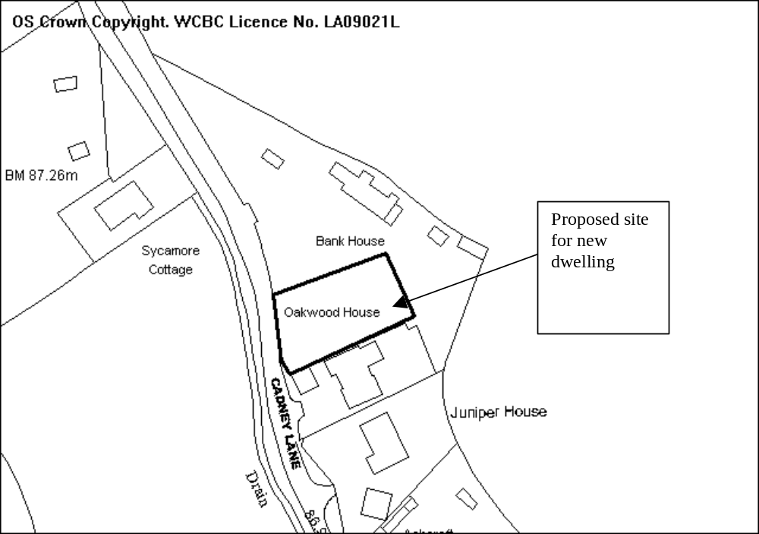

PROPOSAL

As above.

HISTORY

17884 Erection of 2 dwellings, Granted 10/04/1990

DEVELOPMENT PLAN

Within settlement limit of Bettisfield, GDP1, PS2 apply.

CONSULTATIONS

Community Council: No objections
Local Member: Consulted 30/04/08
Highways: Recommend refusal if new access is to be created solely for the proposed property, however would accept joint access for new property and Bank House which currently has a substandard access.
Environment Agency: Object to application as submitted as no details of foul sewerage have been submitted. The land in Bettisfield is (in the main) unsuitable for soakaway of effluent and there are no watercourses available to permit a discharge of sewage. The Agency does not accept the promotion or proliferation of cesstanks as long term sewerage on the grounds of sustainability, pollution prevention and environmental protection.
Other representations: Neighbouring properties notified 02/05/08
Site Notice: Expired 23/05/08

SPECIAL CONSIDERATIONS

The site: The site previously had planning permission for the erection of two houses. This has since lapsed, however subsequent applications were submitted for a property on the adjoining site. This has since been built (Oakwood House).

The proposal is an outline application with all matters reserved for further consideration. The plot of land is of a size that will allow for erection of a dwelling of a similar size to others along Cadney Lane. The alignment and size of the plot will allow for separation requirements to be met.

Highways: The applicants have been advised that it does not appear feasible to construct a new access for the proposed dwelling within the site boundaries that would provide the required visibility splays. A joint access, which would improve the current vehicle access at Bank House (also in the control of the applicant), would ensure that the required visibility splays could be provided.

The applicant has agreed that a joint access would be acceptable. Conditions will be placed on the permission to ensure that an access with adequate visibility that will serve both dwellings is created.

Drainage: The Environment Agency has expressed concerns regarding foul drainage proposals. It does not consider cesspools to be a sustainable option and further development should be discouraged until a foul sewerage system is introduced.

I am not aware that there are any immediate plans for a mains drainage system to be introduced in this area. Building Regulations consider that a proposed septic tank would not be suitable in this location, however a cesspool or biodisc may be able to be installed and would operate satisfactorily. This may not be the most sustainable option available in terms of traffic required to service the site, however I am satisfied that on the basis the system is properly designed and maintained there should not be any pollution problems.

The settlement is fairly well developed and there are few locations where further new dwellings can be sited. Given that there are unlikely to be a significant amount of future development the addition of a cesspool or similar for one additional dwelling will not have a detrimental impact on the locality.

Conclusion: The site is acceptable for the location of a dwelling and I am satisfied that the concerns over drainage and the proposed access can be overcome and I therefore recommend that permission is granted.

RECOMMENDATION That permission be GRANTED

CONDITION(S)

1. Approval of the following details shall be obtained from the Local Planning Authority before any part of the development is commenced:
a. the siting of the building(s)
b. the design of the building(s)
c. the external appearance of the building(s)
d. the means of access to the site and building(s)
e. the landscaping of the site.
2. Plans and particulars of the reserved matters referred to in condition 1 (above) shall be submitted in writing to the Local Planning Authority before the expiry of three years from the date of this permission. The development shall only be carried out in strict conformity with such details as are thereby approved.
3. The development hereby permitted shall be begun before the expiry of five years from the date of this permission or two years from the date of approval of the last of the reserved matters required to be approved, whichever is the later.
4. Notwithstanding the application documentation no development shall take place until a scheme of foul drainage and surface water drainage has been submitted to and approved by the Local Planning Authority. The approved scheme shall be complete before the development is occupied.
5. The existing access serving Bank House shall be improved to serve as a shared access and shall provide visibility splays of 2.4 x 45m in both directions measured to the nearside edge of the adjoining highway in which there shall be no obstruction in excess of 1.0m in height and access to the development shall only be gained via this shared access.
6. The proposed shared access shall provide pedestrian visibility splays of 2.4 x 3.3m in both directions measured from the back of the proposed footway in which there shall be no obstruction in excess of 0.6m in height.
7. The reserved matters applicaion shall include details of a footway tol be constructed along the entire frontage of the development site and the frontage of Bank House. The footway shall be constructed the Highway Authority adoptable standard before the new dwelling is occupied and shal theeafter be retained clear of obstruction to use.
8. The proposed shared access to the development site shall be a minimum width of 4.5m for the first 5m behind the highway boundary.
9. The proposed shared access shall be surfaced using hard bound materials for a minimum distance of 5m behind the highway boundary.
10. Parking provision at the development site shall comply with the requirements of Local Planning Guidance Note 16.
11. No gates shall be erected within 5m of the highway boundary.
12. As part of the submission of reserved matters, a plan shall be submitted showing the location and species of, (and allocating a reference number to,) each existing tree on the site which has a stem with a diameter measured over the bark at a point 1.5 metres above the ground level exceeding 75mm. It shall show trees are to be retained and the crown spread of each retained tree.

REASON(S)

1. To comply with the provisions of the Town and Country Planning (General Development Procedure) Order, 1995.
2. To comply with Section 92 of the Town and Country Planning Act, 1990.
3. To comply with Section 92 of the Town and Country Planning Act, 1990.
4. To ensure satisfactory drainage of the site and to avoid flooding.
5. To ensure the formation of a safe and satisfactory access and to ensure that adequate visibility at the proposed point of access.
6. In the interest of pedestrian safety.
7. In the interest of pedestrian safety.
8. To ensure the formation of a safe and satisfactory access.
9. To ensure the formation of a safe and satisfactory access.
10. To provide for the parking of vehicles clear of the highway.
11. In the interests of highway safety.
12. To ensure a satisfactory standard of appearance of the development.

NOTE(S) TO APPLICANT

The proposed footway should be constructed to a standard suitable for adoption by the Council for future maintenance at the public expense and the developer will need to enter into an agreement with the Council under Section 38/278 of the Highways Act 1980.

You are advised that the Highway Authority will require such works to be completed to their satisfaction before they will formally adopt the relevant highway works for public use and to be maintained at public expense. This will include the provision of a bond to cover the estimated value of such works. The appropriate fees will become due to the Council when the Highways Authority approve the proposed works to be carried out.

As there appears to be a significant issue with flooding in this area, I would recommend the applicant liaises with the Wrexham County Borough Council - Land Drainage Section to discuss the proposed means of surface water drainage for teh development site. Plesae contact Mr Paul Fairclough on telephone number (01978) 296009.

All ancillary operations and the use of plant and machinery which are audible at the boundary shall be carried out only between 07.30 hours to 19.30 hours Monday to Friday, between 08.00 hours to 14.00 hours on Saturdays and at no time on Sundays and Bank Holidays.

There shall be no fires on site; to include the prohibition of the burning of cleared vegetation.

Your attention is drawn to Highway Supplementary Notes on the enclosed 'Applicants' Rights and General Information'.
_____________________________________________________________________

APPLICATION NO:  P/2008 /0461  COMMUNITY:  Acton  WARD:  Borras Park | LOCATION:  8 DENNING ROAD WREXHAM  DESCRIPTION:  DEMOLITION OF EXISTING SINGLE STOREY SIDE EXTENSION AND ERECTION OF 2 STOREY SIDE EXTENSION WITH SINGLE STOREY REAR EXTENSION. REPLACEMENT OF FLAT ROOF WITH NEW PITCHED ROOF.  APPLICANT(S) NAME:  MR K JONES | DATE RECEIVED:  28/04/2008  CASE OFFICER:  SEH  AGENT NAME:  JNL DESIGN  MR J EDSALL
_____________________________________________________________________

THE SITE
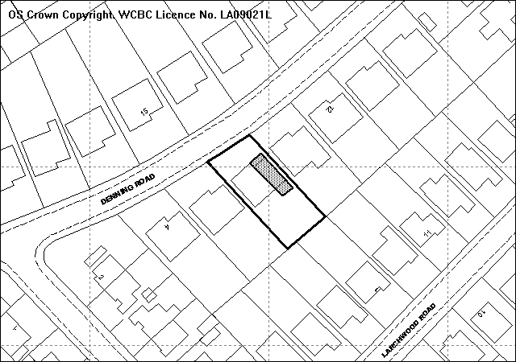
Proposed first floor side extension above existing garage
Proposed single storey rear extension
Site
PROPOSAL

As Above.

HISTORY

No History.

DEVELOPMENT PLAN

Within settlement limit. UDP Policies GDP1 and PS2 apply. LPG Nos 20 ‘House Extensions’, 21 ‘Space around Dwellings’ and 16 ‘Parking Standards’ are relevant.

CONSULTATIONS

Community Council: Consulted 29.04.08
Local Member: Consulted 29.04.08
Other Representations: 5 neighbouring occupiers notified on 30.04.08. Three letters received raising the following:
- Concerned that with builders lorries and skips in the road access to properties opposite will be made almost impossible
- Concerned that the owners of number 8 will be making even more use of on-street parking. Denning Road bends just at that point and additional use of on-street parking could make that point quite dangerous
- The extension would mean all light and sun would be taken away at the end of the day
- Would be very overlooked having a window directly looking out over patio area
- There would be no light whatsoever in the downstairs bathroom and concerned about the amount of light that will taken away from the hall area.
- Idea of growing vegetables in greenhouses along the side of the house has been quashed
- If someone wants bigger premises wouldn’t they just go for a larger house in the first place
- Children will miss out when it comes to playing out of an evening after school in the sun, which is the only time as a family to be in the garden.
- The size of the extension will obstruct light from garden and property
- The further window that will back directly onto back of property (kitchen, conservatory and garden) where majority of time is spent will infringe on privacy.
Site Notice: Expired 21.05.08

SPECIAL CONSIDERATIONS/ISSUES

Background: Several other properties along the road have had similar extensions to the proposed. The site is located on a small hill and as such the properties to the north east are located at a higher level. Amended plans have been received addressing concerns over parking. The design, size etc of the proposal has not been altered.

Residential Amenity: Objections have been raised with regards to loss of light to the garden, particularly at the end of the day. Whilst it is acknowledged that the development would result in the loss of some direct sunlight to the rear garden of 10 Denning Road the orientation of the gardens in relation to buildings already results in a reduction of sunlight in late evening and in my view, the proposal would not significantly worsen the situation.

Planning guidance seeks to protect natural levels of daylight to habitable rooms and the proposed first floor and ground floor extensions are in accordance with the adopted BRE 45 degree daylight test and would not result in a detrimental loss of daylight to the habitable rear windows of the neighbouring dwellings.

The proposed extension will be located around 3 metres from the neighbouring dwelling’s first floor bathroom window. This window is not to a habitable room and Council guidance does not seek to protect the light to this window. Although there will be some reduction light to the bathroom it is not considered to be detrimental.

Concerns have also been raised about the loss of light to the downstairs bathroom and hall area of the neighbouring dwelling. These again are not habitable rooms and a loss of light to them would not justify a refusal of planning permission.

There is a proposed dormer window to a bedroom on the rear elevation. The dormer window is set around 0.45 metres back from the existing rear elevation and will have a separation distance of at least 27 metres between the conservatory on the rear of number 7 Larchwood Road and a separation distance of 32 metres between the first floor rear windows of the 7 Larchwood Road. Local Planning Guidance Note 21 states that where habitable rooms face each other such that direct overlooking is physically possible, there should be a minimum distance of 22 metres between windows. The proposal exceeds this guidance and as such privacy is satisfactorily maintained.

There are no windows proposed facing directly onto the neighbouring dwelling’s patio. The first floor dormer window faces out towards the rear of the site and for direct overlooking to occur to the private garden area of the neighbouring dwelling a person would have to be standing up against the proposed window.

The property to the south west, is located at a lower level and has a conservatory located on the rear elevation. The proposed single storey rear extension has double patio doors proposed on the side elevation facing the conservatory. To prevent overlooking into the neighbouring dwellings garden and conservatory a 1.8 metre high fence has been proposed for part of the existing boundary.

Street Scene: I do not consider this application to adversely impact upon the character of the street scene.

Car Parking: The number of bedrooms will be increasing to 4 so 3 spaces are required in accordance with LPGN 16. Amended plans have been received that demonstrate this site through the widening of the proposed garage to 2.4 metres and an extension to the concrete hardstanding at the front of the property.

Conclusion: The proposed alterations accord with local guidance with regards to daylight separation distance and would not lead to detrimental loss of amenity. The design and materials match the existing and surrounding dwellings and the proposal accords with the appearance of the street scene.

RECOMMENDATION That permission be GRANTED

CONDITION(S)

1. The development hereby permitted shall be begun before the expiry of five years from the date of this permission.
2. No facing materials shall be used other than materials matching those used on the existing building.
3. Development shall only be carried out in strict accordance with the approved plans unless the prior written approval of the Local Planning Authority has been obtained.
4. The 1.8m high fence shown on the amended plan dated 27 May 2008 shall be erected prior to the first use of the development and shal thereafter be retained.
5. The parking spacesshown on the amended plan dated 27 May 2008 shall be implemented prior to the first use of the developmentand shal thereafter be retained for the parking of private cars..

REASON(S)

1. To comply with Section 91(3) of the Town and Country Planning Act, 1990.
2. To ensure a satisfactory standard of appearance of the development in the interests of the visual amenities of the area.
3. To ensure that the development fully complies with the appropriate policies and standards.
4. To protect the amenities of the occupiers of nearby properties.
5. To ensure the satisfactory provision of off street vehicle parking facilities in the interests of highway safety.

NOTE(S) TO APPLICANT

The proposed development lies within a former coal mining area. You should take account of any hazards to stability which may arise from coal working in or near the site. Specific advice on any past working may be obtained from the Coal Authority Mining Reports Service. Phone 0845 762 6848 or from www.coal.gov.uk.

Any operations which may involve entry into former workings, shafts or adits or implementation of site investigations or other works may need permission from the Coal Authority.

Any operations which may involve entry into former workings, shafts or adits or implementation of site investigations or other works may need permission from the Coal Authority.

You should ensure that any difference between the plans approved under the Town and Country Planning Acts and under the Building Regulations is resolved prior to commencement of development, by formal submission of amended plans.
_____________________________________________________________________

APPLICATION NO:  P/2008 /0462  COMMUNITY:  Holt  WARD:  Holt | LOCATION:  10 DEE MEADOWS HOLT WREXHAM  DESCRIPTION:  ERECTION OF NEW SINGLE GARAGE AND CONVERSION OF EXISTING GARAGE TO MUSIC ROOM.  APPLICANT(S) NAME:  MR P YATES | DATE RECEIVED:  28/04/2008  CASE OFFICER:  SEH  AGENT NAME:  WA DAWSON
_____________________________________________________________________

THE SITE

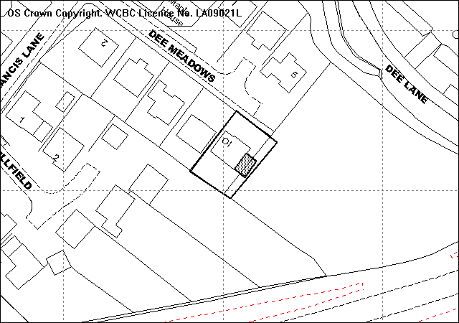
Site
Proposed single garage

PROPOSAL

As Above.

HISTORY

22736 Erection of 11 two-storey dwellings, construction of new vehicular access, associated access roads, services and external works. Approved 02.11.94
P/2008/0108 Erection of dwelling refused (following committee site visit) 18/04/08.

DEVELOPMENT PLAN

Within settlement limit. UDP Policies GDP1 and PS2 apply. L P G No 20 ‘House Extensions’, 21 ‘Space around Dwellings’ and 16 ‘Parking Standards’ are relevant.

CONSULTATIONS

Community Council: Concerned with the application as feel that it would
affect the symmetry of the cul-de-sac and also lend
itself to a further application for planning.
Local Member: Consulted 29.04.08
Highways: Recommend Condition
Other Representations: Neighbours notified 30.04.08
Site Notice: Expired 21.05.08

SPECIAL CONSIDERATIONS/ISSUES

Background: The existing property is a large detached dwelling located close to the settlement boundary. The application is to create a new garage to allow the existing garage to be converted into a music room. The proposal extends onto land outside of the residential curtilage and notice has been served on the land owners.

To the south east of the application site is a large plot of land that has been subject to recent applications for residential development, the latest application for a single dwelling and garage was refused in April. The proposal involves incorporating a 2 metre strip of this land into the applicants curtilage which will allow for the new 3.8 by 6.5 garage to be erected. Since one of the issues which lead to that refusal was the size of the dwelling in relation to the site approval of this application would necessitate a further review of that proposed development.

Amenity and Appearance: The location of the garage would not result in a loss of daylight to the neighbouring dwellings and given its set back from the front elevation the garage would not detract from the current street scene. There are a few different house types located on the Cul-de-sac with continuity retained through the materials used. Although all of the dwellings have garages located on the front elevation, the conversion of the existing garage will lead to a new matching window and brickwork being inserted in the front elevation, retaining the appearance of the area and I do not consider the conversion to negatively impact on the appearance of the original dwelling or the street scene.

Parking/highways: The section of road fronting the development site is unsurfaced and a condition will be attached to ensure hardbound materials are used. Three parking spaces remain at the site.

Conclusion: The proposed extension is acceptable in terms of design and would not result in a loss of amenity to the neighbouring dwelling or adversely impact on the character of the original dwelling or the street scene and I recommend accordingly.

RECOMMENDATION That permission be GRANTED

CONDITION(S)

1. The development hereby permitted shall be begun before the expiry of five years from the date of this permission.
2. No facing materials shall be used other than materials matching those used on the existing building.
3. Development shall only be carried out in strict accordance with the approved plans unless the prior written approval of the Local Planning Authority has been obtained.

REASON(S)

1. To comply with Section 91(3) of the Town and Country Planning Act, 1990.
2. To ensure a satisfactory standard of appearance of the development in the interests of the visual amenities of the area.
3. To ensure that the development fully complies with the appropriate policies and standards.

NOTE(S) TO APPLICANT

You should ensure that any difference between the plans approved under the Town and Country Planning Acts and under the Building Regulations is resolved prior to commencement of development, by formal submission of amended plans.

The permission hereby granted does not authorise encroachment upon, or interference with, the adjoining property.
_____________________________________________________________________

APPLICATION NO:  P/2008 /0466  COMMUNITY:  Brymbo  WARD:  Brymbo | LOCATION:  THE POPLARS AEL Y BRYN BRYMBO WREXHAM  DESCRIPTION:  OUTLINE APPLICATION FOR RESIDENTIAL DEVELOPMENT (4 NO. DWELLINGS), CONSTRUCTION OF NEW VEHICULAR AND PEDESTRIAN ACCESS AND ALTERATION TO EXISTING VEHICULAR AND PEDESTRIAN ACCESS (PREVIOUSLY GRANTED UNDER CODE NO. P/2005/0274.  APPLICANT(S) NAME:  MR & MRS D T JONES | DATE RECEIVED:  28/04/2008  CASE OFFICER:  JS  AGENT NAME:  MR & MRS D T JONES
_____________________________________________________________________

THE SITE

The site is located between High Street and Ael y Bryn. It currently forms the curtilage of the house known as The Poplars, which is a large detached house with access onto Ael y Bryn. The site is surrounded by residential properties, although opposite the High Street frontage there is a post office. The High Street frontage measures about 14m and the Ael y Bryn frontage is about the same.
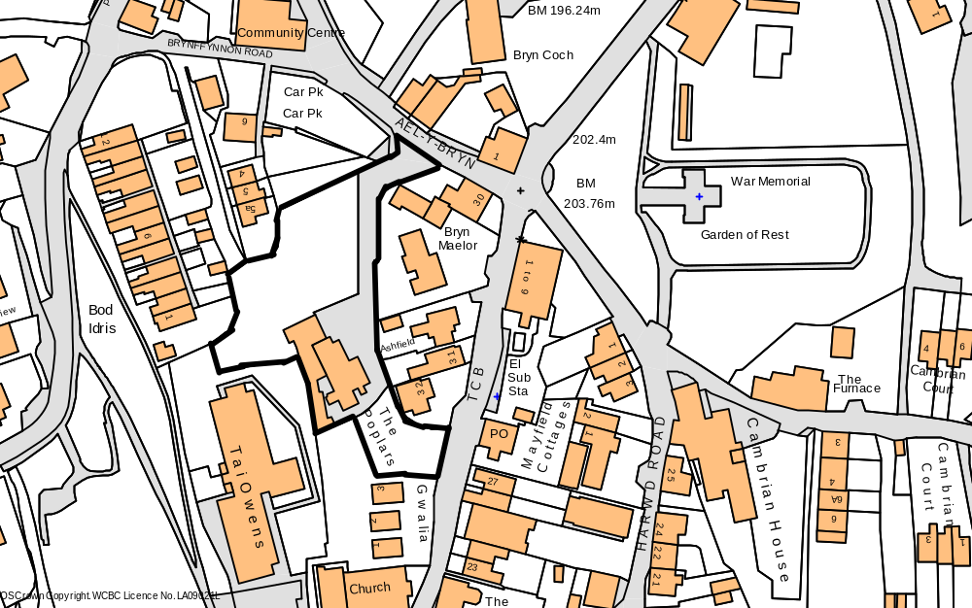
Application Site
High Street

PROPOSAL

As above. All detailed matters are reserved for further approval.

RELEVANT HISTORY

6/19766 Residential development. Withdrawn 17.12.91
6/20261 Residential development (4 houses) and re-conversion of dwelling into single dwelling, and construction of new vehicular access. Granted outline planning permission 8.6.92
P/2002/0080 Residential development (4 no. dwellings) and construction of new vehicular and pedestrian access and alteration to existing vehicular and pedestrian access. Granted outline planning permission 8.4.02.
P/2005/0274 Outline application for residential development (4 no. dwellings, construction of new vehicular and pedestrian access and alteration to existing vehicular and pedestrian access) as previously granted under P/2002/0080. Granted 9.5.05

DEVELOPMENT PLAN

Within the settlement limits Policies PS1, PS2, GDP1, H2 and T8 of the UDP refer.

CONSULTATIONS

Community Council: The parking area to the right of the of the access (off Ael y Bryn) will be affected by the development, and this is frequently used by people taking and picking up children to the school, and by people visiting the chemist. There are problems of on street parking, and it would be unacceptable if even one space is lost.
Local Member: Notified 30.4.08
Public Protection: Consulted 30.4.08
WW: Conditions required.
Highways: Consulted 30.4.08
Access Group: Consulted 30.4.0
Site Notice: Expired 28.5.08
Other representations: 16 neighbours notified, and 7 letters received raising the following:
- A valuable parking area will be lost if this is allowed. The lay-by is used by people visiting the post office and illegal parking will increase if this facility is lost. During the evenings the lay-by is used by residents or visitors in/to the area
- Access onto High Street should not be allowed.
- Extra traffic onto Ael y Bryn will cause issues of highway safety. Own access gates open onto the road which has no pavement, and there is a fear that extra traffic will cause additional safety issues.
- The entrance to the school is only 30m away and there is not enough parking.
- The new development will not provide enough parking for the use.
- Development will cause overlooking issues.
- The new access onto High Street will only benefit The Poplars and not the rest of the Brymbo community.
- Concerned about the possible height, location and type of properties, and the felling of trees.

SPECIAL CONSIDERATIONS/ ISSUES

Policy: Since the last permission there has been no change in policy. Some revisions to the adopted Supplementary Notes will be relevant, but these will need to be applied/considered at the detailed planning stage.

Access: Most of the objections raised as part of this application are related to access concerns, and these issues were examined as part of the earlier applications. As a result a planning condition was imposed as part of that permission to prevent access onto High Street. The same condition can be applied as part of this renewal, and this is necessary in order to prevent the loss of existing on-street parking facilities on High Street.

With regards to access onto Ael y Bryn, the previous application assessed the impact of extra traffic onto this road, and I am not aware that the highway situation has changed since that time. Both the school and the chemist existed at the time of the previous application, and any alterations to the existing access will not involve the loss of any parking spaces in the adjacent car park because this area is outside the application site.

Other matters: Detailed matters such as height, siting, type and overlooking issues can only be considered at the detailed planning stage. The application does not indicate that any trees will be felled. As a result I am of the opinion that the site offers enough scope for a residential development to be designed to meet adopted standards.

Conclusion: The principle of residential development at the site has been supported since 1992, and providing access is not allowed onto High Street, I am of the opinion that permission should be granted again as the policy situation has not materially changed.
P/2008 /0466
RECOMMENDATION That permission be GRANTED

CONDITION(S)

1. Approval of the following details shall be obtained from the Local Planning Authority before any part of the development is commenced:
a. the siting of the building(s)
b. the design of the building(s)
c. the external appearance of the building(s)
d. the means of access to the site and building(s)
e. the landscaping of the site.
2. Plans and particulars of the reserved matters referred to in condition 1 (above) shall be submitted in writing to the Local Planning Authority before the expiry of three years from the date of this permission. The development shall only be carried out in strict conformity with such details as are thereby approved.
3. The development hereby permitted shall be begun before the expiry of five years from the date of this permission or two years from the date of approval of the last of the reserved matters required to be approved, whichever is the later.
4. Development shall not begin on site until a scheme to deal with potential contamination at the site has been submitted to and approved in writing by the Local Planning Authority. This scheme shall include a phased investigation approach to identify the extent of contamination and any measures required to remediate the site, including post-development monitoring. Where remediation works are required, the development shall not be occupied/used until a Validation Report to show that the works have been satisfactorily carried out has been submitted to and approved in writing by the Local Planning Authority.
5. There shall be no direct vehicular access to the development from High Street, Brymbo.
6. As part of the reserved matters, the alterations to the Ael Y Bryn access shall include details to show the position and maintenance of highway visibility splays in either direction of the access.
7. The reserved matters to be submitted in connection with condition 1 above shall include details for:-
i) on-site parking and a communal turning facility for use by both the new and existing properties; and
ii) a passing place along the new or altered private drive;
shall be shown on the site layout plan. Any facilities as approved shall be fully implemented before any of the new houses are occupied and shall thereafter be retained.
8. The reserved matters to be submitted in connection with condition 1 above shall include details of all finished floor/ground levels in relation to surrounding properties. The development shall only be caried out in full accordance with the levels as approved.

REASON(S)

1. To comply with the provisions of the Town and Country Planning (General Development Procedure) Order, 1995.
2. To comply with Section 92 of the Town and Country Planning Act, 1990.
3. To comply with Section 92 of the Town and Country Planning Act, 1990.
4. In the interests of the amenities of the future occupants of the buildings
5. In the interests of retaining existing on-street parking facilities along High Street, in the interests of highway safety.
6. To ensure that visibility is maximised at the existing access point in the interests of highway safety.
7. To ensure that the development is served with an adequate road, parking and turning facilities, for the convenience and safety of residents.
8. To ensure that adequate amenity separation is achieved to comply with the Council's adopted standards in relation to 'Space around Dwellings' ie Local Planning Guidance Note No 21.

NOTE(S) TO APPLICANT

As part of the reserved matters it will be necessary to consider Local Planning Guidance Note 27, and accordingly, it may be necessary to make a provision for any shortfall in educational facilities. This is likely to take the form of a financial contribution towards the provision of additional facilities at nearby existing primary and/or secondary schools.
_____________________________________________________________________

APPLICATION NO:  P/2008 /0472  COMMUNITY:  Brymbo  WARD:  Brymbo | LOCATION:  NEWHOLME VILLA PEN Y GRAIG ROAD BRYMBO WREXHAM  DESCRIPTION:  CONVERSION OF EXISTING DWELLING INTO 2 DWELLINGS.  APPLICANT(S) NAME:  M S BENNETT | DATE RECEIVED:  30/04/2008  CASE OFFICER:  CB  AGENT NAME:  G RAYMOND JONES & ASSOCIATES  MR M DAVIES
_____________________________________________________________________

SITE

The site consists of former hairdressers and dwelling above and redundant undertakers.

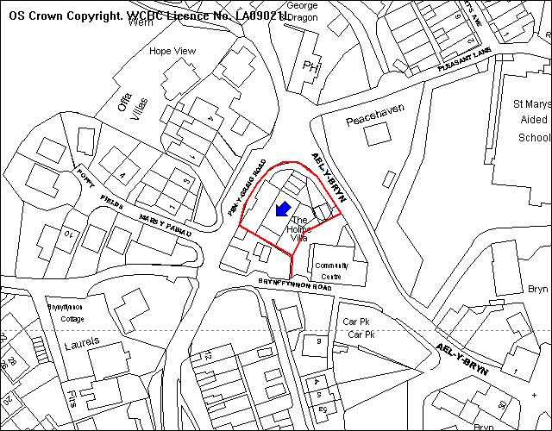
Application Site
Parking

PROPOSAL

As above.

HISTORY

None relevant.

DEVELOPMENT PLAN

Within settlement limit policies PS1, GDP1, H4 and T8 of the Unitary Development Plan and L P 16: Parking Standards and 21: Space around Dwellings are relevant.

CONSULTATIONS

Community Council: Objection received in regards parking and access given its position and limited visibility.
Local Member: Notified 30th April 2008
Adjacent occupiers: One response: adaptations and alterations should not be higher than existing building, or cover any more ground. Existing landscape areas should be retained, and no additional first floor windows to overlook Peace Haven. Materials should match existing, additional street lighting should be provided, the existing public footpath,/right of way from Brynffynnon Road and Ael y Bryn across the site should be retained. Existing parking provision should be kept, at least 2 cars per household given current on street parking issues. Adequate traffic management and parking arrangements during construction should be made, and access to Peace Haven should remain open and unblocked during building works.
Highways: Recommended conditions and advisory notes
Rights of Way: Notified 13th May 2008
Ramblers: Notified 13th May 2008
Site Notices: Expired 27th May 2008

SPECIAL CONSIDERATIONS

Main Issues: The main issues relates to the conversion of this dwelling in terms of proposed alterations, provision of amenity space, parking and access.

Amenity: The proposal would only involve alterations to existing openings and the provision of two semi detached properties which have ground floor bedroom accommodation and first floor living accommodation. It would also involve the removal of the outside stairs/balcony access.

There would be no windows inserted into the first floor of the south west elevation and therefore no issues of overlooking to adjacent property. The insertion of any further windows can be controlled by way of condition and the removal of permitted development rights.

Access and Parking: The proposal would involve alteration to existing access and parking because the properties will be provided with private amenity space. The frontage of the site will retain part of the existing landscaping/boundary wall and the insertion of a new stone boundary wall to the front of the parking area 2. Details of further boundary treatments and surface treatments can be dealt with by condition.

In terms of access the site has existing accesses onto the unclassified highway of Brynfynnon Road and the classified highway Ael y Bryn, both of which suffer from substandard visibility. The site currently comprises of a three bedroom dwelling, a hairdressers shop and three rooms formerly used as an undertakers. The proposed use is likely to generate fewer traffic movements at the site and will enhance visibility on to Ael y Bryn. Vehicular access onto Brynffynnon Road will effectively be prevented by the creation of the garden areas. Pedestrian access from Brynfynnon Road and Ael y Bryn would remain unaltered.

Other considerations: Traffic management issues outside of the site are not considered relevant given that the proposal would provide the maximum standard of four vehicle parking spaces and would not result in additional on street parking. Additional street lighting has not been requested by highways and therefore not considered necessary requirement for this proposal.

The former community centre situated to the south-east of the south has outline permission for residential development. This permission has been only granted in outline with all matters reserved so there are no details to consider in terms of siting and separation distances. The area is predominately residential and there would be no incompatibility of adjacent uses. I have suggested to the applicant’s agent that it would be beneficial for the two owners to work together.

Conclusion: The proposal would involve minimal alterations and no extensions to form two dwellings. The layout of accommodation utilises existing openings and further prevents any issues of overlooking. The conversion into two dwellings would involve a reduction in parking provision and traffic movements therefore no issues of highway or pedestrian safety, and adequate parking and turning would be provided on site.

RECOMMENDATION That permission be GRANTED

CONDITION(S)

1. The development hereby permitted shall be begun before the expiry of five years from the date of this permission.
2. No facing materials shall be used other than materials matching those used on the existing building.
3. The works granted permission shall only be carried out in strict conformity with the details shown on the approved drawing(s) and in the application documentation.
4. Notwithstanding the provisions of the Town and Country Planning (General Permitted Development) Order no windows or other openings shall be inserted in the first floor south west elevation of the building.
5. No part of the development hereby permitted shall be commenced until full details of both hard and soft landscape works for the site have been submitted to and approved in writing by the Local Planning Authority. The works shall be implemented in accordance with a timescale to be approved in conjunction with the scheme of details.
6. The height of the highway boundary means of enclosure shall not exceed 1 metre in height above the level of the nearside edge of the adjoining carriageway.
7. There shall be no vehicular means of access to the site from Brynyffynnon Road
8. The vehicle parking and turning areas indicated on the approved plans shall be laid out, surfaced and drained prior to the first use of the building hereby granted and shall thereafter be retained for those purposes.
9. The access shall be hard surfaced for a distance of 5m behind the highway boundary before the development is brought into use.
10. No gates shall be erected within five metres of the boundary.

REASON(S)

1. To comply with Section 91(3) of the Town and Country Planning Act, 1990.
2. To ensure a satisfactory standard of appearance of the development in the interests of the visual amenities of the area.
3. To ensure that the development fully complies with the appropriate policies and standards.
4. To protect the amenities of the occupiers of nearby properties.
5. To ensure a satisfactory standard of appearance of the development in the interests of the visual amenities of the area.
6. In the interests of highway safety.
7. In the interests of highway safety.
8. To provide for the parking and turning of vehicles clear of the highway and to ensure that reversing by vehicles into or from the highway is rendered unnecessary in the interest of traffic safety.
9. To ensure that no deleterious material is carried onto the highway, in the interests of highway safety.
10. In the interests of highway safety.

NOTE(S) TO APPLICANT

The proposed development lies within a former coal mining area. You should take account of any hazards to stability which may arise from coal working in or near the site. Specific advice on any past working may be obtained from the Coal Authority Mining Reports Service. Phone 0845 762 6848 or from www.coal.gov.uk.

Any operations which may involve entry into former workings, shafts or adits or implementation of site investigations or other works may need permission from the Coal Authority.

You should ensure that any difference between the plans approved under the Town and Country Planning Acts and under the Building Regulations is resolved prior to commencement of development, by formal submission of amended plans.

Your attention is drawn to Highway Supplementary Notes Numbered 1, 3, 4 and 5 on the enclosed "Applicants' Rights and General Information".

You are reminded that the Disability Discrimination Act 1995 applies to this development.

You are reminded that the Disability Discrimination Act 1995 applies to residential development and you will be required to provide (amongst other things) level access, down stairs cloak room and wider doorways.
_____________________________________________________________________

APPLICATION NO:  P/2008 /0482  COMMUNITY:  Llay  WARD:  Llay | LOCATION:  1 COUNCIL STREET LLAY WREXHAM  DESCRIPTION:  SIDE EXTENSION TO FISH BAR FOR STORAGE (IN RETROSPECT)  APPLICANT(S) NAME:  MR B HUYUK | DATE RECEIVED:  01/05/2008  CASE OFFICER:  CB  AGENT NAME:  MR B HUYUK
_____________________________________________________________________

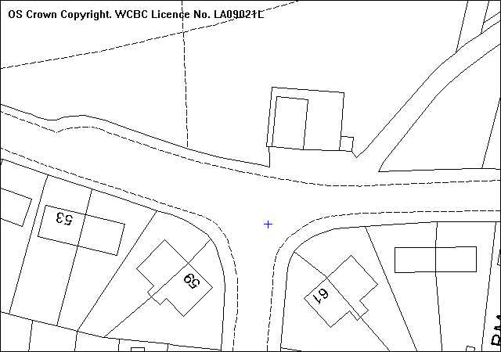
extension

SITE

As above.

PROPOSAL

As above it measures approx 5m x 2.2m with a flat roof

HISTORY

None relevant.

DEVELOPMENT PLAN

Within settlement limit Policies PS1 and GDP1 are relevant.

CONSULTATIONS

Community Council: Notified 8th May 2008
Local Member: Notified 8th May 2008
Welsh Water: Notified 8th May 2008
Public Protection: Notified 8th May 2008
Site Notices: Expired 30th May 2008
Adjacent occupiers: One letter received
Building is an eyesore in wood and iron sheeting
Should be brick, appears a fire hazard..

SPECIAL CONSIDERATIONS

Design: The building is small in scale and situated to the rear of the side elevation. I agree with the objector that the use of materials is inappropriate. The appearance of the building should be improved through the addition of rendering or pebble dash finish that would match the existing building and I suggest a condition below to deal with this. The scale is not an issue as it is set back from the frontage and is small..

The use of the building for potato storage and preparation can be controlled by a condition which links it to its hot food take away usage.

Parking: The storage yard and parking area would appear to be unaffected by the proposal.

Conclusion: The size and scale of the proposed extension would be acceptable if it was finished in materials which matched the existing building. I have asked the owner to confirm whether he is prepared to rebuild it in permanent materials to match. I will update you on the addendum. The recommendation is in two parts to reflect that uncertainty.

RECOMMENDATION A

That permission be REFUSED

The materials used are inappropriate and do not reflect appearance of the building to which it is attached. The development detracts from the visual amenity of the area contrary to Policy GDP1 of the Wrexham Unitary Development Plan

RECOMMENDATION B

If amended plans are submitted confirming that the building will be reclad to match the existing, that permission be GRANTED

CONDITION(S)

1. The development hereby permitted shall be begun before the expiry of five years from the date of this permission.
2. Development shall only be carried out in strict accordance with the approved plans unless the prior written approval of the Local Planning Authority has been obtained.
3. Notwithstanding the approved plans, the building shall be rendered and pebbledashed to match the existing building within one month of the date of this decision.
4. The extension shall only be used for purposes ancillary to the use of the adjoining building as a hot food takeaway premises and for no other purposes.

REASON(S)

1. To comply with Section 91(3) of the Town and Country Planning Act, 1990.
2. To ensure that the development fully complies with the appropriate policies and standards.
3. To ensure a satisfactory standard of appearance of the development in the interests of the visual amenities of the area.
4. To restrict the use of the building for storage associated with the premises.

NOTE(S) TO APPLICANT

The proposed development lies within a former coal mining area. You should take account of any hazards to stability which may arise from coal working in or near the site. Specific advice on any past working may be obtained from the Coal Authority Mining Reports Service. Phone 0845 762 6848 or from www.coal.gov.uk.

Any operations which may involve entry into former workings, shafts or adits or implementation of site investigations or other works may need permission from the Coal Authority.

You should ensure that any difference between the plans approved under the Town and Country Planning Acts and under the Building Regulations is resolved prior to commencement of development, by formal submission of amended plans.
_____________________________________________________________________

APPLICATION NO:  P/2008 /0483  COMMUNITY:  Ruabon  WARD:  Penycae & Ruabon South | LOCATION:  UNITS 2 & 3 WYNNSTAY TECHNOLOGY PARK RUABON WREXHAM  DESCRIPTION:  CHANGE OF USE FROM INDUSTRIAL PREMISES TO USED TYRE RECYCLING PLANT.  APPLICANT(S) NAME:  MR P ARCHER USED TYRE DISTALLATION RESEARCH LTD | DATE RECEIVED:  02/05/2008  CASE OFFICER:  MP  AGENT NAME:  USED TYRE DISTALLATION RESEARCH LTD  MR P ARCHER
_____________________________________________________________________

SITE

The site is just over 2 hectares in area and comprises of a 6800 square metres industrial building with associated hardstandings and loading areas. It is adjacent to an existing unit occupied by Wrexham Mineral Cables and a vacant parcel of land.

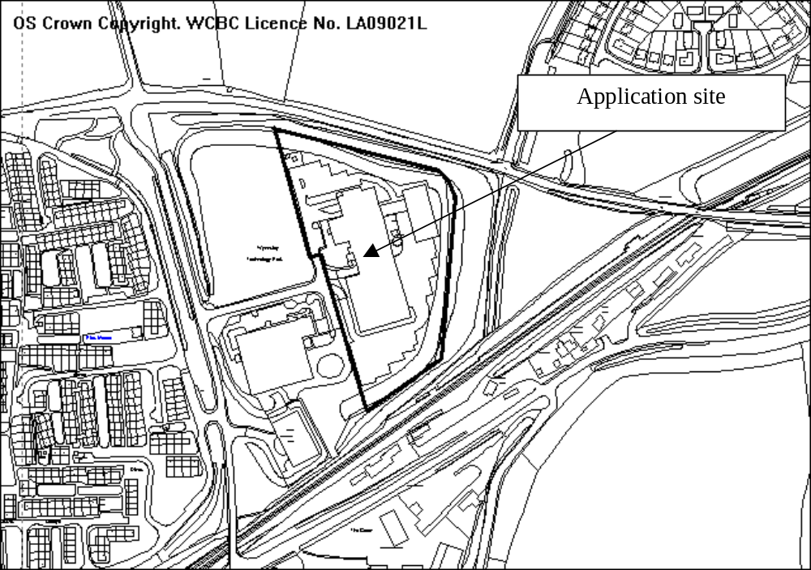

PROPOSAL

To use the existing unit for the processing of used tyres.

HISTORY

P/2000/0250 Extension to factory erection of new materials silo. Granted 24.4.2000
P/2006/0612 Telecommunications mast 25.0 metres height Granted 24.7.2006

Adjacent plot
P/2006/0907 Residential development (80 No. houses and apartments) together with garages and parking spaces. Refused 4.12.2006. Appeal dismissed.

DEVELOPMENT PLAN

Inside settlement limit. Policies PS2, GDP1 and MW12 apply.

CONSULTATIONS

Community Council: Object because the plant is too close to residential property. Residents will suffer because of pollution, noise, smells and traffic.
Local Member: Notified 8.5.08
Public Protection: Following comments:
- Recommend a noise condition;
- Determining if the process requires a PPC permit.
Highways: It is unlikely proposed use will generate a greater number of vehicular movements that existing permitted use. Adequate provision for loading, parking and turning of HGVs. Recommend adequate parking facilities are provided.
Environment Agency: From the details provided it would appear that the process would be regulated and will require an Environmental Permit.
Other representations: 1 letter received making the following comments:
- in principle, the occupation of a large part of the Wynnstay Technology Park is to be welcomed, albeit for a use which falls outside the usual scope of the Use Classes Order classification;
- The proposed is not one that would normally associated with a Technology Park;
- The proposal will not generate employment at levels expected for an area designated for employment uses.
- There are other uses which would create significantly greater levels of employment e.g. retail;
- Consideration should be given as to whether the proposed use would have a detrimental effect on the rest of Wynnstay Technology Park.
- If however this application is an indication of a policy by the authority to widen the types of uses acceptable at the Technology Park as a whole, to include sui generis uses, this will be of interest of our clients (owners of adjacent vacant plot);
- The potential for such a proposed use to be an eyesore and a nuisance to neighbours and nearby residents is high;
- Consideration should be given as to whether such a heavy industrial use is appropriate in such a predominantly residential area;
- The problems of outside storage of raw materials and the recycled product must be dealt with efficiently and the potential for noxious smells from the burning process must be fully evaluated;
- Dust from the various by-products has the ability to blow away from the site and is difficult to remove;
- Is this a relocation of an existing plant or a new process?
- Does this type of plant exist elsewhere in the UK and does it have a successful track record in environmental and neighbourliness?
Site Notice: Expired 3.6.08
Press Notice (Major Dev): Expired 13.6.08

SPECIAL CONSIDERATIONS

General information: The process has been developed by the applicants who have been operating a pilot plant at Flexys for the last 2 years. I understand that no complaints have been received from that operation.

Tyres are shredded (into pieces approximately the size of a human hand) and heated in an oxygen free environment. This process results in gases being produced, some of which are condensed into a liquid oil and the remainder, which consisting of hydrogen, propane, methane and butane is condensed and stored in a tank on site and used in the process to heat the shredded tyres. The heating process also allows for the steel in the tyres to be extracted which is then sent to a metal recycling company. The remaining material is black carbon, which can also be re-used in a variety of processes, including for printing ink. It is estimated that 17,000 tonnes or 2 million used tyres will be processed in this way each year.

The application site was formerly used by a plastic components manufacturer and fell within Class B2 (General Industry) of Use Classes Order 1987. The proposed use involves a number of elements, including the importation and shredding of tyres which, as used tyres are considered to be a waste, and defined as a waste handling/transfer activity. The used tyres are processed to produce gas, oil and carbon and to allow for the recovery of steel. I believe this could be considered a B2 use or a waste processing use. Finally the oil, carbon and steel are stored and distributed for further use, which could be considered to constitute a B8/storage and distribution use. There are also offices on site which, by themselves, would fall within class B1. Whilst I consider the processes that will be carried out on site to be generally industrial in nature, comparable to the permitted use of the premises and adjacent factory, the proposed use does not fit comfortably within a single industrial use class. In addition, the waste handling/processing are considered to be uses not falling within any Use Class ( sui generis). Thus although industrial in nature, planning permission is needed for the use.

Policy: Policy MW12 is applicable as the proposal involves the handling and processing of waste. The development will provide a facility for the recovery and re-use of gas, oil, steel and carbon from tyres in a beneficial way, rather than disposal in the locality and will aid regional self-sufficiency in respect of dealing with used tyres. The process treats used tyres as a raw material, and therefore as a potentially valuable commodity. This in turn could discourage people from indiscriminately disposing of tyres, which would benefit the area both visually and environmentally.

I consider the proposed use to be comparable to the existing permitted use of the building in terms of the likely impacts upon the locality. It should also be noted that policy MW12 accepts that general industrial estates are likely to be suitable locations for processing of waste, therefore I am satisfied the development accords with this policy.

Amenity: The Environment Agency has advised that a permit will be needed to operate at this site. This will regulate any emissions to air, land or water. The processes and potential impacts of them will therefore be regulated through that process. Even so, in accordance with UDP policies, I am still obliged to consider amenity impacts.

The processing of tyres, and the operation of the associated plant and machinery will take place inside the building. The process involved in treating the tyres does not involve burning, but rather the heating of tyres in a sealed container. It is therefore unlikely that the use will result in noxious smoke or odours being emitted from the site. The gasses produced by the process are a resource, either for re-use on the premises for heating, or for condensing into oil, which has the potential to be used as an alternative to oil/fuel (i.e. a saleable product). The main emissions from the site will be carbon dioxide from the combustion of gas use to heat the plant, which is unlikely to impact significantly on the amenity of nearby properties. The applicant anticipates that as heating will be undertaken by normal gas heaters it is likely that existing flue(s) will be used subject to them being appropriately located. Should a specialised flue be required the applicant anticipates that this would be about 1 metre higher than the apex of the factory roof. A further condition is included regarding the siting and appearance of any flue(s) needed.

Used tyres are to be delivered to an existing warehouse at the rear of the site before being moved into the main building for shredding and processing. The finished products (oil, carbon and steel) are then stored in the main building before being transported from the site for use/re-use or further processing elsewhere. As all storage and processing is contained internally, the impact of the premises upon the occupiers of nearby properties (residential and commercial) is unlikely to be noticeable different from the current permitted use of the premises. As no external storage is proposed, and no external alterations to the building or site are proposed the development will not have a detrimental impact upon the visual amenities of the locality.

The development does have the potential to generate noise, from both the tyre shredding process, as well as the gas burners and electric motors uses to power the tyre treatment process. These activities will all take place within the building, which should assist in reducing likely noise impact of the development. The noise generated is however something that should be controlled by condition in the interests of amenity.

Other issues: Whilst the site is called the ‘Wynnstay Technology Park’ there is no specific policy restriction on the types of uses considered acceptable. In accordance with policy, particularly GDP1, provided proposals do not result in amenity, traffic or visual amenity problems, they are likely to be considered acceptable. Should the proposed use be granted it does not mean that the Council will necessarily support other ‘sui generis’ uses, which, by definition are unique, which is why they are considered to fall outside a use class. The process is one that has been under development by the applicants, and can therefore be considered experimental or new technology. I see no reason why it cannot be considered compatible with a ‘Technology Park’. Furthermore I do not consider the proposal incompatible with the existing adjacent unit nor should it prejudice the development of the adjoining vacant plot for industrial or business uses.

I note it is suggested that the proposed use will generate low levels of employment, particularly when compared to other uses, such as retail. UDP policies would not support large scale retail development in this location, indeed anything other than a local needs shop would be contrary to policy. Although the impact a development may have on the local economy is a valid and material consideration, the fact that 15 jobs would be created rather than a larger number would not justify refusal of the application. Bringing a currently vacant unit back into beneficial use is to be welcomed. If the applicants are successful in developing their process there is the potential that further jobs will be created.

The storage and processing of tyres, as well as the storage of the finished products is to take place internally, therefore there is unlikely to be any visual impact, and indeed this should also minimise other impacts, such as noise or dust.

Conclusion: I am satisfied that subject to appropriate controls, the development accords with adopted UDP policies.

RECOMMENDATION That permission be GRANTED

CONDITION(S)

1. The development hereby permitted shall be begun before the expiry of five years from the date of this permission.
2. Notwithstanding the provisions of the Town and Country Planning (Use Classes) Order no part of the premises shall be used except for the precise purposes described in the application plans and documents.
3. No storage shall take place in the open on any part of the site.
4. There shall be no burning or combustion of whole or shredded tyres on any part of the site.
5. The rating level of any noise generated by reason of this development shall not exceed the pre-existing background level by more than 5dB(A) at any time. The noise levels shall be determined at the nearest noise sensitive premises. Measurements and assessments shall be made in accordance with BS4142: 1997 "Method of Rating Industrial Moise Affecting Mixed Residential and Industrial Areas". The assessment shall be carried out by a competant person prior to the commencement of the use hereby granted permission. The noise levels shall be submitted to and approved in writing by the Local Planning Authority prior to the commencement of the use.
6. Details of any acoustic attention measures necessary to achieve the noise levels described in condition 05 shall be submitted to and approved in writing along with the noise assessments required by that condition. The measures shall be installed/put in place prior to the commencement of the use hereby granted permission and thereafter retained unless otherwise agreed in writing by the Local Planning Authority.
- No new flue or other external means of ventilation shall be installed or erected unless details have been first submitted to and approved in writing by the Local Planning Authority.

REASON(S)

1. To comply with Section 91(3) of the Town and Country Planning Act, 1990.
2. To enable the Council to control the use of the premises in the interests of the amenities of nearby properties.
3. To ensure a satisfactory standard of appearance of the development in the interests of the visual amenities of the area.
4. To protect the amenities of the occupiers of nearby properties.
5. To protect the amenities of the occupiers of nearby properties.
6. To protect the amenities of the occupiers of nearby properties.
7. To ensure a satisfactory standard of appearance of the development in the interests of the visual amenities of the area.

NOTE(S) TO APPLICANT

Your attention is drawn to Highway Supplementary Notes Numbered 1, 3, 4 and 5 on the enclosed "Applicants' Rights and General Information".
_____________________________________________________________________

APPLICATION NO:  P/2008 /0497  COMMUNITY:  Esclusham  WARD:  Esclusham | LOCATION:  CHARLES OWEN COMPANY LTD CROESFOEL INDUSTRIAL ESTATE RHOSTYLLEN WREXHAM  DESCRIPTION:  ERECTION OF INDUSTRIAL UNIT FOR THE PRODUCTION OF SAFETY HEADWEAR  APPLICANT(S) NAME:  MR ROY BUREK CHARLES OWEN COMPANY LTD | DATE RECEIVED:  07/05/2008  CASE OFFICER:  SJG  AGENT NAME:  PARRY DAVIES PARTNERSHIP
_____________________________________________________________________

THE SITE

An area of 8120m² of vacant land and part of the existing factory curtilage. There is an existing access to the estate road. To the south is a recently opened car dealership with a building on the frontage and floodlit car parks behind. To the east is a housing estate and health centre.
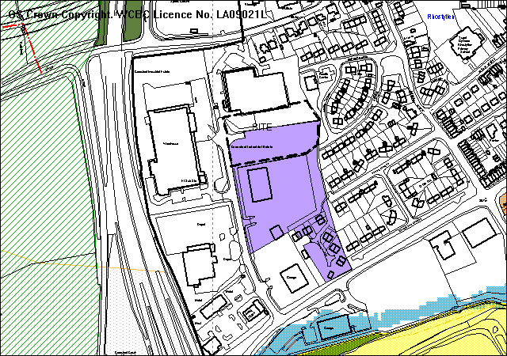
Grey= allocated employment site

PROPOSAL

As Above. The building has a flooorspace of 3005m² and is 6.9 metres high to the eaves.

RELEVANT HISTORY

12031 | Change of use of land to industrial estate ( light industrial and warehousing ) and construction of new vehicular and pedestrian access | Granted | 16/12/1985
13576 | Construction of new vehicular and pedestrian access, sewers and re-grading of ground levels for proposed industrial estate | Granted | 15/12/1986
18942 | Extension to estate roads and sewers | Granted | 18/1/1991
Main Unit
CB2714 | Industrial Unit | Withdrawn | Dec 1998
CB03108 | Industrial Unit | Granted | 14/6/1999

DEVELOPMENT PLAN

Within settlement limits and part of an allocated employment site. Policies E1 E4 PS1 PS2 PS3 PS4 T8 and GDP1 of UDP are relevant, together with LPGN 16, 22, 23, and 26.

CONSULTATIONS

Esclusham C Council: Consulted 12/5/2008
Local Member: Consulted 12/5/2008
Highways: Recommend conditions
Public Protection: No objections in principle
Env Agency: Recommend conditions
Welsh Water: Recommend conditions
Site Notices: expired 6/6/2008
Press advert: expired 6/6/2008
Other representations: Adjoining occupiers notified 19/5/2008. 2 objections received on grounds of:
- Adverse impact on dwellings by reason of loss of view and outlook and height of building
- Additional noise and disturbance during night and early mornings from operations and reversing vehicles
- Detrimental impact on residential amenity in general

SPECIAL CONSIDERATIONS/ ISSUES

Policy: The development is on an allocated employment site, and can raise no policy issues in principle.

Residential amenity: The processes are the same as carried out at the existing factory, and similar conditions would be appropriate. There is no reason to believe that the impacts would be any different from the existing use.

The nearest dwellings to the east are between 25 and 40 metres from the building, and there will be a significant difference in height, based on the height of the proposed building and the +3 metre difference in ground levels. However there is a hedge and planted area between, and the dwellings do not face directly towards the building. The application offers the opportunity to extend the protection over trees within the planted area.

Sustainability: The sustainability statement demonstrates that the development will comply with adopted guidance.

Highway safety: No issues arise.

RECOMMENDATION That permission be GRANTED

CONDITION(S)

1. The development hereby permitted shall be begun before the expiry of five years from the date of this permission.
2. Development shall only be carried out in strict accordance with the approved plans unless the prior written approval of the Local Planning Authority has been obtained.
3. All hard and soft landscape works shall be carried out in accordance with the approved details as set out on drawing(s) No(s) @@@. The works shall be carried out within 3 months of the first use of the development with the exception of soft landscaping which shall be carried out in the first planting season (November to March) or seeding season (April to September) following the first use.
4. All trees, shrubs and hedge plants supplied shall comply with the requirements of the current BS 3936 Specification for Nursery Stock. All pre-planting site preparation, planting and post-planting maintenance works shall be carried out in accordance with the requirement of the current BS 4428 Code of Practice for General Landscape Operations (excluding hard surfaces). All new tree planting shall be carried out in accordance with guidance contained in Section 13 of the current BS 5837 A guide for Trees in Relation to Construction - Recommendations.
5. Any trees or shrubs removed, dying, being severely damaged or becoming seriously diseased within five years from the completion of the scheme shall be replaced by trees or shrubs of similar size and species to those originally required to be planted unless otherwise approved in writing by the Local Planning Authority.
6. No trees shall be lopped, topped, felled or uprooted without the prior written permission of the Local Planning Authority, nor shall any trees be wilfully damaged.
7. Development works must comply with the Council’s Supplementary Planning Guidance for Protection of Trees on Development Sites, and British Standard guide for Trees in Relation to Construction Sites (BS 5837) (1991).
8. The access shall be hard surfaced for a distance of 5m behind the highway boundary before the development is brought into use.
9. The vehicle parking and turning areas indicated on the approved plans shall be laid out, surfaced and drained prior to the first use of the building hereby granted and shall thereafter be retained for those purposes.
10. A 2m wide footway shall be constructed along the site frontage in accordance with details to be submitted to and agreed by the Local Planning Authority and the footway shall be completed in accordance with the approved details prior to commencement of use of the building.
11. Prior to being discharged into any watercourse, surface water or soakaway system, all surface water drainage from parking areas and hardstandings shall be passed through an oil interceptor designed and constructed to have a capacity and details compatible with the site being drained. Roof Water shall not pass through the interceptor.
12. Any facilities for the storage of oils, fuels or chemicals shall be sited on impervious bases and surrounded by impervious bund walls. The volume of the bunded compound should be at least equivalent to the capacity of the tank plus 10%. If there is more than one tank, the compound should be at least equivalent to the capacity of the largest tank, or the combined capacity of interconnected tanks, plus 10%. All filling points, vents gauges and sight glasses must be located within the bund. The drainage system of the bund shall be sealed with no discharge to any watercourse, land or underground strata.
13. The site shall only be drained by means of a separate system of drainage with no surface water being discharged to the foul drain/sewer.
- Noise levels arising from activities on the site as measured on the east and south boundaries of the site shall not exceed 50dB(A) expressed as a 15 minute LAeq between the inclusive hours of 0700 to 1900 hours on any day, nor 40dB(A) expressed as a 5 minute LAeq between the inclusive hours of 1900 to 0700 hours on any day.
- A landscaped buffer zone not less than 8 metres in depth shall be provided along the eastern site boundary and details of the proposed treatment shall be agreed in writing by the Local Planning Authority before development commences. The area shall be provided with fencing to prevent incursion into that area by visitors or employees and shall be landscaped and maintained in accordance with conditions 3,4 & 5 above.

REASON(S)

1. To comply with Section 91(3) of the Town and Country Planning Act, 1990.
2. To ensure that the development fully complies with the appropriate policies and standards.
3. To ensure a satisfactory standard of appearance of the development in the interests of the visual amenities of the area.
4. To ensure a satisfactory standard of appearance of the development in the interests of the visual amenities of the area.
5. To ensure a satisfactory standard of appearance of the development in the interests of the visual amenities of the area.
6. To ensure a satisfactory standard of appearance of the development in the interests of the visual amenities of the area.
7. To ensure a satisfactory standard of appearance of the development in the interests of the visual amenities of the area.
8. In the interests of highway safety.
9. To provide for the parking and turning of vehicles clear of the highway and to ensure that reversing by vehicles into or from the highway is rendered unnecessary in the interest of traffic safety.
10. In the interests of pedestrian and highway safety.
11. To prevent pollution of the water environment.
12. To prevent pollution of the water environment.
13. To ensure satisfactory drainage of the site and to avoid flooding.
- To protect the amenities of the occupiers of nearby properties.
- To protect the amenities of the occupiers of nearby properties

NOTE(S) TO APPLICANT

The proposed footway should be constructed to a standard suitable for adoption by the Council for future maintenance at the public expense and the developer will need to enter into an agreement under sections 38 and 278 of the Highways Act 1980. The scheme shall include the relocation of the existing roundabout warning sign on Windsor Road to the rear of the proposed new footway.

Please note the attached comments from Welsh Water and The Environment Agency.
_____________________________________________________________________

APPLICATION NO:  P/2008 /0502  COMMUNITY:  Acton  WARD:  Rhosnesni | LOCATION:  14 BIRKDALE ROAD WREXHAM  DESCRIPTION:  FIRST FLOOR BEDROOM AND REAR CONSERVATORY  APPLICANT(S) NAME:  MR & MRS B HUGHES | DATE RECEIVED:  07/05/2008  CASE OFFICER:  CB  AGENT NAME:  DMS A & S SERVICES
_____________________________________________________________________

P/2008 /0502

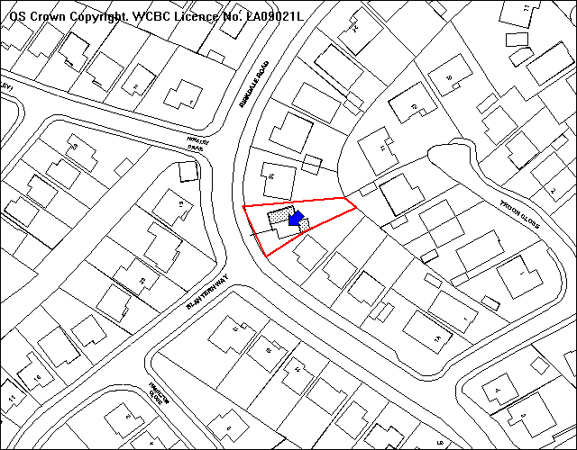
First Floor Extension
Conservatory

SITE

The property sits between two storey and single storey houses.

PROPOSAL

As above.

HISTORY

None relevant.

DEVELOPMENT PLAN

Inside settlement limit therefore UDP policies PS1,GDP1 and LPG note16: Parking Standards and 20: House Extensions are relevant

CONSULTATIONS

Community Council: Notified 12th May 2008
Local Member: Notified 12th May 2008
Adjacent occupiers: One letter received which raises no objection to conservatory but an objection to the first floor extension because of the detrimental impact on the street scene, and further overlooking issues to adjacent property.
Site Notice: Expired 6th June 2008

SPECIAL CONSIDERATIONS

Main Issues: The main issues relate to the size and scale of the extensions in relation to the existing property, the impact on the street scene and amenity of adjacent properties.

There are two elements to this proposal, the conservatory and the first floor side extension. The conservatory is moderate in terms of size and scale and would be located of the rear elevation. The southern boundary consists of 2.5 metre high leylandii hedge and would substantially screen the proposed conservatory and protect the adjacent property from overlooking and loss of privacy. The hedge can be conditioned to be retained.

The extension would be above the existing garage and would project further forward than the front elevation of the property. This property’s position staggered built form maintains the openness of the street scene as the properties change in form, from bungalows to houses. The forward position and scale of this extension would detrimentally harm the street scene. The agent has been advised of these concerns and it has been suggested that the extension is set back from the front elevation by 0.5m.

The rear elevation of the first floor extension would have the en suite bathroom window which is non habitable and likely to be obscurely glazed, there would be no issues of overlooking and loss of privacy.

Parking: The proposal of an additional bedroom to a four bedroom property would not require any increased parking provision. The garage and driveway would easily accommodate the maximum three spaces required in terms of Local Planning Guidance Note 16: Parking Standards

Conclusion: The first floor element requires an amendment in terms of its scale. The agent has been advised but no response received as yet, therefore split recommendation which is subject to the receipt of amended plans and re-consultation process.

RECOMMENDATION A

If the amended plans are acceptable and no further representations are made, it is recommended that the Chief Officer be given delegated powers to GRANT permission subject to conditions:-

CONDITION(S)

1. The development hereby permitted shall be begun before the expiry of five years from the date of this permission.
2. No facing materials shall be used other than materials matching those used on the existing building.
3. The development shall only be carried out in accordance with the amended plan(s).
4. The southern boundary hedge shall be retained at a minimum height of 1.8 metres.
5. Notwithstanding the provisions of the Town and Country Planning (General Permitted Development) Order 1995 any window or opening in the rear elevation of the extension shall only be glazed or re-glazed using obscure glass.
6. The northern boundary fence situated to the rear of the property shall be increased to a height of 1.8 metres and retained therafter.

REASON(S)

1. To comply with Section 91(3) of the Town and Country Planning Act, 1990.
2. To ensure a satisfactory standard of appearance of the development in the interests of the visual amenities of the area.
3. To ensure that the development fully complies with the appropriate policies and standards.
4. To protect the amenities of the occupiers of nearby properties.
5. To protect the amenities of the occupiers of nearby properties.
6. To protect the privacy and amenity of the adjacent occupier.

RECOMMENDATION B

If amended plans are not received, it is recommended that permission be REFUSED for the following reason:-

1. The size and scale of the first floor extension would over dominate the existing property and detrimentally harm the amenity of the street scene, contrary to GDP1 of the Wrexham Unitary Development Plan (2005) and Local Planning Guidance Note 20: House Extensions.

NOTE(S) TO APPLICANT

You should ensure that any difference between the plans approved under the Town and Country Planning Acts and under the Building Regulations is resolved prior to commencement of development, by formal submission of amended plans.
_____________________________________________________________________

APPLICATION NO:  P/2008 /0508  COMMUNITY:  Offa  WARD:  Offa | LOCATION:  36/38 VICTORIA ROAD WREXHAM  DESCRIPTION:  CHANGE OF USE FROM RESIDENTIAL TO BUSINESS TO EXTEND SHOWROOM AND PROVIDE EXTRA STORAGE.  APPLICANT(S) NAME:  MR ROBERT DICKENSON | DATE RECEIVED:  08/05/2008  CASE OFFICER:  SEH  AGENT NAME:  MR ROBERT DICKENSON
_____________________________________________________________________

THE SITE

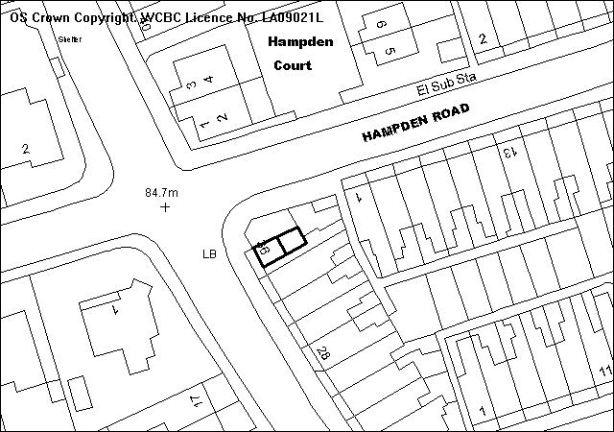
Storage Space
Retail floor space
Existing Shop
Victoria
Road
To Ruabon Rd

PROPOSAL

Change of use of part of the ground floor of the dwelling adjoining the existing shop, to provide additional retail floor space and storage area (in retrospect).

RELEVANT HISTORY

None relevant.

DEVELOPMENT PLAN

Within settlement limit UDP policies GDP1 and T8 applies.

CONSULTATIONS

Community Council: No objection to the change of use as the business enhances the area. However, the large advertising sign over the doorway is out of place and should be removed.
Local Member: Consulted 12/05/2008
Highways: No recommendations.
Public Protection: Consulted 12/05/2008
Welsh Water: No objections subject to recommended conditions/notes.
Other Representations: One letter received raising the following points:
- The lack of on-site parking leads to customers parking on Hampden Road causing congestion.
- Delivery vehicles cause an obstruction.
- Walls should not be increased in height as this would cause loss of light to, and restrict visibility from, the adjacent property,
Site Notice: Expired 03/06/2008

SPECIAL CONSIDERATIONS/ISSUES

Background: The existing florist is located at number 38 Victoria Road, and this retrospective application is for the extension of the retail floor and storage area into part of the ground floor of the adjoining dwelling (No.36). The main issues to consider relate to the impact of the development upon the existing highway network.

Residential Amenity/Highway Safety: There is no on-site parking for the existing use of the site as a flower shop. It is claimed that most customers that visit the shop arrive on foot, and there is a bus stop just metres away. There are double yellow lines outside of the shop on Hampden Road which control on-street parking near the junction with Victoria Road. Any customer/delivery arriving by car/van would have to park either across from the site on Victoria Road or further up Hampden Road, outside residential properties.

Although, no additional on-site parking/delivery facilities have been proposed in connection with this application, the increase in floor area is considered to be so minimal that it would not significantly impact upon the current parking/delivery facilities, or increase the intensity of use of the site to a level which justifies refusal of planning permission.

Other Representations: As the existing sign above the doorway into the store has been in situ for more than 30 years, the Authority does not have any control over the sign.

Concerns have been raised as to the possible increase in the height of the boundary wall. No such proposals have been submitted as part of this application.

Conclusion: For the reasons stated above, I am satisfied that the proposed extended floor area is acceptable in terms of the impact on local residential amenity and highway safety, and I recommend accordingly.

RECOMMENDATION That permission be GRANTED

CONDITION(S)

1. The retail and storage floor area shall be restricted to that shown on the approved plan and shall not encroach further into the residential areas.
2. The proposed access/driveway shall have a maximum gradient of 1:8.
3. The external storage area as shown on the approved plan shall be used in connection with the applicant's business at No 38 Victoria Road only.
5. No development shall take place within 3 metres to both sides of the public sewer which crosses the site.
6. The premises shall only be used for sale of flowers ancillary to the use of the adjoining shop unit (36 Victoria Road) for the same purposes and for no other purpose.

REASON(S)

1. In the interests of highway safety.
2. In the interests of highway safety.
3. To protect the amenities of the occupiers of nearby properties.
5. To ensure access to the public sewer is maintained and to protect the building's foundations if access is required.
6. In the interest of safety and the free flow of traffic on the adjoining highway.
_____________________________________________________________________

APPLICATION NO:  P/2008 /0519  COMMUNITY:  Broughton  WARD:  Bryn Cefn | LOCATION:  21 MOSS HILL MOSS WREXHAM  DESCRIPTION:  TWO-STOREY EXTENSION TO FORM PLAYROOM, UTILITY ROOM AND BEDROOM.  APPLICANT(S) NAME:  MR L HARPER | DATE RECEIVED:  12/05/2008  CASE OFFICER:  LB1  AGENT NAME:  D B DAVIES
_____________________________________________________________________

SITE

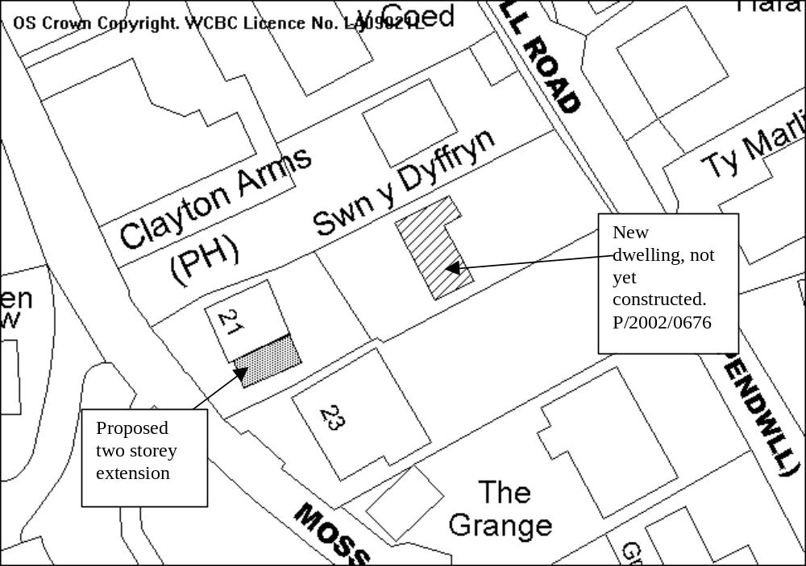

PROPOSAL

As above.

HISTORY

No relevant applications on the property itself.
Land to the rear (at lower level) has been granted permission for one detached dwelling, this has not yet been constructed. Application P/2002/0676 Granted 09/09/02

DEVELOPMENT PLAN

Lies within settlement limit, GDP1, PS2, LPGN 20, 21 & 16 apply.

CONSULTATIONS

Community Council: No objections
Local Member: Consulted 14/05/08
Other representations: One letter of objection :
- Concern raised regarding the proximity of the proposed extension to the boundary. There has been previously been a landslip at the property impacting on the neighbouring property which has not to date been fully resolved.
- Wish to know what steps are being taken to ensure that any ground works are carried out to a high specification and that no further problems will be suffered in the future.
Site Notice: Expired 12/06/08

SPECIAL CONSIDERATIONS

The site: Moss Hill is a steeply sloping hill. The property lies to the front of the plot of land, the rear garden slopes steeply to Pendwll Road at the rear. The ground to the rear is approximately 4m lower than the level of the house. Permission has previously been granted for a detached house and garage to the rear of the site, this has not yet been constructed. The house to the south of the property (23 Moss Hill) is a bungalow.

The proposed extension is a two-storey extension to the side of the existing property providing a new bedroom, utility room and playroom.

Design & Amenity: The proposed extension passes the BRE tests in relation to the neighbouring properties and will not create any overlooking. The design of the extension is in keeping with the property and is set back from the front of the dwelling ensuring that it will be subsidiary to the existing house.

Other considerations: There is a parking area to the front of the property that will provide sufficient space for three cars, thus fulfilling the requirements of LPGN 16.

There has been a decking area constructed to the rear of the property within the garden area. As there have been no previous extensions to the property and the volume created by the decking is less than 70 cubic metres the decking is considered to be permitted development.

The concerns relating to ground slip during the construction process is not normally considered to be a material planning consideration and the matter should be considered under the building regulations. A note to applicant will be added to any permission to remind the applicant that ground slip would be their responsibility. Any ground slip that has occurred previously is a private matter between the occupiers.

Conclusion: The proposed extension will not create any detrimental impact on the neighbouring properties and I am satisfied that providing careful working practices are used there should be no ground slip that will affect the neighbouring property and I therefore recommend accordingly.
P/2008 /0519

RECOMMENDATION That permission be GRANTED

CONDITION(S)

1. The development hereby permitted shall be begun before the expiry of five years from the date of this permission.
2. No facing materials shall be used other than materials matching those used on the existing building.
3. Development shall only be carried out in strict accordance with the approved plans unless the prior written approval of the Local Planning Authority has been obtained.

REASON(S)

1. To comply with Section 91(3) of the Town and Country Planning Act, 1990.
2. To ensure a satisfactory standard of appearance of the development in the interests of the visual amenities of the area.
3. To ensure that the development fully complies with the appropriate policies and standards.

NOTE(S) TO APPLICANT

You should ensure that any difference between the plans approved under the Town and Country Planning Acts and under the Building Regulations is resolved prior to commencement of development, by formal submission of amended plans.

You are advised that building work which involves work on an existing wall shared with another property, building on the boundary with a neighbouring property or excavating near a neighbouring building may require the separate consent of the neighbour under the provisions of the Party Wall Act. If you require further information or advice please contact the Building Control Section on 01978 292050.

The proposed development lies within a former coal mining area. You should take account of any hazards to stability which may arise from coal working in or near the site. Specific advice on any past working may be obtained from the Coal Authority Mining Reports Service. Phone 0845 762 6848 or from www.coal.gov.uk.

Any operations which may involve entry into former workings, shafts or adits or implementation of site investigations or other works may need permission from the Coal Authority.

You are advised to ensure that during the construction process, ground slip does not occur which will affect the neighbouring property.
_____________________________________________________________________

APPLICATION NO:  P/2008 /0526  COMMUNITY:  Isycoed  WARD:  Holt | LOCATION:  LAND BETWEEN HILLVIEW & VILLAGE HALL ISYCOED WREXHAM  DESCRIPTION:  OUTLINE APPLICATION FOR RESIDENTIAL DEVELOPMENT (2 NO. DWELLINGS).  APPLICANT(S) NAME:  MR & MRS JE MORRIS | DATE RECEIVED:  13/05/2008  CASE OFFICER:  DSW  AGENT NAME:  S MURRAY & ASSOCIATES
_____________________________________________________________________

P/2008 /0526

THE SITE

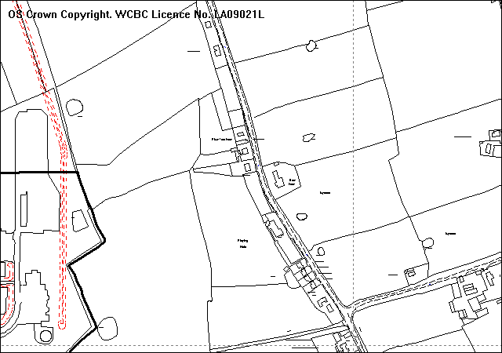
Triangular area of open land located to the north of the village hall and south of “Hillview”, Bowling Bank. The site has frontage to the B5130.
Site

PROPOSAL

As above.

HISTORY

None.

DEVELOPMENT PLAN

Outside settlement. Policies PS1, PS2 and H5 apply. L PG No 13 also applies.

CONSULTATIONS

Community Council: Notified 14.05.08
Local Member: Notified 14.05.08
Highways: No objections subject to appropriate conditions to
ensure adequate visibility, adequate parking and turning
facilities and a 2.0m wide footway along the site
frontage.
Other Representations: Five neighbouring occupiers notified 17.06.08.
Site Notice: Expired 11.06.08

SPECIAL CONSIDERATIONS/ISSUES

The land is designated as unannotated land outside settlement limits in the UDP. In planning terms, the site is referred to as being ‘in open countryside’ where there is a general presumption against development. Therefore, development of new dwellings in the countryside is strictly controlled and any proposal would have to comply with policy H5 – Housing in the Countryside, which states “Outside defined settlement limits new dwellings will only be permitted where …b) proposals comprise infilling subject to policy GDP1”.

Infilling is defined as “the development of no more than two dwellings in a small gap within a well developed built frontage”.

However, in this case, the gap between Hillview and the Village Hall is approximately 70m wide. I would not consider this distance to be ‘a small gap’. Neither would I consider the properties along this section of the B5130 to constitute as ‘a well developed built frontage’ given that there is considerable distance between the Village Hall and the houses to north and to the south. Allowing residential development on this site would result in the consolidation of sporadic groups of housing in the countryside, which would be contrary to policy H5. There are a number of plots along the road between Holt and Cross Lanes which might be eligible for consideration if this were approved and the resultant ribbon of development between those communities would have a major impact upon the rural nature of the area.

RECOMMENDATION

That permission be refused for the following reason:

1. The site is located outside any settlement limit in the Wrexham Unitary Development Plan. Theproposal would not constitute "infill" development because the site does not form a small gap in a well developed built frontage. To allow the development would adversely affect the character and appearance of the area and result in the consolidation of sporadic groups of housing in the countryside, which would be contrary to adopted Unitary Development Plan Policy H5.
_____________________________________________________________________

APPLICATION NO:  P/2008 /0534  COMMUNITY:  Rhosddu  WARD:  Grosvenor | LOCATION:  34 REGENT STREET WREXHAM  DESCRIPTION:  CHANGE OF USE FROM RETAIL (CLASS A1) TO BETTING SHOP (CLASS A2).  APPLICANT(S) NAME:  DONE BOOKMAKERS | DATE RECEIVED:  14/05/2008  CASE OFFICER:  SJG  AGENT NAME:  PEGASUS PLANNING GROUP LLP
_____________________________________________________________________

THE SITE

Macdonalds
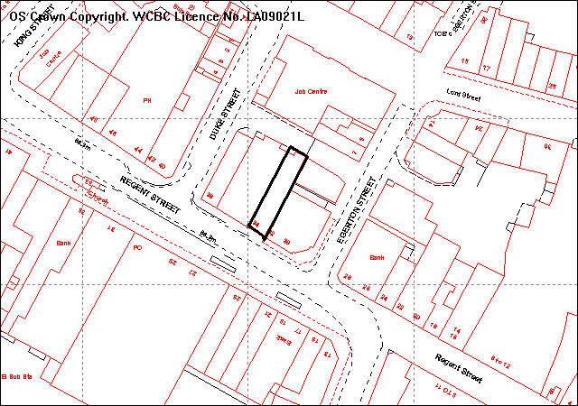
PROPOSAL

As above. The shop was formerly Stationary Box.

RELEVANT HISTORY

None.

DEVELOPMENT PLAN

Within the settlement limit and on a Principal Shopping Street. Policies S1 T8 and GDP1 of UDP are relevant and LPGN 6 and 6 and Technical Advice Note 4.

CONSULTATIONS

Rhosddu C Council: Consulted 15/5/2008
(adj) Offa C Council: Object to the loss of another retail outlet in the “High Street”.
Local Members: Consulted 15/5/2008
Highways: No recommendations, but refer to a possible commuted sum in lieu of any increased shortfall in parking provision
Public Protection: No comments relating to planning issues
CEDO: Supports the application (detailed statement supplied).
Site Notice: Expired 10/6/2008
Other representations: Adjoining occupiers notified 19/5/2008.

SPECIAL CONSIDERATIONS/ ISSUES

Policy Background
Extracts from TAN 4
8. Sustaining the vitality of town centres depends on flexibility in the use of floor space.
10. Changes of use can create new concentrations of single uses, such as restaurants and take-away food outlets, where the cumulative effects can cause local problems. Such proposals should be assessed against development plan policies, on their contribution to diversification and on the cumulative effects on matters such as parking and local residential amenity.

Policy S1 of the UDP:
Non-retail proposals on ground floor frontages in the principal shopping streets… will not be permitted if they have a detrimental effect upon the character, vitality or viability of the area.

The shop is the former Stationery Box, adjoining McDonalds. It has a gross floorspace of approximately 100m² at present. The application includes detailed assessments of the policy background and the local context in terms of Principal Shopping Streets.
- will bring back into use a vacant shop
- the predominant use is retail and this will not change this
- there will not be an undue concentration of non-retail use in the area
- there are no other betting shops nearby

I accept the information in this assessment for these reasons:
- The characteristics of a betting office which appeal decisions appear to accept have a display window and regular activity and are thus not “dead” frontage.
- In this street frontage this would be the only A2 use
- There are a number of empty units within the town centre
- The fact that this unit has been vacant for over 6 months and with the opening of Eagles Meadow this seems unlikely to change in the near future

I therefore accept that this proposal does not conflict with policy S1 or TAN6.

Accessibility: The shop has a level access from Hope Street, and the statement covers all issues.

Parking: LPGN16 requires a higher parking provision for A2 uses (1 per 6m² ie 17 spaces) than A1 shops (1 per 15m² ie 6 spaces) which would require an extra 10 parking spaces for a unit of this size. However the customer floorspace to be provided is reduced to 66m² (ie 11 spaces), and the use applied for is a specific one which is not typical of an A2 use. Any permission could be conditioned to that use and that area. It is considered reasonable to seek a contribution towards car parking provision based on the reduced area (5 spaces) under policies GDP2 and T8.

RECOMMENDATION A

That the Council enters into an Obligation under section 106 of the Town & Country Planning Act 1990 requiring a commuted parking payment to compensate for the shortfall in parking provision. The Chief Planning Officer be given delegated authority to settle the final form and content of the Obligation.

RECOMMENDATION B

Upon completion of the Obligation planning permission be GRANTED subject to the following conditions:

CONDITION(S)

1. The development hereby permitted shall be begun before the expiry of five years from the date of this permission.
2. Development shall only be carried out in strict accordance with the approved plans unless the prior written approval of the Local Planning Authority has been obtained.
3. Notwithstanding the provisions of the Town and Country Planning (Use Classes) Order no part of the premises shall be used except for the precise purposes described in the application plans and documents.
4. The public floorspace shall be limited to 66sq m

REASON(S)

1. To comply with Section 91(3) of the Town and Country Planning Act, 1990.
2. To ensure that the development fully complies with the appropriate policies and standards.
3. To maintain the vitality and viability of the Principal Shopping Street.
4. to limit the car parking demand of the proposed use

NOTE(S) TO APPLICANT

Your attention is drawn to Highway Supplementary Notes Numbered 1, 3, 4 and 5 on the enclosed "Applicants' Rights and General Information".

You are reminded that the Disability Discrimination Act 1995 applies to this development.
_____________________________________________________________________

APPLICATION NO:  P/2008 /0537  COMMUNITY:  Llangollen Rural  WARD:  Llangollen Rural | LOCATION:  LLWYN ONN LLANGOLLEN ROAD TREVOR WREXHAM  DESCRIPTION:  CHANGE OF USE OF FORMER RECEPTION ROOM/GARAGE AND CAR HIRE AND SALES TO OCCUPATIONAL THERAPISTS CONSULTATION ROOM (IN RETROSPECT)  APPLICANT(S) NAME:  MR P LIGHTFOOT & DR R WILLIAMS | DATE RECEIVED:  15/05/2008  CASE OFFICER:  CB  AGENT NAME:  MR P LIGHTFOOT & DR R WILLIAMS
_____________________________________________________________________

SITE

As above.

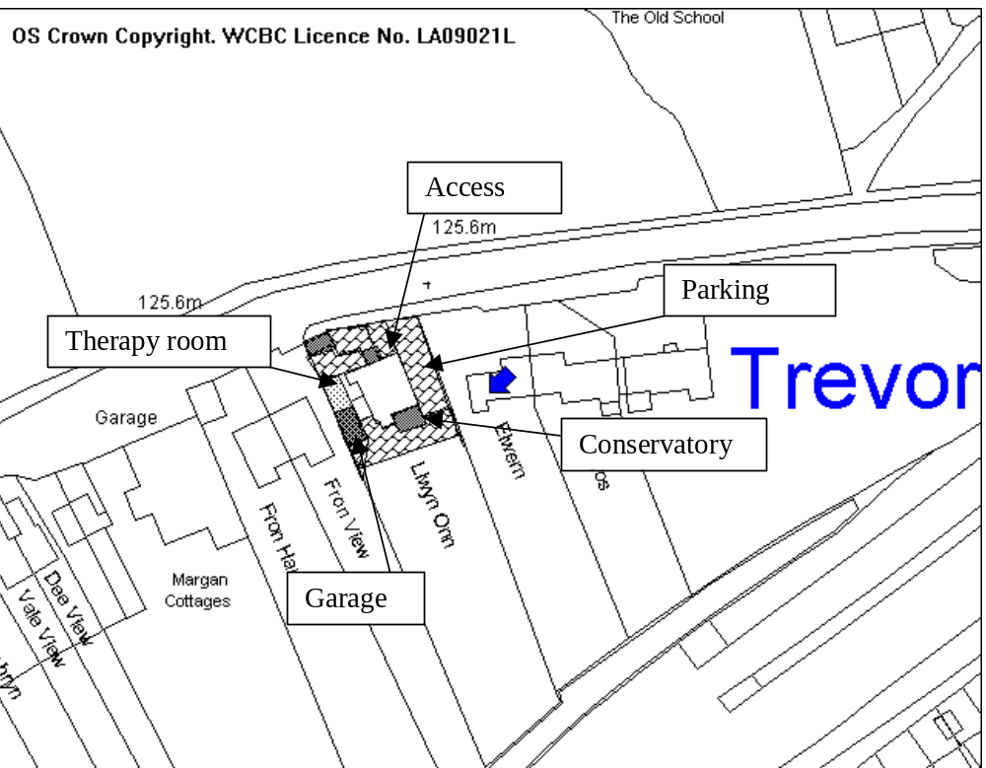

PROPOSAL

As above.

HISTORY

None relevant.

DEVELOPMENT PLAN

Inside settlement policies PS1, GDP1, and LPGN 16: Parking Standards are relevant.

CONSULTATIONS

Community Council: Notified 19th May 2008
Local Member: Notified 19th May 2008
Highways: The visibility at the existing access is in accordance with the recommendations of TAN18, and there is adequate space provided within the site for the parking and turning of vehicles for the existing dwelling and occupational therapists. The proposal is unlikely to generate any significant amount of additional traffic
Adjacent Occupiers: Letter of concern received which raises concerns with the limited parking on site and dangerous entrance, which will lead to parking outside neighbouring properties which is dangerous for pedestrians and vehicles and occupants of neighbouring properties.
Site Notice: Expired 13th June 2008

SPECIAL CONSIDERATIONS

Main Issue: The main issue relates to the scale and intensity of the occupational therapy use and impact on parking and traffic movements associated with the existing dwelling.

Occupational Therapy Use: The use of the building for occupational therapy is limited to two clinic sessions per week, Mondays 09:30 until 12:30pm and Thursdays 16:45 until 18:45pm. Appointments are arranged by appointment and there is an average of four appointments/people per week.

The application proposal contains supporting information which states that the property had previously been used as a car hire and sales business but that this business ceased 13 years ago. There is no planning history to suggest that the use existed on site.

Parking, Access and Highway Safety: The area around the house is block paved and provides a generous amount of parking for the four bedroom property. The two additional spaces required for the occupational use would easily be accommodated.

The access to the site from Llangollen Road is restricted in terms of visibility and any significant traffic generation from this site would be a concern. The site provides adequate parking for at least the five spaces and there would be no concerns in regards to issues of on street parking or highway safety because of the ample parking provided on site. In the interests of highway safety ,it can be conditioned that the hard surfaced area around the house remains clear and free from obstruction for the parking and turning of vehicles .Problems of parking outside of the site, and on the highway or on private land are a civil matter between neighbours.

Conclusion: The scale and intensity of use is small and ancillary to the main house, and I am satisfied that this level of use can be controlled by condition. To ensure it is ancillary, the use should only be operated by the resident of the property. There is ample parking available on the hard surfaced area which surrounds the house, and I do not consider that the level of use would generate sufficient vehicular movements to cause issues of highway and pedestrian safety.

/2008 /0537

RECOMMENDATION That permission be GRANTED

CONDITION(S)

1. The development hereby permitted shall be begun before the expiry of five years from the date of this permission.
2. The premises shall only be used for occupational therapy purposes ancillary to the use of Llwyn Onn for residential purposes and for no other purpose.
3. Prior to the first use of the premises, provision shall be made for ambulant and wheelchair bound disabled people to gain easy and convenient access into and through the building in accordance with details which have been previously approved in writing by the Local Planning Authority and such facilities shall be maintained and kept available so that they can be used at all times when the premises are open.
4. The occupational therapy use shall be strictly restricted to the hours and sessions detailed in the application documents.
5. The hard surfaced area around the property as indicated on the approved plan shall be kept free and clear of obstruction for the parking and turning of vehicles on site.
6. This permission shall not enure for the benefit of the land but shall operate for the benefit of Paul Lightfoot and Dr R Williams whilst he/she are resident at the property and on the discontinuance of his/her use of that land, the use shall cease and be abandoned. The land shall be restored to its previous condition not later than one month after that date.

REASON(S)

1. To comply with Section 91(3) of the Town and Country Planning Act, 1990.
2. To ensure that the impacts upon the area are minimised.
3. In order to secure the satisfactory provision of facilities and access for disabled persons.
4. To ensure that the occupational therapy is not used at a time which would be likely to cause nuisance or disturbance to nearby residents.
5. To ensure that a satisfactory provision of off-street car parking and turning facilities is maintained at all times in the interests of the free flow of traffic and highway safety.
6. To ensure that the impacts of the use on adjoiing residents and upon the highway are controlled.

NOTE(S) TO APPLICANT

The proposed development lies within a former coal mining area. You should take account of any hazards to stability which may arise from coal working in or near the site. Specific advice on any past working may be obtained from the Coal Authority Mining Reports Service. Phone 0845 762 6848 or from www.coal.gov.uk.

Any operations which may involve entry into former workings, shafts or adits or implementation of site investigations or other works may need permission from the Coal Authority.

You should ensure that any difference between the plans approved under the Town and Country Planning Acts and under the Building Regulations is resolved prior to commencement of development, by formal submission of amended plans.

You are reminded that the Disability Discrimination Act 1995 applies to this development.

You are advised to incorporate the requirements of Sections 7 and 8 of the Chronically Sick and Disabled Persons Act, 1970 into the proposed development.
_____________________________________________________________________

APPLICATION NO:  P/2008 /0550  COMMUNITY:  Gresford  WARD:  Gresford East & West | LOCATION:  REAR OF GARDEN 10 WHITEWAY DRIVE GRESFORD WREXHAM  DESCRIPTION:  REMOVAL OF 2 NO. SYCAMORE TREES (WCBC NO.1)  APPLICANT(S) NAME:  ROBIN JAMES THOMAS | DATE RECEIVED:  19/05/2008  CASE OFFICER:  MS  AGENT NAME:  ROBIN JAMES THOMAS
_____________________________________________________________________

SITE

The site is a woodland to the rear of the applicant’s property
2 sycamores
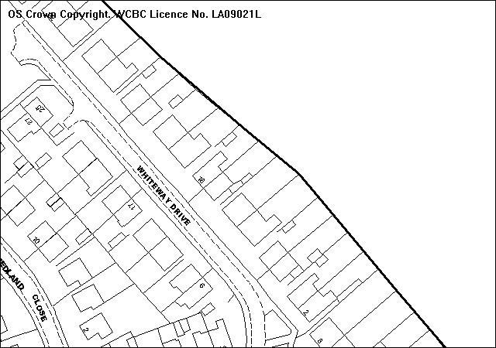

PROPOSAL

To remove two self-seeded sycamore trees in order to allow a planted pine tree to expand. It is stated that both trees show rot and the one nearest the property leans over a shed and green house. No replacement planting is proposed as the applicant wishes to encourage the existing tree and bushes to expand.

HISTORY

No previous applications have been received in respect of this woodland.

DEVELOPMENT PLAN

Policy EC4: Hedgerows, Trees and Woodland.

CONSULTATIONS

Community Council: support views of Tree Officer.
Local Member: Notified 20/05/08. Hopefully trees can be pruned and not
removed.
Building Control: Notified 20/05/08.
Site Notice: Notified 23/05/08.
Other representations: 2 adjacent properties notified on 27/05/08. 1 response:- No
objections.

SPECIAL CONSIDERATIONS

The two sycamore trees are growing adjacent to a much taller Austrian pine. The applicant has stated that he believes that the sycamores are affecting the growth of the Pine, which was originally planted, whilst the sycamores have self-seeded. The applicant also has concerns regarding the safety of the trees. He states that both have rot and one is leaning.

I can confirm that both trees are inhibiting the growth of the pine. The pine is one of a line of pine trees that appear to have been planted as part of a scheme. This particular pine has grown as tall as the others, but it has a much more slender trunk.

I disagree with the applicant that both trees are rotten, as no visual indications of internal or external decay were observed when I viewed the trees. One of the trees is leaning heavily, which has resulted in the tree having a poor structural form. Both sycamores have a relatively low amenity value, compared to the pine as they are smaller in size and cannot be easily seen from Whiteway Drive.

The trees are protected by a woodland Order, not as individual trees. Government guidance on woodland Orders’ states that they should not be used as a means of hindering beneficial management work, such as regular felling and thinning.

I do agree that the removal of the two sycamores will be of eventual benefit to the growth of the pine tree. However if the two sycamores were removed in one go there is a risk that the pine could snap in stormy weather conditions as it has a poor stem diameter to height ratio. The sycamores currently shelter it and if the cover is removed the tree could fail.

A solution to the above quandary would be to remove the sycamores in two stages, i.e. by cutting them down by 40% in height to start with and then removing the other 60% approximately 18 – 24 months later. This would enable the pine tree to gradually become accustomed to the increased wind loading it will receive and to put on extra growth on the trunk in response to the increased wind loading.

CONCLUSION

The application (as amended by the suggestion above (and condition 3 below) would not be to the detriment of the amenity value of the woodland. It would help the growth of the adjacent pine tree. No replacement planting is required.

RECOMMENDATION That permission be GRANTED

CONDITION(S)

1. All tree works hereby approved shall be undertaken to the standard set out in British Standard 3998: Recommendations for Tree Work: 1989 (or any subsequent revisions).
2. The tree works hereby approved shall be commenced within two years of this consent being granted.
3. The works hereby granted consent shall be undertaken in two stages. The first stage of works shall consist of the two sycamores crowns being reduced by up to 40% crown volume and the second stage of works shall consist of the remaining parts of the trees being removed in their entirety. The second stage of works shall not be commenced until a minimum of 18 months has passed since the completion of the first stage of works.

REASON(S)

1. To preserve the health and safety and amenity value of the trees to be worked on.
2. To ensure that works are undertaken within a reasonable timescale.
3. To ensure works will not result in the failure of the adjacent pine tree, thus preserving its amenity value.
_____________________________________________________________________

APPLICATION NO:  P/2008 /0557  COMMUNITY:  Holt  WARD:  Holt | LOCATION:  BORRAS QUARRY HOLT ROAD WREXHAM  DESCRIPTION:  VARIATION OF CONDITION NO. 3 OF PLANNING PERMISSION NO. P/2003/0579 TO ALLOW FOR THE IMPORTATION OF BOTH LIMESTONE AND PRE-PROCESSED GRANULAR GLASS FOR BLENDING PURPOSES.  APPLICANT(S) NAME:  TARMAC LIMITED | DATE RECEIVED:  20/05/2008  CASE OFFICER:  JGK  AGENT NAME:  TARMAC LIMITED  MR RICHARD HULSE
_____________________________________________________________________

THE SITE
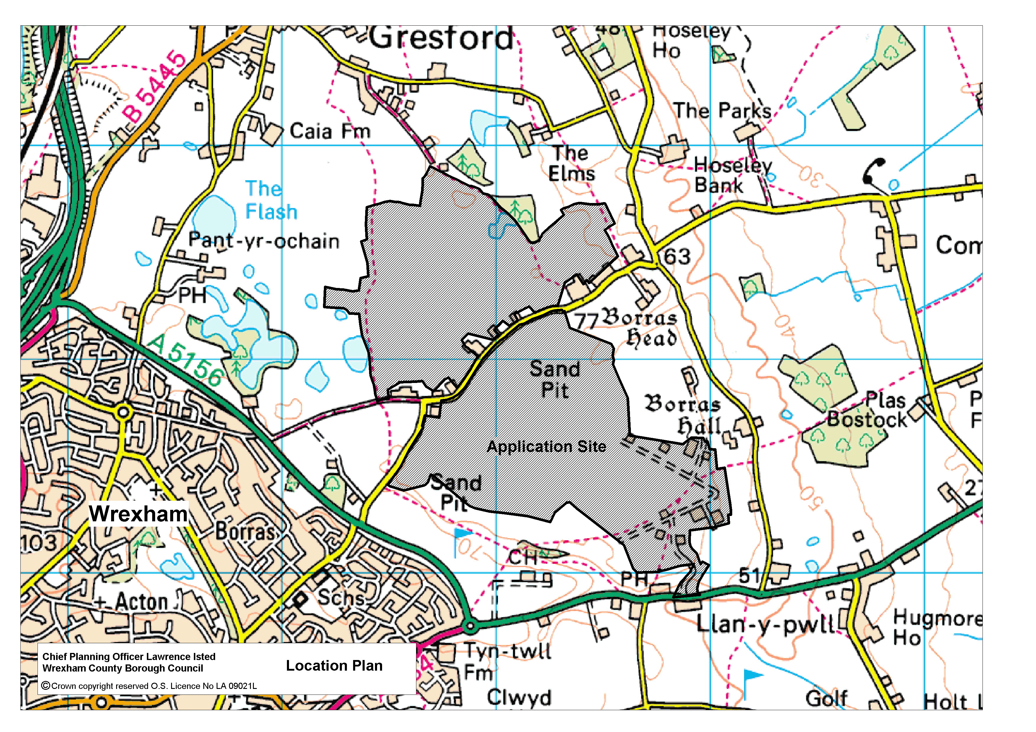
Storage location
Plan No 1 Location Plan

PROPOSAL

As above.

HISTORY

Planning permission for the working of sand and gravel at Borras Airfield was granted by the former Secretary of State for Wales in 1965 under reference 12/4903. Working commenced in the early 1970s and, since that time, over 15 planning permissions have been granted for a range of mineral related developments. The principal permissions are:
6/12353 Erection of concrete block plant. Granted 18.03.86
6/11855 Extension to Borras Airfield sand and gravel pit on land at Borras Farm. Granted 26.11.86.
6/17982 Extension to Borras Airfield sand and gravel pit on land at Caia Farm. Granted 11.06.91.
6/17984 Extension to Borras Airfield sand and gravel pit on land at Borras Hall Farm. Granted 17.07.90.
6/19166 24 hour working at concrete block plant. Granted 24.07.91.
CB2180 Review of Old Mineral Permission application; updating the conditions attached to planning permission 12/4903 to bring them to modern standards. Granted 30.07.01. Revoked.
P/2001/1079 Amendment to condition restricting working hours attached to permission CB2180. Granted 11.03.02.
P/2002/0969 Amendment of condition 11 of CB2180 to allow importation of limestone fines for blending with sand and gravel. Granted 05.07.04. Revoked.
P/2003/0579 Extension of sand and gravel workings. Granted 18.01.07.
P/2007/1130 Variation of condition no 3 of planning permission P/2003/0570 to allow for the recycling of asphalt planings. Granted 03.12.07.
P/2008/0367 Variation of condition no 2 of planning permission P/2002/0969 to allow for the importation of 70,000 tonnes maximum per annum of limestone fines or recycled glass fines for blending purposes (the total amount of imported material on site to be limited to 5,000 tonnes at any one time). Withdrawn

DEVELOPMENT PLAN

Outside settlement limits, UDP policies apply: PS2, GDP1 a) and EC4 (quality of development, landscape & natural environment), EC1 (green barrier), GDP1 f) (noise, dust etc), GDP1 d) and T8, (highways), MW9 (safeguarding of mineral resources from sterilising development, and MW11 (buffer zones surrounding mineral sites).

CONSULTATIONS

Holt Community Council: Notified 22.05.08.
Gresford Com. Council: Notified 22.05.08.
Acton Com. Council: Notified 22.05.08.
Local Member: Notified 22.05.08.
Public Protection: No additional comment as long as current conditions are applied to the site in terms of noise and dust control
Highways: No recommendations. Add Note to Applicant.
CCW: Notified 28.05.08
Environment Agency: Add Notes to Applicant re the requirement for a Para 14 exemption under the Environmental Permitting Regulations 2007 and storage of waste glass.
Site Notice: Expires 02.06.08.
Other Representations: Objection received as follows:
- Increase in existing levels of dust – dust clouds in times of dry weather forcing windows to be shut and unable to work outside

SPECIAL CONSIDERATIONS/ISSUES

Background:
Planning consent was granted in January 2007 (reference no P/2003/0579 refers) combining the deepening proposal for Borras Airfield and Borras Hall Farm and the proposals to extend the quarry by working the adjoining Holt Estate land. This consent was varied in December 2007 to allow for the importation and recycling of road planings from the Wrexham road improvement contract- permission was given for a temporary period of two years until the end of December 2009.
The current proposal also seeks the variation of permission P/2003/0579 to allow for the importation of both limestone fines and recycled glass fines to be blended with the sand quarried at Borras to produce M grade sand and M grade eco-sand for block paving purposes. Tarmac Limited's Borras Quarry is the main producer of M grade sand in North Wales and the GMC Merseyside Regions, producing between 400,000 and 600,000 tonnes per annum. The availability of this grade of sand is limited in the North Wales and the GMC/ Merseyside Regions with only 2 other much smaller quarries producing limited amounts of this grade. The sand produced is a high quality concrete sand product for which there is a high level of demand.

Tests have been carried out on the feasibility of using pre-crushed and processed glass from local sources for blending with the fine sands. The glass has proved to be an excellent additive to the existing sands at Borras to produce a high quality M grade block making sand product. This proposal will provide for a maximum of 20,000 tonnes per annum (10,000 tonnes per annum of each material) to be imported. The Company would also ensure that no more than 5,000 tonnes total for both products would be stored on site at any given time.

It should be noted that earlier consent was granted in 2004 to allow for the importation of limestone fines to Borras Quarry (planning permission P/2002/0969). These limestone fines were blended with the sand quarried at Borras to ensure the continuity of supply of wide range of products, but in particular, M grade concreting sand.

Recycled aggregate glass fines (pre-processed and crushed) is inert and has the appearance of being a granular solid with Ph value of 7 (neutral) and no odour. The recycled aggregate glass is derived from bottles collected through public bottle banks under the control of Local Authorities, which after collection and sorting have been processed through traditional size reduction size technologies involving crushing and screening. No crushing or screening will take place at Borras Quarry.

The current documents listed under condition 3 of planning permission P/2003/0579 do not include a provision for bringing limestone fines and recycled glass into Borras Airfield for recycling. Hence, this application proposes a variation of Condition No.3 to enable this operation to take place.

Impacts

Amenity
The irregular delivery of both limestone fines and recycled glass would necessitate a stock pile of the material at Borras Quarry to ensure continuity of supply for the production of the M grade block making sand. The stock pile would initially be located within an excavated area against a quarry face and the materials would thereafter be transported by a face shovel to the main plant for processing. As stated earlier there will be a maximum importation of 20,000 tonnes per annum total for both materials. The proposed stockpile will occupy an area of 150 metres square located centrally within the lower levels of the quarry area (Borras Airfield) as indicated on the above location plan (Plan No 1 refers). The stock pile would not be visible from outside Borras Quarry and would not result in any adverse visual impact.

Highways
The existing main Quarry access onto the A534 operates safely and there is currently no restriction on its use by Quarry traffic. Alterations to the access have recently been completed to provide improved and satisfactory visibility splays resulting in sufficient capacity to cater for an increase in traffic movements. Combined schemes of lighting and signing and anti skid treatment along the A534 road approaches to the site entrance were secured by condition to the main application (P/2005/0579) and have been recently approved. The implementation of these schemes will further improve highway safety. HGV traffic levels from Borras Airfield are currently in the region of 55,000 lorries per year (110,000 movements). On a daily basis, an average of approximately 214 lorries enter and leave (equating to 428 movements) Borras Airfield each day. The additional HGV traffic resulting from the proposal (up to a maximum of 1000 vehicles per annum – a daily average of 4 movements) will not be significant addition to these numbers.

Hours of working
The proposed development will be in accord with the currently approved hours of working detailed by condition to planning permission P/2003/0579.

Air Quality and Noise
A full Air Quality Assessment and Noise Assessment was submitted in the 2003 and reassessed in August 2005. The potential air quality and noise impacts associated with the then proposed development were considered and, where necessary, measures to reduce these impacts were proposed and secured by condition. The glass fines will be stored in a stock pile against a quarry face and the presence of this stock pile would not result in windblown dust due to its location below natural ground level. I do not consider that the proposed development would adversely increase existing noise causing noise nuisance. Any potential dust emission and nuisance from noise will be minimised by the use of the following existing operations within the Site:
- High standards of ‘housekeeping’ and staff training will be maintained
- Haulage movements will be restricted to designated routes
- Water sprays will be installed along the Airfield access road to suppress dust
- Adherence to approved Dust Management Plan and measures ensuring noise limits are not exceeded

I have received an objection to the proposal in relation to the dust issues. I consider that the comments are more of a complaint regarding existing operations and I have passed the information on to the Council’s Public Protection department for its attention.

Conclusion
The proposed development is in accordance with the principles of sustainable development set out in national and local guidance (including Policy MW12 in the Wrexham Unitary Development Plan), in that it:
- Is at the top of the waste hierarchy, as it enables the re-use of waste materials (recycled glass fines)
- Reduces the demand for primary aggregates therefore helping in preserving natural aggregates for future generations
- Prevents the disposal of waste materials to landfill

In determining this application I have given careful consideration to the proposal in relation to the approved measures in place in relation to planning permission P/2003/0579 approved in December 2007 to secure a minimum of disturbance to the local area. The permission will be restricted to a maximum importation of 20,000 tonnes per annum of both limestone fines and recycled glass with no more than 10,000 tonnes stored at any one time.

RECOMMENDATION That permission be GRANTED

CONDITION(S)

1. The areas referred to in these conditions as 'Borras Airfield' and the 'Holt Estate' are those areas shown edged red and annotated as "Borras Airfield" and the 'Holt Estate' on Drawing no B110/131a, submitted with the Supplementary Statement dated August 2005. 'Borras Airfield' and the 'Holt Estate' are collectively herein referred to as the 'Site' unless individually referred to.
2. The development hereby permitted is for the winning, working, processing, treatment, transport and sale of sand and gravel and associated products, together with ancillary operations, notwithstanding the requirements of conditions attached to this permission.
3. All quarrying and associated operations shall be carried out in accordance with the submitted proposals in May 2003 as amended in August 2005. The development shall be carried out in accordance with the documents listed below:
a. The following sections of the Planning Application Written Statement (Volume I), dated May 2003:
- Chapters 1, 2, 3, 5, 6 and 10
- Chapters 4, 7, 8, 9, 11, 12, as amended by the Supplementary Statement dated August 2005
- Appendices I to VII
b. The following sections of the Environmental Statement (Volume II), dated May 2003:
- Chapters 1-5, as amended/supplemented by the Supplementary Statement dated August 2005
- Chapter 7 (Ecology), as amended by Chapter 7 of the Supplementary Statement dated August 2005
- Chapter 9 (Soils and Agricultural Assessment) as amended by Chapter 9 of the Supplementary Statement dated August 2005
c. All of the Supplementary Statement dated August 2005, including the following plans and drawings:

Plan Ref Title

B110/130a Location
B110/131b Application Site
B110/132a Site Topography and Existing Land Use
B110/133 Planning Boundaries
B110/134a Borehole Information and Limits of Mineral Extraction
B110/135a Illustrative Geological Sections
B110/136a Extraction Boundaries and Development Stages
B110/137a Indicative Development at End of Stage A (2005)
B110/138a Indicative Development at End of Stage B (2010)
B110/139a Indicative Development at End of Stage C (2015)
B110/140a Indicative Development at End of Stage D (2018)
B110/141a Indicative Development at End of Stage E (2023)
B110/142a Indicative Development at End of Stage F (2031)
B110/143b Concept Restoration Plan
B110/144a Restoration Sections
B110/145a Borras Road Conveyor Crossing

d. Non Technical Summary of the Supplementary Statement dated October 2005.
e. Letter from Sloane Mead ref T/4034/a dated 17th September.
f. Letter from Tarmac Limited ref RAH/pas/08/26/B005/G and associated application documents.
4. The use hereby permitted as detailed in the letter from Sloane Mead ref T4034/ dated 17th September shall cease and be abandoned not later than 31st December 2009.
5. The use hereby permitted as detailed in the letter from Tarmac Limited ref RAH/pas/08/26/B005/G and associated application documents is limited to a maximum importation of 20,000 tonnes of both materials (no more than 10,000 tonnes total at any one time) split 10,000 tonnes recycled glass fines and 10,000 tonnes limestone
6 A copy of these conditions, including all documents hereby approved, and other documents approved in accordance with this permission, shall always be available at the Borras Quarry Office for inspection by the Minerals Planning Authority during normal working hours.
7. These conditions do not apply to the various developments permitted under the following planning permissions:

Permission Code | Date of  Permission | Development Permitted
6/BIE/1936 | 26/5/76 | Construction and siting of asphalt plant and associated storage areas.
6/BIE/9165 | 27/10/82 | Disposal of colliery waste.
6/BIE/9295 | 19/11/82 | Installation of colliery washing plant.
6/HOL/12676 | 24/2/86 | Erection of a Minerals Division Office building.
6/HOL/12356 | 18/3/86 | Installation of a concrete block making factory and ancillary works.
6/HOL/12889 | 23/4/87 | Amended siting and design of concrete block making plant.
6/13906 | 28/4/87 | 24 hour working of concrete products factory.
6/14601 | 1/12/87 | Reconstruction of and extension to existing offices.
HOL 14069 | 15/6/87 | Erection of new aircraft hangar.
6/19166 | 24/7/91 | 24 hour working of concrete products factory.
HOL CB00676 | 7/1/97 | Change of use from hangar to aggregate bagging operation with ancillary stocking facilities and parking area.

8. The development hereby permitted shall be limited to a period expiring on 21st February 2042, except for any outstanding restoration and aftercare works. Within a twelve month period following this date, or within a twelve month period following the completion of mineral extraction at the Site, whichever is the sooner, all buildings, plant, machinery and other structures shall be removed and final restoration works shall be completed, allowing aftercare to commence.
9. In the event that winning and working of sand and gravel has ceased for a continuous period of two years, an alternative scheme and programme of implementation for the interim restoration and aftercare of the Site shall be submitted for the written approval of the Mineral Planning Authority. This scheme shall be submitted within twelve months of the end of the two year period, and implemented within twelve months of the date of approval allowing restoration and aftercare to commence.
10. The development hereby permitted shall be begun before the expiry of 5 years from the date of this permission.
11. Written notification of dates of commencement of development, dates of commencement in each successive phase, dates of completion of restoration in each phase and of commencement and completion of aftercare for each restoration phase, and date of cessation or of completion of minerals operations, and completion of the development hereby permitted shall be made to the Minerals Planning Authority in relation to the following:
a. works within the Holt Estate land;
b. soil stripping on each occasion;
c. soil respreading on each occasion; and
d. restoration in each restoration phase.
Notification shall be within 7 days except in the case of soil stripping and respreading whereby prior notification shall be 24 hours.
12. Written notification of the date of cessation of the winning and working of sand and gravel for any continuous period of four weeks shall be provided to the Minerals Planning Authority within seven days of the end of the four week period.
13. A detailed restoration scheme for each restoration phase shall be submitted to and approved in writing by the Minerals Planning Authority before commencement of mineral extraction within each phase. The scheme shall include:
a. details of the final landforms;
b. areas where soils are to be stored and replaced;
c. depths of replaced soils;
d. methods and machinery to be used in soil handling operations;
e. details of temporary and final tree and shrub planting and the creation of any other habitats; and
f. a programme for the work
The detailed restoration scheme as approved, or subsequently amended, shall be implemented in respect of any area of land within the Site that is ready to be restored during the forthcoming twelve months.
14. An outline aftercare scheme for the Site shall be submitted for the written approval of the Minerals Planning Authority within twelve months of the date of this permission or any other date as agreed in writing by the Minerals Planning Authority.
The outline aftercare scheme shall relate to the phased restoration scheme submitted with the Application, or any subsequently amended restoration scheme. The aftercare scheme, where appropriate, shall include details in respect of:
a. cropping patterns;
b. cultivation procedures;
c. remedial treatments;
d. field drainage;
e. fertilisation;
f. weed control;
g. irrigation;
h. tree/shrub planting;
i. ponds and wetland areas; and
j. wildflower meadows
15. Following receipt of the approval in writing of the outline aftercare scheme required under Condition no 12 above, a detailed annual aftercare programme shall be submitted in writing to the Minerals Planning Authority by the last day in March of each calendar year. The detailed annual aftercare programme shall relate to any land within the Site that is ready to be subject to aftercare during the forthcoming twelve months. The aftercare programme shall include, where appropriate, details in respect of:
a. a record of aftercare operations carried out on the land during the preceding twelve months;
b. the nature, timing and depths of soil cultivators, and stone picking operations;
c. proposed fertiliser and lime application rates, based upon the results of soil nutrient analyses;
d. herbicide and fungicide application rates and areas of land to which they are applied;
e. timing, working depths, tine spacings, and equipment to be used in moling and subsoiling operations;
f. timing of the installation of underdrainage, including plans and location of pipes, details of installation methods, drain spacings, drain depths, pipe size and gradients, nature and depth of permeable fill, outfalls and post installation remedial works;
g. irrigation proposals;
h. ground preparation, tree/shrub species, establishment methods, planting density, timing of planting;
i. the retention of existing vegetation;
j. the areas to be planted with trees/shrubs;
k. the species, heights, planting distances, means of protection from rabbits and livestock, means of fertilisation, of trees/shrubs to be planted;
l. maintenance of tree/shrubs by beating up, weeding, fertilisation, cutting back/pruning;
m. the areas that are to be sown with grass/wildflower mixes and the species mixes, provenance, sowing rate, purity, germination rate, of grass/wildflower seeds to be sown;
n. timing and frequency of cutting and grass removal;
o. the age and numbers of livestock to graze the land, and the grazing period.

Any trees or shrubs removed, dying, being severely damaged, or becoming seriously diseased within five years of planting following completion of each twelve month period shall be replaced by trees or shrubs of a similar size and species to those originally required to be planted.
16. The mitigation measures, surveys and monitoring identified within Section 4 the approved Ecological Assessment (May 2003 Ref A5303/EA/Final v4) as updated by the Amended Scheme Ecological Assessment (August 2005 Ref A5304/EA2/Final v3) shall be undertaken throughout the operational development of the Site and subsequent restoration.
17. A detailed Management Plan for each phase of restoration shall be submitted to and approved in writing by the Minerals Planning Authority before commencement of restoration works within each phase. The detailed Management Plan shall take account of any ecological surveys and monitoring that has been carried out within each phase and of any aftercare schemes that have been approved for each phase. The detailed Management Plan will set out how the objectives of the restoration scheme will be achieved and address the practical aspects of the creation and aftercare of new habitats and the protection of species present on the Site as identified in the approved Outline Management Plan (May 2003 Ref A5304/EA/OMP v1).

The detailed Management Plan as approved or with any subsequent amendments shall be implemented in respect of all land within each phase.

Annual review meetings will take place with the Minerals Planning Authority to enable management carried out to date to be reviewed and to allow for changes to be made to future management proposals where appropriate.
18. Within twelve months of the date of this permission, or such other date as may be agreed with the Minerals Planning Authority, a scheme for the management of Borras Bog shall be submitted to and approved in writing by the Minerals Planning Authority. The scheme shall be implemented to an agreed timescale.
19. The existing trees and hedgerows within the Site that are outside of the approved areas of mineral extraction shall be retained and shall not be felled, lopped or removed in areas outside of the current or succeeding phases of mineral working without the written consent of the Minerals Planning Authority. Any such vegetation removed without consent, dying, being severely damaged or becoming seriously diseased shall be replaced with species as may be specified by the Minerals Planning Authority, in the planting season immediately following any such occurrences.
20. Prior to the commencement of operations within each phase of mineral extraction, details of measures to be taken for the protection of trees and hedgerows; and habitats on the edge of the extraction area, from damage in accordance with precise details which shall be submitted to and approved by the Minerals Planning Authority. The means of protection shall include:
a. measures to prevent disturbance to soil levels within the root spread of the tree or hedgerow;
b. fencing erected at a distance of 1m from the canopy spread of all trees; and
c. fencing along working boundaries to prevent damage to adjacent habitats.
The means of protection shall be retained until operations have ceased within each successive phase, restoration operations have been completed and all plant equipment and surplus materials have been removed from that phase. Nothing shall be stored or placed in any area protected and the ground areas within these areas shall not be altered without the prior approval in writing by the Minerals Planning Authority.
21. All soil handling within the Site will accord with MAFF's Good Practice Guidance for Handling Soils: Sheets 1 - 4.
22. All soils and soil making materials shall only be stripped, handled, stored and replaced in accordance with a scheme which shall have been approved in writing by the Minerals Planning Authority before the commencement of any soil stripping.
23. All topsoil and subsoil shall be stripped and stored separately from all areas to be excavated or to be used for internal haul roads, and the siting of fixed plant within Borras Airfield. No plant or vehicle shall cross any area where soils have not yet been stripped except for carrying out soil stripping operations. All soils and overburden at the Holt Estate shall be retained for the restoration of the Holt Estate.
24. An archaeological watching brief shall be undertaken to identify and record any previously unknown archaeological remains, which may be revealed during the removal of topsoil and subsoil within the site. The results of any archaeological findings arising during the watching brief shall be submitted to the Minerals Planning Authority within three months of the completion of the soils removal within each phase of the site.
25. A detailed drawn and photographic survey shall be undertaken of each Category C structure identified in the revised Archaeological Assessment (CPAT Report No 503.1 - August 2005) threatened with destruction or damage to ensure their nature, form, significance and date are recorded prior to working through the site. Such details shall be submitted to the Minerals Planning Authority within 24 months of the date of this permission.
26. An archaeological watching brief shall be undertaken to identify and record any previously unknown archaeological remains, which may be revealed during the removal of topsoil and subsoil within the site. The results of any archaeological findings arising during the watching brief shall be submitted to the Minerals Planning Authority within three months of the completion of the soils removal within each phase of the site.
27. Before any work commences on the Holt Estate a scheme for the recording and assessment of kettle holes within the Site shall be submitted to and approved by the Minerals Planning Authority. The scheme shall be implemented as approved. The results shall include the provision of a digital terrain model to be prepared before the soil stripping begins within each phase of the Site. The scheme shall also include an archaeological assessment of the material in the base of the kettle holes.
28. Unless with the prior approval in writing of the Minerals Planning Authority the hours of working at Borras Airfield will be restricted to:
Mineral extraction and processing
- 0630 hours to 2200 hours (Monday to Friday)
- 0630 hours to 1300 hours (Saturday)
Mineral haulage traffic
- 0630 hours to 1800 hours (Monday to Friday)
- 0630 hours to 1300 hours (Saturday)
No working on Sundays and Bank Holidays except for essential repair and maintenance.
29. Unless with the prior approval in writing of the Minerals Planning Authority the hours of working at the Holt Estate will be restricted to:
- 0700 hours to 1800 hours (Monday to Friday)
- 0700 hours to 1300 hours (Saturday)
No working on Sundays and Bank Holidays except for essential repair and maintenance.
30. Except with the prior written agreement of the Minerals Planning Authority, noise emissions from operations carried out at the Site (excluding soil stripping and replacement, baffle mound construction, removal of soil heaps, the construction of the Borras Road crossing and other similar operations) shall not exceed the following noise levels in dBLaeq (1 hour) at the specified monitoring location, when measured at a height of 1.5 metres above the ground and in free-field conditions:

Monitoring locations | Free-field Laeq.1 hour Noise Limits (dB)
Monitoring locations | Monday to Saturday  0630 – 0730  hours  (excluding Bank Holidays) | Monday to Friday  0730-1800  hours and  Saturday  0730-1300  (excluding Bank Holidays) | Monday to Saturday  1800 – 2200  hours  (excluding Bank Holidays) | Any other  time
1. Sandrosa | 52 | 55 | 45 | 42
2. Canister Cottages | 47 | 48 | 45 | 42
3. Woodlands Farm | 48 | 50 | 45 | 42
4. Borras Head  Cottages | 46 | 48 | 45 | 42
5. Mosshall Cottage | 45 | 45 | 45 | 42
6. Borras hall | 50 | 55 | 45 | 42
7. The Cottage, Borras  Hall Lane | 47 | 48 | 45 | 42
8. Llanypwll Farm | 55 | 55 | 45 | 42
9. Samida | 52 | 55 | 45 | 42

All measurements shall be determined at the facade of the location facing the quarry and the associated noise source. The applicant shall submit, every two months, to the Minerals Planning Authority a noise report detailing noise levels as determined at each of the nine monitoring locations. The measurements shall be carried out at times representative of the operations carried out at the quarry and representative of the times detailed in the noise condition.
31. Upon commencement of mineral extraction operations within extraction Stage D a noise assessment in relation to the properties Canister Cottage and Bancroft shall be undertaken, submitted to and approved in writing by the Minerals Planning Authority. If the assessment demonstrates that additional noise mitigation measures are required to meet the noise limits set out in condition no 28 the measures shall be implemented within one month of approval.
32. Except with the prior written agreement of the Minerals Planning Authority, noise emissions from the short term operations carried out at the Site (such as soil stripping and replacement, baffle mound construction, removal of spoil heaps, the construction of the Borras Road crossing and other similar operations) shall not exceed 70 dBLaeq (1 hour) at the specified Monitoring Locations, when measured at a height of 1.5 metres above the ground in free field conditions. This level shall not be attained for a period greater than eight weeks in any one year at any one of the specified locations and the Minerals Planning Authority shall be notified beforehand in writing before any such operations commence.
33. Unless otherwise agreed in writing with the Minerals Planning Authority, the works detailed below shall only be carried out between the following hours:
a. Construction of the culvert beneath Borras Road
b. Soil stripping and restoration

Monday – Friday  (excluding Bank Holidays) | Saturdays | Sundays & Bank Holidays
08:00 – 18:00 hrs | 08:00 – 12:00 hrs | No works

34. The principles of Best Practicable Means detailed in Section 9.2 of the Noise Assessment (August 2005) shall be implemented in full prior to works commencing in the Holt Estate.
35. During the carrying out of the proposed works, and at intervals agreed with the Minerals Planning Authority, compliance monitoring shall be carried out to determine compliance with the noise limits as detailed above. Where any of the locations, 1 to 9 detailed above in Condition no 28, show an exceedance of the related noise level, then additional noise mitigation measures shall be put in place with the prior agreement of the Minerals Planning Authority. The Minerals Planning Authority shall be advised 14 days in advance of any compliance monitoring that is to be carried out.
36. Details of the operational noise level of any new item of mobile plant and types of audible reversing warning device or a SMART audible reversing warning device (a device that automatically adjusts its noise emission levels in accordance with backgrounds levels) shall be submitted for the written approval of the Minerals Planning Authority. Following receipt of the approval in writing of the Minerals Planning Authority, the audible reversing device shall be operated in accordance with the approved details throughout the period of the development, unless otherwise agreed in writing with the Minerals Planning Authority.
37. All plant and machinery within the Site shall be operated and maintained, including the effective silencers where appropriate, to minimise noise emissions.
38. The Site shall be operated in accordance with the guidance provided in the Best Practice Guide appended to 'The Environmental Effects of Dust from the Surface Mineral Workings' and 'PG3/8(96) Secretary of state's Guidance - Quarry Processes'.
39. Dust management at Borras Airfield shall be carried out in accordance with the Dust Management Plan (Ref R508-R01a prepared by Smith Grant LLP) approved by the Minerals Planning Authority on 7th September 2004.
40. Prior to the commencement of operations on the Holt Estate a Dust Management Plan, setting out practical measures for the control and monitoring of airborne dust emissions from the Holt Estate, shall be submitted to and approved in writing by the Minerals Planning Authority. The plan shall include provision for:
a. management of stockpiled materials;
b. drop heights from crushers;
c. speed restriction on internal roads; and
d. the physical means of watering the Site, and when they will be used in order to suppress dust.
The Dust Management Plan shall be carried out as agreed throughout the period of operations on the Holt Estate.
41. Within 12 months of the date of this permission a scheme to deal with potential contamination at the Site has been submitted to and approved in writing by the Local Planning Authority. This scheme shall include a phased investigation approach to identify the extent of contamination and any measures required to remediate the Site, including post-development monitoring. Where remediation works are required, the development shall not be occupied/used until a Validation Report to show that the works have been satisfactory carried out has been submitted to and approved in writing by the Local Planning Authority.
42. Except with the prior written agreement of the Minerals Planning Authority, or except in emergencies, all heavy goods vehicles entering and leaving Borras Airfield shall do so via the existing access off the A534. All site traffic to the Holt Estate land shall be via the proposed Borras Road crossing, except in emergencies or with the prior written agreement of the Minerals Planning Authority. All transport of mineral from the Holt Estate land to Borras Airfield shall be via the conveyor system and there shall be no vehicular haulage of mineral across Borras Road.
43. Within 12 months of the date of this permission a scheme to deal with potential contamination at the Site has been submitted to and approved in writing by the Local Planning Authority. This scheme shall include a phased investigation approach to identify the extent of contamination and any measures required to remediate the Site, including post-development monitoring. Where remediation works are required, the development shall not be occupied/used until a Validation Report to show that the works have been satisfactory carried out has been submitted to and approved in writing by the Local Planning Authority.
44. An unobstructed visibility splay measuring not less than 4.5 x 160 metres shall be provided and thereafter maintained clear of obstruction to the western side of the existing Site access onto the class 1 road (A534). Such works shall be implemented within twelve months of the date of this permission, or such other date agreed by the Minerals Planning Authority.
45. A scheme for the provision of advance warning signs and anti skid treatment on the A534 shall be submitted to the Minerals Planning Authority for approval within six months of the date of this permission. The scheme shall be implemented within six months of approval.
A scheme of street lighting along the A534 approaches to the Site entrance shall also be submitted to the Minerals Planning Authority for approval within six months of the date of this permission. The scheme shall be implemented within six months of approval, unless work on the realignment and dualling of the A534 (which would result in a new Quarry access to the A534 being provided) is to be commenced within the next 12 months.
46. A scheme for the provision of anti skid treatment along the Site access road at its approach to the A534 shall be submitted to the Minerals Planning Authority for approval within six months of the date of this permission. The scheme shall be implemented within six months of approval. The treated area shall be regularly maintained to ensure the continued effectiveness of the anti skid surfacing.
47. The Borras Road plant crossing shall be constructed in accordance with the details shown in Plan no B110/158a and completed prior to commencement of development within the Holt Estate.
48. At the proposed new Borras Road heavy plant crossing point, within visibility splays measuring not less than 4.5 x 90 metres, all existing obstructions to visibility shall be removed and nothing shall be erected or allowed to grow to a height exceeding 1 metre above the level of the adjacent carriageway. Such measures shall be implemented prior to the commencement of development within the Holt Estate.
49. A scheme for the provision of vehicle activated illuminated advance warning signs along the approaches to the new heavy plant crossing point on Borras Road shall be prepared and agreed in writing with the Minerals Planning Authority and implemented prior to the commencement of development within the Holt Estate.
50. A scheme for the provision of safety fencing and guard-rail along Borras Road above the western portal of the proposed conveyor underpass shall be prepared and agreed in writing with the Minerals Planning Authority and implemented prior to the commencement of development within the Holt Estate.
51. The Borras Road conveyor crossing shall be constructed in accordance with the details shown in Plan no B110/145a and completed prior to commencement of development within the Holt Estate land.
52. Vehicles shall only leave the Site when their wheels and chassis are clean.
53. No loaded lorries shall leave the Site unless their loads have been trimmed and sheeted so as to prevent spillage.
54. Prior to the commencement of development a maintenance scheme for all internal haul roads shall be submitted to and approved by the Minerals Planning Authority. The approved scheme shall be carried out throughout the period of development.
55. Any facilities for the storage of oils, fuels or chemicals shall be sited on impervious bases and surrounded by impervious bund walls. The volume of the bunded compound should be at least equivalent to the capacity of the tank plus 10%. If there is multiple tankage, the compound should be at least equivalent to the capacity of the largest tank, or the combined capacity of interconnected tanks, plus 10%. All filling points, vents, gauges and sight glasses must be located within the bund. The drainage system of the bund shall be sealed with no discharge to any watercourse, land or underground strata. Associated pipework should be located above ground and protected from accidental damage. All filling points and tank overflow pipe outlets should be detailed to discharge downwards into the bund.
56. The surface and groundwater monitoring regime set out in the approved Water Environmental Protection Scheme (Version 3.0 - 1st June 2005 prepared by BCL) as detailed in Appendix 8 of the Hydrological and Hydrogeological Assessment (August 2005 prepared by BCL) shall be implemented in accordance with the submitted detail.
57. In addition to the details contained in Condition 54, the following shall be undertaken:
a. Installation of stage boards at three locations on Vicarage Moss SSSI, and at all surface water bodies within the same aquifer as Borras Quarry. These would include The Flash, Pant yr Ochain, Coed y Bychan ponds, and Borras Bog, and the boards would need to be properly levelled in.
b. Monitoring of water levels at monthly intervals.
c. Two additional piezometers shall be installed within the surface water catchment area of Vicarage Moss SSSI, to ensure that the catchment is properly covered.
d. Measures to ensure that the quarry workings are not taken so low that de-watering is needed at the peak water table, and also to ensure that no disturbance is caused to the impermeable clay level below the perched water tables of Vicarage Moss SSSI, and Borras bog. Locations to be agreed with the Minerals Planning Authority.
Measures a), b) and c) shall be operational within six months from the date of this permission. The new and existing network of boreholes/piezometer locations to be maintained and recorded consistently until completion of the development.
58. The monitoring required under condition nos 54 and 55 shall be carried out until the development is completed. The collated and raw data shall be submitted in writing to the Minerals Planning Authority by the last day in March of each calendar year.
59. Surface water shall not be discharged from the Site onto adjoining land without the permission of the Minerals Planning Authority.

REASON(S)

1. In order that the condition hereby determined is concise and enforceable.
2. In order that the condition hereby determined is concise and enforceable.
3. In order to define the development hereby permitted, to require compliance with the amended proposals and to provide for such minor departures from the said proposals as may properly be determined without formal application for variation of this permission.
4. To allow the Council to reconsider the impact of the proposal upon local amenity and highway safety and because a permanent permission would prejudice the long term restoration of the site.
5. In order to protect the amenity of local residents.
6. In order that the condition hereby determined is concise and enforceable.
7. In order that the condition hereby determined is concise and enforceable.
8. In order to comply with the Town and Country Planning (Minerals) Act 1981.
9. So that the site is reclaimed if working ceases permanently before the end of the permission.
10. To comply with Section 91 (3) of the Town and Country Planning Act 1990.
11. In order that the Minerals Planning Authority retains control over the timescales of operations and monitor the handling of soils .
12. So that the site is reclaimed if working ceases permanently before the end of the permission.
13. In order to bring the site to an appropriate standard for the intended agricultural and amenity afteruses.
14. In order to bring the site to an appropriate standard for the intended agricultural and amenity afteruses.
15. In order to bring the site to an appropriate standard for the intended agricultural and amenity afteruses.
16. In order to ensure that any potentially adverse ecological impacts are avoided or minimised.
17. In order to ensure that the mitigation and restoration schemes deliver the best possible protection and enhancement of the ecological interest within the site.
18. To ensure that this biodiversity priority habitat is safeguarded and enhanced.
19. In the interests of amenity and wildlife conservation.
20. To protect trees, hedgerows and habitats, which are of significant amenity value to the area.
21. In order to protect soil resources.
22. To prevent the loss or damage of soil, or mixing of topsoil with subsoil, or subsoil with overburden or mixing of dissimilar soil types.
23. To prevent a build up of harmful weed seeds in soils that are being or will be used for agriculture.
24. To prevent a build up of harmful weed seeds in soils that are being or will be used for agriculture.
25. In order to properly record areas of archaeological interest.
26. In order to properly record areas of archaeological interest.
27. In order to properly record areas of geological interest.
28. In order to protect the amenity of local residents and in accordance with good planning practice.
29. In order to protect the amenity of local residents and in accordance with good planning practice.
30. In order to protect the amenity of local residents and in accordance with good planning practice.
31. In order to protect the amenity of local residents.
32. In order to protect the amenity of local residents.
33. In the interest of the amenity of local residents.
34. In the interest of the amenity of local residents.
35. In the interest of the amenity of local residents.
36. In order to protect the amenity of local residents.
37. In order to protect the amenity of local residents.
38. In order to protect the amenity of local residents.
39. In order to protect the amenity of local residents.
40. In order to protect the amenity of local residents.
41. In the interests of public safety.
42. In order to protect the amenity of local residents and in the interests of road safety.
43. In the interests of public safety.
44. To ensure adequate visibility from and of emerging vehicles.
45 In the interests of highway safety.
46. In the interests of highway safety.
47. In the interests of highway safety and the proper development of the site.
48. To ensure adequate visibility from and of emerging vehicles.
49. In the interests of highway safety.
50. In the interests of highway safety.
51. In the interests of highway safety and the proper development of the site.
52. In order to protect highway safety.
53. In order to protect highway safety.
54. In order to protect the amenity of local residents and ensure that the internal roads are maintained in a satisfactory condition.
55. In order to protect adjoining areas of ecological interest.
56. To protect the water environment and adjoining areas of ecological interest.
57. In order to safeguard the adjoining land from flooding.
58. In order to protect adjoining areas of ecological interest.
59. In order to safeguard the adjoining land from flooding.

NOTE(S) TO APPLICANT

Your attention is drawn to item nos. 1, 3, 4, 5 & 10 of the enclosed supplementary notes.

You should be aware that a number of public rights of way cross/abut the site and these should be safeguarded before the development commences. You should contact the Public Rights of Way Officer (John Marchant tel. 01978 297151) at an early stage in order to determine the implications of the proposals in relation to maintaining public rights of way.

Work within the existing highway will be required. You are advised to enter into an agreement with the Highway Authority under s.278 of the Highways Act 1980.

The approved activity will require a paragraph 14 exemption from the Environmental Permitting Regulations for the manufacture of products from glass. You can reguster this exemption through the Environment Agency's Permitting Support Centre on 08708 506506. You are advised that you will be only allowed to store up to 15,000 tonnes of any of those waste materials listed and storage can only be at the site where the manufacture takes place.

You must ensure that any waste glass brought olnto the site is stored separately from other materials until used. Transfer notes must be provided for all waste glass accepted at site and kept for a minimum of two years. Information regarding transfer notes and the Duty of care requirements casn be found on the DEFRA and Environment Agency websites.

The only licensed groundwater abstraction within 2km of the site is license 24/67/7/0197 - Tarmac Ltd. This licence allows the abstraction of water from the Carboniferous Coal Measures and, according to the report, should therefore not be affected by the work. However, the extent of the hyraulic link between the groundwater within the drift and the Carboniferous groundwater remains uncertain.

Surface water abstraction licence 24/67/7/0178 is located on a stream whose source is some 1km from the proposed work. The work must not cause any reduction in flow within this stream. Even though surface water abstraction licence 24/67/8/0052 (abstraction from the river Alyn) is within 2km of the site, work is unlikely to have any impact on the abstraction.

In addition, certain private water supplies do not require a licence, therefore the Agency is not necessarily aware of their existence. The locations of private domestic sources may be held by the local District Council on the register required by the Private Water Supplies Regulations 1992.

It is the responsibility of the applicant to ensure that the development will not affect any existing legal water interests in the area.

Further advice on compliance with condition 41 may be obtained by contacting the Council's Environmental Protection section on 297041. Should the investigation identify contamination issues that may affect receptors other than the site users e.g. groundwater, then it is recommended that these issues are also addressed in consultation with the Public Protection Department prior to works commencing on site, so as to avoid enforcement under Part II of the Environmental Protection Act, 1990.

In relation to Condition no 53, CCW will advise on specifications and suppliers of equipment, and also advise on the location of piezometers. You are advised to meet with CCW to discuss the details of the monitoring scheme.
_____________________________________________________________________

APPLICATION NO:  P/2008 /0558  COMMUNITY:  Isycoed  WARD:  Holt | LOCATION:  LOWER OAK FARM OAK ROAD WREXHAM INDUSTRIAL ESTATE WREXHAM  DESCRIPTION:  RECONSTRUCTION OF BUILDING TO DWELLING (PREVIOUSLY GRANTED PERMISSION FOR CONVERSION UNDER P/2003/0582)  APPLICANT(S) NAME:  MR & MRS LIGHTWOOD | DATE RECEIVED:  20/05/2008  CASE OFFICER:  MP  AGENT NAME:  MR & MRS LIGHTWOOD
_____________________________________________________________________

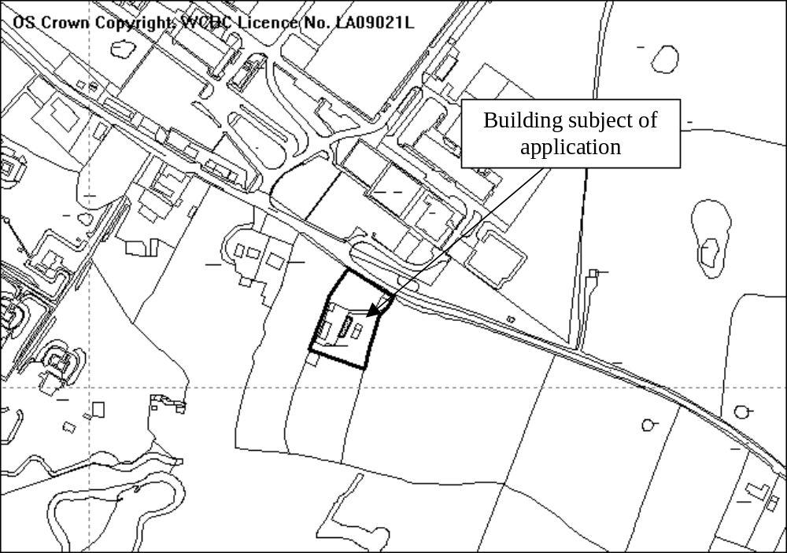SITE

As above.
Wx Ind Estate
Ex Pirelli

PROPOSAL

As above.

HISTORY

P/2003/0582 Change of use of existing agricultural building to dwelling and alteration to existing vehicular access. Granted 18.9.2003
P/2005/0465 Erection of garage and stables. Granted 16.6.2005.
P/2006/0847 Change of use of garage to residential dwelling on a temporary basis. Granted temporary permission 23.8.2006. Permission expires 31 December 2008.
P/2006/0848 Parking and operation of heavy goods vehicles, relocation of existing dutch barn. Refused 22.8.2006
P/2007/0915 Variation of condition no. 3 of planning permission code no. P/2003/0582 for new external openings and design. Granted 29.10.2007

DEVELOPMENT PLAN

Outside settlement limit. Policies PS2, GDP1, H5, H3 and H10 are relevant.

CONSULTATIONS

Community Council: Notified 22.5.08
Local Member: Requested application is reported to committee.
Public Protection: Advise applicants to contact them if any evidence of storage/spillage or agro-chemicals are found
Other representations: None.
Site Notice: Expired 17.6.08

SPECIAL CONSIDERATIONS

Background: Planning permission was granted to convert a then extent building to a dwelling in 2003. Some amendments to window and door details were subsequently granted permission in 2007. The building collapsed following storm damage in early 2008, whilst conversion works were being carried out to it (although it appears that these works were not at a particularly advanced stage). The only part of the building remaining is the northern gable end.

The applicants currently live at the site in the garage granted permission in 2005, having been granted a temporary permission to do so in 2006.

Policy: Policy H3 applies to proposals to convert existing buildings that have been demonstrated to be structurally sound and capable of conversion with minimal re-building. Were this application granted, it is estimated that the resulting building would be at least 90% new-build, therefore it is only possible to consider the proposals as being for a new dwelling rather than for the conversion of an existing building to a dwelling. In which case policy H3 is not applicable. Even so, if considered in light of policy H3, the proposals clearly do not accord with its requirements because the remains of the building still standing are not structurally sound, and are not capable of conversion without substantial re-building tantamount to a new dwelling.

The proposals cannot be considered a replacement dwelling. Policy H10 states that replacement dwellings will only be supported where there is an existing dwelling on site that is either habitable or capable of being made habitable without rebuilding works tantamount to the erection of a new dwelling. There is currently no permanent dwelling on the site, nor has there been at any time in the recent past, and the remains of the barn are not capable of being made habitable without extensive rebuilding.

In addition to conversion, policy H5 indicates that the erection/creation of new dwellings may also be allowed in certain other exceptional circumstances, namely where the proposals are;

- for the subdivision of an existing dwelling; or
- are to meet the essential needs of an agricultural/forestry business; or
- to provide affordable homes to meet an identified local need; or
- the infilling of a small gap within a well developed built frontage.

The current proposals do not meet any of the above criteria, and therefore do not comply with policy H5.

The applicants are aware that the development does not accord with policies dealing with the erection of new dwellings in the countryside but have suggested that this is an exceptional case and that permission should therefore be granted. They have also suggested that, as the development will be sympathetic to the locality, in their opinion, accords with policies PS2 and GDP1.

In considering this application, the Council’s statutory duty is to determine if it is in accordance with the provisions of the adopted development plan and issue a decision accordingly, unless there are clear and justifiable reasons for making decisions that may conflict with development plan policies. Whilst being sympathetic to the situation the applicants now find themselves in, I do not believe their personal circumstances warrant setting aside normal strong planning policy. I appreciate that it was not possible for them to either anticipate stormy weather earlier this year nor the impact this would have on the building however, from the evidence I have seen the measures taken to support the building during the works were very limited. I accept that the collapse of the building was not a result of deliberate demolition. The fact that the building did collapse makes the original permission unimplementable. The principle of residential development on this site was accepted only on the basis of there being a structurally sound building capable of conversion, which is no longer the case. If the Council were to accept proposals for what amounts to the erection of a new dwelling in this particular case, it is likely to set an undesirable and dangerous precedent. Developers elsewhere would be discouraged from protecting redundant buildings once permission for conversion has been granted in the hope that the Council would then permit the erection of a new replacement structure if those buildings later collapsed or were severely damaged beyond economic repair. The Council has been successful previously on appeal where buildings have been allowed to collapse.

Whilst the design and appearance of the proposed dwelling may be a close match to the proposed conversion scheme, this in itself does not mean the development is acceptable. In considering planning applications, the Council has to take account of the provisions of all relevant policies and above all determine whether the principle of a particular scheme is acceptable, in addition to considering detailed matters of design. I do not accept that just because, if considered in isolation, the design of the dwelling may be acceptable, this means the proposals will result in no harm to the open countryside. The adopted policies are designed to strictly control new residential developments in the open countryside, and presume that, unless it meets specific and exceptional criteria, any residential development in the countryside is harmful, irrespective of its appearance.

Human Rights: In making a decision that would clearly have an impact on the applicants’ human rights it is necessary to review whether the impact on their private and family life or right to peacefully enjoy his possessions would be proportionate to the harm caused to the environment. In this instance it is considered that the harm to the environment resulting from allowing a new dwelling to be erected would be sufficient to outweigh the impact on their rights and accordingly is consistent with the European Convention on Human Rights.

Conclusion: The proposals amount to the erection of a new dwelling outside of defined settlement limits and are therefore contrary to policies PS1 and H5.

RECOMMENDATION That permission be REFUSED

REASON(S)

1. The site is located outside any recognised settlement limit as defined in the adopted Wrexham Unitary Development Plan where there is a presumption against new residential development. To allow the development would, in the absence of an essential need justification, result in unacceptable form of isolated rural housing development, contrary to policies PS1 and H5 of the Wrexham Unitary Development Plan.
_____________________________________________________________________

APPLICATION NO:  P/2008 /0559  COMMUNITY:  Rhosddu  WARD:  Grosvenor | LOCATION:  51-52 HOPE STREET WREXHAM  DESCRIPTION:  CHANGE OF USE FROM A1 RETAIL TO A2 RETAIL: FINANCIAL AND PROFESSIONAL SERVICES.  APPLICANT(S) NAME:  MR N CASSON HOLLINS MURRAY GROUP | DATE RECEIVED:  21/05/2008  CASE OFFICER:  MP  AGENT NAME:  CRAIG FOSTER ARCHITECTS  MR CRAIG FOSTER
_____________________________________________________________________

SITE

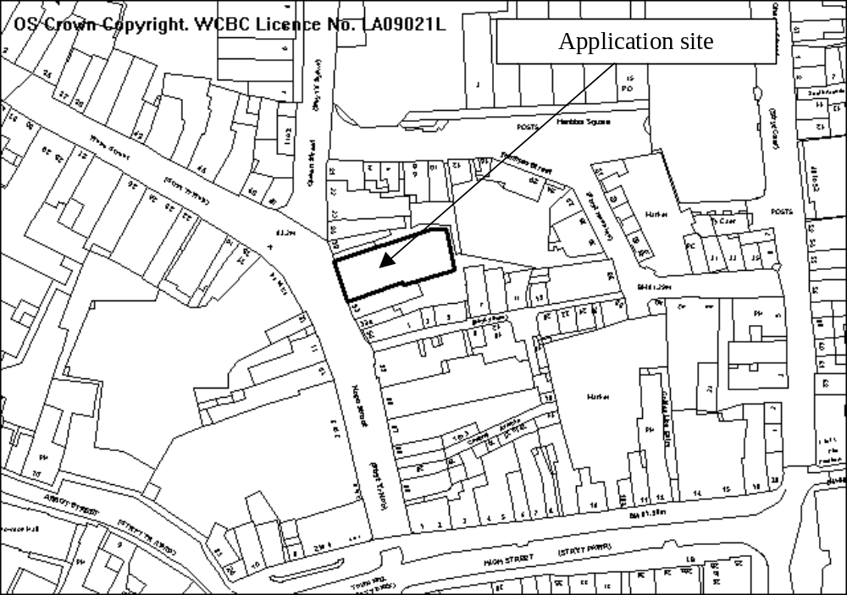As above.

PROPOSAL

As above.

HISTORY

P/2003/1466 Demolition of rear section of existing building and construction of a new three storey extension to rear for retail use. Granted 10.5.2004
P/2006/0277 Illuminated signs. Granted 26.4.2006
P/2006/0445 Installation of new shopfront. Granted 1.6.2006
P/2006/0718 Display of projecting sign. Granted 31.7.2006

DEVELOPMENT PLAN

Within Settlement & Town Centre Conservation Area. Policies S1 and E7 apply.

CONSULTATIONS

Community Council: Notified 22.5.08
Local Member: Notified 22.5.08
Adj (Offa) Community Council: Object to the loss of retail units in the town centre. One similar change of use for a shop unit in the centre of the town has already been agreed and members are concerned at the cumulative effect this relaxation in the rules could have on the nature of the town centre.
Adj LM (Cllr Wynn): Notified 9.6.08
Highways: Commuted sum payment required due to increased parking requirements.
Other representations: Nearby properties notified2.6.2008
Site Notice: Expired 20.6.2008

SPECIAL CONSIDERATIONS

Policy/location: Policy S1 of the UDP does not permit non-retail proposals in ground floor retail units in the principal shopping streets “ ... if they have a detrimental affect upon the character, vitality or viability of the area”. Policy EC7 seeks to preserve/enhance streets/buildings which contribute to the unique character of the Conservation Area.

The unit forms part of a continuous built frontage from the junction with High Street to the junction of Henblas Street/Queen Street, approximately 100m in length. Within this frontage there are 2 existing premises occupied by A2 uses with frontages of approximately 8m and 10m wide respectively, and one vacant unit formerly an A3 use (restaurant/hot food takeaway), with a frontage of approximately 11m wide. The unit has a relatively small frontage (approx 11m) and Hope Street is an area dominated by shop uses. Should this application be granted around 40% of the retail frontage would be non-retail, with a third being specifically A2 use. The non-retail units are/would not be concentrated together, and when viewed in the wider context of Hope Street/Queen Street/Regent Street, the application site would be viewed as an A2 use in an area dominated by retail outlets.

A2 uses include banks, building societies, estate and employment agencies, amongst other uses and are services which provide principally to visiting members of the public. I would not anticipate the use generating any significantly smaller number of customers compared with a retail use. I am satisfied that an A2 (office use) will not threaten the vitality or viability of the shopping area. In reaching this conclusion, I have had regard to the recent granting of planning permission by the Planning Committee in June for the change of use from A1 to A2 of 56 Hope Street (code no. P/2008/0441). It is also worth noting that under the provisions of the Town and Country Planning (Use Classes) Order 1987, it is permitted development to change the use of a property from A2 to an A1. This means that the granting of this permission would not prevent the owner letting the premises to a retail outlet in future.

No physical change to the building frontage is proposed and the use is unlikely to have any significant impact on the character of the Conservation Area. (Any changes would need a separate permission.)

Highways: The use generates a greater demand for parking than the existing use as specified in LPG 16 and as such a commuted parking payment should be required. The existing use generates a requirement for 58 spaces where as the proposed generates a requirement for 194 resulting in a shortfall of 136 spaces. In line with the committee’s recent decision in Hope Street, I would expect the sum to reflect 50% of the shortfall. I have advised the applicant of the need for a payment but have not yet received any formal response.

Conclusion: I am satisfied that the proposal would not undermine the vitality or viability of a strong retail area or have any significant effect on the character on the Conservation Area.

RECOMMENDATION A

That the Council enters into an obligation under Section 106 of the Town and Country Planning Act 1990 requiring a commuted parking payment to compensate for the shortfall in parking provision. The Chief Planning Officer be given delegated authority to settle the amount and the form and content of the obligation.

RECOMMENDATION B

Upon completion of the obligation, planning permission be GRANTED subject to the following conditions:-

CONDITION(S)

1. The development hereby permitted shall be begun before the expiry of five years from the date of this permission.

REASON(S)

1. To comply with Section 91(3) of the Town and Country Planning Act, 1990.

NOTE(S) TO APPLICANT

This permission does not by itself authorise the performance of any proposed acts of work materially affecting the external appearance of the premises, which proposals, if any, shall form the subject of a further submission to the Local Planning Authority.

You are advised to contact the Planning Department prior to the erection of any signage with regards to the requirement for the submission of an application for Advertisement Consent under the Town and Country Planning (Control of Advertisements (Regulations 1992.
_____________________________________________________________________

APPLICATION NO:  P/2008 /0571  COMMUNITY:  Rossett  WARD:  Rossett | LOCATION:  LILAC COTTAGE GOLLY ROSSETT WREXHAM  DESCRIPTION:  TWO STOREY EXTENSION  APPLICANT(S) NAME:  MR & MRS S NUTKINS | DATE RECEIVED:  23/05/2008  CASE OFFICER:  LB1  AGENT NAME:  GARRY BENTLEY ASSOCIATES LTD
_____________________________________________________________________

SITE

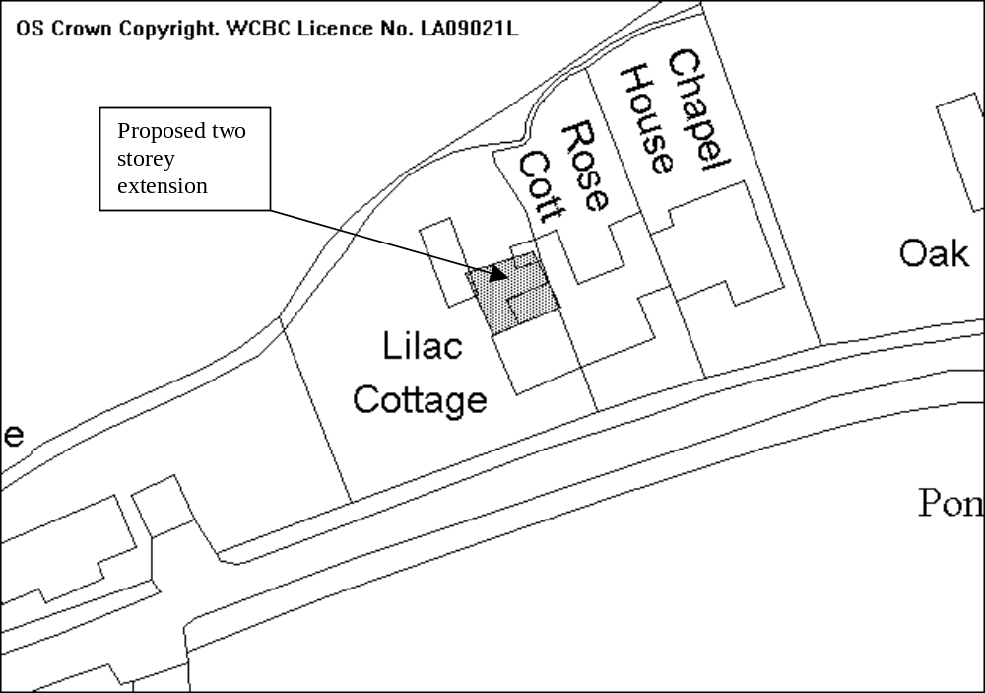

PROPOSAL

As above.

HISTORY

None relevant.

DEVELOPMENT PLAN

Outside of settlement area, GD1, PS2, LPGN 13 apply.

CONSULTATIONS

Community Council: No objections
Local Member: Consulted 27/05/08
Other representations: One letter of objection received raising the following concerns:
- The site currently utilises an out of date septic tank which overflows directly into the stream behind the property. To add more foul drainage to the site would be unacceptable.
- Cars are frequently parked in front of the house, making it difficult for vehicles, especially farm vehicles to pass without pushing in the ditch to the side of the road.
- The builders vehicles would cause blockages and disruption to those using the lane.
- The plans show a large expanse of glass to the rear elevation which is out of character with the area.
about the drainage of the site,

Site Notice: Expired 20/06/08

SPECIAL CONSIDERATIONS

The site: The property is a small two bedroomed cottage. The proposal is for a two-storey extension that will provide an additional bedroom and extend the downstairs kitchen area.

Local Planning Guidance Note 13 states that extensions to properties outside the settlement limit should be restricted to a one third increase of the original floor area. Whilst there have been no previous applications at the site it appears that there has been a single storey rear extension built at some point, although it is not clear when this was constructed. The extension amounts to an approximate increase in the size of the property of 35%. Whilst this is above the guidance levels the property will not be an inappropriate size in comparison to the neighbouring properties.

The elevation to the rear contains windows that are larger than those elsewhere on the property, however as this elevation is not able to be viewed from the road past the properties I do not consider that it will have an adverse impact on the character of the property.

The design of the extension is in keeping with the existing property, it passes the BRE tests and separation distances in relation to neighbouring properties.

Other considerations: There is off street parking at the property for three cars; this will be unaffected by the extension, there is therefore sufficient to comply with the required levels.

Obstruction of the public highway by vehicles is not a planning consideration and is a matter that would fall under the jurisdiction of other authorities. The road through Golly is a small lane that leads to several farms and is not heavily used by vehicles, although there given the number of surrounding farms there are a large number of tractors and trailers using the road.

The applicants state that they are intending to use the existing surface and foul water drainage systems. If there has been discharge into the nearby brook then this is a matter for the Environment Agency. The Agency have confirmed that there have been no recorded incidences of pollution of the stream and a recent site visit has confirmed that there are no current problems.

Conclusion: The proposed extension is in keeping with the existing property and whilst it slightly exceeds the guidance levels of 30% the resulting property will only be a three bedroom property that is not out of keeping with the surrounding properties and I therefore recommend that permission is granted.

P/2008 /057
RECOMMENDATION That permission be GRANTED

CONDITION(S)

1. The development hereby permitted shall be begun before the expiry of five years from the date of this permission.
2. No facing materials shall be used other than materials matching those used on the existing building.
3. Development shall only be carried out in strict accordance with the approved plans unless the prior written approval of the Local Planning Authority has been obtained.

REASON(S)

1. To comply with Section 91(3) of the Town and Country Planning Act, 1990.
2. To ensure a satisfactory standard of appearance of the development in the interests of the visual amenities of the area.
3. To ensure that the development fully complies with the appropriate policies and standards.

NOTE(S) TO APPLICANT

You are advised that building work which involves work on an existing wall shared with another property, building on the boundary with a neighbouring property or excavating near a neighbouring building may require the separate consent of the neighbour under the provisions of the Party Wall Act. If you require further information or advice please contact the Building Control Section on 01978 292050.

You should ensure that any difference between the plans approved under the Town and Country Planning Acts and under the Building Regulations is resolved prior to commencement of development, by formal submission of amended plans.

The proposed development lies within a former coal mining area. You should take account of any hazards to stability which may arise from coal working in or near the site. Specific advice on any past working may be obtained from the Coal Authority Mining Reports Service. Phone 0845 762 6848 or from www.coal.gov.uk.

Any operations which may involve entry into former workings, shafts or adits or implementation of site investigations or other works may need permission from the Coal Authority.

_____________________________________________________________________

APPLICATION NO:  P/2008 /0574  COMMUNITY:  Llangollen Rural  WARD:  Llangollen Rural | LOCATION:  GORFFWYSFA METHODIST HILL FRONCYSYLLTE LLANGOLLEN  DESCRIPTION:  OUTLINE APPLICATION FOR THE ERECTION OF DWELLING AND GARAGE  APPLICANT(S) NAME:  MRS J PACKENHAM-WALSH | DATE RECEIVED:  27/05/2008  CASE OFFICER:  SEH  AGENT NAME:  OVERSITE LIMITED  M M SUTCLIFFE
_____________________________________________________________________

THE SITE

A plot of land, measuring approximately 550 square metres, adjacent to ‘Gorffwysfa’ Methodist Hill.

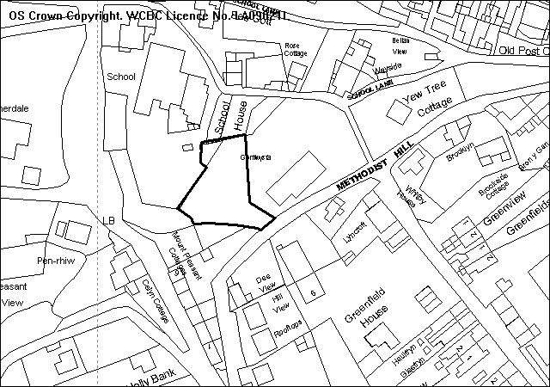
Application Site

PROPOSAL

As above.

HISTORY

P/2008/0254 Outline Application for the erection of 2 no dwellings.
Withdrawn 25/03/2008

DEVELOPMENT PLAN

Within settlement limit. UDP Policies GDP1, PS1, PS2, H2 and T8 apply and LPG 6 ‘Parking Standards’ and 21 ‘Space around Dwellings’ are relevant.

CONSULTATIONS

Community Council: Object for the following reasons-:
- Access during the construction of the building up and down Methodist Hill is unfeasible and there is a genuine fear that property and buildings will be damaged.
- Current state of the access roads to this property unsuitable to take any more vehicles which further residential properties will bring.
- Froncysyllte is an area that is traditional in appearance with very few new developments. Which is how the residents want it, following consultation and discussion at a recent Community fact finding event, organised by N.M.C. this is in line with the bid for World Heritage Status and contravenes area guidelines?
- Access on a very narrow road and the road will not take any more traffic.
- Having taken advice the access is not suitable for any more vehicles.
- Methodist Hill is already classed as unsuitable for heavy goods vehicles, so how are the delivery Lorries etc supposed to bring in the bricks, concrete, timber etc. I expect they will be using the ‘unadopted’ road causing even more disruption to an already overcrowded area.
- More traffic in an already congested part of this village will be in appropriate. Parking will also be an issue regardless of how much is given over to each dwelling there will be an over spill with visitors etc.
Local Member: Requests that this application be reported to Planning Committee.
Highways: Methodist Hill already suffers with parking problems, essential to have adequate off-street parking. Although it is below current standards one additional dwelling will have little detrimental affect. Conditions recommended.
Welsh Water: No objection subject to recommended advisory notes.
Other Representations: Petition of 17 names: unsuitable access, too close to
school, hill unsuitable for construction vehicles
3 letters received:
too close to the school and overlooking our property, road too narrow and already congested and used by school children and villagers. Application refused once., no passing places, traffic too frequent and too fast, excavation may endanger other houses, walls maybe unsafe who is responsible?
Site Notice: Expired 30/05/2008

SPECIAL CONSIDERATIONS/ISSUES

Background: This is an outline application for the erection of one dwelling, with all details reserved for subsequent approval.

Residential Amenity: The site is large enough to accommodate a single dwelling whilst providing adequate on-site parking and outdoor space. Having considered also the properties around the site, it is possible to achieve the erection of a dwelling on this land in accordance with the Council’s separation distances and guidance on ‘Space around Dwellings’.

The applicant has submitted an indicative plan of a possible layout which demonstrates that the plot is large enough to accommodate a dwelling which would be of character in relation to the surrounding properties, whilst protecting the visual amenities of the area. However, design and appearance will be properly considered at the reserved matters stage. Any overlooking will need to be controlled at that time.

Highways: I agree with Highways assessment of the situation and parking will be a key issue for the detailed application. I agree that one further dwelling is unlikely to make any significant difference to traffic issues. However it may be possible to create some limited widening at the access point to ease the situation.

Conclusion: The proposal is in accordance with local policy, and development of the site should make a positive contribution to the visual amenities of the area. 05 /1062008 /0574
RECOMMENDATION That permission be GRANTED

CONDITION(S)

1. Approval of the following details shall be obtained from the Local Planning Authority before any part of the development is commenced:
a. the siting of the building(s)
b. the design of the building(s)
c. the external appearance of the building(s)
d. the means of access to the site and building(s)
e. the landscaping of the site.
2. Plans and particulars of the reserved matters referred to in condition 1 (above) shall be submitted in writing to the Local Planning Authority before the expiry of three years from the date of this permission. The development shall only be carried out in strict conformity with such details as are thereby approved.
3. The development hereby permitted shall be begun before the expiry of five years from the date of this permission or two years from the date of approval of the last of the reserved matters required to be approved, whichever is the later.
4. As part of the reserved matters, details shall be submitted providing parking and vehicular turning for both the new dwelling and Gorffwysfa in accordance with Local Planning Guidance Note No 16, Parking Standards, The scheme, as approved, shall be implemented prior to first use of development, and shall thereafter be retained.
5. This development shall be for a maximum of one dwelling only.
6. The contents of the indicative site plan submitted in support of this application shall not be regarded as representing an approved site layout.
7. As part of the reserved matters, full details of the proposed hard and soft landscaping proposed for the site, to include the specification for any replacement tree planting, shall be submitted.
8. As part of the reserved matters, details of all of the proposed boundary treatments shall be submitted.
9. There must be no discharge of surface water to the combined sewer system.
10. Foul water and surface water discharges shall be drained separately from the site.
11. No land drainage run-off shall be permitted, either directly or indirectly, to discharge into the public sewerage system.
12. The development site is crossed by a public sewer and no part of the building shall be erected within three metres either side of the centreline of the public sewer.
13. The proposed access shall be provided with visibility splays of 2.4m x 11m (west) and 2.4m x 18 (east) prior to first occupation of the dwelling and shall thereafter be retained clear of obstruction..

REASON(S)

1. To comply with the provisions of the Town and Country Planning (General Development Procedure) Order, 1995.
2. To comply with Section 92 of the Town and Country Planning Act, 1990.
3. To comply with Section 92 of the Town and Country Planning Act, 1990.
4. To ensure that adequate manoeuvring and parking is available within the application site and adjacent dwellings, in the interests of highway safety.
5. To ensure that a satisfactory unit of residential accommodation is achieved and to protect the amenities of the occupiers of nearby properties.
6. To ensure that all details are reserved for future consideration.
7. To ensure a satisfactory standard of appearance of the development in the interests of the visual amenities of the area.
8. To ensure a satisfactory standard of appearance of the development in the interests of the visual amenities of the area.
9. There is insufficient capacity in the existing system to cater for additional surface water flow.
10. To ensure proper drainage of the site.
11. To prevent hydraulic overload of the public sewerage system and pollution of the environment.
12. To protect the integrity of the public sewer and avoid damage thereto.
13. To ensure that adequate visibility is provided at the proposed point of access to the highway.

NOTE(S) TO APPLICANT

All ancillary operations and the use of pland and machinery which are audible at the boundary shall be carried out only between 07.30 hours to 18.00 hours Monday to Friday, between 08.00 hours and 14.00 hours on Saturdays and at no time on Sundays and Bank Holidays.

There shall be no fires on site; to include the prohibition of the burning of cleared vegetation.

A suitable dust management scheme shall be implemented on site to prevent dust nuisance from arising.

For further details relating to the location of the public sewer, please see the attached plan.
_____________________________________________________________________

APPLICATION NO:  P/2008 /0576  COMMUNITY:  Rhos  WARD:  Ponciau | LOCATION:  LAND AT ABERDERFYN ROAD JOHNSTOWN WREXHAM  DESCRIPTION:  ERECTION OF 4 NO. SELF-CONTAINED FLATS.  APPLICANT(S) NAME:  TRINITY ENTERPRISES | DATE RECEIVED:  27/05/2008  CASE OFFICER:  MP  AGENT NAME:  WHEAT, EDWARDS & ASSOCIATES
_____________________________________________________________________

SITE

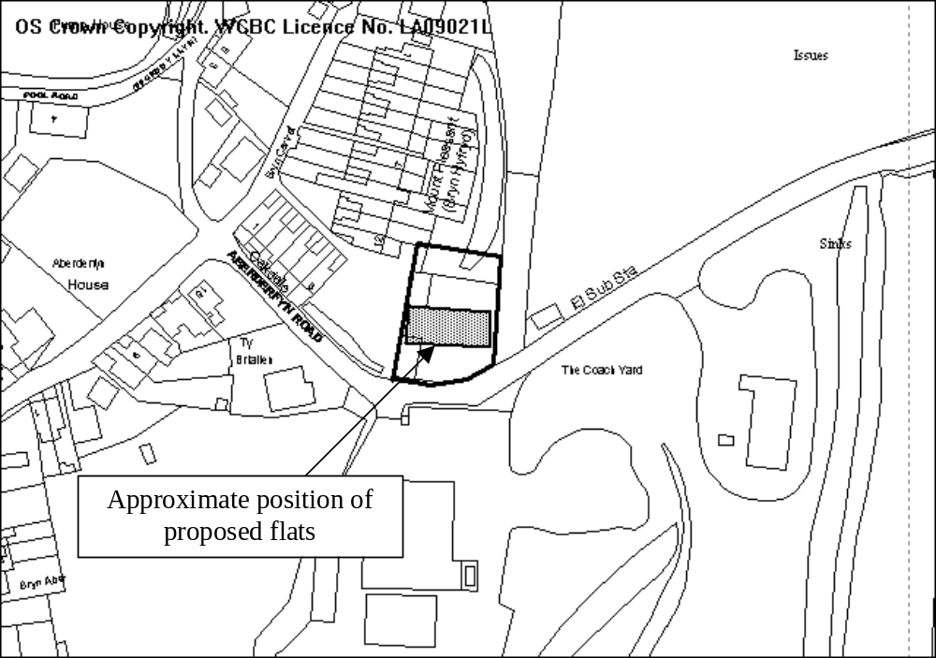

PROPOSAL

As above. The development provides 2 x 2 bedroom flats and 2 x 1 bedroom flats.

HISTORY

No recent planning history.

DEVELOPMENT PLAN

Inside settlement limit. Policies PS2, GDP1 and H2 apply.

CONSULTATIONS

Community Council: Raised concerns on the following matters:
- access to the site and the number of vehicles using the access – the application allowing for 8 spaces;
- request the application is deferred for further discussion and that Highways be asked to review the access and present a report to Council to allow the further discussion to take place;
- safety factors include no pavements in the area, access on a bend, the narrow highway and the site is opposite and already established and used access
Local Members: Notified 28.5.08
Highways: Make the following comments:
- existing access is well below standard in terms of visibility;
- the site has an existing use as a builders yard. It is considered that the traffic generation from the proposed development is likely to be no more onerous than potential traffic from the existing use;
- the access is to be centralised to maximise visibility;
- there is adequate off-street parking;
- there is a lack of pedestrian provision. A 2m footway along the site frontage may offer some improvement for pedestrians and will ensure the visibility splays in perpetuity;
- conditions recommended.
Public Protection: Make the following comments:
- contamination condition required due to previous use as a builders yard to ensure any potential contamination is dealt with;
- Recommend notes to limit impact during construction.
Environment Agency: No comments.
Other representations: Nearby occupiers notified 30.5.08
Site Notice: Expired 20.5.08

SPECIAL CONSIDERATIONS

Background: The site consists of a relatively flat area of land nearly 800 square metres in area. It lies adjacent and above an abandoned railway line, with a retaining wall running along the eastern boundary. The site has been vacant for some time, although it was last used as a builder’s yard. I am unaware of any intervening uses, therefore it would be entirely possible for a similar use to be re-established at the site without the need for planning permission.

Siting and design: The proposal is for a two storey block fronting out onto, but set back (at its closest) 5m, from Aberderfyn with a ‘drive under’ access leading to a parking/turning area to the rear. The building will be of a fairly simple design and I consider it to be acceptable in this location.

The application does not provide full details of proposed site and floor levels. The submission of a detailed survey is awaited. The applicant’s agent has however confirmed it is anticipated that finished floor levels will be around 150mm above existing ground level. I have therefore considered the impacts upon nearby properties on this basis and conditioned the decision accordingly.

The siting of the building will not result in direct overlooking of habitable rooms in adjacent properties. In terms of the privacy of existing gardens, I do not believe that the relationship between the proposed building and nearby gardens will unduly compromise the amenity enjoyed by existing occupiers.

There is sufficient space to the rear of the flats to provide private amenity space for the occupiers of the flats.

Highways: It is accepted that the access will not provide visibility in full accordance with TAN18, however there is potential for reasonable traffic generation were the site to revert to its permitted use. The traffic generated by the development is unlikely to exceed this level, and I also believe it will be possible to secure some improvements to visibility through this development, particularly through the removal or reduction in height of part of the retaining wall along the eastern boundary, as well as the provision of a footway along the frontage of the site – which will also benefit pedestrian safety. Full details of improvements to visibility are awaited.

The development is provided with 7 parking spaces, which is in accordance with LPG16.

Conclusion: Further details are required before I can conclude that the development fully accords with adopted policies, however on the basis of the plans submitted, I am confident that this proposal is likely to prove acceptable.

RECOMMENDATION

The Chief Planning Officer is given delegated authority to grant planning permission following the submission of a satisfactory site survey and details of visibility improvements, subject to the following conditions (and any other as may be necessary following the submission of the outstanding details):

CONDITION(S)

1. The development hereby permitted shall be begun before the expiry of five years from the date of this permission.
2. Prior to their use on the development samples of all external facing and roofing materials shall be submitted to and approved in writing by the Local Planning Authority. The development shall only be carried out in strict accordance with such details as are approved.
3. The vehicle parking and turning areas indicated on the approved plans shall be laid out, surfaced and drained prior to the first use of the building hereby granted and shall thereafter be retained for those purposes, free of all obstruction.
4. The site shall be developed strictly in accordance with the ground and floor levels indicated on the approved plans. No changes to floor levels or external ground levels shall be made without the prior written approval of the Local Planning Authority.
5. No surface water shall be allowed to connect (either directly or indirectly) to the public sewerage system.
6. No surface water or land drainage run-off shall be allowed to connect (either directly or indirectly) to the public sewerage system.
7. No part of the development hereby permitted shall be commenced until full details of both hard and soft landscape works for the site have been submitted to and approved in writing by the Local Planning Authority. The works shall be implemented in accordance with a timescale to be approved in conjunction with the scheme of details.
8. Development shall not begin on site until a scheme to deal with potential contamination at the site has been submitted to and approved in writing by the Local Planning Authority. This scheme shall include a phased investigation approach to identify the extent of contamination and any measures required to remediate the site, including post-development monitoring. Where remediation works are required, the development shall not be occupied/used until a Validation Report to show that the works have been satisfactorily carried out has been submitted to and approved in writing by the Local Planning Authority.
9. Notwithstanding the approved plans, a 2m footway shall be constructed back from the existing carriageway across the full site frontage, in accordance with details that have first been submitted to and approved in writing by the Local Planning Authority. The footway shall be constructed in accordance with the details as approved prior to the first occupation of the flats hereby granted permission and thereafter permenantly retained.
10. Notwithstanding the provisions of the Town and Country Planning (General Permitted Development) Order 1995, no gates shall be erected within 5 metres of the highway boundary.
11. The access shall be constructed in accordance with the approved plans and shall be surfaced using hard bound materials for a minimum distance of 5m behind the highway boundary prior to the first occupation of the flats hereby granted permission.

REASON(S)

1. To comply with Section 91(3) of the Town and Country Planning Act, 1990.
2. To ensure a satisfactory standard of appearance of the development in the interests of the visual amenities of the area.
3. In the interests of highway safety.
4. To ensure that the development fully complies with the appropriate policies and standards.
5. To prevent hydraulic overloading of the public sewerage system.
6. To ensure a satisfactory standard of appearance of the development in the interests of the visual amenities of the area.
7. To ensure a satisfactory standard of appearance of the development in the interests of the visual amenities of the area.
8. In the interests of the amenities of the future occupants of the buildings
9. To ensure adequate provision is made for pedestrians.
10. In the interests of highway safety.
11. In the interests of highway safety.

NOTE(S) TO APPLICANT

You should ensure that any difference between the plans approved under the Town and Country Planning Acts and under the Building Regulations is resolved prior to commencement of development, by formal submission of amended plans.

The proposed development lies within a former coal mining area. You should take account of any hazards to stability which may arise from coal working in or near the site. Specific advice on any past working may be obtained from the Coal Authority Mining Reports Service. Phone 0845 762 6848 or from www.coal.gov.uk.

Any operations which may involve entry into former workings, shafts or adits or implementation of site investigations or other works may need permission from the Coal Authority.

All ancillary works, ancillary operations and the use of plant and machinery which are audible at the site boundary shall be carried out only between 07.30 hours to 18.00 hours Monday to Friday, between 08.00 to 14.00 hours on Saturday and at no time on Sundays and Bank Holidays.

There shall be no bonfires on the site, to include the prohibition of burning of cleared vegetation.

The footway referred to in condition 09 shall be constructed to a condition suitable for adoption by the Council for future maintenance at the public expense. The developer wuill need to enter into an agreement with the Council under section 38 of the Highways Act 1980.

The applicants attention is drawn to the following supplementary notes; 1, 3, 4 and 5.
_____________________________________________________________________

APPLICATION NO:  P/2008 /0586  COMMUNITY:  Rhosddu  WARD:  Garden Village | LOCATION:  DEVELOPMENT AT KENYON AVENUE WREXHAM  DESCRIPTION:  AMENDMENT TO SITING UNITS A & B, REVISION TO DOOR DETAIL UNIT C AND ADDITIONAL WINDOW (GABLE) UNIT C (PREVIOUSLY GRANTED UNDER CODE NO. P/2006/1474)  APPLICANT(S) NAME:  ERIC ROBERTS (BUILDERS) LTD | DATE RECEIVED:  28/05/2008  CASE OFFICER:  MP  AGENT NAME:  THE GARSTON PARTNERSHIP  MR J GARSTON
_____________________________________________________________________

SITE

8 flats are currently under construction on the site, which is located on the corner of Kenyon Avenue and Ffordd Estyn.

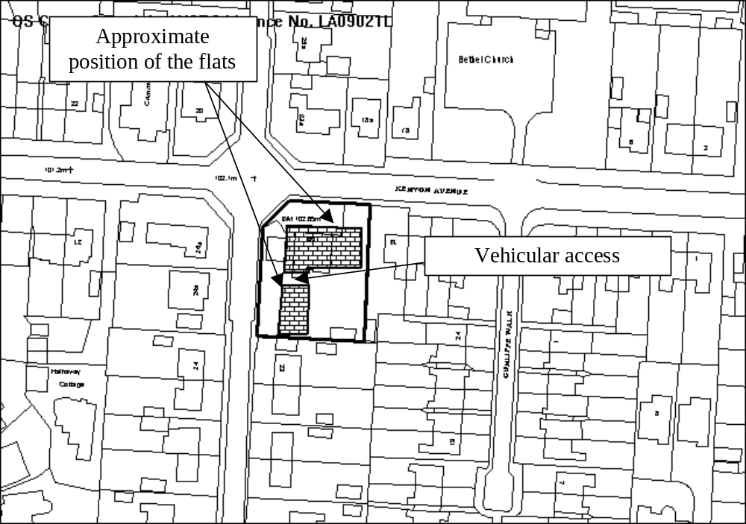

PROPOSAL

As above.

HISTORY

P/2006/1474 Demolition of existing building erection of 8 no. flats, construction of foul and surface water drainage, parking access road and landscaping. Granted 2.4.2007
P/2008/0443 Amendments to entrance doors and canopy (unit c) and windows (unit a) previously granted under code no. p/2006/1474. Withdrawn.

DEVELOPMENT PLAN

Within settlement limit. Policies PS1, PS2, PS3, PS4, GDP1, H2, S9 and T8 apply.

CONSULTATIONS

Community Council: detail be left to Local Member
Local Member: consulted 29/05/2008
Other representations: 1 letter received making the following comments:
- promises made when permission was originally granted was that there was enough space for residents to park off-street;
- the builder has now made sure this is not the case by building the flats in the wrong place. Residents will not be able to park off street;
- Kenyon Avene is a busy route and there are parking/access problems in the area;
- Safety must be given priority;
- The builders knew they were building in the wrong place but carried on anyway. They have no intention of rectifying their mistakes;
- The builders must be made to put the flats in the right place.
Site Notice:

SPECIAL CONSIDERATIONS

Background: The applicant submitted an application earlier this year to regularise some minor changes to the originally approved development, namely the installation of an addition ground floor window in one of the flats on Kenyon Avenue and alterations to the entrance porches to two of flats on Ffordd Estrn. When Officers conducted a site visit in connection with that application, it became apparent that some of the units (described in this application as units A and B) have been built in the wrong position and were in fact around 1 metre closer to Ffordd Estyn than approved. The application was subsequently withdrawn and this application submitted, seeking approval for all of the amendments in one application.

Impact upon nearby properties: The position of Units A and B means that they are closer to dwellings on the opposite side of Ffordd Estyn. I am satisfied however that this does not fundamentally alter the relationship between the existing dwellings and the development so that it would compromise the amenity of existing or future occupiers.

Design: The revised porch to unit C is acceptable and does not compromise the appearance the whole development. The additional window to Unit A will not materially alter the appearance of the development (as approved). These changes are therefore acceptable.

The revised position of Units A and B mean they project forward of Unit C by around half a metre, where as they would have been set back from the front elevation of Unit C had they been built as originally approved. The new position will not detract from the wider street scene and is therefore acceptable.

Parking: The revised position of the buildings do not impact upon the internal parking area that is to be provided to the rear of the buildings. It was accepted when the original permission was granted that adequate provision for off-street parking was proposed. Whilst I note the concerns expressed about on-street parking in the locality, the parking areas are completed as originally approved and the development should not add to parking problems in the locality provided residents use the spaces provided. The Council cannot however force occupiers of dwellings or flats to use private driveways/parking.

Conclusion: I am satisfied the revised plans accord with adopted policies.

RECOMMENDATION That permission be GRANTED

CONDITION(S)

1. Prior to their use of the development samples of the roofing materials and details of the external render to be applied to units A and C shall be submitted to and approved in writing by the Local Planning Authority. The development shall thereafter be carried out in accordance with the details as approved.
2. Notwithstanding the provisions of the Town and Country Planning (General Permitted Development) Order 1995 any window in the southern elevation of Block C (as shown on the approved plans)/flats no 7 and no. 8 (as shown on the plans approved on 2 April 2007 under code no. P/2006/1474) shall only be glazed or re-glazed using obscure glass.
3. Notwithstanding the provisions of the Town and Country Planning (General Permitted Development) Order 1995 any window in the southern elevation of Block A (as shown on the approved plans) shall only be glazed or re-glazed using obscure glass.
4. Notwithstanding the approved plans, or those approved on 2 April 2007 under code no. P/2006/1474, prior to the first occupation of any flat, full details of the siting and external appearance of bin stores shall be submitted to and approved in writing by the Local Planning Authority. The bin stores shall be provided prior to the first occupation of any of the flats in accordance with the details as approved.
5. Within 3 months of the date of this permission full details of both hard and soft landscape works for the site shall be submitted to and approved in writing by the Local Planning Authority. The works shall be implemented in accordance with a timescale to be approved in conjunction with the scheme of details.
6. A scheme of boundary treatment shall implemented prior to the first occupation of any flat in accordance with details that shall first have been submitted to and approved in writing by the Local Planning Authority. The boundary treatment shall, once completed, be thereafter permanently retained.
7. The access onto Ffordd Estyn shall have a visibility splay of 2.4 x 45m to the centre line in a southerly direction within which there shall be no obstruction in excess of 1 metre in height. The splay shall be provided prior to the first occupation of the flats and thereafter maintained.
8. The access onto Ffordd Estyn shall have a visibility splay of 2.4 x 23m to the nearside edge on Kenyon Avenue in a northerly direction within which there shall be no obstruction in excess of 1 metre in height. The splay shall be provided prior to the first occupation of the flats and thereafter maintained.
9. The surface of the access shall be hard paved for a distance of 5 metres behind the highway boundary prior to the first occupation of the flats.
10. A 2 metre wide footway shall be constructed to Highway adoptable standards along the site frontage on Ffordd Estyn prior to the first occupation of the flats.
11. The area of dropped kerbs along the frontage of the site with Kenyon Avenue shall be re-instated to full height kerbs in those areas where vehicular crossing will no longer be required. Further details of the works shall be submitted for the approval of the Local Planning Authority and the works shall be carried out prior to the first occupation of the flats.
12. Foul water and surface water shall be drained separately from the site.
13. No surface water or land drainage run-off shall be allowed to connect (either directly or indirectly) to the public sewerage system.

REASON(S)

1. To ensure a satisfactory standard of appearance of the development in the interests of the visual amenities of the area.
2. To protect the amenities of the occupiers of nearby properties.
3. To protect the amenities of the occupiers of nearby properties.
4. To protect the amenities of the occupiers of nearby properties.
5. To ensure a satisfactory standard of appearance of the development in the interests of the visual amenities of the area.
6. To protect the amenities of the occupiers of nearby properties.
7. To ensure that adequate visibility is provided at the proposed point of access to the highway.
8. To ensure that adequate visibility is provided at the proposed point of access to the highway.
9. To ensure no deleterious material is carried onto the highway
10. To ensure the provision of a safe and satisfactory pedestrian route.
11. To ensure a safe and satisfactory footway in the interests of pedestrian safety.
12. To protect the integrity of the public sewerage system.
13. To prevent hydraulic overload of the public sewerage system and pollution of the environment.

NOTE(S) TO APPLICANT

You should ensure that any difference between the plans approved under the Town and Country Planning Acts and under the Building Regulations is resolved prior to commencement of development, by formal submission of amended plans.

The proposed development lies within a former coal mining area. You should take account of any hazards to stability which may arise from coal working in or near the site. Specific advice on any past working may be obtained from the Coal Authority Mining Reports Service. Phone 0845 762 6848 or from www.coal.gov.uk.

Any operations which may involve entry into former workings, shafts or adits or implementation of site investigations or other works may need permission from the Coal Authority.

The scheme of landscaping referred to in the above conditions shall inlcude any changes to ground levels (shown by existing and proposed contours/levels) and any existing vegetation (showing that to be retained) and proposed planting. In addition, any of the following which apply to the particular site must be included:-
means of enclosure, car parking layout, access and circulation areas, materials for hard surfaced areas, any minor structures (e.g. refuse stores, lamp columns, play equipment) location of services, and any historic landscape features to be retained/improved.

All works, deliveries of materials, ancillary operations and the use of plant and machinery which are audible at the site boundary shall be carried out only between 0830 hours to 1700 hours Monday to Friday and at no time on Saturdays, Sundays and Bank Holidays.
_____________________________________________________________________

APPLICATION NO:  P/2008 /0593  COMMUNITY:  Broughton  WARD:  New Broughton | LOCATION:  LAND ADJACENT TO HAREMIA HILL STREET PENTRE BROUGHTON WREXHAM  DESCRIPTION:  ERECTION OF DETACHED SINGLE GARAGE.  APPLICANT(S) NAME:  MR G EDWARDS | DATE RECEIVED:  30/05/2008  CASE OFFICER:  SEH  AGENT NAME:  BLUE PRINT
_____________________________________________________________________

THE SITE

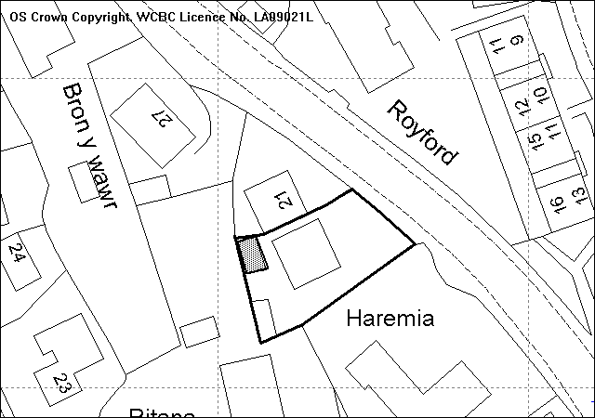
Site
Approximate location of proposed garage

PROPOSAL

As Above.

HISTORY

P/2005/1236 | Erection of 3 bedroom replacement dwelling and construction of new vehicular and pedestrian access | Granted | 07/12/05
P/2007/1472 | Relaxation of condition No. 5 of Planning Permission Code No. P/2005/1236 to allow retention of building at existing height | Granted | 23/01/08

DEVELOPMENT PLAN

Within settlement limit. UDP Policies GDP1, T8 and PS2 LPG 20 ‘House Extensions’, 21 ‘Space around Dwellings’, and 16’Parking Standards’ are relevant.

CONSULTATIONS

Community Council: Consulted 02.06.08
Local Member: Consulted 02.06.08
Highways: Consulted 02.06.08
Other Representations: One letter of support received raising the following points:
- Perfectly happy with the building of the garage as it will result in the rebuilding of a crumbly old boundary wall which is much better.
Site Notice: Expired 24.06.08

SPECIAL CONSIDERATIONS/ISSUES

Background: Planning permission was originally granted for a two-storey 3 bedroom dwelling, at which time, due to the restricted size and layout of the plot, permitted development right were removed. A second application to relax a condition of that permission concerning the height of the building was granted. The proposed garage will be located in the north west corner of the site along the boundaries with number 21 Hill Street and ‘Ritana’ Hill Street.

Residential Amenity: The proposed garage will be located less than 2 metres away from the kitchen window of the dwelling (which is now substantially complete) which would significantly restrict outlook from, and diminish natural daylight to, this habitable room to the detriment of the quality of the development.

The location of the garage along the side boundary with 21 Hill Street will result in the garage following the existing side elevation of number 21. As a result the proposal does not accord with the BRE 45 degree daylight test and would lead to a significant reduction in natural daylight, to the downstairs habitable room windows.

Further, the proposed garage will lead to a significant loss of private outdoor space leaving the usable space well below the required minimum, to the detriment of the development previously approved.

Parking/Highways: The proposed garage will result in the displacement of 1 no. parking space in this location, with the result of pushing that parking space into the previously approved turning area. A condition of the 2007 approval requires an unobstructed turning area to be retained at the site at all times to allow safe access to and from the site without causing a significant highway danger. The obstruction of this would impinge on highway safety to the detriment of the applicants and other highway users and is contrary to policy GDP1(d) of the UDP.

Conclusion: Due to the restricted nature of the site, the development is unacceptable in terms of location and the resulting loss of parking. The close proximity to both the development property and neighbouring dwelling would lead to the detrimental loss of amenity and the obstruction of the turning circle would lead to unacceptable increased danger to highway users. The site is considered incapable of supporting further development and I recommend accordingly.

RECOMMENDATION That permission be REFUSED

REASON(S)

1. The development proposed is undesirable and would have a detrimental impact upon residential amenities particularly in terms of loss of light, restriction of outlook and loss of private garden space. To allow the development would be contrary to Policies GDP1(a) and PS2 of the Wrexham Unitary Development Plan and the Council's Local Planning Guidance Notes Nos 20 - House Extensions and 21 - Space Around Dwellings.
2. The proposed development by virtue of its location upon an existing parking space will lead to the parking of a vehicle within the required turning area which will inhibit the ability of vehicles to enter and exit the site in a safe manner. To allow the development would be contrary to policy (GDP1(d) of the adopted Wrexham Unitary Development Plan and the Council's Local Planning Guidance Notes Nos 20 - House Extensions and 21 - Space Around Dwellings.
_____________________________________________________________________

LIST OF DELEGATED DECISIONS ISSUED

WRR P/2007/1022  WITHDRAWN  on 27/06/2008 | Land off Clarendon Avenue Stansty Wrexham LL11 2DF | Erection of 5 houses and construction of new vehicular and pedestrian access.
CEF P/2007/1464  GRANTED  on 23/05/2008 | RAILWAY INN RAILWAY ROAD CEFN MAWR WREXHAM LL14 3AA | CHANGE OF USE OF FUNCTION ROOM AND OFFICES INTO 2 NO. APARTMENTS
MAR P/2008/0100  GRANTED  on 23/06/2008 | BARN ADJACENT TO OAKLEY HOUSE SONTLEY WREXHAM LL13 0YB | CONVERSION OF BARN TO ONE DWELLING, ALTERATION TO EXISTING VEHICULAR AND PEDESTRIAN ACCESS AND INSTALLATION OF SEPTIC TANK
BAN P/2008/0110  GRANTED  on 20/06/2008 | HIGHGATE COTTAGE WHITCHURCH ROAD BANGOR ON DEE WREXHAM LL13 0BD | FIRST FLOOR REAR EXTENSION
WRO P/2008/0146  GRANTED  on 03/06/2008 | 6 BRON Y COED WREXHAM LL13 7QJ | FIRST FLOOR EXTENSION AND RE-MODEL FRONT ELEVATION.
ROS P/2008/0177  GRANTED  on 30/05/2008 | LODGE FARM COMMONWOOD HOLT WREXHAM LL13 9TE | CONSTRUCTION OF COW SLURRY DIGESTER.
MIN P/2008/0248  WITHDRAWN  on 22/05/2008 | BRAMBLE FARM WERN ROAD MINERA WREXHAM LL11 3DU | ERECTION OF 2 TIMBER FIELD SHELTERS
BRO P/2008/0261  WITHDRAWN  on 30/05/2008 | LAND AT KERAIM HOLLAND ROAD BRYMBO WREXHAM LL11 5DR | OUTLINE APPLICATION FOR RESIDENTIAL DEVELOPMENT
GRE P/2008/0285  GRANTED  on 27/05/2008 | THE BEECHES CHESTER ROAD GRESFORD WREXHAM LL12 8PW | NEW BRANDING SIGN SCHEME.
CHI P/2008/0293  GRANTED  on 04/06/2008 | UNIT D BRYNKINALT ESTATE YARD BRYNKINALT HALL BRYNKINALT CHIRK, WREXHAM LL14 5NS | LISTED BUILDING CONSENT FOR DEMOLITION OF  BUILDING D.
WRR P/2008/0330  GRANTED  on 27/05/2008 | NEWI CRISPIN LANE CAMPUS WREXHAM LL11 2HT | TEMPORARY SITING OF 3 PORTAKABINS
HAN P/2008/0337  GRANTED  on 23/05/2008 | CUMBERS FARM HANMER WHITCHURCH SY13 3DW | SINGLE STOREY EXTENSION
RUA P/2008/0352  GRANTED  on 21/05/2008 | UNITS 7, 7A & 8 GARDDEN INDUSTRIAL ESTATE RUABON WREXHAM LL14 6RG | ERECTION OF UNIT FOR DISMANTLING OF MOTOR VEHICLES AND STORAGE / SALE OF RESULTANT PARTS.
HOL P/2008/0367  WITHDRAWN  on 22/05/2008 | BORRAS QUARRY HOLT ROAD WREXHAM LL13 9SE | VARIATION OF CONDITION NO. 2 OF PLANNING PERMISSION HOL P/2002/0969 TO ALLOW FOR THE IMPORTATION OF 70,000 TONNES MAXIMUM PER ANNUM OF LIMESTONE FINES OR RECYCLED GLASS FINES FOR BLENDING PURPOSES (THE TOTAL AMOUNT OF IMPORTED MATERIAL ON SITE TO BE LIMITED TO 5,000 TONNES AT ANY ONE TIME).
WRR P/2008/0372  REFUSED  on 30/05/2008 | 12 WESTON DRIVE WREXHAM LL11 2DE | LISTED BUILDING CONSENT FOR FIRST FLOOR EXTENSION TO FORM SHOWER ROOM AND ALTERATIONS TO WINDOWS
GWE P/2008/0373  GRANTED  on 28/05/2008 | A A BUTLER SITE RHOSDDU INDUSTRIAL ESTATE RHOSDDU WREXHAM LL11 4YL | ERECTION OF STORAGE/DISTRIBUTION UNITS SPECULATIVE (B8 USAGE)

CHI P/2008/0374  REFUSED  on 22/05/2008 | COED GELLI PENTRE CHIRK WREXHAM LL14 5AW | CHANGE OF USE OF LAND FOR RETENTION OF MOBILE HOME FOR RESIDENTIAL PURPOSES (IN RETROSPECT)
CEF P/2008/0379  REFUSED  on 23/05/2008 | PLOT 5 BROWNS LANE CEFN MAWR WREXHAM LL14 3DS | OUTLINE APPLICATION FOR THE ERECTION OF ONE DWELLING AND CONSTRUCTION OF NEW VEHICULAR ACCESS.
WRA P/2008/0380  GRANTED  on 29/05/2008 | ACTON PARK HOTEL 110 CHESTER ROAD WREXHAM LL11 2SN | CONSTRUCTION OF EXTERNAL SHELTER TO PUBLIC HOUSE
OVE P/2008/0383  GRANTED  on 02/06/2008 | KNOLTON FARMHOUSE CHEESE OSWESTRY ROAD OVERTON WREXHAM LL13 0LG | EXTENSION TO EXISTING CHEESE MAKING DAIRY
CEF P/2008/0384  REFUSED  on 22/05/2008 | 27 CAE BEDW ACREFAIR WREXHAM LL14 3TW | PARKING AND OPERATION OF 1 NO. HEAVY GOODS VEHICLE
WRR P/2008/0385  GRANTED  on 22/05/2008 | 27 EAST AVENUE RHOSDDU WREXHAM LL11 2EG | PARKING AND OPERATION OF 1 NO. PRIVATE HIRE VEHICLE FOR SCHOOL CONTRACTS AND AIRPORT TRANSFERS (ON A PERMANENT BASIS). PREVIOUSLY GRANTED UNDER CODE NO. P/2007/0200.
WRC P/2008/0386  GRANTED  on 27/05/2008 | NEXT RETAIL LTD UNIT D6 2 EAGLES MEADOW WREXHAM LL13 8DG | DISPLAY OF ILLUMINATED SHOP SIGNS TO FRONT AND REAR ELEVATION.
WRC P/2008/0387  GRANTED  on 27/05/2008 | NEXT RETAIL LTD UNIT D6 2 EAGLES MEADOW WREXHAM LL13 8DG | INSTALLATION OF NEW SHOPFRONT
MAE P/2008/0390  REFUSED  on 02/06/2008 | LAND AT BURGESS LANE PENLEY WREXHAM LL13 0ND | ERECTION OF BUILDING FOR USE AS CATTLE SHELTER AND FODDER STORE.
COE P/2008/0392  REFUSED  on 04/06/2008 | LAND ADJACENT TO MANELA & TYN Y FYNNON GRIFFITHS ROAD COEDPOETH WREXHAM LL11 3PF | ERECTION OF TWO-STOREY DWELLING (4 BEDROOM) WITH DETACHED GARAGE.
WRC P/2008/0393  GRANTED  on 12/06/2008 | 126 BENJAMIN ROAD WREXHAM LL13 8EG | EXTENSION & ALTERATIONS
HOL P/2008/0395  GRANTED  on 27/05/2008 | BRYN VILLA HUGMORE LANE LLANYPWLL WREXHAM LL13 9YE | ERECTION OF DOUBLE GARAGE IN AMENDED LOCATION (IN RETROSPECT). INCORPORATION OF LAND INTO RESIDENTIAL CURTILAGE AND PROVISION OF LANDSCAPING SCHEME.
ABE P/2008/0398  GRANTED  on 02/06/2008 | LAND ADJACENT TO DAIRY COTTAGES CEFN ROAD WREXHAM LL13 9TU | SINGLE STOREY EXTENSION TO EXISTING GUN CLUB
CHI P/2008/0399  GRANTED  on 20/06/2008 | CHIRK MANOR TREVOR ROAD CHIRK WREXHAM LL14 5HD | DEMOLITION OF GARAGE/SHED AND ERECTION OF REPLACEMENT TIMBER GARAGE.
BRN P/2008/0400  GRANTED  on 22/05/2008 | LOWER BARNS FARM LOWER BARNS MALPAS SY14 7LB | SINGLE STOREY SIDE EXTENSION
WRO P/2008/0401  GRANTED  on 17/06/2008 | CAR PARK AT CATHEDRAL CLERGY HOUSE SAINT MARYS CATHEDRAL REGENT STREET WREXHAM LL11 1RB | FELL 1 NO. EUCALYPTUS TO GROUND LEVEL
RUA P/2008/0403  GRANTED  on 22/05/2008 | PENTRE CLAWDD FARM RUABON WREXHAM LL14 6HB | ERECTION OF GARAGE BLOCK

GWE P/2008/0404  GRANTED  on 27/05/2008 | 10 DANE CLOSE GWERSYLLT WREXHAM LL11 4SJ | CONSTRUCTION OF NEW PITCHED ROOF TO REPLACE EXISTING FLAT ROOF.
RHO P/2008/0405  GRANTED  on 23/05/2008 | THE HAVEN PADDOCK TURNING RHOS WREXHAM LL14 1HF | REBUILD OVERHEAD LINE
OVE P/2008/0410  REFUSED  on 09/06/2008 | THE TROTTING MARE KNOLTON OVERTON WREXHAM LL13 0LE | USE OF EXISTING SOFTBALL PLAY BUILDING TO RETAIL PREMISES FOR THE SALE OF FOOD AND GIFTS
HAN P/2008/0411  GRANTED  on 23/06/2008 | FIVE OAKS HALGHTON LANE HALGHTON WREXHAM LL13 0BN | CERTIFICATE OF LAWFULNESS FOR RETENTION OF DWELLING WITHOUT ANY AGRICULTURAL OCCUPANCY CONDITION.
WRA P/2008/0413  GRANTED  on 27/05/2008 | 9 BLANTERN WAY WREXHAM LL13 9QP | SINGLE STOREY EXTENSION TO FORM DINING ROOM
GWE P/2008/0415  GRANTED  on 03/06/2008 | 9 MENAI WAY GWERSYLLT WREXHAM LL11 4ND | DEMOLITION OF EXISTING SINGLE STOREY EXTENSION, ERECTION OF NEW TWO STOREY EXTENSION TO PROVIDE LIVING ROOM WITH BEDROOM AND SHOWER ROOM OVER.
BRY P/2008/0419  GRANTED  on 22/05/2008 | THE SWALLOWS BRYMBO ROAD BWLCHGWYN WREXHAM LL11 5UA | SUN LOUNGE EXTENSION
CHI P/2008/0424  GRANTED  on 22/05/2008 | 15 BRON Y WAUN CHIRK WREXHAM LL14 5PR | PORCH AND GARAGE EXTENSION
ROS P/2008/0426  GRANTED  on 27/05/2008 | 6 GUN STREET ROSSETT WREXHAM LL12 0HR | 2 STOREY EXTENSION AND ALTERATIONS.
ABE P/2008/0428  GRANTED  on 12/06/2008 | ROIL FOODS LTD UNIT 52 CLYWEDOG ROAD NORTH WREXHAM INDUSTRIAL ESTATE WREXHAM LL13 9XN | ERECTION OF 2 NEW LIQUID STORAGE SILOS AND REPOSITIONING OF ONE EXISTING LIQUID STORAGE SILO
LLR P/2008/0430  GRANTED  on 27/05/2008 | LLANERCH COTTAGE YR OCHR FRONCYSYLLTE NR LLANGOLLEN LL20 7RS | RENOVATION & EXTENSION TO EXISTING DWELLING & ERECTION OF FENCE
WRR P/2008/0431  GRANTED  on 05/06/2008 | 1 SUNNYSIDE NEW ROAD WREXHAM LL11 2HG | RE-CONSTRUCTION OF GARAGE.
HAN P/2008/0433  GRANTED  on 23/05/2008 | BRYN NEWYDD COTTAGE ROCK LANE HALGHTON HANMER WHITCHURCH SY13 3DS | ERECTION OF DOUBLE GARAGE AND GARDEN STORE.
HAN P/2008/0434  GRANTED  on 23/05/2008 | BRYN NEWYDD COTTAGE ROCK LANE HALGHTON HANMER WHITCHURCH SY13 3DS | TWO STOREY EXTENSION AND ALTERATIONS INCLUDING DEMOLITION OF EXISTING ENTRANCE PORCH.
WOR P/2008/0435  GRANTED  on 28/05/2008 | BORDERBROOK CONTROLLED SCHOOL TALWRN GREEN MALPAS CHESHIRE SY14 7JT | REPLACEMENT OF EXISTING SINGLE MOBILE CLASSROOM WITH DOUBLE MOBILE CLASSROOM UNIT.
ISY P/2008/0436  GRANTED  on 23/05/2008 | CUCKOOS NEST SUTTON GREEN ISYCOED WREXHAM LL13 9RP | 30M X 20M SAND AND RUBBER MANEGE.
WRO P/2008/0437  GRANTED  on 23/05/2008 | HURST NEWTON BERSHAM ROAD WREXHAM LL14 4JA | INSTALLATION OF NEW PALLISADE FENCING
COE P/2008/0440  GRANTED  on 22/05/2008 | LIVERPOOL HOUSE HEOL MAELOR COEDPOETH WREXHAM LL11 3LS | ERECTION OF METAL ROLLER SHUTTERS

RUA P/2008/0444  GRANTED  on 05/06/2008 | 45 GORSE CLOSE RUABON WREXHAM LL14 6BZ | SINGLE STOREY UPVC CONSERVATORY
BRY P/2008/0445  GRANTED  on 18/06/2008 | PENIEL HOUSE GOLAU FRYN FRON WREXHAM LL11 5TW | SINGLE STOREY EXTENSION AND CONSERVATORY
WRO P/2008/0447  GRANTED  on 13/06/2008 | GROUND FLOOR 57 REGENT STREET WREXHAM LL11 1PF | CHANGE OF USE FROM OFFICES TO A CHIROPODY CLINIC (D1)
GRE P/2008/0450  GRANTED  on 13/06/2008 | 1 ANNEFIELD PARK GRESFORD WREXHAM LL12 8NS | EXTENSION TO DWELLING AND ERECTION OF NEW GARAGE.
GWE P/2008/0451  GRANTED  on 05/06/2008 | 6 REGENT CLOSE GWERSYLLT WREXHAM LL11 4AJ | CONVERSION OF EXISTING CARPORT TO UTILITY ROOM AND PROVISION OF OFF STREET PARKING FOR THREE CARS.
COE P/2008/0452  GRANTED  on 28/05/2008 | 52 BRYN DRIVE COEDPOETH WREXHAM LL11 3LJ | TWO STOREY EXTENSION TO DWELLING TO PROVIDE LIVING ROOM KITCHEN AND BEDROOM.
ESC P/2008/0453  GRANTED  on 13/06/2008 | 8 SCHOOL MEWS SCHOOL STREET RHOSTYLLEN WREXHAM LL14 4AJ | ERECTION OF CONSERVATORY
WRC P/2008/0454  GRANTED  on 13/06/2008 | UNIT C7 EAGLES MEADOW WREXHAM | ERECTION OF INTERNALLY ILLUMINATED LETTERING TO FASCIA SIGN
WRO P/2008/0455  GRANTED  on 13/06/2008 | UNIT C7 EAGLES MEADOW WREXHAM | ERECTION OF SHOP FRONT
GRE P/2008/0456  GRANTED  on 18/06/2008 | BEECHMOUNT MARFORD HILL MARFORD WREXHAM LL12 8SW | REDUCE CROWN BY 15% AND PRUNE BACK CROWN FROM PROPERTY.
GLY P/2008/0457  GRANTED  on 21/05/2008 | CRAIGNANT FOREST CRAIGNANT SELATTYN OSWESTRY SHROPSHIRE SY10 7NS | ERECTION OF WOODEN WORKERS SHELTER/TOOL STORE
MIN P/2008/0459  GRANTED  on 27/05/2008 | GREEN MEADOWS GEGIN LANE MINERA WREXHAM LL11 3YT | ALTERATIONS AND EXTENSIONS
ROS P/2008/0460  GRANTED  on 11/06/2008 | BURTON LODGE FARM STRINGERS LANE BURTON WREXHAM LL12 0AP | REBUILD 11KV OVERHEAD LINE
WRA P/2008/0464  GRANTED  on 19/06/2008 | 23 FFORDD DYFED WREXHAM LL12 7EF | SINGLE STOREY REAR EXTENSION
WRA P/2008/0467  GRANTED  on 05/06/2008 | 2 MILE BARN ROAD WREXHAM LL13 9LX | SINGLE STOREY KITCHEN EXTENSION TO REAR
LLA P/2008/0469  GRANTED  on 17/06/2008 | CO-OP LLAY MARKET SQUARE FIFTH AVENUE LLAY WREXHAM LL12 0SA | NEW SHOP FRONT AND AUTOMATIC ENTRANCE DOOR.
ERB P/2008/0471  GRANTED  on 30/05/2008 | LEWIS'S FARM SHOP BROOK COTTAGE EYTON WREXHAM LL13 0SW | ERECTION OF 2 NO. FARM SHOP SIGNS
GRE P/2008/0473  GRANTED  on 20/06/2008 | 8 CHETWYN COURT GRESFORD WREXHAM LL12 8EG | EXTENSION AND ALTERATIONS TO DWELLING.
GRE P/2008/0474  GRANTED  on 09/06/2008 | ROSEHAVEN BORRAS HEAD BORRAS WREXHAM LL13 9TL | ERECTION OF REAR EXTENSION TO REPLACE EXISTING CONSERVATORY

WRO P/2008/0475  GRANTED  on 05/06/2008 | MONEYPENNY ELLICE WAY WREXHAM TECHNOLOGY PARK WREXHAM LL13 7YT | LINK CORRIDOR BETWEEN TWO EXISTING BUILDINGS.
ESC P/2008/0476  GRANTED  on 05/06/2008 | 8 BRACKENWOOD CLOSE RHOSTYLLEN WREXHAM LL14 4DZ | GROUND FLOOR REAR EXTENSION
CHI P/2008/0477  WITHDRAWN  on 24/06/2008 | LAND AT CHIRK FISHERIES GLYN CEIRIOG ROAD CHIRK WREXHAM LL14 5BL | ERECTION OF DWELLING FOR SITE OWNER TO BE USED IN CONJUNCTION WITH FISHERY BUSINESS
CHI P/2008/0478  WITHDRAWN  on 24/06/2008 | LAND AT CHIRK FISHERIES GLYN CEIRIOG ROAD CHIRK WREXHAM LL14 5BL | ERECTION OF CLUBHOUSE TO SERVE EXISTING FISHERY BUSINESS AND TO CATER FOR EDUCATIONAL PROGRAMME
RUA P/2008/0479  GRANTED  on 09/06/2008 | 20 VICARAGE FIELDS RUABON WREXHAM LL14 6LB | SINGLE STOREY REAR EXTENSION
OVE P/2008/0480  GRANTED  on 17/06/2008 | SPINNEY COTTAGE STATION ROAD OVERTON WREXHAM LL13 0LJ | FIRST STOREY EXTENSION ABOVE GARAGE COMPRISING BEDROOM, EN-SUITE AND STUDY.
MAE P/2008/0481  GRANTED  on 19/06/2008 | BLACKHURST FARM NORTHWOOD WEM SHROPSHIRE SY14 5NN | DEMOLITION OF 2 NO. EXISTING FARM BUILDINGS AND ERECTION OF NEW BUILD HAY AND IMPLEMENT STORE AND HARDSTANDING.
BAN P/2008/0484  GRANTED  on 09/06/2008 | TURN O DEE COTTAGE OVERTON ROAD BANGOR ON DEE WREXHAM LL13 0DA | DEMOLITION OF GARAGE AND ERECTION OF TWO STOREY EXTENSION
WRR P/2008/0485  GRANTED  on 05/06/2008 | 53 KING STREET WREXHAM LL11 1HR | FASCIA AND PROJECTING SIGN
WRO P/2008/0486  GRANTED  on 17/06/2008 | 19 PENDINAS RUTHIN ROAD WREXHAM LL13 7YP | ERECTION OF CONSERVATORY
GWE P/2008/0487  GRANTED  on 19/06/2008 | BITESIZE YOUTH THEATRE UNIT 6/7 RHOSDDU INDUSTRIAL ESTATE RHOSROBIN WREXHAM LL11 4YL | USE OF BUILDING AS YOUTH THEATRE (IN RETROSPECT).
LGC P/2008/0488  GRANTED  on 03/06/2008 | SIOP Y GROES HIGH STREET GLYN CEIRIOG LLANGOLLEN LL20 7EH | ERECTION OF SINGLE STOREY EXTENSION WITH FLAT ROOF AT REAR OF BUILDING/SHOP. CONVERSION OF 1ST FLOOR FLAT INTO 2 NO SINGLE BEDROOM FLATS WITH PARKING
GWE P/2008/0489  GRANTED  on 17/06/2008 | DHL EXPRESS RHOSDDU INDUSTRIAL ESTATE RHOSROBIN WREXHAM LL11 4YL | EXTENSION TO DISTRIBUTION WAREHOUSE
WRC P/2008/0491  GRANTED  on 05/06/2008 | 95 KINGSMILLS ROAD WREXHAM LL13 8NN | INTERNALLY ILLUMINATED SINGLE SIDED FREE STANDING DISPLAY UNIT
GWE P/2008/0492  REFUSED  on 18/06/2008 | PENDINE STORES 97-99 THE MEADOWS GWERSYLLT WREXHAM LL11 4TJ | EXTENSION TO COMMERCIAL PREMISES TO FORM ADDITIONAL SHOP UNIT.
WRO P/2008/0493  GRANTED  on 25/06/2008 | 4 CHURCH STREET WREXHAM LL13 8LS | LISTED BUILDING CONSENT FOR ERECTION OF COMMEMORATIVE PLAQUE
BRO P/2008/0494  GRANTED  on 17/06/2008 | GWALIA HOUSE HIGH STREET PENTRE BROUGHTON WREXHAM LL11 6AW | SINGLE STOREY EXTENSION
GWE P/2008/0495  GRANTED  on 17/06/2008 | 34 PENDINE WAY GWERSYLLT WREXHAM LL11 4UQ | SINGLE STOREY REAR/SIDE EXTENSION AND ALTERATIONS TO EXISTING GARAGE ROOF.
GRE P/2008/0496  GRANTED  on 19/06/2008 | 23 GRESFORD PARK PANT LANE GRESFORD WREXHAM LL12 8HF | SINGLE STOREY EXTENSION TO REAR
PEN P/2008/0499  GRANTED  on 20/06/2008 | PENYCAE CONVENIENCE STORE LIVERPOOL HOUSE HALLSTREET PENYCAE WREXHAM LL14 2LE | ERECTION OF 2 STOREY EXTENSION TO EXISTING PREMISES FOR RESIDENTIAL AND COMMERCIAL USE INCLUDING PARTIAL DEMOLITION OF EXISTING SINGLE STOREY STRUCTURES. INSTALLATION OF NEW SHOP FRONT AND ROLLER SHUTTERS.
CHI P/2008/0500  GRANTED  on 18/06/2008 | 88 BRON Y WAUN CHIRK WREXHAM LL14 5PW | SINGLE STOREY EXTENSION
BRY P/2008/0501  GRANTED  on 26/06/2008 | 4 PEN Y DYFFRYN CEFN ROAD BWLCHGWYN WREXHAM LL11 5YE | ERECTION OF CHIMNEY
LLA P/2008/0503  GRANTED  on 24/06/2008 | 30 FFORDD GRYFFYDD LLAY WREXHAM LL12 0RT | TWO STOREY SIDE EXTENSION. SINGLE STOREY REAR EXTENSION AND CONSERVATORY.
WRA P/2008/0505  GRANTED  on 26/06/2008 | 90 MILE BARN ROAD WREXHAM LL13 9JY | GARAGE EXTENSION
WRC P/2008/0507  GRANTED  on 19/06/2008 | 5 RED LION COTTAGES ABENBURY ROAD WREXHAM LL13 0NT | EXTENSION TO DWELLING.
OVE P/2008/0510  GRANTED  on 13/06/2008 | THE MACHINERY SHED (UNIT 7) BRYN Y PYS HOME FARM WREXHAM ROAD OVERTON WREXHAM LL13 0HG | CHANGE OF USE OF PART OF MACHINERY SHED TO JOINERY WORKSHOP
WRR P/2008/0512  REFUSED  on 25/06/2008 | YALE COLLEGE GROVE ROAD WREXHAM LL12 7AB | WORKS TO WHITE POPLAR (WMBC NO. 110)
WRR P/2008/0513  GRANTED  on 19/06/2008 | YSGOL PLAS COCH STANSTY ROAD WREXHAM LL11 2BU | INSTALLATION OF DOUBLE MOBILE CLASSROOM UNIT
HOL P/2008/0514  GRANTED  on 13/06/2008 | 10 ASHLEY COURT HOLT WREXHAM LL13 9JZ | INSTALLATION OF DOUBLE GLAZING
HAN P/2008/0516  GRANTED  on 13/06/2008 | ROCK COTTAGE ROCK LANE BANGOR ON DEE WREXHAM LL13 0BP | LEAN TO EXTENSION TO REAR OF PROPERTY
BRO P/2008/0522  GRANTED  on 18/06/2008 | TIR NA NOG BLACK LANE ROAD PENTRE BROUGHTON WREXHAM LL11 6BA | OUTLINE APPLICATION FOR ERECTION OF 1 NO. DWELLING
BRN P/2008/0523  GIVES APPR  on 06/06/2008 | THE BROOK TY BROUGHTON WHITECHURCH SY13 2JT | ERECTION OF SILAGE CLAMP
WRO P/2008/0525  GRANTED  on 13/06/2008 | FORMER DUSSEKS SITE WATERY ROAD WREXHAM LL13 7SY | VARIATION OF CONDITION NO. 15 OF PLANNING PERMISSION CODE NO. P/2006/0890 TO READ 'THE PROPOSED MEANS OF ACCESS SHALL BE CONSTRUCTED IN ACCORDANCE WITH THE DETAILS SUBMITTED IN DRAWING NO. (0306-22) PL02 REVISION B'.
ROS P/2008/0527  GRANTED  on 19/06/2008 | 5 EATON CLOSE ROSSETT WREXHAM LL12 0EQ | EXTENSION TO DWELLING
WRR P/2008/0530  WITHDRAWN  on 05/06/2008 | 12 WESTON DRIVE WREXHAM LL11 2DE | FIRST FLOOR EXTENSION TO FORM SHOWER ROOM AND ALTERATIONS TO WINDOWS.

BRY P/2008/0533  GRANTED  on 12/06/2008 | LAND ADJACENT TO BRYN DERFEL ST ALBANS ROAD TANYFRON WREXHAM LL11 5ST | AMENDED DESIGN AND LAYOUT OF NEW DWELLING APPROVED UNDER CODE NO. BRY P/2007/0955.
WRAP/2008/0538  GRANTED  on 11/06/2008 | 1 CEDAR CLOSE WREXHAM LL12 7SP | LOUNGE AND MORNING ROOM EXTENSION
MAE P/2008/0544  GRANTED  on 11/06/2008 | 17 TUDOR DRIVE PENLEY WREXHAM LL13 0JN | TWO STOREY AND SINGLE STOREY EXTENSION.
GRE P/2008/0545  GRANTED  on 19/06/2008 | 13 CLAYPIT LANE GRESFORD WREXHAM LL12 8PB | ERECTION OF CONSERVATORY
LLR P/2008/0547  GRANTED  on 19/06/2008 | 1 HEOL PENDERYST TREVOR LLANGOLLEN LL20 7UD | ERECTION OF CONSERVATORY
ISY P/2008/0554  GRANTED  on 24/06/2008 | 3 DUNSTER ROAD WREXHAM INDUSTRIAL ESTATE WREXHAM LL13 9RE | IMPROVEMENTS TO SITE ENTRANCE.
WRO P/2008/0556  GRANTED  on 25/06/2008 | BELLEVUE PARK ADJACENT TO RUTHIN ROAD WREXHAM LL13 7NU | CROWN CLEAN 6 LIME TREES, REMOVE EPICORMIC GROWTH UP TO 4M ON MAIN STEMS ANNUALLY UNTIL THE END OF 2013 (19 TREES), REDUCE HEIGHT BY APPROXIMATELY 4M ON LIME TREE (NO. T8), REDUCE HEIGHT BY APPROXIMATELY 3M ON LIME TREE (NO. T11) (WCBC NO. 42)
WRR P/2008/0564  GRANTED  on 27/06/2008 | 6 - 8 EGERTON STREET WREXHAM LL11 1LW | CHANGE OF USE FROM PAWNBROKERS TO FISH RESTAURANT AND TAKEAWAY
LLA P/2008/0565  GRANTED  on 26/06/2008 | 46 ST DAVIDS CRESCENT LLAY WREXHAM LL12 0PP | FIRST FLOOR EXTENSIONS OVER EXISTING GROUND FLOOR
CEF P/2008/0568  WITHDRAWN  on 17/06/2008 | PLANTS AND FLOWERS CRANE STREET CEFN MAWR WREXHAM LL14 3AB | RENOVATION WORKS TO INCLUDE NEW SHOP FRONT AND POINTING, RENDER TO GABLE.

