AGENDA ITEM NO: 7

REPORT TO: | Executive Board
REPORT NO. | CPLO/49/09
DATE: | 3 November 2009
LEAD MEMBER: | Mark Pritchard  Housing and Planning
LEAD OFFICER: | Chief Planning Officer
CONTACT OFFICER: | Nicola Corbishley (Tel: 292511)
SUBJECT: | Notice of Motion calling for the introduction of a policy on Public Open Space (POS): Survey Results
WARD: | All

- PURPOSE OF THE REPORT

  - To advise Members of the findings of a survey of the quantity of public open space within Community Council areas/Wards of the County Borough, whichever is the smaller (deficits and surpluses compared to the FiT ‘6-acre’ standard) and the quality and accessibility of playing fields, outdoor sport and children’s equipped play areas.

  - To seek Executive Board approval to use the definitions of POS and findings contained in the survey as a basis for informing Council policy and investment (Local Development Plan, Asset Management, leisure and education).

- EXECUTIVE SUMMARY

  - Public open space (POS) can make an important contribution to people's quality of life by providing opportunities for recreation, physical activity and healthy living and by enhancing the visual character of a community by being a ‘green lung’ in built-up areas. There may be deficits and surpluses of POS in some areas and it can vary significantly in terms of its quality and accessibility to the public. In areas with surpluses there may be opportunities for redevelopment to meet other Council priorities, such as for affordable housing.
  - A survey of POS in the County Borough has been undertaken on a Community Council and Ward area basis. It has been based on definitions and standards published in 2008 by Fields in Trust (FiT) (previously the National Playing Fields Association (NPFA)) and therefore provides data on ‘playing fields’, ‘outdoor sports facilities’, ‘children’s equipped play areas’ and ‘informal playing space’.

  - At the Executive Board on the 13th October 2009 Members considered report CPLO/40/09, but requested that further information be provided, namely:
- How to interpret the FiT ‘6-acre’ standard with regard to overall figures or the four component types of open space
- An update of Appendix 1 to show surpluses/deficits in relation to the FiT standard for wards or communities, whichever is the smaller
- Information on informal public open space sites being considered by the Planning Policy Panel for allocation for affordable housing in the emerging Local Development Plan (‘table 3’)

  - This report updates and modifies report CPLO/40/09 to include this additional information (as underlined). The plans of the individual sites previously placed on the intranet and in the Members’ library remain unchanged.

Interpretation of the FiT standard.

  - FiT guidelines do not state explicitly how to interpret the ‘6-acre standard’, but given the distinction made between the four different types of Public Open Space (POS) in the guidance, officers have inferred that POS deficits and surpluses should be interpreted with regard to the four sub-categories and not the amount of POS overall. This approach accords with national planning policy.

  - This, however, is a matter for the Executive Board to decide in the knowledge of the implications for other aspects on the development and use of land via the Local Development Plan. If the Board adopts a POS policy which prevents the development of areas of informal open space in wards/communities where there is a surplus of such space, because there is a deficit in overall POS, the Council faces the risk of not meeting the identified need for affordable housing which in turn risks the Local Development Plan being found to be ‘unsound’ or the inspector allocating land outside the settlement boundaries which Members and the wider public have so strongly opposed during and since consultation on the Preferred Strategy.

  - Alternatively, the Board could adopt a policy with regard to the degree of overall deficiency in POS that would be acceptable for affordable housing.

By way of example, several of the sites listed in Appendix B are in wards/communities which have a surplus of informal playing space but a deficit overall of between half and one hectare.

  - The table below summarises the figures for the four types of open space for the County Borough as a whole.

Borough Totals | FiT standard | Actual | Surplus/ Deficit
Playing Fields | 158.3 | 89.5 | -68.8
Outdoor Sport | 52.8 | 5.4 | -47.4
Children's Equipped Playground | 32.9 | 11.4 | -21.6
Informal Playing Space | 72.5 | 130.2 | 57.6
All POS |  |  | -80.16 ha

Update Appendix 1 in report CPLO 04/09 in respect of the community councils or wards, whichever is the smaller

  - The table below explains how the 57 ‘smallest’ ward or community council areas have been chosen for the purposes of calculating the surpluses/deficits.

 | Chosen Ward or Community
Communities & wards same | Ward/Community Used:  Coedpoeth, Llay, Llangollen Rural, Rossett
Wards are smaller | Wards used:  - Acton, Little Acton, Borras Park, Maesydre, Rhosnesni (Acton Community)  - Bryn Cefn, Gwenfro, New Broughton (Broughton Community)  - Smithfield, Whitegate, Queensway, Wynstay, Cartrefle (Caia Park Community)  - Cefn and Plas Madog (Cefn Community)  - Chirk South and Chirk North (Chirk Community)  - Gresford East and West, Marford and Hoseley (Gresford Community) Gwersyllt North, Gwersyllt East and South Gwersyllt West (Gwersyllt Community)  - Brynyffynnon, Offa, Erddig, Hermitage (Offa Community)  - Stansty, Grosvenor, Garden Village (Rhosddu Community)
Communities are smaller | Communities Used:  - Bangor, Willington/ Worthenbury and Bronington (Bronington Ward)  - Ceiriog Ucha Community, Llansantffraid Glyn Ceiriog and Glyntraian (Ceiriog Valley Ward)  - Holt, Isycoed and Abenbury (Holt Ward)  - Marchwiel, Sesswick and Erbistock (Marchwiel Ward)  - Overton, Hanmer and Maelor South (Overton Ward)
Where community and ward boundaries overlap | Wards used:  - Penycae and Ruabon South, Ruabon and Penycae (Penycae and Ruabon South Ward is split between Ruabon Community and Penycae Community; Ruabon Community also includes Ruabon Ward; Penycae Community includes Penycae Ward)  - Ponciau, Esclusham, Pant and Johnstown (Ponciau Ward contains Esclusham Community and Rhosllanerchrugog Community; Esclusham Community contains Esclusham Ward; Rhos Community contains Pant and Johnstown Wards)
Where community and ward boundaries overlap | Communities used:  - Minera and Brymbo (Minera Ward contains Minera Community and part of Brymbo Community; Brymbo Community contains Brymbo Ward)

  - An updated list of the 57 wards/communities (whichever is the smallest) and their deficits/surpluses for the individual forms of POS and overall provision is attached as Appendix A.

  - In terms of the overall provision of POS, 13 of the 57 areas have a surplus and 44 a deficit.

  - By way of correction to the earlier report, the revised results also show there to be a deficit of playing fields in 30 of the 35 community council areas with 5 having a surplus (Broughton, Gwersyllt, Isycoed, Glyn Ceiriog & Marchwiel), not 4 as stated in paragraph 4.22 of the earlier report.

Sites under consideration for affordable housing.

  - The table attached as Appendix B lists the 40 informal open space sites recently considered by the Planning Policy Panel for possible inclusion in the Local Development Plan (LDP) as affordable housing sites.

  - The last two columns of the table show which of those sites are in wards/communities (whichever is the smallest) where there is a deficit or surplus of POS as a whole and of informal POS. 23 of the 40 sites are in areas with an overall deficit, but all but 2 have a surplus of informal open space.

  - The views of the Panel have yet to be reported to the Executive Board for decision and will not be finalised until the LDP has been considered in the round. An all-Member workshop on the LDP is to be held at the end of November.

  - If the Executive Board wishes to take a decision on POS policy now it must decide whether it wishes to support the develop of sites with a surplus of informal open space with or without there being a surplus of POS overall.

RECOMMENDATIONS

NB. The revisions to the recommendations since the last meeting are underlined.

3.1 That the findings from Public Open Space Assessment be used as the basis for future corporate policy and implementation and specifically that:

- the Fields in Trust ‘6-acre standard’ be adopted in respect of the 4 component types of open space as the basis for Council strategy, policy and implementation regarding public open space provision and retention (outdoor sports, playing fields, children’s equipped play areas and informal playing space) with the exception that school and private POS be excluded from the calculations of surpluses and deficits as not being genuinely and routinely available to the public.

- the methodology employed in the assessment to produce the quantitative, qualitative and accessibility elements of the public open space assessment be endorsed.

- the findings of the assessment inform the forthcoming Wrexham Local Development Plan (including polices for the protection of POS and sports stadia, thresholds for new POS provision, maintenance; off-site developer contributions; and potential redevelopment) and other corporate strategies (e.g. asset management, leisure and education).

- That the Executive Board note the current deliberations of the Planning Policy Panel on the possible inclusion of some areas of informal open space as affordable housing sites as part of the Local Development Plan (LDP), but that any decision on this matter be deferred until the full report on the LDP is presented to the Board in February 2010.

REASON FOR RECOMMENDATIONS

To ensure that the Council take a consistent and co-ordinated approach to the future strategy, design, management and maintenance of public open space in order to meet the needs of all communities in the County Borough.

Lawrence Isted
Chief Planning Officer

4. BACKROUND INFORMATION

Introduction

  - Public open space (POS) can make an important contribution to people's quality of life by providing opportunities for recreation, physical activity and healthy living while at the same time enhancing the visual character of a community by being a ‘green lung’ in built-up areas. There can be deficits and surpluses in some areas and the quality and accessibility of the open space can vary significantly within and between communities.

  - In areas with surpluses of POS there may be opportunities for redevelopment to meet other Council priorities, such as for affordable housing.

  - A survey of the quantity of POS in the County Borough has been undertaken on Community Council and Ward area basis, revealing the amount and distribution of playing fields, outdoor sports facilities, children’s equipped play areas and informal playing space. The quality and accessibility of playing fields, outdoor sports and children’s equipped play areas has also been assessed.

‘Fields in Trust’ Definitions and Standards

  - The findings of the POS survey are based on definitions and the ‘6-acre’ standard for POS published in 2008 by Fields in Trust (FiT), (previously the National Playing Fields Association (NPFA)). FiT defines ‘outdoor playing space’ (i.e. public open space) as ‘space that is accessible and available to the general public and is of a size and nature suitable for sport, active recreation and play’. This definition includes 4 categories, namely: playing fields, outdoor sport, children’s equipped play areas and informal playing space.

  - The six acre standard is per 1000 population as follows:
Playing Fields 1.20ha
Outdoor Sport 0.40ha
Children’s Equipped Play Areas 0.25ha
Informal Playing Space 0.55ha
Total= 2.4 ha (6 acres)

  - FiT does not define each of the 4 categories so it has been necessary to use other definitions for the study where they are available as follows:

  - Playing fields are not defined by FiT, but the Town and Country Planning (General Development Procedure) (Amendment) Order 1996 defines playing fields as the ‘whole of a site which encompasses at least one playing pitch’ and defines a playing pitch as ‘…a delineated area which, together with any run-off area, is of 0.4 hectares or more and which is used for association football, American football, rugby, cricket, hockey, lacrosse, rounders, baseball, softball, Australian football, Gaelic football, shinty, hurling, polo or cycle polo.’

  - This definition was not used in the Council’s 2005 survey as it was felt that in reality sites with playing pitches could be separated into the defined pitch and informal playing space surrounding the pitch.

  - Outdoor sport is not defined by FiT or in other legislation. FiT does however state that the facilities for inclusion in this category are athletics tracks, bowling greens and tennis courts including associated training areas. In addition, basketball courts and multi use games areas (MUGA’s) have been included in this category for the purposes of the survey.

  - Children’s equipped play areas are not defined by FiT, but in practice it is obvious what they are. FiT splits them into 3 types, namely: Local Area for Play (LAP), Local Equipped Area for Play (LEAP) and the Neighbourhood Area for Play (NEAP) which are differentiated by the age range of children they serve, distance from home and the play facilities included as well as other more technical detail such as layout and standards of adoption. BMX and skateboard parks have been included in this category.

  - Informal playing space: is not defined explicitly by FiT guidance, but they do state that their standard is ‘primarily concerned with those areas of amenity green space in housing areas that are available and used by children for play’. This category excludes sites such as grass verges next to busy roads, land considered not to be safe, green spaces next to living room windows and areas with no ball games signs (although this does not necessarily stop children playing there without a ball).

  - Appendix 3 (of the original report) lists numerous definitions of open space from a range of sources.

  - Parks are not, for the most part, recorded in the survey in accordance with FiT guidance, except for formal, clearly defined areas within them used for sports, games, practice and play in accordance with FiT guidelines. It should, however, be acknowledged that parks play a valuable role in providing informal play space within communities and that any surplus/deficit in POS found in the survey may ignore the presence of a large park within a community or within a neighbouring community.

  - Education POS available for public use at schools, such as playing fields, MUGA’s, tennis courts and children’s equipped play areas, are included in the definition of POS in accordance with FiT guidelines and can be included in the assessment. Appendix 4 (of the original report) lists the education facilities with public access received from the Learning & Achievement Department for Members information only. These sites have not been included in the surplus/deficit figures as in reality a number of them as a matter of practice are not available for public access even though they are deemed to be dual use.

  - Other sports facilities, including the racecourse ground and stadiums are not included in the study in accordance with FiT guidelines. Members are advised that where membership is required for the use of a facility e.g. a bowling green, that the facility has been excluded as it is deemed not to be wholly accessible to the public. The same view has been taken in relation to facilities in private ownership.

  - Civic spaces / pedestrianised areas - The definitions currently state that these spaces would not normally have a formal recreational function and they have therefore not been included in the survey. However these are often the places where children and young people will want to congregate, especially in town centres and shopping precincts. If these spaces were recognised as having some informal play value we may be able to encourage the development of civic spaces which support play rather than restrict it. There are often concerns raised about young people’s use of public spaces, for example, when they are skate boarding or ‘free running’. Children have an innate desire to seek out challenge and to take risks. Ultimately these are healthy experiences for children to have and if managed properly do not have to impact greatly on other public space users. This same principle can be applied to all manner of spaces where children and young people choose to meet up and hang out, for example, bus stops, train stations and underneath bridges.

  - Residential Public Streets are not included in the definitions or survey. However, Manual for Streets published by the UK Government’s Department for Transport recognises the function of streets as places where people live and that they should not be designed purely to accommodate the movement of motor vehicles. It also underlines the importance of inclusive design and states: “design that accommodates the needs of children and disabled people is likely to suit most, if not all, user types”. Children need to play; therefore, spaces that accommodate the needs of children are places where they can play freely. If residential streets are included within these definitions then they should be recognised as needing to be “playable”.

Methodology
  - Surplus/deficit information has been calculated for each of the four component types of public open space on the basis of the population information for each Community Council and Ward area. Population estimates based on the Office of National Statistics (ONS) mid year estimates for 2007 have been used to produce these figures.

  - 258 new POS sites have been identified since the 2005 study. 81 of these are the result of new residential developments granted permission between the 1st June 2005 and 1st June 2008 (55 providing POS as part of the development and 26 securing funding through Section 106 agreements to enhance/maintain existing POS in close proximity to the site). The criteria used for site selection included all residential developments of 10 or more dwellings which are required by UDP Policy CLF5 and LPG10 to provide POS as part of the development at a rate of 0.4ha per 50 dwellings for all developments of 10 or more. The other new POS sites were existing spaces that had not been found in the 2005 study, but which were identified by Community Councils and officers. Site visits were carried out to all of the new sites to check their suitability for inclusion in the survey based on the FiT definition of outdoor playing space (paragraph 5.5 above).

  - Members will recall that the Executive board on the 14th July 2009 requested that the preliminary findings presented at that meeting were sent to Community Councils and County Borough Members to check the survey findings and to identify which sites are accessible to the public. This was carried out over the past few months with the responses included in the accessibility and quality work.

  - Playing fields, outdoor sport facilities and children's equipped play areas have been evaluated for quality and accessibility on a sliding scale of 1 to 5 for each of the criteria listed below. A higher score equates with a higher level of satisfaction with each indicator. Scores will be updated as circumstances change in the future. The visual quality of informal open space is currently being evaluated in a separate study of green networks and is, therefore, excluded from this assessment.

Criteria | 5 | 4 | 3 | 2 | 1
a) Outdoor sport including playing fields
Physical quality | Superb | Very good (e.g. well drained, pitch markings) | Adequate (e.g. pitch markings, muddy patches, slightly sloping) | Fair (e.g. no pitch markings, undulating) | Poor (e.g. sloping pitch, no markings)
Visual quality | Attractive, essential green space | Pleasant, very visible, only green space in locality | Pleasant, visible, other green spaces in locality | Dilapidated, not very visible | Hidden from view
Availability of associated facilities/features | Several | More than one | One | None but well maintained | None and not well maintained
Proximity of appropriate alternative facilities | Only one in the community | One other in the community but far away | One other in the community and close | Two others in the community | Three or more others in the community
Accessibility* | Regular bus service, central to community, adequate parking | Regular bus service, inadequate parking | Hourly bus service | Less than hourly bus service, central to community | Poor bus service, car borne accessibility only
b) Children's Equipped Playground
General condition | Very good | Good | Average | Poor | Very poor
Replacement period | 15 years + | 10 - 14 years | 5 - 9 years | 3 - 4 years | 1 – 2 years

Findings

  - The key findings of the survey are:

- In relation to surplus/deficit:
- There is a deficit of playing fields in 30 of the 35 community council areas with 5 having a surplus (Broughton, Gwersyllt, Isycoed, Glyn Ceiriog and Marchwiel).
- There is a deficit of outdoor sport in all community council areas.
- There is a deficit of children’s equipped playgrounds in 33 of the 35 community council areas with a surplus in Brymbo and Llay.
- There is a deficit of informal playing space in 18 of the 35 community council areas with a surplus in 17 (Abenbury, Broughton, Acton, Caia, Cefn, Chirk, Coedpoeth, Esclusham, Gwersyllt, Llay, Llangollen Rural, Marchwiel, Offa, Rhos, Rhosddu, Ruabon & Sesswick).
A summary of the surplus/deficit findings for each community, including maps are contained in Appendix 1 (of the original report)
- In relation to the quality and accessibility of playing fields, outdoor sport and children’s equipped play areas:

- Playing fields:
    - Physical Quality - 39 of the 74 playing fields are of a high physical standard for recreational use (scores of 5 and 4 on the quality and accessibility matrix (Appendix 2 (of the original report));
    - Visual Quality - 41 of the 74 are of a high visual standard and make a significant contribution to the visual amenity/character of the locality;
    - Closeness to other pitches - 7 of the 74 have a score of 5 or 4 on the quality matrix;
    - Availability of associated facilities/features - 61 of the 74 have more than one features such as changing facilities, spectator seating, pavilion/clubhouse, car parking and security etc.
    - Accessibility - 58 of the 74 are highly accessible and are located predominantly within Wrexham Town and the Western Villages.

- Outdoor sport:
    - Physical Quality - 38 of the 47 outdoor sport facilities are of a high physical standard;
    - Visual importance - 9 of the 47 are of a high visual standard and make a significant contribution to the visual amenity/character of the locality.
    - Closeness to other facilities - 22 of the 47 have a score of 5 or 4 on the quality and accessibility matrix;
    - Availability of associated facilities/features - 34 of the 47 have more then one to several features such as changing facilities, spectator seating, pavilion/ clubhouse, car parking and security etc;
    - Accessibility - 35 of the 47 are highly accessible to members of the community.

- Children’s Equipped Play Areas:
    - Quality - 46 of the 88 children’s equipped play areas are in very good or good physical condition; and
    - Replacement period - 54 of the 88 will need replacing in 10 -14 years or greater than 15 years time

  - The assessment emphasises the comparatively high quality of public open space in the County Borough, as well as the need to have policies in the forthcoming LDP to protect such existing facilities, provide additional ones in new housing developments as well as maintenance payments and, where required, off-site contributions from developers. However, the findings also indicate communities where some open spaces are of poor quality and require improvement and some that are surplus to requirements that could be considered for disposal/ redevelopment, subject to normal planning considerations.

Issues

A) The FiT Standard of Open Space Provision

  - The Welsh Assembly Government does not prescribe national standards of recreational provision. The extent to which a standard is acceptable in an area is a matter for local planning authorities having regard to local circumstances. Wrexham County Borough Council (along with the majority of other councils in the UK) uses the FiT standard. The standard helps protect a minimum quantity and quality of public open space which contributes to people's quality of life, provides opportunities for recreation and healthy living and, at the same time, enhances the visual character of local communities through its function as a ‘green lung’ in built-up areas. As such, the standard helps to achieve Welsh Assembly Government and Council objectives. Standards are helpful in appraising provision and also because Planning Policy Wales suggests that playing fields without significant recreational or amenity value in areas of excess provision and not required for future community use, can be redeveloped. The FiT standard and Policies CLF1 and CLF4 of the adopted Wrexham Unitary Development Plan both reflect that guidance. It is recommended that the Fields in Trust ‘6-acre’ standard, in respect of the four component parts of public open space, continues to be the foundation for Council strategy, policy and implementation regarding outdoor sports, playing fields, children’s equipped play areas and informal playing space provision.

B) The Scoring Methodology

  - It is considered that the methodology and scoring system employed in this study provides an objective means of assessing the quality of areas of public open space within the County Borough. It is recommended that the methodology employed in the assessment to produce the quantitative, qualitative and accessibility elements of the open space assessment are endorsed and the findings used in future decisions regarding open spaces within the County Borough.

C) Deficit Provision of Open Space: Protection of Existing Facilities

  - In communities with a deficit of youth/adult playing fields, children’s equipped play areas and informal open space, national and local planning policy guidance emphasise that such facilities should be protected for their recreational and amenity value and, in towns and cities, for their contribution to the urban environment. Policy CLF4 of the adopted Wrexham Unitary Development Plan provides full and stringent protection to facilities in this situation. The LDP will contain policies which will address this issue and will be considered by the Executive Board in due course.

D) Deficit Provision of Playing Fields: Public Use of School Playing Fields and Educational Needs

  - In communities with a deficit of playing fields, the shortfall could be significantly eased if more school playing fields became genuinely available for public use outside of school operating hours. This practice is recommended by FiT; its undoubted benefits have already been accepted in principle by the Council and it is promoted in Policy CLF3 of the adopted Wrexham UDP. However, only a small proportion of the County Borough's school facilities are currently available as a matter of practice for public use and this arrangement needs urgently to be extended.

  - The Education (School Premises) Regulations 1999 [S.I. 1992 No. 2] state the required amount of playing fields (called ‘team game playing fields’ in the regulations) for educational purposes. The minimum area required for a given number of pupils aged over 8 years (i.e. year 4, 2nd year of juniors). However the Council's practice (carried forward from Clwyd CC days) has been to provide for all juniors. The table is arranged to increase in steps e.g. 100 or fewer pupils, 101 to 200 etc. Thus there is no area per pupil ratio. The area of playing fields is taken as usable space, not simply the area within any real or notional boundaries to make allowance for awkwardly shaped or sloping sites. In calculating playing field area which may be considered surplus at any school, it is customary to use the greater of the future maximum pupil capacity envisaged for the school and the present pupil capacity as calculated by the method recently introduced by the Welsh Assembly Government and detailed in the National Assembly for Wales Circular 09/2006. Thus there is balance between the pupil capacity of the school buildings and the playing fields. Also, it should be borne in mind that this defines “team games playing fields” only. There are also recommendations (not requirements) given in part D of Dfes Building Bulletin 99 for the area of hard play, soft play, games and courts habitat. It is considered that in communities with a deficit of playing fields public accessibility to school playing fields should be extended where appropriate (i.e. where it would not affect the statutory educational need of the present or the future) to help overcome existing and predicted shortfalls in provision.

E) Improving Existing Facilities: Use of Section 106 Legal Agreements

  - Many playing fields and children's equipped play areas are of comparatively poor physical standard and lack associated facilities/features. Sources of direct funding for improvement of these spaces and/or conversion of surplus informal open space to playing fields/equipped play areas are extremely limited, but developer contributions through Section 106 legal agreements may provide an opportunity to improve the distribution and quality of such facilities. The use of these contributions should be driven by the level of demand for a facility within the particular community in which a development is proposed or unmet demand within a reasonable travelling distance. Funding would be directed to ensure that all facilities should, in the long term, be enhanced to a level 5 ‘excellent’ score for both their physical quality and associated facilities/features to make sure that the needs of the community are fully met.

  - The LDP will contain polices concerning securing developer contributions towards the provision of POS and will be considered by the Executive Board in due course.

F) Surplus Provision of Informal Open Space (excepting formal parks and gardens): Conversion to Youth/adult Playing Fields

  - Many local communities enjoy a surplus of informal playing space, but a deficit of playing fields and outdoor sport facilities. There would be obvious benefits if some of the surplus could be converted to playing fields or outdoor sport facilities as well as children's equipped play areas where appropriate to reduce this deficit, subject to normal planning considerations. It is considered that the Council should adopt the above approach to managing informal playing space in areas with surplus provision.

G) Surplus provision of Open Space: disposal/redevelopment

  - In communities with surplus open space, some playing fields and equipped play areas are of poor physical and visual quality, lack associated facilities/features and are comparatively inaccessible. Some facilities cannot be improved to level 5 standard. In communities with a surplus of playing fields and children’s equipped play areas, those facilities that are of poor physical and visual quality and lacking in associated facilities/features could be brought forward for disposal/ redevelopment subject to maintaining a minimum standard of provision in accordance with FiT standards and having regard to normal planning considerations.

  - The LDP will contain polices on such sites and will be considered by the Executive Board in due course.

Potential Use of Informal Open Space for Affordable Housing

  - The Planning Policy Panel has considered a number of sites for affordable housing as listed in Appendix B. The potential affordable housing yield from sites on informal playing space within settlement limits in communities/wards with a surplus of informal open space provision is 309.

  - As a result of updating the information in respect of communities and wards, whichever is the smaller, site 249, Chestnut Road, Gwersyllt and site 208 Westminster Drive Acton should be deleted, but it was agreed at the Panel meeting on the 25th September that site 148 adjacent to 191 Ffordd Llanerch, Penycae should remain on the list given the comments of the local Member. This would reduce the overall potential affordable housing yield to 277.

  - At the same time, the allocation of all the potential affordable housing sites in Acton Community would result in the creation of a deficit of informal playing space in the Community (-0.525).

  - The sites listed in Table A in Appendix B are those from the list which have a developable area of greater than 0.4ha; the size nominally required for an adult playing pitch. These sites could, subject to consultation, be converted to playing fields, but this would not have a significant impact on the deficit of playing fields in the wards/communities. Given the time constraints in reporting back to Executive Board, no further assessment of the suitability of converting these sites to playing fields has been undertaken. If they were converted to playing fields, and were therefore not available for affordable hosing, the total potential affordable housing yield from the sites in Appendix B would fall to 123.

  - It is considered that a decision on whether or not to allocate the sites in Appendix B for affordable housing should await consideration of the Local Development Plan in the round by the Planning Policy Panel and Executive Board. This process will involve an all-Member workshop at the end of November.

5. CONSULTATION

  - Community Councils participated in the survey. In December 2008 each council was asked to use their local knowledge to review the 2005 Council survey information for their community, amend the information if it was incorrect and identify any other sites that they felt would be suitable for inclusion. 19 of the 35 community councils responded (Acton, Bangor-Is-Y-Coed, Bronington, Caia Park, Ceiriog Ucha, Chirk, Coedpoeth, Erbistock, Glyntraian, Holt, Isycoed, Llangollen Rural, Llay, Maelor South, Offa, Penycae, Rhos, Rhosddu and Sesswick).

  - Copies of the assessment have been placed in the Members’ Library.

  - The survey and recommendations contained in this report, as far as they affect Planning issues alone, were considered by the Planning Policy Panel on Friday 25th September. The Panel also considered the wording of draft LDP policies on the protections, provision and possible development of areas of POS together with a detailed assessment of sites on areas of informal open space in Community Council areas with a surplus. The Panel resolved to recommend:

- the adoption of the FiT ‘6-acre standard’ for, and definitions of, POS with the exception that POS in use by schools and by private organisations be excluded from the calculations of surpluses and deficits as they are not genuinely routinely available to the public.

- the adoption of a range of policies on POS and sports facilities protection, provision and possible redevelopment for inclusion in the LDP (which will be considered in due course by the Executive Board

- the possible allocation of a number of small areas of land presently used for informal open space for 100% affordable housing (which will be considered in due course by the Executive Board)

  - Consultation with Local Members on the sites under consideration for affordable housing was carried out as part of earlier consideration of these sites and the comments were reported to Planning Policy Panel on the 1st May 2009.

  - Views expressed on behalf of the Chief Officers for Environment; Learning & Achievement; Safeguarding & Support; Leisure, Libraries & Culture and Legal & Democratic Services, particularly those relating to the definitions of ‘open space’ and the use or otherwise of school grounds, are incorporated into the body of the report.

- SCRUTINY COMMITEE COMMENTS

6.1 This matter has not been considered by a Scrutiny Committee.

- IMPLICATIONS

7.1 Policy Framework:

A) Planning Policy Wales (2002): Chapter 11 – Tourism, Sport & Recreation states that the Assembly Government’s main planning objectives in relation to sport and recreation are to promote:
- a more sustainable pattern of development by creating and maintaining networks of facilities and open spaces in places well served by sustainable means of travel, in particular within urban areas;
- social inclusion, improved health and well-being by ensuring that everyone, including the elderly and those with disabilities, has easy access to good quality, well designed facilities and open space; and
- the provision of innovative, user–friendly, accessible facilities to make our urban areas, particularly town centres, more attractive places, where people will choose to live, to work and to visit.

In addition, paragraph 11.1.10 states that formal and informal open spaces including parks with significant recreational or amenity value should be protected from development, particularly in urban areas with paragraph 11.1.11 stating that all playing fields should be protected except where:
- facilities can best be retained and enhanced through the redevelopment of a small part of the site;
- alternative provision of equivalent community benefit is made available; or
- there is an excess of such provision in the area

The 1st and 2nd bullet points above were incorporated into UDP policy CLF 4 – Playing Fields, Children’s Equipped Play Areas and Open Space.

Paragraph 11.1.12 goes on to state that LPA’s may be justified in seeking Section 106 agreements to contribute to the maintenance and in some cases provision of POS from new developments.

Technical Advice Note 16: Sport, Recreation and Open Space (January 2009) amplifies guidance contained in PPW and states in paragraph 2.2 that the best way to achieve the objectives of PPW is to carry out local assessments of need and audits of existing provision which amongst other things should be used to inform the preparation, monitoring and review of LDP policies.

Chapter 3 of TAN16 relates specifically to Local Development Plans and identifies issues that should be addressed in the development plan. This includes guidance on the following:
- protecting and enhancing existing sport and recreation facilities and open spaces;
- planning new open space and recreation facilities;
- major sport and recreation facilities;
- provision for children and young people;

In addition, paragraph 3.1 of TAN16 states that LDP policies should be founded on robust evidence derived from the POS survey, with paragraph 3.2 continuing to state that ‘the LDP should set out the strategic vision for the authority with regard to providing, protecting and enhancing facilities for sport, physical activity, open space and recreation, and provide clear area-based or criteria-based policies. Plans should consider the scale and distribution of facilities and activities when allocating sites for open space and recreational use. Particular regard should be given to the needs of communities, which have poor provision of open space and recreation facilities, and to those of socially and economically disadvantaged communities’.

B) Climbing Higher (WAG): Promotes sport, active recreation and physical activity in order to achieve a more active, healthy and inclusive Wales.

C) Wrexham's Community Strategy 2009-2020
Of particular relevance are the key objectives of caring for people’s health valuing citizenship, community spirit and social responsibility as well as looking after its built and natural surroundings

D) Wrexham Unitary Development Plan (WCBC) and the forthcoming LDP: Policies seek to retain existing leisure facilities, sports grounds, playing fields, children’s play areas and informal playing spaces and provide for additional open space through new housing development.

E) Wrexham’s Play Strategy (2009 – 2013): increase the number of children and young people having regular access to a wide range of play opportunities within their own communities. “Some of our open spaces are sterile places which offer little in the way of inspiration for play. As our parks demonstrate, places that are good for children’s play can be good for everyone. Innovative approaches to landscape design and site planning in public spaces are needed so that certain types of play are promoted while other types, which might cause hazards to other users, are discouraged. Large flat spaces will inevitably attract ball based games however slopes, mounds, rocks, trees and benches would make this less attractive and might encourage more imaginative play instead.”

7.2 Budget: The report aims to improve existing open space and provide more facilities within existing budgets and through developer contributions.

7.3 Legal: No legal implications.

7.4 Staffing: No significant staffing implications.
- EVALUATION OF OPTIONS

The options are to accept the findings or not. The detailed policies relating to this matter will be developed through the LDP and Council’s Asset Management Plan which will be brought back to the Executive Board for decision.

BACKGROUND PAPERS | LOCATION | WEBSITE INFORMATION
2009 POS Survey | Members’ Library | None

APPENDIX A (Revised Appendix 1)

The following shows the surplus/deficit for wards and communities (whichever is the smaller) together with population information:

a) Where communities and wards are the same

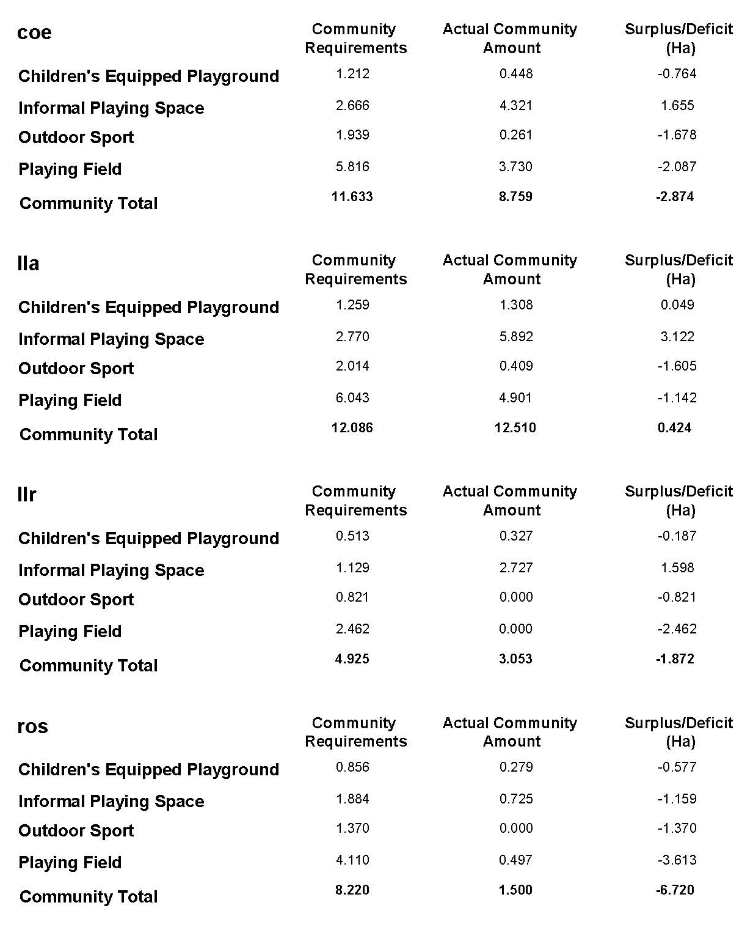

b) Where wards are smaller than communities

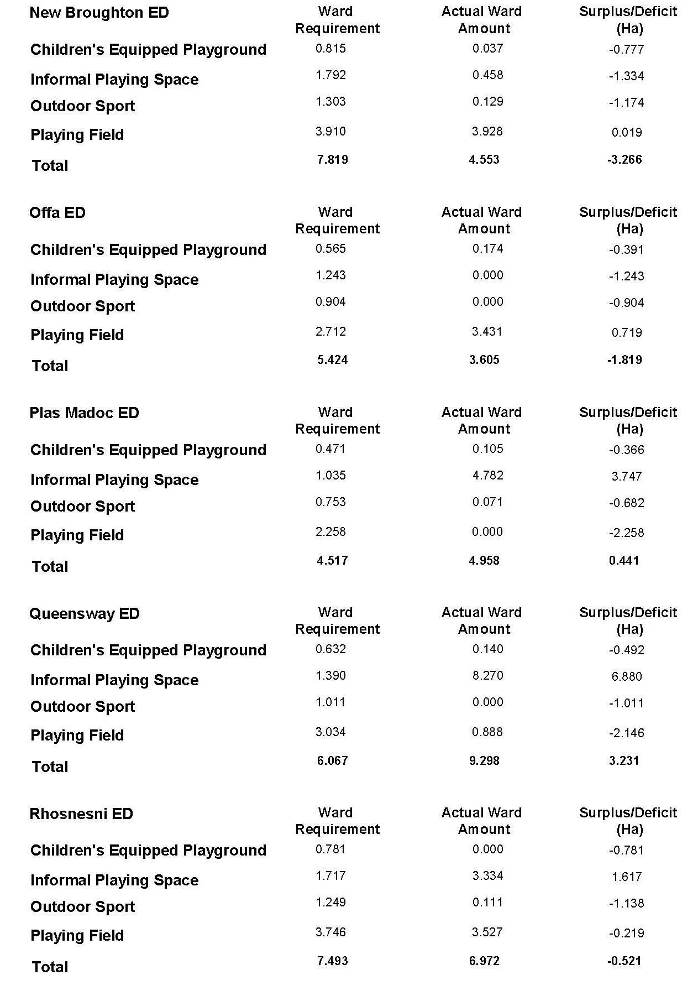
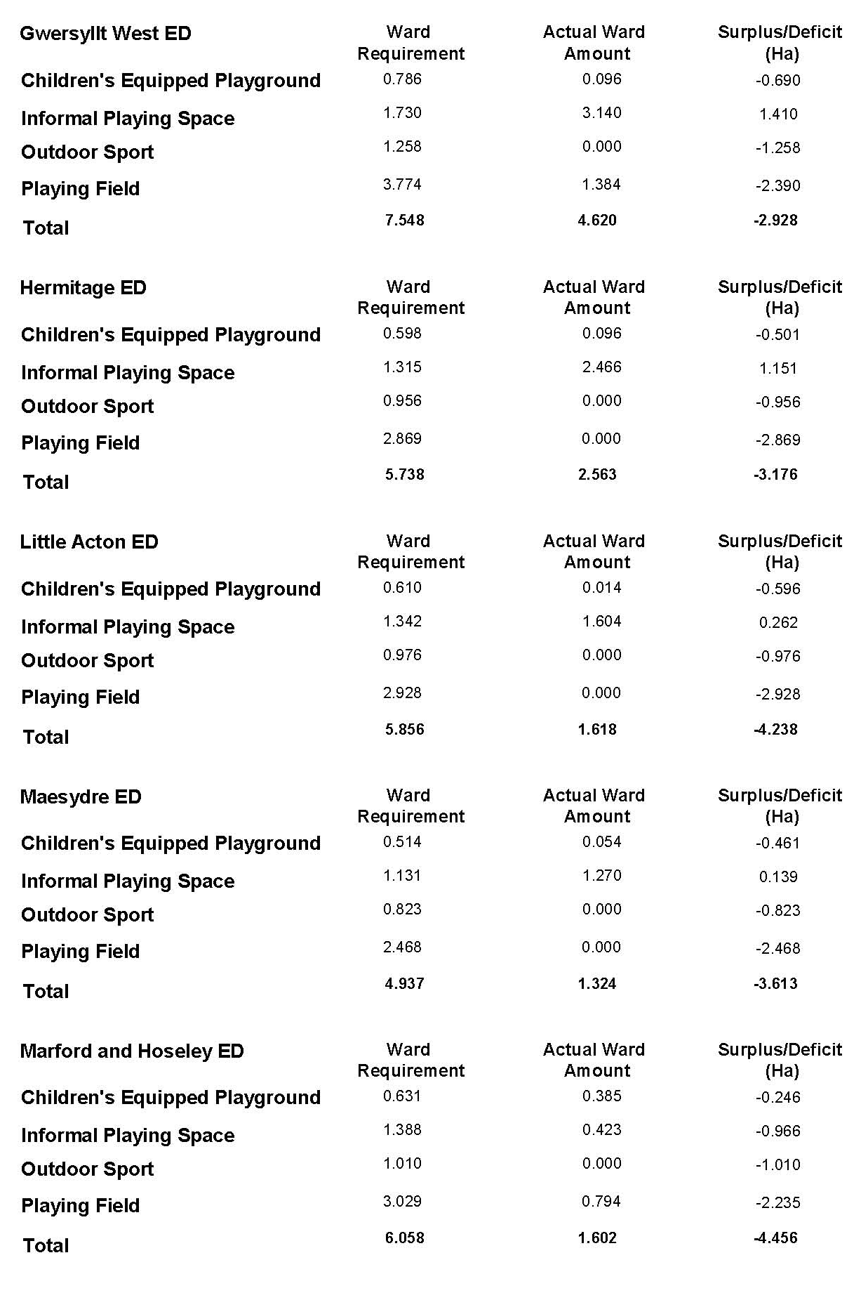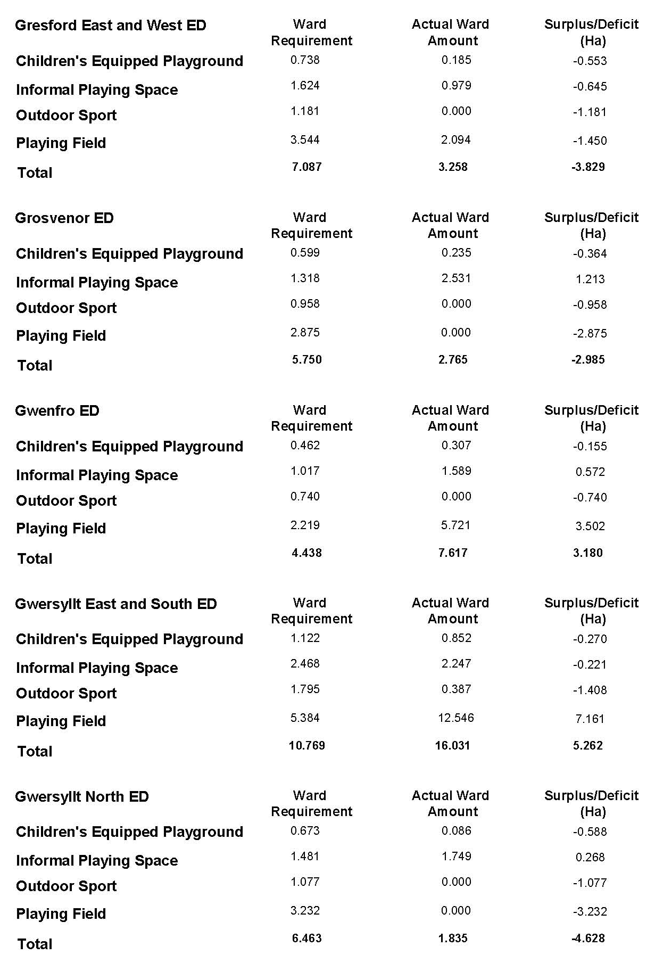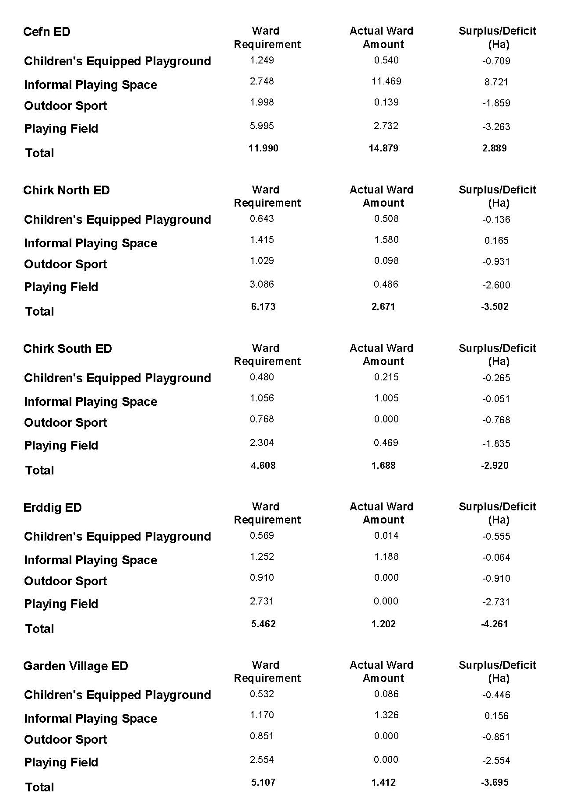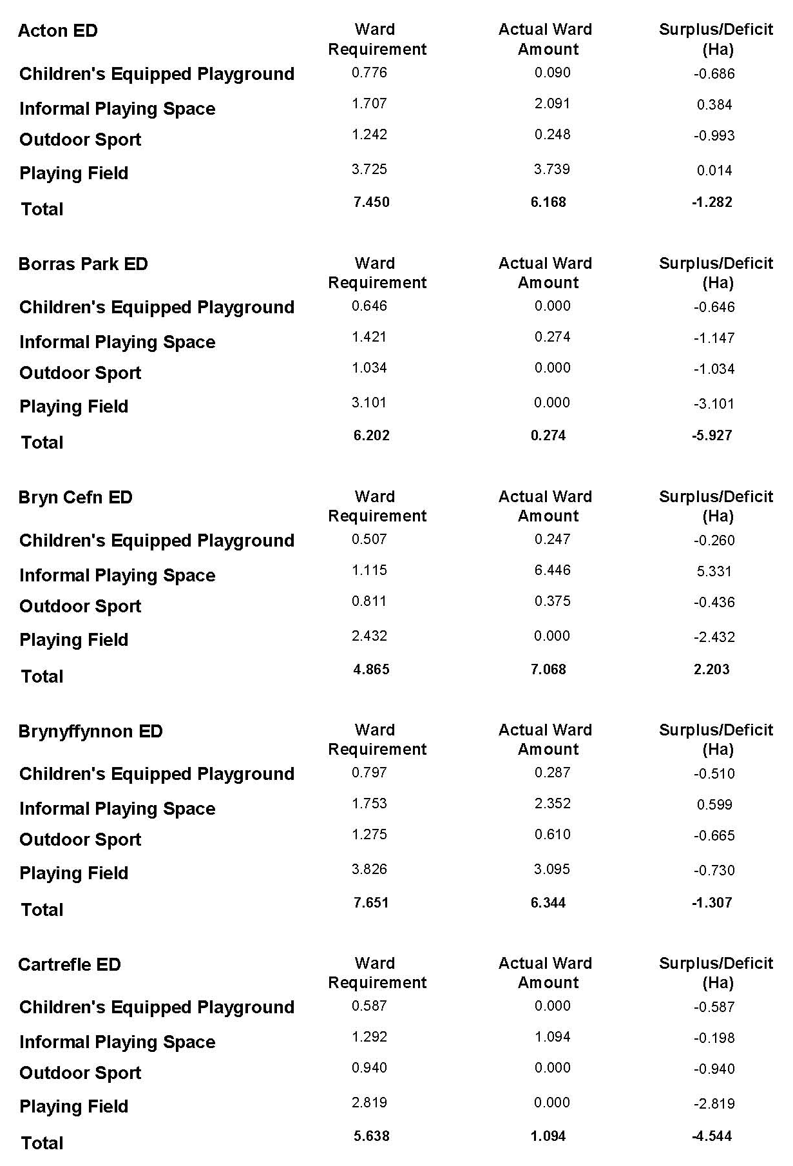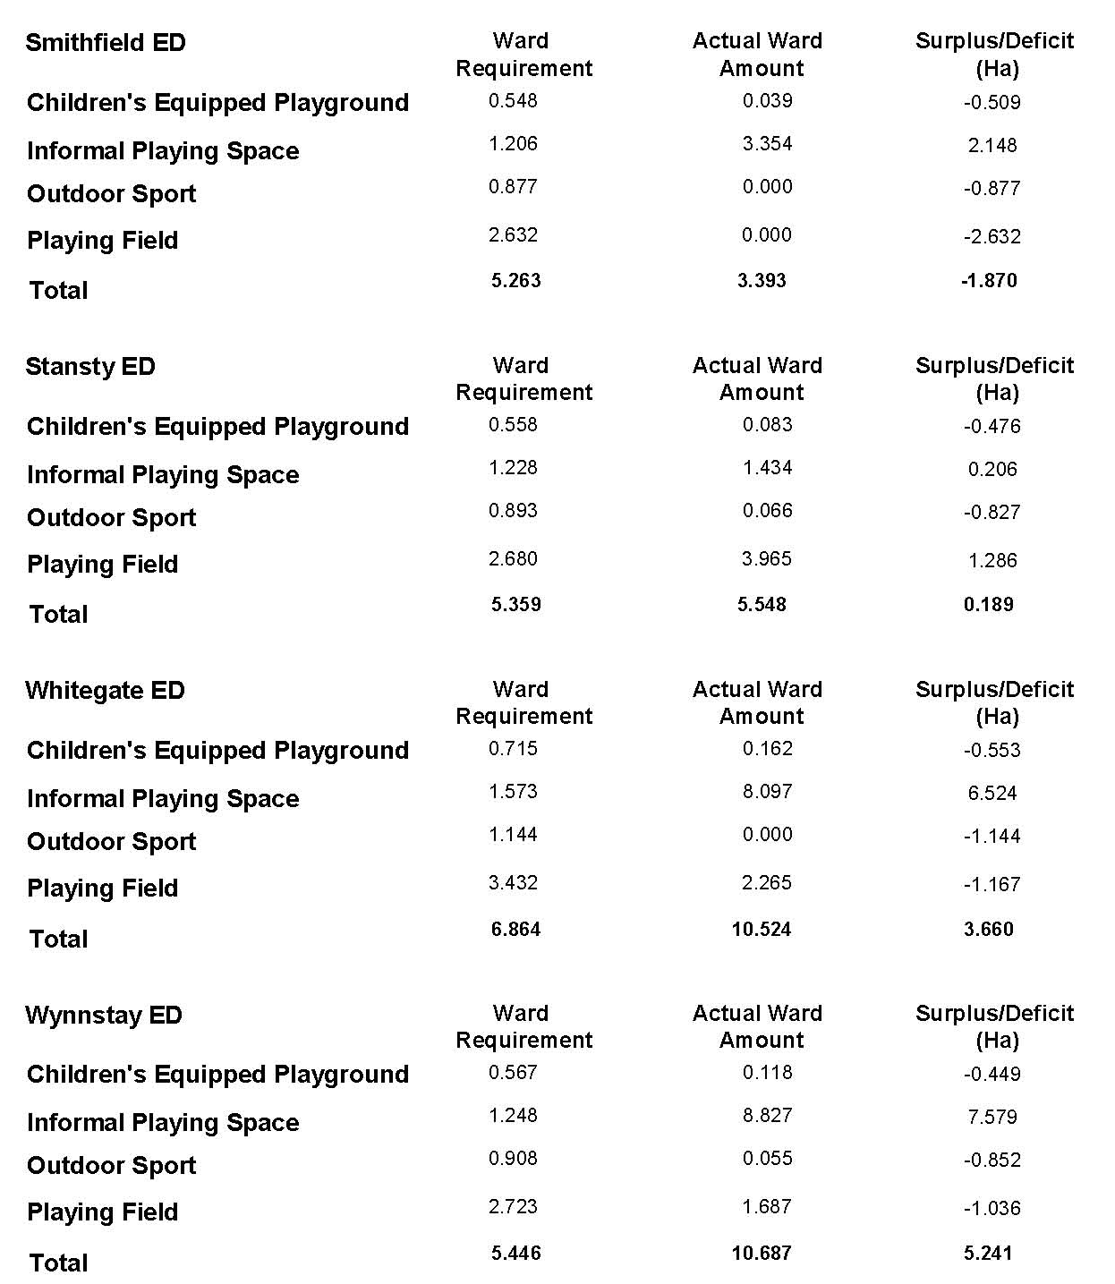

c) Where communities are smaller than wards

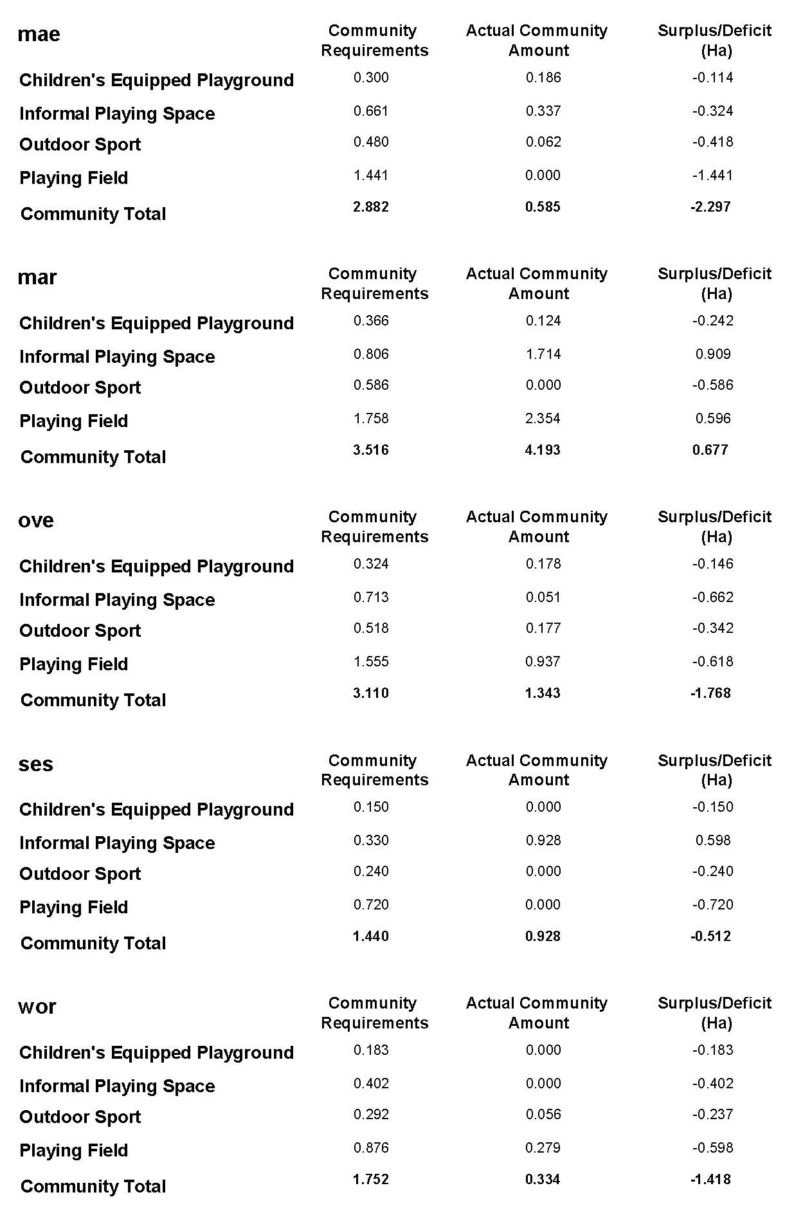
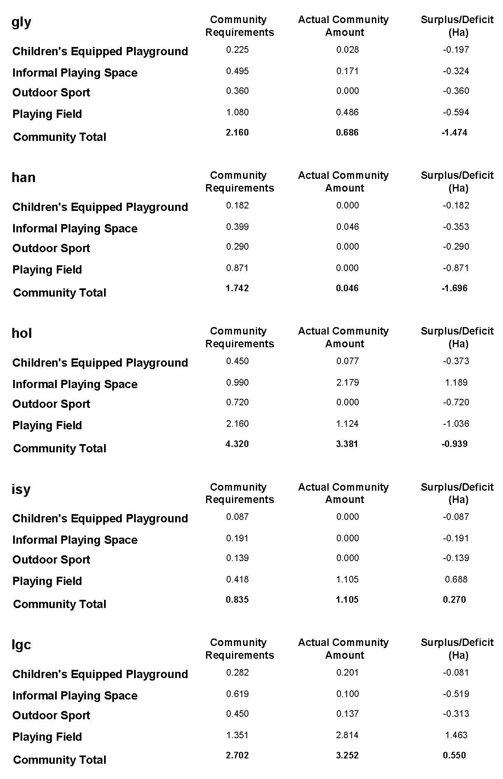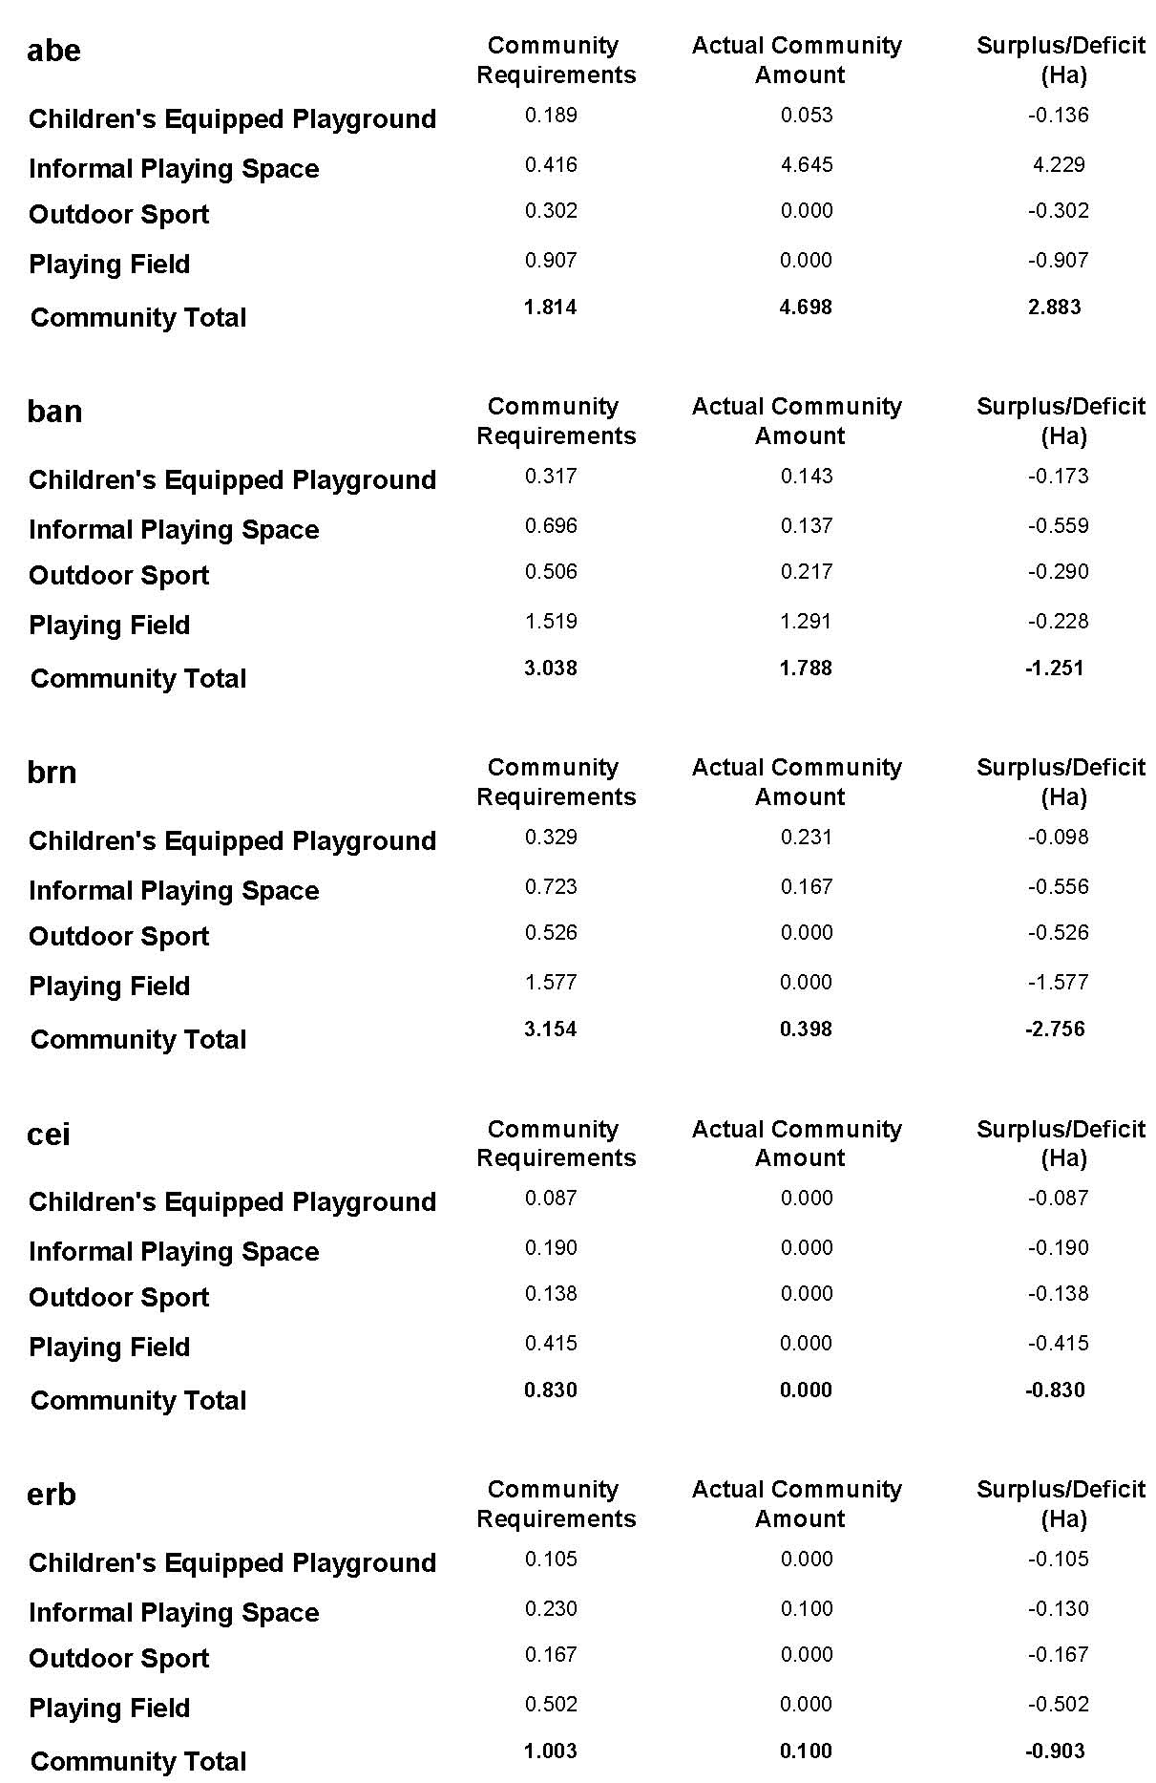

d) Where communities and wards overlap

Wards:
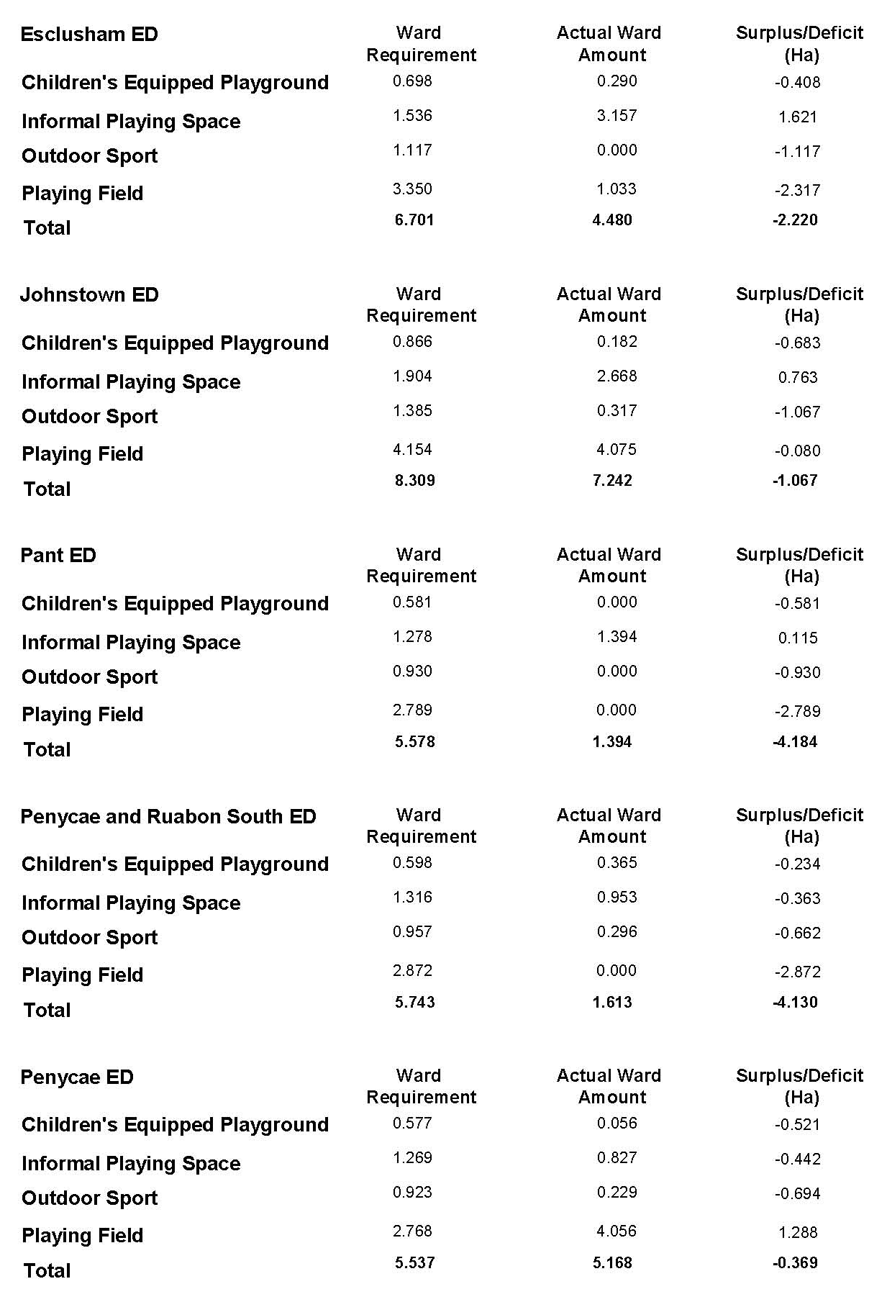
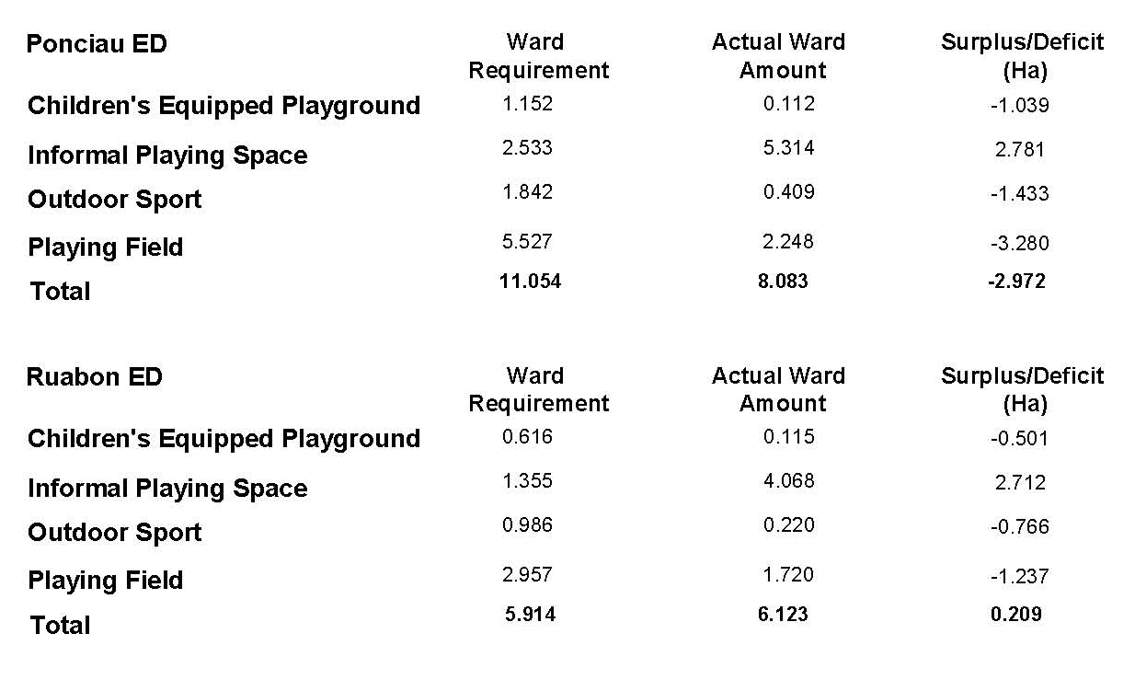

Communities:
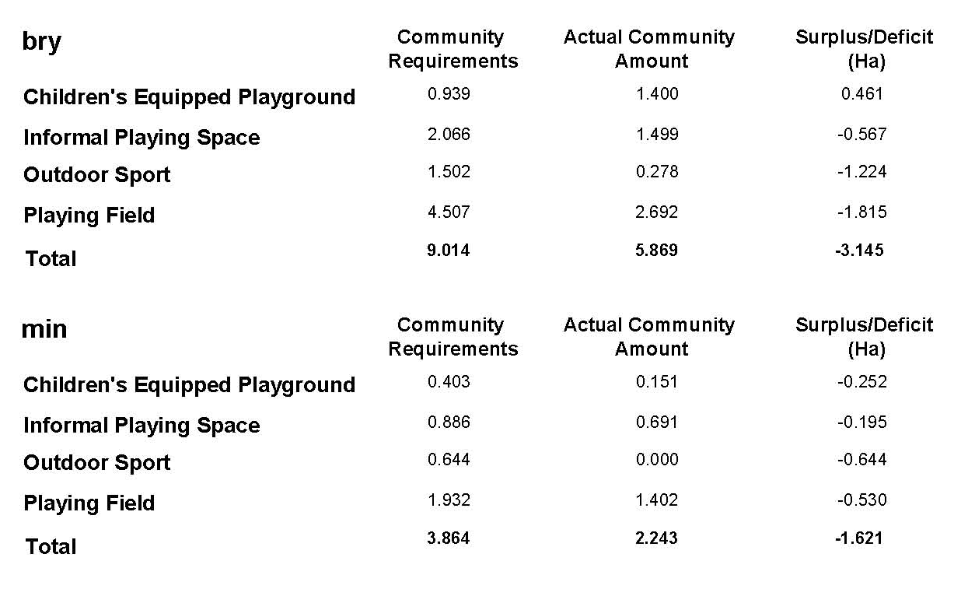
APPENDIX B
Potential Affordable Housing Sites on Informal Open Space
The following table was presented to Planning Policy Panel on the 25th September 2009 where it was resolved that the sites be taken forward in the Local Development Plan for affordable housing purposes.
Table 3: Informal Playing Space sites within settlement limits (sorted by highest surplus per community with ward data included)
POS site ref | A/H Ref No. | Address | Community (where smallest) | Ward  (where smallest) | Developable Area (Ha) | No. of units | Surplus of Informal Playing Space (ha)  (Community) | Surplus of Informal Playing Space (ha) (Ward) | Surplus/Deficit of all POS in the ward/ community (ha)
WRC007 | 10 | Cefn Dre/Tan-y-Coed | Caia Park | Whitegate | 0.06 | 2 | 22.93 | 6.52 | 3.66
WRC045 | 16 | Glan Gors | Caia Park | Queensway | 0.7 | 21 | 22.93 | 6.88 | 3.23
WRC065 WRC064 | 92 | Adj 44 Gwenfro | Caia Park | Queensway | 0.32 | 10 | 22.93 | 6.88 | 3.23
WRC097 | 94 | St Giles Crescent | Caia Park | Wynnstay | 0.5 | 15 | 22.93 | 7.58 | 5.24
WRC082 | 174 | Arenig Road | Caia Park | Queensway | 0.07 | 2 | 22.93 | 6.88 | 3.23
WRC101 | 178 | Rubery Way | Caia Park | Whitegate | 0.09 | 3 | 22.93 | 6.52 | 3.66
** | 125 | Glaslyn Acrefair | Cefn | Plas Madoc | 0.14 | 4 | 12.47 | 3.75 | 0.44
CEF16 | 168 | Trem Dolydd | Cefn | Cefn | 0.15 | 5 | 12.47 | 8.72 | 2.89
*** | 170 | Whalleys Way Acrefair | Cefn | Plas Madoc | 0.13 | 4 | 12.47 | 3.75 | 0.44
** | 198 | Heol Berwyn | Cefn | Cefn | 0.13 | 4 | 12.47 | 8.72 | 2.89
CEF17 | 221 | Whalleys Way | Cefn | Cefn | 0.35 | 11 | 12.47 | 8.72 | 2.89
BRO49 | 66 | Gwalia Road | Broughton | Bryn Cefn | 0.09 | 3 | 4.57 | 5.33 | 2.20
ABE08 | 131 | Pilgrim Way Pentre Maelor | Abenbury | Holt | 0.07 | 2 | 4.23 | 5.80 | 2.88
ABE07 | 238 | Pilgrim Way, Pentre Maelor | Abenbury | Holt | 0.12 | 4 | 4.23 | 5.80 | 2.88
RHO42 | 38 | South of Llwyneinion Wood | Rhos | Ponciau | 0.35 | 10 | 4.13 | 2.78 | -2.97
** | 116 | Pen-y-Graig Playing Field | Rhos | Pant | 1.43 | 43 | 4.13 | 0.12 | -4.18
RHO17 | 136 | Glanrafon | Rhos | Ponciau | 0.05 | 2 | 4.13 | 2.78 | -2.97
RHO43 | 139 | Land at Mountain Street | Rhos | Ponciau | 0.13 | 4 | 4.13 | 2.78 | -2.97
RHO46 | 224 | Erwgerrig | Rhos | Pant | 0.05 | 2 | 4.13 | 0.12 | -4.18
RHO44 | 225 | Bank Street | Rhos | Ponciau | 0.06 | 2 | 4.13 | 2.78 | -2.97
RHO04 | 263 | Brynhyfryd | Rhos | Johnstown | 0.09 | 3 | 4.13 | 0.76 | -1.07
** | 266 | Brynhyfryd | Rhos | Johnstown | 0.02 | 1 | 4.13 | 0.76 | -1.07
LLA33 | 154 | Eleventh Ave | Llay | Llay | 0.02 | 2 | 3.12 | 3.12 | 0.42
LLA11 | 155 | Nant-y-Gaer Road/Eighth Ave | Llay | Llay | 0.52 | 16 | 3.12 | 3.12 | 0.42
COE10 | 32 | Castle Road/Talwrn Road | Coedpoeth | Coedpoeth | 0.74 | 22 | 1.66 | 1.66 | -2.87
WRR25 | 91 | Garden Road | Rhosddu | Grosvenor | 0.09 | 3 | 1.57 | 1.21 | -2.99
GWE05 | 117 | Bickerton Drive | Gwersyllt | Gwersyllt West | 0.05 | 2 | 1.46 | 1.41 | -2.93
GWE02 | 249 | Chestnut Road | Gwersyllt | Gwersyllt East & South | 0.24 | 7 | 1.46 | -0.22 | 5.26
GWE08 | 253 | Pine Close | Gwersyllt | Gwersyllt West | 0.58 | 17 | 1.46 | 1.41 | -2.93
GWE06 | 262 | Chatsworth Drive | Gwersyllt | Gwersyllt North | 0.07 | 2 | 1.46 | 0.27 | -4.63
ESC04 | 164 | Summerfields, Rhostyllen | Esclusham | Esclusham | 0.07 | 2 | 1.23 | 1.61 | -2.22
WRO07 | 270 | Bryn Offa | Offa | Brynyffynnon | 0.14 | 5 | 1.10 | 0.60 | -1.31
WRO08 | 271 | Bryn Offa | Offa | Brynyffynnon | 0.27 | 9 | 1.10 | 0.60 | -1.31
WRA13 | 4 | Rear of Borras Park School | Acton | Rhosnesni | 0.65 | 20 | 0.68 | 1.62 | -0.52
WRA27 | 112 | South of Ansell Road | Acton | Rhosnesni | 0.2 | 6 | 0.68 | 1.62 | -0.52
WRA07 | 113 | East of Ansell Road | Acton | Rhosnesni | 0.2 | 6 | 0.68 | 1.62 | -0.52
WRA51 | 207 | Blantern Way | Acton | Rhosnesni | 0.05 | 2 | 0.68 | 1.62 | -0.52
** | 208 | Westminster Drive | Acton | Maesydre | 0.83 | 25 | 0.68 | 0.14 | -3.61
WRA53 | 213 | Frances Ave | Acton | Little Acton | 0.1 | 2 | 0.68 | 0.26 | -4.24
PEN04 | 148 | Adj 191 Fordd Llanerch | Penycae* | Penycae | 0.15 | 4 | -0.82 | -0.44 | -0.37
Sub – total |  |  |  | 10.07 | 309

* - sites in communities now identified as having a deficit of informal playing space
** - sites not included in POS survey as not deemed to accord with FiT guidelines as they are unsafe for play being located adjacent to busy roads or associated with a school and not accessible
*** - sites deleted from POS study following consultations as they are inaccessible or private

Table A: Potential affordable housing sites that could be converted to playing fields (based on their developable area alone)

POS Site Ref. | A/H Site Ref. | Address | Community | Ward | Developable area (ha) | Possible conversion to P/F? | Remaining S/D (ha) |  | Current Surplus of P/F?
 |  |  |  |  |  |  | Community | Ward | Community | Ward
** | 116 | Pen-y-Graig Playing Field | Rhos | Pant ED | 1.43 | Yes | 2.699 | -1.315 | No (-5.125) | No  (-2.789)
COE10 | 32 | Castle Road/Talwrn Road | Coedpoeth | Coedpoeth ED | 0.74 | Yes | 0.915 | 0.915 | No (-2.087) | No  (-2.087)
WRC045 | 16 | Glan Gors | Caia Park | Queensway ED | 0.7 | Yes | 22.230 | 6.180 | No (-9.804) | No  (-2.146)
WRA13 | 4 | Rear of Borras Park School | Acton | Rhosnesni | 0.65 | Yes | 0.025 | 0.967 | No (-8.703) | No (-0.219)
GWE08 | 253 | Pine Close | Gwersyllt | Gwersyllt West ED | 0.58 | Yes | 0.878 | 0.830 | Yes (1.539) | No  (-2.390)
LLA11 | 155 | Nant-y-Gaer Road/Eighth Ave | Llay | Llay ED | 0.52 | Yes | 2.602 | 2.592 | No (-1.142) | No  (-1.142)
WRC097 | 94 | St Giles Crescent | Caia Park | Queensway ED | 0.5 | Yes | 21.730 | 5.680 | No (-9.804) | No  (-2.146)

