This is a checklist to help you create the College Student Credit Card Offer.
There is also a blank template worksheet, in Resources in the course, to help you create other campaigns for your financial institution.

Step 1 - Category

- Name – College Credit Card Offer
- Category – Credit Cards

Step 2 - Target
- Choose Segment
- “Select Customer Segment” drop down choose Create new Segment
  - Name your segment – College Credit Card Offer
  - Describe your segment (if applicable) –
    - target users who have any mobile activity in the last 30 days and have paid a bill using bill pay
  - Select your Criteria (use below settings for the three drop down boxes)
    - Mobile: Has Smartphone Activity
    - Last 30 days
    - True
  - Add a second segment by selecting the add icon
    - And
    - BP: Has paid a bill
    - All Past
    - True

Your finished segment should look like this:
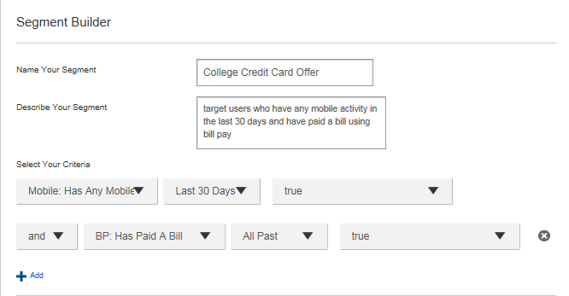
Some versions do not require a description for your segment
Step 3 – Placement

- Consumer Accounts History – Promo 2 location
- Destination – External URL
  - For this example, we used www.fi.com (this is where you would enter a link to your credit card application on your site)

Step 4 – Design
- Layout - Leapfrog bottom history image
- Select Upload New Image
  - Locate the file credit_card.jpg and select it, then select OK.
  - Select the image from your image library. You should see it preview on the left side of the screen.

Step 5 – Schedule

- Start Date (PST) – April 1 8:00 am
- End Date (PST) – April 15 8:00 am

- Impressions per user
  - 20
      - The user could see this promotion up to 20 times between February 1 – March 1. This depends on how many times they log in during that time. You are able to download the views and clicks for a promotion as a report.
- Priority
  - Medium
      - Lowering the priority means that a promotion running in the same location with a higher priority may take precedence, if the user meets the requirements and if there is not smart targeting involved.

Step 6 – Review
- Roll Out Campaign

