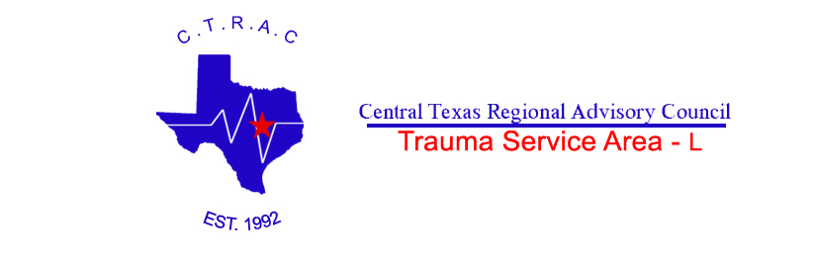

Central Texas
Regional Advisory Council

Trauma Service Area-L

Trauma System Plan

2008

Table of Contents

Section Title | Page
Introduction
- Record of Changes | 4
- CTRAC Introduction | 5
- Texas Department of State Health Services TSA Map | 6
- CTRAC Trauma Service Area-L Map | 7
- CTRAC Officers and Board of Directors | 8
- CTRAC Subcommittees | 9-10
- CTRAC Bylaws | 11-30
Prehospital Services
- Record of Changes | 32
- EMS Providers by County | 33-34
- EMS-Air Medical Providers | 34
- EMS-First Responder Organizations by County | 35-36
Hospitals
- Record of Changes | 38
- Hospitals by County | 39-40
Guidelines
- Record of Changes | 42
- System Access | 43
- Communications | 44-47
- Regional Medical Control & Oversight | 48-49
- Pre-Hospital Triage Criteria | 50-52
- Pre-Hospital Patient Care Guidelines | 53-58
- Air Medical Transport | 59-61
- Facility Diversion | 62-63
- Facility Bypass | 64
- Facility Triage Criteria | 65-66
- Trauma Team Activation Criteria | 67
- Interfacility Transfers | 68-69
- Planning for Designation of Trauma Facilities | 70
- System Performance Improvement | 71-73
- Injury Prevention | 74
- EMSystem Policy | 75-79

Introduction

RECORD OF CHANGES

Introduction

Change # | Date  of Change | Change Entered | Change Entered By
1.0 | Ocotber 24th, 2007 | Updated TSA map, Board of Directors, Subcommittee information and Bylaws. | Danielle Schmitz, CTRAC Exec. Director
1.1 | February 11th, 2008 | Updated Board of Directors and Subcommittee information. | Danielle Schmitz, CTRAC Exec. Director

Introduction

The Central Texas Regional Advisory Council (CTRAC) was established in 1992 through a grant from the *Texas Department of Health’s Regional Trauma System Development Grant Program. It is one of 22 Trauma Service Areas in Texas and consists of six counties known as Trauma Service Area – L. CTRAC is recognized by the IRS as a 501(c) 3 non-profit organization since 1998.

During the 71st legislative session (1989), House Bill 18 was passed directing the establishment of a statewide trauma system for Texas. Specific rules and regulations related to the development of the statewide system were identified and implemented.

The state was divided into 22 Trauma Service Areas that account for the 254 counties in Texas. A Regional Advisory Council for trauma serves each Trauma Service Area. The Regional Advisory Councils were charged with developing a system plan based on standard guidelines for implementing a comprehensive trauma care system. The development of a regional plan is the ultimate responsibility of the stakeholders and participants of the Regional Advisory Councils. Some elements of the plan are required, while others may be added to best reflect the needs of the community. While the Plan may have numerous components, its heart is the dedication of the professionals who transform these guidelines into reality.

Since its inception, CTRAC has been active in trauma prevention and education programs as well as development and implementation of trauma patient care standards. Maintaining public education and awareness activities to increase the understanding of the trauma care system, access to trauma care and prevention of injuries, and providing coordination of acute medical services in mass casualty and disaster settings is an integral part of the mission and goals of CTRAC.

CTRAC covers over 6,192 square miles and has a population of 414,000. Sixty-two percent of the population lives outside of the largest cities of Killeen and Temple. TSA-L has a Level I Trauma Center, Scott & White Hospital, as its Lead Trauma Facility. Additionally, Fort Hood military base, located in Bell and Coryell Counties is the largest military installation in the free world with comprehensive training facilities for reserves and National Guard units from across the country. TSA-L consists of over 4,485 highway miles with Interstate Highway 35 dividing the region. Over 80% of TSA-L is rural, frontier rural and many areas are considered primitive-frontier.

Trauma care should be part of a seamless trauma system that provides patients with well-organized and high-quality care. Incorporation of an overall health care system requires cooperation and availability of each component of the system.

The essence of a trauma system is the ability to get the right patient to the right hospital at the right time to reduce death and disability. CTRAC members have made great strides toward this goal and continue to collaborate and strive to improve care of the trauma patient.

(*Texas Department of Health became Texas Department of State Health Services in 2005)
Page 3 of 89

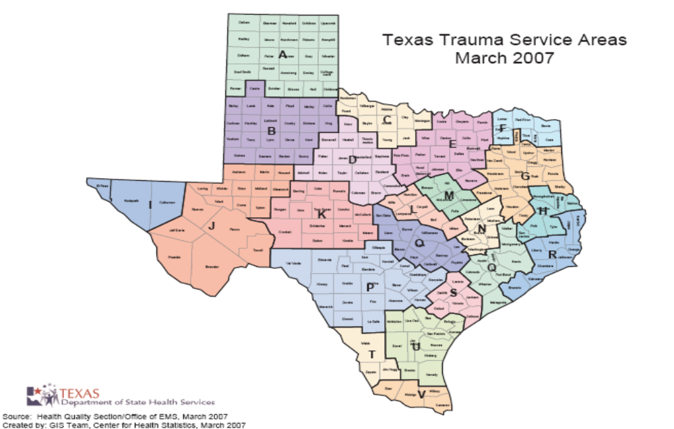

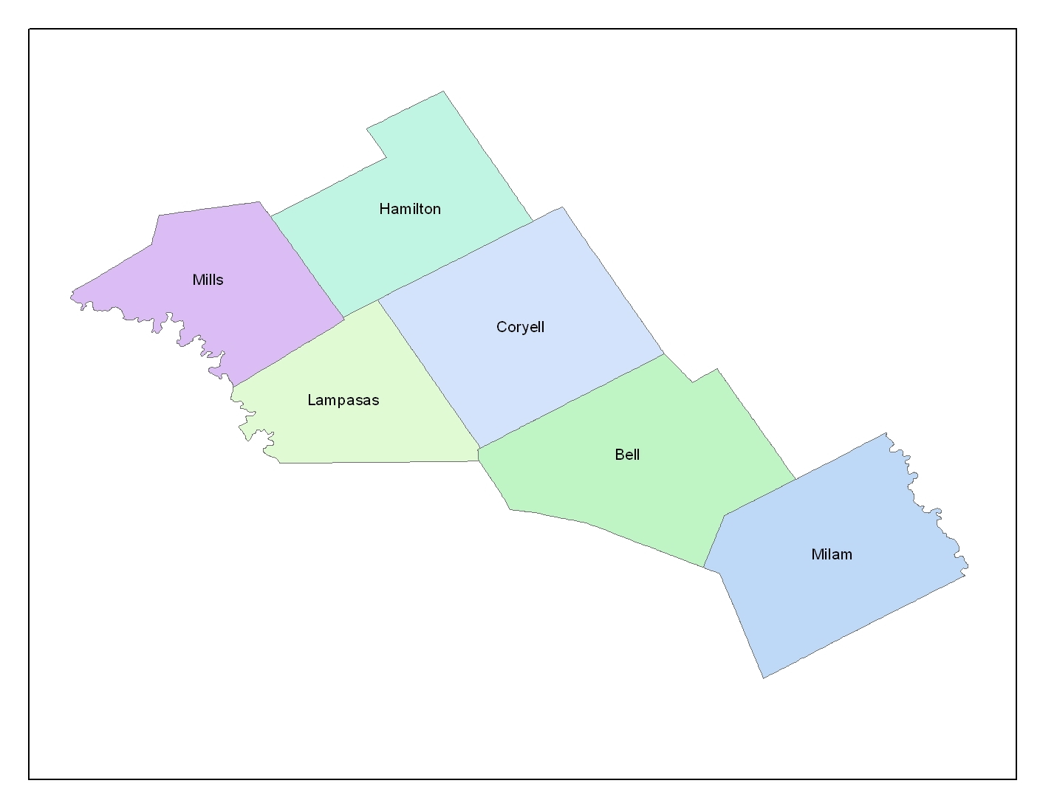
TRAUMA SERVICE AREA - L

CTRAC 2008

Executive Board

Chair Fred Gray, EMT-P
Coryell Memorial Healthcare System EMS

Vice Chair Terry Valentino, RN, EMT-P
Scott & White Memorial Hospital

Treasurer Brittney Misercola, RN, CEN, CFRN, NREMT-P
PHI STAT Air

Secretary Stacey Alley, LP
Harker Heights FD/EMS

Board of Directors

Fred Gray, EMT-P CTRAC Chair
Terry Valentino, RN, EMT-P CTRAC Vice Chair, Hospital Care & Mgmt Committee Chair
Stacey Alley, LP CTRAC Secretary
Brittney Misercola, RN, CEN, CFRN, NREMT-P CTRAC Treasurer, EMSOC Committee Chair
Thomas Pechal, LP Injury Prevention/Public Education Committee Chair
Chad Berg, EMC Emergency Preparedness & Response Committee Chair
Michael Craun, MD Medical Advisory Board Committee Chair
Anita Paniagua, RN Performance Improvement Committee Chair
Vacant Immediate Past Chair
Vacant Rural Member-at-Large
Vacant Emergency Management Member-at-Large
Vacant Physician-at-Large
Vacant Community Member-at-Large
Vacant Trauma Program Rep. of Lead Trauma Facility

Central Texas Regional Advisory Council
2180 N. Main St., Suite B25
Belton, Texas 76513
Phone (254) 770-2316
Fax (254) 770-2382

Subcommittee | Chair & Vice Chair | Subcommittee Mission | Subcommittee Goals
EMS Operations Committee | Chair  Brittney Misercola, PHI STAT Air | To serve as a liaison for pre-hospital providers within this region, to include the monitoring of system development, coordination of activities, performance improvement, and pre-hospital training. | - To incorporate recruitment strategies in an attempt to promote active participation on the EMSOC Committee from all EMS/Hospital service within the TSA-L region.  - The EMSOC Committee will assist the MAB with the development of regional Stroke guidelines and facilitate pre-hospital stroke education.  - Assist the MAB in developing regional pediatric guidelines and assist agencies with pediatric equipment and training needs.  - Assist the MAB with development of regional guidelines as needed and assist with pre-hospital educational needs.
Hospital Care & Management | Chair  Terry Valentino,  Scott & White Memorial Hospital | To serve as a liaison between healthcare facilities within this region to include the monitoring of system development, coordination of activities, performance improvement, facility designations and hospital training. | - Actively support trauma education for ED/Trauma nurses in our trauma service area.  - Establish standard competency list for ED/Trauma nurses in our trauma service area.  - Enhance communication and cooperation between health care facilities and EMS to facilitate transfer of trauma patients to appropriate levels of care.
Emergency Preparedness & Response (EPR) | Chair  Chad Berg, City of Killeen Office of Emergency Management | To coordinate preparedness and responses to acute medical mass casualty and disaster situations. | - To coordinate preparedness activities between entities within our trauma service area.  - Meet all required criteria outlined in the OASPR/DSHS grant guidelines for the Hospital Preparedness Program.
2008 Subcommittees
Medical Advisory Board | Chair  Mike Craun, MD Scott & White Memorial Hospital | To provide oversight and assistance related to patient care/system issues for the CTRAC region and assist the CTRAC PI Committee with PI issue resolutions. | - To revise and review the CTRAC Trauma System Plan on a yearly basis  - To assist in loop closure with identified performance improvement issues brought forth by the CTRAC Performance Improvement Committee.  - To monitor patient care/system issues that may arise warranting the need to develop specific guidelines in the CTRAC region.
Performance Improvement | Chair  Anita Paniagua, Carl R. Darnall Army Medical Center | To provide ongoing performance assessment and improvement activities designed to objectively and systematically monitor and evaluate the quality of trauma patient care through system analysis in an effort to identify and pursue opportunities to improve patient care. | - To facilitate performance improvement in trauma patient care and services by establishing mechanisms to identify opportunities to improve.  - To provide a framework for a planned, systematic and ongoing approach for the objective monitoring and evaluation of the quality appropriateness and effectiveness of trauma patient services provided within TSA-L.  - To create an organizational structure which will be accountable for the coordination and integration of performance improvement activities in accordance with established standards.
Injury Prevention/ Public Education | Chair  Thomas Pechal,  Temple Fire & Rescue | To provide guidance for educating the public within the region to enhance public awareness in this region. To make recommendations and oversee regional activities on preventing injury in this region. | - Increase committee membership.  - Continue distribution of car seats.  - Coordinate training of Child Passenger Seat Technician Course.  - Increase visibility of the CTRAC presence in the community.  - Participate in a minimum of one community health event every three months.  - Injury prevention page link to web site (CTRAC HPPG)  - Write a one-page injury prevention newsletter quarterly and place on the web site.

CTRAC Bylaws
February 2008

THE CENTRAL TEXAS REGIONAL ADVISORY COUNCIL
Trauma Service Area (TSA) L
BYLAWS

Article I – Name

This organization shall be known as the Central Texas Regional Advisory Council (CTRAC). The CTRAC Trauma Service Area includes the counties of Bell, Coryell, Hamilton, Lampasas, Milam, and Mills. The CTRAC Trauma Service Area is also referred to as TSA L.

Article II – Mission Statement

To provide the infrastructure and leadership necessary to sustain an inclusive trauma system within our Trauma Service Area by the following actions:

- Assist member organizations in achieving the highest level of trauma care they are capable of providing, which will result in a decrease in morbidity and mortality and ultimately improve the injured patient’s outcome.
- Encourage activities designed to promote cooperation between member organizations and provide a forum to resolve conflicts regarding the care of the injured patient.
- Provide and facilitate educational programs for the public to increase awareness regarding an inclusive trauma system with a heavy emphasis on prevention activities.
- Develop, acquire and operate facilities to enhance the provision of trauma and emergency care in TSA L.

To provide coordination of acute medical services in the mass casualty and disaster settings.

- Serve as the acute medical services liaison in the CTRAC County Emergency Operations Centers within the Central Texas Council of Governments (CTCOG) Region.
- Coordinate emergency and disaster preparedness and response activities between area hospitals and public health.
- Provide resources to the Office of Emergency Management regarding acute medical services.
- Participate in the Regional Medical Operations Center, if established, and/or the CTCOG Multi-Agency Coordination Center to coordinate disaster activities between area hospitals and pre-hospital providers.

Article III – Purpose

Section 1. The purpose of this organization is to:

A. Advance and improve the state of healthcare for the injured patient within the counties of Trauma Service Area L (Central Texas Regional Area).

B. Decrease morbidity and/or mortality which results from injury.

C. Encourage activities designated to promote cooperation and resolve conflicts between member organizations.

D. Improve funding of trauma care providers within the counties served by this council.

E. Maintain a Trauma System Plan for the RAC which is based on standard guidelines for comprehensive system development.

F. Improve public awareness of the methods of accessing the trauma care system and preventing injury.

G. Coordinate responses to mass casualty and disaster events.

Article IV – RAC Membership

Section 1.

RAC membership encompasses a wide range of professionals and citizens concerned about the health and well-being of the community as it relates to trauma, emergency services and disaster preparedness. Voting membership requires that the member represent a hospital or disaster service, an individual who is involved with trauma, emergency, or disaster care, an emergency medical service, an educational agency involved in training purposes for trauma or disaster preparedness, or a service which provides care to victims of trauma. Each member entity is allowed only one vote. A voting member must practice and/or reside within the boundaries of TSA L.

Section 2. Condition of Membership

- A member entity must complete a Member Information Form.

- A member who resigns in good standing may reapply for membership. Resignations must be submitted in writing to the CTRAC Executive Board.

- A member failing to actively participate in CTRAC activities as defined by the CTRAC Executive Board may be removed from the membership by a majority vote of the CTRAC Executive Board. Said member may appeal this action for re-instatement to the General Assembly.

- Prior to removal from the membership by the CTRAC Executive Board, the Executive Director will notify said member by phone that they are not compliant with RAC bylaws and participation requirements. If participation does not increase, a certified letter will be sent to said member at the last known mailing address. If the issue continues, the Executive Director will bring said member to the CTRAC Executive Board for removal.

Section 3.

Member entities will have one representative designated to vote on their behalf at the General Assembly & Committee meetings. An alternate representative may be designated to attend the General Assembly & Committee meetings by the member. This representative may cast that entity’s vote.

Section 4.

Members are listed in Appendix A.

Section 5. Active Participation in the RAC is defined as the following:

- EMS Provider Agencies

  - Will have representation at 75% of regularly scheduled General Assembly meetings held.
  - Will be electronically downloading information into the Trauma Registry and will have representation at 75% of EMS Operations Committee meetings and/or Emergency Preparedness & Response Committee meetings.
  - Will demonstrate participation in at least one RAC sanctioned prevention activity annually and submit documentation of such.
  - Will submit data as requested by the EMS Operations and/or Emergency Preparedness & Response Committee and/or CTRAC Officers and attend any EMS Operations and/or Emergency Preparedness & Response Committee meetings when agency has a referral on the agenda.
  - Will participate in one disaster preparedness drill per year.
  - Will have Medical Director or designated physician participation at 75% of Medical Advisory Board Committee Meetings.

- Hospital Members

1. Will have representation at 75% of regularly scheduled General Assembly meetings held.
- Will have representation at 75% of Hospital Care & Management and/or Emergency Preparedness & Response Committee meetings.
- Will have Medical Director or designated physician participation at 75% of Medical Advisory Board Committee Meetings.
- Will demonstrate participation in at least one RAC sanctioned prevention activity annually and submit documentation of such.
- Will be electronically downloading information into the Trauma Registry and attend any Hospital Care & Management and/or Emergency Preparedness & Response Committee meeting when the agency has a referral on the agenda.
- Will participate in 75% of scheduled preparedness activities.
- In the event of emergency healthcare activations, will participate as required by the Health & Medical Annex of the County Emergency Operations Plans and/or the Health & Medical Appendix of the Regional Response Plan.

- Non-EMS/Hospital Entities

  - Will have representation at 75% of General Assembly Meetings.
  - Will participate in a minimum of one (1) standing committee and will have representation at 75% of the committee meetings.

- Each member entity will complete an annual Regional Needs Assessment by the 1st March of each year.

- Exceptions to the above requirements may be considered by the Board on an individual basis. An entity seeking such an exception must submit, in writing, a request for the exception and provide documentation to support the request.

Article V – The Board of Directors

Section 1. The Board of Directors shall consist of the following:

CTRAC Executive Board

- Chair
- Vice Chair
- Secretary
- Treasurer

Committee Chairs

- Chair of the EMS Operations Committee
- Chair of the Hospital Care & Management Committee
- Chair of the Medical Advisory Board Committee
- Chair of the Injury Prevention/Public Education Committee
- Chair of the Emergency Preparedness & Response Committee
- Chair of the Performance Improvement Committee

Other Members

- Immediate Past Chair
- Rural Member-at-Large
- Emergency Management Member-at-Large
- Physician-at-Large
- Community Member-at-Large
- Trauma Program Representative of Lead Trauma Facility

Nominations for the position of Rural Member-at-Large, Emergency Management Member-at-Large, Physician-at-Large, and Community-at-Large will be obtained by the General Assembly and appointed by the Board.

Section 2. Quorum:

At least one (1) CTRAC Executive Board member must be present as well as two-thirds (2/3) of the filled Committee Chairs positions, excluding the CTRAC Executive Board, shall constitute a quorum for the purpose of transacting any business of CTRAC.

Section 3. Meetings:

The Board of Directors shall hold at least twelve (12) meetings per year. Additional meetings will be scheduled as needed. Board of Directors’ meetings will be held in January, February, March, April, May, June, July, August, September, October, November and December.

The Chair may call a special meeting at any time with a one (1) week advance notice to the Board of Directors. This notice may be sent by the Chair or the Executive Director electronically. A quorum is required for a special called meeting.

Section 4. Attendance:

Board Members must attend at least 75% of the Board meetings per year. An alternate representative may be designated to attend a Board meeting by the member. This representative may cast that entity’s vote. An alternate may attend no more than 25% of the scheduled board meetings.

Section 5. Resignation/Succession

In the event that the Chairperson resigns or is removed from office prior to the term expiration, the Vice Chair will immediately succeed the resigned/removed Chair.

A Board Member who does not comply with assigned responsibilities may be relieved of office by a majority vote of the Board. Appointment of a replacement shall be made by the Chair with a majority vote of the Board present at the meeting.

Any vacancies shall be filled for the balance of the unexpired term by the Chair with a majority vote of the Board. The Board Member who serves the unexpired term will be eligible for reappointment twice.

Section 6. Elections:

Elections shall be held in November of each calendar year. Terms shall begin the following January.

In order to provide continuity of representation on the CTRAC Board of Directors:

A. The Chair is elected to a 2-year term in even numbered years and serves a 2 year term. The Chair serves on the Board as the Immediate Past Chair for a two year term.

B. The Vice Chair is elected to a 2-year term in odd numbered years and serves a 2 year term.

  - The Secretary and Treasurer shall serve two year terms. The Secretary will be elected on the even years and the Treasurer will be elected on the odd years.

  - Other Member terms shall be limited to two (2) consecutive terms. In the event that there is not other person available or willing to serve, an additional term(s) may be approved by a simple majority roll-call vote of the General Assembly members present at the meeting.

Section 7.

The Board Members shall serve a 2-year term. Board Members terms shall be limited to two (2) consecutive terms. In the event that there is no other person available or willing to serve, an additional term(s) may be approved by a simple majority roll-call vote of the General Assembly present at the meeting.

Section 8.

The Board of Directors shall be empowered to employ personnel and lease or acquire facilities to conduct the business of the RAC.

Section 9.

The Board shall operate in the place of a Finance/Audit Committee.

Section 10.

The Board of Directors shall develop and maintain policy statements that guide the functioning of the RAC. A policy shall receive final approval of the Board with a majority vote of those members present. Copies of such policy statements shall be provided to the General Assembly upon final approval of the Board of Directors at the following General Assembly meeting.

Article VI- Election of Officers and Board of Directors

Section 1.

At the October meeting of each year, nominations shall be requested from floor of the General Assembly.

Section 2.

Nominations shall be provided to the General Assembly two (2) weeks prior to the November meeting each year. The election of expired term Officers and Board of Directors shall be by open ballot during the November meeting each year.

Section 3.

To qualify for the positions of Chair and Vice-Chair, a member must have actively participated at least two years in the CTRAC General Assembly.

Article VII
Article VII- Duties of Board Members

Section 1. The Chair shall:

A. Preside at all meetings of the General Assembly, Board of Directors, and any special meetings.

B. Facilitate development and achievement of organizational goals.

C. Make interim appointments as needed with the approval of the Board of Directors.

D. Sign all contracts with the Executive Director after approval of the Board of Directors.

E. Represent this organization at the Texas Department of State Health Services RAC Chair’s Meeting or identify a designee.

Section 2. The Vice Chair shall:

A. Preside over RAC activities in the absence of the Chair.

B. Perform duties as assigned by the Chair.

  - Coordinate the annual election process.

  - Assist in preparing any necessary reports or documentation required.

Section 3. The Secretary shall:

A. Record and present the minutes of all proceedings of the Board and General Assembly meetings.

B. Handle all correspondence of the organization in the absence of the Executive Director.

C. Assist in preparing any necessary reports or documentation required.

Section 4. The Treasurer shall:

A. Review all financial business conducted by the RAC.

B. Perform financial duties in the absence of the Executive Director.

C. Assist in preparing any necessary reports or documentation required.

Section 5. The Executive Director shall:

  - Maintain a record of all financial business conducted by the RAC in accordance with RAC polices/procedures and common accounting practice.

  - Prepare and submit financial statements to the Board and General Assembly on a quarterly basis.

  - Ensure that Board of Directors & General Assembly meeting minutes are made available to all RAC membership and the Department of State Health Services EMS & Trauma Systems Coordination as requested.

  - Will make available copies of bylaws and the Trauma System Plan annually as requested.

  - Actively assist in seeking funding sources for the activities of the organization.

  - Prepare necessary reports or documentation required by government agencies or grant sponsors.

  - Gather information from Committee Chairs, prepare and submit annual budget projections to the Board and General Assembly.

  - Sign all contracts with the Chair.

  - Preside over meetings in which the Chair and Vice Chair are not available when a quorum is present.

Section 6. The Committee Chairs shall:

A. Organize and conduct meetings as defined in the bylaws.

B. Facilitate the development and achievement of goals for their committee.

C. Provide written agendas and minutes to committee members. Provides these and sign-in sheets to the Executive Director for maintenance and provides verbal reports to the Board and General Assembly during RAC meetings.

D. Assist in preparing any necessary reports or documentation required.

Article VIII – Standing and Ad Hoc Committees/Task Forces

Section 1. The Standing Committees and their missions are as follows:

A. EMS Operations Committee
- To serve as a liaison for pre-hospital providers within this Region to include the monitoring of system development, coordination of activities, performance improvement, and pre-hospital training.
B. Hospital Care & Management Committee
- To serve as a liaison between health care facilities within this region to include the monitoring of system development, coordination of activities, performance improvement, facility designations and hospital training.

C. Medical Advisory Board Committee
- To monitor the performance of identified performance improvement indicators as it relates to the quality of patient care.
- Make recommendations regarding system enhancement and/or improvements.
- Inter-local liaison committees may be formed to provide comprehensive review of issues with greater local participation. Information/inquiries may be originated at either the Medical Advisory Board Committee or the other committees. In either case, the summary of discussions will be reflected in the minutes of the Medical Advisory Board Committee.

D. Injury Prevention/Public Education Committee
- To provide guidance for educating the public within the Region to enhance public awareness in this Region.
- To make recommendations and oversee regional activities on preventing injury in this Region.
E. Emergency Preparedness & Response Committee
- To coordinate preparedness and responses to acute medical mass casualty and disaster situations.
- Performance Improvement Committee
- To provide ongoing performance assessment and improvement activities designed objectively and systematically monitor and evaluate the quality of trauma patient care through system analysis in an effort to identify and pursue opportunities to improve patient care.
- To provide oversight and guidance for the Region regarding the performance improvement objectives issued by the State of Texas.

Section 2.

Each standing committee shall have an identified chair which will be selected by the membership of that committee each year. This process will occur in November of each year in conjunction with the election of Officers and Board of Directors.

Section 3.

Each standing committee shall have at least 4 meetings per year and keep minutes of each meeting. Meeting minutes may be obtained by any RAC member from the Executive Director. The minutes may be provided either in hard copy or electronically.

Section 4.

EMS Operations, Hospital Care & Management, and Medical Advisory Board Committees will have standing agenda items for Trauma, Pediatrics, Stroke, and Cardiac. Discussion of these items improves care across the emergency healthcare system.

Section 5.

Ad Hoc Committees/Task Forces may be established and/or dissolved at the discretion of the Board. Ad Hoc Committees/Task Forces are utilized to address issues that are limited in duration or cyclic in nature.

Article IX – General Assembly Meetings

Section 1. Quorum

At least six (6) hospitals and six (6) EMS providers must be represented in addition to the one (1) CTRAC Executive Board member and three (3) Board of Directors not including the CTRAC Executive Board, shall constitute a quorum for a General Assembly meeting.

Section 2. Meetings

The General Assembly shall meet at least four (4) times per year on the last Wednesday of the month, with the exception of observed holidays. The General Assembly will determine the proper meeting date at the meeting prior to the month where the last Wednesday falls on an observed holiday.

Any member of the CTRAC Executive Board or the Executive Director may call a special meeting with a majority vote of the Board of Directors. A minimum of a two (2) week notice will be provided electronically to all members on the General Assembly email list serve.

Section 3. Attendance

See Article IV, Section 5 for the attendance requirements.

Article X – Funding

Section 1.

State mandated funds shall be allocated according to contract received by CTRAC from the Department of State Health Services. Any entity eligible according to State guidance must be classified as an active participant as stated in Article IV, Section 6, in order to receive any funding.

Section 2.

Any grant funds received by the CTRAC will be made available to those only member entities that are active participants in CTRAC as stated in Article IV, Section 6, in order to receive any funding.

Section 3.

Any member entity receiving funds through and/or from CTRAC must provide required reports, support documents, etc. as stated at the time the funds are received by the member entity. Failure to comply will result in ineligibility of funding through and/or from CTRAC for a period of not less than one (1) fiscal year funding cycle.

Section 4.

Failure to comply with Article IV, Section 5 shall cause a member entity to become ineligible for funding through and/or from CTRAC for a period of not less than six (6) months and not more than twelve (12) months.

Section 5.

All grant funds shall be considered “restricted”. “Restricted funds” are defined as those funds that must be utilized as provided in a full executed contract, grant application and/or award notice, or directed donation.

Any funds received that have not been “restricted” shall be considered “unrestricted” and may be utilized for any type of expenditure. “Unrestricted funds” shall include but not limited to dues, donations, etc.

Article XI - Finance and Fiscal Responsibility Standards

Section 1.

The Central Texas Regional Advisory Council’s fiscal year shall follow each active contract’s fiscal year, and operational years shall follow the calendar year.

Section 2.

Budget preparation is achieved through needs assessments provided by the RAC committees as well as strategic direction provided by the Board. The Budget will be completed by the Executive Director and Treasurer then presented for ratification at the November General Assembly meeting.

Section 3.

All Checks must have two signatures. These signatures may be any combination of the CTRAC Executive Board and the Executive Director. The RAC will maintain a minimum of two (2) checking accounts (“restricted” & “unrestricted”) and may establish additional accounts as needed with approval of the CTRAC Executive Board.

Section 4.

Approval of expenditures must conform to the following schedule:

Amount Approval Required

A. $ 0 - $ 2000.00 Chair only

B. $ 2000.01 - $ 10,000.00 Board only

C. $ 10,000.01 or more General Assembly

In the absence of the Chair, expenditures from $0 - $2000.00 may be approved with the agreement of the remaining CTRAC Executive Board.

Section 5.

The Executive Director shall have the authority to establish charge accounts with advance approval of the Chair or the CTRAC Executive Board in the absence of the Chair.

The Executive Director shall have authority to maintain and utilize RAC’s secured credit card with a limit not to exceed $500 (five hundred dollars), if one is established. A report must be provided upon request of the Chair. A report shall be provided to the Board and General Assembly as a part of the financial statements as requested.

Section 6.

The Chair may authorize expenditures associated with a specific grant if a budget was submitted as part of the grant application process and the grant application was approved by the Board of Directors upon completion or at notice of award.

Section 7.

Distribution of funds will be in accordance with State and Federal regulations.

Section 8.

Annually an external audit shall be completed in accordance with State and Federal regulations.

Article XII – Alternative Dispute Resolution (ADR) Process

Section 1.

- Any provider or individual representing a provider, service, or hospital that has a dispute in connection with another provider or the RAC itself (e.g., bylaws, trauma system plan, guidelines and protocols, etc.) may formally voice its disapproval in writing. The written document will be addressed by the Chair of the RAC and/or the Executive Director.

- A formal protest must contain the following information: a specific statement of the situation that contains the description of each issue and a proposed solution to resolve the matter(s).

- A neutral or impartial group with no vested interest in the outcome of the dispute will be assembled to review the issue. This group may solicit written responses to the dispute from interested parties. If the dispute is not resolved by mutual agreement, the group will issue a written determination, within thirty (30) days of receipt of all pertinent data.

- Party or parties may appeal the determination by the group and ask that the issue be brought before the General Assembly for a final determination. The party or parties have no later than ten (10) working days after the determination to submit the request for secondary review. The secondary review will be limited to the original determination. The appeal must be mailed or hand-delivered in a timely manner. In the event the appeal is not timely in delivery, it will not be considered. If not considered, the party or parties will be notified in writing. The request must be submitted in writing to the following address:

CTRAC
2180 N. Main St., Suite B25
Belton, TX 76513

Article XIII - Amendments

Section 1. Bylaws

The bylaws may be adopted, amended, or revised by an affirmative vote of two-thirds of the General Assembly present at the meeting. Proposed amendments and revisions must be submitted to a CTRAC Executive Board member or the Executive Director. All proposed bylaw revisions and/or changes will be submitted to the General Assembly Membership via United States Postal Service, through the CTRAC email list-serve, or available on the CTRAC website (30) days prior to action.

A roll-call vote shall be taken for approval of the bylaws. The bylaws shall be reviewed/amended/revised at least once per calendar year.

Section 2. Trauma System Plan

The RAC will maintain a Trauma System Plan Workgroup that will annually update the CTRAC Regional Trauma System Plan. This Workgroup shall have membership from hospitals and pre-hospital providers and will be presided over by the Vice Chair or designee.

The Trauma System Plan shall be provided to the Department of State Health Services (DSHS) EMS & Trauma Systems Coordination by November 1st of each year. The Plan shall be approved by the Board of Directors and General Assembly prior to submission to the DSHS.

A majority vote of the Board of Directors present shall constitute approval of the Trauma System Plan. A roll-call vote of the General Assembly shall be taken for approval of the Trauma System Plan.

Article XIII – Administrative Operations

Section 1.

Robert’s Rules of Order shall be used as a guide for all meetings administered by the RAC.

Section 2.

All meetings administered by the RAC are open unless otherwise stated. The RAC will operate according to the Texas Open Meetings Act. Meetings will be posted at the office of the Executive Director.

Section 3.

RAC members may obtain copies of financial records, 990s, audit findings, etc. from the Executive Director or Chair. A request must be submitted in writing. The request must include what items wish to be reviewed and when the member would like to schedule a time to review requested documents. Original documents may not be removed from the RAC offices without written approval of the Chair. Some documents may not be available for copying.

<<signed>> 10.24.07
RAC Chairperson Date

APPENDIX A

Members

Members (those completing a Member Information Sheet) include but are not limited to:

American Medical Response Scott & White Hospital
Bell County Public Health District Scott & White EMS, Inc.
Belton Fire Department/EMS Temple Fire & Rescue
Capital Ambulance Thorndale Volunteer EMS
Carl R. Darnall Army Medical Center United MedEvac Solutions, Inc.
Carl R. Darnall Army Medical Center EMS
Cedar Crest Hospital
Central Texas Hospital
Central Texas Regional EMS
Copperas Cove Fire Department/EMS
Coryell Memorial Healthcare System EMS
Fort Hood Fire Department
Hamilton EMS
Hamilton General Hospital
Harker Heights Fire Department/EMS
Killeen Fire Department/EMS
King’s Daughters Hospital
Metroplex Adventist Hospital
Metroplex Pavilion
Milam County Homeland Security-Emergency Management
Mills County EMS
PHI-STAT Air
Richards Memorial Hospital
Rollins Brook Community Hospital

APPENDIX B

CTRAC TRAINING REIMBURSEMENT

Goal

To provide CTRAC members, staff, and contractors (as needed) with an outline on how to receive reimbursement for training received through the CTRAC.

Training Requirements

- The CTRAC will only pay for tuition associated with an approved training course related to the goals and purpose of the CTRAC.
- The person(s) or entities seeking training reimbursement must be a member, staff, or contractor of the CTRAC.
- Due to constricted funding availability and the nature of grant funding, it is the responsibility of each CTRAC member or entity to make your own up-front payment for training. (Example: Payment for TNCC, PALS, etc., must be paid up-front by the entity sending person(s) to the course.)
- The CTRAC will not make advance payment of training for individuals due to loss of funds from prior experience of individuals not attending training courses which CTRAC has paid for, with the exception of the Board or staff attending training on the behalf of the CTRAC.
- Exceptions to the above requirements may be considered by the Board on an individual basis. An entity seeking such an exception must submit, in writing, a request for the exception and provide documentation to support the request.

Authorization for payment

- Training reimbursement payment will be made once an entity seeking reimbursement submits eligible proof that their person(s) attended the training course.
- Eligible proof of attendance includes:
  - Invoice
  - Sign-in Sheet
  - Receipt of payment
- Once received, the CTRAC will make payment to entity seeking reimbursement no later than thirty (30) days of receipt of receiving eligible proof of attendance for an approved training course.

APPENDIX C

CTRAC TRAVEL REPORT & REIMBURSEMENT

Goal

To provide CTRAC members, staff, and contractors (as needed) with a clear picture on how to receive reimbursement for travel from the CTRAC.

Travel Requirements

- The person(s) or entities seeking travel reimbursement must be a member, staff, or contractor of the CTRAC.
- Due to constricted funding availability, it is the responsibility of each CTRAC member or entity to make your own travel payment and arrangements.
- Travel payment will be allowed only on a limited basis for members of the CTRAC Board of Directors, or CTRAC staff who are traveling on the behalf of the CTRAC. (Example: CTRAC Chairperson is required to attend quarterly GETAC meetings per grant requirements).
- Exceptions to the above requirements may be considered by the Board on an individual basis. An entity seeking such an exception must submit, in writing, a request for the exception and provide documentation to support the request.

Authorization for payment

- Travel payment will be made once an entity submits a Travel Expense Reimbursement Report.
- The Travel Expense Reimbursement Report must be fully completed, if not the reimbursement will not be approved.
- Once received, the CTRAC will make payment to entity seeking reimbursement no later than thirty (30) days of receipt of the completed Travel Expense Reimbursement Report.

CTRAC Travel Expense Reimbursement Report

Name of Traveler |  | Dates of Travel |  |  | Purpose/Destination |  | Reimbursement Address
EXPENSES | Day 1  (date)  _____ |  | Day 2  (date)  __________ |  | Day 3  (date)  _________ | Day 4  (date)  _________ | Day 5  (date)  _________ | Day 6  (date)  ________ | Day 7  (date)  _________
Lodging – Amount

Receipt must indicate dates of stay

TOTAL LODGING __________________
Travel Auto Mileage  _______ miles @ .501/mile (or current State rate)  $________________ |  |  |  | TOTAL AMOUNT TO BE REIMBURSED:  $________________________  (Check will be mailed to the address above)

I certify that the above information is correct and includes only expenses associated with the TSA-L Central Texas Regional Advisory Council for Trauma.

____________________________________ __________
Signature Date

_____________________________
SS #

CTRAC Approval by:

____________________________ ___________________________________
Printed Name & Title Signature

Prehospital
Services

RECORD OF CHANGES

Prehospital Services

Change # | Date  of Change | Change Entered | Change Entered By
1.0 | Ocotber 24th, 2007 | Updated Prehospital provider contact information and level of care | Danielle Schmitz, CTRAC Exec. Director
1.1 | February 11th, 2008 | Updated Prehospital provider contact information | Danielle Schmitz, CTRAC Exec. Director

EMS Providers

County Services | EMS Provider | Contact | Level | RAC Member
Bell | Belton Fire Department EMS | PO Box 120  Belton 76513  254 933-5881 | BLS-MICU | Yes
Bell | Harker Heights Fire Department EMS | 401 Indian Trail  Harker Heights 76548  254 699-2688 | MICU-Ground | Yes
Bell | Scott & White EMS, Inc. | 2401 S 31 St  Temple 76508  254 724-5630 | BLS-MICU, Specialty | Yes
Bell | Killeen Fire Department EMS | 201 N. 28th  Killeen 76543  254 501-7884 | MICU-Ground | Yes
Bell | Carl R. Darnall Army Medical Center EMS | 36000 Darnall Loop  Ft. Hood 76544  254 288-8302 | BLS-MICU | Yes
Bell | Copperas Cove Fire Department EMS | 415 S. Main Street  Copperas Cove, TX 76522  254-547-2514 | BLS-MICU | Yes
Bell | Central Texas Regional EMS | 442 Champions Drive  Georgetown, TX 78628 | ACLS | Yes
Coryell | Coryell Memorial Hospital EMS | 1507 W Main  Gatesville 76528  254 865-1210 | BLS-MICU | Yes
Coryell | Capital Ambulance | PO Box 506  Lampasas, TX 76550  512-556-0064 | MICU-Ground | Yes
Coryell | Copperas Cove Fire Department EMS | 415 S Main  Copperas Cove 76522  254 547-2514 | BLS-MICU | Yes
Hamilton | Hamilton EMS | 400 N. Brown  Hamilton 76531  254-386-5442 | BLS-MICU | Yes
Lampasas | Copperas Cove Fire Department EMS | 415 S Main  Copperas Cove 76522  254 547-2514 | BLS-MICU | Yes
Lampasas | Capital Ambulance | PO Box 506  Lampasas 76550  512-556-0064 | MICU-Ground | Yes
Milam | American Medical Response | 3601 Bluestein Blvd  Austin 78721  254 697-4391  512 926-5652 | MICU-Ground, Specialty | Yes
Milam | Thorndale EMS | PO Box 308  Thorndale 76557  512 898-2523 | BLS | Yes
Mills | Mills County EMS | PO Box 687  Goldthwaite 76844  325-648-6422 | BLS | Yes

Air Medical Providers

- AirEvac (DBA LifeStar Air Medical)
Location – Metroplex Hospital
1-877-633-3544 Dispatch
254 628-1275 Crew quarters
2407 Clear Creek Rd
Killeen, TX 76549
Area Manager: Rick Thurman
Cell Number: 417-274-8554
Base Manager: James Myers
Cell Number: 417-274-8718

- PHI Air Medical STAT Air I
Location: Killeen
254 383-1442 Brittney Misercola (cell)
1-800-456-7477 Dispatch
254 680-3644 Base
1515 Airport Dr.
Killeen, TX 76543

- PHI Air Medical STAT Air II
Location: Georgetown
254 383-1442 Brittney Misercola (cell)
1-800-456-7477 Dispatch
512 763-1486 Base
1515 Airport Dr.
Killeen, TX 76543

- United MedEvac Solutions, Inc. (DBA UMS/UMS-Angel Air)
Location: Killeen
254-680-7111 Ronny Wilson/Dede Wilson
160 Terminal Rd.
Georgetown, TX 78627

EMS-First Responder Organizations

County Services | EMS-First Responder Organization | Contact | RAC Member
Bell | Bartlett Volunteer Fire Dept. | PO Drawer H  Bartlett, TX 76511  254-527-3219 | No
Bell | Fort Hood Fire Dept. | Bldg. 23025  Fort Hood, TX 76544  254-553-0640 | Yes
Bell | Harker Heights Volunteer Fire Dept. | 401 Indian Trail  Harker Heights, TX 76548  254 699-2688 | Yes
Bell | Holland First Responders | PO Box 326  Holland, TX 76534  254-857-2365 | No
Bell | Little River Academy Volunteer Fire Dept./EMS | PO Box 351  Little River, TX 76554  254-982-4251 | No
Bell | Moffat Volunteer Fire Dept. | 5660 LAKEAIRE Blvd.  Temple, TX 76502  254-986-8388 | No
Bell | Morgan’s Point First Responders | 8 Morgan’s Point Blvd.  Belton, TX 76513  254-780-2022 | Yes
Bell | Rogers Volunteer Fire Dept./First Responders | PO Box 309  Rogers, TX 76569  817-642-3312 | No
Bell | Salado Volunteer Fire Dept. | PO Box 503  Salado, TX 76571  254-947-8961 | Yes
Bell | Southwest Bell County Volunteer Fire Dept. | PO Box 10792  Killeen, TX 76547  254-526-4500 | No
Bell | Stillhouse Volunteer Fire Dept. | PO Box 457  Belton, TX 76513  254-933-2302 | No
Bell | Temple Fire & Rescue | 505 N. 3rd Street  Temple, TX 76501  254-298-5682 | Yes
Bell | Troy Volunteer Fire Dept. | PO Box 1  Troy, TX 76579  254-938-2188 | No
Coryell | Coryell City/Osage Volunteer Fire Dept. | 301 CR 255  Oglesby, TX 76561  254-230-8758 | No
Coryell | Flat First Responder Organization | PO Box 60  Flat, TX 76526  254-487-2936 | No
Coryell | Gatesville Volunteer Fire Dept. | 109 S. 23rd  Gatesville, TX 76528  254-865-8416 | No
Coryell | Jonesboro Volunteer Fire Dept. | PO Box 6  Jonesboro, TX 76538  254-463-2200 | No
Coryell | Mound First Responder Organization | PO Box 110  Mound, TX 76558  254-865-7666 | No
Coryell | Oglesby VFD First Responder Org. | PO Box 185  Oglesby, TX 76561  817-470-2204 | No
Coryell | Turnersville Volunteer Fire Dept. | 1205 CR 226  Gatesville, TX 76528  254-494-6585 | No
Hamilton | Hico Volunteer Fire Dept. | PO Box 383  Hico, TX 76457  254-485-1933 | No
Hamilton | Jonesborough Volunteer Fire Dept. | PO Box 6  Jonesborough, TX 76538 | No
Lampasas | Lampasas Fire Dept. | 408 S. Main  Lampasas, TX 76550  512-556-3446 | No
Lampasas | Lometa Volunteer Fire Dept. | PO Box 246  Lometa, TX 76853  512-752-3333 | No
Lampasas | Oakalla Volunteer Fire Dept. | 29111 FM 963  Oakalla, TX 78608  512-556-0540 | No
Milam | No Registered EMS-First Responders | N/A | N/A

Hospitals

RECORD OF CHANGES

hospitals

Change # | Date  of Change | Change Entered | Change Entered By
1.0 | Ocotber 24th, 2007 | Updated Hospital contact information and designation level | Danielle Schmitz, CTRAC Exec. Director
1.1 | February 11th, 2008 | Updated Hospital designation level | Danielle Schmitz, CTRAC Exec. Director

Hospitals

County | Hospital | City | Trauma Designation Level
Bell | Carl R. Darnall Army Medical Center  36000 Darnall Loop  Fort Hood, TX 76544  254 288-8150 | Ft. Hood | Level III
Bell | Cedar Crest Hospital  3500 S. Interstate 35  Belton, TX 76513  254-939-2100 | Belton | Not Applicable
Bell | Central Texas Veterans Health System  1901 Veterans Memorial Drive  Temple, TX 76504  254-778-4811 | Temple | Not Applicable
Bell | King’s Daughters Hospital  1901 SW HK Dodgen Loop  Temple, TX 76502  254-771-8600 | Temple | Undesignated
Bell | Metroplex Hospital  2201 S. Clear Creek Rd.  Killeen, TX 76549  254-526-7523 | Killeen | In active pursuit of Level IV
Bell | Metroplex Pavilion  2201 S. Clear Creek Rd.  Killeen, TX 76549  254-628-1000 | Killeen | Not Applicable
Bell | Scott & White Memorial Hospital  2401 S. 31st Street  Temple, TX 76504  254-724-2111 | Temple | Level I
Bell | Scott & White-Santa Fe Center  600 S. 25th Street  Temple, TX  254-773-1792 | Temple | Not Applicable
Bell | Scott & White Pavilion  2401 S. 31st Street  Temple, TX 76504  254-724-2111 | Temple | Not Applicable
Bell | Scott & White Continuing Care Hospital  546 N. Kegley Road  Temple, TX 76502  254-215-0900 | Temple | Not Applicable
Coryell | Coryell Memorial Hospital  1507 W. Main Street  Gatesville, TX 76528  254 248-6300 | Gatesville | Level IV
Hamilton | Hamilton General Hospital  400 N. Brown Street  Hamilton, TX 76531  254-386-1600 | Hamilton | Level IV
Lampasas | Rollins Brook Community Hospital  608 N. Key Avenue  Lampasas, TX 76550  254 556-3682 | Lampasas | In pursuit of  Level IV
Milam | Richards Memorial Hospital  1700 Brazos Avenue  Rockdale, TX 76567  512-446-2513 | Rockdale | Level IV
Milam | Central Texas Hospital  806 N. Crockett Avenue  Cameron, TX 76520  254-697-6591 | Cameron | Level IV
Mills | No Facility | NA | NA

Texas Department of State Health Services (DSHS) trauma designation levels:
- Level I: Comprehensive trauma facility which meets or exceeds the American College of Surgeons (ACS) and Texas DSHS essential criteria for ACS verification and DSHS designation as a Level I Trauma Center
- Level II: Major trauma facility which meets or exceeds the American College of Surgeons (ACS) and Texas
DSHS essential criteria for ACS verification and DSHS designation as a Level II Trauma Center
- Level III: General trauma facility which meets or exceeds the Texas DSHS criteria for designation as a Level III Trauma Center.
- Level IV: Basic trauma facility which meets or exceeds the Texas DSHS criteria for designation as a Level IV Trauma Center.

Guidelines

RECORD OF CHANGES

guidelines

Change # | Date  of Change | Change Entered | Change Entered By
1.0 | Ocotber 24th, 2007 | Updated Guidelines as appropriate. | Danielle Schmitz, CTRAC Exec. Director
1.1 | February 11th, 2008 | Updated Guidelines developed by Regional Protocol Task Force | Danielle Schmitz, CTRAC Exec. Director

SYSTEM ACCESS

Goal

The Goal for System Access within TSA-L is two-fold. First, rapid access to notification of the need for emergency and trauma care at any location within TSA-L must be available to all persons in the Region. Second, Emergency Medical Services (EMS) must be rapidly available to provide quality health care to injured or ill persons in each CTRAC Community. In portions of this Region, First Responder Organizations (FRO) may provide initial treatment pending EMS arrival.

Objectives

- To ensure that all persons located in Trauma Service Area L will have the availability to access Emergency Dispatch for EMS services.
- To ensure emergency healthcare providers have communication equipment available.
- To strive to maintain an adequate number of First Responders and EMS providers that have the knowledge, skills, and equipment needed to provide emergency care to persons requesting assistance within the Region.

Discussion

Basic ‘911’ is a regional system providing dedicated trunk lines, which allow direct routing of emergency calls. Routing is based on the telephone exchange area, not municipal boundaries. Automatic Number Identification (ANI) and Automatic Location Identification (ALI) are not provided with Basic ‘911’. All of the ‘911’ systems within TSA-L are enhanced ‘911’, with the exception of the military installation known as Fort Hood which utilizes Basic ‘911’.

Enhanced ‘911’ is a system, which automatically routes emergency calls to a pre-selected answering point based on geographical location from which the call originated. All ’911’ systems in TSA-L are enhanced with different levels of service.

This system engages when a telephone caller dials ’911’. The call is routed to the local telephone company or CO where the ANI is attached to the voice and sent to the Public Safety Answering Point (PSAP). With ALI and selective routing, the call is set to the CO and is assigned an address to the phone number electronically and routes the call to the designated PSAP. Calls are routed to Dallas or Houston, and then based upon a pre-assigned ESN number, routed to the appropriate agency.

ANI is a system capability that enables an automatic display of the seven-digit number of the telephone used to place a ‘911’ call. ALI is a system that enables the automatic display of the calling party’s name, address and other information.

Alternate Routing is a selective routing feature which allows ‘911’ calls to be routed to a designated alternative location if all incoming ‘911’ lines are busy, or the central system (PSAP) closes down for a period of time.

Selective Routing (SR) is a telephone system that enables ‘911’ calls from a defined geographic area to be answered at a pre-designated PSAP.

Emergency Care providers for accessing emergency communications use a variety of methods, such as 800 MHz, VHF, and UHR frequencies. CTRAC strives to ensure interoperable communications at all times.

COMMUNICATIONS

Goal

The Goal for Communications within TSA-L is to ensure communication capability between EMS providers, medical control, receiving facilities; and other First Responders entities. Rapid dispatch and notification of the need for emergency and trauma care at any location within TSA-L must be available to all persons in the region. Each agency is responsible for monitoring their own response time(s) using national established guidelines for their geographical area.

Objectives

- To facilitate regional communications, all EMS & First Responder Units as well as hospital emergency personnel will have a list of the communication devices & operating frequencies of the EMS and emergency care providers operating in the CTRAC region.
- To ensure that all EMS providers, First Responders, and hospital facilities in the CTRAC region have functional communications equipment in order to communicate information related to the patient’s condition, the need for medical, EMS, or helicopter back-up, and to receive and communicate information related to patient care and disposition.
- To ensure that emergency dispatch within the CTRAC region is accomplished by persons who have the knowledge, skills, and equipment necessary to rapidly mobilize the appropriate level of emergency care to persons requesting assistance throughout the region. It is recommended that dispatchers attend Emergency Medical Dispatch training or other appropriate training for consistent knowledge among dispatchers within the CTRAC region.
- To ensure agencies are utilizing the National Incident Management System (NIMS)/Incident Command System (ICS) Communications for Multi-agency scenes.

Discussion

The communications network in TSA-L is comprised of UHF, VHF, and 800 MHz radio devices combined with telephone links, both cellular and base site. In some instances individual EMS providers utilize UHF, VHF, 800 and 900 MHz, and cellular phones to ensure communications capability. The use of multiple communications systems ensures regional communications are maintained between public and private EMS agencies, police, fire, and hospital entities.
Dispatch - Emergency dispatch in each of the six (6) CTRAC counties is accomplished through various methods (i.e., sheriff’s office, local police department, or county 911 service).

Pre-hospital Care Providers – Most of the EMS Providers utilize the UHF or VHF frequency, while the EMS services in Bell County utilizes 800 MHz.
Hospital Care Providers - All CTRAC hospital facilities maintain communications capability with pre-hospital care providers through the use of UHF emergency radios, cellular phones, or standard phone lines. CTRAC purchased each facility a HAM radio that is programmed as follows:

CTRAC is an active participant in the interoperability planning efforts being address by the Central Texas Council of Governments. CTRAC strives to remain at Level 4 interoperability.

The Central Texas Council of Governments (CTCOG) administer the ‘911’ communications system in Texas Trauma Service Area–L (TSA-L). All of the ‘911’ systems within Trauma Service Area – L are enhanced ‘911’. Enhanced ‘911’ is a system, which automatically routes emergency calls to a pre-selected answering point based upon geographical location from which the call originated. All ’911’ systems in TSA-L are enhanced with different levels of service.

The communication system includes the following counties:

CTRAC: Bell, Coryell, Hamilton, Lampasas, Milam, Mills
BELL COUNTY:

Bell County has three communications Centers:
- An 800 MHz system for the civilian population
- A 900 MHz system for the military emergency responders including mutual aid within civilian communities.
- Scott and White Hospital Med Comm.

The Bell County Communications Center provides communications for the following departments:
Law Enforcement | Fire Departments | EMS | Hospital
- Bell County Sheriff’s Dept. | - Belton Fire Department | - Belton EMS | - Scott & White Memorial Hospital
- Belton Police Department | - Harker Heights Fire Dept. | - Harker Heights EMS | - Scott & White-Santa Fe
- Temple Police Department | - Temple Fire Department | - Scott & White EMS | - Scott & White Continuing Care Hospital
- Killeen Police Department | - Killeen Fire Department | - Killeen EMS | - Scott & White Pavilion
- Morgan’s Point Police Dept | - Morgan’s Point VFD |  | - King’s Daughters Hospital
- Bartlett Police Department | - Bartlett VFD |  | - Metroplex Hospital
- Holland Police Department | - Holland VFD |  | - Metroplex Pavilion
- Little River/Academy PD | - Little River/Academy VFD |  | - Cedar Crest Hospital
- Nolanville Police Department | - Troy VFD |  | - Carl R. Darnall Army Medical Center
- Troy Police Department | - Rogers VFD
- Rogers Police Department | - Salado VFD
- Salado Police Department | - Moffat VFD
 | - Stillhouse VFD
 | - Southwest Bell VFD
Bell County Communications Center also provides support for the following local offices of:
- TX Department of Public Safety | - TX Parks & Wildlife | - Army Corps of Engineers
- CTC Police Department | - KISD | - UMHB
- DTF & Constables | - Justices of Peace | - District Attorneys
- City Public Works Departments

CORYELL COUNTY:

Coryell County has two enhanced ‘911’ communication centers:

- Copperas Cove Police Department dispatches for the City of Copperas Cove and transfers Coryell County Calls to Coryell County Sheriff’s Department.
- Copperas Cove Fire Department and EMS respond to calls in South Coryell County.
- The City of Gatesville Dispatch Center Dispatches EMS calls within their city on 154.540 (VHF).
- The City of Copperas has an 800 MHz EDACS radio system.

Law Enforcement | Fire Departments | EMS | Hospital
- Copperas Cove PD | - Copperas Cove FD | - Copperas Cove EMS | - Coryell Memorial Healthcare System
- Gatesville PD | - Gatesville FD | - Coryell Memorial EMS
- Coryell County Sheriff’s Dept

HAMILTON COUNTY:

Law Enforcement | Fire Departments | EMS | Hospital
- Hamilton County Sheriff’s Dept | - Hamilton VFD | - Hamilton EMS | - Hamilton General Hospital
 | - Hico/219 VFD
 | - Shive/Evant VFD
- Carrolton/Jonesborough VFD
- Pottsville VFD

LAMPASAS COUNTY:

Lampasas County has two enhanced ‘911’ dispatch centers

- Lampasas Police Department dispatches EMS and fire department to areas of the City of Lampasas and portions of Burnet County.
- Lampasas County Sherriff’s Dept dispatches EMS and fire department to Lampasas County

Law Enforcement | Fire Departments | EMS | Hospital
- Lampasas Police Department | - Lampasas Fire Dept. | - Capital Ambulance | - Rollins-Brook Community Hospital
- Lampasas County Sherriff’s Dept | - Kempner Fire Dept.
 | - Adamsville Fire Dept.
 | - Lometa Fire Dept.

MILAM COUNTY:

Law Enforcement | Fire Departments | EMS | Hospital
- Rockdale Police Dept | - Rockdale FD | - American Medical Response | - Central Texas Hospital
- Cameron Police Dept | - Cameron FD | - Thorndale EMS | - Richards Memorial Hospital

MILLS COUNTY:

Law Enforcement | Fire Departments | EMS | Hospital
- Mills County Sheriff’s Dept | - Goldthwaite FD | - Mills County EMS | - No Facility

* See Attachment 1 for a list of Regional Communications Frequencies.
REGIONAL MEDICAL CONTROL & OVERSIGHT

Goal

The goal for Regional Medical Control and Oversight in TSA-L is multifaceted:

1. To ensure strong physician leadership and supervision for pre-hospital care providers in both on-line and off- line functions.
2. To secure medical involvement in regional planning and educational program development.
3. Provide for the development and implementation of regional protocols and system plan components, as well as in systems evaluation.

Objectives

- To evaluate regional trauma care from a systems perspective, under the direction of representatives of CTRAC medical staff throughout the region.
- To involve CTRAC medical staff in all phases and at all levels of the leadership and planning activities of regional development.
- To ensure appropriate medical oversight of all pre-hospital care providers through a Performance Improvement (PI) process and other administrative processes.
- To identify and educate regional medical control resources, standardize treatment protocols, and analyze accessibility of medical control resources.
- To identify and educate CTRAC EMS providers and sources of on-line and off-line medical control.
- To have each EMS agency track and maintain scene times, which will be periodically monitored by the CTRAC Performance Improvement Committee for quality improvement.
- To identify common practices for Field Command when multiple providers respond, utilizing a NIMS/ICS System.
- To standardize pre-hospital report forms based on the minimal State reporting requirements to ensure each agency has included these into their own document(s).
- Medical Directors are required and responsible for ensuring their personnel are proficiently trained. The CTRAC may assist with providing adequate training when funds are available and a need for training has been adequately documented.

Discussion

The CTRAC region includes both rural and urban hospital and emergency care providers with varying levels of medical capability. There is no single EMS medical director for all the TSA-L EMS providers; however there is one EMS medical director per provider or for multiple EMS providers within each county. All EMS medical directors are members of the CTRAC Medical Advisory Board, which meets on a quarterly basis.

Physician Involvement in Regional Plan Development - The Medical Advisory Board Committee meets on a quarterly basis to conduct its usual business and to review and approve regional planning components, policies, and protocols related to medical care. Each EMS medical director, trauma surgeon, and physician from each CTRAC hospital has representation on this standing committee. Any interested CTRAC physician is invited to attend committee meetings.

Medical Direction of Pre-hospital Care Providers - In accordance with DSHS guidelines, all CTRAC pre-hospital care providers function under medical control. Regional EMS protocols are printed and distributed to all EMS providers for incorporation into local protocols. Periodic reviews and updates are completed and upon approval are distributed as necessary. These protocols serve as a baseline and individual Medical Directors may adapt for their local community.

A tiered system of patient care based on severity of injury utilizes First Responder Organizations and EMS providers with varying level of capability to ensure the rapid assessment and initial care of the trauma patient and transport to the appropriate level of care. Off-line medical control protocols direct EMS provider interventions. On-line medical control from the receiving CTRAC facility is also utilized when the patient’s condition or scene conditions cannot be addressed by off-line protocols.

The Central Texas Regional Advisory Council (CTRAC) Trauma Service Area-L encompasses six counties with fourteen different physician medical directors.

Prehospital Provider- EMS | On-line Medical Control Provider
American Medical Response | Larry Miller, MD
Belton Fire Department EMS | Scott & White Hospital
Capital Ambulance | Rollins Brook Hospital
Carl R. Darnall Army Medical Center EMS | Carl R. Darnall Army Medical Center
Central Texas Regional EMS | Steven Elehrby, MD
Copperas Cove Fire Department EMS | Scott & White Hospital
Coryell Memorial Hospital EMS | Coryell Memorial Hospital
Hamilton EMS | Hamilton General Hospital
Harker Heights Fire Department EMS | Scott & White Hospital
Killeen Fire Department EMS | Robert Greenberg, MD
Mills County EMS | Brownwood Regional Hospital
Scott & White EMS | Scott & White Hospital
Thorndale EMS | Joseph Jones, MD
Prehospital Provider- Air Medical | On-line Medical Control Provider
Air Evac-West | David Hardesty, MD
Air Evac-Marble Falls | James Kempema, MD
LifeStar Air Medical | Robert Genzel, MD
PHI STAT Air Medical | Scott & White Hospital
United MedEvac Solutions (DBA-Angel Air) | Stephen Ellison, MD

PRE-HOSPITAL TRIAGE CRITERIA

Goal

Patients will be identified, rapidly and accurately assessed, and based on identification of their actual or potential for serious injury, will be transported to the nearest appropriate TSA-L trauma facility.

Objectives

In order to ensure the prompt availability of medical resources needed for optimal patient care, each patient will be assessed for the presence of abnormal vital signs, obvious anatomic injury, mechanism of injury, and concurrent disease/predisposing factors.

Definition

Trauma Patient—the patient is a victim of an external cause of injury that results in major or minor tissue damage or destruction caused by intentional or unintentional exposure to thermal, mechanical, electrical, or chemical energy, or by asphyxia, submersion, or hypothermia.

System Triage

1. Unless immediate stabilization (ABC’s, cardiac arrest, etc.) is required, patients in TSA-L with the following injuries, with significant mechanism of injury, should be taken directly to the closest Level 1 Trauma Facility if transport time is ≤ 30 minutes. Also refer to the CTRAC Pre-Hospital Trauma Triage Criteria Algorithm for additional high-risk considerations for transporting the patient directly to Scott and White Memorial Hospital:

- Penetrating injuries to head, neck, and torso
- Respiratory compromise, obstruction, and/or intubation
- GCS less than or equal to 13
- Unstable Vital Signs-Any ONE below:
  - SBP <90 (SBP <100 if patient >60 y.o.)
  - RR <10 or >29 with distress
  - O2 Sat <90%
- Traumatic Paralysis (NOT numbness/tingling)
- Amputation proximal to the wrist or ankle
- Two or more proximal long bone fractures (Femur, Humerus)
  - Pelvic fractures
  - Burns ≥ 20% BSA or ≥ 10% if under 6 years old (2nd & 3rd degree only) – Transport to Burn Center if Possible
  - Pediatrics-Unstable Vital Signs-Any ONE below:
- Tachycardia for age PLUS poor perfusion
- BP not appropriate for age (70 + 2x age)
- RR not appropriate for age

2. If transport time to closest Level 1 Trauma Center greater than 30 minutes or if lifesaving interventions (e. g. airway stabilization, chest tube insertion, etc.) are required for safe transport, take the patient to the nearest designated trauma facility and call for helicopter transport to meet you at the closest agreed upon landing zone.

3. When on-scene EMS personnel are unable to establish on-line contact with medical control at the receiving TSA-L facility, off-line medical trauma triage criteria will be followed.
4. Patients with the below Mechanism of Injury should be transported directly to the nearest appropriate TSA-L designated trauma facility for evaluation:

Mechanism of Injury:

- Motor Vehicle Collision
- With ejection
- High speed ≥ 40 mph
- Unrestrained ≥ 20 mph
- Death in same car
- Extrication ≥ 20 minutes
- Auto-Pedestrian
- MCC/ATV/Bike/Large animal
- Separation of rider
- Crash speed ≥ 20 mph
- Falls
- ≥ to 15 feet
- 2x height if child ≤6 yrs old

- Assault/child abuse
- Burns (partial or full thickness)
- Crush injury (not hands or feet)

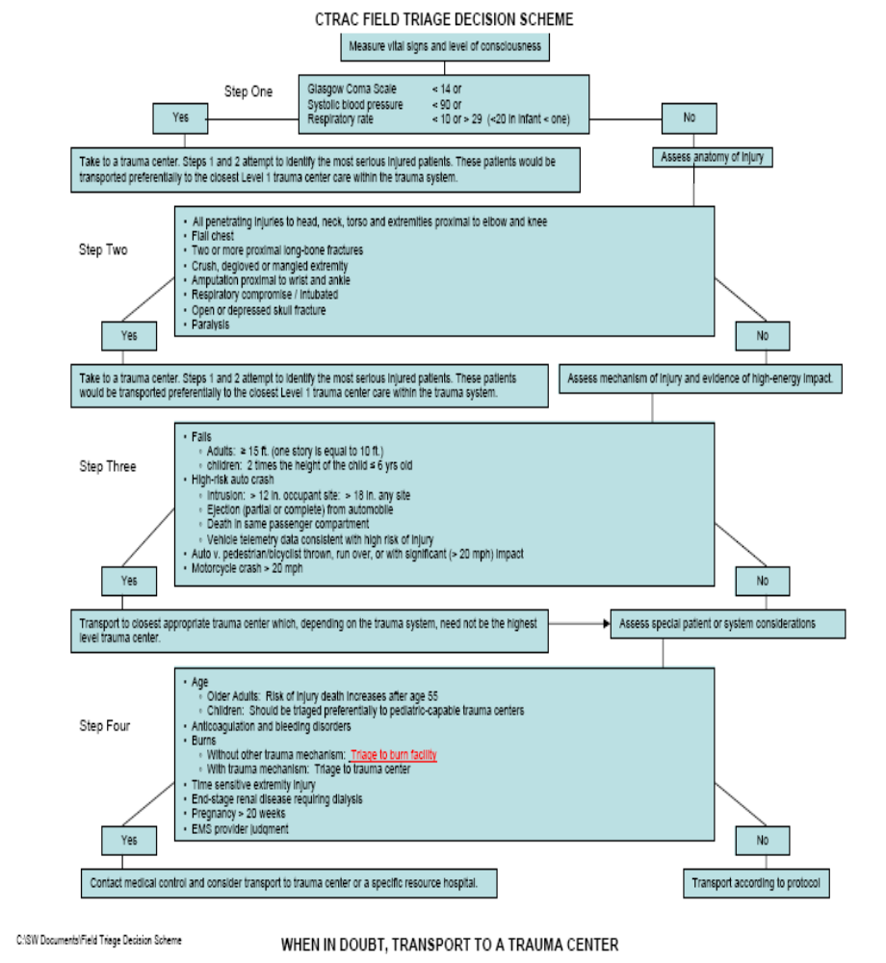

PRE-HOSPITAL PATIENT CARE GUIDELINES

Goal

The attached guidelines for the Central Texas Regional Advisory Council should be used as a minimum standard of care to treat patients with traumatic injuries. The guidelines should be used in conjunction with your agency’s established protocols and not in place of.

Introduction

- A quick and accurate initial assessment of the traumatically injured patient is essential.
- Evaluate and manage any airway and breathing problems first, followed by assessment of circulation. Then perform a brief neurological examination with complete exposure of the patient.
- Always remember to protect the cervical spine with in-line stabilization.
- With major trauma, one of the most important goals of prehospital management is a brief scene time- “LOAD AND GO”. Spend as little time as possible to evaluate the patient, to perform life-saving maneuvers, and prepare the patient for transport to the hospital. Optimally, all scene times for the critically injured trauma patient should be less than 10 minutes (20 minutes maximum) unless extenuating circumstances (extrication, multiple patients, etc.). Do not delay scene times on non-lifesaving procedures!
- Often major trauma is a surgical disease and rapid transport to the closest appropriate hospital is vital in all unstable patients.
- If indicated, request aeromedical helicopter transport.
- Request additional resources (additional ambulances, rescue equipment, helicopter, etc.) early in the scene assessment.

Basic Life Support

1. Scene safety.
2. Airway, breathing, circulation. Assess adequacy of perfusion (mental status), character of pulses, and capillary refill.
3. Stabilize the cervical spine with manual in-line stabilization.
4. Apply oxygen (high-flow via non-rebreather if altered mental status, shortness of breath, or severe multisystem trauma). Assist with bag-valve-mask as needed.
5. Control gross external bleeding with direct pressure. Remember to also hold pressure over penetrating trauma sites (gunshot wounds, stab wounds) to stop any internal bleeding into the tissues.
6. Perform a brief neurological exam (level of consciousness (AVPU), pupil reactivity, and gross motor function).
7. Immobilize the cervical spine as needed with long backboard, head blocks, cervical collar, straps, etc.
8. Immobilize and splint obviously fractured extremities.
9. Obtain vital signs and monitor pulse oximetry if avaliable.
10. Expose patient and perform a secondary survey (head-to-toe). Preserve body heat when possible.
11. Obtain history (SAMPLE): Signs and Symptoms, Allergies, Medications, Past medical /
Past surgical history, Last oral intake / Last menstrual period, Events of accident (mechanism of injury).

Advanced Life Support

1. Advanced airway control (intubation, surgical cricothyrotomy) as needed.
2. If patient has a suspected tension pneumothorax (shortness of breath, hypotension, decreased breath sounds, hyperresonance to percussion) perform a needle thoracostomy (pleural decompression).
3. Establish IV access (large bore antecubital or external jugular IV). Establish a second IV line if patient is hemodynamically unstable and time allows.
4. Administer IV fluid normal saline bolus 250cc - 1000cc (20cc/kg child) IV if the patient is hypotensive or tachycardic, titrate the IV fluids to keep systolic BP >90mmHg.
5. Monitor ECG rhythm.
6. Administer pain medication if indicated
7. Assess the Glasgow Coma Score (GCS), and Revised Trauma Score (RTS) enroute.
8. Contact medical control with patient report early so that the trauma team can be assembled.
9. Reassess the vital signs frequently.
The following are general patient care guidelines for ALL patients and are not specifically listed in each protocol.
ECA | EMT | Intermediate | Paramedic
Assure scene safety | Assure scene safety | Assure scene safety | Assure scene safety
Assess CABC’s | Assess CABC’s | Assess CABC’s | Assess CABC’s
Perform Secondary Assessment | Perform Secondary Assessment | Perform Secondary Assessment | Perform Secondary Assessment
Place patient in position of comfort unless contraindicated | Place patient in position of comfort unless contraindicated | Place patient in position of comfort unless contraindicated | Place patient in position of comfort unless contraindicated
O2 (if indicated) | O2 (if indicated) | IV, O2, Airway control (if indicated) | IV, O2, Cardiac monitor, Airway control (if indicated)

BURNS:
Exposure to heat, chemicals, electrical or inhalation believed to have caused damage to body tissues.
STOP THE BURNING PROCESS!
ECA | EMT | Intermediate | Paramedic
High flow O2 | High flow O2 | High flow O2 | High flow O2
Cool and dress burns , Flush chemicals | Cool and dress burns , Flush chemicals | Intubation if indicated | Intubation if indicated
Moist sterile bandage if <10% SBA | Moist sterile bandage if <10% SBA | Cool and dress burns , Flush chemicals | Cool and dress burns , Flush chemicals
Dry sterile bandage if > 10% SBA | Dry sterile bandage if > 10% SBA | Moist sterile bandage if <10% SBA | Moist sterile bandage if <10% SBA
Assess % & depth of burn. Remove constricting jewelry and clothes | Assess % & depth of burn. Remove constricting jewelry and clothes | Dry sterile bandage if > 10% SBA | Dry sterile bandage if > 10% SBA
Transport | Transport | Assess % & depth of burn. Remove constricting jewelry and clothes | Assess % & depth of burn. Remove constricting jewelry and clothes
 |  | Start IV in unburned area if possible. % of burn area x patient weight in KG x 4 ml = total amount to infuse over 24 hours with ½ being infused in first 8 hours. | Start IV in unburned area if possible. % of burn area x patient weight in KG x 4 ml = total amount to infuse over 24 hours with ½ being infused in first 8 hours.
 |  | Transport | Monitor ECG
 |  |  | Transport

EYE INJURIES:
Do not remove foreign body from the eye. Cover, patch, and transport.
ECA | EMT | Intermediate | Paramedic
Chemical to eyes, continuous flush with NS | Chemical to eyes, continuous flush with NS | Chemical to eyes, continuous flush with NS | Chemical to eyes, continuous flush with NS
Open eye injury, bandage both eyes closed | Open eye injury, bandage both eyes closed | Open eye injury, bandage both eyes closed | Open eye injury, bandage both eyes closed
Abrasion and/or foreign objects—cover effected eye | Abrasion and/or foreign objects—cover effected eye | Abrasion and/or foreign objects—cover effected eye | Abrasion and/or foreign objects—cover effected eye
Impaled objects, stabilize in place, cover both eyes | Impaled objects, stabilize in place, cover both eyes | Impaled objects, stabilize in place, cover both eyes | Impaled objects, stabilize in place, cover both eyes
Transport | Transport | Transport | Transport

HEAD INJURIES
Treatment goals are high-flow oxygen (intubate early if needed), spinal immobilization, and rapid transport.
ECA | EMT | Intermediate | Paramedic
Determine responsiveness (AVPU) | Determine responsiveness (AVPU) | Determine responsiveness (AVPU) | Determine responsiveness (AVPU)
High flow O2 | High flow O2 | High flow O2 | High flow O2
LOAD & GO | LOAD & GO | LOAD AND GO | LOAD AND GO
Elevate backboard 30% at head | Elevate backboard 30% at head | Obtain IV if necessary | Obtain IV if necessary
Transport | Transport | Secure airway with ET intubation (if indicated) | Monitor ECG
 |  | Elevate backboard 30% at head | Secure airway with ET intubation (if indicated)
 |  | Transport | Elevate backboard 30% at head
 |  |  | Transport
Refer to TBI Guideline for additional information on treatment | Refer to TBI Guideline for additional information on treatment | Refer to TBI Guideline for additional information on treatment | Refer to TBI Guideline for additional information on treatment

MULTI-SYSTEMS TRAUMA:
Trauma to one or more of the following: Head Neck Chest Abdomen Pelvis
OR multiple trauma to extremities or soft tissue with evidence of shock.
ECA | EMT | Intermediate | Paramedic
High flow O2 | High flow O2 | High flow O2 | High flow O2
Correct immediate threat to life if possible: Tension pneumothorax, sucking chest wound, aspirations, uncontrolled bleeding | Correct immediate threat to life if possible: Tension pneumothorax, sucking chest wound, aspirations, uncontrolled bleeding | Correct immediate threat to life if possible: Tension pneumothorax, sucking chest wound, aspirations, uncontrolled bleeding | Correct immediate threat to life if possible: Tension pneumothorax, sucking chest wound, aspirations, uncontrolled bleeding
Transport | Transport | Transport | Transport
Continue to re-assess vital signs enroute | Continue to re-assess vital signs enroute | Bilateral large bore IV’s with isotonic solution | Bilateral large bore IV’s with isotonic solution
 |  | Treat minor injuries and fractures as time allows | Monitor ECG
 |  | Continue to re-assess vital signs enroute | Treat minor injuries and fractures as time allows
 |  |  | Continue to re-assess vital signs enroute

MUSCULO-SKELETAL:
Goal is to stabilize injury and/or control bleeding and continuously re-asses patient for change in condition/vital signs/neurological function.
ECA | EMT | Intermediate | Paramedic
O2 | O2 | O2 | O2
Control bleeding/Splinting as indicated | Control bleeding/Splinting as indicated. Assess PMS | Control bleeding/Splinting as indicated. Assess PMS | Control bleeding/Splinting as indicated. Assess PMS
Transport | Transport | IV if long bone fractures are suspected, patient is hypotensive, and/or possible analgesia administration is imminent. | IV if long bone fractures are suspected, patient is hypotensive, and/or possible analgesia administration is imminent.
 |  | Transport | Monitor ECG if pain medication is to be administered
 |  |  | Transport

TRAUMATIC ARREST:
Pulseless and apnic WITH evidence of traumatic cause(s) of cardiac arrest. Goal is to correct underlying cause of the arrest.
ECA | EMT | Intermediate | Paramedic
CPR | CPR | CPR | CPR
Correct immediate life threatening emergencies if possible: Tension pneumothorax, sucking chest wound, uncontrolled bleeding, hypovolemia, hypoxia, etc. | Correct immediate life threatening emergencies if possible: Tension pneumothorax, sucking chest wound, uncontrolled bleeding, hypovolemia, hypoxia, etc. | Correct immediate life threatening emergencies if possible: Tension pneumothorax, sucking chest wound, uncontrolled bleeding, hypovolemia, hypoxia, etc. | Correct immediate life threatening emergencies if possible: Tension pneumothorax, sucking chest wound, uncontrolled bleeding, hypovolemia, hypoxia, etc.
If obvious signs of death on arrival (decapitation, crushed head, asystole on monitor) do not attempt resuscitation | If obvious signs of death on arrival (decapitation, crushed head, asystole on monitor) do not attempt resuscitation | If obvious signs of death on arrival (decapitation, crushed head, asystole on monitor) do not attempt resuscitation | If obvious signs of death on arrival (decapitation, crushed head, asystole on monitor) do not attempt resuscitation
Transport (contact medical control for possible pronouncement in the field) | Transport (contact medical control for possible pronouncement in the field) | Transport (contact medical control for possible pronouncement in the field) | Transport (contact medical control for possible pronouncement in the field)
 |  | Secure airway with ET intubation | Secure airway with ET intubation
 |  | Bilateral large bore IV’s with isotonic solution | Monitor ECG
 |  | Follow appropriate protocol(s) as time allows | Bilateral large bore IV’s with isotonic solution
 |  |  | Follow appropriate protocol(s) as time allows

Notes:
- Remember not to overlook potential chest and abdominal injuries which are often more life-threatening than the obviously deformed limb. Anyone can recognize a severely displaced limb, but it takes an astute prehospital provider to recognize a potentially more severe injury in the abdomen or chest.
- All lacerations should have direct pressure held on them. The first responder should hold pressure on the wound and not place a formal bandage until the ALS crew has visually assessed the wound. The paramedic is ultimately responsible for the wound and needs to visualize them. Remember that penetrating lacerations (i.e. gunshot wounds, stab wounds) may still be bleeding internally even if external bleeding is absent. Always hold direct pressure on these wounds.
- In a single car MVC, always consider the “5 S’s” as a possible cause for the wreck:
Syncope (arrhythmia, MI), Seizure, Sugar (hypoglycemia), Suicide, Slush (intoxication).
Remember:
- Never remove any penetrating object to the body unless the object is impaled into the face and blocks effective airway management.
- Try to perform D-stick for any alterations in LOC if possible and time permits

TRAUMATIC BRAIN INJURY GUIDELINE
History:  - Time of injury  - Mechanism: blunt/penetrating  - Loss of consciousness  - Bleeding  - Medical History  - Medications  - Evidence of multi-trauma  - Helmet use of damage to helmet | Signs and Symptoms:  - Pain, swelling, bleeding  - Altered mental status  - Unconscious  - Respiratory distress/failure  - Vomiting  - Significant mechanism of injury | Differential:  - Skull fracture  - Brain injury (concussion, contusion, hemorrhage, or laceration)  - Epidural hematoma  - Subarachnoid hemorrhage  - Spinal injury  - Abuse

Universal Precautions
C-Spine, A, B, C‘s
Spinal Immobilization

Assessment Practice:
1. Blood Pressure, Pulse, and Respiratory Rate
2. Oxygen saturation measurement, using pulse oximetry
3. Glasgow Coma Scale (GCS) score measurement
4. Eye examination for pupillary asymmetry, fixation, and dilation

Treatment Practices:
A. Airway, Ventilation, and Oxygenation:
1. Administration of supplemental oxygen
2. Airway securement with endotracheal intubation (Advanced Level)
B. Fluid Resuscitation:
1. Fluid resuscitation with isotonic crystalloid solution
2. Avoid hypotension (systolic <90)
- Brain-Targeted Therapy:
1. Hyperventilation in patients with suspected or impending cerebral herniation: See Pearl at bottom
2. Sedation, analgesia, and neuromuscular blockade to optimize transport of the head-injured patient with an unsecured airway
3. Rapid glucose determination in patients with AMS
- Hospital Transport Decisions:
1. Direct transport of severe traumatic brain injured patients to the highest-level trauma center available
2. Follow local emergency service transport protocols
Pearls:
    - EXAM: Mental Status, HEENT, Heart, Lungs, Abdomen, Extremities, Back.
    - The airway should be secured via endotracheal intubation (if able) in patients who have a TBI with a GCS <9, the inability to maintain an adequate airway, or hypoxemia not corrected by supplemental oxygen.
    - Hyperventilate ONLY if cerebral herniation is suspected. (Signs: pupillary abnormalities, bradycardia, posturing). Increased intracranial pressure (ICP) may cause hypertension and bradycardia (Cushing’s Response).
    - Fluid resuscitation should be administered to avoid hypotension (<90 systolic) and / or limit hypotension to the shortest duration possible. Hypotension = Decreased Cerebral Perfusion Pressure.
    - Document - any change in the patient’s level of consciousness and GCS prior to and after administration of sedation, analgesic, and / or neuromuscular blockade medications.
AIR MEDICAL TRANSPORT GUIDELINES

Goal

To establish guidelines for access and dispatch of Helicopter Ambulance Services (HAS) to achieve effective, efficient and coordinated responses to emergencies involving trauma victims. The goal of these guidelines is to reduce delays in providing optimal care for severely injured patients, and to decrease morbidity and mortality.

Decision Criteria

Helicopter activation /scene response should be considered when it could reduce transportation time for trauma patients meeting dispatch guidelines.

Time Intervals

When considering time intervals as they relate to HAS, it is important to consider all aspects of the response and transport. For the purposes of this guideline and for performance improvement criteria, the following time intervals and definitions will be used. All of the following intervals should be considered when evaluating time issues.
- Response Time: Includes the time interval for notification of the Helicopter Communication Center + Time to Launch + Flight Time + Scene Time
- Scene Time: Includes the time spent by the Flight Crews on Scene
- Transport Time: Includes the time for the HAS to fly to receiving Facility, land and deliver the patient.

I. Guidelines for Activation /HAS Dispatch:
The ground emergency medical services (EMS) provider may request a scene response from a HAS when one or more of the activation or triage criteria exist:
- Once an air ambulance has been activated to a scene only the transporting agencies highest level of certification should make the determination to cancel the air response.
- Ground EMS providers should not remain on scene awaiting arrival of HAS if an appropriate Trauma facility is nearby and the trauma patient can be transported faster by ground.
- Ground EMS providers should activate the HAS as early as possible, including Prior to arrival to scene if the mechanism of injury meets activation guidelines.
- The ground EMS provider may activate HAS if the patient has an emergent need for a procedure or intervention not available from ground provider and the HAS can deliver this intervention faster than transport time to trauma facility.
- HAS that participate in the TSA-L RAC should be utilized in the TSA- L service area.
- In all instances the available HAS that best meet the needs of the patient will be utilized.
- Other factors to consider: Location of Incident, Number of Patients, Age of patients, Weight of Patients, Response time of HAS.
- The EMS provider should utilize the Triage guidelines for HAS Activation.
- Appropriate utilization and activation of HAS will be reviewed by the CTRAC Performance Improvement Committee.
- Trauma Patients are to be taken to the nearest Level I, II trauma center unless on diversion for specialty services. Then the patient is to be taken to the next closest Trauma center.

II. Guidelines for Air Activation

General guidelines for use of HAS
Speed - If ground transport time is >20 min. to closest Trauma Center or lifesaving interventions are required for safe transport. Examples include difficult Airway needing immediate stabilization or severe blood loss.
Accessibility – Severely injured or ill patients located in remote or off road area not readily accessible to ground ambulance.
MCI- Multiple Patients that will exhaust region or resources or exceed response times to that region.

Anatomic Considerations
Penetrating Trauma to Head, Chest or Abdomen
Amputations (except Digits)
2 or more long bone fractures or pelvis Fracture
Spinal cord injury
Major Burns > 20 % or burns to the Airway, hands, feet or genitalia
Depressed or open skull Fracture
Trauma patients requiring endotracheal intubation or having difficulty maintaining an airway
VS/ Physiologic Considerations
GCS <10 or deterioration of Mental Status
Significant Hypotension- B/P = or <90 with signs of shock
RR <10 or >29
HR <60 or >120
Mechanism of Injury
Falls > 3 X the Pt. Height or >20 feet
Autoped > 20 MPH
Ejection from MVC
Rollover MVC
Prolonged extrication >20 min.
Death of other occupant in same vehicle
Multiple patients on scene

III. Medical Guidelines
The RAC recognizes that HAS may be useful and appropriate for Non-Trauma cases as well.

Suggested Medical Considerations for Scene Activation for HAS
-Near Drowning with or without Hypothermia
-Acute MI -Suspected CVA
-Cardiogenic Shock -Severe uncontrolled HTN

IV. Air Medical Dispatch and Safety Guidelines
HAS may be dispatched via direct dial or via each EMS providers local dispatch center. When activating a HAS to a scene please give the following information if available:
- City and Location of Incident (2 cross streets or intersection)
- Location of pre-designated LZ site available
- Nature of incident
- Adult or Pediatric Patient
- Requesting Unit and Unit Number to contact
- Radio Frequency

HAS may be placed on Standby or pre-launched (Delta Launch) based on dispatch, fire, EMS, or Police personnel when the situation meets or exceeds activation criteria. The standby mechanism alerts the HAS to prepare for a potential flight. By alerting HAS early, it allows the pilot to check weather, GPS coordinates and maps as well as allows the crews to prepare the a/c for flight. This action will decrease the response time if he HAS is needed. The agency requesting a HAS Stand-by should give the following information:
- City and accident location (please list major cross streets if known)
- Ground Contact unit and unit number to contact via radio
- Radio Frequency to contact
- Nature of incident

V. Air Medical Landing Zone and General Safety Considerations
- The Landing Zone (LZ) should be on a firm level ground, free from loose debris, vehicles, signs or wires.
- The LZ should be approximately 100 X 100 Feet
- An LZ officer should be designated to land the HAS at the LZ site
- A trained tail rotor guard should be available to prohibit bystanders from entering the LZ area.
- Never approach the aircraft (a/c) until signaled by a flight crew member
- Always approach from the front
- No smoking or running around the a/c
- No one is permitted by the Tail rotor.
- Crowds must be kept away from the a/c
- HAS will direct the loading of the a/c and secure the doors

VI. Dispatch and Operational standards for HAS in TSA-L
- An estimated time of arrival (ETA) provided to the requesting agency shall be within 5 minutes of the actual arrival time. The HAS dispatch center shall in a timely and effective manner, update the requesting agency on any changes in ETA or response time. The HAS shall also report any delays or factors that might affect the helicopter’s response.
- Helicopter Ambulance Services must maintain effective and direct communication with field providers and receiving hospitals.
- HAS must interface effectively and safely with the field providers. The responding HAS should report to the Incident Command or Triage officer for assignment.
- HAS will transport Trauma Patients to the Nearest Level I, or Level II facility or closest appropriate designated facility.
- HAS shall demonstrate safe operations at all times when operating within the RAC. Standards of “Safe Operations” shall include those applicable standards endorsed by the National EMS pilots Association, National Association of Air Medical Services, and the Committee on Accreditation of the Air Medical Transportation Services.

VII. Indications for HAS use: Interfacility Transports
HAS is generally indicated for the transfer of a trauma patient between hospitals when:
- The patient requires specialty or critical care services during transport not available by ground operators or
- The patient’s out of hospital time must be minimized.

VIII. Selection of Responding HAS
Only those Helicopter Ambulance Services which participate in the RAC and are in compliance with RAC guidelines should be utilized for transports within the RAC.
For Interfacility Transfers it is recognized that the selection of the HAS to be utilized for Transport is driven by interfacility arrangements, insurance requirements and physician or patient choice.
The RAC also recognizes that clinical and operational capabilities may vary among HAS each agency in the RAC must study HAS options in its area and develop individual guidelines for their departments taking into consideration:
- Response Time
- Clinical Capabilities and QI processes
- Operational Interface and Safety Practices

FACILITY DIVERSION

Goal

TSA-L trauma facilities will communicate “facility diversion” status promptly and clearly too regional EMS and trauma facilities through EMSystem in order to ensure that trauma patients are transported to the nearest appropriate alternate trauma system hospital.

Acknowledgements

TSA-L trauma facilities, both designated an undesignated, should request diversion activation only when the resources or capabilities of that facility have been exhausted to the point that further EMS traffic would jeopardize the care and treatment of patients at that facility as well as any subsequent patient transported to that facility by EMS. It is recognized in advance that no diversion strategy can guarantee total compliance with these guidelines and it is likely that EMS will deliver patients to hospitals that have requested diversion activation. It is further understood that a request for diversion activation is honored as a courtesy by EMS. Patient’s informed wishes will be honored. Each facility is responsible for defining facility-specific policies and procedures for implementation of these guidelines.

Definitions

Transfer: Movement of a patient from one hospital to another based upon the patient’s need (inter-hospital transport) or request.
Bypass: Intentional movement of a patient from the scene to the most appropriate hospital, not necessarily the nearest hospital, based upon the patient’s medical need.
Diversion: Intentional movement of a patient from the scene to an alternate hospital capable of providing appropriate care at the request of the diverting hospital due to lack of available resource or capability. Appropriate Facility: A hospital, not necessarily the nearest hospital, with the resources and capability to care for a patient based upon the patient’s medical needs.

Authorization for diversion status implementation and deactivation:

- Hospital administrator or designee

Communication of diversion status:
- A hospital shall communicate “facility diversion” status promptly and clearly to regional EMS and trauma facilities through EMSystem.
TIME PERIOD FOR DIVERSION STATUS:
- Diversion status will be in allotments up to four (4) hours. A hospital may deactivate a diversion status at any time.
- Failure of a hospital to update EMSystem at the end of the requested four (4) hour allotment will result in automatic deactivation of that hospital’s diversion status.
AUTHORIZATION FOR OVER-RIDE OF DIVERSION STATUS:

EMS may over-ride a diversion status after consideration of the following:
- The patient’s clinical presentation
- Distance and estimated time to an alternate appropriate facility
- Inclement weather conditions
- Resource availability and capability of the transporting pre-hospital provider
- An Informed Patient Preference

FACILITY BYPASS

Goal

Patients who have been assessed and determined to be medically unstable, unconscious, or at high risk of multiple and/or severe injuries will be safely and rapidly transported to the TSA-L Lead Level I Trauma Center. All other trauma patients will be safely and rapidly transported to the nearest appropriate trauma facility or nearest appropriate acute care facility within TSA L.

Decision Criteria

Regional transport protocols ensure that patients who meet the triage criteria for activation of the TSA-L Regional Trauma System Plan will be transported directly to the nearest appropriate trauma facility rather than to the nearest hospital except under the following circumstances:

- If unable to establish and/or maintain an adequate airway, or in the case of traumatic cardiac arrest, the patient should be taken to the nearest acute care facility for stabilization.

- A Level III or Level IV trauma facility may be appropriate if the expected scene to Level I Trauma Center transport time is excessive (> 30 minutes) and there is a qualified physician available at the facility’s Emergency Department capable of delivering stabilizing care.

- Medical Control may wish to order bypass in any of the above situations as appropriate, such as when a facility is unable to meet hospital resource criteria or when there are patients in need of specialty care (burns).

- If expected transport time to the nearest appropriate Trauma Center is excessive (> 30 minutes) or if a lengthy extrication time (> 20 minutes) is expected, medical control or the EMS crew on scene should consider activating air transportation resources.

Note: Should there be any question regarding whether or not to bypass a facility, on-line medical control should be consulted for the final decision from the receiving facility.

FACILITY TRIAGE CRITERIA

Goal

The goal of establishing and implementing facility triage criteria in TSA-L is to ensure that all regional hospitals use standard definitions to classify trauma patients in order to ensure uniform patient reporting and facilitate inter-hospital transfer decisions.

Objectives

To ensure that each trauma patient is identified, rapidly and accurately assessed, and based on identification and classification of their actual or potential for serious injury, transferred to the nearest appropriate TSA-L trauma facility.

To ensure the prompt availability of medical resources needed for optimal patient care at the receiving trauma facility.

Discussion

1. The Trauma Patient - The definition of the trauma patient in TSA-L is derived from the American College of Trauma Surgeon’s definition of trauma. In TSA-L, the trauma patient is defined as one who is a victim of an external cause of injury that results in major or minor tissue damage or destruction caused by intentional or unintentional exposure to thermal, mechanical, electrical, or chemical energy, or by asphyxia, drowning, or hypothermia.
2. Facility Triage Criteria - Trauma patients are assessed in the pre-hospital setting and transferred to the nearest appropriate trauma facility in accordance with the TSA-L Pre-hospital Trauma Triage Criteria. Upon admission to the hospital emergency department, trauma patients receive initial treatment and re-assessment of their condition. The severity of injury of the trauma patient in the initial treating emergency department determines the optimal level of trauma care needed. Inter-hospital transfer is initiated as appropriate according to TSA-L facility triage decision criteria.
Trauma Facility Triage Criteria

Trauma patients meeting the below criteria should be considered high-risk and immediate transfer arrangements to closest Level 1 Trauma Facility should be initiated. Also refer to the CTRAC Facility Trauma Triage Criteria Algorithm for additional high-risk considerations for initiating early transfer:
- Penetrating injuries to head, neck, and torso
- Respiratory compromise, obstruction, and/or intubation
- GCS ≤ to 13
- Unstable Vital Signs-Any ONE below:
  - SBP <90 (SBP <100 if patient >60 y.o.)
  - RR <10 or >29 with distress
  - O2 Sat <90%
- Traumatic Paralysis (NOT numbness/tingling)
- Amputation proximal to the wrist or ankle
- Two or more proximal long bone fractures (Femur, Humerus)
  - Pelvic fractures
  - Burns ≥ 20% BSA or ≥ 10% if under 6 years old – Transport to Burn Center if Possible
  - Pediatrics-Unstable Vital Signs-Any ONE below:
- Tachycardia for age PLUS poor perfusion
- BP not appropriate for age (70 + 2x age)
- RR not appropriate for age

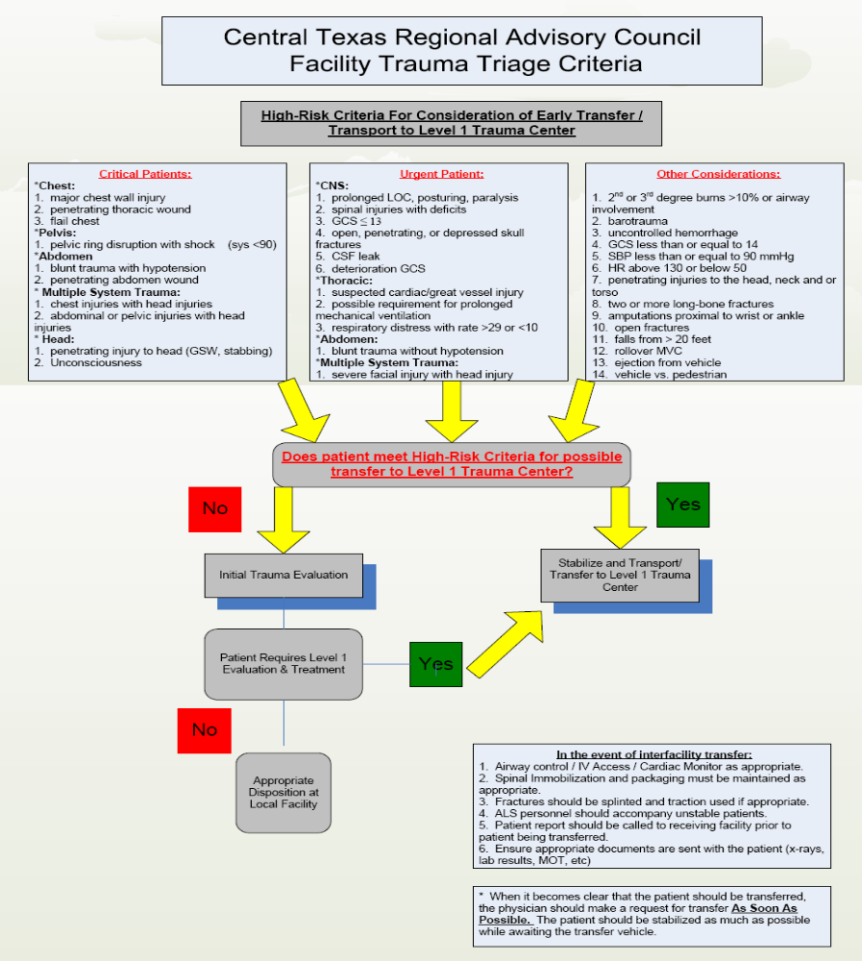

REGIONAL TRAUMA TEAM ACTIVATION CRITERIA

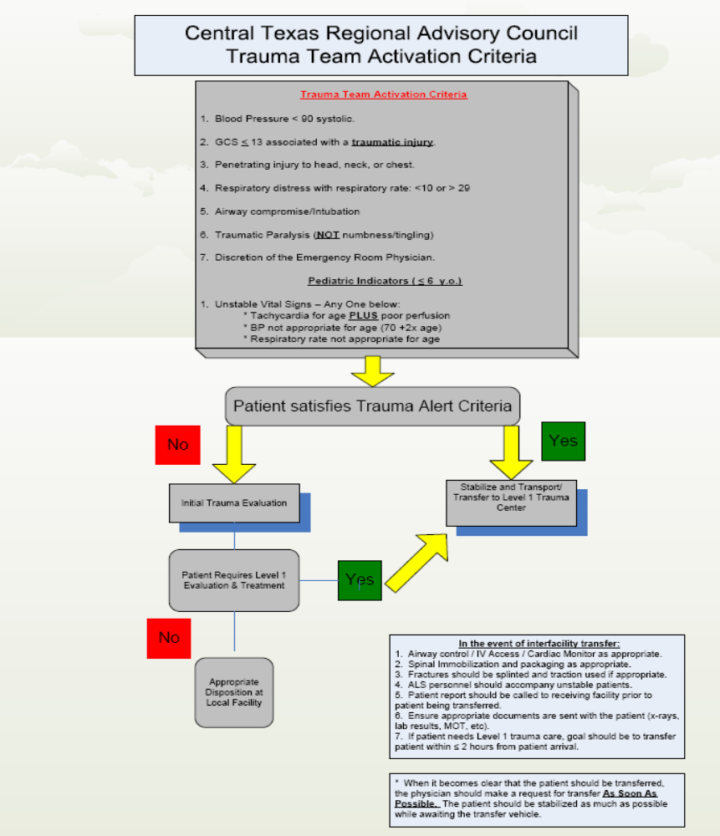

INTERFACILITY TRANSFERS

Goal

The goal for establishing and implementing inter-hospital transfer criteria in TSA-L is to ensure that those trauma patients requiring additional or specialized care and treatment beyond a facility’s capability are identified and transferred to an appropriate facility as soon as possible.

Objectives

- To ensure that all regional hospitals make transfer decisions based on standard definitions which classify trauma patients according to TSA-L facility triage criteria.
- To identify trauma treatment and specialty facilities within and adjacent to TSA-L.
- To establish treatment and stabilization criteria and time guidelines for TSA-L patient care facilities.

Discussion

The level of trauma care resources required for poly-trauma patients is outlined in the TSA-L facility triage criteria and pre-hospital triage criteria. Scott and White Medical Center is the Lead Trauma Facility in TSA-L and accepts all poly-trauma transfer patients from any requesting TSA-L facility. A toll-free number has been established and distributed to all TSA-L emergency medical and hospital providers:

Scott and White Trauma Transfer Phone Line: 1–800–792–3368

Medical personnel calling this number receive an “automatic acceptance” for poly-trauma patients after speaking with the on-call Attending Trauma Surgeon or Staff Emergency Medicine Physician. Severely injured trauma patients should be immediately transferred to the TSA-L Lead Level I Trauma Facility. Patients with less life-threaten injuries should be initially transported to the closest trauma facility for stabilization. If admission is necessary, the patient should be transferred to the Lead Level I Trauma Facility within (2) hours from the time the patient arrived at that facility. The CTRAC Performance Improvement program will monitor all delay in trauma transfers out (>2 hours) for acute patients, trauma transfers outside TSA-L, and any ICU trauma patient admissions (except the Lead Level I).

Identification of Trauma Patients & Trauma Transfers

Trauma patients and their treatment requirements for optimal care are identified in the TSA-L facility triage criteria and pre-hospital triage criteria. Written transfer agreements are available between all TSA-L hospital facilities, and hospital facilities in adjacent regions. Trauma patients with special needs may be transferred to the Lead Trauma Facility for assessment and initial treatment by the trauma team. The TSA-L initial-receiving hospitals may also choose to transfer patients with special needs (burns) directly to these facilities, bypassing the Lead Level I Trauma Facility when appropriate. Below are lists of possible facilities that may be utilized outside TSA L:

- Children's Medical Center of Dallas (Level I Trauma/Pediatric) – TSA E
- Dell Children’s Medical Center (Level I Trauma/Pediatric) – TSA O
- Parkland Health & Hospital System (Level I Trauma/Burn) – TSA E
- Brooke Army Medical Center (Level I Burns) – TSA P
- University Medical Center (Level I Burns) – TSA B

Trauma Patient Transport

Trauma patients in TSA-L are transported according to patient need, availability of air transport resources, and environmental conditions. Ground transport via BLS, ALS, or MICU ground ambulance is available throughout the Region. Air Medical transport (fixed and rotor wing) is also available in this Region.

Inter-hospital Transfer Process

Trauma Patients requiring specialized treatment should be transferred to an appropriate facility for continued care.

Written transfer agreements should be available between the Lead Trauma Facility (Scott and White Hospital) and all the hospitals within the trauma service area. Outlined below are the TSA-L Inter-hospital Transfer Components that have been evaluated and implemented:
- Scott and White Hospital will accept all emergent transfers provided they have the capacity and capability.
- Written transfer agreements are in place for all facilities participating in TSA-L. It is recommended that transfer agreements be renewed at least every three years.
- Available transport agencies have been identified and each acute healthcare facility has been provided with contact information.
- It is recommended that all agencies adopt the two hour rule for completing transfer process for the major trauma patient.

When it’s determined that the patient needs to be transferred to a higher level of care, the following procedures should take place:

- Order obtained from the physician for transfer.
- Obtain acceptance from receiving hospital.
- Complete Memorandum of Transfer (MOT), and consent for transfer from patient.
- It is the transferring facilities responsibility to make transport arrangements. The receiving facility may assist with the decision making if requested by the transferring facility.
- All pertinent ED documentation (x-rays, lab work, medication administration records, MD and nursing notes, etc.), the original MOT, consent for transfer, and other pertinent information should be sent with the patient.
- Report should be called to the receiving hospital and ETA given.
- Appropriate equipment and personnel will accompany the patient during the transfer.

PLANNING FOR DESIGNATION OF TRAUMA FACILITIES

Goal

All facilities actively participating in TSA-L should be designated at one of the four levels of trauma care.

Objectives

- Provide regional resources to assist facilities in maintaining their designation level and those in pursuit of trauma designation.
- The lead level trauma center (Scott and White Memorial Hospital) should have an active roll in the development, planning, and education for those facilities currently trauma designated and those seeking trauma designations.
- Maintain transfer agreements between all facilities as indicated by resource needs within the TSA-L region.
- Increase participation on the CTRAC Hospital Care and Management Committee by ensuring that each acute care hospital within the TSA-L region has a participating member from their facility on the committee.

Planning for Designation of Trauma Facilities

The Omnibus Rural Health Care Rescue Act of 1989 charged the Texas Department of Health through the Bureau of Emergency Management with the responsibility of designation trauma facilities in Texas. The law requires the Bureau to designate trauma facilities that are part of a regional system of trauma care. The law requires that the trauma facilities be designated in accordance with the standards for the American College of Surgeons for Level I, II and III facilities. Level IV facilities may be surveyed based on criteria adopted by the State Board of Health.

In the Texas Trauma System, there are four recognized levels of trauma facility designation: Comprehensive (Level I), Major (Level II), General (Level III) and Basic (Level IV).

At this time, Five (5) out of the nine (9) acute care hospitals in the TSA-L are trauma designated. Three (3) facilities are in active pursuit of Level IV trauma designation. See the “Hospital” section in the TSP for a complete list of TSA-L facilities and their currently trauma designation level/status.

SYSTEM PERFORMANCE IMPROVEMENT PROGRAM

Goal

To provide ongoing performance assessment and improvement activities designed to objectively and systematically monitor and evaluate the quality of trauma patient care through system analysis in an effort to identify and pursue opportunities to improve patient care.
Objectives

- To facilitate performance improvement in trauma patient care and services by establishing mechanisms to identify opportunities to improve.

- To provide a framework for a planned, systematic and ongoing approach for the objective monitoring and evaluation of the quality, appropriateness and effectiveness of trauma patient services provided within TSA-L.

- To create an organizational structure which will be accountable for the coordination and integration of performance improvement activities in accordance with established standards.

Membership

To ensure a multidisciplinary committee, membership of the System Performance Improvement Committee shall include, but is not limited to the following:
Trauma Medical Directors or designee
Trauma Coordinators
Physicians
Hospital Administrators
Prehospital providers, including first responders and aero medical services
Nurses
Trauma Registrars

The Committee Chair shall be selected by the membership of the Committee.
A physician, designated by the CTRAC Medical Advisory Board, shall provide medical oversight.

Meetings will be held in closed session to protect confidential information and only designated committee members from member organizations will be permitted to attend. Alternate members are not permitted to attend the SPI Committee meetings, unless alternate member is a SPI committee member already.
- Representatives from other organizations must receive approval from the SPI Committee Chair prior to attending and must sign a confidentiality statement. They will be offered the opportunity to address a specific area of concern but will not be included in any ensuing discussion concerning the issue.
- Meetings will be held at least 4 times per year at a minimum, providing there are members from three different organizations present. Members must attend at least 75% of the scheduled meetings or risk being removed from the committee. The meeting sign-in sheet will include a confidentiality statement for committee members.
- The Chair, or his/her designee, of the SPI Committee will attend the Medical Advisory Board meeting to report on the committee’s activities, as well as to receive input from the members regarding selection of indicators and other activities.

Responsibilities

The System Performance Improvement Committee shall be responsible for the implementation of monitoring activities, data collection, statistical analysis, identification of opportunities for improvement, recommending action, and re-evaluation.

A. Performance Improvement

- Identification of Indicators
Indicators are related to the quality and/or appropriateness of processes and services related to trauma patient care. The indicators are objective, measurable components that reflect the integration of resources, system organization, and outcomes.
- The System Performance Improvement Committee, with input from other committees, will recommend specific indicators for review, with approval by the Executive Committee.
- Selection of indicators will be based on standards of care, current knowledge and research.
- A calendar of quarterly indicator reviews shall be submitted to the Executive Committee for approval on an annual basis.

- Collection of Data
Data is collected and organized for review under the direction of the System Performance Improvement Committee.
- Each member organization shall be responsible for submitting the essential information to the Department of State Health Services Trauma Registry (recommend quarterly down loads)
- Indicators shall be reviewed on a quarterly basis. Aggregate data from the registry database will be extracted and reported out as a percentage value.
- Indicators that are not retrievable from the trauma registry database will be reported by each member organization as aggregate numbers.

- Evaluation
The System Performance Improvement Committee will analyze the data collected and determine if further investigation is needed. When areas for improvement are identified, the root causes will be established. Root causes are defined as one of the following:
- System
- Education
- Behavior
- Evaluation includes analysis of trends and patterns in the data collected, to be accomplished by the System Performance Improvement Committee.
- Sentinel events and individual peer review will be referred to the Medical Advisory Board. Sentinel events are defined as any event that causes harm or has a high potential to cause harm. These may be identified through mechanisms such as system concern forms, referrals from member organizations or data analysis.

4. Actions
When evaluation identifies an opportunity for improvement, actions are determined and implemented. Actions are directed toward the root cause with the overall goal being to improve the quality of service. Actions may involve, but are not limited to the following:
- Committee recommendations
- Educational offerings
- Performance improvement teams

5. Re-Evaluation (Loop Closure)
Through statistical analysis, the System Performance Improvement Committee will determine if actions/recommendations taken have been successful. Until that time, any identified problem or concern shall be considered “open” and will require continued evaluation until satisfactory closure has been achieved.

B. Agency Compliance

- Submit data to the state trauma registry as required by DSHS and TSA-L. Data shall be submitted to the state on a quarterly basis. (Submit proof of downloads on a quarterly basis to the CTRAC secretary)
- Utilize RAC Protocols
- Participate in RAC activities as determined by CTRAC by-laws.

C. Communication

The System Performance Improvement Committee will communicate results of all monitoring and evaluation activities to the CTRAC in the following manner:

- Quarterly reports of selected indicators, including actions and recommendations.
- Monthly minutes of activities (excluding any identifying information)
- All loop closures

INJURY PREVENTION

Goal

Established to provide leadership to facilitate public education and awareness through trauma prevention activities. Members work closely with entities and community organizations to promote safety and prevent injuries. Topics and activities are selected based on injury trends and by community request.

Objectives

- To provide guidance for educating the public within the Region to enhance public awareness in this Region.
- To make recommendations and oversee regional activities on preventing injury in this Region.

Discussion

Activities include but are not limited to:

- Participation in TXDOT SafeKid training. Members are involved as certified Instructors and Technicians. Events are held throughout area to provide education for the public on the correct selection, installation and use of child car seats. Funds are provided for the distribution of car seats at events and to families who are treated following accidents.
- Sponsorship of annual Farm Safety Day, 2-day event held in Bell County for area 5th and 6th graders. Assist with coordination and presentation of topics.
- Sponsorship of annual Mikeska Bicycle Safety Rodeo. Event held in Temple for area youngsters up to age 15. Provide funds for helmet distribution. Present bicycle safety information and assist with helmet fitting.
- Participation in annual MADD holiday campaign. Distribution of red ribbons and educational materials to remind public of dangers of driving under the influence. Coordinate media coverage to promote campaign.
- Community Health Fairs

CTRAC has injury prevention literature and materials available for distribution. Contact the CTRAC office @ 254- 770-2316 for additional information.

EMSYSTEM POLICY

Goal To provide guidelines for EMSystem use by hospitals, pre-hospital providers, public health departments, as well as others who have access to the system.

TSA-L HOSPITALS INCLUDE: TSA-L EMS INCLUDE:

Cedar Crest Hospital Belton Fire Department EMS
Central Texas Veterans Health Care System Harker Heights Fire Department EMS
Central Texas Hospital Scott & White EMS
Coryell Memorial Killeen Fire Department EMS
Carl R Darnall Army Medical Center CRDAMC EMS
Hamilton General Hospital Copperas Cove Fire Department EMS
King’s Daughters Hospital Central Texas Regional EMS
Metroplex Hospital Coryell Memorial Hospital EMS
Metroplex Pavilion Capital Ambulance
Richards Memorial Hospital Hamilton EMS
Rollins Brook Community Hospital American Medical Response
Scott and White Memorial Hospital Thorndale EMS
Scott and White Continuing Care Hospital AirEvac/LifeStar
Scott and Pavilion Mills County EMS
Scott and White-Santa Fe United MedEvac Solutions
PHI STAT Air

HOSPITAL RESPONSIBILITY

All local, state, and federal laws, including but not limited to EMTALA, pertaining to patients presenting to emergency departments for care still apply. Nothing in this plan should be interpreted in a manner that would violate the right of patients seeking emergency care. Patients presenting to any hospital in the care of EMS will not be denied triage/treatment on the basis of that hospital’s patient acceptance status.

REQUIREMENTS

1). All listed hospitals are required to update the EMSystem daily between 7:00am and 9:00am or as situations warrant as described/defined in this document.
2) All listed EMS agencies are required to update the EMSystem at a minimum of twice a week, preferably Mondays and Fridays between 7:00 am and 9:00 am or as situations arise as described/defined in this document. Air medical services should update daily as feasible.

EMSystem® PROTOCOLS AND POLICIES:

- EMSystem® Description

1. EMSystem® is a Web-based program providing real-time information on status, capacity and availability of resources for emergency departments, hospitals and transport services.
2. EMSystem® is used to coordinate “routine” and emergency medical operations [e.g., mass casualty incidents (MCI)] throughout the defined service area. The purpose of the EMSystem® is not to make decisions regarding transportation, but to facilitate patient transportation and communication.
3. EMSystem® is used to communicate important information, such as disasters, public health alerts or notification of potential terrorist events, simultaneously and consistently to all users.
4. EMSystem® is operated on a computer located in the hub of operations, i.e., in the hospital emergency department or other location staffed 24 hours a day and in the dispatch centers of transporting EMS agencies. EMSystem® is in use 24 hours a day, seven days a week.

- Purpose

1. The implementation of the EMSystem® is an effort to efficiently and effectively:

  - Communicate situations in which the diversion of an ambulance(s) may be necessary due to the existence of temporary conditions in hospital emergency departments or the hospital that may affect patient care.
  - Determine hospital patient capacity, availability of staffed beds and availability of specialized treatment capabilities during an MCI or a terrorist incident.
  - Notify pre-hospital care providers, as well as other health care facilities, of temporary limitations of services or resources at receiving hospitals.
  - To provide real-time public health and other special alerts.

2. With EMSystem®, the definition of hospital status is standardized across the entire state. Participating hospitals will update EMSystem with their current hospital status. However, EMS providers and/or emergency medical systems should continue to follow their local policies and procedures regarding the determination of hospital destinations.

3. Use of EMSystem® will aid in taking patients to the most appropriate facility.

4. Use of EMSystem® and these policies is intended to effectively manage and coordinate hospital and EMS resources, including but not limited to:

- Minimizing prolonged patient transport times.
- Minimizing prolonged out-of-hospital care when definitive hospital based resources are needed.
- Determining EMS resources available to the service area.
- Helping to determine or obtain timely information important during an MCI, public health or other special event.

- EMSystem® Functions

  - Hospital Emergency Department Status

- Participating hospitals update their routine emergency department/hospital status at defined intervals. (Daily between 7:00am and 9:00am or as situation warrants.)
- A status screen displays the status of each hospital in service area.
- The 9-1-1 or dispatch center then uses the displayed information to appropriately alert EMS units to area emergency departments’ status.
- Hospitals, EMS services and other users view the current status page to assess system capacity, potential bottlenecks and the availability of resources.

- Mass Casualty or Bio-Terrorism Incident Support

  - Unplanned, acute, medical emergencies involving significant numbers of ill or injured people require instantaneous EMS resource allocation.
  - Participating hospitals enter MCI details required to respond.
  - Each hospital then enters its ability to accept patients including decontamination patients and/or special needs patients.
  - Incident-specific evaluation and treatment protocols are easily uploaded and immediately available to all facilities.
  - Critical information can be instantaneously disseminated to health care providers, public health agencies and other key emergency medical personnel.

Hospital Status Definitions:

Open—green color: Accepting all traffic

Divert—red color: Diverting ambulance traffic (update every 2 hours)

Resource Alert—maroon color: Actual or pending resource limitations exist

Internal Disaster – black color: Indicates that there is an environmental or physical plant situation, such as utility outage, unsafe situation in the hospital, etc.

The following abbreviations and terms may be used in comments as resources:

Med/Surg Beds - Medical/Surgical inpatient beds
ICU Beds – Adult Intensive Care Unit beds to include Medical, surgical, or coronary.
Telemetry Beds - Beds with monitoring capabilities
NICU Beds - Beds in the Neonatal Intensive Care Unit
PICU Beds - Beds in the Pediatric Intensive Care Unit
PED Beds - Pediatric beds
L & D Beds - Beds in Labor and Delivery
Psych Beds - Available beds in the Psychiatric Unit
Closed Psych beds – Locked Psychiatric beds
OR - Operating Room
Trauma Center Level - Designated Trauma Center Level I, II, III, or IV.
CAT SCAN - Computerized axial tomography
Fixed MRI - Fixed Magnetic Resonance Imaging Unit
Mobile MRI - Mobile Magnetic Resonance Imaging Unit

Pre-Hospital Status Definitions:

Available – green color: Unit or organization is ON-CALL and AVAILABLE to respond to emergency calls

Caution – yellow color: Resource limitations exist. Must specify in comments.

Unavailable – red color: Unit or organization is UNAVAILABLE TO RESPOND to new emergency requirements at this time.

Example from system:
Central Texas

Update Status
help

Top of Form
EXAMPLE HOSPITAL
Update information below. You MUST update required information.
Select All - Clear All
Select the status(es) to update:
 | ED -- Current ED availability
 | Divert -- Diverting ambulance traffic.  Please note: You must select one or more from this list when choosing "Divert" status:  ED Saturation -- All ED beds occupied  Internal disaster (indicate in comments) -- Such as flood or power failure. Please indicate in comments section.  No ICU beds -- All ICU beds occupied  No inpatient beds -- No available inpatient beds.  No monitored beds -- No monitored beds in house.  Other (indicate in comments)
 | Internal Disaster -- Indicates that there is an environmental or physical plant situation, such as utility outage, unsafe situation in the hospital, etc.
 | Open -- Accepting all traffic
 | Resource Alert -- Actual or pending resource limitations exist. Indicate in comments.
Comment:

Select All - Clear All


- Primary Users

- Primary users are service area hospitals, pre-hospital agencies, EMS first responders, public health, and mental health. Additional primary users may be added as they are identified. Primary users have read and write access to their specific information on the system and read-only access to all other users’ information.
- Primary users may view status information and update their respective area service data. User-specific historical data also can be retrieved for data collection, downloading or printing.

- Secondary Users

- Secondary users are all other interested agencies such as Offices of Emergency Management, EMS dispatchers, etc. These users will have read only access to the system.
- Secondary users may view defined area status information. These users cannot update or alter system information unless mutually agreed upon by the Primary user agency and the Secondary user agency.

- Access to Data

The Administrator will have full access to EMSystem® data.

The following policy is in place for data access:

- Each Primary User shall have access to its individual data elements.
- Anyone seeking data queries of a specific facility’s information should direct their request to Administrator or that specific Primary User.
- Requests from the public and media for statistics should be given to that agency’s designated spokesperson.

- Accessing EMSystem® Help

- First discuss any EMSystem problems you encountering with your own IS or IT department.

Technical assistance:

EMSystem® has a 24-hour help desk to assist users with technical issues with the operation of EMSystem®.
They can be reached at (888) 290-6710.

Attachment 1

REGIONAL COMMUNICATIONS FREQUENCIES

Under Separate Cover

