I created a new vendor: maco781@hotmail.com/ 12345678 , payed and activated the Premium Space but the Premium space did not activated in the Front End. It looked like a basic vendor: http://beta.estadeboda.com/proveedores/listado
- Payment Process:
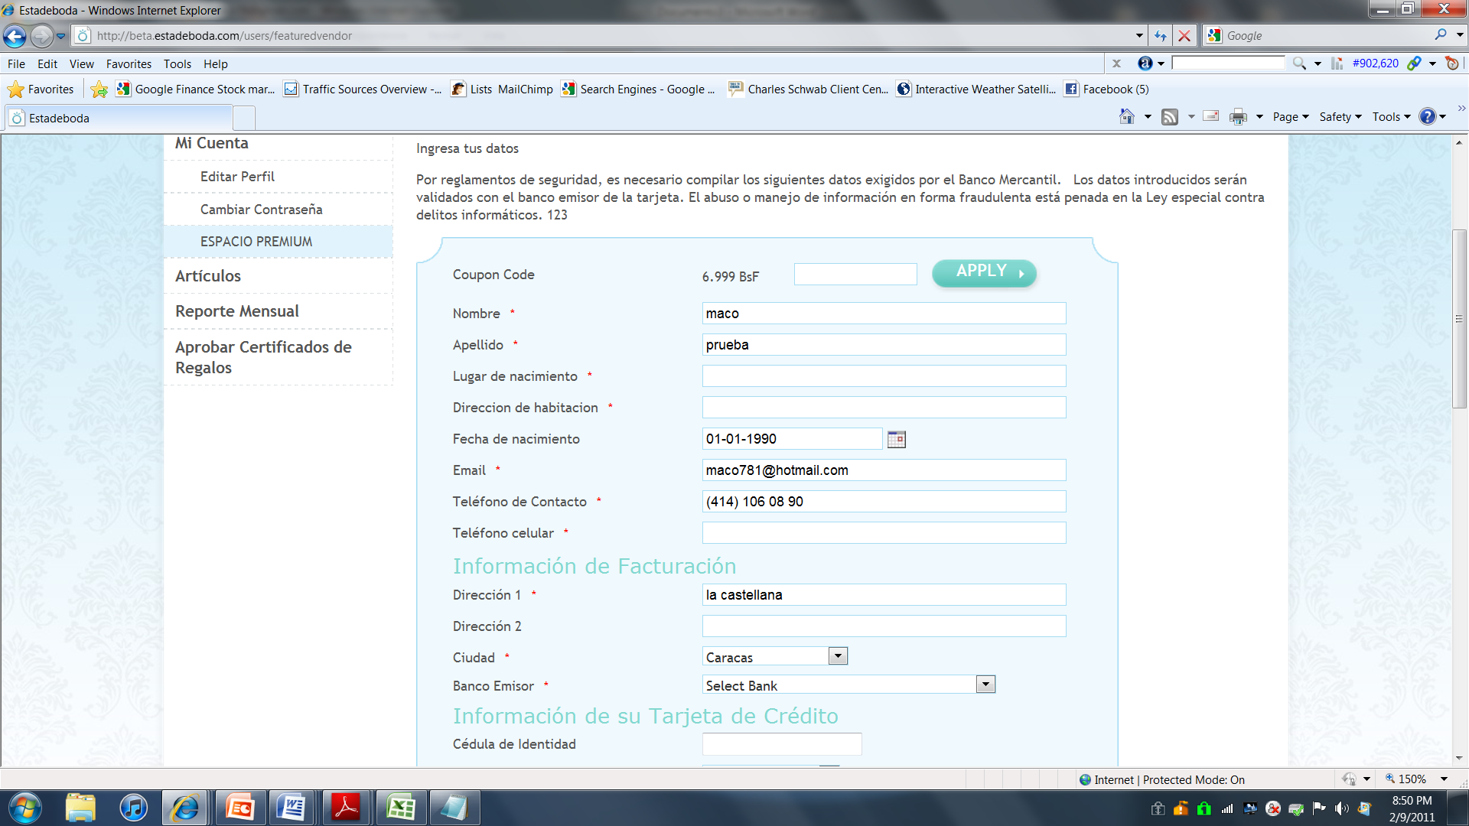
APLICAR
Translations:
- Cupon code: cupón de descuento
- Cupon code is incorrect: el cupón de descuento es incorrecto
- Apply: Aplicar
- Banks: Add Banco Venezolano de Crédito
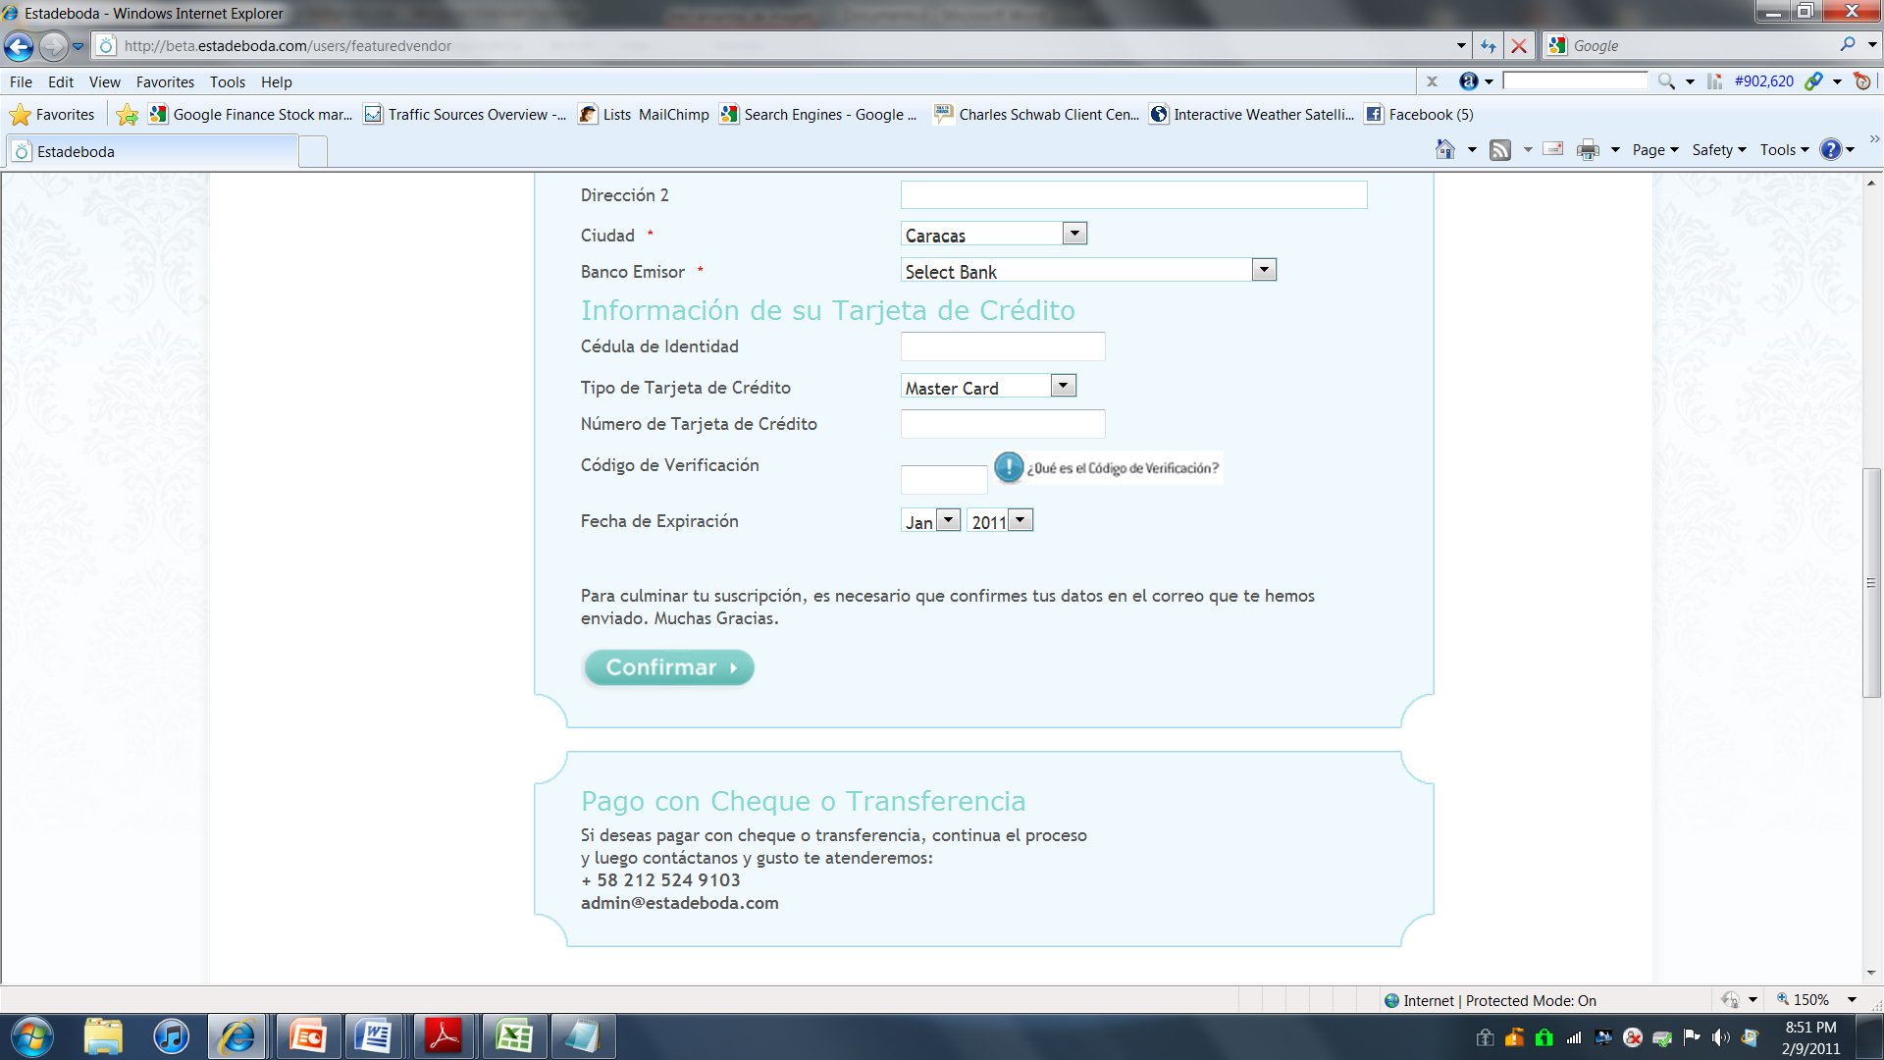
See new text below
- "Pago con Cheque o transferencia: Si deseas pagar con cheque o transferencia, contáctanos y con gusto te atenderemos: + 58 212 524 9103 admin@estadeboda.com"
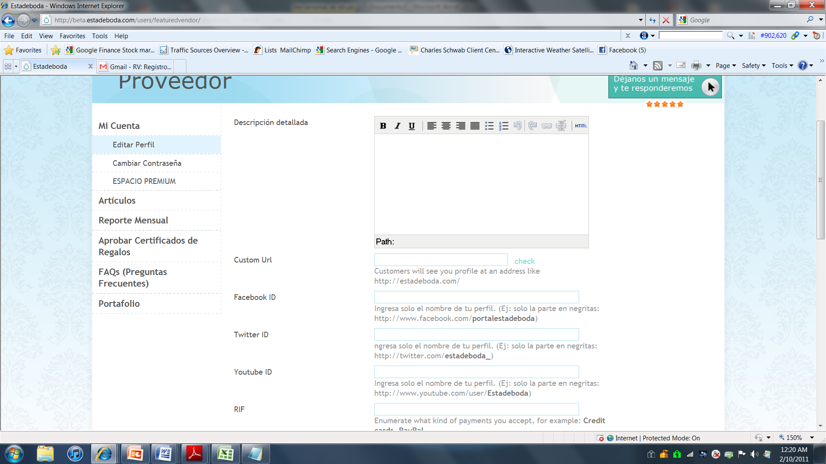
- Custom Url: Direccion Web en estadeboda (URL)
- Customers will see your profile at an address like: http://estadeboda.com/tuempresa: Crea tu propia direccion web en estadeboda. (Ej: http://estadeboda.com/tuempresa. Coloca solo la parte en negritas)
- Check: Revisar. NOTE: This Check function is not working.
- Ingresa el nombre de tu perfil en Facebook. (Ej: http://facebook.com/tuempresa. Coloca solo la parte en negritas)
- Ingresa el nombre de tu perfil en Twitter. (Ej: http://facebook.com/tuempresa. Coloca solo la parte en negritas)
- Enumerate what kind of payments you accept, for example: Credit cards, PayPal.= Eliminate this phrase, everyone understands RIF
- Recommended image size 400px X 400px= Tamaño recomendado 400px X 400px
- PLEASE SEND CONFIRMATION EMAIL TO VENDOR AND BBC COPY at the end of the purchase
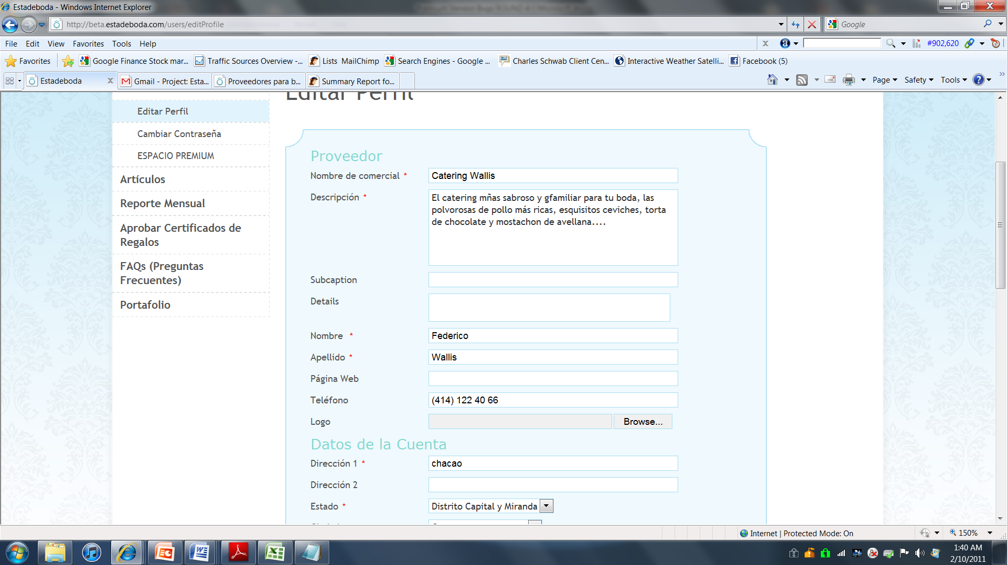
MAX 60Caracteres
What is this?
- Descripcion (Maximo 60 caracteres)
- What is Subcaption and Details?
OTHER IN THE DASHBOARD:
- Could not access the FAQS admin section (When we try it , this system logs us out and drive us to http://beta.estadeboda.com/proveedores/)

- Could not access the PORTFOLIO admin section (When we try it , this system logs us out and drive us to http://beta.estadeboda.com/proveedores/)

- Please deactivate: modules of : Articulos/ Reporte Mensual/ Certificados de Regalos, (It confuses the user)

- Front end: This was using our previous account (maco@estadeboda.com /password: 9WrOMTh)
Listing: http://beta.estadeboda.com/proveedores/listado
- View details = Ver detalles
- The Phone does not show in format (####) ### ## ##
- Website: Please put the link “Open in a new window” so we don’t kick the person off our site.
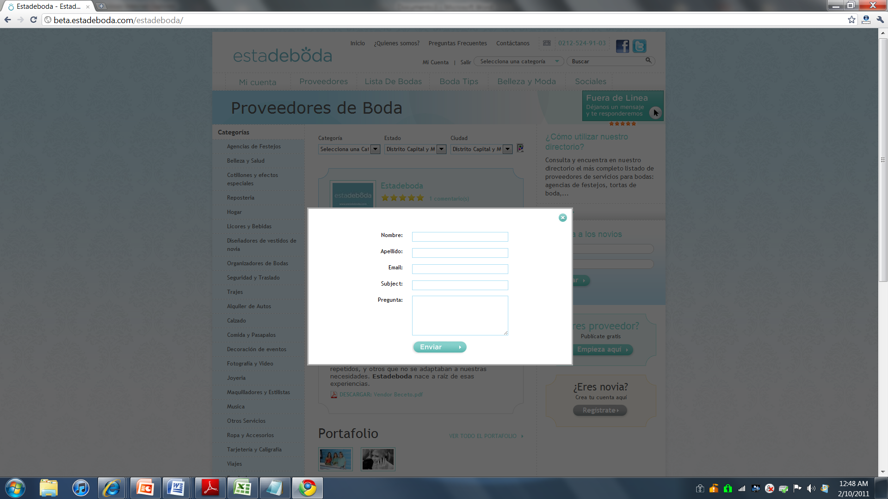
Subject: Asunto

- Portfolio:
  - it still looks like:
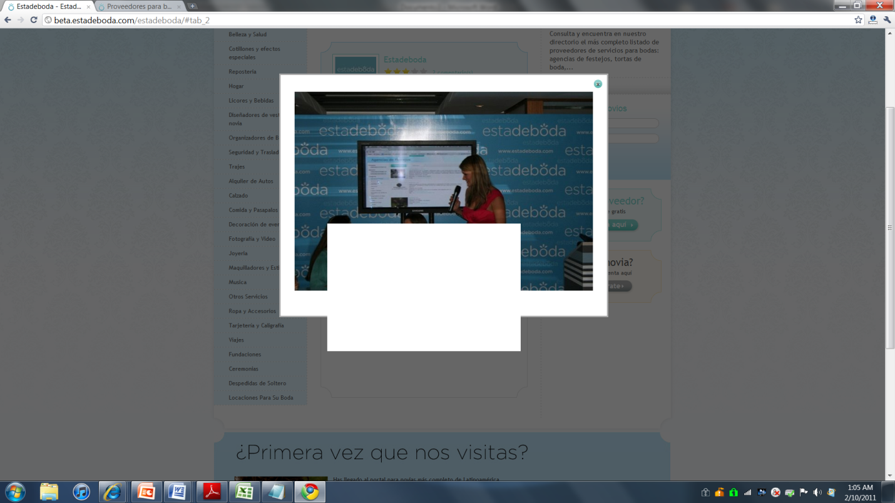
  - It does not show a Feature image like in the mockup
  - Could not test the video (no access from the admin)
- Reviews: When a user wants to leave a comment, she sign in an goes to their admin panel.. she should get to the review section where she was. (Currently she has to go again to Vendors, make the search, go to the review tab etc)
Thank you = Gracias!
- FAQS:
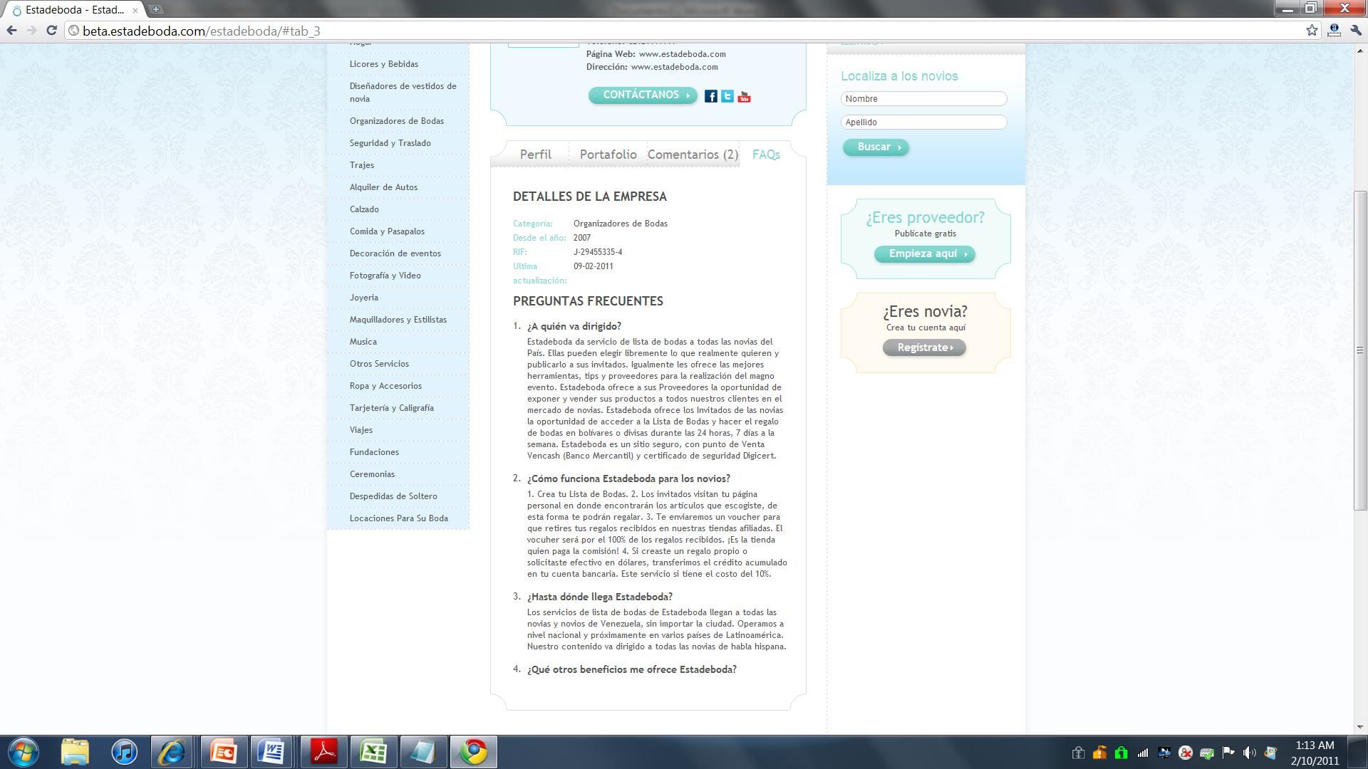
Please move one line down
Where is the answer?, what happens if there is more text?

- Other:
- The Solution to the Images was excellent! We could not try the portfolio but we tested with vertical and an horizontal picture and both looked perfect! Thanks
- Please, if not too complicated, add a “Preview” because it is unfriendly to go to the front end each time we make a change in the dashboard.
- The Tabs issue remains in the IE , I tried ctrl F5 but still not working

