- Contents
01| Getting Started with Discover 1
Overview 1
Additional Documentation 1
What’s New in This Release? 2
Using the Discover SIMS Configuration Utility 5
Permissions 5
Logging Into Discover via SIMS 6
02| Navigating in Discover 7
Introduction 7
Opening a Graph 9
Moving a Graph Around the Canvas 11
Resizing a Graph 11
Bringing a Graph to the Front of the Canvas 12
Using the Slide Bar to View all the Data Points on the X Axis 12
Exporting a Graph as an Image 12
Viewing the Reverse Side of a Graph 13
Rotating a Graph 14
Exporting the Details on the Reverse Side of a Graph to a .CSV File 15
Graph to Graph Filtering 16
Collective Filtering 21
Saving a Graph of Your Own Creation 21
Deleting a Graph of Your Own Creation 23
03| Pre-defined Graphs Available in Discover 25
Introduction 25
Graphical Outputs Available in Discover 25
Client Filters on the Front of Graphs 28
Pupil/Student Graphs 28
PreAdmission Students 30
Pastoral Graphs 31
Attendance Graphs 32
SEN Graphs 34
Behaviour Graphs 35
Achievement Graphs 36
Exclusions Graphs 37
Assessment Graphs 38
For English Primary Schools 38
For English Secondary Schools 39
For Welsh Primary Schools 39
For Welsh Secondary Schools 39
04| Setting up SIMS to Enable the Creation of Assessment Graphs 41
Introduction 41
The Process of Creating Discover Aspects in SIMS and Copying them into Discover 42
Searching for an Existing Discover Aspect 42
Creating a New Discover Aspect 43
Creating a Multiple Grade Targets Discover Aspect 44
Creating a Target Point Score Discover Aspect 51
Creating an Amount of Progress Discover Aspect 54
Generating the Discover Aspect Results 57
05| Using the Discover SIMS Configuration Utility to Create Assessment Graphs 59
Introduction 59
Permissions 59
Logging into the Discover SIMS Configuration Utility 60
Specifying the General Settings 61
Transfer Progress Messages and What they Mean 64
Investigating a Pending Transfer 65
Reviewing the Discover Warehouse Service Log File 66
Editing a Result Set 66
Understanding the Assessment Graphs Page 69
Copying an Existing Assessment Graph Definition 71
Creating a New Assessment Graph Definition 77
Adding/Editing an Assessment Graph of True/False Bar Style 78
Adding/Editing an Assessment Graph of Levels of Progress Style 86
Adding/Editing an Assessment Graph of Marks Tracking Progress Style 94
Adding/Editing an Assessment Graph of Grades Tracking Progress Style 104
Adding/Editing an Assessment Graph of Average Marks Bar Style 113
Adding/Editing a 5 Circle Venn Diagram 120
Deleting an Assessment Graph Definition 126
Creating an XML File of Graph Definitions for Export 126
Importing Graph Definitions 129
Running the Transfer Process 131
06| Working with Venn Diagrams 133
Introduction 133
Hints and Tips for Viewing the Data in Each Segment of a Venn Diagram 137
07| Creating Groups in Discover and Viewing Discover Groups in SIMS 139
Introduction 139
Adding/Editing a Discover Group 140
Deleting a Discover Group 146
Adding/Editing a Dynamic Group 147
Specifying the Dynamic Group Alerts 148
Viewing the Discover Group Details in SIMS 149
Searching for an Existing Discover Group 149
Adding a Supervisor to a Discover Group 151
Viewing and Deleting a Supervisor from a Discover Group 153
Monitoring the Pupil/Student Population of a Discover Group 154
Index 157

Getting Started with Discover
In This Chapter
Overview 1
Additional Documentation 1
What’s New in This Release? 2
Using the Discover SIMS Configuration Utility 5
Permissions 5
Logging Into Discover via SIMS 6

Overview
Discover has been developed to enable schools to analyse their SIMS data and to display the results in a variety of graphical formats, e.g. bar graphs, progression line graphs, pie charts and Venn diagrams.
Discover draws the data from a data warehouse which is an extract of the SIMS SQL database. The Discover data warehouse is designed to manage a high level of data traffic so that several graphs can be created and viewed at the same time for the purposes of data comparison. It is possible to drag and drop various data items from one graph on to another to create a compilation graph as a Venn diagram.

Additional Documentation
Please ensure that you have read and understood the Discover Typical Installation Guide before attempting to use Discover.
For hosted sites and advanced installations, please ensure that you have read and understood the Discover Technical Guide to enable you to set your system up correctly.

What’s New in This Release?
A number of additional features and enhancements have been provided in this release including:

Creation of a 5 Circle Venn Diagram
You can now create a 5 Circle Venn diagram from the Assessment Graphs page of the Discover SIMS Configuration utility. This feature has primarily been provided to enable you to report on the results of pupil/students who are achieving A*-C in 6 GCSE subjects for the English Baccalaureate performance measure.


More Information:
Adding/Editing a 5 Circle Venn Diagram on page 120

Improvements to the Discover Application Bar
The Discover Welcome banner now displays the name of the user who is currently logged in.
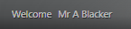
An additional information button is available on the right-hand side of the Discover Welcome banner. Click this button to display a message detailing the status of the most recent Transfer routine between SIMS and Discover.
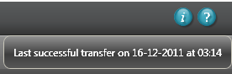

Drill Through on Selected Pre-defined Pupil/Student Graphs
It is possible to drill through into the data points within a number of the pre-defined Pupil/Student Graphs to view the underlying data components. The following pre-defined pupil/student graphs now have the drill through facility:
- Student Totals by Year Group
- Student Totals by House
- Student Totals by Tier
- Student Totals by Subject
- Class Totals by Subject. This is an additional pre-defined graph definition for Spring 2012.
The Magnifying Glass button in the top right-hand corner of a compiled pre-defined graph indicates that it is possible to drill through into the data points to view the data beneath.
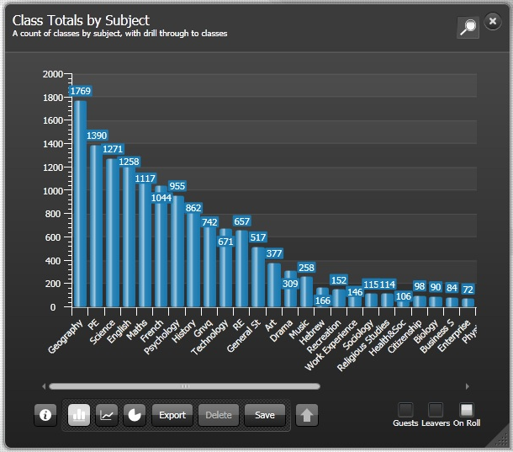
Select a data point and click the Magnifying Glass button to drill down into the graph.
Magnifying Glass button
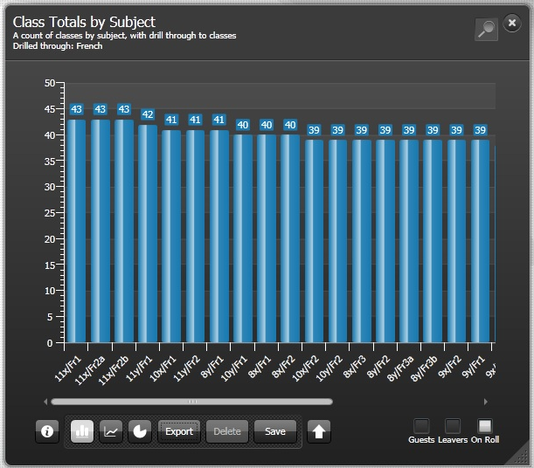
When you have viewed the data beneath a selected data point, click the Drill Up button adjacent to the Save button on the front of the graph to return to the original graphical output.
Drill Up button

More Information:
Pupil/Student Graphs on page 28

Ability to Delete Pre-defined Graph Definitions Provided by Capita SIMS
You can now delete an unwanted pre-defined graph definition that has been provided by Capita SIMS.

More Information:
Deleting an Assessment Graph Definition on page 126

Using the Discover SIMS Configuration Utility
Predefined graphs have been provided with default data items specified by Capita SIMS Ltd. However, as all schools are different, a utility has been provided to enable schools to specify some of their own data items so that you can measure and analyse the data as you wish.
The Discover SIMS Configuration utility provides the ability to change or customise different areas within Discover. These areas mainly concern the display and interval ranges of specific graphs but it is also possible to specify the analysis depth for Post Code searches and the offset timeframe for the SIMS to Discover Transfer routine. Schools can also use the Discover SIMS Configuration utility to specify the information to be included in the creation of their own Assessment graphs.
The General Settings should be specified before initial use of Discover but they can be changed at any time if the relevant graphs are not displaying the data in the manner that you require or if the Transfer process needs to be run immediately instead of waiting for the specified time slot.
There are a number of pages within the Discover SIMS Configuration utility and each page enables the configuration of a different element of data. As a result of this, various user permissions are required for the different areas (please see Using the Discover SIMS Configuration Utility to Create Assessment Graphs on page 59).
IMPORTANT NOTE: The standard Discover SIMS Configuration utility, available with typical installations of Discover, is not available for use with hosted installations of Discover. In order to initiate a manual Transfer process in a hosted installation, please refer to the Discover Technical Guide for further information.

Permissions
It is only possible to see data items in Discover for which you have been granted suitable permissions in SIMS.
- The following user roles can specify and amend the General Settings page in the Discover SIMS Configuration utility:
- Senior Management Team members
- School Administrators
- Administration Assistants
- System Managers.
- The following user roles can initiate the Transfer process from the Discover SIMS Configuration utility:
- Senior Management Team members
- School Administrators
- Administration Assistants
- Assessment Coordinators
- System Managers.
- The following user roles can add and amend aspects, result sets and Assessment graph parameters in the Result Sets and Assessment Graphs pages in the Discover SIMS Configuration utility:
- Senior Management Team members
- Assessment Coordinators.

Logging Into Discover via SIMS
- Open SIMS in the usual way.
- Select Focus | Assessment | Discover.
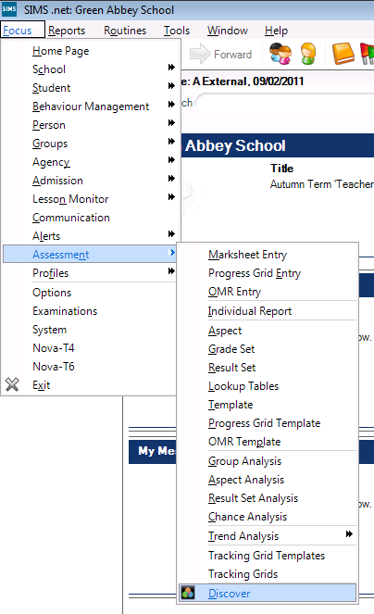
Alternatively, click the Discover button on the SIMS Tool Bar.
Discover button

Navigating in Discover
In This Chapter
Introduction 7
Opening a Graph 9
Viewing the Reverse Side of a Graph 13
Graph to Graph Filtering 16
Collective Filtering 21
Saving a Graph of Your Own Creation 21
Deleting a Graph of Your Own Creation 23

Introduction
The predefined graphs that are provided with Discover are accessible from a series of Category buttons on the Discover Application Bar.
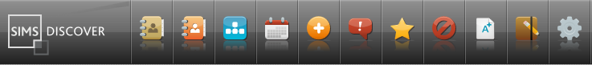
These include options such as Pupil totals, SEN, Behaviour and Achievement records and Attendance statistics.
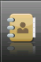 | Pupil button
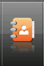 | PreAdmission button
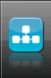 | Pastoral button
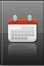 | Attendance button
 | SEN button
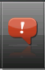 | Behaviour button
 | Achievement button
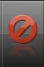 | Exclusions button
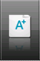 | Assessment button
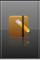 | Custom Graphs button
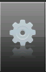 | Groups button
Once created, graphs can be shared amongst other members of staff, governors and members of the Senior Management Leadership Team. It is also possible to export graphs to a .CSV file.
It is possible to rotate a graph to view the reverse side which summarises a breakdown of the data details, e.g. the names, date of birth, admission numbers of the pupil/students and their memberships of the various data items that are included in the graph.

Opening a Graph
- Click one of the Category buttons on the Discover Application Bar. In the following example, the SEN button has been clicked.
SEN button
A drop-down list of available graph names is displayed.
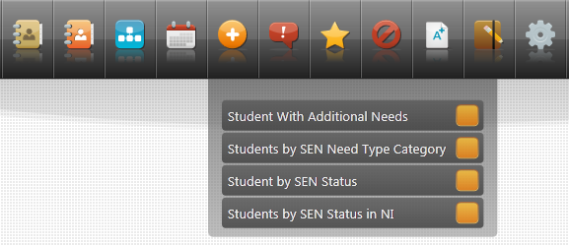
- Click one of the graph names with the mouse and drag the graph name or the associated orange box onto the Discover canvas.
The Discover canvas is the white background area of the application. Looking closely at the canvas, the words Drag on to canvas can be seen in ghosted grey text. The canvas is where the graphs and groups are created and is essentially the work space area of Discover.
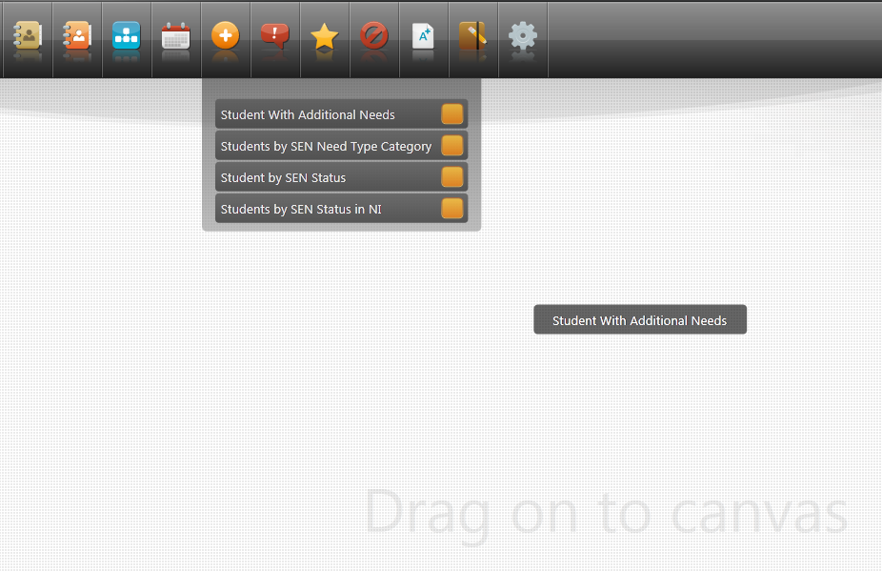
- Release the mouse button to enable the data to be compiled as a graphical output.
TIP: For users with a touch screen, a stylus or a finger can be used in a similar way to the mouse to drag graphs onto the Discover canvas and to move them around.
In most instances, the graphical output is initially created as a bar graph (please see Graphical Outputs Available in Discover on page 25).
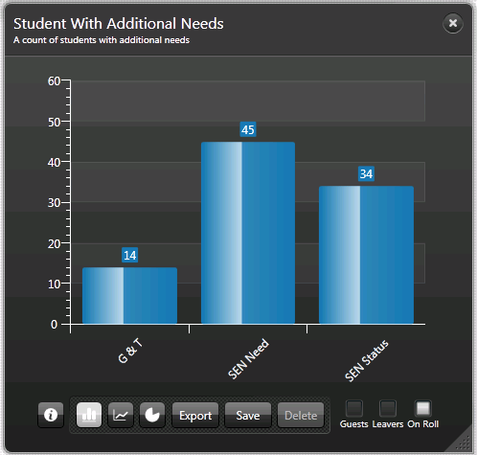

Moving a Graph Around the Canvas
Once a graph has been created, it is possible to move it around the canvas to enable you to maximise the space available. This gives you the opportunity to drag and drop additional graphs onto the canvas at the same time.
- Click into the title area of the graph and drag it around the canvas.
- Release the mouse button to position the graph in the required location.
- If the graph is positioned so that you cannot see the Close button or the graph title, click onto the Discover canvas and move the mouse to scroll and view the graph.

Resizing a Graph
Once a graph is compiled on the canvas, it can be stretched to maximise its size and to enable you to see the data items more clearly.
- Click a border or a corner of the graph until the two-way arrow cursor is displayed.
- Drag the cursor in the required direction to increase or decrease the size of the graph on the canvas.
IMPORTANT NOTE: There is a limit to the size that the graph can be reduced to whilst still displaying the data in a readable form.

Bringing a Graph to the Front of the Canvas
If you have several graphs or groups open on the Discover canvas at the same time and you want to view a graph or a group that is hidden ‘beneath’ several others, click anywhere on the perimeter of the required graph or group to bring it to the front of the canvas.

Using the Slide Bar to View all the Data Points on the X Axis
Where a graph has a large number of data points on the x axis, for example, a data point for each Registration Group in the Behaviour Points by Registration Groups graph, a slide bar is available at the bottom of the graph.
This enables you to view all the data points on the x axis by moving the slide bar backwards and forwards.
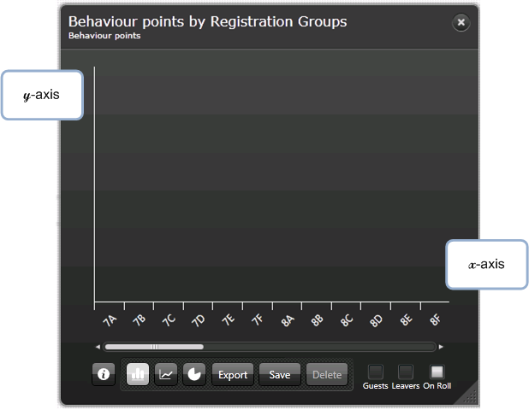
The previous graphical representation does not contain any data in the data points but has been used to demonstrate the slide bar only.

Exporting a Graph as an Image
If you want to share the graphical output of data with other colleagues, governors or members of the Senior Management Team, it is possible to save a graph as an image. This enables you to insert the image into correspondence or reports and in the case of Behaviour graphs, even letters to parents.
- Click the Export button on the front of the graph that you are viewing.
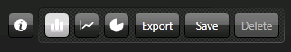
The Save As dialog is displayed.
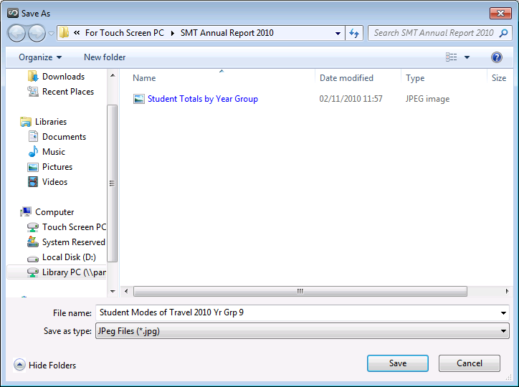
- Browse to a suitable storage location and enter an appropriate File name for the graphical image.
The Save as type field defaults to JPeg Files (*.jpg) but it is possible to save the image as a Bitmap File (*.Bmp) or as a Png File (*.Png).
- Click the Save button.

More Information:
Graphical Outputs Available in Discover on page 25

Viewing the Reverse Side of a Graph
All graphs can be rotated to display the reverse side which reveals a summary of the underlying data that the graph is composed of. The summary of the data is displayed in a tabular format. There are a number of different standard formats used for the reverse side of the predefined graphs depending on the data structure used within the graph.

Rotating a Graph
Click the information button on the front of the graph that you are viewing.
Information button
The graph is rotated by 180 degrees and the underlying data is displayed.
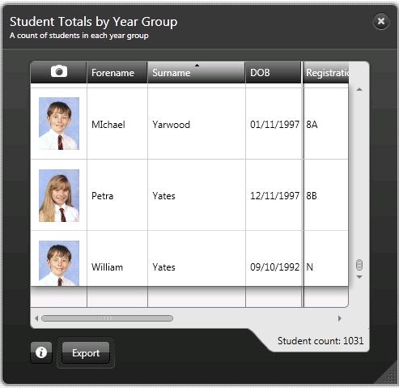
TIP: After rotating a graph to view the details, click on a column heading to change the sort order of the pupil/students.
To enable you to view all of the information, the reverse side of the graph can be resized so that all the column headings are visible.
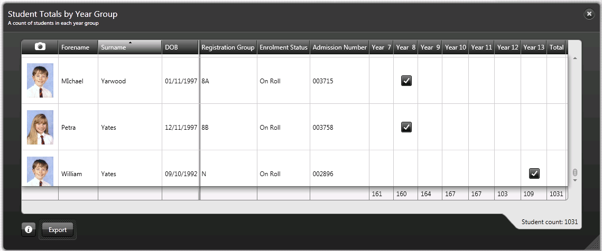
View the entire list of pupil/students by moving the slider up and down on the right-hand side of the reverse side of the graph.

Exporting the Details on the Reverse Side of a Graph to a .CSV File
You may wish to export the data details from the reverse side of a graph to a spreadsheet so that you can further analyse or monitor trends.
- Click the Export button on the reverse side of the graph.
Export button
The Save As dialog is displayed.
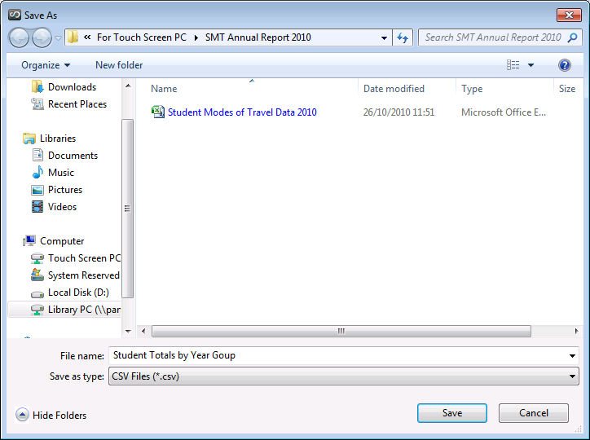
- Browse to a suitable storage location and enter an appropriate File name for the data details.
The Save as type field defaults to CSV File (*.csv). It is not possible to save the data details in another format at present.
- Click the Save button to load the data details into a comma separated file in Microsoft® Excel.
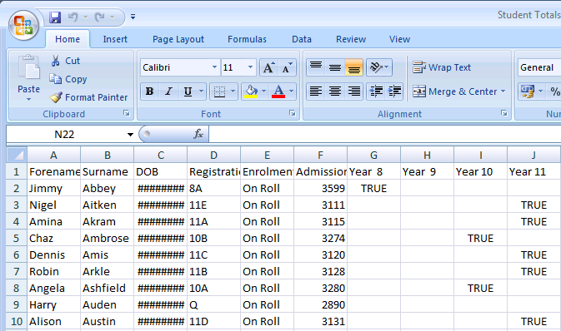
The data details can be sorted and manipulated as required.

Graph to Graph Filtering
When multiple graphs are open on the canvas, it is possible to further refine the results displayed in a selected graph by dragging and dropping a data item from one graph onto another graph.
For example, you are viewing the Student Totals by Key Pastoral Factors graph and the Student Totals by Gender graph and would like a further break down of the pastoral factor results that focus on the girls in Year 7.
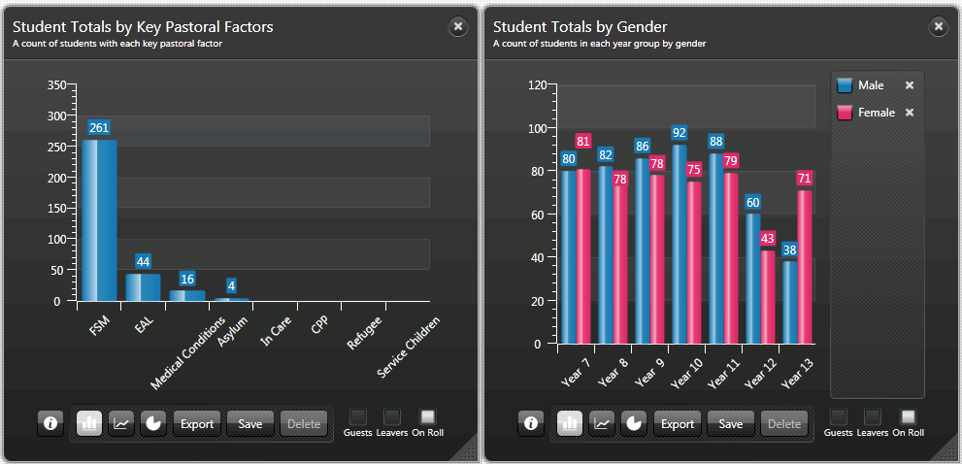
In the Student Totals by Gender graph, select the colour coded data item for the girls in Year 7 and drag and drop it onto the Student Totals by Key Pastoral Factors graph.
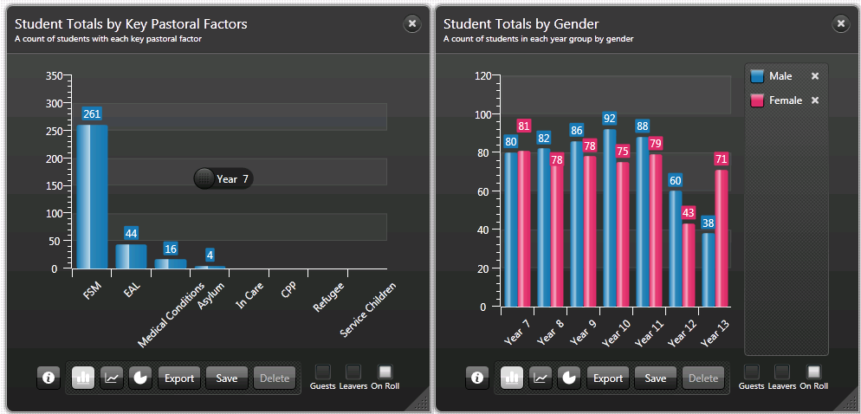
As you drag the data item, the cursor displays the name of the data item that you have selected as an additional filter.
NOTE: When you drop a data item onto another graph, please ensure that the cursor is within the area of the x and y axis.
Once the data item has been dropped onto the selected graph, the results in the graph are re-calculated to incorporate the new filter.
An information caption advises you that the re-calculation is Adding Series to the current results.
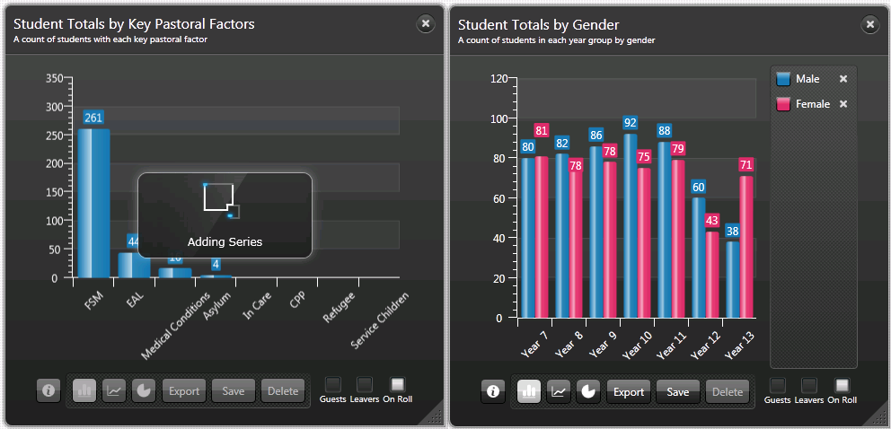
Once the re-calculation is complete, an additional data point is added to the existing results. A panel on the right-hand side of the selected graph displays a key of the filters that comprise the results.
In the example, this shows that of 261 pupil/students in the school who are recorded as taking Free School Meals (FSM), 17 of these are girls in Year 7, of the 44 children who speak English as an Additional Language (EAL), 2 of these are girls in Year 7, etc.
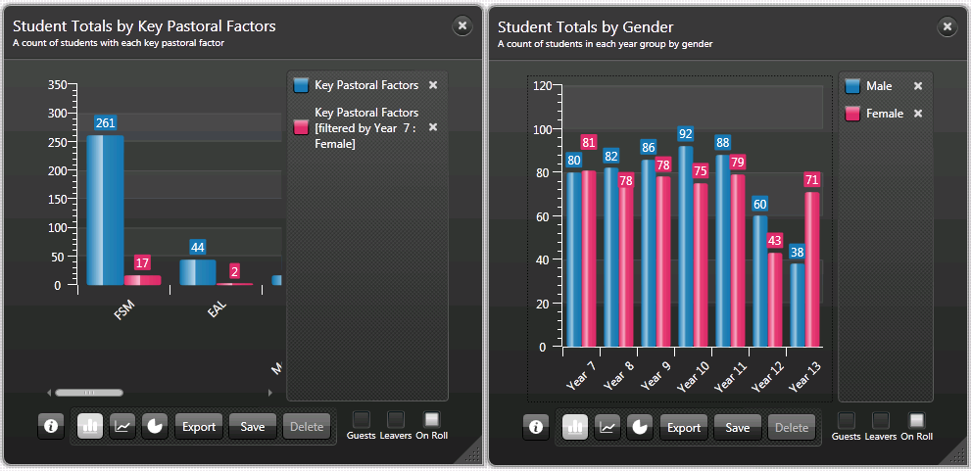
It may be necessary to expand the graph by stretching it across the canvas so that you can view all the data points that are obscured beneath the key panel.
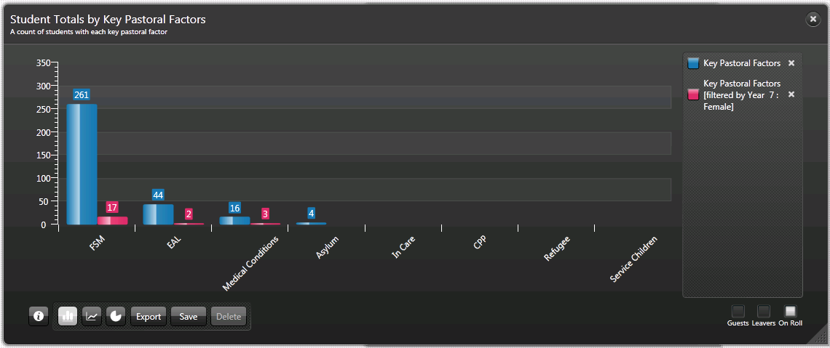
It is also possible to remove the original results from the selected graph and to filter the data points solely on the filter that you have selected.
If you want to remove the original results from the selected graph, select the relevant data point name from the key panel and click the x button to remove the filter.
The graph is re-calculated and an information caption advises that the re-calculation is Removing Series from the current results.
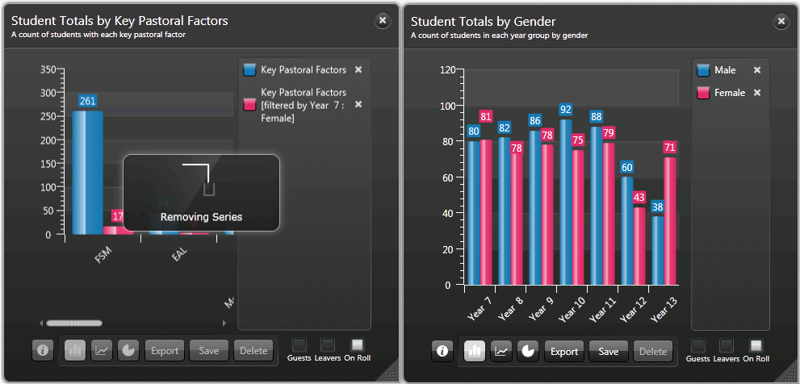
The resulting graph still displays the key pastoral factors but solely from the focus of girls in Year 7.
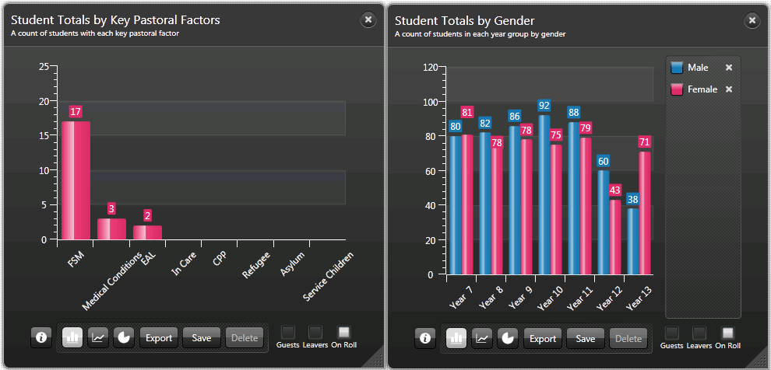
If you want to remove the additional data item from the selected graph instead of removing the original results, select the relevant data point name from the key panel and click the x button to remove the filter.
The graph is re-calculated and an information caption advises you that the re-calculation is Removing Series from the current results.
The graph is restored to its original condition.
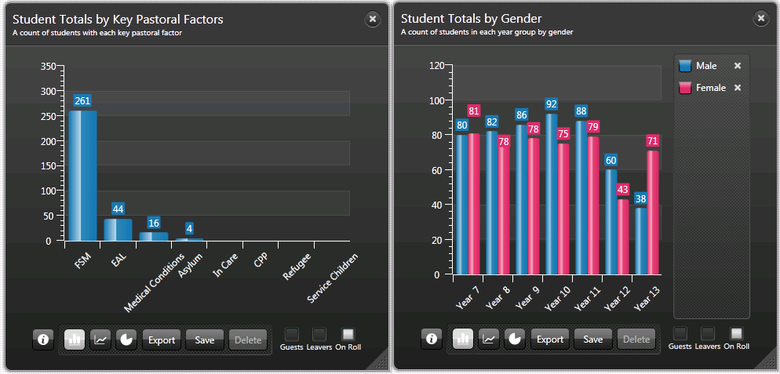
NOTE: It is not possible to carry out the removal of a data item from a graph where the key panel is not available.

Collective Filtering
It is possible to add data items from several different graphs to a selected graph in order to further refine the results using the same method as in Graph to Graph Filtering. You can also add a data item that is a combination of previously filtered data items from various graphs.
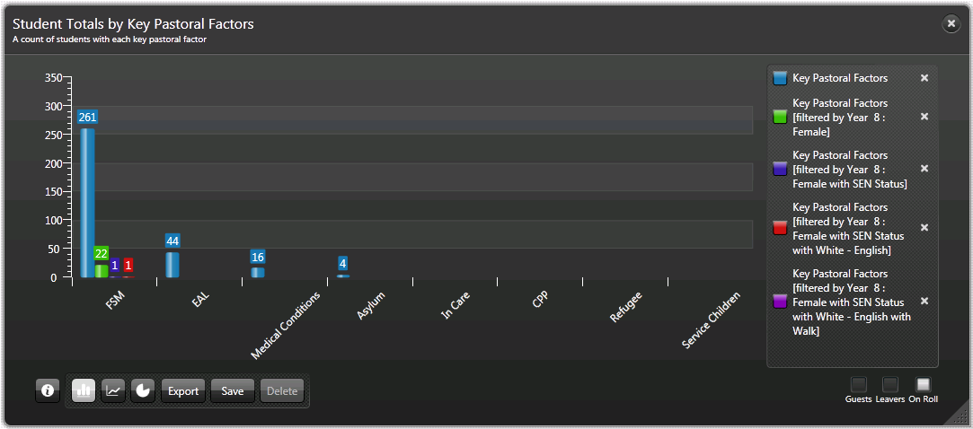
Each time an additional data item is dropped onto the graph, the results are re-calculated based primarily on the original data points, and then on the order that the data items were subsequently added to the graph.
In the previous example, the key panel clearly indicates the calculation order of the data items together with the representative colour that is used to differentiate each data item on the graph.

Saving a Graph of Your Own Creation
As you combine data items from multiple graphs and create graphical outputs that are specifically required in your school, you can save these user defined graph definitions to any of the Catalogue buttons on the Discover Application Bar.
- When you have created a graph definition that you want to keep for future use, click the Save button at the bottom of the selected graph dialog to display the Save as dialog.
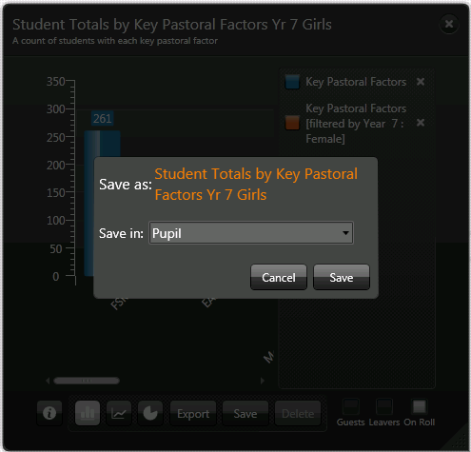
A default name for the new graph is suggested but this can be changed, if required by overtyping the text.
- Select the Save in: drop-down arrow and select the most appropriate Catalogue in which to save the graph, from the list.
If you want to create your own collection of specific graphs, select the Custom Graphs catalogue from the list displayed.
Saving graphs to the Custom Graphs catalogue means that you can revisit graphs that you have previously defined without the need to create them again.
Custom Graphs button
- Click the Save button and an information caption advises you that this graph is Saving to catalogue.
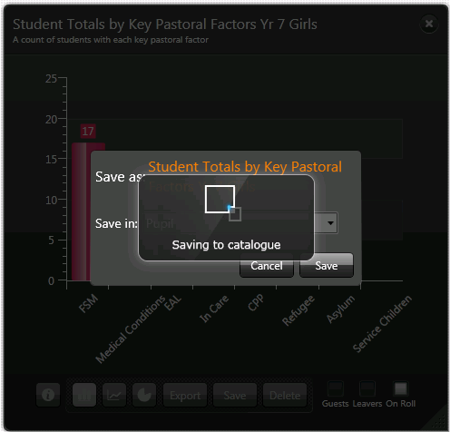
This graph can now be found at the bottom of the list of available graph outputs from the selected catalogue button or the Custom Graphs button on the Discover Application Bar.

Deleting a Graph of Your Own Creation
If any of your user defined graphs have ceased to be relevant or the drop-down list of graphical outputs has become cluttered, user defined graphs can be deleted from the catalogue to which they were saved.
- Click the relevant Catalogue button on the Discover Application Bar to display the list of available graph outputs.
- Select the relevant graph name and drag and drop it onto the Discover canvas.
- Click the Delete button at the bottom of the dialog to display the following message:
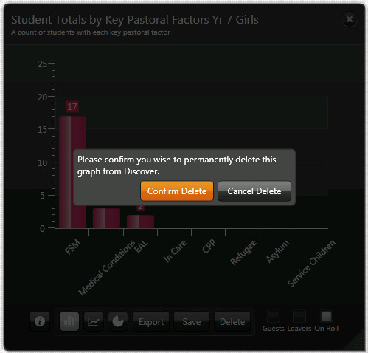
- Click the Confirm Delete button and an information caption advises you that Discover is Deleting this graph.
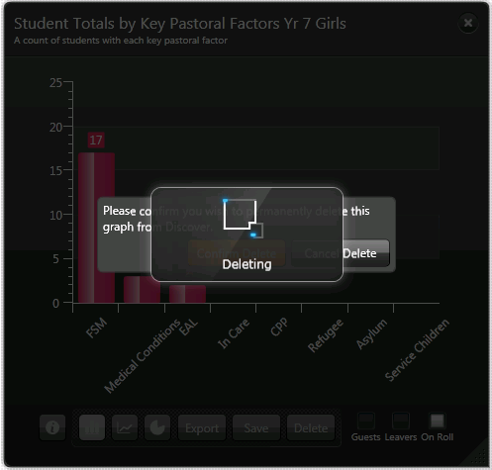
The graph definition is removed from Discover and the graph is no longer available from the drop-down list of available graph outputs from the selected Catalogue button on the Discover Application Bar.

Pre-defined Graphs Available in Discover
In This Chapter
Introduction 25
Graphical Outputs Available in Discover 25
Pupil/Student Graphs 28
Pastoral Graphs 31
Attendance Graphs 32
SEN Graphs 34
Behaviour Graphs 35
Achievement Graphs 36
Exclusions Graphs 37
Assessment Graphs 38

Introduction
The predefined graphs that have been provided are accessible from a series of category specific Catalogue buttons on the Discover Application Bar. These include options such as Pupil, Students with Additional Needs, Behaviour and Achievement records and Attendance statistics.

Graphical Outputs Available in Discover
The majority of the predefined graphs initially open as bar graphs. However, it is possible to change the type of graphical display so that the data can be seen more clearly.
Whichever type of graphical display you select, the data points on the y axis are marked with a count of the number of pupil/students who fall into each criteria or data item on the x axis.
In the following example, 266 pupil/students have been recorded as having a Mode of Travel of Walk and 52 come to school by means of a Car/Van.
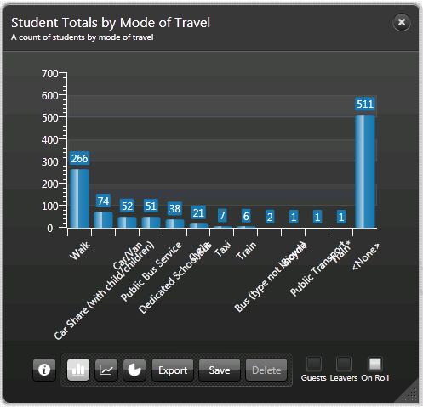
- From the bottom of a graph, select the appropriate button to display the data in a different format from the default of bar graph.
- Click the Progression Line button to display the data as a Progression Line graph.
Progression Line button
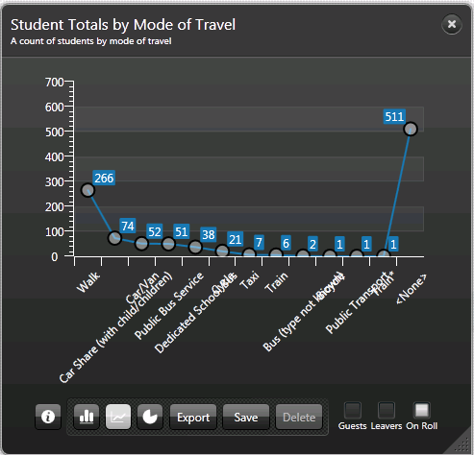
- Click the Pie Chart button to display the data as a Pie Chart.
Pie Chart button
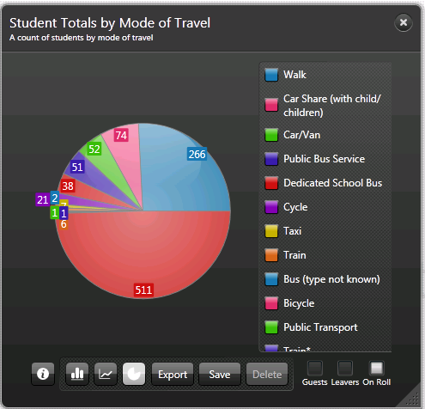
- Click the Bar Graph button to return to the default graphical display.
Bar Graph button

Client Filters on the Front of Graphs
It is possible to change the filter of the data items displayed in the graph by selecting Guests, Leavers and On Roll.
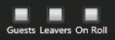
Toggling the client filters updates the graphical display from the default filter.

Pupil/Student Graphs
Click the Pupil button to display the drop-down list of available graph outputs.
Pupil button
All graphical outputs are based on the pupil/student population who are
on-roll as of today.
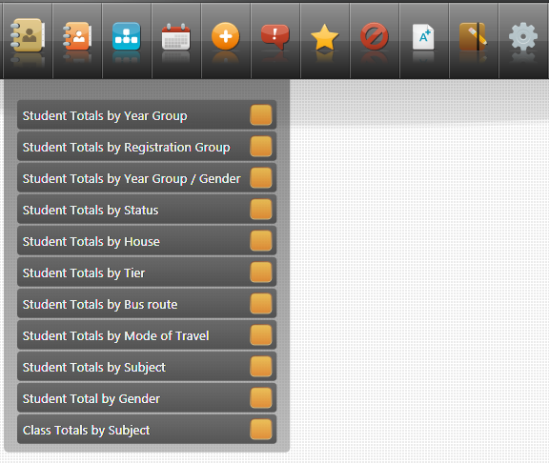
- Student Totals by Year Group – the default graphical display is a bar graph of on-roll pupil/students. It is possible to drill through into a data point by double-clicking to view the composite data beneath.
- Student Totals by Registration Group – the default graphical display is a bar graph of on-roll pupil/students.
- Student Totals by Gender - the default graphical display is a multi-series bar graph of on-roll pupil/students. It is not possible to create a pie chart from the results of this graph. However, it is possible to create pop-ups from any of the data points on both the front and the reverse of the bar or progression lines graph.
- Student Totals by Status - the default graphical display is a bar graph of on-roll pupil/students. Filters of Leavers and Guest can be applied.
- Student Totals by House - the default graphical display is a bar graph of on-roll pupil/students. It is possible to drill through into a data point by double-clicking to view the composite data beneath.
- Student Totals by Tier - the default graphical display is a bar graph of on-roll pupil/students. It is possible to drill through into a data point by double-clicking to view the composite data beneath.
- Student Totals by Bus Route - the default graphical display is a bar graph of on-roll pupil/students.
- Student Totals by Mode of Travel - the default graphical display is a bar graph of on-roll pupil/students.
- Student Totals by Subject - the default graphical display is a bar graph of on-roll pupil/students. It is possible to drill through into a data point by double-clicking to view the composite data beneath.
- Student Total by Gender – the default graphical display is a pie chart of on-roll pupil/students.
- Class Totals by Subject - the default graphical display is a bar graph of on-roll pupil/students. It is possible to drill through into a data point by double-clicking to view the composite data beneath.

PreAdmission Students
Click the PreAdmission button to display the drop-down list of available graph outputs.
PreAdmission button
All graphical outputs are based on the pupil/student population who are current applicants as of today (please see Using the Discover SIMS Configuration Utility to Create Assessment Graphs on page 59).
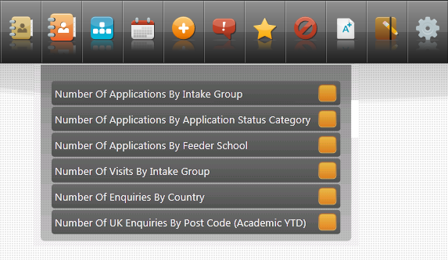
- Number of Applications by Intake Group – the default graphical display is a bar graph of applicants. All intake groups for the current academic year are displayed.
- Number of Applications by Application Status Category – the default graphical display is a bar graph of applicants. All possible statuses are displayed even if they have a null value.
- Number of Applications by Feeder School – the default graphical display is a bar graph of applicants.
- Number of Visits by Intake Group – the default graphical display is a bar graph of applicants. Results are displayed for visits in the past or scheduled for a future date within the current academic year. If an applicant has made multiple visits for various intakes, each visit is counted within the total for each intake group.
- Number of Enquiries by Country – the default graphical display is a bar graph of all enquiries received. This graph is only available for Independent schools.
- Number of UK Enquiries by Post Code (Academic YTD) – the default graphical display is a bar graph of all enquiries received. This graph is only available for Independent schools. Only enquiries from a United Kingdom post code can be displayed.

Pastoral Graphs
Click the Pastoral button to display a drop-down list of available graph outputs.
Pastoral button
All graphical outputs are based on the pupil/student population who are
on-roll as of today.
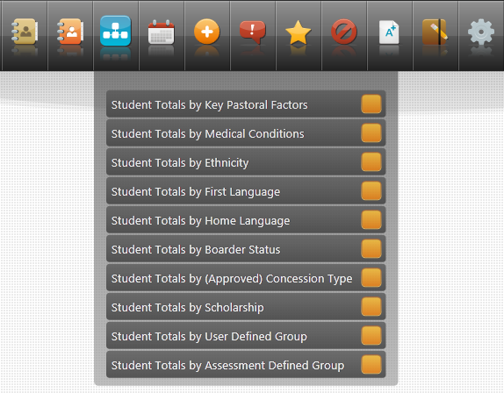
- Student Totals by Key Pastoral Factors – the default graphical display is a bar graph of on-roll pupil/students. EAL is displayed as Newcomer in NI. Only pupil/students with any of the key pastoral factors are displayed, pupil/students who have none of the factors are excluded.
- Student Totals by Medical Conditions – the default graphical display is a bar graph of on-roll pupil/students.
- Student Totals by Ethnicity – the default graphical display is a bar graph of on-roll pupil/students. Only data points with a positive value are displayed.
- Student Totals by First Language – the default graphical display is a bar graph of on-roll pupil/students. Only data points with a positive value are displayed. This graph is not available to schools in Northern Ireland.
- Student Totals by Home Language – the default graphical display is a bar graph of on-roll pupil/students. Only data points with a positive value are displayed.
- Student Totals by Boarder Status – the default graphical display is a bar graph of on-roll pupil/students. This graph is only available for Independent schools.
- Student Totals by (Approved) Concession Type – the default graphical display is a bar graph of on-roll pupil/students. This graph is only available for Independent schools.
- Student Totals by Scholarship – this graph is only available for Independent schools.
- Student Totals by User Defined Group – the default graphical display is a bar graph of on-roll pupil/students. Groups identified for inclusion in Discover via Focus | Groups | User Defined Groups in SIMS. Profiles groups cannot be included in Discover.
- Student Totals by Assessment Defined Group – groups identified for inclusion in Discover via Focus | Groups | Assessment Defined Groups in SIMS. Profiles groups cannot be included in Discover.

Attendance Graphs
Click the Attendance button to display a drop-down list of available graph outputs.
Attendance button
All graphical outputs are based on the pupil/student population who are on-roll as of today (please see Using the Discover SIMS Configuration Utility to Create Assessment Graphs on page 59).
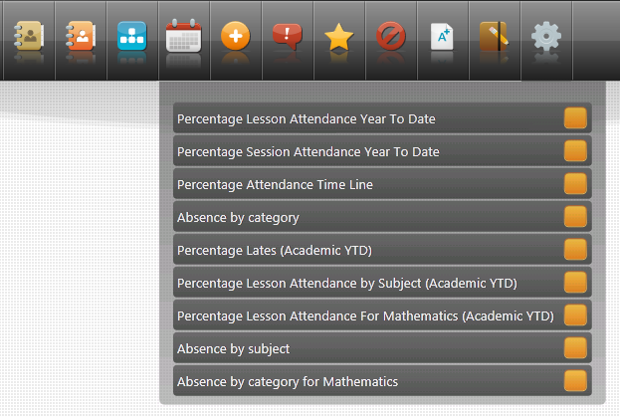
- Percentage Lesson Attendance Year to Date - the default graphical display is a bar graph of on-roll pupil/students. This graph is only available for Secondary schools that are using Lesson Monitor.
- Percentage Session Attendance Year to Date - the default graphical display is a bar graph of on-roll pupil/students. Code D is now excluded from the number of Possible Marks.
- Percentage Attendance Time Line - the default graphical display is a bar graph of on-roll pupil/students. Percentage session attendance is calculated by adding together the number of Present Marks and the number of Approved Educational Absences and dividing this figure by the number of Possible Marks. Code D is now excluded from the number of Possible Marks.
- Absence by category - the default graphical display is a bar graph of on-roll pupil/students. Code D is now excluded from the number of Possible Marks.
- Percentage Lates (Academic YTD) - the default graphical display is a bar graph of on-roll pupil/students. This graph is based on any L or U marks (Late before/after the register closes).
- Percentage Lesson Attendance by Subject (Academic YTD) - the default graphical display is a bar graph of on-roll pupil/students. This graph is only available for Secondary schools that are using Lesson Monitor.
- Percentage Lesson Attendance for Mathematics (Academic YTD) - the default graphical display is a bar graph of on-roll pupil/students. This graph is only available for Secondary schools that are using Lesson Monitor.
- Absence by subject - the default graphical display is a bar graph of on-roll pupil/students. This graph is only available for Secondary schools that are using Lesson Monitor.
- Absence by category for Mathematics - the default graphical display is a bar graph of on-roll pupil/students. This graph is only available for Secondary schools that are using Lesson Monitor.

SEN Graphs
Click the SEN button to display the drop-down list of available graph outputs.
SEN button
All graphical outputs are based on the pupil/student population who are on-roll as of today.
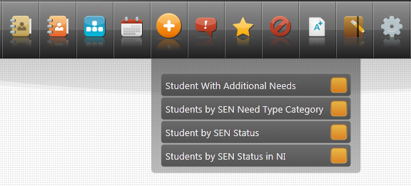
- Student with Additional Needs - the default graphical display is a bar graph of on-roll pupil/students.
- Students by SEN Need Type Category - the default graphical display is a bar graph of on-roll pupil/students. Pupil/students can have multiple SEN Need Types assigned so these are displayed in ranked order. A pupil/student with multiple need types assigned will appear in each data point that is applicable to them.
- Student by SEN Status - the default graphical display is a bar graph of on-roll pupil/students. Pupil/students with a null SEN Status are not displayed in the graph.
- Students by SEN Status in NI - the default graphical display is a bar graph of on-roll pupil/students. This graph is not available for schools outside of Northern Ireland.

Behaviour Graphs
Click the Behaviour button to display a drop-down list of available graph outputs.
Behaviour button
All graphical outputs are based on the pupil/student population who have been on-roll in the current academic year and as such, Leavers are included (please see Using the Discover SIMS Configuration Utility to Create Assessment Graphs on page 59).
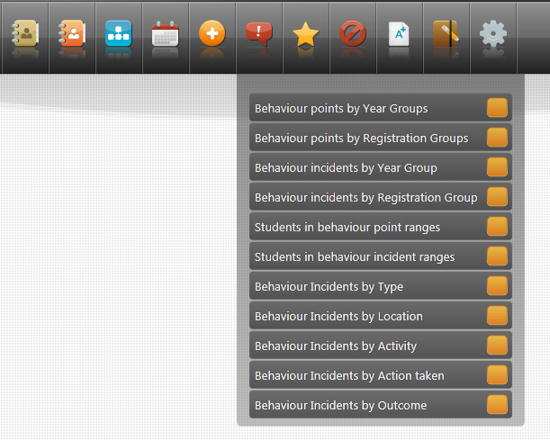
- Behaviour points by Year Groups - the default graphical display is a bar graph of on-roll pupil/students.
- Behaviour points by Registration Groups - the default graphical display is a bar graph of on-roll pupil/students.
- Behaviour incidents by Year Group - the default graphical display is a bar graph of on-roll pupil/students.
- Behaviour incidents by Registration Group - the default graphical display is a bar graph of on-roll pupil/students.
- Students in behaviour point ranges - the default graphical display is a bar graph of on-roll pupil/students.
- Students in Behaviour Incident Ranges - the default graphical display is a bar graph of on-roll pupil/students.
- Behaviour Incidents by Type - the default graphical display is a bar graph of on-roll pupil/students. A pupil/student with multiple incidents will appear in each data point that is applicable to them.
- Behaviour Incidents by Location - the default graphical display is a bar graph of on-roll pupil/students. A pupil/student with multiple incidents will appear in each data point that is applicable to them.
- Behaviour Incidents by Activity - the default graphical display is a bar graph of on-roll pupil/students. A pupil/student with multiple incidents will appear in each data point that is applicable to them.
- Behaviour Incidents by Action Taken - the default graphical display is a bar graph of on-roll pupil/students. A pupil/student with multiple incidents will appear in each data point that is applicable to them.
- Behaviour Incidents by Outcome - the default graphical display is a bar graph of on-roll pupil/students. A pupil/student with multiple incidents will appear in each data point that is applicable to them.

Achievement Graphs
Click the Achievement button to display a drop-down list of available graph outputs.
Achievement button
All graphical outputs are based on the pupil/student population who are on-roll as of today (please see Using the Discover SIMS Configuration Utility to Create Assessment Graphs on page 59).
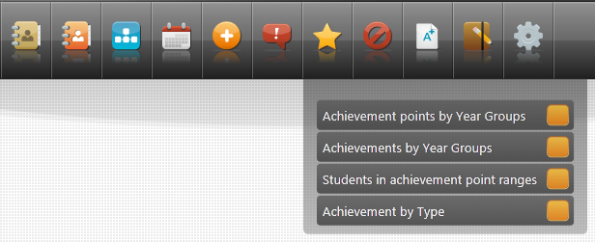
- Achievement points by Year Groups - the default graphical display is a bar graph of on-roll pupil/students.
- Achievements by Year Groups - drill down into data points is enabled, the default graphical display is a bar graph of on-roll pupil/students.
- Students in achievement point ranges - drill down into data points is enabled, the default graphical display is a bar graph of on-roll pupil/students.
- Achievement by Type - the default graphical display is a bar graph of on-roll pupil/students.

Exclusions Graphs
Click the Exclusions button to display a drop-down list of available graph outputs.
Exclusions button
All graphical outputs are based on the pupil/student population who have been on-roll in the current academic year and as such, Leavers are included (please see Using the Discover SIMS Configuration Utility to Create Assessment Graphs on page 59).
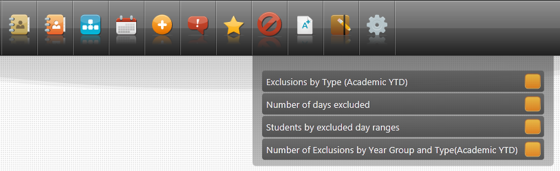
- Exclusions by Type (Academic YTD) - the default graphical display is a bar graph of on-roll pupil/students.
- Number of days excluded - the default graphical display is a bar graph of on-roll pupil/students.
- Students by excluded day ranges - the default graphical display is a bar graph of on-roll pupil/students.
- Number of Exclusions by Year Group and Type (Academic YTD) – the default graphical display is a multi-series bar graph of on-roll pupil/students. It is not possible to create a pie chart from the results of this graph. However, it is possible to create pop-ups from any of the data points on both the front and the reverse of the bar or progression lines graph.

Assessment Graphs
Click the Assessment button to display a drop-down list of available graph outputs.
IMPORTANT NOTE: If schools do not have any data for test results, the drop-down list is empty.
Assessment button
All graphical outputs are based on the pupil/student population who are on-roll as of today (please see Using the Discover SIMS Configuration Utility to Create Assessment Graphs on page 59).
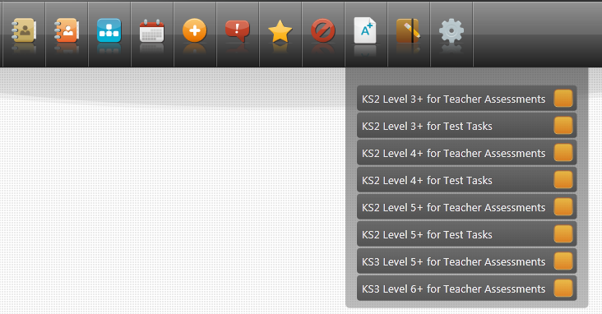

For English Primary Schools
10 pre-defined Assessment graphs have been provided:
- KS1 Level 2+ for Teacher Assessments – the default graphical display is a True/False bar output.
- KS1 Level 3+ for Teacher Assessments – the default graphical display is a True/False bar output.
- KS1 Level 2+ for Test Tasks – the default graphical display is a True/False bar output.
- KS1 Level 3+ for Test Tasks – the default graphical display is a True/False bar output.
- KS2 Level 3+ for Teacher Assessments - the default graphical display is a Boolean Venn output.
- KS2 Level 3+ for Test Tasks - the default graphical display is a True/False Venn output.
- KS2 Level 4+ For Teacher Assessments - the default graphical display is a True/False Venn output.
- KS2 Level 4+ for Test Tasks – the default graphical display is a True/False Venn output.
- KS2 Level 5+ for Teacher Assessments – the default graphical display is a True/False Venn output.
- KS2 Level 5+ for Test Tasks – the default graphical display is a True/False Venn output.

For English Secondary Schools
Three pre-defined Assessment graphs have been provided:
- KS3 Level 5+ for Teacher Assessments – the default graphical display is a True/False bar output.
- KS3 Level 6+ for Teacher Assessments – the default graphical display is a True/False bar output.
- English Baccalaureate - NC Year - the default graphical display is a 5 series Venn diagram.
IMPORTANT NOTE: If you have previously imported CTF files or the Key Stage 1 and 2 Wizards and Aspects from AMPARK, into SIMS, the pre-defined graphs for Primary schools will also be available for selection in secondary schools.

For Welsh Primary Schools
Two pre-defined Assessment graphs have been provided:
- KS1 Level 2+ for Teacher Assessments – the default graphical display is a True/False bar output.
- KS2 Level 3+ for Teacher Assessments - the default graphical display is a True/False bar output.

For Welsh Secondary Schools
One pre-defined Assessment graph has been provided:
KS3 Level 5+ for Teacher Assessments – the default graphical display is a True/False bar output.
IMPORTANT NOTE: If you have previously imported CTF files or the Key Stage 1 and 2 Welsh Wizards and Aspects from AMPARK, into SIMS, the pre-defined graphs for Primary schools will also be available for selection in secondary schools.

Setting up SIMS to Enable the Creation of Assessment Graphs
In This Chapter
Introduction 41
The Process of Creating Discover Aspects in SIMS and
Copying them into Discover 42
Creating a New Discover Aspect 43
Generating the Discover Aspect Results 57

Introduction
The process of setting up and configuring Assessment graphs for use in Discover begins in SIMS with the creation of Discover Aspects. Once Discover Aspects have been created and the results for these aspects have been generated in SIMS, the Discover Aspects must be transferred from SIMS into Discover.
It is possible to create your own graphs in Discover so that you can run analysis for targets, reviews and forecasts across each Key Stage, and to incorporate your school's own Discover Aspects as well as the statutory aspects. You can also create new Discover Aspect definitions that are composed of existing aspects from SIMS Assessment.
The actual creation of specific graphs is undertaken in the Discover SIMS Configuration utility. Once graphs have been created, the data is transferred into Discover so that the compiled graphs can subsequently be viewed in Discover.

The Process of Creating Discover Aspects in SIMS and Copying them into Discover
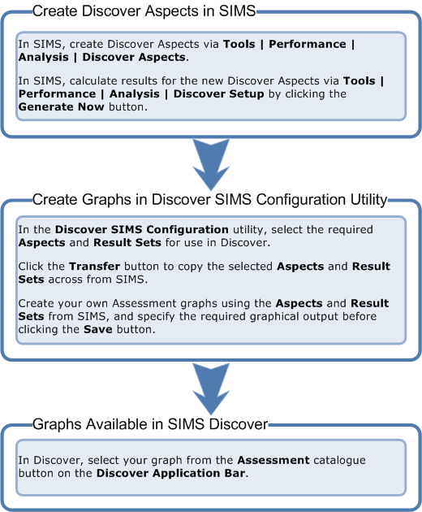

Searching for an Existing Discover Aspect
The pre-defined Assessment graphs that have been provided in Discover have been created using a number of aspects. These aspects can be located in the Find Discover Aspect browser in SIMS and can be identified by the word ‘Discover’ at the beginning of their name.
- In SIMS, select Tools | Performance | Analysis | Discover Aspects to display the Find Discover Aspect browser.
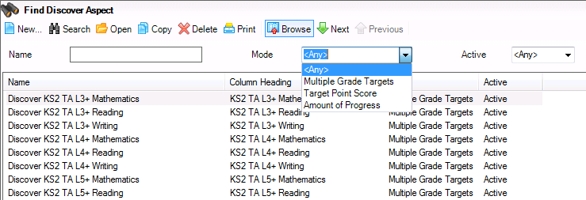
- Enter the Name or a partial name of the Discover Aspect that you are searching for.
- Alternatively, select the appropriate mode of the aspect from the Mode drop-down list:
- Multiple Grade Targets
- Target Point Score
- Amount of Progress.
Leave the Mode set to <Any> to display all existing Discover aspects.
- Select the Active status from the drop-down list before clicking the Search button to display a list of all the aspects that match the search criteria entered.
- Highlight the required aspect and click the Open button on the browser to display the Discover Aspect Detail page.
You can view the components of the ‘Discover’ aspect but it is not possible to change any of these for an aspect that has been provided for use with the pre-defined Assessment graphs.

Creating a New Discover Aspect
If you want to create other aspects for use in the creation of your own specific Assessment graphs in Discover, this can now be done. You may want to create only one or two aspects at a time or several in one go. Whichever approach you choose to adopt when creating your own aspects, it is essential that the Generate Now button is clicked in the Discover Setup Details page every time new aspects are created in SIMS if you want these aspects to be available for use in Discover immediately (please see Generating the Discover Aspect Results on page 57).
- Select Tools | Performance | Analysis | Discover Aspects to display the Find Discover Aspect browser.
- After searching for the aspect to see if it already exists, click the New button and select the relevant mode for the new Discover Aspect:
- Multiple Grade Targets (please see Creating a Multiple Grade Targets Discover Aspect on page 44).
- Target Point Score (please see Creating a Target Point Score Discover Aspect on page 51).
- Amount of Progress (please see Creating an Amount of Progress Discover Aspect on page 54).
It is possible to create three different modes of Discover aspect, each with specific Value Definitions, Range Definitions, Result Sets and Amount of Progress parameters.
The Discover Aspect Detail page displays different fields for completion, depending on the mode selected. However, the Basic Details panel remains the same for all modes of aspect.
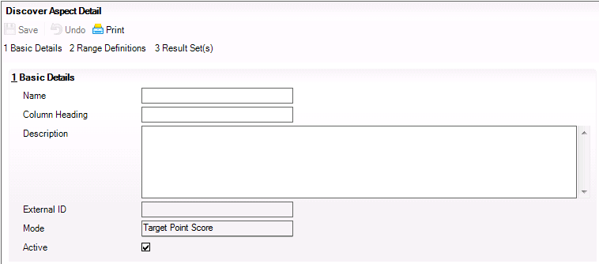
- Enter a unique Name for the new Discover aspect in the Basic Details panel.
- Enter a unique Column Heading and a clear and concise Description to differentiate this Discover aspect from existing aspects.
The External ID field is created when the aspect is saved.
The Mode field is populated automatically according to the mode selected when clicking the New button to add a new aspect.
The Active check box is selected by default.

Creating a Multiple Grade Targets Discover Aspect
When creating a new Discover aspect with the mode of Multiple Grade Targets, the Discover Aspect Detail page contains two additional panels for completion, Grade Value Definitions and Result Set(s).
In the Grade Value Definitions panel, the Equivalence Minimum field is set to 1.0 by default. This value can be changed, if required. The valid range is 1.0 to 100.0.
The Equivalence Maximum field is set to 100.0 by default. This value can be changed, if required but the maximum cannot be greater than 100.0.
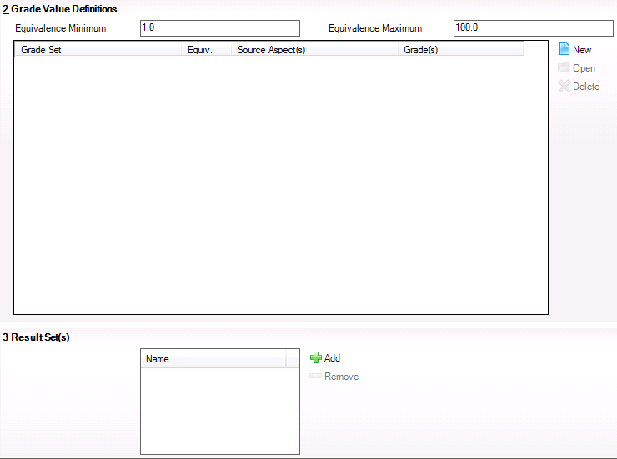
- Click the New button adjacent to the Grade Set panel to display the Add/Edit Discover Grade Value Definition dialog.
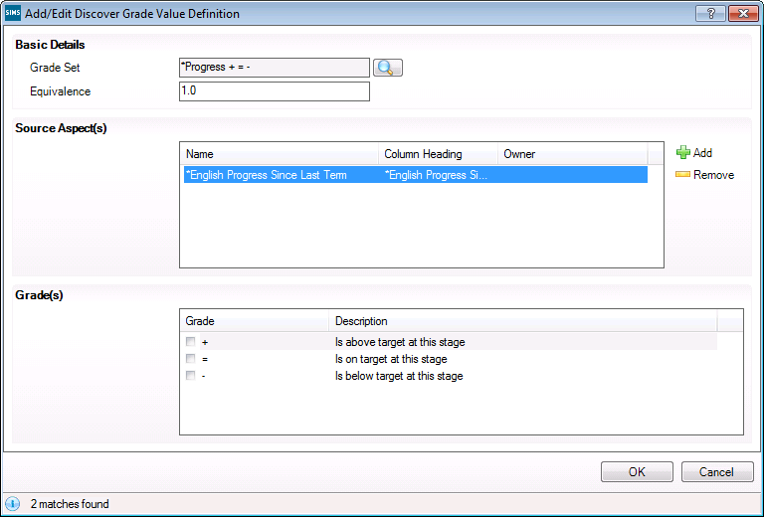
- In the Basic Details panel, click the Browser button adjacent to the Grade Set field to display the Find Grade Set Browser dialog.
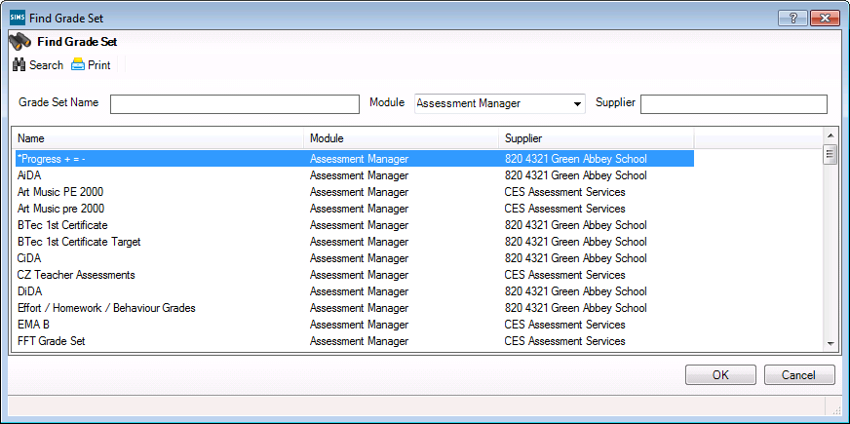
- Enter the Grade Set Name, if known or select the Module from the drop-down list.
The Module field filters the grade sets on the name of the SIMS module that was originally used to create the grade set, e.g. Examinations Organiser, Assessment Manager, etc.
The Supplier field displays the establishment that created the grade set, e.g. your LA or someone in your own school.
- Click the Search button to display a list of grade sets that match the search criteria entered.
- Highlight the required Name and click the OK button to return to the Add/Edit Discover Grade Value Definition dialog.
- In the Source Aspect(s) panel, click the Add button to display the Find Aspect dialog.
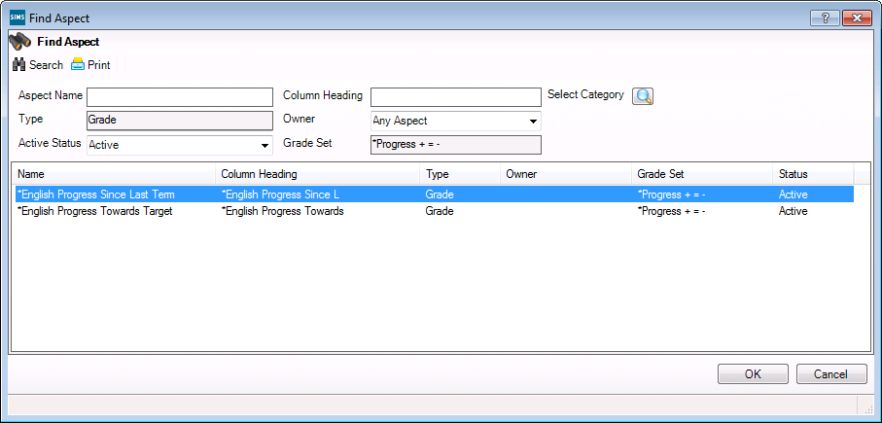
- Enter the Aspect Name, the Column Heading or click the Select Category browser button to display the Category Filter dialog.
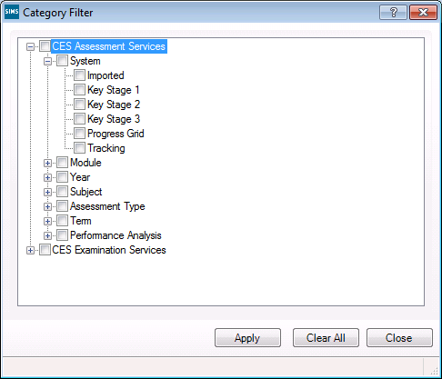
- Use the + and – symbols to expand and contract the tree structure and select the check box of any filters to be applied.
- Click the Apply button to return to the Find Aspect browser.
NOTE: Delete the default entry in the Grade Set field in the Find Aspect dialog to view all available aspects before searching.
- Click the Search button to display a list of aspects that match the search criteria.
- Select the required Aspect and click the OK button to populate the Source Aspect(s) panel. Continue adding source aspects until you have selected all those required.
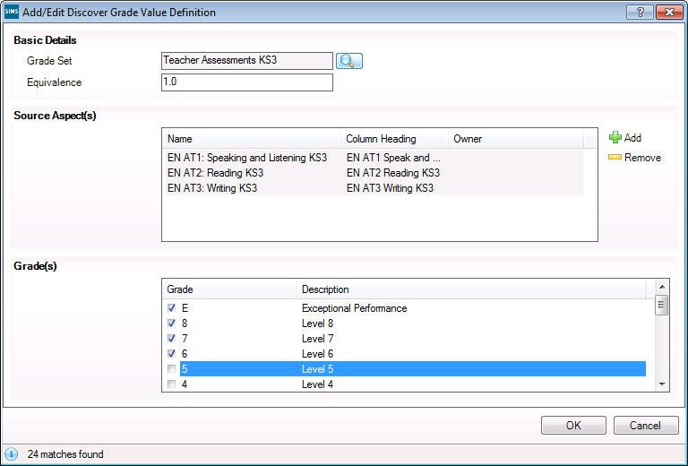
The Grade(s) panel is populated as the source aspects are selected.
- Select the appropriate Grade(s) by clicking in the check box adjacent to each grade.
- Click the OK button on the Add/Edit Discover Grade Value Definition dialog to return to the Discover Aspect Detail page.
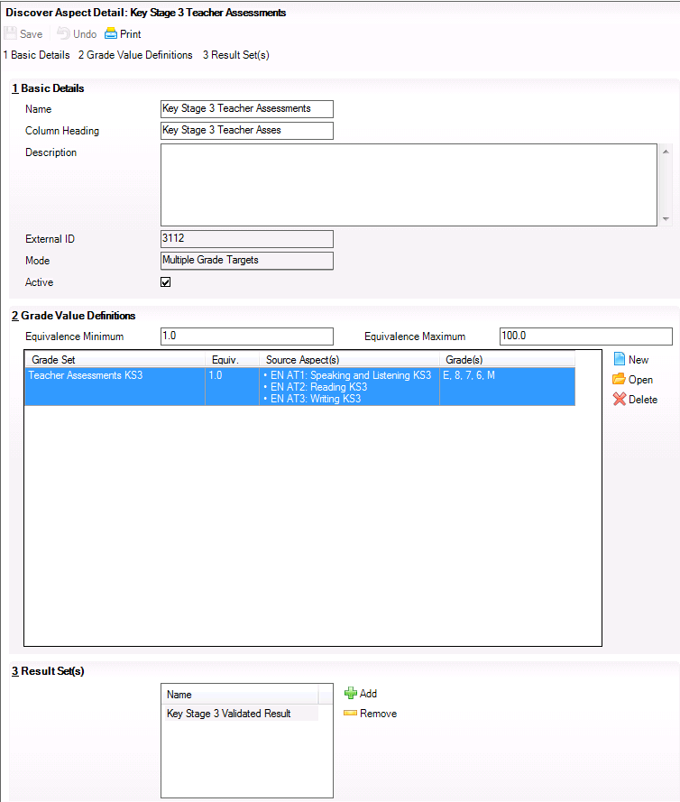
- In the Result Set(s) panel, click the Add button to display the Find Result Set dialog.
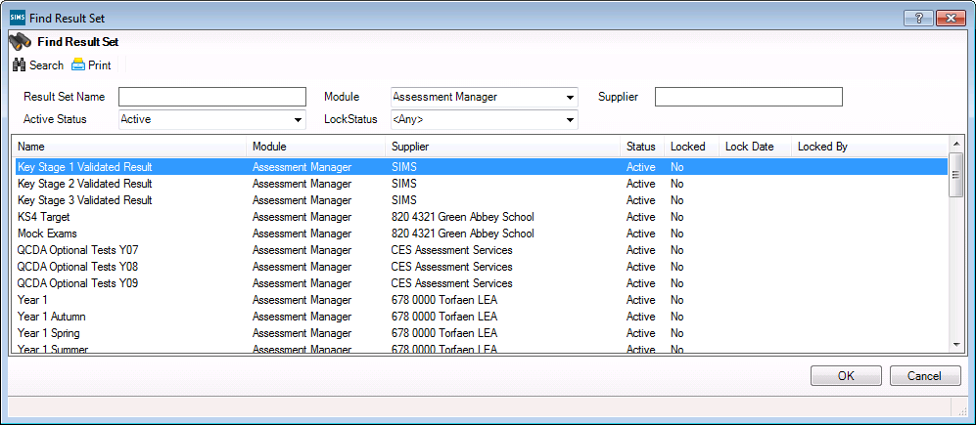
- Enter the Result Set Name, if known or select the Module from the drop-down list.
The Module field filters the result sets on the name of the SIMS module that was originally used to create the result set, e.g. Examinations Organiser, Assessment Manager, etc.
The Supplier field displays the establishment that created the result set, e.g. your LA or someone in your own school.
- Select the Active Status or LockStatus from the respective drop-down lists. Locking a result set prevents the entry or editing of results in any column associated with that result set. The Lock Date and Locked By details are displayed if the result set has previously been locked.
- Click the Search button to display a list of result sets that match the search criteria entered.
- Highlight the required Name and click the OK button to return to the Discover Aspect Detail page.
- Click the Save button on the Discover Aspect Detail page to save the newly created Discover aspect.

Creating a Target Point Score Discover Aspect
When creating a new Discover aspect with the mode of Target Point Score, the Discover Aspect Detail page contains two additional panels for completion, Range Definitions and Result Set(s).
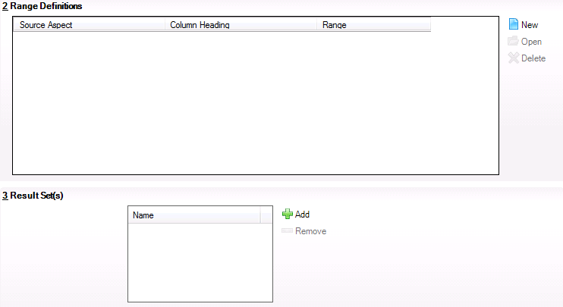
- In the Range Definitions panel, click the New button to display the Add/Edit Discover Range Definition dialog.
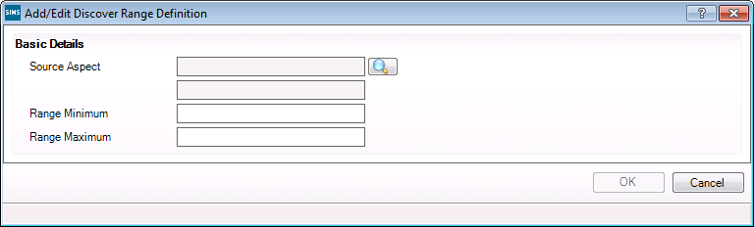
- Click the Browser button adjacent to the Source Aspect field to display the Find Aspect dialog.
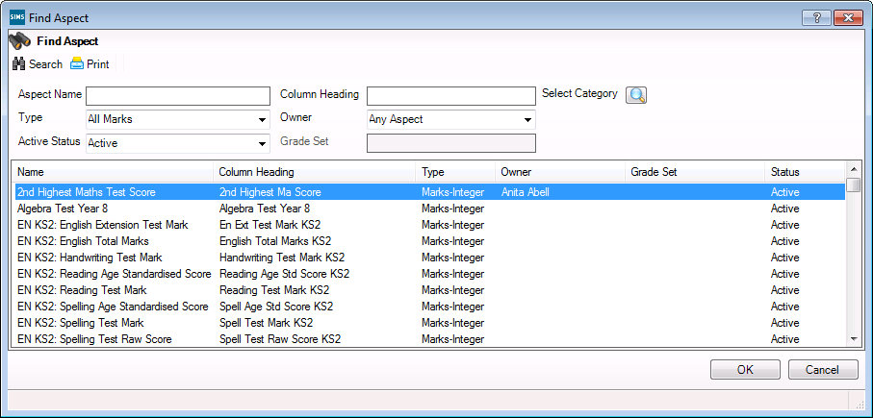
- Enter the Aspect Name, the Column Heading or click the Select Category browser button to display the Category Filter dialog.
- Use the + and – symbols to expand and contract the tree structure and select the check box of any filters to be applied.
- Click the Apply button to return to the Find Aspect browser.
- Click the Search button to display a list of aspects that match the search criteria.
- Select the required Aspect and click the OK button.
Once an aspect has been selected, the remaining fields in the dialog are populated automatically from the existing range definition in SIMS Assessment or Examinations Organiser (depending on the filters applied).
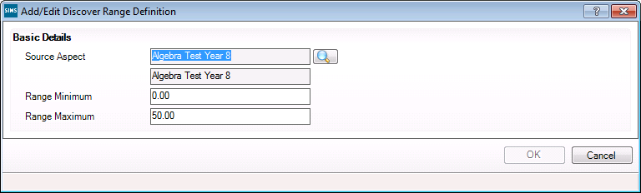
- Modify the Range Minimum and Range Maximum fields, if required.
- Click the OK button to populate the Range Definitions panel.
- In the Result Set(s) panel, click the Add button to display the Find Result Set dialog.
- Enter the Result Set Name, if known or select the Module from the drop-down list.
The Module field filters the result sets on the name of the SIMS module that was originally used to create the result set, e.g. Assessment Manager, Examinations Organiser, etc.
The Supplier field displays the establishment that created the result set, e.g. your LA or someone in your own school.
- Select the Active Status or LockStatus from the respective drop-down lists. Locking a result set prevents the entry or editing of results in any column associated with that result set. The Lock Date and Locked By details are displayed if the result set has previously been locked.
- Click the Search button to display a list of result sets that match the search criteria entered.
- Highlight the required Name and click the OK button.
- Click the OK button to return to the Discover Aspect Detail page.
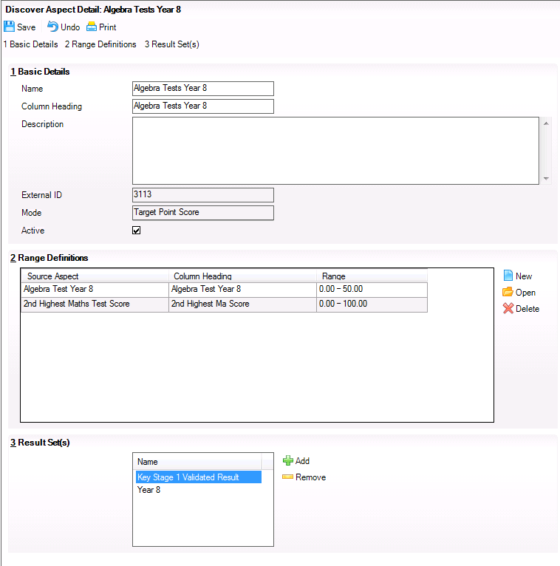

Creating an Amount of Progress Discover Aspect
When creating a new Discover aspect with the mode of Amount of Progress, the Discover Aspect Detail page contains two additional panels for completion, Amount of Progress and Result Sets.
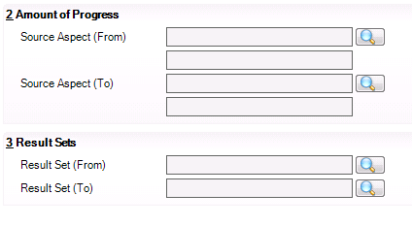
- In the Amount of Progress panel, click the Browser button adjacent to the Source Aspect (From) field to display the Find Aspect dialog.
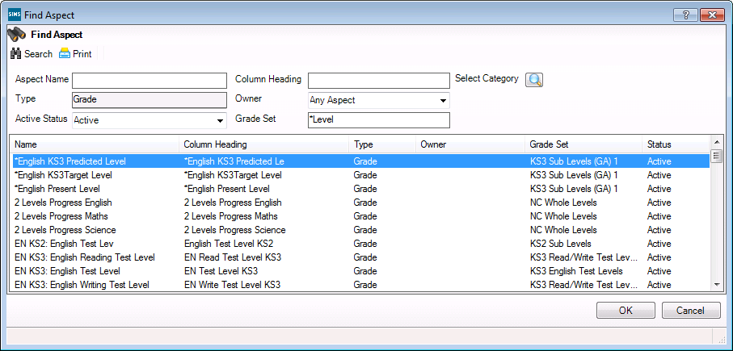
NOTE: Delete the default entry in the Grade Set field in the Find Aspect dialog to view all available aspects before searching.
- Enter the Aspect Name, the Column Heading or click the Select Category browser button to display the Category Filter dialog.
- Use the + and – symbols to expand and contract the tree structure and select the check box of any filters to be applied.
- Click the Apply button to return to the Find Aspect browser.
- Click the Search button to display a list of aspects that match the search criteria.
- Select the required Aspect and click the OK button.
Click the Browser button adjacent to the Source Aspect (To) field to display the Find Aspect dialog again.
Repeat Steps 2-6 to populate the Source Aspect (To) field.
- In the Result Sets panel, click the Browser button adjacent to the Result Set (From) field to display the Find Result Set dialog.
- Enter the Result Set Name, if known or select the Module from the drop-down list.
The Module field filters the result sets on the name of the SIMS module that was originally used to create the result set, e.g. Assessment Manager, Examinations Organiser, etc.
The Supplier field displays the establishment that created the result set, e.g. your LA or someone in your own school.
- Select the Active Status or LockStatus from the respective drop-down lists. Locking a result set prevents the entry or editing of results in any column associated with that result set. The Lock Date and Locked By details are displayed if the result set has previously been locked.
- Click the Search button to display a list of result sets that match the search criteria entered.
- Highlight the required Name and click the OK button.
- Click the Browser button adjacent to the Result Set (To) field to display the Find Result Set Browser dialog again.
Repeat Steps 8-11 to populate the Result Set (To) field.
- Click the Save button on the Discover Aspect Detail page to save the newly created Discover aspect.
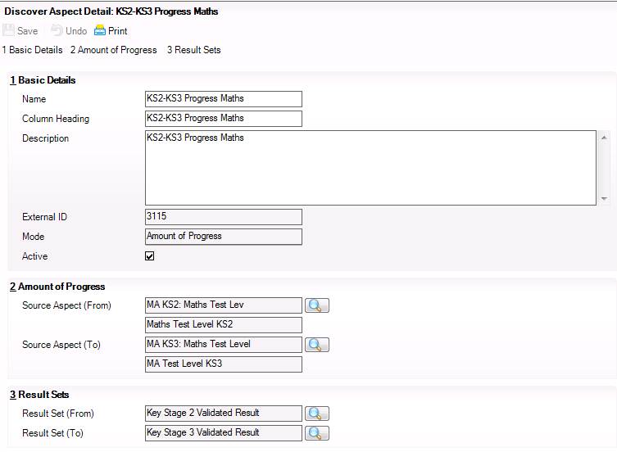

Generating the Discover Aspect Results
Once the required Discover aspects have been defined, it is essential that the results for these aspects are generated in SIMS before the aspects, grade sets and result sets are transferred into Discover to be used in the creation of Assessment graphs.
Before the generation of results is begun, the Aspect Result Generation Settings can be modified, if required.
- In SIMS, select Tools | Performance | Analysis | Discover Setup to display the Discover Setup Details page.
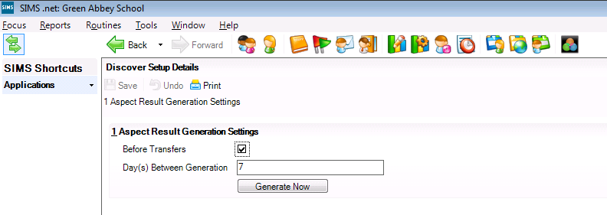
The Before Transfers check box is selected by default.
The Day(s) Between Generation field defaults to the number 1 but this can be changed to a different number of your choice. This figure indicates the numbers of days to elapse before the results are generated.
- Click the Save button.
- Click the Generate Now button to display the following warning message:
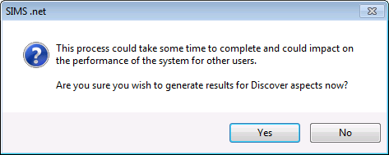
- Click the Yes button to begin the generation of results for the Discover aspects. When the process is complete, a message is displayed.
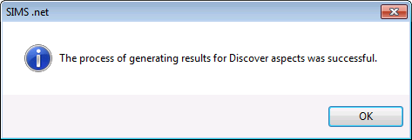
Once the results have been created for the Discover aspects, you can begin incorporating the aspects, grade sets and result sets into your own Assessment graphs via the Discover SIMS Configuration utility.

Using the Discover SIMS Configuration Utility to Create Assessment Graphs
In This Chapter
Introduction 59
Logging into the Discover SIMS Configuration Utility 60
Investigating a Pending Transfer 65
Editing a Result Set 67
Understanding the Assessment Graphs Page 69
Creating a New Assessment Graph Definition 77
Creating an XML File of Graph Definitions for Export 126
Importing Graph Definitions 129
Running the Transfer Process 131

Introduction
The Discover SIMS Configuration utility sits between SIMS and Discover and provides the ability to change or customise different areas within Discover. It also facilitates the copying of data from the SIMS database into the Discover database. The General Settings page of the utility mainly relates to the display and interval ranges of specific graphs but the other pages of the Discover SIMS Configuration utility are instrumental in the creation of your own Assessment graphs.

Permissions
It is only possible to see data items in Discover for which you have been granted suitable permissions in SIMS.
- The following user roles can maintain the Assessment functions within the Discover SIMS Configuration utility:
- Senior Management Team members
- Assessment Coordinators.
- The following user roles can initiate the Transfer process from the Discover SIMS Configuration utility:
- Senior Management Team members
- School Administrators
- Administration Assistants
- Assessment Coordinators
- System Managers.
- The following user roles can add and amend aspects, result sets and Assessment graph parameters in the Result Sets and Assessment Graphs pages in the Discover SIMS Configuration utility:
- Senior Management Team members
- Assessment Coordinators.

Logging into the Discover SIMS Configuration Utility
- Click the Start button and select All Programs | SIMS Applications | Discover Configuration.
- Alternatively, select the Discover Configuration icon from the list of frequently used programs.
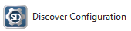
- Click the Discover Configuration icon to display the Discover SIMS Configuration dialog.
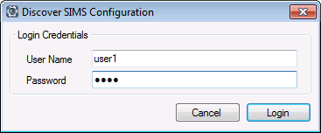
- Specify your SIMS Login Credentials by entering your User Name and Password.
- Click the Login button to display the General Settings page of the Discover SIMS Configuration utility.
Where your Windows account has been defined as a Discover Group User in SIMS with Senior Management and System Manager permissions, you can access the Discover SIMS Configuration utility without logging in.

Specifying the General Settings
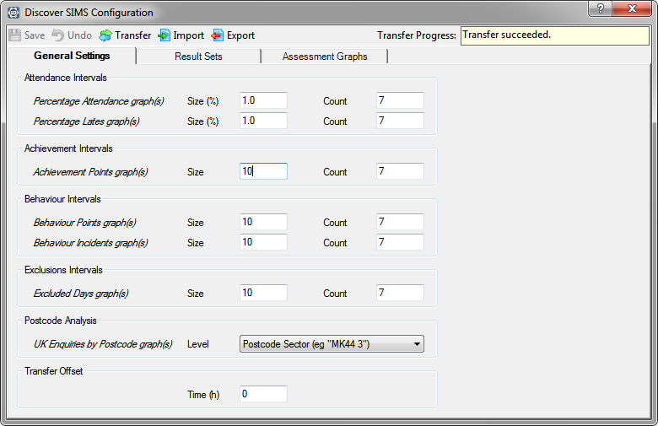
In the Attendance Intervals panel, it is possible to specify the range to be used on the x-axis of the graphs.
- For the Percentage Attendance and Percentage Lates graph(s) set the Size (%) to an interval between 0.2 and 20.0. The default is set to 1.0.
- Set the Count to a figure between 4 and 10. The default is set to 7.
For example, if you select 7 data points in the Count field and you set the interval in the Size (%) field to 2.0, the x-axis of the graph shows seven bars for Attendance or Lates with an interval of 2% between them, e.g. 100%, 98%, 96%, 94%, 92%, 90% and <90%. The calculated value for a student’s percentage attendance is always rounded down so, in this example, students with 98.1% or 99.9% are included in the 2nd bar of the graph.
IMPORTANT NOTE: The combination of the interval and the number of data points cannot allow the x-axis range to be less than 0% or greater than 100%.
- In the Achievement Intervals panel, set the Size to an interval between 2 and 100. The default is set to 10 for Achievement Points graphs(s).
- Set the Count to a figure between 4 and 10. The default is set to 7.
For example, if you select 7 data points in the Count field and you set the interval in the Size field to 10, the x-axis of the graph shows seven bars for Achievements with an interval of 10 points between them, e.g. 0, 1-10, 11-20, 21-30, 31-40, 41-50 and 51+.
- In the Behaviour Intervals panel, set the Size to an interval between 2 and 100. The default is set to 10 for both Behaviour Points and Behaviour Incidents graph(s).
- Set the Count to a figure between 4 and 10. The default is set to 7.
For example, if you select 7 data points in the Count field and you set the interval in the Size field to 10, the x-axis of the graph shows seven bars for Behaviour Points and Behaviour Incidents with an interval of 10 points/incidents between them, e.g. 0, 1-10, 11-20, 21-30, 31-40, 41-50 and 51+.
- In the Exclusions Intervals panel, set the Size to an interval between 2 and 20. The default is set to 10.
- Set the Count to a figure between 4 and 10. The default is set to 7.
For example, if you select 7 data points in the Count field and you set the interval in the Size field to 10, the x-axis of the graph shows seven bars for Exclusion Days with an interval of 10 days between them, e.g. 0, 1-10, 11-20, 21-30, 31-40, 41-50 and 51+.
In the Postcode Analysis panel, it is possible to specify the depth of the search level when analysing postcode data. Some schools may have a high proportion of international students or boarders who are not educated within their residential area, whereas, some Primary schools may have a very low number of pupils who live outside the school’s catchment area. To enable both types of school to specify how the Postcode Analysis is conducted, there are four depths of search level available:
Postcode Area (e.g. "MK")
Postcode District (e.g. "MK44")
Postcode Sector (e.g. "MK44 3")
Postcode Unit (e.g. "MK44 3JZ")
- Click the Level drop-down list and select the appropriate search depth for your school. The default is set to Postcode Sector (e.g. MK44 3) which is an example only.
- In the Transfer Offset panel, it is possible to specify the number of hours, either before or after its preset time, when the transfer of data from SIMS to the Discover database will take place. This is only a precaution in the unlikely event that the transfer is unable to complete successfully at its preset time because it has overlapped or coincided with another backup routine, for example.
It is possible to offset the Time (h) by up to +12 or -12 hours from the original preset time.
IMPORTANT NOTE: It is strongly recommended that transfer routines are not set to run at 12 midnight as memberships generally change at this time. The transfer routines should be staggered to run one after another with a suitable time lapse in between to ensure that each routine has sufficient time to complete successfully.
- For example, if the transfer of data from SIMS to Discover is scheduled to run at 23.00 or 11pm every night, entering a 2 in the Transfer Offset field ensures that the memberships will be as of the following day.
- The transfer is always run at the time specified in the scheduled task, but the effective date for all dated queries is the current date and time at the point of execution with the offset number of hours added to that (either positive or negative).
- For example, a scheduled task run at 01:00 (or 1.00am), with transfer offset of 0 - transfer is actually run at 01:00 (or 1.00am), and all dated queries use 01:00 (or 1.00am) the same day when viewing dated memberships.
- For example, a scheduled task run at 23:00 (or 11.00pm), with transfer offset of 2 - transfer is actually run at 23:00 (or 11.00pm), but all dated queries use 01:00 (or 1.00am) the next day when viewing dated memberships.
If another backup routine is still running at 1am, the routine attempts to run on five consecutive occasions with an interval of one minute between each attempt. If it is still not possible for the routine to run, an error is logged in the Discover.Warehouse.Service.log for your information.
The log file is located in the local application data directory of the service you are running. For example, in Windows 7, when running the service as MYCOMPUTER\DiscoverTransfer, the log file is located in the C:\Windows\ServiceProfiles\NetworkService\AppData\Local \Discover directory on the machine that the service is running on. The log file can be viewed and opened using Microsoft Notepad or the Discover Log Viewer utility.
The Undo button can only be used to undo any unsaved changes.
- Click the Save button to capture the changes.
Click the Transfer button at any time to initiate an immediate transfer without waiting until the preset time.
NOTE: Please ensure that no other users will be affected by the Transfer process before continuing.
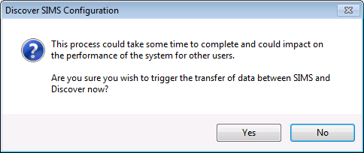
- Click the Yes button to proceed with the Transfer process.
The remaining pages of the Discover SIMS Configuration utility are instrumental in enabling you to create your own Assessment graphs.

Transfer Progress Messages and What they Mean
When the Transfer process is initiated by clicking the Transfer button on the Discover SIMS Configuration utility, a number of possible messages may be displayed for information as the routine progresses.

Message Displayed | Occurrence | Message Meaning
Transfer yet to be run | After installation of Discover but before any attempt has been made to transfer the data. | You must initiate the first Transfer process before using Discover.
Transfer requested, waiting for service | After the scheduled task has begun or you request a Transfer manually. | The SIMS Discover Data Transfer Service is pending.
Transfer started | After the SIMS Discover Data Transfer Service responds to the request and has started a Transfer. | The Transfer process is underway.
Transfer succeeded | After a Transfer has completed successfully. | The Transfer process was successful.
Transfer failed, will try again in N seconds | After a Transfer has completed with an error (typically N is 60 seconds for default settings). | The Transfer process tries to run on five consecutive attempts.
Transfer failed, see log file for details | After the final attempt (usually 5), the transfer has completed with an error. | Please see the Reviewing the Discover Warehouse Log File section below.
If the transfer process has completed successfully, the following message is displayed and it is suggested that you close the Discover SIMS Configuration utility and re-open it before accessing Discover.
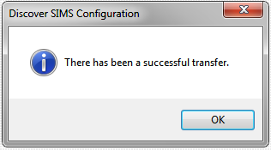
The status of a pending or previous Transfer can be viewed by hovering over the Transfer Progress field in the Discover SIMS Configuration utility. The following states are reported:
- Progress last updated on 15/02/2011 at 11.02. There has never been a successful transfer!
- Progress last updated on 15/02/2011 at 11.02. Last successful transfer on 14/02/2011 at 01.03.
- Data transfer triggered.

Investigating a Pending Transfer
If the Transfer process fails to initiate after several minutes, you should check that the SIMS Discover Data Transfer service is running.
- From the Control Panel on the server that is running the SIMS Discover Data Transfer service, select the Administrative Tools icon and click Services to display the Services (Local) page.
- Scroll down the page until you locate the details of the SIMS Discover Data Transfer service.
The Status of this service should be displayed as Started.
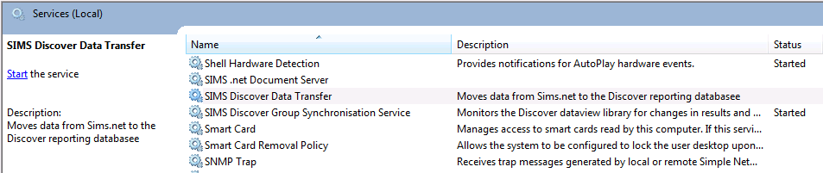
- If this is not the case, highlight the name of the service and click Start the service in the left-hand column of the Services (Local) page.
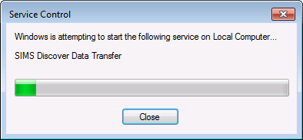
The selected service should now start.
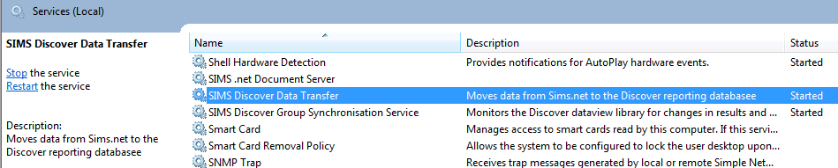
The Transfer process will initiate when the service is running and no further action is required.
If the Transfer process still fails to initiate, please review the Discover.Warehouse.Service.log for further information.

Reviewing the Discover Warehouse Service Log File
Every time the Transfer process is run, a log file entry is recorded in the Discover.Warehouse.Service.log. This log file details any issues identified in the data during the Transfer process and also acts as an audit log for any usage or error messages that may occur whilst using Discover.
The log file is located in the local application data directory of the service you are running. For example, in Windows 7, when running the service as MYCOMPUTER\DiscoverTransfer, the log file is located in the C:\Windows\ServiceProfiles\NetworkService\AppData\Local \Discover directory on the machine that the service is running on. The log file can be viewed and opened using Microsoft Notepad or an xml editing programme.

Editing a Result Set
The Result Sets page is empty until the first Transfer process is initiated. Once you have transferred successfully, all the results sets that are currently present in the SIMS database are available for selection from the Results Sets page.
The Discover aspects that you have created in SIMS and the generated results for these aspects are also transferred into Discover where they can be incorporated into your own Assessment graphs. These are now available for selection from the Find Aspects dialog when adding or editing an Assessment Graph (please see Creating a New Assessment Graph Definition on page 77).
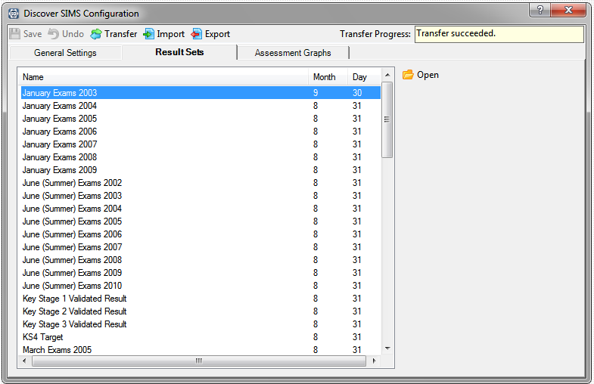
- In the Result Sets page, highlight the required result set and click the Open button to display the Edit Selected Result Set dialog.
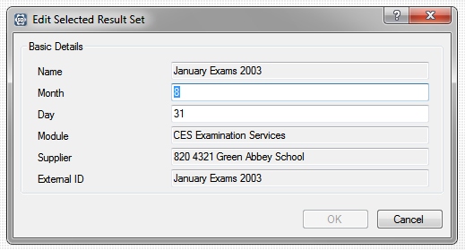
You can only change the figure in the Month field and the figure in the Day field.
The figure in the Month field represents the number of the month in the calendar, e.g. August is month 8, December is month 12, etc.
The figure in the Day field represents the day of the month, e.g. 31 of August is the default end of the academic year. The graphs in Discover are compiled from data collated over an academic year. Result sets from Assessment are not dated so in order to make a comparison against other data, e.g. Attendance data, a default date has been entered.
The Day and Month fields for a result set either represent the end of the academic year or the end of the term, whichever is applicable to the result set. For example, the Key Stage 2 Validated Result is set to Month 8 and Day 31. A result set for a term, for example, the Year 7 Autumn Term is set to Month 12 and Day 31.
- Make the necessary changes and click the OK button to return to the Result Sets page.
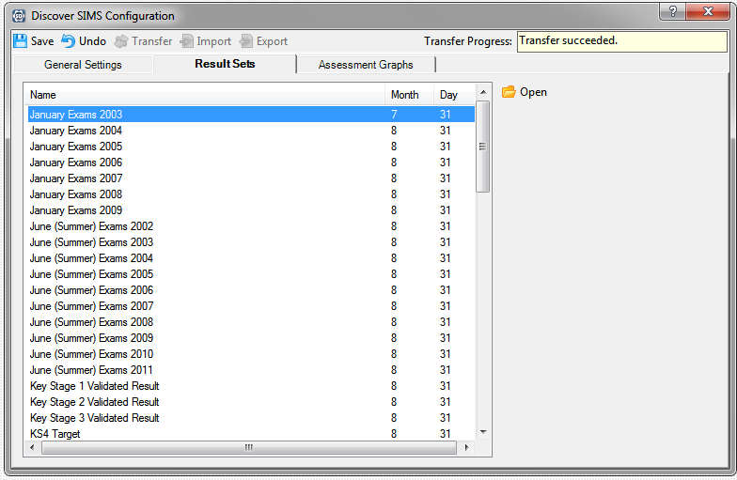
The Undo button can be used to undo any unsaved changes. Please be aware that all unsaved changes will be lost, not just the last action.
- Click the Save button when you have selected all the required result sets.

Understanding the Assessment Graphs Page
The Assessment Graphs page is initially populated with the details of the pre-defined Assessment graph definitions that have been supplied by Capita SIMS. The pre-defined graph definitions are in the Style of a Venn Diagram or a True/False Bar graph, only. It is not possible to edit these pre-defined definitions but you can create a new graph of your own specification based on an existing graph definition.
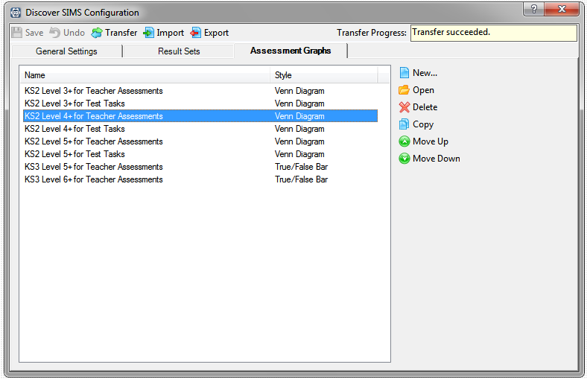
In the Assessment Graphs page, highlight the Name of an existing graph definition and click the Move Up or Move Down button to re-arrange the display order of the graph definitions, if required.
Move Up button
Move Down button
NOTE: The order of the graph definitions listed in the Assessment Graphs page is reflected in the order of the pre-defined Assessment graphs that can be accessed from the Assessment button on the Discover Application Bar.
Assessment button
Highlight any of the existing pre-defined graph definitions and click the Open button to display the Add/Edit Assessment Graph dialog.
Open button
The fields in this dialog vary depending on the Style of the graph definition that you are viewing or creating.
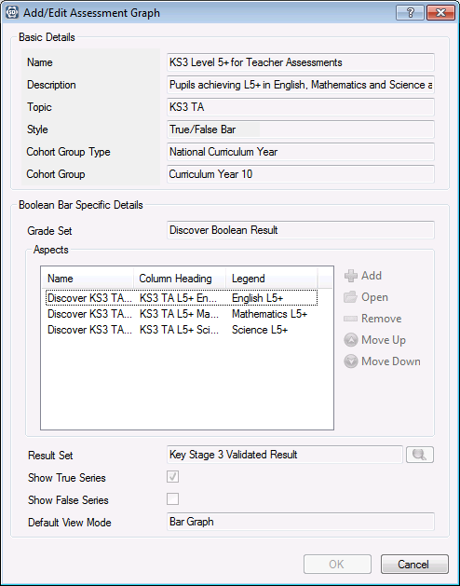
You cannot change the information for any of the pre-defined graph definitions unless you decide to copy the definition and use it as the basis for a new Assessment graph definition.

More Information:
Pre-defined Graphs Available in Discover on page 25

Copying an Existing Assessment Graph Definition
This section uses the Discover Venn Diagram Style as an example to illustrate how to copy an existing graph definition. If you want to create a new graph of this Style, click the New button instead of the Copy button to display the Add/Edit Assessment Graph dialog and carry out the following instructions.
- In the Assessment Graphs page of the Discover SIMS Configuration utility, highlight an existing pre-defined graph definition.
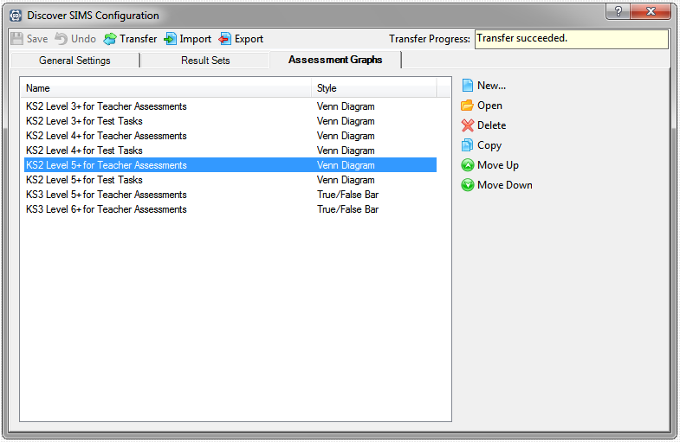
In this example, a new graph definition is being created based on an existing Venn diagram graph definition.
- Click the Copy button to display the Add/Edit Assessment Graph dialog for the selected graph definition.
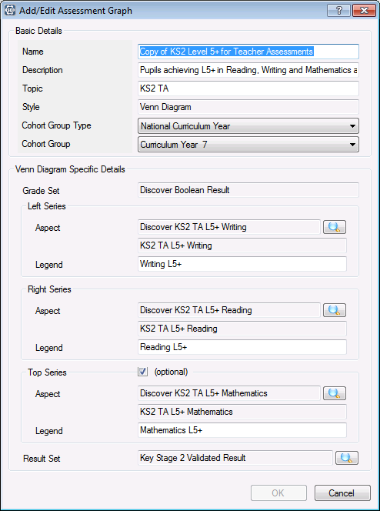
When copying an existing Assessment graph definition to use it as the basis for a new graph definition, the majority of the fields can be changed to reflect your new selections.
- In the Basic Details panel, enter a unique Name for the new graph definition.
- Enter a meaningful Description that enables you to differentiate this Assessment graph from other, existing graph definitions.
- Enter a Topic name. This is a short abbreviation of the graph name and is displayed as the secondary title of the graph when it is compiled on the Discover canvas.
The Style field is populated automatically with the type of graph that you have chosen to define and cannot be changed.
The Cohort Group Type field defaults to National Curriculum year but this can be changed by selecting an alternative cohort of pupil/students from the drop-down list.
- Select the Cohort Group from the drop-down list. This list is restricted by the cohort selected in the Cohort Group Type field above, e.g. if National Curriculum Year is selected as the Pastoral Group Type, you can only select the pastoral group from a list of National Curriculum Years.
In the Venn Diagram Specific Details panel, the Grade Set defaults to Discover Boolean Result and this cannot be changed.
The Left Series, Right Series and Top Series panels relate directly to the circles that are created when the graph definition is output as a Venn diagram. The Top Series is optional and can be included in the graph output by selecting the check box.
- In the Left Series panel, click the Browser button adjacent to the Aspect field to display the Find Aspects dialog.
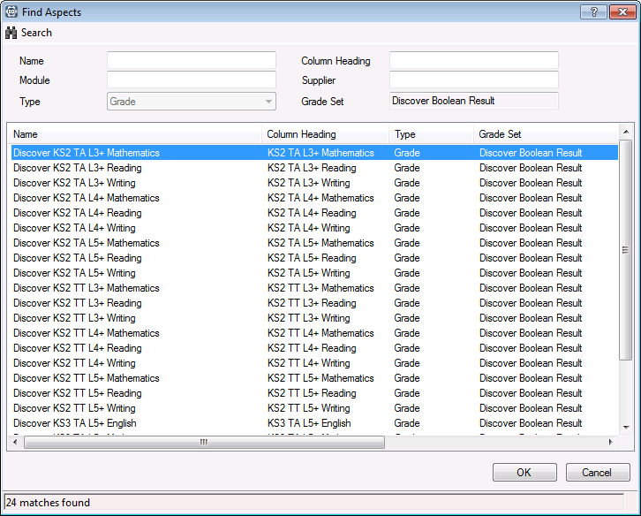
- Enter the Name or the Column Heading of the aspect that you are looking for.
- Alternatively, enter the Module or the Supplier name, if known.
The Module field filters the aspects on the name of the SIMS module that was originally used to create them, e.g. CES Discover Services.
The Supplier field displays the establishment that created the aspect, e.g. your LA or someone in your own school.
- Select the appropriate Type from the drop-down list. The Grade Set name cannot be changed.
- Click the Search button.
The dialog is populated with a list of aspects that match the search criteria entered.
It is possible to leave all the search fields blank before clicking the Search button to display a list of all available aspects, if details of a specific aspect are not known.
- Select the required aspect and click the OK button to select it.
In the Add/Edit Assessment Graph dialog, beneath the Aspect name, the Column Heading is populated automatically when the Aspect is selected.
The Legend field is populated automatically from the selected Aspect name. This will be the name of the data item that is displayed on the x axis of the graph when it is compiled on the Discover canvas. This name can be amended, if required.
- In the Right Series panel, click the Browser button adjacent to the Aspect field to display the Find Aspects dialog.
- Select the required aspect, please repeat Steps 8-10 above.
Beneath the Aspect name, the Column Heading is populated automatically when the Aspect is selected.
The Legend field is populated automatically from the selected Aspect name. This will be the name of the data item that is displayed on the x axis of the graph when it is compiled on the Discover canvas. This name can be amended, if required.
- In the Result Set panel, click the Browser button to display the Find Result Sets dialog. Only one result set can be selected.
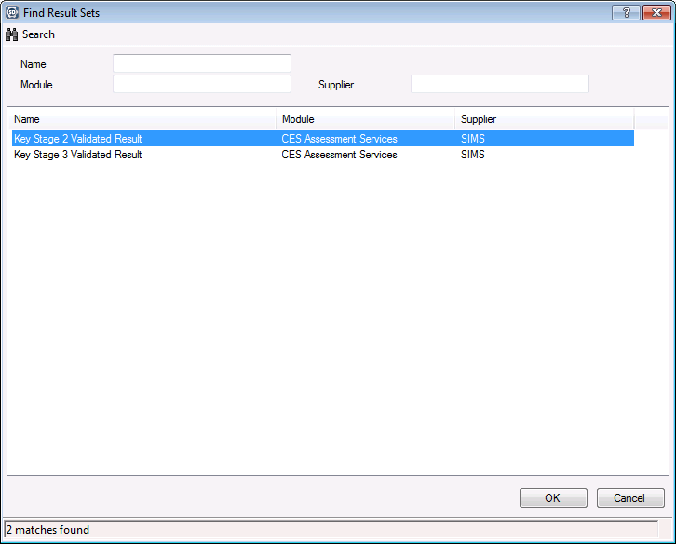
- Enter the Name of the result set.
- Alternatively, enter the Module name or the Supplier name before clicking the Search button.
The Module field filters the aspects on the name of the SIMS module that was originally used to create them, e.g. CES Assessment Services.
The Supplier field displays the establishment that created the result set, e.g. your LA or someone in your own school.
The dialog is populated with a list of result sets that match the search criteria entered.
It is possible to leave all of the search fields blank before clicking the Search button to display a list of all available result sets, if details of a specific result set are not known.
- Select the required result set and click the OK button.
- Click the OK button on the Add/Edit Assessment Graph dialog to save the Assessment graph definition.
- Click the Save button on the Assessment Graphs page of the Discover SIMS Configuration utility.
IMPORTANT NOTE: It is suggested that you click the Transfer button when you have made any changes in the Discover SIMS Configuration utility as this ensures that the changes are made straightaway. However, please ensure that this action will not affect other users of SIMS and Discover before proceeding.
The graph definition that you have created is now available in the drop-down list from the Assessment button on the Discover Application Bar.
Assessment button

Creating a New Assessment Graph Definition
To create a brand new Assessment Graph definition, click the New button on the Assessment Graphs page and select the relevant Style of graph from the drop-down list.
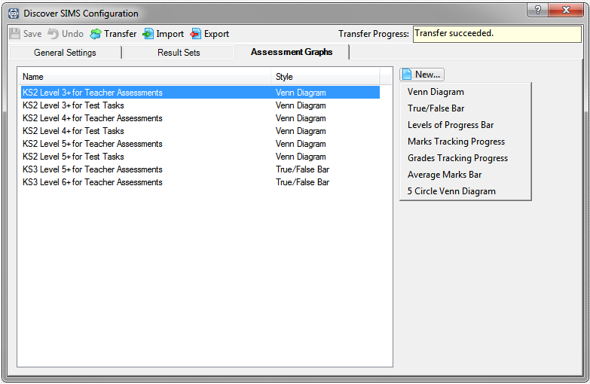
The example in Copying an Existing Assessment Graph Definition details the information that is required to copy or create a new graph of the Venn Diagram Style.
Please refer to the relevant section to view the appropriate Add/Edit Assessment Graph dialog for the style of graph that you are creating. The fields in this dialog vary depending on the Style of the graph definition that you are creating or copying (once created).
The following table details the types of aspects that can be incorporated into each Style of Assessment graph in Discover.

Style of Graph | Grade | Marks (Integer) | Marks (Decimal) | Age | Comment | Discover Aspect
Venn Diagram | x | x | x | x | x | y
True/False Bar | x | x | x | x | x | y
Levels of Progress Bar | y | x | x | x | x | y
Marks Tracking Progress | x | y | y | x | x | x
Grades Tracking Progress | y | x | x | x | x | x
Average Marks Bar | x | y | y | x | x | y
5 Circle Venn Diagram | x | x | x | x | x | y

More Information:
Adding/Editing an Assessment Graph of True/False Bar Style on page 78
Adding/Editing an Assessment Graph of Levels of Progress Style on page 86
Adding/Editing an Assessment Graph of Marks Tracking Progress Style on page 94
Adding/Editing an Assessment Graph of Grades Tracking Progress Style on page 104
Adding/Editing an Assessment Graph of Average Marks Bar Style on page 113
Adding/Editing a 5 Circle Venn Diagram on page 120

Adding/Editing an Assessment Graph of True/False Bar Style
When copying an existing Assessment graph definition to use it as the basis for a new graph definition, the majority of the fields can be changed to reflect your new selections.
IMPORTANT NOTE: If you add a new aspect or import one from SIMS, you must click the Transfer button in the Discover SIMS Configuration utility before creating your graph definition. This ensures that the aspect and its associated results are available for inclusion in your graph definition.
- Click the New button and select True/False Bar from the drop-down list to display the Add/Edit Assessment Graph dialog.
- In the Basic Details panel, enter a unique Name for the new graph definition.
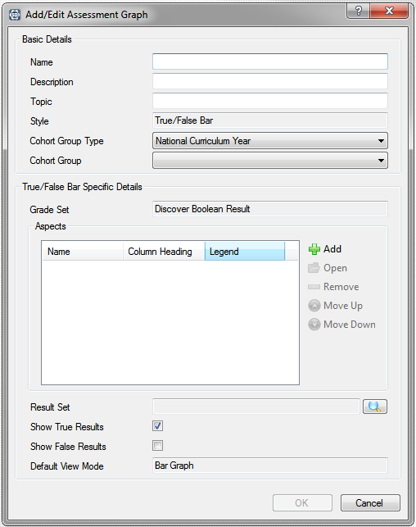
- Enter a meaningful Description that enables you to differentiate this Assessment graph from other, existing graph definitions.
- Enter a Topic name. This is merely a short abbreviation of the Description and can be based on the Key Stage, Year Group or other cohort of pupil/students that the graph definition is based on.
The Style field is populated automatically with the type of graph that you have chosen to define and cannot be changed.
The Cohort Group Type field defaults to National Curriculum Year but this can be changed by selecting an alternative cohort of pupil/students from the drop-down list.
- Select the Cohort Group from the drop-down list. This list is restricted by the cohort selection made in the Cohort Group Type field, e.g. if National Curriculum Year is selected as the Pastoral Group Type, you can only select the pastoral group from a list of National Curriculum Years.
In the True/False Bar Specific Details panel, the Grade Set defaults to Discover Boolean Result and this cannot be changed.
- Click the Add button to display the Find Aspects dialog. At least one aspect must be selected and the maximum number is 25.
- Enter the Name or the Column Heading of the aspect that you are looking for.
- Alternatively, enter the Module or the Supplier name, if known.
The Module field filters the aspects on the name of the SIMS module that was originally used to create them, e.g. CES Assessment Services, CES Discover Services.
The Supplier field displays the establishment that created the aspect, e.g. your LA or someone in your school.
- Select the appropriate Type from the drop-down list. The Grade Set name cannot be changed.
- Click the Search button.
The dialog is populated with a list of aspects that match the search criteria entered.
It is possible to leave all of the search fields blank before clicking the Search button to display a list of all available aspects, if details of a specific aspect are not known. Multiple aspects can be selected in a block using the Shift key. Multiple aspects that are spaced throughout the list can be selected individually using the Ctrl key.
- Select the required aspect and click the OK button to select it.
- In the Add/Edit Assessment Graph dialog, highlight an aspect name and click the Open button to display the Edit Selected Aspect dialog.
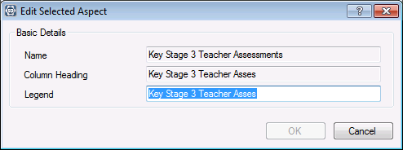
- Edit the Legend, if required. This will be the name of the data item that is displayed on the x axis of the graph when it is compiled on the Discover canvas. This name can be amended, if required.
- Click the OK button to return to the Add/Edit Assessment Graph dialog.
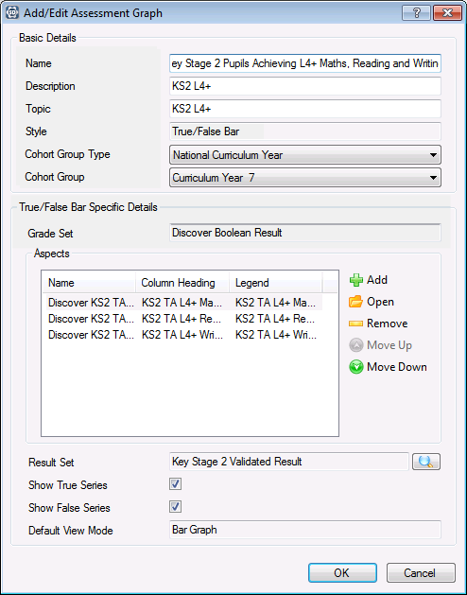
- If you have inadvertently added the wrong aspect, highlight the aspect Name and click the Remove button to delete it from the list of those available for selection.
- Continue adding aspects until you have selected all those that you require.
- Highlight an aspect and click the Move Up or Move Down button to re-arrange the display order of the aspects that you have selected.
- In the Result Set panel, click the Browser button to display the Find Result Sets dialog.
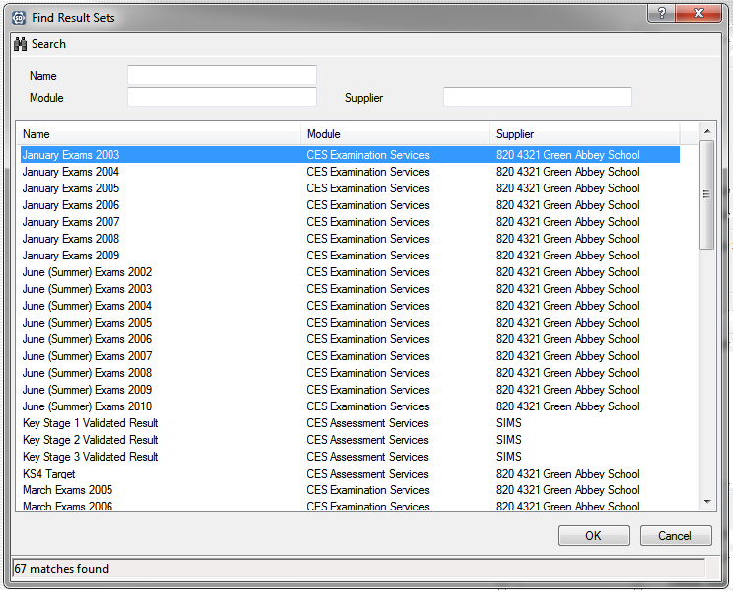
- Enter the Name of the result set.
- Alternatively, enter the Module name or the Supplier name before clicking the Search button.
The Module field filters the result sets on the name of the SIMS module that was originally used to create them, e.g. CES Assessment Services, CES Discover Services, etc.
The Supplier field displays the establishment that created the result set, e.g. your LA or someone in your school.
The dialog is populated with a list of result sets that match the search criteria entered.
It is possible to leave all of the search fields blank before clicking the Search button to display a list of all available result sets, if details of a specific result set are not known.
- Select the required result set and click the OK button to return to the Add/Edit Assessment Graph dialog.
The Show True Series check box is selected by default. This can be deselected if required and the Show False Series check box selected instead. It is possible to select both the check boxes so that the results for both true and false are displayed in the subsequent graph, if required.
The Default View Mode is set to Bar Graph, by default and this cannot be changed.
- Click the OK button to save the Assessment graph definition.
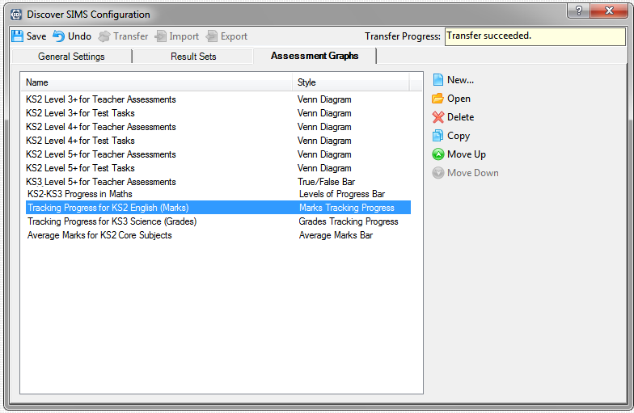
The new graph definition is listed in the Assessment Graphs page.
- Click the Save button on the Discover SIMS Configuration utility to save the graph definition.
IMPORTANT NOTE: If a new aspect has been created or included in the graph definition for the first time, the results associated with it will not have been brought over from SIMS. To ensure that the results are available, it is suggested that you click the Transfer button in the Discover SIMS Configuration utility. However, please ensure that this action will not affect other users of SIMS and Discover before proceeding.
The graph definition is now available in the drop-down list from the Assessment button on the Discover Application Bar.
Assessment button

Adding/Editing an Assessment Graph of Levels of Progress Style
It is essential that a Discover aspect of Mode type Amount of Progress has been created in SIMS and that the results for this aspect have been generated and transferred into Discover before you begin.
When copying an existing Assessment graph definition to use it as the basis for a new graph definition, the majority of the fields can be changed to reflect your new selections.
- Select Levels of Progress Bar from the New button to display the Add/Edit Assessment Graph dialog.
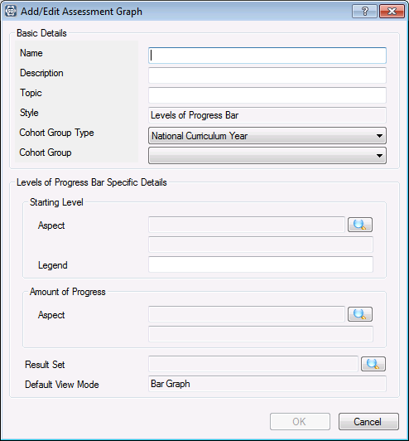
- In the Basic Details panel, enter a unique Name for the new graph definition.
- Enter a meaningful Description that enables you to differentiate this Assessment graph from other, existing graph definitions.
- Enter a Topic name. This is merely a short abbreviation of the Description and can be based on the Key Stage, Year Group or other cohort of pupil/students that the graph definition is based on.
The Style field is populated automatically with the type of graph that you have chosen to define and cannot be changed.
The Cohort Group Type field defaults to National Curriculum year but this can be changed by selecting an alternative cohort of pupil/students from the drop-down list.
- Select the Cohort Group from the drop-down list. This list is restricted by the cohort selection made in the Cohort Group Type field, e.g. if National Curriculum Year is selected as the Pastoral Group Type, you can only select the pastoral group from a list of National Curriculum Years.
- In the Levels of Progress Bar Specific Details panel, click the Browser button to display the Find Aspects dialog and specify the pupil/student's Starting Level.
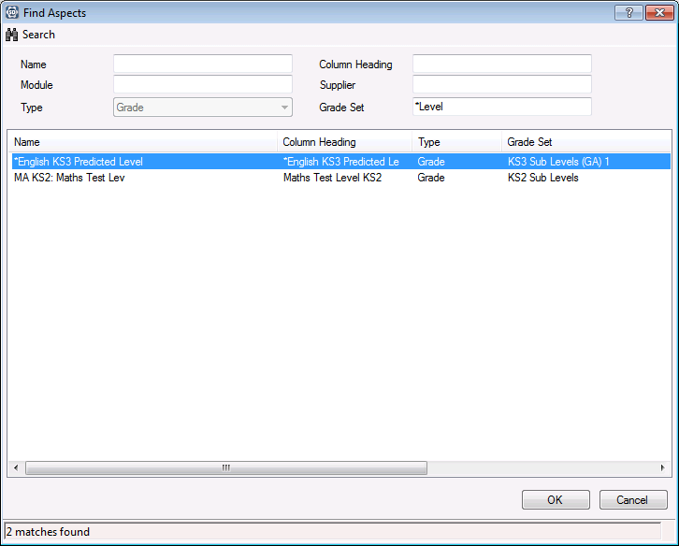
- Enter the Name or the Column Heading of the aspect that you are looking for.
- Alternatively, enter the Module or the Supplier name, if known.
The Module field filters the aspects on the name of the SIMS module that was originally used to create them, e.g. CES Assessment Services, CES Discover Services, etc.
The Supplier field displays the establishment that created the aspect, e.g. your LA or someone in your school.
- The Type field cannot be changed.
NOTE: Delete the default entry in the Grade Set field in the Find Aspects dialog to view all available aspects before searching.
It is possible to leave all of the search fields blank before clicking the Search button to display a list of all available aspects, if details of a specific aspect are not known.
- Select the required aspect and click the OK button to select it.
In the Starting Level panel, beneath the Aspect name, the column heading field is populated automatically when the Aspect is selected.
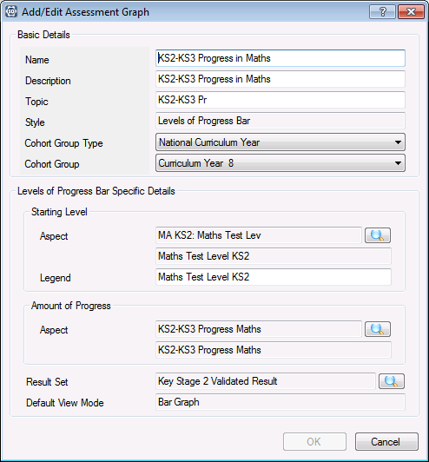
The Legend field is populated automatically from the selected Aspect name. This will be the name of the data item that is displayed on the x axis of the graph when it is compiled on the Discover canvas. This name can be amended, if required.
- In the Amount of Progress panel, click the Browser button to display the Find Aspects dialog.
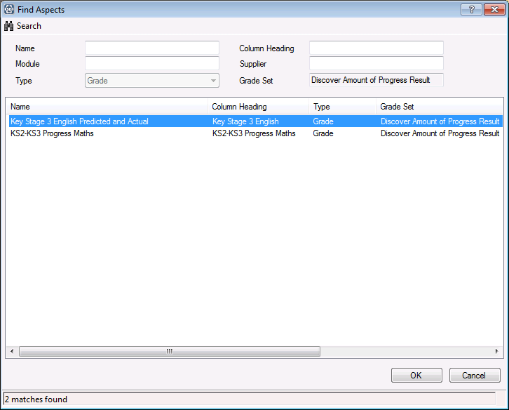
Only aspects with a Grade Set of Discover Amount of Progress Results are available for selection. This indicates how much progress has been made from the original starting level. Please repeat Steps 7-10.
- In the Result Set panel, click the Browser button to display the Find Result Sets dialog. Only one result set can be selected.
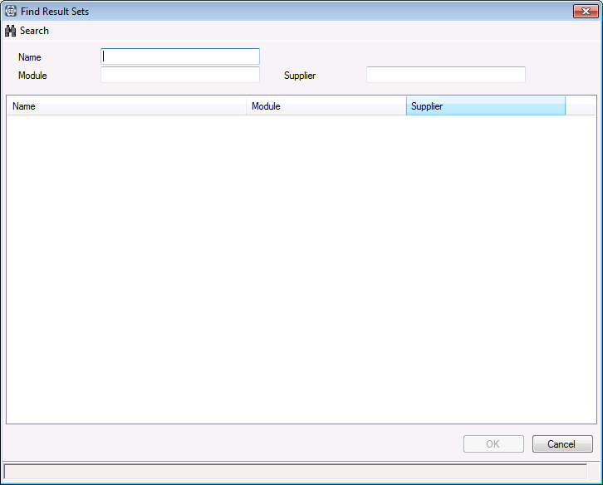
- Enter the Name of the result set.
- Alternatively, enter the Module name or the Supplier name before clicking the Search button.
The Module field filters the result sets on the name of the SIMS module that was originally used to create them, e.g. CES Assessment Services, CES Discover Services, etc.
The Supplier field displays the establishment that created the result set, e.g. your LA or someone from your school.
The dialog is populated with a list of result sets that match the search criteria entered.
It is possible to leave all of the search fields blank before clicking the Search button to display a list of all available result sets, if details of a specific result set are not known.
- Select the required result set and click the OK button to return to the Add/Edit Assessment Graph dialog.
The Default View Mode is set to Bar Graph and this cannot be changed.
- Click the OK button to save the Assessment graph definition.
The new graph definition is listed in the Assessments Graph page.
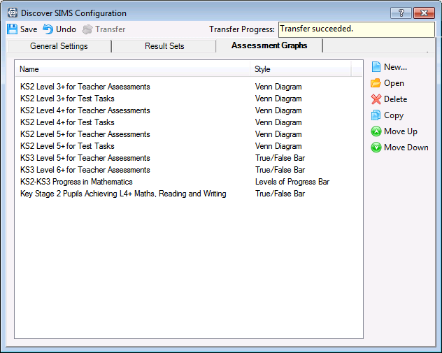
- Click the Save button on the Discover SIMS Configuration utility to save the graph definition.
IMPORTANT NOTE: It is suggested that you click the Transfer button when you have made any changes in the Discover SIMS Configuration utility as this ensures that the changes are made straightaway. However, please ensure that this action will not affect other users of SIMS and Discover before proceeding.
The graph definition is now available in the drop-down list from the Assessment button on the Discover Application Bar.
Assessment button
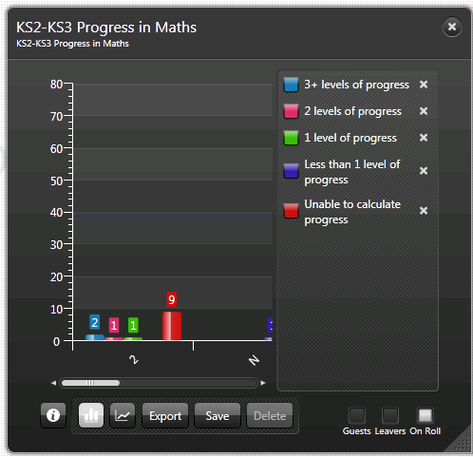

More Information:
Creating an Amount of Progress Discover Aspect on page 54

Adding/Editing an Assessment Graph of Marks Tracking Progress Style
It is essential that at least one Assessment definition is present in the SIMS database and that this has been transferred into Discover before you begin.
When copying an existing Assessment graph definition to use it as the basis for a new graph definition, the majority of the fields can be changed to reflect your new selections.
- Select Marks Tracking Progress from the New button to display the Add/Edit Assessment Graph dialog.
- In the Basic Details panel, enter a unique Name for the new graph definition.
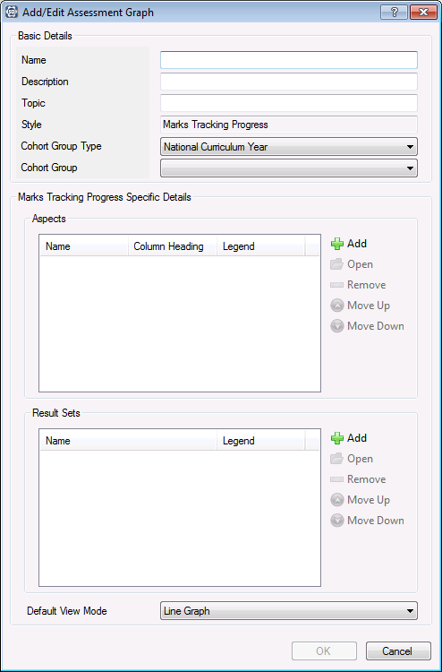
- Enter a meaningful Description that enables you to differentiate this Assessment graph from other, existing graph definitions.
- Enter a Topic name. This is merely a short abbreviation of the Description and can be based on the Key Stage, Year Group or other cohort of pupil/students that the graph definition is based on.
The Style field is populated automatically with the type of graph that you have chosen to define and cannot be changed.
The Cohort Group Type field defaults to National Curriculum year but this can be changed by selecting an alternative cohort of pupil/students from the drop-down list.
- Select the Cohort Group from the drop-down list. This list is restricted by the cohort selection made in the Cohort Group Type field, e.g. if National Curriculum Year is selected as the Pastoral Group Type, you can only select the pastoral group from a list of National Curriculum Years.
- In the Marks Tracking Progress Specific Details panel, click the Add button to display the Find Aspects dialog. At least one aspect must be selected and the maximum number is 25.
IMPORTANT NOTE: If you select a Discover aspect or any other aspect that does not have a score associated with the value, the graph will be blank once compiled.
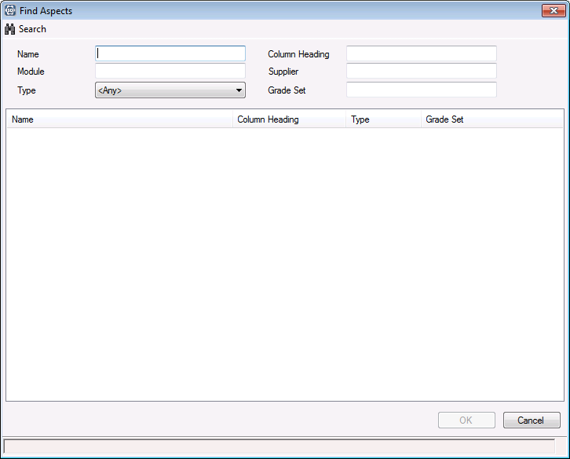
- Enter the Name or the Column Heading of the aspect that you are looking for.
- Alternatively, enter the Module or the Supplier name, if known.
The Module field filters the aspects on the name of the SIMS module that was originally used to create them, e.g. CES Assessment Services, CES Discover Services.
The Supplier field displays the establishment that created the aspect, e.g. your LA or someone in your school.
- Select the appropriate Type from the drop-down list or enter the Grade Set name before clicking the Search button.
The dialog is populated with a list of aspects that match the search criteria entered.
It is possible to leave all of the search fields blank before clicking the Search button to display a list of all available aspects, if details of a specific aspect are not known.
Multiple aspects can be selected in a block using the Shift key. Multiple aspects that are spaced throughout the list can be selected individually using the Ctrl key.
- Select the required aspect and click the OK button to select it. Continue adding aspects, as required. Please repeat Steps 6-10.
- In the Add/Edit Assessment Graph dialog, highlight an aspect name and click the Open button to display the Edit Selected Aspect dialog.
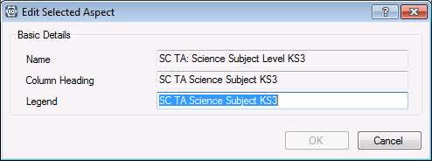
- Edit the Legend, if required. This will be the name of the data item that is displayed on the x axis of the graph when it is compiled on the Discover canvas. This name can be amended, if required.
- Click the OK button to return to the Add/Edit Assessment Graph dialog.
If you have made a mistake when selecting aspects, highlight the incorrect aspect name and click the Remove button to delete the aspect from the list of those available for inclusion in the graph.
Where multiple aspects have been selected, highlight an aspect and click the Move Up or Move Down button to re-arrange the order of the aspects that you have selected.
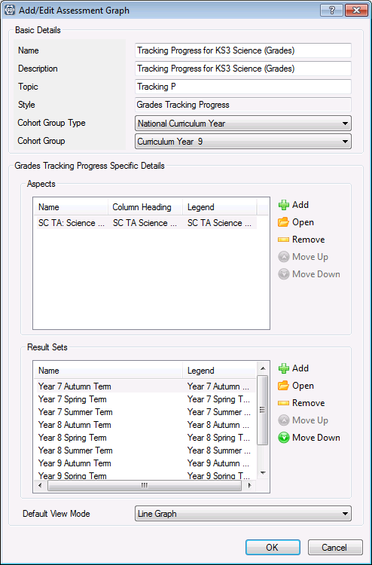
- In the Result Sets panel, click the Add button to display the Find Result Sets dialog. At least one result set must be selected and the maximum number is 25.
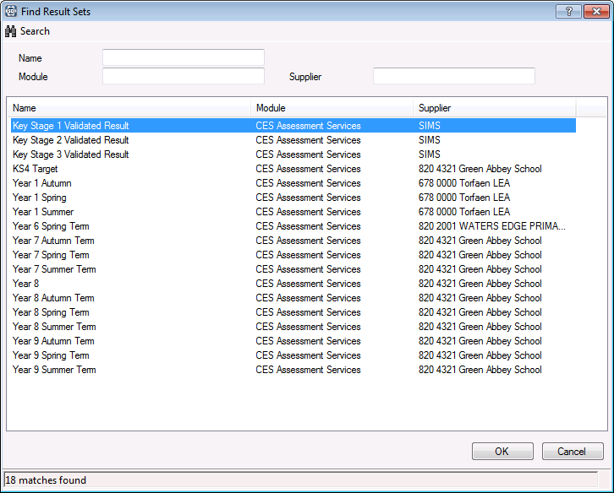
- Enter the Name of the result set.
- Alternatively, enter the Module name or the Supplier name before clicking the Search button.
The Module field filters the result sets on the name of the SIMS module that was originally used to create them, e.g. CES Assessment Services, CES Discover Services, etc.
The Supplier field displays the establishment that created the result set, e.g. your LA or someone in your school.
The dialog is populated with a list of result sets that match the search criteria entered.
It is possible to leave all the search fields blank before clicking the Search button to display a list of all available result sets, if details of a specific result set are not known.
Multiple result sets can be selected in a block using the Shift key. Multiple result sets that are spaced throughout the list can be selected individually using the Ctrl key.
- Select the required result set and click the OK button to return to the Add/Edit Assessment Graph dialog. Continue adding all the required result sets, please repeat Steps 14-17.
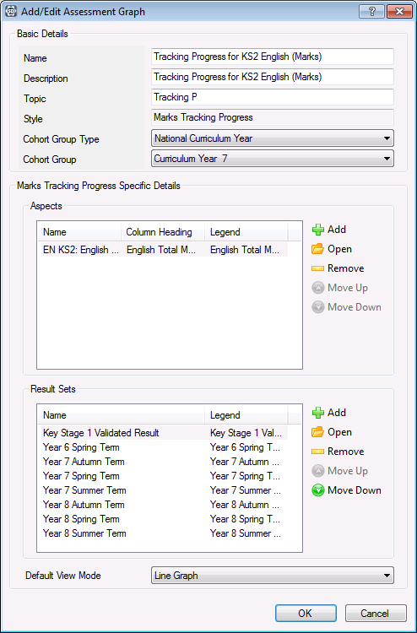
- You can highlight a result set name and click the Open button to display the Edit Selected Result Set dialog.
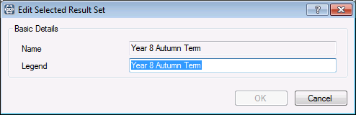
- Edit the Legend, if required. This will be the name of the data item that is displayed on the x axis of the graph when it is compiled on the Discover canvas. This name can be amended, if required.
- Click the OK button to return to the Add/Edit Assessment Graph dialog.
If you have made a mistake when selecting result sets, highlight the incorrect result set name and click the Remove button to delete the result set from the list of those available for inclusion in the graph.
Where multiple result sets have been selected, highlight a result set and click the Move Up or Move Down button to re-arrange the order of the result sets that you have selected.
The Default View Mode can be changed to an output of your choice, if required.
- Click the OK button to save the Assessment graph definition.
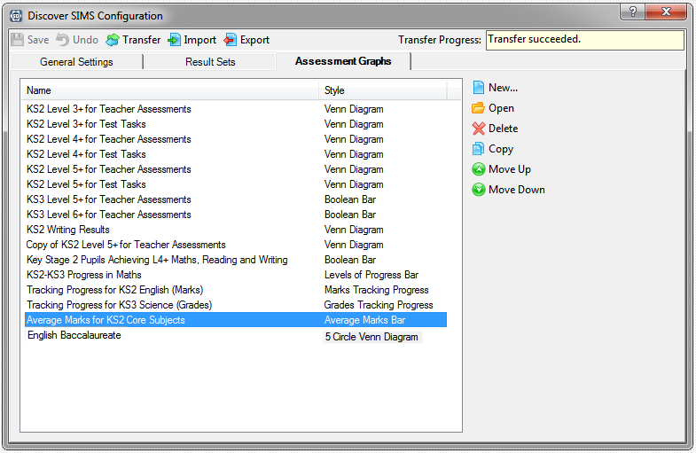
The new graph definition is listed in the Assessment Graphs page.
- Click the Save button on the Discover SIMS Configuration utility to save the graph definition.
IMPORTANT NOTE: It is suggested that you click the Transfer button when you have made any changes in the Discover SIMS Configuration utility as this ensures that the changes are made straightaway. However, please ensure that this action will not affect other users of SIMS and Discover before proceeding.
The graph definition is now available in the drop-down list from the Assessment button on the Discover Application Bar.
Assessment button
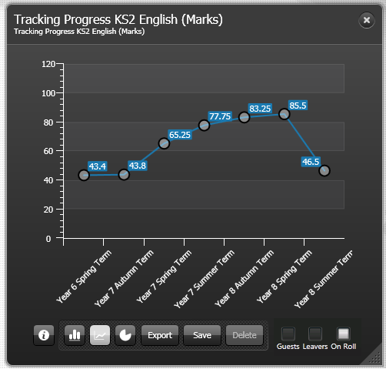
Where you have selected multiple aspects for inclusion in the Marks Tracking Progress graph definition, multiple lines are displayed on the compiled graph. This graphical representation is for a single aspect graph definition represented by a single line.

Adding/Editing an Assessment Graph of Grades Tracking Progress Style
It is essential that at least one Assessment definition is present in the SIMS database and that this has been transferred into Discover before you begin.
When copying an existing Assessment graph definition to use it as the basis for a new graph definition, the majority of the fields can be changed to reflect your new selections.
- Select Grades Tracking Progress from the New button to display the Add/Edit Assessment Graph dialog.
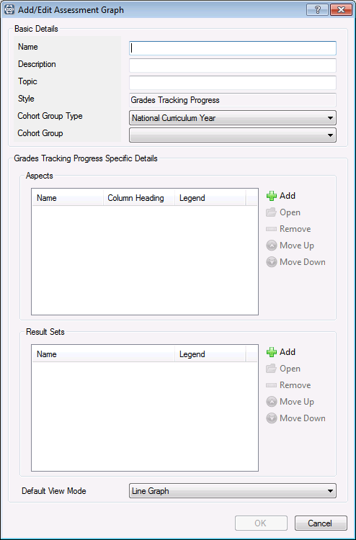
- In the Basic Details panel, enter a unique Name for the new graph definition.
- Enter a meaningful Description that enables you to differentiate this Assessment graph from other, existing graph definitions.
- Enter a Topic name. This is merely a short abbreviation of the Description and can be based on the Key Stage, Year Group or other cohort of pupil/students that the graph definition is based on.
The Style field is populated automatically with the type of graph that you have chosen to define and cannot be changed.
The Cohort Group Type field defaults to National Curriculum year but this can be changed by selecting an alternative cohort of pupil/students from the drop-down list.
- Select the Cohort Group from the drop-down list. This list is restricted by the cohort selection made in the Cohort Group Type field, e.g. if National Curriculum Year is selected as the Pastoral Group Type, you can only select the pastoral group from a list of National Curriculum Years.
- In the Grades Tracking Progress Specific Details panel, click the Add button to display the Find Aspects dialog. At least one aspect must be selected and the maximum number is 25.
IMPORTANT NOTE: If you select a Discover aspect or any other aspect that does not have a score associated with the value, the graph will be blank once compiled.
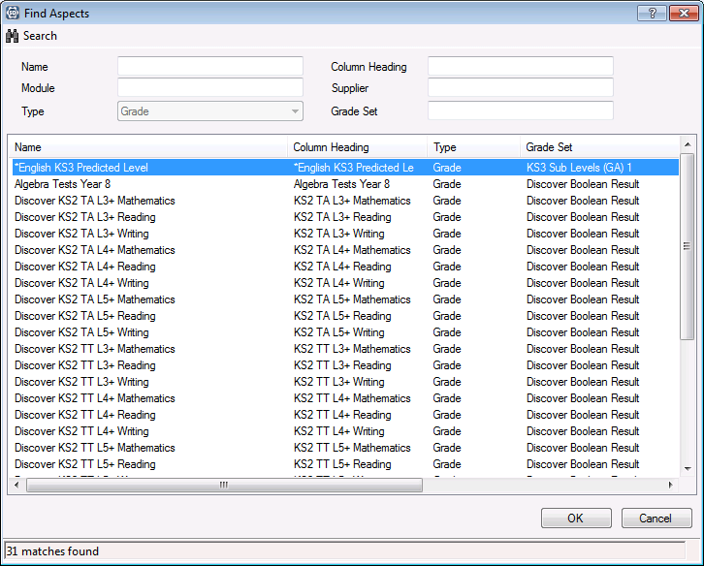
- Enter the Name or the Column Heading of the aspect that you are looking for.
- Alternatively, enter the Module or the Supplier name, if known.
The Module field filters the aspects on the name of the SIMS module that was originally used to create them, e.g. CES Assessment Services, CES Discover Services.
The Supplier field displays the establishment that created the aspect, e.g. your LA or someone in your school.
The Type defaults to Grade and cannot be changed.
- Enter the Grade Set name, if known.
It is possible to leave all the search fields blank before clicking the Search button to display a list of all available aspects, if details of a specific aspect are not known.
The dialog is populated with a list of aspects that match the search criteria entered.
- Select the required aspect and click the OK button to select it. Continue adding aspects, as required. Please repeat Steps 7-10.
Multiple aspects can be selected in a block using the Shift key. Multiple aspects that are spaced throughout the list can be selected individually using the Ctrl key.
- In the Add/Edit Assessment Graph dialog, highlight an aspect name and click the Open button to display the Edit Selected Aspect dialog.
- Edit the Legend, if required. This will be the name of the data item that is displayed on the x axis of the graph when it is compiled on the Discover canvas. This name can be amended, if required.
- Click the OK button to return to the Add/Edit Assessment Graph dialog.
If you have made a mistake when selecting aspects, highlight the incorrect aspect name and click the Remove button to delete the aspect from the list of those available for inclusion in the graph.
Where multiple aspects have been selected, highlight an aspect and click the Move Up or Move Down button to re-arrange the order of the aspects that you have selected.
- Click the Add button to display the Find Result Sets dialog. At least one result set must be selected and the maximum number is 25.
- Enter the Name of the result set.
- Alternatively, enter the Module name or the Supplier name before clicking the Search button.
The Module field filters the result sets on the name of the SIMS module that was originally used to create them, e.g. CES Assessment Services, CES Discover Services, etc.
The Supplier field displays the establishment that created the result set, e.g. your LA or someone in your school.
The dialog is populated with a list of result sets that match the search criteria entered.
It is possible to leave all of the search fields blank before clicking the Search button to display a list of all available result sets, if details of a specific result set are not known.
Multiple result sets can be selected in a block using the Shift key. Multiple result sets that are spaced throughout the list can be selected individually using the Ctrl key.
- Select the required result set and click the OK button to return to the Add/Edit Assessment Graph dialog. Continue adding all the required result sets, please repeat Steps 14-17.
If you have made a mistake when selecting result sets, highlight the incorrect result set name and click the Remove button to delete the result set from the list of those available for inclusion in the graph.
Where multiple result sets have been selected, highlight a result set and use the Move Up or Move Down button to re-arrange the order of the result sets that you have selected.
- Highlight a result set name and click the Open button to display the Edit Selected Result Set dialog.
- Edit the Legend, if required. This will be the name of the data item that is displayed on the x axis of the graph when it is compiled on the Discover canvas. This name can be amended, if required. Click the OK button to return to the Add/Edit Assessment Graph dialog.
The Default View Mode is set to Line Graph but this can be changed, if required.
- Click the OK button to save the Assessment graph definition.
The new graph definition is listed in the Assessment Graphs page.
- Click the Save button on the Discover SIMS Configuration utility to save the graph definition.
IMPORTANT NOTE: It is suggested that you click the Transfer button when you have made any changes in the Discover SIMS Configuration utility as this ensures that the changes are made straightaway. However, please ensure that this action will not affect other users of SIMS and Discover before proceeding.
The graph definition is now available in the drop-down list from the Assessment button on the Discover Application Bar.
Assessment button
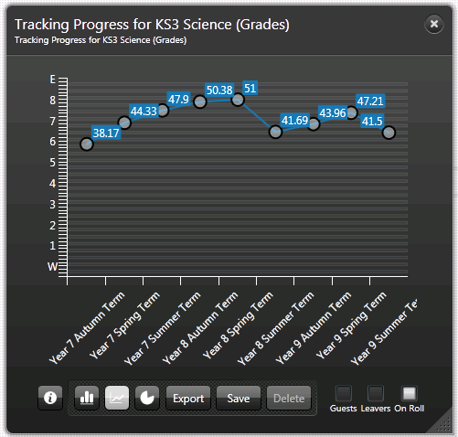
Where you have selected multiple aspects for inclusion in the Grades Tracking Progress graph definition, multiple lines are displayed on the compiled graph. This graphical representation is for a single aspect graph definition represented by a single line.

Adding/Editing an Assessment Graph of Average Marks Bar Style
It is essential that at least one Assessment definition is present in the SIMS database and that this has been transferred into Discover before you begin.
When copying an existing Assessment graph definition to use it as the basis for a new graph definition, the majority of the fields can be changed to reflect your new selections.
- Select Average Marks Bar from the New button to display the Add/Edit Assessment Graph dialog.
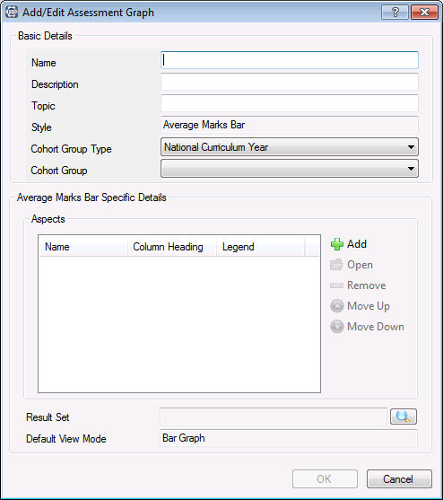
- In the Basic Details panel, enter a unique Name for the new graph definition.
- Enter a meaningful Description that enables you to differentiate this Assessment graph from other, existing graph definitions.
- Enter a Topic name. This is merely a short abbreviation of the Description and can be based on the Key Stage, Year Group or other cohort of pupil/students that the graph definition is based on.
The Style field is populated automatically with the type of graph that you have chosen to define and cannot be changed.
The Cohort Group Type field defaults to National Curriculum year but this can be changed by selecting an alternative cohort of pupil/students from the drop-down list.
- Select the Cohort Group from the drop-down list. This list is restricted by the cohort selection made in the Cohort Group Type field, e.g. if National Curriculum Year is selected as the Pastoral Group Type, you can only select the pastoral group from a list of National Curriculum Years.
- In the Average Marks Bar Specific Details panel, click the Add button to display the Find Aspects dialog. At least one aspect must be selected and the maximum number is 25.
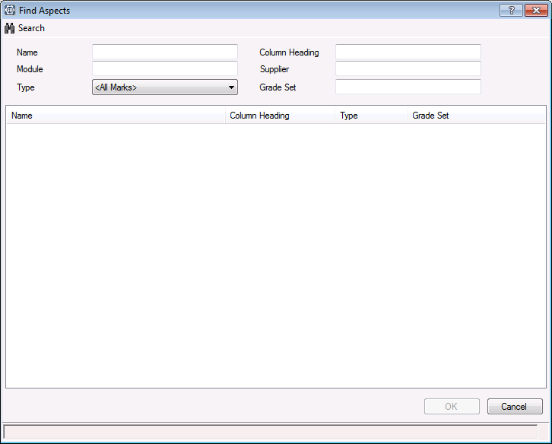
- Enter the Name or the Column Heading of the aspect that you are looking for.
- Alternatively, enter the Module or the Supplier name, if known.
The Module field filters the aspects on the name of the SIMS module that was originally used to create them, e.g. CES Assessment Services, CES Discover Services.
The Supplier field displays the establishment that created the aspect, e.g. your LA or someone in your school.
- Select the appropriate Type from the drop-down list or enter the Grade Set name before clicking the Search button.
It is possible to leave all the search fields blank before clicking the Search button to display a list of all available aspects, if details of a specific aspect are not known.
The dialog is populated with a list of aspects that match the search criteria entered.
Multiple aspects can be selected in a block using the Shift key. Multiple aspects that are spaced throughout the list can be selected collectively using the Ctrl key.
- Select the required aspect and click the OK button to select it. Continue adding aspects, as required. Please repeat Steps 6-10.
- In the Add/Edit Assessment Graph dialog, highlight an aspect name and click the Open button to display the Edit Selected Aspect dialog.
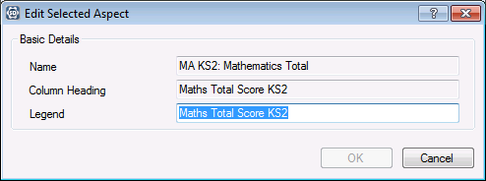
- Edit the Legend, if required. This will be the name of the data item that is displayed on the x axis of the graph when it is compiled on the Discover canvas. This name can be amended, if required.
- Click the OK button to return to the Add/Edit Assessment Graph dialog.
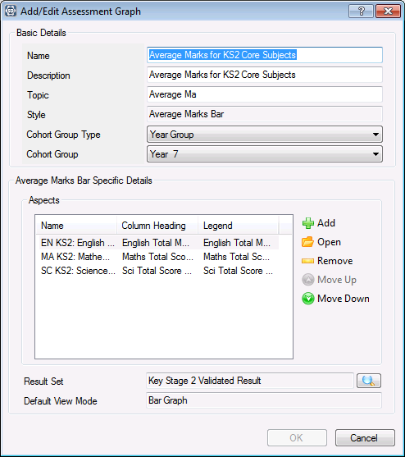
If you have made a mistake when selecting aspects, highlight the incorrect aspect name and click the Remove button to delete the aspect from the list of those available for inclusion in the graph.
Where multiple aspects have been selected, highlight an aspect and click the Move Up or Move Down button to re-arrange the order of the aspects that you have selected.
- In the Result Set panel, click the Browser button to display the Find Result Sets dialog.
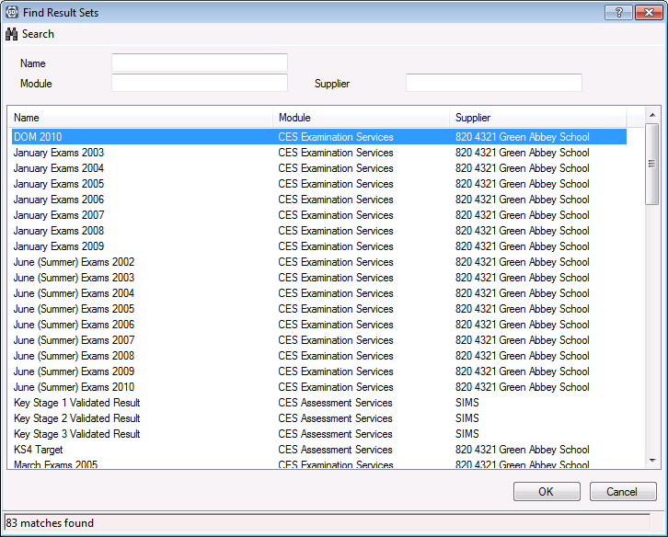
- Enter the Name of the result set, if known.
- Alternatively, enter the Module name or the Supplier name before clicking the Search button.
The Module field filters the result sets on the name of the SIMS module that was originally used to create them, e.g. CES Assessment Services, CES Discover Services, etc.
The Supplier field displays the establishment that created the result set, e.g. your LA or someone in your school.
The dialog is populated with a list of result sets that match the search criteria entered.
It is possible to leave all the search fields blank before clicking the Search button to display a list of all available result sets, if details of a specific result set are not known.
- Select the required result set and click the OK button to return to the Add/Edit Assessment Graph dialog.
The Default View Mode is set to Bar Graph, by default and this cannot be changed.
- Click the OK button to save the Assessment graph definition.
The new graph definition is listed in the Assessment Graphs page.
- Click the Save button on the Discover SIMS Configuration utility to save the graph definition.
IMPORTANT NOTE: It is suggested that you click the Transfer button when you have made any changes in the Discover SIMS Configuration utility as this ensures that the changes are made straightaway. However, please ensure that this action will not affect other users of SIMS and Discover before proceeding.
The graph definition is now available in the drop-down list from the Assessment button on the Discover Application Bar.
Assessment button
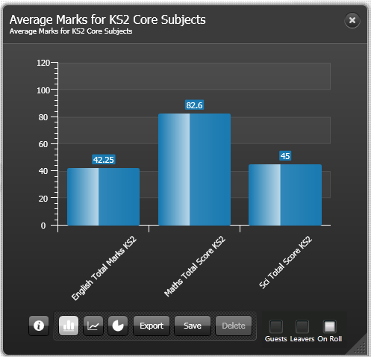

Adding/Editing a 5 Circle Venn Diagram
If you are creating an English Baccalaureate 5 circle Venn diagram, the following activities must have been undertaken in Examinations Organiser to ensure that the necessary data is available for transfer into Discover:
- Exams Basedata for the appropriate season must have been imported.
- Results must have been recorded against the appropriate marksheets that contain the relevant aspects.
- New Discover aspects must be created via Tools | Performance | Analysis | Discover Aspects of Multiple Grade Targets mode.
- Click the Generate Now button in the Discover Setup Details page in SIMS.
- In the Discover SIMS Configuration utility, click the Transfer button to copy the data over into Discover.
- Select 5 Circle Venn Diagram from the New button to display the Add/Edit Assessment Graph dialog.
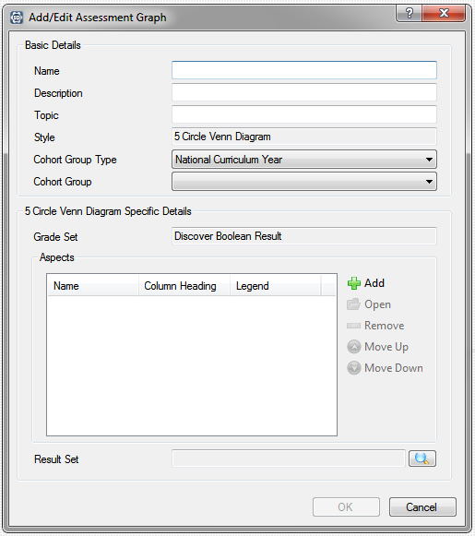
- In the Basic Details panel, enter a unique Name for the new graph definition.
- Enter a meaningful Description that enables you to differentiate this Assessment graph from other, existing graph definitions.
- Enter a Topic name. This is merely a short abbreviation of the Description and can be based on the Key Stage, Year Group or other cohort of pupil/students that the graph definition is based on.
The Style field is populated automatically with the type of graph that you have chosen to define and cannot be changed.
The Cohort Group Type field defaults to National Curriculum year but this can be changed by selecting an alternative cohort of pupil/students from the drop-down list.
- Select the Cohort Group from the drop-down list. This list is restricted by the cohort selection made in the Cohort Group Type field, e.g. if National Curriculum Year is selected as the Pastoral Group Type, you can only select the pastoral group from a list of National Curriculum Years.
- In the 5 Circle Venn Diagram Specific Details panel, click the Add button to display the Find Aspects dialog. At least 5 aspects must be selected and the maximum number is also 5.
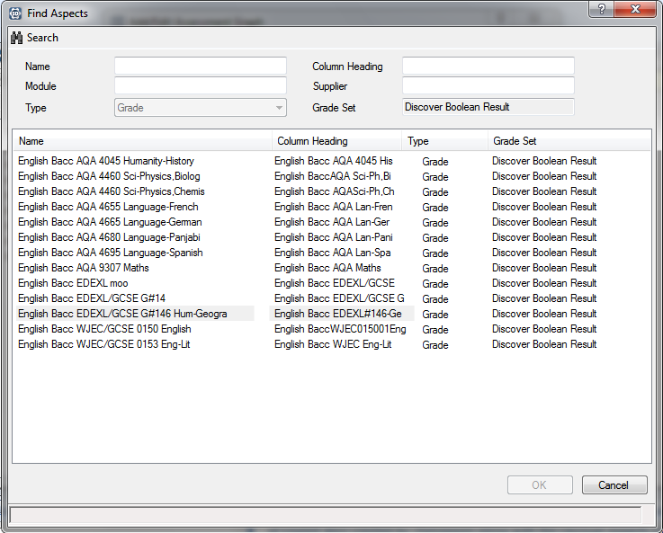
- Enter the Name or the Column Heading of the aspect that you are looking for.
- Alternatively, enter the Module or the Supplier name, if known.
The Module field filters the aspects on the name of the SIMS module that was originally used to create them, e.g. CES Assessment Services, CES Discover Services, etc.
The Supplier field displays the establishment that created the aspect, e.g. your LA or someone in your school.
The Type defaults to Grade and cannot be changed. The Grade Set defaults to Discover Boolean Result and cannot be changed.
It is possible to leave all the search fields blank before clicking the Search button to display a list of all available aspects, if details of a specific aspect are not known.
The dialog is populated with a list of aspects that match the search criteria entered.
- Select the required aspect and click the OK button to select it. Continue adding aspects, as required.
Multiple aspects can be selected in a block using the Shift key. Multiple aspects that are spaced throughout the list can be selected individually using the Ctrl key.
- Click the OK button to return to the Add/Edit Assessment Graph dialog.
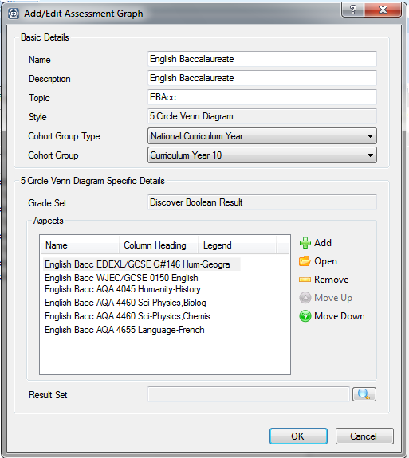
If you have made a mistake when selecting aspects, highlight the incorrect aspect name and click the Remove button to delete the aspect from the list of those available for inclusion in the graph.
Where multiple aspects have been selected, highlight an aspect and click the Move Up or Move Down button to re-arrange the order of the aspects that you have selected.
- Click the Browse button in the Result Set panel to display the Find Result Sets dialog.
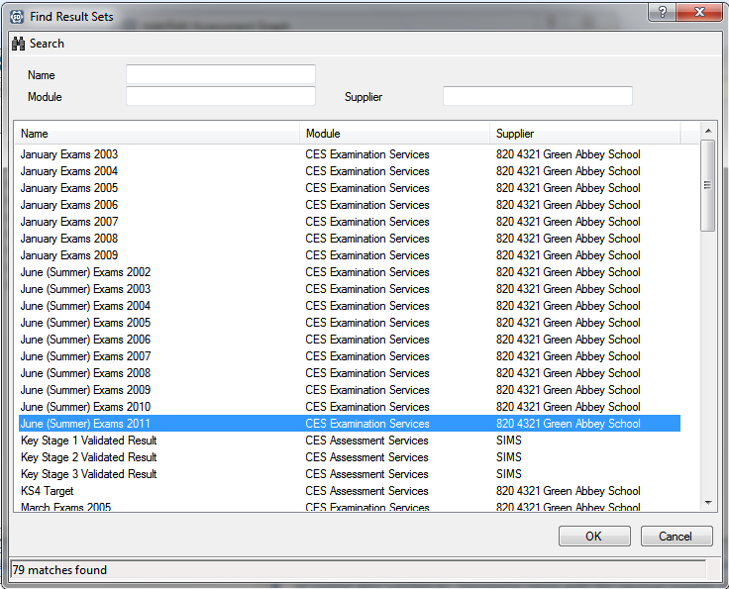
- Enter the Name of the result set.
- Alternatively, enter the Module name or the Supplier name before clicking the Search button.
The Module field filters the result sets on the name of the SIMS module that was originally used to create them, e.g. CES Assessment Services, CES Discover Services, etc.
The Supplier field displays the establishment that created the result set, e.g. your LA or someone in your school.
The dialog is populated with a list of result sets that match the search criteria entered.
It is possible to leave all of the search fields blank before clicking the Search button to display a list of all available result sets, if details of a specific result set are not known.
- Select the required result set and click the OK button to return to the Add/Edit Assessment Graph dialog.
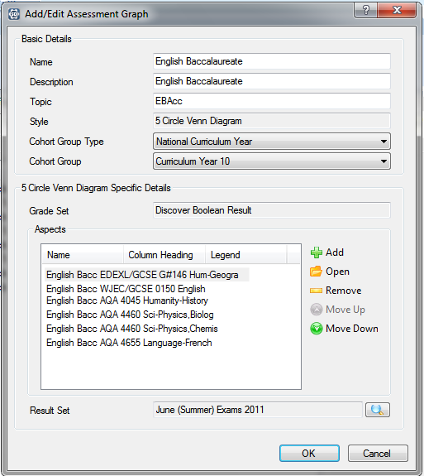
- Click the OK button to save the Assessment graph definition.
The new graph definition is listed in the Assessment Graphs page.
- Click the Save button on the Discover SIMS Configuration utility to save the graph definition.
IMPORTANT NOTE: It is suggested that you click the Transfer button when you have made any changes in the Discover SIMS Configuration utility as this ensures that the changes are made straightaway. However, please ensure that this action will not affect other users of SIMS and Discover before proceeding.
The graph definition is now available in the drop-down list from the Assessment button on the Discover Application Bar.
Assessment button
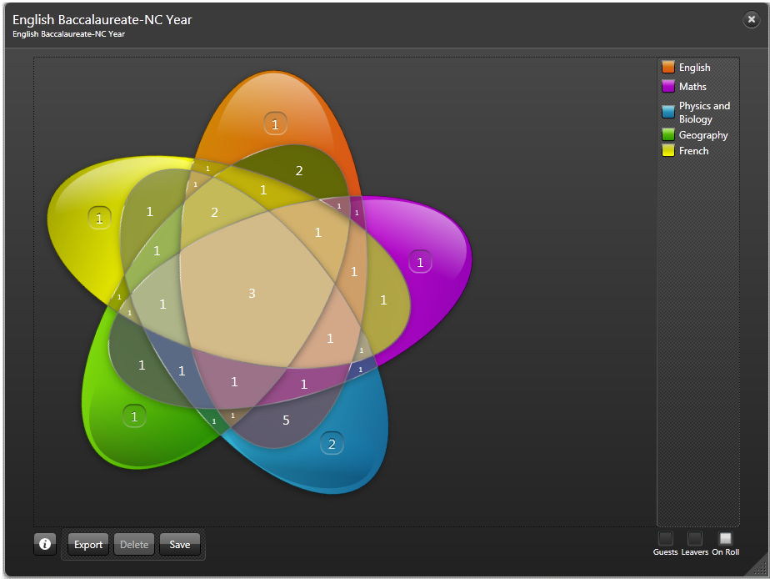

Deleting an Assessment Graph Definition
Highlight an extraneous graph definition and click the Delete button to remove it from the Assessment Graphs page in the Discover SIMS Configuration utility.
If you choose to delete a pre-defined Assessment graph definition that has been supplied by Capita SIMS, a confirmation dialog is displayed.
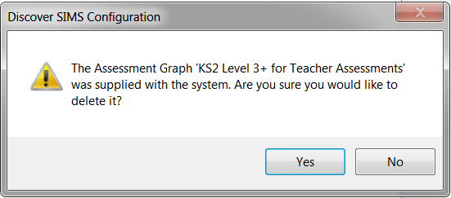
If you are certain that you want to delete the graph definition, click the Yes button.
This also removes the graph definition from the drop-down list of available graph outputs from the Assessment button on the Discover Application Bar.
Assessment button

Creating an XML File of Graph Definitions for Export
It is possible to create an XML file of your own graph definitions. This file can then be imported into Discover by other users to enable them to share the benefit of your user defined graphs without them having to create the graph definitions themselves.
When creating an XML file of graph definitions, you can select which of your graph definitions to share with the appropriate people. When the specific graph definitions are selected for inclusion in the export file, the aspects, result sets and gradesets that form the basis of each graph definition are included in the XML file.
- In the Discover SIMS Configuration utility, click the Export button.
The Export Assessment Graphs dialog is displayed.
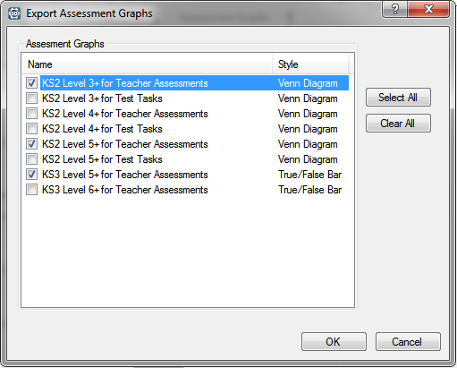
- Select the check box(es) adjacent to the Names of the graph definitions that you want to export. Alternatively, click the Select All button to include all the graph definitions that have been defined.
- If you make a mistake, click the Clear All button and begin your selection again.
- Click the OK button to display the Save As dialog.
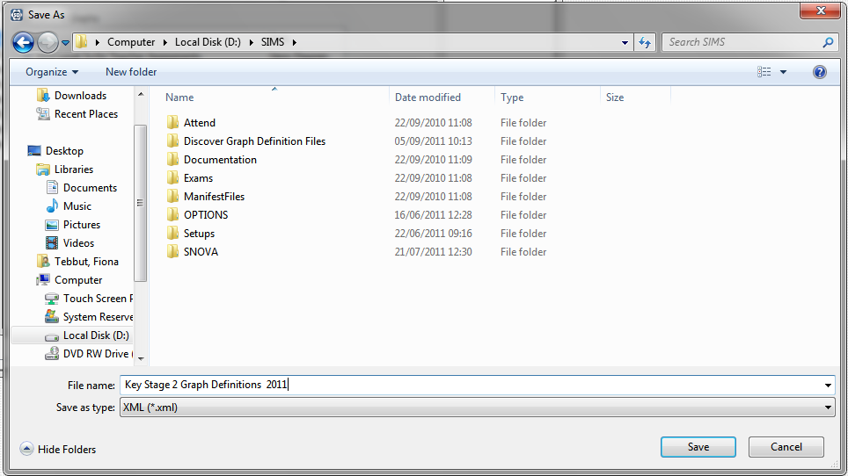
- Navigate to a suitable storage location, specify a File Name and click the Save button to create the .XML file. It is not possible to change the Save as type file extension.
A message is displayed advising that the export is in progress.
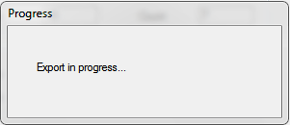
When the file has been created, a message is displayed.
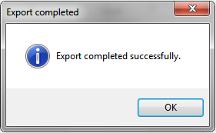
- Click the OK button to close the message dialog.
If the export file fails to create successfully, you can view the Discover.SIMS.Configuration.LogFile.log for more information. This file can be found in the following location:
C:\Users\UserName\AppData\Local\Discover.
You may want to share different graph definitions with various people so it is possible to create a number of different files, all with different names and each containing the relevant graph definitions.

Importing Graph Definitions
It is possible to import an XML file containing graph definitions that have been created by other users.
- In the Discover SIMS Configuration utility, click the Import button.
The Open dialog is displayed.
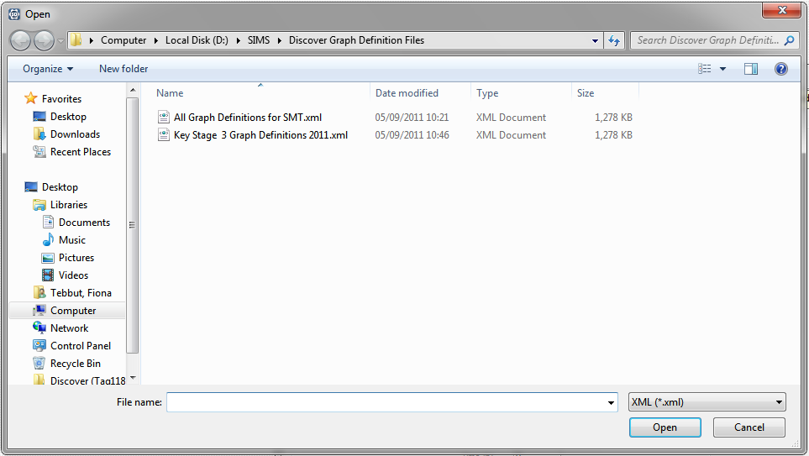
- Select the required file Name and click the Open button to display the Import Assessment Graphs dialog.
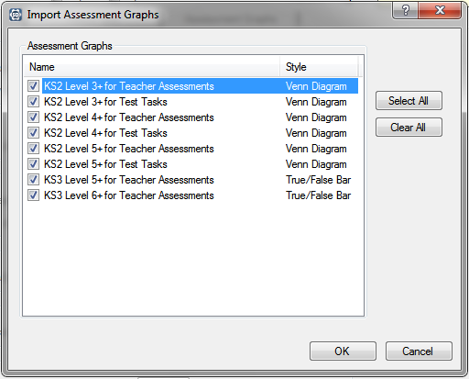
- Select the check box(es) adjacent to the Names of the graph definitions that you want to import. Alternatively, click the Select All button to import all the graph definitions from the file.
- If you make a mistake, click the Clear All button and begin your selection again.
- Click the OK button to display the Cohort Matching dialog.
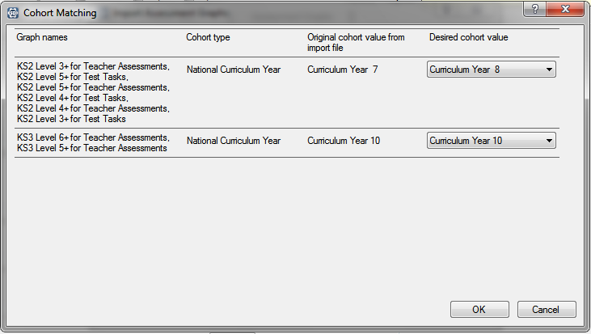
The Graph names that you have selected to import are listed together with the Cohort Type, the Original cohort value from import file and the Desired cohort value.
You can select an alternative Desired cohort value from the drop-down list for each graph definition, if required.
- Click the OK button to begin the import.
If one of the graph definitions being imported is already present in the Discover database, the graph definition will not be imported again unless any of the underlying data, e.g. result sets, gradesets or aspects, has been updated since the graph definition was last imported.
When the import process is finished, a message dialog displays any Errors that were identified during the import.
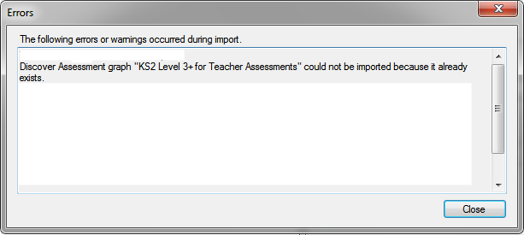
- After reviewing the errors, click the Close button.
If the import is unsuccessful, you can view the Discover.SIMS.Configuration.LogFile.log for more information. This file can be found in the following location:
C:\Users\UserName\AppData\Local\Discover.

Running the Transfer Process
It is possible to click the Transfer button at any time whilst using the Discover SIMS Configuration utility. This ensures that any settings that you may have changed since the last Transfer process was run are applied as soon as possible.
Please ensure that no other users are affected by the transfer process before continuing.
In the Tool Bar of the Discover SIMS Configuration utility, the Transfer Progress data field enables you to see the status of the last transfer that was initiated.
Hover help on this data field displays the date and time of the Last successful transfer along with the date and time of a transfer currently underway, if applicable.

More Information:
Using the Discover SIMS Configuration Utility to Create Assessment Graphs on page 59

Working with Venn Diagrams
In This Chapter
Introduction 133
Hints and Tips for Viewing the Data in Each Segment of a Venn Diagram 136

Introduction
You can select up to three data items from a graph(s) that you are currently viewing and drag and drop them onto the canvas to create a Venn diagram. As a general rule, data items from any graphs that are based on a count of pupil/students can be merged into a Venn diagram.
For the following example, the Students with Additional Needs graph is selected by clicking the Additional Needs button.
Additional Needs button
- Select the required graph name from the drop-down list. Ensure that the appropriate Client Filter is selected, e.g. Guests, Leavers or On Roll pupil/students.
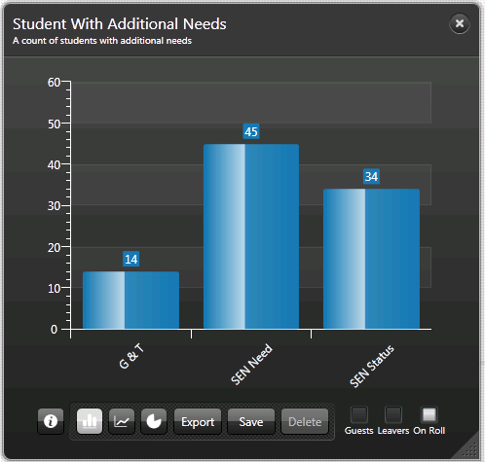
- Click into the required data item on the graph and drag and drop it onto the Discover canvas.
A single, circular Venn diagram is created for the data item. It is labelled with a key in the right-hand side of the new graph showing the colour used to represent the data item. The number of pupil/students, who make up the total of the data item, is shown in the centre of the first Venn diagram circle.
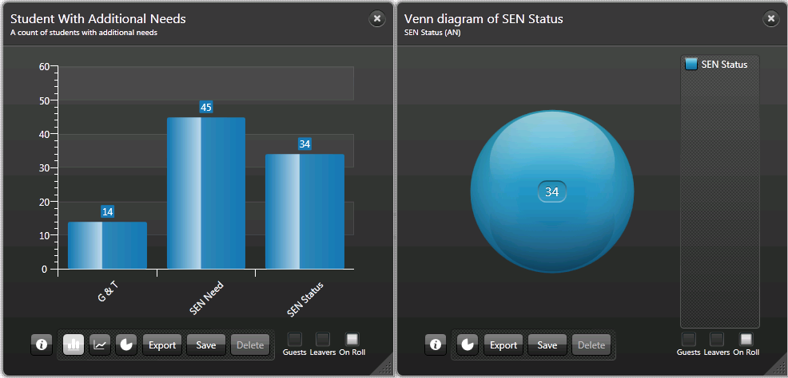
- Click into a second data item from the original graph and drag and drop it onto the Venn circle in the new graph.
A second circle is created and labelled with a key in the right-hand side of the graph showing the colour used to represent this data item. The number of pupil/students, who make up the total of the data item, is shown in the centre of the second Venn diagram circle.
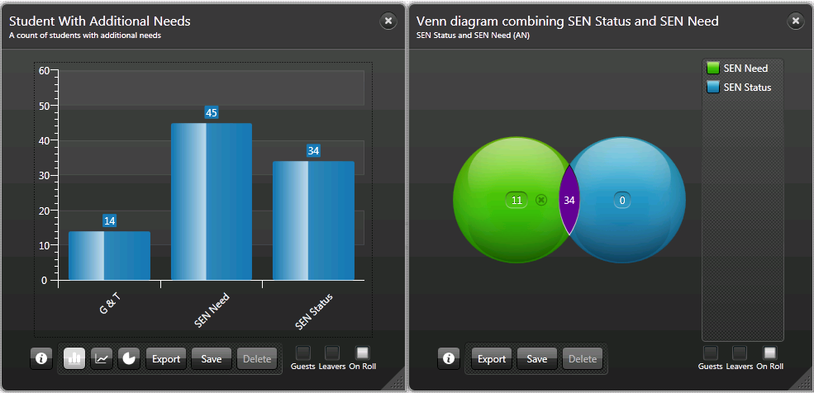
The intersection between the two data items is shown in another colour. This does not have a key because it does not represent a data item. The intersection does not necessarily contain any common data but where it does, the number of pupil/students who share the attributes of both data items, is displayed in the intersection.
The title of the newly created graph is updated each time to reflect the addition of subsequent data items.
- Click into a third data item from the original graph and drag and drop it onto the Venn circles in the new graph.
A third circle is created and labelled with a key in the right-hand side of the graph showing the colour used to represent this data item. The number of pupil/students, who make up the total of the data item, is shown in the centre of the third Venn diagram circle.
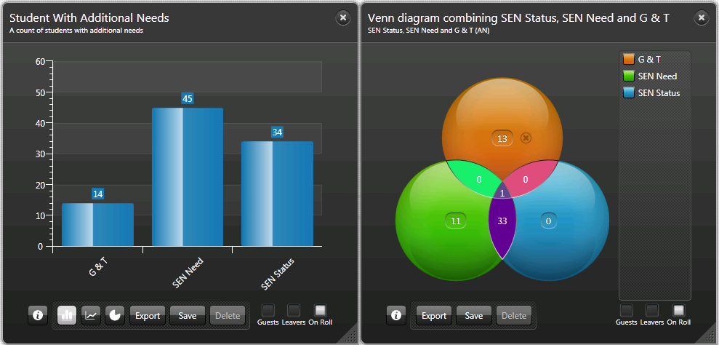
Where the three data items (each represented by an individually coloured circle) intersect, each area of the intersection is represented by a different coloured segment. The number of pupil/students, who share the attributes of any, some or all of the data items, is displayed in each intersection.

Removing a Circle from a Venn Diagram
It is possible to remove one or more of the Venn diagram circles and build another Venn using different data items from another graph, if required.
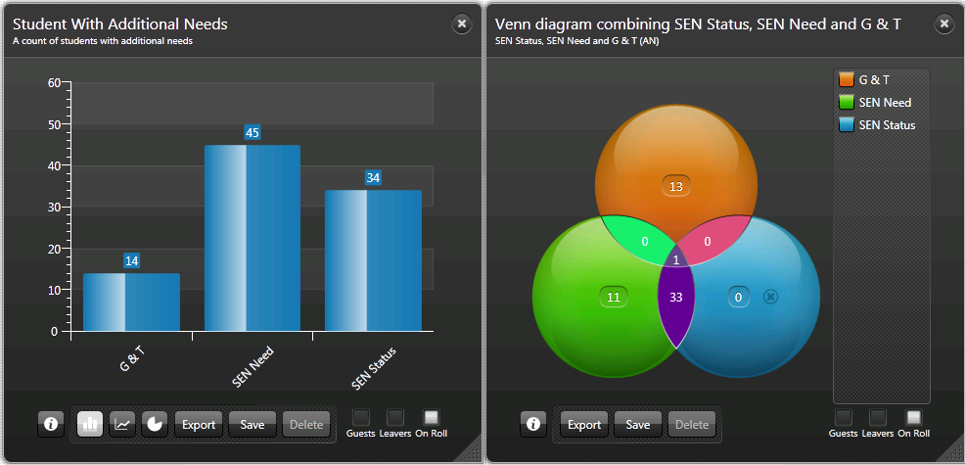
Allow the mouse to hover over the relevant circle. A small circular Delete button is displayed. The following graphic is representative only, the background colour of the Delete button will differ depending on the colour of the circle over which the mouse is hovering (please see Hints and Tips for Viewing the Data in Each Segment of a Venn Diagram on page 136).
Delete button
Click the Delete button to remove the relevant circle.
IMPORTANT NOTES: When creating a Venn diagram from multiple graphs, the Client Filter that is selected on the graph from which the first data item is chosen determines how the subsequent data items are displayed. For example, if the Student Totals by Year Group graph has the On Roll client filter selected and Year Group 8 is chosen as the first data item to use in a Venn diagram, the subsequent data items dropped onto the Venn diagram from other graphs only show On Roll pupil/students and not Guests or Leavers.

Hints and Tips for Viewing the Data in Each Segment of a Venn Diagram
- Before creating pop-ups, it is advisable to maximize the space available on the Discover canvas so that there is sufficient room to arrange the pop-ups into a suitable position around the Venn diagram. Click the relevant Category button to close the drop-down list of available graph outputs and close any other graph outputs that you may have been looking at.
- When you click into a segment of the Venn diagram, a pop-up is created. It is possible to create a pop-up for each individual segment of the Venn diagram.
- Each pop-up is labelled according to the population of pupil/students that it represents in the Venn diagram. The total number of pupil/students who fall into this population is shown in the top left-hand corner of the pop-up. Use the scroll bar to view the details of all the pupil/students. Click into a column heading on a pop-up to sort the pupil/students by the data field represented in the column heading.
- Once pop-ups have been created, the Venn diagram and its associated pop-ups can be moved around the Discover canvas by dragging the Venn diagram. The pop-ups remain in position in relation to the Venn diagram unless they are clicked on and dragged independently of the original graph.
- The pop-ups can be dragged and dropped so that they are adjacent to the segment of the Venn diagram that they relate to. A line indicator links each pop-up to its related segment on the Venn diagram and the line indicator expands and contracts as the pop-up is moved around the Discover canvas. The colour of the line indicator and the pop-up surround correspond to the colour of the applicable segment in the Venn diagram.
- The graph showing the Venn diagram cannot be closed or resized whilst the pop-ups remain open. To close a pop-up, click into the appropriate segment of the Venn diagram and the pop-up and its associated line indicator are removed.
- Changing the Client Filters on the Venn diagram results in all the pop-ups closing automatically.
- When viewing the reverse side of a Venn diagram, it is suggested that you stretch the dialog as far across the Discover canvas as possible so that all the data columns can be seen clearly. Use the scroll bar to view the details of all the pupil/students.
- If you inadvertently drag the Venn diagram and its associated pop-ups off the bottom of the Discover canvas, click into the Discover canvas and drag the mouse cursor upwards until the graph reappears.
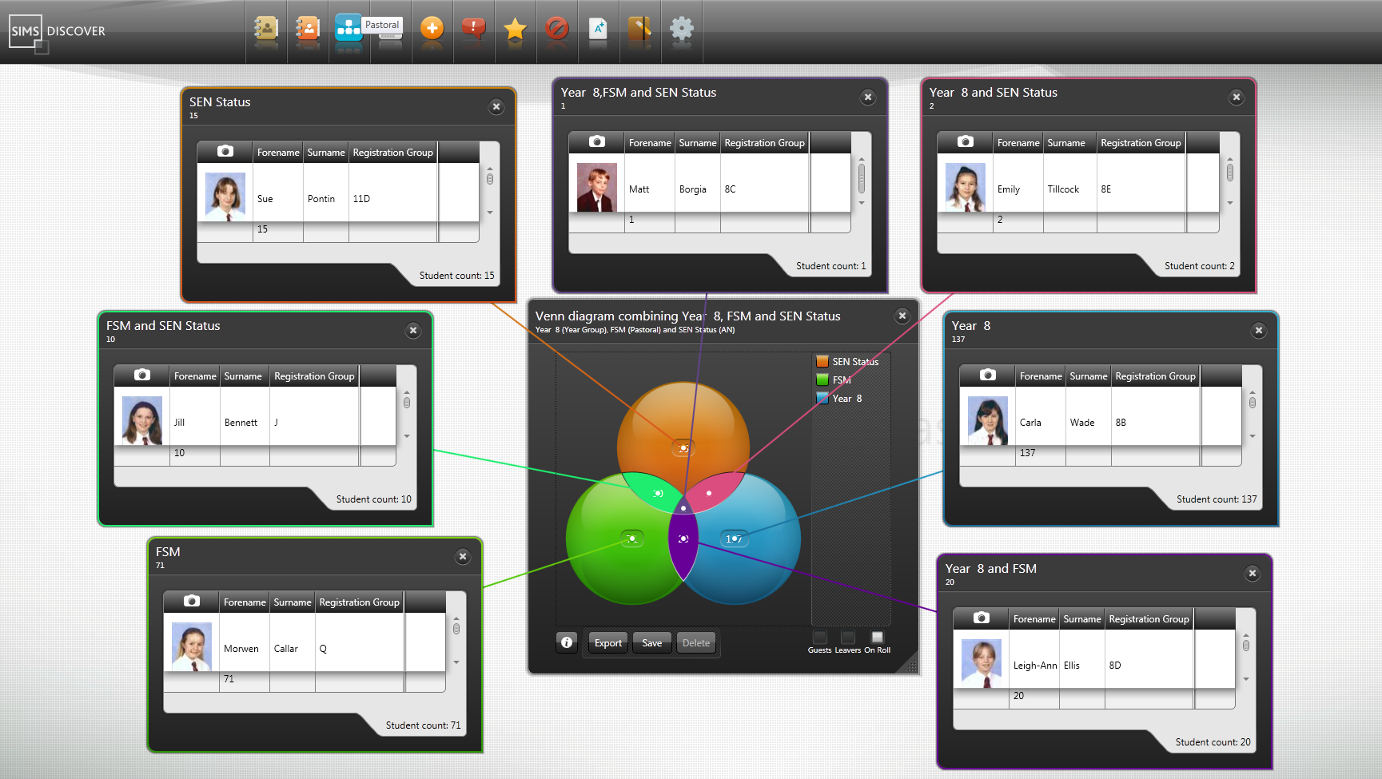
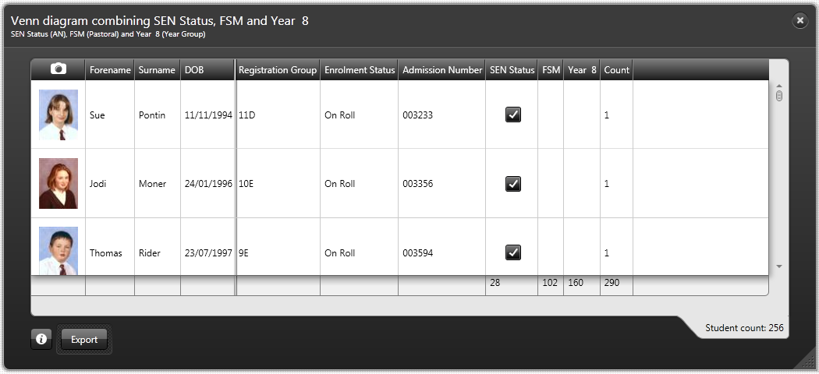

Creating Groups in Discover and Viewing Discover Groups in SIMS
In This Chapter
Introduction 139
Adding/Editing a Discover Group 140
Adding/Editing a Dynamic Group 147
Viewing the Discover Group Details in SIMS 149

Introduction
Two different types of Groups can be created in Discover based on a set of criteria or data items that you define yourself. The groups, once created, are maintained in Discover but Dynamic Discover groups can be transferred into the SIMS database so that they are also available for use in SIMS. Dynamic Discover groups can be used as filters from various places within SIMS including the Reporting Dictionary and areas of Assessment and Performance Analysis.
The two types of group that can be created in Discover are:
- a Discover group; or,
- a Dynamic group.
However, only Dynamic Discover groups are visible in SIMS although these are (rather ambiguously) known as Discover groups in SIMS. A group saved with the type of Discover is only available within Discover and is not visible in SIMS.
Pupil/student membership of both group types is automatically maintained in Discover.
NOTE: Please liaise with your System Manager for further details regarding the Group Synchronisation Service Account. This service is defined as an integral part of the Discover installation process.

Adding/Editing a Discover Group
- Click the Groups category button from the Discover Application Bar.
Groups button
If you have already created some groups, they are listed beneath the Create new Discover Group menu item in the drop-down list.
The group types can be discerned by the two different icons used to identify a Discover group and a Dynamic group.
Discover icon
Dynamic icon
- Drag and drop the Create new Discover Group menu item onto the Discover canvas.
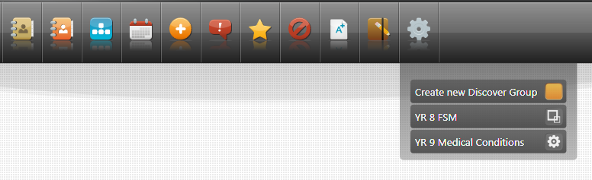
The Discover Group Drop Data Point here box is created.
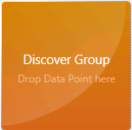
- Click the applicable Category button from the Application Bar to view the drop-down list of available graph outputs.
- Select the name of the relevant graph that contains the data item that you want to use in the new Discover group and drag and drop the graph onto the Discover canvas.
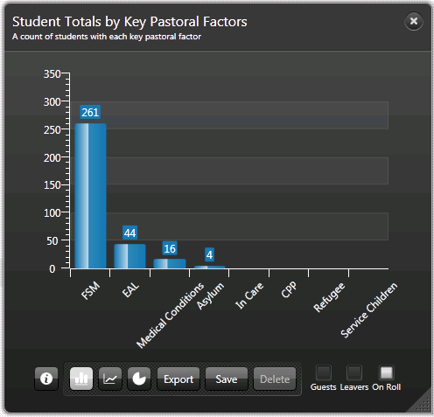
- Once the graphical output has compiled, drag the required data item from the graph and drop it onto the Discover Group Drop Data Point here box.
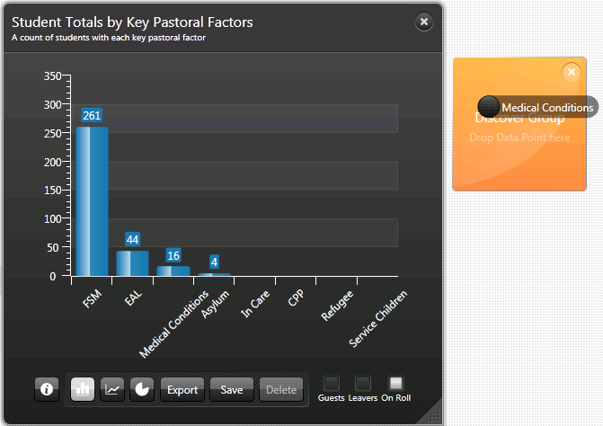
The name of the data item that you are dragging from the graph is visible in the cursor until you drop the data item onto the Discover Group Drop Data Point here box.
The Discover Group Drop Data Point here box becomes a black group dialog. The name of the data item that has been dropped onto the Discover Group Drop Data Point here box is displayed.
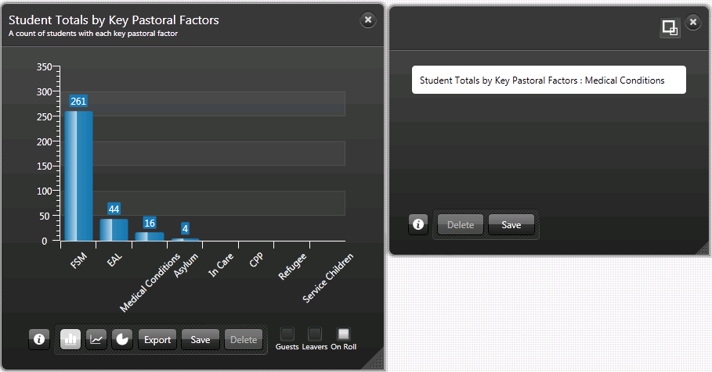
The icon in the top right-hand corner of the dialog indicates that the group type is currently set to the default of Discover group.
Discover button
Continue dropping data items onto the new group dialog until you have created a group that contains all the elements or data items that you want to include.
It is also possible to include a data series from a graph where the data items are separated by gender. For example, you can select only the male or female pupil/students in a year group by dragging and dropping the colour coded data item onto the new group dialog.
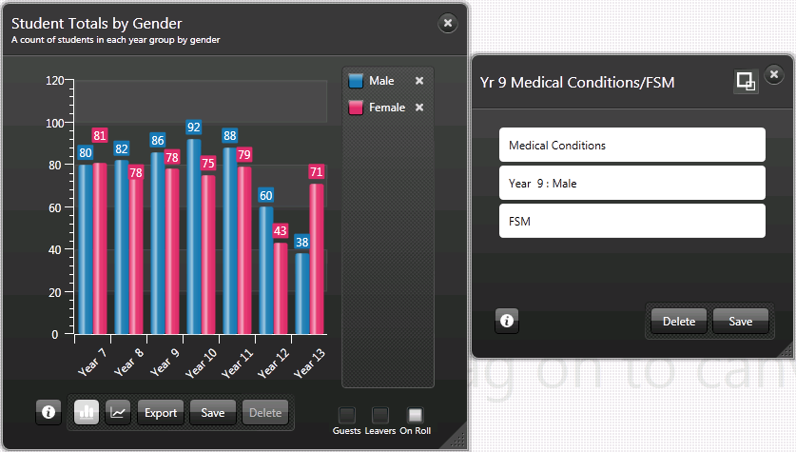
As you add more data items to the new group dialog, a scroll bar becomes visible on the right-hand side of the dialog enabling you to view all the selections that you have made.
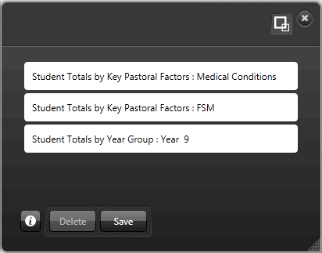
Hover over any of the data items and click the Delete button if the data item is not required in this group.
- When you have added all the data items to the new group that you require, click the Save button to display the Save as: dialog.
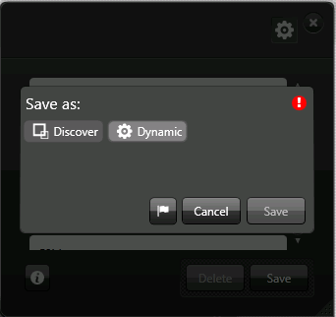
- Enter a unique and descriptive name for the new group and click the Discover button to distinguish the group as a Discover group type.
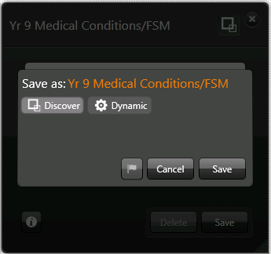
The Alert flag button remains greyed out because it is not necessary to create alerts for a Discover group type. If the Dynamic button were selected, the Alert flag button becomes active (please see Specifying the Dynamic Group Alerts on page 148).
- Click the Save button.
Once you have saved the new Discover group, it is not possible to change the designation of the group to a Dynamic group type.
A group saved with the type of Discover is only available within Discover and is not visible in SIMS.
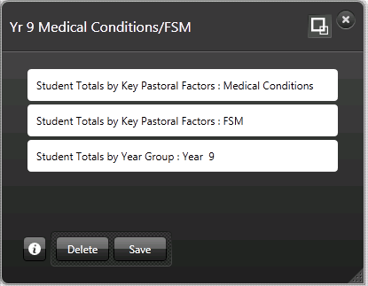
- Click the Information button to rotate the group dialog and to view the reverse side.
Information button
All the pupil/students who match any of the group criteria are displayed as members of the new group.
TIP: After rotating the group dialog to view the details on the reverse side, click on a column heading to change the sort order of the pupil/students.
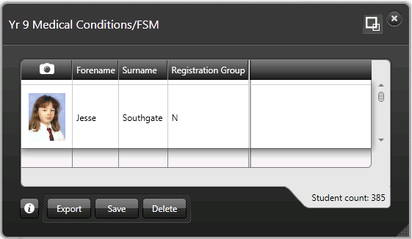
The new group is now available for selection from the Groups catalogue button from the Discover Application Bar.
A Discover group has no end date and continues indefinitely until such time as you delete it from the Discover database.

Deleting a Discover Group
- Click the Groups catalogue button and select the name of the Group you want to delete, from the drop-down list.
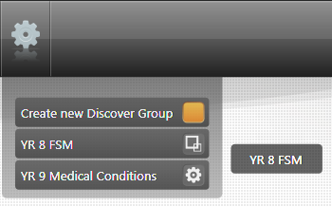
- Drag and drop the Group onto the Discover canvas.
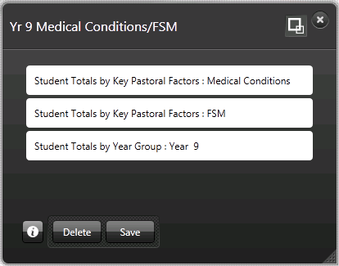
- Click the Delete button to display the following message:
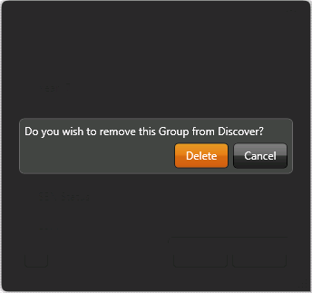
- Click the Delete button to confirm the deletion of the group from Discover.
Deletion of the group can also be carried out from the reverse side of the group dialog.

Adding/Editing a Dynamic Group
Pupil/student membership of a Dynamic Discover group is automatically maintained in Discover with pupil/students being added or removed by the Group Synchronisation Service process.
NOTE: Please liaise with your System Manager for further details regarding the Group Synchronisation Service Account. This service is defined as an integral part of the Discover installation process.
When you create a Dynamic Discover group, you are automatically assigned the role of Supervisor. Additional supervisors can be added to the group once it has been transferred into SIMS, via Focus | Groups | Discover Groups.
- Create a new Dynamic Discover group in the same way as a Discover group (please see Adding/Editing a Discover Group on page 140).
- In the Save as: field, enter an appropriate name for the new Dynamic Discover group before clicking the Save button.
IMPORTANT NOTE: Please exercise caution when naming Dynamic Discover groups because the name will be visible to other users in SIMS who may not have suitable permissions to view the criteria used to define the group.
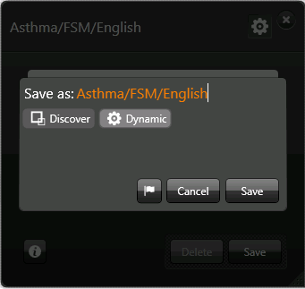
- When saving the newly created group, click the Dynamic button instead of the Discover button.
Dynamic button
The Alerts flag button is activated.
Alerts flag button
- Click the Alerts flag button to display the Alerts dialog for the new Dynamic Discover group.
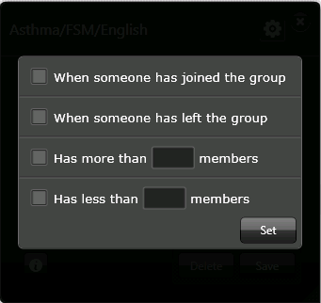

Specifying the Dynamic Group Alerts
The following alert notification options can be selected:
- When someone has joined the group
- When someone has left the group
- Has more than {} members
- Has less than {} members
It is possible to select all four of the alert options, if required.
Ensure that you specify an appropriate number of pupil/students in the third and fourth options.
Click the Set button to activate the alerts that you have selected.
Click the Save button. The new group is now available for selection from the Groups catalogue button from the Discover Application Bar.
Alert messages are sent when the Group Synchronisation Service process is triggered. Alerts are sent to the named Group Supervisors and only one, collective alert is sent to each supervisor when the pupil/student membership of the group changes. An alert is not sent for each individual pupil/student.
It is possible to add alerts retrospectively to a Dynamic Discover group, if required. The Dynamic Discover group details must be saved again if any changes are made to the original group definition.

Viewing the Discover Group Details in SIMS
Discover groups can only be created in Discover and not in SIMS. However, it is possible to view the pupil/student memberships of a group and to add additional supervisors to a Dynamic Discover group from within SIMS, if required. It is also possible to change the period of time that a particular supervisor is responsible for the group.
All members of staff who are recorded as a supervisor of a group will receive alerts advising them of any changes that occur to the pupil/student memberships.
The memberships of both types of Discover groups are updated automatically as the populations change, e.g. when pupil/students leave or join the group based on the criteria defined when creating the group in Discover.

Searching for an Existing Discover Group
- Select Focus | Groups | Discover Groups to display the Find Discover Group browser.
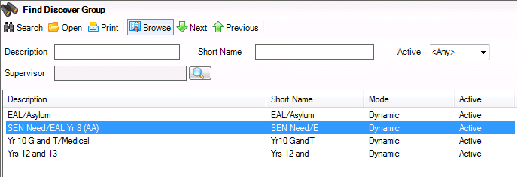
- Enter the Description and Short Name of the group or select the relevant Active status from the drop-down lists.
- Alternatively, click the Browser button adjacent to the Supervisor field to display the Select person dialog.
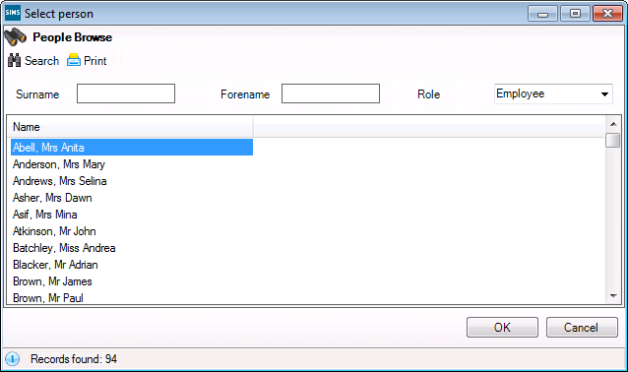
- Enter the Surname, Forename or select the Role of the staff member who was recorded as a Supervisor of the group. When you create a group in Discover, you are automatically assigned to the group as a supervisor.
- Click the Search button to display a list of staff members who match the search criteria entered.
- Highlight the name of the required staff member and click the OK button to populate the Supervisor field in the Find Discover Group browser.
- Click the Search button to display a list of existing Discover Groups. Only groups that were defined as Dynamic groups in Discover are visible in SIMS.
- Highlight the required group and click the Open button to display the Discover Aspect Detail page.
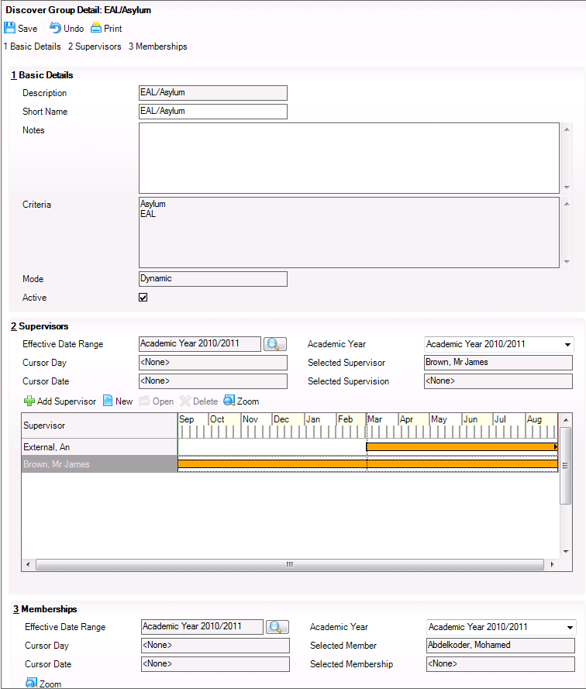
The Basic Details panel displays the Description, the Short Name, any relevant Notes, and the Criteria that were specified when the group was created in Discover, the Mode selected (only Dynamic groups are visible in SIMS) and the Active status of the Discover group.
NOTE: The Criteria are visible to users with appropriate permissions only.
It is possible to change the Short Name and add any relevant Notes that relate to the Discover group in the Basic Details panel. You can also change the active status of the group by deselecting the Active check box. This prevents the Discover group from appearing in other areas of SIMS, e.g. in the User Defined Groups screen but does not affect its availability within Discover.

Adding a Supervisor to a Discover Group
In the Supervisors panel, you can change the Effective Date Range and the Academic Year. The Selected Supervisor and the Selected Supervision details were specified when the group was created in Discover.
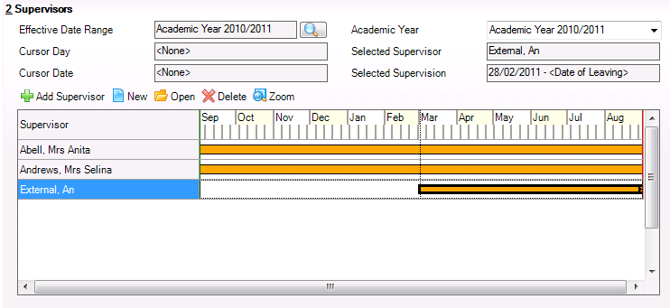
The Cursor Day and Cursor Date fields update to reflect the location of the cursor along the Supervisor timeline.
- Click the Add Supervisor button to display the Select person dialog.
- Enter the Surname, Forename or select the Role of the staff member to be added as a Supervisor of the group. When you create a group in Discover, you are automatically assigned to the group as a supervisor.
- Click the Search button to display a list of staff members who match the search criteria entered.
- Highlight the name of the required staff member and click the OK button to display the Add Supervisor dialog.
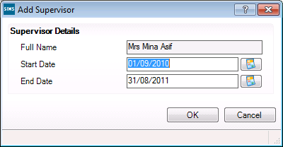
The supervisor’s Full Name field is already populated.
- Click the respective Calendar button to change the Start Date and End Date of the time period that the staff member will be responsible for supervising this group.
- Click the OK button to add the staff member’s name to the Supervisor timeline.
- If you want to edit the time period that an existing staff member is designated as a supervisor, highlight their name in the Supervisor timeline and click the New button to display the Add/Edit Date Range dialog.
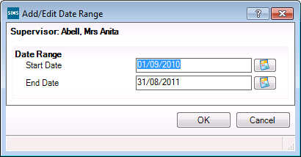
- Click the respective Calendar button to change the Start Date and End Date before clicking the OK button to return to the Supervisor timeline.
The orange bar that represents the time period for the staff member is updated to reflect the changes to the time period.
- Click the Zoom button to expand or contract the Supervisor timeline display into day or calendar month sections.
- Click the Save button on the Discover Group Detail page to save any changes that you have made to the group details.

Viewing and Deleting a Supervisor from a Discover Group
- If you want to remove a supervisor from the Discover group before they reach their End Date, highlight their name in the Supervisor timeline and click the Delete button.
- If you want to view the date range during which a staff member is responsible for the group, highlight their name in the Supervisor timeline and click the Open button to view the Add/Edit Date Range dialog.
If you select the supervisor who originally created the group in Discover, the End Date field is empty.
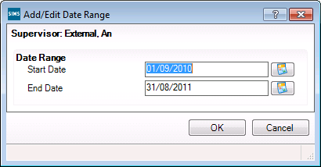
- Click the OK button to return to the Discover Group Detail page.
- Click the Save button on the Discover Group Detail page to save any changes that you have made to the group details.

Monitoring the Pupil/Student Population of a Discover Group
The Memberships panel displays the Effective Date Range, the Academic Year, the Selected Member and the Selected Membership details, where specified.
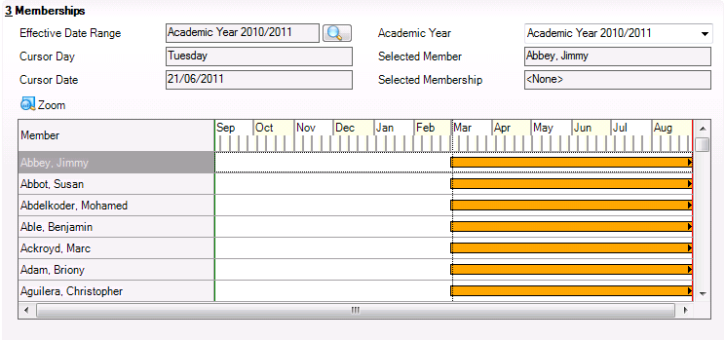
It is possible to change the Effective Date Range and the Academic Year fields to view the pupil/student population of the group at a specified date.
The Cursor Day and Cursor Date fields update to reflect the location of the cursor along the Member timeline.
The Zoom button enables you to expand and contract the Member timeline view into day or calendar month sections.
The orange bar that represents the time period for the pupil/student’s membership is updated to reflect the changes to the time period.
It is not possible to add pupil/student memberships to a Discover group from within SIMS.
Click the Save button on the Discover Group Details page.
Discover Groups are visible from various areas within SIMS, including Performance Analysis, Reporting, InTouch and Assessment.
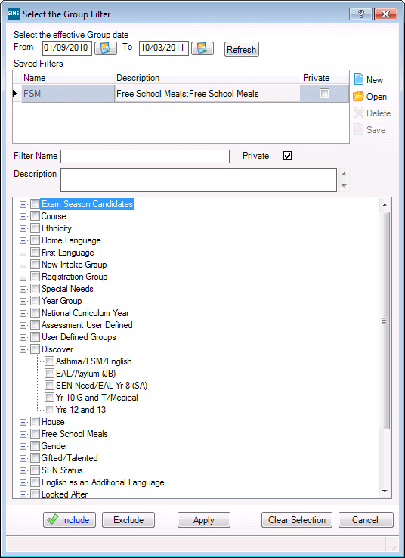
Index
A
achievement
graphs 36
adding/editing
Discover groups 140
dynamic 147
alerts
in Discover groups
dynamic 148
aspect results
generating 57
aspects
amount of progress 54
creating new 43
searching for 42
target point score 44, 51
assessment
graphs 38
Assessment graphs
creating new 77
average marks bar 113
boolean bar 78
marks tracking progress 94
deleting a definition 126
attendance
graphs 32
B
behaviour
graphs 35
bringing to the front of the canvas
graphs 12
C
client filters
graphs 28
collective filtering
graphs 21
creating
new Assessment graphs 77
average marks bar 113
boolean bar 78
marks tracking progress 94
Venn diagrams 133
xml file for export 126
creating new
amount of progress Discover aspects in SIMS 54
aspects in SIMS 43
multiple grade targets Discover aspects in SIMS 44
target point score Discover aspects in SIMS 51
csv files
exporting details 15
D
data
viewing in a Venn 137
data items
graph to graph filtering 16
deleting
a graph of your own creation 23
Assessment graphs
definition 126
Discover groups 146
Discover
navigation 7, 25
overview 1
Discover groups
adding/editing 140
deleting 146
dynamic
adding a supervisor in SIMS 151
adding/editing 147
monitoring the pupil/student population in SIMS 154
searching for in SIMS 149
specifying alerts 148
viewing and deleting a supervisor in SIMS 153
Discover SIMS Configuration utility
general settings 61
selecting result sets 66
transfer pending 65
transfer progress messages 64
transferring the settings 131
understanding Assessment graphs
creating new 77
average marks bar 113
boolean bar 78
marks tracking progress 94
deleting a definition 126
using 5
Discover Warehouse Service Log
reviewing 66
E
exclusions
collective filtering 21
graphs 37
exporting
a graph as an image 12
details as a csv file 15
xml files 126
F
filtering
collective data items 21
graphical data items 16
G
general settings
Discover SIMS Configuration utility 61
generating
Discover aspect results in SIMS 57
graphs
achievement 36
assessment 38
attendance 32
behaviour 35
bringing to the front of the canvas 12
client filters 28
collective filtering 21
deleting your own 23
exclusions 37
exporting as an image 12
graph to graph filtering 16
moving around the canvas 11
opening 9
pastoral 31
pie chart 25
pre-admission pupil/students 30
predefined graphs 25
progression line 25
pupil/student totals 28
resizing 11
rotating 14
saving your own 21
SEN needs 34
viewing reverse side 13
I
importing
xml files 129
introduction to
creating Discover groups 139
M
moving
a graph 11
N
navigation
in Discover 7, 25
O
opening
a graph 9
overview
of Discover 1
P
pastoral
graphs 31
pie chart
graphs 25
pre-admission pupil/students
graphs 30
predefined graphs
available in Discover 25
progression line
graphs 25
pupil/student totals
graphs 28
R
resizing
a graph 11
reverse side of graphs
viewing 13
reviewing
Discover Warehouse Service Log 66
rotating
a graph 14
S
saving
a graph of your own creation 21
searching for
aspects in SIMS 42
selecting result sets
Discover SIMS Configuration utility 66
SEN needs
graphs 34
SIMS
adding a supervisor to Discover groups
dynamic 151
creating new amount of progress Discover aspects 54
creating new Discover aspects 43
creating new multiple grade targets Discover aspects 44
creating new target point score Discover aspects 51
generating Discover aspect results 57
monitoring the pupil/student population in Discover groups
dynamic 154
searching for Discover aspects 42
searching for Discover groups
dynamic 149
viewing and deleting a supervisor in Discover groups
dynamic 153
viewing Discover groups
dynamic 149
slide bar
using the 12
T
transfer pending
Discover SIMS Configuration utility 65
transfer progress messages
Discover SIMS Configuration utility 64
transferring the settings
Discover SIMS Configuration utility 131
U
understanding Assessment graphs
creating new 77
average marks bar 113
boolean bar 78
marks tracking progress 94
deleting a definition 126
using
Discover SIMS Configuration utility 5
the slide bar 12
V
Venn diagrams
creating 133
viewing the data 137
viewing
reverse side of a graph 13
X
xml file
creating for export 126
importing 129

