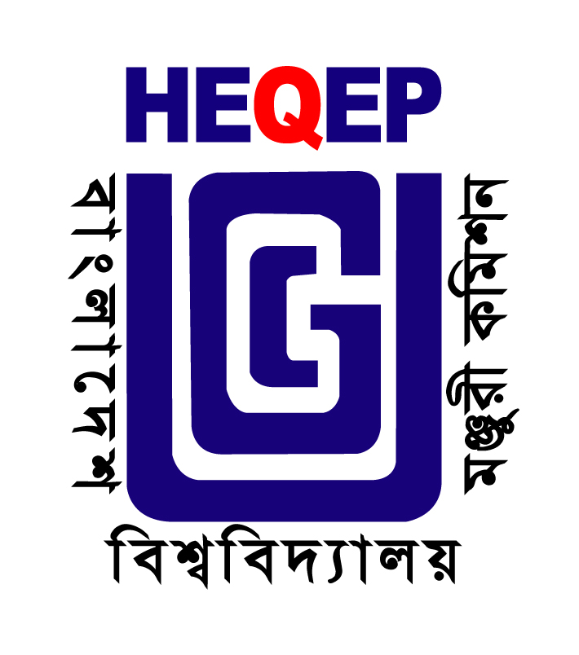 | University Grants Commission of Bangladesh  Office of the Project Director  Higher Education Quality Enhancement Project (HEQEP)  Dhaka Trade Centre (8th Floor)  99 Kazi Nazrul Islam Avenue, Kawran Bazar, Dhaka-1215  Web: www.heqep-ugc.gov.bd Fax: 02-8189021

Ref: UGC/HEQEP/Procurement/S66-AF/2014/**** Dated: 30 November 2014

Request for Expression of Interest (REOI)

The People’s Republic of Bangladesh has received a Credit in an amount of equivalent to US$ 125.0 million (Additional Financing) from the International Development Association (IDA), toward the cost of Higher Education Quality Enhancement Project (HEQEP) and intends to apply part of the proceeds of this Credit to payments under the contract for “Event Management Firm for Showcasing of HEQEP Achievements”. The University Grants Commission (UGC) of Bangladesh is the implementing agency of the Project.

- Scope of Services for the assignment in brief:
- Design, print and publish a Directory/Composition showcasing AIF sub-projects, reports and documents; design, plan and manage the event venue, establishment of booths for showcasing selected sub-projects, arranging the stage, public speaker/sound system and conducting the program; design and distribute invitation cards;
- Produce promotional/mobilization materials such as banners, booklets and brochures, fliers and festoons; souvenirs for the workshop participants;
- Liaise with the media and other professionals for maximum presence and attendance, design and publish newspaper advertisements and supplements;
- Arrange and manage lunch and other refreshments for the participants;
- Maintain security and unwanted entry;
- Preparation of a 5 minutes video clip, along with a summary version, on HEQEP for sharing in workshop, web-site and make arrangement to telecast the “2 minutes video” from at least one reputed TV channel;

- Qualification and Experience:

Reputed Event Management, Media and Advertising firm with at least 10 years’ experience with
- Proven experience in designing and managing the implementation of high-level public communication and development information dissemination programs;
- Possessing a highly professional and trained personnel skilled in information management and in art of modern communication methods;
- Solid understanding of and ability to apply communication tools and techniques, including the ability to analyze and use research data;
- Strong in-house management skills in the planning and financial management of communication work and proven record of achieving results;
- In-depth knowledge and understanding of socio-political, cultural, and economic issues, media, and the civil society in Bangladesh;
- Highest standards of organizational integrity;
- Proven ability to work with government institutions in a collaborative and team environment;
- Regional and international experience in similar work would be an added advantage.

- The Higher Education Quality Enhancement Project (HEQEP) now invites eligible consultants (Firms) to indicate their interest in providing the services. Interested consultants must provide information indicating that they are qualified to perform the services (List of similar assignments, list of conducting similar services in the government programs, list of conducting regional and international events, list of professional and trained personnel).

- A consultant (Firm) will be selected in accordance with the procedures set out in the World Bank’s Guidelines: Selection and Employment of Consultants under IBRD Loans and IDA Credits & Grants by World Bank Borrowers, January 2011. Applicable method will be ‘Selection Based on the Consultants’ Qualifications (CQS)’.

- The Terms of Reference (ToR) and other relevant information are available in the web address: www.heqep-ugc.gov.bd. Interested consultants may also obtain the same from the office of the undersigned during office hours on working days up to the day preceding the deadline for submission of EOI.
- Expressions of interest in sealed envelopes must be delivered on or before 4:00 pm, December 22, 2014 to the office of the undersigned, and be clearly marked "Event Management Firm for Showcasing of HEQEP Achievements (Package No S66-AF)”.
- The authority reserves the right to accept or reject all EOIs.

Md. Zahangir Alam _{ndc}
Project Director (Additional Secretary)
Tel: 02 8189020
Email: pd.heqep1@gmail.com

