THE STATE AND DEVELOPMENT OF E-COMMERCE IN SERBIA

Borislav Jošanov
Novi Sad Business School
Vladimira Perića Valtera 4, 21000 Novi Sad , Serbia
tel. +381214854035
fax +381216350367
e-mail: borjos@uns.ns.ac.yu

Marijana Vidas-Bubanja
Belgrade Business School
Kraljice Marije 73
11120 Beograd
tel. +381113042-300
fakx +381/11/2424069
marijana.bubanja@bbs.edu.yu

Emilija Vuksanović
Faculty of economics, University of Kragujevac
Djure Pucara Starog 3, 34000 Kragujevac, Serbia
tel. +381 34 360 614
fax +381 34 303 516
evuksanovic@kg.ac.yu

Ejub Kajan
High school of applied studies
Filipa Filipovica 20, 17000 Vranje, Serbia
tel. +381117421859
fax +381117421859
eja@bankerinter.net
Bob Travica
Asper School of Business, University of Manitoba
Winnipeg, MB R3T 5V4, Canada
tel. 204-474-9637
fax 204-474-7545
btravica@ms.umanitoba.ca
THE STATE AND DEVELOPMENT OF E-COMMERCE IN SERBIA

ABSTRACT

The authors of this paper constructed and published multidimensional model for the evaluation of e-commerce diffusion in any country. According to this model qualitative research of conditions for e-commerce penetration in Serbia was conducted. Serbia is located on an important geographical location in Southeast Europe. After Yugoslavia’s falling apart and a decade of stagnation, Serbia came to a road of economic changes and it became an economy in transition – it was pronounced the leading reformer in 2005 by The World Bank. Our main finding is that the process of diffusing e-commerce in Serbia is still on the waiting list, but different states are found for different layers of this multidimensional model. Some good experiences found in Serbia’s e-commerce practice are mainly from the B2C e-commerce, while a strategy of B2B e-commerce could be a catalyst for pulling together the facilitating conditions and engaging Serbia in global electronic economy.

INTRODUCTION

This study is the result of the wide research which investigated the conditions for diffusion of e-commerce in Serbia. For developing countries like Serbia, e-commerce can be noticed as a compelling strategy and a paramount opportunity for economic development. The ongoing globalization process has the strong driving force in a “revolution in information technology” which has led to the emergence of a “global informational capitalism” (Castells, 2000). Each developing country which tends to be a part of the global capitalist economy has to be a part of international electronic networks. Our question which we appointed before our research was: how Serbia responds to these opportunities and challenges?

Serbia is one of the most important crossroads of Europe, featuring important roads and railways (USAID, 2007). Flows of row materials from the east and south used to cross Serbian territory on their way to the industrialized European countries, and the finished goods used to follow the opposite direction. The economic turmoil in the 1990s has seriously challenged its capability of integrating into the global digital economy. Significant transitory moves in last seven years brought Serbia to the position of the leading reformer in 2005, according to the investigation of The World Bank (2005). This paper will try to analyze the conditions for diffusing e-commerce in Serbia today.

MAIN FACTS ABOUT SERBIA

Serbia is an old European country and a new member of world community, still waiting for the final definition of the borders and the integration into international community. Main characteristics of Serbia are given in Table 1. Separation processes left strong scarf on economy and social values in Serbia.

Thinking about conditions for diffusion of e-commerce in Serbia, the authors of this study conducted an integral investigation based on a previously defined multidimensional model (Travica et al, 2006). After more than a decade of stagnation Serbia is on the road of economic and political changes. It is located on an important geographical location, on the crossroads between north and south, and east and west of the Europe. That is the reason why Serbia is one of the significant crossroads of Europe, featuring important international roads and railways. This characteristic raises the importance of Serbia in the period of economic restructuring of Europe, triggered by the fall of the Berlin Wall in 1989. Flows of raw materials from the east and south would naturally cross Serbian territory on their way to the industrialized west and north Europe, and the finished goods would follow in the opposite direction. While enjoying this potential role of a geographic chain link, Serbia slid into a political and economic turmoil in the 1990s, which has seriously challenged its capability of integrating into the global electronic economy (Dinkić, 1995). NATO attacks in 1999, which destroyed bridges, main factories and a lot of transport infrastructure, made the situation even much worse. On the other hand, Serbia makes significant transitory efforts. The World Bank has rated Serbia as the “leading reformer in 2005.” These reasons motivated our study.

Table 1: Characteristics of Serbia
Area | 88,361 square kilometers
Population | 9,800,000 (July 2007 est., 7,800,000 excl. Kosovo)
Larger cities | Belgrade (the capital, 1.6 million), Novi Sad (500,000), Niš (250,000), Kragujevac, (175,000) and Subotica (120,000)
GDP | $44.83 billion; $4,400 per capita (excl. Kosovo)
GDP Composition | 57.9% services, 25.5% manufacturing, 16.6% agriculture
Inflation Rate | 18% (2005)
Unemployment Rate | 31.6% incl. Kosovo (Kosovo 50%)
Brain Drain | More than 200,000 with undergraduate and higher education
Telephones | 2,685,000 (2004) mobile 5,229,000 (2005, excl. Kosovo)

This research has one restriction: as the part of Serbia called Kosovo is under the international governance lead by the United Nations and it is now completely autonomous, it is excluded from this research.

Serbia used to be the largest federal unit in a country called Yugoslavia (meaning: the country of Southern Slavs), which stretched from Greece to Austria and Italy. Although situated in Eastern Europe, Yugoslavia was never part of the Eastern Block. Contrary to it, Yugoslavia boasted a hybrid economic system in which major firms were government-run, while private small and medium size enterprises operated across industries—from agriculture, to transportation, tourism, and to software/hardware production. The political system, however, mirrored the model of the Eastern single-party monopoly, while boasting larger individual freedoms. Yugoslavia’s social system was also unique in its capability of balancing enormous differences concerning the economic power of its federal units and the cultural traditions of its many ethnic and religious groups. At a high benchmark level, Yugoslavia was scoring high annual rates of economic growth and played a role of bridging the political east and west, and north and south. Peculiar as it was, Yugoslavian system had long been in operation due to a combination of internal and external political factors, up until winds of change hit Yugoslavia and Europe in the late 1980s.
In the changed international environment of the 1990s, Yugoslavia disintegrated along the borders of its federal units and locations of different ethnic groups, through processes of secession with violent aspects. Serbia fell into a period of hardship, as our analysis will repeatedly point out. The hallmark of the 1990s period was governance that lacked economic and political wisdom needed for adaptation to the changed environment. Serbia plunged into international isolation, economic embargo, and an overall decline. The final blow came in 1999, when the Clinton administration moved NATO’s air force into a campaign against Serbia, which decimated the already unraveled economy. Serbia entered the new millennium with its economy being half the size of that in 1990 (The World Factbook, 2007).

Hundreds of thousands of refugees from war-thorn parts of the former Yugoslavia and from Kosovo ended up in Serbia. In these days, after all efforts for their return, we found information, according to UNHCR, that in Serbia are 100,651 refuges from Croatia, 46,951 refuges from Bosnia and Herzegovina and almost 246,391 internally displaced people from Kosovo, what makes the largest population of refuges and IDP in Europe today (The World Factbook, 2007).

A political turnover in 2000 finally put a bar to the reign of entropy. Serbia joined the line up of the developing countries presenting economies in transition, and began searching for its place in the new world. We believe that the combination of geographical importance and the unleashed economic changes qualifies Serbia’s e-commerce situation as an important topic with potential contributions to theory and practice in the areas of international information systems, e-commerce/business, and management. The present study has investigated the conditions for diffusion of e-commerce in Serbia. Serbia sits on a geographical location that is important for international trade. After a decade of stagnation and seclusion, indications of change show up in the economy and other areas in Serbia (Travica et al, 2007). For developing countries, e-commerce presents a compelling strategy and a paramount opportunity for economic development. The other argument could be found by relating the ongoing process of globalization to a “revolution in information technology” that has led to the emergence of a “global/informational capitalism.” To be part of the global capitalist economy, a developing country, as any other, has to be capable of acting in international electronic networks.

LITERATURE REVIEW & METHODOLOGY

The study of e-commerce in developing countries is interesting for the researchers in the recent years (Palvia et al., 2002; Kamel, 2006; Wolcott et al., 2001). By definition, the theme of e-commerce sits at the intersection of IS research and business/management research. With this anchoring, researchers have been giving different emphases to particular issues, such as culture, regulatory environments, strategies, diffusion models, industry analysis, outsourcing, supply chains, electronic marketplaces, organizational designs, business process change, adoption and success factors, digital divide, and security. Country-focused studies are frequent and usually take the form of case study of a country as a whole or of individual companies in particular nation-state environments.

Cultural issues are a popular choice. Among these, the topic of trust looms throughout every national context (Kamel, 2006; Cronin, 2000). For example, the authors of research in China (Efendioglu & Yip, 2005) specifically propose that a virtual storefront has to be supported by a local distribution center, which would cater to Chinese culture and overcome a lack of “transactional trust.” The problem of trust in on line merchants is also evident in Southern Korea and Latin America (Lee, 1999; Plant, 2000; Travica, 2002). For instance, Costa Rican customers prefer to shop directly from known merchants and thus reduce uncertainty regarding quality of products. Differing kinds and levels of trust are accompanied by particular cultural norms that have come into the relationship with e-commerce. For example, Costa Rica nurtures cultural norms that are responsible for turning a blind eye on violations of satellite regulations by businesses (Travica, 2002) ibid. On the other side of the globe, Russia and Ukraine, the strongest economies in the former Soviet Union, share a host of cultural traits that may constrain e-commerce, including personal networking with the business community, a preference of cash payments, underdeveloped records management (receipts not issued, limited accounting practices), lack of English language skills, a looser approach to time management, and a rigid hierarchal management hostile to information sharing and employee empowerment (Jennex & Amoroso, 2006).

Research on the diffusion of e-commerce in the region interesting to our study is in its initial stage. An early study of 11 countries including Bulgaria, Hungary, Romania, and Slovenia found that the Web sites in English were mostly informational rather than advertising or transaction oriented (Travica & Olson, 1998). Also, ambiguous relationships between sites and the background businesses were detected in Romania, while instances of mixing political expressions with business information were found in Hungary and Slovenia. Furthermore, an important study of Papazafeiropoulou (2004) contains conditions for e-commerce diffusion in some countries in southeast Europe (SEE). The author found government intervention to be a factor for a successful diffusion. This intervention is premised on expected social benefits from greater use of IT, improvements of employees' skills, and increased competition in the telecommunications market that could stimulate new investments and innovative products and services. Country-wise, the study has found that Bulgaria has qualified technical personnel, while it lacks public subsidy needed for commerce entrepreneurs. The Former Yugoslav Republic of Macedonia has many portals and content providers, while suffering from a bad telecommunication infrastructure. In Romania, the IT and telecommunications industries are strong and competitive, while there exist a low penetration of the telephone network and delays in rural development. Albania exhibits a paradox of high annual rates of Internet growth countered by limited Internet access by companies and individuals (Papazafeiropoulou, 2004).

Vidas-Bubanja and colleagues (2002) have provided a study of e-commerce in Serbia, in which they found that about 2,000 firms used the Web sites only for informational purposes. They also reported on interesting examples of e-commerce enterprises in Serbia, including a large portal, a virtual mall, and a content provider specialized in metallurgy. The authors noted the government’s efforts in supporting e-commerce, such as establishing strategic partnerships with foreign IT vendors. Maruzzelli (2004) also investigated similar issues in a study sponsored by a private sector arm of the World Bank Group. The study found that, in 2003, Serbia was in an early phase of Internet adoption, with high growth rates. The infrastructure for distributing Internet access was under development, and methods for e-payment were in infancy, and dialup access was dominant as a profitable operation of the government-owned ISP. Maruzzelli also described major players in the telecommunications and e-commerce sectors, and cites the monopolistic role of Telekom Serbia as a limiting factor. Two important researches come from Travica and colleagues in 2006 and 2007, based on the same model that is used in this research, and they are expanded and refreshed by the same group of authors.

The research problem of our study concerned the possibilities for developing EC in Serbia. The study is aimed at answering on this research question: What are the conditions for diffusion of EC in Serbia? The term “conditions” refers to the dimensions in our research model discussed below. The term “diffusion” refers to the indications of movement toward EC, which could be understood as initiation, action, change, processes, and institutionalization rather than in the narrow technical sense of diffusion of innovation. The term “EC” implied the B2B and B2C segments. The study was driven by a research model of necessary conditions (“layers”) for diffusion of EC, shown in Figure 1. To the original model described by Travica in 2002, two more layers are added: legislature (to reflect the fact that the European EC context is increasingly regulated) and education (to account for the growing importance of education for EC and management). Also, the original e-payment layer is broadened by e-banking, and the bottom layer is renamed into “traffic infrastructure.”

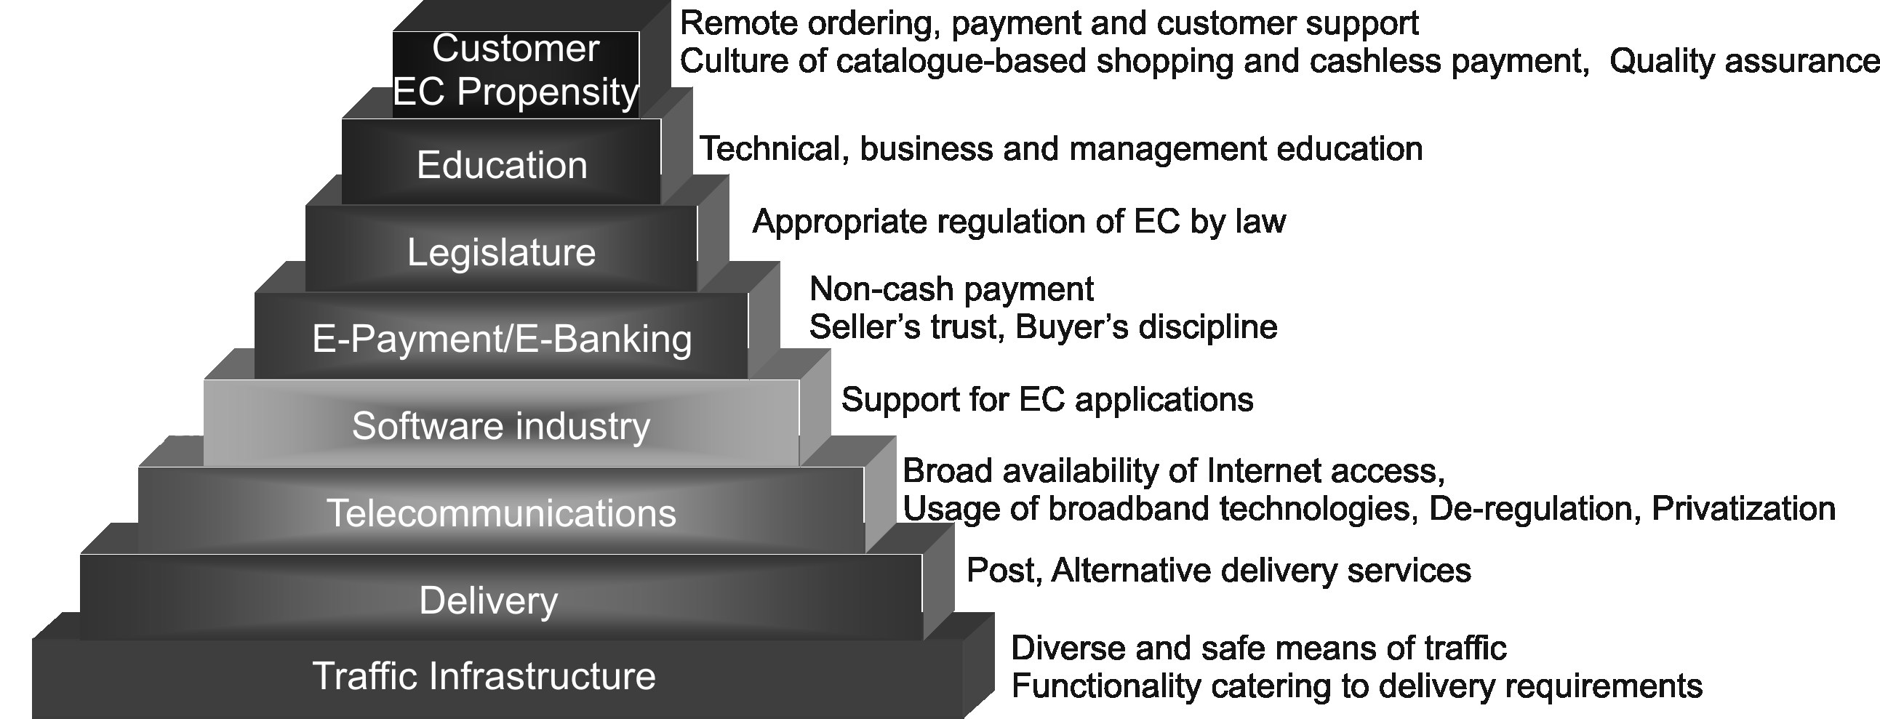
Figure 1: Research model

Our investigation was designed as an interpretive case study (Baskerville & Myers, 2004). We used interviewing, surveying, observation, document analysis, main national statistical researches, and Web site analysis for collecting data. Most of this data was content analyzed. When our attempts to collect data from intended samples failed, we drew inferences from limited samples, while relying on the individual expertise that each of us has in respective areas.

TRANSPORT INFRASTRUCTURE

The most basic layer in our pyramidal model of EC refers to traffic infrastructure—roads, air traffic facilities, railroads, and waterway (Travica, 2002) ibid, which provide support for delivery services required both in B2C and B2B EC. The land traffic infrastructure in Serbia is well-developed intercity road network that is comparable in terms of density and pavement type to that of the most advanced Central and East European countries. The total length of roads is 42,692 km, where 24,860 km are paved roads. Roads are provided for the main transportation route in Serbia. Since ancient times, the Morava river valley is the crossroads between the North and South, and East and West. The major road in Serbia is the cross-Europe highway E-75 that connects Norway with Greece and it is well-known as Corridor 10 (ECMT, 2005). Thru the same valley passes another important road: the international highway E-70 that starts in Spain and, via Romania, ends in Turkey. Also an important road connects Niš with Sofia, the capital of Bulgaria. This is a branch of Corridor 10 that links to Corridor 4 and it is important because, in a way, Corridor 4 competes with Corridor 10 as it bypasses Serbia (originates in Germany, and runs through Hungary, Romania, and Bulgaria to Greece and Turkey). Yet, another important road is E-763, the B-category route that links Serbia with Montenegro, which is now in reconstruction process.

The layout of the roads and their inclusion in European Union’s strategic corridors create favorable conditions for the commercial traffic in Serbia. Some economic experts contend that the country can become a transportation hub. In addition, the degree of the development of inter-city network creates a potential for increasing the reach of delivery that e-commerce may require. However, the scenario of economic development capitalizing on transportation opportunities is far from being uncontested. One difficulty refers to a poor condition of the road network. The funding of road maintenance has decreased dramatically in the 1990s. Unsustainable tariff and financial policies and mismanagement of available funds have resulted in a significant de-capitalization of the transportation sector and in lagging behind the neighboring countries. Serbia spends only $570 per kilometer of road maintenance, which is 26 times less than what is spent in developed European countries.

The railroad traffic infrastructure in Serbia involves over 3,808.5 kilometers of rails (one third being electrified). Backbone lines support the hub position: 40% or railroads are included in Corridor 10 and they fully connect Serbia with the neighbors and with three seas. A railroad also connects Belgrade with the largest seaport Bar in Montenegro. A 500 kilometer-long segment of a high-speed railway is in very slow under way.

Serbia’s waterways also have an international character—four of its five longest rivers flow over the country’s borders. In contrast to the state of air traffic infrastructure, Serbia’s waterways may be exhibiting stronger signs of vitality. There area several significant waterways that support both domestic and international traffic. Here belong the rivers Danube, Sava, Morava, Tisa, and Tamiš. All but the Morava flow over Serbia’s borders. The Danube River is crucial since it flows through ten European countries over 2,850 km and it presents a significant economic potential (World Bank, 2005). It runs through ten European countries, making a transportation corridor in itself. This Corridor 7 connects west and east Europe, and the North Sea with the Black Sea. A realization of the traffic scenario, however, is challenged by a poorer condition of the road network and losses in the road and railroad traffic due to mismanagement and destruction in the 1990s. The stretch of the Danube through Serbia amounts for about 20% of its length. Three bigger ports are in Serbia: Novi Sad, Belgrade, and Smederevo. Port Novi Sad is important as the entry point for the pan-European traffic. The Belgrade port is significant not only as a Danube port but also as a crossroads, for that is where the Danube and the Sava meet, and Corridor 7 (the Danube) and Corridor’s 10 intersect (indeed, two parts of this corridor—the main trunk and north wing; see Figure 2). Some observers posit that the Danube can present a particular economic advantage for the country. Serbian economy also uses the seaports in Montenegro, Bulgaria and Romania.

Another challenge refers to the state of the air traffic infrastructure. For example, the Belgrade Airport lost its international prominence it enjoyed before the 1990s, and the ensuing drop in income downgraded the maintenance and asset renewal capabilities of this and other airports. NATO’s bombing raids in 1999 additionally deteriorated the situation. The air traffic infrastructure in Serbia contains 36 airports (paved or unpaved) and a few heliports. Main airports are in Belgrade (now Nikola Tesla Airport) and Niš (both international). The resent investments in Nikola Tesla Airport promoted this airport as a future hub for Southeast Europe. Another important fact is that this airport is chosen to be the gateway for all flights which are connecting Europe and Cuba.

DELIVERY CHALLENGES

The term delivery can be defined as moving the goods from the seller to the buyer. It includes the services of transportation, warehousing, freight forwarding, logistics (planning the shipment routes and timing, shipment tracking), and other steps in the order fulfillment process. It includes the transportation infrastructure for physical movement of the goods as well as on telecommunications for order placing and shipment management. Fulfilling an order is the final step in a supply chain for a particular commodity. The delivery layer is necessary for shifting commerce into the electronic context.

E-commerce is not just about putting up a Webs storefront or establishing EDI or extranet links between institutional sellers and buyers. If a seller participating in e-commerce markets does not provide delivery on its own, such a seller needs to have stable relationships with providers of delivery services. These relationships could be realized via long-term contracts between sellers and delivery firms. Alternatively, short-term deals suit the purpose, provided that delivery firms operate in the geographical regions in which sellers and buyers reside. The price of jumping into e-commerce without including delivery services into business models can be high.

In Serbia, the main provider of land delivery services is Serbian Post (Public Enterprise of PTT Communications “Srbija;” “PTT” stands for “Post, Telegraph, and Telephone”) (PTT Serbia, 2007). This is a government-owned monopoly with major stakes in a number of subsidiary companies, covering landline and mobile telephony, banking, and Internet services (see the sections on telecommunications and software industry). Serbian Post provides door-to-door delivery of semi-finished goods between manufacturers and from manufactures to retailers, warehousing, handling of returned shipments, and international delivery in cooperation with DHL. In a process of diversifying its portfolio, Serbian Post has partnered with Neckermann, a German retail firm with a long tradition of catalog sale. Serbian Post delivers products ordered through the catalog, and supports the manual payment procedures.

Railroad traffic adds to the delivery capability of the country. The national railroad company plays part in cargo delivery that is at a modest level. The sole domestic player in this industry is the government owned enterprise Serbian Railways, which owns 158 of active stock and 4800 cargo wagons. In 2000, about 4,000 rail lines were operated, which marked a moderate level of railroad traffic in comparison to the neighbor countries. However, the actual cargo traffic was not at par with these countries, placed Serbia in 2001 next to the lowest ranked Bosnia and Herzegovina.

Other players have more limited capabilities. For example, some whole sellers and retailers offer transportation and warehousing services, and smaller private firms and independent truckers offer transportation. FedEx and UPS are present, expanding the global delivery offerings. There are other players in the delivery industry, although their capabilities are limited. Specifically, some whole sellers and retailers offer their own transportation and warehousing services. In addition, about 20 smaller firms offer some delivery services, and there are dozens of independent truckers. Serbia is behind the neighboring countries in terms of the number of trucks, and nearly 40% of these vehicles have recently been unable to meet the technical standards of European Union (UNECE 2003; USAID, 2007). An overall poorer state of vehicles in Serbia combines with the unsatisfactory road conditions to create a significant risk factor.
Waterways delivery of goods is environmentally safer and can be more cost efficient than delivery via other routes. Since it is also capable of carrying larger shipments, delivery via water yields significant economies of scale. Delivery via waterways in Serbia has a great potential that is still not materialized in right manner.

The most significant river is the Danube, which flows through ten European countries and provides good conditions for sailing in its south/east portion, Serbia including. Conditions for intensifying the international traffic on Serbia’s portion of the Danube have recently been surfacing. One of the landmarks in this process was reached in October 2005 with the opening of a new bridge in Novi Sad, a key Danube port in Serbia. The new bridge replaced a pontoon bridge that blocked the international traffic for six and a half years, serving as a substitute for a six-lane bridge destroyed by NATO’s missiles. Since the city of Novi Sad sits on a branch of Corridor 10 (a highway and railroad), the enabling of sailing through Novi Sad implies that the second connection between Corridor 10 and Corridor 7 (the Danube itself) is achieved (the first connection is in Belgrade).

The Danube port Smederevo is poised to support the traffic needed for a gigantic complex of metallurgy factories recently acquired by U.S Steel. Their steel products are shipped downstream the Danube to the Black Sea ports in Romania and Bulgaria. As opposed to the growing traffic on the Danube, the process of reviving what used to be high frequency traffic on the river Sava has been slower. Countries that descended from the former Yugoslavia labor on upgrading the status of this river into an international waterway. Serbian economy also uses the seaport Bar, which lies on the Adriatic Sea in Montenegro. This port is operated under special regulations that allow for a free movement of capital, goods and labor, and duty and tax exemptions.
Delivery of goods via air routes is carried by the national airline Jat Airways (formerly JAT—Yugoslav Air Transport). This company is also the main carrier of passenger traffic. A high ranking airline company in Europe in the 1980s, Jat Airways suffered significant resource and market losses due to the breakup of the former Yugoslavia in 1991 and international trade sanctions imposed on Serbia soon after. The company was grounded abroad and it lost the financial capability to regularly maintain its fleet. The airline is attempting to bounce back, while operating an aging fleet of about 20 mid-range passenger planes.

The airline transportation also features several operators of passenger traffic (the charter company Aviogenex, which owns four mid-range planes) and a few independent operators of small passenger planes. Still, true competition comes to JAT Airways only from international airlines that have taken control of key international routes. In this situation, however, JAT Airways preserves an ownership structure that does not oppose inertia; the same applies to Serbian airports. Also, JAT Airways refrains from participating in international alliances of airline companies, and continues to be focused on passenger traffic. These facts are in a stark contrast to changing characteristics of air transportation industry in the world. For example, Bulgaria allowed split-offs from the main national air company, then privatized part of it, and provided conditions for private carriers to enter the business.

TELECOMMUNICATIONS FACILITIES

By January 2007, 433 million hosts were connected to the Internet—almost three hundred times the number of ten years ago (ISC, 2007). The number of Internet hosts has been adopted as a measure of the Internet penetration of a country and the degree of national connectivity and it is defined by ITU as the number of computers directly connected to Internet. This number is assigned to country code, so the data shown in Fig. 3 is related to Serbia and Montenegro (country code YU), because there is no data available yet for a new country code (RS). Also note that if there is no country code identification in case of generic TLDs (org, com, etc.), such hosts are assigned to US.
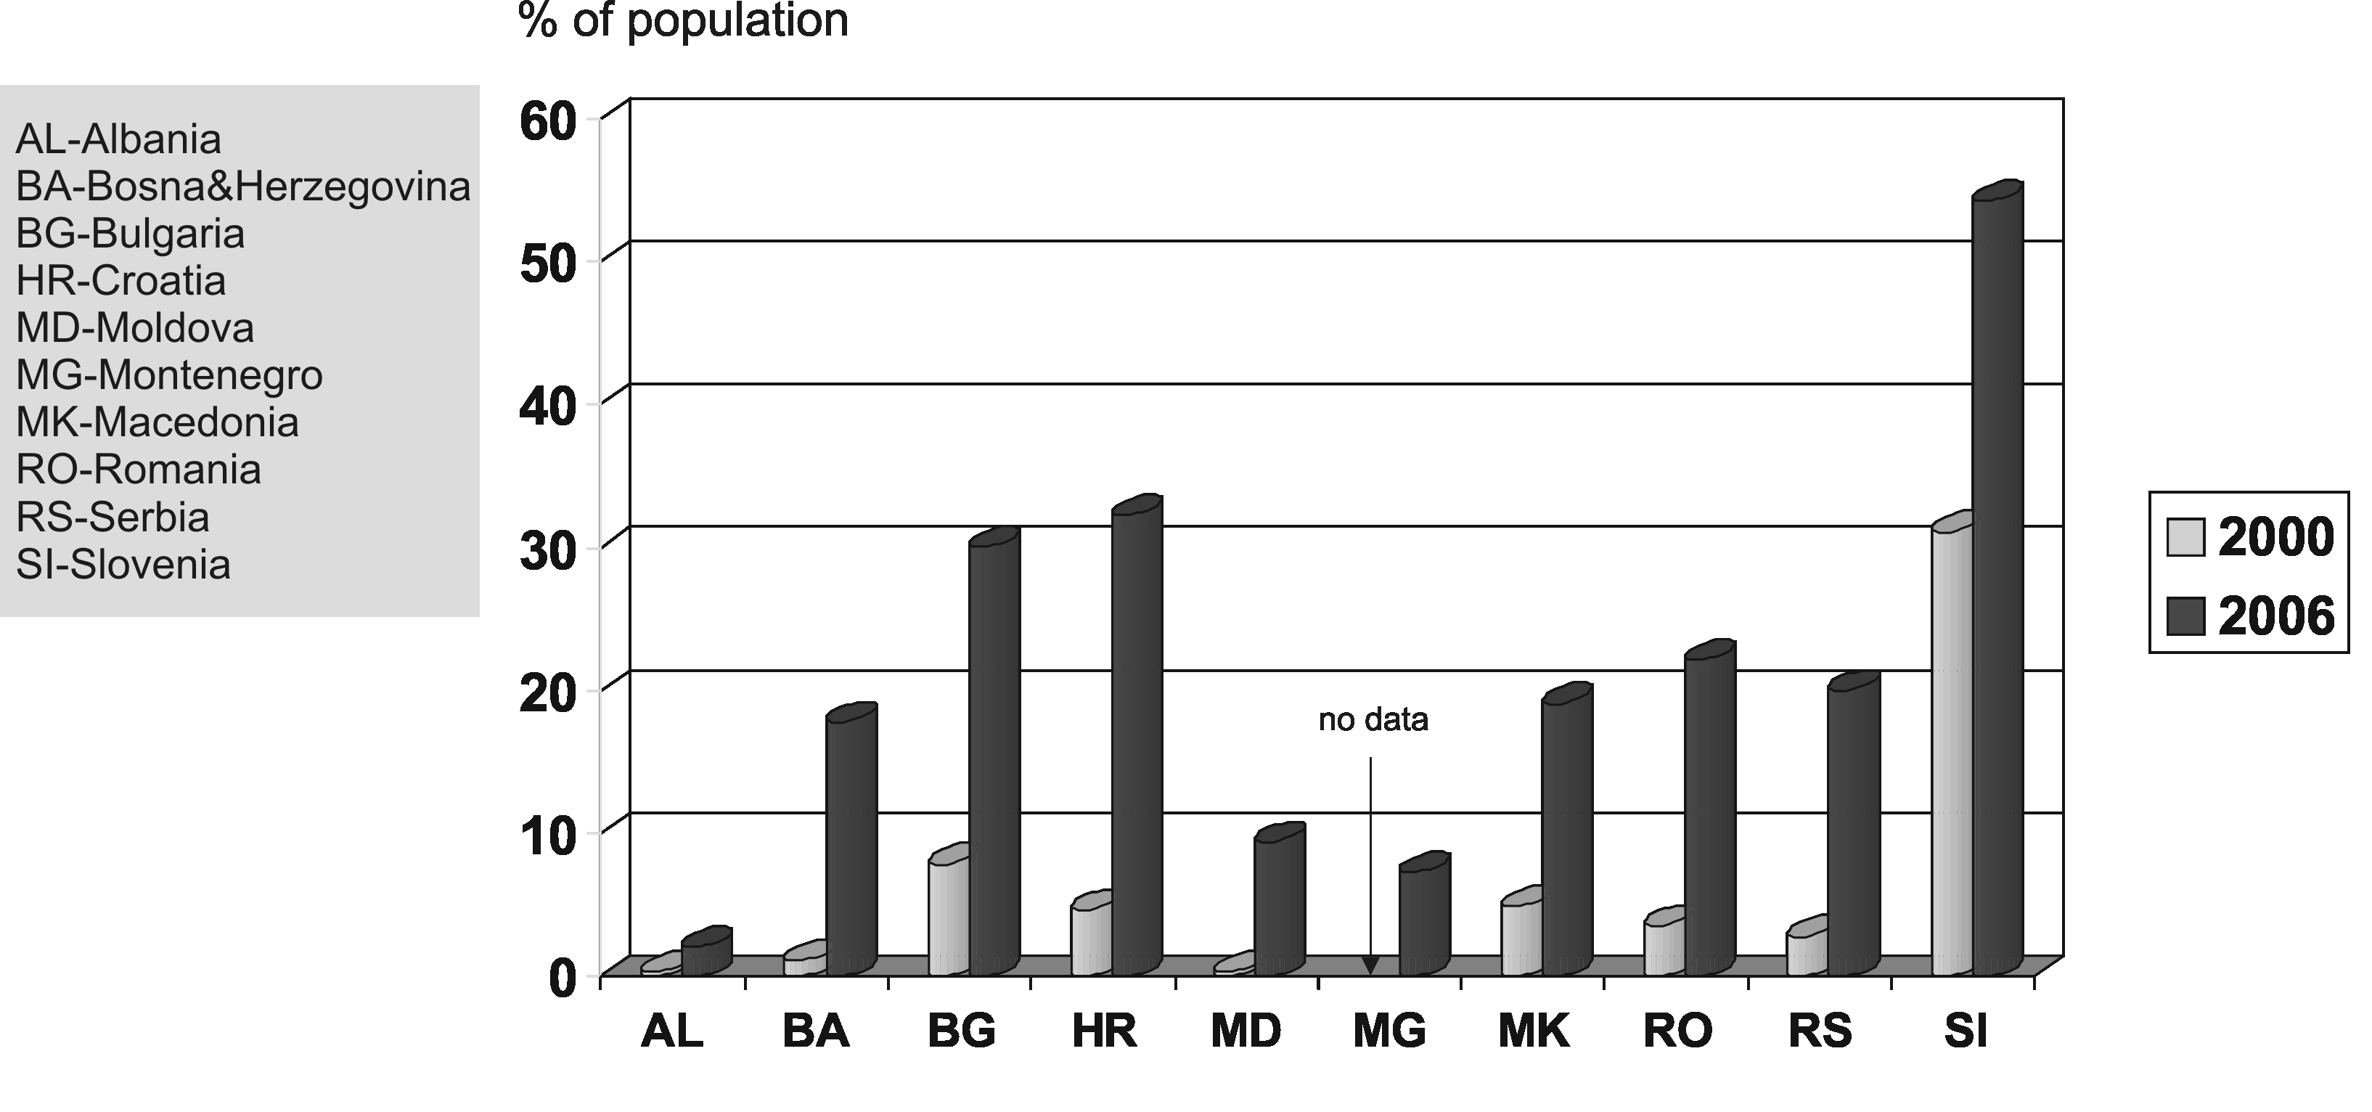
Figure 2: The number of Internet users across SEE countries (by 2006)
Serbia has joined the Internet galaxy. Since 1996, the number of Internet hosts multiplied 75 times. Although this appears to be an impressive achievement, Serbia has just 20% of the population using the Internet and 94.000 Internet hosts. This places it sixth (see Fig. 2) and fourth (see Fig. 3) from the bottom up in the distribution of the countries in South Eastern Europe (SEE). A technological and institutional inertia in the telecommunications industry may be partly responsible for this comparatively slower pace of Internet adoption.
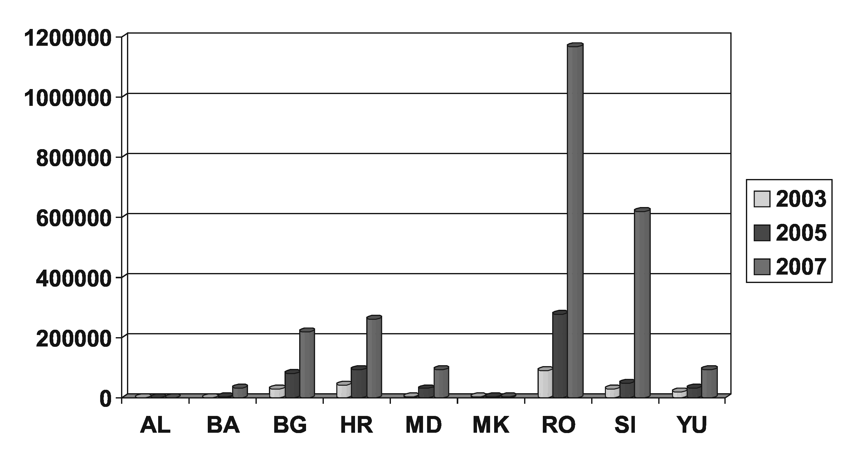
Figure 3: Distribution of Internet hosts across SEE countries (by January 2007)

The Internet backbone in Serbia is Serbian Multiservice Internet Network (SMIN), owned by Telekom Serbia. SMIN is modem accessible from all over Serbia. Primarily intended for Internet services, SMIN is also used for the transfer of voice and data as well as for building Virtual Private Networks (VPNs). SMIN has four Points of Presence (Belgrade, Novi Sad, Niš, and Kragujevac), which are mutually connected by 155 Mbps lines (see Fig.4). Two 155 Mbps lines connect SMIN to the global Internet.
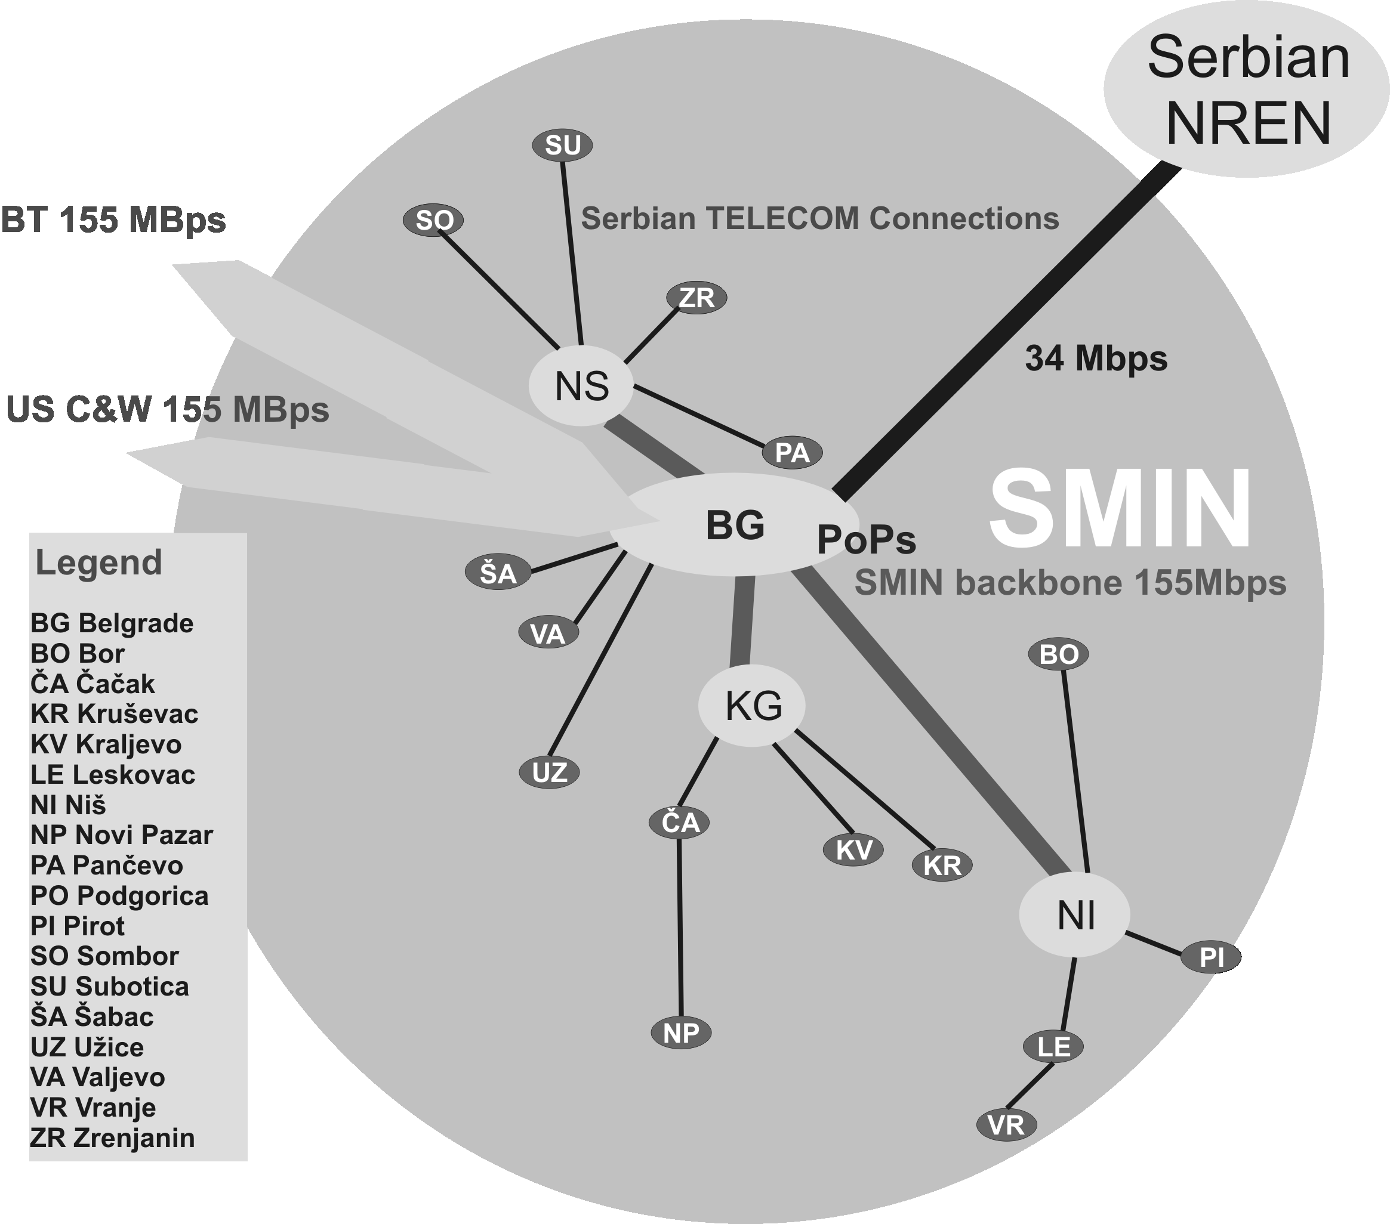 | 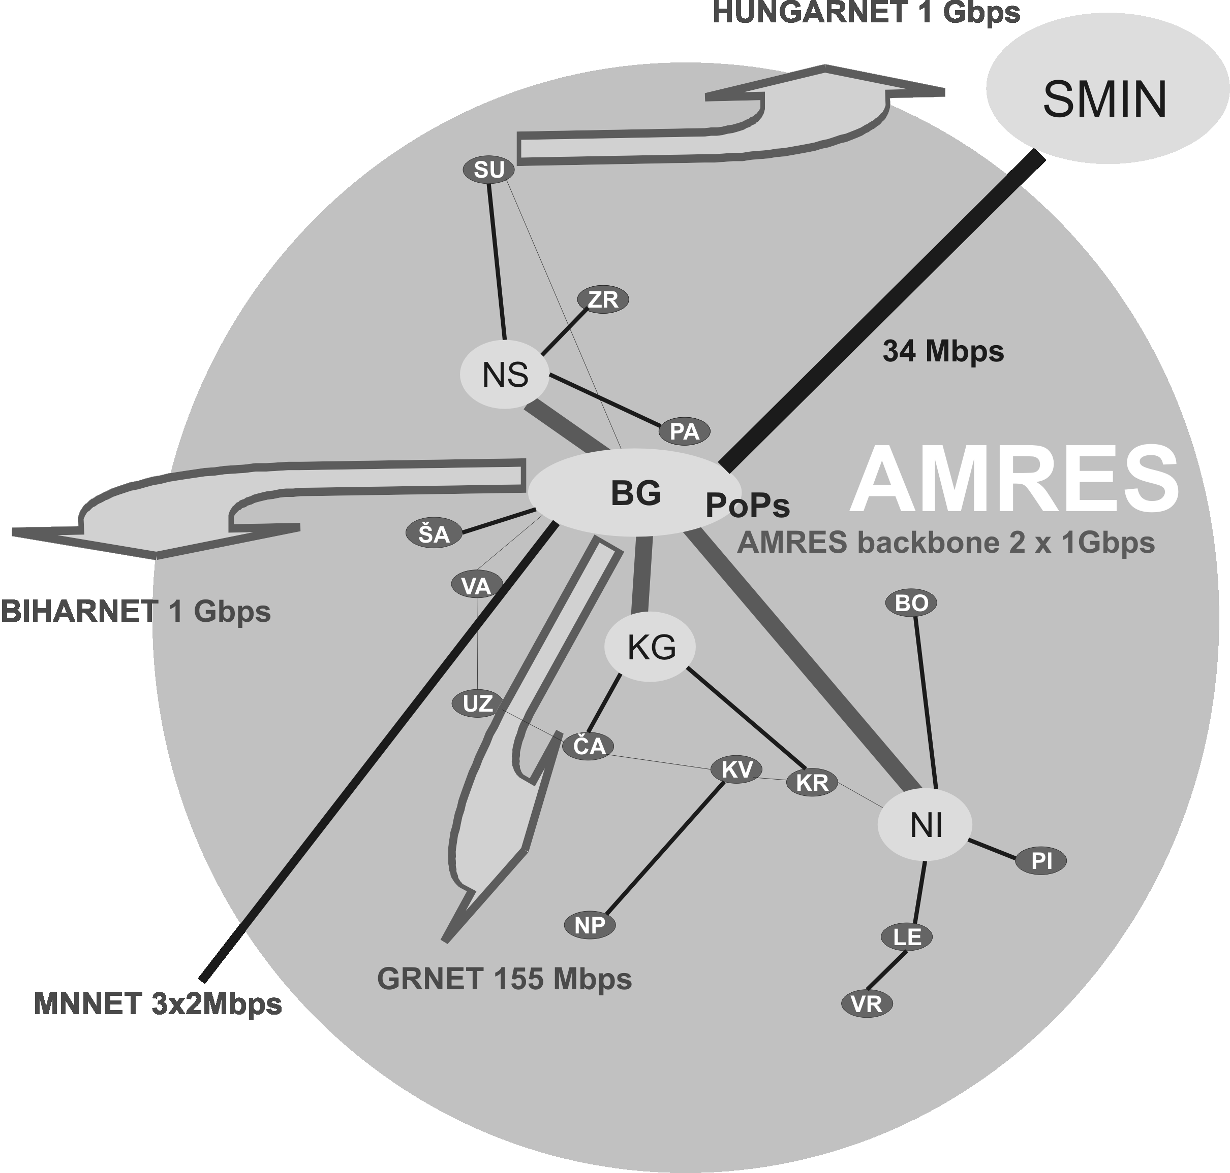
Figure 4: SMIN topology (left) vs. AMRES (right) as per July 2007

Although currently sufficient, SMIN’s speed may cause congestion with the expected growth of the customer base. Access opportunities are skewed toward larger urban centers while rural areas are disadvantaged. In contrast NREN of Serbia (AMRES) demonstrates better design (backup connections are provided) (Jovanović, et al, 04) and much better international connections (RCUB NETIS, 07). In addition to two international GEANT (Gigabit European Academic Network) connections (via HUNGARNET and GRNET), AMRES appears as a key node for connecting academic networks of Bosnia and Herzegovina (BIHARNET) and Montenegro (MNNET) to GEANT.

SMIN’s basic offering is switched access via public telephone network (the 56Kbps-modem access; $30 buy 200 connect hours monthly) or via Integrated Service Digital Network (ISDN). ISDN access has the maximum speed of 128 Kbps and is priced between $200-1,100/year, plus cost of connection time (¢0.37 per minute for local calls). Broadband offerings comprise two types of lines shown in Table 2.

Table 2: Annual cost of broadband access (connection fees included)
Broadband Line | 2 Mbps | 34 Mbps
Direct access to IP VPN | $4,015 | $37,858
Direct access via layer 2 | $3,476 | $34,826

More recently, the Asynchronous Digital Subscribe Line (ADSL) was introduced. The broadband lines are typically unaffordable for small and medium size enterprises and ISDN access is a more feasible solution for this user group (about 80,000 as of October 2005). Although currently sufficient, SMIN’s speed may cause congestion with the expected growth of the customer base. Access opportunities are skewed toward larger urban centers while rural areas are disadvantaged.

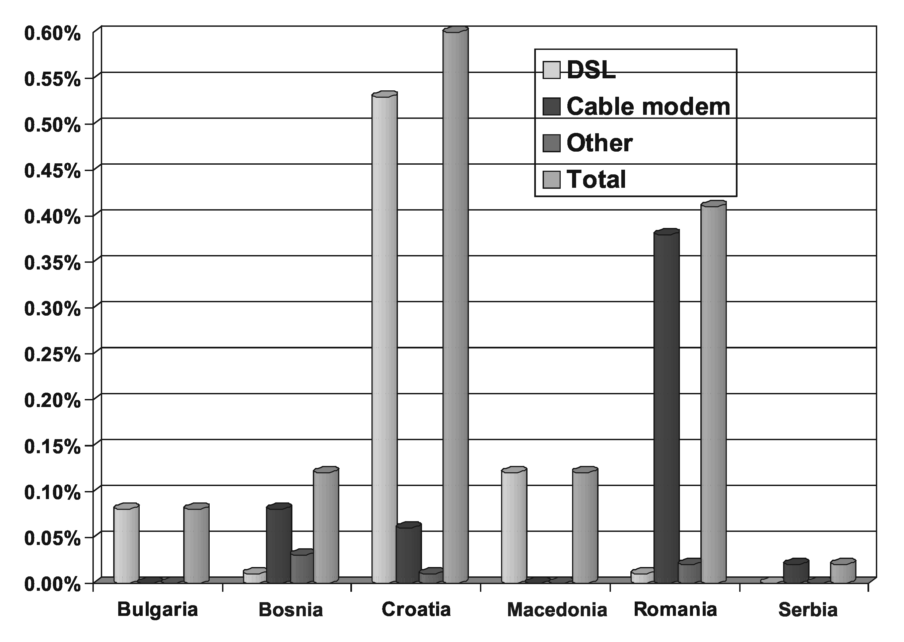
Figure 5: Broadband penetration in SEE by technology as per 2005

Broadband is increasingly available worldwide. It was used by 38% of all Internet subscribers in 2004. The figures of broadband access in SEE countries are far away as shown in Fig. 5. With only 0.02% of subscribers using broadband technologies by the year 2005, Serbia is placed at the bottom of the comparison chart. But, the other SEE countries on the chart are not much better. However it should be noted that ADSL technology has been widely offered in Serbia since the end of 2006. The bandwidths available vary from 256Kbps/64 Kbps to 768Kbps/192Kbps (download/upload), with the prices for the fastest connections, ca 450 US$ per year for individual subscribers and 650 US$ per year for companies. Data that cover prices for leased ADSL lines are not publicly available. Prices for companies are reasonable, but for individuals, with the average salary of 4800 USD per year, prices are quite high. Emerging broadband technologies such are ADSL2, VDSL, FTTx, WiMax, etc. are not in notable use.

The ISP market consists of 107 Internet Service Providers (ISPs) (Serbian Yellow Pages, 2005). Many ISPs are resellers of Internet access that is controlled by larger ISPs and ultimately by Telekom Serbia, the owner of the national wired network. The major private ISPs are Eunet, Beotel, Verat, and YUBC (Maruzzelli, 2004) ibid. Also noteworthy are SezamPro, Neobee in Novi Sad, and Medianis in Niš. International connectivity is provided mainly by Telekom Serbia and private companies YUBC and Verat (connects to Deutche Telekom’s network).

Mobile telephony is on the rise in Serbia. In principle, wireless communications may be conducive to mobile commerce (Varshney & Vetter, 2002). For example, short messaging service (SMS) enables mass trading that one can easily observe in Serbia. Supported by several TV stations, people advertise, sell and buy. Some companies use this model as an additional sales channel. There are 3 GSM operators in Serbia—Telekom Serbia, Telenor and VIP. It is important to say that VIP is working from the first day July, 2007, so there is not any information about this GSM operator.
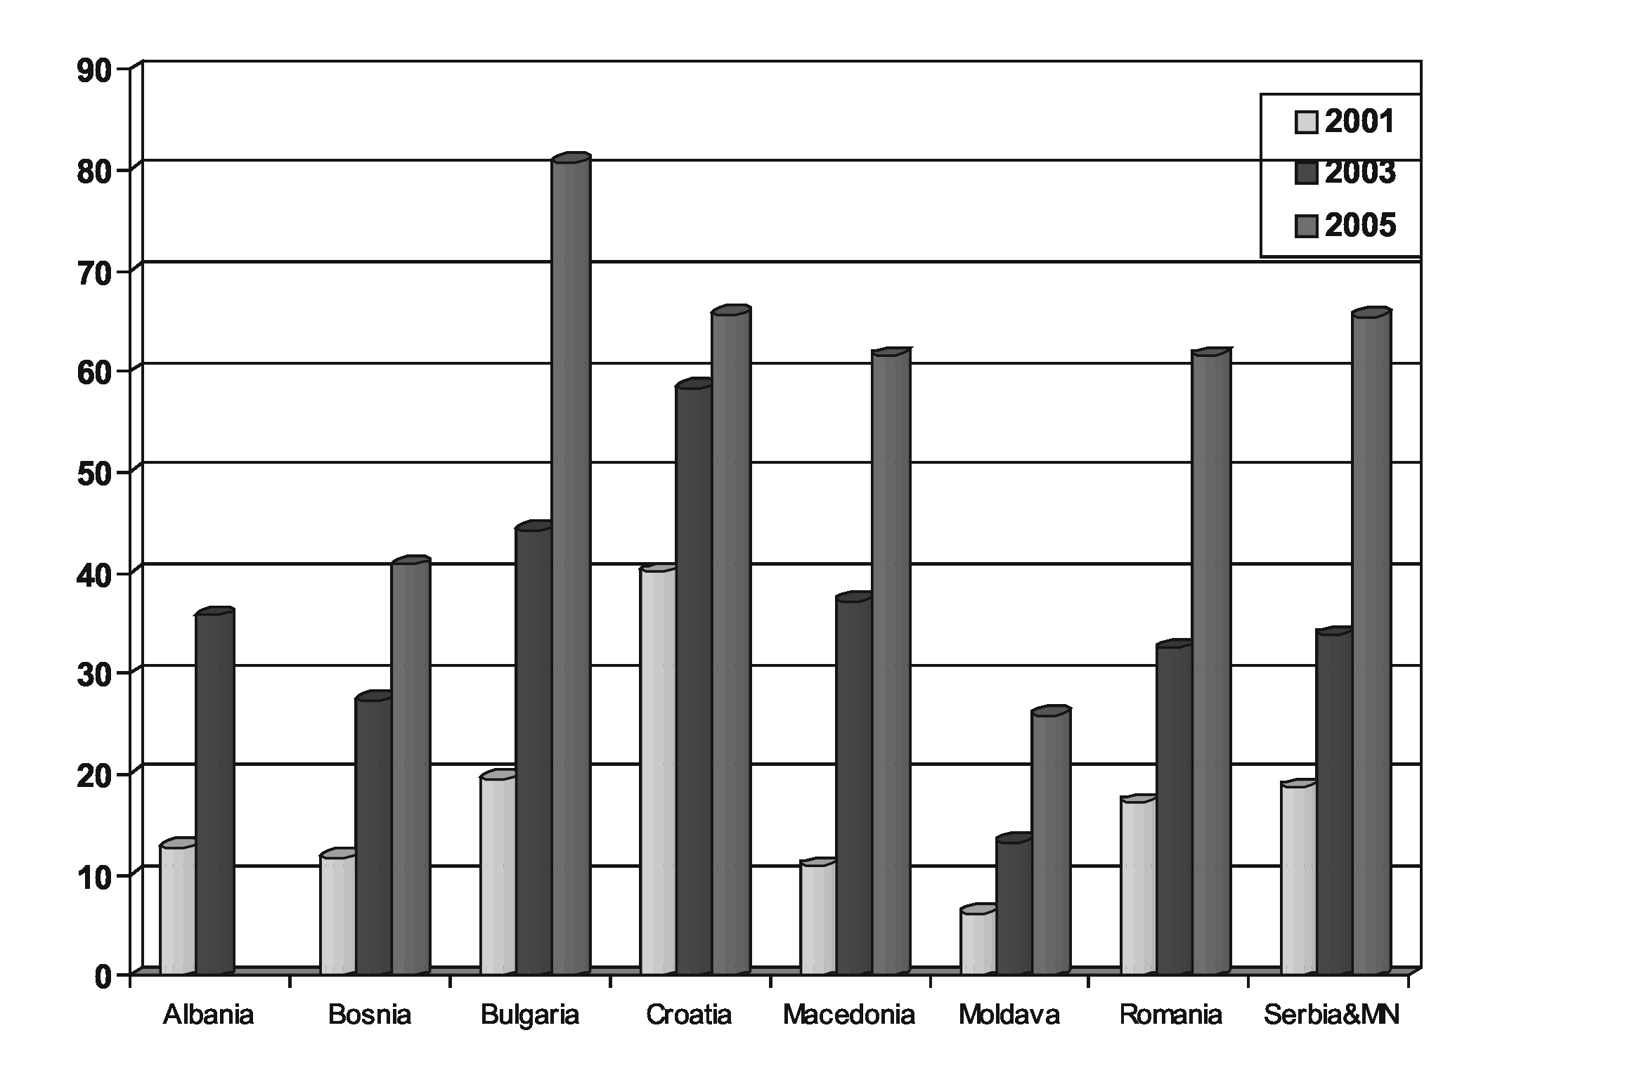
Figure 6: Mobile phones penetration across SEE countries per 100 inhabitants
In addition to technological limitations, the telecommunications industry is under tight government control. Instead of deliberating over crucial issues of de-monopolization, privatization and deregulation of telecommunications, the government has moved in a zigzag manner, sending confusing signals. For example, a 49% share in the national telephone company had been sold to foreign firms, and then 29% was purchased back. Mobile telephony has followed a similar trajectory. The success story of AMRES development has started in the year 2003, when Telekom finally decided to leave academic network development to the University of Belgrade. Before that, the only international connection between AMRES and GEANT was 2 Mbps!

SOFTWARE INDUSTRY

A viable software industry is necessary for developing EC’s front-end (Web sites), back-end (databases systems), and links between buyers and sellers and among trading partners (computer networks). In the 2000s, the software industry in Serbia has been achieving almost three times bigger annual growth than the rest of economy (IDC, 2003). The list of software vendors contained 1,100 companies with over 5,000 employees at the end of 2004 (Medaković, 2005). The company profiles are indicative of new times. Before the 1990s, software development was mainly carried out by internal IS functions of large government-controlled enterprises. Today, smaller private companies and large foreign vendors dominate the industry. The average size of domestic software companies is five employees. Software vendors tend to cluster in urban communities, and more than a half of them are in Belgrade. A good level of software supply exists in other four large cities (Maruzelli, 2004).

A number of vendors offer Web development services, both in the B2B and B2C segment. Examples of the former include PAKOM and Comtrade Group. In the B2C arena, the list of notable vendors includes private companies Yunix Software (powers the on line bookstore Knjizara.com) and Saga. Saga has partnered with Cepp, the e-business department of Serbian Post. The partnership made Cepp the sole enabler of e-business solutions in the Serbian market with a strategy of moving the “trust that customers have in the Post’s correctness and efficiency” into virtual space (Maruzelli, 2004). The software industry outside of Belgrade promoted some successful competitors.

In order to obtain a more comprehensive picture of the industry, we used Serbian Yellow Pages to sample 47 companies offering Internet services and 75 companies offering more general information systems services. We found a wide-variety of applications on the market, from simple applications to complex business information systems. Most of the software vendors use email for business communications and have Web sites. About 28% of the companies offer Web design services, and near 19% are declared builders of EC applications. The education support for software development is quite good. Most of the high schools and faculties which teach software offer crucial courses for electronic commerce and Web development (computer networks, algorithms, databases, software engineering, Internet technologies, web programming, etc.). There are also some academic research efforts that are directly related to electronic commerce architectures and related technologies. Some recent research include, but no limited to B2B interoperable frameworks (Kajan & Stoimenov, 05), agent technologies (Badjonski et al., 06), ontology modeling (Djurić et al., 05), etc. These last figures reflect a new trend and can be considered encouraging. Countering these trends is a mainstream business culture that resists recognizing the economic value of software. The users still wonder “why software is so expensive” and incline to spend money on software only if it is bundled with hardware.

Foreign vendors include AcuCorp, Adobe, Autodesk, Borland, Bull, IBM, Microsoft, SAP, Oracle, Symantec, and TIBCO. Microsoft is especially active. Recently Red Hat has joined, which is big movement in open source software development. The company recently opened a development center in Belgrade and led a campaign for suppressing software piracy. In 2007, the index of software piracy in Serbia is 78%. That is more than double higher of world average (Reporter, 2007), while percentages in the neighboring countries are Slovenia (48%), Croatia (55%), Bosnia and Herzegovina (68%), Macedonia, Romania and Bulgaria (69%), Albania (77%) and Montenegro (82%).

Serbia’s software industry is challenged by the state of IT in companies, a lack of IT awareness, and brain drain. Not many companies own IT resources that can be considered appropriate. Examples of successful B2B EC refer to a handful of companies in the chemical, retail, and insurance industry. Although computers are deployed in many companies, typically simpler office automation applications are used, character-based user interfaces are frequent, and file management systems rather than database applications prevail. Furthermore, exposure to the Internet is measured partly by the figure of 22,670 companies owning Web sites in the co.yu domain. There is no data on the extent of using the .com domain.

The brain drain, measured on a seven-point scale, stands at 1.88 (1=high). In contrast, this rate is 2.06 for Romania, 2.10 for Bulgaria, 2.71 for Croatia, 2.71 for Greece, and 4.15 for Slovenia (EU, 2005). A cause to the brain drain could be in internationally non-competitive salaries, although these actually are up to 10 times bigger that the average salary. Finally, in spite of the limited domestic market, the software industry does not show export ambition yet as opposed to its neighbors—Bulgaria, Romania, and Hungary (Karmel, 2003).

E-BANKING AND E-PAYEMENT SYSTEMS

In the course of the last five years, a number of reforms were carried out in economic and financial sectors in Serbia, in the process of which, a reform of the payment system was a precondition for further development. Through several systemic projects, a radical reform of this field was carried out in accord with global tendencies of implementing new instruments, procedures, and infrastructure in payment systems under the influence of market competition and technological advancement. Today, Serbia has a modern and efficient payment system which is entirely based on international standards and the best practice of the EU countries (Vuksanović, 2002). The achieved results were given full credits by the relevant international institutions (IMF, IBRD, and ECB). In March 2006, the mission of the FSAP (Financial Sector Assessment Program) gave top marks to all relevant criteria.

A significant progress of the existing elements and the introduction of new elements into e-banking into the Serbian banking system is due to the changes in the macroeconomic environment made in 2003 when the new Law on Payment Operations was passed. The goals of these changes were twofold - to replace the existing monopolistic payment system with a market system, and to establish institutional conditions for the electronic banking development. The current situation in the Serbia’s economic system has favorable effects on the further improvement of e-banking and the development of payment-card market. In this connection, the following elements have an enormous impact:
- low inflation,
- a stable foreign exchange rate, and
- new opportunities that will be given to Serbia after the negotiations with the EU have been continued.

The effect of the new Law on Payment Operations enacted on January 1, 2003 on the e-banking development results from direct effects on the very payment system as well as from establishing the preconditions for a radical transformation of the very models of bank operations and their customers. At first, it was the introduction of a payment-card system that was of a primary importance, and later on, it was the implementation of hybrid sorts of mobile telephony.
After the Law on Payment Operations was passed, the banks successfully included in the new systems of inter-bank dealings: the RTGS (Real Time Gross Settlement System) for priority payments and high-value payments, and the net system for low-value payments. Those systems are pursuant to the world principles, organized overtaking of gyro accounts of enterprises and performing payment transactions, simultaneously offering a higher level and quality of services adhering to the slogan “Accommodate demands of customers”. The existing basic information systems (“core- banking”) were upgraded by a new layer of applications intended for the support of electronic wholesale and retail banking.

The wide range of e-banking supply has been expanding drastically in a very short period. By a PC or mobile phone, banks enable their customers to: get an insight into the balance of the account, review transactions, examine the statements of account changes, receive and send personal messages, pay duties by payment orders dated on the current or later date. Practically, all banks issue several types of international and domestic payment cards. Out of all international payment cards, VISA is the most frequent payment card which, after a ten-year absence from Serbia, reached the one-million figure of cards issued just in a three-year period (in comparison with other countries, only China experienced a faster growth). According to the importance of other payment cards, VISA is followed by MasterCard, Diners, and much less by American Express. The system of DinaCard has increasingly been expanding on the domestic payment card market (Španović, 2005). Lately, hybrid sorts of mobile telephony have more commonly been used.

Since 2003, due to new economic and financial environment, an intensive development of payment card market has commenced. This market has been developing faster than any market in the region, owing to, on the one hand, the previous knowledge and experience acquired in the former Yugoslavia, and on the other hand, to a very strong support of the Government’s programs relating to payment cards. The experience from the former Yugoslavia, dates back to the 1980s (VISA was the first card to be issued in 1980, then in 1981, three ATMs (Automated Teller Machines) were installed, and finally, in 1984 the banks started issuing and using payment cards massively, but that successful period lasted only to 1992-93 when the sanctions were imposed).
The Government had a direct interest in giving its full support, because each of these transactions represented a legal cash flow verified by a receipt and meant that taxes had been paid, which was one of the most important factors in fighting the grey economy. The state support became prominent in the course of the national DinaCard system development. Such a situation proves that there is a possibility that a ten-year regression - in this previously developed area - will be made up in a relatively short period of time.

Not only banks, but the related state institutions also back up the activities being carried out, that is promotion of cards as a means of payment. A severe competition between banks has lead to the weakening of the criteria to be met for obtaining payment cards, especially debit ones. These cards (debit) can be obtained free (of charges of issuing and membership fees) provided that a customer has a current account with the bank in question. Some banks provide special stimuli through deal packages (so Delta Bank combines a payment card issuing with particular life policies – Delta Life, or with international insurance cards – Europe Assistance).

Credit card issuing is more complex and it includes membership dues, costs of account maintenance, as well as interest rate on extended credits (which are in most cases the revolving credit options, although all known options are available). But in the banking circles, there is a dilemma about the actual credit worthiness of the major part of population due to its capacity to use the cards massively, taking into account that the monthly interest rate varies from 1,9 to 2.20 percent. To solve problems relating to credit worthiness and to introduce financial discipline, the Credit Bureau (as part of the Association of Banks) was formed. The Bureau keeps records of the total individual indebtedness of each credit beneficiary.

The results of the development of payment card transactions in Serbia can be estimated on the basis of the number of the payment cards issued, the number of POSTs (Point of Sale Transfers) and ATMs, and their application. In 2007, the number of the issued payment cards has reached the figure of 5.6 million, while a rise of 1.2 million was recorded in 2006. The number of the POSTs installed in 2007 has exceeded 50,000, and the number of the ATMs ha reached around 18,000. During the last twelve months, 70 million transactions were made, out of which 6.5 million in May 2007. According to the pace of payment card issuing, Serbia is, on this very day, assigned to be the leader of the region (VISA proclaimed publicly this market to be the leader, due to the fact that in three years only, from 2003 to 2006, three million VISA payment cards came into circulation. As stated by some official research carried out by foreign agencies, Serbia was put on top of the list of the ATMs increase in 2005.

Despite some indices that Serbia is the leader in the region, it still lags behind some countries of the EU by the number of transactions. The reasons for this condition, on the one hand, arise from the population’s ignorance of the use of this kind of services, and, on the other hand, from the acquired habit to use checks as a means of deferred payment. Only when the deferred payment by checks - that is, the opportunity that partially compensated needs of the payment card usage - was abolished were payment cards used to a large extent. As the use of checks for deferred payment had been an unofficial “social valve” in the course of prior years, this check function had to be phased out and the deadline for such a practice was extended several times. The government bodies insisted that checks should regain their function of a payment instrument and that the credit function should be transferred to credit cards. The intention of the bodies was to suppress gray economy and legalize all money flows including all beneficial economic effects which payment cards were to take. This problem was solved officially on January 1, 2006, when the institutions gave a strong incentive for credit cards to become a means that would officially replace the previous unofficial use of checks.

Today, there are a number of systems of international, national, company (loyalty) and co-branded cards on the Serbian market. However, the fact that two thirds of customers of banks have and use mobile telephones affords them new opportunities to get used to paying goods and services by their mobile phones and other hybrid technologies. The survey carried out at the beginning of 2005 (comprised the population of 1000 respondents - beneficiaries of banking services) showed that over 61 percent of respondents uses the mobile phone. According to the results, one fourth of the respondents possessing a mobile telephone are interested in these services, so that a more intensive development of m-banking and m- payment can be expected in the forthcoming period.

The national DinaCard Program comprises a wide range of debit and credit cards: “DinaCard Klasik”, “DinaCard 3”, “DinaCard 6”, and “DinaCard 12”. “DinaCard Klasik” is a debit card, which is automatically conditioned by a possession of a current account and requires no charges. It is accompanied by special family and pension packages, which are created so as to include larger circles of beneficiaries. The Pension plus package entails beneficiaries of different types of payment cards which can be obtained without any membership dues and card issuance or the maintenance of the account (only a monthly charge for the package maintenance has to be paid). The national programs “DinaCard 3”, “DinaCard 6”, and “DinaCard 12” relate to credit cards of a revolving type which differ one from the other in the amount of the loan to be repaid.
Pricing and other benefits made possible the DinaCard quick diffusion, so that this card has been the most often used card with the largest acceptance net in 2007. Out of the total number of all the cards issued in the country, almost one half of them are DinaCards (around 2.8 million). In the early 2007, the number of the installed POSTs of this system has amounted to around 48,000, while the ATMs figure has reached around 1,450. Out of the above figures, in 2006, 19,000 POSTs and about 400 ATMs were installed. Despite this fact, it is believed that, in 2006, the greatest achievement of this system was that the issued cards were activated and the turnover was increased to nearly RSD 48 billion.

Ways of further development of this system are directed to improvement of the existing services and introduction of new kinds of services (m-payment and the Internet payments). As early as 2006, the DinaCard beneficiaries were given the opportunity to make prepaid calls by mobile phones by sending a text message (SMS). It was planned that this attractive system should be diversified in 2007, at first by introducing a service for SMS payments for postpaid mobile-phone bills, after that for standard (fixed) telephone bills, and finally for utilities payments (electricity, various public services, wireless internet etc.).

SMS payment system is being used in a variety of systems for a parking-bay payment in the open-space parking lot (while in the closed-space parking lot, electronic parking-lot gates are installed). So, for example - when coming onto the parking area, the car owner sends an SMS with the registration number of his car to one of the defined short numbers, depending on the zone of the parking lot. These numbers are unique for both active providers of mobile telephony (Telenor and Telekom) regardless of the mobile network to which the beneficiary is connected. After a very short time, the user receives an answer whether he has made a successful one-hour parking-lot payment as well as the exact time when the payment is made. Five minutes before the paid time expires, the car owner receives an SMS informing him about the expiry of the paid parking time, so that he can send a new SMS and make a payment for an additional hour. The payments made in this way are controlled by the PDA (Personal Digital Assistant) which is in possession of each controller. The control is very simple – the registration number, in the form of a question, is entered into the data base.

Some large trading companies begin to incorporate cashless payment systems. Delta M, the largest retailer, which can be considered to be an indicator of the market conditions, is implementing its own net for the card payment acceptance. In order to eliminate particular defects of the current banking offers (slow and unreliable dial-up connections, not sufficiently integrated systems, more than one EPOS terminal on one cash register, dependence on the bank which provides EPOS terminals, an inflexible process of creating of new functions, an unsatisfactory control, and a lack of reports) Delta M returns the existing POSTs to banks and introduces its own system. The new system (SecuriLink) uses internal links within Delta, as well as the advantages of its own system of maintenance. The key element of the improvement is a complete integration of the POST and the cash register. Technically, the system is designed so that it can accept all payment cards through one POST. On the basis of this system, Delta is developing a special Delta loyalty concept which offers an opportunity for a holder of several different payment cards to use each one as loyalty in Delta.

In order to get people used to using payment cards, some important activities are being carried out: introduction and co-branding of special international cards for young people (EURO<26) and for students (ISIC). EURO<26 (a European youth card) was given a reword for the most successful developing project in Europe. At the moment, this card is being distributed by 30 distributive centers, and it is being used by 30,000 beneficiaries. Since 2005, the nongovernmental organization IUVIA has had the right to develop the only internationally authorized pupils and students identification card, the ISIC. It is issued by 30 distributive centers and used by 5,000 beneficiaries. Two hundred services - such as travel and purchase in specific fashion houses - are available to beneficiaries of these cards at discount prices. Within the GAUDEAMUS project, a new official student identity card - EURO<26/ISIC was created on the basis of co-branding of the EURO<26 and the ISIC pursuant to international licenses. Currently, these cards decrease students’ expenses for food and accommodation, improve their standards of living, and develop a platform for new services to be rendered. Very soon, these cards will be used in public transportation. It is also expected that they will be integrated into banking payment systems.

As Serbia has been experiencing a transition process, it has become attractive for electronic crime, so that it should be expected that it will face with a serious problem of payment card abuse in the forthcoming period. Since the payment card structure is being dominated by debit cards whose owners have a low ability to pay – Serbia has not yet been put on the list of international groups which abuse cards by taking the necessary data and identification number off the every card, so that mostly the stolen cards are being abused. Last year, Belgrade banks suffered a 10-million-dollar damage incurred by falsified cards. Fortunately, due to the efficient fraud monitoring system Euro Planet, this chain of abuse was terminated in March 2007.

LEGISLATURE SUPPORT

The national legislature of Serbia started to regulate this area in 2004 when the Law on digital signature was passed. (On the one hand, Serbia was among the last European countries to pass the mentioned law after the European Directive on digital signature had been passed. On the other hand, this Law comprises all experience and recommendations stated in the European directive. Banks and their partners applied the European directive recommendations on digital signatures as a base for certificates and qualified digital signatures to be formed by developing their own systems (PKI). The Criminal Law of the Republic of Serbia (became effective as at 1 January 2006) comprises the issues of payment card regulating, falsifying and abusing (Article 225), production, obtaining from and giving to other persons the means for falsifying (Article 227), check issuing and usage of uncovered payment cards (Article 228). High technology crime is regulated by the Law on organization and powers of the state bodies in charge of the fight against high-technology crime. A special department for high-technology crime was formed as part of the Belgrade District Prosecutor’s Office.

The problems arising in the domain of legal protection in practice relate to the following: deficient collecting and processing of documentation of some participants ( banks, the Ministry of Internal Affairs, prosecution authorities) in the course of processing, lack of video surveillance as a means of evidence to support payment card abuse (which may be a potential advantage of the accused), lengthy judicial processes, a high level of uncertainty over the outcome of the dispute, that is, whether the loss sufferer would be compensated for his financial loss resulting from the abuse of his payment card. Due to incompetent court estimations, an expert evaluation is carried out by experts on bookkeeping and finance.

The achieved level of card payment raises a very important issue of payment system costs and, the so called, commercial commission (interchange). Taking into account that the card issuer’s commission – guaranteed by international card systems – is disproportionately higher then in the EU, and the fact that there is a possibility that this difference increases after the new rates of the EU have been set up in January 2008, the National Bank of Serbia will have to deal with relations between banks and trade. In order to establish an optimal value of interchange for the usage of payment cards issued in Serbia, the NBS is to make a detailed analysis.

The NBS is going to invite banks to make an inter-agreement and make a decision on the interchange value in the course of the forthcoming months. In this way, banks would solve this problem by self-regulations, so that the NBS would not have to pass its regulations concerning the interchange issue. On September 1, 2007, instead of fixed commercial commissions, a new system is going to be established within the national DinaCard system, in which acceptance banks and traders will be able to regulate these relations among themselves. (It will be 0.7 percent for the largest number of trades, and 0.25 percent of the value of purchased gasoline). The NBS has recently – through the centre for payment cards – become a member of the Berlin Group which is a result of the SEPA initiative on national card systems in Europe.
For conducting e-commerce legal infrastructure is very important precondition. There is significant lack of adequate legislation that would legally regulate framework for conducting the electronic commerce.

An important concern of many countries is that existing legal framework may not adequately accommodate e-commerce, and that existing laws centering on paper-based system may prove a barrier to increase global e-trade. Ideally, national legislation should be passed that gives digital signatures and electronic documents the same legal status as written signatures and paper documents. The use of ICT to conduct trade transactions poses a number of legal challenges concerning, for example, the validity of documents produced and exchanged electronically, security of transactions and trust, copyright and ownership issues in trade using a website (Vidas-Bubanja, 2001).

The legal infrastructure for e-commerce in Serbia is likely to be shaped by the corresponding EU legislature, international standards, its legal tradition, and certain regional initiatives which Serbia has endorsed. The body of work realized in the European Union, notably the European Directives related to e-commerce and e-signatures, would most likely have a strong influence on the creation for Serbian e-commerce legal framework. Equally important is Model Law on Electronic Commerce elaborated by UNCITRAL in 1996, which offers a set of internationally accepted rules intended to help states remove legal obstacles to the implementation of e-business, and reduces disparities that may exist between national legislations on this matter. The UNCITRAL model legislation can be a logical starting point but wider issues must also be addressed when building the legal basis for e-business (UN/ECE, 2003).

Table 3: Status of Relevant Legislation for e-commerce and Information Society
Legislation
Digital Signature Law | Adopted in 2004 and ratified in 2005
E-Commerce Law | Under development process
Law on Telecommunication | Signed and ratified in 2003
Intellectual Property Protection | Trademark Law, Copyright and Related Rights Law, Legal Protection of Design Law, Patent Lawsigned and ratified
Protection of personal data | Signed and ratified in 1998, not in compliance to EU law
Protection of consumers | Signed and ratified in 2002
Public Access to Information | Adopted and ratified in 2004
Amended Criminal Code / Convention on Cyber crime | The Convention on Cyber-crime was signed in 2005, but not ratified; Criminal code was amended in 2003 to include special provisions for computer crimes 11

The current legal framework is not fully specified and implemented. The following overview provides more details on the existing regulations and the level of their compliance with the EU legal environment (UNDP and Gov. of Serbia, 2006). The Law on Telecommunications, adopted in April 2003 (Official Gazette No. 44/03) is partly adjusted to the First European Telecommunications Framework and is the first law that regulates the Internet service as a public telecommunications service materialized by applying the Internet technology. Convergent technologies, such as VoIP are not regulated by this Law. This Law prescribes one license per one telecommunication service provider. This implies that Telekom Srbija will probably be split into at least three companies. The Law on telecommunications has defined a regulatory framework for the introduction of a universal service. Under the law, Telekom Serbia is obliged to provide for the universal service until its exclusive rights expire, but it is not entitled to the recovery of costs from the universal service reimbursement fund. This clearly calls for new regulations to facilitate the development of the universal service. The Telecommunications Agency and the Broadcasting Agency should ensure, each within its competence, separate funds for the universal and public broadcasting service.

A poor situation in the area of satellite systems is the consequence of unregulated development in the 1990s and war destructions. The main satellite centre in Ivanjica and another satellite post in Krnjača were devastated. The Ivanjica facilities were rebuilt, but the center has not been reopened since. A number of institutions, including Telekom, have been properly licensed, but many work based on inadequate licenses. In order for the satellite communications market to be liberalized, it is necessary to pass a number of by-laws to simplify the licensing procedure. Accordingly, specific regulations are required to define minimum technical requirements to be met by the satellite communications systems and equipment, in line with the rules of the International Telecommunications Union (ITU) and the European Union. Due to deficient legal regulations in the field of cable distribution systems, there are no accurate statistics on the number of Cable Distributive Systems (KDS) operators and subscribers.

Criminal Code has been amended in order to support better e-commerce (Official Gazette 39/03 and 67/03). The amended Criminal Code regulates criminal offences threatening the safety of computer data. It covers seven new criminal acts against the security of computer networks, systems and data—unauthorized use of computers and computer networks, computer sabotage, creation and spreading of computer viruses, computer fraud, disruption of electronic data processing and transmission, unauthorized access to a protected computer or computer network, and protection against unauthorized limits to the access of public computer networks. The Criminal Code also covers criminal offences related to software piracy. The amendments to the Criminal Code are in accordance with the basic recommendations but are not in full compliance with the Council of Europe.

Regulating copyright is important for protecting proprietary software used in e-commerce. In this are, the situation in Serbia is also changing. There is Law on Copyrights and Related Rights, which is based on the former Constitution (Constitutional Charter). It regulates the privacy of Personal Data in automated data processing. This law is not fully compliant with the European Directives on data protection (i.e. does not predict the existence of data protection commissioner/ombudsman). The new Copyright Law that has been recently passed meets the modern standards and is in line with the EU recommendations and WTO TRIPS.

The right to the protection of personal information is guaranteed by the Constitution of the Republic of Serbia (Official Gazette of the Republic of Serbia No. 6/03) and the Charter of Human and Minority Rights and Civil Liberties (Official Gazette of Serbia and Montenegro No. 1/90). Under the two documents, lawmakers have an obligation to govern the protection of personal data by a special law. The existing Law on the Protection of Personal Data (Official Gazette of the Federal Republic of Yugoslavia No. 24/98 and 26/98) is rather defective, ambiguous and far from the EU standards. To make matters worse, the existing piece of legislation has never been applied at all.

The area of intellectual property is covered by the Law on the Protection of Intellectual Property and the Criminal Code. Neither is in full compliance with international regulations, but at least the basic provisions are in place. This Law covers protection of software products as well. The implementation of intellectual property rules has been governed by the Customs Act (Official Gazette of the Republic of Serbia No 73/03) and the Criminal Code (Official Gazette of the Republic of Serbia 39/03 and 67/03) . The Customs Act stipulates in detail a number of measures to protect intellectual property at the border. Criminal Code, as mentioned above, has for the first time defined as criminal offences the unauthorized use of copyrights and related rights and crimes against the security of computer data.

A draft criminal code of the Republic of Serbia has defined criminal offenses against intellectual property rights as a special group of criminal offenses. In this way, the protection of intellectual property has been expanded, because apart from copyrights and related rights, the new legislation has also covered other intellectual property rights (seals, patents, designs, geographic origin, and the like).

Digital signature is regulated by a law adopted in late 2004. This law is in line with common practices and regulations in the EU and the United States, and various players are preparing themselves for the implementation phase (Certification Authorities). This is one of several acts that constitute a legal framework for e-commerce. However, there is no specific regulation or law to cover electronic commerce, and the Law on Digital Signature is believed to be the first step in this direction. Unfortunately up to 2007 the Digital signature Law was not in practical use due to the fact that state certification body was not still founded, although there a some strong candidates for that function. In this respect this present great impediment in legal e-commerce implementation in the Republic of Serbia.

No systemic approach has been taken towards local e-payments as yet. Business players rely on the National Bank of Serbia Ordinance on Electronic Payments and the Law on Payment Operations (Official Gazette of the Federal Republic of Yugoslavia No. 3/02). While issuing payment cards, local banks rely on the Law on Banks and Other Financial Organizations, international standards, and experiences. In order to govern properly the e-payment area under the Harmonization Programme, it is necessary to take into account the European Commission Recommendation No. 87/598 on a European code of conduct related to e-payments and the European Commission Recommendation No. 88/590 defining the relationship between cardholders and card issuers.

The Law on Access to Information is drafted, and it is compliant with international standards. There are some reservations regarding Government’s capacity to effectively implement the provisions of this Law. In addition, there is The Law on Advertising that regulates spreading of advertisements via traditional media (press, radio, TV), billboards, voice phone and fax. However, it does not provide protection against unsolicited electronic messages (internet, email, SMS, MMS and other multimedia).

EDUCATION SYSTEM

The ICT business guru Peter Keen (2004) pointed out a tight dependence of digital society on the engineering, English speaking, and the education in IT. Technical studies were always very popular in Serbia, and there is common opinion that Serbs are much better engineers than managers. Technical schools have maintained the capability of educating high quality engineers, especially in the area of electronics. Although these experts may get top salaries in Serbia, opportunities that are more lucrative abroad lure many of them to leave the country (Maruzzelli, 2004). Brain drain takes its toll.

As for foreign languages, English has become mandatory from the first grade in the elementary school. Previously, English was the first choice in city schools, competing with Russian (preferable in rural areas), and German. At the university level, all departments offer a mandatory introduction into computer skills (Microsoft Office is the training package of choice). Post-secondary business schools have begun educating students for Internet and EC, and the Internet increasingly plays a role in the entire education process, including e-learning. Unfortunately, the level of IT knowledge among the teachers in basic and secondary schools is not satisfactory and they are still learning about "bits and bytes" (less how to use computer as a tool) although every basic and secondary school has computer laboratories. The problem is that a lot of teachers are not properly trained for their work, because a lot of them were teaching technical education in the past period. New, younger IT teachers are improving that picture continuously.

The first impression about educational system in Serbia is: it is one of the few systems that are working continuously in last 15 years, still with acceptable results. Serbia used to have a quality system of public education at all levels, no illiteracy, and a large number of university-educated people. Suffering a lack of funds in the 1990s, public education remained virtually intact throughout this period. Educational system is the follower of the system which existed in former Yugoslavia and it was very similar with those in Croatia, Slovenia, Bosnia and Herzegovina and Macedonia. Main difference is, according to the information from Ministry of Education in Serbia, significant number of private universities and faculties in Serbia: 7 universities with 32 faculties. This situation brought a big problem to the surface, because those private educational institutions, in most cases, are not offering real education, but the fast road to the diploma. In summer 2005, new legislation was introduced in order to meet major aspects of the Bologna Declaration for Higher Education enacted in 1999, and thereby to bring Serbia closer to the EU model. The first steps of evaluation in existing institutions are bringing down the number of those private institutions to the much more acceptable number. One more important fact: distance learning is a part of the new legislation and there are strong efforts to implement it quickly in the practice.

The Internet is taking important role in education process in Serbia. This new legislation defines mandatory contents for Web sites in all higher level institutions. A lot of useful information for students like calendar and results of exams, schedules, teacher’s CVs, and other interesting information can be found on these Web sites. It is possible to make consultations with professors with the email and to download papers or PowerPoint presentations from the sites.
Some higher level institutions recognized the importance of education experts for e-business. Courses with e-business are taking part in studies in the significant number of institutions. Studies specialized in e-business are also taking place in Serbia's education space. Business schools first introduced such profiles of experts. There are also master studies and doctor dissertations in that direction. In the results of our investigation we found that the most of those courses are dedicated to the studies for software engineers, where they learn main information about e-commerce, information and communication technologies and the techniques of building Web sites and their integration with information system. Business schools also teach e-marketing techniques. Business models and strategies for the development of e-commerce still don’t have an important place in the education process.

CUSTOMER READINESS

The highest level in e-commerce pyramidal model concerns the propensity of customers to engage in e-commerce transactions. This is a compound dimension. It captures a number of traits of economic culture, by taking the perspective of customers. We focused on the issues of trust in merchants, banks and international brands as well on some salient cultural values.
According to the Republic Bureau for Statistics in Serbia, 11.6% of the Internet users ordered some commodities electronically. On the other hand, 97.3% ob business companies are using computers in their work, remote connections are available for 28.4% companies, and access to the Internet exists in 90.2% of them. If we take a look on the functionality of the companies on the Internet, we can see that 65.8% are using financial services, 61% are using the Internet for information from the market, and 15.3% are receiving digital products or services. Web sites are registered in 52.9% of Serbian business companies, but only 8.3% of them received digital orders through the Internet.

The B2B segment of e-commerce in Serbia is still in a rudimentary stage. We have already provided pieces of evidence on B2B e-commerce in the sections on software industry. This evidence indicates success as well as difficulties of growing domestic B2B brands. Another problem is that the growth of commerce in general is impeded by a lack of money in circulation. Due to anti-inflation measures of international lending institutions, the volume of money is strictly controlled, which either slows down trading or pushes it onto the tracks of barter or delayed payment.

The typical Serbian consumer appears to maintain seriously undermined trust, in addition to being disillusioned and impoverished (Vidas-Bubanja et al., 2002). After the bankrupt of the retail chains during the 1990s, black market and makeshift street shops were the main ways of shopping in Serbia, ruining modern trading methods, quality assurance, product return policies, and product servicing (Dinkić, 1995) ibid. The result of these processes was that the trust in merchants disappeared. Even the worse process happened in the banking system, which trapped hard currency savings and engaged in scheming before the eyes of the government in a social system that had slid into anomaly. More than 10% of population lives under the poverty line. On the other hand, according to the information from National bank of Serbia, people in Serbia changed about DEM 8.000,000,000 for more than 4.000.000.000 Euros, taking all that money to their homes and not trusting to the banks. The situation is changing since the political and economic changes that commenced in 2000, but the restore of trust is not an easy process.
Most of the population is traditionally oriented and prefers stability, even if this implies stagnation (Vujić, 2004). But, international brands could make a difference with younger customer groups. In spite of a significantly limited purchasing power, the young consumer appears to equate fashionable foreign brands with a satisfactory value proposition regardless of price/value ratios (Maričić, 2002). In contrast, the segment of older consumers prefers national brands. Part of the traditionalistic culture is a strong focus on the past time dimension and a longer time horizon (Trompenaars & Hampden-Turner, 1998). On a list of 42 countries based on the perceived length of time horizon (the average of the perceived extension of the past, present, and future taken together), Serbia ranked about the top of the list. For comparison, the US is at the opposite side, while Germany is in the middle of the continuum. Cultures focused on the past tend to recreate a golden age and refuse to change unless their heritage is safe. The past time focus might moderate adoption of new ways of shopping in Serbia.

Shopping in physical market places is still considered an important social event in Serbia. Green markets are still very popular: this is where one can meet a friend, personally pick out the produce, and enjoy bargaining with sellers. Mega-markets, drawing on the Wal-Mart concept, are a new type of shop that quickly gains in popularity. Some of them are offering their catalogues on Internet. Catalogue-based selling is another innovation that is related to buying on the Internet. The German retail giant Neckermann, in collaboration with Serbian Post, has recently introduced catalogue sales. Delivery times and unfulfilled orders appear to be difficulties with distracting effects that mark the early stage of this sales channel. A counter example is the sales service called "Order Now," which combines TV and the Web for the purpose of display and ordering products. It uses cash-on-delivery payment, and increases customer’s value by supporting a product return policy.

Regional Cooperation

In order to address the challenges of e-commerce implementation and Information Society development, to tap all the potentials offered by modern IT and to increase the possibilities of integration in the current world market, Serbia and other South Eastern European countries are active on the regional level in initaitive dealing with IT introduction and development, that is within eSEE (Electronic South Easten Europe) Initiative of the Stability Pact for SEE.
The aim of the eSEE Europe Initiative is to better integrate SEE countries into the global, knowledge-based economy by supporting the countries of the region in the development of the Information Society, including benchmarking, best practices and the transfer of knowledge. The Initiative is to promote the creation of a proper institutional environment for building the Information Society for all, in line with EU policies (CEC, 2000). It also aims at the co-ordination and facilitation of the introduction of ICT projects in various fields among others business, governance and education.

On October 29, 2002, at the Telecommunications for Development Conference in Belgrade, SEE countries (Albania, Bosnia and Herzegovina, Croatia, FYR Macedonia, Moldova, Montenegro and Serbia) signed and accepted the international agreement, “eSEEurope Agenda for the Development of the Information Society” (eSEE Agenda), as a basic document for IT development activities in their region. This agreement is in line with eEurope 2002 and 2005 Action Plans and eEurope+ plan of candidate countries (CEC, 2001; CEC, 2002) and represents the confirmation of SEE countries` commitment to develop information societies in their economies in accordance with European models and standards, and to associate them with European IT development process. This document was also endorsed by member countries at the March 2003 South East Europe Cooperation Process (SEECP) Summit.

As is defined in the eSEE Agenda, countries from southeast Europe will take concrete actions within the constraints of their specific environments in the fields of (Stability Pact, 2002):
- Adoption of policy and strategy for the Information Society;
- Adoption and implementation of Legal Infrastructure for the Information Society accordingly to Acquis Communitaire settled within European Union countries;
- Establishment of regional cooperation and national implementation mechanisms; and
- Promotion of the Information Society for development.
The expected result for SEE countries of the eSEE Agenda for the Development of the Information Society is to get stronger political support first in their own countries, than in the EU and the rest of the world for ICT development actions in order to ensure their realization in practice (CEC, 2002).

On the Regional Ministerial Conference on the Information Society, held in Thessaloniki, Greece between 30th June and 1st July 2005 Southeast European countries took stock and reviewed the progress achieved so far under auspices of the Stability Pact eSEE Initiative and discussed continuation of the eSEE Agenda as a joint action plan for development of the Information Society in this region, and also as a prerequisite for more profound integration of SEE region in European technological and developmental currents.

By recognising the need to align the eSEE Agenda with the new targets set out by the i2010 Initiative and the WSIS documents, and by taking into account regional and national circumstances and priorities, SEE countries also agreed that the eSEE Initiative Working Group shall prepare a proposal of the eSEE Agenda+ to be adopted at the next South Eastern Europe Ministerial Conference on the Information Society in November 2007.

In eSEE Agenda+ the i2010 European defined priorities for Information Society development policies are rephrased into our region specific priorities (Stability Pact, 2007):
- Further development of a Single SEE Information Space which promotes an open and competitive internal market for Information Society and media, moving it toward a common European Information Space in terms of interoperability;
- Strengthening Innovation and Investment in ICT Research and Education while working with the private sector to promote growth and more and better jobs;
- Achieving an Inclusive Information Society that promotes growth and jobs in a manner that is consistent with sustainable development and that prioritizes better public services and quality of life.

The Ministerial Conference held in Greece was also an opportunity for SEE countries, as well as Greece and Romania, to sign the Memorandum of Understanding on the Broadband for Southeast Europe (bSEE) Initiative. The main ideas behind this bSEE Initiative are the following (Stability Pact, 2006): 1) the need to promote integral links in the Electronic Communications sector between the countries of the SE European region with a view to leverage capabilities and opportunities on both sides, 2) common interest in advancing the growth of investments, joint ventures, joint initiatives, technology development and markets in the Electronic Communications sector. The main aim of this new Initiative is to develop a unified broadband market fully interconnected to the European and global networks and to implement a technology and industry co-operation program aimed at fostering business partnerships between countries of the South East Europe region.

The scope of co-operation between countries participating in the bSEE Initiative shall include the following areas relating to broadband:
- Setting statutory and regulatory objectives and frameworks with respect to European Union Directives and global standards;
- Aggregating demand leading to broadband development;
- Evaluating broadband technologies and international best practices;
- Developing skills through exchange programs and through joint sponsorship of conferences, training programs and seminars in the field of broadband technologies and services;
- Prompting planned activities regarding broadband investment that would result in building awareness, increasing level of public interest, and empowering SMEs to participate in such initiatives;
- Addressing market failures that are beyond the reach of policy tools;
- Providing incentives to the private sector for broadband development, especially in rural and remote areas;
- Monitoring progress and producing timely reports; and
- Formulation of agreed regional projects, which could be financed from European Union Funds or other available sources.

Beside eSEE Agenda + and organization of the second Ministerial Conference in Sarajevo by November 2007 other priorities for eSEE Initiative for 2007 are:
- A private sector ICT Forum led by the Stability Pact’s Business Advisory Council- an association of leading business persons from the region and from major investor countries, which aims to create closer links between the region’s governments and the private sector on ICT;
- And, an “e Government Center” which is public-private sector effort to create an effective platform for supporting the development and implementation of national (and regional) e Government programs in South East Europe and to allow the transfer of the experience and the best practices of more advanced EU member states to the region.

Achieved results under SP eSEEurope Initiative support the fact that regional cooperation is an important approach for the IS development. SEE countries share common problems in this area such us: capital shortage, hardware + software shortage, underdeveloped telecommunication infrastructures and telecommunication market monopolies, low public awareness, need for improvement in digital literacy and skills by businesses, organizations and consumers, necessity for organizational transformation and national economy reconstruction, need to follow social and cultural implications of new economy. Through regional cooperation in IS development SEE countries can realize advantages in recognizing common problems and barriers to quicker infrastructure development, in undertaking common actions and cooperation in IS development as a cheaper and quicker way to solutions, in creating regional project proposal which are easier accepted and better valued by international donors and financial institutions, in getting synergies of regional knowledge and in sharing regional best practice experiences. These experiences are easy to be accepted and adopted to local circumstances due to regional similarities by all SEE countries.

Implementation of eSEE Agenda, renewed eSEE Agenda+ and further activities under eSEE and bSEE Initiatives will bring the following results for SEE countries:
- Strengthen promotion and co-ordination of mutual interests in IS development
- Combine and synchronize activities and scarce resources for IT development
- Stimulate innovation and exploit the technology potentials of e-commerce and e-business
- Promote and establishment of Business networking of the IT companies in SEE region
- Create an integral central database of IT resources on national and regional level
- Develop partnership with the public sector and universities for the realization of projects of interest of each state and region as the whole
- Promote and provide the investment in IT modernization regardless of industry/sector
- Organize and introduce services such as e-commerce, e-banking, e-tourism, e-agribusiness etc
- Start initiatives for human resources development
- Jointly to face strong competition in the western countries markets
- Marketing jointly efforts to facilitate SEE companies to find business partners in Western Europe etc.

E-COMMERCE SUCCESS STORIES IN SERBIA

According to the Republic Bureau for Statistics in Serbia from 2006, there are 28% of households with personal computer and 18.5% with the Internet connection. The same research shows that 89.2% of students and 97.3% of Serbian companies are using computers in their work, and 90.2% companies have the Internet connection. These figures indicate a significant penetration of ICT and a new opportunity for e-commerce implementation.

Our survey of Web sites in Serbia resulted with a variety of business models implemented in both the B2C and B2B domains of e-commerce. Thus we found more than 300 Web storefronts with different business models which operate in Serbian Internet market. Web storefronts can take orders on their Web sites using different techniques, but they still do not support e-payment because not a single Internet Payment Gateway exist in Serbia, leaving the customer to pay by cash-on-delivery or he can use some classical method of pre-payment. Table 2 shows some interesting examples of B2C models that can be considered as the most successful Serbian stories in their industries.

On the list of 10 the most popular sites in Serbia there are 4 search engines, 3 sites of daily newspaper publishers and 3 sites that are intended to our Diaspora. Among the oldest and the most popular types of Web sites are Web portals. Among numerous entering points to the virtual world there are 2 most prominent: Krstarica and B92. Krstarica.com (the cruiser, in English), the largest Balkan Web portal, is located in Belgrade. The site is established in 1999 on the concepts of knowledge and information, by a group of students of electrical engineering. This hybrid business model registers 21,300,000 visited pages monthly (Cruiser, 2007). It provides the only research engine in Serbian language, catalogue of sites, forum, magazine, and some commercial services as well: selling merchandise, advertisements, ISP services, etc.

Table 4: Business Models in B2C E-commerce in Serbia
B2C Business Models | Example | URL
Portal | Krstarica | http://www.krstarica.com/
Content Provider | NIN | http://nin.co.yu/
Mall | Yu Internet Bazaar | http://www.prodavnice.com
Web Storefront | Knjizara.com | http://www.knjizara.co.yu/
Jobs Agency | Poslovi | http://www.poslovi.net/
Classified Ads | Halo oglasi | http://www.haloglasi.co.yu/
Real Estate | Berza nekretnina | http://www.nekretnine.net/
Tourist agency | Putovanja | http://www.putovanja.info/
Hybrid | B92 | http://www.b92.net

Very popular model in e-commerce in Serbia is content provider. The highest rank among content providers has B92, a very popular news medium, with the Web site which has 100,000 visitors and 900,000 visited pages a day (B92.net, 2007). It is important entry point to the Internet in Serbia, whose blogs are prestige place in Serbian intellectual environment, especially among younger generations. This private organization also owns one of the most popular TV stations in Serbia, and also a very popular radio station. In the chaotic 1990s B92 played very important role in fighting with the oppressive government in Serbia and it survived as an information media which investigates inheritance from the recant past. As it is a business organization, it has added a Web storefront to its business which sells books, music CDs, computers, and digital accessories.

Web storefronts in Serbia don’t have full transactional capability that would include e-payment and typically present data on products and services. Well-known example is Knjizara.com, the on line bookstore, the largest in the region, in the style which follows the Amazon.com. Statements of the company’s representatives are giving deeper picture about this pure dot-company: there are between 8,700 and 13,700 visitors daily, which can browse a catalog featuring offerings with about 30,000 titles from 850 publishers and 10,000 secondhand titles. About 85% of their selling is in the domestic market, in the other countries of former Yugoslavia (where people speak the same or similar language) Knjizara is selling mostly scientific or expert books, but there are a significant number of orders from Western Europe, USA, Canada and Australia. The stuff with 10 employers sends between 30 and 70 parcels daily. Another important storefront, worth to be mentioned, is Mobilnisvet.com, which is selling mobile phones (we believe that it is important to say that there are about 5,200,000 registered users of mobile phones, still waiting for the third operator).

Among the first implemented business models in Serbian virtual world are malls, banks, content providers, and tourist, real estate, advertisement, and job agencies.
The oldest mall in Serbia is Yu Internet Bazaar, found in 2000, which offers the list with 95 links in 18 categories of business on the site Prodavnice.com. MyShop.co.yu is selling products in almost all categories. This relatively new shopping center is open for all sellers and it makes a profit on cost-per-click model. Among the others, relatively new SrbijaTrguje.com, with the concept to bring small and medium-sized enterprises to the Internet market, is winning the expert prices.

Strong penetration of the international capital made real revolution in Serbian banking market and e-payment and e-banking systems will be analyzed in the special chapter. Among about 5,000,000 electronic card users new technologies like Verified from VISA and MasterCard SecureCode are on the way to find respective place. The most important content provider is B92, which still does not sell contents. The subscription business model is the most popular among the media which are selling contents and in that group are newspaper and magazine publishing companies, like NIN and Nedeljni telegraf, but the most of them are still offering their contents for free.

Alike to other Europeans, people in Serbia like to spend their holidays somewhere far enough from their homes and jobs. Tourism is taking an important place in the Serbian information society. Business model implemented in tourist agencies is the similar with the agencies in western world, but in the most of them it is still not possible to make a reservation through the Internet, and the same state is in the most of Serbian hotels. In this group we find the new model, the agency of agencies, which is collecting arrangements and offering the opportunity to make on line reservation with a discount or some other benefit. The most prominent in that group are putovanja.info & pakujse.com. Another interesting group makes the Web sites which are trying to bring tourists to Serbia. In this group is the first on line reservation system called visitserbia.org and the interesting catalogue of rural tourism selo.co.yu.

In the real estate world in Serbia we are finding a substantial growth. The virtual real estate world is also growing and we can find a lot of Web sites which are offering them. The largest in that group is Nekretnine.net, which is offering 2,223 flats, 2,432 houses and 2,337 real estates of other types. This model is offering the first information and it is a kind of guide to the brick-and-mortar agency, where real job will be done. As Serbia has very high unemployment rate, Web sites with advertisements and jobs are making very large groups with the high rates of visits. We will just mention two with the highest rates: Halooglasi.co.yu is the most important place for advertisements and Poslovi.net is interesting place for job seekers.

It is interesting to say that some of the key B2C e-commerce Web sites, which are intended to the Serbian population, are located outside the boarders of Serbia. For example, Balkanmedia is the Web-based music store with the shopping cart capability and credit card payment. The main, winning idea of this company, which operates from Germany since 1995, is to connect nostalgic Serbian Diaspora (people who live out of their native country) with the music from their origins. Another example of the impact from abroad is Serbian Café (also selling music) and YuSerach.com that are operating out of Canada since the middle of 1990s. Beograd.com operates from the United States through different business models: content provider, air tickets reseller, etc.

The B2B e-commerce is still very limited in Serbia by a small number of electronic marketplaces and vertical portals. We will mention only two excellent implementations: IDEA and Key-to-Steel. The wholesaler IDEA has a private electronic marketplace which is supporting its sales operations. The concept is organized on the model of pre-authorized partners which are sending their electronic orders to IDEA. The main partners are small and medium-size retailers and the software is fully developed, maintained and distributed to the retailers by IDEA. Information system called “IDEA on line buyer” is accessible through the Internet, and it processed over 3,000,000 transactions last year.

The concept of vertical portal which sells industry-related information is implemented in Key-to-Steel and Key-to-Metals solutions. An interesting example is the Key-to-Steel portal serving with information the steel industry. This portal has very interesting history. As it was founded in Serbia, the firm was unable in the first year of existence to attract a single customer, because e-marketplaces crucially depend on trust (Hafez, 2006; Humphrey et al., 2003; Pucihar & Podlogar, 2006). After moving the site to Switzerland, the business made a huge success, measured by tens of thousands of subscribers in almost 150 countries, including the world largest companies like Lloyds, Alcatel, GE, Ford, Honda, Black & Decker, Thyssen-Krupp, Shell, Siemens, Chevron, and Total (Jošanov & Perić, 2005).

Preconditions for e-commerce development in Serbia

Serbia must generate and exploit new economic opportunities through the adoption of e-commerce practices in order to reach the following goals (UNDP and Gov. of Serbia, 2006) ibid:
- To promote economic growth and social development,
- To enhance business efficiency and productivity,
- To decrease the cost of doing business, and
- To enable domestic companies easier re-integration to European and world market.

Application of e-commerce in various sectors of national economy increases the linkages and interdependence among computerized networks of private and public organizations involved in internal and international economic activities. In this way, the national economy is moving from interaction of atomistic actors to an integrated system of information flow management and gets the characteristics of e-economy- information based society. In modern global era of world society development, e-commerce is the world’s growth engine. Not to move with e-commerce is to limit your nation’s growth.

Advantages of e-commerce applications can be defined as following: efficiency improve in terms of lower costs, improve effectiveness in terms of widening market potentials and better meeting of customers` need, enhanced product and service innovation through customer-supplier interaction, raising competitiveness and employment possibilities.

The framework for e-commerce cannot emerge by itself. National authorities of Serbia should be involved in its creation, taking into account the evolving circumstances in the increasingly global economy. Firstly, as the strategic choice of Serbia is integration with the European Union, its policy should be aligned with the spirit and recommendations of the eEurope programme and EU legislation in this area.

One of the preconditions for national authority to deal with e-commerce framework is creation of complete national strategy for Information Society Development that will define among others, activities in e-commerce area development as well. Second important step is to have institution in charge to deal with strategy implementation and e-commerce framework creation. In October 2006 Serbia adopted its National strategy for information society development and within the latest government a Ministry for telecommunication and information society was formed as the institution in charge.

After creating strategy and institution in charge for IS and e-commerce development it is important to define concept and responsibilities of public and private sector in e-commerce development process. The development of e-commerce in a country is a multisector and collaborative undertaking as the process cuts across a broad range of technical, legal, economic and institutional issues. In e-commerce development both the private and the public sector should take an active part. As a rule, the private sector takes the lead in technological developments and practical e-commerce applications, and Governments in (a) creating an enabling environment, (b) facilitating the coordination of private/public sector e-commerce initiatives, and (c) supporting the establishment of an Information Society, including the preparation of the general public, SMEs and the public sector for the opportunities offered by new information technologies (UN/ECE, 2003) ibid. Given the multisector nature of e-commerce and the need to associate both the private and the public sector to the process of its implementation, it is important that individual and potentially scattered efforts be streamlined, coordinated and promoted jointly by all relevant players in a country. It would be useful to create guidelines and mechanisms for public-private partnership (PPP) in e-business development aiming to initiate and enable coordination and cooperation between specific industrial sectors and the government how to optimally use ICT in order to increase their performance and competitiveness.

The strategy for the creation of an e-commerce enabling framework should consider the following issues (UN/ECE, 2003) ibid: business process analysis and re-engineering; adapting the national telecommunication networks and educational systems to the development needs of business; creating the legal basis for e-commerce, in compliance with the acquis communautaire; and harmonizing document and data requirements with international standards and requirements.
Also, one of the key responsibilities of the public sector is to create a trustful and secure environment for e-commerce. This would include: a reliable legal framework for doing business electronically, where actors would trust electronic transactions the way they trust traditional ones; intellectual property protection of ICT innovations and digital products; and action to protect companies and users of the network against spam and viruses. The implementation process of e-commerce in Serbia is very complex and should be realized through the following steps:

a. Creation of telecommunication infrastructure and affordable access to Internet services

Telekom operator/ISPs have monopolistic behavior and considerably high price of services. Services have long delivery time and relatively low quality. Huge, state owned Telekom often favors own ISPs. Such behavior slows down the spread of secondary ISPs network. It means that Internet penetration is significantly reduced, and that is the major obstacle for business to spread in cyber space.

One of the priority tasks is to continue the liberalization of network infrastructure and promotion of broadband competition. It is important to encourage the expanding use of affordable broadband networks, to which a critical mass of SMEs and consumers can be linked. Where needs exist, and without pre-empting private initiative, complement private investment with public financial assistance should be realised, especially with a view to cover under-served groups and remote areas. Interested potential subscribers should be involved in financing broadband infrastructure.

It is necessary to move beyond the provision of basic connectivity and ICT readiness, and facilitate a more integrated approach to the participation of public and private entities in e-commerce. Special programmes should target areas where market failures can be clearly identified, e.g. R&D incentives, implementing standards and best practices, skill formation, dissemination of information on recent developments and benefits of the use of ICT, taking into account commercial considerations of the private sector as a driving force for implementing innovative technologies.

b. Application of business process reengineering

For individual enterprises, the private sector as a whole, public administration and the way the public and private sectors interact, introduction of e-commerce offered an opportunity to re-engineer their practices and procedures, and to switch in an integrated way from traditional paper-based processes to electronic means in the exchange of data. This would result in savings of cost and time for both companies and whole countries.

The first step in the analysis and re-engineering of business processes should be to look at the needs of both business and the regulatory authorities, and at the requirements of the international supply chains. The re-engineering of the business processes should start from addressing these needs. The next phase only would include identifying and implementing IT solutions that can fit these requirements.

Through the business process reengineering the concepts of the firm and other economic operators change. They shift from the organizational structure to the way work is organized, the business process, the demand of the market, and the potential of new technology. Economic activity is reorganized around the idea of reunifying the tasks of various agents into coherent business processes. The “new economy” transforms the way business transactions take place. Limiting the reselling of goods and services through direct B2C and B2B transactions saves resources; e-business gives birth to “community business” and a “networked economy”.

c. Facilitation of business processes and acceptance of internationally harmonized standards

Facilitation of commerce processes in terms of simpler procedures and internationally and internally harmonized standards has to take place prior to any meaningful attempt at doing commerce electronically. The most important step in the process of creating the foundations of e-commerce in Serbia is the harmonization of documentary and data requirements for international trade as a prerequisite to doing e-commerce.

Harmonizing documentary and data requirements would be a step in the development and implementation of such important elements of e-commerce as: (1) national electronic documents aligned with international standards and (2) systems for single, electronic submission of trade and transport data for both nationals and foreigners.

Ultimately, this harmonization should be focused on standards and requirements, accepted by the European Union, the World Customs Organization, the United Nations, ISO and other international organizations. For example, the alignment of customs declarations to the EU Single Administrative Document (SAD), itself based on the United Nations Layout Key (UNLK), would help create compatible electronic documents, for example in the eXtensible Markup Language (XML), which can easily be exchanged in advance of the actual movement of goods, thus facilitating risk analysis, single submission of data and a faster movement of goods. In perspective, this would provide the basis for linking national economies to the European computerized systems for binding tariff and trade information, VAT regime, etc (UN/ECE, 2003) ibid.

d. Appropriate management of human resources

Business process re-engineering and related systems applications should be integrated through appropriate management of human resources and, especially, by the provision of training in both the public and private sectors. In order to create conditions for e-commerce, it is important to build, over time, ICT skills, respecting gender equality principle, through the national education system and programmes targeting SMEs. Both public and private sector should encourage higher-level ICT and e-business skill formation, which should include marketing, organizational, security, trust and management skills, in conjunction with educational institutions, business and individuals (UNDP and Gov. of Serbia, 2006) ibid.

CONCLUSIONS

Our findings on the conditions for diffusing e-commerce in Serbia corroborate previous research (Maruzzelli, 2004; Vidas-Bubonja et al., 2002), enriching the picture of opportunities and constraints pertaining to diffusion of e-commerce in Serbia. This investigation of diffusion of e-commerce in Serbia, driven by a multidimensional model, provided interesting and useful results which suggests two implications. First, the case of Serbia teaches about consequences of being late in catching the wave of the ongoing information revolution, and second, the case demonstrates possible means of catching up with the wave. The first implication makes it clear that an economic marginalization is the destiny of the countries that fail to espouse the revolution engendered by computer networks, modern telecommunications, and new generations of computer-based information systems. Serbia was at least five years late in adopting the Internet, and this precipitated a slower rate of e-commerce diffusion. The telecommunications poses a serious roadblock to diffusing e-commerce. Both introduction of new technologies and improvements in the speed of data transfer have been slower that in other SEE countries. Broadband lines are expensive, and rural areas are nearly cut off from the Internet, just like in the other countries in the region (Papazafeiropoulou, 2004) ibid. The government monopoly on the Internet’s infrastructure is likely to be responsible for expensive lines that limit the range of business uses of the Internet. The software industry, another pillar to e-commerce, faces several key challenges: an obsolete IT base in organizations, lower IT readiness, and high brain drain. Furthermore, the inauguration of the legal infrastructure for e-commerce has also started later than in comparable countries, and the school system has just recently begun to transform. Finally, Serbian customers show a lack of trust in merchants, banks, and foreign brands (older consumers). Certain cultural traits could mediate the diffusion of e-commerce, such as a past time orientation, longer time horizon, cultural valuing of the traditional shopping in physical stores, lack of tradition of catalog-based shopping, and mixed experiences from early uses of this channel.

The second implication of our study concerns the possible means of catching up with the wave of the information revolution that Serbia missed in the 1990s. Experiences from the other developing countries show that the later challenge can be difficult enough (Pavlou, 2003). Serbia’s convenient geographical location translates into land and water connections with three seas and the inclusion in two important European corridors. Delivery services are enhanced by operations of global providers of these services. Also, the software industry in Serbia shows signs of vitality. It grows faster than the rest of the economy caters to B2C and B2B e-commerce, nurtures private initiative, and has strategic support of the Serbian government. The area of e-payment and e-banking is another scene of encouraging developments. The government and commercial banks work on enabling cashless payment and once retired credit cards system (domestic and foreign). Rapid moves have also been recently made in laying down building blocks of a legal foundation for e-commerce (IS security, digital signature, intellectual property, and protection of personal information). Education is not in the same category of performance yet, but it may start catching up soon. Finally, the customer propensity for adopting e-commerce might be bolstered by regulatory changes and actions of financial institutions, while younger consumers may be the candidate for increasing the country’s involvement in international flows of goods.

Serbia could benefit from a more ambitious strategy that draws on transforming obsolete economic institutions, capitalizing on Serbia’s geographical location, and leaping into the electronic space (USAID, 2007). The first point refers to abandoning government monopolies in telecommunications and delivery. The last two points have to do with seeking development opportunities through participation in international B2B trading cycles. In so doing, Serbia can draw on its potential of a geographical hub. For example, it could find a lucrative placement for its software industry since flows of goods via land need to be accompanied by information services taking part in order fulfillment. To this end, becoming an off-shore location for foreign software vendors is an option to consider. The ongoing changes in e-banking/e-payment and legislature are supportive of such a B2B strategy, and are the new business conditions that have made Serbia the leading reformer in 2005.

As opposed to a Serb traditionalist that inclines to explaining national historical misfortunes by an “unfortunate” crossroads-based position of Serbia, we concur with today’s experts that praise this location as a great developmental opportunity. We extend this proposition by suggesting that flows of electrons, i.e. inclusion in the global electronic economy, are the way of capitalizing on Serbia’s crossroads location.

The practical contribution of our study is in the detailed look at e-commerce in the country that could become attractive for business. Theoretically, our study contributes to understanding e-commerce in developing countries and particularly in the region of SEE. In addition, the research model we deployed proved to be useful and it lends itself to future uses.

REFERENCES

B92.net. (2007). Available: http://www.b92.net. Accessed: November 12, 2007.

Badjonski, M., Gašević, D., & Budimac, Z. (2006). AJA-Tool for Programming Adaptive Agents. In Applied Intelligent Applications and Innovations. Springer, pp. 516–523.

Baskerville, R., & Myers, M. (Eds.). (2004). Special issue on action research in information systems: making IS research relevant to practice (foreword). MIS Quarterly, 28(3), pp. 329–335.

Castells, M. (2000). Information technology and global capitalism. In Hutton, W., and Giddens, A. (Eds.), Global capitalism (pp. 52–74). New York: The New Press.

Commission of the European Communities, (2001) eEurope+ 2003, Action Plan, June.

Commission of the European Communities, (2002) eEurope 2005, June 21/22 .

Council of the European Union, Commission of the European Communities, (2000). eEurope 2002, An Information Society for All, Action Plan, Brussels, June.

Cronin, M. (2000). Unchained value: The new logic of digital business. Boston, MA: Harvard Business Press.

Cruiser. (2007). Available: http://www.krstarica.com/eng/catalog/Business_and_Economy/Companies/Transportation. Accessed: November 24, 2007.

Dinkić, M. (1995). An economy of destruction: the great robbery of the people. Belgrade, Serbia: VIN.

Dragutinović, G. (2007). EURO <26 & ISIC International & Student Cards (in Serbian), Paying Cards – Actual Trends, Chamber of Commerce in Serbia, Belgrade.

Djurić, D, Gašević, D., & Devedžić, V. (2005). Ontology Modeling and MDA, Journal of Object Technology, 4(1), pp. 109–128.

Djordjević B. (2007). Strategic Options in the Development on Mobile Banking Services (in Serbian), Bankarstvo, no. 3–4, pp. 38–50.

ECMT—European Conference of Ministers of Transport. (2005). Pan-European transport corridors. Available: http://www.cemt.org/topics/paneurop/corridors.htm. Accessed: November 17, 2007.

Efendioglu, A., & Yip, V. (2005). E-commerce in developing countries: issues and influences." Proceedings of the IBEC Annual Conference, Honolulu, Hawaii, January 6-9, 2005, pp. 10–15.

EU – European Union. (2005). Broadband access in EU: situation at January 1, 2005. Available:
http://europa.eu.int/rapid/pressReleasesAction.do?reference=MEMO/05/185&format=HTML&aged=0&language=EN&guiLanguage=en. Accessed: November 10, 2005.
Hafez, M. (2006). Role of culture in electronic business in developing countries. In Sherif, K. (Ed.), Electronic business in developing countries: Opportunities and challenges (pp. 34–44). Hershey, PA: Idea.

Humphrey, J., Mansell, R., Paré, R., & Schmitz, H. (2003). The reality of e-commerce with developing countries.
IDS. Brighton, UK: Institute of Development Studies.

ISC – Internet Systems Consortium. (2007). Internet domain host count. Retrieved July, 15, 2007, from http://www.isc.org.

ITU – International Telecommunication Union. (2003). Retrieved July, 15, 2007, from http://www.itu.int/ITU-D/statistics/WTI_2003.pdf.

ITU – International Telecommunication Union. (2006). World Telecommunications Development Report 2006: Measuring ICT for Social and Economic Development.

Jennex, M., & Amoroso, D. (2006). An e-commerce longitudinal case study from Ukraine. In Kamel, S. (Ed.), Electronic business in developing countries: opportunities and challenges (pp. 376–391). Hershey, PA: Idea Group.

Jošanov B., & Jošanov, I. (2006). "Serbia: on the Road for Determination of e-Readiness Index", Proceedings from Mipro 06: International Conference on Digital Economy, Opatia: pp. 79–86.

Jošanov B., & Perić, D. (Eds.) (2005). Electronic business: Serbian perspective (in Serbian). Belgrade, Serbia: Electro- technical College Press.

Jovanović, Z., Gajin, S., Bukvić, M., Vuletić, P., & Vulović ,Dj. (2004). The optical NREN of Serbia and Montenegro – new solutions in infrastructure and monitoring, TNC 2004. Retrieved July, 15, 2007, from
http://www.terena.nl/conferences/tnc2004/programme/people/show.php?person_id=167

Kajan E., & Stoimenov, D. (2005). Toward an Ontology-Driven Architectural Framework for B2B. Communications of the ACM, 48(12), pp. 60–66.

Kamel, K. (2006). Preface. In Sherif, K. (Ed.), Electronic business in developing countries: Opportunities and challenges (pp. vi-xiv). Hershey, PA: Idea.

Karmel, E. (2003). Taxonomy of new software exporting nations. Electronic Journal of Information Systems in Developing Countries, 13(2), pp. 1-6.

Keen, P. (2004). Bled e-commerce manifesto. Keynote speech at the 17th Bled eCommerce Conference, Bled, Slovenia, June 21-23, 2004.

Klein, H., & Myers, M. (1999). A set of principles for conducting and evaluating interpretive fields studies in information systems. MIS Quarterly, 23(1), pp. 67–94.

Lee, O. (1999). An action research report of an e-commerce firm in South Korea. In Sudweeks, F., & Rom, C. (Eds.), Doing Business on the Internet: Opportunities on the Internet (pp. 246–258). London: Springer.

Maričić, B. (2002). Consumer behavior (in Serbian). Belgrade, Serbia: Savremena Administracija.

Maruzzelli, G. (2004). Republic of Serbia: investing in Serbia’s Internet and IT sector: challenges and opportunities. Retrieved July, 15, 2007, http://www.b92.net/download/Internet_in_Serbia_public_report_15_july_2004.doc.

McMaster, J., & Nowak, J. (2006). The evolution of trade portals and the Pacific islands countries e-trade facilitation and promotion. Electronic Journal on Information Systems in Developing Countries, 26(3), 1–27.

Medaković, R. (2005). ICT in Serbia. Elitex: New Delhi.
Palvia, P., S. Palvia, E. Roche. (Eds.). (2002). Global information technology and electronic commerce. Marietta, GA: Ivy League Publishing.

Palvia, P., Palvia, S., & Whitworth, E. (2002). Global information technology environment: Representative world issues. In Palvia, P., Palvia, S., & Roche, E. (Eds.). (2002), Global information technology and electronic commerce (pp. 2–27). Marietta, GA: Ivy League Publishing.

Papazafeiropoulou, A. (2004). Inter-country analysis electronic commerce adoption in South Eastern Europe: policy recommendations fore the region. Journal of Global Information Technology Management, 7(2), pp. 35–45.

Pavlou, P. (2003). Consumer acceptance of electronic commerce: Integrating trust and risk with the technology acceptance model. International Journal of Electronic Commerce, 7(3), 101–34.

Plant, R. (2000). E-commerce: Formulation of strategy. Upper Saddle River, NJ: Prentice-Hall.
Ponder, J. (2006). Developing Next Generation Access Networks: Challenges in the SEE Region, In The first SEE Broadband Conference, Belgrade, April, 2006.

PTT Serbia. (2007). Available: http://www.posta.co.yu/english/onama/GodisnjiIzvestaj.asp. Accessed: October 25, 2007.

Pucihar, A., & Podlogar, M. (2006). E-marketplace adoption success factors: Challenges and opportunities for a small developing country. In Sherif, K. (Ed.), Electronic business in developing countries: Opportunities and
challenges (pp. 89–117). Hershey, PA: Idea.

RCUB NETIS (2007), Retrieved July, July, 6, 2007,
http://netiis.rcub.bg.ac.yu/netiis/NetIIS?service=main&action=show&ID=group.13952,

Reporter (2007). Retrieved July, 6, 2007, from http://www.reporter.gr/default.asp?pid=16&la=2&art_aid=73175.
Serbian Yellow Pages (2005). Available:
http://www.yuyellowpages.net/search.php?delatnost=173. Accessed: October, 20 2005.

Sridhar, V., & Sridhar, K. (2006). E-commerce infrastructure and economic impacts in countries: Case of India. In

Sherif, K. (Ed.), Electronic business in developing countries: Opportunities and challenges (pp. 63–87). Hershey, PA: Idea.

Stability Pact, eSEE Initiative, (2007) eSEE Agenda+, October, 2007, Sarajevo.

Stability Pact, bSEE Initiative, (2006) bSEE Action Plan, October.

Stability Pact, eSEE Initiative. (2002). Agenda for the development of the information society. June, 4, 2002.

Španović, M. (2005). Credit card as an alternative to checks (in Serbian). In Pay cards: development and prevention of abuse (in Serbian). Belgrade: The Chamber of Commerce of Serbia.

The World Factbook. (2007). Available: http://www.cia.gov/cia/publications/factbook/geos/yi.html#Econ. Accessed: November 21, 2007.

Trompenaars, S., & Hampden-Turner, C. (1998). Riding the waves of culture: understanding cultural diversity in global business. New York: McGraw Hill

Travica, B., Kajan, E., Jošanov, B., Vidas-Bubanja, M., & Vuksanović, E. (2007). E-Commerce in Serbia: Where Roads Cross Electrons Will Flow, Journal of Global Information Technology Management (JGITM), 10(2), 34–56.

Travica B., Kajan, E., Jošanov, B., Vidas-Bubanja, M., & Vuksanović, E. (2006). „E-Commerece in a developing Country: Casa Study of Serbia“, Proceedings from IADIS International Conference e-Commerce 2006, Barcelona: pp. 19–26.

Travica, B. (2002). Diffusion of electronic commerce in developing countries: the case of Costa Rica. Journal of Global Information Technology Management, 5(1), 4–24.

Travica, B., & Olson, R. (1998). Electronic commerce in east and central Europe. Proceedings of the ASIS 1998 Annual Conference, October 24-29, 1998, Pittsburgh, PA, pp. 40–55.

Trompenaars, A., & Hampden-Turner, C. (1998). Riding the waves of culture: understanding cultural diversity in global business. New York: McGraw Hill.

UNCTAD (2006). Information Technology Report 2006: The Development Perspective. Retrieved July, 10, 2007, from http://www.unctad.org/sdateecb2006ch1-en.pdf.

UNDP and Government of Republic of Serbia, (2006) National Strategy for Information Society of Republic of Serbia, Belgrade.

UN/ECE (2003) Guidelines for Creation of National Strategy, Geneva.
USAID. (2007). Available: http://www.usaid.org.yu/left/facts_about_serbia.php. Accessed: October 25, 2007.

Varshney, U., & Vetter, R. (2002). “Mobile commerce: framework, applications and networking support”. Mobile Networks and Applications, 7, 185–198.

Vidas-Bubanja, M, (2001). The importance of information technology for national economic development (in Serbian). Ekonomski anali, April, 2001.

Vidas-Bubanja, M, Jošanov, B., & Vuksanović, E. (2002). Role of e-business in transition of Yugoslav Economy. Proceedings of the 15th Bled Electronic Commerce Conference. Bled, Slovenia, June 17–19, 2002, pp. 19–35.
Vujić D. (2004). Motivation for quality (in Serbian). Belgrade, Serbia-Montenegro: Center for Applied Psychology Press.

Vuksanović, E. (2002). The role of bankcard industry in transition of Yugoslav Economy. Proceedings of The International Conference “ICES 2002”. Sarajevo, Bosnia-Herzegovina, October 17-18, 2002, pp. 767–775.

Vuksanović E. (2005). A Selection of e-Business Cases in Financial System of Serbia, Proceedings from the International Scientific Session: Internationalization and Globalization, Pitesti.

Whiteley, D. (1999). Internet commerce – hot cakes and dead ducks. In Sudweeks, F., and Celia R. (Eds.), Doing business on the internet: Opportunities on the Internet (pp. 9–20). London: Springer.

Wolcott, P., Press, L., McHenry, W., Goodman, S. E., & Foster, W., (2001). “A framework for assessing the global diffusion of the Internet.” Journal of the Association for Information Systems, 2(6).

World Bank. (2005). Serbia ranked number one business reformer. Available: http://www.worldbank.org.yu. Accessed: July 12, 2007.

Borislav Jošanov teaches at Novi Sad Business School in Serbia. Dr. Jošanov’s research focuses on the use of information and communication technologies in e-business and development of business information systems. He authored over sixty papers, a research book on electronic data interchange, and several textbooks. In the past, he was manager of a software development department in a computer factory.

Marijana Vidas–Bubanja teaches at Belgrade Business School and BK University in Serbia. Dr. Vidas–Bubanja’s research focuses on international economy, e-economy, information society, and economic impacts of e-business practices. She authored three books and over a hundred articles. She has also been Chair of the Electronic South East Europe (SEE) Initiative within the SEE Stability Pact. In the past, she worked as senior research fellow at Belgrade’s Institute of Economic Sciences.

Emilija Vuksanović teaches bank management at University of Kragujevac and electronic banking at Belgrade Banking Academy in Serbia. Dr. Vuksanović's research focuses on the use of information and communication technologies in e-payment and e-banking. She authored over 70 papers, a book on electronic banking, and several textbooks. In the past, she served on the Board of Directors of The Belgrade Stock Exchange, and on the Board of Directors of The Bank of Niš.

Ejub Kajan teaches at the High school of applied studies of Vranje and is research fellow at the Faculty of Electronic Engineering in Niš in Serbia. Mr. Kajan’s research focuses on e-commerce architectures, semantic interoperability, computer networks, and open systems. He authored over fifty papers, four research books, and two textbooks. In the past, he worked as software engineer and general manager in the computer industry.

Bob Travica teaches at University of Manitoba in Canada. Dr. Travica’s research focuses on information view of organization, new organizational designs, and international aspects of information systems with a particular focus on e-commerce in East Europe and in Americas. He published in various outlets, including JGITM, The Database, IJIM, JASIS, and Informing Science Journal. In the past, he taught at Indiana University and University of Texas, and worked as journalist and software entrepreneur.

