

INSTRUCTION MANUAL

Model Number:

DX-80.188K
DX-114.270K
DX-119.386DB & DSS
DX-200.450K

Wine Coolers

CAUTION!

BEFORE USE, PLEASE READ AND FOLLOW ALL SAFETY RULES AND OPERATING INSTRUCTIONS.

TABLE OF CONTENTS

1. WINE COOLER SAFETY 3
2. IMPORTANT SAFEGUIDES 4
3. PARTS & FEATURES 6
4. IMPORTANT SAFETY INSTRUCTIONS 7
5. INSTALLATION INSTRUCTIONS 8
5.1. Before Using Your Wine Cooler 8
5.2. Installation of Your Wine Cooler 8
5.3. Electrical Connection 9
5.4. Extension Cord 9
6. OPERATING YOUR WINE COOLER 10
6.1. Special Notice 10
6.2. Control Panel 10
6.3. Shelf types, adjustment 11
7. CARE AND MAINTENANCE 14
7.1. Defrosting Your Wine Cooler 14
7.2. Cleaning Your Wine Cooler 15
7.3. Vacation Time 15
7.4. Moving Your Wine Cooler 15
7.5. Energy Saving Tips 15
8. PROBLEMS WITH YOUR WINE COOLER? 16

THIS PRODUCT IS DESIGNED FOR WINE STORAGE ONLY.

WINE COOLER SAFETY

YOUR SAFETY AND THE SAFETY OF OTHERS ARE VERY IMPORTANT.

We have provided many important safety messages in this manual for your appliance. Always read and obey all safety messages.


This is the Safety Alert Symbol. This symbol alerts you to potential hazards that can kill or injure you and others. All safety messages will follow the Safety Alert Symbol and either the words „DANGER”, “WARNING” or “CAUTION”.


DANGER means that failure to heed this safety statement may result in severe personal injury or death.


WARNING means that failure to heed this safety statement may result in extensive product damage, serious personal injury, or death.


CAUTION means that failure to heed this safety statement may result in minor or moderate personal injury, property or equipment damage.

All safety messages will alert you to know what the potential hazard is, tell you how to reduce the chance of injury, and let you know what can happen if the instructions are not followed.

IMPORTANT SAFEGUIDES

Before the Wine Cooler is used, it must be properly positioned and installed as described in this manual, so read the manual carefully. To reduce the risk of fire, electrical shock or injury when using the Wine Cooler, follow basic precautions, including the following:

- Plug into a grounded 3-prong outlet, do not remove grounding prong, do not use an adapter, and do not use an extension cord.
- It is recommended that a separate circuit, serving only your Wine Cooler be provided. Use receptacles that cannot be turned off by a switch or pull chain.
- Never clean Wine Cooler parts with flammable fluids. These fumes can create a fire hazard or explosion. And do not store or use gasoline or other flammable vapors and liquids in the vicinity of this or any other appliance. The fumes can create a fire hazard or explosion.
- Before proceeding with cleaning and maintenance operations, make sure the power line of the unit is disconnected.
- Do not connect or disconnect the electric plug when your hands are wet.
- Unplug the Wine Cooler or disconnect power before cleaning or servicing. Failure to do so can result in electrical shock or death.
- Do not attempt to repair or replace any part of your Wine Cooler unless it is specifically recommended in this manual. All other servicing should be referred to a qualified technician.

FOLLOW WARNING CALL OUTS BELOW ONLY WHEN APPLICABLE TO YOUR MODEL

- Use two or more people to move and install Wine Cooler. Failure to do so can result in back or other injury.
- To ensure proper ventilation for your Wine Cooler, the front of the unit must be completely unobstructed. Choose a well-ventilated area with temperatures above 55°F (10°C) (recommended) and below 90°F (32°C). This unit must be installed in an area protected from the elements, such as wind, rain, water spray or drips.
- The Wine Cooler should not be located next to ovens, grills or other sources of high heat.
- The Wine Cooler must be installed with all electrical, water and drain connections in accordance with state and local codes. A standard electrical supply (220-240V AC only, 50 Hz), properly grounded in accordance with the National Electrical Code and local codes and ordinances is required.
- Do not kink or pinch the power supply cord of Wine Cooler.
- The fuse (or circuit breaker) size should be 15 amperes.
- It is important for the Wine Cooler to be leveled in order to work properly. You may need to make several adjustments to level it.
- All installation must be in accordance with local plumbing code requirements.
- Make certain that the pipes are not pinched or kinked or damaged during installation.
- Check for leaks after connection.
- Never allow children to operate, play with or crawl inside the Wine Cooler.
- Do not use solvent-based cleaning agents or abrasives on the interior. These cleaners may damage or discolor the interior.
- Do not use this apparatus for other than its intended purpose.
- This appliance is not intended for use by persons (including children) with reduced physical, sensory or mental capabilities, or lack of experience and knowledge, unless they have been given supervision or instruction concerning use of the appliance by a person responsible for their safety.

- Do not use the appliance if the plug, the mains cord or the appliance itself is damaged. If the mains cord is damaged, you must have it replaced by the manufacturer, or an authorized service centre or similarly qualified persons in order to avoid a hazard.
- Children should be supervised to ensure that they do not play with the appliance. Keep the mains cord out of the reach of children. Do not let the mains cord hang over the edge of the table or worktop on which the appliance stands.

PARTS & FEATURES

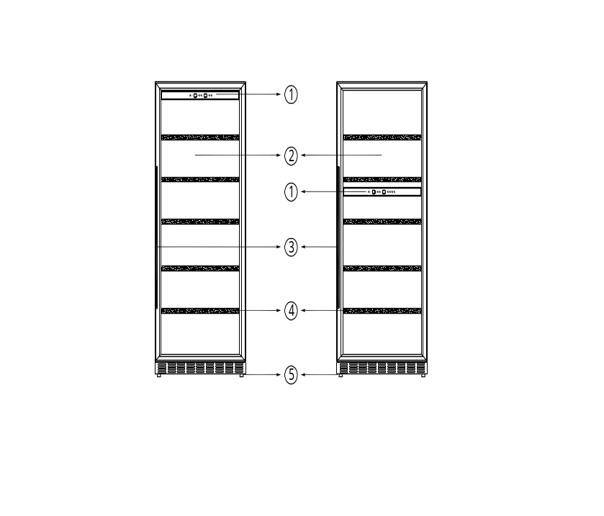

Drawing for reference only.

（1）Control Panel and Temperature Setting
（2）Glass Door
（3）Door Handle
（4）Storage Shelf
（5）Adjustable Feet
Installing the stainless-steel handle (the black model has a black handle)

This wine fridge includes a stainless-steel handle, or a black wine fridge includes a black handle. To install the handle please follow the below instructions:

- Pull away the door gasket in the area where the handle is to be installed on the left side as shown below in Illustration # 1. The gasket is easily displaced by hand, no tools are necessary.

- Align the handle with the screws installed. Tighten the screws using a Phillips head screwdriver until the handle sets both flush and secured tightly against the door frame. (DO NOT over tighten as this will cause damage to the handle assembly).

- Replace the door gasket to its original position.

If you choose not to use the handle supplied, simply follow step 1 to access the installation screws and remove them and then place the two decorative plugs into the two holes separately. Continue on to step 3 to replace the door gasket to its original position.

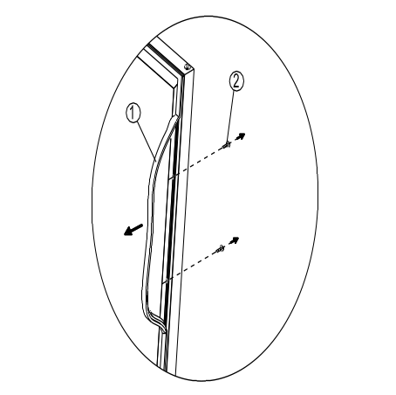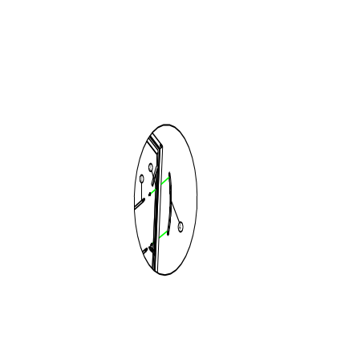
Illustration # 1 Illustration # 2

1. | Gasket | 3. | Phillips Head Screw Driver
2. | Phillips Head Screw | 4. | Handle

IMPORTANT SAFETY INSTRUCTIONS

WARNING | To reduce the risk of fire, electrical shock, or injury when using your appliance, follow these basic precautions:
- Read all instructions before using the Wine Cooler.
- DANGER or WARNING: Risk of child entrapment.
Child entrapment and suffocation are not problems of the past. Junked or abandoned appliances are still dangerous . . . even if they will “just sit in the garage a few days”.
- Before you throw away your old Wine Cooler: Take off the door. Leave the shelves in place so that children may not easily climb inside.
- Never allow children to operate, play with, or crawl inside the appliance.
- Never clean appliance parts with flammable fluids. The fumes can create a fire hazard or explosion.
- Do not store or use gasoline or any other flammable vapors and liquids in the vicinity of this or any other appliance. The fumes can create a fire hazard or explosion.
- Do not repair or replace any part of the Wine Cooler or attempt any servicing unless specifically recommended in the user-maintenance instructions or in published user-repair instructions. Replace the fuse with the same type.

- Save these instructions -

INSTALLATION INSTRUCTIONS

Before Using Your Wine Cooler

- Remove the exterior and interior packing.
- Check to be sure you have all of the following parts:
- Sapele shelves (DX-80.188K 3 pcs, DX-114.270K 4 pcs, DX-200.450K 5 pcs)
- Instruction Manual (hard copy or CD)
- Clean the interior surface with lukewarm water using a soft cloth.

Installation of Your Wine Cooler

- This Wine Cooler is designed to be free standing installation. Can only be built in when there is enough room for ventilation, ask your local dealer how to do this safely.

- Place your Wine Cooler on a surface that is strong enough to support it when it is fully loaded.
- Allow minimum 5 cm of space between the sides and the wall, as well as minimum 8 cm between the back and the, which allows the proper air circulation to cool the heat sink.
- Locate the Wine Cooler away from direct sunlight and sources of heat (stove, heater, radiator, etc.). However the unit supplied with winter protection (in case of low ambient temperature heats up the unit to the set temperature), extreme cold ambient temperatures may also cause the unit not to perform properly.
- Avoid locating the unit in moist areas.
- Plug the Wine Cooler into an exclusive, properly installed-grounded wall outlet. Do not under any circumstances cut or remove the third (ground) prong from the power cord. Any questions concerning power and/or grounding should be directed toward a certified electrician or an authorized service center.
- After plugging the Wine Cooler into a wall outlet, allow the unit to cool down for 2-3 hours before placing any items in the compartment.
- Rest the wine cooler for 24 hours after transportation.
- Do not tilt more than 45° during transportation.

Electrical Connection

Warning | Improper use of the grounded plug can result in the risk of electrical shock. If the power cord is damaged, have it replaced by an authorized service center.

- This appliance should be properly grounded for your safety. The power cord of this appliance is equipped with a three-prong plug which mates with standard three prong wall outlets to minimize the possibility of electrical shock.
- Do not under any circumstances cut or remove the third ground prong from the power cord supplied. For personal safety, this appliance must be properly grounded.
- This appliance requires a standard 220-240 Volt AC / 50Hz electrical ground outlet with three-prong. Have the wall outlet and circuit checked by a qualified electrician to make sure the outlet is properly grounded. When a standard 2-prong wall outlet is encountered, it is your responsibility and obligation to have it replaced with a properly grounded 3-prong wall outlet.
- The cord should be secured behind the appliance and not left exposed or dangling to prevent accidental injury.
- The appliance should always be plugged into its own individual electrical outlet which has a voltage rating that matches the rating label on the appliance. This provides the best performance and also prevent overloading house wiring circuits that could cause a fire hazard from overheated. Never unplug the appliance by pulling the power cord. Always grip the plug firmly and pull straight out from the receptacle. Repair or replace immediately all power cords that have become frayed or otherwise damaged. Do not use a cord that shows cracks or abrasion damage along its length or at either end. When moving the appliance, be careful not to damage the power cord.

Extension Cord

Because of potential safety hazards under certain conditions, it is strongly recommended that you do not use an extension cord with this appliance. However, if you must use an extension cord it is absolutely necessary that it be a 3-wire grounding type appliance extension cord having a grounding type plug and outlet and that the electrical rating of the cord be 220-240 volts and at least 15 amperes.

OPERATING YOUR WINE COOLER

Special Notice

- When you use the Wine cooler for the first time or restart it after having been shut off for a long time, there could be a few degrees variance between the temperature you set and the one indicated on the LED readout. This is normal and it is due to the length of the activation time. Once the Wine Cooler is running for a few hours, everything will be back to normal.
- The Wine Cooler should be placed in a position where the ambient temperature is between 10~32°C/55~90 °F. If the ambient temperature is above or below this range, the performance of the unit may be affected. For example, placing your unit in extreme cold or hot conditions may cause interior temperatures to fluctuate. The range of 5~22°C/40~72 °F may not be reached
- DX-119.386DB, DSS: It is recommended you install the wine fridge in a place where the ambient temperature is between 19ºC-24ºC (66ºF-75ºF), and humidity is under 60%. If the ambient temperature is above or below recommended temperatures, the performance of the unit may be affected. For example, placing your unit in extreme cold or hot conditions may cause interior temperatures to fluctuate. The range of 5ºC-18ºC (40ºF-65ºF) may not be reached.

Control Panel

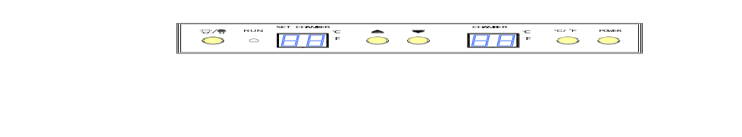
(DX-80.188K, DX-114.270K, DX-200.450K)

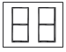 | SET Chamber/Upper chamber  To view the set internal temperature/actual temperature of upper chamber
Chamber/Lower chamber
To view the actual internal temperature/actual temperature of lower chamber
LIGHT
To turn the inner light on/off.
UP
You could increase the set temperature 1 ºC or 1 ºF by pressing this mark once.
DOWN
You could decrease the set temperature 1 ºC or 1 ºF by pressing this mark once.
FAHRENHEIT OR CELSIUS DISPLAY
You could get Fahrenheit or Celsius temperature indicate if you touch the marks.
POWER | Controls the ON/OFF of the whole system. By pressing the POWER button, the system will enter automatic detection mode. In the process of detection, the numbers on the digital tube will be lighted and through this can judge whether the system is working normally. The system will go into the normal working mode after 10s’ automatic detection
RUN | LED light will illustrate when the compressor is operating, you can know the working state through the light.

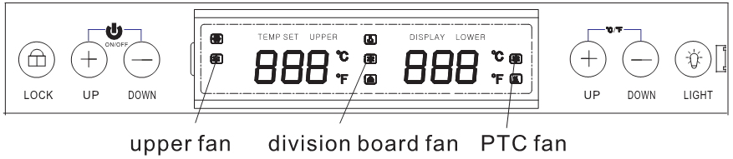

(DX-119.386 DB, DSS)
Dual zone temperature range:
Upper zone: 5-10℃（41℉-50℉）
Lower zone: 10-18℃（50℉-64℉）
 | Press 3 seconds to unlock all the buttons.
 | Press  to turn on or off the light
 | Press or to adjust the temperature of upper & lower zone
 | Press left and at the same time for 3 seconds to power off
 | Press right and at the same time for 3 seconds to switch ℃ to ℉
 | Without touching any button for 6 seconds, the touch screen will be locked automatically.

NOTE:

- The temperature set for the lower zone must always be not lower than the one for upper zone.
- If the unit is unplugged, has lost power, or turned off; you must wait 3 to 5 minutes before restarting the unit. If you attempt to restart before this time delay, the Wine Cooler will not start.

Shelf types, adjustment

- Your wine cooler supplied with sapele shelves. DX-200.450K sapele shelves fixed by screws for safety reason, other models’ sapele shelves placed on rubber ended holders.
- Different type of optional shelves available:
- fix beech shelves to store wines in upright position (fixed by screws to hinges for safety reason)
- rolling beech shelves
- display beech shelves.
- You can place bottles in lay down or upright position. Many bottles may differ in size and dimensions. As such the actual number of bottles you may be able to store may vary. Bottle capacities are approximate maximums when storing traditional Bordeaux 750 ml bottles and include bulk storage.
Shelves:
Display shelf for DX-114.270K
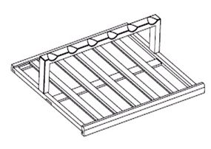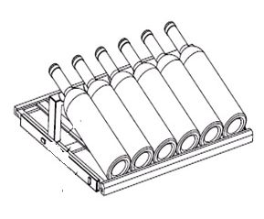
Fix beech shelf for DX-114.270K (for safety reason shelves are fixed by screws)
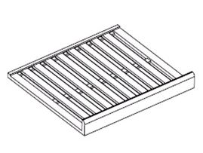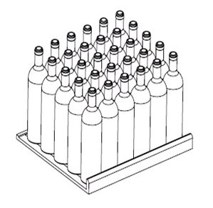
Display beech shelf for DX-200.450K.
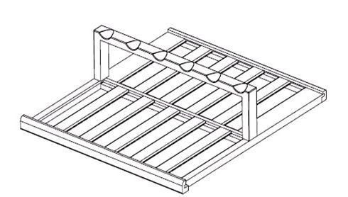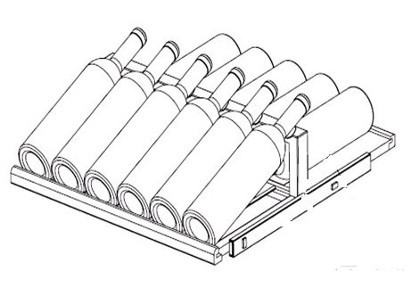

Rolling beech shelf for DX-200.450K
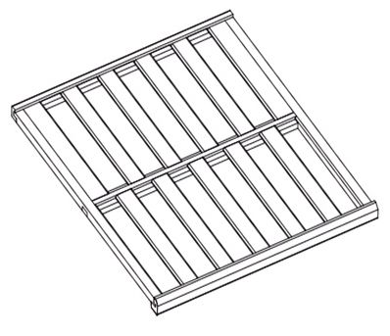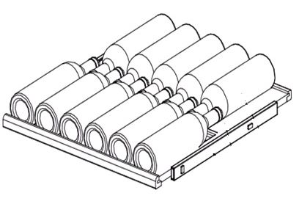

Optional shelves for DX-80.188K: pls contact your local retailer for details.

Read the followings carefully if change the position of shelf:

To move a rolling shelf, first remove all bottles, then move the rolling shelf by sliding guides from walls, while making sure not to mix up the right and left guides.

Installation diagram of sapele shelf and fix beech shelf (for fix beech shelf and DX-200.450K sapele shelf rubber is replaced by screws for safety reason):

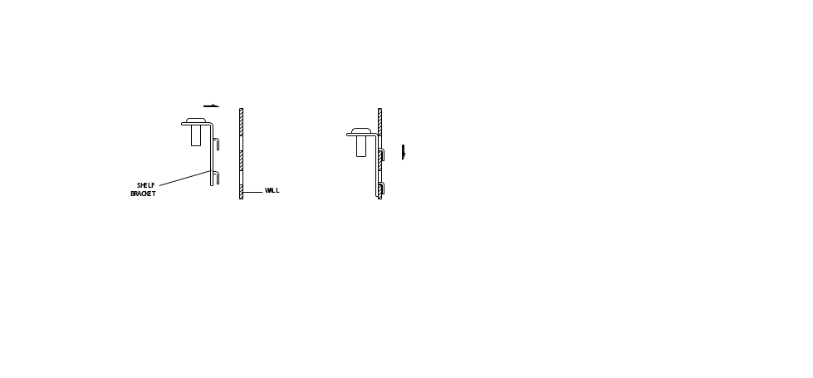

Diagram of rolling shelf:
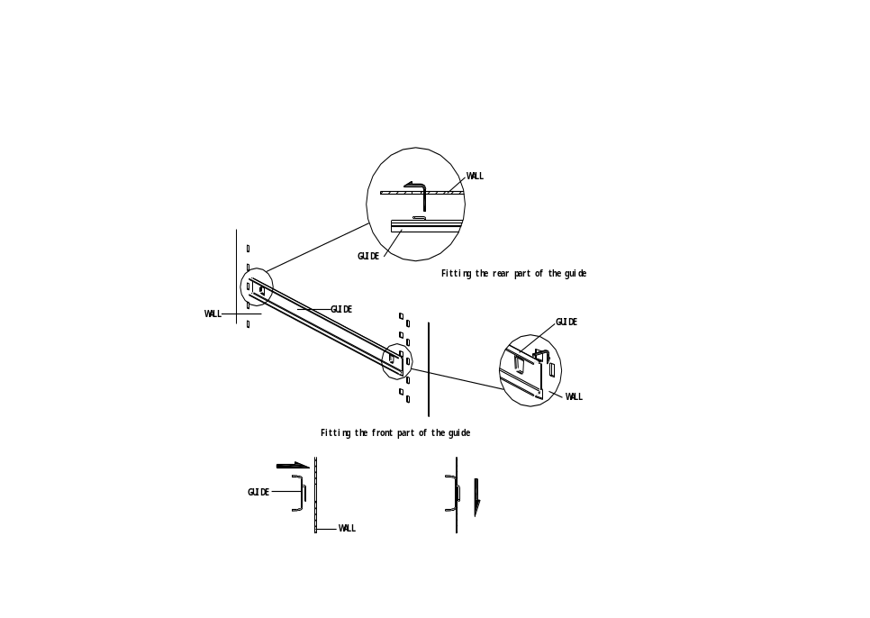

Refit the rolling shelf as shown below:

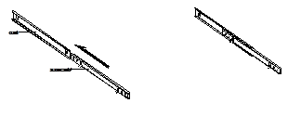

CARE AND MAINTENANCE

Defrosting Your Wine Cooler

The unit defrosts automatically. The evaporator behind the rear wall of the unit defrosts automatically. The condensation collects in the drainage channel behind the rear wall of the unit, and the flows through the drainage hole into the drip tray by the compressor where it evaporates.

Cleaning Your Wine Cooler

- Unplug the Wine Cooler, and remove the Wine and shelves.
- Wash the inside surfaces with a warm water and baking soda solution. The solution should be about 2 tablespoons of baking soda to a quart of water.
- Wash the shelves with a mild detergent solution.
- The outside of the Wine Cooler should be cleaned with mild detergent and warm water.
- Wring excess water out of the sponge or cloth before cleaning the area of the controls, or any electrical parts.
- Wash the outside cabinet with warm water and mild liquid detergent. Rinse well and wipe dry with a clean soft cloth.

Vacation Time

- Short vacations:
Leave the Wine Cooler operating during vacations of less than three weeks.
- Long vacations:
If the appliance will not be used for several months, remove all items and unplug the power cord. Clean and dry the interior thoroughly. To prevent odor and mold growth, leave the door open slightly: blocking it open if necessary.

Moving Your Wine Cooler

- Remove all bottles.
- Securely tape down all loose items (shelves) inside your appliance.
- Tape the door shut.
- Protect outside of appliance with a blanket, or similar item.

Energy Saving Tips
- The Wine Cooler should be located in the coolest area of the room, away from heat producing appliances, and out of the direct sunlight.
- Overloading the Wine Cooler forces the compressor to run longer.

PROBLEMS WITH YOUR WINE COOLER?

You can solve many common Wine Cooler problems easily, saving you the cost of a possible service call. Try the suggestions below to see if you can solve the problem before calling the service.

TROUBLESHOOTING GUIDE

PROBLEM | POSSIBLE CAUSE
Wine Cooler does not operate. | Not plugged in.  The circuit breaker tripped or a blown fuse.
Turns on and off frequently. | The room temperature is hotter than normal.  The door is opened too often.  The door is not closed completely.  The temperature control is not set correctly.  The door gasket does not seal properly.  The Wine Cooler does not have the correct clearances.
Vibrations. | Check to assure that the Wine Cooler is level.
The Wine Cooler seems to make too much noise. | The rattling noise may come from the flow of the refrigerant, which is normal.  As each cycle ends, you may hear gurgling sounds caused by the flow of refrigerant in your Wine Cooler.  Contraction and expansion of the inside walls may cause popping and crackling noises.  The Wine Cooler is not level.
The door will not close properly. | The Wine Cooler is not level.  The door was reversed and not properly installed.  The gasket is dirty.  The shelves are out of position.

Technical specifications, energy classification and consumption: pls consult the label on the backside of your wine cooler and the attached energy label.

Dunavox reserves the right to change any technical parameter, solution, specification without prior notice.

