Airplane Turbofan Engine Operation and Malfunctions

Basic Familiarization for Flight Crews

Chapter 1

General Principles

Introduction

Today's modern airplanes are powered by turbofan engines. These engines are quite reliable, providing years of trouble- free service. However, because of the rarity of turbofan engine malfunctions, and the limitations of simulating those malfunctions, many flight crews have felt unprepared to diagnose engine malfunctions that have occurred.

The purpose of this text is to provide straightforward material to give flight crews the basics of airplane engine operational theory. This text will also provide pertinent information about malfunctions that may be encountered during the operation of turbofan- powered airplanes, especially those malfunctions that cannot be simulated well and may thus cause confusion.

While simulators have greatly improved pilot training, many may not have been programmed to simulate the actual noise, vibration and aerodynamic forces that certain malfunctions cause. In addition, it appears that the greater the sensations, the greater the startle factor, along with greater likelihood the flight crew will try to diagnose the problem immediately instead of flying the airplane.

It is not the purpose of this text to supersede or replace more detailed instructional texts or to suggest limiting

the flight crew's understanding and working knowledge of airplane turbine engine operation and malfunctions to the topics and depth covered here. Upon completing this material, flight crews should understand that some engine malfunctions can feel and sound more severe than anything they have ever experienced; however, the airplane is still flyable, and the first priority of the flight crew should remain "fly the airplane."

Propulsion

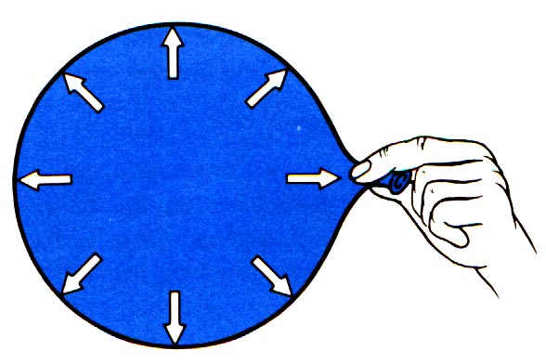

Fig 1 showing balloon with no escape path for the air inside. All forces are balanced.

Propulsion is the net force that results from unequal pressures. Gas (air) under pressure in a sealed container exerts equal pressure on all surfaces of the container; therefore, all the forces are balanced and there are no forces to make the container move.

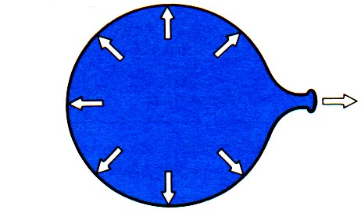
Fig 2 showing balloon with released stem. Arrow showing forward force has no opposing arrow.

If there is a hole in the container, gas (air) cannot push against that hole and thus the gas escapes. While the air is escaping and there is still pressure inside the container, the side of the container opposite the hole has pressure against it. Therefore, the net pressures are not balanced and there is a net force available to move the container. This force is called thrust.

The simplest example of the propulsion principle is an inflated balloon (container) where the stem is not closed off. The pressure of the air inside the balloon exerts forces everywhere inside the balloon. For every force, there is an opposite force, on the other side of the balloon, except on the surface of the balloon opposite the stem. This surface has no opposing force since air is escaping out the stem. This results in a net force that propels the balloon away from the stem. The balloon is propelled by the air pushing on the FRONT of the balloon.

The simplest propulsion engine

The simplest propulsion engine would be a container of air (gas) under pressure that is open at one end. A diving SCUBA tank would be such an engine if it fell and the valve was knocked off the top. The practical problem with such an engine is that, as the air escapes out the open end, the pressure inside the container would rapidly drop. This engine would deliver propulsion for only a limited time.

The turbine engine

A turbine engine is a container with a hole in the back end (tailpipe or nozzle) to let air inside the container escape, and thus provide propulsion. Inside the container is turbomachinery to keep the container full of air under constant pressure.

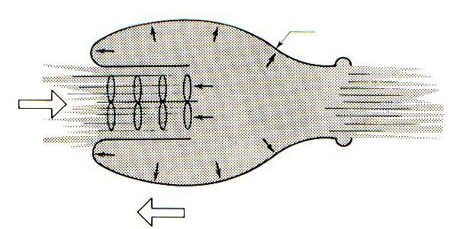
Fig 3 showing our balloon with machinery in front to keep it full as air escapes out the back for continuous thrust.

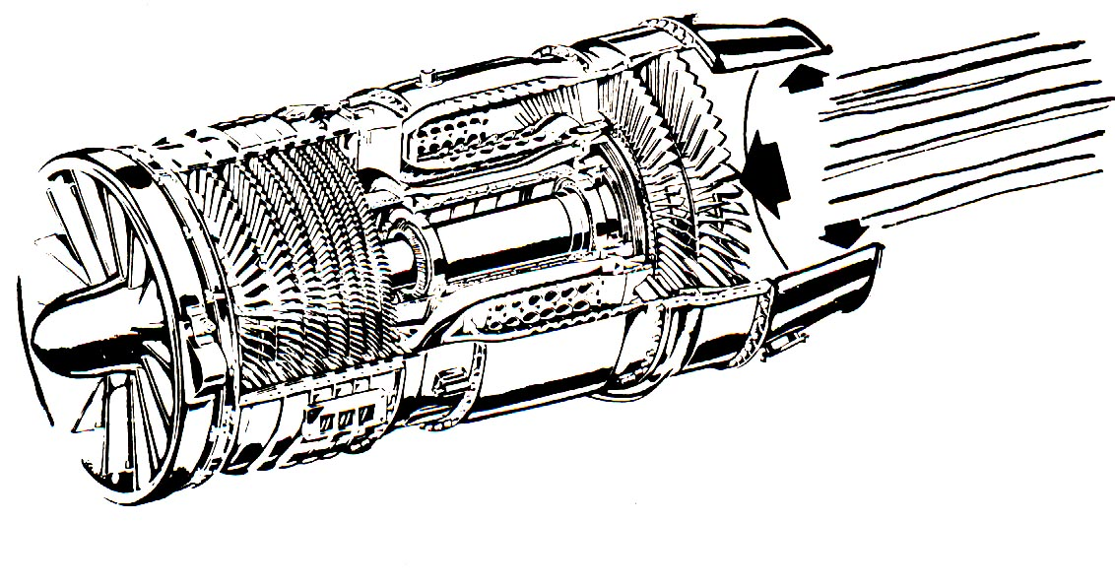
Fig 4 showing turbine engine as a cylinder of turbomachinery with unbalanced forces pushing forward.

Components of a turbine engine

The turbomachinery in the engine uses energy stored chemically as fuel. The basic principle of the airplane turbine engine is identical to any and all engines that extract energy from chemical fuel. The basic 4 steps for any internal combustion engine are:

1) Intake of air (and possibly fuel).
2) Compression of the air (and possibly fuel).
3) Combustion, where fuel is injected (if it was not drawn in with the intake air) and burned to convert the stored energy.
4) Expansion and exhaust, where the converted energy is put to use.

These principles are exactly the same ones that make a lawn mower or automobile engine go.

In the case of a piston engine such as the engine in a car or lawn mower, the intake, compression, combustion, and exhaust steps occur in the same place (cylinder head) at different times as the piston goes up and down.

In the turbine engine, however, these same four steps occur at the same time but in different places. As a result of this fundamental difference, the turbine has engine sections called:

1) The inlet section
2) The compressor section
3) The combustion section
4) The exhaust section.

The practical axial flow turbine engine

The turbine engine in an airplane has the various sections stacked in a line from front to back. As a result, the engine body presents less drag to the airplane as it is flying. The air enters the front of the engine and passes essentially straight through from front to back. On its way to the back, the air is compressed by the compressor section. Fuel is added and burned in the combustion section, then the air is exhausted through the exit nozzle.

The laws of nature will not let us get something for nothing. The compressor needs to be driven by something in order to work. Just after the burner and before the exhaust nozzle, there is a turbine that uses some of the energy in the discharging air to drive the compressor. There is a long shaft connecting the turbine to the compressor ahead of it.

Compressor combustor turbine nozzle
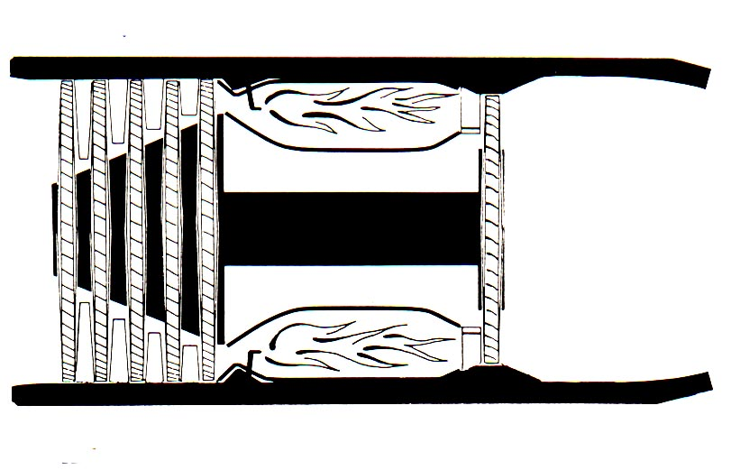
Fig 5 showing basic layout of jet propulsion system.

Machinery details

From an outsider's view, the flight crew and passengers rarely see the actual engine. What is seen is a large elliptically-shaped pod hanging from the wing or attached to the airplane fuselage toward the back of the airplane. This pod structure is called the nacelle or cowling. The engine is inside this nacelle.

The first nacelle component that incoming air encounters on its way through an airplane turbine engine is the inlet cowl. The purpose of the inlet cowl is to direct the incoming air evenly across the inlet of the engine. The shape of the interior of the inlet cowl is very carefully designed to guide this air.
The compressor of an airplane turbine engine has quite a job to do. The compressor has to take in an enormous volume of air and compress it to 1/10th or 1/15th of the volume it had outside the engine. This volume of air must be supplied continuously, not in pulses or periodic bursts.

The compression of this volume of air is accomplished by a rotating disk containing many airfoils, called blades, set at an angle to the disk rim. Each blade is close to the shape of a miniature propeller blade, and the angle at which it is set on the disk rim is called the angle of attack. This angle of attack is similar to the pitch of a propeller blade or an airplane wing in flight. As the disk with blades is forced to rotate by the turbine, each blade accelerates the air, thus pumping the air behind it. The effect is similar to a household window fan.

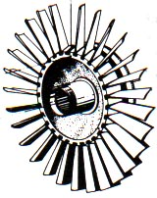

Fig 6 showing compressor rotor disk.

After the air passes through the blades on a disk, the air will be accelerated rearward and also forced circumferen-tially around in the direction of the rotating disk. Any tendency for the air to go around in circles is counterproductive, so this tendency is corrected by putting another row of airfoils behind the rotating disk. This row is stationary and its airfoils are at an opposing angle.

What has just been described is a single stage of compression. Each stage consists of a rotating disk with many blades on the rim, called a rotor stage, and, behind it, another row of airfoils that is not rotating, called a stator. Air on the backside of this rotor/stator pair is accelerated rearward, and any tendency for the air to go around circumferentially is corrected.

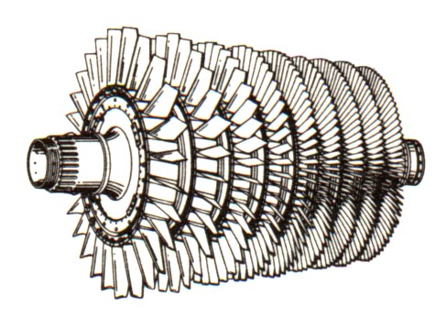
Fig 7 showing 9 stages of a compressor rotor assembly.

A single stage of compression can achieve perhaps 1.5:1 or 2.5:1 decrease in the air's volume. Compression of the air increases the energy that can be extracted from the air during combustion and exhaust (which provides the thrust). In order to achieve the 10:1 to 15:1 total compression needed for the engine to develop adequate power, the engine is built with many stages of compressors stacked in a line. Depending upon the engine design, there may be as many as 10 to 15 stages in the total compressor.

As the air is compressed through the compressor, the air increases in velocity, temperature, and pressure. Air does not behave the same at elevated temperatures, pressures, and velocities as it does in the front of the engine before it is compressed. In particular, this means that the speed that the compressor rotors must have at the back of the compressor is different than at the front of the compressor. If we had only a few stages, this difference could be ignored; but, for 10 to 15 compressor stages, it would not be efficient to have all the stages rotate at the same speed.

The most common solution to this problem is to break the compressor in two. This way, the front 4 or 5 stages can rotate at one speed, while the rear 6 or 7 stages can rotate at a different, higher, speed. To accomplish this, we also need two separate turbines and two separate shafts.

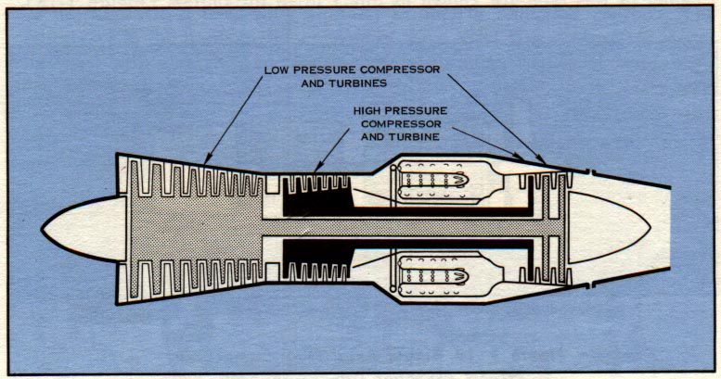
Fig 8 showing layout of a dual rotor airplane turbine engine.

Most of today's turbine engines are dual-rotor engines, meaning there are two distinct sets of rotating components. The rear compressor, or high-pressure compressor, is connected by a hollow shaft to a high-pressure turbine. This is the high rotor. The rotors are sometimes called spools, such as the "high spool." In this text, we will use the term rotor. The high rotor is often referred to as N2 for short.

The front compressor, or low-pressure compressor, is in front of the high-pressure compressor. The turbine that drives the low-pressure compressor is behind the turbine that drives the high-pressure compressor. The low-pressure compressor is connected to the low-pressure turbine by a shaft that goes through the hollow shaft of the high rotor. The low-pressure rotor is called N1 for short.

The N1 and N2 rotors are not connected mechanically in any way. There is no gearing between them. As the air flows through the engine, each rotor is free to operate at its own efficient speed. These speeds are all quite precise and are carefully calculated by the engineers who designed the engine. The speed in RPM of each rotor is often displayed on the engine flight deck and identified by gages or readouts labeled N1 RPM and N2 RPM. Both rotors have their own redline limits.

In some engine designs, the N1 and N2 rotors may rotate in opposite directions, or there may be three rotors instead of two. Whether or not these conditions exist in any particular engine are engineering decisions and are of no consequence to the pilot.

The turbofan engine

A turbofan engine is simply a turbine engine where the first stage compressor rotor is larger in diameter than the rest of the engine. This larger stage is called the fan. The air that passes through the fan near its inner diameter also passes through the remaining compressor stages in the core of the engine and is further compressed and processed through the engine cycle. The air that passes through the outer diameter of the fan rotor does not pass through the core of the engine, but instead passes along the outside of the engine. This air is called bypass air, and the ratio of bypass air to core air is called the bypass ratio.

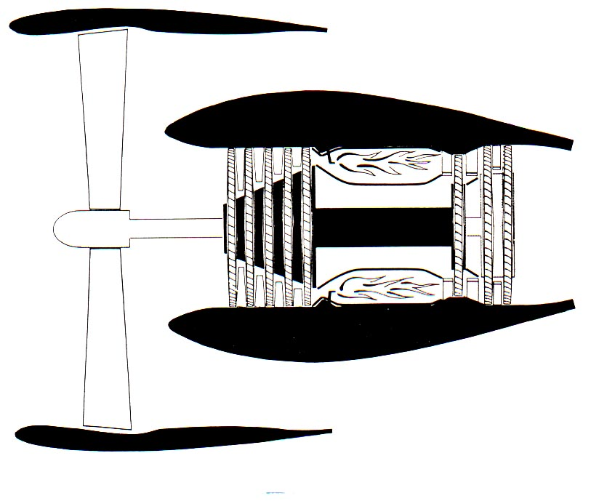
Fig 9 showing schematic of fan jet engine. In this sketch, the fan is the low-pressure compressor. In some engine designs, there will be a few stages of low-pressure compressor with the fan. These may be called booster stages.

The air accelerated by the fan in a turbofan engine contributes significantly to the thrust produced by the engine, particularly at low forward speeds and low altitudes. In large engines, such as the engines that power the B747, B757, B767, A300, A310, etc., as much as three-quarters of the thrust delivered by the engine is developed by the fan.

The fan is not like a propeller. On a propeller, each blade acts like an airplane wing, developing lift as it rotates. The "lift" on a propeller blade pulls the engine and airplane forward through the air.

In a turbofan engine, thrust is developed by the fan rotor system, which includes the static structure (fan exit guide vanes) around it. The fan system acts like the open balloon in our example at the start of this discussion, and thus pushes the engine, and the airplane along with it, through the air from the unbalanced forces.

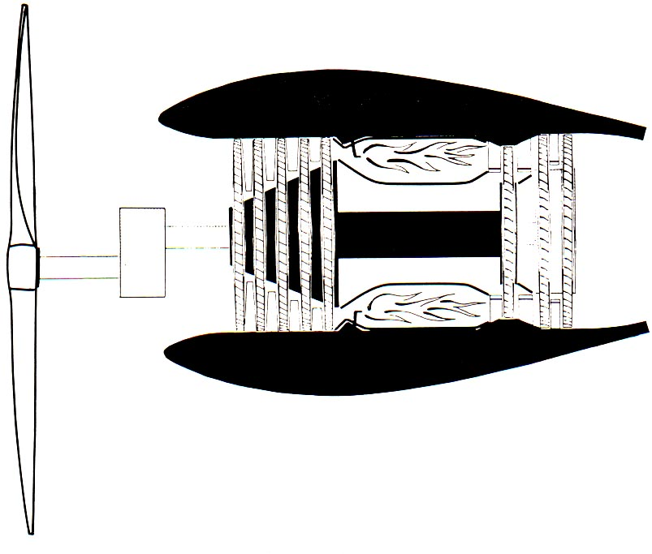

Fig 10 showing schematic of a turboprop. In this configuration, there are two stages of turbine with a shaft that goes through the engine to a gearbox which reduces the rotor speed of the propeller.

What the fan and the propeller do have in common is that the core engine drives them both.

LESSON SUMMARY

So far we have learned:

- Propulsion is created by the unbalance of forces.
- A pressure vessel with an open end delivers propulsion due to the unbalance of forces.
- An airplane propulsion system is a pressure vessel with an open end in the back.
- An airplane engine provides a constant supply of air for the pressure vessel.
- An airplane turbine engine operates with the same 4 basic steps as a lawnmower or automobile engine.
- An airplane turbine engine has sections that perform each of the 4 basic steps of intake, compression, combustion, and exhaust.
- Compression is accomplished by successive stages of rotor/stator pairs.
- The compressor stages are usually split into low-pressure and high-pressure compressor sections.
- The low-pressure section can be referred to as N1 and the high-pressure section can be referred to as N2.
- A fan is the first stage of compression where the rotor and its mating stator are larger in diameter than the rest of the engine.

Chapter 2

Engine systems

From an engineer's point of view, the turbofan engine is a finely-tuned piece of mechanical equipment. In order for the engine to provide adequate power to the airplane at a weight that the airplane can accommodate, the engine must operate at the limit of technical feasibility. At the same time, the engine must provide reliable, safe and economical operation.

Within the engine, there are systems that keep everything functioning properly. Most of these systems are transparent to the pilot. For that reason, this text will not go into deep technical detail. While such discussion would be appropriate for mechanics training to take care of the engine, it is the purpose of this text to provide information that pilots can use in understanding the nature of some engine malfunctions that may be encountered during flight.

The systems often found associated with the operation of the engine are:

1) The accessory drive gearbox
2) The fuel system
3) The lubrication system
4) The ignition system
5) The bleed system
6) The start system
7) The anti-ice system.

In addition, there are airplane systems that are powered or driven by the engine. These systems may include:

1) The electrical system
2) The pneumatic system
3) The hydraulic system
4) The air conditioning system.
These airplane systems are not associated with continued function of the engine or any engine malfunctions, so they will not be discussed in this text. The airplane systems may provide cues for engine malfunctions that will be discussed in the chapter on engine malfunctions.

Accessory drive gearbox

The accessory drive gearbox is most often attached directly to the outside cases of the engine at or near the bottom. The accessory drive gearbox is driven by a shaft that extends directly into the engine and it is geared to one of the compressor rotors of the engine. It is usually driven by the high-pressure compressor.

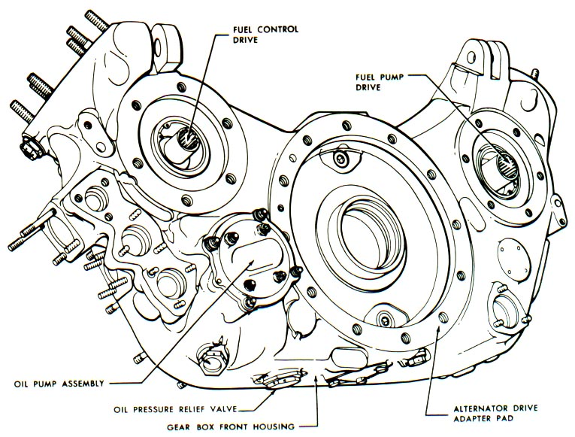
Fig 11 showing typical accessory drive gearbox.

The gearbox has attachment pads on it for accessories that need to be mechanically driven. These accessories include airplane systems, such as generators for airplane and necessary engine electrical power, and the hydraulic pump for airplane hydraulic systems. Also attached to the gearbox are the starter and the fuel pump/fuel control.

Fuel system

The fuel system associated directly with the propulsion system consists of:

1) A fuel pump
2) A fuel control
3) Fuel manifolds
4) Fuel nozzles
5) A fuel filter
6) Heat exchangers
7) Drains
8) A pressurizing and dump valve.

All are external to the engine except the fuel nozzles.

The airplane fuel system supplies pressurized fuel from the main tanks. The fuel is pressurized by electrically-driven boost pumps in the tanks and then flows through the spar valve or low pressure (LP) shut-off valve to the engine LP fuel pump inlet.

The fuel pump is physically mounted on the gearbox. Most engine fuel pumps have two stages, or, in some engines, there may actually be two separate pumps. There is an LP stage that increases fuel pressure so that fuel can be used for servos. At this stage, the fuel is filtered to remove any debris from the airplane tanks. Following the LP stage, there is an HP (high-pressure) stage that increases fuel pressure above the combustor pressure. The HP pump always provides more fuel than the engine needs to the fuel control, and the fuel control meters the required amount to the engine and bypasses the rest back to the pump inlet.

The fuel delivered from the pump is generally used to cool the engine oil and integral drive generator (IDG) oil on the way to the fuel control. Some fuel systems also incorporate fuel heaters to prevent ice crystals accumulating in the fuel control during low-temperature operation and valves to bypass those heat exchangers depending on ambient temperatures.

The fuel control is installed on the engine on the accessory gearbox, directly to the fuel pump, or, if there is an electronic control, to the engine case. The purpose of the fuel control is to provide the required amount of fuel to the fuel nozzles at the requested time. The rate at which fuel is supplied to the nozzles determines the acceleration or deceleration of the engine.

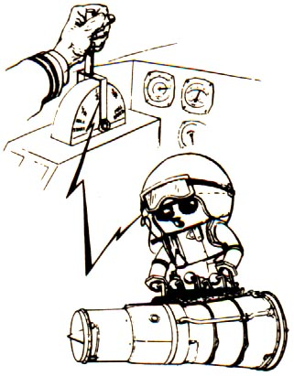
Fig 12 characterizing that the fuel control is an "intelligent" component that does the work once the flight crew "tells it what to do."

The flight crew sets the power requirements by moving a thrust lever in the flight deck. When the flight crew adjusts the thrust lever, however, they are actually "telling the control" what power is desired. The fuel control senses what the engine is doing and automatically meters the fuel to the fuel nozzles within the engine at the required rate to achieve the power requested by
the flight crew. A fuel flow meter measures the fuel flow sent to the engines by the control.

In older engines, the fuel control is hydromechanical, which means that it operates directly from pressure and mechanical speed physically input into the control unit.

On newer airplanes, control of the fuel metering is done electronically by a computer device called by names such as "EEC" or "FADEC." EEC stands for Electronic Engine Control, and FADEC stands for Full Authority Digital Engine Control. The net result is the same. Electronic controls have the capability of more precisely metering the fuel and sensing more engine operating parameters to adjust fuel metering. This results in greater fuel economy and more reliable service.

The fuel nozzles are deep within the engine in the combustion section right after the compressor. The fuel nozzles provide a precisely-defined spray pattern of fuel mist into the combustor for rapid, powerful, and complete combustion. It is easiest to visualize the fuel nozzle spray pattern as being similar to that of a showerhead.

The fuel system also includes drains to safely dispose of the fuel in the manifolds when the engine is shut down, and, in some engines, to conduct leaked fuel overboard.

Lubrication system

An airplane turbine engine, like any engine, must be lubricated in order for the rotors to turn easily without generating excessive heat. Each rotor system in the engine has, as a minimum, a rear and front bearing to support the rotor. That means that the N1 rotor has two bearings and the N2 rotor has two bearings for a total of 4 main bearings in the engine. There are some engines that have intermediate and/or special bearings; however, the number of bearings in a given engine is usually of little direct interest to a basic understanding of the engine.

The lubrication system of a turbine engine includes:

1) An oil pump.
2) An oil storage tank.
3) A delivery system to the bearing compartments (oil lines).
4) Lubricating oil jets within the bearing compartments.
5) Seals to keep the oil in and air out of the compartments.
6) A scavenge system to remove oil from the bearing compartment after the oil has done its job. After the oil is scavenged, it is cooled by heat exchangers, and filtered.
7) Oil quantity, pressure, temperature, gages and filter bypass indications on the flight deck for monitoring of the oil system.
8) Oil filters.
9) Heat exchangers. Often, one exchanger serves as both a fuel heater and an oil cooler.
10) Chip detectors, usually magnetic, to collect bearing compartment particles as an indication of bearing compartment distress. Chip detectors may trigger a flight deck indication or be visually examined during line maintenance.
11) Drains to safely dispose of leaked oil overboard.

The gages in item 7 are the window that the flight crew has to monitor the health of the lubrication system.

Ignition system

The ignition system is a relatively straightforward system. Its purpose is to provide the spark within the combustion section of the engine so that, when fuel is delivered to the fuel nozzles, the atomized fuel mist will ignite and the combustion process will start.

Since all 4 steps of the engine cycle in a turbine engine are continuous, once the fuel is ignited the combustion process normally continues until the fuel flow is discontinued during engine shutdown. This is unlike the situation in a piston engine, where there must be an ignition spark each time the combustion step occurs in the piston chamber.

Turbine engines are provided with a provision on the flight deck for "continuous ignition." When this setting is selected, the ignitor will produce a spark every few seconds. This provision is included for those operations or flight phases where, if the combustion process were to stop for any reason, the loss of power could be serious. With continuous ignition, combustion will restart automatically, often without the pilot even noticing that there was an interruption in power.

Some engines, instead of having continuous ignition, monitor the combustion process and turn the igniters on as required, thus avoiding the need for continuous ignition.

The ignition system includes:

1) Igniter boxes which transform low-voltage Alternating Current (AC) from either a gearbox-mounted alternator or from the airplane into high-voltage Direct Current (DC).
2) Cables to connect the igniter boxes to the igniter plugs.
3) Ignitor plugs.

For redundancy, the ignition system has two igniter boxes and two igniter plugs per engine. Only one igniter in each engine is required to light the fuel in the combustor. Some airplanes allow the pilot to select which igniter is to be used; others use the engine control to make the selection.

Bleed system

Stability bleeds

The compressors of airplane turbine engines are designed to operate most efficiently at cruise. Without help, these compressors may operate very poorly or not at all during starting, at very low power, or during rapid transient power changes, which are conditions when they are not as efficient. To reduce the workload on the compressor during these conditions, engines are equipped with bleeds to discharge large volumes of air from the compressor before it is fully compressed.

The bleed system usually consists of:

1) Bleed valves.
2) Solenoids or actuators to open and close the bleed valves.
3) A control device to signal the valves when to open and close.
4) Lines to connect the control device to the actuators.

In older engines, a control device measures the pressure across one of the engine compressors, compares it to the inlet pressure of the engine, and directs higher-pressure, high-compressor air to an air piston-driven actuator at the bleed valve to directly close the valve. In newer engines, the electronic fuel control determines when the bleed valves open and close.

Generally, all the compressor bleed valves are open during engine start. Some of the valves close after start and some remain open. Those that remain open then close during engine acceleration to full power for takeoff. These valves then remain closed for the duration of the flight.

If, during in-flight operation, the fuel control senses instability in the compressors, the control may open some of the bleed valves momentarily. This will most often be completely unnoticed by the flight crew except for an advisory message on the flight deck display in some airplane models.

Cooling/clearance control bleeds

Air is also extracted from the compressor, or the fan airflow, for cooling engine components and for accessory cooling in the nacelle. In some engines, air extracted from the compressor is ducted and directed onto the engine cases to control the clearance between the rotor blade tips and the case wall. Cooling the case in this way shrinks the case closer to the blade tips, improving compression efficiency.

Service bleeds

The engines are the primary source of pressurized air to the airplane for cabin pressurization. In some airplanes, engine bleed air can be used as an auxiliary power source for back-up hydraulic power air-motors. Air is taken from the high compressor, before any fuel is burned in it, so that it is as clean as the outside air. The air is cooled and filtered before it is delivered to the cabins or used for auxiliary power.

Start system

When the engine is stationary on the ground, it needs an external source of power to start the compressor rotating so that it can compress enough air to get energy from the fuel. If fuel were lit in the combustor of a completely non-rotating engine, the fuel would puddle and burn without producing any significant rearward airflow.

A pneumatic starter is mounted on the accessory gearbox, and is powered by air originating from another engine, from the auxiliary power unit (APU), or from a ground cart. A start valve controls the input selection. The starter drives the accessory gearbox, which drives the high-compressor rotor via the same drive shaft normally used to deliver power TO the gearbox.

Fuel flow during starting is carefully scheduled to allow for the compressor's poor efficiency at very low RPM, and bleeds are used to unload the compressor until it can reach a self-sustaining speed. During some points in a normal engine start, it may even look as if the engine is not accelerating at all. After the engine reaches the self-sustaining speed, the starter de-clutches from the accessory gearbox. This is important, as starters can be damaged with exposure to extended, high-speed operation. The engine is able to accelerate up to idle thrust without further assistance from the starter.

The starter can also be used to assist during in-flight restart, if an engine must be restarted. At higher airspeeds, the engine windmill RPM may be enough to allow engine starting without use of the pneumatic starter. The specific Airplane Flight Manual (AFM) should be consulted regarding the conditions in which to perform an in-flight restart.

Anti-ice system

An airplane turbine engine needs to have some protection against the formation of ice in the inlet and some method to remove ice if it does form. The engine is equipped with the capability to take some compressor air, via a bleed, and duct it to the engine inlet or any other place where anti-ice protection is necessary. Because the compressor bleed air is quite hot, it prevents the formation of ice and/or removes already-formed ice.

On the flight deck, the flight crew has the capability to turn anti-ice on or off. There is generally no capability to control the amount of anti-ice delivered; for example, "high," "medium" or "low." Such control is not necessary.

Chapter 3

Engine instrumentation in the flight deck

Airplanes in service today are equipped with devices available to the flight crew that provide feedback information about the engine to set engine power and monitor the condition of the engine. In older airplanes, these devices were gages on the panel. In newer airplanes, the airplane is equipped with electronic screens which produce computer-generated displays that resemble the gages that used to be on the panel. Whether gages or electronic displays are used, the information given to the flight crew is the same.

The gages are most useful when considered in context with each other, rather than considering one gage in isolation.

What follows is a brief description of the gages and what information they provide.

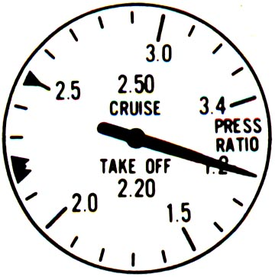

Engine Pressure Ratio or EPR. Engine pressure ratio is a measure of thrust provided by the engine. EPR indicators provide the ratio of the pressure of the air as it comes out of the turbine to the pressure of the air as it enters the compressor. EPR is a certified thrust-setting parameter. Some engine manufacturers recommend that engine power management be performed by reference to EPR.
A low EPR reading may be caused by engine rollback or flameout, or internal damage such as an LP turbine failure. Rapid EPR fluctuations may be caused by engine operational instability, such as surge, or rapidly-changing external conditions, such as inclement weather or bird ingestion. Unexpectedly high EPR may indicate a fuel control malfunction, or malfunction or clogging of the inlet air pressure probes.

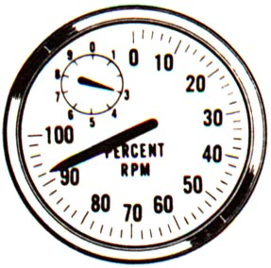
Rotor RPM. On an airplane equipped with a multiple-rotor turbine engine, there will be a rotor speed indication for each rotor. The N1 gage will provide the rotor speed of the low-pressure rotor and the N2 (or N3 for a 3-rotor engine) gage will provide the rotor speed of the high-pressure rotor. N1 is a certified thrust-setting parameter.

The units of rotor speed are Revolutions Per Minute or RPM, but rotor speed is indicated as a non-dimensional ratio – that of engine rotor speed as compared to some nominal 100% speed representing a high-power condition (which is not necessarily the maximum permissible speed). Engine operating manuals specify a maximum operational limit RPM or redline RPM that will generally be greater than 100 percent.

Low N1 may indicate engine rollback or flameout, or severe damage such as LP turbine failure. Rapid N1 fluctuations may be caused by engine operational instability such as surge. Higher rotor speeds will be required at high altitudes to achieve takeoff-rated thrust. Unexpectedly high N1 may indicate a fuel control malfunction.

N2 is used for limit monitoring and condition monitoring. On older engines, it is also used to monitor the progress of engine starting and to select the appropriate time to start fuel flow to the engine.

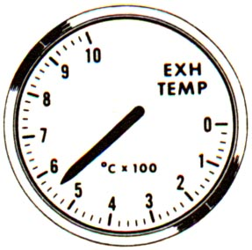
Exhaust Gas Temperature or EGT. Exhaust gas temperature is a measure of the temperature of the gas exiting the rear of the engine. It is measured at some location in the turbine. Since the exact location varies according to engine model, EGT should not be compared between engine models. Often, there are many sensors at the exit of the turbine to monitor EGT. The indicator on the flight deck displays the average of all the sensors.

High EGT can be an indication of degraded engine performance. Deteriorated engines will be especially likely to have high EGT during takeoff.

EGT is also used to monitor engine health and mechanical integrity. Excessive EGT is a key indicator of engine stall, of difficulty in engine starting, of a major bleed air leak, and of any other situation where the turbine is not extracting enough work from the air as it moves aft (such as severe engine damage).

There is an operational limit for EGT, since excessive EGT will result in turbine damage. Operational limits for EGT are often classified as time-at-temperature.

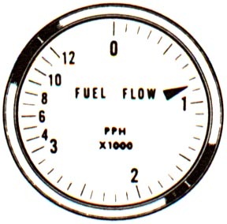
Fuel Flow indicator. The fuel flow indicator shows the fuel flow in pounds (or kilograms) per hour as supplied to the fuel nozzles. Fuel flow is of fundamental interest for monitoring in-flight fuel consumption, for checking engine performance, and for in-flight cruise control.

High fuel flow may indicate a significant leak between the fuel control and fuel nozzles, particularly if rotor speeds or EPR appear normal or low.

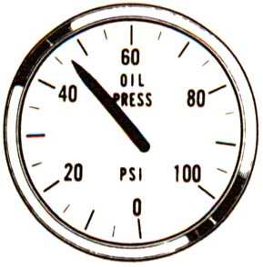
Oil Pressure Indicator. The oil pressure indicator shows the pressure of the oil as it comes out of the oil pump. In some cases, the oil pressure reading system takes the bearing compartment background pressure, called breather pressure, into account so that the gage reading reflects the actual pressure of the oil as it is delivered to the bearing compartments. Oil system parameters historically give false indications of a problem as frequently as the oil system has a genuine problem, so crosschecking with the other oil system indications is advisable.

Low oil pressure may result from pump failure, from a leak allowing the oil system to run dry, from a bearing or gearbox failure, or from an indication system failure. High oil pressure may be observed during extremely low temperature operations, when oil viscosity is at a maximum.

Low Oil Pressure Caution. Generally, if the oil pressure falls below a given threshold level, an indication light or message is provided to draw attention to the situation.

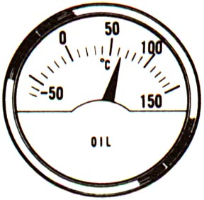
Oil Temperature Indicator. The Oil temperature indicator shows the oil temperature at some location in the lubrication circuit, although this location differs between engine models.

Elevated oil temperatures indicate some unwanted source of heat in the system, such as a bearing failure, sump fire or unintended leakage of high temperature air into the scavenge system. High oil temperature may also result from a malfunction of the engine oil cooler, or of the valves scheduling fluid flow through the cooler.

Oil Quantity Indicator. The oil quantity indication monitors the amount of oil in the tank. This can be expected to vary with power setting, since the amount of oil in the sumps is a function of rotor speed.

A steady decrease in oil quantity may indicate an oil leak. There is likely to still be some usable oil in the tank even after the oil quantity gage reads zero, but the oil supply will be near exhaustion and a low pressure indication will soon be seen. A large increase in the oil quantity may be due to fuel leaking into the oil system, and should be investigated before the next flight. Flight crews should be especially vigilant to check other oil system indications before taking action on an engine in-flight solely on the basis of low oil quantity.

Oil Filter Bypass Indication. If the oil filter becomes clogged with debris (either from contamination by foreign material or debris from a bearing failure), the pressure drop across the filter will rise to the point where the oil bypasses the filter. This is announced to the pilot via the oil filter impending bypass indication. This indication may go away if thrust is reduced (because oil flow through the filter and pressure drop across the filter are reduced).

Fuel Filter Impending Bypass. If the fuel filter at the engine fuel inlet becomes clogged, an impending bypass indication will alert the crew for a short while before the filter actually goes into bypass.

Fuel Heat Indication. The fuel heat indicator registers when the fuel heat is on. Fuel heat indicators are not needed for engines where fuel heating is passively combined with oil cooling, and no valves or controls are involved.

Engine Starter Indication. During assisted starting, the start valve will be indicated open until starter disconnect. The position of the start switch shows the starter status (running or disconnected). If the starter does not disconnect once the engine reaches idle,

or if it disconnects but the starter air valve remains open, the starter will fail when the engine is at high power, potentially damaging other systems. More recent engine installations may also have advisory or status messages associated with engine starting.

Vibration Indication. A vibration gage indicates the amount of vibration measured on the engine LP rotor and/or HP rotor. Vibration is displayed in non-dimensional units, and is used for condition monitoring, identification of the affected engine after foreign object ingestion, and detection of fan unbalance due to icing. The level of vibration will change with engine speed.

Powerplant Ice Protection Indication. If anti-icing is selected, an indication is provided (such as wing anti-ice or nacelle anti-ice).

Thrust Reverser Indication. Typically, dedicated thrust reverser indications are provided to show thrust reverser state: deployed, in transit, and/or fault indications and messages. The exact indications are installation-specific, and further details may be obtained from the airplane flight or operations manual.

Fire Warning Indicators. Each engine has a dedicated fire warning indication, which may cover multiple fire zones and may address lesser degrees of high undercowl temperature (using messages such as “Engine Overheat”).

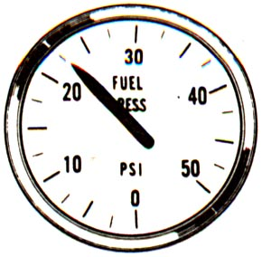

Fuel Inlet Pressure Indicator. The fuel inlet pressure indicator measures the pressure at the inlet to the engine-driven fuel pump. This pressure will be the pressure of the fuel supplied from the airplane.

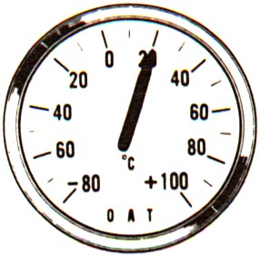

Air Temperature Indicator. This gage is not an actual engine gage, but rather is an airplane gage. The air temperature indicator provides the temperature of the air outside the airplane. This temperature may be recorded from specific locations and, therefore, the actual value may mean different things depending upon the particular airplane. This temperature typically is used to help select EPR in those engines where thrust is set by EPR.

In addition to the above indications, recently-designed airplanes have a wide variety of caution, advisory and status messages that may be displayed in the event of an engine malfunction or abnormal operation. Since these are specific to each particular airplane design, they cannot be addressed here; reference to the appropriate airplane flight or operations manual will provide further information.

Chapter 4

Engine Malfunctions

To provide effective understanding of and preparation for the correct responses to engine in-flight malfunctions, this chapter will describe turbofan engine malfunctions and their consequences in a manner that is applicable to almost all modern turbofan-powered airplanes. These descriptions, however, do not supersede or replace the specific instructions that are provided in the Airplane Flight Manual and appropriate checklists.

Compressor surge

It is most important to provide an understanding of compressor surge. In modern turbofan engines, compressor surge is a rare event. If a compressor surge (sometimes called a compressor stall) occurs during high power at takeoff, the flight crew will hear a very loud bang, which will be accompanied by yaw and vibration. The bang will likely be far beyond any engine noise, or other sound, the crew may have previously experienced in service.

Compressor surge has been mistaken for blown tires or a bomb in the airplane. The flight crew may be quite startled by the bang, and, in many cases, this has led to a rejected takeoff above V1. These high-speed rejected takeoffs have sometimes resulted in injuries, loss of the airplane, and even passenger fatalities.

The actual cause of the loud bang should make no difference to the flight crew’s
first response, which should be to maintain control of the airplane and, in particular, continue the takeoff if the event occurs after V1. Continuing the takeoff is the proper response to a tire failure occurring after V1, and history has shown that bombs are not a threat during the takeoff roll – they are generally set to detonate at altitude.

A surge from a turbofan engine is the result of instability of the engine's operating cycle. Compressor surge may be caused by engine deterioration, it may be the result of ingestion of birds or ice, or it may be the final sound from a “severe engine damage” type of failure. As we learned in Chapter 1, the operating cycle of the turbine engine consists of intake, compression, ignition, and exhaust, which occur simultaneously in different places in the engine. The part of the cycle susceptible to instability is the compression phase.

In a turbine engine, compression is accomplished aerodynamically as the air passes through the stages of the compressor, rather than by confinement, as is the case in a piston engine. The air flowing over the compressor airfoils can stall just as the air over the wing of an airplane can. When this airfoil stall occurs, the passage of air through the compressor becomes unstable and the compressor can no longer compress the incoming air. The high-pressure air behind the stall further back in the engine escapes forward through the compressor and out the inlet.

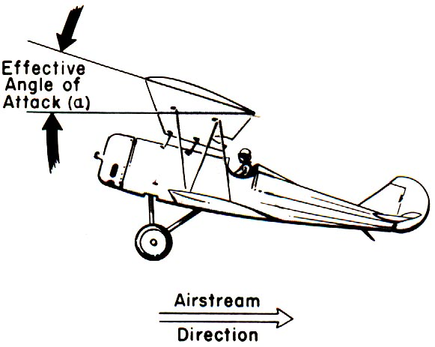

This escape is sudden, rapid and often quite audible as a loud bang similar to an explosion. Engine surge can be accompanied by visible flames forward out the inlet and rearward out the tailpipe. Instruments may show high EGT and EPR or rotor speed changes, but, in many stalls, the event is over so quickly that the instruments do not have time to respond.

Once the air from within the engine escapes, the reason (reasons) for the instability may self-correct and the compression process may re-establish itself. A single surge and recovery will occur quite rapidly, usually within fractions of a second. Depending on the reason for the cause of the compressor instability, an engine might experience:

1) A single self-recovering surge
2) Multiple surges prior to self-recovery
3) Multiple surges requiring pilot action in order to recover
4) A non-recoverable surge.

For complete, detailed procedures, flight crews must follow the appropriate checklists and emergency procedures detailed in their specific Airplane Flight Manual. In general, however, during a single self-recovering surge, the cockpit engine indications may fluctuate slightly and briefly. The flight crew may not
notice the fluctuation. (Some of the more recent engines may even have fuel-flow logic that helps the engine self-recover from a surge without crew intervention. The stall may go completely unnoticed, or it may be annunciated to the crew – for information only – via EICAS messages.) Alternatively, the engine may surge two or three times before full self-recovery. When this happens, there is likely to be cockpit engine instrumentation shifts of sufficient magnitude and duration to be noticed by the flight crew. If the engine does not recover automatically from the surge, it may surge continually until the pilot takes action to stop the process. The desired pilot action is to retard the thrust lever until the engine recovers. The flight crew should then SLOWLY re-advance the thrust lever. Occasionally, an engine may surge only once but still not self-recover.

The actual cause for the compressor surge is often complex and may or may not result from severe engine damage. Rarely does a single compressor surge CAUSE severe engine damage, but sustained surging will eventually over-heat the turbine, as too much fuel is being provided for the volume of air that is reaching the combustor. Compressor blades may also be damaged and fail as a result of repeated violent surges; this will rapidly result in an engine which cannot run at any power setting.

Additional information is provided below regarding single recoverable surge, self-recoverable after multiple surges, surge requiring flight crew action, and non-recoverable surge. In severe cases, the noise, vibration and aerodynamic forces can be very distracting. It may be difficult for the flight crew to remember that their most important task is to fly the airplane.

Single self-recoverable surge

The flight crew hears a very loud bang or double bang. The instruments will fluctuate quickly, but, unless someone was looking at the engine gage at the time of the surge, the fluctuation might not be noticed.

For example: During the surge event, Engine Pressure Ratio (EPR) can drop from takeoff (T/O) to 1.05 in 0.2 seconds. EPR can then vary from 1.1 to 1.05 at 0.2-second intervals two or three times. The low rotor speed (N1) can drop 16% in the first 0.2 seconds, then another 15% in the next 0.3 seconds. After recovery, EPR and N1 should return to pre-surge values along the normal acceleration schedule for the engine.

Multiple surge followed by self-recovery

Depending on the cause and conditions, the engine may surge multiple times, with each bang being separated by a couple of seconds. Since each bang usually represents a surge event as described above, the flight crew may detect the "single surge" described above for two seconds, then the engine will return to 98% of the pre-surge power for a few seconds. This cycle may repeat two or three times. During the surge and recovery process, there will likely be some rise in EGT.

For example: EPR may fluctuate between 1.6 and 1.3, Exhaust Gas Temperature (EGT) may rise 5 degrees C/second, N1 may fluctuate between 103% and 95%, and fuel flow may drop 2% with no change in thrust lever position. After 10 seconds, the engine gages should return to pre-surge values.

Surge recoverable after flight crew action

When surges occur as described in the previous paragraph, but do not stop, flight crew action is required to stabilize the engine. The flight crew will notice the fluctuations described in “recoverable after two or three bangs,” but the fluctuations and bangs will continue until the flight crew retards the thrust lever to idle. After the flight crew retards the thrust lever to idle, the engine parameters should decay to match thrust lever position. After the engine reaches idle, it may be re-accelerated back to power. If, upon re-advancing to high power, the engine surges again, the engine may be left at idle, or left at some intermediate power, or shutdown, according to the checklists applicable for the airplane. If the flight crew takes no action to stabilize the engine under these circumstances, the engine will continue to surge and may experience progressive secondary damage to the point where it fails completely.

Non-recoverable surge

When a compressor surge is not recoverable, there will be a single bang and the engine will decelerate to zero power as if the fuel had been chopped. This type of compressor surge can accompany a severe engine damage malfunction. It can also occur without any engine damage at all.

EPR can drop at a rate of .34/sec and EGT rise at a rate of 15 degrees C/sec, continuing for 8 seconds (peaking) after the thrust lever is pulled back to idle. N1 and N2 should decay at a rate consistent with shutting off the fuel, with fuel flow dropping to 25% of its pre-surge value in 2 seconds, tapering to 10% over the next 6 seconds.

Flameout

A flameout is a condition where the combustion process within the burner has stopped. A flameout will be accompanied by a drop in EGT, in engine core speed and in engine pressure ratio. Once the engine speed drops below idle, there may be other symptoms, such as low oil pressure warnings and electrical generators dropping off line – in fact, many flameouts from low initial power settings are first noticed when the generators drop off line and may be initially mistaken for electrical problems. The flameout may result from the engine running out of fuel, severe inclement weather, a volcanic ash encounter, a control system malfunction, or unstable engine operation (such as a compressor stall). Multiple engine flameouts may result in a wide variety of flight deck symptoms as engine inputs are lost from electrical, pneumatic and hydraulic systems. These situations have resulted in pilots troubleshooting the airplane systems without recognizing and fixing the root cause – no engine power. Some airplanes have dedicated EICAS/ECAM messages to alert the flight crew to an engine rolling back below idle speed in flight; generally, an ENG FAIL or ENG THRUST message.

A flameout at take-off power is unusual – only about 10% of flameouts are at takeoff power. Flameouts occur most frequently from intermediate or low power settings, such as cruise and descent. During these flight regimes, it is likely that the autopilot is in use. The autopilot will compensate for the asymmetrical thrust up to its limits and may then disconnect. Autopilot disconnect must then be accompanied by prompt, appropriate control inputs from the flight crew if the airplane is to maintain a normal attitude. If no external visual references are available, such as when flying over the ocean at night or in IMC, the likelihood of an upset increases. This condition of low-power engine loss with the autopilot on has caused several aircraft upsets, some of which were not recoverable. Flight control displacement may be the only obvious indication. Vigilance is required to detect these stealthy engine failures and to maintain a safe flight attitude while the situation is still recoverable.

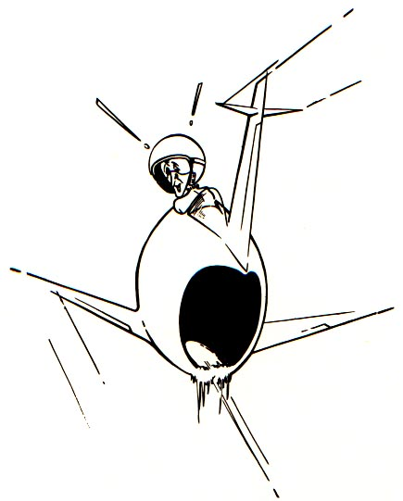

Once the fuel supply has been restored to the engine, the engine may be restarted in the manner prescribed by the applicable Airplane Flight or Operating Manual. Satisfactory engine restart should be confirmed by reference to all primary parameters – using only N1, for instance, has led to confusion during some in-flight restarts. At some flight conditions, N1 may be very similar for a windmilling engine and an engine running at flight idle.

Fire

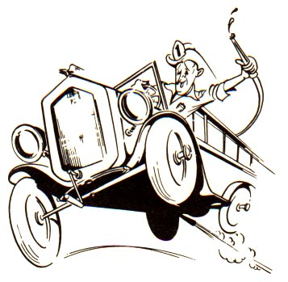
Engine fire almost always refers to a fire outside the engine but within the nacelle. A fire in the vicinity of the engine should be annunciated to the flight crew by a fire warning in the flight deck. It is unlikely that the flight crew will see, hear, or immediately smell an engine fire. Sometimes, flight crews are advised of a fire by communication with the control tower.

It is important to know that, given a fire in the nacelle, there is adequate time to make the first priority "fly the airplane" before attending to the fire. It has been shown that, even in incidents of fire indication immediately after takeoff, there is adequate time to continue climb to a safe altitude before attending to the engine. There may be economic damage to the nacelle, but the first priority of the flight crew should be to ensure the airplane continues in safe flight.

Flight crews should regard any fire warning as a fire, even if the indication goes away when the thrust lever is retarded to idle. The indication might be the result of pneumatic leaks of hot air into the nacelle. The fire indication could also be from a fire that is small or sheltered from the detector so that the fire is not apparent at low power. Fire indications may also result from faulty detection systems. Some fire detectors allow identification of a false indication (testing the fire loops), which may avoid the need for an IFSD. There have been times when the control tower has mistakenly reported the flames associated with a compressor surge as an engine "fire."

In the event of a fire warning annunciation, the flight crew must refer to the checklists and procedures specific to the airplane being flown. In general, once the decision is made that a fire exists and the aircraft is stabilized, engine shutdown should be immediately accomplished by shutting off fuel to the engine, both at the engine fuel control shutoff and the wing/pylon spar valve. All bleed air, electrical, and hydraulics from the affected engine will be disconnected or isolated from the airplane systems to prevent any fire from spreading to or contaminating associated airplane systems. This is accomplished by one common engine "fire handle." This controls the fire by greatly reducing the fuel available for combustion, by reducing the availability of pressurized air to any sump fire, by temporarily denying air to the fire through the discharge of fire extinguishant, and by removing sources of re-ignition, such as live electrical wiring and hot casings. It should be noted that some of these control measures may be less effective if the fire is the result of severe damage – the fire may take slightly longer to be extinguished in these circumstances. In the event of a shut down after an in-flight engine fire, there should be no attempt to restart the engine unless it is critical for continued safe flight, as the fire is likely to re-ignite once the engine is restarted.

Tailpipe Fires

One of the most alarming events for passengers, flight attendants, ground personnel and even air traffic control (ATC) to witness is a tailpipe fire. Fuel may puddle in the turbine casings and exhaust during start-up or shutdown, and then ignite. This can result in a highly-visible jet of flame out of the back of the engine, which may be tens of feet long. Passengers have initiated emergency evacuations in these instances, leading to serious injuries.

There may be no indication of an anomaly to the flight crew until the cabin crew or control tower draws attention to the problem. They are likely to describe it as an “Engine Fire,” but a tailpipe fire will NOT result in a fire warning on the flight deck.

If notified of an engine fire without any indications in the cockpit, the flight crew should accomplish the tailpipe fire procedure. It will include motoring the engine to help extinguish the flames, while most other engine abnormal procedures will not.

Since the fire is burning within the turbine casing and exhaust nozzle, pulling the fire handle to discharge extinguishant to the space between casings and cowls will be ineffective. Pulling the fire handle may also make it impossible to dry motor the engine, which is the quickest way of extinguishing most tailpipe fires.

Hot starts

During engine start, the compressor is very inefficient, as already discussed. If the engine experiences more than the usual difficulty accelerating (due to such problems as early starter cut-out, fuel mis-scheduling, or strong tailwinds), the engine may spend a considerable time at very low RPM (sub-idle). Normal engine cooling flows will not be effective during sub-idle operation, and turbine temperatures may appear relatively high. This is known as a hot start (or, if the engine completely stops accelerating toward idle, a hung start). The AFM indicates acceptable time/temperature limits for EGT during a hot start. More recent, FADEC-controlled engines may incorporate auto-start logic to detect and manage a hot start.

Bird ingestion/FOD

Airplane engines ingest birds most often in the vicinity of airports, either during takeoff or during landing. Encounters with birds occur during both daytime and nighttime flights.

By far, most bird encounters do not affect the safe outcome of a flight. In more than half of the bird ingestions into engines, the flight crew is not even aware that the ingestion took place.

When an ingestion involves a large bird, the flight crew may notice a thud, bang or vibration. If the bird enters the engine core, there may be a smell of burnt flesh in the flight deck or passenger cabin from the bleed air.

Bird strikes can damage an engine. The photo on the next page shows fan blades bent due to the ingestion of a bird. The engine continued to produce thrust with this level of damage. Foreign Object Damage (FOD) from other sources, such as tire fragments, runway debris or animals, may also be encountered, with similar results.

Bird ingestion can also result in an engine surge. The surge may have any of the characteristics listed in the surge section. The engine may surge once and recover; it may surge continuously until the flight crew takes action; or it may surge once and not recover, resulting in the loss of power from that engine. Bird ingestion can result in the fracture of one or more fan blades, in which case, the engine will likely surge once and not recover.

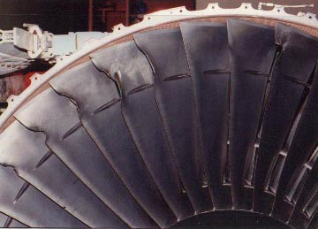

Fig 13 showing fan blades bent by encounter with a bird.

Regardless of the fact that a bird ingestion has resulted in an engine surge, the first priority task of the flight crew is to "fly the airplane." Once the airplane is in stable flight at a safe altitude, the appropriate procedures in the applicable Airplane Flight Manual can be accomplished.

In rare cases, multiple engines can ingest medium or large birds. In the event of suspected multiple-engine damage, taking action to stabilize the engines becomes a much higher priority than if only one engine is involved – but it is still essential to control the airplane first.

Severe engine damage

Severe engine damage may be difficult to define. From the viewpoint of the flight crew, severe engine damage is

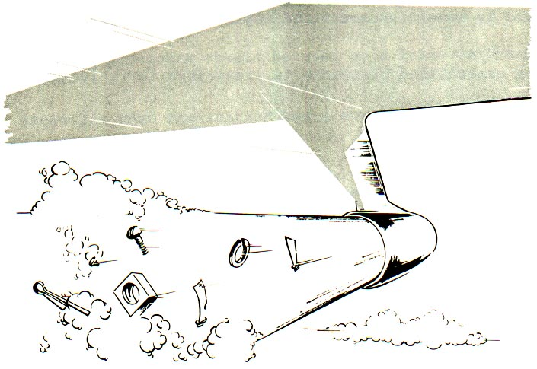

mechanical damage to the engine that looks "bad and ugly." To the manufacturers of the engine and the airplane, severe engine damage may involve symptoms as obvious as large holes in the engine cases and nacelle or as subtle as the non-response of the engine to thrust lever movement.

It is important for flight crews to know that severe engine damage may be accompanied by symptoms such as fire warning (from leaked hot air) or engine surge because the compressor stages that hold back the pressure may not be intact or in working order due to the engine damage.

In this case, the symptoms of severe engine damage will be the same as a surge without recovery. There will be a loud noise. EPR will drop quickly; N1, N2 and fuel flow will drop. EGT may rise momentarily. There will be a loss of power to the airplane as a result of the severe engine damage. It is not important to initially distinguish between a non-recoverable surge with or without severe engine damage, or between a fire and a fire warning with severe engine damage. The priority of the flight crew still remains "fly the airplane." Once the airplane is stabilized, the flight crew can diagnose the situation.

Engine Seizure

Engine seizure describes a situation where the engine rotors stop turning in flight, perhaps very suddenly. The static and rotating parts lock up against each other, bringing the rotor to a halt. In practice, this is only likely to occur at low rotor RPM after an engine shutdown, and virtually never occurs for the fan of a large engine – the fan has too much inertia, and the rotor is being pushed around by ram air too forcefully to be stopped by the static structure. The HP rotor is more likely to seize after an in-flight shutdown if the nature of the engine malfunction is mechanical damage within the HP system. Should the LP rotor seize, there will be some perceptible drag for which the flight crew must compensate; however, if the HP rotor seizes, there will be negligible effect upon airplane handling.

Seizure cannot occur without being caused by very severe engine damage, to the point where the vanes and blades of the compressor and turbine are mostly destroyed. This is not an instantaneous process – there is a great deal of inertia in the turning rotor compared to the energy needed to break interlocking rotating and static components.

Once the airplane has landed, and the rotor is no longer being driven by ram air, seizure is frequently observed after severe damage.

Symptoms of engine seizure in flight may include vibration, zero rotor speed, mild airplane yaw, and possibly unusual noises (in the event of fan seizure). There may be an increased fuel flow in the remaining engines due to aircraft automatic compensations; no special action is needed other than that which is appropriate to the severe engine damage type failure.

Engine Separation

Engine separation is an extremely rare event. It will be accompanied by loss of all primary and secondary parameters for the affected engine, noises, and airplane yaw (especially at high power settings). Separation is most likely to occur during take-off/climb-out or the landing roll. Airplane handling may be affected. It is important to use the fire handle to close the spar valve and prevent a massive overboard fuel leak; refer to the airplane flight or operations manual for specific procedures.

Fuel System Problems

Leaks

Major leaks in the fuel system are a concern to the flight crew because they may result in engine fire, or, eventually, in fuel exhaustion. A very large leak can produce engine flameout.

Engine instruments will only indicate a leak if it is downstream of the fuel flowmeter. A leak between the tanks and the fuel flowmeter can only be recognized by comparing fuel usage between engines, by comparing actual usage to planned usage, or by visual inspection for fuel flowing out of the pylon or cowlings. Eventually, the leak may result in tank imbalance.

In the event of a major leak, the crew should consider whether the leak needs to be isolated to prevent fuel exhaustion.

It should be noted that the likelihood of fire resulting from such a leak is greater at low altitude or when the airplane is stationary; even if no fire is observed in flight, it is advisable for emergency services to be available upon landing.

Inability to shutdown Engine

If the engine fuel shut-off valve malfunctions, it may not be possible to shut the engine down by the normal procedure, since the engine continues to run after the fuel switch is moved to the cutoff position. Closing the spar valve by pulling the fire handle will ensure that the engine shuts down as soon as it has used up the fuel in the line from the spar valve to the fuel pump inlet. This may take a couple of minutes.

Fuel filter Clogging

Fuel filter clogging can result from the failure of one of the fuel tank boost pumps (the pump generates debris which is swept downstream to the fuel filter), from severe contamination of the fuel tanks during maintenance (scraps of rag, sealant, etc., that are swept downstream to the fuel filter), or, more seriously, from gross contamination of the fuel. Fuel filter clogging will usually be seen at high power settings, when the fuel flow through the filter (and the sensed pressure drop across the filter) is greatest. If multiple fuel filter bypass indications are seen, the fuel may be heavily contaminated with water, rust, algae, etc. Once the filters bypass and the contaminant goes straight into the engine fuel system, the engine fuel control may no longer operate as intended. There is potential for multiple-engine flameout. The Airplane Flight or Operating Manual provides the necessary guidance.
Oil System Problems

The engine oil system has a relatively large number of indicated parameters required by the regulations (pressure, temperature, quantity, filter clogging). Many of the sensors used are subject to giving false indications, especially on earlier engine models. Multiple abnormal system indications confirm a genuine failure; a single abnormal indication may or may not be a valid indication of failure.

There is considerable variation between failure progressions in the oil system, so the symptoms given below may vary from case to case.

Oil system problems may appear at any flight phase, and generally progress gradually. They may eventually lead to severe engine damage if the engine is not shut down.

Leaks

Leaks will produce a sustained reduction in oil quantity, down to zero (though there will still be some usable oil in the system at this point). Once the oil is completely exhausted, oil pressure will drop to zero, followed by the low oil pressure light. There have been cases where maintenance error caused leaks on multiple engines; it is therefore advisable to monitor oil quantity carefully on the good engines as well. Rapid change in the oil quantity after thrust lever movement may not indicate a leak – it may be due to oil “gulping” or “hiding” as more oil flows into the sumps.
Bearing failures

Bearing failures will be accompanied by an increase in oil temperature and indicated vibration. Audible noises and filter clog messages may follow; if the failure progresses to severe engine damage, it may be accompanied by low oil quantity and pressure indications.

Oil pump failures

Oil pump failure will be accompanied by low indicated oil pressure and a low oil pressure light, or by an oil filter clog message.

Contamination

Contamination of the oil system – by carbon deposits, cotton waste, improper fluids, etc. – will generally lead to an oil filter clog indication or an impending bypass indication. This indication may disappear if thrust is reduced, since the oil flow and pressure drop across the filter will also drop.

No Thrust Lever Response

A “No Thrust Lever Response” type of malfunction is more subtle than the other malfunctions previously discussed, so subtle that it can be completely overlooked, with potentially serious consequences to the airplane.

If an engine slowly loses power – or if, when the thrust lever is moved, the engine does not respond – the airplane will experience asymmetric thrust. This may be partly concealed by the autopilot’s efforts to maintain the required flight condition.

As is the case with flameout, if no external visual references are available, such as when flying over the ocean at night or in IMC, asymmetric thrust may persist for some time without the flight crew recognizing or correcting it. In several cases, this has led to airplane upset, which was not always recoverable. As stated, this condition is subtle and not easy to detect.

Symptoms may include:

- Multiple system problems such as generators dropping off-line or low engine oil pressure.
- Unexplained airplane attitude changes.
- Large unexplained flight control surface deflections (autopilot on) or the need for large flight control inputs without apparent cause (autopilot off).
- Significant differences between primary parameters from one engine to the next.

If asymmetric thrust is suspected, the first response must be to make the appropriate trim or rudder input. Disconnecting the autopilot without first performing the appropriate control input or trim may result in a rapid roll maneuver.

Reverser malfunctions

Generally, thrust reverser malfunctions are limited to failure conditions where the reverser system fails to deploy when commanded and fails to stow when commanded. Failure to deploy or to stow during the landing roll will result in significant asymmetric thrust, and may require a rapid response to maintain directional control of the airplane.

Uncommanded deployments of modern thrust reverser systems have occurred and have led to Airworthiness Directives to add additional locking systems to the reverser. As a consequence of this action, the probability of inadvertent deployment is extremely low. The airplane flight or operations manual provides the necessary system information and type of annunciations provided by the airplane type.

No Starter Cutout

Generally, this condition exists when the start selector remains in the start position or the engine start valve is open when commanded closed. Since the starter is intended only to operate at low speeds for a few minutes at a time, the starter may fail completely (burst) and cause further engine damage if the starter does not cut out.

Vibration

Vibration is a symptom of a wide variety of engine conditions, ranging from very benign to serious. The following are some causes of tactile or indicated vibration:

- Fan unbalance at assembly
- Fan blade friction or shingling
- Water accumulation in the fan rotor
- Blade icing
- Bird ingestion/FOD
- Bearing failure
- Blade distortion or failure
- Excessive fan rotor system tip clearances.
It is not easy to identify the cause of the vibration in the absence of other unusual indications. Although the vibration from some failures may feel very severe on the flight deck, it will not damage the airplane. There is no need to take action based on vibration indication alone, but it can be very valuable in confirming a problem identified by other means.

Engine vibration may be caused by fan unbalance (ice buildup, fan blade material loss due to ingested material, or fan blade distortion due to foreign object damage) or by an internal engine failure. Reference to other engine parameters will help to establish whether a failure exists.

Vibration felt on the flight deck may not be indicated on instruments. For some engine failures, severe vibration may be experienced on the flight deck either during an engine failure or possibly after the engine has been shut down, making instruments difficult to read. This large amplitude vibration is caused by the unbalanced fan windmilling close to the airframe natural frequency, which may amplify the vibration. Changing airspeed and/or altitude will change the fan windmill speed, and an airplane speed may be found where there will be much less vibration. Meanwhile, there is no risk of airplane structural failure due to vibratory engine loads.

Wrap-up

The tabulation of engine conditions and their symptoms below shows that many failures have similar symptoms and that it may not be practicable to diagnose the nature of the engine problem from flight deck instrumentation. However, it is not necessary to understand exactly what is wrong with the engine – selecting the “wrong” checklist may cause some further economic damage to the engine, but, provided action is taken with the correct engine, and airplane control is kept as the first priority, the airplane will still be safe.

 | Engine separation | Severe damage | Surge | Bird ingestion/FOD | Seizure | Flameout | Fuel control problems | Fire | Tailpipe fires | Hot start | Icing | Reverser inadvertent  deploy | Fuel leak
Bang | O | X | X | O | O |  |  |  |  |  | O
Fire Warning | O | O |  | O |  |  |  | X
Visible flame | O | O | O | O |  |  |  | O | X | O
Vibration |  | X | O | X | O |  |  |  |  |  | X | X
Yaw | O | O | O | O | O | O | O |  |  |  |  | X
High EGT |  | X | X | O | O |  | X |  | O | X | O
N1 change | X | X | O | O | X | X | X |  |  |  |  |  | X
N2 change | X | X | O | O | X | X | X |  |  |  |  |  | X
Fuel flow change | X | O | O |  | O | X | O | O |  |  |  |  | X
Oil indication change | X | O | O |  | O | X |  | O
Visible cowl damage | X | X |  |  |  |  |  | O |  |  |  | X
Smoke/odor in cabin bleed air |  | O |  | O | O
EPR change | X | X | X | O | X | X | X |  |  |  |  |  | X

X = Symptom very likely
O = Symptom possible
Note: blank fields mean that the symptom is unlikely

Appendix

Attached are flash card style summary descriptions of many of the malfunctions discussed in this text.

Engine Stall/Surge
Event Description  Engine Stall or Surge is a momentary reversal of the compressor airflow such that high-pressure air escapes out of the engine inlet. | Symptoms  High power: Loud bang and yaw (may be repetitive). Flames from inlet and tailpipe. Vibration. High EGT/TGT. Parameter fluctuation  Low power: Quiet bang/pop or rumble.

Corrective action
After stabilizing airplane flight path, observe engine instruments for anomalies. Stall/surge may be self-correcting, may require the engine to be throttled back, or may require engine shutdown, if the engine can be positively identified and the stall will not clear.

N1
EPR
EGT
N2

POSSIBLE MESSAGES

ENG STALL

EGT OVERLIMIT

ENG FAIL
FLUX

Flameout
Event Description  Engine Flameout is a condition where the combustor is no longer burning fuel. | Symptoms  Single engine: Core speed, EGT, EPR all decay. Electrical generator drops off line; low oil pressure warning as core speed drops below idle.  Multiple engines:  As above, but also hydraulic, pneumatic and electrical system problems.

Corrective action
After stabilizing airplane flight path, verify fuel supply to engine. Re-start engine according to AFM.

N1
EPR
EGT
N2

POSSIBLE MESSAGES

ENG FAIL

OIL LO PR

GEN OFF

BLD OFF

ALL ENG FLAMEOUT
LOW

Fire
Event Description  Engine fire is a fuel, oil or hydraulic fluid fire between the engine casing and the cowlings (or occasionally a metal fire). It could result from severe damage. Hot air leaks can also give a fire warning. | Symptoms  Fire warning. Flame or smoke may be observed.
Corrective action  After stabilizing airplane flight path, shut the engine down and discharge extinguishant. Avoid restarting the engine. | Symptoms  Fire warning. Flame or smoke may be observed.

N1
EPR
EGT
N2
POSSIBLE MESSAGES

ENG FIRE

PARAMETERS MAY LOOK NORMAL
NORMALL

Tailpipe fire
Event Description  Fuel puddles in the tailpipe and ignites on hot surfaces. | Symptoms  Observed flames and smoke. No fire warning.
Corrective action  Shut off fuel to the engine and dry motor it. | Symptoms  Observed flames and smoke. No fire warning.

N1
EPR
EGT
N2

POSSIBLE MESSAGES

START FAULT
LOW

Bird Ingestion
Event Description  A bird (or other creature) is sucked into the engine inlet. Note: ingestion of ice slabs, blown tires, etc., will produce similar, but more severe, symptoms. | Symptoms  Thud, bang, vibration. Odor in cabin. Surge may result from bird ingestion.

Corrective action
After stabilizing airplane flight path, watch engine instruments for anomalies. If the engine surges, throttle back or shut down as necessary. If multiple engines are affected, operate engines free of surge/stall to maintain desired flight profile.

N1
EPR
EGT
N2
POSSIBLE MESSAGES

ENG STALL

EGT OVERLIMIT

VIB
PARAMETERS MAY LOOK NORMAL
NORMAL

Severe Engine Damage
Event Description  The engine hardware is damaged to the point where the engine is in no condition to run – such as bearing failure, major fan damage from ingestion of foreign objects, blade or rotor disk failures, etc. | Symptoms  Depending on nature of damage – surge/stall, vibration, fire warning, high EGT, oil system parameters out of limits, rotor speed and EPR decay, yaw.

Corrective action
After stabilizing airplane flight path, observe engine instruments for anomalies. Shut down engine.

N1
EPR
EGT
N2

POSSIBLE MESSAGES

ENG FAIL

EGT OVERLIMIT

ENG STALL

VIB

OIL LO PR
LOW

Engine Seizure
Event Description  Engine seizure is the locking up of one or more rotors. It only happens after engines are shut down for severe damage. | Symptoms  After shut down, zero speed on one of the rotors. Minor increase in required thrust for flight conditions.

Corrective action
Trim and adjust power for increased drag.

N1
EPR
EGT
N2

POSSIBLE MESSAGES

ENG SHUT DOWN

LOW

Engine Separation
Event Description  Engine Separation is the departure of the engine from the airplane due to mount or pylon failure. | Symptoms  Loss of all engine parameters.  Hydraulic, pneumatic and electrical system problems

Corrective action
After stabilizing airplane flight path, observe engine instruments for anomalies. Turn off fuel to appropriate engine.
N1
EPR
EGT

POSSIBLE MESSAGES

ENG FIRE

HYD OFF

GEN OFF

BLD OFF
N2
ZERO

