Baltic International Academy



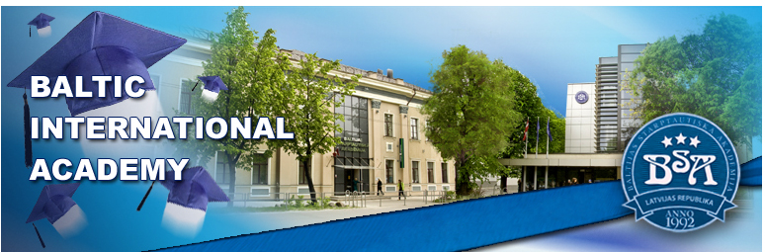

Incoming Student Information Package

ERASMUS Exchange Programme



Table of Contents

BIA Guide 3
Baltic International Academy & ERASMUS Mobility Centre 3
Application and Requirements 4
Studies, Courses and Grading 5
Arrival and Registration 6
Buildings and Departments 7
BIA Library 8
Russian Language School 8
Practical Guide 9
Cost of Living and Expenses 9
Accommodation 9
Visas and Residence Permits 12
Insurance and Medical Treatment 14
Public Transport 14
Mobile Phone Cards 15
Post Office and Telephone 15
Money and Banks 16
National Holidays in Latvia 16
Useful Links 16
Appendices 17
Application Form 18
Learning Agreement 21
Changes to Learning Agreement 22
Programme: European Studies 23
Programme: Translation and Interpreting 25
Programme: Tourism and Hospitality Management 27
Programme: Business Administration (bachelor) 28
Programme: Business Management (master) 30
Programme: Digital Visualisation 31
Programme: Environmental Design 33
Evaluation Sheet Form 34
Confirmation of Study Period Form 35
Transcript of Records Form 36

Name of the Institution | Baltijas Starptautiskā akadēmija (Baltic International Academy)
Address | Lomonosova iela 4, LV-1003 Rīga, LATVIA
Telephone | + 371 67100603
Website | www.bsa.edu.lv/lang/eng/erasmus.html
ERASMUS Institution Code | LV RIGA 28
ERASMUS Charter Number | 227161-IC-1-2009-1-LV-ERASMUS-EUCX-1

BIA ERASMUS Mobility Centre

Our postal address:

Baltic International Academy
ERASMUS Mobility Centre, kab. 107
Lomonosova iela 4
LV-1003 Rīga
LATVIA

Open Hours:
Monday 15:00 -17:00
Thursday 15:00 -18:00

Exchange students and staff are welcome at Baltic International Academy!

Since 2006, BIA has been taking active part in ERASMUS exchange programme. Total number of incoming and outgoing mobilities exceeds 200 people.

ERASMUS students are admitted on the basis of bilateral agreements with universities in EU and EEA countries.

Currently, BIA has 85 bilateral agreements with universities in over 20 countries, and we are always open to establishing new partnerships.

Find us on Facebook:
http://www.facebook.com/groups/227044737325637

ERASMUS Institutional Coordinator
Viktorija Petlak
Tel. + 371 26772532
viktorija.petlak@bsa.edu.lv
Coordinator’s assistant
(ERASMUS Student Officer)
Valeria Leontyeva
Tel. +371 67100603
erasmus@bsa.edu.lv

Basic Information
Baltic International Academy (BIA) is the biggest non-governmental institution of higher education in the Baltic States and Eastern Europe, established in 1992. The number of academy students today amounts to 5700, including more than 450 foreign students from 22 countries worldwide.
BIA offers lectures and master classes carried out by 300 staff lecturers, 100 of whom are doctors of sciences and professors.
Application and Requirements

Language of Instruction and Language Requirements
ERASMUS students at BIA study subjects in English. Exceptions are the cases when students come to BIA to study Russian/Latvian or when students have a solid command of Russian/Latvian and are able to study in these languages.
Therefore, ERASMUS students must have a sufficient knowledge of the English language of at least Upper Intermediate level if studies at BIA are to be successful. Knowledge of Russian or Latvian is needed if the student wishes to take subjects in these languages.


Documents for incoming ERASMUS students:
- Foreign Exchange Student Application Form, filled in by the student
- Letter of Confirmation from sending university (signed by the departmental or institutional coordinator; should indicate the student’s participation in ERASMUS programme, compliance with all the requirements, as well as sufficient knowledge of English of Upper Intermediate level)
- Photocopy of passport
- Learning agreement (prepared in 3 hard copies with original signatures and stamps)
- 2 passport-size photos (2x3 cm) (for the identity card; therefore, they should be original, not scanned)

How to apply?
- first of all, the student should be nominated by the home university coordinator to ERASMUS Mobility Centre via e-mail (erasmus@bsa.edu.lv). Nominee's name, surname, e-mail address, field of study, birth date, gender and citizenship should be indicated.

The nominated student should:
- fill in our Application Form ("LLP ERASMUS foreign exchange student - application form" at www.bsa.edu.lv/lang/eng/erasmus.html); complete it with the necessary signatures and stamps and send to our address together with other documents mentioned above.

NB! When filling in the application and the learning agreement, please type or write in block capitals.

Our postal address:
Baltic International Academy
ERASMUS Mobility Centre, kab. 107
Lomonosova iela 4
LV-1003 Rīga
LATVIA

- The applications are given for departmental head’s and institutional coordinator’s consideration. After their approval, ERASMUS Mobility Centre issues the letter of acceptance, which is sent directly to the student's e-mail, home university coordinator’s e-mail or via post if necessary.

ERASMUS Nomination Deadlines
Autumn semester/whole year – June 1; spring semester – December 1.

BIA Academic Calendar 2013/2014

2 September – beginning of the academic year
20 December – end of lectures for the autumn semester
23 December – 3 January – Christmas holidays
6 January – 31 January – exam period for the autumn semester
10 February – beginning of lectures for the spring semester
30 May – end of lectures for the spring semester
3 June – 28 June – exam period for the spring semester

1 July – ~16 August – summer holidays
Studies, Courses and Grading


Baltic International Academy (BIA) and Baltic Psychology and Management University College (BPMUC) offer courses for ERASMUS students at the following programmes:

- European Studies

- Translation and Interpretation

- Business Administration (bachelor)

- Business Management (master)

- Tourism and Hospitality Management

- Design (Digital Visualisation)

- Psychology (BPMUC)

The programme curricula with the lists of subjects and their ECTS amounts are available at BIA website (http://bsa.edu.lv/lang/eng/erasmus.html) in the section "STUDY PROGRAMMES".

After choosing their courses, students must fill in the Learning Agreement (see "Learning Agreement"), which must be prepared in 3 copies with original stamps and signatures and is signed by the student themself, departmental head and institutional coordinator of both sending and receiving university.
There might a be possibility that one or more subjects will have to be changed later. In this case, Changes to Learning agreement must be filled in (see the 2nd page of the "Learning Agreement") and again approved by departmental heads and institutional coordinators of both universities. All subjects must be listed with the indication whether the are added or deleted. Changes, like the Learning agreement, must be prepared in 3 copies with original signatures and stamps.


BALTIC PSYCHOLOGY AND MANAGEMENT UNIVERSITY COLLEGE (BPMUC)
is the institution that offers courses in the programme of Psychology.
Please contact ERASMUS Mobility Centre (erasmus@bsa.edu.lv) for the BPMUC Application Form and Curriculum.

Examinations and Transcript of Records

Before taking examinations, each ERASMUS student must have their Evaluation Sheet, where each subject must be indicated, and where the lecturer puts the mark and their signature. You may print the Evaluation Sheet form from the website (see "ERASMUS Evaluation Sheet Form") or get a hard copy of one at the Mobility Centre. After all the examinations, the Evaluation Sheet must be submitted to the Mobility Centre.

NB! To avoid any kind of misunderstanding and confusion, the subjects in the Evaluation Sheet must be written exactly in the same way as they are in the Curriculum and the Learning Agreement. Please make sure you know the correct title of all your subjects!

After all examinations are passed, the Mobility Centre will prepare the Transcript of Records (see "ECTS form Transcript of Records") on the basis of the Evaluation Sheet. This can take 2-3 weeks, so you may receive the Transcript via post after you have left.

Before departure you must come to the Mobility Centre to get the Confirmation of Study Period, which shows the dates of your studies (see "ERASMUS Confirmation of Study Period").

Grading System
The explanation of the ECTS grade system can be found on each student’s transcript of records.
1 Latvian credit point equals to 1.5 ECTS credit points.
Please note that students only get credits for the exams which they have passed. Just attending the lectures is not sufficient to receive any credits!

Latvian grade | 10 | 9 | 8; 7 | 6 | 5 | 4 | 3; 2; 1
Meaning | with distinction | excellent | good | almost good | satisfactory | almost satisfactory | unsatisfactory
ECTS grade | A+ | A | B | C | D | E | F

Arrival and Registration
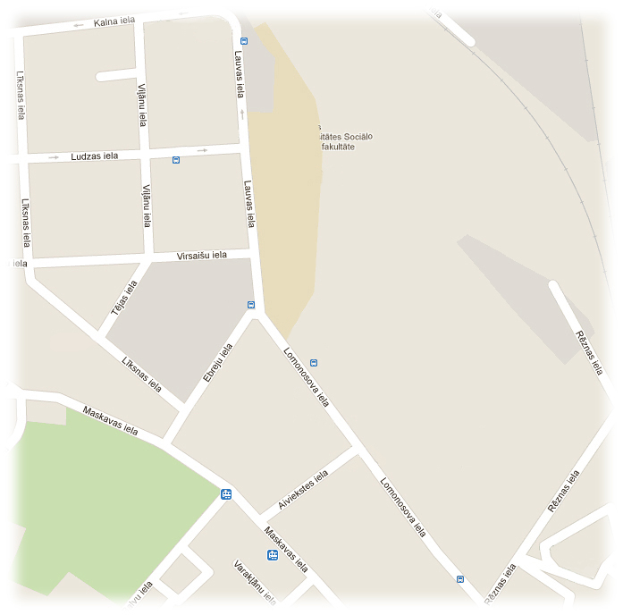

Welcome to BIA!

After arrival, students should register at the ERASMUS Mobility Centre (4 Lomonosova, room 107). The Mobility Centre will issue a student identity card which can be used during studies at BIA.

Before the beginning of the academic year, ERASMUS Mobility Centre organises adaptation days, which include meetings with coordinators, obtaining the lecture schedule and getting acquainted with the academy.

Therefore, students are strongly advised to arrive 2-3 days before the official beginning of the academic year.


Villand Hotel

‘Viļānu iela’

How to find ERASMUS Mobility Centre?

We may be a bit difficult to find for the newcomers :)
ERASMUS Mobility Centre is located in room 107, building Lomonosova 4 (L-4).
When you enter the building, go down the stairs to the basement floor and turn right. Go past the bookstand and the cafeteria, and enter the second corridor on the left side.

‘Lomonosova iela’

BIA L-1




BIA L-4

How to get to BIA?

Coming from Riga Airport, take bus No 22 till the stop ‘Central market’ (Centrāltirgus), which is the next stop after Stockmann shopping centre.
At the same bus stop ‘Central market’, take the trolleybus No 15 and go till the 5th stop ‘Lomonosova iela’ (Dzirnavu iela, Katoļu iela, Mazā Kalna iela, Viļānu iela, Lomonosova iela).

A couple minutes walking and there you are!

Prima Hostel
‘Rēznas iela’


Did you remember
to send your 2x3 cm
photograph for the
student card?
If not, please bring
it when you arrive!
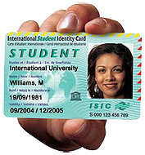
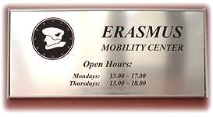

Buildings and Departments

Baltic International Academy is situated in two buildings – Lomonosova 1 and Lomonosova 4.

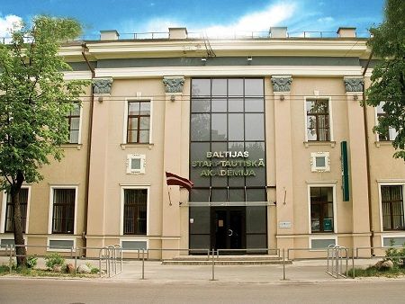

Building Lomonosova 1 (L-1)

1st floor:

BIA Students Parliament room 109

Cafeteria, coatroom

2nd floor:

BIA Library room 204

Ilze Ostrovska, European Studies room 202

Vladimir Strelchonok, Business Administration room 214

Marina Gunare, Tourism Management room 211

3rd floor:

Russian Language School room 308

Classrooms, lecture halls

1st floor (basement floor):

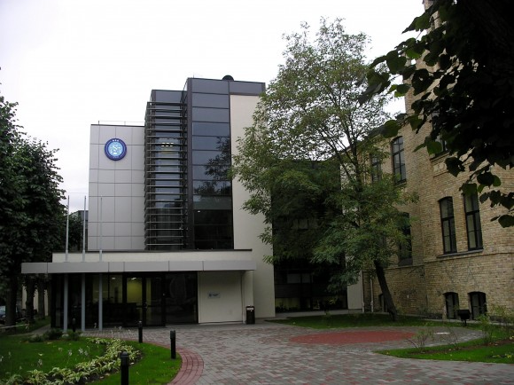

Building Lomonosova 4 (L-4)

Cafeteria, coatroom, bookstand

Computer classrooms, lecture halls

ERASMUS Mobility Centre room 107

2nd floor:

Emma Arhangelska, Translation and Interpreting room 210

BPMUC Student Affairs Office rooms 206, 208

Boriss Heimanis, Business Management (MA) room 218

Mikhail Kopeikin, Design room 209

3rd floor

BIA Student Affairs Office room 303

4th floor

Lecture halls

Departmental directors’ contact details
Programme | Departmental director | Office | Open hours | E-mail address
European Studies | as. prof. Ilze Ostrovska | room 202, Lomonosova 1 | Tuesday 14:00 - 16:00  Thursday 16:00 - 18:00 | eiropas.studijas@bsa.edu.lv
Business Administration | dr. sc. ing. Vladimir Strelchonok  assistant: Rita | room 214, Lomonosova 1 | Monday - Friday  10:00 - 18:00 | uznemejdarbiba@bsa.edu.lv
Tourism Management | as. prof. Marina Gunare  assistant: Anastasia Guscina | room 211, Lomonosova 1 | Tuesday 14:00 - 16:00  Thursday 16:00 - 18:00 | turisma.vadiba@bsa.edu.lv  marina_latvia@mail.ru
Translation and Interpreting | as. prof. dr. philol. Emma Arhangelska  assistant: Linda Ramanauska | room 210, Lomonosova 4 | Tuesday 14:00 - 15:30  Thursday 16:00 - 17:30 | emma.arhangelska@bsa.edu.lv  lindikr@gmail.com
Business Management (Master) | prof. dr. oec. Boriss Heimanis  ENG group official: Vyacheslav Zhilinsky | room 218, Lomonosova 4 | Tuesday 14:00 - 16:00  Thursday 16:00 - 18:00 | boriss.heimanis@gmail.com  v.zhilinsky@gmail.com
Design | as. prof. Mikhail Kopeikin | room 209, Lomonosova 4 | Tuesday 14:00 - 16:00  Thursday 16:00 - 18:00 | mihails.kopeikins@bsa.edu.lv

Russian Language School
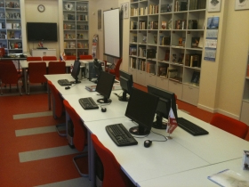
Language courses of Russian and Latvian for incoming students are available on request in advance – group courses or individual ones.

For the Russian Language Course, students should apply directly at the school. E-mail address for application: rls@bsa.edu.lv.
The course equals to 12 ECTS. After finishing the course, students get a certificate of completion.
More information about the BIA Russian Language School is available online at www.rls.bsa.edu.lv.

Practical Guide

Average cost of living

The cost of living in Riga can seem rather inexpensive for students from other European Union countries. Please see some average prices of products and services:

Renting a dormitory room, price per month | 80 - 100 LVL | 114 - 142 EUR
Lunch at a cafeteria | 2.50 LVL | 3.55 EUR
Lunch at a restaurant | 5 LVL | 7 EUR
Single bus ticket | 0.70 LVL | 1 EUR
Cinema ticket | 2.50 LVL | 3.55 EUR
1 litre of milk | 0.70 LVL | 1 EUR
1 loaf of bread | 0.50 LVL | 0.70 EUR
Average student's expenses per month | 300 - 400 LVL | 426 - 569 EUR

Accommodation

1. Hotel "Prima"

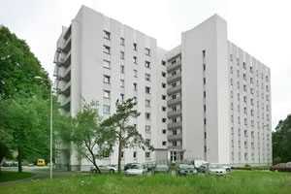
Address: Rēznas iela 10/1
Contact e-mail for reservation: prima@lu.lv
Informational pages:
http://www.visitlatvia.lv/en/hostel/prima http://www.viss.lv/en/?p=151040.

Average price: 150 LVL per month for a single room, 75-90 LVL per month for a double room.
Important: a deposit of 100 LVL should be paid in order to reserve a room in advance.

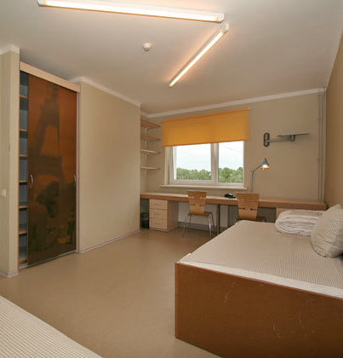
Provided services include: | For extra payment:
- Internet connection (cable connection);  - Computer hall;  - Shower/WC for 3-5 persons (cold and hot water);  - Bed linen;  - Basic kitchen equipment (stove, microwaves, fridges) and dining-room on each floor;  - Lounge for reading or studying;  - Conference/seminar hall;  - 24-hour reception desk;  - Bike and car parking available | - Laundry service;  - Café;  - Printing, fax, scanner;  - Apartment cleaning;  - Household equipment rent;  - Recreation complex with sauna;  - Sports hall (ping-pong, novuss)

Prices may vary depending on accommodation quality. Renting a flat could cost starting from 100 EUR/month per person when sharing a flat.
Accommodation should be reserved in advance before arrival.

How to get to Prima:
- You can take a taxi from the airport (to Hotel Prima, address Rēznas 10/1), it should cost about 15 LVL (~21 EUR).
- Or you may go by public transport:
Coming from Riga Airport, take bus No 22 till the stop ‘Central market’ (Centrāltirgus), which is the next stop after Stockmann shopping centre. (Do not take bus number 22a, it will take you to the other part of city centre.)
At the same bus stop ‘Central market’, take the trolleybus No 15 and go till 6th bus stop 'Rēznas iela’ (Dzirnavu iela, Katoļu iela, Mazā Kalna iela, Viļānu iela, Lomonosova iela, Rēznas iela).
Buy the ticket from the driver when you get in the trolleybus, the ticket costs 0.70 LVL (1 EUR). Please note that we still do not use euros in Latvia, so you should pay in LVL.
After you get out of the trolleybus at ‘Rēznas iela’, follow these directions:
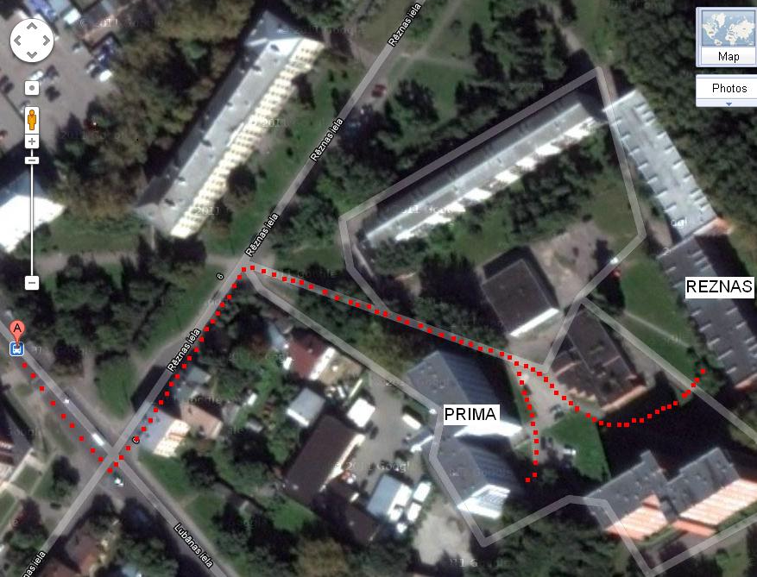

2. Hotel "Villand"
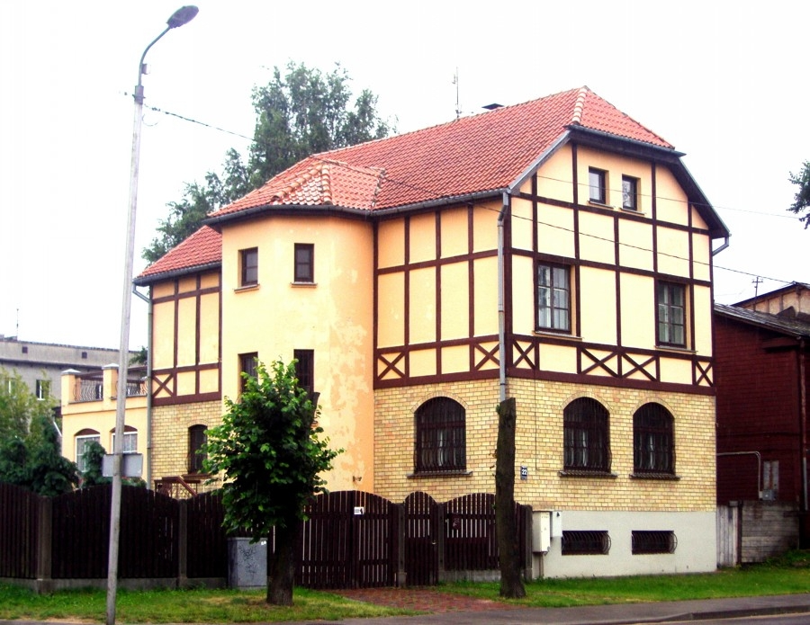
Small, comfortable hotel located 7 minutes away from BIA, 10 minutes away from the city centre.
14 places are available for BIA & BPMUC ERASMUS students.
Special offers for students from September to June.

Address: Viļānu iela 22
Website: http://villandhotel.lv/en
E-mail address: info@villandhotel.lv

How to get to Villand hotel?
- You can take a taxi from the airport (to Villand hotel, address Viļānu iela 22), it should cost about 14-15 LVL (~20-21 EUR).
- Or you may go by public transport:
Coming from Riga Airport, take bus No 22 till the bus stop ‘Central market’ (Centrāltirgus), which is the next stop after "Stockmann" shopping centre. (Do not take bus number 22a, it will take you to the other part of city centre.)
At the same bus stop ‘Central market’, take the trolleybus No 15 and go till 4th bus stop ‘Viļānu iela’ (Dzirnavu iela, Katoļu iela, Mazā Kalna iela, Viļānu iela).
Buy the ticket from the driver when you get in the trolleybus, the ticket costs 0.70 LVL (1 EUR). Please note that we still do not use euros in Latvia so it is better to pay in LVL.

After you get out of the trolleybus at ‘Viļānu iela’, follow these directions:
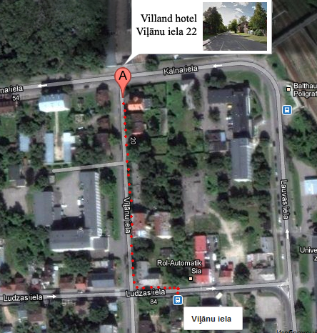
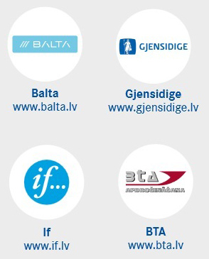
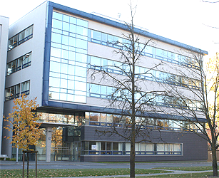
VISA

List of documents:
http://www.pmlp.gov.lv/en/pakalpojumi/visa/documents.html

Before starting the process, you must send your application and learning agreement (properly prepared) to our Erasmus office and they must be signed by our coordinators. These documents, together with letter of acceptance issued by our Erasmus office, serve as "documents verifying the reason for entry".
Another necessary thing is the “invitation number”. In order to issue it, we need a copy/scan of your valid passport.
Please e-mail your questions to our visa department: visa@bsa.edu.lv.
RESIDENCE PERMIT

List of documents (from
http://www.pmlp.gov.lv/en/pakalpojumi/residence/exchange_2.html)

- a definite sample form for a residence permit request
(http://www.pmlp.gov.lv/lv/pakalpojumi/uzturesanas/UA_anketa_web.doc)

- a photograph

- a statement on fluorography or x-ray examining results
(you can make it in Riga. For example, there is a hospital near OCMA, it's called Hospital of the ministry of interior. Fluorographic examination costs 5 lats.
The map is here ("H - Iekšlietu ministrijas poliklīnika" is that hospital, and on the right there's OCMA - "Pilsonības un migrācijas lietu pārvalde").
https://maps.google.com/?ie=UTF8&q=R%C4%ABga%2C+%C4%8Ciekurkalna+1.+l%C4%ABnija+1+k.1%2C+LV+1006+Latvija&hl=en&oi=localspell&ct=clnk&cd=1)

- a statement on punishability issued by a competent institution of the citizenship country
(the document (sabıka kaydı) is issued by a relevant institution of your country)

- a document confirming the necessary subsistence
(take it before you leave from the Erasmus coordinator at home. This paper should say how much grant per month you receive from your university.)

- a document confirming the envisaged place of residence in the Republic of Latvia and the rights to stay there
(should be the agreement with the hotel where you live)

- a document issued by an accredited higher educational establishment of the Republic of Latvia confirming that the foreigner participates at the exchange programme in the framework of the international cooperation of the higher educational establishments
(a confirmation letter issued by our Erasmus office)

also:
- a local insurance from an insurance company in Latvia

- a copy of your Learning agreement (for submitting) and its original paper (just for showing) and a copy of Bilateral agreement between home and host universities
(will be provided by our Erasmus office)
RESIDENCE PERMIT APPLICATION

You will need to apply to the OCMA. Remember that you should obtain
all necessary documents during your first 1-1,5 months in Riga and then apply.

When you have all the documents, you need to book an appointment at OCMA.
Contact the visa official, Anna (visa@bsa.edu.lv), she can do it for you.
Don’t forget that you also need to have a residence permit number!

How to get to OCMA:

Take tram No 11 from the centre (see the map below).
- Get on at stop “Merķeļa iela” located in the city centre on Krīšjāņa Barona
street next to Vērmanes park, see the map: (http://i.imgur.com/OFtwm.jpg)

- Get off at stop “2. Meža kapi” (you get on at "Merķeļa iela", then go "Dzirnavu
iela", "Ģertrūdes iela", "Bērnu pasaule", "Brīvības iela", "AS Laima/Arēna Riga",
"Tallinas iela", "Mēness iela", "Kazarmu iela", "Brasas stacija", "Brāļu kapi",
and then your stop - "2. Meža kapi").
OCMA (Office for Citizenship and Migration Affairs)

Address: Čiekurkalna 1st Line 1, Block 3 (Čiekurkalna 1. līnija 1, k-3)

Phone: +371 67829750
E-mail: rigas.1.nodala@pmlp.gov.lv
Some insurance companies in Latvia

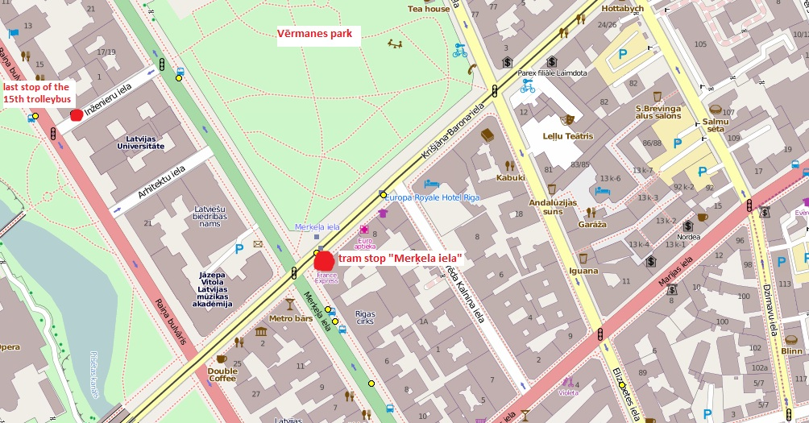
After about a 20-minute ride you will cross a bridge, “2. Meža kapi” is the second stop after the bridge. Look for a big water tower that you will see on the right from the tram. The OCMA is right behind the water tower. See the map (http://i.imgur.com/ZT8ij.jpg):
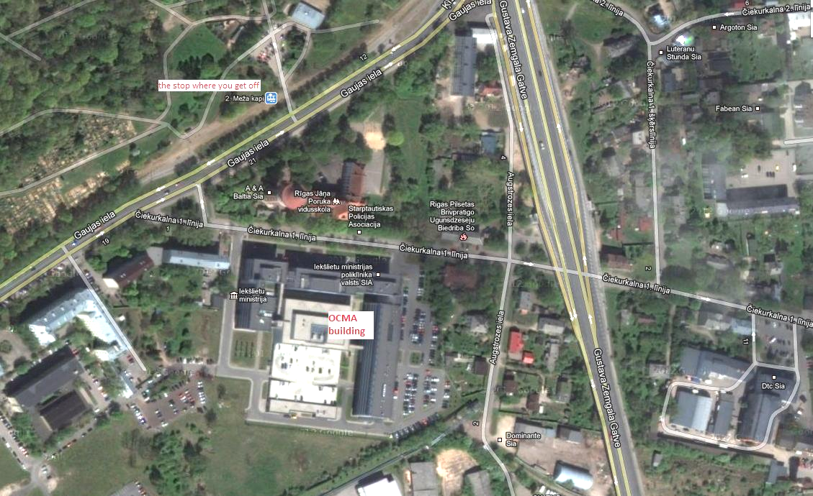
Insurance and medical treatment, emergency assistance

All exchange students must have life and health insurance which is valid in Latvia:

1) For EU citizens - European Health Insurance Card (EHIC)
2) For non-EU citizens – life and health insurance policy which ensures at least the following health care services:
- emergency medical assistance costs;
- treatment costs of growing chronic illness;
- transport costs to the closest medical facility providing the Services mentioned above;
- transportation costs to return the patient to his/her home country in the case of a serious illness or death.

The insurance policy should be valid for a period not less than student’s residence permit validity in Latvia. If the validity date of the policy expires during student’s stay in Latvia, the existing policy should be extended or a new policy shall be purchased.

Non-EU citizens can get the above mentioned insurance policy at the local insurance companies, for example, Ergo (17 Raina blvd.), BTA (K. Valdemāra str. 63) Gjensidige (Brīvības str. 39) or Balta (Raunas str. 10-12).

Emergency number: 112 (toll-free). The operator will connect you with the necessary emergency service.

Find some of the clinics below:
- “Rakstnieku poliklīnika” (Raiņa Blvd. 27, phone: +371 67286470, 67214197, 29627834)
- “Health Center 4” / “Veselības centrs 4” (Kr. Barona str. 117, phone: +371 67847100)
- “Veselības nams 5” (Grēcinieku str. 34, phone: +371 67222892)
- Pauls Stradiņš Clinical University Hospital / Paula Stradiņa Klīniskās universitātes slimnīca (Pilsoņu str. 13, phone: +371 67069600)
- Medical Care Centre “ARS”/ Medicīnas sabiedrība “ARS” (Skolas str. 5,phone: +371 67201006, 67201007, 67201008). ARS has English speaking doctors

Pharmacies in Latvia are called "Aptieka".

Public transport

The public transport system in Riga consists of buses, trams and trolleybuses. They run daily from 5:30 a/m till approximately 11:30 p/m. Some routes have a night service every hour.
Transport routes and schedules are available online at http://www.rigassatiksme.lv/en.

In Riga, tram, bus and trolley bus tickets can be bought from the driver (for 0.70 LVL) or you can buy the E-ticket at a press kiosk (Narvesen, Plus Punkts).
More information about E-tickets at http://etalons.rigassatiksme.lv/en/beginning.


Monthly student ticket

ERASMUS students have a right to receive a transport discount. In order to apply for it, you should request a confirmation of your student status from the Mobility Centre and apply with it for your personalised E-ticket at one of Rīgas satiksme Service centres (http://etalons.rigassatiksme.lv/en/service_centres).

Monthly student ticket
Prices:
- only one route, for example trolleybus No 15 - 7.80 LVL
- all trolleybuses or all buses or all trams - 11.70 LVL
- two kinds of transport, for example all trams and trolleybuses - 14.30 LVL
- all kinds of transport - buses, trolleybuses, trams - 18.40 LVL

Some useful links:
http://www.1188.lv/lang/en (interactive city map, routes and departure times of interregional trains and buses, ferries, planes).
http://www.rigassatiksme.lv/en (routes and shedules of trolleybuses, trams and buses in Riga).

Mobile prepaid cards

There are 3 mobile operators in Latvia - LMT, Tele2 and Bite. All of them offer prepaid call cards. You can buy a start kit of any of these cards in "Narvesen" kiosks or other trading spots. No passport is necessary when buying the prepaid call cards.

 | "BiFri" (BITE) | "Zelta Zivtina" (Tele2) | "Okarte" (LMT)
calling to the same operator | for free | 0.05 LVL for each call | 0.03 LVL/min
calling to other operators | 0.06 LVL/min | 0.11 LVL/min | 0.12 LVL/min
SMS to the same operator | 0.01 LVL | 0.02 LVL | 0.015 LVL
SMS to other operators | 0.04 LVL | 0.04 LVL | 0.04 LVL


"BiFri" card (by Bite)
More information at http://www.bite.lv/lv/en.
You can add a credit of LVL 1, 2, 5, 10 or 30 to your card in all "Narvesen" kiosks and other trading spots.


"Zelta zivtiņa" card (by Tele2)
The real tariffs will be a bit lower, because you get bigger credit than the one you pay for; for example, if you buy a credit for 2.95 Ls you get 4.50 Ls.
There are different tariff plans available. You can add a credit of LVL 1.35 (you pay LVL 0.99), LVL 2.5 (you pay LVL 1.75), LVL 4.5 (you pay LVL 2.95), LVL 8 (you pay LVL 4.95) or LVL 13.50 (you pay LVL 7.95) to your card in all "Narvesen" kiosks and other trading spots.

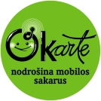
"Okarte" card (by LMT)
More information at http://www.okarte.lv/eng/tarifi.
There are different tariff plans available, for example calling to all operators for 0.077 LVL/min.
You can add a credit of LVL 1, 3, 5 or 10 to your card in all "Narvesen" kiosks and other trading spots.

Post Office and Telephone

Postage stamps can be bought at post offices. If you want to send a postcard or a letter, place it in the yellow post boxes attached to the buildings on the streets. Mail is collected every day, except Sundays.
The prices of the stamps on a letter differ according to the destination: 0.22 LVL within Latvia and 0.40 LVL within Europe. Usually it takes up to three days for a letter to reach its addressee within territory of Latvia; a week for letter to an addressee living somewhere else in Europe and up to two weeks if the destination is outside Europe. Postal services are reliable and you can be sure your letter/postcard will reach its destination.

Telephone numbers in Riga have eight digits and start with 6. Numbers of most mobile phones start with 9, 6, 8 or 2. Other cities have special city codes and five digits.

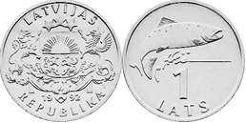
Money and Banks

National currency is Latvian lat (Ls). One lat equals to 100 santims. There are banknotes of 5, 10, 20, 50, 100 and 500 Ls denomination, coins of 1, 2, 5, 10, 20, 50 santims and 1 and 2 lats.
One euro corresponds to 0.702804 lats.
1 lat coin

Most of the shops, restaurants, hotels in the major towns accept credit cards, but if you travel to provincial towns, better take sufficient amount of cash with you.
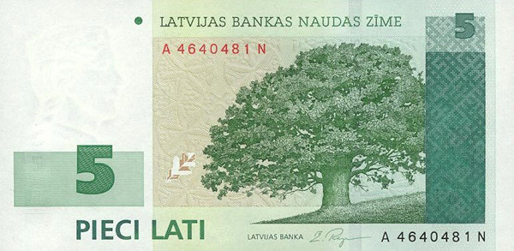
ATMs are installed at the majority of banks, major petrol stations, at the airport and at the Central Post Office in Riga.

Banks are open on working days from 9 a/m to 5 p/m.

5 lats banknote

National holidays in Latvia

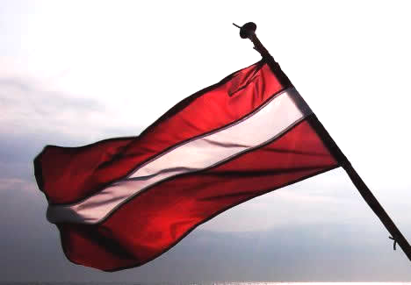
January 1 - New Year’s Day (Jaungada diena)
March 29, 2013 – Good Friday (Lielā piektdiena)
March 31, 2013 - Easter Sunday (Lieldienas)
April 1, 2013 - Easter Monday (Otras Lieldienas)
May 1 - Labour Day (Darba svētki)
May 4 – Independence Restoring Declaration Day (Neatkarības pasludināšanas deklarācijas diena)
June 23 & 24 - Midsummer celebrations (Līgo & Jāņi)
November 18 - Independence day
December 24, 25, 26 - Christmas (Ziemassvētki)
December 31 - New Year’s Eve (Vecgada vakars)

On national holidays, Latvian flag is displayed outside houses.

Useful Information and Links

http://www.studyinlatvia.lv - useful information about studies in Latvia

http://www.1188.lv/lang/en - the most popular site for different information, including Riga map and transport routes

http://map-of-riga.zl.lv - one more website with a map

http://eng.meeting.lv - different information about Latvia

http://www.esn.lv - ERASMUS Student Network of Riga

http://www.aic.lv/portal/en/education_in_latvia.html - description of the education system in Latvia

http://www.rigathisweek.lv - Riga city guide

http://www.virtualriga.com - another Riga guide
__________________________________________
Informational support:
Thanks to ESN Riga (www.esn.lv), University of Latvia (www.lu.lv), Vidzeme University of Applied Sciences (www.va.lv), Riga Stradiņš University (www.rsu.lv), Office of Citizenship and Migration Affairs (www.pmlp.gov.lv), SIA Rīgas Satiksme (www.rigassatiksme.lv).

APPENDICES

ERASMUS INCOMING STUDENT APPLICATION FORM
ACADEMIC YEAR: | 20__ __ /20__ __

PLEASE TYPE OR WRITE IN BLOCK CAPITALS

STUDENT’S PERSONAL DATA |  |  | PLEASE ADD YOUR PHOTOGRAPH HERE
First name |  |  | PLEASE ADD YOUR PHOTOGRAPH HERE
Family name |  |  | PLEASE ADD YOUR PHOTOGRAPH HERE
Gender |  |  | PLEASE ADD YOUR PHOTOGRAPH HERE
Passport number |  |  | PLEASE ADD YOUR PHOTOGRAPH HERE
Date of birth  (day/month/year) |  | Place of birth
Home address

street, house, flat/apartment number
postal code, town/city
country
E-mail address
Telephone number
Name of home university
Home university address
Faculty at home university
Degree course
(i.e. undergraduate/bachelor or postgraduate/master)
Current year of studies
(i.e. 1st, 2nd…)
Year & semester of application (e.g. 2012/2013 autumn semester)
Languages known

INSTITUTIONS WHICH WILL RECEIVE THIS APPLICATION FORM
Institution | Country | Dates of study  dd/mm - dd/mm |  | Duration of stay (months) | Expected amount of ECTS credits
Baltic International Academy | Latvia

Please state briefly the reasons why you wish to study abroad.

LANGUAGE COMPETENCE
Mother tongue:
Language of instruction at home institution:
Languages | I am currently studying this language |  | I have sufficient knowledge to follow lectures |  |  | I would like to learn this language at BIA
Languages | yes | no | yes |  | no | I would like to learn this language at BIA
1. English  2. Latvian  3. Russian | □  □  □ | □  □  □ | □  □  □ |  | □  □  □ | □  □  □

ERASMUS DATA
Field of study: |  | Faculty at BIA:
Starting date: |  | Final date:

SUPPOSED STUDY PROGRAMME AT BIA
SUBJECT |  | ECTS credits
PREVIOUS STUDIES
Have you already been studying abroad?
If yes, when? At which institution?

Do you wish to apply for a mobility grant to assist towards the costs of your study period abroad?
YES  □ | NO  □

STUDENT’S SIGNATURE | SIGNED & STAMPED BY SENDING UNIVERSITY

RECEIVING INSTITUTION
We hereby acknowledge receipt of the application.
□ | The above-mentioned student is provisionally accepted at our institution
Departmental Head: ………………………  Date: ………………….…………………… |  | Institutional Coordinator: …………………………….  Date :. ………………….……………………………….

DOCUMENTS MUST BE SENT WITHIN 2 WEEKS AFTER NOMINATION DEADLINE –

June 1 (for autumn semester/full year) or December 1 (for spring semester)
- Foreign Exchange Student Application Form, filled in by the student
- Transcript of academic progress in English (issued by sending university)
- Letter of Confirmation from sending university (signed by the departmental or institutional coordinator; should indicate the student’s participation in ERASMUS programme, compliance with all the requirements, as well as sufficient knowledge of English of Upper Intermediate level)
- Photocopy of passport
- Learning agreement (prepared in 3 hard copies with original signatures and stamps)
- 2 passport-size photos (2x3 cm) (for the identity card; therefore, they should be original, not scanned)

SEND TO:
Baltic International Academy
ERASMUS Mobility Centre, kab. 107
Lomonosova iela 4
LV-1003 Riga
LATVIA

ERASMUS Programme
ECTS - EUROPEAN CREDIT TRANSFER AND ACCUMULATION SYSTEM
LEARNING AGREEMENT

Academic Year 20 |  |  | /20
Field of study:

Name of student:
Sending institution:
Country:

DETAILS OF THE PROPOSED STUDY PROGRAMME ABROAD/LEARNING AGREEMENT

Receiving institution:
Country:

Course unit code (if any) |  |  | Course unit title (as indicated in the information package) |  |  | Number of ECTS credits
 |  |  |  | TOTAL AMOUNT OF ECTS:
if necessary, continue the list on a separate sheet

Fair translation of grades must be ensured and the student has been informed about the methodology
Student’s signature:……………………………………… Date: ………………………………………

SENDING INSTITUTION
We confirm that the proposed programme of study/learning agreement is approved.

Departmental coordinator:  ………………………………………………………….  Date: ………………………………………………… | Institutional coordinator:  ………………………………………………………  Date: …………………………………………………
RECEIVING INSTITUTION
We confirm that the proposed programme of study/learning agreement is approved.

Departmental coordinator:  ………………………………………………………….  Date: ………………………………………………… | Institutional coordinator:  ………………………………………………………  Date: …………………………………………………

Name of student:
Sending institution:
Country of sending institution:
Receiving institution:
Country of receiving institution:
Academic year:
Semester:

CHANGES TO ORIGINAL PROPOSED STUDY PROGRAMME/LEARNING AGREEMENT
(to be filled in ONLY if appropriate)

Course unit code (if any) |  |  | Course unit title (as indicated in the information package) |  |  | Deleted  course  unit | Added  course  unit | Number of ECTS credits
 |  |  |  |  |  | □ | □
 |  |  |  |  |  | □ | □
 |  |  |  |  |  | □ | □
 |  |  |  |  |  | □ | □
 |  |  |  |  |  | □ | □
 |  |  |  |  |  | □ | □
 |  |  |  |  |  | □ | □
 |  |  |  |  |  | □ | □
 |  |  |  |  |  | □ | □
 |  |  |  |  |  | □ | □
 |  |  |  |  |  | □ | □
 |  |  |  |  |  | □ | □
 |  |  |  |  |  | □ | □
 |  |  |  |  |  | □ | □
 |  |  |  |  |  | □ | □
 |  |  |  |  |  | □ | □
 |  |  |  |  |  | □ | □
 |  |  |  |  |  | □ | □
if necessary, continue this list on a separate sheet

Student’s signature:……………………………………… Date: ………………………………………

SENDING INSTITUTION
We confirm that the changes to the proposed programme of study/learning agreement are approved.
Departmental coordinator:  ………………………………………………………….  Date: ………………………………………………… | Institutional coordinator:  ………………………………………………………  Date: …………………………………………………
RECEIVING INSTITUTION
We confirm that the changes to the proposed programme of study/learning agreement are approved.
Departmental coordinator:  ………………………………………………………….  Date: ………………………………………………… | Institutional coordinator:  ………………………………………………………  Date: …………………………………………………

Academic Bachelor & Master Programme “European Studies”

Departmental contact person:  Address:  Telephone number:  E-mail: | as. prof. Ilze Ostrovska  1 Lomonosova , Riga, Latvia, LV-1003  Tel.: 371-29216425  clendes@apollo.lv
Website: | http://bsa.edu.lv/lang/eng/prog_es.html

No. | Subject | ECTS | Distribution of courses
No. | Subject | ECTS | AUTUMN | SPRING
1 | History of Latvian Politics | 6 | 
2 | History of European Politics | 6 | 
3 | European Idea | 6 | 
4 | The English Language | 6 | 
5 | EU Institutions | 6 | 
6 | History of European Integration | 6 | 
7 | International Law | 6 | 
8 | International Political Economy | 6 | 
9 | The French Language | 9 | 
10 | EU Integration and Policy of Central and Eastern Europe | 6 | 
11 | EU External Policy | 6 | 
12 | Strategy and Instruments of E-Democracy in EU | 6 | 
13 | Diplomatic Communication and Negotiations | 6 | 
14 | Diplomatic Protocol | 3 | 
15 | EU Institutions and Decision-Making (master) | 7.5 | 
16 | Analysis of the Evolution of European Ideas (master) | 7.5 | 
17 | Topical Issues in Political Theory (master) | 7.5 | 
18 | Quantitative and Qualitative Social Research Methods (master) | 7.5 | 
19 | Diplomatic Systems: Intelligence and Foreign Policy (master) | 7.5 | 
20 | EU and Global Economy (master) | 7.5 | 
21 | EU Integration and Topical Issues in Latvia (master) | 7.5 | 
22 | EU, Globalisation and Glocalisation (master) | 7.5 | 
23 | Political Theory | 6 |  | 
24 | Theory of International Relations | 6 |  | 
25 | Comparative Politics | 6 |  | 
26 | Research Methods and Methodology in Political Sciences | 6 |  | 
27 | EU Policy | 6 |  | 
28 | Theory of European Integration | 6 |  | 
29 | EU Economics | 6 |  | 
30 | EU Law | 6 |  | 
31 | The English Language | 6 |  | 
32 | The French Language | 9 |  | 
33 | Quantitative and Qualitative Social Research Methods (master) | 7,5 |  | 
34 | EU Policy Analysis (master) | 7,5 |  | 
35 | Political Economy of the EU Integration (master) | 7,5 |  | 
36 | EU Legislation (master) | 7,5 |  | 

Professional Bachelor Programme “Translation and Interpreting”

LANGUAGE OF INSTRUCTION:
E – English, G – German, L – Latvian, R – Russian

No. | Course title | LV credit points | ECTS  (LV points x 1.5) | Distribution of courses over semesters |  |  |  |  |  |  |  |  | Evaluation
 |  |  |  | Year 1 |  | Year 2 |  | Year 3 |  | Year 4 |  |  | Dif. test |  | Examination
 |  |  |  | 1 sem. (AUTUMN) | 2 sem. (SPRING) | 3 sem. (AUTUMN) | 4 sem. (SPRING) | 5 sem. (AUTUMN) | 6 sem. (SPRING) | 7 sem. (AUTUMN) |  | 8 sem. (SPRING) |  |  | Examination
I. Compulsory extensive professional and general courses
1 | General Psychology [L/R] | 2 | 3 |  |  |  |  |  |  |  |  |  | *
2 | Social Psychology [L/R] | 2 | 3 |  |  |  |  |  |  |  |  |  | *
3 | Business Principles of Economics and Commercial Activity [L/R] | 2 | 3 |  |  |  |  |  |  |  |  |  | *
4 | Sociology [L/R] | 2 | 3 |  |  |  |  |  |  |  |  |  | *
5 | Applied Computer Science: MS Office [L/R] | 2 | 3 |  |  |  |  |  |  |  |  |  | *
6 | Business Organization and Records Management [E/G] | 1 | 1.5 |  |  |  |  |  |  |  |  |  | *
7 | Project Organization and Management Fundamentals [L/R] | 2 | 3 |  |  |  |  |  |  |  |  |  | *
8 | Rhetoric Fundamentals [L/R] | 2 | 3 |  |  |  |  |  |  |  |  |  |  |  | *
II. Theoretical and compulsory special courses
9 | Introduction to Specialty [E/G] | 2 | 3 |  |  |  |  |  |  |  |  |  | *
10 | Introduction to Comparative Linguistics [L/R] | 2 | 3 |  |  |  |  |  |  |  |  |  |  |  | *
11 | Modern English/German [E/G]: - System and Innovations I – II | 3 + 3 | 4.5+  4.5+ |  |   4.5 |   4.5 |  |  |  |  |  |  |  |  | *
12 | Modern English/German [E/G]: - Functional Grammar | 2 | 3 |  |  |  |  |  |  |  |  |  | *
13 | Modern English/German [E/G]: - Stylistics in Translation | 4 | 6 |  |  |  |  |  |  |  |  |  |  |  | *
14 | Modern Latvian/Russian [L/R]: - Functional Grammar | 2 | 3 |  |  |  |  |  |  |  |  |  | *
15 | Native Language (Latvian/Russian) [L/R]:- System and Innovations | 2 | 3 |  |  |  |  |  |  |  |  |  |  |  | *
16 | Native Language (Latvian/Russian) [L/R]: - Stylistic System and Norms | 2 | 3 |  |  |  |  |  |  |  |  |  |  |  | *
17 | Native Language (Latvian/Russian) [L/R]: - Functional Stylistics | 4 | 6 |  |  |  |  |  |  |  |  |  |  |  | *
18 | Native Language (Latvian/Russian) [L/R]: - Basics of Editing I – II | 2 + 2 | 3 + 3 |  |  |  |  |  |   3 |   3 |  |  | *
19 | Theory of Translation [E/G] | 2 | 3 |  |  |  |  |  |  |  |  |  |  |  | *
20 | Basics of Cross-Cultural Linguistic Research [L/R] | 2 | 3 |  |  |  |  |  |  |  |  |  | *
III. Professional special courses
21 | The English/German Language [E/G]: - English/German Actual Usage Problems | 6 | 9 |  |  |  |  |  |  |  |  |  |  |  | *
22 | The English/German Language [E/G]: - Academic Writing | 2 | 3 |  |  |  |  |  |  |  |  |  |  | *
23 | The English/German Language [E/G]: - Communication Skills and Terminology in Economics and Business | 4 | 6 |  |  |  |  |  |  |  |  |  |  |  | *
24 | - The English/German Language [E/G]:  - Communication Skills and Terminology in Culture and Tourism | 2 | 3 |  |  |  |  |  |  |  |  |  |  |  | *
25 | - The English/German Language [E/G]:  Communication Skills and Terminology in Public Relations and Politics | 2 | 3 |  |  |  |  |  |  |  |  |  |  |  | *
26 | The Latvian/Russian Language [L/R]:  - Communication Skills and Terminology in Economics and Business | 2 | 3 |  |  |  |  |  |  |  |  |  |  |  | *
27 | The Latvian/Russian Language [L/R]: - Communication Skills and Terminology in Culture and Tourism | 2 | 3 |  |  |  |  |  |  |  |  |  |  |  | *
28 | The Latvian/Russian Language [L/R]: - Communication Skills and Terminology in Public Relations and Politics | 2 | 3 |  |  |  |  |  |  |  |  |  |  |  | *
29 | Foreign Language (English/German/Spanish):  - Communication Skills | 4 + 4 + 4 | 6+6+6 |  |   6 |   6 |   6 |  |  |  |  |  |  |  | *
30 | Culture and History of GB [E] | 2 | 3 |  |  |  |  |  |  |  |  |  |  |  | *
31 | The English/German Language:  Pre-translation Text Analysis and Interpretation [E/G] | 2 | 3 |  |  |  |  |  |  |  |  |  |  | *
32 | Modern Translation Technologies (TRADOS) [L/R] | 2 | 3 |  |  |  |  |  |  |  |  |  |  | *
33 | Cross-Cultural Communication [L/R] | 2 | 3 |  |  |  |  |  |  |  |  |  |  | *
IV. Optional courses
34 | The Latvian/Russian Language. Communication Skills I – IV [L/R] | 2 | 3 |  |  |  |  |  |  |  |  |  |  | *
35 | Foreign Language (English/German/Spanish). Communication Skills | 2 | 3 |  |  |  |  |  |  |  |  |  |  | *
36 | Basics of Computer Science [L/R] | 2 | 3 |  |  |  |  |  |  |  |  |  |  | *
37 | Political Science [L/R] | 2 | 3 |  |  |  |  |  |  |  |  |  |  | *
38 | Business Ethics and Professional Etiquette [L/R] | 2 | 3 |  |  |  |  |  |  |  |  |  |  | *
39 | Copyright [L/R] | 2 | 3 |  |  |  |  |  |  |  |  |  |  | *
40 | Annotation and Abstract Writing [L/R] | 2 | 3 |  |  |  |  |  |  |  |  |  |  | *
41 | Style in Advertising [L/R] | 2 | 3 |  |  |  |  |  |  |  |  |  |  | *
42 | Tourism Guide Language Style [L/R] | 2 | 3 |  |  |  |  |  |  |  |  |  |  | *
43 | Communication Management [L/R] | 2 | 3 |  |  |  |  |  |  |  |  |  |  | *
44 | Basics of Self-Presentation [L/R] | 2 | 3 |  |  |  |  |  |  |  |  |  |  | *
45 | History of World Civilization [L/R] | 2 | 3 |  |  |  |  |  |  |  |  |  |  | *
46 | Modern Civilization Trends and Globalization [L/R] | 2 | 3 |  |  |  |  |  |  |  |  |  |  | *
47 | Mythology and Folklore [L/R] | 2 |  |  |  |  |  |  |  |  |  |  |  | *
48 | European Integration: Latvia and the EU[L/R] | 2 | 3 |  |  |  |  |  |  |  |  |  |  | *
49 | International Relations [L/R] | 2 | 3 |  |  |  |  |  |  |  |  |  |  | *
50 | Basics of Economy and Business in EU [E] | 2 | 3 |  |  |  |  |  |  |  |  |  |  | *
51 | Theory of Culture [L/R] | 2 | 3 |  |  |  |  |  |  |  |  |  |  | *
52 | Philosophy [L/R] | 2 | 3 |  |  |  |  |  |  |  |  |  |  | *

Professional Bachelor Programme “Tourism and Hospitality Management”

No. | Subject | LV Credit points | ECTS | Distribution of courses
 |  |  |  | AUTUMN | SPRING
1 | Statistic Methods in Tourism | 2 | 3 | 
2 | Management Theory and Corporative Culture | 2 | 3 | 
3 | Tourism and Hospitality Management | 2 | 3 | 
4 | Marketing in Tourism and Hospitality | 2 | 3 |  | 
5 | International Tourism Economy | 2 | 3 | 
6 | Professional English in Tourism | 3 | 4,5 |  | 
7 | E-Marketing in Tourism and Hospitality II | 2 | 3 | 
8 | Tourism Product and Tourism Types | 4 | 6 | 
9 | Professional German in Tourism | 3 | 4,5 |  | 
10 | Communication in Multicultural Environment | 2 | 3 | 
11 | Hotel Management | 4 | 6 | 
12 | Advertising and PR | 2 | 3 | 
13 | The Spanish Language | 2 | 3 | 
14 | Leisure and Entertainment Management | 1 | 1,5 | 
15 | Anglophone Countries: Cultural Studies | 2 | 3 | 
16 | Communication in Multicultural Environment | 2 | 3 | 
17 | History of World Culture | 3 | 4,5 | 
18 | Tourism Geography | 2 | 3 |  | 
19 | Business Tourism | 4 | 6 |  | 
20 | IT in Tourism and Hospitality | 3 | 4,5 |  | 
21 | Special Events | 2 | 3 |  | 
22 | Economics in Tourism | 2 | 3 |  | 
23 | Marketing Research | 2 | 3 |  | 
24 | Accounting | 2 | 3 |  | 
25 | Tour Guide Job Basics | 2 | 3 |  | 

Professional Bachelor Programme “Business Administration”

No | Subject | ECTS | Control way | Language

1 semester (AUTUMN)
1 | Logic | 3 | examination | russian
2 | Higher mathematics | 4,5 | test | russian
3 | Microeconomics | 4,5 | examination | english
4 | Scientific and academic work theory and method |  | test | russian
5 | Business Latvian | 3 | test | russian
6 | Business English | 4,5 | test | english
7 | Informatics | 4,5 | examination | english
8 | Work and fire security bases | 0 | test | russian

2 semester (SPRING)
9 | Macroeconomics | 4,5 | examination | english
10 | Taxes and taxation system | 3 | examination | russian
11 | Higher mathematics | 3 | examination | russian
12 | Law bases | 1,5 | test | english
13 | Business Latvian | 3 | examination | russian
14 | Business English | 4,5 | test | english
15 | Rhetorics | 1,5 | test | russian
16 | Advertising technologies and PR | 3 | test | russian
17 | Economic calculations in electronic worksheets | 4,5 | examination | english
18 | Report of the specialized discipline |  | test | english

3 semester (AUTUMN)
19 | Probability theory and mathematical statistics | 4,5 | examination | russian
20 | Marketing | 4,5 | examination | english
21 | Basics of accountancy | 4,5 | examination | russian
22 | Business English | 3 | examination | english
23 | European employment law | 3 | test | russian
24 | International business | 3 | test | english
25 | Modelling of commercial database | 3 | test | english
26 | Free electives: | 1,5 | test | russian
26 | Business ethics | 1,5 | test | russian
26 | Audiovisual communication | 1,5 | test | russian
26 | Social psychology training | 1,5 | test | russian

4 semester (SPRING)
27 | Philosophy | 3 | examination | russian
28 | Enterprise economy | 4,5 | examination | russian
29 | Management | 4,5 | examination | english
30 | Enterprise law | 4,5 | examination | russian
31 | Corporate finances | 3 | examination | russian
32 | Transnational corporations and economic unions | 3 | test | english
33 | International economics | 4,5 | examination | english
34 | Free electives: | 1,5 | test | russian / latvian
34 | Correspondence and documents | 1,5 | test | russian / latvian
34 | Culture and society of European countries | 1,5 | test | russian / latvian

5 semester (AUTUMN)
35 | Social management | 3 | test | english
36 | Social psychology | 3 | examination | russian
37 | International management | 4,5 | examination | english
38 | Project management | 3 | test | english
39 | General statistics and firm's statistics | 4,5 | examination | russian
40 | Cross-culture in international business | 3 | test | russian
41 | International standarts in financial reports | 3 | test | russian
42 | Free electives: | 1,5 | test | russian
42 | Bidding technologies in international market | 1,5 | test | russian
42 | Carrier's statement technology in EU | 1,5 | test | russian
42 | Basics of geopolitics | 1,5 | test | russian
42 | Sport's marketing management | 1,5 | test | russian

6 semester (SPRING)
43 | Sociology | 3 | examination | english
44 | Introduction into pedagogics | 1,5 | test | russian
45 | Finanses and credit | 4,5 | examination | english
46 | Custom regulation of external economic activities | 3 | examination | russian
47 | Personnel management | 3 | test | english
48 | Currency operations | 4,5 | examination | english
49 | Management accounts | 3 | examination | russian
50 | International taxation system | 3 | test | russian
51 | Free electives: | 1,5 | test | russian
51 | Business security | 1,5 | test | russian
51 | Controlling | 1,5 | test | russian
51 | Credit management | 1,5 | test | russian
51 | Business and authority collaboration theory and practice | 1,5 | test | russian

7 semester (AUTUMN)
52 | Politology | 3 | examination | english
53 | Enterprise's external economic activity management | 3 | examination | russian
54 | IT technologies in management | 3 | presentation/paper | russian
55 | International finances | 3 | examination | russian
56 | European law | 3 | test | russian
57 | Modelling of economic processes | 3 | test | russian
58 | International management | 3 | test | english
59 | Risk management and insurance | 3 | test | russian
60 | Innovation | 3 | test | russian

Professional Master Programme “Business Management and Administration”

Nr | Discipline | ECTS  (LV CP x 1,5) | LV CPs | Sem I | Sem  II | Sem III | Control
1 | Financial Management | 6 | 4 |  | x |  | Exam
2 | International Marketing | 6 | 4 | x |  |  | Exam
3 | Management in Macroeconomic Environment | 6 | 4 | x |  |  | Exam
4 | Business Law | 6 | 4 | x |  |  | Exam
5 | Personnel Management and Business Ethics | 3 | 2 |  | x |  | Exam
6 | Business Economics | 6 | 4 |  | x |  | Exam
7 | Labour and Labour Safety Law | 3 | 2 |  | x |  | Diff.test
8 | Project Management | 6 | 4 | x |  |  | Exam
9 | Logic and Methodology of Scientific Research | 3 | 2 | x |  |  | Exam
10 | Analyses of Problem Situations and Decision Making Methods | 3 | 2 | x |  |  | Diff.test
11 | Application of Information Technologies in Management | 3 | 2 | x |  |  | Exam
12 | Psychology and Pedagogy of Higher Education | 3 | 2 |  | x |  | Exam

Professional Bachelor Programme “Digital Visualisation”

Subject | LV Credit Points | ECTS  (LV Credits x 1.5)
Professional Foreign Language (English) | 3 | 4.5
Applied Informatics | 1 | 1.5
Copyrights | 1 | 1.5
Basics of Business Administration | 2 | 3
Philosophy | 2 | 3
Professional work Psychology | 2 | 3
Logic | 2 | 3
Technical Aesthetics | 2 | 3
Culture Semiotics and Semantics | 2 | 3
Basic Methods of Scientific Research | 2 | 3
Basics of Pedagogics | 1 | 1.5
Labour and Fire Safety Basics | – | -
Introduction to Speciality | 2 | 3
History of Art:
Styles of Art | 2 | 3
20th Century Art | 1 | 1.5
Latvian National Art | 1 | 1.5
History of Form | 2 | 3
History of Design | 1 | 1.5
Ergonomics | 1 | 1.5
Style Analysis | 1 | 1.5
Engineering Psychology | 1 | 1.5
Environment and Visual Communication | 1 | 1.5
Advertisment Psychology | 1 | 1.5
Project Functional Analysis | 1 | 1.5
Computer Technologies in Design:
Vector Graphics Basics | 2 | 3
Raster Graphics | 3 | 4.5
3D Project Graphics | 5 | 7.5
WEB Technology 1 | 2 | 3
Animation Editing | 2 | 3
3D Visualisation Graphics | 3 | 4.5
Multimedia Editing | 2 | 3
Screen Communication Resources | 2 | 3
Composition:
2D Composition | 2 | 3
3D Composition | 2 | 3
Styling | 2 | 3
Colour Composition | 2 | 3
Typography (Letter Studies) | 3 | 4.5
Colour Theory:
Colour Studies | 2 | 3
Colour Psychology | 1 | 1.5
Digital Colour Theory | 1 | 1.5
Basics of Digital Colour Correction | 1 | 1.5

Shape Modelling:
Modelling | 2 | 3
Formation | 2 | 3
Tectonics | 1 | 1.5
Drawing:
Basics | 1 | 1.5
Constructional Drawing | 2 | 3
Colouring | 2 | 3
Sketch | 2 | 3
Analytical Drawing | 1 | 1.5
Painting:
Basics | 2 | 3
Technologies | 2 | 3
Stylistic | 3 | 4.5
Basics of Projecting | 3 | 4.5
Graphics | 3 | 4.5
Drafting and perspective:
Basics of Drafting | 1 | 1.5
Basics of Perspective | 1 | 1.5
Technical Graphics | 1 | 1.5
Photo-art:
Basics | 1 | 1.5
Technologies | 1 | 1.5
Stylistic | 1 | 1.5
Advertisement | 1 | 1.5
Interior | 1 | 1.5
Animation Processes | 2 | 3
Interior Designing | 2 | 3
Home Page Designing | 2 | 3
Advertisement Designing | 2 | 3
Typography and Module Grid Designing | 2 | 3
Applied Graphics | 1 | 1.5
2D Digital Animation | 1 | 1.5
Acoustic Communication | 1 | 1.5
Presentation Organisation | 1 | 1.5
Furniture Designing | 1 | 1.5
Dynamic Graphics | 1 | 1.5
Virtual Modelling Technology | 1 | 1.5
WEB -technology 2 | 1 | 1.5
Advertisment Management | 1 | 1.5
Project Management | 1 | 1.5

Professional Bachelor Programme “Environmental Design”

Subject | Latvian  Credit Points | ECTS  (LV credits * 1,5)
A General Subjects
Foreign language for professional purposes I (Latvian, Russian) | 2 | 3
Foreign language for professional purposes II (English, German) | 2 | 3
Informatics | 1 | 1,5
Communication psychology | 1 | 1,5
History of art | 4 | 6
Basics of legal regulation of professional business activity | 2 | 3
Organization, management and principles of record-keeping in professional business activity | 2 | 3
Environment and visual communication | 1 | 1,5
Principles of project design and management | 1 | 1,5
Computer graphics | 4 | 6
A1 Special Subjects
Introduction to speciality | 2 | 3
Font Studies | 2 | 3
Colour Studies | 2 | 3
Painting | 4 | 6
Drawing | 5 | 7,5
Graphics | 3 | 4,5
Composition | 3 | 4,5
Projecting | 3 | 4,5
Semi-electives
Visual Communication Design
Applied graphics | 2 | 3
Modeling | 2 | 3
Printing technologies in polygraphy | 1 | 1,5
Technologies of Processing and Study of Materials | 1 | 1,5
Automatic projection | 2 | 3
Animation | 1 | 1,5
WEB page design | 1 | 1,5
Interior Design
Drafting and perspective | 1 | 1,5
Basics of architecture | 1 | 1,5
Interior design | 3 | 4,5
Technologies of Processing and Study of Materials | 1 | 1,5
Modeling | 2 | 3
Automatic projection | 2 | 3


Baltic International Academy / Baltijas Starptautiskā akadēmija

ERASMUS
Evaluation sheet / Diferencētā eksāmena/ieskaites lapa

Name of student: |  |  |  | Academic Year:
Programme: |  |  |  | Semester:

No | Title of the course unit  (Disciplīnas nosaukums) | ECTS | Local grade  (Vērtējums) | Lecturer  (Eksaminators) | Lecturer’s signature  (Eksaminatora paraksts) | Date  (Datums)
1
2
3
4
5
6
7
8
9
10
11
12
13
14
15

CONFIRMATION OF STUDY PERIOD

Name of student

Name of sending institution

Name of host institution

Starting date

Ending date

This is to certify that the above-named student has registered at this university.
Signature of the coordinator |  |  | Stamp
Date |  |  | Stamp

ECTS - EUROPEAN CREDIT TRANSFER AND ACCUMULATION SYSTEM

TRANSCRIPT OF RECORDS

NAME OF SENDING INSTITUTION:
Country:

NAME OF STUDENT:
ERASMUS Matriculation Date:
Matriculation Number:

NAME OF RECEIVING INSTITUTION:
Faculty/Department:
Departmental Director:

Course Unit Title | Course Unit Duration (2) | Local Grade (3) | ECTS Grade (4) | ECTS Credits (5)
to be continued on a separate sheet |  |  | Total:
(2) (3) (4) (5) see explanation on back page

Date Signature of registrar/dean/administration officer Stamp of institution:

NB : This document is not valid without the signature of the registrar/dean/administration officer and the official stamp of the institution.

(2) Duration of course unit:

Y = 1 full academic year
1S = 1 semester 2S = 2 semesters
1T = 1 term/trimester 2T = 2 terms/trimesters

(3) Description of the institutional grading system:

Latvian grade | 10 | 9 | 8; 7 | 6 | 5 | 4 | 3; 2; 1
Meaning | with distinction | excellent | good | almost good | satisfactory | almost satisfactory | unsatisfactory
ECTS grade | A+ | A | B | C | D | E | F

(4) ECTS grading scale:

ECTS Grade | % of successful students normally achieving the grade | Definition (only of failing grades)
A  B  C  D  E  FX  F | 10  25  30  25  10  -  - | FAIL - some more work required before the credit can be awarded  FAIL - considerable further work is required

(5) ECTS credits:

1 full academic year = 60 credits
1 semester = 30 credits
1 term/trimester = 20 credits

