
Customizable Credit Card Protection
C³P
Evaluation Plan
Version: | 1.1
Date: | November 28th, 2006
Status: | Draft

Preface:
For more information on this procedure, please contact:

Aaron Fowler
Title: Technical Manager
E-mail: afowler@cs.odu.edu
Tel: 540-589-3232

This document was produced using Microsoft Word.

Revision History:
Date | Ver. | Author | Comments
12/11/2006 | 1.1 | Aaron Fowler | Document Created

Introduction:
During this evaluation we are going to be covering the major sections of the project that will consist mainly of:
Logistics, Purposes, Limitations, Audiences, Technical, Functionality, Sample, Time Line, Budget.

The primary people involved in written this plan are:
Project Manager: Justin Brunelle
Technical Manager: Aaron Fowler
Web Developer, Co-Technical Manager: Jason Benson
Marketing Manager: Nigel Tierney
Financial Manager: Lisa Ortiz
Research and Documentation Manager: Jeremy Archey

Logistics:
This section spells out who does what and who will be responsible for the various implementation, analysis, and reporting aspects of the evaluation:
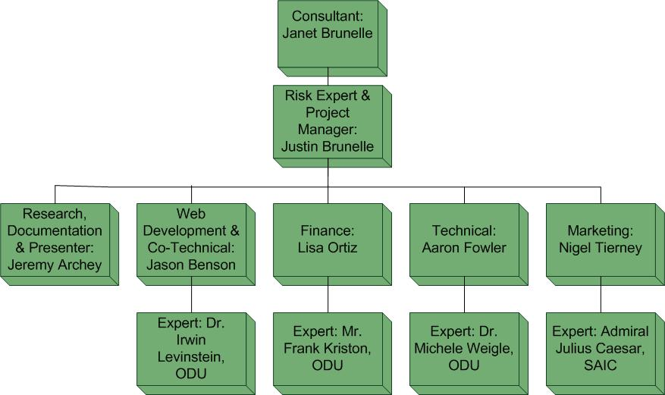
Purposes:
The C³P project life cycle will be evaluated based on the individual and overall results of the four project phases. In order for this project to be deemed successful every phase of the project must be evaluated based on the WBS. The evaluation plan will adapt to accommodate changes during the life of the project. The evaluation plan focuses on the technical, marketing, financial, personnel, and administrative aspects of the project. To ensure quality standards are met, any deviation from the evaluation plan will be brought to the attention of the project manager for approval. A phase is successful when all the items for that phase are completed. Evaluation will occur whenever necessary, but no less often than every three months.

Each phase will be evaluated based on the evaluation checklist for that phase. Evaluation will occur every 3 months or as deemed necessary by the PM. The evaluation checklist consists of five subcategories. They are as follows:

- Personnel Factor: each member of the team will be evaluated based on technical, communication, management (if applicable), and overall impact to the group.

- Administrative Factor: scheduling and task breakdown analysis is included in this evaluation factor.

- Financial Factor: the scheduled budget for the current phase will be evaluated for cost efficiency, and funding allocation.

- Marketing Factor: the current target market and an updated list of competitors will be validated.

- Technical Factor: the components of the software, hardware and overall system will be evaluated for completion, testing, and integration.

Limitations:
The C³P will not be solving any types of fraud. In addition to that, the potential threats to the reliability and validity of the evaluation design and instrumentation reside in:
- Hardware and software malfunction
- Smart Card delivery
- Building the database of UPCs
- Security and privacy concerns
- Cost to customer
- Difficulty of use
- Customer’s employee’s feelings
The higher risk threats are described in great detailed in the Risk Plan.

Audiences:
The C³P will have a primary customer and a secondary customer:
- Primary customer: Corporate sector
- Secondary customer: Concerned parents

Technical:
There are three components in determining the technical success of the project
Software, Hardware and overall system integration.
Software:
Software will be managed and evaluated under the Capability Maturity Model
Integration (CMMI: http://www.sei.cmu.edu/cmmi/cmmi.html).
Testing will be performed whenever new features are added to ensure functionality. Integration testing will be performed at every level of development.

Hardware:
The hardware to be used will undergo exhaustive testing. The network infrastructure will be also tested to determine sufficiency of bandwidth.

System:
The system will be tested to ensure that the software and hardware components work together seamlessly to provide a quality product. Rigorous in-house testing will be performed on a regular basis and in fact may encapsulate both the hardware and software testing once both facets of the project are sufficiently complete.

Success is assured when the following are obtained:
- Functional server software
- Functional POST updates
- Functioning web interface
- Functional database
- Functional integration of hardware and software
- Documentation of interoperability components are published
- Technical documentation for software and hardware

Functionality:
A C³P lab prototype will be developed during Phase 1 of the project. The major functional components will be tested thoroughly in order to show proof of concept. The relevant components of the C³P software solution include the database server, C³P networking server software, and the C³P web interface.

Phase 1 Prototype software:

The server will accept data from POSTs, formatted to include the card number, MCC, and UPCs. The card number will be used find the account in the database. The MCC and UPCs will be compared with the approved lists of the account. If the MCC and all the UPCs are approved, then the server will start the credit card transaction to buy the items specified buy the UPCs, else a failure notification will be sent to the POST. The server will also be able to generate statistics for the customers to analyze.

*refer to the end of the document for software development phase schedule.

The diagram below summarizes the overall process after Phase 3:
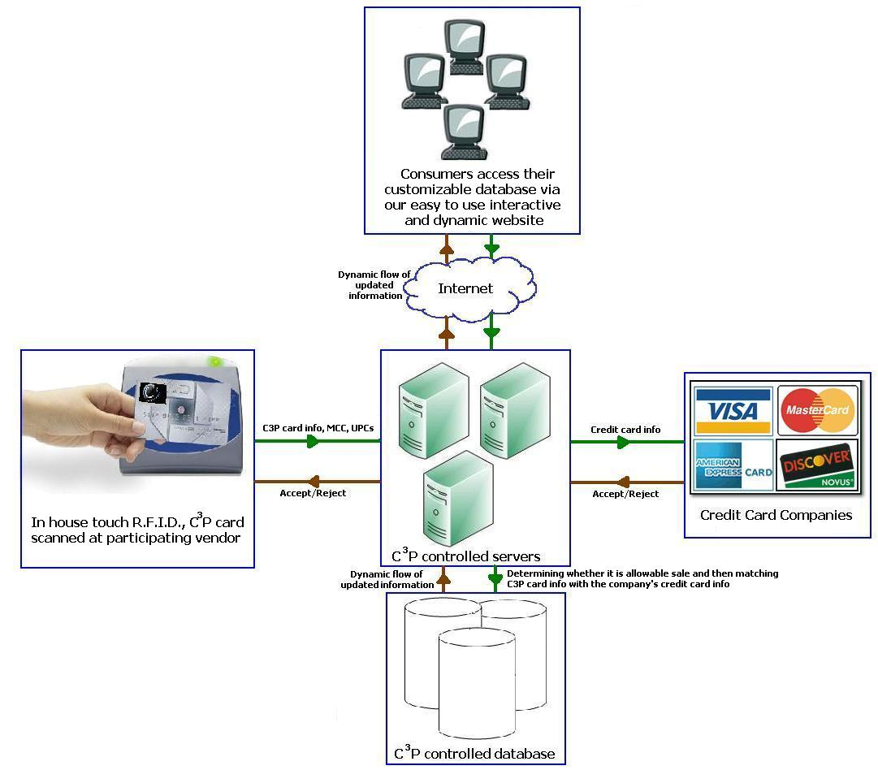

Sample:

Web Interface for customizing C³P Cards:

The user interface for editing the approved list for UPCs
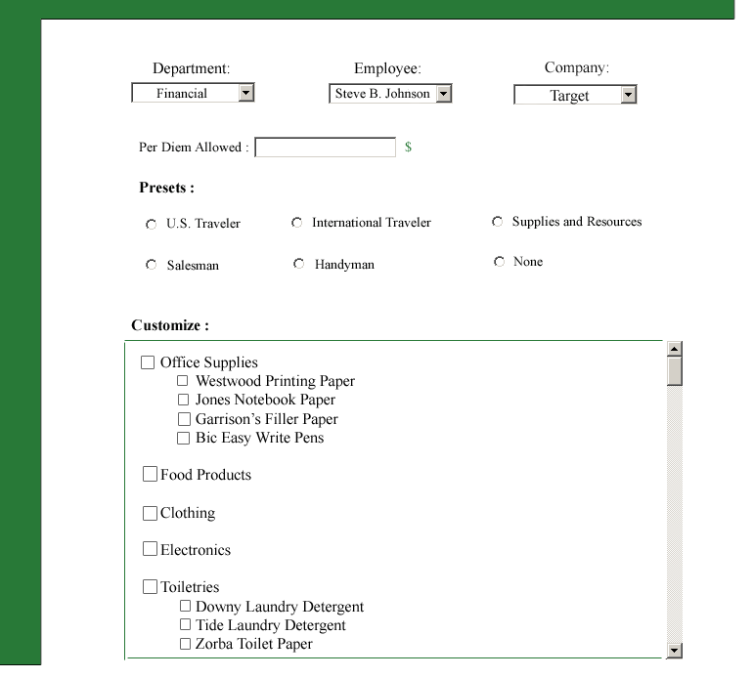

The user interface for editing the approved list for MCCs
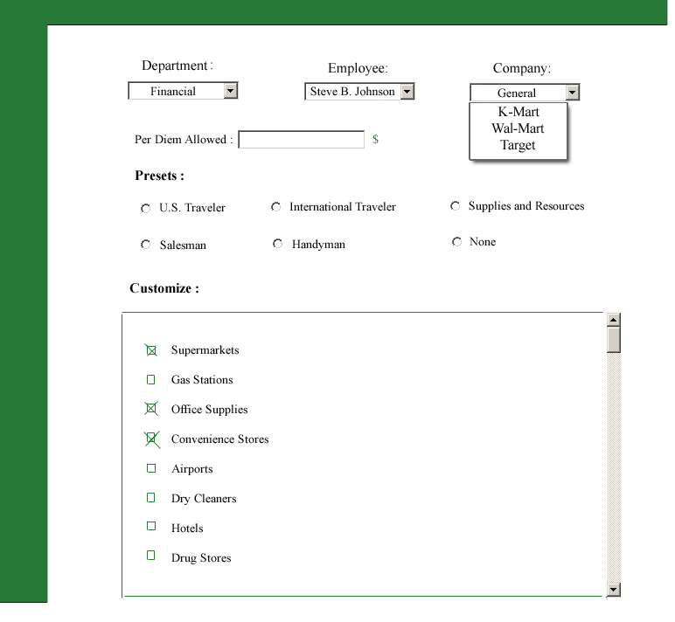
Time Line:
The time line of the project will be summarized in 4 Phases:
ID | Phase | Start | Finish | Length
1 | Phase 0 | 8-30-06 | 12-18-06 | 109 days
2 | Phase 1 | 12-19-06 | 4-17-07 | 120 days
3 | Phase 2 | 4-17-07 | 4-27-08 | 375 days
4 | Phase 3 | 4-27-08 | 8-1-08 | 70 days
A breakdown of each milestone is detailed below.

Phase 0 - Conception Phase:
- Team Formation - Members will meet and determine what task are required to build a team
- Initial Concept - After data has been gathered by each individual member, the team will assemble and discuss the data that has been gathered.
- Feasibility of Project - Task of analyzing the data gathered to determine if the data gathered has potential for success
- Milestone - Evaluation done after the milestone presentation is given. Discuss feedback from panel and grading criteria
- Cost analysis- Try to determine all factor that will contribute to overall cost of project to help in determining return
- Budget analysis- Determine and analyze all factors that will contribute to the cost of the development of the project device(hardware, software, personnel)
- Project test cost factors- Determine and analyze all areas that will influence cost of testing prototype
- SBIR Proposal - Evaluation after feedback is given. Discuss and analyze weakness in project
- Project Approval - Evaluation after presentation to discuss and analyze any weaknesses that were brought up.
- Website Development – Evaluate design concept what will best represent the team and its goals

Phase 1 - Prototype Proof of Concept:

- Software development - Develop software for the application, data mining, and formatting portions of the code.
- Software and hardware testing – Test and analyze hardware and software with development test kits. Determine any weaknesses in design and retest
- Documentation – Document all relevant data and manual development in the requirements and design documents.

Phase 2 - Product Development:

- Documentation – make a test plan, a hardware requirements document, and modify existing documents.
- Software development – Develop software for POST updates, improved data mining, database applications.
- Hardware development – Setup servers for all applications and the database.
- Marketing – Develop a marketing scheme to aid in determine target market
- Funding – Determine how to fund additional phases
- Website – Reevaluate website design to help ensure website represents team and product
- Evaluation – Beta testing

Phase 3 - Production out years:

- Purchasing – Make essential purchases needed to make a complete prototype
- Staffing – Determine any additional staffing needs
- Determine production facility – determine if facility is required for production
- Production/Training – Production of prototype and training development

*Note: For more details about the time line, please refer to the WBS.

