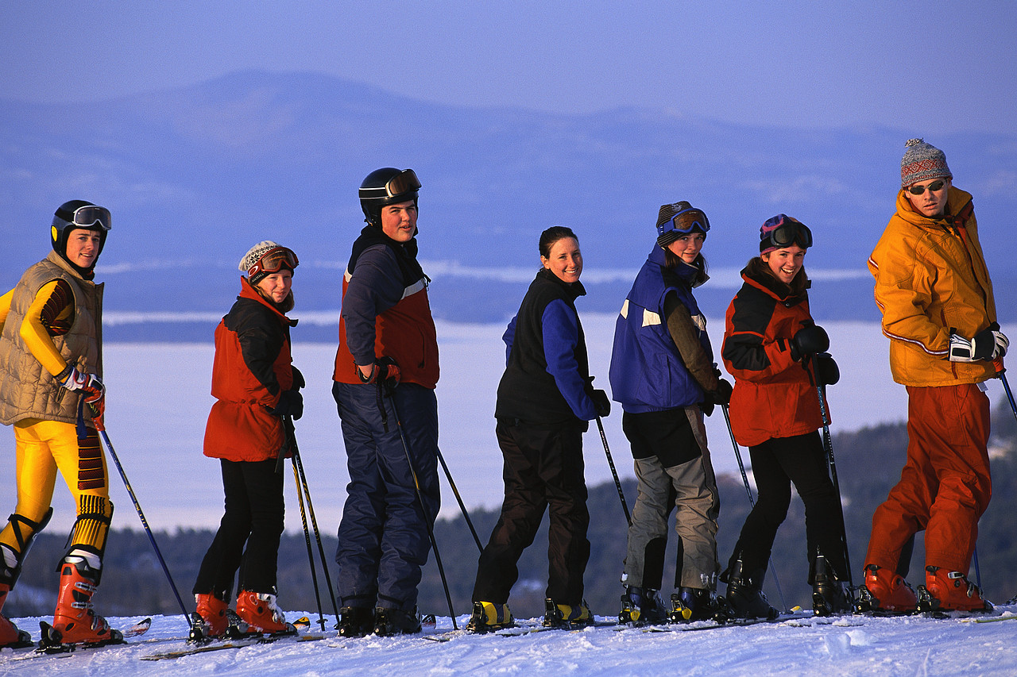

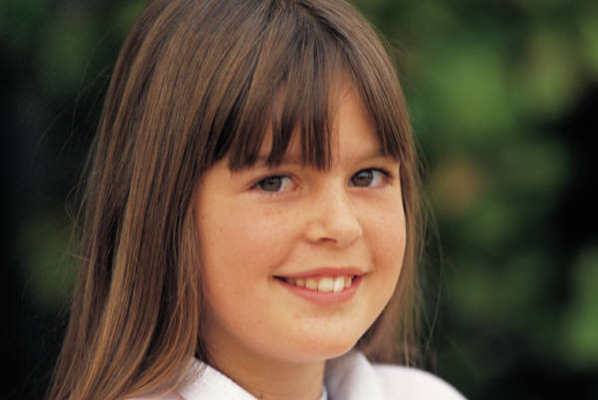
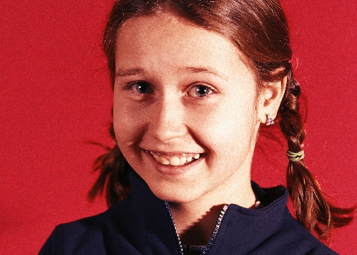
Writing Behavioral Intervention Plans (BIP) based on
Functional Behavior Assessments (FBA): Making Data Based Decisions to Change Behavior

By
Laura A. Riffel, Ph.D.
www.behaviordoctor.org
caughtyoubeinggood@gmail.com

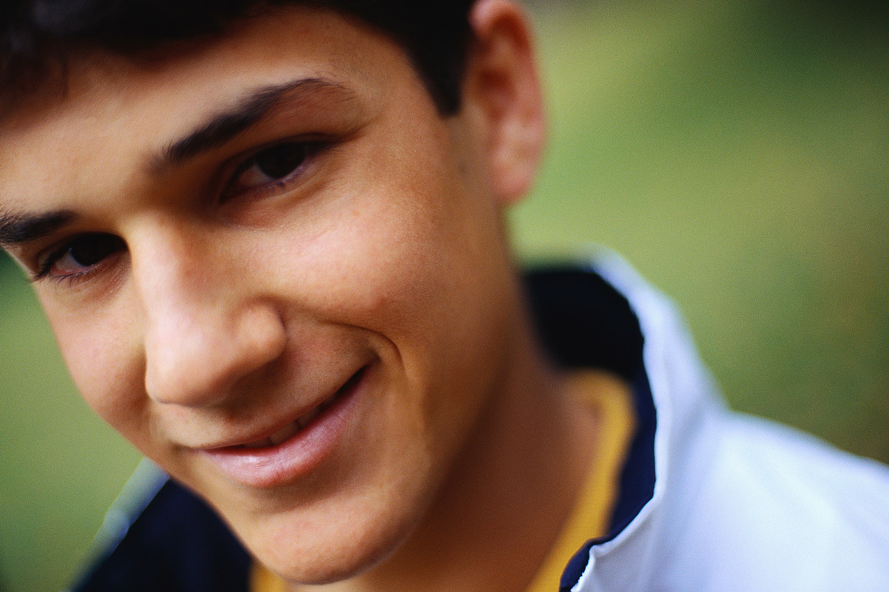


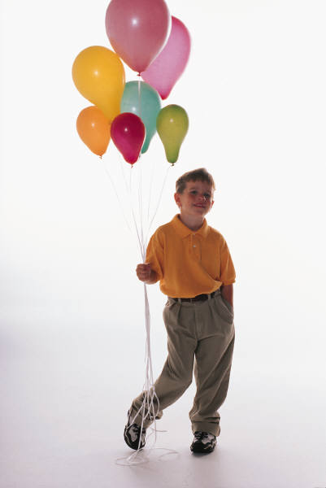
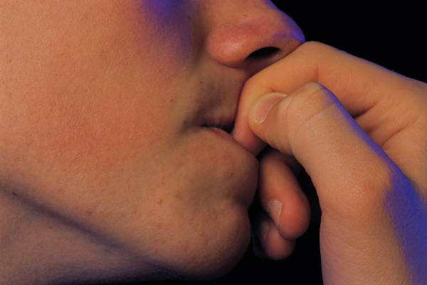



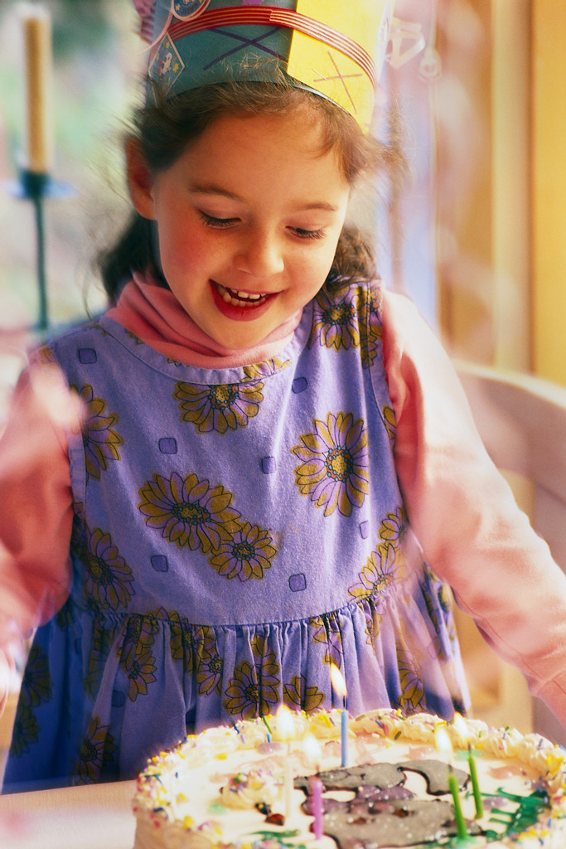



Preface:

The Individuals with Disabilities Education Act (IDEA) 2004 makes provisions for students being served in special education in regard to functional behavior assessments (FBA) and positive behavior support (PBS).

…`` (D) SERVICES.--A child with a disability who is removed from the child's current placement under subparagraph (G) (irrespective of whether the behavior is determined to be a manifestation of the child's disability) or subparagraph (C) shall--
``(i) continue to receive educational services, as provided in section 612(a)(1), so as to enable the child to continue to participate in the general education curriculum, although in another setting, and to progress toward meeting the goals set out in the child's IEP; and
``(ii) receive, as appropriate, a functional behavioral assessment, behavioral intervention services and modifications, that are designed to address the behavior violation so that it does not recur.

`` (B) CONSIDERATION OF SPECIAL FACTORS.--The IEP Team shall--
``(i) in the case of a child whose behavior impedes the child's learning or that of others, consider the use of positive behavioral interventions and supports, and other strategies, to address that behavior;

This training is geared toward meeting the legal requirements of IDEA 2004 for children being served in special education. However, research indicates that not all children who have behavior difficulties are identified as having special needs. The skills taught during this one day training are geared to help all students in a full continuum of support.
Any child who has 3 or more referrals to the office during a nine month period would be a candidate for a functional behavior assessment. While FBA data collection can be time consuming, it is well worth the time investment when considering the alternative of continually dealing with problematic behavior.

This training takes the arduous task of collecting ten days of data and condenses it into an easy format; which gives the behavior support team (BST) the most information with the least amount of effort.
- Participants learn a unique method for collecting ten days of Antecedent, Behavior, Consequence (ABC) Data.
- Once the data are collected, the participants learn how to analyze that data to determine the function of (or the reason behind) the behavior.
  - These behaviors are called the target behaviors because these are the behaviors the team will “target” to change.
  - Once the team knows what is feeding the behavior, they can implement positive proactive choices for making the target behavior unnecessary.
- Participants will use a Competing Pathways Map for analyzing antecedent modifications, behavior teaching, consequence manipulation, and setting changes that may or may not need to take place to change the behavior.
- Participants will learn how to form a behavior support team to develop interventions and will be given a book entitled Positive Interventions and Effective Strategies (PIES) which will guide them through some suggestions for particular behaviors.



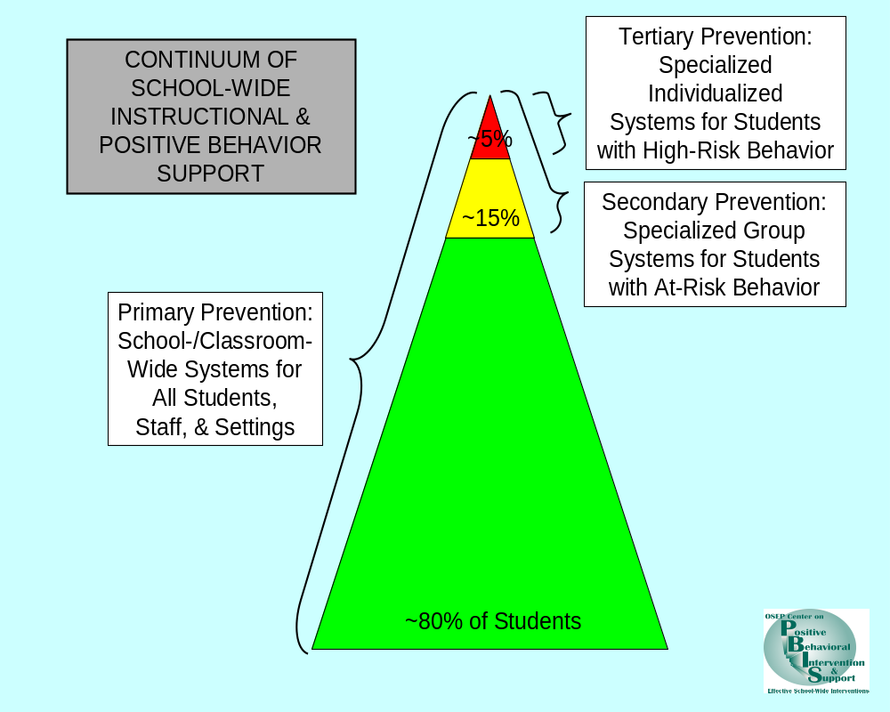Sugai & Horner 2005

Research from the National Technical Assistance Center on Positive Behavioral Interventions and Supports indicates that if 3-5 behavioral expectations are clearly taught, modeled, practiced, and rewarded that approximately 80% of the students in the school will not need interventions. The same research indicates that 10-15 percent of the students will need booster shots or reminders from time to time to keep them on track. Approximately 5% of the student population will need intensive supports in the form of a functional behavior assessment. Not all of the 5% (red zone) group are students identified with special needs. Therefore, although this training is extremely helpful in terms of IDEA 2004, it is also supportive to all students in a school who are exhibiting behaviors that impede their own learning or that of others.

For more information on positive behavior support research, please visit www.pbis.org
What is Positive Behavioral Support?
- A new way of thinking about behavior (based in research)
- Broadens intervention from only one approach - reducing challenging behavior to
- Encompassing multiple approaches: changing systems, altering environments, teaching skills, and appreciating positive behavior

PBS Includes:
- A team process for goal setting
- Functional Behavioral Assessment (Using data to make decisions)
- Behavior intervention plan design, implementation, and evaluation

Goal Setting
Identify team members
- most effective as collaborative process
Develop a profile to include:
- student’s strengths
- student’s needs
- student’s target behaviors
Identify settings & situations that require intervention

Functional Behavioral Assessment (FBA)

FBA is a process for gathering information to understand the function (purpose) of behavior in order to write an effective intervention plan.

Assumptions Underlying FBA
- Behavior is learned and serves a specific purpose.
- Behavior is related to the context within which it occurs

Questions to Address:
- How often does the target behavior occur & how long does it last?
- Where does the behavior typically occur/never occur?
- Who is present for the occurrence/nonoccurrence of the behavior?
- What is going on during the occurrence/nonoccurrence of the behavior?
- When is the behavior most likely/least likely to occur?
- How does the student react to the usual consequences that follow the behavior?

Defining Target Behaviors
Example | Non-Example
Hit others with fist | Poor impulse control
Crying | Angry, hostile, resentful
Lying on the floor and refusing to move | Stubborn

Frequently educators want to list every possible behavior and collect data on those behaviors. It is best to consider putting certain behaviors into classes. Most likely you would react the same way if a child hit you or kicked you; therefore these behaviors could be called physical aggression.

Another frequent dilemma is the child who throws tantrums. The team should list all the behaviors that have been associated with a tantrum and then use tantrum as one of the behaviors to measure with the following caveat:

Johnny frequently has the following behaviors:

- Hitting,
- Spitting,
- Kicking,
- Knocking everything off the table,
- Screaming,
- Head banging

A tantrum will be marked if two or more of the above behaviors happen within a two minute time frame.

This makes it easier to measure the behavior and everyone will understand what a tantrum consists of for this particular child.

There should be a thorough review of anything that might be connected to this child and his or her behaviors.

Record Review

diagnostic & medical records

psychological information

educational assessments

social histories

developmental profiles

previous behavior programs

individual education plans

anecdotal records/incident reports/discipline summaries

Methods for Conducting FBA

Indirect Methods:

MAS - Motivational Assessment Scale

FAST- Functional Analysis Screening Tool

PBQ- Problem Behavior Questionnaire

Indirect Methods:
Strengths and Limitations
Strengths  Easy to implement  Minimal time and training required  Structured methods  May use for initial assessment | Limitations  30% reliability to determine function  Information can be subjective  Non-specific functions identified (ex: escape from work)
Descriptive/Observational Methods:
Examples

A-B-C Analysis

Scatter plot

Interval or time sampling

Descriptive Methods:
Strengths and Weaknesses
Strengths:  Objective & quantitative data  Behavior is sampled in relevant settings  Can ID environmental relationships  Sufficient for BIP development  Reliability (60-80%) | Limitations:  Analysis can be complex  Time requirement  Increased staff training & experience may be necessary  May not ID function of infrequent behavior

Possible Functions

Positive Reinforcement: | Negative Reinforcement:
Social attention or  Access to materials  - Sensory Stimulation  - Control- No Research !!!! | Escape from activities or people  Sensory  Pain
“TO GET” | “TO GET OUT OF”
 | 

Setting Events

Medical concerns

Activity patterns

Relationships with others

Analyzing Patterns

Under what circumstances or antecedent events is the target behavior most/least likely? WHEN? WHERE? WHAT? WHO? WHY?

What consequences or results predictably follow the problem behavior? WHAT DO THEY GET? WHAT DO THEY AVOID?

What broader issues are important influences on behavior?

Other Information:

Times, activities, and individuals when behavior is most or least likely to occur

Conditions that are typically associated before or after the target behavior

Common setting events associated with the behavior

Other behaviors that may occur before or with the target behavior

Summary Statement

1. When this occurs…
(describe circumstances/antecedents)

2. the student does…
(describe target behavior)

3. to get/to avoid…
(describe consequences)

Example Statements:

1. When the teacher’s attention is withdrawn or focused on another student,
2. Zoë makes noises;
3. this results in the teacher scolding and moving closer to Zoë.

1. When unanticipated changes in the schedule occur,
2. Terry throws materials;
3. picking them up delays the transition to the next activity.

When Kim finishes work before the other students,
2. the desk gets scribbled on;
3. this alleviates Kim’s boredom.

Summary Statement Model
Setting Events
Antecedent
Target Behavior
Function
(Reinforcer)

Behavior Intervention Plan (BIP)

The summary statement is the foundation for a positive and supportive plan.

BIP Includes the Following:

Proactive
What environmental adjustments will be used to make the student’s problem behavior unnecessary?

Educative
What behaviors (skills) will be taught to replace or meet the same function as the student’s problem behavior and improve his or her ability to function more effectively?

Effective
How will consequences be managed to insure the student receives reinforcers for positive behavior, not problem behavior?

Proactive

Adjustments to the environment that reduce the likelihood of problem behavior occurring

Allow the student to be independent and successful

Examples: modifying the curriculum, reorganizing the physical setting, clarifying routines and expectations

Educative

Teaching replacement skills

Building generalizable competencies

Allow students to meet objectives in more effective, efficient, and appropriate ways (e.g., communication alternatives)

Enhance the student’s overall independence, integration, and quality of life

Effective

Managing consequences to reinforce desired behaviors and replacement skills

Withhold reinforcement following problem behavior

Use of natural, least intrusive consequences that address the identified function

Behavioral Intervention Plan Model
Antecedent
Setting Event
Target Behavior
Desired Behavior
Acceptable Alternative
Reinforcement
Reinforcement (< R+)
Antecedent Modifications
Reinforcement
(Function)

Let’s Meet Zoë

Zoë is a fifth grade student who constantly interrupts the teacher. When the students are working independently and the teacher is going around the room working with individuals, Zoë makes animal noises to get the teacher’s attention. Zoë does not get work done independently.

antecedent target behavior function of behavior

Example Plan for Zoë:

Tell Zoë when you will be unavailable for extended periods, “I’m helping ___ now.”

Teach Zoë to display a “help” card when help is needed. Remind Zoë to do this.

Provide attention whenever Zoë displays the “help” card, even if just to say “I’ll be there in a minute.”

Ignore all noises.

Behavioral Intervention Plan Model for Zoë
No Teacher attention
Zoë makes
noises
Uses social skills
Use “help” card
Attention
Ignore because Bx was getting attention
Precorrects
Teacher attention & praise

Let’s meet Terry

Terry is a junior high student with a moderate intellectual disability. Terry frequently throws books on the floor during transitions between classes. Terry’s paraprofessional must stop and clean up all the papers and books before proceeding to the next work assignment.

antecedent target behavior function of behavior

Example Plan for Terry:

Provide a written or picture schedule and refer to it throughout the day.

Prepare Terry for changes, noting them on the schedule.

Teach Terry to ask for clarification regarding changes and reward Terry for smooth transitions.

Have Terry pick up materials after finishing the next activity.

Behavioral Intervention Plan Model for Terry

Accepts changes

Positive feedback

Terry throws
materials

Pick up materials later

Changes in schedule

Earns computer time
Teach Terry to ask questions

Schedule noting changes

Let’s Meet Kim.

Kim is a 9th grade student who has a mild learning disability. When Kim finishes work before others either the desk gets scribbled on or neighbors are disturbed.

antecedent target behavior function of behavior

Example Plan for Kim:

Give Kim something to do when work is finished (e.g., extra credit, teacher helper).

Teach Kim to ask for activities or items and provide them consistently following requests.

Behavioral Intervention Plan Model for Kim
Finishes work
Writes on desk
Self-monitoring
Teach to request task
Gets needs met
Ignore & clean after school because attention was the function
Sponge activities
Provide activities when Kim requests as this is an appropriate way to gain attention – give rewards for appropriate behavior (token economy)
Teach to request task or keep a folder of work for Kim to go to when she finishes her work.

Sponge activities

Ignore writing on desk and give plenty of praise and attention when she self-selects to go to extra work folder or requests work to do. Can also be a token economy tied to this.

Promoting Self-Management

Self-monitoring
(e.g., the student tracking own performance by logging incidents such as speaking out of turn)

Self-reinforcement
(e.g., taking a break following completion of a specific number of math problems, recruiting praise from an adult for use of a particular social skill)

Self-correction
(e.g., student uses behavioral checklist to evaluate own performance at the end of each class period)

Crisis Management

If the student’s behavior poses a significant risk to self or others, a plan to ensure safety and rapid de-escalation needs to be developed.

Crisis plans are reactive, rather then proactive.

Team members may require outside training to implement procedures.

Contextual Fit of Plan

How does the plan align with the goals of the student and support providers?

Do the people implementing the plan have the capacity and commitment to do so?

Are the resources needed for the plan available?

Implementing the Plan & Monitoring Outcomes

Team tracks changes in student’s target behaviors and evaluates broader lifestyle changes that occur.

Use objective measures to document success.

If minimal progress occurs, the plan and possibly the assessment need to be reevaluated.

Dynamic Process
Functional Assessment

Positive Interventions

Over time, plans will need to be adjusted as the student’s needs and circumstances change….or …..as we figure out the answers the child changes the test.

How to Build a Behavior Support Team

This information is based on the book: Building Positive Behavior Support Systems in Schools: Functional Behavioral Assessment by Deanne Crone and Robert Horner (2003)
Many schools refer to children with behavior that impedes their learning or that of others as having “problem behavior.” The assertion of this book is to change this verbiage from problem behavior to the behavior the team wants to change. We call this the target behavior rather than the problem behavior. This helps change the philosophy from a “the child is bad philosophy” to a “systems change philosophy.”
Target behavior reduction flourishes when the school designates a behavior support team (BST), instead of relying on only one individual. (Crone & Horner, 2003).
Who should be part of the BST?
Referral process for individual students
Core Team Members
Administrator
Person with behavioral competence
Representative sample of school staff
Action Team Members
1-2 members of core team
Parents of referred student
Teachers of referred student
Significant others
Action Team Members
1-2 members of core team
Parents of referred student
Teachers of referred student
Significant others
Action Team Members
1-2 members of core team
Parents of referred student
Teachers of referred student
Significant others
Members of School Staff and Community
Teachers
Parents
Probation Officers
Social Workers
Mental Health Workers
Crone & Horner, 2003

In order to build a sustainable system of function based behavior support, you will need to determine a team that will meet regularly to discuss the progress of the student. This should include at the very least:
- Administrator who can support the interventions with time, staff, or money
- Regular and special education teachers that work with the referred student
- Ancillary staff that work with the student
- Any staff where problem behaviors occur (cafeteria, bus, playground)
- Parents
- BST member well versed in function based assessment
Together the team will build the structures to use:
- Data based decisions
  - Assessments
  - Testing the hypotheses
- Functional-based interventions
  - Antecedents and Consequences of maintaining behaviors
- Competing behavior pathways
  - Replacement behaviors
  - Antecedent and consequence modifications

Principles the team will use for decision making:
- Behavior is predictable
  - Environmental conditions can be set up to decrease target behaviors or
  - Environmental conditions ca be set off to maintain target behaviors.
- Behavior can be altered
  - Understanding the functions, predictors, and consequences of target behaviors help the BST pinpoint and script the appropriate behavior intervention plan.
- The team will conduct a FBA following the directions in the first half of this training.
  - When the BST meets again the team will use the material gathered to develop a testable hypothesis to serve as a prescription for a behavioral intervention plan.
  - This will help determine what behavior should be manipulated in order to reduce the target behavior or
  - Indicate which new behaviors should be taught to replace the target behaviors.
- The team will design a behavior intervention plan (BIP)
  - Generate strategies for reducing target behaviors and increase appropriate replacement behaviors
  - Ensure that the BIP is based on the FBA
  - Fill out a competing pathways form
- The team will ensure that the intervention plan:
  - Has a contextual fit
    - The plan matches the values, skills, resources, and routines of the people who will implement the plan.
    - Is individualized for each child
- The BST will follow-up for the evaluation and modification of the BIP
  - Without regular evaluation there are no objective means by which to determine if an intervention has been successful or if the efforts of the team have been worthwhile.
  - A well planned evaluation can isolate problem areas in an unsuccessful intervention process.
  - Regular evaluation enables the team to make impartial, data-based decisions

Antecedent, Behavior, Consequence (ABC) Data Collection Tools give us the best information when we can use that information. ABC Data tools are good for students whose behaviors occur less than 10 times per day. This is not the tool to use for a student who interrupts his teacher 63 times in 30 minutes. This training is going to focus on ABC Data collection.

Prior to this training if you conducted an ABC Data Collection you probably wrote copious notes either during the behavior or most likely at the end of the day in the form of anecdotal notes. While this can be useful information, it is very difficult to determine the function based on anecdotal notes or information that is coded differently every time due to a situation called “building the plane while you are flying it.” Rather than reverting to the old method which looked like this:

Student: ________ Circle One: Mon Tue Wed Thurs Fri Page _1_______
Full day Absent Partial day: In _____ Out ______ Date: ____
Time | Context/Activity | Antecedent/ Setting Events | Identified Target Behaviors | Consequence/Outcome | Student Reaction
Begin & End | The student’s environmental surroundings (people, places, events) | Describe exactly what occurred in the environment just before targeted behavior was exhibited. | List types of behaviors displayed during incident | What happened in the environment immediately after behavior was exhibited. | How did the student react immediately following the initial consequence being delivered
8:00-8:30 | Reading | Getting out books and starting a new story. | Threw her book across the room and stomped her feet and cried. | Told her to stop. | She didn’t stop.
9:00- 9:30 | Math | Doing multiplication problems. | Yelled out and disrupted the class. | Told her to stop. | She didn’t stop.
9:45-1015 | Social Studies | Round Robin Reading | Hit Stephen and then hit Sean. | Sent her to time out. | She cried.

As evident above, it would be very difficult to determine the function based on this information. The behavioral data are not exactly accurate because all behaviors do not occur in 30 minute intervals. Information is based on teacher recollection; therefore, the information may not be entirely accurate especially concerning antecedents.

The new format makes it simpler to collect data because the behavior support team (BST) develops a coded form that will be used for the 10 days of data collection. The team brainstorms possible contexts, antecedents, target behaviors, consequences and student reactions. This way everyone is using the same form to mark behaviors. See page 50 for most common entries for school and 51 for home.

Time | Context Activities |  | Antecedents |  | Target Behaviors |  | Consequence (outcome) |  | Student Reaction |  | Staff Initials
Begin & End of behavior | The student’s environmental surroundings. (people, places, events) |  | Describe exactly what occurred in the environment just before targeted behavior was exhibited. |  | List types of behaviors displayed during incident. |  | What happened in the environment immediately after behavior was exhibited. |  | How did the student react immediately following the initial consequence being delivered?
Key: | A | Group | A | Transition | A | Throwing objects | A | Choice given | A | stopped
 | B | Individual | B | Choice given | B | Disruptive outburst | B | Redirection | B | continued
 | C | Reading | C | Redirection | C | Physical aggression | C | Discussion of behavior | C | intensified
 | D | Math | D | Instruction/directive | D |  | D | Personal space given | D | Slept
 | E | Spelling | E | New task | E |  | E | Changed activity | E | Yelled
 | F | Social Studies | F | Routine task | F |  | F | Peer attention | F | Cried
 | G | Science | G | Physical prompts | G |  | G | Verbal reprimand | G | Other behavior
 | H | Free Choice | H | Teacher attention to others | H |  | H | Physical prompt | H | Moved away
 | I | Lunch | I | Told “NO” | I |  | I | Time out | I | Self-stimulation
 | J | Outside | J | Close proximity | J |  | J | Close proximity | J | Left the building
 | K | Bus | K | Loud noise | K |  | K | Sent home | K

Once the key is filled out the team makes at least 15 copies of the key. Now when a behavior occurs the staff member responsible for the student during this time period only has to mark the corresponding letter of the context, antecedent, behavior, consequence, and student reaction. The staff member would write down the beginning time and the ending time of the behavior and their initials.

This takes much less time, makes the data collection consistent no matter who is collecting the data and makes analysis a breeze. See example on the next page:

Time | Context Activities |  | Antecedents |  | Target Behaviors |  | Consequence (outcome) |  | Student Reaction |  | Staff Initials
Begin & End of behavior | The student’s environmental surroundings. (people, places, events) |  | Describe exactly what occurred in the environment just before targeted behavior was exhibited. |  | List types of behaviors displayed during incident. |  | What happened in the environment immediately after behavior was exhibited. |  | How did the student react immediately following the initial consequence being delivered?
8:17 – 8:29 | B |  | A |  | B |  | C |  | B |  | LR
9:23-  9:25 | B |  | F |  | C |  | G |  | A |  | TP
Key: | A | Group | A | Transition | A | Throwing objects | A | Choice given | A | stopped
 | B | Individual | B | Choice given | B | Disruptive outburst | B | Redirection | B | continued
 | C | Reading | C | Redirection | C | Physical aggression | C | Discussion of behavior | C | intensified
 | D | Math | D | Instruction/directive | D |  | D | Personal space given | D | Slept
 | E | Spelling | E | New task | E |  | E | Changed activity | E | Yelled
 | F | Social Studies | F | Routine task | F |  | F | Peer attention | F | Cried
 | G | Science | G | Physical prompts | G |  | G | Verbal reprimand | G | Other behavior
 | H | Free Choice | H | Teacher attention to others | H |  | H | Physical prompt | H | Moved away
 | I | Lunch | I | Told “NO” | I |  | I | Time out | I | Self-stimulation
 | J | Outside | J | Close proximity | J |  | J | Close proximity | J | Left the building
 | K | Bus | K | Loud noise | K |  | K | Sent home | K

Middle and High School teachers can each fill out a page for the portion of the day that the student is in the class that day. Once the team reconvenes to analyze the behavior, the team will put all the Monday data together for each Monday, and so on to build a typical day for the student.

Time | Context Activities |  | Antecedents |  | Target Behaviors |  | Consequence (outcome) |  | Student Reaction |  | Staff Initials
Begin & End of behavior | The student’s environmental surroundings. (people, places, events) |  | Describe exactly what occurred in the environment just before targeted behavior was exhibited. |  | List types of behaviors displayed during incident. |  | What happened in the environment immediately after behavior was exhibited. |  | How did the student react immediately following the initial consequence being delivered?
8:17 – 8:19 | B |  | A |  | B |  | C |  | A |  | LR
9:23- | A |  | A |  | B |  | G |  | B |  | TP
9:54 |  |  | G |  | C |  | I |  | C |  | TP
Key: | A | Group | A | Transition | A | Throwing objects | A | Choice given | A | stopped
 | B | Individual | B | Choice given | B | Disruptive outburst | B | Redirection | B | continued
 | C | Reading | C | Redirection | C | Physical aggression | C | Discussion of behavior | C | intensified
 | D | Math | D | Instruction/directive | D |  | D | Personal space given | D | Slept
 | E | Spelling | E | New task | E |  | E | Changed activity | E | Yelled
 | F | Social Studies | F | Routine task | F |  | F | Peer attention | F | Cried
 | G | Science | G | Physical prompts | G |  | G | Verbal reprimand | G | Other behavior
 | H | Free Choice | H | Teacher attention to others | H |  | H | Physical prompt | H | Moved away
 | I | Lunch | I | Told “NO” | I |  | I | Time out | I | Self-stimulation
 | J | Outside | J | Close proximity | J |  | J | Close proximity | J | Left the building
 | K | Bus | K | Loud noise | K |  | K | Sent home | K

Sometimes the consequence for one behavior becomes the antecedent for a new behavior. When this happens, we ask the team to draw a line from the first line to a new line and begin the behavior chain on the next line beginning with the previous consequence which is now the new antecedent.

We also ask teachers to choose one consequence and to try not to inundate the student with a plethora of consequences.

Blanks can be downloaded for free from www.behaviordoctor.org

The top of the form has a place for the following:

Student Name ____________________

Circle one: Mon Tue Wed Thurs Fri Page _________

Full day Absent Partial Day: In _________ Out ________

This information is important when calculating baseline data and in determining patterns around day of the week.



Meet Scout Radley

Scout is a sixth grade student with mild intellectual disabilities.

Scout has two siblings who attend the nearby high school.

Scout’s mother works full time and father frequently travels.

Scout is included in the regular classroom with support services provided.

The team has met on Scout and agreed on the following behaviors:

Behaviors are in measurable observable terms:

After defining the behavioral terms of the target behaviors the team wrote a key of possible:

Throwing objects
- A physical object leaves Scout’s hands and lands at least six inches from Scout.

Disruptive outburst
- A loud verbal sound or words come from Scout that disturbs the learning environment.

Physical aggression
- Any part of Scout’s body comes in contact with another person with force.

- Contexts
- Antecedents
- Behaviors
- Consequences
- And student reactions

Copies of the keys were made so that behaviors were measured the same way each day for ten days. It is important to have at least ten occurrences of a behavior in order to determine the function of that behavior. Ten days will likely result in at least ten occurrences.

The team is taught how to fill out the charts and behavior data are collected for ten days. The following ten pages are the results of ten days of data collection. This data will be analyzed to form a behavioral intervention plan.
Strengths:
Scout is comfortable talking in front of the class.
Scout is good at drawing pictures.
Scout has a great supportive family.

Reinforcers:
Scout likes to have conversations with adults.
Scout loves to do word searches.

These are very important conversations to have:
- What is a strength for the child?
- What floats this child’s boat?

SCOUT’S DATA
COLLECTED OVER TEN DAYS



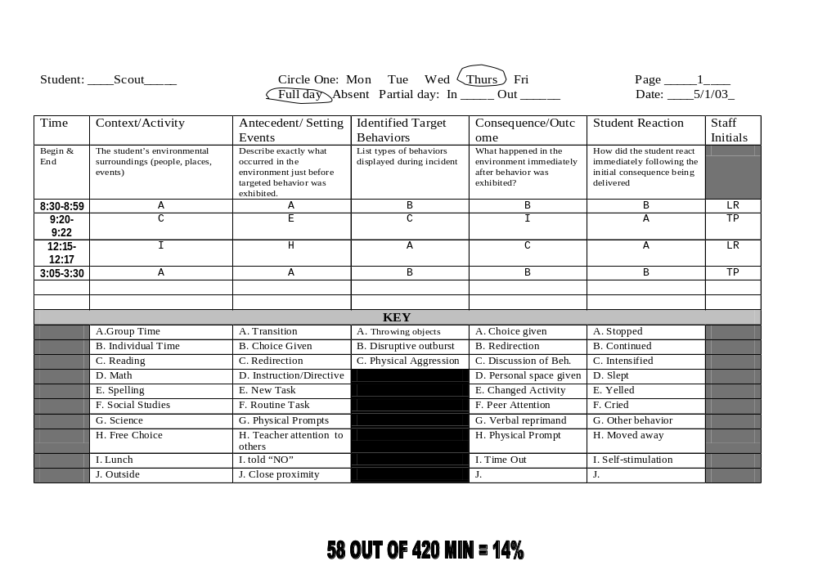
58/420 minutes= 14%

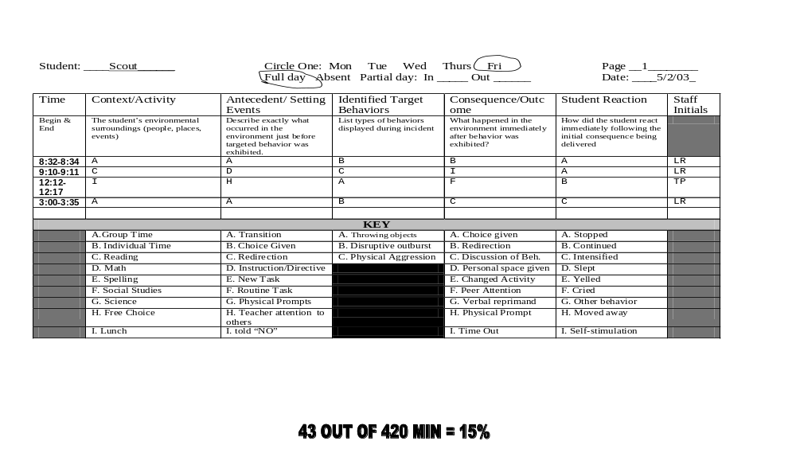
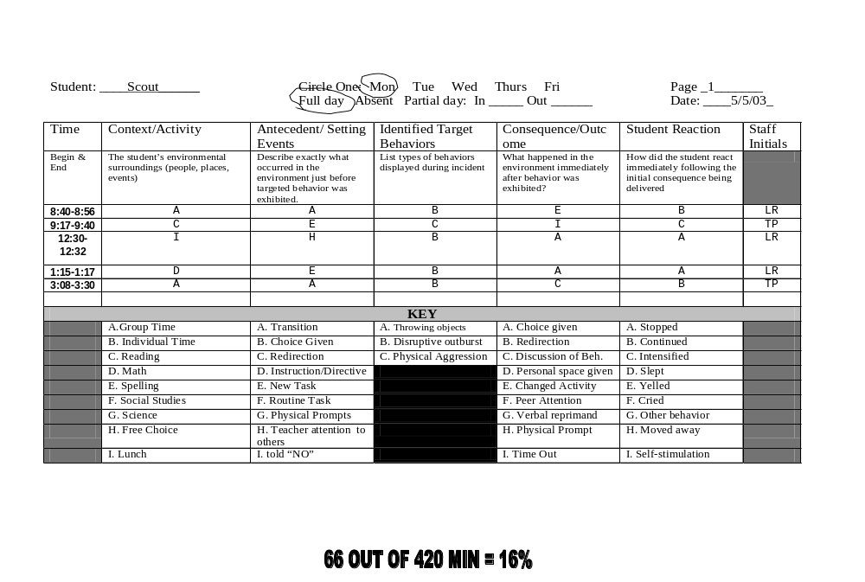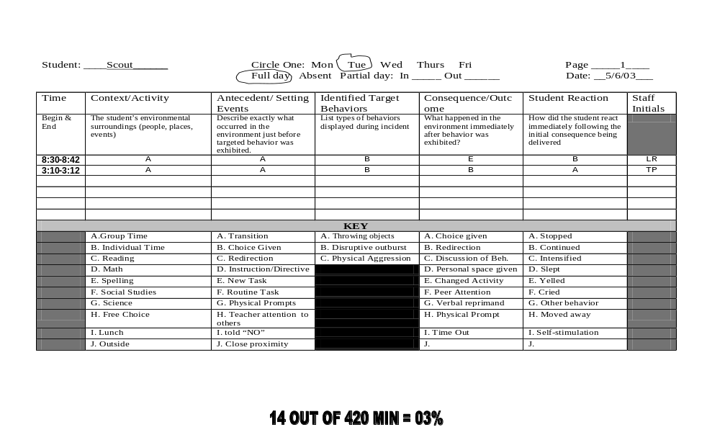
65 out of 420 MIN = 15%
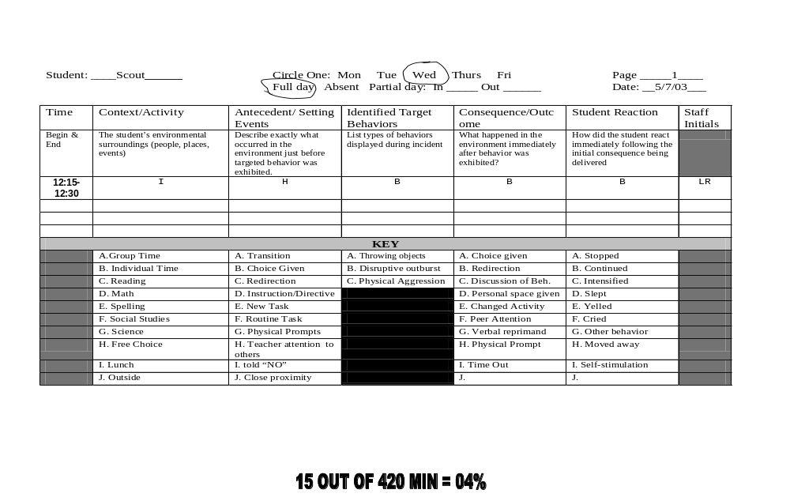
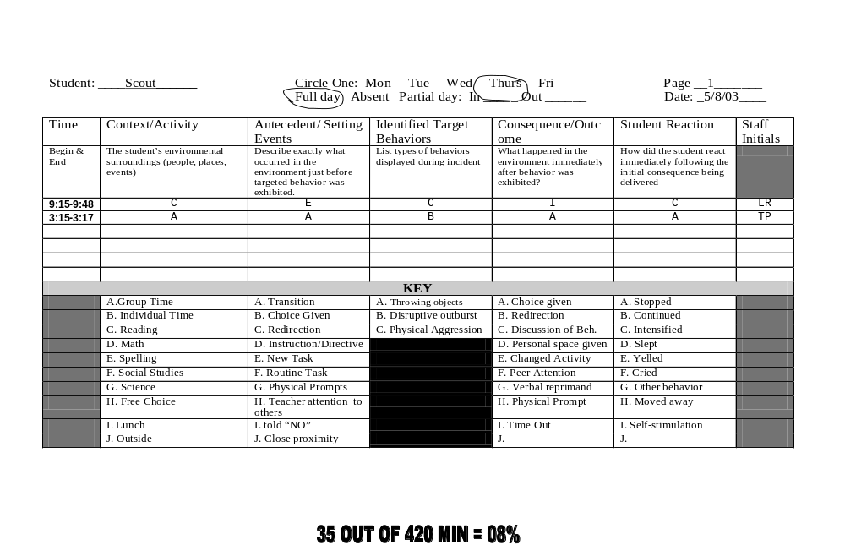
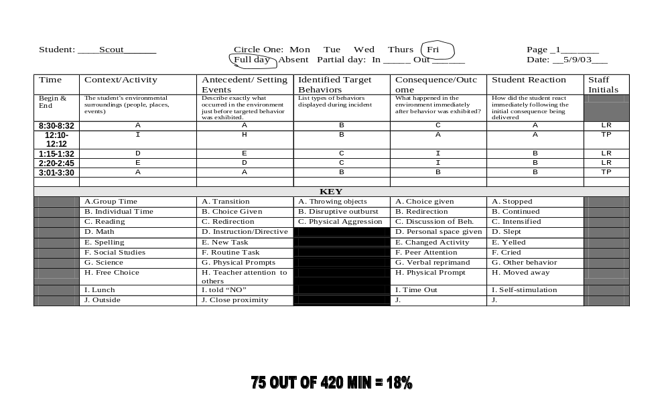
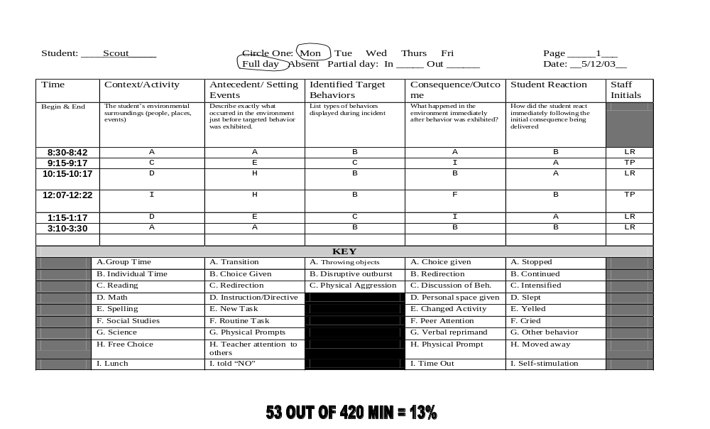
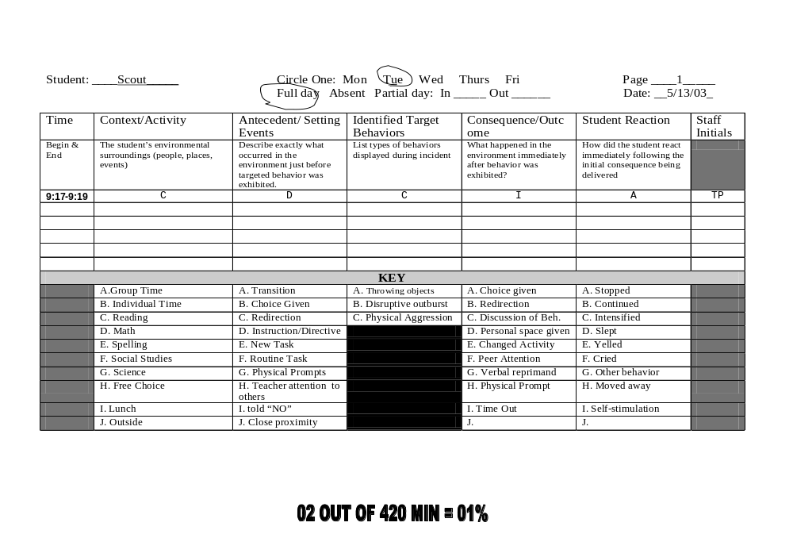
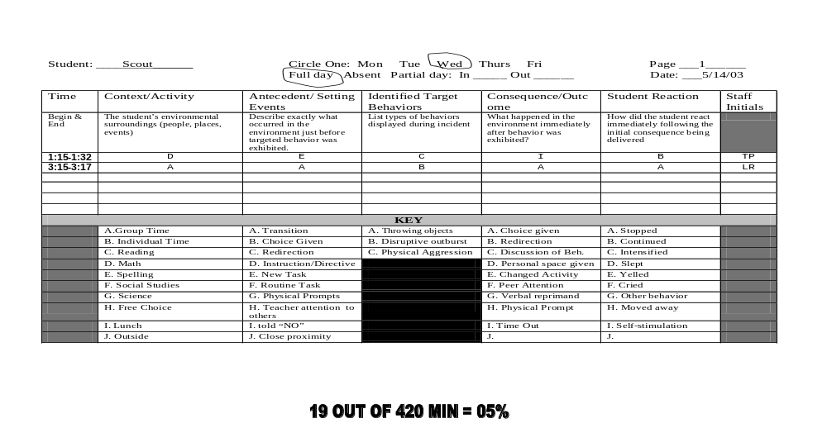
Notes:

Data Analysis:

Student: Scout Radley

Team Members: ___________________________________________________

________________________________________________________________

Date: ________________________________

Days of Data: _____________________________
(count the total number of days that data were collected)

Total Number of Incidents: ________________________
(count the total number of incidents during the data collection)

Average number of incidents daily: ____________________________
(count the total number of incidents and divide by the number of days data were collected)

Average length of time engaged in each behavior: _________________________
(add total amount of time engaged in behavior divided by total number of incidents) 379/32= 11.843 so behaviors are lasting approximately 12 minutes each.

Baseline: Take total minutes engaged in behavior divided by total minutes the child was observed for data collection during the baseline and multiply by 100) _________________________

379/4200 minutes *100 = 9.0238 or 9.02 % of the day - Baseline= 9.02%

Next look at the beginning time of each incident and mark the 30-minute time frame that the incident began. Add up the total tallies in each time zone and divide by the number of total behaviors over the ten day period. This will give a percentage of how often the target behavior occurs in that time zone. You would fill in the schedule for your own student based on that student’s schedule)

TIME OF DAY | Tally | Ratio | % INVOLVED
Your schedule would be based on the child’s day | IIII I | Total tallies/total incidents example: 15/32 | _{15/32 x 100}
8:30-8:59
9:00-9:29
9:30-9:59
10:00-10:29
10:30-10:59
11:00-11:29
11:30-11:59
12:00-12:29
12:30-12:59
1:00-1:29
1:30-1:59
2:00-2:29
2:30-2:59
3:00-3:30

Next you would tally the number of incidents on each day of the week to determine if there is a pattern to the behaviors based on day of the week: (If you have two Mondays you would divide the total tallies by two, if you have three Mondays of data you would divide the total tallies by three)

DAY OF WEEK | Tally | AVERAGE INCIDENTS PER DAY
MONDAY □
TUESDAY □
WEDNESDAY □
THURSDAY □
FRIDAY □

Next you want to look at the context to determine if there is a pattern there:

(Tally and divide just like you did for the time of day)

CONTEXT | Letter | Tally | Ratio | % Involved
Group Time | a
Individual Time | b
Reading | c
Math | d
Spelling | e
Social Studies | f
Science | g
Home Room | h
Lunch | i
Outside | j

Tally the behaviors that occurred. Are there any that we do not have enough information on to make a hypothesis? (Tally and divide just like you did for the time of day)

BEHAVIORS |  | Tally | Ratio | % INVOLVED
Throwing Objects | A
Disruptive Outbursts | B
Physical Aggression | C

Then the team would look at the Antecedents to see if they were maintaining the behaviors: (Tally and divide just like you did for the time of day)
ANTECEDENTS | Letter | Tally | Ratio | % INVOLVED
Transition | A
Choice Given | B
Redirection | C
Instruction/Directive | D
New Task | E
Routine Task | F
Physical Prompts | G
Teacher Attention to others | H
Told “NO” | I
Close Proximity | J
Interaction | K

It might be interesting to see if certain behaviors are paired with certain antecedents: (You will graph this like you are working for an x and y axis. You would look at the antecedent paired with the behavior and determine where to put the tally. For example: if you had a C antecedent and Scout had a B behavior you would tally it in the B column in the C row.)

 | Letter | A | B | C
ANTECEDENTS |  | Throwing Objects | Disruptive Outbursts | Physical Aggression
Transition | A
Choice Given | B
Redirection | C
Instruction/  Directive | D
New Task | E
Routine Task | F
Physical Prompts | G
Diverted Attention | H
Told “NO” | I
Close Proximity | J
Interaction | K

It might also be interesting to see if certain behaviors are paired with certain consequences: (Tally this in the same manner that you did previously- only you will read it backwards- Consequence to Behavior since consequence comes after behavior on the data collection sheets)

 | Letter | A | B | C
Consequences |  | Throwing Objects | Disruptive Outbursts | Physical Aggression
Choice Given | A
Redirection | B
Discussion | C
Personal Space Given | D
Changed Activity | E
Peer Attention | F
Verbal Reprimand | G
Physical Prompt | H
Time Out | I

We want to see if certain consequences stop the behavior effectively. Unless the answer is “A” (stopped) the behavior is considered to have continued.

CONSEQUENCE | Letter | Tally | STUDENT REACTION |  | % Effective
 |  |  | Stopped | Continued
Choice Given | A
Redirection | B
Discussion | C
Personal Space Given | D
Changed Activity | E
Peer Attention | F
Verbal Reprimand | G
Physical Prompt | H
Time Out | I

After you tally the number of consequences and the number of times the behavior stopped or continued in each column do the following:
Add up the total tallies beside each consequence. Add up the number of stops and the number of continues in each row. Divide the total stopped by the total number of tallies in each row and that is the percent of effectiveness during this behavioral observation. It is just an interesting way to look at how consequences may or may not be maintaining the behaviors.
- Behaviors are most likely to occur during:

Behaviors are most likely to stop when:

What do you think is the function of Scout’s behavior during group time?

What do you think is the function of Scout’s behavior during reading time?

What do you think is the function of Scout’s behavior during lunchtime?

What day of the week are behaviors most likely to occur?

Why do you suppose Monday’s and Friday’s are most difficult for Scout?

Now you can take the information that you learned from analyzing the behavior and fill out a competing pathway chart to brainstorm the best possible solutions to make the target behavior unnecessary. For every function of the behavior that you determined; you will need to fill out a competing pathway chart. Since Scout had two functions; we will have two charts.

Summary Statement

1. When this occurs…
(describe circumstances/antecedents)

When Scout has ____ (a transition) ______

2. the student does…
(describe target behavior)

She has a disruptive outburst

3. to get/to avoid…
(describe consequences)

To __________ (gain adult attention during transition times) ______

Summary Statement

1. When this occurs…
(describe circumstances/antecedents)

When Scout has ______ (a new task) ______________

2. the student does…
(describe target behavior)

She has a shows physical aggression

3. to get/to avoid…
(describe consequences)

To _____________ (avoid the work) _______________________

Think Pair Share

Team up with someone and discuss positive ways that you could intervene to make Scout’s day more pleasant for everyone by using the competing pathways chart.
Be ready to share your answers with the whole group in 7 minutes.

The Competing Pathway Charts on the following pages were originally developed by O’Neill and Horner (see references). Dr. Terry Scott has incorporated some changes to their original pathway and his work is evidenced in the forms we use at the Behavioral Intervention Program. Dr. Terry Scott is now at the University of Oregon scottt@uoregon.edu

Setting Events Predictors
Desired Behavior
Consequence/ Function

Target Behaviors

What is maintaining the behavior?/ What will maintain it in the future?

Competing Pathways Chart

Replacement Behaviors
BST Planning Guide

Setting Event or Antecedent Manipulations
Replacement Behavior Teaching
Consequence Modifications
Replacement Behavior
BST Planning Guide
Setting Events Predictors
Desired Behavior
Consequence/ Function
Setting Event or Antecedent Manipulations
Replacement Behavior Teaching
Consequence Modifications
Target Behavior
What’s maintaining the Behavior/ What will maintain the new behavior?

Competing Pathways Chart

FBA Data Collection Tool:

Open FBA Data Collection Tool
- Click Enable Macros (you may have to change your security settings)
- Type in student name
- Click arrows in Context, antecedent, consequence, and student reaction to choose those you selected for your student. If your choice is not there you can type it in.
- Type in up to three behaviors that are being measured for this child.
- Save file as the student’s name and date so you don’t overwrite your blank file.
- Go to Window at the top bar and click on it
  - Click- unfreeze panes
  - This lets you scroll down and enter the rest of the information
- Look at your data collection sheets
- Type in the first observation date in this format: 06/03/05
  - The computer will automatically configure the day of the week so it’s very important to make sure the date is correct.
- Click the pink box beside attendance and click the down arrow to select whether the student was there: full day, partial day, or absent
- Enter beginning and ending time of behavior in this format:
  - 8:32 am in the top box
  - 8:34 am in the bottom box
- In the white boxes type the letter from your data collection sheets that match for context, antecedent, behavior, consequence, student reaction, and staff initials.
- Go to the next line for each behavior that occurred for that day.
- Go to the next page for each new day that you add and finish typing in all the data that you have collected.

When you have entered all your data, click on the tab at the bottom that says “graphs and reports.” Your data are now in a graphed report that you can cut and paste into any Word Document report. This information will now be able to be printed out so the team can fill out a competing pathways chart. You can change the type of graph by double clicking which will take you straight to Excel.
Scout’s Data from the FBA Data Collection Tool

Functional Behavior Observation Data for
Reporting Period Extends across 05/01/03 to 05/14/03
Summarized values are 'first best' and do not reflect potentially equal result in a 2nd set of interactions
Avg Duration of Events: |  |  | 32 events averaged a duration of: 0:11:86 h:m:s
Time of Day: |  |  | 03:00 PM is an active time of day for behavior at 25.% |  |  |  |  |  | 10 days recorded as:
Day of Week: |  |  | Monday is an active behavior day at an average of 5.5 events per day.
Context: |  |  | Group - small ( I ) is a high CONTEXT frequency.
Target Behavior: |  |  | ' B ' at 62.5% is a frequent behavior. |  |  |  |  |  | 10 Full Days
Antecedent: |  |  | ' A ' at 43.8% is a strong antecedent |  |  |  |  |  | 0 Part Days
Antecedent/Behavior: |  |  | Antecedent A with Behavior B Has 14 interactions |  |  |  |  |  | 0 Day(s) Absent
Consequence/Behavior: |  |  | Consequence I with Behavior C has 10 interactions
Consequence/Reaction: |  |  | Consequence A has been 83.3% effective at stopping behaviors

See Samples on Next Page
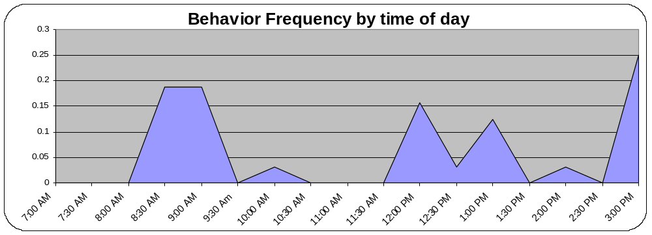

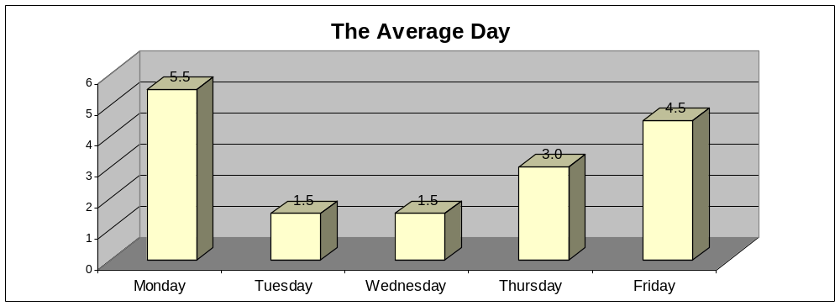

BEHAVIORAL ASSESSMENT FORM: COMMON ENTRIES

Context | Antecedent | Behaviors | Consequences/Outcome | Student Reaction
Assembly | *Transition | (List identified | Choice given | Stopped (set criteria)
Academics | *Denied Access | target behaviors) | Redirection | Continued (set criteria)
Art | *Instruction/Directive |  | Discussion of behavior by staff | Intensified (set criteria)
Bathroom | *New Task | LIMIT NUMBER | Personal space given | Slept
Break | *Teacher attention to others | OF BEHAVIORS | Changed/delayed/stopped activity | Apologized
Bus Area | *Told ‘No’ | TO 3 | Natural consequence | Cried
CBI | *Waiting |  | Ignored | Other behavior
Centers | Corrective Feedback |  | Peer attention | Moved away/left room
Choice | Routine Task |  | Verbal reprimand | Self-stimulation
Computer Lab | Choice Given |  | Physical prompt
Gym/P.E | Physical Prompt |  | Withholding Reinforcer
Group (large, small, whole) | Redirection |  | Removal of materials
Hallway | Attempt to communicate |  | Sent home
Home Living | Down time |  | Office Referral
Individual Work | Close physical proximity |  | Time-out
Leisure | Non-demand Interaction w/others |  | Physical Restraint
Library/media | Non-participation |  | Mechanical Restraint
Lunchroom/Cafeteria | Environmental Changes
Music | Physical Symptoms
Outside/Playground | Vocal Distress
Pre/voc. | Previous Incident
Rest | Displays non-targeted behavior/s
Snack | Challenge/teasing from other student
Speech | Cursing/inappropriate language
Story
 | * Required in assessment key

BEHAVIORAL ASSESSMENT FORM: HOME COMMON ENTRIES

Context | Antecedent | Behaviors | Consequences/Outcome | Student Reaction
Living Room | *Transition | (List identified target behaviors) | Offered a choice | *stopped
Dining Room | *Denied Access | Limit number of behaviors to 3 | Redirection | *continued
Kitchen | *Instruction/Directive |  | Discussion of behavior by parent | *intensified
Bedroom | *New Task |  | Discussion of behavior by caregiver | Slept
Bathroom | *Parent Attention to others |  | Changed/delayed/stopped activity | Apologized
Family Room | *Told No |  | Natural consequences | Cried
Backyard | *Waiting |  | Ignored | Other behavior
Hallway | Corrective Feedback |  | Sibling attention | Moved away/left room
Discount Store | Routine Task |  | Verbal reprimand | Self-stimulation
Relative’s Home | Choice Given |  | Physical prompt
Day Care | Physical Prompt |  | Withholding reinforcer
Automobile | Redirection |  | Removal of materials
Grocery Store | Attempt to communicate |  | Sent to room
 | Down Time |  | Sent to time out
 | Close Physical Proximity |  | Physical restraint
 | Non-demand Interaction with others |  | Personal space given
 | Non-participation
 | Environmental Changes
 | Physical Symptoms
 | Vocal Distress
 | Previous Incident
 | Displays non-targeted behavior/s
 | Challenge teasing from sibling
 | Cursing inappropriate language
 | Company visiting

*Must be used for assessment website FBA Data Tool
Functional Assessment vs. Functional Analysis

A Functional Behavior Assessment is when data are gathered from the natural environment under typical conditions. Occasionally, the function of the child’s behavior can not be discerned from this method and a Functional Analysis must be completed. The difference between an assessment and an analysis is in the environment. In an Analysis the environment is manipulated to elicit the behaviors. The following pages are examples of a real Assessment and a real Analysis. The names have been changed but the data are real.

The report on the following pages are for a fictional student named Billie Bobbie Thornton. The first report is the analysis of the data. This data would be taken to the Behavior Support Team and discussed to determine an intervention plan with everyone present.
Functional Behavior Assessment for Billie Bobbie Thornton

Data Analysis:

Student: Billie Bobbie Thornton

Team Members: Mary Poppins, Teacher; Sergeant Carter, Principal, Rumor Thornton, Parent; Biff Henderson, PE teacher; Chatty Cathy, SLP; Carrie Case, Resource Teacher

Date: May 13, 2003

Days of Data: Ten Days of FBA Data were collected using the Antecedent, Behavior, Consequence Data Sheet

Total Number of Incidents: 32 incidents occurred in ten days

Average number of incidents daily: 32/10 = 3.2 average incidents per day

Average length of time engaged in each behavior: 379 minutes divided by 32 incidents = 11.84 Just under 12 minutes per incident.

Baseline: 379/4200 minutes *100 = 9.0238 or 9.02 % of the day
Baseline= 9.02%
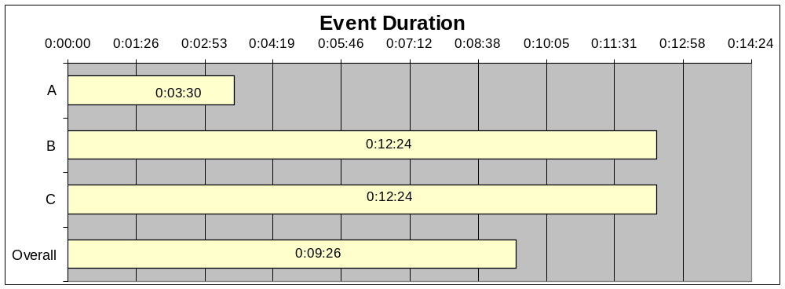

TIME OF DAY | Tally | Ratio | % INVOLVED
Your schedule would be based on the child’s day | IIII I | Total tallies/total incidents example: 15/32 | _{15/32 x 100}
8:30-8:59 | 6 | 6/32 | 19%
9:00-9:29 | 6 | 6/32 | 19%
9:30-9:59
10:00-10:29 | 1 | 1/32 | 3%
10:30-10:59
11:00-11:29
11:30-11:59
12:00-12:29 | 5 | 5/32 | 16%
12:30-12:59 | 1 | 1/32 | 3%
1:00-1:29 | 4 | 4/32 | 13%
1:30-1:59
2:00-2:29
2:30-2:59 | 1 | 1/32 | 3%
3:00-3:30 | 8 | 8/32 | 25%

Based on the data from the FBA Data Collection, it appears that Billie Bobbie had difficulty with the first hour of the morning and the last half hour of the day. It would be prudent to look at these times of day and determine if antecedent modifications can be implemented to assure a smooth transition from home to school and school to home.

DAY OF WEEK | Tally | AVERAGE INCIDENTS PER DAY
MONDAY (2 ) | 11 | 5.5
TUESDAY ( 2 ) | 3 | 1.5
WEDNESDAY ( 2 ) | 3 | 1.5
THURSDAY ( 2 ) | 6 | 3.0
FRIDAY ( 2 ) | 9 | 4.5

Based on the data collected for the FBA, it would appear that Mondays and Fridays are most problematic for Billie Bobbie. Once again these are transition days from home to school and school to home. The team will consider antecedent modifications to ensure a smooth transition between these two areas in Billie Bobbie’s life.

CONTEXT | Letter | Tally | Ratio | % Involved
Group Time | a | 14 | 14/32 | 44%
Individual Time | b
Reading | c | 6 | 6/32 | 19%
Math | d | 5 | 5/32 | 16%
Spelling | e | 1 | 1/32 | 3%
Social Studies | f
Science | g
Home Room | h
Lunch | i | 6 | 6/32 | 19%
Outside | j

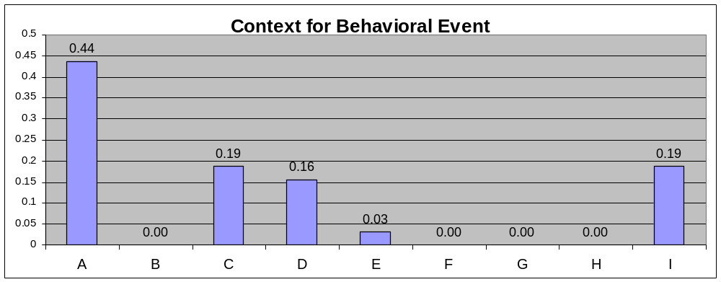

Based on the data collected during the FBA process it appears that group time is most problematic for Billie Bobbie with 44% of the target behaviors occurring during this time frame. Upon closer inspection, the two areas of the day where teacher attention is perceived to be on others (Group Time and Lunchroom) 63% of the target behaviors occur during this time. This would lead the team to hypothesize that 63% of the behaviors are occurring for attention from the teacher. Likewise, 38% of the behaviors are occurring during academic times (Reading, Math, and Spelling) therefore the team may hypothesize that 38% of the behaviors occur to escape work activities.

BEHAVIORS |  | Tally | Ratio | % INVOLVED
Throwing Objects | A | 2 | 2/32 | 6%
Disruptive Outbursts | B | 20 | 20/32 | 63%
Physical Aggression | C | 10 | 10/32 | 31%
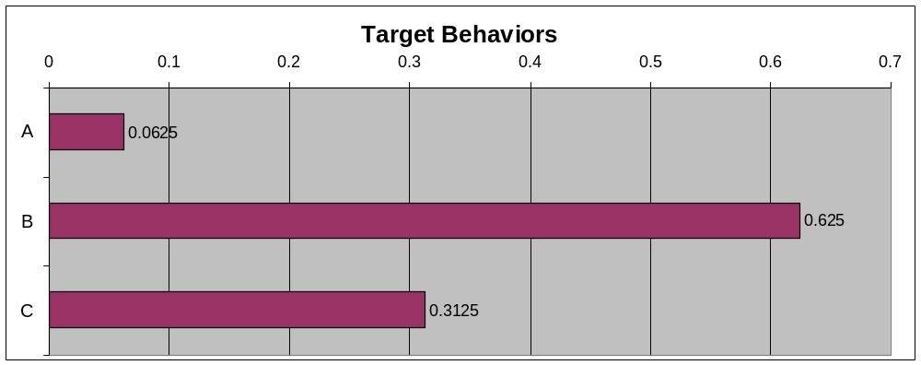

Based on the data gathered during the FBA process, Billie Bobbie had 20 incidents of disruptive outbursts which were 63% of his behaviors and 10 incidents of physical aggression which were 31% of his behaviors. There were two incidents of throwing objects; however, research dictates that it takes 10 incidents to determine the function of a behavior; therefore no hypothesis will be formed concerning the throwing incidents at this time.

ANTECEDENTS | Letter | Tally | Ratio | % INVOLVED
Transition | A | 15 | 15/32 | 47%
Choice Given | B
Redirection | C
Instruction/Directive | D | 3 | 3/32 | 9%
New Task | E | 8 | 8/32 | 25%
Routine Task | F
Physical Prompts | G
Teacher Attention to others | H | 6 | 6/32 | 19%
Told “NO” | I
Close Proximity | J
Interaction | K

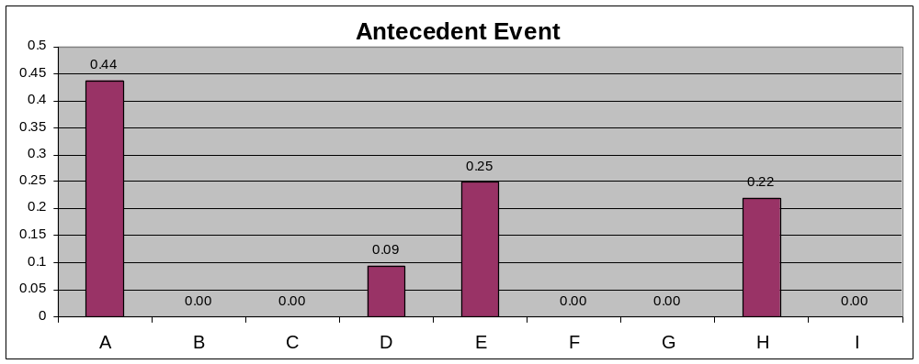

Based on the data gathered during the FBA process, it would appear that 47% of the time the antecedent to a behavior is a transition. Considering again that transitions are times when the teacher attention is focused on many areas of the classroom, it would appear that 66% of the time the antecedent occurred during times when Billie Bobbie perceived the teacher attention to be focused on others. Also, 34% of the time the behaviors occurred during academic times with 9% occurring during an instruction or directive and 25% occurring during a new task being requested of Billie Bobbie.

 | Letter | A | B | C
ANTECEDENTS |  | Throwing Objects | Disruptive Outbursts | Physical Aggression
Transition | A |  | 14
Choice Given | B
Redirection | C
Instruction/Directive | D |  |  | 3
New Task | E |  | 1 | 7
Routine Task | F
Physical Prompts | G
Diverted Attention | H | 2 | 5
Told “NO” | I
Close Proximity | J
Interaction | K

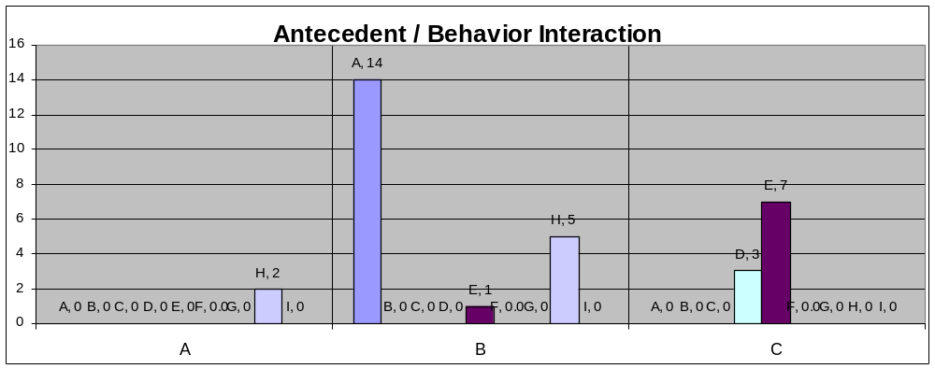

Ten out of ten times (100%) when the antecedent was an instruction directive or a new task, the following behavior was physical aggression. Nineteen out of twenty-two times, when the activity was something where Billie Bobbie perceived the teacher’s attention to be elsewhere, the target behavior was a disruptive outburst.

 | Letter | A | B | C
Consequences |  | Throwing Objects | Disruptive Outbursts | Physical Aggression
Choice Given | A |  | 6
Redirection | B |  | 8
Discussion | C | 1 | 3
Personal Space Given | D
Changed Activity | E |  | 2
Peer Attention | F | 1
Verbal Reprimand | G
Physical Prompt | H
Time Out | I |  |  | 10

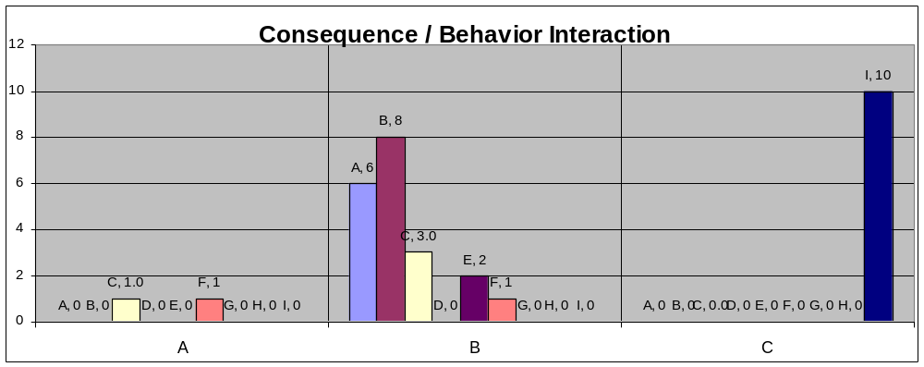

Six times when Billie Bobbie had a disruptive outburst the teacher came over and gave her a choice.
Eight times when Billie Bobbie had a disruptive outburst the teacher came over and gave her a redirection.
Three times when Billie Bobbie had a disruptive outburst the teacher came over and gave her a discussion about his behavior.
Two times when Billie Bobbie had a disruptive outburst the teacher came over and gave her a change of activity.

Upon closer inspection of the consequences, it would appear that Billie Bobbie uses disruptive outbursts for teacher attention during times that he perceives teacher attention to be on others.

Ten times when Billie Bobbie used physical aggression, the teacher sent her to time out. This was 100% of the time. Therefore, the data suggest that Billie Bobbie uses physical aggression to obtain escape from academic tasks.

CONSEQUENCE | Letter | Tally | STUDENT REACTION |  | % Effective
 |  |  | Stopped | Continued
Choice Given | A | 5 | 4 | 1 | 80%
Redirection | B | 8 | 3 | 5 | 38%
Discussion | C | 4 | 2 | 3 | 50%
Personal Space Given | D
Changed Activity | E | 2 | 0 | 2 | 0%
Peer Attention | F | 2 | 0 | 2 | 0%
Verbal Reprimand | G
Physical Prompt | H
Time Out | I | 8 | 4 | 4 | 50%

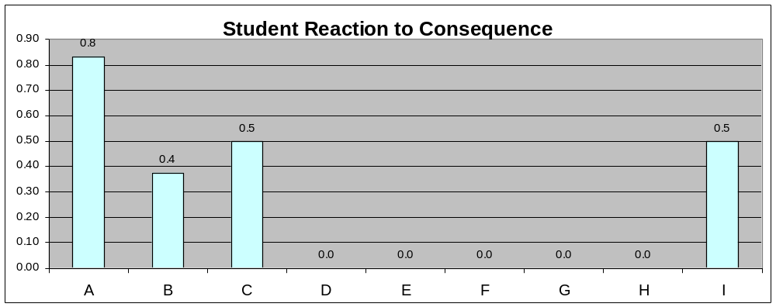

Although, a consequence may prove to be effective 100% of the time, it is not automatic that the team will decide to use the consequence if it is maintaining an inappropriate behavior. One interesting note came from this particular data observation. Billie Bobbie appears to respond to choices. This might be a consequence manipulation that the team puts into place during the intervention phase.

Behavior Support Team Meeting on Billie Bobbie Thornton’s FBA Data Analysis Meeting:

Members present:

Team Members: Mary Poppins, Teacher; Sergeant Carter, Principal, Rumor Thornton, Parent; Biff Henderson, PE teacher; Chatty Cathy, SLP; Carrie Case, Resource Teacher; Poppy Montgomery, Assistant Principal.

Date of meeting:

May 13, 2003

Notes from the Meeting:

- Behaviors are most likely to occur during transitions:

Behaviors are most likely to stop when choices are offered:

What do you think is the function of Billie Bobbie’s behavior during group time? To gain teacher attention.

What do you think is the function of Billie Bobbie’s behavior during reading time? To escape from academic activities.

What do you think is the function of Billie Bobbie’s behavior during lunchtime? Most likely to gain attention from the teacher.

Mondays and Fridays are the days of the week that appear to be most problematic for Billie Bobbie.

The BST hypothesizes that Monday’s and Friday’s are most difficult for Billie Bobbie? Mom shared with the team during the initial meeting that Mondays were very hectic because Dad was flying out and Mom was usually running late for work. Mom also shared that Billie Bobbie had a hard time getting out the door on Monday morning with shoes, backpack, etc.

After filling out a competing pathways form on both functions the team intends to employ the following interventions:

Replacement Behaviors
The alternative behaviors chosen are more conducive to the learning environment and will enable Billie Bobbie to make friends by giving her skills to solicit attention in more appropriate methods.
The team determined that Billie Bobbie’s disruptive outburst behavior stemmed from transition difficulties and her desire to gain attention during these troubling times. Therefore, these are the replacement behaviors that were employed:
- Billie Bobbie will be the “Vanna White” of the class schedule. This will:
  - Give her attention from her teacher and peers
  - Give her a prompt that things are changing
- Billie Bobbie will keep a journal of what she does at home
  - She will bring this in the morning and go directly to the Speech Pathologists’ office to discuss her previous evening or weekend activities. This will give her attention and give her an opportunity to discuss upcoming activities for the day.
  - Billie Bobbie will return to the SLP’s office at the end of the day to discuss her day, discuss what she plans to do that evening at home, and receive her new journal for that evening.
- At any time during the day, that Billie Bobbie appears overwhelmed she will be given an envelope to take to the office.
  - The secretary will know that the smiley face inside the envelope indicates that Billie Bobbie just needs a few minutes away from class and she will engage her in a conversation.
The team further determined that Billie Bobbie’s physically aggressive behaviors were for the function of escape during new activities. The team determined the following replacement behaviors would be employed:
- Billie Bobbie will have a Garfield stuffed animal in her desk. At any time during the day that she feels unable to do the work presented, she will remove the Garfield and place him on her desk. She will then take out a word puzzle; which is something she loves, and work on that until the teacher is able to come give her one on one attention.
  - Billie Bobbie will be rewarded with a token in her token economy for exhibiting this behavior.
  - Billie Bobbie will earn computer time when she has earned 5 tokens. This will be faded later.
- Billie Bobbie will receive pre-training on new topics prior to their introduction in the class. The resource teacher will be given advance notice of lesson plans so preparations can be made for Billie Bobbie’s learning.

These behaviors will allow Billie Bobbie to transition during the day. Billie Bobbie will also have better skills to signal her need for help. Physical aggression will be blocked and ignored and Billie Bobbie will no longer be sent to time out as this was an escape outlet for her previously. Billie Bobbie will be rewarded for following appropriate avenues for attention during transitions and new tasks.

Billie Bobbie Thornton’s Functional Behavior Assessment Follow-Up
Date: May 26, 2003
Members Present:
Team Members: Mary Poppins, Teacher; Sergeant Carter, Principal, Rumor Thornton, Parent; Biff Henderson, PE teacher; Chatty Cathy, SLP; Carrie Case, Resource Teacher; Poppy Montgomery, Assistant Principal.

Student and Objective
Billie Bobbie is a sixth grade student with learning disabilities. Her target behaviors were throwing objects, disruptive outbursts, and physical aggression. Billie Bobbie’s disruptive behaviors as listed below were impeding her learning and that of others in the classroom. The behavior support team decided to create an intervention plan that would make these behaviors unnecessary by teaching replacement skills and making antecedent modifications as necessary.

Billie Bobbie’s Behavior Definitions
- Throwing objects
  - A physical object leaves Billie Bobbie’s hands and lands with purpose more than six inches from her body.
- Disruptive Outbursts
  - Loud noises emitted from Billie Bobbie that disrupt the learning environment.
- Physical Aggression
  - One part of Billie Bobbie’s body comes in contact with another person with intention and force.
Replacement Behaviors
The alternative behaviors chosen are more conducive to the learning environment and will enable Billie Bobbie to make friends by giving her skills to solicit attention in more appropriate methods.
The team determined that Billie Bobbie’s disruptive outburst behavior stemmed from transition difficulties and her desire to gain attention during these troubling times. Therefore, these are the replacement behaviors that were employed:
- Billie Bobbie will be the “Vanna White” of the class schedule. This will:
  - Give her attention from her teacher and peers
  - Give her a prompt that things are changing
- Billie Bobbie will keep a journal of what she does at home
  - She will bring this in the morning and go directly to the Speech Pathologists’ office to discuss her previous evening or weekend activities. This will give her attention and give her an opportunity to discuss upcoming activities for the day.
  - Billie Bobbie will return to the SLP’s office at the end of the day to discuss her day, discuss what she plans to do that evening at home, and receive her new journal for that evening.
- At any time during the day, that Billie Bobbie appears overwhelmed she will be given an envelope to take to the office.
  - The secretary will know that the smiley face inside the envelope indicates that Billie Bobbie just needs a few minutes away from class and she will engage her in a conversation.
The team further determined that Billie Bobbie’s physically aggressive behaviors were for the function of escape during new activities. The team determined the following replacement behaviors would be employed:
- Billie Bobbie will have a Garfield stuffed animal in her desk. At any time during the day that she feels unable to do the work presented, she will remove the Garfield and place him on her desk. She will then take out a word puzzle; which is something she loves, and work on that until the teacher is able to come give her one on one attention.
  - Billie Bobbie will be rewarded with a token in her token economy for exhibiting this behavior.
  - Billie Bobbie will earn computer time when she has earned 5 tokens. This will be faded later.
- Billie Bobbie will receive pre-training on new topics prior to their introduction in the class. The resource teacher will be given advance notice of lesson plans so preparations can be made for Billie Bobbie’s learning.

These behaviors will allow Billie Bobbie to transition during the day. Billie Bobbie will also have better skills to signal her need for help. Physical aggression will be blocked and ignored and Billie Bobbie will no longer be sent to time out as this was an escape outlet for her previously. Billie Bobbie will be rewarded for following appropriate avenues for attention during transitions and new tasks.

Baseline
Billie Bobbie is a sixth grade student with learning disabilities being served in an inclusion model in a middle school. Collections of data were conducted using the Antecedent, Behavior, and Consequence (ABC) charts for ten days. Data were collected by staffs that were present at the time of the target behaviors. Baseline data were collected and determined to be approximately 10 percent of the day. The mean for her target behavior was 41 minutes. The range was 10 minutes to 66 minutes. The trends indicated that Mondays and Fridays were most problematic for Billie Bobbie.
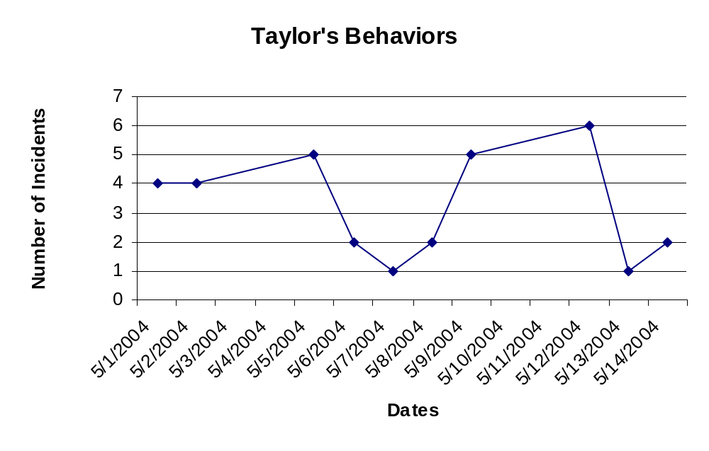
Intervention Phase
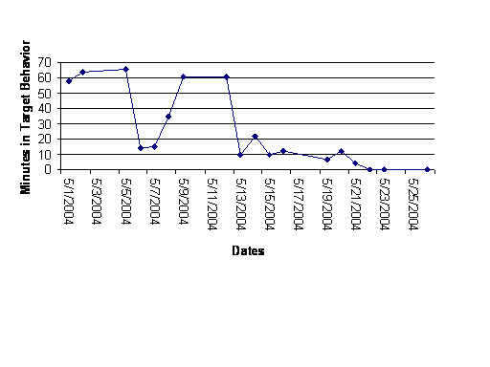
During the intervention phase; which began on May 13, 2003, Billie Bobbie was introduced to the replacement behaviors and schedule changes. The intervention phase lasted for ten days at which time there were three days of zero behaviors for zero minutes. The mean for the intervention phase was six minutes. The range was zero minutes to 12 minutes. The trend appeared to be a downward trend from the immediate introduction of the intervention.
baseline
Intervention

Discussion
The intervention appeared to be successful for Billie Bobbie due to the decrease from baseline which was a decrease from 41 minutes to six minutes. This indicates an 87% decrease in target behaviors. Billie Bobbie appeared to respond very well to the visual class schedule and her responsibilities in turning the schedule for the class. This gave her focus and direction during transition times. The important factor will be consistency and in sharing this intervention with her future teachers. It will be important to follow-up in August since this is the end of the year and Billie Bobbie will be away from school for almost three months.
Functional Analysis for Brandon McKinley

Date of Report: 1/2/2003
Date of Birth: July 9, 1992

General History:
Brandon is currently enrolled in the Behavioral Intervention Program (BIP), which he has attended since November 18, 2002. He had previously been placed in the Little Red Schoolhouse. Brandon has a history of behavioral difficulties that mainly manifest in tantrums. However, he does engage in self-injurious and aggressive behaviors.

Brandon attends respite at Any City Respite and Developmental Services (ACRDS) on Tuesday and Friday after school and occasionally on the weekend.

Background Information:

Brandon was originally diagnosed with autism when he was three-years-old. At the beginning of the 2002-2003 school year, Brandon’s mother hospitalized him due to uncontrollable behaviors. At an IEP meeting, the Behavioral Intervention Program (BIP) was selected to work with Brandon. A teacher and paraprofessional were hired to work two on one with Brandon under the supervision of Dr. Laura Riffel, Behavior Specialist/BIP. These staff will be Brandon’s primary therapists while he is in the BIP. Rather than hospitalizing Brandon again, then sending him back to his home school, the BIP team will assist Brandon to transition to an alternative placement with his trained staff upon completion of his evaluation and training at the BIP center. Once this transition is successful, peers will be integrated into the classroom until he is one of several in his new class at his new school. While with the BIP, his teacher and paraprofessional will be trained in communication systems, positive behavior support methods, and other research validated procedures and practices.

Vineland:

A new Vineland Adaptive Behavior Scale was completed on November 4, 2002. In Communication, Brandon’s raw score yielded a standard score of <20 which is low on receptive, expressive, and written sub-domains.

In Daily Living Skills, Brandon’s raw score yielded a standard score of 22. His sub-domains were low for personal, domestic, and community.

In Socialization, Brandon’s raw score yielded a standard score of 25, with his sub-domains in the low range for interpersonal relationships, play, leisure, and coping skills.

In the Adaptive Behavior Composite, Brandon had a standard score of 22, which puts him in the low level for adaptive skills.

There were no discrepancies between skills found on this particular test.

Medication:

Currently, Brandon takes Ritalin three times per day and Risperdol once per day.

Description of Inappropriate Behavior(s):

Brandon had an intense tantrum that endangered his mother’s ability to maintain control of the car. It occurred while his mother was driving the car and he attacked her. During a tantrum, Brandon has been known to bite himself and others, scratch himself and others, and hit himself and others. Brandon’s tantrums have lasted anywhere from 15 minutes to several hours.

Academic Progress:

Brandon’s academic progress has been sporadic. See Table 1. Although he has made progress in the areas of communication, toileting, and feeding he still requires assistance to complete most activities. It is the goal of this intervention to decrease the number of tantrum behaviors and increase the number of gains in academic achievement and independent living skills for Brandon.

Hypotheses

Physical:
Brandon needs an opportunity to voice his physical wants and needs.
Emotional:
Brandon needs an avenue to voice his emotional wants and needs.
Environmental:
Brandon needs opportunities to control some portion of his environment.
Behavioral:
Brandon needs replacement behaviors for inappropriate ones and guidance to follow what expectations that are held for him.

Analysis for Function of Behavior

Dr. Riffel, Behavior Specialist with the Behavior Intervention Program, conducted the functional analysis by supervising ten, ten-minute sessions of each of Dr. Brian Iwata’s four primary conditions of behavior: 1) social disapproval, 2) academic demand, 3) unstructured play, and 4) alone for functional analysis of behavior. The functional analysis comprised 40 sessions equaling 100 minutes of analog data. Target behaviors were gathered from interviews with mother, observations, and previous staff members. Target behaviors are defined as follows:

- biting self ( teeth in contact with his own arm)
- biting therapist (teeth in contact with any body part of another person)
- scratching self (fingernails in contact, raking skin of self)
- scratching therapist (fingernails in contact, raking skin of another person)
- hitting self (open or closed fist in contact with body part of self)
- hitting therapist (open or closed fist in contact with body part of another person)

The therapists were trained on the four conditions through modeling and written description. Data collection occurred from November 19, 2002 through December 4, 2002. Sessions were staggered to eliminate the possibility that time of day contributed to the outcome of the sessions.

The guidelines for the four conditions are as follows:

To test for Academic Demand:

- Activities: rings on a peg, stacking wooden blocks, placing items in a bucket, putting pieces in a puzzle, threading large plastic beads on a string, grasping and holding small objects, and touching various body parts on command.
- Therapist and student are seated at a table. If student does not remain at the table, present tasks to student wherever he/he is in the assessment room.
- At the 30-second auditory cue, the therapist initially gives verbal instruction and allows the student 5 seconds to initiate a response.
- If after 5 seconds, the student fails to initiate an appropriate response, the therapist repeats the instruction, models the correct response, saying “Do it like this or I’ll have to help you.” And waits 5 seconds.
- If after 5 seconds, the student does not respond, the therapist repeats the instruction and physically guides the student through the response, using the least amount of contact necessary to complete it.
- Therapist presents the next task at the auditory cue.
- Social praise is delivered upon the completion of the response, regardless of whether or not modeling or physical guidance was required.
- Contingent upon the occurrence of a target behavior at any time during the session, the therapist immediately terminates the trial and turns away from the student, for 30 seconds, with an additional 30 second change-over delay for repeated target behavior.
- Therapist ignores auditory cues to present tasks when turned away from student.

Note: The data collection program’s auditory cue is set at 30 second intervals for therapist to present task.

To test Social Disapproval:

- Direct the student to “play with toys” while the therapist “does some work”.
- If the student has lower receptive language or poor hearing, place the student in physical contact with the toys.
- Therapist sits in a chair across the room and reads a book or magazine.
- Attention is given to the student contingent on target behaviors
  - Verbal statements of concern and disapproval (Don’t do that, you’re going to hurt yourself, look at your hand, don’t hit yourself). Paired with;
  - Brief physical contact of a non-punitive nature (hand on shoulder).
- All other responses exhibited by the student were ignored.

To test for Unstructured Play:

- A variety of toys are available within the students’ reach.
- Throughout the session, the therapist maintains close proximity to the student and allows the student to engage in spontaneous isolate or cooperative play or to move freely about the room. The therapist can periodically present toys to the student without making any demands.
- The therapist delivers social praise and brief physical contact contingent upon appropriate behaviors, and absence of target behaviors, at least once every 30 seconds.
- Target behaviors are ignored, until severity reaches the point where the session needs to be terminated.

Note: The data collection program’s auditory cue is set at 30-second intervals for therapist to give verbal/physical praise.

Alone:

- The student is placed in the session room alone, without access to toys or any other materials that might serve as external sources of stimulation.

Graphs of Brandon’s Sessions:

See PowerPoint for graphs of Brandon’s Sessions.

Discussion of Results:
(percent configured on x/10 sessions)

 | Alone | Social Disapproval | Academic Demand | Unstructured Play
Bit self | 0% | 0% | 0% | 0%
Bit therapist | 0% | 0% | 10% | 0%
Scratched self | 0% | 0% | 10% | 20%
Scratched therapist | 0% | 0% | 20% | 10%
Hit self | 0% | 0% | 10% | 0%
Hit therapist | 0% | 0% | 10% | 0%

Amount of Time Engaged in Target Behaviors During Session:

 | Alone | Social Disapproval | Academic Demand | Unstructured Play
Bit self | 0/6000 sec. | 0/6000 sec. | 0/6000 sec. | 0/6000 sec.
Bit therapist | 0/6000 sec. | 0/6000 sec. | 5/6000 sec. | 0/6000 sec.
Scratched self | 0/6000 sec. | 0/6000 sec. | 5/6000 sec. | 3/6000 sec.
Scratched therapist | 0/6000 sec. | 0/6000 sec. | 9/6000 sec. | 45/6000 sec.
Hit self | 0/6000 sec. | 0/6000 sec. | 5/6000 sec. | 0/6000 sec.
Hit therapist | 0/6000 sec. | 0/6000 sec. | 5/6000 sec. | 0/6000 sec.

Percentage of Time Engaged in Target Behaviors During Session:

 | Alone | Social Disapproval | Academic Demand | Unstructured Play
Bit self | 0% | 0% | 0% | 0%
Bit therapist | 0% | 0% | .0008% | 0%
Scratched self | 0% | 0% | .0008% | .0005%
Scratched therapist | 0% | 0% | .0015% | .0075%
Hit self | 0% | 0% | .0008% | 0%
Hit therapist | 0% | 0% | .0008% | 0%

Alone:
To determine if Brandon was receiving sensory stimulation from looking in the two-way mirror during the alone sessions, a session with the mirror covered up was performed, also resulting in no behaviors. The Alone sessions were designed to test evidence that tantrums might be motivated through self-produced reinforcement of a sensory nature.

Social Disapproval:

The Social Disapproval sessions were designed to determine if statements of concern and social disapproval paired with physical contact were maintaining targeted tantrum behavior via the inadvertent delivery of positive reinforcement.

Academic Demand:

99.97 % of the time in the Academic Demand sessions Brandon exhibited no target behaviors. These sessions were designed to assess whether or not tantrums were maintained through negative reinforcement as a result of escaping or avoiding demand situations.

Unstructured Play:

99.98% of the session time, Brandon was engaged in no target behaviors during Unstructured Play. These sessions were designed to be the control procedure for the presence of an experimenter, the availability of potentially stimulating materials, the absence of demands, the delivery of social approval for appropriate behavior, and the lack of approval for tantrums. It was additionally designed to serve the function of an enriched environment in which relatively few tantrums might be expected to occur.

Occurrence of Target Behaviors in Session by Time of Day:

Time of Day | Alone | Social Disapproval | Academic Demand | Unstructured Play
9:15-9:45
9:45-10:05
10:05-10:35 |  |  |  | 1Ss
10:35-10:50
10:50-11:20 |  |  | 1St
11:20-11:45 |  |  |  | 1Ss
11:45-12:15
12:15-12:45
12:45-1:00
1:00-1:30
1:30-1:50
1:50-2:10 |  |  | 1Hs,1Ss,  1Bt,1Ht,1St
2:10-2:30 |  |  |  | 1St
2:30-2:45
2:45-3:00

Key:
St- Scratching therapist
Ss- Scratching self
Ht- Hitting therapist
Hs- Hitting self
Bt- Biting therapist
Bs- Biting self

Looking at the time of day for sessions proved to be inconclusive behaviors only occurred on two days during the same time blocks. Data collected from environmental observations is more conclusive concerning time of day with behavioral incidents.

Summary:

Brandon exhibited the most target behaviors during academic demand. He had two sessions with no behaviors and consistently one or two behaviors during the other sessions. This would indicate that some of Brandon’s behavior serves as a function of escape.

On four sessions of unstructured play, Brandon exhibited no behaviors and the other sessions he exhibited 4 or fewer behaviors. This would indicate that some of Brandon’s behavior does function for attention.

Informal Assessment

Daily logs of Antecedent, Behavior, and Consequence (ABC) for target behaviors were collected. The results are more indicative of daily life and possibly give more insight into the functions of Brandon’s behaviors than the formal sessions. In plotting the time of day that Brandon’s target behaviors occur, the following data are graphed for time of day:
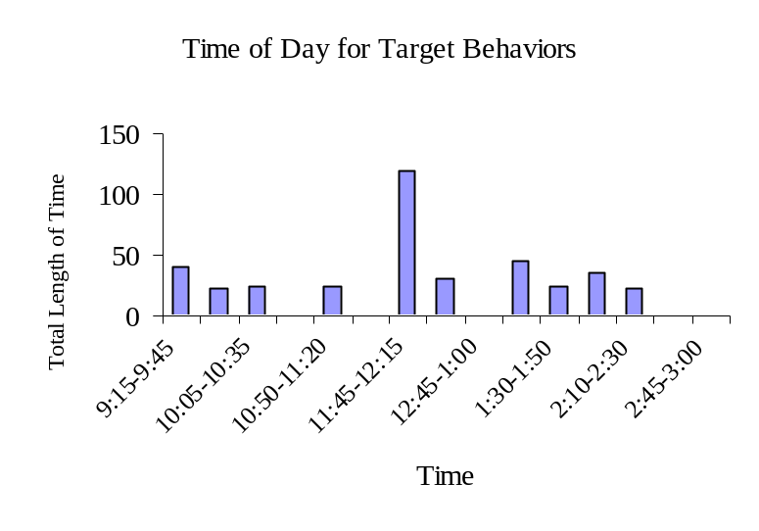
Data were collected from November 18, 2002 through December 17, 2002 for the purposes of this report. Brandon was absent one day during this time frame, which gives him a total time in school of 6,210 minutes.

To break this down in percentages, behaviors occurred:

Time of Day | Activity | Total Minutes | Total Number of Tantrums | Ratio  (in minutes) | Percentage
9:15-9:45 | Arrival/Breakfast | 40 | 2 | 40/540 | 7%
9:45-10:05 | PECS training/oral motor | 23 | 2 | 23/360 | 6%
10:05-10:35 | Intervention/Massage Therapy | 25 | 1 | 25/540 | 5%
10:35-10:50 | Restroom Break | 0 | 0 | 0/270 | 0%
10:50-11:20 | Sensory room | 25 | 2 | 25/540 | 5%
11:20-11:45 | Expressive Arts/Music | 0 | 0 | 0/450 | 0%
11:45-12:15 | Lunch | 120 | 5 | 120/540 | 22%
12:15-12:45 | Video/Social Learning/oral motor | 30 | 1 | 30/540 | 6%
12:45-1:00 | Restroom Break | 0 | 0 | 0/270 | 0%
1:00-1:30 | Intervention/Massage Therapy | 45 | 3 | 45/540 | 8%
1:30-1:50 | Outside Play/Free Play | 25 | 2 | 25/360 | 7%
1:50-2:10 | Music Time/relaxation therapy | 35 | 2 | 35/360 | 10%
2:10-2:30 | PECS training | 22 | 2 | 22/360 | 6%
2:30-2:45 | Snack | 0 | 0 | 0/270 | 0%
2:45-3:00 | Restroom/Clean-up | 0 | 0 | 0/270 | 0%

Discussion of Time of Day:

The highest percentage for target behaviors occurred during the 11:45-12:15 time frame, which coincides with lunch. Delving into a division of what pre-empted the target behaviors during lunch, it was discovered that there were 8 tantrums around food issues in 18 days:

- Tantrums around food issues
  - 4 of these were denial of desired food (example: wanted dessert first)
  - 1 stuffed nose- unable to breathe and eat at the same time
  - 1 time lunch was late due to delays in the kitchen
  - 1 time he was hungry before it was lunch time
  - 1 time he was still hungry after lunch was complete- he was given more food
In summary, the target behaviors that were recorded in this data sample are at similar levels in all activities across the day with the exception of the three restroom breaks, snack, and preparation for home. Antecedents will be discussed in a following section.

Conclusion of Time of Day:

A communication system for Brandon to express and identify his wants and needs should be the first intervention employed to replace target behaviors during meal and snack times.

Day of the Week:

In considering environmental variables, the team evaluated the day of the week in which target behaviors occurred to discern if any patterns developed. A study of available data revealed the following:

Day of the Week | Number of Tantrums per day of week | Number of Total Minutes | Number of Days of the Week Present | Percentage
Monday | 3 | 70 | 5 Mondays = 1725 minutes | 4%
Tuesday | 4 | 73 | 4 Tuesdays= 1380 minutes | 5%
Wednesday | 5 | 52 | 3 Wednesdays = 1035 minutes | 5%
Thursday | 5 | 47 | 3 Thursdays = 1035 minutes | 3%
Friday | 5 | 130 | 3 Fridays= 1035 minutes | 10%

Conclusion of Day of the Week:

With the exception of a Friday tantrum that lasted for one hour and fifteen minutes, all behaviors occurred evenly across this data sample for days of the week. The Friday tantrum is considered an outlier as it was the only one of its kind. Data collection will continue to determine if there is any pattern for this factor.

Antecedents

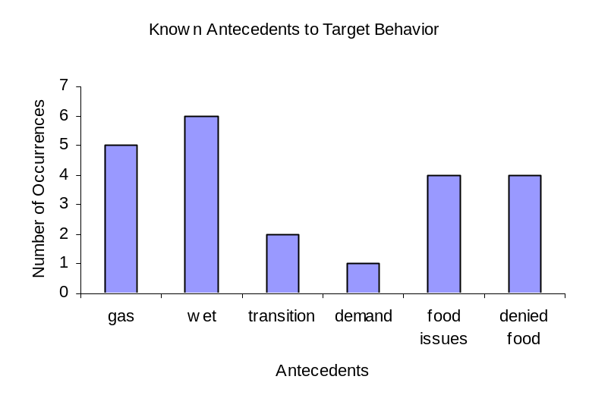

Discussion of Antecedents:

In looking at antecedents for target behaviors, the two highest areas were restroom issues and food issues. Further examination of the restroom issues indicate there is no set pattern for when toileting issues have occurred in this data sample session. There were 6 target behaviors that occurred when Brandon had a wet pull-up. There were 4 target behaviors when he exhibited flatulence at the same time as the target behavior. Staff has observed rigid muscle tension, holding his stomach area, facial distortion, and crying while passing gas, prior to and during exhibition of target behaviors.

Conclusion of Antecedents:

Brandon needs a daily routine for toileting that includes specific communication opportunities, concise expectations, consistent practices, and praise for completion of activities. Data will continue to be collected.

Location

Discussion and Conclusion of Location:

Since Brandon currently spends the majority of his day in the classroom, this data does not substantiate a primary location for the occurrence of target behaviors at this time. Data will continue to be collected.

Observed Behaviors

Brandon exhibited 22 tantrums during an 18-day observation. Several new behaviors were observed during informal observations of tantrum behaviors that were not identified by previous interviews, nor during the formal sessions. Therefore, a new definition of tantrums was established as consisting of three or more of the following behaviors presented at one time:
- biting self
- biting therapist
- scratching self
- scratching therapist
- hitting self
- hitting therapist
- crying
- dropping on the floor
- pacing
- jumping up and down
- clapping in a fast, angry manner

Discussion of Observed Behaviors:

Prior to a tantrum, Brandon sometimes exhibits pouting behavior or begins rocking back and forth; which is not considered a tantrum behavior. Many times a tantrum can be averted when the staff notices this preview behavior and assists Brandon to communicate what is upsetting him. If tantrum behavior subsides for a period of ten minutes then that tantrum is considered over.

Conclusion of Observed Behaviors:

Staff needs to be aware of Brandon’s preview behaviors and attempt to facilitate communication with him for identifying his wants and needs. Assisting Brandon in identifying feelings such as mad, pain, happy, and hungry will help him in his ability to communicate.

Consequences

More than one consequence can occur for each target behavior, for instance Brandon could be talked to calmly and the therapists could block aggressive attempts. Therefore the numbers of consequences total more than the 22 tantrums reported.

Discussion and Conclusion of Consequences:

It is imperative that anyone who works with Brandon not take any attempts at aggression personally. It is very important that all tantrums are dealt with in the same manner. Voices should always remain calm and low, attempts to bite; scratch, kick, or hit should be blocked using validated methods that minimize any chance of anyone getting hurt. Staff uses Systematic Handling Techniques when physical intervention is required.

Informal Assessment Summary

Discussion:

It is more important for the team to develop at least one valid intervention for each function of the behavior, rather than for each target behavior. Once the target behavior is changed through intervention, the behavioral goals of a behavior intervention plan will be achieved without symptom substitution as is frequently seen in interventions that are exclusively behavioral. The goals are merely for measuring the effectiveness of an intervention on a function. It is the function of the behavior, not its structure that leads to intervention selection.

The behavior support plan will be based on this functional analysis, consistent with the fundamental principles of behavior and fit the context of Brandon’s life. If only the proximal escape or acquisition functions of behavior are examined errors could be made in not identifying the function of the behavior. The ultimate goal of the functional analysis is to determine why the child behaves the way they do. Care needs to be taken not to replace Brandon’s current behaviors with counter-control situations that will develop in later stages of development as Brandon learns how to manipulate his environment using the skills taught to him, if only escape and acquisition are considered in the realm of behavior modification.

For this reason, a multimodal functional behavior assessment will continue that identifies the functions of Brandon’s behavior. Escape and acquisition are intermediary descriptions of behavior in terms of assessment or intervention. Emotional functions of his behavior must be considered. Why does Brandon need to escape or acquire items? The interventions for these issues require more than collecting data. Brandon’s deficits need to be addressed including skill and performance deficit information.

In most cases there is more than one cause of behavioral problems. After working with Brandon, this team has come to the conclusion that Brandon has four variables feeding his problem behavior: 1) inability to communicate his wants and needs, 2) chronic sinus infections, 3) few successes in his environment, and 4) frustration with knowing more than he is capable of reporting. Regardless of the misbehavior that Brandon presents, there are different causes for the same type of behavior. Using the causes of the behavior and the topographical information gained in the functional analysis a plan can be designed to shape his behavior through appropriate interventions and monitoring.

Recommended IEP Objectives:

The IEP goals and objectives will be developed during the upcoming IEP meeting based on the discussions contributed by all team members. The following topics will be included in those discussions as well as others generated by the team.
- Oral stimulation
- Feeding
- Sensory diet
- Recreational therapy
- Expressive therapy
- Sensory room
- Self-help skills
- Academic skills
- Computer skills

Current Accomplishments:

Brandon has the same music therapist as he did at his previous school. He noted that he is showing improvement. He stated that he is much more attentive, focused, and verbal than previously.

Teachers who worked with Brandon at summer school have commented on his change in demeanor. They have noticed his response to demands, his calm appearance, and his general happiness.

Brandon has the same speech therapist as he did at his previous school. He is very happy with the progress that Brandon is making with oral therapy, verbalizations, and attentiveness during therapy sessions. Brandon is attempting to imitate vocalizations, sounds, and gestures. He can blow on his food by pursing his lips, he can cluck his tongue, and is attempting to use some sign language along with his PECS system.

Brandon has the same occupational therapist as he did at his previous school. He is very happy with the progress that Brandon is making with feeding (using a piercing method with his fork and holding his dish with his other hand). Brandon is also making much progress in self-help skills in toileting.

Team Based Decisions

The behavior intervention plan (BIP) was determined through a team-based decision using the data derived above. The beanbag procedure and multi-element behavior intervention plan follow:

Figure 1: Bean Bag Chair Procedure

- When Brandon begins to show signs of beginning a tantrum instruct Brandon to go to his beanbag chair to calm down.
- Use a calm voice
- Show him the PECS picture of a mad person
- Identify that Brandon is feeling mad
- Praise Brandon for sitting in his bean bag to calm down when he is mad
- Keep pointing out that he is mad and that he is calming down in his bean bag
- If Brandon gets up from the bean bag before he has calmed down he will be asked to sit back down until he is calm
- If Brandon does not sit back down give him a touch cue (hand on shoulder) to remind him to sit down
- Keep praising Brandon for calming down while sitting on his beanbag chair.

- Brandon can use his beanbag chair anytime during the day or night. It is not meant to be a punishment, but rather a comfortable place to sit and think.

- Anytime Brandon goes to the bean bag when he appears to be upset about the loss of a privilege, item, or food he should be praised for choosing to go there on his own to calm down.

- When it appears that Brandon has calmed down, tell him in a calm voice that he can come back to the previous area when he feels like he’s ready.

In the event that Brandon still has aggressive behavior from the beanbag chair:

- Block Brandon’s aggressive behavior from himself or others but keep him in the bean bag
- Keep talking to Brandon in a calm voice
- Identify to Brandon that he is mad. If someone else is near, have them show Brandon the picture of the mad person from the PECS system
- As soon as Brandon’s body relaxes, tell him you are going to move away and that he needs to stay in his bean bag until he is calm
- Be sure to praise him for relaxing his body and for staying in his bean bag to calm down
- When Brandon is completely calm and has come back to the previous area compliment him for calming down by sitting in his bean bag chair (no matter how long it took him to calm down)

Behavior Intervention Plan:

The intervention plan for Brandon was based on a Functional Analysis and a Functional Assessment of his targeted behaviors. In order to reduce problem behaviors the team must discern the reason for the behaviors. Based on the findings of the functional behavior analysis the following multi-element plan has been developed. The team will discuss this plan and add to it at the IEP meeting. The results of the formal and informal analyses are discussed in a later section.

Element One: Calming Abilities (Alternative Behavior and Crisis Management)

It is this examiner’s opinion that Brandon’s cognitive functioning is higher than his expressive functioning. When he becomes frustrated he is even less likely to be able to communicate his wants and needs. First we need to give Brandon a way to calm down before his behavior escalates into a tantrum.
By providing Brandon with a calming exercise we are able to help him use his cognitive abilities to communicate his wants and needs with us.

The team has designed a method for calming Brandon during the beginning stages of a tantrum. Brandon is prompted to sit in his beanbag chair (a safe environment). See beanbag directions (figure 1). By giving Brandon the ability to calm down the team is able to help Brandon with the second element of his behavior plan.

Beginning trials for this calming activity indicate that this is localizing his behavior to the area of the bean bag rather than jumping and pacing, which have been observed to escalate his behavior. When placed in the beanbag, Brandon rocks which seems to be a self-calming activity. If Brandon attempts to move from the beanbag he can be easily redirected to return.

Element Two: Communication (Antecedent Modification and Alternative Behavior)

While Brandon has shown signs of communicating verbally, it is still not at a functional level nor consistent for him. While building on his current vocalizations, the team will pair an alternative communication system. The team has adopted the Picture Exchange Communication System (PECS) to use with Brandon. See figure 2 for further explanation of the PECS system. Once Brandon is calm, he will be able to use the PECS system to communicate his wants and needs more effectively to the staff and his family.

Outside of the training sessions, Brandon has begun to retrieve pictures that are posted on the wall to indicate his wants and needs to staff such as juice, restroom, and crackers. He also has demonstrated an understanding of needing to trade something to obtain the desired item. He tried to trade a washcloth for some Oreo cookies on two occasions, which indicates he is beginning to understand the reciprocal nature of communication. Brandon is currently in phase two of the PECS training.
Element Three: Labeling (Consequence)

Brandon exhibits many positive behaviors. In a typical classroom setting there may not be time or staff to observe correct behavior in order to give him feedback on a consistent basis. In Brandon’s current setting, the team is able to consistently label those behaviors that Brandon exhibits correctly; such as, walking down the hallway calmly, sitting up straight, looking at an adult who is speaking. These behavior labels will help Brandon connect what is expected of him with the verbalized descriptors. This also gives him reinforcing attention in a most socially acceptable manner.

Element Four: Visual Schedule (Antecedent Modification)

Brandon has demonstrated an understanding of the computerized visuals for PECS therefore, using these same visuals to represent Brandon’s daily schedule will offer him increased predictability and decreased anxiety about what is occurring in his environment. These pictures will be substituted with actual photographs as he learns to understand the function of the visual schedule.

Element Five: PowerPoint Relationship narrative (Antecedent Modification)

Brandon will be presented with relationship narratives using digital pictures, technology, sounds, and high rate repetition in order for him to learn changes in routine, skill steps, and social expectations with adults and peers. This program can be modified quickly should the need arise.

Element Six: Palm Pilot with Visual Assistant Program (Antecedent Modification)

Brandon will use a Palm Pilot loaded with the Visual Assistant Program from AbleLink Technologies (Denver, Colorado) to learn tasks performed in a sequence. This unit enables the programmer to load actual visual and auditory prompts in a sequence for the user. The user can direct the pace with which they attempt the task, listen to directions repeatedly, and view a picture of the completed task. This will enable Brandon to self-monitor his progress and assist him in being independent at a given task.

Element Seven: Home Training

- Dr. Mary Pooler is the behavior specialist providing home training. She has visited Brandon at the BIP Center and met with Brandon’s mother and the BIP team. She has participated in the interventions and activities designed for home use. Dr. Pooler will be meeting with Brandon’s mother on January 8th in the home.
- An identical beanbag chair has been provided for home use to assist with calming activities. First reports from Mrs. McKinley indicate that this has been useful in dissipating the escalation of most tantrums.
- A PECS training video, and a PECS notebook with laminated and Velcro pictures were given to Mrs. McKinley along with a short training and observation so that she can begin to use PECS at home.
- Brandon’s mother was given a CD of Brandon’s favorite music that he likes to listen to when he’s calming down and having music therapy.
- It was suggested at the joint meeting with BIP staff and Dr. Mary Pooler that Brandon’s mother use the McDonald’s or Burger King play land as a sensory area for Brandon especially during winter vacation. It is very similar to the sensory room.
- Dr. Pooler is going to assist Mrs. McKinley to set up the visual schedule for home. The BIP team sent home a nylon pocket chart for Mrs. McKinley to use. Dr. Pooler will take pictures and help Mrs. McKinley get the chart set up.
- Dr. Riffel will create PowerPoint relationship narratives for home using the pictures provided by Dr. Pooler’s visit. She will train Mrs. McKinley how to change the sequence and pictures then provide her with a PowerPoint program for her home computer.
- Mrs. McKinley is collecting data in the home and community environments on Brandon’s tantrum behavior. Dr. Riffel will use this information to work with Dr. Pooler on the success and adaptability of home interventions.

Resources
Information gathered for this workbook was obtained from a wide range of sources over the years. The following bibliography represents a sampling of articles that have contributed to the compilation of this work: (These titles are not in APA format)

Anderson, C.M. (2000, Spring). Positive Support: Expanding the Application of Applied Behavior Analysis. The Behavior Analyst.
Artesani, J., & Mallar, L. (1998). Positive Behavior Supports in General Education Settings: Combining Person-Centered Planning and Functional Analysis [Electronic version]. Intervention in School and Clinic, 34 (1).
Asmus, J. M., Vollmer, T. R., & Borrero, J. C (2002). Functional behavioral assessment: A school based model. Education and Treatment of Children,25, (1), 67-90.
Brooks, A., et al. (2003) Use of functional assessment and a self-management system to increase academic engagement and work completion. Journal of Positive Behavior Interventions, Summer 2003 v5 i3 p144(9) .
Conroy, M., & Davis, C. (2000, Summer). Early Elementary Ages Children with Challenging Behaviors: Legal and Educational Issues Related to IDEA and Assessment [Electronic version]. Preventing School Failure, 44 (4).
Crone, D., & Horner, R. (1999-2000). Contextual, Conceptual and Empirical Foundations of Functional Behavioral Assessment in Schools. Exceptionality, 8 (3).
Cunningham, E., & O'Neill, R.E. (2000, December). Comparison of Results of Functional Assessment and Analysis Methods with Young Children with Autism [Electronic version]. Education and Training in Mental Retardation and Developmental Disabilities, 35 (4), 406-414.
Dunlap, G. (1996). The Effects of Multi-Component, Assessment Based Curricular Modifications on the Classroom Behavior of Children with Emotional and Behavioral Disorders. Journal of Behavioral Education, 6 (4).
Dunlap, G., Vaughn, B. & O'Neill (1998). Comprehensive Behavioral Support: Application and Intervention. Wetherby, A., Warren S. & Reichle, J. (eds.). Transitions in Prelinguistic Communication. Baltimore, Paul H. Brookes Publishing Group.
Dunlap, G. etal (1995). Modifying Activities To Produce Functional Outcomes .JASH, Vol 20, No.4: 248-258 .
Ellingson, S. (2000). Functional Assessment and Intervention for Challenging Behaviors in the Classroom by General Classroom Teachers. Journal of Positive Behavior Intervention, 2 (2).
Ferro, J., Foster-Johnson, L., & Dunlap, G. (1996). Relation Between Curricular Activities and Problem Behaviors of Students with Mental Retardation [Electronic version]. American Journal on Mental Retardation, 101 (2).
Gable, R. A. & et al. (2001) Maintaining the Integrity of FBA-based Interventions in Schools, in Education and Treatment of Children, 24(3), pp. 248-260. (2).
Gresham, F., Watson, S., & Skinner, C. (2001). Functional Behavioral Assessment: Principles, Procedures and Future Directions [Electronic version]. School Psychology Review, 30 (2).
Gunter, P. (1994, November). A Case Study of the Effects of Altering Instructional Interactions on the Disruptive Behavior of a Child Identified with Severe Behavior Disorders. Education and Treatment of Children, 17 (3).
Harrower, J., Fox, L., Dunlap, G. & Kincaid, D. (1999-2000). Functional Assessment and Comprehensive Early Intervention. Exceptionality, 8 (3).
Hastings, R., & Brown, T. (2000). Functional Assessment and Challenging Behaviors [Electronic version]. JASH, 25 (4).
Hendrickson, J., & Gable, R. (1999). Behavioral Problems in Schools: Ways to Encourage Functional Behavior Assessment [Electronic version]. Education & Treatment of Children, 22 (3).
Horner, R., & Carr, E. (1997). Behavioral Support for Students with Severe Disabilities: Functional Assessment and Comprehensive Intervention [Electronic version]. The Journal of Special Education, 31 (1).
Horner, R., Day, M., & Day, J. (1997). Using Neutralizing Routines to Reduce Problem Behaviors [Electronic version]. Journal of Applied Behavior Analysis, 30.
Horner, R., Sugai, G., Todd, A., & Lewis-Palmer, T. (1999-2000). Elements of Behavior Support Plans: A Technical Brief. Exceptionality, 8 (3).
Horner, R. (1990). The Role of Response Efficiency in the Reduction of Problem Behaviors Through Functional Equivalence Training: A Case Study. JASH, 15 (2).
Iwata, B. (2000, Summer). Skill Acquisition in the Implementation of Functional Analysis Methodology [Electronic version]. Journal of Applied Behavior Analysis, 2.
Johnston, S.S., & O'Neill, R.E. (2001, Winter). Searching for Effectiveness and Efficiency in Conducting Functional Assessments: A review and Proposed Process for Teachers and Other Practitioners [Electronic version]. Focus on Autism and Other Developmental Disabilities, 16 (4), 205-214.
Jolivette, K., Barton, S., & Terrance, S. (2000). Functional Behavioral Assessment as a Collaborative Process Among Professionals [Electronic version]. Education and Treatment of Children, 23 (3).
Kennedy, C. (2001, Fall). Facilitating General Education Participation for Students with Behavior Problems by Linking Positive Behavior Supports and Person-Centered Planning [Electronic version]. Journal of Emotional and Behavioral Disorders.
Kern, L., & Vorndran, C. (2000). Functional Assessment and Intervention for Transition Difficulties [Electronic version]. JASH, 25 (4).
Knoster, T. (2000). Practical Application of Functional Behavioral Assessment in Schools [Electronic version]. JASH, 25 (4).
Meyer, K. (1999). Functional Analysis and Treatment of Problem Behavior Exhibited by Elementary School Children [Electronic version]. Journal of Applied Behavior Analysis, 32.
O’Neill, R., Horner, R., O’Brien, M., & Huckstep, S. (1991). Generalized Reduction of Difficult Behaviors: Analysis and Intervention in a Competing Behaviors Framework. Journal of Developmental and Physical Disabilities, 3 (1).
O'Neill, R.E. & Johnson, J.W. (2000). A brief description of functional assessment procedures reported in JASH (1983-1999). The Journal of the Association for Persons with Severe Handicaps, 25 (4).
Reid, D. (2000). Enhancing the Applied Utility of Functional Assessment [Electronic version]. JASH, 25 (4).
Reed, H., Thomas, E., Sprague, J., & Horner, R. (1997). The Student Guided Functional Assessment Interview: An Analysis of Student and Teacher Agreement. Journal of Behavioral Education, 7 (1).
Scott, T. & Eber, L. (2003) Functional assessment and wraparound as systemic school processes: primary, secondary, and tertiary systems examples. Journal of Positive Behavior Interventions, Summer 2003 v5 i3 p131(13) .
Scott, T., & Nelson, C.M. (1999, May). Functional Behavioral Assessment: Implications for Training and Staff Development. Behavioral Disorders, 24 (3).
Scott, T.M., Nelson, C. M., & Zabala, J. (2003). Functional behavior assessment training in public schools: Facilitating systemic change. Journal of Positive Behavior Interventions, 5 (4), 216-225.
Schill, M., Kratochwill, T., & Elliot, S. (1998). Functional Assessment in Behavioral Consultation: A Treatment Utility Study.. School Psychology Quarterly, 13 (2)
Steege, M., & Northup, J. (1998). Functional Analysis of Problem Behavior: A Practical Approach for School Psychologists. Proven Practice, 1 (1).
Sugai, G., Horner, R.H., Dunlap, G., Hieneman, M., Lewis, T.J., et al. (2000). Applying positive behavioral supports and functional behavioral assessment in schools. Journal of Positive Behavior Intervention, 2 (3).
Sugai, G., Horner, R. H., & Sprague, J. (1999). Functional assessment-based behavior support planning: Research-to-practice-to-research. Behavioral Disorders, 24, 223-227.
Scout, J., & Carr, E. (1992, July). Severe Problem Behaviors Related to Social Interaction. Behavior Modification, 16 (3).
Turnbull, H.R. (1999). Two case studies of functional assessment and functional support: IDEA compliance and capacity-building issues. In Repp, A. & Horner, R. H. (eds.). Functional analysis of problem behavior: From effective assessment to effective support. Belmont, CA. Wadsworth .
Turnbull, H.R. & Wilcox, B. (1999). Developing positive behavioral support for students with challenging behaviors. In Sugai, G. & Lewis, T. J. (eds.). Reston, VA: Council for Exceptional Children IDEA 97 and FBA/PBIS: Policy and implementation guidelines.

Vaughn, B., & Horner, R. (1997). Identifying Instructional Tasks that Occasion Problem Behaviors and Assessing the Effects of Students Versus Teacher Choice Among These Tasks [Electronic version]. Journal of Applied Behavior Analysis, 30.

