SCOPE OF THE CONFERENCE

The Quantitative InfraRed Thermography (QIRT) conferences constitute a forum for discussing the latest developments of the instrumentation, protocols and analysis, which involve infrared thermography, helping to disseminate the latest results in the field throughout the industrial and research world. After the international conferences held in Paris (QIRT'92), Sorrento (QIRT’94), Stuttgart (QIRT’96), Lodz (QIRT'98), Reims (QIRT'00), the sixth (QIRT’02) will take place in Dubrovnik (Croatia), with the emphasis on the following topics:
⇨ Calibration and characterisation of infrared cameras
⇨ State of the art and evolution in the field of infrared imaging systems allowing quantitative measurements and related storing systems.
⇨ Related problems like emissivity determination, absorption in media, spurious radiation, three dimensionality of observed objects, moving targets...
⇨ Thermal effects induced e.g. by electromagnetic and acoustic fields or mechanical loading, thermal wave methods; experiments and modelling.
⇨ Applications of infrared thermography for radiometry, thermometry and thermal parameter identification in all fields: fluid mechanics material science, non-destructive testing of structures and materials, medical and biomedical sciences, remote sensing, environment, industrial process,...
⇨ Predictive maintenance applications, inspection of buildings and structures, fire protection, humanitarian demining.

PRE-CONFERENCE COURSES

Proceeding the conference, four courses are organised: A- Basic Thermography, B- Array Detector Systems, C- Application to Fluids, D- Application to Solids. Each course comprises 4 hours of lectures. The courses A and B are scheduled simultaneously in the morning and the courses C and D in the afternoon. The tuition is 150 EUR per course including tutorial and lunch. Attendants at two courses pay 250 EUR.

REGISTRATION

The registration fee covering participation in the conference, coffee, lunch, banquet, supply of abstracts and proceedings is 400 EUR for an early payment (received before July 30th, 2002) and 450 EUR thereafter.

ACCOUNTS FOR PAYMENT

Zagrebacka Banka Savska 66, 10000 Zagreb, Cro
Bank account: 2360000-1000000013
SWIFT ZABA HR 2X 2500-3276546
Purpose of payment: Conference fee for QIRT’02.

If paid in Croatia
Zagrebacka Banka Savska 66, 10000 Zagreb, Cro
Bank account: 2360000-1101346933
Purpose of payment: Conference fee for QIRT’02.

Credit card payment
Download the credit card authorisation form from www.fsb.hr/Qirt2002/fees.htm

PRACTICAL INFORMATION
Conference language
All papers must be written and presented in English, which is the official language of the conference.

Publications
A book of abstracts of all accepted conference papers will be distributed with the conference material. Selected and received conference papers will be published in the proceedings and on a CD after the conference. Coloured plates will be included.

Exhibition
An exhibition of thermographic equipment will be held during the QIRT 2002 Conference.
All conference attendants are invited to compete in “The best thermogram contest”. The submitted thermograms will be exhibited in the poster room. All kinds of thermograms are welcome. They have to be consigned in an envelope with the author’s name (or pseudonym) to the reception desk until 6:00 PM, September 25th. The best thermograms will be awarded.
Venue
The conference will be held at COLLEGIUM RAGUSINUM, (address: C. Carica 4, Dubrovnik), 10 minutes by bus number 6 from the centre of Dubrovnik.
The town of Dubrovnik is easy to access by plane (Dubrovnik international airport is 18 km from the town centre), by car (2hr 30min from Split), liner or ferry (7hrs from Split or Bari).
There is local transport from Dubrovnik airport to the town after each flight (single fare: 3-4 EUR) www.airport-dubrovnik.hr. Taxi service offers door-to-door connections from Dubrovnik airport to your hotel (∼30 EUR). Detailed information may be obtained from the conference web site.

Accommodation
Dubrovnik is a well-known tourist centre with numerous hotels (from 30 to 200 EUR) available in the city. Less expensive rooms are also available (from 18 EUR) close to the city centre.

Social program
Dubrovnik was designated a part of the World Heritage by UNESCO for its unique architecture and historical monuments. During the season (May/October) many events take place in the town and its surroundings.
More information about Dubrovnik on the QIRT web site.

Hotels offering reduced rate to QIRT participants:

EXCELSIOR*****  Put F.Supila 12  Tel: +385 20 414-215,  353-353, 353-453  Fax: +385 20 414-214  E-mail:  hotel-excelsior@du.tel.hr | PARK***  Šet.Kralja Zvonimira 39  Tel: +385 20 436-800  Fax: +385 20 437-433  E-mail: hotel-park@du.tel.hr
LERO***  Iva Vojnovića 14  Tel: +385 20 332-022,  332-122  Fax: +385 20 –2-123  E-mail: hotel-lero@du.tel.hr | VIS**  Masarykov put 4  Tel: +385 20 437-303  Fax: +385 20 437-403  E-mail:  hoteli-maestral@du.tel.hr
ADRIATIC**  Masarykov put 7  Tel: +385 20 437-302  Fax: +385 20 437-402  E-mail:  hoteli-maestral@du.tel.hr | Low cost accommodation:  Private accomodation  Atlas DMC  Tel: +385 1 6327-333  Fax: +385 1 6111-696  E-mail: nina.dumancic@atlas.hr

CORRESPONDENCE

E-mail: qirt2002@fsb.hr
Web site: http: //www.fsb.hr/Qirt2002
or return the attached form to the conference secretary:
QIRT 2002 Igor Šundov
Faculty of Mechanical Engineering and Naval Architecture,
I. Lucica 5, 10000 Zagreb, Croatia
Phone: ++385 1 616 8174; Fax: ++385 1 615 6940

-----------------------------------------------------------------
QIRT 2002

Name:

Affiliation:

Address:

City and postal code:

Country:

Phone:

Fax:

E-mail:

I intend to participate in QIRT 2002.
I intend to present a paper at QIRT 2002.
I wish detailed information on pre-conference courses

INFORMATION FOR AUTHORS

Full-length papers (maximum 6 pages) may be submitted for publication in the Conference Proceedings. The contributions should be sent by September 25th at the latest (preferably by September 1st) to the Conference Secretary exclusively as an attached file to our e-mail: qirt2002@fsb.hr or a 3" ¼ diskette. Please use .doc or .rtf format.
For detailed instructions please consult our web site.

SCIENTIFIC COMMITTEE
Chairmen
D. Balageas, ONERA, France
G. Busse, IKP, Universität Stuttgart, Germany
G. M. Carlomagno, Università di Napoli, Italy
Members
D.P. Almond, University of Bath, United Kingdom
J.-M. Buchlin, Institut von Karman, Belgium
X. Maldague, Université Laval, Canada
J. Rantala, Nokia Research Center, Finland
S. Švaić, FSB,University of Zagreb, Croatia
V. P. Vavilov, Tomsk Polytechnic University, Russia
B. Wiecek, Technical University of Lodz, Poland

LOCAL ORGANIZING COMMITTEE
Local Chairman
S. Švaić, FSB, University of Zagreb
Secretary
I. Šundov, FSB, University of Zagreb
Members
M. Andrassy, FSB, University of Zagreb
V. Damić, Collegium Ragusinum, Dubrovnik
D. Franković, Technical Faculty, Rijeka
M. Franz, FSB, University of Zagreb
M. Milković, Collegium Ragusinum, Dubrovnik

FINAL ANNOUNCEMENT
AND PRELIMINARY TECHNICAL PROGRAM

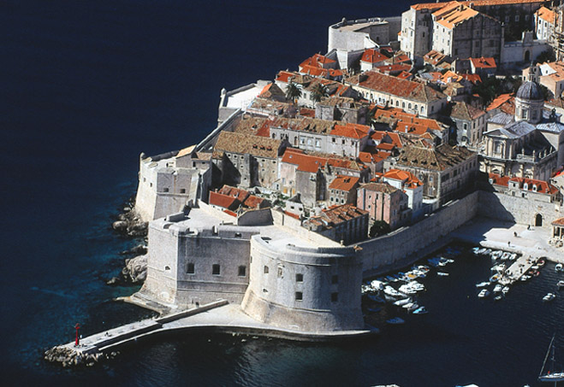

6th International Conference on
quantitative infrared thermography

QIRT 2002

COLLEGIUM RAGUSINUM
(The Politechnic of Dubrovnik) Dubrovnik, Croatia

September 24-27, 2002

Organized by:
University of Zagreb
Faculty of Mechanical Engineering and Naval Architecture, Croatia
in co-operation with
Croatian Ministry of Science and Technology
http: //www.fsb.hr/Qirt2002
TECHNICAL PROGRAM

Conference

The preliminary technical program of the conference is available on the Conference Web site, including the schedule and content of the sessions and the collection of the abstracts. The program counts about 80 regular papers distributed in 14 oral parallel sessions and one plenary poster session. Three invited keynote lectures precede the Three Plenary sessions. A round table is also programmed.

CONFERENCE SCHEDULE
Tuesday, September 24
Pre-conference courses
Wednesday, September 25

Technical Exibition

PS.1-Welcome-Keynote Lecture
OS.1 NDE I | OS.2 Fluids I
OS.3 Modeling I | OS.4 Fluids II
OS.5 Methods I | OS.4 Fluids III
Thursday, September 26
PS.2 Keynote Lecture
OS.7 BioMedicial Appl. | OS.8 Industrial Appl.
PS.3 Poster Session
PS 4 Round Table
Friday, September 27
PS.5 Keynote Lecture
OS.9 NDE II | OS.10 Modeling II
OS.11 Methods II | OS.12 Fluids IV
OS.13 Methods III | OS.14 BioMedical Appl.
PS.6 Closing Session

P.S – Plenary session
O.S: - Oral parallel session

