fINANCIAL INCLUSION
The word Financial Inclusion could be described as being the opposite of financial exclusion. However, financial inclusion is more of a process rather than a phenomenon.
It is a process by which financial services are made accessible to all sections of the population. It is a conscious attempt to bring the un-banked people into banking.
“The process of ensuring access to financial services and timely and adequate credit where needed by vulnerable groups such as weaker sections and low income groups at an affordable cost”
(The Committee on Financial Inclusion (Chairman: Dr. C. Rangarajan, 2008))
Financial Inclusion does not merely mean access to credit for the poor, but also other financial services such as Insurance. Financial Inclusion allows the state to have an easier access to its citizens, with an inclusive population, for e.g.: the government could reduce the transaction cost of payments like pensions, or unemployment benefits.
It could prove to be a boon in a situation like a natural disaster, a financially included population means the government will have much less headaches in ensuring that all the people get the benefits. It allows for more transparency leading to curtailing corruption and bureaucratic barriers in reaching out to the poor and weaker sections. An intelligent banking population could go a long way by effectively securing themselves a safer future.
The objective of Financial Inclusion
- The access to various mainstream financial services e.g. saving bank account, credit, insurance, payments and remittance and financial and credit advisory services.
- The main objective is to provide the benefit of vast formal financial market,& protect them from exploitation of informal credit market, so that they can be brought into the mainstream

WHAT IS CONSIDERED AS MAINSTREAM FINANCIAL SERVICES NECESSARY FOR FINANCIAL INCLUSION OF HOUSEHOLD?
- Basic saving bank account- an account with all basic feature of saving account.
- Payment and remittances services –
- Immediate credit – in case of contingencies like accidents, medical treatment etc, they should be provided immediate credit.
- Entrepreneurial credit – this means, to run/expand small scale business/shop or any economic activity, easy credit should be provided, so that financial dependence can be created amongst households.
- Housing finance- funding for purchasing new residential or reconstruction
- Insurance – life\healthcare- to plan future better
- Financial education\credit counselling centres – to guide them which product suits them better, where to go credit needs, what are various services available to better their personal financial planning.

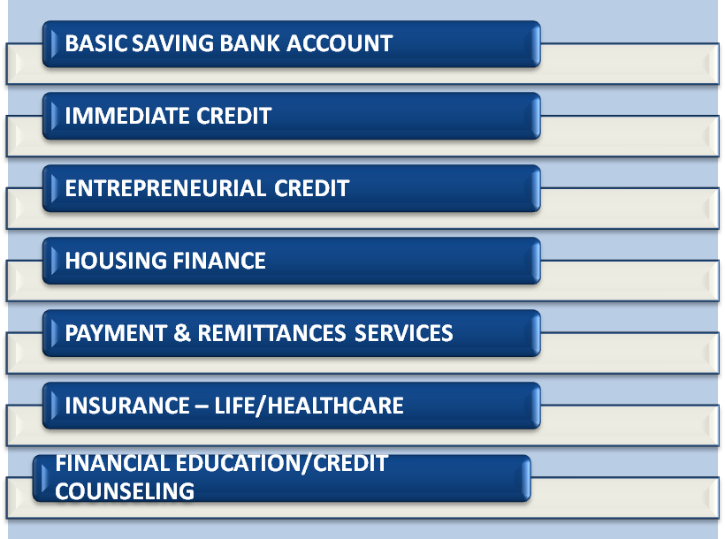
Mainstream Financial Services
Financial Inclusion therefore, is delivery of not only banking, but also other financial services like insurance, pension, remittance, mutual funds, etc. delivered at affordable, though market driven costs. Opening a no-frills account is just a beginning to a continuous process of providing banking and financial services.

Once the first step of safety of savings is achieved, the poor require access to schemes and products which allow their savings to grow at rates which provide them growth beyond mere inflation protection.

To understand it better, let’s take life of migrant street vender living in almost every part of Delhi, and his financial life will look like this-->

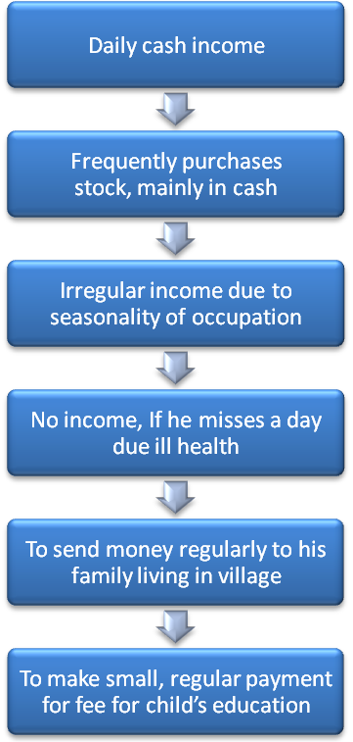
WHAT TYPE OF PRODUCT OR SERVICES IS REQUIRED FOR THIS TYPE OF CUSTOMER??

POSSIBLY
- A bank account, where he/she can save small amounts at regular intervals ideally with savings being collected at their place of work or a specified point of transaction (SPOT) in the locality
- Micro-Credit for working capital to increase stock and business. This credit can be short term and repayment to be configured at regular intervals. Savings history and credibility checks to be used as a proxy for collateral.
- Insurance for life
- Health Insurance for minor illnesses and hospitalization
- Investment plan for child's education
- Pension for old age
So the financial inclusion is a broader term which is not limited to providing a basic bank account but also enabling them to have other necessary financial services, in the table below the broader definition of Financial Inclusion based on different aspect which can be country specific, region specific, or population to included etc.

Working or operational definitions of financial exclusion generally focus on ownership or access to particular financial products and services. The focus narrows down mainly to the products and services provided by the mainstream financial service providers (Meadows et al., 2004). Such financial products may include money transmission, home insurance, short and long-term credit and savings. Furthermore, the operational definitions have also evolved from the underlying public policy concerns that many people, particularly those living on low income, cannot access mainstream financial products such as bank accounts and low cost loans, which, in turn, imposes real costs on them - often the most vulnerable people

More importantly, Financial Inclusion is imperative for creating an inclusive economy at all fronts. This attains special importance at this stage of rising food and oil prices, without an inclusive economy the country’s development will suffer. In the recently concluded G8 meeting in Hokkaido, Japan, the World Bank chief Robert Zoellick reiterated the importance of creating an inclusive economy in an increasingly globalized World.
CAUSES OF FINANCIAL EXCLUSION

Financial Exclusion may also have resulted from a variety of structural factors such as unavailability of products suiting their requirements, stringent documentation and collateral requirements and increased competition in financial services. The Causes of financial exclusion can be identify broadly in two categories, first the demand side and the second supply side.

DEMAND SIDE BARRIERS
The people who have the requirement\need but still not demanding\availing the financial services\products which can be due to the following reasons:

Low Income: A higher share of population below the poverty line results in lower demand for financial services as the poor may not have savings to place as deposit in savings banks; hence the market lacks incentives in providing financial service/products.
Most the people belonging to financially excluded group are having irregular/seasonal income. Hence opening of a bank account and operating it i.e. deposit and withdrawal in very small denominations with high frequency will increase the cost of transaction, adding to that they also anticipate that bank will refuse if they transact with so small amount.
Further provided that, as they have low earning they cannot maintain minimum balance requirements of a normal saving bank account which ranges from Rs. 500 to Rs 5000(Rs. 500 in case of PSB and Rs. 5000 for Pvt. Sector Banks) and various annual maintenance charges(AMC) levied by banks.
- Transaction cost: Vast number of rural population resides in small villages which are often located in remote areas devoid of financial services. Consequently, the overall transaction cost to the customer in terms of both time and money proves to be a major deterrent for visiting financial institutions. The excluded section of the society find informal sector more reachable due to proximity and ease of transaction.

- Financial Services Being Very Complex In Nature: excluded sections of the society find dealing with organized financial sector cumbersome.

Easy access to alternative credit: For a good amount of low income people, the alternative credit provided by the money lenders and pawn shop owners are far more attractive and hassle free compared to getting a loan from a commercial bank.
Some of the poor that do not have property find it impossible to get credit without the collateral. The uneducated poor would rather put their trust in moneylenders who provide easy non-collateral credit than on the well established commercial banks. There might also be cultural reasons for trusting a moneylender rather than a bank.
Distance from bank branch, branch timings, cumbersome documentation/procedures, unsuitable products, language, staff attitude are common reasons – Higher transaction cost

Low literacy level: The lack of financial awareness about the benefits of the banking and also illiteracy act as stumbling blocks to financial inclusion. The lack of financial awareness maybe the single most risk in financial inclusion as those who are newly included in the financial sector have to maintained within the formal financial sector.

Legal identity: Lack of legal identities like identity cards, birth certificates or written records often exclude women, ethnic minorities, economic and political refugees and migrant workers from accessing financial services.
- Sophisticated Financial Terminologies: Bankers often use complex financial terminologies, which the masses are unable to comprehend and hence do not approach for financial services voluntarily.

Terms and conditions: Terms and conditions attached to products such as minimum balance requirements and conditions relating to the use of accounts as in the case of saving bank account often dissuade people from using such products/services

Further, term and conditions and its framework is generally so tedious and detailed that understanding it is not possible for those who cannot even write their name or are less literate and do not understand English or Hindi(in case of some regional rural areas).

- Psychological and cultural barriers: The feeling that banks are not interested to look into their cause has led to self-exclusion for many of the low income groups. However, cultural and religious barriers to banking have also been observed in some of the countries.

- Disincentives for the consumer: The cost of maintaining an account (non-zero balance accounts) and procedural problems in accessing formal credit act as disincentives for consumers with weaker financial background.
The bank would rather give smaller number of large credits to middle and upper class individuals and institutions, due to the lower cost involved in banking with them. The banks and other financial service firms have fewer financial products which are attractive to the poor and the socially disadvantaged. All these act against the interest of a consumer from a poor background.

Supply side barriers
Some of the important causes of relatively low extension of institutional credit in the rural areas are risk perception, cost of its assessment and management, lack of rural infrastructure, and vast geographical spread of the rural areas with more than half a million villages, some sparsely populated

- Perception among banks about rural population: Generally, there exists a perception among banks that large number of rural population is un-bankable as their capacity to save is limited. Therefore, they do not look favourably at small loans often required by marginalized section. Such loans are considered to be non-productive.

- Miniscule margin in handling small transactions: As the majority of rural population resides in small villages that too in remote areas, banks find small transactions cost ineffective.

- KYC requirements: The KYC requirements of independent documentary proof of identity and address can be a very important barrier in having a bank account especially for migrants and slum dwellers.

- Unsuitable products: One of the most important reasons for the majority of rural population not approaching the formal sector for financial services is the unsuitability of products and services being offered to them. For example, most of their credit needs are in form of small lump sums and banks are reluctant to give small amounts of loan at frequent intervals. Consequently, they have to resort to borrowing money from moneylenders at uxorious rates.

- Staff attitude: As public sector banks(PSBs) cater to more than 70% of banked population and about 90% of rural banked population, a majority of staffs in these PSBs remain insensitive to needs of customer and shirk away from duty. The situation is even worst in rural branches where they behave with rural poor in a condescending manner.

- Poor market linkage: It is often argued that we may have been growing second fastest in the world, but still our 40-55% of people living in rural and semi-urban areas do not have access to basic necessities of life. 75% of villages in rural areas have no electricity arrangement, so it can be imagined that how much penetration market would be having especially when it comes to providing financial services/products, this may be that they are reluctant or there is no institutional as well as physical. Therefore there is no institutional infrastructure available in the rural area.
Poor market linkage or say penetration of service providers also constitutes the major factors of financial exclusion.
- Lack of interest from Commercial Banks: There is a lot of criticism on the commercial banks because of their inherent tendency to think that poor people are not worthy of being banked on. Banks are in business to make profit and would like to only indulge in activities that give them profit. Due to high transaction costs on smaller transactions and the speculated high risk in lending credit to the lower strata of the society, they see banking with poor as unviable.
Even if banks are concerned at the poor, they do it in a manner of corporate social responsibility or social service and treat them differently instead of trying to bring them into the mainstream. Unless banks see any incentive in banking with the weaker sections of the society, they would not be willing to do so.

Poor credit record: Areas with poor credit record, bad past experience, socially unstable and poor recovery of previous loan/credit given are observed to be highly financially excluded, as banks blacklist such areas as the part of their risk management strategy.

CONSEQUENCES OF FINANCIAL EXCLUSION
There are three dimensions of consequences that financial exclusion has on the people affected:

Firstly, financial exclusion can generate financial consequences by affecting directly or indirectly the way in which the individuals can raise, allocate, and use their monetary resources.
Secondly, a wider dimension of financial exclusion can be identified as socio-economical consequences i.e. groups which are socially excluded are mostly also found financially excluded.
These consequences are affecting individuals’ patterns of consumption, the way they participate to economic activities or access to social welfare and the distribution of incomes and wealth. They impact the way in which people behave both in terms of purchase decisions and the way in which they choose to spend their time, as well as their overall quality of life.

Finally, a last dimension can be identified as the social consequences generated by financial exclusion. These are the consequences affecting the various links that are binding the individuals: link to corresponding to self esteem, links binding to the society and links binding to community and/or relationships with other individual or groups.

Access to a bank account, credit and insurance are now widely regarded as essential supports for personal financial management and for undertaking transactions in modern societies (Speak and Graham, 1999). According to the Treasury Committee, UK (2006), financial exclusion can impose significant costs on individuals, families and society as a whole. These include

- Barriers to employment as employers may require wages to be paid into a bank account;
- Opportunities to save and borrow can be difficult to access;
- Owning or obtaining assets can be difficult;
- Difficulty in smoothening income to cope with shocks; and
- Exclusion from mainstream society.

In terms of cost to the individuals, financial exclusion leads to higher charges for basic financial transactions like money transfer and expensive credit, besides all round impediments in basic/ minimum transactions involved in earning livelihood and day to day living. It could also lead to denial of access to better products or services that may require a bank account. It exposes the individual to the inherent risk in holding and storing money – operating solely on a cash basis increases vulnerability to loss or theft. Individuals/families could get sucked into a cycle of poverty and exclusion and turn to high cost credit from moneylenders, resulting in greater financial strain and unmanageable debt.

At the wider level of the society and the nation, financial exclusion leads to social exclusion, poverty as well as all the other associated economic and social problems. Thus, financial exclusion is often a symptom as well as a cause of poverty. Financial exclusion is not evenly distributed throughout society; it is concentrated among the most disadvantaged groups and communities and, as a result, contributes to a much wider problem of social exclusion.

A significant portion of demand for credit by rural households arises in order to ease the financial burden of crop failures, illness or death, and health care. In the case of microenterprises, credit may be needed to achieve a reasonable and viable scale of activities. The rising entrepreneurship spanning rural, semi-urban and urban areas, particularly in the unorganized and informal sectors may give rise to large potential demand for credit. The evidence on the demand for credit in India suggests that medical and financial emergencies are the major reasons for household borrowings. Medical emergencies were particularly high for the lowest income quartile (IIMS, 2007) . Thus, the difficulty in obtaining finance from formal sources has major social implications.

Another cost of financial exclusion is the loss of business opportunity for banks, particularly in the medium-term. Banks often avoid extending their services to lower income groups because of initial cost of expanding the coverage may sometimes exceed the revenue generated from such operations. These business related concerns of banks were, however, meaningful when technology development was at a nascent stage and expanding the coverage of financial services required substantial initial investment. The strides in technology have now reduced the required initial investment in a significant manner. What is required is to explore the appropriate technology which is suitable to socio-economic conditions of the region under consideration. Moreover, availability and usage of financial services by the otherwise excluded population groups would lead to increase in their income levels and savings. This, in turn, would have the potential to increase savings deposits as well as credit demand, implying profitable business for banks in the medium-term.

Two other factors have often been cited as the consequences of financial exclusion. First, it complicates day-to-day cash flow management - being financially excluded means households, and micro and small enterprises deal entirely in cash and are susceptible to irregular cash flows. Second, lack of financial planning and security in the absence of access to bank accounts and other saving opportunities for people in the unorganized sector limits their options to make provisions for their old age. From the macroeconomic standpoint, absence of formal savings can be problematic in two respects. First, people who save by informal means rarely benefit from the interest rate and tax advantages that people using formal methods of savings enjoy. Second, informal saving channels are much less secure than formal saving facilities. The resultant lack of savings and saving avenues means recourse to non-formal lenders such as moneylenders. This, in turn, could lead to two adverse consequences –

- Exposure to higher interest rates charged by informal lenders; and
- The inability of customers to service the loans or to repay them

As loans from non-formal lenders are often secured against the borrower’s property, this raises the problem of inter-linkage between two apparently separate markets. Judged in this specific context, financial exclusion is a serious concern among low-income households, mainly located in rural areas

To sum up, the nature and forms of exclusion and the factors responsible for it are varied and, thus, no single factor could explain the phenomenon. The principal barriers in the expansion of financial services are often identified as physical access, high charges and penalties, conditions attached to products which make them inappropriate or complicated and perceptions of financial service institutions which are thought to be unwelcoming to low income people.

There has also been particular emphasis on socio-cultural factors that matter for an individual to access financial services. The most conspicuous dimension of exclusion is that a majority of the low-income population do not have access to the very basic financial services. Even amongst those who have access to finance, most of them are underserved in terms of quality and quantity of products and services.

The critical dimensions of financial exclusion include access exclusion, condition exclusion (conditions attached to financial products), price exclusion, and self exclusion because of the fear of refusal to access by the service providers. The financial exclusion process becomes self-reinforcing and can often be an important factor in social exclusion, especially for communities with limited access to financial products, particularly in rural areas. Apart from the above mentioned supply side factors, demand side factors may also significantly affect the extent of financial inclusion. For instance, low level of income and hence low savings would result in lower deposits. Similarly, at low level of income, the ability to borrow is affected because of low repayment capacity and inability to provide collateral. In the Indian context, both demand and supply side factors have an important bearing on the usage of financial/banking services.

Policy Developments
We have seen in the previous chapter that in our country the financial services has been\being used by a very limited group of people\individuals. To enlarge the area and service sector, certain policy measures have been taken by government.
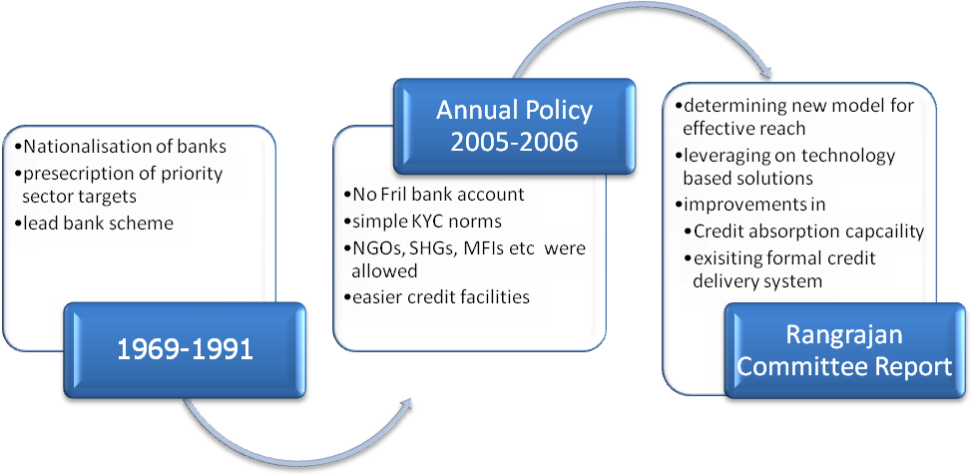
Policy development in India for financial inclusion can be seen in three stages

FIRST PHASE DEVELOPMENTS (1969-1981)

In 1969, the banks were nationalised in order to spread bank’s branch network in order to develop strong banking system which can mobilise resources/deposits and channel them into productive/needy sections of society and also government wanted to use it as an important agent of change. So, the planning strategy recognized the critical role of the availability of credit and financial services to the public at large in the holistic development of the country with the benefits of economic growth being distributed in a democratic manner. In recognition of this role, the authorities modified the policy framework from time to time to ensure that the financial services needs of various segments of the society were met satisfactorily
Before 1990, several initiatives were undertaken for enhancing the use of the banking system for sustainable and equitable growth. These included
- Nationalization of private sector banks,
- Introduction of priority sector lending norms,
- The Lead Bank Scheme,
- Branch licensing norms with focus on rural/semi-urban branches,
- Interest rate ceilings for credit to the weaker sections and
- Creation of specialised financial institutions to cater to the requirement of the agriculture and the rural sectors having bulk of the poor population.
SOCIAL NETWORKING APPROACH
The announcement of the policy of social control over banks was made in December 1967 with a view to securing a better alignment of the banking system with the needs of economic policy. The National Credit Council was set up in February 1968 mainly to assess periodically the demand for bank credit from various sectors of the economy and to determine the priorities for grant of loans and advances. Social control of banking policy was soon followed by the nationalisation of major Indian banks in 1969. The immediate tasks set for the nationalised banks were mobilisation of deposits on a massive scale and lending of funds for all productive activities. A special emphasis was laid on providing credit facilities to the weaker sections of the economy.
THE PRIORITY SECTOR APPROACH
The administrative framework for rural lending in India was provided by the Lead Bank Scheme introduced in 1969, which was an important step towards implementation of the two-fold objectives of deposit mobilisation on an extensive scale and stepping up of lending to weaker sections of the economy. Realising that the flow of credit to employment oriented sectors was inadequate; the priority sector guidelines were issued to the banks by the Reserve Bank in the late 1960s to step up the flow of bank credit to agriculture, small-scale industry, self-employed, small business and the weaker sections within these sectors.

The target for priority sector lending was gradually increased to 40 per cent of advances in the case of domestic banks (32 per cent, inclusive of export credit, in the case of foreign banks) for specified priority sectors. Sub targets under the priority sector, along with other guidelines including those relating to Government sponsored programmes, were used to encourage the flow of credit to the identified vulnerable sections of the population such as scheduled castes, religious minorities and scheduled tribes. The Differential Rate of Interest (DRI) Scheme was instituted in 1972 to provide credit at concessional rate to low income groups in the country
LEAD BANK SCHEME APPROACH
But all these measure were focused towards inclusion of a sector, regional areas etc., there was a very less or no emphasis was on financial inclusion of Individual/household level. The promotional aspects of banking policy have come into greater prominence. The major emphasis of the branch licensing policy during the 1970s and the 1980s was on expansion of commercial bank branches in rural areas, resulting in a significant expansion of bank branches and decline in population per branch. The branch expansion policy was designed, inter alia, as a tool for reducing inter-regional disparities in banking development, deployment of credit and urban-rural pattern of credit distribution. In order to encourage commercial banks and other institutions to grant loans to various categories of small borrowers, the Reserve Bank promoted the establishment of the Credit Guarantee Corporation of India in 1971 for providing guarantees against the risk of default in repayment. The scheme, however, was subsequently discontinued.

SECOND PHASE – ANNUAL POLICY (2005-2006)
As the central bank of the country, the Reserve bank of India has taken steps to ensure financial inclusion in the country. It has tried to make banking more attractive to citizens by allowing for easier transactions with banks. In 2004 RBI appointed an internal group to look into ways to improve Financial Inclusion in the country.
With a view to enhancing the financial inclusion, as a proactive measure, the RBI in its Annual Policy Statement for the year 2005-06, while recognizing the concerns in regard to the banking practices that tend to exclude rather than attract vast sections of population, urged banks to review their existing practices to align them with the objective of financial inclusion. In the Mid Term Review of the Policy (2005-06),
It is observed that there were legitimate concerns in regard to the banking practices that tended to exclude rather than attract vast sections of population, in particular pensioners, self-employed and those employed in the unorganised sector. It also indicated that the Reserve Bank would

- Implement policies to encourage banks which provide extensive services, while dis-incentivising those which were not responsive to the banking needs of the community, including the underprivileged;
- The nature, scope and cost of services would be monitored to assess whether there was any denial, implicit or explicit, of basic banking services to the common person; and
- Banks urged to review their existing practices to align them with the objective of financial inclusion.
RBI exhorted the banks, with a view to achieving greater financial inclusion, to make available a basic banking ‘no frills’ account either with nil or very minimum balances as well as charges that would make such accounts accessible to vast sections of the population. The nature and number of transactions in such accounts would be restricted and made known to customers in advance in a transparent manner. All banks are urged to give wide publicity to the facility of such no frills account so as to ensure greater financial inclusion.
RBI came out with a report in 2005 (Khan Committee) and subsequently RBI issued a circular in 2006 allowing the use of intermediaries for providing banking and financial services. Through such policies the RBI has tried to improve Financial Inclusion. Financial Inclusion offers immense potential not only for banks but for other businesses. Through an integrated approach the businesses, the NGOs, the government agencies as well as the banks can be partners in growth. RBI has realized that a push is needed to kick start the financial inclusion process. Some of the steps taken by RBI include the directive to banks to offer No-frills account, easier KYC norms, offering GCC cards to the poor, better customer services, promoting the use of IT and intermediaries, and asking SLBCs and UTLBCs to start a campaign to promote financial inclusion on a pilot basis.

Brief glimpses of main initiative are followings:-

No-Frill Accounts

It is a basic saving fund account having all the features of a normal saving fund account which it differs in the following aspects

- The holder is not required to maintain any minimum balance requirement and also nothing is charged for opening this type of account
- KYC norms have been simplified so that everyone can have this account
- Transaction are limited to 5-10 free transactions per month
- ATM facility is provided free of cost
- There is no account maintenance cost

Similar types of accounts, though with different names, have also been extended by banks in various other countries with a view to make financial services accessible to the common man either at the behest of banks themselves or the respective Governments

Overdraft in Saving Bank Accounts

Bank were advised to give credit in form of overdraft on saving bank account to its customer so that in case of small credit need like medical bill, any accidental charges etc. can be met in.

KYC norms
The Know Your Customer (KYC) norms were revised in order to make it easy for people to avail financial services on February 18, 2008. These guidelines include
- In case of close relatives who find it difficult to furnish documents relating to place of residence while opening accounts, banks can obtain an identity document and a utility bill of the relative with whom the prospective customer is living, along with a declaration from the relative that the said person (prospective customer) wanting to open an account is a relative and is staying with him/her. Banks can also use any supplementary evidence such as a letter received through post for further verification of the address;
- banks have been advised to keep in mind the spirit of the instructions and avoid undue hardships to individuals who are otherwise classified as low risk customers;
- Banks should review the risk categorization of customers at a periodicity of not less than once in six months.
- Further, in order to ensure that persons belonging to low income group both in urban and rural areas do not face difficulty in opening the bank accounts due to the procedural hassles, the KYC procedure for opening accounts has been simplified for those persons who intend to keep balances not exceeding rupees fifty thousand (Rs. 50,000/-) in all their accounts taken together and the total credit in all the accounts taken together is not expected to exceed rupees one lakh (Rs.1,00,000/-) in a year.

SHG Model

A Self Help Group (SHG) is a group of about 15 to 20 people from a homogenous class who join together to address common issues. They involve voluntary thrift activities on a regular basis, and use of the pooled resource to make interest-bearing loans to the members of the group. In the course of this process, they imbibe the essentials of financial intermediation and also the basics of account keeping. The members also learn to handle resources of size, much beyond their individual capacities. They begin to appreciate the fact that the resources are limited and have a cost.

Once the group is stabilized, and shows mature financial behavior, which generally takes up to six months to 1 year, it is considered for linking to banks. Banks are encouraged to provide loans to SHGs in certain multiples of the accumulated savings of the SHGs. Loans are given without any collateral and at interest rates as decided by banks. Banks find it comfortable to lend money to the groups as the members have already achieved some financial discipline through their thrift and internal lending activities. The groups decide the terms and conditions of loan to their own members. The peer pressure in the group ensures timely repayment and becomes social collateral for the bank loans.

Generally, the SHGs need self-help promoting institutions (SHPIs) to promote and nurture them. These SHPIs include various NGOs, banks, farmers’ clubs, government agencies, self-employed individuals and federations of SHGs. However, some SHGs have also been formed without any assistance from such SHPIs. There are three different models that have emerged under the linkage programme-

  - Model I: This involves lending by banks directly to SHGs without intervention/facilitation by any NGO.
  - Model II: This envisages lending by banks directly to SHGs with facilitation by NGOs and other agencies.
  - Model III: This involves lending, with an NGO acting as a facilitator and financing agency.

Model II accounted for around 74 per cent of the total linkage at end-March 2007, while Models I and III accounted for around 20 per cent and 6 per cent, respectively.

KCC / GCC Guidelines

- GCC SCHEME
With a view to providing credit card like facilities in the rural areas, with limited point-of-sale (POS) and limited ATM facilities, the Reserve Bank advised all scheduled commercial banks, including RRBs, in December 2005 to introduce a General Credit Card (GCC) Scheme for issuing GCC to their constituents in rural and semi-urban areas, based on the assessment of income and cash flow of the household similar to that prevailing under a normal credit card.

The Reserve Bank also advised banks to classify fifty per cent of the credit outstanding under loans for general purposes under General Credit Cards (GCC), as indirect finance to agriculture under priority sector. The Reserve Bank further advised banks in May 2008 to classify 100 per cent of the credit outstanding under GCCs as indirect finance to agriculture sector under the priority sector with immediate effect.

- KCC Scheme
- Eligible farmer will be provided a Kishan Credit Card and a Pass Book or a Card-cum-Passbook.
- Revolving cash credit facility allowing any number of withdrawals and repayments within the limit.
- Entire production credit needs for full year plus ancillary activities related to crop production to be considered while fixing limit. In due course, allied activities and non- farm short term credit needs may also be covered.
- Limit to be fixed on the basis of operational land holding, cropping pattern and scales of finance.
- Seasonal sub limits may be fixed at the discretion of banks.
- Limit of valid for 3 years subject to annual review.
- Conversion /re-schedulement of loans also permissible in case of damage to crops due to natural calamities.
- As incentive for good performance, credit limits could be enhanced to take cares of increase in costs, changing in cropping pattern etc.
- Security, margin and rate of interest as per RBI norms.
- Operations may be through issuing branch / PACS or through other designated branches at the discretion of bank.
- Withdrawals through slips /cheques accompanies by card and passbook.
- Personal Accident Insurance of Rs. 50,000 for death and permanent disability and Rs. 25,000/- for partial disability available to Kishan Credit Card holder at an annual premia of Rs. 15/- per annum.

Financial Literacy Program
Recognizing that lack of awareness is a major factor for financial exclusion, the Reserve Bank has taken a number of measures towards imparting financial literacy and promotion of credit counseling services. The Reserve Bank has undertaken a project titled “Project Financial Literacy”.

The objective of the project is to disseminate information regarding the central bank and general banking concepts to various target groups, including, school and college going children, women, rural and urban poor, defense personnel and senior citizens. The banking information would be disseminated to the target audience with the help of, among others, banks, local government machinery, schools/colleges using pamphlets, brochures, films, as also, the Reserve Bank’s website.

Various initiatives taken by the Reserve Bank in order to promulgate Financial Literacy:
- A multilingual website in 13 Indian languages on all matters concerning banking and the common person has been launched by the Reserve Bank on June 18, 2007.
- Comic type books introducing banking to schoolchildren have already been put on the website. Similar books will be prepared for different target groups such as rural households, urban poor, defense personnel, women and small entrepreneurs.
- Financial literacy programs are being launched in each state with the active involvement of the state government and the SLBC. Each SLBC convener has been asked to set up a credit counseling centre in one district as a pilot project and extend it to all other districts in due course.
- The ‘Financial Inclusion and Financial Literacy Cell’ has been established the college of Agricultural Banking, which would act as a resource centre in this field.

THIRD PHASE - RANGRAJAN COMMITEE
The Government of India (Chairman Dr. C. Rangarajan) constituted the Committee on Financial Inclusion on June 26, 2006 to prepare a strategy of financial inclusion. The Committee submitted its final Report on January 4, 2008. The Report viewed financial inclusion as a comprehensive and holistic process of ensuring access to financial services and timely and adequate credit, particularly by vulnerable groups such as weaker sections and low-income groups at an affordable cost. Financial inclusion, therefore, according to the Committee, should include access to mainstream financial products such as bank accounts, credit, remittances and payment services, financial advisory services and insurance facilities.
The Report observed that in India 51.4 per cent of farmer households are financially excluded from both formal/informal sources and 73 per cent of farmer households do not access formal sources of credit. Exclusion is most acute in Central, Eastern and North-eastern regions with 64 per cent of all financially excluded farmer households. According to the Report, the overall strategy for building an inclusive financial sector should be based on
- Effecting improvements within the existing formal credit delivery mechanism;
- Suggesting measures for improving credit absorption capacity especially amongst marginal and sub-marginal farmers and poor non-cultivator households;
- Evolving new models for effective outreach; and
- Leveraging on technology-based solutions.
Keeping in view the enormity of the task involved, the Committee recommended the setting up of a mission mode National Rural Financial Inclusion Plan (NRFIP) with a target of providing access to comprehensive financial services to at least 50 per cent (55.77 million) of the excluded rural households by 2012 and the remaining by 2015. This would require semi-urban and rural branches of commercial banks and RRBs to cover a minimum of 250 new cultivator and non-cultivator households per branch per annum. The Report of the Committee on Financial Inclusion Committee has also recommended that the Government should constitute a National Mission on Financial Inclusion (NaMFI) comprising representatives of all stakeholders for suggesting the overall policy changes required, and supporting stakeholders in the domain of public, private and NGO sectors in undertaking promotional initiatives.
The major recommendations relating to commercial banks included target for providing access to credit to at least 250 excluded rural households per annum in each rural/semi urban branches; targeted branch expansion in identified districts in the next three years; provision of customised savings, credit and insurance products; incentivising human resources for providing inclusive financial services and simplification of procedures for agricultural loans. The major recommendations relating to RRBs are extending their services to unbanked areas and increasing their credit-deposit ratios; no further merger of RRBs; widening of network and expanding coverage in a time bound manner; separate credit plans for excluded regions to be drawn up by RRBs and strengthening of their boards.
In the case of co-operative banks, the major recommendations were early implementation of Vaidyanathan Committee Revival Package; use of PACS and other primary co-operatives as BCs and co-operatives to adopt group approach for financing excluded groups. Other important recommendations of the Committee are encouraging SHGs in excluded regions; legal status for SHGs; measures for urban micro-finance and separate category of MFIs.
CREATION OF SPECIAL FUNDS
The “Committee on Financial Inclusion” set up by the Government of India (Chairman: Dr. C.
Rangarajan) in its Interim Report recommended the establishment of two Funds, namely the “Financial Inclusion Promotion and Development Fund” for meeting the cost of developmental and promotional interventions for ensuring financial inclusion, and the “Financial Inclusion Technology Fund (FITF)” to meet the cost of technology adoption.

The Union Finance Minister, in his Budget Speech for 2007-08 announced the constitution of the Financial Inclusion Fund (FIF) and the FITF, with an overall corpus of Rs.500 crore each at NABARD.

The Government advised that for the year 2007-08 it was decided to initially contribute Rs.25 Crore each in the two funds by the Central Government, RBI and NABARD in the ratio 40:40:20. The final report of the Committee has been submitted to the Government in January 2008.

HOW GOVERNMENT AND RBI CAN BUILD ON EXISTING BANKING STRUCTURE TO PROVIDE FINANCIAL SERVICES TO ALL
Banking system is like a team, which constitutes from various entities which are different in nature, form, structure and its working but together they makes system in which they efficiently work for a common motive.

SHG BANK LINKAGE PROGRAM
The SHG-Bank Linkage program can be regarded as the most powerful initiative since independence for providing financial services to the poor in a sustainable manner. The program has been growing rapidly YOY basis. Currently, 10 million SHG’s are working across the country with a credit base of Rs. 100000 Crore. But this is not enough to reach the entire mass. This number needs to be increased substantially.

However, the spread of the SHG- Bank linkage program in different regions has been uneven with southern states accounting for the major chunk of credit linkage. Many states with high incidence of poverty have shown poor performance under the program. NABARD has identified 13 states with large population of the poor, but exhibiting low performance in implementation of the programme. The ongoing efforts of NABARD to upscale the programme need to be given a fresh impetus. NGOs have played a commendable role in promoting SHGs and linking them with banks.

As of now, SHGs are operating as thrift and credit groups. They may evolve to a higher level of commercial enterprise in future. Hence, it becomes critical to examine the prospect of providing a simplified legal status to the SHG

MICRO FINANCE INSTITUTIONS (MFIs)
From the late 1980s, the emergence of the Grameen Bank in Bangladesh drew attention to the role of micro- credit as a source of finance for micro-entrepreneurs. Lack of access to credit was seen as a binding constraint on the economic activities of the poor.
Microfinance Institutions (MFIs) are those, which provide thrift, credit, and other financial services and products of very small amounts mainly to the poor in rural, semi-urban or urban areas for enabling them to raise their income level and improve living standards. Lately, the potential of MFIs as promising institutions to meet the demands of the poor has been realized. The closer proximity with the people at grassroots level and the mix of offering right products at right price based on the actual needs of the masses makes their role very important in deepening financial inclusion.
However, there is exigency to upscale their outreach. In India, out of some 400 million poor workers, less than 20 per cent have been linked with financial services provided by MFIs.

Steps needed to promote MFIs
- One of the ways of expanding the successful operation of microfinance institutions in the informal sector is through strengthened linkages with their formal sector counterparts.
- Efforts are needed to make MFIs an integral part of mainstream banking and to bring down the rates of interest on microcredit to ensure the micro finance movement gets further impetus
- A mutual beneficial partnership should be established between MFIs and Banks contingent on comparative strength of each sector. For example, informal sector microfinance institutions have comparative advantage in terms of small transaction cost achieved through adaptability and flexibility of operations.

COOPERATIVE CREDIT INSTITUTIONS
Rural credit cooperatives in India were originally envisaged as a mechanism for pooling the resources of people with small means and providing them with access to different financial services. It has served as an effective institution for increasing productivity, providing food security, generating employment opportunities in rural areas and ensuring social and economic justice to the poor and vulnerable sections.
Despite the phenomenal outreach and volume of operations, the health of a very large proportion of these credit cooperatives has deteriorated significantly. Various problems faced these institutions are:
- Low resource base
- High dependence on external source of funding
- Excessive government control
- Huge accumulated losses and imbalances
- Poor business diversification
- Low recovery
Taking all these facts in mind, there is an urgent need to address the structural deficiencies of these institutions in order to make them play an effective role in meeting the financial inclusion goal.

RRBs

RRBs, post-merger, represent a powerful instrument for financial inclusion. RRBs account for 37% of total rural offices of all scheduled commercial banks and 91% of their workforce is posted in rural and semi-urban areas. They account for 31% of deposit accounts and 37% of loan accounts in rural areas. RRBs have a large presence in regions marked by financial exclusion of high order.

RRBs are, thus, the best suited vehicles to widen and deepen the process of financial inclusion. However, they need to be oriented suitably to serve the rural population with a specific mandate to achieve financial inclusion. It is hoped that recent regulatory changes and fresh impetus provided by the regulator will help in making RRBs front institution in achieving the target of reaching out to financially excluded people.

THE BUSINESS CORRESPONDENT MODEL

In January 2006, the Reserve bank permitted banks to utilize the services of non-government organizations (NGOs/SHGs), micro-finance institutions and other rural organizations as intermediaries in providing financial and banking services through the use of business facilitator (BF) and business correspondent models(BC). The BC model allows banks to do ‘cash in cash out’ transactions at a location much closer to the rural population, thus addressing the last mile problem.

Banks are also entering into agreement with Indian Postal Authority for using the enormous network of post offices as business correspondents for increasing their outreach and leveraging the postman’s intimate knowledge of the local population and trust reposed in him. The intention behind the model is to promote the business of banking with low capital cost by enabling outsourcing of rural business to agents on a commission basis.

Recent guidelines issued by RBI to ensure adequate supervision over operations of BCs:

- Every BC to be attached to a certain bank to be designated as the base branch
- The distance between the area of operation of a BC and the base branch should not exceed 30 km in rural, semi-urban and urban areas.

Initiatives needed to be undertaken to promote BC model

- Allow more entry to private well governed small finance banks. The intent is to bring local knowledge to financial products that are needed locally.
- Facilitate the use of existing networks like cell phone kiosks or kirana shops as business correspondents to deliver products of large financial institutions.
- Liberalize the business correspondent regulation so that a wide range of local agents can serve to extend financial services.

ROLE OF TECHNOLOGY IN FINANCIAL INCLUSION
According to recent Boston Consulting Group report, with cost of funds today at 9%, provision for bad debts at 10% and cost of operation and transaction at 13% for poor customers in far flung areas, banking for the poor by formal sector becomes unviable. The key role the technology is expected to play is to reduce the last two components drastically. Unfortunately, public sector banks (PSBs), which account for 70% of assets, have been slow in making use of modern technology to bring down transaction costs.
How technology can lower operating costs as well as lending rates?
- In rural areas, different villages are separated by large distances and poor connectivity. Consequently, communication technology could play an important role in bridging the last miles between the customer and the provider thus facilitating faster transactions.
- The telecom network in India is expanding rapidly as more and more private operators are entering in the telecom sector. Banks could leverage the network for expanding operations, reducing costs and increase reliability of their operations.
- As more than one million new mobile users are being added every month in India, Mobile Banking can become the most promising front end technology for facilitating financial inclusion in India. As mobile phones have reached out to segments and geographies but not yet penetrated by banking sector, this may be one of the most preferred choice for banks for spreading their network in unbanked areas.
However, banks need to consider certain facts before leveraging technology to bring more and more population under the net of financial inclusion
- Cost effectiveness of technology
- Security of accounts
- Financial viability of technology in rural areas
- Ability of potential beneficiaries to use the technology

PRESENT STATUS OF FINANCIAL INCLUSION IN THE COUNTRY

A GLIMPSE OF EXTENT OF FINANCIAL INCLUSION IN THE COUNTRY
Financial Inclusion:
Table 2: State-wise Index of Financial Inclusion
State | D1 (Penetration) | D2 (Availability) | D3 (Usage) | IFI | IFI Rank
High Financial Inclusion (0.5-1)
Kerala | 0.70 | 0.81 | 0.28 | 0.54 | 1
Maharashtra | 0.62 | 0.29 | 1 | 0.53 | 2
Karnataka | 0.72 | 0.47 | 0.46 | 0.53 | 3
Medium Financial Inclusion (0.3-0.5)
Tamil Nadu | 0.70 | 0.43 | 0.38 | 0.48 | 4
Punjab | 0.45 | 0.69 | 0.29 | 0.45 | 5
Andhra Pradesh | 0.56 | 0.30 | 0.41 | 0.41 | 6
All-India | 0.27 | 0.22 | 0.55 | 0.33 | 7
Himachal Pradesh | 0.42 | 0.40 | 0.18 | 0.33 | 8
Sikkim | 0.28 | 0.33 | 0.34 | 0.32 | 9
Haryana | 0.39 | 0.50 | 0.12 | 0.32 | 10
Low Financial Inclusion (<0.3)
West Bengal | 0.24 | 0.38 | 0.23 | 0.28 | 11
Gujarat | 0.32 | 0.30 | 0.16 | 0.26 | 12
Uttar Pradesh | 0.28 | 0.31 | 0.15 | 0.24 | 13
Meghalaya | 0.21 | 0.28 | 0.14 | 0.21 | 14
Tripura | 0.31 | 0.22 | 0.08 | 0.20 | 15
Orissa | 0.26 | 0.23 | 0.11 | 0.20 | 16
Rajasthan | 0.25 | 0.22 | 0.12 | 0.19 | 17
Arunachal Pradesh | 0.20 | 0.16 | 0.14 | 0.17 | 18
Mizoram | 0.13 | 0.26 | 0.09 | 0.16 | 19
Madhya Pradesh | 0.18 | 0.21 | 0.08 | 0.16 | 20
Bihar | 0.15 | 0.24 | 0.08 | 0.15 | 21
Assam | 0.17 | 0.17 | 0.07 | 0.13 | 22
Nagaland | 0.03 | 0.04 | 0.07 | 0.05 | 23
Manipur | 0.00 | 0.01 | 0.01 | 0.01 | 24

Measure of access to banking services in India

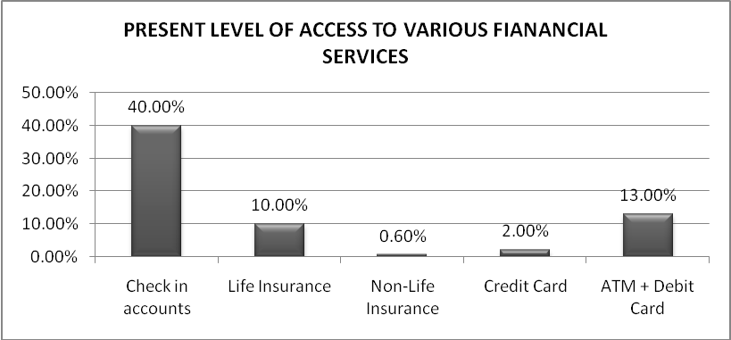
SOURCE: PRESENT STATUS OF VARIOUS FINANCIAL SERVICES AS DISCUSSED BY DR. K.C.CHAKRABARTY, DY GOVERNOR, RBI AT 20TH SKOCH SUMMIT 2009, MUMBAI ON JULY 17, 2009

