




Meeting Information

Date October 13 (Thur.) - 14 (Fri.), 2011

Venue
Seoul Kyoyuk MunHwa HoeKwan
202 Yangjae-dong, Seocho-gu 137-915, Seoul, Korea
TEL: +82-2-571-8100
FAX: +82-2-571-7055
homepage: www.temf.co.kr/eng/

Organized by
The Federation of Korean Microbiological Societies (FKMS)

Hosted by
The Korean Society for Microbiology (KSMi)
The Korean Society of Virology (KSV)
The Korean Society of Mycology (KSMy)
The Korean Society for Microbiology and Biotechnology (KMB)
The Microbiological Society of Korea (MSK)

Secretariat
The Federation of Korean Microbiological Societies
Rm. 810 (New Bldg.), The Korea Science & Technology Center
635-4 Yeoksam-dong, Gangnam-gu
Seoul 135-703, Korea
TEL: +82-2-3453-3321 FAX: +82-2-3453-3322
E-mail: fkms@fkms.kr

Other Events
Welcome Reception
Date & Time: 18:30-21:00, October 13 (Thur.), 2011
Site: Geomungo Hall (2nd Fl. of Seoul Kyoyuk MunHwa HoeKwan)
Fee: Included in the Registration Fee

Homepage www.fkms.kr

Important Dates Deadline of abstract submission: August 31, 2011
Deadline of pre-registration: September 23, 2011

Scientific Program
Tentative Timetable
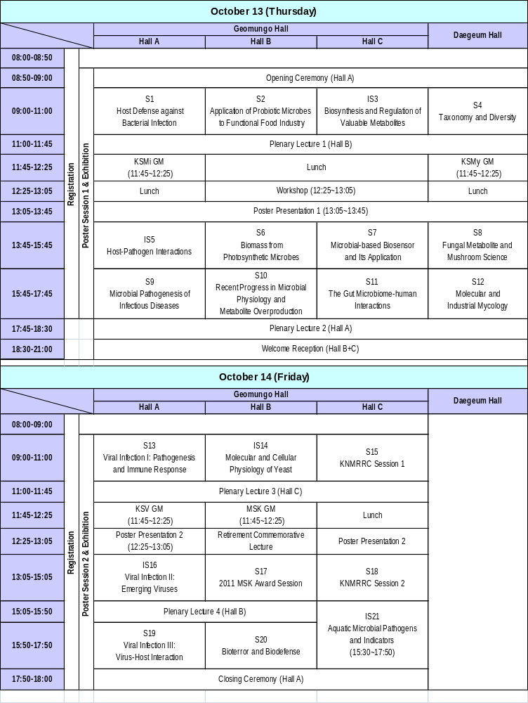

Plenary Lectures
ㆍPL1: Kenn Gerdes, Newcastle Univ., UK
ㆍPL2: Patricia J. Pukkila, Univ. of North Carolina, USA
ㆍPL3: Yeon-Man Jeong, Ministry of Environment
ㆍPL4: Donald A. Morrison, Univ. of Illinois at Chicago, USA

Symposia

S1 Host Defense against Bacterial Infection
Jung Mogg Kim, Hanyang Univ.
Je-Wook Yu, Myongji Univ.
Na Gyong Lee, Sejong Univ.
Chihiro Sasakawa, Univ. of Tokyo, Japan

S2 Application of Probiotic Microbes to Functional Food Industry
Cheol Ahn, Kangwon Nat'l Univ.
Moon-Hee Sung, Kookmin Univ.
Oh Hyoung Lee, Mokpo Nat'l Univ.
Myung Jun Chung, Cell Biotech Co., Ltd.

IS3 Biosynthesis and Regulation of Valuable Metabolites
Heung-Shick Lee, Korea Univ.
Andreas Burkovski, Friedrich-Alexander Universitaet Erlangen-Nuernberg, Germany
Linquan Bai, Shanghai Jiatong Univ., China
Wolfgang Buckel, Max Planck Institute for Terrestrial Microbiology, Germany

S4 Taxonomy and Diversity
Jae-Gu Han, Korea Univ.
Sung-Chul Yun, Sun Moon Univ.
Young Woon Lim, Seoul Nat'l Univ.

IS5 Host-Pathogen Interactions
Hyon E. Choy, Chonnam Nat'l Univ.
Bok Luel Lee , Pusan National Univ.
Akio Nakane , Hirosaki Univ., Japan
Bong-Kyu Choi, Seoul Nat'l Univ.

S6 Biomass from Photosynthetic Microbes
Soon-Ae Yoo , Pai Chai Univ.
Choul-Gyun Lee, Inha Univ.
Youn-Il Park, Chungnam Nat'l Univ.
Young-Ho Chung, Korea Basic Science Institute

S7 Microbial-based Biosensor and Its Application
Hyun Gyu Park, Korea Advanced Institute of Science and Technology
Hyung Joo Kim, Konkuk Univ.
Young-Rok Kim, Kyung Hee Univ.
Man Bock Gu, Korea Univ.

S8 Fungal Metabolite and Mushroom Science
Myung Soo Park, Korea Research Institute of Chemical Technology
Kang-Hyeon Ka, Korea Forest Research Institute
Won-Sik Kong, National Institute of Horticultural and Herbal Science

S9 Microbial Pathogenesis of Infectious Diseases
Sang Sun Yoon, Yonsei Univ.
Hwa-Jung Kim, Chungnam Nat'l Univ.
Yoon-Keun Kim, POSTECH
Je Chul Lee, Kyungpook Nat'l Univ.

S10 Recent Progress in Microbial Physiology and Metabolite Overproduction
Sang Ho Choi, Seoul Nat'l Univ.
Eun Young Lee, The Univ. of Suwon
Yong Taik Rho, Youngdong Univ.
Yong Keun Chang, Korea Advanced Institute of Science and Technology

S11 The Gut Microbiome-human Interactions
Heenam Kim , Korea Univ.
Jin-Woo Bae, Kyung Hee Univ.
Jongsik Chun, Seoul Nat'l Univ.

S12 Molecular and Industrial Mycology
Jin Ho Yoon, Sungshin Women's Univ.
Jungkwan Lee, Dong-A Univ.
Jung-Mi Kim, Chonbuk Nat'l Univ.

S13 Viral Infection I: Pathogenesis and Immune Response
Sang Gu Yeo, National Institute of Health, KCDC
Taegun Seo, Dongguk Univ.
Hee-Sook Jun, Gachon University of Medicine and Science
Insoo Kang, Yale Univ., USA

IS14 Molecular and Cellular Physiology of Yeast
Cheol-Won Yun, Korea Univ.
Won-Ki Huh, Seoul Nat'l Univ.
Cheol-Sang Hwang, POSTECH
Woo-Hyun Chung, CHA Univ.

S15 KNMRRC Session 1 To be announced
※ KNMRRC: Korea National Microorganisms Research Resource Center

IS16 Viral Infection II: Emerging Viruses
Marc Windisch, Institut Pasteur Korea
Ji-Young Min, National Institutes of Health, USA
Jonghwa Kim, Samsung Medical Center
Man-Seong Park, Hallym Univ.

S17 2011 MSK Award Session To be announced

S18 KNMRRC Session 1 To be announced

S19 Viral Infection III: Virus-Host Interaction
Kyung Hyun Kim, Korea Univ.
Kyongmin Kim, Ajou Univ.
Jae-Hwan Nam, The Catholic Univ. of Korea
Bum-Joon Kim, Seoul Nat'l Univ.

S20 Bioterror and Biodefense
Seong Tae Jeong, Agency for Defense Development
Sang Hyeon Kang, iNtRON Biotechnology
Niranjan Y. Sardesai, VGX International
Mi-Na Kweon, International Vaccine Institute

IS21 Aquatic Microbial Pathogens and Indicators
Kevin Oshima, United States Environmental Protection Agency, USA
Tom Edge, Environment Canada, Canada
George Di Giovanni, Texas AgriLife Research Center, USA
Michael J. Sadowsky, Univ. of Minnesota, USA
Poster Sessions
Participants can submit poster abstracts by email (fkms@fkms.kr). The deadline is August 31, 2011 and the abstract should not exceed 1,500 letters including spaces.

Topics
A. Systematics and Evolution
B. Environment and Ecology
C. Physiology and Biochemistry
D. Fermentation and Metabolites
E. Genetics and Genome
F. Infection and Pathogenesis
G. Immunology and Signal Transduction
H. Biotechnology
I. Food Microbiology
J. Others

Sample
Please Capitalize a First letter of the Words in the Title except for Prepositions and Conjunctions.

Gil Dong Hong¹, Hankook Kim², and Sarang Na^{2,*}
¹Department of Microbiology, Hankook University, Korea ²Department of Microbiology, Pusan University, Korea

The text should be single-spaced using Times New Roman font of 12 point for title, 11 point for affiliation and 10 point for the content. Title and authors should be in bold letters. Figures and Tables can not be included in the text.
Do not use abbreviations for authors' name and affiliation. Please write a presenting author's name first. Mark a corresponding author with a superscript * on the right side and affiliations will be sorted and numbered automatically. In case of the same affiliation, please write the exactly same, spellings (including capital and small letters) and space.
Abstracts should be written in less than 1500 letters including spaces (about a 1/2 page of A4) and comment for the research fund can be included at the end of abstract

Keywords: 3~5 words

Poster Abstract Submission Form of FKMS2011

Poster Presenter’s Information
Name:  Mr.  Ms.  Dr.  Prof.
Affiliation:
Address:
Country:
Telephone Number: Fax Number:
Email:

Poster Topics

 A. Systematics and Evolution
 B. Environment and Ecology
 C. Physiology and Biochemistry
 D. Fermentation and Metabolites
 E. Genetics and Genome
 F. Infection and Pathogenesis
 G. Immunology and Signal Transduction
 H. Biotechnology
 I. Food Microbiology
 J. Others

Registration

Registration Fee

 | Pre-Registration  (by Sept. 23, 2011) | On-Site Registration
Regular Participant | 110,000 Korean Won | 140,000 Korean Won
Student | 40,000 Korean Won | 60,000 Korean Won

If you wish to register for this meeting, please fill in Registration Form (P10) and send it to the
Secretariat by fax or email. Please note that the registration fee for invited speakers are waived.

Secretariat]
The Federation of Korean Microbiological Societies
Rm. 810 (New Bldg.), The Korea Science & Technology Center
635-4, Yeoksam-dong, Gangnam-gu Seoul 135-703 Korea
Tel: +82-2-3453-3321 Fax: +82-2-3453-3322
Email: fkms@fkms.kr Homepage: www.fkms.kr

Accommodation

Venue Hotel: Seoul Kyoyuk MunHwa HoeKwan
202 Yangjae-dong, Seocho-gu 137-915, Seoul, Korea
TEL: +82-2-571-8100 FAX: +82-2-571-7055
Homepage: www.temf.co.kr/eng/

Room rate : Standard – Double or Twin
110,000 Korean Won / night (included Tax & SVC / not included a breakfast)

Reservation
Secretariat will reserve one room for foreign invited speakers according to their check-in
and out dates. If foreign participants wish to reserve rooms at the venue hotel, please contact the secretariat.

Location & Transportation between airport and venue hotel.
Please refer to P12.

Registration Form of FKMS2011
(Two way to register : FAX or E-mail complete form with payment :+82-2-3453-3322, fkms@fkms.kr)

1. REGISTRATION INFROMATION
□ Dr. □ Prof. □ Mr. □ Ms.
First Name Last Name Title
Company/Institution
Street Address
City State/Province Zip code
Country Phone FAX
E-mail Address

2. REGISTRATION FEE
 | Pre- Registration  (by Sept. 23, 2011) | On site Registration
Regular participant | □ KRW 110,000 | KRW 140,000
Student participant | □ KRW 40,000 | KRW 60,000
* KRW=Korean Won. KRW 1,052 is approximately US $1.00 (as of July 26, 2011)

* Registration fee (regular and student participant) includes :
1. All scientific session, 2.Meeting materials, (Program book and Proceedings), 3.Welcome reception
(1.Postdoctoral participants are regarded as regular participants, 2.Poster abstracts cannot be included in the program book without at least one author paying the regular or student registration fee. 3. Student participants must submit a proof of their student status. Please send a copy of Student ID with registration form by FAX or Email.)

3. PAYMENT DETAIL
□ I will send my registration fee by bank transfer no later than Sept. 23, 2011.
Please remit your payment to: The Microbiological Society of Korea
CITI BANK Korea, Korean Federation of Science & Technology Societies DTO, Seoul, Korea
Account #: 186-00924-247-01 (Swift Code: CITIKRSX)

□ I will pay my pre-registration fee by credit card on-site.

DATE Signature

About Seoul

Maps of Northeast Asia and Korea

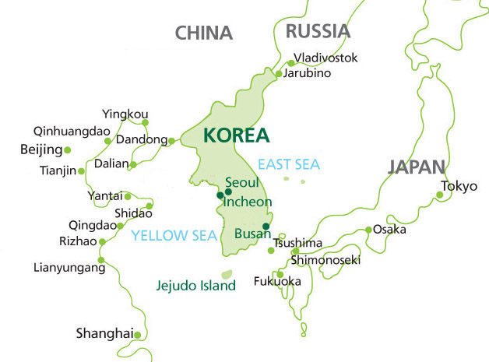

Please visit a site below.
www.miceseoul.com/about-seoul/

Airports near Seoul
Incheon International Airport (ICN) - International
(Primary International Airport, Secondary Domestic Airport) The Incheon International Airport, located about 1 hour from Seoul, is one of the newest transportation hubs in Asia. This award winning airport houses over 64 airline offices, manages over 455 inbound and outbound international flights every day and is also one of the most technologically advanced airports in the world.

Gimpo International Airport (GMP) - Domestic
(Secondary International Airport, Primary Domestic Airport) The Gimpo International Airport is located about 30 minutes from downtown in north-west Seoul and was the main international airport for Seoul and South Korea before it was replaced by Incheon International Airport in 2001. It is now the second largest airport in Korea.

Transportation

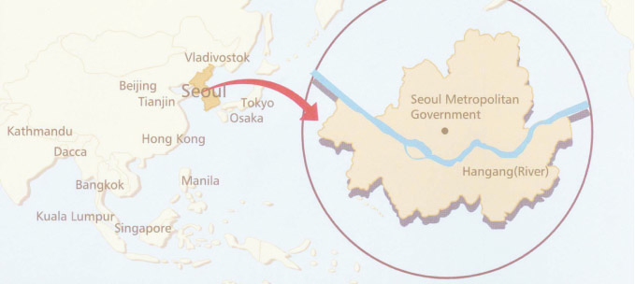

Vicinity of the Venue
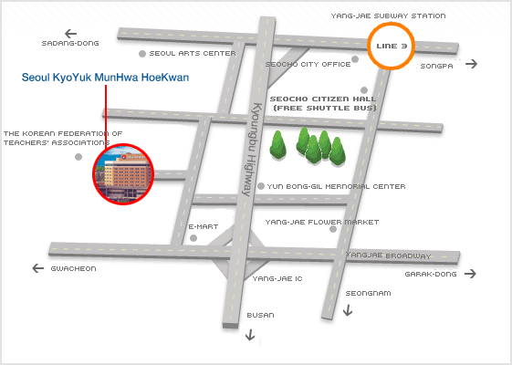

Seoul Kyoyuk MunHwa HoeKwan
202 Yangjae-dong, Seocho-gu 137-915, Seoul, Korea
TEL: +82-2-571-8100 FAX: +82-2-571-7055
homepage: www.temf.co.kr/eng/ email: reservation@temf.co.kr

 Limousine Bus
Please take an Airport Limousine (No. 6009) bound for ILWON Station (Direction: Seoul (South)) at Bus Stop 5A and 11B (1th fl.). If you take a taxi at the Yangjae Station, it takes about 10 min. (about 5,000 Korean Won) to move to the venue.
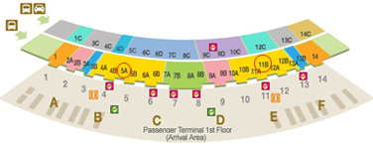

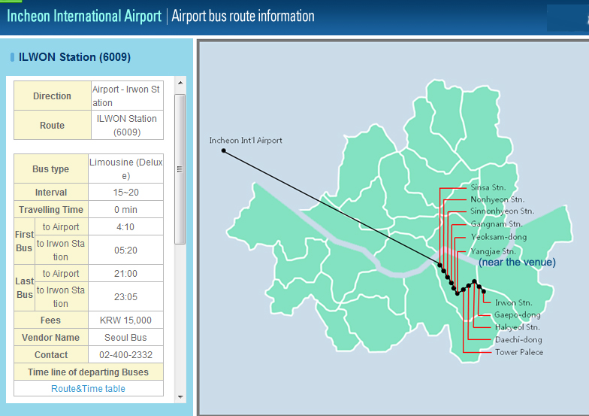

Free shuttle bus
Free shuttle bus from Yangjae subway station to hotel (venue)
Bus stop: front of seocho citizen hall, 150m away from the exit 7 of Yangjae subway station (line 3)
Time: every 20~30 minute from 6 am to 11 pm

