Hey fresher!!
The QMSS 2005/2006 committee would like to welcome you to Queen Mary!!!!!!
For the medics who have recently finished your interviews and for the rest of the lawyers/engineers/& everyone else who have just gotten your offers, I guess you would be making a choice between QM and the other colleges in London as well as in and around the UK. Well, this is just a simple info pack to say Hi, fill you in about Student life in London as well as to inform you about stuff that you can do in Singapore so as to make your getting settled a much easier experience!!

Contents

- Getting Packed!!
- Student essentials:: Cash!! How much to bring? Accommodation?!?! Phone!?
- Fitting with life in London… The first few days
- Contacts! Who to look for if you need help!!
- Living in halls!

Getting Packed!!

Though September may seem like a long time away, it’s sooner than you think! Whether you are doing a temp job, finishing army or just plain slacking it’s good to have an idea of the stuff you need to do closer to the date …. Last minute preparations are no preparations at all!!

- Banking: getting started in Singapore

There are several banks in UK, but presence wise, the 3 biggest banks are HSBC, Barclays and Natwest. All 3 offer Student accounts which give you a certain degree of overdraft, a debit card, cheque books and online banking. Here, I will go through the pros and cons of each bank and how to go about setting up accounts:

Bank | Pros | Cons
HSBC | - Able to setup from Singapore!!*  - ₤1000 interest free overdraft facility  - Switch card (only if you apply in Singapore!)  - Singapore presence  - ₤80 RAIL card (Rail card…not tube) or ₤50 in your bank! (Only if you apply in Singapore!) | - If you apply in the UK they will give you an international student account versus a STUDENT account if you apply in Singapore. With the STUDENT account you get ₤50 in your account just for banking and a switch card!  - Solo cards are given if you apply in the UK (Solo and Switch cards are debit cards but Switch is more widely accepted than Solo)  - As of 2006, opening an International HSBC account in Singapore will incur a monthly fee of £5.
Bank | Pros | Cons
Natwest | - Incremental interest free overdraft, 1st yr: ₤1,250; 2nd yr: ₤1,400; 3rd yr: ₤1,600; 4th yr: ₤1,800; 5th yr : ₤2,000 | - Solo card only, Switch is for local students.
Barclay’s | - Visa Debit card, very good receivership anywhere in the world  - Interest free overdraft 1st yr: ₤1,000; 2nd yr: ₤1,250; 3rd yr: ₤1,500  - Good interest for savings accounts | - The student account must have min. ₤1000 … otherwise they will suck your $$  - They also require you to have ₤10,000 or ₤5,000, with evidence that you have already paid your school fees when you start your account

Now what’s a Solo and what’s a Switch?? They’re quite similar, both being debit cards; but a switch card has credit rating and a much wider receivership, both online and in the shops so basically it’s a better card!!

With HSBC, you have the advantage of setting the account in Singapore and coming over to have your account, bank card and cheque book just waiting for you! A bank is essential for getting your phone sorted (as you can only apply for a phone line after showing them proof that you have a bank account in the UK) and it makes paying of school and accommodation fees much easier since you can write a local cheque; so you won’t have to suffer the cost of surcharge via credit card. Setting up the account in Singapore is also much easier; since banking in the UK is just plain inefficient and you could take weeks to just set up an account. Meanwhile you’d be living out of your cash stashed in your suitcase… not a good idea! However, the new monthly deduction fee has proven to be a major stumble-back in many freshers' choice.

The Switch card that HSBC offers has good receivership around Europe (good for travelling) and the ₤1000 interest free overdraft can help when you’re in a pinch. What’s more they’re going to give you ₤50 just for banking with them!! If you setup a Singapore account, your parents could transfer $$ with less hassle (I suppose), and in the long run, re-locating your funds back to Singapore would be less painful. A Solo card is just a plain debit card which you start with if you set up over in UK, which does not have that good receivership, though it’s more than functional. You start with a Switch card if you did it in Singapore though and that’s a debit card with credit rating so it’s good for online shopping and stuff. Oh yeah and HSBC is everywhere!!

Barclay’s has a strong presence in UK (there’s a branch on campus!) and the Visa debit card offered has very good receivership around the world. However the main turnoff is that you need to maintain a minimum of 1000 quid in your student account at all times... otherwise they’ll start deducting; which can be a major pain when you are paying your school and accommodation fees and you find you have almost no money left. Otherwise, Barclay’s has one of the best interest rates on their savings accounts, for those wanting your $$ to work for you.

Natwest is up and coming and they are friendly! If you’re coming over here to setup an account, and HSBC and Barclay’s are giving you trouble setting up with them, Natwest is a worthy consideration. They offer the basics of a Solo card, cheque book and an incremental offer draft over the years; which is more than functional.

To setup an account:

Whether or not you setup an account in Singapore or you’re starting fresh over in London, you will need the following to get your account started:

- Passport (With valid visa)
- Proof of UK Address (Your tenancy agreement will do)
- Proof of Overseas address (Personal Bank statement that has YOUR name and address)
- Letter from the school (If you’re starting fresh and want a student account) The letter should have the following:

  - FULL NAME (Same as passport)
  - UK address AND Overseas address
  - School fees fully paid
  - Duration and nature of course
e) Student ID (Again only after you have registered)

Basically you can only get a letter from the school only if you have FULLY paid your school fees. To get it, you can look for Hanna Holland (International Officer) at the Office in the Queens building; for Medics, you will need to find Hanna Eno (Admissions Head) down at Bart’s Registry in Whitechapel.

Some Life equations: No bank = No phone = No life…. But if school fees are not paid = No Letter from school = No bank!!!... ADVICE: All this can be avoided IF u setup a HSBC account in Singapore!! Then you can set up your phone, pay for your school fees, and get your switch card…. PAINLESSLY!! Start early though; your Singapore HSBC account must be active for 6 Months before they can help you set up an account in UK. Be a smart one and pop down to HSBC at Coller Quay to get this done.

If you decide to set up an account with HSBC in Singapore, HSBC London will normally let you pick up your bank card, cheque book and settle your account info at the branch in the Strand (near Temple Station)

- School and Fees

Somewhere in June/August, Queen Mary will send a letter to say Hi, let you choose your accommodations (more later) and ask you to PAY YOUR SCHOOL FEES!! Now they’ll ask you to pay either: a) 1 term (minimum as a deposit) or b) the entire year! (₤13k +++)

The thing is at this time you only can pay by credit card or telegraphic transfer (Unless you have a relative over in the UK that could help you write a cheque). However, credit card payment will incur a 2% surcharge (figures as of last year but you can call the fees office to find out the exact amount). You could pay for ALL the fees, so that you could get the whole affair out of your mind, but bearing in mind currency fluctuations versus the cost of credit card/telegraphic transfer, and the interest that you can make with the money still in the bank, it might be good to just pay 1 term’s fees and settle the rest over in the UK, while letting money roll over as interest in the bank. However, paying early has its advantages as well, you might be able to get a discount off your school fees. It is best to call the fees office for enquiry. You can reach them at 020 7882 3087.
- Plane Tickets

Buy your plane tickets early!!! ALL the Singaporeans in all years need to go back to UK in September!! But before you do, ask yourself these questions:

  - Am I coming back in December?
  - Which airline?
  - 1 way (single) or 6-month (return) or 12-month open (return) ticket??
  - Am I going to manage my plane tickets from Singapore or UK??

If you are going back to Singapore in December, your best bet is a 6-month ticket. Scrambling for a return flight while over here (UK) is no joking matter. If you are prepared to go back only in June, you could either go 1 way and book flights from UK or go with a 12-month open ticket. 1 Way would be cheaper because June/July tickets over here can be cheaper, while 12-month would just be more hassle free. Try to get a flight that arrives in the late morning as well (i.e leaving Singapore at night). Besides making it easier for people to send you off, taking a night flight and arriving in the morning eases the pain of jet-lag. Also, try to time your flight so that it doesn’t coincide with the rush hour (Bare in mind that you will need to go and get your keys from the residence office in your respective halls so being too overzealous and getting there too early is just slapping yourself)

Which airplane to choose would depend on the cost of the ticket, the amount of baggage allowance allocated and the number of stop-overs. SQ, for example, is the most expensive, but it’s a straight flight and you can try to bump the luggage to as much as 50kg!! In a long haul flight, it might be good to take a flight with as little stop-overs as possible, since they take longer in transit and more stop-overs = more chance for your luggage to get lost in transit! So unless you want to beat up some foreign baggage lifters on the first day here>> go ahead

Managing tickets from Singapore or UK?? Now u could save some $$ if you manage on UK side and scrupulously watch plane tickets, but that takes a lot of time and effort. On the other hand, doing it on Singapore side, with 2 way tickets leading back to Singapore, allows; for example your parents to sort out any problems, that is, if they arise on the Singapore side… Out of sight; out of mind.

The UK travel agencies that people use are:

- STA Travel (There’s one on campus!)

- Lees Travel (Run by a Singaporean dude.. very friendly!!)
410 Edgware Road
London W2 1ED
Tel 0207 262 2665

- Emerald Travel
15/16 New Burlington Street
London W1X 1FF
Tel: 0207 312 1700

4. Essential Documents

UK customs can get a bit sticky and by the time you get over your 12+ hour flight, the last thing you would want is to get stuck in customs for hours or having to call home to sort stuff out. So to make your transition easier, make sure you have the following documents:

a) Letter of acceptance; indicating the duration and nature of your course (email the international officer, Hannah Holland or Hannah Eno (For Medics) to get this letter written)
b) Passport (Valid for 2 years on entry)
c) Health documents:
i) GV5A Form medical questionnaire, get this from the British Council, they usually send it out in August though) (need to see your GP to get this filled out)
ii) Chest X-ray
d) Proof of accommodation (your tenancy agreement will do)
e) A Level certs
f) Exit permits (for the guys, good to ask your NS unit for letter of disruption from reservice if possible)

5. Other Stuff to bring!

a) Clothes

i) Pair of jeans (the Sept – Feb months only get colder)
- Winter jacket (Just 1 will do, you could buy in UK of course, which may be cheaper, try to get it waterproof)
- Wind breaker (It rains like nobody’s business sometimes)
- Sweater(s)
- Bumming clothes to ZZZ in
- A Shirt/Blouse with Tie(for guys)
- Slippers (for your showers)
- Some formal leather shoes
- Track pants (for the sporty people)

A note about clothes is that come January, they have massive clearout sales!! Up to 50%-70% and more for labels like MNG, Zara, GAP blah, blah… so if you can survive till then it would be good to buy expensive stuff like winter coats during that time. Buy warm wool and don’t waste time on Acrylic!

b) Cooking and food stuff

- Rice cooker (Bring or die)
- Chop sticks
- Packet flavouring like beef rendang or Bak Khu Teh (or whatever your mom thinks is good!!) - We recommend Prima Taste because they are pretty reliable if you want to get your tastes right, though they'll probably cost more
- Chinese tea (if you into it, cause it’s good for those cold days you feeling a bit sick)
- Vitamins

About rice cookers… invest in a good one!! No point buying the cheapest rice cooker in the universe only to have it play you out over here, they cost astronomical over here and you’re going to be here for a LONG TIME; So don’t skimp!! On the other hand if you know who’s coming, settle on who’s going to bring what… 6 people with 6 rice cookers is just dumb. Consider options like a slow cooker instead.
c) Stationary

- Lots of your favourite pens (unless you want to pay the same price, but in pounds)
- Liquid paper (You’d expect gold to flow out, for the price you pay)
- Mech. pencils
- Ruler
- Highlighters
- Post-it pads
- Soft-board pins
- Markers
- Scotch tape/Double sided tape
- Writing paper (Writing paper in the UK is a bit dodgy)
- File(s)
- Book stands

Basically you either can’t find what you like or it just costs too much over here. So if you have any particular fetishes, please indulge, or fork out triple the price.

d) Books

Books cost the same, just in POUNDS here (i.e. 3 times the price). So buy all the books you need in Singapore!! If you’re doing other courses, get in touch with us and we’ll try to get a list for you, for Medical Books:

Essential

- Clinical Medicine by Kumar and Clark (Saunders) >>> This one is Essential!! Written by QM Professors; used by the whole world!! Good core book that tells u the basics of almost all problems you can get.

- Principles of Anatomy and Physiology By Tortora and Grabowski (Wiley) Easy to understand Physiology for you, though it’s REAL basic

Good to have

- Robbins Pathological Basis of Disease By Cotran, Kumar and Collins (Saunders), detailed info for pathology of disease

- Atlas of Human Anatomy By Frank H. Netter, MD (ICON Learning Systems)

- Pharmacology By Rang, Dale, Ritter and Moore (Church Livingstone)

- Wheater’s Functional Histology By Young and Heath (Churchill Livingstone)

- Lippincott’s biochemistry By Champe and Harvey (LW&W)

- Master Medicine: Clinical Anatomy By Stanley Monkhouse
The first 2 are essential, though if you’re more comfortable with another physiology book, besides Tortora go ahead, but you can’t runaway from Kumar and Clark. The other books are for people doing a mini library, they are GOOD (really) to have, but you can survive by loaning out library books or online scrounging; you could also get them in your subsequent terms though, should the need arises.

e) Computer Stuff

- Laptop or mini comp (It’s going to serve you for a long time so get a good one with international warranty!!)
- Printer (It’s cheaper in Singapore so if you can afford the space…++ make sure you have all the cables (USB2 nowadays) and ink u need!)
- Multi-point extension plug (for your comp, speakers, printer, handphone, blah blah)
- Paraphernalia like mouse, webcam (only works with Skype & Yahoo Msger due to school firewall in halls; haven’t tried it out though), microphone if you use skype; which works very well
- Laptop Lock (In case some cuckoo bird tries to nick your laptop while you make a trip to the toilet!)
- Recording media like CD-Rs (Because it’s expensive here, and it’s good to back up!)
- Software especially anti-virus, word processor, make sure you’re well loaded.
- Go get a web-based email like hotmail, makes it easier for correspondence internationally.
- Thumb drives/ Pen disks/ USB drive - the new computer lab located in the new Chemistry building at Mile End allows the use of such equipment

Ultra-fast LAN is available most of the student halls and residences now.

Student essentials:: Cash how much to bring? Accommodation?!?! phone!?

- Cash

Cash; spice of life, essential. How much should you bring though? How much should you get your parents to bank transfer to u?!?! I’ll give you an idea of expenses that you’ll spend day to day…. Gauge for yourself and decide how much you want your parents to transfer to you.

Item | Cost | Comments
School Fess | ₤13,000++ | See latest figures when they send it to you, this varies from course to course
Accommodation | ₤5,000++ | See latest figures. Yearly figure, though they make you pay term by term
Travel (Monthy) | - Tube : 60 (Zone 1 & 2)  - Bus : 20 (Zone 1 to 4) | The tube pass is good for bus as well! Zones 1 to 4
Groceries | ~ ₤50 per month | Pay a bit more initially cause you will need to buy stuff like sauces, oil and rice
Winter Clothes | ₤30-50 for a winter jacket on sale  ₤10-20 for sweaters on sale | Would normally cost twice the amount.
Crockery: pots and pans | ₤30 : Get a nice tefal flat pan, deep pan, pot (for soup and spaghetti), fryers and other stuff | Share it with your hall mates!!
Phone bill | ~ ₤20 to 75, another ₤13 for international calling cards | Depends how much you call back
Eating out | - Around ₤5-7 for lunch in Chinatown, ₤10 for dimsum  - ₤4 for McDonald’s, BK etc.  - ₤2.5-3 for eating in school  - ₤5-10 and up for Italian/English dinners | Not cheap to eat out at all!! So learn how to cook!!

Other things you might want to get may include lamps and other stuff you would want to put in your room, misc stuff like hangers, etc. Do bear in mind the time that you will spend in UK before you go to back to Singapore and that your first few months here will be more expensive since you will need to buy all the stuff to settle in, like crockery and whatnot.

It’d be a good idea to have around ₤250-₤500 cash in hand when you arrive, to pay for transport from the airport to your halls and for your first few days, eating and other things, basically enough to tide you over until your bank account is ready and activated.

2. Accomodation

Here comes the tedious process of choosing a hall to live in for the next year or so. 2 halls are available to everyone; namely the intercollegiate halls (at Russell Square) and the Mile End halls (on campus!). The medics have the Barts halls of Floyer House (Whitechapel) and Dawson Hall (Barbican, near Bart’s Hospital). For people who have done their A Levels in UK make sure you use your Singapore correspondence address!! Or the school might chuck you in some really dodgy hall… international students have special privileges as we pay much more. A few of us wrote about the experience in different halls at the end!! (See annex after Contacts) Go check it out! We have also set up an online Snapfish account for you to check out some pics of the halls. The website is Qmsingsoc@snapfish, if you want to have a look, just email us and we’ll send the invite for you to view the photos! In a nutshell, the halls are:

  - Intercollegiate halls (Russell Square)

  - Mile End halls (On campus, Mile End)

  - Floyer House (Whitechapel)

  - Dawson’s Hall (Barbican)

If you have any queries with residences, it will be good to give the residences office a call and ask for Joanne Mitchell (or the current head) if you want to do things like pushing forward your moving in date, which can be arranged by paying a little extra for the few days that you’re going to be there. It is also good to give yourself a few days to settle down before school starts and to do stuff like manage your bank account, pay school fees, purchase your handphone and book your return ticket.

Otherwise, it may also be a good idea to give the residences office a buzz a few days before you leave just to make sure you have a place to stay when you arrive. Oh by the way, please do not think that the ‘porter’ will help you with your luggage, he’s just there to make sure the building doesn’t burn down!
3. Phone

The hand phone is a student essential for keeping in touch and calling home! Especially since the halls of residence do not have a direct land-line in your room, it can be quite a pain having to wait for the public phone to be free so that you can call home (most international students would call home around the same time!)

There are a few service providers: Vodafone, O2, Orange, Virgin, 3 and T-mobile. For all service providers, incoming calls are free (like Starhub in Singapore) but the pitfall is that they charge an astronomical extra fee to call across the different networks. For example, if you were a Vodafone subscriber and you wanted to call your O2 friend, a normal 5p off-peak call would cost 35p!! It would be good to get the same subscriber as the majority of the people in your year; else no one will want to call you!! Certain ones like Vodafone offer a Family Group where the owner of the group pays £5-7, and everyone else within the group gets to talk for free.

There are several price plans inclusive of a weekend/offpeak plan, anytime plan, or a pay as you go plan. A weekend/offpeak plan would be good since you wouldn’t be making that many calls in the day and you could just text if you had something urgent. An anytime plan would allow you to call at anytime of the day, at the same tariff while for the more expensive plans, the extra cross network charges would be waived. For people leaving their gf/bf, an anytime plan would be worth considering, especially in the order of 500 mins/ 1000 mins per month, since an anytime plan would allow you to call Singapore in the night. The pay as you go plan is good for a temporary phone line in the first few days since only cash is needed for top up instead of you having to go to a bank; you will still stand to benefit from free incoming calls even on the pay as you go. Do check out the various subscribers and their offers online.

Besides buying your phone from the mobile operators, there are other shops like Carphone Warehouse, Phones 4 u and The Link. These shops basically sell you the same subscription deals (eg Vodafone) but they have a wider range of phones. At times, they offer better deals than the shops themselves, so do browse around to check out the different rates. You can also check out online deals which can be cheaper especially if you’re eyeing on a certain phone.

For calling home, you can go to Chinatown to buy calling cards which usually cost about ₤12.50 per card for the duration of 2400 minutes. However, the available minutes in the card is usually much less when you call back due to the administrative charge, but it is still cheaper to call back then for Singapore to call the UK, especially when you’re taking the call on the hand phone.

Fitting with life in London… The first few days

  - Off the plane and to the halls!

There are 2 main airports in London, basically Heathrow and Gatwick. The main difference is the availability of transport. For Heathrow, you have the Heathrow Express, the tube and of course, mini cabs. For Gatwick, instead of the tube, you have the national rail. Your chosen mode of transportation will depend on the cost you are prepared to pay, your confidence level on travelling in an unknown country and the amount of stuff you are prepared to lug around if you travel by public transport. Check out the hall locations online!! Find out more in the halls annex at the end!

Heathrow

If you’re way overloaded or feeling a bit confused by the tube, and do not mind forking out ₤60, you can travel with the London Black Cabs, which would get you to where you want to go in one piece. Mini cabs or self-run cabs can be cheaper but they are a bit dodgy… so do be warned, but frankly I feel it’s not worth the risk, and if you really want to save money, take the tube. But if you are adventurous, these are some licensed companies:

  - Addison Lee 020 7387 8888 www.addisonlee.com (Very reliable but costs slightly more)
  - Stepney Cars 020 7790 9999
  - Compass Cars 020 7790 9090
  - Mile End Cars 020 8981 0070
  - Island Car Service 020 7987 3000

For girls, if you want to make a booking for a cab, arrange for booking with a unisex name like Chris or Alex, and when you arrive at the airport on the day itself, do not ask, ‘are you waiting for Chris??’ Instead, ask ‘who are you waiting for??’ If you ask the former, some other driver might just agree and you might be in for a bad time. Ditto for the guys.

Getting to your halls by tube isn’t that bad, it’s the cheapest (₤3.80 for a single into town!), and people are quite helpful. If they see you lugging your bulky luggage, they’ll usually give you a helping hand up the stairs. The Piccadilly (blue) line services Heathrow. If you’re going to intercollegiate halls, you need to get to Russell Square, so sit tight on the Piccadilly. If you’re going to Dawson’s, which is at Barbican, take the Piccadilly line and change at Hammersmith for the Hammersmith and city line to Barbican. If you’re going to Floyer’s at Whitechapel and the Mile end halls, change at Baron's Court across the platform for the District line without having to climb any stairs. For Mile end, you could get off at either Stepney green or Mile End. Check your route online at http://tube.tfl.gov.uk/content/tubemap/default.asp. Going to King’s Cross to change your train is ill-advised as you will have to climb LOTSA steps up and down to change your train.

Heathrow express (express train service) gets you to town in 15 mins flat. It drops you at Paddington though; this means that you would still have to take the public transport to get to the halls. It’s ₤13 per trip (check out the latest at http://www.heathrowexpress.com/ ).

Gatwick

There’s no tube to Gatwick so it’s either the National rail or cabs. The national rail IS different from the tube system and thus the ticketing as well. The Gatwick Express will get you to Victoria in 20 minutes while the normal trains will get you there in 35. Change there for the tube

If you’re going to the intercollegiate halls, there’s no easy way to get there, you can sit the rail to St Pancras (not as frequent), and change for the Piccadilly line (Tube) to Russell Square. Alternatively, you can take the train to Victoria and from Victoria, go to Green Park and take the Piccadilly to Russell Square.

  - Hall Essentials

There’ll usually be a hall steward on duty during the Freshers week to bring in all the freshers. As long as you arrive in the day, there should be someone to bring you to the residence’s office to grab your keys and bring you to your room, and also give you a little tour of the place.

Once you’re happy with your room, there are some items that you will need to get for your room. These are:

- Bedding (Some halls provide bedding packages; ~₤40 per pack. Though it may seem expensive, it’s actually quite reasonable and at least, this ensures that you’ve something to sleep on for the first night!)
- Lock and chain for your cupboard; theft in halls do happen and people will know that you’re an international fresher, so better safe than sorry. Pop down to a hardware shop to pick up a lock and chain.
- Water filter jug for the nasty water, unless you want gallstones in a few years with all the calcium.
- Clothes Hangers
- Laundry basket

Besides stuff for your room, these are some kitchen utensils you might want to get:

- Flat pan
- Deep Pan (or wok)
- Stir-fryer
- Forks and spoons
- Plates
- Bowls
- Cups
- Vegetable strainer
- Can opener
- Potato peeler
- Knives (Get a chopper if possible)
- Chopping Board
- Dish drainer

Do invest in quality Tefal stuff and you should consider sharing utensils with the
people in your hall as it’d be great in cutting down costs. You can get most of the stuff above from a catalogue order shop called Argos. Argos has substantially cheaper stuff; compared to the other supermarkets, ie Marks and Spencers, Sainsburys, et cetera. More on this when you actually get here.

  - Transport

Now that you’ve gotten into your halls, how do you get around?!?! Well if you’re staying on campus or in Floyer’s, it is of no concern to you as you can easily walk to school. However, if you’re staying in Dawson’s or Intercollegiate halls, you will need to travel to school by either the bus or tube. It is advisable to purchase an Oyster Card (similar to EZ Link) as the price difference per trip is more than half of what you by ticket. Don’t be too hasty to buy a monthly pass, there’s a student photocard that you can get over here which will get you a discount for season tickets (only if you need to travel frequently, e.g. 4 days in a week). To apply for it, you will need to go to www.tfl.gov.uk/oyster and select “Get Oyster”, followed by “Student Photocard” (this is your student ID which you will receive after enrollment. It is usually your UCAS no so you can try and apply for it even before school starts. No guarantees though!). In the mean time, you could just get a weekly card while waiting for the student travel ID card to be processed.

The main draw about going by bus is that it’s cheap. It’s roughly ₤20, versus ₤60 for the tube (these are monthly prices). You can go anywhere you want with the bus system (the ticket is good for zones 1-4) but there’s only 1 bus to school (bus 25) and it can get very crammed with the morning rush. Waiting for the bus can also be a pain because they sometimes almost never come, especially when you are in a rush to go somewhere.

Though a tube pass costs more than twice the price of a bus pass, it gives you the option to take bus in zones 1-4 and also freedom of tube transport within zones 1-2. You’ll appreciate this on rainy days where you don’t have to trudge to the bus stop.

  - Groceries

There are several supermarkets in around London they are basically:

  - Asda (cheapest, hardest to find)
  - Tesco (cheaper, not very convenient to get to)
  - Sainsbury’s (Still reasonably priced, but more accessible)

Asda provides the cheapest groceries though none of the halls are near any! This is the same for Tesco’s. Sainsbury’s has a larger influence and is definitely more accessible, you’ll never be too far from one whilst staying in the halls.

Oriental stuff, like soya sauce and rice, is easily available in Chinatown at Leicester square. See Woo and Loon Moon are pretty cheap, while Loon Fung is at the higher end for the same products. Out of town, there’s Oriental city, this huge shopping mall, but it is in the middle of nowhere. Though it is very well stocked, it is only accessible by car, so if you have friends in UK who have been there for a few years, with a car, it’d be a good idea to call for a favour. The Tube to Edgware can get you there, but you still have to walk a distance if you wouldn't mind.

For the Dawson people, Smithfield meat market is just down the road, where you can buy really cheap meat to stock up; you can get 15 kg of chicken for just ₤12, much much cheaper than anything you can get in any supermarket. That’s enough chicken to feed 6 people for 2 weeks. BUT it’s only open early in the morning on weekdays, so it means waking at 5 am just to go there!

The Floyer people have the advantage of the fruits and vegetables on the streets of Whitechapel, where they sell stuff on weekdays.

Contacts

Well, I certainly hope this info pack has proven to be useful to prepare you for the upcoming phase in your life!! We might have left out certain issues that are considered important to you, thus if you do have any queries, please feel free to contact us!! There’ll be a couple of freshers events in August before you leave; eg British council pre-departure session and numerous other QM Sing Soc get together sessions!! so DO stay tuned!!

Pei Kee Poh (President), Medicine
Tel (UK): 07702873395
Tel (SG): 97353155
Email: pei_kee@hotmail.com

Pei Chia Eng (Vice-President), Medicine
Tel (UK): 07889756187
Email: janoviee@yahoo.com.sg

Matthew Chen (Publicity Officer), Medicine
Tel (UK): 07962589534
Tel (SG): 91772750
Email: papasmelly@gmail.com

Helen Ngu (Treasurer), Dentistry
Tel (UK): 07932844806
Email: helen_ngu@hotmail.com
Eric Koay (Sports Secretary), Dentistry
Tel (UK): 07885727850
Email: eric_koay@hotmail.com

The Queen Mary Singapore Society can be contacted as follows:
President email | singsocpresident@gmail.com
Committee email | qmsingsoc@yahoo.co.uk
Members email | qmsingsoc@yahoogroups.com
Home page | http://qmss.wordpress.com

Living in the Halls!!

To help with your decision on the halls, we got a few people to write about the halls!! Have a look at what they have to say and do feel free to contact them if you have any queries! It’d be good to note that all Medics tend to go to Floyer’s and Dawson’s and cooking on your own isn’t that bad, especially if you do it communally! Check out the places online via streetmap.co.uk::

- Intercollegiate halls (Russel Square)
ttp://www.streetmap.co.uk/streetmap.dll?G2M?X=530047&Y=182618&A=Y&Z=1

- Mile End halls (On campus, Mile End)
http://www.streetmap.co.uk/streetmap.dll?G2M?X=535863&Y=182238&A=Y&Z=1

- Floyer House (Whitechapel)
http://www.streetmap.co.uk/streetmap.dll?G2M?X=534767&Y=181570&A=Y&Z=1E1 2DP

- Dawson’s Hall (Barbican): http://www.streetmap.co.uk/streetmap.dll?G2M?X=531996&Y=181979&A=Y&Z=1

Intercollegiate halls, (Russels Square) by Carole Yang, Law (blueplanez@yahoo.co.uk):

University of London-Intercollegiate halls

Overview

The three main intercollegiate halls of the University of London (Hughes Parry, Canterbury and Commonwealth Halls)are located at Cartwright Gardens(5 mins walk away from Russell Square, Euston and Kings Cross tube station ).These halls are centrally located, in Zone 1, and are within walking distance of the British Library and the British Museum. However, I shall only introduce Hughes Parry Hall here since it’s the hall I lived in during my first year at QMUL

The Boring but Essential details every person looking to apply to Hughes Parry should know

Room rent: Around £105 a week (subject to changes).You can apply to stay during the Easter vacations based on pro rata.It shuts for Christmas though.

Room size:
Fairly large. Radiator does not work all the time so one might have to invest in a heater when it gets bitterly cold in winter. The heater can be obtained cheaply from Argos.

Washroom/Shower facilities:
Impt to note: Rooms are not ensuite (i.e. no attached bathroom) which was a major turn-off for me. There isn’t even a washbasin in the room. The washroom and shower facilities are shared between 19 other people on the floor. (There are about 20 people staying on one floor).However, the toilet is hardly used anyways (I wonder why), so it doesn’t get too crowded.

Other facilities: A pantry and a drying room on each floor

Facilities the Hall has to offer:

BAR
There’s a bar downstairs and it sells really cheap drinks!!£1 per drink I think. So, if you are into the pubbing scene and you don’t want to wander out of the hall, u can have a merry time downstairs.
Occasionally, the ground floor of the hall will be turned into a disco and residents of the hall congregate together to dance and drink. Again, people into clubbing should be interested in this.

SPORTING FACILTIES
1) Squash Courts on the top floor and tennis courts next to the halls
2) There is also a pool table and a table tennis table available next to the bar

OTHER FACILTIES
- Music room
- TV Room
- Quiet Study Rooms

FOOD

Breakfast: 8am-9am (Mon-Fri)
Brunch: 11am-12:30pm
Dinner times: 6pm-7pm
(Note: These times are strictly adhered to, and if you miss it, well…that’s it.)
Breakfast and dinner are provided 7 days a week, with Brunch instead of Breakfast on weekends. The quality of food is pretty average.
*If you can’t make it back in time for dinner, you can request for a packed meal
(Only for weekdays though)

In my opinion…..

Living at Hughes Parry was really a rewarding and enriching experience for me.

The plus points: I got to meet students from other University of London Colleges (like Kings, UCL, and LSE etc).Invariably, I think my social circle was widened and it was really enjoyable mixing with people from other colleges. There were about 15 Singaporeans staying in Hughes Parry during the year I stayed (2003-2004) so I wasn’t too homesick initially. Furthermore, although I was paying more in terms of rent than my other friends staying at QMUL’s college accommodations, I felt it was worth it. The location speaks for itself. The nearest tube station(Russell Square tube stn ) is merely 2 stops away from Covent Garden( a really hip place with nice cafes and shops) and 3 stops away from Leicester Square(where Chinatown and all the major cinemas are located at).After a night out clubbing in central London, it is really convenient to get back to the hall. Most of the time, my friends and I will just walk back from Tottenham court road/Piccadilly Circus/Oxford St. Trust me .Its possible. It’s also a really safe neighbourhood. If you are generally street smart, it should be ok coming back on your own at ard 10+ or 11.In short, definitely safer than east London.

The cons: No washbasin in your room. Plus, if u are live on the lower floors, it might get noisy at times when a party is going on downstairs. Travelling to mile end campus can be quite a chore .Tube journey takes around 25-40 min depending on your luck (as we know how ‘reliable’ the London transport can be at times)

To sum it all up: It’s a great place to live if you want to be near all the action and activity the vibrant city of London has to offer.

Hughes Parry Hall
Cartwright Gardens
London
WC1H 9EF
Tel: +44 (0)20 7685 4000
Fax: +44 (0)20 7383 4328

Getting here from Heathrow Airport

By the tube
Take the Piccadilly line directly from Heathrow Airport to Russell Square tube station
Journey time: Approx 1 hr 15 mins
Then walk 5-10 mins to the hall from the tube station.
*Only take the tube if you have only 1 luggage because it can be a hassle to carry the luggage up the staircases in the tube station
Pros: It’s much cheaper than taking a cab.

By Cab
Take a cab from Heathrow airport directly to Cartwright Gardens. Some people have told me that taking a mini cab is cheaper but I have personally never done that before because it is unlicensed and can be dangerous if you are travelling alone. I took a black cab from Heathrow Airport to Hughes Parry Hall. It costs me a whopping £55 pounds.

Disclaimer: All information provided is accurate as of the academic year 2003/2004 and is subject to change. The opinion provided is the writer’s own and does not necessarily reflect the views of the residents of Hughes Parry Hall, the Hall’s executive committee or any other third parties.
*If you have any further inquiries, email me at blueplanez@yahoo.co.uk

This write-up was painstakingly done by Carole on the 25th of Feb, 2004 @12:15am
©

Mile End halls by Leonard Chu, QMSS President (2004/2005), Law (kar_hwa@hotmail.com):

Living at Mile End is great!! Yes, you will be deprived of the luxury of Central London, with its classy, savvy, and posh places but, think about it…..Where else can you stay that allows you to wake up at 8.45am, and still be in time for a 9.00am lecture? That’s assuming your lessons are at Mile End Campus lah…..and moreover, Mile End is in Zone 2, quite close to Central London what…..a mere 20 mins by tube or by bus…..and with regards to facilities…..we are not that deprived OK…..Co-op is the nearest supermarket, just down the road on the right of the Queen’s Building…..Budgens is another supermarket down the road on the left of the Queen’s Building…..If you are demanding in your grocery shopping, you can walk further down the road on the right of the Queen’s Building and go to Sainsbury’s- a large supermarket……If you are the type that is lazy to cook want, takeaway stalls abound along Mile End Road, from Kebabs, Fried Chicken, to Chinese takeaways…….If you want to catch a movie after lessons, you can go down to Genesis- a cinema to the right of the Queen’s Building……a cinema with great student prices….only 3.65 pounds….it is 3 pounds on Wednesdays…….cheapest in London!!!

Floyer Hall by Wingyan, Medicine (im_wingie@hotmail.com):

Perks | Bad Stuff
Less than 20 mins walk to school (15 mins for long legs.. heheh) | Zone 2… travelling to town by tube is slightly more expensive.
Fridge in every room | Rooms are of different sizes, some very big, some very tiny.. depends on your luck.
Carpeted Floor | East London- area of poverty, not very safe at night
Royal London Hospital Café 3 mins away: nice food, good variety and cheap for students.
Whitechapel library (the best of the 3 libraries) 2 mins walk away
Whitechapel pool 5 mins away
30 mins bus ride to town
Laird Hall (many activities held here: eg kickboxing, streetdancing, capoeira, etc..)
Washbasin in every room
7 mins walk to a big big Sainsburys, 5 mins to Budgens.
3 mins walk to post office
5 mins walk to tube station and bus stop.
5 mins walk to Macs and Pizza hut, and if you want, WFC (whitechapel fried chicken… ☺)
Common room: Pool table, Table-tennis table, TV.

Floyer house is a comfortable place to live in and it is not as dodgy as most people imagine it to be. Very importantly, if you do not like to travel, it is very convenient… with the school’s best medical library literally at your doorstep, a huge Sainsbury’s nearby and school being just a walk away. However, if you want to stay nearer to town and in a safer area, Dawson would be a better choice. The fees for both halls are the same, but you would have to pay quite a lot for monthly travel if you stay in Dawson.

Dawson's Hall by Mark Cheah, QMSS Secretary (2004/2005), Medicine (mark_cheah@hotmail.com):

Perks | Bad Stuff
Huge Room!! 3X5m big Mwahahah | Zone 1, meaning you have to tube or bus to school, meaning you have to fork out $$ every month, meaning that’s a pain….
Lazy reading chair (besides your table chair)
Fridge IN YOUR ROOM
Carpeted Floor
GYM in the basement
Bart’s Library 5 mins away
Bart’s SWIMMING POOL also 5 mins away
Central London location, bus is 15 mins from town
Beautiful front lawn
6th floor Rooms have balconies and some rooms have sinks
10 mins bus ride to Sainsbury’s (equivalent of NTUC) for groceries

Dawson’s hall is the closet you can get to a hotel!! For medics, this is THE choice. The largest room, bar none, with a mini fridge, lazy chair to bum around!?!? Laugh at everybody else!! Some rooms also come with en-suite wash basin and 6 rooms share 1 toilet, complete with bath-tub, 2 shower and 2 cubicles, no rush at all in the morning!

Keeping fit in the UK is hard but with Dawson’s it’ not an issue at all!! It comes with a gym in the basement! (Don’t expect California Fitness!!) it’s functional with all the free weights you want, bench-press, cross-machine, rowing machines, compound weight machines and treadmill!! There’s also a swimming pool just down the road to Bart’s hospital! It’s barely Olympic sized (only 20m!!) but it’s free!! You also have a nice cosy Bart’s Library, which is near home and much, much quieter than at Mile End (though I think the Whitechapel library is grander, bigger and has a computer room)

Dawson’s hall also comes with a fantastic lawn! It’s great to look out the window too and come winter it becomes a battlefield for snowball fights!! The hall stewards also organise BBQs every quarter in the lawn, free food, which is always good!!

You do have to fork out monthly for transport into school since Barbican is in zone 1 and school is in zone 2 but that means that you can make full use of London’s transport to explore town!! Barbican is just 15 mins by bus into town and a stone’s throw from Holborn!

Barbican is one of the most posh neighbourhoods in the whole of UK!! Just look at the galaxy of Porshce’s/ Ferrari’s/ BMW’s parked on the streets!! So at night it’s very, very safe. Plus the tube is just 5 mins walk from the halls. You also get security cards to buzz in to get access to the grounds after 5.

Barbican also has 2 of the most happening clubs; Fabric and Turnmills, with Fabric just 5 mins from the hall and Turnmills within walking distance! So after a night out from clubbing you can literally walk home, vis grabbing a cab…

Just down the road there’s also Smithfield meat market which as mentioned gets you really, really, cheap meat, but at the cost of waking up early!! While Angel, a shopping district is just 10 mins away by bus, which has a Sainsbury’s for your grocery needs!
There’s also the barbican art’s centre and for the arty people and they sometime get people like Yo Yo Ma to come down to perform. It’s also deceptively near the Thames river (10-15 mins walk), and sites like St Paul’s cathedral, the millennium bridge, the Tate modern. You also have the London eye and Big Ben within running distance.

All in all,.Dawson’s hall is an experience to live in!!

Life in Pooley House (Mile End Student Village) by Pei Kee (QMSS President 06/07/08)
(E-mail: pei_kee@hotmail.com)
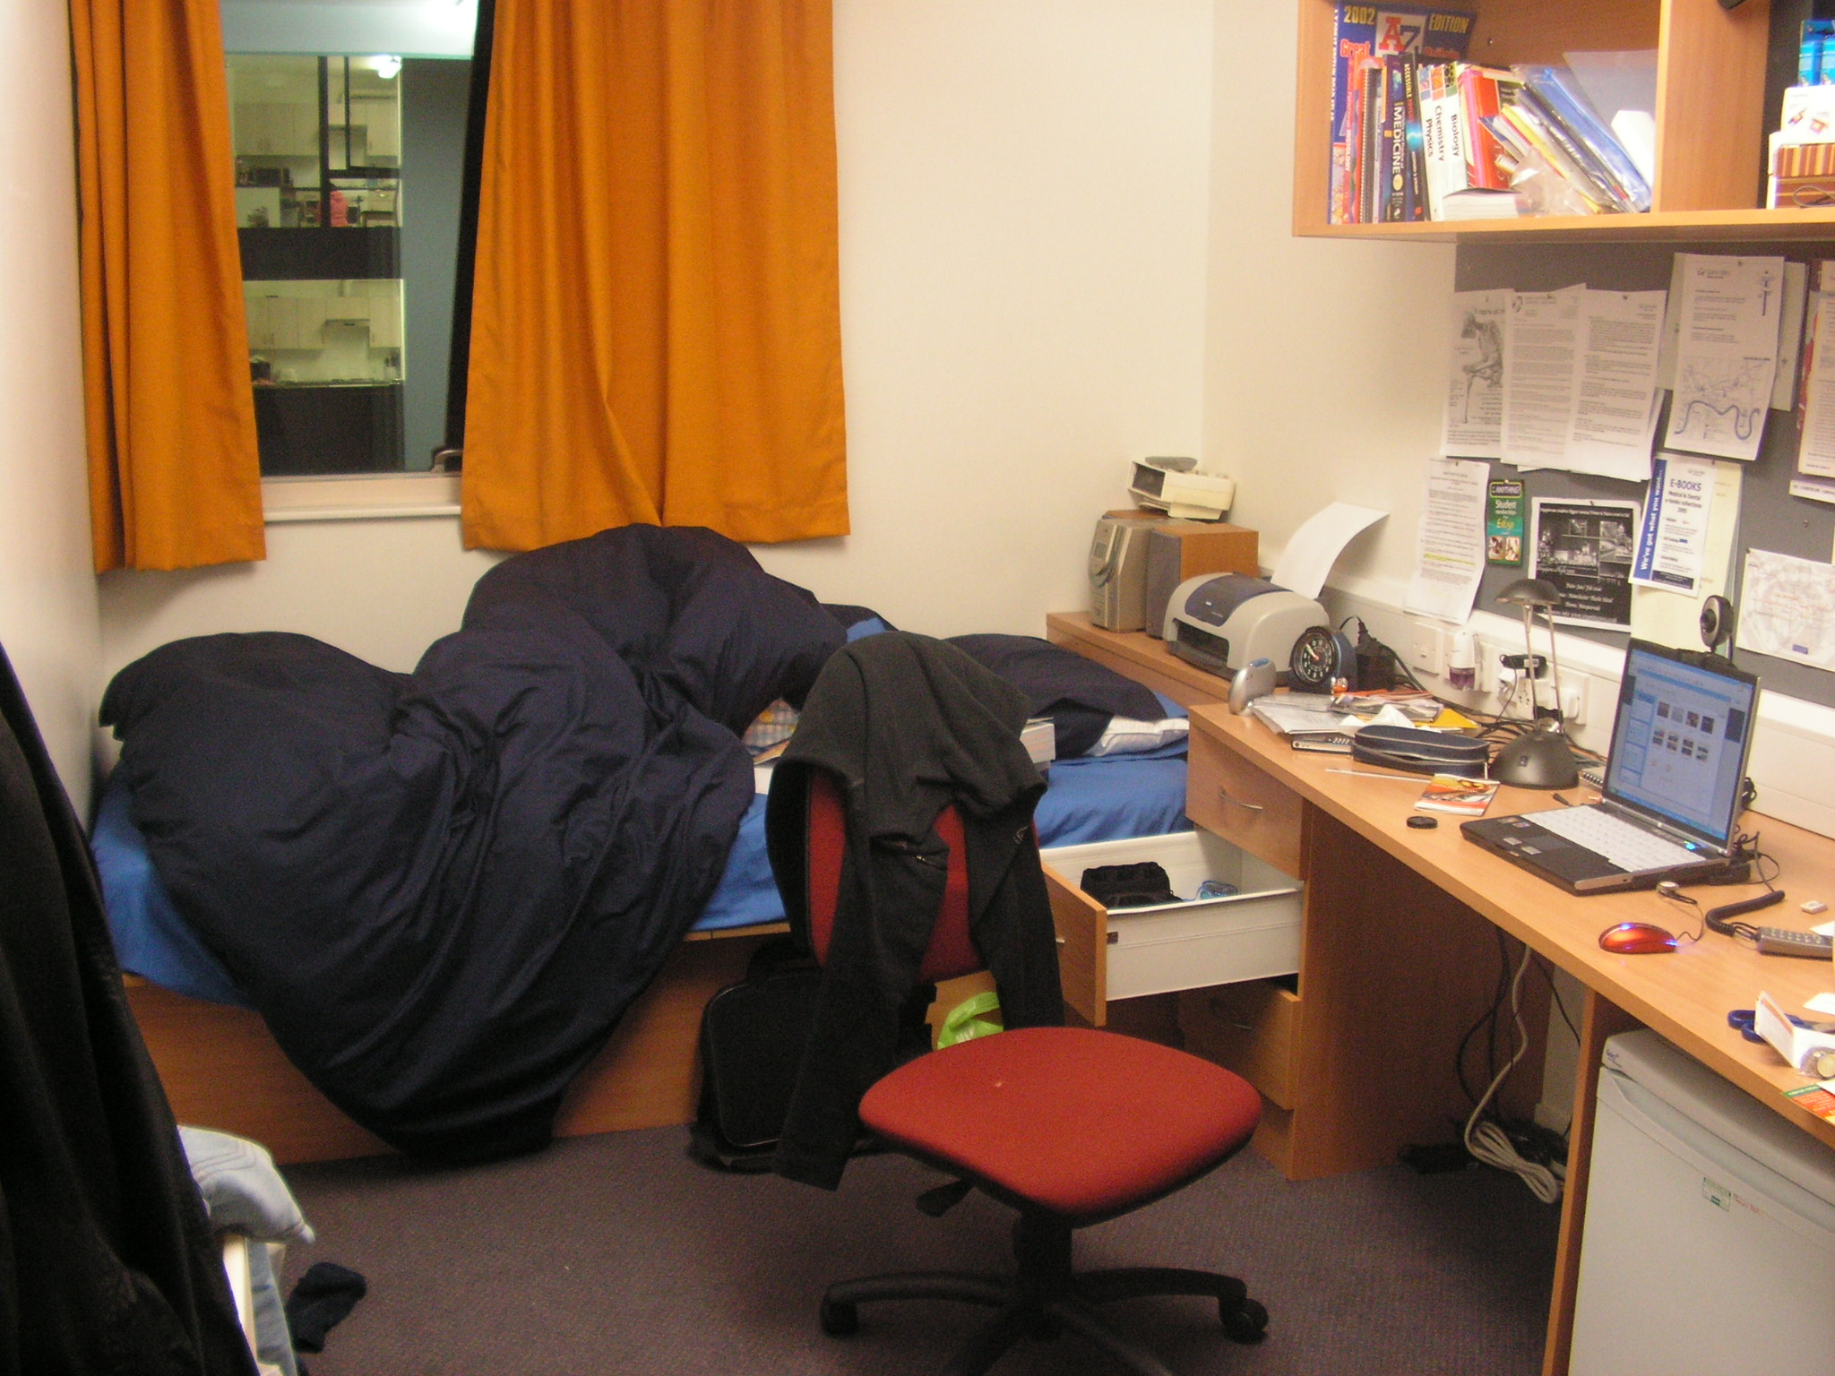
Hi, a brief introduction about me. I’m a 1st year medic at Barts, or what some of you would call Queen Mary.

There are a variety of halls out there for you to choose from, but most of you will eventually end up in the college’s new student village. Rooms are almost brand new, and usually look beautiful, unless you’ve got a messed up one like mine on the right!
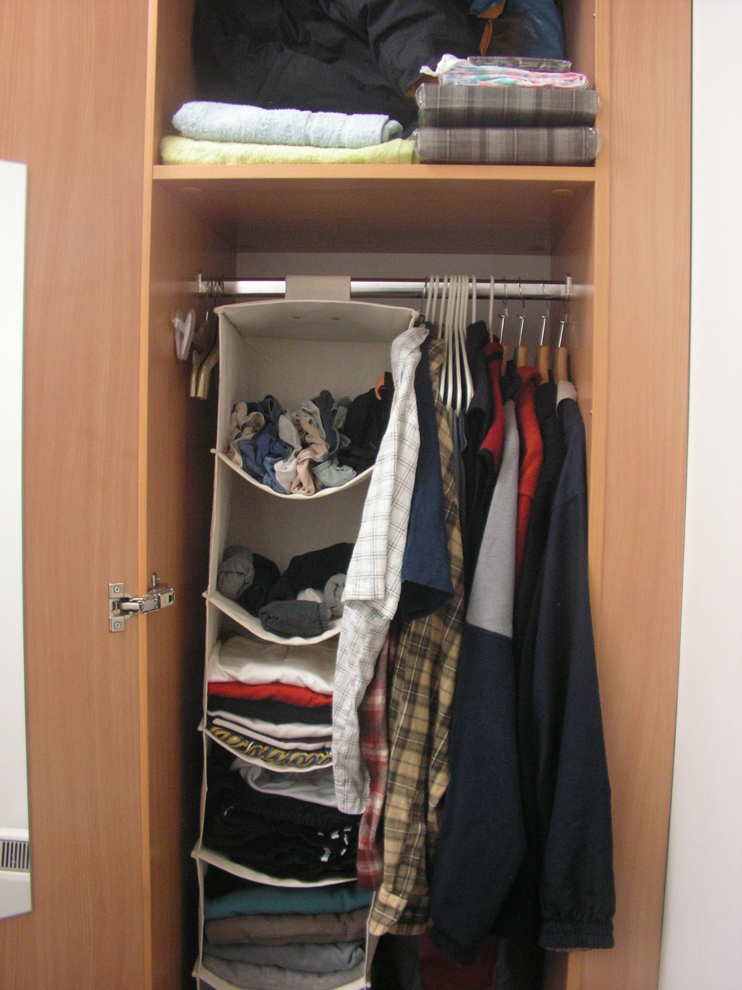

Try not to bring too many clothes, as you will have a different fashion sense after coming here. To save on our laundry, we buy stacks of underwear to last us for usually 2 weeks, otherwise you’ll have to go without it, or what we call ‘going-commando’. It will be useful to get a wardrobe compartmental sorter like the one on the left to sort out all your clothings or whatever lengerie you have. Now stop looking at mine!

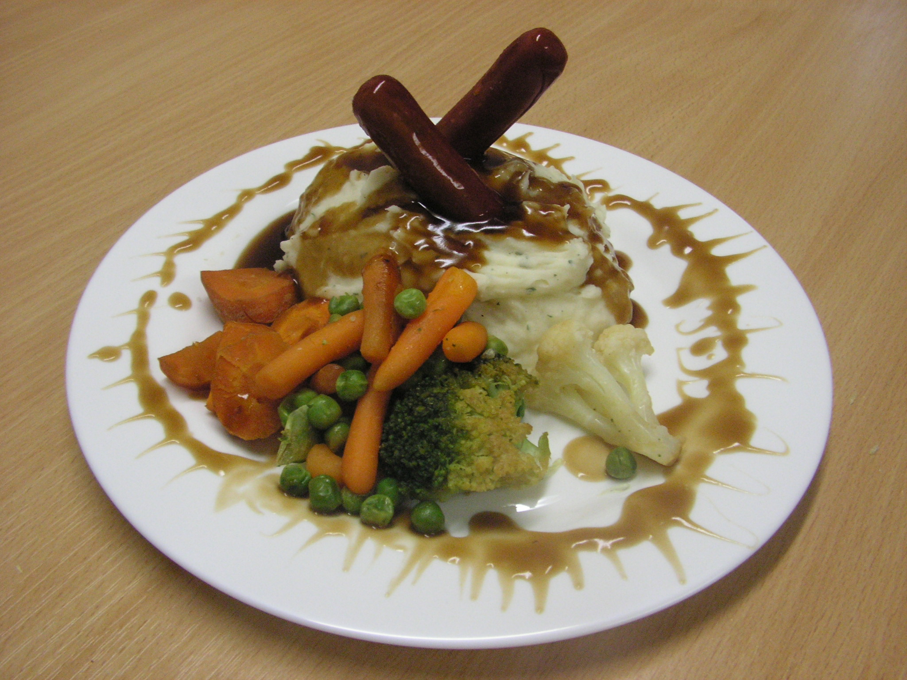
The medical students mostly reside in Pooley House within the student village, within easy access to the Village restaurant and shops (or what we call the mama-shop). The halls are just 5 minutes away from the school’s main campus. The Medical Science building is however undergoing renovation at the moment and as such, walks to the next campus at Whitechapel where lectures are currently held take around 30 minutes. However, as soon as that is done, you can expect to wake up at 9 55 a.m. for a 10 a.m. Lecture! (Note as of 2008: Lectures are at Whitechapel, and practical skills and anatomy sessions are at Mile End. It really doesn't matter!).

One thing to note about Pooley House: fire alarms are hypersensitive. They sound even more frequently than a woman would whine! They used to come on about once a day, but have since reduced to once a week. Often or not, it’s caused by students showering without closing their toilet doors (Now, I’m not suggesting you guys to open others’ doors).
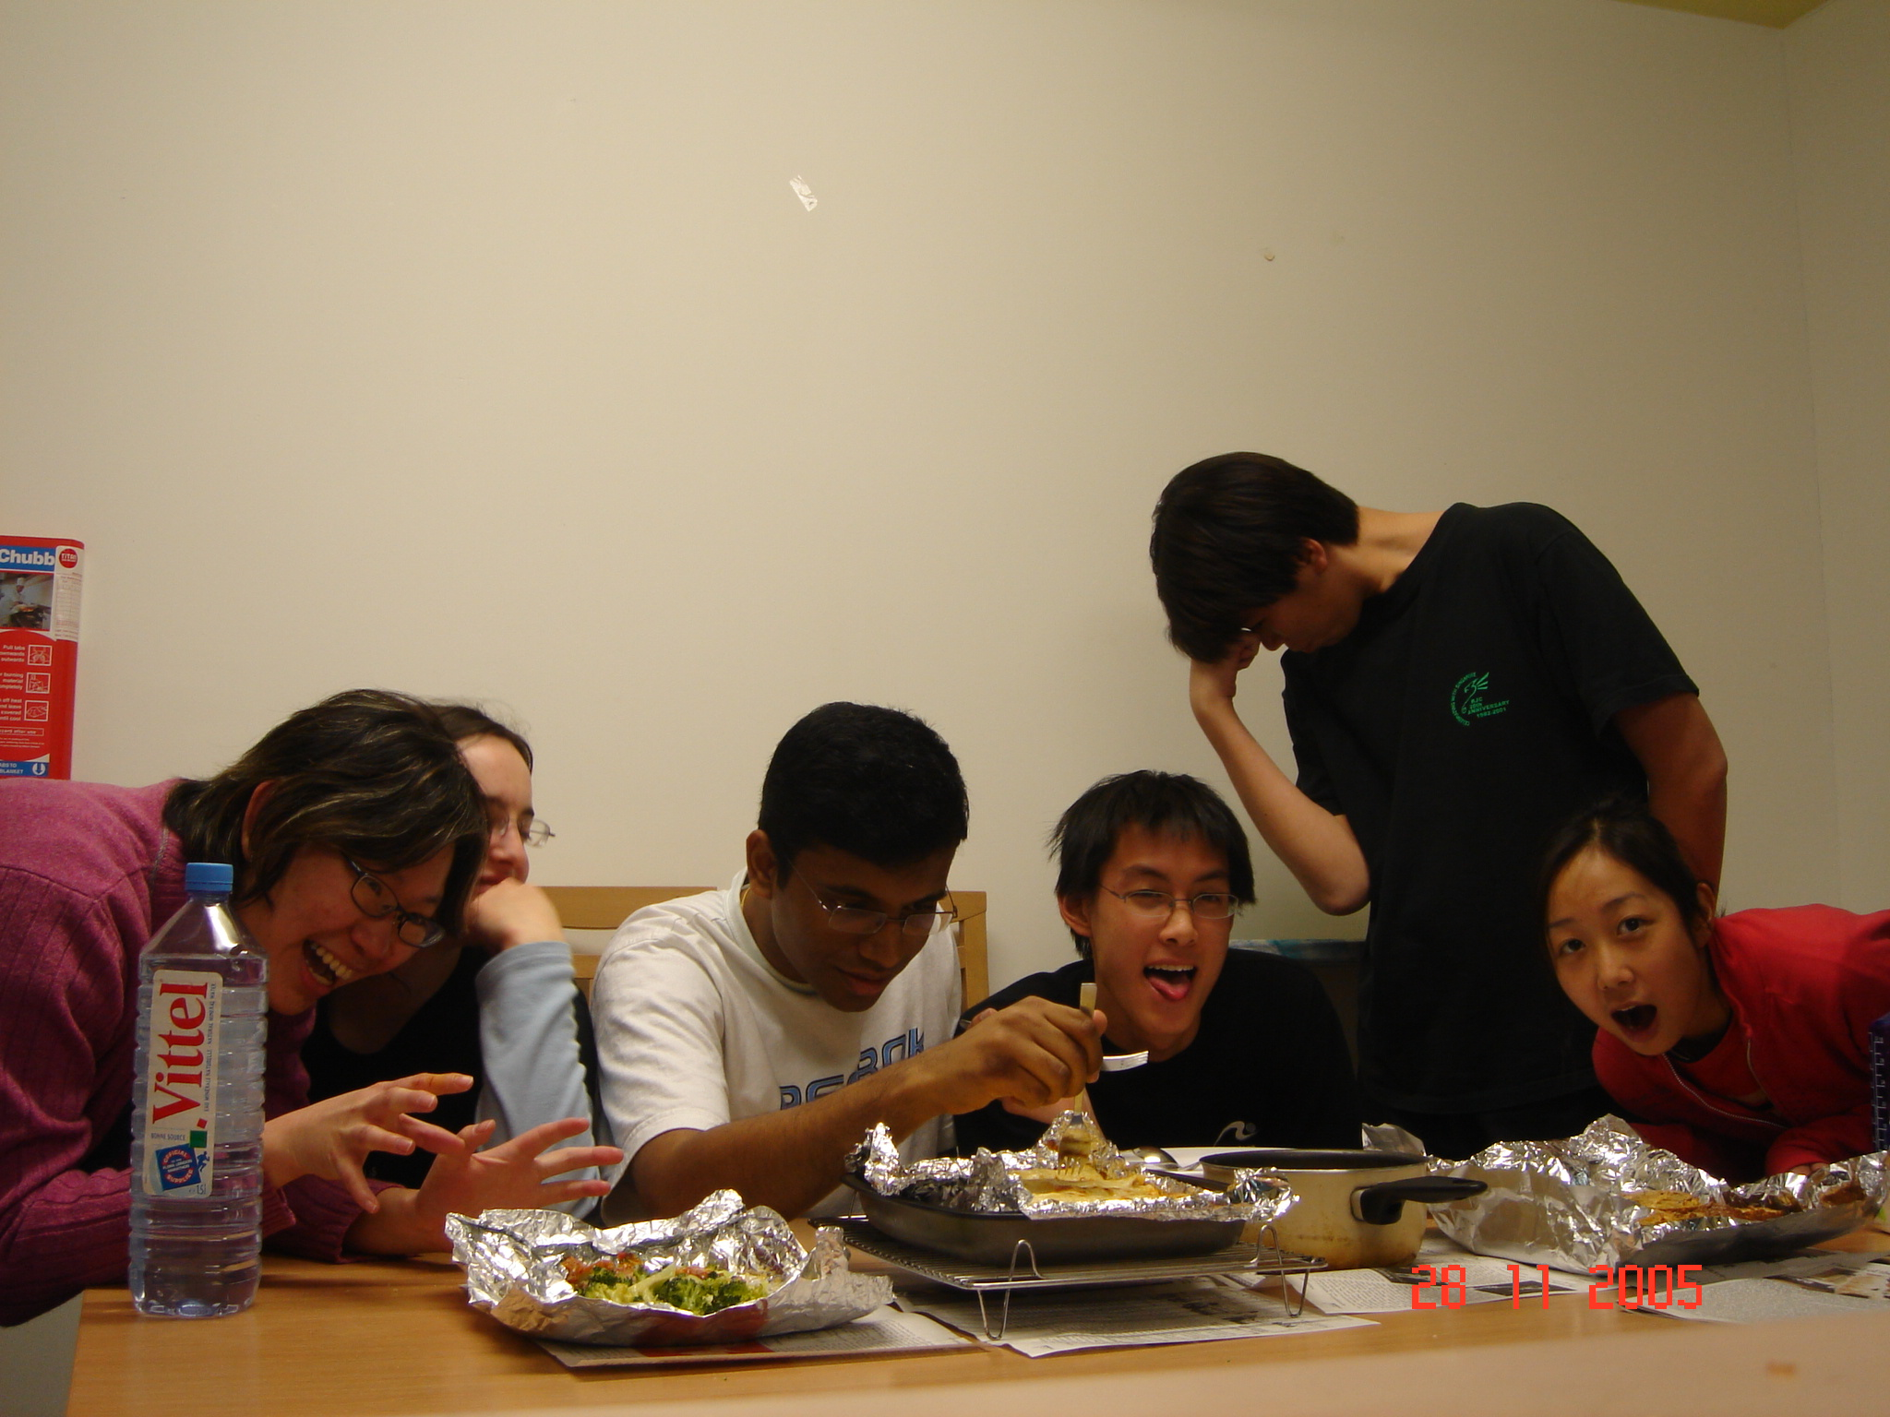
Cooking is no doubt a chore, and it be can quite bothersome at times. But I assure you that it is the best socialising activity out there, especially when you come up with an orgasmic dish like the one above.

Just look at all of us having fun!

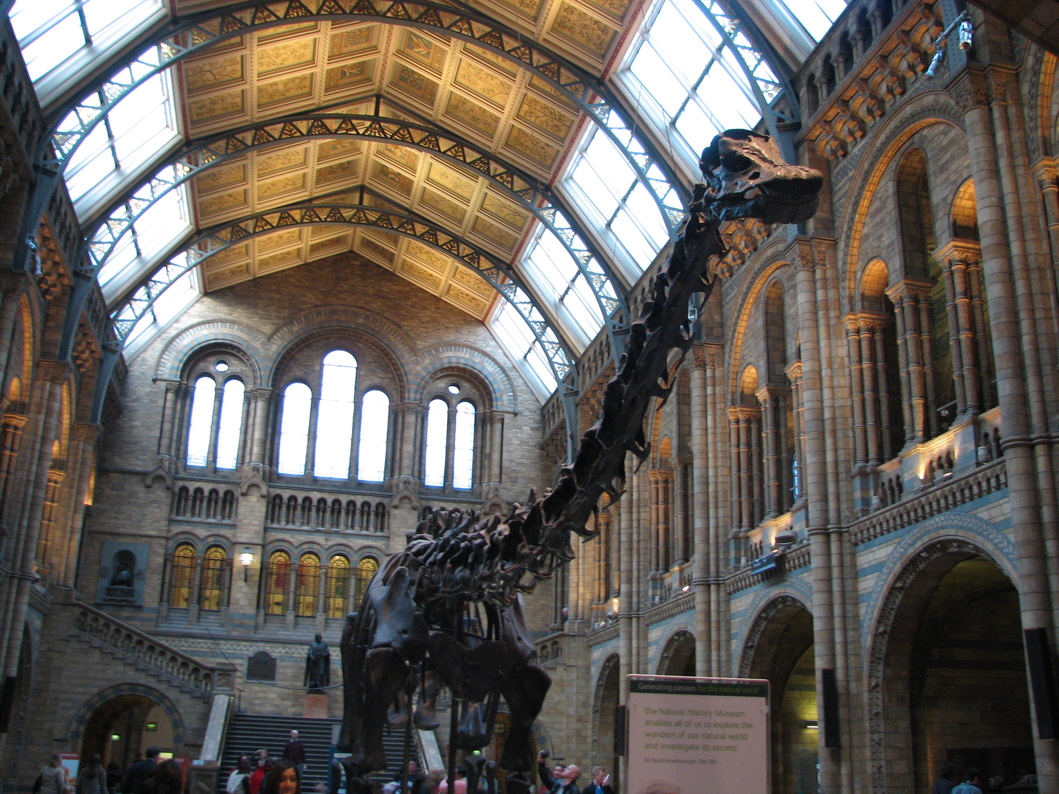
Work at school can be tough at times, especially with the amount of PBLs that us medical students get. However, there’s always a time to chill and hang out. There’s the usual shopping that you can do at Oxford Circus which is less than half an hour away by Tube. Or you can opt for more adventurous outing spots, such as the Natural History Museum in South Kensington.
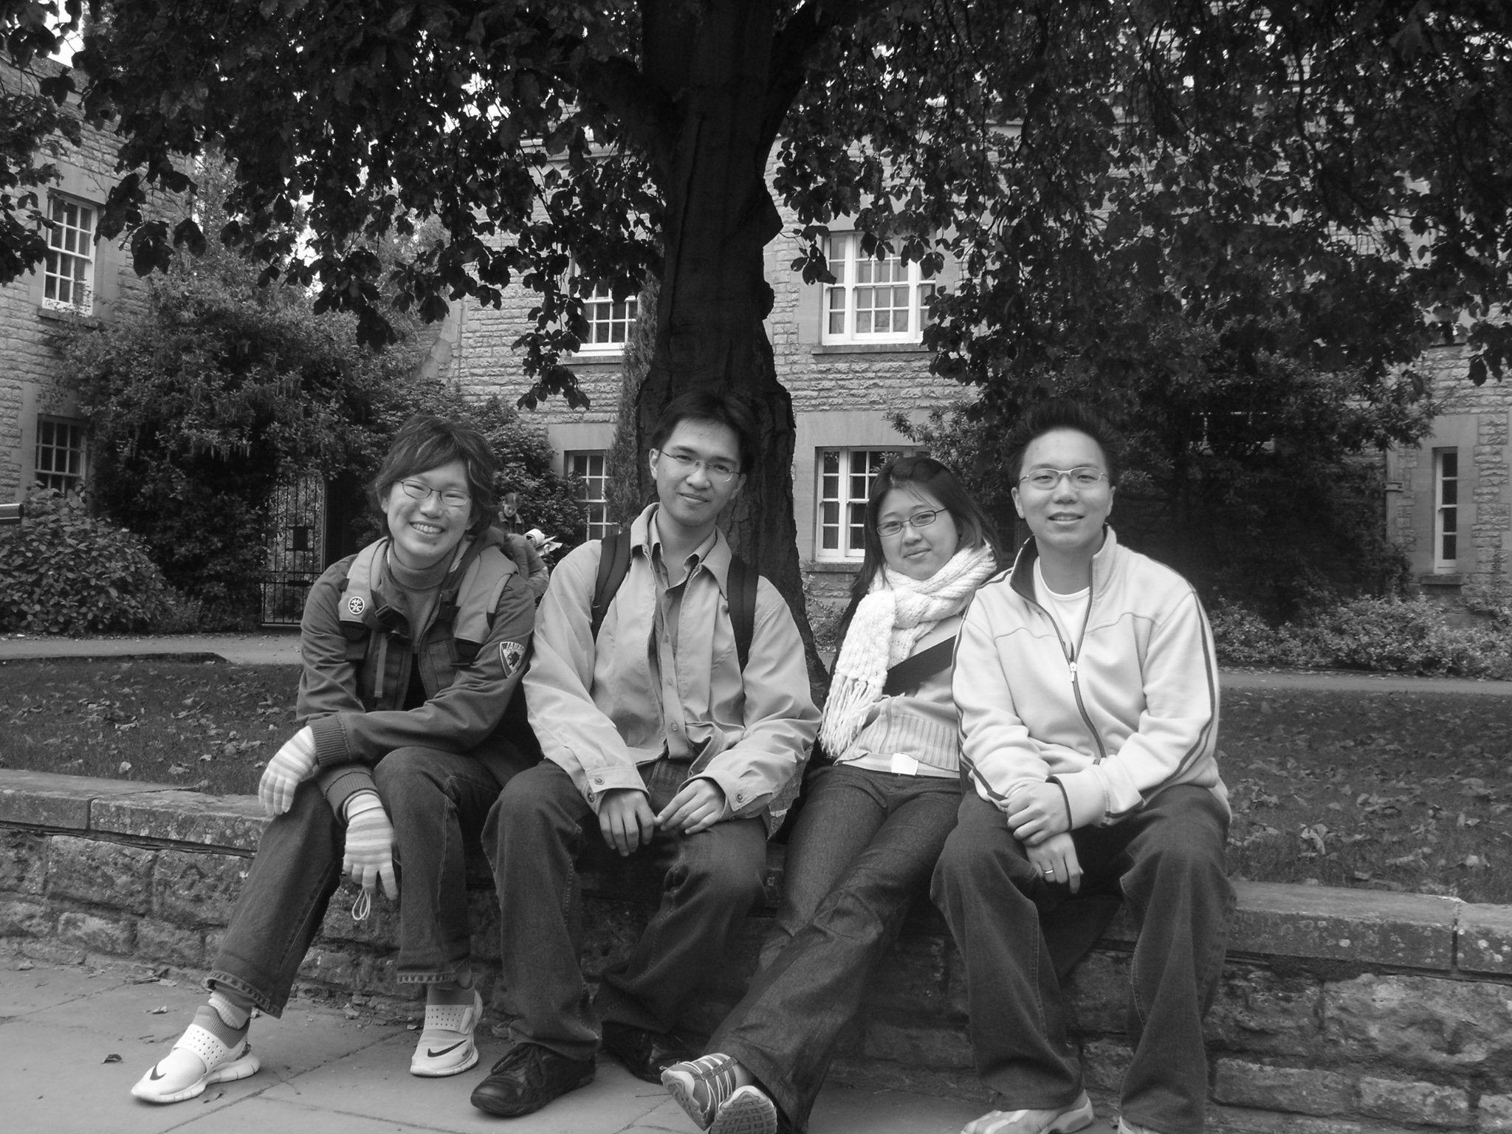
Occasionally, we do go to other cities for day trips when we get bored of London. There are many places to choose from, including scenic Lake District, as well as other famous cities such as Oxford on the right. Buses to these cities take a couple of hours and are rather cheap, costing less than 10 pounds a ride.

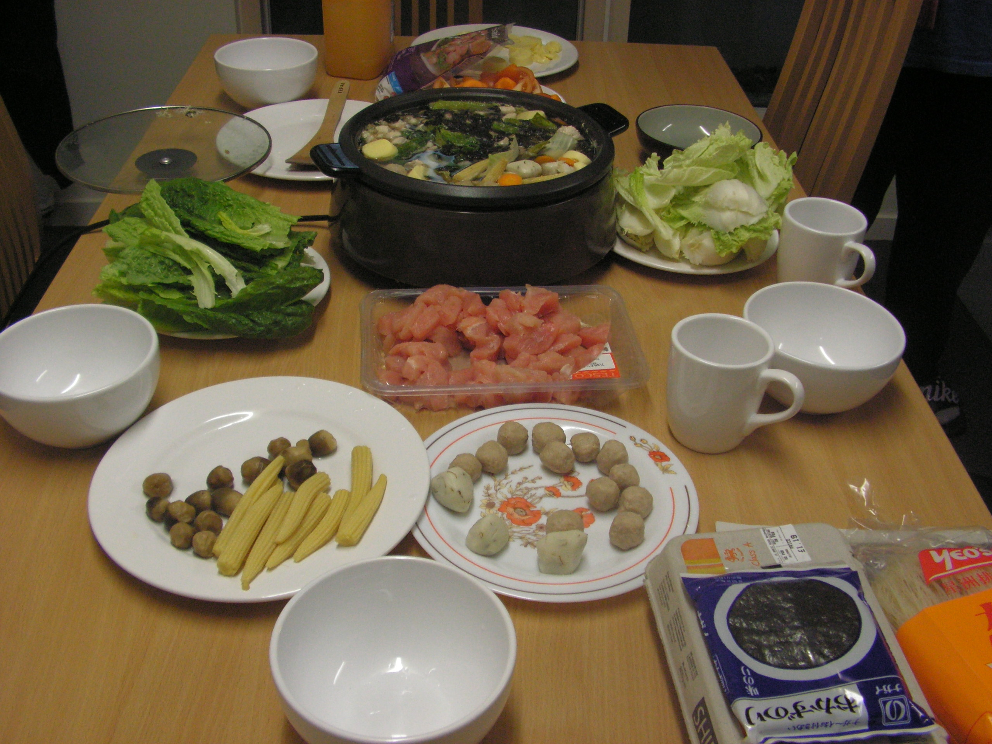

Again, cooking comes in handy when you’ve got festive seasons like Chinese New Year. Even a steamboat isn’t that hard to prepare.

Barts is a great place to study and the people here are really great pals, some of whom may go on to be your colleagues. I wish all you guys a wonderful time if you do come here.

Written painstakingly on 24th March 2006 (02 19 a.m.)... Pay me back my youth!

