Congressional Submission
FY 2009 Performance Budget
United States Attorneys

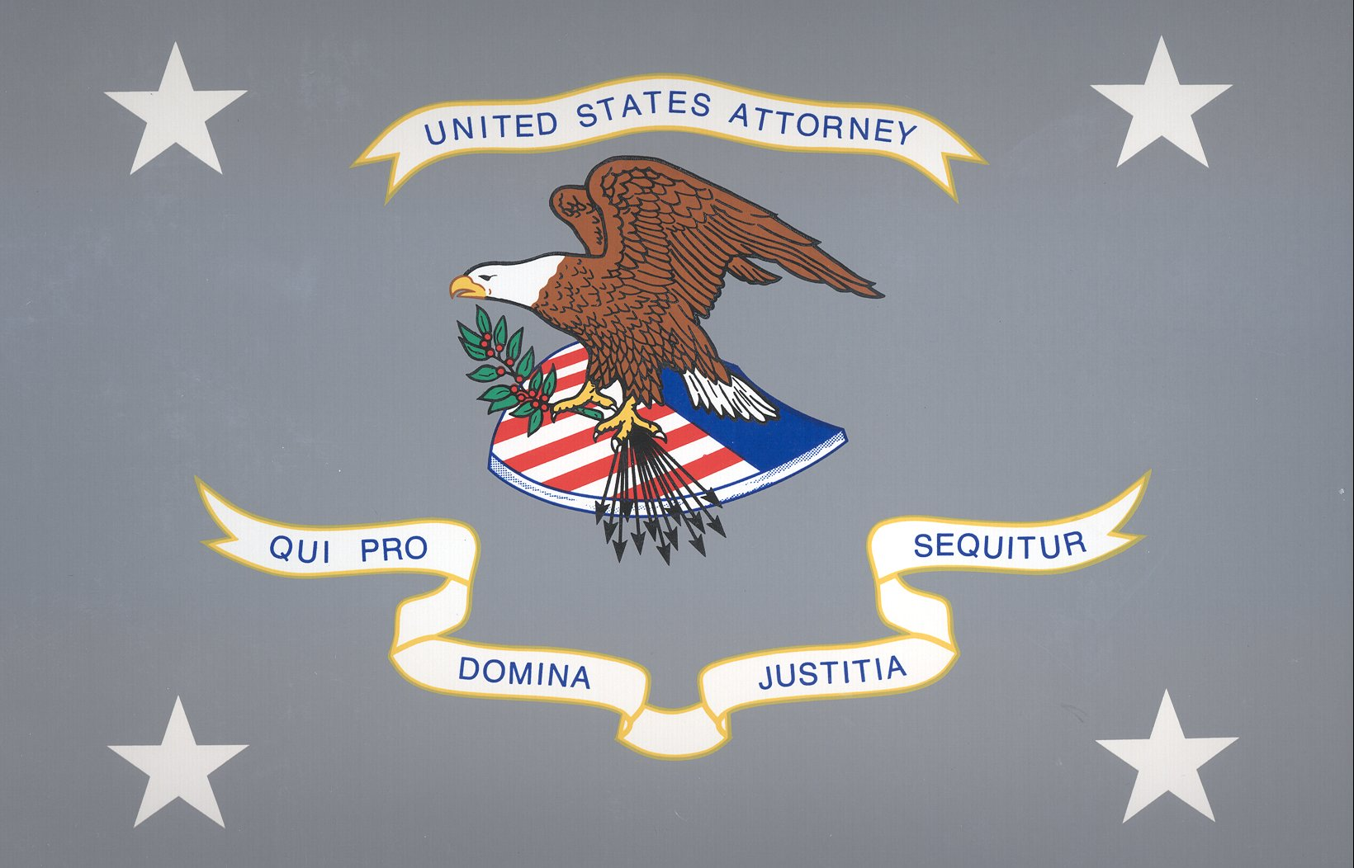

U.S. Department of Justice

Table of Contents

Page No.

I. Overview 1

II. Summary of Program Changes 13

III. Appropriations Language and Analysis of Appropriations Language 14

IV. Decision Unit Justification 15

A. Criminal 15

1. Program Description 16

2. Performance Tables 18

3. Performance, Resources, and Strategies 20
- Performance Plan and Report for Outcomes
- Strategies to Accomplish Outcomes
- Results of Program Assessment Rating Tool (PART) Reviews

4. Program Increases
- Southwest Border Enforcement Initiative 23

B. Civil 28

1. Program Description 29

2. Performance Tables 31

3. Performance, Resources, and Strategies 33
- Performance Plan and Report for Outcomes
- Strategies to Accomplish Outcomes
- Results of Program Assessment Rating Tool (PART) Reviews

C. Legal Education 34

1. Program Description 35

2. Performance Tables 38

3. Performance, Resources, and Strategies 39
- Performance Plan and Report for Outcomes
- Strategies to Accomplish Outcomes
- Results of Program Assessment Rating Tool (PART) Reviews

V. E-Gov Initiatives 41

VI. Exhibits 43

- Organizational Chart
B. Summary of Requirements
C. Program Increases by Decision Unit
- Resources by DOJ Strategic Goal/Objective
- Justification for Base Adjustments
- Crosswalk of 2007 Availability
- Crosswalk of 2008 Availability
- Summary of Reimbursable Resources
- Detail of Permanent Positions by Category
- Financial Analysis of Program Increases/Offsets
- Summary of Requirements by Grade
- Summary of Requirements by Object Class
- Status of Congressionally Requested Studies, Reports, and Evaluations

I. Overview for the United States Attorneys

A. Introduction

The United States Attorneys’ (USAs) mission supports two of the Department of Justice’s strategic goals - (1) prevent terrorism and promote the nation’s security, and (2) prevent crime, enforce federal laws and represent the rights and interests of the American people. The FY 2009 budget request totals $1,831,336,000, including $8,400,000 for a Southwest Border Enforcement Initiative.

Electronic copies of the Department of Justice’s Congressional Budget Justifications and Capital Asset Plan and Business Case exhibits can be viewed and downloaded from the Internet using the following Internet address: http://www.usdoj.gov/jmd/2009justification/.

The United States Attorneys serve as the nation’s principal litigators. In response to the mandates of the Constitution that required establishment of a system of federal courts, Congress enacted the Judiciary Act of 1789 directing the President to appoint, in each federal district, “a person learned in the law to act as an attorney for the United States.” Before 1870, the U.S. Attorneys acted independently, but since then they have worked under the direction of the U.S. Department of Justice.

There are 94 United States Attorneys Offices (USAOs) located throughout the United States, Puerto Rico, the Virgin Islands, Guam, and the Northern Mariana Islands. The USAs are appointed by, and serve at the discretion of, the President of the United States, with the advice and consent of the United States Senate. The USAs report to the Attorney General, through the Deputy Attorney General. Each USA serves as the chief federal law enforcement officer within his or her judicial district and, as such, is responsible for the prosecution of criminal cases brought by the federal government; the litigation and defense of civil cases in which the United States is a party; the handling of criminal and civil appellate cases before United States Courts of Appeal; and the collection of civil and criminal debts and restitutions owed the federal government which are administratively uncollectible.

USAs provide advice and counsel to the Attorney General and senior policy leadership through the Attorney General’s Advisory Committee (AGAC) and its various subcommittees. The AGAC was established in 1973 to give USAs a voice in Department policies and to advise the Attorney General. The Committee meets monthly with the Attorney General and its 20 USA members represent various federal judicial districts, geographic locations, and small, medium and large size offices.

An order of the Attorney General in 1953 established the Executive Office for United States Attorneys (EOUSA) to provide executive assistance and coordination functions for the USAs. Under the direction of the Director of EOUSA, the EOUSA’s mission is to provide the 93 USAs with general executive assistance and direction; policy development; administrative management direction and oversight; operational support; and coordination with other components of the Department and other federal agencies. These responsibilities include legal, budgetary, administrative, and personnel services, as well as continuing legal education. See Exhibit A for an organization chart of EOUSA. Specific offices and functions of EOUSA are outlined below:

- The Office of Counsel to the Director represents USAOs in communications with the Office of Legislative Affairs (OLA) and Office of Public Affairs (OPA), and serves as an ombudsman for USAOs with other Justice components. The Counsel’s office develops new programs and initiatives in the areas of legislation and public affairs, and provides expertise concerning substantive issues to the Director, EOUSA, the AGAC subcommittees and working groups. The Counsel’s office responds to legislative comments, Congressional inquiries and letters, and assists in the preparation of testimony by USAs, AUSAs or staff.

- The Data Analysis Staff is responsible for providing a wide variety of reports and trend analyses for use by the Director of EOUSA when responding to requests from the Department, the Administration, Congress, and the public. The staff analyzes U.S. Attorney work year, caseload and workload information for a variety of management purposes, and produces the United States Attorneys’ Annual Statistical Report. During FY 2007, the Data Analysis Staff responded to over 1,000 requests for trends, data, and management analyses.

- The General Counsel’s office provides advice to USAOs and to EOUSA on a broad array of legal and ethical issues. It provides guidance to USAO and EOUSA personnel regarding ethics and standards of conduct matters including conflicts of interest, recusals, outside activities, gifts and financial disclosures, allegations of misconduct, personnel legal issues, discovery requests and compliance with subpoenas. The General Counsel’s office is also responsible for the employee relations programs of EOUSA and the USAOs.

- Law Enforcement Coordinating Committee (LECC)/Victim-Witness Staff provide support through EOUSA for district LECC and Victim-Witness programs through liaison, monitoring, and assistance activities. LECC coordinators at the district level carry out the important role of coordination and liaison with federal, state, and local law enforcement, and with members of the community on various crime reduction programs. Each District’s LECC is under the supervision of the United States Attorney, who serves as the LECC chairperson or co-chairperson. Through the LECC program, training is provided to federal, state, and local law enforcement in areas such as anti-terrorism, gun crime, asset forfeiture, gang investigations, racial profiling, domestic violence, emerging drug trends, community policing, victim issues, and officer safety. USAOs’ Victim Witness personnel enhance and protect the necessary role of crime victims and witnesses in the criminal justice process, ensuring that the federal government does all it can to assist those individuals through an often extremely difficult process. Victim Witness personnel handle victim notification, explain to victims the criminal justice process, prepare victims and witnesses for testimony and allocution, coordinate their attendance at proceedings and attend proceedings with them, and provide victims with referrals and emergency assistance. Victims’ rights have taken on new importance since the passage of the Crime Victims’ Rights Act of 2004, which provided victims with enumerated rights and, for the first time at the federal level, the mechanisms to enforce their rights. Victims are now playing a more central role in the criminal process, and exercising their rights in greater numbers than ever before. The number of notifications sent to victims alone has doubled since the Act passed.

- The Equal Employment Opportunity (EEO) Staff provides centralized leadership, coordination, and evaluation of all equal employment efforts within EOUSA and the USAOs. The EEO Staff is comprised of two components – Complaint Processing and Affirmative Employment/Special Emphasis Programs.

- The Legal Programs office includes the Financial Litigation Staff (FLS) which assists in the collection and enforcement efforts of district financial litigation programs. FLS assists in the development of financial litigation policy, development and implementation of procedures and programs, and provides liaison functions within the Department and with outside agencies. The Legal Programs office also coordinates asset forfeiture programs in USAOs and develops national policies and initiatives. In addition, Legal Programs coordinates the activities of the Affirmative Civil Enforcement (ACE) Program, which uses civil statutes for federal law enforcement efforts in fighting economic fraud.

- The Evaluation and Review Staff (EARS) conducts the evaluation program, enabling the Director of EOUSA to fulfill his responsibility for conducting reviews of internal management controls and to prevent waste, loss, unauthorized use or misappropriation in federal programs, as required under the Federal Manager's Financial Integrity Act and OMB Circular No. A -123. The evaluation program reviews legal management, administrative operations and financial litigation in each USAO and provides on-site management assistance to the USAs. In FY 2007, EARS conducted 21 evaluation visits, and 14 follow-up visits occurred to ensure that those issues identified as a result of the evaluation process were corrected. Also in FY 2007, EARS implemented new standards for the administrative evaluation program to improve the effectiveness and consistency of the evaluations by focusing on the “big picture” or “high impact” issues during the EARS reviews. During FY 2008, EARS has scheduled 27 evaluation visits.

- The Freedom of Information and Privacy Act (FOIA) Staff processes all FOIA and Privacy Act (PA) requests for records located throughout EOUSA and the USAOs, provides legal guidance to USAOs concerning FOIA/Privacy Act issues, represents them in administrative appeals, and assists Assistant United States Attorneys (AUSAs) and Department of Justice attorneys in litigation in federal courts throughout the country by providing draft pleadings and preparing legal documents.

- The Office of Legal Education (OLE) develops, conducts, and authorizes the training of all federal legal personnel. OLE coordinates legal education and attorney training for the Department of Justice and other departments and agencies. OLE is a separate decision unit of this budget and its functions are discussed in greater detail in Section IV C.

- The Chief Operating Officer (COO) is a key advisor to the Director of EOUSA and the AGAC on nationwide issues. The COO manages and directs the following staffs: The Employee Assistance Program (EAP) provides free, confidential assessments, short-term counseling, and community referrals for EOUSA employees and their families. The Facilities Management and Support Services Staff (FMSS) provides direct support and oversight of all USAOs in the areas of real property management, including space acquisition, relocation, design, repair, and management of rent payments. Support Services include acquisition and procurement, and coordination of records and forms management, printing, and mail metering. The Personnel Staff develops and maintains a component-wide personnel program for attorneys and support staff throughout the USAOs and EOUSA. The Security Programs Staff provides security program support for USAOs, including policy and procedural assistance, training, education and awareness efforts, and emergency and contingency planning.

- The Chief Information Officer (CIO) is responsible for providing advice and assistance to the Director of EOUSA and senior staff to ensure that Information Technology (IT) is acquired and managed according to Department and EOUSA policies and procedures. The CIO ensures the integration of IT into strategic planning, acquisition, and program management processes to support the mission of the USA community. The CIO directs and manages the following staffs: The Case Management Staff provides user assistance and technical support for the nationwide case management systems. The Office Automation Staff supports the purchase and installation of computer systems, equipment, and software, maintenance of hardware and software, and end-user training. The Telecommunications and Technology Development Staff provides administrative and technical support to USAOs in all telecommunications activities, including voice, data and video.

In FY 2007, the IT program accomplished several goals related to implementing Enterprise Voice over Internet Protocol (VoIP), deploying new desktops and laptops, and improving case management and training. The multi-year nationwide deployment of Enterprise Voice over Internet Protocol (E-VoIP) was implemented as a pilot project in one district and then installed in five other districts. Over 15,000 new desktop and laptop computers were replaced nationwide. Conversion to the Consolidated Debt Collection System (CDCS) was completed. Major steps were accomplished towards the implementation of the Department’s new Litigation Case Management System (LCMS). In addition, in conjunction with the Office of Legal Education, a new training initiative – Video on Demand – was implemented.

- The Chief Financial Officer (CFO), through the Resource Management and Planning Staff (RMP), is responsible for budget formulation, budget execution, financial management, audit reviews, and long-range planning. On behalf of the USAs, RMP manages FTE allocations and a budget of approximately $1.75 billion in FY 2008. The staff consolidates resource needs and formulates an annual budget submission for presentation to the Department, the Office of Management and Budget, and Congress. It also manages the day-to-day financial operations through daily contact with USAO Budget Officers and through review of regular accountability reports. An internal Audit and Review Staff participates with the EARS in evaluating internal controls in USAOs. The staff also develops performance measures for the USAs in accordance with the Government Performance and Results Act (GPRA) and coordinates quarterly status reporting and the Program Assessment and Rating Tool (PART) process.

During FY 2007, the United States Attorneys’ program was subject to a PART review and achieved an overall rating of “Moderately Effective.” This was an improvement from the FY 2004 PART rating of “Adequate.” More detailed information is provided in the Criminal Decision Unit Justification on page 22.

CRIMINAL PROSECUTIONS

The USAOs investigate and prosecute the vast majority of criminal cases brought by the federal government, including a more diverse workload than ever before. The types of cases include international and domestic terrorism; immigration; child exploitation and obscenity; firearms and violent crime; complex and time-consuming fraud – including health care, identity theft, white collar crime and public corruption, procurement, mortgage, Katrina-related, and student loan fraud; gangs and organized crime; drug enforcement; human trafficking and criminal civil rights enforcement. Many of these cases involve multiple defendants and are extremely complex. The nature of today’s crimes has required the USAs and AUSAs to become conversant in a wide range of fields, such as banking and health care, computer technology, securities, foreign cultures and languages, and manufacturing processes affected by environmental and other federal regulations.

The USAs receive most of their criminal referrals, or “matters,” from federal investigative agencies, including the Federal Bureau of Investigation (FBI), the Drug Enforcement Administration (DEA), the Bureau of Alcohol, Tobacco, Firearms and Explosives (ATF), the United States Immigration and Customs Enforcement (ICE), the United States Secret Service, and the United States Postal Inspection Service. USAOs also receive criminal matters from state and local investigative agencies, as well as violations reported by private citizens. Following careful consideration of each criminal matter, the USAs decide the appropriateness of bringing criminal charges and, when deemed appropriate, initiate prosecution. Except for misdemeanor offenses and instances in which an alleged offender waives the right to a grand jury indictment, the USAs present evidence against an alleged offender to a grand jury. The grand jurors then decide whether to return an indictment and, if an indictment is returned, the USAs then present the criminal charges in open court at the arraignment of the defendant.

Although historically a large number of criminal defendants enter a plea of guilty prior to trial, the USAs must always fully investigate the crime, prepare the charging document, and be ready to go to trial. Consistent preparation for trial minimizes the risk of dismissal for noncompliance with the Speedy Trial Act and strengthens the government’s position in negotiations with defense counsel for a guilty plea. Pretrial discovery practice also strengthens the government’s position. When a guilty plea is not obtainable, a trial becomes necessary. The USAs then present factual evidence to the jury, or to the judge in a non-jury (bench) trial. If the defendant is convicted, the USAs must prepare and present evidence at the defendant’s sentencing hearing and then defend the conviction at post-trial hearings and appeals. The USAOs handle most criminal appeals at the intermediate appellate level. After filing an appeal brief, the USAs may be required to participate in oral arguments before the United States Courts of Appeal. If there is a further appeal, the USAs may be called upon to assist the relevant litigating division of the Department of Justice (DOJ) or the Solicitor General in preparing the case for review by the United States Supreme Court.

CIVIL LITIGATION

The USAs initiate civil actions, or affirmative litigation, to assert and protect the interests of the United States. They also defend the interests of the government in lawsuits filed against the United States, referred to as defensive litigation. In other civil cases, the United States is a third party plaintiff or defendant, a creditor, or an intervener. These types of civil litigation represent the civil caseload nationwide.

Examples of affirmative litigation include civil actions brought to: enforce the nation’s environmental, admiralty, and civil rights laws; represent the government’s interests in bankruptcy actions; recoup money and recover damages resulting from federal program and other fraud; and enforce administrative summonses and asset forfeiture litigation, which involve assets seized by federal, state, and local law enforcement.

Defensive litigation includes tort suits brought by those who allege suffering as a result of government action, adjudication of Social Security disability claims, alleged contract violations, habeas corpus petitions, and race, sex, and age discrimination actions. The USAOs represent and defend the government in its many roles – employer, regulator, law enforcer, medical care provider, revenue collector, contractor, procurer, property owner, judicial and correctional system manager, and as administrator of federal benefits. In those cases where the United States is sued, DOJ must be its representative.

Civil defensive work is unique because it is non-discretionary and non-delegable. Unlike criminal divisions or sections, civil units of USAOs cannot employ “declination” criteria to manage or reduce the civil defensive caseload. All cases filed against the government, its agencies, and employees in their official capacities must be defended.

CRIMINAL AND CIVIL DEBT COLLECTION

USAOs are responsible for collecting both criminal and civil debt for the U.S. Government. Each USAO has a Financial Litigation Unit (FLU) with the responsibility for both criminal and civil debt collection activities. In addition to the FLUs, USAOs have Affirmative Civil Enforcement (ACE) staff devoted to the collection of civil debts.

Debts are ordered to be collected from a criminal defendant when the defendant is sentenced by the court. These debts may be in the form of restitution to victims of crime, fines imposed by the court to penalize criminals, special assessments on each criminal conviction count, costs of prosecution and other costs, or forfeitures of appearance bonds. Interest may also be collected in certain cases. In instances where restitution is ordered, the USAs are involved in collecting federal restitution payments, or restitution which is owed to the United States, and in collecting non-federal restitution, or that which is owed to private individuals and entities. As a result of the Mandatory Victims Restitution Act (MVRA), courts now must impose monetary restitution orders in all violent crimes and most property crimes. USAs are required to enforce restitution orders on behalf of all victims of federal crimes. The amount of outstanding criminal debt has risen dramatically since the enactment of the MVRA, to $50.5 billion by the end of FY 2007, but not all of this is collectible.

The U.S. Attorneys are also the legal representatives for other federal agencies to pursue repayment of debts. For example, when federal agencies lend money and the recipients default on repayment of the loans, or when federal agencies have paid on guaranteed loans and have not been repaid as provided for in the lending agreement, USAs pursue the repayment of debt. The Departments of Agriculture, Education, Health and Human Services, Housing and Urban Development, Transportation, Veterans Affairs, and the Small Business Administration are some of these client agencies. USAs file suit to obtain judgments to collect debts, foreclose on real property, compel physicians to repay or fulfill their commitment to the Public Health Service in return for education grants, sue to set aside fraudulent transfers of property which could be used to satisfy defaulted loans, and manage debtor repayment schedules.

In FY 2007, the USAOs collected $4.24 billion of criminal and civil debts owed. Of the total debts collected, USAOs recovered: (1) $1.77 billion in criminal debts in FY 2007 or a 16 percent increase over the $1.52 billion collected in FY 2006; and (2) $2.47 billion in civil debts which was a decrease from the $3.72 billion collected in FY 2006. The decrease in civil debt collection in FY 2007 was due to three high dollar health care fraud recoveries in FY 2006. The United States Attorneys’ collection efforts, handled by a very small percentage of the total workforce, returns to the Treasury over twice the $1.83 billion sought in the FY 2009 budget request for the entire USA community.

CRIMINAL AND CIVIL APPEALS

Appeals are generally very time-consuming, requiring a thorough review of the entire record in the case, the filing of a brief and reply brief, and, in most cases, participation in oral argument requiring travel to the city where the United States Court of Appeals for the circuit is located. Furthermore, the complexity of appellate work and the time required to handle that work increases when convictions are based on complex facts, such as those found in organized crime drug enforcement and other narcotics cases, financial institution fraud, other organized crime, armed career criminal, public corruption, health care fraud, and computer fraud cases.

The appellate workload of the USAs increased due to additional appeals prompted by the Supreme Court’s ruling in United States v. Booker in January 2005. The Supreme Court held that the Sixth Amendment right to jury trial applies to factual findings supporting certain sentencing enhancements under the U.S. Sentencing Guidelines, and that the Guidelines are advisory instead of mandatory. As a result, post-sentencing motions filed by incarcerated defendants increased -- primarily to vacate a sentence under the new guidelines. Between FY 2004 and FY 2006, these motions increased by 383 motions from 5,565 to 5,948 or 6.9 percent. During the same period, the number of motions pending also increased by 703 motions from 7,642 to 8,346 or 9.2 percent. In FY 2007, these numbers decreased slightly – to 5,155 motions filed and 7,884 motions pending.
B. Issues, Outcomes, and Strategies

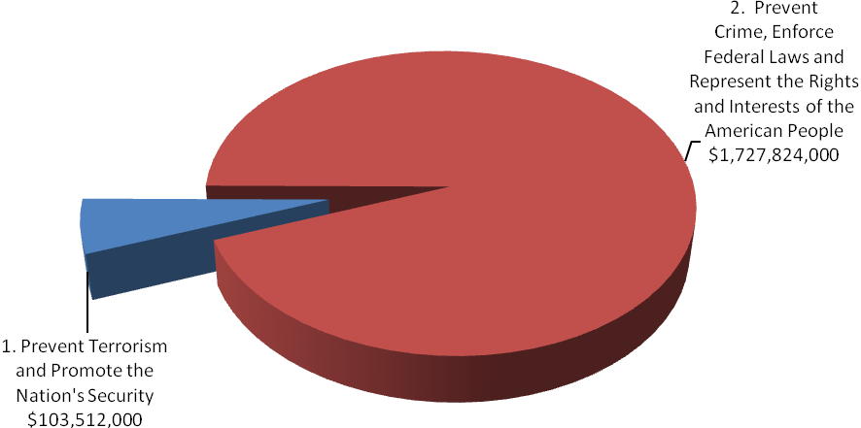

FY 2009 Total Request by DOJ Strategic Goal

The following is a brief summary of the Department’s Strategic Goals and Objectives, in which the USAs play a role.

DOJ Strategic Goal 1: Prevent Terrorism and Promote the Nation’s Security ($103,512,000)

● Prevent, disrupt, and defeat terrorist operations before they occur (1.1)
● Strengthen partnerships to prevent, deter, and respond to terrorist incidents (1.2)
● Prosecute those who have committed, or intend to commit, terrorist acts in the United States (1.3)

DOJ Strategic Goal 2: Prevent Crime, Enforce Federal Laws and Represent the Rights and Interests of the American People ($1,727,824,000)

● Strengthen partnerships for safer communities and enhance the Nation’s capacity to prevent, solve, and control crime (2.1)
● Reduce the threat, incidence, and prevalence of violent crime (2.2)
● Prevent, suppress, and intervene in crimes against children (2.3)
● Reduce the threat, trafficking, use, and related violence of illegal drugs (2.4)
● Combat public and corporate corruption, fraud, economic crime, and cybercrime (2.5)
● Uphold the civil and constitutional rights of all Americans (2.6)
● Vigorously enforce and represent the interests of the United States in all matters over which the Department has jurisdiction (2.7)

C. Full Program Costs

This request funds the strategies that support the USAs’ objectives. We will continue to provide federal leadership in preventing and controlling crime and seeking just punishment of those guilty of unlawful behavior.

FY 2009 Budget Request by Decision Unit

The USAs’ $1,831,336,000 budget request for FY 2009 is divided into three decision units: criminal, civil, and legal education. Some programs, as well as management and administration costs, cross decision units. Both performance and resource tables within each decision unit define the total costs of achieving the strategies the USAs will employ in FY 2009. The various resource and performance charts incorporate the costs of lower level strategies which also contribute to the achievement of objectives, but which may not be highlighted in detail in order to provide a concise narrative. Also included are the indirect costs of continuing activities, which are central to the operations of each decision unit.

D. Performance Challenges

The challenges that impede progress toward the achievement of agency goals are complex and ever-changing. New national priorities since September 11 affect everyone in the law enforcement community as resources and personnel have been redirected to prosecute the Global War on Terror. Border security has become critical after the events of September 11, 2001. Federal prosecution of border crime is a critical part of our Nation’s defense. Internal agency dynamics, political decisions, technological developments, and criminal behavior are factors that broadly impact law enforcement practices and pose challenges that demand attention.

Vacant positions have had a substantial impact on the U.S. Attorneys’ workload. In FY 2004, 198 FTE were left unfilled; that number more than doubled to 465 FTE by the end of FY 2005 and to 786 FTE by the end of FY 2006.

With these vacancies, criminal cases pending or what could be considered as “backlog” increased by 11 percent or 6,733 cases, from 63,499 cases in FY 2003 to 70,232 in FY 2006. Additionally, the number of new cases filed decreased by 4.5 percent from FY 2004 to FY 2006, going from 61,443 cases to 58,702 cases.

Between FY 2003 and FY 2006, the number of civil cases filed or responded to decreased by 13 percent or 10,533 - from 81,935 cases to 71,402, while the number of civil cases referred to USAs decreased by 10 percent or 9,199 - from 89,959 in FY 2003 to 80,760 cases in FY 2006. The number of defensive civil cases filed decreased by 8 percent or 4,507 - from 54,208 cases in FY 2003 to 49,701 in FY 2006. The number of affirmative cases filed decreased by 21 percent or 1,841 - from 8,950 cases in FY 2003 to 7,109 in FY 2006.

The United States Attorneys’ received a budget increase in FY 2007 and, coupled with an expanded carryover authority, the USAOs began filling positions previously left vacant. As a result, during FY 2007 the number of criminal cases filed increased by 1 percent from 58,702 to 59,228 and the number of civil cases filed or responded to by .5 percent from 71,402 to 71,823. USAOs have leveraged the additional funding by taking the necessary management steps to restructure the workforce by backfilling positions with lower salaried employees. As the chart below shows, the incremental increases in the average non-supervisory attorney salary (82 percent of the total attorney workforce are non-supervisors) are well below the cost-of-living adjustment over the last several years:

Fiscal Year | Average Salary | $ Change in Average Salary | % Change in Average Salary
FY 2007 | $106,434 | $1,003 | .9%
FY 2006 | $105,431 | $745 | .7%
FY 2005 | $104,686 | $1,638 | 1.6%
FY 2004 | $103,048 | $2,910 | 2.9%
FY 2003 | $100,138

Despite an increase in hiring actions, the United States Attorney community did not experience
a significant reduction in vacancy rates during FY 2007. However in FY 2008, USAOs will continue to fill vacant positions thereby reducing the vacancy rate and further increasing the number of criminal and civil cases filed.

External Challenges

A highly skilled, dynamic workforce is more important now than ever before. Since September 11, USAOs have taken on more responsibilities in new areas. AUSAs coordinate with state, local, and federal agencies in preventing, investigating, and prosecuting terrorist acts. Furthermore, AUSAs participate in disaster planning and emergency preparedness. These coordination activities involve non-traditional roles for AUSAs and present challenges as we continue combating terrorism.

Coordination with state, local, and federal agencies is not unique to combating terrorism. USAOs are actively involved in these activities in program areas ranging from border enforcement/prosecution to gun violence reduction through Project Safe Neighborhoods to disrupting and dismantling drug organizations, and now child exploitation through Project Safe Childhood. In the border enforcement and prosecution area, additional Border Patrol Agents are resulting in substantial increases in misdemeanor cases requiring even closer coordination with the U.S. Marshals Service, the Office of the Detention Trustee, the Bureau of Prisons, the Department of Homeland Security, the Courts and the local defense bar concerning the availability of bed space, prisoner transport, and translators for those who are detained.

In addition, the economy and emerging criminal activities, often driven by technology, such as cybercrime, are external challenges beyond our control. Downturns in the economy often correlate with increases in criminal activity. We will continue to focus on areas within our spheres of influence and control, concentrating on coordination efforts with state, local, and federal agencies and ensuring our workforce is trained for emerging and complex issues.

Internal Challenges

One internal challenge to the USAs community is keeping the workforce flexible and adaptable. Over the past few years, terrorism, corporate fraud, violent crime and gangs, immigration, internet-related crime, and child exploitation have emerged as important national priorities. The USA community needs to be able to shift resources to respond to changes in case type and case load. The USAs have developed an effective allocation process that distributes new positions and funding to districts with the greatest demonstrated need. Necessary training is provided through the National Advocacy Center (NAC) to ensure that attorneys and support staff have the expertise in these areas. Regular reviews and monitoring of case work and USAOs’ needs are essential to continued responsiveness.

Another related internal challenge is the need to restructure the workforce and to grapple with the upcoming brain drain as Baby Boomers reach retirement age. Several years of using the tool provided by the Voluntary Early Retirement (VERA)/Voluntary Separation Incentive Payment (VSIP) authority have allowed offices to replace those taking the VERA/VSIP with employees hired at lower salaries and with different mixes of skills.

II. Summary of Program Changes

For FY 2009, the USAs’ budget request is $1,831,336,000. The request includes $8,400,000 for a Southwest Border Enforcement Initiative and 83 positions (42 FTE). These new resources are needed to:

- Ensure a sufficient USAO presence to meet the steadily increasing case load generated by additional law enforcement resources, and
- Aggressively enforce the immigration statutes, including those against alien smuggling organizations; those involved in terrorism and violent crimes; and those against aliens, who after deportation, attempt to re-enter or are found in the United States illegally.

USAO Southwest Border Districts are working closely with various components of the Department of Justice, including the U.S. Marshals, the Bureau of Prisons, the Office of the Detention Trustee, the FBI, DEA and ATF and with the Department of Homeland Security (DHS), including Immigration and Customs Enforcement (ICE) and the Border Patrol, as well as with state and local law enforcement and prosecutors’ offices to ensure the most efficient handling of cases and to achieve the most appropriate sentences in the best forum.

Item Name | Description |  |  |  | Page
Item Name | Purpose | Pos. | FTE | Dollars ($000) | Page
Southwest Border Enforcement Initiative | Provides for additional prosecution resources to address illegal immigration along the Nation's Southwest border. | 83 | 42 | $8,400 | 23
TOTAL |  | 83 | 42 | $8,400

III. Appropriations Language and Analysis of Appropriations Language

Appropriations Language

For necessary expenses of the Offices of the United States Attorneys, including inter-governmental and cooperative agreements, [$1,747,822,000] $1,831,336,000 : Provided, That of the total amount appropriated, not to exceed $8,000 shall be available for official reception and representation expenses: Provided further, That not to exceed [$20,000,000] $25,000,000 shall remain available until expended.

Analysis of Appropriations Language

$25 Million In Carryover – An increase in allowable carryover from $20 million to $25 million is needed to keep pace with the percentage increase in the United States Attorneys’ budget. A carryover of $25 million in FY 2009 is 1.3 percent of the budget request, approximately the same percentage that the $20 million current carryover is to the FY 2006 budget.

IV. Decision Unit Justification

- CRIMINAL
(Dollars in Thousands)
Criminal Litigation TOTAL | Perm. Pos. | FTE | Amount
2007 Enacted | 7,933 | 7,959 | $ 1,284,722
2007 Supplementals | --- | --- | $ 5,000
2007 Enacted | 7,933 | 7,959 | $ 1,289,722
2008 Enacted | 8,033 | 8,010 | $ 1,367,795
Adjustments to Base and Technical Adjustments | --- | 52 | $ 52,272
2009 Current Services | 8,033 | 8,062 | $ 1,420,067
2009 Program Increases | 83 | 42 | $ 8,400
2009 Request | 8,116 | 8,104 | $ 1,428,467
Total Change 2008-2009 | 83 | 42 | $ 60,672

Criminal Litigation—Information Technology Breakout (of Decision Unit Total) | Perm. Pos. | FTE | Amount
2007 Enacted | 294 | 294 | $ 92,565
2007 Supplementals | --- | --- | ---
2007 Enacted | 294 | 294 | $ 92,565
2008 Enacted | 294 | 294 | $ 94,652
Adjustments to Base and Technical Adjustments | --- | --- | $ 2,037
2009 Current Services | 294 | 294 | $ 96,689
2009 Program Increases | --- | --- | $ 845
2009 Request | 294 | 294 | $ 97,534
Total Change 2008-2009 | 0 | 0 | $ 2,882
1. Program Description–Criminal Decision Unit

The USAOs investigate and prosecute the vast majority of criminal cases brought by the federal government, including a more diverse and complex workload than ever before. For example, criminal caseloads include: international and domestic terrorism, immigration, youth violence, firearms and gangs, child exploitation and obscenity, complex and time consuming white collar and health care fraud, financial institution and computer fraud, environmental crime, public corruption and organized crime, drug enforcement, human trafficking and cases involving multiple defendants and international organizations.

The USAs receive most of their criminal referrals, or "matters," from federal investigative agencies or become aware of criminal activities in the course of investigating or prosecuting other cases. They also receive criminal matters from state and local investigative agencies. Criminal violations are also reported to the USAs by citizens. After careful consideration of each criminal matter, the USA decides the appropriateness of bringing criminal charges and initiates prosecution.

Criminal Workload
FY 2007 Cases Filed - 59,228

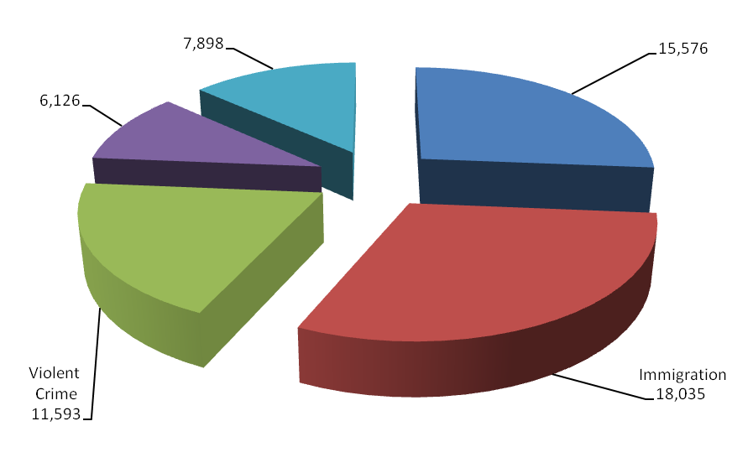
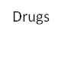

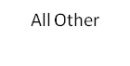

During FY 2007, the USAOs filed 59,228 criminal cases against 80,712 defendants in United States District Court. The number of new cases filed decreased by 3.6 percent from FY 2004 to FY 2007, going from 61,443 cases to 59,228; however, the number of new cases filed increased slightly from FY 2006 to FY 2007.

A total of 57,619 cases against 78,751 defendants were closed during FY 2007. Of the 78,751 defendants whose cases were closed, 92 percent, or 72,436 either pled guilty or were found guilty. Of these, 60,372 received prison sentences, and 257 guilty defendants received sentences of life imprisonment. The rate of convicted defendants who received prison sentences has consistently exceeded 80 percent over the last six years and has exceeded 83 percent for the past two years. Not only did the number of cases filed decline, the number of cases pending increased by 13 percent or 8,407 cases, from 63,499 cases at the start of FY 2004 to 71,906 at the start of FY 2008.
2. Performance Tables

3. Performance, Resources, and Strategies

The Criminal Decision Unit contributes to the Department’s Strategic Goal I: Prevent Terrorism and Promote the Nation’s Security. Within this goal, the decision unit’s resources address three of the Department’s Strategic Objectives: 1.1 - Prevent, disrupt, and defeat terrorist operations before they occur; 1.2 - Strengthen partnerships to prevent, deter, and respond to terrorist incidents, and 1.3 - Prosecute those who have committed, or intend to commit, terrorist acts in the United States.

The Criminal Decision Unit also contributes to Goal II: Prevent Crime, Enforce Federal Laws and Represent the Rights and Interests of the American People. Within this goal, the decision unit’s resources address five of the Department’s Strategic Objectives: 2.1 - Strengthen partnerships for safer communities and enhance the Nation’s capacity to prevent, solve, and control crime; 2.2 - Reduce the threat, incidence, and prevalence of violent crime; 2.3 - Prevent, suppress, and intervene in crimes against children; 2.4 - Reduce the threat, trafficking, use, and related violence of illegal drugs; 2.5 - Combat public and corporate corruption, fraud, economic crime, and cybercrime; 2.6 - Uphold the civil and constitutional rights of all Americans; and 2.7 - Vigorously enforce and represent the interests of the United States in all matters for which the Department has jurisdiction.

a. Performance Plan and Report for Outcomes
In the criminal area, there are two primary performance measures for the USAs, including
1) terrorism convictions, and 2) criminal cases favorably resolved.

1.) Terrorism/Anti-Terrorism Convictions

The prevention of terrorist attacks and the prosecution of the war on terrorism remain the top priorities of the Department of Justice. In FY 2007, the USAs filed a total of 340 terrorism, anti-terrorism, and hoax and financing cases against 515 defendants. This includes international and domestic terrorism, terrorism-related financing, and terrorism-related hoaxes, as well as anti-terrorism cases. Defendants convicted in cases listed as anti-terrorism cases have not necessarily engaged in terrorist activity. Rather, these cases were brought to prevent or disrupt potential or actual terrorist threats where the offensive conduct is not obviously a federal crime of terrorism. A total of 346 cases against 518 defendants were terminated in FY 2007.

The terrorism performance measure is the number of terrorism/anti-terrorism/financing and hoax convictions based on the definitions described above and derived from the USAs’ Case Management System. Included in the terrorism convictions are the original program categories of international terrorism and domestic terrorism. Examples of offenses that could be classified as international or domestic terrorism include the following: destruction of an aircraft or interference with a flight crew; attack on a mass transit facility or on the means of interstate communication; use of weapons of mass destruction; and material support for terrorism. Terrorism-related hoaxes and terrorist financing were added after September 11, 2001 to allow the USAs’ Case Management System to capture more terrorism-related activities. Anti-terrorism cases are those where the underlying purpose or object of the case is to prevent or disrupt potential or actual terrorist threats where the offensive conduct is not obviously a federal crime of terrorism. In FY 2007, there were a total of 459 convictions.

2.) Criminal Cases Favorably Resolved

The USAOs handle most of the criminal cases prosecuted by the DOJ. The USAs receive most of their criminal referrals from federal investigative agencies, including the FBI; the DEA; the ATF; the United States Customs Service; and the United States Secret Service. Criminal referrals may also be received from state and local investigative agencies or USAs may become aware of criminal activities in the course of investigating or prosecuting other cases.

The USAs are called upon to respond to changing priorities and to become involved in specific crime reduction programs. After the events of September 11, 2001, the number one priority of the USAs became the prevention of terrorist acts and the investigation and prosecution of those involved in terrorist attacks. More recently, Southwest Border enforcement - responding to the enormous number of illegal aliens crossing the Southwest Border into the U.S. - has become critical. The USAs also have continued their longstanding commitment to address drug and violent crimes. Within the violent crime category, the USAs continue to address the illegal use of firearms by those who commit crimes and accompanying acts of violence in our communities. Drug prosecutions continue to be a priority of the USAs, with particular emphasis on the operations of large drug organizations.

The performance measure for criminal litigation relates to the percentage of criminal cases favorably resolved. In FY 2007, cases involving 72,436 defendants were favorably resolved, achieving the goal of 92 percent. The FY 2007 total includes 71,977 defendants found guilty of non-terrorist criminal activity, such as violent crime, drug trafficking, and white collar crime. The 92 percent goal is being adjusted to 90 percent starting in FY 2008 to be consistent with the equivalent goal for the other litigating divisions within the DOJ.

b. Strategies to Accomplish Outcomes

In FY 2009, the U.S. Attorneys will continue to place a high priority on prosecution and security efforts in the war on terror as well as addressing other important priorities such as child exploitation, violent crime and gangs, drug trafficking, identity theft, healthcare fraud and other white collar fraud. As part of the prosecution and security efforts in the war on terror, an enhancement of $8.4 million and 83 positions is requested to secure our Southwest Border. Other strategies include:
- Aggressive hiring to fill vacant positions.
- Restructuring the workforce by backfilling some positions with lower salaried employees.
- Leveraging technology to improve efficiency and enhance information flow organization-wide and with our partners.
- Regular reviews and monitoring of case and work load data.
- Ensuring sufficient resources are allocated to meet the caseloads, especially focusing on priority areas.
- Expanded training at the NAC to address substantive new areas as well as leadership and management.

3. Results of Program Assessment Rating Tool (PART) Review

In FY 2007, the USAs’ underwent a second PART review (the first was in FY 2004). The PART evaluates programs in four areas: purpose, strategic planning, program management, and results and accountability. The USA achieved an FY 2007 overall rating of “Moderately Effective,” an improvement from its FY 2004 rating of “Adequate.” As a result of the PART, the USAs and OMB have agreed on the following “findings:” 1) the U.S. Attorneys’ program is effectively designed to achieve the program’s purpose. Despite increases in the number of cases and the changing nature and complexity of the cases, the percentage of favorable resolutions remains high; 2) the program collaborates effectively with its partners. Successful initiatives link prosecutors, law enforcement at all levels, and community leaders to provide a comprehensive, multi-faceted approach to deterring and punishing crime; and 3) the program has improved its efficiency and cost-effectiveness through workforce restructuring, leveraging technology and by implementing cost-saving best practices. The program will continue to pursue additional improvements in order to continue to meet the established efficiency targets.

USAs are implementing the following three follow-up actions to further improve the overall rating: 1) reassess the allocation of new and existing resources, both within and between the USAOs, to balance the caseloads for attorneys across the country; 2) address any concerns relating to internal controls for the Legal Information Online Network Systems (LIONS) for case tracking and reporting; and 3) develop an expanded management training program focusing on core leadership and management competencies to improve agency effectiveness.

The following follow-up actions were implemented to address the FY 2004 PART recommended actions: A working group of U.S. Attorneys and staff was appointed in August 2005 by the Director of EOUSA to draft new performance goals, measures and management standards to strengthen and improve the evaluations of U.S. Attorney district offices conducted through the Evaluation and Review Staff (EARS). Included in this review were district declination processes as well as the overall performance and accountability of USAOs. Revised procedures were reviewed and adopted by the end of FY 2006 and tested and implemented during the first quarter of FY 2007. These revised procedures are now an integral part of each EARS evaluation. The budget shortfalls of the past several years, in addition to the PART recommendation, caused recurring reviews of common administrative functions to achieve savings and increase efficiencies. Lists of cost-saving measures have been developed, posted on the Intranet, and discussed with USAOs during monthly conference calls. One specific example, which has saved over $2 million annually, includes using online legal research services rather than purchasing hard copies and the development of a “core collection” of library materials. All of the FY 2004 PART follow up actions have been completed.

Program Increase by Item

Item Name: Southwest Border Enforcement Initiative

Budget Decision Unit(s): Criminal

Strategic Goal(s) & Objective(s): Goal II: Prevent crime, enforce federal laws, and
represent the rights and interests of the American
people.
Objective 2.2: Reduce the threat, incidence, and
prevalence of violent crime.
Objective 2.4: Reduce the threat, trafficking, use, and related violence of illegal drugs.

Program Increase: Positions 83 Atty 50 FTE 42 Dollars $8,400,000

Description of Item

In FY 2009, the U.S. Attorneys request $8,400,000 for a Southwest Border Enforcement Initiative. This would provide funding for 50 Assistant U.S. Attorneys (AUSAs) and thirty-three support staff to be distributed among the five districts along the Nation’s Southwestern Border. These positions would be allocated through a competitive process among the five districts.

Federal prosecution of border crime is a critical part of our Nation’s defense and gaining operational control of the border is essential. More AUSAs and paralegals are needed to respond to an overall increase in immigration cases and a substantial increase in Border Patrol Agents. The USAOs in the Southwestern Border districts are tasked to support the federal law enforcement agencies that patrol 1,933 miles of our border with Mexico. The Southwestern Border faces an enormous number of illegal aliens. In FY 2007, the Border Patrol apprehended over 850,000 illegal aliens crossing the Southwest Border. The USAOs strategies to combat violations of immigration offenses include:

- Ensuring a sufficient USAO presence to meet the steadily increasing case load generated by additional law enforcement resources, and
- Aggressive enforcement of the immigration statutes, including those against alien smuggling organizations; those involved in terrorism and violent crimes; and those against aliens, who after deportation, attempt to re-enter or are found in the United States illegally.

Justification

Southwestern Border districts have filed significant numbers of immigration cases over the past six years, with large numbers of cases remaining in a pending status. In addition, the Border Patrol has expanded from approximately 9,000 Agents in 2001 to more than 13,000 Agents in 2007. By the end of 2008, there are anticipated to be a total of more than 18,000 Agents. As the number of Border Patrol Agents increases, the number of criminal referrals and interdiction narcotics cases will undoubtedly increase. Currently, each AUSA in the five Southwest Border districts already has a workload of between 150 and 200 cases per year, compared to an our overall criminal cases filed per AUSA work year of 16 cases per year. DOJ has estimated that the additional Border Patrol Agents will double the 850,000 plus apprehensions along the Southwest Border and generate 24,650 new cases over two years.

Filed Cases

 | Actual |  |  |  |  |  | Projected
 | FY 2002 | FY 2003 | FY 2004 | FY 2005 | FY 2006 | FY 2007 | FY 2008 | FY 2009
SW Border  Districts | 8,805 | 10,933 | 12,228 | 12,318 | 11,820 | 11,986 | 24,643 | 36,968

Pending Cases

Pending cases are those cases that have been filed but have not yet been resolved.

 | Actual |  |  |  |  |  | Projected
 | FY 2002 | FY 2003 | FY 2004 | FY 2005 | FY 2006 | FY 2007 | FY  2008 | FY 2009
SW Border Districts | 5,187 | 5,786 | 7,721 | 7,730 | 6,597 | 7,501 | 10,000 | 20,000

Southwest Border districts are currently seeing an increase in law enforcement personnel of up to 500 percent. For example, over the past several years, in the District of Arizona, the number of Border Patrol Agents has increased in the Yuma Sector from 350 to 811, and another 300 are anticipated. In the Southern District of California, the number of Border Patrol Agents in the San Diego sector has increased from 1,400 to 1,952 in 2007, and is expected to increase to 2,400 by the end of 2008. These increases in law enforcement resources require the allocation of additional resources to address the increase in border-related criminal activity and referrals.

The Southwest Border is particularly vulnerable to the operation of cross-border criminal enterprises. These criminal enterprises engage in human and drug smuggling through Mexico into the United States, putting hundreds and hundreds of millions of dollars into the hands of criminals. The associated killings, hostage takings, robberies, and money laundering are all methods employed to gain and expand market share and to maximize profits.

For example, Southern California is an international gateway with six ports of entry into the district. One of these ports is San Ysidro, the busiest land border crossing in the world. In fact, 75 percent of passenger vehicles entering California come through the port of San Ysidro. Additionally, nearly 40 million people per year cross the border. Many are economic migrants coming for jobs, family reunification, health care, education, other social services, or to achieve birthright citizenship. Others are trafficking in drugs or humans and are engaging in other property and violent crimes. The impact of this influx of humanity is an increased strain on infrastructure, government budgets and the criminal justice system at all levels.

The criminals who traffic in drugs and human beings and make their profits through illegal Southwest Border crossings are increasingly targeting Border Patrol Agents and turning to violence. “Rocking” (rock throwing) incidents are increasing and, even more disturbing, some federal agents have been murdered. Recently a Border Patrol Agent was killed when he confronted a group of individuals backpacking drugs into the U.S. Another smuggler shot and wounded an Agent after being pulled over, and the ensuing car chase and shoot-out resulted in the death of a juvenile smuggled alien who was being transported in the trunk of the defendant’s vehicle. In another case, smugglers fled from local police at speeds exceeding 100 miles per hour, running red lights and driving into ongoing traffic until crashing into a car occupied by two newlyweds. That crash killed the newlyweds and three of the 15 aliens who were being transported. Since 1999 a pattern has emerged in which alien smugglers will hijack loads of aliens from other smugglers to extort additional money from the aliens’ families or simply to steal the other smugglers’ profits. Smugglers also use violence to extort payment from their own client.

Yet another significant threat to the Southwest Border is posed by international street gangs. Many members of violent street gangs are foreign born persons who are actively involved in human smuggling, robbery, extortion, rape and murder. These foreign nationals ignore our immigration laws and enter illegally. They then travel to the Nation’s interior cities to join with other gang members to participate in criminal activities.

USAO Southwest Border Districts are working closely with various components of the Department of Justice, including the U.S. Marshals Service, the Bureau of Prisons, the Office of the Detention Trustee, the FBI, DEA and ATF and with the Department of Homeland Security (DHS), including Immigration and Customs Enforcement (ICE) and the Border Patrol, as well as with state and local law enforcement and prosecutors’ offices to ensure the most efficient handling of cases and to achieve the most appropriate sentences in the best forum.

Operation Streamline, implemented in December 2005 in Del Rio, Texas, is a multi-agency law enforcement initiative that involves U.S. Attorneys’ Office, Customs and Border Protection, Immigration and Customs Enforcement, the U.S. Marshals Service and dedicated Federal judges and magistrates in the Western District of Texas. In Del Rio, Operation Streamline has instituted a zero-tolerance policy for all illegal entry.

Impact on Performance

This initiative will address Strategic Goal II: Prevent crime, enforce federal laws, and represent the rights and interests of the American people; and two objectives, 2.2 Reduce the threat, incidence, and prevalence of violent crime, and 2.4 Reduce the threat, trafficking, use, and related violence of illegal drugs.

The goal of the current Border Enforcement Strategy is to disrupt and prevent illegal entry by instituting a sufficiently recognizable presence and level of deterrence along the Southwest Border; by apprehending those who nevertheless seek to cross illegally into the United States; and then by successfully prosecuting them. A holistic approach providing more resources at every stage of the criminal justice process is critical to an effective Border Enforcement Strategy. USAO staffing has not kept up with the increasing caseloads resulting from dramatic increases in law enforcement personnel and the additional AUSA and paralegal support staff provided by this request are critical to this strategy.

Without additional resources, the USAOS will not be able to keep up with the law enforcement efforts of four thousand additional Border Patrol Agents and the five thousand more Agents anticipated to be hired by the end of FY 2008. The number of cases filed will likely remain the same and the number of pending cases will expand dramatically. The Administration’s Border Enforcement Strategy will be undercut and deterrence will be reduced, when offenders are not charged and convicted.

Southwest Border Enforcement Initiative

Base Funding

FY 2007 Enacted |  |  |  | FY 2008 Enacted |  |  |  | FY 2009 Current Services
Pos | Agt/  Atty | FTE | Dollars | Pos | Agt/  Atty | FTE | Dollars | Pos | Agt/  Atty | FTE | Dollars
268 | 183 | 268 | $41,406,000 | 328 | 223 | 298 | $48,806,000 | 328 | 223 | 298 | $50,270,180

Personnel Increase Cost Summary

Type of Position | Modular Cost  per Position | Number of  Positions  Requested | FY 2009  Request | FY 2010  Net Annualization  (change from 2009)
Attorney | $121,040 | 50 | $6,052,000 | $4,123,250
Technical Professional (Paralegal) | 71,690 | 28 | 2,007,320 | 999,040
Clerical | 63,050 | 5 | 317,750 | 131,670
Total Personnel |  | 83 | $8,377,070 | $5,253,960

Non-Personnel Increase Cost Summary

Non-Personnel Item | Unit Cost | Quantity | FY 2009 Request | FY 2010 Net  Annualization  (Change from 2009)
Contract Support | $22,930 | N/A | $22,930 | N/A
Total Non-Personnel | $22,930 | N/A | $22,930 | N/A

Total Request for this Item

 | Pos | Agt/Atty | FTE | Personnel | Non-Personnel | Total
Current Services | 328 | 223 | 298 | $50,270,180 | 0 | $50,270,180
Increases | 83 | 50 | 42 | 8,377,070 | 22,930 | 8,400,000
Grand Total | 411 | 273 | 340 | $58,647,250 | 22,930 | $58,670,180

B. CIVIL

(Dollars in Thousands)
Civil Litigation | Perm. Pos. | FTE | Amount
2007 Enacted | 2,142 | 2,225 | $ 350,889
2007 Supplementals | -- | -- | --
2007 Enacted | 2,142 | 2,225 | $ 350,889
2008 Enacted | 2,142 | 2,225 | $ 367,366
Adjustments to Base and Technical Adjustments | -- | -- | $ 15,451
2009 Current Services | 2,142 | 2,225 | $ 382,817
2009 Program Increases | -- | -- | --
2009 Request | 2,142 | 2,225 | $ 382,817
Total Change 2008-2009 | -- | -- | $ 15,451

Civil Litigation—Information Technology Breakout (of Decision Unit Total) | Perm. Pos. | FTE | Amount
2007 Enacted | 80 | 80 | $ 24,684
2007 Supplementals | -- | -- | --
2007 Enacted | 80 | 80 | $ 24,684
2008 Enacted | 80 | 80 | $ 25,240
Adjustments to Base and Technical Adjustments | -- | -- | $ 544
2009 Current Services | 80 | 80 | $ 25,784
2009 Program Increases | -- | -- | $ 225
2009 Request | 80 | 80 | $ 26,009
Total Change 2008-2009 | -- | -- | $ 769

1. Program Description–Civil Decision Unit

Civil litigation pursued by the USAs falls into two basic categories: affirmative civil litigation, where the United States is the plaintiff, and defensive civil litigation, where the United States is the defendant. Affirmative civil litigation cases are actions taken by USAs to assert and protect the government’s interests, and they include such issues as the enforcement of the nation’s environmental, admiralty, and civil rights laws, as well as the recovery of damages done to the government through fraud. USAs also use affirmative civil litigation to recoup money owed and recover damages done to the government. Defensive civil litigation cases are lawsuits brought against the government by those who allege suffering due to government actions, and they include such issues as the adjudication of Social Security disability claims, alleged contract violations, and alleged race, sex, and age discrimination. USAs may also be called upon to represent the United States in cases which are not clearly defined as either affirmative or defensive civil litigation, but in which the government has an interest, such as bankruptcy cases in which the United States is a party.

One key difference between affirmative and defensive civil litigation is that while USAs have some discretion in deciding which affirmative civil cases they will pursue, USAs must defend the government in all defensive civil litigation. Due to the fact that the federal government’s obligations in the area of defensive civil litigation are non-delegable, the resources remaining for USAs to pursue affirmative civil litigation has resulted in a substantial decrease in cases filed in this area, as is shown in the data below.

Affirmative civil cases can return substantial monies to the federal Treasury: USAOs collected $3.72 billion in civil debts in FY 2006. In two recent cases, Gambro Healthcare agreed to pay $310 million to resolve civil liabilities stemming from alleged kickbacks paid to physicians and payments made to a sham medical equipment company. In addition, GlaxoSmithKline (GSK) agreed to pay the government $150 million to settle charges it violated the False Claims Act in a scheme to increase market share by reporting false and misleading information about the price of two anti-nausea drugs.

Civil matters and cases represent a significant part of the USAs’ workload. In FY 2007, USAs received 80,844 civil matters, which represented 42 percent of all of the 193,868 criminal and civil matters received during the fiscal year. Of the civil matters received, 67 percent or 54,160 were defensive matters, 11,546 or 14 percent were affirmative matters, and 15,138 or 19 percent were other civil matters. USAs filed or responded to 71,823 civil cases in FY 2007, which represented 55 percent of the 131,051 criminal and civil cases filed during the fiscal year. Of the civil cases filed, 74 percent or 53,302 were defensive cases, 6,059 or 9 percent were affirmative cases, and 12,462 or 17 percent were other civil cases.

Civil Workload
FY 2007 Cases Filed/Responded to – 71,823

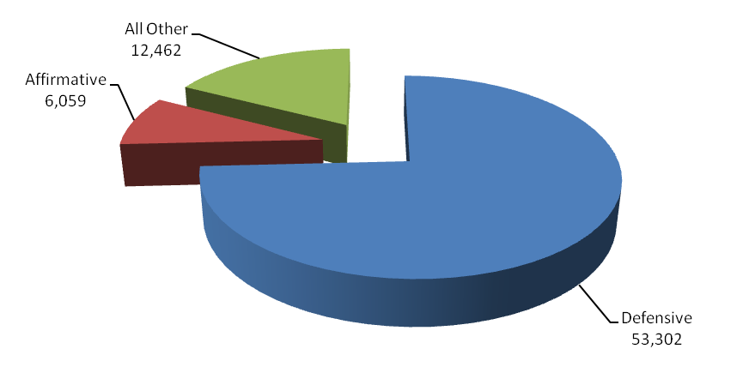

Between FY 2003 and FY 2007, the number of civil cases filed or responded to decreased by 12 percent or 10,112 - from 81,935 cases to 71,823, while the number of civil cases referred to USAs decreased by 10 percent or 9,115 - from 89,959 in FY 2003 to 80,844 cases in FY 2007. The number of defensive civil cases filed decreased by 8 percent or 4,507 - from 54,208 cases in FY 2003 to 49,701 in FY 2006 but increased to 53,302 in FY 2007. The number of affirmative cases filed has decreased by 32 percent or 2,891 - from 8,950 cases in FY 2003 to 6,059 in FY 2007.

In FY 2007, 97 percent of all judgments in affirmative civil cases were in favor of the United States, the highest favorable judgment rate of all case classes. Through affirmative litigation, USAs collected $3.72 billion in civil debts owed to the United States, more than twice the amount the U.S. Attorneys’ FY 2008 budget and an increase of $1.34 billion or 56 percent over the amount of debts collected in FY 2005.

2. Performance Tables

3. Performance, Resources, and Strategies

The Civil Decision Unit contributes to the Department’s Strategic Goal 2: Prevent Crime, Enforce Federal Laws and Represent the Rights and Interests of the American People. Within this goal, the Civil Decision Unit’s resources specifically address two of the Department’s Strategic Objectives: 2.6 - Uphold the civil and Constitutional rights of all Americans, and 2.7 - Vigorously enforce and represent the interests of the United States in all matters for which the Department has jurisdiction.

a. Performance Plan and Report for Outcomes

Prosecution of civil litigation is an essential and vital component of the mission of the USAs. Civil cases prosecute fraud, waste, and abuse in federal programs and ensure that the government is fully compensated for the losses and damages caused by those who have enriched themselves at the government’s expense. In addition, all lawsuits filed against the government must be defended. USAs represented the government in 53,302 defensive civil cases that were filed in court during FY 2007. The USAs successes in civil litigation preserve taxpayer dollars and uphold the requirements and intent of federal laws and programs.

The performance measure for civil litigation relates to the percentage of judgments and settlements resolved in favor of the government. The target for FY 2007 was 85 percent and the actual figure was 82.8 percent. The particularly large decrease in civil affirmative cases filed is because the U.S. must file defensive civil cases – therefore a larger number of affirmative cases are not brought when the focus must be on defensive cases. The USAOs will continue to leverage the positions through workforce restructuring and backfilling with lower salaried employees. This performance goal is being adjusted to 80 percent of cases favorably resolved starting in FY 2008 to be consistent with the equivalent goal for the other litigating divisions within the DOJ.

b. Strategies to Accomplish Outcomes

The two biggest challenges for USAs are to maintain a high favorable resolution rate with existing resources and for AUSAs in particular to adjust to the increased use of technology in the practice of law. Technology is providing a means to increase productivity with existing resources. However, civil cases are increasingly “electronic” – electronic filing, e-discovery and so forth. Some AUSAs and support staff have difficulty making the transition to these different approaches. Workforce restructuring and technical training are both part of the USA strategy for moving forward.

c. Results of Program Assessment Rating Tool (PART) Review

As described in the Criminal Decision Unit, the USAs are underwent a PART review during FY 2007. More details of the review and its findings are described on page 22 in section 3c of the Criminal Decision Unit.
- LEGAL EDUCATION

(Dollars in Thousands)
Legal Education TOTAL | Perm. Pos. | FTE | Amount
2007 Enacted | 38 | 39 | $ 19,275
2007 Supplementals | -- | -- | --
2007 Enacted | 38 | 39 | $ 19,275
2008 Enacted | 41 | 40 | $ 19,661
Adjustments to Base and Technical Adjustments | -- | -- | $ 391
2009 Current Services | 41 | 40 | $ 20,052
2009 Program Increases | -- | -- | --
2009 Request | 41 | 40 | $ 20,052
Total Change 2008-2009 | 0 | 0 | $ 391

Legal Education —Information Technology Breakout (of Decision Unit Total) | Perm. Pos. | FTE | Amount
2007 Enacted | 20 | 20 | $ 6,171
2007 Supplementals | -- | -- | --
2007 Enacted | 20 | 20 | $ 6,171
2008 Enacted | 20 | 20 | $ 6,311
Adjustments to Base and Technical Adjustments | -- | -- | $ 137
2009 Current Services | 20 | 20 | $ 6,448
2009 Program Increases | -- | -- | $ 55
2009 Request | 20 | 20 | $ 6,503
Total Change 2008-2009 | 0 | 0 | $ 192

1. Program Description–Legal Education

The Office of Legal Education (OLE) develops, conducts, and authorizes the training of all federal legal personnel [28 C.F.R. §0.22 (1990)]. OLE coordinates legal education and attorney training for the DOJ and other departments and agencies of the Executive Branch. Virtually all of OLE’s classroom training is conducted at the National Advocacy Center (NAC), a premier federal training facility in Columbia, South Carolina. The NAC features an integrated instructional and residential facility augmented by a conference and research center with student and support services on site.

In FY 2007, OLE provided training to a total of 21,470 students. This included classroom training for 12,399 students and an additional 9,071 students were trained via satellite, videotape, and other means. Eighty-three percent of the 21,470 individuals were Department of Justice employees in legal positions while the other 17 percent or 3,600 were non-Department of Justice employees in legal positions with various federal agencies or state and local government. Overall, in FY 2007 OLE was responsible for the management of 395 events, including traditional advocacy training, national conferences, seminars, symposia, and educational forums on substantive areas of the law.

In April of 2007, OLE introduced Video on Demand (VOD), permitting users to view OLE programming “on demand” at their desktop. OLE also began providing a weekly program called Week in Review (WIR) which highlights the accomplishments of the USAOs nationwide.

Since the opening of the NAC in April 1998, OLE has engaged in a collaborative effort with the National District Attorneys Association (NDAA) and the Executive Office for United States Trustees to create a premier training center that brings together federal, state, and local prosecutors to train in a state-of-the-art facility. Training for NDAA personnel is paid for through a grant administered by the Office of Justice Programs. In FY 2007, approximately 3,000 people attended courses sponsored by these two training partners.

The Publications Unit of the Office of Legal Education edits and publishes the United States Attorneys’ Manual, the United States Attorneys’ Bulletin, and a number of practical skills manuals. During FY 2007, the OLE Publications Unit published six issues of the United States Attorneys' Bulletin. OLE also published a new litigation skills book on Prosecuting Computer Crimes. The Publications Unit also produces the USA Book Online Library, which has now grown to include hundreds of policy manuals, textbooks, and monographs and has become a federal practice encyclopedia. The CD-Rom version of the online library is used by DOJ attorneys and investigators working at home, on travel, on detail, or whenever they do not have access to the DOJ Intranet.

OLE initiated the Justice Television Network (JTN) during FY 2001. JTN is a satellite-based system that provides training and news to the 94 USAOs, as well as branch offices. The JTN schedule includes 40 hours of programming each week, and a 15 hour "re-feed" to the West Coast each workday. In FY 2007, OLE provided 2,260 hours of programming through JTN.
In an effort to enhance its distance learning options for USAOs, OLE developed new training modules on Title III, Professional Responsibility, a Legal Guide to Substance Abuse and Mental Illness, and a Legal Guide to Electronic Discovery, and updated the Evidence and Criminal Federal Practice modules.

Continuing legal education (CLE) credit is provided through OLE for many OLE-sponsored courses. OLE is the primary source of instruction for DOJ attorneys and AUSAs from the 94 USAOs. Basic programs for newly hired attorneys include criminal, civil, and appellate advocacy; federal practice seminars; and specialty courses in priority substantive areas of the law. Advocacy skills programs are available to new and advanced trial attorneys. The Federal Practice Program is designed for attorneys with litigation experience who are new to the federal civilian legal system (e.g., former state and military prosecutors), and as continuing training for DOJ attorneys after the basic criminal, civil, and appellate advocacy courses. In addition, in FY 2007 OLE contracted with West Publishing to provide more than 8,000 CLE programs to USAO and DOJ attorneys over the Internet.

For all its programs, OLE uses experienced federal trial and appellate attorneys as instructors to present lectures, lead discussion groups, direct evidentiary exercises, and offer personalized critiques. Federal judges also participate in OLE's advocacy courses, presiding over mock trials and mock appellate arguments. The caliber of the OLE faculty and the use of sophisticated videotaping facilities provide students with unique training experiences in trial and appellate advocacy. A significant feature of the advocacy training is the use of "learn-by-doing" exercises which concentrate on courtroom skills. These exercises simulate courtroom activities and provide students with classroom critiques and individual video replay analysis. Finally, OLE is meeting the demand for attorney management training for senior criminal and civil attorneys by providing management courses for attorney supervisors of all levels.

OLE conducts programs on federal, civil, and administrative law practices for attorneys in the Executive Branch, including those in the Department of Justice. OLE offers training in civil discovery and trial techniques; negotiation techniques; and administrative law areas such as bankruptcy, the Freedom of Information Act, ethics, environmental law, federal employment, regulatory processes, government contracts, legal research and writing for attorneys, management of attorneys, and computer crime. Course instruction emphasizes the realities of federal practice. Federal attorneys from every agency, including the DOJ, are participants as well as advisors, curriculum developers, lecturers, and instructors. Most instructors come from a cadre of federal prosecutors. On a few occasions, OLE also contracts with professional educators as instructors for these courses.

OLE develops and administers paralegal courses covering basic and advanced skills in civil, criminal, and appellate practice. Training for other support staff personnel (e.g., legal assistants, systems managers, etc.) in USAOs is provided through OLE, which develops the curriculum and recruits instructors.

OLE operates a videotape lending library for USAOs and federal agencies. In addition, commercially produced tapes by recognized legal experts have been purchased by OLE, and the tapes are sent to offices upon request to supplement their in-house training programs. The completion of a video production studio at NAC has provided the capability to produce videotapes and other distance education materials. This has increased the number of tapes available and enhanced the ability to keep videotaped presentations current by updating them to include recent legislation, policy changes or court decisions. In addition, during FY 2006, OLE began using podcasts on an experimental basis as an additional method for distributing materials.

2. Performance Table

3. Performance, Resources, and Strategies

The Legal Education Decision Unit contributes to the Department’s Strategic Goal I: Prevent Terrorism and Promote the Nation’s Security. Within this goal, the decision unit’s resources address three of the Department’s Strategic Objectives: 1.1 - Prevent, disrupt, and defeat terrorist operations before they occur; 1.2 - Strengthen partnerships to prevent, deter, and respond to terrorist incidents; and 1.3 - Prosecute those who have committed, or intend to commit, terrorist acts in the United States.

The Legal Education Decision Unit also contributes to Goal II: Prevent Crime, Enforce Federal Laws and Represent the Rights and Interests of the American People. Within this goal, the decision unit’s resources address five of the Department’s Strategic Objectives: 2.1 - Strengthen partnerships for safer communities and enhance the Nation’s capacity to prevent, solve, and control crime; 2.2 - Reduce the threat, incidence, and prevalence of violent crime; 2.3 - Prevent, suppress, and intervene in crimes against children; 2.4 - Reduce the threat, trafficking, use, and related violence of illegal drugs; 2.5 - Combat public and corporate corruption, fraud, economic crime, and cybercrime; 2.6 - Uphold the civil and constitutional rights of all Americans; and 2.7 - Vigorously enforce and represent the interests of the United States in all matters for which the Department has jurisdiction.

a. Performance Plan and Report for Outcomes

The performance measure for this decision unit is the number of students trained. In FY 2007, OLE conducted classroom training for 12,399 students. An additional 9,071 students were trained via satellite, videotape, and other means, for a total of 21,470 students trained in FY 2007.

This compares with a total of 21,491 in FY 2006 – 13,181 students trained in the classroom and 8,310 students trained by satellite, videotape and other training. Eighty-three percent of the 21,470 individuals were Department of Justice employees in legal positions while the other 17 percent or 3,600 were non-Department of Justice employees in legal positions with various federal agencies or state and local government. OLE anticipates training a total of 21,500 students in FY 2008 in combined classroom, satellite and other training. This number is projected to increase to 22,000 in FY 2009.
Number of Students Trained at the National Advocacy Center
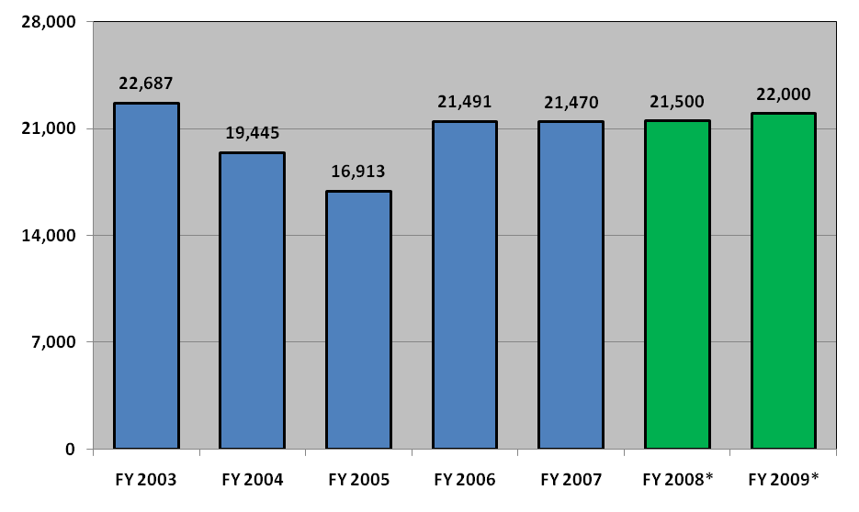

 | FY 2003 | FY 2004 | FY 2005 | FY 2006 | FY 2007 | FY 2008* | FY 2009*
Classrooms | 14,342 | 12,127 | 10,153 | 13,181 | 12,399
Videotape | 1,429 | 1,888 | 1,199 | 1,782 | 1,717
Other/CLE/Satellite | 6,916 | 5,430 | 5,561 | 6,528 | 7,354
Total Students Trained | 22,687 | 19,445 | 16,913 | 21,491 | 21,470 | 21,500 | 22,000
*Projected totals

Overall, in FY 2007 OLE was responsible for the management of 395 events, including traditional advocacy training, national conferences, seminars, symposia, and educational forums on substantive areas of the law. During FY 2007, OLE introduced Video on Demand (VOD) and by the end of FY 2007, approximately 23,000 people had watched WIR news clips and 8,366 individuals had watched one of the 150 programs available through VOD.

In FY 2007, approximately 3,000 people attended courses sponsored by OLE’s two training partners, the National District Attorneys Association (NDAA) and the Executive Office for United States Trustees,

b. Strategies to Accomplish Outcomes

The U.S. Attorneys will continue to ensure that high quality legal education is available for basic and advanced legal training through traditional classroom instruction and expanded use of JTN and distance learning. Additional training will be needed to support the requested Border Enforcement Initiative.

c. Results of Program Assessment Rating Tool (PART) Review

As described in the Criminal Decision Unit, the USAs underwent a PART review during
FY 2007. More details of the review and its findings are described on page 22 in section 3c of the Criminal Decision Unit.

V. E-Gov Initiatives

The Justice Department is fully committed to the President’s Management Agenda (PMA) and the E-Government initiatives that are integral to achieving the objectives of the PMA. The E-Government initiatives serve citizens, business, and federal employees by delivering high quality services more efficiently at a lower price. The Department is in varying stages of implementing E-Government solutions and services including initiatives focused on integrating government- wide transactions, processes, standards adoption, and consolidation of administrative systems that are necessary tools for agency administration, but are not core to DOJ’s mission. To ensure that DOJ obtains value from the various initiatives, the Department actively participates in the governance bodies that direct the initiatives and we communicate regularly with the other federal agencies that are serving as the “Managing Partners” to ensure that the initiatives meet the needs of the Department and its customers. The Department believes that working with other agencies to implement common or consolidated solutions will help DOJ to reduce the funding requirements for administrative and public-facing systems, thereby allowing DOJ to focus more of its scarce resources on higher priority, mission related needs. DOJ’s contributions to the Administration’s E-Government projects will facilitate achievement of this objective.

a. Funding and Costs

The Department of Justice participates in the following E-Government initiatives and Lines of Business (LoB):
Business Gateway | E-Travel | Integrated Acquisition Environment | Case Management LoB
Disaster Assistance Improvement | Federal Asset Sales | IAE – Loans & Grants – Dunn & Bradstreet | Geospatial LoB
Disaster Assistance Improvement Plan – Capacity Surge | Geospatial One-Stop | Financial Management LoB | Budget Formulation and Execution LoB
E-Authentication | GoveBenefits.gov | Human Resources LoB | IT Infrastructure LoB
E-Rulemaking | Grants.gov | Grants Management LoB
E-Government Initiatives and Lines of Business (LoB)

The Department of Justice E-Government expenses – i.e. DOJ’s share of e-Gov initiatives managed by other federal agencies – are paid for from the Department’s Working Capital Fund (WCF). These costs, along with other internal E-Government related expenses (oversight and administrative expenses such as salaries, rent, etc.) are reimbursed by the components to the WCF. The United States Attorneys’ (USAs) reimbursement amount is based on the anticipated or realized benefits from an e-Government initiative. The table below identifies the USAs’ actual or planned reimbursement to the Department’s WCF. As such, the USA E-Government reimbursement to the WCF is $2,109,000 for FY 2008. The anticipated USA e-Government reimbursement to WCF is $751,000 for FY 2009.

b. Benefits
The USAs established baseline cost estimates for each IT investment being modified, replaced, or retired due to the Department’s use of an E-Government or Line of Business initiative. The USAs are measuring actual costs of these investments on an ongoing basis. As the USA completes migrations to common solutions provided by an E-Government or Line of Business initiative, the USA expects to realize cost savings or avoidance through retirement or replacement of legacy systems and/or decreased operational costs. The list below represents only those E-Government initiatives and Lines of Businesses where the USA expects to realize benefits in FY 2008 and FY 2009:
Litigation Case Management Systems (LCMS). The USAs are partnering with JMD to develop and implement in FY 2008 a DOJ-wide case management system which will replace EOUSA’s legacy systems, as part of the Case Management System LoB.
E-Qip. USAOs and EOUSA are using the government-wide E-Qip system for online personnel security processing for all new hires. This saves time, reduces postage costs, and overall streamlines the process.
E-HR. With the Department, currently exploring a web-based Automated Staffing System. Applicants will be able to apply and their applications can be rated and ranked via the web. This will allow individual managers on-line access to applications in order to make selections.
E-Travel. USAOs and EOUSA piggy back on a Department-wide contract with a travel provider to book their airline tickets, hotel reservations, and car rentals and substantial savings are associated with the on-line booking feature.
VI. EXHIBITS

