Ministry of Education and Science of Ukraine
Dnepropetrovsk National University
Applied Mathematics Faculty
Computer Science Department

Graduation research

Title: "An application in e-Business using web services"

Author:
Student of group PK-99-II
Ganna Frankova
Scientific adviser:
Associate professor
PhD Sergey Chernishenko

Tutor:
Doctor Marco Aiello
The University of Trento, Italy
Supposed to defend the graduation research:

Head of Computer Science Department
Sergey Chernishenko

Reviewer:
Associate professor
PhD Alexey Dubinsky

Dnepropetrovsk
2004
ABSTRACT

The graduation research "An application in e-Business using web services" pages 55, figures 18, bibliography 25, supplements 4.
Object of research is architecture of an e-Business application, which can be improved by using web services.
Purpose of work is to develop architecture of an e-Business application using web services composition. Create a process for proving that the approach is feasible.
Research method is using simulation method and programming such languages as Java, WSDL, and BPEL.
As a result of research architecture of an e-Business application using web services composition was proposed. The process for proving that the approach is feasible was developed.
Results of the research can be applied for improving existent e-Business application by using web services and web services composition.
Key words: Distributed System, Service-Oriented Computing, Business process, Workflow, WEB service, XML, WSDL, SOAP, UDDI, orchestration, BPEL4WS.
RESUME

The graduation research of the fifth-year student Ganna Frankova (DSU, Applied Mathematics Faculty, Computer Science Department) deals with research into architecture development of an e-Business application.
The work can be used for creating architecture of an e-Business application. Result of the research, which has been carried out in work, can be applied to improve existent e-Business application by using web services.
The process using web services was developed. It was proven that the approach is feasible.
The work is interesting for information technology specialists and for businessmen.
Bibliography 25, figures 18, supplements 4.
contents

 | INTRODUCTION |  |  |  | ________________________________________ |  |  |  |  |  |  |  |  |  |  |  |  |  |  |  |  | 5
 | 1. PROBLEM STATEMENT |  |  |  |  | _________________________________ |  |  |  |  |  |  |  |  |  |  |  |  |  |  |  | 8
 | 2. Distributed Systems and Web Services |  |  |  |  |  |  |  |  |  |  |  |  |  | __________ |  |  |  |  |  |  | 9
 |  | 2.1. Overview of Distributed Systems |  |  |  |  |  |  |  | …………………. |  |  |  |  |  |  |  | 9
 |  |  | 2.1.1. The basic concepts |  |  |  |  |  |  |  |  |  |  |  |  | 9
 |  |  | 2.1.2. Resource sharing |  |  |  |  |  |  |  |  |  |  |  |  | 10
 |  | 2.2. Service-Oriented Computing |  |  |  |  |  |  |  | ………………………… |  |  |  |  |  |  |  |  | 15
 |  |  | 2.2.1. The basic concepts |  |  |  |  |  |  |  |  |  |  |  |  | 15
 |  |  | 2.2.2. Services life cycle |  |  |  |  |  |  |  |  |  |  |  |  | 16
 |  | 2.3. Overview of Web Services |  |  |  |  |  |  |  | …………………………. |  |  |  |  |  |  |  | 20
 |  |  | 2.3.1. Definition of Web Services |  |  |  |  |  |  |  |  |  |  |  |  | 20
 |  |  | 2.3.2. Core technologies used for web services |  |  |  |  |  |  |  |  |  |  |  |  | 20
 |  | 2.4. Web Services composition |  |  |  |  |  |  |  | ………………………… |  |  |  |  |  |  |  |  | 26
 |  |  | 2.4.1. Business Processes, Workflows and Web Services |  |  |  |  |  |  |  |  |  |  |  |  |  | 26
 |  |  | 2.4.2. Creating Web Service composition |  |  |  |  |  |  |  |  |  |  |  |  |  | 27
 | 3. Proposed architecture |  |  |  |  |  |  |  | __________________________ |  |  |  |  |  |  |  |  |  |  |  |  | 32
 |  | 3.1. Architecture overview |  |  |  |  |  |  | ………………………………….. |  |  |  |  |  |  |  |  | 32
 |  |  | 3.1.1. Web Services description |  |  |  |  |  |  |  |  |  |  |  |  | 32
 |  |  | 3.1.2. Interaction among Web Services |  |  |  |  |  |  |  |  |  |  |  |  | 35
 |  | 3.2. Implementation details |  |  |  |  |  |  | ………………………… |  |  |  |  |  |  |  |  |  | 45
 |  |  | 3.2.1. Software tools |  |  |  |  |  |  |  |  |  |  |  |  | 45
 |  |  | 3.2.2. Creating Web Services with Axis |  |  |  |  |  |  |  |  |  |  |  |  | 46
 |  |  | 3.2.3. Building the business process |  |  |  |  |  |  |  |  |  |  |  |  | 47
 |  | 3.3. Application user guide |  |  |  |  |  |  | …………………………. |  |  |  |  |  |  |  |  | 48
 |  |  | 3.3.1. Deploying the business process |  |  |  |  |  |  |  |  |  |  |  |  | 48
 |  |  | 3.3.2. Running the business process |  |  |  |  |  |  |  |  |  |  |  |  | 51
Conclusion |  |  |  | ____________________________________________ |  |  |  |  |  |  |  |  |  |  |  |  |  |  |  |  |  | 53
Bibliography |  |  |  | ____________________________________________ |  |  |  |  |  |  |  |  |  |  |  |  |  |  |  |  |  | 54
supplement A. JSP Sourses |  |  |  |  |  |  | _ _ _ _ _ _ _ _ _ _ _ _ _ _ _ _ |  |  |  |  |  |  |  |  |  |  |  |  |  |  | 56
supplement B. BPEL Document |  |  |  |  |  |  | _ _ _ _ _ _ _ _ _ _ _ _ _ _ _ _ |  |  |  |  |  |  |  |  |  |  |  |  |  |  | 60
supplement C. WSDL Documents |  |  |  |  |  |  | _ _ _ _ _ _ _ _ _ _ _ _ _ _ _ _ |  |  |  |  |  |  |  |  |  |  |  |  |  |  | 66
supplement D. JAVA Sourses |  |  |  |  |  |  | _ _ _ _ _ _ _ _ _ _ _ _ _ _ _ _ |  |  |  |  |  |  |  |  |  |  |  |  |  |  | 73
Introduction

There, where before borders of a science were, now is its center.
Georg Christoph Lichtenberg

In today's world of extreme competition in business, information exchange and effective communication is sorely needed. For making businesses function more efficiently information technology is growing by leaps and bounds. The need of information exchange brings in another need of making the information selectively available and changing its availability on the fly.
For example, with the introduction of telephone came the need to have a directory service. This gave rise to "Yellow Pages" which brought the client and the provider closer to each other.
Recently the revolution of computerization of companies gave rise to isolated computer systems. Each company had software developed and customized to its specific needs. Later because of mergers and business growths the question of sharing information stored in the isolated computer systems was brought up.
The Internet has solved some of specified problems but there are a lot of open issues. It became peremptory that, for better B2B (Business-to-Business) communication, the systems must have the ability to link up to each other. It must grant permissions through a system other than the Internet and all the systems network with each other should be like an Intranet. The mechanism should be platform and language independent and much less expansive that existent solutions.
Web services became a neat solution of the problem. Web services are autonomous platform-independent computational elements that can be described, published, discovered, orchestrated and programmed for the purpose of developing distributed interoperable applications. The services are identified by an URI. [6] Web services are based on open Internet standards. Web services act as a facade to provide a uniform and widely accessible dynamic interface to expose business operations. [22]
One of the principal issues that is solving in the thesis is architecture development of an e-Business application. We made an attempt to find a mechanism which provides simplified connection applications regardless of the technology or devices they use, or their location. Approach of using web services is proposed.
Nowadays service-oriented computing is becoming the prominent paradigm for distributed computing and e-Business, creating opportunities for service providers and application developers to develop value-added services by combining web services. [5]
Taking into account benefits of a new field in service-oriented computing — web services composition we decide on using web services combination for created a robust e-Business application.
Today we can see that many efforts of researches aim at service-oriented computing investigation [7], service-oriented architecture description [8] and web service composition mechanism [5]. It is worth to pay attention at distributed system concepts in [1]. A good explanation of business processes concepts and web services standard for composition can be found in [25].
Degree thesis is composed of five chapters.
In the first chapter the problem statement is formulated.
The second chapter presents distributed systems and web services concepts. As a way of introduction we describe distributed computing as a paradigm that enabling any organization to make its digital assets available worldwide with unprecedented ease and convenience. A service-oriented computing paradigm is described in second section. In third section we propose web services overview. Finally web services composition is presented.
Proposed architecture of a book store application using web services is described in the third chapter. We describe all developed web services and interaction among web services. For better understanding of the process the flow chart of the services composition and some sequence diagrams are presented. Software tools for developing the application, steps of creating web services and building the business process are summarized in second section. Finally we propose a short user guide to help the user of the system to get started.
The thesis is finished by conclusion with propositions of future work in this field.
Suppliments contain sources listing. It consists of four parts: JSP sourses, BPEL document, WSDL documents and Java sourses.
We tender thanks the scientific advisers of the degree work Doctor Marco Aiello (Department of Information and Communication Technology, the University of Trento, Trento, Italy) and Associate professor Sergey Chernishenko (Computer Science Department, Dniepropetrovsk National University, Applied Mathematics Faculty, Dnepropetrovsk, Ukraine) for their leadership and priceless assistance in research.
1. PROBLEM STATEMENT

The objective of the thesis is research into modern means of distributed computing in e-Business. Show the opportunities of distributed computing by implementing a Book Store business process.
The distinctive feature of the application is use of web services orchestration.
For creating the program it is necessary to select a composition of software tools for development and operability assurance of web-applications.
It is necessary to provide a user interface to input data.
The input data are the information about required goods (name and the number of copies), information of the buyer (name, address, cash card number) and information on the bargain (sum and delivery date of the goods).
It is necessary to note that realization of data integrity chesk and conditions of query execution, execution the query in time control is needed.
The output data are the messages of successful/unsuccessful termination of the process and delivery of the goods, draw out in case of successful termination of the process.
2. Distributed Systems and Web Services

This chapter describes concepts of distributed systems and web services.
As a way of introduction we make overview of distributed systems. For better understanding the idea of resource sharing in distributed systems the example of web services sharing is presented.
The overview of service-oriented computing paradigm is presented in second section.
We describe web services and core technologies used for web services. We cover in detail some of these technologies, which are relevant to the book store process presented in this thesis.
Finally web services composition section which includes BPEL4WS concepts is proposed.

2.1. Overview of Distributed Systems

2.1.1. The basic concepts

In this section we are going to present distributed computing as a paradigm that enabling any organization to make its digital assets available worldwide with unprecedented ease and convenience.
We propose the following definition of a distributed system.
A distributed system is one that consists of a collection of two or more independent computers which coordinate their processing through the exchange of synchronous or asynchronous message passing.
The main characteristics of distributed systems are:
- Concurrency. Concurrency means concurrent program execution. It enables resource sharing between users. Shared resources can be different types: data, services or devices. Typical problems of concurrent systems are deadlocks and unreliable communication.
- No global clock. There is no single global notion of the correct time.
- No global state. There is no single process in the distributed system that would have a knowledge of the current global state of the system.
- Independent failures. It means that each component of the system can fail independently, leaving the others still running
The principal idea of constructing and using distributed system is the sharing resources. We next cover in detail resource sharing, which is relevant to the e-Business application using web services presented in the thesis.

2.1.2. Resource sharing

Resource sharing is the significant motivation factor for constructing distributed systems. Resources such as web service, printer or database records are managed by servers of the appropriate type.
The following example represents sharing of web services. [20]
Suppose you are an employee using a travel planning application. If the request form asks you to fill in your desired flight times, you want to know what flights are available. Since your travel planning application is not integrated with the airline web site, you must launch your web browser, go to the airline web site, find the schedule query page, and then enter your origin, destination, and dates and times of travel. The airline web application then returns a list of scheduled flights, from which you choose the flight you want. Since the information on the airline web page is probably in a different format than that required by the travel application, you must write down or copy the information, switch back to the travel application, enter the information in the travel application, and then submit your request (see Figure 1).
A simple task that should have taken seconds, instead takes minutes, because there is no easy way to integrate the airline web application with the corporate travel planning application.

Weak integration on the application web
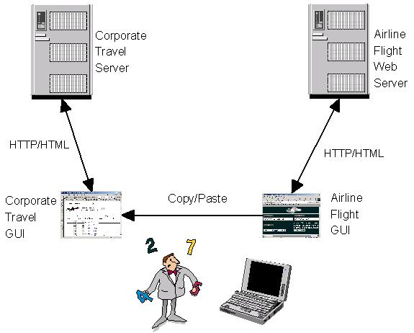
Figure 1

Consider how web services could change this scenario. Suppose the airline develops a web service that allows applications to obtain the list of available flights between two cities on a given date. Now, the corporate travel planning application can programmatically invoke the airline flight schedule web service, so that the employee does not have to navigate through the airline web site. The ease of use of the corporate travel planning application is greatly improved.
Figure 2 shows how web services can improve application integration.
Improved integration on the service web
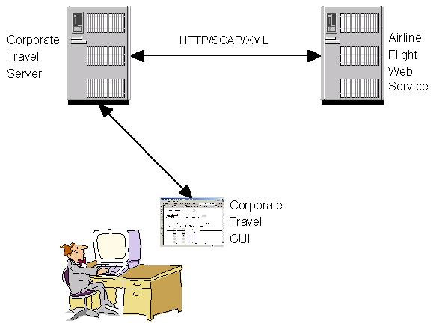
Figure 2

Continuing this scenario, suppose that airlines, hotels, and car rental agencies provide web services that allow applications to programmatically purchase airplane tickets, book hotel rooms, and reserve rental cars. In most cases, a travel planning application could make all of the necessary arrangements without the aid of a human travel agent (see Figure 3).
The use of web services reduces costs, improve quality, and increase function. For example, suppose the airline also had a web service that monitored flight departure and arrival times. The travel planning application is able query the airline to determine if your flight was delayed, and if so, it notifies your hotel and your car rental company to hold your reservations.
Here, the economic motivation for businesses to implement web services is improved customer service and more efficient management of inventory. For example, if the car rental agency knows that you will be two hours late, it might be able to avoid the cost of transporting cars between agencies in order to meet the worst-case peak demand.
More interestingly, the widespread implementation of web services would also enable a whole new wave of advanced applications. For example, suppose your flight is oversold. Your travel application calls you in the departure lounge on your WAP phone and asks what you want to do. Your travel application can access an e-marketplace web service that lists seats on this flight. If you have a confirmed seat, your travel application asks you if you would like to put your seat up for auction, shows you the current bids, and lets you specify an asking price.
The new web services economy
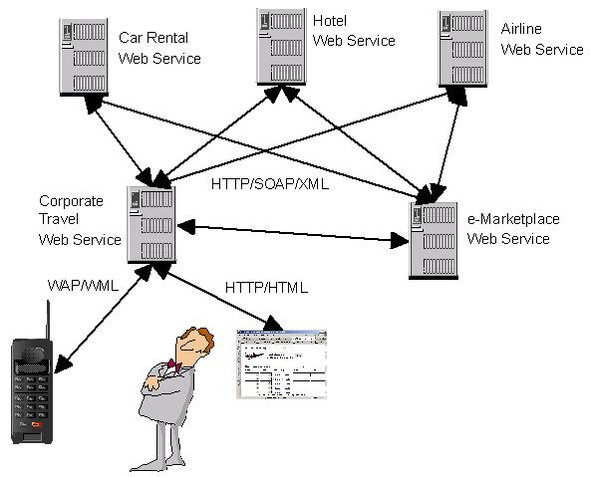
Figure 3

Conversely, if you don't have a confirmed seat, your travel application asks you if you want to bid on a seat, shows you the current prices, and lets you specify a bid. If you need to check your agenda in order to make a decision, your travel planning application accesses your corporate calendar application web service and displays your agenda on the WAP phone. If you don't have a confirmed seat but really need to get to that meeting on time, the travel application verifies that corporate expense guidelines are met and approves your bid. If your bid is accepted, the travel application submits the bill to the corporate expense statement web service.
Figure 3 shows the power of new applications that can be assembled from the web services of multiple suppliers.
2.2. Service-Oriented Computing

2.2.1. The basic concepts

Today we are experiencing a major paradigm shift in the way that software applications are designed, architected, delivered and consumed.
Service-Oriented Computing (SOC) is the computing paradigm that utilizes services as fundamental elements to support the development of rapid, low-cost and easy composition of distributed applications.
We propose the following definition of services.
Services are autonomous platform-independent computational elements that can be described, published, discovered, orchestrated and programmed using XML artifacts for the purpose of developing massively distributed interoperable applications.
Services perform functions, which can be anything from simple requests to complicated business processes. Services allow organizations to expose their core competencies programmatically over the Internet (or intra-net) using standard (XML-based) languages and protocols and be implemented via a self-describing interface based on open standards.
Because services provide uniform and ubiquitous information distributor for wide range of computing devices (such as handheld computers, PDAs, cellular telephones or appliances) and software platforms (e.g., UNIX or Windows), they constitute the next major step in distributed computing.
To the service model build, SOC relies on the Service Oriented Architecture (SOA), which is a way of reorganizing software applications and infrastructure into a set of interacting services. However, the basic SOA does not address overarching concerns such as management, service orchestration, service transaction management and coordination, security and other concerns that apply to all components in services architecture. [8]
2.2.2. Services life cycle

There are three kinds of participants that take part in services life cycle: service providers, service clients and service aggregators.
Services are offered by service providers — organizations that procure the service implementations, supply their service descriptions and provide related technical and business support. Since services may be offered by different enterprises and communicate over the Internet, they provide a distributed computing infrastructure for both intra- and cross-enterprise application integration and collaboration. Clients of services can be other solutions or applications within an enterprise or clients outside the enterprise, whether these are external applications, processes or customers/ users. Consequently, to satisfy these requirements services should be:
- Technology neutral: they must be invocable through standardized lowest common denominator technologies that are available to almost all IT environments. This implies that the invocation mechanisms (protocols, descriptions and discovery mechanisms) should comply with widely accepted standards.
- Loosely coupled: they must not require knowledge or any internal structures or conventions (context) at the client or service side.
- Support location transparency: services should have their definitions and location information stored in a repository and be accessible by a variety of clients that can locate and invoke the services irrespective of their location.
Service descriptions are used to advertise the service capabilities, interface, behavior and quality. Publication of such information about available services (on a service registry) provides the necessary means for discovery, selection, binding and composition of services.
In particular, the service capability description states the conceptual purpose and expected results of the service (by using terms or concepts defined in an application-specific taxonomy). The service interface description publishes the service signature (its input/output/error parameters and message types). The (expected) behavior of a service during its execution is described by its service behavior description (for example, as a workflow process). Finally, the Quality of Service (QoS) description publishes important functional and nonfunctional service quality attributes, such as service metering and cost, performance metrics (response time, for instance), security attributes, (transactional) integrity, reliability, scalability and availability. [7]
As services come in two types: basic and composite services, service clients and aggregators exist. Service clients — end-user organizations that use some service and service aggregators — organizations that consolidate multiple services into a new, single service offering utilize service descriptions to achieve their objectives.
Service layers, functionality, roles and parts of participants are depicted on Figure 4. [8]
Service layers, functionality, roles and parts of participants
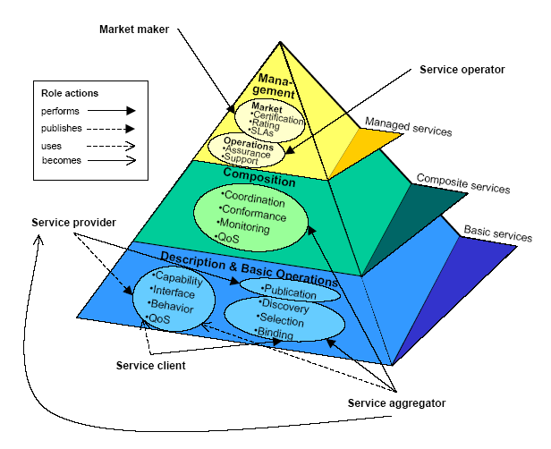
Figure 4

Basic services, their descriptions and basic operations (publication, discovery, selection and binding) that produce or utilize such descriptions constitute the SOA foundation. The higher layers in the SOA pyramid provide additional support required for service composition and service management.
The service composition layer encompasses necessary roles and functionality for the consolidation of multiple services into a single composite service. The resulting composite services may be used by service aggregators as components (basic services) in further service compositions or may be utilized as applications/solutions by service clients. Service aggregators thus become service providers by publishing the service descriptions of the composite service they create. Service aggregators develop specifications and/or code that permit the composite service to perform functions that include:
- Coordination: Control the execution of the component services, and manage dataflow among them and to the output of the component service (by specifying workflow processes and using a workflow engine for runtime control of service execution).
- Monitoring: Subscribe to events or information produced by the component services, and publish higher-level composite events (by filtering, summarizing, and correlating component events).
- Conformance: Ensure the integrity of the composite service by matching its parameter types with those of its components, imposing constraints on the component services (to ensure enforcement of business rules), and performing data fusion activities.
- Quality of Service (QoS) composition: Leverage, aggregate, and bundle the component’s QoS to derive the composite QoS, including the composite service’s overall cost, performance, security, authentication, privacy, (transactional) integrity, reliability, scalability, and availability.
To manage critical applications/solutions and specific markets, SOA provides managed services in the service management layer depicted at the top of the SOA pyramid. [7]
2.3. Overview of Web Services

2.3.1. Definition of Web Services

While the services encapsulate the business functionality, some form of inter-service infrastructure is required to facilitate service interaction and communication. Different forms of this infrastructure are possible because services may be implemented on a single machine, distributed across a set of computers on a local area network, or distributed more widely across several wide area networks. A particularly interesting case is when the services use the Internet as the communication medium and open Internet-based standards. [8]
We present the following definition of web-services. [7]
A web service is a specific kind of service that is identified by a URI, whose service description and transport utilize open Internet standards.
A web service is described using a standard XML syntax [18], called its service description. It covers all the details necessary to interact with the service, including message formats (that detail the operations), transport protocols and location. The interface hides the implementation details of the service, allowing it to be used independently of the hardware or software platform on which it is implemented and also independently of the programming language in which it is written. This allows and encourages web services-based applications to be loosely coupled, component-oriented, cross-technology implementations. Web services fulfill a specific task or a set of tasks. They can be used alone or with other web services to carry out a complex aggregation or a business transaction. [4]
2.3.2. Core technologies used for web services

Many standards used for web services have been recently introduced. Some of them are considered to be the major building blocks of the new web services approach, while others are not yet. Some of them are already well-defined standards, while others are just about to emerge. Some are already introduced into commercial products, while others are available as alpha versions on the web, if at all.
The following are the core technologies used for web services.
- XML (eXtensible Markup Language) is the markup language that underlies most of the specifications used for web services. XML is a generic language that can be used to describe any kind of content in a structured way, separated from its presentation on a specific device. [18]
- WSDL (Web Services Description Language) is an XML-based interface description language. The service provider uses a WSDL document in order to specify the operations a web service provides, as well as the parameters and data types of these operations. A WSDL document also contains the service access information.
- SOAP (Simple Object Access Protocol) is a network, transport, programming language and platform neutral protocol that allows a client to call a remote service. The message format is XML. [21]
- UDDI (Universal Description, Discovery, and Integration) is both a client-side API and a SOAP-based server implementation that can be used to store and retrieve information on service providers and web services. [13]
Figure 5 shows the relationship between the core elements. [9]
Arrows denote communication among the main building blocks.
It is important to note that all elements use XML including XML namespaces and XML schemas. WSDL includes the workflow description (Business Process Execution Language for Web services, BPEL4WS). WSDL is one alternative to make service interfaces and implementations available in the UDDI registry. WSDL is the base for SOAP server deployment and SOAP client generation.

Main building blocks in an SOA approach based on web services
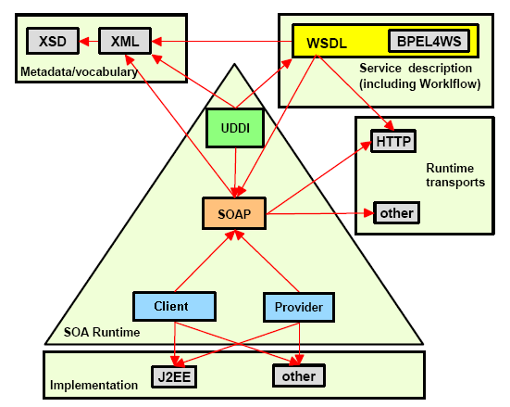
Figure 5

We next cover in detail some of these technologies, which are relevant to the book store process presented in this thesis.

Using the Web Services Description Language (WSDL)
The Web Services Description Language (WSDL) [16] forms the basis of Web Services.
Figure 6 illustrates the use of WSDL. On the left is a service provider. [24]

Using the Web Services Description Language (WSDL)
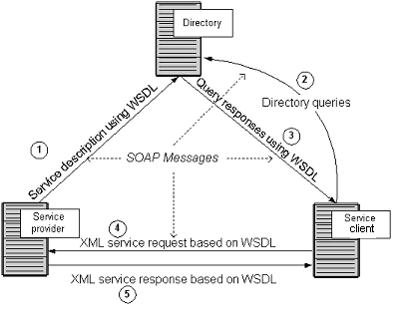
Figure 6

On the right is a service client. The steps involved in providing and consuming a service are:
- A service provider describes its service using WSDL. This definition is published to a directory of services. The directory could use Universal Description, Discovery, and Integration (UDDI). Other forms of directories can also be used.
- A service client issues one or more queries to the directory to locate a service and determine how to communicate with that service.
- Part of the WSDL provided by the service provider is passed to the service client. This tells the service client what the requests and responses are for the service provider.
- The service client uses the WSDL to send a request to the service provider.
- The service provider provides the expected response to the service client.

Using Simple Object Access Protocol (SOAP)
All the messages shown in Figure 6 are sent using SOAP. SOAP essentially provides the envelope for sending the web services messages. SOAP generally uses HTTP, but other means of connection may be used.
Figure 7 provides more detail on sending messages using SOAP. [24]

Messages sending using SOAP
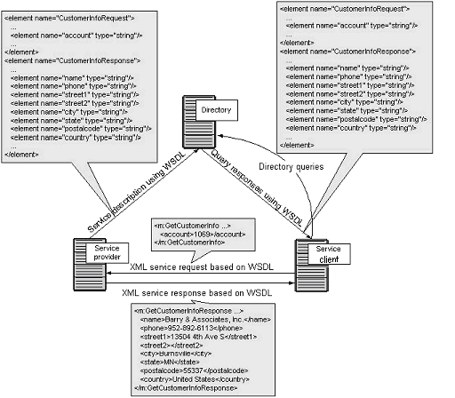
Figure 7

There is a fragment of the WSDL sent to the directory on the left side of the figure. It shows a CustomerInfoRequest that requires the customer's account to object information. Also the CustomerInfoResponse is shown which provides a series items related to customer including name, phone, and address items.
On the right of this figure there is a fragment of the WSDL being sent to the service client. This is the same fragment sent to the directory by the service provider. The service consumer uses this WSDL to create the service request shown above the arrow connecting the service consumer to the service provider. Upon receiving the request, the service provider returns a message using the format described in the original WSDL. That message appears at the bottom of the figure.

Using Universal Description, Discovery, and Integration (UDDI)
The directory shown in Figure 6 could be a UDDI registry. The UDDI registry is intended to eventually serve as a means of "discovering" web services described using WSDL. The idea is that the UDDI registry can be searched in various ways to obtain contact information and the Web Services available for various organizations. An alternative to UDDI is the ebXML Registry. [24]
2.4. Web Services composition

2.4.1. Business Processes, Workflows and Web Services

In this section we present the concepts of business process and workflow.
Business processes are graphs of activities that carry out meaningful business operation. For example, purchasing an airline ticket, managing inventory in a warehouse and ordering furniture for a home or office. Long-running transactions, such as tracking an order to fulfillment or supporting collaborative planning, forecasting and replenishment (CPFR) are also business processes. Business processes vary in level of granularity, and the details of a business process will vary from enterprise to enterprise.
Workflows are business processes that are run in an IT environment. Workflow tools allow businesses to define their business processes as a series of activities carried out by individuals or applications. The tools allow vary the sequence through the activity sequence depending on the output data from an individual activity.
Workflow, as a primary mechanism to compose web services in a nontrivial fashion, is critical for the rapid creation of new, higher-level web services. Workflow provides orchestration for interactions between component web services.
Web services are attractive components of workflows, because they can be composed dynamically or orchestrated into workflows, and because they are widely available across the network.
It is worth to note that a web service that serves as an activity in one workflow can itself consist of a series of sequenced activities (or a workflow) as illustrated in Figure 8. [4]

Compound workflow

Private Flow
in
out
Seller Service
Buyer Service
Credit Validation Service
Inventory Management Service

Customer Accounting Service
Public Flow
Figure 8

The seller service in Figure 8 is actually a complete workflow that is encapsulated as a single web service. The seller service consists of a credit validation activity, an inventory management activity and a customer accounting activity. The seller service presents a single interface to the buyer service using a single WSDL definition, thereby hiding the details of the lower-level workflow that it encapsulates. In Figure 8, the enterprise providing the workflow for the seller service does not expose the details of this service to public applications and services that seek to use the seller service. The seller service participates in a public flow, whereas the workflow that makes up the seller service is a private flow.
This idea of composing an activity or Web service out of a workflow is very powerful, and can be applied at multiple levels of granularity.
2.4.2. Creating Web Service composition

An important characteristic of web services is that web services can be composed.
Service aggregators can use the Business Process Execution Language for Web Services (BPEL4WS) [17] to create new Web services by defining corresponding compositions of the interfaces and internal processes of existing services.
The interface of the composite service is described as a collection of WSDL portTypes, just like any other Web service. The orchestration indicates how the service interface fits into the overall execution of the composition. Figure 9 illustrates this outer view of a BPEL4WS process. [25]

View of a Web service implemented as a BPEL4WS process
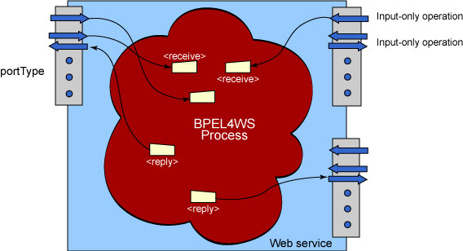
Figure 9

Implementing the service
Unlike a traditional programming language implementation of a WSDL service, each operation of each portType does not map to a separate piece of logic in BPEL4WS. Instead, the entire type of the service (that is, the set of portTypes of the service) is implemented by one single BPEL4WS process. Thus, specific "entry-points" corresponding to external users invoking the operations of the interface are indicated within the BPEL4WS description. These entry points either consume WSDL operations' incoming messages from input-only or input-output operations. In the latter case, the process must also indicate where the output message is generated. BPEL4WS only uses and supports input-only and input-output (request-response) operations of WSDL; output-only (notification) and output-input (solicit-response) operations are neither required nor supported.
The BPEL4WS process itself is basically a flow-chart like expression of an algorithm. Each step in the process is called an activity. There are a collection of primitive activities: invoking an operation on some web service (<invoke>), waiting for a message to operation of the service's interface to be invoked by someone externally (<receive>), generating the response of an input/output operation (<reply>), waiting for some time (<wait>), copying data from one variable to another (<assign>), indicating that something went wrong (<throw>), terminating the entire service instance (<terminate>), or doing nothing (<empty>).
These primitive activities can be combined into more complex algorithms using any of the structure activities provided in the language. These are the ability to define an ordered sequence of steps (<sequence>), to have branching using the now common "case-statement" approach (<switch>), to define a loop (<while>), to execute one of several alternative paths (<pick>), and finally the ability to indicate that a collection of steps should be executed in parallel (<flow>). Within activities executing in parallel, one can indicate execution order constraints by using links.
BPEL4WS allows to recursively combine the structured activities to express arbitrarily complex algorithms that represent the implementation of the service.
Interacting among services
As a language for composing together a set of services into a new service, BPEL4WS processes mainly consist of making invocations to other services and/or receiving invocations from clients. The prior is done using the <invoke> activity and the latter using the <receive> and <reply> activities. BPEL4WS calls the other services that interact with a process partner. A partner is either a service the process invokes (invoked partners) as an integral part of its algorithm, or those that invoke the process (client partners).
The first kind of partners is evident — the process must clearly invoke other services. The <invoke> activity signals the partner to invoke and what operation of which of the partner's portTypes to invoke on that partner. It is worth to notice, however, that invoked partners can end up being clients as well — it can be the case that the process invokes an operation on the partner to request some service. Later on, the partner may invoke an operation on the process to provide the desired data.
Service link types
BPEL4WS uses service link types to define partners. Basically, a partner is defined a name. Then indicating the name of a service link type and identifying the role that the process will play from that service link type and the role that the partner will play. In the pure invoked partner and pure client partner cases, the service link type will have just one role and, hence, only one is indicated at partner definition time. The partner name is then used in <receive>, <reply> and <invoke> activities to indicate the desired partner.
Lifecycle of services
Web services implemented as BPEL4WS processes have an instanced life cycle model. A client of these services always interacts with a specific instance of the service (process). Unlike traditional distributed object systems BPEL4WS instances are not created via a factory pattern. Instead, instances in BPEL4WS are created implicitly when messages arrive for the service. Instances are identified not by an explicit "instance ID" concept, but by some key fields within data messages. For example, if the process represents an order fulfillment system, the invoice number could be the "key" field to identify the specific instance involved with the interaction. If a matching instance isn't available when a message arrives at a "startable" point in the process, a new instance is automatically created and associated with the key data found in the message. Messages can only be accepted at non-startable points in a process after a suitable instance has been located. In these cases the messages are in fact always delivered to specific instances. In BPEL4WS, the process of finding a suitable instance or creating one if necessary is called message correlation. [22]
3. Proposed architecture

This chapter describes a proposed architecture of a book store application using web services.
We describe all developed web services and interaction among web services. For better understanding of the process the flow chart of the services composition and some sequence diagrams are presented.
Software tools for developing the application, steps of creating web services and building the business process are summarized in section 2.
Finally we propose a short user guide to help the user of the system to get started.

3.1. Architecture overview

3.1.1. Web Services description

The book store application is described in four components. These can be seen as four separate and autonomous elements that interact with each other. These elements are implemented using web services technology and are:
- Inventory Service;
- Credit Service;
- Post Service;
- Messenger Service.
Inventory Service. It is responsible for providing information about the warehouse. The Service contains two operations:
- numberOfCopies;
- restockTime.
The numberOfCopies operation. This operation provides information about the number of book copies at the warehouse.
This operation has a string type parameter book name as an argument and returns an integer type parameter number of book copies at the warehouse.
The restockTime operation. This operation is used for retrieving information about the time till the next delivery of the requested book to the warehouse.
The restockTime operation has a string type parameter book name as an argument and returns an integer type parameter time (in days) till the next delivery of the book to the warehouse.
The numberOfCopies operation is invoked when the main process starts.
The restockTim operation is invoked in case that number of book copies at the warehouse is less than number of book copies requested by the user.
Credit Service. It is responsible for payment activity. The Service contains two operations:
- testCard;
- drawOut.
The testCard operation checks whether the user Charge Card is valid.
This operation has an integer type parameters card number and sum as arguments and returns a boolean type parameter test card result.
The drawOut operation draws out the given sum.
This operation has an integer type parameter sum as an argument and returns a void type parameter.
The testCard operation is invoked in two cases. One of them is when the number of book copies at the warehouse is greater or equal than the number of book copies requested by the user. Another one is when the number of book copies at the warehouse is less than the number of book copies requested by the user, but the time till the next delivery of the requested book to the warehouse is less or equal than the time till the next delivery of the requested book that the user agrees to wait.
The drawOut operation is invoked in case that the test card result is equal to true. This operation is invoked along with the delivery operation from the Post Service, because these operations are invoked in the same flow construction.
Post Service is responsible for delivery activity. The Service contains one operation delivery.
The delivery operation posts the requested book to the user.
It has several string type parameters such as customer name, customer address and delivery date etc. as arguments and returns a void type parameter.
The delivery operation is invoked in case that the test card result is equal to true. This operation is invoked along with the drawOut operation from the Credit Service, because these operations are invoked in the same flow construction.
Messenger Service is responsible for messages activity. The Service contains two operations:
- error;
- correct.
The error operation does not have any arguments.
It returns a message, which the user gets in case of deviation.
The correct operation has no arguments.
It returns a message, which the user gets in case of successful application termination.
The error operation is invoked in case of swerving in process running.
The correct operation is invoked in case of successful application termination.
BookStoreInterface Process is responsible for the described above services composition.
The project also has Web-based User Interface which starts BookStoreInterface Process and helps the user to work with the project.

3.1.2. Interaction among Web Services

The BookStoreInterface Process is composed of four services which interact with each other. In Figure 1 the flow chart of these services interaction is represented.
The process starts by the placement of an order. The Place order rectangle denotes it. The user places an order by a Web-based User Interface specifying parameters such as book name, requested number of book copies etc.
When the form is filled and submitted, the numberOfCopies operation of the Inventory Service is invoked and the number of book copies at the warehouse is returned. The numberOfCopies rectangle denotes this circumstance.
The diamond placed after the numberOfCopies rectangle indicates a comparison between the number of book copies at the warehouse and the number of book copies requested by the user. In case the number of book copies at the warehouse is less than the number of book copies requested by the user then the restockTime operation of the Inventory Service is invoked and the time till the next delivery of the book to the warehouse is returned. This is denoted by the restockTime. In case that the number of book copies at the warehouse is greater or equal than the number of book copies requested by the user the testCard operation of the Credit Service is invoked and the test card result is returned. The testCard rectangle denotes this circumstance.
The diamond after the restockTime rectangle indicates comparison of the time till the next delivery of the requested book to the warehouse and the time till the next delivery of the requested book that the user agrees to wait. On condition that the time till the next delivery of the requested book to the warehouse is greater than the time till the next delivery of the requested book that the user agrees to wait the error operation of the Messenger Service is invoked. An error message is returned and the application is terminated. The error rectangle and the End oval denote this circumstance. On condition that the time till the next delivery of the requested book to the warehouse is less or equal than time till the next delivery of the requested book that the user agrees to wait the testCard operation is invoked (see above).
The diamond after the testCard rectangle indicates that the condition of test card is true. If the condition is false, the error operation of the Messenger Service is invoked, an error message is returned and the application is terminated. The error rectangle and the End oval denote this circumstance. In other case the drawOut and the delivery operations are invoked simultaneously. The flow construction of BPEL4WS allows expressing the above flow of control in the book store example. The drawOut and the delivery rectangles denote invocation of corresponding operations. After the correct operation of the Messenger Service is invoked, a message about the successful operation completion is returned and the application is terminated. This is denoted by the correct rectangle and the End oval.
Flow chart of the book store application
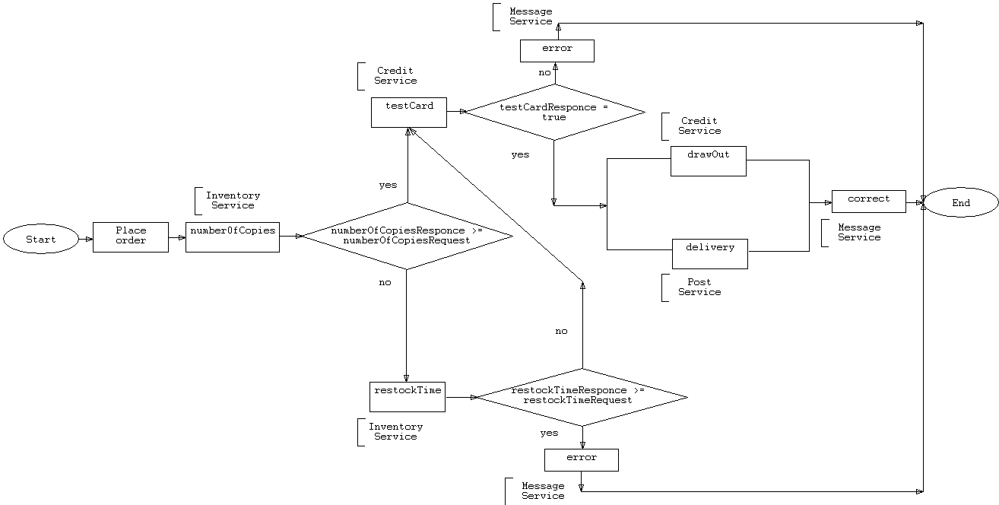
Figure 1
The flow chart in Figure 1 is useful to understand how the control of the book store application flows. Next we present sequence diagrams to illustrate the temporal sequence of message passing between the Services. Sequence diagrams belong to a group of UML diagrams called Interaction Diagrams. Sequence diagrams describe how objects interact over the course of time through an exchange of messages [10].
Figure 2 and Figure 3 illustrate processes of buying a book, which terminate successfully.
The sequence diagram given on Figure 2 presents six instances that interact with each other. Solid arrows denote messages, correlated messages are indicated by dotted arrows.
Figure 2 shows the placing of an order by the user using the UserInterface and passing parameters such as book name, requested number of book copies etc. The UserInterface passes the request of buying a book to the BookStoreInterface. All subsequent interactions among the following services are performed by the BookStoreInterface. The BookStoreInterface requests the number of book copies from the Inventory. The Inventory responds. In case that the number of book copies at the warehouse is greater or equal than the number of book copies requested by the user the BookStoreInterface requests validating the card from the Credit. The Credit responds. On condition that the test card result is true, drawing out and delivering the book from the Credit and the Post correspondingly are requested by the BookStoreInterface. The Credit and the Post respond. The BookStoreInterface request a correct message from the Messenger and there is the response to this request. At the end of the process the BookStoreInterface responds on the request of buying a book to the UserInterface.
The sequence diagram of Figure 3 can be interpreted similarly.
Sequence diagram of successful termination of the application without using the restockTime operation
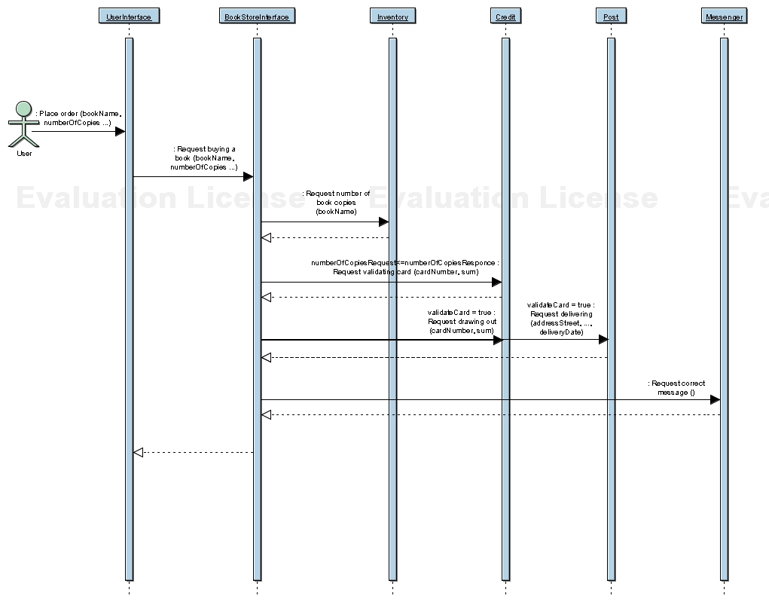
Figure 2
Sequence diagram of successful termination of the application with using the restockTime operation
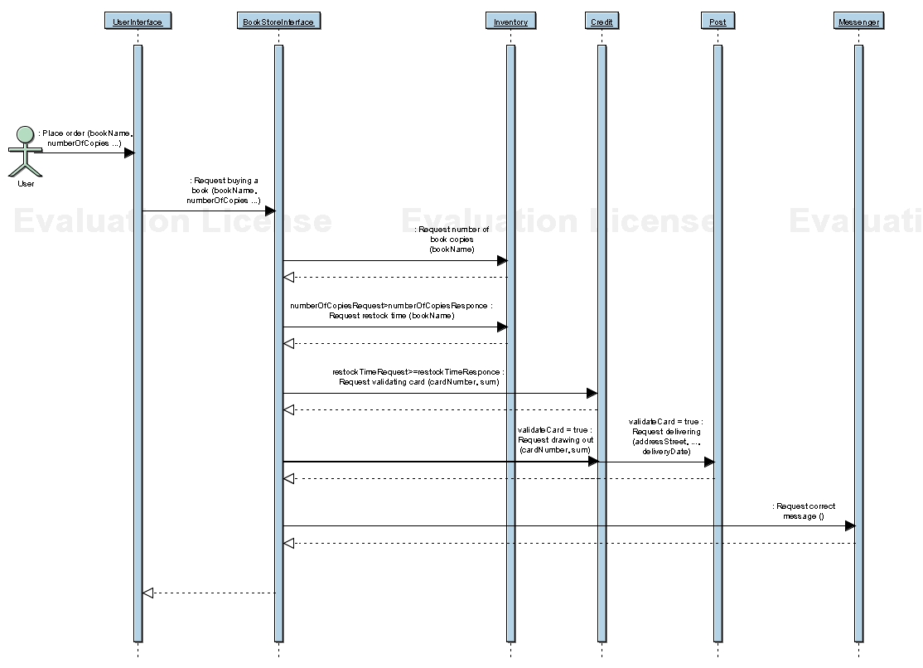
Figure 3
In Figure 4. and Figure 5. we consider the case in which the processes of buying a book terminate with errors.
On the sequence diagram presented on Figure 5 six instances that interact with each other are shown. Notice that the Credit and the Post are not used in this composition, but they are depicted for completeness. Solid arrows denote messages, correlated messages are indicated by dotted arrows.
Figure 5. shows the placing of an order by the user using the UserInterface and passing parameters such as book name, requested number of book copies etc. The UserInterface passes the request of buying a book to the BookStoreInterface. All subsequent interactions among the following services are performed by the BookStoreInterface. The BookStoreInterface requests the number of book copies from the Inventory. The Inventory responds. As the number of book copies at the warehouse is less than the number of book copies requested by the user the BookStoreInterface requests the restock time from the Inventory. The Inventory responds. On condition that the time till the next delivery of the requested book to the warehouse is greater than the time till the next delivery of the requested book that the user agrees to wait the BookStoreInterface requests an error message from the Messenger and there is the response to this request. At the end of the process the BookStoreInterface responds on the request of buying a book to the UserInterface.
The sequence diagram of Figure 4 can be interpreted in the similar way.
Sequence diagram of not successful termination of the application without using the restockTime operation
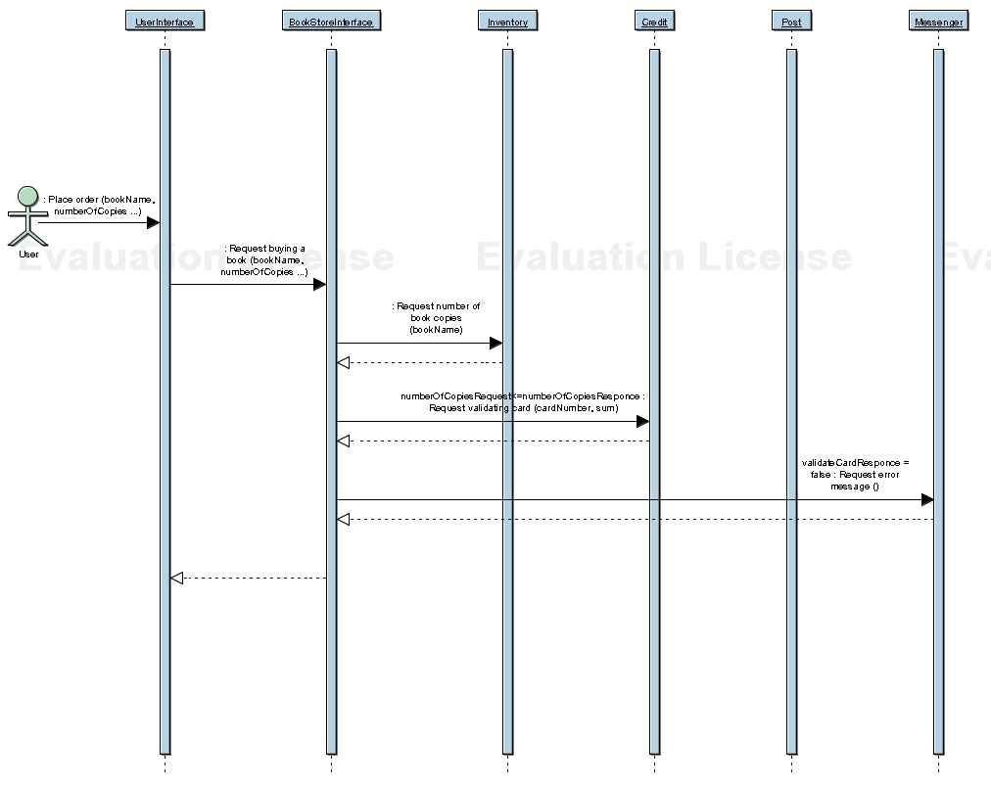
Figure 4
Sequence diagram of not successful termination of the application with using the restockTime operation
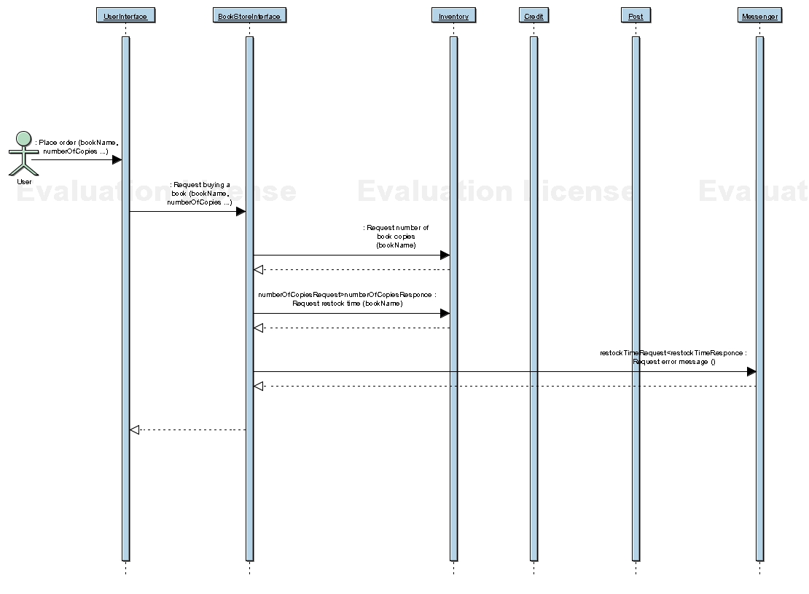
Figure 5
3.2. Implementation details

3.2.1. Software tools

Environment for creating the web services is Apache Axis (Apache EXtensible Interaction System) 1.1 version.
Axis is a SOAP engine — a framework for constructing SOAP processors such as clients, servers, gateways, etc. Axis also includes:
- a simple stand-alone server;
- a server which plugs into servlet engines such as Tomcat;
- extensive support for the Web Service Description Language (WSDL);
- emitter tooling that generates Java classes from WSDL;
- a tool for monitoring TCP/IP packets, etc. [14]
Servlet engine for Axis is Apache Tomcat 4.1 version. [15]
The business process was developed by BPWS4J (the IBM Business Process Execution Language for Web Services JavaTM Run Time) 1.1 version.
BPWS4J includes the following:
- a platform upon which can be executed business processes written using the Business Process Execution Language for Web Services (BPEL4WS);
- a tool that validates BPEL4WS documents, etc.
The BPWS4J platform also includes an Eclipse plug-in that provides a simple editor for creating and modifying BPEL4WS files. Its main features are as follows:
- synchronized XML source and tree views of the business process being created;
- flexibility for accomodating bottom-up as well as top-down approaches to process design;
- context-sensitive menus that facilitate creation of specification-compliant processes;
- validation of process against specification requirements during editing session.
How does BPWS4J work?
For each process, the BPWS4J engine takes in a BPEL4WS document that describes the process to be executed, a WSDL document (without binding information) that describes the interface that the process will present to clients (partners in BPEL4WS terms), and WSDL documents that describes the services that the process may or will invoke during its execution.
From this information, the process is made available as a web service with a SOAP interface. A WSDL file that describes the process interface may be retrieved at run-time. The BPWS4J engine supports the invocation, from within the process, of web services that have a SOAP interface, that are EJBs, or that are normal Java classes. [19]

3.2.2. Creating Web Services with Axis

We created the web services using such a scheme:
- create Java-class for every service. See sources listing in Appendix D;
- copy the above .java files into the webapps directory, and rename them in .jws files;
- make sure that services are being able to access at the following URL (assuming Axis web application is on port 8080): http://localhost:8080/axis/fileName.jws
- tack on "?wsdl" to the end of the URL.
Axis will automatically generate a service description for the deployed service, and return it as XML. See WSDL documents listing in Appendix C.
- the resulting description should be saved.
- it is possible to give the WSDL-generation URL to online partners, and they will be able to use it to access the service with toolkits like .NET, SOAP::Lite, or any other software which supports using WSDL.

3.2.3. Building the business process

For developing the business process the following documents are necessary:
- a BPEL4WS document that describes the process to be executed. See the document listing in Appendix B;
- a WSDL document (without binding information) that describes the interface that the process will present to clients. See the document listing in Appendix C;
- WSDL documents that describe the services that the process may or will invoke during its execution. See the document listing in Appendix C.
The BPEL4WS document is developed using Business Process Execution Language for Web Services version 1.1. [17]
The WSDL documents are developed using Web Service Description Language version 1.1. [16]
3.3. Application user guide

The application is performed under the control of BPWS4J engine that runs on Apache application server (Apache AXIS and Tomcat). It has a Web-based Interface that allows user to deploy the business process. Web-based User Interface that was created by us helps user to run the business process.

3.3.1. Deploying the business process

Before running the application user should deploy the business process.
For process deployment user should open “Deploy a Process” page by navigating his browser to http://localhost:8080/bpws4j/admin/index.html and click Deploy button.
User should enter the path to the WSDL and BPEL4WS files of the process or use the Browse buttons to find them and click Continue Deployment.
See figure 6.
“Deploy a Process” page
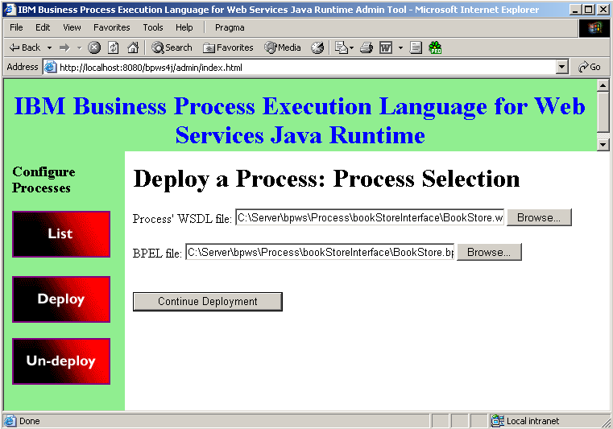
Figure 6

Figure 7 illustrates next step in the business process deployment.
User should enter the path to the WSDL files of the services or use the Browse buttons to find them and click Start Serving the Process.
Next step in the business process deployment
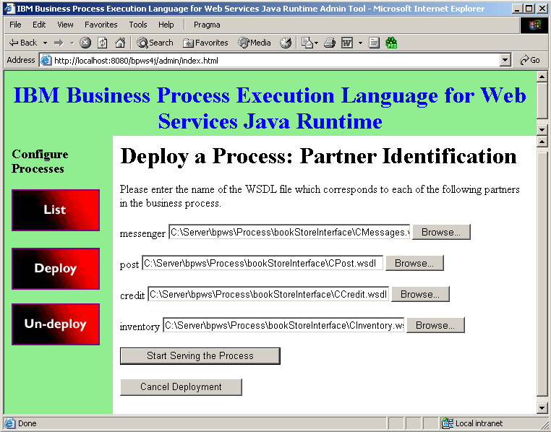
Figure 7

Figure 8 illustrates result of the business process deployment.

Result of the business process deployment
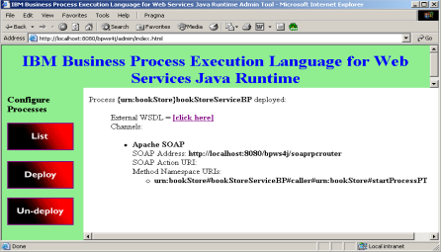
Figure 8
Now the process is deployed.

3.3.2. Running the business process

For running the application user should run Web-based User Interface by navigating his browser to http://localhost:8080/bookStore/index.jsp. See figure 9.

Web-based User Interface
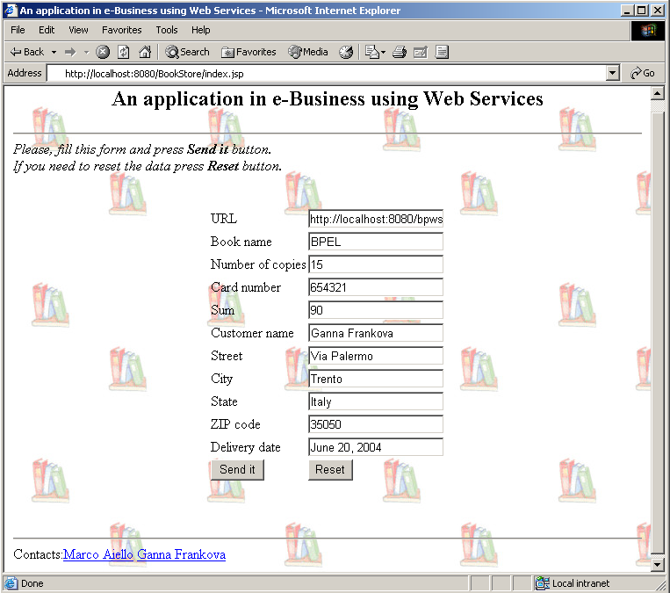
Figure 9

User should fill the form and press Send it button.
In case of successful application termination user gets “Thank you for visiting our shop.” message. In case of deviation user gets “Sorry, see you later.” message.
Conclusion

Nowadays web services in the business world provide a mechanism of communication among remote systems, connected through the network of the web services.
For example, in case of a merger or a business growth, companies don't have to invest large sums of money in developing software to bring the systems of the different companies together. By extending the business applications as web services, the information systems of different companies can be linked. These business systems then can be accessed by using simple SOAP messages over HTTP Web protocol.
The work presented in this thesis has two main parts. One of them is architecture development of an e-Business application. A Book store application was taken as an example. Another part is the development of book store process, which is performed under the control of BPWS4J engine that runs on Apache application server (Apache AXIS and Tomcat).
As stated in “Proposed architecture” chapter, the project was tested on a single PC. It was proven that the approach is feasible. The example can be easily deployed to several computers with slight modifications.
In spite of that fact that business processes are shown to be a suitable solution for B2B needs it will be nice to have a tool for visual business processes composition and monitoring business processes at run-time.
In this work we did not take into account concepts of transaction, reliable messages and security issues. These mechanisms are to be issued in a future work.
Bibliography

- Coulouris G, Dollimore J., Kindberg T. Distributed Systems: Concepts and Design. Third edition. — USA: Addison-Wesley, 2001. — 772p.
- Curbera F., Khalaf R., Mukhi N., Tai S., Weerawarana S. The next step in Web Services. // Communications of the ACM. — October 2003. — Vol. 46, № 10. — p. 29-34.
- D’Andrea Vincenzo, Aiello Marco. Services and objects: open issues. Technical Report # DIT-03-085. — December 2003. — 7p.
- Heather Kreger, IBM. Web Services Conceptual Architecture (WSCA 1.0). — May 2001 — 40p.
- Jian Yang. Web Service Componentization. // Communications of the ACM. — October 2003. — Vol. 46, № 10. — p. 35-40
- Papazoglou M., d'Andrea V., Plexousakis D., Grefen P., Yang J., Mecella M., Plebani P. Service-oriented computing manifesto.
- Papazoglou M.P., Georgakopoulos D. Service-Oriented Computing. // Communications of the ACM. — October 2003. — Vol. 46, № 10. — p. 25-28.
- Papazoglou M.P. Service-Oriented Computing: Concepts, Characteristics and Directions. Keynote for the 4th International Conference on Web Information Systems Engineering (WISE 2003). — December 10-12, 2003. — 10p.
- Ueli Wahli, Gustavo Garcia Ochoa, Sharad Cocasse,Markus Muetschard. WebSphere Version 5.1 Application Developer 5.1.1 Web Services Handbook. — IBM, February 2004. — 560p.
- Буч Г., Рамбо Д., Айвар Д. Язык UML. Руководство пользователя: Пер. с англ. — М.: ДМК, 2000. — 432с.
- Рей Э. Изучаем XML. — 2001 г. — 408 стр.
- A Dynamic e-Business Application Using Web Services
http://www.developer.com/services/article.php/2211381.
- Accenture, Ariba, Commerce One, Fujitsu Limited, Hewlett-Packard, i2 Technologies, Intel, IBM, Microsoft, Oracle, SAP AG, Sun Microsystems, and VeriSign. UDDI Specification Version 3.0.1. — 14 November 2003
http://uddi.org/pubs/uddi_v3.htm.
- Apache Axis:
http://ws.apache.org/axis/.
- Apache Tomcat:
http://jakarta.apache.org/tomcat/.
- Ariba, IBM, Microsoft. Web Services Description Language (WSDL) Version 1.1. — 15 March 2001:
http://www.w3.org/TR/wsdl.
- BEA, IBM, Microsoft, SAP AG and Siebel. Business Process Execution Language for Web Services (BPEL4WS) Version 1.1. — 05 May 2003:
http://www.ibm.com/developerworks/library/ws-bpel/.
- Extensible Markup Language (XML) Version 1.1. — 04 November 2004
http://www.w3.org/TR/xml11/.
- IBM Business Process Execution Language for Web Services JavaTM Run Time (BPWS4J):
http://www.alphaworks.ibm.com/tech/bpws4j.
- Ryman Arthur. Understanding Web Services. — 22 July 2003
http://www-106.ibm.com/developerworks/websphere/library/techarticles/0307_ryman/ryman.html
- SOAP Specification Version 1.2. — 24 June 2003
http://www.w3.org/TR/soap12-testcollection/.
- Solomon Marvin, Wisconsin U. Java for C++ Programmers
http://triton.towson.edu/~mzimand/os/Lect2-java-tutorial.html
- Web Services Activity
http://www.w3.org/2002/ws/
- Web Services articles:
http://www.service-architecture.com/web-services/articles.
- Weerawarana S., Curbera F. Business Process with BPEL4WS: Understanding BPEL4WS
http://www-106.ibm.com/developerworks/webservices/library/ws-bpelcol1/.
supplement A

JSP Sourses

index.jsp

<%@ page language="java" import="java.io.*,java.util.*,java.text.*,java.net.*,org.apache.soap.*,org.apache.soap.rpc.*" %>
<%
boolean success = false;
String urlStr = (request.getParameter("url") == null) ? "" : request.getParameter("url");
String bookName = (request.getParameter("bookName") == null) ? "BPEL" : request.getParameter("bookName");

int numberOfCopies = 1;
try{
numberOfCopies = (request.getParameter("numberOfCopies") != null && request.getParameter("numberOfCopies").trim().length() > 0) ? Integer.parseInt(request.getParameter("numberOfCopies")) : 1;
}catch(Exception e){
e.printStackTrace();
}

int cardNumber = 1234;
try{
cardNumber = (request.getParameter("cardNumber") != null && request.getParameter("cardNumber").trim().length() > 0) ? Integer.parseInt(request.getParameter("cardNumber")) : cardNumber;
}
catch(Exception e){
e.printStackTrace();
}

int sum = 100;
try{
sum = (request.getParameter("sum") != null && request.getParameter("sum").trim().length() > 0) ? Integer.parseInt(request.getParameter("sum")) : sum;
}
catch(Exception e){
e.printStackTrace();
}

String customerName = (request.getParameter("customerName") == null) ? "Ganna Frankova" : request.getParameter("customerName");
String addressStreet= (request.getParameter("addressStreet") == null) ? "Via Palermo" : request.getParameter("addressStreet");
String addressCity = (request.getParameter("addressCity") == null) ? "Trento" : request.getParameter("addressCity");
String addressState = (request.getParameter("addressState") == null) ? "Italy" : request.getParameter("addressState");
String addressZip = (request.getParameter("addressZip") == null) ? "35050" : request.getParameter("addressZip");
Date deliveryDate = new Date();

if(urlStr.length() > 0){
URL url = new URL (urlStr);
Call call = new Call ();
Vector params = new Vector ();

call.setTargetObjectURI ("urn:bookStore#bookStoreServiceBP#caller#urn:bookStore#startProcessPT");
params.addElement(new Parameter("bookNameRequest",String.class,bookName,null));
params.addElement(new Parameter("numeroOfCopiesRequest",Integer.class,new Integer(numberOfCopies),null));
params.addElement(new Parameter("cardNumberRequest",Integer.class,new Integer(cardNumber),null));
params.addElement(new Parameter("sumRequest",Integer.class,new Integer(sum),null));
params.addElement(new Parameter("customerNameRequest",String.class,customerName,null));
params.addElement(new Parameter("addressStreetRequest",String.class,addressStreet,null));
params.addElement(new Parameter("addressCityRequest",String.class,addressCity,null));
params.addElement(new Parameter("addressStateRequest",String.class,addressState,null));
params.addElement(new Parameter("addressZipRequest",String.class,addressZip,null));
params.addElement(new Parameter("deliveryDateRequest",java.util.Date.class,deliveryDate,null));

call.setMethodName ("start");
call.setEncodingStyleURI(Constants.NS_URI_SOAP_ENC);
call.setParams (params);

Response resp = call.invoke (/* router URL */ url, /* actionURI */ "" );

// Check the response.
if (resp.generatedFault()){
Fault fault = resp.getFault();
System.out.println("Ouch, the call failed: ");
System.out.println(" Fault Code = " + fault.getFaultCode());
System.out.println(" Fault String = " + fault.getFaultString());
System.out.println(" Fault = " + fault);
}
else{
Parameter result = resp.getReturnValue();
if (result != null){
%>
<html>
<head>
<title>An application in e-Business using Web Services</title>
</head>
<body background="books.jpg">
<h2 align="center"> An application in e-Business using Web Services</h2> <hr>
</body>
</html>
<%
out.println(result.getValue()+"<br>Return to the <a href=\"index.jsp\">main page</a>.");
success = true;
}
else
out.println("No response was returned. Perhaps there was an error with the flow.<br><hr>");
}
}
if(!success){
%>
<html>
<head>
<title>An application in e-Business using Web Services</title>
</head>
<body background="books.jpg">
<h2 align="center"> An application in e-Business using Web Services</h2><hr>
<i>Please, fill this form and press <b>Send it</b> button.</i></br>
<i>If you need to reset the data press <b>Reset</b> button.</i><br><br><br>
<table border="0" cellpadding="1" cellspacing="0" align="center">
<form action="index.jsp" method="post">
<tr>
<td>URL</td>
<td><input type="text" name="url" value="<%= urlStr %>"></td>
</tr>
<tr>
<td>Book name</td>
<td><input type="text" name="bookName" value="<%= bookName %>"></td>
</tr>
<tr>
<td>Number of copies</td>
<td><input type="text" name="numberOfCopies" value="<%= numberOfCopies %>"></td>
</tr>
<tr>
<td>Card number</td>
<td><input type="text" name="cardNumber" value="<%= cardNumber %>"></td>
</tr>
<tr>
<td>Sum</td>
<td><input type="text" name="sum" value="<%= sum %>"></td>
</tr>
<tr>
<td>Customer name</td>
<td><input type="text" name="customerName" value="<%= customerName %>"></td>
</tr>
<tr>
<td>Street</td>
<td><input type="text" name="addressStreet" value="<%= addressStreet %>"></td>
</tr>
<tr>
<td>City</td>
<td><input type="text" name="addressCity" value="<%= addressCity %>"></td>
</tr>
<tr>
<td>State</td>
<td><input type="text" name="addressState" value="<%= addressState %>"></td>
</tr>
<tr>
<td>ZIP code</td>
<td><input type="text" name="addressZip" value="<%= addressZip %>"></td>
</tr>
<tr>
<td>Delivery date</td>
<td><input type="text" name="deliveryDate" value="<%= DateFormat.getDateInstance(DateFormat.MEDIUM).format(deliveryDate) %>"></td>
</tr>
<tr>
<td colspan="1"><input type="Submit" value="Send it"></td>
<td colspan="1"><input type="Reset" value="Reset"></td>
</tr>
</table>
</form>
<br><br><hr>
Contacts:<a href="mailto:aiellom@ieee.org">Marco Aiello</a>
<a href="mailto:ganna.frankova@dit.unitn.it">Ganna Frankova</а>
</body>
</html>
<%}%>
supplement B

BPEL Document

BookStore.bpel

<process name="bookStoreProcess"
targetNamespace="urn:bookStore"
xmlns:tns="urn:bookStore"
xmlns:inv="http://localhost:8080/axis/CInventory.jws"
xmlns:crd="http://localhost:8080/axis/CCredit.jws"
xmlns:pst="http://localhost:8080/axis/CPost.jws"
xmlns:msg="http://localhost:8080/axis/CMessages.jws"
xmlns="http://schemas.xmlsoap.org/ws/2003/03/business-process/">
xmlns:bpws="http://schemas.xmlsoap.org/ws/2003/03/business-process/"

<variables>
<variable name="bookStart" messageType="tns:startInput"/>
<variable name="numberOfCopies" messageType="tns:startInput"/>

<variable name="bookName4C" messageType="inv:numberOfCopiesRequest"/>
<variable name="bookName4T" messageType="inv:restockTimeRequest"/>
<variable name="cardNumberSumma" messageType="crd:testCardRequest"/>
<variable name="summaPay" messageType="crd:drawOutRequest"/>
<variable name="deliveryData" messageType="pst:deliveryRequest"/>
<variable name="myMessageErr" messageType="msg:errorRequest"/>
<variable name="myMessageCorr" messageType="msg:correctRequest"/>

<variable name="numberOfCopiesResult" messageType="inv:numberOfCopiesResponse"/>
<variable name="restockTimeResult" messageType="inv:restockTimeResponse"/>
<variable name="cardNumberSummaResult" messageType="crd:testCardResponse"/>
<variable name="summaPayResult" messageType="crd:drawOutResponse"/>
<variable name="deliveryDataResult" messageType="pst:deliveryResponse"/>
<variable name="myMessageErrResult" messageType="msg:errorResponse"/>
<variable name="myMessageCorrResult" messageType="msg:correctResponse"/>

<variable name="myMessageFinal" messageType="tns:startOutput"/>
</variables>

<partners>
<partner name="caller" serviceLinkType="tns:startProcessLT"/>
<partner name="inventory" serviceLinkType="tns:inventoryLT"/>
<partner name="credit" serviceLinkType="tns:creditLT"/>
<partner name="post" serviceLinkType="tns:postProcessLT"/>
<partner name="messenger" serviceLinkType="tns:messagesLT"/>
</partners>

<sequence>
<receive name="mainReceive"
partner="caller" portType="tns:startProcessPT"
operation="start"
variable="bookStart" createInstance="yes">
</receive>

<!-- Assigning -->
<assign name="bookStart_bookName4C">
<copy>
<from variable="bookStart" part="bookNameRequest"/>
<to variable="bookName4C" part="sBookName"/>
</copy>
</assign>

<assign name="bookStart_bookName4T">
<copy>
<from variable="bookStart" part="bookNameRequest"/>
<to variable="bookName4T" part="sBookName"/>
</copy>
</assign>

<assign name="bookStart_numberOfCopies">
<copy>
<from variable="bookStart" part="numeroOfCopiesRequest"/>
<to variable="numberOfCopies" part="numeroOfCopiesRequest"/>
</copy>
</assign>

<assign name="bookStart_cardNumberSumma">
<copy>
<from variable="bookStart" part="cardNumberRequest"/>
<to variable="cardNumberSumma" part="nCardNumber"/>
</copy>
<copy>
<from variable="bookStart" part="sumRequest"/>
<to variable="cardNumberSumma" part="sum"/>
</copy>
</assign>

<assign name="bookStart_summaPay">
<copy>
<from variable="bookStart" part="cardNumberRequest"/>
<to variable="summaPay" part="nCardNumber"/>
</copy>
<copy>
<from variable="bookStart" part="sumRequest"/>
<to variable="summaPay" part="sum"/>
</copy>
</assign>

<assign name="bookStart_deliveryData">
<copy>
<from variable="bookStart" part="customerNameRequest"/>
<to variable="deliveryData" part="sCustomerName"/>
</copy>
<copy>
<from variable="bookStart" part="addressStreetRequest"/>
<to variable="deliveryData" part="sAddressStreet"/>
</copy>
<copy>
<from variable="bookStart" part="addressCityRequest"/>
<to variable="deliveryData" part="sAddressCity"/>
</copy>
<copy>
<from variable="bookStart" part="addressStateRequest"/>
<to variable="deliveryData" part="sAddressState"/>
</copy>
<copy>
<from variable="bookStart" part="addressZipRequest"/>
<to variable="deliveryData" part="sAddressZip"/>
</copy>
<copy>
<from variable="bookStart" part="deliveryDateRequest"/>
<to variable="deliveryData" part="dSDeliveryDate"/>
</copy>
</assign>

<!-- Invoke Inventory numberOfCopies -->
<invoke name="myInvokeInvCopies"
partner="inventory" portType="inv:CInventoryPT"
operation="numberOfCopies"
inputVariable="bookName4C"
outputVariable="numberOfCopiesResult">
</invoke>
<!--copiesSwitch -->
<switch name="copiesSwitch">
<case condition="bpws:getVariableData('numberOfCopies','numeroOfCopiesRequest') >= bpws:getVariableData('numberOfCopiesResult','numberOfCopiesReturn')">
<!-- Invoke Inventory restockTime -->
<sequence>
<invoke name="myInvokeInvTime"
partner="inventory" portType="inv:CInventoryPT"
operation="restockTime"
inputVariable="bookName4T"
outputVariable="restockTimeResult">
</invoke>
<!-- timeSwitch -->
<switch name="timeSwitch">
<case condition="bpws:getVariableData('restockTimeResult','restockTimeReturn') >= 10">
<!-- Invoke Messages error -->
<sequence>
<invoke name="myInvokeMsgError"
partner="messenger" portType="msg:messagesPT"
operation="error"
inputVariable="myMessageErr"
outputVariable="myMessageErrResult">
</invoke>

<assign name="myAssignTemp3">
<copy>
<from variable="myMessageErrResult" part="errorReturn"/>
<to variable="myMessageFinal" part="myMessageReply"/>
</copy>
</assign>

<reply name="myReplyMsgError"
partner="caller" portType="tns:startProcessPT"
operation="start"
variable="myMessageFinal">
</reply>
<terminate>
</terminate>
</sequence>
</case>
<otherwise>
<sequence>
<!-- Invoke Credit testCard -->
<invoke name="myInvokeCrdTest"
partner="credit" portType="crd:CCreditPT"
operation="testCard"
inputVariable="cardNumberSumma"
outputVariable="cardNumberSummaResult">
</invoke>
<!--cardSwitch -->
<switch name="cardSwitch">
<case condition="bpws:getVariableData('cardNumberSummaResult','testCardReturn') != false">
<sequence>
<flow>
<!-- Invoke credit drawOut -->
<invoke name="myInvokePay"
partner="credit" portType="crd:CCreditPT"
operation="drawOut"
inputVariable="summaPay">
outputVariable="summaPayResult">
</invoke>
<!-- Invoke Post delivery -->
<invoke name="myInvokePost"
partner="post" portType="pst:CPostPT"
operation="delivery"
inputVariable="deliveryData">
outputVariable="deliveryDataResult">
</invoke>
</flow>
<!-- Invoke Messages correct -->
<invoke name="myInvokeMsgCorrect"
partner="messenger" portType="msg:messagesPT"
operation="correct"
inputVariable="myMessageCorr"
outputVariable="myMessageCorrResult">
</invoke>

<assign name="myAssignTemp100">
<copy>
<from variable="myMessageCorrResult" part="correctReturn"/>
<to variable="myMessageFinal" part="myMessageReply"/>
</copy>
</assign>

<reply name="myReplyMsgCorrect"
partner="caller" portType="tns:startProcessPT"
operation="start"
variable="myMessageFinal">
</reply>
</sequence>
</case>
<otherwise>
<!-- Invoke Messages error -->
<sequence>
<invoke name="myInvokeMsgError"
partner="messenger" portType="msg:messagesPT"
operation="error"
inputVariable="myMessageErr"
outputVariable="myMessageErrResult">
</invoke>

<assign name="myAssignTemp5">
<copy>
<from variable="myMessageErrResult" part="errorReturn"/>
<to variable="myMessageFinal" part="myMessageReply"/>
</copy>
</assign>

<reply name="myReplyMsgError"
partner="caller" portType="tns:startProcessPT"
operation="start"
variable="myMessageFinal">
</reply>
</sequence>
</otherwise>
</switch>
</sequence>
</otherwise>
</switch>
</sequence>
</case>
<otherwise>
<!-- Invoke Credit testCard -->
<sequence>
<invoke name="myInvokeCrdTest"
partner="credit" portType="crd:CCreditPT"
operation="testCard"
inputVariable="cardNumberSumma"
outputVariable="cardNumberSummaResult">
</invoke>
<!--cardSwitch -->
<switch name="CardSwitch">
<case condition="bpws:getVariableData('cardNumberSummaResult','testCardReturn') != false">
<sequence>
<!-- Invoke Messages correct -->
<invoke name="myInvokeMsgCorrect"
partner="messenger" portType="msg:messagesPT"
operation="correct"
inputVariable="myMessageCorr"
outputVariable="myMessageCorrResult">
</invoke>

<assign name="myAssignTemp100">
<copy>
<from variable="myMessageCorrResult" part="correctReturn"/>
<to variable="myMessageFinal" part="myMessageReply"/>
</copy>
</assign>

<reply name="myReplyMsgCorrect"
partner="caller" portType="tns:startProcessPT"
operation="start"
variable="myMessageFinal">
</reply>
</sequence>

</case>
<otherwise>
<!-- Invoke Messages error -->
<sequence>
<invoke name="myInvokeMsgError"
partner="messenger" portType="msg:messagesPT"
operation="error"
inputVariable="myMessageErr"
outputVariable="myMessageErrResult">
</invoke>

<assign name="myAssignTemp7">
<copy>
<from variable="myMessageErrResult" part="errorReturn"/>
<to variable="myMessageFinal" part="myMessageReply"/>
</copy>
</assign>

<reply name="myReplyMsgError"
partner="caller" portType="tns:startProcessPT"
operation="start"
variable="myMessageFinal">
</reply>
</sequence>

</otherwise>
</switch>
</sequence>
</otherwise>
</switch>

</sequence>
</process>
supplement C

WSDL Documents

BookStore.wsdl

<?xml version="1.0" encoding="UTF-8" ?>

<definitions
targetNamespace="urn:bookStore"
xmlns="http://schemas.xmlsoap.org/wsdl/"
xmlns:slnk="http://schemas.xmlsoap.org/ws/2003/03/service-link/"
xmlns:xsd="http://www.w3.org/2001/XMLSchema"
xmlns:tns="urn:bookStore"
xmlns:inv="http://localhost:8080/axis/CInventory.jws"
xmlns:crd="http://localhost:8080/axis/CCredit.jws"
xmlns:pst="http://localhost:8080/axis/CPost.jws"
xmlns:msg="http://localhost:8080/axis/CMessages.jws">

<message name="startInput">
<part name="bookNameRequest" type="xsd:string"/>
<part name="numeroOfCopiesRequest" type="xsd:int"/>
<part name="cardNumberRequest" type="xsd:int"/>
<part name="sumRequest" type="xsd:int"/>
<part name="customerNameRequest" type="xsd:string"/>
<part name="addressStreetRequest" type="xsd:string"/>
<part name="addressCityRequest" type="xsd:string"/>
<part name="addressStateRequest" type="xsd:string"/>
<part name="addressZipRequest" type="xsd:string"/>
<part name="deliveryDateRequest" type="xsd:date"/>
</message>

<message name="startOutput">
<part name="myMessageReply" type="xsd:string"/>
</message>

<portType name="startProcessPT">
<operation name="start">
<input message="tns:startInput"/>
<output message="tns:startOutput"/>
</operation>
</portType>

<slnk:serviceLinkType name="startProcessLT">
<slnk:role name="startService">
<slnk:portType name="tns:startProcessPT"/>
</slnk:role>
</slnk:serviceLinkType>

<slnk:serviceLinkType name="inventoryLT">
<slnk:role name="inventoryService">
<slnk:portType name="inv:CInventoryPT"/>
</slnk:role>
</slnk:serviceLinkType>

<slnk:serviceLinkType name="creditLT">
<slnk:role name="creditService">
<slnk:portType name="crd:CCreditPT"/>
</slnk:role>
</slnk:serviceLinkType>

<slnk:serviceLinkType name="postLT">
<slnk:role name="postService">
<slnk:portType name="pst:CPostPT"/>
</slnk:role>
</slnk:serviceLinkType>

<slnk:serviceLinkType name="messagesLT">
<slnk:role name="messagesService">
<slnk:portType name="msg:CPostPT"/>
</slnk:role>
</slnk:serviceLinkType>

<service name="bookStoreServiceBP">
</service>

</definitions>

CInventory.wsdl

<?xml version="1.0" encoding="UTF-8" ?>

<wsdl:definitions targetNamespace="http://localhost:8080/axis/CInventory.jws"
xmlns="http://schemas.xmlsoap.org/wsdl/"
xmlns:apachesoap="http://xml.apache.org/xml-soap"
xmlns:impl="http://localhost:8080/axis/CInventory.jws"
xmlns:intf="http://localhost:8080/axis/CInventory.jws"
xmlns:soapenc="http://schemas.xmlsoap.org/soap/encoding/"
xmlns:wsdl="http://schemas.xmlsoap.org/wsdl/"
xmlns:wsdlsoap="http://schemas.xmlsoap.org/wsdl/soap/"
xmlns:xsd="http://www.w3.org/2001/XMLSchema">

<wsdl:message name="restockTimeRequest">
<wsdl:part name="sBookName" type="xsd:string" />
</wsdl:message>

<wsdl:message name="restockTimeResponse">
<wsdl:part name="restockTimeReturn" type="xsd:int" />
</wsdl:message>

<wsdl:message name="numberOfCopiesRequest">
<wsdl:part name="sBookName" type="xsd:string" />
</wsdl:message>

<wsdl:message name="numberOfCopiesResponse">
<wsdl:part name="numberOfCopiesReturn" type="xsd:int" />
</wsdl:message>

<wsdl:portType name="CInventoryPT">
<wsdl:operation name="numberOfCopies">
<wsdl:input message="impl:numberOfCopiesRequest" name="numberOfCopiesRequest" />
<wsdl:output message="impl:numberOfCopiesResponse" name="numberOfCopiesResponse" />
</wsdl:operation>
<wsdl:operation name="restockTime">
<wsdl:input message="impl:restockTimeRequest" name="restockTimeRequest" />
<wsdl:output message="impl:restockTimeResponse" name="restockTimeResponse" />
</wsdl:operation>
</wsdl:portType>

<wsdl:binding name="CInventorySoapBinding" type="impl:CInventoryPT">
<wsdlsoap:binding style="rpc" transport="http://schemas.xmlsoap.org/soap/http" />
<wsdl:operation name="numberOfCopies">
<wsdlsoap:operation soapAction="" />
<wsdl:input name="numberOfCopiesRequest">
<wsdlsoap:body encodingStyle="http://schemas.xmlsoap.org/soap/encoding/" namespace="http://DefaultNamespace" use="encoded" />
</wsdl:input>
<wsdl:output name="numberOfCopiesResponse">
<wsdlsoap:body encodingStyle="http://schemas.xmlsoap.org/soap/encoding/" namespace="http://localhost:8080/axis/CInventory.jws" use="encoded" />
</wsdl:output>
</wsdl:operation>
<wsdl:operation name="restockTime">
<wsdlsoap:operation soapAction="" />
<wsdl:input name="restockTimeRequest">
<wsdlsoap:body encodingStyle="http://schemas.xmlsoap.org/soap/encoding/" namespace="http://DefaultNamespace" use="encoded" />
</wsdl:input>
<wsdl:output name="restockTimeResponse">
<wsdlsoap:body encodingStyle="http://schemas.xmlsoap.org/soap/encoding/" namespace="http://localhost:8080/axis/CInventory.jws" use="encoded" />
</wsdl:output>
</wsdl:operation>
</wsdl:binding>

<wsdl:service name="CInventoryService">
<wsdl:port binding="impl:CInventorySoapBinding" name="CInventory">
<wsdlsoap:address location="http://localhost:8080/axis/CInventory.jws" />
</wsdl:port>
</wsdl:service>

</wsdl:definitions>

CCredit.wsdl

<?xml version="1.0" encoding="UTF-8" ?>

<wsdl:definitions targetNamespace="http://localhost:8080/axis/CCredit.jws"
xmlns="http://schemas.xmlsoap.org/wsdl/"
xmlns:apachesoap="http://xml.apache.org/xml-soap"
xmlns:impl="http://localhost:8080/axis/CCredit.jws"
xmlns:intf="http://localhost:8080/axis/CCredit.jws"
xmlns:soapenc="http://schemas.xmlsoap.org/soap/encoding/"
xmlns:wsdl="http://schemas.xmlsoap.org/wsdl/"
xmlns:wsdlsoap="http://schemas.xmlsoap.org/wsdl/soap/"
xmlns:xsd="http://www.w3.org/2001/XMLSchema">

<wsdl:message name="testCardRequest">
<wsdl:part name="nCardNumber" type="xsd:int" />
<wsdl:part name="sum" type="xsd:int" />
</wsdl:message>

<wsdl:message name="testCardResponse">
<wsdl:part name="testCardReturn" type="xsd:boolean" />
</wsdl:message>

<wsdl:message name="drawOutRequest">
<wsdl:part name="nCardNumber" type="xsd:int" />
<wsdl:part name="sum" type="xsd:int" />
</wsdl:message>

<wsdl:message name="drawOutResponse" />

<wsdl:portType name="CCreditPT">
<wsdl:operation name="drawOut">
<wsdl:input message="impl:drawOutRequest" name="drawOutRequest" />
<wsdl:output message="impl:drawOutResponse" name="drawOutResponse" />
</wsdl:operation>
<wsdl:operation name="testCard">
<wsdl:input message="impl:testCardRequest" name="testCardRequest" />
<wsdl:output message="impl:testCardResponse" name="testCardResponse" />
</wsdl:operation>
</wsdl:portType>

<wsdl:binding name="CCreditSoapBinding" type="impl:CCreditPT">
<wsdlsoap:binding style="rpc" transport="http://schemas.xmlsoap.org/soap/http" />
<wsdl:operation name="drawOut">
<wsdlsoap:operation soapAction="" />
<wsdl:input name="drawOutRequest">
<wsdlsoap:body encodingStyle="http://schemas.xmlsoap.org/soap/encoding/" namespace="http://DefaultNamespace" use="encoded" />
</wsdl:input>
<wsdl:output name="drawOutResponse">
<wsdlsoap:body encodingStyle="http://schemas.xmlsoap.org/soap/encoding/" namespace="http://localhost:8080/axis/CCredit.jws" use="encoded" />
</wsdl:output>
</wsdl:operation>
<wsdl:operation name="testCard">
<wsdlsoap:operation soapAction="" />
<wsdl:input name="testCardRequest">
<wsdlsoap:body encodingStyle="http://schemas.xmlsoap.org/soap/encoding/" namespace="http://DefaultNamespace" use="encoded" />
</wsdl:input>
<wsdl:output name="testCardResponse">
<wsdlsoap:body encodingStyle="http://schemas.xmlsoap.org/soap/encoding/" namespace="http://localhost:8080/axis/CCredit.jws" use="encoded" />
</wsdl:output>
</wsdl:operation>
</wsdl:binding>

<wsdl:service name="CCreditService">
<wsdl:port binding="impl:CCreditSoapBinding" name="CCredit">
<wsdlsoap:address location="http://localhost:8080/axis/CCredit.jws" />
</wsdl:port>
</wsdl:service>

</wsdl:definitions>

CPost.wsdl

<?xml version="1.0" encoding="UTF-8" ?>

<wsdl:definitions targetNamespace="http://localhost:8080/axis/CPost.jws"
xmlns="http://schemas.xmlsoap.org/wsdl/"
xmlns:apachesoap="http://xml.apache.org/xml-soap"
xmlns:impl="http://localhost:8080/axis/CPost.jws"
xmlns:intf="http://localhost:8080/axis/CPost.jws"
xmlns:soapenc="http://schemas.xmlsoap.org/soap/encoding/"
xmlns:wsdl="http://schemas.xmlsoap.org/wsdl/"
xmlns:wsdlsoap="http://schemas.xmlsoap.org/wsdl/soap/"
xmlns:xsd="http://www.w3.org/2001/XMLSchema">

<wsdl:message name="deliveryRequest">
<wsdl:part name="sCustomerName" type="xsd:string" />
<wsdl:part name="sAddressStreet" type="xsd:string" />
<wsdl:part name="sAddressCity" type="xsd:string" />
<wsdl:part name="sAddressState" type="xsd:string" />
<wsdl:part name="sAddressZip" type="xsd:string" />
<wsdl:part name="dDeliveryDate" type="xsd:dateTime" />
</wsdl:message>

<wsdl:message name="deliveryResponse" />

<wsdl:portType name="CPostPT">
<wsdl:operation name="delivery" parameterOrder="sCustomerName sAddressStreet sAddressCity sAddressState sAddressZip dDeliveryDate">
<wsdl:input message="impl:deliveryRequest" name="deliveryRequest" />
<wsdl:output message="impl:deliveryResponse" name="deliveryResponse" />
</wsdl:operation>
</wsdl:portType>

<wsdl:binding name="CPostSoapBinding" type="impl:CPostPT">
<wsdlsoap:binding style="rpc" transport="http://schemas.xmlsoap.org/soap/http" />
<wsdl:operation name="delivery">
<wsdlsoap:operation soapAction="" />
<wsdl:input name="deliveryRequest">
<wsdlsoap:body encodingStyle="http://schemas.xmlsoap.org/soap/encoding/" namespace="http://DefaultNamespace" use="encoded" />
</wsdl:input>
<wsdl:output name="deliveryResponse">
<wsdlsoap:body encodingStyle="http://schemas.xmlsoap.org/soap/encoding/" namespace="http://localhost:8080/axis/CPost.jws" use="encoded" />
</wsdl:output>
</wsdl:operation>
</wsdl:binding>

<wsdl:service name="CPostService">
<wsdl:port binding="impl:CPostSoapBinding" name="CPost">
<wsdlsoap:address location="http://localhost:8080/axis/CPost.jws" />
</wsdl:port>
</wsdl:service>

</wsdl:definitions>

CMessages.wsdl

<?xml version="1.0" encoding="UTF-8" ?>

<wsdl:definitions targetNamespace="http://localhost:8080/axis/CMessages.jws"
xmlns="http://schemas.xmlsoap.org/wsdl/"
xmlns:apachesoap="http://xml.apache.org/xml-soap"
xmlns:impl="http://localhost:8080/axis/CMessages.jws"
xmlns:intf="http://localhost:8080/axis/CMessages.jws"
xmlns:soapenc="http://schemas.xmlsoap.org/soap/encoding/"
xmlns:wsdl="http://schemas.xmlsoap.org/wsdl/"
xmlns:wsdlsoap="http://schemas.xmlsoap.org/wsdl/soap/"
xmlns:xsd="http://www.w3.org/2001/XMLSchema">

<wsdl:message name="correctRequest" />

<wsdl:message name="correctResponse">
<wsdl:part name="correctReturn" type="xsd:string" />
</wsdl:message>

<wsdl:message name="errorRequest" />

<wsdl:message name="errorResponse">
<wsdl:part name="errorReturn" type="xsd:string" />
</wsdl:message>

<wsdl:portType name="CMessagesPT">
<wsdl:operation name="error">
<wsdl:input message="impl:errorRequest" name="errorRequest" />
<wsdl:output message="impl:errorResponse" name="errorResponse" />
</wsdl:operation>
<wsdl:operation name="correct">
<wsdl:input message="impl:correctRequest" name="correctRequest" />
<wsdl:output message="impl:correctResponse" name="correctResponse" />
</wsdl:operation>
</wsdl:portType>

<wsdl:binding name="CMessagesSoapBinding" type="impl:CMessagesPT">
<wsdlsoap:binding style="rpc" transport="http://schemas.xmlsoap.org/soap/http" />
<wsdl:operation name="error">
<wsdlsoap:operation soapAction="" />
<wsdl:input name="errorRequest">
<wsdlsoap:body encodingStyle="http://schemas.xmlsoap.org/soap/encoding/" namespace="http://DefaultNamespace" use="encoded" />
</wsdl:input>
<wsdl:output name="errorResponse">
<wsdlsoap:body encodingStyle="http://schemas.xmlsoap.org/soap/encoding/" namespace="http://localhost:8080/axis/CMessages.jws" use="encoded" />
</wsdl:output>
</wsdl:operation>
<wsdl:operation name="correct">
<wsdlsoap:operation soapAction="" />
<wsdl:input name="correctRequest">
<wsdlsoap:body encodingStyle="http://schemas.xmlsoap.org/soap/encoding/" namespace="http://DefaultNamespace" use="encoded" />
</wsdl:input>
<wsdl:output name="correctResponse">
<wsdlsoap:body encodingStyle="http://schemas.xmlsoap.org/soap/encoding/" namespace="http://localhost:8080/axis/CMessages.jws" use="encoded" />
</wsdl:output>
</wsdl:operation>
</wsdl:binding>

<wsdl:service name="CMessagesService">
<wsdl:port binding="impl:CMessagesSoapBinding" name="CMessages">
<wsdlsoap:address location="http://localhost:8080/axis/CMessages.jws" />
</wsdl:port>
</wsdl:service>

</wsdl:definitions>
supplement D

JAVA Sourses

CInventory.jws

/*
* Created on Apr 2, 2004
* @author Ganna
*/

import java.util.*;

public class CInventory{

private Random m_randomizer = null;

// Class data
private final static String sFirstBook = "Inside XML";
private final static String sSecondBook = "Java for C++ Programmers";
private final static String sThirdBook = "BPEL";

// This is randomizer
private int nextRandom(int nMax){
if ( m_randomizer == null ){
m_randomizer = new Random();
}
return m_randomizer.nextInt(nMax);
}

// This fuction returns number of copies of the book
public int numberOfCopies (String sBookName){

int nNumberOfCopies = 0;

if (sBookName.equals(sFirstBook)){
nNumberOfCopies = nextRandom(100)*100;
}
else if (sBookName.equals(sSecondBook)){
nNumberOfCopies = nextRandom(100)*100;
}
else if (sBookName.equals(sThirdBook)){
nNumberOfCopies = nextRandom(100)*100;
}
return nNumberOfCopies;
}

// This function returns restock time (in days) for the book
public int restockTime (String sBookName){

int nRestockTime = 0;

if (sBookName.equals(sFirstBook)){
nRestockTime=nextRandom(100);
}
else if (sBookName.equals(sSecondBook)){
nRestockTime=nextRandom(100);
}
else if (sBookName.equals(sThirdBook)){
nRestockTime=nextRandom(100);
}

return nRestockTime;
}

}

CCredit.jws

/*
* Created on Apr 2, 2004
* @author Ganna
*/

import java.util.*;

public class CCredit{

private Random m_randomizer = null;

// This is randomizer
private int nextRandom(int nMax){
if ( m_randomizer == null ){
m_randomizer = new Random();
}
return m_randomizer.nextInt(nMax);
}

// This fuction validates the card
public boolean testCard (int nCardNumber, int sum){

boolean bTestResult = true;

if (nextRandom(100) > 30){
bTestResult = true;
}
else{
bTestResult = false;
}
return bTestResult;
}

// This function draws out
public void drawOut (int nCardNumber,int sum){

}

}

Cpost.jws

/*
* Created on Apr 2, 2004
* @author Ganna
*/

import java.util.Date;

public class CPost{

//This functions delivers
public void delivery (String sCustomerName,
String sAddressStreet,
String sAddressCity,
String sAddressState,
String sAddressZip,
Date dDeliveryDate){
}
}

Cmessages.jws

/*
* Created on Apr 26, 2004
* @author Ganna
*/

import java.util.*;

public class CMessages {

//This fuction returns error message
public String error (){

return ("Sorry, see you later.");
}

//This function returns success message
public String correct(){

return ("Thank you for visiting our shop.");
}

}

