

General Information

(1) Registration:
Due to the limited availability of seats, early registration is strongly recommended to ensure your participation. Please fill out the attached Registration Form which must be received no later than October 11 (for authors presenting the paper), or November 30 (for participants), by:
Prof. Katsushi Ikeuchi, Institute of Industrial Science, the University of Tokyo,
4-6-1 Komaba, Meguro-ku, Tokyo 153-8505, Japan.
Also, please send the registration fee of 40,000 Japanese yen (before November 11) or 45,000 yen (after November12) by bank transfer to the following account.
Account Name: MVA2002 Account Number: 1673751
Name of Bank: Mizuho Bank, Ltd., Roppongi Branch
Only Japanese yen is acceptable. In the remittance, please be sure to include the registrant's name. Payment only from foreign countries may also be made by credit card provided your registration form with your valid card number and signature is received. Honored cards are VISA, Master Card, and American Express.

Your registration will be confirmed upon receipt of payment, on a first-come-first-serve basis. The registration will end when all seats are filled. The fee covers a copy of the Proceedings (to be distributed at the registration desk), a banquet, Noh attraction and workshop lunches. The registration desk will be open at the headquarter hotel on December 10 and the Workshop site on December 11-13.The registration fee, minus handling fees, will be refunded only if written or cabled notice of cancellation is received no later than November 30. No refunds will be issued after that day. Please note that authors can not receive the refunds.

An on-site registration will be prepared if there are some vacant seats after November 30. The on-site registration fee is 50,000 yen or, 10,000 yen only for students excluding speakers. The registration fee of 10,000 yen does not include a copy of the Proceedings, a banquet, Noh attraction and workshop lunches. We will accept only cash in Japanese yen at the on-site registration.

(2) Accommodations:
Hotel reservations are your own responsibility. However, the headquarter hotel of MVA2002 is Mitsui Garden Hotel Nara, 280 rooms available. You can reserve your room sending the hotel reservation sheet to the hotel directly by November 20. For detail, please read the sheet.

(3) Social Events:
A buffet-style banquet will be held in the evening of December 12 (Thursday) at the Reception Hall. Before the banquet, Noh attraction will be performed at the Noh Hall. It is a classical Japanese performing art which combines elements of dance, drama, music and poetry into one highly aesthetic stage art.

(4) Visas:
Visitors from some countries need visas to enter Japan. If so, apply at the Japanese Consulate or a diplomatic mission in your country. Please note that sometimes one to two months will be needed for obtaining the visa.

(5) Climate:
The weather in the Nara area during the workshop is a little cold. The temperature in this season is about 2-12 degrees Centigrade (35-53 degrees Fahrenheit). A coat is advisable.

(6) Currency:
Currency cannot be exchanged at the Workshop site. Exchanging currency at Kansai International Airport (KIX), banks or hotels is recommended.

(7) Traveler’s checks and credit cards:
The use of traveler’s checks in Japan is not very popular. Credit cards, VISA, MasterCard, Diners Club and American Express, are widely accepted at hotels, shops and restaurants, although we will not accept any credit card at the on-site registration.

(8) Electric Power:
In Nara area, electric voltage is 100V and the frequency is 60Hz.
Transportation Guide

A. From abroad to JR Nara Station
The most convenient mean of transportation to Nara from abroad is shown in the following diagram. Please take a direct flight to Kansai International Airport (KIX). From there, the simplest route to JR Nara Station is by the Airport Limousine Bus, which takes approximately 85 minutes to arrive at JR Nara Station via Nara Hotel and Kintetsu Nara Station. JR Nara Station is the final destination of this Airport Limousine Bus..

This costs 1,800 yen one way, per person. Buses depart from stop No.9 and are scheduled to depart approximately once every 60 minutes. Should there be any inquiries regarding access to Nara, please ask at the Information Desk at the airport on the first floor in front of the arrivals area.

Limousine bus time table: http://www.kate.co.jp/pc/time_table/time.html

NARA-ken New Public Hall
From Overseas
Mitsui
Garden
Hotel
Nara

Taxi 8min
Bus 10min

On foot 1min.

KANSAI
International
Airport
JR NARA
Station

Limousine bus 85min.
(Via Nara Hotel & Kintetsu Nara St.)

B. From JR Nara Station to Headquarter Hotel
Mitsui Garden Hotel Nara is very close to JR Nara Station as shown in the following map. It takes one minutes on foot.

C. From JR Nara Station to Workshop place
From the bus stop No.1 of JR Nara Station, city bus #2, #60, #70, or #88 may be taken to bus stop, “Daibutsu-den Kasugataisha Mae” (approximately a seven-minute ride). From there it is only a three-minute walk to the Nara-ken New Public Hall (Shin-kokaido). Since city bus #2 follows a circular route, you can return to JR Nara Station by this bus (approximately a 14-minute ride). It costs 180 yen each way. Buses run every five minutes.

The basic fare for a taxi is 590 yen for the first 1.5km. The total cost of a taxi from JR Nara Station to the Nara-ken New Public Hall (Shin-kokaido) should be around 680~800 yen.

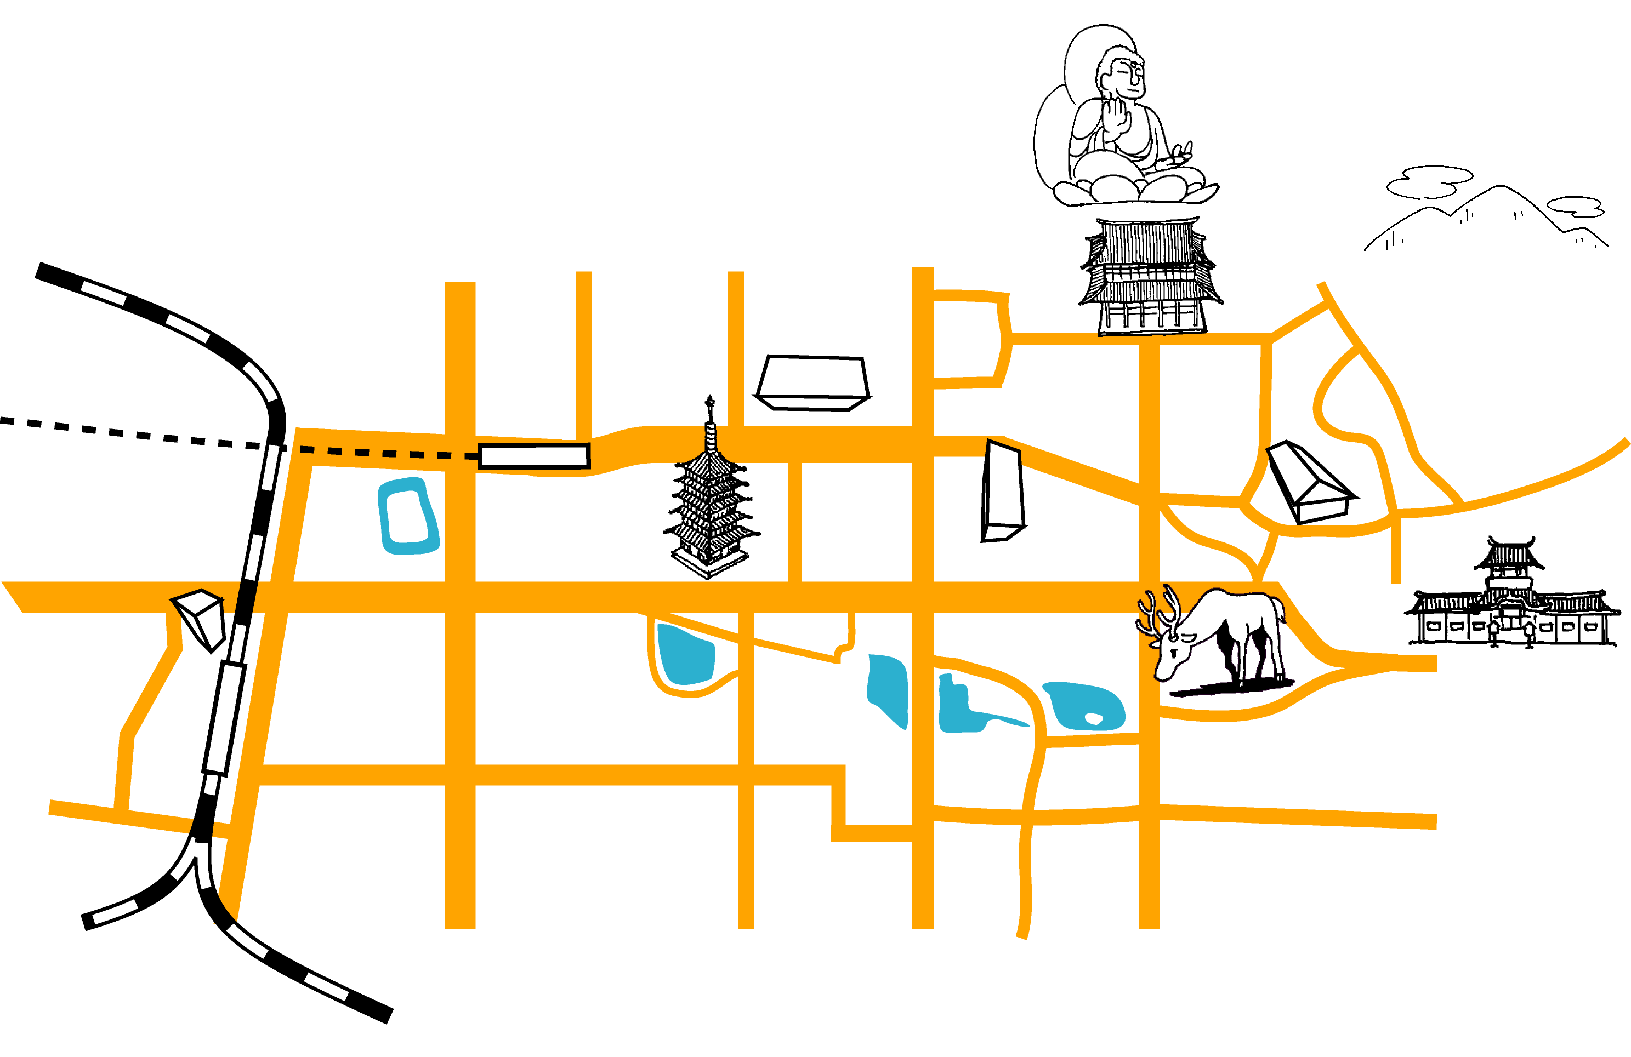
Nara Park
Kasuga Shrine
Todaiji Temple
Nara Prefecture Office
Mt. Wakakusa
Nara-Ken
New
Public Hall
Kofukuji Temple
Nara National
Museum
Kintetsu Nara Station
JR Nara Station
Mitsui
Garden
Hotel
Nara
0
1 km
N
Limousine Bus Stop “JR Nara Station”

: Limousine bus stop

