Getting to know you

Tenses • Questions • Using a bilingual dictionary • Social expressions 1


STARTER
*
1 Match the questions and answers.
2 Ask and answer the questions with a partner.

Where were you born? | A year ago.
What do you do? | Three times a week.
Are you married? | In Mexico.
Why are you learning English? | Because 1 need it for | my job.
When did you start learning English? | I'm a teacher.
How often do you have English classes? | No, I'm single.
TWO STUDENTS
Tenses and questions
llll Look at the pictures. Who ,wc the two people? Read and listen to Marija. Complete the text, using the verbs in the box.
'm enjoying 'm going to work live lasts Yn studying come speak spoke went
Hello! My name's Marija Kuzma and
from Zagreb, the capital city of Croatia. I'm 20, and
(2) medicine at the University of Zagreb.
The course (3) six years, and it's all in
English! It's hard work, but I (4) it a lot.
come
1(5)
at home with my mother, father, and
grandmother. I can speak three foreign languages -
English, French, and Italian. I (6)
Italian because my grandmother's from Italy,
and she always (7) to me in
Italian when I was very young. I speak
English because I (8) to an
English-speaking high school.
After I graduate, I (9)
for
Medecins sans Frontieres in West Africa, because I want to travel and help people.
6 Unitl • Getting to know you

2 Look at the photo of Jim. Complete the questions about him.
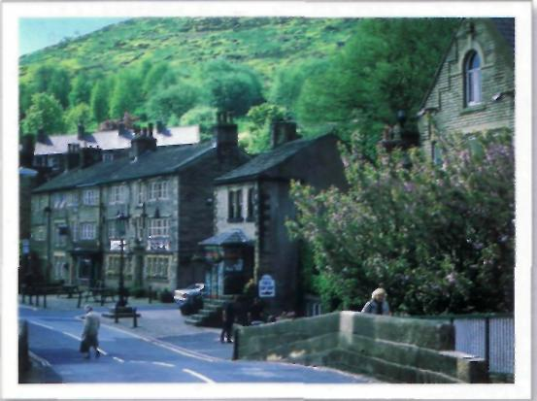
1 Where does he come from?
- live?
- live with?
- do before he retired?

- When leave school?
- What studying?
- How many children have?
do next year?
8 What
Listen to Jim, and answer the questions. Ask and answer them with a partner.
3 Complete the questions to Jim.
1 'Do you have a job?'
'No, I don't. I'm retired. I'm a student now/
2 'Which university to?'
'I don't go to university. I study at home.'
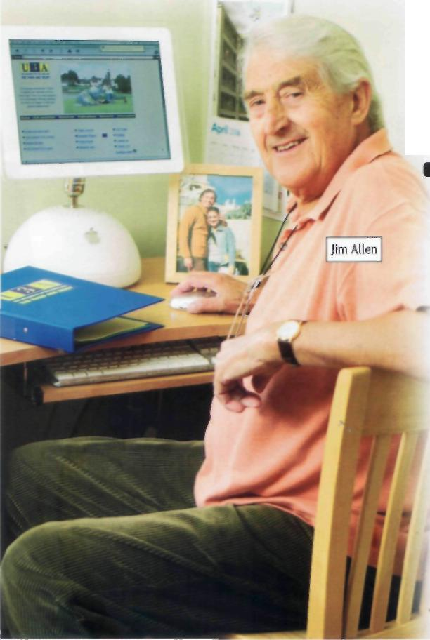
3 ' the course?'
'Yes, I am. It's wonderful.'
4 'What at the moment?'
'I'm writing an essay about Don Quixote!
5 'Why leave school at 15?'
'Because my family was poor. We needed the money.'
6 ' to visit next year?'
'My son and his wife. They live in Spain now.'
Listen and check.

GRAMMAR SPOT
Find examples of present, past, and future tenses in the tapescripts about Marija and Jim on pll6.
What are the tenses in these two sentences? What is the difference between them?
She lives with her parents.
She's living with an English family for a month,
Match the question words and answers.

What... ? -v | Because 1 wanted to.
Who... ? \ | Last night.
Where ... ? \ | S5.
When ... ? ^{Ч} | - A sandwich.
Why... ? | By bus.
How many ... ? | In New York.
How much ... ? | Jack.
How ... ? | The black one.
Whose ... ? | It's mine.
Which ... ? | Four.
Grammar Reference 1.1,1.2 and 1.3 pl27
Unit 1 * Getting to know you 7
PRACTICE
Talking about you

1 Ask and answer the questions in small groups. [^ Where do you live? J
- Where... live? • What... like doing at the weekend? js
How жаиу languages ... speak?
- Who... live with? • What... do last weekend?


Make more questions. Use some of the question words in the Grammar Spot on p7. Ask your teacher some of the questions.
How ... you come to school this morning?
Each of the questions has one word missing. Write it in.
to
- Do you like listening^music? 5 Where you go on your last holiday?
- What sort of music you like? 6 What did you yesterday evening?
- Do you often jeans? 7 What you doing this evening?
- What your teacher wearing today? 8 What are you going do after this course?
Listen and check. Ask and answer the questions with a partner. i Write a paragraph about you. Use the text about Marija on p6 to help you.
Check it
4 Choose the correct verb form.
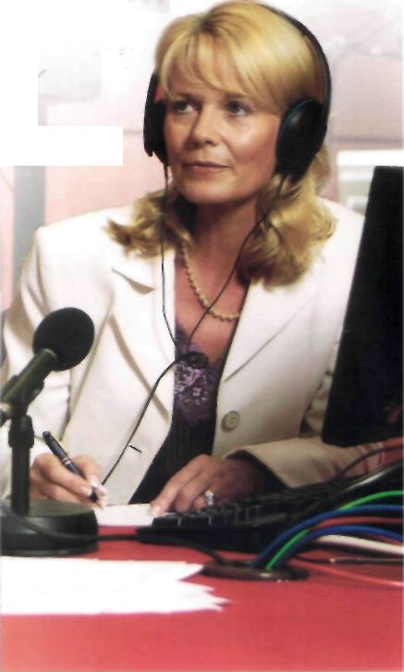
- Marija comes / is coming from Zagreb.
Dr Mary Steiner
- Jim speaks I is speaking Spanish and English.
- Today he wears I is wearing jeans and a shirt.
- Are you liking / Do you like black coffee?
- Last year I went /go on holiday to Florida.
- Next year my sister studies I is going to study at university.
Exchanging information
- Look at the picture of Dr Mary Steiner. She's a radio agony aunt. What do radio agony aunts do? Who phones them? Why?
Student В
Look at the information on pi46.
Dr Mary Steiner lives in Santa Barbara, California. She's married and has... (How many children?).
- Work with a partner. You have different information about Dr Mary Steiner. Take it in turns to ask and answer questions.
Student A
Look at the information on pl43.
Dr Mary Steiner lives in ... (Where?). She's married and has twin sons.
Where does Mary Sterner live? ]
~V
In Santa Barbara, California.
^
How маму children does she have?
She has twin sons. J⁴^"

8 Unitl • Getting to know you




•
Michael
Getting to know you 9
LISTENING AND SPEAKING
Best friends
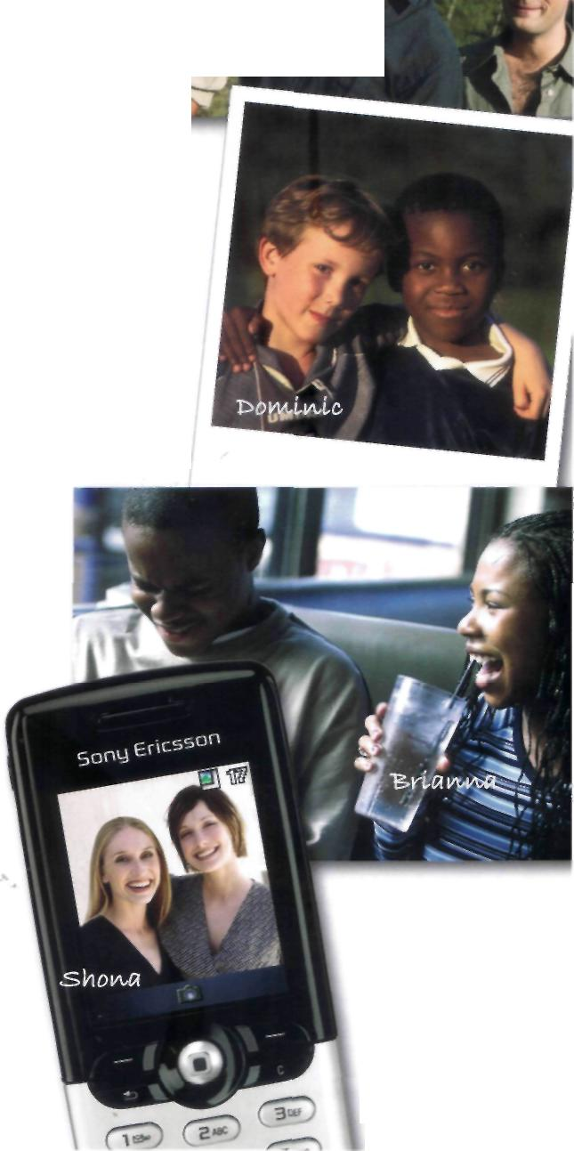
1 Discuss the questions in pairs.
- How many good friends do you have?
- Do you have a best friend?
- Why is he/she your best friend?
2 Look at the photos. You are going to hear Michael, Dominic,
Brianna, and Shona talk about their best friends.
Listen and complete the chart.
T1.5

Best friend | Whose friend? When did they meet? Why are they friends?
Kirsty
■SflkKkVty
Dave flkvd
3 Work with a partner. Answer the questions.
- Which friends talk to each other about their problems?
- Which friends share the same hobby? What is it?
- Which friends only see each other once a year?
- Which friends go to school?
- Whose friend likes Indian cooking?
- Whose friend has a dog called King?
- Whose friend is tall?
- Whose friend is like a brother?
DQ Listen again. Check your answers. Language work
to
4 Match the verbs with the words or phrase.
Caleb
become | the Internet
play | emails
send | friends
give | on the phone
talk | football
have | together
grow up | parties
go on | advice
►► WRITING Describing friends pW2
READING AND SPEAKING
A blind date
f

1 What's your star sign? Find out all the star signs in the class. Which is the most common? Do you think it's interesting or necessary to know the star sign of your boyfriend/girlfriend?
Who is looking for the perfect partner this week?

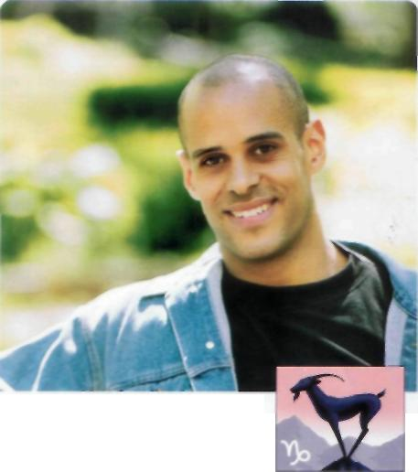





Aries (March 21-April 20) Taurus (April 21-May 21) Gemini (May 22-June 21)
Cancer {June 22-July 22) Leo (July 2J-Aug 22) VirgO (Aug 23-Sept 23)
Libra (Sept 24-Oct 23) Scorpio (Oct 24-Nov 22) Sagittarius (Nov 23-Dec 22)
Capricorn (Dec 23-Jan 20) Aquarius (Jan 20-Feb 19) Pisces (Feb 20-March 20)
- Look at the photos and headings in the newspaper article. What is a blind date? What does the Evening Star do? Who are the people? What are their star signs?
- Work with a partner. Read about Matt and answer the questions.

- What is his job? Does he enjoy it? How do you know?
- What did he do after university?
- Why does he like being back in London?
- Where does he go in summer? Why?
- What does he like doing there?
- What does he do in London at weekends?
- Who is his perfect partner? What is most important?
4 Read the information about the three girls carefully.
Who do you think Matt will choose? Why? Discuss your
ideas with your partner and then the class.
MATT 29, a climate change scientist from Balham, South London Star sign: CAPRICORN

I travel a lot in my job. I go to meetings and conferences all over the world. It's great for me, because I studied oceanography and environmental science at university. After university I spent a lot of time at sea on scientific research ships. Now I'm back in London, it's much better for my social life. I have a lot of friends.

But I miss the sea, so, in summer, when I want to relax, I like going to the coast, and sometimes I spend the weekend camping with friends, having barbecues and diving or surfing. It's great to get away from the city and goto a different world.

I also enjoy weekends in London. I like meeting friends, having a few beers, going to a football match. I'm an Arsenal fan. I sometimes go clubbing but not very often, and I love Indian food. I go to an Indian restaurant at least once a week.

Who is his perfect partner? My perfect partner is outgoing, funny, and good to talk to. She dresses nicely, but isn't too worried about fashion. Someone who enjoys having a good time in the city but also likes travelling, sports, and country life. This is very important to me.

10 Unitl * Getting to know you

Every week the EVENING STAR helps a single person choose the perfect partner and have a date in an expensive restaurant. The couple then tell the STAR what happened.

Ю do you think Matt will pick from these three lovely girlsj




MIRANDA, 29
Star sign: SCORPIO
Lives: Camden Town, North London
Job: A lawyer, loves her job. but it's hard work so she needs to relax.
Interests: Dancing, going to clubs, pubs, and the cinema. Meeting friends to exchange news. ('I have lots of friends.') Visiting art galleries sometimes.
Hates: Men who are crazy about football.
Clothes: Loves designer clothes. 1 spend too much money on clothes.'
Food: Italian. French, and a McDonald's 'but only after a night out clubbing!'
Love life: Lots of boyfriends. Last relationship ended a few weeks ago.
Perfect partner: Good-looking, good fun and good to talk to.
BETH, 25
Star sign: PISCES
Lives: Clapham, South London
Job: Bookstore manager, 'I love working with books/
Interests: Reading, the theatre, art galleries, cycling (1 cycle to work'), and walking. 'Sometimes I really need to get out of London and walk in the country.'
Hates: 'I can't think of anything.'
Clothes: Comfortable. 'I like to look nice but I don't think too much about clothes.'
Food: Vegetarian. Loves Indian food because 'there are so many delicious 'veggie' dishes'.
Love life: One long relationship, ended six months ago.
Perfect partner: Someone who's kind and good to talk to, who likes both town and country life.

HOLLY, 30
Star sign: CAPRICORN
Lives: Canary Wharf, by the River Thames
Job: Fashion designer. 'I started studying art history, but changed to fashion design.'
Interests: Travelling, skiing ('I'm learning to snowboard now'), going out with friends to restaurants, bars, and clubs.
Hates: People who smoke.
Clothes: 'Of course, I love clothes. I always try to look good, but I like to be casual and comfortable sometimes.'
Food: Loves all food. 'It's a problem. I just love going out to restaurants, all kinds.'
Love life: Two long relationships. One just finished.
Perfect partner: Good-looking and good fun. Someone who likes sports, travel, and adventure.

Listening
Listen to Matt. Who did he choose? Why? What happened on the date? Are they going to meet again?
ШШШШ Listen to the girl he chose. What impression do you get of the couple? What kind of people are they? Do you think they will stay together? Why?
Language work
A friend arranges a blind date for you. Write questions to ask your friend about your date. Use all of these question words. Compare questions with another student. Who...? What...? Why...? When...? Where...? How...?
What do you think?
- Are blind dates a good idea? Why? Why not?
- Why do people go on blind dates?
- Do you know anyone who has been on a blind date? Was it successful?
- Would you like to take part in a newspaper blind date like this one?

* •
Unitl • Getting to know you 11

VOCABULARY AND PRONUNCIATION
Using a bilingual dictionary

1 Look at the entry from an English-Spanish dictionary.
the pronunciation in phonetic symbols
the translation the word used in an example sentence.

the part of speech: n = noun v = verb
book /bok/1 n libro: I'm reading a book by Cervantes at the moment, {notebook) cuaderno; (of cheques, tickets) talonario 2 v [seat, room) reservar: / booked a table at the restaurant for pur people.
•booking office/'bokirj ,ofis/ «taquilla
•bookseller /'bokseb(r)/ n librero
•bookshelf /'bokfelf/ n>pi -shelves /-Jelvz/ estante
Information in brackets (...) helps you to find the right translation.

Other words made with book (compounds) are in separate entries.
2 What part of speech are these words? Write n (noun), v (verb), a (adjective), adv (adverb), prep (preposition), or pt (past tense).


12 Unit 1 * Getting to know you
  com'puter и | 'wonderful | on | 'quickly
poor | in | came | went
speak | 'usually | en'joy | 'factory
3 These words have more than one meaning. Write two sentences that show different meanings. Use a dictionary.
Listen and compare.
Here are some of the words from exercises 2 and 3 in phonetic symbols. Read them aloud, then write them.
►► Phonetic symbols p159
- /'wAndafl/
- /k3m'pju:t3(r)/
- /flat/
- /spi:k/
- /keim/

- /mi:n/
- /rig/
- /trem/
9 /'kwikli/
10 /'fektri/
5 What are the everyday objects in the pictures? Look
around the room you are in. Find five things you
don't know the words for in English. Look them ₍
up in a dictionary and check the pronunciation.

book  kind  mean  flat  can  play  train  ring | Cm reading a good book. | 1 booked my flight online.

/

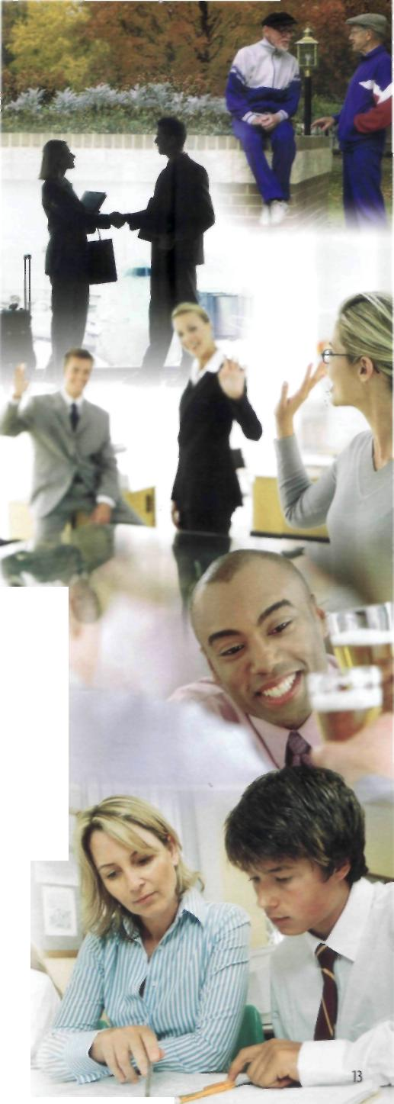
EVERYDAY ENGLISH
Social expressions 1
1 In everyday situations we use a lot of social expressions.

Anna. How are you?

'm fine, thanks. How are you?
Listen and repeat. Which words are stressed?
Music of Enelis
^
Every language has its own 'music' (stress and intonation).
1 Sentence stress
ДДД Listen and practise. Thank you very much indeed. I'm sorry. I can't come tonight. Can you help me with this exercise?
2 Intonation English goes higher and lower than many
other languages. QEEI Listen and practise.
Good morning! Excuse me! Can I help you?
Listen and check. Pay attention to the stress and intonation. Practise saying the expressions and responses with a partner.
Test your partner. Say an expression from A in exercise 3. Can your partner give the correct response from B?
J Match an expression in A with one in B. Which expressions go with the photos? Which are more formal?A | В
1 Good morning! | a Bye! See you later.
2 See you tomorrow! | b Of course 1 can. No problem.
3 How do you do? | с Never mind. Perhaps another time.
4 Thank you very much indeed. | d Thanks! Same to you.
5 Excuse me! | e Good morning! Lovely day again.
6 I'm sorry. 1 can't come tonight. | f Yeah! About nine, in the coffee bar.
7 Can you help me with this exercise? | g It doesn't matter. You're here now.
8 Can 1 help you? | h Not at all. Don't mention it.
9 Bye! | i No. thank you. I'm just looking.
10 Bye! Have a good weekend! | j How do you do? Pleased to meet you.
11 Sorry I'm late. | к Cheers!
12 Cheers! | 1 Yes. Can 1 help you?
2 Look at the photos. What do you think the people are saying?
T 1.12
With your partner, write two short conversations that include some of the social expressions. Mark the stressed words. Act your conversations to the class.

Pairwork activities Student A

UNITl p8


UNIT 3 _{P}25

PRACTICE
Exchanging information
Ask and answer questions to complete the information about Mary Steiner.
PRACTICE
Exchanging information
Ask and answer questions to complete the information about Hugo Fenton-Jones.

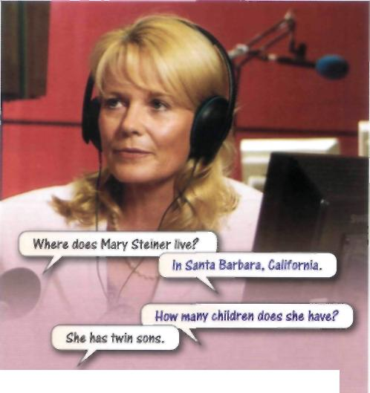
>r Mary Steiner lives in ... {Where?). She's married and has twin sons. Her husband's name is ... {What... name?) and he's a surgeon. They met... {When?). Both her sons went to Harvard University and studied ... {What?), and now they both work for Miramax film studios in California.

Mary started working as a radio agony aunt... {When?), and does five programmes a week. Every day more than 60,000 people try to phone her. They have ... problems - all sorts! {What sort?) The programme lasts an hour, and at the end Mary feels ... {How?).

At the moment she's writing a book about marriage, because ... {Why ... a book about marriage?). Her own parents divorced when she was five.

She's going to retire ... {When?). She wants to spend more time travelling.

Teenager goes on spending spree with father's credit card

Teenager Hugo Fenton-Jones stole ... {What?) while his father was working in the garden. He then went to ... {Where?) and stayed in the Ritz Hotel. His room was £... a night {How much?). While he was shopping in the Champs-Elysees, he bought ... {What?).
He phoned two English friends because he wanted them to come to Paris. They were eating breakfast... {Where?) when Hugo's father, James, phoned. His credit card company wanted to know why he was spending so much money. They thought James was staying in the Ritz.
Hugo went... {Where?), where his father was waiting for him. 'He isn't speaking to me at the moment,' said Hugo yesterday. 'He's a bit angry with me.'

Pairwork activities • Student A 143

Pairwork activities Student В

Ни
NIT1 p8
fy и
NIT 3 p25

PRACTICE
Exchanging information
Ask and answer questions to complete the information about Mary Steiner.
PRACTICE
Exchanging information
Ask and answer questions to complete the information about Hugo Fenton-Jones.

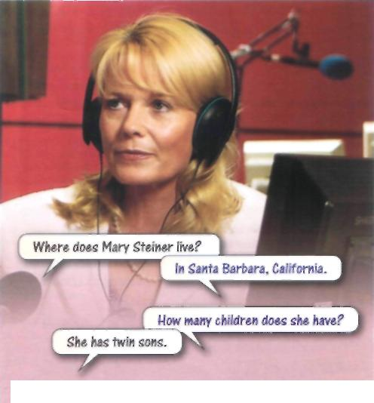
Dr Mary Steiner lives in Sanca Barbara, California. She's married and has ... (How many children?). Her husband's name is Dan and he's a ... (What ...do?). They met when they were both at college. Both her sons went to ... University (Which university?) and studied law, and now they both work for ... (Who ... for?).


Mary started working as a radio agony aunt thirty years age, and does ... programmes a week (How many?). Every day more than 60,000 people try to phone her. They have money problems, relationship problems, work problems - all sorts! The programme lasts ... (How long?), and at the end Mary feels really tired.

At the moment she's writing ... (What?) because she's worried about the number of divorces. Her own parents divorced when she was ... (How old ... parents divorced?)

She's going to retire next year. She wants to ... (What ... do?).

Teenager goes on spending spree with father's credit card
Teenager Hugo Fenton-Jones stole his father's credit card while his father was working ... (Where?). He then went to Paris and stayed in the ... Hotel (Which hotel?). His room was £500 a night. While he was shopping in the ... (Where?)_{y} he bought clothes, jewellery, and perfume.
He phoned two English friends because ... (Why?). They were eating breakfast in the Ritz when Hugo's father, James, phoned. His credit card company wanted to know ... (What?). They thought James was staying in the Ritz.
Hugo went home to London, where ... was waiting for him (Who?). 'He isn't speaking to me at the moment,' said Hugo yesterday. 'He's a bit angry with me/

Pairwork activities • Student В

Grammar Reference

UNIT!
Past tense
He went to America last year.
I started learning English two years ago.

1.1 Tenses
Ex. 1
This unit has examples of the Present Simple and Present Continuous,
the Past Simple, and two future forms: going to and the Present
Continuous for the future. All these are covered again in later units.
Present tenses Unit 2
Past tenses Unit 3
Future forms Units 5 and 9
The aim in this unit is to revise what you already know.
Present tenses
He lives with his parents.
I'm enjoying the course.
Future forms
Vm going to work as a doctor.
What are you doing tonight?
1.2 Auxiliary verbs ► Ex. 2
Present Continuous
The Present Continuous uses the auxiliary verb to he in the positive, questions, and negatives.
Positive Question
I'm studying medicine. Are you enjoying the course?
She's living at home.
Negative
We aren't learning French.
Present Simple and Past Simple
The Present Simple and the Past Simple use the auxiliary verb do in
questions and negatives. There is no auxiliary verb in the positive.
Positive Question
He lives in Spain. Where does she work?
We went out last night. Who did you see yesterday?
Negative
/ don't have a job. They didn't watch TV.
1.3 Questions ► Ex. 3-4
- Yes/No questions have no question word. Are yon hot? Does he smoke?
- Questions can also begin with a question word.
what where which how who when why whose
5 How can be followed by an adjective or an adverb. How big is his new car? How fast does it go?
How can also be followed by much or many.
How much is this sandwich?
How many brothers and sisters have you got?

EXERCISES
1 Write the verbs in brackets in the correct tense.
1 The Pope (live) in the Vatican.
2 Last year we (visit) Paris.
3 you (go) out yesterday?
4 My sister (speak) three languages.
5 I like the shirt you _ (wear).
6 They (not/see) the film last night.
7 you (know) my brother?
8 They (arrive) at 11.00 pm tomorrow.
9 Vicky (enjoy) meeting new people.
10 I (not/like) working late at night.
2 | Complete the sentences with a verb form from the box.
 | don't Do s doesn't 'm didn't aren't (x2)
 | 1 1 really enjoying this book.
2 you always walk to work?
3 Why you come to school yesterday?
4 He going to study Greek art next year.
5 Jo eat meat. She's a vegetarian.
6 They coming by bus, they've got a car.
7 Sorry, I understand.
8 We working tonight. We're going out.
3 | Choose the correct question word.
 | which whose who why where when what how
 | 1 is the bank? 6 do you live wil |  | :h?
2 are you smiling? 7 is yours - this one
3 time is it? or that one?
4 do I open this? 8 did you last see
 | 5 books are these? Peter?

Where's the station? Why are you laughing? Whose is this coat? How does she go to work?
3 What, which, and whose can be followed by a noun.
What time is it?
Which coat is yours? Whose book is this?
4 Which is generally used when there is a limited choice.
Which is your pen? The black one or the blue one?
This rule is not always true.
What , ,,
-yi - , newspaper do you reaiu
4 Write questions for these answers.
1 They're watching the news. 6 I like blues and rock V roll.
2 James arrived yesterday.
7 It costs 25 euros.
8 No, he didn't enjoy the film.
3 She lives in Madrid.
4 Joanna comes from Poland. 9 They're coming at 3 o'clock.
5 Yes, 1 can drive.

•
Grammar Reference 127

Word list

Here is a list of most of | ad) = adjective | pl= plural
the new words in the units of | adv = adverb | prep = preposition
New Headway Pre-Intermediate | conj= conjunction | pron = pronoun
Student's Book. | coll= colloquial | pp = past participle
 | n = noun | v = verb
 | opp = opposite | US= American English

UNITl
>
*
advice n /ad'vais/
agony aunt n /'шдэт ,a:nt/
art gallery /i /'a:t ,дж1эп/
adventure и /sd'ventfafr)/
bar n /ba:(r)/
blind date n /.blaind 'deit/
brave ad) /brerv/
can v, n /кап, кэп. ka?n/
casual ad) /'кжзоэ1/
Cheers! /tfisz/
chewing gum и ;"tju:ig ,длт/
club n /kUb/
comfortable ad) /"клтГ1эЬ1/
conference n /'kDnforons/
couple n /'клр1/
course n /ko:s/
date n /deit/
designer n /di'zam^r)/
diary л /'dareri/
discover v /di'skAV3(r)/
diving n /'daivirj/
Don't mention it.
/.daunt menjn ,it/ downtown (US) и/'daontaon/ end и/end/ environmental ad)
/m.vairan'mentl/ essay n /'esei/ everyday ad) /'evridei/ exchange v /iks'tjeindy Excuse me! /iks'kju:z ,mi:/ factory n /Tiektori/ foreign ad) /Тогэп/ funny яя;/Тлт/ go clubbing v /,дэо 'kUbin/ good fun ad) /,gud Тлп/ good looking ad) /.god 'lokig/ graduate v /'gra?djoeit/ grow up v /,дгэо 'лр/ guilty fld;7'gilti/ hairbrush n /'hesbrAj¹/ hard (*= difficult) ad) /ha:d/ Have a good weekend /,ruev э
,gud ,wi:k'end/ information n /.infa'meijn/ It doesn't matter /it .dAznt
'тж!э(г)/ kid (child) «/kid/ kind я, ad)/kaind' last v /la:st/ last яд; /la:st/ lawyer я /'b:J3(r)/ leave v /li:v/ mean v, ad) /mi:n/ medicine и /'medsn/ or /medisn/ midnight n /'nudnait mouse mat n /'maos ,maet/
Never mind /'neva .maind/ No problem /,пэо 'ртЬЬт/ object n /'obcVjikt/ outgoing ad) /.aot'gaoirj/ pencil sharpener n
/'pensl ,Ja:pno(r)/ Pleased to meet vou
/,pli:zd ta 'mi:t ju:/ poor ad) /роэ(г)/ or /рэ:г/ problem n /'prDbbm/ relationship n /n'leijnj'ip/ retired ad) /n'tared/ ring i', n /nrj/ rubber и /'глЬэ(г)/ ruler n /'ru:b(r)/ scissors л /'siS3z/ See you later. /,si: ju: 'leitafr)/ separate ad) /'seprst/ share v /Jea(r)/ single яд; /'singl/ snowboard v /'snsobo:d/ sometimes arfv /'sAmtaimz/ star sign я/'sta: ,sain/ store w/sto:(r)/ successful ad) /sak'sesfl/ sunglasses и /'sAngla:siz/ surfing м /'S3:fin/ theatre n /'Gretafr)/ tissues n /'tijuiz/ twin n /twin/
vegetarian яя; /.vedjs'tearren/ wallet « /'wdIh/ wonderful ad) /'wAndafl/
UNIT 2
abroad adv /o'broid/
accent «/'«ksant/
accident n /'sksidsnt/
act the part coll /,iekt дэ 'pa:t/
almost adv /'oilmaost/
always fl<fv /'o:lweiz/
at least advldi 'li:st/
at the moment (= now)
/э1 6э 'тэотэт/ awful яд; /'э:П/ bedtime и /'bedtaim/ boss и /bos/ bring v /bnrj/ celeb (celebrity) n
/ss'leb (sa'lebrati)/ clear up v /.klrer 'лр/ coast n /kaost/ communication л
/k3,mju:ni'keijn/ competition n /.kompa'tij'n contact lenses и pi
/'kontakt Jenziz/ conversation n /.konva'seijn/ disadvantage n /.disad'vamtid^ distance n/'distsns/ divide v /di'vaid/ divorced ad) /di'vo:st/ do overtime v /,du: 'aovataim/ dormitory n /'doimatri/ employ v /im'pbi/ essential <td;7rsenjl/ European ^//'/joara'piian/ exchange v /iks'tjeindy exhausting ad) /ig'zo:stin/ factory я /Ttektari/ farmhouse n /'fa:mhaos/ First things first! /,f3:st .Girjz
'f3:st/ fiat яд; /Пал/
glamorous ad) /'gtemoras/ Guess what! /,ges 'wot/ guest n/gest/
hairdresser л /'headresafr)/ a handfull /э 'hamdfol/ have something in common (= to
share interests or experiences)
/,ha?v ₍SAmGin in котэп/ hundred n /'hAndrad/ hurt v /h3:t/
impossible ad) /im'posabl/ interested ad) /'mtrsstid/ just adv /d3ASt/ keep (us) busy v /,ki:p (as) 'bizi/ landscape « /'la?ndskeip/ lifestyle n /'laifstail/ lonely яд)7'ЬопН/ loft n /loft/
lucky яд¹; /'Uki/
make-up n /'meik лр/
manicure n /'mienikjuatr)/
mess n /mes/
miss v /mis/
monthly дяЧ- /'тлпвН/
nail (= on your finger) n /neil/
national park n /.пж^пэ! 'ра:к/
never я^г /пе\э(г)/
occupation «/.Dkja'peijn/
often adv /'Dm. 'Dftan/
pearl n /рз:1/
politician n /.pob'tijn/
poster n /'p30st3(r)/
practise v /'praktis/

prefer v /рпТз:(г)/
private яя*; /'praivst/
province n /'provins/
racing и /'reisirj/
rent i' /rent/
robot «/'rsobDt/
rooftop fli///'ru:ftDp/
routine л /ru:'ti:n/
sale n /sell/
send v /send/
sip v /sip/
situated pp /'sitjoeitid/
skills n pi /skilz/
social life n /'ssujl ,laif/
society n /ss'sareti/
sometimes adv /'sAmtaimz/
strange яя)' /sireind^
surprise n /sa'praiz/
technology л /1ек'поЫз1/
test v /test/
text v /tekst/
That's really kind of you.
/,da;ts ,п:эН kamd av ju:/ tiring яд; /'tarenrj/ transatlantic ad) /,tnenz9t'I;entik/ trendy дд*; /'trendi/ twins n /twmz/ uniform' n /'ju:nifD:m/ useful яд; /'ju:s(V usually adv /'ju^oali/ view n /vju:/ view of n /'vju: sv/ voice n /vois/ wage и /weidj/ wear (your hair) up v
/,wea (jo: 'hear) \\p/ wonderful я*// /'wAndsfl/ worst яд; /W3:st/

Word list

Tapescripts
UNIT1

Marija Kuzma Hello! My name's Marija Kuzma and I come from Zagreb, the capital cily of Croatia. I'm 20, and I'm studying medicine at the University of Zagreb. The course lasts six years and it's all in English! It's hard work, but I'm enjoying it a lot. I live at home with my mother, father and grandmother. I can speak three foreign languages -English, French, and Italian. I speak Italian because my grandmother's from Italy, and she always spoke to me in Italian when I was very young. I speak English because I went to an English-speaking high school. After I graduate, I'm going to work for Medecins sans Fronueres in West Africa, because I want to travel and help people.
Jim Allen Hello. My name's Jim Allen and I come from the north of England, near Manchester. I live in a village just outside the city.! live alone now, because my wife died three years ago. But I'm near my daughter and her family, so that's OK. Until last year, I worked in a paper factory, but now I'm retired. I never liked my job much but now I'm really enjoying life! I'm a student again. I'm studying with the University of the Third Age. It helps retired people like me who want to study again, and it's really wonderful. You see, I left school when I was 15 and started work in the factory, because we needed the money. Now I'm studying Spanish. I love it. My son lives in Spain with his Spanish wife. Next year I'm going to visit them for six months, so I want my Spanish to be good!
IJM !-Interviewer J = Jim
1 I Do you have a job?
J No, 1 don't. I'm retired. I'm a student now.
2 I Which university do you go to?
J I don't go to university. I study at home.
- I Are you enjoying the course? J Yes, I am. It's wonderful.
- I What are you doing at the moment?
J I'm writing an essay about Don Quixote.
5 I Why did you leave school at 15?
J Because my family was poor. We needed the money.
6 I Who are you going to visit next year?
I My son and his wife. They live in Spain now.
- Do you like listening to music?
- What sort of music do you like?
- Do you often wear jeans?
- What's your teacher wearing today?
- Where did you go on your last holiday?
- What did you do yesterday evening?
- What are you doing this evening?
- What are you going to do after this course?
liH Best friends
Shona I have three or four good friends, but I think my best friend is Kirsty. We first met when we were 12. She started at my school, and the teacher asked me to look after her. We soon became friends. We looked quite funny together. She's very tall, and I'm quite small! Because we grew up together, we know everything about each other. So Kirsty knows me better than anyone else. I can always talk to her about my problems. She always listens and then gives me good advice! I hope I do the same for her. We are both married now, and - er, we live quite near each other, but in different towns. We talk on
the phone all the time, especially now, because we are both having a baby this summer!
Dominic My best friend is called Sammy -er and he often comes to play at my house after school. A long time ago -er when I was four -er we went to Busy Bee Nursery School together. Me and Sammy are both six now. I like him 'cos he's funny and he plays football. I like going to play at his house, too. He's got a big garden, and a nice dog called King.
Michael I have two very good friends from university called Dave and Azam. We stayed in the same house near the university. I don't know why wc became friends. We were all very different. Dave was very quiet and always worked hard, and Azam was, well, a bit crazy! He never remembered his house keys. He climbed in through the window at least once a week. He loved cooking Indian food and having parties. Wc had parties all the time in our house. Now, of course, life is very different. Dave is a writer and lives in France. He sends me long, funny emails every month. Azam is an international lawyer. He's working in Hong Kong at the moment. But we still meet once a year with our families. Wc usually meet at Dave's house in France and have a holiday together.
Brianna My best friend is my neighbor, Caleb. He's 16. Our moms are good friends, and I call Caleb's mom Auntie lanine. We grew up together. When we were kids, we always liked the same games. Now we're into the same music. Weekends, we usually go on the Internet, or sometimes we go downtown to the music stores to listen to our favourite artists. Caleb's cool. He's like a brother to me.
Blind Date
I = Interviewer M = Matt
I So, Matt, which lovely lady did you choose and why did you choose her?
M Well, they all looked lovely and at first I thought 'Oh I'll choose Holly, she sounds sporty and good fun'. But in the end I chose Beth. I chose her because I liked her eyes, and because she seemed a bit different from the other London girls. Best of all, I liked the fact that she couldn't think of anything that she hated.
I So tell us about the date. What happened when you met?
M Well, I arrived first at the restaurant - an Indian restaurant, of course, and when Beth walked in -er I could see she was nice-looking, but she seemed quite nervous, -er, shy, and perhaps a bit embarrassed by being on a date with a stranger... but I liked that. We ordered our meals, and she tried to tell me why she was vegetarian. I felt a bit guilty because I ordered chicken curry, but it was OK, we laughed about it, and after that she started to relax and wc began to really enjoy ourselves. I told her that she was very brave to cycle in London, because you know I can surf and swim in rough seas, but I really couldn't ride a bike in the London rush hour. But she said it's fine if you're careful. She was really interested in my job and my time at sea. We both agreed that one day we'd like to move out of London and live in the country - I'd like to be beside the sea, of course. Suddenly it was midnight and time to part. We're going to meet again next week. There's a lot more I'd like to know about Beth.
I = Interviewer В = Beth
I And now Beth. What did you think of the date, Beth?
В Oh, I liked Matt a lot, the moment I saw him, but I felt so nervous. I was amazed he chose me and at first I just couldn't speak, but he was really kind. He asked me about my job and said how brave I was, cycling in London - it's not really brave - anyway, soon we were laughing like old friends. I think he's very good-looking. He
has a really interesting job and he's very funny. I hope I'm interesting enough for him. Anyway, he's coming to see me at the bookshop next week and we're going to have lunch together. Who knows? I'd love to go camping with him one day.
1 I'm reading a good book.
[ booked my flight online.
- What kind of music do you like? My mother's a very kind person.
- What does this mean?
Some people are very mean. They don't like spending their money.
4 I live in a flat.
Holland is a very flat country.
5 Can you swim?
I'd like a can of coke.
- Do you want to play football? We saw a play at the theatre.
- The train's coming.
Athletes have to train very hard.
8 The phone's ringing.
What a lovely ring you're wearing!
seep!3

and
UNIT 2
Anne-Marie Boucher has a small family hotel with her husband, Pascal, near Quebec City, Canada. It's situated on the coast outside the town, and near two national parks. She says,'Our hotel has got wonderful views of the St Lawrence River and the Isle of Orleans.'
She has visitors from all over the world. She says, 'We speak French, English, and a little Italian, which is very useful! Our guests keep us busy both summer and winter, so we've always got lots to do.' They don't have much free time. 'But I like it that way,' she says. 'And I love meeting new guests.' In winter it's very cold, -10° C. Their guests go skiing or snowmobiling in Mont Sainte-Annc Park. It's January now, and she is enjoying her favourite sport, dog-sledding. She's got twelve dogs, and she's racing them across the snow. She says 'I'm working the dogs very hard at the moment. Next year I want to race in a dogsled competition. It's really exciting.'
Lien Xiaohong is 22. She lives and works in a toy factory in Guangdong province, China. She lives in a room with 14 other women in the factory dormitory, seven hundred miles from her family. The factory where she works employs 15,000 workers, nearly all of them women in their twenties. She works from 8 a.m. to 7 p.m. She has just an hour for lunch. She says, T work five and a half days a week, but I usually do overtime in summer. It's very tiring. When I'm not working or studying, I sleep.' Her monthly wage is about S65, enough to send a little back home to her family, and to pay for computer classes and English classes in town. She says,* I haven't got any money left to buy things for me.' It's the evening now, and she is having a computer lesson in a private school. 'There are two skills that are essential these days,' she says. 'English and computers. One day I want to be my own boss.'
1 'Do you like your job, Lien?'
'No, 1 don't like it much. My hands hurt all the time.
- 'What are you doing at the moment?' 'I'm having a computer lesson.'
- 'Have you got any brothers or sisters?'
'I've got a brother. He lives with my parents in Hunan province."

Tapescripts
Tapescripts 1.1-2.2

Writing

UNIT 1 DESCRIBING FRIENDS - Correcting common mistakes


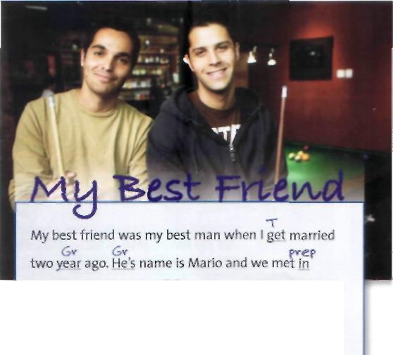
1 Look at the symbols often used to correct mistakes in writing. Correct the mistakes in the sentences. Compare your answers with a partner.
4 Correct this piece of student writing.

Sp Spelling | €p  1 I m enioing the party.
WW Wrong word | WW 2 My brother has a good work.
Wo Word order | wo  3 I have two brothers younger.
Gv Grammar | 4 She's got some new reds shoes.
T Tense | 5 He arrive vesterdav.
P Punctuation | p  6 Thev arent coming.
A Word missing | 7 She's doctor.  ^ p.  8 They went in Italy on holiday.
Pvep Preposition | 7 She's doctor.  ^ p.  8 They went in Italy on holiday.
2 Work in two groups. In each of the sentences below there is one mistake.
Group A Find the mistakes in A. Use the symbols to mark them, but don't correct them.
Group В Find the mistakes in B. Use the symbols to mark them, but don't correct them.
university in Bologna. In fact, we met on our very first
Sp pvep
day their. Mario was.first person I spoke with and we
discovered we were both studying Spanish and that
we were both football fans. When we left university,
Wo 6v
we went together travelling for six month. We had
P P
a fantastic time touring north and south america.

- I like Rome because is a beautiful city.
- She studied for three years psychology.
- There aren't any milk.
- He's speaking French, German and Spanish.
- I watched TV than I went to bed.
- pid you by any bread at the supermarket?
В
- I lost my all money.
- What did you last night? *
- He always wear jeans.
- My town is quite at the weekend.
- I want that I pass the exam.
- They arrived at London.
5 Find a partner from the other group. Correct each other's sentences.
Кы\»
The travel through Chile was amazing. When we were pvep in Mexico, we met two sisters of London,Tamsin and pvep Tanya. Now I'm married with Tanya, and next year
Mario and Tamsin going to get married. I like Mario because he very funny and we has really good times
A
Gv
together. He Nye in a different town now, but we text
WO or call often each other. I'm very lucky that he's my
friend.
- Write about your own best friend.
- Swap with a partner and see if you can find any mistakes. Read some examples of your work aloud to the class.

Writing Unitl

Tenses • Questions • Words with more than one meaning Pronunciation - Phonetic symbols
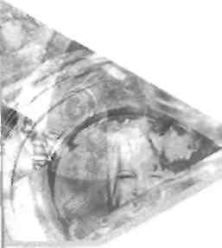

Getting to know you

Tenses
1 Recognizing tenses
Complete the texts using the verbs in the box.

Vanessa Ying Lo from Hong Kong

:■•: ззййбЯВ^ННЛВКНЗВЯЯ
'm living like play made comes 'm going to look arrived s studying

. from Hong Kong. She (2)
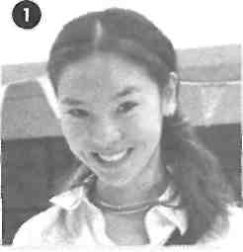
mathematics at the University of
Vanessa (1)
Newcastle, in the north of England.
'I (3) the people very much. They are warm and friendly. When I first (4)
I was very worried, but I soon (5) friends. I (6) on a campus. It takes me
five minutes to walk to the city centre, where I can shop, or go to cafes and clubs. I often
(7) sport here - squash and table tennis. I (8) for a job in a bank
when I finish. Maybe here in Newcastle. Who knows?'
.....

Steven Sonnenberg from in

has studied speaks emigrated was born 'm going was 'm doing

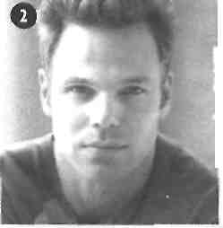

in Germany, but he (2)
I with his parents when he (3)
''■■ He (5) three languages - German, English, and Russian.
' 'I (6) law at Harvard from 2000-2004. Now I (7)
international studies at the Sorbonne in Paris. After the course, I (8)
Russia. I can't wait to see the Hermitage Museum in St Petersburg.'
six years old. He (4)

Steven Sonnenberg (1)
■
to Boston, USA
two sisters.
. a course in _ on holiday to
■ ■

Nick and Carol Taylor from England

come teaches got helps 're going to train 're staying are doing love

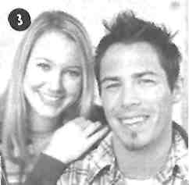
4 Unitl • Getting to know you
voluntary work in Kenya for a year. They (2)
Nick and Carol (1)
married last year, but decided to live abroad before starting their careers. They (3) at
Camp Kenya with fifty other volunteers, who (4) from all over the world. Carol
(5) English, and Nick (6) local people to build schools and
playgrounds.
'The kids (7) football,' says Nick, 'and now they've got a real pitch to play on.'
When Nick and Carol go back to England, they (8) to be teachers.
...
J

2 Choosing the correct form
Choose the correct form of the verb.
- I'm speaking I1 speak I I'm speak three languages: French, Spanish, and English.
- A Where does Hans come I
Hans come I is Hans coming from? В He's Swiss. He comes from Zurich.
3 A What you do I do you do I
are you doing tonight? В I'm going out.
4 A Where's George?
В He has I's having I have a shower.
5 A What means this word I does
mean this word/ does this word mean?. В I don't know. Look it up.
6 A Do you want a cigarette?
В No, thanks. I don't smoke I
no smoke/smoke not.
- Last year I went I go I was go to America on holiday.
- How long you stay I did you stay I stayed you in America?
- The weekend was boring. I no do I didn't I didn't do anything.
- A I'm going to university next year. В What are you going to /you going
to I do you study?
3 Correcting mistakes
Correct the mistakes in these sentences.
- At the weekend I'm usually go swimming.
- Are you enjoy the party?
- We can't play tennis because it rains.
- How many sisters you have?
- I no understand what you're saying.
- What you do tonight?
- What time you get home last night?
- Last weekend I see some friends and we have a meal.
- I'm go see my friends tonight. We go to the cinema.
- I'm loving English food. It's wonderful!
Question forms
4 Making questions with auxiliaries
Write Yes/No questions for these sentences.
Is she French?
- She's French.
- It's raining.
- They're at school.
- They're learning English.
- You're tired.
- She was at home last night.
- I'm right.
- He was born in 1960.
- We're going to see Jim.
5 Making questions with do / does / did
Write Yes/No questions for these sentences.
Do you like music?
- You like music.
- She comes from France.
- They live in a flat.
- You take sugar in tea.
- I speak English well.
- She watched a film last night.
- It started at 8.00.
- You want to go home.
- He works hard.
6 Question words
Match the questions in A with the answers in B.

A | В
1 What do you do? | a Fifty dollars.
2 Who did you go out with last night? | b Twenty-five.
3 Where do you live?  4 When's your birthday? | с Fine. And you? d Maria and Pedro. e I'm a teacher.
5 Why are you wearing a suit? | f The Times.
6 How many students are there in the class? | g It's today!
7 How much did you pay for your shoes?  8 How are you?  9 Whose is this money? | h I'm sure it's mine. i In a flat in the centre  of town. j Because I've got an
10 Which newspaper do you read? | interview.

Unitl • Getting to know you 5

Kate Hi, Dad.
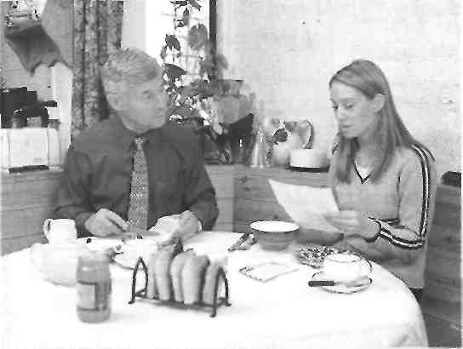
7 Which question word?
Complete the conversation with question words.
Dad Morning, Kate. (i;
are you today?
Kate Fine, thanks. A bit tired.
Dad I didn't hear you come home last night.
(2) time did you get in?
Kate About 11.00.
Dad (3) did you go?
Kate Just round to Beth's house.
Dad Oh! There's a letter for you on the table.
Kate Oh! (4) s it from?
Dad I don't know. Open it and see.
Kate Oh!
Dad (5) 's the matter?
Kate Nothing. It's from Luis in Spain.
Dad That's interesting.
Kate He says he's coming to England soon.
Dad (6) ?
Kate Because he's going to study English.
Dad (7) 's he going to stay?
Kate Here in London.
Dad (8) school is he going to?
Kate He doesn't know yet.
Dad (9) is he coming?
Kate Next week.
Dad You must invite him round. (10) don't
you write back and invite him to Sunday lunch?
Kate OK, I will. Thanks, Dad.
8 Word order
IIM Put the words in the correct order to make questions. Then answer the questions about you.
- you / last / get / for / what / birthday / did / your / ?
- is / who / teacher / your / English / ?
- parents / moment / where / your / the / at / are / ?
- cinema / you / go / last / when / did / the / to / ?
- learning / you / why / English / are / ?
- you / how / to / come / school / do / ?
- brothers and sisters / you / many / have / how / do / ?
9 What + noun, How + adjective or adverb
QQ Match a question word in A with a word in В and a line in C. Then answer the questions about you.

A | В | С
 | time | shoes do you take?
 | colour | did you get up this morning?
 | far | do you read?
How | tall | is it from your house to the town centre?
 | sort | are you?
What | much | is your hair?
 | often | do you go swimming?
 | size | does a hamburger usually cost?
 | long | of music do you like?
 | newspaper | does your English lesson last?
1
2 3 4 5 6 7 8 9 10

6 Unitl • Getting to know you

Reading
10 If you can't master English, try Globish
1 Read the text and answer the questions.
- What sort of English is Globish?
- Who speaks it?
- Write the full conversation between the Korean and the Colombian.
- How does Jean-Paul Nerriere describe Globish?
- What language did the hundred colleagues speak in?
- Why didn't they understand Jim and Bill?
2 Find words in the text which mean ....
- the act of travelling from one place to another
- a person who makes or thinks of something new
- the most important part of something
- the people who you work with
- people who learnt English as their first language

3 | Complete the questions.
 | 1 Who |  | work for?
 | IBM.
 | ?. | got | )d English?
 | Yes, excellent English.
 | 3 Hnw |  | '/
 | 1,500.
 | 4 When |  | ?
 | While he was at a meeting in | Paris.
 | S What |  | ?
A version of Globish to help the English understand.

By Daniel Klune • Incernarional Herald Tribune

If you can't master English, try Globish
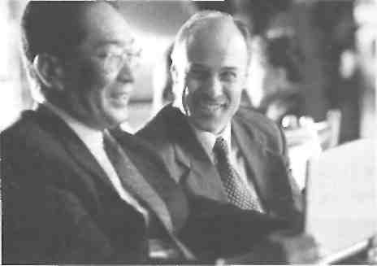
It happens all the time. You are at an airport, and the man on your left, who is maybe Korean, starts talking to the man opposite, who is maybe Colombian, and soon they are talking in what seems to be English:

'Where you fly?'
'Paris. You?'
'I go New York business.'
'When arrive?'
'Four Tomorrow in afternoon.'
'Children?'
'One boy, two girl. You ?'
'No. Only girlfriend.'
'OK. Have good journey.'
'Thanks. And you.'
They don't know ir., but the Korean and the Columbian are speaking Globish. Its inventor, a Frenchman called Jean-Paul Nerriere, doesn't see it as a real language.
'It isn't a language, it's a tool, a means of global communication. It's a sort of 'English lite' -simple language that people all over the world can understand.
'The language spoken all over the world, by 88 per cent of the people, is not exactly English, but it works; it does the job.'
Nerriere, who retired from the computer giant, IBM, speaks excellent English. The main feature of Globish is that it has only 1,500 words. Grammar isn't important. He had the idea while he was at a meeting in Paris. Before the
meeting, one hundred colleagues from over forty different countries were talking in a sort of English. Everyone was happy, and everyone understood. Then the two American speakers arrived to talk to the group- They began by saying 'Hi, I'm Jim,' 'Hi, I'm Bill,' but after that no one understood a word they said. And the Americans had difficulty understanding other people in the group.
This is the problem. Do native speakers of English understand Globish? No worries. Nerriere is writing a version of Globish to help the English understand.

Unitl • Getting to know you 7

Pronunciation
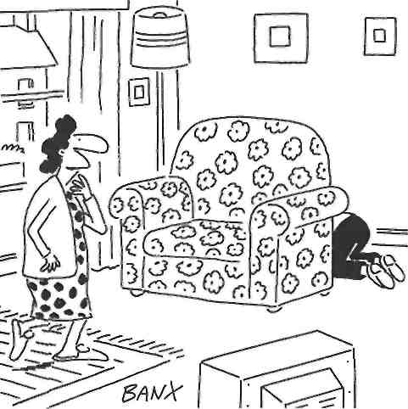
the answer?
your address down,
11 Phonetic symbols
1 11И Phonetic symbols help with pronunciation. Write the words in В next to the correct phonetic symbols in A.

A | В
1 /m?'>hml/ | scissors  mouse  chewing gum  diary  mobile  watch  hairbrush  wallet
? /Hapri/
3 /siraz/
4 /ЬезЬгл|/
Ц /wnfJV
6 /lju:in длт/
7 /wnht/
8 /maos/
Words with the same pronunciation
■■Н.-И Some words have the same pronunciation, but a different spelling and a different meaning.
/si:/ see sea
/bat/ buy Bye!
/tu:/ two too
/saii/ son sun
3 ДДД Write the correct spelling.
1 I have /tu:/ /SAnz/
- Do you /пэи/
- Could you /rait/
please?
- What did you /bai/ at the shops?
- 1 can't /si:/ you. Where are you?

2 Write the other word (with a different spelling and meaning) for the words in phonetic symbols.

 | A | В
1 /пэи/  2 /аиэ/  3 /rait/  4 /nju:/  5 /hi₃/ | no
1 /пэи/  2 /аиэ/  3 /rait/  4 /nju:/  5 /hi₃/ | no | our
1 /пэи/  2 /аиэ/  3 /rait/  4 /nju:/  5 /hi₃/ | right | our
1 /пэи/  2 /аиэ/  3 /rait/  4 /nju:/  5 /hi₃/ | right | knew
1 /пэи/  2 /аиэ/  3 /rait/  4 /nju:/  5 /hi₃/ | here | knew
Words with silent letters
ЩйГгЖ Many words have letters which we write, but we don't pronounce.
/hsn/ listen
/to:k/ talk
/rait/ write / right
ЛЪгэп/ foreign
/aitand/ island
4 Write the spelling of the words in phonetic symbols. Careful! They all have silent letters.
/a:nss/

Unitl • Getting to know you
/mserid/ /cb:ta/ _
/naif/ _
/nciba/
/wenzdei/
/citi/
8 /nait/

Vocabulary

with me because I failed my
12 Words with more than one meaning
1 Look at the dictionary entries. In each sentence below, which of the definitions is kind an example of?
1 I kind of like her.
- It was very kind of you to help me. _
- What kind of music do you listen to?
..-,... ... ■ . .
- kind /kamd/ adj (kinder, kindest) caring about others; friendly and generous: a kind and helpful person • Be kind to animals. • Thank you for your kind invitation.
- kind /kamd/ n [C] a group of people or things that are the same in some way; a type or sort: This shop sells all kinds of things. • What kind of house do you live in?
- kind of {informal) a little: He's kind of strange, but I like
him.
,
2 Complete the sentences with a word from the box. Use each word twice with a different meaning.
course fair match fine party train cross suit miss leaves
, thanks.'
1 'How are you?' 'I'm
I got a parking
_ today. £30.
on Saturday. Can you come?
in Britain.
2 I'm having a
Labour is a political
3 Your tie is nice, but it doesn't
your shirt.
Did you see the football
on TV last night?
4 My sister has hair and blue eyes.
You gave her £20, and me nothing! That's not
5 Athletes have to very hard.
I'm catching the at 10.00 in the morning.
the train.
6 I'm going now. I don't want to
my family. in the summer.
I'm happy in London, but I
7 I'm going to do an English
'Do you love me?"Of I do.'
8 The on the trees are beautiful in autumn.
My train at 9.00, so I don't want to be late.
9 Put a tick if it's right, and a if it's wrong.
My father is very. exams.
Check it
13 Correcting mistakes
Correct the mistakes in these sentences.
- I'm coming from Portugal.
- Where do she come from?
- I have 27 years.
- When you go bed last night?
- What do you do last night?
- Carlos spend too much money on designer clothes.
- I studied for two years at school English.
- 'Who's bag is this?' 'It's mine.'
- 'Where you go on holiday this year?' 'I'll go to Miami in August.'
10 He have long blond hairs and blue eyes.
14 Listening
Phoning a dating agency
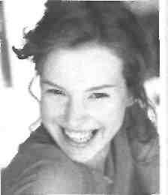
Cathy has recently moved to London to start a new job. She wants to join a dating agency to find a boyfriend. Listen to the telephone conversation with someone from the dating agency. Are these sentences true (/) or false (X)? Correct the false ones.
- Cathy comes from Scotland.
- She moved to London two weeks ago.
- She doesn't have a Scottish accent.
- She teaches science in a school near London.
- She has blue eyes and red hair.
- She likes keeping fit.
- She doesn't like living in London.
- Her perfect man has blond hair.
2 ДДД Put the words in the right order to make questions. Answer the questions.
- calling / the / why / Cathy / is / agency / ?
- she / her / did / when / job / start / ?
- the / she / does / weekend / what / doing / at / like/?
- tall/how/she/is/?
- does / where / teach / she / ?
- partner / how / perfect / old / is / her / ?
Unitl • Getting to know you 9

