 | British Blood Transfusion Society 2016 | 
 | HIC, Yorkshire
 | 21st – 23rd September 2016 | GRAPHIC ORDER FORM

EXHIBITOR NAME AND INVOICE ADDRESS | CONTACT NAME | PLEASE RETURN  By: 17th August 2016
EXHIBITOR NAME AND INVOICE ADDRESS | CONTACT TELEPHONE | Joe Manby Limited  Hookstone Park  Harrogate  HG2 7DB, UK  Email: ops@joemanby.co.uk
EXHIBITOR NAME AND INVOICE ADDRESS | CONTACT EMAIL
STAND NUMBER | ACCOUNTS EMAIL FOR INVOICE
VAT REG. NUMBER (Non-UK EU Customers) | SIGNATURE  I agree to Joe Manby Limited’s terms and conditions of sale | Tel: +44 (0) 1423 814730  Fax: +44 (0) 1423 814760
EARLY BOOKING PRICES ARE AVAILABLE ONLY ON ORDERS RECEIVED AND PAID FOR BY 17th AUGUST 2016
STANDARD PRICES WILL APPLY TO ORDERS RECEIVED OR REMAINING UNPAID AFTER THIS DATE, INCREASING YOUR COSTS BY 20%.

DESCRIPTION |  |  |  |  |  |  |  |  |  |  |  |  |  |  |  |  |  |  |  |  |  | EARLY BOOKING PRICE | STANDARD PRICE |  | QTY | TOTAL
GRAPHIC CLAD |  | 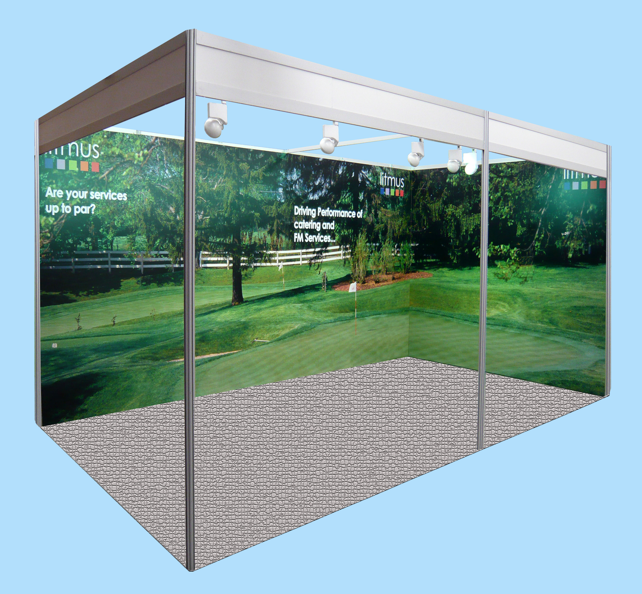 |  |  |  |  |  |  |  |  |  |  | A full graphic clad, offering you an uninterrupted graphic display for your shell scheme walls.  The graphic clad panels are fixed in front of the shell scheme posts using a purpose-made extrusion. The panels are 2440mm high. |  |  |  |  |  |  |  |  | £198.25 per metre run | £237.90 per metre run
PANEL GRAPHICS |  | 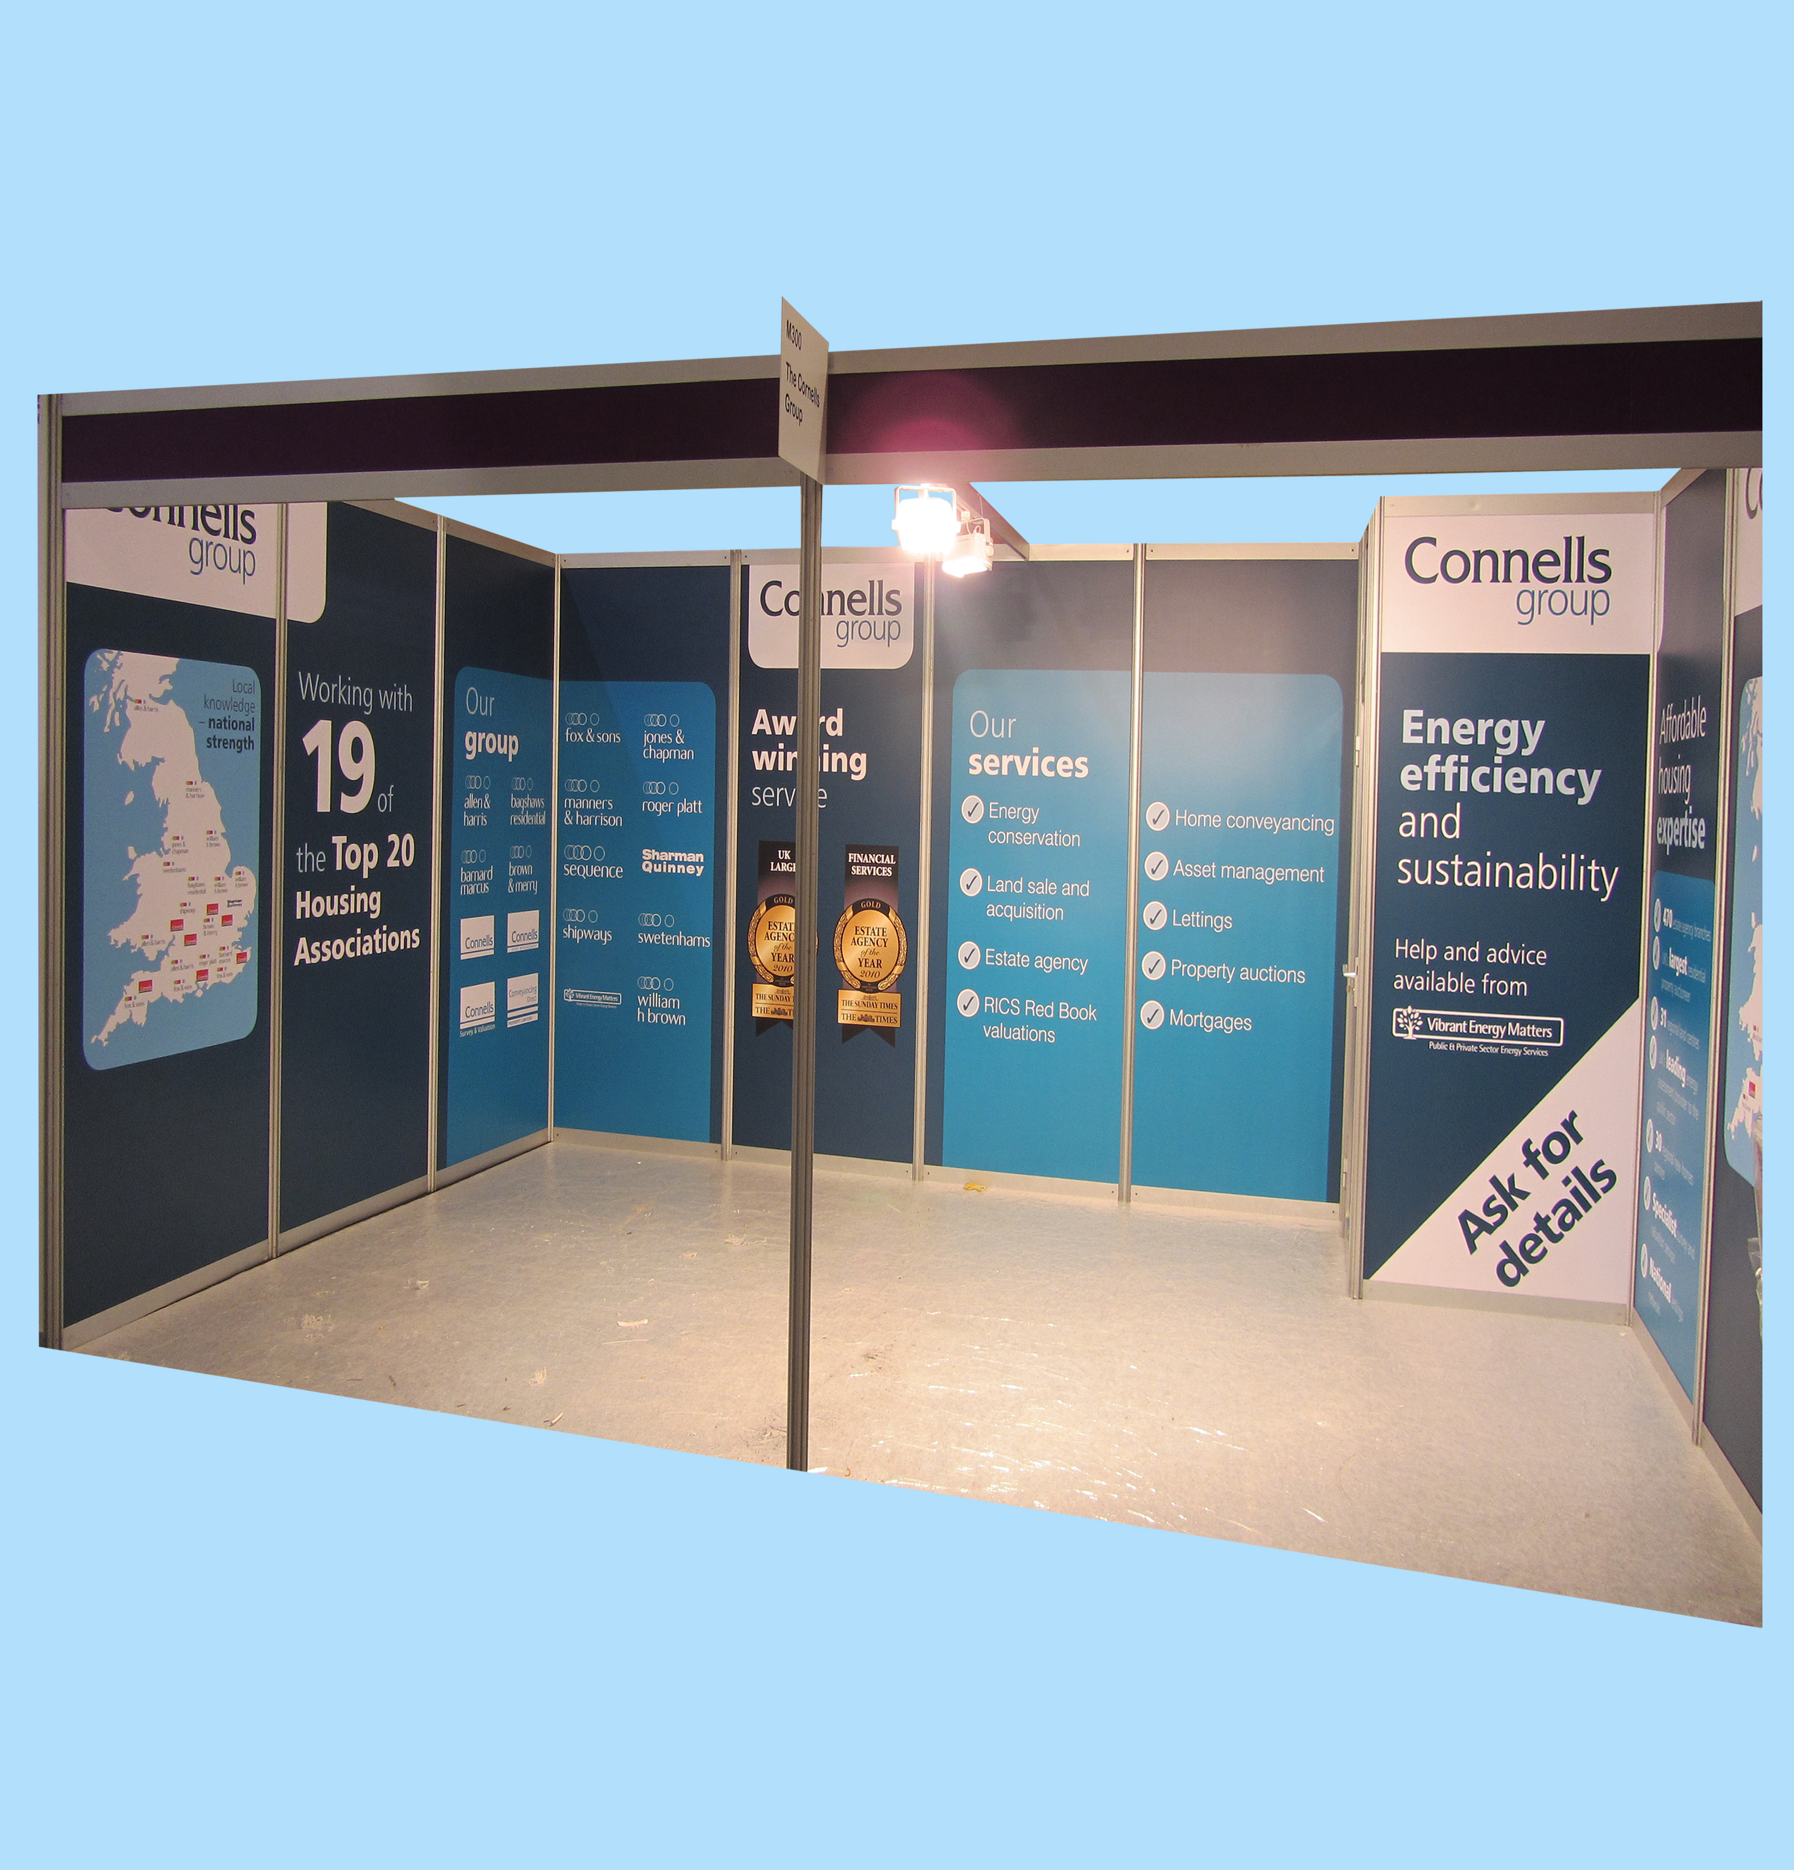 |  |  |  |  |  |  |  |  |  |  | Individual graphic panels, offering you a full height graphic display, whilst allowing additional fixtures to be fastened to the shell scheme uprights.  The graphic panels are fitted within the click shell scheme system. The visual area on a full panel is 2370mm high x 945mm wide. |  |  |  |  |  |  |  |  | £160.00 per metre run | £192.00 per metre run
FOR FULL ARTWORK REQUIREMENTS OR DETAILED ADVICE, PLEASE CONTACT OUR MANAGER AS ABOVE |  |  |  |  |  |  |  |  |  |  |  |  |  |  |  |  |  |  |  |  |  |  |  |  | - | -
PLEASE NOTE THAT ORDERS RECEIVED WITHIN TWO WEEKS OF AN EVENT ARE SUBJECT TO CONFIRMATION  ALL ITEMS ARE ON HIRE UNLESS STATED OTHERWISE |  |  |  |  |  |  |  |  |  |  |  |  |  |  |  |  |  |  |  |  |  |  |  | Credit Card  Surcharge @ 2.5%
 |  |  |  |  |  |  |  |  |  |  |  |  |  |  |  |  |  |  |  |  |  |  |  | SUB TOTAL £
 |  |  |  |  |  |  |  |  |  |  |  |  |  |  |  |  |  |  |  |  |  |  |  | VAT @ 20% £
 |  |  |  |  |  |  |  |  |  |  |  |  |  |  |  |  |  |  |  |  |  |  |  | TOTAL £

FULL PAYMENT INCLUDING VAT AT 20% IS DUE WITH ORDER. A 2.5% SURCHARGE APPLIES TO ALL CREDIT CARD PAYMENTS
CHEQUE ENCLOSED (PAYABLE TO Joe Manby Limited) |  |  |  |  |  |  |  |  |  |  |  |  |  |  |  |  |  |  |  |  | BANK TRANSFER/BACS PAYMENT
PLEASE CHARGE THE FOLLOWING CREDIT/DEBIT CARD |  |  |  |  |  |  |  |  |  |  |  |  |  |  |  |  |  |  |  |  | BANK DETAILS
CREDIT CARD (2.5% surcharge applies) |  |  |  |  |  |  |  |  |  | DEBIT CARD |  |  |  |  |  |  |  |  |  |  | Bank Name: NATWEST, HARROGATE  Account No: 36611913  Bank Sort Code: 53-50-21  IBAN Number: GB28NWBK53502136611913  Swift Number: NWBKGB2L  Account Name: JOE MANBY LIMITED  Value date: ..............................................
CARD NO:
SECURITY CODE: |  |  |  |  |  |  |  |  |  | ISSUE NUMBER:
VALID FROM: |  |  |  |  |  |  |  |  |  | EXPIRY DATE:
NAME ON CARD:
SIGNATURE OF CARDHOLDER:
VAT reg. no. GB 171 5637 59 PLEASE KEEP A COPY OF THIS FORM FOR YOUR RECORDS

