Golden
Times 3-4/00

The official Newsletter of the
World Goldpanning Association ISSN-1238-0083

Publisher: Kauko Launonen
Editors: Paul Thurkettle, Inkeri Syrjanen, Pirjo Muotkajarvi

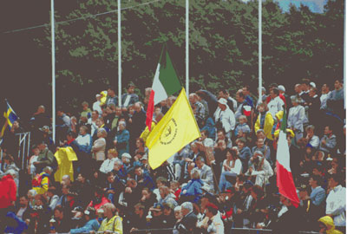
The 2000 World Goldpanning Championships
In this issue:
- Message from the President 2
- Editorial 3
- A visit to South Africa 4
- Reports on the 2000 Gold Championships 5
- Mini glossary of gold terms 12
- Gold in Peru 14
- 2001 Events 19
- Statement from participants in the World Championships 21
- We are panning gold 22
- News from the world 23
- Report on the 2000 WGA meeting 24
- Buried Rivers of Gold 25
- Gold In Transylvania 26
- Dates for you diary 30

Message from the President

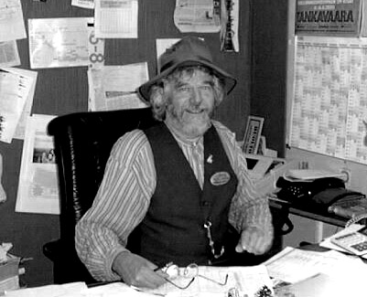
Dear goldpanners and members of WGA,
The most important events of our year of activity, the World Goldpanning Championships and the general annual meeting of WGA are now behind us. The meeting was significant since the board of directiors were elected for the next period of three years. The former board of directors received the right and duty to continue their work. I would like to express sincere thanks for the confidence you have in us on behalf of my directors and myself.
This three-year period will be the last one for me as President of our association. Then it will be time to give responsibility to the younger ones or at least to those more young like in mind. During this period I still would like, however, to do my best to stabilized the position of our association as an international organization. During the past twenty years a small association of "friends" founded by Rudy Ertl has spread worldwide. Full international co-operation is naturally highly desirable but it also brings many problems. Problems which one could not have considered when the first rules were made. To develop and maintain these rules in line with our community is the most important work we can do.
Goldpanning championships have become a priority in our activities. I wish that we would not forget in all this, that the most important task, the study and recording of gold panning traditions as well as the spread of knowledge and information.
I hope that the organizers of international championships would pay more attention to following the rules. Those who apply to host the World Goldpanning Championships should consider very carefully their responsibilities to arrange the championships to an international level. There, following all the rules is absolutely necessary. To arrange a world event should not be the first target after the international contacts have been made.
During the past 24 years some good World Goldpanning Championships have been arranged and some less good. I don’t want mention venues, but I do want to underline that the following areas should be already fully prepared before one applies for the World Championships:
- A proper competition site
- Training of the board of judges
- Whole organization should know the rules and methods of competition
- All the rules should be published on the notice boards in the most important languages, specially the rules of the unofficial categories
- All the rules should be followed carefully (notice also the depth of the water in the pools)
- If unofficial categories will be arranged the rules should be sent to the member countries at least 2 months before the event for translating.
- An official competition program should be given during the previous world goldpanning championships
- The gold flakes should be counted and then inserted into a container with great care without any mistakes! (The best way is to prepare everything ready in peace before the competition) A final count within the bottle should confirm all is correct.
- Judges should have "sample gold flakes" from every heat so that they can compare if problems appear.
- If sand used from the local area may include natural gold, the competition gold should be from another area and be easily recognized to allow the judges to make sound decisions.
- The number of members in the team competitions should be as the rules dictate and not changed at each competition.
And so on…
The rules should be followed very carefully and everything should be published on the notice boards, this is highly important as we noticed during the World Goldpanning Championships this year the problems caused regarding the acceptance of extra gold flakes. Probably because of confusion with all the languages spoken, the information that competitors who find extra flakes will not be disqualified spread among the competitors. Regarding the official rules the competitor who finds more gold flakes than are inserted in the sand must be disqualified. The only reason for the exception is in the case where the chief judge and his team can say for sure that extra gold flakes are natural gold. Any mistakes in counting and in preparing the sand must not happen! I am convinced that in every member country sand without natural gold can be found. It might cause some extra work to get this kind of sand but certainly not impossible. Nowadays the World Goldpanning Championships is such an important event that organizers should do everything they can in order to arrange successful championships.
I hope these comments do not upset the forthcoming organizers but help them avoid and foresee the problems other have suffered. I wish them all the best for the successful arrangements regarding the World Championships.

Kauko Launonen

Editorial
Welcome to this issue of Golden Times, which by the time you read this will be in the new year. Due to work loading both in Finland and the USA we have been delayed in preparing and publishing this edition of Golden Times. Please accept our apologies. The next issue will be out in the early summer with full details on the World Championships. (Registration details are included in this issue) At the WGA meeting in Poland Golden Times was discussed with many ideas for an electronic version and for a WGA web site. Please let us know if you can host a WGA web site or are interested in helping us out in preparing this task. As you read through this issue you can realize how important Golden Times is to our community. For opinions, trip reports and information Golden Times is the only link to all nations. Please continue to send articles to us and make GT a good nights reading!
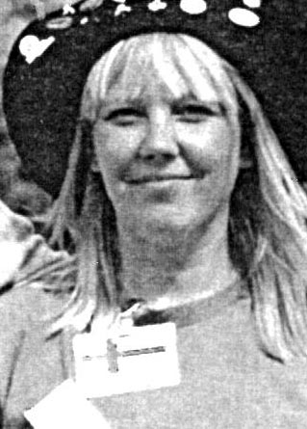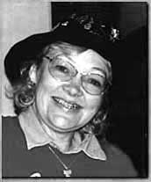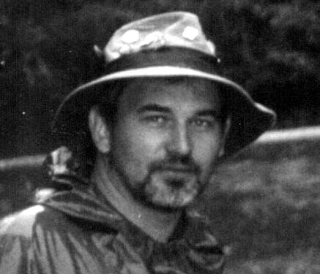
Pirjo Inkeri Paul

A visit to South Africa

It was raining cats and dogs when we took off from Heathrow on route for Johannesburg but I didn't care, I was on my way to the sun. 11 hours later I was driving in an air-conditioned car heading north in bright sunshine.
It took me about 5 minutes to drive out of Jo`berg on the motorway and 4 hours later I arrived at Pilgrims Rest where the South African Goldpanning Championships were to be held. The drive was one of constant wonder as picture scenery after picture scenery passed by.
Pilgrims Rest is made up of two small villages called Downtown and Uptown, which are separated by about 2 kms. The villages belong to the bygone age of early mining settlements and now form part of the whole Pilgrims Rest experience.
Friendliness is a byword here and every one will smile and speak to you as you browse through the very interesting museum buildings and curio shops.
A trip to the diggings to see how the old miners fared and one to the mine managers house to see the opulent life style of the 19 century wealthy, is well worth it. Oh and by the way, this little array of buildings had an electrically operated train running alongside the Pilgrims River to move the gold bearing ore during the 1890s whilst we in the UK were still using gas and candles!!!
Not far from Pilgrims Rest Is an area called Gods Window where local archeologists suggest that life on earth began (the first bacteria that converted the carbon dioxide into oxygen and without them we would not be here). Just a little further north is the Kruger National Park where a trip to see the animals in their natural world is a must. Day trips or trips overnight are arranged.
The gold panning competition had everything that you would expect, a good diggers ball, a good parade which formed at Downtown and wandered to Uptown and was supported by all the villagers and an exiting competition held over two days.
For me the highlight of the competition was a group called the Pikkies who are children up to 6 years old. They were fantastic as they struggled with buckets as big as themselves, full of sand which was not for playing in but to get rid of, to find something called gold which they had never seen before. There were nearly 20 competitors and some of them found all the "gold" that was seeded. The future of South Africa is in their hands and from the determination I saw the future is bright.
Oh and by the way I ended up as the open champion.
Oh and by the way I won the veterans as well.

My week in Pilgrims Rest was over all to quickly and as I bid farewell to the many, many new friends I had made, I reflected on the week..........

Good Welfare.
Food is very cheap with meals from around £3.50. Beer at around £0.50p, and the accommodation I was in was £15.00 per night but had 4 beds!!!!!, Car hire cost £129.00 for a week and petrol was £0.35p per ltre.

Good Banquet.
This cost around £10.00 and for my money I was given a diggers hat, a diggers metal mug and plate, a dance with live music and a buffet. Extremely good value and very well organised.

Good and Fair Competition.
The competition was a typical National Championship. The veterans group here is set at 50 due to the newness of panning to the locals hence my involvement. Competitions were well contested with heats and finals held over two days. The whole atmosphere was that of a celebration with good humored banter and music filling the air between heats. I really did enjoy it but there again I did win twice.

Value for money.
I have spent more cash and received far less when attending competitions in Europe so I would give South Africa a 9 out of 10. I will be going back, Who's coming with me?

Mike Gossage

Reports on the 2000 Goldpanning Championships from the World

Zlotoryja 2000. World Championships. We were there.

Attending the prize giving ceremony

Last year in Kocaba when the WGA flag was lowered and handed over to the Polish delegates, the people with me were already speaking about the longer journey awaiting us the following year. In fact the arrival in Zlotoryja of the three minibuses carrying the 22 participants of our Association was not the easiest: several hitches on departure, a delay of hours due to a traffic jam in Switzerland, an overnight stop on German soil and almost an hour at a border passport checkpoint- do I need to go on? Alright, alright, we reach the location of the Championships and so begins our tale....
I was contacted via e-mail (three cheers for 20th century technology!) by the editorial staff of our world magazine who asked me to write this piece and I am very happy to be able to do so in the name of those who shared with me a week which, like every World Championships, will remain through the good and the bad, well preserved in our memories. Each year, as the Event is drawing to a close and a couple of tears are being shed while parting with Friends (more and more numerous), we are thinking that it did not last long enough and that the rules should be changed in order to give us an extra day to toast our plans to meet again the coming year!
We experienced some problems in the competitions this year, but you can read about that elsewhere in this magazine; and I must say that at the distance of a month since our arrival home there remains the memory only of nice moments spent in that golden atmosphere which only we lucky amateur goldpanners can find. Every pleasantly spent moment we admire as a nugget, and we forget that stone in our shoe which possibly caused us some annoyance on Thursday afternoon.
Our week begins on Tuesday afternoon when we arrive at our hotel in Legnica (a good 20 kms from the competition site!): we had tried to book in the town of Zlotoryja but were told that the biggest hotel had been literally "invaded" by Finns and that no further room remained for the 22 of us! So each day an early wake-up call and the trip to Zlotoryja and back in the evening. Following the customary registration we at once got down to testing the material in the nice little lake where the practice area had been set up. The material immediately appeared "difficult" to us and some of us felt demoralized straight away. I personally lost a chip on every attempt! We made initial contact with friends who were camping a few metres away from the competition area and we returned to our hotel.
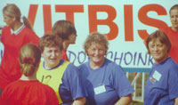
Women looking for medals
On Wednesday some of our group, under the kindly guidance of experts provided by the organisers, went panning for gold on a local stream, and gleaned a discreet sample which will look well in the glass showcases that each of us builds up every year from new auriferous sites. But the high point of the day was the traditional nations' parade which officially opens the golden week; it had been unheard of in the past for the different delegations to have to almost elbow their way through the crowd, as happened in the streets of Zlotoryja! Our delegation was attired as a company of Roman soldiers keeping at bay a group of submissive Victimuli, obliged by ancient Rome to search for gold (you will see the full show next year in Biella!) and we were literally submerged in applause and cries of joy throughout the entire parade! Incredible, really!
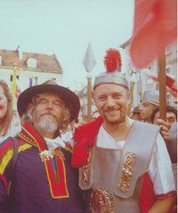
Presidentially yours
After the parade came a long opening ceremony and other items dealing purely with the local Association and their rites of initiation so we availed of this opportunity to take photographs with the South Africans (who were themselves greatly appreciated and much applauded) and to take part in a series of tricks and dances and songs with those around us. The evening was spent in a restaurant awaiting the courses ordered.....

On Thursday things began in earnest and from early morning with its bracing air and intermittent rain everybody tried to do his best. I have to say that I observed a different spirit among those who for years have been competing in World Championships, friendlier, less under stress, while at the same time more competitive, different from usual and very nice. It may have been that we were doing well in the competitions, it may have been that I had never been so much at the centre of attention on the part of my "adversaries", but I must say that I enjoyed myself immensely, at least until the result of the finals..
.
Thursday is also the day devoted to the annual meeting of the WGA which was held at an away venue: a bus picked up the participants who were taken to a luxurious premises in a nearby village where a room worthy of a Grand Hotel had been prepared! A table set with complimentary drinks and following the meeting an excellent cold buffet! The burden of being a delegate is not without its advantages!... The meeting skimmed over the various topics until reaching the most important ones, the assignment of the organisation of the 2004 World Championships. There were two candidates, Slovakia and South Africa. I must say that Eugene Swanepoel of South Africa produced a most impressive audiovisual presentation, but victory went to Hodrusa Hamre of Slovakia who got the majority of votes and to whom I would like to extend best wishes for the success of the event. I hope Eugene will want to present a new request which I trust will be accepted for 2005!

Voting then took place on renewal of charges within the WGA and I will not go into detail here as I believe you will read about this in another part of the newsletter. I will just say that I think we voted the best of the batch and I would not rule out in the future being able to wage an electoral campaign in favour of a female President of the WGA..

The week's competition reached its full intensity over the weekend when agonistic level livened up. The various heats were a bit slow and the excellent atmosphere was upset by a few controversies too many on account of misunderstandings with judges; but in the end things appeared to check out.

I don't intend listing the results here, but the satisfaction of the 22 of us from Biella lies in our having acquitted ourselves well in the field and bringing home some medals in the unofficial competitions. The event closed with the rich prize-giving ceremony, local personages in traditional costume and President Launonen awarding medals and cups, bicycles and personal computers....

What remains with us following another week spent at the World Championships is the knowledge of the hard job ahead in organising the European Championships next year! In fact the problem lies right within the word "organising", which means ensuring that every piece of the immense jigsaw will fit perfectly into place....Something that I do not retain at all easy.

Arturo Ramella - Biella Goldprospectors' Association Chairman

CIAO DIEGO!

Shortly after returning home, on Sept.15th, we underwent a grave loss. Diego Rossetti, Founder member and Honorary Vice-President of the Biella Goldprospectors' Association passed away. He would have celebrated his 70th birthday on Oct.22nd. Diego contributed in an exemplary way to the growth of the Biella Association and to the popularising of our hobby among young people and children and I hope in the future to have the opportunity of drawing his portrait in the pages of this magazine. A man of a sincere and friendly nature, during our 1998 event he played host, in his garden in Borriana, to dozens of foreign friends in their tents: messages of sympathy have arrived from many of them. We thank them from these pages.

Zlotoryja - Poland 2000 -

Excitement mounted in South Africa in August 2000 whilst we prepared for our sojourn to Zlotoryja, Poland at the end of August 2000. At last we had everything in place and packed our bags for what would turn out to be a wonderful experience. This time we were really going to be represented in force and in the end there were 10 South Africans at the World Gold Panning Championships in Zlotoryja. Over and above the excitement of actually competing there was also an air of anticipation amongst our group. This was the year that we were going to present our bid for the 2004 Championships. As per usual once we arrived there friends from all over the world was quick to come and say hello and to meet the "new" South African Gold Panning friends. New friendships were made and old ones taken up from where they left of, it was not long before the rest of the group was part of the whole fraternity. Thank you to our Polish friends, from the minute of our arrival you made us feel welcome.
What an experience it was for us to see the "Pied Pipers" of South Africa, Obed Mashego and Sanjay Singh, being surrounded by dozens of people of all ages, also being asked to have their photographs taken. For the most of us it was the first Championships and therefore a priority to gain as much experience as possible. Even though we practised hard and had high hopes we did not manage to win a medal, once again the cry went out "Next year will be our turn" The same thoughts went through our minds as we narrowly lost the 2004 World Championships to the Slovak Republic. We wish the Slovak Republic every success and good fortune with the 2004 event, you were worthy opponents and once again congratulations.
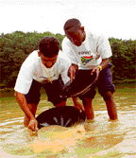
Sanjay Singh and Obie Mashego practising hard
To all the gold panning friends from all over the world and the organisers in Zlotoryja, a heartfelt thanks for making this such a wonderful event and experience for all of us. We sincerely hope that one day it will be our turn to host you here in our beautiful country, South Africa!
The South African Gold Panning Association (SAGPA) is now more determined than ever to bring the World Championships to Pilgrim’s Rest and South Africa. So watch out we are hoping to have a larger contingent in Maryborough, Australia, next year and will make an even more concerted effort to win the bid for 2005.
At present we are busy organising our National Championships and this year promises to be best ever. A lot of interest has been created with our bid for the 2004 Championships and from our competition we will be able to select a strong team for next year in Australia.

Obed Mashego reports on Poland:
On our first day in Poland, my friend Sanjay and I found it so amazing that everyone, young and old, was pointing their fingers at us as if we were strange. But soon we were treated as VIP’s in Poland. It was difficult for us to communicate with them as few could speak English and on one occasion we ended being served chicken wings instead of chicken pizza (we had described what we wanted by flapping our arms) I was also lucky as I was called Obie and not Obed.
We became very popular and everyone wanted to see, greet and talk with us. We responded by being friendly and open with the Polish people. The Street Parade was a great experience and I think more than 500 pictures were taken of me posing with the local people and especially the children.
Coming to the Gold Panning, I enjoyed myself and experienced that gold panning is not child’s play. I intend to practice a lot so that next time I can bring a medal home. Lastly I miss Poland and would like to say thanks to the South African Gold Panning Association and our sponsors for making the trip possible.
Future South African Events:
South African Gold Panning National Championships
November 2001 - Pilgrim’s Rest - South Africa
Information: Tel +27 013 7681296 or +27 013 7681471
Fax: +27 013 768 1469
e-mail: digger@netactive.co.za

ITALIAN OPEN GOLDPANNING CHAMPIONSHIPS
Ovada 22nd –23rd July 2000

More than hundred goldpanners participated to the classic event that the Italian Federation organize regularly every year starting in 1986. Also participating were old foreign friends, like Niko Grannegger and Helmut Koch from Austria, Peter Pfander and Toni Obertufer from Switzerland, and many new ones.

Saturday the 22nd morning, after a speedy visit to the Italian Gold Museum, many of them lived for a gold rush in the Orba river and can find good gold samples.

The competition took place along the Stura River in the nice natural place of Ovada town.
The results:
Men: 1) Armando Pasqualini 2) Pierino Angoli 3) Piero Odini
Women: 1) Liliana Claut 2) Pina Vacchini 3) Franca Assandri
Veterans: 1) Claudio Taddia 2) Emilio Fedi 3) Germano Uberti
Children: 1) Paolo Angelico 2) Felix Lüdi 3) Giulia Torra

The team competition was gained by the Oro in Natura Milano Association, followed by the Orba river Association, the Swiss team and the Austrian one.

Note that the three first classified in the men category were World Champions.

The Miss Nugget election, also a traditional event introduced in Italy 15 years ago, was gained by the Swiss lady Marlise Lüdi.

The winners received important samples of Orba River gold, and all the participants received the new book of doctor Giuseppe Pipino “Le Valli dell’ORO…” (Gold Valleys: Geology, Archaelogy and History of the Ovada land and lower Orba valley).

As always, the Championship was followed and registered by TV networks and many newspapers.

Gympie Gold Rush Festival October 2000
By Christine Harch

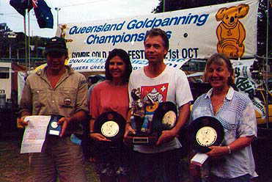JUST the mention of the word gold conjures up images of bearded men with gold pans of swirling water who are hoping for that unmistakable glitter at the bottom of the pan - some things don’t change. Each October the city that saved Queensland – Gympie, pays homage to James Nash – the man who is credited with finding the first gold in Gympie and those who followed him. That October event is known as Gold Rush and while celebrations continue to grow, change direction and mature, the one activity that is paramount to its success is the Goldpanning.

In the year 2000 Gympie hosted the Queensland Goldpanning Championships for the second time, proving that the city has the facilities and the motivated people to host such an event.
Goldpanning heats got under way at 9.30am on October 21st, 2000, and finished with a presentation ceremony at about 2.30pm on the same day. There were categories for skilled women, skilled men, beginners and youth. The winner of each category joined in a Grand Final heat at the end of the day. The winner of the Queensland Championships (Grand Final as well as skilled men) was a Swiss man by the name of Victor Jans.

Victor’s story is a fascinating one that highlights not only one man’s fascination with Goldpanning but the degree of esteem with which the pastime is held. He heard about Gympie hosting the Queensland Goldpanning Competition through a friend in Switzerland who had friends from the Hervey Bay Gem Club who had written about the Gold Rush Festival they were going to attend - word of mouth is no doubt one of the best forms of advertising.

A recreational panner, Victor arrived in Gympie without any title wins but as keen as mustard – but that soon changed. He will remember Gympie forever because it was here that he won the Queensland Championship title. His wife Carolyn scored second place in the Championships.

The president of the Australian Goldpanning Association Fred Olsson kept the Goldpanning action alive in Gympie’s Nelson Reserve throughout the day. A man who is passionate about promoting Goldpanning, Mr Olsson has the task of co-ordinating all Goldpanning events in Australia and liaises with world authorities. Mr Olsson mentioned that he felt Gympie should consider hosting the World Goldpanning Championships in 2009 which speaks volumes for the city’s ability to host an international title given his participation in so many national and world titles.

The weekend of October 21 and 22 2000 was not just about Goldpanning. Gympie also hosted the Australian Rock Drill Titles with former Tasmanian and now living in Victoria, David Butler walking away with the big cheque. If readers have never seen a rock drill, it is something to behold. The strength of the miners who take part in the competition and their ability to control powerful machinery is nothing short of awesome. Sitting in the audience, the action of rock drilling has one on edge of the seat. The noise and flying watery mud that covers the muscle men are all part of the fun and action.

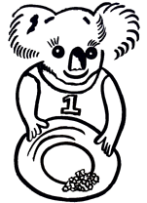Essentially Gympie’s Gold Rush celebrations are all about celebrating the birth of Gympie when, on October 16, 1867, James Nash discovered the shimmering metal that literally saved the state of Queensland. Creatively decorated floats form part of the annual street parade with this year’s celebrations taking on a whole new dimension thanks to the Gold Rush Committee. The committee secured funding for multicultural music workshops. The fact that these week-long workshops were full, indicated the desire for locals to learn more about other cultures and what better way than through the universal language of music and dance. Those taking part in the workshops found themselves part of a public concert after the street parade.

Set in Gympie’s beautiful Memorial Park with Jacaranda’s in bloom, the haunting peaceful sounds of African singing, Macedonian Gypsy bands, Samba bands and Zimbabwean marimba emanating from the park will not be easily forgotten. When guests from other states and countries remark on what a wonderful Festival Gympie hosted, it can only further promote the city and the event and reinforces what local already know – it’s a great to visit and live.

Next year Gympie will again host the Queensland Goldpanning Championships on 20th October 2001. This will be the weekend prior to the World Goldpanning Championships being held in Victoria. Is there any better opportunity for you oversee-goldpanners to get another goldpanning title while visiting in the same time Queensland - the sunshine-state.
More Informationen is available on http://www.goldrush.org.au or through the Secretary of the Goldrush-Festival festival@goldrush.org.au or fax 07 54821954.

Inaugural North Queensland Goldpanning Championships

In 2001, Chillagoe celebrates the Centenary of the Smelters and the Mareeba-Chillagoe-Mungana rail line. As a prelude, last September, Chillagoe hosted the inaugural North Queensland Gold Panning Championships. Over two hundred visitors watched as competitors in a variety of categories lined up at large competition tubs in the main street. A family fun weekend included heritage displays, vintage cars and trucks, machinery and gold panning artefacts.

Kim Hillier took out the North Queensland Championship. Three Japanese backpackers got lucky in the beginners’ competition. Chillagoe hasn’t seen so much excitement for a century and it will all be repeated in the year 2001.

The Etheridge Goldfields, in far north Queensland, were known, in the boom years at the end of last century, as the “Poor Man’s Goldfields” because of the many surface nuggets. However, much of the gold needed processing from ore as in other areas. A great many small mining towns sprang up in this area west of Cairns, most now long gone. Copper, silver and lead were also found in this region now better known for its gemstones.
Chillagoe is 200 kms west of Cairns. Best time to visit is April to October, the roads can become impassable in the Wet so check first between December and March.

Heather Donovan, Australia

Championship 2000 of Slovak and Czech Republic in gold panning
The good tradition of common championship continued this year as well. Both national associations expect from these events, higher competition standards and strengthening of friendship persisting from the common state – Czechoslovakia. This year’s competition took place on August 17-20 at Jasenie, under the southern slopes of Low Tatras, in Middle Slovakia. The first days were devoted to panning in the free nature, hard championship competition panning took place during the weekend. In total there were 187 participants not only from the Czech and Slovak Republic, but also from Austria, Germany and Canada. Among women professionals Vera Vecerova from Czech Republic and from men Ondrej Komora from Slovak Republic became the champions. The representatives of both associations agreed on the common championships for the next four years. We are already looking forward to the next championship at Zlate Hory in Czech Republic.
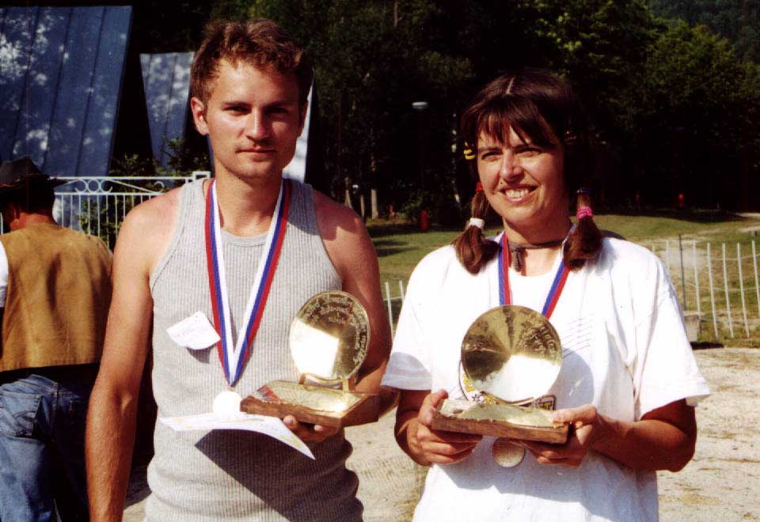
The picture is Vera Vecerova and Ondrej Komora, champions in the competitions of professional

The Sky on the head
(or how did the first Belgian Goldpanning championships take place).

It had not been easy to gather all the people for such an event. Although Goldpanning in our country is rich from a 2000 year old tradition, there is no goldpanning association and the gold is so scarce now that we count the flakes instead of weighing them. Even if we recently discovered the first Belgian hard rock gold mine, goldpanning remains a weird activity for many people. So when we came up with the idea of the first Belgian goldpanning championship we knew it would be hard work. And so it was.
When ,finally, after months of preparation we were ready, what our ancestors, the Gauls, feared most has happened to us.
Of course, we had had foreboding during the week before. It began with the sudden skyrocketing of the fuel price and then trucks started to block the roads a bit everywhere paralyzing the country and preventing the people from refueling. The filling stations were closing one after the other. Would the competitors be able to come?
What a stress until the end of the week when, the day before the championship, the government gave the truck drivers what they wanted and all the blockades were removed. But more problems were to come. Our national weather office was forecasting heavy rains for the whole week end. Still this didn’t discourage the participants and Saturday 16 September 2000 almost every of the 60 competitors were there.
Thanks to the collaboration of the local tourism office, everything had been wonderfully set up but the temperature was below 10°C and the grey sky was heavy with rain. At 9.30 am when the judge started the first round, the sky burst into rain and this wouldn’t stop until the very end of the competition. The little creek where the event was held even ran out of its banks. We really got the sky on the head.
Surprisingly people held on and panned their sand to the end. They were soaked but got out of the boxes proudly displaying their vials with more or less flakes. It was amazing to witness so much tenacity from the panners against the weather conditions. People who had never seen each other before were panning together for their greatest pleasure. Even the children who had so much trouble in keeping the water out of their rubber boots panned to the end with great courage. There were three categories : juniors, beginners and skilled. Almost constantly people came to me to say how happy they were to take part to this competition and how pleased they were to see such a good organization.
When needed people could go under a big marquee that had been specially set up for the occasion. There, they could eat our Belgian specialty : Fries with beer. Stronger alcohol, some local specialty, was also plentiful to warm up the freezing competitors and supporters. During the day some also went panning in the little creek nearby (the Goldbach = the Golden Creek) and collected a sample of our nice (small) Belgian gold.
At the end of the day everybody was soaked but happy. All the rounds had been held on time. We gathered under the big marquee for the proclamation of the results and the handing over of the prizes (Australian gold nuggets). Several Politicians had come to give this event some solemnity. The necessary speeches and thanks brought a lot of enthusiasm and emotion among the competitors and the numerous crowd. Every face was gleaming with a big smile. It had been a hard day but a rewarding one. Not only for the prizes won but above all for new friendships.
Since our championship was so successful, we have decided to open it to other countries for the 2001 edition. So this is our formal invitation to come to the second Belgian Goldpanning Championships on 25 and 26 august 2001 in Faymonville near Waimes. We have changed the date since last time to increase the chances of good weather. Accommodation will be possible by either camping near the competition site or booking in a hotel nearby.
For more info please do not hesitate to contact me
BRUNO VAN EERDENBRUGH
Rue Bassenge 4
4000 Liege
Belgium
Tel 32-4-221.39.19

Bruno.van.eerdenbrugh@tnt.com

wishing to see many of you again.
Bruno

Mini-glossary

English (-English)
1. A traditional gold claim
2. Cabin
3. Shovel
4. Riverbank
5. Gold pan
6. Stream
7. Dam
8. Spoil
9. Sluice
10. Back board
11. Crowbar
12. Riffle
13. Pickaxe
14. Waterflow
15. Trestle
16. Tailings, debris
17. Concentrate
18. Gold

Dutch
1. Een traditionele goud claim
2. Hut
3. Schop, Spa
4. Rivierdever
5. Goud pan
6. Stroom, Beek
7. Dam, Dyk
8. Verspilling
9. Sluis
10. Schut, Opstand
11. Koevoet
12. Richel
13. Pikhouweel
14. Watervloed
15. Schraag, Bok
16. Puin, Resten
17. Consentraat
18. Goud

Finnish
1. Perinteinen kultavaltaus
2. Kämppä
3. Lapio
4. Jokipenkka
5. Vaskooli
6. Virta
7. Pato
8. Joutomaa
9. Ränni
10. Luontilauta
11. Rautakanki
12. Rihla
13. Hakku
14. Vesivirta
15. Rännipukki
16. Jätemaa
17. Upa
18. Kulta

French
1. Une concession aurifère traditionnelle
2. Cabane
3. Pelle
4. Bord de rivière
5. Pan, Batée
6. Rivière
7. Barrage
8. Stèriles
9. Rampe de lavage, Sluice
10. Planche
11. Barre-à-mine
12. Riffle
13. Pioche
14. Débit d’eau
15. Tréteau
16. Déblais, Débris
17. Concentré
18. Or

German
1. ein traditioneller Goldwaschplatz
2. Blockhaus, Blockhütte
3. Schaufel
4. Kiesbank
5. Goldwaschpfanne
6. Flub, Bach
7. Damm
8. Schutt
9. Rinne
10. Rückwand
11. Brechstange
12. Rillen
13. Pickel
14. Auslaufrinne
15. Bock
16. Schutthaufen
17. Konzentrat
18. Gold

Italian
1. Una tradizionale concessione aurifera
2. Capanno
3. Pala
4. Sponda del fiume
5. Batea
6. Torrente
7. Diga
8. Detrito, discarica
9. Scaletta
10. Sponda, Tavola di sponda
11. Palanchino
12. Scaletta, Traps
13. piccone
14. Scarico, Canale di Scarico
15. Cavaletto
16. Coda, Conoide, Scarto
17. Concentrato
18. Oro

Polish
1. Dzialka zlotono´sna
2. Chata
3. Lopata, Szpadel
4. Brzeg rzeki
5. Miska
6. Potok, Strumien
7. Tama, Zapora
8. Halda
9. Koryto
10. -
11. Lom
12. Zlobki, Rowki
13. Kilof
14. Wodospad
15. Koziol
16. Halda, Rumowisko
17. Koncentrat
18. Zloto

Slovakian
1. Tradicný zlatokopecký kleim
2. Zrub, Chata
3. Lopata
4. Riecny breh
5. zlatokopecká ryzovacia panvica
6. Bystrina, Potok
7. Hrádza
8. hlusina
9. zl’ab
10. Bocnica
11. Sochor
12. Ryhovanie
13. Krompác
14. Vodný prúd
15. Stojan
16. Odpad
17. koncentrát
18. Zlato

Swedish
1. En vaskgulds Inmutning
2. Koja
3. Spade
4. Åstrand
5. Vaskpanna
6. Vatten dam
7. Fördämning
8. Varp
9. Vask ränna
10. Sargbräde
11. Spett
12. Stege
13. Korp
14. Vattenström
15. Stöd bock
16. Vaskat grus
17. Koncentrat
18. Guld

PERU 2000
By Inkeri Syrjänen
(Inkeri Syrjänen and Kauko Launonen of Finland visited Peru in October 2000)

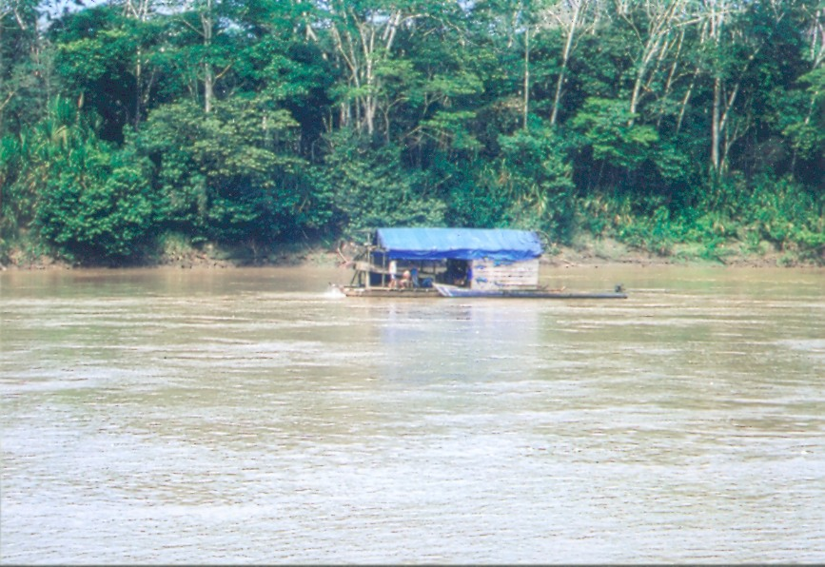
(A small dredge working in the River of Rio Madre de Dios (Photo: Kauko Launonen)

In October it is springtime in Peru. It is cold in Lima even though the equator is only a few steps away. In Cuzco, which is in the mountains, it was so cold that we had to buy the alpaca pullovers. Next day we flew to the rain forest of Puerto Maldonado where there were temperatures over +35 C!
Our dream of many years’ about the journey to Peru finally came true last October. All are familiar with the gold treasures of the Incas and their amazing skill in goldsmithery but our target was to get information where and how Incas got their gold and where it’s washed today. We were prepared by reading a few guidebooks and from the books at the library of the Gold Museum. On the Internet we followed the weather and read the information about tourist attractions. But about the modern day gold panning we didn’t find any information. The geologists said the gold is washed everywhere in Peru.

We left for the journey of three weeks with “poor planning”. Air tickets to Lima and two nights in a hotel in Lima, which were booked beforehand, were the only preparations for the journey. A credit card and a few dollars in the pocket, a small bag of cloths and another filled with souvenirs from Lapland were the only things we had with us.

Fabulous luck followed us during the journey. We saw and experienced the things we were not even able to dream of. In Lima the Ambassador of Finland as well as other staff at the Embassy gave us great help when we tried to get further information about the gold panners in the country where only Spanish is spoken. It would help a lot if we could have spoke the language but we didn’t… Another important contact we had already during the Golden World project some five years ago when we co-operated with “Sosiedad Nacional de Mineria, Petróleo y Energia and one of its department “Comité Aurifero” worked with gold. From the publication made by the Comité I understood that in 2000 Peru produced 35.093 kg of gold during the first three months. 12 % of the amount (4.200 kg) was produced by the individual miners who still worked mainly manually. We met the directors of the Comité who donated to the Gold Museum two very beautiful golden replicas of objects of Incas; a sacrificial knife and a bowl. We were warned that customs could confiscate all the objects valuable in cultural history and therefore we got a stack of papers which proved that the objects were only replicas and they were going to be displayed in a museum.

Lima was a culture shock but it was just the beginning. There is only one word to describe the traffic in Peru – terrible. Cars are old and everybody drives as it would the last day of their lives. There were no brake lights in the cars and most of them didn’t even have winkers, all of them were dented. There were no traffic regulations or at least one can’t understand them. Horns were tooted all the time, especially in the crossing; the one who toots loudest can go first. It’s hard to understand how otherwise so peaceful and benevolent Peruvians become so angry when they step behind the wheel. Every time I took a taxi I clasp my hands hoping the best but fearing the worst… However - within a week we were there driving in the chaos – with a rented car.

After obligatory tourist attractions Cuzco and Macchu Picchu we flew to the city of Puerto Maldonado which is situated two hours flying from Cuzco. Thus the journey should go fast if the plane was at the scheduled time. But one might have to wait for hours at the airport like we did; no one was able to say when the plane would arrive… After four hours it finally came.

We got from the Embassy the precious telephone numbers and addresses in Puerto Maldonado. From one place we got maps of goldpanning areas, another place there were a person who was able to tell a lot about the panners and amounts they are digging and from the third place we got a bundle of written material. In the last place we collide with the language barrier and don’t know what we missed.

So we had some information where we could find the gold panners. We asked the hotel reception about the guide to the gold areas and got the address of Nadir who was in the other side of the town. We took a moped-taxi and drove to another hotel and around the swimming pool there was sitting a chatty Italian man. The following day we were sitting in the taxi on our way to the town of Labyrinth. We spent a sweltering hot day in the middle of the jungle in the gold mine of another Italian man.

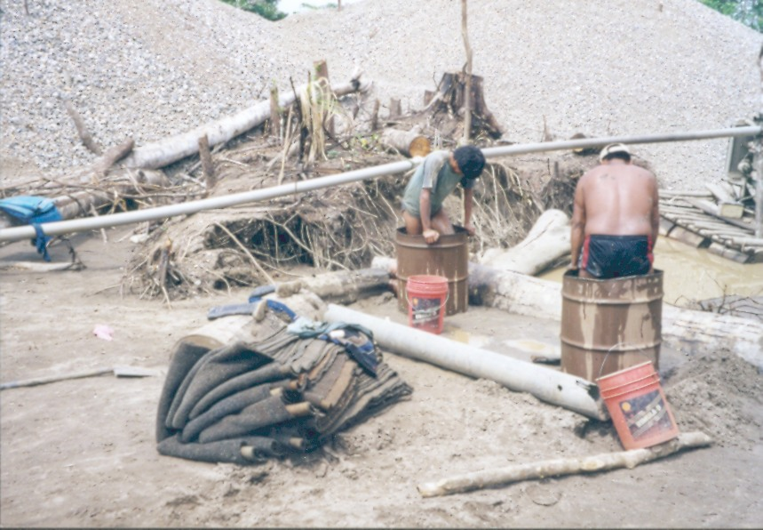
Gold remains in the carpets, which are placed in the bottom of the sluices/washing tables. The carpets are tread on in the barrels and the remaining sand is panned by the gold pan with mercury (Photo: Kauko Launonen)

The digging is started by clearing and burning the jungle away. The uppermost earth layer is scraped away and in the pit the water is led. In the pit there is a sucker which sucks the soil mixed with water to the sluice-boxes, which were placed high. There are no riffles in the bottom of sluices but coarse pieces of carpets where the tiny little gold pieces will stick. The carpets are washed in the barrels where the men stand and tread on the carpets with their feet. The gold is separated from the remaining sludge in the barrels with help of mercury. Panning itself is done with a small round-bottom gold pan where the mercury is poured off the bottle. Mercury can be bought in every gold shop in the town. Many of those shops have also the “ burning-in oven of the mercury” where the pipes stick out straight to the sky. At the mine where we visited, the owner washed himself the remaining concentrate and took the piece of mercury to his tent where he had a gas heater. We were shown the gold, which they mined yesterday; a porous gold nugget of 150 grams purified from mercury.

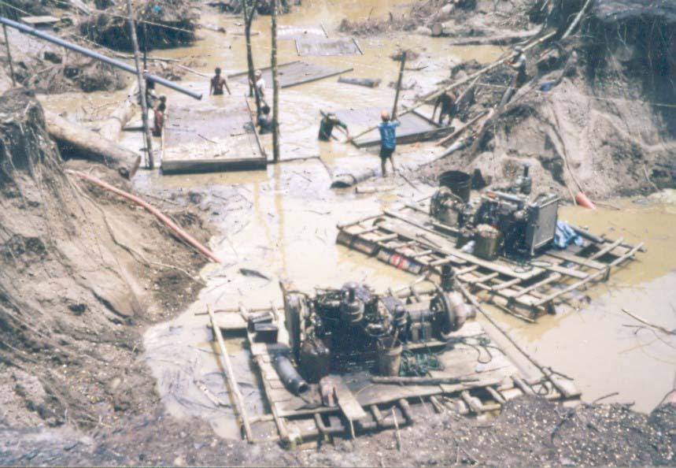
In the front there are machines, which suck the sludge from the bottom of the pit. Behind the men are preparing to lift the washing tables/sluices up to the poles. They are lifted as high as possible so that they don’t have to move them continuously when the heap of tailings grows (Photo: Kauko Launonen)

The building of the sluices interested me most. Without any nails or ladders ten men made fast the sluices in the water pit to the height of three or four meters with the help of ropes. The poles sank in to the sludge because of the weight of the men, the crossbars and longitudinal props were tied to the poles and the sluices of two meters wide and four meters long were lifted up. Men climbed in the staging and used the ropes like circus performers. We would have liked to stay longer in the mine but Nadir said there was still another mine to visit nearby.

Rio Madre de Dios is a muddy river, which is part of large Amazon waterway.
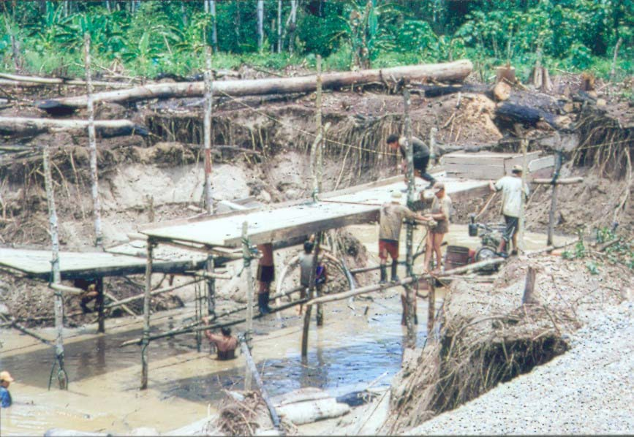
The washing tables/sluices are lifted up to the poles with help of ropes and the coarse carpets are spread on the tables (Photo: Kauko Launonen)

The gold in the bottom of the river is taken by dredges. We visited two different dredges where there were 3-4 working men in both. Some have their family with them since they live in the dredges and work along the days and nights. They sleep in the bunk beds inside the mosquito nets. The machines works with diesel and the noise is awful. In another dredge there was one man at a time diving and using the sucker in the bottom of the river. In another dredge work was done mechanically. Both places the auriferous sand is led to the washing tables covered by carpets where the concentrate is taken for panning. We got a warm reception in every place and the machines and dredges were shown willingly. We were also allowed to try panning with our Finnish pans and the locals thought they were much too flat for the purpose. We got a good amount of gold but it was very, very fine and not worth to try to take without the mercury. In the river there we saw five dredges before the curve and we were told behind that there are much more. Together at least 400 men are working in this part of the river in this season. When the monsoon rains arrive the people leave or move to the tributaries since it’s impossible to work in the main bed during the flood.

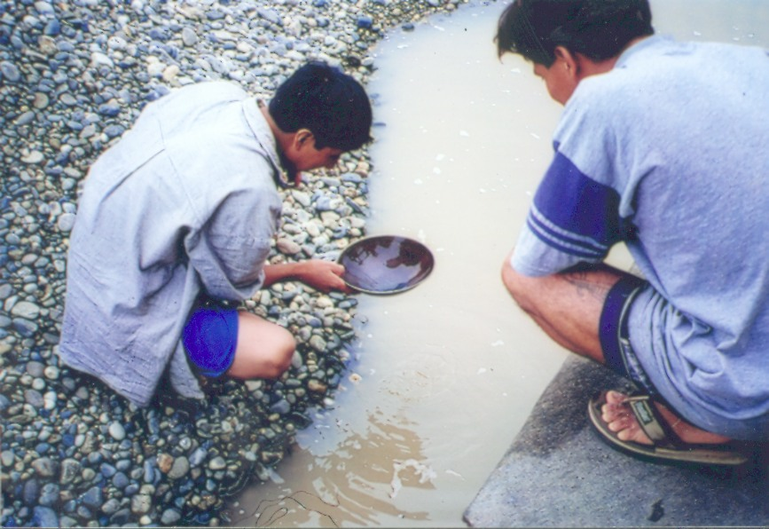
Peruvian gold pan is a round-bottom. The gold is very fine and mercury is commonly used (Photo: Kauko Launonen)

Another gold area where we had time to visit is 500 km from Lima to the north near the town of Lambayeque. At least it should be located near. In fact we had to drive 200 km more and actually it was near the town of Jaé. The journey there was a real adventure. Daringly we rented a car and it almost turned out to be a nightmare. Without a Spanish-speaking guide and interpreter we probably would be still there! There is a good asphalt road from Lima to the north, the Pan-American Highway, partly even four lanes. According to the guide book the road goes across a desolate sand desert. In our opinion the only desolate thing was all the dirty rubbish caused by the lack of dumps and waste management. Right outside of town it starts with filthy roadsides since all the waste are dumped to the roadside or rivers. A number of miserable people are rooting about the waste and plastic rubbish is spread all over the places by birds and the wind from the sea. Along the road there are the numerous memorial stones to the victims of traffic. We were wondering why so many accidents happen on such good roads with quiet traffic. Otherwise the sand desert is multiplicity and kaleidoscopic. The rocks and the sandbars are beautiful but there is not much vegetation. Mountain walls of different colours, sand hills and special form of rocks varies together with archaeological views and towns of dense population. Interesting with everything else but a monotonous journey.

In the town of Jaén after diligent detective work, we found out that the closest gold mine was about one hour away. We got a guide from the town who told us that a few weeks ago some locals had been killed in the area. In the border district there are drug dealers and other outlawed people. Closer to the border of Ecuador there would be more gold mines and panners but we decided not to go there for these reasons.

Two young men who had several assistants owned the mine we visited. One of the owners spoke very good English since he had been many years in Australia. First they took a little bit sceptical attitude to us but after learning that we are from the Gold Museum and we have also a gold panning activities in Lapland they became very friendly. They allowed us to pan for gold in the claim, we took some pictures and videos and finally we exchanged gold pans. The museum got a flat wooden pan; traditional shape of hundreds of years named “pico”. Also we got some gold samples.

On our way back it happened. Without any warnings from the bushes along the roadside a small boy flew in our way. Fortunately our speed was very slowly and Kauko was able to turn the car so that the boy hit only the side mirror. When backing the car the big brother appeared. We took the boys and the mirror and drove to the hospital. On our way we found out that the boy we hit is an epileptic and has mental deficiency and didn’t understand to watch out the cars. The big brother explained that he tried to stop him jump on the road but failed. At the hospital the doctors said that the boy’s shinbone was fractured. We paid all the hospital costs, x-rays, medical examinations and gave some money to the boys for their journey back home. We thought everything was clear since the medical staff said that the policemen were not needed. However, the father of the boy didn’t agree: he wanted money! Now the policemen also interfered. Our car was confiscated and locked in the backyard of the police station. We got a room at the hotel and prepared to wait until the police commissioner would come to work again on Monday. It was a long weekend about to come. The father demanded thousands of sols and we didn’t have enough money. The journey was about to end and we were going to fly from Lima to home after couple of days. We were told that investigations would take at least three days maybe one week. We were lucky when the police commissioner promised to interrupt his weekend vacation and so the hearings started and blood test was taken. Finally we were asked how much money we had with us. We scraped almost every penny of our travelling funds and paid a tidy sum of money to the father and so everything was clear with him. Now we needed our car. The police commissioner promised to give it as soon as we paid him “a hearing fee”. In the evening we had dinner together with the commissioner and we were free to leave. All’s well that ends well!

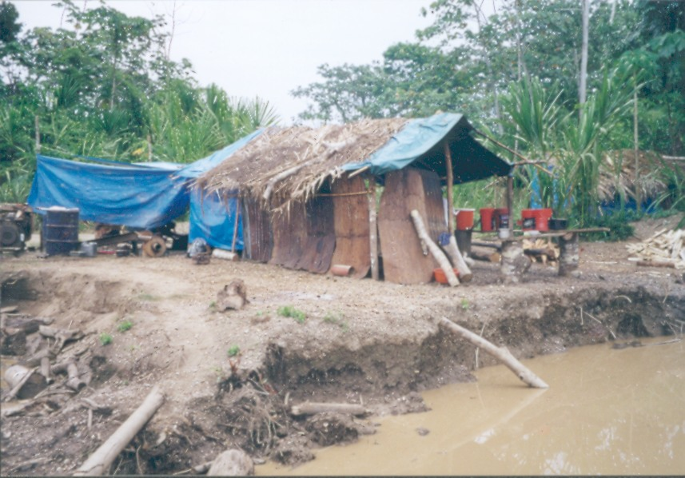
Restaurant of the gold fields. The food was delicious and the owner didn’t accept any payment (Photo: Kauko Launonen)

2001 Events

Dear Goldprospectors

The year 2001 approaches and the good news is that a Swiss Goldpanning
Championship is scheduled for June 22 to 24 2001. Brig in the Canton
Valais will be the meeting point of Swiss and international
Gold prospectors. Have a look at the program and register online
Already now on http://www.goldwaschen.ch/egold_sm01.htm. By the way:
The Goldpanning Europe Championship will be held one week later in
nearby Biella/Northern Italy. Why not participate there as well?
You might plan a little bit further ahead the year 2001: Would Australia
Be the ultimate holiday destination for you? Australian
Maryborough/Victoria will be the host of the Goldpanning World
Championships during October 22nd to 28th 2001. As a "warm-up" one week
earlier, I can personally recommend to participate in the Queensland
Goldpanning Championship on October 20th in Gympie in the Sunshine-state
Queensland.
You find informationen and links to all Goldpanning Championships of
2001 on http://www.goldwaschen.ch/gold_wm.htm
I wish you a happy New Year, auriferously
Victor
http://www.goldwaschen.ch/egold.htm - The Swiss Internet platform for
recreational goldprospecting

2001 World Gold Panning Championships
22-28 October 2001

Maryborough, Victoria, Australia

Program

Monday 22 Oct 2001
- Registration
- Goldfields Discovery Tours
- Practice Panning – local gold

Tuesday 23 Oct 2001
- Registration
- Goldfields Discovery Tours
- Practice Panning – local gold

Wednesday 24 Oct 2001
- Registration closes at noon
- Free panning in historic area
- Opening Parade & Ceremony

Thursday 25 Oct 2001
- Preliminary Heats
- Jackpot Panning
- Annual Meeting of WGA

Friday 26 Oct 2001
- Preliminary Heats
- Novelty Events
- Evening Presentation
- 2002 Host Nation, Japan

Saturday 27 Oct 2001
- Semi-Finals
- Nugget Rush
- 1851 Panners’ Dinner/Dance

Sunday 28 Oct 2001
- Finals
- Awards/Closing Ceremony

Competition Categories
- Men’s Skilled
- Women’s Skilled
- Youth (12-16)
- Children (Under 12)
- Veterans (Over 60)
- National Team (5 person)
- Men’s Beginner
- Women’s Beginner
- Open Team (3 person)

Fees
Individual Adult $20 US
Youth & Children $10 US
Veteran $10 US
Open Team $30 US
National Team $50 US

For Registration or Further Information
Australian Goldpanning Association Inc
PO Box 480
MARYBOROUGH VIC 3465
AUSTRALIA
Ph/Fax 61 3 5461 4709
E-mail: freddo@iaa.com.au

Maryborough – Centre of The Victorian Goldfields
Victoria has a historic recorded gold production in excess of 2.5 million kgs of gold. Almost half of this gold was alluvial.
The area surrounding Maryborough produced most of the World’s big nuggets including the World’s largest and famous Welcome Stranger which was found to the north at Moliagul.
In 2001, gold panners from all around the World are invited to join the celebration of the 150th Anniversary of the Victorian Gold Rushes and 25 years of World competition gold panning.
It is fitting that miners from all nations return to this historically famous gold rush area to enjoy the competition and gold friendship.

For All Your Goldfields Inquiries and Bookings
Phone Central Goldfields Visitor
Information Centre (03) 5460-4511
Phone Toll Free 1800 356511

STATEMENT
OF PARTICIPANTS OF THE WORLD CHAMPIONSHIPS 2000 IN ZLOTORYJA

Members of the national goldpanning associations signed below would like to express their experience from the World Goldpanning Championships 2000 held in Zlotoryja, Poland.

We highly appreciate a very good level of the event in general, however, we must complain about the technical standard of the competition itself:

- There was natural gold in the competition sand of size that in some cases interfered with the competition gold.
- The recognised extra gold was sometimes counted as the competition gold, and sometimes was not.
- Sometimes judges did not help with counting of gold chips in “less skilled” categories which seriously affected results (beginner ladies, juniors).
- Competition gold was shown within the restricted area only, which is against rules.
- Competition rules were not displayed for competitors.
- Holes for tubes were too small for the tubes used, so that the tubes could not be fixed properly, and some competitors lost the gold already found.
- The generally accepted WGA rule concerning disqualification of competitors for extra gold was changed during the competition. This change of the rule, in combination with probable presence of extra gold in the sand, caused unfair disqualification even from the final heats (professional men, beginner ladies).
- In few cases, organisers were not fully familiar with WGA rules, and gave incorrect information to the competitors:
- allowed the start of the 4-member national team what lead to the disqualification of the team
- allowed the registration of two national teams (Italy).

In general, the above mentioned imperfections affected legality of results of the championships held on excellent level in other aspects.

Signatures of members of the national associations supporting the statement:

Italian Federation (Pasqualini)
Czech Goldpanning Association (Veronika Stedra)
French Federation of Goldpanners (P. Guiollard)
Slovak Goldpanning Association (Richard Kana ll)
ABCD’Oro Italia (Arturo Ramella)
Australian Goldpanning Association (Fred Ollsson)
Swedish Goldpanning Association (Sten Bergström)
Finnish Goldpanners’ Association (Kauko Launonen)

We are panning gold

The jubilee millenium gold panning season is at the end. Many ideas, experiences and memories about the time spent with old or new friends are resonating in our heads. Time spent in free nature and panning competitions in different corners of the world. The culmination of the season is, for several years, the world championship. They reflect the time spent at practicing. Who falls in love with the panning passion , he rarely gives up. We are happy and excited, who has more luck and nuggets.

Allow me to deal with the very substance of panning - the gold grains used at the world championship. According to WGA regulations, the size of the gold grains has to be minimally 0.5 mm. I will compare the gold grains size used during the last world championships 1998 Coloma – USA, 1999 – Kocaba - Czech Republic, 2000 Zlotoryja – Poland. I analysed the gold grains panned by myself in the official and free competitions as individual and also team member. I think, they can be considered as representative, since they are from all qualification rounds, up to finals. Their basic parameters are listed in the following table:

DATA COLOMA KOCABA ZLOTORYJA

Number of grain 90 61 59
Total weight of grams 0.750 g 0.127 g 0.049 g
Average grains weigh 0.0083 0.0021 g 0.00083 g

From the table it is obvious, that the lightest gold grains were used at the World Championship in Zlotoryja , exactly 10 times lighter than at Coloma and 2.5 times from those of Kocaba, The gold grains used at Coloma were really large. 1– 4 mm, mostly 2–3 mm. I am sure, they pleased every participating panner and are the precious pieces of his collection. Because of the considerable difference in the size, I did not continue with their treatment. However, the gold grains from Kocaba and Zlotoryja are comparable. I determined their parameters on the laboratory sieves with the mesh of 0.315 and 0.500 mm. I was aware of the possibility that larger flat grains could slip along the diagonal. On the sieve with the mesh of 0.500 mm only one grain Kocaba passed through, but up to 12 from Zlotoryja. I subjected to observation all 12 grains from Zlotoryja under the enlargement of 16x. The length of all exceeded 0.5 mm. Grains from Zlotoryja are thin, usually below 0.1 mm. I also separated 12 smallest grains from Kocaba. If the length was similar to those from Zlotoryja, they were considerably thicker.
What was the purpose of my ‘research’? In the beginning I suspected the grains from Zlotoryja were below the permitted size of 0.5mm. However, as I stated., all grains that I observed comply with the WGA regulations. Despite of that, I have some remarks to their parameters. I hope, I can be considered as a good competition panner. During all competitions at Coloma I lost only one grain in the finals. At Kocaba, none and I became the world champion. A completely different situation was at Zlotoryja. Despite my full attention and achieved time of above 8 min., I lost 1–3 grains in each round of the main competition. In all competitions, that I attended, they were surely more than 20. Up till now, it would be all O.K. Mass escape of the gold grains made the competition for many panners interesting. I am not sure, all grains escaped just as a result of panner’s faults or carelessness. I work in a gold producing company, and I observed many times how the small gold grains behave. They simply float on the water level. I suspect, in the same way gold grains behaved in Zlotoryja. Not always following the law of gravity at their minimal thickness. To be particular, I do not remember any competition with so many cases, that the panners washed more chips than was seeded into the sand. I am sure, the vast majority of panners did not add any chips into the sand. According to me, they were disqualified without justification!!!
How could such a higher number of chips get in their test tubes? Very simply, I think, they were unintentionally added by the organizers. Small and thin chips can easily stick together and with there small weight can escape from the bare eye observation. They disengage only in a water environment, under agitation in the washing pan. Nothing can reverse the fact, that the disqualified panners were considered as crooks. I do not admit, that the extra chips come from the used sand. I have attended three championships in Zlotoryja. The same sand had been used, and the presence of foreign gold chips was not observed. After analysing of all above facts, my opinion is, with the used chips the competition in Zlotoryja could not be objective. It would be perhaps essential to change the WGA regulations in the chapter dealing with the grain parameters and amend it for the average grain weight. After all we pan for gold.
My intention is not blaming somebody, but to attract attention to the aspects, which are not completely straightforward. Several competitions were affected by this drawback, including the men professional finals.

Richard Kana II. Vice-president of Slovakian Goldpanners Association

News from the World

Japan

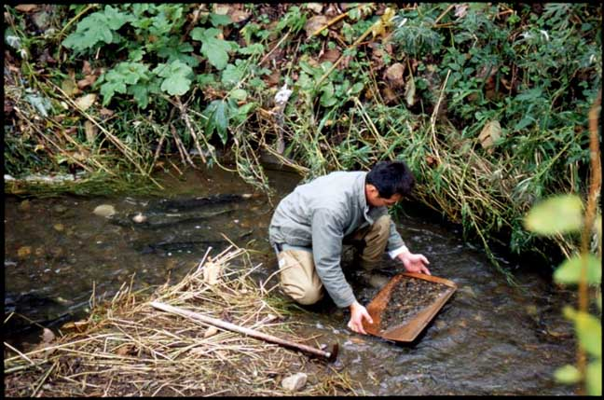
One fall day at the Usotan River in Hamatonbetsu while I was panning for gold, salmon returning to their spawning grounds came right by me on their way up the river saying “you are in the way” by splashing up water as they passed by. Once while deeply involved panning for gold, I mistakenly dug up some salmon eggs. At that time I felt badly about digging up the eggs so I covered them again and moved on to another spot to pan. In all truth, during this season we are unable to pan much gold because we often have to recover salmon eggs that we mistakenly dig up and move on to another spot. However, when you think that new life will be born somehow it makes you happy and you enjoy panning for gold.
Editor Masanori Hosoi
All Japan Goldpanning Association.

Austria

This is Good Old Austria writing. We’d like to thank you for the cordial invitation to contribute to "Golden Times" after all these years that flew to the past. We actually would appreciate if we could spread the word about last years goldpanning tournament in Rauris and this years Austrian Open. In order to flock the folks to Rauris on Jul. 7 - 8 2001. Cause all who might travel back home from Biella on their northbound journey, will criss cross the Rauris Open with their itinerary anyway. And Rauris will do its best to make their stay - after a breathtaking European Championship - as comfortable and cosy as possible. The exposée I am referring to has been written by Betty Mueck, the German counterpart of Pirjo. She is treasurer of the German Goldpanning Assoc. and ghost writer of the goldpanning newsletter "Goldfieber".
Niko Granegger

Golden News from Koos Schoenmaker

England
There is not so much left of the Cathedral of Canterbury. The archbishop of Canterbury, Thomas Becket, has been killed by the knights of king Henry 2nd, on December 29th, 1170. Mr. Becket’s body has been lead out in a tremendous tomb of gold. For 3 centuries, pilgrims were visiting the tomb (see: The Canterbury Tales, a collection of poems by Geoffry Chauser 1340-1400). In 1534, king Henry 8th proclaimed himself head of the Church of England. (PM the queen still is). He ordered the demolition of the tomb. The remaining of the bishop have been burned. and the gold has been appropriated by himself!

Burma
In 1871 erected, golden and of gemstones provided pagoda is crowning the Shwe Dagon temple of the 6th century (near Ragoon). The pagoda, with 8 ribs – which is symbolical the eightfold of Buddhism – was a gift from king Mindon, who founded Malaya. The temple consists relics of Buddha. The robust stupa (99 m high) is covered with 8.688 (1) thin plates of gold, they are circa 30 cm long and 30 cam broad; value of each Drls 20.000,-!

History of money
(see Golden Times 1-2/99)
Since there was no money, people changed wares against wares. Only the distance between two people and sometimes the sort of merchandise was a stumbling-block.
About 2000 BC, metal has been a favoured and a dearly medium of exchange. The forerunners of the real coins have appeared about 690 and 650 BC, in Lydia: this is now in the east of Turkey.
These coins have been hammered very rough and made of electrum, a natural alloy of gold (25 % or more).
The value of a coin was her weight.
King Croesus of Lydia was the first man, who ordered to strike a golden coin; weight 8 grams = 10 silver coins.

Paper money
It is supposed that for the first time paper money has been used in China in the 7th up to the 9th century, by failure of coins.
At that time, Europe has been used confessions of quilt.
Today we are using credit cards and cheques; both are in fact a promise to pay.
The most modern way is electronic settlement without a trail of paper, metal or even gold!

Highlights from the Annual meeting of the World Goldpanning Association
Held 31st August 2000 in Wilkow, Poland.

- The chairman opened the meeting and outlined that two representatives from each country are allowed to participate in the meeting.
- The annual report July 1999 – June 2000 was read and approved. Income $1513 Outgoing $775 Golden Times
- Membership fees were agreed to stay the same as last year.
- Applications to host the 2004 Event from South Africa and Slovak Republic.
- Votes counted, South Africa 22 Slovak Republic 33. Chairman declared Slovak Republic the 2004 host.
- Team Rules discussed – Five people one pool, one at a time with leader panning last, each member must collect their own gold. These rules will be valid for the next three years.
- Election of board of directors. The national representatives voted the current directors to stay in post.
  - Chairman/President - Kauko Launonen
  - Vice President – Veronika Stedra
  - Treasurer – Vincent Thurkettle
  - Secretary – Inkeri Syrjanen
- Golden Times was discussed with a view to improving it and having an electronic version available from a WGA web site. These ideas were agreed and the GT editors will investigate.
- Chairman thanked all and closed the meeting.

Buried Rivers of Gold

The amazing system of Deep Leads in Ballarat had formed thousands of years ago, when rivers and creeks had collected in their bends and rapids the grains and nuggets of gold eroded from hard rocks on the hills. Then, these streams and the gold they harboured lay buried for hundreds of years until miners at Ballarat discovered them in the early 1850’s.

These buried watercourses had drained the country for thousands of years, and held huge quantities of gold, particularly in the bends where the river had narrowed and curved. In these pockets, huge nuggets collected – a mighty prize for those miners brave enough to risk the dangers of this type of mining. For dangers there were – aplenty. Deep lead mining is renowned for being one of the most dangerous forms of mining in the World. Imagine the difficulties: most of the leads in Ballarat East were at a fairly shallow depth – generally only one or two hundred feet beneath the surface, the ground was notoriously unstable – basically only the detritus of old river beds – pebbles, gravels, mud, rotting vegetation and such – which meant a high possibility of tunnel collapse. Added to this was the fact that a great deal of water was still extant in the old leads, and chances of flooding were high. As well, gases from the rotting vegetation had collected and were trapped in these underground leads. All this adds up to simply ghastly conditions in which to work: constant dampness and the risk of flooding, very bad air and impossibly cramped conditions.

But did they find gold? “this deep sinking is nothing more nor less than a lottery”, said H.W. Sylvester, a Ballarat digger, to a parliamentary committee in 1853. Lottery it was, but the rewards were fabulous. Most of the large nuggets discovered on the Ballarat goldfields were found in deep lead mines – particularly, of course, the Welcome Nugget, one of the largest nuggets ever discovered. In the Blacksmith’s Hole eight men took over 24,000 pounds of gold, and the gravel was so rich that successive parties re-opened it and gained yet more gold. It was claimed that this tiny claim held about one ton weight of gold – only one of the fabulous jeweller’s shops in Ballarat’s buried rivers.

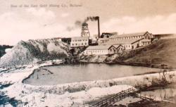
Star of the East gold mine
Mining in Ballarat has ever been a capricious and tantalizing occupation – the deep leads particularly so. Italian miner Rafaello Carboni described it thus: “This Ballarat, a Nuggety Eldorado for the few, a ruinous field of hard labour for many, a profound ditch of Perdition for Body and Soul to all.”

Article supplied by Gerry Tobin, Australia

Seeking gold in Transylvania

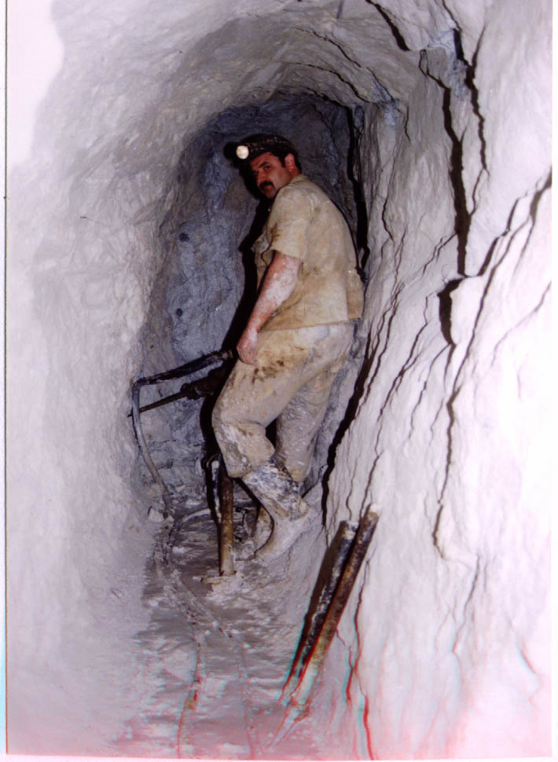
Work face Filon 13 of the Barza plan mining operation in the Old Valley of Mills. The gallery is driven along the narrow vein with visible gold wires. The new gold samples of Brad museum are from this locality.

‘The hills bordering the road from Zlatna to Offenbanya [presently Baia de Aries] did not from seem from the beginning interesting neither from the point of view of oryktognostic [mineralogical] nor metallurgy. However, what a pleasant surprise after about a quarter of mile, when I came to three gold stamps. I asked where the ore was supplied. And, imagine, to my surprise, I was told and verified it myself, after removing the fertile soil, the slime was washed away by rain, and from the remaining sand and gravel, the most beautiful gold was washed. The idea, that I am riding horse on gold, instigated my imaginations. Unnoticed, I put off my travel cap and made a bow to the land, in which one rides on gold. It seemed to me, that even my horse began to trample more loudly on this golden land. All my imaginations got so golden, that I did not think of anything else.’

This is the beginning of the book of travels across Transylvania [Romania] by the advisor and forestry inspector from Hermanstadt [present Sibiu] Dominic Athanes Guilleame. He was neither first nor the last. Before and after there have been many travellers, laymen and professional scientists and miners, inspired by the beauties and richness of this corner of Europe. Their interest has always had the same basis- gold. I feel very happy; I could be one of them. The territory of golden pentagon with the town of Brad as centre was, during the time of socialism in Romania, closed to foreigners for tens of years. As a passionate mineral collector, I was attracted by the rumours on beautiful druses of different minerals locally called ‘Flor de Mina’. For this purpose, I visited between 1985-1990, thirteen times the region of Maramures and its centre Baia Mare, in the NW part of Romania. We had experienced a lot of adventures, often unpleasant, since the government officials did not welcome the mineral collectors. That is why I appreciate my collection of minerals linked to exciting memories. Only in the course of recent years, three times I succeeded in visiting the largest European gold mining region called ‘golden pentagon’, and the town of Brad.
The mining region spreads 30 x 50 km, occupying part of Eastern Carpatian Mountains called Muntii Apuseni or Muntii Metaliferi. They are bordered by the rivers Aries on the north, Muresul on South Crisul Alb cutting deeply from the W. The area has the shape of irregular pentagon, limited by lines connecting Baia de Aries - Zlatna – Sacarimb – Certej – Caraci, west of Brad town.
Hydrothermal vein deposits are the main type. They are hosted in the Neogene volcanic rocks [andesite, rhyolite]. The veins are usually steep [above 45º], and 0-1.2 m thick. Their length ranges from tens of meters to several km. The grade varies from 10 to 100 g/t, at the visible gold up to several thousands. The veins filling is quartz / carbonatic, containing ore minerals like galena, sphalerite, pyrite, arsenopyrite. Native gold occurs as free in sulphides and quartz-carbonates mass as well. Intensive mining of tellurides occurred in some places in the past.
Disseminated hydrothermal gold deposits form the second group. They occur in volcanic rocks – andesites and rhyolites. The grade varies between 1-1.5 g/t. Currently mined Rosia Montana is considered to be the largest European gold deposit.
Hydrothermal replacement deposits occur in andesite environment. The mineralization grading 1.5 g/t is linked to vent breccias [Baia de Aries].
The beginning of gold mining reach deep into B.C. era. The Greek historian Herodotos stated that the third great king of Persia –Darius Hystaspes, during his campaign against Scyths in 513 B.C., met the tribe of Aghatyrs on the banks of Maris river [Mures [, who wore beautiful golden jewellery. Agathyrses were expelled by Dacis who were ruled around 100 A.C. by king Decebal. After the conquer of Dacis by the Roman emperor Traianus in 107 A.C., Dacia became the Roman province. Many historical remnants remained from this era, such as tombstones, household utensils, miner tools, and old galleries as well [Rosia Montana [. Also the Lathin names of the settlements like Rosia Montana = Alburnus Maior. The mining activity had been organized, by ‘Procurator aurarium’. The labourers were mostly convicts, often Christians, whose verdict was ‘in metallum’ or ‘ad metalla damnatus’. The considerable quantity of gold was won from the placers. Reportedly, only under Traianus 165 t of gold were exported to Rome. Till the end of Roman rule in 273 about 1,600 t of gold were exported to Rome. In the 9-th century A.C. the region was conquered by Hungarian tribes. The original population, who had merged with Romans [Romanians], survived only in mountains. During the peaceful times they spread in to the valleys. During the 12-13th century the region was colonized by Germans, mostly Saxonians. The rulers were frequently changing [Among them Vlad Dracula] till 1687, when the Transylvania was annexed by the Austrian Empire. Under the Empress Maria Theresia it was promoted to Grand Ducky in 1765. In the Transylvania lost its independence and was included into Hungary. Tens of years of magyarization ended by changes after the I-st and II-nd world wars and finally the Transylvania was incorporated into present day Romania. The first records on gold production in middle Ages are from the first half 13-th century [League of mining towns]. Also in this time, along with hard rock mining, there was large contribution of gold was from placers. The data on mining, both in Middle Ages and modern time. I was not able to compile. However, similarly as in Banska Stiavnica – Hodrusa region, the peak of mining productivity was in 18-th century and later, before and during the W.W.II. – 1930 – 1945. During the socialism era, there was a quantitative boom in ore extraction, however, the grade was falling down and the whole activity became unproductive. It could continue and has continued up till now only with heavy government subsidies. At present there are five active mining plants in this region, specializing in extraction and processing low-grade ores. They belong to the Minvest Deva Company and are as follows:
Barza
Zlatna
Certej
Rosia Montana
Baia de Aries
Their current production is around 2 t/a. The hydrothermal deposits are extracted both by surface and underground operations. The ore treatment is by flotation methods. The gravitation methods are not used, however, the amalgamation is still applied. The flotation concentrates are cyanized and the precipitate is processed in the local refinery.
At least the hints of the production levels can be seen from the diagram from still operating plant Barza. With the permission I took the picture in the museum in Brad. It was during my first visit. It shows the production between 1885 – 1997. The plant started its production in 1885. Until 1910 its production gradually rose to 2 t/a at the ore grade of 10-30 g/t. Later till 1920 the production dropped below 1 t/a at the grade less than 10 g/t. After that, the extraction grew up to 200,000 t ore/a at the grade 20-30 g/t. Shortly before, and during the W.W.II. The production rose to 4-5.2 t/a. After the war, the ore extraction rose to 4-5.2 t/a. After the war, the ore extraction rapidly rose up to 900,000 t/a in 1968, however, the grade gradually sank. Also the ore extraction decreased later to the present level of 300,000 t/a, at the grade 1.52 g[t. It means, that about 37 mil t of ore has been extracted so far from the Barza deposit, yielding almost 200 t of gold.

I have visited the golden pentagon in Transylvania three times between 1998 – 2000 in order to get acquainted with the local gold production. Except for Zlatna I visited all active gold plants and saw many interesting things liked to the gold production.
Rosia Montana plant is located about 50 km NE of Brad town, in the river Aries valley. The mining activity goes back to Roman era. Right on the plant area is underground as well as open air museum having chiselled underground galleries both from Roman and Mediaeval era, water driven stamps, Californian stamps, man driven stone mill for ore grinding, flotation line and Roman tombstones. Disseminated ore averaging 1.5 g/t is extracted by quarrying in quantity of 400.000 – 500.000 t/a. According to plant officials and to literature, it is the largest known gold deposit in Europe. It is also reflected in the interest of foreign investors. The picturesque town is located right next to the plant. The glory of the past centuries is reflected in the numerous Renaissance and Baroque style buildings, unfortunately in bad shape. A massive development of the mining activity is expected in a short time and the town with its historical core would be the victim. I am sorry for it, however, nothing could be done. There was still a relatively intensive gold panning done by Gypsies and also Romanians in the stream below the plant till the middle of the 20-th century. The special wooden pans were used, which will be described later.
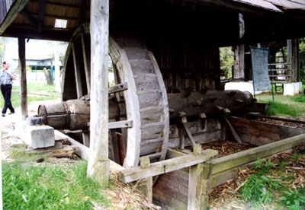
Open-air museum in Rosia Montana plant. The water driven wood stamps crushed the ore prior to gravitation treatment.

Certej plant is situated about 30 km SE of Brad town. To the Coranda open pit belongs also Sacarimb deposit well known for the tellurides mining in the past [Nagyagit]. The present mining is oriented to steeply dipping veins, however, mostly to the old back fills, that grade between 5-6 g/t. The Certej deposit, like the Rosia Montana yields poor disseminated ores, extracted by quarrying, and some part by underground methods as well. The ore from the mine, 200 t/d, is treated in a wooden plant from 1934. 2,000 t/d of ore from the quarry is treated in the new dressing plant. The total ore extraction is around 500,000 t/a.
After the plant excursion we set for a visit to the Scarab area, well know for beautiful samples of native gold and the telluride’s mining. The narrow asphalt road gradually gave way to a steep stony one. The normal car cannot pass it without problems. The miners settlements are squatting on the steep slopes, next to the adits of different mine levels. When passing through one of them an old man in a fluent Slovak greeted me. His name was Jozef Tokar. He was a Hungarian and complained, that his wife, who was Slovak, had died just recently. He told us many interesting stories about his difficult miner’s live.
Baia de Aries plant is the most remote from the Brad town, about 80 km NE. It is located in a picturesque valley of the gold bearing river Aries. Many remnants from the intensive placer mining form small hills, visible on the banks. The gold mining here reaches also back to Roman times. Two deposits are mined presently. Replacement Pb-Zn-Cu deposit [100,000 t/a] and breccias with the low gold content 1-1.5 g/t [250,000 t/a]. Richer vein bodies had been extracted long ago. We could not resist the temptation and made wet our pans. The reward was in form of several gold grains.
Barza plant is located immediately at the Brad town, on its E outskirts. I visited its surface and underground operations during my second and third journey. Its activity is oriented to thin, steeply dipping hydrothermal veins. The plant premises, including the portal of the main transport adit ‘Galerie of 1. May’ are situated in a side valley of the Crisul Alb river, with a nice miner’s name ‘the old valley of mills’. I visited several work faces. The rich ore is handpicked, using a special hammer and placed into metal pans. Later, it is tipped into transport containers that are carried out by miners. The remaining ore is blasted. During our last trip we visited a face with visible wire shaped gold. The handpicked ore was certainly above 1,000 g/t. After the faces inspection, accompanied by plant manager, we were all checked by the foreman to avoid taking of gold samples. When reaching the surface, we watched miners [special room] to hand over 10-20 kg heavy containers with rich picked ore, samples with visible gold and mineral crystals as well. After reaching the surface, all miners are subjected to personal check-up. Here I also noticed wooden pans hanging in a row on the wall. They had been carved from on piece of wood and for me, panner, very interesting. I could not stop thinking of how to acquire some of them.
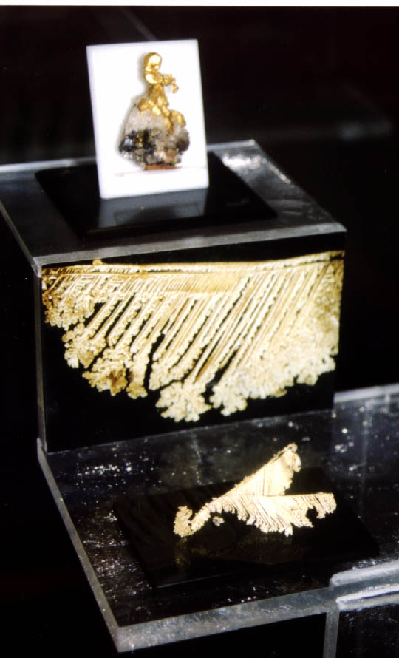
Museum of gold in Brad. The golden butterfly. Above is enlargement of its wing
Museum of Gold in Brad belongs to one of the best know of its kind. It is placed in a low, relatively shabby building, in the middle of town. Reportedly it was based in 1896. It got the present shape in 1972. It consists of historical, technical, gold and mineralogical exhibitions. In the first one

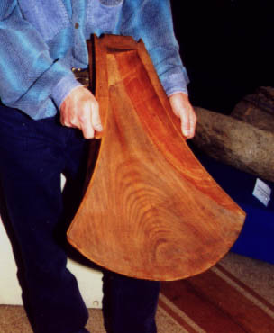
‘Shaitrok’, the Transylvanian wooden pans out of one piece of wood. I am glad this is in my possession
I was attracted by the ceramics lamps from Roman times or early Middle Age, historical photographs of local gold diggers, of course, with the interesting pans called ‘shaitrok’. However, nobody was able to explain the way of his or her use at gold panning. In gold exhibition there are samples of gold and tellurides from all localities of gold pentagon. The native gold samples are very impressive. I was also impressed by the gold grains panned from the Local River and streams. The mineralogical exposition supplements the first two ones. The culmination point of our visit was the inspection of new samples from faces in Barza plant. They were from the stopes, that I had also visited and saw the wire shaped gold. I could touch them, take pictures, however, no way to acquire them.
The Carpathian range Muntii Metallliferi, in which the town of Brad and the whole golden pentagon is located is exceptionally impressive. The mining region has many similarities with our Banska Stiavnica in Slovakia. As the mining specialist, gold panner and tourist, I always discover something new. That is, I like returning back. I
Am already looking forward to gold panning in the streams around Brad, or in Aries River.

Richard Kana II

Dates for your Diary…..

GOLDPANNING CHAMPIONSHIPS IN 2001

NATIONAL CHAMPIONSHIPS

- Polish Championships
26th-27th May 2001, Zlotoryja
Information: The Polish Guild of Gold Prospectors, ul. Eromskiego 15 A, 59-500 Zlotoryja, Poland. Tel/Fax 048-76-8787440, e-mail: pbkz@pro.onet.pl http://www.gold2000.pro.onet.pl

- Swiss Championships
23rd-24th June 2001, Brig, Canton Valais
Information: Swiss Goldprospectors’ Association, c/o V. Jans, Veilchenstr. 15a, CH-6010 Kriens, Tel. 041-3406824, e-mail: sgv@goldwaschen.ch, web site: http://www.goldwaschen.ch/egold_sm01.htm

- Yukon Gold Panning Championship
1st July 2001, Northend Park, Dawson City, Yukon, Canada
Information: Klondike Visitors Association, Box 389, Dawson City, Yukon, Canada YOB 1GO, e-mail: kva@dawson.net, web site: http://www.dawsoncity.com

- French Championships
7th-8th July 2001
Information: FFOR, Nenert Serge, La Villatte, 23500 St Quentin La Chabanne, France Tel/Fax. 05 55 66 55 34, e-mail: serge_nenert@yahoo.com

- Austrian Championships
7th-8th July 2001, Rauris
Information: Austrian Open, c/o FVV, Postfach, 5661 Rauris, Austria, e-mail: rauris@ping.at

- Swedish Championships
14th-15th July 2001, Kopparberg
Information: Swedish Goldpanning Association

- Czech and Slovak Championships
24th-26th July 2001, Zlate Hory, Czech Rep.
Information: Czech Goldpanning Association

- Finnish Championships
3rd-5th August 2001, Tankavaara
Information: Goldpanning Finnish Open 2001, 99695 Tankavaara, Finland, Tel. +358-(0)16-626171, Fax +358-(0)16-626271, e-mail: tankavaara@saariselka.fi, web site: http://www.urova.fi/~kulta

- Belgian Championships
25th-26th August 2001, Faymonville, Waimes
Information: Bruno Van eerdenbrugh, Rue Bassenge 4, 4000 Liege, Belgium, Tel. 32-4-2213919, e-mail: Bruno.van.eerdenbrugh@tnt.com

* EUROPEAN GOLDPANNING CHAMPIONSHIPS IN 2001
25.6.-1.7.2001, Victimula Gold Village, Vermogno, Zubiena, Biella, Italy
Information: Associazione Biellese Cercatori d’Oro, 50 Via Debernardi – Vermogno, 13888 Zubiena BI, Italy Tel. +39-330-681983, Fax. +39-015-94939, e-mail: euro2001.abcdoro@libero.it, web site: http://www.digilander.iol.it/abcdoro

* WORLD GOLDPANNING CHAMPIONSHIPS IN 2001
22.-28.10.2000 Maryborough, Victoria, Australia

Information: Australian Goldpanning Association Inc, PO Box 480, Maryborough, Vic 3465, Australia, Tel/Fax. 61-3-54614709, e-mail: freddo@iaa.com.au, web site: www.visitvictoria.com

OTHER COMPETITIONS

- NT Gold Panning Championships (Australia)
5th-7th May 2001, Pine Creek, NT, Australia

- St Yrieix Open (France)
2nd-4th June 2001 St. Yrieix la Perche, France
Information: French Goldpanning Federation, Serge Nenert, La Villatte, 23500 St Quentin La Chabanne, France, Tel/Fax. 05-55-66-55-34, e-mail: serge_nenert@yahoo.com, web site: http://www.saint-yrieix.com

- Lannavaara Open (Sweden)
7th-8th July 2001 Lannavaara, Sweden
Information: Swedish Goldpanning Association

- Ullånger Open (Sweden)
28th-29th July 2001 Ullanger, Sweden
Information: Anki Hamberg, Viksäter 2550, 87032 Ullånger, Sweden, Tel. 0046-61310669, e-mail: miranatura@swipnet.se

- Far Nth Qld Gold Panning Championships (Australia)
August 2001, Chillagoe, QLD, Australia

- Qld Goldpanning Championships (Australia)
20th October 2001 Gympie, Queensland, Australia
Information: Gold Rush Festival, P.O. Box 248, Gympie 4570, Australia, Fax 07 5482 1954, e-mail: festival@goldrush.org.au, web site: http://www.goldrush.org.au

_______________________
* EUROPEAN GOLDPANNING CHAMPIONSHIPS IN 2002
1.-7.7.2002 St Yrieix near the Le Bourneix Mine, France
Information: French Goldpanning Federation, Serge Nenert, La Villatte, 23500 St Quentin La Chabanne, France, Tel/Fax. 05-55-66-55-34, e-mail: serge_nenert@yahoo.com, web site: http://www.saint-yrieix.com

* WORLD GOLDPANNING CHAMPIONSHIPS IN 2002
26.8.-1.9. 2002, Kutcharo Lake Side, Hamatonbetsu, Japan
Information: All Japan Goldpanning Association, 154, Hamatonbetsu, Esashi-gun Hokkaido 098-5792 Japan, Tel.+81-1634-2-2345, Fax. +81-1634-2-4766

* WORLD GOLDPANNING CHAMPIONSHIPS IN 2003
12th-17th August 2003 Willisau, Switzerland
Information: SGV, Friedrich Grundbacher, Moosstrasse 34, 3113 Rubigen, Switzerland

* WORLD GOLDPANNING CHAMPIONSHIPS IN 2004
Slovak Rep.

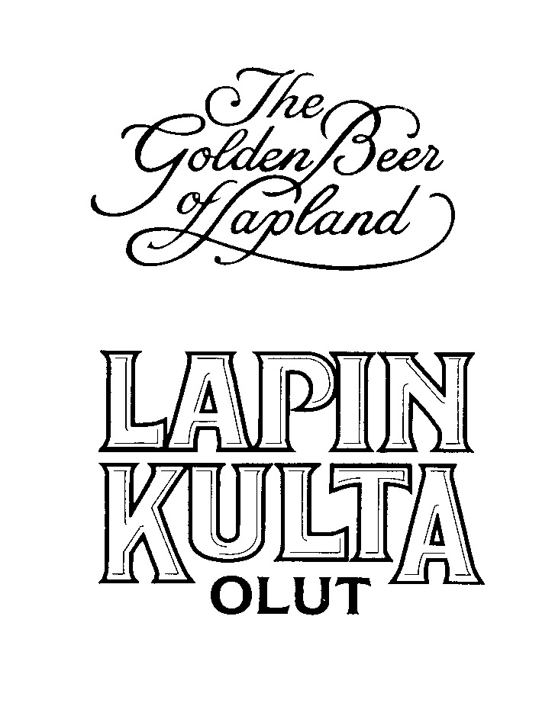

Golden Times
The Official Newsletter of the World Goldpanning Association
ISSN 1238-0083
Publisher: Kauko Launonen, FIN-99695 Tankavaara
Tel: +358-16-626158, Fax,+358-16-626261
Editors:
Paul Thurkettle USA 757-848-9070 FAX 757-445-3785 Email: thurkettle@hotmail.com
Address: 306 Riverside Dr, Hampton, VA, 23669 USA
Pirjo Muotkajárvi, FIN-99695 Tankavaara-Email:pirjo.muotkajarvi@kultamuseo.inet.fi
Tel: +358-16-626171, Fax,+358-16-626271
Website: http://www.urova.fi/~kulta

