
Siemens Zrt. Késmárk street plant
24-28. Késmárk str
H-1158 Budapest XV.
Route Description for Visitors

Airport information:

You arrive at the airport Liszt Ferenc Terminal 2.

Just before the passport checking desk there is a currency exchanger on the left-hand side in case if you need local currency at an acceptable rate. Nevertheless credit cards are accepted in most shops, markets and restaurants.

After passport checking and baggage claim you get to the arrival lounge.

On the right hand side, you can find the minibus service desk where you have the opportunity to buy a ticket to your destination place. Price is 4.000 HUF (approx. 13-14 EUR) per person to the City Centre of Budapest (in year 2012).

In the arrival lounge there are several counters for Car Rental Services. All companies provide a free shuttle bus to their car parking facilities. We recommend using the National Car Rental Service. Unfortunately there is no National counter at the airport but at the information desk on the left-hand side the car rental process can be arranged by request.

Before renting a car, it is important to know that in Hungary it is strictly forbidden to drink any alcohol when driving. In Hungary the following speed limits are existing:

− Inhabited area the maximum speed limit is 50 km/h − On roads the maximum speed limit is 90 km/h
− On highways the maximum speed limit is 130 km/h
According to the current regulations the penalties are rather high, up to 100.000 HUF (approx. 400 EUR), and may lead to license withdrawal.

How to get to Siemens Zrt. Késmárk street plant from the airport

As you drive out of the Airport area, you get to the main road number 4 where you have to turn right (see pic. 1).
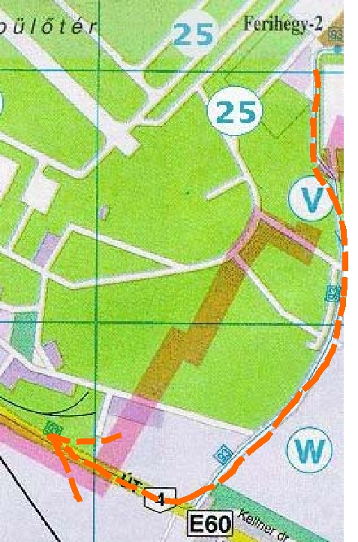

pic.1.

Just go straight ahead for approximately a quarter of an hour keeping in the left lane, because the road will split later. You will cross an over-bridge and proceed until you can see a big sport stadium (Ferencváros) on the left-hand side of the road. Before the stadium there is a busy junction (Könyves Kálmán street – Üllői street) where you have to turn right as it is shown by the red arrow (see pic.2):

Page 1 of 5

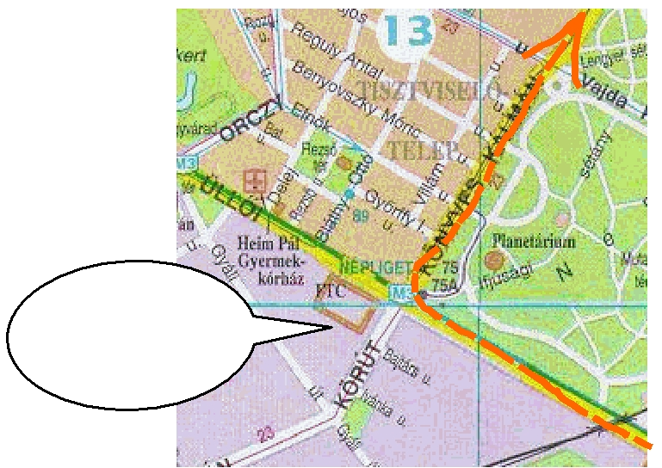

Sport

Stadium

pic.2.

On this street just go straight. Please notice that the name of the street will change as you proceed. Once you can see another big sport stadium called “Népstadion”, which is now under construction please turn right as the arrow shows (pic. 3). After the next junction the road will split so please stay in the left lane and proceed to the left as shown by the arrow:
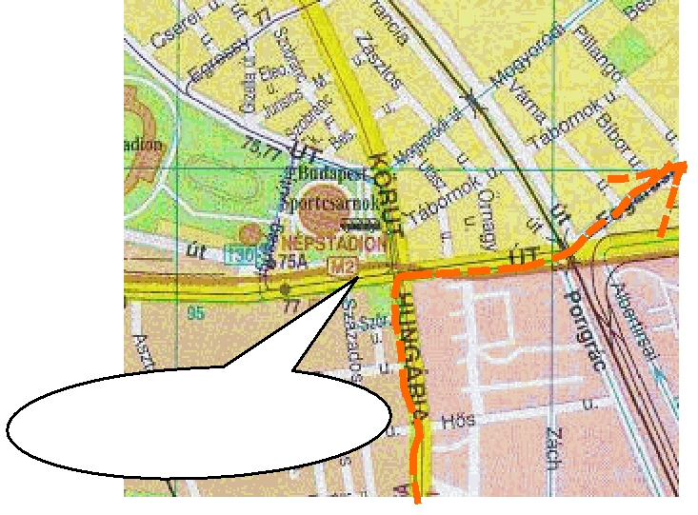

„Népstadion”

pic.3.

This road “Fogarasi street” will be called “Csömöri street” later on. As you proceed on this road you will cross an over-bridge (see pic. 4). Afterwards, please follow the red line of the map through a housing area to finalise your trip to Erőműtechnika Kft.

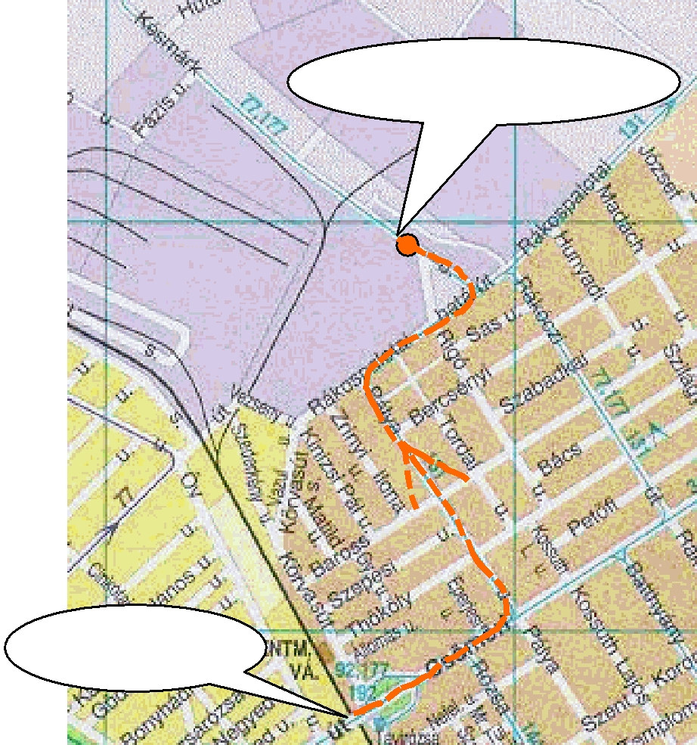
Siemens Zrt.
Késmárk street plant

Over-bridge

pic.4.

Page 2 of 5

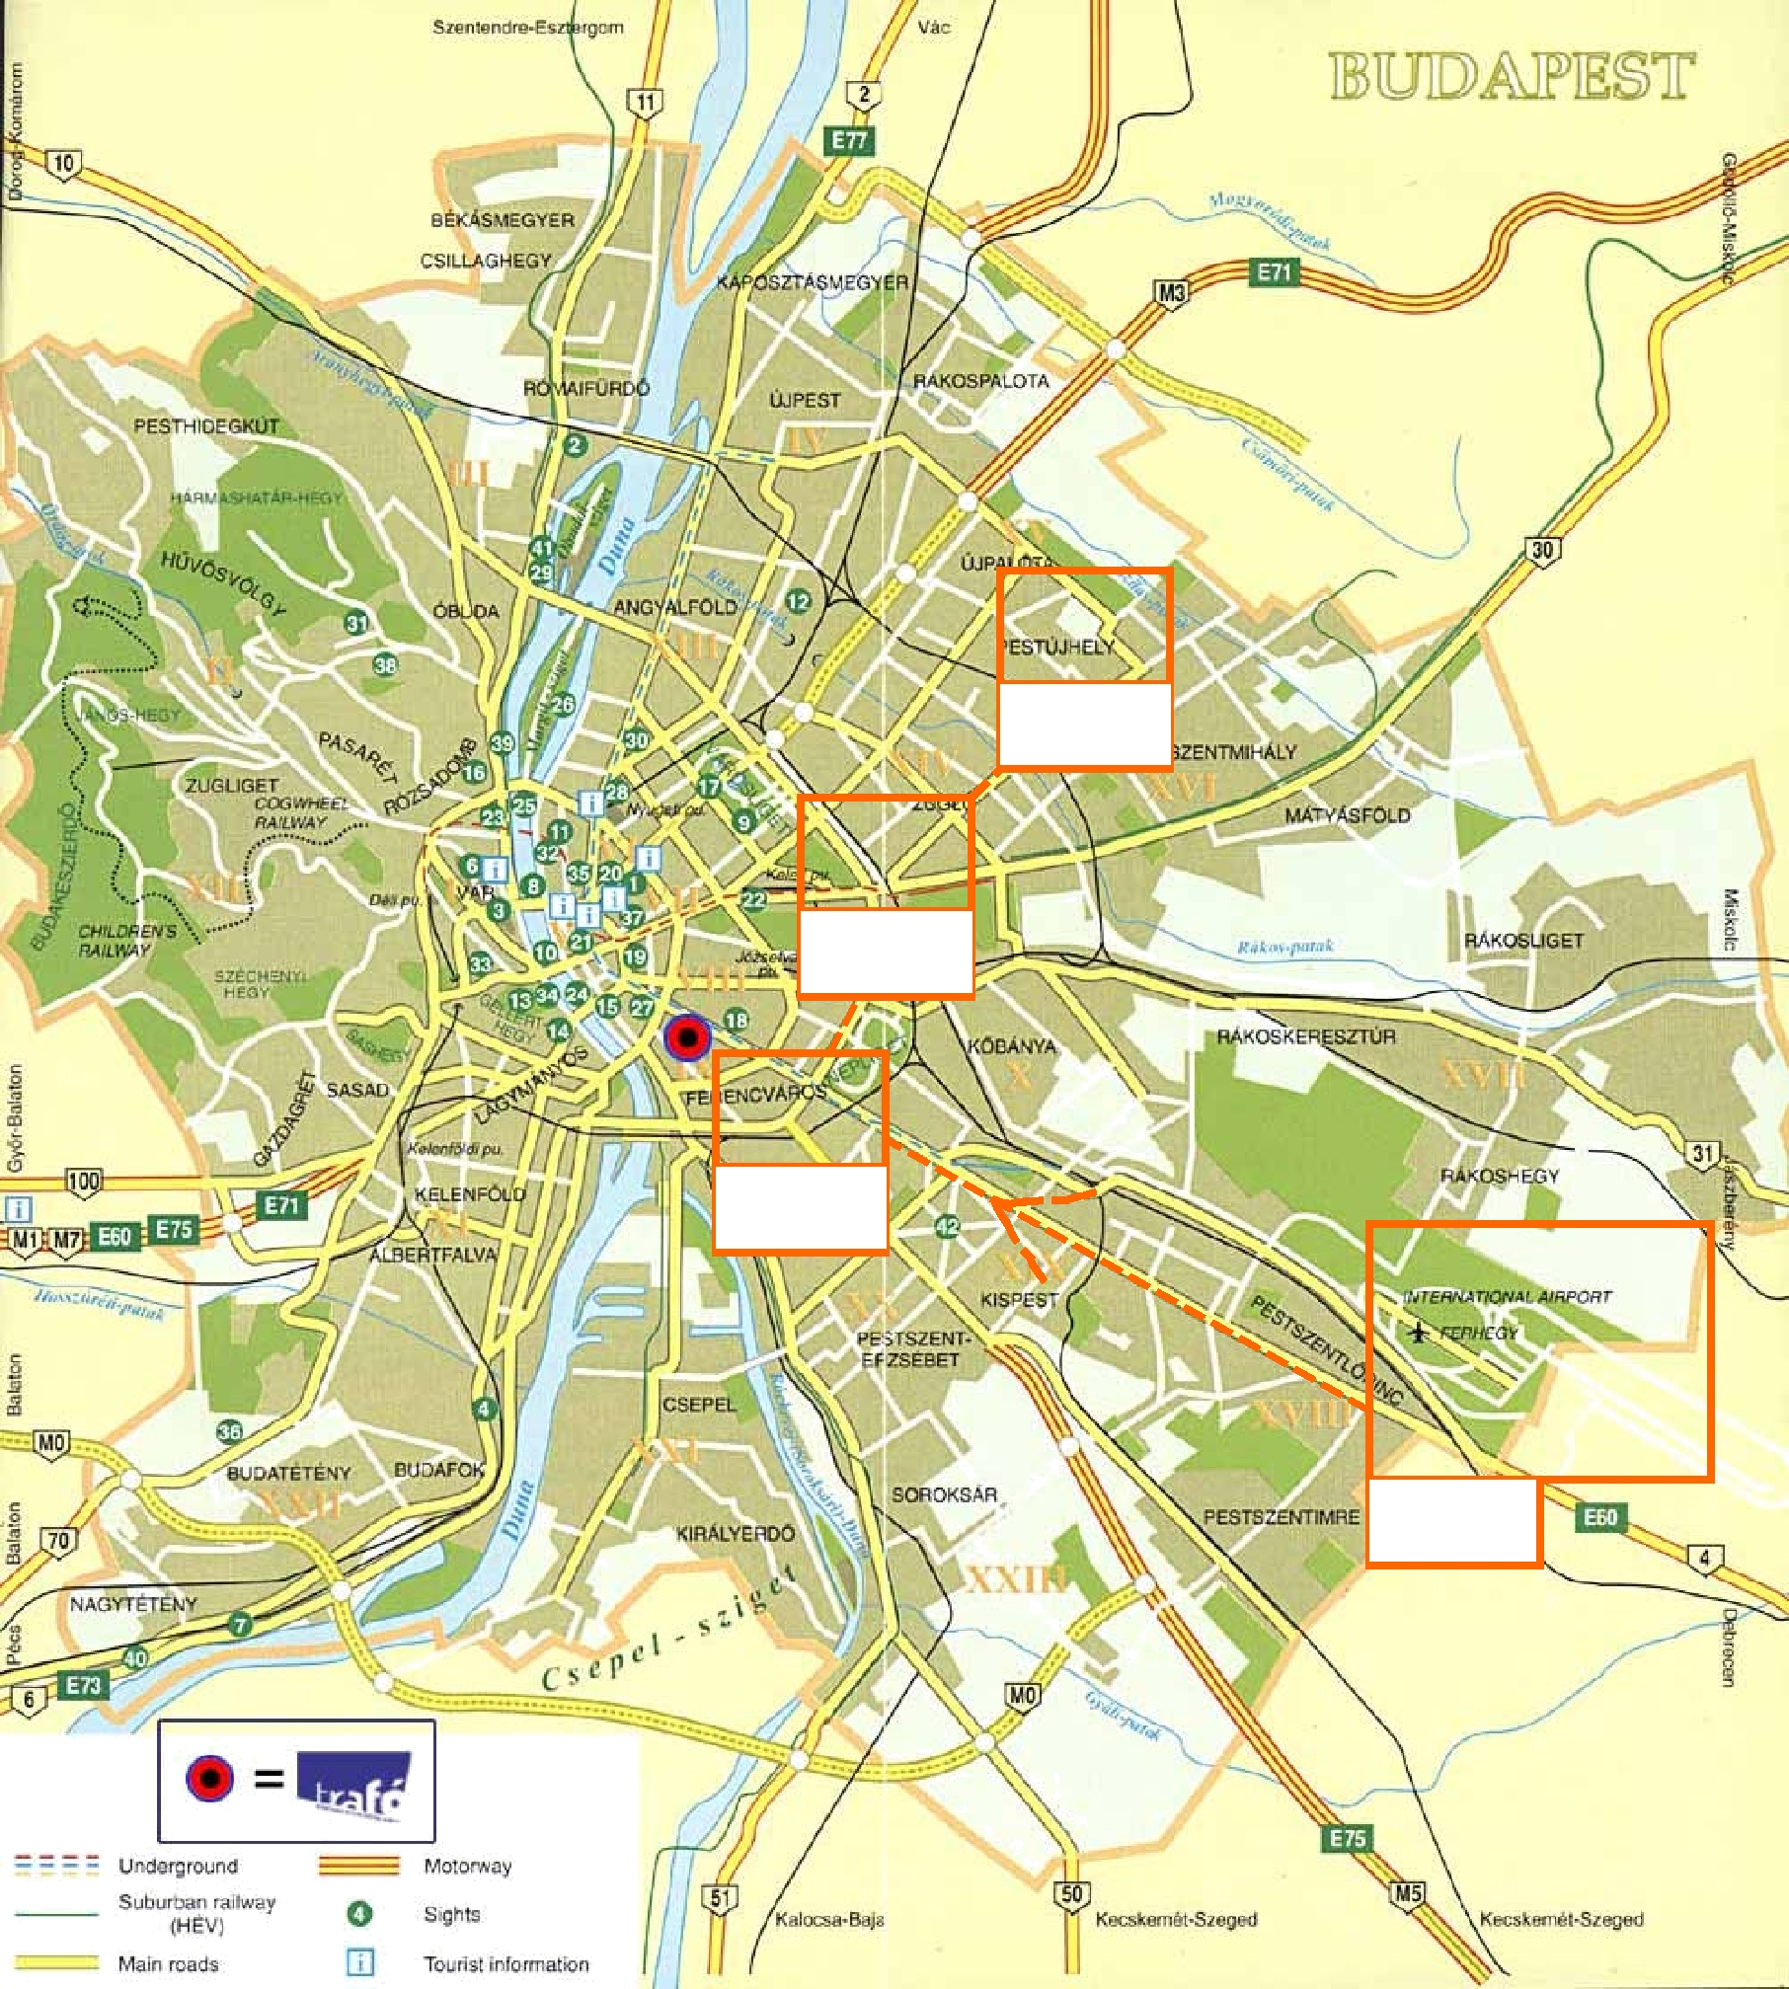

Pic.4.

Pic.3.

Pic.2.

Pic.1.

Contacts at Siemens Zrt Késmárk street plant:

Person | Office | Phone Number | Language skills
Mr. Dr. Stefan Pieper | 1st floor, room 101 | +36-1-414-4710 | German, English
Plant Manager
Secretary of Director | 1st floor, room 101 | +36-1-414-4700 | Hungarian, English
Mr. Árpád Goszták | 1st floor, room 101 | +36-1-414-4720 | German, English
Director of Business Administration
Mr. Sandor Lajko | 3rd floor, room 322 | +36-1-414-4786 | German, English
Leader of the Network Engineering
Secretary of Network Engineering | 3rd floor, room 322 | +36-1-414-4690 | Hungarian, English

Page 3 of 5
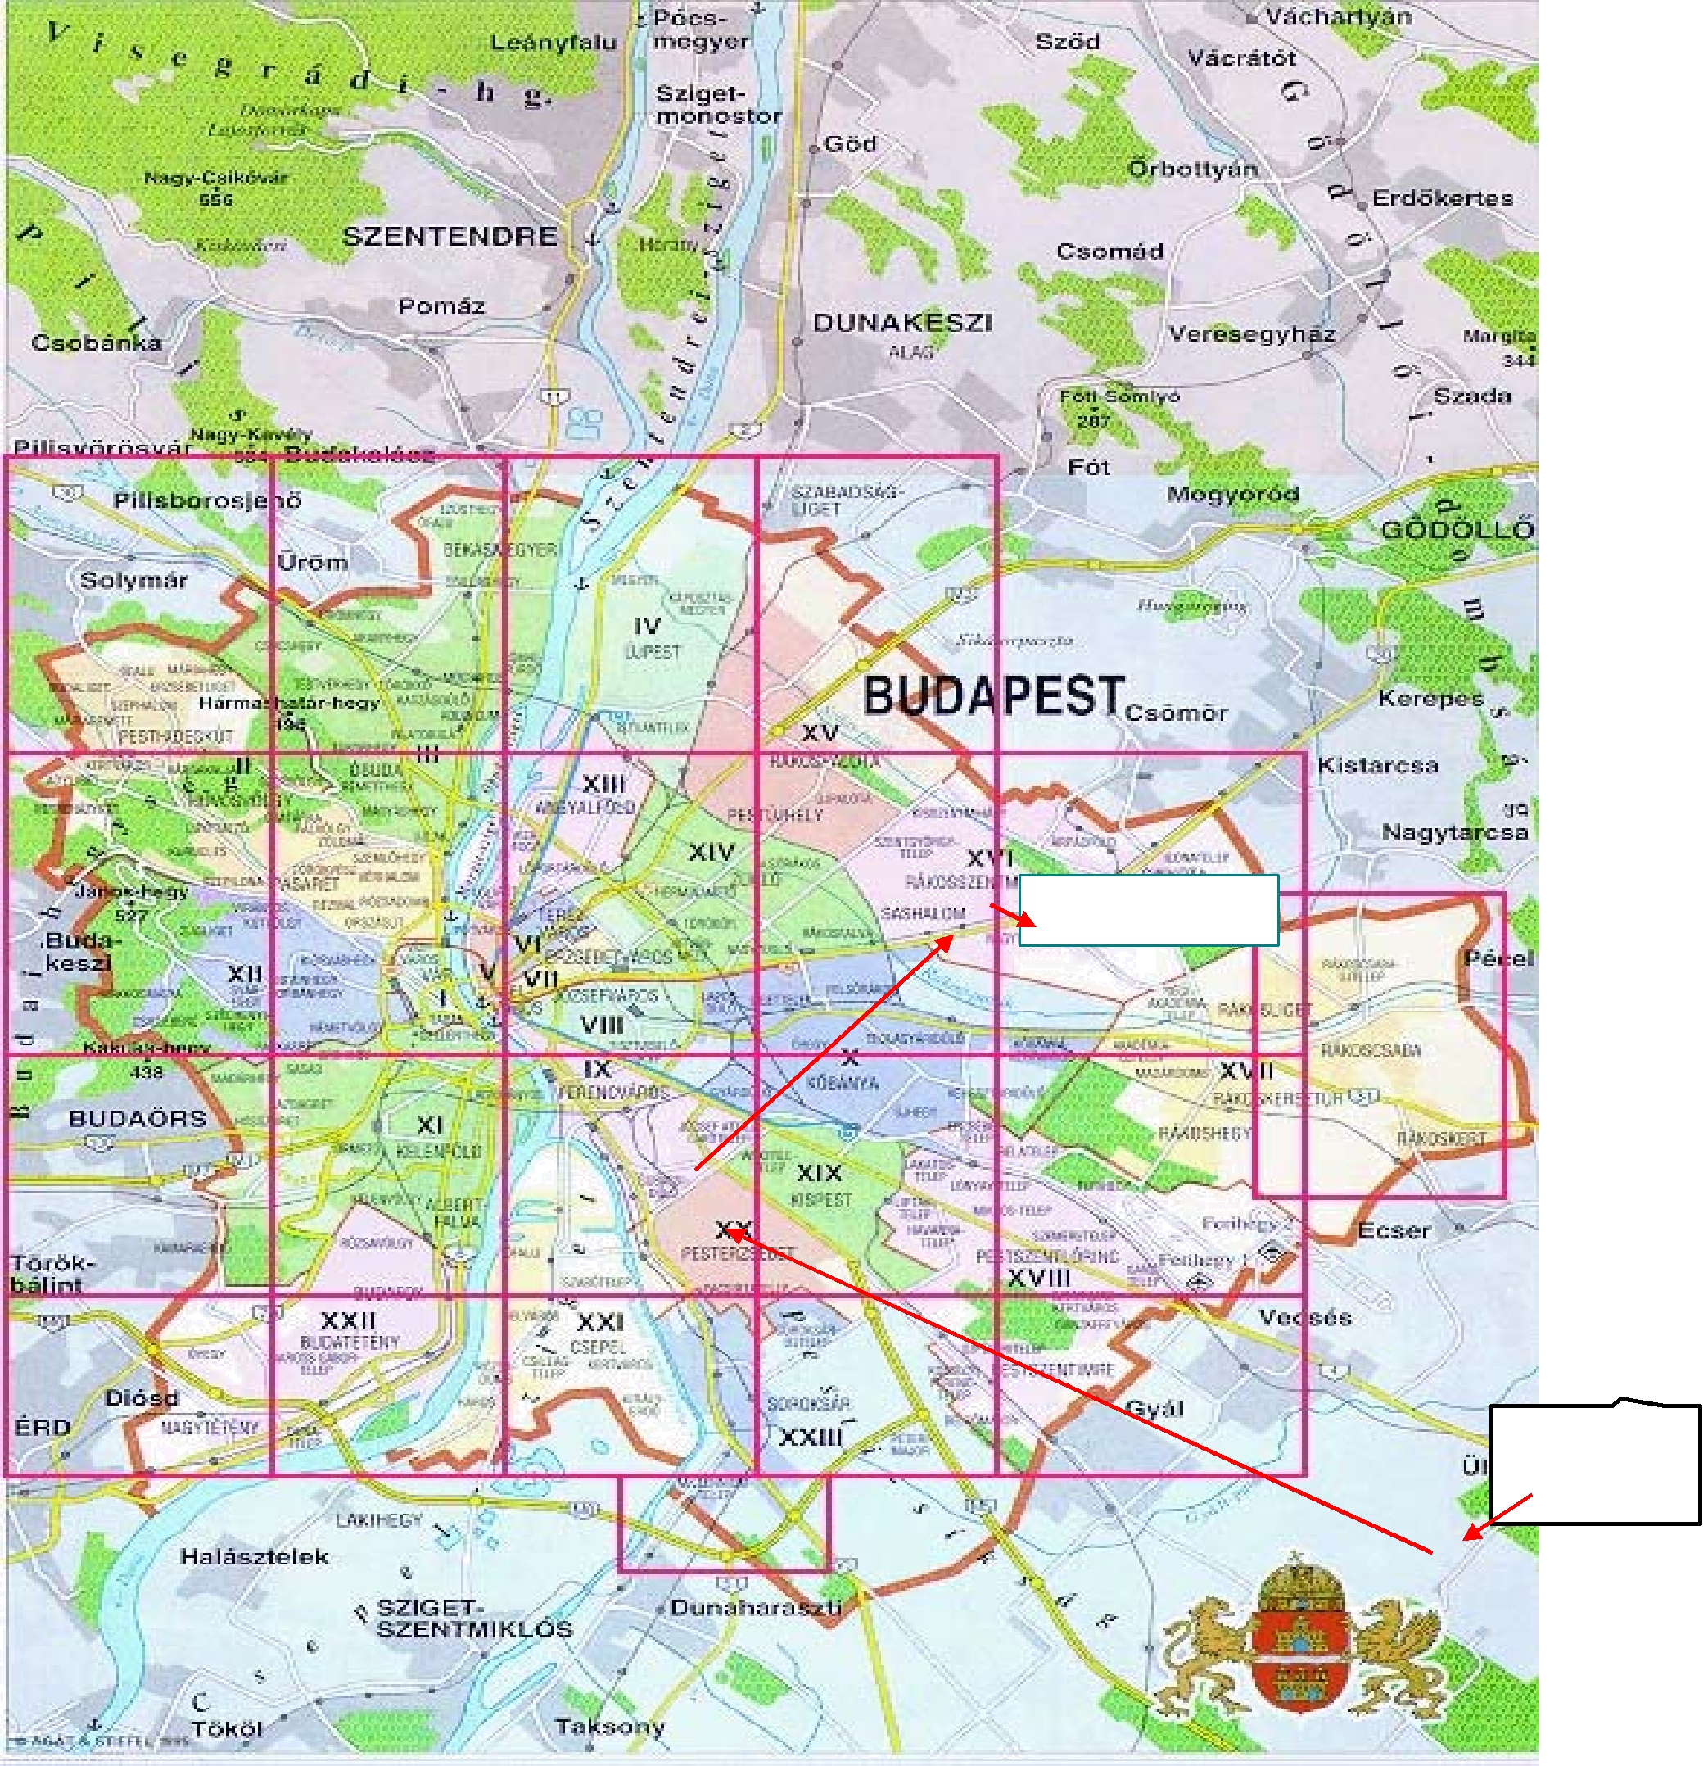

Késmárk str plant

Liszt Ferenc airport

Page 4 of 5
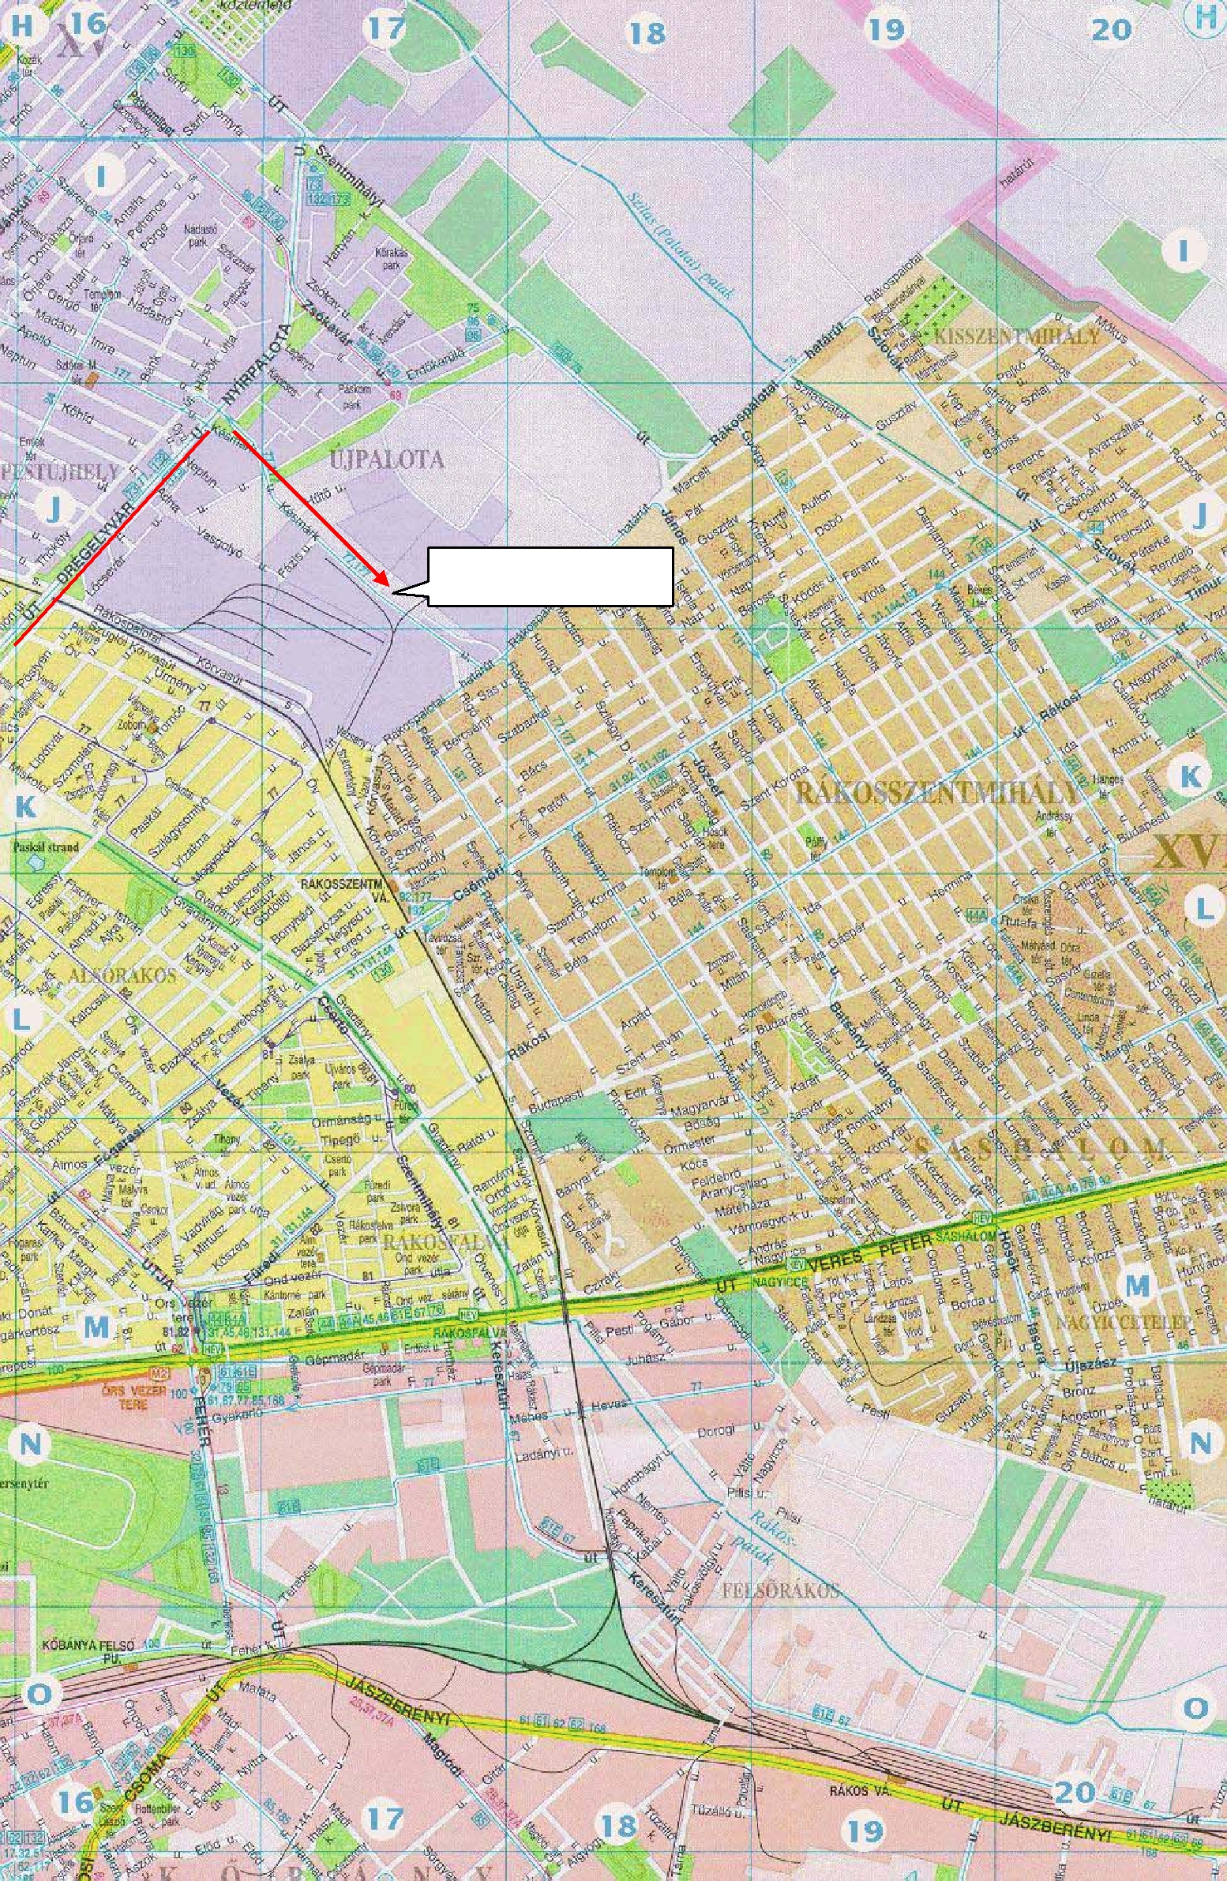

Késmárk street plant

Page 5 of 5

