M.Ed. in
SPORT MANAGEMENT



Department of Wellness and Sport Sciences

Student Handbook

Dr. Mowrey
Sport Management Program Coordinator
rebecca.mowrey@millersville.edu
(717) 871-4214

V.5/16

Welcome!
Welcome to the Master’s of Education in Sport Management program at Millersville University. Your decision to pursue this graduate degree marks an important step in your career. The graduate faculty of the Wellness and Sport Sciences Department (WSSD) have developed a comprehensive sport management curriculum that follows the recommended guidelines of the North American Society for Sport Management (NASSM). Your course of study leading to the M.Ed. draws on expertise in sport science, educational theory, research and business administration. We anticipate that your experiences at Millersville University will be both challenging and rewarding.

On the following pages of this handbook you will find important and helpful information that you will need to reference throughout your time as a student in the M.Ed. in Sport Management program, so be certain to retain your handbook until graduation. It is imperative that you now read through this handbook and complete steps 1-8 as indicated. These steps address common concerns and questions. Please contact your faculty advisor if you have further questions, as we want you to enjoy your graduate experience at Millersville University.

Best wishes for success as you work towards the completion of your M.Ed. in Sport Management.

On behalf of the WSSD Graduate Faculty, welcome and best wishes,
Dr. Mowrey, Sport Management Coordinator

The Graduate Faculty of the Wellness and Sport Sciences Department

Faculty Phone E-mail

Dr. Dupain 871-4215 mdupain@millersville.edu

Dr. Keefer 871-4218 dkeefer@millersville.edu

Dr. Lombardi 871-4213 jlombardi@millersville.edu

Dr. Mowrey 871-4214 rmowrey@millersville.edu

Dr. Nesbitt 871-3705 gnesbitt@millersville.edu

Dr. Wimer 871-5367 jwimer@millersville.edu

Dr.Wushanley 871-4211 ywushanley@millersville.edu

TABLE OF CONTENTS

IMPORTANT FIRST STEPS……………………………………………………….………..4

TIME LINE/CHECKLIST……………………………………………………………..……..9

INTERNSHIP REQUIREMENTS/DOCUMENTS……………………………………….…11

DEGREE AUDIT REPORT………………………………………………………………….15

GRADUATE ASSISTANT PROGRAM
Information………………………………………………………………………...…17

SPORT MANAGEMENT PROGRAM
Members Only Website………………………………………………………18
Employment Outlook………………………………………………………....21

I.D. CARDS
Using your I.D. …………………………………………………………….....21
Lost I.D. ………………………………………………………………………22
Important Notes……………………………………………………………….22
Marauder Gold Accounts……………………………………………………..22

INSURANCE
University Sponsored…………………..…………………………………………...…24

GRADUATE STUDENTS’ ORGANIZATION…………………………………………….…25

DIRECTIONS TO MU CAMPUS………………………………………………………..……25

DIRECTIONS TO MU-LANCASTER…………………………………………………..……26

HOUSING AND RESIDENCE……………………………………………………..…………27

PROFESSIONAL DEVELOPMENT/ORGANIZATIONS OF INTEREST………………….28

STUDENT SERVICES SUMMARY……………………………………………………...…..29

APPENDIX OF FORMS
Request for Change of Curriculum……………………………………………32
Request to Add or Change Concentration…………………………………….33
Internship Application…………………………………………………….…..34
Application for Admission to Degree Candidacy…………………………..…36
Application for Graduation……………………………………………..……..37

Step #1: Contact information

Within two weeks of your acceptance, please complete this form and return it to the address below. A returnable form is located in the Forms and Paperwork section of the members only website. If any of this information changes while you are enrolled in the program, please complete the Change of Contact/Personal Information Form found in the Forms and Paperwork section of the members only website. Thank you.
***If your employer has a firewall application in place that will prevent reception of outside e-mail, please provide an alternate e-mail address***

Contact and Personal Information

Full Name M.U. #

( ) ( )
Home phone Cell phone Marauder E-mail address

Concentration Year and semester of acceptance
(Note: You have 5 years from this date to complete your degree)

( )
Place of employment and title (if applicable) Work phone

_________________________________________________________________________
Home or Work Email Address

Mail to: Dr. Mowrey, Sport Management Coordinator, Pucillo Rm. 112

Wellness and Sport Sciences Dept.

Millersville University

Millersville, PA 17551

Step #2: Obtain a copy of the Graduate Studies Catalog and Student Handbook

If you do not already have a current copy of the Millersville University Graduate Studies Catalog, contact the Office of Graduate Studies to request a copy, or refer to the online copy found at http://www.millersville.edu/~gcatalog/ . The Graduate Office can be contacted through one of the following means:
Web address: http://www.millersville.edu/gps/
E-mail: gradstu@millersville.edu
Telephone: (717) 871-4723
Once you obtain or view the catalog, read through the Academic Information, Sport Management Academic Program, and the General Information sections as you are responsible for adhering to this information.
You should also obtain a Student Handbook as you are responsible for adhering to this information as well. The student handbook can be accessed at http://muweb.millersville.edu/~handbook/index.php or obtained by calling the Office of Student Affairs at (717) 871-5344

Step #3: Forms

Complete the Verification of Student Understanding and the Contact and Personal Information form (returnable copies found in the Forms and Paperwork section of the members only website) and return both within two weeks of your acceptance to:
Dr. Mowrey, Pucillo Rm. 112

Verification of student understanding

I have read the contents of the M. Ed in Sport Management Handbook, the Millersville University Graduate Catalog and the Millersville Student Handbook. I know, understand and appreciate the content, and I understand that I am responsible for adhering to and abiding by the content of these documents. My signature represents my willingness to abide by these documents.

Name (print) __________________________________________________

Name (sign) __________________________________________________

Date_________________________________________________________
Step #4: Choose and register for courses

The courses in the M.Ed. in Sport Management Program are not sequenced; therefore, you may take courses the order that best suits your progress toward degree completion. Typically, students select the courses they take by determining the “best fit” with their work and personal schedules. If possible, it is advisable to enroll in EDFN 601 (Research Methods) early in your course of study, as it will likely assist you with the research you complete in other courses.

If you have any questions about course selection, please contact your faculty advisor as your advisor will be very happy to discuss course selection and other aspects of the degree with you.

Visit the Registrar’s Office website (http://www.millersville.edu/registrar/) to view semester course schedules, determine when you may register for courses, and obtain additional information regarding registration.

You may register for courses by following these steps:

REGISTER ONLINE VIA “MAX”

Instructions for first-time users:

1. Create your myVille and MAX accounts online at http://myville.millersville.edu/ (click on the “New Students Activate Account” link on this page and follow the on-screen instructions).
2. Access MAX from Millersville’s homepage and login with the User ID and PIN you created in Step 1.
3. Follow this menu path to get to the registration screen:
- Student Services
- Registration
- Add/Drop Classes
4. Select Term
5. Enter CRNs for your courses – Submit Changes.
6. Check your schedule – if “Registered” appears in the Status column on the left, you
successfully enrolled in the course. If there are any problems, you will see a “Registration Errors” block.

TIPS: Need help using MAX? Check out the on-line instruction booklet at this site
http://www.millersville.edu/registrar/scheduleandregistration/index.php
Open two web sessions: one to search for classes (has prerequisites and course restrictions listed) and the other to register on MAX

Registration Help Line 717-871-2400

Step #5: Purchase textbooks

Required and recommended course books and materials will be available for purchase at the MU bookstore, located in the Student Memorial Center on campus. Visit http://www.studentservicesinc.com/book-room/ to order books online or to get more information about the textbook room. Please contact the University Store Book Room at (717) 871-7610 to order books by phone if you wish to have them shipped to your address. Prior to this, you will need to have all of your course details such as:
- Course number and section
- Name of any optional books you would like to order
- Credit card information
- Shipping address
- Telephone number

You may also purchase books online or through local bookstores, but be careful to purchase the correct editions. The textbook information for all courses can be located by clicking on the little box marked “book info” beside each course registration listing.

Step #6: Learning Support Services

Millersville encourages students with cognitive or other disabilities to contact the Office of Learning Services in Lyle Hall at (717) 871-5344 to discuss their needs. Students requesting assistance must complete a request for assistance form and provide documentation regarding the nature of and limitations imposed by their disabilities. Accommodations are then arranged through the Office of Learning Services upon completion of this process. It is the student’s responsibility to initiate this process prior to beginning a course.

Related forms and more information can be found at http://www.millersville.edu/~ols/.

Step #7: I.D. Cards and Parking Permits

Identification Cards

Graduate students are required to have a Millersville University student identification card which may be obtained at the Campus I.D. Office in Boyer Computer Center. This identification card serves as a library and activity card. There is no charge for the initial I.D. card; replacement cost is $15. The office is open from 8 a.m. to 4:00 p.m., Monday through Friday. For more information on I.D. cards, see pages 21-23.

Parking Permits

If you will only be taking classes in the fall and/or spring semester, your classes may be held at MU-Lancaster where a parking permit is provided for no cost during you first class meeting.
See page 28 for directions to MU-Lancaster.

To park on campus at Millersville, students must purchase a parking permit. Permits may be obtained from the University Police Department in Lebanon House. The fees are as follows:

Commuter Yearly Permit- $95 (Valid from 7 a.m. until 3 a.m. from Fall to Fall)
Summer Permit- $53 (Valid from 7 a.m. until 3 a.m. during Summer I, II, and III)

**Please note that Graduate Students who only attend evening or blended classes that meet in the evenings are no longer required to purchase a parking permit***

If you have any questions, please contact University Police at 717-872-3432.

Displaying Permits

All regular student parking permits must be displayed on the rearview mirror with the permit visible from the outside of the vehicle. If the operator decides to place the permit in any other manner, he/she is responsible for the issued ticket. The permit must be displayed at all times when the vehicle is parked on University property.

Step #8: Library Use/Access

The Helen A. Ganser Library is located on the Northwest corner of North George Street and West Frederick Street. Graduate students are encouraged to visit and familiarize themselves with the library and the services offered. In order to utilize library services off-campus, students must have their I.D. card scanned at the circulation desk, which is located to the right of the front entrance. This process takes a few minutes and will allow you to request research articles and make duplication and interlibrary loan requests from off-campus locations. Through the library website, you can:
- Access periodical databases
- Search the library catalog for available materials
- Duplication requests (The library will digitize and make available to you electronically (via a pdf file) materials from the library's various collections)
- Request materials via interlibrary loan (Materials such as books, videos and/or articles which are unavailable through the library collections may be available to borrow from other libraries)

For more information, visit: http://library.millersville.edu/

Sport Management Timeline/Checklist
*This is provided as a resource only. Consult www.millersville.edu
for current deadlines and requirements

- Upon admittance, you should:
_____ Congratulate yourself on being accepted to MU’s Sport Management Degree!
_____ Obtain a copy of the Sport Management Handbook/
Graduate Student Handbook/Millersville Student Handbook
_____ Review handbooks and address any questions/concerns with the Graduate
Program Coordinator or your faculty advisor
_____ Turn in the Verification of Student Understanding and
Contact Information forms
_____ Use your online Degree Audit Report to verify the completion of all
necessary required and elective courses and to confirm degree
concentration. Go to the section of this Handbook that describes the steps for
activating your Degree Audit Report and activate it now! This resource will
be invaluable as journey toward your degree completion.

2. Graduate Assistantship (if applicable):

_____ Obtain an application through the Graduate Studies Office (717) 871-4723
_____ Submit application by established deadline

- Registration Process:

_____ Review the online graduate class schedule containing all course information
_____ Double check what classes you need to fulfill requirements
_____ Register
_____ Print out detailed schedule of courses through MAX
_____ Purchase books prior to start of class
_____ Direct specific course questions to the faculty member teaching the course
_____ Get an ID card and parking permit
_____ Determine course location and get directions, if necessary

4. Internship Requirement:

_____ See Handbook Section “Internship Requirement”.

5. Thesis Option:

_____ Begin thinking about possible research topic areas as early in your
program as possible
_____ Make an appointment with the Graduate Program Coordinator/Research
Committee
_____ Submit the name of your thesis advisor and a completed proposal to the
Graduate Research Committee one month prior to your appointment
_____ Complete the Permission to Register for WSSD 699, Thesis Form
_____ Submit forms to the Graduate Studies Office and register for WSSD 699
_____ Make a second appointment with the Graduate Research Committee to present your thesis in its final form and respond to any questions

If you are planning to complete your thesis in time for graduation in a given semester, be aware that the final paper must be completed and accepted two weeks before the date of graduation. For any other questions and/or concerns regarding the Thesis Option contact the Sport Management Graduate Program Coordinator.

6. Permission to Complete Credits in Transfer Following Admission to a Degree Program
Following acceptance into a graduate degree program, students desiring to pursue graduate work at another institution for transfer purposes
must receive the prior recommendation of their advisor and graduate coordinator, and the prior approval of the dean of the College of Graduate Studies and Adult Learning. Approval forms are available at www.millersville.edu/graduate/currentstudents or in the
College of Graduate Studies and Adult Learning, Lyle Hall.

7. Graduation:

_____ Obtain the Application for Graduation Form from the Office of Graduate Studies at the start of the semester you anticipate to graduate. Submit the completed form to the Sport Management program coordinator (contact the Office of Graduate Studies regarding the application deadline). Graduate Studies Commencement takes place on the last Friday of the Spring Semester, typically in early May, at 6 pm.

Internship REQUIREMENT

The internship is a three-credit capstone course designed to provide students with the opportunity to apply their knowledge and abilities in meaningful ways while gaining practical experience and professional development opportunities in sport management. The internship may be completed in the Fall, Summer and Spring semesters. As a minimum standard, 40 clock hours in the internship per semester are required per credit hour. Therefore, the three-credit internship requires a minimum of 120 hours spread over five weeks during the Summer and Winter semesters, or over fourteen weeks during the Fall/Spring semesters. Additional important information is located on the Internship Application Form which is included in this Handbook and is also available on the Sport Management website.

Step #1

The following requirements must be fulfilled to qualify to pursue the Internship:

**Check when completed**

_______ Completed or currently enrolled in all core Sport Management courses

_______ Minimum cumulative quality point average (QPA) of at least 3.0

_______ I have identified a location and supervisor for my Internship experience.
I must turn in the Internship Application by the established deadlines (see application for dates)

OR

_______ I desire Sport Management Faculty Advisement to secure my internship.
I must speak with my faculty advisor or Dr. Mowrey a minimum of one full semester before I wish to begin my internship.

Step #2

_______ Use the Internship Application located in the Forms and Paperwork section of the members only website to start the internship process. Students who have not decided on a location and supervisor for their internship and would like faculty
advisement regarding the internship experience and identifying and
securing an internship agreement may indicate this request on the application. It
is the student's responsibility to identify and secure an internship site and
supervisor, but the faculty at Millersville will make suggestions during the
advising process.

After the Application has been completed, submit it to Dr. Mowrey,
Wellness and Sport Sciences Department, Pucillo Room 112,
Millersville University, Millersville, Pa. 17551- 0302

STEP #3
_______ Upon receipt and approval of your Internship Application you will be notified to schedule an appointment to sign the official Millersville University Request for Special Studies Application. This form will register you for your internship.

Step #4

_______ After you sign the Request for Special Studies Application, the

chairperson of the department will sign and forward the form to the Dean

of the School of Education, who will give the final approval. Your

application will then be forwarded to the Registrar’s Office, where it will

be processed.

Step #5

_______
At the start of the semester of your internship, you will automatically be enrolled in WSSD 616 or WSSD 619 on D2L. This is where field site reports, etc. for your internship will be located. All forms can be accessed by clicking on the “Resource” tab at the top right-hand corner of the page, and selecting “Content”.

M. Ed IN SPORT MANAGEMENT
INTERNSHIP APPLICATION

Personal Information

Name: ___________________________________________ E-Mail:___________________________
First Last M.I.

Preferred Phone (check): 􀂅 ( ) ___________________________ home
􀂅 ( ) ___________________________ cell
􀂅 ( ) ___________________________ work

Student ID (MU#) __________________ Expected graduation date: ____________________________

Faculty Advisor ______________________________________________________________________

********************************************************************************************
SECTION 1: Complete this section if you have not already designated a proposed internship site, otherwise, skip to Section 2 below.

1.) I will be meeting with my faculty advisor to discuss internship site goals and possibilities on _______________
(insert date and time of the appointment) date time

2.) What are my short and long term career goals?___________________________________________________
_____________________________________________________________________________________________

3.) What internship experience / setting would complement my current resume and professional strengths and weaknesses; and, be relevant to my response to question #2 above? _______________________________________
_____________________________________________________________________________________________

*********************************************************************************************
*If your field site is or will likely request background clearances, they must be attached to this application. If you do not have your background clearances and they are required at your field site, it is your responsibility to acquire them and provide them to us as soon as possible. If you need more information, visit http://www.millersville.edu/edfoundations/clearances.php. Questions about background clearances are on page two of this application. DO NOT FORGET TO ANSWER!
*********************************************************************************************
SECTION 2: If you have already identified a proposed internship site and supervisor, please answer the following:

What are my short and long term career goals? _____________________________________________________________________________________
_____________________________________________________________________________________

How will this proposed internship site and supervisor help fulfill these goals? _____________________________________________________________________________________
_____________________________________________________________________________________

How will this proposed internship experience expand my resume? ____________________________________________________________________________________
____________________________________________________________________________________

Name of Proposed Internship Site: ____________________________________________________________________________________
*CONTINUE ONTO PAGE TWO

Location of Proposed Internship Site: ____________________________________________________________________________________

Internship responsibilities: be specific! (Failure to provide details may result in denied or delayed approval)
____________________________________________________________________________________
____________________________________________________________________________________

Name, Title, Phone Number, and E-Mail Address of Proposed Internship Supervisor:
____________________________________________________________________________________

Proposed Internship Start Date: ____________ End Date: ____________

Check the semester in which you would prefer to enroll for your internship:

FALL SPRING SUMMER I SUMMER II SUMMER III
***********************************************************************************
CLEARANCES:
Does you field site require background clearances?

YES NO
If so, which ones?

- Child Abuse History Clearance?

YES NO

- Criminal Background Check?

YES NO

- Federal Bureau of Investigations (FBI) Criminal Background Check?

YES NO

- TB Testing?

YES NO

- Other: ___________________________________

YES NO

Have you attached a copy of your current clearances?

YES NO

Have you provided a copy of your current clearances to the Field Services Office in Stayer Hall Room 120?

YES NO
**************************************************************************************
RETURN HARD COPY OF THIS FORM TO: APPLICATION DEADLINES
Dr. Rebecca Mowrey March 1st- Summer Semester Internships
PUCILLO ROOM 112 July 15 – Fall Semester Internships
MILLERSVILLE UNIVERSITY October1st- Winter Session Internships
MILLERSVILLE, PA 17551-0302 November 1st – Spring Semester Internships

M.Ed. In Sport Management
(For your planning and faculty advising purposes only; see the following page for directions for accessing DegreeWorks (the University’s degree audit site)
Semester
_______

________
________
________
________

________
________
________
________

________
________
________
________
________
________
________
________

_______

________
________
________
________
________

_______
_______
_______
_______

Professional Core Requirements (9 s.h.)
EDFN 601 Methods of Research (3)
One of the following:
PSYC 525 Advanced Developmental Psychology (3)
PSYC 526 Advanced Adolescent Psychology (3)
EDFN 545 Advanced Educational Psychology (3)
PSYC 625 Human Growth and Development (3)
One of the following:
EDFN 511 Comparative Education (3)
EDFN 590 Social Foundations of Education (3)
EDFN 603 Philosophy of Education (3)
EDFN 604 Education and Public Policy (3)

Athletic Management Concentration Requirements (24 s.h.)
WSSD 601 Organization and Administration of Sport Programs (3)
WSSD 602 Sport in American Culture (3)
WSSD 603 Moral and Ethical Issues in Sport (3)
WSSD 604 Facilities and Event Management (3)
WSSD 605 Sport and the Law (3)
WSSD 622 Sport Finance (3)
WSSD 689 Topics: Marketing of Sport (3)
WSSD 616 Internship in Sports Management (3)
Program Elective (3 s.h.)
____________________________________ (3)

Athletic Coaching Concentration Requirements (18 s.h.)
WSSD 601 Organization and Administration of Sport Programs (3)
WSSD 602 Sport in American Culture (3)
WSSD 603 Moral and Ethical Issues in Sport (3)
WSSD 604 Facilities and Event Management (3)
WSSD 605 Sport and the Law (3)
WSSD 619 Internship in Athletic Coaching (3)

Program Electives (9 s.h.)
Note: Students in the Athletic Coaching Concentration make select
WSSD 622 Sport Finance (3) and WSSD 689 Marketing of Sport (3) as electives.
____________________________________ (3)
____________________________________ (3)
____________________________________ (3)

For course descriptions please refer to the Graduate Studies Catalog.

Thesis Option:
_______WSSD 698 Research Proposal
_______WSSD 699 Thesis
Graduate Degree Audit Report

The Graduate Degree Audit Report organizes your courses according to degree requirements. It includes completed MU courses, transfer work and courses currently in progress. The degree audit provides detailed information about how your course work applies toward requirements in your degree program. It also identifies whether your degree requirements have been satisfied. When you apply for graduation, the degree audit will be used to verify that all graduation requirements have been met. It can serve as a guide for discussion with your adviser concerning your degree program, and guide you in course selection and scheduling.

To access this report follow these steps:
- Go to www.millersville.edu and click on the “Current Students” tab at the top right section of the page.
- From the drop down menu under the “Current Students” tab select “Logins”.
- From the Services Directory section, select “MAX”
- Log into your MAX account with your User ID and PIN
- Select “Student Services” and then select “Advisement”
- On the Advisement screen, select “Degree Audit Report”
- You will automatically be directed to the “Worksheets” tab. At this point, you will be able to see the student view of your Degree Audit Report.

The master's degree audits serve as an advisement tool to report progress toward completing program requirements. It indicates how the completed courses count toward each of the requirements in the curriculum. Students should submit an audit and review it with their graduate program coordinator because it can serve as a basis for discussion and assessment of the academic program and the continued development of the degree audit. Please continue to consult regularly with your graduate program coordinator and the graduate office to be aware of policy and curriculum details.

If you have questions about the master's degree audit, or if you think there might be errors or discrepancies, please contact degreeaudit@millersville.edu.with "Graduate Degree Audit" in the subject heading.

Further questions about the master's program requirements (curriculum), transfer courses or approved graduate courses taken in non-degree status applying towards the program requirements should also be emailed to the graduate office and your program coordinator with a copy to degreeaudit@millersville.edu.. Since the master's degree audits are drafts, the requirements are unofficial until the development of curricula on the graduate level is completed. Your communication will assist us with improving the master's degree audits. The graduate office and program coordinators will be actively involved with answering your questions.

GRADUATE ASSISTANTSHIP PROGRAM

Graduate Assistantship Information

Interested students should obtain a Graduate Assistantship (G.A.) Application and return the completed form to the Office of Graduate Studies. Applications can be found online at www.millersville.edu/graduate/currentstudents/assistanships.php or by calling the Office of Graduate Studies at (717) 871-4723

Please note: The application deadline for Graduate Assistant applications is February 1.

Graduate assistants have an opportunity to work with professionals in areas commensurate with their course of study. This enables the graduate assistant to contribute significantly to his/her own intellectual development while gaining valuable professional experience and receiving a stipend. The college community benefits as well, as graduate assistants serve a vital role in the departments, offices, and programs where they are employed.

Typical graduate assistant opportunities include, but are not limited to, the following:
- Admissions / Recruitment Office
- Athletic Training
- Campus Recreation/Intramurals
- Development/ Fundraising
- Grants and Funded Projects
- Athletic Administration
- Residence Halls (room fees are waived for graduate assistants with residence hall assignments)
- Athletic Communications
- Sport Management Graduate Program
- University Communications
- University Marketing

In addition to completing the G.A. application, you may wish to contact the G.A. Supervisor. For G.A. Supervisor information, email the Sport Management graduate assistant at sportmgmtga@millersville.edu. Please specify the position (s) of interest.

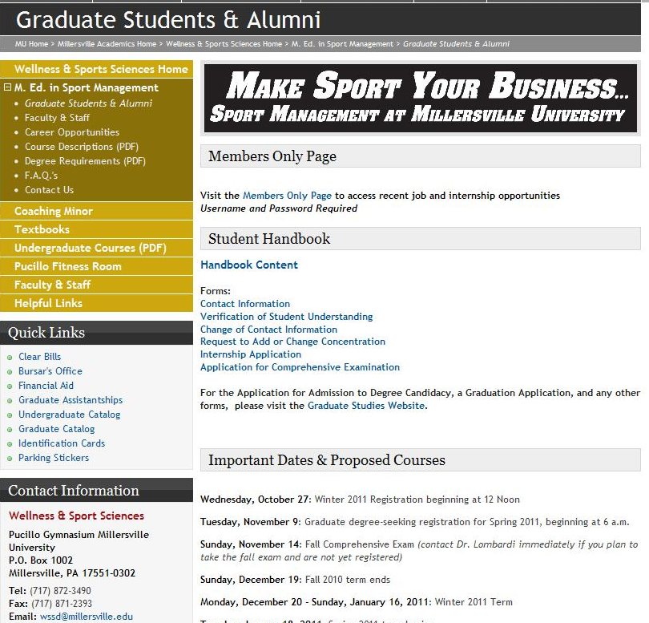
The M.Ed in Sport Management
Graduate Students & Alumni Page & Members Only Page
http://www.millersville.edu/wssd/graduate/graduate-students--alumni.php

This page is a part of the M.Ed in Sport Management site and can be found under the subheading Graduate Students & Alumni. It includes upcoming proposed courses, important dates, newsletters, the Student Handbook content and forms, recent job and internship postings within the sports management field, as well as helpful links for potential job and internship announcements.

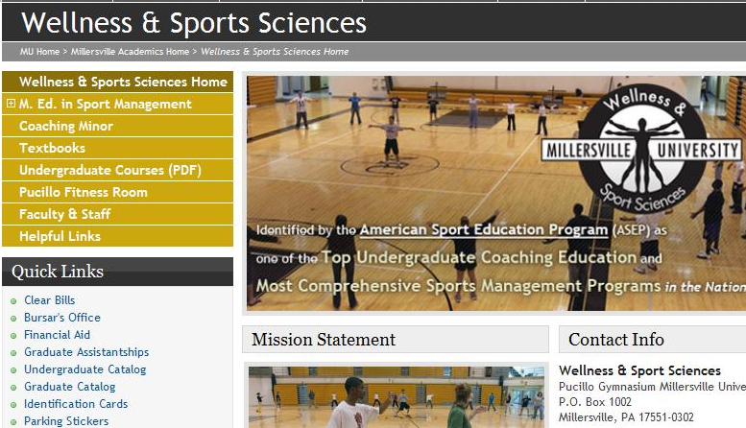


To access the website directly, follow the link and web address. http://www.millersville.edu/wssd/graduate/graduate-students--alumni.php

The website can also be found by going to the Millersville Wellness and Sport
Sciences page http://www.millersville.edu/wssd/index.php, clicking on the M.Ed in Sport Management heading on the left side navigation bar,

and then clicking on the subheading Graduate Students & Alumni.

The information on this website is intended for M. Ed in Sport Management students and alumni only. In order to protect this access you will need to provide a restricted username and password the first time you access the site. Below you will find the username and password needed to enter this restricted site. DO NOT share this login information with any organization, group, or individual. Thank you!

Username:
Password:

We will constantly be working to update and improve this website.
Please Contact the Sport Management Graduate Assistant with any questions, suggestions, or job/internship updates you would like posted on the website by calling or emailing:

(717) 871-4209 or sportmgmtga@millersville.edu

IDENTIFICATION CARDS

Using your Identification Card at Millersville

Keep your I.D. card with you at all times. You'll need it to use the facilities and services at Ganser Library (access library online from off campus), Gordinier and Lyle dining halls, Brooks and Pucillo gymnasiums, Biemesderfer Stadium, the Student Memorial Center, Lyte Auditorium, Health Services at Witmer Building, and other areas on campus. Your I.D. card contains your name and your photograph. The magnetic stripe on the back of the card is encoded with your identification number, a lost-card code, and a school code.

Lost I.D. Cards

If you have lost your I.D. card, you should report the loss to the Campus I.D. office as soon as possible by calling (717) 872-3448 during office hours in order to invalidate the lost card. Before going through the procedure of getting a replacement card, it is a good idea to wait a day or two in case your I.D. card is merely misplaced rather than lost.

If you find your card after having reported it lost, go to the Campus I.D. office right away so that they can revalidate your card. There is no charge for this procedure. If your card is turned in to or confiscated by the campus I.D. office, you can get it back at no charge, if you had previously reported it lost.

If you do not find your I.D. card within a few days, you should stop by the Campus I.D. Office to get a temporary I.D. card; and to have your picture retaken for a permanent, replacement I.D. card. The cost will be the current replacement fee posted at the Campus I.D. Office. The replacement fee is payable when you receive your temporary I.D.
When your card is ready, you will be notified through the message feature on the electronic card readers installed in various buildings and facilities throughout campus. (Using your temporary I.D. in one of the card readers will initiate the message feature on the respective card reader.) When you pick up your replacement I.D. card at the Campus I.D. Office, you must turn in your temporary I.D.

Two Important Notes

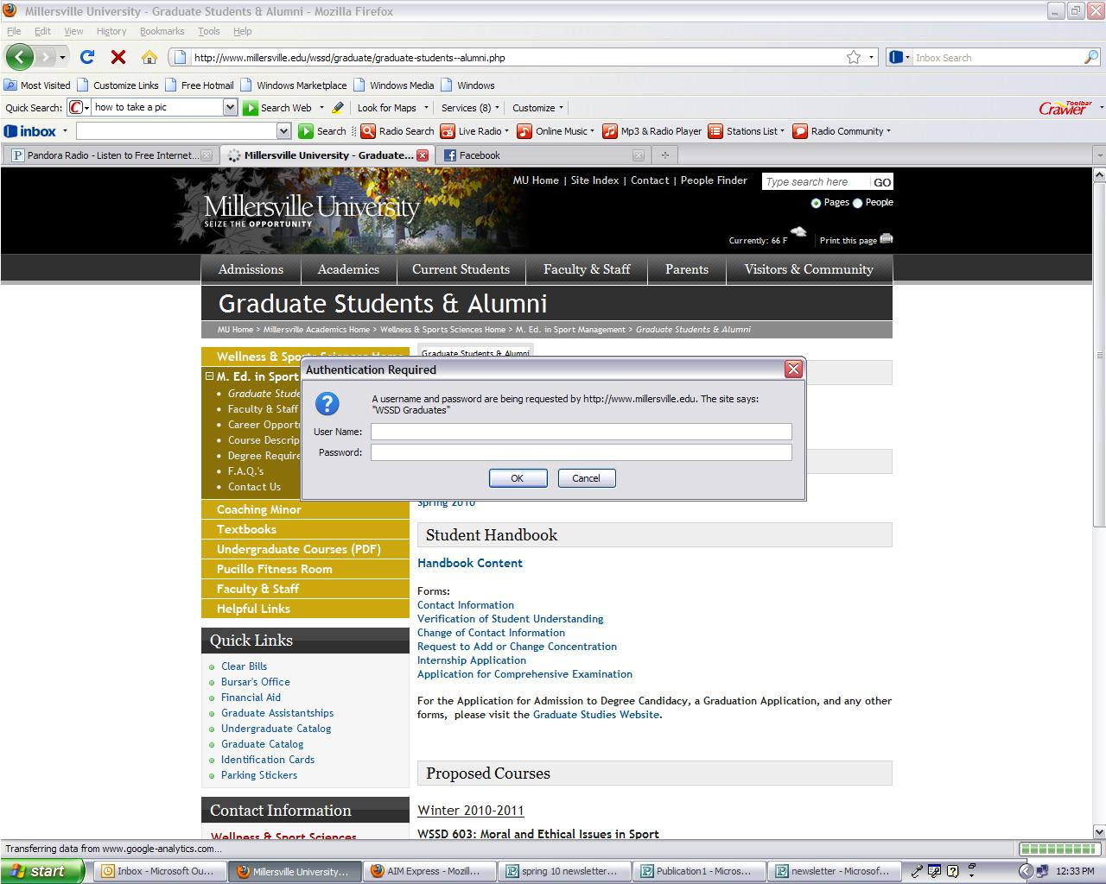
- If your lose your temporary I.D. card, there is a replacement fee, just as there would be for a permanent I.D. card.

- If you find your campus I.D. card after having had your picture taken for a replacement I.D., the replacement fee is no longer refundable.

Your I.D. Card and a Marauder Gold Account

What is Marauder Gold?
Marauder Gold is the former Millersville Advantage Plan--MAP. Marauder Gold is a declining balance program that works like a credit card in reverse. Money deposited into your Marauder Gold account may be used to make cash-free purchases at various on and off campus locations that display the Marauder Gold logo. Having a Marauder Gold account is more convenient than carrying cash.

Who can join?
Millersville University students, faculty and staff who possess a valid Millersville University identification card are eligible to participate in the Marauder Gold program.

Can I participate in Marauder Gold if I have a meal plan with flexible dollars?
Yes! Marauder Gold has been developed to add services and more flexibility to your I.D. card; it can be used at the Bookstore, The Galley, and Copy Shop in the Student Memorial Center and the library circulation desk. For an up-to-date listing of off-campus merchants, visit http://www.maraudergold.com

Can I check my Marauder Gold account balance at any time?
At the time of each transaction or purchase, your account balance will appear at the sales register. Marauder Gold balances may be checked online using my’ VILLE. . You may also check your balances at http://www.maraudergold.com. Account balance statements also are available through the University I.D. Office on a special request basis only.

How much can I deposit and is there a minimum balance required?
You can open a Marauder Gold account with a minimum deposit of $50. There is no minimum balance required, and additional deposits of at least $25 can be added through-out the semester.

How do I open a Marauder Gold account?
For your convenience, your initial deposit can accompany your tuition payment. You may deposit to an existing Marauder Gold (former MAP) account online by using a credit card (American Express, Discover or MasterCard) or e-check via MAX. In-person deposits (cash or check) may be made at the Bursar’s Office on the first floor of Dilworth Building. Mail-in forms are available at any of the locations accepting the Marauder Gold plan.

Can I take cash out of my account?
No, cash withdrawals are not permitted. You can only make deposits to your Marauder Gold account. Balances remaining at the end of any semester will carry over to the next semester and will continue to be held until graduation or official withdrawal from the University.
Visit http://www.millersville.edu/bursar/maraudergold.php for more details.

Campus I.D. Office Hours: 8:00 a.m. to 4:00 p.m. Monday through Friday

OneCard I.D. Services
Boyer Building, Room 121
P.O. Box 1002
Millersville, PA 17551-0302

GRADUATE STUDENTS’ ORGANIZATION (GS0)

The purpose of this association is to provide a forum for academic and social interests. Because of the typical graduate student schedule, graduate assistants have become the most vital liaison, acting on behalf of the GSO, as representatives to Faculty Senate, the Graduate Course and Program Review Committee, and other administrative, advisory or policy-making bodies of the University.

All graduate students, regardless of degree status, are automatically members of the GSO and are encouraged to hold offices and participate in the activities of the association.

For further information visit involved.millersville.edu/organization/GSA or contact the Office of Graduate Studies at (717) 871-4723.

DIRECTIONS TO MILLERSVILLE CAMPUS

From Harrisburg and West:
Take Route 283 East to the Route 741 exit (Millersville/Rohrerstown). Then follow “From Route 30” below.

From Baltimore/York and South:
Take I-83 North to Route 30 East. Then follow “From Route 30” below.

From the Pennsylvania Turnpike, traveling east:
Take Exit 266 (Lancaster/Lebanon, old Exit 20) and follow Route 222 South to Route 30 West. Then follow “From Route 30” below.

From the Pennsylvania Turnpike, traveling west:
Take Exit 286 (Reading/Lancaster, old Exit 21) and follow Route 222 South to Route 30 West. Then follow “From Route 30” below.

From Scranton-Wilkes Barre and North:
Take Route I-81 South to Exit for Lebanon/Route 72. Follow Route 72 South through Lebanon and into the Lancaster vicinity. Where Route 72 joins Route 30, take Route 30 West. Then follow “From Route 30” below.

From Route 30:
Take to exit for Route 741 East. Follow Route 741 East (Rohrerstown Road) until it becomes Millersville Road. After about four miles, turn right at the light at Route 999. At the third traffic light, turn left onto George Street. Follow George Street. After you cross West Cottage Avenue, you will be on the campus.

Alternative from Route 30:
Take to exit for Centerville Road. Turn left off the exit ramp. Travel on Centerville Road until you reach the dead-end/intersection with Charlestown Road. Turn right onto Charlestown Road. Make the first left onto Ironstone Ridge Road. Turn left at stop sign onto Route 999 (Blue Rock Road). Turn right at the first light onto Duke Street. Turn left at stop sign onto Frederick Street. Go straight to intersection with George Street.

From Downtown Lancaster:
Go west on Orange Street in the city, turn left onto Charlotte Street and bear right onto Manor Street. It will become Route 999 (Manor Avenue). When you cross route 741, follow Manor Avenue to the third traffic light and turn left onto George Street. Follow George Street for about three blocks to the campus.

Alternative from East of Lancaster:
From Lincoln Highway, turn left onto Strasburg Pike. After approximately 1 mile, turn right onto Rockvale Road. After approximately 1.5 miles, turn left at the stop sign onto Lampeter Road. At the second light, turn right onto Village Road. Take this until it dead-ends. Turn right onto Route 222 (Beaver Valley Pike will turn into Long Lane). Turn right onto Stehmans Road, which will turn into Duke Street. Turn right onto Frederick Street. Go straight to intersection with George Street.
Directions to Pucillo Hall:

Go straight on George Street until you reach the light at Frederick Street. Turn left. Follow and make a sharp right turn onto Creek Drive. Make the first left after the parking lots to stay on Creek Drive. Make your first left onto Pucillo Drive. Proceed up the hill and the parking lot will be on your right-hand side.

DIRECTIONS TO MU-Lancaster

Millersville University’s Lancaster Campus is located at 42 North Prince Street, Lancaster PA 17603.
http://www.millersville.edu/services/lancaster/index.php

Amenities at MU-Lancaster
- All students, faculty, staff, and visitors to the building can park at the Central Parking Garage with entrance locations on the first block of South Prince Street or Vine Street using a parking card for access.
- Central Parking Garage is located two blocks up from 42 N. Prince Street
- Parking cards will be issued during your first visit to the building.
- Restrooms located on 1st and 3rd floors
- Please note that all concerns regarding Millersville University courses running from 4:00 – 9:30pm should be directed to Fran Wakefield 717.871.7013. Ms. Wakefield is on site Monday – Thursday from 4:00 – 10:00pm.

Directions to MU-Lancaster
42 North Prince Street, Lancaster PA 17603

From York and Points West  -Take Route 30 East to Harrisburg Pike Exit  -Turn Right on Harrisburg Pike (Becomes W. James St.)  -Turn Right onto North Prince Street  -42 North Prince is on the Right | From Harrisburg and Points North  -Take I-283 South to PA 283 East via Exit 1A  -Take Exit toward Fruitville Pike  -Stay straight onto Chester Road  -Turn Right onto Fruitville Pike  -Fruitville Pike becomes PA-72 South  -PA 72 South becomes North Prince Street  -42 North Prince is on the Right
From Philadelphia and Points East  -Take I-76 West to Exit 286 toward US 222  -Take US 222 South toward Lancaster  -Merge onto US 30 East  -Take PA-23 East Exit  -Take Ramp toward New Holland Ave/Downtown Lancaster  -Merge onto New Holland Pike  -Turn Left onto North Plum St.  -Turn Right onto East Walnut Street  -Turn Left onto North Prince Street  -42 North Prince is on the Right | From Millersville University Campus  -Turn Right onto Manor Ave/Route 999  -Turn Right onto West King Street  -Turn Left onto North Queen Street  -Turn Left onto West Orange Street  -Turn Left onto North Prince Street  -42 North Prince is on the Right

HOUSING AND RESIDENCE

The Office of Graduate Studies and the Department of Housing and Residential Programs compile a non-exhaustive list of local apartments and housing options. You can obtain a copy of this information by contacting the Office of Graduate Studies at: http://www.millersville.edu/gps/index.php

Office of Graduate Studies (Lyle Hall)
P.O. Box 1002
Millersville University of Pennsylvania
Millersville, PA 17551
Phone (717)871-4723
Fax (717)872-3453
gradstu@millersville.edu

PROFESSIONAL DEVELOPMENT / ORGANIZATIONS OF INTEREST

The following is a non-exhaustive list of different professional organizations and journals that students are encouraged to research:

- North American Society for Sport Management - www.nassm.com
- Pennsylvania Coaches Association - http://www.piaa.org/pca/
- Pennsylvania State Athletic Directors Association - http://www.psada.org/
- National Federation of State High School Associations - http://www.nfhs.org/ScriptContent/Index.cfm
- National Intramural-Recreation Sports Association - http://www.nirsa.org/
- Sport and Recreation Law Association - http://www.ithaca.edu/srla/
- Street and Smith’s Sport Business Journal - http://www.sportsbusinessjournal.com/
- National Sports Marketing Network - http://www.sportsmarketingnetwork.com/
- Sports Lawyers Association - http://www.sportslaw.org/
- Sports Turf Managers Association - http://www.sportsturfmanager.com/
- Association of Luxury Suite Directors - https://www.alsd.com/
- International Ticketing Association - http://www.intix.org/
- North American Society for the Psychology of Sport and Physical Activity - http://www.naspspa.org/
- American College of Sports Medicine - http://www.acsm.org/
- National Athletic Trainers’ Association - http://www.nata.org/
- National Sporting Goods Association - http://www.nsga.org/
- College Sports Information Directors of America - http://www.cosida.com/

Student Services Summary
Fee | Service | Description of  Services | Location | Phone #
 | Banking Center | Cash personal checks up to $50 and payroll up to $250 with ID card, ATM located outside | Student  Memorial  Center (SMC) | 871-7630
 | Career Services | Career counseling, job search help, workshops on resume writing, interviewing skills, job search strategies | Lyle Hall | 871-7655
 | Computer science | Computer labs, e-mail, accounts, laser printers, etc. | Boyer | 871-4306
* | Copy Shop | Fax, copy, binding, printing services available | SMC | 871-7672
* | Costume shop rental | Over 12,000 costumes to rent | Jefferson Hall | 871-5653
 | Counseling center | Confidential counseling and testing service | Lyle | 871-7821
 | Help Desk | Computer labs, e-mail accounts, laser printers, etc. | Boyer | 871- 7777
 | Department of Housing and Residential Programs | General listing of local apartments and housing | Harbold Hall
 | On-campus employment | Work for a variety of campus offices (minimum wage) | Payroll  (Dilworth) | 871-5904
 | Escort service/call boxes | Campus police walk you to and from various locations after dark, police phones are positioned around for  emergencies | University Police  (Lebanon House) | 871-4357
 | Financial Aid | Scholarships, grants, and loans are available for students | Lyle | 871-5100
* | Fitness Center | Free for 12+ credits, $13.50 per credit for under 12, full service gym with weights, aerobics classes, racquetball | Student  Memorial  Center (SMC) | 871-7690
* | Dining and Conference Services | Eateries in various locations: The Cove in Lyle, The Gallery in the SMC, Gordy’s and the Campus Grill in Gordinier | Various | 871-5275
 | Graduate Student Association | The graduate student’s voice on campus | Lyle (Grad Studies office) | 871-4723
 | Graduate assistantships | Work for variety of campus offices (free tuition). | Lyle (Grad Studies office) | 871-4273
 | ID cards | Photo ID needed for most campus activities and services | Boyer | 871-7008
 | Information | Call if you need a phone number of location of services | Dilworth | 871-7770
 | Learning and Disabled Services | Support services and accommodations available | Lyle | 871-5554
* | MU Health Services Center | Limited medication free, $400 per year medication expense, other free services | Witmer Building | 871-5250
 | Newspaper (The Snapper) | Published every Thursday | Office at SMC | 871-7081

Fee | Service | Description of  Services | Location | Phone #
* | Parking | Pass needed for all students in all lots on campus, with the exception of Grad students who only attend evening classes | University Police (Lebanon House) | 871-4357
 | Payment of University fees | Any scholastic charges incurred | Bursar’s Office (Dilworth) | 871-5101
 | Pool | Available during “open swim” times, need ID card | Pucillo Gymnasium | 871-4224
* | Mail Services | Stamps, mailbox, other postal services | Boyer | 871-7008
 | Registration for classes | Pick up and drop off point for all class registration materials | Lyle | 871-5005
 | Shuttle bus | Runs Monday-Friday, loop every 15 minutes, ID card only | Various
 | Social equity | Issues surrounding racial, gender, sexual orientation discrimination, sexual harassment, diversity training | Delaware House | 871-4100
 | Speech therapy | Support services and accommodations available | Counseling center (Lyle) | 871-7821
* | Sporting events | Variety of events, schedules available | Various
* | Tickets for on-campus events | Speakers, concerts, sporting events | SMC | 871-7600
* | Transcripts | Only “official” copies, “unofficial” on website | Registrar’s office (Lyle) | 871-5005
 | Wellness center | Variety of healthy lifestyle programs and services | Montour House | 871-4141
 | Women’s center | Programs, services and information relating to female issues | Montour House | 871-4141

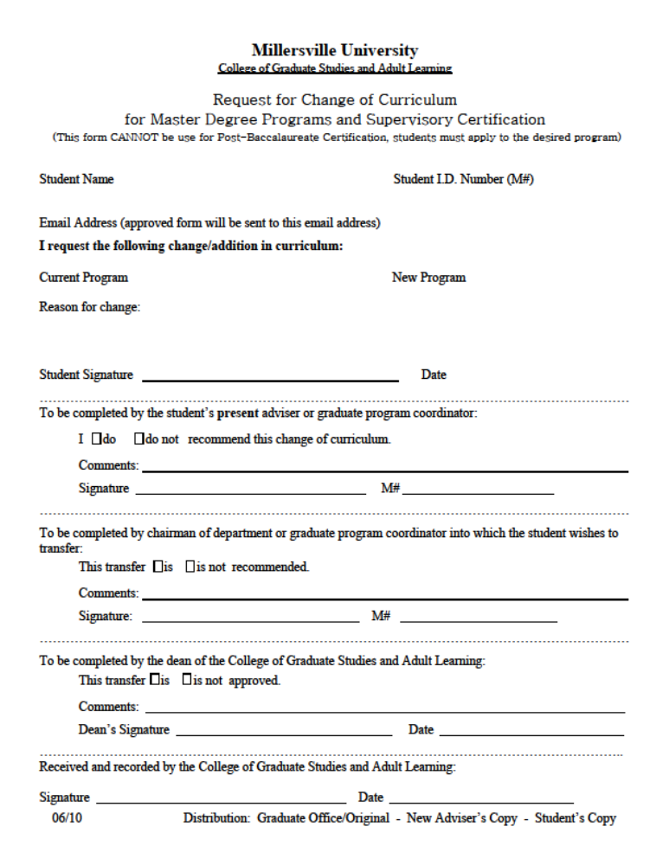

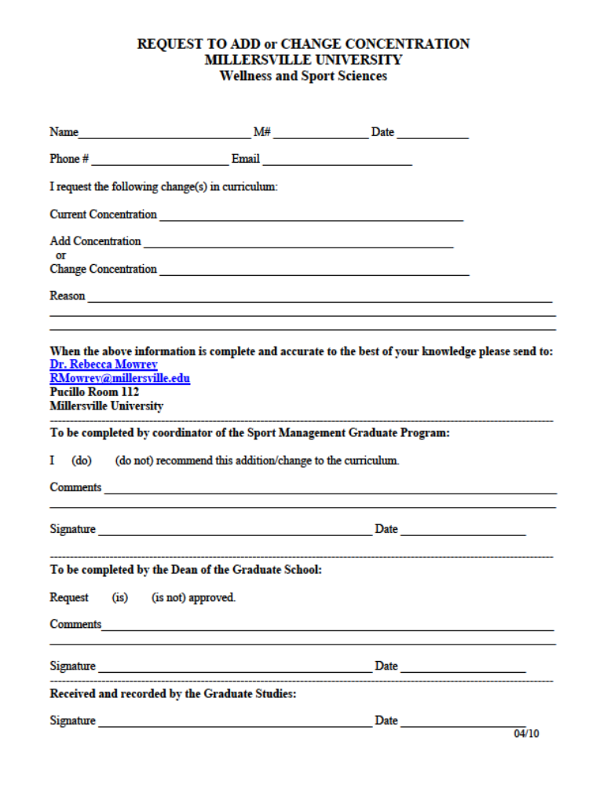
M. Ed IN SPORT MANAGEMENT
INTERNSHIP APPLICATION

Personal Information

Name: ___________________________________________ E-Mail:___________________________
First Last M.I.

Preferred Phone (check): 􀂅 ( ) ___________________________ home
􀂅 ( ) ___________________________ cell
􀂅 ( ) ___________________________ work

Student ID (MU#) __________________ Expected graduation date: ____________________________

Faculty Advisor ______________________________________________________________________

*******************************************************************************************
SECTION 1: Complete this section if you have not already designated a proposed internship site, otherwise, skip to Section 2 below.

1.) I will be meeting with my faculty advisor to discuss internship site goals and possibilities on _______________
(insert date and time of the appointment) date time

2.) What are my short and long term career goals?___________________________________________________
_____________________________________________________________________________________________

3.) What internship experience / setting would complement my current resume and professional strengths and weaknesses; and, be relevant to my response to question #2 above? _______________________________________
_____________________________________________________________________________________________

*********************************************************************************************
*If your field site is or will likely request background clearances, they must be attached to this application. If you do not have your background clearances and they are required at your field site, it is your responsibility to acquire them and provide them to us as soon as possible. If you need more information, visit http://www.millersville.edu/edfoundations/clearances.php. Questions about background clearances are on page two of this application. DO NOT FORGET TO ANSWER!
*********************************************************************************************
SECTION 2: If you have already identified a proposed internship site and supervisor, please answer the following:

What are my short and long term career goals? _____________________________________________________________________________________
_____________________________________________________________________________________

How will this proposed internship site and supervisor help fulfill these goals? _____________________________________________________________________________________
_____________________________________________________________________________________

How will this proposed internship experience expand my resume? ____________________________________________________________________________________
____________________________________________________________________________________

Name of Proposed Internship Site: ____________________________________________________________________________________
*CONTINUE ONTO PAGE TWO

Location of Proposed Internship Site: ____________________________________________________________________________________

Internship responsibilities: be specific! (Failure to provide details may result in denied or delayed approval)
____________________________________________________________________________________
____________________________________________________________________________________

Name, Title, Phone Number, and E-Mail Address of Proposed Internship Supervisor:
____________________________________________________________________________________

Proposed Internship Start Date: ____________ End Date: ____________

Check the semester in which you would prefer to enroll for your internship:

FALL SPRING SUMMER I SUMMER II SUMMER III
***********************************************************************************
CLEARANCES:
Does you field site require background clearances?

YES NO
If so, which ones?

- Child Abuse History Clearance?

YES NO

- Criminal Background Check?

YES NO

- Federal Bureau of Investigations (FBI) Criminal Background Check?

YES NO

- TB Testing?

YES NO

- Other: ___________________________________

YES NO

Have you attached a copy of your current clearances?

YES NO

Have you provided a copy of your current clearances to the Field Services Office in Stayer Hall Room 120?

YES NO
**************************************************************************************
RETURN HARD COPY OF THIS FORM TO: APPLICATION DEADLINES
Dr. Rebecca Mowrey March 1st- Summer Semester Internships
PUCILLO ROOM 112 July 15 – Fall Semester Internships
MILLERSVILLE UNIVERSITY October1st- Winter Session Internships
MILLERSVILLE, PA 17551-0302 November 1st – Spring Semester Internships

This page left blank intentionally; please continue to the next page.


