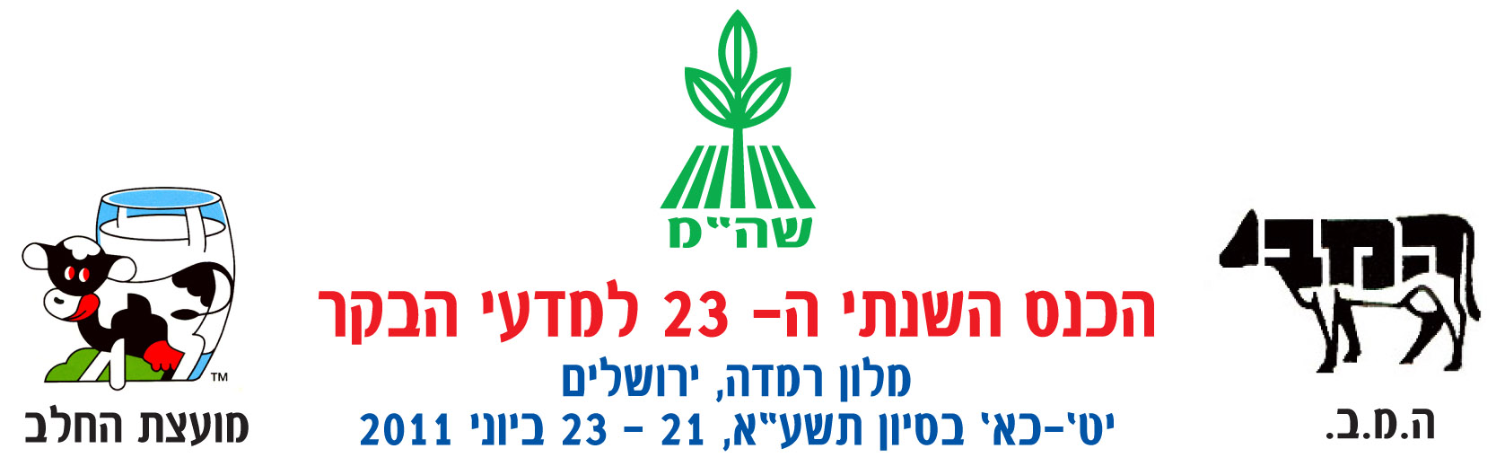
The 23rd Annual Conference of
Cattle Breeding Sciences
"Ramada" Hotel
June 21-23, 2011

To the Dairy Farming Public!

Dear Farmer,

You are cordially invited to attend the 23rd Annual Conference of Cattle Breeding Sciences that will take place Tuesday-Thursday June 21– 23, 2011 at the "Ramada" Hotel in Jerusalem.
Throughout the years, the annual Cattle Breeding Sciences Conference has become the largest of the agriculture related conferences conducted in Israel and is highly regarded. The conference is organized by the Cattle Department of the Agriculture Extension Service - the Ministry of Agriculture and Rural Development, the Israel Cattle Breeders Association and the Israel Dairy Board.

The conference's schedule is rich, varied and especially interesting, and includes lectures by top Israeli experts from the field as well as guests from abroad. At the conference, a number of reports will be presented concerning the updated findings of new studies and guest lectures concerning important issues on the agenda of the Israeli dairy farmer. The lectures to be given at the conference underwent scientific refereeing by a professional committee composed of representatives from the fields of research, instructing, and agriculture. Similar to prior years, the conference will conclude with a fascinating lecture from the world of animal sciences.

The conference, attended by the Minister for Agriculture and Rural Development, industry leaders, and ministry management, will open with the awarding of the "Farmer of the Year" award and other certificates of appreciation to various individuals that have made unique contributions to the cattle industry, as well as scholarships to outstanding students.

The conference will be devoted to the Israeli dairy industry, its economics and management, the marketing of milk and dairy products, nutrition and feed, fertility, herd health, udder health, nurturing, climate and the Israeli cow, as well as various issues such as environmental quality, animal welfare, and nurturing human capital in the industry.
This year, attendees will be invited to hear various guest lectures on subjects such as the Milk Law, the Feed Law and a panel discussion on the subject of caring for animals in the severe summer heat.
Because of the enormous number of subjects being heard, the lectures will be divided throughout the days of the conference into two parallel sessions.

The opening session will be devoted to the the dairy industry, expected changes and transformations in the industry in Israel and the world.

A large exhibition area containing the industry's premier companies will enable the exhibition of a variety of new products, technologies and services.

The loyalty of the conference's attendees year after year testifies to the meeting's significance and as a gathering place of a majority of those involved in the industry, i.e. industry colleagues, guides, researchers, doctors and veterinarians and raw material suppliers. At the conference, a meeting room will be dedicated to enabling one-on-one meetings in a quiet and comfortable ambiance.
- In light of the success of previous years, we intend to enable five free internet workstations!
- The conference's opening evening, a donation by the Strauss Group, will enable conference participants to sit around tables of light refreshments, wine and beer. Attendees will be entertained by a "Joint Performance" starring Sherry, Gabi Shushan and Uzi Fuchs.
- The second evening, donated by the Tnuva Dairy Co., will include a festive social evening including dinner outside the hotel and a performance that should not be missed!
For those new to the industry or have yet to attend past conferences, now is the time to join us and enjoy a unique experience for those who are the elite members of the cattle industry.

Free parking for conference attendees
Free indoor parking will be available at the "Hanyon HaLeom" (see-attached map). Shuttle transportation to/from the hotel and parking lot will operate regularly every 15 to 30 minutes during the days of the conference (Tuesday and Wednesday) between the hours of 8:00-19:00 and on Thursday between 8:00-15:00.

The conference will open on Tuesday June 21, 2011 at 9:30 attended by Ms. Orit Noked MK, the Minister of Agriculture and Rural Development and industry executives.

Looking forward to seeing you at the conference,

The Organizing Staff
The Manner of Registration

There are, at your service, a number of channels by which you can register. These include:

- Through the internet: you are welcome to register using a quick and friendly process through means of the conference's registration site at:
http://www.eventact.com/kenes/bakar11
Please click on the link to enter the relevant registration site.
On-line registration requires payment through one of the following methods:
- By credit card 2. A promissory note to "Sion"
- Through the mail: Fill out your personal details on the form attached to the invitation, or that which appears in the registration form and can be printed. Return the registration form with a check written out to the 'Israel Cattle Breeders Association' and send it to: Israel Cattle Breeders Association, Accounting, POB 3015, Caesarea Industrial Park, 38900.
- By Fax: Fill out your personal details on the application form contained in the invitation, or that which may be downloaded through the internet, and send it by fax to the Israel Cattle Breeders Association at 04-6273501. Payment will be made by one of the following methods:
1. Credit card 2. A promissory note to
"Sion"
- Cancellation fees: For any cancellation received by June 14, 2011 - a full refund will be made.
Following this date - no refunds will be made!
- Retirees (above age 65) and students: will enjoy a 15% discount when registering with a photocopy of the individual's Senior Citizen or Student ID card. The registration in this case will be permitted solely by the attached registration form.
- Shared accommodations: Those interested in shared accommodations are kindly asked to first verify conference participation and only afterwards note the name of the participant on the registration form. Reserving a room for any person who has not registered for the conference, will incur a fee by the individual making the initial reservation.
- Use of "Extras" - Conference participants staying at the hotel will be required to present the reception desk with a valid credit card number to cover any costs in the use of hotel facilities requiring any additional fee(s).
Attendance Costs and Registration Procedure for the 2011 Cattle Breeders Conference

Full board accommodations for the entire conference - cost per participant

(2 nights, 3 lunches, 2 breakfasts and 2 dinners)

 | Regular price | Discount price
Single room (without a partner) | 1640 ₪ | 1470 ₪
Per guest in a double room | 1310 ₪ | 1140 ₪
Three guests in a room | 1155 ₪ | 1130 ₪

Accommodations for 2 days of the conference - cost per participant
(1 night, 2 lunches, 1 breakfast and 1 dinner)

 | Regular price | Discount price
Single room (without a partner) | 1205 ₪ | 1080 ₪
Per guest in a double room | 985 ₪ | 895 ₪
Three guests in a room | 930 ₪ | 850 ₪

Hospitality on a daily basis, without accommodations
(1 lunch, coffee and cake)

 | Regular price | Discount price
Single days only - Tuesday or Wednesday | 385 ₪ | 330 ₪
Thursday only | 350 ₪ | 300 ₪
Two days: Tuesday-Wednesday or Wednesday-Thursday | 605 ₪ | 545 ₪
Three conference days | 800 ₪ | 720 ₪

"Early-bird Accommodations" - the evening prior to the conference's opening session on June 20, 2011 - 490 NIS for a single room and 380 NIS per person in a double room (includes accommodations and breakfast).
Additional registration information and assistance is available by contacting:
- Gabi Adin, the Conference Chairperson:
Telephone: +972-(0)3-9485610; Mobile phone: +972-(0)50-6241581; email: gadin@shaham.moag.gov.il
- Ricky Moav, Organization and Production Coordinator: Telephone: 03-9485305; Mobile phone: +972-(0)52-3744434;
Fax: +972-(0)3-9485614;
email: rikim@moag.go.il.

