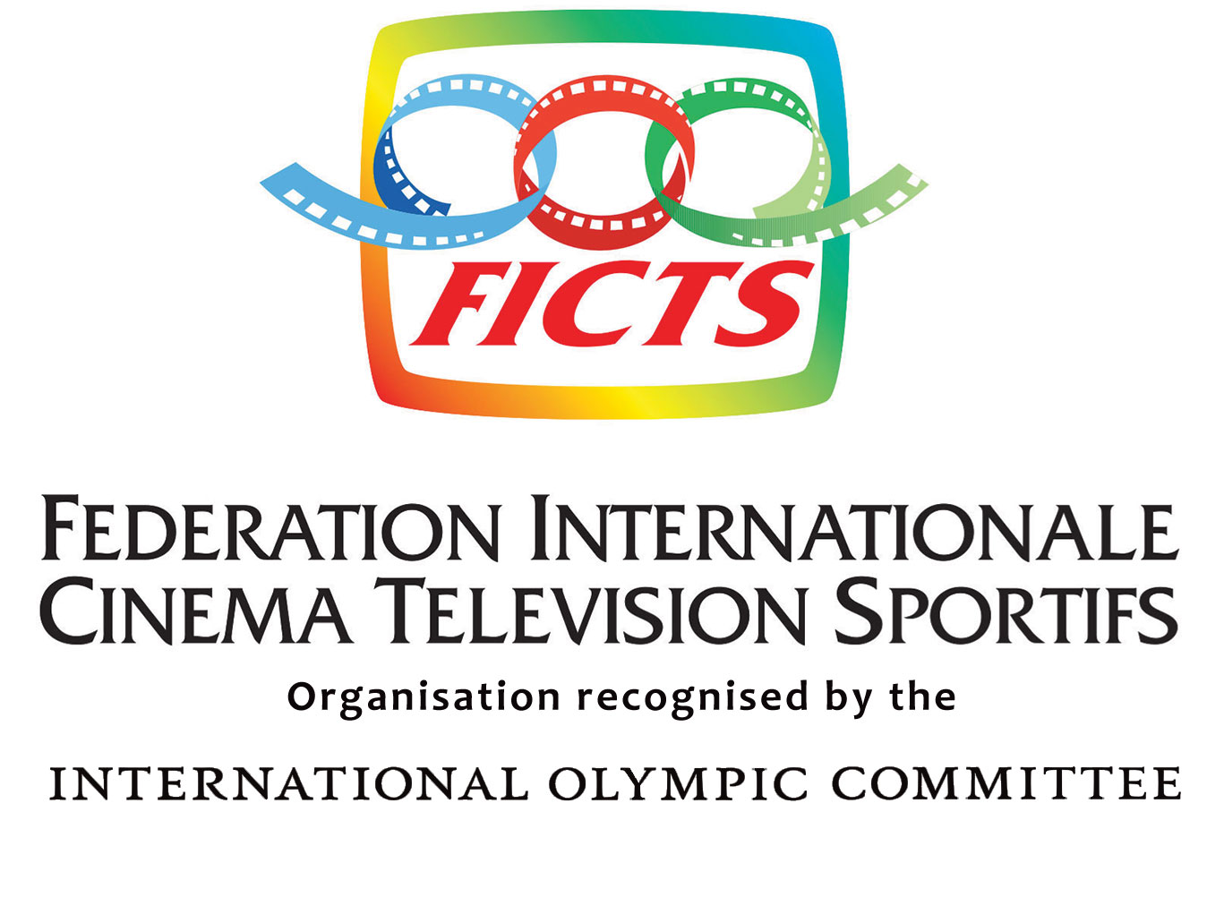
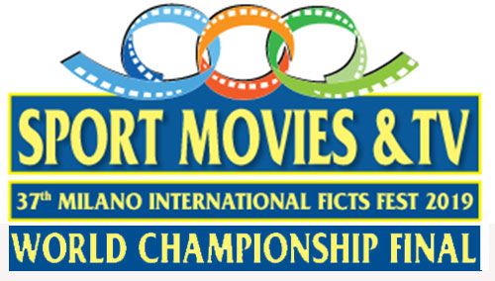
HOTEL RESERVATION FORM
SCHEDA DI PRENOTAZIONE HOTEL
“SPORT MOVIES & TV 2019”©
37th MILANO INTERNATIONAL FICTS FEST
Milano (Italy), October 25 – 30, 2019

THIS FORM IS VALID TO REQUIRE HOTEL RESERVATION / Richiesta di prenotazione alberghiera
(WRITE IN CAPITAL LETTERS / Compilate in stampatello)

COMPANY / Ente:
ADDRESS / Indirizzo:
CITY / Città: ZIP CODE / Cap: COUNTRY / Paese:
TELEPHONE: FAX: E-MAIL:
PERSON IN CHARGE / Referente: TITLE /Titolo

JOB POSITION / Incarico

PARTICIPANTS / Partecipanti

1. Mr / Sig.  Ms / Sig.^{ra} 
Last name/ Cognome First name/Nome
Arrival date/ Data arrivo Departure date/ Data partenza

❖ Credit Card (to guarantee the reservation) / Carta di credito a garanzia prenotazione:
Type/ Tipo Number/ Numero Exp. Date/ Scadenza
Cardholder / Intestatario

2. Mr / Sig.  Mrs / Sig.ra 
Last name/ Cognome First name/Nome
Arrival date/ Data arrivo Departure date/ Data partenza

❖ Credit Card (to guarantee the reservation) / Carta di credito a garanzia prenotazione:
Type/ Tipo Number/ Numero Exp. Date/ Scadenza
Cardholder / Intestatario

❑ ADMIRAL HOTEL **** (Via Domodossola 16, 20145 Milano - Italy)
(al giorno / per day): Camera doppia uso singola / Double room single use 138 € ^{(*)} / doppia/double 168 € ^{(*)}

La Federation Internationale Cinema Television Sportifs - per gli Invitati (max. 2 persone) - si farà carico del 50% del costo presso l’ADMIRAL HOTEL nel periodo dal 24 al 31 OTTOBRE 2019.
Le prenotazione effettuate dopo il 31 AGOSTO 2019 prevedono il costo a totale carico dell’ospite

Federation Internationale Cinema Television Sportifs will pay – for the Guests (max. 2 people) - the 50% of the cost to the ADMIRAL HOTEL in the period between OCTOBER 24 – 31, 2019.
The reservations carried out after AUGUST 31, 2019 expect total expenses by the guest.

^{(*)} Le tariffe includono: servizio, prima colazione a buffet, connessione high speed e wifi completamente gratis in tutto l'hotel. The rates include: service, a rich buffet breakfast, high speed Internet connection and wifi completely free of charge throughout the hotel.

OVERNIGHT STAY IN MILAN 24/10 25/10 26/10 27/10 28/10 29/10 30/10 31/10 Pernottamenti a Milano

PLEASE MAIL / FAX TO: Hotel Admiral PHONE: (+39) 02. 3492151
FAX: (+39) 02. 33106660
e-mail: info@admiralhotel.it
Deadline / scadenza: September 7th, 2019

DATE / Data…………………………… SIGNATURE / Firma …………………………………

ALL FORMS RECEIVED WITH NO CREDIT CARD REFERENCES, WILL BE AUTOMATICALLY REFUSED.
HOTEL 4****

ADMIRAL HOTEL
Via Domodossola 16 - 20145 Milano (Italy)
L’Hotel Admiral, con oltre 6.000 pezzi di memorabilia e cimeli del cinema in esposizione, è situato di fronte (50 metri) al Parco di CityLife, l'area residenziale più esclusiva di Milano con una superficie di 255.000 mq. CityLife District offre tre aree di shopping, ognuna da vivere come un’esperienza unica, tutta da scoprire: collegate da un percorso pedonale, la galleria commerciale su due livelli, la grande piazza centrale e la “promenade open air” riuniscono oltre cento spazi commerciali e propongono un’offerta completa (80 negozi, 1 supermercato, 20 ristoranti e bar e 7 sale cinema per un totale 1.200 posti).
L’Hotel Admiral - collegato con tutta la rete metropolitana - gode di facile accesso al centro della città e alle zone commerciali essendo a 30 metri dalla Metropolitana (Lilla M5 fermata Domodossola) nonché alla Stazione Ferroviaria Milano Nord Domodossola collegata con il Malpensa Express per l’aeroporto. Si può raggiungere Piazza Duomo (sede del Festival) in 13 minuti con il tram n° 19 (fermata V.le Boezio davanti all’Hotel).

Admiral Hotel, with over 6,000 pieces of memorabilia about cinema in exposition, is located just opposite (50 meters) to the CityLife park, the most exclusive residential area in Milan with an area of 255.000 square meters. The CityLife District features three shopping areas that offer their own unique experience with plenty to discover. Linked together by a pedestrian pathway, the double-story shopping complex, large central square and open air promenade bring together more than one hundred retail premises for a complete customer experience (80 stores, 1 supermarket, 20 restaurants and bars and 7 movie theater screens with a total of 1.200 seats).
The Admiral Hotel - connected to the entire underground network - enjoys easy access to the city center and shopping areas being 30 meters from the Metro (M5 stop Domodossola) as well as the Milano Nord Domodossola train station directly connected to the Malpensa Express to airport. You can reach Piazza Duomo (venue of the Festival) in 13 minutes by tram n° 19 (V.le Boezio stop in front of the hotel).

Prenotazioni / Bookings:

Tel.: +39 02 3492151 – fax +39 02 33106660
mail to: info@admiralhotel.it; website: www.admiralhotel.it

❑ DOUBLE ROOM SINGLE USE Euro 138,00^{(*)}  DOUBLE ROOM Euro 168,00^{(*)}
Camera doppia uso singola (DUS) Camera doppia

La FICTS si farà carico - per i destinatari del presente Invito - del 50% del costo nel periodo del Festival dal 25 al 31 Ottobre (se prenotato entro il 31 Agosto 2019).

FICTS will pay - for the beneficiaries of this Invitation - the 50% of the cost during all the period of the Festival between October 25 – 31, 2019 (if reserved by August 31st, 2019).

^{(*)}Le tariffe includono: servizio, prima colazione a buffet, connessione high speed e wifi completamente gratis in tutto l'hotel. The rates include: service, a rich buffet breakfast, high speed Internet connection and wifi completely free of charge throughout the hotel.

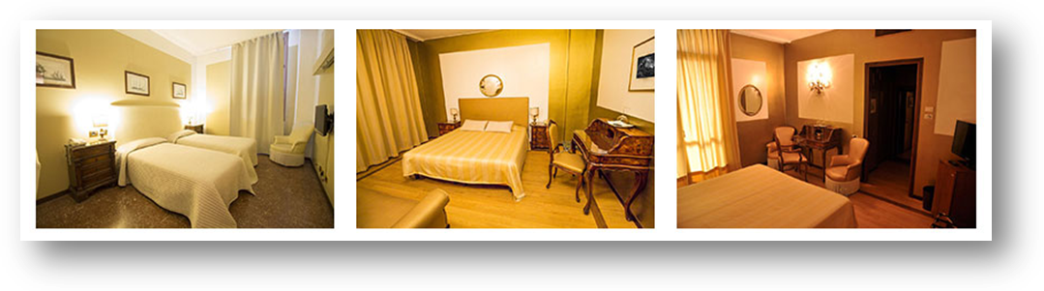
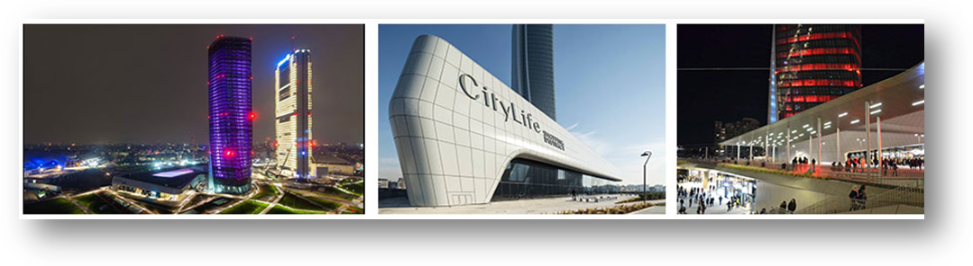

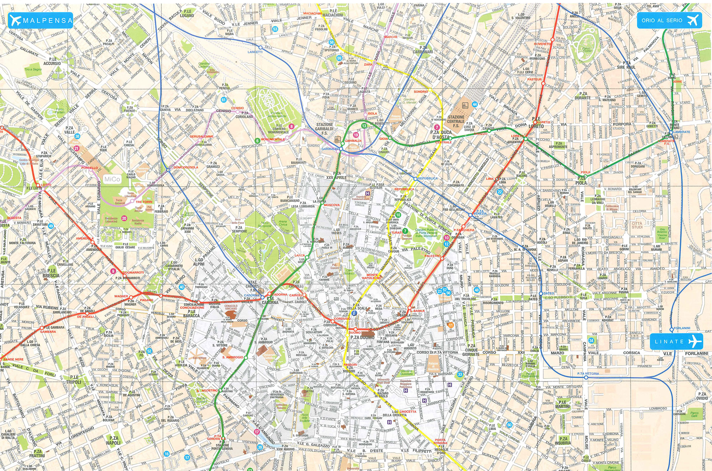
1
4
4
2
3
1
Headquartes: FICTS-Federation Internationale Cinema Television Sportifs, Via de Amicis, 17
2
Festival’s seat: Palazzo Giureconsulti, Piazza Mercanti, 2 (Piazza Duomo)
3
Seat of the Official Ceremonies: Palazzo Lombardia (), Piazza Città di Lombardia, 1 (corner Via Melchiorre Gioia 37)
4
Official FICTS Hotel: Admiral Hotel, Via Domodossola 16

AIRPORTSP
ORTS
FROM MALPENSA - Distance from Milan center is about 50 Km. Approximately 45 minutes by Taxi or public transport (Malpensa Express train to Cadorna railway station) then Tram n° 19 (V.le Boezio stop front hotel).

FROM LINATE: Approximately 30 minutes by Taxi or public transport (Bus no. 78 to Piazza San Babila), Underground Red Line M1 to Lotto stop then M5 to Domosossola stop

AEROPORTI

DA MALPENSA - Dista circa 50 Km dal centro di Milano. Con il taxi in circa 45 minuti oppure con il treno Malpensa Express (12 €) fino alla Stazione Cadorna, poi Tram n° 19 (Fermata V.le Boezio di fronte all’Hotel).

DA LINATE: con il taxi in circa 30 minuti oppure con i mezzi pubblici Autobus 78 fino a San Babila poi metropolitana Linea Rossa M1 sino alla fermata Lotto poi Linea Lilla M5 (fermata Domodossola).

FROM HOTEL TO THE SEAT OF FESTIVAL

By Taxi (15 min) or by Tram n° 19 in Viale Boezio (13 min). By Metro line M5 (stop Domodossola) for 3 stops and go off at stop Lotto Red line M1 and than for 7 stops till Piazza Duomo in front of seat of the Festival.

DALL’ HOTEL ALLA SEDE DEL FESTIVAL

Con il Taxi (15 min) oppure con il Tram n° 19 in Viale Boezio (13 min). Con la Metropolitana Lilla M5 (fermata Domodossola) per 3 fermate scendere fermata Lotto M1, poi Piazza Duomo per 7 fermate di fronte la sede del Festival.

TOUR OF MILANO BY FOOT
(Seat of the Festival is in the middle of any points of Tour - 10 minutes by foot)

- Piazza Mercanti (seat of the Festival)
Built from 1228 in the form of an enclosed quadrilateral, on the like named "piazzetta", was the administrative and political centre of Medieval Milan. The piazza originally included Palazzo dei Giureconsulti, Festival seat, that was separated from the rest of the complex when via dei Mercanti was opened in 1867-1878. The buildings forming this Piazza include Palazzo of the Ragione, built in 1233 with a large ground floor portico, originally seat of the city's government and the law courts and now an exhibition venue; Palazzo degli Osii, 1316; Palazzo of the Scuole Palatine, 1644 -1645. The itinerary finishes in Piazza Duomo. Free entrance.

- Duomo Cathedral - Vittorio Emanuele Gallery (50 m from the seat of the Festival)
To return to piazza Duomo, take Galleria Vittorio Emanuele, built by Giuseppe Mengoni from 1865 to 1877, one of the largest and most prestigious arcades in Italy, with its old cafes, bars, bookshops and the renowned Savini restaurant. Free entrance.

- The Fashion District – Civic Fashion Museum (250 m from the seat of the Festival)
The great stylists have their showrooms in via Montenapoleone, via S. Andrea, via della Spiga, via Gesù, via Borgospesso, via Santo Spirito and via Verri. Important jewellery shops, design and furnishing showrooms can also be found here. This district is one of the most elegant and refined parts of the city from the architectural point of view, because it has preserved the fascination of 19th century Milan, with its Neoclassical "palazzi". Free entrance.

- Piazza della Scala – Gallery of Italy (100 m from the seat of the Festival)
Via Manzoni is another historic, elegant street, with its famous jewelleries, antique shops and banks. Fascinating attraction here are the Grand Hotel et de Milan, where Giuseppe Verdi stayed and died, the long façade of Palazzo Borromeo d’Adda, in Neoclassical style. Free entrance.

- Sforzesco Castle (350 m from the seat of the Festival)
The Castel is Milan's most important Renaissance building, although its present appearance owes much to rebuilding at the turn of the century. Originally a fortress (1368), it was razed to the ground by the Ambrosian Republic in 1447 and rebuilt three years later under Francesco Sforza. Free entrance.

- Theatre La Scala – Museum of La Scala (http://www.teatroallascala.org) – (100 m from the seat of the Festival)
La Scala, the world-famous opera house renowned for its acoustics excellent, was built by Giuseppe Piermarini on the site of the church of Santa Maria della Scala and inaugurated in 1778. The splendid horseshoe auditorium, upholstered in red and gold velvet has four balconies (with 260 boxes), two galleries and orchestra. The theatre house a museum, established in 1901, that traces the history of theatres, opera and La Scala thought its vast collection of masks, costumes, scenery, musical instruments and scores. Price 6 €.

- Science and Technology National Museum (http://www.museoscienza.org/) - (600 m from the seat of the Festival)
The Museum is housed in an early XVI century Olivetan monastery in the centre of the city. Covering a surface of 40,000 sqm, it is now the largest science and technology museum in Italy. In the course of its history the Museum has collected and exhibited objects, machinery and evidence that retrace the key phases of scientific and technological evolution, with a special focus on Italian heritage. Collections and interactive laboratories are organised into thematic departments that retrace the evolution of science, technology and society. Guided tours price 10 €.

Pinacoteca of Brera (http://www.brera.beniculturali.it/) – (500 m from the seat of the Festival)
One of most popular National Gallery in the world. Masterpieces of Italian picture from the XIV to the XX century. You'll see “Pala di Urbino” Piero della Francesca -“Sposalizio della Vergine” Raffaello - il “Cristo Morto” Andrea Mantegna - la “Pietà” Giovanni Bellini - “Cristo alla Colonna” Bramante, - “Cena di Emmaus” Caravaggio. Price € 6.

___________________________________More than 10 minutes________________________________

- The CityLife District (in front of Admiral Hotel - https://www.city-life.it/en)
Features three shopping areas linked together by a pedestrian pathway, the double-story shopping complex, large central square and open air promenade bring together more than one hundred retail premises for a complete customer experience (80 stores, 1 supermarket, 20 restaurants and bars and 7 movie theater screens with a total of 1.200 seats).

Discover Milano (http://www.milano.city-sightseeing.it/)
BY BUS: City Sightseeing from Piazza Duomo to Galleria, Piazza della Scala, Pinacoteca di Brera, Castello Sforzesco, Cenacolo di Leonardo Da Vinci, i Navigli. Price: starting from 20 €. Departure from Piazza Duomo in front of the seat of the Festival.

- Casa Milan (http://casamilan.acmilan.com/en)
Mondo Milan is an exhibition experience that presents AC Milan trophies in a unique way, and narrates the club's history through the innovative matching of rare historic memorabilia with the most advanced interactive technologies. An experience that allows you to live the emotions of AC Milan's 115 years of history, a unique mix of success, shadows and lights from the past blended with the present of a modern multimedia-oriented club.

San Siro Tour & Museum (http://www.sansiro.net/)

The museum, the first and the only in Italy located in a stadium tells us F.C. Inter and A.C. Milan history thanks to a number of unique memorabilia which got into the world football legend. You can reach by taxi, by tram and by bus.

Fidenza Chic Outlet Shopping Villages (http://www.fidenzavillage.com)

Fidenza Village is one of the Collection of Chic Outlet Shopping Villages founded in 1992 by Value Retail the creator and operator of Outlet, a unique concept in outlet shopping. Among brands: Armani, CK, D&G, Ferrari Store, Missoni, Valentino, Versace, etc. By bus: departure from Piazza Castello 1 (350 m from the seat of the Festival) at 10 a.m. Departure from Fidenza Village at 6.30 p.m. Price 10 €.



