

ON-ARRIVAL INFORMATION

The time of your arrival at Mendel University in Brno is approaching and therefore I would like to give you more details about your arrival and the first days of your stay in Brno.

HOW TO GET TO BRNO FROM PRAGUE OR VIENNA AIRPORT?

- The easiest way is to take the yellow Student Agency bus from Schwechat Airport, Vienna or from Vaclav Havel Airport, Prague to Brno (the final bus stop is called Grand). The bus from Vienna is direct, but if you are going by bus from Prague Airport, you will have to change your bus at the main bus station Florenc in Prague – the steward will guide you from one bus to another, from the same company. One ticket is valid for the whole journey by both buses. There is a ticket office Student Agency at Terminal 1 in Prague, in Vienna there is no ticket office. In any case, you can buy your ticket in advance and pay by credit card, it is really easy:
  - Go to: https://jizdenky.studentagency.cz/?0
  - In the place “Station of departure” choose: Praha, Vaclav Havel Airport Prague / Vienna, Schwechat Airport Busstation, in the place “Station of arrival” choose: Brno
  - Change the suitable time and click on the button with the price.
  - Choose the seat number on the bus and click on “Create reservation”.
  - Continue with the payment.
  - After doing all of this, you will be able to print out your electronic bus ticket; you will also receive a confirmation e-mail.

You can also find other possibilities how to get from Prague or Vienna Airport to Brno. More detailed information you can find on the website of Vienna Airport at http://www.viennaairport.com/en/passengers/arrival__parking or on the website of Prague Airport at http://www.prg.aero/en/parking-transport/transport.

HOW TO GET TO THE ACADEMY HALL

Address:
The Academy Hall
Tř. Generála Píky 7
613 00 Brno

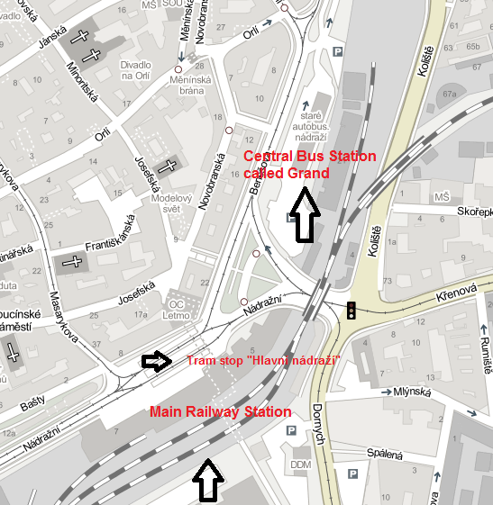

In the map above, you can see the location of the main railway station (“Brno hlavní nádraží”) and the central bus station called Grand (opposite the Grand Hotel). From those two stations, it is easy to get to the Halls of Residence by public transport.

Take tram no. 9 from the tram stop “Hlavní nádraží” in the direction of “Čertova rokle” and get off at the stop called “Bieblova” (11th stop). This ride takes 14 minutes. Then cross the road to the Academy Hall and find the reception (see the maps below).

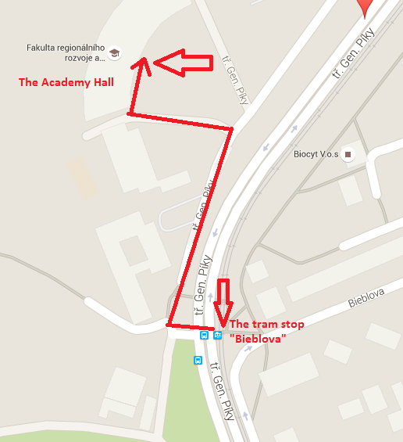

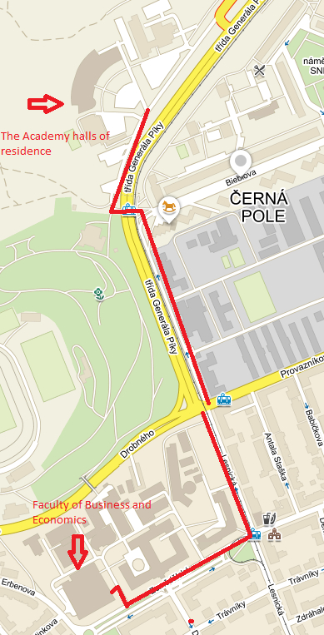

Below you can see The Academy Hall.

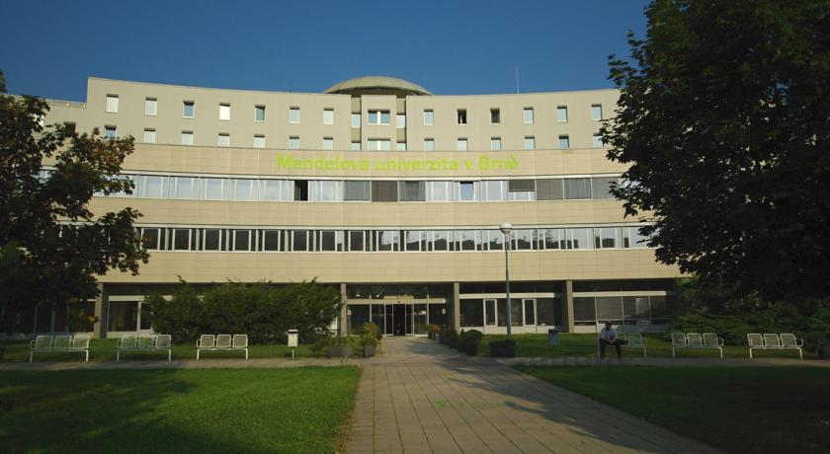

MENDELU CAMPUS PLAN
Faculty of Business and Economics is located in the building Q. Below you can see the entrance to the building Q. The International Relations Office is located on the ground floor in Deans Office (“Děkanát PEF”).



