“Comparing debt characteristics and LGD models for different collections polices”
LC. Thomas, A. Matuszyk, A. Moore,

Abstract

This paper discusses the similarities and the differences in the collection process between in-house and 3rd Party collection. The objective is to show that although the same type of modelling approach to estimating Loss Given Default (LGD) can be used in both cases the details will be significantly different. In particular the form of the LGD distribution suggests one needs to split the distribution in different easy in the two cases as well as using different variables. The comparisons are made using two data sets of the collections outcomes from two sets of unsecured consumer defaulters.
Keywords: credit risk, collection process, LGD modelling

- Introduction
When a borrower defaults on a loan some of the debt will be recovered during the subsequent collections process. Loss Given Default (LGD) is the percentage of the exposure at default which it is not possible to recover during this collections and recovery process. Modelling LGD has come to prominence in the last few years because under the internal ratings based regulations of the Basel Accord, (BCBS 2005) on capital adequacy, lenders have to estimate LGD for each segment of their loan portfolio.
There is a literature on LGD modelling for corporate loans, mainly because LGD is a vital factor in the pricing of risky bonds. The main approach to estimating LGD in this case is to use linear or non-linear regression based on a number of factors. These include details of the loan, such as the priority of the bond, details of the borrower, particularly the geographic and industry sector that the firm is part of, and the economic conditions. The book edited by Altman et al (Altman et al 2005) gives details of some of the models developed, though it is worth noting how difficult such estimation seems to be as indicated by the low R² values of many of the regressions. One example of a non linear regression is the commercial product LossCalc (Gupton and Stein 2005) which is based on the fact that the LGD distribution should be approximated by a Beta distribution.
The literature for unsecured consumer credit is much sparser and it is only with the advent of the new Basel Accord in 2007 that there has been a concentrated attempt by practitioners and academics to model LGD for this type of debt. Earlier Makuch et al (Makuch et al 1992) used linear programming to determine the best allocation of resources in a collections department, but did not use this to estimate LGD. Thomas et al (2007) pointed out that one of the problems with LGD modelling for unsecured credit is that the outcome depends both on the ability and the willingness of the debtor to repay but also on the decisions by the lender. They used a decision tree approach to model the strategic level decisions of a lender of whether to collect in-house, through an agent or to sell off the debt to a third party. They also suggested that LGD estimates for one type of collection might be built using mixture distributions. Caselli et al (Caselli et al 2008) used data from an Italian banks in-house collection process to show that economic effects are important in LGD values. Bellotti and Crook (Bellotti and Crook 2009) also looked at using economic variables as well as loan and borrower characteristics in a regression approach to LGD for in-house collection while Somers and Whittaker (Somers and Whitaker 2007) suggested using quantile regression to estimate LGD, but in all cases the resultant models had R² values between 0.05 and 0.2. It seems estimating LGD is a difficult problem.
This paper concentrates on the fact that recovering unsecured consumer debt is a sequential process with different parties being involved in seeking to recover the debt. Usually the first attempt to recover the debt is by the collections department of the lender (the “in-house” process). If this is not proving worthwhile, or for other commercial reasons, such as not wanting the lender’s reputation to be affected by it bringing court actions against debtors, the lender can use agents to collect the debt on a commission basis – i.e. they keep x% of what is recovered. Alternatively, or sometimes after using agents, the debt can be sold to third parties for a small fraction of the value of the debt. The price (P) the debt is sold at is related to what the third party believes the LGD or rather the Recovery Rate (RR) (where RR=1-LGD) is likely to be. If no money has been collected on the loan after default, then the price (P) gives the original lenders LGD (LGD_{in-house}), because that LGD_{in-house}= 1-(P/EAD) where EAD is the Exposure At Default. Note that if LGD_{third party} is the third party’s estimate of LGD then P≤EAD(1- LGD_{third party}).
This paper investigates the differences in the debt characteristics between the debt, which is being collected in-house, and that which is being collected by a third party. Although the general approach to modelling LGD can be applied to both forms of collection, the differences in debt characteristics lead to differences in both the form of the model and the types of characteristics used to estimate LGD.
- Data description
Normally the first attempt at collections is undertaken by an in-house team belonging to the lender. Such a team will have the information the debtor supplied on application, all the details of the loan and the borrower’s repayment performance until default. Although the formal Basel definition in the UK for default is that the debtor is 180 days overdue (unlike most other countries which is 90 days overdue) most lenders will freeze the loan or credit card facilities and undertake recovery measures once the loan is 90 days overdue. The representative data set we used for modelling such “in-house” collections was provided by a UK financial institution. It consisted of 11,000 defaulted consumer loans which defaulted over a two year period in the 1990s together with their repayment performance in the collection process. We concentrated only on this performance in the first two years in collections to match the information that was available on the third party collections process. For modelling purposes we split the data into 70% training set and 30% holdout test set.
Our second data set consisted of loans, which had been purchased by a third party from several UK banks. This data set consisted of the information on 70,000 loans where the outstanding debts varied from £10 to £40,000. These debts were purchased in 2000 and 2001 and so most of the defaults had occurred in the late 1990s. The repayments of the debtors for the first 24 months in this “third party” collections process were available at an individual loan level. Again for modelling purposes we split the data into a training set and a test set in the ratio 70:30.
It is clear when examining the “third party” data that there is less information available on the debtor than was available to the in-house collectors. The details of the debt, including the amount outstanding, when default occurred and when last there was a payment was available. Also in order to set the purchase price, the history of how many different parties had sought to collect the debt is reported. There was some information available about the debtor including details of address and telephone numbers when available, and some demographic information. However there was little information on the default risk scores of the borrower- either application score or behavioural score- or on the borrower’s performance before default. Thus in comparing the data we have restricted it to the details that were available both in the “in-house” and in the “third party” data sets.
- Collection Strategies
As well as the information available to the in-house collection department being different to the data available to the 3rd Party the way the debts are collected is different. The original lender is initially interested in protecting their relationship with the debtor. Once they believe this relationship cannot continue they are only interested in recovering the money they are owed. The third party has no relationship with the debtor and so from the start is only interested in recovering the money owed. That is why we can distinguish the following sequences of events:
- Recovery process – internal collection tries to save person
- Collection process – internal collection tries to save money
- Collection process – 3rd Party tries to save money
The actions undertaken by the original lender during the recovery or collection process do not differ; only the objective has changed. The main tool used in the in-house recovery process is letter. There are different types of letters and sending them depends on the status of the customers and the characteristics of the debt. Third party collectors tend to use the telephone followed by legal action when necessary. The debt sold to the 3rd Party will normally be debt, which has proven hard for the lender to collect in-house. This debt continues to be hard for the third party to collect. In fact over 80% of the 3rd Party’s debts have had no payments made on them at all.
Figure 1: Collection trees
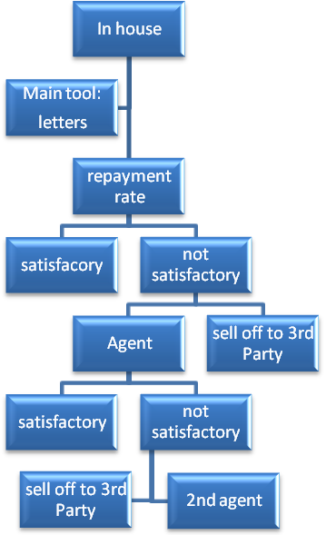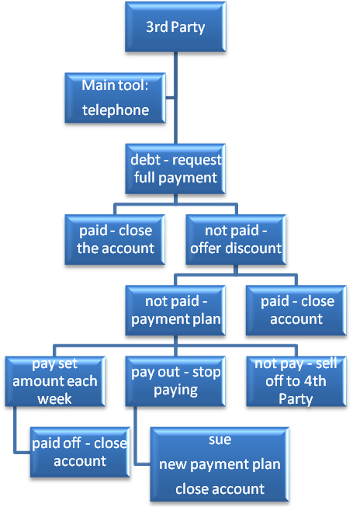
Deciding which action to take for in-house collection, is made on the basis of different conditions. Ususally, the first step is to send the letters at the beginning of every month. There are different types of letters and sending them depends on how much in arrears the customers are indebted; the langage becomes stronger as the debtor fails to pay. If this method is not sufficient the company must use other possible methods: calling the client, paying a visit to the client, trying to set up an agreement or find other possible solutions like rearranging the mortgage, selling the property etc.
When either a 3rd Party or in-house collections department takes over an account, they have to decide how to collect the debt. Their first step will be to try to collect the full outstanding debt. If debtor pays then they close the account. If not then a discount is offered for a lump sum payment. If the debt is paid then the account is closed, otherwise a payment plan is set up (most likely outcome). If the customer pays and stops then the lender will have to decide to either close the account if the total amount paid is satisfactory. If it is not – they may try to sue or start up a new payment plan. If the debtors don’t pay the payment plan at all then the collectors will either sell the debt or close the account. The primary method of debt collection, used by the 3rd Party from which the data was acquired, is telephone with written communication in support. The telephone is used because it can lead to fast recovery of debt, as it is a direct line of communication with the debtor and can result in a payment from the first conversation. The telephone is also very cost effective compared to face-to-face communication but is just as personal. There is also the element of surprise and the debtor and collector can negotiate to achieve a mutually satisfactory result.
Table 1: Debt comparison
Factor | In-house data set | 3rd Party data set
Main tool | Letter | Telephone
Age of Debt | New | Old
Type of Debt | Unsecured | Unsecured
Average Debt Amount | £3,609 | £562
Percentage Who Paid Back Whole Debt | 30% | 0.7%
Percentage Who Paid Back Part of the Debt | 60% | 16.3%
Percentage Who Paid Nothing | 10% | 83%
Mean value of LGD | 0.544 | 0.95
Collection model | Decision tree model with sub-models | Agent’s sub-model
LGD model | 2-step model | 2-step model
Information available | All details of loan and customer | Restricted data since not original lender
- Distribution of LGD
Analyzing the distribution of LGD, in Figure 2, it can be seen that 30% of the debtors paid in full and so had LGD=0. Less than 10% paid off nothing. For some debtors the LGD value was greater than 1 since fees and legal costs had been added. This is not the case usually in 3rd Party collection where almost 90% of the population have LGD=1 (Figure 3). It is clear that if attempts had already been made to collect the debt, then the LGD would be higher.
Figure 2: Distribution of LGD in the sample for in-house collection (collection for 24months: January1991-dec 1992)
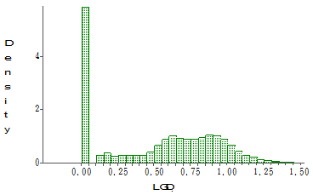
30%
60%
10%

Figure 3: Distribution of LGD for credit card debt sold to a 3rd Party
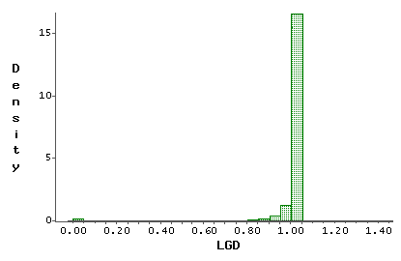
0.7%
83%
16.3%%

Figure 3 shows the Loss Given Default (LGD) for the credit card debt collected by the 3rd Party. The x-axis shows the LGD, the column above 1 represents the number of debtors who failed to pay back any of their debt hence LGD=1. The column above 0.95 represents all of the debtors who paid back up to 5% of their debt (0.95<=LGD<1). The column above 0 represents all of the debtors who paid back more than 95% of their debt (0<=LGD<0.05). The y-axis shows the number of debtors within each LGD bracket. The majority of the debtors (83%) failed to pay back any of their debt.
The recovery rates or loss given default for the two samples are very different. The majority of loans collected in-house have an LGD < 1, where as the loans collected by the 3rd Party have LGD = 1. There are several factors contributing to this difference. Firstly the debt collected in-house is new debt, no one else has previously tried to collect the debt and they have only recently defaulted at the time of collecting. On the other hand the 3rd Party debt is most likely old and has been collected before. This makes it harder for the 3rd Party to collect the debt. Secondly the in-house collection department will have access to more data and that data will have more details. This means that they can look at past behaviour, and the original loan details. In some cases they may also have access to data connected with their bank account and income. The 3rd Party will not have any of this data, in some cases the debtor may even need to be traced because they have moved or are deliberately trying to hide from the debt collectors.
- Analysis of the common variables
The variables available for analysis, which are common in both data sets, are as follows: age, amount of debt and residential status.

- Age
Majority of debtors from in-house data set, are in the “<25” and “25-35” brackets; far less are in “65+” bracket. Most of the customers from 3rd Party data set are in the “25-35” and “35-45” brackets. In the 3rd Party case, the ratio of RR>0:RR=0 is stable, where for the in-house case; the higher ratio is in the 35-45 age group, then the older the debtor the lower the ratio.
Figure 4: RR distribution by age for in-house collection and 3rd Party collection
In-house 3rd Party

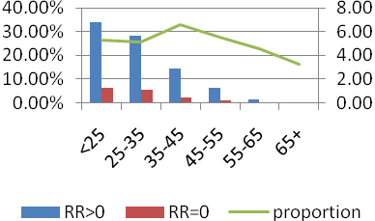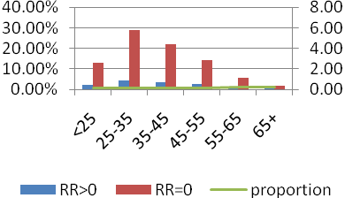

*) proportion=RR>0/RR=0

Residential status
Homeownership is divided into the following classifications: family, owner, and tenant. If the debtor is known to reside in a property owned by a member of their family, but not themselves or live with parents, then their homeownership is classified as family. If the debtor resides in a property owned by them then their homeownership status is owner. The vast majority, over 85% of the debtors in the 3rd Party data set are recorded as tenants, while in the in-house data set, 40% of the debtors are owners. This can also explain the behaviour of customers. Owners are more likely to pay off the debt where tenants belong to the most risky group.
Figure 5: RR distribution by homeownership for 3rd Party collection
In-house 3rd Party
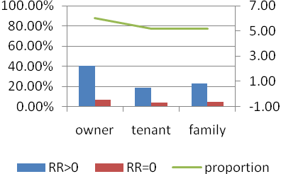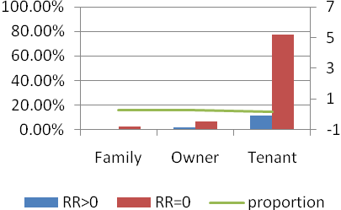

Debt Amount
The amount of the debt was from few pounds to £50,000. The variable was divided into eight groups. What is surprising; is that clients, who owe similar amounts in each data set, behave differently. For in-house collection the recovery rate is growing with the amount of debt; in case of 3rd Party the trend is flat with the only exception being the first bucket (£0-£100) where the repayment rate is the highest.
Figure 6: RR distribution by debt amount for in-house collection
In-house 3rd Party
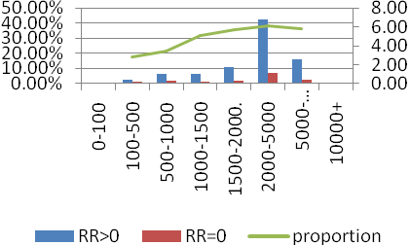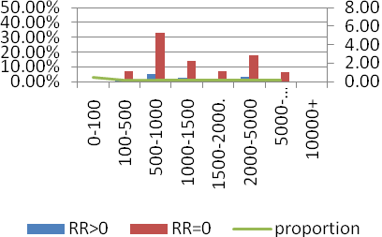
This analysis demonstrates that some debtor properties like their age, debt amount and residential status have a clear effect on the recovery rate.

- LGD models
For both data sets, models built consisted of two steps. In the first step we tried to estimate the spike in the distributions. So for in-house we were concerned with LGD≤0 versus LGD>0; for 3rd Party collection LGD=1 versus LGD<1. The splits were necessary because of the distribution of LGD (Figures 6 a and b). Logistic regression models were built for both data sets to split them into two groups. The predicted value for those in the first class should be either LGD=0 (In-house) or LGD=1 (3rd Party). For those who paid back part of their debt, the LGD was estimated using a number of different variants of linear regression. These included using ordinary linear regression, applying Beta and log normal transformations to the data before applying regression, the Box-Cox (Box, Cox, 1964) approach to “normalising” the data and using linear regression with Weight Of Evidence (WOE) approach.
Figure 6: LGD models
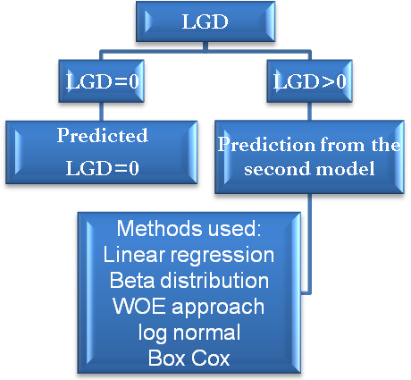
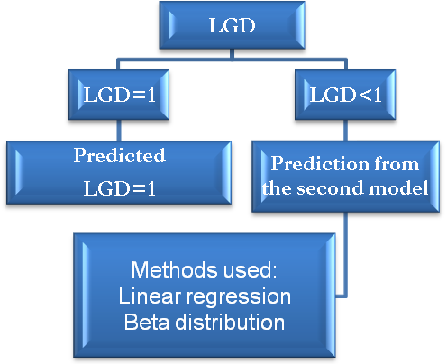
- In-house b. 3rd Party

Table 2a: Variables and results from the 1st stage modelling LGD
In-house | 3rd Party
1st stage
LGD=0 versus LGD>0 | LGD=1 versus LGD<1
The higher the loan amount the lower the chance of paying off everything  The longer the lifetime of the loan the higher the chance of paying off everything  The higher the application score the higher the chance of paying off everything  The more time spent in arrears during the loan the higher the chance of paying off everything. However those who were in arrears for more than 2/3 of the time, had lower chance of paying off everything  The more the customer was in arrears recently (in the last 12 months) the higher the chance of paying off everything | Having a work telephone number increases the likelihood of paying back part of the debt  Having a mobile telephone number increases the likelihood of paying back part of the debt  Having more telephone number increases the likelihood of paying back part of the debt Owing less than £100 at default increases the likelihood of paying back part of the debt.
Table 2b: Variables and results from the 2nd stage modelling LGD
In-house | 3rd Party
2nd stage predicting: 0<LGD<1
LGD>0 LGD<1
The higher the loan amount the higher the expected loss  The higher the application score the lower the expected loss  The longer the lifetime of the loan the lower the expected loss  The more the customer was in arrears recently (in the last 12 months) the lower the expected loss  The more time spent in arrears during the loan the lower the expected loss | The younger the debtor’s age the lower the expected loss  The lower the default amount owed the lower the expected loss  Owners will have lower the expected loss Having a mobile decreases the expected loss  Not having a contact number decreases the expected loss

Tables 2a and 2b contains the variables and results achieved during the LGD modelling for both data sets. As can be seen, different variables were used because of the information available. In-house collections have more data available to them because they have access to the original loan details and behaviour variables from monitoring the loan throughout its lifetime. The 3rd Party is restricted to information given by the lender. This information is limited due to lender policy and lack of requirements on the lender to provide useful debtor information.
Stage one for in-house and 3rd Party is focused on different extreme LGD results. For in-house we were concerned with paying off the whole loan whereas for 3rd Party we were concerned with not paying of any of the loan because these were the spikes in the LGD distributions. The in-house model found that the higher the loan amount the lower the chance of paying off everything and the third party model found that the higher the loan amount the lower the chance of paying off part of the debt. Applicants with a high application score are predicted less likely to default and if they do default the in-house results suggest they are more likely to pay off everything. This suggests the application score recognises the applicant’s willingness to pay, which applies both before and after default. A more counterintuitive result is that being in arrears recently increases the chance of paying off completely. This phenomenon has been found in other data set [9]. Implying that people who have been struggling with debt in their past may cope better with default than those who have never had financial problems. The rest of the in-house model was based on behaviour and application variables, which were unavailable to the third party. Therefore the third party model’s variables were more focused on how to contact the debtor i.e. the telephone numbers available.
The second stage model is focused on predicting the LGD between 0 and 1 and trying to fit a distribution. In all our cases the models were built on the training set but the results are based on the hold out test set. Different methods were tried (see table 3), the best method was weight of evidence with an R² of 0.23 for in-house and R² of 0.15 for 3rd party model. Table 3 shows the fits of the different approaches used in both data sets with $R^{2}$ value. It can be noticed that $R^{2}$ values are not high, which suggest that LGD values are difficult to forecast. All of the models for 3rd Party and in-house except weight of evidence gave a narrow distribution focused around the mean. Only weight of evidence gave a distribution covering the whole range 0-1.
The variables used by the in-house and 3rd Party models are again very different due to the information available. The in-house collections were privy to application and behaviour variables whereas the 3rd Party were limited to personal variables and contact information. Yet despite these different variables and the greater information held in-house the results of the models are very similar. Both the linear regression and the beta distribution models gave R² values around 0.1, where the predicted results were a poor representation of the observed results since in all cases the predictions were clustered around the means.
Table 3: Comparison of the results for the 2nd stage models
Method | In-house $R^{2}$ | 3rd Party $R^{2}$
Box Cox | 0.1299
Linear regression | 0.1337 | 0.1097
Beta distribution | 0.0832 | 0.1161
Log Normal transformation | 0.1347
WOE approach | 0.2274 | 0.1496

In the WOE approach we defined the target variable - LGD to be above or below the mean. We split the values of a characteristic into ten groups and looked at the ratio of above and below the mean in each group. We combined adjacent groups with similar odds, so as to divide the values of each characteristic into a number of “bins”. Then we defined WOE modifications for each characteristic, which took the weight of evidence value for each bin that the corresponding variable had been classed into. Generally, if N_{a} and N_{b} are the total number of data points with LGD values above or below the mean and n_{a}(i) n_{b}(i) are the number in bin i with LGD values above or below the mean. The bin is given the value:
$$\text{log}\left(\frac{n_{a}\left(i\right)}{n_{b}\left(i\right)}/\frac{N_{a}}{N_{b}}\right)$$
These previous models were all focused on predicting at the time of default the LGD within two years. When looking at whether to sell or buy the debt, which is already in the collections process, it is useful to predict future recoveries based on what has already been recovered. This is useful for deciding at what price to sell or buy the debt. The next model is a simple linear regression based on what was collected in the first 12 months in-house to see what would happen in the second 12 months. These models estimate the recovery rate (RR) at 24 months and 36 months after default; RR₂₄ and RR₃₆ respectively.
RR₂₄=0.047+1.205RR₁₂
This model had an R²=0.58 and a Root MSE=0.13. Expanding the model to see what would happen in the 3rd year gave an R²=0.80 and a Root MSE=0.11:
RR₃₆=0.037-0.258RR₁₂+1.233RR₂₄
Using the above models a lender can make more informed decisions about when to sell and how much to sell for. The reason these results are so superior to the previous models is because there is a dependence on both sides of the equation. RR₂₄ and RR₃₆ are dependent upon RR₁₂ since they cannot be smaller than RR₁₂ by definition. This artificially inflates the R² results.
Conclusions
Although both analysed data sets are about debt recovery, the information available in each case, is quite different and the average recovery rate varied from 5% to 46%. The two stage model is appropriate for both, even though the spikes are at opposite ends of the LGD distribution. All of this is not surprising because third party debt will usually go through several collection processes, so by definition must be harder to collect.
These models can be used by both sides to determine the price at which to buy a debt. The third party model gives an indication of recovery rate so the third party can set an internal upper limit for the price of buying the debt. For the in-house collection; the question is how much more would they get by keeping the debt in their collection process for some further time? To get a feel for this one needs to estimate RR in the next year using the information on the borrower and the amount already recovered. The models above which estimate RR₂₄ and RR₃₆ could help the in-house lender set a minimum price at which to sell the debt and determine which debts to sell and which to continue with. However internal politics and procedures are more likely to determine when to sell off the debt.

References
- Altman, E. I., Resti, A., Sironi, A.(2005): Recovery Risk, Risk Books, London
- Basel Committee on Banking Supervision (BCBS), (2005): International Convergence of Capital Measurements & Capital Standards- A Revised Framework
- Bellotti, T., and Crook, J., (2009): Calculating LGD for credit cards, QFRMC Conference on Risk Management in the Personal Financial Services Sector
- Box, G.E, Cox, D.R., (1964): An analysis of transformation, J. Royal Statistical Society Series B, 26, 211-246
- Caselli, S., Gatti, S., Querci, F., (2008): The Sensitivity of the Loss Given Default Rate to Systemic Risk: New Empirical Evidence on Bank Loans
- Gupton, G.M., Stein, R.M., (2005), LossCalc v2; Dynamic Prediction of LGD, Moody KMV,
- Makuch, W.M., Dodge, J. L., Ecker, J.G., Granfors, D. C., Hahn, G. J. (1992): Managing Consumer Credit Delinquency in the US Economy: A Multi-Billion Dollar Management Science Application
- Somers, M., Whittaker, J., (2007): Quantile Regression for Modelling Distributions of Profit and Loss
- Thomas, LC, Mues, C., Matuszyk, A., (2007): Modelling LGD for unsecured personal loans: Decision tree approach”, CORMSIS WP 07/07, School of Management, University of Southampton, to appear in J. Operational Research Society

Because of the in-house data set distribution, we took the following assumption: if RR<=0, then RR=0.

