Extract from Annex 2 of TSB Circular 19
*********************************
PRACTICAL INFORMATION

NGN Technical Workshop
(Jeju Island, Korea, 14 – 15 March 2005)

Meeting Venue
JEJU Lotte Hotel
2812-4, Saekdal-dong, Seogwipo City
Jeju -do, South Korea 697-130
Phone: (82)(2)759-7051~4 (Seoul Office) (Please quote group name 'ITU-T')
Fax: (82)(2)779-1353(Seoul Office) (Please quote group name 'ITU-T')
Sales Executive : JW Park
Email: jwparka@hotellotte.co.kr (Please quote group name 'ITU-T')
Home Page: http://www.hotellotte.co.kr

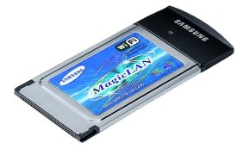
Computer Networking
Each meeting room will be equipped with wireless access (Wireless LAN, supporting IEEE802.11b, 2.4GHz band) to the Internet. Those who wish to use the wireless access must be equipped with the necessary hardware and correctly configured PC.

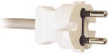
Electricity & Voltage

Jeju Lotte Hotel is equipped with V220 electricity outlets only (the shape of plug is the same as in France), but a transformer for V110 is also available upon request.

Airport
The closest airport is the Jeju International Airport

Transportation
(From Jeju International Airport to Jeju Lotte Hotel)
* Only Korean currency (Won) can be used for all transportation.

1. Limousine Bus
For visitor’s convenience, Samyoung Limousine bus is in service between the Jeju Lotte Hotel and the Jeju Airport
- Operation Hour: Everyday 06:20 – 22:00 (15minutes interval – A 50minutes ride from the Airport)
- Charge: 3,900 Korean Won (approximately 3.9 USD)

2. Taxi
It costs approximately 35,000 Korean Won (approximately 35 USD) from Jeju Airport to Jeju Lotte Hotel.

3. Rental car Information
Kumho Rent a car
Tel: +82-64-738-8101

We recommend that you take public transportation.

Map of Jeju island
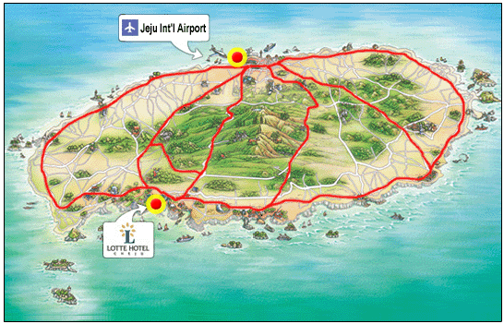

Hotel Information
1. Jeju Lotte Hotel
Address: 2812-4, Saekdal-dong, Seogwipo City, Jeju -do, South Korea 697-130
Phone: (82)(2)759-7051~4 (Seoul Office) Fax: (82)(2)779-1353(Seoul Office)
Home Page: http://www.hotellotte.co.kr
Category: 5 Star
There are 500 rooms equipped with cable TV, internet access, air conditioner, hairdryer, bath, telephone, voice mail, radio, alarm clock, in-house movie, writing desk and mini bar. The Hotel offers coffee/tea facilities and parking.

2. Hana Hotel
Address: 2812-2 sackkdaldong(Chung Mun Tourist Area), Seokkwipo, Cheju
Phone: +82-64-738-7001~2 FAX : +82-64-738-7000
Home Page: http://www.hotelhana.co.kr/
Category: 4 Star
There are 86 guest rooms equipped with color TV, air conditioner, telephone, radio, alarm clock, and mini bar, writing desk. The Hotel offers coffee/tea facilities and parking. The distance to Jeju Lotte Hotel is about 2 minutes on foot.

3. Hankook(Korea) Condominium
Home Page: http://www.koreacondo.co.kr
Home Page: http://www.koreacondo.co.kr/branch/branch_jeju_s.asp
Category: 4 Star
There are 216 apartments equipped with color TV, air conditioner, telephone, radio, alarm clock, and mini bar, writing desk. Each apartment accommodates up to 5 people with cooking facility. The distance to Jeju Lotte Hotel is about 2 minutes on foot.

Hotel Reservation and Cancellation
Reservation requests should be received no later than 4 March 2005. You are kindly requested to make use of the indicated hotel and the attractive rate offered. No other hotel room blocks have been reserved. Should you wish to seek other accommodation, please see: http://dir.yahoo.com/Regional/Countries/Korea__South/Provinces/Jeju_do/Travel_and_Transportation/Lodging/.
Hotel rooms must be guaranteed against a credit card and the reservation must be cancelled 3 days prior to arrival day to avoid a “no-show” charge.

Map of nearby Hotels
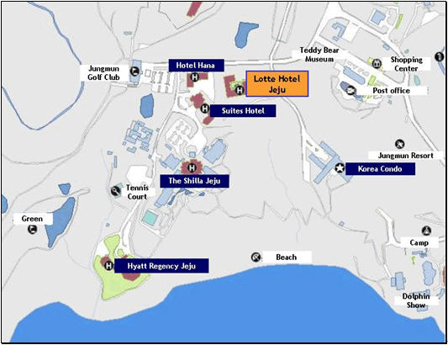

Passports and Visas
Most visitors with confirmed outbound tickets may stay up to fifteen days without visas. However, this does not apply to certain nationalities. Please check with your travel agent, Korean embassy or Korean consulate in your country in advance of your trip. Participants who need an invitation letter and/or visa-supporting letter for entering into Korea are strongly advised to contact the following person:
Mr. Youngjae Kim, TTA
Tel: +82 31 724 0195
Fax: +82 31 724 0119
Email: fgngn@tta.or.kr
The 18 Countries that need VISA: Cuba, Macedonia, Palestine, China, Mongolia, Philippine, Vietnam, Nepal, Sri Lanca, and India. Chinese nationals with more than five people to a group with a sightseeing purpose do not require visa. For further information, contact your local Korean Embassy or visit the website at http://www.mofat.go.kr/en/visa/e_visa.mof

About the Place
Jeju island is located at the southwest of Korean peninsula. The island is somewhat warmer than Seoul and has excellent beach resorts. It is favored with nature, clean water, fresh air and blessed climate. Jeju island’s total area is 1,845㎢. It is the smallest Province of Korea. The land is flat and oval-shaped but with Mt. Halla at center of the Island, contour lines draw concentric circles, letting the cultivated lands spread on the seacoast. Hilly areas of 200-300m above the sea level are gently sloped but most of them are idle land or meadows.
Jeju Island is a place favored by many honeymooners because of it’s weather, resorts, and beautiful surroundings. Also, Jeju Island has all the ingredients for an attractive convention or incentive tour site. For detailed information about Jeju, please find at http://www.jeju.go.kr

Climate & Clothing
The climate of Jeju during meeting may be a little bit cool. The temperature is around 13 degrees Celsius during March. For more detailed climate information, please contact the Korea Meteorological Administration (http://www.kma.go.kr/ema/eindex.htm )
Currency
Korea’s currency is called the won. Coins come in denominations of W 10, W 50, W 100, and W 500 and notes come in denominations of W 1,000, W 5,000, and W 10,000. The exchange rate fluctuates daily, dependent on international foreign exchange rates. Foreign currencies and traveler’s cheques can be exchanged at banks, airports, international ferry terminals and hotels.
* Current exchange rate: W1,039 / 1 USD ( as of 14 Jan 2005)
Credit Cards
Credit cards (Visa, American Express, Diners Club, Master Card and etc.) are accepted in almost all places such as major hotels, and major restaurants.

Korea & Korean Tourism
Please visit the following Websites for more information on Korea and possible tours:
http://www.kois.go.kr and http://www.visitkorea.or.kr/
Local time
GMT + 9 hours.

