
National Assessment of
Career and Technical Education

Interim Report

U.S. Department of Education

Office of Planning, Evaluation and Policy Development

Policy and Program Studies Service
This page intentionally left blank

National Assessment of
Career and Technical Education

Interim Report

Prepared by:
U.S. Department of Education
Office of Planning, Evaluation and Policy Development
Policy and Program Studies Service
2013
U.S. Department of Education
Arne Duncan
Secretary
Office of Planning, Evaluation and Policy Development
Denise Forte
Acting Assistant Secretary
Policy and Program Studies Service
Thomas Weko
Director
May 2013

This report is in the public domain. Authorization to reproduce it in whole or in part is granted. While permission to reprint this publication is not necessary, the suggested citation is U.S. Department of Education, Office of Planning, Evaluation and Policy Development, Policy and Program Studies Service. National Assessment of Career and Technical Education: Interim Report,Washington, D.C., 2013.

This publication is also available at the Department’s website at www.ed.gov/about/offices/list/opepd/ppss/reports.html#ve.

Request for Alternate Format documents such as Braille or large print should be submitted to the Alternate Format Center by calling 202-260-0852 or by contacting the 504 Coordinator via email at om_eeos@ed.gov.

Content Contact
Michael Fong
202-401-7462
michael.fong@ed.gov

Contents
Exhibits…… v
Accompanying Statement from the Independent Advisory Panel vii
NACTE Independent Advisory Panel ix
Highlights… xi
Executive Summary xiii
Chapter 1. Introduction 1
1.1 Key Provisions in Perkins IV 1
1.2 National Assessment of CTE 4
Congressional Mandate 5
Evaluation Issues and Strategies 5
Independent Advisory Panel 6
Interim Report: A Special Focus on Secondary CTE 7
Organization of Interim Report 8
Chapter 2. Framework for Evaluating the Implementation of Perkins IV Provisions on Accountability and Programs of Study 9
2.1 Logic Model 9
Policy Guidance 11
Funding 11
Programs of Study (POS): College and Career Pathways 11
Accountability Measures and Targets 13
2.2 Conclusion 17
Chapter 3. Participation in Secondary Career and Technical Education from 1982 to 2004 19
3.1 Data Sources for the Analyses 21
3.2 Measuring CTE Participation 21
3.3 Participation in CTE 24
Graduates Earning an Increasing Number of Total Course Credits 24
CTE Credits Are a Smaller Share 24
CTE Participation Patterns Are Also Changing 27
3.4 CTE Investors’ Characteristics 29
Gender 29
Race and Ethnicity 30
Socioeconomic Status 31
3.5 CTE Investors’ Academic and CTE Occupational Coursetaking 32
New Basics Coursetaking 32
Highest Mathematics and Science Courses Taken 33
3.6 Math Achievement 36
3.7 Postsecondary Education 37
Senior-Year Educational Expectations 38
Ever Attended Postsecondary School 39
3.8 Post–High School Employment 40
High School Senior-Year Occupational Expectations at Age 30 41
First Job Type of Non-College Attendees 42
3.9 Conclusion 42
3.10 Annex: Statistical Tables 44
Chapter 4. Outcomes of Career and Technical Education: Some New Evidence 51
4.1 Context for NACTE Outcome Studies 51
4.2 NACTE Outcome Studies 52
4.3 Education Longitudinal Study of 2002 53
Math Achievement 53
Dropping Out of High School 55
4.4 CTE Schools in Philadelphia: A Natural Experiment 57
Research Questions 57
Key Findings on the Impact of CTE Schools 58
4.5 Conclusion 59
Chapter 5. Career and Technical Education in International Perspective 61
5.1 OECD Nations 62
5.2 Labor Market Context 62
5.3 Upper Secondary Education 64
5.4 Upper Secondary School Completion Requirements, by Program Orientation 67
5.5 Career and Technical Education in International Perspective 69
5.6 Annex: America’s Global Competitors 70
Chapter 6. Implications and Final Report 73
6.1 Implications 73
6.2 Final Report 73
References… 75
Appendix A. Perkins IV NACTE Requirements 79

Exhibits
Exhibit ES-1. Percentage of high school graduates participating in career and technical education, by level of CTE occupational coursetaking: 1982, 1992, 2004 xx
Exhibit ES-2. Percentage of CTE investors and other high school graduates (non-investors), taking the new basics courses: 1982, 1992, 2004 xxi
Exhibit ES-3. Percentage of upper secondary school enrollment in concentrated vocational education (25 percent of total credits) in OECD countries: 2006 xxiv
Exhibit ES-4. Perkins IV requirements for NACTE and associated NACTE studies xxvi
Exhibit 1. Overview of changes in federal legislation of CTE 2
Exhibit 2. Logic model of Perkins IV key reforms 10
Exhibit 3. Performance indicators required by Perkins IV and ESEA at the secondary and postsecondary levels 14
Exhibit 4. Percentage of U.S. workers ages 18–64 years old performing selected tasks on their job or requiring specified job skills or attributes, by occupational category: October 2004–January 2006 20
Exhibit 5. Types of CTE investors 23
Exhibit 6. Average number of secondary credits earned by public high school graduates, by type of course work: 1982, 1992, and 2004 25
Exhibit 7. Average number of credits (Carnegie units) earned by public high school graduates, by subject area: 1982, 1992, and 2004 26
Exhibit 8. Percentage of total credits earned by public high school graduates, by type of course work: 1982, 1992, and 2004 27
Exhibit 9. Percentage of high school graduates participating in CTE, by level of CTE occupational coursetaking: 1982, 1992, 2004 28
Exhibit 10. Percentage of CTE investors, by level of CTE course concentration: 1982, 1992, and 2004 29
Exhibit 11. Percentage of public high school graduates who are CTE investors, by gender: 1982, 1992, and 2004 30
Exhibit 12. Percentage of public high school graduates who are CTE investors, by selected race or ethnicity: 1982, 1992, and 2004 31
Exhibit 13. Percentage of public high school graduates who are CTE investors, by socioeconomic status quartile: 1982, 1992, and 2004 32
Exhibit 14. Percentage of CTE investors and non-investors taking the new basics courses: 1982, 1992, 2004 33
Exhibit 15. Percentage of public high school graduates who were CTE investors and non-investors taking advanced mathematics (above geometry and algebra II): 1982, 1992, and 2004 34
Exhibit 16. Percentage of public high school graduates who were CTE investors and non-investors taking advanced science courses (advanced biology, chemistry, or physics): 1982, 1992, and 2004 35
Exhibit 17. Average estimated number-right math scores of CTE investors and non-investors: 1992 and 2004 37
Exhibit 18. Percentage of public high school graduates expecting to earn a bachelor’s degree or more, by CTE occupational investment: 1982, 1992, and 2004 38
Exhibit 19. Percentage of public school graduates expecting to earn no more than a high school degree, by CTE occupational investment: 1982, 1992, and 2004 39
Exhibit 20. Percentage of public high school graduates ever enrolled in a postsecondary education institution in the first two years after graduation, by CTE occupational investment: 1984, 1994, and 2006 40
Exhibit 21. Percentage of public high school graduates with given expectations of occupation at age 30, by CTE occupational investment: 1982, 1992, and 2004….. 41
Exhibit 22. Percentage of non-college-attending public high school graduates in first job type, by CTE occupational investment: 1984, 1994, and 2006 42
Exhibit 23. Percentage of public high school graduates, by CTE occupational investment: 1982, 1992, and 2004 44
Exhibit 24. Percentage of public high school graduates, by student characteristics and CTE investment: 1982, 1992, and 2004 45
Exhibit 25. Percentage of public high school graduates completing given highest level of mathematics, by curricular foundation and CTE occupational investment: 1982, 1992, and 2004 47
Exhibit 26. Percentage of public high school graduates completing given highest level of science, by curricular foundation and CTE occupational investment: 1982, 1992, and 2004 48
Exhibit 27. Percentage of public high school graduates with given educational expectations in 12th grade, by curricular foundation and CTE occupational investment: 1982, 1992, and 2004 49
Exhibit 28. Proportion of 25- to 64-year-olds in the workforce, by skill level of occupation in selected countries: 2006 64
Exhibit 29. Upper secondary school enrollment distribution in the United States and selected other countries, by program orientation percentage: 2006 66
Exhibit 30. Completion requirements for upper secondary school programs in the United States and selected other countries, by program orientation: 2006 69
Exhibit 31. Global Competitiveness Index (GCI) rankings of selected nations: 2009–10 and 2008–09 72

Accompanying Statement from the Independent Advisory Panel
To: Chairman John Kline, Committee on Education and the Workforce, U.S. House of Representatives
Chairman Tom Harkin, Committee on Health, Education, Labor, and Pensions, U.S. Senate
From: Independent Advisory Panel of the National Assessment of Career and Technical Education
Re: Interim Report of the National Assessment
The Carl D. Perkins Career and Technical Education Improvement Act of 2006 (Perkins IV) called on the secretary of education to appoint an Independent Advisory Panel (IAP) to provide guidance on the topics and methodology of the National Assessment of Career and Technical Education (NACTE), and to provide an independent report on the findings of the assessment. The IAP, which includes experts in career and technical education as well as experts in research techniques and methodology, has met four times in Washington to provide guidance and feedback on the NACTE studies. We have also reviewed the NACTE Interim Report and the studies on which it is based.
We are writing at this time to draw your attention to key issues that emerge from the Interim Report, which we trust you will read with great interest.
Changing Landscape of Career and Technical Education
Just as 21st-century workforce needs are changing what it means to be prepared in career and technical education (CTE), the population of students engaged in CTE is also shifting. Whereas three decades ago, secondary occupational courses were primarily the province of students without a strong academic orientation, the most recent data (from the high school class of 2004) reveal that students from across the academic spectrum are enrolled in both academic and occupational courses. Students participating in occupational courses are taking more academic credits than ever before, and low-income students make up a smaller share of course enrollments than in the past. Overall participation in CTE courses remained steady, but the proportion of students concentrating in CTE—those enrolled in three or more courses in the same field—has declined since the 1980s. These patterns are consistent with a view that secondary CTE has become less of a “track” for low-achieving, low-income students and more of a “field” in which students participate from a wide variety of backgrounds and interests.
Meanwhile, the new realities of the workplace such as the increasing use of technology and the growth of the health care sector have occurred alongside an expansion of occupational preparation at the postsecondary level. These trends have been accompanied by a desire to create pathways of occupational studies that extend from the secondary to the postsecondary level. More students who invest in CTE at the secondary level (those who take three or more credits in any CTE field) are continuing to the postsecondary level, and the gap in postsecondary attendance between CTE investors and nonparticipants in secondary CTE has declined. However, data on whether students are actually following specific CTE pathways or “Programs of Study” are not available, nor are they required by CTE accountability systems. Among students who do not attend college, moreover, national data show that CTE investors are more likely to find skilled jobs than are students who earn few or no occupational credits, an advantage for CTE students that has increased since the 1980s.
Evaluation Framework and Evidence
The NACTE has devised a framework for evaluation that is appropriate given its charge and resources. However, three main challenges have necessarily limited the scope of the evaluation
- Timing: Because the 2006 act is just now being fully implemented, the NACTE will evaluate mainly the quality of implementation. Evaluation of impact will also be part of the NACTE, but impact estimates will mainly reflect conditions of CTE that were in place at the start of the 2006 act, not those that unfolded subsequently.
- Longitudinal data: Until now, few states have had the longitudinal data necessary to permit evaluation of more than short-term outcomes; Florida is the noteworthy exception. As states move to comply with the education provisions of the American Recovery and Reinvestment Act, one may expect that longitudinal data will become more widely available.
- Evidence of quality: Despite important new accountability provisions in the 2006 act, available data focus mainly on who takes which CTE programs and courses, and little evidence is available to assess the quality of CTE instruction. Case studies that will be discussed in the NACTE final report will begin to address this gap, but such information is not regularly gathered.
Ensuring that students complete high school “college- and career-ready” has been identified as an important national policy goal. The IAP wishes to emphasize the potential for CTE to contribute meaningfully toward achieving this aim. Broader education reforms such improving teacher quality, turning around low-performing schools, setting high standards, and improving data systems should also be considered for CTE. Lessons may also be drawn from CTE that apply to education reform efforts more generally. Including CTE in broader conversations about education reform would ensure CTE is part of an overall improvement strategy and not isolated from other, complementary efforts to improve educational outcomes.
Looking Toward the Future
CTE has the potential to play a vital role in strengthening America’s competitiveness in the global economy. Because it spans the secondary and postsecondary levels, CTE can not only help students become “college- and career-ready,” it can encourage them to pursue postsecondary education or training, especially in high-skill, high-wage, and high-demand occupations.

NACTE Independent Advisory Panel

Adam Gamoran, Chair
Professor of Sociology and Educational Policy Studies
University of Wisconsin–Madison
Belinda Cole
Francis Tuttle Chair Professor
Oklahoma State University
Willard R. Daggett
President
International Center for Leadership in Education
James Jacobs
President
Macomb Community College
Timothy W. Lawrence
Executive Director
SkillsUSA
Katharine Oliver
Assistant State Superintendent
Division of Career and College Readiness
Maryland State Department of Education
James E. Rosenbaum
Professor of Sociology, Education & Social Policy
Northwestern University
Larry Rosenstock
Chief Executive Officer
High Tech High
Becky Smerdon
Managing Director
Education Research and Policy Quill Research Associates, LLC
Mala B. Thakur
Executive Director
National Youth Employment Coalition
John Tyler
Professor of Education, Public Policy and Economics
Brown University
Charles Ware
Vice Chair (Retired)
Wyoming Workforce Development Council
Ross Wiener
Executive Director
Aspen Program on Education and Society
Aspen Institute

This page intentionally left blank

Highlights
Background
Under the Carl D. Perkins Career and Technical Education Act of 2006 (Perkins IV), Congress mandated a National Assessment of Career and Technical Education (NACTE) to evaluate the implementation of the law and its outcomes. This interim report is the first of two reports. The purpose of this NACTE interim report is two-fold:
- To describe the overall research approach to meeting the congressional mandate.
- To present interim findings to date from the national assessment focused on participation, outcomes and international comparisons of secondary school career and technical education (CTE).
The final NACTE report will provide a more complete and integrated perspective on the progress made in implementing Perkins IV.
The findings in this interim report focus primarily on the role of secondary CTE in the preparation and transition of youths for college and careers. The report notes that a special challenge facing CTE in meeting these twin goals of academic and career preparation is the role of CTE for the approximately half the students in each secondary class who do not directly enter college upon leaving high school. Many of these students were having difficulty finding employment before the financial crisis and now employment is even more difficult. Based on Bureau of Labor Statistics data, a majority of recent graduates (54.3 percent) were jobless in 2011 as were nearly two-thirds (65.6 percent) of recent high school dropouts.
Findings
1. Participation in secondary CTE changed significantly over the 22-year period between 1982 and 2004. Although most students continue to take at least one CTE course, the focus of this report is on participation trends of students who invest in CTE (take three or more CTE courses).
- The percentage of CTE investors among high school graduates initially declined from 46 percent to 35 percent between 1982 and 1992 but stabilized and even increased slightly from 35 percent to 38 percent between 1992 and 2004.
- CTE investors have substantially closed the academic gap with non-investors in taking core academic courses (“new basics”) due in part by increasing academic course requirements as a condition for graduation in most states. By 2004, about 58 percent of CTE investors had completed the new basics, compared with about 61 percent of other students. Additionally, a small set of new courses that generally enrolled higher achieving students (e.g, in computer science and education) became classified as CTE.
- In 1982, 65 percent of investors concentrated in one occupational area. By 2004, the situation reversed when a majority (55 percent) of CTE investors took CTE in more than one occupational area (exploring) rather than in a single occupational area (concentrating). Because states generally report performance data under Perkins IV for only CTE concentrators, which most states define as secondary students who have taken at least three courses in a single CTE program area, Perkins IV accountability data reflects the performance of somewhat less than half of students who invest in CTE.
2. The NACTE presented new evidence of secondary CTE outcomes from two studies, with mixed outcome findings. An analysis of the nationally-representative NCES Education Longitudinal Study (ELS:2002) failed to find any relationship between CTE coursetaking and student achievement on a standardized math assessment or school completion. However, one study in a large urban school district (The School District of Philadelphia) found a positive relationship between CTE school attendance in oversubscribed schools and course and school completion but no relationship between CTE school attendance and achievement.
To further advance understanding of the potential effects of secondary CTE, evaluations would benefit from going beyond the approach of current studies that examine the outcomes of CTE without taking into account program variation or implementation quality. A more useful approach would be to focus on rigorously assessing the potential for CTE benefits from a defined and well-implemented set of programs.
3. The Organization for Economic Cooperation and Development (OECD) data show that secondary students in competitor nations devote a higher share of their course work to secondary vocational education programs than the United States, with the exception of Canada. Using OECD standards of vocational enrollment, in most European countries examined, almost half or more of secondary school graduates enroll in a vocational-oriented program (in which they earn 25 percent or more of their total credits). Even in Korea and Japan, with their strong academic traditions, a quarter of secondary graduates concentrate in vocational education by OECD standards. By contrast, since the early 1980s the percentage of U.S. secondary students meeting OECD standards for vocational education enrollment declined from about 18 percent to 6 percent.
Implications
Evidence from the interim report suggests that secondary CTE is shifting away from its historical dual-track approach and that successive cohorts of secondary CTE students are closing the gap with non-CTE students with respect to the number of core academic credits earned and college-going rates.
The interim report also raises issues of the role of secondary CTE in preparing for work the nearly half the students who do not directly go on to postsecondary education. With about half of all secondary students not going directly to college, and many having difficulties finding employment, it is important that information on the effectiveness of potentially exemplary CTE be investigated.

Executive Summary
The Carl D. Perkins Career and Technical Education Act of 2006 (Perkins IV) reinforces a longstanding federal commitment to supporting career and technical education (CTE). Although federal contributions account for only a fraction of total state and local spending on CTE, federal policy has had, and continues to have, a large influence on state and local programs and policies. Over time, as national attention has turned to globalization and its implications for a more highly skilled workforce, so too has Perkins IV’s emphasis shifted, with current legislation aimed at raising the academic and technical rigor of secondary and postsecondary CTE instruction to prepare students for entry into high-skill, high-wage, or high-demand occupations.
Perkins IV attempts to strengthen CTE and improve its quality primarily by increasing the emphasis on accountability and introducing programs of study (POS) that, among other things, integrate and align secondary and postsecondary levels across challenging and rigorous academic and technical content.
Under Perkins IV, Congress mandated a National Assessment of Career and Technical Education (NACTE) to evaluate the implementation of the law and its outcomes. This interim report is the first of two reports. The purpose of this NACTE interim report is two-fold:
- To describe the overall research approach to meeting the congressional mandate.
- To present interim findings to date from the national assessment focused on participation, outcomes and international comparisons of secondary school CTE.
The final NACTE report will provide a more complete and integrated perspective on the progress made in implementing Perkins IV. The final report will also include more detailed information about the outcomes of CTE participation, drawing upon several NACTE studies. The complete agenda of NACTE studies is listed in Exhibit ES-4 at the end of this executive summary.
ES-1 Congressional Mandate for the NACTE
Perkins IV directs the secretary of education to “provide for the conduct of an independent evaluation and assessment of career and technical education programs under the Act, including the implementation of the [Act].” Following the enactment of the new law, the secretary of education directed the Office of Planning, Evaluation and Policy Development (OPEPD) to conduct the NACTE.
NACTE’s evaluation agenda is driven by the requirements in the congressional mandate to examine the implementation of provisions in Perkins IV and the outcomes of CTE. The congressionally mandated issues and the set of NACTE studies to address the mandate are, as follows:
- How have secondary and postsecondary student enrollments in CTE programs changed? Examples of studies providing data for the NACTE include secondary data analysis of the National Center for Education Statistics (NCES) longitudinal data from the Education Longitudinal Study of 2002 (ELS:2002), the National Education Longitudinal Study (NELS:88), the High School and Beyond (HS&B) study, the National Assessment of Educational Progress (NAEP) High School Transcript Studies, and the Integrated Postsecondary Education Data System (IPEDS).
- Do students who participate in CTE realize any educational or workforce benefits? NACTE studies include secondary data analysis of ELS:2002 and secondary data analysis of natural experiments and quasi-experiments using local administrative data in Philadelphia and San Diego and state administrative data from Florida.
- How are Perkins IV funds distributed and used? NACTE studies include analysis of subgrantee fiscal data; state, district, and postsecondary institution surveys; and case studies of selected states, districts, schools, and postsecondary institutions.
- To what extent are Perkins IV accountability data valid, reliable, and comparable, and to what extent are decision-makers using these data? NACTE studies include state, district, and postsecondary institution surveys; case studies of selected states, districts, schools, and postsecondary institutions; and analysis of Perkins IV performance data systems.
- Are grantees meeting the requirement to develop and implement programs of study (POS) that integrate academic and technical content? NACTE studies include state, district, and postsecondary institution surveys; expert panel review of state POS; and case studies of selected states, districts, schools, and postsecondary institutions.
Thus, NACTE is sponsoring a set of interrelated but distinct studies to address the congressional requirements and associated research questions. The overall agenda calls for diverse data collection and analytic methods: qualitative case studies, national surveys of states and local entities, use of national longitudinal and cross-sectional databases, use of state and local administrative databases, an expert panel, and both a natural experiment in choice of CTE schools and econometric estimation of national and local program effects. A detailed listing of NACTE study activities in relation to individual provisions in the legislative mandate is presented at the end of this executive summary.
Results from the NACTE are to be reported in interim and final reports. This interim report will address parts of the first and second research questions in the preceding list: the participation of students in secondary CTE programs and a first look at the academic outcomes of CTE from two of NACTE’s quantitative studies. The final report will address the other topics.
Independent Advisory Panel
Congress further mandated that an Independent Advisory Panel (IAP) be formed for NACTE. The purposes of the IAP are to—
- Provide guidance to the secretary of education on the implementation of the NACTE, including the issues to be addressed and the methodology of its research studies to ensure that they meet the highest standards of quality.
- Prepare an independent analysis of the findings and recommendations resulting from the assessment.
The U.S. Department of Education has assembled an IAP whose members have a wide range of expertise (see p. ix for a list of the members).
Interim Report: A Special Focus on Secondary CTE
The findings in this interim report focus primarily on the role of secondary CTE in the preparation and transition of youths for college and careers. While postsecondary CTE plays a critical role in workforce development and specialized skills training, the final report will examine this area more fully when the NACTE studies on postsecondary education have been completed.
For a large part of the 20th century, CTE (formerly vocational education) was a mainstay in the career readiness preparation of the majority of secondary students who entered the labor force directly from high school. Those going on to college were schooled in the academic track and exposed to a more rigorous set of college preparation courses. Vocational majors in secondary school were placed on a track that was more occupationally focused. As greater percentages of high school graduates enrolled in college directly from high school, this dual track system resulted in increasingly negative perceptions of vocational education as programs where students were not adequately prepared for further education at the postsecondary level. Moreover, employers raised their expectations that new job entrants would bring strong basic academic skills, including high school graduates who were firmly grounded in reading, writing and mathematics skills (Levy and Murnane, 2004).
Congress responded over the years by moving to modernize the federal vocational education law to meet the newer and more rigorous education and workplace requirements and eliminate the sharp separation between the academic and CTE course work under the dual track approach. The strengthening of the integration of academic and technical tracks continued in Perkins IV. One key feature is the introduction of POS, which as noted, establish in different occupational areas formal course sequences connecting high school and college work. POS combine academic and career-related courses and lead to credentials or certificates of attainment. Perkins IV also requires states and subgrantees to report on performance standards around core academic, technical, and graduation and placement indicators.
This strategy of integration between academic and technical content also seeks to prepare secondary CTE students for postsecondary education and careers. The movement over the years has been to strengthen secondary CTE students’ access to a sound academic program while maintaining a strong technical program. This should permit students access without wasteful remediation at the postsecondary level while also building a foundation toward “high-skill, high-wage, or high-demand occupations in current or emerging professions.”
A special challenge facing CTE in meeting these twin goals of academic and career preparation is the role of CTE for the approximately half the students in each secondary class who do not directly enter college upon leaving high school. These include the approximately one-third of the high school graduating class who currently do not directly go on to postsecondary education as well as students who drop out of high school before graduation.
To gain a measure of the challenge in preparing students for the workforce, the employment of recent high school graduates and dropouts declined sharply between 2007 and 2011. Since the financial crisis, the labor force participation rate of high school graduates is down, the unemployment rate is up, and a majority of graduates not enrolled in college (54.3 percent) are jobless compared to 38.6 percent in 2007.
The picture for high school dropouts is starker. Between 2007 and 2011, the unemployment rate for those looking for work has risen from 26.9 percent to 38.4 percent of high school dropouts. The jobless rate, which includes those who are not actively seeking work, went from 58.9 percent in 2007 to 65.6 percent in 2011.
To better understand the potential role of secondary CTE, this interim report will present information on the participation of secondary students in CTE using a variety of participation measures and examine the coursetaking and academic outcomes of secondary CTE students. The interim report will also compare CTE preparation in the U.S. to other industrialized nations.
Organization of Interim Report
This interim report provides baseline information and lays the groundwork for a comprehensive final report. It consists of six chapters:
- Chapter 1 provides an overview of the NACTE research agenda.
- Chapter 2 provides an introduction to the legislative provisions of Perkins IV and issues they raise for NACTE’s evaluation of the implementation and outcomes of the law.
- Chapter 3 examines trends in student participation in CTE before Perkins IV was enacted using data from longitudinal studies of high school graduates conducted by the U.S. Department of Education’s NCES.
- Chapter 4 summarizes prior studies of CTE outcomes and presents preliminary findings from two NACTE studies (a national study and a large city study) of secondary CTE outcomes associated with earlier versions of the Perkins Act.
- Chapter 5 presents international benchmark data on pre–Perkins IV CTE participation and experiences comparing U.S. secondary students with their peers in other developed countries and drawing upon a report from the Organization for Economic Co-operation and Development (OECD, 2008).
- Chapter 6 draws implications for the final report.
The Chapter 1 overview of NACTE has been discussed above, so that the remainder of this executive summary summarizes Chapters 2–6.
ES-2 Chapter 2: Framework for Evaluating the Implementation of Perkins IV Provisions on Accountability and Programs of Study
Chapter 2 provides an analytic perspective on the provisions in Perkins IV aimed at improving the quality of CTE. The framework employed is called a logic model because it looks at the implicit logic in the program’s structures and requirements found in Perkins IV. By identifying the key elements in the law, the sequences and causal assumptions about the way they operate and interact, and the incentives and requirements for required actions, the logic model and theory of action provide direction for what NACTE should be examining in assessing whether Perkins IV is achieving its intended effects.
Perkins IV employs three major policy avenues for improving CTE services: (1) POS defining the expectations of a comprehensive sequence of CTE instruction; (2) accountability provisions holding state agencies and local subgrantees responsible for their performance; and (3) spending directives detailing the purposes and required uses of federal funds. These three legislative themes provide a range of policy levers for influencing the delivery of CTE services across secondary and postsecondary levels.
First, the requirement that all local subgrantees must offer at least one POS is a major change in Perkins IV. Perkins IV describes POS as (1) incorporating secondary education and postsecondary education elements; (2) including coherent and rigorous content aligned with challenging academic standards and relevant CTE content in a coordinated, nonduplicative progression of courses that align secondary education with postsecondary education; (3) possibly including an opportunity for secondary students to participate in dual or concurrent enrollment programs or other ways to acquire postsecondary credits; and (4) leading to an industry-recognized credential or certificate at the postsecondary level, or to an associate or baccalaureate degree.
The second new change is that accountability is strengthened in Perkins IV in several ways. Accountability for performance is extended from the state agency to local subgrantees, giving a state more leverage in holding its subgrantees responsible for improving the outcomes associated with their CTE programs. Local subgrantees (generally local education agencies [LEAs] at the secondary level and community colleges at the postsecondary level) have the option to negotiate with their state agency their level of expected performance, with those falling short of their performance benchmarks required to develop a program improvement plan. Continued failure to achieve negotiated targets could lead to the loss of some or all of their federal Perkins Act funding.
Congress has required that states use their measures of academic achievement (in mathematics and reading or language arts) and of high school graduation required in the Elementary and Secondary Education Act of 1965 as amended (ESEA) for assessing the performance of secondary CTE students. States must report disaggregated performance data, and identify any gaps in performance compared to all CTE students, for certain categories (subgroups) of students specified in the ESEA as well as for the special populations defined in Perkins IV. Congress further required a number of other student performance measures, including indicators of student attainment of career and technical skill proficiencies such as student achievement on technical assessments, which are aligned with industry-recognized standards, if available and appropriate.
The U.S. Department of Education has issued nonregulatory guidance that allows states to limit performance reporting to the subgroup of CTE students who are CTE concentrators. At the secondary level, a CTE concentrator is primarily a “secondary student who has earned three (3) or more credits in a single CTE program area (e.g., health care or business services).” States are to report the percent of CTE concentrators who have passed academic requirements and “technical skill assessments that are aligned with industry-recognized standards, if available and appropriate.” At the postsecondary level a concentrator is primarily a student who completes at least 12 academic or CTE credits within a single program area sequence that is comprised of 12 or more academic and technical credits and terminates in the award of an industry-recognized credential, a certificate, or a degree.
The guidance further explains that the Department recognizes that a “State may not have technical skill assessments that are aligned with industry-recognized standards in every CTE program area and for every CTE concentrator.” In this regard, the State Plan guide for Perkins IV required each state to identify the program areas for which it had technical skill assessments and submit a plan and timeframe for increasing the coverage of programs and students reported in this indicator to cover all CTE concentrators and all program areas in the future.
The final report will provide a careful examination of the state-reported performance information in response to Perkins IV. Also the final report will examine how states have interpreted the provision “if available and appropriate” for reporting students’ technical skills, including the consistency of reporting across states. Chapter 3 of this interim report on secondary CTE participation will assess the implications of limiting secondary performance reporting to CTE concentrators.
Third, although Perkins IV allows some flexibility in how its funds are spent, the purposes of the law provide some specific guidance for funding uses. One new focus is on preparing students for “high-skill, high-wage, or high-demand occupations in current or emerging professions. Another focus is on providing professional development for improving leadership and the quality of CTE personnel at all levels (teachers, faculty, administrators, and counselors). And third, giving states the flexibility to consolidate their Title II (Tech Prep) funds into their Title I (Basic State Grants) funds is important because it allows states to tailor their CTE programs to their unique circumstances. These funding uses will be examined in the final report.
This program logic model guides NACTE’s studies for examining the ways states and local entities are implementing Perkins IV. However, Perkins IV has only been in effect for a short period of time. Perkins IV was enacted in 2006, and states and local entities were allowed school year 2007–08 as a transition year before fully implementing the new law in school year 2008–09. Hence, it will be the final report that will explore most of the initial effects of Perkins IV, with the interim report findings establishing a baseline by which to evaluate Perkins IV.
ES-3 Chapter 3: Participation in Secondary Career and Technical Education from 1982 to 2004
Chapter 3 examines changes in participation in secondary CTE among high school graduates from 1982 to 2004, the period from before the Carl D. Perkins Vocational Education Act (Perkins I) was enacted in 1984 into the period covered by the Carl D. Perkins Vocational and Technical Education Act of 1998 (Perkins III). Over this period, CTE moved away from being what many described as a high school curriculum track—then known as vocational education, in contrast to academic and general tracks—students focused on occupationally specific courses in one occupational area. Instead, CTE has shifted to an educational field, in which students spend relatively less time in one occupational area but are more likely to explore several.
The background for the changes in CTE participation is the shift in which a majority of secondary graduates complete the academic curricular foundation defined by the new basics courses recommended in the 1983 report, A Nation at Risk (National Commission on Excellence in Education, 1983). These new basics consist of at least four Carnegie credits in English and three credits each in mathematics, science, and social studies. The proportion of high school graduates choosing the academic foundation consisting of the new basics rose from 14 percent in 1982 to 60 percent in 2004 (Dalton et al., 2013).
As the shift to more academic coursetaking occurred, patterns of investing in secondary CTE occupational courses changed (Exhibit ES-1):
- While the percentage of graduates enrolling in at least one CTE course declined by a small amount, almost all high school students (96 percent in 2004) still enroll in at least one CTE course, so that CTE has some meaning for nearly all graduates.
- The share of graduates who are CTE investors—those who earn three or more occupational credits—declined from 46 percent in 1982 to 35 percent in 1992, but that share has since stabilized and increased between 1992 and 2004 from 35 percent to 38 percent of high school graduates.
- A key measure of CTE occupational concentration is earning three or more credits of CTE in a single occupational area—there was a decline in the percent of occupational concentrators from 30 percent of all graduates in 1982 to 17 percent in 2004.
- However, another key descriptor of CTE investors is the percent of high school graduates who took three or more CTE credits in more than one occupational area (CTE explorers). The proportion of CTE explorers increased from 16 percent in 1982 to 21 percent in 2004.
Exhibit ES-1. Percentage of high school graduates participating in career and technical education, by level of CTE occupational coursetaking: 1982, 1992, 2004
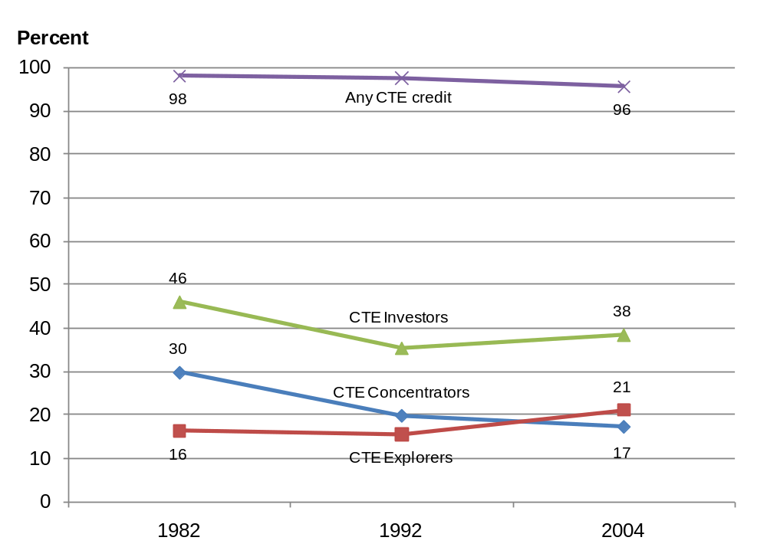
Exhibit reads: The percentage of public high school graduates with any CTE credit was 98 percent in 1982.
NOTE: CTE = career and technical education. CTE concentrators earned three or more credits in at least one occupational area. CTE investors consist of CTE concentrators plus CTE explorers who earn three or more total occupational credits but did not concentrate in an occupational area. A Carnegie unit is equivalent to a course taken for one period each day for one full school year.
SOURCE: U.S. Department of Education, National Center for Education Statistics, High School and Beyond Longitudinal Study of 1980 Sophomores (HS&B-So:80/82), “High School Transcript Study”; National Education Longitudinal Study of 1988 (NELS:88), “Second Follow-up, Transcript Survey, 1992”; and Education Longitudinal Study of 2002 (ELS:2002), “First Follow-up, High School Transcript Study, 2004.”
The fact that there are currently more students who invest in CTE who are explorers (three or more credits in more than one occupational area) rather than concentrators (three or more credits in one occupational area) has important implications for performance reporting under Perkins IV. Federal nonregulatory guidance, as noted above, allows states to report performance data for concentrators and hence, states are permitted to report on less than half of investors who take three or more CTE courses upon graduation.
As the share of graduates investing in three or more CTE credits stabilized between 1992 and 2004, CTE investors were also able to close nearly all the gaps in the rate of completing “new basic” courses compared with non-investors in CTE (Exhibit ES-2):
- In 1982, only about 6 percent of CTE investors completed the new basics, compared with about 22 percent of other students.
- By 2004, about 58 percent of CTE investors had completed the new basics, compared with about 61 percent of other students.
Exhibit ES-2. Percentage of CTE investors and other high school graduates (non-investors), taking the new basics courses: 1982, 1992, 2004
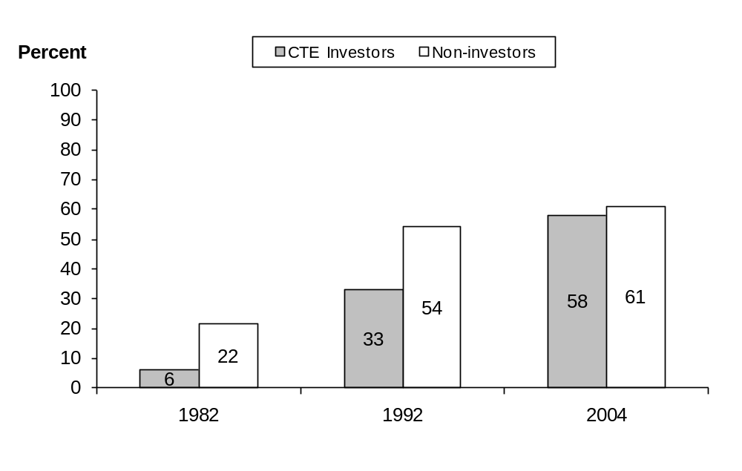
Exhibit reads: In 1982, 6 percent of CTE investors completed the new basics courses.
NOTE: CTE = career and technical education. CTE investors earned three or more total occupational credits (regardless of concentration in any occupational area). Non-investors are all other students—those who earned zero to less than three total occupational credits (Carnegie units). A credit (Carnegie unit) is equivalent to a course taken for one period each day for one full school year.
SOURCE: U.S. Department of Education, National Center for Education Statistics, High School and Beyond Longitudinal Study of 1980 Sophomores (HS&B-So:80/82), “High School Transcript Study”; National Education Longitudinal Study of 1988 (NELS:88), “Second Follow-up, Transcript Survey, 1992”; and Education Longitudinal Study of 2002 (ELS:2002), “First Follow-up, High School Transcript Study, 2004.”
Students could take CTE and still complete the new basics course load at greater rates because of the increase in total credits earned. The total number of credits earned by high school graduates went from 21.7 credits in 1982 to 26.2 credits in 2004, an increase of over one-fifth.
There was also major narrowing in rates of postsecondary attendance between CTE investors and non-investors. Between 1982 and 2004 high school graduates who were CTE investors significantly increased their postsecondary attendance during their first two years after high school. Among CTE investors, the proportion of CTE investors attending postsecondary programs increased from 54 percent in 1982 to 75 percent in 2004, narrowing the postsecondary rate of attendance gap with non-investors from 23 percentage points to only 8 percentage points.
ES-4 Chapter 4: Outcomes of Career and Technical Education: Some New Evidence
The mandate for the NACTE in Perkins IV includes not only examining the law’s implementation but also analyzing the impact CTE has on academic achievement and employment outcomes.
NACTE’s investigations into the impact of CTE on outcomes extend the findings from the earlier mandated study of Perkins III, namely, the National Assessment of Vocational Education (NAVE; Silverberg et al., 2004), which largely examined CTE outcomes occurring under Perkins II. At the secondary level, NAVE reported that research evidence showed that CTE did not bring about or contribute to academic achievement gains. NAVE also reported that only mixed evidence exists that CTE reduces the high school dropout rate. Moreover, it reported, CTE neither helped nor hurt the chances of students going on to postsecondary schooling. Postsecondary vocational education did, however, provide significant economic returns, with those earning a credential (certificate or degree) experiencing the largest benefits.
The NACTE looked for rigorous new evidence of CTE outcomes and found opportunities using existing data: a national study of secondary students using the NCES ELS:2002 and a natural experiment involving choice of a CTE high school in Philadelphia. The CTE outcomes studied occurred in periods covered by Perkins II and Perkins III.
The study of ELS:2002 looked at a representative sample of high school sophomores in 2002 and examined the relationship of CTE coursetaking to math achievement gains and dropping out of high school in 2004. In particular, this study examined differences in outcomes for students who take more versus fewer CTE courses in traditional high schools. NACTE’s study using ELS:2002 (Bozick and Dalton, 2013) analyzes gains in math using fixed effects regression analysis that reduces the influence of unmeasured factors—such as attitudes, preferences, or innate ability—that may lead to self-selection into certain educational programs.
The ELS:2002 study failed to find any relationship between CTE coursetaking and student outcomes (Bozick and Dalton, 2013):
- The total number of occupational credits earned during the last two years of high school had no relationship to the increase in number of correct answers on the mathematics assessment.
- Controlling for socioeconomic and academic differences among students as well as semester timing, the number of credits students earned in occupational courses was unrelated to their likelihood of dropping out.
A second study took advantage of a natural experiment in Philadelphia involving the choice of CTE high schools. Within the context of the district’s high school choice program, more students applied for entry to Philadelphia’s five CTE high schools than could be accepted, and acceptance was based on a random lottery. Therefore, the study examined the effects of winning admission to a CTE high school as opposed to attending another type of high school where they might also take CTE courses. This permitted comparing the outcomes of students accepted into CTE high schools with those who were not accepted. Outcomes for three cohorts of students were examined—the high school classes of 2003, 2004, and 2005. For two of the three cohorts (the classes of 2004 and 2005), the results are generalizable only to a more select group of Philadelphia students who applied to a CTE school and passed some moderate screens for achievement, attendance, and behavior.
The natural experiment in choice of CTE high schools in Philadelphia found some positive effects from attendance at CTE schools:
- Attending a CTE high school increased the probability of students successfully completing the college preparatory mathematics sequence of algebra 1, algebra 2, and geometry.
- Attending a CTE high school had no relationship to math or reading achievement growth from eighth to 11th grades.
- CTE high school attendance was related to higher on-time graduation rates.
The findings from the ELS:2002 study of student outcomes support the prior NAVE findings that CTE courestaking does not contribute to academic achievement gains as measured by standardized achievement tests. However, evidence from a natural experiment in Philadelphia found a positive relationship between attending a CTE school and mathematics coursetaking and graduation. To further advance understanding of the potential effects of secondary CTE, evaluations would benefit from going beyond the approach of current studies that examine the outcomes of CTE without taking into account program variation or implementation quality. A more useful approach would be to focus on rigorously assessing the potential for CTE benefits from a defined and well-implemented set of programs.
ES-5 Chapter 5: Career and Technical Education in International Perspective
Chapter 5 provides international comparative information on CTE—more widely known internationally as vocational education—in 15 nations that are competitors to the United States and participants in data collections sponsored by OECD. International comparisons address one of the legislative purposes of Perkins IV: to provide students the opportunities to develop “the knowledge and skills needed to keep the United States competitive.” The Congress has also expressed interest in international comparisons under section 114(a)(3), which provides that NCES “may include international comparisons” in its assessments of CTE. Moreover, major education organizations including the National Governors Association and the Council of Chief State School Officers have also called for international benchmarking studies to help maintain and improve the competitiveness of the United States.
OECD data show that secondary students in competitor nations devote a higher share of their course work to secondary vocational education programs than the United States, with the exception of Canada (see Exhibit ES-3). Using OECD standards of vocational education enrollment, in most European countries examined, almost half or more of secondary school graduates enroll in a vocational-oriented program (in which they earn 25 percent or more of their total credits). Even in Korea and Japan, with their strong academic traditions, a quarter of secondary graduates concentrate in vocational education by OECD standards. By contrast, since the early 1980s the percentage of U.S. secondary students meeting OECD standards declined from about 18 percent to 6 percent.
Exhibit ES-3. Percentage of upper secondary school enrollment in concentrated vocational education (25 percent of total credits) in OECD countries: 2006
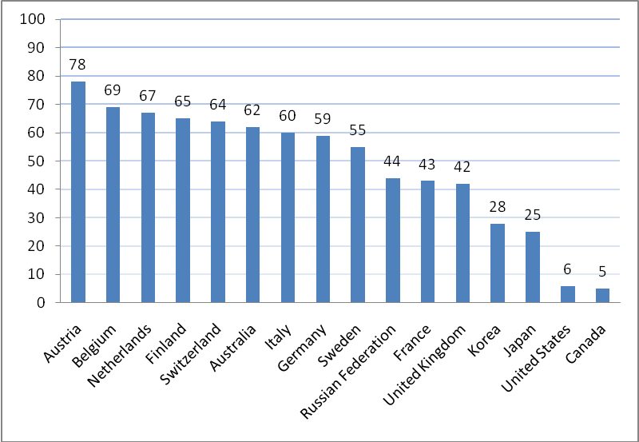
Exhibit reads: The percentage of upper secondary students enrolled in concentrated vocational education is 78 percent for Austria.
SOURCE: Organization for Economic Co-operation and Development (OECD), Education at a Glance 2008 (2008, Table C1.1). Website: http://www.oecd.org/edu/eag2008.
It is worth noting that 25 percent of total credits earned in CTE in the United States is well above the definition of three CTE credits in one occupational area used to define a CTE concentrator for Perkins IV accountability reporting. The OECD definition of a vocational education concentration would be equivalent to five or six CTE credits in the United States, which is more typical of U.S. career academy models or programs with an apprenticeship or internship component.
ES-6 Chapter 6: Implications and Next Steps
Evidence from the interim report suggests that secondary CTE is shifting away from its historical dual-track approach and that successive cohorts of secondary CTE students are closing the gap with non-CTE students with respect to the number of core academic credits earned and college going rates. The interim report findings about CTE participation, effectiveness, and international benchmarking, also raise important implementation and outcome issues that warrant further exploration in the final NACTE report and beyond. These issues include:
- How to assess the outcomes of the increasing proportion of students who invest in CTE courses (take three or more credits) but take fewer than three credits in a single occupational area (explorers). CTE explorers are not part of the current Perkins performance accountability system yet they are a growing majority of CTE investors. Research could examine the implications of including the category to assess program performance. Given that explorers do not concentrate in any one CTE field, the program questions to address are what are the expected outcomes of explorers and how could these outcomes be assessed within the accountability system?
- How to reconcile different results from studies about the benefits of secondary CTE on academic coursetaking, achievement, and high school graduation? Some studies find no such benefits from CTE, but other studies find CTE strengthening academic coursetaking and graduation rates. Research could explore whether these differences arise from differences in study methodology, nature of CTE courses and programs, or differences in CTE population and context. Research could also move beyond only exploring average effects of CTE without taking into account program variation or implementation quality and focus on assessing the benefits from a set of defined and well-implemented programs.
The first question about CTE accountability coverage and measures will be examined closely in the final report. The second question about the empirical benefits of secondary CTE populations will be difficult to address given present data. With about half of all secondary students not going directly to college, and many having difficulties finding employment, it is important that information on the effectiveness of potentially exemplary CTE be investigated.
There are two reasons for creating an evaluation agenda of studies that examine specific CTE programs or interventions in the near future. First, existing evidence shows the effectiveness of programs like career academies (e.g., Kemple and Willner, 2008). While these programs are now widely offered, much is unknown about the variation among them and what that variation might mean for program outcomes and their effectiveness in turning around whole high schools. Following students from well-implemented programs could be especially informative for identifying what works in improving student outcomes.
A second reason for initiating new studies of CTE programs is that OECD data suggest that many of our global competitors having substantial shares of secondary students enrolled in more CTE programs also have higher achievement on international tests like the Program for International Student Assessment and higher secondary completion rates. This suggests, and rigorous studies need to confirm, that it is feasible to provide a sound academic and additional technical education at the secondary level.
In conclusion, the transformation of CTE culminating in Perkins IV represents key program innovations to integrate academic and technical skills through programs of study and new accountability systems. The success of these innovations will depend upon sound implementation and having access to rigorous and timely evaluative data on what works and what is not working. The evidence in the interim and final NACTE reports along with implementing the proposed research agenda will help provide the needed evaluative data.
Exhibit ES-4. Perkins IV requirements for NACTE and associated NACTE studies
Pursuant to section 114(d)(2)(B) of Perkins IV, Legislative Requirements: “[t]he assessment required … shall include descriptions and evaluations of— | NACTE studies
“(i) the extent to which State, local, and tribal entities have developed, implemented, or improved State and local career and technical education programs assisted under the Act; | - Accountability and programs of study  - Surveys of state career and technical education (CTE) directors and local Perkins funds subrecipients (secondary and postsecondary)  - Case studies of states, districts, schools, and postsecondary institutions  - Expert panel review of state programs of study  - Analysis of Perkins performance data systems  - Funding  - State CTE director survey  - Tech Prep  - State CTE director survey  - Promising practices  - Literature review of effectiveness of online technology and distance education in CTE  - Developing comprehensive, longitudinal state databases for CTE reporting
“(ii) the preparation and qualifications of teachers and faculty of career and technical education (such as meeting State established teacher certification or licensing requirements), as well as shortages of such teachers and faculty; | - Teachers and faculty  - Secondary analysis of National Center for Education Statistics (NCES) data and reports  - Analysis of SAT scores of CTE teachers  - Supply and demand  - Secondary analysis of data from NCES and Higher Education Opportunity Act Title II
“(iii) academic and career and technical education achievement and employment outcomes of career and technical education, including analyses of—  (I) the extent and success of the integration of rigorous and challenging academic and career and technical education for students participating in career and technical education programs, including a review of the effect of such integration on the academic and technical proficiency achievement of such students (including the number of such students receiving a secondary school diploma); and | - Integration of academic/career and technical education content  - Surveys of state CTE directors and local Perkins funds subrecipients (secondary and postsecondary)  - Expert panel review of state programs of study  - Case studies of selected states, districts, schools and postsecondary institutions
See notes at end of table.

Continues next page
Exhibit ES-4. Perkins IV requirements for NACTE and associated NACTE Studies—continued
Pursuant to section 114(d)(2)(B) of Perkins IV, Legislative Requirements: “[t]he assessment required … shall include descriptions and evaluations of— | NACTE studies
(II) the extent to which career and technical education programs prepare students, including special populations, for subsequent employment in high skill, high wage occupations (including those in which mathematics and science skills are critical), or for participation in postsecondary education; | - Impact and educational/occupational outcomes  - Secondary analysis of national NCES longitudinal data Education Longitudinal Study of 2002 (ELS:2002)  - Secondary analysis (natural experiments and quasi-experiments) using local administrative data in Philadelphia and San Diego and state administrative data from Florida
“(iv) employer involvement in, and satisfaction with, career and technical education programs and career and technical education students’ preparation for employment; | - Employer involvement and satisfaction  - Review of employer surveys
“(v) the participation of students in career and technical education programs; | - Student participation  - Secondary analysis of NCES data and reports (e.g., ELS:2002, High School and Beyond Longitudinal Study [HS&B], and National Education Longitudinal Study of 1988 [NELS:88])  - Secondary analysis of Organization for Economic Co-operation and Development (OECD) data on CTE participation
“(vi) the use of educational technology and distance learning with respect to career and technical education and tech prep programs; and | - Effectiveness of technology/distance education  - Literature review of effectiveness of online technology and distance education in secondary CTE
“(vii) the effect of State and local adjusted levels of performance on the delivery of career and technical education services, including the percentage of career and technical education and tech prep students meeting the adjusted levels of performance described in section 113.” | - Adjusted levels of performance (also see Accountability above)  - Surveys of state CTE directors and local Perkins funds subrecipients (secondary and postsecondary)  - Case studies of selected states, districts, schools and postsecondary institutions
NOTE: NACTE = National Assessment of Career and Technical Education; Perkins IV = Carl D. Perkins Career and Technical Education Act of 2006 (20 U.S.C. 2301 et seq. as amended by P.L. 109-270).
This page intentionally left blank

Chapter 1.
Introduction
The Carl D. Perkins Career and Technical Education Act of 2006 (Perkins IV) reinforces a longstanding federal commitment to supporting career and technical education (CTE). Although federal contributions to the CTE enterprise account for only a fraction of state and local spending, federal policy has had, and continues to have, a large influence on state and local programs and policies.
Over time, as national attention has turned to globalization and its implications for a more highly skilled workforce, so too has the Perkins Act’s emphasis, with current legislation aimed at raising the academic and technical rigor of secondary and postsecondary CTE instruction to prepare students for entry into high-skill, high-wage, or high-demand occupations. New legislative provisions, which promote the alignment of secondary and postsecondary education through programs of study (POS) that, among other things, lead to an industry-recognized credential or certificate or degree at the postsecondary level, reinforce this goal. These are backed by secondary and postsecondary accountability provisions for student results.
Under Perkins IV, Congress mandated a National Assessment of Career and Technical Education (NACTE) to evaluate the implementation of the law and its outcomes. This interim report is the first of two reports. The purpose of this NACTE interim report is to describe the research approach and present findings to date from the national assessment. This interim report consists of six chapters plus an appendix on the NACTE requirements. The first chapter provides an introduction to Perkins IV and the NACTE research agenda, while the second chapter offers a framework for evaluating Perkins IV implementation. The remaining four chapters present baseline information focused on secondary CTE including participation trends, new outcome evidence and the international comparative information.

1.1 Key Provisions in Perkins IV
Federal legislation addresses particular challenges facing the nation, and these policy issues can and do change over time (Exhibit 1). During the early years of vocational education (1917–68) the stress was on expanding vocational programs to provide a trained semiskilled workforce to meet the needs of industry. Between 1968 and 1990, ensuring equal access to vocational education for disadvantaged and special need populations was stressed. Most recently, the stress is on improving the academic and technical quality of programs in the form of CTE along with strengthened performance standards to ensure program quality.
Exhibit 1. Overview of changes in federal legislation of CTE
Periods of CTE legislation | Policy objectives and tools
1917–63 | Provide trained workers for growing semiskilled occupations and retain more students in secondary education through:  - Expansion of separate vocational schools and programs.  - Funds for basic maintenance of programs.  - Focusing on agriculture, industry, and home economics for high school students.
1963–68 | Improve and expand vocational education through:  - Separate funds for innovative programs, research, and curriculum development.  - Support for construction of regional or area vocational schools.  - Support for adult training and retraining (postsecondary vocational education).  - Encouragement to states to promote vocational education equity, better service to special populations.
1968–90 | Improve vocational education and facilitate access through:  - Periodic encouragement to states to distribute some funds by community’s economic need and levels of student disadvantage.  - Establishment and expansion of set-aside funds to serve special population groups.  - Prohibiting the use of most federal funds for maintenance of programs.  - Continuation of set-aside funds for program improvement.
1990–98 | Expand equal access and emphasize academic quality through:  - Introducing intrastate and intradistrict funding formulas: distribution to agencies and schools weighted by special populations.  - Promoting integration of academic and vocational education and “all aspects of the industry.”  - Set-aside funds for new program linking secondary and postsecondary vocational education: Tech Prep.  - Requirement that states develop performance standards.
1998–Present | Improve academic and technical quality in CTE programs through:  - Introducing programs of study, a sequence of high school and college course work that combines academic and career-related courses that lead to a credential.  - Requirement that states and local subgrantees develop performance standards around core academic, technical, and graduation/placement indicators.  - Elimination of most set-asides but greater share of funds and flexibility to local subgrantees in exchange for an accountability system that would be used to improve student performance and document gaps in performance by student subgroups.
NOTE: CTE = career and technical education.
SOURCE: Millsap and Muraskin (1992); Boesel et al. (1994).
Perkins IV employs three major avenues for improving the academic and technical quality of CTE services:
- Programs of study (POS), defining the expectations of a comprehensive sequence of CTE instruction;
- Accountability provisions, holding state agencies and local subgrantees responsible for their performance; and
- Spending directives, detailing the purposes and required uses of federal funds.
These three thematic areas provide a range of policy levers for influencing the delivery of CTE services across secondary and postsecondary levels.
First, the requirement that all local subgrantees offer at least one POS is perhaps the most ambitious change in Perkins IV. Perkins IV describes POS as (1) incorporating secondary education and postsecondary education elements; (2) including coherent and rigorous content aligned with challenging academic standards and relevant CTE content in a coordinated, nonduplicative progression of courses that align secondary education with postsecondary education; (3) possibly including an opportunity for secondary students to participate in dual or concurrent enrollment programs or other ways to acquire postsecondary credits; and (4) leading to an industry-recognized credential or certificate at the postsecondary level, or to an associate or baccalaureate degree. This direction aligns well with recent initiatives for better integrating secondary and postsecondary education. For example, some states have linked K–12 and postsecondary data systems.
Second, accountability is strengthened in Perkins IV in several ways. Notably, accountability for performance is extended from the state agency to local subgrantees, giving states more leverage in holding their subgrantees, which generally are secondary local education agencies (LEAs) and community colleges, responsible for improving the outcomes associated with their CTE programs. Local subgrantees (which are referred to as “eligible recipients” in Perkins IV and are generally LEAs at the secondary level and community colleges at the postsecondary level) have the option to negotiate with their state agency their level of performance or targets. Those falling short of their performance levels are required to develop a program improvement plan. Continued failure to achieve negotiated targets could lead to the loss of some or all of their Perkins IV funding.
Congress also has required that states use the measures of academic achievement (in mathematics and reading or language arts) and of high school graduation required in the Elementary and Secondary Education Act of 1965 as amended (ESEA), for assessing the academic performance of secondary CTE students. States must report disaggregated performance data, and identify any gaps in performance compared to all CTE students, for certain categories (subgroups) of students specified in ESEA as well as for the so-called special populations defined in Perkins IV. Congress further introduced the accountability requirement that states report separately on programmatic outcomes for students participating in Tech Prep programs funded under Title II of Perkins IV, although no level of performance must be stipulated for these measures.
Third, although Perkins IV allows some flexibility in how states and local entities spend their funds, the purposes of the law provide specific spending directives for funding uses. A new spending directive is on preparing students for “high-skill, high-wage, or high-demand occupations in current or emerging professions.” This purpose reflects congressional awareness that technological changes along with shifts in global markets are driving occupational changes in the American workforce. Another is on providing technical assistance for improving leadership and the quality of CTE personnel at all levels (teachers, faculty, administrators, and counselors). Leadership is a key responsibility in a time of change, and the quality of CTE staff is critical for preparing qualified students. States are also given the flexibility to consolidate their Title II Tech Prep funds with their Title I Basic State Grants funds, which is important because it could allow states to tailor their CTE programs to their unique circumstances. Finally, another spending focus in Perkins IV calls for—
Providing individuals with opportunities throughout their lifetimes to develop, in conjunction with other education and training programs, the knowledge and skills needed to keep the United States competitive [italics added].
This focus recognizes the challenges the United States faces in remaining competitive in a global economy, and that individuals may need to continue their education and training throughout their lifetimes to remain active members of the workforce.

1.2 National Assessment of CTE
Perkins IV directs the secretary of ducation to conduct “an independent evaluation and assessment of career and technical education programs under the Act, including the implementation of the [Act].” Following the enactment of the new law, the secretary of education directed the Office of Planning, Evaluation and Policy Development (OPEPD) to conduct the NACTE.

Congressional Mandate
In its mandate (see Appendix A), Congress specified that NACTE should address issues that include the following:
- participation of students in CTE programs;
- academic and CTE achievement and employment outcomes of CTE;
- funding distribution and uses;
- effect of accountability provisions on the delivery of CTE services; and
- extent to which state and local entities have developed, implemented, or improved state and local CTE programs assisted under the Perkins Act.
The research NACTE conducts is to be reported in interim and final reports. This interim report will address parts of the first and second issues above: the participation of students in secondary CTE programs and a first look at the academic outcomes of CTE from two of NACTE’s quantitative studies. The final report will address the other topics as well as those listed in Appendix A.

Evaluation Issues and Strategies
The primary policy question is whether at both secondary and postsecondary levels CTE is effective in helping students attain the academic and technical skills required for securing high skill, high wage, and high demand jobs, or put more broadly, in preparing students for college and careers. Perkins IV attempts to strengthen CTE and improve its quality by increasing the emphasis on accountability and introducing POS that integrate and align, within and across secondary and postsecondary levels, challenging and rigorous academic and technical content as conditions for federal funding.
NACTE’s evaluation agenda examines the implementation of provisions in Perkins IV to strengthen CTE and the outcomes of CTE through a set of studies addressing the congressionally mandated issues identified above, as follows—
- How have secondary and postsecondary student enrollments in CTE programs changed? Examples of studies providing data for the NACTE include secondary data analysis of the National Center for Education Statistics (NCES) longitudinal data from the Education Longitudinal Study of 2002 (ELS:2002), the National Education Longitudinal Study (NELS:88), the High School and Beyond (HS&B) study, the National Assessment of Educational Progress (NAEP) High School Transcript Studies, and the Integrated Postsecondary Education Data System (IPEDS).
- Do students who participate in CTE realize any educational or workforce benefits? NACTE studies include secondary data analysis of ELS:2002 and secondary data analysis of natural experiments and quasi-experiments using local administrative data in Philadelphia and San Diego and state administrative data from Florida.
- How are Perkins IV funds distributed and used? NACTE studies include analysis of subgrantee fiscal data; state, district, and postsecondary institution surveys; and case studies of selected states, districts, schools, and postsecondary institutions.
- To what extent are Perkins IV accountability data valid, reliable, and comparable, and to what extent are decision-makers using these data? NACTE studies include state, district, and postsecondary institution surveys; case studies of selected states, districts, schools, and postsecondary institutions; and analysis of Perkins IV performance data systems.
- Are grantees meeting the requirement to develop and implement programs of study (POS) that integrate academic and technical content? NACTE studies include state, district, and postsecondary institution surveys; expert panel review of state POS; and case studies of selected states, districts, schools, and postsecondary institutions.
Thus, NACTE is sponsoring a set of interrelated but distinct studies to address the congressional requirements and associated research questions. The overall agenda calls for diverse data collection and analytic methods: qualitative case studies, national surveys of states and local entities, use of national longitudinal and cross-sectional databases, use of state and local administrative databases, an expert panel, and both a natural experiment in choice of CTE schools and econometric estimation of national and local program effects.
The short time period available to NACTE for conducting its research and reporting findings affects the ways evaluation studies can be carried out and how the data they produce may be used. Although NACTE is collecting new data focused on the state and local implementation of Perkins IV, available data largely capture outcomes associated with the periods in which Perkins II—the Carl D. Perkins Vocational and Applied Technology Education Act of 1990—and Perkins III—the Carl D. Perkins Vocational and Technical Education Act of 1998—were in effect. The interim report is relying on available data which do not reflect Perkins IV; however, the final report will include findings from new data collections under Perkins IV.
NACTE’s surveys of state and local entities for the final report will assess Perkins IV implementation for program year 2008–09. The data collected will capture the early implementation of Perkins IV at the state and local levels but may not reflect the longer term effects of Perkins IV.

Independent Advisory Panel
Congress further mandated that an Independent Advisory Panel (IAP) be formed for NACTE. The purposes of the IAP are to—
- Provide guidance to the secretary of education on the implementation of the NACTE, including the issues to be addressed and the methodology of its research studies to ensure that they meet the highest standards of quality.
- Prepare an independent analysis of the findings and recommendations resulting from the assessment.
The U.S. Department of Education has assembled an IAP whose members have a wide range of expertise (see p. ix for a list of the members).

Interim Report: A Special Focus on Secondary CTE
The findings in this interim report focus primarily on the role of secondary CTE in the preparation and transition of youths for college and careers. While postsecondary CTE plays a critical role in workforce development and specialized skills training, the final report will examine this area more fully when the NACTE studies on postsecondary education have been completed.
For a large part of the 20th century, CTE (formerly vocational education) was a mainstay in the career readiness preparation of the majority of secondary students who entered the labor force directly from high school. Those going on to college were schooled in the academic track and exposed to a more rigorous set of college preparation courses. Vocational majors in secondary school were placed on a track that was more occupationally focused. As greater percentages of high school graduates enrolled in college directly from high school, this dual track system resulted in increasingly negative perceptions of vocational education as programs in which students were not adequately prepared for further education at the postsecondary level. Moreover, employers raised their expectations that new job entrants would bring strong basic academic skills, including high school graduates who were firmly grounded in reading, writing and mathematics skills (Levy and Murnane, 2004).
Congress responded over the years by moving to modernize the federal vocational education law to meet the newer and more rigorous education and workplace requirements and eliminate the sharp separation between the academic and CTE course work under the dual track approach. The strengthening of the integration of academic and technical tracks continued in Perkins IV. One key feature is the introduction of POS, which as noted, establish in different occupational areas formal course sequences connecting high school and college work. POS combine academic and career-related courses and lead to credentials or certificates of attainment. Perkins IV also requires states and subgrantees to report on performance standards around core academic, technical, and graduation and placement indicators.
The strategy of integration between academic and technical content also seeks to prepare secondary CTE students for postsecondary education and careers. The movement over the years has been to strengthen secondary CTE students’ access to a sound academic program while maintaining a strong technical program. This should permit students access without wasteful remediation at the postsecondary level but also in building a foundation toward “high-skill, high-wage, or high-demand occupations in current or emerging professions.”
A special challenge facing CTE in meeting these twin goals of academic and career preparation is the role of CTE for the approximately half the students in each secondary class who do not directly enter college upon leaving high school. These include the approximately one-third of the high school graduating class who currently do not directly go on to postsecondary education as well as students who drop out of high school before graduation.
To gain a measure of the challenge in preparing students for the workforce, the employment of recent high school graduates and dropouts declined sharply between 2007 and 2011. Since the financial crisis, the labor force participation rate of high school graduates is down, the unemployment rate is up, and a majority of graduates not enrolled in college (54.3 percent) are jobless compared to 38.6 percent in 2007.
The picture for high school dropouts is starker. Between 2007 and 2011, the unemployment rate for those looking for work has risen from 26.9 percent to 38.4 percent of high school dropouts. The jobless rate, which includes those who are not actively seeking work, went from 58.9 percent in 2007 to 65.6 percent in 2011.
To better understand the potential role of secondary CTE, this interim report will present information on the participation of secondary students in CTE using a variety of participation measures and examine the coursetaking and academic outcomes of secondary CTE students. The interim report will also compare CTE preparation in the U.S. to other industrialized nations.

Organization of Interim Report
This interim report provides baseline information and lays the groundwork for a comprehensive final report. It consists of six chapters:
- Chapter 1 provides an overview of the NACTE research agenda.
- Chapter 2 provides an introduction to the legislative provisions of Perkins IV and issues they raise for NACTE’s evaluation of the implementation and outcomes of the law.
- Chapter 3 examines trends in student participation in CTE before Perkins IV was enacted using data from longitudinal studies of high school graduates conducted by the U.S. Department of Education’s NCES.
- Chapter 4 summarizes prior studies of CTE outcomes and presents preliminary findings from two NACTE studies (a national study and a large city study) of secondary CTE outcomes associated with earlier versions of the Perkins Act.
- Chapter 5 presents international benchmark data on pre–Perkins IV CTE participation and experiences comparing U.S. secondary students with their peers in other developed countries and drawing upon a report from the Organization for Economic Co-operation and Development (OECD, 2008).
- Chapter 6 draws implications for the final report.

Chapter 2.
Framework for Evaluating the Implementation of Perkins IV Provisions on Accountability and Programs of Study
This chapter provides an introduction to the Carl D. Perkins Career and Technical Education Act of 2006 (Perkins IV) in the form of a logic model. Logic models are systematic and visual ways to depict how the elements of a program are supposed to work to bring about desired outcomes.
The purpose of developing a logic model for Perkins IV is to guide the conduct of the independent evaluation and assessment of career and technical education (CTE) programs mandated by Congress in Perkins IV (see Section 114(d)(2) in Appendix A). The National Assessment of Career and Technical Education (NACTE) will provide information on the Act’s implementation in and influence on state and local programs. By identifying the key elements in the law, the sequences and causal assumptions about the way they operate and interact, and the incentives and requirements for required actions, the logic model provides direction for what NACTE should be examining in assessing whether Perkins IV is achieving its intended effects.

2.1 Logic Model
The underlying logic model presented in this chapter is premised on the interaction of two key legislative provisions contained in Perkins IV. First, it is postulated that programs of study (POS) demonstrating challenging academic standards and technical content, aligned across secondary and postsecondary levels, and offered in an articulated, nonduplicative sequence of courses, that lead to an industry-recognized credential or certificate, or a degree, will improve educational and career outcomes. Second, a valid and reliable system of accountability measures should provide overall information of CTE effectiveness and provide a basis for feedback and continuous improvement. The logic model (Exhibit 2) is organized in terms of critical inputs and activities as well as the student outcomes they are expected to yield.
- System inputs, which include federal legislation and funding, supplemented by federal guidance and technical assistance and state and local policies, form the foundation upon which state and local program design and operation occur.
- New activities in Perkins IV reflect congressional priorities in framing legislation that would more fully develop the academic knowledge and technical skills of secondary and postsecondary education of CTE students through the use of POS while holding systems accountable for both academic and technical preparation of CTE students.
- Outcomes in Perkins IV are separated into school and workplace domains. School outcomes at the secondary level include academic outcomes that align with ESEA requirements, postsecondary placement rates and technical skills attainment. Postsecondary outcomes include retention rates and technical degrees or certificates. Workplace outcomes are employment and earnings.
Exhibit 2. Logic model of Perkins IV key reforms
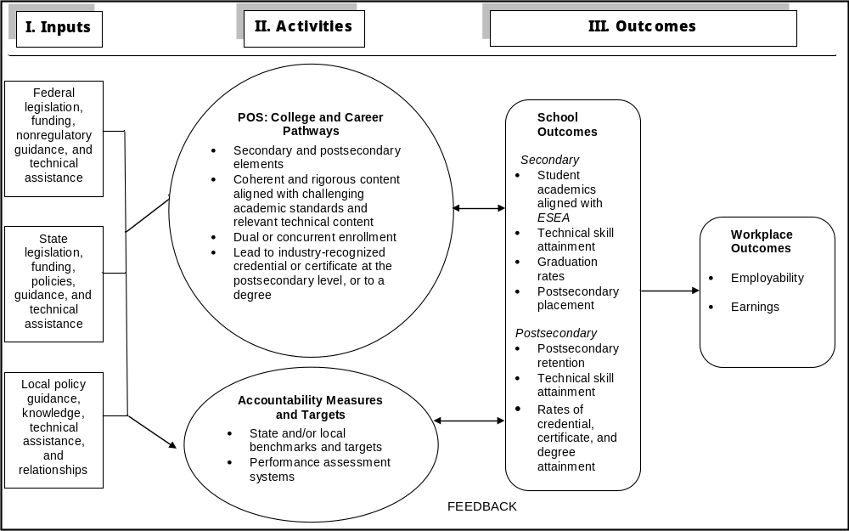
NOTE: ESEA = Elementary and Secondary Education Act of 1965 as amended; POS = programs of study.
The remainder of this discussion takes a closer look at the Perkins IV logic model with respect to the intended operation of four key elements: (1) policy guidance, (2) funding, (3) POS, and (4) accountability.

Policy Guidance
The U.S. Department of Education is responsible for assisting states in implementing the Perkins IV legislation. In keeping with past practice and with the limitation on federal regulations described in Sec. 318 of Perkins IV, the Department chose to issue nonregulatory guidance, rather than issue regulations for implementing the Act’s key provisions. For example, this nonregulatory guidance provides states with suggested approaches for defining CTE student populations and constructing performance measures. States have used this guidance in consultation with U.S. Department of Education staff to develop their own policy guidelines to support local programs in implementing the Act’s provisions.
Little is known about state strategies and local choices in implementing Perkins IV or how, and to what extent, federal nonregulatory guidance is filtered down to the local level. NACTE’s final report will examine this translation from statutory language to federal guidance to state policy to local implementation to understand how it influences the implementation of Perkins IV.

Funding
As in previous legislation, states have discretion in how federal funds are distributed between the secondary and postsecondary sectors, how reserve funds may be used to target resources for specified uses, and how the set-aside amounts are used to support nontraditional programming and to serve individuals in State institutions.
One new provision in the Act is the option for states to consolidate their Title II (Tech Prep) funding with their Title I (Basic Grant) resources. States that choose to maintain Tech Prep as a separate funding stream continue to have flexibility in how funds are allocated and distributed to local consortia, because there is no statutory Tech Prep formula for making subgrants stipulated in the Act. Perkins IV also introduces requirements that could affect state and local uses of funds, in particular for POS design and developing accountability systems.

Programs of Study (POS): College and Career Pathways
Through the requirement that all local recipients of Perkins funds must offer at least one POS, Perkins IV provides a new programmatic strategy shifting away from isolated stand-alone CTE classes to requiring a coherent program. POS should be viewed as embodying challenging academic content and technical content conveyed in a progressive sequence of course work incorporating secondary and postsecondary education elements. Its adoption implies that adequate career preparation requires readiness for advanced learning beyond high school, and that CTE course work should culminate in the award of an industry-recognized credential or certificate at the postsecondary level, or to a degree.
The federal legislation details four core elements that are essential to a POS:
- incorporate secondary education and postsecondary education elements;
- include coherent and rigorous content aligned with challenging academic standards and relevant CTE content in a coordinated, nonduplicative progression of courses that align secondary education with postsecondary education to adequately prepare students to succeed in postsecondary education;
- may include the opportunity for secondary students to participate in dual or concurrent enrollment programs or other ways to acquire postsecondary education credits; and
- lead to an industry-recognized credential or certificate at the postsecondary level, or an associate or baccalaureate degree.
There are, however, a number of components within a Perkins-defined POS that may require additional attention. Though these components currently exist in many, if not most, CTE programs, state agency and local subgrantee staff have not consistently sought to integrate these parts into a unified instructional strategy. Components that are critical to the success of POS include the following:
1. Secondary and Postsecondary Education Articulation
- Agreement between the participating secondary and postsecondary Perkins subgrantees educators is reached that outlines the scope and sequence of content within the POS.
- Joint adoption by the secondary and postsecondary subgrantees of rigorous technical content and the alignment of the delivery of content between the two educational sectors in a way that establishes a nonduplicative sequence of courses.
- Identification by secondary and postsecondary subgrantees of relevant academic standards that support the desired outcomes for the POS.
- Conscious attention by secondary and postsecondary subgrantees to constructing the secondary POS component to assure student attainment of sufficient knowledge and skills to avoid postsecondary remediation.
2. Academic and Technical Content Alignment
- Selection of relevant academic standards that align with secondary ESEA content standards and postsecondary certificate or degree general education requirements.
- Selection of industry-based technical content for the POS area.
- Selection or development of valid and reliable assessments of technical skill attainment.
- Curriculum, instruction, and assessments aligned with challenging academic and technical content.
- Professional development for secondary and postsecondary instructors on offering and teaching courses in the POS.
3. Dual or Concurrent Enrollment Accessibility
- Implement dual or concurrent enrollment agreements that award high school students with required credits for a postsecondary certificate or degree.
- Provide for integrating existing Tech Prep program components into POS.
- Where feasible, co-locate joint secondary-postsecondary CTE instructional facilities or provide secondary student access to postsecondary CTE facilities when the student is ready for advanced postsecondary education within his or her POS.
4. Credential, Certificate, or Degree Attainment
- POS are designed with the intended outcome of an industry-recognized credential or certificate at the postsecondary level, or a degree that is recognized and valued by employers.
- POS are constructed to promote preparation for career areas that are considered high skill, high wage, and high demand as defined by economic and workforce development needs and labor market information.
The NACTE final report will explore in considerable detail these critical success factors in terms of how states and districts are implementing POS. It will explore the likelihood that state agencies and local subgrantees will adopt differing approaches to implementing the POS model. In some settings, many of the core elements and components of a POS may already exist in Tech Prep programs, and need only be integrated into the POS framework. Other agencies or subgrantees may need to create new strategies for administering and delivering program services, may discover additional components integral to POS support, or may find ways of merging elements to accomplish the indicated goal. In addition, the final report will examine the extent to which POS are available. Currently, each local CTE recipient is only required to implement one POS.

Accountability Measures and Targets
Congress used its 2006 Perkins reauthorization to clearly spell out a set of CTE performance indicators within educational levels. In a break from earlier legislation, policymakers crafted a separate set of performance measures for secondary and postsecondary education (Exhibit 3).
They also introduced a new set of measures for Tech Prep programs, and extended accountability requirements to the local level by requiring that all subrecipients of Perkins IV funds negotiate local performance levels with their state CTE agency or accept their state’s statewide performance levels.
Exhibit 3. Performance indicators required by Perkins IV and ESEA at the secondary and postsecondary levels
Performance indicator, by level | Perkins IV | ESEA | Performance indicator requirement
Secondary  1. Academic attainment in mathematics | Same as ESEA | Yes | Student attainment of challenging academic content standards and student achievement standards, as adopted by a state in accordance with section 111(b)(1) of the ESEA and measured by state-determined proficient levels on academic assessments described in section 1111(b)(3) of the ESEA
2. Academic attainment in reading or language arts | Same as ESEA | Yes | Student attainment of challenging academic content standards and student achievement standards, as adopted by a state in accordance with section 111(b)(1) of the ESEA and measured by state-determined proficient levels on academic assessments described in section 1111(b)(3) of the ESEA
3. Technical skill attainment | Yes | No | Student attainment of career and technical education (CTE) skill proficiencies, including student achievement on technical assessments, that are aligned with industry-recognized standards, if available and appropriate
4. Graduation rate | Same as ESEA | Yes | Student graduation rates (as described in section 1111(b)(2)(C) of the ESEA)
5. Completion rate | Yes | No | Rates of attainment of a secondary school diploma, a GED credential or other state-recognized equivalent, and a proficiency credential in conjunction with secondary diploma, if offered in state
6. Placement rate | Yes | No | Placement in postsecondary education or advanced training, military service or employment
7. Nontraditional participation and completion | Yes | No | Student participation in and completion of CTE programs that lead to employment in nontraditional fields (defined as those for which one gender comprise less than 25 percent of the individuals employed in each such occupation or field of work)
Postsecondary  1. Technical skill attainment | Yes | — | Student attainment of challenging career and technical skill proficiencies, including student achievement on technical assessments, that are aligned with industry-recognized standards, if available and appropriate
2. Credential, certificate, or degree attainment | Yes | — | Student attainment of an industry-recognized credential, a certificate, or a degree
3. Retention or transfer | Yes | — | Student retention in postsecondary education or transfer to baccalaureate degree program
4. Placement | Yes | — | Student placement in military service or apprenticeship program or placement or retention in employment
5. Nontraditional participation and completion | Yes | — | Student participation in and completion of CTE programs that lead to employment in nontraditional fields (defined as those for which one gender comprise less than 25 percent of the individuals employed in each such occupation or field of work)
— Not applicable. ESEA is not applicable to the postsecondary level.
NOTE: ESEA = Elementary and Secondary Education Act of 1965 as amended; Perkins IV = Carl D. Perkins Career and Technical Education Act of 2006 (20 U.S.C. 2301 et seq. as amended by P.L. 109-270).
To support states in refining their accountability systems under Perkins IV, the U.S. Department of Education issued nonregulatory guidance detailing preferred approaches for defining measurement populations and constructing performance measures. These guidelines included a description of the intent of each measure, a suggested approach for assessing student performance, and examples of numerator and denominator constructions. Implementing these accountability measures and guidelines raises a number of issues that NACTE will study including:
Which CTE students are covered? Under federal guidelines states report the performance only of CTE concentrators. The nonbinding guidance encourages states to adopt the following definitions to identify students concentrating in CTE programs:
Secondary CTE Concentrator. A student who has earned three or more credits in one CTE program area, or two credits in one CTE program area, but only in those program areas where two credit sequences are recognized by the state and/or its local eligible subrecipients.
Postsecondary CTE Concentrator. A postsecondary/adult student who completes at least 12 academic or CTE credits within a single program area sequence comprised of 12 or more academic and technical credits that terminates in the award of an industry-recognized credential, a certificate, or a degree, or completes a short-term program sequence of less than 12 credit units that terminates in an industry-recognized credential, certificate, or degree.
Because states have flexibility in adopting their definition of a CTE concentrator, Chapter 3 examines the effect of reporting program performance using a variety of CTE participation measures.
How accurate are performance indicators reported? Legislative requirements and U.S. Department of Education policy guidance appear to have focused state reporting around a common set of performance measures although a number of issues merit further study by the NACTE. One is that the Perkins IV does not adequately address the contribution that CTE can make to academic performance of high school graduates. Although states are now required to use their ESEA measure to assess the academic attainment of CTE concentrators, many states assess students in the spring of their 10th-grade or fall of their 11th-grade year, prior to when students complete their CTE concentration. Thus, the measure is more likely to reflect the attainment of those who enter CTE than the effects of participation in CTE.
Perkins IV also does not allow for trade-offs among the performance indicators—all are assumed to be equally important and attainable. Measures are seen as independent of one another; that is, a state or local program that underperforms on one measure may not offset its shortfall with superior performance on another. Possible trade-offs in performance across indicators are also ignored, nor is any priority attached to individual measures. State and local agencies are expected to achieve their negotiated performance targets within a 90 percent threshold across all measures, with sanctions kicking in when any one falls below agreed-upon levels.
Finally, questions remain about the accuracy of accountability data because states only report raw data on the number of concentrators included in the numerator and denominator of each measure. States are neither required to detail the methodology used to collect information nor the manner in which state or local administrative records were accessed to report outcomes. For this and other reasons, NACTE is examining how state measures are constructed and data are collected. Case study visits to states and local agencies are providing rich, in-depth information on these topics.
The organization of state data systems and state privacy laws also affects data quality and availability. Many states have been maintaining separate data systems for CTE concentrators that, in some cases, do not include individually identifiable data. When those data do exist, state CTE administrators in the past have had to conduct matches across one or more state databases, which can be challenging if a unique student identifier, such as a Social Security number, is not incorporated in the data file. The availability of funding from the American Recovery and Reinvestment Act of 2009 for developing and expanding state student-level databases promises to address many of these concerns and CTE administrators need to fully participate in designing and upgrading those databases.
What are the additional accountability requirements if Tech Prep is continued? A state’s choice to continue separate funding for its Tech Prep program, rather than consolidating those funds into the basic grant program, requires additional accountability measures under Perkins IV. Specifically, states are required to maintain separate funding streams and to collect data on a set of nine Tech Prep performance indicators. These states also face the task of reporting on Tech Prep students who transition from the secondary to postsecondary levels, which has, in the past, proven to be a difficult undertaking. Because the U.S. Department of Education does not collect data on the measure used by each state as it is not required to negotiate performance levels for Tech Prep, the validity and reliability of Tech Prep data within and across states is as yet undetermined.
How will performance negotiations affect accountability? Perkins IV extends the requirement that state agencies negotiate with the U.S. Department of Education a level of performance for each of the accountability measures contained within the legislation. In the case of the secondary measures, states have little latitude in the negotiation of some measures: states are expected to align their targets for their measures of secondary reading and mathematics skill attainment and secondary graduation rate with their state’s annual measurement objectives established through their ESEA negotiations. The negotiations for targets for all measures are on a two-year cycle.
One substantial innovation in Perkins IV is the requirement that states reach agreement with local subgrantees on performance levels for each performance measure. In some states, all local entities receiving Perkins IV funds have agreed to accept the performance level negotiated by the state with the U.S. Department of Education; in others, locals negotiate with the state to set their own individual performance levels. In either instance, states must ensure that agreed-upon local performance levels will require that local entities make continual progress toward improving the performance of CTE students.
Perkins IV further requires that, if a subgrantee does not meet at least 90 percent of its performance level on each core indicator every year, it must develop and implement an improvement plan to address its deficiencies. Gaining a clearer understanding of how the state and local negotiation process occurs, the outcomes of these discussions, and how local subgrantees are held accountable for their performance is a particular emphasis for the NACTE.

2.2 Conclusion
The NACTE studies are assessing state and local implementation of the Perkins IV legislation along with outcomes of CTE realized under earlier versions of the Perkins legislation. The final report will present these results. Study findings should provide useful information in assessing the effects of statutory changes introduced in Perkins IV, which include updated accountability indicators, the extension of performance accountability to the local subgrantee level, the introduction of CTE POS, and increased state flexibility in allocating Tech Prep funds.

The remaining sections of the interim report will present initial findings with respect to secondary CTE including participation trends in CTE programs, student outcomes, and international benchmarking.
This page intentionally left blank.

Chapter 3.
Participation in Secondary Career and Technical Education from 1982 to 2004
Participation in career and technical education (CTE) at the secondary education level has changed significantly over the last three decades. This chapter describes those changes based on national longitudinal studies of the educational experiences of the high school classes of 1982, 1992, and 2004. These data provide a baseline against which to evaluate more recent student participation data that will be included in the final National Assessment of Career and Technical Education (NACTE) report.
The background for the changes in CTE participation is the shift in which a majority of secondary graduates complete the academic curricular foundation defined by the new basics courses recommended in the 1983 report, A Nation at Risk (National Commission on Excellence in Education, 1983). These new basics are also touted more recently by ACT (2008b) as the foundation for a student being college and career ready. The proportion of high school graduates choosing the academic foundation consisting of the new basics rose from 14 percent in 1982 to 60 percent in 2004 (Dalton et al., 2013).
A representative survey of employees covering white-collar, blue-collar, and service jobs indicate that employers need workers who have a foundation of both academic and technical skills but with differential skill levels required for different occupational categories (Exhibit 4). Jobs in all areas typically are filled with workers who have a high school diploma or more. In order to obtain white-collar and upper-blue-collar jobs, workers on average need more than a high school diploma and especially strong reading and writing skills. With respect to technical skills, white-collar jobs on average stress greater computer skills, and blue-collar jobs stress greater mechanical skills. Only service jobs on average have neither higher levels of computer or mechanical skill requirements, although this average may mask requirements in specific service sectors.
The Carl D. Perkins Vocational and Applied Technology Education Act of 1990 (Perkins II) supported students in CTE programs to take more rigorous academic courses along with technical courses. Succeeding Perkins legislation—including the Carl D. Perkins Career and Technical Education Act of 2006 (Perkins IV)—has also increasingly emphasized the importance of having students in CTE programs master rigorous academic and technical content.
Exhibit 4. Percentage of U.S. workers ages 18–64 years old performing selected tasks on their job or requiring specified job skills or attributes, by occupational category: October 2004–January 2006
Task performed on job or job skill needed (See footnotes for score codes) | All workers (average) | Upper white collar (e.g., management, professional, technical) | Lower white collar (e.g., clerical and sales) | Upper blue collar (e.g., craft repair, construction, mechanics) | Lower blue collar (e.g., factory work, truck driving) | Service workers (e.g., food, home health, child care, police)
Education required (3 = HS grad.; 6 = BA)ª | 4.15 | 5.42 | 3.72 | 3.49 | 3.10 | 3.17
Complexity of computer skills used^{b} | 4.21 | 5.91 | 5.06 | 1.95 | 2.43 | 1.77
Math skills—% using any math | 94 | 95 | 97 | 94 | 91 | 88
Algebra I (%) | 19 | 30 | 8 | 36 | 16 | 4
Reading—any reading (%) | 96 | 99 | 97 | 91 | 91 | 95
Documents 5 or more pages (%) | 54 | 81 | 47 | 46 | 26 | 32
Writing—do writing (%) | 91 | 99 | 93 | 83 | 80 | 83
Use forms (%) | 67 | 78 | 77 | 61 | 46 | 46
Mechanical skill level^{c} | 2.50 | 1.73 | 1.38 | 5.97 | 4.55 | 2.12
Exhibit reads: The average education level required by all U.S. workers is 4.15 (above high school). The percentage of all U.S. workers using math in their jobs is 94.
ª 1 = eighth grade or less; 2 = high school dropout; 3 = high school graduate; 4 = high school + vocational education; 5 = some college or two-year degree; 6 = bachelor’s degree; 7 = more than bachelor’s degree.
^{b} Self-rated complexity of computer skills used on job (0 = no computer use, 1 = very basic, 10 = very complex).
^{c} Self-rated complexity of mechanical skills used on job (0 = very basic, 10 = very complex).
NOTE: The Survey of Skills, Technology, and Management Practices (STAMP) is a random-digit-dial telephone survey of employed wage and salary workers in the United States at least 18 years of age conducted between October 2004 and January 2006 (n = 2,304). Eligible individuals were selected randomly within households. All respondents were interviewed with respect to their own jobs.
SOURCE: Michael J. Handel, A New Survey of Workplace Skills, Technology, and Management Practices (STAMP): Background and Descriptive Statistics, May 23, 2007; NAS presentation. http://www7.nationalacademies.org/cfe/Future_Skill_Demands_Michael_Handel_Paper.pdf.
In tracing the change in CTE participation between 1982 and 2004 as school systems strengthen enrollment in the new basics, this chapter follows the National Assessment of Vocational Education (NAVE; Silverberg et al., 2004) in focusing on CTE investors. CTE investors include two categories of students—
- CTE concentrators who earn three or more credits in one CTE occupational area, and
- CTE explorers who earn three or more credits in any CTE occupational areas.
This chapter starts by describing data sources for the analyses of CTE participation trends. It next examines trends in CTE investor participation within the context of overall trends in academic and enrichment coursetaking. It then compares CTE investors and non-investors with respect to academic and employment experiences including (1) coursetaking in math and science, (2) mathematics achievement, (3) postsecondary expectations and initial postsecondary enrollment, and (4) post–high school employment experiences within two years of graduation.

3.1 Data Sources for the Analyses
Data used in this chapter come from three national longitudinal studies tracking the secondary and postsecondary experiences of the high school graduating classes of 1982, 1992, and 2004. The three studies are the High School and Beyond Longitudinal Study (HS&B) for the high school class of 1982; the National Education Longitudinal Study of 1988 (NELS:88) for the class of 1992; and the Education Longitudinal Study of 2002 (ELS:2002) for the class of 2004. While these data do not cover the period since Perkins IV was enacted, they are the most recent longitudinal data on high school cohorts from the National Center for Education Statistics (NCES) with the necessary follow-up period required for the analysis.
These three studies provide information on the depth and extent of CTE participation, independently and in relation to: academic and other subjects; the social and demographic characteristics of graduates; their high school experiences and achievement outcomes; and their initial postsecondary education and employment experiences. A particular advantage of the longitudinal studies is their collection of achievement outcomes and post–high school academic and employment experiences. All studies were conducted by NCES, which is part of the Institute of Education Sciences in the U.S. Department of Education.
All three studies share similar content and design enabling cross-study comparability over time. All include a nationally representative sample of seniors. As part of the senior-year surveys, each study gathered and systematically coded high school transcripts. All comparisons between values discussed in this chapter’s text (changes over time, differences between groups, and differences between groups in changes over time) are statistically significant at p < .05, unless explicitly noted as nonsignificant. The tests for statistical significance are based on point estimates and standard errors that account for the complex nature of the studies’ samples. The samples used were restricted to public high school graduates who had a complete set of transcripts.

3.2 Measuring CTE Participation
This analysis focuses on student enrollment in CTE occupational courses offering specific labor market preparation. CTE courses in general fall into three groups:
- Family and consumer sciences education (FCSE)
- General labor market preparation (GLMP)
- Specific labor market preparation (SLMP) or occupational education
FCSE courses prepare students for family and consumer roles outside the paid labor market. GLMP courses teach general employment skills that are not specific to one occupational area, such as basic computer literacy, keyboarding or typing and general work experience courses. In contrast, occupational courses (SLMP education) are designed to prepare students for work in a specific occupational field or for related postsecondary education or training.
The CTE occupational courses being studied are divided into the following 11 mutually exclusive occupational areas (Bradby and Hudson, 2008; Hudson and Laird, 2009):
- Agriculture and Natural Resources;
- Architecture, Construction, and Science Technology;
- Business;
- Communications and Design;
- Computer and Information Science;
- Consumer and Culinary Services;
- Engineering Technologies;
- Health Sciences;
- Manufacturing, Repair, and Transportation;
- Marketing; and
- Public Services.
Measuring participation in CTE in terms of occupational coursetaking can be done in two ways: the number of CTE occupational credits earned or some threshold number of courses representing a significant investment in CTE (e.g., Hoachlander, Kaufman, and Levesque, 1992). Continuous measures of the number of credits may be less useful because their representation as numerical averages can mask substantial variation within the population and overstate the influence of particularly high or low values. In considering whether CTE has particular outcomes associated with it, some minimal level of exposure seems necessary. In particular, some level of concentration in CTE occupational courses may be particularly important for postsecondary work opportunities.
This descriptive report expresses a concentration level for CTE participation in terms of CTE investors (Silverberg et al., 2004). This category is defined on the basis of the number of occupational courses a student takes. Those taking three or more are classified as CTE investors, while those taking fewer than three are non-investors.
CTE investors are also divided into two groups of students (Silverberg et al., 2004). Those who earn their three or more occupational credits in one occupational area are CTE concentrators. In contrast, those who earn their three or more occupational credits in more than one area are called CTE explorers (see Exhibit 5).
Exhibit 5. Types of CTE investors
CTE investor: Earns three or more CTE occupational credits
CTE concentrator: Earns three or more occupational credits in one area (but may earn more credits in other occupational areas)
CTE explorer: Earns three or more occupational credits, but fewer than three credits in a single occupational area
NOTE: CTE = career and technical education.
These categories build upon the work of a number of previous analyses (Arum and Shavit, 1995; Hudson and Laird, 2009; Levesque, 2003a, 2003b; Levesque et al., 1995, 2000, 2008; Silverberg et al., 2004). Their advantage is twofold. First, although the categories are discrete, they reflect the fact that participation in CTE occupational coursetaking is a matter of degree. Almost all students (96 percent) took at least one occupational course in 2004. But most states do not report students in their Perkins IV secondary level performance data unless they are a CTE concentrator, which they define in terms of a threshold level of participation in occupational courses, usually three courses in one occupational area, but sometimes two when only two are offered in an area.
But as the data below show, students today are increasingly likely to take three or more CTE courses in more than one occupational area. The pattern of CTE coursetaking could reflect the common perception that most new entrants to the labor force should expect to change their careers several times over the course of their lives, and investing in CTE courses in high school is one way to become familiar with possibly appealing alternative careers. And that is the second advantage of this typology, namely, that it recognizes students take different pathways toward investing in CTE, even if the credits are in more than one occupational area.
In measuring students’ participation in CTE occupational coursetaking, high school transcripts for each graduating class were the primary data source. Participation in specific CTE programs, enrollment in certain types of high schools, and coursetaking experiences could all be used, independently or jointly, to define CTE students. However, coursetaking data from transcripts provide the most precise information about student participation in CTE. The specific course credits found on transcripts enable the construction of the categories of CTE investment.

3.3 Participation in CTE
Participation in career and technical education in high school occurs in the context of meeting curriculum requirements for high school graduation. Over the past quarter century or so, those requirements have increased, especially the academic credits needed to earn a diploma. Those increasing requirements are part of a longstanding high school reform movement going back at least to the early 1980s (e.g., National Commission on Excellence in Education, 1983) that started because of concern about the level of academic achievement of high school graduates.

Graduates Earning an Increasing Number of Total Course Credits
One of the most striking findings regarding coursetaking patterns of high school graduates since 1982 is the large increase in the number of credits (Carnegie units) earned (reminder: all changes or differences reported in the text are statistically significant unless otherwise noted). The total number of credits earned by high school graduates went from 21.7 credits in 1982 to 26.2 credits in 2004, an increase of over one-fifth (Exhibit 6 and Exhibit 7). The increasing credits earned were in academic and enrichment fields. Academic credits earned increased from 14.6 credits to 19.2 credits and enrichment credits from 2.6 credits to 3.2 credits between 1982 and 2004. More recent graduates increased their academic coursetaking in every field between 1982 and 2004 (Exhibit 7), with the largest increases in science (from 2.3 credits to 3.3 credits) and in non-English language (from 1.0 credits to 2.0 credits). Over the same 1982–2004 period, CTE coursetaking diminished from 4.6 credits to 3.8 credits, with the decrease concentrated between 1982 to 1992.

CTE Credits Are a Smaller Share
A major issue for many CTE educators has been that increasing academic course requirements could squeeze out participation in CTE courses, especially occupational courses. In looking at the period between 1982 and 2004, the share of CTE credits earned by high school graduates dropped from over a fifth of all credits in 1982 to about 14 percent in 2004 (Exhibit 8). Students continued, however, to take a significant number of CTE courses. While total CTE credits earned dropped between 1982 and 2004, in the last year students still earned, on average, 3.8 CTE credits.
Exhibit 6. Average number of secondary credits earned by public high school graduates, by type of course work: 1982, 1992, and 2004
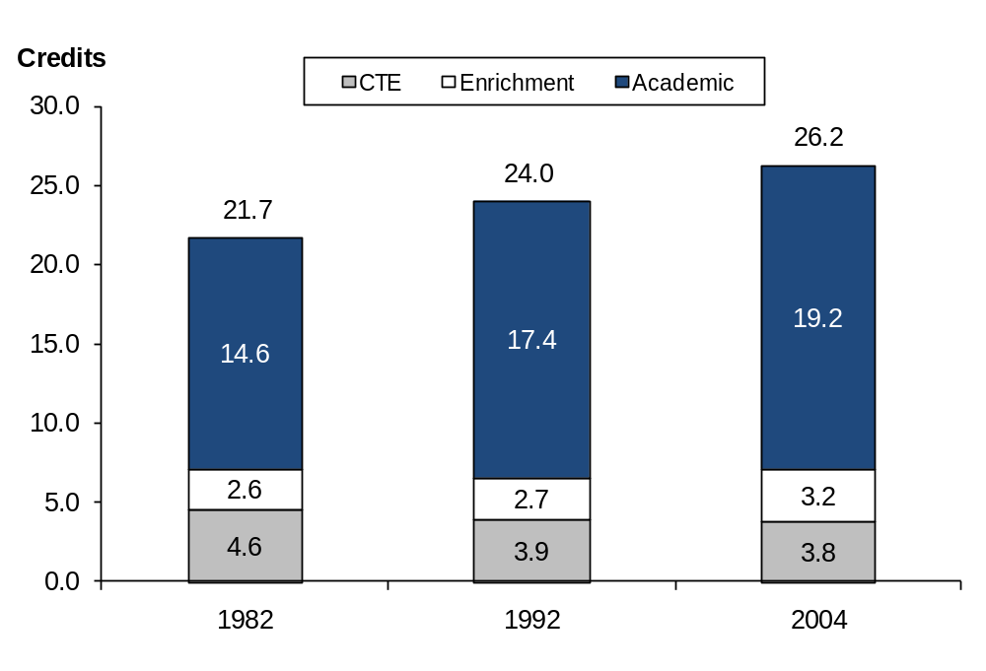
Exhibit reads: In 1982, the average number of academic credits earned by public high school graduates was 14.6 credits.
NOTE: CTE = career and technical education. See Exhibit 7 for details on data. Enrichment credits include courses such as physical education, religion, and military education. A credit (Carnegie unit) is equivalent to a course taken for one period each day for one full school year.
SOURCE: U.S. Department of Education, National Center for Education Statistics, High School and Beyond Longitudinal Study of 1980 Sophomores (HS&B-So:80/82), “High School Transcript Study”; National Education Longitudinal Study of 1988 (NELS:88), “Second Follow-up, Transcript Survey, 1992”; and Education Longitudinal Study of 2002 (ELS:2002), “First Follow-up, High School Transcript Study, 2004.”
Exhibit 7. Average number of credits (Carnegie units) earned by public high school graduates, by subject area: 1982, 1992, and 2004
Total and subject area | 1982 | 1992 | 2004
Total credits earned | 21.7 | 24.0 | 26.2
Total career and technical education (CTE) credits earned | 4.6 | 3.9 | 3.8
Family and consumer sciences education | 0.5 | 0.4 | 0.3
General labor market preparation | 1.0 | 1.0 | 0.9
Occupational area credits, total | 3.0 | 2.4 | 2.6
Agriculture and natural resources | 0.2 | 0.2 | 0.2
Architecture, construction, and science technology | 0.1 | 0.1 | 0.1
Business | 1.0 | 0.7 | 0.5
Communications and design | 0.2 | 0.2 | 0.3
Computer and information science | 0.1 | 0.2 | 0.4
Consumer and culinary services | 0.2 | 0.2 | 0.2
Engineering technologies | 0.2 | 0.2 | 0.2
Health sciences | 0.1 | 0.1 | 0.1
Manufacturing, repair, and transportation | 0.7 | 0.4 | 0.3
Marketing | 0.1 | 0.1 | 0.1
Public services | 0.1 | # | 0.1
Total academic credits earned | 14.6 | 17.4 | 19.2
English | 4.0 | 4.2 | 4.3
Mathematics | 2.7 | 3.3 | 3.6
Science | 2.3 | 3.0 | 3.3
Social studies | 3.2 | 3.5 | 3.9
Fine arts | 1.5 | 1.7 | 2.1
Non-English language | 1.0 | 1.8 | 2.0
Total enrichment credits earnedª | 2.6 | 2.7 | 3.2
Exhibit reads: In 1982, the average total credits earned by public high school graduates was 21.7 credits.
# Rounds to zero.
ª Enrichment credits include courses such as physical education, religion, and military education.
NOTE: A Carnegie unit (credit) is equivalent to a course taken for one period each day for one full school year.
SOURCE: U.S. Department of Education, National Center for Education Statistics, High School and Beyond Longitudinal Study of 1980 Sophomores (HS&B-So:80/82), “High School Transcript Study”; National Education Longitudinal Study of 1988 (NELS:88), “Second Follow-up, Transcript Survey, 1992”; and Education Longitudinal Study of 2002 (ELS:2002), “First Follow-up, High School Transcript Study, 2004.”
Exhibit 8. Percentage of total credits earned by public high school graduates, by type of course work: 1982, 1992, and 2004
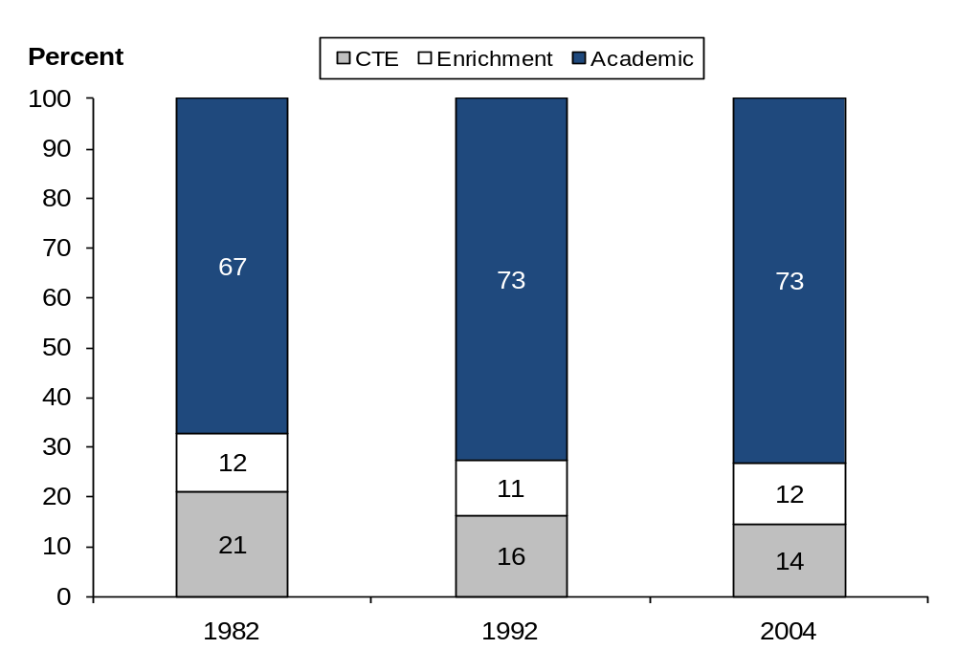
Exhibit reads: For public high school graduates, the percentage of total credits that were academic was 67 in 1982.
NOTE: CTE = career and technical occupation. Sums may not total to 100 percent because of rounding. Enrichment credits include courses such as physical education, religion, and military education. A credit (Carnegie unit) is equivalent to a course taken for one period each day for one full school year.
SOURCE: U.S. Department of Education, National Center for Education Statistics, High School and Beyond Longitudinal Study of 1980 Sophomores (HS&B-So:80/82), “High School Transcript Study”; National Education Longitudinal Study of 1988 (NELS:88), “Second Follow-up, Transcript Survey, 1992”; and Education Longitudinal Study of 2002 (ELS:2002), “First Follow-up, High School Transcript Study, 2004.”

CTE Participation Patterns Are Also Changing
Patterns of CTE coursetaking also changed over this period as public high school graduation requirements rose (Exhibit 9). The share of graduates who are CTE investors—those who earn three or more occupational credits—declined from 46 percent in 1982 to 35 percent in 1992, but that share has since stabilized and increased between 1992 and 2004 from 35 percent to 38 percent of high school graduates. The proportion of those earning three or more credits in one occupational area, the CTE concentrators, declined from 30 percent in 1982 to 17 percent in 2004, but the share of CTE explorers who earned three or more CTE occupational credits in more than one occupational area increased from 16 percent in 1982 to 21 percent in 2004.
Exhibit 9. Percentage of high school graduates participating in CTE, by level of CTE occupational coursetaking: 1982, 1992, 2004
Exhibit reads: The percentage of public high school graduates with any CTE credit was 98 percent in 1982.
NOTE: CTE = career and technical education, CTE concentrators earned three or more credits in at least one occupational area. CTE investors consist of CTE concentrators plus CTE explorers who earn three or more total occupational credits but did not concentrate in an occupational area. A Carnegie unit is equivalent to a course taken for one period each day for one full school year.
SOURCE: U.S. Department of Education, National Center for Education Statistics, High School and Beyond Longitudinal Study of 1980 Sophomores (HS&B-So:80/82), “High School Transcript Study”; National Education Longitudinal Study of 1988 (NELS:88), “Second Follow-up, Transcript Survey, 1992”; and Education Longitudinal Study of 2002 (ELS:2002), “First Follow-up, High School Transcript Study, 2004.”
This shift meant that investing in CTE went from being predominantly CTE concentrators to a majority of investors being CTE explorers (Exhibit 10). Almost two-thirds of students investing in CTE were CTE concentrators in 1982, but about 55 percent were CTE explorers by 2004. Note also that the share of graduates earning at least some CTE occupational credit declined only slightly over this period, from 98.0 percent in 1982 to 97.6 percent in 1992 to 95.6 percent in 2004, and still included virtually all students.
This shift in the composition of investors away from concentrators to explorers has implications for CTE performance reporting at the secondary level. As noted in Chapter 2, federal guidance suggests that states report the performance only for secondary CTE concentrators, who currently account for less than half (45 percent) of all CTE students who take three or more CTE courses (investors). Hence, no state performance information is available on the majority (55 percent) of CTE investors who take more than three courses but in two or more occupational areas.
Exhibit 10. Percentage of CTE investors, by level of CTE course concentration: 1982, 1992, and 2004
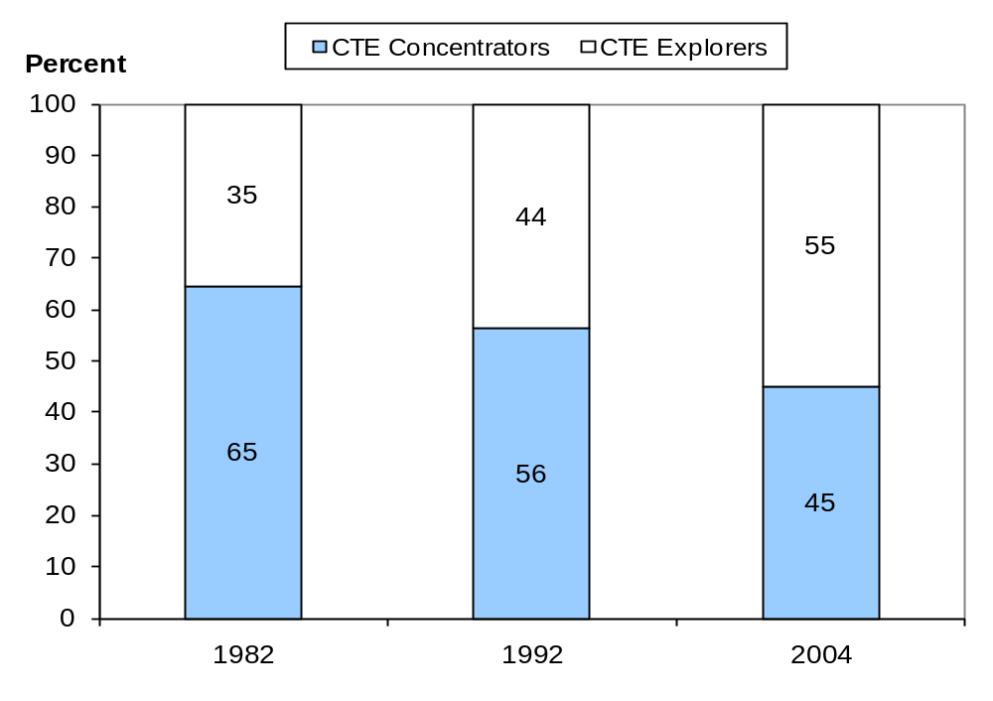
Exhibit reads: In 1982, the percentage of CTE explorers was 35 percent.
NOTE: CTE = career and technical education. CTE concentrators earned three or more credits in at least one occupational area. CTE explorers earned three or more total occupational credits but did not concentrate in an occupational area. A credit (Carnegie unit) is equivalent to a course taken for one period each day for one full school year.
SOURCE: U.S. Department of Education, National Center for Education Statistics, High School and Beyond Longitudinal Study of 1980 Sophomores (HS&B-So:80/82), “High School Transcript Study”; National Education Longitudinal Study of 1988 (NELS:88), “Second Follow-up, Transcript Survey, 1992”; and Education Longitudinal Study of 2002 (ELS:2002), “First Follow-up, High School Transcript Study, 2004.”

3.4 CTE Investors’ Characteristics
Concern about the student characteristics of those earning high school credits in CTE occupational courses goes back to when CTE was called vocational education and seen as an educational track for low-performing students. In some cases, students were counseled (or even directed) into occupational courses based on their personal characteristics, not their preferences, aspirations, and abilities. This section examines how patterns of participation by gender, race or ethnicity, and socioeconomic status have changed between 1982 and 2004 among CTE investors (concentrators and explorers combined).

Gender
Between 1982 and 2004, patterns of participation in career and technical education by gender became less similar (Exhibit 11). In 1982, about 49 percent of males and 43 percent of females were CTE investors. In contrast, by 2004, about 45 percent of males were CTE investors, but only about 32 percent of females were CTE investors. Within the category of CTE investor, in 1982 females and males were approximately equally likely to be CTE concentrators (Exhibit 24). By 2004, males (21 percent) were more likely than females (14 percent) to be CTE concentrators.
Exhibit 11. Percentage of public high school graduates who are CTE investors, by gender: 1982, 1992, and 2004
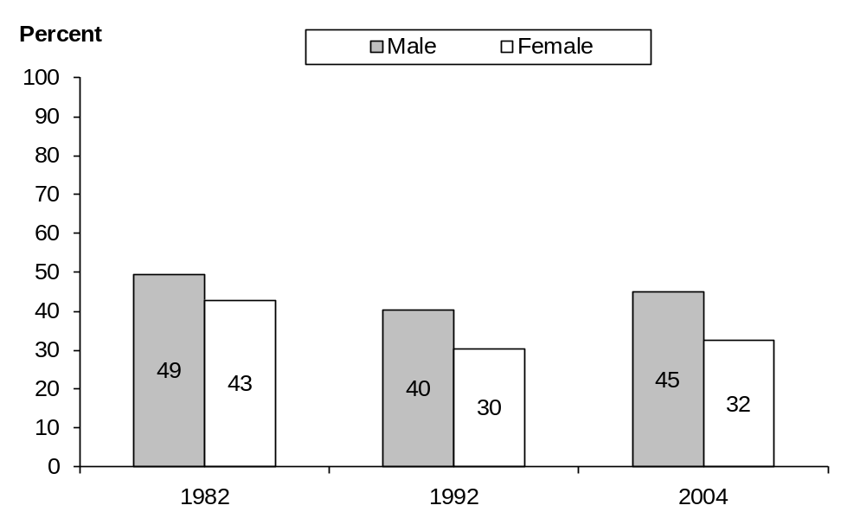
Exhibit reads: In 1982, the percentage of male public high school graduates who were CTE investors was 49 percent.
NOTE: CTE = career and technical education. CTE investors earned three or more total occupational credits (regardless of concentration in any occupational area). A credit (Carnegie unit) is equivalent to a course taken for one period each day for one full school year.
SOURCE: U.S. Department of Education, National Center for Education Statistics, High School and Beyond Longitudinal Study of 1980 Sophomores (HS&B-So:80/82), “High School Transcript Study”; National Education Longitudinal Study of 1988 (NELS:88), “Second Follow-up, Transcript Survey, 1992”; and Education Longitudinal Study of 2002 (ELS:2002), “First Follow-up, High School Transcript Study, 2004.”

Race and Ethnicity
Between 1982 and 2004, patterns of participation in career and technical education by race or ethnicity became more similar (Exhibit 12 and Exhibit 24). The general pattern was for the proportions of CTE investors, particularly CTE concentrators, to decline among all racial and ethnic groups except Asian or Pacific Islanders over that period. Hispanics had a larger decrease than blacks or whites, with Hispanic investors declining by 20 percentage points, compared with 9 and 4 percentage point declines for black and white investors, respectively. Within CTE investors, by 2004 blacks and whites were most likely to be CTE concentrators (about 18 percent and 19 percent, respectively), followed by Hispanics (about 13 percent) and Asian or Pacific Islanders (about 10 percent).
Exhibit 12. Percentage of public high school graduates who are CTE investors, by selected race or ethnicity: 1982, 1992, and 2004
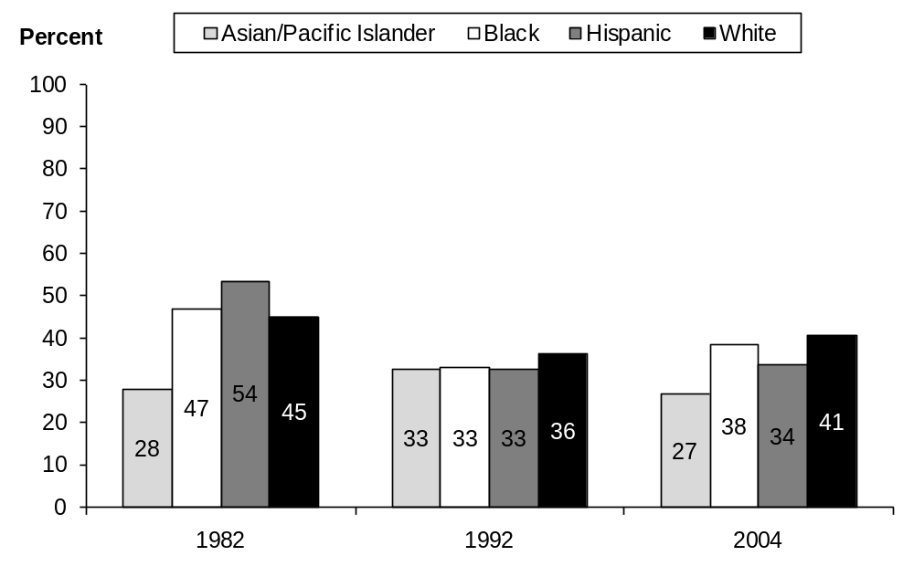
Exhibit reads: In 1982, 28 percent of Asian or Pacific Islander public high school graduates were CTE investors.
NOTE: CTE = career and technical education. CTE investors earned three or more total occupational credits (regardless of concentration in any occupational area). A credit (Carnegie unit) is equivalent to a course taken for one period each day for one full school year. The category Asian or Pacific Islander includes Native Hawaiians. Hispanic may be of any race.
SOURCE: U.S. Department of Education, National Center for Education Statistics, High School and Beyond Longitudinal Study of 1980 Sophomores (HS&B-So:80/82), “High School Transcript Study”; National Education Longitudinal Study of 1988 (NELS:88), “Second Follow-up, Transcript Survey, 1992”; and Education Longitudinal Study of 2002 (ELS:2002), “First Follow-up, High School Transcript Study, 2004.”

Socioeconomic Status
Patterns of participation in CTE also became more similar over time when graduates who are CTE investors are grouped by socioeconomic status (SES) quartiles. The major shift was the decline in the share of lower SES quartile graduates who were CTE investors from about 58 percent to about 44 percent and of middle SES quartiles graduates from 48 percent to 41 percent (Exhibit 13). The share of upper SES quartile graduates who were CTE investors was basically unchanged at about 29 percent between 1982 and 2004. Within the category of CTE investors, CTE concentrators declined from about 40 percent to about 21 percent among lower SES quartiles, while the share of upper SES quartile graduates who were CTE concentrators saw no decline (Exhibit 24).
Although graduates grouped by SES quartile converged in their patterns of CTE participation between 1982 and 2004, important differences among the groups remained. Among graduates in the lower SES quartile about 21 percent were CTE concentrators in 2004, while only about 12 percent in the upper SES quartile were (Exhibit 24).
Exhibit 13. Percentage of public high school graduates who are CTE investors, by socioeconomic status quartile: 1982, 1992, and 2004
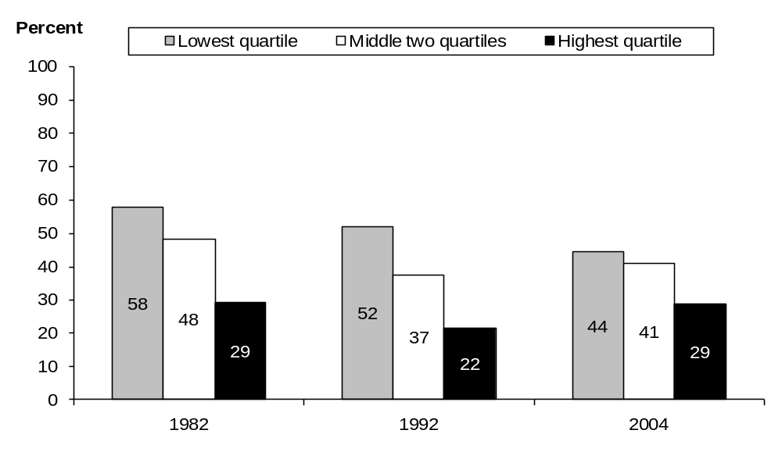
Exhibit reads: In 1982, 58 percent of the lowest socioeconomic status–quartile public high school graduates were CTE investors.
NOTE: CTE = career and technical education. CTE investors earned three or more total occupational credits (regardless of concentration in any occupational area). A credit (Carnegie unit) is equivalent to a course taken for one period each day for one full school year. Socioeconomic status is based on parental income, education, and occupation.
SOURCE: U.S. Department of Education, National Center for Education Statistics, High School and Beyond Longitudinal Study of 1980 Sophomores (HS&B-So:80/82), “High School Transcript Study”; National Education Longitudinal Study of 1988 (NELS:88), “Second Follow-up, Transcript Survey, 1992”; and Education Longitudinal Study of 2002 (ELS:2002), “First Follow-up, High School Transcript Study, 2004.”

3.5 CTE Investors’ Academic and CTE Occupational Coursetaking
After looking at new basics coursetaking by CTE investors and non-investors, this section examines how coursetaking in mathematics and science among investors and non-investors has changed between 1982 and 2004.

New Basics Coursetaking
The share of students completing the core academic new basics courses recommended in the A Nation at Risk report (National Commission on Excellence in Education, 1983) and by ACT (2008b) increased for both CTE investors and non-investors between 1982 and 2004. Among all graduates, the percent completing the new basics rose from 14 percent in 1982 to 47 percent in 1992 and 60 percent in 2004. Among CTE investors, only about 6 percent completed the new basics in 1982, compared with about 22 percent of non-investors (Exhibit 14). By 2004, about 58 percent of CTE investors had completed the new basics, compared with about 61 percent of other students, a gap that is not statistically significant. Hence, there is no longer a discernable gap between CTE investors and other students in completing the new basics as preparation for college and career. CTE investors have substantially closed the academic gap with non-investors due in part by increasing academic course requirements as a condition for graduation in most states. Additionally, a small set of new courses that generally enrolled higher achieving students (e.g, in computer science and education) became classified as CTE.
Exhibit 14. Percentage of CTE investors and non-investors taking the new basics courses: 1982, 1992, 2004
Exhibit reads: In 1982, 6 percent of CTE investors completed the new basics courses.
NOTE: CTE = career and technical education. CTE investors earned three or more total occupational credits (regardless of concentration in any occupational area). Non-investors earned zero to less than three total occupational credits (Carnegie units). A credit (Carnegie unit) is equivalent to a course taken for one period each day for one full school year. The new basics courses include four credits of English, three credits of math, and two credits each of science and social studies.
SOURCE: U.S. Department of Education, National Center for Education Statistics, High School and Beyond Longitudinal Study of 1980 Sophomores (HS&B-So:80/82), “High School Transcript Study”; National Education Longitudinal Study of 1988 (NELS:88), “Second Follow-up, Transcript Survey, 1992”; and Education Longitudinal Study of 2002 (ELS:2002), “First Follow-up, High School Transcript Study, 2004.”

Highest Mathematics and Science Courses Taken
The percentages of CTE investors and other high school graduates taking various levels of math and science courses are shown in Exhibit 15 and Exhibit 16 (see also Exhibit 25 and Exhibit 26). For mathematics, courses were divided into five levels: level 1 = no math credits or low-academic math only; level 2 = algebra I or plane geometry; level 3 = algebra II; level 4 = algebra III, trigonometry, or analytic geometry; and level 5 = precalculus or calculus (Burkam and Lee, 2003). If a high school graduate earned at least one credit at one of the five levels, in any grade, he or she was counted in that level. For science, courses were divided into four levels: level 1 = no science credits or low-level science only; level 2 = secondary physical science (e.g., earth science) or basic biology; level 3 = general biology; or level 4 = advanced biology, chemistry, or physics. Again, if a graduate earned at least one credit at a given level, in any grade, he or she was counted in that level. Note that the composition of the CTE investor and non-investor group changed between 1982 and 2004 as the percentage of investor students in the lowest socioeconomic group declined.
Exhibit 15. Percentage of public high school graduates who were CTE investors and non-investors taking advanced mathematics (above geometry and algebra II): 1982, 1992, and 2004
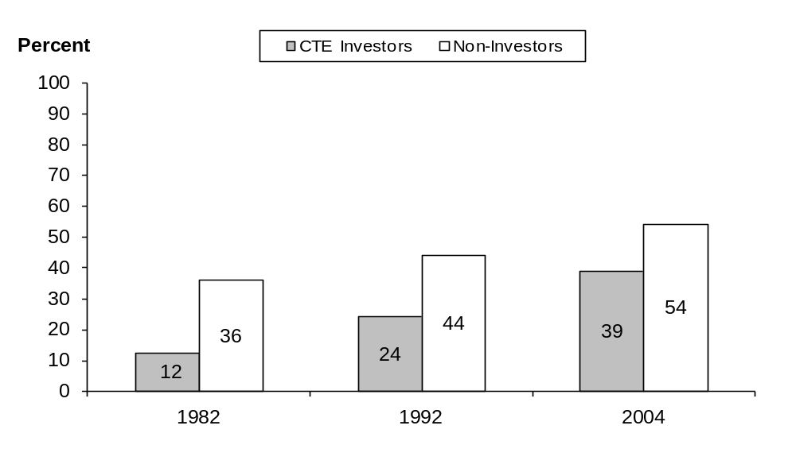
Exhibit reads: In 1982, 12 percent of CTE investors took advanced mathematics.
NOTE: CTE = career and technical education. CTE investors earned three or more total occupational credits (regardless of concentration in any occupational area). Non-investors earned zero to less than three total occupational credits (Carnegie units). A credit (Carnegie unit) is equivalent to a course taken for one period each day for one full school year. Advanced math includes at least one course in algebra III, trigonometry, analytic geometry, precalculus, calculus, and any Advanced Placement or international baccalaureate course.
SOURCE: U.S. Department of Education, National Center for Education Statistics, High School and Beyond Longitudinal Study of 1980 Sophomores (HS&B-So:80/82), “High School Transcript Study”; National Education Longitudinal Study of 1988 (NELS:88), “Second Follow-up, Transcript Survey, 1992”; and Education Longitudinal Study of 2002 (ELS:2002), “First Follow-up, High School Transcript Study, 2004.”
Exhibit 16. Percentage of public high school graduates who were CTE investors and non-investors taking advanced science courses (advanced biology, chemistry, or physics): 1982, 1992, and 2004
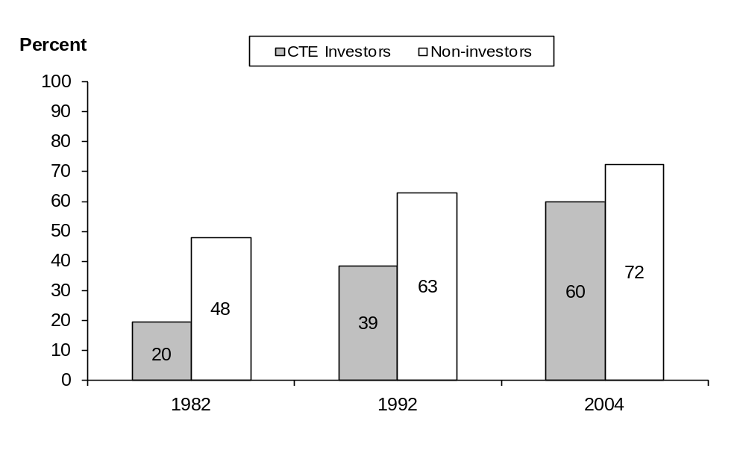
Exhibit reads: In 1982, 20 percent of CTE investors took advanced science courses.
NOTE: CTE = career and technical education. CTE investors earned three or more total occupational credits (regardless of concentration in any occupational area). Non-investors earned zero to less than three total occupational credits (Carnegie units). A credit (Carnegie unit) is equivalent to a course taken for one period each day for one full school year. Advanced science includes at least one course in chemistry II, physics II, or an advanced biology course such as anatomy, cell biology, or genetics.
SOURCE: U.S. Department of Education, National Center for Education Statistics, High School and Beyond Longitudinal Study of 1980 Sophomores (HS&B-So:80/82), “High School Transcript Study”; National Education Longitudinal Study of 1988 (NELS:88), “Second Follow-up, Transcript Survey, 1992”; and Education Longitudinal Study of 2002 (ELS:2002), “First Follow-up, High School Transcript Study, 2004.”
The general pattern is that credits earned in the highest-level math and science courses increased for CTE investors as well as for non-investors between 1982 and 2004, and the gap between CTE investors and non-investors has narrowed. For example, in 2004, in mathematics about 39 percent of CTE investors earned math credits at the level of algebra III, precalculus, or calculus courses, up from 12 percent in 1982. While non-investors also increasingly earned higher-level math credits, the gap in advanced math credits between CTE investors and non-investors decreased by 9 percentage points from 24 percentage points to 15 percentage points between 1982 and 2004.
CTE investors also earned more credits in advanced science courses and decreased the advanced science gap, compared with non-investors between 1982 and 2004 (Exhibit 15 and Exhibit 26). In 1982, only 20 percent of CTE investors earned credits in advanced biology, chemistry, or physics; by 2004, 60 percent of CTE investors did. Non-investors also were more likely to earn advanced credits in science over the period from 1982 to 2004, but the gap in credits earned in advanced science courses between CTE investors and non-investors decreased from 28 percentage points to 13 percentage points.

3.6 Math Achievement
There is considerable interest in the academic achievement of secondary CTE students. Perkins IV requires states to report on the academic achievement of CTE concentrators using the measures of math and reading or English language arts achievement required by the Elementary and Secondary Education Act of 1965 as amended. Previous legislation had also called for a core indicator that measured student attainment of academic (as well as vocational and technical skill) proficiencies.
This section looks at how the academic achievement of CTE investors in math changed over time, both independently and relative to non-investors’ achievement, and focuses on math achievement and its relationship to CTE coursetaking in the graduating classes of 1992 and 2004. Math achievement is based on a standardized math test developed for the NCES longitudinal studies, and students were high school seniors when they took the test. While mathematics knowledge and skills were also assessed for graduates in 1982, only the 1992 and 2004 math tests are on the same psychometrically developed scale (0–81) that permits comparisons of change over time. The math test is the only assessment comparable across the longitudinal studies being used. Note also that the composition of the CTE investor and non-investor group changed, with the relative percentage of investor students in the lowest socioeconomic group declining.
Exhibit 17 shows the overall mathematics number-right scores for high school graduates in 1992 and 2004 for CTE investors and non-investors. While math scores for non-investors showed no change over time, the overall score of CTE investors increased from 46 correct items in 1992 to 48 correct items in 2004. However, in both 1992 and 2004, CTE investors scored lower in math achievement than non-investors.
Exhibit 17. Average estimated number-right math scores of CTE investors and non-investors: 1992 and 2004
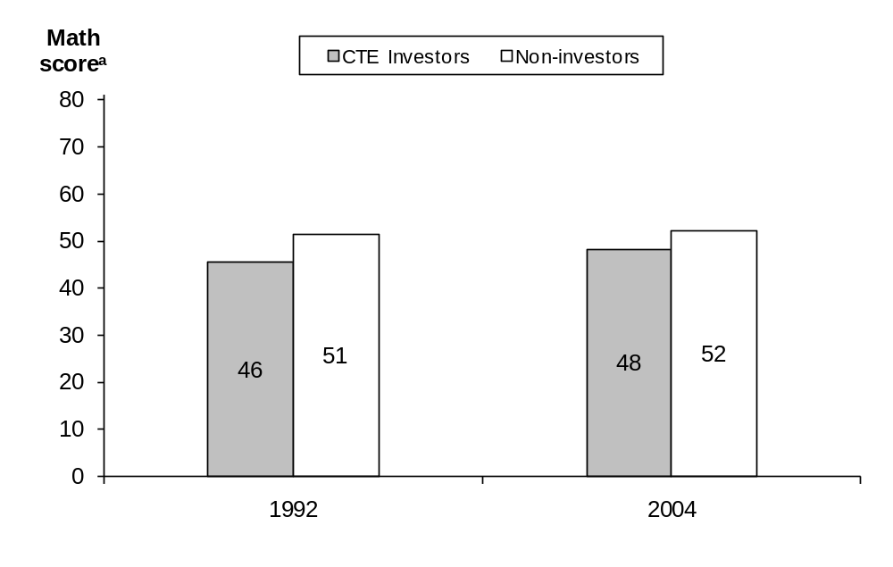
Exhibit reads: In 1992, CTE investors had an average math score of 46.
ª Estimated number-right math scores represent the item response theory–estimated number correct students would have answered had they received all test questions in the NELS:88 test item pool; the scale runs from 0–81 and has been equated across the two years.
NOTE: CTE = career and technical education. CTE investors earned three or more total occupational credits (regardless of concentration in any occupational area). Non-investors earned zero to less than three total occupational credits (Carnegie units). A credit (Carnegie unit) is equivalent to a course taken for one period each day for one full school year.
SOURCE: U.S. Department of Education, National Center for Education Statistics, High School and Beyond Longitudinal Study of 1980 Sophomores (HS&B-So:80/82), “High School Transcript Study”; National Education Longitudinal Study of 1988 (NELS:88), “Second Follow-up, Transcript Survey, 1992”; and Education Longitudinal Study of 2002 (ELS:2002), “First Follow-up, High School Transcript Study, 2004.”

3.7 Postsecondary Education
Economic competition in the global economy makes it increasingly important that high school graduates gain higher-level skills and knowledge only obtainable from postsecondary education or training. Even if graduates focus on occupational areas while in high school and do not plan to obtain a baccalaureate degree, most white-collar positions in many fields require further training and more advanced skills than can be learned in high school (Exhibit 4). Examining the expectations and initial postsecondary education experiences of high school graduates can help identify the areas of success and weakness in CTE investors’ high school training. Each of the three longitudinal surveys used for analyses in this report include data on public high school graduates’ educational expectations in the 12th grade, as well as information on postsecondary educational status in the two years immediately following graduation.

Senior-Year Educational Expectations
Educational expectations rose for both groups of graduates—CTE investors and non-investors—between 1982 and 2004 (Exhibit 18 and Exhibit 27). But the educational expectations of CTE investors rose more than non-investors. Between 1982 and 2004, the proportion of CTE investors who expected to get a bachelor’s degree or higher increased from about 26 percent to about 60 percent, while among non-investors those expectations increased from about 58 percent to about 76 percent. As a result, the gap in educational expectations between CTE investors and non-investors was reduced by 15 percentage points (value differs from exhibit due to rounding), although CTE investors still have lower educational expectations than non-investors.
Exhibit 18. Percentage of public high school graduates expecting to earn a bachelor’s degree or more, by CTE occupational investment: 1982, 1992, and 2004
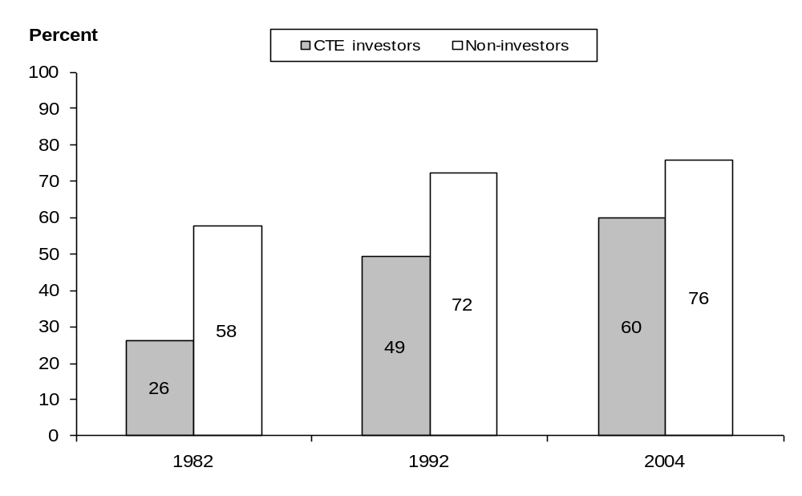
Exhibit reads: In 1982, 26 percent of CTE investors expected to earn a bachelor’s degree or more.
NOTE: CTE = career and technical education. CTE investors earned three or more total occupational credits (regardless of concentration in any occupational area). Non-investors earned zero to less than three total occupational credits (Carnegie units). A Carnegie unit is equivalent to a course taken for one period each day for one full school year. “Bachelor’s degree or more” refers to expectations of a four-year college degree, a master’s or equivalent degree, or an advanced graduate or professional degree.
SOURCE: U.S. Department of Education, National Center for Education Statistics, High School and Beyond Longitudinal Study of 1980 Sophomores (HS&B-So:80/82), “High School Transcript Study”; National Education Longitudinal Study of 1988 (NELS:88), “Second Follow-up, Transcript Survey, 1992”; and Education Longitudinal Study of 2002 (ELS:2002), “First Follow-up, High School Transcript Study, 2004.”
A large change in educational expectations occurred at the level of completing no more than high school (Exhibit 19 and Exhibit 27). The proportions of both CTE investor and non-investor students expecting to complete no more than a high school education dropped over time, but the decline was greater among CTE investors. Fewer than 10 percent of high school graduates who are CTE investors now expect to complete no more than a high school education, compared with one-quarter in 1982. These graduates seem to have received the message that a high school diploma is no longer enough for getting a good job in today’s more competitive global economy.
Exhibit 19. Percentage of public school graduates expecting to earn no more than a high school degree, by CTE occupational investment: 1982, 1992, and 2004
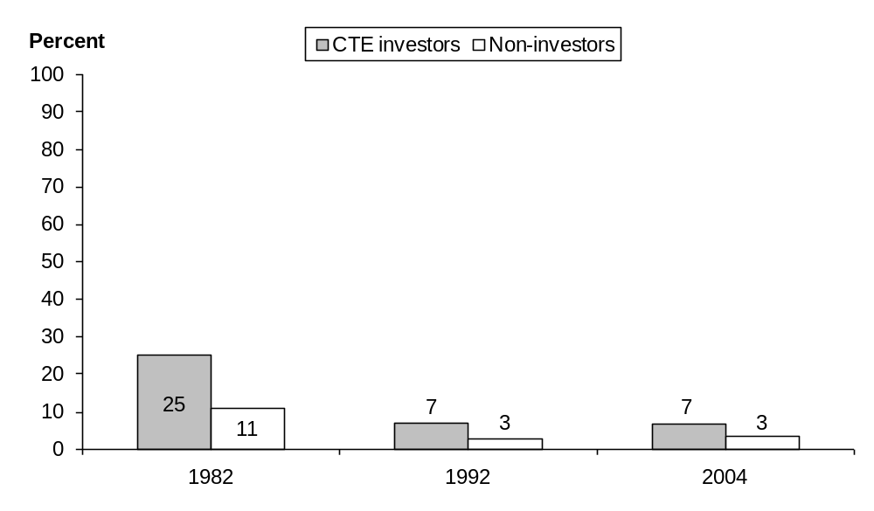
Exhibit reads: In 1982, 25 percent of CTE investors expected to earn no more than a high school degree.
NOTE: CTE = career and technical education. CTE investors earned three or more total occupational credits (regardless of concentration in any occupational area). Non-investors earned zero to less than three total occupational credits (Carnegie units). A Carnegie unit is equivalent to a course taken for one period each day for one full school year.
SOURCE: U.S. Department of Education, National Center for Education Statistics, High School and Beyond Longitudinal Study of 1980 Sophomores (HS&B-So:80/82), “High School Transcript Study”; National Education Longitudinal Study of 1988 (NELS:88), “Second Follow-up, Transcript Survey, 1992”; and Education Longitudinal Study of 2002 (ELS:2002), “First Follow-up, High School Transcript Study, 2004.”

Ever Attended Postsecondary School
Between 1982 and 2004, high school graduates who were CTE investors increased their postsecondary attendance during their first two years after high school (Exhibit 20). Among CTE investors, that proportion increased from 54 percent in 1982 to 75 percent in 2004. Among non-investors, that proportion also increased, but not as rapidly, with the result being that the gap between CTE investors and non-investors in enrolling in postsecondary education in the first two years after high school graduation decreased by 15 percentage points, from 23 percentage points to 8 percentage points (value differs from exhibit due to rounding).
Exhibit 20. Percentage of public high school graduates ever enrolled in a postsecondary education institution in the first two years after graduation, by CTE occupational investment: 1984, 1994, and 2006
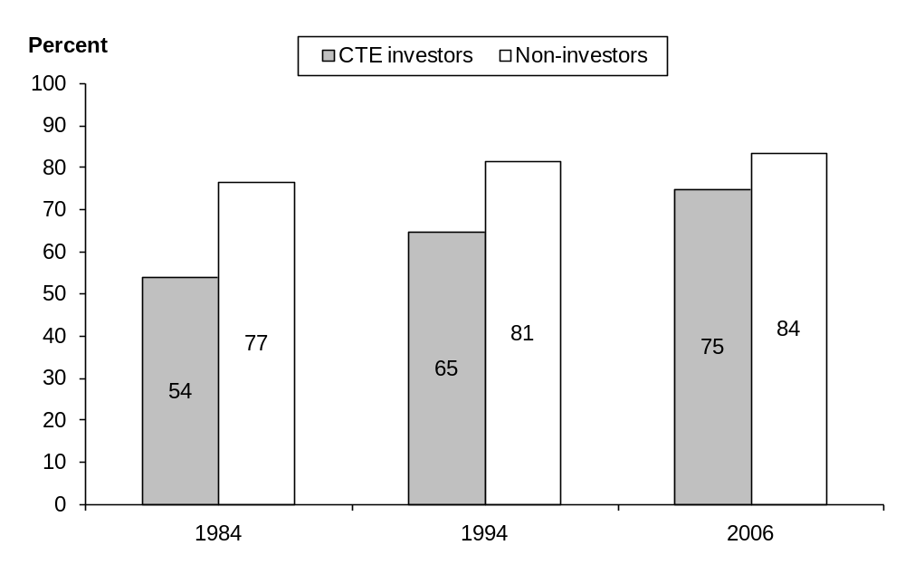
Exhibit reads: In 1984, 54 percent of high school CTE investors had ever enrolled in a postsecondary education institution.
NOTE: CTE = career and technical education. CTE investors earned three or more total occupational credits (regardless of concentration in any occupational area). A Carnegie unit is equivalent to a course taken for one period each day for one full school year. Non-investors earned zero to less than three total occupational credits (Carnegie units). “Postsecondary education institution” refers to both two-year and four-year institutions as well as private and public schools.
SOURCE: U.S. Department of Education, National Center for Education Statistics, High School and Beyond Longitudinal Study of 1980 Sophomores (HS&B-So:80/84), “High School Transcript Study”; National Education Longitudinal Study of 1988 (NELS:88), “Second Follow-up, Transcript Survey, 1992” and “Third Follow-up, 1994”; and Education Longitudinal Study of 2002 (ELS:2002), “First Follow-up, High School Transcript Study, 2004” and “Second Follow-up, 2006.”

3.8 Post–High School Employment
Because one of the goals of CTE is to prepare students for work as well as further education after high school, the occupational expectations and initial post–high school work experiences are important outcomes to consider in evaluating trends in outcomes associated with CTE occupational coursetaking. Because the high school graduates of 2004 have been surveyed only once after graduation, the only comparable information across the three cohorts studied here is restricted to the initial two years after graduation. Given that entering the labor force can be a multiyear transition for many high school graduates, even for those who do not attend college, these initial experiences represent only part of the association between occupational coursetaking and work outcomes.

High School Senior-Year Occupational Expectations at Age 30
Graduates who were CTE investors have both similarities and differences with non-investors regarding their occupational expectations at age 30 (Exhibit 21). The most common occupational expectation at that age in all three cohorts among CTE investors and non-investors alike is a professional job. What is especially striking about the expectation is its increase among CTE investors, rising from about 27 percent of such graduates expecting to be in a professional occupation by age 30 in 1982 to almost 54 percent in 2004. By 2004, the proportion of non-investors expecting a professional occupation by age 30 had increased to almost 70 percent, but the gap between non-investors and CTE investors had decreased from 25 percentage points to 16 percentage points.
Exhibit 21. Percentage of public high school graduates with given expectations of occupation at age 30, by CTE occupational investment: 1982, 1992, and 2004
Occupational expectation | CTE investor, 1982 | CTE investor, 1992 | CTE investor, 2004 | Non-investor, 1982 | Non-investor, 1992 | Non-investor, 2004
Clerical | 13.5 | 5.5 | 0.7 | 4.6 | 2.1 | 0.5
Craftsperson | 10.4 | 5.7 | 8.1 | 3.4 | 0.7 | 2.7
Farmer | 3.4 | 2.0 | 0.6 | 1.0 | 0.4 | ‡
Homemaker | 2.6 | 0.8 | 0.2 | 2.2 | 0.9 | ‡
Laborer | 1.2 | 1.1 | 1.0 | 0.8 | 0.1 | 0.3
Manager | 7.5 | 5.5 | 4.9 | 9.0 | 3.7 | 3.9
Military | 2.4 | 2.9 | 1.6 | 1.8 | 1.9 | 1.5
Operative | 4.2 | 2.2 | 1.6 | 1.7 | 1.4 | 0.1
Professional | 27.4 | 42.0 | 53.7 | 51.9 | 59.8 | 69.5
Proprietor | 5.0 | 6.3 | 4.7 | 3.4 | 4.9 | 3.2
Protective services | 1.7 | 4.3 | 3.5 | 1.5 | 3.6 | 4.2
Sales | 1.7 | 1.3 | 1.8 | 2.0 | 2.1 | 1.9
Service | 4.1 | 3.6 | 7.0 | 2.9 | 2.3 | 6.1
Technical | 11.5 | 7.7 | 9.7 | 11.2 | 5.6 | 5.3
Other | 3.5 | 9.2 | 1.0 | 2.7 | 10.6 | 0.6
Exhibit reads: The percentage of CTE investors who expected to have a clerical occupation at age 30 was 13.5 percent in 1982.
‡ Reporting standards not met.
NOTE: CTE = career and technical education. CTE investors earned three or more total occupational credits (Carnegie units). Non-investors earned less than three total occupational credits. A Carnegie unit is equivalent to a course taken for one period each day for one full school year.
SOURCE: U.S. Department of Education, National Center for Education Statistics, High School and Beyond Longitudinal Study of 1980 Sophomores (HS&B-So:80/82), “High School Transcript Study”; National Education Longitudinal Study of 1988 (NELS:88), “Second Follow-up, Transcript Survey, 1992”; and Education Longitudinal Study of 2002 (ELS:2002), “First Follow-up, High School Transcript Study, 2004.”
Another notable change among CTE investors includes a large drop in the proportion of graduates expecting to have a clerical occupation by age 30—no doubt, a tribute to technological change in the form of computers and word processing. Over the same period, expectations for being in the occupations of craftsperson and technical worker remained relatively popular for CTE investors (especially CTE concentrators) across all three cohorts. For example, about 18 percent of CTE investors expected one of those jobs in 2004, about the same percentage as in 1982. Another interesting finding is that few CTE investors and non-investors in 2004 had expectations for being a manager.

First Job Type of Non-College Attendees
High school graduates in 1982, 1992, and 2004 who had no postsecondary attendance in their first two years after high school answered a series of questions two years after graduation regarding their first post–high school job. Distributions of these first-job types are shown in Exhibit 22.
Exhibit 22. Percentage of non-college-attending public high school graduates in first job type, by CTE occupational investment: 1984, 1994, and 2006
Type of first job | CTE investor, 1984 | CTE investor, 1994 | CTE investor, 2006 | Non-investor, 1984 | Non-investor, 1994 | Non-investor, 2006
Clerical | 18.5 | 20.0 | 13.5 | 18.0 | 25.5 | 13.3
Craftsperson | 10.5 | 9.3 | 11.4 | 6.5 | 3.3 | 6.9
Laborer or farmer | 15.8 | 21.4 | 13.2 | 14.0 | 21.3 | 8.4
Skilled operative | 11.8 | 8.2 | 11.1 | 11.5 | 5.4 | 6.8
Sales or service | 33.1 | 26.3 | 39.4 | 37.2 | 32.9 | 50.4
Managerial | 2.9 | 6.0 | 5.4 | 3.3 | 5.2 | 6.4
Other | 7.4 | 8.9 | 6.0 | 9.5 | 6.5 | 7.7
Exhibit reads: The percentage of high school CTE investors who had a clerical first job was 18.5 percent in 1984.
NOTE: CTE = career and technical education. CTE investors earned three or more total occupational credits (Carnegie units). Non-investors earned less than three total occupational credits. A Carnegie unit is equivalent to a course taken for one period each day for one full school year.
SOURCE: U.S. Department of Education, National Center for Education Statistics, High School and Beyond Longitudinal Study of 1980 Sophomores (HS&B-So:80/84), “High School Transcript Study”; National Education Longitudinal Study of 1988 (NELS:88), “Second Follow-up, Transcript Survey, 1992” and “Third Follow-up, 1994”; and Education Longitudinal Study of 2002 (ELS:2002), “First Follow-up, High School Transcript Study, 2004” and “Second Follow-up, 2006.”
Sales or service occupations were the most commonly reported first-job type among all coursetaking groups in 1984 and 2006 (which were two years after high school graduation in 1982 and 2004, respectively). About 50 percent of non-investors reported holding that kind of first-job, while about 40 percent of CTE investors did. Among non-investors, the second most common first job was clerical, reported by about 13 percent, which was similar to the 14 percent of CTE investors reporting that kind of job.
But among CTE investors, about 22 percent reported holding a first job as a craftsman or skilled operative, compared with about 14 percent of non-investors. That experience appears to be consonant with the expectations and technical training of many CTE investors noted above. CTE investors were also more likely to report being a laborer or farmer in their first job (about 13 percent) than were non-investors (about 8 percent). Similar and small proportions (about 5 percent or 6 percent) of both groups reported a first job as a manager.

3.9 Conclusion
Participation in CTE in high school changed significantly over the 22-year period between 1982 and 2004—from before the Carl D. Perkins Act of 1984 (Perkins I) to after the Carl D. Perkins Vocational and Technical Education Act of 1998 (Perkins III). The backdrop for the changes in CTE participation was the overall shift from 14 percent to 60 percent between 1982 and 2004 of high school graduates completing a new basics academic foundation (earning at least four credits in English, and three credits each in mathematics, science, and social studies). A Nation at Risk recommended these new basics in 1983, and from 1990 on, Perkins legislation authorizing funding for CTE supported the new basics courses.
As the shift to more academic coursetaking occurred, participation in CTE changed in relation to total courses. Although the average number of CTE credits earned dropped between 1982 and 1992 (from 3.0 credits to 2.4 credits), it increased somewhat between 1992 and 2004 (to 2.6 credits). Because the total number of course credits earned by graduates increased over this period, average CTE credits between 1982 and 2004 did not decline as much as might be expected from the rise in new basics courses taken. Moreover, overall participation in CTE remained relatively stable, with over 95 percent of high school graduates earning some CTE credit between 1982 and 2004.
Similarly, the proportion of high school graduates who are CTE investors (three or more CTE credits) declined by 11 points, from 46 percent to 35 percent between 1982 and 1992, but by 2004 the proportion increased to 38 percent.
CTE coursetaking became more diverse over these three decades. CTE explorers (three or more CTE credits in more than one occupational area) grew from 35 percent of investors in 1982 to 55 percent of investors in 2004, while CTE concentrators (three or more credits on one occupational area) fell from 65 percent to 45 percent between 1982 and 2004.
These trends coincided with CTE investors taking more advanced math and science courses and some improvement in their mathematics achievement. Among CTE investors, the proportion completing the new basics rose from 6 percent in 1982 to 58 percent in 2004. Further, the educational expectations and postsecondary education participation of CTE investors increased as well. Differences in initial postsecondary work experiences among CTE investors and non-investors did not substantially change. Those non-college-attending investors who had a first job were more likely to enter craft or skilled operative positions reflecting consistency with their CTE secondary school training.
These changes are consistent with the direction of Perkins legislation for greater academic engagement by CTE students so that there are increasing similarities between CTE investors and non-investors in academic coursetaking. However, the nature of CTE investment is changing as a greater percentage of investors are taking their CTE courses in multiple occupational areas and thus exploring CTE rather than concentrating within a CTE occupational area. Explorers benefit from knowledge about several occupations, but they do not obtain the in-depth knowledge and skills of single-occupation concentrators. Secondary CTE performance reporting is also limited to reporting on concentrators who now constitute less than half the students who take three or more CTE courses.

3.10 Annex: Statistical Tables
Exhibit 23. Percentage of public high school graduates, by CTE occupational investment: 1982, 1992, and 2004
CTE occupational investment | 1982 | 1992 | 2004
CTE investors | 46.0 | 35.3 | 38.4
CTE concentrators | 29.7 | 19.8 | 17.3
CTE explorers | 16.3 | 15.5 | 21.1
Non-investors | 54.0 | 64.7 | 61.6
Exhibit reads: The percentage of public high school graduates who were CTE investors was 46.0 percent in 1982.
NOTE: CTE = career and technical education. CTE investors are the sum of concentrators and explorers. CTE concentrators earned three or more credits in at least one occupational area. CTE explorers earned three or more total occupational credits but did not concentrate in an occupational area. Non-investors did not earn three total occupational credits. A credit (Carnegie unit) is equivalent to a course taken for one period each day for one full school year.
SOURCE: U.S. Department of Education, National Center for Education Statistics, High School and Beyond Longitudinal Study of 1980 Sophomores (HS&B-So:80/82), “High School Transcript Study”; National Education Longitudinal Study of 1988 (NELS:88), “Second Follow-up, Transcript Survey, 1992”; and Education Longitudinal Study of 2002 (ELS:2002), “First Follow-up, High School Transcript Study, 2004.”
Exhibit 24. Percentage of public high school graduates, by student characteristics and CTE investment: 1982, 1992, and 2004
Student characteristic and CTE investment | 1982 | 1992 | 2004
Gender  Male  CTE investors | 49.5 | 40.4 | 44.9
CTE concentrators | 31.0 | 22.6 | 21.0
CTE explorers | 18.5 | 17.8 | 23.9
Non-investors | 50.5 | 59.6 | 55.1
Female  CTE investors | 42.9 | 30.3 | 32.4
CTE concentrators | 28.6 | 17.1 | 13.8
CTE explorers | 14.2 | 13.2 | 18.5
Non-investors | 57.2 | 69.7 | 67.6
Race/ethnicityª  Asian/Pacific Islander  CTE investors | 27.8 | 32.7 | 26.7
CTE concentrators | 13.0 | 16.8 | 9.6
CTE explorers | 14.7 | 15.8 | 17.2
Non-investors | 72.2 | 67.4 | 73.3
Black  CTE investors | 46.9 | 32.8 | 38.4
CTE concentrators | 31.4 | 16.6 | 17.9
CTE explorers | 15.5 | 16.2 | 20.5
Non-investors | 53.1 | 67.2 | 61.6
Hispanic  CTE investors | 53.6 | 32.8 | 33.5
CTE concentrators | 33.9 | 16.0 | 12.8
CTE explorers | 19.7 | 16.8 | 20.7
Non-investors | 46.4 | 67.2 | 66.5
White  CTE investors | 45.0 | 36.1 | 40.5
CTE concentrators | 29.2 | 21.1 | 18.8
CTE explorers | 15.9 | 15.0 | 21.7
Non-investors | 55.0 | 63.9 | 59.5
See notes at end of table.

Continues next page
Exhibit 24. Percentage of public high school graduates, by student characteristics and CTE investment: 1982, 1992, and 2004—continued
Student characteristic and CTE investment | 1982 | 1992 | 2004
Other  CTE investors | 52.4 | 41.7 | 36.7
CTE concentrators | 34.7 | 18.6 | 17.2
CTE explorers | 17.7 | 23.1 | 19.6
Non-investors | 47.6 | 58.3 | 63.3
Socioeconomic status  Lowest quartile  CTE investors | 57.7 | 52.1 | 44.2
CTE concentrators | 40.2 | 30.8 | 21.1
CTE explorers | 17.5 | 21.3 | 23.1
Non-investors | 42.3 | 47.9 | 55.8
Middle two quartiles  CTE investors | 48.1 | 37.4 | 40.9
CTE concentrators | 31.6 | 21.8 | 18.4
CTE explorers | 16.5 | 15.6 | 22.5
Non-investors | 51.9 | 62.6 | 59.1
Highest quartile  CTE investors | 29.0 | 21.5 | 28.6
CTE concentrators | 14.6 | 9.8 | 11.9
CTE explorers | 14.4 | 11.7 | 16.7
Non-investors | 71.0 | 78.5 | 71.4
Exhibit reads: The percentage of male public high school graduates who were CTE investors was 49.5 percent in 1982.
ª The category Asian or Pacific Islander includes Native Hawaiians. Hispanic may be of any race. Other category refers to those answering “other” in 1982 and 1992 and those answering “more than one race” in 2004.
NOTE: CTE = career and technical education. CTE investors are the sum of concentrators and explorers. CTE concentrators earned three or more credits (Carnegie units) in at least one occupational area. CTE explorers earned three or more total occupational credits but did not concentrate in an occupational area. Non-investors earned less than three total occupational credits. A Carnegie unit is equivalent to a course taken for one period each day for one full school year.
SOURCE: U.S. Department of Education, National Center for Education Statistics, High School and Beyond Longitudinal Study of 1980 Sophomores (HS&B-So:80/82), “High School Transcript Study”; National Education Longitudinal Study of 1988 (NELS:88), “Second Follow-up, Transcript Survey, 1992”; and Education Longitudinal Study of 2002 (ELS:2002), “First Follow-up, High School Transcript Study, 2004.”
Exhibit 25. Percentage of public high school graduates completing given highest level of mathematics, by curricular foundation and CTE occupational investment: 1982, 1992, and 2004
CTE investment and highest level of math completed | 1982 | 1992 | 2004
CTE investors  No math or low academic math | 34.9 | 19.1 | 7.5
Algebra I/plane geometry | 37.2 | 29.8 | 23.5
Algebra II | 15.6 | 26.8 | 30.0
Algebra III/trigonometry/analytic geometry | 9.1 | 13.8 | 15.9
Precalculus/calculus | 3.3 | 10.4 | 23.2
CTE concentrators  No math or low academic math | 38.5 | 24.1 | 9.4
Algebra I/plane geometry | 38.2 | 31.6 | 24.7
Algebra II | 14.3 | 24.7 | 30.7
Algebra III/trigonometry/analytic geometry | 7.0 | 12.0 | 14.5
Precalculus/calculus | 2.0 | 7.6 | 20.6
CTE explorers  No math or low academic math | 28.2 | 12.7 | 5.8
Algebra I/plane geometry | 35.3 | 27.5 | 22.4
Algebra II | 17.9 | 29.6 | 29.4
Algebra III/trigonometry/analytic geometry | 12.9 | 16.2 | 17.0
Precalculus/calculus | 5.6 | 14.0 | 25.3
Non-investors  No math or low academic math | 17.7 | 8.0 | 4.3
Algebra I/plane geometry | 26.0 | 19.2 | 17.0
Algebra II | 20.2 | 28.8 | 24.5
Algebra III/trigonometry/analytic geometry | 20.6 | 17.6 | 18.3
Precalculus/calculus | 15.4 | 26.4 | 35.9
Exhibit reads: The percentage of CTE investors who completed only “no math or low academic math” was 34.9 percent in 1982.
NOTE: CTE = career and technical education. CTE investors are the sum of concentrators and explorers. CTE concentrators earned three or more credits (Carnegie units) in at least one occupational area. CTE explorers earned three or more total occupational credits but did not concentrate in an occupational area. Non-investors earned less than three total occupational credits. A Carnegie unit is equivalent to a course taken for one period each day for one full school year.
SOURCE: U.S. Department of Education, National Center for Education Statistics, High School and Beyond Longitudinal Study of 1980 Sophomores (HS&B-So:80/82), “High School Transcript Study”; National Education Longitudinal Study of 1988 (NELS:88), “Second Follow-up, Transcript Survey, 1992”; and Education Longitudinal Study of 2002 (ELS:2002), “First Follow-up, High School Transcript Study, 2004.”
Exhibit 26. Percentage of public high school graduates completing given highest level of science, by curricular foundation and CTE occupational investment: 1982, 1992, and 2004
CTE investment and highest level of science completed | 1982 | 1992 | 2004
CTE investors  No science or low-level science | 22.8 | 4.1 | 3.4
Secondary physical science and basic biology | 17.2 | 10.2 | 4.6
General biology | 40.2 | 47.1 | 32.3
Advanced biology, chemistry, or physics | 19.7 | 38.6 | 59.7
CTE concentrators  No science or low-level science | 25.7 | 4.9 | 5.0
Secondary physical science and basic biology | 18.6 | 10.6 | 5.8
General biology | 39.9 | 53.1 | 33.6
Advanced biology, chemistry, or physics | 15.9 | 31.5 | 55.6
CTE explorers  No science or low-level science | 17.7 | 3.1 | 2.2
Secondary physical science and basic biology | 14.7 | 9.8 | 3.6
General biology | 40.8 | 39.4 | 31.2
Advanced biology, chemistry, or physics | 26.8 | 47.7 | 63.0
Non-investors  No science or low-level science | 8.2 | 1.7 | 2.3
Secondary physical science and basic biology | 13.3 | 5.4 | 3.0
General biology | 30.4 | 29.9 | 22.3
Advanced biology, chemistry, or physics | 48.2 | 63.0 | 72.5
Exhibit reads: The percentage of CTE investors who completed only “no science or low-level science” was 22.8 percent in 1982.
NOTE: CTE = career and technical education. CTE investors are the sum of concentrators and explorers. CTE concentrators earned three or more credits (Carnegie units) in at least one occupational area. CTE explorers earned three or more total occupational credits but did not concentrate in an occupational area. Non-investors earned less than three total occupational credits. A Carnegie unit is equivalent to a course taken for one period each day for one full school year.
SOURCE: U.S. Department of Education, National Center for Education Statistics, High School and Beyond Longitudinal Study of 1980 Sophomores (HS&B-So:80/82), “High School Transcript Study”; National Education Longitudinal Study of 1988 (NELS:88), “Second Follow-up, Transcript Survey, 1992”; and Education Longitudinal Study of 2002 (ELS:2002), “First Follow-up, High School Transcript Study, 2004.”
Exhibit 27. Percentage of public high school graduates with given educational expectations in 12th grade, by curricular foundation and CTE occupational investment: 1982, 1992, and 2004
CTE investment and educational expectations | 1982 | 1992 | 2004
CTE investors  High school or less | 25.1 | 7.1 | 6.5
Some college | 48.5 | 37.8 | 25.0
Bachelor’s degree | 17.2 | 30.0 | 34.3
Graduate or professional degree | 9.3 | 19.2 | 25.7
Don’t know | — | 6.0 | 8.5
CTE concentrators  High school or less | 28.9 | 9.5 | 8.3
Some college | 49.6 | 40.5 | 27.9
Bachelor’s degree | 13.6 | 28.2 | 30.4
Graduate or professional degree | 7.8 | 14.9 | 24.0
Don’t know | — | 7.0 | 9.4
CTE explorers  High school or less | 18.0 | 4.0 | 5.1
Some college | 46.4 | 34.3 | 22.7
Bachelor’s degree | 23.5 | 32.3 | 37.4
Graduate or professional degree | 12.0 | 24.6 | 27.1
Don’t know | — | 4.8 | 7.8
Non-investors  High school or less | 11.0 | 2.8 | 3.3
Some college | 31.3 | 20.6 | 14.6
Bachelor’s degree | 30.5 | 36.6 | 35.5
Graduate or professional degree | 27.2 | 35.7 | 40.4
Don’t know | — | 4.3 | 6.2
Exhibit reads: The percentage of CTE investors who expected to complete only high school or less was 25.1 percent in 1982.
— Not available.
NOTE: CTE = career and technical education. CTE investors are the sum of concentrators and explorers. CTE concentrators earned three or more credits (Carnegie units) in at least one occupational area. CTE explorers earned three or more total occupational credits but did not concentrate in an occupational area. Non-investors earned less than three total occupational credits. A Carnegie unit is equivalent to a course taken for one period each day for one full school year.
SOURCE: U.S. Department of Education, National Center for Education Statistics, High School and Beyond Longitudinal Study of 1980 Sophomores (HS&B-So:80/82), “High School Transcript Study”; National Education Longitudinal Study of 1988 (NELS:88), “Second Follow-up, Transcript Survey, 1992”; and Education Longitudinal Study of 2002 (ELS:2002), “First Follow-up, High School Transcript Study, 2004.”
This page intentionally left blank

Chapter 4.
Outcomes of Career and Technical Education:
Some New Evidence
The mandate for the National Assessment of Career and Technical Education (NACTE) in the Carl D. Perkins Career and Technical Education Act of 2006 (Perkins IV) includes an analysis of the impact that career and technical education (CTE) has on academic achievement and employment outcomes. Because of the time it takes for a newly authorized or reauthorized program to have an impact on students, NACTE will only be able to examine early outcome evidence associated with Perkins IV in its final report. Most of the studies and databases available for examining CTE impacts only include outcomes associated with the Carl D. Perkins Vocational and Applied Technology Education Act of 1990 (Perkins II) and the Carl D. Perkins Vocational and Technical Education Act of 1998 (Perkins III), and such is the case for the evidence presented in this chapter. The evaluators of the NACTE looked for additional ways to examine CTE outcomes and found two opportunities to utilize existing data that were available for this interim report. Our new evidence is based on a recent national longitudinal study of secondary students and a natural experiment involving choice of a CTE high school in Philadelphia. The final report will contain additional outcome studies.

4.1 Context for NACTE Outcome Studies
The context for NACTE’s investigations into the impact of enrollment in CTE on academic and employment outcomes was provided by the earlier mandated study of Perkins III, namely, the National Assessment of Vocational Education (NAVE; Silverberg et al., 2004; for a 1994 NAVE review, see Gamoran, 1998). NAVE sponsored its own research into the value added by CTE under the Carl D. Perkins Vocational Education Act (Perkins I) and Perkins II on a range of student outcomes and also conducted a review of the literature on CTE outcomes available at the time.
At the secondary level, NAVE found that during the 1990s, students in CTE programs significantly increased their academic coursetaking and achievement. This finding is consistent with the evidence presented in Chapter 3 of this report. At the same time, NAVE also found that the research evidence consistently showed that enrollment in CTE programs did not bring about or contribute to those academic achievement gains. The larger context of those gains (also noted in Chapter 3) was the increase in high school graduation requirements among the states and the more intense focus on academic knowledge fostered by the ongoing education reform movement.
NAVE also reported that only mixed evidence exists that enrollment in CTE reduces the high school dropout rate, with the most rigorous evidence suggesting that it did not. NAVE cites analyses of data from the National Education Longitudinal Study of 1988 as well as a natural experiment involving CTE programs in New York City (Crain et al., 1999) as having no impact or even a negative impact, which was the case in the latter study.
Impact studies of career-related education and training programs found potentially positive results on some student outcomes. The evaluation of Career Academies looked at a CTE program model, a school-within-a-school, that had students take career-related curricula and related work experience through local employers. This study found positive effects on staying in and progressing through high school as well as earnings gains at the eight-year follow up for young men. The evaluation of Talent Development High Schools, a whole school reform with a “career academies” component in the upper grades, found positive effects on progressing through school.
In moving to postsecondary attendance, NAVE found that the value added by CTE was negligible: CTE neither helped nor hurt the chances of students going on to postsecondary schooling. In the past, vocational education was criticized as handicapping students’ prospects of going on to postsecondary education, but current programs did not appear to have those negative consequences.
Postsecondary vocational education did, however, provide significant economic returns. NAVE reported those earning a credential (certificate or degree) experienced the largest benefits. NAVE found in particular that CTE provided by community colleges appeared to produce substantial gains for the vast majority of participants. Those completing even as little as a year of postsecondary CTE courses, especially males, realized economic gains.

4.2 NACTE Outcome Studies
In developing its research agenda for examining the impact of CTE on student outcomes, NACTE looked for sources of existing data that could be used for analyzing CTE impacts. Four sources were identified.
The first source was the Education Longitudinal Study of 2002 (ELS:2002), sponsored by the National Center for Education Statistics (NCES) in the U.S. Department of Education (this study was also discussed in Chapter 2). This longitudinal study continues the pattern NCES started of studying a cohort of secondary students every decade or so. This study began with high school sophomores in 2002, then followed up in 2004 with seniors, and then again in 2006, two years after the expected graduation date. The ELS:2002 study has transcript data so that the degree of participation in CTE can be measured along with secondary outcomes, postsecondary education and training, and employment history.
The second source was administrative data in Philadelphia associated with the local high school choice program. Philadelphia has a fairly extensive high school choice program involving CTE as well as other (academic) high schools. Admission to CTE schools was basically made randomly, forming a natural experiment. That process allows studying how students randomly selected into CTE high schools perform, compared with those not selected. The data available allow looking at the high school classes of 2003, 2004, and 2005.
The third source was also city-level administrative data, but from San Diego, California. Although San Diego does have a choice program, the data for it have not been as readily accessible as in Philadelphia. But longitudinal data on students exist going back into elementary school. These data are being used to look at a variety of secondary and postsecondary outcomes for several cohorts of high school graduates. Results are not available for the interim report but will be available in time for the final report.
The last source of data was Florida administrative data on the ninth-grade cohort of 1995–96, which was followed over 11 years. The entire cohort was followed through high school and then into postsecondary education and employment. The focus of this study is on postsecondary outcomes, in terms of education and employment. Results are not available for the interim report but will be available in time for the final report.

4.3 Education Longitudinal Study of 2002
ELS:2002 tracks students who were high school sophomores in 2002 and follows them into their postsecondary years. A nationally representative sample was drawn of 10th-graders in public and private schools in the United States in 2002 when Perkins III was in effect. Sample members were surveyed again in spring 2004, when most were high school seniors. In pring 2005, transcripts were collected from these students’ high schools. The data allow key student subgroups defined by the Elementary and Secondary Education Act of 1965 as amended (ESEA) to be examined as well as alternative ways of defining and analyzing CTE as occupational coursetaking.
The ELS:2002 study measures student achievement in mathematics when they are sophomores and seniors and thus lends itself to evaluating how participation in CTE affects gains in math achievement between the sophomore and senior years. The study also is appropriate for looking at how CTE affects dropping out and completion of high school between the sophomore and senior years. Although relatively more students drop out of high school in or after the ninth grade than in other grades, dropping out between sophomore and senior years remains an important problem. Because ELS:2002 also gathers information on the type of high school students who attend, it can also be used to examine whether high school types—for example, an area CTE high school—helps or hinders secondary educational outcomes.

Math Achievement
NACTE’s study (Bozick and Dalton, 2013) analyzes gains in achievement in mathematics between the sophomore and senior years through the use of fixed effects regression analysis. This is a more rigorous approach than standard cross-sectional regression analysis that looks at student achievement at one point in time. Standard regression analysis can only suggest factors or variables that are associated with achievement but cannot identify causal effects because other unmeasured (sometime called unobserved) factors are not available for use in the analysis. Those factors may be associated with student self-selection into certain educational programs, making it impossible to determine whether the program or some student characteristics leading to self-selection into the program were the causal factors affecting an outcome.
Fixed effects regression analysis as used in this NACTE study (Bozick and Dalton, 2013) reduces unmeasured factors—such as attitudes, preferences, or innate ability—that are time invariant and may lead to self-selection into certain educational programs. Additional factors that vary over time also were added to the analysis. As a result, causal inferences about the efficacy of identified factors (such as CTE participation) can be made more confidently by using fixed effects regression, although estimates are not as unbiased as typically obtained from random experiments.
In the fixed effects regression analysis, math achievement gains associated with CTE participation are measured in two ways (Bozick and Dalton, 2013). An overall test score is used to provide a general measure of math gains. In addition, five scores are calculated measuring the likelihood of mastery over specific and progressive benchmarks in mathematics ranging from basic to advanced mathematical proficiency.
Participation in CTE was also measured two ways. First, overall CTE participation was measured in terms of the number of occupational courses taken. Family and consumer science courses and general labor force preparation courses were not included. Second, a more focused measure of occupational courses in science, technology, engineering, and mathematics (STEM) areas was used.
The key findings from the study (Bozick and Dalton, 2013) follow.
- The total number of occupational credits earned during the last two years of high school has no relationship to the increase in number of correct answers on the mathematics assessment. However, when occupational courses make up a larger percentage of the total number of courses taken, students answer fewer additional questions correctly on the mathematics assessment.
Overall, there are no differences in mathematical proficiency gains between students who take a small number of occupational courses alongside their academic courses and students who take only academic courses. When students take relatively more occupational courses during the last two years of high school, however, they answer slightly fewer additional questions correctly on the mathematics assessment. This relationship remains statistically significant after controlling for a range of factors, but its magnitude is substantively small: about one-tenth fewer questions were answered correctly on the math assessment for each additional occupational course taken.
- Gains in basic and intermediate mathematics skills and concepts are unrelated to occupational credits earned in the last two years of high school. However, taking relatively more occupational courses and fewer academic courses during the last two years of high school limits the acquisition of advanced mathematical skills and concepts.
The development of skills such as simple arithmetic operations, operations with decimals and fractions, and basic problem solving is not compromised by enrollment in occupational courses. The development of advanced mathematics skills such as solving multistep word problems is impeded when occupational courses make up a larger share of students’ course schedules. Though this relationship again remains statistically significant after controlling for a range of factors, its magnitude is substantively small. For example, those who earned at least eight and one-half credits in academic courses and two credits in occupational courses were less than a half percent less likely to be proficient at level 4, one of the most advanced skill levels, than those who earned 10.5 credits in academic courses and zero credits in occupational courses.
- Occupational courses have similar effects on gains in mathematics achievement for both economically disadvantaged and affluent students as well as nonnative English speakers and native English speakers. Black and Asian students benefit more from occupational courses than do white students.
Occupational courses improve the development of basic and intermediate math skills more for black students than for white students, while the development of intermediate and advanced math skills is fostered more for Asian students than for white students.
- In general, STEM courses in the CTE curriculum neither enhance nor compromise overall math achievement.
Improving learning in mathematics is largely a function of traditional academic mathematics courses.
- Attendance at a full-time CTE school or a school located in a rural area is not related to mathematics gains.
Effects of occupational coursetaking on math achievement gains do not vary by attendance at full-time CTE schools, but occupational coursetaking is less harmful to math achievement gains for students attending rural schools than for students attending suburban schools.
The conclusion from the NACTE study of math gains (Bozick and Dalton, 2013) is that secondary CTE participation is largely unrelated to gains in mathematics proficiency between sophomore and senior years in high school. This new evidence from analyzing the ELS:2002 data does not change the conclusion reached by the NAVE (Silverberg et al., 2004) report.

Dropping Out of High School
NACTE’s study of the relationship between CTE participation and dropping out of high school from the sophomore to senior years was also done with the ELS:2002 data (Bozick and Dalton, 2013). Semester-by-semester dropout rates are generally low (2 percent or less). In the period analyzed over the last two years of high school, dropout rates increased each semester to the typical end of high school for most students (two years later). Then, in the fall semester following the on-time graduation date for the cohort, over half of the remaining students dropped out.
The analytic strategy used for examining dropping out was event history regression analysis. This approach predicts the odds of dropping out of high school, contingent on a set of independent factors or variables. A wide variety of student characteristics and some school-level characteristics were used in the analysis to isolate their effects. CTE and academic coursetaking patterns were calibrated to match the timing of possible dropping out.
Key findings from the NACTE study of dropping out of high school (Bozick and Dalton, 2013) were the following:
- Controlling for socioeconomic and academic differences among students as well as semester timing, the number of credits students earn in occupational courses is unrelated to their likelihood of dropping out.
However, students who have accumulated relatively more credits in academic courses have a reduced likelihood of dropping out. On average, each additional academic credit earned lowers the odds of dropping out by 19 percent.
- High school dropouts typically accumulate fewer academic credits than enrolled students over the same period of time; however, dropouts and enrolled students earn similar numbers of occupational credits.
When comparing dropouts to enrolled students in any given semester, differences in the number of earned academic credits between students who drop out and students who remain enrolled are striking. However, no differences in occupational credits earned were observed.
- The cumulative number of occupational credits relative to academic credits is positively associated with dropping out. However, this relationship is driven by low academic course completion among students enrolled in occupational courses.
When occupational credits earned are considered relative to academic credits earned, a greater tilt toward occupational credits is related to a greater likelihood of dropping out. This relationship holds even when student socioeconomic and academic characteristics associated with dropping out are held constant. However, students with high numbers of academic credits and high occupational credits are no more or less likely to drop out than other students, indicating that accumulating a low number of academic credits drives the relationship between relative occupational coursetaking and dropping out.
- Attendance at a full-time CTE school or a school located in an urban area is not related to dropping out.
Effects of occupational coursetaking on dropping out do not consistently vary by full-time CTE school attendance or rural school attendance (where one might also expect a more positive influence of occupational courses on high school persistence).

4.4 CTE Schools in Philadelphia: A Natural Experiment
NACTE’s study of career and technical education high schools in Philadelphia used a natural experiment to examine the impact of CTE high schools on student outcomes, including achievement and completion (Neild, Boccanfuso, and Byrnes, 2013). These high schools have long been known as Area Vocational and Technical Schools. Three cohorts of their students were studied—the high school classes of 2003, 2004, and 2005, all of whom graduated when Perkins III was still in effect. The study involved four CTE schools whose primary focus was on providing career and technical training for students hoping either to pursue postsecondary education or enter the workforce immediately after high school. A fifth high school was given CTE status for the class of 2005. These high schools served students from across the district. Although the issue of attendance at CTE schools was also examined in the ELS:2002 study of achievement and dropping out discussed above (Bozick and Dalton, 2013), in which no positive effects were detected, most studies of CTE outcomes focus on coursetaking, not the effects of CTE schools. NACTE’s Philadelphia study examines the impact of CTE schools.
The natural experiment in the impact of CTE schools occurred because many more students in each cohort applied to the CTE schools than could be accepted, and the CTE schools admitted students using a lottery that took into account only student race and ethnicity to achieve racial balance and how highly each student had prioritized the school on his or her application form. For the class of 2003, CTE schools entered all applicants into their lotteries, regardless of their prior achievement, attendance, or behavior. For the classes of 2004 and 2005, each of the CTE schools prescreened applicants for school-related performance. After students with weaker records were removed from the applicant pool, the lottery was conducted. As a result of this prescreening, the CTE classes of 2004 and 2005 entered high school with stronger prior academic performance than the class of 2003. CTE coursetaking differed between those who attended CTE schools and those who applied but did not attend. Those attending CTE schools earned approximately twice as many CTE credits as those who applied but did not attend a CTE school.
Career and technical courses were offered at most of the approximately 40 public high schools in Philadelphia. (Other types of high schools besides CTE schools include neighborhood and special admission [magnet] schools, plus 17 charter schools.) Some of the larger neighborhood high schools had a variety of CTE courses of study that rivaled those offered in CTE schools. But, in general, the greatest variety of occupationally focused courses was found at CTE schools. CTE high schools operated within a district context that supported high school choice and that encouraged all high schools to offer college preparatory courses in mathematics, science, and foreign languages.

Research Questions
The Philadelphia study addressed the following three key questions:
- What is the effect of CTE schools on educational attainment, specifically, credit accumulation, grade promotion, and graduation?
- What is the effect of CTE schools on college preparatory coursetaking in mathematics, science, and foreign language?
- What effect do CTE schools have on academic performance, specifically, academic growth in mathematics and reading comprehension?
The natural experiment allowed two types of estimates of the impact of CTE schools to be calculated. The first is called an intent-to-treat (ITT) estimate, which is conventionally used in experiments. It addresses the question of how the outcomes of students who were accepted to CTE schools differed from the outcomes of students who were not accepted. Because some of the students accepted may not have attended, a second estimate is often calculated in experimental studies that takes participation or exposure into account. This is called a dosage estimate (DE), and it estimates the association of actual participation in CTE schools with outcomes.
This study relies entirely on student record data kept by the School District of Philadelphia. These data include enrollment and graduation status, transcript information (including course grades), test scores, attendance, special education status, English-language-learner status, and school(s) attended, from eighth grade forward, in addition to applications to high schools and high school admissions decisions.

Key Findings on the Impact of CTE Schools
The findings from the study represent those from one large urban community with large minority concentrations. The study also involves students who were motivated to apply to CTE schools. Therefore, these findings may not generalize to other community types or to other students. In addition, the study examined selective CTE schools for the classes of 2004 and 2005, where students applied to a CTE school and passed some moderate screens for achievement, attendance, and behavior. Therefore, findings for the classes of 2004 and 2005 cannot be generalized to other CTE school models that are not selective.
- Attending a CTE high school increased the probability of students successfully completing the college preparatory mathematics sequence of algebra I, algebra II, and geometry.
The ITT estimates placed the odds of completing this course sequence as one-quarter to one-third greater for students in CTE schools (25 percent to 32 percent increase in the odds of completing the sequence), while the DEs placed the odds for those attending CTE schools between two and three times greater than those who attended other schools (232 percent to 255 percent increase in odds of completing mathematics course sequence).
- Attending a CTE high school had no relationship to math achievement growth from eighth to 11th grades.
The CTE effect for learning growth in mathematics was generally statistically insignificant, and the effects were always small.
- Attending a CTE high school had no relationship to reading achievement growth from eighth to 11th grades.
The CTE effect for learning growth in reading comprehension was generally statistically insignificant, and the effects were always small.
- Attending a CTE high school improved on-time graduation rates in each of the three cohorts.
This CTE advantage in on-time completion continued to five-year graduation rates for the two cohorts for which data were available and to the six-year graduation rates for the one cohort for which data were available (13 percent to 27 percent increase in the odds of graduating using ITT estimate, and 111 percent to 183 percent increase in the DE). Likewise, there were CTE impacts on total credits earned (0.7 credits to 0.8 credits with ITT estimate, and 5.9 credits to 6.6 credits with DE) and total CTE courses taken (0.33 to 0.38 with ITT estimate, and 2.30 to 2.34 with DE).
- Estimates of impact of attending CTE schools on completing both chemistry and physics credits were inconsistent across cohorts and often not statistically significant.
- Estimates of impact of attending CTE schools on earning two course credits in foreign language were inconsistent. The DE but not the ITT indicated an impact on completing a foreign language course sequence (with those attending CTE schools having over twice the odds of successfully completing two years of a foreign language).

4.5 Conclusion
When the NACTE studies of CTE were first initiated, the context for examining the outcomes of CTE came largely from the conclusions of the NAVE final report and other recent studies of CTE-related programs. As such, the NACTE team looked for opportunities to clarify, extend, and deepen the research based on CTE outcomes. Studies of CTE can examine quite different treatments and can vary by research methodology and population. The NACTE commissioned studies that examined differences in student outcomes using two different program approaches. The ELS:2002 study looked at the effects of CTE coursetaking, in particular students who take more versus fewer CTE courses in traditional high schools, while the Philadelphia study examined the effects on students of winning admission to a selective CTE high school versus another type of high school where they might also take CTE courses.
Two additional NACTE studies on the effects of CTE coursetaking are also being examined. One analyzes the administrative data available in San Diego for high schools and colleges; and the other capitalizes on the administrative database spanning secondary and postsecondary levels in Florida. This interim report has findings to date from the ELS:2002 and Philadelphia studies, with additional follow-up to be reported on every study in the final report.
NACTE’s findings from ELS:2002 study are consistent with the conclusions reached by NAVE. At the secondary level, evidence suggests that CTE coursetaking does not bring about or contribute to academic achievement gains nor does it reduce the high school dropout rate. Evidence from a natural experiment in Philadelphia found a positive relationship between CTE school attendance in oversubscribed schools and course and school completion but no relationship between CTE school attendance and achievement.
Chapter 5.
Career and Technical Education
in International Perspective
In reauthorizing the Carl D. Perkins Career and Technical Education Act of 2006 (Perkins IV), Congress added to section 2 a new purpose for career and technical education (CTE)—
(7) providing individuals with opportunities throughout their lifetimes to develop, in conjunction with other education and training programs, the knowledge and skills needed to keep the United States competitive [italics added].
To help maintain and improve the competitiveness of the United States, it is useful to compare and understand how the CTE provided by U.S. competitors differs from that in the United States. The importance of learning from the practices of other education systems to keep the United States competitive is increasingly being recognized. The Congress has also expressed interest in international comparisons under section 114(a)(3) of Perkins IV, which provides that National Center for Education Statistics (NCES) “may include international comparisons” in its assessments of CTE. In Benchmarking for Success: Ensuring U.S. Students Receive a World-Class Education, three leading educational policy organizations—the National Governors Association (NGA), Council of Chief State School Officers and Achieve, Inc.—call for benchmarking U.S. education systems against those of top-performing nations.
This chapter provides an introduction to CTE—more widely known internationally as technical and vocational education and training, or simply as vocational education—in nations that are economic competitors to the United States and are members of (or participants in data collections sponsored by) the Organization for Economic Cooperation and Development (OECD).
The analysis of OECD data addresses two questions:
- How does the mix of skilled and unskilled workers in the U.S. workforce compare with the mix in other OECD countries?
- How does the preparation of secondary CTE students in vocational education compare with the preparation in other OECD countries?
The OECD data used here and published in its report Education at a Glance 2008 provide a basis for initiating a discussion of what the United States needs to learn from its close competitors about providing CTE. Further research will be needed for achieving a full understanding of the different approaches to vocational education taken by other nations and of their applicability to the U.S. CTE system.
The OECD data used in the chapter have strengths and weaknesses. A strength of the data is that they are collected from a range of developed nations using standard definitions and terminology, thus permitting comparative analyses. But capturing the unique features of a nation’s educational system using terms designed to be universally applicable often means missing important subtleties about how that system really works. Hence, international comparisons from large-scale studies are only suggestive of promising practices and require further in-depth analysis; ultimately, actual validation occurs only by evaluating promising practices within the U.S. context. In some instances, it also means that a nation (sometimes the United States) cannot provide the data requested by OECD because its data system uses very different definitions and produces data that cannot be easily mapped into OECD categories.

5.1 OECD Nations
Vocational education in 15 OECD nations and CTE in the United States are compared. The nations were identified as top competitors to the United States in The Global Competitiveness Report, 2009–2010, issued by the World Economic Forum (Schwab, 2009), and had data reported in OECD’s Education at a Glance 2008 report (see Section 5.7 for more detail on the included nations).
According to The Global Competitiveness Report, 2009–2010 (Schwab, 2009), 13 of the nations compared with the United States in this chapter are among the top 20 nations most competitive with the United States, while the other two, Italy and the Russian Federation, are ranked 48 and 63, respectively (see Exhibit 31). The nations identified by the World Economic Forum were linked with the nations included in the OECD report (2008) that have relatively complete data on their vocational education systems.

5.2 Labor Market Context
Before examining the OECD education data to compare CTE in the United States with the vocational education provided in the 15 selected competitor countries, it is worth briefly examining the skill-level distributions of occupations in the economies of these countries.
Occupational skill-level distributions are important because education systems need to provide new (and upgrade continuing) workers with the requisite knowledge, skills, and abilities needed to successfully perform jobs requiring different levels of skill. It is likely that some of the differences in the characteristics of the education systems among nations are related to differences in the occupational skill-level distributions in their economies. Some countries will have more—and others fewer—highly skilled jobs, for example, and this could affect the kinds of education offered in a country.
The occupational skill-level distributions in the United States and the 15 selected comparison nations are found in Exhibit 28. The OECD uses the International Standard Classification of Occupations (ISCO) in defining skilled jobs (those at what are defined in ISCO as skill levels 3 and 4), semiskilled jobs (skill level 2), and unskilled jobs (level 1). Because of missing data (e.g., the United States did not provide separate data on semi-skilled and unskilled jobs), occupations in Exhibit 28 are divided into two categories: skilled jobs, and semiskilled and unskilled jobs.
- Skilled jobs encompass professionals, managers, technicians, and associate professionals. They require at least some tertiary education (usually called postsecondary education in the United States). For example, jobs at skill level 4 require a degree, in the United States, at the bachelor’s level or above, while level 3 requires completion of at least a short or medium tertiary program. Sample skilled occupations include engineers, secondary school teachers, computer systems analysts, shop managers, medical laboratory technicians, and broadcasting and recording technicians.
- Semiskilled jobs typically involve the performance of tasks such as operating machinery and electronic equipment, driving vehicles, maintaining and repairing equipment, and manipulating, ordering, and storing information. They require at least the completion of lower secondary education (as defined by the 1997 revision of the International Standard Classification of Education [ISCED97] level 2, or grades 7 through 9 in the United States), and many require completion of upper secondary schooling (ISCED97 level 3, or grades 10–12 in the United States), including a significant component of vocation-specific education undertaken after the completion of secondary education (ISCED97 level 4). Sample occupations include account clerks, machinists, police officers, hairdressers, electricians, and mechanics.
- Unskilled jobs, which typically constitute less than 10 percent of all occupations in OECD countries, require performance of simple and routine physical or manual tasks. Completion of primary education (ISCED level 1, or grades 1 through 6 in the United States) may be required, plus possibly some on-the-job training. Sample occupations include office cleaners, freight handlers, gardeners, and kitchen assistants.
Between 1998 and 2006, the share of jobs in the skilled category increased in the United States and all competitor countries except the Netherlands. Among all OECD countries, almost 4 percent more workers were in skilled occupations, and about 4 percent less were in semi-skilled jobs in 2006 than in 1998. OECD (2008) identifies technicians, in particular, as the largest occupational group in 2006. Technicians are in the skilled occupation category and now outnumber those in craft and related trades, which are in semiskilled occupations and were the largest occupational group in 1998. Note that the OECD advises caution in interpreting these figures since some countries have revised their ISCO classification in the past several years.
Exhibit 28. Proportion of 25- to 64-year-olds in the workforce, by skill level of occupation in selected countries: 2006
Country/economy | Total (%)ª | Skilled (%) | Semi- and  unskilled (%) | Change in percent skilled, 1998 to 2006
United States | 100 | 39 | 61 | 2
Australia | 100 | 51 | 50 | —
Austria | 100 | 40 | 60 | 7
Belgium | 100 | 46 | 54 | 4
Canada | 100 | 46 | 54 | 3
Finland | 100 | 48 | 52 | 4
France | 100 | 42 | 58 | 5
Germany | 100 | 44 | 56 | 4
Italy | 100 | 41 | 59 | 11
Japan | 100 | — | — | —
Korea | 100 | — | — | —
Netherlands | 100 | 53 | 47 | −1
Sweden | 100 | 46 | 55 | 3
Switzerland | 100 | 49 | 52 | 4
United Kingdom | 100 | 44 | 56 | 1
Russian Federation | 100 | — | — | —
Exhibit reads: The percentage of U.S. 25- to 64-year-olds in the workforce who are in skilled occupations is 39 percent.
ª Totals may not add to 100 because of rounding.
— Not available or not applicable.
SOURCE: Organization for Economic Co-operation and Development (OECD), Education at a Glance 2008 (2008, Table A1.6).
Perhaps the most interesting data in Exhibit 28 concern the relative proportions of workers in skilled and semiskilled and unskilled occupations in the United States, compared with its competitor nations. Among the reporting countries, the United States has the smallest share of workers in skilled occupations, at 39 percent, and the largest share in semi-skilled and unskilled jobs, at 61 percent. The median share of skilled jobs among competitor countries is 46 percent, and at the upper end the Netherlands reports 53 percent and Switzerland 49 percent skilled occupations (with the converse being the share of workers in semiskilled and unskilled occupations).
The relative proportions of workers in skilled versus semi-skilled or unskilled occupations have implications for the kinds of education needed for preparing students for the workforce. Since skilled occupations typically call for tertiary education, often at the level of the bachelor’s degree in the United States, while semiskilled occupations generally require completion of upper secondary schooling (a high school diploma) or some nontertiary postsecondary training, one might expect to see differences among countries in the degree to which they enroll students in tertiary education programs leading to skilled occupations.

5.3 Upper Secondary Education
OECD uses the classification system and definitions for education developed in ISCED97. The basic categories relevant for vocational and career and technical education are upper secondary and tertiary education levels.
Secondary education (which begins after six years of primary education) encompasses two levels: lower secondary education and upper secondary education.
- Lower secondary education (which typically takes three years) essentially completes a basic education and coincides with the end of compulsory education in many economies. In the United States, lower secondary education corresponds to grades 7 through 9.
- Upper secondary education (which typically also lasts three years) provides students with more in-depth knowledge to prepare them for tertiary education or entry into the labor market. In the United States, upper secondary corresponds to grades 10–12.
Upper secondary education (level 3 in the ISCED97 categories) encompasses three types of program orientation—
- General education (3A) provides students with a deeper understanding of a subject (or group of subjects), especially to prepare them for further education at a higher (or the same) level (e.g., tertiary education). Such programs are typically school-based and may or may not provide participants with a labor-market-relevant qualification.
- Pre-vocational or pre-technical education (3B) is intended to introduce students to the world of work and prepare them for entry into vocational or technical education programs. Successful completion generally does not lead to a labor-market-relevant vocational or technical qualification, but such education must have at least 25 percent of its content be vocational or technical.
- Vocational or technical education (3C) is designed to have students acquire practical skills, know-how, and understanding necessary for employment in a particular occupation or trade or class of occupations or trades. Successful completion leads to a labor-market-relevant vocational qualification recognized by competent authorities in the country in which it was obtained (e.g., ministry of education, employers’ associations). Some countries combine school- and work-based learning in their vocational programs, and OECD classifies a program as school-based if at least 75 percent of the curriculum is presented at school.
Upper secondary school enrollment patterns of the United States and its competitor countries are shown in Exhibit 29. Because the United States does not have routine data collections including information on vocational programs at the upper secondary school level meeting the ISCED97 definitions, the proportion of secondary students whose curriculum is made up of at least 25 percent vocational or technical (occupational) courses must be estimated using special periodic data collections. In this chapter we use the Education Longitudinal Study of 2002, sponsored by the National Center for Education Statistics in the U.S. Department of Education, which collected transcript data for high school graduates in 2004. Among those 2004 high school graduates, about 6 percent earned 25 percent or more of their credits in CTE occupational courses (for more detail, see Chapter 3 above), the share of the curriculum specified in ISCED97. This figure is used in Exhibit 29 instead of the number reported in Education at a Glance 2008 (OECD, 2008).
Exhibit 29. Upper secondary school enrollment distribution in the United States and selected other countries, by program orientation percentage: 2006
Country/economy | Total | General | Vocational, total | Vocational type: Pre-vocational | Vocational type:  Vocational | Combined school- and work-based | Includes enrollment in formal apprenticeships
United States | 100 | 94 | 6 | — | — | — | No
Australia | 100 | 38 | 62 | — | 62 | — | Yes
Austria | 100 | 22 | 78 | 6 | 72 | 33 | Yes
Belgium | 100 | 31 | 69 | — | 69 | 4 | Yes
Canada | 100 | 95 | 5 | — | 5 | — | Yes
Finland | 100 | 35 | 65 | — | 65 | 11 | Yes
France | 100 | 57 | 43 | — | 43 | 12 | Yes
Germany | 100 | 41 | 59 | — | 59 | 44 | Yes
Italy | 100 | 40 | 60 | 35 | 25 | — | —
Japan | 100 | 75 | 25 | 1 | 24 | — | No
Korea | 100 | 72 | 28 | — | 28 | — | No
Netherlands | 100 | 33 | 67 | — | 67 | 18 | Yes
Sweden | 100 | 45 | 55 | 1 | 54 | — | No
Switzerland | 100 | 36 | 64 | — | 64 | 58 | Yes
United Kingdom | 100 | 58 | 42 | — | 42 | — | Yes
Russian Federation | 100 | 56 | 44 | 14 | 30 | — | Yes
Exhibit reads: The percentage of U.S. upper secondary school students in a general education program is 94 percent.
— Not available or not applicable.
SOURCES: Organization for Economic Co-operation and Development (OECD), Education at a Glance 2008 (2008, Table C1.1, p. 326); U.S. estimate based on National Center for Education Statistics’ Education Longitudinal Study of 2002 for 2004 high school graduates.
OECD data show that secondary students in competitor nations devote a higher share of their course work to secondary vocational education programs than the United States, with the exception of Canada (see Exhibit 27). Using OECD standards of vocational education enrollment, in most European countries examined, almost half or more of secondary school graduates enroll in a vocational-oriented program (in which they earn 25 percent or more of their total credits). Even in Korea and Japan, with their strong academic traditions, a quarter of secondary graduates concentrate in vocational education by OECD standards. By contrast, since the early 1980s the percentage of U.S. secondary students meeting OECD standards declined from about 18 percent to 6 percent.
It is worth noting that 25 percent of total credits earned in CTE in the United States is well above the definition of three CTE credits in one occupational area used to define a CTE concentrator for Perkins IV accountability reporting. The OECD definition of a vocational education concentration would be equivalent to five or six CTE credits in the United States, which is more typical of U.S. career academy models or programs with an apprenticeship or internship component. The OECD data raise but cannot answer the question of the likely effectiveness for U.S. secondary students taking these types of CTE programs.
Among U.S. competitors, 9 of 15 have a majority of their students enrolled in vocational (including prevocational) programs instead of general education programs. Besides the United States, exceptions include Canada, France, Japan, Korea, the United Kingdom, and the Russian Federation. However, only Canada is similar to the U.S. in that it has a percentage of students enrolled only in vocational education programs around the 5 percent level.
With the exception of Italy and the Russian Federation, most of the students in vocational programs are in programs leading to a labor-market-relevant credential (or an ISCED97 3C vocational program; enrollment in 3B pre-vocational programs is relatively low).
Among countries with a majority of students in upper secondary vocational programs, six have at least 10 percent of enrollment in programs jointly school- and work-based. In Germany and Switzerland, for example, most vocational students are in such programs.
All the countries in Exhibit 29, with the exception of the United States, Japan, Korea, and Sweden (and possibly Italy), have apprenticeship programs that are a recognized part of their educational system. The United States does have apprenticeship programs, but they are not part of the formal education system (and, at the federal government level, are coordinated through the U.S. Department of Labor). In some countries (e.g., Austria and Germany), students are responsible for securing an apprenticeship. Across the countries with apprenticeship programs (which start after completion of lower secondary schooling), the duration ranges from one to four years. Successful completion of the apprenticeship usually results in the awarding of an upper secondary qualification (or, in some cases, a postsecondary, nontertiary one).

5.4 Upper Secondary School Completion Requirements, by Program Orientation
Student performance is sometimes measured by the number of required courses or hours of instruction in a program that a student must take to complete a program and earn a credential, diploma, or degree. And, sometimes, it is reflected in the use of assessments or tests at various points in a program, including at the end, where a test may be used to ensure that a program completer has met at least minimum standards of competence or proficiency, as measured by a test (an exit test) before a credential, diploma, or degree is awarded.
There is particular concern in many countries about the preparation of general versus vocational programs at the upper secondary school level. In some countries, vocational programs are seen as less rigorous than general programs, and there is a concern that this shortchanges students by not adequately preparing them for career and life success. Students need to be equipped with the skills that will allow them to continue learning throughout their lifetimes so that they may adapt to changing economic and occupational demands. Such learning might occur immediately after secondary schooling, through tertiary education or training, or it might occur later, after some experience is acquired in the labor market. But students need to have mastered the foundational skills and knowledge necessary not only for immediate entry into the labor market but also for being able to successfully continue into tertiary schooling.
Among competitor countries to the United States, the variety of approaches taken to ensure appropriate rigor in terms of upper secondary education program completion requirements is shown in Exhibit 30 by type of program orientation (general vs. vocational).
The options include the use of a final exam, a series of exams during the program, or a specified number of required course hours. It can also be noted that only two of these countries (France and Italy) have national examinations in lower secondary general education programs.
Regarding upper secondary program completion requirements in countries having both general and vocational (which includes prevocational) programs, the strategy to ensure program rigor through program completion requirements is typically identical. If a general program has a final exam, the vocational program has a final exam. Similarly, if the completion requirement for a general program is in terms of number of courses, a similar requirement will hold for vocational programs.
In terms of the specific strategies used, only the United States and Korea rely on a specified number of course hours for students to complete their programs and earn an upper secondary credential. In the United States, those requirements are generally specified in terms of Carnegie units (i.e., completion of one hour per day for two semesters to earn one credit).
Competitor countries to the United States, except for Japan and Korea, widely rely on exams to ensure rigor: either final exams or a series of exams during the program. Some of the states in the United States do require exams—either final (school exit) exams or during the program (end-of-program exams)—and some do not. A similar situation appears in Australia, which also has a federal structure, with territories as well as states.
Most competitor countries examined in Exhibit 30 require a final exam. However, in some countries—such as Finland and Sweden—not all programs do. But a number of countries rely on both a series of exams during the program as well as a final exam. These include Belgium, Germany, the Netherlands, and Switzerland.
Exhibit 30. Completion requirements for upper secondary school programs in the United States and selected other countries, by program orientation: 2006
Country/  economy | General programs: Final exam? | General programs: Series of exams during program? | General programs: Only specified number of course hours? | Vocational programs: Final exam?ª | Vocational programs: Series of exams during program?ª | Vocational programs: Only specified number of course hours?ª
United States | 20 states Y/30N | Some states | Y | — | — | —
Australia | N/Y^{b} | Y | N | N | Y | N
Austria | Y | Y | N | Y/N^{c} | Y | N
Belgium | Y | Y | N | Y | Y | N
Canada-Quebec^{d} | N | Y | N | N | Y | N
Finland | Y/N | Y | N | — | — | —
France | Y | N | N | Y/N | Y | —
Germany | Y | Y | N | Y | Y | N
Italy | Y | N | N | Y | Y/N^{c} | N
Japan | N | N | N | N | N | N
Korea | N | N | Y | N | N | Y
Netherlands | Y | Y | N | Y | Y | N
Sweden | Y/N | Y/N | Y/N | — | — | —
Switzerland | Y | Y | — | Y | Y | —
United Kingdom | N^{e} | Y | N | — | Y | N
Russian Federation | — | — | — | — | — | —
Exhibit reads: Twenty of the States in the United States require a final exam in order to complete a general upper secondary school program.
Y = yes; N = no.
— Not available or not applicable.
ª Includes prevocational programs.
^{b} Completion requirements vary by state or territory.
^{c} Some vocational and prevocational programs have different requirements.
^{d} This information about Canada only applies to Quebec.
^{e} There is usually no final examination, but some programs can be completed that way.
SOURCE: Organization for Economic Co-operation and Development (OECD), Education at a Glance 2008 (2008, Table X1.3).

5.5 Career and Technical Education in International Perspective
In assembling data published by OECD in Education at a Glance 2008 on career and technical education in the United States and 15 of its competitor countries, this chapter has identified a number of contextual findings, including—
- The share of skilled occupations increased in all but one competitor country between 2000 and 2006, but the United States has relatively fewer workers in skilled occupations and more semi-skilled and unskilled occupations than the 15 competitor nations examined. Further analyses are needed to assess whether this reflects a lower supply of skilled workers or a different occupational structure.
- Based on OECD’s definition of a secondary vocational education program, which has at least 25 percent of total course work as being vocational or technical in content, the United States at 6 percent is near the international bottom in its small share of secondary students enrolling in a greater proportion of vocational education course work compared with OECD countries. Moreover, nine of 15 competitor nations have more students enrolled in secondary vocational programs than in secondary general programs.
- Among countries with expenditure data at the secondary level, vocational education is typically more expensive to provide than general education. Seven of the eight competitor nations reporting data spend more on vocational education than on general education.
- OECD countries typically use the same completion requirements (e.g., exams or course hours) to ensure program rigor in secondary general and vocational programs (although, e.g., the exams or courses would not necessarily be identical).
- Most competitor nations use final exams or a series of exams during secondary educational programs to ensure program rigor and the competency level of completers, but such practices are found in only about half of the states in the United States.
- Only the United States and Korea address upper secondary program completion requirements primarily through a specified number of course hours (usually in Carnegie units in the United States).

5.6 Annex: America’s Global Competitors
The World Economic Forum approach to calculating economic competitiveness examines the institutions, policies, and factors that determine the level of productivity of a country or economy because productivity sets the sustainable level of prosperity that can be earned by an economy (Schwab, 2009). In this perspective, productivity not only determines a country’s level of income, it is also central to determining an economy’s growth potential.
In examining a nation’s competitiveness, education is a central factor, or as the World Economic Forum terms it, “pillar of competitiveness” (Schwab, 2009). Today’s globalizing economies need to nurture pools of well-educated workers who are able to adapt rapidly to their changing technical and economic environments. More specifically, education and training are seen as efficiency-enhancing factors interacting with and supporting “innovation and [business] sophistication” factors that are critical if a nation is to remain among the very most competitive economies.
As Exhibit 31 below indicates, the United States is identified as the world’s second most competitive economy in 2009–10, behind Switzerland and down from being the most competitive nation in 2008–09. According to Schwab (2009), the United States also does not have the top-rated pillar for higher education and training (which covers secondary and tertiary—in the United States, postsecondary—levels of education). That distinction is held by Finland, while the United States ranks 7. Countries ranking higher besides Finland are Denmark (2), Sweden (3), Iceland (4), Singapore (5), and Switzerland (6).
A strong association exists between overall global economic competitiveness and the strength of the higher education and training pillar. The rank correlation between the overall Global Competitiveness Index score and the higher education and training pillar score among the 22 countries in Exhibit 32 is over 0.8 (on a scale of zero to one), meaning an overlap in variation of over 65 percent between overall competitiveness and strength of higher education and training. This suggests that while overall competitiveness depends on other factors, the higher education and training pillar (covering secondary and tertiary education levels) is clearly associated with maintaining and improving a nation’s overall competitiveness.
Exhibit 31. Global Competitiveness Index (GCI) rankings of selected nations: 2009–10 and
2008–09
Countries/economies examined using OECD education data | Overall rank,  2009–10 | Overall score, 2009–10 | Higher education and training pillar rank,  2009–10ª | Higher education and training pillar score,  2009–10ª | Overall ranking, 2008–09
Switzerland | 1 | 5.60 | 6 | 5.60 | 2
United States | 2 | 5.59 | 7 | 5.57 | 1
Sweden | 4 | 5.51 | 3 | 5.76 | 4
Finland | 6 | 5.43 | 1 | 5.97 | 6
Germany | 7 | 5.37 | 21 | 5.15 | 7
Japan | 8 | 5.37 | 23 | 5.06 | 9
Canada | 9 | 5.33 | 9 | 5.50 | 10
Netherlands | 10 | 5.32 | 10 | 5.49 | 8
United Kingdom | 13 | 5.19 | 18 | 5.27 | 12
Australia | 15 | 5.15 | 14 | 5.33 | 18
France | 16 | 5.13 | 15 | 5.30 | 16
Austria | 17 | 5.13 | 17 | 5.19 | 14
Belgium | 18 | 5.09 | 8 | 5.52 | 19
Korea (Rep.) | 19 | 5.00 | 16 | 5.24 | 13
Italy | 48 | 4.31 | 49 | 4.35 | 49
Russian Federation | 63 | 4.15 | 51 | 4.30 | 51
Others^{b}
Singapore | 3 | 5.55 | 5 | 5.62 | 5
Denmark | 5 | 5.46 | 2 | 5.90 | 3
Hong Kong, SAR | 11 | 5.22 | 31 | 4.74 | 11
Taiwan, China | 12 | 5.22 | 10 | 5.52 | 17
Norway | 14 | 5.17 | 12 | 5.48 | 15
New Zealand | 20 | 4.98 | 4 | 5.69 | 23
Exhibit reads: Switzerland was ranked first overall on the GCI for 2009–10.
ª Schwab (2009) defines this higher education pillar or component index as spanning secondary and tertiary (in the U.S., postsecondary) education (primary—or, in the U.S., elementary—education is included with health in a separate pillar). The higher education pillar measures secondary and tertiary enrollment rates as well as the quality of education as assessed by the business community; the extent of training is also factored in because of the importance of vocational and continuous on-the-job training for ensuring workers’ skills are upgraded to the changing needs of the evolving economy.
^{b} Singapore, Hong Kong, and Taiwan are not further compared in this chapter because they do not participate in the Organization for Economic Co-operation and Development (OECD) survey; neither do China (ranked 29) and India (49). Denmark, Norway, and New Zealand are not used because key data on vocational education are missing.
SOURCE: Schwab, K. 2009. The Global Competitiveness Report 2009–2010. Geneva, Switzerland: World Economic Forum. Downloaded October 30, 2009, from http://www.weforum.org/pdf/GCR09/GCR20092010fullreport.pdf.

Chapter 6.
Implications and Final Report
This interim report is the first of two reports to Congress that make up the National Assessment of Career and Technical Education (NACTE). The report lays out a framework for evaluating state and local implementation efforts under the Carl D. Perkins Career and Technical Education Act of 2006 (Perkins IV) and in measuring student successes in career and technical education (CTE). The purpose of the interim report is to describe the research approach and present findings to date from the national assessment. The interim report provides baseline information and builds a foundation for the more comprehensive final report.

6.1 Implications
These interim report findings about CTE participation, effectiveness, and international benchmarking with the Organization for Economic Cooperation and Development (OECD) countries raise questions that warrant further exploration in the final NACTE report and beyond. These issues include:
- How to assess the outcomes of the increasing proportion of students who invest in CTE courses (take three or more credits) but take fewer than three credits in a single occupational area (explorers). CTE explorers are not part of the current Perkins performance accountability system yet they are a growing majority of CTE investors. Research could examine the implications of including the category to assess program performance. Given that explorers do not concentrate in any one CTE field, the program questions to address are what are the expected outcomes of explorers and how could these outcomes be assessed within the accountability system?
- How to reconcile different results from studies about the benefits of secondary CTE on academic coursetaking, achievement, and high school graduation? Some studies find no such benefits from CTE, but other studies find CTE strengthening academic coursetaking and graduation rates. Research could explore whether these differences arise from differences in study methodology, nature of CTE courses and programs, or differences in CTE population and context. Research could also move beyond only exploring average effects of CTE without taking into account program variation or implementation quality but instead focus on assessing the benefits from a set of defined and well-implemented programs.

6.2 Final Report
Perkins IV calls for an independent evaluation and assessment of career and technical education programs funded under the Act to examine both program implementation and outcomes. In response, the U.S. Department of Education, in consultation with the NACTE Independent Advisory Panel, formulated a research agenda that lays out the full range of studies and methodologies that are addressing the legislative requirements of the national assessment (Exhibit ES-1). The final report will present results from these studies in preparation for future discussions around the reauthorization of the Perkins Act.
The final report will include qualitative evidence of secondary and postsecondary CTE implementation and, when possible Tech Prep implementation, based on state and local surveys and case studies. Additionally, the final report will examine the secondary and postsecondary experiences of students who concentrated in CTE in high school using quantitative analysis, and earnings analysis when possible.
In particular, the final report will (1) build on previous analyses of student participation in CTE by updating enrollment trends using the latest statistics from the National Center for Education Statistics (the National Assessment of Educational Progress, 2009 High School Transcript Study); (2) present descriptive statistics of secondary CTE teachers; (3) assess the effects of key legislative provisions on state and local implementation of Perkins IV particularly with respect to programs of study at the secondary and postsecondary levels; (4) examine the effectiveness of CTE participation in improving student outcomes; (5) establish how well new performance reporting requirements are working to promote accountability and program improvement at the secondary and postsecondary levels; and (6) assess the distribution and targeting of Perkins IV funding at both the secondary and postsecondary levels.

References
Achieve, Inc. 2009. Closing the Expectations Gap 2009: An Annual 50-State Progress Report on the Alignment of High School Policies with the Demands of College and Careers. Washington, DC: Author.
ACT. 2008b. Making the Dream a Reality. Iowa City, IA: Author.
Alliance for Excellent Education. 2009. Reinventing the Federal Role in Education: Supporting the Goal of College and Career Readiness for All Students. Washington, DC: Author.
Arum, R., and Y. Shavit. 1995. Secondary vocational education and the transition from school to work. Sociology of Education 68:187–204.
Boesel, D., B. Ferrar, D. Hollinger, L. Hudson, C. Masten, R. Myers, S. Schneiderman, and D. To. 1994. National Assessment of Vocational Education, Interim Report to Congress (NLE 98-2023). Washington, DC: Office of Educational Research and Improvement, U.S. Department of Education.
Bozick, R., and B. Dalton. 2013. Career and Technical Education and Academic Progress at the End of High School: Evidence from the Education Longitudinal Study of 2002. Research Triangle Park, NC: RTI International.
Bradby, D., and L. Hudson. 2008. The 2007 Revision of the Career/Technical Education Portion of the Secondary School Taxonomy (NCES 2008-030). Washington, DC: National Center for Education Statistics, Institute of Education Sciences, U.S. Department of Education.
Burkam, D. T., and V. E. Lee. 2003. Mathematics, Foreign Language, and Science Coursetaking and the NELS:88 Transcript Data (NCES 2003-01). Washington, DC: National Center for Education Statistics, U.S. Department of Education.
Crain, R., A. Allen, R. Thaler, D. Sullivan, G. Zellman, J. Little, and D. Quigley. 1999. The Effects of Academic Career Magnet Education on High Schools and Their Graduates. Berkeley, CA: University of California, National Center for Research in Vocational Education.
Dalton, B., E. Lauff, R. Henke, M. Alt, and X. Li. 2013. From Track to Field: Trends in Career and Technical Education Across 3 Decades. Research Triangle, NC: RTI International and Berkeley, CA: MPR Associates.
Gamoran, A., ed. 1998. The Quality of Vocational Education. Washington, DC: 1994 National Assessment of Vocational Education, U.S. Department of Education.
Handel, M. J. 2007. A New Survey of Workplace Skills, Technology, and Management Practices (STAMP): Background and Descriptive Statistics. Posted at: http://www7.nationalacademies.org/cfe/New_Survey_Workplace_Skills_Presentation_PDF.pdf.
Hoachlander, E. G., P. Kaufman, and K. Levesque. 1992. Vocational Education in the United States: 1969–1990 (NCES 92-669). Washington, DC: National Center for Education Statistics, U.S. Department of Education.
Hudson, L., and J. Laird. 2009. New Indicators of High School Career and Technical Education Coursetaking: Class of 2005 (NCES 2009-038). Washington, DC: National Center for Education Statistics, Institute of Education Sciences, U.S. Department of Education.
Kemple, J. J., and C. Willner. 2008. Career Academies: Long-term Impacts on Labor Market Outcomes, Educational Attainment, and Transitions to Adulthood. New York: MDRC.
Levesque, K. 2003a. Public High School Graduates Who Participated in Vocational/Technical Education: 1982–1998 (NCES 2003-024). Washington, DC: National Center for Education Statistics, Institute of Education Sciences, U.S. Department of Education.
Levesque, K. 2003b. Trends in High School Vocational/Technical Coursetaking: 1982–1998 (NCES 2003-025). Washington, DC: National Center for Education Statistics, Institute of Education Sciences, U.S. Department of Education.
Levesque, K., J. Laird, E. Hensley, S. P. Choy, E. F. Cataldi, and L. Hudson. 2008. Career and Technical Education in the United States: 1990–2005 (NCES 2008-035). Washington, DC: National Center for Education Statistics, Institute of Education Sciences, U.S. Department of Education.
Levesque, K., D. Lauen, P. Teitelbaum, M. Alt, and S. Liebrera. 2000. Vocational Education in the United States: Toward the Year 2000 (NCES 2000-029). Washington, DC: U.S. Department of Education.
Levesque, K., M. Premo, D. Emanuel, S. Klein, R. Henke, R. Vergun, and S. Kagehiro. 1995. Vocational Education in the United States: The Early 1990s (NCES 95-024). Washington, DC: National Center for Education Statistics, U.S. Department of Education.
Levy, F., and R. J. Murnane. 2004. The New Division of Labor: How Computers Are Creating the Next Job Market. Princeton, NJ: Princeton University Press.
Millsap, M. A., and L. D. Muraskin. 1992. “United States: Federal Vocational Education Policy.” In The International Encyclopedia of Education (2nd ed.), ed. T. Husen and T. N. Postlethwaite. Oxford, England: Pergamon Press.
National Commission on Excellence in Education. 1983. A Nation at Risk: The Imperative for Educational Reform. Washington, DC: U.S. Department of Education.
Neild, R., C. Boccanfuso, and V. Byrnes. 2013. The Academic Impacts of Career and Technical Schools: A Case Study of a Large Urban School District. Baltimore, MD: Johns Hopkins University, Center for Social Organization of Schools
Organisation for Economic Co-operation and Development (OECD). 2008. Education at a Glance 2008. Paris: OECD. Posted at: http://www.sourceoecd.org/education/9789264046283.
Schwab, K. 2009. The Global Competitiveness Report 2009–2010. Geneva, Switzerland: World Economic Forum. Posted at: http://www.weforum.org/pdf/GCR09/GCR20092010fullreport.pdf.
Silverberg, M., E. Warner, M. Fong, and D. Goodwin. 2004. National Assessment of Vocational Education (NAVE). Washington, DC: Policy and Program Studies Service, Office of Under Secretary, U.S. Department of Education.
This page intentionally left blank.

Appendix A.
Perkins IV NACTE Requirements
SECTION 114(d)(2)(B)
CARL D. PERKINS CAREER AND TECHNICAL EDUCATION
IMPROVEMENT ACT OF 2006
NATIONAL ASSESSMENT OF CAREER AND TECHNICAL EDUCATION (NACTE)
MANDATED BY THE CARL D. PERKINS CAREER AND TECHNICAL EDUCATION ACT OF 2006 (Perkins IV) (20 U.S.C. 2301 et seq. as amended by P.L. 109-270)
Legislative requirements:
Pursuant to section 114(d)(2)(B) of Perkins IV, “[t]he assessment required…shall include descriptions and evaluations of—
“(i) the extent to which State, local, and tribal entities have developed, implemented, or improved State and local career and technical education programs assisted under the Act;
“(ii) the preparation and qualifications of teachers and faculty of career and technical education (such as meeting State established teacher certification or licensing requirements), as well as shortages of such teachers and faculty;
“(iii) academic and career and technical education achievement and employment outcomes of career and technical education, including analyses of—
(I) the extent and success of the integration of rigorous and challenging academic and career and technical education for students participating in career and technical education programs, including a review of the effect of such integration on the academic and technical proficiency achievement of such students (including the number of such students receiving a secondary school diploma; and
(II) the extent to which career and technical education programs prepare students, including special populations, for subsequent employment in high skill, high wage occupations (including those in which mathematics and science skills are critical), or for participation in postsecondary education;
“(iv) employer involvement in, and satisfaction with, career and technical education programs and career and technical education students’ preparation for employment;
“(v) the participation of students in career and technical education programs;
“(vi) the use of educational technology and distance learning with respect to career and technical education and tech prep programs; and
“(vii) the effect of State and local adjusted levels of performance on the delivery of career and technical education services, including the percentage of career and technical education and tech prep students meeting the adjusted levels of performance described in section 113.”



The Department of Education’s mission is to promote student achievement and preparation for global competitiveness by fostering educational excellence and ensuring equal access.

www.ed.gov

Perkins IV, S 250-2.
Of the 3.1 million youths age 16 to 24 who graduated from high school in January through October 2011, 2.1 million went directly on to college and one million (31.8 percent) were not enrolled in college in October 2011.
Bureau of Labor Statistics. College enrollment and work activity of high school graduates news releases. Analysis of Current Population Survey data, 2007 and 2011. http://www.bls.gov/schedule/archives/all_nr.htm#HSGEC.
Dual or concurrent enrollment allows secondary students to earn college credits while also meeting requirements for high school graduation. This terminology is not consistent across jurisdictions, and such programs are implemented in various ways.
Perkins IV does not define a CTE student. However, the states have adopted Perkins IV performance measures that cover students concentrating in CTE. Although the definition of CTE concentrator varies across states, at the secondary level it generally includes students who take at least three occupational courses in one occupational area, unless only two courses are offered in an area, and at the postsecondary level it includes students who complete at least 12 academic or CTE credits in a program that consists of 12 or more credits, or who complete a shorter CTE program, that terminates in an industry-recognized credential, certificate, or degree.
All differences and changes over time described in the executive summary are statistically significant at p<.05, unless otherwise noted.
National Governors Association, Council for Chief State School Officers and Achieve. Benchmarking for Success: Ensuring U.S. Students Receive a World-Class Education. http://www.achieve.org/files/BenchmarkingforSuccess.pdf.
This chapter was prepared by ED staffers Jay Noell (retired) and Michael Fong with assistance from Steven Klein, MPR Associates.
Dual or concurrent enrollment allows secondary students to earn college credits while also meeting requirements for high school graduation. This terminology is not consistent across jurisdictions, and such programs are implemented in various ways.
Perkins IV does not define a CTE student. However, the states have adopted Perkins IV performance measures that cover students concentrating in CTE. Although the definition of CTE concentrator varies across states, at the secondary level it generally includes students who take at least three occupational courses in one occupational area, unless only two courses are offered in an area, and at the postsecondary level it includes students who complete at least 12 academic or CTE credits in a program that consists of 12 or more credits, or completes a shorter CTE program, that terminates in an industry-recognized credential, certificate, or degree.
See next paragraph: Perkins IV also allows funds for Tech Prep programs under Title II to be consolidated with funds for programs under Title I, eliminating separate reporting requirements, and about half the states have done so.
Perkins IV, S 250-2.
Of the 3.1 million youths age 16 to 24 who graduated from high school in January through October 2011, 2.1 million went directly on to college and one million (31.8 percent) were not enrolled in college in October 2011.
Bureau of Labor Statistics. College enrollment and work activity of high school graduates news releases. Analysis of Current Population Survey data, 2007 and 2011. http://www.bls.gov/schedule/archives/all_nr.htm#HSGEC.
This chapter was prepared by Steven Klein, MPR Associates.
The federal legislation does not detail how the four core elements of POS should be operationalized in the field. Based on knowledge of state procedures, we examine each of the core elements to identify additional components that may need to be addressed in practice. It is important to emphasize that these are not mandated in the Perkins IV legislation.
Definitions cited are referenced in the U.S. Department of Education’s March 13, 2007, program memorandum, entitled Student Definitions and Measurement Approaches for the Core Indicators of Performance Under the Carl D. Perkins Career and Technical Education Act of 2006 (Perkins IV). A copy of the document may be accessed at http://www.ed.gov/about/offices/list/ovae/pi/memoperkinsiv.html.
Perkins IV puts forward a progressive set of sanctions that begin with a state agency or local provider being required to develop a program improvement plan to address areas in which performance data show a state or local entity has failed to meet at least 90 percent of an agreed-on performance level or target for any indicator. Monetary sanctions may be imposed if a state agency or local entity fails to implement an improvement plan, fails to make any improvement in meeting any of its levels of performance within the first program year of the implementation of its improvement plan, or fails to make improvement on its performance for the same core indicator for three consecutive years.
The National Association for Tech Prep Leadership has convened a working group to develop measurement definitions including preferred constructions for the numerators and denominators of the Tech Prep indicators. To date, all states are agreeing to use these constructions, which will help to ensure the validity, reliability, and consistency of Tech Prep data.
States generally use their statewide ESEA Annual Measurement Objective (AMO) to establish their performance levels for the secondary academic attainment and their ESEA statewide targets for the high school graduation indicators although some have negotiated with the U.S. Department of Education to set different levels or targets under Perkins IV. As of May 2009 (excluding the District of Columbia and the territories), 48 states were using their statewide AMOs for reading and 49 states for math. A total of 37 states used their ESEA targets for high school graduation.
This chapter is based on From Track to Field: Trends in Career and Technical Education Across 3 Decades, by Ben Dalton and Erich Lauff, RTI International, and Robin Henke, Martha Alt, and Xiaojie Li, MPR Associates (Dalton et al., 2013).
The core academic new basics consist of at least four Carnegie credits in English and three credits each in mathematics, science, and social studies. A Carnegie credit is equivalent to a course taken for one period each day for one full school year.
The final report of the NACTE will incorporate data from the 2009 High School Transcript Study of NCES that will have Perkins IV CTE participation data.
In this report, the terms CTE investor, CTE concentrator, and CTE explorer all use the same definitions employed in the NAVE (Silverberg et al., 2004). However, the classification of occupational courses has changed since NAVE was issued so that the numbers reported here cannot be directly compared to that report. Since the NAVE was released, NCES revised the CTE portion of its Secondary Schools Taxonomy of courses used for transcript analyses and made two consequential changes. First, a total of 21 courses were moved from occupational areas into FCSE or GLMP categories. Most importantly, all home economics, introduction to computers, and keyboarding courses were removed from occupational area categories. Second, a large occupational area used in the NAVE report, trade and industry, was partitioned into separate occupational areas or combined with smaller existing occupational areas. Both of these changes mean that smaller proportions of students are now identified as occupational concentrators than in the NAVE. This report also follows the conventions of NCES in defining occupational courses.
Enrichment credits include courses in physical education, religion, and military education.
This chapter was prepared by ED staffers Jay Noell (retired) and Michael Fong based on NACTE studies by Bozick and Dalton (2013) and Neild, Boccanfuso, and Byrnes (2013).
Earlier forms of CTE were known as vocational education; the name was changed because CTE encompasses a broader approach to preparing students for further education, training, and careers rather than vocational education, which was more narrowly focused on providing job-specific skills.
Such causal inferences cannot be made with the same degree of confidence possible as when an experiment can be conducted in which students are randomly assigned to different programs, but that is not possible when examining many educational programs besides CTE.
All analyses for results reported below controlled for student race and ethnicity because empirical analysis showed the probability of acceptance at particular CTE schools in particular cohorts did vary according to racial and ethnic background.
This chapter was prepared by ED staffers Jay Noell (retired) and Michael Fong. Sam Nayman, U.S. Department of Education intern, provided research assistance.
Unfortunately, China and India are not members of OECD and have not been participating in OECD data collections for the Education at a Glance series from which this chapter draws.
Among other top 20 U.S. competitors, Singapore (3), Hong Kong (11), and Taiwan (12) are not further compared in this chapter because they do not participate in the OECD survey; Denmark (5), Norway (14), and New Zealand (20) are not included because key data on their vocational education systems are missing.
The School-to-Work Opportunities Act of 1994 supported developing apprenticeships as part of local education systems in the United States but was not reauthorized.
The ISCED97 categories also include level 4, postsecondary nontertiary education programs that straddle secondary and tertiary levels. In some countries, such programs are considered secondary; in others, they are considered postsecondary. These programs are primarily vocational or technical in nature. In the United States, such programs often take the form of vocational certificate programs (often of a year or less duration) offered by community colleges or proprietary educational institutions. Because OECD data are sparse for this level, they are not considered here.
An option pursued by some countries—including Japan—is to combine course hour requirements and exams.
The World Economic Forum classifies “higher education and training” as one pillar of competitiveness and “health and primary education” as another pillar. In its terms, higher education and training covers secondary and tertiary (the latter, in U.S. terms, postsecondary) enrollment as well as the quality of education as assessed by the business community. The forum also notes the importance of vocational and continuous on-the-job training—which is neglected in many economies—for ensuring a constant upgrading of workers’ skills to the changing needs of the evolving economy (Schwab, 2009).

