Internet Applications

Introduction
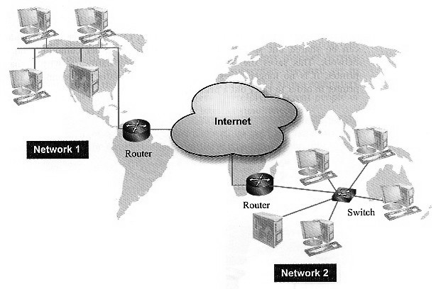
A network is a set of nodes connected together to share information and resources. A node may be a computer or a connecting device, e.g. a router or a switch.
The Internet is a large collection of individual networks that are all interlinked. Networks can be connected to the Internet through many technologies, including dial-up access, DSL, cable modems, and wireless technologies. An organization that offers a path (dial-up or broadband) to us is called an Internet Service Provider (ISP).

TCP/IP
Transmission protocol is a set of transmission rules governing the format of data to be transmitted. TCP/IP (Transmission Control Protocol / Internet Protocol) is a technology that manages the transmission of data by packet switching.
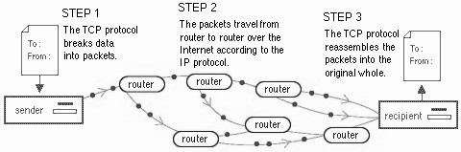
When a computer sends data over the Internet, the data is divided into small packets. Each packet contains the data, as well as the destination, origin, and the sequence information used to reassemble the data at the destination. During transmission, each packet will be directed by a series of routers across the Internet. Finally, when the packets reach the receiver, they are recombined to form the original message. In packet switching, different packets of the same message may take different paths and directed by different routers.
1. Packet Structure
Structure of a packet:
Receiver address  Sender address  Sequencing Information  Time-to-live (TTL)  …… | Header  Data
……
Error control  …… | Trailer
The receiver address is to make sure that the packet can be sent to the recipient.
The sender address is necessary to acknowledge receipt of packet. It is useful if an error occurs in transmission so that re-transmission is needed.
Since packets may reach the recipient out of order, the sequencing information helps to re-assemble the packets into the correct order.
TTL information is to avoid any undelivered packet moving on a network forever. When a packet is created, TTL is initialized to 64, say. This value would be decreased by 1 when the packet reaches a router. If the value of TTL falls to zero, the packet would be discarded.
Error-control information ensures that errors in transmission can be detected, and even recovered. If the errors cannot be recovered, the recipient will ask for re-transmission.
2. Benefits of Packet Switching
- Packet switching can avoid monopolization of transmission line. If a very large un-split unit of data is transmitting continuously along a transmission line, it would occupy all the available bandwidth so that other computers cannot communicate. By splitting the data, packets from different nodes can be interleaved and the transmission line would be equally shared.
- Also, since packets from the same sender may use different paths, the loading of the transmission line can be evenly distributed.
- Since there is always more than one path, the transmission will not complete fail due to the failure of part of the nodes.
- If an error occurs, re-transmitting a very large unit of data is inefficient. By splitting the data into smaller packets, only those with errors need re-transmission. Then, error recovery is much more easier.
3. Transport Control Protocol
TCP/IP is not a single protocol. Instead, it is a protocol suite that consists of a set of protocols. One of the two major components is Transport Control Protocol (TCP). TCP is responsible for breaking a message into packets and re-assembling them at the destination. It also re-sends packets which have errors during transmission.
4. Internet Protocol
Another major component is Internet Protocol (IP). Internet Protocol handles the IP addresses used in packets through the network. In the sender computer, IP receives data from the TCP, adds sequencing information, addresses and other control information. The reverse process will be done by the IP of the receiver computer.
5. Pros and Cons of TCP/IP
- Pros: As TCP/IP is the actual implementation of the concept of packet switching, the advantages of TCP/IP are similar to those of packet switching. Besides, TCP/IP also allows computers of different hardware and software to communicate as long as the operating systems supporting TCP/IP.
- Cons: The major disadvantage of TCP/IP is that it is not designed for transmitting real-time signals, like live voice or video. Since packets may arrive out of sequence and it is impossible to re-transmit erratic packets of real-time signals, the quality of conversation may be reduced.

IP Address
Each computer or device on the Internet is uniquely identified by an address, called IP address (short for Internet Protocol address).
The IP address consists of 4 bytes, each byte separated by a period (called dot). The number in each part is between 0 and 255. The total possible combination is 256 × 256 × 256 × 256. But, a considerable portion is reserved for special purposes. For example, 202.153.125.18 is a valid IP address.
In order that packets can reach the destination, each packet must carry the IP address of the receiver. Routers on the Internet keep a table of IP addresses and make use of these addresses to determine he best path for each packet. On the other hand, in order to facilitate re-transmission in case of errors in transmission, each packet must also carry the IP address of the sender. This approach is similar to writing addresses on an envelope in sending traditional letters.
There are two types of IP addresses: global (public) and local (private).
1. Global IP address
A global IP address of a computer is visible to all computers of the Internet. Global addresses are a precious resource and are managed by ICANN (Internet Corporation for Assigned Names and Numbers) which is a non-profit organization located in USA.
Users may apply for a global IP address through their ISP. Each network is assigned with only a few global IP addresses, which are normally used in mail server, web server and routers etc.
As the Internet grows rapidly, global IP addresses will be used up finally. Therefore, a Next Generation Internet Protocol called “IPv6” is recommended in recent years.
Try to find out the global IP address of your computer using the command “ipconfig”. Is the IP address always fixed or dynamic? Why?
2. Local IP address
Local IP addresses are assigned to computers within a private network. They cannot be routed over the Internet. The three major ranges of local IP addresses are:
• 10.0.0.0 - 10.255.255.255,
• 172.16.0.0 - 172.31.255.255 and
• 192.168.0.0 - 192.168.255.255.
In order that a computer on a network can be recognized on the Internet, a translation in IP address is necessary. This is done by a technology known as Network Address Translation (NAT). The NAT maintains an address translation table as below and rewrites the IP address in the header of each incoming and outgoing packet.
Local IP address | Global IP address
10.0.0.1 | 202.121.38.62
10.0.0.2 | 202.121.38.63
… | …
NAT serves three main purposes:
- Translate internal IP address into global IP address, and vice versa
- Enable an organization to use more internal IP addresses than its available global IP addresses. For each outgoing transmission, the NAT assigns an arbitrary port number between 1,024 and 49,151 to the packet and records the local IP address in the NAT table as shown below.
Local IP address | Global IP address | Port number
10.0.0.1 | 202.121.38.62 | 2610
10.0.0.2 | 202.121.38.62 | 2618
10.0.0.3 | 202.121.38.62 | 2637
… | … | …
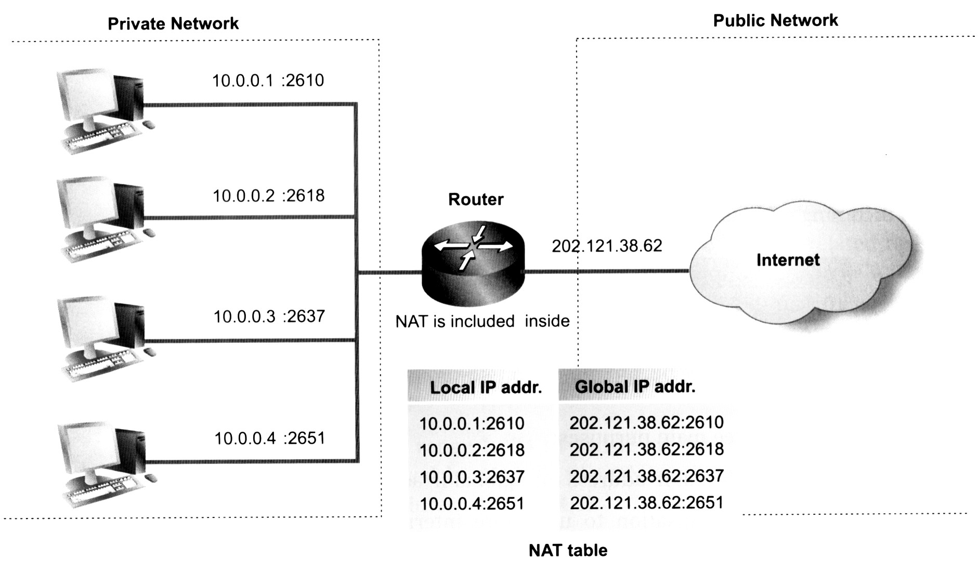
The sender address of the going out packet will then carry both the global IP address (as sender address) and the port number, which will not be changed by the remote site. For each returned transmission, the NAT will look up the table and find out the local IP address according to the port number.
- Provide firewall protection by hiding internal IP addresses.
Assigning IP Addresses
On a local area network, each device is assigned with a unique local IP address. There are two ways to assign IP address:
- Manually assigning static IP addresses to devices.
- Making use of Dynamic Host Configuration Protocol (DHCP) which assigns dynamic IP addresses automatically. This saves a lot of administrative efforts.
In general, servers, network printers and routers are assigned with static IP addresses, whereas ordinary workstations are assigned with dynamic addresses.
Similarly, the global IP addresses can also be static or dynamic. Large organizations are usually assigned with one or more permanent global IP address, which is used in the web server, FTP server or mail server that must be identified by users in the Internet.
For home users, the global IP address is assigned (or leased) dynamically by the DHCP of the ISP's server. The leased time is usually in hours or days.

Domain Name System (DNS)
Computers use IP addresses to communicate with one another on the Internet. But, a numeric IP address is not easy for people to memorize. Also, an IP address sometimes changes (in the case of using temporary global IP address, because it may be shared by different machines at different times).
Domain name system (DNS) is developed to solve the above problems. Computers on the Internet are classified into different groups, called domains. Each domain is made up of one or more network. A domain name is the text version of the IP address of a server using words separated by periods.
Every domain name contains a top-level domain abbreviation that identifies the type of organization that is associated with the domain. The direction of reading a domain name is from right to left.
Like global IP addresses, domain names must also be unique. It means that no two organizations will use the same domain name. Examples of domain names are "emb.gov.hk" and "hkeaa.edu.hk". These domain names will be converted into IP addresses which belong to the servers of the Education and Manpower Bureau, and the Hong Kong Examinations and Assessment Authority respectively. Compared to an IP address, a domain name is more meaningful and easier to remember.
The words in a domain name represent domains at different levels. The top level domains have two types: generic top level domains and country-code top level domains. Currently, there is six second-level domains under "hk"
NAME | ORGANIZATION |  | NAME | CONUTRY
.com | Commercial organization |  | .hk | Hong Kong
.net | Network provider |  | .cn | China
.edu | Educational institute |  | .tw | Taiwan
.gov | Governmental agencies |  | .jp | Japan
.org | Non-profit organization |  | .au | Australia
.idv | Individual |  | .ca | Canada
 |  |  | .ma | Macau
For example, bhscmc.edu.hk is the domain name of a HK educational institute called "bhscmc".
In a domain, there may have many files or web pages. The Internet address of a web page is known as Uniform Resource Locator (URL). An URL defines the route to a file on the web. It contains the protocol prefix, type of host server, domain name, subdirectory name and filename.
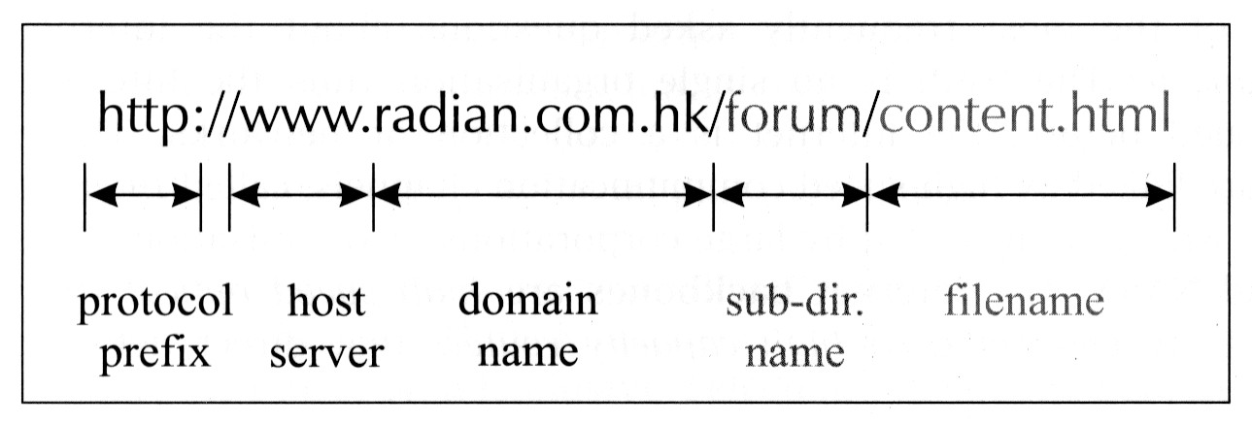
For example, the above URL retrieves the file "content.html" stored on the Radian Publishing Company’s web site.
The domain names and their corresponding IP addresses are stored in a huge database. This database is not stored as a whole in a single location. Instead, it is a distributed database that is maintained by many computers, called Domain Name System servers (DNS servers).

DNS servers are kept by major ISP (Internet Service Providers), which update the database regularly. They are responsible for translating a domain name into an IP address. If a DNS server does not contain a record of the domain name, it may contact another DNS server. As a result, the translation from a domain name into an IP address is done by one or more DNS server.
Below are examples of domain names:
IP address | Alternative domain name
210.0.211.245 | bhscmc.edu.hk
203.112.93.11 | www.hsbc.com.hk
202.43.220.99 | hk.yahoo.com
203.189.170.34 | www.wellcome.com.hk
NSLOOKUP is a command that can translate between IP address and its domain name. Try to complete the following conversion table:
IP address | Alternative domain name
59.188.18.234
203.145.76.28
 | www.hangseng.com
 | www.cuhk.edu.hk

Communication Links to Internet
In order to access the Internet, a computer needs basic networking software that supports TCP/IP, specific hardware (router, modem and/or network adapter) and a connection to an Internet Service Provider (ISP), such as PCCW, HGC, HKB & Cable TV. An ISP offers Internet access to individuals and companies. It has a permanent connection to the Internet backbones.
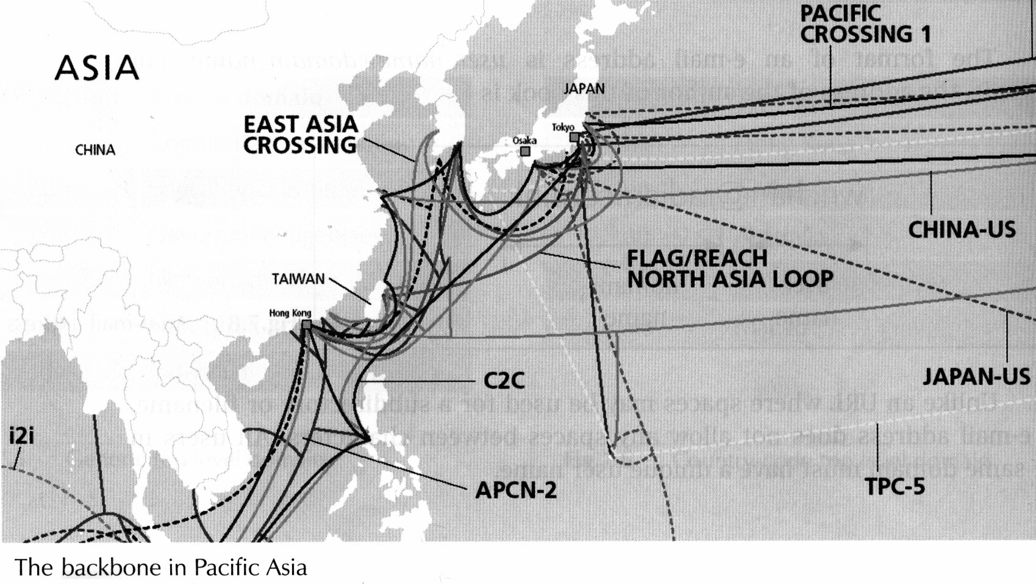
1. Internet Access for Home Users
Currently, the two common services offered by an ISP for home users are: dial-up access and broadband access.
- Dial-up access means sending data over ordinary telephone lines (also called Public Switched Telephone Network, PSTN). In dial-up access, the computer must have a modem which converts between digital data (of computer) and analog data (audio tones transmitted over phone lines). Network interface card is not required in such dial-up access.
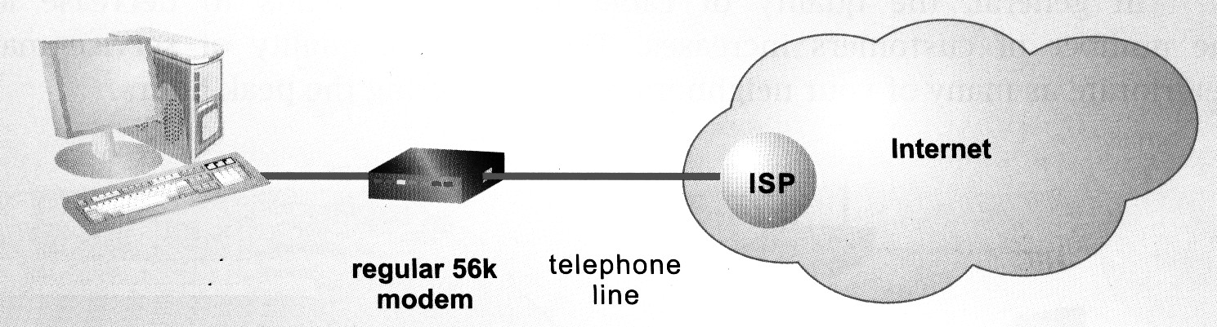
Modems are used in pair, i.e. another modem must be installed at the opposite end of the phone line to convert analog data back to digital data. In fact, the ISP that provides dial-up access usually has a pool of modems.
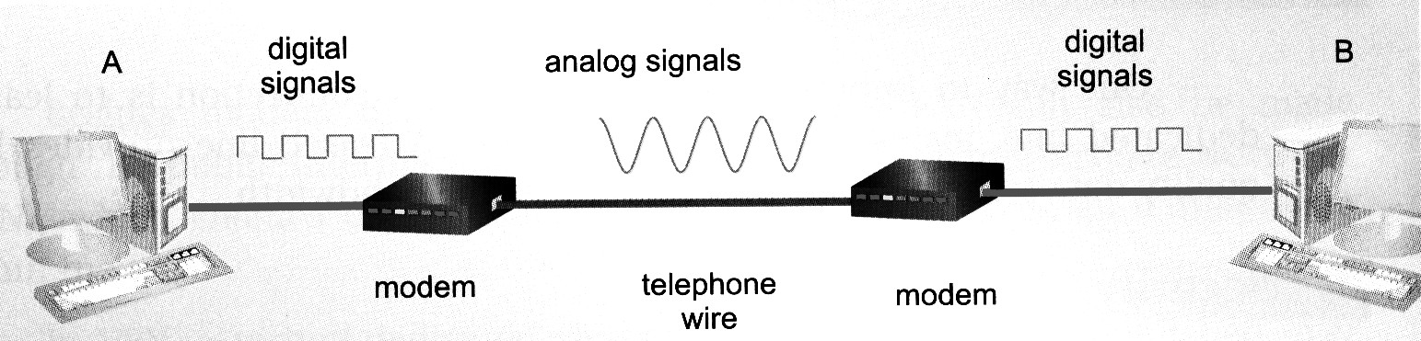
The fact that ordinary phone line was originally designed for voice-only communication makes it a low-quality choice. The error-rate can be high as 40%. Thus, re-transmission is quite often. The maximum bandwidth of dial-up access is 56 Kbps. The modems at both ends negotiate the highest possible transmission rates. If your modem is 56 Kbps, but the other end is 14.4 Kbps, the highest transmission rate is only14.4 Kbps.
Since dial-up is necessary, the connection is not permanent and is known as “dial-on-demand”, in contrast to “always-on connection”. One way to improve the quality of dial-up connection is to lease a dedicated phone line (leased line). In general, the cost for a local dial-up access connection is cheap.
In Hong Kong, just a few users are still using dial-up access now since it is inconvenient (due to dial-on-demand) and provides low-speed and unreliable service.
- Broadband transmission allows multiple frequencies to transmit over a copper wire to achieve a high transmission rate. Currently in Hong Kong, the two common types of broadband access are cable TV and ADSL (Asymmetric Digital Subscriber Line).
DSL is built upon ordinary phone lines using advanced technology, known as broadband, to offer high bandwidth. ADSL is a type of DSL that has a higher download speed than upload speed. ADSL can reserve a small proportion of total bandwidth for voice signals. Therefore, ADSL is able to transmit both data and voice at the same time. Since the data is also transmitted on ordinary phone lines, an ADSL modem is necessary.
Another broadband technology works with the coaxial cables of cable TV network, which has bandwidth as high as 10 Mbps. In general, the quality of cable TV network tends to decrease as the number of customers increase since the bandwidth is sharing. Cable TV network is able to transmit data and telephone signals simultaneously. Also, a cable modem is necessary.
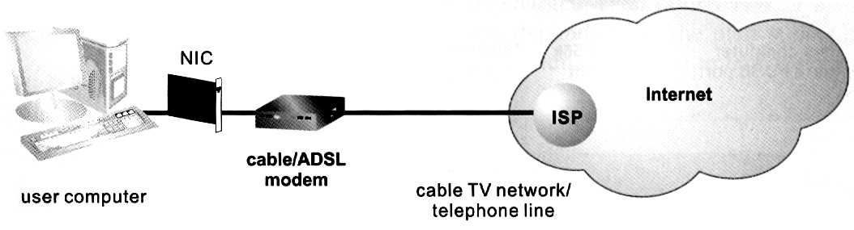
The following table shows the comparison between dial-up and broadband accesses:
 | Dial-up access | Broadband access
Speed of data transfer | Slow (max. 56 Kbps) | High (up to 1000 Mbps)
Monthly charge | Low | Higher
Dial-up | Necessary | Not necessary
Hardware requirement | Regular modem | Special modem
Transmission medium | Telephone line | Telephone line or cable TV network

2. Internet Access for Network Users
Similar to home users, corporate networks also need an ISP which provides the services and communication links. In addition, special devices e.g. routers, proxy server, NAT and firewall should be installed. Since the Internet uses TCP/IP, LANs connected to the Internet must also be configured to communicate in TCP/IP.
- Hardware
Firstly, all the computers on the LAN must be installed with a NIC and connected to a hub or switch.
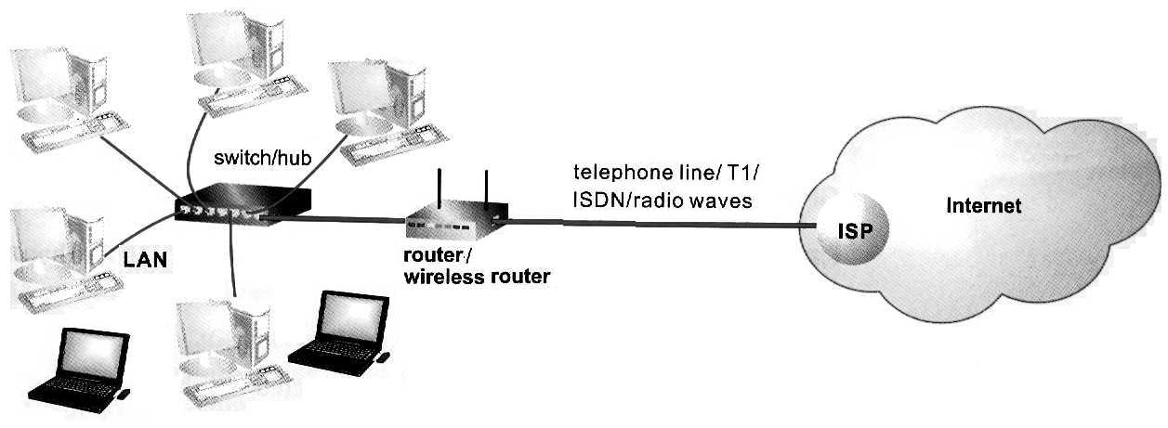
Router -- A router connects the LAN to the network of the ISP. Used on Internet, this router connects dissimilar networks and helps to direct traffic along the packet-switching circuits. Each router maintains a routing table of the NetIDs which are important to determine the best path for routing packets. Nowadays, most routers used are wireless one.
Proxy server -- A proxy server helps to improve the traffic by storing accessed Web pages, so that other users accessing the same Web pages do not need to access the remote Web site. Instead, they can get the contents from a local computer. Proxy server also helps to filter the contents to avoid users from accessing certain Web sites.
NAT -- NAT is used to translate local IP address into global IP address, and vice versa.
Firewall -- A firewall is software, or a combination of software and hardware, designed to prevent unauthorized access to a LAN. It sits between the router and the organisation’s network (i.e. between the Internet and the network) and decides whether it is safe to let messages pass through to the network.
- Communication links
In a LAN, one Internet link from an ISP can be shared among all users within the network. Usually, the access is unlimited and charged with a fixed monthly payment.
In Hong Kong, the common Internet accesses used by networks may be:
(a) DSL broadband that uses a telephone line or optical fibre
(b) ISDN (Integrated Services Digital Network) that uses a dedicated phone line
(c) T1 (1.5 Mbps) or T3 (44.7 Mbps) dedicated digital links
(d) ATM (Asynchronous Transfer Mode) that is expensive but has very high transmission speed (over 155 Mbps)

The following picture demonstrates a full picture of the communication links:
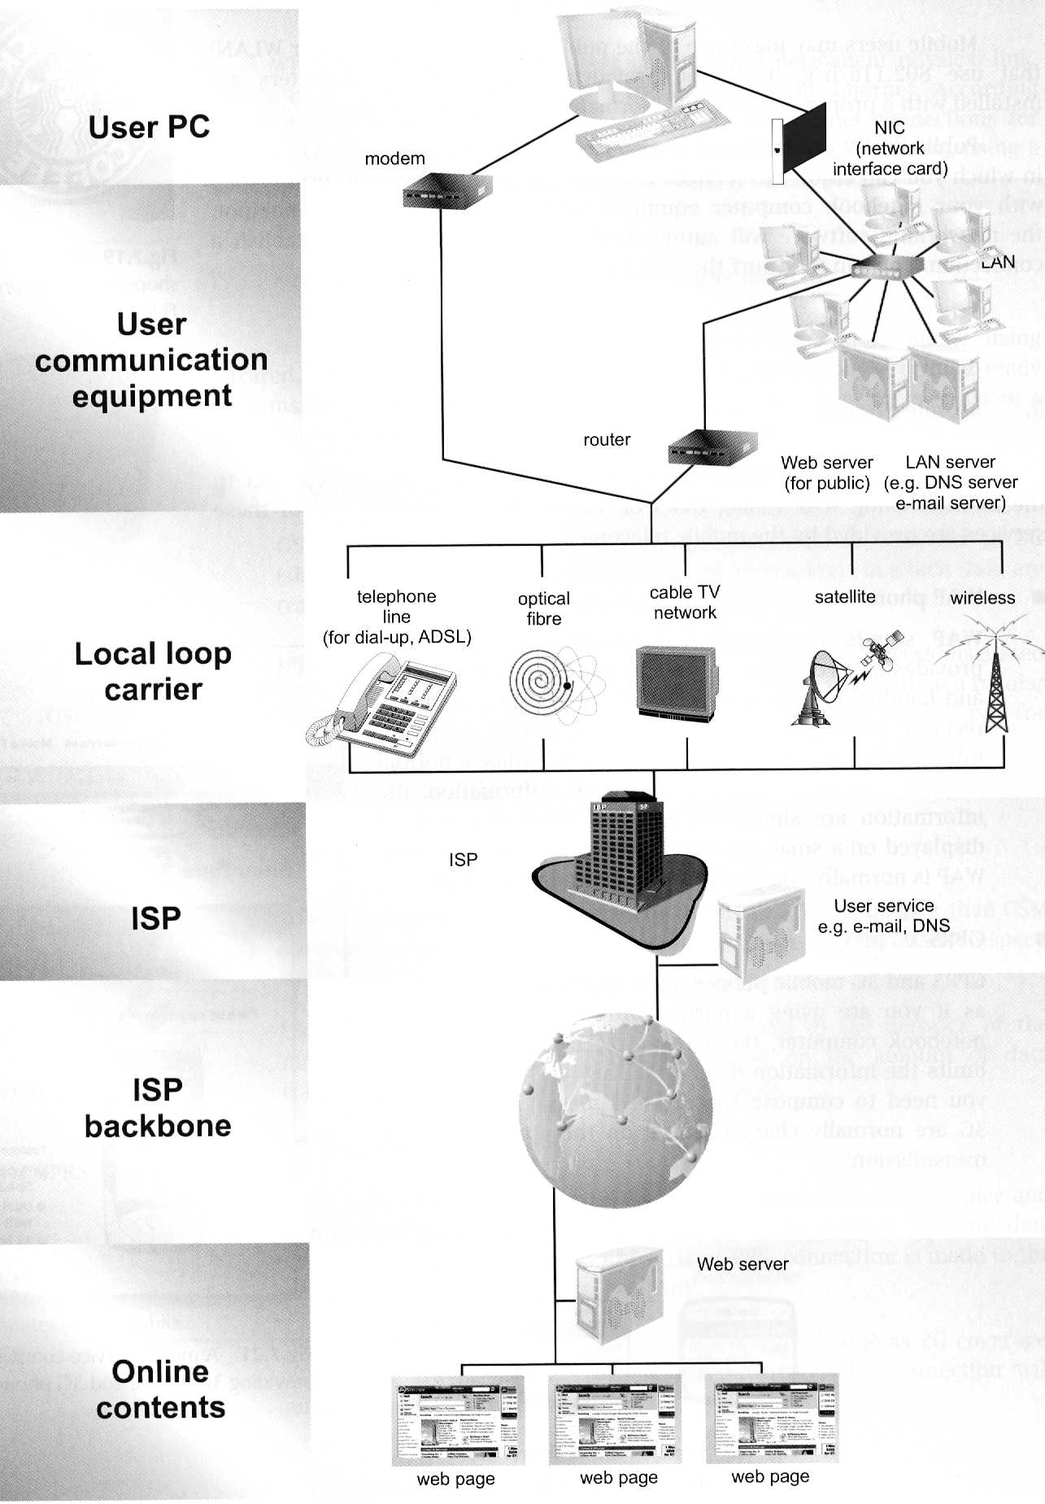
Exercise 1:
1. On most networks, messages to be transmitted are split into smaller chunks called packets. Each packet consists of the sender’s address, receiver’s address and control information like error control, sequencing information etc.
(a) State the device which is responsible for splitting the message into packets.
(b) Describe the purposes of the following found in a packet:
i) Sender’s address
ii) Receiver’s address
iii) Error control information
iv) Sequencing information
(c) Explain why splitting messages could avoid monopolization of communication channels by certain users.
(d) Using packets, error recovery is easier. Explain this fact.

2. The diagram below shows the physical channels that a message would use as it is sent from one computer to the other over the Internet. The message is broken into smaller packets.
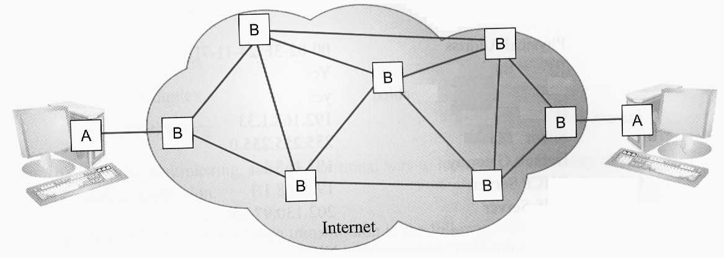
(a) Assume that A is installed inside a computer. Give the names for devices A and B. Briefly describe their functions.
(b) What is the major reason for sending packets in different routes?
(c) Packets are re-assembled at the destination. Discuss how the following cases are handled:
i) The arrived packets are out of order.
ii) Some packets are found to have errors.
(d) State THREE types of transmitting media that can be found on the Internet, linking devices B together.
(e) If a message is not received by any computer on the Internet, it would loop continuously.
i) Explain why the signals would not attenuate to zero.
ii) Suggest how this problem can be solved.

3. TCP/IP is the protocol suite used on the Internet. Messages sent over the Internet are broken into packets. Each packet carries the IP addresses of the sender and receiver.
(a) State the meaning of protocol.
(b) Give the full name for TCP and describe TWO functions carried out by TCP.
(c) Give the full name for IP and describe ONE function carried out by IP.
(d) Describe the format of an IP address. Hence, determine the theoretical maximum numbers of IP addresses.

4. On an IP-based network, all the computers are assigned with a unique IP address.
(a) Name TWO other devices on the network that also have an IP address.
(b) Discuss TWO methods in assigning an IP address to a computer or device, giving an example of use in each case.
(c) Are IP addresses always unique? Explain your answer by giving an appropriate example.

5. On a TCP/IP network, the IP address of workstations is assigned automatically by a DHCP server.
(a) Give the full name for DHCP.
(b) State TWO advantages of using DHCP.
(c) Suppose there are only twenty workstations on the network. State which part of the IP addresses of these computers is different from one another.

6. John is the sales manager of a company in Hong Kong. He has flied to Tokyo to host a seminar. In preparing for the seminar, he has to access the company’s network in Hong Kong. He plans to use the long-distance phone call line in the hotel to connect his notebook computer to the company’s network. Sketch a diagram to show how the connection could be made. In your diagram, state clearly the equipment needed.

7. A medical center has a Web site with domain name “www.medhk.com”.
(a) Can the domain name tell the country/location of the Web site? Explain briefly.
(b) Is it the only way for a man to type “www.medhk.com” in a web browser to access this Web site? Explain.
(c) State the
i) top level domain;
ii) second level domain of the Web site.
(d) What is the default URL of this Web site?

8. Peter’s family has installed a traditional voice phone. He has a standalone computer with a modem, but without any other network adapter.
(a) Discuss whether Peter can make access to the Internet.
(b) Describe the function of the modem.
(c) Computers on the Internet are recognized by IP addresses. Explain why Peter does not need to know the IP addresses of his friends when he sends message to them.
(d) Peter wishes to change to use broadband to access the Internet by ADSL service provided by an ISP.
i) What does “A” in ADSL stand for?
ii) Explain why ADSL is more common than DSL technology.

9. An Internet service provider for home and business in Australia has following services:
Plan | Type of service | Monthly fee | Speed*
A | Broadband with ADSL | $ 200 | 1500/256 Kbps
B | Broadband with cable TV | $ 120 | 10 Mbps**
C | Broadband with satellite | $ 560 | 512 Kbps
D | ISDN | $ 180 | 128 Kbps
E | Dial-up | $ 80 | 56 Kbps
* The speeds vary according to Internet traffic, server capacity and other factors.
** The speed is shared by simultaneous users of the same cable.
(a) Explain why two data are presented in the speeds for plans A.
(b) Suggest a type of users who will use plan C. Explain briefly.
(c) Which of the above plans use(s) digital transmission?
(d) The fee shown above does not include “set up fee”, which is the one-time charge on customers for installation. Which plan has the
i) highest probable set up fee?
ii) lowest probable set up fee?
Explain your answers.
(e) One of the services of the ISP is to provide fixed IP address for users. State TWO benefits of having a fixed IP address for home users.
Internet Services
Many different services have evolved as the technology of Internet develops. The following services are provided in recently year:
1. World Wide Web (WWW)
The WWW consists of a worldwide collection of electronic documents called web pages. The web consists of documents written in Hyper Text Markup Language (HTML). Using HTML, authors can present text, images, sound, animation and video, as well as hyperlinks to other web pages. A web site is a collection of related web pages and the homepage is the top-level web page of a site.
Hyperlink is a connection to another document. It allows you to obtain information in a nonlinear (not step by step) way. Hyperlinks can be used to move quickly and efficiently from one document to another one. Hyperlink may be a file name, a document name or another web site. Hypertext is a document that contains hyperlinks.
To browse a web, you need a web browser and a computer connected to the Internet. A web browser is a software program that interprets the web codes and allows you to watch the effects made. HTML files stores the text content and HTML instructions called HTML tag. Each HTML tag is enclosed by a pair of "<" and ">". While most HTML tags are used to format text, some are used to specify where images located. For instance <IMG SRC = "apple.jpg"> specifies the filename of an image located in the same directory. It is important to note that an HTML file is a pure text file –– the images are stored separately.
A browser downloads web pages. Downloading is the process of receiving a file from a server on the Internet. Uploading is the process of putting files onto a server. The protocol used in browsing web is called Hypertext Transmission Protocol (HTTP).
Some Webs involve multimedia. To run a multimedia application, a browser may need an auxiliary program called a plug-in e.g. Flash Player, QuickTime and ActiveX Control … etc.
2. Search Engine
A search engine is a program that accepts queries from users and then retrieves lists of Web pages that meet the criteria specified in the queries. A query, known as search text, may consist of one or more keywords with optional search operators. The search result is a list of filenames in the form of URLs and brief descriptions of the Web pages.
The major component of a search engine is a program called crawler. The crawler regularly and automatically locates new documents or sites by following hyperlinks from server to server. The information is stored in a huge database with a smaller table called index.
The usefulness of a search engine depends on the relevance of the results it returns, which in turn depends on the algorithm used to order the search results.
Yahoo and Google are two common search engines used in Hong Kong. The following techniques are useful for searching information in an effective way:
- Using Multiple Keywords
If the query consists of a commonly used term, the list of results can be very long. For example, a search with the keyword, "Computer" has resulted in 87,400,000 items.
To reduce the size of search results, you can use multiple keywords in the query. Then, the search engine will locate sites that contain all (or most) of the keywords. For example, the search text, "Computer facilities for blind in Hong Kong" reduces the number of results to 6,150.
- Using Search Operators
You may also use one or more search operators, such as AND, OR and NOT, to refine your search. A search operator describes a relationship between keywords.
Search Operator | Example | Meaning
AND | Computer AND blind | Pages with both "Computer" and "blind"
OR | Computer OR blind | Pages with either "Computer", "blind" or both
NOT | Computer NOT blind | Pages that contains "Computer" but without "blind"
- Using Quotation marks and Wildcard characters
A pair of quotation marks is used with more than one word. For example, the query "Computer facilities" means requesting for pages with the exact phrase "Computer facilities".
Wildcard character (*) is usually used with part of a word. For instance, comput* means requesting for pages with "computer", "computing", "computation" and so on.
- Using Advanced search
Many search engines provide an advanced search that helps you create a more focused query by filling in a form. A search form can replace the search operators for a focused.
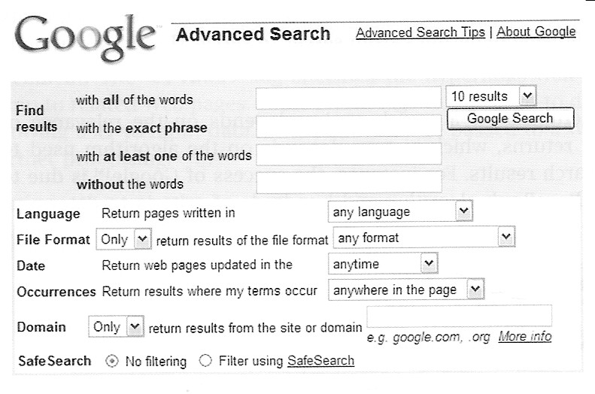

3. Electronic Mail (E-mail)
E-mail is the exchange of messages with other users via a computer network. Today exchanging e-mail is the most popular feature on the Internet. You can exchange electronic mail with people around the world.
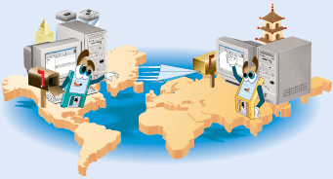
An e-mail message can be simple text or can include an attachment such as a word processing document, an image, or an audio clip. An e-mail can be forwarded and replied to easily. Also, e-mail is fast, easy, inexpensive and saves paper.
Just as you address a letter when using the postal system, you must address an e-mail message with the e-mail address of your intended recipient. Also, to receive an e-mail message, you need an e-mail address. An e-mail address is a combination of a user name and a domain name separated by the @ symbol. A user name is a unique combination of characters, such as letters of the alphabet or numbers that identify you. Different user must use different user name in a same domain. For example, bh-mail@bh.hkcampus.net is an e-mail address provided by the domain bh.hkcampus.net.
Each e-mail user has an account maintained by the mail server of an organization, such as an ISP, a school or a web-mail company like Yahoo. Users are required to provide a correct user name and password to log in the account in order to send or receive mails.
The communication method used in e-mail is store-and-forward. It means that the message from the sender is not sent directly to the receiver. Instead, it is stored temporarily in a server until receiver retrieves the message. E-mail messages are normally handled by two servers: SMTP servers and POP (or IMAP) servers.
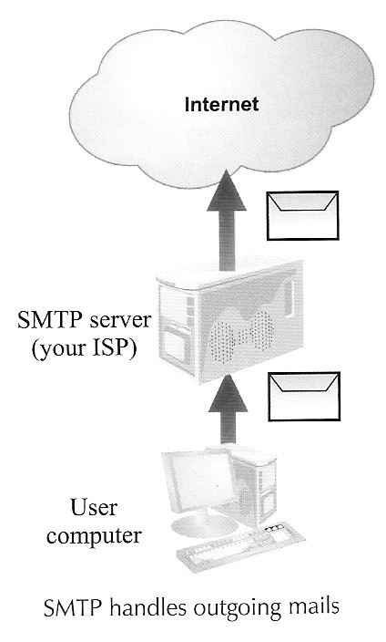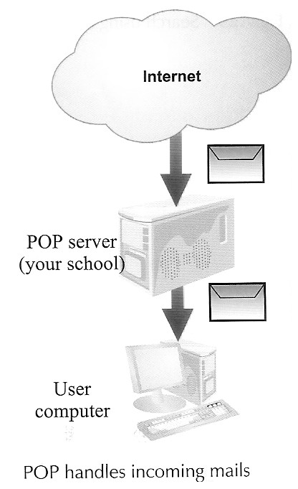
- SMTP
An SMTP server is a computer kept by your ISP to handle outgoing mails. SMTP (Simple Mail Transfer Protocol) is a protocol for routing e-mails from one server to the other.
- POP (or IMAP)
A POP (or IMAP) server is a computer kept by your e-mail service provider to store the incoming mails. POP3 (Post Office Protocol version 3) is a protocol for downloading e-mails from the server that stores users' incoming mails. Mails will be forwarded to users’ computer when the users allow transmission. This is what we call store-and-forward.
An e-mail software allows you to create, send, receive, forward, store, print and delete e-mail. According to the software that you use to send and receive mails, e-mails are classified into two types:
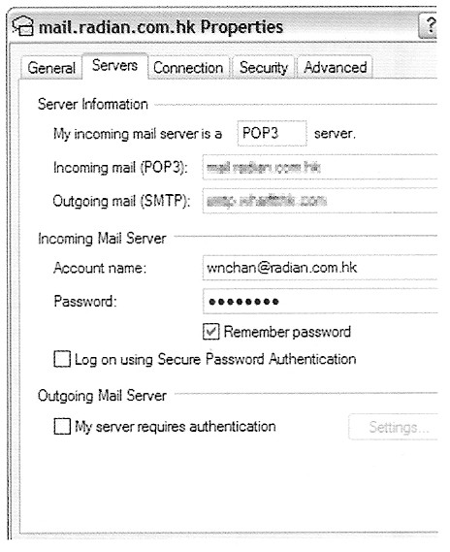
- E-mail Clients
Before you can use the e-mail client, you need to configure the program by providing the following:
(a) Name of the incoming mail server (i.e. POP server)
(b) Name of the outgoing mail server (i.e. SMTP server)
(c) Your account information (including a user name and a password)
An e-mail client should not be used with a public computer, because your private information will be stored in the computer.

- Web-mails
Web mails are e-mails which are retrieved using a browser. You will use the browser to read, write, reply to, forward and delete mails. You need not care about the names of the SMTP and POP servers since all this information are handled by the Web site behind the scene. All you need is the URL of the Web site and your user name and password that are required to log on your e-mail account.
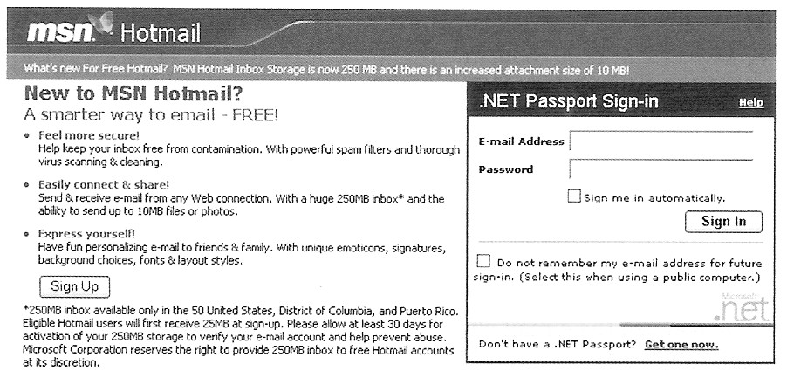
Web mails are convenient to use: you can send or receive mail anywhere. Web mail accounts can be applied from some Web mail providers on the Internet, for example, Hotmail@ and Yahoo@, which offer free e-mail service.
The major disadvantage of Web mails is insecure. Web mails do not support digital certificate that uses PKI technologies. Therefore, you cannot digitally sign a Web mail. Also, you cannot encrypt Web mails. Therefore, Web mails should not be used to transmit confidential information, like credit card number.

4. Newsgroup
A newsgroup is a forum on the Internet for threaded discussion on a specified range of subjects. A newsgroup consists of articles and follow-up postings. It is an online area where users conduct written discussions about a particular subject. You can join any newsgroup on the Internet to meet people around the world with similar interests. You can ask questions, discuss problems and read interesting stories. There are thousands of newsgroups on topics such as the environment, food, humor, music, pets, photography, politics, religion, sports and television, etc. To participate in a discussion, a user sends a message to the newsgroup, and other users in the newsgroup can read and reply to the message.
Usenet is a worldwide forum with over 30,000 newsgroups. There are many Usenet servers that keep the same set of messages all over the world. Usually, postings of a newsgroup will be maintained for only a short period of times, generally, a week or less.

5. Chat Room & Instant Messaging
A chat room is an online forum where people communicate by typing messages in real time. Anyone in the chat room can participate in the conversation, which usually is specific to a particular topic. The major difference between a chat room and a newsgroup is that the latter is not real time. Also, messages posted by others before a user enters the chat room will not be visible to the user.
Instant messaging is a private version of a chat room that allows two or more people to send typed messages back and forth. Popular instant messaging services on the public Internet include MSN Messenger, Yahoo Messenger and ICQ.
Besides transferring typed messages, many instant messaging services also offer videoconferencing features. By videoconferencing, each participant can see the images and hear the voice of others through the use of video input device, microphone, and speakers.
6. File Transfer Protocol (FTP)
FTP is a protocol that defines how to upload and download files between a client and a server. To gain access to an FTP server, you need an FTP client program that allows you to access the server's file directory system. Besides uploading and downloading files, you may also carry out file management tasks, like creating directory, deleting files, renaming files etc.
As mentioned before, HTTP is the set of rules for downloading Web pages. FTP provides two-way file transfer between computers. Downloading files using FTP is more efficient than HTTP because FTP is more simple.
While most FTP sites are private, meaning that authentication is needed, an anonymous FTP site is publicly accessible. For instance, you enter "anonymous" in response to the authentication prompts. Such FTP sites are normally read only.

7. Remote Logon
It is possible to control another computer remotely over the Internet. Tools include Telnet and SSH (Secure shell).
Telnet is a protocol that enables users to log on and control another computer via the Internet. Telnet simulates a text-based terminal screen so that users can interact with the remote computer as if they were sitting before its screen and keyboard. Telnet is a very powerful application since users can control the remote computer, performing tasks like managing files, running applications, or even administer the remote system. Yet, commands and passwords are sent in plain text without encryption. Unless it is really necessary, network administrator should turn off the Telnet service.
SSH is developed to overcome the problems of Telnet, providing better security using encryption and capturing the screen of a remote computer real-time. This allows you to operate the remote computer as if you are sitting in front of it.

8. Blog
Blog refers to a web site that contains messages posted by a person in the form of an online diary for access by the general public. Blog is similar to a web page because the messages are viewed by a browser. It is similar to a newsgroup because the posts are time-stamped and usually arranged in reverse chronological order. Other people may respond to the messages by writing their comments. Such discussions are moderated by the person in charge of the blog.

9. Peer-to-peer File Sharing
P2P file distribution is a technology developed to overcome the problem of bottlenecks due to a huge demand on some large files, like sound and video files distributed by a single web site using HTTP or FTP. With P2P, files are broken into smaller fragments and the same fragment can be found repetitively in the computers of many users (peers), who agree to share with other users.
The scenario is that while a user is downloading fragments from hard disks of other users, he may be providing fragments for others to upload at the same time. Finally, the fragments are reassembled to form the original file.
The most popular tool for P2P is Bit Torrent that is a freeware written in 2002. BT was initially designed to share open source software, such as Linux OS, among programmers. But, it turns out to be a popular tool to share MP3 and movie files by many Internet users. It is an offence in law in Hong Kong to download copyrighted materials using whatever means, including P2P.

10. Internet Phone
Internet phone (also called IP phone or VoIP) allows inexpensive telephone-style conversations to travel over the Internet. Using Internet phone, voices are converted into packets and sent using different paths. As packets may get lost or arrive out of sequence, the sound quality in Internet phone is typically worse than traditional phone calls. However, voice transmission over the Internet is free of charge especially for long-distance calls.
Security and Privacy
On the Internet, users’ data are often transmitted between a client computer and a server. There are always concerns about security and privacy. The same is true for message transmission in e-mails and other kinds of communications.
When you send a message over the Internet, it can be intercepted at any point. You want your message to be read only by the intended recipient but not someone else.
Integrity ensures that a message transmitted over the Internet is not modified.
Confidentiality ensures that the message is protected from being read by unintended recipient.
1. Encryption
Encryption is the conversion of data into a form so that only the intended recipient can read it using a key. Without the key, the information will appear as scrambled characters. Using a key, the encrypted messages can be decrypted back to their original form. There are mainly two kinds of encryptions:
- Symmetric Key Encryption
In symmetric key encryption, messages are encrypted and decrypted by the same key.
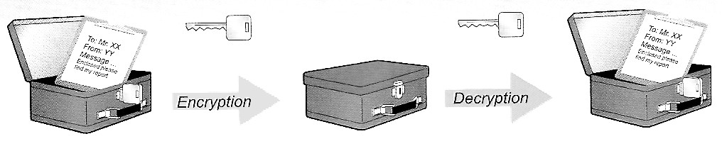
For example, a simple encryption method is to shift the letters in the message by a number of characters. For instance, A is coded as C, B as D, C as E, and so on. The decryption is done by shifting the coded message by the same number (key) of characters in opposite direction.
However, the coded message can be cracked easily. One technique is to analyse the frequency at which each letter appears. In English documents, letters "e", "t", "a", "0" and "n" appear more frequently than others. By mapping the coded letters to these letters, the key may be guessed.
Besides the ease in being cracked, there is a serious limitation in using symmetric key encryption to transmit confidential information over the Internet because the key must first be passed from one party to the other before subsequent messages can be encrypted. This key can only be passed in plain text during the initial connection. This makes it easy for hackers to grab the key, rendering the subsequent encryption meaningless.
- Public key infrastructure (PKI)
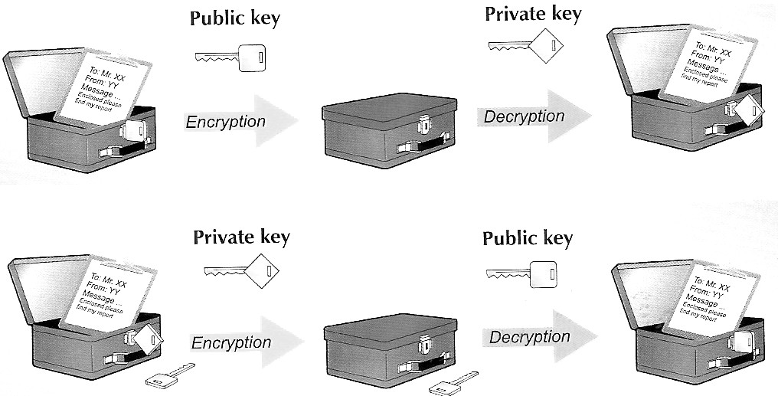
A very secure encryption method is to use a pair of asymmetric keys: public and private keys. As their names imply, public key is known to everyone and private key should be kept confidential.
Anything locked using one key can only be unlocked using another. For example, a message encrypted by a public key can only be decrypted by the corresponding private key. Likewise, a message encrypted by a private key can only be decrypted by the public key.
You may give your public key to all your friends, who encrypt using the key (public) before sending a message to you. Then, you decrypt the messages using your private key.
The disadvantage of PKI compared to symmetric key encryption is that it takes much longer processing time –– 1000 times more than for symmetric key encryption. In general, the longer is public key, the more secure is the transmission but longer processing time. The private key size can be 128, 192 and 256 bits.
- Secure Sockets Layer (SSL)
Some web sites use SSL to ensure secure data transmission. They are identified by the lock icons on your browser. In addition, the protocol prefix will change from http:// to https://. Most financial transactions in e-commerce use this technique.
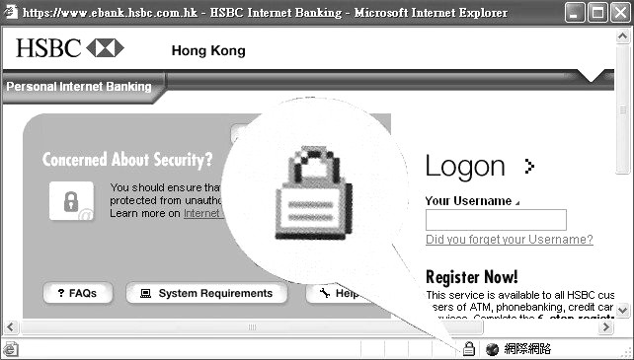
When you visit such a Web, your browser will receive the public key of the organization. Any data you want to send to the Web will be encrypted using the public key. This is done by your browser. When the encrypted data are transmitted to the Web, they will be decrypted using the private key of the organization. All these procedures are done automatically. Such data cannot be viewed by anybody except the company which uses its own private key to decrypt the data. SSL can only be handled by newer browsers, for instance, Internet Explorer 3.0 or above.
2. Identification
When you use e-commerce, it is possible that the online shop is a fraudulent one. Also, do you believe that someone called himself "Lau Tak Wah" in the Internet is really the singer "Andy Lau"? You want to confirm that the sender or the recipient is really the person or organization. You want the person or organization to prove them with a recognized identity.
Similarly, you need to prove yourself on the Internet. You want a secure means to show your personal identity to others.
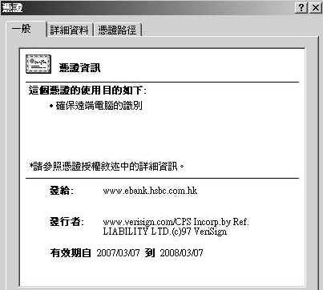
- Digital Certificate
A digital certificate is a digital document that includes the name and the public key of a person or an organisation. It identifies a person or an organisation on the Internet.
Every person may apply for a digital certificate. On successful application, you will receive your private key (a 16-digit password) and software that installs your digital certificate into your computer. Your identity on the Internet is endorsed by the certificate authority.
The digital certificate of a Web site that uses SSL can be checked by double-clicking on the lock icon on your Web browser.
- Digital Signature
A digitally signed document carries a digital certificate and is partially encrypted using a private key. This encrypted part is called digital signature.
When the receiver computer gets your digitally signed message, it will open it with your public key which is included in the digital certificate. Since only your public key can open the signed document, this proves that the message is really sent from you.
It also means non-repudiation. For example, when a customer places a digitally signed order at an online shop, he/she cannot deny having sent the order.
3. General Good Practices on the Internet
The following practices may help you protect yourself on the Internet.
- When transferring sensitive or personal data over the Internet, such as credit card number, the data should be encrypted before being sent.
- You need to regularly change your password especially during the first logon.
- Do not select "remember your password" when you log in a system or Web site.
- Your password should be long enough and be a combination of numbers, upper, and lower case letters. The more complicated the password, the less likely it can be guessed.
- Scan all downloaded files and attachments of e-mails for virus before opening them. You should switch off automatic processing of e-mail attachment in the e-mail software.
- When using the Internet in public areas, such as schools or libraries etc. remember to logoff the system before you leave. Otherwise, other people can use your account to do illegal activities on your behalf.
- Shopping on Web site with a digital certificate and having physical storefronts.

Legal Issues
The convenience in using computers and the Internet has brought about changes in our lifestyles. But, this also creates social, legal and ethical issues. Statistics show that there has been a significant increase in computer-related crimes. Below are some common type of computer crimes:
1. Copyright Infringement
Copyright is the right held by the author to reproduce, publish, and sell his/her work. The Copyright Law aims to protect creativity. The efforts of writers, artists, designers, software programmers and other talents should be protected so as to create an environment where creativity can flourish and hard work can be rewarded. In return, the public benefits from the creations.
Copyright infringement (侵權) means illegally reproducing someone's copyrighted work. The mere possession of an infringing copy of copyrighted software is a criminal offence and can result in severe penalties. Software piracy means using and/or selling illegal software.
Besides computer software, most other things on the Internet are also copyright protected. These include articles, graphics, animations, music, movies and even e-mail messages. The copyright ownership belongs to the original author. Anyone using other's material, whether it is downloaded from the Internet or not, should seek for permission and state the source clearly.
Putting up copyrighted material for other people to download is a criminal offence, whether you are using a Web page or P2P technology. This implies that downloading illegitimate MP3 songs using BT or WinMX is an offence, because fragments are found in your computer that can be uploaded by others.
2. Hacking
The crimes committed by hackers fall into the following types:
- Spreading virus which attack the system causing damage of files or the hard disk.
- Illegally stealing personal information.
- Changing the content of a Web site.
- Using hack tools to disrupt the operation of a Web server by flooding it with a lot of unwanted material, which leads to shutting down of service.
- Using spyware to trap keystrokes or steal documents from the victim's computer.
Some hackers may do it for profit or hatred, while other may do it to get pleasure of the intellectual challenge. For whatever reasons, it is a criminal offence to hack by laws in HKSAR. The police are capable of detecting these offences.
Unfortunately, a large percentage of detected hacking cases involve young persons. Very often, these youngsters do not realise that they are committing criminal offences. ;
3. Phishing (Phone-fishing)
Phishing means acquiring sensitive personal information such as password and credit card details of other people through deception by setting up a fraudulent storefront or sending official-looking e-mails.
The step that follows is usually impersonation i.e. unlawfully pretending someone else to carry out illegitimate transactions, such as opening new charge accounts, ordering goods or borrowing money.
4. Unlawful Gambling
In HKSAR, gambling is allowed only for adults through certain kinds of games and in certain places. Participating in unlawful gambling is a criminal offence. The more common unlawful gambling on the Internet involves the results of a football game.
5. Publishing Objectionable Materials
Although the Internet provides us with numerous useful information, it also consists of undesirable subject matters, such as pornographic, racist, violent, drug-related materials. Parents may use filtering software to block these materials, but it is unlikely to be 100% successful.
It is an offence to publish and display obscene and indecent articles on the Internet. The law is set up to protect the well-being of young people by preventing their access to indecent materials. However, these materials are easily found on the Web.
Government censorship on the Internet is not effective because the Internet is a worldwide network. It is difficult to limit access to the Internet which crosses numerous geographical, political and cultural boundaries.
6. Online Harassment and Defamation
Online harassment (騷擾) means that a person harasses another person by sending rude, suggestive, or threatening e-mail or online messages.
Online defamation (誹謗) involves publishing over newsgroups or Web sites some hate speech, unfair bias, discrimination or profiling of various minority groups, like disabled, racial, ethnic, or religious minorities.
7. Spamming
Spam (垃圾電郵) means junk e-mail that is unsolicited (unwanted). The sources are mainly from certain companies which want to promote goods or services. As of the print of this book, spamming is not a criminal offence in HKSAR, but agenda has been scheduled for discussion in the Legislative Council. Spamming produces a lot of inconvenience to many people and causes loss to the economy of the society.
Since a spammer (spam sender) may send thousands of mails every minute, the Internet will be flooded with unwanted mails and the Internet channels can be clogged. It also wastes people's time in going through their mail boxes to delete junk mails.
You may set the e-mail software to block spam from entering your mail box. However, the spammers often forge their e-mail addresses and change them frequently. Therefore, if the spam blocking rule is not strict enough, spam will continue to reach your mail box. On the other hand, if the rule is too tight, you will block mails from your friends who use a new e-mail address.
It is important, however, not to reply to any e-mail from an unknown source that has an address inside. If you reply the e-mail with an intention to request the spammers to take your e-mail address off from their lists, this will help the spammer to verify your address and then you will get even more spams. If the e-mail software fails to block the spam, just ignore them.

Computer Virus
To many people, the term computer virus means all kinds of unwanted software that will cause damage to data and program files of a computer system. Now, we shall use the term malicious software to describe any software developed for the purpose of doing harm to a computer system.
The intended action of a malicious software is known as payload. Traditional payloads include displaying messages, formatting users' hard disks, deleting or overwriting other files.
With the proliferation of networks, payloads now include threats to users' privacy, unauthorised access to a network, overloading a server causing malfunctioning etc.
1. Virus
A virus is a set of malicious codes that attaches to a file, replicates itself and spreads to other files. A virus is not a standalone program file, but needs a host. The host may be the boot-sector, a program file (with extensions .exe, .corn, .bin or .vbs) or a data file (e.g. Macro virus of word documents, spreadsheet files or database files).
Before other hosts are infected, the viral code must be brought to the memory so that it will be executed by the computer. This will happen when the user opens an infected file, or even previews an e-mail attachment. Thereafter, the set of codes will search for other hosts to begin the massive infection. If the boot-sector is infected, the viral code will reside on the memory whenever you turn on the computer.
Most viruses have payload. The activation of the payload may require a trigger event, such as a specific date or running another program etc. As a result of this characteristic, you may not be aware of having a virus, and therefore inadvertently help to spread it.
Up-to-date virus information can be obtained from http://www.hkcert.org/.
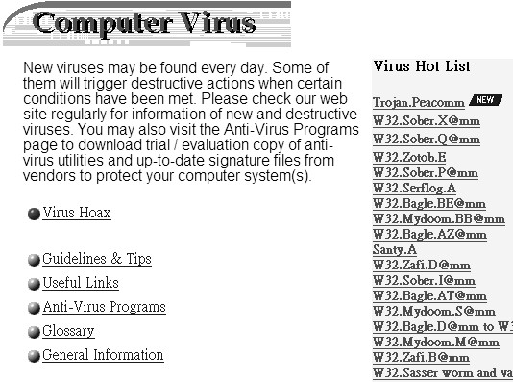
2. Worm
A worm is a malicious program file designed to spread from one computer to another over a network or the Internet, taking the advantages of the bugs or insecure settings of a network. They are standalone programs that replicate themselves outside an infected computer. Worms are now more common than viruses, because of the proliferation of networks and the Internet. Most spyware are worms which get into the infected computer through e-mail attachment. They will also cause file destruction.
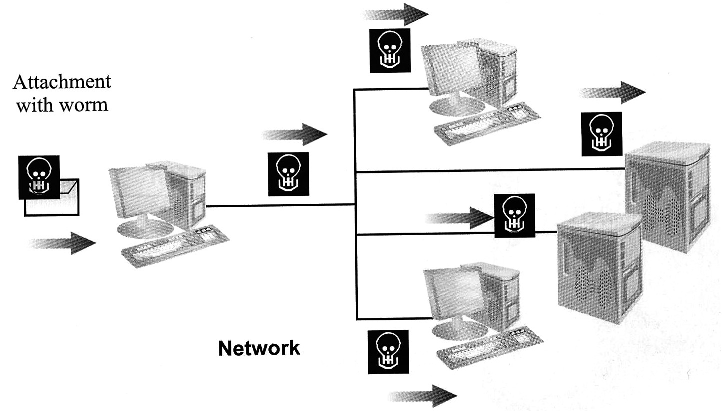
3. Trojan Horse
A Trojan horse is a malicious program file that portrays itself as something else, for instance, as a useful application or a picture. By definition, a Trojan horse would not infect other files (i.e. no transfer of codes), nor will it find ways to propagate from one computer to the other. However, once executed, it will immediately deliver the payload.
Trojan horses are commonly found in freeware from unknown sources. They are transferred to your computer with your consent. Payload usually includes destruction of files or modification of the system security so that the system will allow access by other computers.

Threats to Personal Privacy
1. Hack Tools
A hack tool attacks the security of a system. Some hack tools may install a backdoor to the victim system that will allow access by hackers. Some may attack the victim network by overloading the computational resources or consuming the bandwidth. Such tools are known as DoS (Denial of service) programs. Some may make use of the affected computer to send junk e-mails. Such tools are known as spamware.
2. Spyware
A spyware gathers information about the victim user and passes the information back to a remote computer. The information includes usage of browser, computer habits and even personal information stored as cookies, such as credit-card number and e-mail addresses. Some spyware are able to record your keystrokes so that the user ID and password you enter in an e-commerce purchase can be captured.
A typical spyware installs itself so that it starts every time the computer boots up and runs at all times, monitoring Internet usage. Therefore, spyware will slow down the performance of a computer. As its name implies, a spyware rarely causes destruction to data files. This is a way for them to hide themselves without your notice.
3. Adware
An adware produces window pop-ups that show advertisements. It is important to distinguish between the pop-ups produced by JavaScript and an adware. The former are simply due to the style of a certain Web site. They can be turned off by setting your browser or installing third party software. The latter are caused by a malicious software.
Some adware will highjack your browser by redirecting the browser's default home page to some Web sites. You cannot revert your browser unless the adware is removed. Such adware are usually installed in your computer with your consent voluntarily or involuntarily.

Avoiding Malicious Software
To avoid being infected with malicious software, you need to understand the symptoms of malicious software and how computers are infected.
1. Symptoms
- annoying messages, pop-ups or unusual visual and sound effects
- deterioration in system performance
- sudden reboot
- difficulty in saving files
- unaccountable busy network traffic
- unaccountable busy disk access
2. Infection Ways
- opening the attachment in an e-mail
- sharing of data files
- use of illegal software
- installing software from an unknown source
- attacked by hackers who spread the virus
3. Prevention
To avoid infecting malicious software, the following rules should be observed:
- Install anti-virus software and update the virus definition file daily.
- Scan your hard disk to check for virus regularly.
- Do not open or forward e-mails with attachments from unknown sources.
- Scan all downloaded files and e-mail attachments.
- Do not use illegal software.
- If your computer is connected to the Internet via a LAN, a firewall should be installed to prevent unauthorised access.
- Install latest patches (software amendment) for OS and application software to amend security holes.

Digital Divide
In HKSAR, while the social wealth gap is an existing problem, digital divide is getting more and more concern. Digital divide refers to the gap between people who have different opportunities to access IT and the Internet.
The lack of access to IT and the Internet will make poor people poorer. They cannot make access to vast amount of information on the Internet. They have difficulty in seeking for jobs which require high IT skill.
The government has been working hard to diminish digital divide by raising IT awareness. Public facilities are being installed to provide greater access to IT for people from the disadvantaged groups, like those who cannot afford computers, people with disabilities, the elders and new arrivals etc.

Knowledge-based Society
Knowledge is obtained through understanding and using the information that you have. The world in the 21st century is a knowledge-based society. Many people make use of information technology on a regular basis to learn or to solve their job-related tasks. They must have the skill to obtain, filter, understand and use the information.
In a knowledge-based society, an educated person is one who has the capacity to continually learn new concepts and new modes of operation throughout his or her life.
A knowledge-based society requires workers different from the past. In fact, technology has already changed the nature of jobs and caused routine tasks to disappear. Nowadays, a large proportion of jobs are associated with the computer, and these jobs require persons highly skilled in IT.
To equip yourself in this knowledge-based society, you should develop the habit of reading, learning and sharing information with others. You should learn the best use of communication technology and become habitual IT users. This will not only benefit you in learning in schools but also in job-related tasks in your future careers.

Globalisation
Globalisation in the computer field means that the geographic distances are shortened by the use of information technology. The computer networking technology has created a global village in which computers and people are linked between countries.
You can obtain news on the Internet that reports an accident in a village of Africa. You can attend videoconferencing with other people in New York and London, directly seeing their images and hearing their voices. You can purchase goods from an online storefront which is located on the other side of the world.

Use of Cookies
Cookies are a small chunk of data generated by a dynamic Web page and stored in a text file on your computer's hard disk. They are developed because pure HTML does not maintain records of previous interactions. Therefore, the server of a static Web page cannot deliver customised Web page to you, nor can it track the pages you have visited.
Cookies allow a Web site to store information, such as your name provided in a form, the hyperlinks your have clicked and so on, on a client computer for later retrieval. For instance, if you have an e-mail account in a Web mail provider, such as Yahoo, every time you visit the Web site, you will be greeted with your name appeared on the Web page. This is because your name is stored as a cookie in a file of your computer.
A cookie is data, not a computer program or script. It will not be executed in the same way as a virus. Although a cookie does not store malicious codes, it does cause privacy issue:
For example, a search engine website could create cookies on your computer to store the queries that you have typed and the hyperlinks on the search result page that your have clicked. Then, the search engine can create a personal profile about you and select advertisements targeted for you. In worse case, they can transmit the derived information to third parties.
Most browsers include security settings that block cookies. If you turn off cookies, you probably will not be able to make online purchases from some major e-commerce Web sites which make use of cookies for their shopping carts.
Advantage: If a computer is shared by more than one user, the cookies may be confused to each other. Also, the browsing record can also be tracked by others.

Exercise 2:
1. Miss Lee is a Mathematics teacher in a secondary school. She has compiled the question paper for the coming examination. The principal wishes to view the questions before they are sent to print. But, the principal is now staying aboard.
(a) Suggest TWO different ways that Miss Lee can submit the papers to the principal electronically.
(b) As a security measure, Miss Lee has protected the question paper by setting a password to stop unauthorised access. Then, she sends the password to the principal via an e-mail.
i) State THREE common practices in designing a password.
ii) Comment on the security of using e-mail to send passwords.
(c) Miss Lee has applied a digital certificate.
i) A pair of keys are involved in a digital certificate. Briefly describe the function of the keys.
ii) Discuss whether the digital certificate of Miss Lee can increase the security of e-mail messages sent by her.

2. Wonderland is a retailer that sells toys for children. A database system has been set up to record the stocks and all the transactions with the customers and suppliers. Programs are written so that the database is updated using a browser.
(a) State
i) the language for producing document read by browsers,
ii) the protocol used by browsers.
(b) Staff using the programs are authenticated.
i) Suggest TWO ways to authenticate the staff.
ii) State TWO reasons for authentication.
(c) Currently, purchase orders are mainly mailed through letters to the suppliers. Usually, payment is mailed together with the purchase order.
i) Discuss TWO disadvantages of using traditional mailings.
ii) Most suppliers do not accept purchase orders through e-mail. Give TWO reasons for this.
(d) An oversea supplier has set up a Web site with secure connection to accept purchase orders from clients. For clients with a digital certificate, payment can be made within two months after receiving goods. Otherwise, clients have to pay before delivery of goods.
i) Discuss the techniques that enforces security in data transmission.
ii) State the payment method commonly used on the Internet.
iii) State the importance of digital certificate.
iv) State TWO advantages to the suppliers of online purchase.
3. A is an international airline company. A Web site is set up to allow customers from all over the world to reserve air tickets. Paul is going to purchase an air ticket from the Web site.
(a) Before a user can purchase a ticket, he/she needs to join membership by creating a member account. The first step in creating a member account is to select a user name.
i) Paul has entered "paul" as his user name, but is rejected. Explain.
ii) What are the advantages of using membership to
(1) the customers?
(2) the airline company?
(b) Paul has to select a password too.
i) The Web site has two facilities to help users in case they forget their password. Describe these facilities.
ii) Suggest THREE major personal information that Paul must provide in creating his member account.
iii) How can Paul know that the information he submitted will be transmitted securely?
(c) Payment for air-ticket will be collected before the reservation is completed.
i) State TWO advantages of collecting payment by the airline company online.
ii) Suggest a possible way for Paul to collect his ticket.

4. PKI is commonly used for secure data transmission.
(a) Maria wants to send a message to Joseph. How Maria can ensure that the message will not be read by other people except Joseph?
(b) Olivia purchased a book from BookOnline, which is an online book store, using her credit-card. What purchase information were needed? Discuss how the purchase information was transmitted securely through the Internet?
(c) Maria wants to send an application form to the Transportation Department to apply for a driving license. How can the Transportation Department authenticate Maria?
(d) A team leader, Peter, wants to send an e-mail message to his boss, Miss Wong, to give a report about the staff in his team. He wants to make sure that only Miss Wong can read the message. Also, he wants to confirm Miss Wong that the message is really sent by him. What should Peter do?

5. IP telephony is getting popular in some countries. In fact, when you have ever made long-distance phone calls, chances are you have used IP Telephony except that you were not aware of using it.
(a) What is the full name for IP?
(b) It can be proved that the utilisation of phone line in conventional phone call is about 10%. Give TWO reasons to explain the low utilisation.
(c) IP Telephony uses packet-switching technology.
i) What information are included in each packet?
ii) Explain why packet-switching can improve the utilisation of the phone lines.

6. In order to encourage students and teachers to communicate with one another using IT, a school has activated certain services of the local area network.
(a) One of these services is newsgroup. There are different newsgroups for students of different interests.
i) Discuss how newsgroups can help students in their studies.
ii) The newsgroups do not support anonymous login. Discuss the purpose of this policy.
(b) The school has also set up a mail server and allocated an e-mail account for each student and teacher. The account names for the students make use of class and class number, for example, 4A31 is the name of account for the student in class 4A with class number 31.
i) State the problems of naming e-mail account in this way.
ii) Suggest an alternative naming method.
iii) Students can send and receive e-mails in school only. State TWO additional requirements for the mail server in order that students can also handle e-mails at home.
(c) Recently, some students find that they have received too many unsolicited mails.
i) What should the network administrator do about this?
ii) Explain why students should not reply to these mails.

ANSWER
Exercise 1:
1. (a) Network interface card (NIC)
(b) i) To help sending a message to the sender to acknowledge the receipt of data or to ask for re-transmission in case errors occur.
ii) To help directing the message to the receiver.
iii) To check whether errors has occurred in the data transmission or not.
iv) As packets may arrive out of order, sequencing information helps re-arranging the packets into the correct order before they are re-assembled.
(c) When a pair of stations is transmitting a large chunk of data, all other stations cannot transmit. By splitting the data into smaller chunks, data can be interleaved and stations have equal chance to transmit their data.
(d) If there is error, re-transmission is necessary. Using packets, the amount of data needed to be re-transmitted is smaller.

2. (a) A: NIC -- Splits the message into packets and receives packets from other computers.
B: Router -- Keeps a table of IP address of other networks to determines the best path to route the packets
(b) To balance the load of the connecting lines.
(c) i) Use sequencing information to rearrange the packets
ii) The receiver will ask the sender to retransmit the erroneous packets.
(d) Copper wire (phone cables), fiber-optic cables, microwaves (satellite) and radio waves
(e) i) The signals would be amplified by the routers.
ii) A field called time-to-live (TTL) is added to each packet. The value of TTL is deduced by each router until it falls to zero. Then, the packet is discarded.

3. (a) Protocol is a set of rules governing how data are transmitted and received.
(b) Functions of TCP (Transmission Control Protocol):
(1) Breaking a message into packets.
(2) Re-assembling the packets into message.
(3) Re-sends packets which have errors.
(c) Functions of IP (Internet Protocol):
(1) Adding the IP address to the packets.
(2) Removing the IP address from the packets.
(3) Routing packets through the network.
(d) An IP address consists of four numbers, between 0 and 255, separated by periods.
The maximum number of IP address is 256 × 256 × 256 × 256 = 4.295 × 10⁹ .

4. (a) Router, print server and switch, etc.
(b) TWO methods in assigning an IP address to a computer or device:
(1) Assigned manually: e.g. Web server, routers have fixed IP address.
(2) Assigned automatically by DHCP: e.g. workstations on the network.
(c) IP addresses used internally inside a LAN are unique inside the network. But, two networks may use the same set of internal IP addresses for their workstations. So, internal IP addresses are not unique when more than one network is considered.

5. (a) Dynamic Host Configuration Protocol
(b) Advantages of using DHCP:
(1) Efficient (fast) in allocating IP addresses to devices.
(2) Save efforts in manually assigning the addresses.
(3) Conflicts in IP addresses can be avoided.
(c) Their IP addresses differ only in the last decimal number.
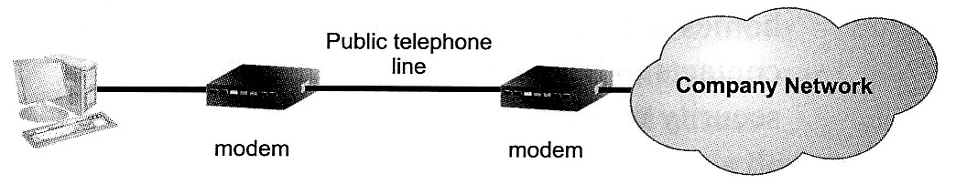
6.

7. (a) No, there is no country code on the domain name.
(b) The man can type in the IP address instead of the domain name to access the Web site.
(c) i) Top level domain: com
ii) Second level domain: medhk
(d) Default URL: www.medhk.com/index.html or www.medhk.com

8. (a) Peter can make access to the Internet by dial-up access using only a modem.
(b) Function of modem: convert digital data of computer to analog signal, and vice versa.
(c) Peter uses domain name when sending e-mails. DNS is able to resolve domain name into IP addresses.
(d) i) “A” in ADSL stands for asymmetric.
ii) The download speed is higher than the upload speed. Users often use the Internet for Web surfing, which involves more downloading than uploading.

9. (a) Different upload and download speeds, with download speed being higher.
(b) Users living in remote/rural area where cables are not accessible
(c) Plan D: ISDN
(d) i) Broadband with satellite. Installation of satellite requires expert knowledge.
ii) Dial-up. Connecting a modem to the phone jack on the wall is as easy as connecting up an ordinary phone.
(e) Benefits of having fixed IP address for home users:
(1) Users can host their own domain and Web sites.
(2) Users may set up VPN so that they can log into their computers remotely.
(3) Users may set up e-mail server themselves.
(4) Users may make use of smart home technology to monitor their homes remotely.
(5) Some companies require online contacts to have a static IP address for Internet security reasons.

Exercise 2:
1. (a) Electronic ways that Miss Lee can submit the papers to the principal:
(1) Send an e-mail with attachment.
(2) Place the file on a file server and let the principal access the file remotely.
(3) Place the file on a secure FTP site that authenticates the users.
(b) i) Common practices in designing a password:
(1) Never use information that can be guessed easily, like name, date of birth.
(2) Length of password should be long enough.
(3) Use a combination of letter and digits.
(4) Never write down the passwords.
ii) Security is low because e-mail is sent in plain text. When the e-mail is intercepted, the contents are known to others.
(c) i) Public key which is known to everyone and private key which must be kept secret. When the message is encrypted by one key, it can only be decrypted by the associated key.
ii) Miss Lee can encrypt and sign the e-mail using her private key. If the message is tampered, it will be known to the recipient only.

2. (a) i) HTML -- Hypertext Markup Language
ii) HTTP -- Hypertext Transmission Protocol
(b) i) Ways to authenticate the staff:
(1) Password authentication
(2) Biometric authentication, like finger print, face recognition
(3) Access control using smart card
ii) Reasons for authentication:
(1) Avoid unauthorised access.
(2) Trace transactions done by the staff.
(c) i) Disadvantages of using traditional mailings:
(1) Long time delay
(2) Insecure
(3) Mail may be lost
ii) Reasons for not accept purchase orders through e-mail:
(1) Payment cannot be done through e-mail.
(2) E-mail messages are not legally recognized. Clients may deny the order.
(d) i) PKI encryption
ii) Credit card payment
iii) It is used to identify the owner of the digital certificate on the Internet.
iv) Advantages to the suppliers of online purchase:
(1) Save staff cost in handling the purchase or enquiry.
(2) Sales data can produce statistics quickly.
(3) Can provide the up-to-date information about products and services.

3. (a) i) User name must be unique. Probably "paul" has been used by someone before.
ii) (1) No need to re-type the same information in future.
(2) Records can be managed in orderly way. Useful information can be extracted.
(b) i) Facilities to help users in case they forget their password:
(1) Provide hints for the password. The hints are collected from user when the password is created.
(2) E-mail the password to the user’s official e-mail account.
ii) Major personal information that must provide in creating account:
(1) Name
(2) ID card number
(3) Nationality
(4) Date of birth
(5) Residential address
iii) A locked icon is shown on the status bar of the browser. The URL’s prefix shows "https".
(c) i) Advantages of online payment:
(1) Save time in counting money and transferring to its bank account.
(2) Higher security than cash flow.
(3) Avoid denial from customers.
ii) He can print the transaction confirmation page and collect the ticket when he arrives at the airport.

4. (a) Maria should encrypt the message using the public key of Joseph. When Joseph receives the encrypted message, he can open it using his private key.
(b) The purchased information included Olivia's name, address, e-mail address, book code (and related information, like book name), amount and credit-card number (and related information, like type of credit card).
All the purchased information were encrypted by Olivia's Web browser using BookOnline's public key before transmission. BookOnline decrypted the scrambled data using its private key.
(c) Maria should digitally sign the application form using her private key. This message can be sent along with Maria's digital certificate to the Transportation Department. By using Maria's public key included in Maria's digital certificate, the Transportation Department can verify that the sender is Maria.
(d) Peter should digitally sign the e-mail using his private key. Then, he should encrypt the digitally signed message using the public key of Miss Wong. When Miss Wong receives the message, she can check the authenticity with Peter's public key. The encrypted message is decrypted by Miss Wong's private key.

5. (a) Internet Protocol
(b) Reasons for low utilisation of phone line:
(1) When one is speaking, the other is listening.
(2) There may have "dead air" (silence) between conversations.
(c) i) Data, IP addresses, control information (e.g. error control, sequencing information, time to live)
ii) Packets from different computers interleave along the phone line.

6. (a) i) Use of newsgroups in teaching:
(1) Students may seek help in their studies by posting questions at any time.
(2) Share opinions among students.
(3) Practices on writing.
ii) If anonymous login is not allowed, the users are identifiable and they will post their messages more cautiously.
(b) i) The e-mail account of a student will change every year. The school needs to reset all the e-mail accounts every year. Some senders may send mail to the wrong receivers.
ii) The school may use the student code (which is fixed for a student) or let students choose their own user name on a first come first serve basis.
iii) The mail server should have a registered static IP address or a registered domain name.
(c) i) Install spam filtering software on the mail server.
ii) Students should not reply to these mails. Otherwise, they would help the spammer to confirm their e-mail. As a result, they would receive more spam.

