Financial Derivatives

By

Muhammad Arif
Member Visiting Faculty Sheikh Zayed Sultan Institute University of Karachi/Biztek/KASBI/Muhammad Ali JinnahUniversity

According to the course and syllabus prescribed in all universities in Pakistan

Contents

Chapter 1 | World of Derivatives-Culprit or a Market to reckon with | 3
Chapter 2 | Risk and Opportunities | 7
Chapter 3 | Forwards and Futures | 17
Chapter 4 | Determinants of Forward and Future Prices/Interest Rate Forwards and Futures
Chapter 5 | Options | 21
Chapter 6 | Trading Strategies Involving Options | 24
Chapter 7 | Forward Rate Agreement (FRA)/Swaps/Currency Swaps/Cross Currency Swaps | 32
Chapter 8 | Pricing of Derivatives | 38
Chapter 9 | Volatility/Price Value at Basis Point (PVBP):/Value at Risk | 47
Chapter 10 | Credit Derivatives and their role in Global Financial Crisis | 53
Chapter 11 | Derivatives in Islamic Finance | 65
Chapter 12 | Derivatives Market in Pakistan | 69
 | Writer’s profiler | 73

Chapter 1

World of derivatives-culprit or a market to reckon with

Robert Frost an American poet once wrote “Some say the world will end in fire, some say in ice”. This exactly applies on derivatives to explain what its dynamics are.
The quantum of global derivatives market has surpassed an amount of 1.14 quadrillion dollars (one and 12 zeros) i.e. 548 trillion $ in listed credit derivatives and 596 trillion dollars in notional/Over the counter (OTC) derivatives. In contrast the world GDP is estimated around 60 trillion dollars. So one can question that how the size of derivatives market can grow to 1,140 trillion dollars in comparison to 60 trillion dollars of world GDP. The answer is, it can, through betting. Any one can bet any amount one may like and that is where the huge risk comes in.
Regulations are either non existent or weak on this area and that was the reason of its being an instrument in bringing global meltdown of 2008-09. G-20 in its recent meeting has vowed to make stringent regulations for this part of financial market.
Derivatives are those financial instruments whose price is dependent on or derived from the value of some other underlying assets. The most common underlying assets include Stocks, Bonds, Commodities, currencies, interest rates, Other than these any other random event/uncertain event, like temperature, weather can also be used for derivative contract. Broadly speaking, two distinct groups of derivatives contracts exist viz: Exchange traded and OTC. Over the Counter derivatives are contracts that are traded (and privately negotiated) directly between two parties, without going through an exchange or other intermediary. Products such as swaps, forward rate agreements and exotic options are almost traded in this way. Reporting of OTC amounts are difficult because trade can occur in private without activity being visible on any exchange. According to Bank of International settlement (BIS) as of June 2008, notional outstanding amount in OTC stands as $ 648 trillion of which 67 % are interest rate contracts, 8 % are credit default swaps, 9 % are foreign exchange contracts, 2 % are commodity contracts, 1 % are equity contracts and 12 % are others. In absence of counterparty, these contracts are subject to counterparty risk. Exchange traded derivatives are products that are traded via specialized derivatives exchanges or other exchanges. They can be futures, options and swaps. Some of the notable exchanges include Korea Exchange (lists KOSPI index futures and options), Eurex (lists interest rate and index products) Chicago Mercantile and Chicago board of Trade, New York Mercantile Exchange. According to BIS, the combined turnover of exchange traded derivatives has ranged in between $ 300-500 trillion on quarterly basis in 2005-08.
Derivatives contracts can be made as much complex as one likes, however in strict definition those contracts where exchange of notional does take place, like in forwards or currency swaps, are not treated as derivatives.
Derivative contracts are based on zero sum game i.e. somebody gains is somebody’s loss, so they can not be conceived without considering hedgers, speculators and arbitrageurs active in the market. One recently introduced concept is the positive sum game that is more close to Islamic finance that permits hedging but no speculation.

To elaborate further market participants can be like this:-
Hedger
Hedgers face risk associated with the price of an asset. They use futures or options markets to reduce or eliminate this risk
Speculators
Speculators wish to bet on future movements in the price of an asset. Derivatives can give them an extra leverage to enhance their return
Arbitrageurs
Arbitragers work at making profits by taking advantage of discrepancy between prices of the same product across different markets

Secret of derivatives lies in their specialty that is that they do not have their own independent value. This may sound not very logical, but indeed this is the secret quality of derivatives: Their value is derived from the value of another asset, the so called underlying (u/l).
This enables market participants to protect themselves against the risk of a price change in the underlying.

- Ancient Greece: Aritstoteles mentioned for the first time the
use of derivatives
- Cho-ai-mai“ were used in Japan to sell the rice crop in advance
- 12th century: „Lettres de faire“ were used to sell crops in advance
- 17th century: Tulip market in the Netherlands used options
- 19th century: The US markets in New York and Chicago
developed quickly into the world´s biggest derivatives exchanges

Types of derivatives can be plain vanilla or exotic. The plain vanillas are as follows.

- Forward
- Futures
- Options
- Forward Rate Agreement (FRAs)
- Swaps

Derivatives can be traded through Exchange or OTC i.e. in

- Exchange Traded

The trading takes place in a central market place, under defined rules and regulations, through the members of those exchanges:

  - Futures contracts on indices, commodities, currencies etc.
  - Options on futures contracts, indices, commodities, currencies etc.

In Over the Counter

Bilateral deals between counterparties executed directly between them with or without the help of brokers, e.g.:

  - Swaps
  - Forward contracts
  - OTC options
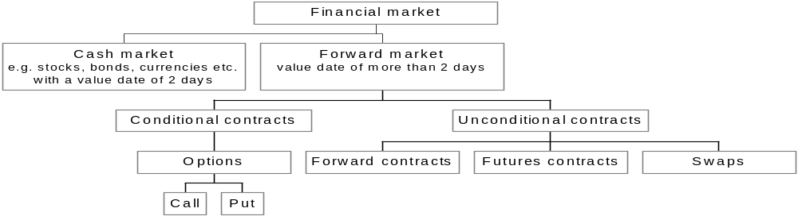

World wide uses of derivatives by 500 top companies are as follows:-.

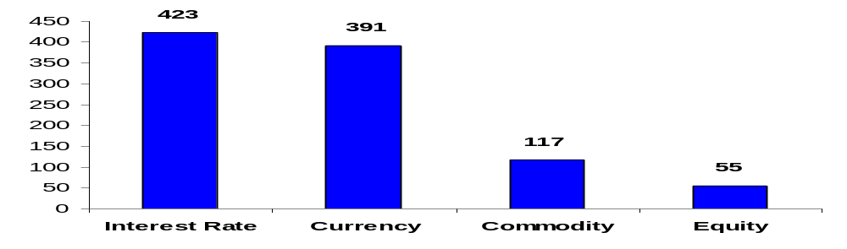

In Pakistan derivatives came first in form of Stock futures in 2001 that were not cash settled, however in 2003, the cash settlement was allowed. So now deliverable futures are available on 30 days settlement basis (discontinued by SECP on April 8, 2009), whereas cash settled futures are available on 30, 60, 90 days basis. Stock index futures are also available now in a number of contracts. Each contract is to buy or sell a fixed value of the index. Stock index future contract occurs 90 days after the contract is purchased. In addition Options are also on cards. However future market has not picked up significantly due to the reason that customers mostly prefer in ready trading (T+2) or CFS (having less than one month settlement/now discontinued by SECP without providing any instrument for leveraging) in absence of price discovery and due to convergence mechanism. Hence volume in derivatives on stock is mostly reflected in 30 days futures.
Another platform for derivatives in Pakistan is National Commodity Exchange Ltd (NCEL) with 3 month futures in gold. It now undertakes NCEL 10 tola futures, NCEL mini gold futures, NCEL Irri rice-6 futures and NCEL Palm oil futures. Trading volume on this exchange has remained thin in the past due to significant rise in the commodity prices last year. Now with downward trend and later with less volatility in prices, the exchange is expected to revive its business in the time to come.
SBP issued first of its instructions on derivatives through its Financial Derivatives Business Regulation (FDBR) in 2004. The purpose was to develop formal OTC market in Pakistan. The regulations permitted FX options, Forward Rate Agreements (FRAs) and Interest rate swaps (IRS). Other products including Cross Currency Swaps (CCS) were allowed to be approved on case to case basis by the SBP. Under these regulations on date, five banks i.e. Chartered Bank, Citi bank, Deutsce bank, Royal bank of Scotland and UBL are the authorized dealers.

Table.1 Derivatives Market in Pakistan (FY07 and FY08)
PKR in billion | H1FY07 | H2 FY07 | H1FY08 | H2FY08
IRS* | 78.4 | 80.0 | 84.0 | 106.9
CCS | 30.1 | 89.6 | 156.3 | 194.9
FX options | 10.9 | 42.5 | 47.3 | 88.7
FRAs | .2 | .3 | .0 | 2.6
Total | 119.6 | 212.4 | 287.6 | 393.1
*Includes IRS in PKR and FX
The data in Table 1 reflects growth of derivatives market of Pakistan (OTC) by 229% just in two years. The largest segment in this remained cross currency swaps with almost 50% share in overall transactions. The main factors behind these contracts were almost stable exchange rates (up till H1 FY08) and increase in discount rate i.e. widening of gap between KIBOR and LIBOR.Though SBP allowed these transactions to those corporates who were naturally hedged against exchange risk (on the basis of their export proceeds) but when PKR declined significantly, the corporate felt the pinch. Telecom, Textile, Cement, Fertilizer, Sugar, Refineries were the main sectors who were engaged in the CCS. Now it seems that most of them are on their way to wind up their contracts with final position to emerge on finalization of data for H1 FY09.
Contrary to CCS, FX options became lucrative in H2 FY08 for Corporates to hedge their exchange risk when exchange rate came under pressure particularly in this period. Fertilizer, Telecom, Cement, textile and automobiles were the main contributors of this contract. The activity could have and can increase further in case SBP allows $/PKR option not available as yet. Currently transactions on FX options are allowed against G7 currencies only.
IRS has also shown substantial growth on the basis of rising interest rate scenario. Telecom, Textile and cement were the main contributors for the contract. Since IRS includes FCY IRS as well, hence its volume can probably go down in H2 FY09, since one of its contributor i.e. GOP has concluded its contract against Eurobond in Feb, 09. The contract had a share of 42% in total volume of FCYIRS.
FRAs and IRS are one and the same product in terms of structure i.e. continuation of FRA means IRS. Both can be floating against fixed or floating against floating rate of interests. However in both cases prime requirement is to have price discovery which is non existent since no interbank market exists in Pakistan in this regard as yet. Only 3 authorized dealers or one or two banks have been found active in the IRS/FRAs market. Till some activities are generated on interbank level, one may not expect growth of swap market in Pakistan.
The case of $/PKR currency swaps are somewhat different as activities generated in them are demand driven to meet SBP requirements against banks short/long position in their FC exposures.
Liquidity meltdown and volatility in rates are going to effect derivatives volume in H1 FY09 in Pakistan; however importance of derivatives as hedging tool can not be denied. For this regulations are required to be made further stiff with proper capacity building in institutions for dealing in derivatives business.
The revival of derivatives market in H2 FY09 depends on market performance taking its clues from macro indicators on track towards recovery. However caution would prevail in the market till recession is countered not looking possible prior FY10.
The same holds good for the world market as well. Along with fight against recession, countries are also serious enough in containing demon of derivatives within safe limits to get benefit out of its activities without getting their fingers burnt.

Chapter – 2

Risk and Opportunities

As elaborated in chapter 1, emergence of derivatives came in to being so as to mitigate financial risks. So obviously these transactions carry with them speculators and arbitrageurs who are in seek of making money on the basis of future transactions. So it becomes necessary to understand first that how risks are defined and how they can be quantified.

Risk refers to the possibility that you will lose money (both principal and any earnings) or fail to make money on an investment.

Every type of investment involves risk.

Investment objectives and its holdings are influential factors in determining how risky a fund is and how you are managing your risk.

Call Risk. The possibility that falling interest rates will cause a bond issuer to redeem—or call—its high-yielding bond before the bond's maturity date.

Country Risk. The possibility that political events (a war, national elections), financial problems (rising inflation, government default), or natural disasters (an earthquake, a poor harvest) will weaken a country's economy and cause investments in that country to decline.

Credit Risk. The possibility that a bond issuer will or counterparty would fail to repay interest and principal in a timely manner. Also called default risk.

Currency Risk. The possibility that returns could be reduced for investing in foreign securities because of a rise in the value of the foreign currencies. Also called exchange-rate risk.

Income Risk. The possibility that a fixed-income dividends will decline as a result of falling overall interest rates.

Industry Risk or Unique Risk. The possibility that a group of stocks in a single industry will decline in price due to developments in that industry.

Inflation Risk. The possibility that increases in the cost of living will reduce or eliminate a fund's real inflation-adjusted returns.

Interest Rate Risk. The possibility that a fund will decline in value because of an increase in interest rates.

Manager Risk. The possibility that an actively managed investment adviser will fail to execute the fund's investment strategy effectively resulting in the failure of stated objectives.

Market Risk. The possibility that stocks or fixed income prices overall will decline over short or even extended periods. Stock and bond markets tend to move in cycles, with periods when prices rise and other periods when prices fall.

Principal Risk. The possibility that an investment will go down in value, or "lose money," from the original or invested amount.

Major Requirements for mitigating Risks:-

- The ability to derive above average returns for a given risk class.
- The ability to completely diversify the portfolio to eliminate all unsystematic risk.

Requirement 1 can be achieved through better timing or superior security selection. For this one can select high beta securities during a time when he thinks the market will perform well and low (or negative) beta stocks at a time when he thinks the market will perform poorly.
Conversely one can try to select undervalued stocks or bonds for a given risk class.

Requirement 2 argues that one should be able to completely diversify away all unsystematic risk.

For this you have to measure the level of diversification by computing the correlation between the returns of the portfolio and the market portfolio.

Risks on investments

They can arise on

- Portfolio of Government securities
- Portfolio of Government Bonds
- Corporate Debt Securitas
- Common stocks
Instrument | Return nominal % | Risk Premium
T-bill (6 month) | 12.44 | 0
Gov. bonds (10 year) | 14.00 (12.43) | .2
Corporate Bonds (TFCs) | 16.00 (14.55) | .3
Common stocks | 18.00 ( 6.0) | .5

Use of simple or compound average

Suppose a stock of Rs 100 has a equal chance of going Rs 90, Rs 110 or Rs 130 at the end of year. This would draw average return of -10%, 10% or 30%’
By simple arithmetic average the return would be -10+10+30/3=10%.
By average compound annual return the position would be (.9x1.1x1.3) is to power1/3 =.088 or 8.8%. This would give a wrong picture.
So always use arithmetic average in evaluation of returns.
The variance is a measure of statistical dispersion, averaging the squares of the deviations of its possible values from its expected value (mean). Whereas the mean is a way to describe the location of a distribution, the variance is a way to capture its scale or degree of being spread out. The unit of variance is the square of the unit of the original variable. The positive square root of the variance, called the standard deviation, has the same units as the original variable and can be easier to interpret for this reason.
If a random variable X has expected value (mean) μ = E(X), then the variance Var (X) of X is given by:
Var (x) = E ( (x-µ)² ) or variance (rm (actual value)= E (rm-r expected)²

Covariance is a measure of how much two variables change together. (Variance is a special case of the covariance when the two variables are identical.)
If two variables tend to vary together (that is, when one of them is above its expected value, then the other variable tends to be above its expected value too), then the covariance between the two variables will be positive. On the other hand, if one of them tends to be above its expected value when the other variable is below its expected value, then the covariance between the two variables will be negative.

The covariance between two real-valued random variables X and Y, with expected values is defined as
Cov x, y = E (X-µ) (Y-µ)

Understanding variance and Standard Deviation

Suppose you invest Rs 100 and use two coins tossing for evaluating returns. For each head you get your money back plus 20%. For each tail you get your money back less 10% on tossing you have following outcomes.

Head + Head = 40%
Head + Tail = 10%
Head + Tail=10%
Tail + Tail = -20%
There is a chance of ¼ i.e. .25% to make 40%, 2/4 i.e. .50% to make 10% and ¼ i.e. .25 to lose 20%.
Expected return (.25x40) + (.5 x10) + (.25x-20) =10%

% rate of return | Deviation from expected return | Squared Deviation | probability | Probability squared deviation
40 | +30 | 900 | .25 | 225
+10 | 0 | 0 | .5 | 0
-20 | -30 | 900 | .25  Variance =  St dv = | 225  450  √450 =  21

In statistics, correlation (often measured as a correlation coefficient, ρ) indicates the strength and direction of a linear relationship between two random variables. In general statistical usage, correlation or co-relation refers to the departure of two random variables from independence. In this broad sense there are several coefficients, measuring the degree of correlation, adapted to the nature of the data.

Þ x, y = Cov (x,y)/ σ x σ y = E (x- µx) (y-µy)/ σ x σ y

One way to mitigate risk is to go for diversification by forming a portfolio.

Suppose you have invested in your portfolio 60% of NBP securities and 40% of PSO securities NBP would give a return of 10% and PSO would give 15%. Expected return on portfolio would be (.60x10) + (.40x15) =12% the σ of NBP is 18.2% and for PSO it is 27.3%.
Now to find expected σ of portfolio we have to go through the process of adding factors of co variance and correlation co efficient.
For this we have to complete the box as in next slide. This would require variance on NBP by the square of the proportion of investment and like variance of PSO in the same way. The covariance of these stocks would be Þ x & y σ (x) σ (y). This we have assumed as moving positive.

 | NBP | PSO
NBP | X²σ²= (.6)² x (18.2)² | x y Þ 1 * σ (x) σ (y) = ( .6) x (.4) x 1 x (18.2) x (27.3)
PSO | x y Þ 1 * σ (x) σ (y) = ( .6) x (.4) x 1 x (18.2) x (27.3) | Y²σ² = (.4)² x (27.3)²

Portfolio variance = x y Þ 1 * σ (x) σ (y) = (.6) x (.4) x 1 x (18.2) x (27.3) = 477 or σ = √ 477 = 21.8

In above case we assumed correlation as perfect lockstep .If we assume it as .4 than the result would be = 18.3%

If correlation is assumed as negative (-1) than the St Dev comes out as = 0 that never happens.

In Portfolio management we have to determine portfolio and covariance of securities in a portfolio. Suppose a portfolio is built up of N stocks than portfolio variance would be 1/N * average variance + (1- 1/N) * average covariance.

Suppose N increases than the portfolio variance would steadily approach the average covariance. In case average covariance is zero than all risks would be eliminated by holding a sufficient number of securities. That never happens as stocks move together and are tied up to draw positive covariance which set the limit to the benefits of diversification.

In finance, the beta (β) of a stock or portfolio is a number describing the relation of its returns with that of the financial market as a whole.

An asset with a beta of 0 means that its price is not at all correlated with the market; that asset is independent. A positive beta means that the asset generally follows the market. A negative beta shows that the asset inversely follows the market; the asset generally decreases in value if the market goes up and vice versa.

Correlations are evident between companies within the same industry, or even within the same asset class (such as equities). This correlated risk, measured by Beta, creates almost all of the risk in a diversified portfolio.

The beta coefficient is a key parameter in the capital asset pricing model (CAPM). It measures the part of the asset's statistical variance that cannot be mitigated by the diversification provided by the portfolio of many risky assets, because it is correlated with the return of the other assets that are in the portfolio. Beta can be estimated for individual companies using regression analysis against its own sector or a stock market index.

To calculate a stock's beta you only need two sets of data:

Closing stock prices for the stock you're examining.
Closing prices for the index you're choosing as a proxy for the stock market.
Most of the time beta values are calculated using the month-end stock price for the security you're examining and the month end closing price of the KSE Index .The formula for the beta can be written as:
Beta = Covariance (stock versus market returns) / Variance of the Stock Market

Alpha is a risk-adjusted measure of the so-called active return on an investment. It is the return in excess of the compensation for the risk borne, and thus commonly used to assess active managers.

It reflects the movement of a security of an entity in relation to market movement. In an efficient market, the expected value of the alpha coefficient equals the return of the risk free asset: E(α_{i}) = r_{f}.

What Does R-Squared Mean?
A statistical measure that represents the percentage of a fund or security's movements that can be explained by movements in a benchmark index. For fixed-income securities, the benchmark is the T-bill. For equities, the benchmark is the S&P 500. In other words R squared measures the proportion of the total variance in the stocks returns that can be explained by market movements.
For example in case a R squared of an security is .25 than it transpires that one quarter of the risk on this security is market risk and three quarter is of unique risk.

R-squared values range from 0 to 100. An R-squared of 100 means that all movements of a security are completely explained by movements in the index. A high R-squared (between 85 and 100) indicates the fund's performance patterns have been in line with the index. A fund with a low R-squared (70 or less) doesn't act much like the index.

A higher R-squared value will indicate a more useful beta figure. For example, if a fund has an R-squared value of close to 100 but has a beta below 1, it is most likely offering higher risk-adjusted returns. A low R-squared means you should ignore the beta.

R squared is nothing but the square of correlation coefficient.

Asset Pricing Models

Objectives of all these endeavourer evolved around finding value or expected returns on any asset class.

First effort in this regard was made by Bachelor in 1900 . He recognized that past present, future events can be discounted in security prices not exactly but their likelihood can be mathematically evaluated.

In the first half of 20th century Williams theory ruled by saying that investors should invest in assets that bear maximum returns without accounting for the associated risks. He assumed that law of large numbers would insure that actual yield to the portfolio would be the same as the expected yield.

It was 1953 when Markowitz challenged this notion and presented a meaningful measure of portfolio risk i.e. variance of returns.

Modern portfolio theory (MPT) proposes how rational investors will use diversification to optimize their portfolios, and how a risky asset should be priced. The basic concepts of the theory are Markowitz diversification, the efficient frontier, capital asset pricing model, the alpha and beta coefficients, the Capital Market Line and the Securities Market Line.

MPT models an asset's return as a random variable, and models a portfolio as a weighted combination of assets so that the return of a portfolio is the weighted combination of the assets' returns. Moreover, a portfolio's return is a random variable, and consequently has an expected value and a variance. Risk, in this model, is the standard deviation of return.

Risk and return

The model assumes that investors are risk averse, meaning that given two assets that offer the same expected return, investors will prefer the less risky one. Thus, an investor will take on increased risk only if compensated by higher expected returns. Conversely, an investor who wants higher returns must accept more risk. The exact trade-off will differ by investor based on individual risk aversion characteristics. The implication is that a rational investor will not invest in a portfolio if a second portfolio exists with a more favorable risk-return profile – i.e., if for that level of risk an alternative portfolio exists which has better expected returns.

In finance, the capital asset pricing model (CAPM) is used to determine a theoretically appropriate required rate of return of an asset, if that asset is to be added to an already well-diversified portfolio, given that asset's non-diversifiable risk. The model takes into account the asset's sensitivity to non-diversifiable risk (also known as systematic risk or market risk), often represented by the quantity beta (β) in the financial industry, as well as the expected return of the market and the expected return of a theoretical risk-free asset.

The model was introduced by Jack Treynor (1961, 1962)William Sharpe (1964), John Lintner (1965) and Jan Mossin (1966) independently, building on the earlier work of Harry Markowitz on diversification and modern portfolio theory. Sharpe, Markowitz and Merton Miller jointly received the Nobel Memorial Prize in Economics for this contribution to the field of financial economics.

CAPM is a model for pricing an individual security or a portfolio. For individual securities, we made use of the security market line (SML) and its relation to expected return and systematic risk (beta) to show how the market must price individual securities in relation to their security risk class.

The CAPM is a model for pricing an individual security or a portfolio. For individual securities, we made use of the security market line (SML) and its relation to expected return and systematic risk (beta) to show how the market must price individual securities in relation to their security risk class. The SML enables us to calculate the reward-to-risk ratio for any security in relation to that of the overall market. Therefore, when the expected rate of return for any security is deflated by its beta coefficient, the reward-to-risk ratio for any individual security in the market is equal to the market reward-to-risk ratio, thus:

E (Ri)-Rf/Bi =E (Rm)-Rf or E (Ri) = Rf + ßi (E (Rm)- Rf)

The market reward-to-risk ratio is effectively the market risk premium and by rearranging the above equation and solving for E(Ri), we obtain the Capital Asset Pricing Model (CAPM).

Arbitrage pricing theory (APT), in finance, is a general theory of asset pricing, that has become influential in the pricing of stocks.
APT holds that the expected return of a financial asset can be modeled as a linear function of various macro-economic factors or theoretical market indices, where sensitivity to changes in each factor is represented by a factor-specific beta coefficient. The model-derived rate of return will then be used to price the asset correctly - the asset price should equal the expected end of period price discounted at the rate implied by model. If the price diverges, arbitrage should bring it back into line.
Return = a + b1 (r factor1) + b2 (r factor2) + b3 (r factor3) +------+ noise. Here it is assumed that each stocks return depends on specific macro economic factor whereas noise is the unique risk to the particular company. The macro economic indicators can be identified like yield spread (Return on long government bond – return on 30 days T-bill), interest rate (Change in T-bill rate), exchange rate (change in $/PKR parity), Real GDP, (change in Real GDP forecasts)Real GNP (Change in real GNP forecasts),inflation (Change in forecast of inflation) etc.
The theory was initiated by the economist Stephen Ross in 1976.

Three factor model of Fama shows that stocks of small firms and those with a high book into market ratio have provided above average return. So it means that these factors are contributing more return as well risk that have not been accounted for in CAPM. So obviously investor is justified in claiming higher premium in these securities

R-rf = b market (market factor) + b size (r size factor) + b book to market factor (r book to market facto

Identification of factors:-

Factors | Measured by
Market factor | Return on market index – risk free rate
Size factor | Return on small firm stocks – return on large firm stocks
Book to Market factor | Return on high book to market ratio- Return on low book to market ratio stocks

Jack L. Treynor was the first to provide investors with a composite measure of portfolio performance that also included risk

He suggested that there were really two components of risk: the risk produced by fluctuations in the market and the risk arising from the fluctuations of individual securities

Treynor introduced the concept of the security market line, which defines the relationship between portfolio returns and market rates of returns, whereby the slope of the line measures the relative volatility between the portfolio and the market.

The Treynor measure, also known as the reward to volatility ratio, can be easily defined as:
(Portfolio Return – Risk-Free Rate) / Beta

The numerator identifies the risk premium and the denominator corresponds with the risk of the portfolio. The resulting value represents the portfolio's return per unit risk.

Suppose that the 10-year annual return for the KSE (market portfolio) is 10%, while the average annual return on Treasury bills is 5%. Then assume three distinct portfolio managers with the following 10-year results:

Managers Average Annual Return Beta
Manager A 10% 0.90
Manager B 14% 1.03
Manager C 15% 1.20

(Market) = | (.10-.05)/1 = | .05
(manager A) = | (.10-.05)/0.90 = | .056
(manager B) = | (.14-.05)/1.03 = | .087
(manager C) = | (.15-.05)/1.20 = | .083

The higher the Treynor measure, the better the portfolio. If you had been evaluating the portfolio manager (or portfolio) on performance alone, you may have inadvertently identified manager C as having yielded the best results. However, when considering the risks that each manager took to attain their respective returns, Manager B demonstrated the better outcome. In this case, all three managers performed better than the aggregate market.

Because this measure only uses systematic risk, it assumes that the investor already has an adequately diversified portfolio and, therefore, unsystematic risk (also known as diversifiable risk) is not considered. As a result, this performance measure should really only be used by investors who hold diversified portfolios

The Sharpe ratio is almost identical to the Treynor measure, except that the risk measure is the standard deviation of the portfolio instead of considering only the systematic risk, as represented by beta.

Conceived by Bill Sharpe, this measure closely follows his work on the capital asset pricing model (CAPM) and by extension uses total risk to compare portfolios to the capital market line.

The Sharpe ratio can be easily defined as:
(Portfolio Return – Risk-Free Rate) / Standard Deviation

Using the Treynor example from above, and assuming that the S&P 500 had a standard deviation of 18% over a 10-year period, let's determine the Sharpe ratios for the following portfolio managers:

Manager Portfolio Return Standard Deviation
Manager X 14% 0.11
Manager Y 17% 0.20
Manager Z 19% 0.27

(Market) = | (.10-.05)/.18 = | .278
(manager X) = | (.14-.05)/.11 = | .818
(manager Y) = | (.17-.05)/.20 = | .600
(manager Z) = | (.19-.05)/.27 = | .519

Like the previous performance measures discussed, the Jensen measure is also based on CAPM. Named after its creator, Michael C. Jensen, the Jensen measure calculates the excess return that a portfolio generates over its expected return. This measure is also known as alpha.

The Jensen ratio measures how much of the portfolio's rate of return is attributable to the manager's ability to deliver above-average returns, adjusted for market risk.
The higher the ratio, the better the risk-adjusted returns. A portfolio with a consistently positive excess return will have a positive alpha, while a portfolio with a consistently negative excess return will have a negative alpha

The formula is broken down as follows:

Jensen's Alpha = Portfolio Return – Benchmark Portfolio Return

Where: Benchmark Return (CAPM) = Risk Free Rate of Return + Beta (Return of Market – Risk-Free Rate of Return)

So, if we once again assume a risk-free rate of 5% and a market return of 10%, what is the alpha for the following funds?

Manager Average Annual Return Beta
Manager D 11% 0.90
Manager E 15% 1.10
Manager F 15% 1.20

First, we calculate the portfolio's expected return:

ER(D) = | .05+0.90(.10-.05) = | .0950 or 9.5% return
ER(E) = | .05+1.10(.10-.05) = | .1050 or 10.50% return
ER(F) = | .05 + 1.20(.10-.05) = | .1100 or 11% return
Then, we calculate the portfolio's alpha by subtracting the expected return of the portfolio from the actual return:

ER(D) = | 11% - 9.5% = | 2.5%
ER(E) = | 15% - 10.5% = | 4.5%
ER(F) = | 15% - 11% = | 4.0%
Which manager did best? Manager E did best because, although manager F had the same annual return, it was expected that manager E would yield a lower return because the portfolio's beta was significantly lower than that of portfolio F.

Sensitivity of Bond prices are measured through duration and convexity analysis. They are calculated on the basis of relationship of prices and yields on a bond

The duration of a bond is calculated as = (1+y/y) – {(1+y) + T (c-y)}/ C {(1+y) ͭ - 1}} + y
In this C= Coupon rate
T= number of coupon periods (yield to maturity)
Y = Bond yields per payment period

Example: - 10 % coupon Bond with 20 years paying capacity seminally would have 5 % semiannual coupon & 40 payments. The result would be incase the yields to maturity as per purchase price of 120 against par value is PKR 4% = 1.04/.04 – 1.04 + (.05-.04)/ .05{(1.04)⁴⁰ - 1} +.04 = 19.74

Formula for YTM. In above case B0 is 120 as per appended formula.

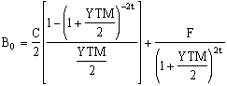

Where
- B₀ = the bond price,
- C = the annual coupon payment,
- F = the face value of the bond,
- YTM = the yield to maturity on the bond, and
- t = the number of years remaining until maturity.
The yield to maturity usually cannot be solved for directly. It generally must be determined using trial and error or an iterative technique. Fortunately, financial calculators make the task of solving for the yield to maturity quite simple

Modified duration is just an addition to get that how much change in duration can take place against 1 bp change in prices. The higher the yields the lesser would be the duration.

In finance, convexity is a measure of the sensitivity of the duration of a bond to changes in interest rates. There is an inverse relationship between convexity and sensitivity - in general, the higher the convexity, the less sensitive the bond price is to interest rate shifts, the lower the convexity, the more sensitive it is.

Calculation of convexity

Duration is a linear measure or 1st derivative of how the price of a bond changes in response to interest rate changes. As interest rates change, the price is not likely to change linearly, but instead it would change over some curved function of interest rates. The more curved the price function of the bond is, the more inaccurate duration is as a measure of the interest rate sensitivity.
Convexity is a measure of the curvature or 2nd derivative of how the price of a bond varies with interest rate, i.e. how the duration of a bond changes as the interest rate changes. Specifically, one assumes that the interest rate is constant across the life of the bond and that changes in interest rates occur evenly. Using these assumptions, duration can be formulated as the first derivative of the price function of the bond with respect to the interest rate in question. Then the convexity would be the second derivative of the price function with respect to the interest rate.
In actual markets the assumption of constant interest rates and even changes is not correct, and more complex models are needed to actually price bonds. However, these simplifying assumptions allow one to quickly and easily calculate factors which describe the sensitivity of the bond prices to interest rate changes....
The price sensitivity to parallel changes in the term structure of interest rates is highest with a zero-coupon bond and lowest with an amortizing bond (where the payments are front-loaded). Although the amortizing bond and the zero-coupon bond have different sensitivities at the same maturity, if their final maturities differ so that they have identical bond durations they will have identical sensitivities. That is, their prices will be affected equally by small, first-order, (and parallel) yield curve shifts. They will, however start to change by different amounts with each further incremental parallel rate shift due to their differing payment dates and amounts. For two bonds with same par value, same coupon and same maturity convexity may differ depending on at what point on the price yield curve they are located. Suppose both of them have at present the same price yield combination; also you have to take into consideration the profile, rating etc of the issuers; suppose they are issued by different entities. Though both the bonds have same p-y combination bond that may be located on relatively more elastic segment of the p-y curve compared to bond II. This means if yield increases further, price of bond II may fall drastically while price of bond I won’t change, i.e. bond II holder are expecting a price rise any moment and so reluctant to sell it off, while bond I holders are expecting further price-fall and ready to dispose it.
This means bond II has better rating than bond I.
So the higher the rating or credibility of the issuer the less the convexity and the less the gain from risk-return game or strategies; after all less convexity means less price-volatility or risk, less risk means less return.
Algebraic definition

If the flat floating interest rate is r and the bond price is B and d is the duration then the convexity C is defined as
C = 1/B x (d² (B (r))/d r²

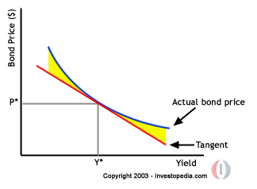

Day count conventions

Money market rates like LIBOR/KIBOR have usually a day count convention of actual/360. Actual means here the number of days since the last interest payment date.

The fixed rate that is paid in a swap transaction or in T-bill/Bond pricing is similarly quoted with a particular day count basis being specified. If the fixed rate is quoted as actual/365 or 30/360, it is not directly comparable to LIBOR

To compare a T-Note rate in a 365-day year, either the LIBOR/KIBOR rate must be multiplied by 365/360, or the T-Note rate must be multiplied by 360/365

Another complication might be weekends and holidays. The following business day convention means that if the day specified for a cash flow turns out to be a non-business day, the cash flow actually occurs on the next business day.

In Pakistan T-Bill pricings are done on the basis of 365 days and for Pakistan Investment Bonds/Sukuk actual over actual convention is used

Chapter 3

Forwards and Futures

Forward contract is a binding contract which fixes now the buying/selling rate of the underlying asset to be bought/sold at some time in future. There can be long Forward i.e Binding to buy the asset in future at the predetermined rate or Short Forward i.e Binding to sell the asset in future at the predetermined rate. Pay offs can be:-

Pay Off = S_{T} – K (for the long forward)

Pay Off = K – S_{T} (for the short forward)

Here T = Time to expiry of the contract

S_{T} = Spot Price of the underlying asset at time T

K = Strike Price or the price at which the asset will be bought/sold

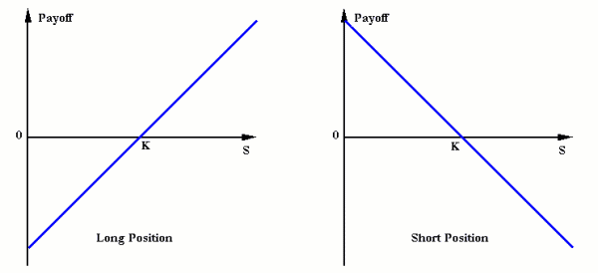

A futures contract is a standardized contract, traded on a futures exchange, to buy or sell a certain underlying instrument at a certain date in the future, at a specified price

Specification of a standard contract say Gold can be

    - Commodity Name
    - Exchange Name
    - Size of Contract : 100 troy ounce
    - Delivery month: Feb/April/June/Aug/Oct/Dec

Since in future exchange is the counterparty so both buyers and sellers have to provide some margin specified by the exchange that alters on daily basis. The margins can be:-

Initial Margin-An Initial margin is the deposit required to maintain either a short or long position in a futures contract.

Maintenance Margin-Maintenance margin is the amount of initial margin that must be maintained for that position before a margin call is generated.

Margin Call-If the amount actually falls below the maintenance margin, a margin call is given to the investor to replenish the account to the initial margin level, otherwise the account is closed.

Variation Margin-The additional funds deposited to make up to the initial margin.

In the delivery month the Futures’ Price is almost equal to the prevailing Spot Price.

Or we can say that with the passage of time the Futures’ Price gradually approaches the prevailing Spot Price. Why Because of No Arbitrage Principle.

Hedging Strategies

Assume Notations

T = Delivery/Expiry time of the futures’ contract

F₀ = Futures Price now to be delivered at time T

S_{T} = Spot Price of the underlying at delivery time T

If F₀ > S_{T} there is an arbitrage opportunity

Short Hedge

Short the futures contract, buy the asset and make the delivery

Pay Off = F₀ - S_{T} > 0

If F₀ < S_{T}

Parties, who want to buy the asset, would immediately go long the futures’ contract and wait for the delivery.

Because of increased demand for the futures, the futures’ price would go up to the actual market spot price of the asset to remove the anomaly.

Suppose

Commitment to sell 1000 barrels after 3 months at the then prevailing spot price say S_{T}

Futures Price for delivery after 3 months = 18.75

Strategy

Go short a 6 months future contract to lock in a price now

At maturity go long a futures to close the position

Scenario | Cash flow from sale at spot rate | Gain/Loss on futures
If S_{T} = 19.5 | 19.5 | 18.75-19.5
If S_{T} = 17.5 | 17.5 | 18.75-17.5
If S_{T} = 18.75 | 18.75 | 0

Long Hedge

When a company knows it will have to purchase a certain asset in the future and wants to lock in a price now.

By going long an appropriate futures contract the hedger can lock in a price he will be paying after time T to buy the asset.

Suppose

Commitment to buy 1000 barrels after some time T at the then prevailing spot price say S_{T}

Futures Price = 18.75

Strategy

Go long a 6 months future contract to lock in a price now

At maturity go short a futures contract to close the position

Scenario | Price paid after 6 months at spot rate | Gain/Loss on futures
If S_{T} = 19.5 | - 19.5 | 19.5-18.75
If S_{T} = 17.5 | -17.5 | 17.5-18.75
If S_{T} = 18.75 | -18.75 | 0

Case studies (Futures)

A British bank with a history of 233 years collapsed because of imprudent use of derivatives.

One of the traders Nick Leeson, who was basically responsible to make arbitrage profits on Stock Index Futures on Nikkei 225 on the Singapore and Osaka exchanges.

Instead of looking for arbitrage opportunities, the trader started making bets on the index and went long the futures.

Unfortunately the market fell by more than 15% in the 1995 leading to margin calls on his positions.

Because of his influence on the back office, he was able to hide the actual position and sold options to make for the margin calls.

But his view on the market proved to be wrong and losses mounted to an unmanageable amount.

Another case

METALLGESELLSCHAFT, A US Subsidiary of a German Company used hedging strategies, which went against them, resulting in heavy cash outflows.

Being an Oil Refinery and Marketing Company, they sold forward contracts on oil maturing up to 10 years.

To hedge their position, they went long the available futures contracts with maturities up to 1 year.

They planned to use “Stack & Roll” strategy to cover their short forwards contracts.

But due to decreasing oil prices they had margin calls on their futures contracts.

They were unable to meet those heavy cash outflows.

Ultimately the US team of the company was kicked out and a new team from Germany came to USA and liquidated the contracts making heavy losses.

Another Case

On January 24, 2008, the bank (Societe General a French bank) announced that a single futures trader at the bank had fraudulently caused a loss of 4.9 billion Euros to the bank, the largest such loss in history.

Jerome Kerviel, went far beyond his role -- taking "massive fraudulent directional positions" in various futures contracts.

.He got caught when markets dropped, exposing him in contracts where he had bet on a rise.

Due to the loss, credit rating agencies reduced the bank's long term debt ratings: from AA to AA- by Fitch; and from Aa1/B to Aa2/B- by Moody's.

The alleged fraud was much larger than the transactions by Nick Leeson that brought down Barings Bank.

Chapter 4

Determinants of Forward and Future Prices/Interest Rate Forwards and Futures

Forward prices are calculated on investment assets that provide (1) no income e.g. non-dividend paying stock, (2) that provides a known cash income i.e. coupon bonds or (3) that provides a known dividend yield I.e. equity and than on consumption assets.

Investment assets are assets held by significant numbers of people purely for investment purposes (Examples: gold, silver, bonds etc)

Consumption assets are assets held primarily for consumption (Examples: copper, oil)

Short selling involves selling securities you do not own. Your broker borrows the securities from another client and sells them in the market in the usual way. At some stage you must buy the securities back so they can be replaced in the account of the client. You must pay dividends and other benefits to the final owner of the securities

Pay off in case of short selling
Suppose in April 500 shares are short sold and the share price is Rs 50 He buys it back when its price is 30. Suppose a dividend is paid in May of Rs 1. The investor receives 500 * 50 =25000 pay dividend as 1* 500 =500. The investor also pays 500*30 = 15000 .The gain is 25000-5000-15000 =9500. Here short seller is acting as speculator by going short for the term of the agreement but getting long in between to get the profit. To avoid its ills, regulators normally impose heavy margins on short sellers.
In determining Forward and Future prices the compounding frequency used for an interest rate is the unit of measurement. The difference between quarterly and annual compounding is analogous to the difference between miles and kilometers. In the limit as we compound more and more frequently we obtain continuously compounded interest rates.

PKR100 grows to PKR100e^{RT} when invested at a continuously compounded rate R for time T
PKR100 received at time T discounts to PKR100e^{-RT} at time zero when the continuously compounded discount rate is R

Consider an amount A invested for n years at an interest rate r per annum. If the amount is compounded once a year than the terminal value would be A (1+r) ᶯ. In case if rate is compounded m times per year than the value would be A (1+r) ᶮ ͫ
In case the A = 100 r = 10% n = 1 or m = 1 or 2 than the value would be 100 * 1.1 =110 in case the m =1 In case the m = 2 than the value would be 100 * 1.05 ² = 110.25. In case the m = 4 than the value would be = 100 * 1.025⁴ = 110.38 or if you go for infinity than it is continuous compounding Ae ʳ ⁿ i.e. 100 * 2.71°˙¹ = 110.52. Here e represents value of exponential function.

By Using
R _{c:} for continuously compounded rate
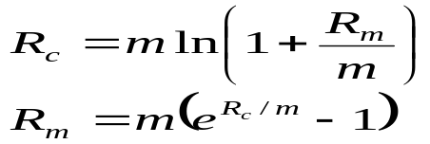R_{m}: for same rate with compounding m times per year

In case R =10% with semiannual compounding than Rc would be = 2In (1+0.1/2) =0.0978 or 9.78% suppose the interest rate is 8% and it is paid on quarterly basis than Rm = 4 ((2.71 °˙° 8/4) -1) =0.0808 or 8.08%

For gold the Future prices would be (assuming no storage costs)
F₀ = S₀ (1 + r )^{T}
If r is compounded continuously instead of annually than

F₀ = S₀e^{rT}
Suppose u is the storage cost i.e. Rs 2 per year spot price is Rs 450 and interest free rate on interest is 7% than r = 0.07 S = 450 and T=1 First u = 2e ̄ °˙°7 * ¹ =1.865
Than F = (450 + 1.865) °˙°7 * ¹ = 484 .63

In case F> 484.63 than arbitrageur can buy gold and short one year gold futures. In case F< 484.63 than arbitrageurs already owning the gold can sell it and buy gold futures

When an Investment Asset Provides a Known PKR Income than
F₀ = (S₀ – I )e^{rT}
Where I is the present value of the income

Consider a coupon bearing bond with price at 900. Forward contract matures at 1 year. Bond maturity is of 5 years. Coupon payments are 40 on semiannual basis. Interest free rates for six months and one year are 9 % and 10% per annum. There can be two cases. Suppose forward price is high at 930. Than the arbitrageur would buy the bond and short a future. Why?

The PV of first coupon payment would be 40e ̄ °˙° 9 * ° ˙ °5 =38.24. Out of 900, 38.24 is borrowed at 9% whereas remaining 861.76 is borrowed at 10% the amount owed at the end of the year = 861.76 e °˙ ¹ * ¹ = 952.39. The second coupon provides 40. This make a net profit = 40 + 930 – 952.39 = 17.61
In second case suppose the forward price is low i.e. 905. Than the investor who holds the bond would sell it and enter in to long forward contract. In this case PV of coupon payments 40 i.e. 38,24 is invested for six months to make it equal the coupon paid on the bond The remaining 861.76 would be invested for 12 months at 10% and grows to 952.39. The investor therefore gains 952.39-40-905 = 7.39

From both cases it comes out that in the first case if F> 912.39 than the profit comes and in the second case if F< 912.39 than the profit comes so with no arbitrage opportunities the forward price must be 912.39

When an Investment Asset Provides a Known Yield than
F₀ = S₀ e^{(r–q )T}
Where q is the average yield during the life of the contract (expressed with continuous compounding)

Consider a six month forward contract on security with continuous dividend yield of 4% per annum. The risk free interest rate is 10% per annum and stock price is 25 than
F= 25 e (° ˙ ¹° - ° ˙ °4) * ° ˙ °5 =25.76.

Forward v/s Future Rates
Excluding arbitrage opportunities, if interest free rate remains constant and same for all maturities than the forward price for a contract with a certain delivery date would remain the same as the future price for a contract with the same delivery date. Hence when S is strongly correlated with interest rates than the future prices would tend to be higher than the forward prices and conversely forward prices would remain higher from future prices in case they are negatively correlated.

Keynes and Hicks argued that future prices would be below the expected future prices in case hedgers tend to hold short position and speculators hold to tend long position. This is because speculators would require risk premium for the risk they are bearing. Conversely happens other way round. Practically speaking speculators always deal in case they get pay off, so position as explained above always holds well in general terms

The value of a forward contract when entered is always zero however at a later stage it tends to have positive or negative value. So in general, in all forward contracts, there is a value of forward contract, i.e. f, the delivery price K and current forward price F.

Consider a six month long forward on non dividend stock. The risk free interest rate on continuous compounding basis is 10% per annum. Stock price is 25 and delivery price is 24 than
F = 25 e ° ˙ ¹ * ° ˙ ° 5 = 26.28

However the value of forward contract stands at = f = (26.28 – 24) e ̄ ° ˙ ¹ * ° ˙ 5 = 2.17
Confirmation comes from = 25 – 24 e ̄ ° ˙ ¹ * ° ˙ 5 = 2.17

So after going above exercises, we know that Forward contract on Types of Assets: (Each asset has an associated cost of carrying the asset from the spot to forward market) includes:-

Financial Investments includes Investments that provide no income, Investments that provide known cash income, Investments that provide a known dividend yield and Commodities for investment with storage costs (e.g., gold and silver)

Consumption Investments includes Commodities with a known cash storage cost, Commodities with a known continuous storage cost and Convenience yields

Stock index tracks the change in the value of a hypothetical portfolio of stocks. The weight of a stock in the portfolio equals the proportion of the portfolio invested in the stock. The % increase in the value of a stock index over a small interval of time is usually defined so that it is equal to the % increase in the total value of the stocks comprising the portfolio at that time. A stock index is not usually adjusted for cash dividends
S&P 500 Index is based on a portfolio of 500 stocks (400 industrial, 40 utilities, 20 transportation, and 40 financial companies.). In this index one future contract is on 500 times of the index
Nikkei 225 Stock Average is based on a portfolio of 225 of the largest stocks trading on the Tokyo Stock Exchange in this index one future contract is on 5 times of the index
They can also be viewed as an investment asset paying a dividend yield
Hence in this case the futures price and spot price relationship is therefore
F₀ = S₀ e^{(r–q )T}

Where q is the dividend yield on the portfolio represented by the index.

In other words, changes in the index must correspond to changes in the value of a tradable portfolio
Consider 3 month future contract on S & P 500. Suppose the stocks underlying the stock provide a dividend yield of 3 % per annum. Current value of index is 400. The continuously compounded risk free rate is 8% than in that case the
F = 400 * 2. 71° ˙ °8 ̄ ° ˙ °³ * ° ˙ ²5 =405.03
The purchase or sale of a portfolio of stocks that replicates a stock index and the sale or purchase of a futures contract on the index Occurs when the F₀ does not equal S₀e^{(r-q)T}. When F₀>S₀e^{(r-q)T} an arbitrageur buys the stocks underlying the index and sells futures

When F₀<S₀e^{(r-q)T} an arbitrageur buys futures and shorts or sells the stocks underlying the index that is often implemented/corrected through program trading. Index arbitrage involves simultaneous trades in futures and many different stocks .Very often a computer is used to generate the trades

A foreign currency forward or future is analogous to a security providing a dividend yield and in this the continuous dividend yield is the foreign risk-free interest rate
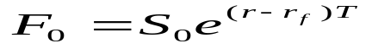It follows that if r_{f is} the foreign risk-free interest rate and r is the domestic risk free interest rate

Convenience Yields

Benefits to users of physical commodity can some time over cross the benefits obtained by the holders of futures contracts. This may take place due to
Ability to keep a production process running
Ability to profit from temporary local shortages

These benefits are called convenience yield, y. For investment assets they must be zero. Increases in case of shortage of commodity and decreases on other way round

If storage costs are a known cash amount i.e. in form of PV than
F₀e^{yT} = (S₀+U)e^{rT}
If storage costs are proportional to the commodity price than
F₀ = S₀e^{(r+u-y)T}

Cost of Carry
The cost of carry, c, is the storage cost plus the interest costs less the income earned
For an investment asset F0 = S₀e^{cT}
For a consumption asset F0 £ S₀e^{cT}

Cost of Carry pricing
Underlying Assets | F₀ = S₀ e ^{cT}  c = cost of carry  u = storage cost
Non-dividend paying stock or non-coupon paying bond | F₀ = S₀e^{rT}
Stock or asset with known cash income (ie., not proportional to asset price) | F₀ = (S₀ – I )e^{rT}  Where I = p.v. income
Stock index or asset with known dividend yield | F₀ = S₀e^{(r – q)T}  ^{q = dividend yield}
Foreign currency | F₀ = S₀e^{(r – r}_{f}^{)T}  ^{r = domestic} risk free rate  rf = foreign risk free rate
Commodity not for consumption with storage costs proportional to price | F₀ = S₀e^{(r + u)T}
Consumption asset | F₀ < = S₀e^{(r + u)T},  F₀ = S₀e^{(c – y)T}  where c = r + u

Spot interest rate is the rate for loans and debt securities issued at a given time. The advantage of borrowing at the spot interest rate is the fact that it is a known quantity and one can amortize the loan accordingly. The risk of the spot interest rate is that interest rates may rise or fall in the future to the disadvantage of one of the parties to a contract. For this one has to know about Forward Interest rate

The forward rate is the future yield on a bond. It is calculated using the yield curve.
For example, the yield on a three-month T-bill six months from now is a forward rate.
In order to extract the forward rate, one needs the term structure of interest rates. The general formula used to calculate the forward rate is:
R F = R2T2-R1T1/T2-T1

Where we assume that all involved tenors are at most 1 year (short term rate or linear discount) than actuarial form for long term rate(>1 year). In this RF is the Forward rate R2 and R1 are risk free rates at time T2 or T1

In case data available is as follows
Year | Spot Rate % per annum,
1 | 10.0
2 | 10.5
3 | 10.8
4 | 11.0
5

Than in this case forward rate for 4th year would be as follows i.e. T1 =3 T2 =4 R1 = 0.108 R2 = 0.11 RF would come out as =0.116. From this method we can complete the chart
Year | Spot Rate % per annum | Forward Rate % per annum
1 | 10.0
2 | 10.5 | 11.0
3 | 10.8 | 11.4
4 | 11.0 | 11.6
5 | 11.1 | 11.5

Zero Coupon yield curve
A zero coupon Bond is a bond that pays no coupons. Zero coupon Bonds are not often issued often, however sometime they are created artificially by stripping i.e. selling of coupons independently. The zero coupon yield curve shows the relationship between the yields on zero coupon bonds and maturity. The zero coupon yield curve always stands above the yields curve of coupon bearing bonds as in coupon bearing instruments the holder gets the profit in between in interval of time. Like other yield curves the zero coupon yield curve can also be upward or downward sloping.

For determining zero coupon yields bootstrap method is used. For this let us use the given data
Principal | Time to Maturity (years) | Annual coupon | Bond Price
100 | .25 | 0 | 97.5
100 | .50 | 0 | 94.9
100 | 1 | 0 | 90
100 | 1.5 | 8 | 96
100 | 2 | 12 | 101.6

From the chart it is observed that first three bonds pay no coupons. Hence the 3 month bond provides profit of 2.5 on an investment of 97.5. On compounding it quarterly it becomes 2.5/97.5 = 2.56 in 3 months. On continuous compounding it becomes 4In (1 + 2.5/97.5) = 0.1013.Similarly six month rate becomes 2In (1 + 5.1/94.9) = 0.1047, one year rate with continuous compounding would become In (10/90) = 0.1054. The 4th bond lasts 1.5 years. The payments are as follows 6 month = 4, 1 year = 4 and 1.5 year 104

Since we know that the discount rate at six month is 10.47, 1 year is at 10.54. We also know that the PV of bond i.e. 96 must equals the PV of all payments received So the R (spot rate) should be 4e ̄ ° ˙ ¹ °47 * ° ˙ 5 + 4e ° ˙ ¹°54 * ° ˙ ¹ °+ 104e ̄ ʳ * ¹ ˙ 5 = 96 or
e¹ ˙ 5 ʳ =0.85196 or r = In (0.85196)/1.5 = 1.1068. This is the spot rate for 1.5 years.

For 2 years it would be 6e ̄ ° ˙ ¹°47 * ¹ + 6e ̄ ° ˙ ¹° 54 * ° ˙ ¹ ° + 6e ̄ ° ˙ ¹° 68 + 106 e ̄ ʳ * ² = 101.6

This gives r = 0.1081 . By plotting all these numbers against interest rates v/s maturity we get the zero yield curve

Term structure reflects relationship between time period and yields arrived on any investment. Three theories are prominent in this regard.

Expectation theory says that long term interest rates should reflect expected short term interest rates.
Market segmentation theory says that the there is no need of any relationship in between short term, medium term or long term bonds as investors mostly institutions invest in different maturities and do not switch on maturities. According to this theory demand and supply determines the interest rates in this regard.

Liquidity preference theory says that forward rates always stands above the future expected spot rates The third hypotheses has been verified through many empirical studies

Forward Rate Agreement FRA is an over-the-counter contract between parties that determines the rate of interest, to be paid or received on an obligation beginning at a future start date. On these agreements, it is only the differential that is paid on the notional amount of the contract.

Client has a six month borrowing requirement in three months and wants to hedge its floating interest rate exposure

Client can enter into a 3*9 FRA Agreement with bank whereby:
Bank will pay 6m KIBOR rate to the customer.
Customer will pay a fixed rate to the bank.
Since the exchange will take place at the start of the borrowing period, only the net discounted amount will be exchanged

FRA Rate Calculation:
Current KIBOR rates:
- month 13% = i3
9 month 14% = i9

FRA (3*9) rate
= {[1+ (i9*9/12)]/[1+(i3*3/12)]}-1*[12/6]
= 14.04
Or it can be solved as follows:-
90 days = 0.13* 90/360 = 0.325
270 days = 0.14* 270/360 = 0.105
(1+0.105/1+0.325) -1 = 0.0702
7.02*360/180 = 14.04

Effectively the behavior of FRA would be as follows where 6 month KIBOR is at 13.50% and the buyer is committed to pay his floating loan at 6 month KIBOR + 1
After Month | Do Nothing | Buy 3*9 FRA@14.04%
KIBOR rises to 14.5 % | Borrow@ 15.5% | Borrow@15.5%,  Get 0.46 % from seller. your cost 15.04 %
Kibor fall to 12.5 % | Borrow @ 13.5 % | Borrow@ 13.5%,  Pay 1.54 % to seller. your cost 15.04 %

Bonds Futures
Bonds are quoted with a face value of 100. For example price of 90.50 means that face value of 100,000 is worth 90156.25. However the quoted price is not the same as the cash price is because Cash price = quoted price + accrued interest since last coupon date

Say a bond has a price of 95.50. Suppose it is March 5, 2011. The bond carries 11% interest paid semiannually with maturing on July 10, 2011. In this case last coupon was paid on Jan 10, 2011. So effectively number of days in between January and March are 54 whereas they are 181 in between January to July On a bond with 100 worth the profit comes out as 5.5. Since in bonds actual over actual days conventions are used so the accrued interest amount comes out as 54/181 * 5.5 = 1.64 Hence the cash price in this case would be 95.5 + 1.64 = 97.14 Bond future prices are quoted in the same way as Bond prices themselves. However in case of futures one contract can involve the delivery of 100,000 face values of the bonds.

Normally in bond futures contract the party with the short position is provided to choose to deliver any bond that has a maturity of more than 15 years and that is not callable within 15 years. Hence at delivery the party in a short position receives cash as follows = (quoted future price * conversion factor of the bond delivered) + accrued interest since last coupon date on bond delivered. For calculating conversion factor we have to go through following example.

Consider a 14% coupon bond with maturity of 20 years and 2 months .For conversion factor we assume it exactly 20 years. The coupon payments are on semiannual basis with discount rate as 8% per annum. Discounting all the payments to a point in 3 months time from today gives a value of = ∑40 * 7/1.04 ᶤ + 100/1.04⁴° =159.38

By dividing it with the face value we get conversion factor as 1.5938

Going forward we have to consider following prices and conversion factors of different bonds
Bond | Quoted price | Conversion factor
1 | 99.50 | 1.0382
2 | 143.50 | 1.5188
3 | 119.75 | 1.2615

Since for the party shorting the cheapest to deliver bonds would be in which quoted price – (quoted future * conversion factor) is the least. Assuming the future price as 93.25 the cost of deliverance comes out as

Bond 1. 99.50 – (93.25 * 1.0382) = 2.69
Bond 2 143.50 – (93.25 * 1.5188) = 1.87
Bond 3 119.75 – (93.25 * 1.2615) = 2.12

Hence the cheapest to deliver bond is no 2

It is difficult to find exact future price of a bond but if cheapest to deliver bond and date of delivery is known than one can venture for that
For calculating future prices the formula is very simple as F = (S – I) e ʳ t
Where I is the PV of the coupons during the life of the future contract, but the matter is not very simple. This is due to choice of the bond and time of its delivery at the disposal of person shorting the agreement. Suppose that a bond with 12% coupon has conversion factor of 1.4000. The coupon payment is on semi annual basis Suppose delivery is known to be taking after 270 days i.e. last coupon date was 60 days ago, the next coupon date is 122 days away and the coupon date thereafter is in 305 days. The rate of interest is 10% per annum and the current quoted price is 120. This gives the first cash price as = 120 + (60/60 +122) * 6 =121.978 since the coupon of 6 would be received after 122 days (0.3442 years). The PV of the same would be 6e ̄ ° ˙ ¹ ˟ ° ˙ ³ 44 ² = 5.803. The future contract lasts for 270 days (0.7397). The cash price at 12% bonds would be (121.978 – 5.803) e ° ˙ ¹ ˟ ° ˙ 7³97 =125.094. At delivery there are 148 days accrued interest so the cash would be = 125.094 - 6 * (148/305 -122) 120.242. The rate of interest is 8% and the conversion factor is 1.4000, hence quoted price should be = 120.242/1.400 = 85.887

T-bill Futures

A T .Bill is a discount instrument. Assume maturity of the future contract is longer than 90 days. In case it matures in 160 days than the underlying asset is a 250 days T-bill. In case future contract maturity is denoted asT1 and the underlying T-bill as of T2 (the difference between T1 and T2 is 90 days). Since R1 and R2 are the continuously compounded interest rates for risk free investments maturing at time T1 and T2 than the current value of face value of 100 denoted as V would be = 100 e ̄ R2T2. Since no income is paid, hence in this case F= 100e ̄ R1 T1-R2T2 or F = 100e ̄ Rf (T2-T1). Here Rf is the forward rate for the period in between T2 and T1.

Suppose a T bill maturing in 146 days has a cash value of 95.21 and the cash future price for T-bill maturing in 56 days is 96.95. In this case 90 days (T1) is 0.2466 years and 146 days (T2) is 0.4000 than the continuously compounded 146 days rate is 1/0.4000 * (In * 0.9521) = 0.1227 or 12.27%. From this Rf comes out as – 1/0.2466(In* 0.9695) = 0.1256. Rearranging R1 by implying R2 and Rf it comes out as R1 = R2T2-Rf (T2-T1)/T1. This is implied Repo rate or = + 12.27 * 146-12.56* 90/56 = 11.80 If actual 56 days rate is less or above 11.80 than their exists arbitrage opportunity

Eurodollars futures

On the surface the Eurodollar future contract appears structurally to be the same as the T-bill future contract. However they stands bit higher than corresponding T-bill interest rate as Eurodollar interest rate is a commercial lending rate whereas T-bill rate is the rate at which government borrows. In case of T-bill its future price quote = 100 – corresponding T-bill price quote. Suppose a T-bill price quote of 8.00 corresponds to future price quotes of 92.00. Further if we assume Z to be the future quoted price and Y to be the corresponding price than Y = 100- 0.25(100 -92 ) = 98
However in spite of calculation similarities, T-bill contract price converges at maturity to the price of T-bill whereas in case of Eurodollar contracts, future contract is settled in cash on 2nd business day before the Wednesday of the month.

Duration

It is an important concept in the use of interest rate for hedging. The duration is a measure of how long on average the holder of the bonds has to wait before receiving cash payments. A zero coupon bond matures in n years and has a duration of n years whereas in case of coupon bearing bonds maturing in n years have always duration of less than n years because the holder receives some of the cash payments prior to n years .
For a standard bond with fixed, semi-annual payments the bond duration closed-form formula is:
- FV = par value
- C = coupon payment per period (half-year)
- i = discount rate per period (half-year)
- a = fraction of a period remaining until next coupon payment
- m = number of full coupon periods until maturity
- P = bond price (present value of cash flows discounted with rate i)
A portfolio of fixed income securities can be described as of its average duration, hence most of the governments and corporate try to match the duration of their assets with the average duration of their liabilities.
Another tool of convexity is also used in hedging strategy of interest rate portfolio incorporating changes in interest rates. Since increase and decrease in yields is not followed in line by the changes in fixed income securities hence its relationship always stands convex. This measure is used in hedging strategy of fixed income securities. Further convexity also depends on credibility of the bonds.
If the flat floating interest rate is r and the bond price is B, then the convexity C is defined as
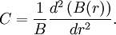

Chapter 5

Options

An option is a contract that gives the buyer the right, but not the obligation, to buy or sell an underlying asset at a specific price on or before a certain date

Unlike a forward/future, this contract gives the right but not the obligation. So its not a binding contract.

The holder will exercise the option only if it is profitable on the basis of payoff structures

Call option

A call gives the holder the right to buy an asset at a certain price within a specific period of time.

Put option

A put gives the holder the right to sell an asset at a certain price within a specific period of time.

The type of option and the relationship between the spot price of the underlying asset and the strike price of the option determine whether an option is in-the-money, at-the-money or out-of-the-money.

Exercising an in-the-money call or in-the-money put will result in a payoff. Neither a call nor put that is at-the-money will produce a payoff.

 | Call Option | Put Option
In-the-Money | Spot > Strike | Spot < Strike
At-the-Money | Spot = Strike | Spot = Strike
Out-of-the-Money | Spot < Strike | Spot > Strike

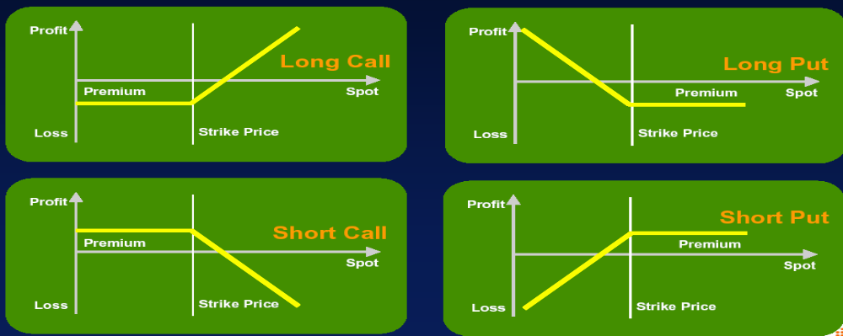

Kinds of options

On the basis of exercise the options can be:-

American options

Can be exercised at any time between the date of purchase and the expiration date.

Mostly American options are exercised at the time of maturity. But when the underlying makes cash payments during the life of option, early exercise can be worthwhile. In case of non dividend stocks exercise of American options remains the same as of European option. It means that the lower bound on the price of both the options is maximum at S-X/ (1+RFr) ᵀ ̄ ᵗ. If exercised earlier than it would fetch value of S-X which would be less than its minimum value of S-X/ (1+RFr) ᵀ ̄ ᵗ. In case of dividend paying stocks this argument does not hold as in that case it would be advantageous to exercise early option prior to the stock ex dividend date particularly if the dividend is expected to decrease the price of the stock. In case of put if the company that has issued the stock is going to be bankrupt than its price can go to zero. Therefore it would be better to exercise the option earlier rather than to wait i.e. worth more dead than alive.

European options

Can only be exercised at the end of their lives

On the basis of versatility the options can be:-

Vanilla Option

A normal option with no special or unusual features

Exotic Option

A type of option that differs from common American or European options in terms of the underlying asset or the calculation of how or when the investor receives a certain payoff.

Bermuda Option-A type of option that can only be exercised on predetermined dates, usually every month

Compound Option-An option for which the underlying is another option. Therefore, there are two strike prices and two exercise dates. These are the four types of compound options:

- | Call | on | a | Call
- | Put | on | a | Put
- | Call | on | a | Put
- | Put | on | a | Call

Asian Option-An option whose payoff depends on the average price of the underlying asset over a certain period of time as opposed to at maturity. Also known as an average option.

Digital Option- An option whose payout is fixed after the underlying stock exceeds the predetermined threshold or strike price. Also referred to as "binary" or "all-or-nothing option."

Shout Option- An exotic option that allows the holder to lock in a defined profit while maintaining the right to continue participating in gains without a loss of locked-in monies.

Barrier Option- A type of option whose payoff depends on whether or not the underlying asset has reached or exceeded a predetermined price.

Chooser Option-An option where the investor has the opportunity to choose whether the option is a put or call at a certain point in time during the life of the option

Quantity-Adjusting Option (Quanto Option)-A cash-settled, cross-currency derivative in which the underlying asset is denominated in a currency other than the currency in which the option is settled. Quantos are settled at a fixed rate of exchange, providing investors with shelter from exchange-rate risk.

Chapter 6

Trading Strategies Involving Options

Rights and Obligations

 | Call | Put
Buyer… | … has the right, but NOT the obligation to buy the U/L  … pays premium  … has no performance bond requirement | … has the right, but NOT the obligation to sell the U/L  … pays premium  … has no performance bond requirement
Seller… | … has the obligation to sell the U/L (underlying) – if assigned  … collects premium  … has performance bond requirement | … has the obligation to buy the U/L – if assigned  … collects premium  … has performance bond requirement

Straight underlying Buy- U/L price 30 and U/L Delta 1
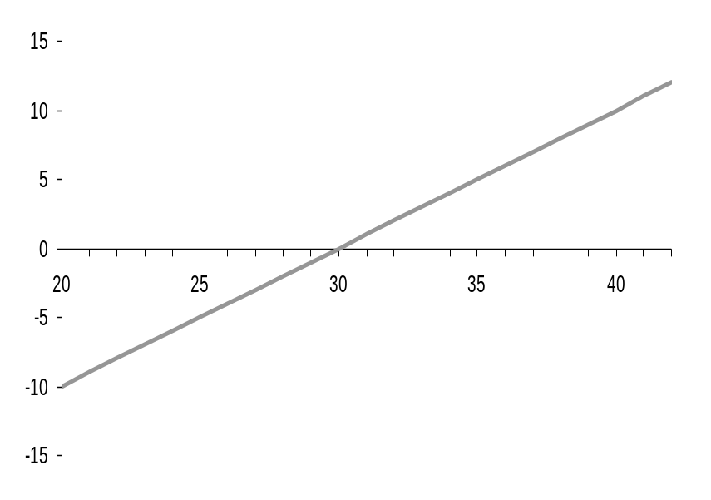

Gain

Loss

Underlying

Pay off maturity-call

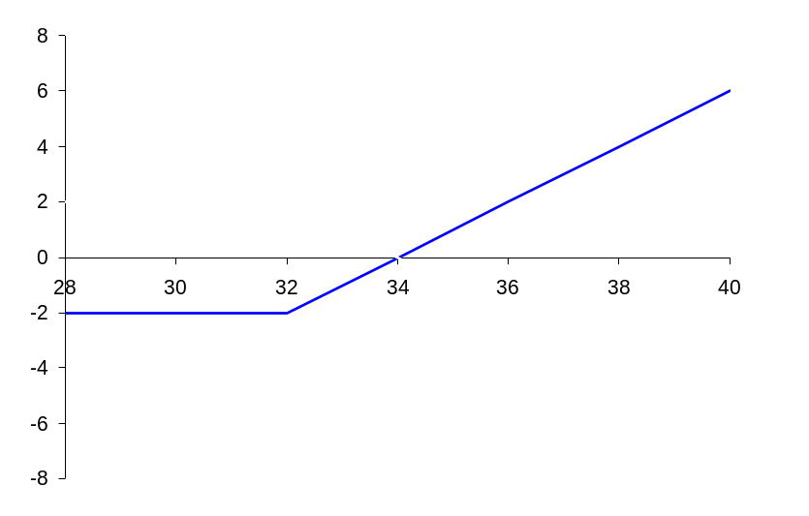

Break even

Long call

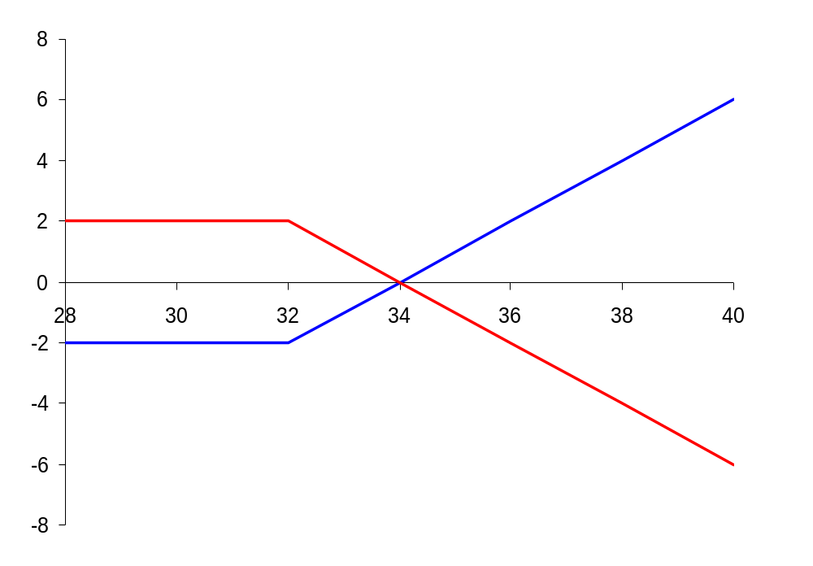

Gain

Short call

Break even

Long call

Loss

Strike 32 Premium 2 Break Even 34

Pay off at maturity: PUT

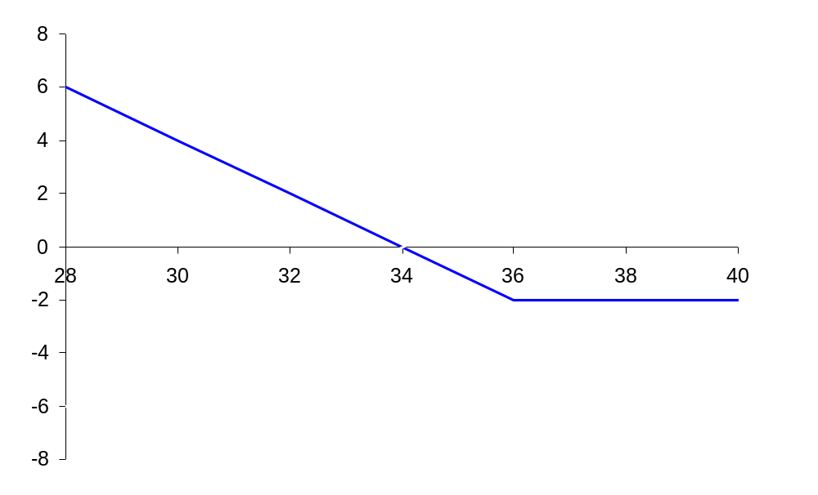

Long put

Break even

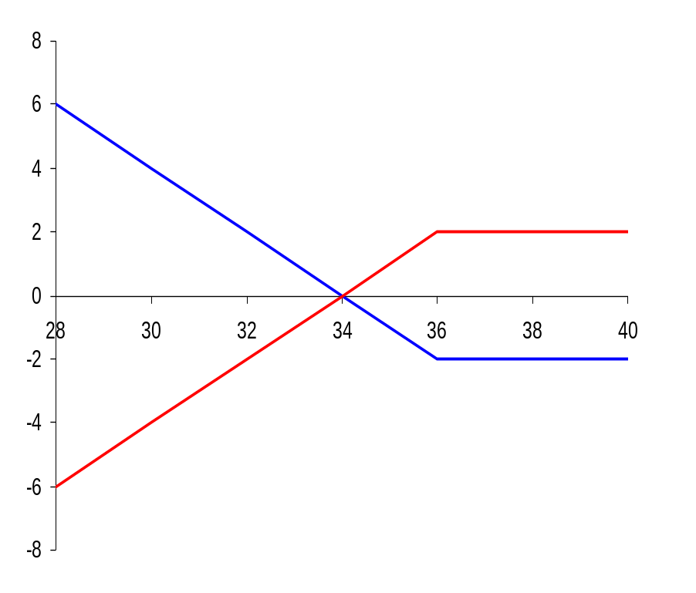

Long put

Gain

Breakeven

Loss

Short put

Strike 36 Premium 2 Break Even 34

Chances and Risks

 | Call | Put
Buyer… | … has theoretically an unlimited profit chance  … has limited risk in form of the paid premium | … has theoretically a limited profit chance – maximum payout is the strike price  … has limited risk in form of the paid premium
Seller… | … has theoretically an unlimited loss risk  … has limited profit chance in form of the paid premium | … has theoretically an limited loss risk – maximum payout is the strike price  … has limited profit chance in form of the paid premium

Covered Call Writing

Covered Call Writing is an earnings generation strategy with limited risk and a profit cap
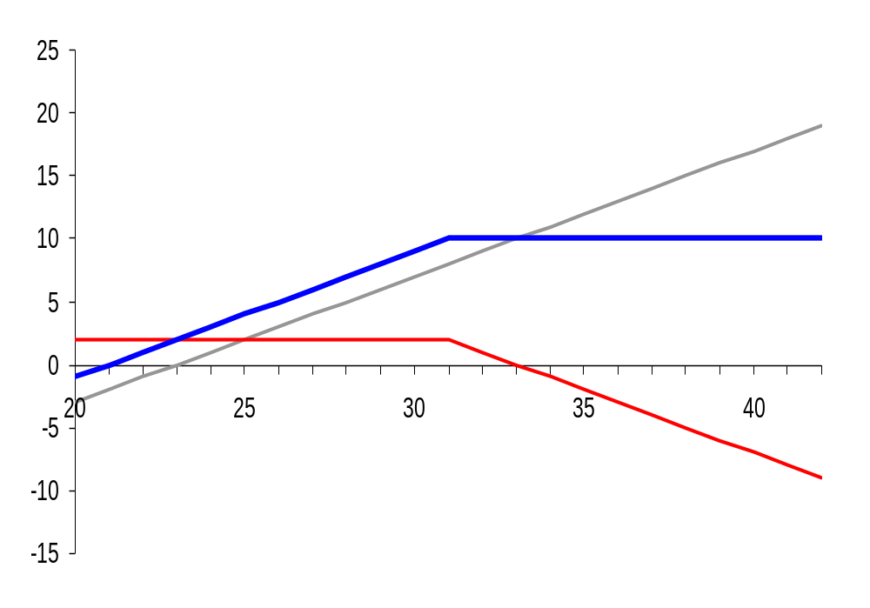

Gain

Combined

Payout

Underlying

Loss

act. U/L price 23 U/L Delta 1 Strike 31 Premium 3

What we mean by Covered Call Writing

- Simultaneous buy of the U/L (e.g. stock) and sell of a call on that U/L
- The strike of the short call is about the actual U/L price and should be set at/above the maximum expected price niveau for the U/L during the life of the product à The goal is that the call is not exercised
- The cap is calculated by summing up the actual U/L price and the premium for the sold call
- If the U/L price is rising above the cap, the investor would sustain an opportunity loss
- If the U/L price is falling, the investor would have the premium cushion and sustain a loss, only when losses are greater

Driving factors of the option price

Factor | Call price | Put price
Underlying (U/L or S):  - rises  - falls | rises  falls | falls  rises
Time to expiration (T-t):  - Long  - Short  - abbreviates | high  low  falls | high  low  falls
Implied Volatility (σ):  - High  - Low  - rises  - falls | high  low  rises  falls | high  low  rises  falls
Risk-free rate (r):  - rises  - falls | rises  falls | falls  rises
U/L income, e.g. dividend:  - High  - Low | low  high | high  low

Different Strategies

Bull Spread

Buy a Call Option with strike X 1, and sell a call option with strike X2 (whereas X2>X1). Date of maturity for both the options is same

Pay Off
      - If S_{T} ≤ X1 : Zero
      - If X1 < S_{T} ≤ X2 : S_{T} – X1
      - If S_{T} > X2 : S_{T} – X1 – (S_{T} – X2) = X2 – X1

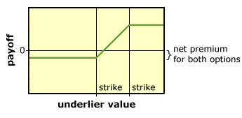

Bear Spread

Buy a Put Option at strike price X2 and sell a put option at a lower strike price of X1. Both options have same expiry

Pay Off
      - If S_{T} ≥ X2 : Zero
      - If X1 ≤ S_{T} < X2 : X2 - S_{T}
      - If S_{T} < X1 : X2 - S_{T} – ( X1 - S_{T})

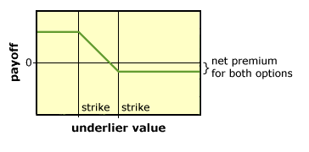

Butterfly Spread

Buy a call option at strike price X1, and buy another call option at a higher strike price of X2. Sell 2 call options at strike price X3, exactly halfway between X1 and X2

Pay Off
      - If S_{T} ≤ X1 : Zero
      - If X1 < S_{T} ≤ X3: S_{T} – X1
      - If X3 < S_{T} ≤ X2: S_{T} – X1 – 2(S_{T} – X3) = X2 - S_{T}
      - If S_{T} > X2: Zero

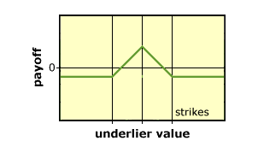

Straddle

Buy a call option and a put option both at strike price X

Pay Off
        - If S_{T} > X : S_{T} – X
        - If S_{T} < X : X- S_{T}
        - If S_{T} = X : Zero

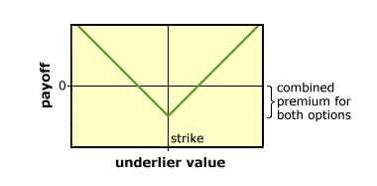

Strangle

Buy a Put Option with strike price K1= and buy a Call Option at strike price K2 > K1

Pay Off
      - If S_{T} > K2 : S_{T} – K2
      - If S_{T} < K1 : K1 - S_{T}
      - If K1 ≤ S_{T} ≤ K2 : Zero

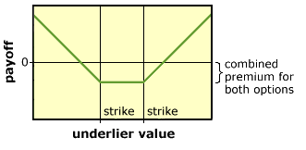

Chapter 7

Swaps/Currency Swaps/Cross Currency Swaps

Imagine any two cash flows with different characteristics. They can be devised in to a contract for their exchange and this contract will be called a swap.

FRAs are the simplest form of swaps and culminate cumulatively at a specified time frame. The continuation or series of FRAs can be termed as Swaps. However scope of FRAs is restricted up to agreements specifying interest rates applicable on principal in domestic or in foreign currencies and they are generally settled at the beginning of the specified period of time. Both are structured on expectations theory and liquidity preference theory saying that long term interest rates should reflect expected future short term interest rates and forward rates should always be higher than expected future spot interest rates.

At initiation a swap is a pure exchange and hence does not require any additional net cash payments at initiation. In other words the initial value of the swap contract that secures this exchange is at zero. The contract needs to specify a swap rate, or spread to make the two swap parties willing to exchange the cash flows.

Unlike most standardized options and futures contracts, majority of swaps are not exchange-traded instruments. Instead, swaps are customized contracts that are traded in the over-the-counter (OTC) market between private parties. Because swaps occur on the OTC market, hence it always carries the risk of a counterparty defaulting on the contract.
The first interest rate swap occurred between IBM and the World Bank in 1981. However, despite their relative youth, swaps have exploded in popularity.

The Bank for International Settlements (BIS) publishes statistics on the notional amounts outstanding in the OTC Derivatives market. At the end of 2006, this was USD 415.2 trillion, more than 8.5 times the 2006 world GDP

The Common types of swaps, in order of their quantitative importance, are Interest Rate Swaps (IRS), Currency Swaps, Credit Default Swaps, Commodity Swaps, Equity Swaps Variance Swaps. The most common and simplest swap is a "plain vanilla" interest rate swap. In this Party A agrees to pay Party B a predetermined, fixed rate of interest on a notional principal on specific dates for a specified period of time. Concurrently, Party B agrees to make payments based on a floating interest rate to Party A on that same notional principal on the same specified dates for the same specified time period. In a plain vanilla swap, the two cash flows are paid in the same currency. The specified payment dates are called settlement dates, and the time between are called settlement periods. Because swaps are customized contracts, interest payments may be made annually, quarterly, monthly, or at any other interval determined by the parties. If an interest rate swap involves the swapping of a stream of payments based on the fixed interest rate for a stream of floating interest rate, then it is called a coupon swap. A plain vanilla swap can be called a generic swap. In case two streams of payments are involved using different floating rate indices than they are called basis swaps or floating-against-floating swaps.

Currency swaps involve exchanging principal and fixed interest payments on a loan in one currency for principal and fixed interest payments on a similar loan in another currency. Unlike an interest rate swap, the parties to a currency swap will exchange principal amounts at the beginning and end of the swap. The two specified principal amounts are set so as to be approximately equal to one another, given the exchange rate at the time the swap is initiated. Then, at intervals specified in the swap agreement, the parties will exchange interest payments on their respective principal amounts. Finally, at the end of the swap, the parties re-exchange the original principal amounts. These principal payments are unaffected by exchange rates at the time. Thus a Cross Currency Swap (CCS) is an instrument that may be used to swap the interest-rate and currency risk on a loan. Cross Currency Swaps are suitable for companies that wish to control the interest-rate risks in foreign currencies stemming from their standard business operations.

Credit Default Swap is designed to transfer the credit exposure of fixed income products between parties. The buyer of a credit swap receives credit protection, whereas the seller of the swap guarantees the credit worthiness of the product. Credit default swaps are the most widely traded credit derivative product. Credit default swap index is a credit derivative used to hedge credit risk or to take a position on a basket of credit entities through a company. Unlike a credit default swap, which is an over the counter credit derivative, a credit default swap index is completely standardized credit security and may therefore be more liquid and trade at a smaller bid-offer spread. There are currently two main families of CDS indices: (1)CDX containing North American and Emerging Market companies and are administered by CDS Index Company and marketed by Markit Group Limited. (2)Traxx contains companies from the rest of the world and are managed by the International Index Company (IIC).

Commodity swaps are swaps where exchanged cash flows are dependent on the price of an underlying commodity. There are two major types of commodity swaps i.e. exchange of fixed to floating payments based on a commodity price index and exchange of payments when one payment is based on an index and the other on a money market rate, which is often the Libor rate.
An equity swap is a swap where a set of future cash flows are exchanged between two counterparties. One of these cash flow streams will typically be based on a reference interest rate. The other will be based on the performance of a share of stock or stock market index. The two cash flows are usually referred to as "legs".

A variance swap is an over-the-counter financial derivative that allows one to speculate on or hedge risks associated with the magnitude of movement, i.e. volatility, of some underlying product, like an exchange rate, interest rate, or stock index. One leg of the swap will pay an amount based upon the realized variance of the price changes of the underlying product. The other leg of the swap will pay a fixed amount, which is the strike, quoted at the deal's inception.

Rollercoaster Swap is a seasonal swap providing flexibility of payments at predetermined periods to best meet the counterparty's cyclical financing needs or other requirements. For example, an international company that sells lawn flowers might have a keen interest in a rollercoaster swap because it can match swap payments with the seasonal demand for lawn flowers.

Non-Deliverable Swap (NDS) is a swap that is similar to a non-deliverable forward, with the only difference being that settlement for both parties is done through a major currency. Non-deliverable swaps are used when the swap includes a major currency, such as the U.S. dollar, and a restricted currency, such as the Philippine peso or South Korean won.

Zero Basis Risk Swap (ZEBRA) is an agreement between a municipality and a financial intermediary. It is also known as a "perfect swap" or "actual rate swap". In this the municipality pays a fixed rate of interest to the financial intermediary and receives a floating rate of interest in return. The floating rate received is equal to the floating rate on the outstanding floating rate debt initially issued by the municipality to the public.

Total Return Swap is a swap agreement in which one party makes payments based on a set rate, either fixed or variable, while the other party makes payments based on the return of an underlying asset, which includes both the income it generates and any capital gains.

Quanto Swap is a type of derivative in which the underlying is denominated in one currency, but the instrument itself is settled in another currency at some fixed rate. It is a swap with varying combinations of interest rate; currency and equity swap features, where payments are based on the movement of two different countries' interest rates. Though they deal with two different currencies, payments are settled in the same currency.

A swaption is an option granting its owner the right but not the obligation to enter into an underlying swap. Although options can be traded on a variety of swaps, the term "swaption" typically refers to options on interest rate swaps. There are two types of swaption contracts: A payer swaption gives the owner of the swaption the right to enter into a swap where they pay the fixed leg and receive the floating leg. A receiver swaption gives the owner of the swaption the right to enter into a swap where they will receive the fixed leg, and pay the floating leg. The buyer and seller of the swaption agree on: the premium of the swaption, the strike rate, length of the option period the term of the underlying Swap, notional amount, amortization and frequency of settlement of payments on the underlying swap. The participants in the swaption market are predominantly large corporations, banks, financial institutions and hedge funds. There are three types of Swaptions. Each type reflects a different timeframe in which the option can be exercised. American swaption, in which the owner is allowed to enter the swap on any day that falls within a range of two dates, European swaption, in which the owner is allowed to enter the swap only on the maturity date and the Bermudan swaption, in which the owner is allowed to enter the swap only on certain dates that fall within a range of the start (roll) date and end date.

The motivations for using swap contracts fall into two basic categories: It may be due to commercial needs i.e. the normal business operations of some firms lead to certain types of interest rate or currency exposures that swaps can alleviate or due to acquiring a comparative advantage since some companies have a comparative advantage in acquiring certain types of financing. For example, consider a well-known U.S. firm that wants to expand its operations into Europe, where it is less well known. It will likely receive more favorable financing terms in the US. By then using a currency swap, the firm ends with the Euros it needs to fund its expansion. Positively Interest rate swaps primarily allow institutions to manage interest rate risks by swapping for preferred interest payment obligations. They also provide institutions with vehicles to obtain cheaper financing by exploiting arbitrage opportunities across financial markets and to gain access to debt markets that otherwise would have been unattainable or too costly. Negatively, Swaps are not standardized contracts, which lead to several problems. Further negotiating a mutually agreeable swap contract involves time, energy, and resources. Non availability of secondary market also makes this transaction difficult and costly to "back out" of swap agreement if the need arises. Swaps holders are also exposed to default risk and a default on one party exposes the other party to interest rate risk and possible loss of funds.

As per Financial Derivatives Business Regulation (FDBR) November 2004 of State Bank of Pakistan, permitted swap transactions are Interest Rate Swaps in PKR only with no restriction on the minimum tenor; however the maximum tenor of the IRS is initially restricted to 5 years. There is no restriction on the minimum or maximum size of notional principal amount of Interest Rate Swaps. The parties are free to use any domestic money market / debt market rate or interest rate implied in the foreign exchange forward market as a benchmark rate for entering into IRS, provided methodology of computing the rate is objective, transparent and mutually acceptable to counterparties and approved by the Financial Market Association (FMA). In addition to IRS, banks are also actively trading “Cross Currency Swaps” (CCS) with the prior approval from State Bank of Pakistan. In this case, a Pakistani exporter having exports proceeds in USD and loan liability in PKR (KIBOR) can enter in to transaction by converting his PKR liability in to USD (LIBOR) liability in order to exploit its low interest rates as compared to that of PKR. In doing so he is taking on exchange risk but with his exports’ proceeds in FX he has a natural hedge. As compared to IRS and CCS, FRA market is very small on account of non existence of interbank market wherefrom it can get its rates. volumes of FRAs, IRS (including PKR & in FX) and CCS at end June FY08 remained at Rs 2.6 billion, Rs 106.9 billion and Rs 194.9 billion as compared to Rs 300 million, Rs 80.0 billion and Rs 89.6 billion respectively at end June FY07.The figures show a healthy growth in FY07 and 08 but onward going they are expected to come down under immense volatile interest rate environment that prevailed in 1H FY09. Though derivatives market is very small and at its infancy in Pakistan but it has great potential to rise in the coming days on becoming interest rates and exchange rates somewhat stable. The challenges ahead are creation of awareness on derivatives, built up of its interbank market and dissemination of its data from some reliable source i.e. from SBP. These steps would obviously help market participants to play their due role in built up of derivatives market in Pakistan.

In fact a swap is a derivative in which two counterparties agree to exchange one stream of cash flows against another stream. These streams are called the legs of the swap

There are two basic types of swaps:

- Interest Rate Swap
- Currency Swaps

An agreement between two parties where one stream of future interest payments is exchanged for another based on a specified principal amount. Interest rate swaps often exchange a fixed payment for a floating payment that is linked to an interest rate.

EXAMPLE

Counterparties: A and B Maturity: 5 years A pays to B: 6% fixed p.a.. B pays to A : 6-month KIBOR. Payment terms: semi-annual. Notional Principal amount: PKR 10 million.

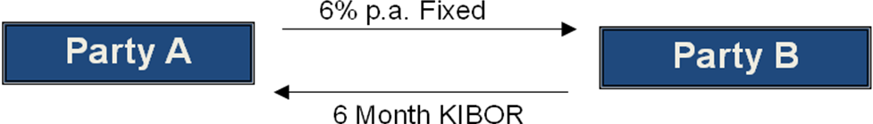

Payments at the end Half year period | Fixed rate payments | Floating rate Payments 6m KIBOR | Net Cash From A to B
1 | 300000 | 337500 | -37500
2 | 300000 | 337500 | -37500
3 | 300000 | 337500 | -37500
4 | 300000 | 325000 | -25000
5 | 300000 | 325000 | -25000
6 | 300000 | 325000 | -25000
7 | 300000 | 312500 | -12500
8 | 300000 | 312500 | -12500
9 | 300000 | 312500 | -12500
10 | 300000 | 325000 | -25000
 |  |  | -250000

Typical Characteristics of the Interest Rate Swaps:

The principal amount is only notional.

Opposing payments through the swap are normally netted.

The frequency of payment reflects the tenor of the floating rate index.

Calculating prices for interest

At initiation both the fixed- and floating-rate notes must have the same par value to replicate a swap, so that the principal values match up at maturity

For the swap to have zero value at initiation, the notes must have the same market price at that point in time as well

The fixed rate note will have coupons (C) as periodic payments such that:
At initiation both the fixed- and floating-rate notes must have the same par value to replicate a swap, so that the principal values match up at maturity

For the swap to have zero value at initiation, the notes must have the same market price at that point in time as well

The fixed rate note will have coupons (C) as periodic payments such that:
Rs100 = = C (1/R1 +1/R2 +1/R3)+ 100/R4 or

C = (1-1/R4) / ( 1/R1+1/R2+1/R3+1/R4) * 100

Now suppose1-year spot rates are 2%, 4%, 6% and 8%, respectively. Than the fixed rate that makes the value of a 4-year swap at initiation equal to zero would be:-

C% = (1-1/1.08)/(1/1.02+1/1.04+1/1.06+1.08) =0.0194. 0r 1.94%

The fixed rate per period as percentage of principal value must be 1.944%.

Currency Swap

A swap that involves the exchange of principal and interest in one currency for the same in another currency. It is considered to be a foreign exchange transaction and is required by law to be shown on the balance sheet.

To further elaborate the modus operandi and underlying fundamentals of a swap transaction we shall discuss a simple ready against six month forward swap. As the first leg of the transaction is in ready therefore it would be executed today at the today prevailing exchange rate. For sake of simplicity we shall make the following assumptions

READY USD/PKR Rate 60.00

PKR 6-month interest rate 11.00%

USD 6-month interest rate 6.00%

In order to ensure that no opportunities of arbitrage arise the Therefore, interest rate differential being (11-6) 5% the theoretical depreciation in rupee would be

60.00 * 5% * ½ (as interest rates are quoted on annual basis the six months impact would be roughly ½) = 1.5

This will result in a six month forward rate of 60 + 1.5=61.5

Cross-currency swaps offer companies opportunities to reduce borrowing costs in both domestic and foreign markets

A currency swap involves the exchange of payments denominated in one currency for payments denominated in another. Payments are based on a notional principal amount the value of which is fixed in exchange rate terms at the swap's inception

Consider a Pakistani Exporter having exports’ proceeds in USD. He/She has a PKR(KIBOR) loan liability on its balance sheet and he/she wants to convert this PKR liability to USD(LIBOR) liability to exploit the low interest rates as compared to that of PKR.

In doing so he/she is taking on exchange risk but with his exports’ proceeds in FX he/she has a natural hedge.

Chapter 7

Pricing of Derivatives

Pricing-basic features

Market price, i.e. the price at which traders are willing to buy or sell the contract

For exchange-traded derivatives, market price is usually transparent.

Complications can arise with OTC or floor-traded contracts though, as trading are handled manually, making it difficult to automatically broadcast prices.

Arbitrage-free price, meaning that no risk-free profits can be made by trading in these contracts.
Forward (currency) Mechanism  SELL USD IN FORWARD (EXPORT) BUY USD IN FORWARD (IMPORT)  In above and below case  Future Mechanism-Currency |  |  |  |  |  | BUY USD IN FORWARD (IMPORT)
   | Bid | Offer
  US D Interest Rate | 4.00% | 4.25%
  PKR Mark up Rate | 8.00% | 8.50%
  USD/PKR Spot | 60.00 | 60.05
  US D Amount | 100
  Tenor | 181 days
  USD Borrowing | 100 | 4.25% | 2.14 | PKR Borrowing | 6005 | 8.50% | 253.11
  Sell USD | 100 | 60 | 6000 | Buy USD | 100 | 60.05 | 6005
  Invest PKR | 6000 | 8% | 238.03 | Invest USD | 100 | 4% | 2.0
  After 181 days |  |  |  | After 181 days
  PKR Cash in flow | 6238.03 |  |  | PKR Cash out flow | 6253.11
  Export process shall be used to pay |  |  |  | USD shall be used to Pay import
  USD Cash outflow | 102.14 |  |  | USD cash inflow | 102.01
  Forward Rate | 61.07 |  |  | Forward Rate | 61.30
  Swap points | Paisa 1.07 |  |  | Swap points | Paisa 1.30
  USD is at | PREMIUM |  |  | USD is at | PREMIUM
   | 61.07 |  |  |  | 61.30
   | Bid | offer
  Spot$/Euro | 1.3505 | 1.351
  3 month future rate | 1.353 | 1.3535
  Standard size of 3 months contract in Euro |  |  | As of today 125,000
  In a month time rate moves to (Spot $/Euro) | 1.354 | 1.3545
  3 months Future Rate | 1.3565 | 1.357
  Actual trade amount | 750,000 Euros |  | Due in 30 days

Sell Euro Futures (Export) |  |  | Buy Euro Futures Import
Which Contract | Next following the actual receipt date of contract |  | Which Contract | Next following the actual payment date
Type of contract | Sell Euro Futures |  | Type of contract | Buy Euro Futures
No of contract | Amount/Std contract size | Round off 6 | No of contract | Amount/Std contract size | Round off 6
Tick size | Minimum price movement * contract size | 0001*125000=  $12.50 | Tick size | Minimum price movement * contract size | 0001*125000=  $12.50
Actions required today i.e. transaction date
Sell contract of Euro Futures | 6 * 1.353=  1.014,750 |  | Buy contract of Euro Futures | 6 * 1.3535=  1.015,125
Actions required after 30 days i.e.
Receipt/
Payment date
Futures Market |  |  | Futures Market
Buy contracts of Euro Futures | 6 * 1.357 =  1,017,750 |  | Sell contracts of Euro Futures | 6 * 1.3565 =  1,017,375
Spot Market |  |  | Spot Market
Sell Euros | 750,000 * 1.354 = 1,015,500 |  | Buy Euros | 750,000 * 1.3545 = 1,015,875
Outcome of Hedge
Opportunity Gain/Loss in Spot |  |  | Opportunity Gain/Loss in Spot
Actual Sell | 1,015,500 |  | Actual Buy | 1,015,875
Could have sell @ 1.3505 | 1,012,875 | 2,625 (gain) | Could have bought @ 1.351 | 1,013,250 | -2,625 (loss)
Futures Market |  |  | Futures Market
Sell futures contract@ | 1,014,750 |  | Buy futures contract@ | 1,015,125
Buy Futures Contract@ | 1,017,750 |  | Sell Futures Contract@ | 1,017,375
Loss | -3000 |  | Gain | 2,250

Valuing Option

The value, or premium, of an option is determined by the future price of its underlying asset.

Of course, no one can really know for certain what an asset’s future price will be.

To help estimate this price, techniques have been developed using probabilities and statistics.

Current Price of Asset

Strike Price

Time to Expiration

Volatility

Risk-Free rate

The Black-Scholes model and the Cox, Ross and Rubinstein binomial model are the primary models used for pricing options.

The binomial option pricing model uses an iterative procedure, allowing for the specification of nodes, or points in time, during the time span between the valuation date and the option's expiration date.

The Black Scholes Model is regarded as one of the best ways of determining fair prices of options The model assumes that the price of heavily traded assets follow a geometric Brownian motion with constant drift and volatility. When applied to a stock option, the model incorporates the constant price variation of the stock, the time value of money, the option's strike price and the time to the option's expiry.

DCF model does not work in case of option since in that our standard procedures for valuing an asset is to (1) figure out expected cash flow and (2) discount them at the opportunity cost. This is not practical for option; however by combining stock investment and borrowing, the option equivalent can be calculated. In this case, suppose we have a stock with an exercise price of Rs 60, than assuming the day when the option is at the money and by taking the short term risk free rate as 1.5% for 8 months and 1.0 % for a year, we assume that the price of the stock may fall by a quarter to 45 or rise by one third to 80. In the case if price falls to 45 than the option is worthless but in case of moving to 80 the pay off is 80-60 = 20. Now suppose you buy 4/7 shares and borrow 25.46 from the bank than it would turn in to given scenario. 4/7 shares of valuing 45 would value 25.71 and valuing 80 would value 45.71. The repayment of loan with interest would come out as 25.71.

In this method we borrowed money and exactly replicate it with the pay off from a call option. The number of shares needed to replicate one call is called hedge ratio or option delta which is = spread of possible option prices/ spread of possible share prices = 20-0/80-45= 20/35= 4/7

Now to value call option we would use given formula = value of 4/7 shares -25.46 bank loan = 60 x (4/7) – 25.46 = 8.83 (value of call).

To calculate value of put we would go reverse, that in the case stock at 80 would give a payoff of 0 and at 45 would give a pay off of 15. This would give option delta of 0-15/80-45 = -3/7. The delta of put option would always be negative. Now with this case, the option payoffs can be replicated by selling 3/7 shares and lending 33.95 making it 34.29 after one year. Now at sale of 3/7 shares of 45 you get -19.29 and against shares of 80 you get -34.29 (that you would lend). This give 0 payoffs for stock valuing 80 and 15 against stock valuing 45. From this, value of put would be -3/7 shares + 33.95 as lending = -3/7 x 60 +33.95 = 8.23

In the above case the call option should sell at 8.83. If the option price is higher than 8.83 you can have payoff by buying 4/7 shares, selling a call option and borrowing 25.46. Similarly if the prices are less than 8.33 you can make equally payoff by selling 4/7 shares, buying a call and lending the balance. In either case there would be an arbitrage opportunity. This provides us another way to value the option. In this we pretend, that investors are indifferent about risk, work out the expected future value of the option and discount it back at the risk free rate to get the current value. If investors are indifferent about risk than Expected return on stock = 1.0% per 8 months. In this case we have presumed that stock can either rise by 33.33 % to 80 or fall by 25 % to 45. The probability of price rise is = Expected return = (probability of rise x 33.3) + ( (1-probability of rise) x (-25) ) =1.00%. Probability of rise can be ascertained as ρ =interest rate –downside change/ upside change – downside change =.01 – (- .25)/.333 – (-.25) = . 446. The expected value of the call option would be (probability of rise x 20 + ( (1-probability of rise) x 0) = (.446 x 20) + (.554 x 0) =8.92. PV of call would be = 8.92/1.01 = 8.83

valuing the put option through risk neutral valuation method we would proceed as

(probability of rise X 0 ) + ((1 – probability of rise ) X 15 ) = (.446 X 0) + ( .554 X 15) = 8.31 PV of put option would be 8.31/1.01 = 8.23

Relationship of call and put

In European option there is a simple relationship between call and the put i.e. value of put = value of call –share price + PV of exercise price = 8.83 -60 + 60/1.01 = 8.23

Binomial pricing model

One of the most widely used options pricing techniques is the Binomial Pricing Theory. It involves the construction of a binomial tree, and this tree is used to represent all of the possible paths that the price of an underlying asset may take during the life of the option.

An example of a two-step option valuation of a European Call will be used here to demonstrate the general functioning of this pricing method. For this model a few assumptions have to be made:

1. The direction and degree of the underlying asset’s fluctuation is given. Assume for each stage of the tree that the underlying asset’s price may either go up or down by 10%.

2. The risk free interest rate is known with certainty. For this example assume 12%.

3. The current price of the stock is used to project forward possible movements through the binomial tree. For the purpose of this example a price of $10.00 is used, with the option having a strike price of $10.50. Thus, the option is out of the money

4. No arbitrage.

The following notation will be used in this example:

So = Current price of the stock, Let so = $10.00

X = Strike or Exercise price of option i.e. 10.50

r = Risk-free rate interest, Let r = 12%

T = Time between periods in years. This example has two 3-month periods, making T = 3months/12months or .25. T = .25

U = Degree or percentage change in upward movement, Let U = 1.1

D = Degree or percentage change in downward movement, Let D = 0.9

Pu = Probability of an upward movement

Pd = Probability of a downward movement

A two-step binomial tree model would, in theory, look like this

Figure 1

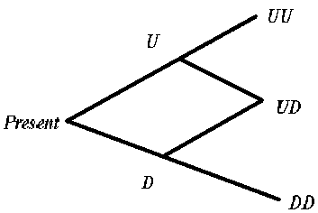

U = 1 upward movement in the price of the asset.

UU = 2 consecutive upward movements in the price of the asset.

D = 1 downward movement in the price of the asset

DD = 2 consecutive downward movements in the price of the asset.

UD = An upward or downward movement in the price of the asset followed by an upward or downward movement in the price of the underlying asset.

The tree with all of the possible asset prices would look like this:

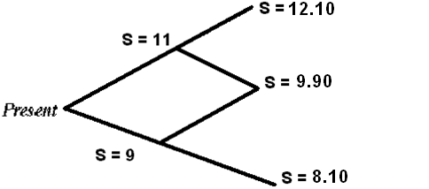

It is assumed that the strike price of the option is $10.50, and the following possible option prices are then calculated as follows:

Cuu = | 12.10 – 10.50 | = 1.60
Cud = | 9.90 – 10.50 | = -.60, nil
Cdd = | 8.10 10.50 | = - 2.40,nil

These prices are two periods forward, and the valuation occurs at the present period. Thus, the prices of the options may be calculated through working a path back through the tree, eventually ending up at the first node. For example, the option price at node U is calculated as the expected value of the two nodes that follow it discounted by the risk-free rate of interest.

However, to calculate the expected value one needs to calculate the probability of an upward and downward movement. This probability of an upward movement may be calculated through using the following formula:

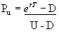

PU = 2.7 is to power .12*.25 - .9/ 1.1 - .9 = $.6523

Pd = .6523 -1 = .3477

Subbing in the values assumed at the beginning of this example the expected value of Cu is as follows :-

= $1.04

This expected value has to be discounted back one period to node U. This is the present value equation:

= $1.01

The tree would now look like this:

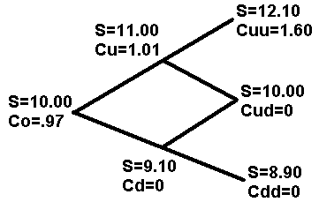

Where the value of the call at time zero is found through this equation:

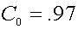

Therefore, the price of this call is $0.97

The big advantage of binomial model over the Black-Scholes model is that it can be used to accurately price American options. This is because with the binomial model it's possible to check at every point in an option's life

The main limitation of the binomial model is its relatively slow speed

The Black-Scholes Model was first discovered in 1973 by Fischer Black and Myron Scholes, and then further developed by Robert Merton. It was for the development of the Black-Scholes Model that Scholes and Merton received the Nobel Prize of Economics in 1997 (Black had passed away two years earlier). The idea of the Black-Scholes Model was first published in "The Pricing of Options and Corporate Liabilities" of the Journal of Political Economy by Fischer Black and Myron Scholes and then elaborated in "Theory of Rational Option Pricing" by Robert Merton in 1973

The Black and Scholes Call Models

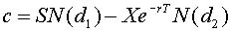

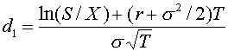

C = Theoretical Call Premium

r = Risk-Free Interest Rate

sigma = Standard Deviation of Stock Returns

T = Time until expiration (years)

N = Cumulative Standard Normal Distribution

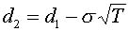

X = Option Strike Price

S = Current Stock Price

e = Exponential Function

Assumptions

- The stock pays no dividends during the option's life
- European exercise terms are used
- Markets are efficient
- No commissions are charged
- Interest rates remain constant and known
- Returns are log normally distributed

Other models

For rapid calculation of a large number of prices, analytic models, like Black-Scholes, are the only practical option. However, the pricing of American options (other than calls on non-dividend paying assets) using analytic models is more difficult than for European options

To handle American option pricing in an efficient manner other models have been developed. Three of the most widely used models are:

Roll, Geske and Whaley analytic solution: The RGW formula can be used for pricing an American call on a stock paying discrete dividends.

Black's approximation for American calls: Black's approximation basically involves using the Black-Scholes model after making adjustments to the stock price and expiration date to take account of early exercise.

Barone-Adesi and Whaley quadratic approximation: An analytic solution for American puts and calls paying a continuous dividend.

Advantage: The main advantage of the Black-Scholes model is speed -- it lets you calculate a very large number of option prices in a very short time

Limitation: The Black-Scholes model has one major limitation: it cannot be used to accurately price options with an American-style exercise as it only calculates the option price at one point in time -- at expiration

Chapter 9

Volatility/Price Value at Basis Point (PVBP)/Value at Risk

Volatility

Volatility is a measure of the rate and magnitude of the change of prices (up or down) of the underlying

If volatility is high, the premium on the option will be relatively high, and vice versa

Once you have a measure of statistical volatility (SV) for any underlying, you can plug the value into a standard options pricing model and calculate the fair market value of an option

Implied Volatility is the estimated volatility of a security's price

In short, the more a stock is expected to make a big move due to some important news release or earnings release in the near future, the higher will be the implied volatility of that stock

In fact, implied volatility rises as the date of that important release approaches

Under such circumstances, market makers also hike implied volatility in order to charge a higher price for the higher demand

Volatility measures are

- Standard Deviation
- Beta
- R-Squared
- Alpha

The above have already been explained in Chapter 2 underRisk and Opportunities.

They are further supported by Hedging Greeks that are

- Delta
- Gamma
- Vega
- Theta
- Rho

Delta

Options Delta measures the sensitivity of an option's price to a change in the price of the underlying stock

In layman terms, delta is that options Greek which tells you how much money a stock options will rise or drop in value with a $1 rise or drop in the underlying stock

This means that the higher the delta value a stock option has, the more it will rise with every $1 rise in the underlying stock

Gamma
Options Gamma is the rate of change of options delta with a small rise in the price of the underlying stock

Just as options delta measures how much the value of an option changes with a change in the price of the underlying stock, Options Gamma describes how much the options delta changes as the price of the underlying stock changes

Vega

Options Vega measures the sensitivity of a stock option's price to a change in implied volatility

When implied volatility rises, the price of stock options rises along with it. Options Vega measures how much rise in option value with every 1 percentage rise in implied volatility

Model's fair market value, however, is often out of line with the actual market value for that same option. This is known as option mispricing. The answer can be found in the amount of expected volatility (implied volatility) the market is pricing into the option

Theta

Options Theta measures the daily rate of depreciation of a stock option's price with the underlying stock remaining stagnant. In layman terms, Theta is that options Greek which tells you how much an option's price will diminish over time, which is the rate of time decay of stock options.

Time decay is a well known phenomena in options trading where the value of options reduces over time even though the underlying stock remains stagnant

Rho

Options Rho measures the sensitivity of a stock option's price to a change in interest rates

Options Rho is definitely the least important of the Options Greeks and have the least impact on stock options pricing. In fact, this is the options Greek that is most often ignored by options traders because interest rates rarely change dramatically and the impact of such changes affect options price quite insignificantly measure used to describe how a basis point change in yield affects the price of a security

Price Value at Basis Point (PVBP):- It gives a picture of increase or decrease in price on increase or decrease in one basis point in yield. This simple relationship is widely used in the market to anticipate loss or gain.

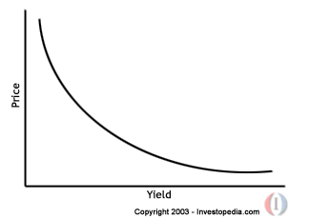

Value at Risk (VAR)

The Question Being Asked in VAR is

“What loss level is such that we are X% confident it will not be exceeded in N business days?”

Advantages

It captures an important aspect of risk in a single number

It is easy to understand

It asks the simple question: “How bad can things get?”

There are three methods of calculating VAR:

The Historical Method

The Variance-Covariance Method

The Monte Carlo Simulation

The historical method simply re-organizes actual historical returns, putting them in order from worst to best

It then assumes that history will repeat itself, from a risk perspective

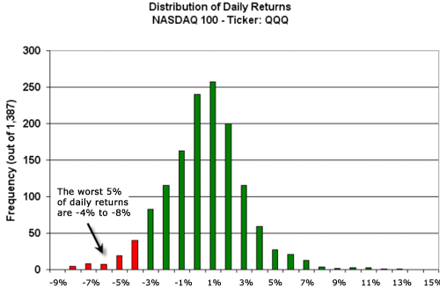

With 95% confidence, we expect that our worst daily loss will not exceed 4%

If we invest $100, we are 95% confident that our worst daily loss will not exceed $4 ($100 x -4%)

This method assumes that stock returns are normally distributed

√

The Variance-Covariance Method

It requires that we estimate only two factors:

Expected (or average) return

Standard deviation

It allows us to plot a normal distribution curve. The JP Morgan (An investment Bank which introduced VAR metrics) Risk metrics uses a different database using a different definition of volatility from the standard one. Its definition of volatility is 1.65 times the standard definition for 95% confidence level used for corporates and 2.33 times the standard definition for 99% confidence level used for banking sector. This turns out to be 1.65 σ/ day or 2.33 σ/day. The σ/day can be obtained through σ/day = σ/ year/√252. From the table of normal distribution which can be in negative and positive i.e. Nx where x ≥ 0 or Nx where x≤ 0 and through going interpolation we can get the value of x that comes out as N (-1.65) = 0.05 and N (-2.33) =0.01. Normal distribution is always in contrast to lognormal distribution which always remain in positive

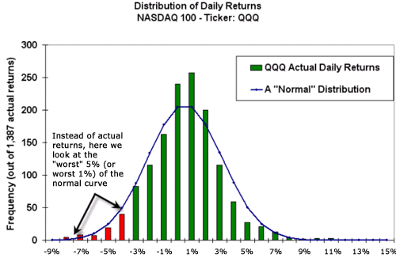

The advantage of the normal curve is that we automatically know where the worst 5% and 1% lie on the curve. They are a function of our desired confidence and the standard deviation

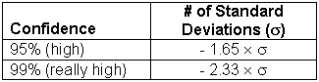

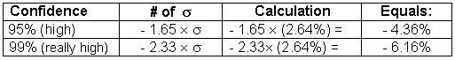

A Monte Carlo simulation refers to any method that randomly generates trials, but by itself does not tell us anything about the underlying methodology

A Monte Carlo simulation amounts to a "black box" generator of random outcomes

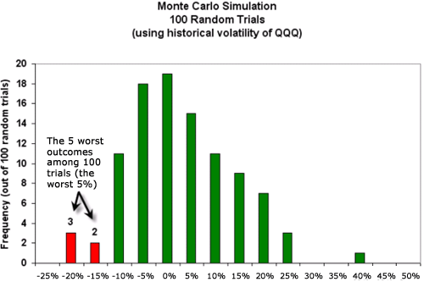

Because of the time variable, users of VAR need to know how to convert one time period to another

They can do so by relying on a classic idea in finance: “The standard deviation of stock returns tends to increase with the square root of time”

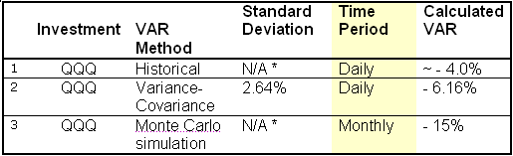

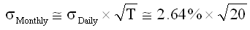

Chapter 10

Credit Derivatives and their role in Global Financial Crisis

Typical Credit Derivatives are (1) Credit Default Swap (CDS) (2) Collateralized Debt Obligations (CDOs).

Credit risk is the risk of financial loss due to a reduction in the credit quality of a debtor. Types of credit risk include Default Risk and Credit Deterioration Risk.

Default Risk is the risk that an obligor does not repay part or his entire financial obligation whereas Credit deterioration risk is the risk that the credit quality of the debtor decreases.

Financial instruments designed to transfer credit risk from one counterpart to another are CDs and CDOs. In this legal ownership of the reference obligation is usually not transferred. However Credit Derivatives allow an investor to reduce or eliminate credit risk or to assume credit risk.

From a more technical point of view, credit derivatives are financial instruments, whose value is derived from the credit quality of an underlying obligation.

The main reasons for the rise of credit derivatives are:

The general desire to reduce credit risk in the financial markets expressed by increased regulatory requirements as the Basel II Accord (Market and operational risk in addition to credit risk in arriving at banks risk weight age assets), an increase in personal bankruptcies, recent corporate and sovereign bankruptcies and increase in the ability to value and manages credit risk. These risks have visibly seen in the Latin American Debt Crisis, the saving and Loan Crisis, the Asian Financial Crisis, the Russian Debt Crisis, Argentinean Crisis and the Enron Bankruptcy Filing

Like any swap, the CDS is an exchange of two payments: on the one hand a fee payment and on the other a payment that only occurs if a credit event occurs.

A default swap is similar to knock-in put option. Default Swap buyer has a short position in the credit quality of the reference obligation and vice versa.

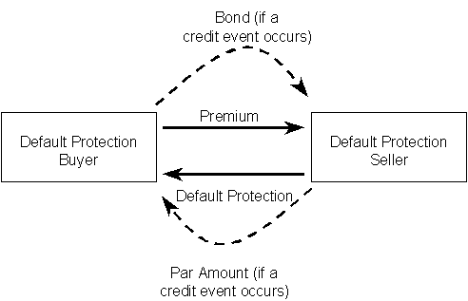

Why Credit Default Swaps are required? Because for, hedging, Yield Enhancement, Convenience & Cost Reduction, Arbitrage or for Regulatory Capital Relief
Buying a default swap means buying protection whereas selling a default swap means selling protection or assuming risk.

The default swap premium, also called fee, price or fixed rate, is often referred to as the default swap spread.

What Constitutes Default? They can be Bankruptcy, Failure to pay, Obligation Acceleration, Obligation Default, Repudiation/Moratorium or Restructuring. CDS normally range in between 10-20 million dollars and their maturity runs up to 5 years.

Settlement of CDS can take place through

Physical settlement .In case of default the investor delivers a defaulted asset to the say AAA bank the seller of the swap that pays the investor the Par value of the asset.

Cash settlement: In this case which are normally done by the speculators, AAA bank the seller of the swap would pay the difference between the par value and the market price of a specified debt.

Cash Settlement = N * [Reference Price – (Final Price +Accrued interest on reference obligation)]

Example: - Suppose CDS is of 5 million dollars. The company that has issued bonds default and the price of its bonds comes down to 25% from 100% of its par value. Than in this case the payment would be made against this naked credit default swap where investor do not pass on the defaulted asset. This would come out as 5 million * (100% - 25%) =3.75 million. In this case no accrued intetst has been included.

Physical Settlement N * Reference Price

Cash flow statement of a CDS can be like this:-

Time | Recovery Value | Fee to protection seller | Contingent payment to protection buyer | Net Cash Flow to Protection Buyer
6 months | NA | $ 5 | $ 0 | - $ 5
12 months | NA | $ 5 | $ 0 | - $ 5
18 months | NA | $ 5 | $ 0 | - $ 5
24 months | NA | $ 5 | $ 0 | - $ 5
30 MONTHS | NA | $ 5 | $ 0 | - $ 5
36 months | $ 400 | $ 5 | - $ 600 | $ 595
Total |  |  |  | $ 570

Global Scenario

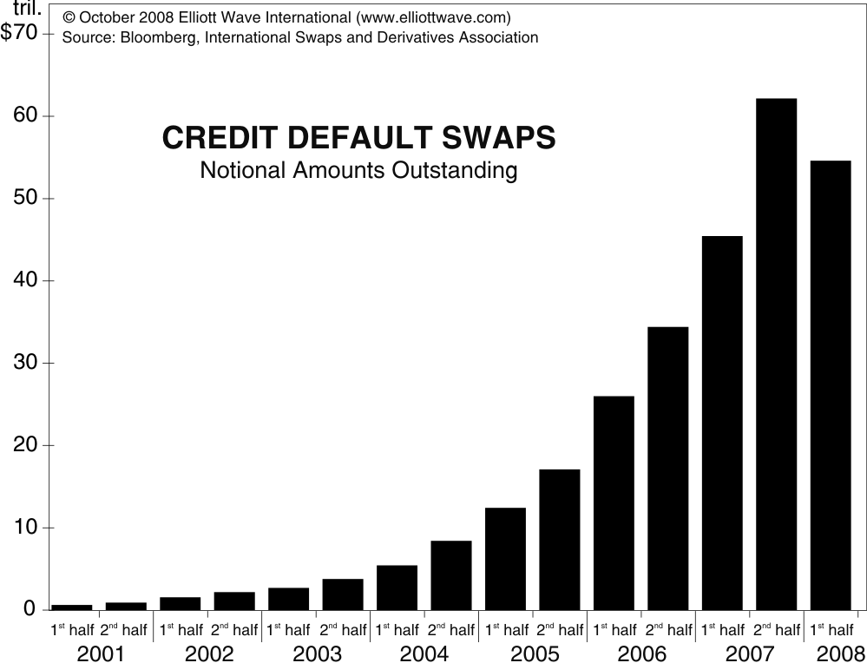

Credit Debt Obligations

A CDO gathers reference assets such as loans, bonds, or other debt instruments and sell of pieces of interests from the pool or tranches to investors.

Depending on which type of debt instrument the CDO holds, it can also be referred to as a Collateralized loan obligation (CLO), a Collateralized bond obligation (CBO), or a Collateralized mortgage obligation (CMO) or securitization.

Securitization is a structured finance process that distributes risk by aggregating debt instruments in a pool, then issues new securities backed by the pool. The term "Securitization" is derived from the fact that the form of financial instruments used to obtain funds from the investors is securitization. As a portfolio risk backed by amortizing cash flows - and unlike general corporate debt - the credit quality of securitized debt is non-stationary due to changes in volatility that are time- and structure-dependent. If the transaction is properly structured and the pool performs as expected, the credit risk of all tranches of structured debt improves; if improperly structured, the affected tranches will experience dramatic credit deterioration and loss. All assets can be securitized so long as they are associated with cash flow. Hence, the securities which are the outcome of Securitization processes are termed asset-backed securities (ABS). From this perspective, Securitization could also be defined as a financial process leading to an issue of an ABS.

Securitization often utilizes a special purpose vehicle (SPV), alternatively known as a special purpose entity (SPE) or special purpose company (SPC), reducing the risk of bankruptcy and thereby obtaining lower interest rates from potential lenders. A credit derivative is also sometimes used to change the credit quality of the underlying portfolio so that it will be acceptable to the final investors. Securitization has evolved from its tentative beginnings in the late 1970s to a vital funding source with an estimated outstanding of $10.24 trillion in the United States and $2.25 trillion in Europe as of the 2nd quarter of 2008. In 2007, ABS issuance amounted to $3,455 billion in the US and $652 billion in Europe

Securitization, in its most basic form, is a method of financing assets. Rather than selling those assets "whole," the assets are combined into a pool, and then that pool is split into shares. Those shares are sold to investors who share the risk and reward of the performance of those assets. It can be viewed as being similar to a corporation selling, or "spinning off," a profitable business unit into a separate entity. They trade their ownership of that unit, and all the profit and loss that might come in the future, for cash right now. A very basic example would be as follows. XYZ Bank loans 10 people $100,000 a piece, which they will use to buy homes. XYZ has invested in the success and/or failure of those 10 home buyers- if the buyers make their payments and pay off the loans, XYZ makes a profit. Looking at it another way, XYZ has taken the risk that some borrowers won't repay the loan. In exchange for taking that risk, the borrowers pay XYZ a premium in addition to the interest on the money they borrow. XYZ will then take these ten loans, and put them in a pool. They will sell this pool to a larger investor, ABC. ABC will then split this pool (which consists of high risk loans and low risk loans) into equal pieces. The pieces will then be sold to other smaller investors as bonds.

Asset Securitization began with the structured financing of mortgage pools in the 1970s. For decades before that, banks were essentially portfolio lenders; they held loans until they matured or were paid off. These loans were funded principally by deposits, and sometimes by debt, which was a direct obligation of the bank (rather than a claim on specific assets). But after World War II, depository institutions simply could not keep pace with the rising demand for housing credit. Banks, as well as other financial intermediaries sensing a market opportunity, sought ways of increasing the sources of mortgage funding. To attract investors, investment bankers eventually developed an investment vehicle that isolated defined mortgage pools, segmented the credit risk, and structured the cash flows from the underlying loans. Although it took several years to develop efficient mortgage Securitization structures, loan originators quickly realized the process was readily transferable to other types of loans as well.

In this case the issuer is classified as a "qualifying special purpose entity" or "qSPE".

Because of these structural issues, the originator typically needs the help of an investment bank (the arranger) in setting up the structure of the transaction.

To be able to buy the assets from the originator, the issuer SPV issues tradable securities to fund the purchase. Investors purchase the securities, either through a private offering (targeting institutional investors) or on the open market. The performance of the securities is then directly linked to the performance of the assets. Credit rating agencies rate the securities which are issued in order to provide an external perspective on the liabilities being created and help the investor make a more informed decision.

In transactions with static assets, a depositor will assemble the underlying collateral, help structure the securities and work with the financial markets in order to sell the securities to investors. The depositor has taken on added significance under Regulation AB. The depositor typically owns 100% of the beneficial interest in the issuing entity and is usually the parent or a wholly owned subsidiary of the parent which initiates the transaction. In transactions with managed (traded) assets, asset managers assemble the underlying collateral, help structure the securities and work with the financial markets in order to sell the securities to investors.

Some deals may include a third-party guarantor which provides guarantees or partial guarantees for the assets, the principal and the interest payments, for a fee.

The securities can be issued with either a fixed interest rate or a floating rate. Fixed rate ABS set the “coupon” (rate) at the time of issuance, in a fashion similar to corporate bonds. Floating rate securities may be backed by both amortizing and non amortizing assets. In contrast to fixed rate securities, the rates on “floaters” will periodically adjust up or down according to a designated index such as a U.S. Treasury rate, or, more typically, the London Interbank Offered Rate (LIBOR). The floating rate usually reflects the movement in the index plus an additional fixed margin to cover the added risk.

Unlike conventional corporate bonds which are unsecured, securities generated in a securitization deal are "credit enhanced," meaning their credit quality is increased above that of the originator's unsecured debt or underlying asset pool. This increases the likelihood that the investors will receive cash flows to which they are entitled, and thus causes the securities to have a higher credit rating than the originator. Some securitizations use external credit enhancement provided by third parties, such as surety bonds and parental guarantees (although this may introduce a conflict of interest). In February 1970, the U.S. Department of Housing and Urban Development created the transaction using a mortgage-backed security. The Government National Mortgage Association (GNMA or Ginnie Mae) sold securities backed by a portfolio of mortgage loans.

To facilitate the Securitization of non-mortgage assets, businesses substituted private credit enhancements. First, they over-collateralized pools of assets; shortly thereafter, they improved third-party and structural enhancements. In 1985, Securitization techniques that had been developed in the mortgage market were applied for the first time to a class of non-mortgage assets — automobile loans. A pool of assets second only to mortgages in volume, auto loans were a good match for structured finance; their maturities, considerably shorter than those of mortgages, made the timing of cash flows more predictable, and their long statistical histories of performance gave investors confidence.
This early auto loan deal was a $60 million Securitization originated by Marine Midland Bank and securitized in 1985 by the Certificate for Automobile Receivables Trust (CARS, 1985-1).
The first significant bank credit card sale came to market in 1986 with a private placement of $50 million of outstanding bank card loans. This transaction demonstrated to investors that, if the yields were high enough, loan pools could support asset sales with higher expected losses and administrative costs than was true within the mortgage market. Sales of this type — with no contractual obligation by the seller to provide recourse — allowed banks to receive sales treatment for accounting and regulatory purposes (easing balance sheet and capital constraints), while at the same time allowing them to retain origination and servicing fees. After the success of this initial transaction, investors grew to accept credit card receivables as collateral, and banks developed structures to normalize the cash flows. Starting in the 1990s with some earlier private transactions, Securitization technology was applied to a number of sectors of the reinsurance and insurance markets including life and catastrophe. This activity grew to nearly $15bn of issuance in 2006 following the disruptions in the underlying markets caused by Hurricane Katrina. Key areas of activity in the broad area of Alternative Risk Transfer include catastrophe bonds, Life Insurance Securitization and Reinsurance Sidecars.

The first public Securitization of Community Reinvestment Act (CRA) loans started in 1997. CRA loans are loans targeted to low and moderate income borrowers and neighborhoods.

As estimated by the Bond Market Association, in the United States, total amount outstanding at the end of 2004 at $1.8 trillion. This amount is about 8 percent of total outstanding bond market debt ($23.6 trillion), about 33 percent of mortgage-related debt ($5.5 trillion), and about 39 percent of corporate debt ($4.7 trillion) in the United States. In nominal terms, over the last ten years, (1995-2004,) ABS amount outstanding has grown about 19 percent annually, with mortgage-related debt and corporate debt each growing at about 9 percent. Gross public issuance of asset-backed securities remains strong, setting new records in many years. In 2004, issuance was at an all-time record of about $0.9 trillion.

At the end of 2004, the larger sectors of this market are credit card-backed securities (21 percent), home-equity backed securities (25 percent), automobile-backed securities (13 percent), and collateralized debt obligations (15 percent). Among the other market segments are student loan-backed securities (6 percent), equipment leases (4 percent), manufactured housing (2 percent), small business loans (such as loans to convenience stores and gas stations), and aircraft leases. More recently an attempt to securitize excess energy generated by renewable energy resources is being attempted by Joseph Brant Arseneau and his team.

Securitization only reached Europe in late 80's, when the first securitizations of mortgages appeared in the UK. This technology only really took off in the late 90's or early 2000, thanks to the innovative structures implemented across the asset classes, such as UK Mortgage Master Trusts (concept imported from the US Credit Cards), Insurance-backed transaction (such as the ones implemented by the insurance securitization guru Emmanuel Issanchou) or even more esoteric asset classes (for example securitization of lottery receivables for the Greek government, executed by Philippe Tapernoux).

As the result of the credit crunch precipitated by the subprime mortgage crisis the market for bonds backed by securitized loans was very weak in 2008 unless the bonds were guaranteed by a federally backed agency. As a result interest rates are rising for loans that were previously securitized such as home mortgages, student loans, auto loans and commercial mortgages

The originator initially owns the assets engaged in the deal. This is typically a company looking to raise capital, restructure debt or otherwise adjust its finances. Under traditional corporate finance concepts, such a company would have three options to raise new capital: a loan, bond issue, or issuance of stock. However, stock offerings dilute the ownership and control of the company, while loan or bond financing is often prohibitively expensive due to the credit rating of the company and the associated rise in interest rates.
The consistently revenue-generating part of the company may have a much higher credit rating than the company as a whole. For instance, a leasing company may have provided $10m nominal value of leases, and it will receive a cash flow over the next five years from these. It cannot demand early repayment on the leases and so cannot get its money back early if required. If it could sell the rights to the cash flows from the leases to someone else, it could transform that income stream into a lump sum today (in effect, receiving today the present value of a future cash flow). Where the originator is a bank or other organization that must meet capital adequacy requirements, the structure is usually more complex because a separate company is set up to buy the assets.

A suitably large portfolio of assets is "pooled" and sold to a "special purpose vehicle" or "SPV" (the issuer), a tax-exempt company or trust formed for the specific purpose of funding the assets. Once the assets are transferred to the issuer, there is normally no recourse to the originator. The issuer is "bankruptcy remote," meaning that if the originator goes into bankruptcy, the assets of the issuer will not be distributed to the creditors of the originator. In order to achieve this, the governing documents of the issuer restrict its activities to only those necessary to complete the issuance of securities.

Accounting standards govern when such a transfer is a sale, a financing, a partial sale, or a part-sale and part-financing. In a sale, the originator is allowed to remove the transferred assets from its balance sheet: in a financing, the assets are considered to remain the property of the originator. Under US accounting standards, the originator achieves a sale by being at arm's length from the issuer, in which Individual securities are often split into tranches, or categorized into varying degrees of subordination. Each tranche has a different level of credit protection or risk exposure than another: there is generally a senior (“A”) class of securities and one or more junior subordinated (“B,” “C,” etc.) classes that function as protective layers for the “A” class. The senior classes have first claim on the cash that the SPV receives, and the more junior classes only start receiving repayment after the more senior classes have repaid. Because of the cascading effect between classes, this arrangement is often referred to as a cash flow waterfall. In the event that the underlying asset pool becomes insufficient to make payments on the securities (e.g. when loans default within a portfolio of loan claims), the loss is absorbed first by the subordinated tranches, and the upper-level tranches remain unaffected until the losses exceed the entire amount of the subordinated tranches. The senior securities are typically AAA rated, signifying a lower risk, while the lower-credit quality subordinated classes receive a lower credit rating, signifying a higher risk.

The most junior class (often called the equity class) is the most exposed to payment risk. In some cases, this is a special type of instrument which is retained by the originator as a potential profit flow. In some cases the equity class receives no coupon (either fixed or floating), but only the residual cash flow (if any) after all the other classes have been paid.

There may also be a special class which absorbs early repayments in the underlying assets. This is often the case where the underlying assets are mortgages which, in essence, are repaid every time the property is sold. Since any early repayment is passed on to this class, it means the other investors have a more predictable cash flow.

If the underlying assets are mortgages or loans, there are usually two separate "waterfalls" because the principal and interest receipts can be easily allocated and matched. But if the assets are income-based transactions such as rental deals it is not possible to differentiate so easily between how much of the revenue is income and how much principal repayment. In this case all the income is used to pay the cash flows due on the bonds as those cash flows become due.

Credit enhancements affect credit risk by providing more or less protection to promised cash flows for a security. Additional protection can help a security achieve a higher rating, lower protection can help create new securities with differently desired risks, and these differential protections can help place a security on more attractive terms.
In addition to subordination, credit may be enhanced through:
A reserve or spread account, in which funds remaining after expenses such as principal and interest payments, charge-offs and other fees have been paid-off are accumulated, and can be used when SPE expenses are greater than its income.

Third-party insurance, or guarantees of principal and interest payments on the securities.
Over-collateralization, usually by using finance income to pay off principal on some securities before principal on the corresponding share of collateral is collected.

Cash funding or a cash collateral account, generally consisting of short-term, highly rated investments purchased either from the seller's own funds, or from funds borrowed from third parties that can be used to make up shortfalls in promised cash flows i.e. A third-party letter of credit or corporate guarantee.

A back-up servicer for the loans.

A servicer collects payments and monitors the assets that are the crux of the structured financial deal. The servicer can often be the originator, because the servicer needs very similar expertise to the originator and would want to ensure that loan repayments are paid to the Special Purpose Vehicle.

The servicer can significantly affect the cash flows to the investors because it controls the collection policy, which influences the proceeds collected, the charge-offs and the recoveries on the loans. Any income remaining after payments and expenses is usually accumulated to some extent in a reserve or spread account, and any further excess is returned to the seller. Bond rating agencies publish ratings of asset-backed securities based on the performance of the collateral pool, the credit enhancements and the probability of default.

When the issuer is structured as a trust, the trustee is a vital part of the deal as the gate-keeper of the assets that are being held in the issuer. Even though the trustee is part of the SPV, which is typically wholly owned by the Originator, the trustee has a fiduciary duty to protect the assets and those who own the assets, typically the investors.

Unlike corporate bonds, most securitizations are amortized, meaning that the principal amount borrowed is paid back gradually over the specified term of the loan, rather than in one lump sum at the maturity of the loan. Fully amortizing securitizations are generally collateralized by fully amortizing assets such as home equity loans, auto loans, and student loans. Prepayment uncertainty is an important concern with fully amortizing ABS. The possible rate of prepayment varies widely with the type of underlying asset pool; so many prepayment models have been developed in an attempt to define common prepayment activity.

A controlled amortization structure is a method of providing investors with a more predictable repayment schedule, even though the underlying assets may be no amortizing. After a predetermined “revolving” period, during which only interest payments are made, these securitizations attempt to return principal to investors in a series of defined periodic payments, usually within a year. An early amortization event is the risk of the debt being retired early.

On the other hand, bullet or slug structures return the principal to investors in a single payment. The most common bullet structure is called the soft bullet, meaning that the final bullet payment is not guaranteed on the expected maturity date; however, the majority of these securitizations are paid on time. The second type of bullet structure is the hard bullet, which guarantees that the principal will be paid on the expected maturity date. Hard bullet structures are less common for two reasons: investors are comfortable with soft bullet structures, and they are reluctant to accept the lower yields of hard bullet securities in exchange for a guarantee.
Securitizations are often structured as a sequential pay bond, paid off in a sequential manner based on maturity. This means that the first tranche, which may have a one-year average life, will receive all principal payments until it is retired; then the second tranche begins to receive principal, and so forth. Pro rata bond structures pay each tranche a proportionate share of principal throughout the life of the security.

A master trust is a type of SPV particularly suited to handle revolving credit card balances, and has the flexibility to handle different securities at different times. In a typical master trust transaction, an originator of credit card receivables transfers a pool of those receivables to the trust and then the trust issues securities backed by these receivables. Often there will be many tranched securities issued by the trust all based on one set of receivables. After this transaction, typically the originator would continue to service the receivables, in this case the credit cards.

There are various risks involved with master trusts specifically. One risk is that timing of cash flows promised to investors might be different from timing of payments on the receivables. For example, credit card-backed securities can have maturities of up to 10 years, but credit card-backed receivables usually pay off much more quickly. To solve this issue these securities typically have a revolving period, an accumulation period, and an amortization period. All three of these periods are based on historical experience of the receivables. During the revolving period, principal payments received on the credit card balances are used to purchase additional receivables. During the accumulation period, these payments are accumulated in a separate account. During the amortization period, new payments are passed through to the investors.

A second risk is that the total investor interests and the seller's interest are limited to receivables generated by the credit cards, but the seller (originator) owns the accounts. This can cause issues with how the seller controls the terms and conditions of the accounts. Typically to solve this, there is language written into the securitization to protect the investors.

A third risk is that payments on the receivables can shrink the pool balance and under-collateralize total investor interest. To prevent this, often there is a required minimum seller's interest, and if there was a decrease then an early amortization event would occur.

In 2000, Citibank introduced a new structure for credit card-backed securities, called an issuance trust, which does not have limitations, that master trusts sometimes do, that requires each issued series of securities to have both a senior and subordinate tranche. There are other benefits to an issuance trust: they provide more flexibility in issuing senior/subordinate securities, can increase demand because pension funds are eligible to invest in investment-grade securities issued by them, and they can significantly reduce the cost of issuing securities. Because of these issues, issuance trusts are now the dominant structure used by major issuers of credit card-backed securities.
Grantor trusts are typically used in automobile-backed securities and REMICs (Real Estate Mortgage Investment Conduits). Grantor trusts are very similar to pass-through trusts used in the earlier days of Securitization. An originator pools together loans and sells them to a grantor trust, which issues classes of securities backed by these loans. Principal and interest received on the loans, after expenses are taken into account, are passed through to the holders of the securities on a pro-rata basis.

In an owner trust, there is more flexibility in allocating principal and interest received to different classes of issued securities. In an owner trust, both interest and principal due to subordinate securities can be used to pay senior securities. Due to this, owner trusts can tailor maturity, risk and return profiles of issued securities to investor needs. Usually, any income remaining after expenses is kept in a reserve account up to a specified level and then after that, all income is returned to the seller. Owner trusts allow credit risk to be mitigated by over-collateralization by using excess reserves and excess finance income to prepay securities before principal, which leaves more collateral for the other classes

Benefits of Securitization

Securitization reduces funding costs: Through Securitization, a company rated BB but with AAA worthy cash flow would be able to borrow at possibly AAA rates. This is the number one reason to securitize a cash flow and can have tremendous impacts on borrowing costs. The difference between BB debt and AAA debt can be multiple hundreds of basis points. For example, Moody's downgraded Ford Motor Credit's rating in January 2002, but senior automobile backed securities, issued by Ford Motor Credit in January 2002 and April 2002, continue to be rated AAA because of the strength of the underlying collateral and other credit enhancements.

Securitization reduces asset-liability mismatch: "Depending on the structure chosen, Securitization can offer perfect matched funding by eliminating funding exposure in terms of both duration and pricing basis.“ Essentially, in most banks and finance companies, the liability book or the funding is from borrowings. This often comes at a high cost. Securitization allows such banks and finance companies to create a self-funded asset book.

Securitization lower capital requirements: Some firms, due to legal, regulatory, or other reasons, have a limit or range that their leverage is allowed to be. By securitizing some of their assets, which qualifies as a sale for accounting purposes, these firms will be able to lessen the equity on their balance sheets while maintaining the "earning power" of the asset.

Securization helps in Locking in profits: For a given block of business, the total profits have not yet emerged and thus remain uncertain. Once the block has been securitized, the level of profits has now been locked in for that company, thus the risk of profit not emerging, or the benefit of super-profits, has now been passed on.

Securitization transfer risks (credit, liquidity, prepayment, reinvestment, asset concentration): Securitization makes it possible to transfer risks from an entity that does not want to bear it, to one that does. Two good example of this are catastrophe bonds and Entertainment Securitizations. Similarly, by securitizing a block of business (thereby locking in a degree of profits), the company has effectively freed up its balance to go out and write more profitable business.

Off balance sheet treatment: Derivatives of many types have in the past been referred to as "off-balance-sheet." This term implies that the use of derivatives has no balance sheet impact. While there are differences among the various accounting standards internationally, there is a general trend towards the requirement to record derivatives at fair value on the balance sheet. There is also a generally accepted principle that, where derivatives are being used as a hedge against underlying assets or liabilities, accounting adjustments are required to ensure that the gain/loss on the hedged instrument is recognized in the income statement on a similar basis as the underlying assets and liabilities. Certain credit derivatives products, particularly Credit Default Swaps, now have more or less universally accepted market standard documentation. In the case of Credit Default Swaps, this documentation has been formulated by the International Swaps and Derivatives Association (ISDA) who have for long time provided documentation on how to treat such derivatives on balance sheets.
Securitization creates a reinvestment book which may well be at better rates.

Earnings: Securitizations makes it possible to record an earnings bounce without any real addition to the firm. When a Securitizations takes place, there often is a "true sale" that takes place between the Originator (the parent company) and the SPE. This sale has to be for the market value of the underlying assets for the "true sale" to stick and thus this sale is reflected on the parent company's balance sheet, which will boost earnings for that quarter by the amount of the sale. While not illegal in any respect, this does distort the true earnings of the parent company.
Admissibility: Future cash flows may not get full credit in a company's accounts (life insurance companies, for example, may not always get full credit for future surpluses in their regulatory balance sheet), and a Securitizations effectively turns an admissible future surplus flow into an admissible immediate cash asset.

Liquidity: Future cash flows may simply be balance sheet items which currently are not available for spending, whereas once the book has been securitized, the cash would be available for immediate spending or investment.

May reduce portfolio quality: If the AAA risks, for example, are being securitized out, this would leave a materially worse quality of residual risk.

Adverse sides

Costs: Securitizations are expensive due to management and system costs, legal fees, underwriting fees, rating fees and ongoing administration. An allowance for unforeseen costs is usually essential in Securitizations, especially if it is an atypical Securitization.

Size limitations: Securitizations often require large scale structuring, and thus may not be cost-efficient for small and medium transactions.

Risks: Since Securitization is a structured transaction, it may include par structures as well as credit enhancements that are subject to risks of impairment, such as prepayment, as well as credit loss, especially for structures where there are some retained strips.

It provides an Opportunity to potentially earn a higher rate of return (on a risk-adjusted basis)
It provides an Opportunity to invest in a specific pool of high quality credit-enhanced assets: Due to the stringent requirements for corporations (for example) to attain high ratings, there is a dearth of highly rated entities that exist. Securitizations, however, allow for the creation of large quantities of AAA, AA or A rated bonds, and risk averse institutional investors, or investors that are required to invest in only highly rated assets, have access to a larger pool of investment options.
Portfolio diversification: Depending on the Securitization, hedge funds as well as other institutional investors tend to like investing in bonds created through Securitizations because they may be uncorrelated to their other bonds and securities.

Isolation of credit risk from the parent entity: Since the assets that are securitized are isolated (at least in theory) from the assets of the originating entity, under Securitization it may be possible for the Securitization to receive a higher credit rating than the "parent," because the underlying risks are different. For example, a small bank may be considered more risky than the mortgage loans it makes to its customers; where the mortgage loans to remain with the bank, the borrowers may effectively be paying higher interest (or, just as likely, the bank would be paying higher interest to its creditors, and hence less profitable).

Credit/default: Default risk is generally accepted as a borrower’s inability to meet interest payment obligations on time. For ABS, default may occur when maintenance obligations on the underlying collateral are not sufficiently met as detailed in its prospectus. A key indicator of a particular security’s default risk is its credit rating. Different tranches within the ABS are rated differently, with senior classes of most issues receiving the highest rating, and subordinated classes receiving correspondingly lower credit ratings.

However, the credit crisis of 2007-2008 has exposed a potential flaw in the Securitizations process - loan originators retain no residual risk for the loans they make, but collect substantial fees on loan issuance and Securitization, which doesn't encourage improvement of underwriting standards.
Prepayment/reinvestment/early amortization: The majority of revolving ABS are subject to some degree of early amortization risk. The risk stems from specific early amortization events or payout events that cause the security to be paid off prematurely. Typically, payout events include insufficient payments from the underlying borrowers, insufficient excess Fixed Income Sectors: Asset-Backed Securities spread, a rise in the default rate on the underlying loans above a specified level, a decrease in credit enhancements below a specific level, and bankruptcy on the part of the sponsor or servicer.

Currency interest rate fluctuations: Like all fixed income securities, the prices of fixed rate ABS move in response to changes in interest rates. Fluctuations in interest rates affect floating rate ABS prices less than fixed rate securities, as the index against which the ABS rate adjusts will reflect interest rate changes in the economy. Furthermore, interest rate changes may affect the prepayment rates on underlying loans that back some types of ABS, which can affect yields. Home equity loans tend to be the most sensitive to changes in interest rates, while auto loans, student loans, and credit cards are generally less sensitive to interest rates.

Moral hazard: Investors usually rely on the deal manager to price the Securitizations' underlying assets. If the manager earns fees based on performance, there may be a temptation to mark up the prices of the portfolio assets. Conflicts of interest can also arise with senior note holders when the manager has a claim on the deal's excess spread.

Servicer risk: The transfer or collection of payments may be delayed or reduced if the servicer becomes insolvent. This risk is mitigated by having a backup servicer involved in the transaction.
Recently there have been several lawsuits attributable to the rating of Securitizations by the three leading rating agencies. In July, 2009, the USA’s largest public pension fund has filed suit in California state court in connection with $1 billion in losses that it says were caused by “wildly inaccurate” credit ratings from the three leading ratings agencies.

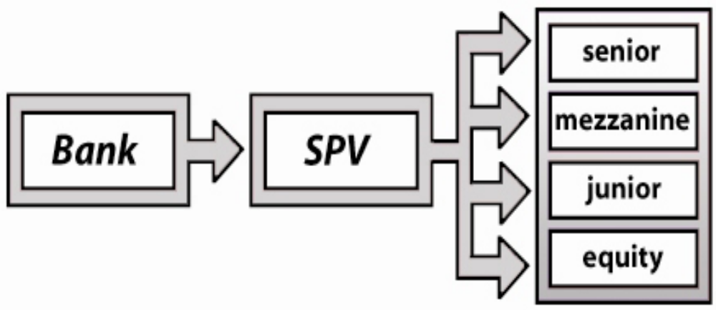
The process of securitization is comprised of

- Ramp-up period
- Cash-flow period
- Unwind period

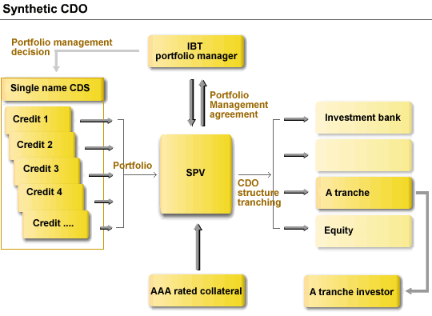

To complete the process, Special purpose vehicles (SPV) with securitization payments do it in form of tranches. A collateralized debt obligation squared (CDO-squared) is backed by a pool of collateralized debt obligation (CDO) tranches.

This is identical to a CDO except for the assets securing the obligation. Unlike the CDO, which is backed by a pool of bonds, loans and other credit instruments; CDO-squared arrangements are backed by CDO tranches.

The reasons for current US recession

The economy was at risk of a deep recession after the dotcom bubble burst in early 2000 and September 11 terrorist attacks. Central banks around the world tried to stimulate the economy by creating Liquidity. However lenders approved subprime mortgage loans to borrowers with poor credit.

Consumer demand drove the housing bubble to all-time highs in the summer of 2005, which ultimately collapsed in August of 2006. This Increased foreclosure activity. Declaration of Bankruptcy by large lenders and hedge funds went immensely high. Fears gripped the market regarding further decreases in economic growth and consumer spending.

Above all biggest Culprit of current sub prime crisis can be attributed to the behavior of Lending funds to the people with poor credit and a high risk of default. The result was obvious.

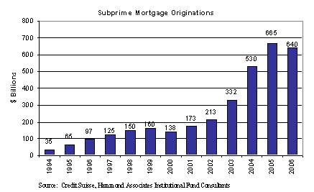
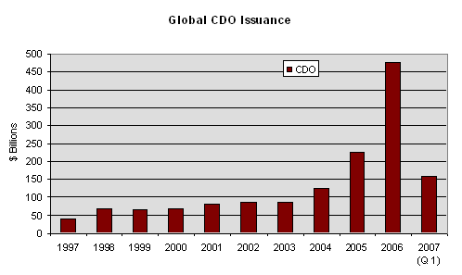Credit rating agencies and bond insurers played major roles in the disconnect between the true credit quality and promised performance of the securities. If the ratings had been more accurate, fewer investors would have bought into these securities, and the losses may not have been as bad. Rating agencies were enticed to give better ratings in order to continue receiving service fees, or they run the risk of the underwriter going to a different rating agency. Investors were the ones willing to purchase CDOs at ridiculously low premiums over Treasury bonds. Investors are also responsible for the whole mess because it is up to individuals to perform due diligence on their investments and make appropriate expectations. Another party that added to the mess was the hedge fund industry. It aggravated the problem not only by pushing rates lower, but also by fueling the market volatility that caused investor losses.
Chapter 11

Derivatives in Islamic Finance

It is generally perceived that derivatives in Islamic Finance are not permissible. In totality, this perception is not correct.

Derivatives in their object are financial products, whose prices are derived from the value of something else. So basically derivatives are financial products for trading risk. They came in to existence on becoming financial markets volatile, so in fact they are products for hedging risks, but on market expansions and becoming profitable, they turns lucrative for speculators as well, and at this point, risks enter in to the business.

Islamic Finance in its operation is also subject to such risks. However, while managing such risks, it has to follow some basic principles that are; should be riba free, should avoid uncertainty, should have some underlying asset and in transactions to ensure real possession and not to make any investment in some haram business.

In derivatives, no real transaction takes place in most of the cases, with no transfer of ownership, so apparently it dose not have any place for Islamic finance. Secondly derivatives unbundle risk from real economic activity, making it a commodity separate from real economic activities, so in this form, it is also not acceptable. In fact derivatives make the economy more risky in this form.

Islamic approach for defining risk has been explained by Ibn Taymiah (728H-1328G) as: Risk falls in two categories: Commercial risk, where one would buy a commodity so as to sell it for profit, and rely on Allah for that. The other type of risk is that of gambling, which implies eating wealth for nothing. This is what Allah and his Messenger (peace be upon him) have prohibited.

Considering commercial risk, Ibn Taymiah further explains that reward of deed (or business) should be based on their usefulness and not on their hardness. In other words, value of an economic decision should not depend on, how much risk one intends to take, but should be determined by wealth it creates and value it adds. So risk is appreciable, in case it creates wealth and adds value. In this respect hedging techniques in derivatives qualify for Islamic finance, which is generally denoted for neutralizing and minimizing risks. However the matter is not very simple as it appears. Shariah does not approve zero sum nature of derivatives; hence to design hedging products without maisir (betting) is a challenge for Islamic Finance.

Going forward, the question of conditions comes in, under which risks can be tolerated. Generally Muslim scholars agree that with following conditions risk can be tolerated; 1) it is inevitable 2) it is insignificant 3) it is unintentional.

It is generally agreed that willingness to take risk is essential to the growth of a free market economy; however Shariah does not allow pure exchange of liability (risk) for a given price. In other words, it has to be ensured that failures should occur less than that of success. From Islamic perspective, uncertainty in the market requires the decision makers to take proper causes to achieve desirable results, and entrust Allah to avoid possible but less likely failures. Example is of lottery, where winning prize is not sure; hence it is not permissible in Shariah.

Islamic finance promotes positive sum game instead of zero sum game. Example is of Musharkah where both or all partners gain, if the project succeeds and lose if it fails. Hedging in Islamic Finance has to follow this principle.

The possible hedging strategies in Islamic Finance are outlined as:

- Economic hedging.
- Cooperative hedging.
- Contractual hedging.
Economic hedging stems from the decision makers and needs no explicit arrangements. 1) The oldest example is of diversification 2) Another example is of alignment of assets and liabilities, since in most of the cases, risks come from the asymmetry between revenues and costs or assets and liabilities. “Khan and Miraokhor” of IMF, in their paper on Islamic Finance, has pointed out that Islamic banks are supposed to enjoy much more symmetric and aligned balance sheets and thus much more stable structure. Thus alignment of balance sheet appears as an essential property of the Islamic system. Aligning assets and liabilities to reduce interest rate or currency risks is also called natural hedging. Balance sheet hedging can be done by altering asset and or/liability repricing characteristics or volumes to reduce interest rate risk exposures. An exporter with US$ liability can hedge its currency risk through his export proceeds or a bank can reduce its currency risk by managing ‘multicurrency based share capital”. A Scandinavian Bank did this by reconstituting its Sterling capital in four currencies: US$, Swiss frank, Deutsce Marks and Sterling. If share capital is denominated in a mix of currencies to match the volume of business assets and liabilities, then capital ratios will not change by much during exchange rate fluctuations. 3) Another example is to find out a portfolio that pays the same payoff as the derivatives pay at maturity without any payment except the initial investment.

In cooperative hedging the economic problems are solved through cooperation rather than for profit arrangements 1) one example is of Islamic insurance (Takaful). The main difference between conventional insurance and Takaful lies on their liability arrangements. A conventional insurance is liable to pay the claims regardless of the size of available funds from subscription. Islamic insurance on the other hand is limited by the size of available funds: if funds are not sufficient, then either policy holders would voluntarily contribute the deficit or the compensation would be reduced in proportion. In this way, limited liability structure enhances incentives to monitor and discipline the members to avoid exploiting the system thus reducing problem of moral hazard. AIG of US is one of the recent examples that have been bailed out by the government since it was unable to meet its claims due to its high exposures. 2) To hedge currency risks, Islamic institutions can establish a cooperative fund to diversify the risk of its members efficiently, having different risk profiles. 3) Bilateral mutual adjustment mode can be used to design bilateral risk sharing between the financier and the customer in ordinary Islamic Finance. In case of lease agreement the same can be renewed mutually but in case of Mudarbah the risks can be shared by speeding up the payments in case mark up goes up or by lowering amount of installment with longer period payments, in case rate of returns comes down.

The strategy of contractual hedging focuses on contractual instruments. In case of Mudrabah, normally three kinds of risks are involved i.e. 1) risk of misreporting 2) risk of loss 3) risk of liquidity. Risk of misreporting can be avoided by due diligence and careful examination of companies requesting finance. Further Credit Based Mudarbah can be used for this purpose as well i.e. bank will not provide capital except after the transaction or deal is closed. This is based on Hanbali view that Mudarbah essentially is a labor contract and thus capital or money needs not be paid upfront. In Mudarbah and in most form of partnership (Musharkah), investor faces downside risk.i.e risk of losing their capital. One alternative to avoid this kind of risk is to combine deferred sale with partnership. For example, the financier instead of providing money to the company would sell required inputs, say, in return for a deferred price plus a deferred share of the company’s assets. This allows the financier to hedge the downside while share in the upside. Another way to hedge the downside risk is through a third party. The investor provides money to the company through Musharkah by which the financier becomes the passive shareholder in the company. This allows him to sell all or part of his shares to the third party. The remaining shares if he keeps, allow the investor to participate in the company’s profit, while the deferred price protects his investment.
Sale with deferred price or Bay ajil is common in Islamic finance. It carries three kinds of risks. They are: Credit risk, liquidity risk and rate of return risk. Credit risk can be treated mostly, the same way conventional credit risk is i.e. by taking collateral and guarantees and for late payments to charge the customer and add to his debt. Since deferred price is a monetary debt so under Shariah principles it can not be sold for cash. This means that on long term basis, bank can face liquidity risk. For this, there are two solutions i.e. to exchange debt with commodities or to combine monetary debt with real assets in to one portfolio with debts not exceeding 50% (on %, Shariah scholars in Pakistan allows it up to 67%) and then securitize the portfolio. Since the deferred price is a debt, it can not be increased after the sale is concluded. For this, parties can address it, by changing the installment amount, in case rates vary on higher or lower side. Deferred price structure can also be diversified through deferred price Sukuk. These Sukuks are different from commodity linked bonds in a sense that bonds pay money in exchange for money while a diversified price pays in kind and money in exchange for a good.

Currency risk in Murhabah (principal+ markup) can be transferred to counterparty. For example if an Islamic bank provides Murhaba to a customer in Euro but capital is in US$, the customer (debtor) shall pay in US $ instead of Euro. The customer may not like to take the risk so he may arrange a forward with his bank ( say a conventional bank) who may pay a payment guarantee to the Islamic bank in US$. If the customer is an Islamic entity that may not use forwards than the deal can be done through parallel Murhabah: the Islamic bank would sell to the customer’s bank in US$, which in turn sells to the customer in Euro.

Salam is another Islamic product that means advancement of payment in exchange for a specified quantity of a defined good that provides financing to the seller as well as price discount to the buyer. The main problem with Salam is the price value of the good at maturity that can change. This problem can be solved through value based Salam i.e. value rather than the quantity is determined upfront, hence quantity alters at change of value. This arrangement has been approved by Ibn Taymiah.
Islamic Finance is not very simple to adopt and requires lot of work to do on its financial engineering, in order to make it a reality.

Chapter 12

Derivatives Market in Pakistan

In Pakistan derivatives came first in form of Stock futures in 2001 that were not cash settled, however in 2003, the cash settlement was allowed. So now deliverable futures are available on 30 days settlement basis (discontinued by SECP on April 8, 2009), whereas cash settled futures are available on 30, 60, 90 days basis. Stock index futures are also available now in a number of contracts. Each contract is to buy or sell a fixed value of the index. Stock index future contract occurs 90 days after the contract is purchased. In addition Options are also on cards. However future market has not picked up significantly due to the reason that customers mostly prefer in ready trading (T+2) or CFS (having less than one month settlement/now discontinued by SECP without providing any instrument for leveraging) in absence of price discovery and due to convergence mechanism. Hence volume in derivatives on stock is mostly reflected in 30 days futures.

Another platform for derivatives in Pakistan is National Commodity Exchange Ltd (NCEL) with 3 month futures in gold. It now undertakes NCEL 10 tola futures, NCEL mini gold futures, NCEL Irri rice-6 futures and NCEL Palm oil futures. Trading volume on this exchange has remained thin in the past due to significant rise in the commodity prices last year. Now with downward trend and later with less volatility in prices, the exchange is expected to revive its business in the time to come.

SBP issued first of its instructions on derivatives through its Financial Derivatives Business Regulation (FDBR) in 2004. The purpose was to develop formal OTC market in Pakistan. The regulations permitted FX options, Forward Rate Agreements (FRAs) and Interest rate swaps (IRS). Other products including Cross Currency Swaps (CCS) were allowed to be approved on case to case basis by the SBP. Under these regulations on date, five banks i.e. Chartered Bank, Citi bank, Deutsce bank, Royal bank of Scotland and UBL are the authorized dealers.

Table.1 Derivatives Market in Pakistan (FY07 and FY08)

PKR in billion | H1FY07 | H2 FY07 | H1FY08 | H2FY08
IRS* | 78.4 | 80.0 | 84.0 | 106.9
CCS | 30.1 | 89.6 | 156.3 | 194.9
FX options | 10.9 | 42.5 | 47.3 | 88.7
FRAs | .2 | .3 | .0 | 2.6
Total | 119.6 | 212.4 | 287.6 | 393.1
*Includes IRS in PKR and FX
The data in Table 1 reflects growth of derivatives market of Pakistan (OTC) by 229% just in two years. The largest segment in this remained cross currency swaps with almost 50% share in overall transactions. The main factors behind these contracts were almost stable exchange rates (up till H1 FY08) and increase in discount rate i.e. widening of gap between KIBOR and LIBOR. Though SBP allowed these transactions to those corporate who were naturally hedged against exchange risk (on the basis of their export proceeds) but when PKR declined significantly, the corporate felt the pinch. Telecom, Textile, Cement, Fertilizer, Sugar, Refineries were the main sectors who were engaged in the CCS. Now it seems that most of them are on their way to wind up their contracts with final position to emerge on finalization of data for H1 FY09.

Contrary to CCS, FX options became lucrative in H2 FY08 for Corporate to hedge their exchange risk when exchange rate came under pressure particularly in this period. Fertilizer, Telecom, Cement, textile and automobiles were the main contributors of this contract. The activity could have and can increase further in case SBP allows $/PKR option not available as yet. Currently transactions on FX options are allowed against G7 currencies only.

IRS has also shown substantial growth on the basis of rising interest rate scenario. Telecom, Textile and cement were the main contributors for the contract. Since IRS includes FCY IRS as well, hence its volume can probably go down in H2 FY09, since one of its contributor i.e. GOP has concluded its contract against Eurobond in Feb, 09. The contract had a share of 42% in total volume of FCYIRS.

FRAs and IRS are one and the same product in terms of structure i.e. continuation of FRA means IRS. Both can be floating against fixed or floating against floating rate of interests. However in both cases prime requirement is to have price discovery which is non existent since no interbank market exists in Pakistan in this regard as yet. Only 3 authorized dealers or one or two banks have been found active in the IRS/FRAs market. Till some activities are generated on interbank level, one may not expect growth of swap market in Pakistan.

The case of $/PKR currency swaps are somewhat different as activities generated in them are demand driven to meet SBP requirements against banks short/long position in their FC exposures.

Liquidity meltdown and volatility in rates are going to effect derivatives volume in H1 FY09 in Pakistan; however importance of derivatives as hedging tool can not be denied. For this regulations are required to be made further stiff with proper capacity building in institutions for dealing in derivatives business.

The revival of derivatives market in H2 FY09 depends on market performance taking its clues from macro indicators on track towards recovery. However caution would prevail in the market till recession is countered not looking possible prior FY10.

The same holds good for the world market as well. Along with fight against recession, countries are also serious enough in containing demon of derivatives within safe limits to get benefit out of its activities without getting their fingers burnt.

Commodity futures contracts have recently been introduced from the platform of National Commodity Exchange Limited Karachi. Currently they only trade in Gold futures and plan to expand the contracts on agricultural commodities and interest rates.

SBP took initiative in 2004 by granting Authorized Derivative Dealers (ADD) license to five commercial banks

Pakistan has got volatile financial markets due to:

- Political Uncertainty
- Monetary Policy
- Fiscal Policy
- Foreign Investment/Disinvestment
- War On Terror
- Who need them
- Equities/Interest Rate/Currency Portfolios
- Mutual Funds
- Pension Funds
- Banks
- Majority Stockholders/Owners
- Foreign Investors
- Corporate
- Farmers

SBP approved Derivatives

FX Options

Dealing in FX option is permitted in G-7 currencies only with 1 year tenor and the restriction to cover them on back to back basis by the ADDs/NMIs

Interest Rate Swaps

Dealing in IRS is permitted in PKR Rupees only up to 5 years tenor

Forward Rate Agreement

Dealing in FRAs is permitted in PKR only up to 24 months tenor

Derivatives at Bourses

Karachi Stock Exchange is the biggest stock exchange of Pakistan

As on December 31, 2007, 654 companies were listed with the market capitalization of Rs. 4,329,909.79 billion (US $ 70.177) having listed capital of Rs. 671.269 billion (US $ 10.880 billion)

KSE has been well into the 6th year of being one of the Best Performing Markets of the world as declared by the international magazine “Business Week”

Products | Settlement Basis | Since
Ready Market | T+1 | 2001
Deliverable Futures | 30 Days | 2003- discontinued in 2005 but now again rehabilitated
Cash Settled Futures | 30, 60 & 90 Days | 2007
COT (Stopped in 2006) | T+22 | 1994
CFS (Stopped in 2009) | T+22 | 2005
Stock index Futures | 90 days contract | 2008
7 days cash settled Futures | 7 days | 2010

On coming products include Margin Financing (in place of CFS) and options with 90 days settlement basis

Within 5 years, the volume of trades in Derivatives is expected to reach 50%of the total trading volume at the KSE. However currently it is quite dismal. NCCL has started disseminating data for futures from 2010 onward. During Jan-June 2010, Futures have been seen trading with contracts of 211,479 / month. In this institutional participation is very thin i.e. companies, banks/DFIs/Mutual funds/n NBFCs/Foreigners with a participation of 3.7%, 1.12%, 0.05%, 1.97% and 0.18% respectively. This makes around less than 10%. Remaining above 90% is being participated from individuals and that is too up to 30 days futures. It may be noted that before 2005 the volume of futures trading at KSE came about 40-50% of its trading volume, however it came down drastically after March, 2005 crisis. Some analysts suggest that the March 2005 crisis was due to delivery pressures on account of Deliverable Future Contracts, concluding in the fourth week of March 2005

To prevent another crisis, the Securities & Exchange Commission (SECP) had advised the KSE to introduce Cash Settled Futures

Non-Deliverable Future Contracts or cash settled futures have been introduced in 2007 but in 2010, SECP have again reintroduced deliverable futures mainly due to silent market of cash settled futures

Non-Deliverable Futures have not gained momentum due to:

  - Absence of price discovery & convergence mechanics
  - Presence of scrip level circuit breakers, as opposed to Market halts

National Commodity Exchange Ltd (NCEL) now named as Pakistan Mercantile Exchange (PME) is the first technology driven, de-mutualized, on-line commodity futures exchange in Pakistan

PME shareholders are Karachi Stock Exchange, Lahore Stock Exchange, Islamabad Stock Exchange, Pak Kuwait Investment Company (Pvt.) Limited, and Zarai Taraqiati Bank Ltd

PME is regulated by Securities and Exchange Commission of Pakistan.

PME has formally started rice trading based on three-month futures contracts becoming the country's first electronic commodity trading platform.

PME had first started operations on May 11, 2007 with three-month futures trading in gold and the first delivery was successfully executed in mid-August

Later on PME has also launched futures related to following commodities:

- Cotton Seed
- Oil Cake
- Palm Oil
- Rice Irri-6
- Interest rate futures
- Furnace oil

Writer’s Profile

Muhammad Arif has served SBP for more than 30 years. Basically he remained involved in catering money market activities, interest rate management and market product development. After leaving SBP in 2007 as Head of Financial markets and Strategy Department, he served as Head of Research of Arif Habib Investments. Now he is Research Consultant to ‘The Financial Daily’ a notable English newspaper and member of the visiting faculty on the subjects of Financial Management/Investment Banking/Islamic Economics at Sheikh Zayed Sultan Institute University of Karachi and BIZTEK. During his tenure of service he also served on deputation to the UN Poverty alleviation group in Bangkok on development of Fixed Income Market in Pakistan. He also remained member of Task Force of IFSB, a Malaysian based group of Islamic countries on development of Islamic Finance. He also remained member of Investment Committee of Access to Justice Fund of Supreme Court of Pakistan. He also represented Pakistan in 28 member group formed in Bangkok under Chiang Mai declaration on development of fixed income Market in these member countries. Further to these he has also represented Pakistan in different forums in other countries on issues pertaining to development of financial markets in various jurisdictions.

