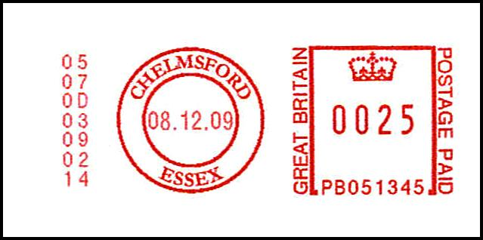

Editor: Alastair Nixon, 7 Bramblegate, Edgcumbe Park, Crowthorne, Berks, RG45 6JA. Tel: +44 (0) 1344 775378

Email: alastair@nixon48.freeserve.co.uk Web site: http://www.meterfranking.co.uk

.

Meter of the Month

In June 2004, my Meter of the Month on page 44-1 showed an ‘item number 1’ on a PB5 series meter. This was an ‘Invalid’ test item made by the engineer who installed the machine. Since then, I have naturally assumed that all first impressions from Pitney Bowes machines would be test items, but it appears that this is not always the case. My Meter of the Month this month is a PB0 series ‘item number 1’ that has been applied on live mail.

Editorial

Let’s take a look back at the main events for 2009. January saw the launch of the Frama ‘Matrix’ (F1-series) machines in the UK, although the first live example was not found until September. The Neopost N105-series (IJ-25 machine) appeared in June, but only a few examples have so far been seen. Abroad, Pitney Bowes launched their ‘DM Infinity’ systems but no examples have so far been identified in the UK. The only new Pitney Bowes sub-series to make an appearance during 2009 was the prefix PB148 on the DP200 machines.

In order to counter the increasing competition from independent carriers, Royal Mail increased the discount rates to meter franking users and even further savings are now being offered to Advanced Mail users. This has inevitably resulted in the continued rise in the number of users applying their franks in blue ink, although the vast majority of examples are still to be found on the larger FC, PB5 and N12 series machines.

The recession during 2009 has taken its toll on businesses and maybe explains the quiet year for new machines. That does not, however, mean that we have been starved of news and, indeed, I produced a record number of pages (118 in total) during the year. I am enormously appreciative of the continued support from all contributors throughout 2009.

Membership & Acknowledgements

This month I would like to extend a warm welcome Michael Dobbs as member number 0030. Michael is the Hon Secretary of the (British) Forces Postal History Society. Michael collects BFPO meter franks as well as the Access meter franks from the 1980s (see page 76-4). Michael is also a keen collector of PPI (Printed Postage Impression) marks and is currently attempting to write-up the history of PPIs.

My thanks this month go to Jim Ashby, David Crotty, Richard Goring, Peter Huss, David Jones, Peter Mantell, Stafford May, Richard Peck, Rick Stambaugh, Peter Wood and Ray Woodward-Clarke for their reports and communications.

Latest Numbers
Below is the list of ‘Latest Numbers’ as at 30th December 2009 – with updates shown in red. Please could I have the next reports by 29th January, thanks.

Frama (UK)

Matrix F2 F1000228 23.11.09 Reported by AN

EcoMail FSC356030 06.11.09 See MN 109

MailMax FSC909446 04.09.09 See MN 107

Francotyp-Postalia

Optimail? B 0788095 23.03.09 See MN 101

Optimail T402872 12.10.09 See MN 108

Optimail 30 F04111990 03.11.09 See MN 109

Centormail FC5110374 27.11.09 Reported by RG

Mymail FM2119677 13.08.09 See MN 109

Ultimail? FU3115176 23.11.09 See MN 109

Neopost

IJ-25 N1050457 17.12.09 Reported by PM

IS-350 (Ex IJ-25) N1172178 20.11.09 Reported by SM

IJ-65 N1208315 30.10.09 See MN 109

Various upgraded N1240468 05.11.09 See MN 109

IJ-80/90/110 N1254046 20.11.09 See MN 109

Various upgraded N1290032 01.06.09 See MN 104

IJ-35/45 N1317911 12.10.09 See MN 109

IS-460 (Ex IJ-50) N1373322 03.03.09 See MN 101

IS-420 (Ex IJ-30) N1384887 04.06.09 See MN 104

IJ-40 N1390202 01.12.09 Reported by PM

IS-480 N3009103 06.11.09 See MN 109

Pitney Bowes

DM50, 55 PB051497 03.12.09 Reported by AN

DP200? PB130194 01.12.09 Reported by AN

DP400? PB143208 08.06.09 See MN 106

DP400? PB148004 03.04.09 See MN 105

Personal Post PB294355 21.12.09 Reported by PM

DM 200? PB311641 15.01.09 See MN 107

Personal Post PB499249 18.08.09 See MN 109

DM 550 etc. PB525944 21.10.09 See MN 109

DM 400C / 450C PB613783 14.12.09 Reported by PM

Post Perfect PB764228 08.10.09 See MN 108

DM100i PB844288 05.11.09 See MN 109

Advanced Mail

AABJ-LC N1253924 07.07.09 See MN 106

.

Last month, in error, I listed the Frama Matrix entry under Francotyp-Postalia – my apologies.

Dead Series updates


Until now, the lowest recorded number for the ST22 series (DP200 machine) was ST220587. Richard Goring now reports ST220574 – see below. It is interesting to note that the item count has only reached 002576 in 8 years, as the machine would have been new in about Feb 2002. I suppose that it is just possible that the item count has been ‘around the clock’ in that time.

Your editor reports a highest number for the 5450/5460 machine, with item 5NE19616 dated 19.9.07, shown below. Previously, the highest number recorded was 5NE19565. Note the unusual underlining of the words ‘Return Address’.
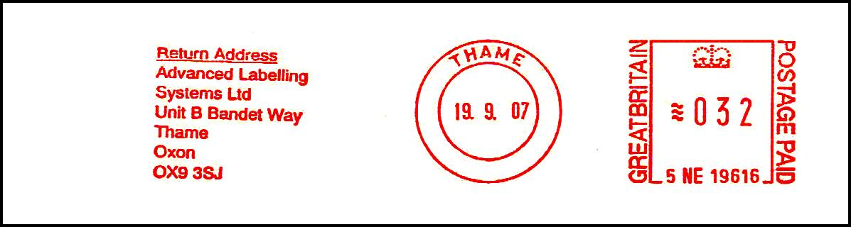

Royal Mail Franking User Guide

The Royal Mail web site currently has a ‘Franking User Guide’ that can be downloaded. It contains an interesting section on the topic of ‘Correcting mistakes’, as follows.

“If you frank your mail with the wrong date, put a line through the incorrect date in black ink, adjust the date on your franking machine and set the postage to £0.00. Then re-frank the envelope with the correct date on the reverse. Alternatively, frank a label with zero postage and the correct date, and place it on the envelope to the left of the original impression, covering the date but not the postage paid.


If you miss the last acceptance or collection time and your mail is already franked, it’s best not to post it. Instead, follow the instructions above.

If you frank your mail with insufficient postage, add another impression with the necessary amount to the bottom left-hand corner, franking the shorter edge of the envelope. Alternatively, frank a label with the extra amount and place it to the left of the original impression.

If you frank your mail with too much postage, remove the contents and start again with a new envelope. Retain the over-franked envelope or label - you can apply for a refund by sending it to Royal Mail within six months of the franked date as per the Royal Mail Scheme for Franking. Call 08457 950 950 for more information.”

The web address for the User Guide is:

http://www.royalmail.com/portal/rm/content3?mediaId=3100008&catId=600024

Recent Interesting Items

Further to page 105-1, Peter Mantell has come across two further examples of a missing date in the town dies produced by Francotyp-Postalia Optimail machines.




Peter’s brother, Martin, has kindly supplied the second example and it comes with an interesting and very feasible story. Martin’s company, Colborne, has recently upgraded their franking machine – and this is what happened. Apparently, before a machine gets sent back to the manufacturer an engineer comes in to decommission it. The engineer’s initial task is to ‘empty’ the machine of any remaining credit by printing-off a selection of meter impressions onto labels. Only the engineer knows the code to enable this, and these final impressions have no date! The user is then able to apply these labels onto envelopes at a future date and is supposed to fill in the date on which it is applied in red ink.

My initial reaction is that this process makes a lot of sense, but why have the only examples been seen from Optimail machines? Then I recalled the Pitney Bowes items on pages 19-1 & 31-3 that had peculiar second town dies with no dates. Is it possible that somehow these were also special dies associated with decommissioning? As a reminder, here are the illustrations:
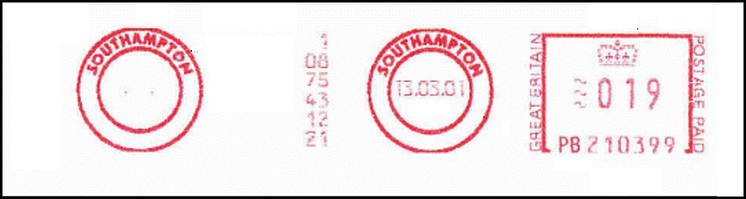

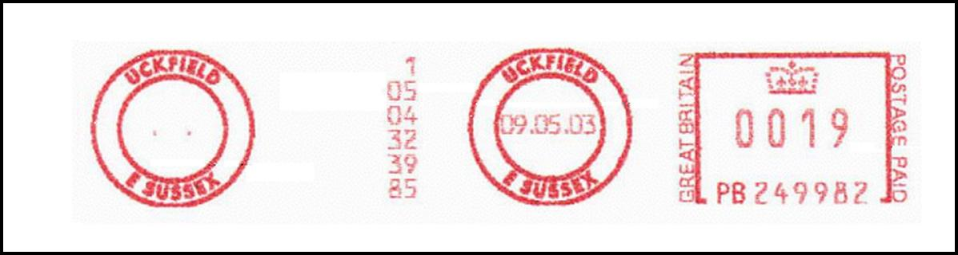

Recent Interesting Items continued

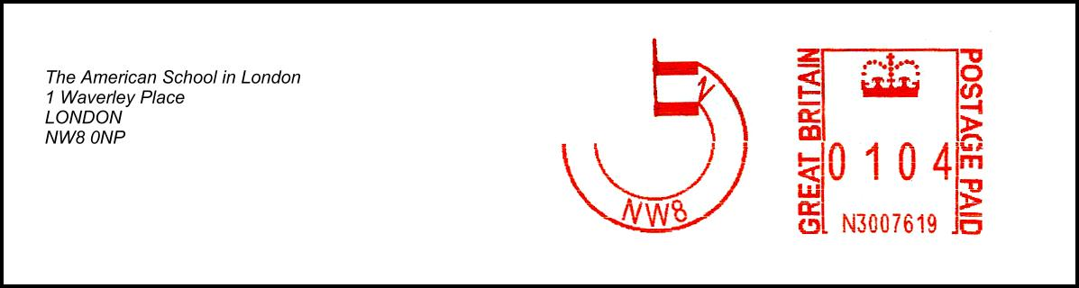
Richard Goring reports another strange printing error – this time from an IS-480 (N3 series) machine, resulting in the date failing to print. It would be interesting to know whether a whole batch of frankings are affected by such errors, or whether the are generally ‘one-offs’. The lack of Royal Mail date correction handstamp would tend to suggest the latter in this particular case.

Further to pages 98-6 & 99-5, Richard Goring reports another elusive Hasler ‘Z’ series suffix - this time with machine number HS01296Z from Banbridge, Northern Ireland. It is believed that, in total, there were about 300 HS-Z machines issued (starting at HS01100Z), but only about 35 HT-Z machines issued (starting at HT38000Z). It seems that about 95% of all of these refurbished ‘Z-series’ machines were allocated to businesses in Northern Ireland.
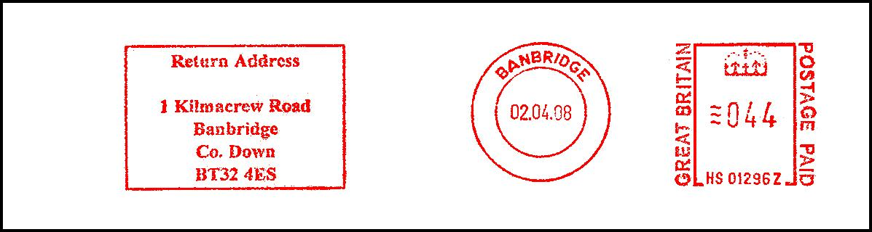

Peter Mantell reports two examples of spelling errors. The first is a mis-spelling of the town name, which should be ‘MIDDLESBROUGH’ - the slogan spelling of the college being correct.
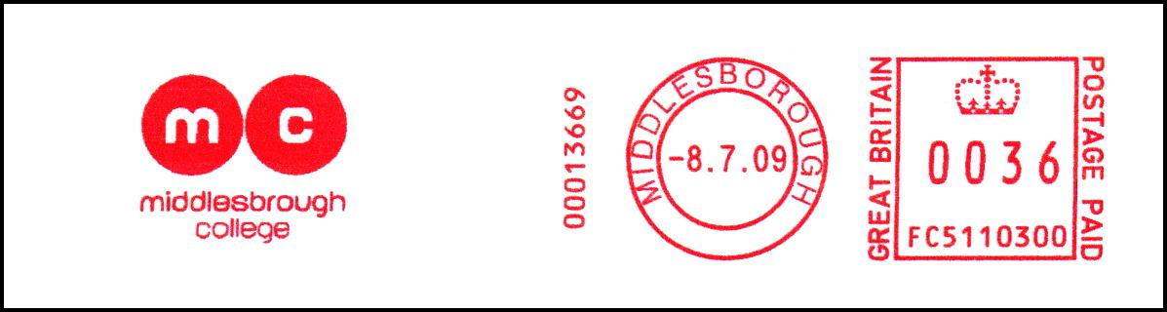

The second is a missing ‘s’ from the words “Return Address”:
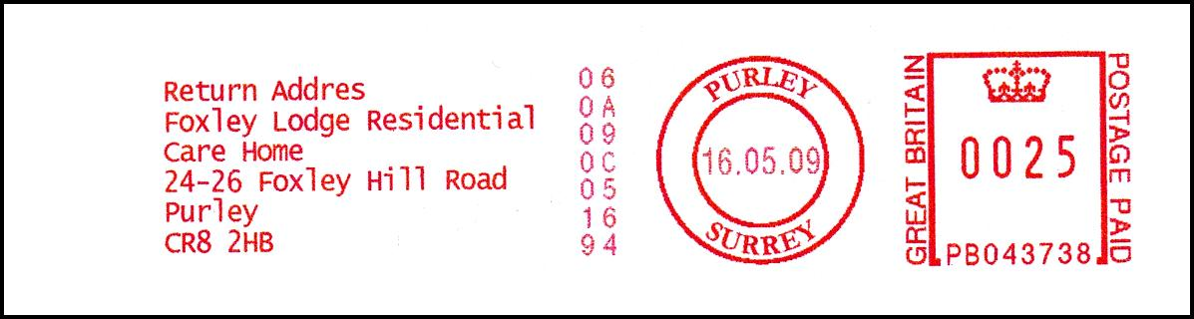

Recent Interesting Items continued

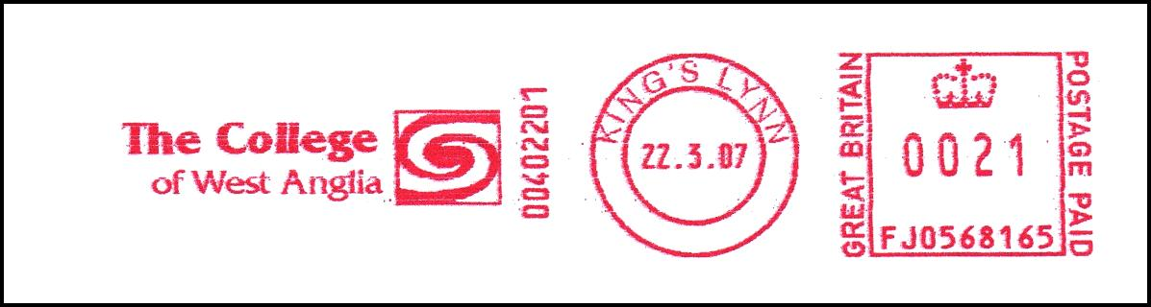
Peter Mantell reports an example of machine re-use with these two franks of FJ0568165 from different users. Your editor wonders whether the other manufactures have a similar policy for machine re-use, or whether a new licence number is always allocated.

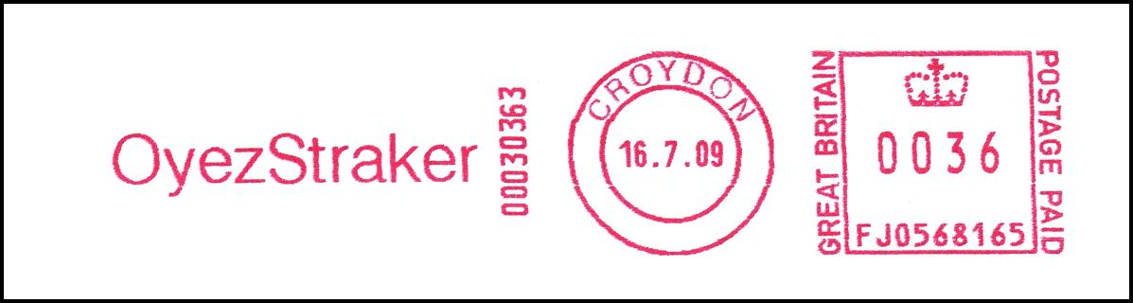

Peter Mantell reports another case where a machine is being shared between two users. On page 103-4, I illustrated frank N1240382 dated 09.04.09 from Littlehampton, with the town name in lower case font. The slogan in that example was shown as Arun District Council, Arun Civic Centre, BN17 5LF. Peter Mantell now reports an item franked on 01.07.09 by the same machine, but it bears a different slogan - namely “Inspire Leisure, Phoenix House, BN17 5NA”. The town name remains in lower case font.
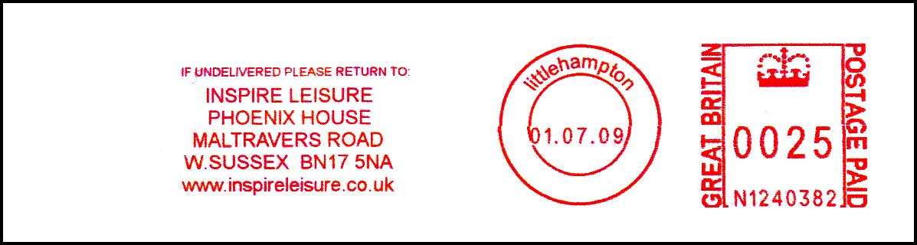

Furthermore, Peter reports that their previous machine, N1207222 (with town name correctly in upper case font) was also similarly shared. The following shows the ‘Inspire Leisure’ slogan, but examples of the Arun District Council version are also known from this machine.
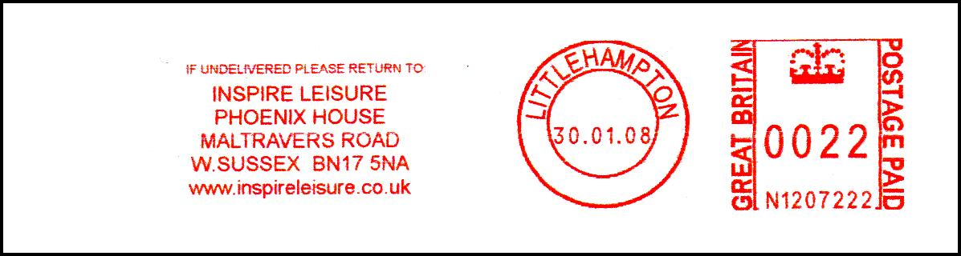

Instructional Markings

Richard Goring reports two more instructional markings. The first is another example of a Revenue Protection PPI label and handstamp applied at Glasgow Mail Centre.
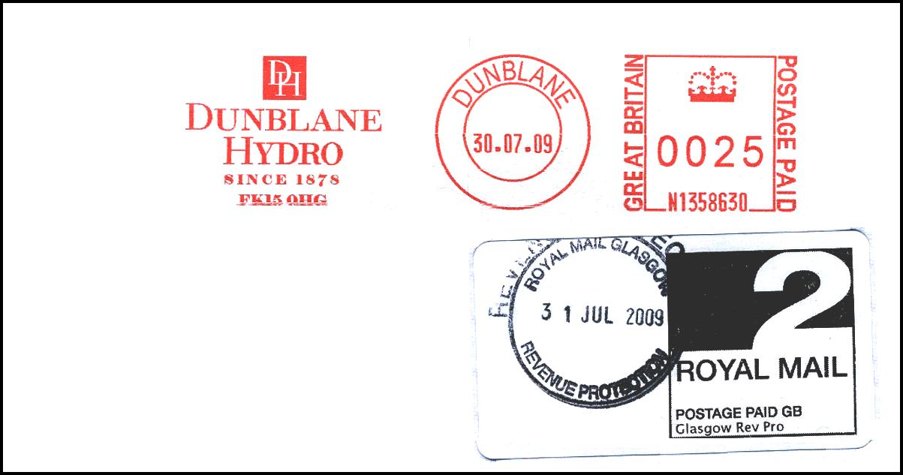

The second example shows a ‘2nd PAID’ overprint made by a stamp cancelling machine at Chelmsford Mail Centre.
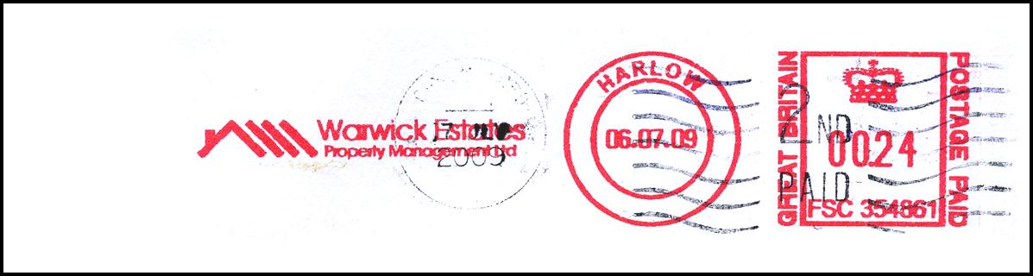

In contrast, Peter Mantell reports this more traditional 2nd Class Revenue protection handstamp applied to a 1st Class item at Preston Mail Centre:
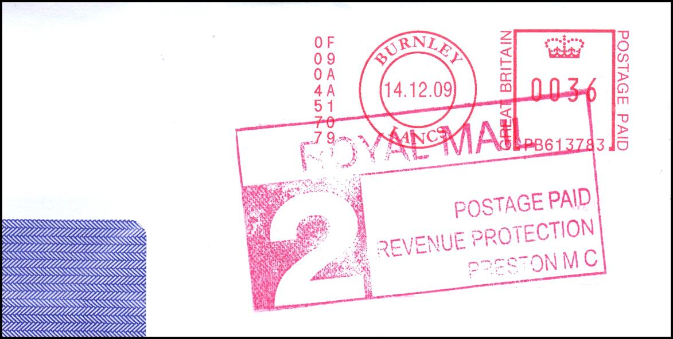

Historic Items

Jim Ashby kindly sends a scan of this interesting Frama card from 1984, advertising the ‘Philcard International’ Value Card. These Value Cards were the mechanism used to top-up the credit on the machines and were available from the distributors in amounts of £20, £100, £500 and £2000. The advertising card shown here was franked by an E4 machine, which had the serial number ‘MMC 40488’. The Swiss company ‘Frama AG’ entered the UK market in 1983 but it used a UK-based distribution company called ‘Mail & Mechanisation Co.’ – hence the prefix ‘MMC’. In 1984 the name of the distributor was changed to ‘Scriptomatic’ and the serial prefixes were accordingly changed to ‘FSC’. As we know, the FSC prefix is still used to this day. A total of about 260 machines were issued with the MMC prefix but, by the mid-1990s, virtually all of these machines had been replaced.

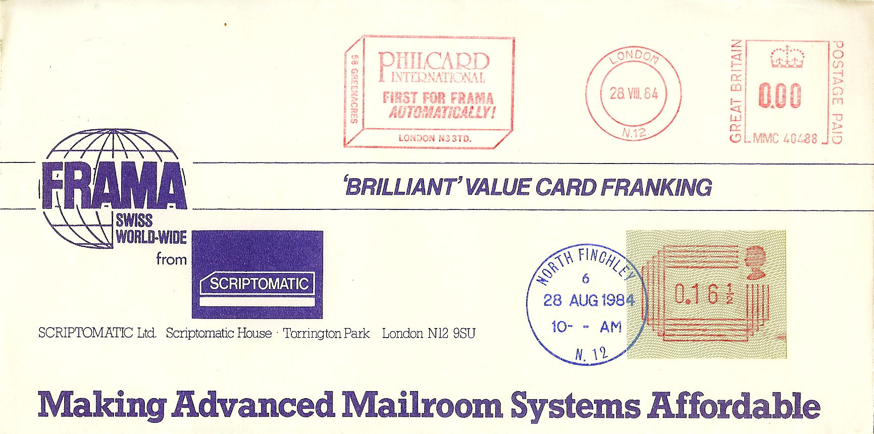

Further to page 108-11, Jim Ashby reports some further Post Office Saving Bank markings:
London W.14 | PAID. A^{D} | 30 NOV 1926 | Lettering is different to that in MN108-11
London W.14 | PAID. B^{D} | 30 NOV 1927
London W.14 | PAID. B^{D} | 21 JUL 1941 | Slogan: SERVE BY SAVING
London N7 | PAID D | 21 JUL 1941 | Slogan: KEEP ON SAVING
Lytham St Annes | PAID B.S.D | 16 JAN 1964 | As illustrated in Mann 1972 p 42
Manchester | PAID BD | 20 APR 1946 | Cut-out
Harrogate Yorks | PAID SB | 9 JAN 1953 | As MN108-11 but no lines at right
Harrogate Yorks | PAID SB | 30 NOV 1944
Richmond & Twickenham | PAID CD | 24 MAY 1952 | As Mann 1972 p 42 but without slogan
Richmond & Twickenham | PAID CD | 3 JUN 1949

Christmas Slogans

Very few 2009 Christmas slogans have been reported so far. Those that have been seen were standard ‘built-in’ slogans. Two Christmas slogans from Pitney Bowes DM50/55 machines have been recorded, the first is from your editor and the second is from Peter Mantell.
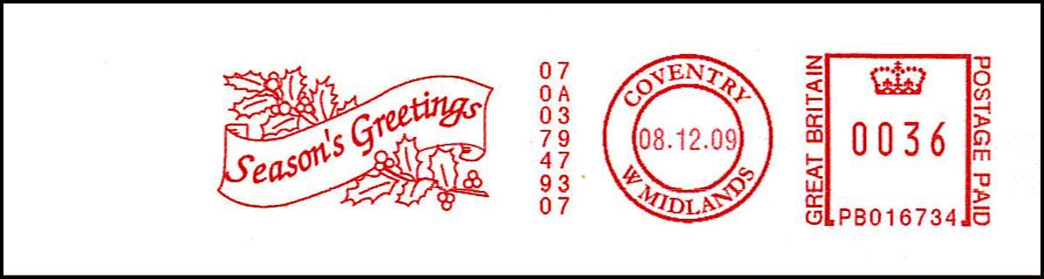

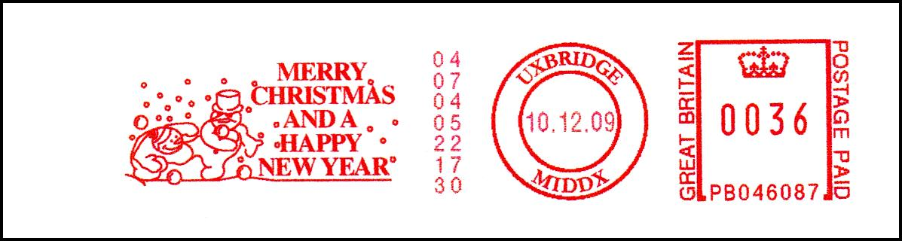

Your editor also reports this standard Christmas thematic slogan from a Neopost IJ65 machine:

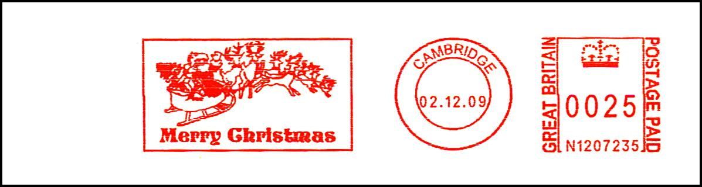

Your editor has also re-discovered this colourful Yuletide candle depicted on a SmartStamp from 2004.

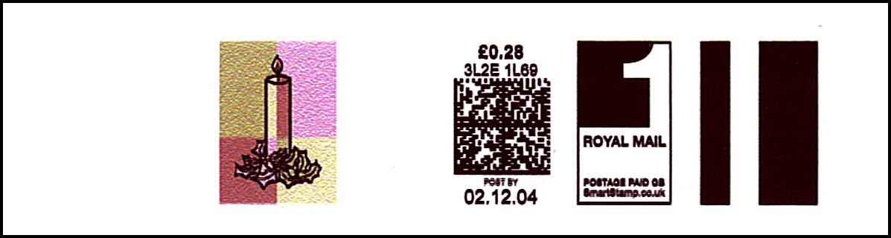

Meter Thematics

Further to page 108-12, Richard Goring sends another trireme design – this time adopted by a company called Yara UK Ltd., based in York.

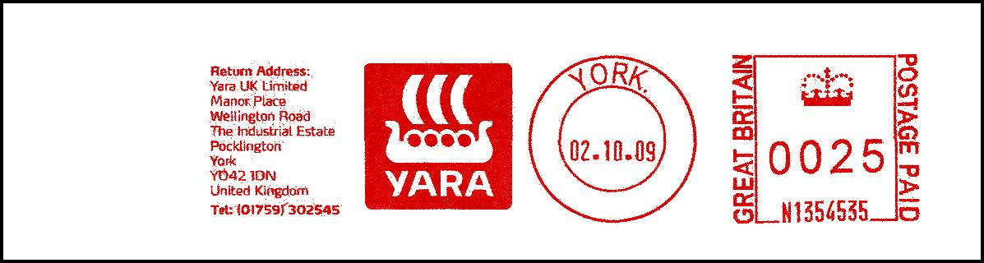

Peter Mantell has found this wasp design from the London Wasps Rugby Football Club:
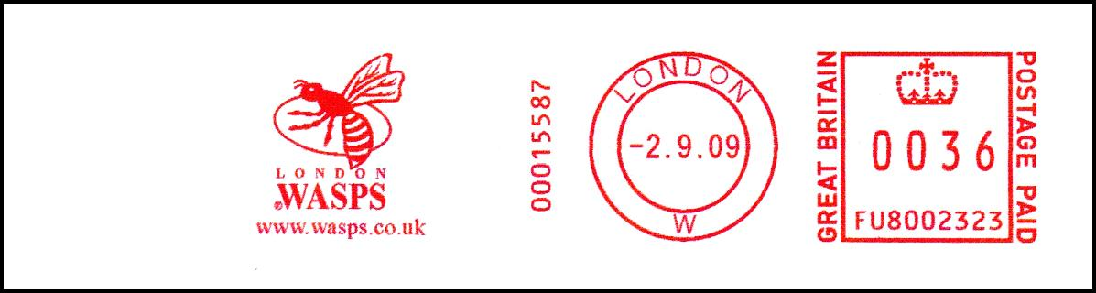

Staying with Rugby Football, Peter also sends this magnificent heraldry design from the Plymouth Albion RFC.

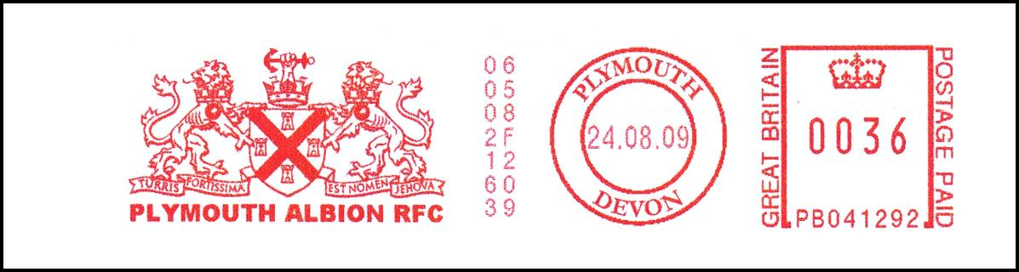

For my Meter Thematic of the Month, I rather like this chef design being used by a company called Surrey Gourmet, based in Dorking, Surrey – thanks again to Peter Mantell.



- - - End - - -

