iSupplier Portal
Sensing & Control
Reference Manual

Purchase Orders January, 2008

This document may not, in whole or in part, be copied, photocopied, reproduced, translated or reduced to any electronic medium or machine readable without prior, express written consent of Honeywell International Inc.

Table of Contents

Prerequisites 1
Objectives 1
Using the Reference Manual 1
Getting Started 2
System Requirements 2
Types of Notifications 2
Standard Email Acknowledgement & Acceptance 3
To Acknowledge & Accept a PO by Email 3
Honeywell Control Products Global Supply Management Web Site 5
iSupplier Portal Log on 5
First Time Log on 8
iSupplier Portal Home Page 9
To Access Notifications & Orders at a Glance 9
Working with the Home Page 10
Notifications 11
Orders At A Glance 13
Requesting Changes to POs 14
To Request Price Changes 14
To Request Quantity or Promise Date Changes 15
To Request Split Shipments 16
To Request Changes to Blanket Agreements or Releases 17
Navigation 18
Using Search Functions 19
Other Information 20
Log off 20
Help 20

Prerequisites
Prior to accessing iSupplier Portal you will need to complete a survey and attend iSupplier training. A sample of the iSupplier Portal survey is in the appendix of this manual. For training options contact your Honeywell S&C Buyer.

Objectives
This manual is designed to cover the basics of electronic acknowledgment and acceptance of purchase orders initiated by Honeywell Sensing and Control (S&C).
For information or requirements for iSupplier Portal enter the following URL in your internet browser.
http://content.honeywell.com/sensing/ve/
This site will provide you with a comprehensive guide to Honeywell’s Global Supply Management Organization.

Using the Reference Manual
The Sensing & Control User’s Guide for Purchase Orders will be used as a guide for the topics covered during training. Due to time constraints every feature many not be covered during training.
Left & Right Mouse Buttons
This manual assumes that the left mouse button is used as your primary mouse button and that the right mouse button is your secondary mouse button. When you see the instruction click, click your left (or primary) mouse button. When you see the instruction to right-click, click your right (or secondary) mouse button.
Shortcut Keys
When you see an instruction such as press Ctrl + X, this means to hold down the Ctrl key as you press and then release the letter X.
Notes

Notes: this will indicate an important item or process.

Getting Started
iSupplier Portal is a collaborative application that enables Honeywell S&C buyers and our suppliers to communicate with each other. As a supplier using iSupplier Portal, you have real-time access to view and acknowledge purchase orders, and the ability to respond with order acknowledgments and change requests.

System Requirements
In order to access the Supplier Portal, there are some basic system requirements. A personal computer with at least a 486 processor and 128K of RAM is required. An internet connection of at least 56K BPS is recommended.
Note: You may need to contact your IT department or email provider, to whitelist emails sent from wfxprod@honeywell.com.
Whitelist is the act of creating a rule in one's spam filter program that allows email from a particular destination (or matching other specified criteria) to be delivered to you even though the spam filter program would have ordinarily blocked it.


Note: You may need change your email security level setting to allow scripted messages. While using the Supplier Portal, it is recommended to close as many other applications running on your desktop as possible.


Types of Notifications
Email subject lines and document names will generally indicate the order type. The most common are: Standard PO, Blanket Agreement, and Blanket Release followed by a system assigned order number.
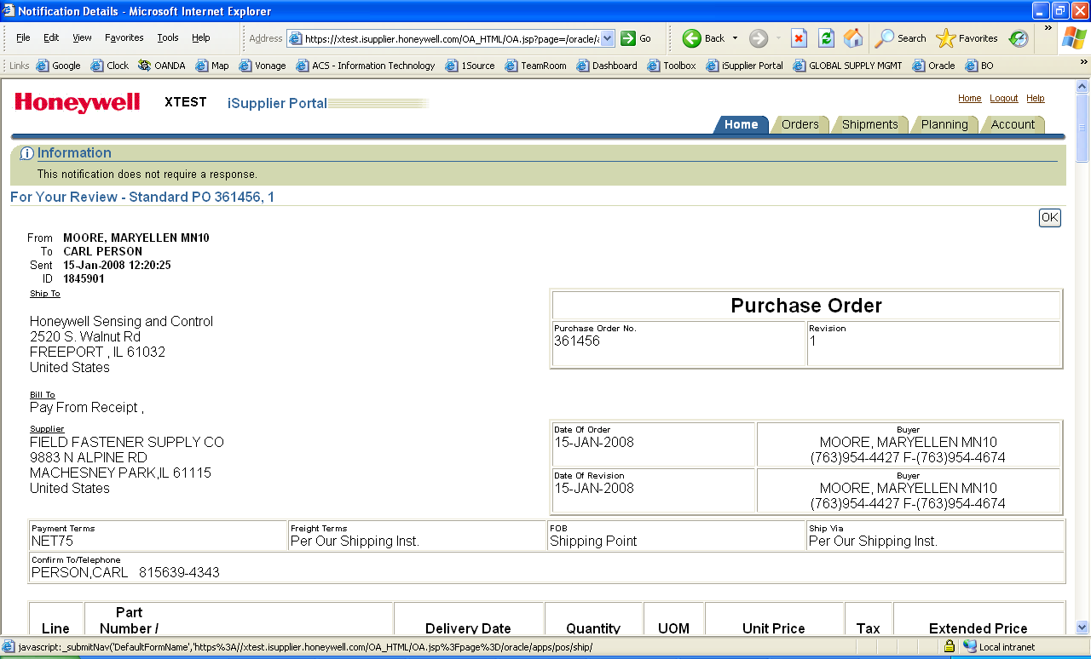
In addition to the document number there may be another number separated by a common and/or hyphen. A number listed after a comma indicates a Revision to the original order while a number listed after a hyphen indicates a release number against a blanket agreement.
Other notification listings may begin with, For Your Review . . . , or Response to your change . . . When you open these types of notifications an instruction at the top of the screen will indicate if any action is required by the Supplier.

Standard Email Acknowledgement & Acceptance
When a new purchase order or blanket release is created an email notification will be sent to the supplier’s designated mailbox & listed in the iSupplier Portal home page. There are two methods for acknowledging and accepting a purchase orders. This section will cover the “simple method” where no changes to the order are needed. For purchase orders requiring price, quantity or delivery changes the supplier will be required to log on to iSupplier Portal home page to request changes. This will be covered later in this reference guide.
All purchase orders require an acknowledgment of the purchase order by the supplier within 2 days.


To Acknowledge & Accept a PO by Email
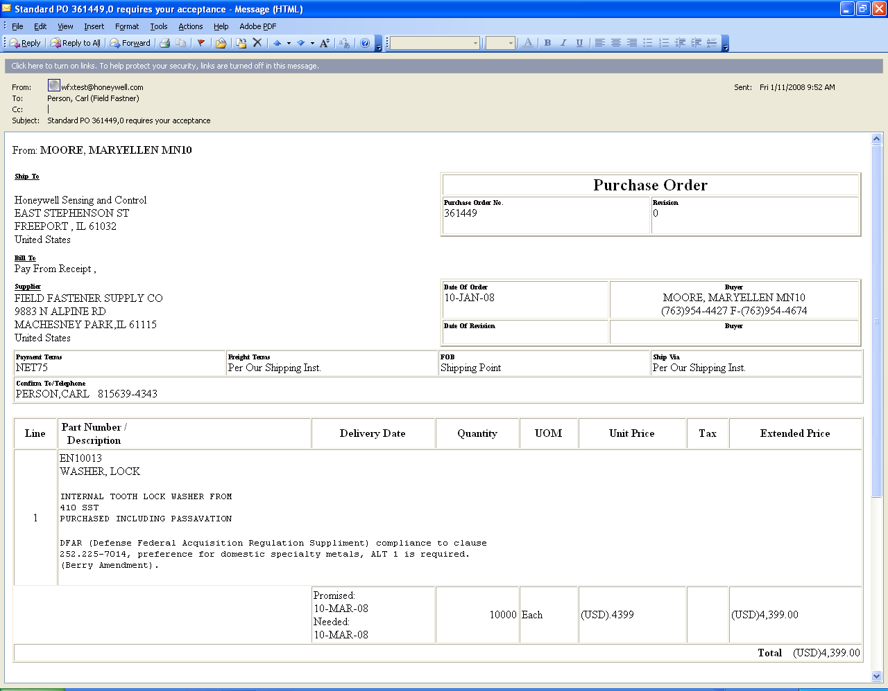
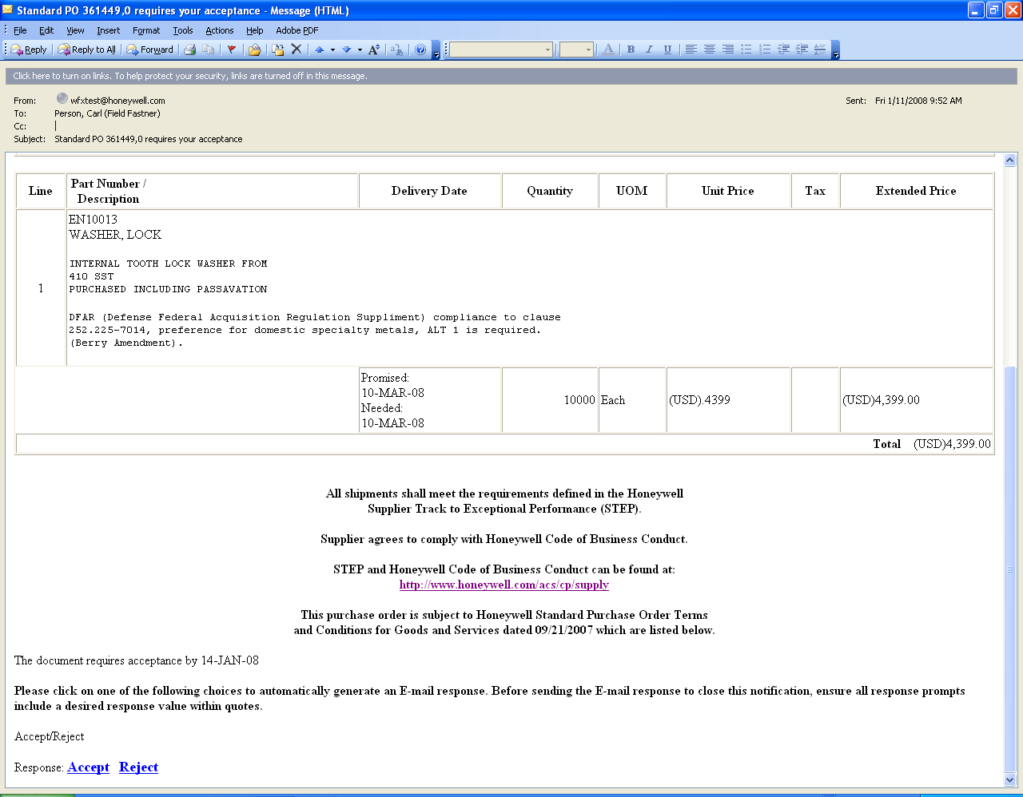
Following is an example of a PO email notification and an explanation of the various sections.
Use the Scroll bar to move down the page.
The email will be sent from wfxprod@honeywell.com which appears in the From: section of the email header. The Subject field will include the PO number, revision, and the notation, requires your acceptance.
To review the purchase order use your mouse or keyboard to page through the document.
Besides the order information the document will include the Terms and Conditions, a link to STEP and Honeywell Code of Business Conduct, and a required acceptance date.

At the bottom of the order are Links to Accept or Reject the order.

To acknowledge and accept the order:
- Click Accept at the bottom of the order. This will open a reply email which is specifically formatted to be received by Oracle. Any changes, modifications, or adjustments to this email will cause the email to not be received by Oracle.
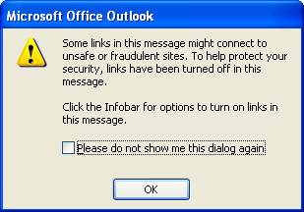
Note: You may need change your email security level setting to allow for scripted messages and links that are required for iSupplier Portal transactions.
Your system may display a dialog box similar to this and an Infobar may appear above the message header. Select the appropriate response to allow the autoreply process

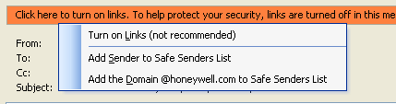

- Click Send to confirm your acknowledgment and acceptance of the order. Do not make any modifications to the reply email.
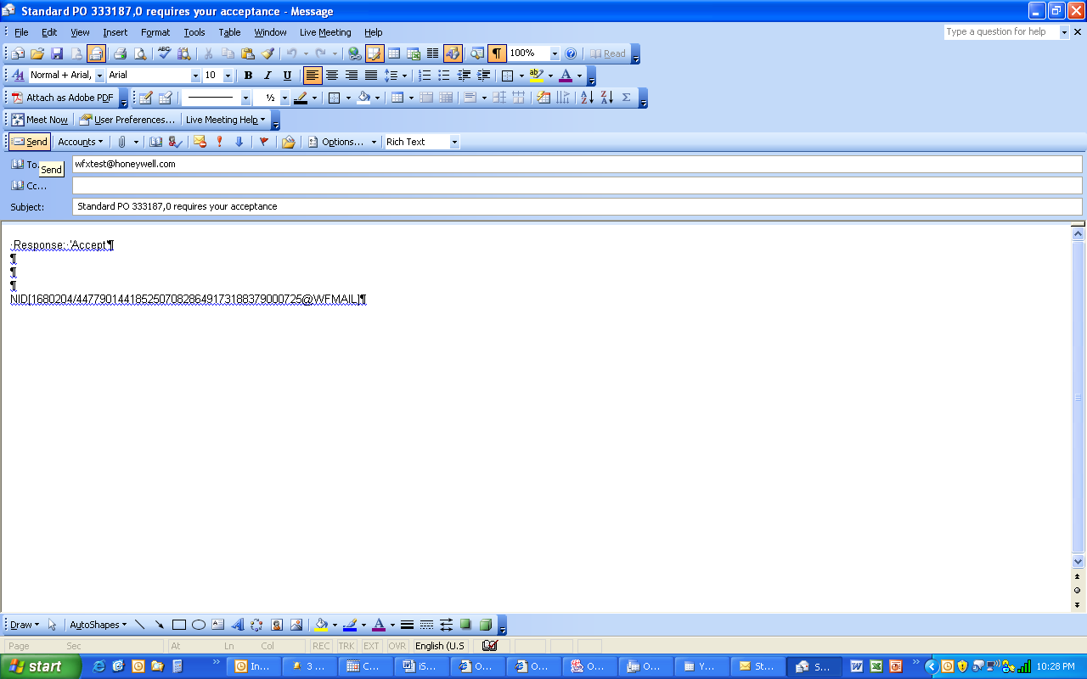
Click Send to complete the PO acknowledgment process.

Do not make any other modifications to this email

If you need to change or modify an order you will need to login to the iSupplier Portal, see iSupplier Portal Log on, pg. 32.

Honeywell Control Products Global Supply Management Web Site
To access the iSupplier Portal enter in the following URL in your internet browser. You may want to add this URL to your favorites in your internet browser.
http://content.honeywell.com/sensing/ve/
The ACS-CP Global Supply Management home page contains links to key information including the Supplier Track to Exceptional Performance (STEP) manual, Terms and Conditions, and access to S&C iSupplier Portal.

iSupplier Portal Log on
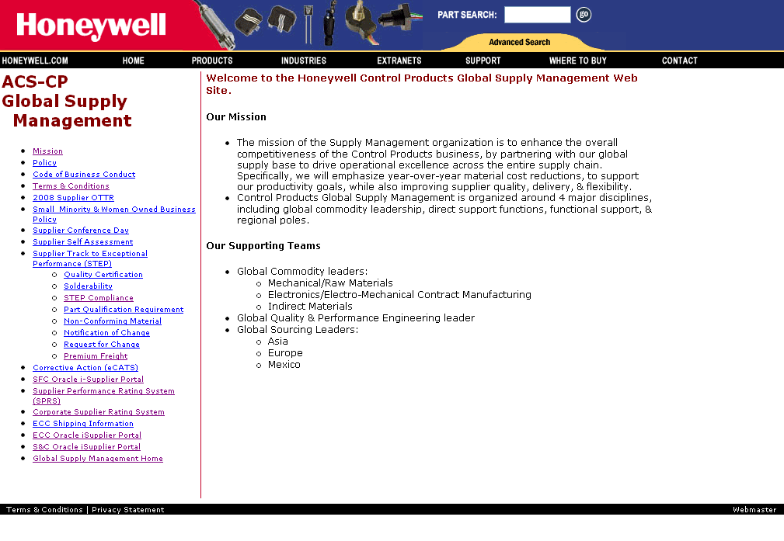
- To access the iSupplier Portal select the S&C Oracle iSupplier Portal link from the left navigation pane.
Click S&C Oracle iSupplier Portal
This page displays various links and information for Supply Management, such as mission statement, policy, and Terms & Conditions.
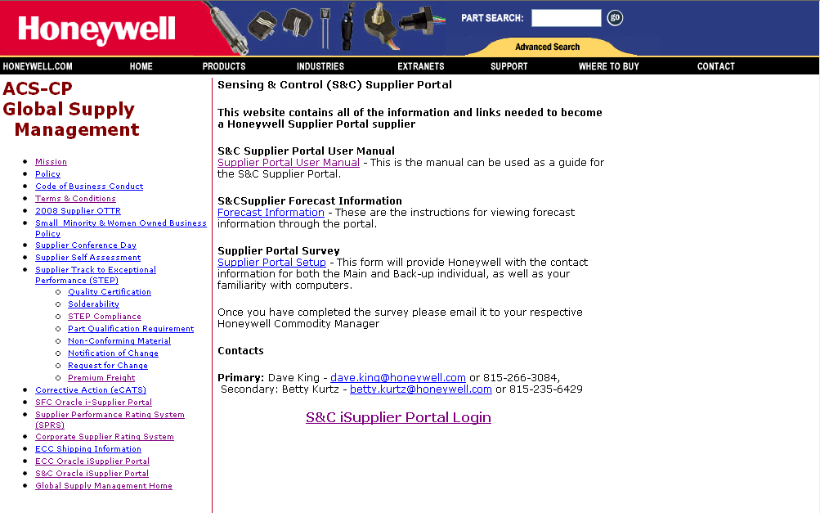
- Select the S&C iSupplier Portal Login link
Click S&C iSupplier Portal Login
Before entering the iSupplier Portal you must agree to Honeywell’s Terms & Conditions (T&Cs) which will be displayed prior to entering the portal. If you need to print the Terms & Conditions a copy can be downloaded from the web site in a pdf format. All purchases orders will include the Terms & Conditions.
Once you click on the S&C iSupplier Portal Login link the screen displays an Information Update section followed by the Terms & Conditions. The Information Update provides password instructions and may include information on the status of the application.
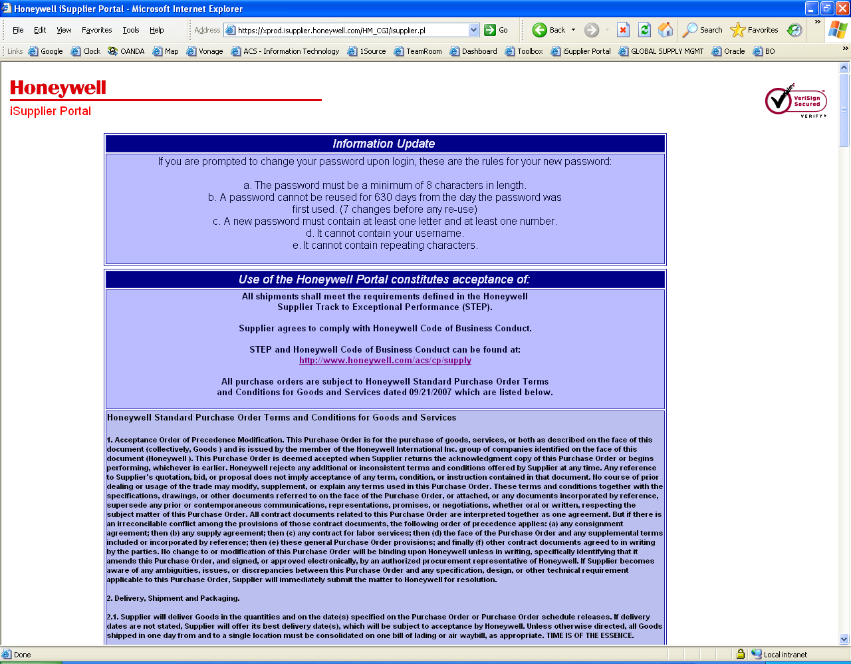

To complete the login review the Use of the Honeywell Portal constitutes acceptance of section. Use the scroll bar on the right or keyboard to move the display to end of the page.
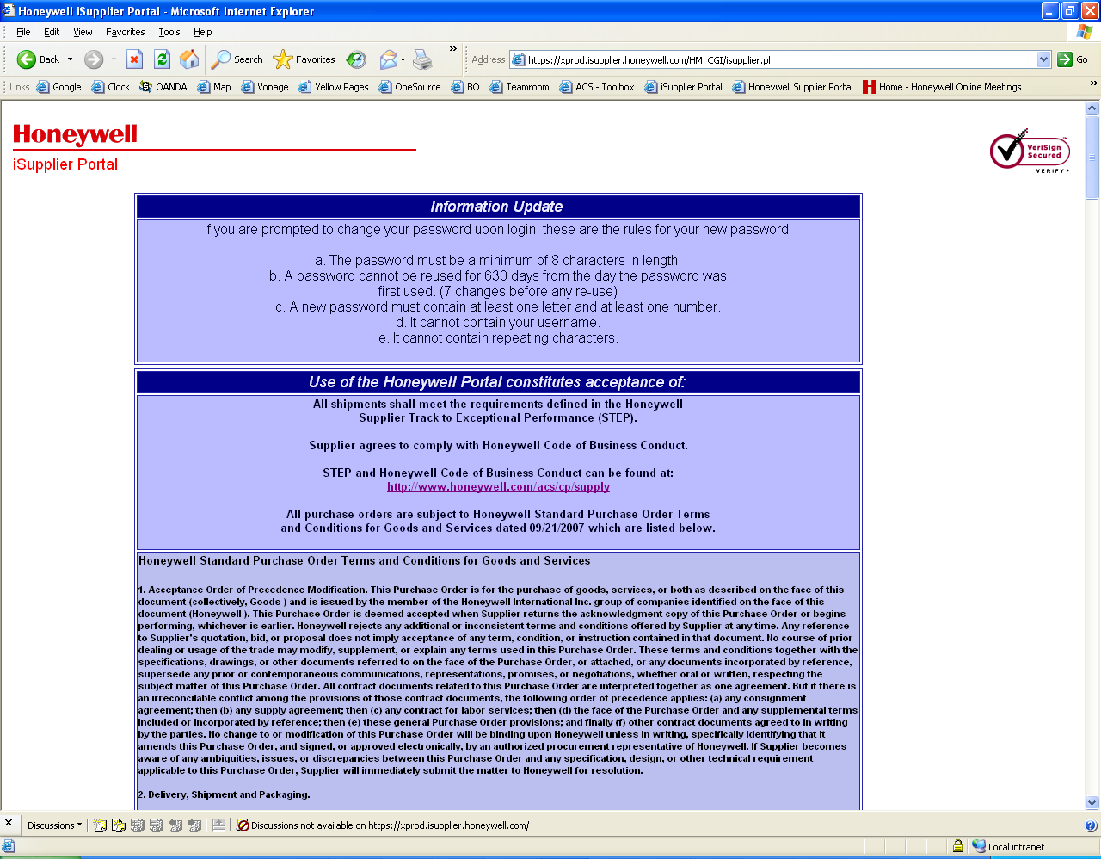
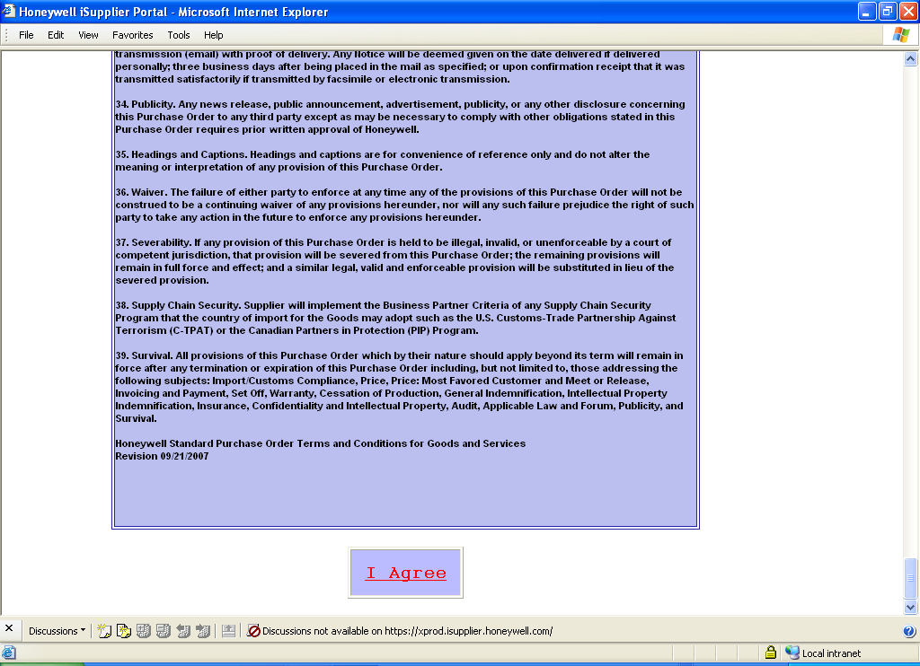
Use the Scroll bar to move down the page.

- Click on I agree at end of the Terms & Conditions and the Oracle Login screen will launch. Each time you log on to iSupplier Portal you will be required to Agree to the Terms & Conditions set by Honeywell.
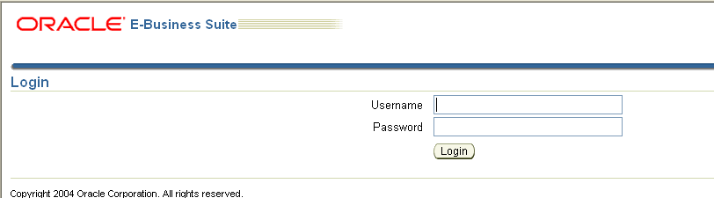
- At the login screen enter your iSupplier Portal ID in the Username field, and your password. Click Login.

Note: If this is the first time you have accessed the portal you will be prompted to change your password. For instructions on changing your password continue to the next section, First Time Log on, pg. 13.

If you have already changed your password skip the next section and go to iSupplier Portal Home Page, pg. 14.

First Time Log on
If this the first time you have logged on to the portal you will be prompted to change the temporary password that was issued to you. Passwords are masked so you will not be able to see the keyboard characters that are entered.
Passwords:
- must be a minimum of 8 characters in length
- cannot be reused for 630 days from the day the password was first used (7 changes before any re-use)
- must contain at least one letter and at least one number
- cannot contain your username
- cannot contain repeating characters

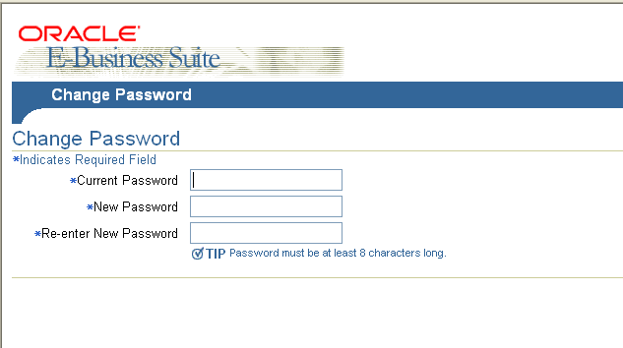
To change your password:
- Enter the password that was supplied to you in the Current Password field
- Enter and Re-enter the new password in the designated fields, and
- Click Apply to update your password.
The next time you login you will use the new password.

iSupplier Portal Home Page
The iSupplier Portal home page provides access to various tools for working with Purchase Orders. This section will cover the use of Notifications and Orders At A Glance. Honeywell S&C purchases orders can be acknowledged and accepted by email (see To Acknowledge & Accept a PO by Email, pg. 4) or by using the tools on the portal.
When you have logged onto the Portal you will need to navigate to the portal home page.

To Access Notifications & Orders at a Glance
- Select the HM iSupplier Portal Full Access link and the screen will refresh.
- Select the Home Page link to complete the navigation.
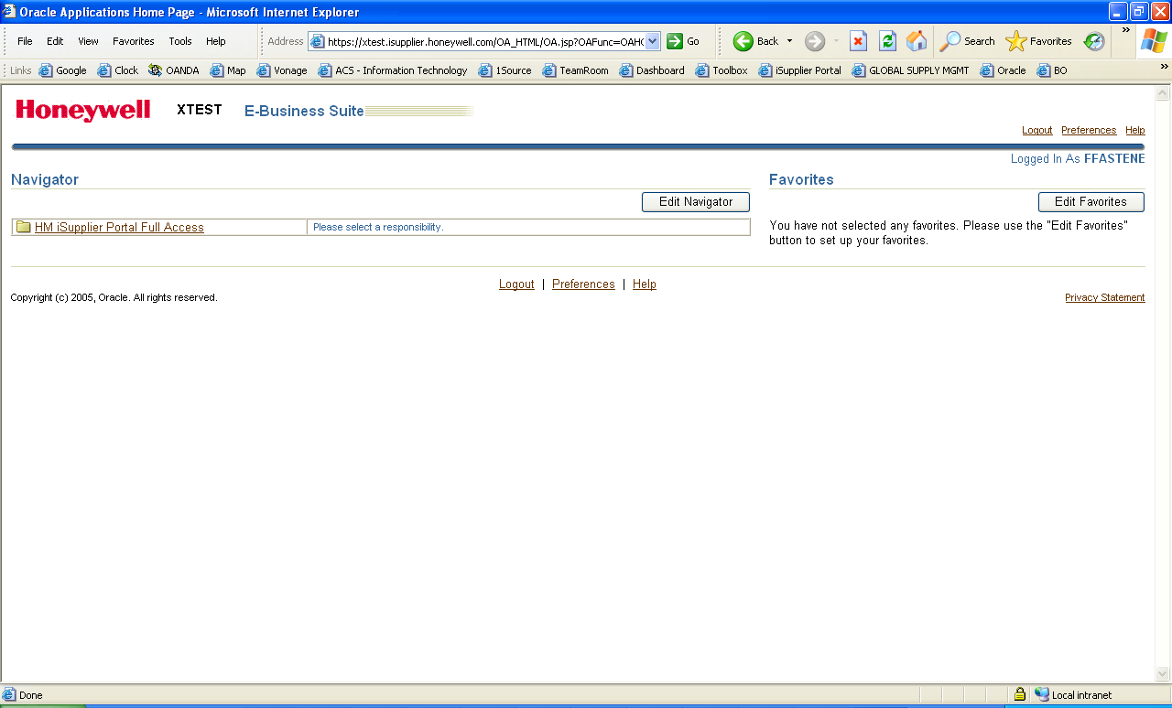
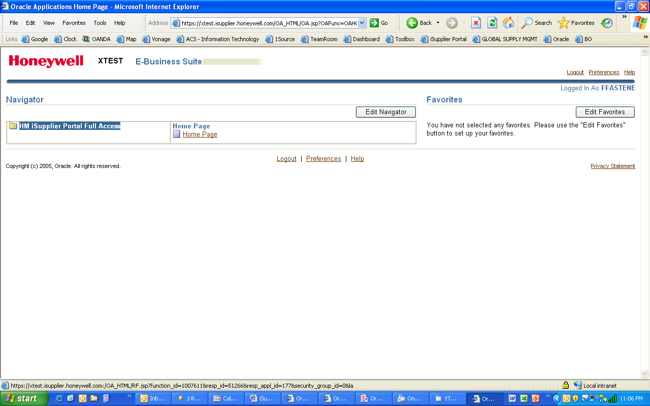
Select HM iSupplier Portal Full Access link
Select Home Page link


Note: Using your iSupplier Portal ID will only display orders assigned to you.

Working with the Home Page
There are two areas on the iSupplier home page that are available to work with purchase orders. The first section, Notifications is used to acknowledge and accept orders. The second section, Orders At A Glance provides tools to request changes to orders. Each section displays the five most recent purchase orders.
Notifications – On the upper left side of the display is a Notifications section which provides a quick list and links to current orders for acceptance and acknowledgement. This list is sorted by the most current order.
Orders At A Glance – On the lower left side of the display is a Orders At a Glance section which provides tools after an order is accepted and acknowledged, to request changes to the price, quantity and promise dates of orders.

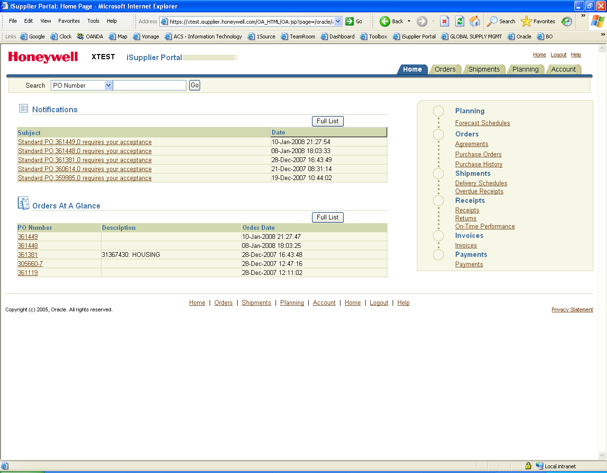
Orders At A Glance allows you to request changes to an order after an order as been accepted.
Notifications provides a quick list and links to current orders for review and acceptance.

Note: The default display will show 5 orders in the Notifications and Orders At A Glance sections. This view may change while working in the Portal. Once you log off the portal the next time you return the default layout will be re-displayed.


Notifications
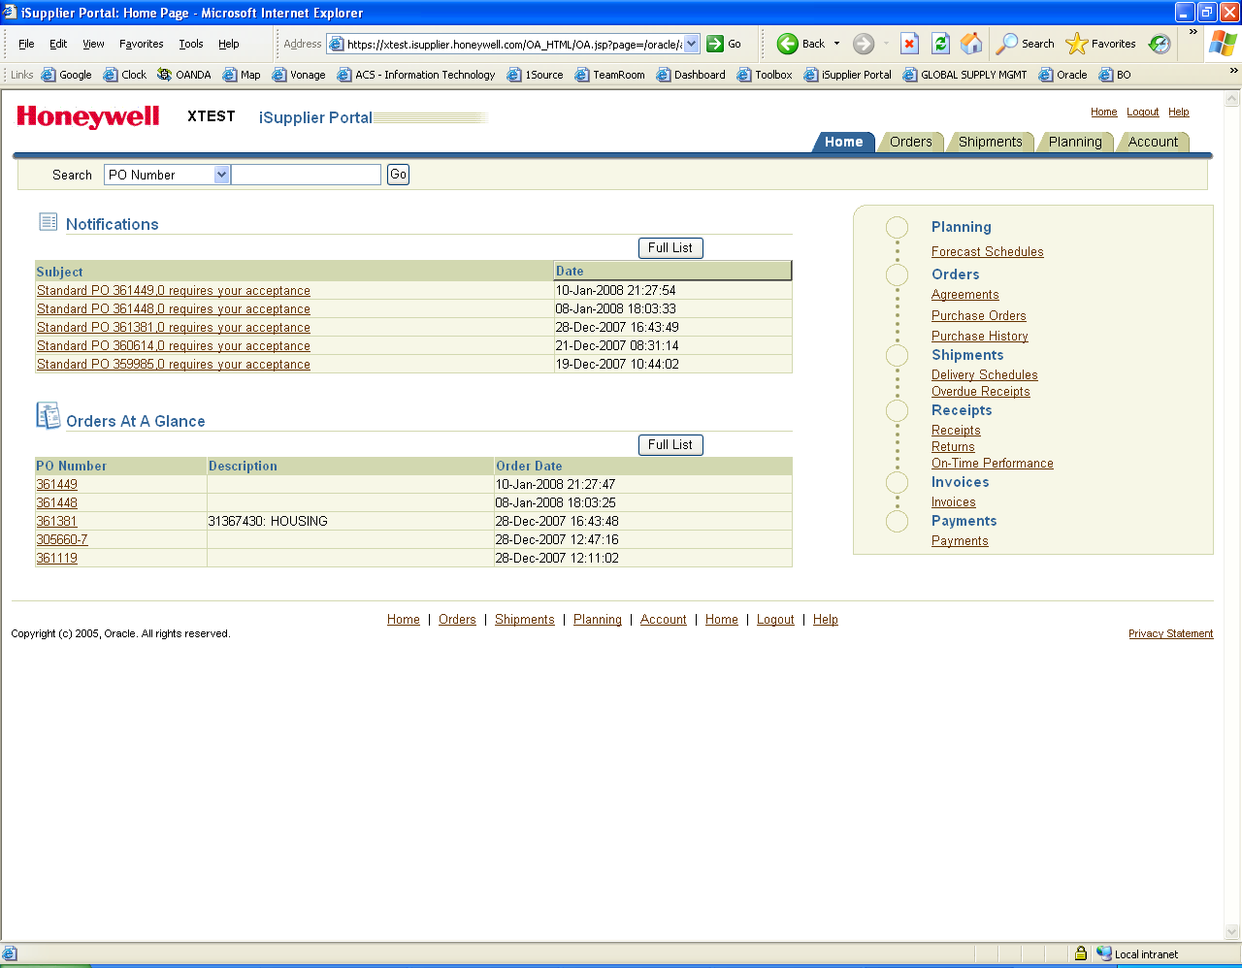
Notification will enable you to acknowledge and accept purchase orders. The subject area of the notification will state the purchase order number and a brief status. No requirements can be changed using Notifications. To change the price, quantity, or delivery you must first acknowledge and accept the order, then changes can be requested using Requesting Changes to POs, pg. 32.
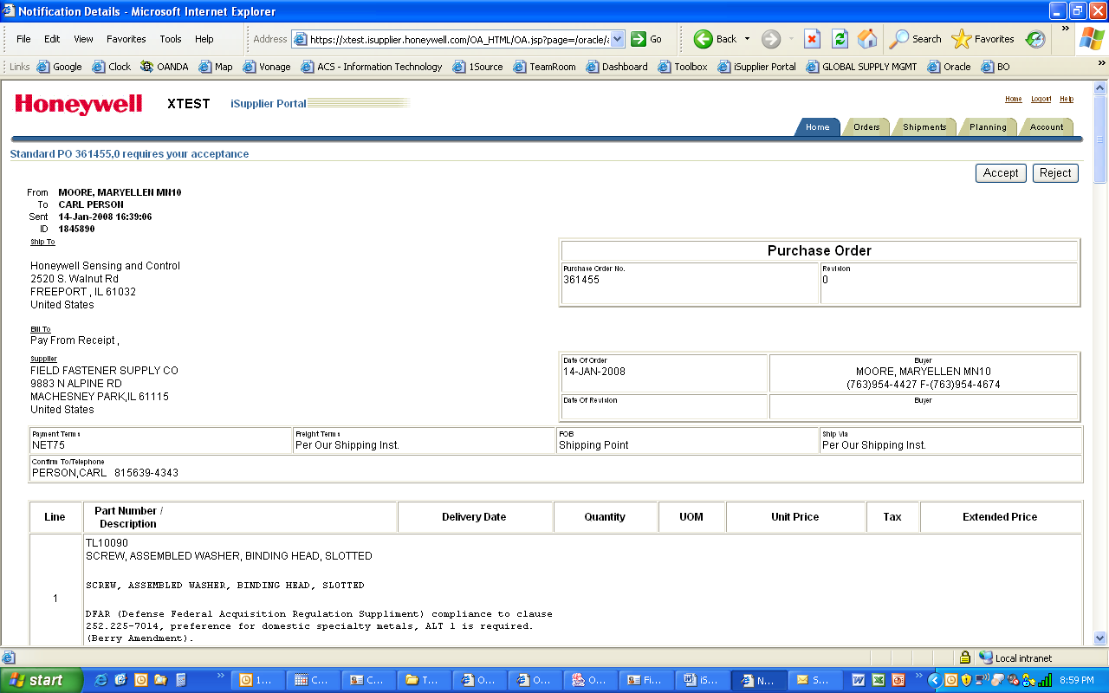
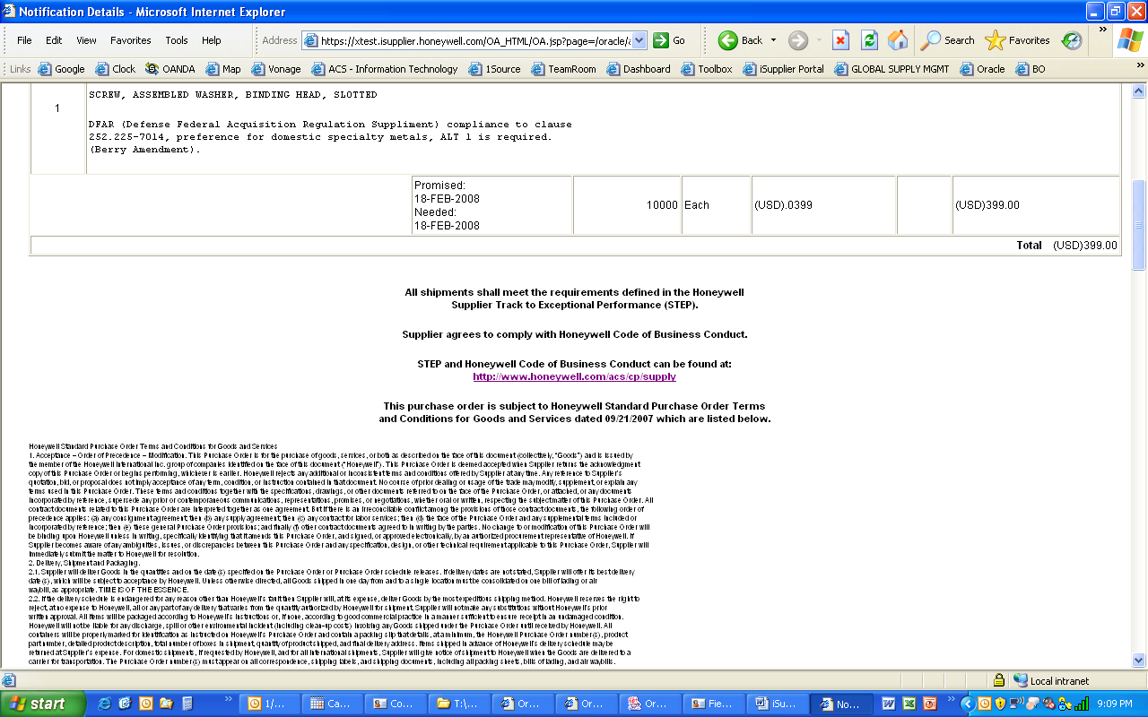
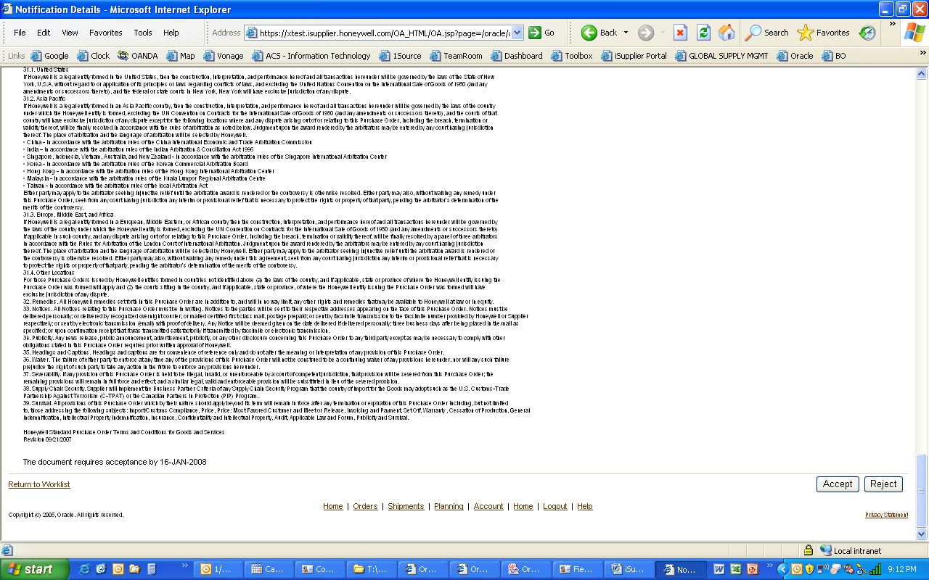
- Click the desired purchase order number listed in the Subject column to open the order.
The details of the order will be will be displayed. Review the purchase order by using the scroll bar on the right or using Page Dn on your keyboard.
Order Details
Terms & Conditions
Buyer, Supplier Information
- To Accept or Reject the order click the appropriate button located both at the top and the bottom right-hand side of the document. The transaction is submitted online.



Note: On the bottom left-hand side is the notation, The document requires acceptance by [a specified date].
- Once you have completed the acceptance and acknowledgment of an order you will see a list of pending notifications. You may select another order to acknowledge or click on the Home tab to return to the portal Home page.
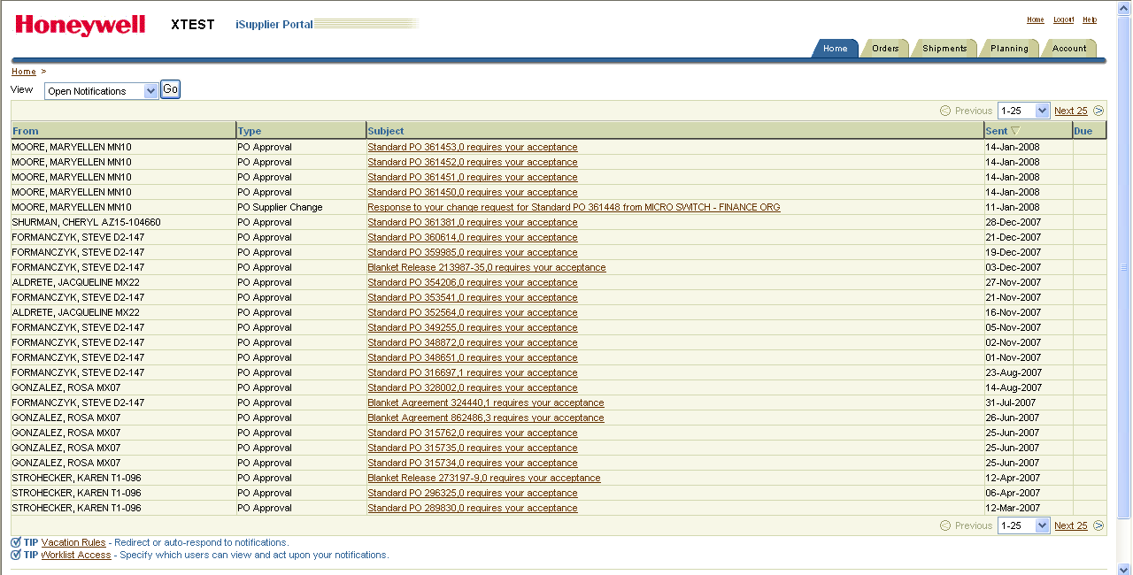

Click Home tab to return to the Home Page

Orders At A Glance
Once an order has been acknowledged and accepted a supplier may wish to change the price, quantity or ship date of the order. This is the only section of the iSupplier Portal home page that enables an order to be modified.
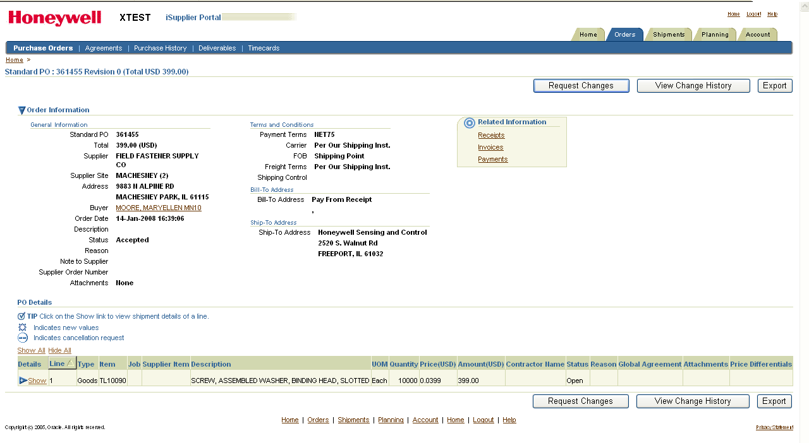
- Click the desired purchase order number listed in the PO Number column to open the order. If you do not see the PO Number you need, click on Full List.
The details of the order will be displayed. Review the purchase order. You may need to use the scroll bar on the right or Page Dn on your keyboard to review the entire order.
Click on Show/Hide to expand or collapse the details of this line.

Only purchase orders that have been acknowledged and accepted will provide Request Changes buttons on the right-hand side, at the top and bottom of the document.

Requesting Changes to POs
Once a purchase order has been acknowledged and accepted by the supplier a request may be made to change the price, quantity or delivery dates. A confirmation window displays after each change request and the request will automatically be sent to the Honeywell S&C buyer. Each change to an order must include a reason for the change to complete the request.

To Request Price Changes
Click order to open
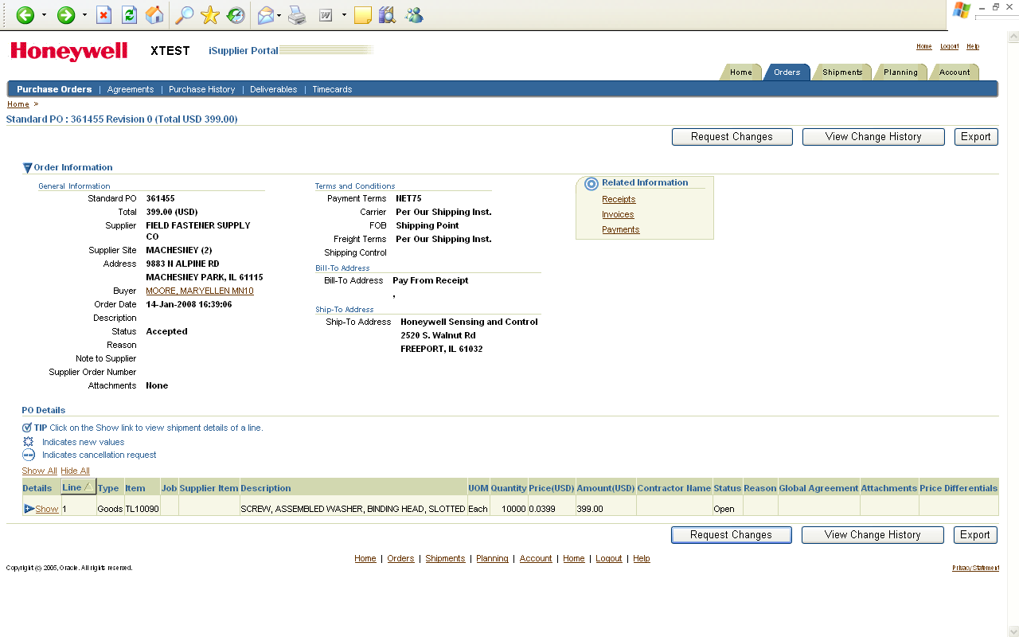
- Click the desired purchase order number listed in the PO Number column to open the order.
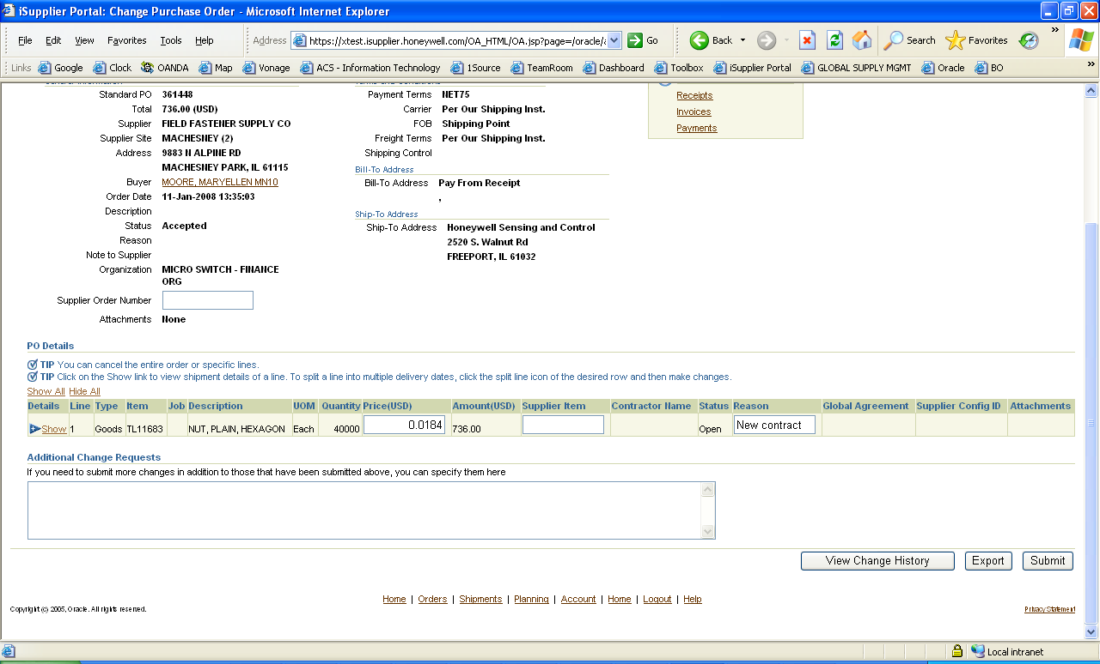
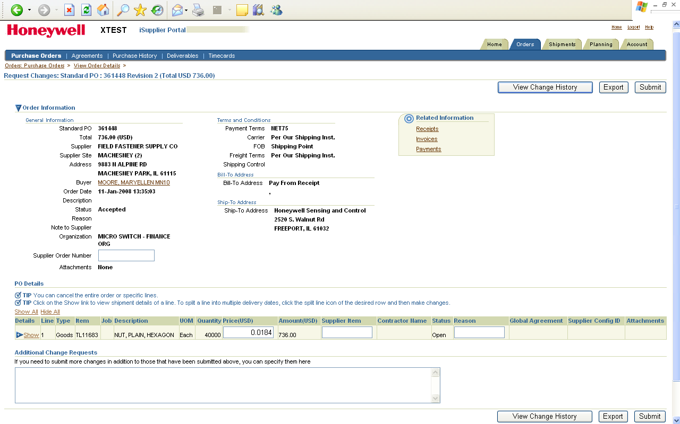
- Select button, update the price and fill in the Reason field with a brief explanation.
Modify the price
Enter the reason (required)
When selected, Request Changes will toggle to View Change History
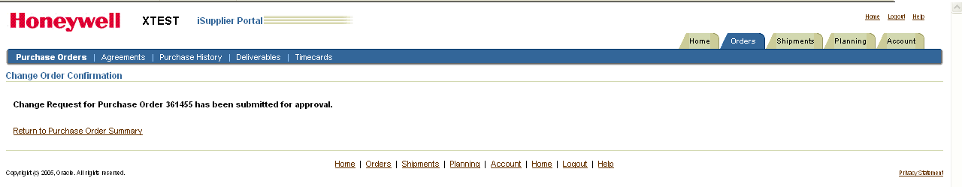
- Select Submit to complete the request and a confirmation message displays.

To Request Quantity or Promise Date Changes
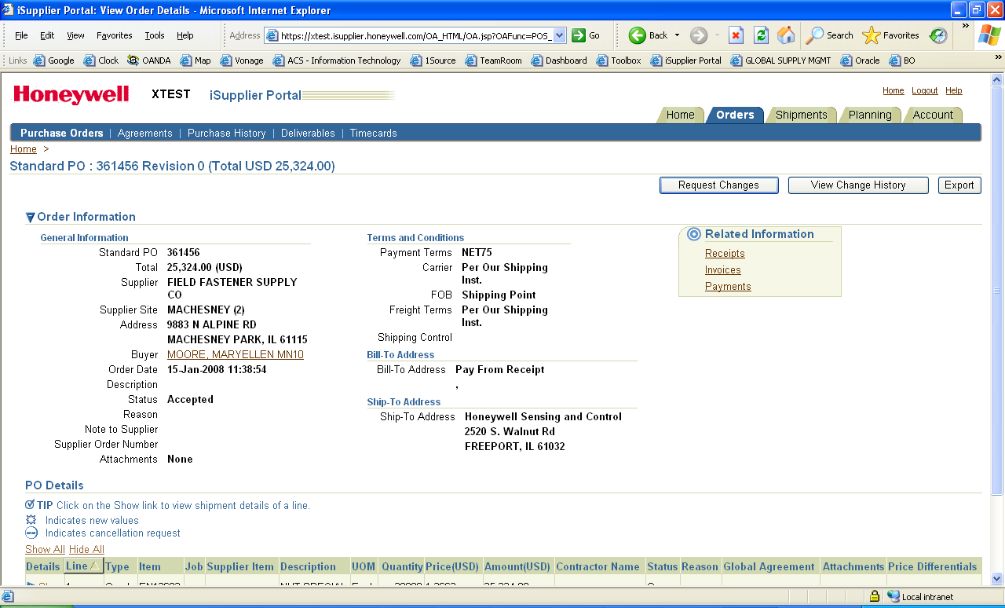
To modify an order after it has been acknowledged and accepted open the order from the Home page or Orders tab. Use your mouse to scroll or keyboard to Page Dn to the PO Details section. A change to an order must include a reason for the change to complete the request. The request will automatically be sent to the Honeywell S&C buyer.
Select Request Changes
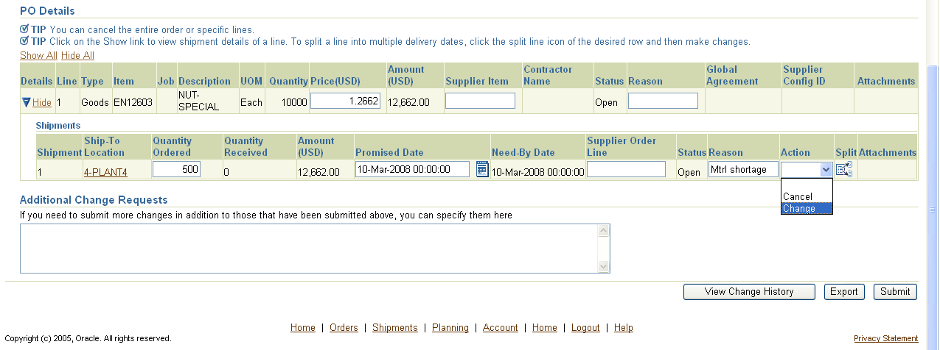
- Click in the upper or lower right-hand side of the display.
Move your view to the PO Details section of the order.
Modify Quantity Ordered
Click the Calendar icon to select a new Promise Date
Enter Reason & select Action
Click Show to expand line for order details
2
3
4
5
6
3
- Click Show to expand the contents of the order line.
- Modify the Quantity Ordered field and/or click the Calendar icon to select a new Promise Date.
- Fill in the Reason field with a brief explanation. This is required.
- Click dropdown from Action field and select Change.
- Select Submit to complete the request and a confirmation message displays. Once the request is accepted the order number will indicate the revision by adding a common, “ , ”and revision number to the document name.

To Request Split Shipments
On occasion it may be necessary to initiate a request for a split shipment, or modify split shipment dates. Once an order has been acknowledged and accepted a request can be initiated to split or modify the order promise dates. This process automatically advises the Honeywell S&C buyer of the request. If the change is accepted or rejected a notification is sent to the Supplier.
Click order to open
- Open an accepted order using Orders At A Glance or xxxx.
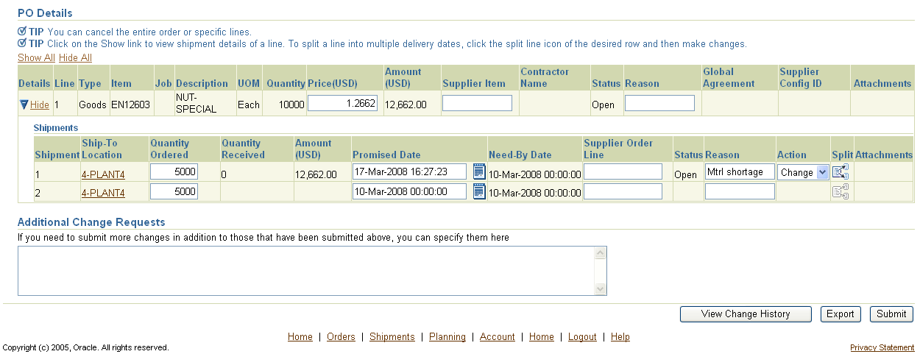
- Click in the upper or lower right-hand side of the display.
Move your view to the PO Details section of the order.
.
Click Show to expand line for order details
Modify Quantity Ordered
Click the Calendar icon to select a new Promise Date
Enter reason & select Action
Click Split icon to add another shipment line
3
4
5
6
7
5
- Click Show to expand the contents of the order line.
- Click Split icon to create another shipment line.
- Modify the Quantity Ordered field(s) and/or click the Calendar icon to select new Promise Date(s).
- Fill in the Reason field with a brief explanation (required), and Click dropdown from Action field to select Change.
- Select Submit to complete the request and a confirmation message displays.

To Request Changes to Blanket Agreements or Releases
Once a Blanket Agreement has been accepted and acknowledged, Honeywell S&C buyers can initiate releases, identified as Blanket Release to agreements. Blanket releases will indicate the Agreement number with a hyphen followed by the release number. For example, Blanket Release 108659-5 indicates the 5th release of Blanket Agreement number 108659.
In order to request a change to a Blanket Agreement or Blanket Release the supplier must first acknowledge and accept the order. To initiate a change to the agreement or release follow the same procedures used for a Standard PO, see Requesting Changes to POs, pg. 32.

Navigation
The following tools will help you navigate the iSupplier Portal.
Global Links & Tabs
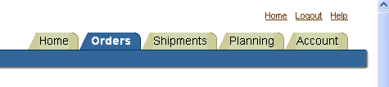
Home & Logout links are present at the top & bottom of all displays.

The Orders tab defaults to the last 25 purchase orders. To see the next 25 listings click on the Next 25 link above the table. To see alternate views make your selection from the View dropdown and select Go.
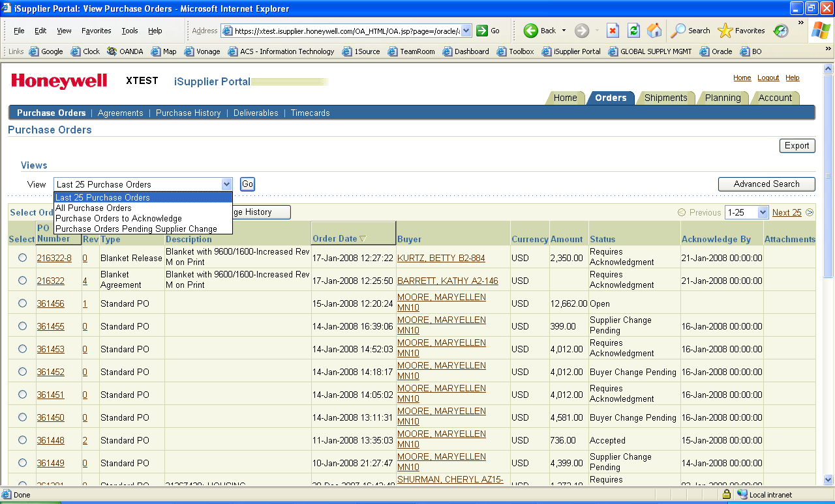

Quick Search
Home Page tab
To locate a PO by its number, enter in the PO number in the search field and click the Go button.
The Full List button is available for Notifications and Orders At A Glance sections. This will expand the list beyond the 5 that are currently displayed.

Using Search Functions
From the Orders tab the Advanced Search button appears above the table on the right-hand side of the display. Click on the button to expand a search.
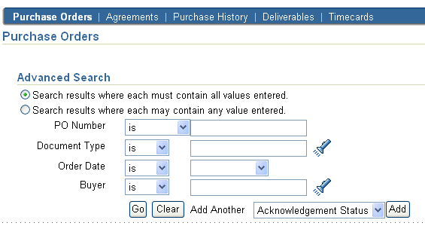
iSupplier Portal provides extensive search criteria on all pages to help you retrieve information. The search results have a number of columns that you can sort for your data. Some common search fields are PO number,
You can use the percent sign (%) as a wildcard to search for generic items. For example, to search for all orders beginning with 27 and end in a 5 (such as 275, 2715, 27125) enter 27%5. The% wildcard does not control the number of wild characters.
Note: The search logic attempts to find matches containing values in any position.

Using "Advanced Search," you can build and narrow searches with the available search operators. Search operators enable you to specify the matching conditions for a search.
Available search operators are:
- is - Use this operator for an exact match.
- is not - Use this operator to exclude a specific match.
- contains - Use this operator to find a partial match.
- starts with - Use this operator to find a partial match only at the beginning.
- ends with - Use this operator to find a partial match that only ends with your criteria.
- greater than - Use this operator to include results greater in value than a value specified.
- less than - Use this operator to include results lower in value than a value specified.
- after - Use this operator to include results with a date after the specified date.
- before - Use this operator to include results with a date before the specified date.

Other Information

Log off
While working in iSupplier Portal you will see a Logout link on most screens at the top and bottom of the display. To log off simply click on this link.

Help
The first step for help with iSupplier Portal is to contact your S&C Honeywell Buyer. They will facilitate your request.
If you need to change a contact name or email address contact your S&C Honeywell Buyer.

iSupplier Portal Survey & Access Information

The following information can be found on a standard S&C Purchase Order.
(Supplier Name) |  | (Supplier Number)
(Supplier Adress) |  | (Buyer Name)

Appropriate person to contact regarding portal transactions.
 |  | Primary Contact |  | Back-up Contact
Name
Email
Phone

Email notifications should be sent to:
Note: only one email address can be identified for an individual or distribution type mailbox. | (email address)

Please answer the following:
What version of Internet Explorer are you using?
(required minimum, IE 5.5)
 | What version of Windows are you using?
 | Do you currently do any Internet transacations with other customers? |  | Yes No
What email application are you using?
(Outlook, Lotus, etc.)
 | What is your (Supplier) comfort level with computers? |  | 1 2 3 4 5
 |  |  | (1-Not Comfortable; 5-Very conformtable)

Any other comments:

Return this form to your Honeywell S&C Buyer

This area should be completed by the Honeywell S&C buyer and returned to: iSupplier Portal Survey
Supplier Site Name:

This page left intentionally Blank

