 | INTERNATIONAL TELECOMMUNICATION UNION
 | WORKSHOP ON PROMOTING BROADBAND | Document: PB/07  7 April 2003
Geneva, 9-11 April 2003

Promoting Broadband:
The Case of Japan

April 2003

This case study has been prepared by Yoshihisa Takada (yoshihisa.takada@ties.itu.int), Project Officer for the Strategy and Policy Unit (SPU) of the International Telecommunication Union (ITU) and Takeshi Shinohara
(t-shinohara@nri.co.jp), Chief Consultant, Centre for Knowledge Exchange and Creation, Nomura Research Institute, Ltd (NRI). Megumi Komiya (mkomiya@nri.co.jp), Senior Consultant, NRI Europe, also contributed to the report. ‘Promoting Broadband : The Case of Japan’ is part of a series of telecommunication case studies produced under the New Initiatives Programme of the Office of the Secretary General of the ITU. The promoting broadband case studies programme is managed by Taylor Reynolds under the direction of Tim Kelly. Other country case studies on promoting broadband, including Canada, Hong Kong China, Iceland and Korea (Rep.) can be found at http://www.itu.int/osg/spu/ni/promotebroadband/index.html.
The opinions expressed in this study are those of the authors and do not necessarily reflect the views of the International Telecommunication Union, its membership, or the Japanese Government.

TABLE OF CONTENTS
1 Introduction 3
1.1 Geography and demographics 3
1.2 Human development 4
1.3 Political economy 4
2 Telecommunication policy and regulatory framework 5
2.1 Regulatory history 5
2.2 National strategy for information society–“e-Japan Strategy” 6
2.3 Regulatory framework – Broadband telecommunications related laws 7
3 Telecommunication market 8
3.1 Current Telecommunication market 8
3.1.1 Market overview 8
3.1.2 Internet market 10
3.2 Businesses in the telecommunication market 11
4 Broadband market 12
4.1 Types of network 12
4.1.1 ADSL 12
4.1.2 FTTH 13
4.1.3 CATV 16
4.1.4 Wireless LAN 17
4.2 Types of terminal 18
4.2.1 Personal computers 18
4.2.2 Game consoles , Internet TVs and Set-top box (STB) 18
4.2.3 Portable devices (PDA etc.) 20
4.3 Platform 20
4.3.1 Secure payment for online purchase 20
4.3.2 Content delivery network (CDN) 21
4.3.3 ADSL or FTTH portals by ISPs 22
4.4 Broadband content/application 22
4.4.1 Online games 22
4.4.2 Digital photos 23
4.4.3 Electronic publishing 23
4.4.4 Video over broadband 23
4.4.5 IP Telephony 25
4.5 Consumer behaviour towards broadband 26
5 Broadband promotion 28
5.1 Successes 28
5.1.1 Increasing new market entries 28
5.1.2 Cheap prices and higher speed 30
5.2 Weaknesses to be overcome 31
5.2.1 Regional imbalance in broadband development 32
5.2.2 Retrofitting for broadband in apartment buildings 34
5.2.3 Lack of broadband content and applications (especially for FTTH) 35
6 Ubiquitous networks –The future of broadband 37
7 Conclusion 39
Annex A: Mobile Internet market 41
Annex B: Legal framework for telecommunication business 43
Annex C: Telecommunication Business Dispute Settlement Committee 45
Annex D: Target of fibre optic infrastructure 47

Introduction
The technological innovation and commercial development of telecommunications have gone hand in hand—particularly during recent decades—and the combined influence of economic, communications and technological developments are fast leading towards what is now known as the “information society”. Broadband telecommunications are beginning to feature highly among these technologies, and their growing prevalence is testifying to their future potential for users, businesses and governments alike. As a country that has been a world leader in the field of telecommunications, Japan presents a richly informative example for study. This case study attempts to examine developments and to analyse the situation in respect of broadband telecommunications in Japan, which, for many, represents the cutting edge of telecommunications development and policy.

Geography and demographics
Not far off the eastern coast of the world’s largest continent, Asia, lies the relatively small Japanese archipelago – almost at shouting distance from the Korean peninsula. This chain of islands, of which four distinguish themselves as the main ones, is home to some 127 million people, equivalent to almost half the population of the United States. Its land mass is 377’835 square kilometres, 71 per cent of which is mountainous. It is half again the size of the United Kingdom, but only one-ninth the size of the Indian subcontinent. The national territory is divided into eight or nine geographical regions. These regions are categorized mainly by their economic and human characteristics. The Kanto region, Kinki region and Tokai account for over 60 per cent of the total population. Apart from fishing (Japan accounts for 15 per cent of the world’s catch), the country is lacking in natural resources. This is in sharp contrast to its huge economy, which is among the world’s largest. Its rate of urbanization is high, as 80 per cent of its population now lives in crowded urban areas, a factor not be neglected in accounting for the considerable success of mobile communications in Japan. The national currency is the Japanese Yen (JPY). One language is spoken throughout the land even though two systems of writing prevail. They are: Kanji, written in the manner of Chinese hieroglyphics (3’000 symbols are in daily use) and the phonetic Kana (with a 46-character set). Standard Japanese word-processors recognize up to 6’000 Kanji characters.

Figure 1.1: Geographical regions and population distribution in Japan

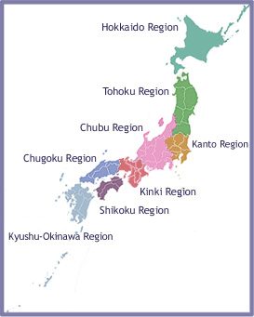
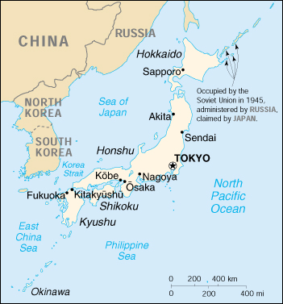
Note: The Kinki region is also known as Kansai.
The Hokuriku region is the northern part of the Chubu region and Tokai region is the southern part of the Chubu region.
Table 1.1: Basic social and economic indicators for Japan
 | 1996 | 1997 | 1998 | 1999 | 2000 | 2001
Population (thousands) | 125'864 | 126'166 | 126'490 | 126'500 | 126920 | 127291
Urban population (in per cent) | 78.26 | 78.42 | 79.00 | 79.00 | 78.70 | n.a.
Gross Domestic Product (GDP) (JPY Billion) | 500'310 | 509'645 | 498'499 | 511'837 | 513534 | 503594
GDP Per Capita (US$) | 36'541 | 34'203 | 31'179 | 35'478 | 37544 | 32553
Average Annual Exchange Rate Per US$ | 108.78 | 120.99 | 130.91 | 113.91 | 107.77 | 121.53
Source: ITU World Telecommunication Indicators Database, International Monetary Fund.

Human development
Japan ranks ninth among the 174 countries that make up the United Nations Development Programme Human Development Index and is placed in the “high” human development group. In this respect, it ranks ahead of France, Switzerland and Hong Kong China, but behind Canada, the United States and the Netherlands. Table 1.1 provides some relevant social and economic indicators for the country.

Political economy
Japan is universally regarded as one of the world’s leading industrial nations. Significant government-industry collaboration, rapid technological innovation and a strong work ethic have sustained the economy at its present high level.
One of the most remarkable characteristics of the economic scene is the “keiretsu”, or tightly-knit groups consisting of manufacturers, suppliers and distributors. Much of the labour force enjoys lifetime employment and in general there is a high degree of staff loyalty. The use of robotic technology and telecommunications are important factors contributing to its economic strength. In fact, Japan possesses 410,000 of the world's 720,000 “working robots”.
Historically, the economy suffered greatly as a result of the jSecond World War, particularly due to destruction of infrastructure, severe food shortages and high inflation. Various social reforms were carried out after the war in order to establish a basic framework for economic recovery and development. The process of liberalization began with the break-up of the “zaibatsu”, or large business trusts. For instance, postwar demilitarization and the prohibition of rearmament are written into a new constitution, and Japan now spends as little as 1 per cent of its total gross domestic product (GDP) on defence.
In the latter half of the twentieth century, overall economic growth in Japan was phenomenal. In the 1960s, for instance, the annual growth rate averaged close to 11 per cent. This was far above the growth rates for the Federal Republic of Germany at 4.6 per cent and for the United States at 4.3 per cent during the same period. This growth was spurred by large investments from the private sector in infrastructure and equipment, and by the increased capital spending and the introduction of new technology.
There was a significant slowdown between 1992-95, largely due to the after-effects of increased investment during the late 1980s, and constrictive domestic policies intended to wring out speculative excesses from the stock and real estate markets. Since then, periods of growth have been frequently interspersed with stagnation. Growth picked up in 1996 following the introduction of stimulating fiscal and monetary policies coupled with low inflation. Again, in 1997-98, Japan’s economy took a downward turn. After the bursting of the IT bubble in 2000, Japan has once again plunged into a severe recession.

Telecommunication policy and regulatory framework

Regulatory history
Telephone services were introduced in 1880 and a Ministry of Communications was established soon after, in 1885. It remained in place until the end of the Second World War, when it was split up into the Ministry of Telecommunications and the Ministry of Posts. In 1952, the Ministry of Telecommunications became a public corporation and Nippon Telegraph and Telephone (NTT) was born. It was to be the monopoly domestic operator. At the same time, the Ministry of Posts became the Ministry of Posts and Telecommunications (MPT) responsible for the regulation of the telecommunication market. In the same year, the KDD Corporation Law of 1952 was enacted, establishing Kokusai Denshin Denwa (KDD) as the international operator. NTT was the primary regulator, responsible for the setting of technical standards, the development of telecommunication regulation, and for policy-making in conjunction with the Japanese parliament (the Diet). NTT already controlled an R and D system in collaboration with the large equipment manufacturers, such as Fujitsu, NEC, Hitachi and Oki Electric. Although the MPT was charged with overseeing NTT operations through a Telecom Supervision Bureau, it had a tight budget and one of its two senior members was to be from the NTT.
While substantial network development had been achieved, NTT was nevertheless perceived as being out of touch with user needs. Consequently, in 1970, the MPT set up a number of study groups to consider reforms to telecommunication policy. These study groups, made up of about 100 younger MPT staff, examined the possibility of reorganizing the NTT, and openly questioning its monopoly status. The report, released in June 1971, recommended the “reorganization” of NTT and the liberalization of value-added services. These reforms were not adopted until 1985, fifteen years later. And despite NTT’s role as primary regulator, the involvement of the MPT in regulatory reform in the 1970s sealed MPT’s future role as the telecommunications regulatory authority for Japan.
With respect to value-added networks, by the end of the 1970s, the Ministry of International Trade and Industry (MITI) and the MPT were in competition with each other. As the regulator for the computer and IT industry, the MITI was pushing for the liberalization of value-added services, whereas the MPT was of the view that all new entrants should be subject to MPT regulation. Finally it was decided to liberalize value-added networks for small and medium-sized enterprises under the MPT’s framework. At the same time, telecommunication reform got under way in Japan.
Significant reform in telecommunications occurred in the 1980s, as the United States began liberalizing its telecommunications market and started the process leading to the break-up of AT&T. In Japan, the Second Provisional Council on Administrative Reform (Rincho) announced a proposal in 1982 to allow competition in all sectors of telecommunication services, as well as to privatize and “reorganize” NTT. Approval was given to separate telecommunication services on the basis of ownership rather than service types. Under this scheme, Type I service providers (those owning their own facilities or infrastructure) would require permits from the MPT. Special Type II service providers (those not owning infrastructure but with a large user base) would need to register with the Ministry. Basic Type II service providers (confined to operation in limited areas) need to merely register. The licensing regime in Japan is just under revision (see Annex B).
Surprisingly, the Rincho collaborated with officials in the NTT to push forward privatisation. NTT agreed to proceed with privatisation so long as it was not broken up. On 1 April 1985, three reform laws came into effect: the Telecommunications Business Law, the NTT Law, and the Background Law for the Telecommunications Law. NTT privatisation began in October 1986, when the government issued the first block of 200,000 shares. Complete privatisation did not take place and the government still holds a substantial share in NTT. In 2001, moves were afoot to continue the process
The reforms of 1985 placed regulatory power firmly in the hands of the MPT, e.g. the authority over price and service regulation (the Diet’s original domain) and technical regulation (NTT’s original domain). The MPT also increased its role in telecommunication policy, and research and development. It even began exerting its authority over competition issues, for instance selecting new entrants (new common carriers – NCCs) in the 1980s and 90s. A large number of companies entered the market, and by 1996, 124 Type 1 and 3134 Type II carriers were offering services.
In the 1990s, the MPT evolved its regulatory framework significantly to adapt to technological innovation and changing market dynamics. It started with the liberalization of the cable TV market in the early 1990s. In 1996, the MPT embarked upon a deregulation process which included, inter alia, a new regime for end-to-end interconnection with NTT (known as “ko-sen-ko” interconnection) and a relaxation of foreign ownership restrictions. Once the privatization process had begun, the MPT was able to focus more effectively on developing policies for information and communications technologies (ICT) in Japan. The MPT and two other ministries were merged into the Ministry of Public Management, Home Affairs, Post and Telecommunications (MPHPT) in the administrative reform of central government in January 2001.

National strategy for the information society–“e-Japan Strategy”
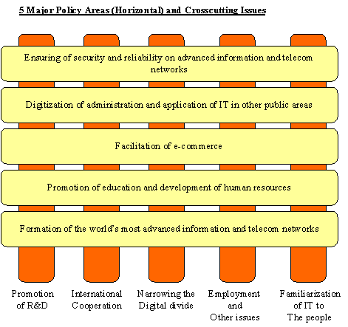
Figure 2.1: Five major policy areas in the e-Japan Priority Policy Programme

Source: Prime Minister’s office (http://www.kantei.go.jp/foreign/policy_e.html)

Japan regards broadband networks as critical for its future development. To enable rapid and focused policy implementation related to establishing advanced information society, the Government of Japan has established the Cabinet-level Head Quarter on IT Strategy (led by the Japanese Prime Minister) and enforces the Basic Law on the Formation of an Advanced Information and Telecommunications Network Society (usually called the “IT Basic Law”) in January 2001 that prescribes headquarter’s framework of and Priority Programmes. The headquarters announced the “e-Japan Strategy” in January 2001. The Strategy sets an ambitious target to be the most advanced IT state in the world within five years. In March 2001, it revealed the “e-Japan Priority Policy Programme” to clarify specific action plans in the Strategy. It also sets five policy areas that Japan should focus on. They are (1) infrastructure, (2) human resource, (3) e-commerce, (4) e-government and (5) network security (see Figure 2.1). One major contrast among countries is who takes the initiative in infrastructure development. The Programme states that, “the private sector is to play a leading role in the area of IT”. This programme is reviewed every year. Among its 220 projects to be implemented by the end of the financial year 2001 (March 2002), 103 had been completed as scheduled. The head quarters reviewed it in June 2002 to include 318 projects. It also produces an annual e-Japan Programme that reflects both the Strategy and the Priority Programme in the measures of each ministry in each fiscal year.
The Strategy would see that at least 30 million households are within reach of high-speed Internet access (e.g. via DSL, CATV and Fixed Wireless Access) and at least 10 million are within reach of ultra-high-speed Internet access (e.g. via Fibre-To the Home, or FTTH ) by the end of 2005. The review of the Priority Plan in June 2002, estimates that 34 million households are within reach of ADSL services, about 23 million of cable modem service and about 14 million households within reach of FTTH. Headquarters concluded that the missions to establish ultra/high-speed networks is succeeding. How to tackle to access to these networks may be the next policy target.
Concerning human resources development, head quarters issued the “IT Human Resource Development Plan” in March 2002. This Plan aims to (1) enhance ICT education in schools, (2) offer people chances to study ICTs for using them in their daily life and (3) create human resources with special ICT knowledge, skills and creativity.

Regulatory framework – Broadband telecommunications related laws
In April 1985, NTT (until then a public corporation) was privatized and the Japanese telecommunication market was opened to new entrants. At the same time, the Telecommunications Business Law (hereinafter referred to as the “Business Law”) was established to regulate telecommunication companies. Businesses offer telecommunication services are required to either to obtain permission, or to register/to notify the Ministry of their intention, depending on their type of operation. (See Annex B: Highlights of Japan’s Telecommunication Related Laws) for more details about the regulatory framework.)
The Radio Law, enacted in 1950, ensures the equitable and efficient utilization of spectrum. This law covers spectrum use, wireless equipment and related issues. An operator wishing to establish a wireless network must obtain a Radio Law licence in addition to the permission stipulated in the Business Law. Operators were required to meet all requirements relating to the radio station licence, as prescribed by the Radio Law, including equipments and operations.
These laws regulate telecommunication business and radio frequency that are core for telecommunication business. The Cable Television Broadcast Law (hereinafter referred to as the “CATV Law”) regulates CATV operators that are categorized as broadcasting stations. They must obtain permission for installation from MPHPT and submit the notification of service commencement to MPHPT when they start CATV broadcasting services. These processes are applied only for their CATV broadcasting services. Thus, before a CATV operator launches an Internet access service, it must also obtain permission for Type I Telecommunication Business under the Business law. About 290 CATV operators had a Type I business licence and offered Internet access service by the end of 2002. In Japan, the incumbent telecommunication operators, such as NTT East and West, do not operate CATV businesses.
The Broadcasting Law requires operators to obtain broadcasting licences when they launch broadcasting services. Under this Law, operators that plan to offer only facilities, not TV programmes, for broadcasting must obtain broadcasting licences. As broadband telecommunication networks and the quality of service have improved, more demand to broadcast programmes through broadband networks has arisen. The Law on broadcasting over the wired telecommunication network was enforced in January 2002 to meet these demands. This Law enables a telecommunication operator to offer its networks to a broadcasting station that receives the licence as “a broadcasting station using wired telecommunication network” prescribed by this Law. In this case the telecommunication operator doesn’t have to obtain the broadcasting licence. From the view of a broadcasting station, if it obtains a licence as a “broadcasting station using the wired telecommunication network”, it can launch a broadcasting service by “borrowing” telecommunication operators’ networks. BB Cable, a subsidiary of SoftBank BB which offers ADSL broadband access service “Yahoo! BB”, obtained this licence in July 2002, making it the first broadcasting station to do so. It launched a trial broadcasting service in December 2002 using Softbank BB’s ADSL network.

Telecommunication market

Current Telecommunication market

Market overview
Table 3.1: Basic telecommunication indicators for Japan
 | 1995 | 1996 | 1997 | 1998 | 1999 | 2000 | 2001 | 2002
Main Telephone Lines (000s)* | 62'292 | 64'037 | 65'735 | 67'488 | 70'530 | 74'343 | 76'000 | n.a.
Main Lines per 100 inhabitants* | 49.61 | 50.88 | 52.10 | 53.35 | 55.75 | 58.58 | 59.71 | n.a.
Mobilephone Subscribers, Cellular and PHS (000s) | 11'712 | 26'906 | 38'254 | 47'308 | 56'846 | 66'784 | 74,819 | 79,081
Mobilephone Subscribers per 100 inhabitants | 9.33 | 21.38 | 30.32 | 37.43 | 44.88 | 52.62 | 58.76 | n.a.
Mobile Lines as % of Fixed Lines | 18.8% | 42.0% | 58.2% | 70.1% | 80.6% | 87.0% | 98.0% | n.a.
Number of Personal Computers per 100 inhabitants | 12.03 | 16.21 | 20.21 | 23.72 | 28.69 | 31.51 | 34.87 | 41.80

Note: includes ISDN connections
Source: ITU World Telecommunication Indicators Database, MPHPT
In April 1985, Nippon Telegraph and Telephone (NTT), which had been a public corporation since 1952, was privatized. This marked the start of competition in Japan’s telecommunication market. Statistics show that there are about 400 Type I operators that own their circuits and over 10,000 Type II operators that don’t own their circuits, at the end of 2002. The market size has also expanded from JPY 100 billion (US$ 0.8 billion) in 1995 to JPY 171 billion (US$ 1.4 billion) in 2002.
Basic telecommunication indicators for Japan are set out in Table 3.1. Over the past few years, overall telephone density in Japan has been increasing at a rapid rate. However, the expansion of main lines has slowed and is being overtaken by mobile connections. The number of mobile subscribers has been increasing dramatically since 1995. Including ISDN connections, the figure for mobile lines as a percentage of fixed lines were overtaking fixed lines in 2002. PC penetration rate has been increasing gradually, but the rate, 34.87 per cent in 2001, is still lower than other high-income countries (the average of high-income countries is 41.77 per cent in 2001).
NTT was restructured to the holding company and its subsidiaries in 1999. This NTT group has two regional telecom subsidiaries, NTT East and West. They dominate the local voice-call market (over 90 per cent of market share). Another subsidiary, NTT Communications, owns NTT’s long-distance and international networks. Some other subsidiaries, such as NTT-ME, also offer telecommunication services such as ISP service.
Three operators—KDD (mainly international telecommunication), DDI group (long-distance and mobile) and IDO (mobile)—merged into KDDI in 1999. This is the second largest telecommunication group in Japan. The third largest is the Japan Telecom group. In 1999, Vodafone obtained over half of its stocks and since then has controlled this group.
In the fixed line market, other than above-mentioned three groups, ten telecommunication subsidiaries of ten regional electric power companies own their nationwide networks. Their telecommunication networks are along electric power lines. In Japan, most CATV operators’ service areas are only small areas. About 290 CATV operators offer telecom services. Most of their services are Internet access service.
In the mobile market, NTT’s subsidiary NTT DoCoMo group owns about 60 per cent of the market share. KDDI (KDDI has Tu-Ka group that offer mobile service in three main regions) and J-Phone that is Vodafon’s subsidiary are other players in this market. They offer nationwide mobile services. NTT DoCoMo, J-Phone and the Tu-Ka group adopted the Personal Digital Cellular (PDC) system—Japan’s original 2G phone system. KDDI initially adopted this system too, but later replaced it by the cdmaOne system and terminated the PDC service in March 2003. These operators offer mobile Internet services based on these technologies, but with some differences (see details in the Annex A). In September 2001, DoCoMo launched its 3G service “FOMA (Freedom of Mobile Access)” based on W-CDMA system. KDDI followed launching its 3G service in April 2002. It adopted cdma2000 1x that has upper-compatibility as its 3G system. J-Phone, which uses the W- CDMA system, launched 3G services in December 2002.
Figure 3.1: Internet market status for Japan
Internet subscribers and penetration rate (upper-left), Dial-up and broadband Internet subscribers (upper-right), broadband subscribers by technologies (middle-left), ISDN subscribers (middle right) and Mobile Internet subscribers (bottom-left)
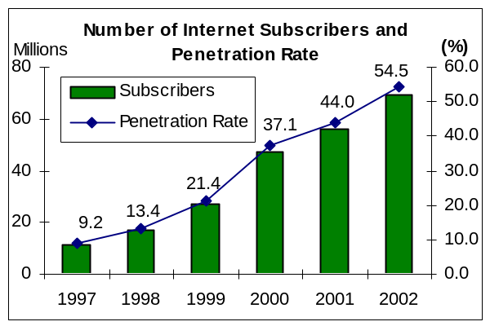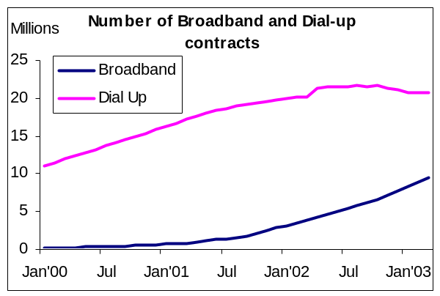
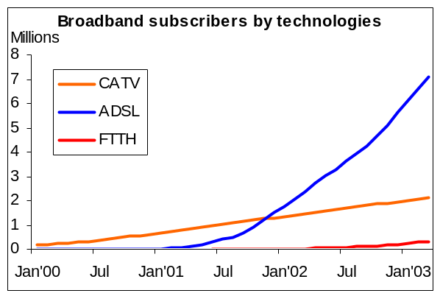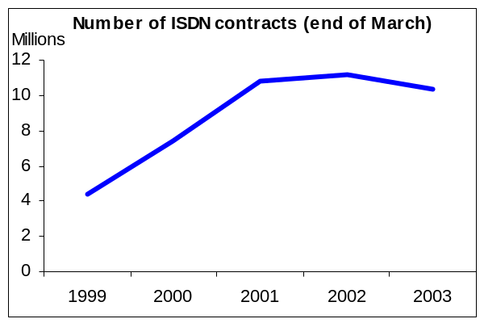

Note: Top right chart: stimated ISDN subscribers at end of March 2003; Bottom right chart: Dial-up subscribers are the total of major 15 ISPs.
Source: MPHPT, NTT Holding (ISDN).

The other mobile system is the Personal Handy phone System (PHS) launched in 1995. NTT DoCoMo, DDI Pocket (a subsidiary of KDDI) and the ASTEL group offer nationwide PHS services. With the drop-off in the market share since 1997 due to competition from mobile, the operators have switched their attention to PHS data services. This system has the advantage in terms of transmission speed (maximum 128kbit/s), compared with 2G mobile systems. (See Annex A for details of mobile Internet market.)

Internet market
For the most part, Japan’s Internet services market has been largely unregulated. The largest fixed-line ISPs in Japan are affiliated to equipment manufacturers. In the late 1980s, NEC and Fujitsu started offering closed PC communication network services. It was in the mid-1990s that both launched their Internet access businesses (NEC: Biglobe and Fujitsu: @Nifty). In the late 1990s, fixed-line operators, such as KDDI (DION), Japan Telecom (ODN) and NTT Communications (OCN) entered the market. Soon, they were well on the way to becoming major ISPs. Except for these fixed-line operators’ ISPs, the majority of fixed-line ISPs do not own circuit facilities. Of the other ISPs, So-net, owned by SONY, is among the major ISPs in Japan.
For dial-up Internet access, local access charges remain an obstacle and interconnection arrangements do not include revenue-sharing arrangements for Internet calls. The average flat-rate subscription charges for ISP services are JPY 1,000-2,000 (US$ 8.00-16.00). In addition, users have to pay the associated call charges. It costs about JPY 7.5-8.5 (US$ 0.6-0.7) for three minutes, daytime, weekends, without any discount services.
Figure 3.1 (upper-left chart) shows the increase in Internet penetration. In fact, fixed Internet use in Japan has been limited compared to other high-income countries. At the end of 1999, only 21.4 per cent of the Japanese population was using the Internet, whereas other high-income countries in the region exhibited higher penetration rates: Singapore at 29.5 per cent and Hong Kong China at 25.2 per cent. Since 2000, the Internet market in Japan has been expanding. The penetration rate more than doubled from 21.4 per cent at the end of 1999 to 54.5 per cent at the end of 2002. Even in those three years, the leading Internet technologies changed. ISDN and mobile Internet bumped up penetration in 2000 and 2001: ISDN users doubled from 1999 to 2001 (see Figure 3.1 bottom-right). At the end of 2001, Japan’s ISDN penetration (8.11 per cent of inhabitants) was fifth in the world. In the same period, the number of mobile Internet users had rocketed ten times to the initial levels. In 2002, the leading technology was changed to broadband: subscribers had increased 2.7 times from 2.8 million to 7.8 million. (see Figure 3.1 upper-right) The number of broadband subscribers has been increasing since the latter half of 2001. In 2002, this increase accelerated with more than half a million new subscribers per month, most of them were ADSL subscribers: 1.5 million to 5.6 million in 2002 (see Figure 3.1 bottom-left). In contrast, the number of ISDN subscribers has been stable since early 2001 and in 2002 is estimated to have decreased to slightly under 10 million. The number of dial-up (both analogue and ISDN) Internet users shows the same trend. It has been stable since early 2002 and it has been decreasing since October 2002 (see Figure 3.1 upper-right).
Figure 3.2: Mode of Internet access (millions of subscribers, total 69.42, end of 2002)
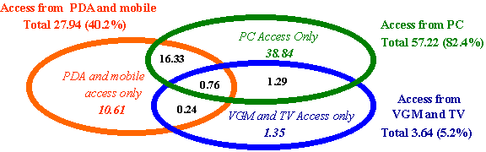

Note: VGM = Video Game Machine, PDA = Personal Digital Assistant
Source: MPHPT, “Trends of Telecommunication Usage”, 7 March 2003
The most famous recent success in Japan’s telecommunication market is mobile Internet services such as NTT DoCoMo’s “i-mode”. Does this make mobile Internet the most popular Internet access technology in

Figure 3.3: Broadband penetration in 2002
Broadband penetration rate (right) by countries
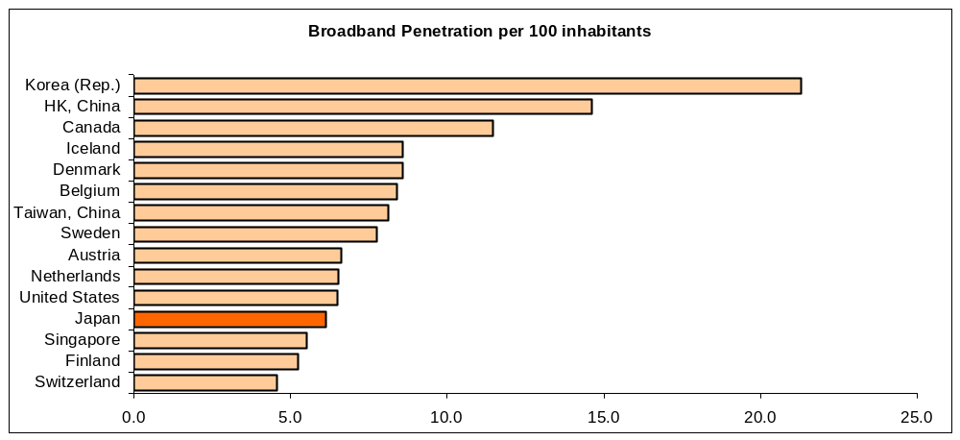
Source: ITU adapted from national reports
Japan? Figure 3.2 shows the mode of the Internet access by individuals in the end of 2002. Only 10.61 million (15 per cent of total subscribers) access the Internet only from PDA and mobile handsets. The majority (82.4 per cent) access from PCs. About a quarter of total Internet subscribers access the Internet from both PCs and mobile handsets, while over 60 per cent of mobile handset users also access the Internet from PCs. Internet access technologies are being diversified in Japan.
Japan’s broadband penetration rate ranked 12th in the world (see Figure 3.3) at the end of 2002. Considering that there was no broadband market in the end of 2000, it can be said that Japan has caught up with the top-class broadband countries. The quality of service has improved. ADSL service speeds have been widely upgraded from a maximum of 1.5Mbit/s in 2001 to a maximum 8M bit/s or 12Mbit/s in 2002. FTTH services were launched in 2002. At first, the normal service speed was a maximum of 10Mbit/s, but with soon increased to 100Mbit/s. Keen competition among broadband operators has led to the world’s lowest prices (see details in Section 5.1).
Broadband also brings change in market structure, not only in the Internet market but also in the voice market. NTT has already seen fixed-line voice traffic fall by nearly 20 per cent over the past two years. This is mainly due to the growing use of mobile phones. The penetration of IP telephony and decreasing use of dial-up Internet access may accelerate this trend. Yahoo! BB launched IP telephony service utilizing its ADSL networks in June 2002. By the end of 2002, it had about 1.6 million subscribers. This is about 2 per cent of total telephone lines. Other major broadband operators also plan to launch similar services in early 2003 (see details in session 4.4).

Businesses in the telecommunication market
Various broadband technologies have already emerged that enhance the user experience (such as ADSL) and the number of users is increasing dramatically on a global scale. Networks are shifting from circuit-switched to packet-based, from narrowband dial-up connections to broadband always-on connections, and from voice calls to data transmission. And the tide of change has not yet tarried.
These technology innovations cause an evolution in telecommunication market structure. In the analogue era, telecommunication services were provided only by network operators, with telephone services offered over the PSTN. But in broadband era, each telecommunication service can be unbundled. Various telecommunication services emerge and various entities offer their telecommunication services. Figure 3.4 shows this evolution and how services are unbundled. Each business area contains various businesses. Telecommunication operators can develop their businesses in each area or areas. This report defines business examples as follows: “terminal” includes businesses involved in the production and sales of telecommunication terminals. “Platform” includes businesses involved in the authorization, charging, content distribution and copyright management. Finally, “content/application” includes businesses involved in content/application production and sale.
Figure 3.4: Telecommunication business unbundling and examples of cross- area businesses

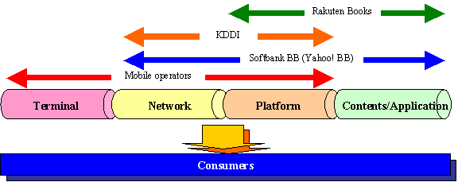

Source: ITU
In the network business in particular, access charges have been dropping. Thus, operators cannot expect high profits from their network businesses, but may do better by expanding into the platform and content/application markets.

Broadband market
The definition of broadband varies country by country, but for the discussion in this paper, ADSL, CATV, FTTH and wireless local area network (W-LAN) are considered as broadband.
The region that boosts the highest broadband penetration is Asia Pacific, and the Republic of Korea has been the leader for some time now. Japan had been trailing behind not only Korea, but also Hong Kong, Singapore and Taiwan, China until a few years ago. However, in 2001, the take-up of broadband services suddenly started to increase and in 2002 it has further increased from 3.1 million at the beginning of the year to 7.8 million at year-end 2002.

Types of network

ADSL
In Japan, ADSL services were launched in December 1999 by Tokyo Metallic (later merged with SoftBank BB). Since then, various operators, including incumbent NTT East and West, have joined the ADSL market. As shown below, a substantial jump in the number of ADSL subscribers occurred in the fourth quarter of 2001. From October to December, around 300,0000 new subscribers signed up every month and since then the growth rate has escalated throughout 2002 (see Figure 4.1). This can be mainly attributed to the launch of SoftBank BB's ADSL service called Yahoo BB! in September 2001.
Within just 16 months, Yahoo! BB attracted 1,690,100 users at the end of 2002, accounting for 30 per cent of the total number of ADSL lines in Japan. There were more than 2 million Yahoo BB! subscribers as of February 2003, which means that the Yahoo! BB service has finally reached a break-even point.
Yahoo BB! offers both Internet access and ISP services. NTT East and West offer only Internet access lines. Acca Network and eAccess are wholesalers that get dry-copper from NTT East and West and offer their Internet access lines. Their users must subscribe to an ISP service separately.

Figure 4.1: Change in number of residential ADSL subscribers (January 2001 to January 2003)
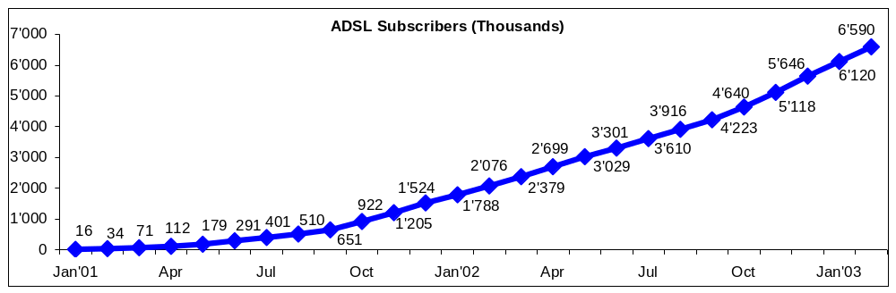
Note: The number of subscribers was calculated from the PSTN subscriber lines offered by the NTT regional companies for ADSL services to itself and other carriers.
Source: MPHPT (http://www.soumu.go.jp/joho_tsusin/eng/index.html)
What is different about consumer ADSL services in Japan compared to other highly developed countries is the transmission speed and the price, as the following two charts indicate. In Japan, the price leader is Yahoo! BB and, since its launch in September 2001, its competitors have been forced to lower their charges substantially in order not to be left behind (see Table 4.1).
Table 4.1: Detail of Residential ADSL Services in Japan (February 2003)
Providers | Services | Monthly  Rental Fee | Modem  Rental Fee | Monthly  Virus Check  Service Fee
Yahoo! BB | 8Mbit/s  12Mbit/s | JPY2,280  (US$ 19)  JPY2,480  (US$ 20.6) | JPY550~660  (US$ 4.6~5.5)  JPY890  (US$ 7.42)
DION (KDDI) | 12Mbit/s | JPY2,870  (US$ 23.9) | JPY500  (US$ 4.17) | JPY150  (US$ 1.25)
OCN (NTT) | 12Mbit/s | JPY2,970  (US$ 24.75) | JPY500  (US$ 4.17) | JPY200  (US$ 1.67)
ODN (J-Telecom) | 12Mbit/s | JPY3,080  (US$ 28.2) | JPY500  (US$ 4.17) | JPY300  (US$ 2.5)
@Nifty (Fujitsu) | 12Mbit/s | JPY3,380  (US$ 28.2) | JPY500  (US$ 4.17) | JPY200  (US$ 1.67)
So-net (Sony) | 12Mbit/s | JPY3,280  (US$ 27.3) | JPY500  (US$ 4.17) | JPY150  (US$ 1.25)
BIGLOBE (NEC) | 12Mbit/s | JPY3,380  (US$ 28.2) | JPY500  (US$ 4.17) | JPY300  (US$ 2.5)
Source: ISPs

Operators plan to launch a 16Mbit/s ADSL services in 2003 though not all users may need faster ADSL access. Acca Networks has announced that it will offer a new ADSL service that is slower but much cheaper: Its “ADSL entry service” is for light users, and has a maximum down-link speed of 1Mbit/s and up-link speed of 512kbit/s. The planned charge, including ISP charge is from JPY 1,450 (US$ 12.08; ISP: TikiTiki).

FTTH
The Japanese Government and the incumbent operator, NTT, have long been preparing for provision of FTTH. NTT has been developing FTTH as an all-in-one service where voice, data and video can be transmitted across the same set of optical fibers. This requires connecting terminal devices such as telephones, PCs, and television sets to an optical network unit (ONU), which is at the end of fibre cable installed all the way to each household. This ONU is capable of delivering high performance, but it is a proprietary standard and has the disadvantage of raising the unit cost of FTTH to unacceptably high levels.
For some time now, NTT is not the only operator wanting to play a significant role in the FTTH market. Japan's regional electric power utilities entered the telecommunications market in the late eighties through their telecom subsidiaries, such as Tokyo Telecommunications Network (TTNet), Osaka Media Port, Chubu Telecommunications Network (in the Nagoya region), etc. Each of them has invested substantial funds to install optical fiber networks in their own region. If combined, these networks would form a nationwide network almost on a par with that of NTT.
Figure 4.2: Change in the number of FTTH subscribers (January 2002 to January 2003)
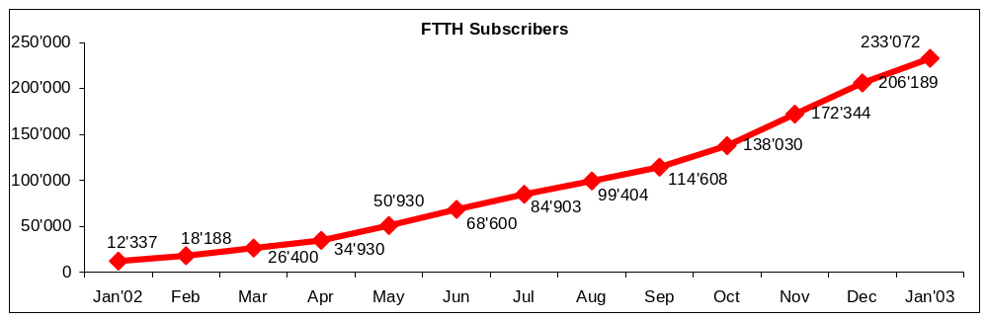
Source: MPMHPT (http://www.soumu.go.jp/joho_tsusin/eng/index.html)

Usen Broadnetworks is another company that offers FTTH service at 100Mbit/s, but has a very different corporate culture from traditional carriers, such as NTT and TTNet. Moving into telecommunications from the cable radio business, Usen already control a nationwide electric-pole network infrastructure on which optical fiber has been added region by region. In fact, the total length of optical fiber installed on its network is now 220,000 km, which is almost neck-and-neck with NTT.
What is also unique about Usen Broadnetworks is that they took a different approach where FTTH is offered only for high-speed Internet connection. Thus, it is completely independent of the telephone network, and is distinct from NTT's approach. In addition, Usen’s service to apartment blocks and condominiums is actually fibre-to-the-building (FTTB) FTTH infrastructure cost was much lower than that of the other operators. Subsequently, NTT decided to alter its FTTH strategy and switched to Usen's IP only approach. The rest of the providers also followed suit.
Usen also took a lead in moving from technical trial to commercial FTTH service in March 2001. At the beginning the service coverage was only in Tokyo, but now it has been expanded to the majority of regional metropolitan areas across Japan. Usen also can be seen as the price leader in FTTH market with low monthly charges of around JPY6,000 (approximately US$ 46). Users of most other FTTH services have to pay ISP charges in addition, which is not the case for Usen’s users. NTT closely followed Usen and started to offer commercial FTTH service, called B Flet's in August 2001. Their price is not as attractive as Usen’s but still reasonable.
As of March 2001, the major power utility, Tokyo Electric Power (TEPCO), already owned 53,000 km of optical fiber networks and the company will be investing JPY65 billion to install a further 50,000 Km of fiber lines by March 2006. Just like NTT, the company has been a wholesale provider of FTTH infrastructure to various ISPs in the area including its own, TTNet. Its counterpart in the Kansai region (where Osaka, Kyoto and Kobe are located), K-Opticom, has been offering the same service. Below is the summary of FTTH services and charges by provider. Table 4.2 indicates change in the number of FTTH subscribers in 2002.
Table 4.2: Summary of FTTH services and charges by provider (March 2003)

Providers | Services/Charges
NTT East and West | Maximum speed: 100 Mbit/s  Installation charges:  apartments --JPY11,900 (US$ 99.2)  detached houses--JPY27,100 (US$ 225.8)  Monthly charges:  apartments --JPY3,500 (US$ 29.2)  detached houses—JPY4,500 (US$ 37.5)
TTNet (Kanto region)) | Maximum speed: 100 Mbit/s  Installation charges:  houses--JPY29,000 (US$ 241.7) up to 5 terminals  SOHOs--JPY29,000 (US$ 241.7) up to 20 terminals  Monthly charges:  houses--JPY9,880 (US$ 82.3)  SOHOs--JPY17,380 (US$ 144.8)
K-Opticom  (Kinki region) | Maximum speed: 100 Mbit/s  Installation charge: JPY30,000 (US$ 250)  Monthly charges: JPY6,000 (US$ 50)
Usen | Maximum speed: 100 Mbit/s  Installation charges:  apartments --JPY15,000 (US$ 125)  detached houses-- JPY33,000 (US$ 275)  Monthly charges:  apartments --JPY 4,700 (US$ 39.2)  detached houses--JPY 5,200 (US$ 43.3)
Note: FTTH subscribers need to pay ISP charge in addition to the above. The exception is Usen which also acts as a FTTH ISP.
Source: Operators.

There are still various challenges that FTTH providers are facing, one of which is service area coverage. Some households are not located close enough to electric poles and additional installation takes some time to be implemented. Even in the case of apartment blocks or condominiums, it takes time to obtain permission from landlords or building management companies to wire inside the building.
Therefore, an increasing number of providers obtain wiring permission from the parties concerned before marketing the service in a specific area. Consequently, providers first focus their marketing efforts on the areas where there are enough subscribers to exceed the associated administration costs. However, the competition for customers is quite fierce and providers do not always have the option of withholding service provision in certain areas.
The second and more insurmountable challenge has to do with content, such as: when will there be content attractive enough to the majority of users to migrate from ADSL to FTTH? This issue will be addressed later in this paper.

CATV
Figure 4.3: Number of subscribers using Internet services that utilize cable TV network
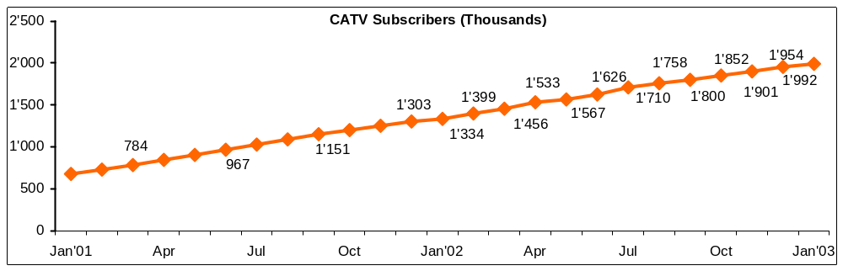
Source: MPMHPT (http://www.soumu.go.jp/joho_tsusin/eng/index.html)

In other developed countries, cable TV (CATV) networks are often hailed as harbinger of change that can present effective competition through bypassing the bottleneck of dominant telecom carriers' local exchanges. In Japan, this has not been the case for a long time due to the fact that the ownership of more than one local franchise nor provision of cable telephony was not allowed until ten years ago, which resulted in over several hundred small systems, fragmenting the cable TV market.
Table 4.3: Jupiter Telecommunications' subscriber on its broadband cable systems (December 2002)
Number of Franchise Homes | 6,707,000
Number of Homes Passed
Cable TV | 5,810,400
Telephony | 2,882,600
High-Speed Internet Access | 5,749,800
Number of Subscribing Households
Cable TV | 1,422,800
Cable TV & BS Digital | 23,100
Telephony | 349,900
High-Speed Internet Access | 504,500
Number of Households Subscribing to  At least 1 service | 1,590,800
Note: High speed Internet access is at around 1.5Mbit/s
Source: Jupiter Telecommunications

Only in 1993 was provision of cable telephony as well as the formation of multi-system operators (MSOs) allowed, and for the first time cable TV companies in Japan could operate nationally instead of being limited to a single geographical area. At the same time, foreign ownership restrictions have been loosened from 20 per cent to 33 per cent. Subsequent to deregulation, consolidation of operators has taken place. Among domestic players, Tokyu Cable started to emerge as the MSO with the highest number of paying subscribers for a single system, covering affluent areas in Tokyo and its suburbs.
Also, United States MSOs, such as Titus Communications (a joint venture between Time Warner, US West, Itochu Trading and Toshiba) and Jupiter Telecommunications or J-Com (a joint venture between Liberty Media, i.e. the former TCI, and Sumitomo Trading) have entered the market. In 2000, Jupiter became the largest MSO in Japan and acquired Titus in the same year. But operators such as J-Com and Tokyu Cable are an exception rather than the rule and the majority of cable TV systems in Japan have not been able to re-establish themselves as MSOs mainly due to the funding difficulty and lack of management know-how. Hence, even now there are still over 600 cable TV systems across the country.
Despite substantial investment made for upgrading some cable TV systems including that of J-Com, the take-up of high-speed cable modem service has been relatively low.

Wireless LAN
Since the beginning of 2002, wireless LAN (WLAN) hotspots have emerged in restaurants, cafés and convenience stores as well as airports and train stations all over large metropolitan cities in Japan. With transmission speed up to 11 Mbit/s, they have posed considerable competitive threat to the third-generation mobile services, which have only managed 384kbit/s so far. Table 4.4 shows wireless access systems in Japan.
For telecommunication network operators, it is rather difficult to create a business model where they can attract enough number of subscribers to make it commercially viable.
Much media attention was paid to the launch of the first commercial wireless LAN service called Mobile Internet Services (MIS) in April 2002, but service was suspended in December after only garnering around 1,300 subscribers in eight months. Even the major operator, NTT Communications managed to acquire only around 1,000 users.
Table 4.4: Wireless access systems in Japan
Frequency band | Place of use | Examples of usages | Transmission distance | Maximum Transmission speed | Licence
2.4GHz | Indoor/  Outdoor | (1) Wireless LAN in the office  (2) FWA (in hot spots and to buildings) | Around 5km | 20Mbit/s | Not necessary
5GHz | Outdoor | FWA (in hot spots and to buildings) | Around 300m | 5-20Mbit/s | Necessary
5.2GHz | Indoor | (1) Wireless LAN in the office  (2) FWA (indoor hot spots)  (3) Home network | Around 3km | 36Mbit/s | Not necessary
22/26/38GHz | Outdoor | FWA (for companies) | Around 4km | 10Mbit/s (P-MP)  156Mbit/s (P-P) | Necessary
25GHz | Indoor/  Outdoor | (1) FWA (in hot spots and to buildings)  (2) Relay line to access points  (3) Wireless LAN in the office  (4) Home network | Around 100m | 100Mbit/s  400Mbit/s  (Short distance) | Not necessary
Note: P-P: a system used when one radio station communicates with another radio subscriber station
P-MP: a system used when one base station communicates with more than one subscriber station
Source: MPHPT
A few companies are planning to offer wireless IP phone service for personal digital assistants (PDAs) and WLAN service providers are hoping this will get them out of the current difficulty, but it remains to be seen if that will actually happen.
In any case, the situation—in which it is difficult to profitably operate public wireless LAN services –does not seem likely to change in the foreseeable future, and W-LAN service providers are exploring various options where they might generate profits in combination with other services.
A company called Yozan, which acquired the Personal Handy Phone (PHS) infrastructure from ASTEL Tokyo, has been planning to offer mobile Internet service combining public wireless LAN access and PHS service. Thus, users have the option of using a PHS terminal, a PDA, a portable or a desktop PC depending on their location. Yozan is currently conducting a trial of this combined service and its commercial service is planned from July 2003. The company is also planning to offer on IP phone service through PHS from spring 2004.
NTT DoCoMo, on the other hand, is offering "Mzone" public wireless LAN in combination with its 3G service. The latter is called FOMA and its current transmission speed is 256kbit/s. Transmission at a much higher speed of 14.4 Mbit/s is being planned for Spring 2005. Currently, FOMA and public wireless LAN (at a transmission speed up to 11Mbit/s) complement each other well.
Table 4.5: Domestic shipment of PCs and peripherals
Type of PC / peripheral | Total units shipped
Servers/Desktop PCs | 5,870,000
Portable PCs | 6,232,000
Display monitors | 1,318,000
Printers | 4,663,000
Note: These figures are the combined shipment by 17 suppliers (Apple Computer, NEC, Oki Electric, Casio, Sanyo Electric, Sharp, Seiko Epson, Sony, Toshiba, IBM Japan, Gateway Japan, Hewlett Packard Japan, Hitachi, Fujitsu, Matsushita, Mitsubishi).
Source: Japanese Electronic Information Technology Industry Association (JEITA)

Types of terminal

Personal computers
According to the latest annual random sample survey carried out for the past several years by the MPHPT, the percentage of households that own at least one personal computer is 71.7 per cent of the total. There are 44.21 million households in Japan, which means there are at least 31.7 million personal computers in people's homes. The data is as of 31 December 2002. But the actual number is quite certainly over 40 million since quite a few middle and upper-class households own more than one PC.
Also, the same survey concluded that there are 48.9 million Internet users who access the Internet from their personal computers.
Even though the precise number of PCs in use is not known, Table 4.5 shows shipments of PCs to the Japanese market by type between April 2000 and March 2001, which gives some indication of demand.

Internet access terminals at home
In the broadband era, PCs do not represent is not the only possible type of terminal for Internet access. Since the expansion of broadband services, manufactures have been producing various broadband terminals, yet only minority of subscribers use such terminals. Examples are video game consoles, Internet TV, STB and home servers. However, it should not be forgotten that these are the early days of broadband, which has only been developing since 2001, and the future way see a change to the situation.
Box 4.1: SONY’s Personal IT Television Airboard (IDT-LF3)
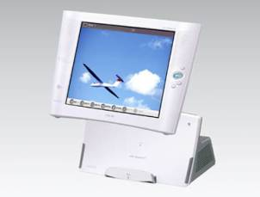
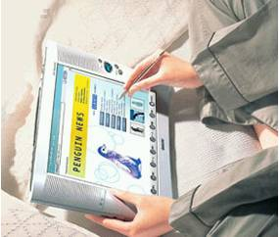

Source: SONY Website (http://www.sony.jp/products/Consumer/airboard/).

For example, globally 50 million units of Sony Play Station 2 consoles were sold in 2002. The equivalent figure for Microsoft's XBox was 8 million.
But when it comes to Internet-enabled game consoles in use, PS2 and Xbox are approximately 2 to 1 at 760,000 vs 350,000 for 2002.
In Japan, the MPHPT's latest annual random survey concluded that there were 3.64 million people who accessed the Internet either from their game console or from a TV set in 2002, even though the precise number of units in use is not known.
Box 4.2: BB Cable TV’s set-top box and SHARP’s Personal server HG-01S
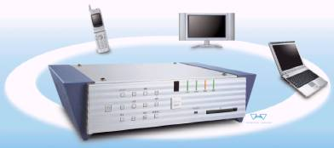
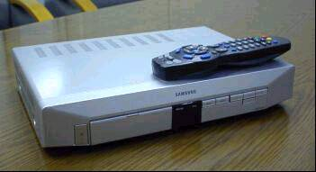

Source: BB Cable TV (Left), SHARP (Right)

Internet TVs started to emerge in 1999 in Japan and the products available at the time did not attract many consumers. However, technology has evolved since then and the user interface has also improved substantially.
Sony's Airboard was one of those products and it was a state-of-the-art wireless video device back then (Box 4.1). Improvements added over the past three years culminated in the latest version, IDT-LF3, which was released in January, 2003. Airboard was created as a wireless Internet tablet rather than audiovisual equipment, however, SVGA (800x600 pixels) delivers vivid moving images.
Compliant with the IEEE802.11b standard, it can be connected to the Internet at up to 6Mbit/s. The device can be used almost anywhere (30m radius) in one's home including the garden and in the bathroom (with an optional protective cover). It can be connected to a wide range of printers as well. One can watch TV as well as capturing video images of choice from the programmes one watches. The battery life is currently a bit short, but with improvements expected in the near future, devices like these will certainly change the way an increasing number of people use video information.
A set-top box (STB) is defined as a device that is connected to TV to watch various contents. Here, STB will be considered only in broadband content distribution. Broadband subscribers can watch broadband video programmes on their TV with STB. In Japan, BB Cable TV, for example, offers its subscribers STB (see Box 4.2 left, and Box 4.5). FTTH service provider, Bbit-Japan, also offers STB. Subscribers with STB can enjoy higher quality video than those with a PC (see section 4.4.4 details about the service).
A new development in 2002 was the emergence of home servers, consisting of PC, DVD, TV etc. SHARP’s Personal server HG-01S, produced in February 2003, is one example (see Box 4.3 right) which can interconnect a PC, mobile phone, TV, etc. This device even enables the user to access his/her home network when absent from home, by, for example, setting the video timer via their mobile phone and watching recorded TV programmes on their PC.
Box 4.3: SHARP’s Linux PDA ZAURUS SL-C700
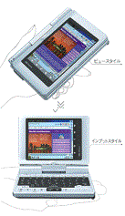
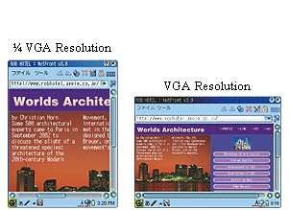

Source: SHARP Website (http://sl.ezaurus.com/index.html)

Portable devices (PDA etc.)
As indicated in the Annex of this paper, there were some 73 million mobile phone users and over 59 million mobile Internet users at the end of 2002. The high-end mobile phones have many features that are common with PDAs including JavaVM, and they cost between JPY20,000 and JPY30,000 (US$ 166.7-250). For the majority of users who want to manage personal information through a portable device, high-end mobile phones seem quite sufficient, rather than spending an extra JPY30,000-40,000 (US$ 250-333.3) to purchase PDAs. Furthermore, for users who need more sophisticated applications quickly and efficiently, there is a variety of portable "note PCs" (B5 size) not much bigger and not much heavier than PDAs. Between these two categories of device, PDAs aimed at general users do not have that much room to grow.
SHARP revealed its new Linux PDA ZAURUS SL-C700 in November 2002 (see Box 4.3). This PDA has a 3.7 inch VGA (640x480 pixels) resolution display. This resolution is twice or four times higher than existing PDAs. It has strong interoperability with PCs. This high performance is necessary to attract new users to buy PDAs.

Platform
Platforms in this context can be defined as service enablers and would include mechanisms for electronic billing, secure payment, user/supplier authentication, copyright protection, and efficient content distribution on the Internet. Various software suppliers increasingly focus on some of these services.

Secure payment for online purchase
According to a survey conducted in March 2001, the average Internet user in Japan spent around JPY43,000 (about US$ 330) during the previous year and the average purchase frequency was 5.7 times.
A significant proportion of Japanese consumers have been wary of disclosing their personal bank details over the Internet. Convenience store chains, such as Seven-Eleven, that have become national institutions, have found a niche and have offered a new shopping experience. Internet users order goods on the Internet, then pop into the nearest store to receive the products and pay for them, or they purchase goods online by a prepaid card bought at a nearby convenience store.
There have been other payment services offered in order to avoid entering personal banking details directly on the Internet. For example, one method consists of registering user ID and password and banking details prior to ordering on the Internet, in order to enter only user ID and password online and then pay once a month to the payment service providers.
However, these arrangements restrict consumers' freedom to buy from the supplier of their choice on the Internet, and the system did not catch on. The largest Internet currency service provider, Millicent, a subsidiary of KDDI, left the market in September 2001 and some of Millicent's competitors have also done so, or are planning to do likewise. But there are still some offline payment service providers who are active in the market.
Even though the usage rate is still lower than in the US or even in Europe, with the increase in the number of websites adopting secure payment methods, such as Secure Socket Layer (SSL), a growing number of people currently use credit/debit cards for purchases over the Internet.

Content delivery network (CDN)
CDN is a service which offers Internet infrastructure to run a website with large amounts of content efficiently. Internet content providers who would benefit from the use of CDN typically have a high level of traffic with music or video content requiring large capacity. Examples in Japan would be large portal sites, such as Yahoo! Japan, MSN and shopping sites such as Rakuten and UNIQLO. CDN providers would be in charge of optimizing the running of data centers and servers for the website operation of the clients.
CDN providers from the United States, such as Akamai Technologies and Digital Island have entered the Japanese market through their respective partners, NTT-ME and J-Stream; and have so far dominated the market. However, Japanese players are starting to emerge.
Box 4.4: Outline of content delivery network
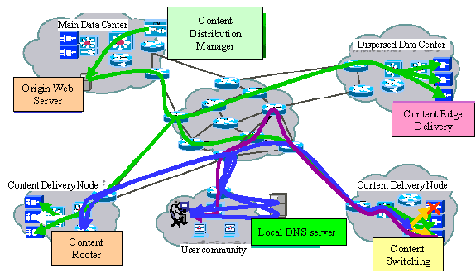

Source: MPHPT, Report on Broadband Competition Policy in Telecommunication Business, 6 June 2002

NTT established a subsidiary, Broadband Initiative, in June 2001, specialising in broadband CDN service, and Sony has done the same with AII. Produce on Demand (PoD) is another new entrant, a subsidiary of Internet Research Institute as well as All Broadband Contents (ABC), a joint venture by Rakuten, a company
known for the largest shopping website in Japan and Usen, a cable radio and FTTH provider. But one of the most recent and significant entry to this market is Alphabridge, a joint venture of Sumitomo Trading, NEC and Microsoft among others.
One notable difference about the service this company offers is that, with its original software, it can automatically store clients' requested content to their subscribers' hard disk so that they can view that content whenever they wish.
This market is still young in Japan and the future CDN growth depends on how soon current challenges that preventing large-scale contents to flourish, such as copyrights and online billing, can be efficiently dealt with.

ADSL or FTTH portals by ISPs
Up until the burst of the IT bubble, portals with search engines such as Yahoo and Excite flourished with much advertising revenue. For some time now that has no longer been the case. In most of the OECD countries, fixed ISPs have gone through significant market consolidation and individual ISPs have been searching for an alternative business model.
In Japan, many fixed ISPs have been hit very hard financially because Yahoo! BB has entered the ADSL market with a low monthly charge (see Section 4.1.1), not much higher than the dial-up Internet access charge. In order to compete with Yahoo! BB, all other ISPs have to offer ADSL connection. To do so they have had to invest substantial funds to acquire ADSL backbone infrastructures, which is an additional cost, yet they have not been able to charge significantly more than for dial-up connection.
To earn additional revenue, as well as to attract more subscribers, many ISPs have opted for creating broadband portals. The content of these portals is composed of video-centric or sound-centric material, mostly for a fee. It has been less than a year since many ISPs established broadband portals, and is therefore too early to say whether they will soon be commercially viable. Some in the industry are already sceptical as to their profitability.
Some maintain that the only profitable segment of broadband services is currently pornography, and the one that will catch on in the future will likely be IP telephony with video transmission.

Broadband content/application

Online games
With "always-on" ADSL connections, cable modem or FTTH, game players do not have to worry about increases in communication charges, thus they can be ever more willing to play online as well as offline, if per usage charge is set at the right level. The game industry is keen to take advantage of the momentum.
Sega's "Fantasy Star Online Game", which can be played in five languages, attracted 300,000 members in and out of Japan.
Meanwhile, Bandai has struck an alliance with a Korean company that developed a very popular online game called "Potoris" whose membership numbers 10 million. It has started to market a Japanese version of the game.
One of the most popular game console makers, Sony Computer Entertainment (SCE), has launched a broadband service in Japan for its PlayStation 2 in April 2002. It has been reported that around 60 per cent of Sony Group's entire profits for fiscal year 2002 will be PlayStation-related, which indicates how serious Sony must be in this market.
What Sony calls "PlayStationBB" services is a platform to access broadband network services provided through PlayStation 2 connected to a TV monitor and to the broadband networks. Together with its business partners, the company has been planning to make various contents including games and music which are more enhanced than what is currently available on computers.
Server hosting, billing and fee collection services are or will be provided by various ISPs run by NTT, Sony, NEC, Fujitsu, Usen Broadnetworks, Yahoo Japan, etc.
The ISPs are the ones to distribute PlayStation BB Unit (home entertainment platform with 40G byte hard disk drive) which subscribers either for around JPY 18,000 (US$150) or they pay monthly rental fee of around JPY1,000 (US$ 8.3).
Users of PlayStation BB Unit will also need "Broadband Navigator," software that allows them not only to access SCE's original games, pictures, music and film contents, but also the proprietary home pages based on HTML/XML. It is a sort of media player.
Many of the broadband ISPs which are marketing Play Station BB Service are still running trials after more than 10 months since the launch of the service, which seems to indicate there is not yet enough demand for the service to make it commercially sustainable.
In the case of packaged games, suppliers could expect drawing revenues significantly exceeding expenditures as the product cycle proceeds from the software development stage to the mass production/marketing stage. The cost structure of online games is complicated.
In addition to the cost of pre-launch software and server development, labour costs for 24-hour online service and the cost of enhancing system hardware and server capacity to cope with the changing level of peak-demand can be substantial. Sony learned the lesson the hard way when its Final Fantasy XI online game was released in May 2002. The system broke down, with too many users trying to access it at the same time. Subsequently, the company has established a content distribution network (CDN) arm called AII.
Online games are a service from which it is difficult to generate profits. But, in order to win in the game machine war, no company can ignore this segment of the market.

Digital photos
With 15 million mobile camera phones sold in 2002, this recent success has clearly demonstrated the fact that people like to send pictures they have taken to their family and friends. This applies to fixed networks as well as mobile networks. For many consumers, sending such pictures e-mail is one of the main reasons they switch to broadband, and they encourage their friends and family do the same. Many are also attracted by the prospect of being able to upload digital photos on their personal websites to share with their circle of friends and acquaintances.

Electronic publishing
Amazon.co.jp aside, there are some Japanese companies selling electronic books which take advantage of broadband capability. One of the largest electronic bookshops is called Papyless, which offers over 10,000 books for Internet users to purchase and download. The annual revenue of Papyless from electronic book sales is still relatively small at JPY 300 million (US$ 2.5 million), however, with broadband subscribers fast on the increase, revenues are growing.
Here again, the lion's share of e-books sold is adult material. Users of electronic books usually download them either on their notebook PCs or PDAs so that they can carry them on the move.
There are some intiatives by writers who enjoy the freedom of publishing whatever they like and which are not tied to the editorial intervention from publishing houses. One of these groups is called e-Novels Associates. There are currently over 40 writers contributing their work for sale on the website and the number of hits passes the one-million mark every month.
Whether this operation is profitable is not certain. In any case, many consumers do not see any need to purchasing books on the Internet because most of them can obtain them easily offline. Needless to say, web-based bookshops or publishers have to offer value-added services to compete with their established brick-and-mortar competitors.
Nikkei Business Publishing is one of the few profitable online publishers in Japan. Even in the post-bubble economy era, they have managed to attract enough advertisers. This is attributed to the fact that the publisher has had a wide-range of business publications off-line for many years and they were able to bring a large number of their off-line advertisers online from the start of their Internet operation.

Video over broadband
Video streaming on the Internet has been available for some time. However, with an increasingly large proportion of Internet users subscribing to broadband, there is a momentum for video viewing over the Internet. Video streaming seems particularly popular in Korea and the United States. In Japan too, the trend is catching on.
As has been discussed already, almost all the major ISPs have launched a broadband portal where they distribute video- and sound-enhanced contents.
One of the most popular broadband portals is Showtime, which is the flagship of All Broadband Contents (ABC). ABC is a joint venture between FTTH provider, Usen and Rakuten that boosts the largest Internet shopping website in Japan in association with a CDN provider, Produce-On-Demand. And Show Time is not just for Usen but it is an open portal for all broadband ISPs. They have over 2,700 video-centric and music-centric titles, some of which are free for sample viewing, while most others are for subscribers who pay a monthly access fee of JPY280 (around US$ 2.3)
Box 4.5: BB Cable TV’s content distribution system
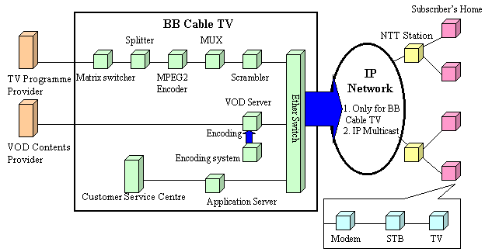

Source: Adapted from BB Cable TV (http://www.bbcable.tv/).

Other broadband portals have a different charge structure. They do not impose a monthly charge to browse, but individual contents have either monthly or pay-per-view charges.
Yahoo! BB has also had its own broadband portals since the launch of the ADSL service. In addition, BB Cable TV, a group company of Soft Bank, has obtained a broadcast licence over DSL. It is the first company to obtain this particular type of licence taking advantage of the new law (on using the wired telecommunication network, see section 2.3.1). In addition to existing terrestrial stations, Yahoo! BB subscribers will be able to watch variety shows, animations, dramas and sports, distributed over 19 basic channels. This broadcasting requires a faster ADSL connection: a minimum of 3Mbit/s.
Besides these, there are three à-la-carte channels and true video-on-demand (VOD) programmes for extra fees, probably between JPY500 and JPY600 (US$ 4.2~5.0). The service wasrolled out in Tokyo in March 2003 and it will be expanded to vicinities of Tokyo and several other major cities all over Japan during 2003.
Even though BB Cable TV can bank on a large ADSL subscriber base (more than two million), doubts remain as to what they can offer that many VOD providers who failed in the US and Europe did not offer in the past. One would be more optimistic if one sees the situation in Korea where VOD over ADSL seems to be on its way to popularity. But then, the market environment there is quite different from that of Japan.
FTTH ISPs also have plans to set up portals. Subsidiaries of regional power companies, such as TTNet and K-Opticom, established a cooperation, “BBit-Japan”, to launch a portal called "Fiber TV," in November 2002 where subscribers have access to 3,000 MPEG-2 compressed video titles that are optimised for FTTH transmission (5Mbit/s). Subscribers can view the contents either through a set-top box attached to a TV set or on a personal computer. When a subscriber uses a PC, the transmission speed is limited to 1Mbit/s. Because the capacity of all PCs is not the same, however, some PCs cannot play back high quality video.
Besides Showtime, Usen also has a portal site specifically for FTTH called Gate 01 which boosts 5,000 titles. But they do not expect to make profits for some time to come. Rather, these titles are placed on the portal to let current and potential subscribers know the capability of FTTH transmission.
There have also been some initiatives taken by traditional broadcasters. A consortium called Tresola was established in early 2002 by three of the six major terrestrial TV networks and some consumer electronics companies to assess the commercial feasibility of video streaming of their programme contents.
Table 4.6: Number of Yahoo IP telephony subscribers (July-December 2002)

Month | Number of subscriber lines | Monthly increase
July | 319,000 | ---
August | 413,000 | 94,000
September | 520,000 | 107,000
October | 773,000 | 253,000
November | 1,028,000 | 255,000
December | 1,294,000 | 267,000
Source: Yahoo Japan.

Between September and November 2002, Tokyo Broadcasting System (TBS), Fuji Television and Television Asahi have carried out a commercial trial service to show their popular programmes from the 1980s and 1990s through the Internet. Viewers were charged JPY1000 (US$ 8.3) a month and could watch any of the programmes as many times as they wanted, when they wanted, by downloading video streams.
The trial was well received, however Tresola is still trying to come up with a way to differentiate "TV on broadband" from their terrestrial counterparts. For example, they may distribute documentaries such as "the making of …" popular programmes in order to offer value-added elements. Also, the consortium has not yet decided what level of charges is appropriate for fee-based video streaming. Furthermore, they need to work further on efficiently managing copyrights of programmes and music used in these programmes. Their commercial service might start in mid-2003 at the earliest.

IP telephony
Strictly speaking, IP telephony is not considered as content. However, the ability to make very inexpensive calls (even free calls among users of the same broadband networks) seems to be "the killer application" for ADSL and FTTH services.
Ease of use, afforded by, not having to leave the PC on all the time and being able to make calls to mobile phones and PHS terminals, has made a critical difference compared with IP phone services associated with narrowband networks. Here again, Yahoo! BB took the initiative of offering ADSL IP phone service for the first time in mid-2002 (see Table 4.6).
Since the launch of the IP Phone service by Yahoo BB!, which has met with the whole hearted enthusiasm of Japanese consumers, other fixed ISPs have been somewhat left behind.
Besides being the ADSL price leader, Yahoo Japan has also been the company that has the highest number of Internet Protocol (IP) telephony users. Its popularity can be attributed not only to the attractive price (JPY7.5/3 minutes, ie 0.057 US$ /3 minutes and calls between Yahoo! BB users are free) but also to the fact that Yahoo has done away with the problems long associated with IP telephony.
For instance, its users do not have to leave their PCs on 24 hours to receive calls as long as the VoIP adopter is connected to the PSTN lines through their ADSL modem. They can also make calls to mobile phone or PHS users, which previously was not possible. This improvement made its users sign up for "BB Phone" service in droves, which is demonstrated in the Table 4.6. Again, other ISPs are following suit
As a way to tackle this situation, five large ISPs, namely, NEC (BIGLOBE), NTT Communications (OCN), Sony Communication Network (So-net), Fujitsu (Nifty) and Matsushita (Hi-ho) have struck an IP Phone alliance.

Box 4.6: IP telephony network
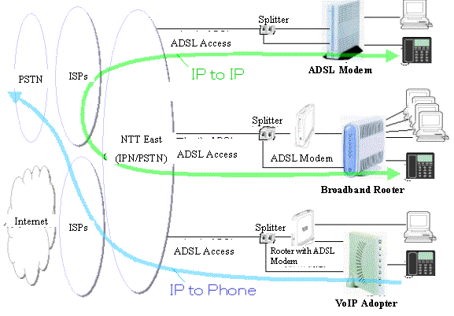

Source: Adapted from NTT East (http://www.ntt-east.co.jp/release/0303/030311b_2.html)

The new alliance's combined Internet subscriber base is around 2 million, which is very closed to that of Yahoo! BB's subscriber figures. Member companies have standardized technical specifications of their respective IP telephony service so that all of their subscribers can phone each other free of charge. The joint service was launched in March 2003.
Usen, is also putting much hope in IP telephony over FTTH. But their main focus is transmission of video images. They will target video IP telephone service for business and education with applications such as video conferencing, telemedicine, and distance education. Usen is confident that FTTH is more suitable for
video IP telephony since download and upload speeds are symmetrical, as opposed to DSL technology where upload speed is much lower than download speed.

Consumer behaviour towards broadband
According to a biannual survey on Japanese consumers' use of information and telecommunication equipment and services called "NRI Cyber Life Observations," use for large-volume content, such as image- up rate increased. Figure 4.4 is an excerpt from the survey indicating this trend.viewing over the Internet, content downloading, game-playing have been on the increase as broadband take-up rate increased. On the other hand, subscribers cut down sleeping hours and TV viewing.

Figure 4.4: Changes in consumer behaviour due to broadband usage
NRI Cyber Life Observations consumer survey results, September 2002
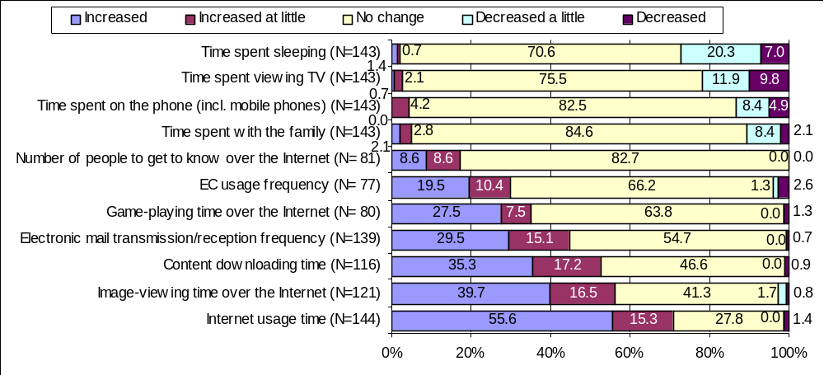

Male (Age group) | No. of Respondents | Female (Age group) | No. of Respondents
Teens | 78 | Teens | 68
Twenties | 166 | Twenties | 163
Thirties | 147 | Thirties | 158
Forties | 165 | Forties | 167
Fifties | 170 | Fifties | 165
Sixties | 128 | Sixties | 128

Note: The brief profile of the above survey is as follows: Number of samples: 2,400; Number of Responses: 1,703. (Survey period: from 1 to 10 September 2002.)

Source: "Cyber Life Observations," in November 2002; a biannual survey on the Japanese consumers' use of information & telecommunications equipment and services carried out by Nomura Research Institute

Broadband promotion

Successes
Japan’s broadband market took off in 2001. Investigation and analysis of that year in particular therefore gives good insight into the successes. The announcement of the e-Japan Strategy in January 2001 appealed to industry to focus on IT development. In the broadband market, two main points support the development: the first is new market entries that affect the competitive environment of the market. The second is the lowering of service prices and the increase in data transmission speeds that benefit and give an incentive to users.

Increasing new market entries
In the interests of fair market competition, the market to new entrants. This is necessary for the development of the broadband market, it is beneficial to open to stimulate investment and innovation by supporting new market entrants and creating a pro-competitive environment. In the broadband market, Japan has been highly successful in stimulating competition in this way, with a number of players taking advantage of local loop unbundling (LLU) and strong infrastructure competition, thereby encouraging the fast rollout of broadband.
In practice, LLU makes incumbents’ local lines available to consumers, and makes space in their exchanges, use of certain circuits and an array of important ancillary facilities available for other operators in order that they can provide their telecommunication services over those lines.
Figure 5.5: Unbundling in NTT East and West telephone networks

Copper lines
Z C
G C

Unbundling at MDF
Interconnection at ZC or GC Optical-fibre lines
Note: ZC: Zone Center, GC: Group Unit Center Unbundling at CTF
Source: MPHPT
Since March 1999, Tokyo Metallic negotiated with NTT concerning conditions of collocation and interconnection. NTT was negative for ADSL, because NTT had invested heavily in ISDN. NTT’s intention had been to jump straight to FTTH as the next generation of high-speed networks after ISDN. In December 1999, interconnection at the main distribution frame (MDF) was realized (See Figure 5.5). This means that telecommunication operators divide network components and lease them to Internet connection providers. This reform enabled other operators to provide ADSL services, and was—uniquely—to provide Japan with a high level of facilities-based competition. Tokyo Metallic then became the first company in Japan to offer DSL in December 1999, followed by other new entrants.
However, the speed of take-up was slow because the ADSL service was only available in metropolitan areas and the price was high. It took a further four months to upgrade NTT’s exchanges for ADSL elsewhere. The MPT prescribed conditions for LLU in its revised ordinances in September 2000, in order to solve these problems and promote ADSL. This revised ordinance defines technical conditions and interconnection fees concerning unbundling of facilities that NTT East and West have to mention in their interconnection conditions.
As a result, 47 operators offered ADSL services as at the end of June 2002. As seen in Figure 5.6 incumbent NTT East & West’s ADSL market share in February 2003 was 37 per cent - about one third of market. Thus, it can be said as a result of early and effective LLU enables strong market competition among incumbents and new entries. This leads to cheap prices and consequent rapid take-up that are discussed in detail in section 5.1.2 below.
Concerning optical fiber, MPHPT also revised ordinances to establish rules for unbundling of fiber optic networks in April 2001.
Typical examples of unbundling costs are (October 2002 figures):
(1) Subscriber lines (not overlapped by telephone lines) JPY 1,829 (US$ 15.24)
(2) Subscriber lines (overlapped by telephone lines) JPY 168 (US$ 1.40)
(3) Subscriber fiber-optic lines JPY 5,213 (US$ 43.44)
Figure 5.6: ADSL market share
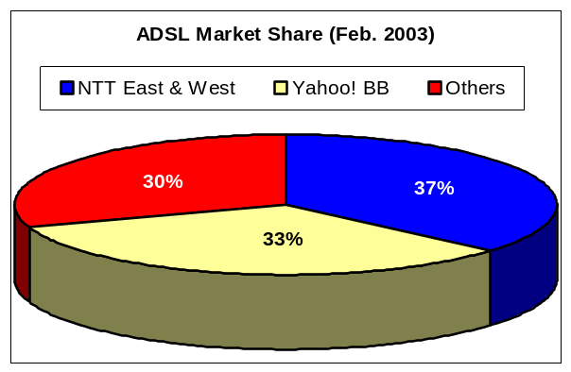
Source: ITU
(4) Relay operators’ fiber-optic networks JPY 2,627 (US$21.89)/meter + JPY 139 (US$ 1.16)
Besides LLU, collocation that enables Internet access providers to install their network equipments in the free spaces in incumbent operators’ buildings is also important for new entrants. Appropriate collocation resource allocation is necessary for these new entrants to launch their business smoothly. MPT revised the telecommunication business ordinance to introduce rules for collocation in September 2000. This revised ordinance obligates NTT East and West to clarify collocation conditions in their interconnection conditions.
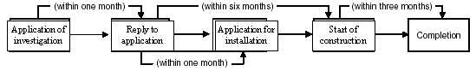
Figure 5.7: Procedures for collocation

Source: MPHPT, “Outline of the Telecommunications Business in Japan”, October 2002
In October 2001, just after the service launch of Yahoo! BB, its competitors found that the company reserved too many collocation resources, such as spaces and electronic capacities in NTT East and West’s buildings. This caused difficulties for other ADSL access providers because NTT could not afford to lend its resources to them when they requested such arrangements. At the request of NTT East and West, MPHPT authorized a revision of their collocation contracts with ADSL access providers in December 2001. This revision was to shorten the free resource-reservation duration from one year to six months. It effectively forced those who keep resources beyond their actual needs to release them. Also, the Telecommunication Business Dispute Settlement Committee (See Annex C for the details of this Committee) sent a recommendation in February 2001 to the Minister of MPHPT to improve the collocation rule to avoid disputes. It reported that three cases out of seven that had requested mediation from December 2001 to February 2002 concerned collocation. NTT East and West again revised its contract to introduce the upper limit concerning collocation resources to each ADSL access service provider. NTT also added an article to offer information about collocation resources. MPHPT authorized these in May 2002. Yahoo! BB returned reserved collocation spaces for 9.9 million lines to NTT in June 2002.
Other than facility-level liberalization, another business model and deregulation also accelerate competition. In 2000, ADSL wholesale providers, such as E-Access and ACCA Networks, launched provision of ADSL lines to other ISPs. This enables existing ISPs without their own circuits to offer ADSL service to end-users. Wholesale, on the other hand, had been regarded as an exceptional business that needed authorization by MPT. In a move to MPHPT added the concept of wholesale business in the Business Law in its 2001 revision.
Figure 5.5: Detail of residential ADSL services in selected countries (December 2002)
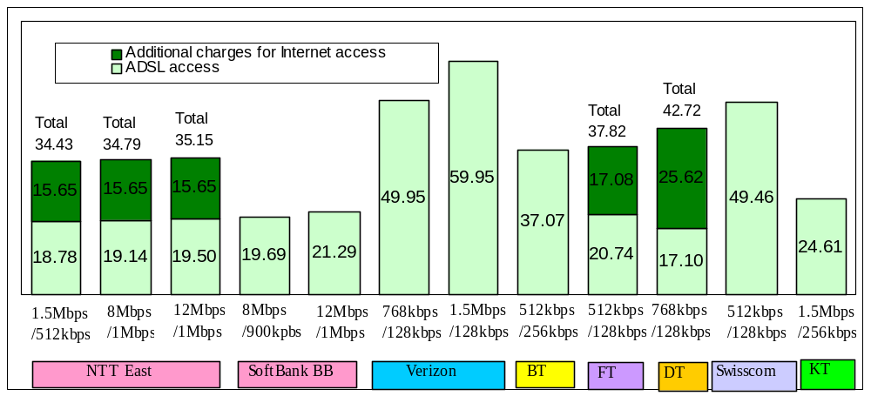
Note:1) Fees are as of December 2002
2) Foreign exchange rates were calculated on the basis of the TTS (Telegraphic Transfers Selling) rate on December 2,2002, which was JPY 124.61, GBP0.64, Euro 1.00, CHF 1.48 and KRW 1219 to US$1
3) Tax is not included
Source: MPHPT

Cheap prices and higher speed
A substantial jump in the number of ADSL subscribers has occurred since Yahoo Japan entered the market – from around 290,000 to 1,520,000 in the latter half of 2001. This popularity has been mainly attributed to three factors – price, transmission speed and an improved IP telephony service.
The lowest monthly charge prior to Yahoo’s arrival in the ADSL market was around JPY4,800 (US$ 40), more than twice as much as Yahoo's, (JPY2,400(US$ 20)), as indicated in Figure 5.4.
At launch, Yahoo! BB download speed was 1.5 Mbit/s, but it soon went up to 8Mbit/s and for some time now, users have an option of selecting 12Mbit/s with a small additional charge for the two higher bit rates.
In mid-2002, IP telephony service over DSL was added to the menu of Yahoo! BB and, at the year-end, the number of subscribers approached 1.3 million. The popularity seems to derive from the fact that one can make calls to other Yahoo! BB Phone service users on-net free of charge and it only costs JPY 7.5 (US$ 0.06) per three minutes to any phone anywhere in Japan and the United States. Also, it is easy to use.
Figure 5.4: Comparative prices for ADSL and FTTH
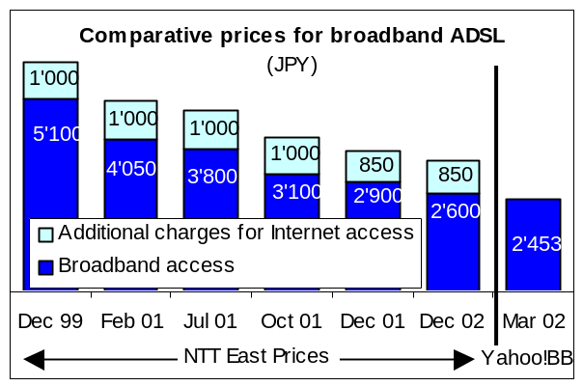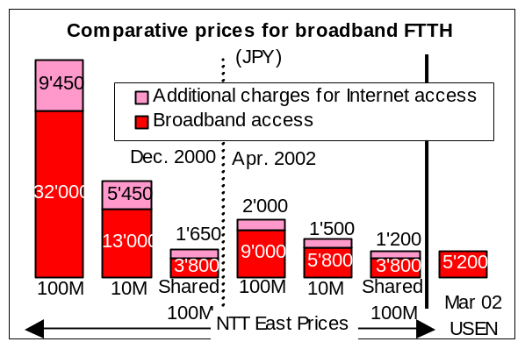

Source: MPHPT, NTT East

Users can make calls not only to ordinary phones, but also to mobile phones and PHS terminals. Moreover, users need not leave their PCs on at all times to receive calls as long as the VoIP adopter is connected to the PSTN line through the ADSL modem.
The fact that Yahoo! BB went ahead to offer ADSL with a much lower charge than its competitors meant that they needed as many as 2 million subscribers to turn a profit, which was a risky strategy at the time of its launch, but the company achieved the milestone after 18 months. In addition, profits mainly came from the sale of contents, advertising and rental and sale of ADSL modems, and not from the monthly fees.
In the FTTH market, Usen offers the lowest monthly usage charge of any provider, at JPY5,200 (US$43.3), as shown in Figure 5.4, and it seemed to have gone beyond the price threshold that consumers feel comfortable with. As a result, the price triggered a significant level of demand, even though concurrent market efforts by NTT East/West and subsidiaries of power utilities have definitely helped raise the demand too.
Usen took a different technical approach from the incumbent, NTT. It has offered FTTH only for high-speed Internet connection, independent from the telephone network, whereas NTT originally intended to offer telephone, TV and Internet access all-in-one by FTTH. In addition, Usen’s service to apartment blocks and condominiums is actually fibre-to-the-building (FTTB) and from there the company either uses local area network (LAN) or very high data rate digital Subscriber Line (VDSL). As a result, Usen's FTTH infrastructure cost was much lower than that of the other operators. Subsequently, NTT decided to alter its FTTH strategy and switched to Usen's IP only approach. The other Japanese providers have also followed suit.

Weaknesses to be overcome
As mentioned in Chapter 2, the target set by e-Japan Strategy of 30 million households within reach of high-speed Internet access and 10 million households within reach of ultra-high-speed has already achieved completed. But, although Japanese broadband operators offer the fastest and the cheapest Internet access service in the world, the numbers of subscribers in February 2003 were 8.6 million and 0.27 million respectively for the target figures of 30 million and 10 million, representing just 28.7 per cent and 2.7 per cent of the set target. This section describes what are, and what will be the weaknesses of broadband Internet services, and analyses how these might be overcome. The first two are weaknesses that relate to physical location: the traditional digital divide between urban and rural areas, and digital divide in broadband service areas, especially in urban areas. The competitive environment makes providers more reluctant to introduce broadband into rural areas, where profits are hard to come by, and there is now a widening gap between broadband provision in the rural areas and that available in the cities. But, even if broadband access lines have already constructed, some cannot subscribe to any broadband services. The next issue relates to application/content. What use is to be made of faster Internet access services? Without attractive application/content, users are willingly to take the step of subscribing to faster Internet access.
Box 5.1: The Okayama Information Highway
Okayama prefecture was the first regional government to establish an information highway project, making it a pioneer in this area. The prefecture, which lies to the west of Japan, set up an experimental scheme in 1996, drawing businesses, schools and ordinary citizens both inside and outside the prefecture into the debate and stimulating discussion into both infrastructure and its uses.
By establishing an independent optical fibre network infrastructure and Internet exchange, and opening these up to ISPs and CATV companies, this project has smoothed the way for companies to develop their own broadband services. In 1998, the MPHPT set up gigabit network access points for research and development purposes in this area and these are currently being used on a trial basis.
Source:Okayama Prefecture ( http://www.harenet.ne.jp/villa/)

Regional imbalance in broadband development
About 70 per cent of Japan’s territory, where around 20 per cent of the population lives, is mountainous. In these rural areas, broadband access is as desirable as it is in urban areas. But, broadband service providers are now finding themselves exposed to intense competition. Inevitably, the competitive environment makes providers more reluctant to introduce broadband into rural areas, where profits are hard to come by, and there is now a widening gap between broadband provision in the rural areas and that available in the cities.
Box 5.2: Hyogo Information Highway and cooperative ventures in ADSL
This is a particularly interesting example, focusing as it does on ADSL as its popularity starts to spread rapidly throughout the country. Awaji is a small town in the Hyogo prefecture with some 2,600 households and a population of around 7,000. It is exactly the kind of place in which an ISP would normally be reluctant to invest for fear of poor profit returns.
On 1 October 2002, however, the ISP Kansai Broadband was commissioned by Awaji's local council to install ADSL in the town and a contract was subsequently signed, providing broadband services to all residents at a monthly charge of JPY1,980 (US$ 16.5). Kansai Broadband Corporation is a private ADSL provider that caters to the particular needs of such local communities and has undertaken to invest in the necessary equipment to provide an ADSL service in the more rural areas of the prefecture, with the proviso that there are minimum of 100 subscribers.
The monthly charge for this service varies depending on the number of customers, so that an area with 100 subscribers would be charged a monthly fee of JPY4,000 per head, while one with a user base of 500 would be charged at a rate of JPY1,980 (US$ 16.5). In Awaji’s case, the town itself has undertaken to pay the difference so that every subscriber only has to pay JPY1,980. This venture has done much to encourage the development of broadband throughout the Hyogo prefecture.
Work is underway to provide a Hyogo Information Highway, using fibre optics to link up public organizations within the prefecture, with a total transmission distance of 1,400km and 26 access points. This was opened up to the private sector in April 2000 and it is this infrastructure that is utilized by the aforementioned Kansai Broadband Corporation.
The Hyogo venture is of particular interest for the following reasons. Firstly, it is an instance of a local government assessing the level of demand and taking appropriate steps to ensure a service is provided. Secondly, it is a good example of cooperation between local government and a regional ISP.
Source: Hyogo Prefecture

Efforts are now being made by regional (prefecture or city) governments and local peoples to tackle the specific problems encountered in these rural areas. Regional governments are opening up their networks to the private sector for various usages (see Box 5.1). Even if local networks are opened up, however, various problems still remain. One of these problems is the low profit return on services such as ADSL, which has very few customers in a particular area, and another is that in many cases, the distance from the local exchange to some of the potential customers exceeds the technical restrictions of ADSL. Box 5.2 provides an example of how these problems have been tackled through cooperation between local government and an ISP. It is vital that cooperative ventures be set up to tackle these problems, involving both the local population and regional government (see Box 5.3 as an example). It is also important that central government take steps to provide support for these ventures.
Box 5.3: Nankoku City’s WLL system –an example of a community-based network
An example of regional broadband involves the participation of the local population in the installation of wireless LAN networks. Nankoku is a city in the Kochi prefecture in southern Japan, with some 17,000 households and a population of around 50,000. The Nankoku area was hit by a typhoon in 1998, causing large-scale damage to the entire infrastructure of the city, including its telecommunication links.
Realising how time-consuming it would be to rebuild the telecommunications network, a number of residents (led by university lecturers) decided to investigate the possibility of installing wireless LAN and established a working group to this end. Despite the fact that wireless LAN technology and products were neither as cheap nor as stable as they are today, the group set out to overcome the various technical problems and ultimately succeeded in establishing a wireless Internet network.
They were also able to expand the scale of the project further with the financial assistance of both local and central government funding (Telecommunications Advancement Organisation (TAO) - under the auspices of the MPHPT). The success of this scheme has had a profound influence on the information infrastructure of the region and, having been commissioned by the city to construct a wireless surveillance system to assist in disaster recovery, the group has taken on the role of regional provider. Nowadays wireless LAN products are both cheaper and more stable, and regional broadband ventures of this kind are starting to appear all over Japan. By June 2002, there were over twenty known instances of this type of project.
Source: “Broadband Access in Japan: Implications for the Future Universal Network”
Concerning the role of the state and the private sector in network construction, the e-Japan Priory Programme mentions that, “the private sector is to play the leading role in the area of IT. The government’s role is, therefore, to implement an environment where markets function smoothly through the promotion of fair competition and revision of regulations”.
Central Government offers various programmes to give broadband operators incentives to invest broadband facilities. Box 5.3 shows these programmes, which are divided into three categories: financing systems, tax reductions and guarantees of liabilities. Concerning financing support, The Development Bank of Japan (DBJ), that is based on special law, offers operators a low or no-interest loan to support their establishing broadband access lines such as optical fiber and xDSL. The other organization that offers financial support is the Telecommunications Advancement Organization of Japan (TAO). This subsidizes up to 2 per cent interest of DBJ’s loan.
The second is tax reduction. The government offers a 6-18 per cent redemption on corporation tax for operators’ broadband equipment and a reduction of 20-25 per cent of the fixed asset tax for broadband equipment.
Table 5.2: Establishment of optical fibre network in Japan
Size of cities |  |  | Curb Coverage (%)
 |  |  | March 1999 | March 2000 | March 2001
Cities over 1million and prefectural capital cities |  | All areas | 56 | 61 | 77
Cities over 1million and prefectural capital cities |  | (Business areas) | 93 | 94 | 95
Cities over 100 thousands population |  | All areas | 31 | 40 | 54
Cities over 100 thousands population |  | (Business areas) | 72 | 72 | 77
Small cities and towns (under 100 thousands) |  |  | 14 | 22 | 38
Nation wide |  |  | 36 | 43 | 59
Note: “Business area” means an area in which more than 50 per cent of subscribers are business customers.
Source: MPHPT
Table 5.2 shows the percentages of curbs that are joined to optical fiber networks (FTTC). In these three years, the coverage rate has been increasing rapidly, but the divide between big and small cities has not yet been narrowed. In small cities and towns, most of which are in rural areas, operators find it difficult to establish optical fiber networks because of low potential returns on investment. On the other hand, demand for broadband is strong in rural areas. Thus, local governments have opened their networks up to operators and the MPHPT has launched a new subsidy programme, grants for FTTH networks to support the establishment of FTTH networks in rural areas. This programme subsidizes the establishment of networks from core regional public networks to the home (the total budget was JPY one billion (US$ 8.33 million) in FY2002).
Box 5.4: Support systems for fibre-optic networks and broadband access networks
1. Financing systems
(1) no/low-interest financing by the Development Bank of Japan (DBJ);
- no/low-interest financing by the DBJ for operators introducing broadband access networks;
(no interest for public corporations, low interest for private corporations).
(2) Ultra low-interest financing by the DBJ and Telecommunication Advancement Organisation (TAO).
- TAO makes interest-based assistance for private corporation with low interest financing from the DBJ.
2. Tax benefit incentives
(1) Special redemption for corporate tax;
- Operators introducing broadband access networks can apply for a special 6-18 per cent redemption on corporate tax.
(2) Decrease of the tax standard for fixed assets tax;
- Operators introducing broadband access networks can decrease the tax standard for fixed assets tax by 20-25 per cent.
3. Guarantee of liabilities;
- TAO guarantees the debt liabilities of operators introducing broadband access networks.
Note: to receive support, applicants must obtain authorization of deployment plans from MPHPT in line with the Provisional Measures Law for Telecommunications Infrastructure Improvement.
Source: MPHPT, “Outline of the Telecommunication Business in Japan”, October 2002

Retrofitting for broadband in apartment buildings
The most popular broadband technology in Japan is ADSL. There are some residents of apartments who cannot subscribe to ADSL services, especially in urban areas. Where networks to the curb have already been converted from copper cable to optical fiber or, even the cables are copper, the telephone lines are utilized not only for telephone calls but also for interphones, or remote water or gas meter checking. In these cases, apartment residents have to introduce another broadband network bringing new access lines to their home. This introduction needs, in most cases, retrofitting in public spaces such as corridors, walls and pillars. Residents’ agreements for individually owned apartments and landlords’ permission for rental apartments are necessary for such retrofitting. In many cases, it is hard to get their approval; because not all people feel it necessary to subscribe broadband and most people are not familiar with broadband technologies.
Some 37.7 per cent of Japanese households live in apartment buildings. This percentage is higher than in other developed countries such as the United States (26.9 per cent) and the United Kingdom (19.4 per cent). In particular, over 50 per cent live in apartments in two metropolitan areas – Tokyo (66.2 per cent) and Osaka (52.3 per cent). Thus, without solutions to introduce broadband access lines to apartments smoothly, many people wouldn’t subscribe to broadband services.
When an individually owned apartment resident wants to bring the Internet access line to their home, in most cases, the majority of residents must agree to the retrofitting. The Building Partitionary Property Act requires that three quarter or half of residents approve improvements in public spaces of buildings. The difference is the scale of improvement –if it would “greatly change the public space”, approval is needed by three quarters. In other cases, approval by half of the residents is enough. It was not clear whether retrofitting for broadband was considered as a “great” change or a minor improvement. This was important since it was often difficult to convince three-quarters of residents that broadband retrofitting was indeed worthwhile. Without a majority, no residents would be able to enjoy high-speed broadband.
In December 2001, the Ministry of Justice released the construction of the Partitionary Property Act concerning the improvement of ITC in existing apartment buildings that pointed out (1)FTTH, (2)FTTB + VDSL or HomePNA, (3)FTTB + LAN, (4)FTTB + FWA and (5) CATV as broadband technologies for apartment buildings and made it clear that broadband technologies would be considered minor improvements and only require approval by half of the residents before the changes could go ahead in most cases. The other obstacle was that not all residents understood the process of approval. In an attempt to improve the situation, in July 2002, the Ministry of Land, Infrastructure and Transport published manuals explaining how to reach approval smoothly at individually owned apartment residents’ councils.
Now, various operators already offer broadband access to apartment building residents with above-mentioned five technologies. Operators are improving their business strategies to get more subscribers.
Experience has shown that apartment residents and owners don’t always have enough knowledge about broadband technologies and experience of broadband services; thus, at first, broadband network operators should try to persuade them to introduce broadband networks to their apartments. In December 2002, USEN, a FTTH operator, and So-net, the fifth largest ISP in Japan, announced a partnership for broadband services. In this partnership, USEN will offer FTTB + VDSL or FTTH + LAN networks to apartments and So-net will offer ISP services. USEN, which was originally a cable radio operator (as mentioned in section 4.1.2) has a lot of know-how to persuade apartment residents and owners. So-net, which is a subsidiary of SONY, is strong on content. They expect, therefore, some synergetic effect in rolling out their services. USEN also exchange a memorandum with the Metropolitan Area Middle- and High-Rise Apartment Association that is an association of one-room apartment developers. The association members offer 80 per cent of such apartment buildings in Tokyo metropolitan area. USEN will offer its FTTH service to their new and existing apartment buildings.
Infranet Japan, a Type II operator, launched a new FTTB plus LAN, VDSL or HomePNA service for rental apartments in November 2002: the landlord pays it the monthly basic charge and monthly charges in proportion to the number of subscribers living in the apartment. A part of the latter charge is paid to the landlord as a commission. Subscribers pay the landlord the charge with the rent. This solution allowing landlords new profit may give them greater incentive to introduce broadband services.
Technological breakthrough is also emerged: Most broadband services for existing apartment buildings utilize VDSL and HomePNA that use telephone lines as access lines to each apartment block. The introduction of new access lines involves substantial building work, and, moreover, optical fiber cables cannot be bent around corners. NTT-ME revealed its new FTTH service for existing apartment buildings with single mode optical fiber cables in December 2002. NTT-ME insists that apartment residents’ needs for FTTH to subscribe various broadband contents that will appear in future are very strong and they can bring optical fiber cables where wasn’t considered to be able to bring: It uses a new-type optical fiber cable that is bendable in diameter of 7.5 or 15mm just half or quarter of existing cable.

Lack of broadband content and applications (especially for FTTH)
As mentioned in section 5.1, Japan’s broadband service prices are the lowest in the world. In contrast to existing dial-up Internet access, broadband services bring subscribers always-on, flat-rate Internet access. These factors create a strong incentive to dial-up users to migrate and to new users to subscribe. But access is not the final goal: people access the Internet to get information. Without attractive application and content, subscribers will not feel it necessary to subscribe to faster Internet access. Table 5.1 shows number and amount of Internet contents on “.jp” domain websites. In these tables, “Movies” and “Voice” are considered as “broadband” content. The amount of broadband content was only 0.3 per cent in August 2001. Recently the number would be increasing, but yet may not enough to meet the penetration rate of broadband subscribers.
Generally speaking, there are two models of content distribution business: the first is the free-content distribution in which the provider gets profit from advertising. The second is the “pay-per-view”. The first of these targets mass (this means that the provider must acquire a lot of subscribers, like broadcasting –this can prove difficult with the Internet, as peoples’ interests tends to be highly diversified) and the size of
Table 5.1: Amount of content: “.jp” domains
Number of files (thousands)
 | Aug 1998 | Aug 1999 | Aug 2000 | Aug 2001 | (%)
HTMLs | 17,840 | 38,450 | 55,730 | 65,060 | 39.0
Pictures | 17,750 | 44,690 | 72,770 | 97,070 | 58.1
Movies | 40 | 70 | 100 | 110 | 0.1
Voice | 100 | 250 | 340 | 370 | 0.2
Others | 750 | 2,270 | 3,100 | 4,400 | 2.6
Amount of data (G bite)
 | Aug 1998 | Aug 1999 | Aug 2000 | Aug 2001 | (%)
HTMLs | 86 | 211 | 354 | 468 | 10.5
Pictures | 306 | 745 | 1,135 | 1,140 | 32.4
Movies | 78 | 280 | 434 | 505 | 11.4
Voice | 29 | 88 | 155 | 204 | 4.6
Others | 165 | 565 | 1,134 | 1,829 | 41.1

Source: MPHPT, ICT White Paper 2002, July 2002

advertising market is limited. The latter, which offers interactivity and makes it possible to target small groups, would be more suitable for broadband content distribution.
An MPHPT report points out that stable data transmission is required for broadband content distribution. ADSL, for which transmission speed varies depending on the environments (such as the factor of distance from the switch), will not be able to offer high-density resolution video. FTTH would possibly be the best broadband infrastructure from the perspective of high quality services in future. This case study has already described current broadband content distribution services in section 4.4 (Broadband content/application). In this section, the focus is on content distribution for FTTH subscribers.
Portals specifically optimized for high-speed FTTH transmission have been launched or will be rolled out soon by NTT (Broadband Initiative), Usen (Gate 01) and subsidiaries of power utilities (Fiber TV) of significant expense.
Usen, NTT Broadband Initiative (NTT–BI) and So-net are preparing offer IP video phone service suitable for FTTH transmission for various applications including video conferencing, telemedicine and distance education as well as personal communication between family members and friends. One of NTT-BI's new services will involve "video chat" where up to 30 people can be simultaneously connected to communicate with each other. Another service will allow users to upload and distribute their own video contents. The speed of transmission for these services is up to 6Mbit/s. These new services will evolve in the future, helped by technological developments in the third generation mobile service, the transmission speed of which will go up from current 384kbit/s to 14.4 Mbit/s in early 2005.
At the end of January 2003, Microsoft released Windows Media 9, where HTML display, purchasing of contents and payment can all be done online within the player. To coincide with the release, Microsoft Japan and broadband portals such as ShowTime (operated by Usen and Rakuten) and BROBA (operated by NTT Broadband Initiative); and pay TV content providers, such as Sky Perfect Communications and WOWWOW, started to offer new fee-based broadband contents, which are optimised for Windows Media 9. Many contents offer either higher video quality, 5.1 channel surround sound, and/or multi-language option.
In the case of Microsoft Japan, the premium content service will be offered only during the nine weeks from the launch of Windows Media 9. Transmission speed of these contents ranges between 384kbit/s to 3Mbit/s. The monthly charge is between JPY300~500 (US$2.5~4.2). Whether these new contents will attract a large enough audience remains to be seen.
The Internet is not a face-to-face world, but one in which buy content from unknown service providers. Thus, reliable platforms for broadband content distribution services are important for safe content distribution. A MPHPT report makes three proposals about platforms:
- To create a broadband market in which content providers will be able to make their business plans, it is effective to establish platform(s) which offer integrated service of authorization, charging and etc. with large number of subscribers.
- The Government should promote the development of technologies for a platform in which various service providers can participate.
- In particular, the Government should support an authorization mechanism as a basic social infrastructure to ensure network security.
When broadband platforms are planned, the cost of acquiring first-class internationally-known contents, whether it is a film or music, is a big factor. Even if the problem of cost is overcome, the complexity of handling copyright still presents a challenge to content providers.
Emergence of digital content management software might alleviate some of the problems; however, fundamental changes in regulation are needed before a wider variety of contents can be presented on the Internet, whether this content is accessed via narrowband or broadband connections.
One of the most powerful lobbying forces, Nippon Keidanren (Japanese Federation of Businesses) created a taskforce on digital content management in 2002 and its recommendations to the government on the subject are imminent.

Ubiquitous networks –The future of broadband
Looking to the future, what comes after current broadband networks? FTTH already shows us a migration path to faster technology, however, in order to enhance ease of use as well as user applications, one needs to look at emerging ubiquitous networks.
Box 6.1: IP communication roadmap
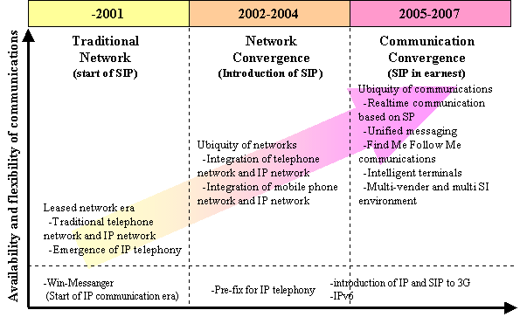

Note: SIP: Session initiation protocol. A telecommunication protocol for controlling calling among terminals. Standardised by Internet Engineering Task Force (IETF)
Source: Nomura Research Institute, “Roadmap of information and communication technologies leading to ubiquitous network”, 2003

Ubiquitous networks have three basic layers: a network layer, an information equipment layer and a content and application layer. Each layer requires major innovations to create a new technological environment. This environment is different from that built around narrowband networks or even using broadband networks such as ADSL or cable Internet.
Ubiquitous networks are both broadband and mobile in the sense that they can be accessed from anywhere and are "always-on." They are multi-modal networks, that is, users can freely cross the boundaries between fixed and mobile networks, wired and wireless, communication and broadcasting, and between terrestrial and satellite transmission.
The information equipment used in ubiquitous networks includes not only personal computers and cellular phones but also terminal equipment already in the market but currently not capable of accessing the Internet.
Ubiquitous networks make it possible for all devices to access the Internet using Internet protocols, preferably IPv6. These include PDAs, videogame consoles, and popular audio-visual equipment, including home servers, set-top boxes digital TV sets, networked home appliances, (commonly called information appliances), car navigation systems and intelligent transport systems (ITSs) and servers in trains, ships and airplanes. All can be connected via IPv6.
The effectiveness of ubiquitous networks as the basis of a new social system will be enhanced further by linking radio frequency IDs (RFIDs), sensors, webcams and other devices which enable machine-to-machine (MtoM) communication via the Internet protocols. This new environment will be also enhanced by establishing "always-on" connection with equipment that is connected to IP, in addition to connecting the information equipment that works as a medium for human communication.
At the same time, such equipment must provide high user-friendliness. In Japan, the use of mobile phones for portable Internet access has contributed to a certain extent to the problem of the digital divide. As this example shows, equipment that is linked via IP to ubiquitous networks must all have a highly user-friendly interface.
Box 6.2: Concepts of a ubiquitous network society
The report on Future Prospects of Ubiquitous Network Technologies produced by MPHPT identifies five technologies –broadband, mobility interface, IPv6, real-time operation system (OS) and secure communication – as core ubiquitous network technologies. These technologies will realise ubiquity that is summarised as five concepts, (1) everyone can access networks from everywhere at any time, (2) various things in life work as network terminals, (3) users can download various digital contents safety, (4) many users can access high-speed network at once and (5) network security and reliability are enhanced. Ubiquitous network society will be based on these concepts. There are seven components: (1) flexible broadband: high-speed networking, (2) teleportation: everywhere and at any time networking, (3) agent: real-time information sharing, (4) contents: free contents distribution protecting IPR, (5) sensor network: getting information automatically by terminals, (6) platform: secured networking and (7) appliance: easy handling.
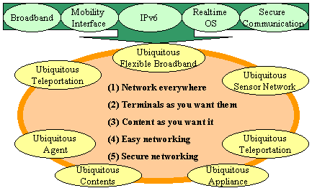

Source: MPHPT, “Report on Future prospects of Ubiquitous Network Technologies”, August 2002

Content application in ubiquitous networks will give a far greater degree of freedom to both the suppliers and consumers of content than is possible in the existing narrowband environment or even the broadband network environment.
Instead of the three hours a day users spend on average in front of their PCs or with their mobile PCs, broadband network users can be connected a round the clock, 365 days a year. (They can be disconnected, of course, whenever they need to.) This means they are connected even when they are at work, in transit, or even while having fun.
Consumers can be connected wherever they are, including train stations, convenience stores, coffee shops or in a car or a train. They can use whatever contents—letters, numerals, still pictures, sounds, moving pictures regardless of their format. Transmission is not just uni-directional, but multi-directional and interactive—seamless across time and space. They can use data, information and knowledge obtained from such contents received in whatever fashion they wish by processing, accumulating or sharing the content.
Ubiquitous networks will be available to both those highly computer literate and those still unable to operate the keyboard or software. The widespread use of special terminals will make it possible for everyone to use the ubiquitous networks.
Some of these features are already available in the existing narrowband environment. However, the implementation of ubiquitous networks is essential to offer all of these features simultaneously. Ubiquitous networks will create an IT environment in which systems and networks meet the needs of the user rather than the user trying to adapt himself or herself to the systems or networks, as has hitherto been the case.

Conclusion
In describing Japan’s telecommunication market, many commentators have mentioned its lower Internet penetration rate than other developed countries. While highlighting its ground breaking mobile telephony status, the reasons for this are often given as high telecommunication fees and restricted competition among telecommunication businesses.
Nonetheless, compared with the end of 2000, dial-up Internet access has doubled and the number of broadband subscribers has leapt from almost zero to 7.8 million, and over half a million subscribe to broadband services per month. Telecommunication fees have been falling, and broadband service charges in particular, are the lowest in the world, while broadband speed is the fastest. This is largely due to high level of competition.
Japan has long been preparing for provision of broadband—since the early 1990s. After core telecommunication networks were transformed to optical fibre. Japan introduced optical fibre to subscriber lines. After the development of xDSL technologies in the late 1990s, Japan was not keen to adopt xDSL technologies that utilize existing copper cable and continued pushing ISDN. As a result, Japan’s broadband penetration was far behind not only that of North America and Europe, but also its Asian neighbour countries in 2000.
This situation has changed in 2001, when the pro-competitive environment and the launch of lower prices for ADSL services accelerated broadband penetration. Yet there is still a digital divide in rural areas, and uneven service provision to apartment buildings in urban areas. Both the government sector and private sector need to cooperate to overcome these issues.
In the first stage of broadband penetration, Japan already satisfies the highest service quality in the world. For the further development of broadband telecommunication, Japan needs to leap to a new stage of the broadband era—the enrichment of the usages of broadband telecommunication. Currently, most broadband subscribers view existing Internet content and applications. For them, broadband is just a faster and always-on alternative to dial-up Internet access. Content and application for broadband telecommunication is necessary to attract more people to broadband and in order for broadband telecommunications to become an essential communication tool for society.
Recently, the term “ubiquitous networking” has become popular in the Japanese telecommunication business. Various definitions are given to the term. Most agree that this concept at least means the ability to access the network everywhere at any time. This concept would be realized by the convergence between broadband and mobile telecommunications.
Japanese mobile operators already have over 60 million mobile Internet contracts—almost half of population —and the service is evolved quickly. Recently, migration from second-generation to third-generation mobile networking is also progressing well.
In both the broadband and mobile markets, Japan is in an advantageous position to go forward with its “ubiquitous network”. Even though it is too early to conclude that Japan will realize “ubiquitous network” soon, the Japanese telecommunication market is sure to offer us further insights into the possibilities of the future information society.

Annex A: Mobile Internet market
Some broadband operators offer or plan to offer services in conjunction with the mobile Internet. For broadband operators, the mobile Internet would be indispensable to offer ubiquity to their customers. This Annex gives an overview of the current mobile Internet market.
Japan has the highest total number (and percentage) of mobile Internet users in the world (Figure A.1, left). Around 60 million mobile users subscribed to Internet access services as at the end of 2002, which is 79.5 per cent of the total number of cellular subscribers. Japan has eschewed GSM in favour of its homegrown PDC (Personal Digital Communications) platform, which is not used anywhere else, and the cdmaOne platform. There are currently three 3G licensees, namely NTT DoCoMo, J-Phone and KDDI.
Mobile Internet services have been progressing year by year in Japan. In 1999, when mobile operators first launched the service, handsets had monochrome displays only. In 2000, handsets with a colour display were introduced. In 2001, operators launched Java-enabled handsets. In 2002, J-Phone’s sha-mail (photo-mail) was introduced and quickly gained popularity. This is a multimedia messaging service that allows users to send photos and even short video-films. The other two operators also introduced similar handsets in 2002. Photo and video messaging could be the new killer application to drive the high-speed mobile Internet. In December 2001, KDDI launched its GPS-based location service ez navigation. Location services may also prove to be another killer application in the future.
currently, around 20 per cent of NTT DoCoMo’s average revenue per user (ARPU) comes from data transmission. Around half of its i-mode subscribers are using Java-enabled handsets. They transmit data packets at twice the rate of non-Java enabled handsets. Its photo-mail enabled handset subscribers transmit even more packets than Java enabled handset users. It can be argued that the volume of packets transmitted per user is a good measure of the degree of sophistication of a mobile Internet service.
NTT DoCoMo started to offer its W-CDMA services called FOMA (Freedom of Mobile Access) back in October 2001. At the beginning, DoCoMo was hoping to sign up 150,000 users by the end of 2001. However, due to the very limited service coverage at the time of launch, the fact that the W-CDMA system does not have backward compatibility with its 2G service based on Personal Digital Cellular (PDC) system, relatively short battery life and lack of killer applications (the highly publicized video-phone capability was a definite flop), it took another year to reach 152,000 subscribers (by the end of 2002). In early 2003, DoCoMo introduced new W-CDMA handsets which have a battery life three times longer than previous handsets.
One of its competitors, KDDI's CDMA2000 1x offered a much smoother migration path from cdmaOne and managed to attract almost 4.7 million users by the end of 2002, despite the fact that it was launched much later than FOMA.
Figure A.1 (right) shows transmission speed by type of mobile Internet technology offered in Japan. Though mobile Internet services cover over 90 per cent of the population and offer seamless Internet access between basestations, the maximum transmission speed is far slower than W-LAN services. Mobile operators will introduce new faster Internet access services. KDDI has announced that it will run a CDMA2000 1x EV-DO
Figure A.1: Mobile Internet maximum data transmission speeds
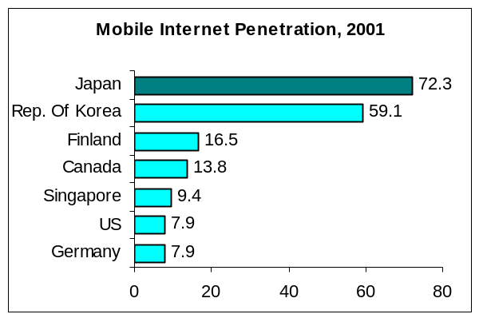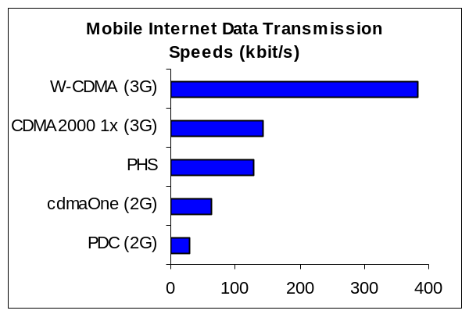
Souce: MPHPT, White Paper 2002 (left), ITU (right)

(Evolution, data optimized) trial service from April 2003. This service is specifically optimized for data transmission and can transmit up to 2.4Mbit/s. NTT DoCoMo plans to overlay high-speed downlink packet access (HSDPA) technology over its 3G FOMA network and start trials of the new platform in autumn 2003. Its maximum download access speed will be 14.4Mbit/s.
Japan has another mobile system. The PHS service has been offered since 1995 and is similar to the Digital European Cordless Telecommunications (DECT) system. The PHS service was originally conceived as a cordless phone that could be used outdoors. The biggest difference from other mobile phone systems is the low radio power of both its handsets and wireless base stations.
The PHS system has the following merits: its base stations are less expensive to set up due to the lower radio power, and the transmission speed up to 128 kbit/s is substantially higher than 2G ensuring higher voice quality and faster data transfer.
On the other hand, the disadvantages of PHS include disruptions in service due to the limited coverage area and failed hand-overs for users traveling at more than 40km/h. However, after much technical improvement PHS turned out to be a relatively low-cost and efficient data transmission and Internet access system with a transmission speed up to 128kbit/s.
DDI Pocket, one of three PHS operators, launched Air H” Internet access service in 2001. It offered PC card-shaped handsets especially for mobile Internet. There is a monthly or annual flat fee. Japan Telecom, a MVNO borrowing facility from DDI Pocket, offers similar flat-rate mobile Internet service. NTT DoCoMo also plans to launch PHS flat-rate Internet access service in April 2003.
The number of PHS subscribers has been decreasing substantially since 1997. It has stabilized recently at around 5.5 millions mainly because the success of mobile Internet.

Annex B: Summary of revision of Telecommunication business
The legal framework is a crucial element of market competition. This annex describes a summary of the bill to amend Telecommunications Business Law.
Currently, the Law classifies telecommunications businesses into Type I and Type II businesses. The latter are divided into General Type II and Special Type II businesses. Operators that install circuit facilities are classified as Type I businesses and others as Type II businesses. The rationale behind this classification comes from the crucial role played by of the Type I operators, who are large telephone companies and are responsible for providing basic infrastructure indispensable to people’s lives and overall socio-economic activities. They are therefore subject to more stringent regulations. On the other hand, Type II operators, not installing, circuit facilities, are small value-added service providers with less direct influence on socio-economic activities.
But, recently this market situation has changed. While a lot of Most of the Type I operators are small operators such as CATV, W-LAN and CBD (central business district) access operators, large-scale Type II operators such as Internet, IP-telephony, and ADSL service providers have emerged. These operators compete in the same market. If an operator has its own circuit facilities, though the business scale is small, it is recognized as Type I and should be subject to more stringent regulation. Corresponding to the recent market changes, the present regulatory framework based on the distinction between Type I and Type II businesses need to be amended. On March 17, 2003, the Cabinet submitted the Bill to the Diet to amend Telecommunications Business Law. The summary of revision is:
- Abolition of the distinction between Type I and Type II telecommunications business;
- Abolition of permission system for market entry with regard to Type I telecommunications business;
- Abolition of permission system for suspension and discontinuance of business with regard to Type I telecommunications business;
- Abolition of tariff regulations for non-dominant operators;
- Abolition of ex-ante regulations with regard to interconnection such as prior notification of interconnection agreement for non-dominant operators;
- Maintenance of asymmetrical regulations for dominant operators.
Table B.1 shows the comparison between current and revised scheme of the Business Law, especially the first, second and forth points.
This amendment will enable all operators to develop business swiftly, catching emerging business opportunities and meeting users’ needs in a timely manner, thereby enhancing user protection.

Table B.1: The main amendments of the Telecommunication Business Law

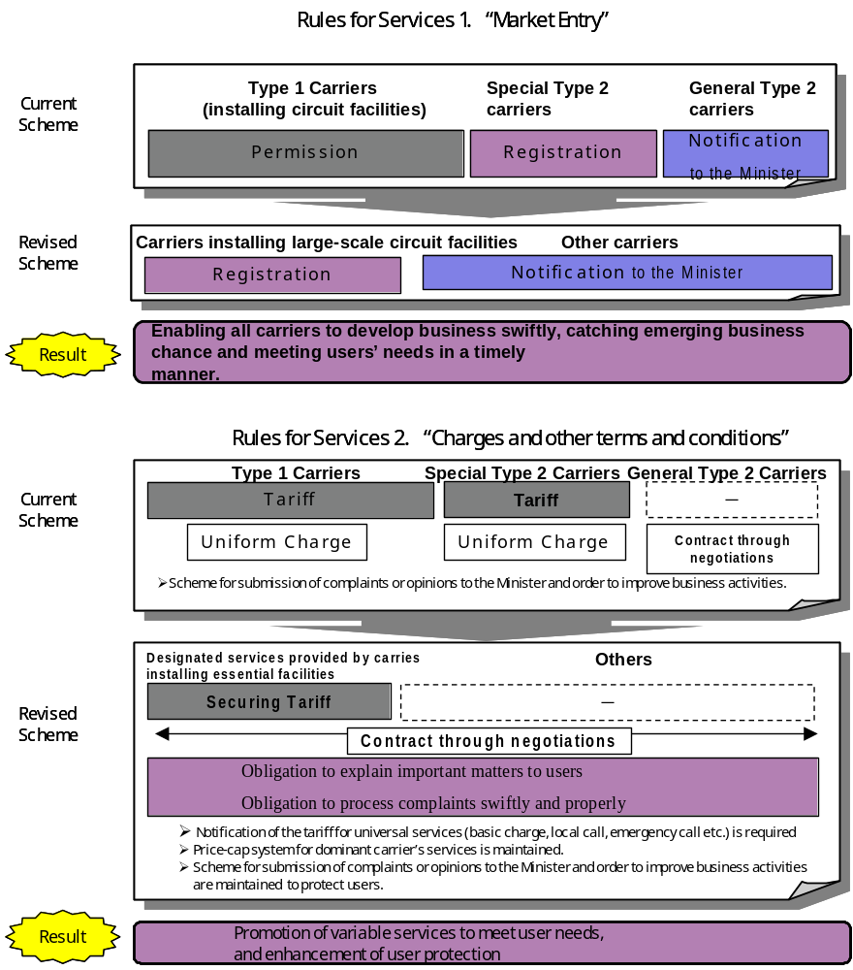
Source: MPHPT

Annex C: Telecommunication Business Dispute Settlement Committee
A number of amendments to the Telecommunication Business Law were passed by the Diet in June 2001. One of these amendments calls for the establishment of the “Telecommunication Business Dispute Settlement Committee”, whose main objective is resolution of disputes between operators. This committee is independent of the telecommunication market regulation sections, and consists of five commissioners appointed by the Minister with approval of the Diet. This committee started its service in November 2001. The Committee offers mediation and arbitration services for telecommunication operators to reach agreements on such issues as interconnection and collocation earlier and easier. The Committee, if necessary, gives recommendations to the Minister of MPHPT concerning dispute settlements.

Figure D.1: Dispute Settlement System

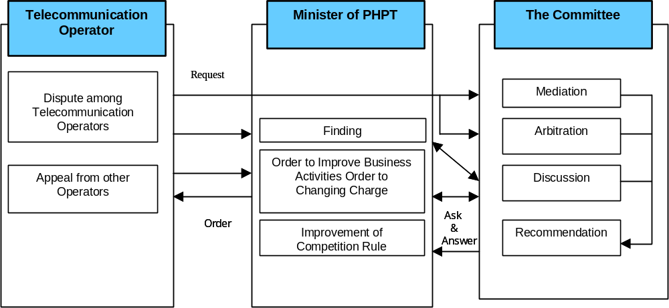

Source: MPHPT

Annex D: Target of fibre optic infrastructure

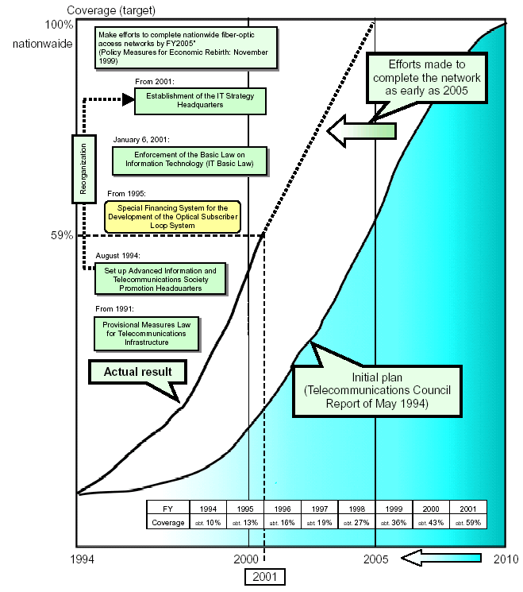
Source: MPHPT, Outline of the Telecommunications Business in Japan, October 2002.

The UNDP’s HDI is a composite of key indicators of well-being such as life expectancy, literacy, school enrolment and per capita GDP.
IT Strategic Headquarters: http://www.kantei.go.jp/foreign/policy/it/index_e.html
the Basic Law on the formation of an Advanced Information and Telecommunications Network Society: http://www.kantei.go.jp/foreign/it/it_basiclaw/it_basiclaw.html
e-Japan Strategy full text: http://www.kantei.go.jp/foreign/it/network/0122full_e.html
e-Japan Priority Policy Program summary: http://www.kantei.go.jp/foreign/policy/it/0618summary/01_e.html
The e-Japan Priority Policy Programme defines high-speed Internet access networks as “The Internet access networks through which music data and others can be smoothly downloaded. At present, the Internet networks by such lines as xDSL, cable TV and Subscribers’ Wireless Access System are the major examples”, and ultra high-speed Internet access networks as “The Internet access networks through which even large volume picture data such as movies can be smoothly downloaded. At present, the Internet access network by optical fibre is the major example”.
combined sales by Type I operators (MPHPT)
ITU World Telecommunication Indicators Database
ITU World Telecommunication Indicators Database
ITU World Telecommunication Indicators Database. The top five were: (1) Norway 15.54%, (2) Germany 11.07%, (3) Switzerland 10.06%, (4) Luxemburg 9.19% and (5) Japan 8.11%
Strictly speaking, FTTB, fibre-to-the-buildings, plus VDSL service within buildings are offered as well, but those will be included in FTTH figures
source: IT and Telecommunications Institute
Source: MPHPT. Since June 2002, MPHPT hasn’t had data.
Source: MPHPT, “Outline of the Telecommunications Business in Japan”, October 2002.
e-Japan Priority Policy Programme (http://www.kantei.go.jp/foreign/it/network/priority-all/2.html).
Survey of housing and land by Ministry of Construction, Japan, in 1998
HomePNA “is the high-speed, reliable networking (LAN) technology that uses the existing phone wires in your home to share a single Internet connection with several PCs in your home” (Home Phoneline Networking Alliance: http://www.homepna.org/ ) NTT adopts the Ver. 2.0 technology that enable maximum 10Mbit/s data transmission.
MPHPT, “Info-Communication Policy Session Report on Broadband Business Taking off, March 2003
MPHPT, “Info-Communication Policy Session Report on Broadband Business Taking off, March 2003

