Kommunikációs rendszerek alapjai

2007

Vizsga

összeállította:
Esztergár-Kiss Domokos

BASICS:

- topic:
  - basics of telecommunication technology and basic components, boxes;
  - system and network constructed from boxes;
  - services based on systems and networks;
  - application based on the services;
  - business aspects, regulation issues, demonstrations;;

- internet is telecom based;
- revolution: total transit traffic: 180 petabit/day;
- convergence: telecom (mobility)+ computer (PC, internet)+ media industry (electronic publishing and entertainment)→ infocom industry;
- convergence in networks (tel on CaTV, internet on tel line),
convergence in terminals (music on mobile, TV on computer, email on TV);;
- reasons:
  - common technology platform (digital),
  - unlimited telecom possibilities (no practical limit in bandwidth, no limit in geographic distance),
  - store, copy and searching of information content;;
- cultural differences:
  - telecom:
    - stupid terminals and intelligent network;
    - state monopoly,
    - international standards (rigid, accurate),
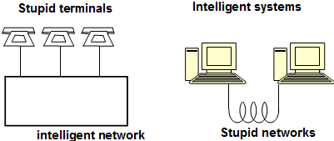
    - detailed regulation,
    - statistical figures available;
  - computer:
    - intelligent systems and stupid networks;
    - market oriented,
    - proprietary solutions,
    - self regulation,
    - estimations only;;

- competition in ICT: Carelli (director of Eurescom)- processing power, transmission capacity, storage capacity- which grows faster?;
- laws:
  - Moore-law (processing power 2x within 18 months),
  - Gilder-law (total bandwidth 3x/12),
  - Metcalf-law (potential value of networks are proportional with quadrate of users),
  - Shugart-law (price per bit in magnetic storage devices(memory) 1/2x/18),
  - Ruettgers-law (memory capacity 2x/12),
  - Wacker-law (on meta-data: info related to transaction can have more value than transaction itself);;
- statements:
  - winner is bit transport (highest exponent: 3x, physical limits are close in memories and processors);
  - practically infinite bandwidth (optical fibre cable: 10Gbit/s per carrier, 1000 carrier per fibre, 1000 fibre per cable- total: 10¹⁶ bit/s/cable; whole human life in ¼ sec);
  - practically free bandwidth (leasing fee for dark fibre: 200.000 Ft/month, 2Gb/s link- 1Gb: 0,079 Ft);
  - no distance limits (smallest attenuation: 0,001 dB/km, connect without repeater);
  - leads to revolution in infocommunication (free products are good basis of business;
- network architecture:
  - circuit: band is cheap; establishes fix bandwidth connection, constant bit delay, cannot be used by many users;
  - packet switching: processing is cheap; dynamic bandwidth allocation, packet sent and the router locks destination, in the nodes packets are queued or buffered- variable delay;;
  - distributed vs centralized intelligence;
  - peer world: no switching, but broadcasting in fibresphere (as now the radio)- send every info and pick up your related info;;
- consequences:
  - wasteful usage: free products are not good basis of business- to have profit: force wasteful usage or pay for other products (eg: transistor);
  - router is not able by 10¹⁶ bit/s→ new network philosophy: new structure, new functions in the nodes;
  - different user behaviour: new ratio of computing – downloading – storing;
  - university level education:
    - efficiency of telelearning will be comparable of contact courses;
    - canned free courses;
    - peer-to-peer communities of students (no profs);
    - consultation of experts/profs for a fee;;
- technology:
  - transmission (copper=twisted pair, optical, radio),
  - switching (circuit, pocket, cell, signaling),
  - networks (tel, mobile, broadcast, CATV, data, special),
  - services (dialogue, content, network),
  - applications (commerce, learning, working, medicine),
  - terminals (tel, mobile, special),
  - regulation (EU, Hun, limited resources);;
- ADSL:
  - Asymmetric Digital Subscriber Line;
  - modem technology, converts existing twisted-pair tel lines into access paths;
  - max downstream: 6 Mbps, up: 832 kbps till 8 kilofeets;
  - RE-ADSL2: Reach Extend ADSL2: till 14 kilofeets;
  - ADSL2+: increasing downstream extending bandwidth to 2,2MHz- max down: 24 Mbps till 4 kilofeets;;
- BIX (=Budapest Internet Exchange): traffic intensity;;;

WIRELINE:
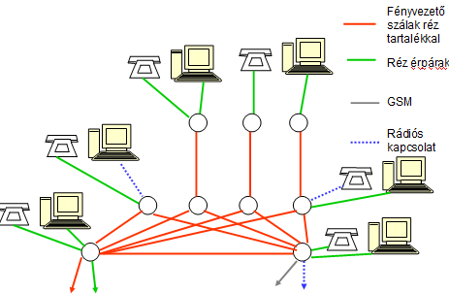
- works as a receiving antenna;;
- wire line transmission media:
  - symmetrical twisted pair copper cable,
  - coaxial cable,
  - optical fibre cable;;
- media and cable characteristics:
  - transmission parameters (attenuation, delay, reflection, crosstalk, noises, interferences);
  - laying, connection technologies;
  - faults, fault localization;
  - matching, accessories, termination;;
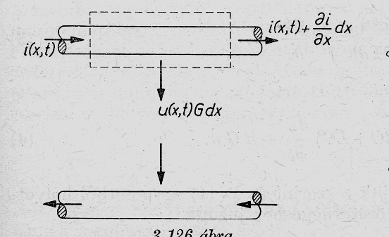
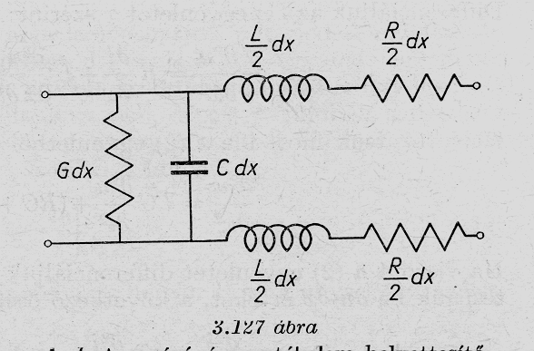
  - symmetric or asymmetric: related to the ground, to protect from interferences, basic equations and characteristics of wires are very similar, eg: coaxial(asymm): 1D problem;;
- notation:
  - u(x,t)..voltage as the function
of time and distance; i(x,t)..current;
  - γ..attenuation coefficient;
  - R,G,C,L..resistance, conductivity, capacity, inductivity;
  - Z..complex input impedance of the cable; Z₀..characteristic impedance;;
- basic equations for wires:
  - relation of voltage and current: -đu/dx= Ri+ L*đi/đt; -đi/đx= Gu+ C*đu/đt;
  - solution: u= U₀e^{jωt- γx} (voltage in cable= t..delay, x..distance);
    - γ= α+jβ (complex attenuation is related to geometrical parameters);
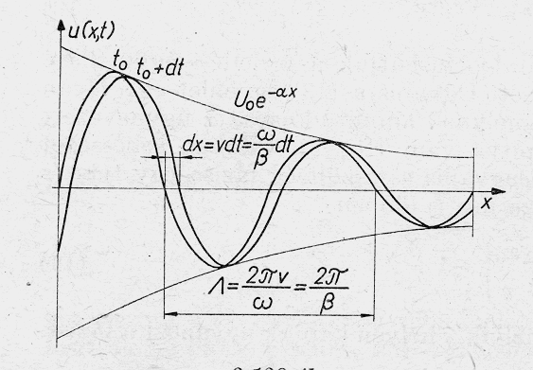
    - γ= +/- gyök((R+jωL)*(G+jωC));
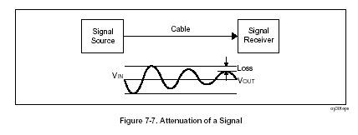
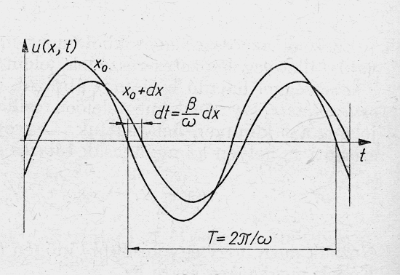
    - u(x,t)= u⁺+u⁻ (along cable+coming from end)= U₀⁺e^{jωt}- ^{γx} + U₀⁻e^{jωt+ γx}; i(x,t)= i⁺+i⁻= I₀⁺e^{jωt- γx} + I₀⁻e^{jωt+ γt};;

- consequence:
  - waveform of voltage as a fkt of distance along wire- different amplitudes (sometimes max sometimes min);
  - signal source (V_{in})- (through cable)- receiver (V_{out} has a loss);
  - waveform of voltage as a fkt of time;
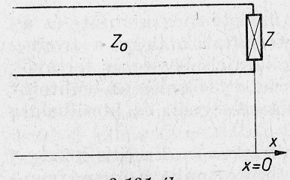
- transmission properties of wires: depends on attenuation, phase shift, characteristic impedance (Z₀= gyök(R+jωL / G+jωC));
- phenomenon at the end of terminated wire:
  - reflection coefficient: r= U₀⁻/U₀⁺; r= Z-Z₀ / Z+Z₀;
  - matched termination: Z=Z₀ – no reflection;
  - shortcut: (no voltage, max current) – everything comes back;
  - open end: (no current, max voltage) r=1, same phase, will define points, where amplitude is 0 due to standing waves – same wave comes back;
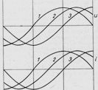
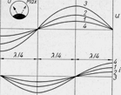
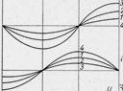
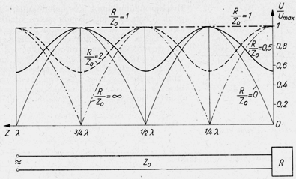
  - ohmic termination: max and min, but never 0 – standing waves;;
- types of cables:
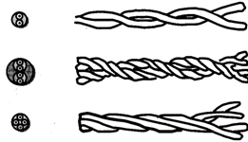
  - pair,
  - quad (multiple twist),
  - quad;
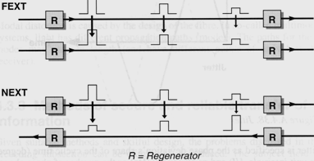
  - without twisting not homogenous el filed (household: 6 1/2 mm; outside: 20 mm cable- higher quality, smaller attenuation);;
- far end crosstalk(=FEXT):
measure amplitude on other cable,
increases simultaneously;
- near end crosstalk(=NEXT):
in other direction, backwards always smaller,
higher conflict, more harmful;;
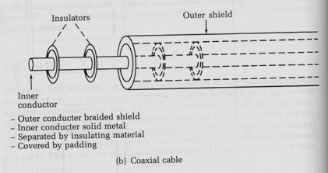
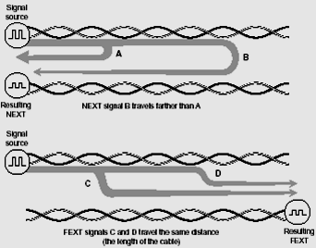

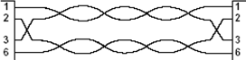
- characteristics of UTP cable: CAT6 (1 Gbit/s), attenuation (higher fr has higher att), propagation delay (speed: 70% of light), NEXT, FEXT, RL(=return loss), crosstalk; place on problem can be identified; split pair: incorrect, will spoil communication;;
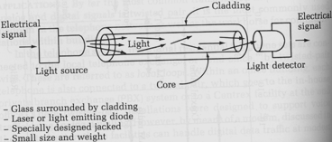
- structure of a coaxial cable: inner conductor (solid metal)-
insulator (plastic disks separates)- outer conductor (shield); several cables into coat;
twin cable: 1 coat, coaxial and twisted pair cable together;;
- principle of optical cable:
  - glass core (n1..refractive index)-
glass cladding (n2)- coat;
  - n1>n2 (total reflection- to keep light
inside core without loss);
  - light source (laser or LED)- cable- light detector;
  - specially designed jacket, small size and weight, fibre diameter: 125um;
  - glass has better attenuation (less dB/km) than plastic;
  - typical core and cladding diameters (um): 8/125, 50/125, 62,5/125, 100/140;;
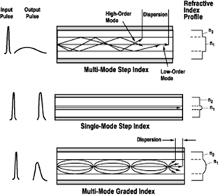
- type of mode propagation:
  - always narrow input pulse;
  - mode step index: big diameter of n1,
big dispersion, high speed, big attenuation,
wide output pulse- for small distances;
  - single-mode step index: slow, small attenuation,
narrow output pulse- for high distances;
  - multi-mode graded index: changing reflection index,
higher bitrate, higher attenuation,
not easy to produce,
small dispersion, not so narrow output pulse;;
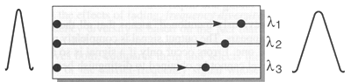
- intermodal dispersion coefficient: D= đT/ L (group delay difference between slowest and fastest mode/ length of cable)- chromatic dispersion;;

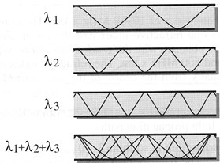
- principle of wavelength division multiplexing:
different bitstreams at same time;;

- production of cable:
  - perform (core and cladding produced),
  - heater (melt glass),
  - string (pull glass, if slower than bigger diameter),
  - laser micro-meter (check diameter),
  - coater (get a coat),
  - ultraviolet curving system;;;

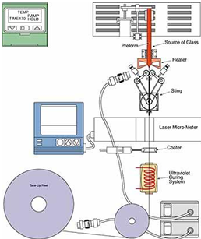

RADIO:
- radio transmission media: fr bands and wave propagation modes, terrestrial, satellite and indoor radio connection;
- media characteristics:
  - transmission parameters (path loss, delay, fading, radio interferences);
  - reliability and availability – equipment and propagation parameters (lighting, snow, rain, fog, smoke);
  - openness- interferences- privacy;;
- is it a technical issue? not only pure technical;
  - radio communications use open and common media- using it means consuming- management of radio fr is inevitable;
  - environment pollution- fr police?;
  - radio fr are limited resources- fr fees (good fr: low attenuation, not sophisticated receiver, good propagation - already consumed);
  - propagation of radio waves do not consider political borders- fr management is international process (CCIR, ITU-R);
  - considerable physiological effect;
  - special construction (regulated construction rules and building licenses, eg: antennas);
  - satellite positions are limited resources (good positions consumed);
  - differential equations of elmagnetic propagation are quite simple (if plane wave and free space);
but if real geographic situation, then extremely difficult);;
- frequency bands:
  - LF (=low fr, 30-300 kHz, not used),
  - MF (=medium fr, 300-3000kHz, radios),
  - HF (=high fr, 3-30Mhz, not used),
  - VHF (=very high fr, 30-300MHz, URH radio, TV broadcasting),
  - UHF (=ultra high fr, 300-3000Mhz, also mobile),
  - SHF (=centimetric waves, 3-30GHz, in the future),
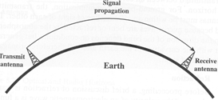
  - EHF (=millimetric waves, 30-300GHz, in the future, but expensive transmitter and receiver);;

- propagation modes and antennas:
  - ground wave propagation:
    - below 2 MHz, LF,MF; 1000 kms;
    - transmit antenna- signal propagation- receiver antenna;
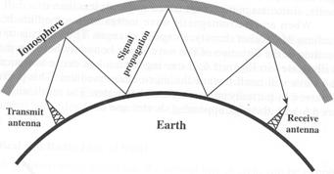
    - ground behaves as conductor- surface waves follow earth shape;
  - sky wave propagation:
    - HF (high fr= short wave); 1000 kms;
    - transmit- signal prop (to ionosphere
and back to earth)- receiver antenna;
    - reflections;
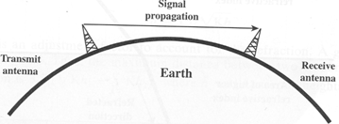
  - line-of-sight (=LOS) propagation:
    - above 30 MHz, UHF,VHF,SHF,EHF;
    - in free space(ε₀, μ₀):
rotH= jωε₀E, rotE= -jωμ₀H;

  - plane-wave solution: spec case (receiver+transmitter compared to wavelength) E= 1/ jωε₀* rotH= -1/ jωε₀* e_{x}* đ/đz H_{y}= -e_{x}/ jωε₀* H_{y}⁰(-jβ)e^{-jβz}= E_{x}e_{x};
el and mag field vectors are perpendicular /merőleges/;
  - free-space wave impedance: E_{x}/H_{y}= β/ ωε₀= gyök(μ₀/ε₀) – ratio of their amplitudes constant;
  - characteristic impedance: Z₀= gyök(R+jωL / G+jωC);
  - reflection coefficient: r= U₀⁻/U₀⁺, r= Z-Z₀ / Z+Z₀;;
- polarization:
  - property of radiated elmagnetic wave;
  - describes the time varying direction and relative magnitude of electric-field vector;
  - in general: elliptic polarized;
  - special case: linear, circuit polarization;;
- reflection:
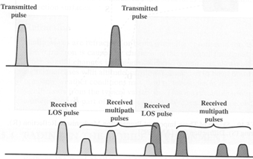
  - amplitude, phase, polarization of reflected wave is determined by material parameters of medias and surface irregularity;
  - magnitude of Earth reflection coefficient:
    - Γ= E_{r}/E_{i} (reflected/incoming),
    - depends on incoming angle (ϑ_{B}: 0-90⁰),
and fr (1MHz: earth is good mirror,
100MHz: not much reflection),
    - consists of |Γv| and |Γ_{h}| (vertical and horizontal);
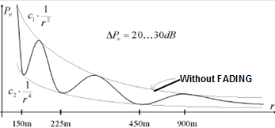
  - consequence of reflection: transmitted pulse=
received LOS pulse+ received multipath pulses;;
- fading: đP_{v}= 20-30 dB; max amplitude: c₁/r²; min: c₂/r⁴;
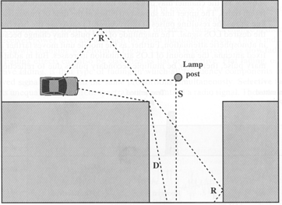
- attenuation of the atmospheric gases: depends on fr, rain rate;;
- propagation mechanism: reflection, scattering, diffraction;;

- free space radio link (LOS):
P_{R}= P_{T}G_{T}/ 4πd² * A_{e}= P_{T}G_{T}/ 4πd² * λ²G_{R}/ 4π;
P_{R}..received signal, P_{T}..transmitted power, G..gain factor /erősítés/,
d..distance (inverse prop), A_{e}..effective area of antenna, λ..wavelength;
  - loss is proportional to distance, the higher fr, the higher loss;
  - example: P_{R}= k*P_{T}/ d², if mobile: d= 3cm, P= 5W – P_{R}= k*5555, if base station: d= 30m, P= 50W – P_{R}= k*0,0555, so 100000x higher power;
- gain factor of antenna:
  - demands on size (diameter)- the smaller size, the smaller gain;
  - the smaller diameter, the bigger beam width /sugárnyaláb/ (degree)- angle where antenna can receive signal;
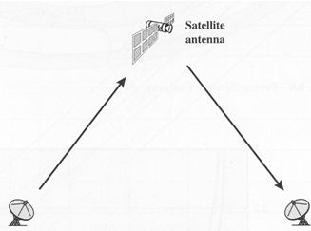
- good fr: low attenuation (loss), high bandwidth, beaming (circular characteristics), cheap or free, no interference, exclusive usage –
not existsing, only compromise of limitation;;
- radio link types:
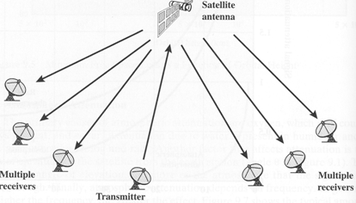
  - point-point connection: earth station- satellite-
earth receiver station; eg: ATM bank machine;
  - point-multipoint connection: earth station (=transmitter)-
satellite antenna- multiple receivers within footprint,
eg: VSAT (point-of-sale terminal- banking, buying);
  - cellular system;;
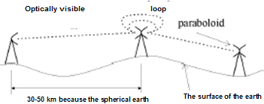
- terrestrial microwave connections:
  - optically visible (LOS),
  - 30-50 km distance because of
the spherical earth;
  - top of the hills – limited;;
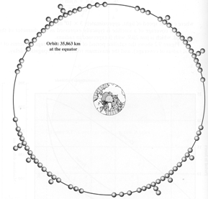
- satellite: parameters (coverage, delay, period) as a function of orbital height;
has a definite height limit (if more, then it would move form earth);
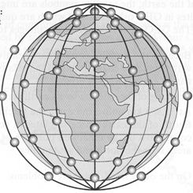
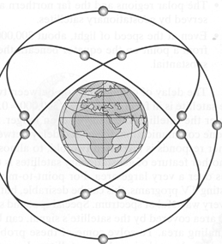
  - GEO (=Geostationary Earth Orbit): 35.863km at equator,
very good position (it looks like stabile position on the earth);
broad coverage (40% by one, with 3 satellites can cover earth);
F= GMm/r² = mv²/r (G..gravitation, M..earth mass, m…satellite mass) –
force from earth and centrifugal movement is in equilibrium,
eg: Astrolink, Euroskyway, VSAT, television;
  - GPS (=Global Positioning System);
  - MEO (=Medium Earth Orbit):
at 5000 to 12000 km, inclined to the equator;
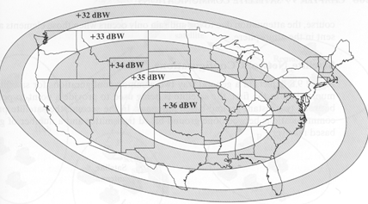
  - LEO (=Low Earth Orbit):
at 500 to 1500 km, often in polar orbit,
not fix position, special movement, eg: Iridium, Globalstar;

  - footprint: if GEO, then 17,5⁰ can be seen, can be focused;
  - beam: problem if receives from 2 satellites;;
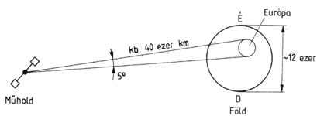
- fr bands: the higher fr, the higher loss;
  - L (1-2GHz, MSS=Mobile Satellite Service),
  - S (2-4GHz, MSS, NASA, deep space research),
  - C (4-8GHz, FSS=Fixed Satellite Service),
  - X (8-12,5GHz, FSS military, terrestrial earth exploration and meteorological),
  - Ku (12,5-18GHz, FSS, BSS=Broadcast Satellite Service),
  - K (18-26,5GHz, BSS,FSS),
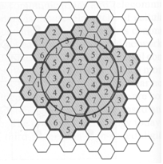
  - Ka (26,5-40GHz, FSS, it has very high loss: 200 dB);

- cellular systems:
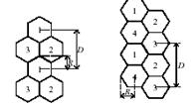
  - cell: limited area where base station is situated,
1 ore more dedicated fr;
in a cluster each cell has a separate fr;
K= A/a= (D/ (gyök(3)*R))²,
a..area of one cell, A..cluster area, R..cell diameter,
D..distance between clusters (= distance between cells with identical fr),
K..#of cluster cells, eg: K=7;
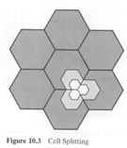
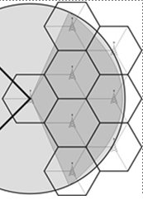
  - function: radio propagation, traffic handling capacity – calculate probability how many calls are processed in an area;;
  - increase capacity:
    - adding new channels (new fr),
    - fr.borrowing,
    - cell splitting,
    - cell sectoring,
    - microcells;;
- indoor wireless connection: standards are IEEE based;
server- base station- wireless workstation (PC), portable; peer-to-peer (eg: BT);;;

BEAMING: /nyalábolás/
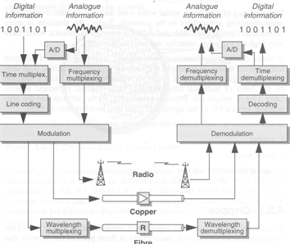
- network:
  - terminals,
  - nodes (fkt: multiplexing,
switching, signalling, demultiplexing),
  - links;;
- SITA..airplane ticket booking in the world;
- switch: temporary connection is constructed
between transmitter and receiver, circuit or packet;;

- analogue modulation systems:
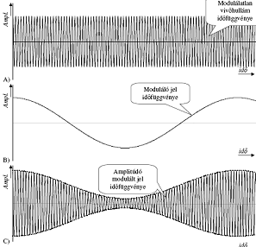
- AM (=amplitude modulation):
the momentary amplitude of the carrier is proportional
to momentary amplitude of the modulation signal;
u= [U_{v}+ U_{m}cos(ω_{m}t)]cos(ω_{v}t) –
u..modulated, U_{v}..carrier, U_{m}..modulating, eg: 540kHz;;

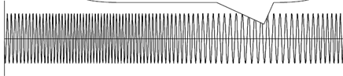
- FM (=Frequency modulation):
the momentary fr of the carrier is proportional
to momentary amplitude of modulation signal;
u= U_{v}cos[ω_{v}t+ đω/ω_{m}*sin(ω_{m}t)] –
đω/ω_{m}..ratio of fr.stroke /löket/; time fkt: constant amplitude, fr higher and lower, eg: VHF /Hun: URH/;;

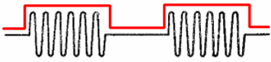
- digital modulation methods:
- ASK (=Amplitude Shift Keying):
modulating like Morse telegram, 0..not, 1..modulated;
definite fr→ undefined fr (unlimited spectrum - /négyszögjel/), eg: 3G,Wifi;;
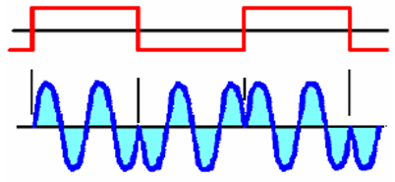
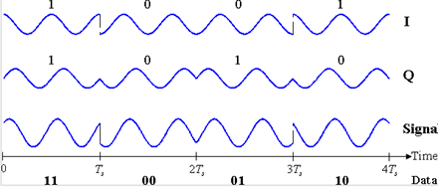
- BPSK (=Binary Phase Shift Keying):
if change from 1 to 0, then change phase of sinus signal;
more efficient; constellation diagram: 2 possible positions,
eg: old modems;;

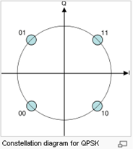
- QPSK (=Quadrature Phase Shift Keying):
2 carriers: sine wave(Q) and cosine wave(I);
phase says: 0 or 1;
modulated signal: sum of 2 components;
1 symbol: 2 bits; constellation diagram: 4 possible positions;;
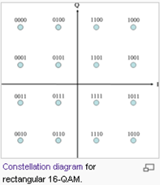
- QAM (=Quadrature Amplitude Modulation):
2 carriers: sine wave(Q) and cosine wave(I);
modulated signal: sum of 2 components;
different amplitude and different phase for one symbol;
16QAM: 1 symbol is 4 bits (16 positions) –
in the same radiofr can transmit more bits;;
- multiplexing principles:
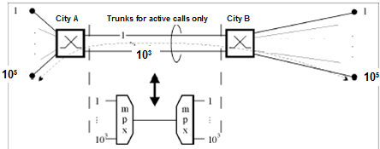
- switching: subscriber line- trunk line
(only for active calls);
- multiplexing: how to put together
different calls (with different probabilities);
- principles: to reduce transmission
costs, to utilize higher bandwidth, framing and packing of info;;
- TDM (=Time Division Multiplexing): PCM (=Pulse Code Modulation frame: 125us);
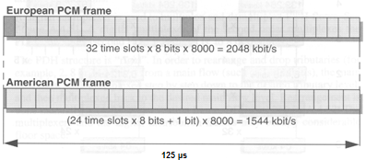
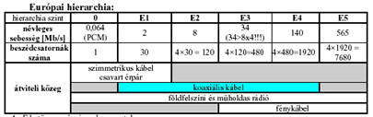
  - PDH(=Plesiochronous Digital Hierarchy): Japan, USA, EU;

  - SDH (=Synchronous Digital Hierarchy):
    - POH (=Path OverHead, control and supervisory info);
    - bits are in VC (=Virtual Container, it contains: POH and payload, can be packaged into larger VC- multiplexing level);
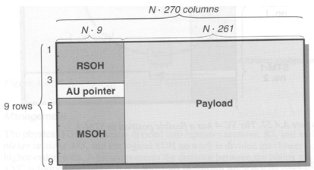
    - STM-N (=Synchronous Transport Modules- line signal level, eg: N=1, then duration: 125 us),eg: at ITK STM-16(2,5 Gb/s);
    - transport modules:
RSOH (=Regenerator Section OverHead),
MSOH (=Multiplexer Section OverHead),
AU Pointer(=Administrative Unit,
specifies where payload starts);
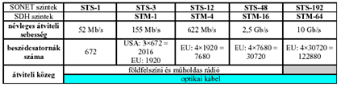
    - General Transport Module:

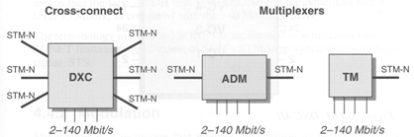
  - SDH network elements:
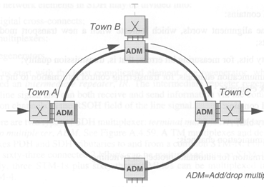
    - DXC (=Digital Cross Connect,
permanent switch with SW,
we can modify AU which
input/output can be connected),
    - ADM (=Add-Drop Multiplexer,
huge container in/output),
    - TM (=Terminal Multiplexer, put together
inputs into higher speed containers);
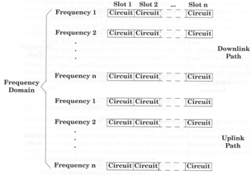
  - variable bit-rate data transfer within TDM time-slots:
1 timeslot can be shared with different users;;
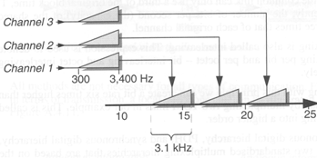

- FDM (=Fr Division Multiplexing):
sources have a fr band, eg: 3,1 kHz;
- example1: TDM/FDM channel architecture in GSM
(fr domain: n timeslots; downlink and uplink path);
- example2: CableTV (8MHz bands; upstream band,
FM band, midband, superband, hyperband channels);;
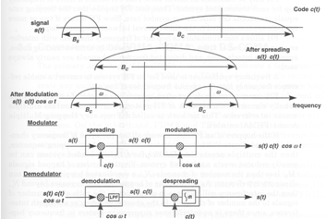
- Spread Spectrum Concept:
CDMA(=Code Division Multiple Access):
  - only who knows code can receive signals;
signal: s(t) has spectrum B_{s} →
code: c(t) with spectrum B_{c}→
spreading: s(t)c(t)→
modulation: s(t)c(t)cos(ωt);
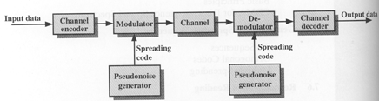
  - model:

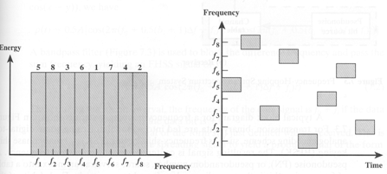

  - FHSS (=Frequency Hopping Spread Spectrum):
    - some channels are allocated for FH;
    - transmitter: operates in 1 channel for fixed time interval (T_{c}), during that some bits are transmitted (signal elements)- time interval of signal elements (T_{s});
    - sequence of channels: dictated by spreading code;
    - transmitter and receiver use same code to tune into a sequence of channels in synchronization;
    - transmitter: binary data- modulator (FSK or BPSK)- FH spreader (pseudonoise bit source- channel table- fr synthesizer)- bandpass filter- spread spectrum signal;
    - receiver: FH despreader (pseudonoise bit source- channel table- fr synthesizer)- bandpass filter- demodulator- binary data;
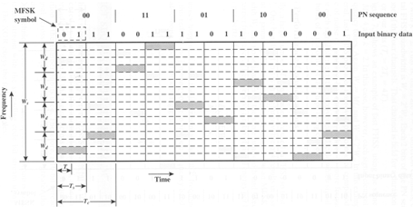
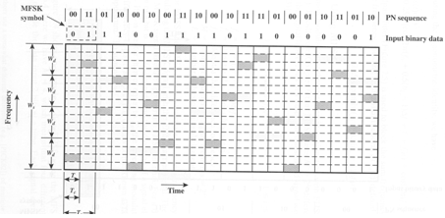
    - slow FHSS: T_{c}>T_{s}; fast FHSS: T_{c}<T_{s} submit in different subbands to avoid fading;;

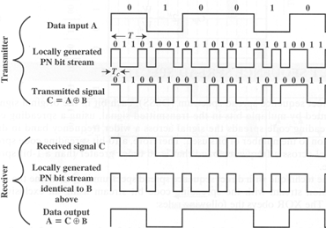
  - DSSS (=Direct Sequence Spread Spectrum):
          - transmitter: binary data- modulator (BPSK)- DS spreader (pseudonoise bit source)- spread spectrum signal;
          - receiver: spread spectrum signal- DS despreader (pseudonoise bit source)- demodulator (BPSK)- binary data;;

- WDM (=Wavelength Division Multiplexing):
light has different colours- separate in fibres; filters to select colour;;
- mixed;;
- switching techniques:
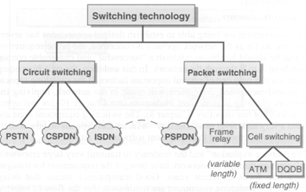
- circuit (telephony)- PSTN, CSPDN, ISDN;
- packet (computer: TCP/IP)- PSPDN,
frame relay (variable length), cell switching
(fixed length)- ATM, DQDB);
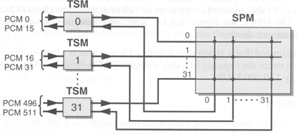
- group switch: interconnects incoming and outgoing timeslots;
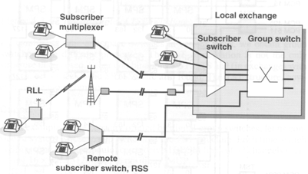
- time and space switch(=TST= time space time):
crosspoint control- well defined column and row
in the matrix – switches more users;
- local exchange: group switch and subscriber switch;
- router: reads label of parcels,
structure: input buffer- central control
and switching unit- output buffers;

- packet switching:
  - connection-oriented:
setup (setup packet with complete address, LCN(=Logical Channel Number) stored in each node)- data transmission (only LCN in header)- release;
each packet has same route, same transmission delay;
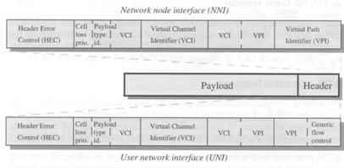
  - connectionless:
whole destination address is processed- looks for free pass toward destination, not guaranteed then 1.packet comes 1., transmission delay with big variation;

- ATM (=Asynchron Transfer Mode):
  - cell switching principle;
  - fixed cell length
(53 bytes: header(5) and payload(48));
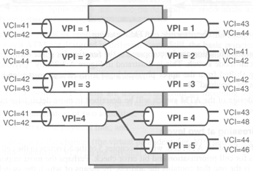
  - header:
- NNI(=Network Node Interface,
inside network):
HEC (=Header Error Control),
VCI (=Virtual Channel Identifier,
fine level addressing),
VPI (=Virtual Path Identifier,
coarse level addressing- shorter identifiers→
connection-oriented transport);
- UNI (=User Network Interface, at terminal):
HEC, VCI, VPI, Generic flow control;
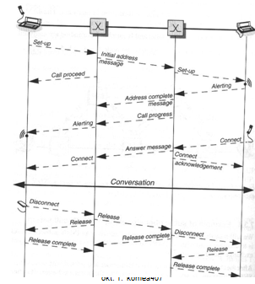
  - structure: incoming links- input stages- switching stage- output stages- outgoing links;
- signalling principles in circuit switching:
subscriber signalling (tones, ringing signals)-
interexchange signalling (data packet);
if prepaid card, then very sophisticated signalling-
network intelligence;;;
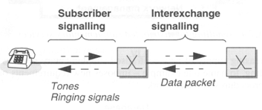

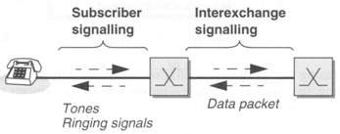
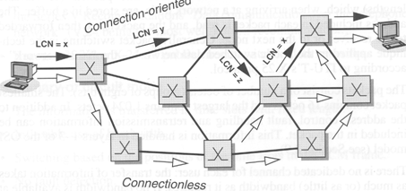

PSTN: Public Switched Telephone Networks, ISDN(=Integrated Service Digital Networks);
- network components:
  - backbone networks: long distances, high traffic, interconnection of nodes, eg: tel, TV, filetransfer;
  - access networks: local distances, interconnection of terminals and local nodes;
  - network planning: optimal selection of position of nodes, dimensioning of node traffic handling capacity, link capacity, selecting technology;;
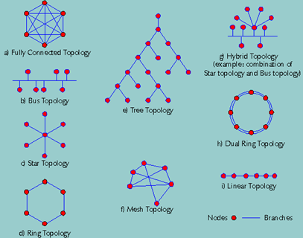
- topologies:
  - fully connected
(less injured, high reliability),
  - bus (everybody sees everything,
data not at same time),
  - star (least cable),
  - ring, dual ring,
  - tree,
  - linear,
  - mesh (less cable, bur reliable),
  - hybrid;;
- history:
  - 1876: G.Bell patent of telephone, Edison: carbon microphone,
  - 1878: Puskás Tivadar: 1.tel exchanging,
  - 1892: 1.automatic tel exchange;
  - size of global te network: 2,4 billion subscriber;
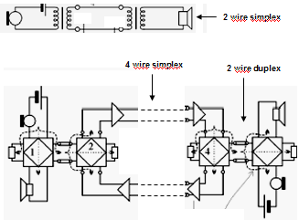
  - Hun: high technical level, almost fully digital network, covered distance between nodes max 100 km, telecom traffic concentrated
in Bp, fault tolerant topology is required;;
- basics:
  - 2/4 wire for voice:
tel set- subscriber line- backbone;
2 wire simplex or 4 wire simplex (2 wire duplex);
  - feeding of circuit: DC line current: 20..60 mA
(to subscriber, only if picked up), 48V;
  - access solutions: local exchange;
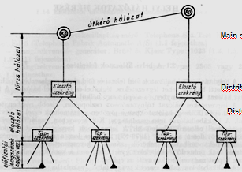
    - town: multiplexer,
    - small village: RSS
(=Remote Subscriber Switch),
    - farm: radio (RLL);
  - backbone:
    - main cables (backbone)-
    - distribution cabinets-
    - distribution cables (distr)-
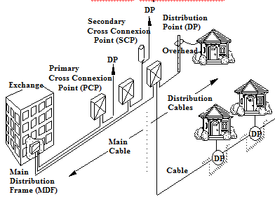
    - distribution boxes-
    - drop cables, indoor cables (subscriber);
    - implementation:
MDF (=Main Distribution Frame)-
PCP (=Primary Cross Connection)-
SCP (=Secondary Cross Connection)-
DP (=Distribution Point);;
- signalling basics:
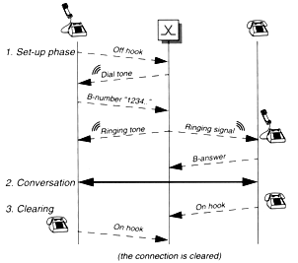
  - telephone call;
  - CAS (=Channel-associated Signalling);
  - CCS (=Common Channel Signalling);;

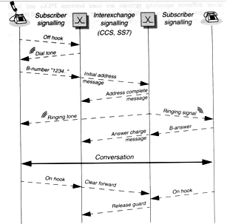

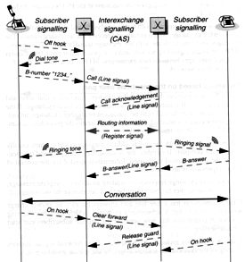

- ADSL principles: Asymmetric Digital Subscriber Line;
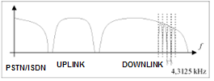
  - max download: 8 Mbit/s, up: 256 kbps,
  - DMT(=Discrete Multi Tone) coding,
  - 256 channels (1-5 for PSTN/ISDN,
32 for uplink, 218 for downlink);
  - DSLAM(=DSL Access Multiplexer);;

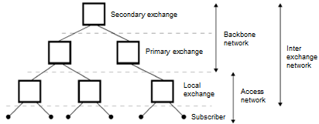
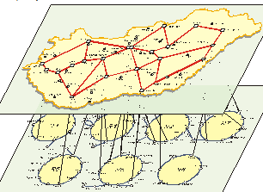
- network structures: basic structures (star, multipolar, meshed, ring, bus),
eg: MATÁV, PanTel;;

- interconnection principles: network- regional connection point- 3.rd network;;
costs and revenues (monthly fees and traffic based fees);;;
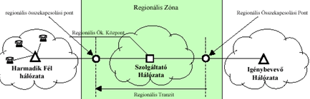
GSM: 80% of subscribers;
- USA:
  - no USA level decision on applied technology,
  - concept: competition (AMPS, DAMPS, GSM, UMTS work parallel),
  - state level service licenses;
- EU:
  - specification and standardization,
  - free competition in the terminal market,
  - regulated service market;
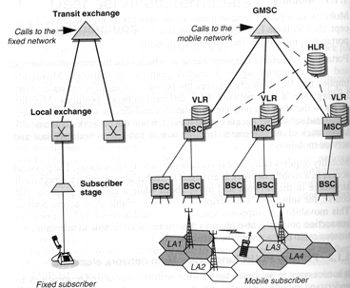
- GSM specification: since 1990, TDM, 125 channels, 1 channel (200kHz+ signalling) 8 users, max 20W, speech: 13 kbps;
  - voice oriented service,
  - separation of terminals and subscription,
  - international roaming,
  - low bitrate speech coding,
  - high bandwidth utilization,
  - low power consumption in inactive mode,
  - standards for system concept and air interface,
  - authentication process,
  - handover up to 200km/h,
  - outdoor and indoor coverage;
- wireline: fix place, system with low intelligence can manage analyze number (country code, area code, number);
- wireless: no geographical destination, task: find- look cell position in HLR;;
- GSM network components:
- SS (=Switching System):
  - AUC (=Authentication Center, PIN, PUK- authenticates subscriber- answer to HLR);
  - VLR (=Visitor Location Register, copy of items of HLR);
  - HLR (=Home Location Register, databank, everybody has logically one (subscriber name, call number, kind of services, payment method, connection status, location info, authentication info, PIN not stored));
  - EIR (=Equipment Identity Register, database block calls from stolen, unauthorized or defective MS);
  - GMSC (=Gateway Mobile services Switching Center, from other network);
  - MSC (=Mobile services Switching Center, where I am now- copy to VLR);;
- NMC (=Network Management Center, centralized control of network, for long term, system wide issues);
- OMC (=Operation and Maintenance Center, computer system, connencted to MSC,BSC via data links, presents info on status of network, controls system parameters, for short term, regional issues);;
- BSS (=Base Station System):
  - BSC (=Base Station Controller, manages all the radio related fkt, MS handover, radio channel assignment, collection of cell configuration data, controlled by MSC);
  - BTS (=Base Transceiver Station, antennas, towers, radio transmitter and receiver, control radio interface to MS, controlled by BSC);;
- MS (=mobile station, consists of: mobile terminal and SIM (=Subscriber Identity Module), subscription is separated from mobile terminal, subscription info stored in smart card);;
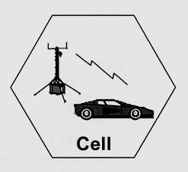
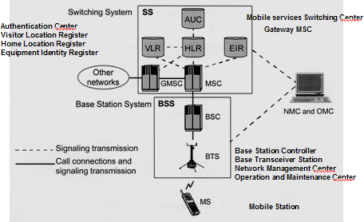
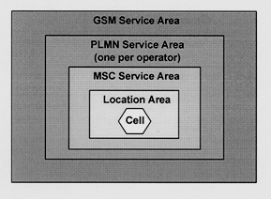

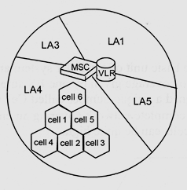

- GSM geographic structure:
- Cell: area of radio coverage by one BS antenna system, assigned to specific number (Cell Global Identity);
- LA (=Location Area): group of cells, identity stored in VLR;
- MSC service area: number, location is secret;
- PLMN service area (=Public Land Mobile Network): set of cells served by one operator;
- GSM service area: geographic area in which a subscriber can gain access to network;;
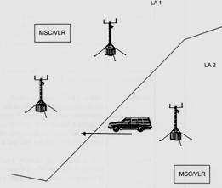
- functions:
- MS states:
  - idle (is on, call not in progress),
  - active (is on and call in progress),
  - detached (is off, no connection);;
- idle key terms:
  - registration: MS informs network that it is attached: power on, scans for signal levels on control channel fr, measures signal levels, tunes to strongest, register in HLR: status to idle, store location info;
  - roaming: moves around the network, scan the control channel- tune to strongest, inform network of new location;
  - international roaming: moves into not home network;
  - location updating: MS inform network when enters in new LA;
  - locating: BSC function to suggest connection to another cell- based on MS measurement report;
  - paging: network tries to contact an MS by broadcasting message containing MS identity;
  - handover: when call is switched from one physical channel to another;;
- identification:
  - MSISDN: MSRN (=Mobile Station Roaming Number) is the same; CC(=Country Code), NDC(=National Destination Code), SN(=Subscriber Nr);
  - IMSI-TMSI: temporary IMSI, local significance;
MCC(=Mobile Country Code), MNC(=Mobile Network Code), MSIN(=Mobile Station Identification Number);
  - IMEI: TAC(=Type Approval Code, fits to GSM standards), FAC(=Final Assembly Code, manufactures), SNR(=Serial Number);
  - LAI (=Local Area Identity): MCC, MNC, LAC(=Location Area Code);
  - CGI (=Cell Global Identity): MCC. MNC, LAC, CI(=Cell Identity);
  - BSIC (=Base Station Identity Code): NCC, BCC(=Base Station Colour Code);
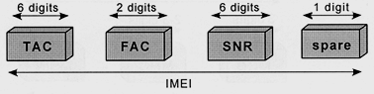
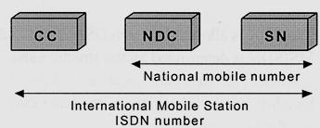
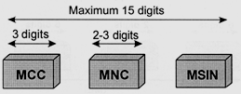

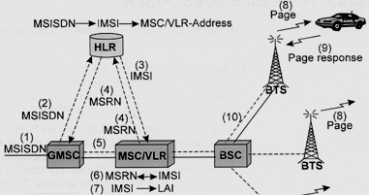
- call to MS:
  - 1. entering call routed to nearest
GMSC (MSISDN);
  - 2. the network analyzes the MSISDN
to find HLR, the MSC/VLR,
IMSI address is stored in HLR;
  - 3. HLR sends request to MSC/VLR
(included IMSI);
  - 4. MSRN is returned via HLR to GMSC;
  - 5. GMSC routes the call to the MSC/VLR (by MSRN);
  - 6. MSC/VLR retrieves /kinyer/ MSs IMSI;
  - 7. MSC indentifies LA (using IMSI);
  - 8. MS is paged in cells of the LA (LAI)- while paging only one MS answers;
  - 9. MS responds, authentication, cipher /rejtjeles/ mode setting, IMEI check;
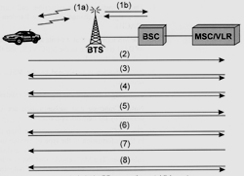
  - 10. traffic channel connected from MSC to BSC (it assigns fr, timeslot) and the BTS;;
- call from MS:
  - 1. connection establishing with signalling
channel using RACH (=Random Access CHannel);
  - 2. MS indicates request (SMS, MMS, speech);
  - 3. authentication performed by MSC
(IMSI analyzed, MS marked busy in VLR);
  - 4. ciphering mode is initiated, IMEI validated;
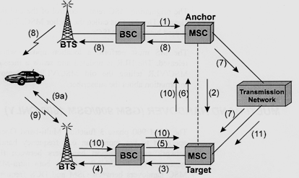
  - 5. call initiation (MSC receives a setup message from MS including B number);
  - 6. link established between MSC
and BSC to assign traffic channel;
  - 7. call confirmation;
  - 8. call accepted;;

- basic handover:
  - 1. BSC send handover-required message to MSC (anchor);
  - 2. MSC asks target MSC to assist, target MSC allocates a handover number;
  - 3. handover request sent down to the new BSC;
  - 4. new BTS activates a TCH (=Traffic CHannel);
  - 5. MSC receives info about the new TCH;
  - 6. MSC passes info on new TCH from new BSC;
  - 7. transmission network sets up a speech path to the new MSC;
  - 8. handover command goes to the MS with fr and timeslot data;
  - 9. MS sends handover burst on new TCH;
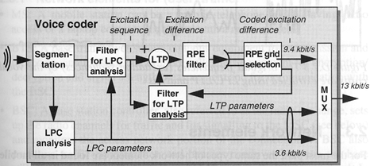
  - 10. target MSC is informed about successful handover;
  - 11. new path in the Group Switch is set up;;

- voice coding: lin.comb of past speeches,
param.+errors transmitted, quantized, compressed;
processing: speech coding- channel coding- bit interleaving- encryption- burst assembly- modulation – radio waves – demodulation- delay equalization- burst disassembly- decryption- bit deinterleaving- channel decoding- speech decoding;;;

BROADCAST NETWORKS:
- program transportation networks (eg: Antenna Hungária),
- terrestrial broadcasting (eg: Antenna Hungária),
- satellite broadcasting (eg: UPC direct),
- cable distribution (Matávkábel, UPC);
- allocation: entry in the Table of Frequency Allocations of a given fr band for the purpose of its use by one or more terrestrial or space radiocommunication services or radio astronomy services under specified conditions;
- allotment: entry of a designates fr channel in an agreed plan, adopted by a competent conference, for use by one or more administrations for a terrestrial or space radiocommunication service in one or more identified countries or geographical areas and under specified conditions;
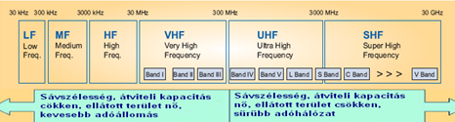
- assignment: authorization given by an administrator for a radio station to use radio fr (or radio fr channel) under specified conditions;

- fr bands for broadcasting:
  - the higher fr, the higher bandwidth,
tr.capacity, but smaller area, more transmitters;
  - bands below 30 MHz are not suitable for multimedia services, VHF is not preferred by TV manufacturers;
  - Radio Spectrum Policy Group prefer UHF IV-V bands for broadcasting;
  - problem: Hungary has only 3 terrestrial TV channels;
  - solutions:
    - DVB-T (=Digital Video Broadcasting- Terrestrial, free of charge service from Antenna Hungária- nobody uses it),
    - DVB-H (=DVB- Handheld),
    - DVB-S (=DVB- Satellite),
    - IPTV(=Internet Protocol TV from T-Online, set top box),
    - Antenna Digital (digital cable TV without cable from Széchényi-hegy, 12 GHz (microwave), EPC (=Electronic Programming Guide), Dolby Digital sound, 100 channels);;
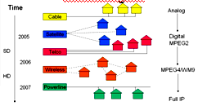
- changing on TV market:
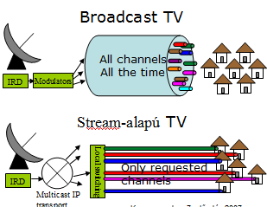
  - few→ many providers,
  - analogue→ digital,
  - broadcast→ personal,
  - MPEG2→ MPEG4,
  - SD→ HD (=High Definition);;
- customized TV:
  - broadcast: uses full bandwidth even if no user,
100-130 analogue program, 6-8 MHz bandwidth*programs;
  - multicast: bandwidth according to actual usage, eg: IPTV;
  - unicast: stream based, limitless, 3,8 Mbps*used TVs, local switching, customized content for individual users, eg: VoD, time-shifting;;
- radio based digital multimedia systems:
  - cellular: GSM, UMTS;
  - terrestrial broadcasting: DVB-T (high power transmission, large coverage area, lower min signal level due to fixed antennas),
DVB-H (dense tr network, higher signal level, interferences);
  - hybrid: satellite and terrestrial;;
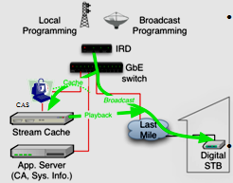
- personal TV system:
  - program time shifting: digital broadcast and
through Stream Cahce- from there comes new stream;
the program can be seen from its beginning, pause,
instant playback, backjump, forward jump,
on one TV set can be seen real-time program
on the other the stopped one;
  - movies on demand: choosing from a databank, pause, rew-ff, starting again (once or unlimited within 24 hours);
  - personal playlist: EPG (=Electronic Programming Guide), order of watching programs can be chosen (even saved), RetroVue starts personal steams, child control, blocking of programs;;
- multimedia program distribution: basic transport networks:
  - traditional broadcasting (analogue or digital),
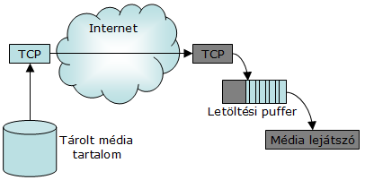
  - dedicated data network for multimedia transport (IPTV, T-home)
  - general network (internet based, GPRS,UMTS);;
- applications:
  - file transfer: starting player:
    - after complete downloading OR
    - after content enough to avoid risk of empty buffer OR
    - target is safety download and delay has secondary importance;
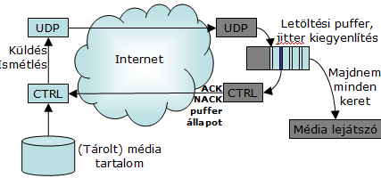
  - http streaming: T..time, M..bits, r..estimetad bitrate, play if: M< T*r,
problem: it has to be realized per frame, r can change;
  - media streaming:
permanent playing has to be provided;
  - protocol layers: access network- IP- UDP, TCP-
packaging, synchronizing-
audio decoder, video decoder, control, datatransfer;
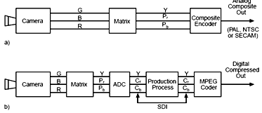
  - interactive transfer: most important: keep real-time, prompt start, round time: 200 ms, but reliability is not so important;;
- television systems:
  - traditional: matrix: Y,P_{r},P_{b}
(brightness, colour difference signal) ;
  - MPEG-2: compression: SDI (=Serial Digital Interface);;
- MPEG-2:
  - intra-coding: relies on two characteristics of a typical image: not all spatial fr-s are simultaneously present, the higher spatial fr, the lower amplitude; regularity→redundancy- analysis of 1 picture;
  - inter-coding: relies on finding similarities between more pictures; next picture can be created by sending only the picture differences- the shifting process is controlled by motion vector (horizontal and vertical displacement value);;
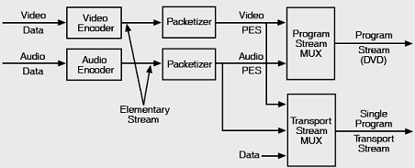
- MPEG streams:
  - elementary stream:
endless near real-time signal;
  - program stream:
variable length packets with headers;
  - transport stream:
PES packets are subdivided into short fix-size packets, asynchron;

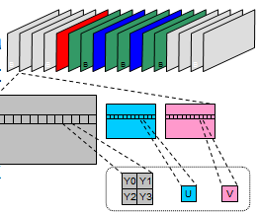
- MPEG structure: Y:C_{b}:C_{r}= 4:2:2 because of human eye,
interpolation from both sides;
  - hierarchy: sequence, picturegroup,
picture, slice, macroblock, block;
  - scalable bitrate: VHS: 1,1 Mb/s, HDTV: 14 Mb/s;;

- CaTV:
  - traditional analogue system: satellite OR cable- Head-end (FDM)- distribution networks (fibre)- house networks (coaxial);
  - AM VSB TV sets,
  - set top box for receiving DVB programs (including demodulator, MPEG decoder, descramble),
  - internal fr plan with 8 MHz raster (free assignment of programs to 8 MHz channels),,
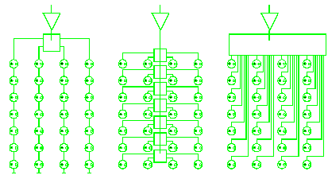
  - low split system (5-55 MHz: uplink, 70-630 MHz: analogue downlink,
630-862 MHz: digital downlink path),
  - in one 8 MHz channel (8 TV and 8 radio channels),
  - nominal impedance: 75 Ohms;
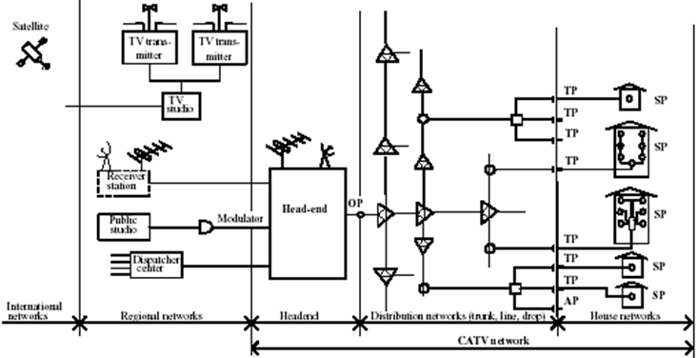
  - structure: felfűzéses, tap-off, star;;;

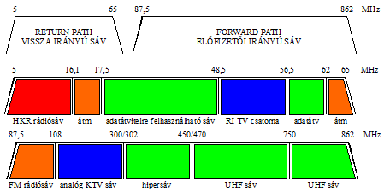

PRIVATE NETWORKS:
- Closed User Group, special purpose network, eg: railway, pipeline, fleet (taxi group), water management, energy systems, emergency services, police, military, company-wide, Global Company Network, Seat Reservation Network, Bank;;
- main questions of planning:
  - new or present building (duration of building: 100 years, of network: 10),
  - one or more places (standard interfaces, leased, managed, backup lines, independent technologies- more reliable),
  - integrated or separate network (uniform, structure: horizontal, vertical),
  - fibre (10 Gbit/s, special, expensive, fits to each pipe) or cupper (UTP to 100m: 10 Gbit/s, easy, cheap, fits not) or radio (300 Mbit/s, exp) technology – price!,
  - choosing a structure (star, if reliable: meshed, connection to public network),
  - place and size of nodes, channels (regulated);
  - critical: födém áttörése, power line, climatization;;
- features:
  - internal numbering scheme, addressing system;
  - strictly regulated gateway fkt for interconnection to other networks;
  - transmission: leased line or radio;
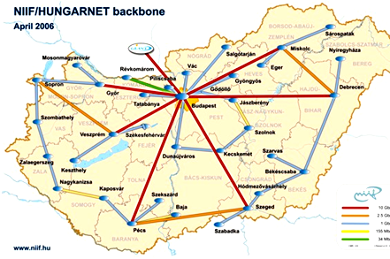
  - multiplexing, switching, management, authentication are private fkt; task oriented service quality parameters (reliability, usability, error rate, response time, redundancy, backup time);
  - separated fr management;;
- example: Hungarnet: Pázmány is a member;
  - for research and academic community
(university, high school, museums);
  - governmental support;
  - part of EU GEANT project;
  - transmission: leased dark fibre
(multiple wavelengths at 10 Gbit/s, have backup IP connections);
  - switching and operation at Hungarnet (provided by NIIF);
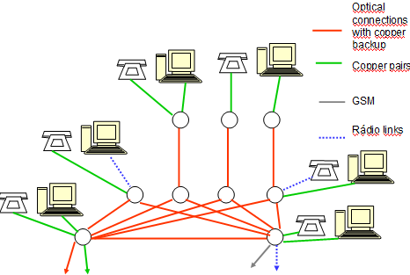
  - services of NIIF: HBONE, ADSL, registration service (name, IP address allocation), e-mail, web hosting, webpage, ftp, news;
- planning principles:
  - fast, error free and reliable operation,
  - ready system for any new technologies,
  - popular test bed for system suppliers,
  - no disturbing in outlook;
- consequences:
  - robust, multi-path external connection, meshed topology;
  - copper, optical, radio technologies in internal and external links;
  - over dimensioned and accessible duct system;
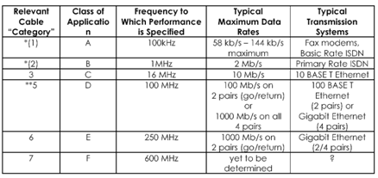
  - structure: primary - (meshed) – secondary- third level; optical and twisted pair panel;
- cable categories: 1-7;
  - STP: Shielded Twisted Pair;
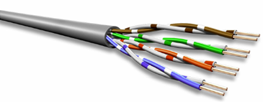
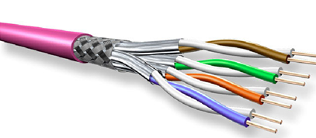
  - UTP: Unshielded Twisted Pair;;

- impairments inside the cable:
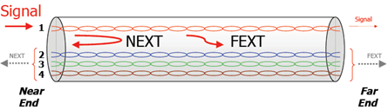
  - IL (=Insertion Loss, attenuation, loss the signal experiences travelling down the cable),
  - NEXT (=Near End Cross Talk, what
comes out on near end of the other pairs),
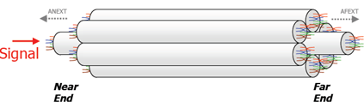
  - FEXT (=Far End Cross Talk,
what comes out on far end of the other pairs);
- impairments outside the cable:
  - ANEXT(=Alien NEXT, at near end…);
  - AFEXT(=Alien FEXT, what comes out on the near end of the other pairs when you inject a signal on a pair in the center cable);;
- cat-6a: to provide more than 10 Gb/s, increased the twist, varied twist rates between 4 pairs, increased diameter, installed separator for controlling pair position, 625MHz;
- 10 GBASE-T: Ethernet, IEEE 802.3ae, since 2006, horizontal, compatible, for 100m;;
- key issues: higher signal bandwidth, higher performance, more complex signal procession, cancellation of FEXT, timing requirements;;;
SZOLGÁLTATÁSOK:
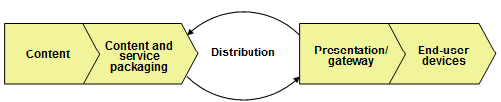

- the value chain: sequence of business (each part is important);
- content (music, film, table, document);
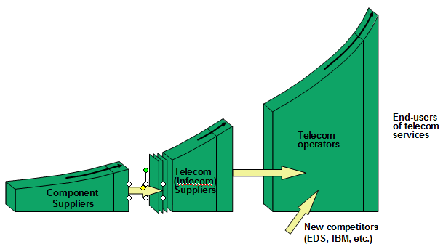
- content and service packaging (origo, index, RTL Klub, Kossuth);
- ⬄ distribution ⬄
- presentation/gateway (PSTN, GSM, broadcasting network);
- end-user devices (terminals, eg: TV, mobile);;

- shift in the value chain: component suppliers (provides cable, chip, transistor, SW) < telecom/infocom suppliers (provides router, exchange, multiplexer, eg: IBM, Sisco, HP, Ericsson, Nokia) < telecom operators (provides network, eg: Pannon, T-mobile) < end-users (they pay bills);;

- roles in service provision:
- electronic communication activity:
  - transmission of messages in the form of electronic signals;
  - message: speech, voice, music, text, picture, video, data, multimedia;
  - eg: tel call within building, opening garage by radio controller, leasing dark fibre, sending bits, but not: receiving radio signals from a star;
  - requirements:
    - content fidelity: same message, not distorted or changed, depending on message type (speech ⬄ data; bandwidth ⬄ bit error rate);
    - acceptable delay: depending on message type, isochronous services are sensitive on delay(coding,packaging) and jitter(variation in the delay);;
- electronic communication service:
  - activity for other entity for fee (service, facility, feature), needs 2 partners;
  - eg: local tel exchange, but not: entry on wireless station (it’s free);
  - requirements:
    - for real demand of users;
    - affordable price (not: Iridium: LEO, global, works only outside, expensive, alternative to GSM; HDTV: 1250 lines, 2,4H optical view distance, 9 MHz);
    - high penetration (attractive for many users);
    - user friendly (easy to use, react quickly);
    - continuous availability;
  - traditional players:
    - network operators;
    - service providers (Hungary: same, eg: T-Com, Pannon);
    - operator partners (eg: access provider, collocation provider);
    - wholesale (/nagykereskedő/, eg: Media Markt: products sold in many brands) and retail (/kiskereskedő, viszonteladó/, eg: Suzuki Hollós: not own product, fix price) partners;
    - end users, subscribers;
  - other players:
    - content providers (eg: film studio, writer);
    - content and service packagers (eg: origo, MTV1);
    - service and application brokers (eg: service contract with T-Kábel, insurance companies);
  - categories: based on user groups; not: network issues!
    - public services: available for anyone (cannot refuse request, only if technical conditions), based on uniform service conditions, subscriber contracts;
    - CUG (=closed users group services): VPN (=Virtual Private Network: uses cable, facilities, routers of public service providers);
    - Interconnection services and access services: services for other service providers, eg: call from Vodafone to Pannon;
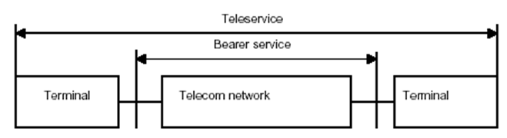

- service structures:
- Teleservices: defined at user interface, providing full communication between users (terminal- telecom network- terminal), eg: telephone service, emergency calls, SMS;
  - from point of view of provider:
    - basic services: mandatory service element with minimal quality requirements (eg: real time, understandable);
    - supplementary services: to make basic services even more usable, eg: call transfer, conference call, automatic callback on busy, wake up service, least cot routing service, credit card based call;
    - value added services: eg: bank transaction by phone, televoting, telephone based donation;
  - from point of view of: user/ voice/ data and still pictures/ video/ multimedia;
    - interactive services: telephone, videoconference/ tel, voice conference/ interconnection 2 PCs for big distance, POS(=Point Of Sales, paying by bank card) transaction/ videoconference, telepresence/ videoconference including EKG, EEG, X-ray transmission, multimedia games;
    - messaging services: voice mail, e-mail/ voice mail/ telex, EDI(=Electronic Data Interchange, eg: order sg from USA), e-mail/ MMS/ MMS;
    - retrieval services: /lekérdező/ account balance, time table/ ua/ Web browse/ downloading/ downloading multimedia shows;
    - distribution services: cable TV, personalized news by fax/ telephone news/ teletext/ cable TV/ video on demand, pay per view;;
- Bearer services: /hordozó/ defined at network interface, providing signal transmission capabilities between network access points, eg: 64 kbit/s unrestricted, structured circuit mode, packet mode bearer service;;

- network and terminal requirements:
  - voice, music, video: sensitive on delay (max 300 ms), jitter (max 30 ms), synchrony (lin-sync: lip movement and voice), error tolerant (BER: 10⁻³);
  - games: sensitive on delay (max 10 ms), error;
  - data, still picture: sensitive on error (BER: 10⁻⁶), delay and jitter tolerant;
- network intelligence:
- interactive services:
  - PSTN/ISDN: mandatory features of public telephone services: (implemented in switches)
    - available for public,
    - originating and receiving national and international calls,
    - access to emergency services,
    - provision of operator assistance,
    - directory enquiry service /tudakozó/,
    - directories /tel.könyv/,
    - public payphones,
    - legal interception /törv.lehallgatás/,
    - carrier selection /közvetítő szolgáltatóválasztás/,
    - number portability,
    - itemised billing,
    - calling-line identification;
  - IN: (=Intelligent Networks): concept for easy service creation and provision: terminal- access- network management (service switching (transport) ⬄ service control (NI))- access- terminal;
standardized IN elements (CS1= Capability Services Nr1):
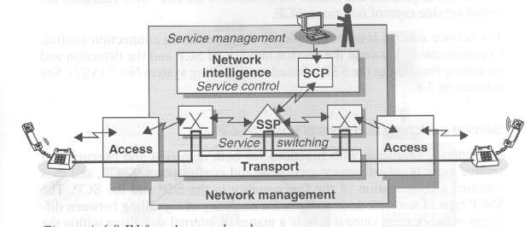
    - freephone services /zöldszám/,
    - shared cost services /kékszám/,
    - premium rate services /emeltdíjas/,
    - virtual card /hívókártya/,
    - prepaid card,
    - virtual private network,
    - universal personal number/személyhívó/;

  - GSM: supplementary services:
    - CLIP (=Calling Line Identification Presentation),
    - CLIR (=Calling Line Identification Restriction),
    - COLP (=Connected Line Identification Presentation),
    - COLR (=Connected Line Identification Restriction),
    - CFU (=Call Forwarding Unconditional)
    - CFB (=Call Forwarding on Mobile Subscriber Busy),
    - CFNRy (=Call Forwarding on No Reply),
    - CFNRc (=Call Forwarding on Mobile Subscriber Not Reachable),
    - CD (=Call Deflection),
    - HOLD (=Call Hold),
    - CW (=Call Waiting),
    - BAOC (=Barring of All Outgoing Calls) /letiltás/,
    - BOIC (=Barring of Outgoing International Calls),
    - BAIC (=Barring of All Incoming Calls),
    - BIC-Roam (=Barring of Incoming Calls when roaming outside the home country),
    - CUG (=Closed User Group),
    - AOC (=Advise Of Charge),
    - UUS (=User-to-User Signalling) /partner állapotát lekérdezni/,
    - MPTY (=Multi ParTY Service);
  - IP telephony: carriage of voice over IP-based networks irrespective of ownership;
    - service: PSTN- Internet telephony;
    - technology: PSTN (E.164- IP address) or internet tel (circuit switched- IP address);
    - defining VoIP (= Voice over Internet Protocol): voice traffic carried wholly or partly using IP over broadband networks competing with incumbent operators – ITU Report 2001, Genova;
    - traffic: 15% of total minutes, subscribers: 5% of total;
    - shift toward flat-rate pricing (not data, not time-rate);
  - Telefax: G3 (PSTN), G4 (ISDN), mobile fax; functions:
    - call setup,
    - data communication controlled by terminals,
    - interworking based on standardised protocols,
    - negotiations on transfer mode (discuss speed, coding),
    - scan the document,
    - data transfer in the agreed mode with adaptation,
    - acknowledgement;
  - voice mail:
    - boxes assigned to subscription or individual,
    - indication on received messages,
    - voice box, fax box, mail box – universal messaging;
  - SMS:
    - start and success in GSM network,
    - available in PSTN networks as well (CLIP+);
  - IP multimedia channel: on packet-switched network (GPRS or 3G):
    - voice,
    - presence,
    - messaging,
    - video sharing,
    - push to talk,
    - interactive gaming,
    - content sharing,
    - chat;
  - IMS (=IP Multimedia Subsystem):
    - finds other terminal and connects it with IP (GPRS, EDGE, WCDMA, WLAN, ADSL);
    - mobile terminal with IP connection- SIP (= Session Initial Protocol, find and connect)- packet-switched network- SIP- other terminal;
    - layers: service plane (application servers)- control plane (call session control function)- transport plane (connected to PSTN, PLMN, Internet);
    - announced 2005; services:
    - HSDPA,
    - POC (=Push-to-tal over cellular),
    - multimedia conferencing,
    - VoIP,
    - video sharing,
    - instant messaging,
    - gaming;;
- network services:
- leased line services: on pipe level connected;
  - transparent transmission capacity without switching function;
  - for operator partners to extend their networks;
  - for interconnection of network nodes;
  - for end users to access networks or services;
  - interconnection of private network nodes;
  - main characteristics: service features,transmission parameters,interface types;
  - main classes: analogue/digital, 2wire/4wire, simple/observed/managed;
  - standardised services: ETS 300 488 2wire/4wire (ordinary quality voice bandwidth), ETS 300 288/300 289 (64 kbit/s), ETS 300 418/300 247 (2048 kbit/s), ETS 300 299 (Nx155520 kbit/s);;
- interconnection services: even on service level connected;
  - call origination, call termination, call transit;
  - support services (eg: billing);
  - carrier selection services /közvetítő szolgáltató választás/;
  - standard solution for interconnection PSTN, ISDN and GSM- ETS 300 356;
  - peer-to-peer interconnection without detailed traffic accounting;
  - mandatory for public networks;
  - technical, commercial and legal aspects;
  - critical issues: which services are supported? Where is interconnection point?;
  - network operators with significant market power have special obligations;
  - reference interconnection offers are accepted by authority;
  - all the accepted interconn. reference offer in Hungary are bringing to justice;
  - functions: local, regional interconnection points, eg: user network- regional interconnection point- service provider network (regional zone)- regional interconnection point- other user;;
- VPN (=Virtual Private Network) services: part of public network;
- network access services: eg: ADSL;
- billing services;
- Centrex services: (=Central exchange), type of telephone exchange;

- services to gain content:
- telefonhírmondó: 1881, Puskás Tivadar, 14,5 hours daily for thousands of subscribers for 30 years, radio broadcasting killed it;
- content: the free flow of information and access to information are fundamental rights of human. The European Convention of Human Right authorize national bodies to limit the harmful and dangerous content; protecting of children and the dignity /magasztosság/ of human being;
  - representation of violence in media: free access (unencrypted), fee-paying (encrypted), programming time;
  - responsible: editor; competent id debates concerning content: ORTT;
  - illegal contents: child pornography, violent pornography, extreme violence, incitement of racial;
  - limited contents: legally publicised to adults but might harmful for children;
  - protection methods:
    - markup with cooperation the content providers;
    - classification of programs;
    - anti violence V chip (Canada);
    - limited content only between 23-5 (Hungarian media law);;;
TERMINALS, REGULATION:
- terminals:
- parts of the network, but individual elements;
- if no terminal, then no electronic communication;
- commerced in normal shops and supermarkets, are owned by users;
- international standards are the guarantee of interworking and interoperability of public networks and terminals (eg: tel set, modem, fax machine, set-top-box)- fitting to the adequate international standard (RTTE directive);
- have to be fit both to the networks and to the users;
- specification of terminal network interfaces is the task of service providers;
- manufacturer is responsible to cooperate well with network;
- requirements:
- basic technical functions:
  - main functions of PSTN terminals: BORSCHT:
    - Battery supply,
    - Overload protection,
    - Ringing,
    - Supervision, signalling,
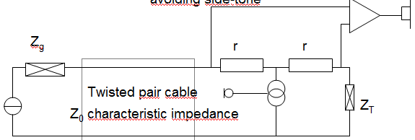
    - Coding (ISDN, VoIP),
    - Hybrid (2/4 wire transformation),
    - Testing;
  - functional elements of tel terminals:
    - speech circuit (2 wire subscriber loop, separation of transmission and receiving, termination, avoiding reflection,side-tone),
    - dialer circuit,
    - handset,
    - ringing circuit,
    - display, number memory, message recorder, B-number display, SMS receiver;
  - GSM terminal:
    - microphone- A/D- coding- modulating- D/A- processing (PLL)- amplifying;
    - earphone- D/A- coding (Viterbi)- balancing- A/D- PLL;
    - keyboard, SIM card- system interface- receiver/transmitter or display or memory;
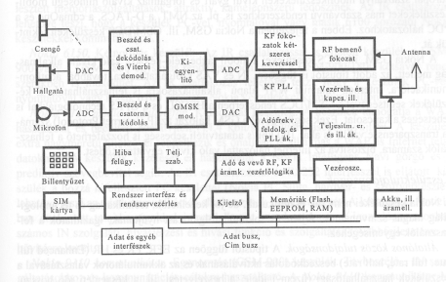
    - battery;;
- handset:
  - good matching to any normal head,
  - comfortable use,
  - good microphone position,
  - ITU-T (=International Telecommunication Union) P.35 recommendation (fit well to 90% of adult users);
- hands free terminal:
  - loudspeaker and microphone are mounted inside,
  - receiving and transmission sensitivity is defined independently from the position of speaking person,
  - protection against oscillation by half duplex mode (receiving, transmission separately- impossible to speak together),
  - automatic and fast changing or transmission or receiving,
  - automatic level control;
- keyboard:
  - uniform arrangement of figures (not as at computers),
  - tactile mark on 5,
  - specified characteristics of force-displacement,
  - acoustic feedback;
- display:
  - 1-8 rows, max 24 characters, 9x7 matrix,
  - min 1:10 contrast,
  - backlight,
  - pro: icons;
- intelligence in terminals:
  - calling services (last called numbers, call from memory, call by voice),
  - storing numbers (shortcut, into memory with name, during call),
  - barring calls (directions, locking keyboard),
  - speaking services (mute, level of voice, holding),
  - ringing signal (depending on caller, visual, vibrating),
  - indications (called number, speaking time, price, battery, signal strength);
- special requirements of elderly or handicapped people:
  - blind: standardized and single buttons (not with color);
  - hard of hearing: connection to hearing aid /nagyothalló készülék/, extra receiving gain (20 dB, with shock protection), flashing;
  - handicapped: booths /tel.fülke/, public telephones;
- public information terminals:
  - multifunction services,
  - closed, robust (vandal-proof) construction,
  - very simplified usage,
  - applications: official affairs, travelling information, banking actions, ticket selling, paying bills;
  - construction: no banknotes inside, touch-screen, card reader, identifying by mobile, printer;
- FOMA: Far-East 3G first introduced;

- regulation:
- directive: very concrete impact into law order;
- regulation: law in every country, eg: ADSL access point;

- electronic communications service: EU parliament framework /váz/ directive in 2002 (Hungary accepted in 2003. C. law; IHM, government regulation, other laws) ;
  - service normally provided for remuneration /ellenszolgáltatás/ which consists wholly or mainly in the conveyance /továbbítás/ of signals on electronic communication networks;
  - including telecommunication and transmission services in networks;
  - but exclude services providing or exercising editorial control over content;
  - Universal Service Directive: one provider chosen- gives service everywhere and other providers pay for its loss;
  - Access Directive;
  - Authorization Directive;
  - Directive on privacy and electronic communication;
  - Unbundled access to the local loop (regulation in 2000, new companies can have local loops- new end-users);;
- electronic communication regulation periods:
  - natural state monopoly:
    - official price, supporting, controlled network tools, terminals;
    - poz: uniform system no need of control;
    - neg: 20 years waiting for a telephone);
  - separating: in 1993: post, telecommunication, broadcasting, official areas;
  - privatizing:
    - concessions, obligation of supporting and developing;
    - restricted competition, helping for new companies with cherry peaking (choose of users);
    - obligation of companies with significant market power (transparency, equal treatment, same conditions, same quality, cost-based prices, controllability of fees, RIO= Reference Interconnection Offer, RUO= Reference Unbundling Offer);
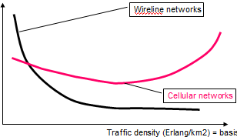
    - liberalizing the tool market;
    - market failure- need of regulation (network costs vs traffic density: Erlang/km²);;

- new regulation in November 2007:
  - the sector is changing rapidly (VoIP, television through broadband lines);
  - strengthening consumer rights;
  - reinforcing competition between telecom operators (carrier selection /közvetítő/, unbundling of local loops, number portability);
  - promoting investment into new communication infrastructures (freeing radio spectrum for wireless broadband service);
  - making networks more reliable, more secure (less viruses, cyber-attacks);
  - new European Telecom Market Authority and national telecom regulations ensuring that market rules are applied consistently;;

- regulation issues in Hungary:
  - regulation of fees,
  - usage of frequency, frequency assignment,
  - constructing supervision,
  - installation of radio stations, networks,
  - authorization of networks,
  - interworking and interoperability,
  - quality,
  - support for handicapped people,
  - collecting and handling data,
  - market analysis,
  - number portability,
  - choosing provider,
  - subscribing;;;

VoIP and ADSL:

- VoIP:
- definition:
  - voice over Internet Protocol, phone service over the internet, not Skype!;
  - people use as addition to traditional phone service;
  - lower rates, but not telephone, because no common phone services (eg: no directory);
- devices:
  - hard phones: power over Ethernet, G.711 and G.729a/b codec, adaptive jitter buffer;
  - cordless hard phones: with IP interface on its base station, eg: DECT;
  - dialup hard phones:
    - with a built-in modem (not Ethernet port),
    - connection via a dialup internet service to a remote VoIP server- self-contained /fglen/,
    - it does not require PC or software, only a phone line,
    - popular in countries with little broadband infrastructure;
  - Wifi phones:
    - with built-in WiFi transceiver unit (not Ethernet port), which connects to WiFi base station and from there to a remote VoIP server,
    - it does not require PC or software;
  - Hard phones (voice and video): with video telephony support;
  - Soft phones (only voice):
    - IP telephone in software,
    - requires appropriate audio hardware (sound card with speakers or earphones and microphone),
    - inferior to hard phones, but cheaper (or free);
  - Soft phones (voice and video);;

- Skype:
  - a proprietary /saját/ protocol VoIP system using P2P (=Peer-to-peer) technique;
  - free of non commercial use when using soft phones- PC to PC;
  - offers toll access to PSTN via SkypeOut and SkypeIn;
  - from the company that created KaZaA;
- key issues:
- SIP (=Session Initiation Protocol):
  - an agile, general-purpose application layer protocol for creating, modifying, terminating and managing sessions (= exchange of data between an association of participants);
  - it works independently of transport protocols and type of session;
  - users may move between endpoints, addressable by multiple names, communicate in several different media (sometimes simultaneously);
  - enables internet endpoints (user agent) to discover one another and to agree on a characterization of a session they share;
  - enables the creation of an infrastructure of network hosts (proxy servers) for locating prospective /jövőbeli/ session participants;
  - user agents can send registration, invitation to session and other requests to proxy servers;
  - functionality:
    - multimedia sessions (conferences),
    - Internet telephony calls,
    - multicast conferences (inviting participants),
    - media can be added to (or removed from) an existing session,
    - supports personal mobility (name mapping, redirection services /átirányítás/);
  - multimedia communication:
    - user location (determination of the end system to be used for communication),
    - user availability (determination of the willingness of called party to engage in communication),
    - user capability (determination of the media and media parameters to be used),
    - session setup (ringing, establishment of session parameters at both users),
    - session management (including transfer, termination, modification of sessions and invoking services);
  - call session without proxy: invite(→), 100 trying (←), 180 ringing (←), 200 OK (←), ACK (→), RTP data (←,→), bye (←), 200 OK (→);
- Voice codec:
  - used to convert an analogue voice signal to digitally encoded version;
  - vary in the sound quality (bandwidth, computational requirements);
  - each service, program, phone, gateway typically supports several different codecs (when talking, choosing one);
  - used to compress regular audio (16 bit, 8000 Hz), lossy;
  - if on WAN, then compress as much as possible- smaller packets- less audible delay and lower risk of packet loss;
  - some devices, gateway providers offer only G.729 codec (uses less bandwidth, less CPU power);
  - few phones implement iLBC;
  - most phones offer G.711;
  - codec family:
    - GIPS (13,3 kbps),
    - GSM (13 kbps, 20 ms frame size),
    - iLBC (15 kbps, 20 ms frame size; 13,3 kbps, 30 ms frame size),
    - ITU G.711 (64 kbps, sample based, a-law/u-law),
    - ITU G.722, G.723, G.726, G.728 (16 Kbps),
    - ITU G.729 (8 kbps, 10 ms frames with short algorithm delays, short term filter (10th order LP (= Linear Predictor) filter), long term filter (adaptive-code book)),
    - LPC10 (2,5 kbps),
    - CELP (4,8 kbps),
    - to use G.729 or G.723.1 have to pay royalty fee- available to download for education purpose only;
- Packet Loss Control;

- ADSL:
- Asymmetric Digital Subscriber Line (downlink > uplink, not because of grounded!);
- a modem technology, converts existing twisted-pair telephone line into access path for multimedia and high speed data communication;
- transmit up to 6 Mbps downstream, 832 kbps upstream;
- crucial role over the next 10 years, no competitive technology (fibre: too expensive, radio: limited fr, not free outside);
- FDM (=Frequency Division Multiplexing), TDM (=Time Division Multiplexing), modulation, error control, flow control, scrambling (long 0 series) , signal processing, adaptation, STM-ATM, trellis coding, in-service performance monitoring and surveillance /felügyelet/, initialisation, handshaking, channel analysis are mixed in ADSL;
- modem and splitter and router in 1 box;
- ATM/IP network- DSLAM (=Digital Subscriber Line Access Multiplexer)- twisted pair cable- HUB- Ethernet- PC;
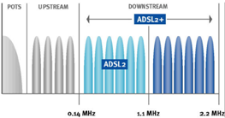
- max speed: 1500/384 kbit/s in 2004, 8000/512 kbit/s in 2007;
- in Hungary cables less, than 15 years old;;
- key requirements:
  - test loops- makeup and topology (to ensure adequate penetration);
  - cross talk or steady state noise margin (to allow for interactions form other DSL in a multi-pair cable);
  - data rates (both line and payload);
  - impulsive or transient noise margin (to allow for noise spikes, eg : ringing) ;
  - transmitter power spectral density limits (to ensure spectral compatibility and minimize unwanted RF emissions);
  - return loss (to ensure good line matching and signal power transfer);
  - line interface balance (to prevent EMC (=excessive field strength) problems);
  - framing and data scrambling (to prevent cyclo-stationary effects);
  - latency (to minimize delay, eg: for voice traffic);
  - jitter and wander (= high speed and low speed variation of delay, to minimize data loss);
  - start up protocols (handshaking);
  - warm/cold start limits (time taken to synchronize and achieve reliable bit transport- to minimize circuit unavailability);
  - line coding (to achieve efficiency in terms of bits/s/Hz);
  - duplexing (simultaneously used for up and downlink, eg: time, fr, echo cancellation);
  - forward error correction (to self-correct physical layer transmission errors);
  - embedded operations and maintenance (for the transfer of service related information, eg: QoS);;
- DMT (=Discrete MultiTone):
  - copper lines have a fr spectrum of 1,1 MHz, which can be used for data communication under 2 main limitations (lower 4 KHz used by POTS; amplification isn’t the same in all frequencies);
  - divides fr range into 256 sub-frequencies from 64 KHz to 1,1 MHz;
  - carriers are situated in 4 kHz grid (DMT or 32QAM modulation);
  - data rate= number of channels * number of bit/channel * modulation rate;
  - theoretical maximum upstream= 25*15*4 kHz= 1,5 Mbit/s;
  - theoretical maximum downstream= 249*15*4= 14,9 Mbit/s;
  - each sub-fr is an independent channel (own stream of signals);
  - ADSL protocol defines a basic stream of data, which is known to both endpoints in advanced (it enables to find the specific SNR for each sub-fr; info to split the data over sub-fr);;
- Code and error correction:
  - constellation encoding (16 state 4D trellis code) and Reed Solomon coding;
  - decoding can be damaged, but decoder can rebuild info very reliable;
  - FEC (=Forward Error Correction): increases system reliability;;
- Framing and Scrambling:
  - ADSL uses a specific framing method: the main frame (superframe) is composed of 68 ADSL data frames;
  - ATU-C (=ADSL Transceiver Unit-Central Office End) sends a superframe every 17 ms;
  - each data frame gets his information from 2 data buffers (interleaved and fast buffer), which are scrambled at a specific sequence- more efficient coding;;

- ADSL family:
  - ADSL (G.992.1, 1999),
  - ADSL2 (G.992.3, 2002),
  - ADSL 2+ (G.992.5, 2003, increases downstream data rate to 24 Mbps on short loops by extending bandwidth to 2,2 MHz);

WiFi, WiMAX, Wireless Home Gateway:

- ASK, FSK, PSK;
- Spread Spectrum Concept (inventor: Hedy Lamarr), FHSS (= Fr Hopping Spread Spectrum; slow, fast), DSSS (= Direct Sequence Spread Spectrum);
- hierarchy:
  - WPAN (= Wireless Personal Access Network- BT, 10 m, standard: IEEE 802.15, eg: notebook, printer, mobile phone);
  - RLAN (= Radio Local Area Network=WLAN- WiFi (subset of standard working at 2,4 GHz), 150 m, IEEE 802.11, eg: computers);
  - WMAN (= Wireless Metropolitan Area Network- WiMax, 50 km, IEEE 802.16, ETSI HiperMAN, eg: computer system);
  - WAN (= Wireless Access Network- WiMax mobile (roaming, not fast moving), whole country, IEEE 802.16e);;

- WiFi:
- frequency bands: 2,4 GHz (2400-2483,5 MHz), 5,2 GHz (5150-5350 MHz), 5,6 GHz (5470-5725 MHz);
- IEEE standards: brutto data speeds (with signalling, error correcting);
  - 802.11a (5 GHz, 54 Mbps),
  - 802.11b (2,4 GHz, 11 Mbps),
  - 802.11d, 802.11e (QoS for voice and video),
  - 802.11f (IAPP= Inter-Access Point Protocol),
  - 802.11g (2,4 GHz, 54 Mbps),
  - 802.11h (DFS= Dynamic Frequency Selection, TPC= Transmit Power Control),
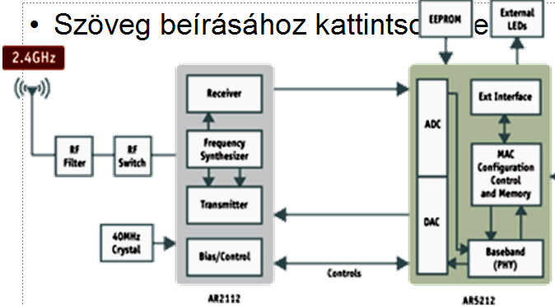
  - 802.11i (security),
  - 802.11j (5 GHz, Japan),
  - 802.11k (measurement),
  - 802.11m (maintenance),
  - 802.11n (high speed, max 2*248 Mbps),
  - 802.11y (higher power up to 5 km);;
- chipset:
  - RF filter;
  - RF switch;
  - AR2112 Radio-on-a-chip for 2,4 GHz WLAN (Receiver, fr synthetizer, transmitter, bias/control);
  - AR5212 Multiprotocol MAC/baseband processor (ADC, DAC, baseband, MAC configuration control and memory, ext interface);
  - EEPROM;
  - External LED;
  - PCI, PC card;
- WiMAX:
- Worldwide Interoperability for Microwave Access;
- standards which have the option to fulfil the prescriptions: IEEE 801.16d, 801.16-2004, 802.16e; ETSI HiperMAN;;
- WiMAX profil: a tool has to dispose some properties to fulfil the technical parameters for WiMAX qualification (defined by WiMAX Forum);;
- frequency bands: 3,5 GHz (3410-3494 / 3510-3594 MHz), 5,8 GHz (5725-5875 MHz);
- regulation:
- authorization: if individual authorization, then no frequency fee, but technical norms (eg: power) have to be kept; only 3,5 GHz band needs individual authorization;
- usage of 2,4 GHz RLAN:
  - for industrial, scientific and medical tools (eg: microwave, remote control, alarm)- not controllable noise level, interference;
  - 3. priority (no need of protection from interference);
  - limits only power levels (so usually usable for 150 m), but technology-neutral;
  - harmonized: 2400-2454 MHz, not harmonized (from separating power): 2454-2483,5 MHz;
  - applications: BT (for 10 m), homeRF (for 50 m), WiFi (for 150 m, solution of RLAN, IEEE 802.11 standard), ORLAN (Outside Radio LAN not prohibited, but has many disadvantages at this fr.band); for ORLAN suggested 5470-5725 MHz;
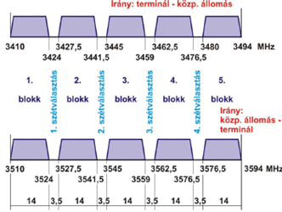
- usage of 3,5 GHz WMAN:
  - for point-multipoint structure;
  - terminals can be only endpoints (cannot be used for mobile infrastructure);
  - uses FDD (=Fr Division Duplex, separated into 5 two way(=duplex) 14 MHz blocks, between them 3,5 MHz space)
  - base stations are obliged to individual authorization;
  - terminals are not obliged to individual authorization, not even to announce;
  - 1. priority (fix placed or nomadic);
  - technology-independent (can establish WiMAX);
  - authorized users: Invitel, GTS, Antenna Hungária, Magyar Telekom, Pantel;
- the IEEE 802.11 standard architecture:
  - 13 channels,
  - US (=User Station, eg: laptop, PDA),
  - BSS (=Basic Service Set: access over a shared medium),
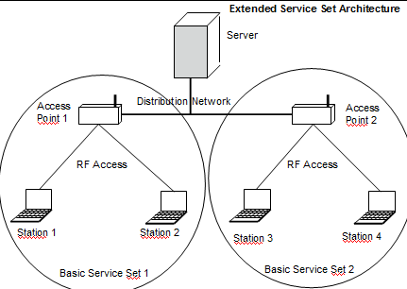
  - AP (=Access Point),
  - ESS (= Extended Service Set: completes set of BSSs and interconnections of BSSs by a DS network),
  - DS (=Distribution System, backbone network);;
- MAC:
  - Media Access Control is mandatory for all stations;
  - to assemble data into a frame including local address and error detection field;
  - checks the frame address, performs error correction on the frame, disassembles the frame and passes it to the LLC (= Logical Link Control);
  - the LLC identifies higher layer programs to handle the data and provides an interface to these programs while performing flow and error control;
- 802.16 MAC:
  - point-to-multipoint, MAN, connection-oriented;
  - supports difficult user environments (high bandwidth, continuous and burst traffic, very efficient use of spectrum);
  - protocol-independent core (ATM, IP, Ethernet);
  - balances between stability and efficiency;
- CA: Collision Avoidance;
  - the access methods differs from wired Ethernet (CSMA/CD= Carrier Sensing Media Access and Collision Detection) operation;
  - wireless networks use: CSMA/CA (avoided rather detected);
  - requires each station to listen for transmission from the others;
  - if channel is idle- no else is currently transmissing;
- timing and power:
  - all station clocks within a BSS are synchronized by time stamped beacon signal received from APs;
  - stations employ 2 power-saving modes:
    - awake: fully powered and can receive packets at any time;
    - doze: informs AP before entering this mode, cannot receive packets;
  - stations wake up periodically to listen for bacon signals (AP has message for it or not);
- beaconing:
  - every 100 ms, all AP sends out a 50 byte frame (contains: ID for WLAN, time stamp);
  - time stamp is used to synchronize each station’s local clock;
  - the beacon message includes the speeds supported by AP and the supported modulation technique;
  - the USs listen to all the beacons received on every channel from APs and choose the one that has the strongest signal;
- access and transmission sequence: transmitted frames may not receives successfully due to over-the-air transmission;
  - two way: data transfer (→), acknowledgement of transfer (←);
  - four way: request to send (→, contains source address, destination address, duration of transaction), clear to send (←, contains same information or denial), data transfer (→), acknowledgement of transfer (←);
- media access methods for control of access to the network:
  - distributed:
    - each US makes access decision independently;
    - each station implements the DCF (=Distributed Coordination Function) protocol to determine whether there is competing traffic to the AP, which must be avoided;
    - DCF uses a set of delays to assist in CA (IFS= Inter-Frame Space, then Back-off), because the mobile network interface card cannot distinguish among noise, weak signal an own message over a weak medium of the air;
  - centralized(=polling):
    - a central access protocol in BS controls which station can access the network;
    - stations need for a special service- identifying themselves as one of the special PCF (=Point Control Function) stations;
  - stations must cycle between PCF and DCF mode ensure that time-sensitive transmission doesn’t block out all other types of transmissions;
- MAC frame:
  - format: header contains protocol and control information (destination, source hardware address, cyclic redundancy check for error detection and correction);
  - fields:
    - 802.11 protocol version,
    - 802.11 frame type (control, management frame or user data),
    - data (destined or leaving DS),
    - indicator (more frames are following or not),
    - indicator (retransmission or previously lost frame),
    - duration and connection ID,
    - sequence control number,
    - source and destination hardware address;
- LLC fields:
    - common to all 802 networks,
    - provides connectionless un/acknowledgement, connection oriented network,
    - contains the destination and source APs,
    - provides the acknowledgement of each frame;
    - no flow or error control mechanism,
    - each datagram contained in a MAC frame is acknowledgement;
- Multiple Access and Duplexing:
  - TDD: Time Division Duplex: DL and UL time-share the same RF channel, dynamic asymmetry, not simultaneously transmit and receive;
  - FDD: Frequency Division Duplex: DL and UL on separate RF channels, static asymmetry, half-duplex SSs supported, not simultaneously transmit and receive;
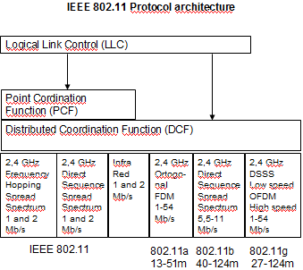
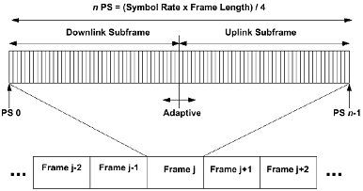

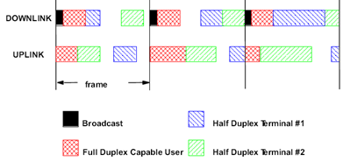

- Wireless Home Gateway:
- to reach with each tool the broadband network;
- each tool has to be integrated and the services have to pass to the abilities of the tools;
- eg: sharing multimedia content;
- network-independence and tool-independence (eg: any kind of display);
- manageable tools from far away;
- detect and harmonize abilities of tools;
- eg: dual-mode mobile (GSM, WiFi);

