Wide angle x-ray diffraction analysis of semi-crystalline polymers

1. Purpose
To accurately determine the d-spacing, unit cell dimension, and degree of crystallinity of well-known polymers (i.e., polystyrene (PS), polypropylene (PP), and polyethylene (PE) using wide angle X-ray diffraction (WAXD).

2. Theory
X-rays are electromagnetic waves which, when incident on a material, interact with electrons in the material and are scattered. X-ray waves scatter from different electrons and interfere with each other. This interference gives the resulting diffraction pattern, the positions of diffraction peaks and their relative heights, in which the intensities vary with scattering angle. Upon analysis of the diffraction pattern, information on the arrangement of atoms in a given lattice can be obtained: the shape and size of the unit cell is obtained directly from diffraction peak positions while the positions of atoms within the unit cell are related to the relative heights of the diffraction peaks. X-rays are useful in determining lattice structures because their wavelengths are on the order of 1 angstrom, the same order of magnitude as the interatomic distances in condensed matter.
X-rays scattered from the periodic repeating electron density of a perfectly crystalline material give sharp diffraction peaks at angles that satisfy the Bragg relation, whether the crystal consists of atoms, ions, small molecules, or large molecules. Amorphous materials will also diffract X-rays and electron, but the diffraction is a much more diffuse, low frequency halo (the so called “amorphous halo”). Analysis of the diffraction peaks from amorphous materials leads to information about the statistical arrangement of atoms in the neighborhood of another atom.
In polymers, which are never perfectly crystalline, a superposition of both diffuse and sharp scattering occurs. First, the crystals present in polymers are very small in size. This leads to considerable broadening of the peaks as compared with fully crystalline materials. Second, there exists some fraction of noncrystalline region in even the most highly crystalline polymer. This results in a background of a broad, amorphous halo.,,

2.1 Bragg’s law
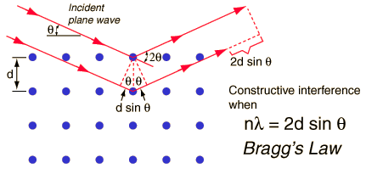
When X-rays are scattered from a crystal lattice, observed peaks of scattered intensity, which correspond to the angle of incidence, should be equal to angle of scattering while the path length difference is equal to an integer number of wavelengths (Figure 1). Bragg’s law for the distance d between consecutive identical planes of atoms in the crystal is given by Eq. (1),
Figure 1. Schematic diagram for determining Bragg’s lawError: Reference source not found
nλ = 2d sin θ (1)
Where λ is the x-ray wavelength, θ is the angle between the x-ray beam and normal to the atomic planes and n corresponds to the order of diffraction. The condition for maximum intensity contained in Bragg's law allow us to calculate details about the crystal structure, or if the crystal structure is known, to determine the wavelength of the x-rays incident upon the crystal.Error: Reference source not found,
2.2 Percent Crystallinity in polymer
A general polymer x-ray spectrum will have a broad amorphous peak, and if the polymer has crystallinity, it will show up as sharp peaks on the top of large amorphous peak (Figure 2). The spectrum is the sum of crystalline peaks and an amorphous peak. The true area of the crystalline peaks and the amorphous peak can be determined using deconvolution software peaks.
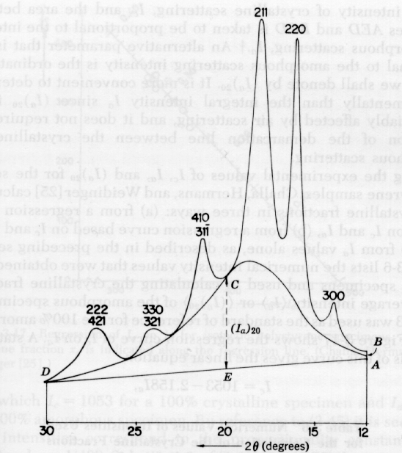
The percentage of the polymer that is crystalline can be determined from Eq. (2). 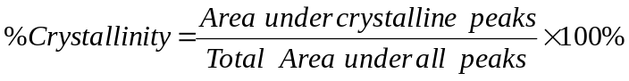 (2)
Figure 2 : An example of semi- crystalline polymer x-ray spectrum⁵
The amount of crystallinity in a polymer depends on the following:
- The secondary valence bonds (hydrogen bonding and Vander Waal’s forces) which can be formed
- The structure of the polymer chain (degree of order)
- The physical treatment of the polymer (e.g. tensile pull)
- The thermal history of the polymer (e.g., above T_{m}, it becomes amorphous while if it is cooled slowly it will crystallize)
- The molecular weight of the polymer. 5

3. Experimental Procedure
3.1 Initial Hardware Set-up and Sample Insertion
- Press Control Power On on the front of the Scintag. The switch will be lit when the machine is on.
- Open door and insert the sample into the sample holder by pressing down on both sides of the metal plates as shown with arrows in figure 3 below. Make sure that the sample is centered in the holder.
- Write down the angular positions of both the detector and the source arms using the scale and the OM and TH micrometers above the arms (Figure 3).
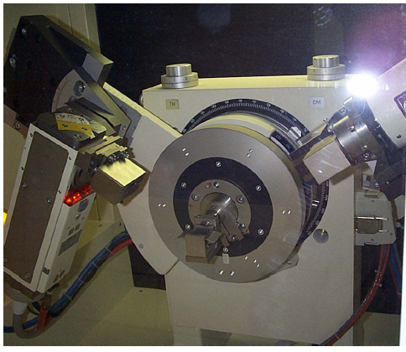
A
B
C
D
E
Figure 3: Detector Configuration. A: Source. B: Detector. C: Sample holder. D: TH micrometer. E: OM micrometer.
- Close the door and press the red Interlock button; the button should not be lit when the interlock is reset. This button is above the Control Power On button. The Interlock must be reset each time the door is opened.
- Press and hold the green X-ray Off button for at least five seconds. Check the current and voltage of the system. The current should register as 2 mA and the voltage should read 10 kV.
- Press down the X-ray On button. The button will be lit when it is on. The x-ray shutter will remain closed although the generator will be powered up to produce x-rays.

3.2 Computer Set-up
- On the desktop, click on the icon for the x-ray software. A small dialog box will open up. Use your login and password. Under Account Number, place “MatE 453” and for advising professor, place “Eliseo De León.”
- Choose “OK” and the software will open up. This will include a dialog box as seen in Figure 4 that needs filled for running the XRD. The window will consist of two parts, a column on the left and an event data part on the right.
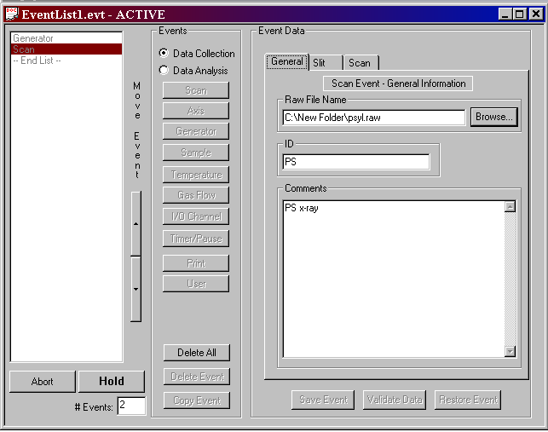
Figure 4: EventList.evt Window.
- To begin, click on Scan button, then choose Normal.
- Under “General”, there is a command line entitled “Raw File Name.” This command line shows you the directory you are in. You can now name your data file. Use the Browse button open a window called “Set Raw File Path”. The name of the last data file used will appear highlighted in the “File Name” box. Type a name for your file and it will replace the highlighted text. For the filename, use the abbreviation of the polymer and your section/group name (e.g., if you are using polystyrene and your group is #3 your filename should be “PS group 3”.) The file will automatically be given a “.raw” suffix. Make sure the file is saved under C:\XRAYDATA\MatE453 2013

- Hit Save.
- Type in the “ID” box to give the file a short description that will appear on each printout. Be as specific and brief as possible with this ID.
- Type in the “Comments” box for a longer, more detailed description that is saved along with the file. The program will not let you print these comments out!
- If you have changed anything you can click on Save Event now, or you can wait until you are finished all setup pages.
2
- Select Slit. See Figure 5 on next page. Verify that the slits dimensions have not
been changed and press the Save Event button if it is lit. The numbers should be 2 for divergence Slit Width and 4 for Scattered Slit Width.
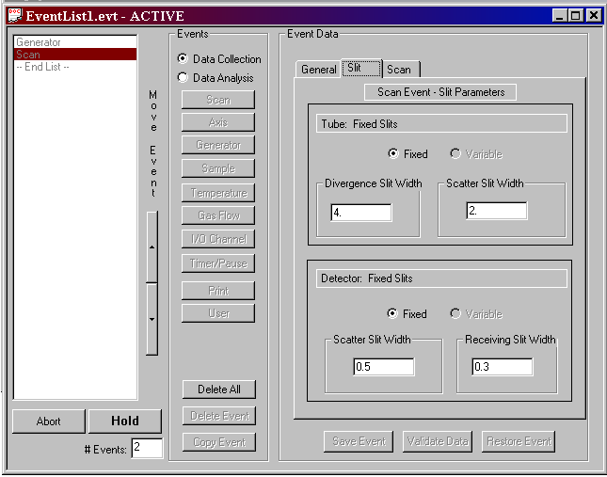
2 4
Figure 5: Slits Window. ⁸
- Select Scan. This page is show in Figure 6. This page is used to set the step size, start and stop angles and the scan rate. The scan settings should be as follows: 0.02 for step size; Normal for Type; 5 for Start Angle; 25 for Stop Angel; check the Scan Mode button for Continuous; and 2.00°/min in rate. If the Set button on the lower right side is highlighted you MUST press it. Press Save Event when done modifying this page.

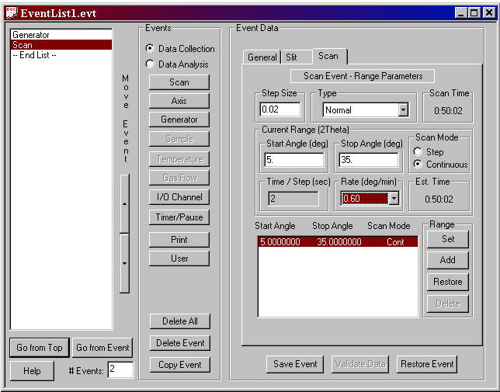
- Press Go From Top. Do NOT save changes. The software will ask if you want to initialize hardware. Press OK. You will be shown a page that has the current positions of both arms of the X-ray machine. If these numbers correspond to what those from Step 6 of Initial Figure 6. Normal Window. ⁸ Hardware Setup, hit OK. If they are not the same as those that are given, you will have to change them. Enter the correct values into the “Set Axis Position” box for both detector and tube. Hit Set after entering each true value.
- Verify that X-ray On button is lit and hit OK. This will initiate the scan. The detector and tube will move to the appropriate positions, the shutters will open, and the scan will begin.
- A Small window called “Scan Status – filename.raw” will appear noting the progress. Click on the Realtime Display button to watch the progress of the scan. WARNING: DO NOT PRESS HOLD OR ABORT AFTER STARTING THE SCAN! THE X-RAY MACHINE WILL STILL BE TAKING DATA EVEN THOUGH THE SOFTWARE HAS STOPPED COLLECTING IT! DO NOT USE THE DATA FITTING OPTIONS WHILE SCANNING.
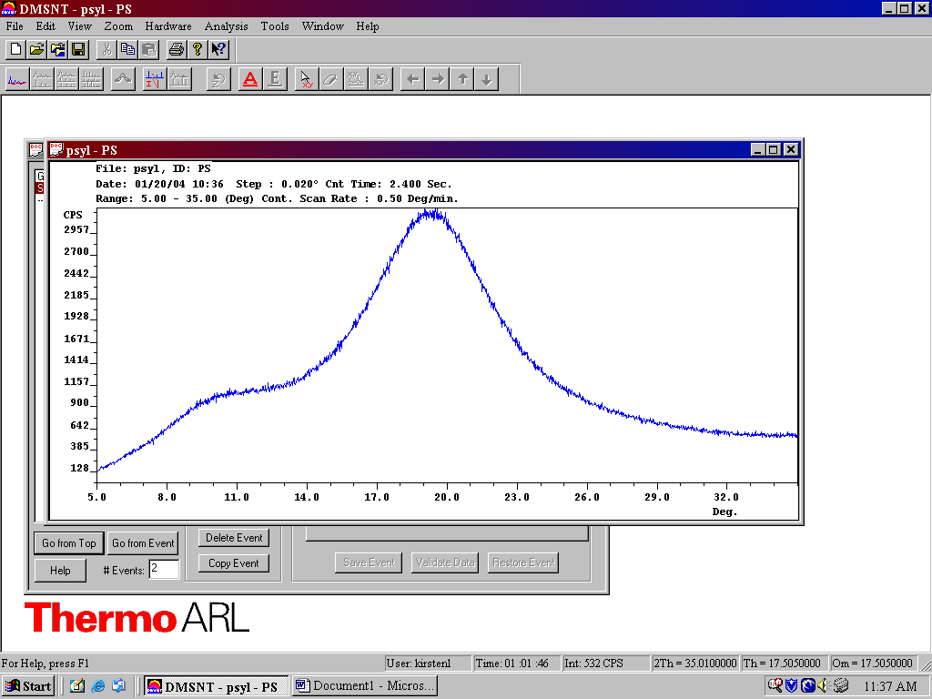
- When the scan is done you will get the message, “Event list execution complete.” Hit OK.

3.3 Analyzing and Printing Data
- Open the file you just collected by choosing Open from the “File” menu and select your saved data file. An opened scan may appear similar to the one if Figure 7. Using the Print option from the “File” menu, print out your diffraction pattern using the Microsoft XPS Document Writer.
Figure 7: Example scan of PS. ⁸
- Press the Background Curve Fitting button shown in Figure 8. This will bring up the window shown in Figure 7. Select the Manual Spline Curve Fitting Button and Click on Edit Points.
B
A
Figure 8: A-Background Curve Fitting, B-Peak Curve Fitting, C-Insert a New Peak.⁸

C
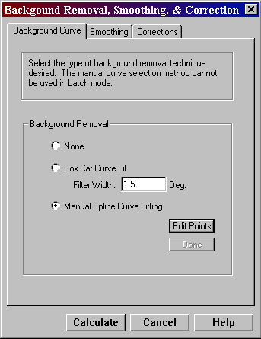
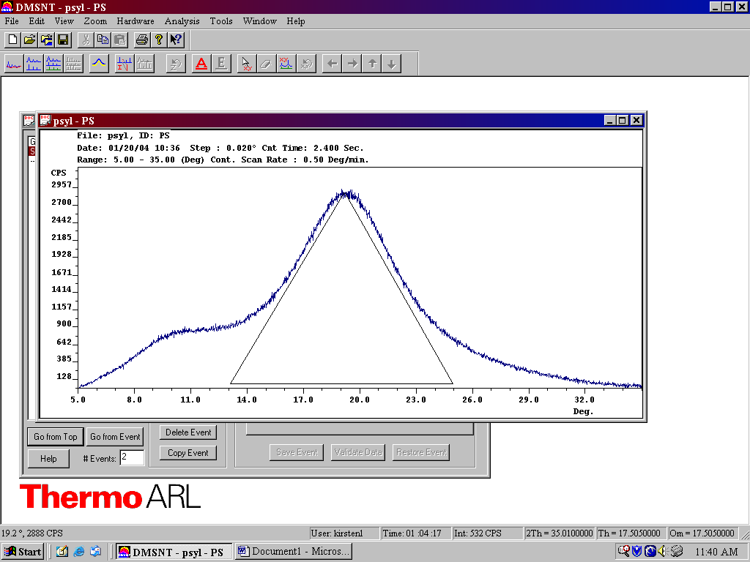
- A line will be automatically drawn for you. If this line does not fit the data, (black line in Figure 7) click on the end that does not fit the data and move the line until it fits the end points of the graph. Click on Calculate (Figure 9) when done.
- Press on the Insert Peaks button on the menu (see Figure 8 above) and draw a triangle to represent each peak, starting from the bottom left to bottom right and then pull the point up until it fits your peak. See Figure 10 for a sample triangle. Repeat this step until all peaks that are three times greater than the background have been fit. You will also need to fit an amorphous peak for your data. When fitting this peak make sure that its point does not correspond to that of any other peak in the plot.
Figure 9: Background window. ⁸

Figure 10: Sample Triangle⁸

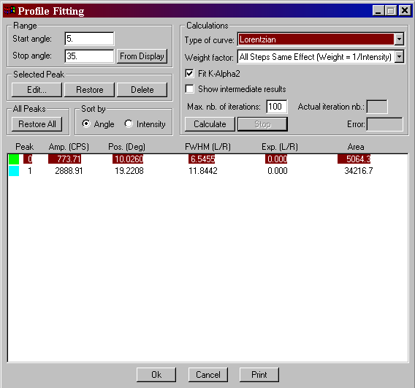
- Now press the Curve Fitting button (see Figure 8). A window called “Profile Fitting” will come up, Figure 11.
- Choose the Lorenzian option from the “Type of Curve” dropdown box (Figure 11). Press Calculate until you see the message, “Profile fitting cannot be improved”. Click on OK. Use the Print option on the page to printout the peak information in the box.
Figure 11- Profile Fitting page
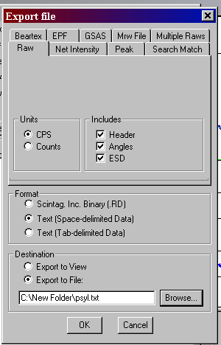
- Now using the Print option from the “File” menu, print the plot with the fitted curves on it. If you close the “profile fitting window” before you print, your peaks will be lost.
Figure 12- Export window
- Export the data to a file. Choose Export from the “File” menu and a window like that seen in Figure 12 will appear. Under the “Raw” tab, choose CPS under the Units heading. Under the Format heading choose space delimited text. Choose Export to file from the Destination option. Name the file the same as before and click OK.

Turn off x-ray (green button) and change out your sample. Push Interlock Reset button and X-ray On. Proceed to Section 3.2 step #3 for the new sample analysis.
4. Assignments
4.1. Calculate the d-spacing, unit cell dimension, and degree of crystallinity of syndiotactic β-PS (orthorhombic), PP (monoclinic), and HDPE (orthorhombic).
WAXD radiation: Cu Kα
Wavelength: 1.540562 Å
Scanning range: 5 -25 degrees
Note: c for HDPE is 2.55 Å, c for PP is 6.5 Å, and c for PS is 5.1 Å

4.1.1 Peak Positions
syndiotactic β-PS
Peak # | Amp.(counts per second CPS) | Pos.( 2θ) | FWHM | Area

PP
Peak # | Amp.(CPS) | Pos. ( 2θ) | FWHM | Area

HDPE
Peak # | Amp.(CPS) | Pos. ( 2θ) | FWHM | Area
    - Interplanar spacing (i.e., d-spacing)
Bragg’s Equation: λ = 2dsin (θ)
syndiotactic β-PS
λ (Å) | Pos. ( 2θ) | θ | Sin(θ) | d (Å)

PP
λ (Å) | Pos. ( 2θ) | Θ | Sin(θ) | d (Å)

HDPE
λ (Å) | Pos. ( 2θ) | θ | Sin(θ) | d (Å)

4.1.3 Unit Cell Dimensions
4.1.3a Monoclinic: PP
4.1.3b Orthorhombic: syndiotactic β-PS
4.1.3c Orthorhombic: HDPE

4.1.4 Degree of Crystallinity
X_{c} = Crystalline Area / Total Area

Polymer sample | Crystalline Area | Amorphous Area | X_{c}

4.2 Based on the experimental results, discuss the differences between syndiotactic β-PS, PP and HDPE.

Sperling, L. H., “An Introduction to Physical Polymer Science”, John Wiley and Sons, Inc., 2001, 3rd Ed.
Bradly, R. F., Jr., “Comprehensive Desk Reference of Polymer Characterization and Analysis”, American Chemical Society, Washington, D.C., 2003
Surman, D., “Percentage Crystallinity Determination by X-Ray Diffraction”, http://www.kratos.com/XRD/Apps/pcent.html
“Bragg’s Law”, http://hyperphysics.phy-astr.gsu.edu/hbase/quantum/bragg.html
Alexander, “X-ray Diffraction Methods in Polymer Science”, Wiley, Interscience, New York, 1969.
Percharsky, V. K., MSE 535 Class Notes, ISU, Ames, IA, Fall 2003
Scintag User Manual
Scintag Applications DMSNT Software

