PCDH version 3.0
(Interfaces and specifications for Instrumentation and Control)

Abstract

This document defines interfaces and general I&C specifications for Plant Systems and provides a single source of information on the decisions made to date.

Document Revision History

This document and historical documents are placed on ITER IDM.

Version Number | Status | Version Date | Summary of Changes | File name
1.0 | Draft | 29 Jun 2007 | Initial draft | I&C Design Handbook Version 1.0 (ITER_D_272RZA v1.0)
1.1 | Draft | 02 Aug 2007 | Outlined document scope and table of contents | Plant Control Design Handbook (ITER_D_27LH2V v1.1)
1.2 | Draft | 08 Feb 2008 | Major changes following CODAC team review including PMWG. | Plant Control Design Handbook  Version 1.2
2.1 | Draft | 24 Apr 2008 | CODAC Team | Plant Control Design Handbook  Version 2.1
2.2 | Draft | 10 Jun 2008 | In-ITER Review comments | Plant Control Design Handbook  Version 2.2
3.0 | First Official Release | 02 Jul 2008 | PMWG Review comments | Plant Control Design Handbook  Version 3.0

Preface

Currently work is underway to define specifications and standards in all areas of ITER Instrumentation and Control (I&C).

This document provides technical guidelines and specifications for ITER I&C to be used by Plant System Responsible Officers (ROs), Design Engineers and Plant System Suppliers.

This handbook is not the final document. It should be noted that this version of the Plant Control Design Handbook (PCDH) presents our current state of knowledge but it is by no means complete. At present it is too early to provide a complete picture of specifications and standards.

The COntrol Data Access and Communications (CODAC) team has made great efforts to define I&C design process and to define the selection criteria for technologies.. This means, final choices between competing candidate technologies are still outstanding, or that our knowledge about interfaces with other Plant Systems is still incomplete. The work on this standardisation is a continuous process due to technological evolution and increasing knowledge about detailed technical designs. Last, but not least, lessons learned from future prototyping with promising technologies may change the views expressed here and will help to reach final technical solutions.

The document will be updated whenever new technologies are chosen or standards are found and have to be imposed by the ITER Organisation (IO). The refinement of the PCDH is an ongoing and evolutionary process and the CODAC team will continue to work on it. Missing specifications will be added progressively, maintained under IDM (ITER Document Management) until a final version that can be used as legal binding document within a Procurement Arrangement (PA) can be produced.

The CODAC team plans to release first version of the PCDH in end of June 2008 and a further version at the end of 2008 addressing many of the current TBDs.

All comments on this handbook should be sent by e-mail to the CODAC Technical Officer for I&C Specifications – Haresh Dave – Haresh.Dave@iter.org.

Contents
1 Introduction 8
1.1 Document Scope 8
1.2 Acronyms 8
1.3 Definitions 10
1.4 Document structure 12
1.5 Documents 13
1.5.1 Reference Documents 13
1.5.2 Guideline Documents 13
2 Plant System I&C Design Philosophy and Guidelines 14
2.1 Introduction 14
2.2 Functional role of systems 14
2.3 CODAC and Plant Systems I&C structure 15
2.3.1 CODAC Systems 16
2.3.2 CODAC Networks 16
2.3.3 I&C Bridge 16
2.3.4 Plant Systems 16
2.3.5 Plant System Host 17
2.3.6 Subsystem 17
2.3.7 Equipment 17
2.3.8 Central Interlock System 17
2.3.9 Plant Interlock System 18
2.3.10 Central Safety System 18
2.3.11 Plant Safety System 18
2.4 ITER I&C design conditions 18
2.4.1 “In kind” procurement of Plant Systems 18
2.4.2 Data driven approach to CODAC and Plant Systems 19
2.4.3 Technology Evolution 19
2.4.4 Quality Assurance 19
2.4.5 Responsibility Boundary between CODAC and Plant Systems 19
2.4.6 Plant System Procurement Types 20
2.4.7 Plant System Simulator 20
2.5 Plant Systems I&C Interface 21
2.5.1 Network Data Exchange Interface 21
2.5.2 Building Interface 21
2.6 Plant System Operation & Control 21
2.6.1 CODAC Control 21
2.6.2 Local Control 22
2.6.3 Operation request 23
2.6.4 Operation sequence 23
2.6.5 Direct communication 23
2.7 Hardware considerations 23
2.8 Software consideration 24
2.8.1 Self Description data 24
2.8.2 Software Security 24
2.8.3 Performance 25
2.8.4 Self Diagnostics 25
2.8.5 Error logging and fault traceability 25
2.8.6 Application lists and programming standards 25
2.8.7 Visualization 25
2.8.8 Plant System I&C configuration 25
2.8.9 Mini CODAC 26
2.9 I&C Design requirements 26
2.9.1 ITER I&C Requirements 27
2.9.2 CODAC I&C Requirements 27
2.9.3 Plant System I&C Requirements 28
3 Instrumentation and Control System Life Cycle 30
3.1 Introduction 30
3.2 Lifecycle Phases 30
3.2.1 Preliminary Design 30
3.2.2 Detailed Design 31
3.2.3 Factory Acceptance 31
3.2.4 Pre-Operational Phase 32
3.2.5 Operational Phase 32
3.3 Process 32
3.3.1 Plant System I&C Assessment 34
3.3.2 Preliminary Design 34
3.3.3 Detailed Design 36
3.3.4 Factory Acceptance Tests 37
3.3.5 Pre Operational Phase 38
3.4 Maintenance 41
3.5 Deliverables 41
3.5.1 List of hardware and basic software deliverables 41
3.5.2 List of application deliverables 41
3.6 Plant System I&C Documentation 44
3.6.1 Documentation 44
3.7 Quality Assurance (QA) 45
3.7.1 Development and Manufacturing 46
3.7.2 Inspections and Tests 46
3.7.3 Test Responsibilities 46
3.7.4 Validation and Verification process 47
3.7.5 Codes and Standards 47
4 Plant System I&C - CODAC Interface Specification 48
4.1 Introduction 48
4.2 Functional Interface 48
4.3 Network Interface 49
4.3.1 Network Types 49
4.3.2 Network Interface Points 53
4.3.3 Plant System Local Communication Bus Interfaces 55
4.3.4 I&C Bridge 56
4.3.5 Communication Protocol 57
4.3.6 Provision for Plant System Interface I&C 58
4.4 Power Supply Interface 58
4.5 Building Interface 61
5 Plant System I&C Specification 62
5.1 Introduction 62
5.2 I&C naming conventions 62
5.3 Installation and Conditions 62
5.3.1 Location for cubicles and equipments 62
5.3.2 Local Control Rooms 63
5.3.3 Grounding 63
5.3.4 Insulation 63
5.3.5 Explosive Atmosphere - ATEX Rating 63
5.3.6 EMC Policy 64
5.3.7 Environmental conditions 65
5.3.8 Status Monitoring 65
5.4 Plant System I&C Hardware Specifications 66
5.4.1 Plant System Host 66
5.4.2 Subsystem Controller 67
5.4.3 PLC resources 67
5.4.4 Computer resources 68
5.4.5 Local Bus Structure 68
5.4.6 I/O modules 69
5.4.7 Sensors and actuators 70
5.4.8 Cubicles 71
5.4.9 Cabling and wiring 75
5.4.10 Power Supplies 76
5.5 Plant System Software Specification 76
5.5.1 Computer Software Operating Environment 77
5.5.2 Computer Programming and Design Tools 78
5.5.3 Self description data 79
5.5.4 Computer Software Applications 85
5.5.5 Performance 91
5.5.6 Software Security 91
5.5.7 Display devices 91
5.5.8 Printing devices 92
6 Interlock I&C Specifications 93
6.1 Introduction 93
6.2 Sensors 93
6.3 Actuators 93
6.4 Programmable Logic Controllers 93
6.5 Field buses 94
6.6 I/O modules 94
6.7 Cubicle 94
6.7.1 Cable and wiring 94
6.7.2 Power Supply 94
6.8 Software Specification 95
6.8.1 Software Operating Environment 95
6.8.2 Computer Programming and Design Tools 95
6.8.3 Data Exchange Mechanism 95
6.8.4 Display devices 95
6.9 Hardwired logic controllers 95
6.10 Maintainability requirements 95
7 Safety I&C Specifications 96
7.1 Introduction 96
7.2 Hardware Specification 97
7.3 Software Specification 97
8 Appendices 98
8.1 Appendix A: Typical Plant System FAT Procedure 98
8.1.1 Introduction 98
8.1.2 Items Under Test 99
8.1.3 Recording of hardware serial numbers 99
8.1.4 Recording of Software and Firmware versions 100
8.1.5 Hardware Tests 100
8.1.6 System Configuration tests 100
8.1.7 Input/ Output tests 100
8.1.8 CODAC Database test 100
8.1.9 Communication Tests 101
8.1.10 Test Completion Sheet 101
8.1.11 Test Defect report Sheet 101
8.2 Appendix B: Typical Plant System SAT procedure 102
8.2.1 Introduction 102
8.2.2 Items under test 103
8.2.3 Recording of software version numbers 104
8.2.4 I&C Database test 104
8.2.5 Communication tests 105
8.2.6 End-to-end data point tests 105
8.2.7 System performance 106
8.2.8 UPS testing 106
8.2.9 Test Completion Sheet 106
8.2.10 Test Defect Report Sheet 107
8.3 Appendix C: Codes and Standards 108
8.4 Appendix D: Deviation policy 112
8.4.1 Request for deviations 112
8.4.2 Deviations from Individual Plant System 112
8.4.3 Deviations from class of Plant Systems 112
8.4.4 Modifications to technical specifications 112

Introduction

Document scope
The purpose of the PCDH is to provide specifications and guidelines for I&C to CODAC RO, Plant System ROs as well as to Designers and Plant System Suppliers. The information will cover I&C specifications, testing and installation of I&C components for the ITER I&C facility. PCDH also defines interfaces and standardised hardware components and software environments including safety and interlock systems, which all Plant Systems including CODAC systems should follow.

PCDH prescribes interfaces and I&C hardware and software standards for the integration of in-kind procured Plant Systems and provides a single source of information on the decisions made to date. It defines the responsibility boundary between the CODAC RO and Plant System’s RO.

The PCDH will be a part of the ITER PAs to guide and constrain Plant System I&C design specifications.

Acronyms
AC | Alternating Current
AI | Analogue Input
ANSI | American National Standards Institute
AO | Analogue Output
ATCA | Advanced Telecom Computing Architecture
ATEX | Potentially Explosive Atmospheres
ATTR | Acceptance Test and Test Report
AVN | Audio Video Network
BD | Block Diagram
CAD | Computer Aided Design
CASE | Computer Aided Software Engineering
CDROM | Compact Disc Read-Only Memory
CE Mark | Communauté Européenne Mark (European Conformity)
CEP | Central Engineering and Plant support
CHD | CODAC & IT , Heating and Diagnostics
CIN | Central Interlock Network
CIS | Central Interlock System
CODAC | COntrol Data Access and Communications
COS | Common Operating State
COTS | Commercial Off the Shelf
CPCI | Compact Peripheral Component Interface
CPU | Central Processing Unit
CSMA/CD | Carrier Sense Multiple Access with Collision Detection
CSN | Central Safety Network
CSS | Central Safety System
DA | Domestic Agency
DAQ | Data Acquisition
dB | Decibel
DC | Direct Current
DI | Digital Input
DIO | Digital Input Output
DO | Digital Output
EDH | Electrical Design Handbook
EDN | Event Distribution Network
EFT | Electric Fast Transient
EMC | ElectroMagnetic Compatibility
EMI | ElectroMagnetic Interference
EMS | Environment Monitoring System
ESD | ElectroStatic Discharge
FAT | Factory Acceptance Test
FBD | Functional Block Diagram
FD | Functional Diagram
FMEA | Failure Mode and Effect Analysis
FSM | Finite State Machine
Gbps | Giga bits per second
GPS | Generic Plant System
GUI | Graphical User Interface
HART | Communications protocol
HMI | Human Machine Interface
I&C | Instrumentation & Control
IT | Information Technology
I/O | Input / Output
IAEA | International Atomic Energy Agency
IBD | Interlock Block Diagram
ICD | Interface Control Document
ID | Identification
IDM | ITER Document Management
IEC | International Electrotechnical Commission
IEEE | Institute of Electrical and Electronics Engineers
IL | Instruction List
IO | ITER Organization
IP | Ingress Protection
IPC | Industrial Personnel Computer
IPv6 | Internet Protocol version 6
ISO | International Standards Organization
ITER | International Thermonuclear Experimental Reactor
LD | Ladder Diagram
LED | Light Emitting Diode
LTM | Long Term Maintenance
MCR | Main Control Room
NFC | Near Field Communication
NS | Nuclear Safety
NTP | Network Time Protocol
O&M | Operation and Maintenance
OPC | OLE for Process Control
OPN | Open Public Network
ORG | Operation Request Gatekeeper
OS | Operating System
P&ID | Process and Instrumentation Diagram
PA | Procurement Arrangement
PAT | Provisional Acceptance Test
PC | Personnel Computer
PCDH | Plant Control Design Handbook
PCI | Peripheral Component Interconnect
PCN | Plant Commissioning Network
PCS | Plasma Control System
PFD | Process Flow Diagram
PIS | Plant Interlock System
PLC | Programmable Logic Controller
PMWG | Project Management Working Group
PON | Plant Operation Network
POS | Plant Operating State
POZ | Plant Operation Zone
PP | Procurement Package
PSH | Plant System Host
PSS | Plant Safety System
PTP | Precision Time Protocol
PXI | PCI eXtensions for Instrumentation
QA /QC | Quality Assurance / Quality Control
QAP | Quality Assurance Program
R&D | Research & Development
RAMI | Reliability, Availability, Maintainability, and Inspectability
RF | Radio Frequency
RFI | Radio Frequency Interference
RH | Remote Handling
RJ | Registered Jack
RO | Responsible Officer
RTD | Resistance Temperature Detectors
SAT | Site Acceptance Tests
SCADA | Supervisory Control and Data Acquisition
SDN | Synchronous DataBus Network
SFC | Sequential Function Chart
SIC | Safety Implicated Components
SIL | Safety Integrity Level
SNMP | Simple Network Management Protocol
SRD | System Requirements Document
ST | Structured Text
SW | Software
TBC | To Be Confirmed
TBD | To Be Decided
TCN | Time Communication Network
TCP/IP | Transmission Control Protocol/Internet Protocol
TMK | Tokamak
UML | Unified Modelling Language
UPS | Uninterruptible Power Supply
UTF | Unicode Transformation Format
VME | Versa Module Europa
WBS | Work Breakdown Structure
WIP | Work In Progress
XML | eXtensible Mark-up Language

Definitions
In this document the following definitions apply:

- Active commissioning - is the period in time when several Plant Systems are operated together to verify that they can meet their design requirements
- ATEX - is the set of directives for equipment and protection systems intended for use in potentially explosive atmospheres. It lists the minimum requirements for improving the safety and health protection of workers potentially at risk from explosive atmospheres.
- Alarm - is a visual or audible means of indicating to an Operator that an equipment or process malfunction or an abnormal condition has occurred.
- Commissioning - The process of putting the Instrumentation & Control systems into service, the setting of all adjustable devices and adjusting the systems to enable them to operate safely and efficiently.
- HAZID (HAZard IDentification) study - a systematic method for identifying possible security threats and accident risks that have the potential to have an impact on the public and/or environment.

- HAZOP (HAZard and Operability) study – a systematic method for examining processes to identify potentially hazardous procedures or operations in complex Plant Systems so that they can be eliminated or mitigated with an identified series of actions.
- Inactive commissioning - is the period in time when a Plant System is commissioned and is available to operate in conjunction with other Plant Systems.
- Inspection - Verification that all instruments, equipments and cabling have been installed in accordance with the design documentation and that the installation conforms to I&C standards.
- Instrument - A device used for detecting, measuring or analyzing parameters of the process and equipment. Equipment defined as instruments includes control panels.
- IO site- ITER Organisation site at Cadarache.
- Mechanical completion - All equipment and cabling installed and terminated.
- Package means a factory assembled system delivered to IO site completely tested ready to be installed.
- Pre-commissioning - Tests on the instrument, equipment and cabling, prior to being powered.
- Stick built – A small piece of equipment that is assembled and installed at the IO site.
- Shutdown Equipment – Subsystem or Plant System used to bring the Tokamak to safe shutdown conditions.
- Supplier - The supplier will be the Domestic Agency (DA) or industrial contractor providing the manufactured product to IO.
- Trip – A protective trip is a defense against excursions beyond the safe operating limits. This is accomplished by detecting excursions beyond set points related to the safe operating limits (i.e. the onset of a hazard) and taking timely action to maintain or restore the safe state of the equipment.

Document structure
PCDH is organized as follows:

- Chapter 1 gives an introduction to the Plant Control Design Handbook.
- Chapter 2 gives an overview of Plant System I&C design philosophy and defines design practices and guidelines.
- Chapter 3 defines the ITER I&C development process and operational life cycle.
- Chapter 4 specifies the interface between Plant System I&C and CODAC.
- Chapter 5 specifies rules and standards imposed on the Plant System I&C for hardware and software.
- Chapter 6 specifies rules and standards for the Interlock System.
- Chapter 7 specifies rules and standards for the Safety System.
- Chapter 8 is an Appendix

Figure 1.1 presents the relation between this document, other CODAC documents, PAs and Plant System documents including requirements and specifications. It also depicts the clear boundary of responsibilities between CODAC RO and Plant System ROs.

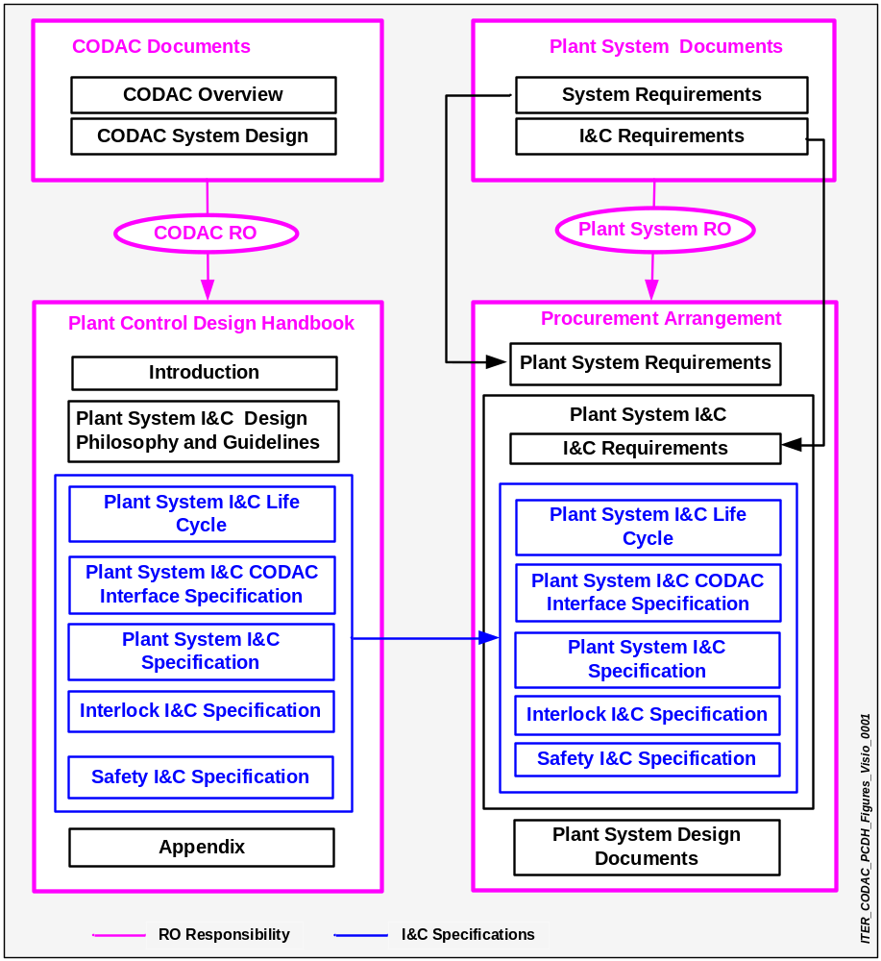
Figure 1.1 I&C Document Structure

Documents

Reference Documents
- RD1: Project Requirements (ITER_D_27ZRW8 v 2.4)
- RD2: Plant Description Document (ITER_D_282COP v1.0 )
- RD3: SRD-45 (CODAC) (28C2HL_v1_3)
- RD4: ITER Numbering System (28QDBS_v1_0)
- RD5: Electrical Design Handbook (EDH) (222QF5_v1_0)
- RD6: Room book for buildings [WIP]
- RD7: SRD-46 (ITER_D_2EVTP5 v1.0)
- RD8: SRD-48 (ITER_D_2EBF97 v1.1)
- RD9: ITER Quality Assurance Program (22K4QX_v7_3)

Guideline Documents

- GD1: CODAC Conceptual Design Document ( 27LBWG v1.1)

Plant System I&C Design Philosophy and Guidelines

Introduction
This section describes the design guidelines of the Plant System I&C and the requirements for its interface with CODAC. The project-wide Plant System I&C standardization is essential for the long-term operationl, maintenance and upgrade requirements. The PCDH is intended to assist Plant System ROs and I&C design engineers in developing their designs. These designs must be based on the guidelines with figures where necessary, to explain the topology to be employed in the Plant System I&C.

Technical specifications and interfaces must follow these rules in order to make ITER I&C as homogeneous as possible.

Functional role of systems
The ITER I&C is divided into three tiers with two layers as shown in Figure 2.2

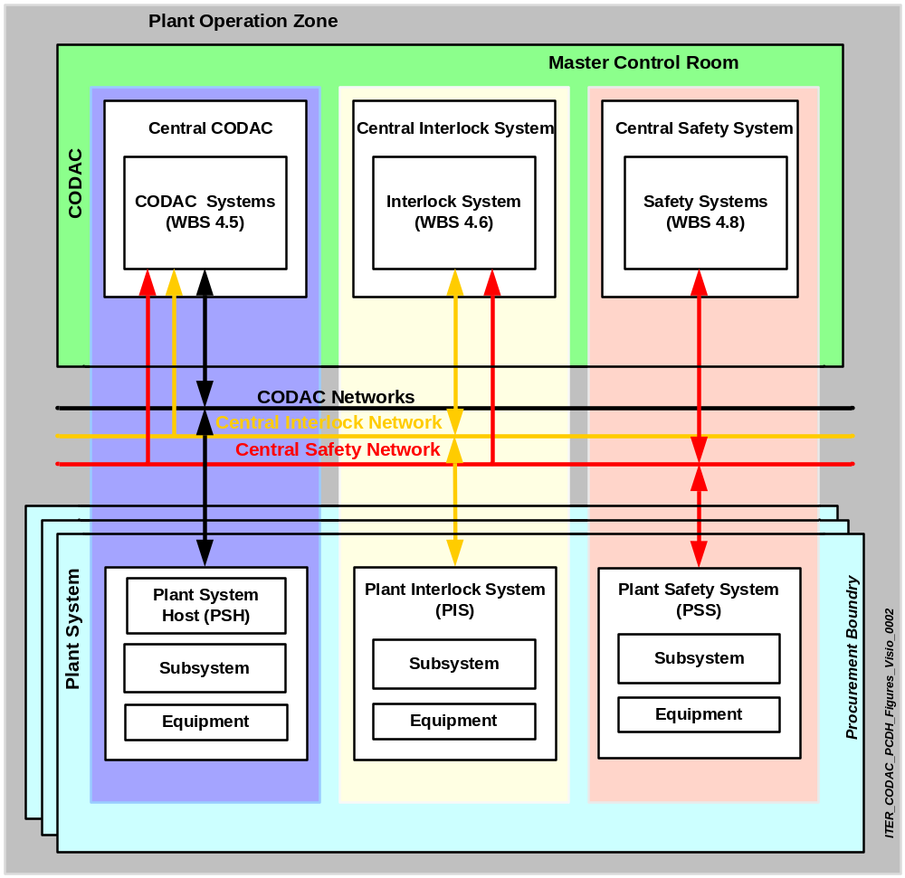
Figure 2.2 ITER I&C: CODAC, Interlock and Safety System
The segregation of ITER I&C into these different tiers and the control of data flow between them and within their layers in Plant Operation Zone (POZ) are essential elements of I&C concept. CODAC uses three independent networks to ensure segregation of the three tiers. CODAC orchestrates all the Plant Systems in a harmonious way.
The operation of ITER includes:
- Continuous monitoring of all the Plant Systems.
- Display of their status to the operators.
- Preparation and automatic scheduled operations (including pulsed operation with and without plasma).
- Retrieveing of data from Plant Systems.
- Storage of all the experimental data and making it available to users.

The Interlock system (WBS 4.6) provides protection of equipment at the Plant System level as well as at the project level.

The Interlock I&C, the CODAC I&C [WBS 4.5] and the Safety I&C [WBS 4.8] are totally independent systems.

The safety system provides safety related actions and monitors and records all the data related to the safety functions as required by the French safety regulations.

CODAC monitors, displays and archives the behaviour of the Central Interlock System (CIS) and the Central Safety System (CSS).

CODAC will be able to take corrective or preventive action to bring the Plant System back to its normal operation state or to its safe shutdown state.

CODAC and Plant Systems I&C structure
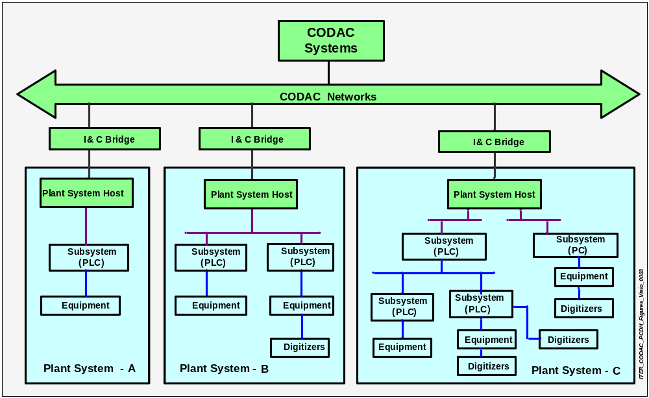
Figure 2.3 Plant System I&C architecture
Plant Systems are divided into three different types, A, B, or C depending on their complexity – as shown in Figure 2.3. The Plant System has a hierarchical structure Plant System Host (PSH), Subsystem Controller, equipment; which is capable of autonomous plant operation by using standardized hardware components and software environment.

CODAC Systems and Plant Systems are defined as per IEC 15288 (International Electrotechnical Commission) standard for system lifecycle process.

CODAC Systems
CODAC is designed, procured and implemented independently of any other ITER Procurement Package. It provides supervisory functions for ITER plant operation, plasma experiments, overall ITER plant operating status monitoring, data archiving, alarm handling, plant visualization (i.e. Human Machine Interface - HMI) and functions for remote experiments.

CODAC Networks
CODAC Networks provide the ITER-wide physical and logical interconnections between CODAC and Plant Systems. The roles and functions of the networks are defined according to their performance requirements.

I&C Bridge
The I&C Bridge provides standard physical interfaces between Plant Systems and the CODAC networks. It will contain network patch panels, cabling and signalling. The three tiers have individual I&C bridges: the CODAC I&C Bridge, Interlock I&C Bridge and Safety I&C Bridge.

Plant Systems
Plant Systems will provide data acquisition, operation & control, status/alarm monitoring and functionality for data communication with the CODAC systems. Plant Systems will also have local autonomous operation and control which is independent from the CODAC systems. Plant Systems cannot themselves initiate asynchronous communication with their peer Plant Systems and only communicate through CODAC. Plant Systems are thus slaves in a master-slave relationship with CODAC.

Plant Systems are data driven and they use Finite Sate Machine (FSM) and rule engines and their behaviour can be simulated [TBD].

Plant Systems I&C must be designed and implemented by their designers according to specifications and guidelines provided by CODAC.

The Plant System type shall be decided on a case by case basis by Plant System RO approved by CODAC.

2.3.4.1 Plant System Type A
This is a simple Plant System I&C which is composed of single PSH and single Subsystem.

2.3.4.2 Plant System Type B

Type B is a Plant System I&C which is composed of multiple subsystems and a single PSH. The internal communication among Subsystems is less frequent and hence the functional relations among the Subsystems and the PSH is similar to Type A.

2.3.4.3 Plant System Type C

Type C is a complex Plant System I&C which is composed of multiple hierarchical slave Subsystems under one master Subsystem which supervises all the slave Subsystems. It has one PSH which is interfaced to CODAC. Each Plant System must have at least one PSH which communicates with the CODAC Systems.

Plant System Host
PSH provides multiple functions and a standard image of Plant System to the CODAC. It is a single point of entry for the asynchronous communication (data exchange) from CODAC to Plant System and vice versa. It controls data flow between CODAC and Plant System, interprets all the commands from CODAC and passes them to the Subsystem Controller for necessary actions. The PSH provides the self description of the Plant System.

Subsystem
A Subsystem is an intelligent component of a Plant System. It may function independently and may even communicate using the Plant System methods but it cannot be addressed directly by the CODAC systems. It will have different internal communication standards which have to be agreed by the IO and have to be defined at the time of procurement.. Subsystems may have any number of layers of subsystems beneath them and this structure is expected for the most complex systems such as the Cryoplant Plant System or a Vacuum Pumping Plant System.

- Subsystem Controller

A Subsystem Controller is a local controller which co-ordinates Plant System functions autonomously. It communicates asynchronously with PSH and synchronously with the High Performance Networks (i.e. Synchronous DataBus Network [SDN], Electrical Design Handbook [EDN], Time Communication Network [TCN], and Audio Video Network[AVN] ).

Equipment
The lowest level is defined as equipment, it does not necessarily communicate in a project-wide standardised form and it includes, for example, instrumentation and electronics modules. Equipment may be configured hierarchically according to the individual Plant System design. The equipment level cannot be procured to directly interface with CODAC but has to be part of an integration procurement arrangement to deliver it as a Plant System component.

Central Interlock System
The CIS provides project-wide investment protection and it interfaces with the Plant Interlock Systems through the Interlock I&C Bridge. All the communications or coordinations among Plant Interlock Systems must go though the CIS.

Plant Interlock System
The PIS provides Plant System protection irrespective of CODAC operation and control. It is interfaced with the Central Interlock System. PIS provides the protection of each Plant System component when individual Plant System operating conditions are outside their normal operational range.

Central Safety System
The CIS provides plant-wide safety functions and is interfaced with the Plant Safety Systems through the Safety I&C Bridge. All the communications or coordinations among Plant Safety Systems must go though the CSS.

It includes

- Nuclear Safety functions
The Radiological safety functions measure radiation levels inside the Tokamak building and initiate corrective measures to protect personnel, the environment and people outside the ITER plant boundary.

- Non-nuclear Safety functions

The functions are not nuclear safety functions. They include protection of high voltage switching, fire protection, protection from high-pressure gas, materials, and personnel.

- Access to equipment

This covers all aspects of general safety for workers and is provided by conventional means for all of the Plant Systems.

Plant Safety System
The PSS provides Plant System safety functions irrespective of CODAC and interlock functions. It is interfaced with the Central Safety System. Plant Safety System operates autonomously at the Plant System level to ensure safety. These systems are subject to licensing by the French Safety authorities. They must comply with safety standards (hardware and software), their lifecycle must be tracked and their compliance with the regulations must be proven.

ITER I&C design conditions
CODAC provides specifications and standards for data, software/hardware interfaces and defines technical solutions for the I&C elements of all Plant Systems. These specifications include interface standards, programming standards, validation and verification standards, storage/repository standards for programs, data services, data format and archiving standards, remote participation standards, documentation standards and safety and interlock standards.

The following considerations have been taken into account during I&C design.

“In kind” procurement of Plant Systems
Plant Systems are procured "in kind" with specific technical features to meet their design goal and allow their integration with the CODAC. Standards which include component selection, documentation and design methodology, as well as data exchange protocols, are imposed on Plant System Suppliers by the IO. CODAC must integrate all Plant Systems on the IO site; this includes integration of multiple Plant Systems with CODAC systems to operate as integrated ITER Plant.

Data driven approach to CODAC and Plant Systems
The data driven approach has been chosen to minimize software development activities and facilitate its evolution. It facilitate acceptance, commissioning and integration of CODAC functionality at the remote production sites, also helps by facilitating fault recovery during operation and maintenance.

Technology Evolution
Technological evolution will continue during both the detailed design and manufacturing phases of Plant Systems as well as during their operation throughout project lifetime. I&C design will address these issues in a number of ways. These include having a large number of standard components to increase modularity, use of standardized communication protocols, data-driven architecture to adapt to the requirements of fast technological evolution, maintaining knowledge but replacing methods and by putting maximum reliance on the appropriate off-the-shelf technical solutions.

IO will restrict the number of equipment types, brands and suppliers but the list will evolve as technologies change. The purpose for choosing a small number of accredited suppliers is to have long-term partnerships with them. This will help maintain a consistent and quality approach to technological evolution.

Quality Assurance
CODAC design will be subject to the relevant Quality Assurance (QA) conditions to ensure that quality criteria are met in the design as well as during construction, installation, commissioning and operation. QA provisions for the design, construction and operation of ITER are governed by ITER Quality Assurance Program and French regulations.

Responsibility boundary between CODAC and Plant Systems

CODAC responsibility
- CODAC will provide project-wide supervisory control functions and specifications for the interface between CODAC Systems and Plant Systems.

- CODAC will provide central data management functions i.e. data archiving, data monitoring, data logging and visualization functions.

- CODAC will provide PSH functional profile and data exchange software [TBD] for the asynchronous communication interface between CODAC and Plant Systems.

- CODAC will provide mini CODAC as a tool to carry out Factory Acceptance Test (FAT) [TBC].

- CODAC will provide specifications for the Network Interface Units [i.e. SDN Interface Unit, EDN Interface Unit, TCN Interface Unit, AVN interface unit].

- CODAC will provide a tool [TBD] and the self-description schema to be filled by the Plant System I&C designers.

2.4.5.2 Plant System Supplier’s responsibility
  - Plant System Suppliers must provide their self-description data and will receive interface requirements from the CODAC.

  - Plant System Suppliers must respect I&C standardization in their design documents.

  - Plant System Suppliers must provide and implement applications for monitoring, data acquisition, autonomous operation and control functions of their Plant System.

  - Plant System must provide monitoring and control capability to CODAC using standard interface in PSH in order to operate and maintain the Plant System from Main Control Room (MCR).

  - Plant System Supplier shall provide Plant System Simulator [TBD]

  - Plant System Suppliers must carry out (FAT) Acceptance Tests using mini-CODAC as a testing tool. In addition, the Plant System Supplier is responsible for installation, commissioning (inactive and active) and Site Acceptance Tests (SAT) at the IO site [TBD].

Plant System Procurement Types

Built to print
IO will provide the complete list of documents that include technical design, specifications, management, and testing as shown in Figure 2.4. Plant System Supplier responsibility covers the phases from the Procurement and Manufacturing up to the end of the Plant System integration. “Build to print” refers to design packages that are provided by IO and have either been designed by them or have subcontracted to a design engineering firm.

      - Detailed design

IO will provide functional specifications and technical design documents as shown in Figure 2.4. The Plant System Supplier responsibility covers the phases from the detailed design to the FAT & SAT.

2.4.6.3 Functional design

IO will provide only functional specifications whereas the Plant System Supplier must provide the remainder of the documents shown in Figure 2.4. The Plant System Supplier’s responsibility goes from the Preliminary design up to the Pre-Operational phase.

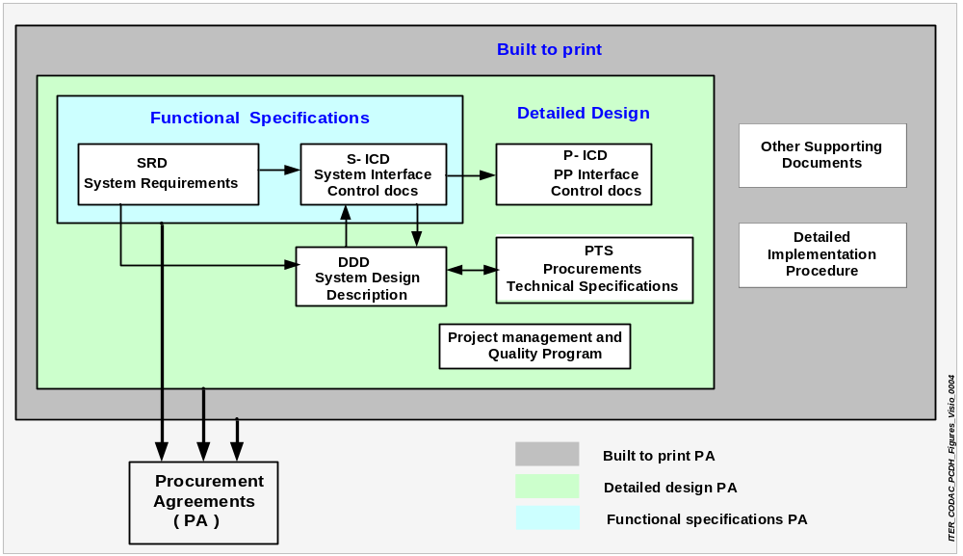
Figure 2.4 Plant System procurement types

Plant System Simulator
The Plant System Simulator shall provide test environment to test the behaviour of the Plant Systems during different phases of integration such as FAT, Installation, Commissioning, SAT and during plant operation. Each individual Plant System Supplier shall provide the Plant System Simulator [TBD]. This Plant System Simulator should be developed using Plant System’s self description data.

Plant Systems I&C Interface

Network Data Exchange Interface
Plant Systems may have differing degrees of complexity, containing in the simplest case a single Subsystem Controller to a full hierarchy of controllers in the case of a complex system. Each Plant System has a single PSH which provides the basic interface functions between CODAC and the Plant System.

The PSH will be part of the Plant System PA [TBD]. However, to obtain project wide conformity, CODAC will define a full set of hardware and software tools. PSH will provide asynchronous data exchange between CODAC and Plant Systems.

The I&C Bridge provides physical and logical interconnection among different network types.

Special purpose High Performance Networks (SDN, EDN, TCN, and AVN) will be used for a small number of networks and will be directly interfaced with the Plant Subsystem Controller through Network Interface Units which are defined by CODAC.

Building Interface
As part of the engineering design, the Plant System Supplier must provide their I&C requirements for

- Space for control cubicles.
- Power consumption
- Weight
- Uninterruptible Power Supply (UPS) requirements
- Local control room constraints, if any.
- Cabling route requirements, weight , number of cables (separation between safety and non-safety and between main and redundant cables).
- Environmental conditions (air conditions, noise, dust, lighting, humidity,temperatur radiation level, magnetic field).
- Grounding.
- Floor conditions if any.

Plant System Operation & Control

CODAC Control

CODAC Control refers to the normal state in which CODAC is monitoring and supervising all Plant Systems. Plant Systems such as utilities, may not be controlled in the active sense but continuously monitored and supervised by CODAC.

Figure 2.4 shows the switching of control mode from "CODAC Control" to "Local Control" which is under CODAC supervision. Control mode switching can be made by automated sequence control in CODAC systems. During either CODAC Control mode or during Local Control mode, status of the Plant Systems will be monitored by the CODAC through the PSH from the MCR.

- Plant Systems will always be in CODAC Control mode during normal operation.
- CODAC Control is always done through the CODAC operator or Plant System operator from MCR.
- CODAC Control is authorized by the CODAC operator through switch -1 implemented in the HMI.
- CODAC Control functions are supervisory control, configuration and automation.
- There can be no intervention from Local Control during CODAC control mode i.e. all the Local Control operations are disabled, including front panel.
- The CODAC may grant Local Control to a Plant System during the maintenance, testing or commissioning states of the Plant System but monitoring functions from CODAC will be maintained.
- Plant Systems always take control in the case of a failure of CODAC or when CODAC is not available.

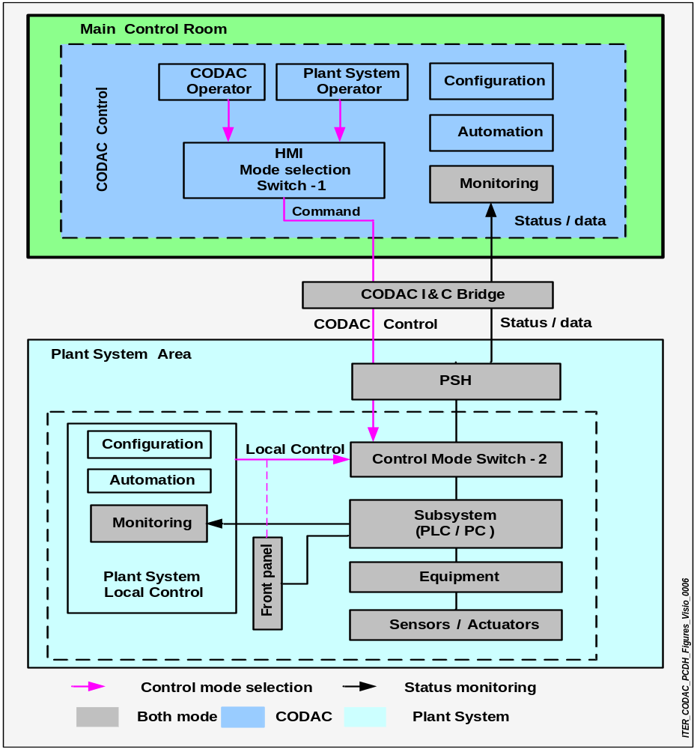
Figure 2.4 Plant System control modes

Local Control
Local control refers to the ability of personnel inside the Plant System buildings to control the Plant System or its components from the Local Control area independently from CODAC during maintenance, testing, commissioning and fault recovery states. As far as possible, usage of Local Control mode should be minimized.

- Local Control is always from the Plant System area and independent from CODAC.
- Switch-2 is used for the selection of Local Control mode.
- Switch-2 is either protected by software authorisation or by a key lock. Operation of the Key is authorized by CODAC (i.e. central authority).
- The transition from CODAC Control to Local Control and back must be seamless. All transitions will be logged by CODAC.
- Front panel controls can be operated only during the Local Control mode and their functionality must be defined by the Plant Systems I&C designers. Front-panel control will be enabled or disabled from the Local Control panel. Front-panel control functionality is always disabled during CODAC Control. Front panel displays are always available during both control modes.
- CODAC control actions are inhibited during Local Control mode but continue to provide the status display in the MCR.
- Plant System parameters modified during Local Control mode must be updated in the CODAC database when the system returns to CODAC Control mode.

Operation request
An operation request is a mode of data exchange operation that allows configuration parameters to be managed from outside the POZ. through the Operation Request Gatekeeper (ORG). It shall include pulse schedules, remote testing and maintenance activities [TBD].

Operation sequence
Operation sequences are those associated with start-up, normal and emergency operation of the Plant Systems.

Finite State Machine (FSM) diagrams must be provided by the Plant System design engineers in the form of self describing data which defines the operation scenario of the Plant System [TBD]. Also, these diagrams are implemented by the Plant System Suppliers and installed into Plant Subsystem controllers.

Operation sequence will normally be monitored by the Plant System operator from the MCR if authorized by the CODAC. This sequence may also be monitored by the Plant System operator from local control within Plant System area if authorization is provided by CODAC.

Direct communication
Direct communications are not allowed with Plant Systems from outside the POZ. The ORG will be used for pulse schedule operation request from outside the POZ .

Hardware considerations
Plant System I&C hardware must be designed in accordance with the specifications provided in this document. Any non-standard equipment must be justified by Plant System Supplier, approved by IO. and added to a non-conformance register. Every non-conformity must be accompanied by an obsolescence management plan as suggested by IEC 62402.

Items to be standardised include [TBD]:

- PLCs.
- Embedded resources.
- Field buses.
- Grounding and Isolation schemes and terminal strips.
- Control Cubicles.
- Computers i.e. servers and workstations.
- Networks.
- Power Supply.
- Cabling , Connectors and wiring.
- Display terminals.
- Data Acquisition Hardware

Software consideration
Plant System I&C software must be designed in accordance with the specifications of the tools which are provided in this document. Any non-standard software must be justified by Plant System Supplier, approved by IO and added to a non-conformance register accompanied by an obsolescence management plan as suggested by IEC 62402.

The Plant System Interface requires software standardization for the homogeneous management of the data.

Standards will be defined for:

- Operating systems and platform.
- Data acquisition systems.
- Data representation.
- SCADA (Supervisory Control and Data Acquisition).
- Allowable programming and scripting languages.
- Allowable Database management packages.
- File formats for documents and drawings.
- Programs used for documents and drawings.
- Coding practices.
- HMI.
- Reviewing practices.
- Analyzing and Modelling of the systems.
- Network Addressing (i.e. IP addressing).
- Standard libraries.
- Data naming.

Self Description data
The knowledge about the Plant Systems is centralised and this information will be distributed to the CODAC later. CODAC will define the tools for gathering the structured self describing data from the Plant Systems. These tools will employ eXtensible Mark-up Language (XML) based plant-wide data standards. XML is a platform/ Operating System (OS) independent (system agnostic) technology for transferring information and transforming and validating it on reception or transmission. All the information including data, logic, document, diagrams will be provided in the PSH as self describing data.

Self description of Plant Systems will evolve during design, development, fabrication, testing and commissioning phase. Plant System Supplier will update self description before SAT while IO will carry out updates after SAT.

Software Security
CODAC will have modular design and operational structures. Based on the architecture, Plant Systems will be controlled from MCR and Local Control Room within the POZ. The personnel in these locations will have different authorisation levels based on their role and responsibilities.

The authorisation levels will be as mentioned below:

- Observer: Normal password protected access, where a user can just observe the system conditions.
- Technician: Specialised level, password protected access. Restricted access rights where a user can address alarms and change the set points for various sensors.
- Engineer: Super specialised level, using password protected access. Full access rights including right to change the control action and PID loops for a system.

Security will be provided using firewalls at the POZ limits and authentication and authorization procedures to prevent unauthorised access to the Plant Systems and CODAC Systems. The PSH data exchange mechanism will validate the commands and data for Plant System coming from the CODAC. Access to all the data will be authenticated and authorized by ITER IO standardized security methods. A log of all commands and communications will be kept to resolve and analyze possible security risks.

Performance
The performance of the data exchange with the Plant Systems provided is expected to vary depending on the function being considered. Data exchange performance will depend on the hardware platform, operating system, network type, physical medium and bandwidth, packet size, CPU load and resident memory.

The following performance properties will be defined:

- Data exchange throughput.
- Latency
- Physical and logical network planning.
- Application characteristics and software security requirements.

The typical performance requirements for slow controls will be of the order of 100 msec while for fast controls, it will be below 1ms. These parameters are Plant System specific and will be defined for each Plant System individually.

Self Diagnostics
Computers and equipments shall have provisions for self-diagnosis and provide a visual indication of the status on the local front panels and at MCR. Computers and equipments should conduct repeated self checks at scheduled times. This will provide long term trends to predict problems in the future.

Error logging and fault traceability
In the event of failure of any sensor or a software glitch; the error will be detected and an error message will be generated and logged in the Plant System and communicated to CODAC.

Application lists and programming standards
The Plant System will be expected to provide a list of applications along with their associated standards. All application programs must be written using the preferred languages as specified in this document. The process for validation and acceptance will be defined for these applications.

Visualization
CODAC will define the tools for Mimics (HMI standards, SCADA packages and Mimic storage) of the full ITER plant operation in a sequential manner like in any conventional industrial SCADA system. Displayable data should include the logical and analogue state of different parts of the Plant Systems, the parameters recorded from all the instrumentation systems and their alarm states, interlock and safety system status.

English is the sole language for the HMI. CODAC also defines the visual display convention guidelines and set of operational dialogues as part of its framework for the HMI. Modification of synoptic views of the HMI will be done by handling of the data but not the code. HMI will include different authentication levels for access control.

Plant System I&C configuration
Under CODAC control mode, parameters of the Plant System equipment and field devices will be configured from MCR as shown in Figure 2.5. In Local Control mode, Plant Systems can be configured from the local control panel or from MCR through HMI. The configuration data must be consistent with the central CODAC database and also with the locally configured data.

PSH will be fully configurable [TBD] using self description and levels of configuration of Plant System equipments must be defined in the Plant System design documents. This data must be supplied by Plant System Suppliers using self describing schemas.

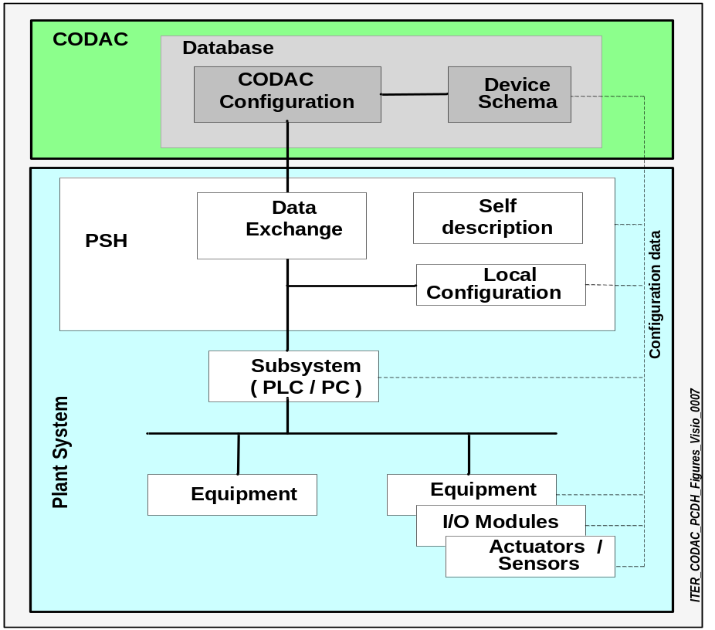

Figure 2.5 Configuration of Plant System equipment parameters

Mini CODAC
Mini CODAC will be used to certify Plant System functional integration. It is a tool for carrying out functional testing of the Plant System. Mini CODAC does not define the technical functionality and test processes for a Plant Systems but defines and provides an environment with limited performance to facilitate testing of integration of Plant Systems with CODAC. It will have scalable functionality to facilitate limited performance testing with CODAC of the Plant System interfaces.

I&C Design requirements
The design of ITER I&C will comply with the project wide specifications imposed by CODAC. It includes the hardware and software interface between Plant System I&C and CODAC for control and monitoring. The design facilitates the standardization of Plant Systems I&C. This is required to simplify the in-kind procurement arrangements from different DAs and takes into account the long-term operation, maintenance and upgrade requirements. The procurement arrangements will include all these requirements and technical specifications. The requirements will be specified as completely and thoroughly as possible even though revisions may be inevitable in future. It may be impossible to specify all the details at the time of the initiation of the project (e.g. during the requirements phase it may be impossible to define all of the screen formats for an interactive program). Additional changes may be needed as inaccuracies, shortcomings and deficiencies are discovered. The need to meet these requirements may have to evolve as the development of the system software and hardware progresses.

The primary requirements of Plant Systems should be provided in ITER Quality Assurance program which are reliability and availability of the all components. Other requirements are fault traceability, strict development traceability, the easiness of maintenance taking into account the evolution of both software and the hardware over the 35 year project span and the continuous changes in personnel during construction and operation.

ITER I&C Requirements
IO will specify:

- Clean power supply with UPS support (applies to the whole project).
- Grounding and isolation as defined by the technical specifications (applies to the whole project).
- The building condition parameters including environmental conditions/ventilation for all the cubicles inside the Plant System.
- Plant wide naming, colour coding and labelling convention (applies to the whole project).
- Access control, lighting and emergency exit facility.

CODAC I&C Requirements

2.9.2.1 CODAC will provide

- Interface between PSH and CODAC systems.
- Networks for data exchange between Plant Systems and CODAC.
- Network monitoring functions.
- Project wide time reference i.e. synchronization signal to Plant Systems I&C through TCN.
- Plant-wide distribution of events through EDN with minimum acceptable latency.
- SDN network to receive feedback data from Plant Systems along with computing functionality for feedback control.
- AVN interface to Plant Systems.
- Definition of PSH and Network Interface Units functionality.
- Mini CODAC to carry out FAT.
- CODAC for commissioning and SAT at IO site.
- Facility for data recording with time stamp, this will include data logging, data monitoring, data archiving and data visualization functions.
- Project wide supervisory and automation functions as well as co-ordination and control command structure for the Plant Systems.
- Facility to log all the commands and state transitions.
- Alarm handling.
- Log handling policy.
- Software security functions; this includes the authorization levels defined within Plant System applications.
- Tools and templates for self-description schemas. This will include formats and manuals.
- Plant System I&C configuration parameters which are manipulated from physics parameters from the higher level plant control application programs.
- Data for configuration of the Plant Systems.
- Requirements of environmental conditions for their I&C.
- Hardware and software used in the Plant System I&C design.
- Preferred suppliers list for PLC, fieldbuses, SCADA.
- Specifications for servers and workstations, PCs, network monitoring and application development tools/languages, cubicles.
- Mimic graphical libraries.

2.9.2.2 Central Interlock System

The CIS will provide:

- Project wide interlock functionality.
- Hardware and Software specifications for Interlock System.
- Interface specifications between CIS and PIS.
- Alarm management policy.

2.9.2.3 Central Safety System

The CSS will define:

- Project wide safety functionality
- Hardware and Software specifications for Safety Systems.
- Interface specifications between CSS and PSS
- Safety functions which are necessary for the monitoring and recording of the data, seismic accreditation, segregation and separation from the control system, power supply requirements and reliability requirements.

Plant System I&C Requirements
The different Plant Systems will preferably provide the following information regarding interface requirement with CODAC, safety and interlock system. CODAC expects these details from Plant Systems in the engineering design documents. CODAC Conventional, Interlock, and Safety functionality will be defined separately

2.9.3.1 Plant Systems must provide

- Self-describing data to CODAC.
- Design diagrams.
- The interface requirements of their I&C with CODAC networks by using PSH and Network Interface Units.
- Subsystem controllers like PLCs or PCs selected according to PCDH specifications.
- Compliance with network interface requirements from CODAC; including data volume to be exchanged with CODAC, performance of data exchange.
- Slow and fast data exchange requirements.
- Information for the data archiving, functional requirements for monitoring and visualization from the MCR.
- Monitoring parameters in the MCR at the specified intervals.
- Monitoring parameters with acquisition /logging by CODAC with specified frequency/time interval.
- State change sequencing information; this includes functionality to change states following a request from CODAC.
- Execution of its own control algorithms with respect to state transition and control commands from CODAC.
- Design principles and design methodology of the software application requirements.
- Functionality for operation under Local Control and CODAC Control.
- Configuration requirements from CODAC Control mode.
- Control parameters for control algorithms.
- Feedback control data from and to CODAC using SDN Network if required.
- Local control panels in accordance with CODAC standards if needed.
- Synchronization functions, if required. This includes synchronization with the project wide time reference of computers, equipment, modules and digitizers.
- Visualization of parameters in MCR.
- Approximate volume and duration of data storage required by CODAC.
- Requirements for local data storage volume and duration.
- Events/trigger requirements from the CODAC to start/stop the Plant System, this includes receive, log and transmit events with time stamping.
- Facility to collect and manage their data and supply it to CODAC with appropriate ITER data naming conventions.
- Relevant process data, warnings, alarms, and fault indications to CODAC.
- Alarm handling and monitoring from the CODAC [MCR] and local control.
- Operating Limits and Conditions (OLC) for the process and act on alarm signalling received from CODAC.
- OLC for all three tiers as self describing data i.e. set points for all the main parameters.
- Error management functionality.
- Maintenance and repair procedure if required.
- I&C environmental conditions requirements i.e. I&C elements must be compatible with the electromagnetic and ionizing radiation fields in which they operate.
- Cubicle requirements and their placement including access to cubicles.
- Process for FAT using mini CODAC.
- Test, installation, operation and maintenance requirements and procedures.
- Requirements and dependency on other Plant Systems for FAT and SAT testing, including Plant System simulators / Plant Subsystem simulators from other Plant Systems.[TBD]
- Plant System simulator or Plant Subsystem simulators based on the data driven approach [TBD].
- Information for all the signals to and from the components in the field must be made available at the terminal boxes and cubicle interfaces.
- Transient and steady state response of each instrument, equipment, sensors /actuators, subsystem.
- History of all the delivered equipments.
- Pre-pulse check functionality to ensure that all the systems and sub-systems are in the required states and the requested parameters are within the prescribed limits.
- Space and cable installation requirements.
- Audio–video monitoring requirements for surveillance and diagnostics during operation and maintenance i.e. to provide Audio/ Video data to CODAC if required.
- Sensors and actuators requirements and their interface to Data Acquisition (DAQ) modules.
- Obey grounding and interface rules as defined by ITER.
- Unique power requirements, surge current, peak power.
- Classification of signals into safety, interlock, access control and non-safety types and numbering of signals by hierarchical system and sub system levels.
- Information for signal type (analogue, digital) and location (port cell number, room, floor and building) of signal origination, description of the conditions of the electrical cubicles and electrical components.

2.9.3.2 Plant Interlock System
The PIS will provide:

- Events and preventive actions according to them.
- Information for the operational state transfers from the other Plant Systems.
- Interlock signals for other Plant System actions or activities.

2.9.3.3 Plant Safety System

The PSS will provide:

- Assumed event and necessary actions for safety .
- Monitoring data related to safety matters.
- The state of the machine when Human Access control in specified building is required.
- Specify safety critical level [TBD].

Instrumentation and Control System Life Cycle

Introduction
The purpose of this section is to outline the processes that must be followed by the Plant System Suppliers when providing Plant System Instrumentation and Control to the ITER project. As well as controlling the Plant System, they must interface with the overall CODAC systems in a known and pre-engineered manner. Acceptance phases highlighted in this section target Instrumentation and Control and do not focus on Plant System functional behaviour which will be subject to a supplementary test within the scope of the Procurement Arrangement.

This section is related to conventional I&C. More stringent requirements may be applied to Interlock and Safety Systems.

Lifecycle Phases
After the completion of the project conceptual design stage, the lifecycle of a Plant System can be split into phases such as:
- Preliminary design (Project Contract review, ITER Specification review, Initial design, Quality Assurance Program).
- Detailed Design (detailed design of Plant Systems and Subsystems, procurement).
- Factory Acceptance Tests.
- Pre-operational phase (Installation, pre-commissioning checks and testing, Plant System inactive commissioning and SAT).
- Operational phase (active commissioning and performance testing of the Plant System to prove that the design requirements have been met and that the various Plant Systems react as required by the design to ensure the safe operation of the Tokamak and its support Plant Systems).
IO will perform a review of the deliverables at the end of each phase and will give an authorisation to proceed.
There are three PA types:
- Build to Print where the Supplier responsibility covers phases from the Procurement and Manufacturing up to the end of the Plant System integration.
- Detailed Design where the Supplier responsibility covers phases from the detailed design to the FAT & SAT.
- Functional Specification where the Supplier responsibility covers phases from the Preliminary design up to Pre-operational phase inclusive.

Preliminary Design
A complete review of the procurement specification will be carried out in order to identify the overall control philosophy, the Plant System I&C parameters and interface with other Plant Systems including CODAC.

The preliminary design must be based on the Procurement. The requirements identified in the overall safety case, HAZOP studies and interfaces with other I&C systems including those provided by third parties must be used as the basis of design.

A Quality Assurance Program covering the various stages from contract award through design, design reviews procurement, installation and commissioning (inactive and active) and eventual decommissioning must be prepared by the Plant System Suppliers.

The preliminary design must be based on input from the Procurement Arrangement and Safety Functional Requirements identified from the site wide safety analysis.

Plant System hardware specifications, including sensors and signals, must be based on the project functionality and the installation environment, according to SRDs and Room book for buildings.

Where software is either developed or adapted to meet the project requirements, the procedures and methods used must follow internationally accepted guidelines.

The processes, hardware, software and documentation will be subjected to independent verification and validation processes carried out either by IO or their nominated representatives.

The Plant System Supplier must provide the complete Plant System I&C design schemas in an agreed format for incorporation (called self description) into CODAC. Thereafter, the schemas will be used to identify the interface and functional testing of the Plant System I&C.

A definition of the information to be carried on the SDN network must be provided to IO at this stage

FAT must be prepared by the Plant System Supplier at this stage.

A manufacturing programme that identifies the major activities between contract and completion of the Factory Acceptance Tests must be prepared. The interface points between Plant System Supplier and IO must be identified.

The Plant System Supplier must prepare a FAT document which must be approved by IO. Sufficient time must be built into the programme to allow IO to attend and witness Factory Acceptance Tests. FAT must be formally signed on completion of testing by IO and Supplier.

Detailed Design
During the Design stages, design reviews at pre selected points in the overall production cycle must be carried out and be attended by members of IO.

A review of Factory Acceptance Testing procedures prepared by the Plant System Supplier must be carried out by IO or IO representatives. The FATof the I&C equipment must include utilisation of the mini CODAC provided by CODAC. Mini CODAC will be programmed to exercise the I&C equipment including any other Plant System signals that are needed. The Plant System itself must provide simulators for the field sensors and signals when they are not available.

Project risk assessments, method statements and operational procedures must be prepared.

Manuals covering all aspects of operation and maintenance for the equipment must be prepared and submitted in time to allow review by IO before onward transmission to the site for use during initial I&C set up and calibration.
An Integration and Test strategy programme including pre-commissioning tests, inactive commissioning, active commissioning and performance testing must be prepared and submitted for review by the Supplier to IO. Pre-commissioning must include static testing and verification of Subsystem terminations and sensor connections at the various junction boxes and termination chambers where an interface to Plant System I&C and CODAC occurs. The Integration and Test programme strategy must include the means involved in each phase (tools, simulators, scenarios, data set). The design must ensure that I&C equipment can be decommissioned successfully at the end of the project life without impact on personnel and the environment.

Factory Acceptance
This phase completes the work done by the Supplier with respect to the I&C. There could be additional functional tests but not within the scope of the IO. On IO approval, the Plant System I&C must be sent to the IO site.

Pre-Operational Phase
The Pre-Operational phase will be managed by IO and must be supported by the Supplier from the initial installation to the end of inactive commissioning.

On completion of I&C installation, the sensor and signal cable connections and core terminations to cubicles on control panels must be tested in accordance with Project Quality Assurance Program and the results recorded on previously agreed test schedules.

Thereafter the equipment must be calibrated using data provided by the Plant System Supplier and the Plant Systems progressively commissioned. On completion, the equipment must be subjected to a SAT. This is a repeat of the FATusing field sensors and signals to ensure that the equipment is functionally the same as that tested in the factory. The SAT must also prove that the I&C equipment controls the process within the limits stated in the design. The results of pre-approved test procedures must be recorded and submitted to IO for review and acceptance prior to the equipment being released to the next phase of the project.

On completion of the SAT the equipment inactive commissioning will be considered to have been completed. The equipment will be made available for continuous use either on its own, or as part of test procedures forming part of larger systems. Ownership of the items will be transferred to the IO upon Site Acceptance.

Operational Phase
The Operational phase will be managed by IO and will commence immediately after completion of Pre- Operational phase i.e. after completion of inactive commissioning.

In this phase the Plant System will be tested to ensure that performance requirements are met. After an initial proving period the Plant System will be available for operation on demand according to the requirements of other Plant Systems being brought into service.

As operational experience is gained the I&C equipments may require re-configuration or for modifications to be made to optimise the interfaces to CODAC.These changes and corresponding update of self description will be carried out by the IO.

In the Operational Phase the I&C equipment will be used continuously under local control or CODAC control.

Ongoing routine maintenance tasks will be carried out in accordance with the Operation and Maintenance (O&M) manuals and ‘As installed’ drawings and documentation supplied as part of the project.

As part of its duties IO will implement procedures that highlight when the I&C equipment will be subjected to deeper maintenance involving instrument re-calibration, cleaning of sensing and impulse lines and the updating of software.

As the plant nears the end of its operational life, and using information provided by the Plant System Supplier, IO will prepare decommissioning plans for all of the relevant I&C equipment.

Process
The Plant System I&C process will be as shown in Figure 3.1 which illustrates the stages that must be completed in the preparation for the successful delivery of I&C systems.
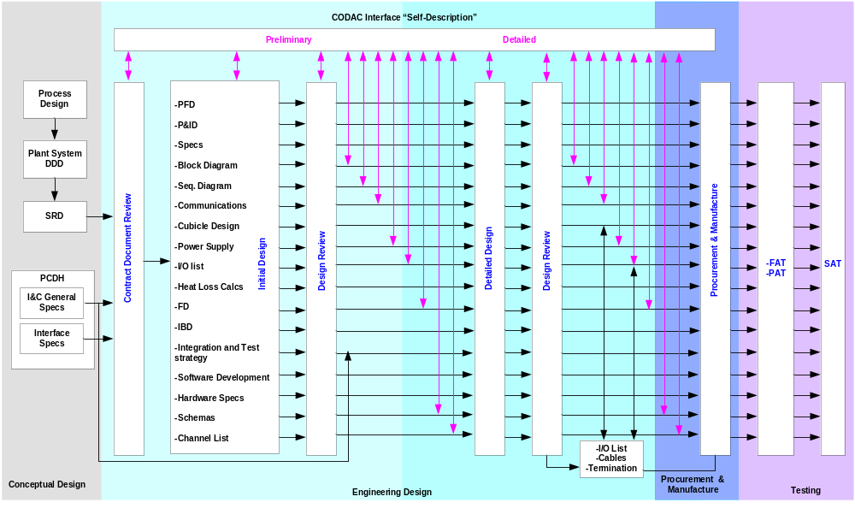Figure 3.5 Plant System I&C Design Process

Plant System I&C Assessment

Impact Assessment

Plant System Level
This assessment must document the Plant Systems that will be installed and also ascertain the impact of the Plant System on normal and safe operation [TBD] of the whole plant.

The impact has been categorised as below:

- Direct Impact: Instruments or Plant Systems that are expected to have direct impact on normal Tokamak operation.
- Indirect Impact: Instruments or Plant Systems that are not expected to have direct impact on normal Tokamak operation, but typically will support a direct impact system.
- No impact: Instruments or Plant Systems that are not expected to have an impact on normal Tokamak operation.

Component Level
The component level assessment classifies instruments as critical or non critical for normal plant operation.
The criticality levels are:
- Critical instruments: Instruments where operation, contact, data, control alarm or failure will have a direct impact on Safety. These components will be identified as Safety Important Class (SIC) in drawings, labelling and documentation.
- Major instruments: Instruments where operation, contact, data, control alarm or failure will have a direct impact on operation and could cause interlocks to trigger.
- Non-Critical instruments: Instruments where operation, contact, data, control alarm or failure will have indirect impact or no impact on normal plant operation.

Safety Assessment

During the Detailed Design Phase, Safety Integrity Level (SIL) Assessment and HAZOP studies will be undertaken by IO in accordance with the relevant standards (IEC 61513, IEC 61226 : TBD) to define which instruments are to be considered Safety critical.

Refer to section 7 for Safety systems.

Validation process Assessment

A validation process will be associated to the criticality level. The validation process will be undertaken after considering the instrument lifecycle, software requirements and instrumentation functionality.

Preliminary Design
The IO must receive details of the Plant System to allow a full understanding of the I&C. Where information will be transmitted to another discipline, then proforma interface sheets must be used. The details must include:
- Overall Plant system control philosophy.
- Process Flow Diagrams providing information on design limits e.g. pressures, temperatures, flows.
- Start-up, normal operation, shutdown of Plant System.
- All details of interfaces with the Plant System and with CODAC including control panels, space requirements, junction boxes and transition boxes.
- All process and instrumentation diagrams (P&IDs), loop and logic block diagrams, system schematics, input/output signals, power distribution and wiring and termination diagrams.
- Interlock systems including any interfaces with CIS and conventional I&C.
- Safety systems including any interfaces with CSS, PSS and PIS.
- Cable schedules including rating calculations and cable specifications.
- Lists of sensors and I/O signals including accuracies and materials most suited for the intended environment.
- Breakdown into subsystems with their specification and interface details.

The I&C systems must be designed to allow the safe and reliable Plant System operating modes required by CODAC.

Easy access for routine maintenance must be achieved without the use of temporary platforms. Where local signals are provided then these must be easily read from floor level.

In the event of power interruptions or failures then the instrumentation must fail in such a manner that there is no injury to personnel and no Plant System damage occurs.

Regardless of any control and monitoring functions provided by CODAC, the primary responsibility for assuring the safety of the plant system and of personnel rests with the plant system supplier rather than with CODAC. This means that plant systems must not rely on a rapid (or indeed any) computer response to abnormal conditions. All equipment, therefore, shall have built-in absolute-limit protection to preclude manual and CODAC control errors. Time critical devices shall have built-in time-outs to assure safe operation in case of CODAC failure.

Instrument symbols must be in accordance with the latest revision of standard IEC 60617 [TBC]. This standard must be used in conjunction with ITER Numbering system.

Local controls must be available to assist in Plant System start up and to allow routine on-line testing to take place.

Instrument systems must be designed for maximum simplicity, reliability and minimum maintenance with calibration intervals in accordance with the manufacturer’s recommendations.

Instruments furnished as part of major equipment package units must be identified on Process and Instrumentation Diagrams (P&IDs) and mechanical flow sheets and they must be verified & tested against the equipment being supplied for the project.

Unusual instrument loops and circuits must be avoided. Components for the same or similar functions must be standardised as far as practical.

Where the design interfaces with CODAC, then details must be submitted to IO so that CODAC can begin preparing the specification for mini CODAC.

The design is expected to progress through various levels of verification and validation with checking and approval. This will include, if required, a multi discipline design review to ensure that the correct interfaces are captured along with the detailed requirements of each package or plant concerned.

A formal design verification process will be carried out at the end of the Preliminary design.

Prior to the design verification meeting, the Plant System Supplier must issue to the attendees a full package of drawings and documentation mature enough to allow the design to be assessed including but not limited to:
- Process Flow Diagram.
- Process and Instrumentation Diagram.
- Instrument Database including Data sheets.
- Plant Overall Control Philosophy.
- Proposed Alarm list indicating alarm priorities.
- Preliminary HAZOP study and Cause and Effect Diagrams.
- Proposed cubicle specifications, positions and layouts based on overall site layouts.
- Preliminary cable list showing proposed types, ratings.
- Component identification.
- Any other drawing or document considered necessary to demonstrate the overall design
principles employed to comply with the project requirements.

As part of this review and before purchase or manufacture, an obsolescence analysis according to IEC 62402 will be carried out by IO with PS Supplier assistance to determine if the design, operation and maintenance of the equipment is fit for the intended purpose.

At the conclusion of the Preliminary design stage, a Design Review must be carried out and attended by IO or IO representatives.

The Preliminary design must be updated to include any comments, clarifications, changes and modifications accumulated during the initial design review. Thereafter the design documentation must be updated to reflect the latest understanding of the design.

Detailed Design

The Plant System I&C design process life cycle from conceptual design to detailed engineering design and ready for fabrication is described below:

Conceptual design, defines the functional and technical requirements to and from the Plant Systems, The engineering design phase defines the specifications for the procurement while the detailed design and fabrication phase is when the execution of all the Plant Systems design will be done.

This process will be followed by the Plant System RO and design engineers supported by the CODAC RO. A formal design verification process will be carried out at the end of the detailed design.

Prior to the design verification meeting, the Plant System Supplier must issue to the attendees a full package via the self description of drawings and documentation mature enough to allow the design to be assessed including but not limited to:
- FATprocedures.
- Plant System communication diagrams including timing diagrams.
- Interface with PSH , synchronous networks [ SDN, AVN, TCN ,EDN ] and interlock & safety networks.
- Cable schedules including proposed cable routes and installation requirements within the Plant System.
- Cubicle connection diagrams.
- Grounding, isolation and power supply interface diagrams.
- Marshalling and junction box termination diagrams.
- Instrument loop diagrams.
- Control system architecture diagrams and supporting documentation.
- O&M manuals including proposed control system settings.
- Plant System simulator.

Factory Acceptance Tests
Before the Instrumentation and Control system leaves the factory, CODAC interface tests and Instrumentation and Control verification tests must be carried out.

These tests will validate the Plant System I&C functionality and ensure that it meets the general and specific technical, user, functional; safety and installation requirements specified for the Plant System. The Plant System Supplier must complete the Acceptance Test document which will be based on the Plant System design, agreed test specifications and test.

The test items include standardisation of hardware equipment, cubicles, software applications.

The features to be tested must include:
- Software requirement specifications described in design document that includes data transmission, data visualisation, HMI, Alarm handling both software and hard wired circuits, data logging and storage and Plant System operation states.
- A test procedure that consists of simulating (where possible) , interfaces between Plant System I&C components and PSH and CODAC components both physical and logical (data exchange).
- Checking as far as reasonably practicable all the interfaces from sensors and signals that replicate the interface with the Plant System. If considered practical, the I&C equipment will be directly connected to the actual Plant System to be controlled.
- The equipment and applications that are already covered by a certificate of conformity will not be required to be tested again.
- The test must include functional testing and all checks necessary to verify normal and off- normal operation of the Plant System in a controlled environment.

More details are given in the Appendix A.

The tests must be carried out at Plant System Supplier premises. IO will provide a mini CODAC (with a partial simulation of CSS and CIS) along with the associated network connection cables [TBD], which must be used to represent the interface with CODAC.

On detecting a defect during FAT, the details must be recorded and resolved by the relevant parties (IO, Plant System Suppliers) either at the time or later, according to the severity of the defects. The FAT will only be declared as concluded when all the defects have been resolved and the solution proved.

After a successful FAT, the tests results will be reviewed and if accepted, confirmation in the form of a test certificate will be signed and issued. The Plant System will then be released for shipment to IO site.

IO reserves the right to be present or to be represented by an organization of its choice, to witness any tests carried out at the Plant System Supplier’s premises.

CODAC will provide an interface unit which will represent the plant wide CODAC system in the form of a mini CODAC. The unit will be programmed with the features, Input/Outputs, process limits, functionality, alarms and trips derived from design information issued to and received from the Plant System Supplier. The information will be presented in the form of data which will be installed in the mini CODAC where it will be compared with the values expected under the declared test conditions.

The test conditions will include response to different conditions generally covering normal steady state, step response, alarm, start-up, shut-down and trips. Where the local Subsystem includes data logging then the accuracy of time stamps will be verified to ensure that the complete Plant System is on the same time base.

The test set up including final assembly and results will be recorded and shipped with Plant System’s I&C and its calibration

All test instruments must have valid calibrations and have valid test certificates available for inspection by IO prior to any test.
The Plant System Supplier must provide all necessary test equipment and services to carry out FAT in accordance with the agreed procedure. A typical FAT procedure can be found in Appendix A.

Pre Operational Phase

Installation
The installation of the I&C equipment at IO site will be done using drawings and documentation that has been subjected to design review and accepted by IO.

This task is the responsibility of the Supplier [TBD].

Cabling outside cubicles is the responsibility of IO [TBD].
Cabling within cubicles is the responsibility of the Supplier.

On completion of the installation, static checks on cabling, including verification of the communication cable performance, will be carried out.

Site Commissioning Procedures

Provisional Acceptance Tests (PAT) will be carried on-site before commencing the SAT. This must include checking the integrity of hardware (including calibration of sensors) and software before interfacing to CODAC I&C.

The Supplier must carry out acceptance tests to demonstrate that an installation complies with all the requirements stipulated in this specification. These tests must be done in collaboration with the Supplier or ITER staff and the safety services concerned.

These tests must be carried out by Plant System RO and will include:

- All the sensors / equipments must be tested with use of the specified calibration sources.
- The correctness and performance of the data and alarm transmission must be verified.
- All automatic activation of ancillary equipment must also be tested.
- All safety actions and interlocks must be checked.
- The record of correct transmission of the data must be kept in the centralized data management system and be available at the request of authorized personnel.

After a successful PAT, tests and calibration will be carried out at ITER premises and must be performed and organized by the Supplier. Testing and calibration must be performed according to a pre-established and agreed checklist that contains, at least, tests for checking the performance and compliance with the applicable standards.

During these tests, a person or team from the Supplier must be present and they must carry out the tests. ITER will validate the tests .The testing schedule will be described in the Acceptance Test Document.

These tests must include:

- On-site tests which repeat the factory tests (with the exception of the burn-in test).
- Additional mandatory SAT which include cycling through all Operating States compatible with the state of construction of ITER and the availability of appropriate dummy loads.
- The conformity of the standards specified in the Procurement Arrangement must be demonstrated.
- Proving of all alarm and trip system states.

Site Acceptance Tests
These tests will check that the system has been connected up correctly and that it will perform all the activities expected of it under normal operation conditions in the real working environment and as far as possible during abnormal situations and trip conditions..

SAT and instrument calibration will be carried out at IO site.

Performed and organised by the Supplier, Testing and calibration must be according to a pre-established and agreed checklist that contains, at least, tests for checking the required performance and the compliance to the applicable standards.

ITER team will validate the test results.

The testing schedule will be described in the SAT document written by IO.
On-site tests must repeat the factory tests (with the exception of the burn-in test).

The conformity with the standards specified in the Procurement Arrangement must be demonstrated

Specifications on acceptable limits for provisionally accepting I&C equipment will be provided by the Plant System Supplier.

Any deviation from a test procedure must be recorded and identified in the appropriate test report. It is proposed to maintain a log during a test. This log will be used as part of the test report, together with the record of the results. If the deviation is caused by an error in the test procedure, then the procedure can be marked as faulty and the test can continue.

SATs will be carried out in two stages: with Mini CODAC and with CODAC. The same mini CODAC (same version and configuration) as for Factory Acceptance tests will be used in the first stage. This is to verify that the installation is acceptable and that the features, Input/Outputs, process limits, functionality, alarms and trips are available at the specified CODAC interface point.

When a problem is detected during the tests, the severity of the problem must be determined. The overall system is said to have been validated when all the errors are corrected.

The testing plan will include normal testing and off-normal testing case.

Test results must be documented together with the test setup and testing criterion. As far as possible, these tests shall be automated.

A typical SAT procedure is presented in Appendix B.

At the end of this SAT, an obsolescence review must be carried out by IO with PS Supplier assistance to determine if the components are or are becoming obsolete. For software dependant systems the subsequent reviews are likely to occur at more frequent periods than for more robust mechanical plant. The Supplier must provide guidance on which parts of his I&C systems are likely to require upgrading over the postulated design life.

- Resources provided by CODAC during SAT

Mini CODAC must be used to carry out Provisional Acceptance Tests and for repeating the FAT if necessary. These are done to prove that all plant cabling and connections have been terminated correctly and that the input and output schedule is as required by the design.

When the installation is accepted as being complete, the connections to the CODAC system will be made. A number of tests must be carried out to verify that the network connections to that item of plant are fully functional and that data is being transferred between CODAC and the equipment control system correctly.

Thereafter there will be a SAT consisting of a simulation of a series of operating modes expected to occur during normal steady state, step response, alarm and trip conditions.

Where the system under test includes information that is required by Safety Interlocks and plant safety interlocks then these systems must also be tested prior to the system SATs being declared complete.

Plant Systems Suppliers must provide assistance to IO for verifying integration of CODAC with Plant Systems. ITER will provide necessary Control Room facilities, electrical infrastructure and network cables with connectors and access to CODAC.

The operator console for the actual CODAC interface testing will allow the on-site installation and testing of the equipment supplied in accordance with the safety regulations in force on the IO site.

ITER will provide the space necessary at the testing site, electric power to operate electronic components, internal telephone line and the necessary network lines.

In the contract document, the Plant System Suppliers must provide the list of resources required during SAT and the duration of their use. Any deviation from this resource requirement specification must be agreed mutually by the Plant System Suppliers and IO.

The vehicles to transport personnel, tools and small equipment for the execution of the work under the contract will not be provided by IO.

All consumables used by the Plant System Suppliers personnel must be paid for by the Plant System Suppliers.

The Plant System Supplier and his personnel must be aware of, and follow, IO site rules and regulations. The Plant System Supplier must strictly observe all safety regulations in force at the IO site.

The Plant System Supplier will be deemed to know all of the regulations specified by IO in the contract documentation.

Training
Training for IO by the Plant System Supplier will be carried out at various levels such as engineering, maintenance and operator. Each of these disciplines is allocated specific authority for access to computer systems.

Training requirements will be based on:
- Skill.
- Procedure and equipment familiarity.
- Knowledge of the process.
- Experience.
To assist in forward planning, a Training Plan must be prepared and issued to IO identifying the skills required, the duration and the location for the training. On site familiarisation must be taken in account within the plan.

Training must be provided to IO by the Plant System Supplier (i.e. the staff member can be from Plant System personnel, CODAC personnel, Engineering, Physics and Plant Operator) for the purpose of carrying out Plant Systems I&C operations, to carry out first line maintenance and to carry out maintenance including fault resolution.

The training must include operation of the Plant System during the commissioning and initial operational period, configuration of Plant Systems I&C, alarm management and Plant System operation scheduling e.g. experiment preparation.

The training and training manuals must be in the English language and be based solely on the equipment being supplied to site.

Maintenance
IO will be responsible for maintenance activities once the Plant System I&C has been accepted.
The Supplier is responsible for supplying Plant System I&C with embedded diagnostics such as health check in order to minimise fault diagnosis times.
Health checks and I/O card checks must be carried out. In addition to local maintenance tools, the record of fault descriptions and the associated preventive and corrective actions must be sent to CODAC as alarms with the associated severity..
Preventive maintenance may be carried out on some hardware modules by periodically replacing them during service. The particular case of preventive maintenance on protective actions corresponding to simulated and actual fusion power shutdown tests must be performed according to special procedures and a defined schedule. The detailed list of components and items for inspection during preventive maintenance must be provided by the Plant System Supplier.
The Supplier is responsible for the warranty as specified in the PA.

Deliverables
If I&C design is performed using CODAC standard tools the equipment deliverables will be mostly in the form of structured data.

List of hardware and basic software deliverables
- The hardware and software licenses required for performing the Plant System role.
- The set of spare parts necessary for maintenance of the I&C up to the end of the warranty.
- The set of testing tools needed to perform the FAT and commissioning (apart from mini CODAC).

List of application deliverables
- Any non standard application programs developed by Plant System I&C developers.
- Application software must be delivered by the Plant System Supplier with:
- Executable applications (Binary applications).
- Complete source code.
- Report for test environment, test processes and error correction processes
- A list and versions of all development tools.
- Details of the verification and validation processes.

Non standard software components
- Libraries.
- Software device driver for I/O modules and components.
- BIOS for host CPU.
- Firmware for FPGA, Controller and I/O modules.

FAT and SAT Test documentation

Before testing begins
In order of completion:

- User and product requirements document.
- Design Description Document (latest revision).
- Approved acceptance test documentation, except for the test reports.
- Mini CODAC and associated documentation.

After testing
The information that must be recorded during testing and validation will include:

- Documentation for original testing and validation activities in chronological order.
- The version of the specification for the overall safety and user requirements.
- The requirements as defined in the specification documents, being validated.
- The test design, test case, test setup, test procedures and test environment definition or
identifier.
- Tools and equipment used, along with calibration and simulation data.

Test results
On completion of the test processes the following must be submitted to IO for review:
- Test reports.
- List of items that passed or failed the test requirements.
- List of hardware and software components where errors occurred during the validation test.
- List of problems encountered.
- Suggestions or comments from the user.
- History of the test process reports.
- Corrective actions to resolve discrepancies between expected and actual results.

Design diagrams
A process diagram will be expected for each procurement package.

There are three categories of diagrams:

1. Process diagrams.
2. Design and data diagrams.
3. Circuit diagrams.

Process diagrams
The process diagram displays the top level interaction between the major components of a Plant System facility whilst hiding the minor details such as piping and designations from the reviewers.

Depending on the procurement package, definition the functionality of the major components must be described in the design description document by IO. The IO must provide P&IDs, single line diagrams, which are key interfacing documents required by Plant System I&C designers.

Design and data flow diagrams (BD, FD, IBD, and SFC) must be created by the Plant Systems designers using IEC 61131-3 compatible tools [TBD] which will be defined by CODAC and that are part of the self description data.

The design must define a clear separation between different levels of programs and the data flow diagrams must be capable of re-use or be used on similar Plant Systems.
If used, Unified Modelling Language (UML) diagrams made by the Plant System designers must employ structured data from the Plant System designs.

Process diagrams include but are not limited to:
- Process Flow Diagrams
The diagram must show general flow of Plant System processes and equipment. It must display the relationships between the major components in a Plant System facility.
- Process & Instrumentation Diagrams
The diagrams must show the main processes, complete with a symbolic representation of the proposed Instrumentation and Control functions which will be fitted to the Plant System. The Symbols used will be provided by IO according to the CATIA instrument symbol library. The symbols will be based on the Instrument Society of America or an agreed equivalent [TBD].

Design and data diagrams.

Design and data flow diagrams include but are not limited to:

1. Block Diagrams (BDs)
The Plant System control process must be shown as a series of blocks each representing an element of the control process. Each block must also show its relationship with other blocks within the overall control process.
2. Functional Diagrams (FDs)
The functional diagrams must show the functions of the Plant System control elements.
- Interlock Block Diagrams (IBDs)
The interlock Block Diagram must show the interlocks and the conditions for an interlock to be satisfied.
- UML diagrams
Optional representation of “System Engineering Process Diagrams” for the Plant Systems.

Circuit diagrams.
Circuit diagrams include but are not limited to:
1. Circuit diagrams
All electrical and electronics circuit diagrams with detailed comments including the document itself.

The PLC programming must be compatible with IEEE 61131-1 standard diagrams and the documentation shall include:

- Instrumentation layouts.
- Termination diagrams.
- Schematic diagrams.
- Cubicle layouts and circuit details.
- Power supplies circuits and schematics.
- Alarm and trip circuits.
- Process start up and shutdown sequence diagrams.
- Mathematical model for simulation (either for testing another Plant System or for project wide
simulation) [TBD].

Non standard development and design tools
The non standard programming environment must be delivered with detailed documentation and list of licenses necessary for the software delivered.

This includes programming language compiler, SCADA tool and firmware code, Controller driver application, editing tools, and configuration tools, maintenance packages or any other development tools necessary to convert proprietary software into a format that allows easy and faultless communication and data transfer to and from CODAC.

Non standard packages and tools
- Simulation [TBD]
Where necessary, the Plant System Supplier will be expected to provide any software tools required to convert his data into a format that can be used by CODAC to allow the simulation of the Plant System process. In turn, the results will be used to verify the overall performance of control of the Plant System under normal and abnormal conditions. Simulation must be delivered according to a separate life cycle and separate time schedule.
- Testing and analysis
Tested software elements and programmes must be submitted for the purpose of using the data as the basis for confirming the operation of the installed software.

Storage and Delivery
All software, documentation and data sets must be stored and delivered within a Configuration Management Tool [TBD].

Plant System I&C Documentation
The documentation must give a detailed description of all the subsystems in the Plant System and their operation. It must also contain a detailed listing of the instrumentation and communication media used.

This documentation must be delivered in a format compatible with the Plant System Self Description.
The English language is mandatory for documentation.

Documentation

Document Deliverables
Specifications are provided in this section on the deliverables expected.

Technical documentation of the equipment must include:
- A detailed description of the software and hardware components.
- A detailed description of the final hardware design and implementation.
- A detailed description of the software design and implementation.
- A detailed description of design diagrams which includes Functional Block Diagram (FBD), P&ID, Technical drawing, SFC, operational sequence diagrams, IBD and timing diagrams etc. as part of the self description data.

As a minimum, manuals for programmable electronic systems must include:
- Test procedures and debug reports including test environment scenarios and results of the hardware safety validation of the assembled system.
- Reports (test reports, logbook file).
- Application program source code with its full audit trail. The source code listings for all software must be delivered in specified standards [TBD] or XML formats..
- Configuration management plan for software, documentation and data set.
- Operating and maintenance procedures for software.
- Documents for the acceptance tests.
- Maintenance documentation.
- Historic documentation.
- Site installation documentation.
- Detailed cabling information.
- Cabling and termination diagrams.
- Alarms and trip listing.
- Procedures for operating and maintenance of hardware.
- Tables of self description data.
- Detailed training plan.
- Calibration instructions.

All the Plant System Suppliers must comply with the codes and standards described in this document. To this effect, Test certificates and Certificates of Compliance must be produced for all equipment supplied under the contract.

Quality Assurance (QA)
A Quality Assurance Program (QAP) must be prepared to ensure that the correct level of QA to achieve the safety and performance objectives of IO is obtained. The objective is to provide evidence that the required quality of the product has been achieved and that the design requirements have been met.

In addition to the generic Plant System QAP, a specific I&C QAP must be provided by the Plant System Supplier as described below.

The QAP must cover the full life cycle of the ITER machine (i.e. design, Research & Development [R&D], procurement, manufacturing, construction, commissioning, operations, and decommissioning). It is recognised that the latter two activities are outside with the Plant System Suppliers or their subcontractor’s scope but these activities must be taken into account during the preceding processes.

The QA principles must be based the (International Standards Organization) ISO 9001:2000 and (International Atomic Energy Agency) IAEA Code GS-R-3. The QAP should make use of the experience gained in the implementation of QA programs applied to similar projects. It must be subject to periodic evaluation, updating and audits carried out by IO or their nominated representative.

Attributes to be addressed or demonstrated must include, but are not limited to, adaptability, availability, correctness, flexibility, interoperability, maintainability, portability, reliability, reusability, robustness, testability, usability, Inspectability, ease of use and ease of learning, verification and validation procedures (e.g. for software), compliance with the design and associated standards for the Plant System I&C components and subsystems.
Reliability and availability are required for continuous operation 24 hours/day, and 365 days/year.
The QAP must describe the organisation necessary to deliver the Plant System I&C requirements.
Sub contractors must comply with the same QA standards as the Plant System Supplier. The sub contractors will be expected to demonstrate to the satisfaction of IO that the components and subsystems selected have a low failure rate and that in the event of failure the component, it can be repaired with the minimum of downtime.

Where practical, Commercial off the Shelf (COTS) equipment employing proven technology is preferred. Any special requirements, such as requiring additional testing to ensure compliance with the site overall reliability, availability and maintainability targets, must be highlighted in the QAP.

Development and Manufacturing
The QAP must describe process for developing the I&C and for the procurement of COTS products. This part of the QAP must describe the procedures for designing and development/manufacture of the I&C from the PA to the tests, including the integration of Plant Systems and their subsystems.

Inspections and Tests
The specification for inspecting and testing of components, subsystems and overall control system must be defined in this section.

Before the Plant System I&C leave the factory, a FAT shall be processed..

The purpose of the tests is to ensure that all testable functionality is correct before the Plant System reaches the IO site.

The Plant System design document must include the list of tests which must be carried out during FAT, SAT and during site commissioning. It will also define the process for the validation and verification of equipment and of any software specifications.

Test Responsibilities
The IO team must be notified when formal testing is to commence. Testing must only start if the IO review body judges the Plant System ready for test. At this time, IO will issue the agreed procedure and authorize the start of testing.

The tests must be carried out by the Plant System Supplier and monitored by the DA team concerned and possibly in the presence of the IO Plant System users.

At the end of the testing the IO test team will assess the test results and declare if the equipment can be released to the next stage in the process.

On completion of testing, an Acceptance Test and Test Report (ATTR) must be prepared and issued to interested parties.

The subcontractor and manufacturer will be expected to propose test procedures outlining the methods that will be used to demonstrate that the equipment has met the design requirements, performance and functionality specified.

The equipment, Plant System or Subsystem or component will remain in the factory until the results have been accepted. The review for nuclear safety related equipment must include the assessment of any special test results for example; compliance with specific site requirements such as seismic qualification is specified.

If required, defect logs must be attached to the equipment so that corrective action can be monitored and recorded as the equipment proceeds through manufacture.

Before the Plant System I&C leave the factory, a FATshall be processed.
The tasks must be carried out according to test procedures previously agreed with IO. The tests must be carried out to the satisfaction of IO or his nominated representative.

Tests results must be reviewed and accepted prior to instrumentation and Plant Systems being made ready for shipment to IO site. Test and calibration instrumentation must have certificates valid at the time of test and all details must be recorded on the Factory Test Procedure.

The purpose of these tests is to ensure that all specified functionality and interface requirements are operating correctly before the I&C and Plant Systems reach the IO site.

Validation and Verification process
Verification must include the Self Description Data (structured data) provided by Plant Systems and the unstructured documentation within the work scope.

The technical standards for the software being developed must be verified.

The control system logic inputs and outputs, the analogue inputs and outputs and the accuracy required must be verified as being in conformity with the overall CODAC requirements.

The validation process must include cycling through the available operating states under factory conditions using dummy loads.

The burn-in period of all subsystems and components including the PSH to Subsystem Controller must be 500 hours [TBD]. In the event of a failure, the cause must be discussed with the Supplier and IO to establish the proposed solution and the effect on the overall scheme.

Changeovers to any alternative power supplies connected to the Plant System must be proven during the burn in period to ensure that no change occurs to the status of any of the I&C equipment.

The verification and validation schedule for the relevant Plant System must be described in Plant System technical specifications. The schedule must be agreed with the IO.

For every Plant System and Subsystem developed, the test procedures and results from the tests must be reviewed and accepted by an in-house ITER Test Team which is independent from the original design team. The reviewers must be chosen from personnel with experience of the Plant System I&C and of the Plant System to be controlled.

The results from any tests carried out on a component or Subsystem must be recorded in table format. The table must show the required value and the actual value obtained. The tolerance on the value must be provided and if it is dependent on inputs from test equipment then the details must be recorded in the table.

To assist in the software validation process, clear and unambiguous notes and software source code must be retained by the original developer. The notes must describe the background to the development process and allow easy tracing of code used for the different functions. Comments within the source code shall be in English.

The software test procedure must consist of a series of tests that demonstrate the Subsystem or component is fit for the intended purpose and meets the required standards.

These tests ensure that each part of an installation operates in accordance with the performance required.

These tests must be performed by the Plant System Supplier under the supervision of IO or IO representatives.

Codes and Standards
The list of codes and standards are taken from International Organizations for standards, French Nuclear Authority and partner organisations see details in Appendix C. This list of codes and standards must be followed by all the Plant System Suppliers during life cycle from conceptual design to commissioning.

Plant System I&C - CODAC Interface Specification

Introduction
This section describes the I&C interface specifications between CODAC and individual Plant System, as well as power supply and building interfaces. Each Plant System must adhere to the interface conditions described in this section. Any deviation from these specifications must be declared and approved by IO.

Functional Interface
CODAC will provide data logging, data monitoring, data archiving and data visualisation functions within the MCR. The data must be provided from the Plant System in a format compatible with CODAC specifications.
CODAC will provide the development tools and templates to the Plant System Supplier to provide Plant System self-description data.

CODAC will provide functional mimic diagrams for operation integrating multiple plant systems. Plant System Suppliers will provide mimic diagrams for local development/control/testing/troubleshooting. CODAC will standardize mimic diagrams development environment in order to re-use of mimic diagrams developed by the Plant System Suppliers.

CODAC will provide functional mimic diagrams for Plant System data monitoring, trends, plasma discharge preparation, sequencing, and data display. Note that the mimic diagrams supplied by the Plant System Supplier will be reused for Plant System maintenance purposes. CODAC will also provide functions for management of global and plant operating states [TBD], plasma control, data recording with time stamp, data marshalling, data archiving etc. The facility will include the capability to log all commands and state transitions along with all the associated data with time stamping.

As each Plant System I&C will contain a variety of different instrumentation necessary to monitor and control the Plant System, the Generic PSH must be customized to match the differing requirements of the Plant System in the overall CODAC system. Customisation of the PSH will require the Plant System Supplier to supply all the Plant System data in the detail required and in time to ensure that the Operator is informed of all events taking place within the Plant System.

CODAC will have a modular design with dual redundancy where appropriate. The Plant System I&C is requested to take into account these redundancy characteristics (CODAC server, networks). In case of complete failure of CODAC or a loss of communication, the Plant System must be operated autonomously or switch back to a safe state.

The interface with the Plant System must include status information, alarm conditions, trip conditions, control system set points, power supply status and any other information required to operate the plant safely from a MCR [TBD].

Status information must include information relevant to the plant condition e.g. standby, run up, normal shutdown and normal operational information such as pressure and flows. Alarm conditions must be presented to the operator in time and in such a manner as to allow a corrective action to be taken.

Under some conditions for testing or maintenance purposes, the operator may access the Plant System status information using a local screen. This screen can be mounted locally on the PC or PLC, separately mounted on front of the panel or being a laptop. The design will be subject to review by IO.
CODAC will be mostly configured from the Plant System I&C using the self description. Some parameters of the Plant System I&C could be configured from CODAC.

Network Interface
Networks provide the physical and logical interconnection between all parts of the ITER plant and project wide communication methods. The Networks include the entire infrastructure, both hardware and software. The roles and functions of networks are defined according to the performance requirements.

Plant Systems integrated into CODAC can never be operated by "direct communication" between any computer, inside or outside the Plant Operation Zone (POZ) or other Plant Systems. This would violate the POZ concept and present a major security risk and hence create a risk to the project. Security of I&C shall be compliant to IEC 27002. To allow effective communication between CODAC and Plant System I&C, network communications must be installed by IO. The physical network will consist of fibre optic cables [TBD] installed in ducts which will be separated from those carrying the power distribution system. Communication message lists, message formats and protocols for data exchange between Plant Systems and CODAC will be defined by CODAC.
A plant-wide time reference will be distributed to all Plant Systems via the plant wide network for the purposes of synchronization; ensuring all types of events are recorded on the same time frame.

All interfaces with CODAC will be provided by the CODAC I&C Bridge through prescribed communication messages.

Wireless communication and power line communication for plant operations, control and monitoring purposes is prohibited within the POZ.

Network Types

Asynchronous general purpose networks
- Plant Operation Network

Plant Operation Network defines the primary interface between Plant System and CODAC through PSH and CODAC I&C Bridge.

The specification of the PON will be provided by IO. It will be based on Fibre Optic Ethernet with Transmission Control Protocol/Internet Protocol (TCP/IP) and will support Quality of Service using Internet Protocol version 6 (IPv6) [TBD].

It provides slow control with data exchange of the order of PLC performance. Data exchange application protocols and software application development tools will be defined by the CODAC [TBD].

Special purpose High Performance Networks

Synchronous DataBus Network
The SDN network is used for fast control (i.e. plasma feedback control ) and fast data exchange with a cycle time of the order of the 1 millisecond, This performance level guarantees that the data transfer rate between multiple Plant Systems and CODAC Systems is fast enough to provide feedback control functions for the plasma .

The SDN network is interfaced with Plant Systems I&C through the SDN Interface Unit which will be located in the Plant System cubicles along with the PSH.

The specification of the SDN will be provided by IO. It is probable that the Subsystem Controller can be
SDN slave [TBD].
SDN is not for internal communication in the Plant System. If there is any need for an SDN within the Plant System (i.e. Plant System local network), usage of the same technology as for CODAC – Plant System interface is the preffered choice.

As SDN performance depends on the volume of data transported, it is required that the Supplier delivers the following information during the Preliminary Design stage:
- The amount of data supplied to CODAC or to another Plant System through CODAC (identification, reason for transmission, consumers - at least volume).
- The amount of data required from CODAC or from another Plant System through CODAC (identification, reason for transmission, producer - at least volume).
- Timing requirements for these data.

Time Communication Network
TCN will provide a project-wide definition of time and communicate this time to all Plant Systems.
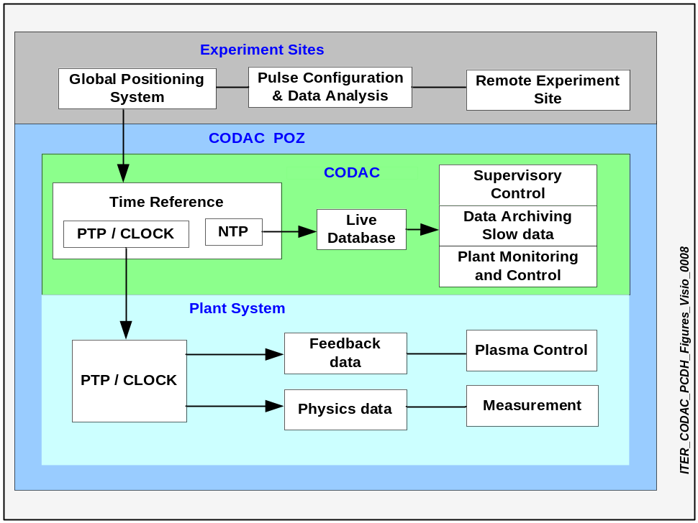
Figure 4.6 Time Domain

TCN allows actions, events, and data in all ITER systems to be synchronized through Global Positioning System (GPS)/Galileo (TBD) connection. Global Positioning System/Galileo will provide the external reference timing signals for CODAC. These signals will feed all the subsystems using IEEE 1588-, Precise Time Protocol (PTP) and Network Time Protocol (NTP) or from a stable master clock. The GPS/Galileo system link will be dual redundant.

CODAC will provide the timing signals or master clock to all of the Plant Systems. If some of the Plant Systems require their own synchronisation system, this must be slaved to the master clock provided by CODAC.
The reference time for ITER will be UTC.
All the computers located within POZ must be synchronized by NTP through the Plant Operation Network. For feedback control, diagnostics, and physics purposes a dedicated TCN network will be used. It will be interfaced with Plant Systems I&C through the TCN Interface Unit which will be located in Plant System cubicles along with PSH. NTP signals are used for overall plant monitoring, time stamping for slow data sampling, data logging and supervisory control.

Remote experiment sites are synchronized by Global Positioning System/Galileo signalling and managed outside the POZ.

PTP signals are used for feedback control and fast data acquisition. They provides a reference time for data exchanges between Plant Systems and between Plant Systems and CODAC through the SDN.

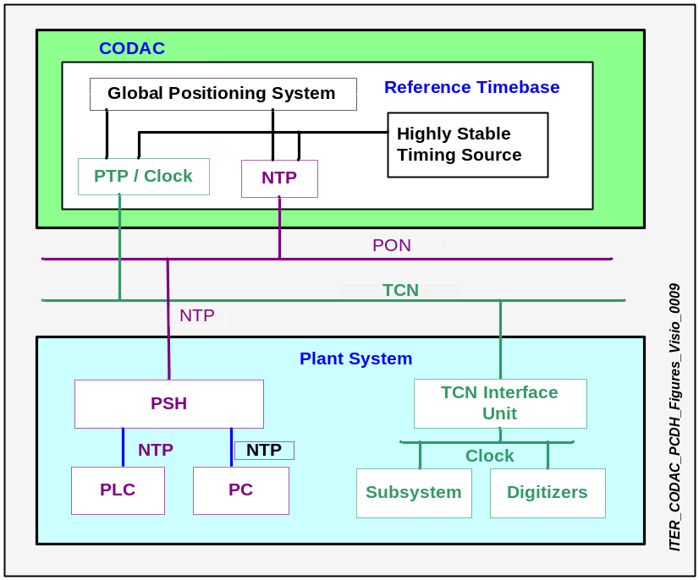

Figure 4.7 Time Synchronization

The TCN Interface Unit will provide CLOCK or IEEE 1588 signals to Plant System I&C through dedicated cables.

The front end functionality is:

  - PTP : IEEE 1588 version 2.0 [TBC].
  - NTP : 1msec with 100nsec jitter [TBC].
  - CLOCK : 1MHz with 50nsec jitter (TBC: CLOCK synchronized with PTP ).

The specification of the TCN will be provided by IO.
PTP and TCN will be supplied by IO. TCN interface unit / card will be supplied by IO [TBC].

Event Distribution Network
The EDN network is used for real time event data exchange purposes for which the latency time must be minimized.

The specification of the EDN will be provided by IO. It will be based on a dedicated fibre connection. It will be interfaced with Plant Systems I&C through the EDN Interface Unit which will be located in the Plant System cubicles along with the PSH.

EDN will provide following functions:
- Distribution of hardware & software events.
- Configuration of Event parameters.
- Recording and display of events with time stamp.

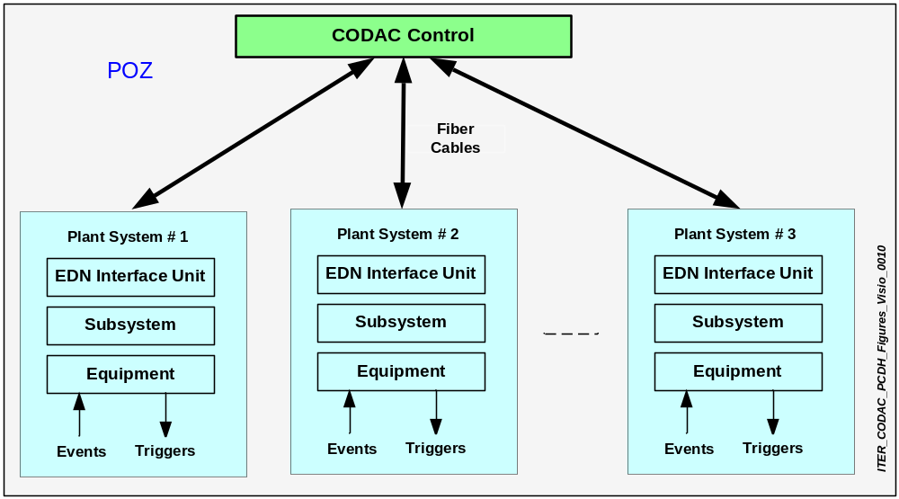
Figure 4.8 EDN Architecture
EDN Parameters:

- Event distribution latency: < 10 µsec [TBC].
- Event coding: 64 bits [TBC].
- Resolution of events recording: 100nsec [TBC].

Audio/Video Network
The AVN network will be used for visual monitoring of the Plant Systems and wide diagnostics purposes. The specification of the AVN will be provided by IO. It will probably be based on dedicated Ethernet fibre connections. It will be interfaced with Plant Systems I&C through the AVN Interface Unit which will be located in the Plant System cubicles along with the PSH.

The AVN Protocol standard will probably be
- Surveillance: H32x or H.264 [TBC].
- Fast Video Data: H32x or H.264 [TBC].

The AVN components and its specification includes

- Source devices: Camera, MIC [TBD].
- Receiving devices: Screens, TV .
- Transport devices: N/W, Fibre Optic, switches [TBD].

Central Interlock Network
The primary function of CIN is to provide a communication interface between the Central Interlock System and the Plant Interlock System through the interlock I&C Bridge. The specification of the Central Interlock Network will be provided by IO. More details are given in section 6.

Central Safety Network
The primary function of Central Safety Network (CSN) is to provide the data exchange mechanism between the Central Safety System and the Plant Safety System through the safety I&C Bridge. The specification of the Central Safety Network will be provided by IO. More details are given in section 7.

Network Interface Points

The networks that will be interfaced are:

- Asynchronous communication (PON or PCN during commissioning).
- Synchronous communication for time distribution (TCN), synchronous data exchanges (SDN), events (EDN) and Audio/video communications (AVN).

Figure 4.4 shows the network interface points between Plant Systems and CODAC. Currently Network Interface Units are black boxes and described as use model interface between Plant Systems I&C and CODAC.

The interfaces between PSH and CODAC will be Ethernet fibre and interfaces between SDN, EDN, TCN, AVN are dedicated fibre links provided by IO. The technology choice will be decided later. The interface between the PSS and PIS signalling for status and data only is a dedicated fibre link. It will be provided by the Plant System.

The connectors and fibre cables from Network Interface Units to Subsystem Controller and from PSH to Subsystem Controller are defined by CODAC and will be provided by the Plant System Supplier [TBD]. Plant System I&C must provide the necessary space to locate the Network Interface Units along with PSH in their cubicles.

CODAC Plant Operation Network to Plant System Host
The PSH is the single entry point for asynchronous communication into a Plant System as shown in Figure 4.9. Currently PSH is a high performance Industrial Computer and will be defined by CODAC [TBD]. It provides the data exchange mechanism for commands and status information between CODAC and Plant Systems.

Specification of the PSH and CODAC interface i.e. PON, will be provided by IO. It will probably be an Ethernet fibre connected to the PSH from CODAC networks through CODAC I&C Bridge.

Data Exchange messages between PSH and CODAC are provided and defined by the PSH software applications. Self Description Data and status of the Plant System parameters will be marshalled from PSH to CODAC by this interface.

Synchronous DataBus Network to Subsystem Controller
The interface specification between the SDN and Subsystem Controller will be provided by IO. The interface between the SDN and Subsystem Controller will probably be as shown in Figure 4.9 and will be a real time Ethernet fibre. The connectors and Fibre cables are defined by IO and shall be provided by the Plant System Suppliers [TBD].

SDN Interface Unit
The specification of the SDN Interface Unit will be provided by IO. [TBD]

Time Communication Network to Plant System I&C
The interface specification between the TCN and Plant System I&C will be provided by IO. The interface between the TCN and Plant System I&C will probably be as shown in Figure 4.9. It will be an Ethernet fibre.

TCN Interface Unit
The specification of the TCN Interface Unit will be provided by IO. [TBD]
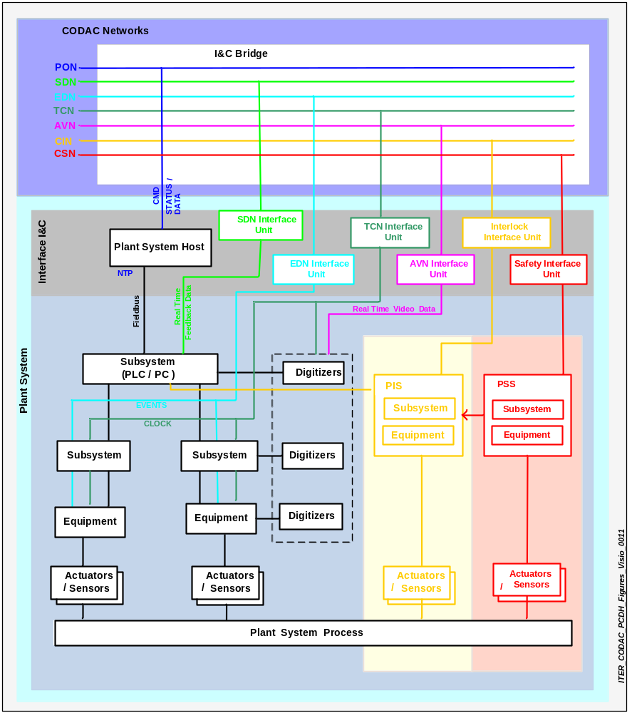
Figure 4.9 Plant System interface points

Event Distribution Network to Subsystem Controller
The interface specification between the EDN and Subsystem Controller will be provided by IO. The interface between the EDN and Subsystem Controller will probably be as shown in Figure 4.9 and will be a dedicated fibre link.

EDN Interface Unit
The specification of the EDN Interface Unit will be provided by IO. [TBD]

Audio Video Network to Plant System I&C
The interface specification between the AVN and Plant System I&C will be provided by IO. The interface between the AVN and Plant System I&C will probably be as shown Figure 4.9. It will be an Ethernet fibre.

AVN Interface Unit
The specification of the AVN Interface Unit will be provided by IO. [TBD]

Central Interlock System to Plant Interlock System
The Plant Interlock System (PIS) connection to the Central Interlock System (CIS) permits the PIS to communicate its status and data to the CIS. The interface specification of the CIS and PIS will be provided by IO. The interface will probably be as shown in Figure 4.9. Central Interlock System provides monitoring, recording of Interlock actions. The status of PIS and CIS will be monitored by the CODAC.

Central Safety System to Plant Safety System
The Plant Safety System (PSS) connection to the Central Safety System (CSS) permits the PSS to communicate its status and data to the CSS. The interface specification of the CSS and PSS will be provided by IO. The interface between CSS and PSS will probably be as shown in Figure 4.9 and it will be SIL3 [TBD]. Central Safety System provides monitoring, recording and safety actions which are regulatory requirements. The status of PSS and CSS will be monitored by the CODAC.
Please refer to section 7.

Plant System Local Communication Bus Interfaces
The Plant System Local Communication bus structure will be based on a field bus or Personel Computer (PC) interface standard. The network topology will be selected according to the engineering requirements. The network or field bus topology inside the Plant System will be selected by the Plant System designer. However, the network topology must have sufficient redundancy.

Plant System Host to Subsystem Controller
The interface specification between the PSH and Subsystem Controller will be provided by IO. The interface between the PSH and Subsystem Controller will probably be an Ethernet (fibre) in most cases and the connectors and fibre cables will be defined by CODAC but will be provided by the Plant System Suppliers [TBD].

Software specifications will be defined and implemented by IO inside the PSH to communicate effectively with the Subsystem Controller, provided it belongs [TBD]

This interface as shown in Figure 4.9 will be between PSH and a standard PLC or using Standard Computer architecture.

The communication network will be based on field bus or PC interface standards. If a non standard PLC or Computer is used, then the Supplier must provide and validate all the interface software provided in the PLC or PC and develop and validate the additional communication software in the PSH. Such deviations from standard specifications must be justified by the Plant System Supplier and will be considered on a case by case basis and must be agreed by IO, provided an obsolescence management plan has been supplied.

Plant Interlock System to Subsystem Controller
The interface specification of the PIS and Subsystem Controller will be provided by IO. This interface is inside the Plant System I&C boundary as shown in Figure 4.9. This signalling will be a unidirectional interface from PIS to the Subsystem Controller but it is internal to the Plant Systems design.

Plant Safety System to Plant Interlock System
The interface specification of the PSS and PIS will be provided by IO
The communication bus structure will be based on field bus or PC interface standard.

The hardware interfaces (Physical layer: cables, connectors) will be defined by IO and documented by Plant System Supplier. As a minimum, software interfaces will be status data from the Plant Safety System to the Plant Interlock System.

Subsystem Controller to Equipment
The Subsystem Controller will interface with the equipment through a field bus. The field bus will be chosen from the preferred field bus list specified by IO [TBD].

Hardware interfaces (Physical layer: cables, connectors) must be documented by the Plant System Supplier. Status, configuration and command control data will be exchanged between the Subsystem Controller and the I&C equipment. Data throughput will be defined in terms of volume and performance requirements.

Actuator Sensor Interface
The hardware interfaces (Physical layer: cables, connectors) must be documented by Plant System Supplier.

The status, configuration and command and control data will be exchanged between instrumentation / equipments and sensors / actuators.

This interface may be analogue or digital. [TBC]. The power must be provided to the actuators or sensors through this interface [TBD].

I&C Bridge
CODAC networks interface with the Plant Systems through the single entry point called the I&C Bridge. Its primary function is to provide a cross data exchange mechanism among CODAC networks.

The I&C Bridge is a standard Network Interface Unit that provides physical communication between Plant Systems and the CODAC Networks. Normally it would be a patch panel with no internal function other than connecting cables. It will be a wall or rack mounted unit, to be decided by CODAC network design choice or on a case by case basis.

The concept of the I&C bridge is currently under development and will be fully defined later during CODAC network design. The specification for the I&C Bridge will be provided by IO.

The I&C Bridge for FAT will be defined by CODAC as a part of the mini-CODAC test.

I&C Bridge will provide support for interfacing multiple networks. [TBD]

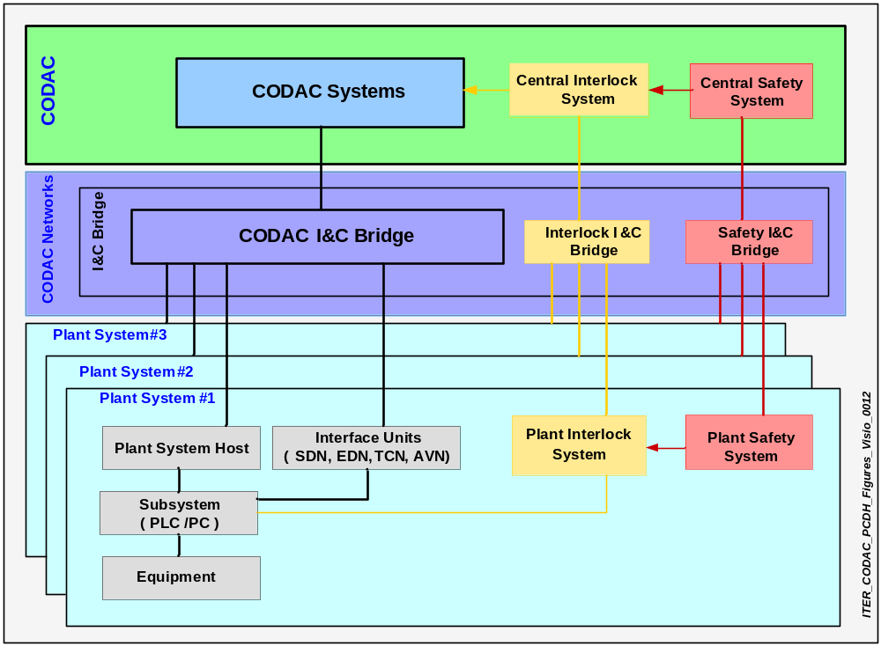
Figure 4.10 I&C Bridge

Communication Protocol

Methods and protocols
Data exchange methods and protocols will be defined by IO. These software interfaces are embedded in PSH while either embedded or recommended by IO for Network Interface Units. Plant System designers must use the software interfaces.

Physical Layer
The physical layer interface between CODAC and Plant Systems I&C defines communication cables, connectors, connection methods (i.e. network interface card), location. The choice of technology will be made later by IO and it will be provided as a separate specification document [TBD].

All the communication at this level will be through Fibre Optic cable [TBD]. Sufficient redundancy must be put in place for smooth operation. In the event of failure, the transfer must be seamless.

Network Standard
The technology choice will be made by IO and provided as a separate specification document [TBD].

Installed LANs must comply with standards and codes such as those for commercial building wiring, flammability, and emissions. as listed in Appendix C.

Data Transfer Rate
Specification of the data transfer rate will be provided by IO. The Ethernet rates will probably be in the range 0.1/1/10Gbps and comply with the relevant section of IEEE 802.3 or equivalent standard [TBC].

Provision for Plant System Interface I&C
Connectors and fibre cables from CODAC Networks up to the corresponding Network Interface Unit will be provided onsite by CODAC.[TBD]

- Network Interface Units

Network Interface Units (which includes SDN Interface Unit, EDN Interface Unit, AVN Interface Unit, TCN Interface Unit) connecting to a CODAC I&C bridge will be defined by CODAC.

Interface cabling
Cabling (Electrical and Fibre) and connectors between Plant System Interface I&C (this includes PSH, SDN Interface Unit, TCN Interface Unit, EDN Interface Unit and AVN Interface Unit) and the CODAC I&C Bridge will be provided onsite by CODAC. The required length of each cable for the FAT must be provided by the Plant System Supplier.

The Supplier must, as part of his documentation, provide full details of the connections on his equipment. Cabling (Electrical and Fibre) and connectors between PSH and Plant Subsystem Controller must be provided by Plant System Supplier.

Space for Interface I&C
Plant Systems must have the necessary space in their cubicles (i.e. inside rack) for the PSH and Network Interface Units.
A continuous space of 10 rack-units [TBC] shall be allocated for this.
I&C Bridge (switches, routers) are outside the cubicles.

Power Supply Interface
- Power Supply Class

The Class of power supply will be determined by the function being carried out by the Subsystem Controller and I&C and its position in the overall control hierarchy.

The power distribution is specified in the Electrical Design Handbook:
- Class I uninterruptible DC (48/110Vdc)
- Class II uninterruptible AC (230/400Vac)
- Class III temporarily interruptible AC (230/400V and 6.6kV)
- Class IV Indefinitely interruptible AC (230/400V and 6.6kV)
The IO will provide cubicle power derived from Class II supplies, backed up from UPS supplies. The acceptable Power Supply load and voltage variations required by the I&C equipment within the Plant System cubicles must be made known to IO at the earliest opportunity and at latest at the end of the Preliminary design. If, other power supplies are required because of the application then details must be supplied to IO.
Reference data for equipment power supplies and cubicles power supplies inside and outside the cubicles can be found in the Electrical Design Handbook document.

The power supply interface must be at the entry point to the cubicle, control panel or at an agreed set of terminals. Within the cubicle or panel the power supply must have electrical protection rated to protect the internal circuits and which discriminates (i.e. isolates) with the first upstream power supply protective device.

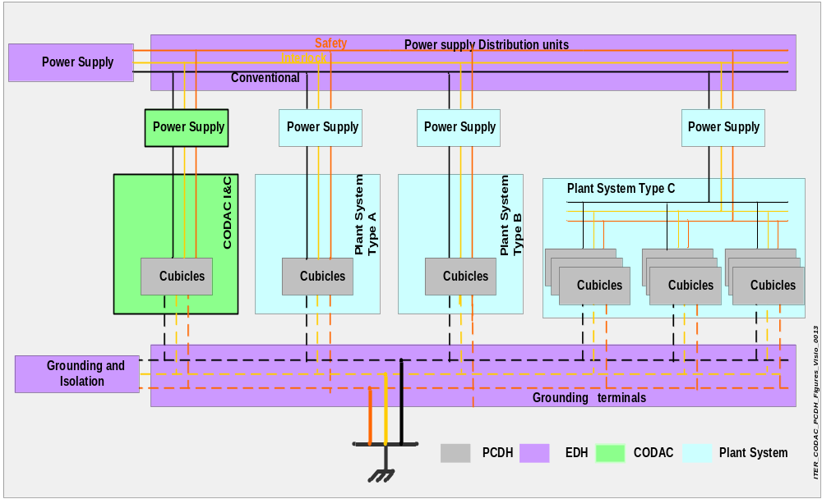
Figure 4.11 Power Supply interface
The power for the I&C systems has been categorised as a Class II supply which consists of an uninterruptible 230V AC. Input power other than Class II to the cubicles or panels must be monitored and if it fails or goes out of tolerance then the status must be transmitted to CODAC for immediate attention. This event should be taken into account for alarm reduction process.
The power supply distribution to equipment will be monitored and available from CODAC for recording and alarm reduction.
Whenever availability requirements lead to redundant equipment, the redundant units must be powered independently. Internal power supplies are expected to operate successfully during excursions of any one or combination of the supply parameters throughout the design life of the plant. A separate supply must be made available for anti condensation heaters and for door operated panel lighting circuits.

Building Interface
The operating environment inside buildings will be controlled by ventilation or air conditioning but possible temperature rises brought about by cubicle heat losses. must be allowed for. Given these boundary conditions, the cubicle will be expected to stay within the ambient conditions specified in Section 5.3.7. This information will be superseded by the environmental conditions defined in the Room book for buildings whenever they will have been defined.

IO is responsible for providing the ventilation in the buildings and rooms. The details of the heat losses expected from the Plant System I&C equipment must be documented so that sufficient allowance can be made in planning the capacity of the ventilation equipment.

Where the Plant Systems I&C are in stand alone cubicles or local control rooms (outside equipment rooms) then the Plant System Supplier must ensure that the equipment is capable of operating in the ambient temperatures expected at the IO site. In all cases, if internal temperatures in control cubicles exceed the recommended operating temperatures then an alarm must be generated and sent to CODAC.
Cubicles must be naturally ventilated unless agreed otherwise with IO. It is expected that proprietary equipment will make use of fans to cool the internals of some smaller components. Monitoring must be made available to ensure that in the event of fan failure or filter clogging these conditions are reported to CODAC at the MCR.

When designing and building equipment the operational environment must take into account all conditions including Electro Magnetic Compatibility (EMC) and any radiation effects. These may lead to additional requirements for:

The Building Plant System will define environment measurement sensors and their locations and provide interfaces to them through the Buildings PSH. The CODAC system will monitor environmental data such as temperatures, electro-magnetic field strengths, radiation levels, humidity, lighting conditions within the building through the PSH and report extreme or out of tolerance conditions.

Plant System I&C Specification

Introduction
This section describes the general I&C specifications which are common to all Plant Systems. It includes Installation of I&C hardware components and their environmental conditions, cubicles, software, alarm and error management. ITER I&C must follow the specifications provided in this section.

The hardware and software specifications are separated into Monitoring & Control, Interlock, and Safety.

I&C naming conventions
I&C project wide identification is not uniquely a CODAC challenge, but is a challenge for all ITER entities. All devices, components, self description data must be named in accordance with the convention which will provide meaningful and descriptive identification based on semantic data. I&C naming conventions will be provided by IO in a separate document called ITER Numbering System. The naming conventions will be supported and used during the whole life cycle of the ITER project.

Installation and Conditions
Installation methods based on different conditions expected at different locations around the facility will be defined.

Location for cubicles and equipments

The location of the instrumentation, cubicles, junction boxes will depend on the functional requirements and will be chosen so as to allow ease of access for initial installation and later for routine maintenance. Where the instrument can not be easily reached for practical reasons, then access platforms including ladders must be provided and must comply with the local safety regulations.

Computers, PLCs and other sensitive electronic equipment must be housed within rooms or buildings or annexes to the Plant System that they are serving. The CODAC equipment will be located near to Plant System I&C cubicles or inside them. Each facility must have space allocated to house the PSH at the interface point within the control cubicles for the facility

Access to the instrument, cubicle, junction box must be sufficient to allow installation of testing and calibration equipment without disturbing any other activity taking place in that area. Where test instruments have to be connected to cubicles, front panel connection points must be provided.

Installation of cubicles
Cubicles must be installed in pre designated locations in accordance with design drawings. Sufficient space must be available around the cubicle to allow easy access to terminate cables and to connect test and commissioning equipment.

The cubicles must be bolted down using recognised proprietary fixtures and fixings that meet the seismic classification for the cubicle.

Where vibration from either the process or from normal operations could cause premature failure then the cubicle must be mounted on appropriate anti vibration mounts.

Maintenance Access
Plant Systems Suppliers shall take measures to provide an easy access to components in order to facilitate maintenance or replacement..

Local Control Rooms
During normal operation, all Plant Systems will be operated from the MCR. Local control rooms may be required during commissioning, maintenance and problem recovery. By default IO assumes that no Local Control Room is needed for the Plant System; the necessity of the Local Control Room must be justified by the Plant System RO on a each particular case by case basis.

Grounding
Grounding inside the cubicles must comply with the ITER grounding plan specified in the Electrical Design Handbook (EDH).

Plant System I&C components connected to the ground line must comply with the noise and surge criteria requirements of IEC61000. All metal masses of electrical equipment must be earthed.

Ground grid components must be installed in accordance with the requirements specified in the ITER grounding plan.

Wires, cables, size of ground grid components, shielding, terminals, layout, impedance, transient ground potential and electronic equipment will be defined in the grounding plan in the EDH.

Insulation
CODAC and Plant Systems I&C components must withstand the following conditions:

- 1000V, 1 min (AC power supply~ ground).
- Digital I/O line; 1000V, 1 min (signal line~ ground).
- I&C Components [TBD].
- I/O Modules [TBD].
- Computers [TBD].

Cable insulation which must be tested includes but is not limited to:

- Between sensors and equipment.
- From the digital I/O to equipment.
- From actuators to controllers.

The cable insulation specifications will be provided in the EDH.

Explosive Atmosphere - ATEX Rating
An explosive atmosphere is defined as a mixture of dangerous substances above a specific limit, under atmospheric conditions, in the form of gases, vapours, mist or dust which, after ignition has occurred, combustion spreads to the entire unburned mixture either in the form of flame or more probably by explosion.

Atmospheric conditions are commonly referred to as ambient temperatures and pressures. That is to say temperatures of –20°C to 40°C and pressures of 0.8 to 1.1 bar [TBC].

ATEX is the name commonly given to the framework for identifying and categorising explosive atmospheres and the standards of equipment and protective systems used to prevent unsafe conditions. It is based on the requirements of two European Directives.

- Directive 99/92/EC (also known as ‘ATEX 137’ or the 'ATEX Workplace Directive’) on minimum requirements for improving the health and safety protection of workers potentially at risk from explosive atmospheres.
- Directive 94/9/EC (also known as ‘ATEX 95’ or ‘the ATEX Equipment Directive’) on the approximation of the laws of Members States concerning equipment and protective systems intended for use in potentially explosive atmospheres.

According to the ATEX classification:

A place where an explosive atmosphere may occur in quantities that require special precautions to protect the health and safety of workers is defined as hazardous.

A place where an explosive atmosphere is not expected to occur in quantities that require such special precautions is defined as non-hazardous.

IO will prepare hazardous area drawings from which an ATEX assessment must be carried out. In turn this assessment must be used to identify the classification of instrumentation to be used. Thereafter a HAZOP assessment must be made to confirm that any risk has been mitigated. A key document in this work will be the site safety case as this will identify areas and processes deemed to be hazardous. The rest will be non-hazardous.

The assessment must include:

- An identification of any hazardous properties and the amount of the dangerous substances involved;
- A review of the work processes and their interactions, including any cleaning, repair or maintenance activities that will be carried out in these areas;
- An identification of the temperatures and pressures at which the dangerous substances will be handled;
- An assessment of the containment system and controls provided to prevent liquids, gases, vapours or dust escaping into the general atmosphere of the workplace;
- An assessment of the explosive atmosphere formed within an enclosed plant or storage vessel; and,
- A review of the measures provided to ensure that any explosive atmosphere does not persist for an extended time, e.g. ventilation.

The assessment will also be used to identify areas within a workplace that are connected to other areas where an explosive atmosphere may occur., The areas distant from the source of the hazard to which an explosive atmosphere may spread, for example, through ducts, must be categorised based on this information.

The hazardous areas must be classified into zones based on the frequency and persistence of the potentially explosive atmosphere.

EMC Policy
The electromagnetic compatibility policy aims to ensure correct operation in the electromagnetic environment created by the Plant System during ITER operation. Compliance with international EMC standards applicable to industrial, commercial and special equipment does not, by itself, guarantee proper operation of the equipment and therefore the standard only provides guidance. Full compliance will involve the equipment being submitted to a series of tests that are representative of the conditions expected within the ITER plant.

Standards Applicable
The equipment must, as a minimum, comply with international standards IEC 61000 with equipment acceptance criteria determined on a case by case basis. Compliance must be by certified testing carried out by a recognised test facility accredited by an international organisation to conduct such testing.

Environmental conditions
The environmental conditions in this section will be superseded by those defined in the ITER room book.
These conditions will be continuously monitored and reported to CODAC.

The overall environmental conditions expected at different locations around the plant wide complex are as follows:

Inside air-conditioned rooms
- Normal Condition Temperature (guarantee required performances): 10-35°C [TBC].
- Off normal condition (guarantee operational): -10-50°C (air condition failed) [TBC].
- Humidity: < 80% RH [TBC].
- Radiation:[TBD].
- Dust < 0.xx mm³ [TBD.]
- Vibration: Anti vibration mounts to be used in high vibration situations.
- Seismic: Panels and cubicles etc. must withstand the expected seismic conditions expected for
that area of Plant System. Where appropriate, the equipment must be subjected to shaker table
testing or by equivalence to a project having the same levels.
- Electromagnetic: ElectroStatic Discharge (ESD), Radio Frequency (RF), Electric Fast Transient (EFT) [TBD].
- Lightning: [TBD].
- EMC Level IEC 61000 applied for the Radio Frequency Interference (RFI) and surge criteria for
the components.

Inside air-conditioned rooms
[TBD]

Outside air-conditioned buildings
Outdoor installation operating temperature: -20°C to +40°C (< 1000W / m² solar heat gain)
Operating humidity: <= 100% [TBD]
Noise: the maximum acceptable noise level less than 50dBA [TBC] measured at floor level (1.60 m) at a distance of 15 meters.

Status Monitoring
Interface specifications for the status monitoring including environment parameters of the Tokamak building will be provided by IO.

Cubicles and ex-cubicles
Each Plant System or Subsystem Supplier must produce a manufacturing programme showing all the activities involved in the production cycle including but not limited to:

- Metal work procurement.
- Cutting and welding.
- Paint preparation and painting.
- Component mounting and assembly.
- Internal Wiring.
- Internal factory testing.
- Witness factory testing.

Hold points must be agreed with IO and reasonable access to the production facilities must be granted to IO to allow verification of the status at that point in the production cycle.

Equipments and Instruments
Proprietary equipment and off the shelf components will be subjected to ‘Goods Inward’ inspection, part of which will include confirming that the component meets the claims outlined in the Certificate of Compliance. Where multiple components of the same or similar type are supplied, then tests will be carried out on a sample to verify accuracy and repeatability. Equipment supplied shall comply with Restriction of Hazardous Substances Directive (RoHS) [TBC].

Building environment
The entire building environment will be monitored and the status will be recorded and displayed at Local panel and at MCR. Control panels; alarms will be raised for any out of OLC signals. The data will be stored in the CODAC database.

Plant System I&C Hardware Specifications
Each hardware equipment and instrument within the Plant System I&C must comply with these specifications.

Plant System Host
The Plant System must be supplied with a unique controlled unit called PSH. The PSH provides a standard image of the Plant System to CODAC; it therefore presents a clear boundary for the limit of responsibility as well as providing a standard asynchronous interface.

The PSH must be a standard high performance industrial computer with application development tools, templates for self description data and standard applications [TBD].

IO has the responsibility for providing PSH software, providing Data exchange software, PLC suppliers SCADA & development tools, PLC communication platform, logging function, visualization functions [TBD]. IO will supply a generic PSH hardware and software to be configured and customised by the Supplier [TBD]. Any customisation shall be justified to IO.

It is the IO responsibility to provide PSH hardware [TBC].

The PSH must be located in the Plant System instrumentation cubicle. Appropriate allocations for space, power, ventilation, and connectivity must be made in the Plant System cubicle design.

The functionality of the PSH will include providing the interface to PLCs, PCs and non-standard field buses. It must provide standard gateway functionality for all asynchronous network communication.

The PSH must:

- Provide all self describing information concerning its Plant System.
- Marshal the flow of status data from the Plant System into CODAC.
- Interpret all the commands sent to the Plant System by CODAC.
- Provide local visualization and alarm handling functions for the Plant System.
- Support execution of Finite State Machine translations of the Plant System.
- Provide short term time local storage, error management functions for the Plant System.
- Contain the documentation and drawings of the Plant System at FAT.
- Handle configuration data coming into the Plant System from CODAC.
- Handle transition requests sent to the Plant System from CODAC.
- Provide data conversion, compression and decompression functions.
- Provide software security functions by data exchange mechanism.
- Support time synchronization from CODAC and propagate it to the Plants System I&C.

Detailed specifications of PSH will be provided in separate document [TBD].

Subsystem Controller
The functional specifications of the Subsystem Controller are defined in this section together with guidance on implementation.

The Subsystem Controller is the master of a single or multiple subsystems, supervising and managing their operation.
The Subsystem Controller must:
Communicate with CODAC through a PSH. In case of loss of communication with CODAC the Subsystem Controller has to take over control and operation, i.e. operate autonomously. The Sub System Controller shall be self-protected against erroneous controls coming from CODAC or PSH.
The Sub System Controller can be operated in one of the following modes:

Local mode
  - Execute Plant System states.
  - Provide alarm and logbook handling functions.
  - Provide data monitoring & visualization.
  - Provide data collection from local equipment / sensors.
  - Provide data conversion functions (binary data into engineering units).

CODAC mode
- Execute Plant System states.
- Provide alarm and logbook handling functions.
- Provide data monitoring & visualization.
- Provide data collection from local equipment / sensors.
- Provide data conversion functions (binary data into engineering units).

The mode is selected by CODAC software from the operator’s console or locally by a key operated selector switch and with the selection based on current state of the Plant System. Key authorization is handled by IO responsible officer.

The Subsystem Controller must be able to control, monitor, handle alarms, configure and test sub- system functions during the local mode of operation from the local control panels during commissioning, maintenance, testing, or fault recovery state. During normal automatic operation, the Subsystem Controller will be under CODAC control.

The Subsystem Controller may be a PLC, Industrial Personnel Computer (IPC), or embedded bus resource depending on the performance requirements.

The preferred solution for the Plant System slow data exchange for operation and control (response time in the range greater than 100ms), is an industrial PLC.

Beyond the PLC performance limits (i.e. a response time less than 100ms), called real time data exchange for operation and control, the preferred architecture is a computer or an embedded bus technology.

The Subsystem Controller must also have a facility for local data storage so that in case of loss of communication with CODAC, history can be retrieved from the Plant System on request from CODAC at a later date. Plant System Supplier must provide requirement of local data storage in their design documents.

PLC resources
Where the performance requirements for the Plant Systems operation and control are of the order of 100ms or slower PLCs will be used.

A restricted number of suppliers will be declared by IO as preferred suppliers.

Each Plant System or Plant Subsystem must use a single PLC manufacturer selected from the preferred supplier list.

The preferred supplier list: [TBD]

Computer resources
The interface between the PSH and faster subsystems outside the PLC "slow controls" domain will be from preferred technologies such as industrial PCs. Computer resources required for each Plant System will be defined by IO. The final requirements will be dictated by CODAC interface requirements (e.g., with regard to speed of response or sampling rates).

Each Plant System must select computers from a single supplier from the preferred supplier list.

Computer specifications: Industrial PC [TBD]

As computer technology evolves, specifications shall address compatibility issues or ensure upward compatibility.

A restricted number of suppliers shall be declared by IO as preferred suppliers.

Preferred supplier list: [TBD]

Local Bus Structure
Each Plant System must rely on a minimum number of communication networks. The Interface between PSH and Subsystem Controller must be based on field buses selected from the list of preferred field buses.

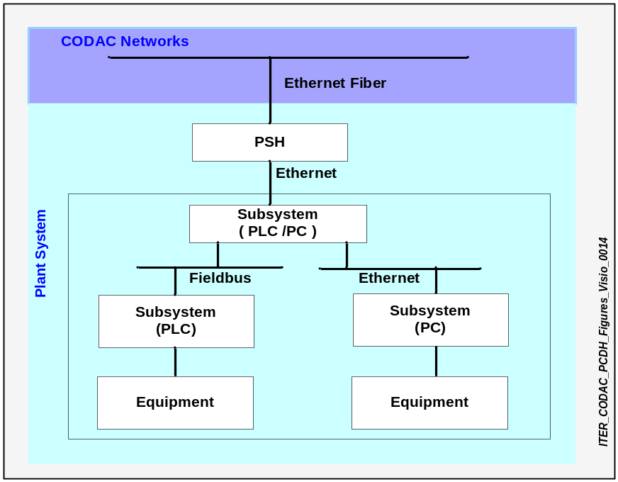

Figure 5.12 Plant System local communication bus structure
The Plant System local network design will be driven by the complexity of the data communication and the volume of data to be transferred within the Plant System. It is the responsibility of Plant System design engineers to design an efficient Plant System local communication network which will provide the required performance.

This local network must have alarm handling, monitoring, data exchange and control functions local to the Plant System.

Embedded Bus resources
For embedded bus technology, a restricted number of types and their suppliers will be declared as preferred suppliers.

Each Plant System or Plant Subsystem should use a single bus technology from the list.

Preferred supplier list: (TBD)

Examples of the likely embedded resources include, but are not limited to: (Peripheral Component Interconnect) PCI express /Advanced Telecom Computing Architecture (ATCA) / PCI Mezzanine Card

Field buses
The interface between the Subsystem Controller and PSH, as well as between Subsystem Controller and equipment must be chosen from the list of preferred field buses.

A restricted number of types and suppliers for field buses will be declared by IO as the preferred field buses.All fieldbus protocols should be defined as IEC 61158 standard [TBD]

Each Plant System or Plant Subsystem must use a single type of field bus selected from the preferred supplier list.

The preferred list shall be: [TBD]

Examples of the likely field bus include, but are not limited to: DeviceNet, ProfiNet, EtherCAT, PowerLink.

I/O modules
The general specifications for the I/O modules including accuracy and power supplies are specified in this section.

I/O modules must be standard I/O cards consisting of processor module, digital I/O, analogue I/O, Common Mezzanine Cards (compatible with IEEE 1386 standard), chassis, mother board, signal isolation, signal conversion, signal diagnostics. The performance must match the requirements of Plant System I&C.

I/O modules must be selected by the Plant Systems designers from the list of preferred PLC and embedded bus technology suppliers.

The selection and choice of I/O modules made by the Plant Systems designers should be based on the following typical specifications:

- Digital I/O
  - Digital Input Output (DIO) Voltage 0 – 5 V (Logic Level).
  - DIO Voltage 0 – 24V (Logic Level).
  - DIO Current 4 to 20 mA.
  - Digital Output (DO) Contact.
  - DO Open Collector.

- Analogue I/O
- Process Input:

A/I Transmitter 4 to 20 mA.
A/I RTD (Resistance Temperature Detectors) 3Line 4Line.
A/I TC.
A/I Contact.

- Process Output:

A/O Voltage 1 to 5 V.
A/O Current 4 to 20 mA.

I/O Modules shall have a self test facility and status of self test shall be displayed on front side by Light Emitting Diode (LED) and communicated to CODAC.

The types of I/O Modules and their model numbers must be clearly specified by the Plant Systems designers and details recorded in the System Operation and Maintenance manuals.

Diagnostics will have generally specific I/O modules [TBD].

Selection and choice for long term availability, quality of products and compatibility with Plant System I&C must be justified by the Plant Systems designers in their documents if non-compliant with the technologies selected by IO.

Sensors and actuators

Sensors and Actuators for Plant System processes
The selection and choice of sensors and actuators is the responsibility of Plant Systems Suppliers while IO will recommend for the choice. [TBD]

Isolation, noise, withstanding surges and the environmental conditions during operation must be considered during selection. Also, if possible they should be fitted with self test facilities, e.g. to allow operation of switch contacts, as an aid to end-to-end testing.

AVN sensors
Specifications for AVN sensors for surveillance purposes must be defined; these include microphones and cameras which must be compatible with H.323 or H.264 standards [TBC].

The Specifications for diagnostic AVN sensors is the responsibility of diagnostics Plant Systems. CODAC will provide interface to these diagnostic sensors.

Basic properties of Sensors and Actuators
Since the selection and supply of sensors and actuators is the responsibility of the Plant System , this section is not prescriptive but only indicative.

Specifications defined by Plant Systems will make use of these basic properties for sensors and actuators.
- The power supply to instruments, sensors and actuators must be individually protected against short circuits.
- There will be monitoring for short circuits and they must be reported through the HMI for monitoring and also a visual LED indication must be provided at the power supply for over current detection.
- All current pulse inputs for sensors and actuators must be equipped with galvanic isolations.
- All digital inputs must be optically isolated. All outputs must be isolated and buffered to drive the load requirements.
- Sensors and actuators must be easy to maintain (require little maintenance) and their body must be made of robust material which is compatible with the application environment.
- The data exchange mechanism will preferably use a single cable.
- The sensor connection cable should have mechanical and electrical connections that are suitable for rapid attachment and exchange of the sensor.
- For all the different detector types and measuring functions which are in harsh environments, analogue signals of 4–20 mA must be used in each low frequency measuring system in order to minimise noise in measured signals.
- Status information and controls signals must be defined.
- High power actuators, motors, valves, magnetic valves, must be equipped with an individual control module and must contain the electronics required for the most important functions. These electronic control modules must be supplied by Class-II power supplies.
- Monitoring information for sensors should be transmitted to the Plant System I&C whenever possible.

Cubicles
A restricted number of types and suppliers for cubicles and patch panels will be declared as preferred suppliers by IO.
All deliveries to I&C must be enclosed in racks and the racks must be in cubicles.

Specifications will be provided for the enclosures and for chassis manufactures covering cases, chassis, crates, mainframes and enclosures (rack-mount, wall mount, tower, or top table).

Cubicle specifications will be defined according to the IP protection ratings that are determined by the cubicle location and application.

Subsystem controllers, equipment and I/O modules must be installed inside these cubicles.
Visual indications such as LEDs to indicate PLC/PC/Module status and operating mode must be provided on the front of the housing.

Cubicles General Specifications
Dimensions: The minimum dimension must be 800 mm square with front and rear access and bottom cable entry. The front door must have a minimum of two lockable handles and be supported by three chrome plated hinges of a size that each can support the weight of the door. The cubicle and contents must be seismically accredited for the levels expected at the cubicle location. As much as possible, ventilation slots sized for natural ventilation must be provided to ensure that the internal temperature does not exceed that at which damage would occur to the internal components. Forced cooling will be envisaged if necessary.

Material: The enclosure material must be Corten steel or equivalent and be a minimum of 2 mm thick. The material selected must resist the expected environmental conditions over the design life of the Plant System. The material must be stainless steel where high magnetic fields are expected. The cubicles must ensure that the number of openings is minimised to reduce the effects on the internal equipment of electrical noise and RFI. The front of panel equipment must not be susceptible to the levels of RFI expected at the location.
Colour: once fabrication has been completed the panel steelwork must be shot blasted, primed and painted in a semi glass finishing coat of colour – [TBD]. Where the cubicles are mounted remotely, the paint finish must be gloss. The paint specification, type will be – [TBD]
The position and sizes of spaces for Cubicle identification labels and Hazard warning labels will be specified by the IO [TBD].

Location and Interfaces
The cubicles and panels must be located in positions where operational internal temperatures do not exceed the design limits.

The layout and access to components within the cubicles and panels must assume that only front access is available. Rear access shall be justified by the Plant System designers. The recommended minimum space required for access for maintenance and to withdraw major components must be shown on project drawings.

Internal cubicle drawings showing the location of external connections, equipment locations including their identity label, internal wiring routes between major components and the location of incoming power supplies,must be provided
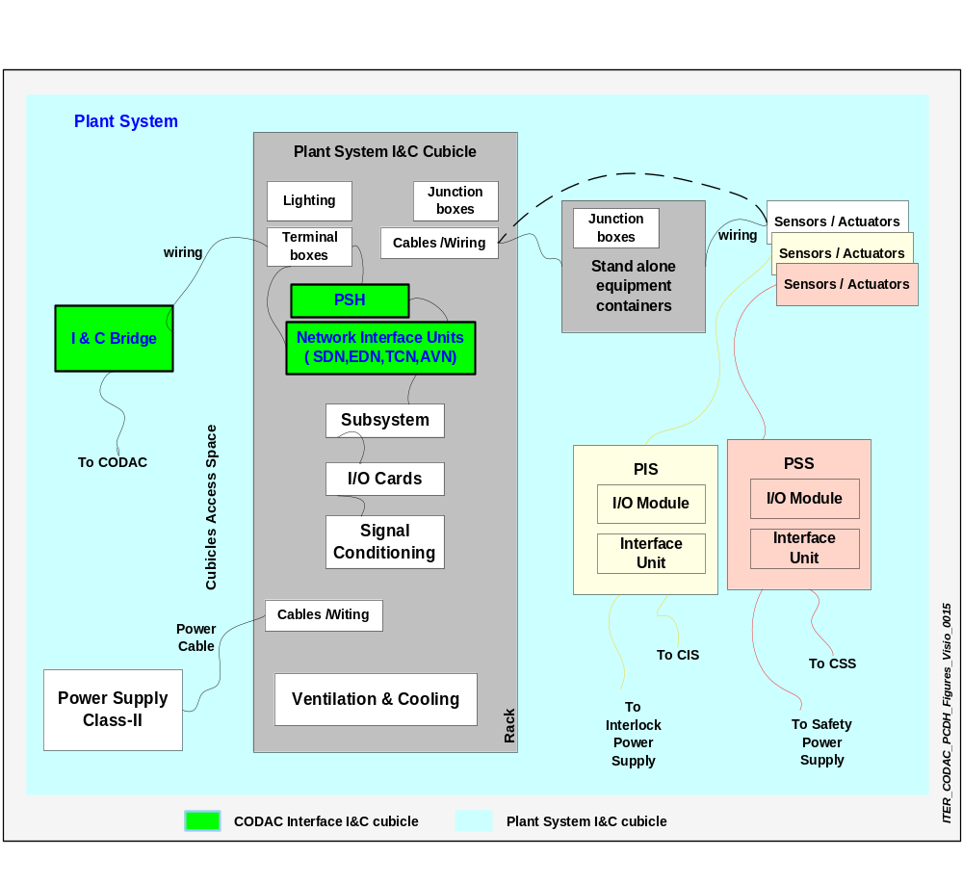 Figure 5.13 Plant System I&C cubicles

Cubicle Wiring

Internal
The insulation must be of a specification to meet the requirements of the voltage and process concerned.

The wiring can either be single core multi strand, solid or flexible multi core depending on the requirements.

Consideration must be given to thermal rating, ease of stripping, operating temperature, flammability, scuff resistance and hardening especially on circuits located on doors. Consideration must also be given to the proximity of the cable to the Tokamak which could result in insulation embrittlement.

The function of the wiring must be taken into account as some circuits will need screened cables which must, where practical, be kept segregated (i.e. separated in group) from any wiring that could either introduce or be susceptible to electrical noise and interference.

Facilities must be made available to terminate screens on ‘clean’ grounding points within the panel.

Wiring terminated in connection blocks must be grouped according to function and terminated using appropriate crimps. The terminals must be selected to match the function and trip circuits must use hooked type crimps with spring loaded terminals.

Care must be taken to ensure that wiring is not subjected to undue mechanical stress and is properly supported using trunks, cages.

Wiring and cables must follow the latest IEC recommendations for colour coding [TBD] and must all be numbered.

External
External cables must enter the panel or cubicle at the bottom in rooms where a false floor is available and at the top for others. They must terminate on a gland plate sized to accept the number and types of cable required. Once terminated, the cable cores including screen must be run and terminated internally at terminal strips identified for the function with the terminals sized to match the cable core.

Each terminal strip must be identified and each core provided with an identifier using circle type cable markers. The markers must be installed on both sides of the terminal strip and be read starting from the terminal and working outwards.

Cables will be numbered according to a site-wide cable numbering scheme [TBD].

The gland plate must be bonded to the cubicle or panel carcass and the cable armour must also be bonded to the gland plate using separate bonds.

It is essential that cable armour and cable screens are kept separate to prevent the introduction of loop circuits within the screen.

Where special grounding is required then the Plant System Supplier should notify IO at the earliest time possible.

The cable selected must not violate the IP rating of the cubicle, junction box or marshalling panel.
When a cubicle is located outside where it can be exposed to inclement weather, then the IP rating should be IP55 or higher and the cable gland plate and where practical, the cable gland must have the next higher IP rating,

Standards on Hazardous Area Classification of the operating areas within the facility must be consulted so that the correct type of cable and glands are specified. Information on cable penetrations into different zones and hazardous areas inside the cubicles will be defined and approved by IO.

Specifications of cables and their layout outside & inside the cubicles must be in accordance with the requirements of the Electrical Design Handbook.

Cubicle IP Rating
The cubicle IP rating will be determined by assessing the environment in which the cubicle, junction box or marshalling kiosk is located.

In general, if located indoors with a controlled environment, the IP rating could be as low as IP32. Conversely if located out of doors and exposed to the external environment then the IP rating should be IP 55 or higher. Where for practical purposes high IP ratings can not be achieved, then the cubicle must be located inside a weatherproof enclosure so that with no separate mechanical means of ventilating the enclosure the cubicle internal temperatures do not exceed the design values for the highest ambient temperatures.

The classification in terms of hazardous areas must also be taken into account when determining IP rating.

Racks
Racks must be used for housing crates, computers, electronic components and instrumentation.
The mechanical dimensions must be compatible with IEC 60297 standards.
The installation must comply with IEC standards. [TBD]
The screws, bolts, studs, washers and nuts must be specified in accordance with the metric system.
The metallic parts of the cubicle and other accessories must be made of steel. The material can change to accommodate environmental and process requirements with the agreement of the IO.
Access to the cubicle or rack must be through a hinged door equipped with a key-lock. Door opening shall be reported to the MCR.
All connections must be made on terminals located on side walls or if the integrity of the system requires, in a separate termination cubicle.
All luminous signals (LEDs) must be located on the front panel.
Luminous signals shall be visible under normal working ambient lighting: 250 lux [TBC] and [TBC] viewing angles.

Interface Cubicles
These include connectors / sockets, terminal boxes / junction boxes, signal wiring used to interface inside and outside to the instrumentation racks.

Specifications for the interface cubicles like dimensions, colour coding, and material properties are included in this section.
All individual items of equipment and their interface cubicles must comply with the IEC-60529 standard.
The cubicles must have Class-I or Class-II power supplies according to the specific application.
Connectors and junctions boxes must be fitted where quick connection and disconnection are necessary.
Access to the connectors and internal connections must be easy.
All connectors and junction boxes must be identified. The labels must be clearly visible and readable and be permanently fixed with screws. The inscription must withstand weathering and aging.
The degree of protection provided by connectors and enclosures of junction boxes must be specified by the Plant System Supplier.

Free standing items
These include wall hanging panels, panel doors, keys, channel base, hooking bolts and must comply with the requirements specified for cubicles.

Measurement of cubicles environment conditions
Plant System Supplier shall provide information for the requirement of environmental conditions inside and outside the cubicles.

Specifications for the cubicles environmental conditions measuring sensors will be provided by IO. [TBD]

Cabling and wiring
This concerns all cabling and wiring inside the cubicle (i.e. inside the racks and interface terminals)

EDH will provide the specifications for cabling and wiring inside and outside the cubicles, while standards for high voltage, power supply cable specifications are included in the Electrical Design Handbook.

Electrical
The electrical specifications for the Power Supply, Cable (including its terminal, type, size, and rated voltage/ampere) Use in different environmental conditions, Layout, Interface connectors, Screw terminals, Labelling, Wire types, Cabling, and wiring installation, colour codes, cable carriers and conduits are provided in EDH.

Labeling standards
- Labels must be used to identify cubicles, Plant System instrumentation, control valves and actuators and they must be clearly visible.
- Labels must be sufficiently robust to survive their environment for the project lifetime. The material for outside labels must be stainless steel and a heavy duty composite material for internal control cubicles and panels.
- The cables, jointing chambers, marshalling cubicles, termination chambers and cubicles must be labelled with a unique identifier to enable tracing and fault finding in both directions. The label details must be shown on the design drawings.
- IO will specify these standards which are applicable throughout the project [TBD].

Network cables
Plant wide cabling and its layout standards for networks will be defined in EDH. Fibre optic cables compliant with TCP/IP protocol IEEE 802.3 must be used [TBC]. The installation must be in compliance with the Ethernet standard.

[TBC]

Power Supplies

The power required by the Plant Systems must be categorised in accordance with the project standards. Guidance will be provided on the source of the required power and the expected voltage levels.

Unless specified in the design, all interface I&C electronics and equipment must be powered from Class II supplies in order to minimise the loss of availability due to a temporary loss of Class III or Class IV power, which would require a cold start of the I&C.

These power supplies along with interface terminals, sockets, cable types, plugs, colours, characteristics will be defined in EDH.

Plant System Software Specification
A restrictive programming environment is selected for Computers, PLCs and Embedded Resources.
This specification includes the use of languages, OS and platforms, methods, protocols, application development tools, testing and analysis software tools, tools for documentation, compilers, translators, editors, debuggers.

The Procurement Arrangement document must describe the software licensing policy including backup by IO for the software and tools employed by the Plant Systems.

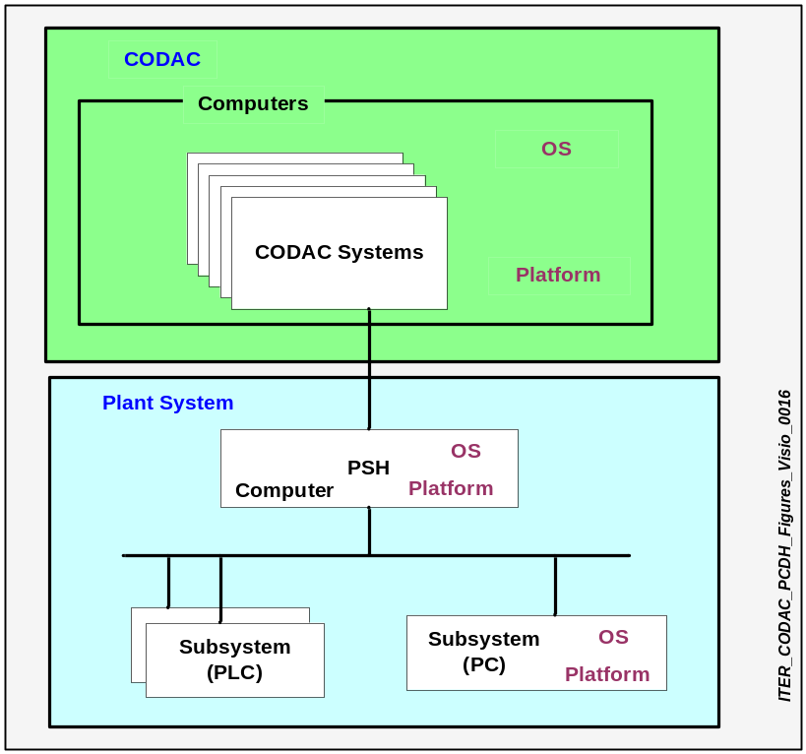

Figure 5.14 Operating system and platform

Specifications for operating systems and computer platforms will evolve in time and they have to be defined for plant-wide homogeneity. Selection of OS and platforms will be based on Plant Systems application requirements and integration of CODAC Systems and Plant Systems. [TBC]

Computer Software Operating Environment

Operating system and version
The OS for the Server Computers, PCs, PSH and Embedded bus technology will be standardized by IO. [TBD]

It also includes BIOS, device drivers, FPGA environment if used.

Software applications and components
Software applications: [TBD]
Functional specifications for the following components will be prepared: [TBD]

- Input data, format, and parameters.
- Output data, format.
- Application software.
- Performance, including the respect of any standard benchmarks.
- File structure
- Compilation rules if applicable
- Code reviewing procedure and code inspection

Methodology of testing software
- Standards : TBD

Computer Programming and Design Tools
These specifications will be based on the requirements offered by the Plant Systems but in compliance with CODAC.

Computer Programming Languages
A restrictive programming environment covering languages, compilers and editors etc. will be selected by IO.

The Supplier must provide current and final versions of all source code when the relevant equipment is delivered.

The preferred character encoding system is (Unicode Transformation Format) UTF-8.

Application programming languages will be standardised by IO. [TBD]

Scripting language
A restricted set of scripting languages will be defined by IO. [TBD]

Design and development tools
A restricted list of design and development tools will be specified as the preferred tools and it will include major and minor version numbers, supported standards, etc…

- Analysis tools
A restricted set of analysis tools will be defined by IO. [TBD]

- CAD tools (Computer Aided Design)
A restricted set of CAD tools will be defined by IO. [TBD]

- CASE tools (Computer Aided System Engineering)
A restricted set of CASE tools will be defined by IO. [TBD]

- Database management tool
A database management system must be utilised for production of the instrumentation and automation engineering deliverables including schedules and drawings. [TBD]

- System Simulation and Modelling Tools
A restricted set of system simulation and modelling tools will be defined by IO. [TBD]

- Software Versioning Control tools
A single VCS tool will be defined by IO. [TBD]

- Timing Diagram editing tools
A restricted set of tools will be defined by IO. [TBD]

PLC programming and design tools
The software design process must conform to IEC 61131-3 standards and use some or all of the following PLC programming languages:

- FBD (Function Block Diagram).
- LD (Ladder Diagram).
- ST (Structured Text).
- IL (Instruction List).
- SFC (Sequential Function Chart).

Tools for the PLC programming languages must be selected from the list of preferred PLC suppliers’ tools.

Software development SCADA tools
CODAC restricts the use of these environments [TBD]

Self description data
All technical information is provided in the form of structured data (i.e. self description data ) derived from the design tools or from CODAC tools.

This self describing feature requires a project wide use of a uniquely defined set of structured data. The data itself must be expressed in XML and the structure of the data must be defined using the XML Schema Definition language (XSD).

The Plant System exports all the relevant information as a "self description" data that is verified during Factory Acceptance Test. It will be a part of each procurement package. As long as only data are concerned, IO does not constrain the use of tools for development of the self-description data; however, IO will provide tools facilitating this work. [TBD]

After Plant System site acceptance, IO will maintain the master reference record of all changes to the data and will provide an off line backup of all the Plant System data.

CODAC will provide these self-description schemas to Plant System design engineers who are expected to fill the data in accordance with their design.

Data supplied by Plant System to CODAC

Self Description Data
The data that needs to be reflected in a self-description includes, but is not limited to:
- Signal List: Digital and analog signals on wires, sensor origins, electronic treatment (software), drawing references.
- Input-output list: Signals exported by the PSH: names, descriptions, units, properties.
- Set points: All information on values in the Plant System which can be set by CODAC: names, descriptions, units, properties, cross-reference.
- Alarms and Warnings: List of alarm conditions and their descriptions and priorities.
- Common Operating States (COS): List of COS, their transition commands and conditions, standard delays and alarm delays.
- Plant Operating States (POS): List of POS, their transition commands and conditions, standard delays and alarm delays.
- Plant Operating Limits and Conditions (OLC): Restrictions on operating this Plant System, independently of other Plant Systems.
- Data Sampling: Data sampling frequencies, dependence on COS, upper and lower limits, definition of streams.
- Synchronous DataBus signals: Definitions of signals on the Synchronous DataBus Network.
- Software: Firmware in modules, software in the Subsystem Controllers, software in the PSH, including source code, validation and verification results. History will be supplied.
- Module List: Hardware modules, origins, types, conversions, limits, configurations data, jumpers, manufacturers serial umbers, calibration histories and references to calibration measuring devices, histories of modules.
- Time Communication Signals: Definition of signals on the Time Communication network.
- Network use: Requirements for the use of the Synchronous DataBus Network, Event Distribution Network, Time Communication Network, Audio-Video Network and Plant Operation Network.
- Monitoring Data: Definitions of monitoring data provided by the systems.
- Access Rights: Access rights for categories of personnel identified in a secure list.
- Mimics: Structured data description of engineering mimics using a project-wide symbol library, mimics and diagrams delivered by the Supplier.
- Documentation: List and source of all documents, drawings, concerning the Plant System.
- Interlock Signals: Definitions of signals on the Central Interlock Network.
- Contacts: Information for contacting subcontractors for the equipment.
- General: Identification (ID) of the system, URL of the principle technical documentation for the system.
- History of the Plant System: All modifications to and tests of the Plant System from the time the initial testing is performed.
[WIP]

Schemas
XSD schemas are used for representation of the self-description data structure for Plant Systems. These schemas will be provided by IO as a separate document or can be downloaded from a dedicated IO website, https://portal.iter.org/departments/CHD/CODAC/SD. Version 0.2 is currently in effect.

Tools for typing in, importing from general ITER CAD databases and for exporting to PLCs, PCs and PSH will be supplied by IO.

Below is an example of self-description schemas: it shows the Plant System schema directory, Plant System I/O list, Plant System networks, Plant System modules, Plant System data streams and Plant System PLC I/O list. These are draft versions which indicate what these schemas are expected to provide.

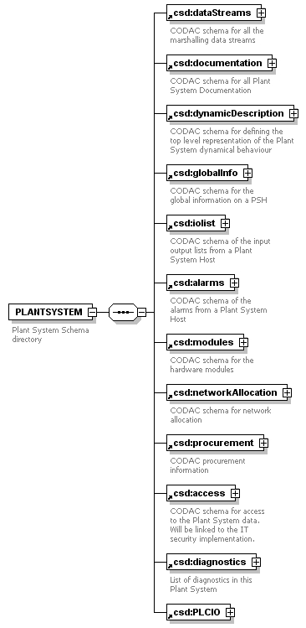

Figure 5.15 Plant System schema directory
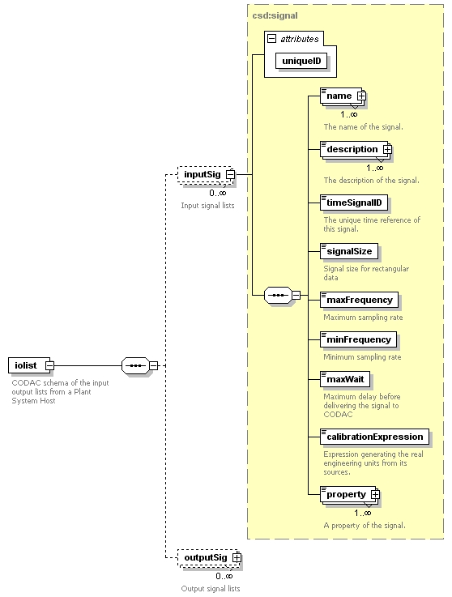

Figure 5.16 Plant System iolist schema

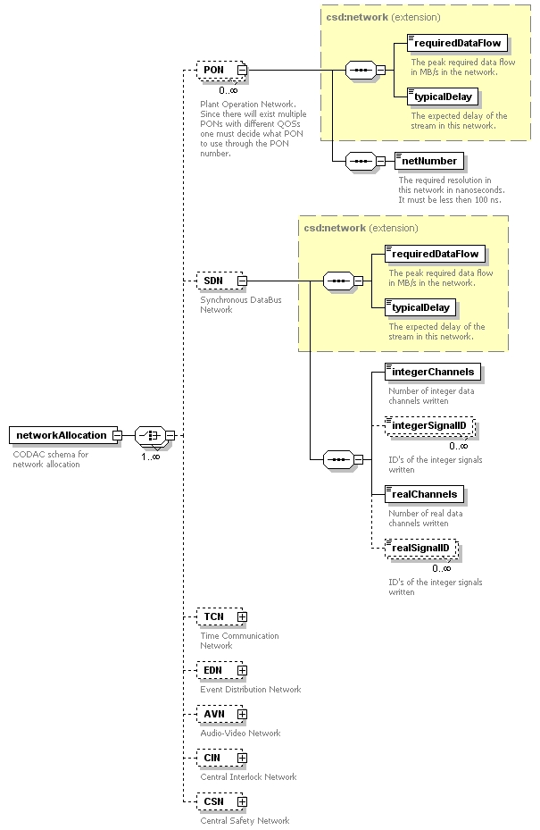

Figure 5.17 Plant System networks schema

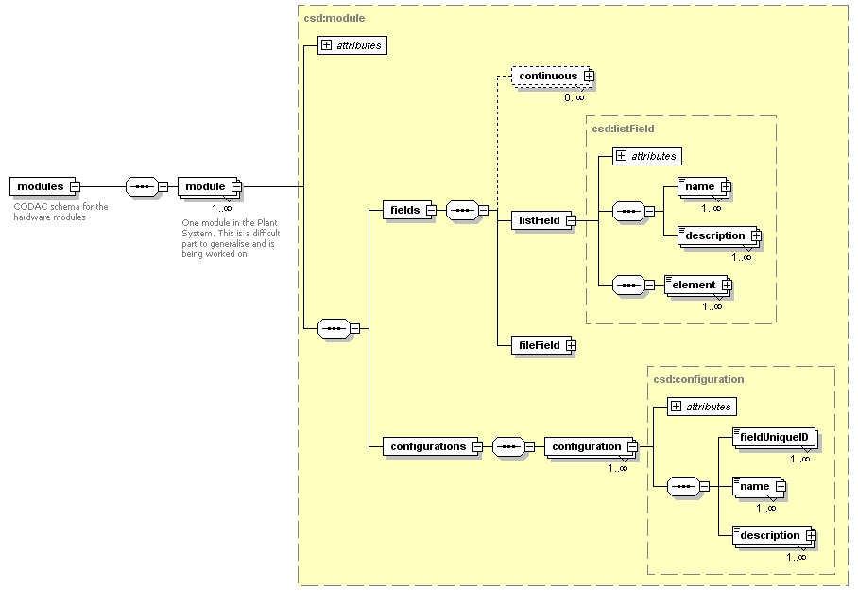

Figure 5.18 Plant System - modules schema

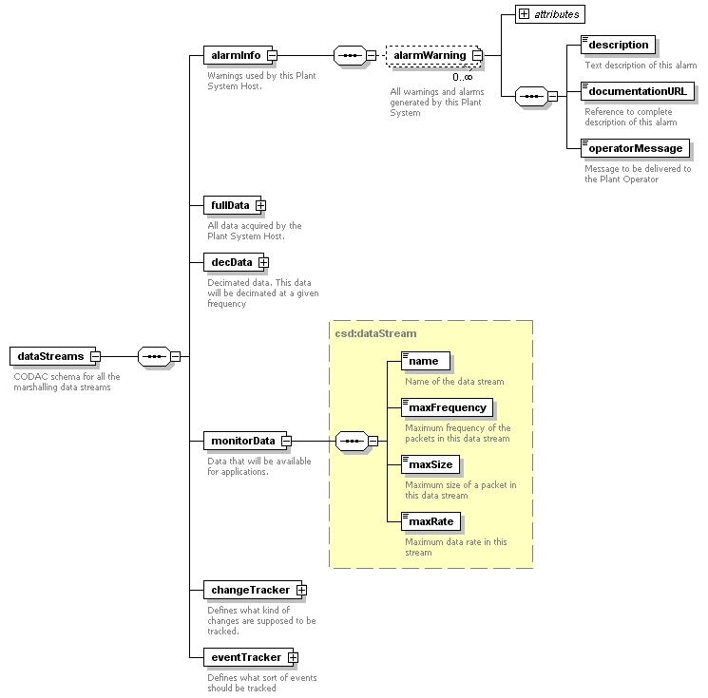
Figure 5.19 Plant System - data stream schema
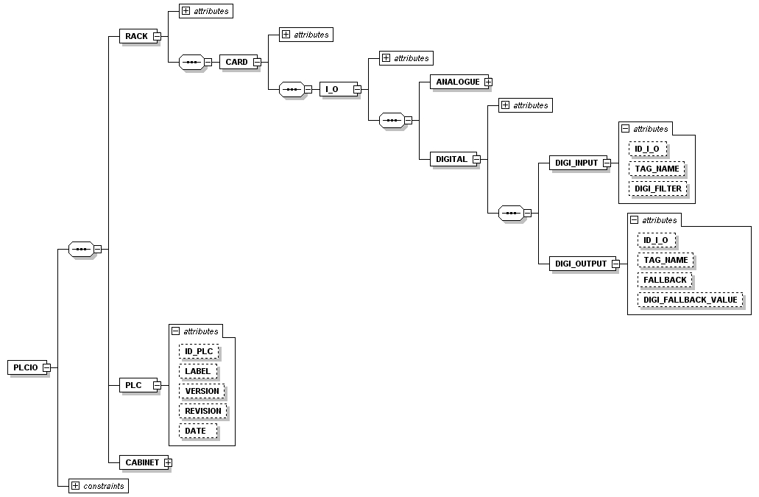

Figure 5.20 Plant System PLC I/O list

Plant System I&C templates
Templates for the Plant Systems interface I&C will be provided by IO and they must be completed by the Plant System Suppliers.

An overall generic specification for the different Plant Systems will be developed as more information becomes available from the Plant System Suppliers.

Information specific to the Plant System is provided as part of the self description.

Data supplied to Plant System by CODAC

For proper Plant System configuration some data will be provided by CODAC to the Plant System. Examples include:
- Definition of message exchanges on the CODAC networks.
- Allocation for signalling on CODAC networks.
- Project-wide parameters required by the Plant System.

Computer Software Applications

Subsystem control applications
Subsystem Controller applications are developed by the Suppliers. [TBD]

Plant System Local Data Management [TBD}

User Interface (HMI)
The operator must perform supervisory and control tasks through the HMI in an effective and efficient manner. This requires the use of various interactive windows such as graphics windows, control windows, alarm handling, trend windows, history, logs and reporting. This section addresses some of these aspects.

- Operator Console in local control panels.
- Alarm Monitoring.
- Alarm attributes and OLC.

Where a local control room is part of the Plant System, the HMI for Plant System will consist of a local interactive device integrated into the Plant System cubicles as part of a local operator workstation. Screen resolution will be standardised by the IO [TBD].
If there is no local control room, HMI is handled through CODAC in the MCR, but the Plant System designer still has to define and develop all the relevant mimics for his/her Plant System and it shall be reused by CODAC from MCR [TBD].

The HMI will have different access and authorization levels and IO is working towards developing a universal standard for this. [TBD]

- Visualization (Graphic Display)

The operator interface consists primarily of a workstation screen and the associated displays. Customized process and equipment operating displays (including faceplates) provide the interface for day-to-day operations, along with trend displays. The graphic interface will have following capabilities:

- Depict instruments, Plant System and piping using the image libraries provided by IO [TBC].
- Display live process data in a range of selectable display formats such as bars, numerical characters, line graph representation.
- Define window manipulation and switching functions for graphic windows.
- Define changes in primitive shapes and attributes according to process or system conditions.

CODAC will provide the guidelines for designing the HMI [TBD].

CODAC provides the tools for using Mimics for operation of the full ITER plant, for authorised setting of parameters manually, causing operation sequence transitions, just like any conventional industrial SCADA system. Displayable data include the logical and physical state of different parts of the plant, the recorded values from all instrumentation, engineering and scientific data, alarm states, interlock status.

Mimic diagrams will be displayed in the MCR and will be based on information and data taken from the Plant System P&ID. The information shown must be clear and easily read by the operator on his workstation.

The top level mimic will display all relevant information relating to the process being reviewed. When there is a change the Operator will have facilities to interrogate the Plant System where the change originated to determine the reason for the change.

The mimic will show any standing alarms associated with the process being reviewed. The information displayed will include the identity tag and the value of the process variable assigned to that device.

Selection of a signal or data or process will allow the operator to gain more detailed information relating to that particular item.

The interface must be user friendly, effective, efficient and durable. The actual interface can be a keyboard or touch screen, or a mixture of both.

Only the top level interface will be available to the operator. Where action has to be taken to maintain or modify a mimic, this must be carried out through a controlled (i.e. authorized) procedure and only by identified engineering personnel. The access procedure will conform to the site-wide IT security requirements.

CODAC uses English as the main language for the HMI, has a standard symbol set and a visual convention guideline as part of its framework.

Removal, addition or modification of synoptic views in the HMI must be done by manipulating data, not code.

Local storage
The Plant System must continuously monitor its own state and provide this information to CODAC during normal operation. The Plant System must also be able to be operated autonomously. This implies presence of local storage. After a loss of communication with CODAC, it must be possible for CODAC to retrieve the history once communications have been re-established. The local storage provided should be capable of storing a minimum of 3500 seconds (rotating buffered storage) and it must be provided in the PSH for asynchronous data communication between CODAC and Plant System.

Alarm handling
The purpose of the alarm system is to provide information to the Operator on conditions that are outside of the normal operating range by using both displays and audible signals. The alarm policy must comply with IEC 61511 standards.
Alarms can be prioritised into groups. Once an alarm is prioritised and accepted into the design, a formal procedure must be followed to make a change to its severity status. The alarm must be emphasised by a change in colour corresponding to the severity. For example, a Severity 1 will be red, a Severity 2 will be amber, and a Severity 3 will be white.
All alarms must be recorded and time stamped and must be transmitted to the alarm handing system even when the plant is in local mode.

- Severity 1 — Urgent or Emergency
These alarms result from a process trip which could lead to other systems tripping and number of alarms being generated from lower order systems. Where practicable, these alarms should allow some time for response but in general may need an immediate Operator action.

- Severity 2 — Warning or Caution
If not handled in a reasonable time, these alarms can allow the fault to develop and have an immediate effect on the process.

- Severity 3 — Information or Advisory
Information is provided where a system or process has changed state but it will not have an immediate effect on the process.

A plant wide alarm handling policy will be put in place to handle the alarm situations and to undertake corrective action to allow normal and safe operation to continue. Combinatorial alarms between Plant Systems will be processed at central level (CODAC, CIS, CSS).

Alarms must be generated at every level (PLC, PSH and CODAC) during all plant situations (alarms will be conditioned against global, common, Plant System operating states) and for various reasons as illustrated below:

1. Tolerance Errors: Errors generated when an analogue input- output device is operating outside its normal tolerance limits and conditions.
2. Hardware Errors: Errors generated from malfunctioning devices.
3. Time-out Errors: Errors generated due to a fault in the system’s communication media. In this instance a time out occurs and is acknowledged as an error.
4. Process Errors: Errors resulting from wrong interpretation of system commands. e.g. a valve commanded to open but responds as closed.

Alarm Management
Alarm management is the ensemble of processes and practices for determining, documenting, designing, monitoring and maintaining alarm messages. It will be a collection of hardware and software that transmits the alarm messages that are displayed to the Operator.
The alarm management system will:
- Where practical, identify nuisance alarms by verifying if the state of the process being monitored is healthy.
- Highlight alarms that have been present beyond a reasonable time after corrective action has been requested through routine maintenance procedures.
- Prioritise and filter alarms resulting from a major event and present these to the Operator in a manner that helps to identify the cause of the event.
- Assign the correct status to real alarms so that the Operator can take corrective action.
- Provide a timeout alarm if a severity alarm is not addressed in a reasonable time.
- Facilities will be available to acknowledge, accept and reset alarms from the MCR.
- Whenever control is switched to local mode, the acknowledgement will take place from the local control room.

Alarm Design
The designer will be expected to follow a formal procedure that:

- Identifies the hazard from the process being monitored and therefore the purpose of the alarm.
- Defines specific alarms for HMI i.e. identify source.
- Identifies the response time required to recover from an alarm and the time remaining before the alarm state develops into a more critical level.
- Identifies if the process requires alarms driven from independent sensors
- Identifies if the process requires two thresholds alarms so that the Operator has time to take corrective action before a critical situation is reached e.g. high, high-high, then trip.

Alarm Display
- The overall list of plant alarms will be available on CODAC together with their triggering causes but each individual Plant System will be capable of local and remote display of the alarms at the local control room and at MCR.
- Different alarm priorities must be shown as a different colour and have a different audible alarm. The audible sound must also differentiate between normal process alarms and safety important alarms.
- Where equipment is declared as out of service then any alarms associated with that item should be suppressed.
- Facilities will be available to allow the Operator to select predefined filtered lists of alarms. For example, chronological alarms, list of trip alarms, list of alarms related to a Subsystem or a component, list of alarms taking into account their states (raised, acknowledge).
- Facilities will be available to show an alarm sheet while accepting an alarm in a list. Every alarm will have its own alarm sheet listing the possible causes, the potential consequences if no action has been undertaken, the procedure to be followed to fix the problem and a mimic showing information useful to the operator in charge of dealing with the problem.
- The start up or shutdown alarm must always been visible on the HMI and it must not be possible to hide it with other windows.

Operator Action
The Operator will have facilities to:
- Suppress the display of lower severity alarms. The suppressed alarms must be available for review on screen as a separate list.
- Accept (acknowledge), either singly or as a group, similarly prioritised lower level alarms.
- Review previous alarms associated with the process being considered.
- Ensure any critical alarm status is always available.
- Manipulate the list to be most recent first or oldest first timewise.

Operator actions must be logged and time stamped on a log separate from the alarms system.

Logbook handling
Logbook handling provides functionality for all the events of the plant.
The logbook consists of a set of messages and each message corresponds to the recording of an event.
An event will include:
- A time stamp.
- A process identifier according to the naming scheme.
- A text explaining the event.

All these events will be recorded as lists, one line per event.

These events could be normal events or abnormal events. The following events at least will be recorded:
- All PSH state changes (start, configuration, stop, failures).
- All data configuration related operations.
- All OLC transitions.
- All commands sent by CODAC.
- All binary state changes (valve opened or closed for example).
- All events on an analogue variable or a group of analogue variables (threshold overshooting, out of range, discrepancy,...).
- All variable validity changes.
- All actions done locally by operators (log on/off, local commands, variable tagging or forcing).
- All local alarm acknowledgements.
- All timing, PSH, Subsystem Controller, PLC or PC system events.

The logbook will have both a follow-up and a history mode.
It will have sorting capabilities:
- Chronologically.
- By Subsystem.
- By Variable identification.
- By type of event (process, system).

In addition, it will be possible to print events sorted as defined above.

Plant System monitoring
The Plant System I&C will be monitored in order to diagnose faults and facilitate fast recovery.
The Plant System events will be reported in the logbook and also as alarms if necessary. This information will also be propagated to CODAC. The PSH will be able to display the states of the equipment part of the Plant System I&C on a mimic diagram.
Information on equipment performance will be included.
The consequences of equipment failure will be derived, displayed and recorded.

Preferably, SNMP (Simple Network Management Protocol) probes shall be used for CODAC networks in order to have a common central monitoring tool [TBD]

For each piece of equipment at least, three different states will have to be managed:
- Fully Operational
- Degraded (ability to fulfil the mission but with a reduced availability)
- Out Of Order

The equipment to be monitored will include at least:
- PSH hardware/software.
- PLC (CPUs, networks and I/O cards).
- PCs.
- Network.

Plant System monitoring will include self tests and live tests. The CODAC interface will be monitored in order to take local control of the Plant System if there is a CODAC/CODAC network failure.

Performance information such as CPU occupation, memory usage or network bandwidth used shall be recorded for capacity planning.

Display of variables
This display covers three types of data:
- Follow-up values.
- On-Off value trends.
- Analogue value trends.
To implement these displays, two functions have been defined:
- The Follow-up Values function, which displays the current values and current status of the variables.
- The Trend function, which displays the trends, values and status, of the variables with the ability to pre-pend historic data.

In order to provide for the grouped handling and display of several variables, various groupings may be defined. They are implicit, declared at the configuration stage or on line on an Operator work station.

By selecting any variable, on any screen, for any function, the operator may access a technical data sheet giving additional detailed information on the variable such as:
- Full name.
- Acquisition path or computation equation.
- Electrical train.
- Location of the sensor.

A trend function will be provided to monitor the trends of analogue variables along with on-off variables individually or belonging to a group.

This display can be made in two modes:
- Numeric mode, which displays values as text.
- Graphic mode, which displays values as plots.

In both of these modes, the operator has the choice between:
- Follow up mode, where the value of the variables is displayed on the screen in real time, from the time the request is made and is updated in accordance with the time scale chosen by the operator.
- History mode, where the value of the variables - whether they are acquired or computed, Analogue or On-Off - are displayed on the screen after retrieving the history.

Applications for the execution of Plant System state machine [TBD]

Plant System coordinating applications: [TBD]

Performance
This section gives requirements for the Plant System I&C performance.

The Plant System I&C is split into:

- Mandatory functions such as monitoring, controlling the Plant System.
- Auxiliary functions such as printing, visualization, archiving.

The following performance parameters must be considered by Plant System I&C designer.

- Plant System I&C availability must be guaranteed for mandatory functions.
- Each CPU’s load ratio of the processor module must be less than 60% on average in any 10s period.
- Usage of main memory should not exceed 60%.
- Network and bus loads must not exceed 60%, and for the Ethernet based on the Carrier Sense Multiple Access with Collision Detection (CSMA/CD) principle it must not exceed 30%.
- Additional I/O channels reserves (not equipped) per type must be more than 20%.
- Additional I/O channels reserves (equipped) per type must be more than 5%.
- Update of information from sensors to PSH HMI and centralised CODAC networks must be less than 1 sec.
- Operator response for selection on display shall not exceed 200ms.
- Unitary commands from CODAC Networks to actuators must not exceed 1sec.
- In the case of an avalanche situation (caused by the loss of a subpart of the I&C or by loss of power), display and control performance can be degraded by 50%, provided this situation does not last more than 1 minute.

Software Security
Access to the CODAC Systems will be through approved access points and agreed with the site overall security requirements. There is no need to employ network security on the levels below PSH. Direct communication to the Plant System from outside the POZ is prohibited.

Display devices
Display devices will be specified for different areas of the Plant Systems taking into account the environment in which it is expected to operate. Usage of local hardware panels will be limited as much as possible.

Layout of control panels will be based on the design principles of IEC 60964 standards for operator controls.

The exact specification of Plant System display devices and mimics will be provided by IO as a separate document [TBD].

Panel Layout
Design principles predefined by IEC 60864 standards for operator controls in Plant System must be used.

The Plant System local control panels must be defined and specifications provided for control room instrumentation like controllers, recorders, relays, annunciators, control stations (push buttons), socket outlets.

Display terminals
The IEC 61772 standard must be used to provide guidance for designing high quality displays and understanding the processes through which people using the displays interact with Plant Systems.

In particular the standard includes:

- Consistency of format, symbols, character types, character sizes and colour.;
- Task focus, whereby the displayed information directly supports the task for which the display is designed.
- Ease of navigation, so that from a given display other displays in the hierarchy can be easily accessed.
- Consistency with the user expertise level, so that novices as well as experts can make effective use of the displays.
- Mimics for interface boards, status, and operator control panels must be defined.
- The display must also show the status of the Plant Systems including alarms and warnings.

Printing devices
The Plant System I&C must include at least one colour printer which will be defined by IO [TBD].

Interlock I&C Specifications
  - Introduction
The interlock I&C components must have a Safety Integrity Level (SIL) that complies with the requirements decided during HAZID and HAZOP studies. The selection of the level of redundancy will be made on SIL levels for individual interlock functions. For the highest SIL levels, it is likely that the interlock system will consist of a two out of three (2oo3) system in order to provide the required level of reliability and availability.
  - Sensors
The choice of sensors for interlock functions will be based on the requirements decided during the HAZID and HAZOP studies.
The number, the type, the SIL classification and the functional allocation of sensors must guarantee the required level of reliability and availability.
  - Actuators
The choice of actuators for interlock actions will be based on the requirements decided during the HAZID and HAZOP studies.

As a rule of thumb, interlock actuators that have a direct impact on the plasma operation will employ redundancy.
  - Programmable Logic Controllers
Where the interlock system makes use of a PLC system, then the designer must ensure that the PLC system has been assessed by an independent third party as having the necessary safety integrity level for the interlock functions.

The choice of the PLC must be based on the requirements set in chapter “5.4.3, PLC resources”.

The PLC must have the capability and capacity to:
- Interface with the input/output signals from the Plant System.
- Control any actuators or solenoids required to make the process safe
- Provide the diagnostics required to monitor the health of the PLC and its support signals
- Store data over a period of time that will be agreed with IO and have the capacity to download the data on request by CODAC and at the agreed rate
- Drive process mimic diagrams on the local panel
- Exchange data with CODAC using an open standard format
- Manage the alarms generated from within the process.
- Manage the operating limits specified by the designer as applicable to the Plant System.

In addition to the above, the PLC must have sufficient capacity to control and monitor the relevant Plant Systems.

It must be possible to control, monitor and test subsystems from the PLC using a standard interface unit during initial pre-commissioning, commissioning, operation, and Subsystem testing and fault recovery. The interface unit must use a universal open communication system.

The volume of data to be handled is a critical parameter for the overall PLC performance within the Plant System. During the PLC specification process, 20 percent spare capacity [TBC] should be allowed for future needs.
  - Field buses
Where field buses are proposed, the software must be subject to a full independent assessment to verify and validate that the software can meet the SIL. The fieldbus must comply with IEC 61158 and be capable of fast, accurate transfer of data between the process controller and the subsystems and devices connected to it.

The fieldbus must be capable of handling the volumes of data requested under the conditions imposed by CODAC.
As no particular fieldbus has assumed ascendancy in the market and because the time scale of the ITER plant spans over 35 years, it is probable that fieldbus will change significantly. For these reasons ITER will define a list of preferred buses from which the Plant System Supplier must choose.
  - I/O modules
Input/output modules will be supplied to convert data to and from sensors into a digital form that the PLC can use to monitor particular parts of the Plant System.

The signals will be grouped by type and accuracy with each I/O module handling the circuits for one particular function. Each module must be powered from within the control panel or cubicle. The power source and signal must be designed to comply with the area classification in which the device is located.

In order to reduce the spare parts inventory standard modules must be used where ever practical.
It must be possible to replace the module whilst it is energised and on-line. Sufficient spare parts must be available to accommodate I/O module maintenance, replacement and upgrade.

Full details of module conversion rates, accuracy, limits and connections will be determined by the requirement for compliance with the overall CODAC system.

Spare capacity for future needs must be included in the specification.
  - Cubicle
The cubicle construction and dimensions must comply with the standards stated section 5.4.8 of this document.[TBC]

Cable and wiring
Cubicle internal wiring must comply with the standards stated section 5.4.9 in this document.[TBC] External cabling must use diverse routes to keep it separate from other instrument cabling. The cable sheath should be of a different colour to highlight that the circuits have a special function.

Power Supply
The power supply to the cubicles must be Class II.

Software Specification

Software Operating Environment
The software must have integrity and be fit for the intended purpose. [TBC]

Computer Programming and Design Tools
Specifications for the computer programming and design tools will be provided by IO and subject to review by IO to ensure compatibility with CODAC conventional tools.

Data Exchange Mechanism
The Plant System Supplier must provide software in accordance with the standards specified section 5.5 of this document. [TBC]

Display devices
The interlock systems (for example a PLC) must be fitted with a display device which has the capacity to show the status of the interlock events and/or the interlock actions associated with the devices.
It must be possible for a technician to check the status of the interlock system without the need to use additional tools or connection to servers.

Hardwired logic controllers
Hardwired logic controllers must be used where the number of interlocks, the performance requirements or the high SIL levels does not justify the use of programmable logic controllers. The same facilities and functions as described in the previous sections (i.e. section 6.1 to section 6.8) apply.

Maintainability requirements
Most of the interlock systems functions, especially for overall ITER machine protection and access control must continue to function even during maintenance of Plant Systems. Therefore, total interlock system shutdown for maintenance must be avoided.
The basic philosophy of interlock system maintenance is as follows:
- Provide enough spare components for rapid recovery from failures. Most of the interlock system components are typical industrial equipment; therefore replacement of the failed components will be an efficient way to obtain availability.
- Use standard components as much as possible.
For most interlock system components, corrective maintenance will be the most expedient maintenance strategy. However, performance and reliability monitoring during operation, such as periodic I/O module checks must be taken into account in the Plant System I&C design.

Safety I&C Specifications

Introduction
The ITER safety systems are of three categories:

- Nuclear safety – subject to the French Nuclear Regulatory requirements (IEC 61513)
- Non-nuclear safety (IEC 61508)
- Access safety system (IEC 61508)

The Safety I&C for Nuclear safety are part of the ITER safety case and classed as Safety Important Components (SIC); therefore they must be designed to perform the safety functions defined in the RPrS [reference will be provided in later version of PCDH] and allocated to the Central Safety System with the level of safety class that has been defined.

The Safety I&C for Nuclear safety must resist a seismic level SL- 2 event without failing and resist a seismic level SL-1 event without any need of repair or intervention.

The Safety I&C for the access safety system must allow the exit of personnel in the case of a seismic level SL- 2 event.

The Safety I&C for non-nuclear safety must resist a seismic level SL- 1 without failing.
The seismic levels SL-2 and SL-1 are defined in the Load Specification (LS) Document, which is an annex of the Project Requirement (PR) document.

The following criteria will apply to the design of Safety I&C (extracted from the IEC 61513 and IEC 61508)

The design of the Safety I&C architecture must encompass the entire Safety I&C necessary to implement the Safety I&C functions important to safety.

The Safety I&C architecture must decompose the Safety I&C into systems and equipment sufficient to meet the requirements for:
- Independence of the functions in different lines of defence;
- Separation of the systems of different classes (IEC 61513 classes);
- The constraints on the physical separation and electrical isolation arising from the environmental and layout constraints, hazard analysis, and maintenance during operation.

The design of the Safety I&C architecture must provide appropriate systems and sub-systems so that the single failure criterion for category A functions is met for all permitted configurations of the systems and the plant (see 7.5 of IAEA 50-SG-D3).

Each Safety I&C system must be classified according to its suitability for functions up to a defined category (IEC 61226 category).

The interfaces with the plant and interconnections between the Safety I&C must be defined as part of the architectural design in order to identify:
- sharing of (measurement) signals by different functions important to safety;
- the voting of, and priority between, actuation signals from different systems;
- signal paths and equipment that are common to automatic or manual actuation functions in different lines of defence.

The description of the systems, equipment and their interconnections in the design of the Safety I&C architecture must be sufficiently detailed to allow analysis of the corresponding safety issues.

WORK IS CURRENTLY ONGOING IN COLLABORATION WITH THE ENVIRONMENT, SAFETY AND HEALTH SECTION TO PUT THIS SPECIFICATION IN LINE WITH THE RPrS DOCUMENTS.

Hardware Specification
- The Safety systems must meet French Nuclear Regulatory requirements in all respects.
- It is probable that the monitoring unit will not make use of software to carry out the required tasks.
- It is probable that the SIL 3 [WIP] will be applied to provide the required reliability and availability.
- All sensors must operate in a two out of three (2oo3) configuration with additional trains to ensure that the correct plant status is detected under all postulated operating conditions. It is probable that there will be a need for 4 sources (4 channels 2 trains system)
- All cables from the Safety systems must use separate and diverse routes with the cables identified with a bright orange sheath.

[WIP]

Software Specification
[WIP]

Appendices

Appendix A: Typical Plant System FAT Procedure

Introduction
The purpose of this document is to specify the requirements for FAT of any new Plant Systems and equipment supplied to IO. The FAT shall be carried out at the Plant System Supplier premises

New hardware
The new hardware consists of,
- PLC or Industrial PC as required by the design documentation
- Process Controllers and sensors
- Sequencing Circuits.

Test Session
The test procedure shall be carried out over a predetermined period of time and shall include the inspection and testing of all the equipment supplied for the project.
The testing shall be carried out using mini CODAC supplied by IO. The mini CODAC shall replicate the functionality of the main CODAC systems. Non functional testing and verification of screen displays. shall reflect the Plant System as per project P&ID and shall also be undertaken during factory testing.

Reference
Following documents to be supplied by the Plant System Supplier:

  - Functional Design Specification
  - FAT Procedure (Internal)
  - Hardware Design Specification
  - Software Design Specification
  - Wiring and termination Schedule
  - Fibre optic specifications
  - System user and configuration guide
  - Hardware and Software ordering list
  - User/ Operations manual.
  - Alarm list

Following documents to be provided by IO:

  - I/O Summary
  - Instrument Index
  - P&IDs
  - Process description including EMC policy.

Testers
Each test must be carried out by engineers from the Plant System supplier and witnessed by the I/O team.

The engineer from the Plant System Supplier must have the appropriate specialist knowledge for the tests in question. All the engineers of Plant System Supplier must have a full working knowledge of the CODAC system associated with the Plant System.

Test procedure
Each successful test must be signed off by the tester and the IO witness in the spaces provided in the document. If any individual test fails, a defect sheet (Table 8.2) must be generated. Remedial actions must be taken and the test repeated before signing it off. All the faults must be registered and signed off in Table 8.1 once they have been resolved.

When all individual tests are complete, both tester and witness must sign off the test completion sheet (Table 8.1). The whole document must be retained for inclusion in the site lifetime records.

If an unacceptable number of individual tests fail the witness may decide not to sign off the test completion sheet until all the faults are resolved and the whole test procedure has been repeated.

Fault Diagnosis
If any fault occurs during test, the tester must record and test until either:

- It is found that the faults are really misunderstandings rather than faults, in which case an observation should be made when the fault is signed off. Then the test will continue. or
- It is found that the faults are not necessarily related to the Plant System or hardware on test. In such cases, the tests will continue and the faults will be reported for resolution via the normal database and software defect reporting procedures. or
- It is found that the faults are definitely related to the Plant System or hardware on test. In such cases, remedial action and re-testing required must be undertaken within 2 weeks [TBC].

Items Under Test

The purpose of this section is to make it clear exactly which items of hardware, database and software are under test in this FAT.

- Under Test means that a failure of the item will be regarded as a failure of the FAT, requiring recording, explanation and perhaps remedial action and subsequent re-testing.

- Not under test means that a failure of this item shall not be regarded as a failure of FAT. An, observation will be recorded for a future fix. If the failure means that the FAT tests cannot be successfully completed, the item must be repaired or replaced (to be agreed between the testers), and the FAT test must be repeated.

Test Environment (i.e. test setup )
During FAT, the test environment must consist of mini CODAC, Plant System or Subsystem/ device under test and an equivalent system replicating the field devices and sensors. Thus, the test environment will reflect the Plant System conditions.

List of items under test
  - Hardware
  - Database
  - Software and Firmware

List of items not under test
  - Hardware: Test Power Supply and Instrumentation.
  - Database
  - Third Party Software and Firmware

Recording of hardware serial numbers

This section is for the tester to record the serial numbers of the items of hardware under test apart from test equipment. The reason behind this is to allow the customer to check, when the Plant System is delivered to them, that they are receiving the hardware that was tested, not an untested substitute.

Not all hardware components carry serial numbers and some that do are so simple that it is unnecessary to record them, e.g. even if a cubicle metalwork carries a serial number, there is no need to record it.

Recording of Software and Firmware versions

The tester must record the version number of all items of software under test. These include the following: SCADA, firmware, OS and configuration. Also versions of all third party software used for support during the testing must be recorded.

Hardware Tests

These tests are to be carried out for each Plant System under test. They check that the Plant System under test has been built correctly according to the specification. For these tests the Plant System should not be connected to the CODAC.

Mechanical Inspection
Carry out a general mechanical inspection of the Plant System covering these points:

- Check all cubicle bodies and internal metalwork for signs of transit damage.
- Make sure all cubicles comply with the hardware design specification.
- Check the build quality: fit of doors, paint finish, tightness of fixtures, neatness of internal cabling, labelling.

Grounding
The objective of these tests is to check that all points inside the cubicle which should be earthed are correctly bonded to the cubicle’s main earth stud.

UPS testing
The tests are undertaken to check the transfer of the Plant System’s power supply from 230V AC mains to the backup UPS [TBC] and vice versa in case of failures.

System Configuration tests
These tests configure the Plant System and prepare it for further testing. During this stage, the parameters like set points, ranges, channels are configured for the Plant System.

Input/ Output tests
These tests check the correct functionality of each input and output on the Plant System. Software alarms must be tested as well.

CODAC Database test
These tests check each input and output on the CODAC systems. Each input data point should have an appropriate response appear on the CODAC systems. It should replicate all the readings and alarms generated in the Plant System.

Every output data point, when fed from the CODAC system must result in the correct action in the Plant System. All the control actions and the alarm responses should be handled from CODAC system.

These tests must be carried out by checking the cross- wiring/ channel allocation schedule for the CODAC system and test Plant System.

Communication Tests
These tests check that the Plant System I&C and CODAC can communicate with each other through the primary and alternate route. Also the throughput rate for both the routes is checked and verified that it meets the prescribed standards. Moreover, seamless transfer of data between the two routes must also be verified.

Test Completion Sheet
The Plant System Supplier and witness should sign this sheet to record successful conclusion of a session of the FATof the new system/ hardware supplied to IO.
Table 8.1 : Test Report
Test completion
Signature | Name | Date | Company

Test Defect report Sheet

Use this sheet to report a problem discovered during a session of the FATof the new system/hardware. Complete one sheet per problem. Each problem should be assigned a unique number on the form. Record as much detail as possible about what went wrong, how to reproduce the problem.

Table 8.2 : Defect Sheet
Defect number……………….
Date……………………...
Test number…………….
Testers…………………..
Description of Problem

Appendix B: Typical Plant System SAT procedure

Introduction
This document is the specification for the I&C SAT of the new hardware, database and software supplied to IO. The objectives of the SAT is to test all elements of the hardware including its functionality, interface including communications, database, logging including time stamping and software in their final versions and configurations, all at the same time.

Test pre-requisites
The test must be carried out after the equipment has been installed at IO site. In particular, the following work will have been done.
- The preceding FATand Provisional SAT must be completed by the Supplier and accepted by IO.
- The PSH, Network Bridges and all communications cabling between the CODAC networks will have been installed by IO. Where necessary, interlock and safety system links will be established with the PSH.
- The equipment will be configured as detailed in the FAT Specification by the Supplier.
- IO will carry out a full rebuild of the database and software of the CODAC system for the equipment under test.
- A fully functionally tested mini CODAC capable of interfacing with the control system under test will be available.

References
Following documents to be supplied by the Plant System Supplier:
- Functional Design Specification
- SAT Procedure
- Hardware Design Specification
- Software Design Specification
- Fibre optic specifications
- Wiring and Termination Schedule
- System user and configuration guide
- Hardware and Software ordering list
- User/ Operations manual.
- The completed FATSpecification including results, comments and details of residual defects or anomalies.
- Database Design Specification.

Following documents will be provided by IO either directly or through Supplier ( i.e. Domestic Agency or his contractor ) :
- I/O Summary
- Instrument Schedule including interface details
- P&IDs including details of all control loops
- Process description and control philosophy
- EMC policy including installation details for the equipment under test.

Testers
The tests will be carried out with permission and with the co-operation of the ITER’s Responsible Officer who must obtain the necessary permission from the Site Authorities
Three testers, representing IO, Supplier (i.e. the Domestic Agency and the Contractor) will undertake and witness the test procedure. Depending on the test procedure, testing will initially be carried out locally and later from the MCR. In the MCR the Operator workstation must be used to demonstrate that all status, alarm and trip information is received correctly and acknowledged by the Operator using the operator terminal in the MCR.

The supplier must provide personnel as required for the purpose of:
- Operating Plant System e.g. to open and close contacts demonstrate equipment alarms and trips.
- Verifying that inputs and outputs from the equipment result in the correct response from the control system.
Where items of Plant System cannot be operated because of operational restrictions unforeseen at the time of testing, signals from the Plant System to the CODAC will be simulated using agreed procedures.

Test procedure
Each successful individual test must be signed off by all three testers in the space provided in the test document. If any test fails, the testers must not sign but must complete a defect report sheet that provides details of the fault discovered and the proposed action to correct the defect. After remedial action the individual test must be repeated.
When the tests documented in the test procedure have been completed, all three testers must sign the Test Completion sheet. The whole document must be retained, along with details of the list of test equipment and inputs and outputs used in the End-to-end data point tests procedure.
If an unacceptable number of individual tests fail, the testers may decide not to sign off the Test Completion sheet until all remedial work has been completed and the whole acceptance test procedure has been repeated.

Fault diagnosis
If any faults occur during the test, the testers must investigate and decide either:
- That the fault is a misinterpretation rather than a fault, in which case the fault will be recorded as an observation; or
- That the fault is not related to the existing system, in which case the fault will be recorded as an observation and the test; or
- That the fault is definitely related to the project, in which case the fault will be recorded. Remedial action must be undertaken and re-testing instigated.

Items under test
The purpose of this section is to identify which items of hardware, database and software must be tested as part of the SAT.
  - Under test
A failure of the hardware, database or software will be regarded as a failure of the SAT, requiring recording and remedial action and subsequent re-testing.
  - Not under test

A failure will not be regarded as a failure of the SAT and will be subject to remedial action but will not affect the outcome of the Test procedure.

List of items under test
- Hardware including all Plant System I&C equipment.
- Field I&C systems
- System Database
- Software and firmware supplied as part of the project.

List of items not under test
- Hardware
Site Power Supplies. and Test Instrumentation used to provide or monitor signals required as
part of the test procedure.
- ITER Database including that required for mini CODAC. ITER networks and the PSH. These systems are expected to have been validated prior to inclusion in the I&C system.
- Any Third party Software and firmware.

Test Equipment
Any and all test equipment used to carry out the test procedure must be listed in the table provided below:
Table 8.3
Make/Model | Serial Number | Next Calibration Date

Recording of software version numbers
The version number of all items of software under test must be recorded. The items to be recorded must include mini CODAC, firmware, Plant System, configuration details and hardware serial numbers including card locations. Also versions of all third party software used for support during the testing must be recorded.

Subsystem Controller version
The Subsystem Controller version number, including software and the database will be recorded. This is the date of the most recent software rebuild.
Table 8.4
Subsystem database version
Subsystem software version
Date of software rebuild

Support software versions
Where third party software is used in the test, the version numbers must be recorded.

I&C Database test

These tests must verify each input and output on the CODAC system. Each input data point measured from the Plant System must have an appropriate response monitored and recorded on CODAC. The response must replicate all the readings, alarms and trips generated in the system.
Every output data point i.e. setpoint from the CODAC system must have the correct response in the system under test. All the control actions and the responses must be processed in the CODAC system.
The tests carried out must verify the connecting wiring and input output signal allocation between the CODAC system and the Plant System under test as listed in the design documents.

Communication tests
These tests shall verify that the Plant System under test and CODAC can communicate with each other through the main and backup route for all the network connections. Also the design throughput rate for the communication routes must be checked and verified that it meets the values specified in the documents and standards. Seamless transfer of data between the different routes must also be verified.

Normal conditions
Under this test, the throughput rate of the communication path designated ‘main’ must be checked by injecting data packets over the network.

Route failure
This test checks that the CODAC system changes to the backup route automatically when the designated route fails.

End-to-end data point tests

These tests must be carried out for all equipment under test. The tests will:
- Verify each signal loop with all links present, including the Plant System, equipment configuration, CODAC- equipment communication, I&C software and database.
- Verify that the wiring of sensors and signal cables between items of Plant System and the CODAC via the PSH is correct.

Overview
The purpose of the tests is to verify a pre-defined list of the inputs and outputs based on design documentation, testing each point and recording the result.

The testing comprises the following:
- For each digital input data point, the Plant System must be operated to change the status of the data point on the Plant System I&C and this must be recorded in the CODAC system.
- For each analogue data point, various 4-20mA currents will be injected at the Plant System end of the signal cable that connects the Plant System I&C to the field devices and it must be verified that the expected responses appear on CODAC and the I&C system.
- For each output command to the Plant System I&C must be verified that the Plant System responds in the specified manner.

Inputs and Outputs
Depending on the status of the equipment on the Plant System, IO may choose between these options:
- Real operation: Operate real Plant System e.g. opening and closing contacts, measuring available analogue signals, etc. and recording the results. Check Plant System and equipment outputs by allowing real Plant System to operate from CODAC inputs.
- Simulated operation at the Plant System: Generate equipment inputs by injecting signals at the Plant System and the field devices. For digital inputs, this is achieved by shorting or opening Plant System terminals; for analogue inputs, a 4-20mA current will be injected.

Checking the results
The results must be displayed locally on the Plant System I&C database. Looking at database values checks the basic functions of retrieving data from the field device and storing it in the database.
Further checks specified in the sections below, for example generation of alarms when a data point moves from a “normal” state to an “alarm” state will be verified.
When a data point, either input or output, has been satisfactorily tested, the results will be signed off in the test documentation schedule.

Digital inputs
The test procedure must include a definitive list of digital input data points. For each input, the Plant System must be operated to put the data point into all valid states. Depending on the individual signal, check:
- All digital changes of state are logged by Plant System I&C and on CODAC.
- That, where appropriate, a change of state causes an alarm to be generated or to be reset, or both.
- All digital changes of state are added to the event list i.e. recorded and time stamped.

Analogue input tests
The test procedure must include a definitive list of analogue input data points. For each input, the value must be changed by, say, varying a 4-20mA current source injected at the Plant System end of the signal cable. Depending on the individual analogue signal, check:
- That where analogues have high and low alarm limits defined, the alarm is generated in the Plant System I&C and CODAC systems.
- That the analogue alarm is added to the event list i.e. the value recorded and time stamped.

Control outputs
The test procedure must include a definitive list of control outputs. For each control output:
- Under normal working conditions, force the control output through the Plant System I&C and record the Plant System change.
- Check that the control final state is as required by the test schedule.

System performance
The objective of this section is to check that the performance of CODAC is not adversely affected by the addition of the new equipment onto the CODAC networks. The performance must be tested by verifying that the network can transmit and receive at the rates specified in the Test schedule.

UPS testing
Tests must demonstrate that the Plant System can transfer from the normal power system to the back-up system and vice versa without loss of functionality.

Test Completion Sheet

All test personnel must sign and date this sheet to record successful completion of the SAT of the new hardware, database and software supplied to IO for the CODAC project

Table 8.5 Test Report

Test completion
Signature | Name | Date | Company

Test Defect Report Sheet

Where defects are discovered during the SAT of the new hardware, database and software these must be recorded along with the action required to recover from the defect.
Each defect must be assigned a unique number of the form.
Test location
Defect Number
Date
Test Procedure number
Test Personnel
ITER
DA
Contractor
Defect Description

Appendix C: Codes and Standards
I&C Cubicles
Standard | Title | Date
IEC 60129 | Alternating current disconnections and earthling switches.
IEC 60137 | Bushings for alternating voltages above 1000V.
IEC 60146 | Semiconductor converters.
IEC 60147 | Essential ratings and characteristics of semiconductor devices and general principles of measuring methods. (See also, IEC 60747/8/9)
IEC 60265 | High voltage switches
IEC 60269 | Low voltage fuses
IEC 60549 | High voltage fuses for external protection of shunt power capacitors
IEC 60593 | Internal fuses and internal overpressure disconnectors for shunt capacitors
IEC 60747 | Semiconductor devices. Discrete devices and integrated circuits.
IEC 60748 | Semiconductor devices. Integrated circuits.
NFC 01 826 | Vocabulaire electrotechnique partie 826: installations electriques | 2004
NFC 15 100 | Installations electriques de premiere categorie
[TBD] | Fiber optic cable

Software
Standard | Title | Date
EN 50136 | Alarm systems and alarm equipment
IAEA NS G 2.2 | Operational limits and conditions and operating procedures for nuclear power plants | 2000
IEC 1513 | Important to Safety: General requirements for Computer based systems
IEC 60617 | Graphical symbols for diagrams
IEC 61025 | Calculating method of the availability for industry computer system
IEC 61131 | Programmable Controllers – Multi language programming environment | 2003
IEC 61734 | Graphical symbols for logic diagrams
IEC 61772 | Visual display unit (VDU) application to MCR in nuclear plants | 1995
IEC 987 | Programmed Digital Computers Important to safety for Nuclear Power Plants This is a system oriented standard.
ISO/IEC 12207 | Software Engineering Standard
IEC 61918 ; IEC 61784,IEC 62439 , IEC 61158 | Digital data communications for measurement and control
ISO/IEC 24702 | Information technology — Generic cabling
ISO/IEC 15288 | System Life Cycle standard
NUREG 0700 rev2 | Human System Interface Design Review Guidelines | 2002
NUREG 0711 rev2 | Human Factors Engineering Program Review Model | 2004

Hardware
Standard | Title | Date
IAEA NS G 1.3 | Instrumentation and control systems important to safety in nuclear power plants | 2000
IEC 15288 | Systems engineering System life cycle processes
IEC 60232 | General characteristics of nuclear reactor instrumentation
IEC 60964 | Design for control rooms of nuclear power plants | 1989
IEC 60965 | Supplementary control points for reactor shutdown without access to the MCR | 1989
IEC 61227 | Nuclear power plants—control rooms—operator controls | 1993
IEC 61360 | Standard data element types
IEC 61771 | Nuclear power plants—MCR—verification and validation of design | 1995
IEC 61839 | Nuclear power plants—Design control rooms—Functional analysis and assignment | 2000
IEC 61963 | Comparison of 60964 with similar standards | 2005
IEC 62241 | Alarm functions in nuclear power stations | 2004
IEC 62247 | review of the application of 60964 | 2003
ISO 10218 | Manipulating industrial robots
ISO 10628 | Process flow diagrams
ISO 11064 | Ergonomic design of control rooms
PD 6611 | Ventilation for buildings – symbols and terminology
IEC 60864 | Interface Standards for Systems using Data Bus Type Interconnections
IEC 60297 | Dimensions of Mechanical Structures of the Panels and Racks

Environment
Standard | Title | Date
ASTM E 662 | Standard Test Method for specific optical density of smoke generated by Solid Materials.
BT 73/23/CEE | Directives basse tension
IAEA 50 SG D9 | Design aspects of radiation protection for nuclear power plants | 1985
IEC 60068- 2- 5 | Simulated solar radiation at ground level
IEC 60544 | Guide for determining the effects of ionizing radiation on insulating materials
IEC 60544 1 | Part 1: Radiation interaction
IEC 60544 2 | Part 2: Procedures for irradiation and test
IEC 60544 4 | Part 4: Classification system for service in radiation environments
IEC 61000 | Electromagnetic compatibility Requirement
IEC 61850 | Substation Automation

QA / QC and Testing
Standard | Title | Date
IAEA NS G 1.3 | Instrumentation and control systems important to safety in nuclear power plants
IEC 255 | Electric relays, test and measurement procedures for electromechanical all
IEC 1000 4 2 | EMC compatibility testing and measurement techniques , Electrostatic discharge immunity test
IEC 1000 4 3 | EMC compatibility ; radiated radio frequency , EM field immunity test
IEC 1812 | Requirement and test
IEC 60071 | Insulation co ordination.
IEC 60300 | Dependability management part 1 3
IEC 60438 | Tests and dimensions for high voltage DC insulators.
IEC 60529 | Degrees of protection provided by enclosures, (IP Code).
IEC 60605 | Equipment reliability test
IEC 60671 | Periodic tests and monitoring of the protection system of nuclear reactor
IEC 60695– 7 | Part 50: toxicity of fire effluent, estimation of toxic potency, test method
IEC 60749 | Semiconductor devices. Mechanical and climatic test methods.
IEC 60812 | Analysis technique for system reliability, procedure for Failure Mode and Effect Analysis (FMEA)
IEC 60911 | Measurement requirements for reactor core sub cooling monitoring | 1987
IEC 61069 | Industrial process measurement and control; evaluation of system properties for the purpose of system assessment | 1999
IEC 61131 2 | Programmable controllers , equipment requirements and test
IEC 61224 | Nuclear Reactors Response Time in Resistance Temperature Detectors (RTD) In Situ Measurements First edition | 1993
IEC 68 2 | Environmental testing
ISO 9001  ISO/IES 90003 | Quality standard
IEC 27001/2 | Security Practices | 2005
IEC 62402 | Obsolescence management plan

In addition to the above standards, where more restrictive, the following are applicable to the interlock systems.

Interlock
Standard | Title | Date
IEC 61225 | Nuclear Power Plants Instrumentation and Control Systems Important for Safety Requirements for Electrical Supplies v2.0 | 2005
IEC 61226 | Nuclear Power Plants Instrumentation and Control Systems Important for Safety Classification v2.0 | 2005
IEC 61508 | Functional safety of electrical/electronic programmable electronic safety related system
IEC 61511 | Functional safety instrumented system for the process industry sector
IEC 61513 | Nuclear power plants Instrumentation and control for systems important to safety General requirements for systems | 2001
IEC 61519 | I&C system important to safety general requirements for system
IEC 62046 | Safety of machinery Application of personnel sensing protection equipment to machinery (PSPE)
IEC 62138 | Nuclear power plants Instrumentation and control important for safety Software aspects for computer based systems performing category B or C functions | 2004
ISO 12100 | Safety of machinery Basic concepts, general principles for design
ISO 14121 | Principles of risk assessment
ISO/IEC Guide 51 | Safety aspects , Guidelines for their inclusion in standards

In addition to the above standards, where more restrictive, the following are applicable to the safety systems.
Safety
Standard | Title | Date
IAEA NS G 1.1 | Safety guide Software for Computer Based Systems Important to Safety in Nuclear Power plants
IAEA NS G 1.2 | Safety assessment and verification for nuclear power plants | 2001
IAEA NS R 1 | Safety of nuclear power plants: Design | 2000
IAEA NS R 2 | Safety of nuclear power plants: Operation | 2000
IAEA Technical Reports Series No.397 | Quality Assurance for Software Important to Safety
IEC 60204 | Safety of machinery Electrical equipment of machines
IEC 60289 | Reactors.
IEC 60348 | Safety requirements for electronic measuring apparatus.
IEC 60709 | Separation within the Reactor Protection System | 1981
IEC 60880 v2.0 | Nuclear power plants Instrumentation and control systems important to safety Software aspects for computer based systems performing category A functions | 2006 05
IEC 60980 | Recommended practices for seismic qualification of electrical equipment of the safety system for nuclear power stations | 1989
IEC 60987 | Programmed digital computers important to safety for nuclear power stations | 1989
IEC 62138 | Nuclear power plants Instrumentation and control important for safety Software aspects for computer based systems performing category B or C functions | 2004

Appendix D: Deviation policy
IO recognizes that there will be deviations from these specifications, typically as a result of the local use of particular products or methods. These deviations should firstly be justified by the Plant System Supplier. Secondly, there should be an argument presented by the Plant System Supplier (i.e. supplying DA) for long-term maintainability.

Any deviation from the PCDH specifications must be defined and justified by the Supplier (i.e. DA) and their contractors and must be agreed by IO. An Obsolescence Management Plan should be proposed c.f. IEC 62402. Policy for deviations of Plant Systems I&C design specifications from PCDH specifications will be defined by the IO and made available to the Plant System Supplier (i.e. supplying DA) through the PA.

[WIP]

Request for deviations

- An explanation of the need for the deviations, services;
- The reasons why normal I&C specifications in this document or procurement procedures were not followed;
- The price competition that was obtained or the price otherwise justified;
- The amount of any funding needed to meet the obligation created by the Plant Systems.

Deviations from Individual Plant System

In individual cases, proposed deviations from Supplier must be submitted to the IO for approval or other necessary (or appropriate) action. A supporting statement must be submitted with the proposed deviations indicating briefly the nature of the deviations and the reasons for granting the deviations.

Deviations from class of Plant Systems

For deviations which affect more than one contracting actions, Plant Systems or Suppliers, the proposed deviations from Plant Systems must be submitted to IO for approval or other necessary (or appropriate) actions. Request for deviations must be supported by statements which fully disclose the nature of the deviations and the need there of.

The IO will consider the proposal on an expedited basis.

Modifications to technical specifications

If the Supplier discovers that he had misinterpreted these technical specifications after signing the contract; it will not be accepted as an excuse for deviations from it.

During execution of the contract, all deviations from the technical specifications proposed by the Supplier will be reviewed by IO.

IO reserves rights to reject or accept such proposals without justification.

IO reserves rights to modify these technical specifications during the execution of the contract. The consequences of such modifications must be mutually agreed between Supplier and IO.

The Supplier can suggest employing upgrade technology from the technical specifications; these suggestions will be reviewed by IO or by IO nominated parties; IO reserves rights to accept or reject the employment of upgrade technology.

