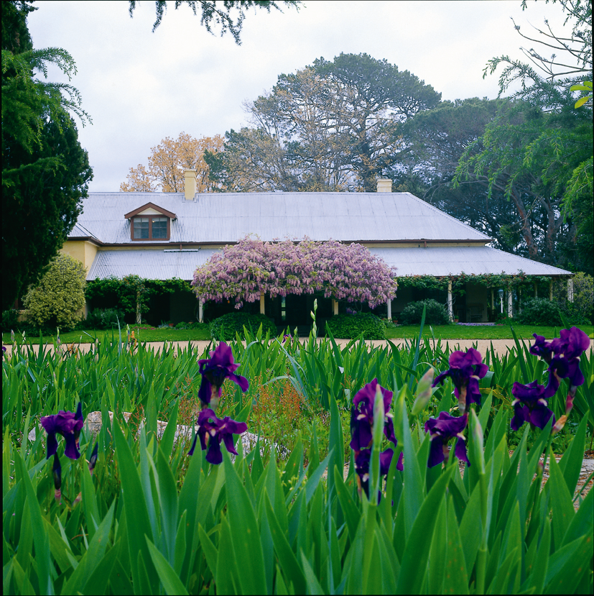

LANYON HOMESTEAD
Venue Hire Manual



Contents:

Welcome to Lanyon Homestead pg 3

Lanyon Venue Hire pg 4
- Venue locations at Lanyon Homestead
Venue Hire Charges pg 5
- Wedding Ceremony only
- Wedding Ceremony and Reception packages

Weddings by the Lanyon Cafe pg 6

Other Venue Hire Information pg 7
- Education Centre venue hire
- Equipment Hire

Access Times pg 8
Photography pg 8

Videography/ Filming pg 8
General Venue Hire Information pg 8
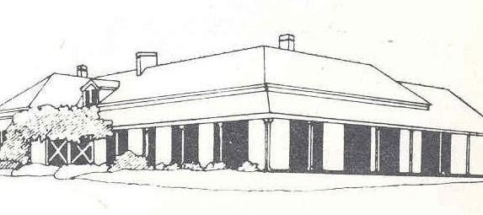

WELCOME TO LANYON HOMESTEAD

Thank you for considering Lanyon Homestead for your upcoming function. We pride ourselves in being able to assist you in holding a memorable event whether it is a wedding or other type of function.
Lanyon Homestead is Canberra’s most prestigious heritage site. Nestled in the Lanyon Valley in Canberra’s south, Lanyon Homestead is situated along the Murrumbidgee River, the Historic Precinct dates from the 1830s and offers tranquil surrounds for any style of function.

To make a booking or further enquiries about Lanyon Homestead Venue Hire, please contact the venue hire coordinator Ann Sutherland on 6235 5677, for catering enquiries contact Owen Brennan at the Lanyon Café directly on 6237 5268. You will receive your Booking Agreement Form separately.
At Lanyon Homestead we hire out areas of the garden and outbuildings for private use, wedding receptions and ceremonies, corporate functions, conferences, training workshops and so on. We have various wet weather options, such as; the Homestead Veranda, the Education Centre, The Lanyon Cafe and The Lanyon Cafe Marquee.
This manual has the information you are likely to need for venue hire at Lanyon Homestead. If there is something you need to know which is not covered in this booklet, please ring our venue hire coordinator listed below who will assist with any further information.

- Lanyon Homestead
Ann Sutherland 6235 5677

- Lanyon Café
Owen Brennan 6237 5268

We trust that your time at Lanyon Homestead will be enjoyable and that the memories of your event will last a lifetime! 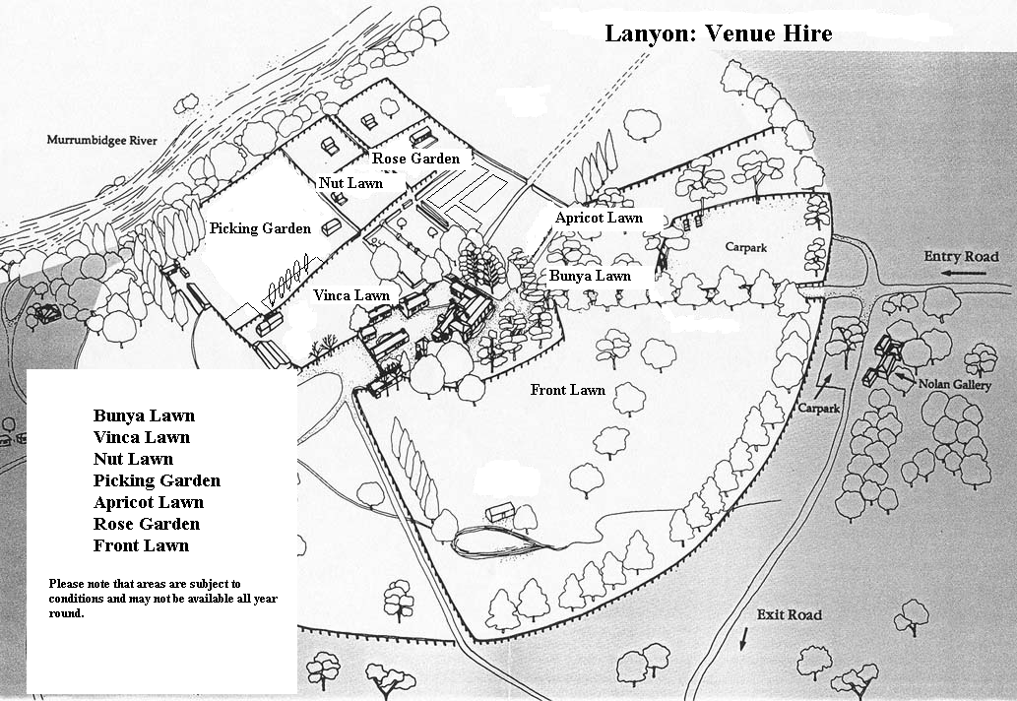
- The Bunya Pine Lawn: Directly under the two huge Bunya Pines, and immediately adjacent to the homestead. Power can be accessed from the Homestead. Great for photographs, as the Homestead forms the backdrop.
- The Vinca Lawn: Vinca Lawn is the perfect option for a spring or autumn day wedding, with open sprawling 360 degree views of the garden and homestead. Overlooking the Murrumbidgee River, and the Southern Cross windmill in the back ground. Power is not accessible here.
- The Nut Lawn: A particularly private area, with the walled garden, this section of the garden is full of colour in spring time. No power available. The Picking Garden is immediately adjacent.
- The Apricot Lawn: For larger groups, this area can accommodate a small marquee. The Apricot Lawn offers views to the Homestead, gardens and, paddocks and Murrumbidgee River beyond. Full access to power.
- The Front Lawn: Looking down to the Convict built barn, this area has many showcase plantings and spectacular views of the front of the Homestead. Power by negotiation.
- The Rose Garden: For small groups only, an intimate area. When in season the blooms and scented roses provide a very romantic setting. No power available.
- The Education Centre: The Lanyon Education Centre was once the garage of the Homestead. Now fitted out for conferences and workshops. Unattached to the rest of the Homestead, privacy is assured. Full electrical access and lighting is provided. Additional charges apply for equipment hire. Charges for hire of the Education Centre are listed in this manual, discounts will be offered to Community non- profit groups.
- The Lanyon Veranda: Is only available in the event of wet weather. No food or drinks are allowed on the veranda. Limited seating is available and can be provided by negotiation.
- The Lanyon Café: Originally the single men’s barracks at the Homestead, this building is full of old world charm and has glorious vies to the Murrumbidgee River. Maximum capacity 40 guests.
- The Lanyon Cafe Marquee: A permanent fixed marquee looking over the Murrumbidgee River. The marquee can seat 118 guests comfortably. Add on marquees are available, as too are outdoor gas heaters.
VENUE HIRE CHARGES
Lanyon Homestead provides venue hire in the grounds of the historic precinct for weddings, group functions and other celebrations.
Venue hire fees include public liability insurance, and the use of ONE venue hire area i.e. ‘The Vinca Lawn’. Venue Hire fees do NOT include entry to the Homestead; however entry and guided tour packages can be arranged with the Venue Hire Coordinator.
VENUE HIRE FEE: $500

WEDDING FUNCTIONS

Lanyon Homestead can accommodate all of your wedding needs, with packages for complete ceremony and reception functions, or ceremony only packages, as well as reception only packages.

WEDDING CEREMONY ONLY
10.00am-4.00pm

Wedding ceremony only is the use of the grounds for venue hire only without catering; the following conditions apply:
- Venue Hire for 1.5 hours during open hours 10am-4.00pm.
- Public liability insurance, photographic session, the hire of one venue hire area, use of the registry table and 12 chairs is included with the venue hire fee.
- Venue hire outside of standard open hours are negotiable, however security fees may apply.
- Please note that the main entry gates on Tharwa Drive are locked at 4.30pm sharp daily.
- Late departures incur a fee, unless out of hours hire is approved. Security fee pricing information is included on the Equipment Hire Price Chart page 7.

WEDDING CEREMONY AND RECEPTION
10.00am-10.00pm

Wedding ceremony and reception packages are tailored to meet your needs. All catering is provided on site by The Lanyon Cafe, the following conditions apply:
- Public liability insurance, photographic session, the hire of one venue hire area for the ceremony and use of an additional venue hire area for the reception [additional fees may apply], use of the registry table and 12 chairs is included with the venue hire fee.
- Menu/ Catering packages are arranged through the Lanyon Cafe at an additional cost.
- Late departures incur a fee, unless out of hours hire is approved. Security fee pricing information is included on the Equipment Hire Price Chart page 7.

PAYMENTS AND DEPOSITS
- Tentative bookings will be held for 30 days ONLY. To secure the tentative booking date payment of deposit MUST be received in 30 days of initial enquiry.
- For ceremonies full payment is to be paid to The Lanyon Cafe together with a completed ACT Historic Places Booking Agreement form within 30 days or as negotiated.
- Reception bookings require $500 deposit to be paid to The Lanyon Cafe together with a completed ACT Historic Places Booking Agreement form.
- Full payment is to be paid within ONE week of the function.
- Additional Conditions do apply.
- The Lanyon Café can assist with payment options.
Please note:
The Lanyon Café has exclusive catering rights at Lanyon Homestead. Self-catering or external catering from another firm is not permitted. No Alcohol to be served on site unless purchased from the Lanyon Cafe, Lanyon Homestead does NOT have a BYO licence.
‘WEDDINGS BY THE LANYON CAFE’
Terms and Conditions of Hire

- WEDDING PACKAGES
The Lanyon Cafe can provide numerous catering and beverage packages to meet your requirements.
For further information and details please contact the Functions Manager at the Lanyon Cafe.

- MENUS
Menu is to be finalised 28 days prior to the scheduled wedding date.
Prices are calculated on 100 guests, for large bookings and weddings of more than 100 guests, additional costs may apply.

- DIETARY NEEDS
We can cater for most dietary requirements. Please advise in advance so that our Chefs can prepare meals for guests with particular dietary needs.

- CHILDREN
Children under the age of 12 years are charged at 50% of the adult rate for a children’s menu.

- ENTERTAINMENT
Clients must advise the Lanyon Café of any planned entertainment or performances at their wedding in advance- approval processes apply. Ceremony hirers should note that not all areas of the garden have access to electricity.
The Café reserves the right to reduce the volume of entertainers/performance, in keeping with the restrictions of the venue hire.
Please refer to page 9; Noise Restrictions/ Audio.

- BOOKING CONFIRMATION
Bookings will be held for 30 days ONLY, to secure the booking date payment of deposit and signed and completed booking form must be received by the Lanyon Cafe.

- FINAL ATTENDANCE
Final guest numbers are required 7 days prior to the function. This will be the minimum number of guests for which you will be charged. The outstanding function hire charge is also required at this time. Additional guests will be charged for on the date.

- NOTICE OF CANCELLATION
In the event that your booking is cancelled or moved, the following conditions will apply:
- The Lanyon Café required written notice of any cancellation or postponement.
- 90 days or more: Your full deposit will be refunded or transferred to a new date.
- 30-60 days: 50% of your deposit will be refunded.
- Less than 30 days: The full deposit will be forfeited.

- CREDIT CARDS
There will be a 2% surcharge for credit card payments.
We accept Visa Card and MasterCard

OTHER VENUE HIRE INFORMATION

- EDUCATION CENTRE VENUE HIRE ONLY: $350 per day.

The Education Centre at Lanyon Homestead has the ability to seat 50 guests comfortably.
- The Lanyon Education Centre was once the garage of the homestead. Now fitted out for conferences and workshops the Centre is unattached to the rest of the Homestead, privacy is assured. Full electrical access and lighting is provided, additional charges apply for further equipment hire. Discounts may be applicable for Community non- profit groups.
- An external marquee can be set-up outside the Education Centre to extend the floor space and provide additional outdoor seating or entertaining areas. The marquee is available at an extra fee.

EQUIPMENT HIRE
Any additional equipment beyond that described on the booking form must be hired independently by the hirer from a party hire firm. Please advise the venue hire coordinator of any equipment hired. Note, any equipment hired is not covered by insurance, and the hirer will be liable for any loss, damage or theft to equipment, and even for any damage to the site resulting from additional equipment being delivered, collected or erected.

Equipment Hire Price Chart
Marquee [9m x 9m] including full white ceiling flounce, erection and dismantle | $850.00
Flip Chart (with pens) | $25.00
Electronic Whiteboard (with pens and eraser) | $50.00
LCD/Light Pro (portable) | $125.00
P.A. System/Fender (portable) with microphone | $125.00
Lectern | $25.00
Laptop Computer | $100.00
Security Fee; applied for late departures and out of approved hours venue hire | $150.00
Wedding furniture; one registry table and 12 chairs | Included in venue hire charges
Tables (trestle); Education Centre venue hire ONLY | Included in venue hire charges
Chairs; Education Centre venue hire ONLY | Included in venue hire charges
White linen table cloths; Education Centre venue hire ONLY | Included in venue hire charges
Drinking water and glassware; Education Centre venue hire conferences ONLY | Included in venue hire charges
Mints and glassware; Education Centre venue hire conferences ONLY | Included in venue hire charges
Waste Removal | Included in venue hire charges

ACCESS TIMES AND INFORMATION

VENUE HIRE ACCESS
LANYON HOMESTEAD: TUESDAY - SUNDAY 8.30AM – 4PM.

- Venue Hire on Mondays can be arranged by negotiation.
- Out of hours hire only available by negotiation. Out of hours security fees apply. Security fee pricing information is included on the Equipment Hire Price Chart page 7.
- The front gates of Lanyon Homestead are locked daily at 4.30pm sharp.
- Access to the turning circle for Bridal Party transport is by negotiation. Written request is to be submitted to the Venue Hire Coordinator.
- Vehicle access for mobile impaired guests/ visitors is by negotiation.

PHOTOGRAPHY

LANYON HOMESTEAD PHOTOGRAPHY ONLY
HIRE FEE $250.00 PER SESSION

- For weddings booked at Lanyon Homestead, there are no additional charges to have your photography session conducted at Lanyon Homestead. Hirers are not authorised to move any furniture around. If required please apply in writing to the Venue Hire Coordinator.
- All photography sessions must not impede access or use of the site for any other visitors.
- Internal photography is not permitted without specific approval from the Assistant Director of ACT Historic Places.
- Professional photography for corporate use is quoted on individual basis.

VIDEOGRAPHY/ FILMING

LANYON HOMESTEAD VIDEOGRAPGY/ FILMING ONLY
HIRE FEE $250.00 PER SESSION

- For weddings, there are no additional charges to have your videography session conducted at Lanyon Homestead.
- Hirers are not authorised to move any furniture around. If required please apply in writing to the Venue Hire Coordinator.
- All videography sessions must not impede access or use of the site for any other visitors.
- Internal videography is not permitted without specific approval from the Assistant Director of ACT Historic Places.
- Professional videography for corporate use is quoted on individual basis.

NOISE RESTRICTIONS/ AUDIO
Lanyon Homestead is primarily a heritage site and a place of residence. Lanyon Homestead staff and Lanyon Cafe Function Supervisor have the right to reduce volume levels of music or to discontinue an event at their discretion.

- Acoustic music/ musicians are the preferred entertainment on site at Lanyon Homestead for functions.
- Amplified music is permitted, [such as IPod and DJ set-ups] between the hours of 4.00pm and 7.00pm.
- No amplified music is permitted after 7.00pm; soft background music is permitted after 7.00pm.

CONDITIONS AND GENERAL VENUE HIRE INFORMATION

- NOTICE OF CANCELLATION
Please note that Lanyon Homestead requires written notice of any cancellation or postponement.
In the event that your booking is cancelled or moved, the following conditions will apply:
  - 90 days or more: Your full deposit will be refunded or transferred to a new date.
  - 30-60 days: 50% of your deposit will be refunded.
  - Less than 30 days: The full deposit will be forfeited.
  - Less than 14 days: All payments made will be forfeited.

- Tentative bookings will be held for 30 days ONLY. To secure the tentative booking date payment of deposit MUST be received in 30 days of initial enquiry.

- Full payment is to be paid within 14 days of the of the function date.

- Lanyon Homestead has a curfew time of 10pm. All guests must be off site by 10.30pm, late fees and security charges will apply if curfew is not adhered to.

- Alcohol service from the Lanyon Cafe ceases at 9.30pm.

- Confetti is strictly banned in the gardens. Rose Petals and bubbles are permitted.

- Set-up and pack-down must be done by the hirer. The registry table and 12 chairs, if desired, will be placed in your selected venue hire area by The Lanyon cafe staff. The café staff can arrange requested lay-out for set-up, but this needs to be discussed as part of the venue hire booking.

- Additional equipment can be privately hired by the hirer, please inform the venue hire officer of any external equipment coming onto site. Be aware that any equipment hired from a Party Hire Company is not covered by insurance, and the hirer will pay for any loss, damage or theft. Set-up and Pack-up of additional equipment hired must be negotiated with the venue hire coordinator of the Lanyon Cafe and be conducted within open hours.

- Parking for the wedding party and guests is provided in the large Lanyon Homestead Visitor car park. There is no access to the carriage turning circle in front of the homestead. We also encourage the use of ushers to help guests from the car park to the wedding area.

- The use of the carriage turning circle in front of the Homestead is granted on an individual basis. But is primarily available for bridal parties using Horse and Carriage.

The Lanyon Homestead has limited mobile coverage. Contact can be made though The Lanyon Homestead and/ or The Lanyon Cafe telephone number during open hours only.

Any damage to the equipment and/ or the premises must be paid for. The hirer will be invoiced for the full amount after professional damage assessment.

ACT Historic Places and the Cultural Facilities Corporation are not liable for any damage done to cars on the property.

- There is a Public Toilet Block on the property at the end of the Homestead. Portable toilets will be required for events with more than 100 guests [this will be arranged by The Lanyon Cafe].

- We can also recommend Mugga-Mugga Cottage’s Education Centre. For further information discuss details with the venue hire officer.

- A hirer may elect to book two sites, such as the Vinca Lawn at Lanyon Homestead for their wedding ceremony, and the Mugga-Mugga Education Centre for their reception. Charges will be negotiated individually.

- Function guests are provided access to the hired area only [i.e. the Cafe Marquee, or the Rose Garden and so on] and facilities. Liquor licensing is only for the booked function area only no alcoholic beverages are to be consumed within the Homestead Precinct unless prior arrangement has been approved.

