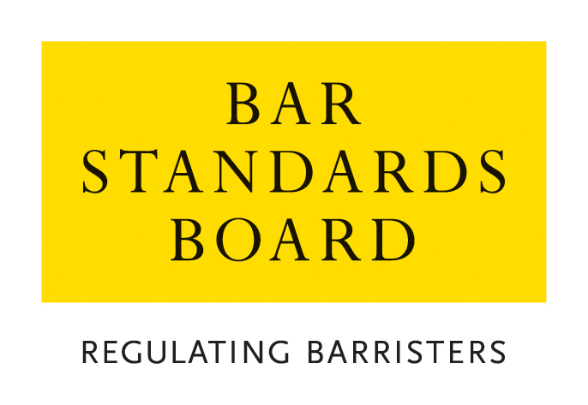
Licensed Access - Registration Form

This form is for registration on the Licensed Access licensing scheme operated by the Bar Standards Board and should be returned to The Regulatory Assurance Department, The Bar Standards Board, 289-293 High Holborn, London WC1V 7HZ, with the current application fee (payable by either BACS or credit/debit card) and a copy of your current OISC registration certificate.

The form is for use of Immigration Advice Agencies accredited at the Office of the Immigration Services Commissioner (OISC) level three. This form must be completed and signed by a member of the Governing Body of the Agency i.e. a member of the Board of Directors, a Trustee, Chief Executive or equivalent.

Name of Organisation:

Address:

Registration or Exemption Number:

Telephone Number: | Fax Number:

DX Address: | E-mail Address:

Contact Name in Organisation:

*The name provided will be included on the Bar Standards Board website of licensed organisations and you should inform the contact name about the inclusion on the website.

Please provide the name of your advisors and their level of accreditation: |  | Name |  |  | Level

Authorised Signature: |  | Date:
See note above

PAYMENT OF FEES
The BSB’s preferred method of payment is bank transfer (BACS), the details for which are:
Bank: The Royal Bank of Scotland PLC
Incorporating Child & Co Bankers
Address: 1 Fleet Street London EC4Y 1BD
Sort Code: 15.80.00
Account: The General Council of The Bar
Account No: 66050206
Swift Code: RBOSGB2L
Child Bank Identifier Code (BIC): RBOS GB 2L
International Bank Account Number (IBAN): GB98 RBOS 1580 0066 0502 06

When paying by BACS, you must ensure with your bank that the BSB receives the full amount in Sterling: ie, you must pay all charges of both your bank and agents charges, including those of the BSB: ie, the handling charge levied by RBS if the issuing bank does not pay all bank charges. PLEASE ALSO ENSURE YOU PUT A REFERENCE OF “AUTH” AGAINST YOUR NAME ON THE TRANSACTION TO IDENTIFY THE PAYMENT.

If you are unable to pay by this method, you can pay by credit/debit card by contacting the Authorisations Team on 020 7611 1444.

