 |  |  | Ovid Technologies, Inc.  Ovid LinkSolver™

LinkSolver™ End-User Feature Guide

Table of Contents
Introduction 3
General Characteristics of Ovid LinkSolver™ 3
Understanding the “Link Set” as a Vehicle for Customization 4
Default Link Sets Used in Ovid LinkSolver™ 4
Article Review 5
Bibliographic Links 6
Buy Now (PayPerView Account) 7
Chemical Images 8
Document Delivery 10
EDRS Full Text 11
External Link Resolvers 12
Full Text 13
Internet Resources 13
Ovid’s Current List of Internet Resource Sites 14
Library Holdings 15
Ovid Database PDFs 15
Ovid Full Text 16
Reprints/Rights 19
Topic Review 20
Linking Ovid to External Full Text and Other Internet Sources 22
Navigating Between Ovid and External Providers 22
Ovid Customer Support 23

Introduction
Ovid LinkSolver™, Ovid’s universal linking solution, adds tremendous value to your research process by delivering on the promise of ‘open link access.’ Ovid LinkSolver allows your site administrator to set up access to all subscribed full text and other valuable online resources, regardless of where that content resides, in one centralized location. This allows you to link to that content from any bibliographic database whether provided by Ovid or another information provider.

General Characteristics of Ovid LinkSolver™
Ovid LinkSolver can be set up to link, not only from Ovid’s bibliographic databases to relevant full text, but from any other bibliographic database or resource that uses OpenURL Standard. For example, a link can be generated from a Web-based OPAC or PubMed. LinkSolver makes an ‘inbound’ request and receives a set of matches based on the information passed. All the link definitions are maintained in one central location, the LinkSolver database, so any updating that is required is handled once, through the LinkSolver Administrative Tool.

Ovid LinkSolver provides full resource linking from any OpenURL Standard compliant resource. Ovid uses the OpenURL Standard to define the link syntax used in contextual linking. OpenURL Standard is a standard that defines the dynamic generation of a URL based on the information (metadata) contained in a citation. For more information on OpenURL Standard, please see http://www.linksolver.com/site/openURL.jsp.

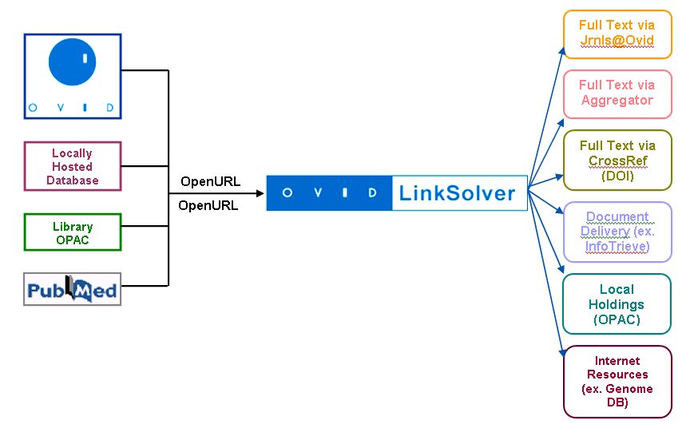

Understanding the “Link Set” as a Vehicle for Customization
Ovid LinkSolver is also completely customizable and allows your institution’s site administrator to create “Link Sets” (Link Sets are what you, the user, sees in the titles display) based on specific types link types. For example, your administrator may choose to group ALL sources of electronic full text under a single link name: “Electronic Full Text Sources” to distinguish from “Print Sources,” that link to document delivery services.

LinkSolver allows site administrators to use graphics for the link buttons to identify specific institutionally branded services across all resources, change link set groupings and customize the link set names.

In addition, links can be customized on a group by group basis. The links you see displayed with a bibliographic citation depend on the following factors:
- nature of the link set up and organization as determined by your Ovid librarian or site administrator,
- availability of your institution’s full text, OPAC, document delivery and other internet resources, and
- information that is indexed in the database you are searching.

Given the ease of customization, there are an infinite number of link set scenarios.

Default Link Sets Used in Ovid LinkSolver™

Link Set Name | Description
Article Review | Associated with citations in the EBM (Evidence Based Medicine) databases.
Bibliographic Links | Gives access to both Ovid and non-Ovid bibliographic content. Ovid Bibliographic are references such as records in Medline, or Current Contents that you might see in the cited reference section of an Ovid Fulltext article. Non-Ovid Bibliographic links include, but are not limited to Pub-Med.
Buy Now | Lets you make an online purchase of a Journals@Ovid article directly using a credit card.
Chemical Images | Links to chemical structure images (gif) in the following Ovid databases:  - Derwent  - PharmaProjects  - R&D Insight  - R&D Focus  - Patent Focus
Document Delivery | Lets your institution maintain a link to a document delivery service such as BibSYS or InfoTrieve.
EDRS Full Text | Provides links to ERIC full text EDRS documents.
External Link Resolver | Defines a single link that takes you to a non-Ovid OpenURL Standard link server.
Full Text | Links to the full text of a journal located at a remote publisher’s web site.
Internet Resources | Allows you to configure and link to internet based sources such as search engines or an online medical dictionary.
Library Holdings | Links to the resources maintained by your institution’s Online Public Access Catalog (OPAC).
Ovid Database PDFs | Gives access to full text such as CINAHL full text.
Ovid Full Text | Gives access to the full text article from Journals@Ovid, Ovid’s premier aggregated database of full text journal articles. As well as, Evidence-Based Medicine Review (EBMR) databases full text.
Reprints/Rights | Rights Permissions and Reprint Ordering service.
Topic Review | Associated with citations in the EBM (Evidence Based Medicine) databases.

Article Review
The Article Review link is a review associated with citations in the Evidence Based Medicine (EBM) databases. The Article Review uses an outline format to describe methodologies used by researchers to conduct their studies.

With each review, you see a high-level outline of topics (such as Abstract, Commentary, and References, and more) including hyperlinks that lead directly to the details.

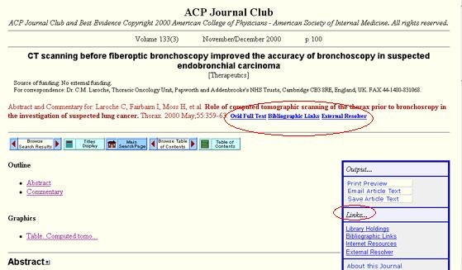

This is the same article in the old way of linking--only now a Bibliographic MEDLINE link shows under the title and non-service links like Abstract show in the Full Text Manager box under the Links (Library Holdings) section as shown in the graphic below.

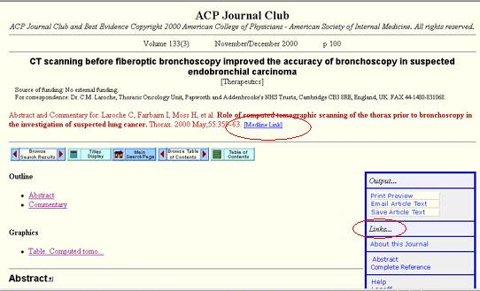

Quick Steps (Refer to the Ovid Gateway User Guide for detailed instructions)
- Click the Article Review link.
- Review the outline and click the desired hyperlink to move to the related text.
- Click to return to the outline the outline to select your next topic.

Bibliographic Links
Bibliographic Links give access to both Ovid and non-Ovid bibliographic content. Ovid Bibliographic links are references to records in Medline, Current Contents or other bibliographic databases. Non-Ovid Bibliographic links include, but are not limited to, Pub-Med. You will find Bibliographic links in the titles display:

You will also find Bibliographic Links in the cited reference section of an Ovid Full Text record.

If there is more than one source available, an intermediate page will display such as this:

Buy Now (PayPerView Account)
The Buy Now link supplements your Journals@Ovid collection by providing you immediate access to Journals@Ovid articles for which your institution has not subscribed.

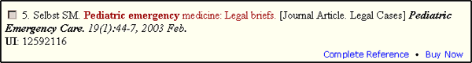

Your librarian or site administrator controls the availability of the Ovid Buy Now link at your site.

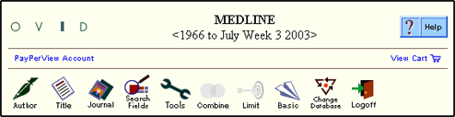

Note: Prior to displaying the Buy Now link, Ovid determines whether your institution has an electronic subscription to an article through Ovid or from an external source. The Buy Now link is not available for all citations.

Buy Now allows you to use the familiar “shopping cart” approach to select from Journals@Ovid articles available for individual purchase using a credit card. Upon payment, your order is processed immediately making your article(s) available to read online, download, or save on your computer for a period of 24 hours following purchase. In addition, your article is delivered to your email account, and accessible at www.ovid.com. Click on the PayPerView Account link and the PayPerView page displays.
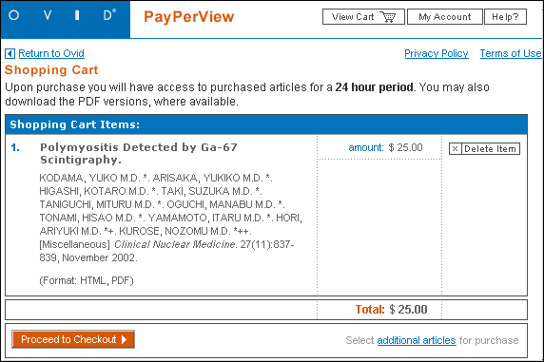

Quick Steps
- Click the Buy Now link to access PayPerView.
- Log in by entering your email address and your password. If you are a first time user of PayPerView, click the Create New Account button.
- Follow the screen instructions to place your order and submit your credit card payment.

After purchasing an article, the Buy Now link continues to display as an “active” link, whereby on subsequent access, within the 24-hour period, you can still click on it to retrieve your article during your current Ovid search session.

Chemical Images
Ovid gives you access to databases from which you can access image (gif) files of chemical structures. Available databases include:
- Derwent Drug File (DERD)
- Pharmaprojects (PHAZ)
- R & D Insight
- R & D Focus
- Patent Focus

The above databases previously displayed either Weblink or Image File (gif) links for these images. Now, all of these databases display a Chemical Images link instead. The following example displays a citation listing within the Derwent Drug File (DERD) database.
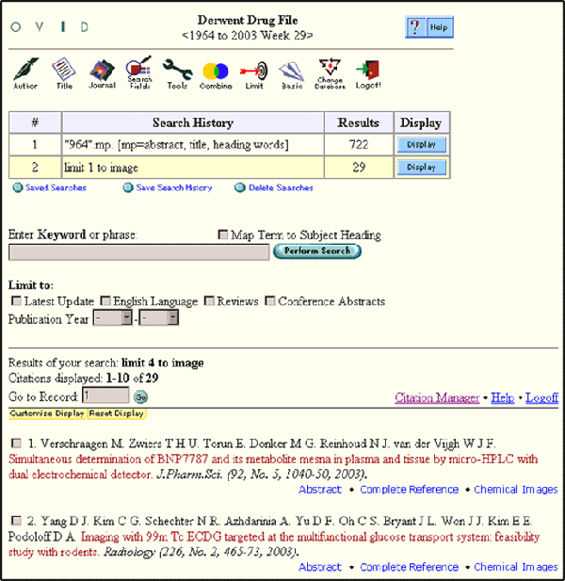
Sample Citation from the Derwent Drug File Database

A click on the Chemical Images link for citation 2, Accession Number 16295, Drug Name: SC 964, a new screen displays with the chemical structure of the cited drug image as shown in the next graphic.
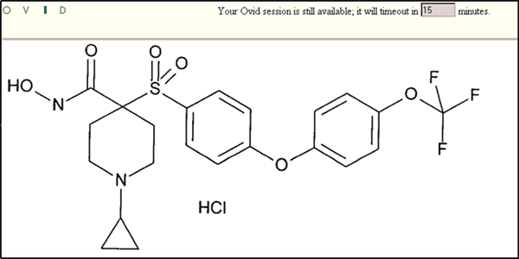
Sample Image File

Document Delivery
The Document Delivery link lets you identify and generate order requests to document delivery services for items selected during your search of the database. This is not to be confused with the traditional Ovid Document Order, available in the Citation Manager. Please note that Document Order will function as it always has.

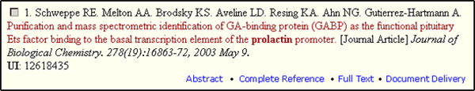

Document Delivery is available with Links@Ovid. Your librarian or site administrator can configure the system to check for any institutional-subscribed content first, and display the Document Delivery button only if no locally held or electronic resources are available.

Quick Steps
- Click listed under your selected citation.
- Await opening of the external publisher’s window displaying journal article.

Traditional Document Order
Document Order is the traditional way of accessing your institution’s Document Order Service. From the Ovid Search results set, you select an article(s) from the titles display, the click in the Citation Manager.

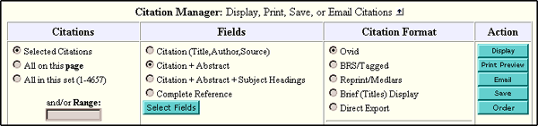

Quick Steps
- Select the adjacent check box next to the citation. Repeat this for each citation you desire. Alternately, you can order all documents on the current page, a range of documents, or all documents in the current search set by changing the citations setting in the Citation Manager.
- Go to the Citation Manager and click to display the Personal Information Form.
- Complete the Personal Information form and proceed to the Order Source Form.
- Submit your order.

EDRS Full Text
The ERIC Document Reproduction Service (EDRS) Full Text link provides access to full text documents located on ERIC, the national education database sponsored by the U.S. Department of Education. This site contains over a million citations related to education information.

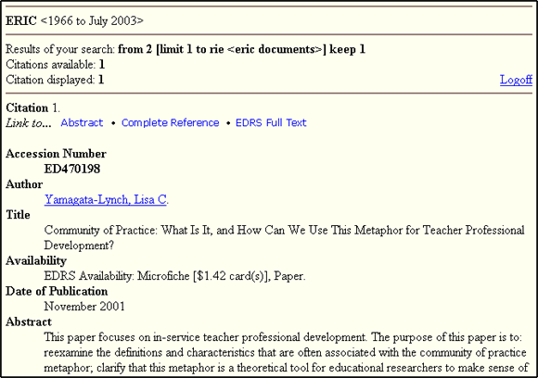

Sample ERIC Titles Display

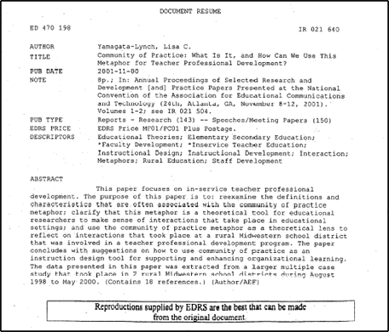

Excerpt of Full Text Document from EDRS

External Link Resolvers
If your institution has purchased an OpenURL Standard link resolver, you may see a link on an Ovid citation that takes you to that link server. There, you are presented with a choice of the links available to you.
The name of the link may be specific to that link resolver or may be a name that your institution has created to alert you to a centralized link service that has been set up for your use (eLink).

When an external link resolver has been configured, you see that link button on an Ovid bibliographic citation. Click on that link to see exactly what services are available for that citation. Some citations have full text links—if your institution has a valid subscription to the electronic full text. Others have links to your OPAC, letting you know that a print copy of the article is available. Still others link you to a document delivery or inter-library loan service where you may order a copy of the article.

With an external link resolver, the configuration of the specific links is handled externally to Ovid. Check with your site administrator if you have questions.

Full Text
The Full Text link takes you to the target publisher’s web site or a locally hosted collection where the article text resides. The display you see depends upon the number of sources for full text. If there is only one source of electronic full text, clicking on the Full Text Link takes you directly to the article’s text at the publisher’s website.


Alternatively, if your site administrator has identified either multiple sources or multiple formats for the article, you see another page where you can select your desired source and/or format.

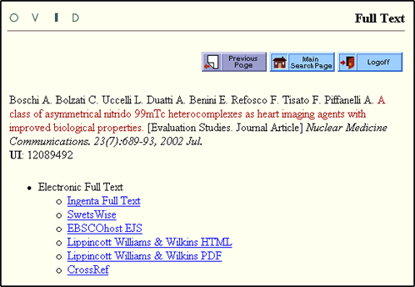
Note: The publisher or aggregator controls access and authentication for full text access external to Ovid.

Quick Steps (Refer to the Ovid Gateway User Guide for detailed instructions)
- Click Full Text.
- Await opening of the external publisher’s window displaying journal article.

Note: When returning to Ovid, if you close the second window, you can view subsequent full text links without having to press ALT + TAB.

Internet Resources
The Internet Resources link connects you to numerous sites hosted by diverse educational or governmental institutions and removes barriers to your research by offering you seamless access to records maintained on databases located around the world. Internet Resources links you to a compilation of sites that have been carefully reviewed and chosen based upon Ovid’s thorough understanding of the scope and depth your research requirements.

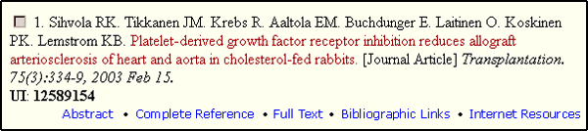

Ovid’s Current List of Internet Resource Sites
You can expect to see this list of sites expand over time. Please note that your administrator is able to add additional resources.
ARC - Cross OAI Archive searching service hosted by Old Dominion University, contains most of the pre-print and dissertation documents currently available. We link to it by using subject information (controlled vocabulary terms) from the Bibliographic database record to identify related pre-prints, dissertations etc. More info on http://arc.cs.odu.edu/
AVEL - Australasian Virtual Engineering Library. Using subject information to link to related Engineering resources in Australia and Asia. More info on http://avel.edu.au/
BIOME - Biomedical Subject Gateway, Using subject information to link to related Biomedical resources. For more info see http://biome.ac.uk/
CERN Research Reports - using subject information for linking. For more information, see http://weblib.cern.ch
ChemFinder, - using CAS numbers to link to chemical structure and related phys/chem/tox information http://chemfinder.cambridgesoft.com/
CogPrints - using subject information to link to preprints in the domain of cognitive sciences. For more info see http://cogprints.ecs.soton.ac.uk/
DOE InfoBridge - technical reports of the US Department of Energy, for more info see http://www.osti.gov/bridge/
DOE Preprint network - For more info see http://www.osti.gov/preprints/
Education Line - Preprints in the domain of education, see http://www.leeds.ac.uk/educol/
EEVL - Edinburgh Engineering Virtual Library - similar to AVEL but UK based, http://www.eevl.ac.uk/
Karolinska Institute searchable web index of diseases and disorders http://index.ki.se/diseases/
NCBI Molecular Sequence Information - using molecular sequence information to link to Genome information, http://www.ncbi.nlm.nih.gov/entrez/query.fcgi?db=Nucleotide
NCBI Taxonomy - using taxonomy information (mostly in BIOSIS) to display more information about species/genus http://www.ncbi.nlm.nih.gov/entrez/query.fcgi?db=Taxonomy
NCBI Protein Information - http://www.ncbi.nlm.nih.gov/entrez/query.fcgi?db=Protein Using EC protein codes to link to more information on specific protein.
RDN - Resource Discovery Network - UK collection of Subject gateways (including BIOME and EEVL) http://www.rdn.ac.uk/
RePec archive - Working papers and preprints in Economy, http://ideas.repec.org/
RxList Drug Information - using drug names to link to drug monographs (indications, dosage, and so on) http://www.rxlist.com/
Scirus - Elsevier Science portal (Ovid only links to the web index, not to ScienceDirect documents.) www.scirus.com

Library Holdings


Library Holdings accesses your institution’s Online Public Access Catalog (OPAC) where you can obtain information about your institution’s locally held print resources, including journals, books, and unique holdings. If no specific coverage information is configured, the Library Holdings link appears on every bibliographic citation, and links you to your OPAC where you can determine if a print version is available to you.

Ovid Database PDFs
The CINAHL database supplies Ovid customers with a direct link to full text PDF from selected citations. Previously, the Full Text link displayed as Full Text (PDF), but now displays as Ovid Full Text. Ovid Full Text is still displays in PDF format.

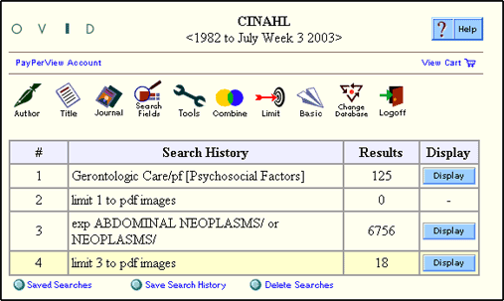

Sample Search Results from CINAHL Database



Sample Citation

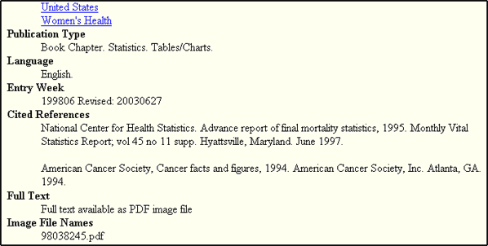
Excerpt from Complete Reference Noting Availability of PDF

Ovid Full Text
Ovid Full Text links to Journals@Ovid, Ovid’s flagship product, an aggregated online database of over 900 premier journals, as well as, the Evidence Based Medicine Databases (EBM), ACP Journal Club, Cochrane and DARE. (These are not to be confused with the Article and Topic Review links in the EBM databases. As the name suggests, the Ovid Full Text link contains actual full text whereas the Review links are ‘reviews’ of the articles). The Ovid Full Text link lets you view an article online as it appears in the printed version of the journal, including charts, images, and cited references. And because the Journals@Ovid database is fully searchable, when you do a search, you are searching every word in every journal article, including caption text.

Within the article, you can easily navigate throughout the text using convenient Outline which highlights important section links. Contextual links within the body of the article take you directly to the appropriate references. The Full Text Navigation box appears adjacent to the Outline of every full text document you display. You can choose the way you display, print, save, or email your full text documents. It also facilitates your movement between Full Text options by tracking a history of links you follow, and providing links to abstracts and complete references of the Full Text documents you view.

From Journals@Ovid cited references, you can link to Ovid Full Text available through your institution, as well as other Full Text links, Holdings and Document Delivery links, abstracts and citations in relevant bibliographic databases. Besides the availability of text display, graphics appear in context as placeholders or thumbnails (miniaturized images) in full text articles. These are links that correspond to full-size graphics.

You can access Ovid Full Text links from several different points including:
- title, individual citation (Complete Reference), and Table of Contents displays, and
- reference links in a Journals@Ovid article.

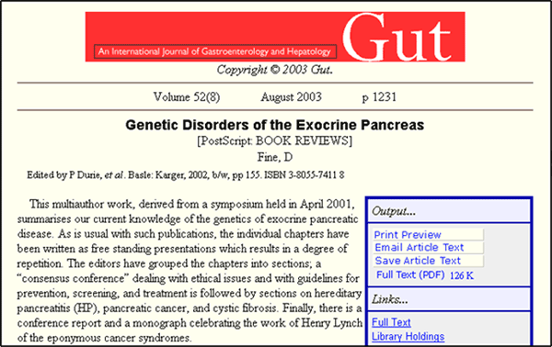

HTML Version

The initial display is always in HTML format. From the Full Text Manager, you may have the option to select the PDF format.

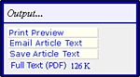

Full Text Manager with PDF Availability

The following graphic is the PDF of the previous graphic.

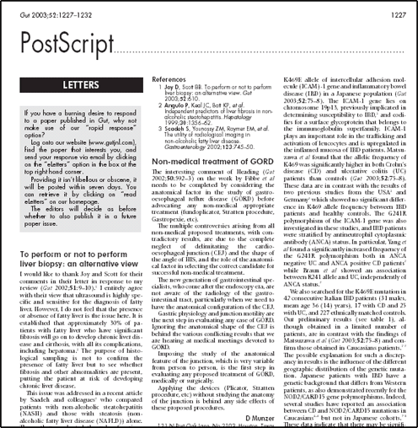

PDF Version

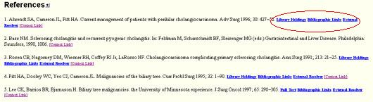

Quick Steps (Refer to the Ovid Gateway User Guide for detailed instructions)
- Click Ovid Full Text to link to the full text journal article.
- Choose a format. You can view the article in the default display format. Alternatively, if available, you can display the article as a PDF by clicking on that option located in the Full Text Manager located in the lower right side of the screen.

Reprints/Rights

The Reprints/Rights link displays for citations which have been activated for specific journals. The link goes to the RightsLink a service from Copyright Clearance Center, Inc., http://www.copyright.com/Rightslink/Default.asp., where the user can identify the requested ‘use permissions’ and order reprints.

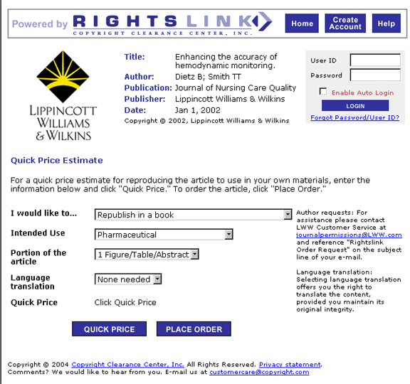

Topic Review
Like the Article Review link, the Topic Review link appears for citations found within the Evidence Based Medicine (EBM) databases. The Cochrane database conducts systematic reviews of topical research studies and delivers the critical information in outline format with hyperlinks to the details. As well, the Full Text manager box contains all other Link Service links that you may have enabled.

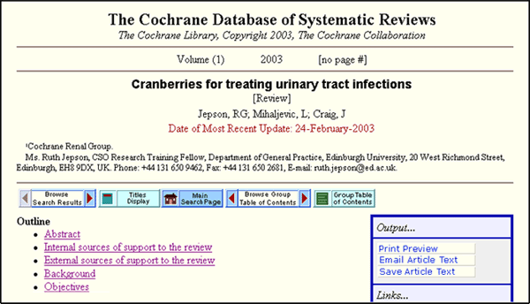

Quick Steps (Refer to the Ovid Gateway User Guide for detailed instructions)
- Click the Topic Review link.
- Review the outline and click the desired hyperlink to move to the related text.
- Click to return to the outline to select your next topic.

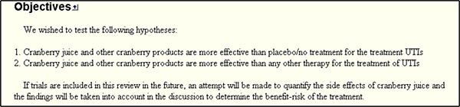

Linking Ovid to External Full Text and Other Internet Sources
Use the flowchart below to guide yourself through a typical Ovid LinkSolver scenario that opens a gateway to your institution’s scholarly resources.

At the Ovid Site | Choose  Citation
 | Select Link to External Source
At the External Site | IP  Validation?  Yes | Login  Page  No
HTML | View  Full Text  Alt-Tab  to Return to  Ovid Session | PDF
 | No  Continue Using  Resource at  External Site | Yes

Navigating Between Ovid and External Providers
One of the primary functions of Ovid LinkSolver is to allow you access to external resources. Once you are through using those resources, you may want to return to Ovid.
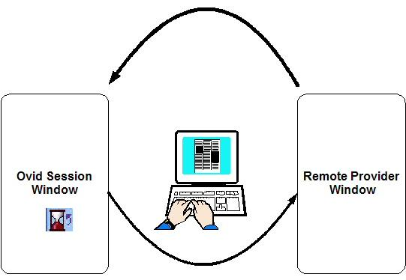

You can return to Ovid in either of the following ways:

 | Click this icon to return to your previous Ovid session. Your “Ovid Session” expires after 15minutes of inactivity. You have to log in again after your Ovid session expires.
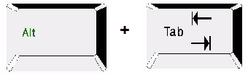 | Click ALT + TAB to switch between Ovid and an External Provider.

In practical terms, LinkSolver allows you to experience an optimized search effort whereby a click on a single link set exposes you in to a broad realm of resources that have been determined entirely by your site administrator’s configuration and organization of the various links.

Ovid Customer Support
If you have further questions or would like more information on Ovid LinkSolver, contact Ovid Technical Support at the location nearest you.
North/South America  (800) 343-0064  support@ovid.com | Europe  44 (0) 20 7981 0660  eusupport@ovid.com | Australia and Far East  (61) 2-9231-5599  ausupport@ovid.com

