

BINDURA UNIVERSITY OF SCIENCE EDUCATION
AN ANALYSIS OF THE MARKETSHARE DEFENSIVE STRATEGIES EMPLOYED BY THE ZIMBABWEAN MOBILE MONEY SECTOR IN THE TEECOMMUNICATIONS INDUSTRY: A case of Econet Wireless Zimbabwe
BY

TSHANDO MADHAVA
B1337658

A DISSERTATION SUBMITTED TO BINDURA UNIVERSITY OF SCIENCE EDUCATION (BUSE) IN PARTIAL FULFILMENT OF THE REQUIREMENTS FOR THE MASTERS IN BUSINESS LEADERSHIP (MBL) DEGREE QUALIFICATION

BINDURA, ZIMBABWE

2016

BINDURA UNIVERSITY OF SCIENCE EDUCATION

RELEASE FORM

NAME OF AUTHOR | Tshando Madhava
TITLE OF PROJECT | An analysis of the market share defensive strategies employed by the Zimbabwean mobile money sector in the telecoms industry: A case of Econet Wireless Zimbabwe
DEGREE FOR WHICH PROJECT WAS SUBMITTED | Masters in Business Leadership  (MBL)
YEAR DEGREE WAS GRANTED | 2016

Permission is granted to Bindura University of Science Education (BUSE) to produce single copies of this dissertation and lend or sell copies for private scholarly or scientific research purposes only. The author reserves the publication rights with his office.

SIGNED……………………………………….DATE…………………….

PERMANENT ADDRESS 2-87th Avenue, Greencroft
HARARE

EMAIL ADDRESS tinamadhava@gmail.com

CELLPHONE NUMBER 0774222417

BINDURA UNIVERSITY OF SCIENCE EDUCATION

APPROVAL FORM

The undersigned certify that they have read and recommend to Bindura University of Science Education (BUSE), Faculty of Commerce, for acceptance; a dissertation with the title, ‘An analysis of the market share defensive strategies employed by the Zimbabwean mobile money sector in the telecommunications industry: A case of Econet Wireless’ by Tshando Madhava in partial fulfilment of the requirements for the Masters in Business Leadership (MBL) degree.

__________________ ____________________ ____________
Tshando Madhava Signed Date

__________________ ____________________ ____________
C.B. Mashavira Signed Date
Supervisor

___________________ _____________________ _____________
Program coordinator Signed Date

___________________ _____________________ _____________
Faculty Chairperson Signed Date

___________________ _____________________ _____________
External Examiner Signed Date

DEDICATION
This research is dedicated to my dear wife Ashley, as well as my two sons Adonis and Adoniah Madhava.

ACKNOWLEDGEMENTS

I would like to thank the Lord for giving me the strength and wisdom to do this project. This project would not have been a success, without the assistance of many people. Great appreciation goes to the following:

- My Supervisor, Mr C. B. Mashavira, whose patience and guidance was extra-ordinary.
- Staff members of Econet Wireless Zimbabwe.
- Bindura University of Science Education staff for their assistance and advice.
- My classmates for their assistance, support and advice.
- My employer for availing information that was necessary for the success of the research.
- My family members whose love and morale support contributed immensely to the success of this study.

ABSTRACT

The organization which was researched on is Econet Wireless Zimbabwe, a leading telecommunications company in Southern Africa. The organization launched mobile money in 2011, and was enjoying a market share of 98% until that market share declined to 78% within a period of 6 months, being January to June 2015. A compelling need to establish the cause of the decline, as well as analysing the effectiveness of the defensive strategies being employed was therefore necessary. The topic for this research is ‘An analysis of the market share defensive strategies employed by the Zimbabwean mobile money sector in the telecommunications industry: A case of Econet Wireless Zimbabwe’
The sources of literature that were used in this research ranged from primary, secondary and tertiary. The literature review sections that were covered in this research included the purpose of literature review, sources of literature review, definition of strategy, marketing strategy, marketing warfare strategies, defensive marketing warfare strategies, channel management, value chain, as well as the resource based view.
The research techniques were the questionnaire, face to face interviews as well as desktop research techniques. The structure of the research adopted a positivist philosophy, together with a deductive approach which was done in a case study form. The respondents were selected through a stratified random sampling, and the questionnaire was used to gather data. The target population was the five million Ecocash customers, with the research sample being 150 respondents. The breakdown of the sample respondents was 10 senior managers, 20 operational managers, 30 non-managerial staff, 30 agents and 60 customers. A total of 130 respondents were presented with a questionnaire whilst 20 were to be interviewed face to face. The study concludes that Econet is managing the channel network well through attractive commissions, which have ensured that no competition rides on their network.
The conclusions that were drawn from the research showed that employees were not involved in strategy formulation and were therefore not motivated to defend market share. Bad customer service contributed immensely to the decline of Econet Wireless’ market share and Econet does not provide adequate support for newly launched products. Furthermore, competition was seen as the major driver for Econet Wireless’ defensive strategy formulation.
It was recommended that Econet must involve employees in strategy formulation in order to foster ownership. Moreover, the organization must support new products which they launch into the market. Furthermore, good customer service must be upheld at all levels in the organization.
The areas for further study would be to assess the value derived from the new products that the organization introduces into the market in terms of their contribution to revenue as well as their capacity to safeguard the organization’s market leadership position.

Table of contents
Item page
Title/cover page…………………………………………………………………….….i
Release form ……………………………………………………………………....….ii
Approval form …………………………………………………………………..…...iii
Dedications……………………………………………………………………..…….iv
Acknowledgements………………………………………………………………...…v
Abstract …………………………………………………………………………….. vi
Table of contents………………………………………………………………….…vii
List of tables…………………………………………………….………………….....x
List of figures………………………………………………………………………...xi
List of appendices……………………………………………………………………xii

CHAPTER ONE: INTRODUCTION
1.1 Introduction 1
1.2 Background to the Study 1
1.3 Problem Statement 7
1.4 Purpose of the Study 8
1.5 Objectives of the Study 8
1.6 Research Questions 9
1.7 Significance of the Study 9
1.8 Scope (Delimitation) of the Study 11
1.9 Research Assumptions 12
1.10 Definition of Terms 13
1.11 Ethical Considerations 13
1.12 Research Limitations 14
1.13 Chapter Summary 14

CHAPTER TWO: LITERATURE REVIEW
2.1 Introduction 15
2.2 Purpose of Literature Review 15
2.3 Sources of Literature 16
2.4 Definition of Strategy 17
2.4.1 Marketing Strategy 17
2.4.2 Marketing Warfare Strategies 18
2.4.3 Defensive Marketing Warfare Strategy 20
2.4.4 Other Defensive Strategies 23
2.5 Case Studies on Defensive Marketing Warfare Strategies 31
2.5.1 M-PESA in Kenya 31
2.5.2 TIGO Paraguay 35
2.6 Chapter Summary 35

CHAPTER THREE: RESEARCH METHODOLOGY
3.1 Introduction 36
3.2 Research Design 37
3.2.1 Research Philosophy 37
3.2.2 Justification of the chosen Philosophy 38
3.3 Research Subjects 38
3.4 Research Instruments 39
3.4.1 Questionnaire Technique 39
3.4.2 Face to Face Interview Technique 41
3.4.3 Desktop Research Technique 42
3.5 Data Collection Procedures 43
3.6 Chapter Summary 44

CHAPTER FOUR: DATA PRESENTATION AND ANALYSIS
4.1 Introduction 45
4.2 General Information and Demographics 46
4.3 Defensive Strategy Analysis 50
4.4 Chapter Summary 57

CHAPTER FIVE: SUMMARY, CONCLUSIONS &
RECOMMENDATIONS
5.1 Introduction 58
5.2 Summary 58
5.3 Findings 59
5.4 Conclusions 60
5.5 Recommendations 61
5.6 Potential Areas for Future Study 62

REFERENCES 63

LIST OF TABLES
TABLE DESCRIPTION PAGE
  - Banks offering mobile money……………………………………....4

  - Mobile Network Operators……………………………………….....5
4.1 Level of Education…………………………………………………46
4.2 Respondents………………………………………………………..48

LIST OF FIGURES

FIGURE DESCRIPTION PAGE
  - Remittances – Global Perspective…………………………………..................3

  - Remittances – Zimbabwe Perspective…………………….…………………..5
2.1 Porter’s Five Forces……………………………………………………….…18
2.2 Strategies for Dealing with Competition………………………….………….19
2.3 The Customer Loyalty Ladder……………………………………..................25
2.4 The Value Chain Comparison……….…………………….……………….…28
2.5 Mobile Money Value Chain………………………………………….………29
2.6 Assets and Competencies…………………………………….........................30
3.1 Conceptual Framework……………………………………………………....42
4.1 Gender…………………………………………………………………….….46
4.2 Type of Relationship with Econet…………………………………………....46
4.3 Ages of Respondents………………………………………...…………….…47
4.4 Duration of Relationship……………………………………………….…….49
4.5 Product Usage…………………………………………………………….….49
4.6 Defensive Strategy Drivers………………………………………………......50
4.7 First in Product Launch………………………………………........................51
4.8 Frequency in Product Launch…………………………………………….….51
4.9 New Product Support...………………………………………........................52
4.10 Current Defensive Strategies………………………………………………....53
4.11 Market share Decline Factors………………………………………………...54
4.12 Commission Attractiveness…………………………………………………..54
4.13 Tariff Competitiveness……………………………………….........................55
4.14 Variables Driving Market share……………………………………………...56
4.15 Management Competence Rating…………………………………………....57

LIST OF APPENDICES

APPENDIX DESCRIPTION PAGE
A Letter of Introduction – Questionnaire 67
B Letter of Introduction – Interview 68
C Research Questionnaire 72
D In depth Interview Guide 73

CHAPTER ONE
  - Introduction
This research study presents a detailed historical background of Econet Wireless. Some of the issues that will be covered in this document include a problem statement, purpose of the study, objectives of the study, research questions, significance of the study, scope (delimitation) of the study, research assumptions, definition of terms, ethical considerations, literature review, research methodology as well as a summary.

  - Background to the Study
1.2.1 Business Operating Envinronment
Since the dollarization in February 2009, the mobile money business environment has significantly improved. Foreign direct investments into the country have remained elusive, owing to the uncertainties posed by the Indigenisation and Economic Empowerment regulations. External lines of credit have also remained low due to the risk associated with the country. These factors have negatively impacted the operations of Zimbabwe mobile operators. As a result of the high cost associated with local borrowings, the Econet Wireless Group has been forced to look for offshore funding amounting to US$362 million through a facilitation by AfriEximbank (Econet Wireless Zimbabwe, 2012). The portion of the facility which was allocated to Zimbabwe was US$307 million. According to Mboweni, 2012, US$255 million was then used in the re-financing of existing short-term facilities, whilst US$55 million was used in the purchasing of equipment for network expansion (Econet Wireless Zimbabwe, 2012).

NetOne has also been able to secure US$280 million worth of network expansion equipment from China (Newsday, 2014). Kangai, 2014 stated that they would use part of the money secured from the Chinese government to expand internet services. Telecel Zimbabwe also secured a US$70 million fund from Orascom Telecom, its parent company for purposes of expanding its network.(Mawindi (2012). The sources of all these funds were external, having been obtained from overseas.

The legal and political environment in which businesses are operating in Zimbabwe, has made it difficult for making long strategic planning. The voice call tariff has been slashed from $0,23 to $0,15 per minute, and a further reduction to $0,09 is scheduled for January 2016, (Techzim, 2014). Portraz regulates and approves voice call charges for telecommunication companies, whilst the Reserve Bank of Zimbabwe regulates the mobile money tariff. In response to pressure which was exerted by banks on the Reserve Bank of Zimbabwe owing to the fears posed by Ecocash’s meterioric rise, the Central bank, announced some measures which govern Mobile Money Transfer in Zimbabwe (Monetary Statement, 2013). The regulation touched on issues to do with Payment Systems oversight guidelines, electronic payments guidelines as well as Agency banking (Gono, 2013). These regulations have impacted on the operations of Mobile Money services in Zimbabwe. Telecel has had its license revoked following the failure to honour the renewal of the same.
The government, through the Ministry of Information Communication and Technology has given a 90 day ultimatum for telecomunication players to share infrustructure, a development which has been viewed as unfair by Econet who claim to have made good investment decisions in network expansion, only to have free riders taking advantage (The Chronicle, 2015).

The sociological environment in the mobile money sector and the telecommunications sector continue to evolve as customer tastes and preferences continue to change. The social factors which include the need for internet information, communication, together with the changing population demographics, as well as rural urban migration have positively impacted the demand for mobile money and telecommunications services. This is witnessed by the increase in funds being sent to the rural areas by the people who are working in urban areas as they support families in the rural areas. The Mobile Money services is therefore essential in servicing the unbanked people who are not only predominant in the rural areas, but also in urban areas.
Below is a global perspective on mobile money remittances, as established by the Worl bank.
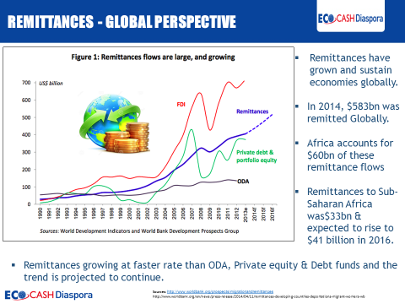
Figure 1.1: Remittances – Global Perspective

1.2.2 Mobile Money Industry in Zimbabwe
In Zimbabwe, the Mobile Money Industry comprises of Mobile Network Operators as well as banking insitutions. These need each other to operate effectively and efficiently. It is essential for a mobile network operator to partner with a bank so as to get approval from the Reserve bank of Zimbabwe. On the other hand, banks also need mobile network operators for purposes of accessing the Unstructured Supplementary Service Data (USSD) shortcode which facilitates the offering of mobile banking services to customers through the use of their hand held devices and mobile phones.

Below are Table 1.1 and Table 1.2 which show banks and Mobile Network Operators that offer Mobile Money services in Zimbabwe.
Table 1.1 Banks offering mobile money services in Zimbabwe: RBZ Monetary Policy (2012)
Banking Institution | Mobile Network Operator | Mobile Banking Platform
FBC Bank | Netone / Telecel | ZIPIT / One Wallet
POSB | Netone / Telecel | ZIPIT
CABS | Netone / Telecel | ZIPIT / Textacash
Metropolitan | Netone / Telecel | ZIPIT / Metbank Mobile
FBC Building Society | Netone / Telecel | ZIPIT
Interfin | Netone / Telecel | ZIPIT
TN Bank | Econet | EcoCash
Tetrad | Telecel | e-Mali
CBZ | All | E-Tranzact/CBZ Mobile
Stanchart | Netone / Telecel | ZIPIT
Trust | All | E-Tranzact / Bank at Ease
ZB |  | E-Solutions
ZABG |  | E-Solutions

Table 1.2. Mobile network operators offering mobile money services
Mobile Network Operator | Mobile Money Service
Econet Wireless (Pvt) ltd | EcoCash
Netone | One Wallet
Telecel | Telecash

Figure 1.2 presents a Zimbabwean perspective on the mobile money remittances as published by the Sunday Mail, (December 14, 2014).
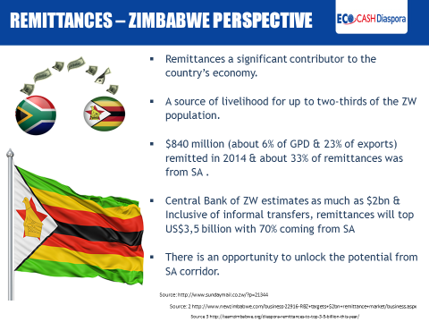
Figure 1.2: Remittances – Zimbabwe Perspective

1.2.3 GSM Telecommunications Industries in Zimbabwe
There are three telecommunications companies in Zimbabwe which also offer mobile money services. These are Econet Wireless, Telecel, and NetOne.

NetOne’s OneWallet
NetOne‘s mobile money service is branded OneWallet. The One wallet functions include money transfer service, airtime top up as well as bill payments. When sending money, a depositor simply deposits cash into their One Wallet account at a NetOne Shop or accredited One Wallet Money Agent and makes a transfer. Subscribers are also able to withdraw money from their wallets (Netone, 2015).

Telecel’s Telecash
Telecel was the first mobile network operator to launch its mobile money service called Skwama in 2010, which was later rebranded to Telecash in 2012. This Skwama product died a natural death according to Kabweza (Kufandirimbwa, 2012). The product is thriving, after being revived under a new name called Telecash.

Econet Wireless’s EcoCash
EcoCash is a Mobile Money service whereby mobile phone customers are provided with an e-money repository (m-money in an m-wallet) in exchange for cash, linked to their mobile line and are able to, inter alia, withdraw cash via an agent or transfer the m-money electronically to another person using their mobile phone, without the need to have a bank account.

Since the launch on 29 September 2011, EcoCash has seen tremendous growth, as over 4.2 million subscribers have registered for Ecocash. Mobile money transfer (EcoCash) service was initially developed with the unbanked in mind but it has since been developed into a fully-fledged financial service that cut across all sectors (Econet Wireless 2013). The service allows Econet mobile clients to be able to send money relatives and friends, pay for goods and services, and to transfer money from bank to wallet and wallet to bank. Those in the rural areas have embraced the product more as it is believed to have changed the way they live their lives and how they transact.
Ecocash Agents currently are around 19 000 strategically distributed nationwide (Econet Wireless 2015). Ecocash customer can visit the agent to register for the service, cash in and cash out. In additions customers can send money, check balance, buy airtime, pay for goods and services, and perform bank to wallet and wallet to bank among other transaction. With Ecocash customers can receive money from the diaspora straight to their wallets and they can open a bank account on their mobile phone and start saving as little as $1 without visiting the bank (Econet Wireless Zimbabwe, 2014).
Two successive Chief Executive Officers (CEOs) have resigned within two years of assuming office at Ecocash. Ecocash has operated without a CEO for the past year, with the Chief Operating Officer overseeing the business operations. Moreover, six senior managers have also left to get employment in competitor organizations.

  - Problem Statement
There has been a proliferation of new players in the mobile money industry, posing a great threat to the market leadership of Econet Wireless Zimbabwe. This has seen the market share of Ecocash declining to 78% from 98% within six months, being January to June 2015. There is therefore, a compelling need to establish the causes of this decline and explore initiatives that can be employed to defend this market share.
  - Purpose of the Study
The research hopes to establish efficient and effective strategies that will enhance customer loyalty, leading to the formulation of defensive market share strategies. It is hoped that the research findings will enhance quality of service, increase customer satisfaction and foster loyalty in Ecocash through the implementation of effective defensive warfare strategies.
As a secondary reason, the researcher’s study program makes it a compulsory requirement to conduct a research, in partial fulfilment of the MBL degree qualification.

  - Objectives of the Study

    - Overall Objective
The overall objective of this study is to establish and analyse the defensive market share strategies that are employed by Econet Wireless in the mobile money industry.

1.5.2 Specific Objectives
The specific objectives of this study are:
- To establish current levels of customer satisfaction in Econet mobile money.
- To assess the effectiveness of current market share defensive strategies that are being employed by Econet.
- To determine the availability and adequacy of channels for service delivery (Ecocash Agents).
- To establish the current levels of employee satisfaction at Econet Wireless Zimbabwe.

  - Research Questions
The persistence of the decline in market share has triggered several investigative questions within this researcher. It is of paramount importance that effective responses to these questions be established as this will lead to a long lasting solution. Some of the questions are listed below:

i. What is the current level of customer satisfaction in Econet mobile money?
ii. How effective are the current defensive strategies that are being employed by Econet
mobile money?
iii. Which are the available channels of service delivery in Econet mobile money?
iv. Which are the current levels of employee satisfaction at Econet Wireless Zimbabwe?
- What are the factors that affect customer service delivery excellence in Econet mobile
money?
- Which are the challenges of providing mobile money service in Zimbabwe?

  - Significance of the Study
There are many beneficiaries to this study. These beneficiaries will benefit from the findings, conclusions and recommendations of the research study. Some of the beneficiaries are listed below:
1.7.1 Top Management of Econet Wireless
The results of the research will help the top management to formulate defence strategies that will lead to effective and efficient service delivery. Top management will be able to scan the environment for threats and opportunities as well as assessing the organization’s strengths and weaknesses. Repositioning of the organization as a global company will also be possible for top management after the conclusion of the research.

1.7.2 The Marketing Manager
The marketing manager can effectively develop programming strategies and ensure unmatched quality standards of service delivery. The research findings will enable the marketing manager to implement communication strategies and co-ordination between marketing and other functions to effect service delivery excellence.

1.7.3 Other Functional Managers
The Business and Market Development Manager will be able to produce financial solutions and products that have a distinctive competence over the firm’s rivals. The Finance Manager will be able to come up with an effective budget that will enable the firm to regain lost market share. The operations manager can build effective teams for various use cases on the Ecocash platform, all of which will help to implement Total Quality Management (TQM) in their day to day operations.

1.7.4 Employees of Econet Wireless
The results of this research will help employees to know what is expected of them and boost their self-confidence. By so doing, targets will be met, thereby contributing to the company’s growth as well as more salaries for employees resulting from increased profits. This will lead to increased employee morale and satisfaction as well as boosting employment security.

1.7.5 Customers
Customer satisfaction can be improved through the findings of this research. This will foster long term relationships which will be nurtured through relationship marketing. Customers are the main stakeholders and consequently, the lifeblood of the organization. The organization will be able to defend its market share through satisfied customers who can become ambassadors and advocates of the organization. It is easier to keep a customer than to create one.

1.7.6 The Government
Since the government derives revenue from the profits of businesses, the research findings will help in developing strategies that will maximize profits for the long term benefit of the government. The government can use the funds in servicing the salaries and wage bills of the civil service.

1.7.7 The Researcher
The researcher will be able to apply the theoretical concepts learnt for research purposes as well as gain industrial experience through interaction with management, employees and customers of Econet Wireless. Moreover, the researcher’s capabilities will be enhanced through carrying out this research as it is a mandatory requirement for graduation.

  - Scope (Delimitation) of the Study
The research focuses on the mobile money operators in a Southern African Development Community, (SADC) country called Zimbabwe. The focus of the research will be in the Harare province, which happens to be the capital city of Zimbabwe. The researcher uses information for the years 2010 to 2014. Information on the number of Mobile Money Transfer agents and the volume of Mobile Money Transfer transactions shall be collected from mobile telephone operators in Zimbabwe.

Mobile money services are offered by both mobile network operators and banks. The scope of this research will however be limited to mobile network operators. A total of five million customers who are currently using mobile money services will be the target population in this research. The research sample of 150 respondents will be derived from the population. The sample will comprise of 10 senior managers, 20 operational managers, 30 employees, 30 Agents and 60 customers. A total of 130 individuals will be requested to complete a self-administered questionnaire with the remainder (20) being interviewed face to face by the researcher. Stratified random sampling was used in the selection of senior, middle, operational management as wee as non-managerial employees.

  - Research Assumptions
    - The management of Econet Wireless is competent, flexible and willing to try out new strategies that go with the times.
    - The researcher will find it extremely difficult to interview all targeted respondents owing to the fact that senior management will not permit such an exercise to be conducted during office hours. In order to overcome this, the researcher will make advance appointments to ensure availability of participants.
    - The researcher is a registered member at two libraries within Harare, and as such, he will find it easy to source literature for review in Chapter 2.
    - The customers have an appreciation of the mobile money industry and what to expect from the operators.

  - Definition of Terms
    - Mobile Money Transfer: A form of electronic banking where financial transactions are conducted using mobile phones.
    - Agent: A business which is contracted to facilitate mobile money transactions for subscribers.
    - E – Money: Electronic money which is stored in the subscriber’s mobile wallet. A customer or subscriber gives an agent cash, in exchange for electronic money (E- Money).
    - Cash In: The process by which a customer or subscriber deposits value into their mobile wallet, which is a process similar to making a cash deposit at a bank.
    - Cash Out: The process by which a customer or subscriber withdraws cash from their mobile money wallet.
    - Float: The e – money value in an agent’s mobile wallet which is used to process transactions.
    - Mobile Wallet: An account which is created to store value on a mobile phone.
    - Market share: Percentage of market that is served by the company

  - Ethical Considerations
The researcher will seek authorization from Econet to access the information before commencing the research. Participation of respondents will be on voluntary basis as well as confidential. Interviewees and respondents will not be forced to participate in the research. Upon the successful compilation of the research report, a copy will also be given to Econet authorities.
  - Research Limitations
    - The researcher was temporarily transferred to South Africa by his employer for a period of four months, thereby affecting the smooth flow of the research process. He however, would come to Zimbabwe twice every month and meet with the research supervisor for longer hours in order to cover up for the lost time. Moreover, the researcher made use of the research assistants to distribute and collect questionnaires which were also used for data collection.
    - The researcher faced challenges in collecting data as some respondents argued that the information required was very confidential and sensitive. The researcher overcame this challenge by assuring them that the information was required purely for academic purposes, and the findings would be treated with utmost confidentiality. Furthermore, the recommendations would help the organisation in developing more relevant defensive strategies.

  - Chapter Summary
The research study outlined a detailed historical background of Econet Wireless. The issues which were covered include a problem statement, purpose of the study, objectives of the study, research questions, significance of the study, scope (delimitation) of the study, research assumptions, definition of terms, ethical considerations, literature review as well as research methodology. The next chapter will review various literatures from different authors that is related to marketing warfare.
CHAPTER TWO
LITERATURE REVIEW
2.1 Introduction
The previous chapter discussed the Econet Wireless background. The sub-topics that were covered included a problem statement, purpose of the study, objectives of the study, research questions, significance of the study, scope (delimitation) of the study, research assumptions, definition of terms, ethical considerations, literature review and research methodology. This chapter will also cover purpose of literature review, sources of literature review, definition of strategy, marketing strategy, marketing warfare strategies, defensive marketing warfare strategies, channel management, value chain, as well as the resource based view.

2.2 Purpose of Literature Review
Literature review has been defined as a “critical analysis of a segment of a published body of knowledge through summary, classification, and comparison of prior research studies, reviews of literature and theoretical articles” (University of Winsconsin Writing Center). It refers to the works consulted in order to understand and investigate the research problem. The major purpose of literature review is to give a clear understanding and insight into the research on defensive strategies that have emerged from marketing warfare.
.
By conducting a literature review, the researcher is able to conduct an up-to-date assessment of the topic as well as discover other related literature that was written prior to the research. The researcher is also able to see the extent of research that was previously conducted around the intended area of research. The researcher is also able to identify key questions that may require further research as they carry out the review.

2.3 Sources of Literature
Sources of Literature can take various forms ranging from print to electronic. They are mainly classified into three broad categories; primary, secondary and tertiary.
http://classguides.lib.uconn.edu/content.php?pid=239974&sid=1981391[Accessed12 October, 2015]
- Primary Sources
Primary sources of literature include a wide range of literature including interviews, emails, minutes of meetings, audio recordings, video recordings, speeches, patents and research articles.
- Secondary Sources
Secondary sources of literature include textbooks, journals, documentaries, commentaries, magazines and newspapers.
- Tertiary sources
Tertiary sources of literature include handbooks, dictionaries, manuals and encyclopedias.
http://www.lib.umd.edu/tl/guides/primary-sources#primary [Accessed 12 October 2015]

2.4 Definition of strategy
Strategy is defined as the direction and scope of an organization over the long term, which achieves advantage in a changing environment through its configuration of resources and competences with the aim of fulfilling stakeholder expectations, (Johnson et al, 2008). This definition is very similar to that of Johnson and Scholes (1997) who define strategy as the direction and scope of an organization over the long-term which achieves an advantage for the organization through its configuration of resources within a changing environment, to meet the needs of markets and to fulfill stakeholder expectations. These definitions are summarized by Mintzberg (2001) who defines strategy using the 5 ‘P’s; plan, ploy, pattern, position and perspective.

2.4.1 Marketing Strategy
Kotler et al (1999) define marketing strategy as the marketing logic that businesses use to achieve their marketing objectives. This definition is consistent with Kotler (1990) where he defines marketing strategy as the broad principles an organization uses to achieve marketing objectives. Any business should have a marketing strategy as it will inform many decisions that the business has to make that include product, pricing, promotional and distribution decisions, (Bovee and Thill, 1992). As highlighted in the definitions, it will help in the attainment of the organizational goals and objectives (Peterson, 1992).

Porter provided a framework that models an industry as being influenced by five forces. The strategic business manager seeking to develop an edge over rival firms can use this model to better understand the industry context in which the firm operates, Worthman (2004). The five forces are Degree of rivalry, Threat of substitutes, Buyer power, Supplier power and Threat of new entrants.

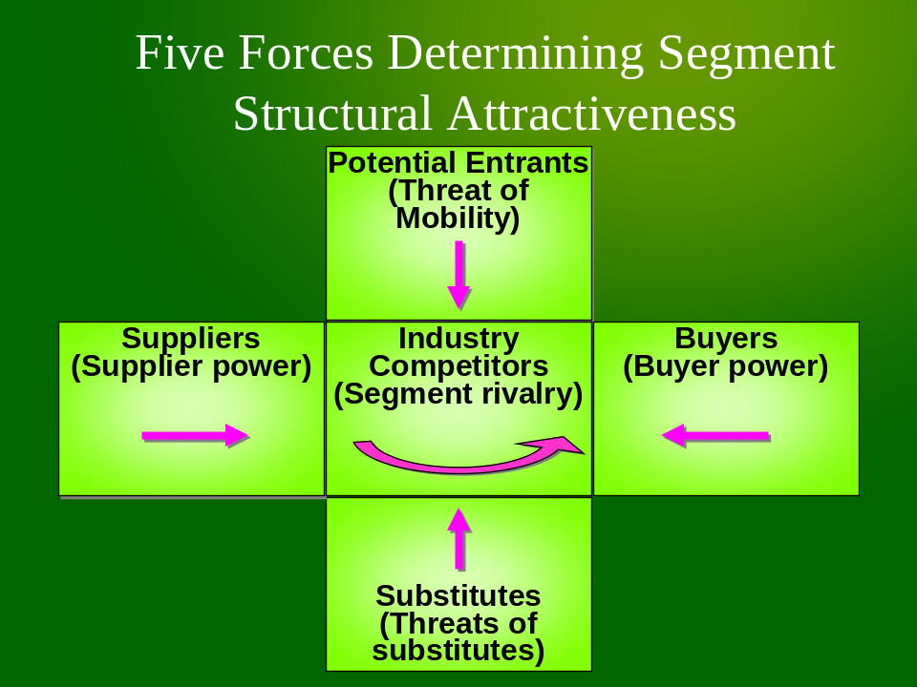

Figure 2.1 Porter’s Five Forces Model

2.4.2 Marketing warfare strategies
Business can be paralleled to warfare in many respects. Both have to decide on the best way to make use of their resources and to perform better than the competition. In that light, military principles can be imported into the business world and be applicable, hence the phrase marketing warfare.

Ries and Trout (1997) shift the organizations’ focus from being only customer oriented to inclusion of a competitor orientation. This is a proactive way of looking at the operating environment and would remove marketing myopia from organizations.
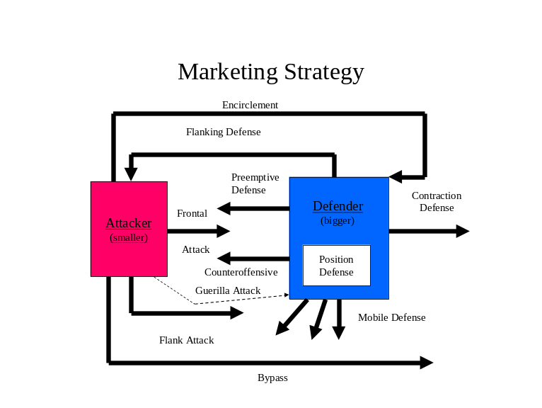
Fig 2.2 Strategies for dealing with competition
Source : Adapted from Schewe (2008).

The marketing warfare strategies can largely be broken down into two major categories, attack and defense. The attacker is usually the smaller player or the market challenger whilst the defender is the bigger player or the market leader as depicted in Figure 2.2

Attack Strategies include:
- Frontal attack
- Flanking attack
- Bypass attack
- Guerilla attack
- Encirclement
http://nataliecopuroglu.com/2011/04/14/theory-vs-practice-1-marketing-warfare/ [Accessed 12 October 2015]
Defense strategies include
- Position Defense
- Flank Defense
- Preemptive Defense
- Counteroffensive Defense
- Mobile Defense
- Contraction Defense
http://nataliecopuroglu.com/2011/04/14/theory-vs-practice-1-marketing-warfare/ [Accessed 12 October 2015]

2.4.3 Defensive Marketing Warfare Strategies
Ries and Trout (1997) disagree to the fact that a market leader can maintain its position by merely using the power of leadership. The position of leader needs to be maintained using a set of defensive strategies one at a time or in combination.

Ries and Trout (1997) propose three basic principles of defensive marketing warfare
- Defensive strategies should only be used by a market leader
- The best defense is for an organization to attack
- Always block competitors’ offensive moves

- Position Defense
Duro and Bjourn (1987) describe the simplest form of defense as building an impregnable fortification. This fortification is built in the minds of the consumers regarding an organizations product or brand such that the consumer does not have a desire to switch to competitor products or brands.

- Flank Defense
This strategy involves covering all parts of the market even those that may seem insignificant. This is to prevent competitors from seeing these ‘flanks’ as ports of entry into the market, (Wesley, 1989).

- Preemptive Defense
The truism ‘prevention is better than cure’ best describes this form of defence. The market leader pre-empts attack from competitors and attacks before they do, (Porter, 1990).

- Counteroffensive Defense
This strategy refers to the attack that the leader will launch in response to an attack waged against them. Ries and Trout (1997) identify counteroffensive strategies as including a price war, new product development and promotional campaigns.

- Mobile Defense
The leader stretches its domain over new territories that can serve as future centres for defence and offense, Duro et al (1987). This is a proactive form of defence to allow an organization to penetrate certain markets ahead of the competition.

- Contraction defense
Contraction defence can be likened to strategic withdrawal (Michaelson, 1987). An organization will withdraw from some of its markets and focus its attention and resources on those markets it feels it has the capacity to defend.

Sun Tsui, as quoted by Kotler (2008), said; ‘One does not rely on the enemy not attacking, but relies on the fact that he himself is unassailable. The most constructive response is continuous innovation. In this regard, the leader refuses to be content with the way things are and leads the industry in developing new product and customer services, distribution effectiveness, and cost cutting. The leader applies the military principle of the offensive, which states that, The commander exercises initiative, sets the pace, and exploits enemy weaknesses.’
2.4.4 Other Defensive Strategies
Apart from marketing warfare strategies, there are other strategies that can be employed to defend an organization’s market share. These strategies include Human Resources strategies and service strategies.
2.4.4.1 Human Resource Strategies
2.4.4.1.1 Motivation
Gredler, Broussard and Garrison (2004) define motivation as “the attribute that moves us to do or not to do something”. Motivation can also be explained as the reasons that make an individual behave in a certain manner (Guay et al, 2010). Organizations should define the behaviors they want their employees to exhibit and find ways to encourage those behaviors out of them. If an organization’s employees feel they will also benefit from acting in a certain manner, they will perform wholeheartedly. Highly motivated and self driven employees are of necessity in organizations as a defense strategy as they will be loyal and defend the cause of the organization.

Vroom’s expectancy theory is one of the motivation theories which are to be used. According to Vroom, a person’s motivation is dependent upon his expectation for success. The theory is based on three concepts.
- Expectancy- a person’s perceived relationship between effort and performance. Increased effort leads to higher performance.
- Instrumentality- a person’s perception of the relationship between performance and reward. Higher performance should lead to promotion.
- Valence-This represents the value placed upon a particular reward. Appleby (1994) says that people must be attracted or motivated to:
  - Join an enterprise and remain within it.
  - Exert sufficient energy and effort at an acceptable rate.
  - Maintain and develop the human resources of the enterprises.

2.4.4.1.2 Training
Cronje et al (2001) define training as a systematic and planned process to change the knowledge, skills and behavior of employees in such a way that business objectives are achieved. Beach (1990) defines training as the organized procedure by which people learn knowledge and skills for a definite purpose. The metaphor ‘knowledge is power’ supports the definitions above. From the definitions it is evident that increasing ones level of skill and knowledge results in increased individual performance which can translate to an increase in the organization’s performance. When defending a market one cannot afford to make mistakes but needs to stay on top in every aspect of the business. Through training or employees, organizations can enjoy operational superiority that its competitors cannot match.

2.4.4.1.3 Employee Retention
According to Jubenkanda (2001), the three main Human Resources activities are attracting human resources, retaining human resources and developing human resources. Employees are the major resource in any organization as they carry the intellectual capital, experience and knowledge of how to operate the business. The Brookings Institute (2003) observed that the source of market value has shifted from the tangibles to the intangibles such as intellectual property. This then emphasizes the criticality of employees as a source of competitive advantage.
When an organization takes care of this resource, it fosters loyalty and commitment such that the competition cannot penetrate or lure employees away. This in itself creates a form of defence.

2.4.4.2 Service Quality Strategies
Martins (1997) defines customer care as a fundamental approach to standards of service quality which covers every asset of a company’s operations from the design of a product or service to how it is packed, delivered and serviced. Customer care entails doing whatever is necessary to ensure the customer is delighted and satisfied. By delighting and satisfying customers organizations increase customer’s switching costs and foster loyalty as illustrated by the customer loyalty ladder. This loyalty can serve as a defence for the organizations market share.
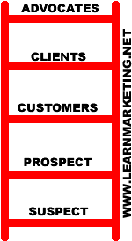
Fig 2.3 The customer loyalty ladder
Source: http://www.learnmarketing.net/ladder.htm[Accessed 14 October 2015]
2.4.4.3 Leadership strategy
According to Cronje (2001), leadership is the ability to influence others to cooperate willingly for the attainment of the business’ pre-designed goals. If an organization’s goal is to defend its market share, it can equip itself with competent leaders that fit the description of Montgomery when he says a leader is “one who can be looked up to, whose personal judgment is trusted, who can inspire the hearts of those he leads, gaining their trust and confidence, as well as explaining what is needed in a language which can be understood”. Such individuals are important in market defence. These leaders will steer the ship and keep everyone in high spirits and focused on the goal which is to defend the position of the organization.
2.4.4.4 Channel Management
Channel management typically involves overseeing and monitoring the activities of agents. Mobile money services are largely driven by agents, as such it is critical to manage the network of agents in order to retain the customer experience. Retaining customer experience is key in scaling mobile money services.

2.4.4.5 Value Chain
The understanding of value chain is essential in the effective crafting and implementation of marketing warfare strategies. According to Porter, (as cited in Rich, Baker, Negassa & Rodd, 2009), value chain is a firm’s representation of its value-adding activities, which are based on its pricing strategy and cost structure. The Institute of Management Accountants, (1996) also support this notion as they state that the value chain encompasses those internal and activities that a company performs in designing, producing, marketing and delivering its products or services.
Porter (1985), divided a firm’s activities into primary and support activities, where primary activities are directly involved in the processing of inputs into outputs, delivery of products to the market as well as offering after sales support.
- Inbound Logistics include material handlng and warehousing.
- Operations include the transformation of inputs into final products.
- Outbound Logistics include order processing as well as product distribution.
- Marketing and Sales include channel management, communication and pricing.
- After Sales Service includes installation, parts as well as repairs.
According to Porter (1985), support activities are those activities which are designed to support primary activities. Some of the support activities are include procuremement, Technology Development, Human Resource Management as well as Firm Infrastructure.
There have been criticisms to the value chain concept as stated by Shank and Govindarajan (1999). Whilst Porter’s model focused on those activitiesthat are performed by the firm, Shank and Govindarajan came up with a broader model, arguing that the value chain starts with suppliers who engage in value creating processes, different customer classes as well as disposal and recycling of materials. According to Shank and Govindarajan (1999), the understanding of the value chain will unlock more value, leading to sustainable competitive advantage and more profitability.

Figure 2.4 below shows a comparison between Porter’s value chain and the one proposed by Shank and Govindarajan (1999).
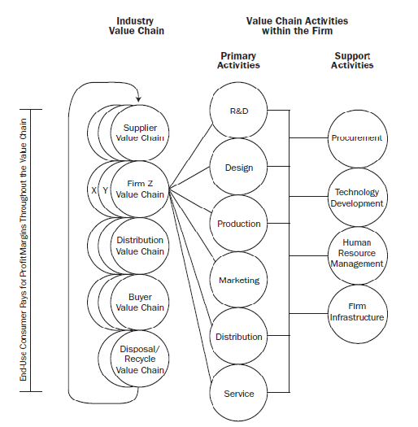
Figure 2.4 The Value Chain Comparison
The Institute of Management Accountants (1996) states that value chain is useful to businesses in identifying profitability sources as well as costs of their internal processes. Ii is therefore of paramount importance for businesses in the mobile money service to have a clear picture of their value chain. It is critical to note that mobile money being a service, will have a different value chain from that of a physical product. The concept however remains the same, as the the value chain for mobile money services also has primary and support activities.
Donaldson (2011), developed the mobile money value chain activities as shown in figure 2.5 below.
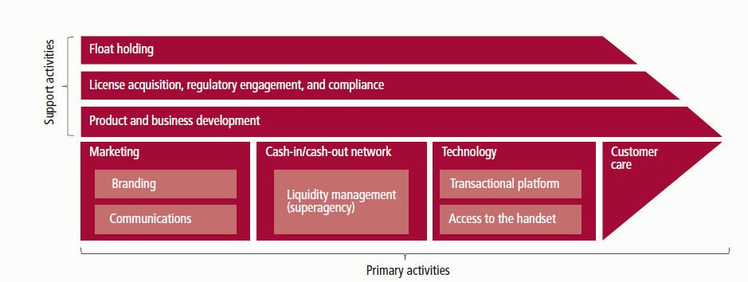
Figure 2.5. Mobile Money Value Chain. Adapted from Annual Report 2011 (p.25), by Davidson, 2011, London: GSMA-Mobile Money for the Unbanked.

In mobile money service, primary activities include marketing, the agent network, technology as well as customer care. Support activities will include float handling, acquisition of licensing, compliance, product development, business development as well as regulatory engagement.

2.4.4.6 Resource Based View (RBV)
Powell (2007) states that the resource based view concept views an organization as a bundle of resources, which are combined to differentiate firms. The capabilities of an organization will enable it to usher value adding products into the market, and also grow its market share. Madhani (2010) also shares the same sentiments and also adds that the RBV focuses on an inside-out view of a firm and explains why businesses succeed or fail in the market. Sustainable competitive advantage is therefore hinged on the resources and capabilities of an organization according to the resource based view.
Madhani (2010) further states that competitive advantage is only possible if there is resource heterogeneity as well as resource immobility. However, it is essential to note that not all resources are able to provide a source of competitive advantage. Morover, not all resources are also strategic.
According to Davidson (2011), the Resource Based View is also applicable to the mobile money industry. This is illustrated in figure 2.6 below.
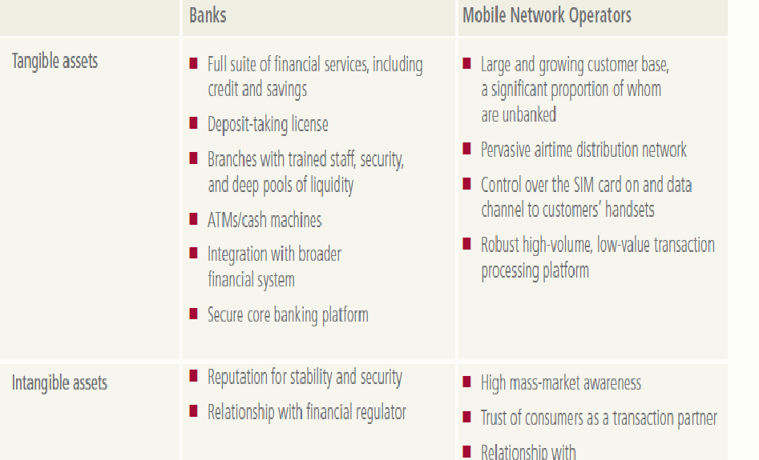
Figure 2.6. The assets and competencies, relevant to mobile money, of banks and mobile operators. Adapted from Annual Report 2011 (p. 26), by Davidson, 2011, London: GSMA-Mobile Money for the Unbanked.

2.4.4.7 Branding
DeChernatony and McDonald (as cited in Blythe, 2005) defined branding as a name that is used to identify a product, service, person or place, augmented in such a way that the buyer or user perceives relevant, unique added values which match their needs most closely. In addition, the success of the brand results from being able to sustain those added values in the face of competition. Thus, branding is a key issue in positioning since it is used to identify a product as well as conveying an impression of its quality. In mobile money services, branding is very key as it helps customers to identify where service is being offered. It is also, important that the mobile money service leverage on the corporate brand. This makes it easier for brand recognition and awareness. M-PESA leveraged on the Safaricom brand which enjoyed 80% market share in Kenya. Similarly, in Zimbabwe EcoCash is leveraging on the brand of its parent Econet which enjoys 70% of the Zimbabwean market share.

2.5. Case Studies on Defensive Marketing Warfare Strategies
2.5.1 M-PESA in Kenya
In order to effectively grow and defend market share, it is of paramount importance that a mobile network operator focuses on how to get subscribers to trust such an intangible electronic service and make them comfortable using it. It is also important that subscribers find value in joining the service. A review of literature by Mas & Ng'weno (2010) reveals the undernoted key strategies employed by M-PESA.

Brand development
The Kenyan market had little experience with formal fiancial services. As a result, it was crucial for M-PESA to develop a good brand that was able to appeal to the highly financial illiterate clientele base. Safaricom invested in marketing such that M-PESA’s brand was stronger than Safaricom’s corporate brand in Kenya (TNS Research International, 2009). The strategy adopted by Safaricom was to go for a full blown national launch and choose a deliberate messaging and marketing mix. This helped to overcome network effects. In Zimbabwe, of the three mobile network operators, only Econet and to a lesser extent Netone went on a full blown national launch.

In order to develop its brand M-PESA used according to Mas & Ng'weno (2010):
- A single, simple message meant to address the key customer need of domestic remittances. Here we can draw parallels with the Zimbabwean experience. As compared to Kenya, there is no single mobile money service in Zimbabwe that has a simple message that is meant to address a key customer need what is referred to as the customer pain point. In the case of the Kenyan market, the customer pain point was the need to send domestic remittances to the rural areas as a result of the predomiant rural to urban migration. In Kenya most families reside in the rural areas whilst the husbands got to the cities to work. They therefore, required a safe and efficient service to send money back home. Also, by focusing on a single simple message, M-PESA unlike other mobile network operators particularly those in Zimbabwe, did not make the mistake of attempting to replace cash in customers’ day to day life but simply offered a new solution of remote payments where cash was not very effective. M-PESA’s message ws simply “Send money home.”. The message was well suited to Kenya’s phenomenon of split families as a result of rural to urban migration. 3 years down the line, this has remained M-PESA’s main marketing message.

- An appropriate marketing mix was also crucial to M-PESA’s success. Initial marketing was targeted at the rich city dweller thereby avoiding the notion that it was a low value product that was aimed at the poor. As time went on, M-PESA’s marketing efforts shifted from the rich with desk jobs to ordinary Kenyans from lower values professions. In terms of advertising medium, M-PESA used television and radio, radio shows and tents that explained the product and demonstrating its use cases. As people became more accomstated with the product, M-PESA abandoned the hands on outreach approach and television and radio advertisements repalcing them with branding at agents and billboards.
- Consistent store branding and customer experience. There are 19,000 stores with a prominet M-PESA logo.
- Service branding building on a strong corporate image. M-PESA leveraged on the strong Safaricom brand.
- An easy intuitive service design. This comprised of an easy to use interface. However, M-PESA’s customers needed to get a new sim card which was provided for free. In Zimbabwe, Netone required its subscribers to obtain new sim cards as well. Telecel and Econet subscribers on the other hand did not require new Sim cards.

Channel Management
Safaricom built a channel that wasbased on key requirements for profitability namely:
- Providing insentives for third party retail players to get involved.
- Scalability (achieving rapid growth).
- Control over the brand, customer experience and geographic distribution of agents.
In order to manage its over 19,000 stores Safaricom employed a parallel mechanism. The first way was to introduce a two tier structure with individual stores (agents) depending on master agents. These master Agents would maintain contact with Safaricom while performing two key functions of liquidity management and distributing agent commissions to the individual stores. Econet’s EcoCash is growing rapidly and has over 21000 agents hence the reason for this research to find out how it can defend its marketshare that has been successfully grown over the years. The second way was to engage a third party company, Top Image, to conduct evaluation and training new stores and performing periodic on site supervision of all stores. Top Image visits agents monthly and scores them on a range of criteria.

Customer Tariff and Agent Commission Structure
M-PESA uses a combination of flat rate and stepping up according to the size of the transaction for its tariff structure. Safaricom also pays commission to agent HeadOffices which in turn pass on to its agents usually at 30% to 70% ratio. M-PESA charges the same rate as P2P (person to person transfer) for Bill Payment and customers incur no charges on airtime top up. International remittances are charged at GBP4 per every GBP100.

2.5.2 TIGO Paraguay
Tigo Paraguay had four success factors according to Tellez & McCarthy (2011):
- Deep market understanding
- Building a satisfied and motivated agent network
- Developing complelling marketing strategies to drive customer activition and usage
- Collaborating with an aligned bank partner.
An analysis of the Kenyan and Paraguayan case studies reveal common key success factors to both companies and these are: channel management, marketing and developing a deep marketing understanding to ascertain a customer need or customer pain point.

2.6 Chapter Summary
This chapter covered the literature review which is relevant to the analysis of defensive marketing warfare strategies for Econet Wireless. The sub-topics that were covered included the purpose of literature review, sources of literature review, definition of strategy, marketing strategy, marketing warfare strategies, defensive marketing warfare strategies, channel management, value chain, as well as the resource based view.

CHAPTER THREE
RESEARCH METHODOLOGY
3.1 Introduction
The previous chapter was Literature Review. The topics which were covered included literature review, sources of literature review, definition of strategy, marketing strategy, marketing warfare strategies, defensive marketing warfare strategies, channel management, value chain and resource based view. The topics which were covered in literature review were very relevant in providing a clear understanding of the concept of marketing warfare as well as the defensive strategies that can be employed in order to survive in hostile environments.

In this chapter, a comprehensive view of the research design, research subjects, research instruments as well as data collection procedures will be discussed. The researcher also explains how the data and information that was relevant in the addressing of the research objectives and questions was collected, presented as well as analysed. Furthermore, reasons and justifications for the employed research design, research instruments, data sources, data collection techniques, data presentation as well as analysis are also provided. The researcher will also provide solutions of minimizing weaknesses associated with the employed techniques.

3.2 Research Design
Robson (2006), as sited by Saunders et al (2008), define research design as the process of turning your research questions into a research project. Saunders et al (2008) further explain that research design is the general plan of how the researched will go about answering the research questions. Aaker et al (2008), also agree and state that a research design is a detailed blueprint that is used to guide a research study towards achieving its objectives. All the cited authors, being Robson (2006), Saunders et al (2008) and Aaker et al (2008), concur that a research design is there to guide the researcher to articulate the objectives of the research study. In this particular research study, data and information were collected with the assistance of self-administered questionnaires, face to face interviews as well as desktop research.

3.2.1 Research Philosophy
Saunders et al, (2008) present a research philosophy as a belief in which data about a phenomenon can be gathered, interpreted and used. The western tradition scientists have identified positivism and intepretivism as two key research philosophies, Galliers (1991). This research was more inclined to the positivist approach. However, the intepretivist concept was also included. Mixed philosophies can be applied as this enriches the understanding of the subject under study, Creswell (2011). According to Clark (2006), the belief that one research philosophy is better than the other will result in a misleading outcome. It is therefore essential that mixed philosophies be adopted. Levin (1988), states that reality is stable and can be objectively observed and described. Positivists focus more on existing theories, carefully examining prior literature, and often designing their research based on concepts and themes developed by others, Saunders (2008). Collins (2010) noted that the positivist philosophy is in accordance with the empiricist stand point which states that knowledge stems from human experience. Intepretivists on the other hand, believe that reality is relative to human construction which can be understood subjectively, Myers (2008). The intepretivists admit that they may be many meanings attached to outcomes, but maintain that these philosophies are a part of the scientific knowledge which they are pursuing, Saunders et al (2008). Carson et al (2001), also state that the knowledge that is generated from this discipline is perceived as socially constructed and open to subjective intepretations.

3.2.2 Justification of the chosen Philosophy
The positivism philosophy was suitable for this research as it allowed the investigator to determine the state of things and how they work, Cuba and Lincoln (1994). The positivist paradigm allows the researcher to use the key criterion which are validity, reliability and generalizability. The validity thereof can strengthen the notion that answers testable questions and the process can also be repeated. Since the research findings can be used in other contexts, the generalizability of the positivist philosophy becomes essential. The research study also adopts a reductionist approach which simplifies the real life environment and the relationships between the studied constructs. This will allow the researcher to assess the defensive marketing warfare strategies using case studies.

3.3 Research Subjects
EcoCash currently has five million customers on the platform. These will be the target population for the research study. From the said population, the research sample of 150 respondents will be derived. The breakdown of the sample will be 10 senior managers, 20 operational managers, 30 EcoCash Agents, 60 Customers as well as 30 non-managerial employees. A total of 130 individuals will be requested to complete the self-administered questionnaire, whilst the remaining 20 will be interviewed face to face by the researcher.

3.4 Research Instruments
This section of the research report presents the methodology that was used in the collection, presentation and the analysis of the collected data. The study adopted the instruments which the researcher deem necessary for this particular research design. The research instruments that were used include the questionnaire technique, face to face interview technique and desktop research technique. Saunders (2009) states that it is entirely up to the researcher to establish whether the research objectives can be achieved using a single instrument or many are required.

3.4.1 Questionnaire Technique
A questionnaire is a device used to secure answers by completing a form which the respondent completes on their own, Good and Halt (2009). DeVaus (2002), as cited in Saunders et al, (2009), define a questionnaire as a general term that includes all data collection techniques which involve questions answered from a piece of paper. A questionnaire technique was used to collect survey data in this study. This technique is also supported by Wegner (2005), who asserts that questionnaires are most suitable when targeting respondents who are geographically dispersed. Hussey (1997) defines a questionnaire as a list of carefully structured questions which are selected for considerable testing with the objective of eliciting reliable responses from a chosen sample.

The questionnaire technique made it easy to collect data from many dispersed participants. Anonymity of the respondents’ names was also possible through the use of the questionnaire technique. Since their names were not disclosed, the respondents freely gave their views and comments without fear of reprisals. Moreover, the questionnaire technique proved to save time in those instances where respondents at localized places were able to complete the questionnaires at the same time. This was possible on the part of employees at the workplace, and EcoCash Agents at the Agent training venues.

The questionnaire technique forms a permanent record which can always be referred to in the event of any such need arising. Questionnaires also work best if the questions are ordered and standardised as done in this study. This is also supported by Saunders et al (2008), as it becomes easy to interpret uniformly by the respondents. The questionnaire technique also increased the validity of the research study as it was responded to by the relevant people.

However, the questionnaire technique had its limitations as well. It has a high volunteer bias as only those who were willing, answered the questionnaire. In order to overcome the limitation of the high volunteer bias, the researcher had to explain the purpose of the research as well as the benefits that would accrue to Econet Wireless Zimbabwe through the adoption of the recommendations derived from this study. Another disadvantage of using the questionnaire technique is that some of the respondents may not be literate. It was however fortunate that all the respondents were literate and therefore able to answer all the questions on the questionnaire. The other disadvantage of using the questionnaire technique is also that some respondents would just respond to the questions without fully understanding the questions asked. This problem was overcome by further interviewing the respondents through the help of a research assistant.

3.4.2 Face to face Interview Technique
The researcher also used the face to face interview technique in collecting data. The semi-structured interview is used to get in-depth information and clarity on issues that need further understanding. Interviews are ranked in the group of the most powerful data collection tools due to the flexible nature which allows the researcher to pursue those leads that appear fruitful, and require further elaboration, which the respondent would not have made clear or partially avoided.

Another advantage of the face to face interview is that it allows the researcher to clarify questions that the respondent would have misunderstood. This ensures the collection of quality data as well as getting the respondent to answer all questions asked.
Unfortunately, interview bias cannot be avoided owing to the flexible nature of the method. This limitation was mitigated by the researcher being very objective in recording answers, with the understanding that the outcome of the process will be critical in the improved operations of Econet Wireless Zimbabwe as a business.

3.4.3 Desktop Research Technique
Conceptual Framework
Figure 3.1 below depicts the conceptual which will be used for purposes of guiding the research.

Independent Variable Dependant
Outcome
Market share
Defensive Strategies
- Human Resource Strategies
- Leadership Strategies
- Service Quality Strategies
- Channel Management
- Value Chain
- Resource Based View Strategy
- Branding

Figure 3.1 Conceptual Framework

This research study will be underpinned on the above conceptual framework. An analysis of the defensive strategies such as Human Resources, Leadership, Service Quality, Channel Management, Value Chain, Resource Based View and Branding will be done with the objective of assessing whether they have any effect on defending Econet Wireless Zimbabwe’s market share.

Previous researchers highlighted that the impact of some defensive strategies being applied on market share were inconclusive. However, these previous studies were not within the context of the mobile money industry, as also alluded to by Boddewyn and Leardi (2009) as well as Odunlami (2011). This has therefore necessitated the in-depth study within the context of the mobile money industry in Zimbabwe.
3.5 Data Collection Procedures
Self-administered Questionnaire
The self-administered questionnaire was crafted in light of the research problem. The questions thereof were focused on the problem. The questions were then presented in a questionnaire format, which was pilot tested as a research tool. After effecting all the necessary amendments, numerous questionnaire copies were printed for distribution to all the targeted respondents. The respondents were given up to two hours to complete the questionnaires. The completed questionnaires were collected through the help of research assistants and placed in a locked cabinet to guard against contamination. The questionnaires were later opened to allow for analysing them at an appropriate time.

Face to face interview
The interview guide was prepared by the researcher. This guide had various questions which were in relation to the topic under investigation. After a pilot run of the questions with the supervisor, the interview guide was then used to ascertain responses from the respondents. The interview presented a face to face interaction with the respondents. Those responses which were vague such as those responded to by way of nodding the head, or frowning, were further probed for elaboration. The respondents were given the opportunity to clarify their responses as they had ample time to explain themselves. As a way of ensuring validity and reliability, the respondents were probed further with the objective of clarifying those statements which appeared vague. The face to face interviews were held at scheduled times, and responses were recorded as the interviews progressed. These responses form part of this report.
Desktop Research
The desktop research was conducted through the collection of industry journals, business reports, Econet Wireless financial reports, magazines, competitor websites, as well as books. The researcher started to read, extracting data and information that he deemed to be appropriately relevant to the area of current research. This data and information which was collected was then applied to enhance the research process.

3.6 Chapter Summary
This chapter presented a comprehensive view of the research design, research subjects, research instruments as well as data collection procedures. An explanation on how the data and information that was relevant in the addressing of the research objectives and questions was collected, presented as well as analysed was done by the researcher. The researcher also provided solutions of minimizing weaknesses associated with the employed techniques of data collection. The next chapter is chapter four, which focuses on data presentation, and analysis. The chapter will cover the findings, analysis and interpretation of the research results.

CHAPTER FOUR
DATA PRESENTATION AND ANALYSIS

4.1 Introduction
The previous chapter discussed the research methodology which covered topics such as the research design, research subjects, research instruments and data collection procedures. Solutions for mitigating the weaknesses of the data collection techniques were also provided. This chapter provides a detailed presentation, analysis and interpretation of the data gathered from the research. The research findings were interpreted and analysed against a benchmark from literature.

The researcher was assisted by three research assistants to distribute, and collect questionnaires from individual customers and agents. A total of 130 questionnaires were distributed and 110 were sent back or collected in time, representing an 84% success rate. In terms of interviews, the researcher targeted to interview 20 individuals, with 14 being successfully held, giving a 70% success rate. The overall response rate was 82%. In the opinion of this researcher, the achieved success rates were quite satisfactory, and thus, he proceeded with the analysis of the collected data.

The researcher will present the data that was collected with the assistance of questionnaires and interviews. The researcher will comment briefly on some of the analyses made. The data was tabulated and graphs were used to further simplify presented in the findings.
4.2 General Information and Demographics
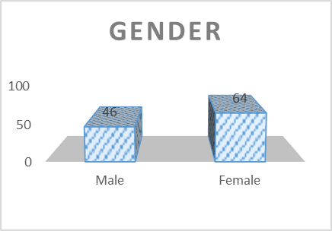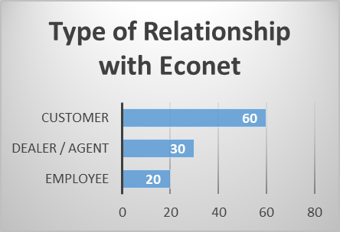
Figure 4.1 Gender Figure 4.2 Type of Relationship
The initial research sample was 130 respondents, where 110 individuals completed the research questionnaire, resulting in a response rate of 84%. The composition of the respondents was 46 males and 64 females (See Figure 4.1). Of the 110 respondents, there were 60 individual customers, 30 channel partners which include Dealers and Agents and 20 internal employees as shown in Figure 4.2 above.
Table 4.1 Level of Education
Source: (Survey Results, 2016)
Level of Education | Response
 | Number | %
O’ level | 14 | 13%
A’ level | 21 | 19%
Diploma | 16 | 14%
Degree | 47 | 43%
Other | 12 | 11%
Total | 110 | 100%

The minimum education level of all the respondents who completed questionnaires as well as attended the face to face interviews was O’Level as shown in Table 4.1. The bulk of the respondents had at least a degree, representing 43% of the total respondents. The other qualification represents doctorate and masters, being 11% of the total respondents.

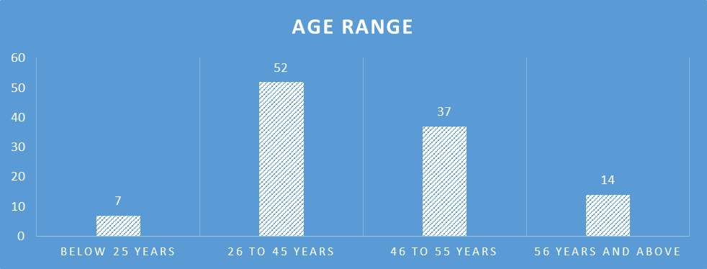
Figure 4.3 Ages of Respondents
The study sought to explore whether the respondents were mature enough in terms of age, to give an objective assessment of the defensive strategies used by Econet Wireless Zimbabwe. As shown in Figure 4.3 above, the bulk of the respondents are in the 26 to 45 years age range, which constitutes 47% of the respondents. The 46 to 55 years age range is also represented by 34% of the respondents. Just 6% of the respondents were aged below 25 years.

Table 4.2 Respondents
Respondents | Sample | Response |  | Non Response
 |  | Number | % | Number | %
Director | 2 | 2 | 100% | 0 | 0%
Senior management | 5 | 4 | 80% | 1 | 20%
Supervisory management | 8 | 6 | 75% | 2 | 25%
Non managerial staff | 8 | 8 | 100% | 0 | 0%
Customers | 72 | 60 | 83% | 12 | 17%
Dealers / Agents | 35 | 30 | 85% | 5 | 15%
Total | 130 | 110 | 84% | 20 | 16%

Source: (Survey Results, 2016)

Internal employees were also requested to complete the questionnaire and the results are shown in Table 4.2 above. The researcher received completed questionnaires from 20 internal employees comprising of 2 directors, 4 senior managers, 6 supervisors and 8 non managerial staff members. On the face to face interviews, 4 non managerial employees, 2 senior managers and 1 director were interviewed, making a total of 11 employees interviewed. A total of 60 individual customers and 30 Agents also completed the research questionnaire.
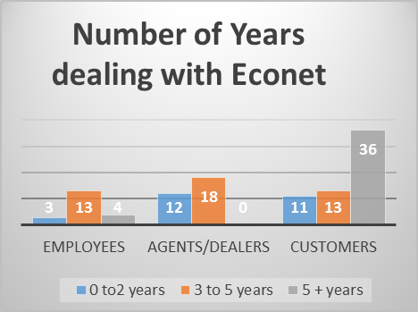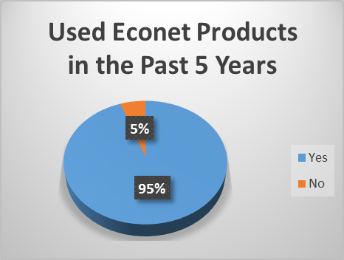
Figure 4.4 Duration of Relationship Figure 4.5 Product Usage
The researcher sought to establish the number of years that the respondents had dealt with Econet Wireless Zimbabwe and its products, as this would help in assessing the experience and intimacy with the brand. The results in Figure 4,4 above show that 36 out of the 60 customer respondents had more than 5 years experience in dealing with Econet Wireless Zimbabwe. This represents 60% of the total customer respondents. Whilst there were no Agents with more than 5 years experience, 18 of the 30 were in the 3 to 5 years category. Out of a total of 20 employees who responded to the self-administered questionnaire, 13 had between 3 to 5 years experience with Econet Wireless Zimbabwe. The more the number of years in experiencing the Econet relationship, the more authentic and confident the researcher had in the information given.

From Figure 4.4 above, 84 out of the 110 respondents, representing 76% had dealt with Econet for 3 years and above. As shown in Figure 4.5 above, a total of 95 % of the respondents who completed questionnaires as well as attended face to face interviews have used Econet products in the past 5 years. This will help the researcher in establishing the customer satisfaction, loyalty and product stickiness levels.
4.3 Analysis of the Defensive Strategies being used
This section will present the findings of the current defensive strategies being employed by Econet Wireless Zimbabwe.

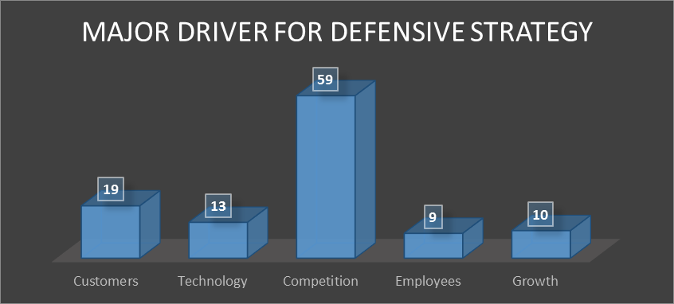
Figure 4.6 Defensive Strategy Drivers
The researcher sought to establish what the respondents thought were the current drivers for defensive strategies being employed by Econet Wireless. As shown in Figure 4.6 above, a total of 59 respondents cited competition as the major driver. The second driver, as highlighted by 19 respondents was customers’ changing tastes and preferences, followed by technology with 13 respondents.
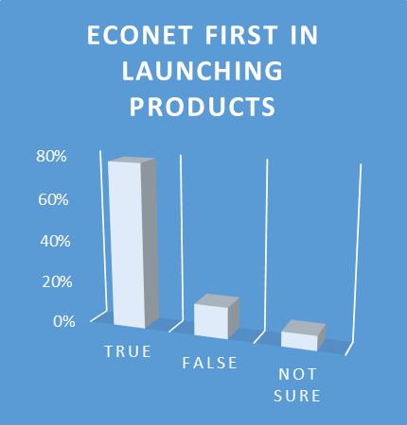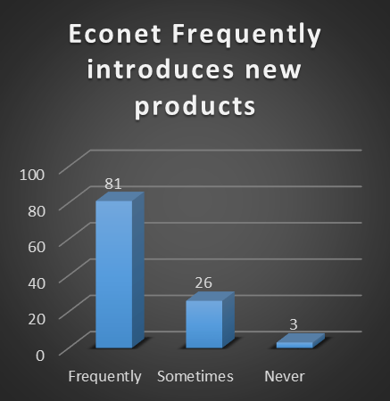
Figure 4.7 First in Launching Products Figure 4.8 Frequency of Product Launch

The researcher sought to establish whether Econet Wireless Zimbabwe was always first in launching new products, and also the frequency of doing the same. Out of the 110 respondents, 78% feel that Econet is the first to launch new products as depicted in Figure 4.7 above. A total of 16 respondents, representing 15% feel that Econet is not the first in launching new products, with only 7% of the respondents being unsure. A total of 81 out of the 110 respondents believe that Econet frequently introduces new products as shown in Figure 4.8. Twenty six respondents feel that Econet sometimes introduces new products whilst only 3 feel that it never introduces new products.

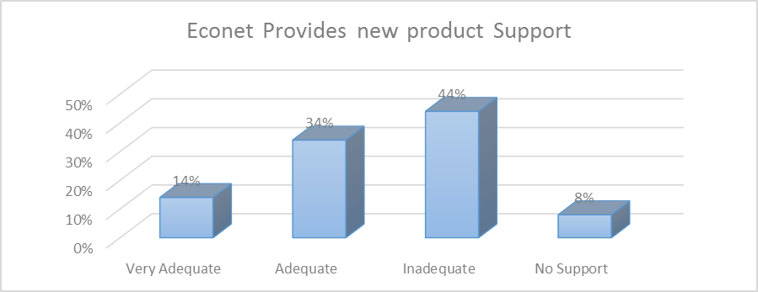
Figure 4.9 New Product Support

Figure 4.9 above, shows the results of the new product support given by Econet Wireless on its products. Forty four percent feel that Econet provides inadequate support, with 8% stating that there is no support at all. This accounts for 52% of the respondents who feel that there is no or inadequate support for new products. A total of 48% feels that Econet provides at least adequate support for new products.

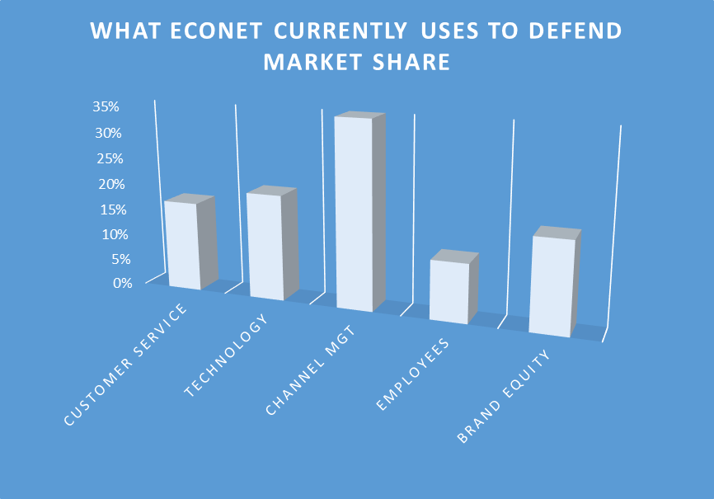
Figure 4.10 Current Defensive Strategies
The researcher sought to establish the current defensive strategies being employed by Econet Wireless to defend its market share. The results in Figure 4.10 above show that 35% of the respondents feel that Econet uses effective channel management to defend its market share, whilst 20% fell that it uses superior technology in defending the same. The least rating is on employees who constitute 11% of the current market share defensive strategies.

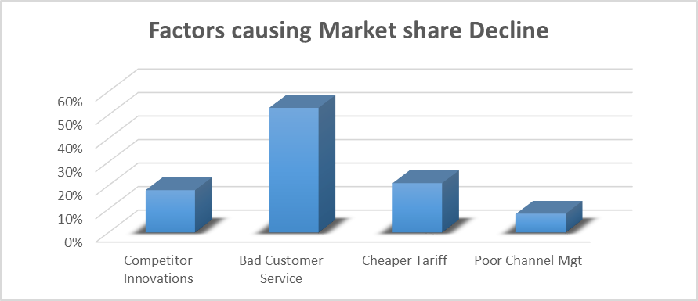
4.11 Market share Decline Factors
From the results shown in Figure 4.11 above, Bad Customer Service, constituting 53%, is the major factor causing the decline of Econet Wireless’ market share. Twenty one percent of the respondents cited cheaper tariffs from competing players as the cause of market share decline, with competitor innovations constituting 18% of the results as depicted in figure 4.11.

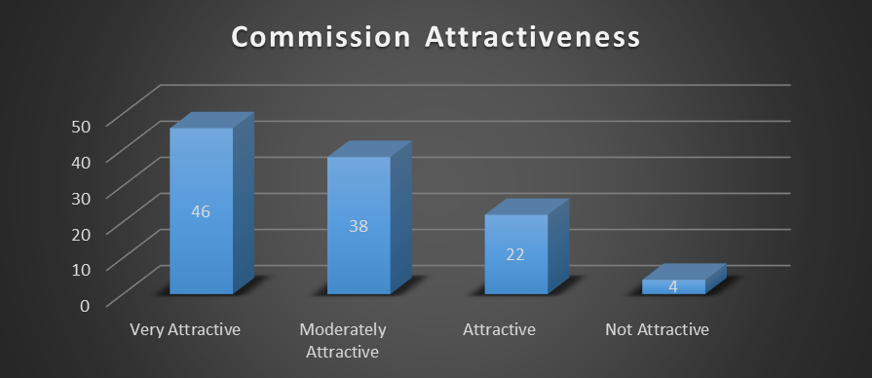
Figure 4.12 Commission Attractiveness
The results in Figure 4.12 show that 46 respondents feel that the commissions paid by Econet Wireless are very attractive, 38 respondents feel that they are moderately attractive, 22 respondents feel that they are attractive and only 4 feel that the commissions are not attractive. In total, 106 respondents, representing 96%, feel that the commissions paid by Econet are at least attractive, with only 4% feeling otherwise.

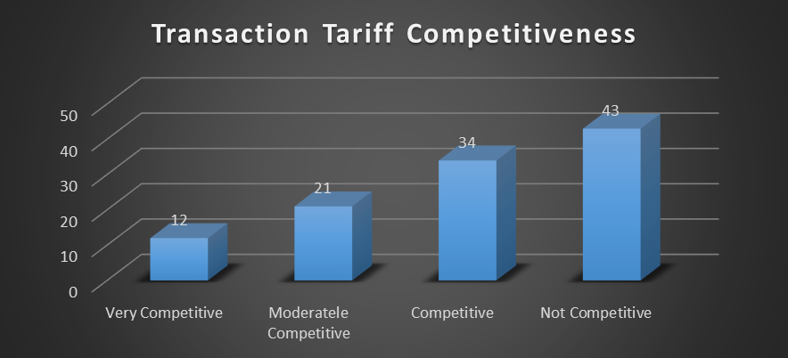
Figure 4.13 Tariff Competiveness
The results in Figure 4.13 above show competitive rating of the EcoCash transaction tariff to customers. A total of 43 out of the 110 respondents believe that the tariff is not competitive. Thirty four respondents feel that the tariff is competitive, 21 feel that the tariff is moderately competitive and 12 feel that it is very competitive. In total, 67 respondents, representing 61% agree that the Econet transaction tariff is at least competitive.

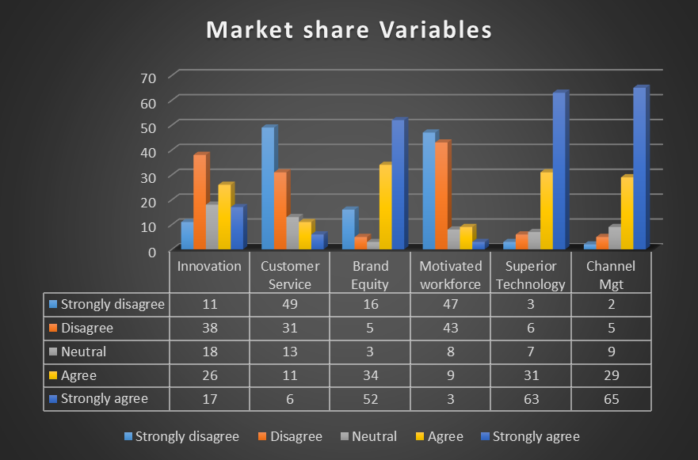
Figure 4.14 Variables Driving Market share
The researcher sought to establish the variables that drive market share for Econet. The results presented in Figure 4.14 show that 65 respondents, 63 respondents and 52 respondents strongly agree that channel management, superior technology and brand equity respectively, are the major variables driving market share for Econet. On the other hand, 49 respondents and 47 respondents strongly disagree that customer service and motivated workforce respectively, are market share driving forces for Econet Wireless. A total of 43 respondents, 38 respondents and 31 disagree that motivated workforce, innovation and customer service are respectively the market share driving variables being used by Econet.

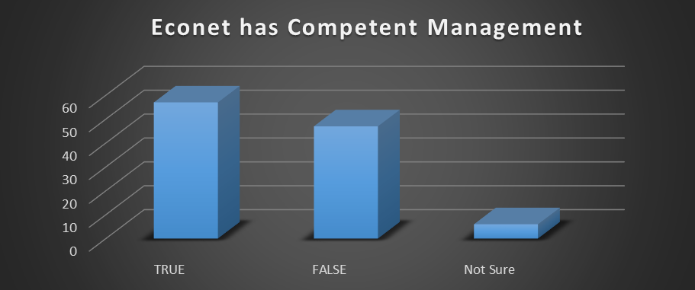
Figure 4.15 Management Competence Rating

From the results shown in Figure 4.15 above, 57 out of the 110 respondents agree that Econet has competent management. Forty seven respondents disagree and state that it is a false statement to say Econet has competent management. Only 6 of the 110 respondents were not sure of the Econet management competency.

4.4 Chapter Summary
The chapter presented data presentation and analysis. The data that was presented was gathered through interviews, questionnaires and documentary analysis. The most important findings which were deemed relevant to the study are the only ones that were covered in this chapter. The chapter covered the findings which are related to the objectives which were covered in chapter one. The next chapter will explore a comprehensive summary, conclusions and recommendations.

CHAPTER FIVE
SUMMARY, CONCLUSIONS AND RECOMMENDATIONS

5.1 Introduction
The previous chapter presented data that was gathered through face to face interviews and questionnaires. The data which was relevant to the research was also analysed in the previous chapter. This chapter concludes the research report. The major focus of the study was to analyse the market share defensive strategies employed by the Zimbabwean mobile money sector, with particular focus on Econet Wireless Zimbabwe as the market leader. After analysing the collected data the researcher drew conclusions and suggested recommendations through with the research problem may either be eliminated or remarkably reduced. This chapter will explore summary, conclusions, recommendations as well as areas for further study.

5.2 Summary
The proliferation of new players in the mobile money industry posed a big threat on the market leadership position for Econet Wireless Zimbabwe. This was made worse by the decline in market share from 98% to 78% within the period January 2015 to June 2015. This presented a compelling need to establish the cause of this sudden decline, as well as coming up with initiatives to mitigate against this loss.
The research was therefore conducted to analyse market share defensive strategies which were being employed by Econet Wireless Zimbabwe in defending its market share. The objectives were to establish the current levels of customer satisfaction with Econet mobile money, to assess the effectiveness of the current defensive strategies being employed by Econet, to determine the adequacy of channels for service delivery as well as to assess the levels of employee satisfaction in Econet Wireless Zimbabwe. The sources of literature used in this research were ranging from primary, secondary and tertiary. The research techniques that were used were the questionnaire, face to face interview and desktop research techniques.

5.3 Findings
5.3.1 The bulk of the customers have dealt with Econet Wireless for over five years. Most agents and dealers have been dealing with Econet for a period between three and five years. Most customers, agents and employees have used the Econet mobile money service at some point in the past five years
5.3.2 Competition is the major driver for defensive strategies being employed by Econet Wireless Zimbabwe.
5.3.3 Econet Wireless is the first in launching new products in the Zimbabwe market and frequently introduces new products.
5.3.4 Econet provides inadequate support for new products.
5.3.5 Good channel management is being used to defend market share by Econet Wireless Zimbabwe. Econet also defends its market share through payment of attractive commissions, superior technology as well as brand equity.
5.3.6 Bad customer service is the major factor causing a decline in Econet Wireless’ market share in Zimbabwe. Customer transaction tariffs are also not competitive.
5.3.7 Econet employees are not motivated to defend market share.
5.3.8 Econet Wireless Zimbabwe has competent management.

5.4 `Conclusions
This chapter explores the major conclusions which are related to the research objectives outlined in chapter one.
5.4.1 The study concludes that Econet is managing the channel network well through attractive commissions, which has ensured that no competition rides on their network (See Figure 4.12).
5.4.2 Employees are not involved in strategy formulation and are therefore not motivated to defend market share (See Figures 4.8, 4.12 and 4.16).
5.4.3 Bad customer service has contributed immensely to the decline of Econet Wireless’ market share (See Figures 4.8, 4.12, 4.13 and 4.16).
5.4.4 Econet does not provide adequate support for newly launched products, which results in customers having a bad experience, leading to cognitive dissonance (See Figure 4.11).
5.4.5 The study concludes that competition is the major driver for Econet Wireless’ defensive strategy formulation (See Figure 4.8).

5.5 Recommendations
Saunders (2009) states that where research gaps have been identified, the study should at the end recommend how to fill these gaps. The study recommends the below strategies to Econet in order to effectively defend market share.
5.6.1 The Chief Operating Officer must ensure that Agent refresher trainings and updates are held at least twice in every quarter to ensure all customer touch points are aligned in terms of product knowledge and service delivery. The Chief Marketing Officer must ensure that all agents and dealers are properly branded so that visibility is enhanced and the agent footprint is well represented. The Chief Finance Officer must ensure that commissions remain competitive, and should also explore options for reducing customer transaction tariffs to encourage more transactions.
5.6.2 The Chief Executive Officer, together with the research and development manager must involve employees in reviewing and crafting strategy so that they take ownership and run with the vision of the organisation. However, the extent of involvement should be monitored as it may end up impeding progress. The Chief Executive Officer must therefore apply emotional intelligence in leading the initiative. This will ensure that the employees become active and willing participants in defending market share from competition.
5.6.3 The Chief Customer Service Officer must instil a culture of customer delight in every employee. The importance of customer services should be emphasized and it must be the responsibility of everyone at every level to uphold and satisfy the customer service charter expectations. The Talent Management and Training Manager must hold workshops and administer trainings to ensure that there is a seamless delivery of good customer service. This culture must also be extended to the agents and dealers so that customers get a uniform and great customer experience. Those in breach should also be reprimanded to ensure that customer experience is taken seriously by everyone as bad customer service leads to loss of market share through customer dissatisfaction.
5.6.4 The Chief Product Development and Innovation Officer must ensure that launched products have low teething problems and are user friendly to customers. The Chief Finance Officer must ensure that budgets are availed for all launched products for both advertising and distribution. The Chief Marketing Officer must ensure that the customers are well educated on the functionalities of the products as well as how they can be used. The Chief Sales and Distribution Officer must also ensure that there is adequate customer support on the ground in terms of sales representatives and agents to assist customers who may experience difficulties in using the newly launched products. The Chief Customer Services Officer must also ensure that the helplines are available and ready to assist any customer who may call in for assistance. The Chief Executive Officer must oversee the support structures and ensure that communication channels open at all times.
5.6.5 The Chief Executive Officer must ensure that Econet does not only concentrate on superior technology as a market share defensive strategy, but also include customer service, brand equity, employees and channel management. These strategies, if used together, will fortify the market leadership position for Econet and ensure that customer, employee and agent loyalty is improved, thereby contributing immensely in defending market share.

5.6 Potential Area for Future Study
The research focused on analysing the defensive strategies being employed by Econet Wireless Zimbabwe in defending its market share. There is need to assess the value derived from the new products that the organization introduces into the market in terms of their contribution to revenue and profitability as well as cementing market leadership position.
REFERENCES

Blythe, J. (2005). Essentials of Marketing (3rd ed.). Essex: Prentice Hall Fianncial Times.
Creswell, J.W. (2003). Research Design: Qualitative, Quantitative, and Mixed Methods
Donaldson (2011) Mobile Money Value Chain. Adapted from Annual Report 2011 (p.25), by
Davidson, 2011, London: GSMA-Mobile Money for the Unbanked.
Davidson (2011)Adapted from Annual Report 2011 (p. 26), by Davidson, 2011, London:
GSMA-Mobile Money for the Unbanked.
Econet Wireless. (2013, January 10). Home: Econet Wireless. Retrieved June 28, 2015, from
Econet Wireless Web site: https://www.econet.co.zw/node/263
Econet Wireless Zimbabwe. (2012, May 24). Home: Econet Wireless Zimbabwe. Retrieved
June 28, 2015, from Econet Wireless Zimbabwe Web site: https://www.econet.co.zw/node/213
Ernst & Young. (2009). Mobile money: An overview for global. London: EYGM Limited.
Retrieved June 27, 2015, from
http://www.ey.com/Publication/vwLUAssets/Mobile_Money./$FILE/Ernst%20&%20Young %20-%20Mobile%20Money%20-%2015.10.09%20(single%20view).pdf
Freel, M.S. & Robson, P.J. (2004). ‘Small firm innovation, growth, and performance’,
International Small Business Journal, vol.22, no. (6), pp.561-575.
Gono, G. (2013). Monetary Policy Statement. Harare: Reserve Bank of Zimbabwe.
GSMA. (2011). Annual Report 2011. London: GSMA Mobile Money for the Unbanked.
JOHNSON, G.SCHOLES, K. & WHITTINGTON, R. (2008). Exploring Corporate
Strategy. 8th ed. England: Prentice Hall.
Johnson, M, Christensen, C., & Kagermann, H. (2008). ‘Reinventing your business model’,
Harvard Business Review, vol.86, no.12, pp.51-59.
Kotler, P. (2010). Principles of Marketing: A South Asian Perspective, 13/E: Pearson
Education India.
Kotler, P., & Keller, K. L. (2013).A framework for marketing management.
Kufandirimbwa, O. (2012). MOBILE MONEY IN ZIMBABWE: HARNESSING
TECHNOLOGY FOR DEVELOPMENT. The Science, Engineering and Technology Week Seminar (p. 5). Harare: Computer Science Department (UZ).
Madhani, P. M. (2010, March 26). Resource Based View (RBV) of Competitive Advantage:
An Overview. ICFAI Business School (IBS), 3-22. Hyderabad, India: Icfai University Press,. Retrieved November 2, 2015, from http://ssrn.com/abstract=1578704
Mas, I., & Morawczynski, O. (2009). Designing Mobile Transfer Services. Innovation
Quarterly, IV(2), 77-89.
Mas, I., & Ng'weno, A. (2010). Three keys to M-PESA's success: Branding, channel
management and pricing. Journal of Payments Strategy & Systems, IV(4), 352-370.
Mawindi, F. (2012). Press Conference Address by Telecel Chief Executive Officer Francis
Mawindi. Harare: Press Conference.
Mobile Money Value Chain. Adapted from Annual Report 2011 (p.25), by Davidson, 2011,
London: GSMA-Mobile Money for the Unbanked.
Netone. (2015). Value Added Services: Mobile Money Transfer. Retrieved from Netone Web
site: http://www.netone.co.zw/index.php?option=com_content&view=article&id=22&Itemid=39
Newsday. (2013, January 9). Home: No joy yet for NetOne. Retrieved November 15, 2015,
from Newsday Web site: http://www.newsday.co.zw/2013/01/09/no-joy-yet-for-netone/
Powell, T. (2007, June 30). Resource Based View. Retrieved from A Taman Poweel Web
site: http://tamanpowell.com/Writing/assets/Resource%20Based%20View.pdf
Rich, K. M., Baker, D., Negassa, A., & Ross, B. R. (2009). Concepts, applications, and
extensions of value chain analysis to livestock systems in. International Association of Agricultural Economists Conference (p. 3). Beijing: International Livestock Research Institute. Retrieved September 22, 2015, from http://ageconsearch.umn.edu/bitstream/51922/2/51922.pdf
Saunders M, Lewis, Thornhill A. (1997), Research Methods for Business Students, Pitman
Publishing.
SAUNDERS, M., LEWIS, P., & THORNHILL, A., (2007). Research Methods for Business
Students. 4th Ed. Prentice Hall Financial Times: Harlow.
Tellez, C., & McCarthy. (2011). Case Study: Mobile Money in Paraguay. London: GSMA –
Mobile Money for the Unbanked.
http://classguides.lib.uconn.edu/content.php?pid=239974&sid=1981391[Accessed 12
October, 2015]
http://www.lib.umd.edu/tl/guides/primary-sources#primary [Accessed 12 October 2015]
http://nataliecopuroglu.com/2011/04/14/theory-vs-practice-1-marketing-warfare/ [Accessed
12 October 2015]
http://www.learnmarketing.net/ladder.htm[Accessed 14 October 2015]

APPENDIX A: LETTER OF INTRODUCTION – QUESTIONNAIRE

2-87TH Ave
Mabelreign
Harare

Dear Respondent,

RE: Request for a face to face interview.
My name is Tshando Madhava, a Masters in Business Leadership (MBL) student with Bindura University of Science Education. My student number is B1337658. As part of the MBL degree qualification, I am expected to conduct a research, which includes the completing of questionnaires as a tool for gathering relevant information. The topic for my research is An analysis of the market share defensive strategies employed by the Zimbabwean mobile money sector in the Telecommunications industry: A case of Econet Wireless Zimbabwe. In that regard, I am requesting you to complete the attached questionnaire, as I am confident that your responses and expertise will add great value to the research which I am conducting.
It is also essential for you to know that all the responses will be confidential and used only for purposes of advancing my research work. Moreover, the respondents’ identity will not be revealed for any purpose whatsoever.
Thank you for the assistance which I hope to generously get from you.

Yours Faithfully,

Tshando Madhava
tinamadhava@gmail.com
0774222417

APPENDIX B: RESEARCH QUESTIONNAIRE
SECTION A.
Please tick the appropriate box to indicate your response. Where appropriate, write the answers in the spaces provided.

- How long have you been employed by Econet Wireless, or dealt with Econet as a Dealer, Agent or Customer?

- 0 to 2 years
- 3 to 5 years
- More than 5 years

- Indicate your gender
- Male
- Female

- Indicate your highest level of education
- O Level
- A Level
- Diploma (specify)………………………………………………….
- Degree (specify)……………………………………………………
- Other (specify)……………………………………………………..

- Indicate the age range in which you fall
- Below 25
- 26-45
- 46-55
- 56 and above

SECTION B.

- What relationship do you have with Econet Wireless?
- Employee
- Dealer / Agent
- Individual Customer

- Have you used any of Econet’s mobile money products or services in the past five years?
- Yes
- No

- In your opinion, which is the major driver for Econet’s defensive marketing strategy?
- Customers
- Technology
- Competition
- Employees
- Growth

- Econet Wireless is always the first to launch new mobile finance products in the Zimbabwean market
- True
- False
- Not sure

- Econet Wireless has a competent management team which crafts relevant market share defensive strategies.
- True
- False
- Not sure

- Do you feel Econet provides adequate support for new product development?
- Very Adequate
- Adequate
- Inadequate
- No Support
- The organization frequently introduces new products or services, which provide solutions to the pain points in the market
- Frequently
- Sometimes
- Never

- Currently, what do you think Econet is using to defend its market share?
- Customer Service
- Technology
- Channel Management
- Employees
- Brand Equity

- How attractive are the Ecocash Agent commissions paid by Econet Wireless compare to other companies in the local industry?
- Very attractive
- Moderately Attractive
- Attractive
- Not Attractive

- How competitive are the Ecocash customer transaction tariffs charged by Econet Wireless compared to other companies in the local industry?
- Very competitive
- Moderately Competitive
- Competitive
- Not Competitive

SECTION C

Business growth | Strongly disagree | Disagree | Neutral | Agree | Strongly agree
- Econet Wireless’ market leadership comes from innovation
- Good customer service at Econet Wireless has secured the organization’s market leadership position.
- Econet Wireless, market share growth is linked to brand equity leverage.
- The organization’s market share growth is as a result of a motivated workforce
- In your opinion does superior technology increase customer experience and help defend market share?
- There is a direct relationship between channel management and defending market share

- What are the factors causing a decline in the market share of Econet mobile money service?

- New innovations from competitors
- Bad Customer Service
- Cheaper Tariff
- Poor Channel Management

Thank you for taking the time to complete this questionnaire

APPENDIX C: LETTER OF INTRODUCTION – INTERVIEW

2-87TH Ave
Mabelreign
Harare

Dear Respondent,

RE: Request for a face to face interview.
My name is Tshando Madhava, a Masters in Business Leadership (MBL) student with Bindura University of Science Education. My student number is B1337658. As part of the MBL degree qualification, I am expected to conduct a research, which includes face to face interviews as a way of gathering relevant information. The topic for my research is An analysis of the market share defensive strategies employed by the Zimbabwean mobile money sector in the Telecommunications industry: A case of Econet Wireless Zimbabwe. In that regard, I am requesting you to attend a face to face interview with me, as I am confident that your expertise will add great value to the research which I am conducting.
It is also essential for you to know that all the responses will be confidential and used only for purposes of advancing my research work. Moreover, the respondents’ identity will not be revealed for any purpose whatsoever.
Thank you for the assistance which I hope to generously get from you.

Yours Faithfully,

Tshando Madhava
Student ID (B1337658)
tinamadhava@gmail.com
0774222417

APPENDIX D: IN DEPTH INTERVIEW GUIDE

- What is Econet Wireless’ current market share?

- What are the business constraints faced by Econet Wireless?

- How can those constraints be overcome?

- What business opportunities are available for Econet Wireless in the Mobile Money sector?

- What are the current defensive strategies being employed by Econet Wireless in defending its market share?

- What other operational strategies do you recommend for Econet Wireless?

- How does Econet value its customers?

- How does Econet value its EcoCash Agents?

- Which technological driving force does Econet use in defending its market share?

- Are employees involved in strategy development and implementation?

- What channel management loyalty programs are being executed by Econet?

- Are EcoCash Agents loyal to the cannel management initiatives?

- How are Econet employees motivated to remain loyal to the organization?

- How intense is the competitive landscape in the Zimbabwean mobile money sector?

- What are the recommended strategies for Econet Wireless to ensure market share is defended from competition?

