Evaluation of the Agusan Del Sur Malaria Control and Prevention Project
Community Trust Fund

Prepared by Dr Jeffrey Hii and Dr Gary Simpson

October 2012
Contents
Executive Summary 1
1. Introduction 5
1.1 Activity and TOR Background 5
1.2 Evaluation Objectives, Scope and Questions 7
1.3 Evaluation Method 8
1.4 Evaluation Team 9
2. Evaluation Findings 10
2.1 Relevance 12
2.2 Effectiveness 13
2.3 Efficiency 15
2.4 Impact 18
2.5 Sustainability 20
2.6 Gender Equality 20
2.7 Monitoring and Evaluation 22
2.8 Analysis and Learning 22
3. Conclusion and Recommendations 24

Annexes

- Draft Evaluation Plan
- Terms of Reference
- Itinerary and Persons Met
- Outbreak Response Activities Supported by CTF in Esperanza
- Declining Trend in Malaria Cases 1995-2011.
- References

Acronyms
ADS MCP  APHDFI  API | Agusan Del Sur Malaria Control Program  Agusan for People’s Health Development Foundation Incorporated  Annual Parasite Incidence
AusAID  CTF  CCI  CHO  CIP  DOH  EO | Australian Agency for International Development  Community Trust Fund  Class Room Construction Initiative  City Health Office  Consolidation and Integration Phase  Department of Health  Executive officer
GF  ICR  ITN  ILHZ  LLIN  MCP  MHO  NGO  PBSP  PCC  PHO  PHRC  PIDSR  PMC  PMT  PRMF  P-TAC  ROA  SIP | Global Fund to fight AIDS, Tuberculosis and Malaria  Independent Completion Review  Insecticide Treated Net  Inter-Local Health Zone  Long Lasting Insecticidal Net  Malaria Control Programme  Municipal Health office  Non Government Organization  Philippines Business for Social Progress (PBSP)  Project Coordinating Committee  Provincial Health office  Provincial Health Resource Centre  Philippines Integrated Disease Surveillance Response  Provincial Malaria Coordinator/Provincial Malaria Control  Provincial Management Team  Provincial Road Maintenance Fund  Provincial Technical Advisory Committee  Rapid Operational Assessment  Strategy and Implementation Plan

Executive Summary

1. Background

The Community Trust Fund (CTF) was established in 2004 as a Perpetual Trust to enhance the sustainability of the Agusan del Sur Malaria Control and Prevention Project (ADS MCP) funded by AusAID since 1995 but transferred to the full management of the Provincial Health Office (PHO) through the ADS Provincial Government in December 2003.

The objective of the CTF is to build a permanent and sustainable community source of funding to supplement the cost of critical malaria control supplies at the provincial and municipal levels of the Province of Agusan del Sur.

The rationale for establishing the Trust was, for a small investment (AU$0.75 million = P22.5 million) in a Principal Fund, income could be generated (a Reflow Fund) from the interest earned to support malaria control activities while the Principal was reinvested each year thereby creating a perpetual fund.

The original assumptions which underpinned the CTF financial model acknowledged that inflation and variable interest rates would eventually undermine the real value of the fund and that periodic top-ups of the Principal would be required if the fund was to operate in perpetuity.

In September 2004 an entity, the Agusan for People’s Health Development Foundation Incorporated (APHDFI) was established to manage the fund under the supervision of a Project Coordinating Committee (PCC) comprising the Governor of Agusan Del Sur, the Department of Health Under Secretary for Mindanao and the First Secretary AusAID. A formal Agreement between the PCC and APHDFI was later signed in August 2006 governing the terms and conditions of the Trust.

Under this Agreement the APHDFI is to work with the Provincial Health Office (PHO) through the Provincial Health Resource Centre (PHRC) to respond to proposals consistent with the ADS MCP and release CTF funds to project partners as approved by the PCC. The first tranche of CTF funds (P2.3 million) was released to APHDFI in March 2007.

2. The OCT 2007 CTF Rapid Operational Assessment (ROA) Report

In October 2007 AusAID commissioned an independent Audit of CTF and a Rapid Operational Assessment (ROA) of the efficiency and effectiveness of its operations. While the Audit was generally acceptable, the ROA raised a range of issues which suggested the APHDFI was not managing the CTF in accord with the intent of the Agreement. Principal among these was concern of a possible conflict of interest in that APHDFI was both a manager and beneficiary of the CTF.

The APHFI prepared a response to the findings and recommendations of the Assessment Report for the consideration of PCC members which sought to clarify its position and actions. Included in this response was acknowledgement APHDFI should withdraw from all implementation activities associated with Malaria Control and Prevention Program (MCP) functions to avoid any potential conflict of interest.

However, due to problems with mobilising the PCC which continue to this day, the APHDFI was unable to directly present its case and clarify its intent to the PCC members. As the only independent review of the CTF, the 2007 ROA Report findings and recommendations still have currency in AusAID and, in the opinion of the Evaluation Team, have made successive CTF Activity Managers wary of the capacity and intent of APHDFI in the absence of any other analysis.

In sum, because of the breakdown in the PCC process, communication and coordination between the PCC members and the APHDFI post 2007 has been poor. As a result, AusAID has not kept abreast of, or been informed about, subsequent developments in the ADS MCP which provide a more positive perspective on APHDFI and the CTF activity.

3. ADS MCP Strategy and the CTF post 2007

Around the same time as the APHDFI started drawing down on the CTF, as part of a Department of Health (DOH) national program, Pilipinas Shell Foundation set up operations to manage the Global Fund (GF) to Fight AIDS, Tuberculosis and Malaria in Agusan. The GF has an almost identical agenda to the CTF, namely, to support the PHO through the ADS MCP to reduce and eventually eliminate malaria in the province.

From 2008 the PHO through its ADS MCP Project Management Team (PMT) decided to prioritise use of GF for the purchase of malaria control commodities, principally bed nets, because it had more money and was more flexible in its counterpart funding requirements than the CTF. The CTF was allocated the status of a ‘Standby Fund’ to top up the GF as the need arises.

Because of the effectiveness of the bed net program (136,780 pieces have been distributed through the GF since 2008 at a cost of around P22.0 million), early diagnosis, prompt management and treatment and referral of malaria cases, community awareness and promotion, and outbreak response, malaria in ADS is largely under control. The few malaria outbreaks which have occurred (in 2005, 2007 and 2010) have been contained by the PHO through the combined use of GF and CTF funds with the CTF principally being used as top-up for transport, spraying equipment and allowances.

Central to the current ADS malaria control strategy is recognition that CTF expenditure needs to be conserved to address ADS MCP needs post 2014 when the GF expires. In sum, as the GF progressively expanded from 2009 on, the PHO has become increasingly aware that from 2014 the province will need to develop a strategy for the replacement of the existing bed nets which only have an effective life of 3-5 years if malaria is to continue to be contained.

4. Evaluation Findings

The Terms of Reference require the Evaluation Team to evaluate the CTFs relevance, efficiency, effectiveness, impact, sustainability and gender equality. This analysis is detailed in section 2. The team is also required to comment on the financial audit of APHDFI commissioned under a separate contract (section 3.2) and to outline directions in terms of future management of the CTF when the Current Trust Agreement expires in 2013 (section 3.3).

4.1 The Performance of the APHDFI and the CFT

The team recognises that the CTF is a funding mechanism and that its principal function is to respond to submissions prioritised through the ADS MCP as directed by the PMT. Since 2008 it has been utilised sparingly and principally as top-up for activities financed by the GF.

Given this situation the evaluation findings are contextualised within the framework of how the GF and the CTF have been utilised to date and the likely future contribution of the CTF to the ADS Malaria Control and prevention Program post 2014. The Team concludes that while legitimate concerns were raised in the 2007 ROA Report, these concerns were either addressed in the APHDFI response and/or in its subsequent actions. The Evaluation Team note:

- APHDFI is an active member of the ADS MCP Project Management Team and has responded appropriately and promptly to all requests for assistance, few though they may be; and

- The CTF has been used in the manner for which it was intended (as a supplementary fund) and the Perpetual Trust Principal Fund is still preserved.

The Team further notes, however, that unless the CTF is topped up as prescribed in the initial financial model to offset inflation and variable interest rates, it will have insufficient funds to replace and maintain the GF bednet investment post 2014 without severely depleting its Principal Fund, thereby compromising the integrity of the Perpetual Trust concept.

If CTF cannot be topped up, APHDFI and the PHO under the guidance of the PCC will need to consider whether to continue to retain the CTF as a perpetual fund or utilise the remaining funds for discrete ADS MCP project activities over a 3-5 year period.

In the opinion of the Evaluation Team top-up is unlikely and its preference is for cashing in the Principal Fund and utilising the proceeds for developing a discrete project. The Evaluation Team notes, however, that there is strong support within the PHO, the Office of the Governor and APHDFI for maintaining a Perpetual Trust and that these parties plan to investigate all options.

4.2 The Audit Findings

For a more detailed summary of the 2012 Audit findings refer to section 3.2.

The 2012 Audit Findings of the 2007-2011 accounts are complicated by the destruction of the 2007, 2008 and 2009 books and supporting documentation. The documentation was stored in a building which was inundated by flood waters in 2010. As a result there are unsupported expenses amounting to P1.15 million pesos.

In relation to the Audit general findings, the Auditor’s opinion is that while APHDFI should have been more diligent in storing its records, the documents were almost certainly destroyed by the flood and there has been no attempt to defraud or cover up. The Evaluation Team concurs with the Auditor’s view.

The Team further notes that the Auditor is satisfied that the discrepancies identified in APHDFI accounting procedures in 2007 have been rectified with minor exceptions.

4.3 Management Options Post June 2013.

The Evaluation Team explored the following management options in terms of the future management of the CTF. Four options were considered for managing the fund post 2013:

- Transfer CTF to the Philippines Office of the World Health Organisation (WHO).
- Transfer CTF to the National Department of Health.
- AusAID recoups the fund on the basis of the 2012 audit findings.
- Leave the fund under the management of APHDFI but seek partnership with the Shell Foundation to assist in its management
In the opinion of the Evaluation Team, ongoing support for the ADS MCP and AusAID’s development assistance program in Agusan Del Sur and the wider Caraga region in Mindanao would be best served by leaving the fund under the management of the APHDFI with the following provisions:
- The ADS MCP Project Management Team, which includes the APHDFI and the Shell Foundation, is mobilised over the next 6 months to prepare an ADS MCP 5 year plan (2014-2018) covering the GF exit and the utilisation of the CTF either as a Perpetual Trust or as a discrete project.
- The PCC continues to oversight the CTF for its duration but the Shell Foundation, which has experience in Trust Fund Management and Malaria control in Agusan, replaces AusAID as a member of the PCC in a seamless transition prior to the Expiry of the CTF Trust Agreement in 2013.
The Evaluation Team note Shell Foundation’s interest in participating in the development of the ADS MCP five year plan and the PCC in support of the ongoing development of the ADS MCP and the GF exit strategy.

1. Introduction

1.1 Activity and TOR Background

The CTF was established in 2004 as a Perpetual Fund to enhance the sustainability of the Agusan del Sur Malaria Control and Prevention Project (ADS MCP) funded by AusAID since 1995 but transferred to the full management of the PHO through ADS Provincial Government in December 2003.

The objective of the CTF is to build a permanent and sustainable community source of funding to supplement the cost of critical malaria control supplies at the provincial and municipal levels of the Province of Agusan del Sur.

The rationale for establishing the Trust was, for a small investment AU$0.75 million (P22.5 million – The Principal Fund), income could be generated (the Reflow Fund) from the interest earned to support malaria control activities while the principal was reinvested each year thereby creating a perpetual fund.

The fund was initially proposed in 2001 as part of the Consolidation and Integration Phase (CIP) to sustain ADS MCP project achievements and to integrate activities into Provincial and municipal health programs. The project was extended for three years until 2004.

The CTF design envisaged:

- The fund would be established in 2001, immediately invested and build up its capital base whereupon in 2004, when AusAID assistance to ADS MCP through the CIP ceased, a reserve of funds would be available to support the ongoing malaria control activities of the PHO.

- The CTF would be managed by a Board of Trustees comprising AusAID, the Department of Health and the Governor of ADS and, at a suitable time in the future, the Fund would be transferred by the Trustees to either the ADS PHO or the Caraga Regional DOH.

- Due to inflation and variable interest rates the real value of the Fund would decline and that periodic top-ups of the Principal would be required if it was to operate in perpetuity.

However, approval of the CTF was not finalised until 2003 and to expedite arrangements for its mobilisation in 2004 AusAID engaged the Agusan del Sur Civil Society Network, with technical assistance from Philippines Business for Social Progress (PBSP), as interim manager while the organisation of a permanent CTF entity was underway. The Land Bank of the Philippines was identified as the Trustee Bank and the CTF was invested in May 2004.

In September 2004 the Agusan for People’s Health Development Foundation Incorporated (APHDFI) was established to manage the fund under the supervision of a Project Coordinating Committee (PCC) comprising AusAID, the Governor of Agusan Del Sur and the Department of Health Under Secretary for Mindanao. A formal Agreement between the PCC and APHDFI was later signed in Sept 2006 governing the terms and conditions of the Trust.

Under this Agreement the APHDFI is to work with the PHO through its Project Management Team (PMT) and Provincial Technical Advisory Committee (P-TAC) to process community and municipal project submissions consistent with the ADS MCP and release CTF funds to project partners as approved by the PCC.

The Agreement provides for two sets of funds: a restricted fund (Also known as the Principal Fund) and an accessible fund (also known as the Reflow Fund). The restricted fund represents the whole amount (A$750,000) that is being invested annually by Land Bank. The ‘restricted fund’ is rolled over for investment annually. The income from the restricted fund’s investment becomes the perpetual source of funding for malaria control projects (ie. accessible funds). Thirty percent of the income goes to the NGO’s operations as fund manager while the remaining 70% goes to malaria control-related activities.

The first tranche of CTF funds (P2.3 million) was released to APHDFI in March 2007 for operational and malaria control activities.

As part of an Independent Completion Review (ICR) of the ADS Malaria Control and Prevention Project, AusAID commissioned an ROA Report to assess the progress and performance of the APHDFI and the CTF in October 2007. The report noted that the Fund had not been used for its intended purpose and that re-focusing the CTF’s operating budget and work plan and extension of the Project Coordinating Committee oversight were strongly recommended. The assessment also noted that there was a failure to maintain a separate set of books for the CTF and there were some violations on the basic internal financial control but these did not represent material weaknesses and could be rectified.

In preparing the Terms of Reference for this evaluation AusAID notes:

- CTF remains a perpetual source of funding in Agusan del Sur and that under the Trust Agreement it reserves the right to withdraw the Fund on grounds of possible misuse.

- The Trust Agreement for the CTF indicated an implementation period from 2006 – 2007 after which the Trust Fund was supposed to be fully turned over to the managing NGO subject to the NGO meeting pre-conditions on fund usage and subject to AusAID’s agreement.

- In 2009, however, in the light of the ROA and Audit findings on the CTF’s usage and management, AusAID amended the Trust Agreement to extend the project’s duration until 2013 effectively stopping its full transfer to and ownership by the NGO.

- Except for attending annual PCC meetings AusAID is not involved in regular daily management of the CTF nor does it strictly monitor fund usage, except for monitoring the submission of financial reports from the Land Bank.

1.2 Evaluation Objectives, Scope and Questions

Given the elapsed time since the 2007 CTF Assessment Report (almost 5 years), AusAID has deemed it necessary to undertake an ex-post evaluation of the project with particular emphasis on the effectiveness, efficiency, sustainability and impact of the Community Trust Fund.

The ex-post evaluation has two components:

- A Financial audit of the CTF focusing on its use and intended purpose and corresponding management accountability of the NGO, including determining progress of recommended actions from the 2007 financial audit.

- Performance evaluation of the CTF as an innovative model (relevance, efficiency, effectiveness, impact and sustainability) and recommended actions on the future of the CTF.

Scope of Work:

As per the Terms of Reference the principal objective is to evaluate the performance of the CTF as an innovative model for addressing project sustainability after completion based on relevance, efficiency, effectiveness, impact and sustainability; and recommend actions on the future of CTF management.

As per the 2006 Trust Sub Agreement between the APHDFI and the CTF PCC the development objective of the CTF is specified as:

‘Building a permanent and sustainable community source of funding to supplement the cost of critical malaria control supplies at the provincial and municipal levels of the Province of Agusan del Sur’.

This objective is further qualified in the Sub Agreement between APHDFI and the CTF PCC (Clause 1.2):

In preparing the annual plan and budget CTF retains a primary focus on malaria control and prevention and secondary focus on malaria outbreak detection until there is demonstrable, objective evidence of a decline in endemicity in high priority municipalities and that prevention has remained well integrated at community level for a number of years. When such evidence is available, income from the CTF may be accessed for the purpose of addressing other endemic communicable disease problems in ADS.

In addition to evaluating the performance of the CTF the Evaluation Team is also required to:

- Comment on the findings of the financial audit of the APHDFI commissioned under a separate contract; and

- Outline directions in terms of future management of the CTF to AusAID when the current Trust Agreement expires in June 2013.

In sum, the key questions to be addressed by the Evaluation Team are:

- How has the APHDFI responded and performed since the 2007 ROA?

- Is the CTF model suitable for addressing sustainability issues post project completion in an aid delivery context?

- What are the implications of the 2012 Audit findings and recommendations for the APHDFI and the future management of the Trust?

- What other CTF management options are there should AusAID not wish to transfer the fund to APHDFI?

These questions are addressed in Section 3, Conclusion and Recommendations.

1.3 Evaluation Method

As required by the TOR, the Evaluation Team prepared an Evaluation Plan in advance of mobilisation (refer Annex 1). This plan was presented to AusAID during mission mobilisation. In subsequent discussion, it was decided that because of the tight schedule there was insufficient time to fully administer the proposed evaluation questionnaire and that the meetings with the various stakeholders should focus on eliciting responses to complement the key questions outlined in section 1.2. Namely:

- The level of stakeholder knowledge and understanding of the CTF and the degree of participation in the in ADS MCP activities post 2007.

- Based on their knowledge and level of participation, their perception of the successes and challenges in managing and implementing the CTF.

- Whether at the end of the Trust Agreement in 2013, the fund should continue as a Perpetual Trust or be cashed in for funding discrete time bound project activities in support of the ADS MCP or other infectious diseases.

In framing these questions and discussing the project, the Evaluation Team and the CTF Activity Manager recognised that the classification of the exercise as an Ex-Post Evaluation was not appropriate as the CTF is a Perpetual Trust supporting an ongoing project and it would be more appropriate to classify the assignment as a Terminal Evaluation.

A Terminal Evaluation is conducted as a project either approaches or is at the end of its effective cooperation with partners; it examines on a comprehensive level whether the project objective was achieved. Consequently relevance, efficiency, and effectiveness are examined based on the actual situation and performance. Impact and sustainability are also examined based on performance and the status of activities up to that point. (JICA: Issues in Ex-ante and Ex-post evaluation 2002).

This approach is considered appropriate for the CTF as the 2006 Trust Agreement between the PPC and APHDFI will expire in 2013, however the project and the CTF is likely to continue with new partners either as a Perpetual Trust or as a discrete time bound project.

In order to respond to the key questions identified in section 2.1 the Evaluation Team employed the following methodology:

CTF Progress and Performance

The operation of the CTF was last reviewed in Oct 2007. This review was critical of the way in which APHDFI was managing the CTF and made a number of recommendations to improve the governance and focus of the fund. The findings and recommendations of this review were revisited as the starting point for the current evaluation. The intent was to determine whether the recommendations had been actively pursued and whether any issues remain outstanding.

This analysis was undertaken in separate discussions with AusAID, APHDFI and the PHO as manager of the ADS MCP. A field visit was also conducted to the municipality of Esperanza which was the site of the 2010 malaria outbreak which was the subject of a response by the PHO utilising the CTF and GF resources.

APHDFI/CTF Audit

AusAID commissioned an independent audit of the CTF accounts from 2007-2011. The draft findings and recommendations of this audit were published in August 2012.

The evaluation team met with the Auditor to discuss the findings and recommendations, consulted with APHDFI to seek a right of response and visited the site where the CTF 2007-2009 accounts were destroyed in the 2010 flood.

CTF Sustainability and Management Options

This analysis was undertaken in discussions with AusAID, the DOH, WHO, APHDFI, the Under-Secretary for DOH in Mindanao, the Governor of ADS, ADS MCP Project Management Team members, and the Pilipinas Shell Foundation.

1.4 Evaluation Team

The Evaluation was undertaken between August 2 and August 13. The TOR is detailed as Annex 2, the Itinerary and Persons met as Annex 3.

The evaluation team comprised Dr Gary Simpson Team Leader and Monitoring and Evaluation Specialist and Dr Jeffrey Hii, Medical Specialist. Pablo Lucero AusAID CTF Activity Manager represented AusAID throughout the assignment.

2. Evaluation Findings

2.1 Background

The following evaluation findings are prefaced by an analysis of the of the 2007 ROA Report, the APHDFI response to the report and the subsequent approach by the PHO in financing and managing the ADS MCP from 2008 to present.

(a) The CTF ROA Report

In October 2007 AusAID commissioned an independent Audit of CTF and an ROA of its progress and performance. While the Audit was generally acceptable, the ROA raised a range of issues which suggested the APHDFI was not managing the CTF in accord with the intent of the Agreement. The Report noted APHDFI was not seeking recourse to technical review through the P-TAC for its project proposals; (ii) not heeding TAG instructions to quarantine funds for malaria outbreaks; (iii) its process for endorsing or rejecting proposals was not transparent; and (iv) that it APHDFI had a conflict of interest in being both a manager and recipient of CTF.

The ROA also noted that PCC oversight of the CTF was scheduled to terminate in December 2007 and recommended an extension of one more year to Dec 2008.

In its response to the ROA APHDFI noted:

- That it had been first to raise the issue with the ROA Team that the P-TAC had ceased to function and that its activation was the responsibility of the ADS Provincial Health Research Centre (PHRC) under the supervision of the PHO, not APHDFI.

- That the APHDFI had not sought a separate appropriation for quarantining funds for a malaria outbreak in 2007 because that in accordance with the 2006 TAG instruction it had set aside funds for malaria outbreaks but these were unspent and could be rolled into the 2007 budget.

- That the criticism it was not transparent in the management of the CTF project approval process was based on events surrounding one project in which the APHDFI Executive Officer requested the ADS MCP Project Manager to resubmit a project proposal to comply with CTF project submission guidelines. The issue became personalised with the Project Manager refusing to resubmit the proposal and the APHDFI refusing to approve.

This response was forwarded to AusAID for the consideration of PCC members with the intent of clarifying its position and actions. Included in this response was acknowledgement APHDFI should withdraw from all implementation activities associated with MCP functions to avoid any potential conflict of interest.

However, due to problems with mobilising the PCC which continue to this day, the APHDFI was unable to directly present its case and clarify its intent to the PCC members. As the only independent review of the CTF, the 2007 ROA Report findings and recommendations still have currency in AusAID in the absence of any other analysis.

In sum, because of the breakdown in the PCC process, communication and coordination between the PCC members and the APHDFI post 2007 has been poor. As a result, AusAID has not kept abreast of, or been informed about, subsequent developments in the ADS Malaria Control and Prevention Project which provide a more positive perspective on APHDFI and the CTF activity.

(b) ADS MCP Strategy and the CTF post 2007

Around the same time as the APHDFI started drawing down on the CTF the Pilipinas Shell Foundation set up operations to manage the Global Fund (GF) to Fight HIV/AIDS, Tuberculosis and Malaria in Agusan as part of a national DOH initiative. The GF has an almost identical agenda to the CTF, namely, to support the PHO through the PMT to reduce and eventually eliminate malaria in the province.

From 2008 the PHO through its ADS MCP Project Management Team decided to prioritise use of GF for the purchase of malaria control commodities, principally bednets, because it had more money and was more flexible in its counterpart funding requirements than the CTF. Whereas the CTF required counterpart contributions from communities and municipalities seeking funding support, the GF had no such provisions. As a result, those requesting or being allocated support under the ADS MCP had a strong preference for utilising the GF and the CTF was allocated the status of a ‘Standby Fund’ to top up the GF as the need arises.

Because of the effectiveness of the bed net program (136,780 pieces have been distributed through the GF since 2008 at a cost of around P22.0 million), early diagnosis, prompt management and treatment and referral of malaria cases, community awareness and promotion, and outbreak response, malaria in ADS is largely under control. The few malaria outbreaks which have occurred (in 2005, 2007 and 2010) have been contained by the PHO through the combined use of GF and CTF funds with the latter principally being used as top-up for transport, spraying equipment and allowances.

Central to the current ADS malaria control strategy is recognition that CTF expenditure needs to be held back to address ADS MCP needs post 2014 when the GF expires. In sum, as the GF progressively expanded from 2009, the PHO has become increasingly aware that from 2014 the province will need to develop a strategy for the replacement of the existing bed nets which only have an effective life of 3-5 years if malaria is to continue to be contained.

2.2. CTF Evaluation Findings

The CTF is a funding mechanism and its principal function is to respond to submissions prioritised through the ADS MCP as directed by the ADS MCP Project Management Team. Since 2007 it has been utilised sparingly with only P4.7 million being expended through the Reflow Fund between 2007 to 2011. Of this, only P2.2 has been used for malaria control and prevention activities while the rest has been spent on administration. In comparison, the GF has allocated over P22 million to the ADS MCP for bed nets alone for the same period. As background this situation has arisen because of:

- The provisions of the PCC/APHDFI Trust Fund Agreement which limit APHDFI to processing community and municipal requests as endorsed by the ADS MCP Project Management Team and as approved by the PCC.

- The APHDFI response to the ROA Report which led it to withdraw from any active engagement in malaria control service delivery.

- The conditionality of the CTF, as opposed to the GF, which requires community and municipal contributions to projects.

- The decision by the ADS MCP PMT since 2008 to prioritise the utilisation of the Global Fund for the purchase of malaria control and prevention commodities and use CTF as a ‘Standby Fund’ for malaria outbreaks until 2014 when the Global Fund exits the province.

The following assessment of the CTF in relation to its relevance, efficiency, effectiveness, impact, sustainability and gender equality dimensions is contextualised within the framework of its original intent, its existing use and likely future contribution to ADS MCP post 2014.

2.1 Relevance

The extent to which the project activity is suited to the priorities and policies of the target group, recipient and donor.

At the Policy Level

The DOH Malaria Program Medium Term Development Plan, 2011-2016 recognizes that without input from external sources, the Philippines would not have reached the reduced levels of malaria morbidity and mortality that it has achieved today.

In the Agusan context, the GF and the CTF are the current principal providers of this external assistance. However, whereas the GF has a large budget and defined targets to achieve by 2014, after which time it will exit the province, the CTF was established with the specific objective of building a small but permanent and sustainable source of funding to supplement the cost of critical supplies for malaria control and outbreak response at the municipal and community levels.

While the CTF has been used sparingly to supplement GF activities from 2007 to present, the APHDFI and the PHO have recognised that maintaining the fund is highly relevant to the future of ADS MCP post 2014, as it is likely to be the only source of additional external funding.

At the Activity Level

Now in its seventh year of implementation, the CTF is still relevant and appropriate to the priorities and policies of the ADS MCP. Specifically, the CTF has responded to localised outbreaks in Esperanza municipality in 2010 by procuring pump sprayers in response to a MHO request and supported outreach surveillance, bed net distribution and follow-up activities. As a result of these interventions, the CTF directly contributed to the control of the malaria outbreak.

At the donor Level, the Evaluation Team notes that AusAID’s new Statement of Commitment to the GOP no longer includes provision for supporting the Health Sector in the Philippines. In this context, while the CTF through AusAID’s ADS MCP Health sector initiative was a contributing activity to what was acknowledged to be a successful health initiative (Malaria control), the CTF is now no longer of direct relevance to the AusAID country program. The exception being, the lessons learned from this assignment in relation to the utilisation CTF as an aid delivery mechanism through a perpetual trust (refer section 3.2) have relevance in that they contribute to AusAID’s wider corporate knowledge of aid delivery modalities.

2.2 Effectiveness

The extent to which the activity has obtained its objectives.

As per the 2006 Trust Sub Agreement between the APHDFI and the CTF PCC the development objective of the CTF is specified as:

Building a permanent and sustainable community source of funding to supplement the cost of critical malaria control supplies at the provincial and municipal levels of the Province of Agusan del Sur.

This objective is further qualified in the Sub Agreement between APHDFI and the CTF PCC (Clause 1.2):

In preparing the annual plan and budget CTF retains a primary focus on malaria control and prevention and secondary focus on malaria outbreak detection until there is demonstrable, objective evidence of a decline in endemicity in high priority municipalities and that prevention has remained well integrated at community level for a number of years. When such evidence is available, income from the CTF may be accessed for the purpose of addressing other endemic communicable disease problems in ADS.

At the Management level

Under the management of APHDFI and the direction of the PMT :

- The CTF Principal Fund has continued to grow from an initial investment of P22.5 million in 2007 to P32 million as of 2011 and there is strong support for maintaining the fund as a Perpetual Trust; and,

- The CTF Reflow Fund has retained its primary focus on malaria control and prevention and its secondary focus on malaria outbreak detection.

In this context, the APHDFI working through the PMT continues to ensure that the CTF is in compliance with the Trust Fund objectives.

However, the question of whether the CTF remains a ‘permanent and sustainable’ fund will depend on the strategy adopted post 2014 currently being considered by the APHDFI and the ADS MCP PMT. If the PMT decides that it wishes to maintain the GF bednet investment post 2014 solely with CTF funds, it could not do so without severely depleting the CTF Principal Fund and compromising the integrity of the Perpetual Trust.

On average, the CTF is generating around P1.5 in interest each year for the Reflow Fund. Thirty percent of this goes on administration leaving P1.0 million for malaria control and prevention and outbreak detection. Assuming P0.8 million was allocated for bed net replacement the CTF could afford to replace around 450 bed nets per year at today’s prices without eroding its Principal Fund. In the opinion of the Evaluation Team these numbers are unlikely to be sufficient to provide the level of replacement coverage required to maintain the current low incidence of malaria in ADS.

The CTF could only contribute more if the Principal Fund was topped up by another funding source in parallel with the pursuit of alternative investment strategies which provide higher yields on the Principal. To this end, APHDFI is currently seeking to have the ADS MCP P-TAC and the PMT convened to discuss the development of a strategy and implementation plan which would address the GF exit and the future of the CTF.

As noted in the CTF assumptions, unless the fund is periodically topped up its real value will decline in the face of variable interest rates and inflation. If CTF cannot be topped up, APHDFI and the PHO under the guidance of the PCC will need to consider whether to continue to retain the CTF as a Perpetual Fund or utilise the remaining funds for discrete project activities over a 3 to 5 year period. As outlined in section 3.4 Conclusion and Recommendations, the Evaluation Team believes it is important that this decision is made prior to the termination of the current CTF Agreement in 2013 and the Shell Foundation, as manager of the GF participate in assisting the PHO and the APHSFI to plan for its exit in 2014.

At the Activity Level

The effectiveness of ADS MCP interventions utilising CTF and GF resources is illustrated in Figure 1. At the request of the MHO Veruela, APHDFI provided financial assistance to support outbreak response in the municipality in 2007. Another municipality was covered - San Luis, but supporting information for Esperanza and Loreto, was not available due to missing and damaged records. The field activities included one health care giver per family (P22,930), bednet distribution and survey (P 69,496.25) and early case detection and treatment (P284,139.55).

Funds amounting to (P926,923.10) were also spent on Malaria Consciousness Month. The 2007 Rapid Operations Assessment (ROA) report targeted this expenditure as being inappropriate. The ROA finding became the foundation for the argument that APHDFI was not managing the CTF in accord with the intent of the Agreement and that it should withdraw from direct involvement in service provision which it subsequently did in 2008.

In 2009 and 2010, APHDFI also provided financial assistance to Sibagat and Esperanza municipalities to control outbreaks.

Figure 1: Outbreaks of Malaria, Agusan del Sur, 2003 – Jun 2012. 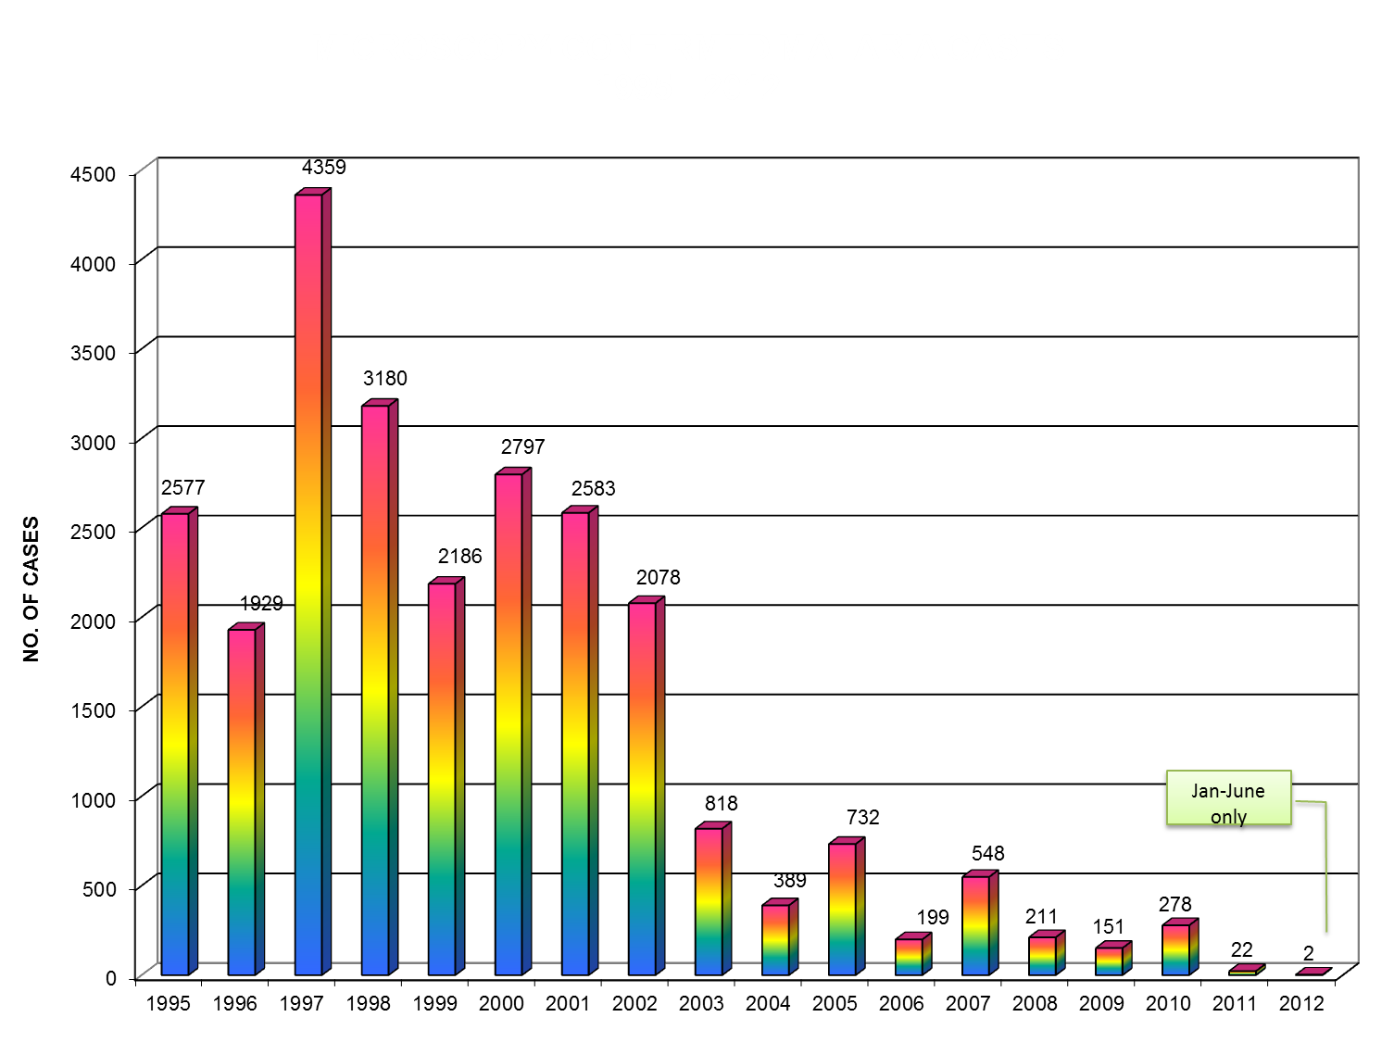
Esperanza, La Paz, Loreto, San Luis, Talacogon, Trento
San Luis, Esperanza, Loreto, Veruela
Esperanza
Sibagat

In sum, while small malaria outbreaks and clusters continue to occur, they have been managed promptly by Municipal and Provincial personnel using the stockpile of drugs and equipment maintained at the PHO principally through the GF with the assistance of CTF. There has been rapid containment in every case and no loss of life (Figures 1 and 4).

2.3 Efficiency

The extent to which the project was implemented in an efficient way with best use of the available inputs.

Managing the Investment

The Evaluation Team considers that the CTF is managed efficiently under the Trusteeship of the Land Bank and the fund continues to maintain its integrity.

The Team notes, however, that in response to declining revenue from the Principal Fund due to low interest rates, APHDFI has prompted Land Bank to review its investment strategy and has now secured a better investment portfolio with higher interest rates as confirmed in the June 2012 PCC Minutes.

Managing the PCC APHDFI Relationship

The mobilisation of the Consolidation and Integration Phase (CIP) in 2001 provided for the establishment of a PCC to oversee the management of the ADS MCP. In August 2006 the APHDFI entered into a sub-agreement with PCC to manage the CTF. The PCC comprises the Governor of Agusan del Sur, the DOH Under Secretary for Mindanao and the First Secretary for AusAID.

The Sub-Agreement stipulated the objectives of the CTF and policies and procedures for the management of the Fund by APHDFI. Under the agreement the APHDFI is required to submit to the PCC a budget plan each year stipulating the annual management costs and estimated augmentation requirements for malaria control. The budget submissions are to be accompanied by liquidation/acquittal of the previous annual expenditures for approval by the PCC.

The APHDFI Executive Officer cites the following management and chronology of PCC meetings.

- From 2005 to2008 AusAID convened PCC meetings. The EO recalls attending two PCC meeting one in 2005 prior to the Sub-Agreement and one in 2008 after the Agreement. At the 2008 meeting the EO APHDFI informally presented his ROA response to AusAID.

- In 2009 AusAID requested APHDFI to convene all future PCC meetings and to prepare the agenda.

- Upon this instruction, APHDFI sought to convene the PCC in 2009 but a meeting did not eventuate because a suitable time convenient for PCC members could not be agreed. There was, however, correspondence between the PCC members on the extension of the Sub-Agreement to 2012.

- In 2010, PCC Members agreed to have a meeting in November however DOH Assistant Secretary Ubial was replaced as the ASEC for Mindanao and the meeting had to be deferred.

- In January of 2011, APHDFI sought an audience with the new DOH Assistant Secretary for Mindanao, Dr. Romulo Busuego, to brief him on the project and determine a suitable time for the PCC. While he expressed support to the project and committed to attend a PCC Meeting mobilisation of the meeting was delayed, once again, by the commitments of other members.

- In response, APHDFI then proposed to AusAID that permanent proxy/authorized representative be allowed to attend the meeting. However, the First Secretary AusAID noted that she wanted to see the principal members themselves.

- Finally, in September of 2011, a PCC Meeting was set. The venue was the AusAID Conference Room. APHDFI was represented by its Executive Officer but again no members of the PCC were able to attend. The meeting was relegated to an update between APHDFI and the AusAID CTF Activity Manager.

- Following representation from APHDFI, the DOH Asec agreed to host a PCC meeting in Tagum City in June 2012. This meeting was attended by the ADS Governor and an AusAID Manager representing the First Secretary/Counsellor. At this meeting it was suggested that permanent proxy/authorized representatives could attend future PCC meetings and report back to the principal PCC members.

In sum, while there has been ongoing correspondence between PCC members, between 2008 and 2012, the PCC has only formally met twice with the APHDFI - in 2008, and in June 2012. In accordance with the Trust sub-agreement requirements the APHDFI has continued to submit its annual budget and acquittals. While the PCC has been unable to meet on a regular basis AusAID CTF Activity Managers have continued to approve the annual plan and budget to keep APHDFI operational.

In the opinion of the Evaluation Team, the APHDFI Executive Officer has made reasonable efforts to convene the PCC, however, due to the very senior positions of the PCC principals within their respective organisations and their heavy work schedule their attention has been constantly diverted by other commitments.

It has been unfortunate that the PCC was unable to meet during the period in which there has been significant achievement by the ADS MCP through the judicious utilisation of its two principal funding sources – the GF and CTF.

In response, AusAID Activity Managers felt that APHDFI, as the fund manager, should have been more resourceful in convening the PCC and ensuring participation of stakeholders. APHDFI should have, for example, sought the assistance of the Office of the Governor to ensure participation of the representative from DoH.

As suggested, authorising representatives and/or proxies to future PCC meetings will avoid cancellations and postponements due to unavailability of principals. In hindsight, the authorisation of proxies should have been taken several years earlier.”

At the activity level

While communication and coordination between APHDFI and the PCC has been poor, there has been good communication between APHDFI, the PHO and the Global Fund through the PMT which meets monthly. This has enabled APHDFI to monitor and respond to the work of other partners, and represents the principal vehicle for CTF planning and priority setting.

2.4 Impact

The extent to which the project has brought about change.

The ADS MCP, principally through the GF, and with the support of the CTF has achieved a significant result in that it has been able to maintain continuous reduction in malaria cases throughout the Province (Figure 2) and address the sporadic cases and occasional clusters of malaria outbreak which have occurred (Figure 1, above).

The overall annual parasite incidence (API) for the Province was 6.59 per 1,000 population at the commencement of the Project in 1995, rose to a peak of 10.75 per 1,000 in 1997 (associated with improved surveillance but also increased epidemic activity), and was steady at 5 per 1,000 at the end of the first phase of the Project in 2001. The API had fallen to 1.39 per 1,000 by the end of the CIP and further sustained reduction in incidence saw it fall to 0.32 per 1,000 in 2006 and a further drop to 0.003 per 1,000 in 2012 (Figure 3). This represents a 99.5% decrease in malaria incidence from 1997.

The declining trend in malaria cases and API are also seen in each of the 14 municipalities from 1995 to 2011 (refer Annex 5). There has not been a death from malaria recorded in ADS for eight consecutive years from 2004 to 2012 (Figure 4).

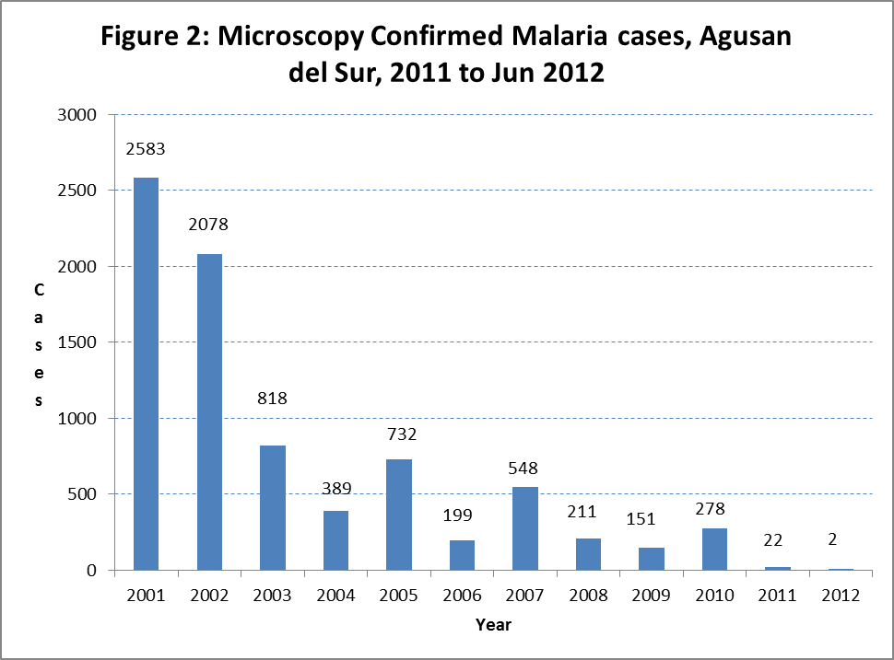

To conclude, CTF has made a contribution to health system strengthening and this was evident through the mobilisation and establishment of integrated outbreak response teams responsible for mass blood surveys, outreach services, targeted house spraying and bed net distribution, community awareness and health education.

Health system strengthening and capacity building are interlinked thus investment in either ultimately provided benefits to both the system and individuals in the system. The GF provided resources for improved staff knowledge in managing malaria both clinically and programmatically, whilst CTF capitalized on the trained staff for outbreak response activities.

2.5 Sustainability

The extent to which the project is contributing to sustainable development and can continue to do so in the future.

The ADS MCP

Post 2014, with the exit of the Global Fund, the ADS MCP is faced with the challenge of sustaining the achievements gained in malaria control from 1995 to date. There is therefore a need for high vigilance and pre-emptive action to prevent the establishment of new foci.

Malaria control requires a sustained commitment over time and a dynamic scientific and programmatic approach to modify strategies, as the vectors and parasites adapt to the various control strategies – and, as the threat diminishes, people may become complacent. In sum, malaria control is long-term business and support will have to continue.

In a time of global financial crisis, economic downturn and reduction in donor support for global health, it is incumbent on the PHO, APHDFI and the Shell Foundation (the partners) to develop an investment strategy for CTF post 2014. This may comprise a cost-effective mix of interventions tailored to the needs of individual municipalities, address current and emerging vulnerabilities, gradually hand over functions as MHOs are able to manage them and develop a phased exit strategy with local government and partners.

These are difficult goals to accomplish in a time of flat or declining resources. In moving forward, however, it is imperative that the partners build on the Global Fund and CTF success, and deal forthrightly with efforts to ensure continuity over the longer term.

However, as indicated in section 2.2, the CTF is not in a position to fully maintain the GF investment and can only contribute some of the resources required for ongoing malaria control if it is to continue to operate as a Perpetual Trust and not deplete its Principal Fund.

In the opinion of the Evaluation Team top-up is unlikely and its preference is for cashing in the Principal Fund and utilising the proceeds for developing a discrete project. This approach will at least ensure that malaria is contained at current rates for another 3-5 years post 2014 while the PHO, the DOH and the APHDFI strategise how they may secure other funding sources. The Evaluation Team notes, however, that there is strong support within the PHO, the Office of the Governor and APHDFI for maintaining a Perpetual Trust and that these parties plan to investigate all options in the lead up to the Global Fund exit.

2.6 Gender Equality

The extent to which resources are shared equally between the sexes and the administration and management

The ADS MCP is founded on the principle of gender equality. All women, men and children who have malaria or are at risk must be treated and given commodities such as bed nets that prevent the transmission of malaria. Because of their mobility men are most at risk. Among the screened and confirmed cases reported from 2007 to June 2012, the gender distribution was 791 positive among male and 421 positive among female patients, giving a ratio of 1.9 male: 1female.

At the ADS MCP administration and management level there is a relatively even gender distribution among the workforce For example P-TAC has 2 female and 4 male employees); PMT has 8 females, 10 males, GF-PSFI (1 female); PHRC (5 females, 4 males); PHT (18 females, 16 males), and at the municipal level, eg MHOs (10 females, 4 males), CO (3 females, 1 male) and Medical technologists (34 females, 13 males).

However, at the local government level, most of the serviced deliverers are women. Eg RHU staff (207 females, 19 males), barangay health worker federation (2,491 females, 27 males), barangay malaria microscopy centre workers (4 females) and RDT centre workers (51 females, 2 males). In this context, the PHO needs to give consideration as to how it can attract more males into the health service.

For the management of the CTF the APHDFI has allocated the services of an Executive Officer (Male) and a Finance Officer (Female).

2.7 Monitoring and Evaluation

The extent to which monitoring and evaluation has been conducted and contributed to knowledge and understanding of the project.

At a Management Level

In the absence of an operational PCC to formally request and receive information on the progress and performance of the ADS MCP and the respective contributions of the CTF and the Global Fund there has been a breakdown in the process of monitoring and evaluation and the PCC executives remain largely uninformed about ADSS MCP and CTF activities.

Had the CTF Sub-Agreement required that the CTF report its activities against the achievements of the ADS MCP, instead of limiting reporting to CTF annual budget activities and acquittals, a more complete picture of how the CTF was contributing to the malaria control in Agusan would have emerged much earlier. Assuming of course the PCC process was in place.

At the Project Level

Under the ADS MCP the PHRC has a full-time computer operator for monitoring malaria project activities and processing malaria data through Philippines Malaria Information System (PhilMIS) which is currently used to monitor CTF and Global Fund activities. PhilMIS was developed by the Department of Health (DoH) through the National Epidemiology Center to provide information in a computerized form needed for planning, implementation, monitoring and evaluation of the malaria control program; and to standardize the collection of malaria data using the same reporting and recording forms in malaria endemic provinces.

2.8 Analysis and Learning

The extent to which the activity is based on sound technical analysis and continuous learning.

At the Management Level

Because of the breakdown in the PCC process, communication and coordination between the PCC members and the APHDFI post 2007 has been poor. As a result AusAID has:

- Relied on analysis which at the time was relevant but is now out of date; and

- Not kept abreast of, or been informed about, subsequent developments and learning in the ADS Malaria Control Program which provide a more positive perspective on APHDFI and the CTF activity.

The key lessons from this evaluation are that for projects to which AusAID is still a party by formal Agreement, in this case through the Trust Fund Amendment of January 2009, Activity Managers need to:

- Maintain the process of communication and coordination with their project partners through a formal PCC process if they are to remain knowledgeable and informed about the project.
- Exercise due diligence in allocating PCC tasks to project partners (in this case APHDFI) who may lack experience in facilitating communication and coordination and reporting at an executive level . Experience suggests that senior executives tend to be more responsive to their own peer group than to junior managers seeking to coordinate their activities. I.e. if the ADS Governor calls a meeting other executives are likely to attend as a matter of protocol.

- Be diligent in the handover/takeover of projects to ensure that the incoming Activity Manager is fully briefed on the project history and status in order to maintain AusAID’s institutional memory of the project. In 2010, due to rapid staff changes, there was no handover/ takeover between CTF Activity Managers and AusAID lost track of the CTF for a time and assumed it was being managed by WHO.

At the Activity Level

Many aspects of the ADS-MCP and CTF activity are informed by quality technical analysis and access to WHO’s global technical networks (also see WHO malaria guidelines in http://www.who.int/GMP). These included strategies that performed well in the national operational programmes, such as:
- Promotion of early diagnosis, prompt management, treatment and referral of malaria cases have largely contributed to the improved MCP performance in the past 8 years as it entailed the expansion of microscopy centres and rapid diagnostic test (RDT) sites nationwide and province wide, continuous availability of anti-malarial drugs to endemic areas, training of health staff, update of the Malaria Diagnosis and Management Policy and Guide and the operationalization of the quality assurance system for microscopy services and anti-malarial drugs;
- Promotion of the effective and regular use of insecticide-treated bednets (ITN) including universal coverage has provided increased protection to families from malaria. The introduction of long lasting insecticidal nets (LLINs) was seen to be a breakthrough in enhancing vector control measures at the community level;
- Stratifying endemic areas by rate of transmission down to the barangay level provided a sound basis for better targeting and prioritization of assistance. It has also led to a tailor-fit package of intervention appropriate for each stratified area.
- Increasing the demand for anti-malarial services helped raise the awareness of community members about malaria transmission and prevention and the compliance of clients to treatment protocols and the use of ITN/LLINs as protective measures.
- Promoting the principles and approaches set out in the strategic framework on Integrated Vector Management (IVM) to improve the efficacy, cost-effectiveness, ecological soundness and sustainability of vector control. To be effective, the methods of vector control should be adapted to the ecology, behaviour and insecticide susceptibility of vector populations and personal protection methods should be tailored to people’s habits and preferences. To be efficient, vector control should be targeted where and when people are most at risk. Well-adapted and well-targeted vector control strategies will ensure the efficient use of resources and contribute to the effective reduction of the disease burden.

3. Conclusion and Recommendations

This section focuses on the objectives of the CTF and the core questions raised in section 1, namely:

- How has APHDFI responded and performed since the 2007 ROA?

- Is the CTF model suitable for addressing sustainability issues post project completion in an aid delivery context?

- What are the implications of the Audit findings and recommendations for the APHDFI and the future management of the trust?

- What other CTF management options are there should AusAID not wish to transfer the fund to APHDFI?

3.1 APHFI Response and Performance

The 2007 Assessment Report raised a range of concerns relating to the capacity of the APHDFI and the future of the CTF after the Trust Agreement lapsed.

The APHFI prepared a response to the findings and recommendations for the consideration of PCC members which sought to clarify its position and actions. However, due to problems with mobilising the PCC, the APHDFI was unable to directly present its case and clarify its intent. In the absence of any other analysis, the 2007 ROA Report has become the benchmark for assessing APHDFI and CTF progress and performance in subsequent years. The current terms of reference for this assignment still reflect the influence of this report.

As described in section 2, the Evaluation Team concludes that while legitimate concerns were raised in the 2007 ROA report, these concerns were either addressed in the APHDFI response and/or in its subsequent actions. Notably, resolving its potential conflict of interest as both a manager and recipient of the CTF by ceasing its MCP service delivery activities and restricting its focus to Trust Fund management in accordance with its mandate.

The Evaluation Team further notes:

- APHDFI is an active member of the ADS MCP Project Management Team and has responded appropriately and promptly to all requests for assistance, few though they may be.

- The CTF is being used in the manner for which it was intended in that it still retains a primary focus on malaria control and prevention and secondary focus on malaria outbreak detection.

- While APHDFI’s accounting practices need improvement, the intent of the CTF as a Perpetual Trust is still preserved in that some P33.0 million is available to support ADS MCP activities upon expiry of the current Trust Agreement.

The outstanding contention is over the issue of PCC management. In an amendment to the Trust Agreement 2009 AusAid transferred authority to the APHDFI for mobilising PCC meetings and preparing financial and activity reports to keep the PCC informed. While it would appear that the APHDFI made reasonable efforts to convene annual PCCs and met its annual financial reporting and budget requirements, in the opinion of the Evaluation Team, its activity reporting was insufficiently comprehensive to keep PCC members informed, particularly AusAID, on GF and CRF planning and management issues.

In sum while APHDFI continues to manage the CTF in accordance with the objectives and principles outlined in the 2006 Trust Agreement, its reporting on activity progress and performance has not met with AusAID standards. Should the Fund pass to it upon expiry of the current Agreement, it would need to improve its activity reporting to PCC members.

3.2 The Suitability of the CTF Model for Addressing Sustainability Issues

In the opinion of the Evaluation Team the CTF model is a suitable mechanism for addressing project sustainability issues both during implementation and after project completion. As described in section 2, the Fund has demonstrated its value as a supplementary source of revenue in the current implementation phase of the ADS MCP and as a future source of funding for malaria control post 2014. However, the sustainability of model is premised on three principles:

- Periodically topping up the fund to maintain its real value to offset variable interest rates and inflation.

- Limiting and prioritising expenditure to the income that can be generated from interest earned from the Principal Trust.

- Good governance by the Fund Manager and Trustee. i.e. the fund manager and trustee are participatory, transparent, accountable and equitable in trust planning and decision-making.

If these principles are adhered to there is no reason why the fund cannot continue in perpetuity.

While the Evaluation Team believes that a Perpetual Trust model has application to other AusAID projects in the Philippines such as the Class Room Construction Initiative (CCI) and the Provincial Road Maintenance Fund (PRMF), AusAID is now far more risk averse than it was in 2001. The Team assesses there is no longer the appetite to entertain Perpetual Trust models of resource allocation in the AusAID Philippines Country Program. Activity Managers would now appear to equate Perpetual Trusts with managing Perpetual Risk to Australian tax payer’s money and the administrative and political fallout therein.

Although AusAID may be no longer interested in establishing Perpetual Trusts to support project sustainability after official development assistance has ceased, the CTF ably demonstrates the value of having a fund which provides the PHO with capacity to continue to consolidate the ADS MCP achievements over the medium-term after the conclusion of donor assistance.

The CTF experience suggests that for some projects there may be value in establishing a Trust Fund in the implementation phase which, upon cessation of donor development assistance, is drawn down and used to support discrete time- bound project initiatives under a short term Trust Agreement managed by credible local partners . This approach would limit exposure to perpetual risk.

3.3 What are the implications of the 2012 audit findings?

The financial audit and operations review conducted by Into-Opamin yielded the following findings:

The Financial Audit revealed the following findings:
- Subsidiary Ledger for Cash Advances was not maintained.
- There was incorrect use of books of accounts.
- Management failed to inform AusAID of the destruction of the documents on the CTF fund.
- There were unsupported and disallowable expenditures (Documents were said to be destroyed by the flood).
- There were cash advances not liquidated on time.
- Cash advances were allowed to persons not officers and employees of the foundation.
- Cash Advance Liquidation Report and other supporting documents were not stamped “PAID”.
- Cash advances were not supported by certificate of appearance
- Management failed to comply with the 3-canvass procurement requirement.

The Operational Review revealed the following findings:
- No subsidy fund for the project was released for 2008 and 2010
- No program of activities was done for 2008 and 2011
- There was an available fund of P1.035Million in 2008, but there was no download during the year, neither was there a program activity conducted.
- Sixty-one percent (61%) of the total CTF released in 5 years was unspent.
- The administrative cost was higher than the program cost.
- The Global Fund with its scheme of dole out distribution of supplies was preferred by the people over CTF with its shared responsibility (counterpart contribution) and request for program funds which is proposal driven.
- APHDFI spent 35% of the total downloaded interest income or 29% of the accrued interest income for the 5 year period.
- No periodic audit by external auditor was done.
- Only 2 PCC meetings were held in 5 years (from 2007 to 2011).

The audit of the 2007-2011 accounts is complicated by the destruction of the 2007, 2008 and 2009 books and supporting documents. The records were stored in a building which was inundated by typhoon induced flooding in 2010. As a result there are unsupported expenses amounting to P1.15 million.

The evaluation team questioned the Auditor whether she believed that APHDFI was involved in fraudulent activity and an attempt at cover up. The Auditor responded that in her opinion, while APHDFI should have been more diligent in storing their records, the documents were almost certainly destroyed by the flood and there has been no attempt to defraud or cover-up. The Evaluation Team after visiting the site where the documentation was stored concurs with the Auditor’s view. Whereas destruction of the records can be considered an example of poor risk management by APHDFI at the time, records are now housed in a more secure office.

The Audit also noted that while there were some minor accounting procedural issues for which remedial action was required the APHDFI had largely complied with the 2007 audit recommendations. In response to the outstanding issues raised in the 2012 audit, APHDFI has taken action to improve the accounting skills of its finance officer by enrolling her in training and mentoring program with a qualified audit firm. The Evaluation Team noted that in the Auditor’s opinion, the measures taken to secure records and to improve the accounting skills of the finance office should be sufficient to give APHDFI the capacity to continue to manage the CTF. In the absence of any other evidence the Evaluation Team accepts the Auditor’s opinion.

The Evaluation Team notes the Auditor has queried whether APHDFI is in compliance with the Trust Sub-Agreement which stipulates that administrative costs must be limited to 30% of the annual interest while the remainder (70%) must be spent on malaria control activities.

The audit highlights that between 2007-2011 APHDFI incurred Php2,310,828.12 in management costs representing 51% of the total project cost of Php4,469,321.61. The Auditor queries whether the management cost should have been adjusted as a proportion of actual annual expenditure rather than on annual income.

The Evaluation Team notes the Clause 1.1 (Management Costs) of the Trust Sub-Agreement states that ‘upon written approval of the proposed budget by the PCC, the Trustee (the Land Bank) will transfer funds in the Reflow Fund in amounts not exceeding 30% of the annual interest earned to the beneficiary (APHDFI).

Neither Clause 1.1or any subsequent clauses contain reference to aligning APHDFI management costs with malaria control expenditure on an annual basis. In the opinion of the Evaluation Team, APHDFI is in full compliance with the management provisions of Clause 1.1 of the Trust Sub-Agreement.

3.4 What are the CTF Management Options?

The CTF Trust Fund Agreement expires in 2013. The following options were considered for managing the fund post 2013.

- Transfer the Fund to WHO
- Transfer the Fund to DOH
- AusAID recoups the fund
- Leave the fund under the management of APHDFI but seek partnership with the Shell Foundation to assist in its management

Of these, only two are considered real options for AusAID. Namely recouping the fund or leaving it under the management of APHDFI.

WHO and and DOH while initially happy to consider the option of managing the fund subsequently qualified their respective positions in favour of leaving the fund under the management APHDFI but pursuing wider institutional development agendas which, in the opinion of the Evaluation Team, would both divert the intent and complicate the management of the fund.

(a) Transfer the Fund to WHO

WHO indicated that it did not want to manage the fund in its own right and its preferred strategy would be to work with the ADS Governor on projects of mutual interest including malaria.

WHO expressed interest in collaborating with the APHDFI in the utilisation of the CTF to develop their Philippines Integrated Disease Surveillance Response (PIDSR) concept in Agusan Del Sur. PIDSR is a national strategy of the DOH in response to International Health Regulations 2005 call to improve disease surveillance and response of emerging diseases. Specifically, PIDSR is an enhanced surveillance system that monitors notifiable diseases and other health-related events of public health importance utilizing an integrated approach.

On reviewing the status of PIDSR, the Evaluation Team considered that the project is too complex, requires significant further development and there is insufficient revenue in the in CTF to sustain the initiative past its initial establishment.

PIDSR involves a diverse array of stakeholders and implementers without guarantee of commitment. These include a PIDSR Management Committee to oversee implementation in the province, Disaster Coordinating Councils to oversee implementation of epidemic and disaster response, PHO, Inter-Local Health Zone (ILHZ), Municipal Health office (MHO)/City Health Office (CHO) to set up and maintain a functional disease surveillance system at their level; a technical management committee comprising PHO and ILHZ; surveillance units at the provincial, municipal, city and ILHZ level to collect organize, analyse and interpret surveillance data and outbreak response teams to conduct epidemiologic investigations,

In the opinion of the Evaluation Team, while being an impeccable candidate to assist in the management of the fund, the WHO agenda is too broad based and not directly related to building and consolidating the achievements of the ADS MCP.

(b) Transfer the Fund to DOH

The DOH through Assistant Secretary Busuego is willing to consider managing the CTF if this was an AusAID requirement for retaining the fund in the region after the current Agreement lapses. His preference is, however, to leave the fund under the management of APHDFI and to work more closely with the ADS Governor, with whom he has good relations. The Assistant Secretary and the Governor are members of the CTF PCC.

Asec. Busuego believes that the current Trust Agreement needs to be revised to:
- Broaden the scope of its response to other communicable diseases such as schistosomiasis prevention and control.

- Move away from the community submission model, support the Provincial Investment Program for Health (PIPH).

- Diversify the investment portfolio to include local cooperatives and procurement of portable ultrasound imaging equipment and hospital dispensaries which in his experience are viable commercial propositions.

Like the ADS Governor he is keen to retain the CTF as a Perpetual Trust and believes that, through his own hospital investment experience, he could significantly increase Trust revenues.

If, on-the-other-hand, AusAID was to directly transfer the funds to the DOH it would need to first satisfy GOA fiduciary risk assessment requirements while at the same time negotiating some assurance on program expenditure. This may take some time for no less risk.

(c) Recoup the Fund

On the basis of the 2012 Audit report, lack of detailed activity reporting to AusAID, lack of attention to risk management on behalf of Australian tax payers, AusAID may wish to recoup the fund and use it elsewhere.

In the opinion of the Evaluation Team, this action is likely to be strongly opposed by the ADS Governor and the DOH Assistant Secretary both of whom see value in retaining the fund. The Governor, in particular, is acutely aware that the fund is a critical element in the ADS MCP strategy post 2014 and is likely to see removal of the fund by AusAID as an expression of lack of confidence in his administration.

The Evaluation Team also notes that (a) ADS is susceptible to the re-emergence of malaria outbreaks if control, prevention and elimination activities are withdrawn and (b) the Global Fund intends to withdraw its support to malaria in ADS after 2014.

If the CTF is recouped on the basis of the audit report, the ADS is unlikely to be able to secure an alternative source of funding of the scale of the CTF to continue to address malaria outbreaks over the medium term post 2014 . On this basis malaria outbreaks are likely to re-emerge in ADS post 2014 and be difficult to contain.

(d) Leave the Fund with APHDFI

ADS Governor’s perspective

The Governor is strongly supportive of APHDFI, CTF and the principal of maintaining the fund as a Perpetual Trust. He is very much aware of the value of the fund post 2014 and talked about topping it up by P10 million post-2014 as well as asking the GF for top-up.

He believes, on the basis of the current working relationship with the ADS MCP and the PMT, APHDFI is doing a good job and is strongly supportive of its current Executive Director who he uses to promote his wider community development agenda. Like the DOH Assistant Secretary, he believes that the CTF investment strategy has been too conservative and is keen to explore other options and has already consulted with the Assistant Secretary on this matter.

The Governor indicated he is a strong supporter of AusAID and wishes to maintain the aid relationship which was established in 1995 and continues to this day.

ADS PHO Perspective

Unlike 2007, when there was personal conflict between the its ADS MCP Manager and the APHDFI Executive Officer, the PHO now has a good working relationship with the APHDFI and expressed confidence in working with the NGO to get the best use out of the CTF post 2014.
The Evaluation Team’s Perspective
In the opinion of the Evaluation Team, ongoing support for the ADS MCP and AusAID’s development assistance program in Agusan Del Sur and the wider Caraga region in Mindanao would be best served by leaving the fund under the management of the APHDFI with the following provisions:
- The ADS MCP Project Management Team, which includes the APHDFI and the Shell Foundation, is mobilised over the next 6 months to prepare an ADS MCP 5 year plan (2014-2018) covering the Global Fund exit and the utilisation of the CTF either as a Perpetual Trust or as a discrete project.
- The PCC continues to oversight/oversee the CTF for its duration but the Shell Foundation, which has experience in Trust Fund Management and Malaria control in Agusan, replaces AusAID as a member of the PCC in a seamless transition prior to the Expiry of the CTF Trust Agreement.
Whereas there has been some discussion on diversifying the utilisation of the fund to cover other diseases and health priorities, the Evaluation Team recommends that the CTF remain focused on malaria given that the exit of the GF is likely to pose significant challenges to malaria control in ADS if a targeted replacement program for the bed nets or a continuous distribution system through antenatal care services and household access to commercial LLINs cannot be maintained post 2014.
The Evaluation Team noted Shell Foundation’s interest in participating in the development of the ADS MCP five year plan and the PCC. The Shell Foundation has yet to develop an exit strategy for the GF and views the CTF as an important vehicle for providing ongoing support to the bed net program post 2014 and thereby contributing to the sustainability of the initial GF investment and Shell’s work in the Philippines.
The Executive Director of the Shell Foundation indicated that while his organisation did not want to manage the fund he would be pleased to work with the APHDFI and the PCC to assist in the development of an ADS MCP strategy and implementation plan in the lead up to the GF exit. The Executive Director noted that the Shell Foundation had extensive experience in Trust Fund Management and would be willing to share this experience with APHDFI and the PCC if invited by the ADS Governor. He further noted that Shell would be able to support its own administrative overheads in the development of an exit strategy and as a PCC member but indicated that Shell was not in a position to top up the CTF.
In supporting the APHDFI, the Shell Foundation would need to take into account the weaknesses raised in the Audit Report and assist the APHDFI to address these issues. The basis for this assistance would need to be spelt out in the proposed ADS MCP 5 year plan (2014-2018) as part of risk minimisation.

3.5 The PCC/APHHDFI Agreement and CTF Conditions of Turnover

Section 6 of the PCC/APHDFI Trust Sub-Agreement outlines the Conditions of Turnover of the CTF on the expiry of the Trust agreement originally envisaged as December 2007.

Clause 6.1 states The Community Trust Fund shall be turned over to APHDFI if, and only if:

- APHDFI is able to manage the CTF well, according to the policies mentioned in this sub-agreement.

- APHDFI will maintain the original principle and spirit of the CTF.

- APHDFI will ensure that the PCC maintain its original oversight role beyond the CTF’s foundation year.

- APHDFI maintains its annual certification from the Philippine Council for NGO certification (PCNC) while managing the CTF.

Clause 6.2 further states AusAID reserves the right to withdraw the full amount of the CTF should there be any misuse of the fund outside the above-mentioned parameters.

In the opinion of the Evaluation Team, the PCC needs to review these conditions in the light of the Team’s recommendation that the ADS MCP Project Management Team, which includes the APHDFI and the Shell Foundation, be immediately mobilised to prepare a 2014-2018 ADS MCP Strategy and Implementation plan (SIP) covering the GF exit and the utilisation of the CTF either as a Perpetual Trust or as a discrete project.
The Evaluation Team recommends that in developing the SIP, AusAID revisit the Conditions of Transfer in consultation with the ADS MCP partners as the transfer conditions are now somewhat dated and, if required, develop a new Trust Agreement more suited to the utilisation of the CTF post 2014.
For example, if the PMT opts to cash in the fund and develop a time bound project then the policies as mentioned in the sub agreement are likely to change, the original principle and spirit of the Agreement will be changed (i.e the policy and principle of managing a perpetual trust would no longer apply), and ensuring that the PCC retains its original oversight role would require amendment to reflect the exit of AusAID and the entry of the Shell Foundation. The Evaluation notes that the APHDFI as an organisation has satisfied PCNC requirements for certification.
The new Agreement would need to focus on the respective roles and responsibilities of the partners post 2014, most notably APHDFI and the Shell Foundation and the governance provisions for the CTF in the light of changed circumstances.
It is proposed the SIP should be finalised and approved by June 2013 together with a revised CTF Trust Agreement if required. The Evaluation Team believes that AusAID’s interests would be best served and risk managed more effectively if it appointed a Technical Adviser with experience in malaria control to assist the PMT in the preparation of the SIP and the new Agreement. Based on the outcome AusAID could then make a final assessment of the risk of turning the fund over to the new entity and act accordingly.

Annex 1: Draft Evaluation Plan
Agusan del Sur Malaria Control and Prevention Project Community Trust Fund (CTF)
Evaluation Plan, August 6, 2012

This evaluation plan has been prepared by Jeffery Hii and Gary Simpson (the consultants) and draws in part upon a draft Evaluation Plan format developed by Susan Dawson for AusAID under the Evaluation Capacity Building Program. Monitoring and Evaluations Standards (2012).

1. Collaborating Participants

The principal clients are:
- AusAID which mobilised the CTF in 2004.
- Agusan for People’s Health Development Foundation INC (APHDFI) – which administers the CTF.
- The Department of Health in Mindanao and Agusan – whose staff utilise the fund for malaria control activities.
The Evaluators are:

- Drs Jeffery Hii (Medical Specialist)
- Gary Simpson (Design and Monitoring and Evaluation Specialist)
2. Primary Users

The evaluation findings and recommendations principally target AusAID, DOH and APHDFI. However, there are a wide range of stakeholders with an active interest in the outcome of the evaluation. Annex 1 summarises the stakeholder interest groups. To the extent that time is available, all or some of these stakeholders will be interviewed during the course of the evaluation

3. The Evaluation Objective

As per the Terms of Reference the evaluation objective is:
To evaluate the performance of the CTF as an innovative model for addressing project sustainability after completion based on relevance, efficiency, effectiveness, impact and sustainability; and recommend actions on the future of CTF management.

As per the 2006 Trust Sub Agreement between the APHDFI and the CTF PCC the development objective of the CTF is specified as:

Building a permanent and sustainable community source of funding to supplement the cost of critical malaria control supplies at the provincial and municipal levels of the Province of Agusan del Sur
This objective is further qualified in the Sub Agreement between APHDFI and the CTF PCC (Clause 1.2)

In preparing the annual plan and budget CTF retains a primary focus on malaria control and prevention and secondary focus on malaria outbreak detection until there is demonstrable, objective evidence of a decline in endemicity in high priority municipalities and that prevention has remained well integrated at community level for a number of years.

When such evidence is available, income from the CTF may be accessed for the purpose of addressing other endemic communicable disease problems in ADS.

4. Evaluation Scope

It is within the context of the CTF objective as specified in the Trust Sub Agreement that the Evaluation Team will:

- Review progress to date within the with a focus on:
- Performance of the CTF as an alternative model (relevance, efficiency, effectiveness, impact and sustainability);
- Implementation of interventions;
- Individual and team performance;
- The influence of the operating environment;
- Important epidemiological factors.

- Identify critical elements and challenges that affect achievement of the purpose, if any. Recommend measures to respond to these challenges.
- Assess the degree to which the initiative is aligned with partner government systems and harmonised with other donors.
- Provide recommendations or actions on the future of the CTF, including the improvement of project strategies and implementation of future activities with reference to current GF consolidated malaria grant Phase 2 (scheduled to start on January 2012).
- Capture the general perception of the community regarding the project’s and/or NMCP’s impact on their lives.
The principal focus will be on the performance of the CTF and its governance practice and management systems during the implementation phase, from 2007 to June 2012, and looking forward to the second half of 2012, and beyond.

As the Philippines is moving towards an integrated implementation and monitoring approach for malaria, the evaluation will also examine how well inputs under the CTF are harmonised and synchronised with the WHO/RBM project and with DOH policies in relation to concurrent and complementary activities at the regional, provincial and community levels.
As a result of the analysis of these aspects of the CTF, the evaluation should be able to identify the key lessons and make recommendations in relation to overall program implementation and performance to achieve intended outcomes during the current implementation phase and beyond.

5. Limitations

The most recent minutes of the CTF PCC (Alikpala June 16, 2012) note that there has been no drawdown on the CTF by the Agusan for People’s Health Development Foundation INC other than for administrative expenses for almost two years (2011-2012) .

The reasons cited are:

- The PCC did not meet in 2011 to approve the budget and has deferred the 2012 budget until after the evaluation

- The Pilipinas Shell Foundation has been active in providing support for malaria supplies since 2011 and the program will continue through to 2014.

- Malaria is largely contained in Agusan del Sur for the time being.
In sum the CTF appears to have been overshadowed by Shell Foundation activity and its immediate future as a perpetual trust targeting malaria needs to be re-assessed. In this context, evaluation of the efficiency, effectiveness and impact of the CTF is only possible up to 2010 and it will be difficult to make an assessment of the current management capacity of the (APHDFI) with respect to the utilisation of funds in relation to malaria control and malaria outbreak detection.

6. Evaluation Design

6.1 CTF Management

The operation of the CTF was last reviewed in Oct 2007. This review was quite critical of the way in which APHDFI was managing the CTF and made a number of recommendations to improve the governance and focus of the fund.

It is suggested that the findings and recommendations of this review be revisited and used as the starting point for the current evaluation. The intent is to determine which recommendations were actively pursued and whether any issues raised in the 2007 review remain outstanding. This analysis will be undertaken in separate discussions with AusAID , APHDFI, DOH (Mindanao/Agusan).

6.2 CTF Contribution

The contribution of the Trust in terms of funding and activities will be tabulated on an annual basis from 2004-2010. This data will be collected from APHDFI records.

6.3 CTF/Shell Foundation Comparative Analysis

Comparative analysis of CTF and Shell Foundation organisation and Management and Program/Planning approach

6.4 Evaluation Criteria, Sustainability

In evaluating the progress and performance of the CTF, the following DAC Evaluation Criteria will be applied:
Relevance | The extent to which the project activity is suited to the priorities and policies of the target group, recipient and donor. In evaluating the relevance of a programme or a project, it is useful to consider the following questions:  To what extent are the objectives of the programme still valid?  Are the activities and outputs of the programme consistent with the overall goal and the attainment of its objectives?  Are the activities and outputs of the programme consistent with the intended impacts and effects?.
Efficiency | Efficiency measures the outputs -- qualitative and quantitative -- in relation to the inputs. It is an economic term which signifies that the aid uses the least costly resources possible in order to achieve the desired results. This generally requires comparing alternative approaches to achieving the same outputs, to see whether the most efficient process has been adopted. When evaluating the efficiency of a programme or a project, it is useful to consider the following questions:  Were activities cost-efficient?  Were objectives achieved on time?  Was the project implemented in the most efficient way compared to alternatives?
Effectiveness | A measure of the extent to which the activity attains its objectives. In evaluating the effectiveness of a programme or a project, it is useful to consider the following questions:  To what extent were the objectives achieved / are likely to be achieved?  What were the major factors influencing the achievement or non-achievement of the objectives?
Impact | The positive and negative changes produced by a development intervention, directly or indirectly, intended or unintended. This involves the main impacts and effects resulting from the activity on the local social, economic, environmental and other development indicators. The examination should be concerned with both intended and unintended results and must also include the positive and negative impact of external factors, such as changes in terms of trade and financial conditions. When evaluating the impact of a programme or a project, it is useful to consider the following questions:  What has happened as a result of the programme or project?  What real difference has the activity made to the beneficiaries?  How many people have been affected?
Sustainability | Sustainability is concerned with measuring whether the benefits of an activity are likely to continue after project funding has been withdrawn. Projects need to be environmentally as well as financially sustainable. When evaluating the sustainability of a programme or a project, it is useful to consider the following questions:  To what extent did the benefits of a programme or project continue after funding ceased?  What were the major factors which influenced the achievement or non-achievement of sustainability of the programme or project?

7. Key Questions

The Scope and Design of the CTF evaluation is underpinned by key questions targeting the principal collaborating participants AusAID, DOH and APHDFI . These questions are detailed in Attachment 2.
Attachment 1

Stakeholder Groups and Their Interest in the Outcomes of the CTF

Stakeholder | Interest / Stake | Involvement
- Most at-risk populations: indigenous people (IP), internally displaced populations (IDP) and mobile populations | - Direct primary target groups for long life insecticide treated bed nets (LLIN), retreatment of conventional bednets (ITN) and indoor residual spraying (IRS) provided and community education supported through the CTF  - Primary beneficiaries of early diagnosis and treatment services supported through the CTF  - Potential primary beneficiaries of improved enrolment rates in PhilHealth | - Interviews and group discussions as feasible in communities visited during the evaluation
- High risk groups: pregnant women, children under the age of 5, elderly | - Direct primary target groups for LLIN, ITN, IRS and community education supported through the CTF  - Primary beneficiaries of early diagnosis and treatment services supported through the program  - Potential primary beneficiaries of improved enrolment rates in PhilHealth | - Interviews and group discussions as feasible in communities visited during the evaluation
- General population living in the 14 target municipalities of ADS | - Direct primary target groups for LLIN, ITN, IRS and community education supported through the CTF  - Primary beneficiaries of early diagnosis and treatment services supported through the CTF  - Potential primary beneficiaries of improved enrolment rates in PhilHealth | - Interviews and group discussions as feasible in communities visited during the evaluation
- Community malaria action committees | - Direct and indirect beneficiaries community education supported through the CTF  - Key partners for community mobilization activities  - Key partners for private sector linkages | - Interviews and group discussions in communities visited during the evaluation
- Barangay Health Workers (BHW) and staff of Rural Health Units (RHU) in target areas | - Primary beneficiaries of training inputs, and of the provision of anti-malarial drugs, laboratory supplies, microscopes and Rapid Diagnostic Test (RDT) kits through the CTF | - Semi-structured face-to-face interviews in those health stations and RHUs visited durin/g the evaluation
- LGU Malaria Coordinators, Provincial Health Resource Centre staff (PHRC), Municipal Health Officers, Medical Technologists in target areas | - Primary beneficiaries of training inputs for IRS, and of the provision of LLINs and IRS materials through the CTF  - Principal provincial and municipal planning and coordination mechanism | - Semi-structured face-to-face interviews in those health stations and RHUs visited durin/g the evaluation
- Physicians and other health workers in participating health facilities | - Primary beneficiaries of clinical and diagnostic training inputs  - Secondary beneficiaries of improved diagnostics, drugs and drug quality management systems, and referral systems supported through the CTF  - Potential secondary beneficiaries of improved population enrolment rates in PhilHealth | - Semi-structured face-to-face interviews in those hospitals and other health facilities visited during the evaluation  - Audit of hospital medical records
- Provincial Technical Advisory Committee (P-TAC); Provincial Management Team (PMT) | - Primary role to provide technical advice to the PMT, and appraisal of funding submissions to the CTF  - Appraise innovative operational research in support of MCP in remote and at-risk communities and other MCP activities as determined by the PMT on the advice of the P-TAC  - Review Budget and Implementation plans to ensure that it is consistent with PHO and MHO priorities and national, regional and provincial malaria control strategies  - Policy-makers in relation to how inputs of CTF are reflected in PIPH and/or costed within the Implementation Plan of APHDFI or LGU health budget | - Semi-structured face-to-face interviews during the evaluation  - De-briefing on completion of field work in ADS
- PCC | - Review CTF Budget and Implementation plan and supporting policies and guidelines for accessing funds to ensure compliance with the purpose and primary objective of the CTF  - Provide stringent oversight of the management of the CTF by APHDFI  - Review implementation performance and organizational governance of CTF including periodic follow-up assessment and periodic financial audits | - Semi-structured face-to-face interviews in ADS (separate from APHDFI)
- APHDFI | - Collaborate with the PMT, P-TAC and PHRC  - Establish eligibility criteria, maximum funding limits and a fast-track process for approval of and access to the outbreak response funds and suitable mechanisms for the acquittal of expenses by the recipient | - Semi-structured face-to-face interviews in ADS (with and separate from CTF local audit team) and Davao City  - Review of program performance data, operations of CTF, interview staff to determine relevance, efficiency, effectiveness, impact and sustainability of CTF model
- NMCP (DOH) and CHD Malaria Managers | - Key partners for linking support provided through the program with national and regional DOH plans and evolving Malaria MTDP  - Key partners for broader health sector strengthening | - Semi-structured face-to-face interviews and briefings prior to field activities  - De-briefing on completion of field activities
- WHO Philippines | - Member of the P-TAC  - Manager of AusAID-funded RBM project | - Semi-structured face-to-face interviews in Manila
Attachment 2

Key Questions

  - Evaluation Questionnaire for APHDFI

Dear Respondent,

AusAID has commissioned an ex-post evaluation of the CTF performance during its initial 5 years. This exercise is managed by the AusAID Post in Manila which has recruited a team to carry out the evaluation with the following members:

Dr Gary Simpson, Team leader, Manila
Dr Jeffrey Hii, Health specialist, Malaysia

For the evaluation, we will visit Manila and ADS provincial centres and communities, where we will meet a range of Government, NGO and community health and malaria managers, health workers and community members.

Thank you for agreeing to take part in the evaluation, and for meeting with the consultants and members of the malaria team – subject to travel requirements, we expect your meeting to last about 1 to 1½ hours.

The team will be taking some notes during their time with you, which will be used to prepare a report for AusAID. They will also de-brief with key health and malaria partners as they complete their field work in ADS province and in Manila.

The report will acknowledge your involvement in the evaluation. However, if you do not wish some of your comments to be recorded, please let the team know at the time you meet with them.

Please answer some questions about yourself:
For how long have you been in your present position?
Before starting as project staff in APHDFI, for how long had you worked in malaria control or research?
For how long have you worked in public health, field research or other development work in a malaria endemic area?
What is (are) your academic qualifications)?

    - APHDFI Organization and Staffing

  - What are your roles and responsibilities as APHDFI President or advisor?
      - Do you have a job description (please attach)?
      - How do you divide and allocate tasks between your staff?
      - From whom do you receive technical support [DOH, CHD, PHO, P-TAC, PMY, WHO, own professional networks, others]?

  - APHDFI decided to staff ADS-CTF malaria program with one Executive Director and 3 staff. Given your experience to date, what would you recommend as the optimal staffing pattern for provincial programs during the next phase of CTF activities?

      - What role should APHDFI staff play?

    - Priority setting on planning and research

- IMPLEMENTATION PLAN (IP)
      - In your opinion, are the IPs and annual budgets effective planning and programming tools?
        - If yes, why?
        - If not, why not?
      - Should the IPs and budgets be annual or multi-year exercises?
i. If yes, why?
ii. If not, why not?
      - Are the IPs and budgets effective in fostering partnerships with government and/or other development actors involved with malaria control?
i. If yes, why?
ii. If not, why not?

- RESEARCH
      - What operational research has been carried out to examine and overcome implementation challenges?
      - How were the research questions identified?
      - How is the research implemented (PHO staff, CHD staff, local university, external research groups, DOH, RITM)?
      - Have the results/findings been used?
        - If so, how?
        - If not, why not?
      - Going forward, how should APHDFI organize the research activities?

    - COMMODITIES

- How does the procurement and distribution system for malaria commodities function at country level?
      - Is it solely within provincial/CHD or are parallel systems operating (private sector, AusAID contractor-managed, PSFI-managed, Global Fund, through WHO)?
      - What percentage of total malaria commodities (ACTs, LLINs, microscopes, insecticides for IRS, spray pumps, replacement spare parts, IR test kits and papers) are purchased by APHDFI?
- What has been the role of the emergency Procurement supply fund?
      - If it has been used, why?
- How has APHDFI collaborated with DOH/CHD/PGO, DOH, Global Fund, WHO etc in commodity procurement?
a. How have these relationships affected APHDFI’s effectiveness?

    - Performance of APHDFI in terms of putting its Operating Principles into practice

Strengthening health systems and integration

          - What health system components beyond malaria-specific components have the CTF investments strengthened?
            - And how?
          - Have CTF activities been integrated into the infectious diseases control programmes (TB, HIV/AIDS, lymphatic filariasis, schistosomiasis, neglected tropical diseases)?
            - If yes how?
            - If not, why not?
Strengthening NMCP capacities and ownership of malaria control efforts

          - Has APHDFI strengthened the capacity of provincial MCP to lead the national malaria control efforts?
            - If yes, how?
            - If not, why not?
          - What managerial and technical support has APHDFI provided to the provincial programmes?
            - How effective/successful has the technical assistance been?
            - What have been the challenges in utilizing this technical assistance?
            - Has APHDFI engaged both public and private providers/formal and informal sectors in its programmes?
              - If yes, how?
              - If not, why not?

    - Partnership environment in which APHDFI operates at provincial level

          - What challenges have APHDFI faced working with PMT, P-TAC, CHD and other partners, eg WHO, AusAID?
          - In which ways has APHDFI collaborated in the broader partnership environment, eg:
            - Were key partners (which one?) involved in the design of CTF strategies and approaches at provincial or municipal level?
            - Was APHDFI involved in similar processes for other partners?
              - If yes, which?
            - Are there MOUs/agreements between APHDFI and any major partnership for cooperation/collaboration or financing?
              - If so, for what purpose?
              - If not, should there have been?

    - GENERAL
          - What have been the greatest successes in managing and implementing CTF in ADS?
            - How have you built on these?
          - What have been the greatest challenges in managing and implementing CTF?
            - How have they been addressed?
          - Are there positive or negative lessons from CTF (policies, staffing patterns, mechanisms, implementation, M&E etc)?
            - If yes, please describe.
          - Please share any other insights related to the work of CTF which you would like to bring to the attention of the evaluation team
          - Is the fund losing its real value and should it be topped up?
          - Should the Fund continue as a Perpetual Trust or should it be cashed in and used for other development purposes.
          - Should Shell Foundation be requested to make an end of project contribution to the CTF?

2. Evaluation Questionnaire for ADS MCP: PHO, MHO, LGU, P-TAC, PGO

  - General preamble to the Ex-post Evaluation Questionnaire for DOH, CHD, PCC, WHO and other stakeholders

Outline of the Scope of the Evaluation
The evaluation is trying to answer a number of over-arching questions:

    - How effectively has the CTF program supported by the APHDFI been in meeting its objectives (listed in the Introduction section, above) and improving the delivery of essential malaria control services in its target provinces?
    - How might we improve its performance?
    - How effectively is the program aligned with Philippines and Local Government systems and harmonised with the work of other partners (e.g. ADS-MCP, DOH, WHO)
    - What impact is the malaria program having on people’s lives?

We will review all major aspects of APHDFI support for malaria control, outbreak response and other communicable diseases in ADS province since the beginning of 2007, and assess its contribution to the performance of the ADS-MCP / NMCP and the health sector more broadly. This will help us to provide recommendations for the future of the CTF program, and about how best to support the ADS-MCP beyond that as it strives towards malaria elimination.

To do this, we would like to work through a series of questions with you that will help us to understand:
  - what your role is in malaria control at the national level or in your region, province or community;
  - what your relationship is with the DS-MCP and APHDFI;
  - how effectively malaria diagnosis and treatment, surveillance, outbreak response, health promotion, and the distribution and use of LLINs and IRS are working in your area;
  - how effectively malaria program coordination, planning, resource mobilisation, management and evaluation are working in your area;
  - what you see is working more broadly in health service delivery and what isn’t; and
  - what has changed and what hasn’t over the last 1–5 years.

We will take a particular interest in services for indigenous and internally displaced populations and other groups who are more vulnerable to malaria.

While we will focus to a certain extent on areas that have received support through APFDHI, our aim is not to attribute results exclusively to the CTF. In most cases, APFDHI will have been working together with Government, ADS-PHO, CHD and other development partners (like WHO) – the Evaluation will examine the effectiveness of these joint efforts and, in particular, the mechanisms to coordinate and monitor them under a single national program.

We will also consider the extent to which current and planned malaria-related activities tap into international networks and resources and whether they adequately reflect lessons from international experience or other previous successes in the Philippines – especially in relation to malaria elimination.

Questions or further comments? How to contact us:

We will be moving around the country quite a lot during the review period, so the best way to reach us will be to leave a message by email.

For queries related to the team’s movements and organising their meeting with you, please contact the AusAID Project officer in the AusAID Office in Manila, Mr Pablo Lucero at PabloRenato.LuceroJr@ausaid.gov.au or lucero.prjo@gmail.com.

If you have any questions about the Evaluation, or wish to make some additional comments or submit further information after your meeting, please also send these to Pablo – he will forward your message to us.
Evaluation Questionnaire for ADS MCP: PHO, MHO, LGU, P-TAC, PGO
Please answer some questions about yourself:

How long have you been manager of ADS-MCP?
What did you do before you were appointed?
What is your profession?
What are your academic qualifications?
      - General questions and relation to APHDFI / CTF
- Please provide an overview of ADS-MCP
  - Structure within government
  - Human resources
  - Financing (internal and external)
- In which ways has APHDFI collaborated with the ADS-MCP?

      - Programme Intervention Mix
          - How deeply involved was NMCP in the planning and budgeting process?
          - Has APFDHI adapted its policies and procedures to align with the country’s or provincial malaria strategy and systems to enhance smooth implementation of the package of intervention?
            - If yes, how?
            - If not, why not?

      - Capacity Strengthening

        - In your opinion, has the APFDHI strengthened the capacity of the ADS-MCP to lead the provincial malaria control efforts?
          - If yes, how?
          - if not why not?
        - What managerial and technical support has APHDFI provided to the country programmes?
        - Has APHDFI made contributions to strengthen the ADS-MCP systems?
          - If so, how has this functioned?
          - If not, why not?

      - Programme Support

        - What has been the major contribution of APHDFI in commodity procurement?
          - What are the successes and challenges encountered?
        - Have CTF activities been integrated into the infectious disease programmes (TB, HIV-AIDS, filariasis elimination, schistosomiasis, neglected tropical diseases)
          - If yes, how?
          - If not, why not?
        - Has APHDFI contributed to strengthening health systems?
          - If yes, explain which areas and how?
        - In what areas has APHDFI technical assistance been provided?
          - What have been the challenges in utilizing this technical assistance?
        - Can you comment or evaluate on the quality of the APHDFI staff. Do they have:
          - The level of field experience you would expect from them?
          - The right skill mix to assist your programme?
          - Sufficient communication, inter-cultural skills?

      - OPERATIONS RESEARCH
        - Were operations research/applied field research carried out with APHDFI support?
          - If so, to what extent were the findings useful for ADS-MCP?
          - If yes, how?
        - Has APHDFI strengthened research capabilities in the country?
          - Are these capabilities relevant for ADS-MCP needs?
          - Have the right research institutions been selected from the viewpoint of ASDS-MCP?

      - PARTNERS
        - How has APHDFI collaborated with other malaria partners outside the DOH / CHD / PHO?
          - How have these relationships affected ADS-MCP or national programme effectiveness?
        - How would you rate APHDFI as a partner for ADS-MCP on a scale from 1 (antagonistic) to 5 (excellent)?
          - What adjectives would you use to describe APHDFI?
        - In comparison with other malaria partners working in the province or country:
          - What are the strengths and advantages of APHDFI?
          - What are the weaknesses and disadvantages of APHDFI?

      - SUMMARY QUESTIONS
        - What have been the greatest successes in managing and implementing CTF?
          - How have you built on these?
        - What have been the greatest challenges in managing and implementing CTF?
          - How have they been addressed/

        - Is the Fund losing its real value?

        - Should the Fund continue as a Perpetual Trust or should it be cashed in and used for other development purposes?

Thank you very much for taking the time to address these questions.

3. Evaluation Questionnaire AusAID

- Since the inception of the 2006 CTF Trust Agreement how many AusAID Activity Managers have been assigned to oversee the coordination of the CTF?

- What have been the greatest successes in managing and implementing CTF?

- What have been the greatest challenges in managing and implementing the CTF?

- Is the Fund losing its real value?

- Should the Fund be continued as a Perpetual Trust or should it be cashed in and used for other purposes?
Annex 2

Terms of Reference

Terms of Reference for the Ex-Post Evaluation of the
Agusan del Sur Malaria Control and Prevention Project Community Trust Fund

Background

The Agusan del Sur Malaria Control and Prevention Project (ADS-MCP) was initiated in July 1995 through a grant from AusAID. The project is located in the province of Agusan del Sur (ADS) in Mindanao. ADSis a highly endemic malaria area. Initial project management was through the Research Institute for Tropical Medicine (RITM) an attached agency to the Department of Health (DOH) until it was eventually devolved to the Provincial government. The goal of the project was to reduce the transmission of malaria in hyperendemic areas of ADS.
In 2001 the project entered into a Consolidation and Integration Phase (CIP) to sustain initial project achievements and to integrate activities into DOH and LGU health programs. The project was extended for three years until 2004 with AusAID providing additional A$3.224 million. The CIP is made up of the following components and objectives:
- Management and Institutional Strengthening: To build planning and management capacity to ensure sustainability of malaria control services at the municipal level;
- Community Participation: To strengthen and integrate community-based approaches and activities in provincial and municipal malaria control health systems in ADS;
- Enterprise Development: To build viable community enterprises to supplement the income of community health workers;
- Surveillance: To consolidate and integrate project and DOH malaria surveillance and control activities; and
- Operational Evaluation: To consolidate evaluation of project activities and processes, so as to inform national malaria control policies and practices and those at all other levels of the health system.
Management of the CIP was devolved to the provincial government after one year of implementation. One of the final activities under the CIP was the provision of A$750,000 by AusAID to set up a Community Trust Fund (CTF) that serves as a permanent and sustainable source of funding to supplement the cost of critical supplies for malaria control and outbreak response at the municipal and community levels.

The CTF is managed by an NGO, the Agusan for People’s Health Development Foundation Inc. Responsibility for the oversight, direct access and ultimate disposition of the CTF is restricted to the Project Coordinating Committee (PCC) composed of AusAID, Provincial Government of Agusan del Sur and Undersecretary of DOH. The Trust Fund has two sets of funds: a restricted fund and an accessible fund. The restricted fund represents the whole amount (A$750,000) that is being invested annually by Land Bank (the trustee) consistent with the CTF guidelines. The ‘restricted fund’ is rolled over for investment annually. The income from the restricted fund’s investment becomes the perpetual source of funding for malaria control projects (ie. accessible funds). 30% of the income goes to the NGO’s operations as fund manager while the remaining 70% goes to malaria control-related activities.

An Independent Completion Review (ICR) of the ADS Malaria Control and Prevention Project was undertaken in 2007. Findings from the review indicate that the project performed strongly in: building clinical and municipal level management capacity; community level diagnosis; surveillance and outbreak response; introducing new treatment protocols and adjusting vector control methods based on evolving evidence; and strengthening community participation. A significant reduction in malaria incidence has been maintained throughout the Province since the project concluded in 2003. No malaria deaths have been recorded in ADS for four years.

In terms of the Community Trust Fund, it noted that the Fund had not been used for its intended purpose and that re-focusing the CTF’s operating budget and work plan and extension of the Project Coordinating Committee oversight are strongly recommended. In 2007, an audit of the CTF was initiated by AusAID. The assessment showed that there was a failure to maintain separate set of books for the CTF. Some violations on the basic internal financial control requirements were noted but these did not represent material weaknesses and can be rectified.

The CTF remains a perpetual source of funding in Agusan del Sur, with AusAID reserving the rights to withdraw the Fund on grounds of possible misuse. The Trust Agreement for the CTF indicated an implementation period from 2006 – 2007 after which the Trust Fund was supposed to be fully turned over to the managing NGO subject to the NGO meeting pre-conditions on fund usage and subject to AusAID’s agreement. In 2009, however, with the initial audit findings on the CTF’s usage and management, AusAID amended the Trust Agreement to extend the project’s duration until 2013. Except for attending the annual PCC meetings, AusAID is not involved in the regular daily management of the CTF nor does it strictly monitor fund usage. Hence, AusAID considers that an ex-post evaluation is necessary.

Objectives:

Given the time elapsed since the ICR and the audit of the Trust Fund (2007), AusAID deemed it necessary to undertake an ex-post evaluation of the project with particular emphasis on the effectiveness, efficiency, sustainability and impact of the Community Trust Fund.

The ex-post evaluation has two components:
- financial audit of the CTF focusing on its use and intended purpose and corresponding management accountability of the NGO. Determine progress of recommended actions from the 2007 financial audit.
- performance evaluation of the CTF as an innovative model (relevance, efficiency, effectiveness, impact and sustainability). Recommend actions on the future of the CTF.

Scope of Work:

The ex-post evaluation team is expected to:
- evaluate the CTF’s relevance, efficiency, effectiveness, impact, sustainability and gender equity
- conduct a financial audit of the Agusan Peoples Health for Development Foundation Inc (APHDFI) – the non-government organisation (NGO) entrusted with managing the CTF following completion of the ADSMCP Project – and to conduct an operational review of the CTF.

The financial and operations audit on the CTF under the management of Agusan for People's Health and Development Foundation will:
    - issue an audit opinion on the financial statements ;
    - evaluate the adequacy of the internal control system, disbursement procedure, advances, liquidations and reporting system in compliance with the Financial Manual Guidelines;
    - ensure that financial disbursements, if any, have complied with the Trust Agreement between Land Bank of the Philippines (LBP) and APHDFI, as well as the Sub Trust Agreement between the Project Coordinating Committee (PCC) and APHDFI;
    - estimate the extent of any remaining funds;
    - determine the extent of cash advance acquittal by APHDFI personnel
- outline directions in terms of future management of the CTF to AusAID (whether to continue or fully turn-over the funds to the NGO) based on governance practice, fund management and lessons learned in adopting the CTF model

The team is expected to travel to Agusan del Sur to meet and interview the project’s stakeholders. Separate meetings will also be organised in AusAID Manila and the Department of Health.

Team Composition

The team composed of a Design/M & E expert and a Health Specialist knowledgeable about the local context will be engaged for this activity. A local firm will be contracted separately for the financial and operational audit of the CTF and the NGO (with separate TOR to cover Scope of Work item 2 above).

Design/M&E Expert
Qualifications
- Experience in conduct of evaluation services, studies with AusAID
- Familiarity with AusAID activities including guidelines for conduct of evaluation services
- Sound understanding of local context and development challenges in the Southern Philippines

Responsibilities
- Lead the evaluation service with particular focus on doing the analysis for the project’s effectiveness, efficiency, impact and sustainability
- Work with the Health Specialist in undertaking the review
- Write the draft and final reports
- Coordinate with the Financial Auditor for inclusion of audit findings into the over-all ex-post evaluation report
- Meet with the stakeholders and review key documents

Number of input days: 13 days maximum (inclusive of travel and report preparation). This is broken down into 5 days of data gathering and 5 days of report writing (draft and final reports, including presentation to AusAID/PCC) and 2 days for return trip.

Health Specialist

Qualifications
- Sectoral experience particularly on malaria control/vector borne diseases
- Experience in conduct of evaluation services, studies with AusAID
- Familiarity with AusAID activities including guidelines for conduct of evaluation services
- Sound understanding of local context and development challenges in the Southern Philippines, particularly on health issues

Responsibilities
- Work with the Team Leader on the evaluation service with particular focus on doing the analysis for the project’s effectiveness, efficiency, impact and sustainability from the health perspective
- Write the reports in collaboration with the Team Leader
- Meet with the stakeholders and review key documents

Number of input days: 13 days maximum (inclusive of travel and report preparation). This is broken down into 5 days of data gathering and 5 days of report writing (draft and final reports, including presentation to AusAID/PCC) and 2 days for return trip.

Reporting Outputs
The team will provide the following reports to AusAID:

- Draft Report to be submitted at the end of the in-country mission.
- Final Report to be submitted one week after receipt of comments from AusAID.

The Audit report is treated as an attachment to the ex-post evaluation report but it should be able to stand on its own as a separate document when warranted.
Indicative Timetable (subject to confirmation/availability)
The whole evaluation will entail two weeks inclusive of in-country mission and report preparation.

The financial audit is expected to occur a week prior to the ex-post evaluation. Audit findings should feed into the final evaluation report. It is expected that the team will work together to ensure there is smooth transition and proper communication of findings to come up with the full report.

2 – 6 August 2012 – In-country mission (technical review)
2 – 6 August 2012 – Financial audit (local firm/auditor)
7 – 9 August 2012 – Team meeting / Report preparation
10 August – Submission of draft report / presentation to AusAID
12 August – Presentation to CTF Project Coordinating Committee (subject to further discussions)
16 August – Submission of final report (indicative date as this is contingent on AusAID’s provision of comments)

Key Documents for Review

The following documents will be provided to the team in advance:
- Philippines – Australia Development Assistance Strategy 2007-2011
- 2007 Independent Completion Review of the ADS Malaria Control and Prevention Project
- 2007 Financial Audit Report
- Trust Agreements with Agusan del Sur Network
- Trust Agreement with the APHDFI
- CTF Design (see annex)

-end-

Annex 3 : Itinerary and Persons Met

Day | Time | Activity | Purpose
Aug 2 (Thursday) |  | Review of evaluation documents | Desk review of documents to get the context and background of the CTF
Aug 3 (Friday) |  | Review of evaluation documents | Desk review of documents to get the context and background of the CTF
Aug 6 (Monday) | 8:30-9:00 | Move from home/hotel to AusAID
 | 9:00-10:30 | Meeting at AusAID Manila | Levelling off on expectations; clarification of issues; direction-setting
 | 10:30-11:30 | Meeting with Badette Cariaga | Discussion with the former officer-in-charge to gather historical context of the CTF project
 | 11:30-12:30 | Lunch
 | 12:30-13:30 | Move to WHO office
 | 13:30-14:30 | Meeting with WHO-Malaria Team (Dr. Lasse Vestergard and staff) | Discussion on current programs and thrusts of WHO on malaria; engagements of WHO in Agusan del Sur; future prospects
 | 14:30-15:00 | Move to DoH
 | 15:30-16:30 | Meeting with DoH Malaria Team (Infectious Diseases Office and National Center for Disease Prevention and Control) | Discussion on current programs and thrusts of DoH on malaria; engagements of DoH in Agusan del Sur; future prospects
 | 16:30-17:00 | Move back to home/hotel in Makati
Aug 7 (Tuesday) | 9:00-10:50 | Flight from Manila to Davao City (PR811)
 | 11:00-12:00 | Lunch
 | 12:00-13:30 | Move to Tagum City
 | 13:30-14:30 | Meeting with Asec. Romulo Busuego of DoH | Discussion on involvement of DoH-Mindanao on CTF; current programs of DoH-Mindanao in Agusan;
 | 14:30-16:00 | Move back to Davao City
 | 16:00-18:00  18:00-18:30 | Meeting with CTF local audit team  Move to hotel in Davao City | Discuss findings of financial and operational audit conducted by local audit team
Aug 8 (Wednesday) | 07:30-12:00 | Move to Prosperidad, Agusan del Sur
 | 12:00-13:00 | Lunch
 | 13:00-14:00 | Meeting with Agusan del Sur Governor and other PCC members in the | Discuss participation and involvement in CTF; programs of the provincial government on health and malaria; determine future prospects
 | 14:00-17:00 | Meeting with NGO (Exec. Dir. Rex Linao and staff) | Discuss operations of the CTF, review documents, interview staff in order to determine relevance, efficiency, effectiveness, impact and sustainability of the project and CTF model
 | 17:00-17:30 | Move to hotel in Prosperidad
Aug 9 (Thursday) | 9:00-10:00 | Move to Esperanza
 | 10:00-12:00 | Meeting with project beneficiaries | Discuss and find out efficiency, effectiveness and impact of the CTF using beneficiary lens
 | 12:00-13:00 | Lunch
 | 13:00-15:00 | Follow-up meetings with other project beneficiaries | Discuss and find out efficiency, effectiveness and impact of the CTF using beneficiary lens
 | 15:00-16:00 | Move to hotel in Butuan City
Aug 10 (Friday) | 9:00-11:50 | Follow-up discussions with NGO | Discuss further clarifications on CTF operations and performance
 | 11:50-12:30 | Lunch and airport check-in
 | 12:50-14:20 | Flight from Butuan to Manila (PR478)
 | 14:20-15:00 | Move to AusAID
 | 15:00-17:30 | Presentation to office of findings gathered from the field and submission of draft report | Discuss the evaluation findings with relevant AusAID Manila officers
Aug 13 (Monday) | 10:00-12.00 | Meeting with Pilipinas Shell Foundation | Discuss Shell’s interest in participating in the design of
Aug 17 (Friday) | 10.00-12.00 | Meeting with Bernadette Cariaga. CTF Activity Manager 2005-2007.

Annex 4

Outbreak Response Activities Supported by CTF in Esperanza
Annex 3: Outbreak response activities and outcomes conducted in Esperanza municipal in 2010. SPR is slide positivity rate.

Barangay (population) | No. of slides collected | No. of Pf+ | No. of Pv+ | No. mix infections | SPR, % | No. of houses sprayed (2010-2011) | Spray coverage, % | No. of insecticide sachets | No. of LLINs distributed (2008-2011) | Ratio people: 1 LLIN
- Balubo (930) | 567 | 15 | 0 | 0 | 2.64 | 253 | 100.0 | 230 | 458 | 2.03
- Hawilian (2147) | 760 | 48 | 74 | 1 | 16.2 | 959 | 90.7 | 795 | 1,330 | 1.61
- Maliwanag (163) | 158 | 0 | 3 | 0 | 1.89 | 60 | 95.0 | 58 | 84 | 1.94
- Nato (1639) | 153 | 3 | 14 | 0 | 11.1 | 359 | 95.8 | 259 | 1154 | 1.42
- Segunda (314) | 240 | 1 | 32 | 0 | 13.7 | 71 | 100.0 | 65 | 187 | 1.68
Total 1-5 Bgys (5193) | 1878 | 67 | 123 | 1 | 10.17 | 1702 | 93.7 | 1407 | 3213 | 1.61

Annex 5:
Declining Trend in Malaria Cases 1995-2011.
Note: The scale on the “Y” axes differs from municipality to municipality.

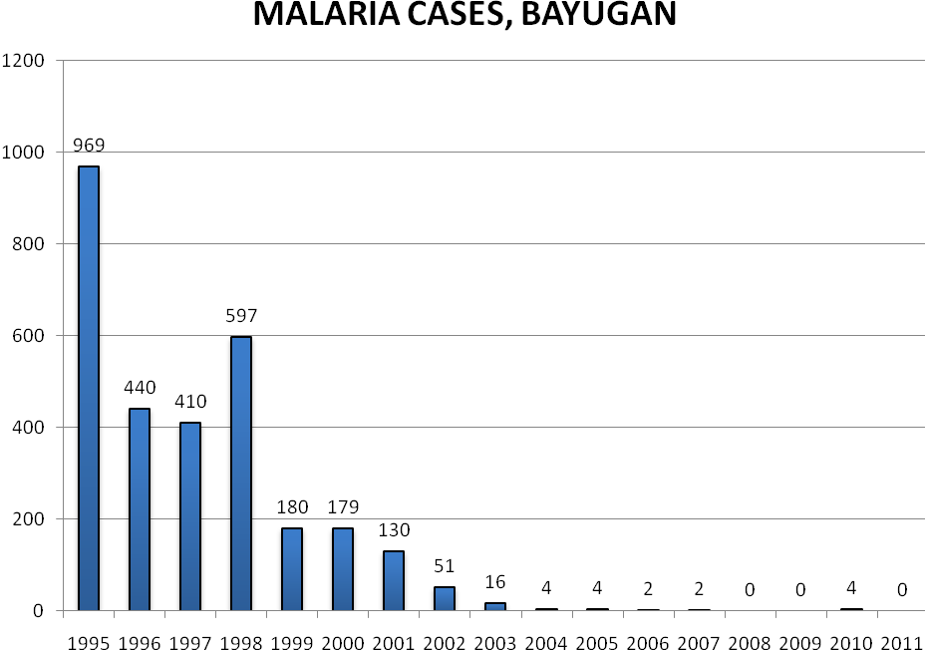
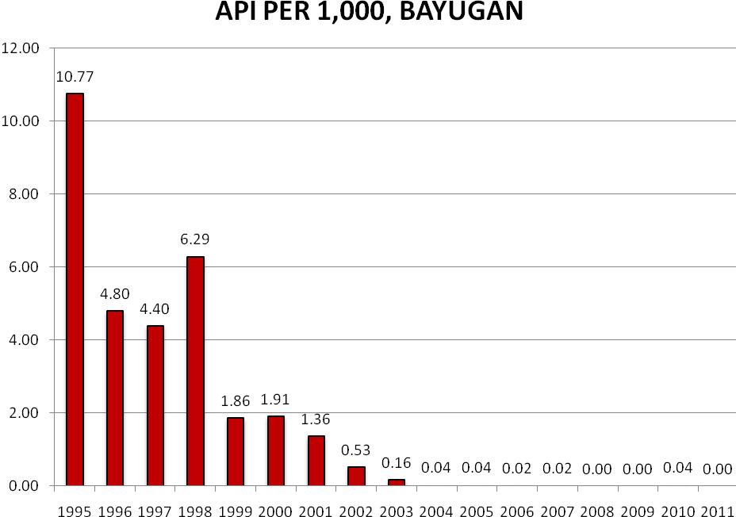

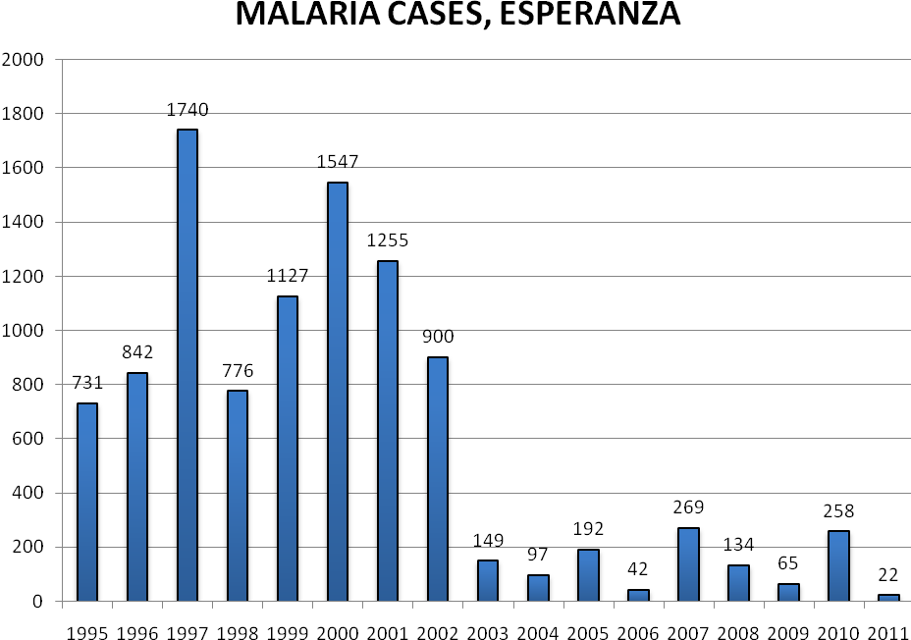
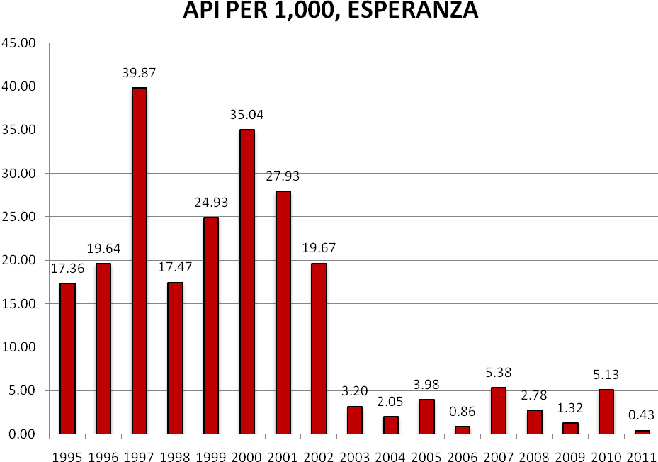

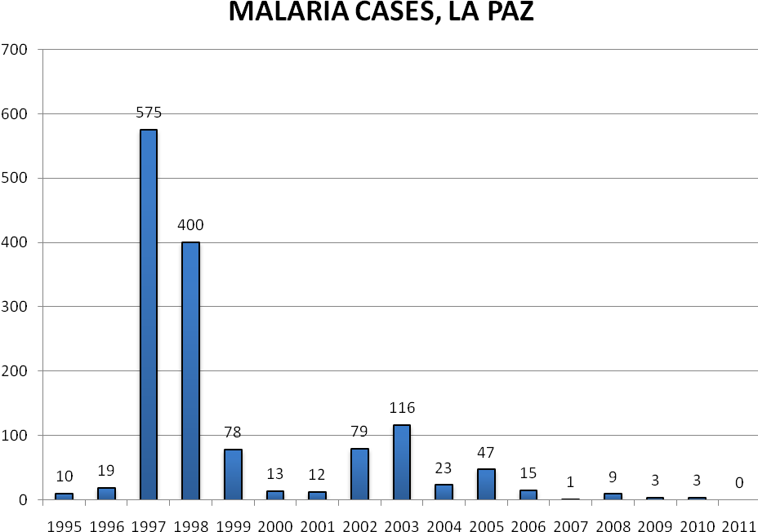
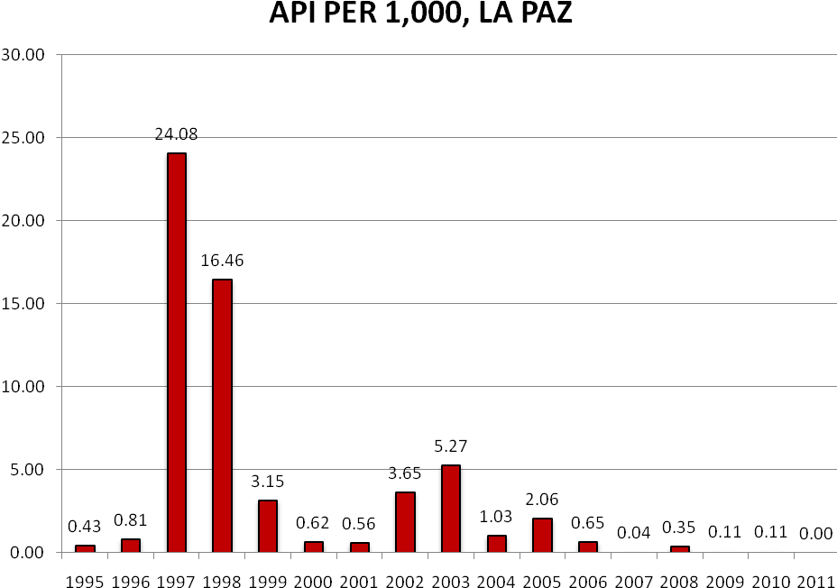

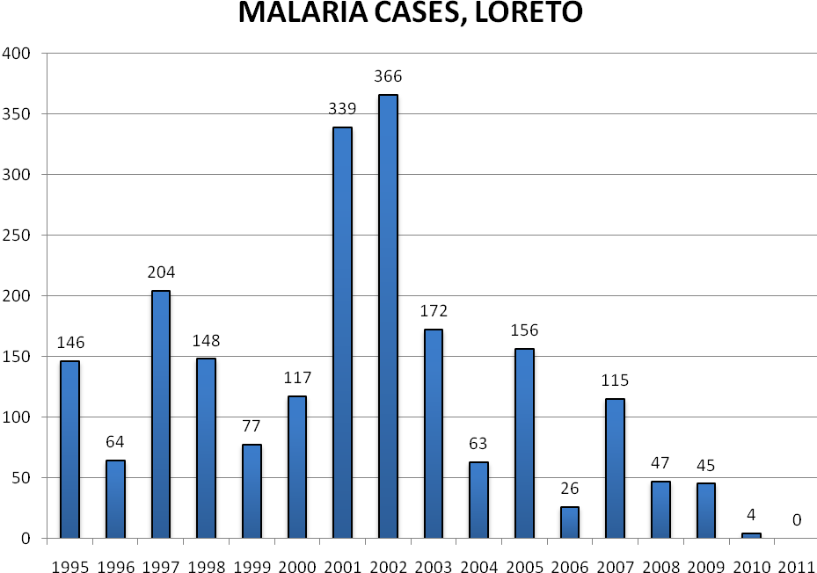
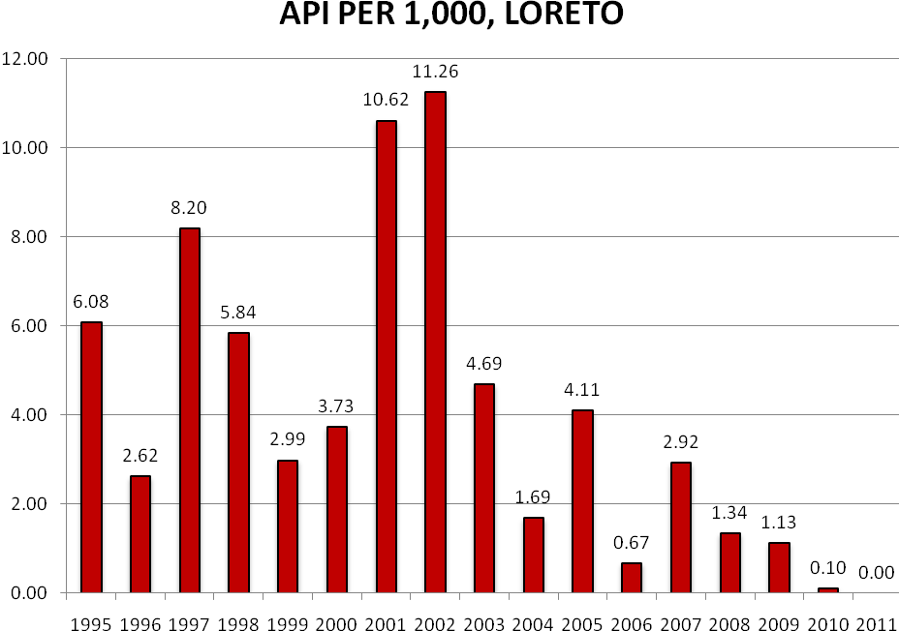

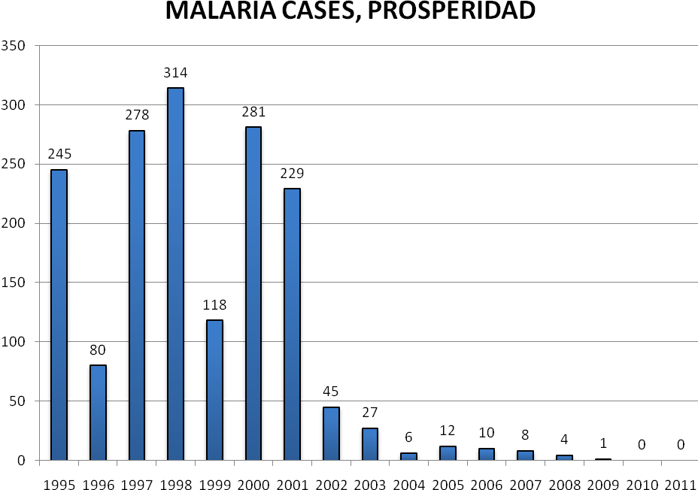
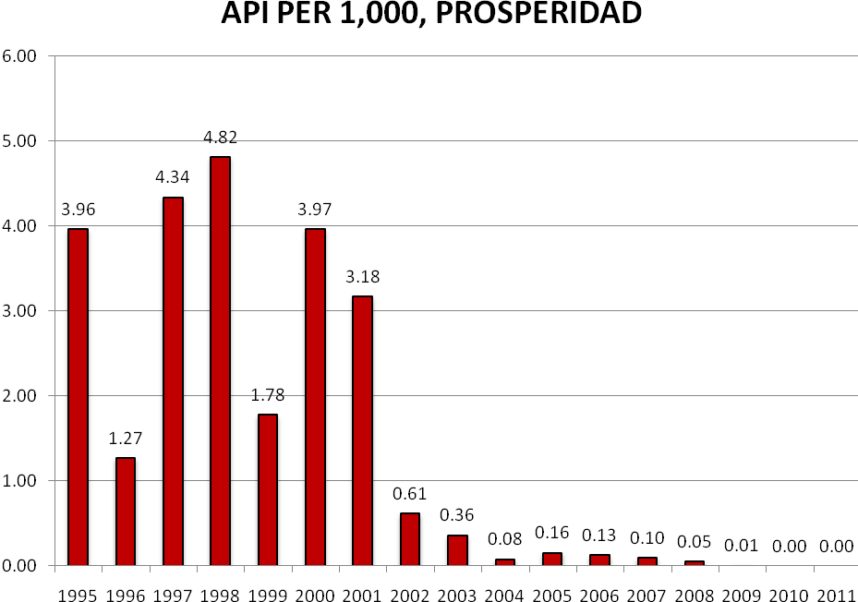

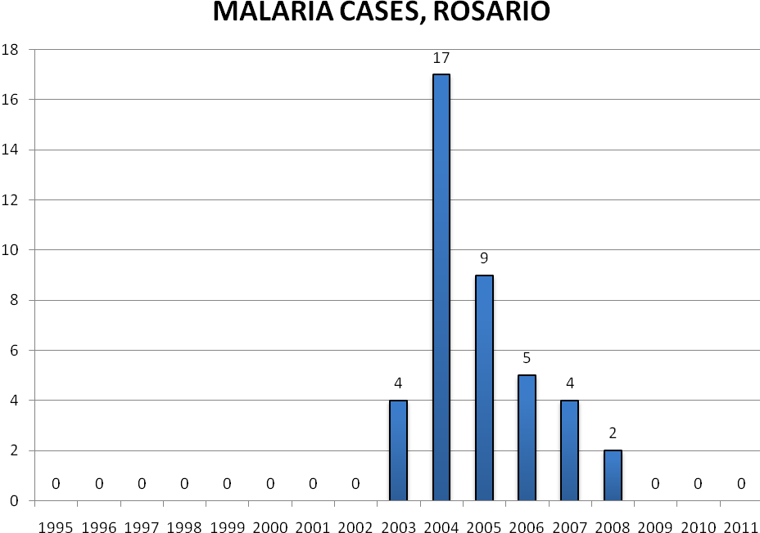
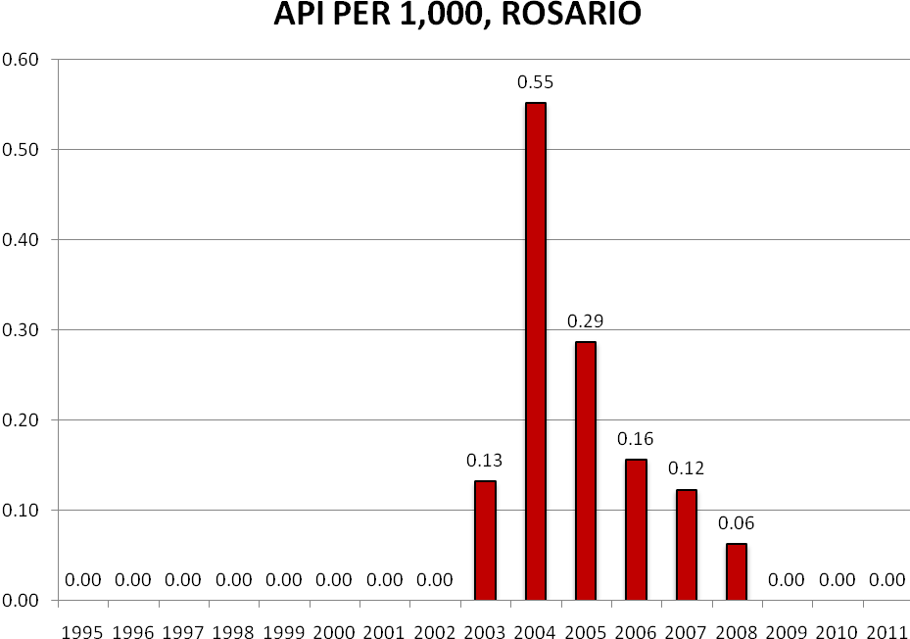

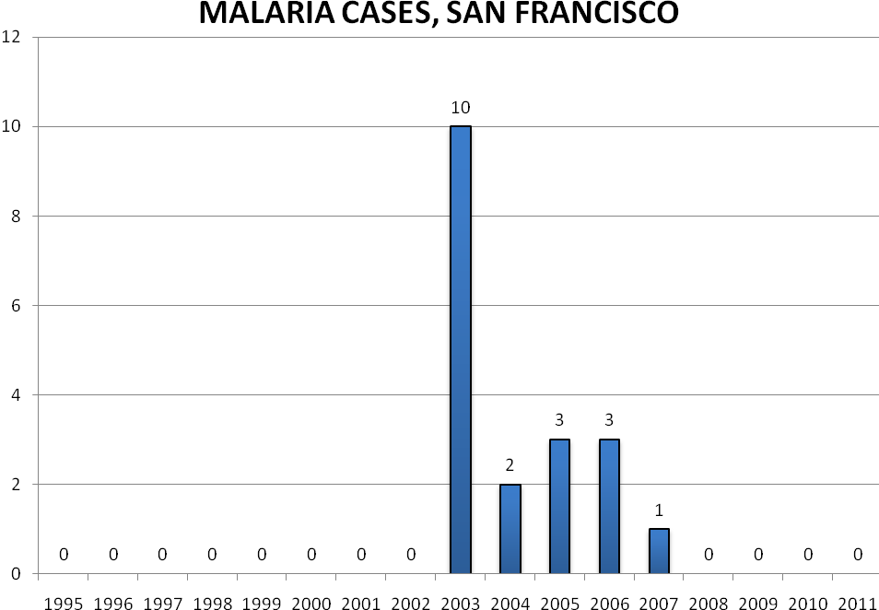
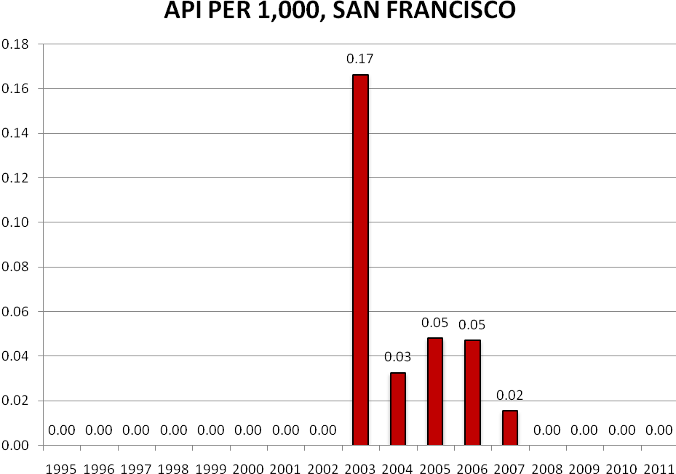

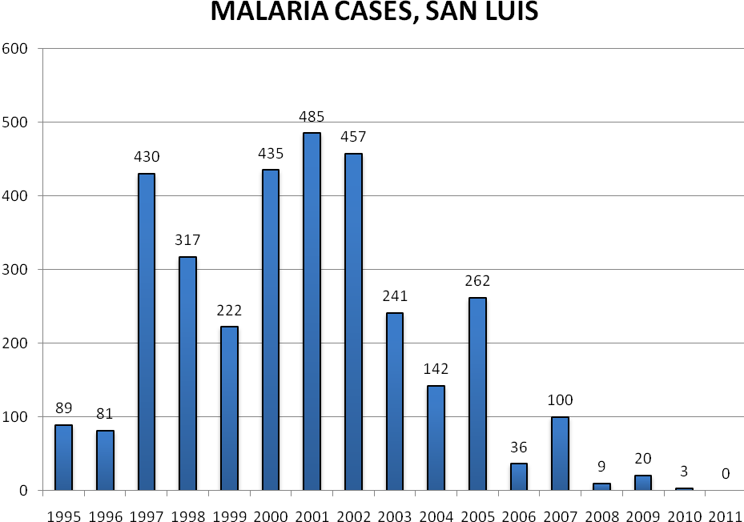
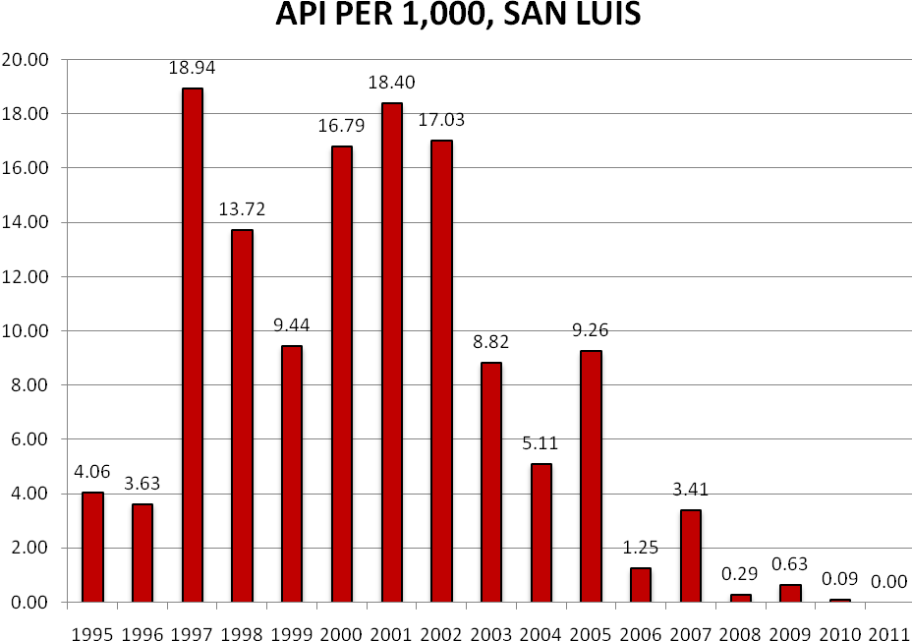

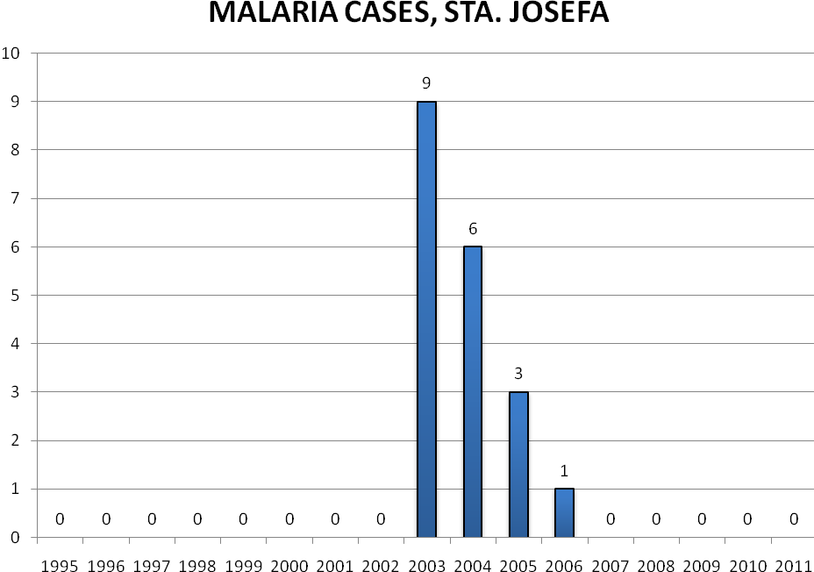
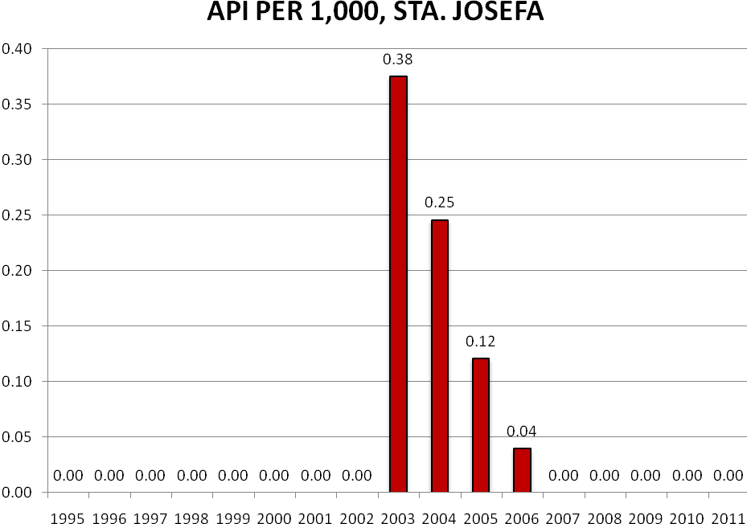

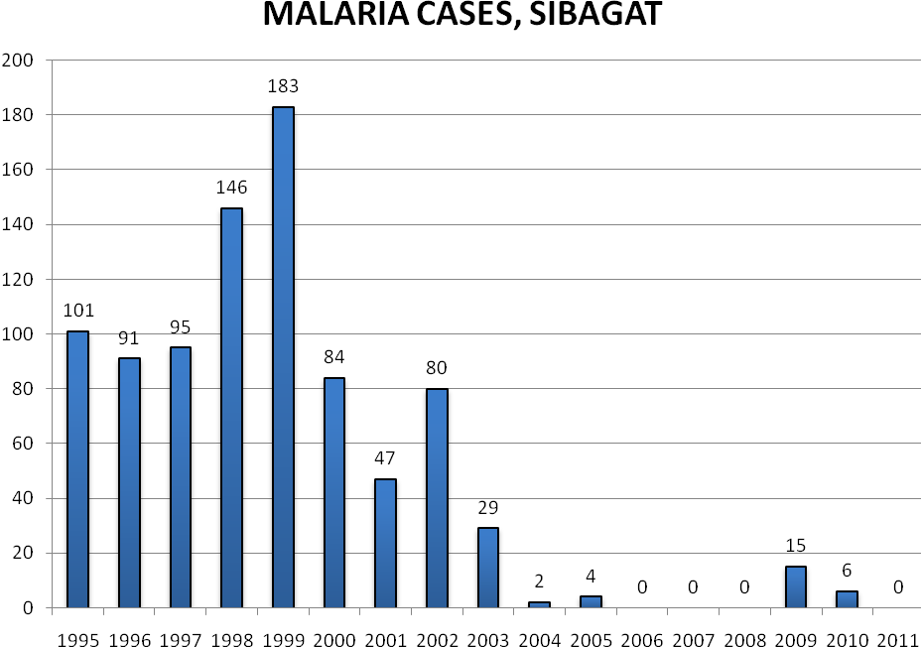
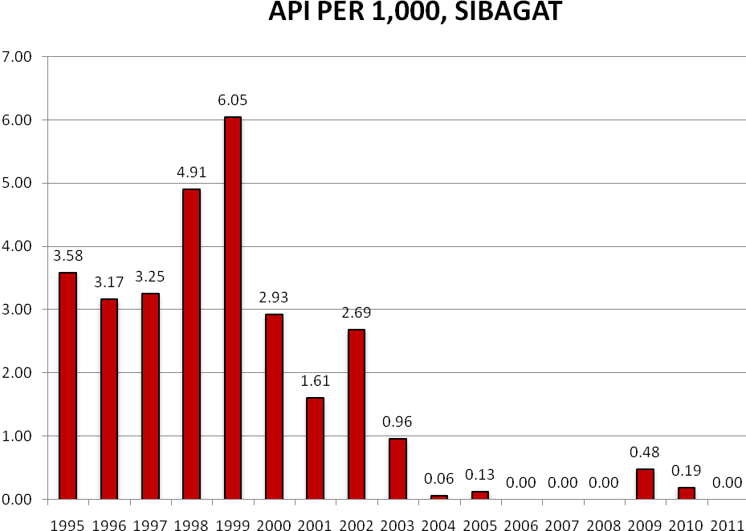

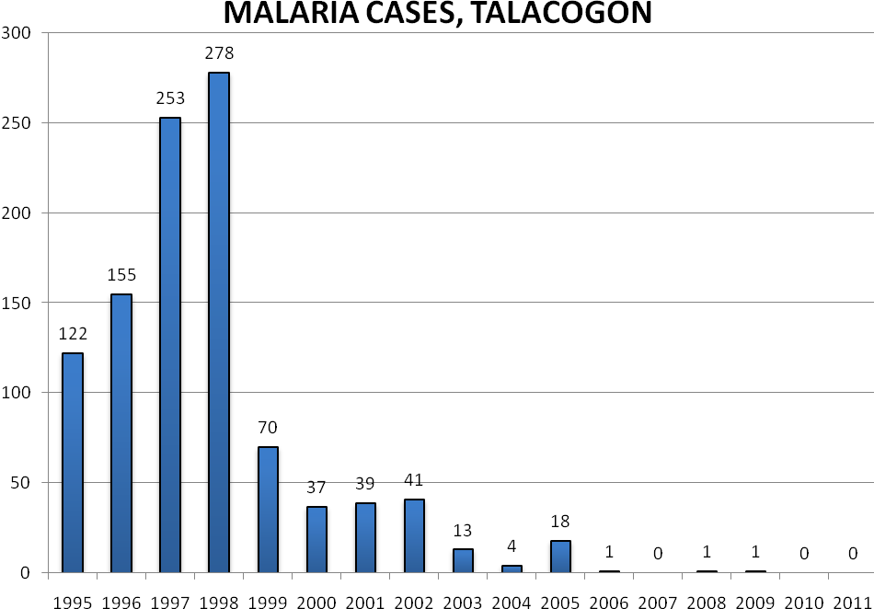
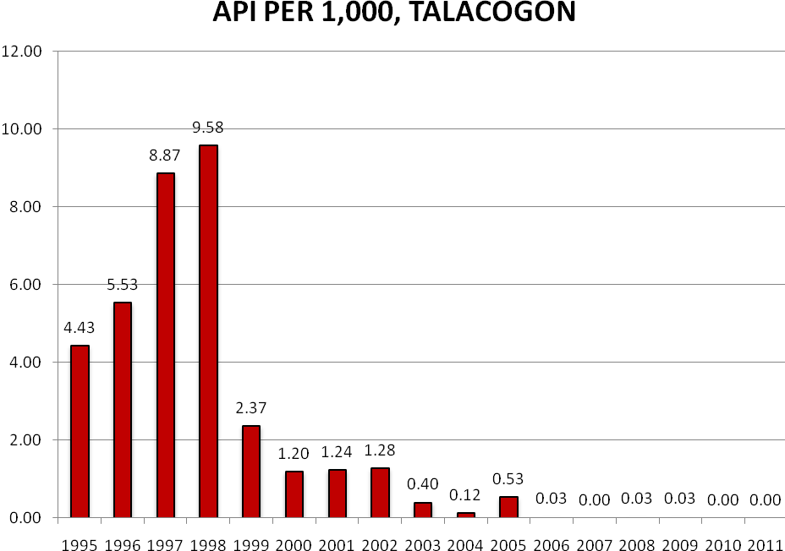

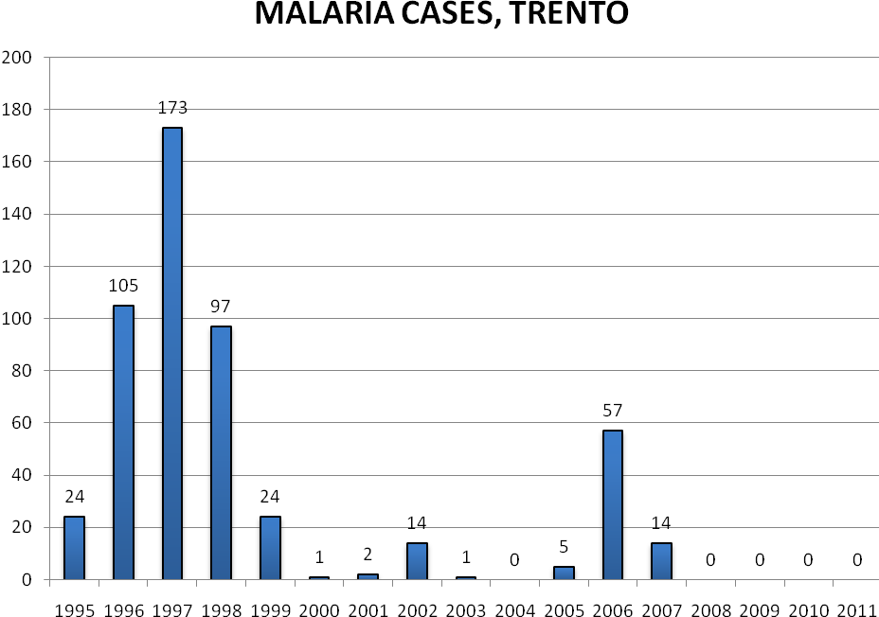
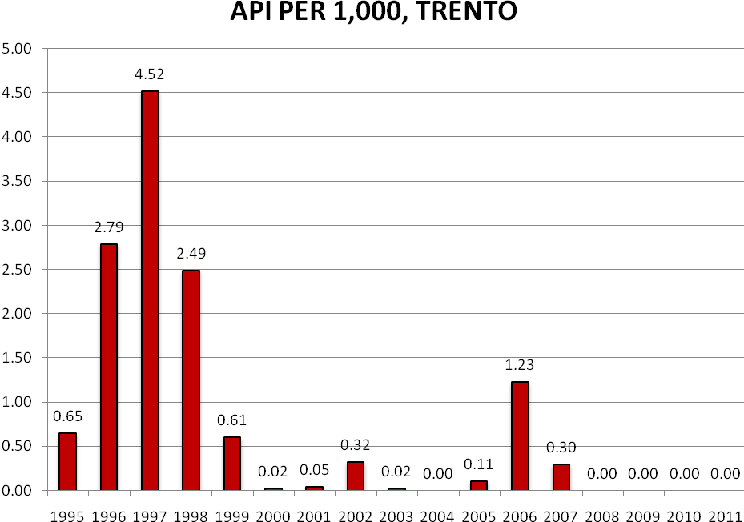

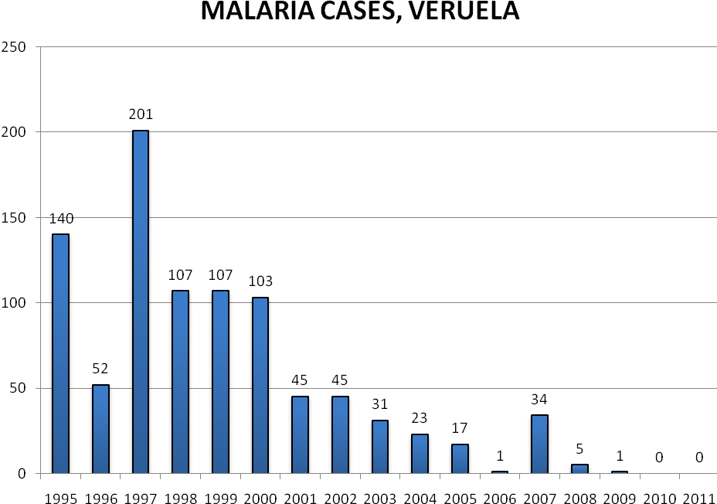
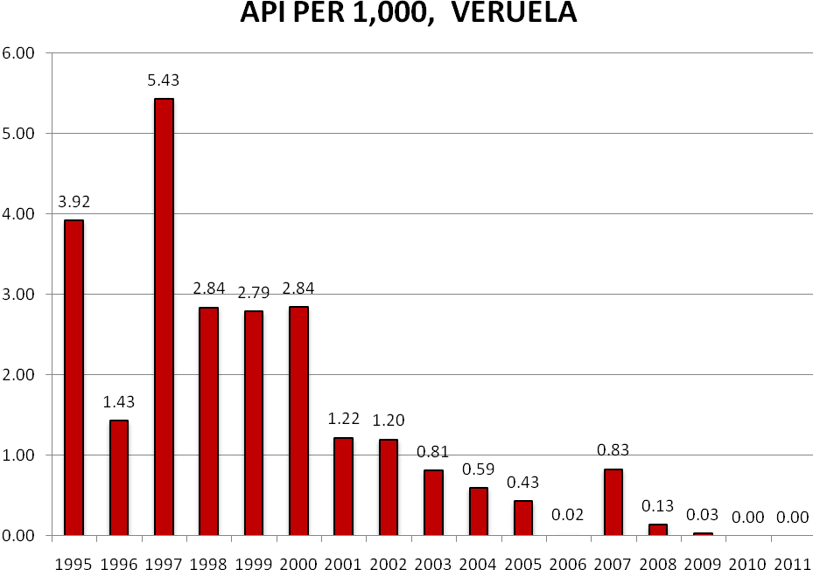

Annex 6

References

AusAID (January 2001): The Agusan del Sur Malaria Control and Prevention Project. Consolidation and Integration Phase. Review and Project Design Document.

Dr Rob Condon (October, 2007): The Community Trust Fund for Malaria Control and Prevention in the Province of Agusan del Sur. Rapid Operational Assessment for the first 6 months of the CTF; Options and Recommendations for Improved Performance and Governance.

Rex Linao (November 20, 2007): Letter to Governor Maria Valentina G Plaza. Response to TAG Findings.

(October Rex Linao (Undated): The Provincial Health Research Centre (PHRC) Management: Requiring Immediate Emendations.

APHDFI (2010): Accomplishment Report for Year 2010.

Into-Opamin CPAs & Co (August 2012) Operational View of the CTF-MCP. Details of Operational Audit Results.

AusAID (June 2012): Back to Office Report. Agusan del Sur Community Trust Fund Project Coordinating Committee Meeting.

AusAID (Jan 2009) Renewal /Updating of the Trust Fund for Malaria Control and Prevention in the Province.

AusAID (2006): ADS MCP Community Trust Fund Sub-Agreement Between APHDFI and PCC.

Annex

Response to Comments

Reference | Response
PL1:

In commenting on the APHDFI’s recollection of events for the mobilisation of the 2012 PCC meeting, AusAID notes (a) that it had to pursue the matter vigorously with the APHDFI and the other PCC members and (b)the CEO APHDFI was close to the Governor and should have been more proactive in urging his engagement in PCC matters.
AusAID Activity Managers further note that while the APHDFI submitted its budget activities its technical reporting was of poor quality and gave no indication of the wider developments within the program, notably its relationship with the Global Fund.
Malaria antigen detection tests are a group of commercially available tests that allow the rapid diagnosis of malaria by people who are not otherwise skilled in traditional laboratory techniques for diagnosing malaria or in situations where such equipment is not available. There are currently over 20 such tests commercially available (WHO product testing 2008).
[1] A long-lasting insecticidal net is a factory-treated mosquito net made with netting material that has WHO-approved insecticide incorporated within or bound around the fibres. The net must retain its effective biological activity without re-treatment for at least 20 WHO standard washes under laboratory conditions and 3 or 5 years of recommended use under field conditions.
Global strategic framework for Integrated Vector Management. WHO document WHO/CDS/CPE/PVC/2004.10. Geneva: World Health Organization, 2004.
Schistosomiasis is a parasitic disease caused by several species of a parasitic worm of the genus Schistosoma. Snails serve as the intermediary agent between animal hosts and humans. Schistosomiasis is endemic in the Philippines with a prevalence rate of 2.5% (0.04% to 6%) and active transmission in 12 regions, 28 provinces and 190 municipalities, 15 cities and approximately 2,222 barangays (DOH report 2008).The total population at risk is approximately 12 m people, with 2.5 m individuals directly exposed to the disease (http://www.wpro.who.int/mvp/epidemiology/en/index.html ). Schistosomiasis programmes need to move towards elimination by expanding from preventive chemotherapy interventions to include control of snails and animal reservoirs and improvements in water and sanitation.
Purchase price per unit is between 300-500 K pesos including one year warranty
Source of insecticides were from GF-PSFI (Shell Foundation) and CHD Caraga
Source of LLINs were from GF-PSFI, CHD Caraga and WHO-RBM

