THE MANIAC™
RGBA LED MOVING HEAD FOGGER
Operating Instructions

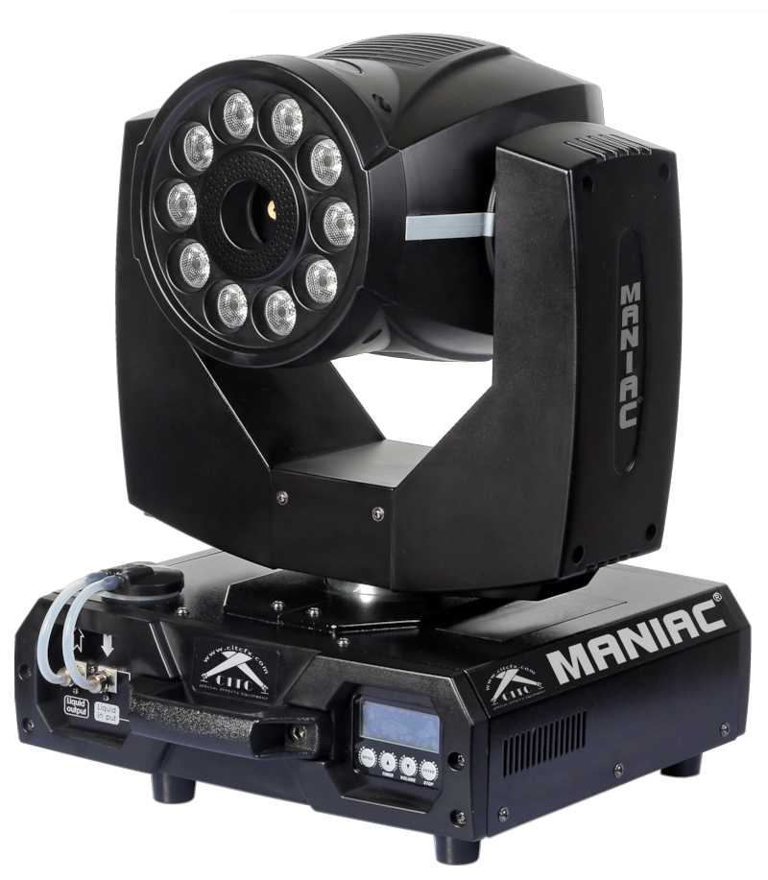

P/N 100120 (120 VAC w/DMX)

Thank you for purchasing the MANIAC™!

- To ensure proper operation of this unit, please take some time to read the manual carefully.

- We believe you will enjoy years of great service if you properly care for your new MANIAC™ RGBA LED MOVING HEAD FOGGER.

CITC
1420 80th St. SW #D
Everett, WA 98203
(888) 786-CITC
www.citcfx.com



Contents
- Equipment Supplied
- Accessories
- Description
- Safety Instructions
4.1 Unpacking & Handling Precautions
- Operating the MANIAC™
5.1 Selecting The Location
5.2 Electrical Power Requirements
5.3 Hooking Things Up
5.4 Unlocking the X & Y Axis Locks
5.5 Operation
5.6 DMX Control
5.7 Wireless Remote
5.8 System Menu
5.9 Hanging/Floor Operation
5.10 Cleaning
5.11 Troubleshooting
- Technical Data
- Limited Warranty Conditions

1. Equipment Supplied

- 1 x MANIAC™ 120V P/N 100120
- 1 x Wireless Fog Control Remote
- 2 x Hanging Brackets
- 1 x Antenna
- 1 x Power Cord
- 1 x Operating Instructions Booklet & Warranty Card

2. Accessories

- CITC Natural “Custom Quick” Fogging Fluid™
- (2) C-Clamps w/Safety Cable

Please check whether all the products you ordered are supplied.

3. Description of the MANIAC™
The MANIAC™ RGBA LED MOVING HEAD FOGGER is two machines in one. Intelligent moving light fixture with a fogger built right in. It utilizes 10 groups of 8W QUAD RGBA LED lamps for rapid color changing along with dimmer, strobe and color mixing functions. This machine can be used with its fog and lights, lights only or fog only. Its adjustable fogging effects are amazing when used in conjunction with the LED lighting or without. The MANIAC’s instant stop technology allows for bursts of fog without any wispy fog escaping when you don’t want it. The rapid 540 degree pan and 270 degree tilt get the fog and light to where you want it, quickly. This machine can operate on a flat surface or hung overhead using the included hardware and c-clamps.

4. Safety Instructions

WARNING: Read and understand all labels and
operating instructions before attempting installation.

NEVER POINT OR AIM A FOG MACHINE TOWARDS PEOPLE OR THEIR CLOTHING. THIS MACHINE EMITS HOT VAPOR AND SHOULD BE USED WITH THE SAME CARE THAT YOU WOULD OSERVE WHEN USING AN ELECTRIC KETTLE OR IRON.

- No user serviceable parts. Taking apart the MANIAC™ will void your warranty. Never open the machine without disconnecting power first!
- Do not operate if any of the service panels or covers are missing.
- RISK OF ELECTRICAL SHOCK- This device is supplied with a grounding conductor. To reduce risk of electrical shock, connect only to properly grounded, grounding type receptacles. Never remove the third prong from the plug.
- If you have any doubts about the capacity or grounding of your existing circuits, consult a qualified electrician.
- Do not operate or store in wet locations. Be sure area around the unit is dry before applying electrical power.
- Do not spill water or other liquids into or on to this machine.
- Be aware that the Maniac™ has moving parts. Serious injury could occur if this machine isn’t allowed to operate in an area free of obstructions.
- Never add flammable liquids of any kind to this machine.
- Never connect this machine to a dimmable circuit.
- Do not attempt to operate this machine if it becomes damaged in any way.
- Always install this machine in a safe and stable manner.
- This machine should only be serviced by qualified service personnel.
- Keep away from flammable materials and combustibles.
- For professional use only.
- For adult use only. Keep out of the reach of children.
- Use only CITC approved fogging fluid in this machine.
- Fog machines can potentially set off smoke alarms.

4.1 Unpacking & Handling Precautions

Please check the shipping container for any damage which may have occurred during shipping. If the box appears to be damaged, inspect your machine thoroughly for any signs of damage and make sure all equipment necessary to operate the machine has arrived intact. Before operating, please take the time to fully read and understand all the information provided in this manual.

- Operating the MANIAC™

  - Selecting The Location

Secure a level, dry location for the MANIAC™ to rest solidly on the floor or hang suspended. You can find the steps within this section on how to convert the MANIAC™ from floor operation to hanging operation. Make sure that your MANIAC™ is pointed in a direction that leaves an open area out in front so that the fog can escape without restriction. Ensure the front of the machine is not directed towards anything that could cause a hazardous or unsafe environment.

  - Electrical Power Requirements

The MANIAC™ requires a grounded 120V circuit for operation. The MANIAC™ uses a 15 amp breaker. If you have any doubts about the capacity or grounding of your existing circuits, consult a qualified electrician.

  - Hooking Things Up

- Remove the fluid cap on the fluid tank in the base of the machine. Only fill until you reach the line marked MAX on the tank. Use only CITC approved fogging fluid.
- Attach the power cord by inserting blue connector into the receptacle on the machine. Twist to lock in place.
- The MANIAC™ can accommodate 3-Pin or 5-Pin DMX. Install DMX cables accordingly.
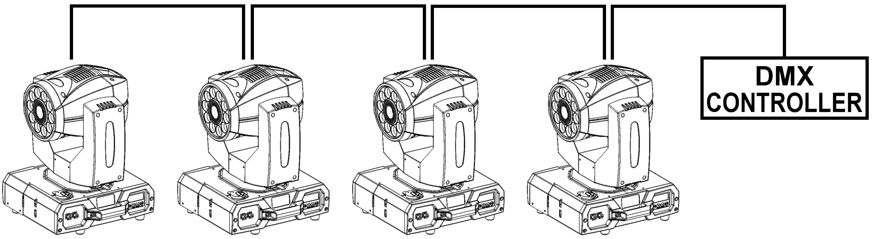

- LED Housing  - Spray Nozzle  - Fluid Tank  - Fluid Input Connector  - Fluid Outlet Connector  - LCD Menu Display | 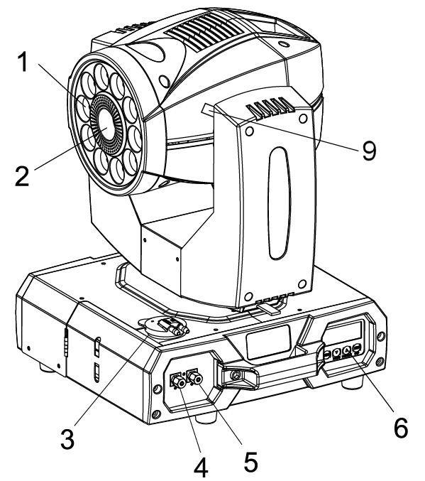
- 3-Pin DMX  - 5-Pin DMX  - X and Y Axis Locks  - Power Connector  - Power Switch  - Wireless Remote Antenna | 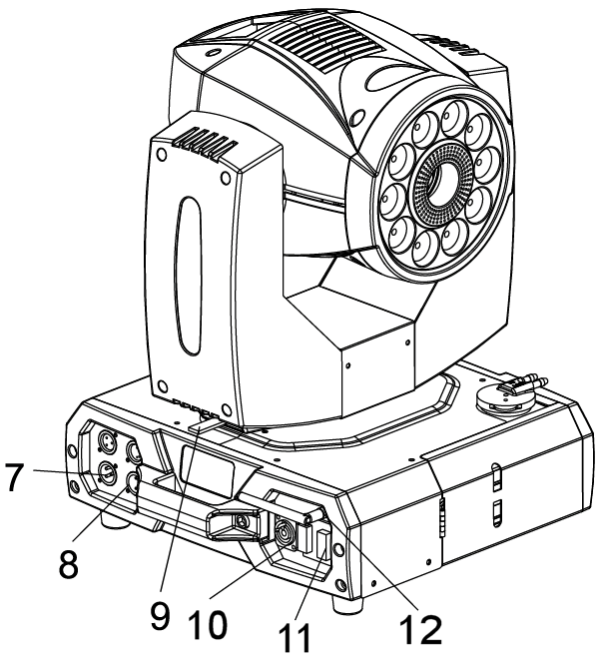

  - Unlocking the X and Y Axis Locks

The MANIAC™ is shipped with its X & Y Axis Locks engaged. YOU MUST UNLOCK THE X / Y LOCKS BEFORE TURNING ON OR YOU WILL CAUSE DAMAGE! Between the moving yoke and the stationary base of the machine you will see a small lever. Slide the lever to release the first lock. The second lock is found up higher between the yoke and moving head. Slide this lever as well to release the lock. These levers allow you to lock both the X and Y axes in many different positions for shipping and/or storage. It is recommended that you always lock this machine when transporting to prevent damage.

  - Operation

- Once the MANIAC™ is in a safe and secure location, flip the power switch to the ON position. The MANIAC™ will begin its 5 minute warming up process. During this process it will also perform diagnostics which may cause the LED lights to come on and the head may spin.
- RED LEDs illuminate the fluid tank while the machine is warming up and turn BLUE when the Maniac™ is ready to emit fog.
- The MANIAC™ is designed to produce short bursts of fog. Running the fog for an extended amount of time will cool the heating element used to produce the fog. This will cause the MANIAC™ to momentarily stop fogging to heat back up to operating temperature. The pan/tilt and LED lighting functions are not affected during reheat.
- If you run the fog at its lowest level continuously, after 3 minutes and 30 seconds the fog function switches off and doesn’t come on unless you drop the channel back down to 0% and then turn it back on again.

  - DMX Control

- After the MANIAC™ is receiving a DMX signal via its 3-pin or 5-pin panel, the LCD screen will only display the DMX-512 address settings page. You can adjust the DMX address by pressing the UP or DOWN buttons. The DMX channel that you pick will use that channel and the nine following channels to control the MANIAC™. The following is a list of the channel attributes.

CHANNEL | VALUE | FUNCTION
1 | 0 - 9  10 - 255 | FOG OUTPUT  OFF  ON
2 | 0 - 9  10 - 255 | RED LEDs  OFF  ON
3 | 0 - 9  10 - 255 | GREEN LEDs  OFF  ON
4 | 0 - 9  10 - 255 | BLUE LEDs  OFF  ON
5 | 0 - 9  10 - 255 | AMBER LEDs  OFF  ON
6 | 0 - 9  10 - 255 | COLOR MIXING  OFF  ON
7 | 0 - 9  10 - 255 | STROBE  OFF  ON
8 | 0 - 9  10 - 255 | DIMMER  OFF  ON
9 | 0 - 255 | X-AXIS  0 - 540 Degree
10 | 0 - 255 | Y-AXIS  0 - 270 Degree


  - Wireless Remote

- The wireless remote included only controls the fog ON and OFF
function of the MANIAC™. The buttons both work the same.
They turn the fog on when depressed and off when released.

  - System Menu

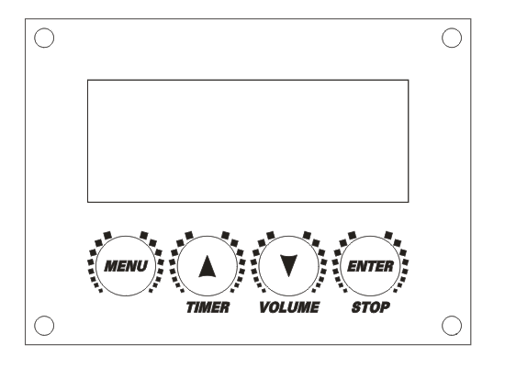
MENU: |  | This button allows you to scroll through all 6 menu pages.
UP: |  | Increase value.
DOWN: |  | Decrease value and VOLUME button for turning ON / OFF fog in manual mode.
ENTER: |  | IN / OUT and the STOP button for turning OFF fog in manual mode.
PAGE | DISPLAY |  | DESCRIPTION
1 | Ready To Fog |  | MANIAC™ is done warming and ready to fog.
2 | DMX512 Address |  | Set DMX address by using UP or DOWN buttons.
3 | Wireless Set |  | Turn wireless control function ON or OFF.
4 | Language |  | Choose between English or Chinese languages.
5 | Pan Inverse |  | Adjust if pan is inverted or not.
6 | Tilt Inverse |  | Adjust if tilt is inverted or not.

  - Hanging / Floor Operation

- To switch from floor operation to hanging operation, remove tank lid from tank.
- Open side tank door and slide tank out of the inner chamber located in the base of the machine. Set aside.
- Lock X and Y axis locks.
- Gently place MANIAC™ on its side so the bottom of the machine is accessible.
- Attach the included hanging brackets by lining up the tabs on the brackets with the holes on the base of the machine.
- Spin both screw handles clockwise until they snap in place. If need be, use a wrench to make certain they are not under tightened. Repeat for remaining hanging bracket.
- Attach mounting clamps (c-clamp) rated for the appropriate weight capacity to the hanging bracket. You must use two mounting clamps to mount the MANIAC™.
- Make certain that the structure or surface onto which you are mounting this machine can support the weight.
- Mount the MANIAC™ securely to a rigging point, such as an elevated platform or truss along with a safety cable. Reinstall fluid tank (now inverted) into the inner fluid tank chamber.
- Unlock X and Y axis locks.

  - Cleaning

- It is recommended that after 40 hours of continuous use or before this machine is put into storage, you run an 80% distilled water and 20% distilled white vinegar mixture through the machine. Run a small amount of distilled water through machine and turn off.
- When machine is unplugged and cooled down, use a vacuum (or dry compressed air) and a soft brush to remove dust collected on the air vents and external surfaces.
- To prevent damage, do not spin any of the cooling fans using compressed air.

  - Troubleshooting

Problem: | Solution:
Pan or Tilt chattering | - Check X and Y Axis Locks.  - Check DMX signal.
Loud Humming and No Fog | - Check Fluid Tank.
Not Fogging | - Machine may be heating up.  - Check DMX address.  - Check DMX signal.

6. Technical Data

MANIAC™
P/N 100120 (120V)
Dimensions | 19” x 18” x 22”  (48.5cm x 44cm x 55.5cm)
Weight (Net / Gross) | 39lbs. (17.5kg) / 47 lbs. (21.2kg)
Fog Output | 20,000 ft³/min
Preheat Time | About 5 minutes
DMX Channels | 10
LED Lamps | 8W RGBA x 10
Fluid Type | CITC Natural Fogging Fluid
Fluid Capacity | 1.31 qt. (1.2L)
Pan | 540°
Tilt | 270°
Electrical Supply | 1600W (100-120 VAC, 15A, 50/60 Hz)
Electrical Breaker | 15A – 250 VAC
Limited Warranty | One Year
Rev. 05/20/2015

7. Limited Warranty Conditions

This limited warranty guarantees to the original purchaser that this product shall be free of defects in material and workmanship, under normal use, for a period of one year from the date of purchase shown on the sales receipt. This warranty covers parts and labor providing the product is returned to CITC in the original shipping carton and packaging. The warranty for electrical is a (90) NINETY DAY limited warranty.

Damage resulting from shipping, accidents, misuse, negligence, unauthorized repairs or modification is not covered by this warranty. Using any fluid other than what is recommended for this machine will void warranty. No liability is accepted for injury or for loss, damage or expense resulting from any interruption whatsoever in the operation of the product or from any consequential loss arising there from. No liability is accepted for normal wear and tear.

We wish to satisfy YOU, our customer, and have implemented many measures to prevent problems and assure customer satisfaction. However, should you need a missing part or have a functional problem with your product, please call (888) 786-CITC from 7:30 am – 4:00 pm (Pacific Time) Monday – Friday, except for holidays. Our customer service department will respond to your problems immediately.

Please have the following information available when you call:
Model and Serial Number
Where and when the product was purchased
Nature of the problem

Subject to the following conditions, CITC will repair any defect or fault in the unit if it is caused by a proven factory defect within one year of delivery to the end user. Insignificant deviations of the regular product quality does not guarantee replacement rights, nor do faults or defects caused by water, by generally abnormal environment conditions or Force Majeure:

Faulty parts will be repaired or replaced (manufacturer’s choice) with correct parts. Faulty units must be shipped to CITC at customer’s expense. An RMA# must come with the unit.
- Exposure to outside elements voids Warranty. Unit cannot be used outdoors or in wet weather without complete protection against the elements. Even then, high salty or humid conditions will cause instant corrosion of connectors and will void Warranty.
- The customer loses all rights for limited warranty services, if any repairs or adjustments are done to the units by unauthorized persons and/or if spare parts are used, which are not approved by CITC. The right of limited warranty service is also lost if a fluid other than appropriate CITC fluid has been used or if units are sent to in with full fluid bottles.
- Freight costs to and from CITC when under the limited warranty services are the responsibility of the customer. Customer must place appropriate insurance on return of product. However, if product is returned due to factory defect within the first 30 days of receipt, CITC will cover the cost of returning the repaired unit to the customer.
- Limited warranty services do not cause an extension of the limited warranty time or the start of a new limited warranty time. The warranty of replaced parts ends with the limited warranty time of the whole unit.
- If a defect/fault can not be repaired by us in a satisfactory time, we will, within 30 days after sale of the unit, either:

Replace the whole unit for free or take back the whole unit and refund the purchase price.
- Further claims, especially for damages, losses etc. outside the unit are excluded.
- Your limited warranty coverage is based on completion of the warranty card and returning it with your proof of purchase within 30 days of purchase.

Your limited warranty coverage is based on completion of the warranty card and returning it with your proof of purchase within 30 days of purchase. If you should send the unit for service, do not forget to remove any liquid from the fluid bottle, and place unit in original box. Obtain your RMA# by calling CITC. Payment arrangements for repair must be made before receiving RMA # in case unit is not covered under Limited Warranty.
Obtain your RMA# by calling CITC. Payment arrangements for repair must be made before receiving RMA # in case unit is not covered under Limited Warranty.

Send unit to:

CITC
RMA # XXXXXXX
1420 80th St. SW #D
Everett, WA 98203
Tel: (888) 786-CITC or (425) 776-4950
Fax: (425) 776-5129
Website: www.citcfx.com
E-mail: info@citcfx.com

1420 80th St. SW, Everett, WA 98203
425-776-4950  FAX: 425-776-5129
www.citcfx.com  info@citcfx.com

 | Find us on Facebook!  www.facebook.com/CITCFX

May 28, 2015

