432 AND ABOVE EME NEWS
MARCH/APRIL 2018 VOL 47 #3

EDITOR: AL KATZ, K2UYH; DEPT. ELECTRICAL/COMPUTER ENGINEERING, THE COLLEGE OF NEW JERSEY, PO BOX 7718 EWING, NJ 08628, TEL (W 609-584-8424), (C 609-047-3889), E-MAIL alkatz(x)tcnj.edu
ASSOCIATE EDITOR AND Reflector/NETNEWS Matej Petrzilka, Simunkova 1609/21, 18200, Praha 8, Czech Republic, TEL (+420 603 489 490), E-MAIL ok1teh(x)seznam.cz
CW INITIAL LIST G4RGK, DAVID DIBLEY, E-MAIL zen70432(x)zen.co.uk, AT: http://www.zen70432.zen.co.uk/Initials/index.html
SUN & EXTRATERRESTRIAL NOISE LIST MANAGED BY OK1TEH: http://www.ok2kkw.com/next/nl_k2uyh/sun_table_2017.xls
EME INFORMAL NETS: 14.345, ~1500 SATURDAY AND SUNDAY, NET COORDINATOR: OPEN
ON0EME EME BEACON, 1296.000 IS QRV WHEN MOON >10°, SEND RX REPORTS TO WALTER (ON4BCB) on4bcb(x)gmail.com
DL0SHF 3 CM EME BEACON, 10368.025, SEND INFO & QUESTIONS TO Per (DK7LJ) per(x)per-dudek.de.
NL EMAIL DISTRIBUTION and EMAIL LIST CORD: WARREN, W2WD wbutler(x)ieee.org [PDF]
THE NL WEB VERSION IS PRODUCED BY REIN, W6SZ rein0zn(x)gmail.com, AT http://www.nitehawk.com/rasmit/em70cm.html

CONDITIONS: This NL is being completed just at the start of the 13 cm DUBUS EME Contest (24/25 March). We had hoped to complete it earlier, but it was not possible. This issue will thus cover both Feb and March. Coming up on 21/22 April is the DUBUS 23 cm CW EME Contest. This contest produces some of the largest 1296 activity of the year. The big news in Feb was the DUBUS 432 CW EME Contest. Although CW operation on 432 has been decreasing, activity on 432 was definitely up from recent years. G3LTF has the highest reported score with 24x23 (21x19 last year). There was also an excellent dxpedition to Guatemala. TD9CHR provided 42 stations on 432 and 47 on 1296 new countries! See report later in this newsletter (NL). The number of dxpeditions is about to skyrocket. QRV already is CR2EME in Azores, but activity on 432 is not expected until the end of the dxpedition – see later in this NL. Mauritius, 3B8MB (LH30ta) will be on 1296 from 20 to 28 April with a 2.3 m dish and 250 W. About the same time, 21 to 30 April, Z66EME (Kosovo) will be on the Moon from 70 to 3 cm thanks to the team of DG8NCO and DL2NUD – report in this NL. The T46MB, Cuba dxpedition has been rescheduled for next Jan, but EAQ6/HB9COG will be coming up in May – also in the NL. The next 70 cm CW ATP (activity time period) is coming up on 2 April at 1000-1200 and 1900-2100.
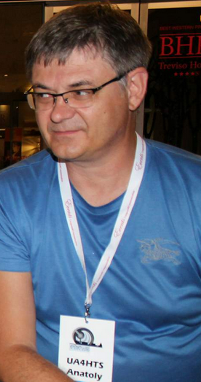
MORE SAD NEWS: The EME community continues in morning for more friends. We learned that Anatoly UA4HTS (at Venice EME Conference in 2016) had died at the beginning of March after an illness at age 51. Toly was just active in the ARRL EME Contest. Also among the recent SKs is PY2BJO. Junior passed away in Jan. Although not recently active, he was my and many others first PY 432 EME QSO and QRV on 70 cm EME for several years. We also learned that OK1DIG is also a SK. Dan had a big signal on both EME and terrestrial and well know by many EMEers. All will be greatly missed; our condolences to their families. May they all rest in peace.

CR2EME: Frank (DH7FB) and Bernd (DF2ZC) xteamdxp(x)gmail.com confirm that the dxpedition X-Team will be QRV from the Azores (HM77ft) from 24 March to 30 March. Operation will be from the QTH of CU2CE. -- We will start on 2 m and later switch to 70 cm [was on 27th]. On 432 we will use 2 x 17 el DK7ZB yagis with a 200 W SSPA built by OK1DFC (special thanks to Zdenek) and a 0.4 DB NF HG8ET LNA to a FT857. For last minute information see http://xteamdxps.blogspot.de.

DL7APV: Bernd dl7apv(x)gmx.de only made a few QSOs during the DUBUS 432 CW EME Contest -- Due to bad WX and a cold that would not go away, I did not put my usual time into the contest. I did QSO in Jan/March initials on 432 with JG7PEF (#) – 2 yagis and 50 W, ON6KX (#), PA1BVM (#) - (2 x 26 el yagis and 100 W, R7MU (#) – 2 x 3 wl yagis and 50 W, KC0V (#), OK2PWY (#) – on horizon, F6KBF (#) – 2 x 21el yagis on the horizon, TD9CHR (#) and new DXCC and RA2FGG (#) – 30 el yagi and 300 W. I now have the F1EHN tracking system working FB on 3 towers. With warmer WX coming I hope to have my new array working soon.

DL9KR: Jan Bruinier(x)t-online.de sends an update on his recent activity -- Since my last report I had lots of fun on EME; primarily due to all those recent, fantastic and courageous expeditions. I worked on CW of course 4Z5CP for an initial (#), EA9LZ (#) – incredible signal, SM4IVE, SM7THS (#), VK4EME, DK5SO (#), YL2GD, UB4UAA (#), LZ1OA (#), 3DA0MB (#) and DXCC 141 with superb signal, IK0IXO (#), ON4GG (#), KD4FOV (#)- a nice surprise, G3LTF, K3MF, K2UYH, F6HLC, OZ4MM, SM7THS, D44TVG (#) - fighting adverse condx, RW0LDF (#) - first 0-district station ever, OK1CA, G4ALH, PA2CHR - 1 yagi, I2FHW, SP7DCS, DX7EME (#) - plagued by rain and thunder, GI6ATZ (#), SM5EPO (#), IZ2DJP (#), IK1FJI (#), S51LF (#), V31EME (#) and DXCC 142 with extra slow CW and S57M (#). I liked the idea of a "Radio Astronomy Corner" in the NL. Recently, I received a Scientific American Collector's Edition about "Innovators and Nobel Prize Winners who changed our World". Among the 40 Nobelists identified was K1JT because of his cutting-edge research on gravitational waves. In an interview, Joe answers a personal question on how it all started. Excerpt: "I had a brother a year and a half older than me. We did things together all the time as youngsters and we got interested in gadgets, electronics and machinery. I think we got started with farming machinery and then evolved to crystal radio sets and radios that we started to build out of the pieces removed from junk television sets. We learned the MORSE code and taught ourselves what was necessary to become licensed as ham radio operators. For that, of course, we needed to have antennas; so we strung wires in the trees and built things on the roof. We had one very ambitious project that was attached to the chimney. The antenna rotated so that it could direct our signals into various parts of the world. One windy day, not only the antenna was blown down, but the chimney blew down as well"!

EA6/HB9COG: Dan (HB9CRQ) dan(x)hb9q.ch sends news on his dxpedition with HB9COG, “The Q-Team”, to Ibiza Island (JM08ov). We will be QRV from 13 to 24 May on 23, 13 (all subbands), 6 and 3 cm (10368 and 10450). We are sorry, but 9 cm is not allowed from EA6. The equipment will be basically the same as used in 3DA0MB: A 1.5 m fine mesh dish with 100 W ((x) feed) on 1296, with 90 W on 2300, with 80 W at 5760 and with 50 W on 10 GHz using V-pol feed (circular on other bands). We have rented a house with moonrise at approx. 5-10° el and moonset on the sea. We will have Internet but the bandwidth may be limited. During activity we’ll be standby on the HB9Q logger of the active band. You may send e-mails anytime to <dan(x)hb9q.ch>. We will monitor our in-basket several times a day. We have planned our activity as follows: 12 May arrive and setup station. 13 May on 1296.090 from 0414 to 1630; 14, 15 and 16 May not QRV; 17 May on 1296.090 from 0645 to 2115; 18 May on 23xx from 0745 to 2215 (starting 2301.990 on request only, then 2400.090 on request only, later on 2320.090 and finally to 2304.090 as announced on logger); 19 May on 5760.090 from 0850 to 2300; 20 May on 10xxx from1000 to 0000 (starting 10450.090 and later 10368.090 as announced on logger); and on 21 – 24 May we will be QRV on request only. 24 May is our last day of activity. If you are not able to be QRV during our announced activity days or do not work us during the initial operation, you may ask by email for additional activity on any of the bands. We will do our best to accommodate your needs/proposals. The station will be dismantled, pack-up and loaded in the car on 25 May. We depart on 26 May. Now that WSJT-X 1.9 RC2 is available, we will use it on 23 and 13 cm for JT65C with Doppler Control (“Own Echo”, in other words we listen on our own echo). On 6 and 3 cm we will use QRA64D (if necessary JT4F) including Doppler Control (“Constant Frequency On Moon” and if necessary “Full Doppler to DX Grid”). Hopefully more people take advantage of automated Doppler control. Especially on 6 and 3 cm it is a MUST for successful QRP operations. Although it is on the limit, we will work CW on all bands. However only with big-guns and after the pile-up on JT/QRA is over. How big does your station need to be to work us? During our 3DA0MB activity the smallest stations worked had the following equipment: on 23 cm a 2.35 m dish and 150 W at the feed; on 13 cm a 2.4 m dish and 150 W at feed, with excellent signals both sides; on 6 cm a 2.4 m dish and 30 W at the feed, with excellent signals both sides; on 3 cm a 1.2 m solid dish with 40 W at the feed with excellent signals both sides. QSL only direct including an SAE to: HB9Q, P.O. Box 133, CH-5737 Menziken. If you wish to sponsor our activity, you are welcome to do so by using PayPal dan(x)hb9q.ch (please mention your call).

F1PYR: André andre_f1pyr(x)yahoo.fr is back on 3 and 1.25 cm – In March I QSO’d on 10 GHz IW2FZR (569/569) for an initial, and on 24 GHz an FB contact with OZ1LPR (O/529) for another initial. Earlier I was QRV on 13 cm, but my 13 cm SSPA went QRT. I put on a smaller one, 150 W with my 3.5 m dish. I am only QRV on CW at the moment. [Hopefully Andre will be QRV for the DUBUS 13 cm CW Contest].

F8KHO: Matej (OK1TEH) and Vladimir OK1VPZ visited F8KHO club in JN29ha during their car-trip to Paris (by the way this QTH was often visited by Frank, F5SE). EME dish was built by F5RZU. Check out following picture from 25th February with interesting elevation system for dish maintenance. Hopefully we’ll hear him on 23 cm EME soon.

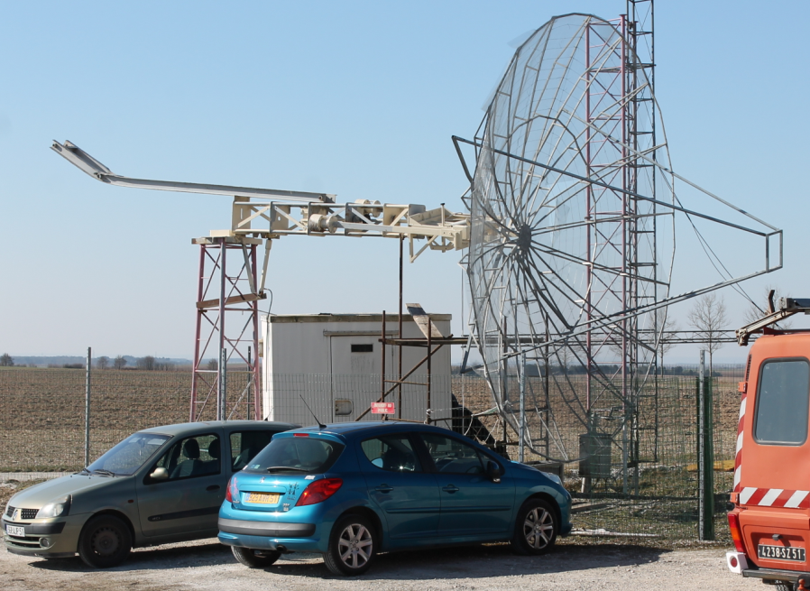
Dish at F6KHO to be used on 23 cm EME

G3LTF: Peter’s pkb100(x)btinternet.com EME report for Feb -- There hasn’t been much opportunity to operate this month due to the winter WX, which has been quite severe for the southern UK. I worked 24x23 stations on CW during the DUBUS 70 cm contest weekend. This is 20% up on 2017 and with 4 initials. Fortunately during that weekend the WX was kind, cold and dry; and the wind was from a protected direction for the dish. Conditions were good two; Faraday rotation varied but was sharp and not spread in angular extent. I suspect that the very cold WX in much of EU and NA reduced activity a bit. I worked on 24 Feb OK1CA, KL6M, LZ1DX, DF3RU, SP6JLW, OH2DG, VK5MC, ES5PC, G4RGK, OZ4MM, JA6AHB, OZ6OL, OE3JPC, UA3PTW, K2UYH, VE6TA, S51LF for initial #477 and DL2HWA #478, and on 25 Feb DL9KR, UA4AAV #479 (4.7 m and 300 W), DL6SH, VA3ELE #480 and NC1I. Heard over the weekend were SM5EPO, DL5FN, DL8DAU, G4ALH and DL7APV. I was not able to get on for the TG9 dxpedition. The WX was just too unpleasant to undo the dish and fit the feed at 4 am! I have been worried for a while about the possibility of intermod noise from the two TV stations that I have LOS plus a Tetra (civil mobile) base station on 395 MHz. I have changed the inter-stage in the LNA to a double tuned resonator pair and changed the second stage to an SPF5043 MIC. This has almost completely eliminated the TV and has improved the 1 dB compression point by 15 dB. I am also building a new 432 feed, a rotatable loop in the hope of finding a dB or so to enable me to work some of the single yagi dxpedition stations on CW. My current 432 DXCC list is at 76. I plan to be on for the 13 cm DUBUS contest with my 6 m dish and 250 W.

G3WDG: Charlie charlie(x)sucklingfamily.free-online.co.uk writes -- For the last few weeks I have been working towards getting QRV on 1296 again. Initially I experimented with a G3RUH 2.25 turn helix feed for the 3 m dish and heard many stations during the Africa dxpeditions. I have since built an SM6FHZ patch feed, and with this (using linear pol) and 40 W worked HB9Q, K5DOG, DK3WG, UA9YLU, DF3RU, G4CCH and JA6AHB. The patch feed resulted in 2 dB extra sun noise (now approx 11.5 dB) compared to using the helix feed. I’m in the process of converting to CP with the patch feed. Initial tests receiving ON0EME showed RHCP/LHCP ratio of only 7dB. Measuring the quadrature hybrid afterwards showed an amplitude imbalance of 2 dB (phase was reasonable, within ~5 deg error). The coupler is a triplate design similar to DJ9BV’s, but with a thin PCB centre conductor. The problem was that the center conductor had distorted so that in places it was not central between the two groundplanes. This was fixed by inserting 8 x M4 PTFE screws through the ground planes from both sides to locate the center conductor firmly (and also to allow some tweaking). After these modifications, the amplitude balance was improved to < 0.05 dB, phase error to <1 deg with a through loss of 0.13 dB (including SMA connectors). Tests on the 3 dish then showed the RHCP/LHCP ratio on ON0EME had improved to 14 dB. I’d be interested to hear if anyone else has done similar measurements. When the patch was configured for linear pol, VK7MO and I did some tests on 1296 using a single 34 el yagi and 120 W at Rex’s end. We used QRA64C for approximately 3 dB better performance than JT65C. Rex’s 1000 Hz tuning tone was easily visible on the WSJT-X 1.9.0 improved waterfall display. I was QRV with the new 1296 feed in CP mode on 17/18 March and worked HB9Q, DL8FBD, LA3EQ, SM7FWZ, G4YTL, EA3HMJ, SP3XBO, W2HRO, F1RJ, NC1I, IK5VLS, DF2GB, K5DN and CWNR PA2DW. The QSOs with LA3EQ and EA3HMJ needed QRA64, as my 40 W was not enough for JT65. LA3EQ struggled to decode me with QRA64C but with QRA64B it worked easily. I have also been trying to see how small an antenna can be used to receive HB9Q’s huge signal on 1296. So far, I have been able to decode Dan with about 8 dB margin with a 14 turn LHCP helix (audible level signal) and the SM6FHZ patch feed (in CP mode with the improved hybrid). Levels were (14DB) at best with the helix and (18DB) with the patch. These results were with the Moon at almost max S declination and apogee with high spreading and probably additional ground noise. More info on these tests can be found at https://drive.google.com/file/d/1wxBdMylfrQyrqDIQLIuWzveVmVvuaJG/view?usp=sharing.

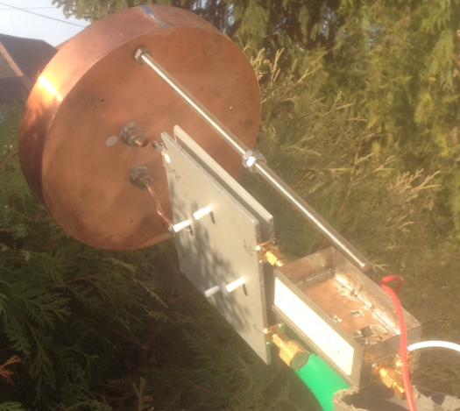
G3WDG coupler attached to patch feed

HB9Q: Dan dan(x)hb9q.ch sends a quick summary of his recent activity -- Initials worked from Dec thru Feb were on 70 cm using JT65B KC0V, IZ2DJP, UT7EL, V31EME for DXCC 161, IU2EFA, S56P, OK2PWY, VK3NX, N2END, RK2P, S51LF, WC4N, JF3MKC, PA1BVM, ON6KX, BD9BU, M0SSK, PA3HDG, R7MU, JG7PEF, SO4R, SP4CUC, RV0AGY, N0AKC and TD9CHR for DXCC162 to being me to mixed initial #1026*; on 23 cm using JT65C N1H, ZL2MQ, VK4RF, ZL3NW, VK1KW, LY2WR, W3HZU, YT1AR, RX9AT, DL1RME, RA2FGG, AA7HC, G3WDG, YL2CP, TD9CHR for DXCC 120 and K7ULS for UT and WAS 39 to bring me to mixed initial # 628*; on 6 cm CW SA6BUN for mixed initial #72* and at DXCC 32; and on 3 cm using CW JA6XED, JF3HUC and DL0SHF to bring me to mixed initial132* and at DXCC 32. On 1296, we still need the following 11 states to complete WAS: AL, AR, DE, KY, MS, MT, NV, OR, SD, WV and WY. We can work easily stations running 1 yagi (40-70 el) and 15 W or 1.5 m dish and 10 W. Any help is very much welcome!

IK1FJI: Valter valter_dls(x)yahoo.it reports on his 1296 activity at the very end of Jan – I worked using CW/SSB on 25 Jan at 1955 K5DN (569/569), 2205 K5DOG (559/559) and 2220 N4PZ (569/569), on 26 Jan at 1904 PA3FXB (559/559), 1913 G4CCH (579/569), 2205 G4CCH on SSB (55/54), and 2341 W4AF (559/559) for initial # 77, on 27 Jan at 2324 XE1XA (569/569) and 2333 WA6PY (579/569), on 28 Jan at 0035 9A5AA (559/559), 0104 (N5BF (549/559), 1815 G4YTL (559/559) #78 and 2210 VE3KRP (559/549) #79, and 31 Jan at 0105 K5DN (569/549) 0225 W3HZU (539/549) #80 (first CW QSO for W3HZU team) and 0243 K5DN (53/53) on SSB. I also made some JT65C QSOs also.

IW2FZR: Dario dario296(x)virgilio.it is now also QRV on 10 GHz EME – On 18 Feb I made my first 3 cm EME QSO with my friend JA4BLC. Much thank for Yoshiro’s for patience and help. The next weekend on 25 Feb, it was a fantastic Sunday. I made 7 contacts with JA1WQF, JF3HUC, JA4BLC, JA6XED, DL6ABC, DL7YC and F1PYR.

JA4BLC: Yoshiro’s ja4blc(x)web-sanin.co.jp EME report for Feb follows -- I worked on 18 Feb on 3 cm IW2FZR (O/O) for initial #47 XB, and on 25 Feb JF3HUC (549/549), and IW2FZR (579/569).

K4MSG: Paul pbockjr(x)gmail.com writes – I "officially" became operational on "small station" 432 EME again in mid-Feb. I began with several QSOs with "Big Guns" who were old acquaintances on 432 EME. This was followed a few days later by a first-time QSO with OZ4MM for a new DXCC and new grid. My signal report was (21DB) for my "small station" (one 15 el. K1FO yagi, 300 W and a 0.5 dB NF LNA). I am making some progress compiling a list of stations who have earned the 432 WAC. Right now, the list of calls includes DF7VX, DF5AI, DL7YCA, DL9KR, F2TU, G3LTF, HB9Q, I5MSH, K2OS, K2UYH, K3MF, K3NSS, K3PGP, K4MSG, K4PKV (now W4PID), KD3UY, KL7WE (SK), NC1I, OK1CA, OK1DFC, OK1KIR, OK3CTP, PA0PLY, PA0SSB, PA3CSG, SM0PYP, SM4IVE, SM5LE, VE4MA, VE6TA, VE7BBG, W0YZS (SK), W1JR, W1SL (SK), WB5AFY, WB5LUA, YU2RGC and ZE5JJ (SK). If you have info on additional stations who belong on this list, please send them to me. Please include callsign, full name, and year of endorsement.

K7ULS: Mike k7uls(x)yahoo.com is now QRV on 1296 from Utah – I made my first 1296 EME QSO with HB9Q using a single 55 el loop yagi and 10 W. I also have been heard by NC1I and am anxious to try more skeds and looking for ways to improve my system.

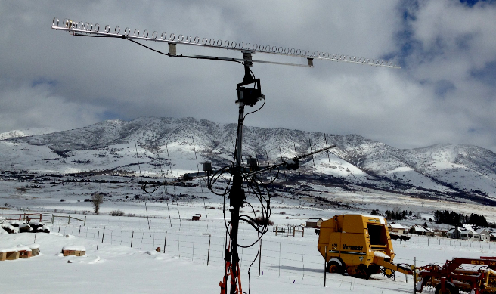
K7ULS’ 55 el loop yagi used on 1296 EME

KA1GT: Bob ka1gt(x)hotmail.com in Maine is QRV on 432 with his 2.4 m dish and 500 W (about 350 W at his OK1DFC loop feed) – I have worked NC1I, HB9Q, VK4EME (who was running only 200 W at the time), JA6AHB and KF8MY (who was running 500 W to a pair of 33 el yagis). Overall my 2.4 m dish is doing surprisingly well on 432, despite significant local noise sources and birdies. On 1296, I now have 20 W of drive and I'm working on getting my 100 W PA running. I hope to be QRV on 1296 by sometime in April.

KN0WS: Carl carlhasbargen(x)q.com lives in Minnesota and contributes -- During these bitterly cold winter days I am not able to get up north to do the EME thing. I have obtained a 1.2 m satellite dish and to keep myself occupied have been working on programming an Arduino to control it. The idea is to see if I can do 3 cm EME from my back yard here in town instead of being on the side-lines all winter. The power lines, buildings and trees only give me several hours of window to the southeast, depending upon Moon declination. This window gives me the opportunity to work EU and the US, but not Asia. I have a both CP linear feeds and Kuhne 25 W SSPA, transverter and low noise preamp. I know this may only allow me to work big guys, but VK7MO has inspired me! The dish is mounted and I have figured out how to do computer control of my TS-2000 and use WSJT-X, so I am getting there!

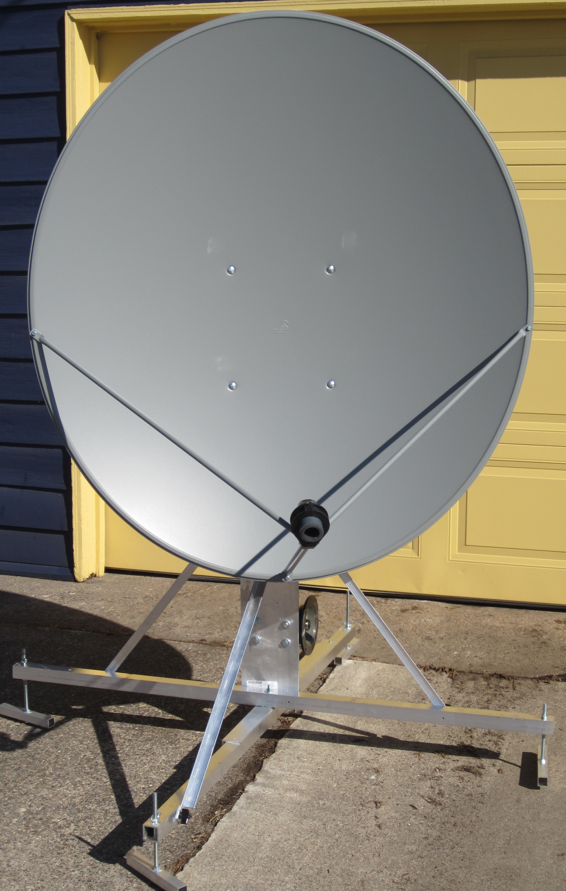
KN0WS’s 1.2 m for 3 cm EME from home

N4PZ: Steve n4pz(x)live.com has his 13 cm system working well -- I finally have consistent (549) echoes and but there is no activity at the moment. A good filter seems to have solved my WiFi noise problems. My polar mount only goes to -2 degs dec. I thus have to wait for northern dec Moon to be operational. I will be on the Moon at the end of March for the DUBUS Contest for sure. I was getting discouraged but I never give up as you know. Now I am ready for some action on 13 cm!

N4QH: Lyle lylen4qh(x)aol.com plans to become more active on EME -- I have been busy building a new home for the past year and half; as a result my 23 cm operation has suffered. I am now rebuilding my 1296 EME station. I am using an SG Labs transverter (awesome unit), a new preamp from those guys in the Ukraine (dual stage with 0.3 dB NF and 30 dB gain) - it works great! I still have to build a new dish; it will be 2.8 m dia with a new W6PQL 700 W SSPA. I hope to be back on 1296 EME in the fall.

N5BF: Courtney’s courtney.duncan.n5bf(x)gmail.com 23 cm EME report for Feb -- New initials since last report were W3HZU (#115), SP6ITF (#116), VK5OQ (#117), VK2BCC (#118), RA2FGG (#119) and EA5DOM (#120). I tried but unfortunately failed with the TD9CHR dxpedition. They were just too small for me to see their decode, but I did assist in an ultimately successful attempt between W2HRO and VE4MA/K7. I still have a water leak in my TX coax that shows up as a high reflected power (> 50 W for 400 W forward), and 10 dB down radiated (30 W at the feed instead of 300 W), which is a show stopper, and nearly trips the Load Fail on the W6PQL amplifier. This was revealed after over a year of trouble free operation by the start of the rainy season (finally!) in southern California, which is otherwise long overdue and anticipated. Right now I have both coaxes capped off to keep them dry and only mate them for operating sessions; a five minute trip up the 20’ tower at the beginning and end of the session.

NC1I: Frank’s frank(x)NC1I.COM report for Feb and early March -- All QSO’s are WSJT unless otherwise noted. On 432 we QSO’d starting on 4 Feb KC0V and DL8DAU, on 22 Feb SM7THS, R7MU (2 x 15 el yagis & 50 W), ON6KX (1 x 21 el yagi & 100 W), IK2OFO and DL8DAU, on 23 Feb DL8DAU, W5LUA and VA3ELE, on 24 Feb [during DUBUS Contest] OH2DG (CW), G4RGK (CW), VE6TA (CW), W5LUA (CW), K2UYH (CW), KL6M (CW), DL8DAU, and G3LGR, on 25 Feb [second day of contest] K4MSG (18DB/13DB) (1 x 15 el yagi), JE2UFF, UA1AAV, OZ4MM (CW), G6HKS, G4ALH, ES5PC (CW), G3LTF (CW), DL9KR (CW), and IK2OFO [Total CW 9x9], on 26 Feb K4MSG (again great signals at 17DB/12DB), N7NW and SM5EPO, on 27 Feb KF8MY, on 28 Feb K4MSG and N7NW, on 3 March TD9CHR (12DB/11DB) - outstanding signal for a new country, on 4 March UA4AAV, K4MSG and DL8DAU. It was nice to see the CW activity during the DUBUS event. I would have liked to spend more time on CW but like so many others have noted in recent years the bottom portion of the band is getting to be quite challenging. I am even starting to see an increase in “junk” signals up in the digital portion. I use to hang out on .072 but in recent months have had to move up 10 KHZ to around .082. Hopefully the trend does not continue; 432 is still my favorite band! On 1296 we QSO’d starting on 22 Feb G4YTL and UA1CCU, on 25 Feb TD9CHR (16DB/16DB) for a new country and LA3EQ, on 27 Feb VE4MA, on 28 Feb AA7HC, W2HRO, and LU8ENU, and on 2 March OK1DFC. My 1296 activity was limited over this time period. I am hoping to have my 432 polarity repaired sometime in April. W1QA and I have spent many hours uploading logs (EME & HF) to LOTW and filling out and mailing QSL cards. I believe we are now caught up on both LOTW and paper QSL cards (thanks Bob). If anyone is missing a card from me drop me a note and I will get a card out in the mail. Again I would encourage more stations to utilize LOTW. I am looking forward to the upcoming dxpeditions.

OK1CA: Franta strihavka(x)upcmail.cz was QRV in the EU EME Contest on 70 cm – I could be only active on Saturday 24 Feb. I worked OH2DG, KL6M, VK5MC for initial #185, LZ1DX, SP6JLW, G3LTF, DF3RU, ES5PC, JA6AHB, OZ4MM, G4RGK, OZ6OL, OK1DFC #186, K2UYH, DL7APV and VE6TA. My total score is 16x16. I also worked using JT65B initials with JA4UMN, SM7THS, PA0BAT, UA4AAV and DL8DAU for digital initial {#25} outside of the contest. The activity on digital traffic was better than CW. It was very cold but sunny with northen winds during the contest.

OK1IL: Ivan ivaknn(x)gmail.com was active on 1296 -- During the end of Jan and Feb, I worked RA2FGG, CT7AFN and TD9CHR all for new DXCCs on 23 cm. My biggest thrill was QSOing 23 cm newcomer BV3CE with his 2 x 30 el yagis and100 W on his balcony. It took half an hour to decode him at (28DB to 30DB), but he RXed me easily by (24DB). Honestly, this was more exciting than working a 10 m dish station on CW. With the Sun rising higher and higher, I checked my CS/Sun ratio and found out that there is still 1 dB to improve according to VK3UM Calc. I plan to fine adjust the septum ring and the horn’s position at the dish’s focus.

OK1KIR: Vlada (OK1DAK) vlada.masek(x)volny.cz and Tonda (OK1DAI) send news about there group’s recent operation (26 Jan to 3 March) -- In a 24 GHz sked arranged with OZ1LPR at a time of low spreading on 26 Jan, we worked Peter with a great signal first at 2229 with QRA64D (11DB/12DB) for digital initial {#39} (max. spread 115 Hz, real ≈40 Hz) and then with CW at 2249 (549/539) for initial #24 (real spread ≈ 30Hz). The Moon noise measured ≈ 2.1 dB. Peter used a 2.4 m offset dish and TWTA with about 25 W output in digi mode (to safeguard the TWT) and up to 40+ W on CW. We worked on 23 cm, while waiting for TD9 dxpedition with our linear feed, on 24 Feb using JT65C at 1900 UA1CCU (25DB/26DB) for digital initial {#294} and 1936 SM7SJR (10DB/10DB) {#295}, the next day on 25 Feb at 2054 TD9CHR (19DB/14DB) {#296} (17DB) for DXCC 115 (112 via EME). On 70 cm we contacted while waiting for the TD9 dxpedition on 2 March using JT65B at 2218 SM5EPO (16DB/23DB) for digital initial {#218} and 2231 G6HKS (20DB/19DB), and finally on 3 March TD9CHR heard and CWNR immediately after their MR at 0234 (22DB), 0236 heard (18DB) and 0254 QSO’ TD9CHR (23DB/22DB) {#219} DXCC 121 (118 via EME).

OK1TEH: Matej ok1teh(x)seznam.cz wrote -- During March I wasn’t that active on 70 cm EME, but was did work my mixed initial #126* with my single 23 el yagi! I QSO’d UX5UL (23DB/23DB) on JT65B. He used 4 x 39 el M2 yagis and a 1 kW PA. I also decoded several times UA4AAV (26DB) and JA4UMN decoded me (26DB), but we did not complete; so there are good chances for future contacts.

ON0EME: Eddy (ON7UN) ejespers(x)telenet.be reports having a problem with one of the two PA’s in the 1296 Moon Beacon. The beacon was switched OFF for a Moon pass while a spare PA was installed. There was also a problem with the web server used to check the status of the beacon. It is back on line. We changed the ISP and all seems to work fine again. Note you can check the status of the beacon at http://www.on0eme.org/.

PA3DZL: Jac pa3dzl(x)ziggo.nl sends a word of caution that we all need to heed -- Beware while working on your antenna!! If you wonder why I was not QRV lately; on 18 Jan I fell off a ladder while tightening a steel cable of my 3.7 m dish. I had radial head and capitellum fractures of the elbow. Surgery was needed and was in hospital for 2 days. For the time being my dish is still in the “storm position”. My recovery is going well and I should be by the end of March. [This is not an isolated event. F2TU is permanently brain damaged and will very likely never operate again after falling from the feed of his dish. K2TXB fell off a ladder while at the feed of my dish and required hospitalization. You cannot be too careful].

SP6ITF: Gregory sp6itf(x)neostrada.pl sends in belatedly his 23 cm SSB EME Funtest report – I worked on 27 Jan using SSB at 1245 I1NDP (59/56) JN, 1248 OK2DL (59/55) JN, 1356 DF3RU (55/55) JN, 1359 SP6JLW (59/56) JO, 1405 DL3EBJ (55/55) JO, 1639 DL6SH (55/55) JN, 1654 OH2DG (55/44) KP, 1700 IZ1BPN (59/55) JN, 1733 DJ8FR (57/55) JO, 1751 LX1DB (59/57) JN, 1955 K2UYH (59/44) FN and 2110 VE6TA (59/44) DO for a total of 12x2x12 = 288 points. I used a 4.5 m dish and 300 PA (4x MRF286 - W6PQL kit).

TD9CHR: Chris (PA2CHR) post(x)pa2chr.nl reports that his and PA3FYC’s dxpedition to Guatemala was very successful -- We are now home again safe after a very exciting trip to Guatemala. A nice surprise on the way was to be upgraded to business class by KLM. We had a very comfortable flight to Mexico City! The next flight was from Mexico to Guatemala. Unfortunately one of our suitcases was missing when we arrived. It had the preamp box, lots of coax, tools and other essential parts. We soon found it had been left in Amsterdam. They promised to send it on the next flight as ‘urgent and rush’ material. Luckily all antenna parts and the tripod packed in 2 golf bags did arrive OK, and we were able to build up the complete antenna system. In the afternoon we received the good news that the suitcase had arrived and was on the way by taxi. We started on 144 and despite problems with interference made many QSOs. On 25 Feb we began operation on 23 cm with a 67 el yagi mounted in between the 2 m yagis. We made 27 QSO’s in the first moonpass. We found that we could operate on both 2 m and 23 cm at the same time, and did this for the next few days. The last weekend we took down the 2 m antennas and mounted the 30 el (DG7YBN design) yagi for 70 cm. We could easy control our pol manually by turning the boom into the mast clamp. On Sunday 4 March we had some problems with the local Internet connection and during the night, we had no Internet at all. Because of this some stations missed us unfortunately. Our final results on 432 were 42 QSO’s. Logged were HB9Q (13DB), OK1DFC (21DB, OK1KIR (22DB), NC1I (11DB), UA3PTW (16DB), I1NDP (25DB), W5LUA (24DB), DL7APV (21DB), DL8FBD (26DB), DF3RU (22DB), DL9KR (529) on CW, G4RGK (27DB), DK3WG (25DB), UT6UG (26DB), PAØBAT (26DB), K5QE (22DB), K2UYH (18DB), SM7THS (22DB), ON4AOI (24DB), VE6TA (-25DB), YL2GD (23dB), DK4RC (24DB), N7NW (27DB), DJ4TL (27DB), K5DOG (26DB), VK4EME (26DB), JA6AHB (27DB), DL6SH (22DB), UA4AA (27DB), UX5UL (28DB), LZ1DX (22DB), OH2DG (19dB), UT5DL (21DB), UXØFF (28DB), DL5GP (27DB), OZ4MM (13DB), G4EZP (27DB), ES3RF (22DB), PA3CSG (21DB), ES5PC (22DB), OH6UW (19DB) and PA5Y (25DB).
1296 yagi

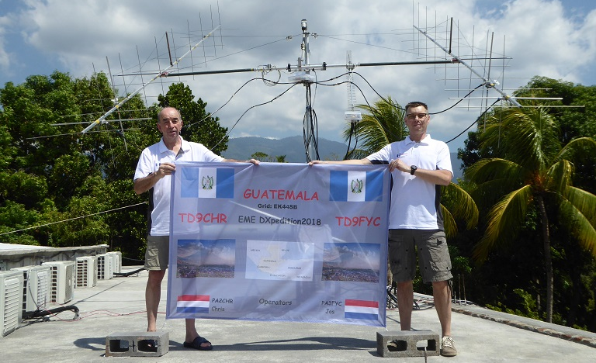
PA3CHR and PA3FYC in front of TD9CHR 67 el 23 cm yagi in the middle of the 2 m array
On 1296 we made 47 QSO’s - twice the amount we expected! We logged I1NDP (21DB), HB9Q (10DB), OK1DFC (20DB), OZ4MM (14DB), G4CCH (22DB), OK1KIR (14DB), OK1IL (25DB), PE1LWT (27DB), PE1CHQ (23DB), YL2GD (22DB), UA3PTW (16DB), ES6RQ (17DB), PI9CM (25DB), DK3WG (-29DB), DF3RU (19DB), K2UYH (18DB), PAØBAT (22DB), DJ9YW (20DB), PA3FXB (27DB), IK2COJ (24DB), NC1I (16DB), K5DN (19DB), K5DOG (22DB), W2HRO (26DB), ON4AOI (24DB), DL7UDA (26DB), W5LUA (26DB), DGØFE (26DB), JA6AHB (21DB, VA6EME (25DB), VK4CDI (26DB), SP5GDM (28DB), SP3XBO (27DB), PA7JB (27DB), OK1DFC (15DB) DUP, UA9YLU (26DB), ZS6JON (25DB), EA8DBM (20DB), PA3CSG (25DB), OH2DG (16DB), K5DN (21DB) dup, XE1XA (23DB), VK2JDS (22DB), DLØSHF (8DB), YO3DDZ (23DB), I5YDI (26DB), PA2DW (26DB), ZS1LS (28DB) and PA3DZL (24DB) for a total of 47 stations! We are very happy that nothing broke and we did not forget anything, It was a real challenge for 2 people to become QRV on 3 bands. Thanks to our very good host: Hostel Las Marias in Taxisco; a perfect place to be and very cooperative. And many thanks to all our sponsors without whose help it would not have been possible to organize this kind of dxpeditions. All QSL’s, for both calls, will be handled by Jos, but QSLs may take up to May because of another planned trip. The logs, list of sponsors and some pictures are uploaded to QRZ, See PA3FYC. All sponsors will receive QSLs direct. We hope to CU from other nice DXCC locations in the future.

VE3KRP: Fast Eddie eddie(x)tbaytel.net writes that there was not much 23 cm activity this last month – There is still 2-3’ of snow around. I tried to work the TD9 boys, but had no luck. On 19 Feb, I did work DL8FBD on JT65C for an initial. This QSO brings my digital initial count on 23 cm to {#145}. [Last month in some of the NLs, Eddie’s call was list as VE3RKP. This error was corrected on the web page and in the achieved version - our apology].

VE4MA: Barry barryve4ma(x)gmail.com send his Feb/March report – It has been very quiet here since my last report. On 26/27 Feb on 23 cm, I QSO'd OK1DFC, K2UYH, N5BF, EA3DBM, NC1I, LU8ENU and AA7HC for mixed initial #64* from AZ! I plan to be active on 2.3 GHz for the DUBUS contest. My 2320 RX (Dongle) is not very good but I will try my best. I plan to have a better RX next fall. I have been working on restoring a 100 W TWTA for 10 GHz and also trying to test a "400 W" commercial PA for 13 cm; both of which I hope to use in AZ next fall. I will be travelling back to VE4 on March 26.

VE6TA: Grant ve6ta(x)xplornet.com updates us on his recent activity -- I got on for the 432 DUBUS CW EME Contest and worked the following: W5LUA, NC1I, K2UYH, KL6M, JA6AHB, VK5MC, OK1CA, G3LTF, OH2DG, ES5PC, UA3PTW, LZ1DX, SP6JLW, OK1DFC and OZ6OL for a total of 15x14. I CWNR DL5FN as well. It sure gets quiet when NA has common window to the Pacific. Thanks to JA6AHB and VK5MC for being on. After the contest I managed to work VA3ELE on both CW and JT65B for a 432 initial, and TD9CHR for a new country. I plan to be on 13 cm for the next leg of the DUBUS contest, and I hope to see many of you there.

VK7MO: Rex rmoncur(x)bigpond.net.au is planning a 3 cm dxpedition in May/June. This time I will be on the East of Australia, Queensland Coastal, so my window to EU will be limited. On 20 May I will be at QG62 doing a 10 GHz EME demonstration at the Wireless Institute of Australia (WIA) Annual General Meeting. I have arranged a sked with W5LUA on my MR as 0100 to fit in with the WIA program. I can stay on later for other skeds, but only have 10368 with me. I will take my 1.2 m dish and 90 W PA with me. After 20 May my intention is to do a 10 GHz grid dxpedition moving north in Queensland up until about 20 June. I also plan to do some terrestrial work between my 90 W, 1.13 m dish and a 50 W, 60 cm dish, both with 10 GHz systems. I won't have room for 24 GHz.

W2HRO: Paul w2hro.fn20(x)gmail.com reports that he has completed WAC on 23 cm – I worked VK4CDI to complete WAC on 23 cm. Sigs were good even thru the tree. I think the narrow beamwidth at 23 cm makes my pine tree less of a noise problem than on 2 m. These same pine trees are a solid wall of noise for me on 2 m. I have my SM6PGP patch feed now configured for CP and it is working well. ON0EME is now a (7DB) on WSJT-X. My sun noise is now a solid 10 dB, but this improvement is related to removing feed line between the feed and my preamp. Condx were good, not excellent. I worked 10 new stations and all signal reports were very strong. My construction and testing of the patch feed was intended to prepare it for use on my 1.8 m portable dish. I'm now happy with how the patch performs. I am now up to digital Initial {#70} on 23 cm in 3 months of QRV. I have not found a station that I could not work - HI. I'm sure I'll lose one eventually. I need to get setup for 23 cm CW. 50% or more of the activity on 23 cm is CW. Also, many stations don't announce on 23 cm, so I need to get MAP65 installed.

WB3DZC: Rich rbradley(x)nrao.eduis is finalizing an agreement with the University of Virginia (UVA) to get a 10 m dish back into operation and writes -- The process has been dragging on for quite some time but we're making steady progress. This dish is my first step in attempting to organize a Center for Radio Science at UVA. We have several astronomy and engineering education-type projects planned for the dish with EME being one of them via the amateur radio club at UVA (W4UVA). I welcome and greatly appreciate any advice or suggestions that the EMEers that read this NL may have on the project. My 80 m dipole is now back up; and I'll also be joining the EMEers down on 3670 kHz when I can. [See also Rich’s comments in the Radio Astronomy Corner].

Z66EME: Uwe (DG8NCO) uwedanzinger(x)web.de will travel with DL2NUD to the new DXCC area, Kosovo, between 21 to 30 April -- After my good experience in V31EME, I will use with the same equipment on 70 cm, 2 x 25 el I0JXX yagis (horz) with dipole modification of DG7YBN. For 23 thru 3 cm Herman (DL2NUD) will use the same equipment he has used for his past GHz dxpeditions. We have rented a motor home and will drive via OE/9A/4O to Z6. It is about a 2000 km trip. We hope there will no problems on this journey and at the border to Kosovo. A power supply and emergency generator will be used so that we are independent of local power and can look for a low-noise location. Therefore we do not yet know the exact locator. Since this dxpedition involves a considerable expense, we would be very happy to receive your support. Please donate via Paypal to: uwedanzinger(x)web.de. Be sure to specify your call sign. Supporters will receive a QSL card unsolicited. Should the expedition fail for any reason, donations will be refunded. Logs will be found at mmmonvhf.de and later on qrz.com under Z66EME. 2m and 70 cm QSLs should be sent to DG8NCO and 23 thru 3 cm QSLs to DL2NUD.

ZS1LS: Allan allan(x)rfdesign.co.za sends some 23 cm news from SA – I made a few contacts on the 23 and 24 Feb in preparation for the TD9 expedition. I added digital initials using JT65C on the 23rd with RU4HU (28DB), GM4PMK (21DB), LU8ENU (26DB), SP6ITF (14DB) and DL8FBD (19DB), and on the 24th with UN7PDP (23DB) {#100}, PE1LWT (16DB), EA5DOM (22DB) SM7FWZ (12DB), SM3KPX (25DB) - using only 2 loop yagis and PA2DW (19DB). When TD9CHR came up, the first and subsequent few nights I could only copy his RRR reports at between (31DB and 29DB). The big guns were moving my S meter. I had almost given up but on the last day his signal suddenly came out of the noise at about 20 degs elevation and I started getting full decodes of his CQ and worked TD9CHR for DXCC #38. Thanks to Chris for his patience and persistence. I think if they had 3dB more power it might have been a bit easier. I am also working on 3 cm and hope to be able to use my present 3 m dish.

K2UYH: Al alkatz(x)tcnj.edu was not very active in the beginning of March because of a combination of bad WX, conflicting activities (TCF2018) and QRL travel. I was on for the 432 DUBUS EME CW Contest. I was joined by K2YY for part of the contest. We work on 24 Feb at 0032 VE6TA (559/579), 0039 NC1I (589/579), 0054 W5LUA (559/569), 0100 KL6M (559/569), 0437 JA6AHB (559/569), 0450 VK5MC (559/559), 2050 OK1CA (559/559), 2057 LZ1DX (559/579), 2110 SP6JLW (559/559), 2113 G3LTF (569/569), 2122 OH2DG (569/569), 2142 UA3PTW (569/589), 2152 OZ6OL (559/569), 2206 DL5FN (559/559), 2225 DL2HWA (559/519) and initial #743, 2228 SP6JLW (569/559) DUP, 2242 OK1DFC (589/579), 2309 OE3JPC (569/559) and 2336 ES5PC (559/559), and on 24 Feb at 2245 DL9KR (589/589) for a total score of 19x19. I switched to 1296 in the middle of the contest to look for the TD9 dxpedition. I worked on 24 Feb using JT65C at 2145 TD9CHR (22DB/O) for mixed initial #563* and DXCC 113, and later at 2306 DL8FBD (12DB/6DB), 2310 EA3DOM (13DB/9DB)#564* and 2325 VE4MA (13DB/12DB), and on 25 Feb at 0018 RA2FGG (19DB/18DB) #565*. I also worked on 432 using JT65B on 3 March at 0439 TD9CHR (15DB/18DB) for mixed initial #964* and DXCC 135. I plan to be QRV for the DUBUS 13 cm contest.

NET/REFLECTOR NEWS: G4BAO plans to be QRV during the 13 cm DUBUS contest weekend on 2320 plus 2300-2302. John can listen on 2304. CW/JT65 WHU skeds welcome. JH1KRC expresses concern with his QSL return rate. It is only about 30%! If you have received one of his QSLs he asks that you reciprocate. If you are missing a QSL from him please let Mike know. K2OS reports he achieved his 432 WAC in 2006, but has not been active for a long time because of the lack of CW activity. SM4IVE report that he is stopping EME on higher bands – his 13 cm equipment is up for sale. W9IIX is still having problems with his 432 EME system and looking for help - w9iix1(x)yahoo.com. WA6PY expresses his concern about both contest and activity weekend that are not at high northern dec – No one from EU is on to work the US west coast. The same tends to happen for JA/VK. JA6ERE will be on 2400.050 looking XB during the DUBUS 13 cm contest. VK5MC is sometimes QRV 70 cm EME with his 10 m DISH but in CW only, sked can be done via cjskeer(x)bigpond.com.

FOR SALE: PE1LTW has for sale a 23 cm station used on the dxpedition to PJ7/FS. It consists of a 250 W SSPA (PE1RKI), transverter (DB6NT) and a preamp (G4DDK). Also available is an FT857 and VK3KHZ ref unit also used on the trip. If interested contact Jurgen at pe1lwt(x)xs4all.nl. ZS1LS is working on 3 cm EME and looking for a WR90 waveguide switch. Does anyone has something to offer? Email allan(x)rfdesign.co.za. SM4IVE has for sale a complete ready to go 300 W 13 cm SSPA. He has other stuff too. See his “For Sale” at www.sm4ive.com. If interested in the SSPA contact Lars at sm4ive(x)telia.com.

TECHNICAL CORNER: Michael, DB6NT released his new 76 GHz transverter including 250 mW RF module and 5 dB NF LNA, it can be bought at https://shop.kuhne-electronic.de/. While the 76 GHz traffic in EU is going up thanks to data-links and even some 1 W amplifiers are used, maybe we’ll get soon some good amplifiers even for EME tests. By the way DB6NT is already selling 1 W SSPAs (12dB gain) for the 47 GHz band!

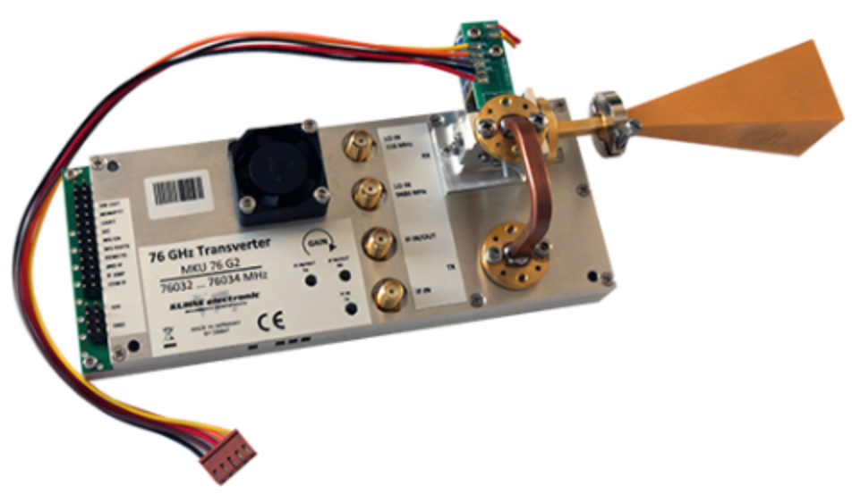
DB6NT’s new 76 GHz transverter

RADIOASTRONOMICAL CORNER: As you probably heard, one of the best known astrophysics, Stephen Hawking, Passes Away… It seems appropriate that the Event Horizon Telescope is about to finish the processing of the first picture of a black hole, located in
Sagittarius A* in the Center of our Milky Way - (of course not the black hole itself but it’s shadow and accretion disk). Mr. Hawking was supporting this project and greatly hoped that it would be successful. It is possible that the Event Horizon Telescope website https://eventhorizontelescope.org will release the expected picture (taken close to 230 and 345 GHz) in the very near future, This event will be one of the biggest successes of radioastronomy in the last couple of years. Stay tuned to twitter at twitter.com/ehtelescope and public.nrao.edu/news/.

WB3DZC is chair of international URSI Commission J (radio astronomy) and edits a monthly newsletter on Commission J activities. Rich also use this forum to highlight areas of radio science that impact the Commission. The relationship between amateur radio and radio astronomy was featured in the Dec issue as follows: “CQ all radio amateurs who also have a career in radio astronomy! Our spotlight this month is on the hobby of amateur or “ham” radio and how it plays an indirect role in radio astronomy. For some, amateur radio was an endeavor that opened a gateway into the world of radio science, which led to a career in radio astronomy. For others, it provides a means by which to explore various avenues of radio science, nurturing a deeper, more expansive understanding or fingerspitzengefühl of radio that can be applied throughout one’s scientific research career. Amateur radio also serves STEM education, introducing radio science fundamentals to students of all ages and engaging the public in some challenging “citizen science” initiatives (see http://www.hamsci.org ). Indeed, from 1922-1948 one of the URSI Commissions was “Liaison to operators, practitioners, and amateurs.” Today, the radio amateur is being recognized again by an “Amateur Radio Operators Breakfast” at the annual IEEE AP-S Symposium on Antennas and Propagation and USNC-URSI Radio Science Meeting. For more information on this fascinating hobby I invite you to read Martin Ewing’s article in this edition of the Newsletter. [See article reprinted at the end of this NL].

EME 35/25 Years ago by G3LTF: In the Jan-Feb 1983 issues, these NLs contained over 40 reports each, mostly covering 432 boosted by the recent ARRL EME contest with scores of 63 and 53 QSOs by the top stations. 1296 activity was high from stations such as Z25JJ, ZL3AAD, OE9XXI and included a number of SSB QSOs. The first cross-band EME QSOs 432/1296 were made by WB5LUA and VE7BBG using dual band feeds and with VE7BBG using CP on 432. 25 Years ago in the Jan-Feb 1993 issues, two interesting new stations appeared on 432 in the form of 9M2BV and FR5DN and were worked by several. Activity for S. America was anticipated on 1296 with an 8 m dish at OA4AO and CX9BT on 432 and 1296 with a 6 m dish. F1FHI reported 123x34 on 432 in the ARRL contest and activity on 2304 was growing fast with all of the following making QSOs OK1KIR, OZ4MM, SM3AKW, F2TU, W4HHK, W7GBI, IN3HER, OE9XXI and G3LTF. DL9EBL described his impressive station working on 9 cm with a pair of 2C39BA combined to give 80W into a 12 m dish, 0.45 dB NF and 12 dB/noise echoes in 500 Hz. So far his tests with VE4MA were negative.

FINAL: There is a great amount of information in the reports of the NL. Beware! Please see PA3DZL’s report about falling from his dish. None of us can be careful enough. Also see G3WGD and W2HRO comments on using a patch feed on 1296 EME.

► 2018 Microwave Activity Weekend (MWAW) proposal - G3LTF writes: For newcomers: The idea of an AW is to encourage activity on the higher microwave bands outside contest weekends. There are no restrictions... if you wish then use the logger, telephone, HF....and use any mode. It is not a contest. It enables everyone to make QSOs, test new equipment, feeds, preamps etc. Hopefully some of the big guns get on and provide signals for newcomers to look for. MWAWs have been scheduled in the summer time in recent years when it is easier (in the Northern Hemisphere) to throw stuff together for an initial try at a new band. This year’s dates are for 6 cm 12/13 May, 3 cm 9/10 June, 9 cm 7/8 July, 13 cm 4/5 Aug. There will also be a 1.25 cm weekend, but the date has not yet been decided.

► EME2018 the Netherlands at https://www.eme2018.nl/ is now 5 month away. It is time to get your registration in – the sooner the better. Abstracts of papers are due by April. Please send your contributions to jvm(x)netvisit.nl. It is going to be a great conference and one that you will not want to miss. PA3FXB says you must see in prepara
tion the incredible movie of Dwingeloo dish in 1956 at https://www.youtube.com/watch?v=SBPqfkU7STo.

►The wirte up by K1DS and official results of the ARRL 2017 EME Contest can be found at http://www.arrl.org/contest-results-articles and http://www.arrl.org/files/file/ContestResults/2017/2017%20EME%20Contest%20-%20Full%20Results%20-%20Version%202_03.pdf. [The top multi-op/multi-band award went to the K2UYH team, but UA3PTW should be awarded the top multi-op award as Demi’s top single-op score of 5.6 mil points exceeded ours. It does not make sense otherwise].

►The Dayton Hamvention VHF/UHF/Microwave/EME Dinner will be on Friday, 18 May 18 at the same place – same times – Double Tree Suites at Miamisburg. Social activities will begin at 6 PM. Dinner at 7 PM. Contact Kim (WG8S) whensley11(x)comcast.net if you are interested. [Unfortunately the Dayton weekend conflicts with the 6 cm DUBUS Contest]

►G3WDG announces that a beta version of WSJT-X 1.9 has recently been publicly released with a number of features of interest to digital EME operators. These include new Doppler control methods compatible with listening on one’s own echo frequency, improvements to the JT65 decoder, and to the waterfall display for weak signals. These are described in detail in K1JT’s release notes at http://physics.princeton.edu/pulsar/k1jt/Release_Notes.txt; program download is at https://physics.princeton.edu/pulsar/ k1jt/wsjtx.html. Users will see a 'splash' screen asking them to provide feedback on its use as it's a beta release. Charlie asks that any comments on the new Doppler modes be sent to him.

►The 2018 Mid-Atlantic States VHF Conference sponsored by the Packrats is on 28-30 Sept. It will again be held at the Holiday Inn Bensalem-Philadelphia. They are looking for papers. Please contact rick1ds(x)hotmail.com with your idea. Sadly the conference again conflicts with the ARRL Microwave EME Contest.

► MUD2018 will be in Fairborn, Ohio (near Dayton) on 11-14 Oct.
Registration and conference details are at www.MicrowaveUpdate.org. and info from Tom n8zm(x)mvus.org. This is always a great conference.

► We heard from N4GJV since the last NL. Ron has problems with his EME system, but has not been feeling up to making repairs as he is still recovering from a most devastating family tragedy. I suspect that he would like to hear from his EME friends. His email is rmb1991(x)live.com.

► 432 and Microwave WAC Club: Paul, K4MSG is working on collecting data on 432 WACs – see his report for an initial list. Plans are to expand this list and info on WACs on 1296 and the higher bands. This will eventual turn into a 432 and Up WAC Club.

►I afraid time has run out for this NL. This issue should have been mailed more than 2 weeks ago, but both Matej and I were tied up with QRL. What we have missed, we will try to get into the May NL. Please keep the info coming, both reports and tech. It is a real incentive to get this NL completed. We both plan to be QRV for the1296 DUBUS CW EME Contest in April. We hope to CU off the Moon. 73, Al – K2UYH & Matej, OK1TEH.

******************************************************************************
The Indirect Influence of Amateur Radio in Radio Astronomy by Martin Ewing, AA6E -- How did you find your way into radio astronomy or allied fields? Many of us got our start as radio amateurs at an early age. Amateur ("ham") Radio is a government-licensed radio service that promotes public service communications and experimentation in dozens of allocated frequency bands ranging from 135 kHz to 250 GHz. Hams must pass exams that cover regulations and radio technology, before they are authorized to operate (with up to 1.5 kW power) and are assigned a call sign. (Mine is AA6E.) While Amateur Radio had its beginning with telegraphy using spark transmitters and "damped" waves, you will now find hams communicating with advanced digital modes as well as traditional voice and "CW" (continuous waves, Morse code). Our colleague Joe Taylor (K1JT) has notably revolutionized digital ham radio by applying astronomy-inspired digital signal techniques to enable long distance work with low power – even using moonbounce transmission.
Besides signal processing, there is are important overlaps between radio astronomy and Amateur Radio. Both involve exquisitely sensitive receiving gear that is vulnerable to all sorts of human source interference. Both have to fight for spectrum allocation and protection from other spectrum users who may operate at high power levels. A group of some 35 ham/astronomers has formed an Internet list to discuss our shared history and to think about how the connection may evolve in the future. One point of agreement: an early background in do-it-yourself radio and electronics continues to be a significant boost for a later scientific or engineering career, and we would like to encourage young people along those lines. We note that a number of leading astronomer/hams have passed on to become "Silent Keys", as we say, including Lloyd Berkiner, Sam Harris, Dave Heeschen, Hein Hvatum, John Kraus, Grote Reber, Martin Ryle, and George Swenson. We invite anyone working in astronomy (all wavelengths), including students and retirees, who is or would like to be connected with the ham radio world to join our "Radioastronomy-hams" group at https://groups.io/g/ radioastronomy-hams . For information on ham radio, check the websites of various amateur radio organizations including http://arrl.org in the U.S., http://rsgb.org in Great Britain, http://www.wia.org.au in Australia, and http://www.jarl.org in Japan.

Grote Reber, the famous pioneer of radio astronomy, was also an active radio amateur. Following is pictured his license, his personal “QSL” card that was exchanged with other hams to confirm a radio contact (his callsign was W9GFZ), and his home-built station equipment. Learning of Karl Jansky’s discovery, Reber designed, built, and operated the worlds first radio telescope to study the nature of this strange “cosmic static”. His experience gained through amateur radio helped to provide the self-confidence and motivation needed to take on such an ambitious task.
If you have an interesting photograph that you wouldn’t mind sharing with others in the public domain, I encourage you to please send a copy to me along with a brief caption and the person’s name to whom I should credit.



